Implementing a playgroup on a public school site

Guidance for public schools

Contents

Introduction 2

Key principles of playgroups 3

Considerations and key information 4

Playgroups run by a community organisation 4

Facilitator’s guide – planning for playgroups 5

Play-based learning as an age-appropriate pedagogy 6

Role of the facilitator 6

Suggested learning experiences for playgroups 7

Further support 7

Appendix A – checklist for facilitators 8

# Introduction

Starting a playgroup as part of your overall school transition plan can be an effective way to build relationships with children and families and contribute to a successful start to school.

Playgroups provide opportunities for children and their families to participate in unstructured learning through play to support their development. A playgroup is often run by a facilitator who plans fun and creative experiences on a regular basis. Many public schools run playgroups for parents and children before they start school.

Playgroups enhance parent and carer understanding of child development and early childhood learning. They also provide access to community information and resources relevant to their child’s developmental needs while creating social and support networks.

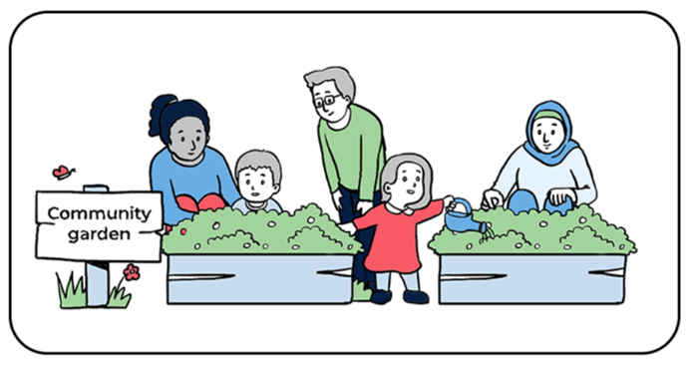

# Key principles of playgroups

* Focus on engaging play experiences. Provide children and families with a learning environment that offers engaging play-based learning experiences that are both structured and unstructured.
* Create opportunities for learning through play to promote positive child development. The play experiences should be open-ended, self-directed, intrinsically motivating, spontaneous and enjoyable.
* Recognise and appreciate the needs, perspectives and experiences of children. Foster learning and development of children by offering experiences that support their developmental milestones in a nurturing and collaborative setting.
* Encourage families to collaborate with staff by participating in the program to further develop skills in supporting their child’s learning, development and wellbeing.
* Create opportunities for families to build connections with other parents and carers, and for families to engage with their local community such as their local Aboriginal Education Consultative Group (AECG) representatives or local multicultural network. The aim is to serve as a foundation for social and community bonds by facilitating the formation of informal social networks and connecting families to local resources and services.
* Provide secure, inviting and adaptable environments. Schools establish a space for the operation of a playgroup that is culturally, physically, and emotionally secure and inclusive, prioritising the safety of children. Educators need to ensure that the environment is inviting, safe, accommodating and adequately resourced.
* Ensure a culturally-safe environment that is tailored to specific cultures, fostering connections through play. Educators adapt the program to the strengths and needs of diverse cultural groups, acknowledging and respecting the cultural heritage and needs of the families and children within their cultural context.
* Focus on strengths and provide support. Educators acknowledge and appreciate the strengths, skills and knowledge of families, and provide a platform to enhance and build upon their capabilities. They recognise the parent or carers as the child’s first teacher and facilitate opportunities for them to actively contribute to the program.

# Considerations and key information

Considerations before implementing a playgroup on a school site include:

* liaising with your director, educational leadership (DEL)
* a school not taking the duty of care or responsibility for a child attending a playgroup – a parent or carer must attend with the child
* ensuring a safe environment or space and resources suitable for children under the age of 5 years, aligned with play-based pedagogy
* following school visitor protocols, including all adults and children signing in as visitors
* families attending the playgroup completing a registration form, outlining emergency contact information and medical information
* utilising school funds for a staff member(s) to facilitate the playgroup – this might be a teacher, school learning support officer (SLSO) or Aboriginal education officer (AEO) funded by the school
* conducting a [risk assessment](https://education.nsw.gov.au/inside-the-department/health-and-safety/risk-management/whs-risk-management-procedure/risk-management-procedures1#/asset1) to identify hazards, assess and control risks associated with operating a playgroup on a school site (the [risk guidance document (DOCX 310 KB)](https://education.nsw.gov.au/teaching-and-learning/curriculum/early-learning/transition-to-primary-school-el#:~:text=Guidance%20on%20risk%20management%20for%20transition%20programs%20(staff%20only)%20(DOCX%20329%20KB)) can be used to support planning).

## Playgroups run by a community organisation

If a playgroup is run by a community organisation, a [community use agreement (PDF 1.2 MB)](https://education.nsw.gov.au/about-us/our-facilities/community-use/general.html#:~:text=A-,Community%20Use%20Agreement,-is%20required%20to) should be in place between the school (the department) and the community organisation. The community organisation will be bound by the terms of that agreement.

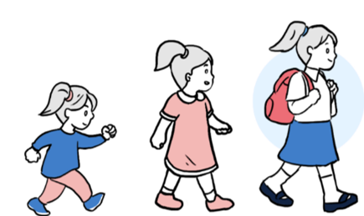

# Facilitator’s guide – planning for playgroups

A playgroup routine means establishing an adaptable schedule that can offer reassurance and a sense of security for everyone involved. This promotes a smooth flow and enables children to develop confidence by understanding what is happening. When creating a plan, take the following factors into consideration:

* address the needs, preferences and interests of all families
* incorporate a variety of play-based learning experiences that encompass every aspect of development
* allow sufficient time and space for all families to contribute to the planning process
* consider if a parent or carer has a special skill and would like to lead an experience or group time
* ensure that cultural celebrations of participating families are acknowledged and incorporated
* keep in mind the importance of flexibility (playgroups may not always follow the same structure, and unexpected events can impact the plan)
* stay adaptable and consider having some alternative learning experiences available
* ensure there are opportunities to participate in whole-school activities and events such as school tours
* playgroup sessions vary widely based on the needs and interests of children and families
* most sessions operate for approximately 1.5 to 2 hours per week.

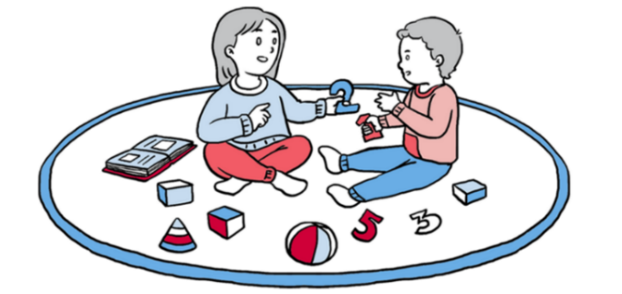

## Play-based learning as an age-appropriate pedagogy

* Research shows that structured programs using ‘push-down curriculum’ is counter-intuitive. The more age and child-appropriate pedagogical practices are, the greater the benefit for children.
* Age-appropriate pedagogies are evidence-based teaching strategies tailored to the age, development and abilities of children. Early childhood, spanning from birth to 8 years, is a critical developmental phase that requires specific approaches to support young children's concrete learning experiences and hands-on investigations.
* [Professional learning microlearning modules](https://education.nsw.gov.au/teaching-and-learning/curriculum/professional-learning/play-based-learning-as-an-age-appropriate-pedagogy) are designed to support you to understand the why and how of play-based learning.

## Role of the facilitator

Facilitators should ask open-ended questions and encourage and support families to do the same when interacting with children during their play. This encourages children to think about their learning and supports the development of their language skills.

Types of open-ended questions include:

* Tell me more about what you’re doing?
* Why do you think …?
* How do you know …?
* How did this happen?
* What can you do about it?
* What do you think would work?

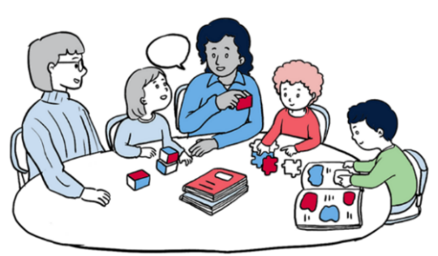

# Suggested learning experiences for playgroups

Table 1 – learning experience suggestions for playgroups

|  |  |  |
| --- | --- | --- |
| Explore diverse themes such as seasons, months, current trends, cultural celebrations and awareness weeks, local community events | Science experiments | Cooking experiences |
| Music and movement (using songs, instruments, dance, drama) | Teddy bears’ picnic | Nature hunts |
| Gross motor experiences, including fundamental movement skills (for example, [Munch & Move Resources](https://healthykids.nsw.gov.au/munch-move-resources/)) | Guest speakers attending sessions: allied health, community groups, school staff | School staff attending sessions: completing enrolment forms, school tours, foundation literacy and numeracy workshops |

For more suggestions, see: [Early childhood learning packages](https://sites.google.com/education.nsw.gov.au/ec-guided-learning/) and [Resources for families: Learning outcome cards.](https://education.nsw.gov.au/teaching-and-learning/curriculum/early-learning/resources-for-families)

## Further support

For any further guidance with implementing a playgroup on a school site, please contact [earlylearning@det.nsw.edu.au](mailto:earlylearning@det.nsw.edu.au).

# Appendix A – checklist for facilitators

|  |  |
| --- | --- |
| Playgroup planning elements | Complete/Comment |
| Consult with your director, educational leadership (DEL). |  |
| Establish the lead facilitator and/or playgroup-staff team, including organising school-funded allocation. |  |
| Identify a suitable venue for playgroup sessions and check that it is safe and free of potential hazards. Features to look for include:   * outdoor areas and shade * adequate fencing * tables and chairs for use * bathroom and kitchenette facilities * storage space for resources * accessibility and parking. |  |
| Consider an appropriate day, time and session length (may include surveying families). Add dates to school planning calendars. |  |
| Consider how you will facilitate both indoor and outdoor play and play-based activities to maximise opportunities for development. Consider how to maximise opportunities for adult and child engagement. |  |
| Create an expression of interest register (child or children’s name(s), age, parent or carer, address, contact information). |  |
| Share [Playgroup information for families (DOCX 397 KB).](https://education.nsw.gov.au/teaching-and-learning/curriculum/early-learning/transition-to-primary-school-el) |  |
| Inform school administrative staff of the program details, including the expression of interest and visitor sign-in systems. |  |
| Advertise your playgroup locally through communications on the school’s social media platforms, school website, sharing at school assemblies, flyers in the local community and places where families are likely to attend (shopping centres, sporting groups and so on).  Consult with your local cultural organisations, including the AECG.  Partner with local education and care services to share your program in their foyer or their online platforms.  Survey families or the community to decide on the most suitable day or time to run a playgroup.  Note: ensure you include information about a parent, carer or adult remaining on the school site for the duration of the playgroup. |  |
| Plan for activities to offer a wide range of opportunities in music and movement, creative arts, imaginative play, physical play, sensory play, construction and quiet play. |  |
| Identify how the playgroup will be resourced. Will resources be purchased or donated? How they will be stored? |  |
| Reflect and review how your program supports families and children, building a sense of belonging. |  |
| Place signs in the school to support families navigating to the playgroup location. |  |
| Reach out to [earlylearning@det.nsw.edu.au](mailto:earlylearning@det.nsw.edu.au) for any further support. |  |

**© State of New South Wales (Department of Education), 2024**

The copyright material published in this resource is subject to the Copyright Act 1968 (Cth) and is owned by the NSW Department of Education or, where indicated, by a party other than the NSW Department of Education (third-party material).

Copyright material available in this resource and owned by the NSW Department of Education is licensed under a [Creative Commons Attribution 4.0 International (CC BY 4.0) license](https://creativecommons.org/licenses/by/4.0/).

[](https://creativecommons.org/licenses/by/4.0/)

This license allows you to share and adapt the material for any purpose, even commercially.

Attribution should be given to © State of New South Wales (Department of Education), 2024.

Material in this resource not available under a Creative Commons license:

* the NSW Department of Education logo, other logos and trademark-protected material
* material owned by a third party that has been reproduced with permission. You will need to obtain permission from the third party to reuse its material.

**Links to third-party material and websites**

Please note that the provided (reading/viewing material/list/links/texts) are a suggestion only and implies no endorsement, by the New South Wales Department of Education, of any author, publisher, or book title. School principals and teachers are best placed to assess the suitability of resources that would complement the curriculum and reflect the needs and interests of their students.

If you use the links provided in this document to access a third-party's website, you acknowledge that the terms of use, including licence terms set out on the third-party's website apply to the use which may be made of the materials on that third-party website or where permitted by the Copyright Act 1968 (Cth). The department accepts no responsibility for content on third-party websites.