English Stage 5 (Year 9) – resource booklet – television series
Exploring the speculative – Phases 3a and 4a – Crazy Fun Park
This document contains the teacher-facing resources and activities that accompany the Year 9 teaching and learning program, ‘Exploring the speculative’.

Contents
About this resource 4
Purpose of resource 4
Target audience 4
When and how to use 4
Texts and resources 5
Phase 3a – discovering and engaging analytically with the core texts 7
Phase 3a, activity 1 – genre and the core text 8
Phase 3a, activity 2 – practising nominalisation 9
Phase 3a, resource 1 – nominalised sentence examples 11
Phase 3a, activity 3 – revising the core tenses 12
Phase 3a, activity 4 – episode synopses 13
Phase 3a, resource 2 – episode synopses answers 16
Phase 3a, activity 5 – narrative conventions in film activity 18
Phase 3a, activity 6 – analysing narrative conventions in film 20
Phase 3a, resource 3 – narrative conventions in film 21
Phase 3a, activity 7 – hybrid genre bingo 23
Phase 3a, activity 8 – the aesthetic qualities of Crazy Fun Park 25
Phase 3a, activity 9 – What’s in a name? 26
Phase 3a, resource 4 – What’s in a name? Model response 28
Phase 3a, activity 10 – symbol and metaphor in the core text 29
Phase 3a, resource 5 – symbols and metaphors in Crazy Fun Park 32
Phase 3a, resource 6 – cultural allusion in Crazy Fun Park 33
Phase 3a, activity 11 – literary allusions in Crazy Fun Park 34
Phase 3a, activity 12 – planning an imagined world 36
Phase 3a, activity 13 – See, Think, Wonder activity 37
Phase 3a, resource 7 – point of view 38
Phase 3a, activity 14 – analysing frames 41
Phase 3a, activity 15 – positioning the responder Think, Pair, Share 45
Phase 3a, activity 16 – limited and omniscient point of view 46
Phase 3a, activity 17 – characters and values 48
Phase 3a, activity 18 – hierarchy of values gallery walk 49
Phase 3a, resource 8 – character values example 50
Phase 3a, activity 19 – exit ticket reflection 51
Phase 3a, activity 20 – character archetypes 52
Phase 3a, activity 21 – reflecting on the learning 55
Phase 3a, activity 22 – character arcs 56
Phase 3a, resource 9 – What is discursive writing? 58
Phase 3a, activity 23 – comparing analytical and discursive writing 59
Phase 3a, resource 10 – conducting a silent discussion 62
Core formative task 3 – response to characterisation, writing discursively 64
Phase 4 – deepening connections between texts and concepts 66
Phase 4a, activity 1 – allegory and symbolism in famous speculative fiction texts 67
Phase 4a, activity 2 – understanding grief and loss 70
Phase 4a, activity 3 – viewing questions for episode 9 – ‘Stay’ 72
Phase 4a, activity 4 – Chester’s grief 73
Phase 4a, resource 1 – Step in, Step out, Step back 76
Phase 4a, activity 5 – authorial intent in Crazy Fun Park 78
Phase 4a, activity 6 – identifying thematic messages 79
Phase 4a, resource 2 – potential thematic messages 82
Phase 4a, activity 7 – considering the audience 83
Phase 4a, activity 8 – connecting genre and theme 84
Phase 4a, resource 3 – Values, Identities, Actions 87
Core formative task 4 – research task 89
Phase 4a, resource 4 – additional thematic representations 92
Phase 4a, resource 5 – persuasive versus discursive writing 94
References 96

Updating the table of contents
Want to update the table? Have you added content to the document and noticed the page numbers have changed? As you add content to this report, you can update the table of contents to accurately reflect the page numbers within the resource. To update the table:
- Right click on the table and select ‘Update table of contents’ (in the browser version) or ‘Update field’ (in the desktop app). In the browser version, it will automatically update the entire table.
- In the desktop app, you will then need to select ‘Update entire table’. Your table numbers should then update to reflect your changes.

About this resource
This teacher resource booklet is not a standalone resource. It has been designed for use by teachers in connection to Year 9 resources designed by the English curriculum team for the English K–10 Syllabus (NESA 2022). These include the Year 9 scope and sequence, Year 9 ‘Exploring the speculative’ program and the Year 9 Term 4 sample assessment task, which includes a student work sample.

Purpose of resource
The content in this resource booklet has been prepared by the English curriculum team, unless otherwise credited. Some of the information is collated from relevant NESA and department documentation. It is important that all users re-read and cross-reference the relevant syllabus, assessment and reporting information hyperlinked throughout. This ensures the content is an accurate reflection of the most up-to-date syllabus content. Links contained within this resource were correct as of 16 February 2024.

Target audience
These samples are intended to support teachers as they develop teaching and learning resources for their students’ needs. The program and associated resources are not intended to be taught exactly as is presented in their current format. There are instructions for the teacher and instructions for the student throughout the resources and activities. Teachers using this resource booklet should edit and refine these to suit their students’ needs, interests, abilities and the texts selected.

When and how to use
This resource booklet, which includes resources and activities for Phases 3a and 4a has been designed for the Year 9 Term 4 teaching and learning program – Exploring the speculative. It provides opportunities for the teacher to build on the learning in Phase 1 and Phase 2.
Phases 3 and 4 have been designed to allow teachers the flexibility to adopt and adapt as appropriate for their contexts. This document and accompanying teaching and learning program document focus on the ABC television series Crazy Fun Park. The English Stage 5 (Year 9) – teaching and learning program – Exploring the speculative – Phases 3b and 4b document and accompanying resource booklet focus on Lois Lowry’s prose fiction text The Giver. The teaching and learning activities in these documents are driven by the same syllabus outcomes and content points and follow a similar structure. This models how resources and activities can be adapted for a range of texts.
Teacher-facing material has been included as a ‘resource’, while student-facing material has been labelled ‘activity’ in this booklet. The resources and activities can be used as an example and adapted for the teacher’s own design of resources. The booklet also serves as an example of how resources and activities can be designed for the English K–10 Syllabus (NESA 2022). The resources and activities should be used with timeframes that are created by the teacher to meet the faculty and school assessment schedules.

Texts and resources
A succinct overview of the core text required for this part of the teaching and learning program is outlined in the table below. This brief overview provides the name and details of the core text, the syllabus requirement being addressed and points of note.
Table 1 – core texts and their alignment to the text requirements
Text | Text requirement | Annotation and overview
Verso N and Hickey S (directors) (2023) Crazy Fun Park [television series], ABC, Melbourne.  The series trailer, episodes 4, 9, 10 and an extract from episode 3 have been reproduced and made available for use by NSW Department of Education for its educational purposes with the permission of Australian Children’s Television Foundation. We are grateful for their support in the development of this resource. This resource is licensed up until March 2029. | This television series is a complex text as per the National Literacy Learning Progression (NLLP) (V3). The text explores complex, abstract concepts using historical and cultural allusion to create subtle inferences and implied meanings. The structure includes shifts in time to represent ideas that can be challenging or unconventional.  EN5-RVL-01 requires students to use a range of personal, creative and critical strategies to engage with complex texts. This text meets several of the requirements outlined in the Text requirements for English 7–10; the series can be considered as one of ‘at least 2 films’, as well as meeting the requirement for students to have experiences of a range of cultural, social and gender perspectives, including from popular and youth cultures. | This 10-episode speculative fiction television series explores a range of themes pertinent to teenagers such as belonging, friendship, grief and growing up. The series draws on the conventions of a range of genres including horror, comedy and mystery. This allows students to explore genre hybridity. The television series explores mature themes of teenage death and feelings of grief and loss. The impact of these representations on students and context should be considered before selecting this text.

Phase 3a – discovering and engaging analytically with the core texts
In this phase, students engage with the core text to develop a strong initial personal response. This response then deepens through close analytical engagement with the text. Students consider how responses to the core text are shaped through a composer’s use of narrative conventions. They examine how point of view positions responders and reflects values. Students build upon the understanding of the speculative fiction genre and sub-genres in Phases 1 and 2 to explore characterisation in the core text and its significance to the speculative fiction genre. Opportunities arise for students to develop and consolidate specific literacy skills required in the summative assessment task.

Phase 3a, activity 1 – genre and the core text
- View the trailer for Crazy Fun Park(1:20).
- Identify the sub-genre of speculative fiction to which the trailer suggests the series belongs.
- Use evidence from the trailer to support your ideas. You may like to consider discussing:
- setting
- colour palette
- non-diegetic and diegetic soundtrack
- camera movement
- camera angles
- symbolism
- lighting
- camera shots
- Select 4 to 6 adjectives in the table below to create a word cline to describe atmosphere.
- Where on the word cline does the atmosphere created in the trailer fit? Support your stance with evidence.
Table 2 – adjectives to describe the atmosphere
Adjectives
chilling  distressing  disturbing  frightening | horrifying  startling  stressful  terrifying | uncomfortable  unnerving  unsettling  worrying

Phase 3a, activity 2 – practising nominalisation
Teacher note: nominalisation is the process of converting a verb or adjective into a noun. It is a feature of formal register and academic writing. For further information, access the resources available on the Writing in Secondary Resource Hub, including the Grammar Guide. Select ‘Word level’ and then select ‘Nominalisation’.
Student note: nominalisation is the process of converting a verb or adjective into a noun. It is a feature of formal register and academic writing. This skill should assist you in composing your feature article for your assessment task.
- Underline the verbs in the following sentence:
- The trailer uses a dark colour palette. This creates an unsettling atmosphere. This intensifies the fear that horror films evoke.
- Match the verbs with the noun version of the word:
Table 3 – match verbs with noun versions
Verb | Noun
uses | intensity
creates | use
intensifies | evocation
evoke | creation
- Your teacher will demonstrate how to change the verbs in the sentence to nouns.
- How does this change affect the sentence structure and the register?
- Work with your class to rewrite the following sentence so that it uses at least one example of nominalisation.
- The low-key lighting used in the trailer creates shadows across the scene. This reflects the fear that the character is feeling in this frightening setting.
- Work with a partner to rewrite the following sentence so that it uses at least one example of nominalisation.
- The composer uses a non-diegetic soundtrack. This creates an unnerving atmosphere. It becomes louder and combines with fast-paced camera movement. This reflects the disorientation felt by the character in this setting.
- It is important to not overuse this technique because your expression may become less clear. This strategy can also support you to write using varied sentence structures. An example has been provided. Experiment with the sentence order and the other nouns to practise nominalisation.
- Write a sentence using your own observations about the film techniques used and the atmosphere created in the trailer. You may like to write it first and then edit it as you change the verbs to nouns.
Table 4 – the process of nominalisation
Version 1 | Version 2 – after nominalisation

Phase 3a, resource 1 – nominalised sentence examples
Table 5 – the process of nominalisation possible answers
Version 1 | Version 2 – after nominalisation
The trailer uses a dark colour palette. This creates an unsettling atmosphere. This intensifies the fear that horror films evoke. | The use of a dark colour palette in the trailer creates an unsettling atmosphere and heightens the intensity of the fear that horror films can evoke.
The low-key lighting used in the trailer creates shadows across the scene. This reflects the fear that the character is feeling in this frightening setting. | The reflection of the fear that the character feels in this frightening setting is conveyed though the creation of the shadows across the scene by the low-key lighting.
The composer uses a non-diegetic soundtrack. This creates an unnerving atmosphere. It becomes louder and combines with fast-paced camera movement. This reflects the disorientation felt by the character in this setting. | The composer’s use of the non-diegetic soundtrack creates an unnerving atmosphere. The combination of the increase in volume and the fast-paced camera movement reflects the disorientation felt by the character in this setting.

Phase 3a, activity 3 – revising the core tenses
You may have heard verbs described as ‘action words’. Verbs do show action, but they can also communicate information about when an action takes place – in the past, present or future. For example, the verb ‘visit’ communicates the action of going to spend time with someone. The form of the verb changes depending on when the action takes place.
- Chester visits Crazy Fun Park. (present tense)
- Chester visited Crazy Fun Park. (past tense)
- Chester will visit Crazy Fun Park. (future tense)
- Practise changing the form of the verb ‘challenge’ in the following sentence:
- Remus _______________ Chester to an arcade game competition. (present tense)
- Remus________________ Chester to an arcade game competition. (past tense)
- Remus________________ Chester to an arcade game competition. (future tense)
Sometimes, changing the tense requires you to add the suffix ‘ed’ for the past tense or an ‘s’ or ‘es’ for the present tense, but there are irregular verbs that do not follow this pattern. For example, the past tense of ‘write’ is ‘wrote’, not ‘writed’.
- Complete the gaps in the table below by inserting the correct form of the verb.
Table 6 – past, present and future tense
Past | Present | Future
studied |  | will study
talked | talk
 | believe | will believe
chose |  | will choose

Phase 3a, activity 4 – episode synopses
Student note: tense tells a reader when actions take place. Tense is conveyed through verbs.
When we write about texts, we use the present tense. The synopses of the Crazy Fun Park episodes (ABC 2024) have been written using the present tense.
- In the synopses for episodes 1 and 2, underline the verbs.
- In the synopses for episodes 3, 4, 5 and 6 insert the correct form of the missing verb.
- Rewrite the synopses for episodes 7, 8, 9 and 10 so that they are written in the present tense.
- Write a 50-word synopsis of the whole Crazy Fun Park series. Be sure to write in the present tense.
Table 7 – episode synopses of Crazy Fun Park
Episode number | Episode title | Episode synopsis
1 | ‘I Don’t Want To Grow Up’ | Chester and Mapplethorpe are both social misfits and the very best of friends. A visit to the abandoned Crazy Fun Park changes their lives dramatically.
2 | ‘One Of Us’ | Desperate to reconnect with Mapplethorpe, Chester continues to wrestle with the grief he feels over the loss of his friend.
3 | ‘Let It Go’ | Chester _________ torn between the world of the living and the world of Crazy Fun Park. His unpredictable behaviour ___________Violetta suspicious.  (is, was)  (makes, made)
4 | ‘Remember Me’ | Gonzo ____________ literally falling apart. Violetta ____________ determined to stop his decay. Chester ____________ to _________ death more comfortable for Mapplethorpe but his plan ___________.  (was, is)  (was, is)  (attempts, attempted)  (make, made)  (backfired, backfires)
5 | ‘Together Forever’ | Chester ___________ with the head of a prestigious creative school ____________ Mapplethorpe to fear that he may __________ his best friend. Violetta __________ an interest in the romantic lives of some of the Fun Kids.  (meets, met)  (led, leading)  (lose, lost)  (took, takes)
6 | ‘This Is Halloween’ | It is Halloween. For one night, the dead can _________ the earth. There __________ surprising outcomes – particularly for the unlucky-in-love Destinee.  (walk, walked)  (were, are)
7 | ‘Friends With Feelings’ | When Chester lied to Mapplethorpe about a momentous opportunity tensions rose between the two best friends. Nimrod reconnected with someone special.
8 | ‘My Name Is’ | While Chester wrestled with his future, Zed wrestled with his past. Mapplethorpe attempted to adjust to life without his best friend and focused his attention on helping Zed remember the details of his arrival at Crazy Fun Park.
9 | ‘Stay’ | Chester prepared to make a decision that affected the lives of everyone, forever.
10 | ‘Mirrors’ | When Remus set a dangerous plan into action, Chester, Mapplethorpe and Violetta were forced to confront uncomfortable truths that they preferred to forget.

Phase 3a, resource 2 – episode synopses answers
Teacher note: the following table can be used to address gaps in students’ understanding of the core text if the decision is made to not view the series in its entirety. Provide students with Phase 3a, resource 2 – episode synopses answers for their reference.
The table below provides the answers for Phase 3a, activity 4 – episode synopses.
Table 8 – episode synopses of Crazy Fun Park answers
Episode number | Episode title | Episode synopsis
1 | ‘I Don’t Want to Grow Up’ | Chester and Mapplethorpe are both social misfits and the very best of friends. A visit to the abandoned Crazy Fun Park changes their lives dramatically.
2 | ‘One of Us’ | Desperate to reconnect with Mapplethorpe, Chester continues to wrestle with the grief he feels over the loss of his friend.
3 | ‘Let it Go’ | Chester is torn between the world of the living and the world of Crazy Fun Park. His unpredictable behaviour makes Violetta suspicious.
4 | ‘Remember Me’ | Gonzo is literally falling apart. Violetta is determined to stop his decay. Chester attempts to make death more comfortable for Mapplethorpe but his plan backfires.
5 | ‘Together Forever’ | Chester meets with the head of a prestigious creative school leading Mapplethorpe to fear that he may lose his best friend. Violetta takes an interest in the romantic lives of some of the Fun Kids.
6 | ‘This is Halloween’ | It is Halloween. For one night, the dead can walk the earth. There are surprising outcomes – particularly for the unlucky-in-love Destinee.
7 | ‘Friends With Feelings’ | When Chester lies to Mapplethorpe about a momentous opportunity tensions rise between the two best friends. Nimrod reconnects with someone special.
8 | ‘My Name Is’ | While Chester wrestles with his future, Zed wrestles with his past. Mapplethorpe attempts to adjust to life without his best friend and focuses his attention on helping Zed remember the details of his arrival at Crazy Fun Park.
9 | ‘Stay’ | Chester prepares to make a decision that affects the lives of everyone, forever.
10 | ‘Mirrors’ | When Remus sets a dangerous plan into action, Chester, Mapplethorpe and Violetta are forced to confront uncomfortable truths that they prefer to forget.

Phase 3a, activity 5 – narrative conventions in film activity
Student note: narrative conventions can vary across genres and modes. Film shares some narrative conventions with prose fiction such as setting, conflict and plot structure. There are some narrative conventions in film, however, that are specific to the text type.
- View an extract from Crazy Fun Park episode 3 – ‘Let It Go’ from 4:48–6:35. Each of the film devices in the table below are featured in this extract.
- Draw on your prior understanding, interpretation of the extract and research if required to complete the blank cells in the table below.
Table 9 – narrative conventions in film activity
Film narrative convention | Definition | Example from Crazy Fun Park extract
Montage | Sequential placement of scenes to create an implied meaning.
 | Literally translates to ‘put in a scene’. This refers to how a scene is constructed using lighting, props, costume, placement of characters. | 5:09–5:13 in episode 3 – ‘Let It Go’ reflects the growing distance between Chester and his family and his gradual disconnection with the ‘real world’ of school.
Diegetic soundtrack |  | The sound of Chester’s skateboard on the road. The teacher calling ‘Chester’ when he is asleep in the classroom. The sound of the rollercoaster that Chester and Mapplethorpe ride.
 | Sound that does not come from within the world of the film. Characters cannot hear this sound and it is usually added post-production. Examples include music used to create atmosphere and establish tone, voice over narration. | The amplified ‘whoosh’ sound of Chester tossing the vanilla slice to Mapplethorpe.
Trans-diegetic soundtrack | Combining diegetic and non-diegetic soundtrack for creative storytelling and seamless transitions between scenes. For example, a song that may appear to be non-diegetic is revealed to be playing on a radio that characters are listening to.
 | The degree and type of light (such as key and fill lighting) on the subject in a frame used to enhance the mood and atmosphere of a scene. | Low key lighting is used in the scenes set in Crazy Fun Park while high key lighting is used in the scenes set in school and Chester’s home.
Editing | Methods used to connect frames and scenes together for the greatest impact and meaning. Examples include cut, dissolve, fade and wipe.
Camera movement |  | A tracking shot is used when Chester and Mapplethorpe ride the rollercoaster. The camera moves backwards in a dolly shot when Chester is at the dinner table with his parents.

Phase 3a, activity 6 – analysing narrative conventions in film
- Use the information in the table in Phase 3a, activity 5 – narrative conventions in film activity and your understanding of nominalisation developed in Phase 3a, activity 2 – practising nominalisation to construct 3 sentences that explain how film narrative conventions shape meaning in the extract from Crazy Fun Park. Examples are provided below.
- The removal of the distinction between Chester’s ordinary world and Crazy Fun Park is achieved using the trans-diegetic soundtrack which acts as a bridge connecting the 2 worlds.
- The use of the trans-diegetic soundtrack suggests that Chester is attempting to exist in both worlds – in his ordinary world during the day and in Crazy Fun Park at night.
- The exploration of the need to belong is conveyed through the use of the trans-diegetic soundtrack which reflects Chester’s inability to belong fully to either the ordinary world or to Crazy Fun Park.
- You may write 3 sentences that explore the same narrative convention in different ways, or you may write 3 sentences that each explore a different narrative convention.

Phase 3a, resource 3 – narrative conventions in film
Teacher note: there are several ways to use the information in the table in Phase 3a, resource 3 – narrative conventions in film in addition to the strategy that has been modelled in Phase 3a, activity 5 – narrative conventions in film activity. Consider cutting each row and column and giving one to each student. They then have to find students with the corresponding cards from the other columns to form a group of 3. Consider omitting the final column and requiring students to find their own examples from the extract. Allocate each film narrative convention to a pair or small group who will then write a definition and find an example from the extract.
Table 10 – narrative conventions in film
Film narrative convention | Definition | Example from Crazy Fun Park extract
Montage | Sequential placement of scenes to create an implied meaning. | Juxtaposing Chester’s life during the day and his time at Crazy Fun Park at night reveals the adverse impact this has on his schooling, family life and health.
Mise en scène | Literally translates to ‘put in a scene’. This refers to how a scene is constructed using lighting, props, costume, placement of characters. | 5:09–5:13 in episode 3 – ‘Let It Go’ reflects the growing distance between Chester and his family and his gradual disconnection with the ‘real world’ of school.
Diegetic soundtrack | Sound that can be heard by the characters in a film or television show such a dialogue, the sound of an alarm clock in a scene where a character is waking up, a song being played at a party. | The sound of Chester’s skateboard on the road. The teacher calling ‘Chester’ when he is asleep in the classroom. The sound of the rollercoaster that Chester and Mapplethorpe ride.
Non-diegetic soundtrack | Sound that does not come from within the world of the film. Characters cannot hear this sound and it is usually added post-production. Examples include music used to create atmosphere and establish tone, voice over narration. | The amplified ‘whoosh’ sound of Chester tossing the vanilla slice to Mapplethorpe.
Trans-diegetic soundtrack | Combining diegetic and non-diegetic soundtrack for creative storytelling and seamless transitions between scenes. For example, a song that may appear to be non-diegetic is revealed to be playing on a radio that characters are listening to. | The song that is played over the montage is initially diegetic as Gonzo plays it in Crazy Fun Park. It is non-diegetic in the scenes at school and in Chester’s home.
Lighting | The degree and type of light (such as key and fill lighting) on the subject in a frame used to enhance the mood and atmosphere of a scene. | Low key lighting is used in the scenes set in Crazy Fun Park while high key lighting is used in the scenes set in school and Chester’s home.
Editing | Methods used to connect frames and scenes together for the greatest impact and meaning. Examples include cut, dissolve, fade and wipe. | Scenes cut from night-time at Crazy Fun Park to daytime at school, the convenience store and Chester’s home.
Camera movement | The movement of the camera while a subject is being filmed. Examples include panning, tracking, dolly, tilt and point of view. | A tracking shot is used when Chester and Mapplethorpe ride the rollercoaster. The camera moves backwards in a dolly shot when Chester is at the dinner table with his parents.

Phase 3a, activity 7 – hybrid genre bingo
Student note: a hybrid genre blends themes and elements of 2 or more genres. Postmodernism is a literary movement that rejects more traditional texts and conventions so mixing of styles and genres is commonly found in postmodern texts such as Crazy Fun Park.
- Re-watch episode 3 of Crazy Fun Park – ‘Let It Go’.
- As you watch, cross off the genres that you identify elements of in the episode. You must be prepared to support your identification with evidence. There is space in your bingo card boxes to record this evidence.
- When you have completed the bingo card, yell ‘Bingo!’ The first student to yell ‘Bingo’ and be able to identify where in the episode the elements of the different genres can be seen will be the winner.
Table 11 – hybrid genre bingo
Genre
Speculative fiction | Romance | Comedy
Horror | Drama | Mystery
- Complete the following ‘because’, ‘but’ and ‘so’ sentences:
- Crazy Fun Park is a hybrid genre text because…
- Crazy Fun Park is a hybrid genre text but…
- Crazy Fun Park is a hybrid genre text so…

Phase 3a, activity 8 – the aesthetic qualities of Crazy Fun Park
Teacher note: the definition of aesthetic in the activity below is drawn from the glossary of the English K–10 Syllabus Glossary (NESA 2022).
Aesthetic refers to ‘a sense of beauty or an appreciation of artistic expression’.
When considering a visual or multimodal text such as Crazy Fun Park, the visual aspects of the text influence the text’s distinctiveness and memorability.
- Re-watch the opening scene of episode 2 – ‘One Of Us’ from 1:56 until 7:12.
- As you watch the scene, note down anything that stands out as aesthetically distinctive or interesting. This could, for example, be part of the setting, or the costumes of the characters.
- Answer the following questions in your books:
- How do the text’s aesthetic qualities enhance the viewing experience?
- How do you think different audiences might respond to and appreciate the aesthetic qualities of the text? For example, how might an adult audience respond similarly or differently to an adolescent audience?
- How do the aesthetic qualities of Crazy Fun Park make this text memorable?

Phase 3a, activity 9 – What’s in a name?
Student note: the following activity requires you to compose an explanatory text. The structure provided in the tables in this resource are designed to support you to first compose a sentence that serves a similar purpose to a topic sentence. You will then elaborate on key terminology. You will conclude by composing supporting sentences with detail, evidence and further discussion. This scaffold will help you to compose sentences in a logical and sequential fashion, which will be of benefit to future extended analytical writing tasks.
Symbolism and metaphor are narrative conventions that are used by composers to add layers of meaning in a text. In Crazy Fun Park, the following names can be seen to be symbolic:
- Asphodel Heights
- Chester Dante
- Remus and Romulus
- Gonzo
- Nimrod
- Destinee and Diana
- Violetta
- Using the lateral reading strategy introduced in Phase 1, activity 11 – researching sub-genres to develop your understanding of the significance of these names.
- Select 2 of the names in the list above. Use the tables below to explain how the names used in Crazy Fun Park add layers of meaning to the text.
- Give a different reason in each row of the table. An example has been completed for you as a model in Phase 3a, resource 4 – What’s in a name? Model response.
Table 12 – exploring the symbolic use of names in the core text (name 1)
How does the name _________________ add meaning to Crazy Fun Park?
Table 13 – exploring the symbolic use of names in the core text (name 2)
How does the name _________________ add meaning to Crazy Fun Park?

Phase 3a, resource 4 – What’s in a name? Model response
Table 14 – exploring the symbolic use of names in the core text (model response)
How does the name Violetta add meaning to Crazy Fun Park?
Violetta helps viewers to understand the role of the character.
It means ‘violet’ which is a flower that represents balance and harmony. Violetta brings harmony to the Fun Kids.
A violet is purple which is symbolic of creativity and spirituality – Violetta embodies both of these. Her creativity is revealed through her photography and her spirituality is evident when she helps Chester create a shrine for Mapplethorpe.

Phase 3a, activity 10 – symbol and metaphor in the core text
- Work with your group to study closely an episode of Crazy Fun Park.
- In the table below, identify any symbols or metaphors that have been used in the episode or throughout the series.
- In the final column, explain how the symbol or metaphor deepens the responder’s understanding of the text. An example has been provided for you.
- You will present your analysis to the class.
- When other groups are presenting their analysis, you will listen carefully and complete the table with the information that is presented by 3 groups of your choosing.
- At the end of this activity, you will have information on the symbols and metaphors used in the episode that you looked at, as well as 3 other episodes.
Table 15 – symbol and metaphor in the core text
Episode | Symbol or metaphor | How does the symbol or metaphor deepen the responder’s understanding about values reflected in the text?
‘Remember Me’ | Violetta’s letters | The letters from Violetta’s mother act as a metaphor for her changing attitude towards her. At the beginning of the episode, the letters are unopened indicating that Violetta is not ‘open’ to understanding her mother. At the end of the episode, Violetta opens the letters, metaphorically opening her heart to her mother again. This reflects the values on family and forgiveness that are reflected throughout the series.

Phase 3a, resource 5 – symbols and metaphors in Crazy Fun Park
If students require support to complete Phase 3a, activity 10 – symbol and metaphor in the core text, they can be guided to:
- clowns
- music
- Gonzo’s disintegration
- food
- Crazy Fun Park
- mirrors
- the rollercoaster
- art
- skeletons.
Please note, this is not an exhaustive list, but should help guide students.

Phase 3a, resource 6 – cultural allusion in Crazy Fun Park
Composers of speculative fiction draw on the real world and familiarity with other speculative fiction works to reveal the connections to the world of the responder. An allusion is reference to another story or text used to add meaning and enhance a text.
Figure 1 – Walt & Mickey
Walt & Mickey by Travis Gergen is licensed under Unsplash License.
Figure 2 – Luna Park
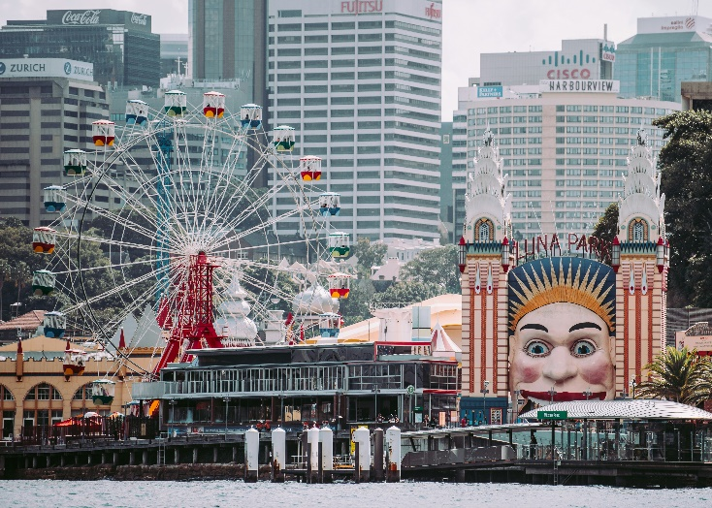
Luna Park, Sydney, Milsons Point, Australia by Annie Spratt is licensed under Unsplash License.

Phase 3a, activity 11 – literary allusions in Crazy Fun Park
Teacher note: to identify and understand literary allusions, students need to have prior knowledge of the texts to which the allusions are being made. Many students, particularly EAL/D students, may not have this cultural knowledge. Adapt and adjust this activity as required, taking into account the context of your class.
Composers of speculative fiction draw on the real world and familiarity with other speculative fiction works to draw on the prior knowledge of the responder to orient them into the world of the text. An allusion is reference to another story or text used to add meaning and enhance a text.
- For each of the allusions in the table below, note an example from Crazy Fun Park and the impact that the allusion has on the responder’s understanding of the television show.
Table 16 – allusion in Crazy Fun Park
Allusion | Example | Effect
Disneyland
Luna Park
Peter Pan
The Wizard of Oz
Pinocchio
Frankenstein
Experimenting with allusion
- Revisit your vision of the future from Core formative task 1 – generating ideas.
- Identify one aspect of the world you created that you particularly want the audience to understand.
- Incorporate an allusion into your vision of the future to help you convey your ideas to your audience.

Phase 3a, activity 12 – planning an imagined world
- Revise what you have learned about speculative fiction texts.
- Complete the following template as a plan for your own imagined world that could be the setting of a speculative fiction text.
Table 17 – plan for creating an imagined world
Feature of a speculative fiction text | Plan for own writing
Alternate reality. Locate your imagined world. Is it in the future? A completely fictional place? Another planet?
What real-world issue or experience will you use your imagined world to explore?
What sub-genre(s) will influence your piece?
How could you use symbolism, metaphor or allusion to help you convey your ideas and enhance your writing?
What are the ‘rules’ of your imagined world that readers will need to understand?

Phase 3a, activity 13 – See, Think, Wonder activity
Teacher note: this activity has been adapted from the See, Think, Wonder Project Zero toolbox thinking routine.
View the Crazy Fun Park teaser sequence for episodes 2 to 9. (The ‘teaser sequence’ is the opening sequence of a television show that is played before the title credits. It is also called a ‘cold open’ or ‘pre-credits sequence’). Then answer the following questions in your books.
- What do you see in the sequence?
- Why do you think this scene has been included before the title credits?
- What does this inclusion make you wonder about the connection between this teaser sequence and the point of view that is privileged in the episode?
- How does the director, Nicholas Verso, help the audience to understand that the action in the teaser sequence takes place before the action of the episode?

Phase 3a, resource 7 – point of view
Figure 3 – point of view poster
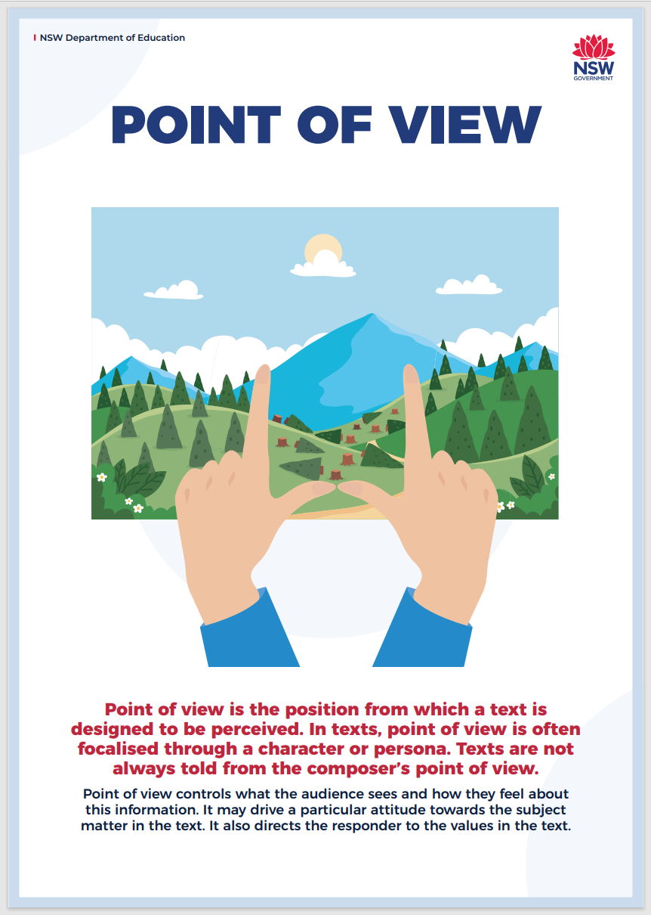
Narrative point of view
‘Point of view’ describes the connection between the narrator of a story and the characters and events created by the narrative. The point of view is through whose eyes the responder perceives the narrative and this is a powerful way to position the reader. Understanding that narratives are framed by a specific point of view reminds responders that texts are a construct, and the point of view is crucial to encouraging them to adopt the values and attitudes of the character whose point of view is privileged.
The table below outlines common point of view techniques in written texts.
Complete the final column by providing examples of texts with which students are familiar or by asking students to locate texts written using this narrative point of view.
Table 18 – narrative point of view
Narrative point of view | Definition | Example
First person | One of the story’s characters is narrating. First person is often used to create intimacy between the narrator and the responder because we learn the narrator’s inner thoughts.
Second person | Uses the pronoun ‘you’ to bring the responder into the narrative. It is an uncommon choice for a narrative voice for an extended text.
Third person limited | The narrative is told in the third person but is closely aligned with one of the characters. This point of view is limited to knowing only the thoughts, feelings and experiences of the character with whom it is aligned. The effect is that a connection between the responder and that character is formed.
Third person omniscient | An omniscient narrator is all-seeing and all-knowing; they know more than the characters in a story. There are no limitations to this point of view – they know the inner thoughts of all characters.

Phase 3a, activity 14 – analysing frames
Teacher note: when exploring this scene and these frames in response to Violetta’s point of view, you may need to explore how the creation of point of view in a film text differs to that in a print text. How, for example, does Chester’s dialogue in screenshot 6 echo Violetta’s in screenshot 5 and therefore reinforce her point of view?
Student note: in multimodal texts such as film, point of view is established through visual language devices such as foregrounding, positioning, lighting and camera shots and angles.
Consider the following frames from episode 4 – ‘Remember Me’ of Crazy Fun Park.
- Re-watch episode 4 – ‘Remember Me’. This episode is the first where the point of view moves from Chester. This episode positions responders to adopt Violetta’s point of view. Examine the following frames from the episode. Annotate the stills and use these annotations to analyse how Violetta’s point of view is privileged in the episode.
Figure 4 – screenshot 1 from Crazy Fun Park episode 4 – ‘Remember Me’
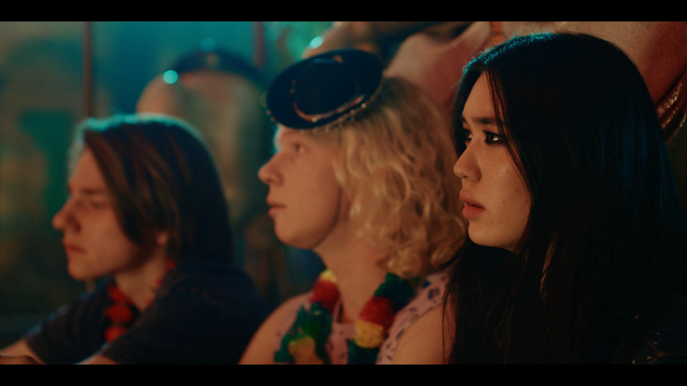
Figure 5 – screenshot 2 from Crazy Fun Park episode 4 – ‘Remember Me’
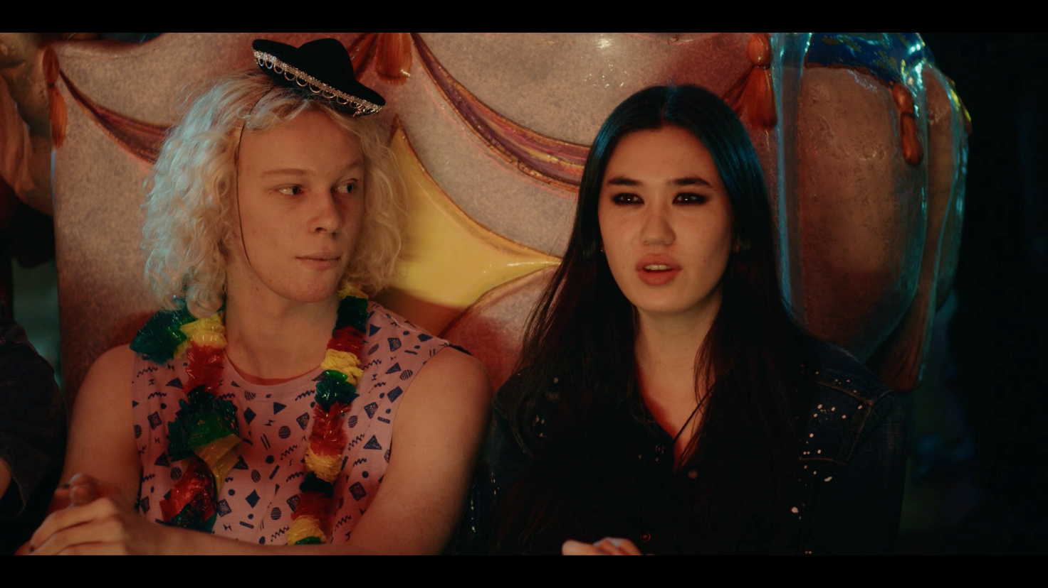
Figure 6 – screenshot 3 from Crazy Fun Park episode 4 – ‘Remember Me’
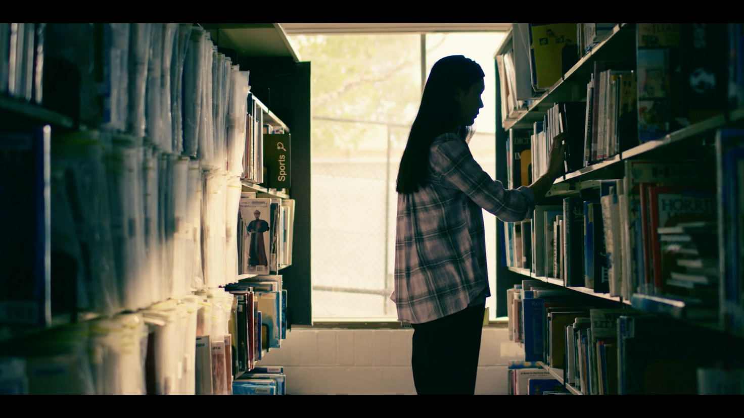
Figure 7 – screenshot 4 from Crazy Fun Park episode 4 – ‘Remember Me’
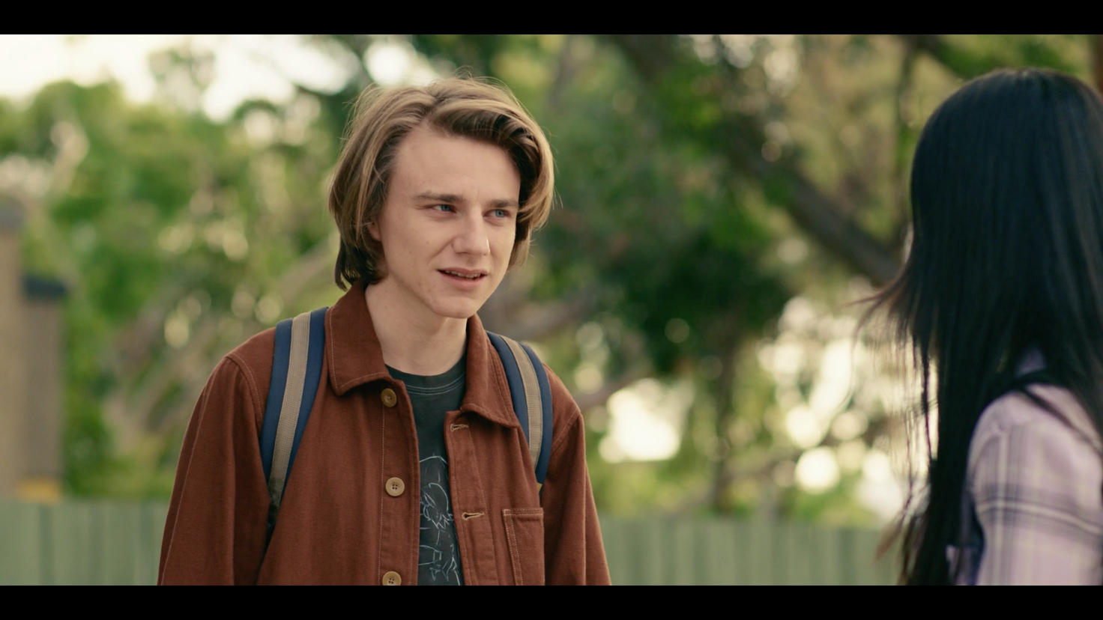
Figure 8 – screenshot 5 from Crazy Fun Park episode 4 – ‘Remember Me’
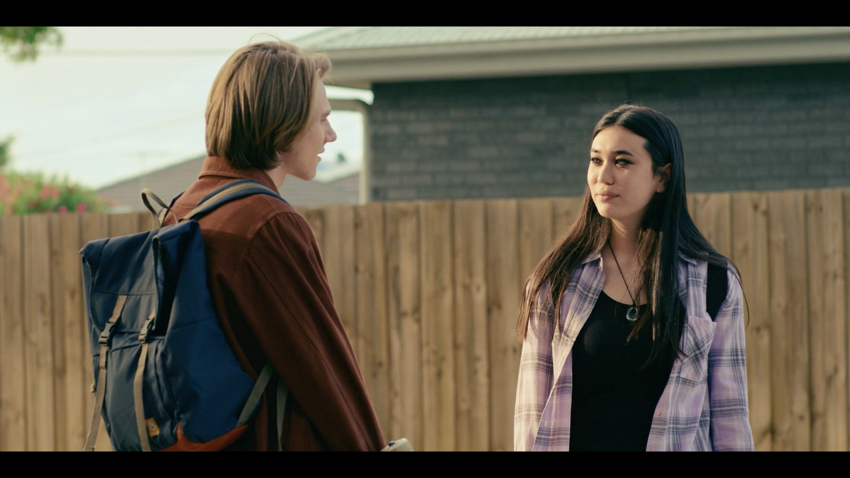
Figure 9 – screenshot 6 from Crazy Fun Park episode 4 – ‘Remember Me’
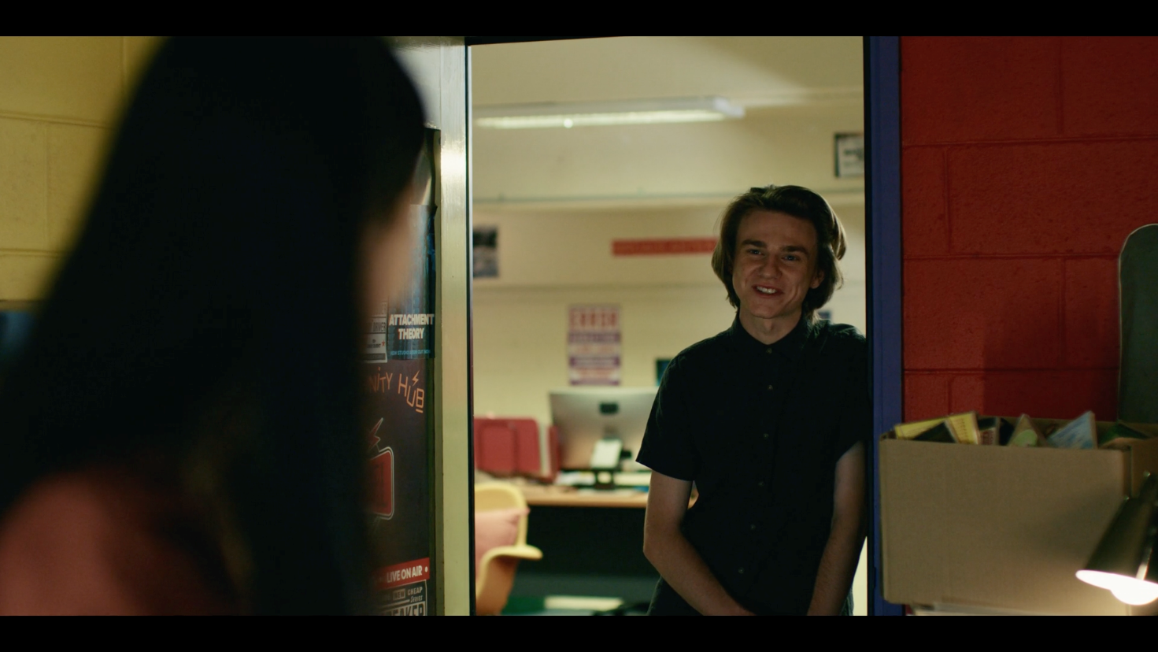
Figure 10 – screenshot 7 from Crazy Fun Park episode 4 – ‘Remember Me’
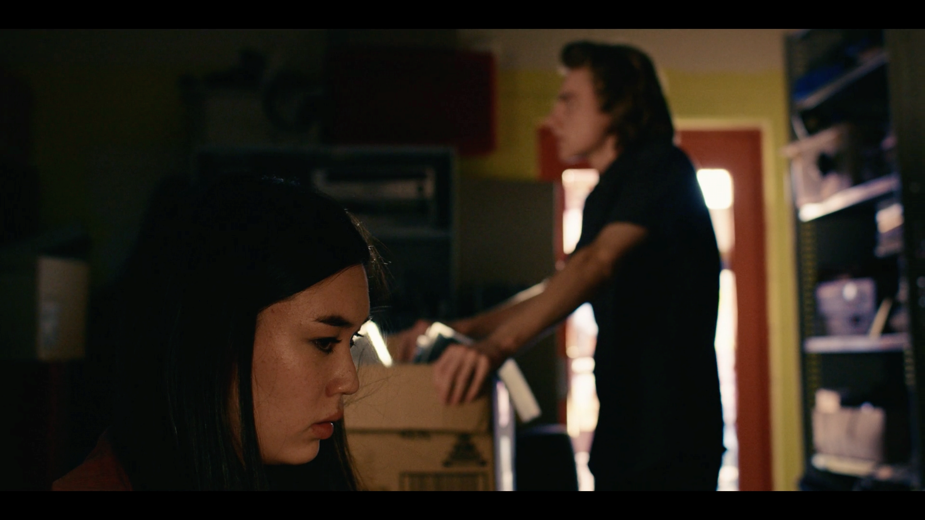

Phase 3a, activity 15 – positioning the responder Think, Pair, Share
- Re-watch 16:29–17:12 in Crazy Fun Park, episode 4 – ‘Remember Me’. This extract reflects competing values that lead to conflict between Violetta and Chester.
- Use the Think, Pair, Share thinking routine to guide a discussion of the following questions:
- Which character’s point of view does Nicholas Verso want his audience to adopt?
- How does Verso use language forms and features to position the audience to align themselves with a particular character?

Phase 3a, activity 16 – limited and omniscient point of view
The point of view in Crazy Fun Park has shifted between characters, but it is generally limited. In the final episode of the series, ‘Mirrors’, the audience’s understanding of the characters develops as the story unfolds from different points of view.
- Re-watch episode 10 – ‘Mirrors’.
- List the information that is revealed in this episode that has previously been omitted using the limited point of view.
- How does the new information affect the way that audiences respond to the characters?
Table 19 – examples of limited point of view
New information | Evidence | Effect on response to character
Violetta’s mother leaves to take care of her sick mother. | Through the dialogue we learn that Violetta’s mother does not simply abandon her family; she is ‘going to go home to take care of’ Violetta’s sick grandmother. | Responders that have been critical of the absence are more forgiving of Violetta’s mother. Violetta’s self-reflection on her interaction with her mother symbolised through the mirrors in this episode demonstrates her character development.

Phase 3a, activity 17 – characters and values
To value something is to place importance on it. Values are aspects of life or ideas to which people attach importance and these drive actions and behaviour.
- In the first column in the table below, identify the values that are represented in Crazy Fun Park.
- In the second column, list the characters who hold that value. The first row has been done as an example.
- Select a character and use the diagram in Phase 3a, activity 18 – hierarchy of values gallery walk to represent the values held by that character. The value that is most influential in driving actions and behaviour should be in the top box.
Table 20 – characters and values
Value | Characters
Family | Violetta, Remus, Nimrod, Gonzo

Phase 3a, activity 18 – hierarchy of values gallery walk
Teacher note: Figure 11 should be printed out and the selected character names written on the back. This activity could also be done using sticky notes. Students may select a character themselves or draw one from a hat, or teachers may allocate characters to ensure that there is a range.
- Select a character from Crazy Fun Park. Write their name on the back of the diagram.
- Identify the values that they demonstrate throughout the series placing the most influential value at the top.
- Stick your diagram to a space on the wall.
- When all diagrams are on the wall, look at each of them and stand at the one that you believe most aligns with your own values.
- When all students have made their selection, remove the diagram from the wall and read the character name on the back.
- Complete Phase 3a, activity 19 – exit ticket reflection.
Figure 11 – chosen character’s values

Phase 3a, resource 8 – character values example
Figure 12 – Mapplethorpe’s values
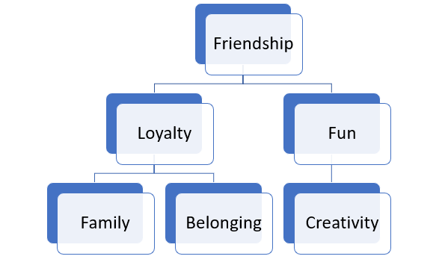

Phase 3a, activity 19 – exit ticket reflection
- Which character’s values align most closely to your own? Why?
- Did this surprise you? Why?
- Is this the character you felt the strongest emotional and intellectual connection to throughout the series? Why?
- What do you think are Nicholas Verso’s values?
- What did you learn from completing this activity?

Phase 3a, activity 20 – character archetypes
Character archetypes are the characters that we see repeatedly in texts. They share a series of traits and qualities that are often what make them life-like constructions. Characters can conform to archetypes – that means, they follow the expected pattern. Characters can subvert the archetype – that means, they might appear to conform to an archetype, but there are elements of their characterisation that challenge this expected pattern. Some characters may do both and some characters may be a combination of a range of archetypes.
- View the short video The 12 Archetypes Every Writer Needs to Know (11:17).
- In your own words, explain the meaning of the word ‘archetype’ and the connection to the word root and etymology.
- You will be allocated an archetype. You will become an ‘expert’ in this archetype. There should be at least one other student who is allocated the same archetype.
- What is your understanding of the archetype you were allocated?
- As you watch the video, listen carefully to the traits and qualities of the archetype that you have been allocated. Summarise these in the Character type column of the table.
- In the table below, identify an example of your archetype from Crazy Fun Park. Consider if this example conforms to or challenges or subverts what is expected of the archetype. What function does this example have in the text? What have they been created to achieve?
- Find a student who focused on the same archetype that you did. Compare and share your interpretations. Add to your table the notes taken by your peer.
- Share your knowledge with class members, recording what they have discovered as you go. Move through small groups until you have completed the table.
Table 21 – character archetypes
Row | Character type | Example from the core text | Conforms to or subverts the archetype? | Function in the text
1 | Explorer:  - purpose is to escape conformity  - fears becoming trapped  - motivated by freedom  - ambitious and true to self  - can become ‘lost’ on their journey. | Zed | Conforms – Zed fears being trapped in an old identity and thrives in the freedom represented by Crazy Fun Park. He is true to himself through the way he expresses his gender. The loss of his name symbolises that he has ‘become lost’ on his journey. | Zed serves as a symbol of the value of diversity. He also is instrumental in Verso’s exploration of the importance of belonging.
2 | Sage
3 | Innocent
4 | Artist
5 | Ruler
6 | Caregiver
7 | Lover
8 | Jester
9 | Orphan
10 | Hero
11 | Rebel
12 | Magician

Phase 3a, activity 21 – reflecting on the learning
Answer the following questions in your books.
- What is the value of understanding archetypes?
- How are archetypes different from stereotypes?
- If a composer uses archetypes in their texts, are they being unoriginal?
- How can an understanding of archetypes deepen the emotional or intellectual connection that a responder has with a character?
- How was your understanding of your allocated character from Crazy Fun Park enhanced or challenged when you compared your interpretation to your peer’s interpretation?

Phase 3a, activity 22 – character arcs
- View episode 1 – ‘I Don’t Want To Grow Up’ 12:50–19:48 and episode 10 – ‘Mirrors’ 20:44–24:29.
- With your class, write a description of Chester as he is represented in the first extract. Justify the description with reference to the language features used to construct this character.
- With your class, write a description of Chester as he is represented in the second extract. Justify the description with reference to the language features used to construct this character.
- Include these descriptions in Figure 13 below with the description from the first extract in the first ‘step’ and the description from the second extract in the last ‘step’.
- With your class, identify the pivotal moments in Chester’s character journey that leads him from the first ‘step’ to the final ‘step’.
- In small groups, repeat this process in Figure 14 using either Mapplethorpe or Violetta. You must locate relevant extracts that reflect the character arc throughout the series.
Figure 13 – Chester’s character development

Figure 14 – Mapplethorpe or Violetta’s character development

Phase 3a, resource 9 – What is discursive writing?
NESA’s definition of discursive writing
The following definition has been taken from NESA’s Frequently Asked Questions section on the Module C:The Craft of Writing page.
Discursive texts are those whose primary focus is to explore an idea or variety of topics. These texts involve the discussion of an idea(s) or opinion(s) without the direct intention of persuading the reader, listener or viewer to adopt any single point of view. Discursive texts can be humorous or serious in tone and can have a formal or informal register. These texts include texts such as feature articles, creative nonfiction, blogs, personal essays, documentaries and speeches.
Typical features of discursive writing
Discursive texts may include some of the following features:
- Explores an issue or an idea and may suggest a position or point of view
- Approaches a topic from different angles and explores themes and issues in a style that balances personal observations with different perspectives
- Uses personal anecdotes and may have a conversational tone
- Primarily uses first person although third person can also be used
- Uses figurative language or may be more factual
- Draws upon real life experiences and/or draws from wide reading
- Uses engaging imagery and language features
- Begins with an event, an anecdote or relevant quote that is then used to explore an idea
- Resolution may be reflective or open-ended.

Phase 3a, activity 23 – comparing analytical and discursive writing
Teacher note: the following activity draws on The Giant and the Sea which was explored in Phase 2. Having knowledge of the content of the text should allow students to focus on the writing features in both extracts. It may be appropriate to adapt this activity using the core text. A sample feature article that explores Crazy Fun Park is available in Phase 6, resource 3 – sample responses.
Student note: the extracts in the table explore the same subject matter – they are both responses to The Giant and the Sea which you engaged with in Phase 2. The text features are what make the extracts different. Understanding the differences between analytical and discursive writing should help the composition of your feature article for your assessment task.
Comparing analytical and discursive writing
- Read the first extract from written responses to The Giant and the Sea.
- Work with your class and teacher and use a highlighter to indicate where the extracts are the same.
- Use a different coloured highlighter to identify specific text features used to create a ‘voice’ in the extract. You may consider sentence structure and type, tone and other text features.
- Read the second extract and work with a partner to highlight the similarities and differences between the 2 extracts.
Table 22 – comparing analytical and discursive writing
Analytical | Discursive
The extremely moving lyrical fantasy story The Giant and The Sea resonates with the concept and value of speculative fiction and what it teaches us about our real world. Authored by Trent Jamieson, this tale not only captivates with its fantastical elements but also imparts profound lessons about climate change, activism and the resilience of hope. Through its rhythmic prose and evocative illustrations by Rovina Cai, the story transcends the boundaries of a children’s fantasy book and becomes a powerful mirror reflecting the complexities of our reality. | What if we turn to the world of fiction to explore the consequences of our actions – or, in this case, inaction? What if a picture book could inspire a new generation to better protect our world?  What if we consider the extremely moving lyrical fantasy story The Giant and The Sea and what it teaches us about our real world? Authored by Trent Jamieson, this tale not only captivates with its fantastical elements but also imparts profound lessons about climate change, activism and the resilience of hope. Through its rhythmic prose and evocative illustrations by Rovina Cai, the story transcends the boundaries of a children’s fantasy book and becomes a powerful mirror reflecting the complexities of our reality.
In conclusion, The Giant and The Sea exemplifies how speculative fiction, with its imaginative storytelling and allegorical elements, can serve as a powerful tool for teaching us about the challenges we face in our current world. Through the lens of a fantastical lyrical narrative, readers are prompted to consider the implications of climate change, the importance of activism and the enduring power of hope, where the end is the beginning and ‘there is only so much |that bravery can do’. The story’s rhythmic and cyclical nature, coupled with evocative illustrations, creates a narrative tapestry that not only entertains but also educates, leaving a lasting impression on readers and encouraging them to engage with the real-world issues it reflects. | And this hope is crucial. It is what is often missing from the doom and gloom of the messages delivered to us by climate scientists. This is the beauty of packaging this message in an engaging, fantastical lyrical narrative – readers get to consider the answer to ‘what if we continue to destroy the climate?’ but also the answer to ‘what if we take action now?’ and this speculation leaves a lasting impression and a feeling of hope. My hope is that the readers of The Giant and the Sea will be just like the brave girl in the story and through commitment and courage, protect our beautiful planet.
Similarities and differences in analytical and discursive writing
- Use the Venn diagram below to record your observations about the similarities and differences in analytical and discursive writing.
Figure 15 – Venn diagram

Phase 3a, resource 10 – conducting a silent discussion
Teacher note: in a silent discussion, students should be arranged into pairs or groups of 3. Each group member will receive a different prompt. The prompts could be set up on a Google doc or Padlet which is then shared with all group members, or they could be written at the top of an A3 piece of paper.
Silent discussion prompts
- The characters in speculative fiction texts are more important than the setting.
- Composers of speculative fiction spend so long building a world that they neglect to create characters that engage audiences.
- The characters in Crazy Fun Park reflect and challenge or subvert the values and attitudes of the context in which they were composed.
- Crazy Fun Park constructs characters that are authentic and connect with the audience both intellectually and emotionally.
- A composer has complete control over how responders react to the characters they create.
Silent discussion example
‘Composers of speculative fiction spend so long building a world that they neglect to create characters that engage audiences.’
Student A: It’s super important to create a world in speculative fiction texts. The whole point is to use the constructed world to show up the flaws in our own world. Writers of spec fic get so wrapped up in building this fictional world that they then just fill it full of unbelievable characters that are boring and really hard to like. Look at Mapplethorpe from Crazy Fun Park. He did not behave in the way that you expect a best friend to. He was super selfish and got mad jealous of Chester still being alive and being able to go to art school and stuff that he got all controlling over Chester and tried to stop him from getting over his grief. I think Mapplethorpe was meant to be likable, but this is a massive fail because he’s just annoying.
Student B: I agree with you about how it is super important for a spec fic writer to build a world well but I think you have missed a few important points about Mapplethorpe. I get what you mean about him being selfish, but I think it’s interesting to think about why he was being selfish. He was also grieving the loss of his own life and this made him angry towards Chester. And I also disagree with you about how you said that you don’t expect a best friend to behave like that. I do! I reckon it’s a pretty accurate portrayal of friendship. People often lash out at the people they are closest to.

Core formative task 3 – response to characterisation, writing discursively
The purpose of this core formative task is for you to experiment with a discursive style of writing by offering ideas and responding to the ideas of your peers in writing. You will compose a short discursive piece of writing using the content from the silent discussion in which you have engaged.
- Select one of the ‘silent discussions’ you had with a partner or small group. The content from this discussion will form the basis of a piece of discursive writing of 200 to 400 words that responds to the prompt ‘How important is the reader’s connection to characters in speculative fiction texts?’
- Revise and edit the content of the silent discussion to compose one to 2 paragraphs of a discursive response to the characterisation in Crazy Fun Park. Remember that when writing about texts, you should use the present tense.
- Complete the self-assessment checklist below. It is not necessary for your piece of writing to include all the features in the table.
- Identify 3 features on discursive writing that you will aim to include in your feature article for the assessment task. These may be features that you successfully used in this piece of writing, or they may be features with which you have not yet experimented.
Self-assessment checklist
Table 23 – self-assessment checklist
My discursive piece | Tick the features evident in your writing
Explores an issue or idea
Suggests a point of view
Explores more than one perspective
Has a conversational tone
Uses first person
Uses figurative language
Uses factual language
Draws upon real-life experiences
Draws upon wide reading
Uses engaging language features
Is reflective
Begins with an engaging quote or anecdote that is used to explore an idea
Three features of discursive writing that I will aim to experiment with in my feature article are:
- _____________________________________________________________
- _____________________________________________________________
- _____________________________________________________________

Phase 4 – deepening connections between texts and concepts
In this phase, students explore the ways that genre is used to communicate thematic messages about the real world. Students engage in research to develop an understanding of the text and author, and of the real-world experiences or events represented through the text. Students investigate authorial intent and how this impacts the creation and delivery of thematic messages within a text. Students will also consider and evaluate how the text’s thematic qualities impact the literary value of the text. Students are provided with opportunities to think critically about the text, its context and the contribution it makes to public discourse. Students demonstrate their understanding by writing informatively, analytically and persuasively in response to the core text and non-fiction texts.

Phase 4a, activity 1 – allegory and symbolism in famous speculative fiction texts
- Read through the list of texts in the table below and the allegorical or symbolic representations that the texts contain.
- Fill the final 3 rows with information about speculative fiction texts from your own wide reading or viewing.
Table 24 – allegory and symbolism in famous speculative fiction texts
Text | What happens | Allegorical representation
Jurassic Park – originally a novel by Michael Chrichton before becoming the first in a popular film franchise. | Scientists have discovered a way to grow dinosaurs in a lab, using DNA from ancient Amber. However, disaster ensues when the dinosaurs escape their enclosure, and creatures including velociraptors, dilophosauruses and the tyrannosaurus rex rampage through the park, killing all who get in their way. | The text allegorically comments on a range of real-world issues, including:  - the cruelty of zoos  - genetic modification and cloning  - capitalist and corporate greed.
The Hunger Games trilogy – a series of books originally written by Suzanne Collins and turned into a popular film series. | A young girl volunteers through a process called ‘the reaping’ to take the place of her sister in a competition against children from 11 other districts in her world. These ‘Hunger Games’ force the children to compete in a televised battle where the last child left is crowned the winner. The annual Games are a punitive tool to remind the Districts that they lost the war against the Capitol. | The text allegorically represents a range of real-world issues, including:  - capitalism and the developed world’s reliance on third-world labour  - voyeurism and reality television  - society’s desensitisation to violence  - teenage rebellion against authority  - urban versus rural living.
Animal Farm – a famous novella written by George Orwell in 1945. | A group of farm animals rebel against their farmer and take over the farm. They do this because they do not appreciate that the farmer controls their lives, takes their produce yet gives them very little in return. However, over the course of the novella, the pigs that comprise the leadership group start acting more and more like humans, until they walk on their hind legs, live in the farmhouse and treat the other animals the same as they were being treated by the farmer. | This novel is a very famous allegory for the overthrowing of the Tsar of Russia, Nicholas II, in 1917. Orwell’s work allegorises and satirises the Communist system that was established to replace the Tsar.
Star Wars – a popular film franchise, originally directed by George Lucas, that has spawned texts across a range of different types, including novels, television shows and comics. | The main premise of Star Wars is an intergalactic war set ‘a long time ago, in a galaxy far, far away’. An evil power, the Galactic Empire, and its order of warriors called the Sith, dominate society. Led by peacekeepers called the Jedi, a group of fighters called The Resistance, fight to overpower the Empire and restore balance to the Force. | Star Wars contains many allegorical references to historical wars, figures and events, including:  - World War II through the costuming of the Imperial officers of the Empire, and through the name given to their fighters – ‘stormtroopers’  - American president Richard Nixon, who was the inspiration for Emperor Palpatine  - the Vietnam War, particularly the guerrilla style fighting  - Ancient Rome through power structures like the Senate, the Republic and the Empire.

Phase 4a, activity 2 – understanding grief and loss
Teacher note: this activity has been designed to allow students to complete it electronically. Students could be instructed to submit their work through an online assignment submission using a tool like Microsoft Teams or Google Classroom. If you would prefer for students to handwrite their answers, you may wish to alter the formatting of this activity accordingly.
Student note: the hyperlinks on the website you will use for this activity demonstrate clear and effective labelling – it is obvious what information you will be taken to if you select the hyperlinks. This is something to keep in mind for any hyperlinking that you may include in the feature article for your assessment task.
Open up the healthdirect Grief and loss webpage. Type your answers to the questions into the spaces provided below. The cells will keep expanding as you type Use the hyperlinks provided in the ‘On this page’ section to help navigate the page.
- In your own words, define ‘grief’ and ‘loss’.
- What are 4 different reasons why people may feel grief and loss?
- What effects might grief have on an individual?
- What is prolonged grief?
- What are some signs that a person should seek help to deal with their feelings of grief?
- What strategies can people use to help them manage their feelings of grief?
- What supports are available for people if they need additional help with managing their grief?
- Find on the webpage and open the document ‘Supporting your child through Grief and Loss’ by the Australian Child and Adolescent Trauma, Loss and Grief Network (ACATLGN). What does this document say about the way grief may impact adolescents?

Phase 4a, activity 3 – viewing questions for episode 9 – ‘Stay’
Teacher note: this episode explores 3 different but interconnected narratives – Chester’s existential crisis, Violetta’s investigation into Romulus and Kiba’s deaths and Mapplethorpe learning about the impact of his death on his mother. The questions in this activity focus on Chester’s storyline.
As you view Crazy Fun Park episode 9 – ‘Stay’, answer the following questions in your books.
- Describe the mood in the opening scene by the pool where Chester and Mapplethorpe talk to each other and ride the merry-go-round. How is this mood achieved through a combination of camerawork, lighting and audio?
- How does the episode acknowledge the impact of music on mood through the diegetic music at approximately 3:30?
- The conversation between Chester and Mapplethorpe from 4:30 takes a serious turn when Chester suggests he could ‘stay’. What is Chester implying with this suggestion? What advice do the other members of the Fun Kids give to Mapplethorpe?
- From approximately 12:30, a scene occurs showing Chester sitting at the top of a mountain, where he and Mapplethorpe used to go together. What film devices are used to show that he feels alone?
- What does Mapplethorpe learn from his visit to his mother? How does this influence his point of view about Chester’s desire to stay in the park?
- Multiple people ask Chester if he is okay in this episode. Why do you think they do this? How does he respond?
- Describe Chester’s entry to the fun park from 20:40. What music is used, what facial expressions and body language are used and so on.
- What does Chester see in the house of mirrors? Why do you think this vision appeared to Chester? What emotions are expressed during this scene?
- What does the cliffhanger at the end of the episode reveal about Chester’s decision to ‘stay’?

Phase 4a, activity 4 – Chester’s grief
Teacher note: the experiences and symptoms listed in this table have been adapted from the healthdirect Grief and loss webpage.
- The left column of the table below contains common experiences felt by those suffering from prolonged grief, and symptoms that indicate that a person should seek help for their grief. In the right column, provide some examples from Crazy Fun Park that indicate that Chester is suffering prolonged grief. The final row has been completed for you.
Table 25 – identifying evidence of Chester’s prolonged grief
Experiences and symptoms of prolonged grief | How can this be seen in Chester?
The person may have difficulty sleeping.
The person may have difficulty socialising with friends, family, peers or colleagues.
The person feels a sense of overwhelming sadness.
The person experiences more extreme thoughts or behaves in an extreme manner.
The person may have an ongoing longing for the past.
The person may experience a range of intense emotions.
The person may have difficulty committing themselves to tasks they would normally find straightforward.
The person may have thoughts of harming themself. | Chester’s struggles with his desire to stay at the fun park are a representation of his conflicting emotions whilst grieving. Chester knows that if he stays beyond sunrise, he will be unable to ever leave the park and will join the undead Fun Kids in their purgatory-like state. However, he considers this as a way to maintain the friendship with Mapplethorpe and be a part of this new group of kids who seemingly are having fun every night.
- A common feeling or emotion experienced by people who are suffering from grief is guilt. Chester clearly feels guilty about Mapplethorpe’s death. Why does Chester feel guilty, and how do you think this guilt influences his desire to join the Fun Kids in death? Answer on the lines below.

Phase 4a, resource 1 – Step in, Step out, Step back
Teacher note: the Step in – Step out – Step back thinking routine outlined in this resource has been adapted from the Project Zero Thinking Routine toolbox resource.
How to use
This routine could be adapted and implemented as an individual activity, a group activity or a whole-class activity. It is useful when applied to characters within a text to consider different points of view. In this task, students will apply the routine to the composer, Nicholas Verso, to consider his perspective on the emotions and experiences he has chosen to represent through his television show.
Step in
Remind students that in this initial phase they are hypothesising or speculating, based on the information that is available to them. Their answers don’t need to be correct at this point, but they should be able to justify their answers by pointing to examples from the text.
Question prompt – What do you think the writer and director Nicholas Verso might feel, believe, know or experience about grief and loss?
Step out
This stage in the process is a good reminder to students that to understand the perspectives conveyed through texts fully, they need to develop an understanding of context. In the case of Crazy Fun Park the dominant context that affects representations of grief is Verso’s personal context. However, the cultural and social context also plays a clear role in other aspects of the text, such as the intentional representation of diverse identities.
Question prompt – What might you need to know or learn about Nicholas Verso’s personal context to understand the perspective about grief that is communicated through Crazy Fun Park?
Step back
Students reflect in this stage about their own biases and perspectives, and how these may have shaped their initial responses. This could pose an opportunity to discuss the role of the audience and the audience’s perspectives in interpreting the thematic messages and representations within texts.
Question prompt – What did this activity make you notice about your own perspective, and the challenges and opportunities provided by forcing yourself to consider someone else’s?

Phase 4a, activity 5 – authorial intent in Crazy Fun Park
Answer the following questions in your books.
- What do you think inspired Verso to write and direct Crazy Fun Park?
- The quote below from Nicholas Verso is included in the article Welcome to Crazy Fun Park! In this article, we discover that ‘Verso was inspired to create the show after losing several friends as a teenager’. Does this quote influence your thoughts about the text? Why or why not?
‘I never really spoke about it. There was no language for a teenage boy to process grief and what happens when you watch somebody’s life get ripped away from them. So I wanted to create a show that dealt with grief and loss but was also a fun, explosive celebration of life and spirit and how that energy can live on in our memories.’ (ABC Publicity Media Room 2022)

Phase 4a, activity 6 – identifying thematic messages
- Using the table below, brainstorm a series of sentences that clearly identify thematic messages about grief that are communicated through Crazy Fun Park. An example of a thematic message could be ‘grief and loss can have a significant and lasting impact on people’.
Table 26 – thematic messages brainstorm
Thematic messages about grief
Grief and loss can have a significant and lasting impact on people.
- For a theme to be validly identified, it is important to determine that it is represented consistently across the entirety of a text. Use the table below to provide 3 different examples and analyse how the author has represented the thematic messages you have identified in the table above. These examples could be in reference to one character, or to multiple.
Table 27 – connecting themes to textual examples
Theme | Example 1 | Example 2 | Example 3
Grief and loss can have a significant and lasting impact on people. | Chester’s grief reaches its worst point in episode 9 – ‘Stay’. It is most obvious in the scene where Chester sits alone at the top of the mountain. An over-the-shoulder shot of him staring out at the broad horizon, coupled with the time lapse shot of the sun setting indicates the immense loneliness that Chester continues to feel about his friend’s death. | The mise en scène of Mapplethorpe’s kitchen when he visits his mum shows her continued grief at his death. The rubbish and mess demonstrate the difficulty she has performing everyday tasks in the aftermath of her son’s death. Furthermore, Mapplethorpe sobs as he reads the Facebook posts on his mother’s computer, exemplifying the immense sadness that she communicates through the posts. | The characterisation of Nimrod’s Aunty Winne conveys the grief that she still feels years after his death. The hat that she wears is the same hat that Nimrod was trying to retrieve when he died, symbolically demonstrating her continual desire to connect with his memory.

Phase 4a, resource 2 – potential thematic messages
The following thematic messages could be provided to students to support their engagement in Phase 4a, activity 6 – identifying thematic messages:
- Grief and loss can have a significant and lasting impact on people.
- Grief impacts people in a range of different ways.
- Grief provokes a range of emotional responses, such as guilt.
- Grief is a particularly challenging emotion for adolescent boys to process.
- It is important to call upon support structures when experiencing grief.

Phase 4a, activity 7 – considering the audience
Answer the following questions in your books.
- Who do you think is the target audience of this television show? Provide an age range.
- Why did you pick this as an age range? Why do you think it isn’t targeted at audiences younger or older than your identified range?
- Think, Pair, Share – do you think Crazy Fun Park is effective in communicating thematic messages about grief, and ways to manage it, to your identified target audience? Why or why not?
- Think, Pair, Share – do you think that audiences outside of your identified age range might respond to the text and its thematic messages differently? Why or why not?

Phase 4a, activity 8 – connecting genre and theme
- Complete the table below by filling in the empty cells. Some examples have been completed for you already. To complete the table you should:
- identify in the first column a feature of the text that reflects the conventions of the speculative fiction genre, or the horror and comedy hybrid that more specifically suit this text.
- explain in the second column how this aspect is useful in communicating thematic messages about grief.
Table 28 – connecting genre to theme
Speculative features of the text | Connection to theme
The reanimation of the characters as the zombified Fun Kids. (Characterisation) | The Fun Kids also exhibit significant grief. Mapplethorpe in particular demonstrates his despair at his own death after a tragic accident. This allows the audience to understanding the trauma associated with death, grief and loss.
Chester, and other characters, are able to see and communicate with the dead Fun Kids. (World building – rules)
The abandoned Crazy Fun Park which is used as the setting. (Setting)
The choice of lighting throughout the television show is often very dark, and much of the action happens at night. (Setting and mood)
The temporal setting of Halloween in episode 6 – ‘This is Halloween’ and its spatial setting within the graveyard. (Setting)
The specific rules and regulations around the visits of the living to the Fun Park – particularly that they can only come at night, and if they stay over their time, they cannot return to the world of the living. (Worldbuilding – rules)

Phase 4a, resource 3 – Values, Identities, Actions
Teacher note: this activity has been adapted from the Values, Identities, Actions resource from the Project Zero Thinking Routine toolbox. This routine is one that has been adapted from a process used to explore aspects of works of art. Routines such as these are easily transferrable and provide an opportunity to reinforce to students the connections between thinking skills across subjects.
Values
Opening question:
- What values does Crazy Fun Park invite us to think about?
Additional questions to further student reflection:
- Who do these values belong to?
- Are these commonly held values or are they unique?
- Do you share similar values?
Identities
Opening question:
- Who is Crazy Fun Park speaking about, and who is it speaking to?
Additional questions:
- Did the text speak to or impact on you personally?
- Are there any people in society that you think are excluded from or by this text?
- What barriers or challenges might some audiences have in connecting to this text?
Actions
Opening question:
- What actions might this work encourage?
Additional questions
- Who is this text encouraging actions from?
- What might be some actions that this text might encourage that the author may not have intended?

Core formative task 4 – research task
Teacher note: the instructions in this resource are specific to Crazy Fun Park and its representations of grief. This task could easily be replicated for a different text or for a different idea, theme or experience represented within the text. An overview of representations within the text has been included in the teaching and learning program. Consider adding additional bullet points to the first instruction as required and relevant to the content you have explored.
Student note: the research you conduct in this core formative task will support you to create the feature article for your assessment task. By gaining a deeper understanding of the real-world issues explored in Crazy Fun Park, you will be able to speak about its impact on audiences with greater confidence and authority. Any sources you find now could also be potentially used as hyperlinks within your feature article.
The purpose of Core formative task 4 is for you to undertake research into your core text and one or more of the ideas, themes or experiences represented within the text.
In this core formative task, you will be conducting research about 2 things:
- the television show Crazy Fun Park
- real-world experiences of grief as relevant to the television show.
Step 1 – gathering your information
In the table below, complete each of the rows by:
- identifying and hyperlinking the source in the first column
- identifying what type of source it is in the second column and comment on its reliability as a source
- summarising what valuable information can be found within the source in the third column. Some example rows have been provided for you. Add additional rows to the table for any additional sources you may find.
Table 29 – gathering research
Name of source with hyperlink | Type of source and reliability | Summary of information
ACTF news | The Australian Children’s Television Foundation distributes children’s media all over the world including Crazy Fun Park. It is reliable source because they work with the directors of the series and with the ABC through which the series was released. | - Details about the inspiration for the series  - Description of the series and the content it explores  - Details about where and how to access the episodes.
Welcome to Crazy Fun Park! | This is a media release from ABC. It is a reliable source as the ABC is the broadcaster who aired the television show. | - A brief overview of the plot of the television show  - A list of some of the main actors  - A quote from the director explaining what inspired his creation of the series
Crazy Fun Park | The entire series on ABC iView. This is a reliable source as it is the direct location for accessing the television show online. | - All of the episodes  - The titles and a one sentence synopsis of each episode
Grief and loss | This is an Australian government health website, which makes it a reliable source for information. | - Definitions for grief and loss, and a list of common occurrences that might instigate grief  - Some of the common effects of grief  - Advice on how to cope with grief and how to support others who are grieving  - Links to different websites and phone numbers for people who need further support
Step 2 – consolidating your learning
- In the table below, summarise the main learnings about the text and about grief that you have gained as a result of the research you have conducted.
Table 30 – summary of learnings from research
Focus of research | Summary of learnings
Crazy Fun Park
Grief
Step 3 – identifying the usefulness of your research
Using the sources that you have found, complete the following table by:
- identifying sources in the first column that may be useful in support of your feature article
- explaining how you may be able to link to them in support of your discussion.
You can add additional rows to the table as required.
Table 31 – usefulness of sources
Useful source | Explanation of how it could be used
Crazy Fun Park | I will be able to directly take screenshots from the television show to include images in my article.
Grief and loss | I could use the list of symptoms here to discuss how Chester’s feelings of grief are reflective of those experienced by many people in the real world.

Phase 4a, resource 4 – additional thematic representations
Teacher note: this resource contains suggestions for further contextual and thematic representations that could be explored through Crazy Fun Park. You could choose to investigate these in varying amounts of detail, dependent on your class needs and time constraints. These could be explored as a whole class or divided up among groups of students. Consider using the strategies, resources and activities provided in the exploration of representations of grief to support your teaching of these representations.
Additional representations that could be investigated in Crazy Fun Park include:
- capitalist negligence, through Violetta’s investigation into Remus’ origins and through the depiction of the deaths of different members of the Fun Kids. This could include an exploration of real-world tragedies like the 2016 Dreamworld tragedy or the 1979 Luna Park fire. For the latter, the ABC interactive article Accident or arson?: Luna Park’s Ghost Train fire provides an engaging, multimodal exploration of the tragedy.
- social and public perceptions of female beauty and attractiveness, through the focus on Destinee in episode 6 – ‘This is Halloween’ and on the way her characterisation develops over the course of the show. This could include a focus on the way that Destinee dies or her need to wear a mask when talking to Bridget. This could lead to a discussion of the importance of visibility and representation of a range of body types, as a key feature of the Body Positivity movement.
- the importance of family, through a focus on various familial connections explored throughout the episodes. Potential case studies could by Chester and his parents (throughout each episode), Mapplethorpe and his mother (particularly in episode 9 – ‘Stay’), Gonzo and his sister (in episode 4 – ‘Remember Me’), Xander, Darius and Kyros’ relationships (in episode 5 – ‘Together Forever’) and Nimrod and Aunty Winnie (in episode 7 – ‘Friends With Feelings’).
- the importance of friendship, through the dynamics of Chester and Mapplethorpe’s relationship, and the bonds shared between the Fun Kids. This could connect quite closely to the exploration of grief. An exploration of episode 10 – ‘Mirrors’ and an exploration of how the characters come together to save Chester could complement this exploration.
- the challenges faced by youth with diverse identities, through an exploration of the obstacles different characters overcome. This could include a consideration of the subplot focused on Zed discovering his identity (from episode 8 – ‘My Name Is’). This could lead to a discussion about the obstacles that young people, particularly those from diverse cultural, social and/or gender backgrounds, face in establishing a sense of identity.

Phase 4a, resource 5 – persuasive versus discursive writing
The table below outlines some of the key similarities and differences in the language and structural features of discursive writing.
Table 32 – persuasive versus discursive writing
Feature | Persuasive writing | Discursive writing
Structure – introduction | The introduction’s purpose is to clearly communicate the thesis or argument of the text and to orient the reader with the arguments that will be explored through the rest of the piece of writing. | The introduction’s purpose is to introduce the topic being explored and to engage the reader intellectually. This may be done through an anecdote, or the posing of a provocative statement or question, for example.
Structure – body paragraphs | Body paragraphs have a clear and logical structure. They begin with a topic sentence, the middle of the paragraph contains examples and evidence and they conclude with a final sentence that links directly back to the thesis. | There is no definitive structure required for body paragraphs. Their length can vary, and they should focus on a singular idea. The paragraphs should flow in a connected manner that takes the reader through a journey on which they explore the writer’s chosen topic in a logical fashion.
Structure – conclusion | The conclusion serves to restate and reinforce the main thesis and arguments explored throughout the introduction and body paragraphs. | The conclusion serves to leave the reader with a final thought or something to consider moving forward.
Language – formality | The language should be formal. Nominalisation is a key feature of persuasive writing. | The language will vary in formality dependent on the audience, purpose and context of the piece of writing. Colloquial and informal language may be appropriate.
Language – first or third person | Third person is recommended for persuasive writing to increase the formality. | Either first person or third person is suitable. First person can be used to authentically connect with and engage an audience.
Language – subjectivity and modality | High modality language should be used to strengthen the persuasiveness of arguments. Information should be presented objectively as fact- and evidence-based. | A variety of modalities can and should be used. Both objective and subjective language can and should be used to further the discussion of ideas.
Language – figurative and literal | Figurative language should be mostly avoided in persuasive writing. Language should be literal and direct. | Figurative language can and should be used in discursive writing to explore the ideas being discussed.

References
This resource contains NSW Curriculum and syllabus content. The NSW Curriculum is developed by the NSW Education Standards Authority. This content is prepared by NESA for and on behalf of the Crown in right of the State of New South Wales. The material is protected by Crown copyright.
Please refer to the NESA Copyright Disclaimer for more information https://educationstandards.nsw.edu.au/wps/portal/nesa/mini-footer/copyright.
NESA holds the only official and up-to-date versions of the NSW Curriculum and syllabus documents. Please visit the NSW Education Standards Authority (NESA) website https://educationstandards.nsw.edu.au/ and the NSW Curriculum website https://curriculum.nsw.edu.au.
English K–10 Syllabus © NSW Education Standards Authority (NESA) for and on behalf of the Crown in right of the State of New South Wales, 2022.
ACARA (Australian Curriculum, Assessment and Reporting Authority) (2020) Version 3 of National Literacy and Numeracy Learning Progressions, ACARA website, accessed 15 February 2024.
ABC Publicity Media Room (29 November 2022) ‘Welcome to Crazy Fun Park!, ABC website, accessed 2 February 2024.
Abstract Youth (10 May 2022) ‘The 12 Archetypes Every Writer Needs to Know │ Abstract Youth’ Abstract Youth, YouTube, accessed 15 February 2024.
Collins S (n.d.) Works, Suzanne Collins website, accessed 26 February 2024.
Harvard Graduate School of Education (n.d.) ‘Step in – Step out – Step back’, Project Zero’s Thinking Routine Toolbox, Project Zero website, accessed 15 February 2024.
Harvard Graduate School of Education (2020) ‘Values, Identities, Actions’, Project Zero’s Thinking Routine Toolbox, Project Zero website, accessed 15 February 2024.
Healthdirect Australia Limited (2024) Grief and loss, Healthdirect website, accessed 15 February 2024.
Internet Movie Database (n.d.) Jurassic Park, IMDb website, accessed 26 February 2024.
Literary Devices (2024) Point of View: Definition of Point of View, Literary Devices website, accessed 21 February 2024.
Lowry L (2014) The Giver, HarperCollins Children’s Books, London.
Lucasfilm Ltd (n.d.) STAR WARS, Disney website, accessed 26 February 2024.
McLaughlin J (2001) Edible English, Edible Publishing, Evans Head.
Meldrum-Hanna C, Begley P, Karagic D and Balendra J (16 March 2021) Accident or arson? Luna Park’s Ghost Train fire, ABC News, accessed 15 February 2024.
Moon B (1992) Literary Terms: A Practical Glossary, Chalkface Press P/L, Cottesloe.
NESA (NSW Education Standards Authority) (n.d.) ‘Module C: The Craft of Writing – Frequently Asked Questions’, English Advanced, NESA website, accessed 8 February 2024.
Orwell G (1945) Animal Farm, Project Gutenberg, Australia, eBook No: 0100011h.html, accessed 16 January 2024.
Psychology Today (2024) Body Positivity, Psychology Today website, accessed 15 February 2024.
State of New South Wales (Department of Education) (n.d.) ‘Google Classroom’, Digital Learning Selector, NSW Department of Education website, accessed 15 February 2024.
State of New South Wales (Department of Education) (n.d.) ‘Microsoft Teams’, Digital Learning Selector, NSW Department of Education website, accessed 15 February 2024.
Verso N and Hickey S (directors) (2023) Crazy Fun Park [television series], ABC, Melbourne, accessed 17 January 2024. The series trailer, episodes 4, 9, 10 and an extract from episode 3 have been reproduced and made available for use by NSW Department of Education for its educational purposes with the permission of Australian Children’s Television Foundation. We are grateful for their support in the development of this resource. This resource is licensed up until March 2029.
Wikipedia (n.d.) Hybrid genre, Wikipedia website, accessed 21 February 2024.
Woltmann S (2022) Diegetic vs. Non-Diegetic Sound: What’s the Difference?’, Backstage website, accessed 21 February 2024.

© State of New South Wales (Department of Education), 2024
The copyright material published in this resource is subject to the Copyright Act 1968 (Cth) and is owned by the NSW Department of Education or, where indicated, by a party other than the NSW Department of Education (third-party material).
Copyright material available in this resource and owned by the NSW Department of Education is licensed under a Creative Commons Attribution 4.0 International (CC BY 4.0) license.
This license allows you to share and adapt the material for any purpose, even commercially.
Attribution should be given to © State of New South Wales (Department of Education), 2024.
Material in this resource not available under a Creative Commons license:
- the NSW Department of Education logo, other logos and trademark-protected material
- material owned by a third party that has been reproduced with permission. You will need to obtain permission from the third party to reuse its material.
Links to third-party material and websites
Please note that the provided (reading/viewing material/list/links/texts) are a suggestion only and implies no endorsement, by the New South Wales Department of Education, of any author, publisher, or book title. School principals and teachers are best placed to assess the suitability of resources that would complement the curriculum and reflect the needs and interests of their students.
If you use the links provided in this document to access a third-party's website, you acknowledge that the terms of use, including licence terms set out on the third-party's website apply to the use which may be made of the materials on that third-party website or where permitted by the Copyright Act 1968 (Cth). The department accepts no responsibility for content on third-party websites.

