Geography 7–10 – guide  
to teaching climate graphs

Contents

Overview 2

Outcomes 2

Learning sequence 1 – guide to teaching climate graphs 3

Syllabus content 3

Learning intentions and success criteria 3

Learning intention 3

Success criteria 4

What is a climate graph? 5

Features of a climate graph 5

Interpreting climate graphs 7

Teaching seasons through climate graphs 12

Drawing a climate graph 17

Constructing a climate graph in Excel 20

Create the data table 20

Create the combination chart 21

Format the chart 22

Include additional information 30

Appendix 1 – climate graph template 33

References 34

This resource has been developed to assist teachers in NSW Department of Education schools to create learning that is contextualised to their classroom. It can be used as a basis for the teacher’s own program, assessment, or scope and sequence, or be used as an example of how the new curriculum could be implemented. The resource has suggested timeframes that may need to be adjusted by the teacher to meet the needs of their students.

# Overview

**Description:** this teaching support resource addresses the K–10 geographical tools continuum providing examples of how students can engage with the geographical tool of climate graphs and climate data. The lessons and sequences in this resource are designed to allow students to build understanding of this geographical tool through a range of working geographically with geographical skills across geography 7–10.

**Duration:** this sequence is designed to be completed in approximately 3 hours.

# Outcomes

A student:

* **GE4-7** acquires and processes geographical information by selecting and using geographical tools for inquiry

[Geography K–10 Syllabus](https://www.educationstandards.nsw.edu.au/wps/portal/nesa/k-10/learning-areas/hsie/geography-k-10) © NSW Education Standards Authority (NESA) for and on behalf of the Crown in right of the State of New South Wales, 2015.

# Learning sequence 1 – guide to teaching climate graphs

**Note:** the guide to teaching climate graphs is designed to be used as a support resource for teachers addressing the tools continuum. This resource is not guiding teaching and learning of a specific topic content in the Geography 7–10 Syllabus; rather, it provides resources and strategies that can be applied at any point across the stages in the context of the content they are teaching.

## Syllabus content

Content addressed in this guide is sourced from the [Geography K–10 Syllabus](https://www.educationstandards.nsw.edu.au/wps/portal/nesa/k-10/learning-areas/hsie/geography-k-10). Geographical tools are to be embedded in content where appropriate.

Graphs, also called charts, take many forms and include digital and non-digital mediums. Examples include, but are not limited to, tally charts, pictographs, column graphs, line graphs, pie graphs, weather charts, climate graphs and population profiles.

Statistics also take many forms and include digital and non-digital mediums. Students will begin with basic data tables and progress to complex representations of statistics and common themes.

Graphs and statistics are used to collate, organise, illustrate, summarise and compare patterns, relationships and trends in geographical data and information.

## Learning intentions and success criteria

**Note:** these learning intentions and success criteria are general and should be contextualised to suit your school and students’ needs.

### Learning intention

Students learn about:

* the purpose and characteristics of climate graphs.

### Success criteria

Students will be able to:

* interpret a climate graph to compare rainfall and temperature patterns
* construct a climate graph.

# What is a climate graph?

A climate graph shows the average monthly temperatures and precipitation for a place over a year. A climate table contains average monthly temperature and precipitation data for a place over the year. Climate graphs are drawn from the data in a climate table.

## Features of a climate graph

**Note:** knowledge of [Common graphs](https://education.nsw.gov.au/teaching-and-learning/curriculum/hsie/hsie-curriculum-resources-k-12/hsie-7-10-curriculum-resources/common-graphs), particularly line and column graphs, and the statistical terms ‘sum’ and ‘mean’ are recommended prior learning.

A climate graph consists of 2 graphs – a line graph and column graph. The line graph illustrates temperature (°C) and the column graph illustrates precipitation (mm) for each month. Figure 1 illustrates the key features of climate graphs and climate tables.

Figure 1 – features of climatic graphs and climatic tables

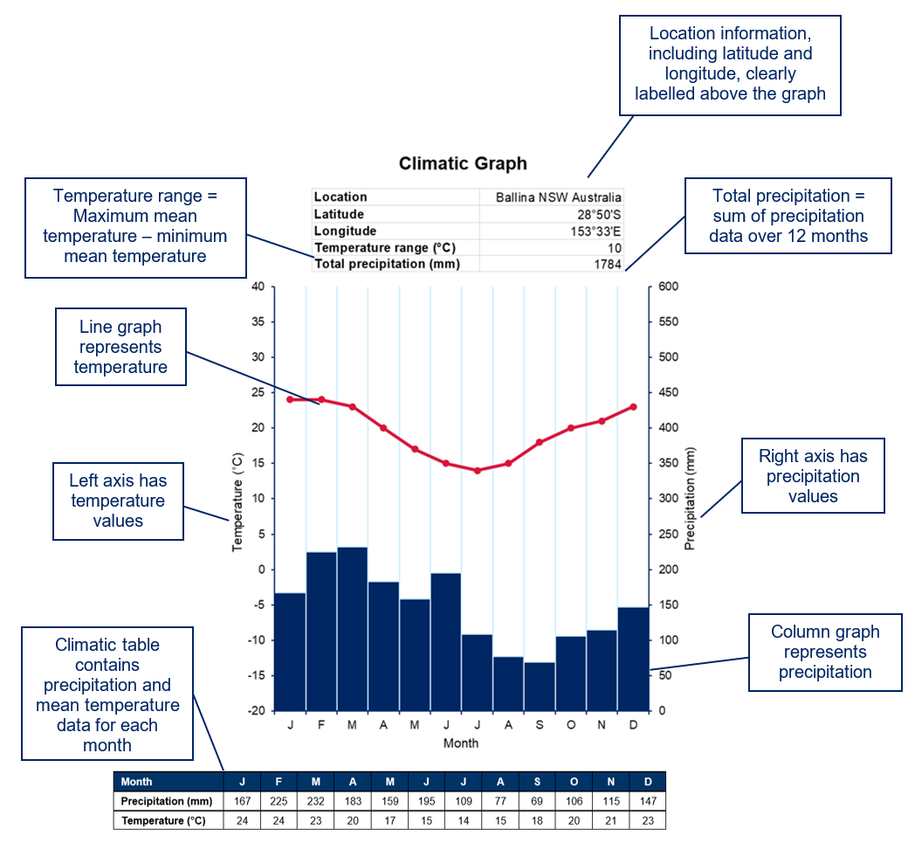

Watch [Climatic graphs (2:14)](https://education.nsw.gov.au/teaching-and-learning/curriculum/hsie/hsie-curriculum-resources-k-12/hsie-7-10-curriculum-resources/climatic-graphs) and review Figure 1 to answer the questions below.

* Which town in Australia is represented by this table and graph?
* What is the latitude and longitude of this town?
* Why would we want to know the latitude and longitude of this town?
* Which hemisphere is the town located in?
* Which unit of measurement is used to show the temperatures?
* Which unit of measurement is used to show the precipitation (rainfall)?
* What is the mean temperature in the town during April?
* In which month did 109 mm of rain fall?

## Interpreting climate graphs

Climate graphs give information about the temperature, precipitation and location of a place. We can use this to learn more about the seasons and local environment. People interpret climate graphs when making a range of decisions including what crops or plants they will grow and where they want to live or travel.

The highest precipitation will be shown by the highest column in the graph or the largest precipitation figure in the table.

The lowest precipitation will be shown by the lowest column in the graph or the smallest precipitation figure in the table.

A grouping together of several high columns will show a distinct wet season and a group of low columns will show a distinct dry season.

To find out the total precipitation for the year, add up all 12 precipitation figures from the table.

The maximum temperature is shown by the highest point on the line graph, or the highest temperature value in the table.

The minimum temperature is shown by the lowest point in the line graph, or the lowest temperature shown in the table.

The temperature range is the difference between the highest and lowest temperature. This is found by subtracting the minimum temperature from the highest temperature.

Figure 2 – Darwin climatic graph

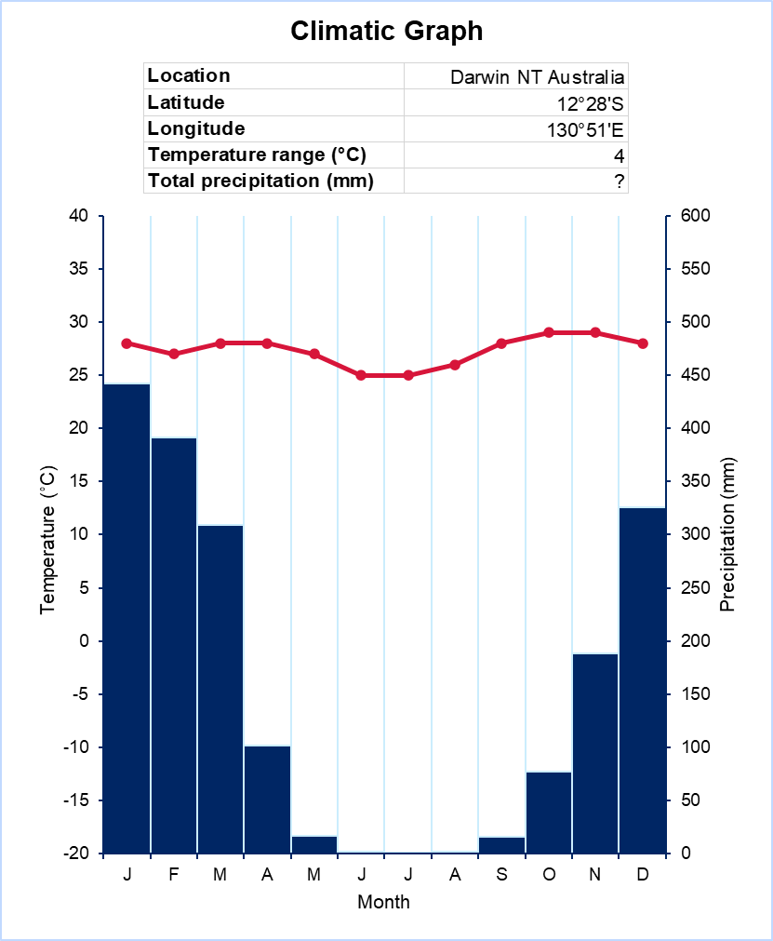

Data adapted from [Australian Bureau of Meteorology, Climate statistics for Australian locations: Darwin Airport](http://www.bom.gov.au/climate/averages/tables/cw_014015.shtml) and reproduced with the permission of the Bureau of Meteorology.

Review Figure 2 and answer the following questions:

* Which month has the highest precipitation?
* How much rain fell during this month?
* Which month had the lowest precipitation?
* What is the total annual (yearly) rainfall for the year?
* Name the months in the wetter season.
* Name the months in the drier season.

**Answers:**

* January; 442 mm (plus or minus 3 mm acceptable).
* June, July and August.
* 1873 mm (plus or minus 20 mm acceptable).
* January, February, March, November and December; April, May, June, July, August, September and October.

Figure 3 – Tokyo climatic graph

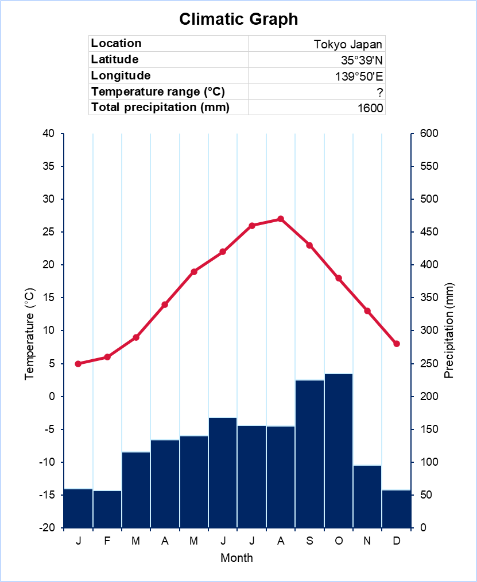

Data sourced from [Japan Meteorological Agency website](https://www.data.jma.go.jp/obd/stats/data/en/normal/normal.html).

Review Figure 3 and answer the following questions.

* What is Tokyo’s maximum temperature?
* In what month does this occur?
* What is Tokyo’s minimum temperature?
* In which month does this occur?
* What is the annual temperature range in Tokyo?

**Answers**:

* 30°
* August
* 5°C
* January
* 25°C.

Places located in the northern hemisphere will show a temperature line dip during December, January and February. Places located in the southern hemisphere will show a temperature dip during June, July and August. A temperature line which is almost flat shows that this place is close to the equator. Places close to the equator have a small temperature range. A temperature line which has a large dip in it shows a place that is a long way from the equator or a long way inland. These places have large temperature ranges.

Figure 4 – climatic graph examples

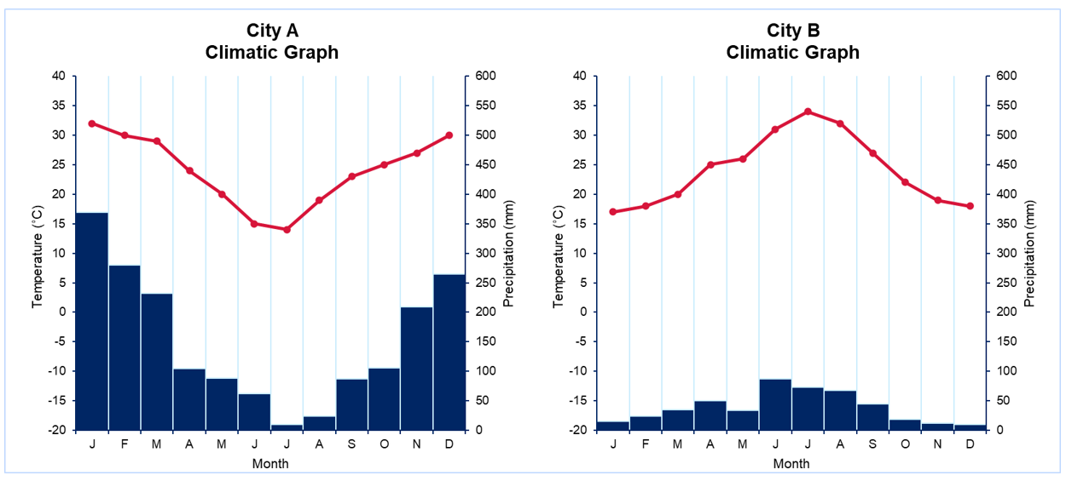

Data adapted from [Australian Bureau of Meteorology](http://www.bom.gov.au).

Review Figure 4 to answer the following questions.

* Which city is located in the northern hemisphere?
* Is City A close to the Equator? Explain your answer.

**Answers:**

* City B is located in the northern hemisphere
* no, because there is a temperature variation.

## Teaching seasons through climate graphs

Climate graphs are useful for identifying seasons at a location. Seasons can be determined by temperature data.

* Summer: shown by a peak on the temperature line.
* Autumn: shown by a downturn on the temperature line.
* Winter: shown by a trough on the temperature line.
* Spring: shown by an upturn on the temperature line.

Seasons can also be determined by precipitation data.

* Wet: a series of months with high precipitation columns.
* Dry: a series of months with low precipitation columns.

Figure 5 – climatic graphs for Troughton Island and Gunnedah

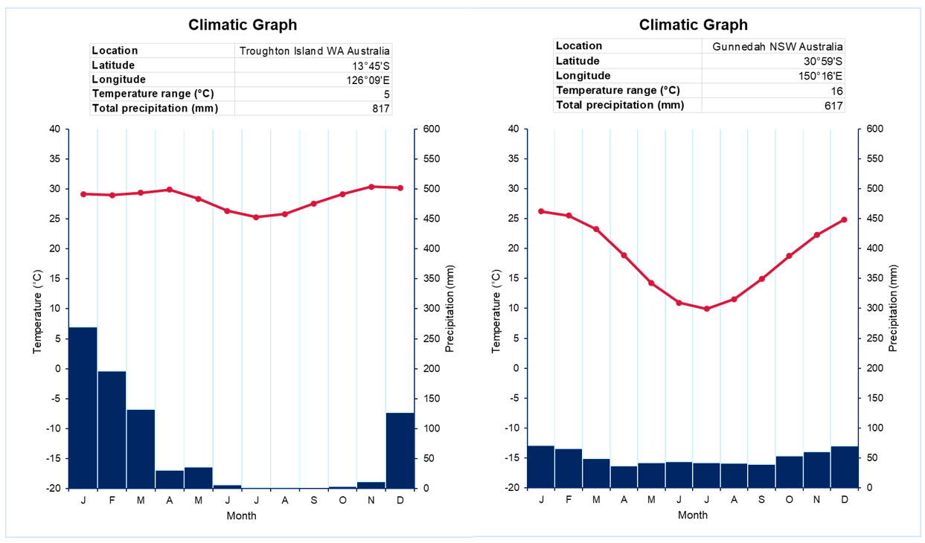

Data adapted from Australian Bureau of Meteorology, Climate statistics for Australian locations: [Troughton Island](http://www.bom.gov.au/climate/averages/tables/cw_001007.shtml) and [Gunnedah](http://www.bom.gov.au/climate/averages/tables/cw_055023.shtml) have been reproduced with the permission of the Bureau of Meteorology.

Review Figure 5 and answer the following questions:

* During which 3 months is winter in Troughton Island?
* During which 3 months is autumn in Gunnedah?
* When is the wet season in Troughton Island? Justify your response.

**Answers:**

* Troughton Island – June, July and August
* Gunnedah – March, April and May
* answers will vary.

Seasons differ across cultures and environments. The Cree, one of the largest First Nations in Canada, observe 6 seasons each year: Pipon (winter), Sikwan (spring), Mitoskamin (when the ice breaks up), Nipin (summer), takwākin (fall), and mikiskāw (lakes freeze). India has also observed 6 seasons, called ‘Ritu’, since ancient times. Figure 6 shows these seasons annotated on a climatic graph of New Delhi.

Figure 6 – annotated climatic graph of New Delhi

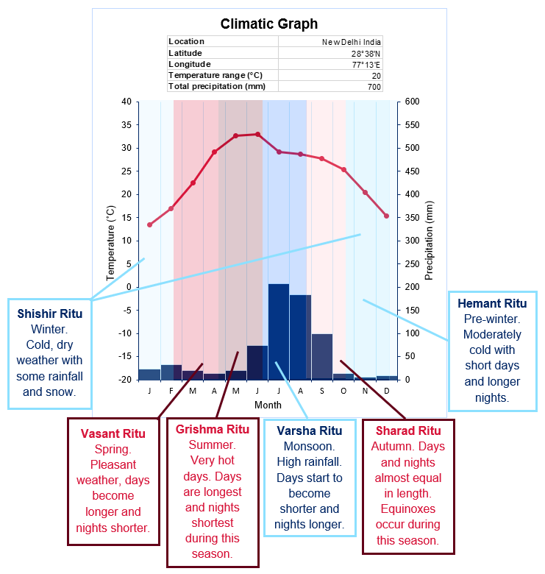

Data adapted from [New Delhi Climate (India)](https://en.climate-data.org/asia/india/delhi/new-delhi-30/) © Climate-Data.org.

In Australia, Aboriginal and Torres Strait Islander Nations have distinct seasons based on climate and the environment. Visit [Indigenous Weather Knowledge](http://www.bom.gov.au/iwk/) and explore the seasons of the Nations in Figure 7 and Figure 8. Using Figure 6 as an example, annotate the climatic graphs with the season names, months and key climatic and environmental management features.

Figure 7 – climatic graph for Guyra NSW located in the Banbai nation

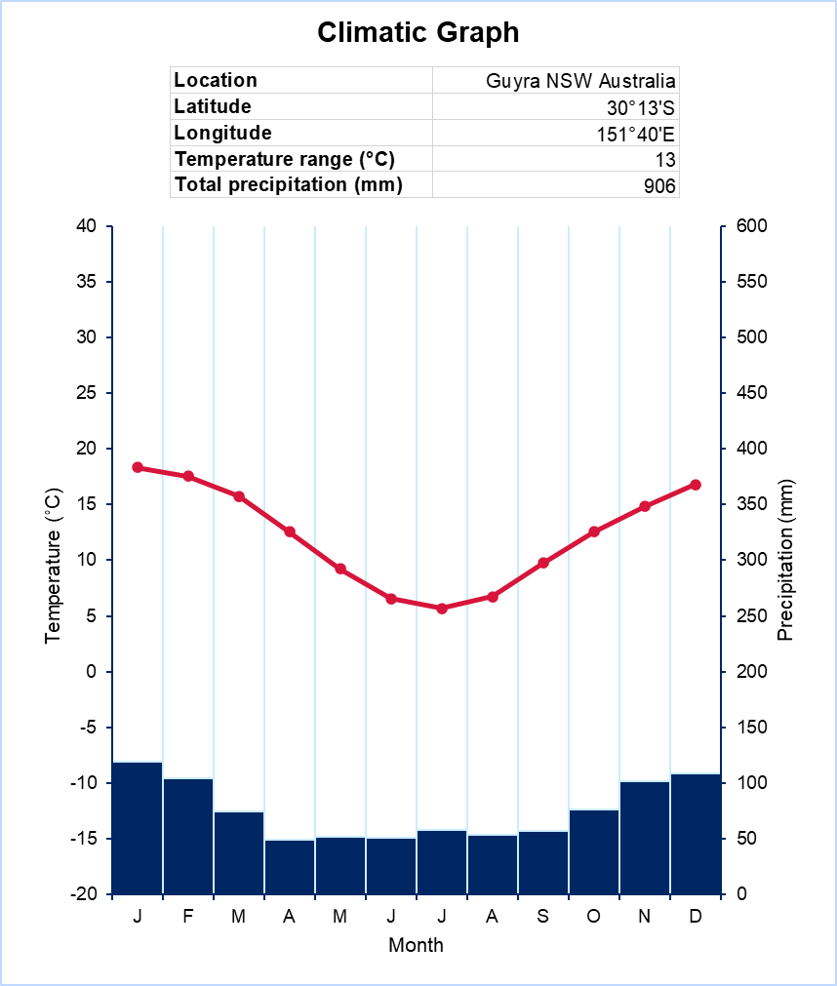

Data adapted from [Australian Bureau of Meteorology, Climate statistics for Australian locations: Guyra Hospital](http://www.bom.gov.au/climate/averages/tables/cw_056229.shtml) and reproduced with the permission of the Bureau of Meteorology.

Figure 8 – climatic graph for Sydney NSW located in the D’harawal nation

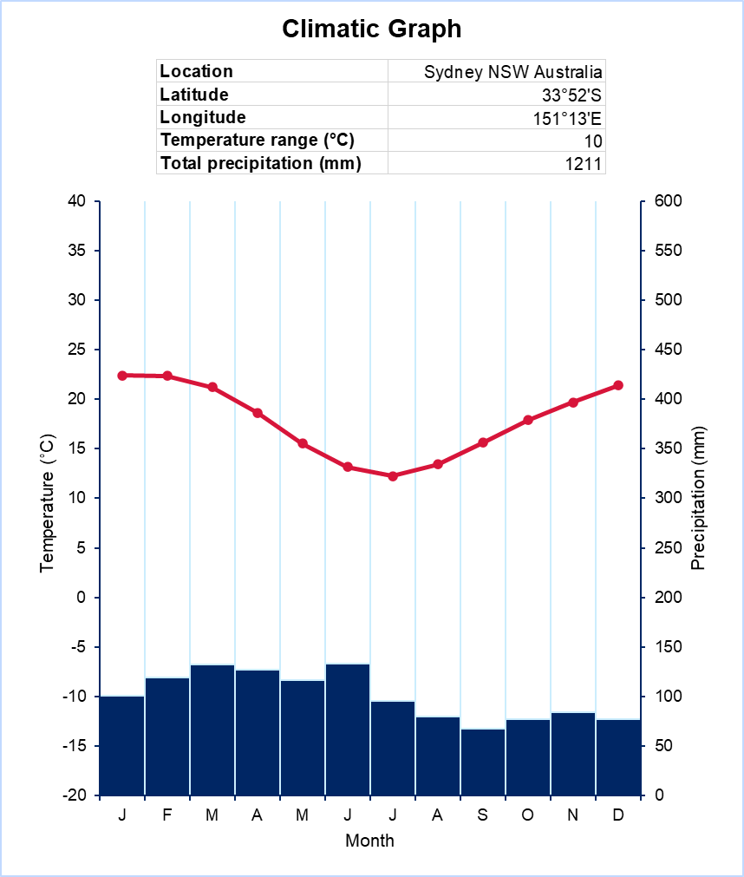

Data from [Indigenous Weather Knowledge](http://www.bom.gov.au/iwk/index.shtml) and [Australian Bureau of Meteorology, Climate statistics for Australian locations: Sydney](http://www.bom.gov.au/climate/averages/tables/cw_066062.shtml) and reproduced with the permission of the Bureau of Meteorology.

## Drawing a climate graph

**Note:** students will require graph paper, a pencil, ruler, eraser, black pen, blue pen and red pen to construct a climate graph. A climate graph template is provided in Appendix 1.

Draw a climate graph of the data from Table 1 using these steps:

1. Look carefully at the climate table and decide the size your vertical and horizontal axis for the graph.
2. Rule up the horizontal axis so that there are 12 spaces across it. Write the letter for each month.
3. Rule up the temperature scale and the precipitation scale. Write in the temperature and precipitation figures. Label each axis.

**Note:** axis ticks (the increment marks on the axis) must be evenly spaced with a consistent change in value. Standard tick increment values are 5°C for the temperature axis and 50 mm for the precipitation axis, however, any values can be used.

1. Begin plotting the temperature information from the table. Mark temperature values with a dot in the middle of the column for their corresponding month in line with the value on the temperature axis. Join the dots in a straight line.
2. Use a ruler to draw the column graph for precipitation. The columns in a climate graph touch each other. Start with drawing the column for January and repeat until each month is complete.

Table 1 – climate table for Ballina, NSW

|  |  |  |  |  |  |  |  |  |  |  |  |  |
| --- | --- | --- | --- | --- | --- | --- | --- | --- | --- | --- | --- | --- |
| Month | J | F | M | A | M | J | J | A | S | O | N | D |
| Temperature (°C) | 24 | 24 | 23 | 20 | 17 | 15 | 14 | 15 | 18 | 20 | 21 | 23 |
| Precipitation (mm) | 167 | 225 | 232 | 183 | 159 | 195 | 109 | 77 | 69 | 106 | 115 | 147 |

Data modified from [Climate statistics for Australian locations: Ballina](http://www.bom.gov.au/climate/averages/tables/cw_058198.shtml) and rounded to nearest whole number.

Use the marking rubric and Figure 9 to conduct a peer assessment of your climate graphs:

Table 2 – peer marking rubric for climate graphs

|  |  |  |  |
| --- | --- | --- | --- |
| Criteria | Yes | No | Comments |
| Title is clear and concise |  |  |  |
| Axis is labelled correctly |  |  |  |
| Climate graph is presented |  |  |  |
| Scale of measurement on axis is appropriate |  |  |  |
| Spelling is correct |  |  |  |
| Climate graph is neatly presented |  |  |  |

Figure 9 – Ballina, NSW climatic graph

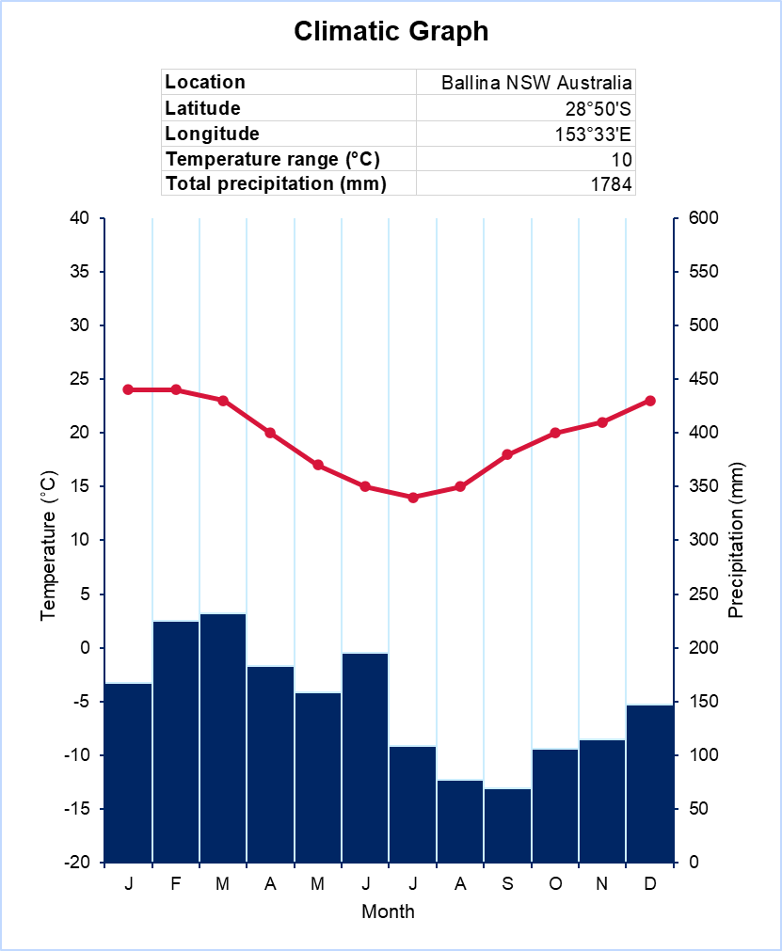

Data adapted from [Australian Bureau of Meteorology, Climate statistics for Australian locations: Ballina](http://www.bom.gov.au/climate/averages/tables/cw_058198.shtml) and reproduced with the permission of the Bureau of Meteorology.

## Constructing a climate graph in Excel

**Note:** teachers need to provide students with climate data. [Bureau of Meteorology](http://www.bom.gov.au/) and [Climate data for cities worldwide](https://en.climate-data.org/) may provide data relevant to the context of your school.

### Create the data table

Open a new Excel workbook. Enter the following headers in column A:

* location
* latitude
* longitude
* temperature range (°C)
* total precipitation (mm).

Figure 10 – Excel screenshot of column A data

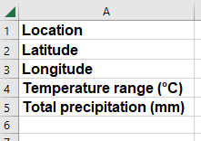

**Note**: use the **Symbols** icon in the **Insert** menu to insert the degrees symbol (°).

Enter the data for each header in column B. Type the following formulas to calculate temperature range and total precipitation:

* Cell B4: =MAX(E3:P3)-MIN(E3:P3)
* Cell B5: =SUM(E2:P2)

Figure 11 – Excel screenshot column B data

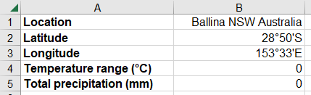

**Note:** the formulas will result in 0 until the climate data is entered.

Enter the climate data in a table across columns A to M with months in the header row starting from cell A7. Enter precipitation data in the second row starting from cell A8 and mean temperature data in the third row starting from cell A9.

Figure 12 – Excel screenshot of location, precipitation and temperature data

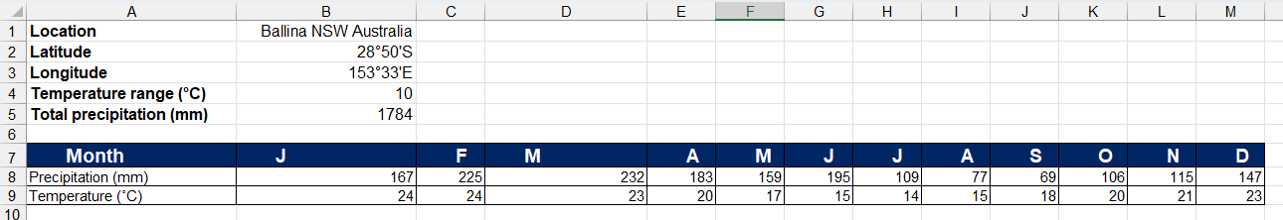

### Create the combination chart

Select the climate data in cells A7:M9.

Figure 13 – Excel screenshot of precipitation and temperature data



Open the **Insert** menu. Select the **Combo** icon in the charts submenu. Select the **Clustered Column – Line on Secondary Axis** icon.

Figure 14 – Excel screenshot of the icon for charts in Excel

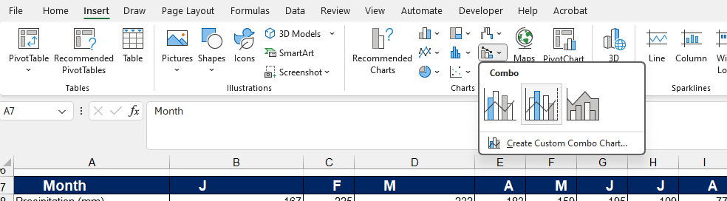

**Note:** if the combo icon is not visible, select the **Expand** icon for charts  to see all charts.

A chart will be created in the worksheet.

Figure 15 – Excel screenshot of basic climatic graph

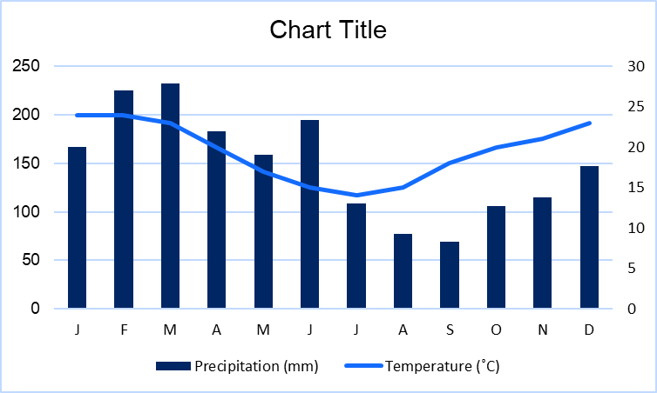

### Format the chart

Double click a precipitation column in the chart to open the **Format data series** menu. Select the chart icon and change series options to plot series on the secondary axis.

**Note**: repeat this step if the right axis disappears. The final chart should have the temperature on the left axis and the precipitation on the right.

Change the gap width to 0%.

Figure 16 – Excel screenshot of the Format Data Series menu

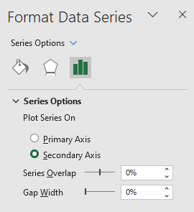

Figure 17 – Excel screenshot of climatic graph

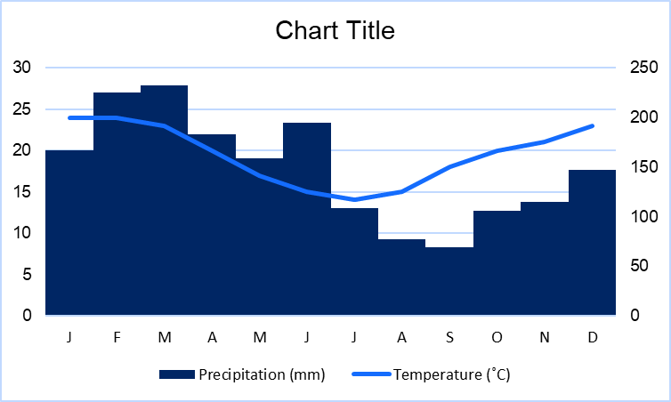

Select the green plus symbol next to the chart to change the chart elements. Turn on **Axis Titles**. Turn off **Legend**. Select the arrow next to gridlines. Turn off **Primary Major Horizontal**. Turn on **Primary Major Vertical**. Select anywhere in the worksheet to close the chart elements box.

Figure 18 – Excel screenshot of chart elements

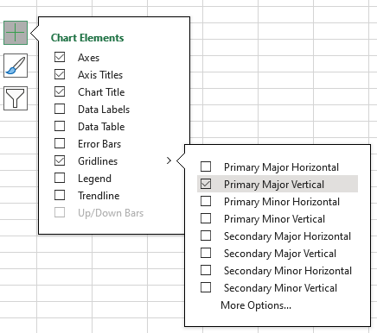

Select the chart title. Select the formula bar at the top of the worksheet and type ‘Climate Graph’.

Figure 19 – Excel screenshot to find chart title

A screenshot of an excel chart title for altering title in chart. 

Figure 20 – Excel screenshot of axis titles

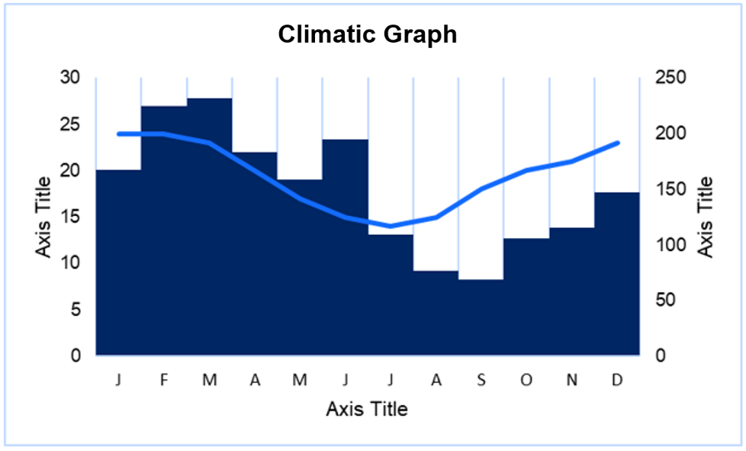

Select the left axis title. Select the formula bar. Type: =A9. Press enter.

Figure 21 – Excel screenshot of left axis

A screenshot illustrating how to change the formula bar by typing in =A9.

Figure 22 – Excel screenshot climatic graph temperature labelled

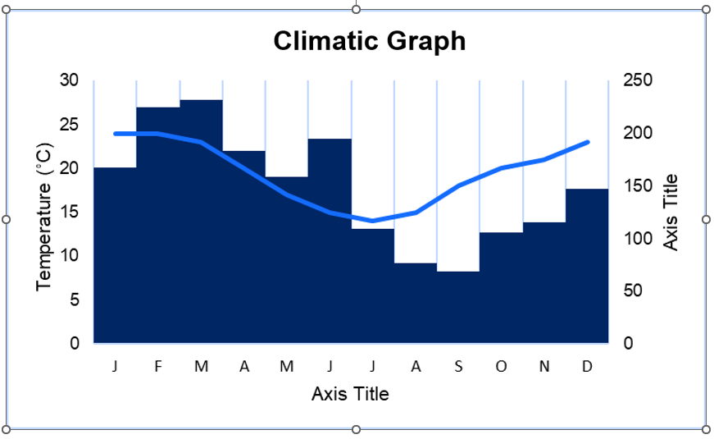

Select the right axis title. Select the formula bar. Type: =A8. Press enter on your keyboard. Select the horizontal axis title. Select the formula bar. Type: =A7. Press enter on your keyboard.

Figure 23 – Excel screenshot labelled climatic graph

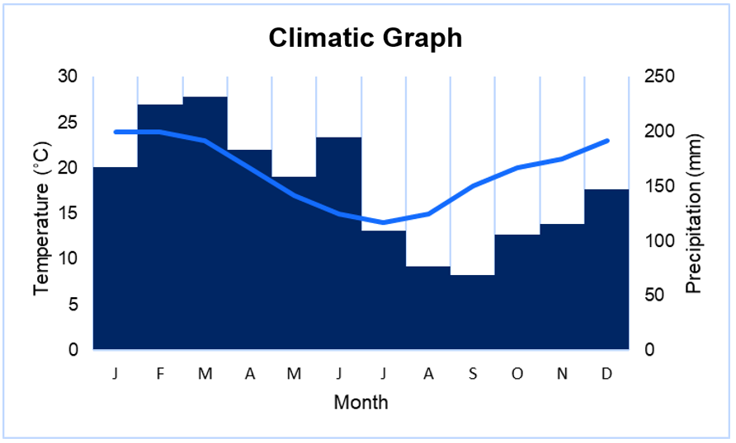

Double click on the left axis values to open the **Format axis** menu. Select the chart icon and expand axis options. Set the following values:

* bounds
* minimum: −20.0
* maximum: 40.0
* units
* major: 5.0
* minor: 1.0
* horizontal axis crosses axis value: −20.0.

Expand tick marks. Set major type as Outside.

Figure 24 – Excel screenshot format axis

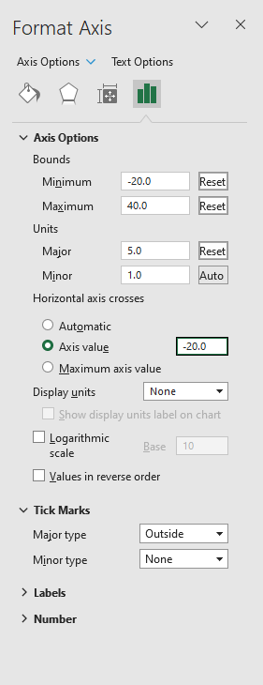

Select the right axis. Select the chart icon and expand axis options. Set the following values:

* bounds
* minimum: 0.0
* maximum: 600.0
* units
* major: 50.0
* minor: 10.0

Expand tick marks. Set major type to Outside.

Figure 25 – Excel screenshot of formatting axis outside

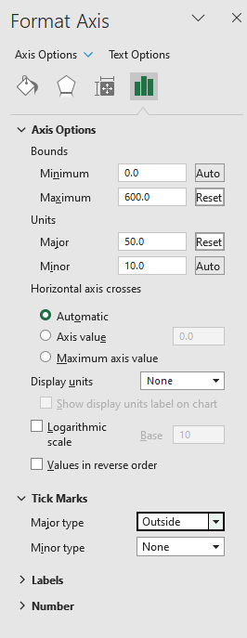

Select the horizontal axis. Select the chart icon and expand tick marks. Set major type as Outside.

Figure 26 – Excel screenshot formatting axis interval marks

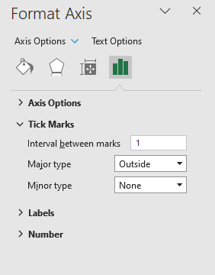

Figure 27 – Excel screenshot of climatic graph

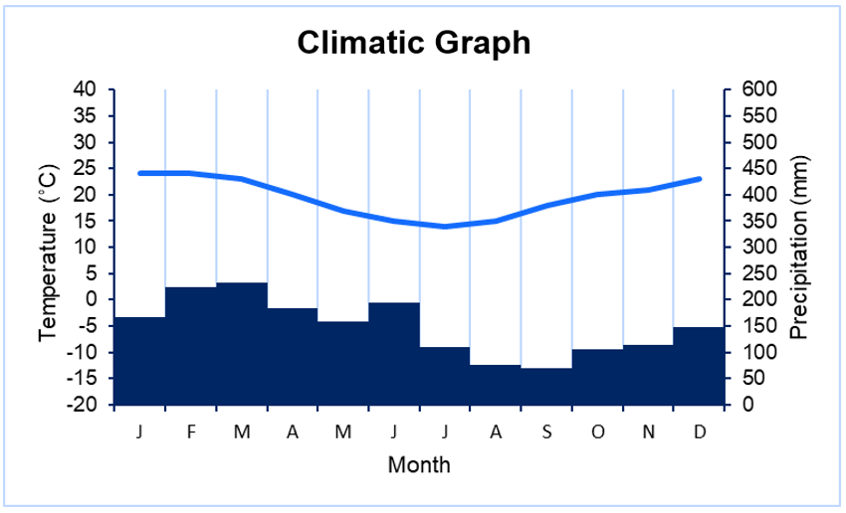

Double click on a precipitation column. Select the paint bucket icon to change the colour and add a border to the columns. This is optional. Blue is recommended for precipitation columns.

Figure 28 – Excel screenshot of Format Data Series

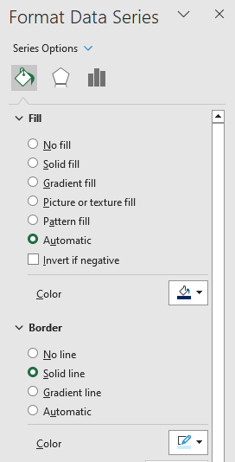

Double click on a temperature column. Select the paint bucket icon to change the colour of the line. This is optional. Red is recommended for temperature columns. Select the marker sub-menu. Expand marker options. Select automatic. Select the colour for the marker fill and border.

Figure 29 – Excel screenshot of marker and fill series

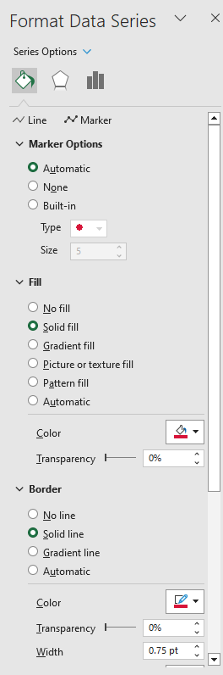

Figure 30 – Excel screenshot of climatic graph

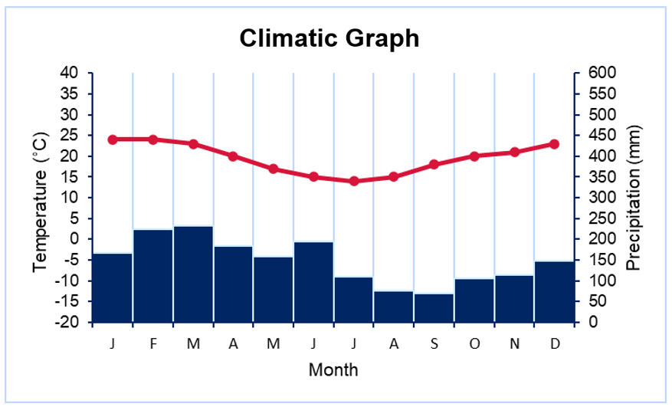

### Include additional information

Increase the chart height by dragging the bottom middle white dot downwards. Select a blank space within the chart plot area. Drag the top middle white dot for the chart plot area downwards to create a white space between the chart title and the chart.

Figure 31 – Excel screenshot of chart title

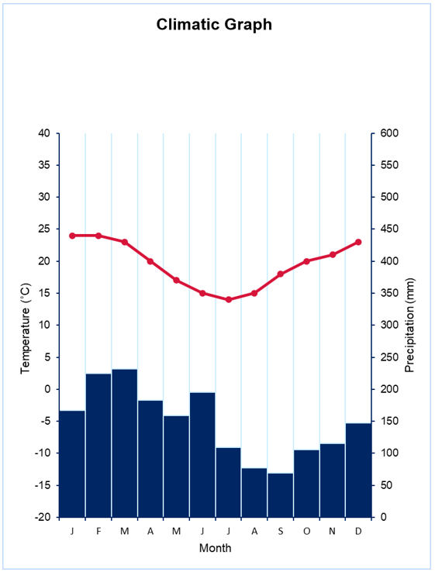

Select cells A1:B5.

Figure 32 – Excel screenshot of cells A1:B5

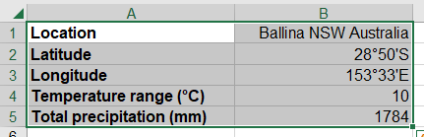

Press Ctrl+C on your keyboard to copy the cells. Place the cursor in cell A11. Select the down arrow on the **Paste** button in the Home tab. Select the clipboard icon with the link and picture.

Figure 33 – Excel screenshot of the copy and paste graph images

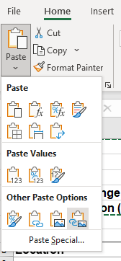

Select the picture. Press Ctrl+C on your keyboard. Select the open space on the chart. Press Ctrl+V on your keyboard to paste the picture in the chart. Move and resize if needed.

Figure 34 – climatic graph Ballina, NSW



# Appendix 1 – climate graph template

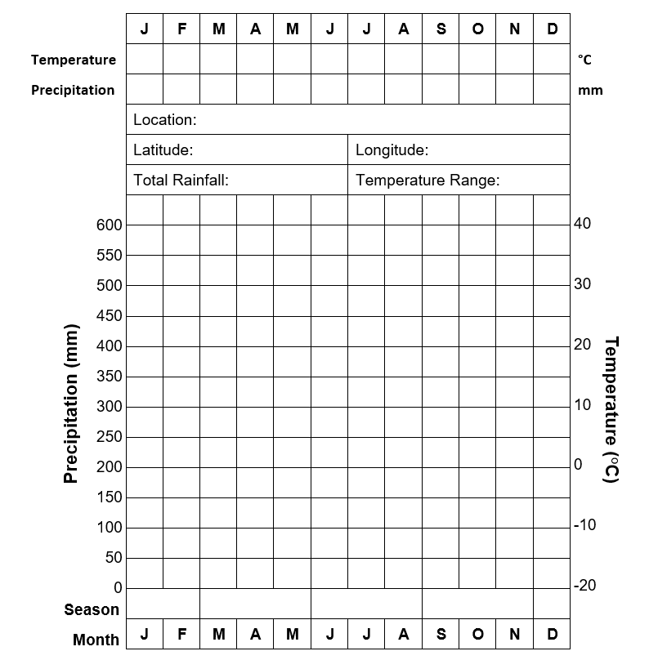

# References

This resource contains NSW Curriculum and syllabus content. The NSW Curriculum is developed by the NSW Education Standards Authority. This content is prepared by NESA for and on behalf of the Crown in right of the State of New South Wales. The material is protected by Crown copyright.

Please refer to the NESA Copyright Disclaimer for more information <https://educationstandards.nsw.edu.au/wps/portal/nesa/mini-footer/copyright>.

NESA holds the only official and up-to-date versions of the NSW Curriculum and syllabus documents. Please visit the NSW Education Standards Authority (NESA) website <https://educationstandards.nsw.edu.au> and the NSW Curriculum website <https://curriculum.nsw.edu.au>.

[Geography K–10 Syllabus](https://www.educationstandards.nsw.edu.au/wps/portal/nesa/k-10/learning-areas/hsie/geography-k-10) © NSW Education Standards Authority (NESA) for and on behalf of the Crown in right of the State of New South Wales, 2015.

Australian Government Bureau of Meteorology (2023a) [*Climate statistics for Australian locations*](http://www.bom.gov.au/climate/averages/tables/cw_200288_All.shtml), Australian Government Bureau of Meteorology, accessed 20 July 2023.

Australian Government Bureau of Meteorology (2023b) [*Indigenous Weather Knowledge*](http://www.bom.gov.au/iwk/), Australian Government Bureau of Meteorology, accessed 20 July 2023.

Climate data (2023) [*Climate data for cities worldwide*](https://en.climate-data.org/), Climate Data website, accessed 20 July 2023.

Elders Weather (2023) [*Weather*](https://www.eldersweather.com.au/climate-history/qld/masig), Elders Weather website, accessed 20 July 2023.

Japan Meteorological Agency (2023) [*Tables of Climatological Normals (1991–2020)*](https://www.data.jma.go.jp/obd/stats/data/en/normal/normal.html), Japan Meteorological Agency website, accessed 20 July 2023.

NESA (NSW Education Standards Authority) (2022) ‘[Proficient Teacher: Standard descriptors’](https://www.nsw.gov.au/education-and-training/nesa/teacher-accreditation/proficient-teacher/standard-descriptors), *The Standards*, NESA website, accessed 20 July 2023.

**© State of New South Wales (Department of Education), 2024**

The copyright material published in this resource is subject to the Copyright Act 1968 (Cth) and is owned by the NSW Department of Education or, where indicated, by a party other than the NSW Department of Education (third-party material).

Copyright material available in this resource and owned by the NSW Department of Education is licensed under a [Creative Commons Attribution 4.0 International (CC BY 4.0) license](https://creativecommons.org/licenses/by/4.0/).

[](https://creativecommons.org/licenses/by/4.0/)

This license allows you to share and adapt the material for any purpose, even commercially.

Attribution should be given to © State of New South Wales (Department of Education), 2024.

Material in this resource not available under a Creative Commons license:

* the NSW Department of Education logo, other logos and trademark-protected material
* material owned by a third party that has been reproduced with permission. You will need to obtain permission from the third party to reuse its material.

**Links to third-party material and websites**

Please note that the provided (reading/viewing material/list/links/texts) are a suggestion only and implies no endorsement, by the New South Wales Department of Education, of any author, publisher, or book title. School principals and teachers are best placed to assess the suitability of resources that would complement the curriculum and reflect the needs and interests of their students.

If you use the links provided in this document to access a third-party's website, you acknowledge that the terms of use, including licence terms set out on the third-party's website apply to the use which may be made of the materials on that third-party website or where permitted by the Copyright Act 1968 (Cth). The department accepts no responsibility for content on third-party websites.