Geography 7–10 – guide to using photographs in geography

Contents

Overview 2

Outcomes 2

Learning sequence 1 – using photographs in geography 3

Syllabus content 3

Learning intentions and success criteria 3

Learning intentions 3

Success criteria 4

Working with photographs 5

Ground photographs 8

Oblique and vertical aerial photographs 9

Photo sketches 11

Satellite images 15

References 17

This resource has been developed to assist teachers in NSW Department of Education schools to create learning that is contextualised to their classroom. It can be used as a basis for the teacher’s own program, assessment, or scope and sequence, or be used as an example of how the new curriculum could be implemented. The resource has suggested timeframes that may need to be adjusted by the teacher to meet the needs of their students.

# Overview

**Description:** this teaching support resource addresses the K–10 geographical tools continuum, providing examples of how students can engage with the the geographical tool of photographs. The lessons in this teaching support resource are designed to allow students to build understanding of geographical inquiry skills and tools.

**Duration:** this teaching resource is designed to be completed in approximately 2 hours.

## Outcomes

A student:

* **GE4-7** acquires and processes geographical information by selecting and using geographical tools for inquiry

[Geography K–10 Syllabus](https://www.educationstandards.nsw.edu.au/wps/portal/nesa/k-10/learning-areas/hsie/geography-k-10) © NSW Education Standards Authority (NESA) for and on behalf of the Crown in right of the State of New South Wales, 2015.

# Learning sequence 1 – using photographs in geography

**Note:** this guide to using photographs in geography is designed to be used as a support resource for teachers addressing geographical tools in geography 7–10. This resource is not guiding teaching and learning of specific topic content in geography 7–10; rather, it provides resources and strategies that can be applied at any point across the course.

## Syllabus content

Visual representations take many forms and include digital and non-digital mediums. Examples include, but are not limited to, diagrams, images, photographs, paintings, illustrations, symbols, models, posters, collages, cartoons, multimedia, infographics and mind maps. Visual representations are used to display, visualise, analyse and communicate geographical data and information.

Fieldwork is an integral part of geography. Students must undertake and participate in fieldwork in each Stage of learning. There are many opportunities for fieldwork in Stages 4 and 5, such as investigating the characteristics of a local place or observing aspects of human-induced environmental change.

## Learning intentions and success criteria

**Note:** these learning intentions and success criteria are general and should be contextualised to suit your school and students’ needs.

### Learning intentions

Students learn about:

* different types of photographs used in geography
* key features of photo sketches
* the purpose of drawing photo sketches in geography
* identifying time of day from photographs.

### Success criteria

Students will be able to:

* distinguish between different types of photographs used in geography
* construct a photo sketch that is useful in the context of a learning sequence
* explain how a photo sketch assists in investigating characteristics of a local place
* use photographs and maps to identify the location where the photograph was taken
* use photographs and knowledge of latitude and longitude and direction to determine the time of day a photograph was taken.

## Working with photographs

**Note:** the video [Types of photos (3:21)](https://education.nsw.gov.au/teaching-and-learning/curriculum/hsie/hsie-curriculum-resources-k-12/hsie-7-10-curriculum-resources/types-of-photos) might provide a useful explanation for recognising the different types of photographs used in geography. Teachers might use this video to improve their understanding of types of photographs used in geography or as a stimulus in the context of a lesson.

Photographs provide a reliable alternative to visiting a location that you are studying. Photographs can be used in many ways in geography, including to:

* illustrate and describe physical and human features
* allow for comparison between places around the world
* show how places change over time
* record events such as natural disasters
* illustrate unusual features of places
* illustrate how people live in different parts of the world
* save on words when describing a location.

There are 4 main types of photographs geographers use:

* ground level photographs – these are taken from the ground
* oblique aerial photographs – usually taken from a plane or more recently drones
* vertical aerial photographs – usually taken from a plane or more recently drones
* satellite imagery – taken from a satellite.

Figure 1 – ground level photograph

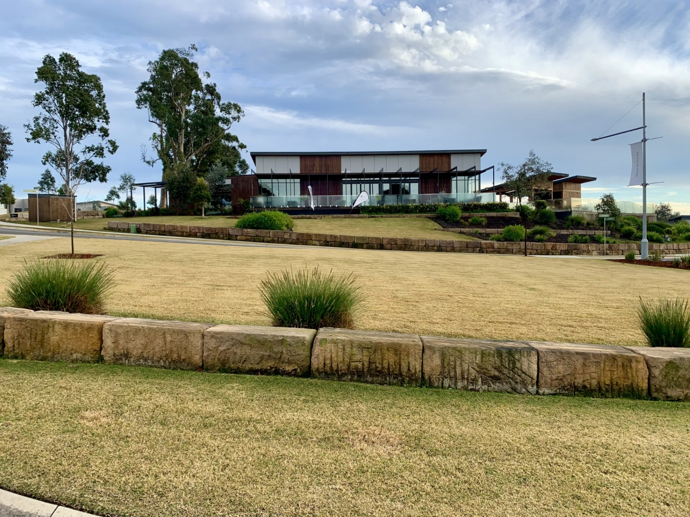

Figure 2 – oblique aerial photograph

An oblique aerial photograph that shows a circular road with buildings around it. In the centre of the circle is a tennis court and building with gardens surrounding. 


Figure 3 – aerial photograph

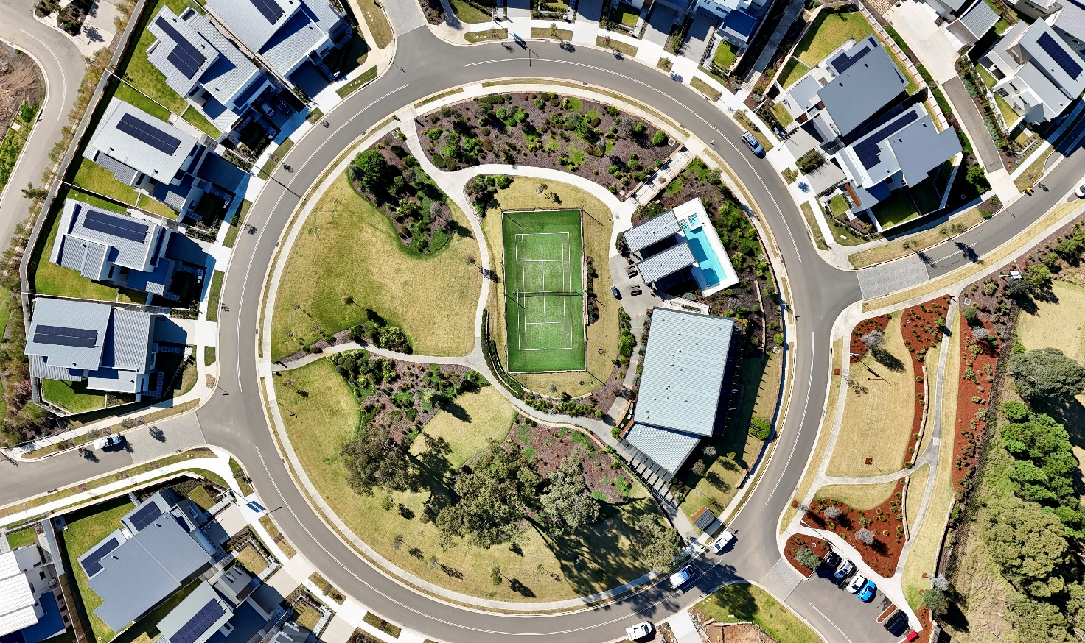

### Ground photographs

Working with a partner, choose 3 photographs from [Latest Photo Galleries](https://www.nationalgeographic.com/pages/topic/photo-galleries) to complete the following table. You need to carefully:

* observe the photograph to find out what it shows, where it might have been taken and identify key features
* record important details from the photograph into your table
* interpret what you are recording and ask questions about what you have observed and suggest answers about some of the questions you posed.

Table 1 – photograph observation record

|  |  |  |  |  |
| --- | --- | --- | --- | --- |
| Photograph | Where it might have been taken | Key features and any important details | Questions you might have about the photograph | Suggested answers you have to your questions |
| 1 |  |  |  |  |
| 2 |  |  |  |  |
| 3 |  |  |  |  |

**Note:** students will need to be provided with a ground level photograph for the following learning activity. National Geographic [Latest Photo Galleries](https://www.nationalgeographic.com/pages/topic/photo-galleries) provides many high quality photographs from around the world, or you might choose to use a photograph relevant to the school context or field location you are currently teaching.

[Think-Pair-Share](https://app.education.nsw.gov.au/digital-learning-selector/LearningActivity/Card/645?clearCache=d04e1207-7d91-222a-36ec-e577945a1cc3) the following questions:

* What information does this photograph provide?
* What information is not available from this photograph?
* What are the advantages of using ground level photographs when learning about a place?
* What might be some disadvantages of using ground level photographs when learning about a place?

### Oblique and vertical aerial photographs

Oblique aerial photographs can be used to:

* make accurate maps
* observe changes to a place
* assist in interpreting landforms on a map
* show the slope of the land
* show the relationship between natural and built features.

Vertical aerial photographs can be used to:

* make accurate maps
* plan for changes to towns and cities
* survey resources at a location
* plan how to access resources at a location
* illustrate how places have changed over time
* make predictions.

**Note:** the following learning activity suggests using a drone to collect oblique aerial and vertical aerial photographs. If drone use is not available, teachers might use Figure 2 as a substitute for the learning activity.

The video [Episode 9 - Using shadows to calculate time of day (9:09)](https://youtu.be/lAmnehQVIR4?si=HTbnUJmijlJc08zF) might prove helpful in explaining how to calculate time of day using photographs.

Compare an oblique aerial photograph with a vertical aerial photograph (Figure 2 and Figure 3):

* Which photograph gives you a better idea of the:
* shape of the land
* size of the area
* elevation of the landscape
* steepness of any slopes
* length of significant features
* number of houses or buildings
* patterns of rivers, creeks or streams
* patterns of any roads or streets?
* [Think-Pair-Share](https://app.education.nsw.gov.au/digital-learning-selector/LearningActivity/Card/645?clearCache=d04e1207-7d91-222a-36ec-e577945a1cc3) the advantages and disadvantages of oblique aerial photographs and vertical aerial photographs.

Geographers can estimate the time a day a photograph was taken by shadows. Longer shadows indicate the photograph was taken either early morning or late afternoon as the sun is lower in the sky. Short shadows indicate the photograph was taken when the sun was high in the sky, near the middle of the day. Use vertical aerial photograph of Camden, NSW (Figure 4) to estimate the time of day the photograph was taken. Note this photograph was taken in July (winter season).

Figure 4 – Camden orientation

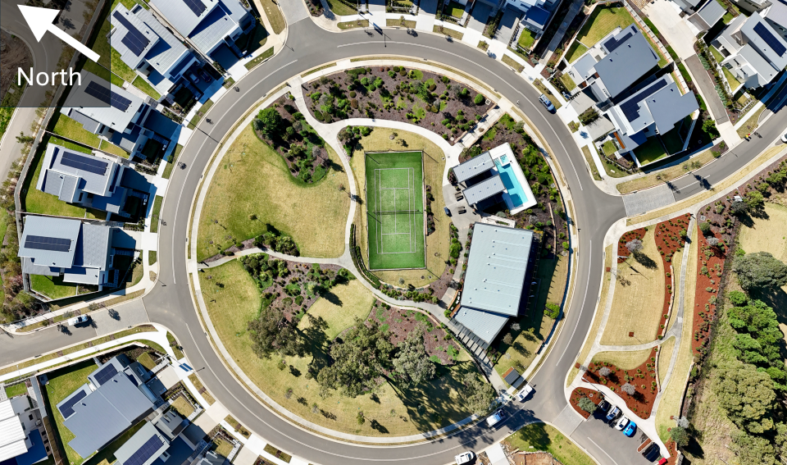

**Answer:** the time of day Figure 4 was taken is approximately 12 pm. The shadows are long and directly facing south which is accounted for by the latitude and longitude of Camden. This photograph was taken in winter resulting in longer shadows as Earth is tilted away from the sun, so the sun appears lower in the sky, casting longer shadows.

### Photo sketches

**Note:** teachers will need to identify an appropriate time in a learning sequence to teach photo sketches. It is easier to draw a photo sketch from a photograph of a location with obvious distinguishing features such as a cliff, significant landform or building.

[Photo sketch (2:06)](https://education.nsw.gov.au/teaching-and-learning/curriculum/hsie/hsie-curriculum-resources-k-12/hsie-7-10-curriculum-resources/photo-sketch) might prove helpful in explaining how to teach drawing a photo sketch or used as a stimulus in the context of a lesson.

A drawing made from a photograph is called a photo sketch or line drawing. Photo sketches have many uses. To:

* ensure careful observation
* assist in keeping an accurate record of what is observed in the field
* assist in describing places to other people.

Figure 5 and Figure 6 provide examples of a photograph and associated photo sketch.

Figure 5 – photo of floating fishing village, Halong Bay

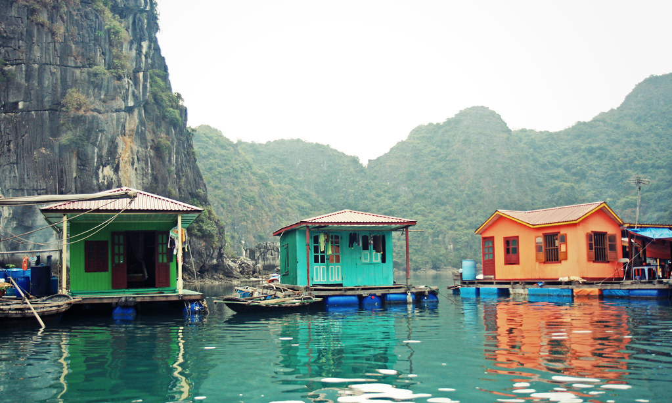

‘[Floating fishing village, Halong Bay](https://commons.wikimedia.org/wiki/File:Floating_fishing_village,_Halong_Bay_(5678845937).jpg)’ by [Andrea Schaffer](https://www.flickr.com/people/49021451@N00) is licensed under [CC BY-SA 2.0](https://creativecommons.org/licenses/by/2.0/deed.en).

Figure 6 – line sketch

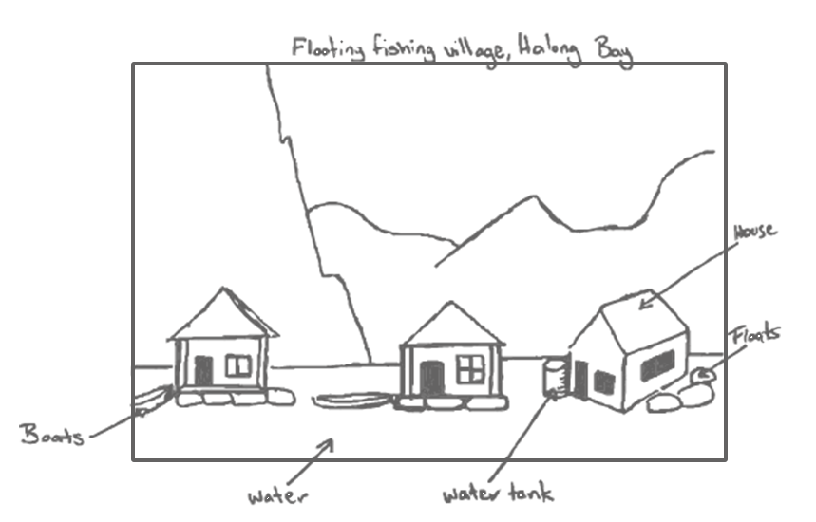

**Note:** students will need to be provided with Figure 1, paper, pencil and a ruler for the following activity.

Use the following steps to construct a photo sketch of Figure 1.

1. Rule up a frame the same size as the photograph.
2. Use a pencil to lightly draw 2 simple grid lines that divides the image into quadrants.
3. Figure 6 provides an example of the grid lines. This will assist in drawing the sketch.

Figure 7 – photo sketch grid

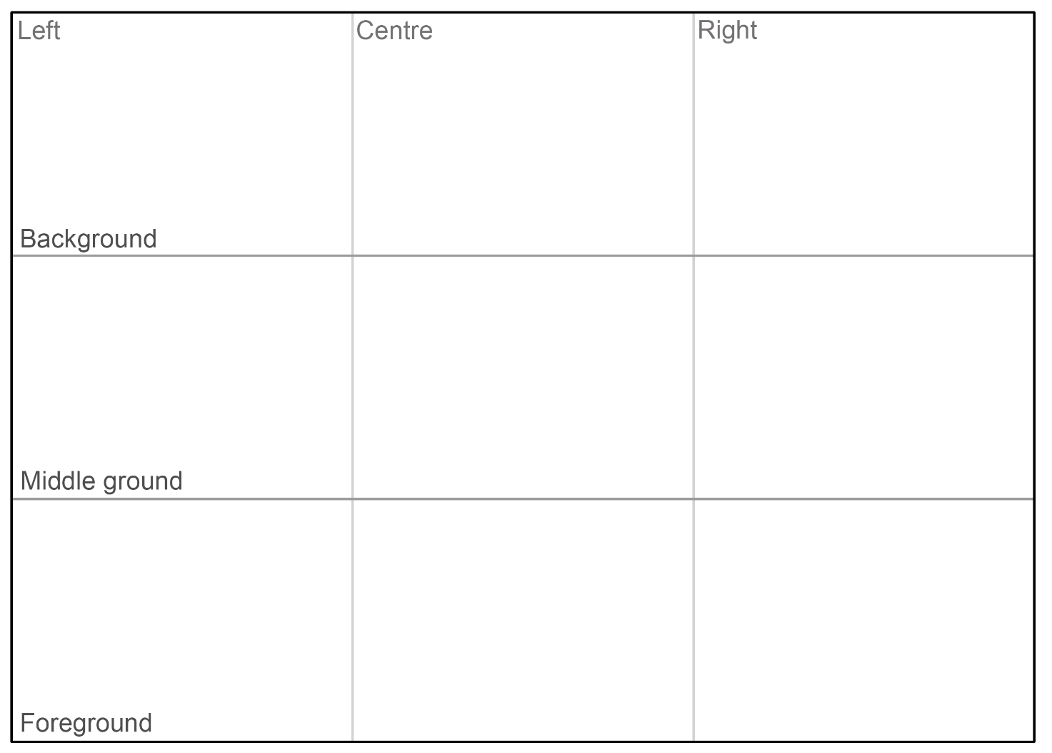

1. Using the gridlines as a guide lightly draw the outline of the land and the location of the relevant buildings and roads.
2. Draw in some of the details like fences, other roads, clouds, vegetation.
3. Add labels and a title.

**Note:** when using assessment as learning in the classroom, peer and self-assessment is an effective approach to enhance the learning of students. Explicitly teaching students how to assess their own work, and the work of their peers, has many benefits. It promotes student understanding of their learning and provides opportunities for critical analysis of their own efforts encouraging them to become more autonomous learners.

Exchange your photo sketch with a peer. Provide [peer feedback](https://app.education.nsw.gov.au/digital-learning-selector/LearningActivity/Card/549#.XsS4Wf4kcgA.link) on your partner’s photo sketch using TAG feedback. Ideas you might like to consider in your feedback:

* How effective is the photo sketch in illustrating the location?
* How well presented is the photo sketch? Is it easy to read?
* How well labelled is the photo sketch?
* Is there enough relevant information provided with the photo sketch?

Before submitting your photo sketch to your teacher use your peer feedback to amend and improve your work.

### Satellite images

**Note:** teachers might wish to use a satellite image of their town or city for the following activity. The search bar at the top right of the screen on [Map Compare](https://tools.geofabrik.de/mc/#15/49.0094/8.3902&num=4&mt0=here-satellite&mt1=here-satellite&mt2=here-satellite&mt3=here-satellite) can be used to find local maps and satellite images (if available). Select the map type as **HERE Satellite** from the drop-down menu, set the **number of maps** to **1** (bottom right of the screen) and use the zoom slider on the left to select an appropriate scale before sharing with students. The questions might need adjusting to suit your selected location.

[Map Compare of Tamworth NSW](https://tools.geofabrik.de/mc/#8/-31.0880/150.9208&num=1&mt0=here-satellite) can be viewed either as a class or on individual student devices.

Use [Map Compare of Tamworth NSW](https://tools.geofabrik.de/mc/#8/-31.0880/150.9208&num=1&mt0=here-satellite) to answer the following questions:

* Select the **+** on the zoom slider (left side of the satellite image) 5 times. Observe the new satellite image each time. Discuss as a class:
* What different features can you observe?
* What could a satellite image at this level of magnification be used for?
* Do you think the use of satellite imagery could overtake the use of aerial photography as technology improves? Justify your position.
* Ensure the magnification of the map is now **zoom=13** (bottom right corner of the screen). If not, use [Map Compare of Tamworth NSW (zoom=13)](https://tools.geofabrik.de/mc/#13/-31.0880/150.9208&num=1&mt0=here-satellite). Identify the following features in the satellite image:
* built-up areas
* farming areas
* forest areas
* areas of higher elevation
* parks and recreational areas
* main roads
* water courses and bodies of water.
* Select the **+** on the zoom slider two times. Observe the new satellite image each time and consider:
* Can you see any features from the list you didn’t identify previously?
* Change the number of maps to **2** using the link in the bottom right corner of the screen. Select **Geofabrik** from the drop-down menu for the second map.
* Which features did you correctly identify based on the information provided by this map?
* What new things did you learn about the satellite image from this map?
* Change the second map to **Geofabrik Topo** and select the **–** on the zoom slider two times. As you zoom out, consider:
* Which features did you correctly identify based on the information provided by this map?
* What new things did you learn about the satellite image from this map?
* Change the number of maps to 4. Select **Geofabrik** for map 2, **Geofabrik Topo** for map 3 and **HERE Hybrid** for map 4. Use the zoom function and navigate the map to explore the images further. Discuss as a class:
* What different purposes do the satellite image and maps have?
* In what ways can satellite images and maps be used together during a geographical inquiry?

# References

This resource contains NSW Curriculum and syllabus content. The NSW Curriculum is developed by the NSW Education Standards Authority. This content is prepared by NESA for and on behalf of the Crown in right of the State of New South Wales. The material is protected by Crown copyright.

Please refer to the NESA Copyright Disclaimer for more information <https://educationstandards.nsw.edu.au/wps/portal/nesa/mini-footer/copyright>.

NESA holds the only official and up-to-date versions of the NSW Curriculum and syllabus documents. Please visit the NSW Education Standards Authority (NESA) website <https://educationstandards.nsw.edu.au> and the NSW Curriculum website <https://curriculum.nsw.edu.au>.

[Geography K–10 Syllabus](https://www.educationstandards.nsw.edu.au/wps/portal/nesa/k-10/learning-areas/hsie/geography-k-10) © NSW Education Standards Authority (NESA) for and on behalf of the Crown in right of the State of New South Wales, 2015.

Aboriginal Education Consultative Group (2024) [*AECG Languages App*](https://www.aecg.nsw.edu.au/download-aecg-languages-app/), Aboriginal Education Consultative Group website, accessed 23 July 2024.

AIATSIS (The Australian Institute of Aboriginal and Torres Strait Islander Studies) (2023) [*Map of Indigenous Australia*](https://aiatsis.gov.au/explore/map-indigenous-australia), AITSIS website, accessed 23 July 2024.

Australian Government Geoscience Australia (2023) [*Topographic Maps*](https://www.ga.gov.au/scientific-topics/national-location-information/topographic-maps-data/topographic-maps), Geoscience Australia website, accessed 23 July 2024.

NESA (NSW Education Standards Authority) (2022) ‘[Proficient Teacher: Standard descriptors’](https://www.nsw.gov.au/education-and-training/nesa/teacher-accreditation/proficient-teacher/standard-descriptors), *The Standards*, NESA website, accessed 23 July 2024.

NSW Government Spatial Services (2024) [*Topographic Maps*](https://www.spatial.nsw.gov.au/products_and_services/topographic_maps), Spatial Services website, accessed 23 July 2024.

**© State of New South Wales (Department of Education), 2024**

The copyright material published in this resource is subject to the Copyright Act 1968 (Cth) and is owned by the NSW Department of Education or, where indicated, by a party other than the NSW Department of Education (third-party material).

Copyright material available in this resource and owned by the NSW Department of Education is licensed under a [Creative Commons Attribution 4.0 International (CC BY 4.0) license](https://creativecommons.org/licenses/by/4.0/).

[](https://creativecommons.org/licenses/by/4.0/)

This license allows you to share and adapt the material for any purpose, even commercially.

Attribution should be given to © State of New South Wales (Department of Education), 2024.

Material in this resource not available under a Creative Commons license:

* the NSW Department of Education logo, other logos and trademark-protected material
* material owned by a third party that has been reproduced with permission. You will need to obtain permission from the third party to reuse its material.

**Links to third-party material and websites**

Please note that the provided (reading/viewing material/list/links/texts) are a suggestion only and implies no endorsement, by the New South Wales Department of Education, of any author, publisher, or book title. School principals and teachers are best placed to assess the suitability of resources that would complement the curriculum and reflect the needs and interests of their students.

If you use the links provided in this document to access a third-party's website, you acknowledge that the terms of use, including licence terms set out on the third-party's website apply to the use which may be made of the materials on that third-party website or where permitted by the Copyright Act 1968 (Cth). The department accepts no responsibility for content on third-party websites.