Geography 7–10 – guide to teaching mapping – topographic maps

Contents
Overview 2
Outcomes 2
Learning sequence 1 – topographic maps 3
Syllabus content 3
Learning intentions and success criteria 3
Learning intentions 3
Success criteria 3
Working with maps 4
Topographic maps 4
Topographic contour lines 6
Engaging with geographical tools 10
Using spatial technologies 13
Appendix 1 – mapping tools 17
Appendix 2 – activity answers 19
References 20

This resource has been developed to assist teachers in NSW Department of Education schools to create learning that is contextualised to their classroom. It can be used as a basis for the teacher’s own program, assessment, or scope and sequence, or be used as an example of how the new curriculum could be implemented. The resource has suggested timeframes that may need to be adjusted by the teacher to meet the needs of their students.

Overview
Description: this teaching support resource addresses Thinking and working geographically, providing examples of how students can engage with the geographical tool of maps. The lessons in this resource are designed to allow students to build understanding of this geographical tool through a range of learning activities and can be applied where appropriate across Geography 7–10.
Duration: this learning sequence is designed to be completed in approximately 2 hours.

Outcomes
A student:
- GE4-TAP-01 selects and uses geographical tools to acquire and process geographical information
- GE5-TAP-01 applies and evaluates a range of geographical tools to acquire and process geographical information
Geography 7–10 Syllabus © NSW Education Standards Authority (NESA) for and on behalf of the Crown in right of the State of New South Wales, 2024.

Learning sequence 1 – topographic maps
Note: this resource provides resources and strategies that can be applied at any point across Geography 7–10 where relevant to syllabus content.

Syllabus content
Maps take many forms and include digital and non-digital mediums. Examples include, but are not limited to, pictorial maps, large-scale and small-scale maps, relief maps, choropleth maps, flowline maps, cadastral maps, isoline maps, land use maps, physical maps, political maps, précis maps, cultural mapping, road maps, thematic maps, tactile maps, topographic maps and special-purpose maps.
Maps are used to locate, visualise, represent, display and record spatial data.

Learning intentions and success criteria
Note: these learning intentions and success criteria are general and should be contextualised to suit your school and students’ needs.

Learning intentions
Students learn about:
- key features on topographic maps
- the different representations of landforms using contour lines.

Success criteria
Students will be able to:
- interpret contour lines to describe the topography of a landscape
- determine different types of landforms using topographic maps.

Working with maps
Note: teachers who are not familiar with topographic maps and contours may find the video Topographic maps (3:55) useful in explaining the geographical tool. The video may be used as a stimulus in lessons if required.
Teachers will need to provide students with a topographic map for learning activities in this sequence. Geoscience Australia and Spatial Services provide a variety of topographic maps useful for this activity. Teachers need to be aware of the representative fraction scale on the Geoscience Australia maps and the recommended print sizes are A1 for Geoscience Australia 1:50000 maps. NSW Topographic Maps from Spatial Services include a linear scale and can be printed on A3 paper.

Topographic maps
The topography of an area is the physical features such as rivers, hills and valleys in the landscape. Topographic maps show the physical features of the land. They show geographical position and elevations for natural and built features. Topographic maps show relief, the shape of the land, the mountains, valleys and plains. They also show vegetation and hydrology – the rivers, streams, lakes and dams. Figure 1 is an annotated example of a topographic map.
Note: Figure 1 is a fictional location used for illustrative purposes. The map is not to scale in this document.
Figure 1 – annotated topographic map
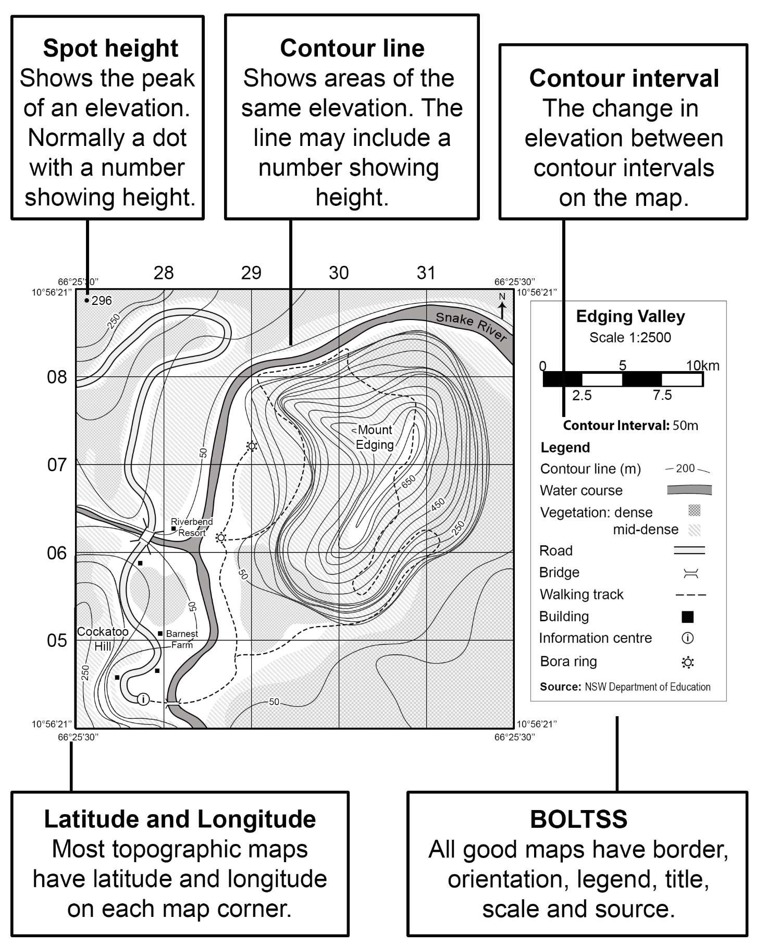

Topographic contour lines
A key feature of topographic maps is contour lines. These show areas of the same elevation above sea level. They give an indication of the height and shape of the land. The Australian Height Datum (AHD) is the standard measure of elevation used in Australia. Contour lines usually show this height in metres (m). Sometimes not all contour lines are numbered to improve legibility of the map, especially if the contours are close together.
The contour interval is the change in elevation between each contour line. It will be consistent across the map and is usually provided in the legend. The contour interval can be determined by calculating the difference in elevation between 2 adjacent lines.
Consider Figure 2:
- Determine the contour interval of Diagrams A to D.
- Justify your answers to a partner.
Figure 2 – contour interval diagrams
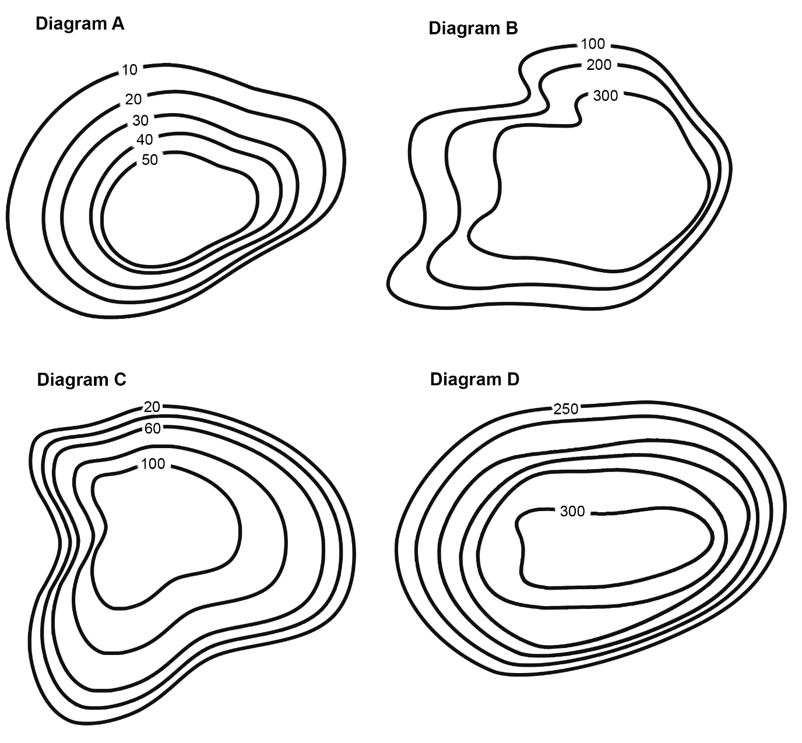
Note: the contour intervals are:
- Diagram A: 10 metres
- Diagram B: 100 metres
- Diagram C: 20 metres
- Diagram D: 10 metres.
Contour lines are useful to understand the shape of the land. A steep slope is indicated by contour lines that are close together, while contour lines further apart indicate a gradual slope. Common landscape features can be identified through contour patterns. Table 1 outlines some key contour patterns.
Table 1 – contour patterns
Landscape feature | Visual and description | Contour pattern
Cliff | Figure 3 – cliff  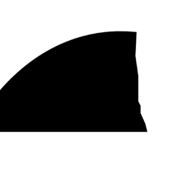 | Figure 4 – cliff contour lines  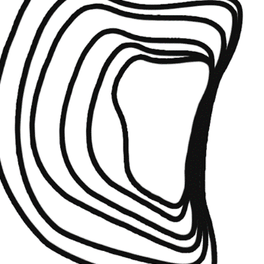
Plateau | Figure 5 – plateau  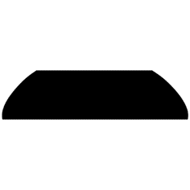  An elevated area of flat land. | Figure 6 – plateau contour lines  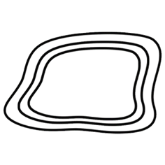  A wide area with little to no contour lines surrounded by contour lines indicating increased elevation.
Ridge | Figure 7 – ridge  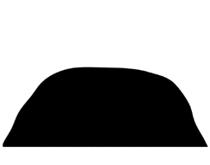  A long, narrow hilltop. | Figure 8 – ridge contour lines  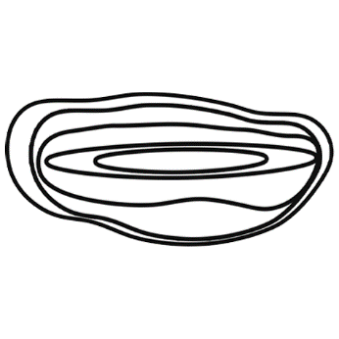  Close contour lines that form a thin, long rectangular shape.
Round hill | Figure 9 – round hill  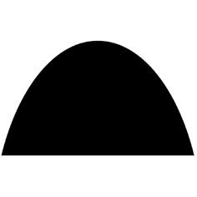  A high round area of land that is not as large as a mountain. | Figure 10 – round hill contour lines  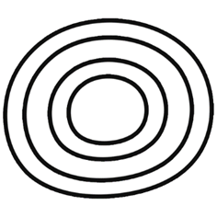  Contours are in a circular or oval shape.
Saddle | Figure 11 – saddle  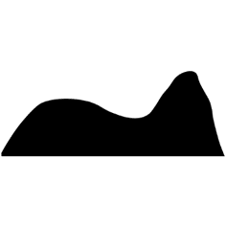  Dip between 2 higher areas of land. | Figure 12 – saddle contour lines  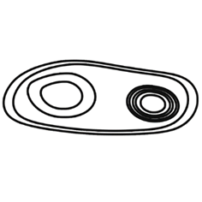  Two circular or rectangular shaped contours with a gap between them.
Spur | Figure 13 – spur  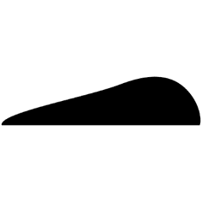  An area of land jutting out the side of a mountain or hill. | Figure 14 – spur contour lines  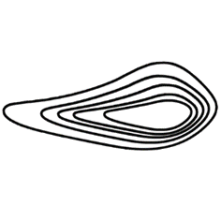  Contour lines pointing away from high land in a U- or V-shape.
Valley | Figure 15 – valley  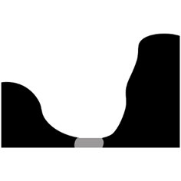  Land between hills or mountains. Usually, a river or creek is present. | Figure 16 – valley contour lines  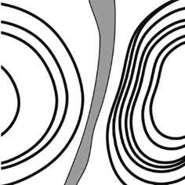  Low area between contour lines for different hills or mountains.
Conduct a digital scavenger hunt to find a real-world example of each landscape feature in Table 1. Display images of your examples in the classroom or on a digital platform such as Google Slides or Microsoft Sway..

Engaging with geographical tools
Note: students will need to be provided with Figure 17 to answer the learning activities.
Use Figure 17 to complete the following activities.
- Determine the contour interval of the map.
- Identify the elevation at point:
- A
- B
- C.
- Which point is higher: point C or point D?
- What is the elevation of the spot height?
- Is the spot height the highest point on the map?
- Is the slope at point E gentle or steep?
- Shade the following landscape features:
- cliff: red
- plateau: blue
- ridge: orange
- round hill: green
- saddle: yellow
- spur: purple.
Answers:
- 200 metres
- A = 800 metres, B = 200 metres, C = 1200 metres
- point C
- 920 metres
- the spot height 920 metres is not the highest point on the map, as the contour line of 1400 metres is higher
- gentle
- see Appendix 2 for landscape feature answers.
Figure 17 – Dreamouth Siding topographic map
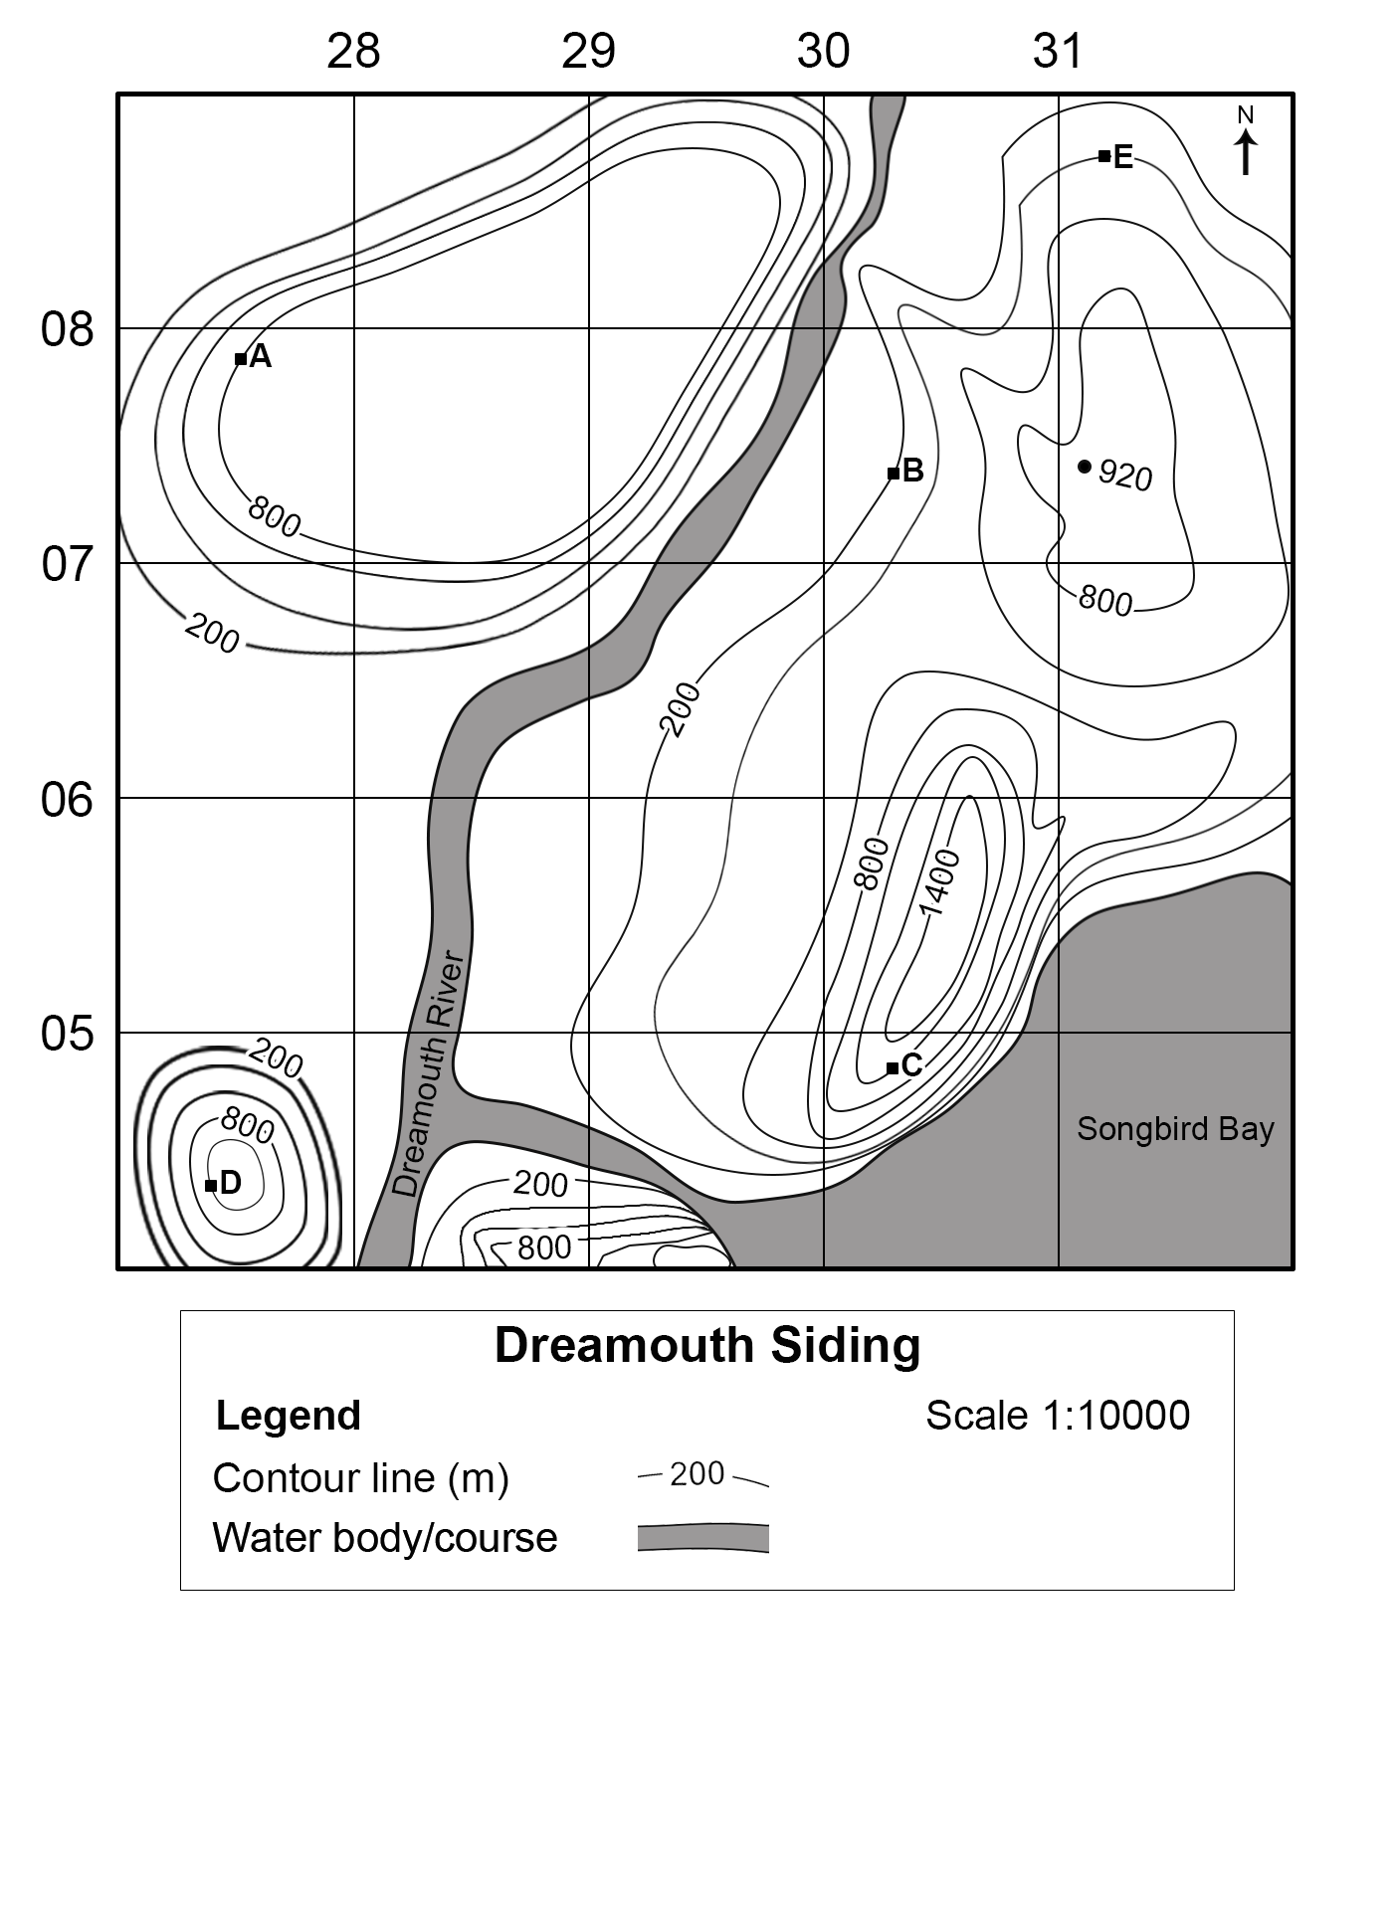
Note: teachers may wish to assess student understanding of contour interval, spot height, BOLTSS, elevation and slope further by using a topographic map specific to their school context or more familiar with students. Teachers will require a topographic map and should amend the questions below to apply to the chosen map.
- What is the contour interval on the map?
- What is the spot height at (choose location)?
- What human feature is located at (choose location)?
- What feature is at point (choose location)?
- Are (location) and (location) equal heights above sea level?
- Describe the slope at locations (location), (location) and (location).
Reflect on your understanding of topographic maps:
Table 2 – self-assessment
Statement | Confident | Somewhat confident | Need more help
How confident are you in determining a contour interval?
How confident are you in identifying elevation using contour lines?
How confident are you in identifying common landscape features using contour patterns?

Using spatial technologies
Note: the following learning activity requires Google Earth Pro. Google Earth web edition does not support image overlays at time of publishing. Google Earth Pro is available for free download and authorised for use on department devices. Seek support from your school Administration team or EdConnect if installing on department devices.
A topographic map for the local area is suggested for this task to increase student connectedness.
Complete the following steps to view a topographic map overlay in Google Earth Pro:
- Visit NSW Topographic Maps.
- Search for a location using the search box in the top right of the screen.
Figure 18 – screenshot of NSW Topographic Maps
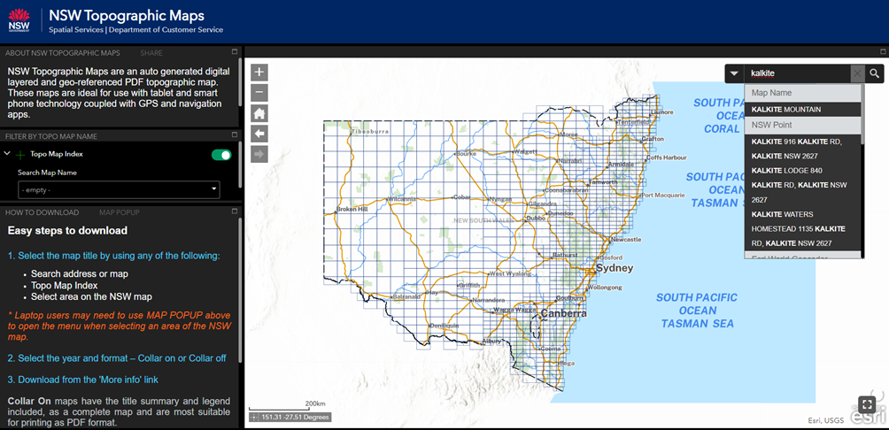
Image by Spatial Services 2023. © State of New South Wales (Spatial Services, a business unit of the Department of Customer Service NSW). For current information go to spatial.nsw.gov.au.
- Select More info next to the Collar Off option. This will download a GeoTIFF file for the map.
- Open Google Earth Pro (desktop version).
- In the menu, select File, then Import.
Figure 19 – screenshot of Google Earth Pro file menu
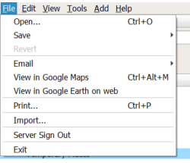
Image by © Google 2023.
- Ensure GeoTIFF (*.tif) is selected in the file type drop-down box. Select the GeoTIFF file downloaded in step 3.
Figure 20 – screenshot of file type drop-down box
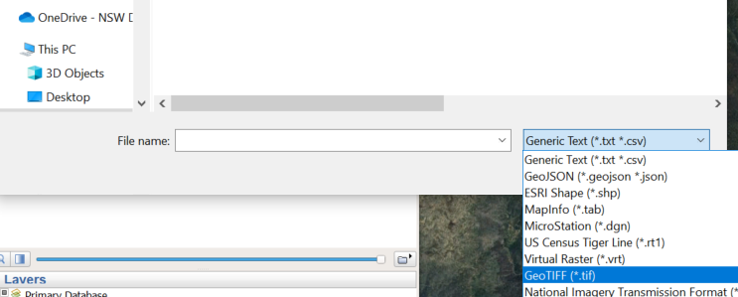
Image by © Google 2023.
- A dialogue box with options will appear. For a high-resolution view, Create Super Overlay… is preferable. This will create many .kmz files that need to be stored in a folder on your computer and can take a few minutes. Scale is a quicker option that does not require additional files to be created; however, the quality will be reduced.
Figure 21 – screenshot of Google Earth Pro dialogue box
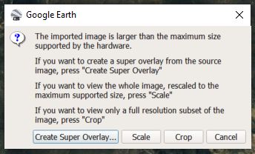
Image by © Google 2023.
- The map should now be visible over the correct location in Google Earth Pro.
Figure 22 – screenshot of map overlay in Google Earth Pro
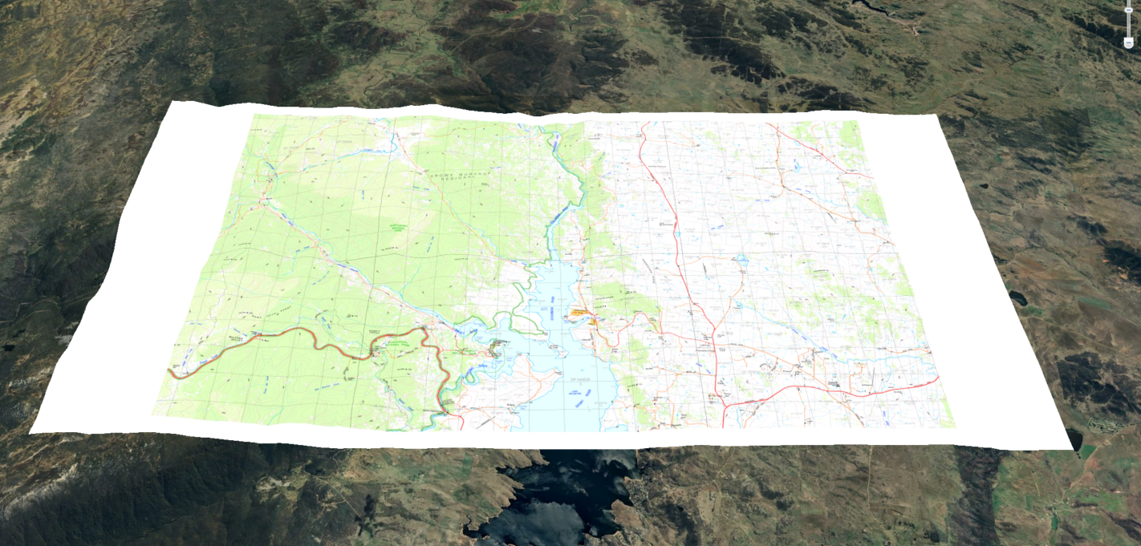
Image by © Google 2023.
- The Adjust Opacity button and slider at the bottom of the Places menu on the left of the screen can be used to view the Google Earth Pro imagery through the topographic map.
Figure 23 – screenshot of Adjust Opacity button and slider
Image by © Google 2023.
- You can zoom in to specific locations on the map and explore the 3D landscape view.
Figure 24 – screenshot of map overlay zoom view
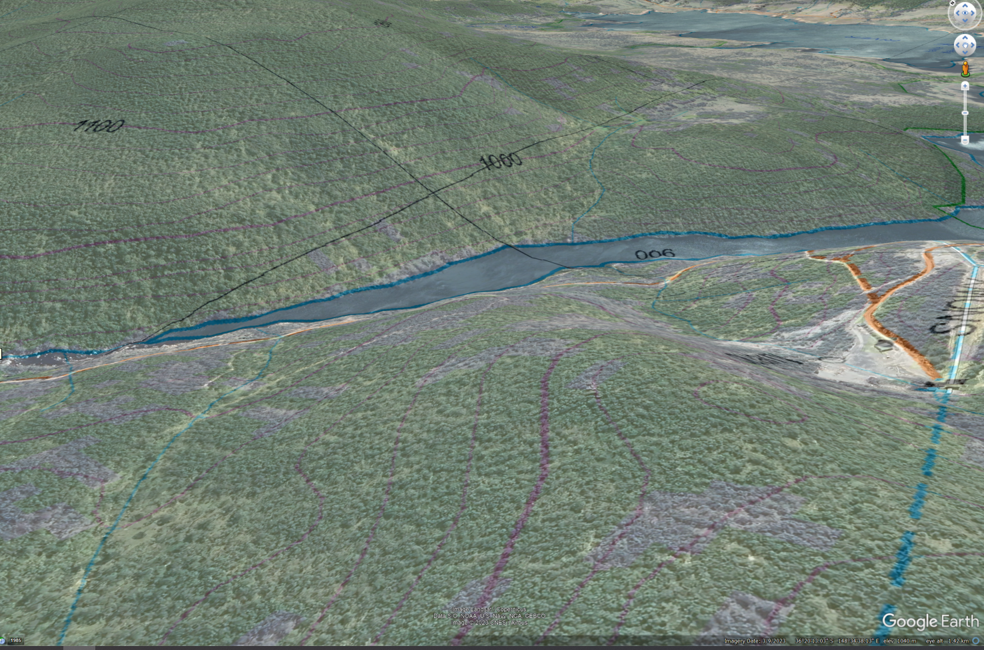
Image by © Google 2023.

Appendix 1 – mapping tools
The following page contains images of a ruler, protractor, compass and 1 cm × 1 cm grid to support students when completing paper-based mapping skills tasks. It should be printed on A4 transparency sheets. Do not scale the page when printing.
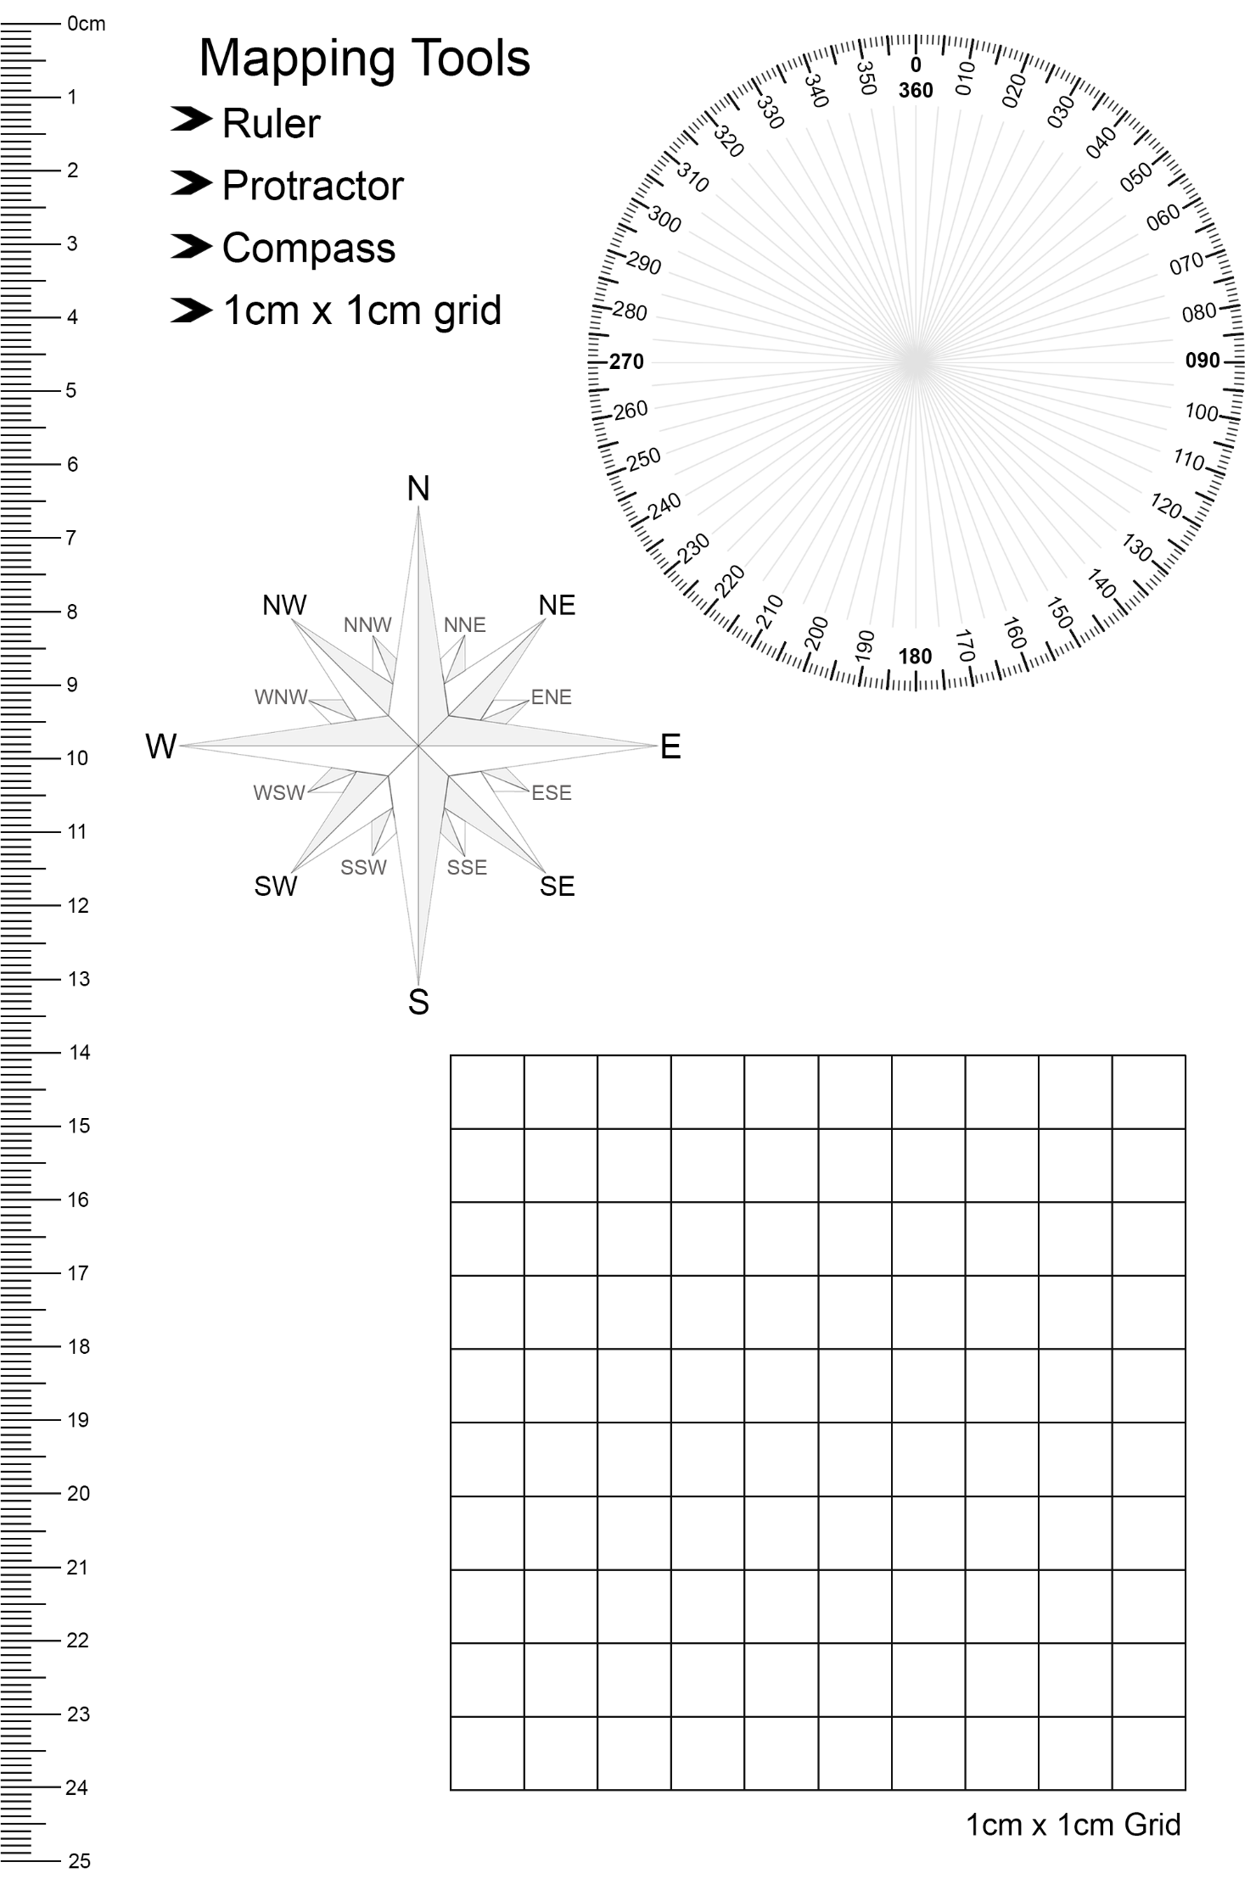

Appendix 2 – activity answers
This appendix shows the answers to the shading question 7 on page 11.
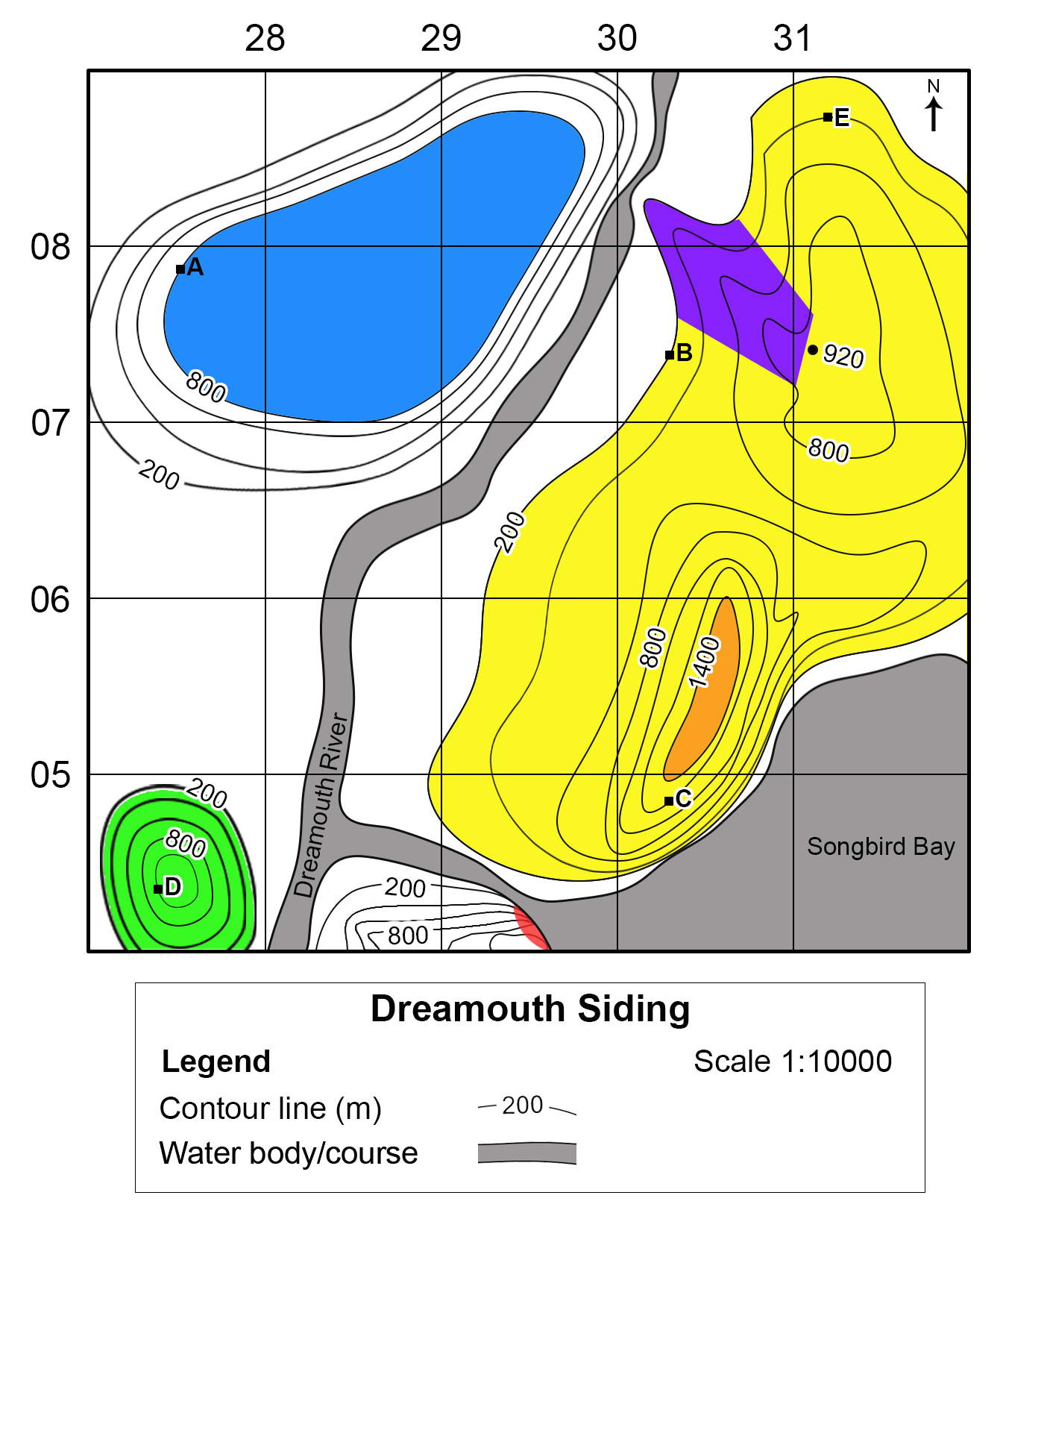

References
This resource contains NSW Curriculum and syllabus content. The NSW Curriculum is developed by the NSW Education Standards Authority. This content is prepared by NESA for and on behalf of the Crown in right of the State of New South Wales. The material is protected by Crown copyright.
Please refer to the NESA Copyright Disclaimer for more information https://educationstandards.nsw.edu.au/wps/portal/nesa/mini-footer/copyright.
NESA holds the only official and up-to-date versions of the NSW Curriculum and syllabus documents. Please visit the NSW Education Standards Authority (NESA) website https://educationstandards.nsw.edu.au and the NSW Curriculum website https://curriculum.nsw.edu.au.
Geography 7–10 Syllabus © 2024 NSW Education Standards Authority (NESA) for and on behalf of the Crown in right of the State of New South Wales.
AIATSIS (The Australian Institute of Aboriginal and Torres Strait Islander Studies) (2023) ‘Map of Indigenous Australia’, Explore, AIATSIS website, accessed 24 August 2023.
Geoscience Australia (2023) ‘Topographic Maps’, Topographic information. Geoscience Australia website, accessed 21 August 2023.
Google (2023) ‘Google Earth Pro’, Earth Versions, Google Earth website, accessed 21 August 2023.
NESA (NSW Education Standards Authority) (2022) ‘Proficient Teacher Standard descriptors’, Teacher accreditation, NESA website, accessed 20 July 2023.
NSW Aboriginal Education Consultative Group (2023) NSW AECG Languages App, WellMob website, accessed 21 August 2023.
NSW Government Spatial Services (2023) ‘Topographic Maps’, Products and Services, Spatial Services website, accessed 21 August 2023.

© State of New South Wales (Department of Education), 2025
The copyright material published in this resource is subject to the Copyright Act 1968 (Cth) and is owned by the NSW Department of Education or, where indicated, by a party other than the NSW Department of Education (third-party material).
Copyright material available in this resource and owned by the NSW Department of Education is licensed under a Creative Commons Attribution 4.0 International (CC BY 4.0) license.

This license allows you to share and adapt the material for any purpose, even commercially.
Attribution should be given to © State of New South Wales (Department of Education), 2025.
Material in this resource not available under a Creative Commons license:
- the NSW Department of Education logo, other logos and trademark-protected material
- material owned by a third party that has been reproduced with permission. You will need to obtain permission from the third party to reuse its material.
Links to third-party material and websites
Please note that the provided (reading/viewing material/list/links/texts) are a suggestion only and implies no endorsement, by the New South Wales Department of Education, of any author, publisher, or book title. School principals and teachers are best placed to assess the suitability of resources that would complement the curriculum and reflect the needs and interests of their students.
If you use the links provided in this document to access a third-party's website, you acknowledge that the terms of use, including licence terms set out on the third-party's website apply to the use which may be made of the materials on that third-party website or where permitted by the Copyright Act 1968 (Cth). The department accepts no responsibility for content on third-party websites.

