Geography 7–10 – guide to teaching mapping – latitude and longitude

Contents

Overview 2

Outcomes 2

Learning sequence 1 – latitude and longitude 3

Syllabus content 3

Learning intentions and success criteria 3

Learning intentions 3

Success criteria 3

Working with maps 4

Atlas maps 4

Engaging with geographical tools 9

Appendix 1 – mapping tools 13

Appendix 2 – world maps 15

References 18

This resource has been developed to assist teachers in NSW Department of Education schools to create learning that is contextualised to their classroom. It can be used as a basis for the teacher’s own program, assessment, or scope and sequence, or be used as an example of how the new curriculum could be implemented. The resource has suggested timeframes that may need to be adjusted by the teacher to meet the needs of their students.

# Overview

**Description:** this teaching support resource addresses Thinking and working geographically, providing examples of how students can engage with the the geographical tool of maps. The lessons in this resource are designed to allow students to build understanding of this   
geographical tool through a range learning activities and can be applied where appropriate across Geography 7–10.

**Duration:** this learning sequence is designed to be completed in approximately 2 hours.

## Outcomes

A student:

* **GE4-TAP-01** selects and uses geographical tools to acquire and process geographical information
* **GE5-TAP-01** applies and evaluates a range of geographical tools to acquire and process geographical information

[Geography 7–10 Syllabus](https://curriculum.nsw.edu.au/learning-areas/hsie/geography-7-10-2024/overview) © NSW Education Standards Authority (NESA) for and on behalf of the Crown in right of the State of New South Wales, 2024.

# Learning sequence 1 – latitude and longitude

**Note:** the guide to teaching mapping – latitude and longitude is designed to be used as a support resource for teachers addressing Thinking and working geographically in Geography 7–10. This resource is not guiding teaching and learning of a specific topic content in geography; rather, it provides resources and strategies that can be applied at any point across the course.

## Syllabus content

Maps are to be integrated into Stage 4 and Stage 5 as appropriate: large-scale maps and small-scale maps, relief maps, special-purpose maps, physical maps, political maps, sketch maps, précis maps, topographic maps, land use maps and thematic maps, such as choropleth maps, isoline maps, cartogram maps, dot maps, flowline maps, weather maps or synoptic charts, graduated or proportional symbol maps.

## Learning intentions and success criteria

**Note:** these learning intentions and success criteria are general and should be contextualised to suit your school and students’ needs.

### Learning intentions

Students learn about:

* key features of latitude and longitude
* using latitude and longitude coordinates.

### Success criteria

Students will be able to:

* identify and describe key differences between lines of latitude and longitude on maps
* use latitude and longitude to locate places on a map.

## Working with maps

**Note:** teachers who are not familiar with latitude and longitude on maps may find the video [Latitude and longitude (4:24)](https://education.nsw.gov.au/teaching-and-learning/curriculum/hsie/hsie-curriculum-resources-k-12/hsie-7-10-curriculum-resources/latitude-and-longitude) useful in explaining the geographical tool. The video may be used as a stimulus in lessons if required.

The inclusion of maps with latitude and longitude and use of GPS devices during fieldwork activities is recommended to reinforce learning from this sequence.

### Atlas maps

Map projections are used to draw the curved surface of the earth on a flat piece of paper. The ideal map projection will show true shape, land in its correct size (proportion) and true direction from one location to another. It is not possible to have all 3 in a map of the Earth. This is why different map projections are beneficial for use in different ways.

A common map projection is the Mercator projection. The direction on a Mercator projection map is accurate however the shape and size of the continents are not. Figure 1 is an example of a Mercator projection world map.

Figure 1 – Mercator projection square

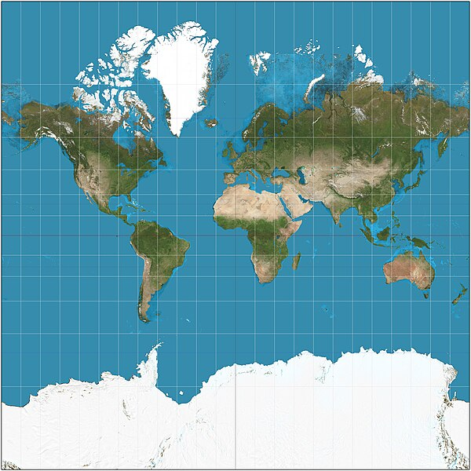

‘[Mercator projection Square](https://commons.wikimedia.org/wiki/File:Mercator_projection_Square.JPG)’ by Daniel R Strebe is licensed under [CC BY-SA 3.0](https://creativecommons.org/licenses/by-sa/3.0/deed.en).

Another common map projection is the equal-area projections. This type of projection is used because the area of continents is accurate, however shape distortion can occur. These projections are useful for thematic maps that present area-based measurements. Figure 2 is one of these projections, known as Strebe 1995.

Figure 2 – Strebe 1995 projection

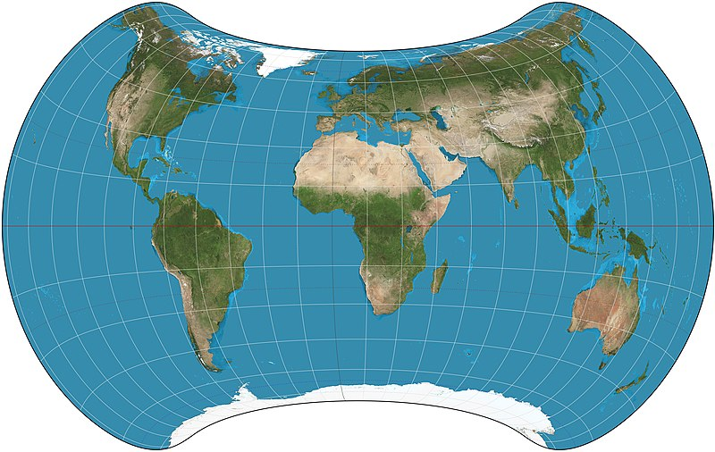

‘[Strebe 1995 11E SW](https://commons.wikimedia.org/wiki/File:Strebe_1995_11E_SW.jpg)’ by Daniel R Strebe is licensed under [CC BY-SA 4.0](https://creativecommons.org/licenses/by-sa/4.0/deed.en).

Compromise projections aim to get a balance between area and shape distortion. They tend to distort polar regions more than the equator and have an oval shape. Figure 3 shows a compromise projection called the Robinson projection.

Figure 3 – a compromise projection called the Robinson projection

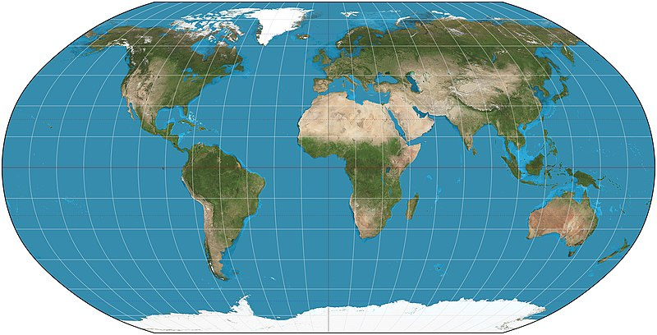

‘[Robinson projection SW](https://en.wikipedia.org/wiki/File:Robinson_projection_SW.jpg)’ by Daniel R Strebe is licensed under [CC BY-SA 3.0](https://creativecommons.org/licenses/by-sa/3.0/deed.en).

Latitude and longitude are imaginary lines across the globe used to provide coordinates for identifying the exact location of places. They are measured in degrees (°), minutes (’) and seconds (”) that represent their angle from the centre of the Earth. There are 60 minutes in every degree, and 60 seconds in every minute.

Digital systems often present latitude and longitude in degrees with a decimal place instead of minutes and seconds. The following worked example shows how to convert a decimal into minutes and seconds. Note that seconds are only required if the result for step 1 (minutes) has a decimal place.

Write the latitude 29.67°S using degrees, minutes and seconds.

Step 1: 0.67 × 60 = 40.2

Step 2: 0.2 × 60 = 12

Therefore, 29.67°S is 29°40’12” S.

Convert the following lines of latitude and longitude from decimals to minutes and seconds:

* 130.5°W
* 5.85°N
* 62.33°S
* 38.271°E.

**Answers:**

* 130°30’ W
* 5°51’ N
* 62°19’48” S
* 38°16’16” E (rounded to nearest minute).

**Differentiation:** to increase complexity for high potential and gifted education (HPGE) students, students can be given lines of latitude and longitude to convert from minutes and seconds to a decimal.

Lines of latitude run horizontally across the world. They are known as parallels of latitude as they are parallel (equally distant and never touching). The most important latitudinal line is the equator (0°). It runs across the centre of the Earth, dividing it into the northern and southern hemispheres. All other lines of latitude are written with an N or S at the end to identify whether they are in the northern or southern hemisphere. 90°N (North Pole) and 90°S (South Pole) are the parallels of latitude furthest from the equator. Figure 4 shows the key parallels of latitude.

Figure 4 – latitude diagram

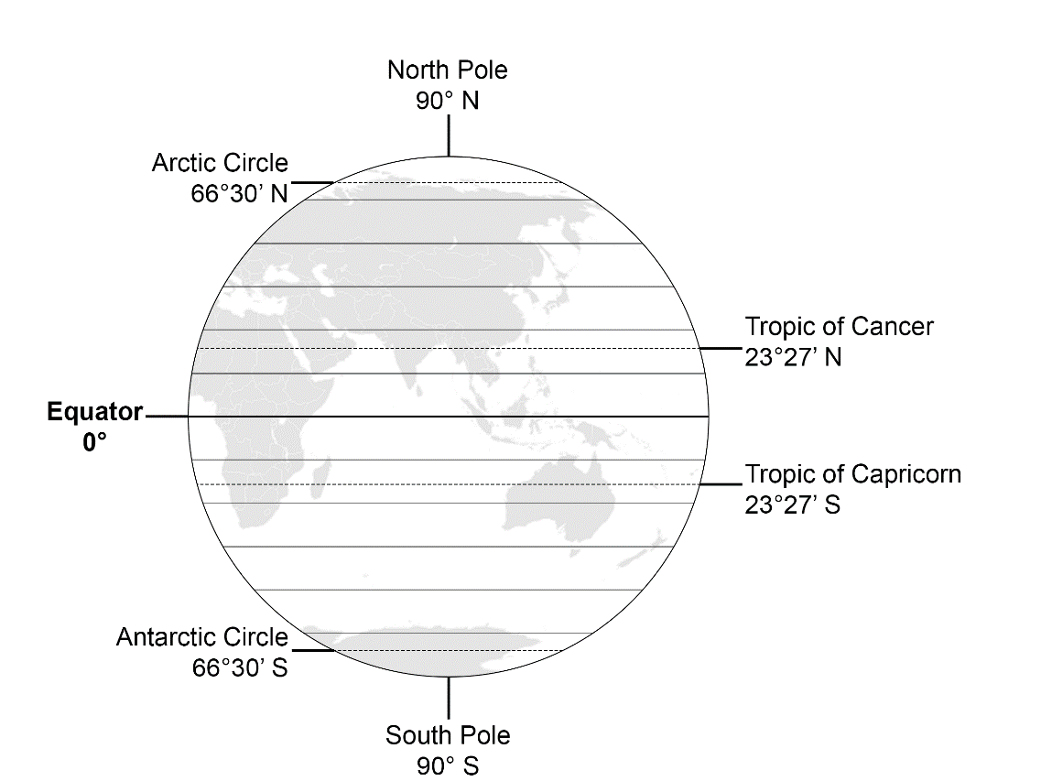

Lines of longitude run vertically across the globe. They are commonly known as meridians. All meridians of longitude meet at the north and south poles. Two important meridians are the prime meridian (0°) and international date line (180°). The prime meridian divides the earth into the eastern and western hemispheres. All other meridians of longitude are written with an E or W at the end to identify whether they are in the eastern or western hemisphere. Figure 5 represents the layout of meridians of longitude across the globe.

Figure 5 – longitude diagram

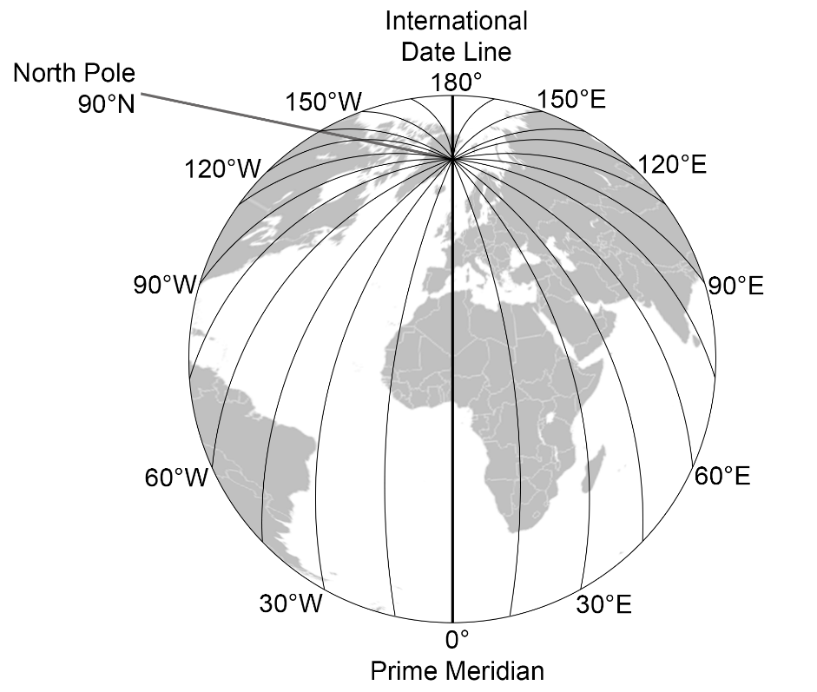

When providing coordinates, we state the latitude then the longitude for the location. For example, Sydney is located at 33°52’8” S 151°12’33” E. Figure 6 is a map of Australia showing lines of latitude and longitude. It is easy to find a location on a map when it is directly located on a line of latitude and longitude, such as Pardoo which is located at 20°S 120°E. When a location is not directly on a provided line of latitude and longitude, we use a ruler to estimate the coordinates based on the lines provided on the map.

Figure 6 – map of Australia

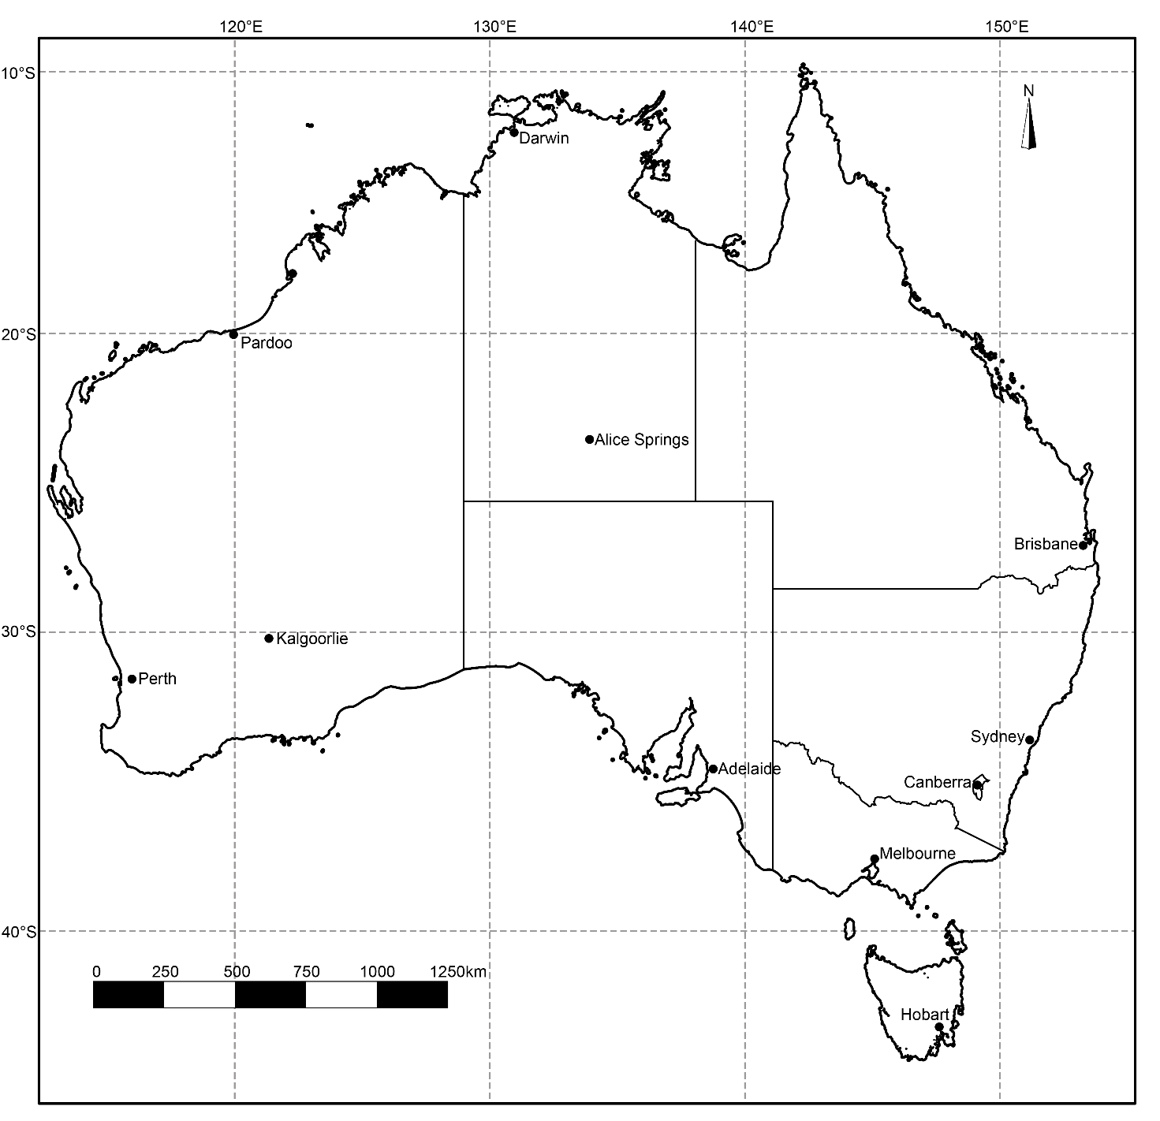

### Engaging with geographical tools

**Note:** provide students with a printed copy of a world map and Figure 6 to complete the following activities. World maps have been provided in Appendix 2 – world maps. One map has continents and oceans labelled, the other has no labels.

Label the following on the world map provided by your teacher:

* Equator
* Prime Meridian
* Tropic of Capricorn
* Tropic of Cancer
* Arctic Circle
* Antarctic Circle
* International Date Line
* North Pole
* South Pole.

Use the world map to identify the continent or ocean found at the following coordinates:

1. 30°N 90°E
2. 60°S 30°W
3. 0° 120°W
4. 20°S 140°E
5. 5°N 70°W
6. 25°S 25°W.

Write 4 coordinates for continents and oceans of your choice and swap with a partner. Identify the continents and oceans from your partner’s coordinates, then mark each other’s answers.

**Answers:**

1. Asia
2. Southern Ocean
3. Pacific Ocean
4. Australia
5. South America
6. Atlantic Ocean.

Use Figure 6 to identify the town or city found at the following coordinates:

1. 42°52’57” S 147°19’33” E
2. 23°41’53” S 133°52’51” E
3. 27°28’14” S 153°1’34” E
4. 31°57’50” S 115°51’42” E
5. 35°16’49” S 149°7’52” E.

Estimate the coordinates to the nearest degree for the following locations in Figure 6:

* Melbourne
* Darwin.

**Answers:**

1. Hobart
2. Alice Springs
3. Brisbane
4. Perth
5. Canberra.

* Melbourne – 38 S 145 E
* Darwin – 12 S 131 E.

**Note:** students need an atlas to complete the following learning activity. Teachers may like to illustrate how to find latitude and longitude on devices to support this activity.

Use an atlas to complete the following table:

Table 1 – latitude and longitude record

|  |  |  |  |  |
| --- | --- | --- | --- | --- |
| Place | Country | Continent | Latitude | Longitude |
| Adelaide |  |  |  |  |
| Beijing |  |  |  |  |
| New York |  |  |  |  |
| Cairo |  |  |  |  |
|  |  |  | 41°17’33” S | 174°46’43” E |
|  |  |  | 35°40’35” N | 139°39’ E |
|  |  |  | 48°51’24” N | 2°21’8” E |
|  |  |  | 12°2’47” N | 77°2’34” W |

Check your answers using [Google Earth](https://earth.google.com).

# Appendix 1 – mapping tools

The following page contains images of a ruler, protractor, compass and 1 cm × 1 cm grid to support students when completing paper-based mapping skills tasks. It should be printed on A4 transparency sheets. Do not scale the page when printing.

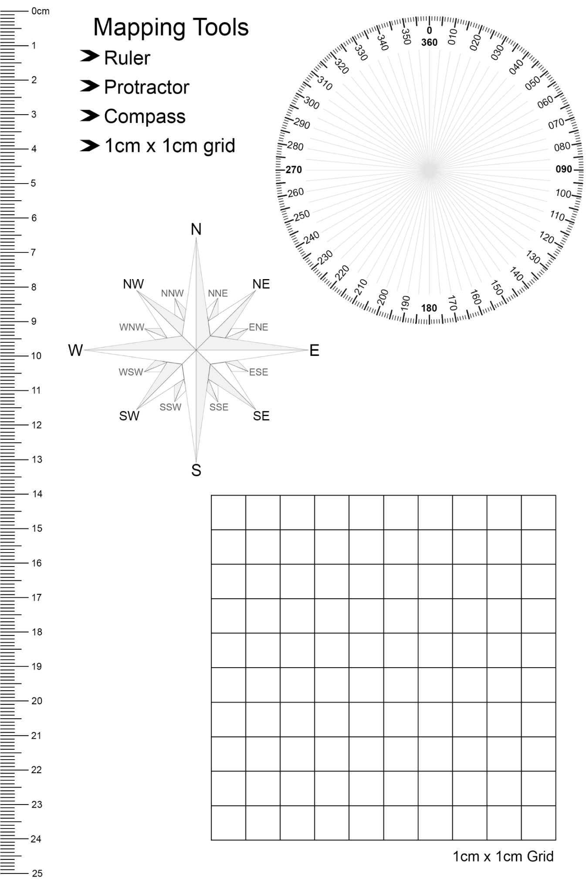

# Appendix 2 – world maps

The following pages provide 2 options of blank world maps with latitude and longitude. They are scaled to be printed on A4 paper. Note the map scale will be incorrect if printed to a different scale.

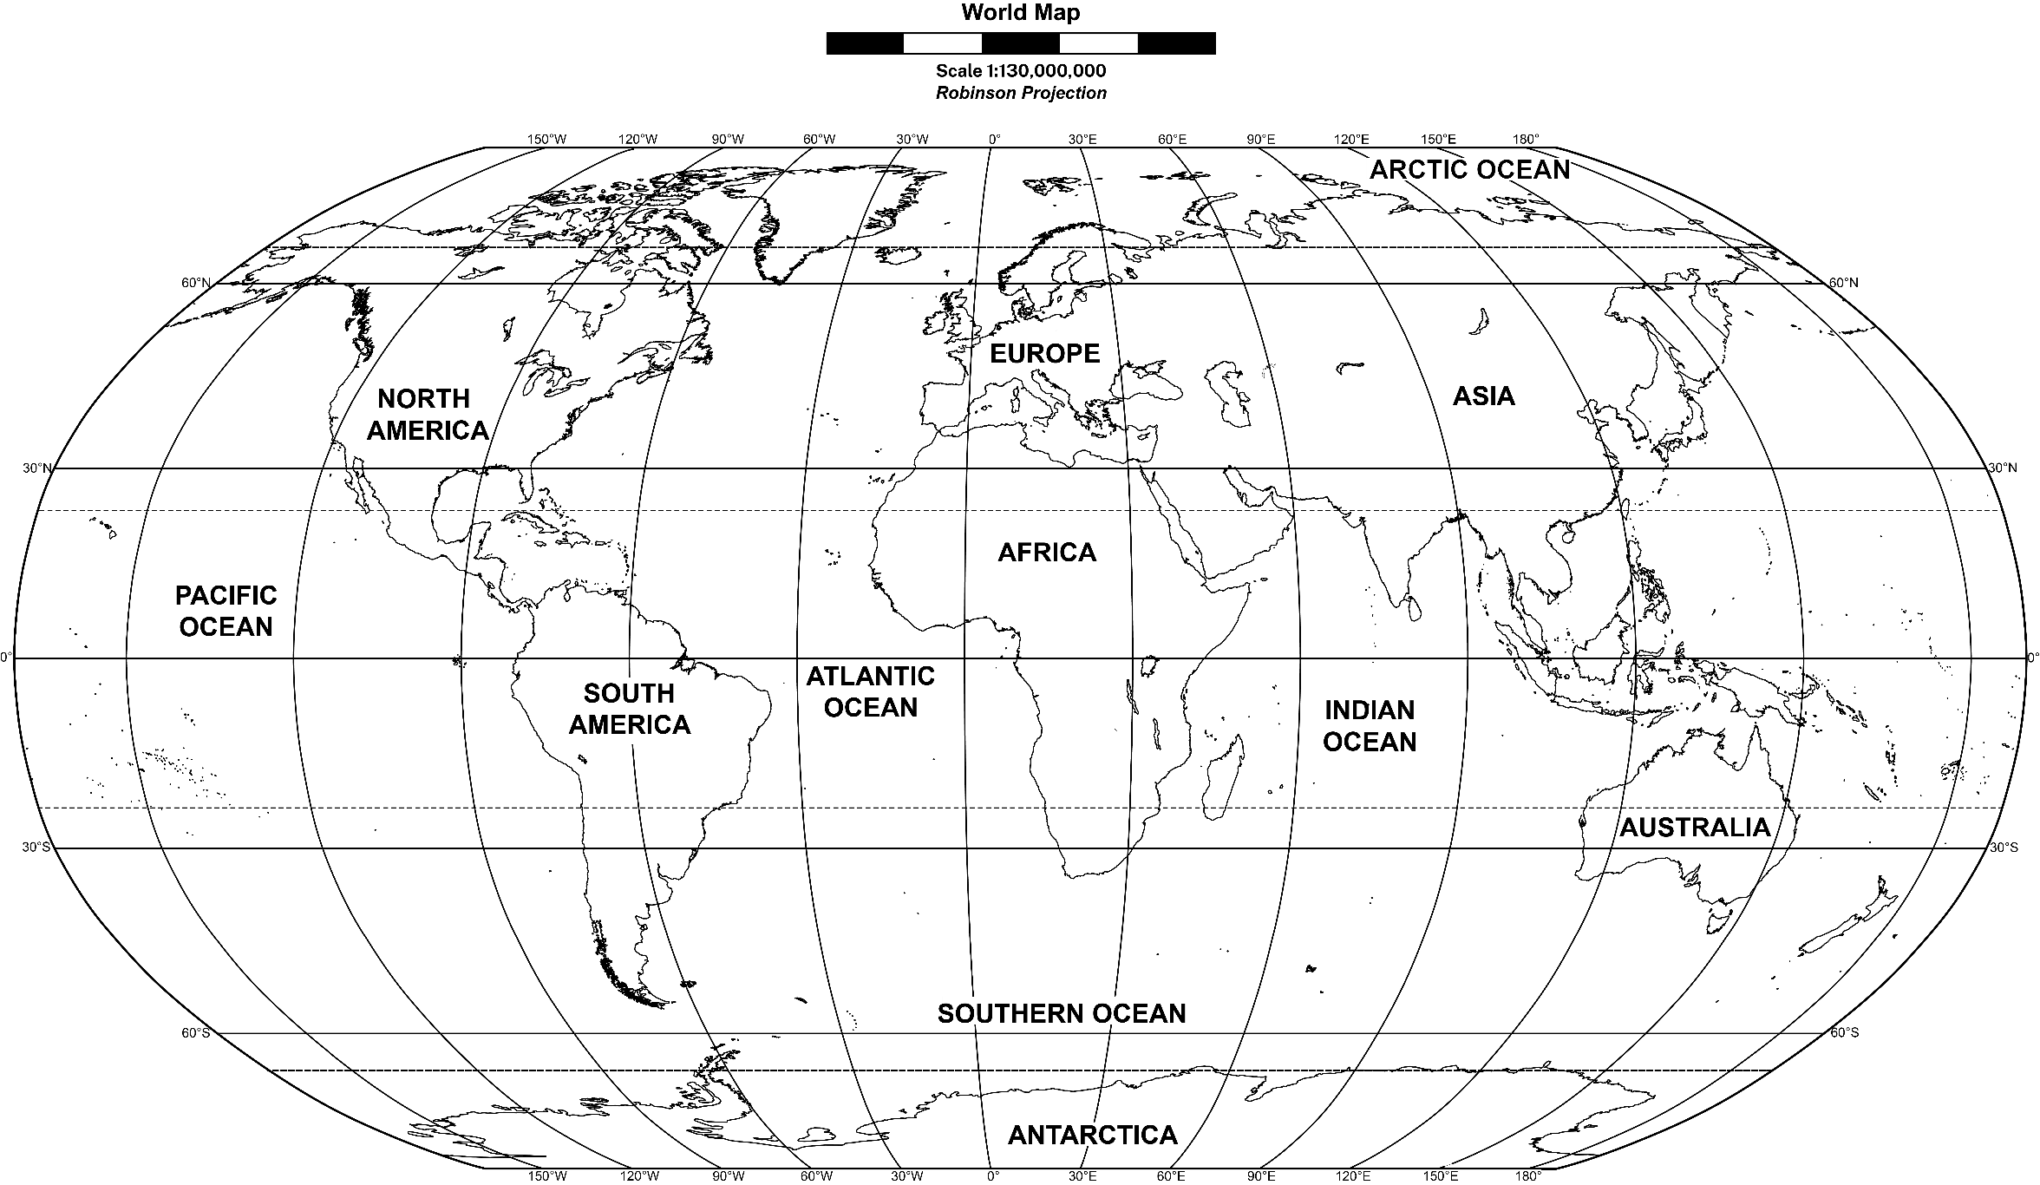

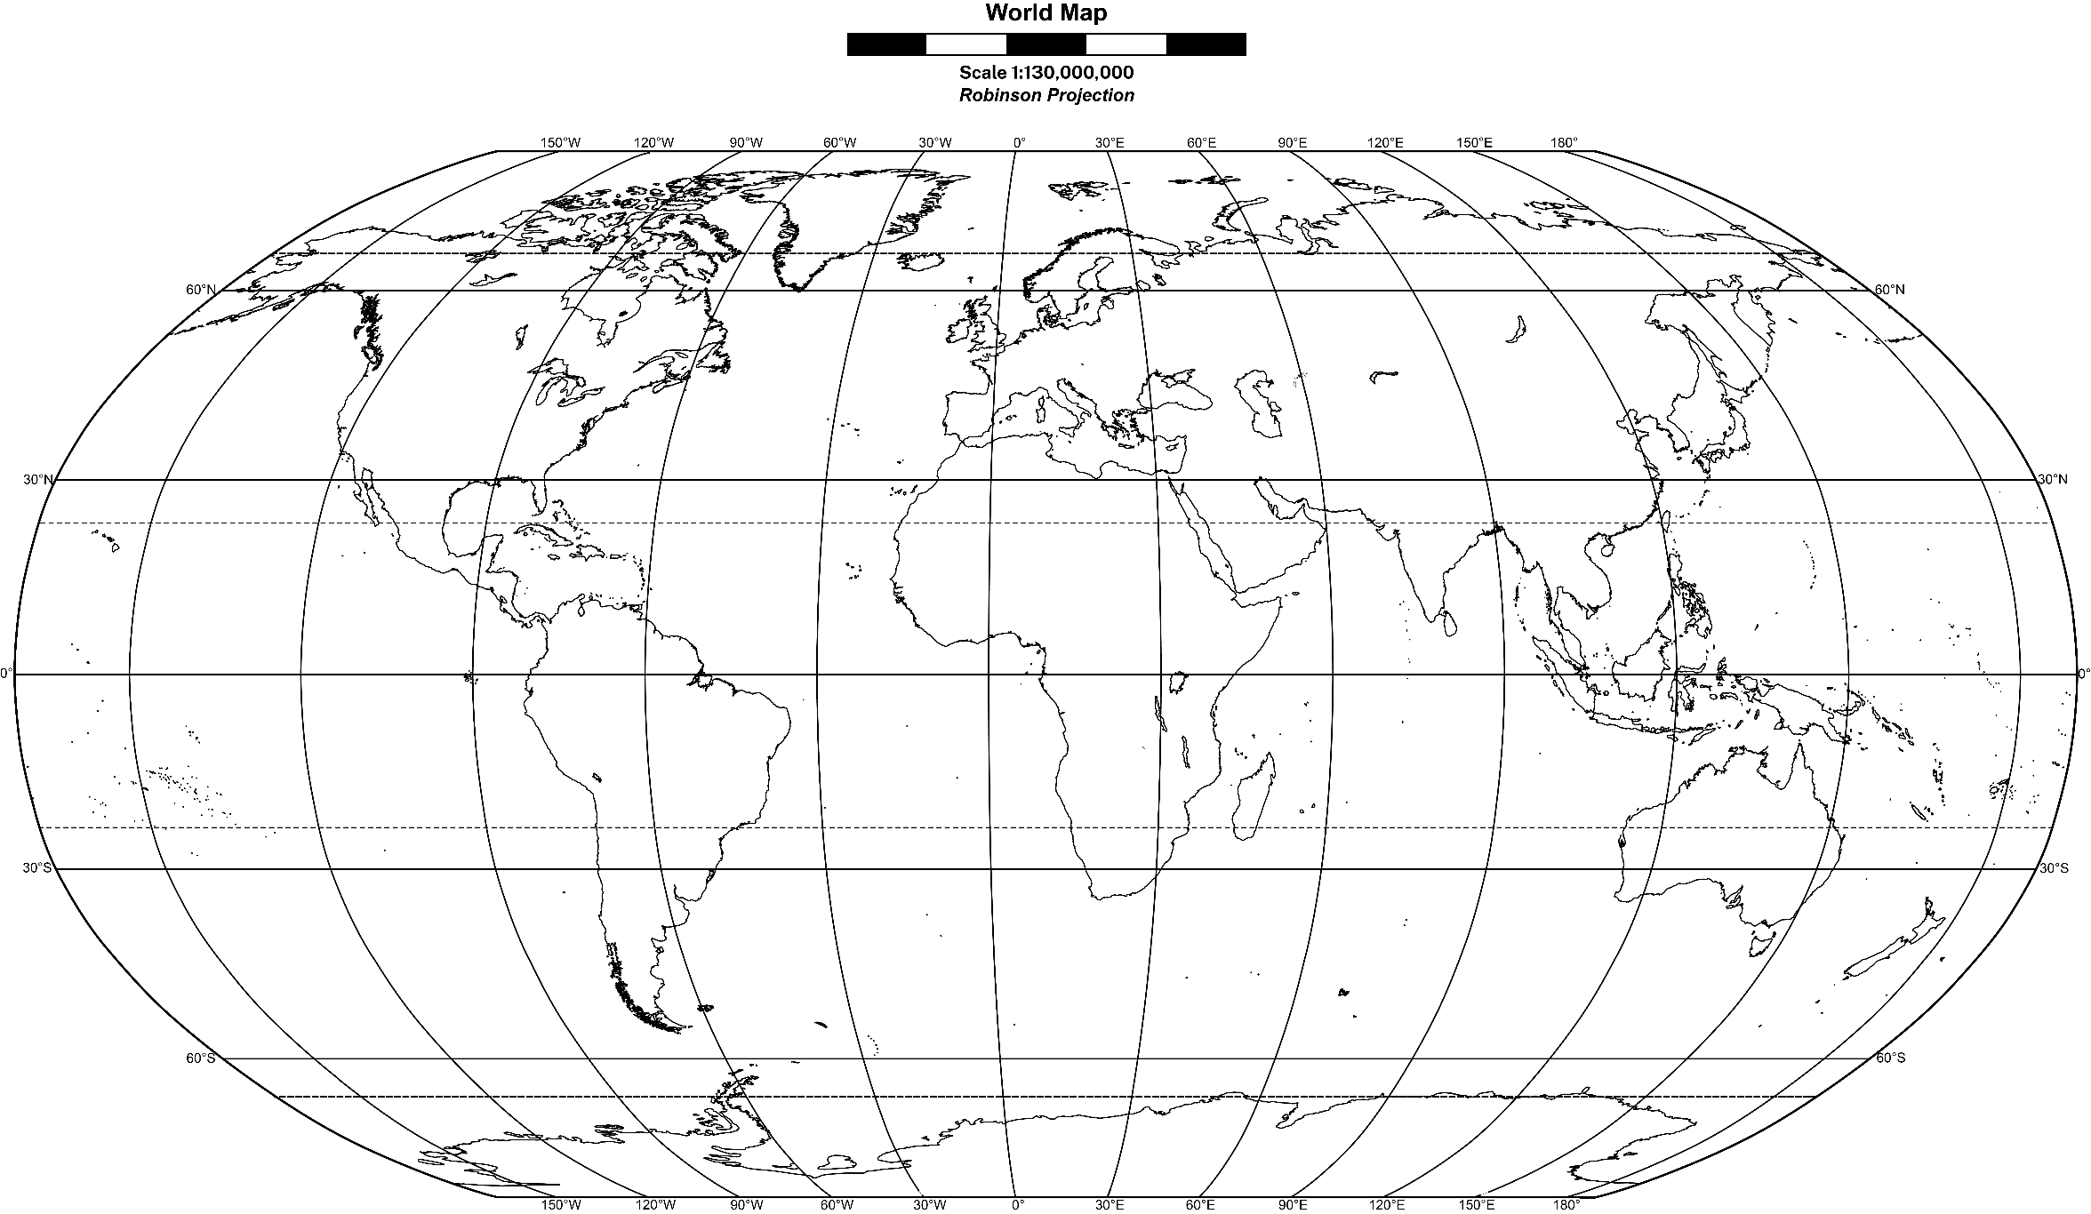

# References

This resource contains NSW Curriculum and syllabus content. The NSW Curriculum is developed by the NSW Education Standards Authority. This content is prepared by NESA for and on behalf of the Crown in right of the State of New South Wales. The material is protected by Crown copyright.

Please refer to the NESA Copyright Disclaimer for more information <https://educationstandards.nsw.edu.au/wps/portal/nesa/mini-footer/copyright>.

NESA holds the only official and up-to-date versions of the NSW Curriculum and syllabus documents. Please visit the NSW Education Standards Authority (NESA) website <https://educationstandards.nsw.edu.au> and the NSW Curriculum website <https://curriculum.nsw.edu.au>.

[Geography 7–10 Syllabus](https://curriculum.nsw.edu.au/learning-areas/hsie/geography-7-10-2024/overview) © NSW Education Standards Authority (NESA) for and on behalf of the Crown in right of the State of New South Wales, 2024.

AIATSIS (The Australian Institute of Aboriginal and Torres Strait Islander Studies) (n.d.) [*Map of Indigenous Australia*](https://aiatsis.gov.au/explore/map-indigenous-australia), AITSIS website, accessed 24 August 2023.

Australian Government Geoscience Australia (2023) [*Topographic Maps*](https://www.ga.gov.au/scientific-topics/national-location-information/topographic-maps-data/topographic-maps), Geoscience Australia website, accessed 21 August 2023.

NESA (NSW Education Standards Authority) (2022) ‘[Proficient Teacher Standard Descriptors’](https://www.nsw.gov.au/education-and-training/nesa/teacher-accreditation/proficient-teacher/standard-descriptors), *The Standards*, NESA website, accessed 20 July 2023.

NSW Aboriginal Education Consultative Group (2023) [*NSW AECG Languages App*](https://wellmob.org.au/key-resources/resources/43997/?title=NSW+AECG+languages+app&contenttypeid=1&contentid=43997_1), WellMob website, accessed 21 August 2023.

NSW Government Spatial Services (2023) [*Topographic Maps*](https://www.spatial.nsw.gov.au/products_and_services/topographic_maps), Spatial Services website, accessed 21 August 2023.

**© State of New South Wales (Department of Education), 2024**

The copyright material published in this resource is subject to the Copyright Act 1968 (Cth) and is owned by the NSW Department of Education or, where indicated, by a party other than the NSW Department of Education (third-party material).

Copyright material available in this resource and owned by the NSW Department of Education is licensed under a [Creative Commons Attribution 4.0 International (CC BY 4.0) license](https://creativecommons.org/licenses/by/4.0/).

[](https://creativecommons.org/licenses/by/4.0/)

This license allows you to share and adapt the material for any purpose, even commercially.

Attribution should be given to © State of New South Wales (Department of Education), 2024.

Material in this resource not available under a Creative Commons license:

* the NSW Department of Education logo, other logos and trademark-protected material
* material owned by a third party that has been reproduced with permission. You will need to obtain permission from the third party to reuse its material.

**Links to third-party material and websites**

Please note that the provided (reading/viewing material/list/links/texts) are a suggestion only and implies no endorsement, by the New South Wales Department of Education, of any author, publisher, or book title. School principals and teachers are best placed to assess the suitability of resources that would complement the curriculum and reflect the needs and interests of their students.

If you use the links provided in this document to access a third-party's website, you acknowledge that the terms of use, including licence terms set out on the third-party's website apply to the use which may be made of the materials on that third-party website or where permitted by the Copyright Act 1968 (Cth). The department accepts no responsibility for content on third-party websites.