Geography 7–10 – guide to teaching mapping – scale

Contents

Overview 2

Outcomes 2

Learning sequence 1 – scale 3

Syllabus content 3

Learning intentions and success criteria 3

Learning intentions 3

Success criteria 3

Working with maps 4

Scale 4

Understanding ratio scales 5

Understanding linear scales 5

Converting scale on maps 6

Engaging with geographical tools 10

Construct a scaled map 13

Appendix 1 – mapping tools 16

Appendix 2 – scale on maps 18

Appendix 3 – making a school map 19

References 21

This resource has been developed to assist teachers in NSW Department of Education schools to create learning that is contextualised to their classroom. It can be used as a basis for the teacher’s own program, assessment, or scope and sequence, or be used as an example of how the new curriculum could be implemented. The resource has suggested timeframes that may need to be adjusted by the teacher to meet the needs of their students.

# Overview

**Description:** this teaching support resource addresses Thinking and working geographically, providing examples of how students can engage with the geographical tool of maps. The lessons in this resource are designed to allow students to build understanding of this geographical tool through a range of learning activities and can be applied where appropriate across Geography   
7–10.

**Duration:** this learning sequence is designed to be completed in approximately 3 hours.

## Outcomes

A student:

* **GE4-TAP-01** selects and uses geographical tools to acquire and process geographical information
* **GE5-TAP-01** applies and evaluates a range of geographical tools to acquire and process geographical information

[Geography 7–10 Syllabus](https://curriculum.nsw.edu.au/learning-areas/hsie/geography-7-10-2024/overview) © NSW Education Standards Authority (NESA) for and on behalf of the Crown in right of the State of New South Wales, 2024.

# Learning sequence 1 – scale

**Note:** this guide to teaching mapping – scale is designed to be used as a support resource for teachers addressing Thinking and working geographically. This resource provides resources and strategies that can be applied at any point across Geography 7–10 where relevant to syllabus content.

## Syllabus content

Maps are to be integrated into Stage 4 and Stage 5 as appropriate: large-scale maps and small-scale maps, relief maps, special-purpose maps, physical maps, political maps, sketch maps, précis maps, topographic maps, land use maps and thematic maps, such as choropleth maps, isoline maps, cartogram maps, dot maps, flowline maps, weather maps or synoptic charts, graduated or proportional symbol maps.

## Learning intentions and success criteria

**Note:** these learning intentions and success criteria are general and should be contextualised to suit your school and students’ needs.

### Learning intentions

Students learn about:

* representations of scale on maps used in geography
* ways we measure distance in real life and convert to scale on a map.

### Success criteria

Students will be able to:

* determine different types of scale used on maps
* determine distance in real life and convert to scaled distance on a map.

## Working with maps

**Note:** teachers will need to provide students with a topographic map for learning activities in this sequence. [Geoscience Australia](https://www.ga.gov.au/scientific-topics/national-location-information/topographic-maps-data/topographic-maps) and [NSW Spatial Services](https://www.spatial.nsw.gov.au/products_and_services/topographic_maps) provide a variety of topographic maps useful for this activity. Teachers need to be aware of the representative fraction scale on the Geoscience maps and the recommended print sizes are A1 for Geoscience 1:50000 maps. NSW Spatial Services maps include linear scale and can be printed on A3 paper.

Students will need a ruler, protractor and pencil to complete the activities in this learning sequence. Appendix 1 – mapping tools provides printable mapping tools. These need to be printed on transparency sheets. Activities in this learning sequence are aligned with PrT3 of the [National Numeracy Learning Progressions Version 3](https://www.australiancurriculum.edu.au/resources/national-literacy-and-numeracy-learning-progressions/version-3-of-national-literacy-and-numeracy-learning-progressions/).

## Scale

The scale of the map tells the relationship between distances on the map and distances in real life. It provides the ratio of map distance to actual distance. Small scale maps show a small amount of detail over a large area. Large scale maps show a large amount of detail in a small area. We show scale in geography by:

* writing in words
* for example, 1 centimetre to 10 metres
* by showing it as a ratio
* for example, 1:1000
* by drawing a linear scale
* for example, see Figure 1.

Figure 1 – example of a linear scale

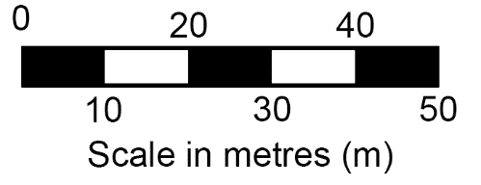

## Understanding ratio scales

Figure 2 shows what each part of a ratio scale represents.

Figure 2 – annotated ratio scale

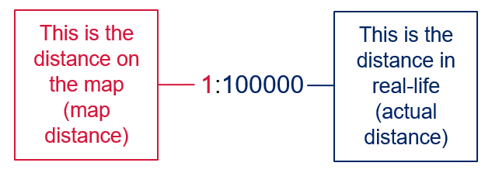

Any unit of measurement can be used to interpret a ratio scale, such as centimetres or inches as long as the same unit of measurement is used to compare both sides. For example, the scale 1:100 can be:

* 1 centimetre on the map represents 100 centimetres in actual distance
* 1 inch on the map represents 100 inches in actual distance.

In Australia, we use centimetres when converting ratio scales. When using small-scale maps, we convert the real-life distance to metres or kilometres to simplify the scale. For example, the scale 1:500000 could be written as:

* 1 centimetre represents 500000 centimetres
* 1 centimetre represents 5000 metres

or

* 1 centimetre represents 5 kilometres.

The final option, 1 centimetre represents 5 kilometres, is the most simplified.

## Understanding linear scales

To use a linear scale, place your ruler on the scale and measure the size of the first bar. This is the map distance. The value for the bar is the actual distance. For example, in Figure 1 the first bar is 1 centimetre long and the value is 10 metres. This means the scale is 1 centimetre represents 10 metres.

## Converting scale on maps

**Note:** students unfamiliar with scale may need to revisit the geographical skill. The video [BOLTSS and scale (4:06)](https://education.nsw.gov.au/teaching-and-learning/curriculum/hsie/hsie-curriculum-resources-k-12/hsie-11-12-curriculum-resources/boltss-and-scale) may be useful for revision or addressing this skill.

1. Convert the ratio scale to words using centimetres:
2. 1:100000
3. 1:50000
4. 1:250000
5. Convert the ratio scale to words using metres:
6. 1:100000
7. 1:50000
8. 1:250000
9. Convert the ratio scale to words using kilometres:
10. 1:100000
11. 1:50000
12. 1:250000

**Answers for ratio scale to words:**

1.a.1:100000 is 1 centimetre to 100000 centimetres

1.b.1:50000 is 1 centimetre to 50000 centimetres

1.c.1:250000 is 1 centimetre to 250000 centimetres

2.a.1:100000 is 1 centimetre to 1000 metres

2.b.1:50000 is 1 centimetre to 500 metres

2.c.1:250000 is 1 centimetre to 2500 metres

3.a.1:100000 is 1 centimetre to 1 kilometre

3.b.1:50000 is 1 centimetre to 0.5 kilometre

3.c.1:250000 is 1 centimetre to 2.5 kilometres.

**Note:** when using assessment in the classroom, peer and self-assessment is an effective approach to enhance the learning of students. Explicitly teaching students how to assess their own work, and the work of their peers, has many benefits. It promotes student understanding of their learning and provides opportunities for critical analysis of their own efforts, encouraging them to become more autonomous learners. The following learning activities provide an example of self-assessment. More information on this aspect of formative assessment is available at [Peer and self-assessment for students](https://education.nsw.gov.au/teaching-and-learning/professional-learning/teacher-quality-and-accreditation/strong-start-great-teachers/refining-practice/peer-and-self-assessment-for-students).

Reflect on the answers from the previous learning activity. Working with a partner, create 2 ratio scales (minimum 1:5000). On a separate piece of paper, draw a linear scale to represent each ratio scale you created using a pencil and ruler. When complete, swap your linear scale with another pair and answer these questions:

* Are the linear scales drawn accurately?
* What is the ratio scale for each linear scale? Check your answers with the pair who created the scales.
* Do you have suggestions for how the linear scales could be improved?

**Note:** students will need to be provided with Figure 3 to answer the following learning activities. Gamilaraay language is used in Figure 3. Gamilaraay Nation is located in north-eastern NSW and south-western Queensland.

The [NSW AECG Languages app](https://wellmob.org.au/key-resources/resources/43997/?title=NSW+AECG+languages+app&contenttypeid=1&contentid=43997_1) contains all words used. Permission to use the traditional language of Gamilaraay was sought and approved by the NSW Aboriginal Education Consultative Group (AECG). Figure 3 is a fictional location used for illustrative purposes.

Use Figure 3 to answer the following questions:

* What is the scale of this map in words?
* What is the scale of this map as a representative fraction?

Figure 3 – Bandaar Walaay map

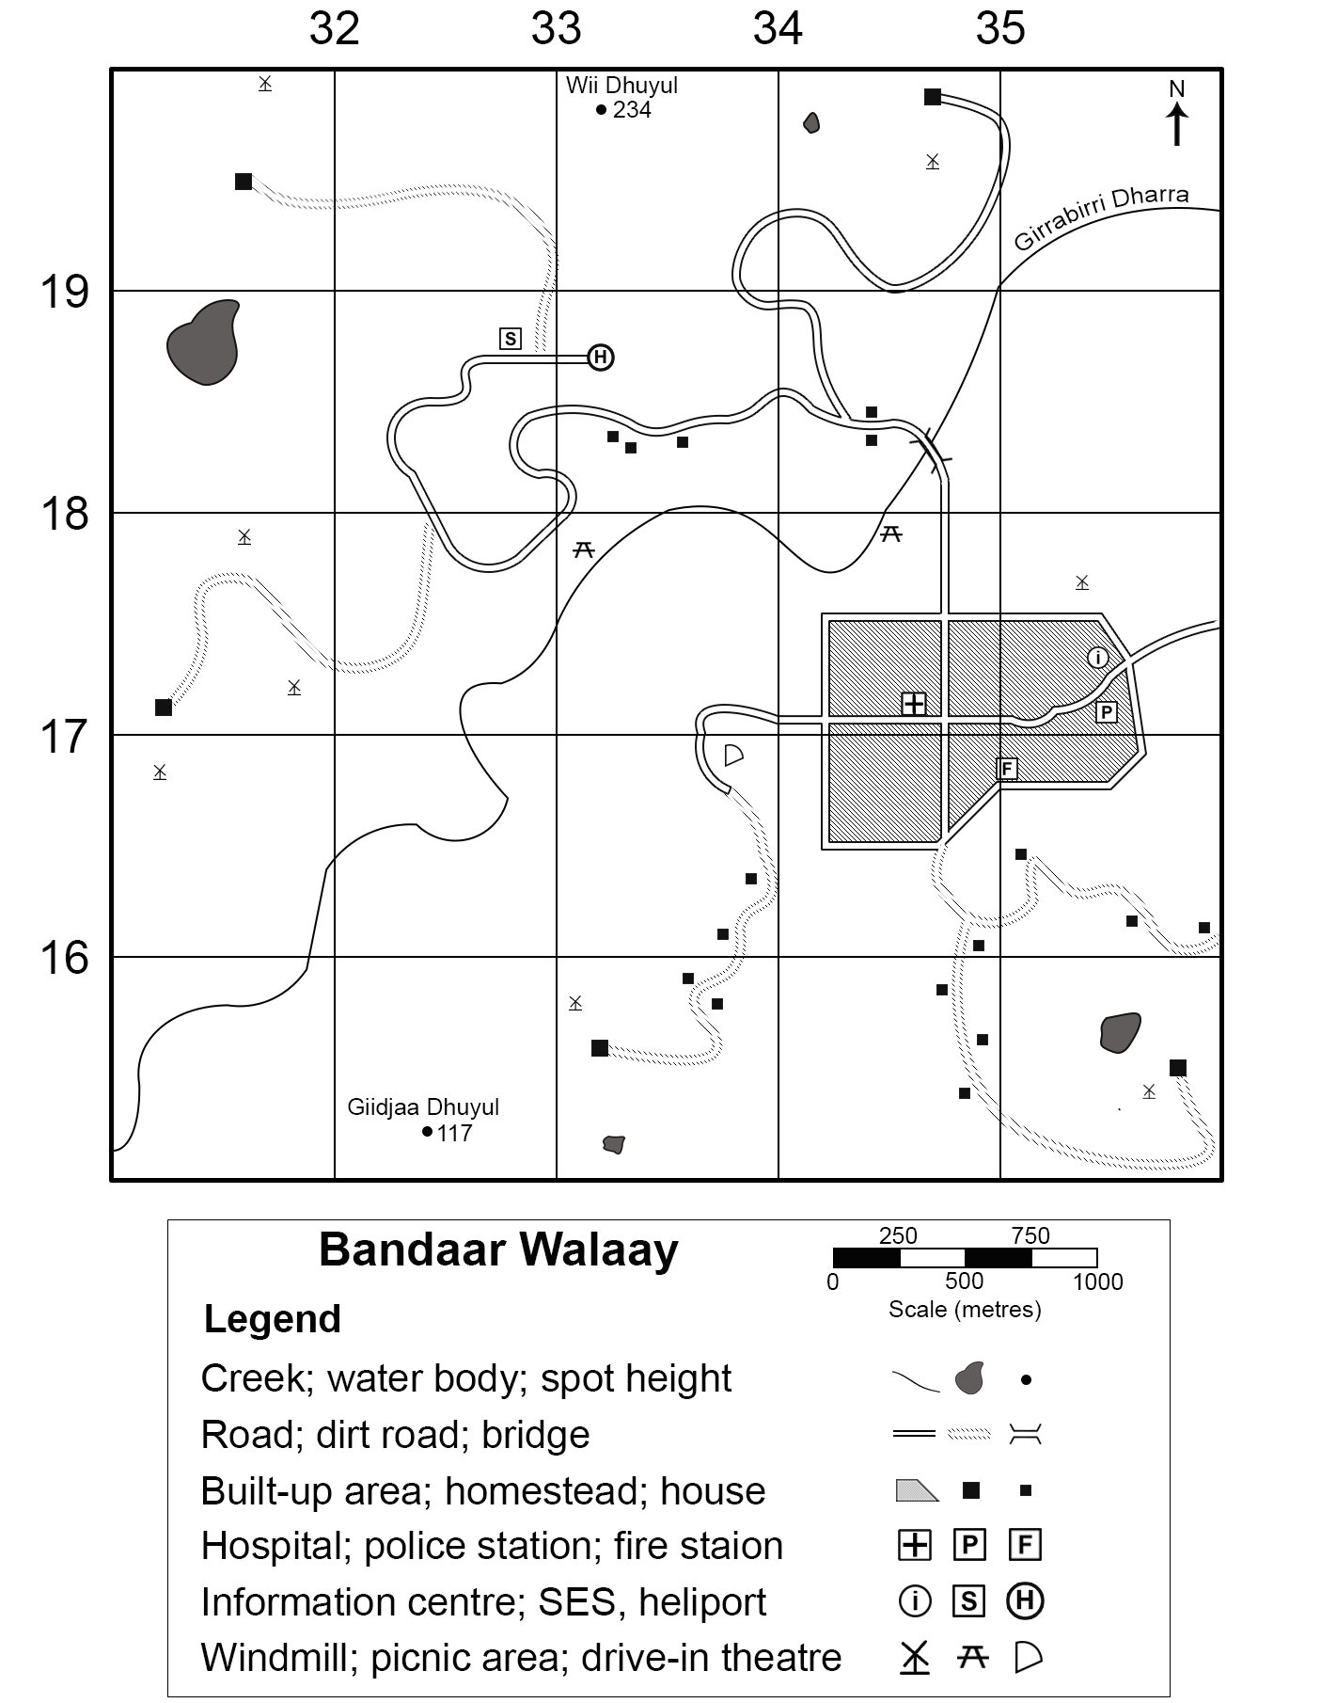

Gamilaraay language used with permission of NSW AECG.

**Note:** the resources required for this learning activity are digital or printed copies of Appendix 2 – scale on maps and 8 printed topographic maps, each with a different scale. Instructions on accessing topographic maps has been provided on page 4.

Set out each topographic map on a different table or space in the classroom. Students will work with a partner to progress around the room identifying the different types of scale used on the maps and complete the table provided in Appendix 2.

Your teacher will allocate you a partner. Working together, examine each topographic map provided by your teacher. Complete a row in the table from Appendix 2 for each map. Swap your answers with another pair and provide peer feedback on:

* the accuracy of the scale for each map
* how well the linear scale has been drawn.

## Engaging with geographical tools

**Note:** a map of the school with the scale removed is needed for the following activity. If the map scale is unknown, teachers should determine the scale using the activity steps prior to implementation. Appendix 3 – making a school map provides instructions for developing a suitable school map if one is not available. Students will also require a trundle wheel or tape measure, a ruler and a calculator.

It is also recommended that teachers pre-determine appropriate locations in the school for students to measure real-life distances that allow for adequate supervision. This activity is aligned with PoL5 of the [National Numeracy Learning Progressions Version 3](https://www.australiancurriculum.edu.au/resources/national-literacy-and-numeracy-learning-progressions/version-3-of-national-literacy-and-numeracy-learning-progressions/).

Your teacher will provide you with a printed copy of a map of your school. You will notice there is no scale for the map. Working in pairs, determine the scale for the map using the following steps and Table 1.

1. Select 3 specific areas of the school clearly shown on the map. Examples include a building, oval or walkway. Write the selected areas in the first column of Table 1.
2. Use a tape measure or a trundle wheel to measure the real-life length and width of the first area in centimetres. Write the measurements in the second column.
3. Use a ruler to measure the length and width of the area on the map in centimetres. Write these measurements in the third column.
4. Use a calculator to divide the real-life measurements by the map measurements. Write the answers in the fourth column.
5. Use a ruler to measure the other 2 areas on your map. Write these measurements in the third column.
6. Estimate the real-life measurements for these 2 areas using the calculations for the first area you measured. Write your estimations in the second column using a pencil.
7. Collect the real-life measurements of the 2 areas using a trundle wheel or a tape measure. Compare the measurements to your estimates. How accurate were you?
8. Use a calculator to divide the real-life measurements by the map measurements. Write the answers in the fourth column.
9. Discuss your answers with another pair and estimate the scale for the map. Round the scale to the nearest 100 centimetres. Write the scale:

* in sentence form
* as a ratio scale
* as a linear scale.

Table 1 – map scale calculations

|  |  |  |  |
| --- | --- | --- | --- |
| Area | Real-life measurements | Map measurements | Scale calculations |
|  | Length:   * estimate * actual   Width:   * estimate * actual | Length:  Width: | Length:  Width: |
|  | Length:   * estimate * actual   Width:   * estimate * actual | Length:  Width: | Length:  Width: |
|  | Length:   * estimate * actual   Width:   * estimate * actual | Length:  Width: | Length:  Width: |

**Differentiation:** the complexity of the task can be increased for high potential and gifted education (HPGE) students by not supplying a calculator and having students complete the activity using either [cross division](https://worldmentalcalculation.com/how-to-divide-by-long-numbers-in-mental-math/) or [estimating multi-digit division](https://www.khanacademy.org/math/cc-fifth-grade-math/multi-digit-multiplication-and-division/multi-digit-division-estimation/v/approximating-multi-digit-division). Preselecting and measuring areas is recommended to support students with lower numeracy ability. Mixed-ability grouping may encourage social support for this task.

## Construct a scaled map

**Note:** students will construct a classroom map with BOLTSS to develop an understanding of scale. Creating scaled visual representations of known locations supports student numeracy in proportional thinking. This activity is aligned with PrT6 of the [National Numeracy Learning Progressions Version 3](https://www.australiancurriculum.edu.au/resources/national-literacy-and-numeracy-learning-progressions/version-3-of-national-literacy-and-numeracy-learning-progressions/).

The following equipment is required:

* tape measure
* A3 paper
* lead pencil
* ruler.

Optional equipment:

* coloured pencils
* markers.

To support smooth progression in this activity, assign student groups to quadrants or sections in the classroom and display a timer for when groups will rotate to the next quadrant.

The gallery walk is a strategy that can be used as formative assessment. Students will need a teacher-modified [Gallery walk](https://app.education.nsw.gov.au/digital-learning-selector/LearningActivity/Card/555) response form to assess specific criteria for the classroom mapping exercise.

**Differentiation:** provide students with lower numeracy skills a pre-drawn classroom outline on the page using a simple scale, such as 1:20 or 1:100. Mixed-ability grouping may be appropriate to enable social support. HPGE students can be directed to use a more complex scale, such as 1:7 or 1:90, to increase task complexity.

Working in small groups, use the following instructions to draw a scaled map of your classroom.

1. Measure the length and width of the classroom and the paper being used for the map in centimetres.
2. Determine what scale should be used to fit the classroom clearly on the paper. Ensure you leave enough blank space on the paper for a legend.

**Tip:** divide the classroom measurement by multiples of 10 until you reach a size that will fit effectively on the paper.

1. Draw the outline of the classroom on the paper using this scale. This is the border of the map.
2. Draw a rectangle outside the border to be the legend. Name the box ‘Legend’ and write the chosen scale in ratio and linear form.
3. Brainstorm ideas for symbols to represent 8 to 10 key objects in the classroom, such as student desks, teacher desk, windows or display boards. Draw and label these in the legend.

**Tip:** consider using symbols you can easily change the size of on the map to reflect their scaled size, such as a rectangle for student desks.

1. Measure the objects in the room, as well as the distance between the various objects.

**Tip:** measuring an object’s distance from the 2 nearest walls is useful to ensure correct positioning on the map.

1. Mark the objects to scale on your map using the symbols from the legend. Ensure the distances between objects on the map accurately reflect the distances you measured.
2. Conduct a [Gallery walk](https://app.education.nsw.gov.au/digital-learning-selector/LearningActivity/Card/555) reviewing classroom maps constructed by yourself and your peers. Follow instructions from your teacher and complete a Gallery walk response form.

Table 2 – self-assessment

|  |  |  |  |
| --- | --- | --- | --- |
| Statement | Confident | Somewhat confident | Need more help |
| How confident are you in converting scale, such as linear to ratio or into words? |  |  |  |
| How confident are you in scaling real life features onto a map? |  |  |  |

# Appendix 1 – mapping tools

The following page contains images of a ruler, protractor, compass and 1 cm × 1 cm grid to support students when completing paper-based mapping skills tasks. It should be printed on A4 transparency sheets. Do not scale the page when printing.

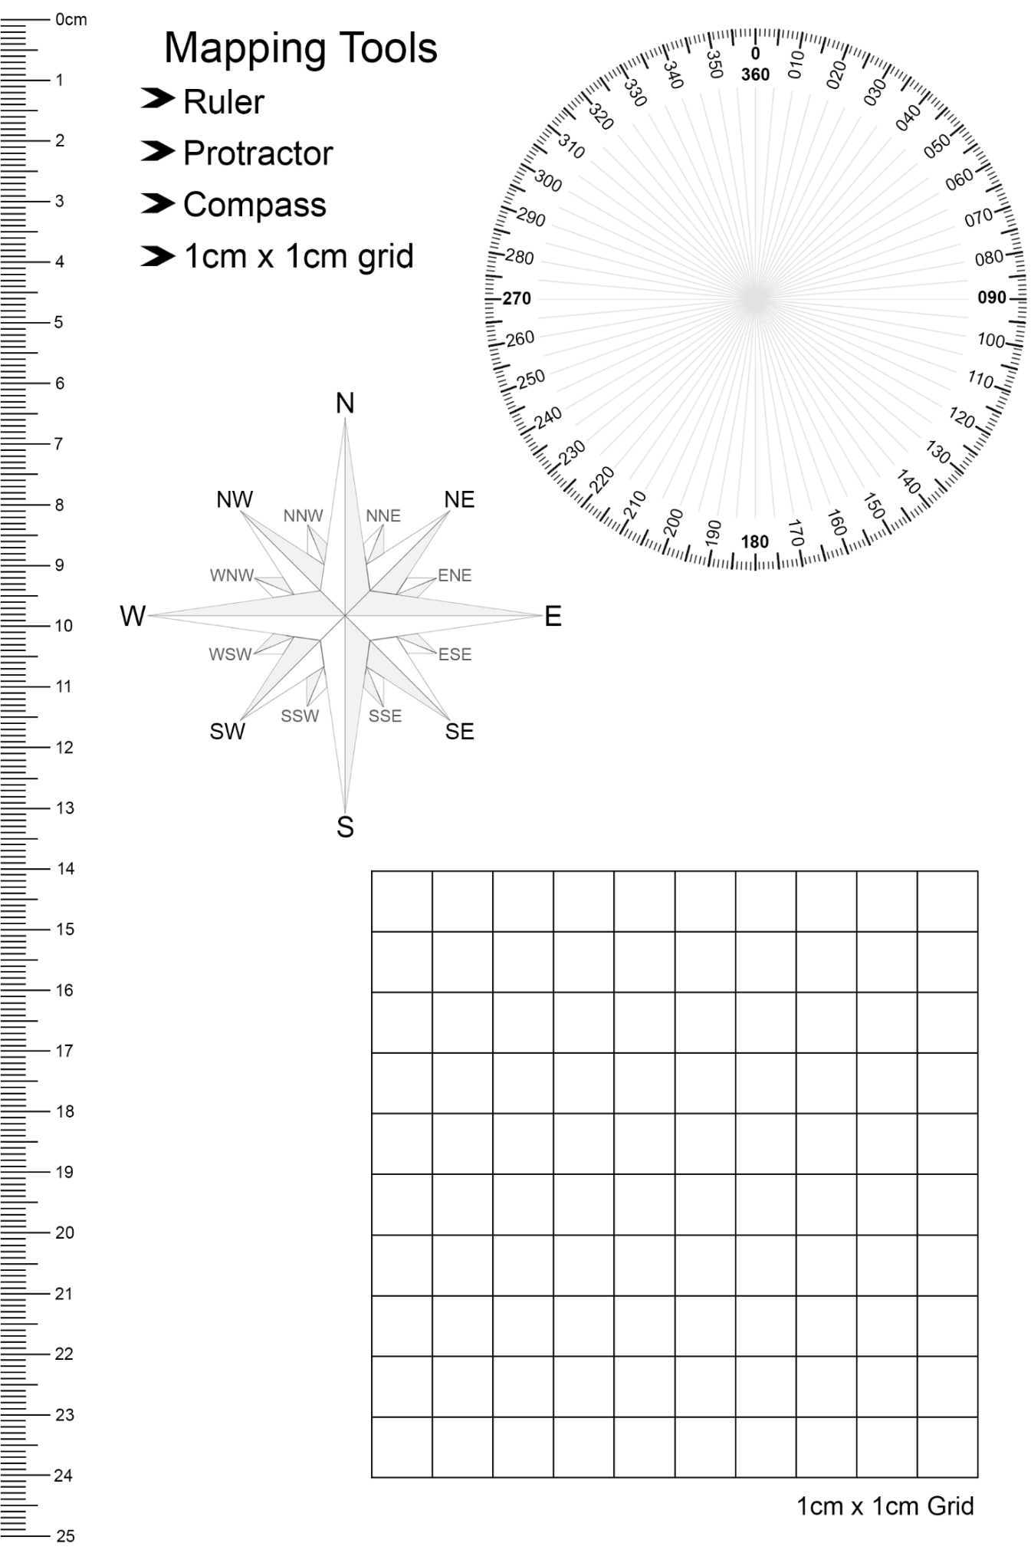

# Appendix 2 – scale on maps

|  |  |  |  |  |  |  |  |  |
| --- | --- | --- | --- | --- | --- | --- | --- | --- |
| **Linear scale** |  |  |  |  |  |  |  |  |
| **Ratio scale** |  |  |  |  |  |  |  |  |
| **Written scale** |  |  |  |  |  |  |  |  |
| **Map title** |  |  |  |  |  |  |  |  |

# 

# Appendix 3 – making a school map

Complete the following steps to create a map of your school for the scale measurement activity.

1. Open [Google Maps](https://maps.google.com).
2. Search for your school.
3. Zoom in or out until all your school is clearly visible. The zoom tools will be in the bottom-right corner of the screen.

Figure 4 – Google Maps zoom tools

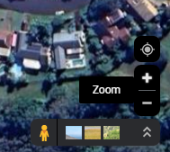

Image by © [Google 2023](https://maps.google.com).

1. Navigate to the best map type by selecting **Layers** to swap between **Default** and **Satellite**. Satellite view is recommended if students will be measuring outdoor spaces such as ovals and walkways. The **Layers** button will be in the bottom-left corner of the screen.

Figure 5 – Google Maps Layers button

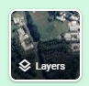

Image by © [Google 2023](https://maps.google.com).

1. If using satellite view, hover over **Layers**, select **More**, then untick **Labels**. This removes location tags to reduce cognitive load for students when using the map.

Figure 6 – Google Maps ‘More’ menu with ‘Labels’ unticked

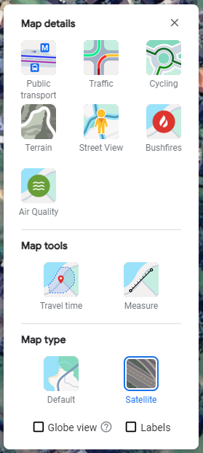

Image by © [Google 2023](https://maps.google.com).

1. Print your map. Select **File** and then **Print**, and then **Print to PDF**. This allows you to use the Adobe ‘Edit PDF’ tool to remove the scale in the map caption before printing. It is recommended to print landscape to achieve a larger map.

**Note**: the map scale provided by Google for the printed version could be inaccurate. It is recommended teachers complete the measurement activity in this learning sequence to determine a scale for the map before using it with the class.

# References

This resource contains NSW Curriculum and syllabus content. The NSW Curriculum is developed by the NSW Education Standards Authority. This content is prepared by NESA for and on behalf of the Crown in right of the State of New South Wales. The material is protected by Crown copyright.

Please refer to the NESA Copyright Disclaimer for more information <https://educationstandards.nsw.edu.au/wps/portal/nesa/mini-footer/copyright>.

NESA holds the only official and up-to-date versions of the NSW Curriculum and syllabus documents. Please visit the NSW Education Standards Authority (NESA) website <https://educationstandards.nsw.edu.au> and the NSW Curriculum website <https://curriculum.nsw.edu.au>.

[Geography 7–10 Syllabus](https://curriculum.nsw.edu.au/learning-areas/hsie/geography-7-10-2024/overview) © NSW Education Standards Authority (NESA) for and on behalf of the Crown in right of the State of New South Wales, 2024.

[National Numeracy Learning Progression](https://www.australiancurriculum.edu.au/resources/national-literacy-and-numeracy-learning-progressions/version-3-of-national-literacy-and-numeracy-learning-progressions/) © Australian Curriculum, Assessment and Reporting Authority (ACARA) 2010 to present, unless otherwise indicated. This material was downloaded from the [Australian Curriculum](http://www.australiancurriculum.edu.au/) website (National Numeracy Learning Progression) (accessed 11 December 2023) and was not modified. This material is licensed under [CC BY 4.0](https://creativecommons.org/licenses/by/4.0/).

AIATSIS (The Australian Institute of Aboriginal and Torres Strait Islander Studies) (n.d.) [*Map of Indigenous Australia*](https://aiatsis.gov.au/explore/map-indigenous-australia), AITSIS website, accessed 24 August 2023.

Australian Government Geoscience Australia (2023) [*Topographic Maps*](https://www.ga.gov.au/scientific-topics/national-location-information/topographic-maps-data/topographic-maps), Geoscience Australia website, accessed 21 August 2023.

NESA (NSW Education Standards Authority) (2022) ‘[Proficient Teacher Standard Descriptors’](https://www.nsw.gov.au/education-and-training/nesa/teacher-accreditation/proficient-teacher/standard-descriptors), *The Standards*, NESA website, accessed 20 July 2023.

NSW Aboriginal Education Consultative Group (2023) [*NSW AECG Languages App*](https://wellmob.org.au/key-resources/resources/43997/?title=NSW+AECG+languages+app&contenttypeid=1&contentid=43997_1), WellMob website, accessed 21 August 2023.

NSW Government Spatial Services (2023) [*Topographic Maps*](https://www.spatial.nsw.gov.au/products_and_services/topographic_maps), Spatial Services website, accessed 21 August 2023.

**© State of New South Wales (Department of Education), 2024**

The copyright material published in this resource is subject to the Copyright Act 1968 (Cth) and is owned by the NSW Department of Education or, where indicated, by a party other than the NSW Department of Education (third-party material).

Copyright material available in this resource and owned by the NSW Department of Education is licensed under a [Creative Commons Attribution 4.0 International (CC BY 4.0) license](https://creativecommons.org/licenses/by/4.0/).

[](https://creativecommons.org/licenses/by/4.0/)

This license allows you to share and adapt the material for any purpose, even commercially.

Attribution should be given to © State of New South Wales (Department of Education), 2024.

Material in this resource not available under a Creative Commons license:

* the NSW Department of Education logo, other logos and trademark-protected material
* material owned by a third party that has been reproduced with permission. You will need to obtain permission from the third party to reuse its material.

**Links to third-party material and websites**

Please note that the provided (reading/viewing material/list/links/texts) are a suggestion only and implies no endorsement, by the New South Wales Department of Education, of any author, publisher, or book title. School principals and teachers are best placed to assess the suitability of resources that would complement the curriculum and reflect the needs and interests of their students.

If you use the links provided in this document to access a third-party's website, you acknowledge that the terms of use, including licence terms set out on the third-party's website apply to the use which may be made of the materials on that third-party website or where permitted by the Copyright Act 1968 (Cth). The department accepts no responsibility for content on third-party websites.