Geography (Stage 4) – resource booklet

Landscapes and landforms – Geography   
7–10 Syllabus (2024)

Contents

Overview 3

Learning sequence 1 – dynamic landscapes and landforms 4

Lesson 1 – introducing landscapes and landforms 4

Lesson 2 – the world’s dynamic landscapes 9

Lesson 3 – exploring local landscapes 12

Lesson 4 – Earth’s layers, plate tectonics and continental drift 14

Lesson 5 – geomorphic processes – weathering, erosion and deposition 17

Lesson 6 – geomorphic processes responsible for dynamic mountains 20

Lesson 7 – location and features of mountain landforms 25

Learning sequence 2 – human impacts on landscapes and landforms 29

Lesson 1 – human impacts on landscapes and landforms 29

Lesson 2 – human impacts on landscapes and landforms 32

Lesson 3 – human impacts on landscapes and landforms 34

Learning sequence 3 – value and protection of landscapes and landforms 36

Lesson 1 – overview of the value of landscapes 36

Lesson 2 – landscapes we value 39

Lesson 3 – local landscapes we value 42

Lesson 4 – Australia’s valuable landscapes, Mt Kosciuszko and the Australian Alps 42

Lesson 5 – valuable landscapes around the world 47

Lesson 6 – valuable landscapes and landforms summative task 48

Learning sequence 4 – the importance of landscapes and landforms as Country 51

Lesson 1 – Dreaming stories to explain the formation and significance of landscapes and landforms 51

Lesson 2 – Aboriginal and Torres Strait Islander Peoples’ responsibility to Country 52

Lesson 3 – landscapes and landforms as part of Country 55

Lesson 4 – landscapes and landforms on Country 58

Learning sequence 5 – geomorphic hazards 62

Lesson 1 – nature of geomorphic hazards 62

Lesson 2 – volcanoes and the Ring of Fire 66

Lessons 3a to 4b – investigation of a geomorphic hazard 68

Lesson 5 – responses to and management of volcanoes 68

Appendix 1 – blank outline map of Australia 73

Appendix 2 – Think-Pair-Share template 74

Appendix 3 – photo sketch template 75

Appendix 4 – TAG template 76

Appendix 5 – 3-2-1 routine 77

Appendix 6 – blank outline map of Asia 78

Appendix 7 – field sketch template 79

Appendix 8 – KWL chart 80

Appendix 9 – Frayer diagram template 81

Appendix 10 – blank world map 82

Appendix 11 – climate graph template 83

Appendix 12 – brainstorming template 84

Appendix 13 – KWLH chart 85

Appendix 14 – group brainstorming template 86

Appendix 15 – traffic light reflection 87

Appendix 16 – PEEL paragraph template 88

Appendix 17 – Y-chart template 89

Appendix 18 – hamburger planning template 90

Appendix 19 – Snake in the grass 91

References 92

# Overview

This resource booklet is not a standalone resource. It has been designed for use by teachers in conjunction with the Geography (Stage 4) – sample program of learning – Landscapes and landforms. The material in this resource booklet is a sample and is intended to support teachers as they develop contextually appropriate teaching and learning resources that meet their students’ needs. It is not intended to be taught exactly as presented in its current format. There are instructions for both the teacher and students throughout the resource. Teachers using this resource should edit and refine these to suit their students’ needs, interests, abilities and the tasks selected.

The content in this resource booklet has been prepared by the HSIE curriculum team, unless otherwise credited. The HSIE curriculum team have created a range of support resources for Geography 7–10, including sample assessment schedules, scope and sequences, learning sequences and assessment tasks. The Geography (Stage 4) sample program of learning – Landscapes and landforms contains key information to complement this resource.

Some of the information in this resource booklet is collated from relevant NESA and department documentation. It is important that all users review and cross-reference the relevant syllabus, assessment and reporting information hyperlinked throughout. This ensures the content is an accurate reflection of the most up-to-date syllabus content. Links contained within this resource were correct as of 11 November 2024.

# Learning sequence 1 – dynamic landscapes and landforms

## Lesson 1 – introducing landscapes and landforms

### 1.1.1. – defining landscapes and landforms

1. Write a definition for landscapes.
2. Write a definition for landforms.

### 1.1.2 – identifying Australia’s major landscapes

On the blackline map of Australia shade Australia’s major landscapes. Ensure you include deserts, mountains and coastal plains (Appendix 1).

### 1.1.3 – landscape and landforms scavenger hunt

Copy and complete Table 1. Use Table 1 to collect images of examples of landforms. Remember to reference where images were found using Table 1.

Table 1 – landscape scavenger hunt

|  |  |  |
| --- | --- | --- |
| Landscape | Examples of landforms | Image source record |
| Coastline | [bay, cliff, headland] |  |
| Desert | [dunes, mesa, buttes, canyon, oasis] |  |
| Glacial | [glacier, u-shaped valley] |  |
| Mountain | [waterfall, valley] |  |
| Volcanic | [volcano, hot springs] |  |

Contribute to the class slideshow of dynamic landscapes around the world.

### 1.1.4 – multiple choice

Engage with [Geography: Landscapes and Landforms – Chapter 2: Landscape types (4:30)](https://www.abc.net.au/education/digibooks/geography-landscapes-and-landforms/102231488?vcOpensOnLoad=true&vcPageId=102641884).

Circle the correct response for each of the following multiple-choice questions:

1. What is a landscape?
2. A small stream flowing into a river
3. Visible features within an area on the surface of the earth
4. A type of rock formation
5. A process of rock formation
6. Which of the following is NOT a landform?
7. Beach
8. Cliff
9. Desert
10. Mesa
11. What natural force is responsible for creating different landforms and landscapes?
12. Tectonic plates
13. Artificial structures
14. Human activities
15. Vegetation growth
16. A mesa is best described as a:
17. hill with steep sides and a flat top
18. valley created by a river
19. bend in a river
20. type of sand dune.
21. Which landscape is characterised by features like stalactites and stalagmites?
22. Coastal
23. Mountain
24. Riverine
25. Karst

### 1.1.5 – Think-Pair-Share

Make a copy of the [Think-Pair-Share](https://app.education.nsw.gov.au/digital-learning-selector/LearningActivity/Card/645?clearCache=f2973e31-825d-2563-b547-9f8dacb36949) template (Appendix 2) and respond to the following questions:

1. Describe the main features of a coastal landscape.
2. What is the difference between a stalactite and a stalagmite?
3. How do tectonic plates contribute to the formation of landscapes and landforms?
4. Why is a riverine landscape important for human settlement?
5. Explain how erosion can change the shape of a landscape over time.

### 1.1.6 – capacity matrix

Review the capacity matrix below for geographical concepts and terms relating to the focus area ‘Landscapes and landforms’. Using different colours for the matrix criteria, shade or tick where you think you are according to the matrix categories for each geographical concept. The criteria for the matrix includes:

* Information – at this level, you have heard of the term and/or you can recall basic facts about it.
* Knowledge – at this level, you can explain and know what the term or concept means.
* Know-how – at this level, you can draw connections between this geographical term or concept and relate them to other concepts or situations.
* Wisdom – at this level, you can use the term or concept in new contexts or teach others.

You will revisit this matrix throughout the learning sequence.

Table 2 – capacity matrix glossary of terms

|  |  |  |  |  |
| --- | --- | --- | --- | --- |
| Glossary word | Information | Knowledge | Know-how | Wisdom |
| biodiversity |  |  |  |  |
| conservation |  |  |  |  |
| convergent boundary |  |  |  |  |
| cross-section |  |  |  |  |
| crust (Earth) |  |  |  |  |
| deposition |  |  |  |  |
| divergent boundary |  |  |  |  |
| erosion |  |  |  |  |
| field sketch |  |  |  |  |
| geomorphic |  |  |  |  |
| igneous |  |  |  |  |
| Indigenous Protected Area |  |  |  |  |
| landforms |  |  |  |  |
| landscapes |  |  |  |  |
| latitude |  |  |  |  |
| lava |  |  |  |  |
| longitude |  |  |  |  |
| magma |  |  |  |  |
| mantle |  |  |  |  |
| metamorphic |  |  |  |  |
| national park |  |  |  |  |
| photo sketch |  |  |  |  |
| plate tectonics |  |  |  |  |
| rock cycle |  |  |  |  |
| sedimentary |  |  |  |  |
| sustainability |  |  |  |  |
| topographic mapping |  |  |  |  |
| traditional ecological knowledge |  |  |  |  |
| transformative boundary |  |  |  |  |
| values (aesthetic, cultural, spiritual and economic) |  |  |  |  |
| volcano |  |  |  |  |
| weathering |  |  |  |  |
| worldview |  |  |  |  |

## Lesson 2 – the world’s dynamic landscapes

### 1.2.1 – short response

What is the difference between a landscape and a landform?

### 1.2.2 – photo sketch

Construct a photo sketch of a photograph of your choice from the scavenger hunt completed in the previous lesson. Need help with how to draw a photo sketch? Watch [Photo sketch (2:06).](https://education.nsw.gov.au/teaching-and-learning/curriculum/hsie/hsie-curriculum-resources-k-12/hsie-7-10-curriculum-resources/photo-sketch-video)

Use the photo sketch template (Appendix 3) and the following steps to scaffold your sketch:

1. Using the gridlines as a guide, lightly draw the outline of the land and where relevant buildings and roads are located.
2. Draw in some of the details, such as fences, other roads, clouds, vegetation.
3. Add labels and a title.

Exchange your photo sketch with a peer in the class. Provide peer feedback using Appendix 4 which is a template for TAG (Tell, Ask, Give) feedback. Ideas you might like to consider in your feedback include:

* How effective is the photo sketch in illustrating the location?
* How well presented is the photo sketch? Is it easy to read?
* How well labelled is the photo sketch?
* Is there enough relevant information provided with the photo sketch?

Before submitting your photo sketch to your teacher use your peer feedback to amend and improve your work.

### 1.2.3 – short response questions

Respond to the following about your photo sketch:

1. What type of landscape does your photo sketch illustrate?
2. Identify any landforms illustrated in your photo sketch.
3. Describe the landscape drawn in your photo sketch.
4. Describe any human aspects illustrated in your photo sketch.

Think about your local environment and answer the following questions:

1. What type of landscapes do you see in and around your home or school?
2. Are there any distinguishing features that help identify the landscape in and around your home or school?
3. Are there any unique landforms you can identify in your local area?

### 1.2.4 – mapping Australia’s landscapes

On the map of Australia (Appendix 1), create a summary of Australia’s landscapes. Choose 3 landscapes from the list provided.

Table 3 – Australian landscapes

|  |  |  |
| --- | --- | --- |
| * Grampians National Park * Blue Mountains National Park * Kosciuszko National Park * Springbrook National Park * New England National Park * Oxley Wild Rivers National Park | * Great Otway National Park * Tamborine National Park * Daintree National Park * Davies Creek National Park * Barron Gorge National Park * Rural Australia landscape | * Mount Field National Park * Dorrigo National Park * Girraween National Park * Glass House Mountains National Park * Australian outback |

### 1.2.5 – mapping Asia’s landscapes

Create a summary of Asia’s landscapes. Choose 3 of the following:

* Mount Everest and the Himalayas
* Yangtze River
* Mount Fuji
* Lake Baikal
* The Dead Sea.

Using an appropriate key, identify and locate your chosen landscapes on the map of Asia (Appendix 6).

### 1.2.6 – exit ticket

Use Appendix 5 and complete the exit ticket.

## Lesson 3 – exploring local landscapes

### 1.3.1 – Think-Pair-Share

Use Appendix 2 to Think-Pair-Share responses to the following questions:

* How has the landscape in your neighbourhood changed over time? How do you know this?
* Why are geographical questions or hypothesis considered useful when preparing for fieldwork?
* How does the inclusion of fieldwork, data and evidence strengthen your findings?
* Construct a question or hypothesis for your local neighbourhood.

### 1.3.2 – field sketch

Figure 1 provides an example of a field sketch drawn at Shelly Beach, Ballina NSW.

Figure 1 – field sketch example

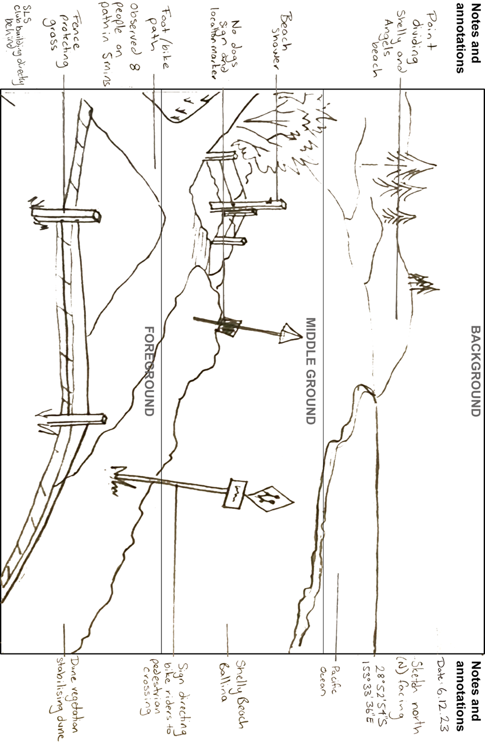

Use Appendix 7 to construct a field sketch of an area designated by your teacher. Need help with drawing a field sketch? Watch [Conducting a field sketch (4:50)](https://education.nsw.gov.au/teaching-and-learning/curriculum/hsie/hsie-curriculum-resources-k-12/hsie-7-10-curriculum-resources/conducting-a-field-sketch).

Complete the following analysis from your field sketch:

* Identify the type of landscape your field sketch illustrates.
* Describe the landscape drawn in your field sketch.
* Identify and list any landforms illustrated in your field sketch.
* Describe any human aspects illustrated in your field sketch.
* How can you inquire about the landscape drawn in your field sketch? Who would know if the landscape has any cultural or spiritual significance for local Aboriginal and Torres Strait Islander Peoples’?

## Lesson 4 – Earth’s layers, plate tectonics and continental drift

### 1.4.1 – creating written texts

Watch [Scrat causes the Continental Crack-Up Scene - ICE AGE 4 (2012) Movie Clip (4:54)](https://youtu.be/bKzQMnZRdU0?si=ZF_pd5vFav_ALrSX) and write a paragraph predicting what we will be learning about in the next section of our learning sequence.

### 1.4.2 – defining geomorphic processes

Read the definition for ‘geomorphic processes’.

**Geomorphic processes:** natural processes that transform the lithosphere to create distinctive landscapes and landforms, for example, erosion, weathering, tectonic activity.

Work with a partner to highlight and discuss your understanding of the following geographical terms used in the definition:

* [lithosphere](https://www.britannica.com/science/lithosphere)
* [erosion](https://www.britannica.com/science/erosion-geology)
* [weathering](https://www.britannica.com/science/weathering-geology)
* [plate tectonics](https://www.britannica.com/science/plate-tectonics).

### 1.4.3 – KWL

Complete a KWL chart (Appendix 8) for geomorphic processes that create landforms. Complete the first 2 categories outlining:

* what you already know about geomorphic processes (under the brain)
* what you wonder about geomorphic processes (under the question mark).

You will come back later and complete the last space, what you learnt (under the light bulb).

### 1.4.4 – short response

Watch [Landforms, Hey!: Crash Course Kids #17.1 (3:57)](https://www.youtube.com/watch?v=FN6QX43QB4g) to respond to the following:

1. Identify the geographical processes that shape and change our landforms and landscapes.
2. Outline the 4 spheres that make up our Earth’s system.
3. Identify the geomorphic processes outlined in the video.

### 1.4.5 – working in pairs

Access National Geographic’s [Plate Tectonics](https://education.nationalgeographic.org/resource/plate-tectonics/) and use this to work with a partner to construct 3 questions to share with the class. Use Table 4 to record your questions and answers.

Table 4 – class plate tectonic questions and answers

|  |  |
| --- | --- |
| Questions | Answers |
|  |  |
|  |  |
|  |  |

As a class, swap questions and answer your peer’s questions.

At the conclusion of the exercise, check answers with your peers.

### 1.4.6 – annotated diagrams

Watch [Plate Boundaries-Divergent-Convergent-Transform (2:52)](https://www.youtube.com/watch?v=3ZpDjdFzQUM) and draw sketches illustrating the convergent, divergent and transformative plate boundaries.

### 1.4.7 – multiple choice

Engage with [Geography: Landscapes and Landforms – Chapter 1: Earth is Moving (10:24)](https://www.abc.net.au/education/digibooks/geography-landscapes-and-landforms/102231488?vcOpensOnLoad=true&vcPageId=102641852) and answer the following multiple-choice questions. Circle the correct answer.

1. What are geomorphological hazards?
2. Natural disasters like floods and hurricanes
3. Natural events like earthquakes, tsunamis and volcanoes
4. Man-made disasters like pollution
5. Weather phenomena like storms
6. On what layer of the Earth do tectonic plates sit?
7. Lithosphere
8. Asthenosphere
9. Crust
10. Mantle
11. What causes earthquakes?
12. Movement of tectonic plates
13. Heavy rainfall
14. Human activities
15. Solar flares
16. What is the ‘Ring of Fire’?
17. A chain of volcanoes in Australia
18. A major area in the Pacific Ocean with many earthquakes and volcanic eruptions
19. The Earth’s equatorial line
20. A volcanic region in Africa
21. What usually causes tsunamis?
22. Heavy winds
23. Underwater earthquakes or volcanic eruptions
24. Lunar tides
25. Large oceanic animals

Use Appendix 2 to [Think-Pair-Share](https://app.education.nsw.gov.au/digital-learning-selector/LearningActivity/Card/645) responses to the following questions:

1. Describe the relationship between tectonic plates and earthquakes.
2. What is the asthenosphere and why is it important for tectonic plate movement?
3. Explain how volcanic mountains can form at tectonic plate boundaries.
4. Why are there no active volcanoes on mainland Australia?
5. How do seismometers help scientists understand earthquakes?

## Lesson 5 – geomorphic processes – weathering, erosion and deposition

### 1.5.1 – capacity matrix

* Return to your capacity matrix and highlight any new learning you have about the concepts covered in the previous lesson.
* Check in with your teacher for a list if you are unable to recall.

### 1.5.2 – the rock cycle

Watch [Gillespie Museum Short Takes – The Rock Cycle (2020) (6:09)](https://www.youtube.com/watch?v=_JzrkOk4oHI) and review the Rock Cycle diagram accessible at the end of the [Stetson University – Gillespie Museum – Educational Programs webpage](https://www.stetson.edu/other/gillespie-museum/educational-programs.php) under the heading ‘The Rock Cycle’. Use this to respond to the following:

1. Identify the 3 main forms rocks take in our environment.
2. Explain why the change in rock formation is called the rock cycle.
3. Where are you most likely to find sedimentary rocks?
4. Where are you most likely to find metamorphic rocks?
5. Where are you most likely to find igneous rocks?
6. Explain why the rock cycle is relevant to our study of geography.

### 1.5.3 – short response

Watch [Difference between Weathering and Erosion (4:44)](https://youtu.be/qGw1yB10lX0?si=YFeo1Ksvuy-JAmCo) and write a definition for weathering, erosion and deposition.

### 1.5.4 – Frayer diagram

Review Figure 2 and discuss how to complete a Frayer diagram with your peers.

Figure 2 – sample Frayer diagram

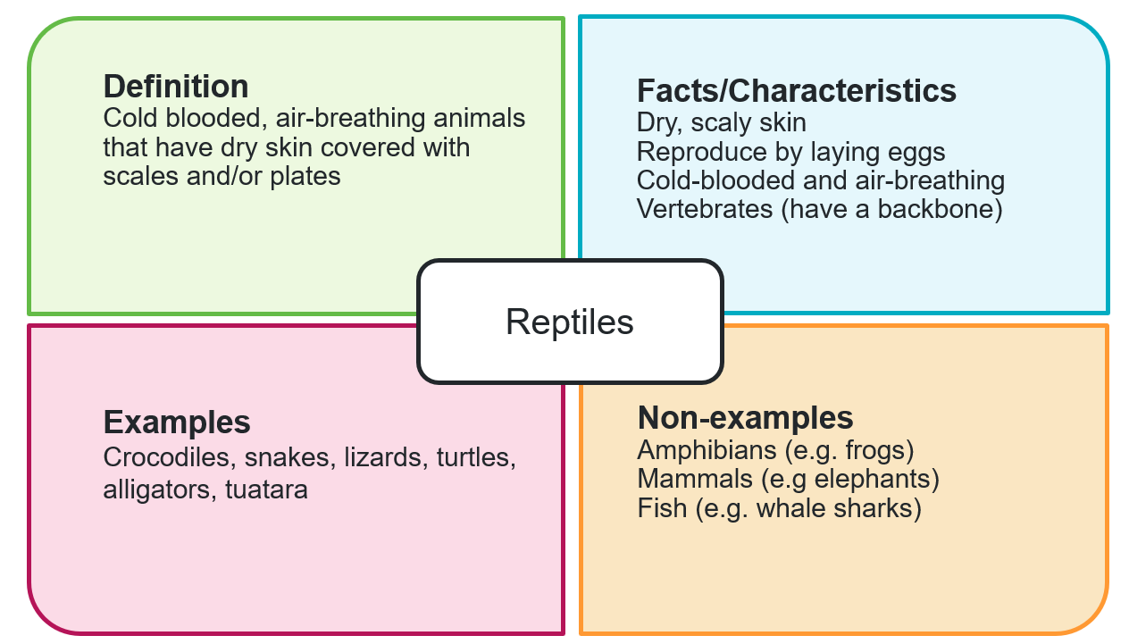

Complete a Frayer diagram (Appendix 9) to share with the class. Choose from one of the following concepts:

* erosion
* weathering
* deposition
* transportation.

Move to find a peer in your class that chose a different concept. Share your Frayer diagrams and complete a sticky note summarising what you learnt in 1 to 2 sentences. Continue this process until you have met with someone who chose each of the other 3 concepts.

Your teacher will allocate a concept to each corner of the classroom. Reflect on your understanding of the 4 concepts explored erosion, weathering, deposition and transportation. Follow the teacher instructions:

* move to the corner of the classroom with the concept you feel you understand the best
* move to the corner of the classroom with the concept you understand the least.

### 1.5.5 – fieldwork

Copy and complete Table 5 to record field observations of weathering, erosion and deposition.

Table 5 – field observation record sheet

|  |  |  |
| --- | --- | --- |
| Classification | Location description | Sketch and justification for classification |
| Weathering |  |  |
| Erosion |  |  |
| Deposition |  |  |

Reflect on your observations made in the field and answer the following question: ‘How do fieldwork activities, such as field sketches, observation, photos and surveys, help us understand a landscape?’

## Lesson 6 – geomorphic processes responsible for dynamic mountains

### 1.6.1 – capacity matrix

Return to your capacity matrix and highlight any new learning you have about the concepts covered in the previous lesson. Check in with your teacher for a list if you are unable to recall.

### 1.6.2 – multiple choice

Watch [Geography: Landscapes and Landforms – Chapter 7: Mountain landscapes (8:25)](https://www.abc.net.au/education/digibooks/geography-landscapes-and-landforms/102231488?vcOpensOnLoad=true&vcPageId=102641922).

Circle the correct response for each of the following multiple-choice questions:

1. What defines a mountain according to geologists?
2. A landform that rises at least 300 metres above the surrounding area
3. A landform that rises at least 100 metres above the surrounding area
4. A landform that rises at least 500 metres above the surrounding area
5. A landform that rises at least 200 metres above the surrounding area
6. Which mountain range is Mount Everest a part of?
7. The Andes
8. The Sierra Nevada
9. The Himalayas
10. The Great Dividing Range
11. What type of mountains are the Himalayas?
12. Block Mountains
13. Volcanic Mountains
14. Fold Mountains
15. Dome Mountains
16. Which of the following is NOT a process that forms mountains?
17. Tectonic Plate Movement
18. Erosion
19. Volcanic Activity
20. Photosynthesis
21. What is the Great Dividing Range known for?
22. Being the tallest mountain range in the world
23. Stretching for around 3,500 kilometres along the east side of Australia
24. Being composed entirely of volcanic mountains
25. Being the youngest mountain range in the world

Use Appendix 2 to [Think-Pair-Share](https://app.education.nsw.gov.au/digital-learning-selector/LearningActivity/Card/645) responses to the following questions:

1. Describe the key characteristics that differentiate mountains from hills.
2. Explain how fold mountains are formed.
3. How do tectonic plate movements contribute to the formation of volcanic mountains?
4. Compare and contrast the formation processes of block mountains and fold mountains.
5. Discuss the impact of weathering and erosion on the Great Dividing Range.

### 1.6.3 – types of mountains and their formation

Copy and complete Table 6 illustrating how mountains are formed, appear and exist around the world.

Table 6 – types of mountains and their formation

|  |  |  |  |
| --- | --- | --- | --- |
| Type | Formation (description) | Formation [(sketch and scribble)](https://app.education.nsw.gov.au/digital-learning-selector/LearningActivity/Card/657?clearCache=3bfeca1e-f93f-901-29fa-862b5270e718) | Examples from around the world |
| Fold |  |  |  |
| Block or Fault |  |  |  |
| Volcanic |  |  |  |
| Dome |  |  |  |

Resources that will assist you in completing Table 6.

Fold mountains:

* [World Atlas – Formation of Fold Mountains](https://www.worldatlas.com/articles/how-are-mountains-formed.html#:~:text=martin%20in%20Mexico.-,Formation%20Of%20Fold%20Mountains,-Like%20all%20mountains)
* [National Geographic – Fold Mountain](https://education.nationalgeographic.org/resource/fold-mountain/)
* [NASA Earth Observatory – Folding a Mountain (Flinders Ranges)](https://earthobservatory.nasa.gov/images/145002/folding-a-mountain)
* [TectonicsObservatory – Mountain Building Animation (0:16)](https://www.youtube.com/watch?v=loFxYSHxTf0)

Block and fault mountains:

* [World Atlas – Block Mountains](https://www.worldatlas.com/articles/how-are-mountains-formed.html#:~:text=types%20are%20present.-,Formation%20Of%20Block%20Mountains,-Illustration%20showing%20block)
* [Universe Today – Fault-Block Mountains](https://www.universetoday.com/29823/fault-block-mountains/#google_vignette:~:text=BY%20FRASER%20CAIN-,Fault%2DBlock%20Mountains,-%5B/caption%5D%0AFault)
* [Yosemite National Park – Geology](https://www.nps.gov/yose/learn/nature/geology.htm)

Volcanic mountains:

* [World Atlas – Formation of Volcanic Mountains](https://www.worldatlas.com/articles/how-are-mountains-formed.html#:~:text=Of%20Block%20Mountains-,Formation%20Of%20Volcanic%20Mountains,-Volcanic%20mountains%20are)
* [National Geographic – Plate Tectonics and Volcanic Activity](https://education.nationalgeographic.org/resource/plate-tectonics-volcanic-activity/)
* [SciShow Kids – All About Volcanoes](https://www.youtube.com/watch?v=K7Oq9_DU1Mc): How They Form, Eruptions & More! (3:04) (0:40–1:40)

Dome mountains:

* [Universe Today – Dome Mountains](https://www.universetoday.com/29827/dome-mountains/#:~:text=BY%20FRASER%20CAIN-,Dome%20Mountains,-%5B/caption%5D%0AThe)
* [Nature Kingdoms – Dome Mountains](https://naturekingdoms.com/dome-mountains)

Using the information gathered from the ‘examples’ column in Table 6, develop an annotated collage. Ensure that a variety of both mountain and photograph types are included in the collage.

### 1.6.4 – Piz Cengalo

Using [Google Earth: Piz Cengalo,](https://earth.google.com/web/search/piz+cengalo/@46.29489485,9.6019999,3348.91128384a,2830.00517676d,35y,0h,0t,0r/data=CnUaSxJFCiQweDQ3ODQ3YTU4MTViODhmZTk6MHhkMWUzZjIxZTFkYjQwYmEZ017pIb8lR0Ah-mO1VDk0I0AqC3BpeiBjZW5nYWxvGAIgASImCiQJd6uh7xKYOkARd6uh7xKYOsAZ_cYYIR8QS0Ahui8D8mOoS8A6AwoBMA) explore the map and identify 5 key facts about Piz Cengalo.

On which continent is Piz Cengalo located?

Watch [Latitude and longitude (4:24)](https://education.nsw.gov.au/teaching-and-learning/curriculum/hsie/hsie-curriculum-resources-k-12/hsie-7-10-curriculum-resources/latitude-and-longitude), then as a class, review and discuss Figure 3 and Figure 4.

Using [Google Earth: Piz Cengalo,](https://earth.google.com/web/search/piz+cengalo/@46.29489485,9.6019999,3348.91128384a,2830.00517676d,35y,0h,0t,0r/data=CnUaSxJFCiQweDQ3ODQ3YTU4MTViODhmZTk6MHhkMWUzZjIxZTFkYjQwYmEZ017pIb8lR0Ah-mO1VDk0I0AqC3BpeiBjZW5nYWxvGAIgASImCiQJd6uh7xKYOkARd6uh7xKYOsAZ_cYYIR8QS0Ahui8D8mOoS8A6AwoBMA) navigate to the 2D map and identify the latitude and longitude for Piz Cengalo.

Watch the images of the debris flow from [Piz Cengalo to the village of Bondo (2:11)](https://youtu.be/Fjfn4bWKABA?si=ubIybM7H45655sNw).

Figure 3 – lines of latitude

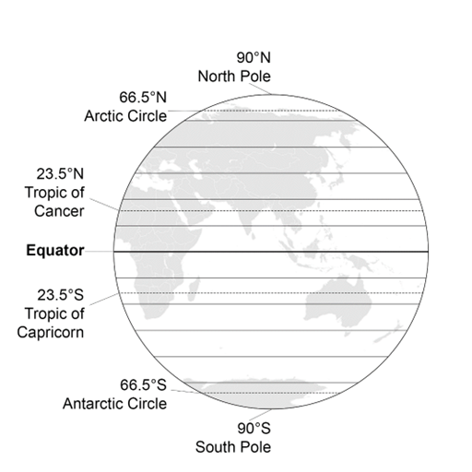

Figure 4 – lines of longitude

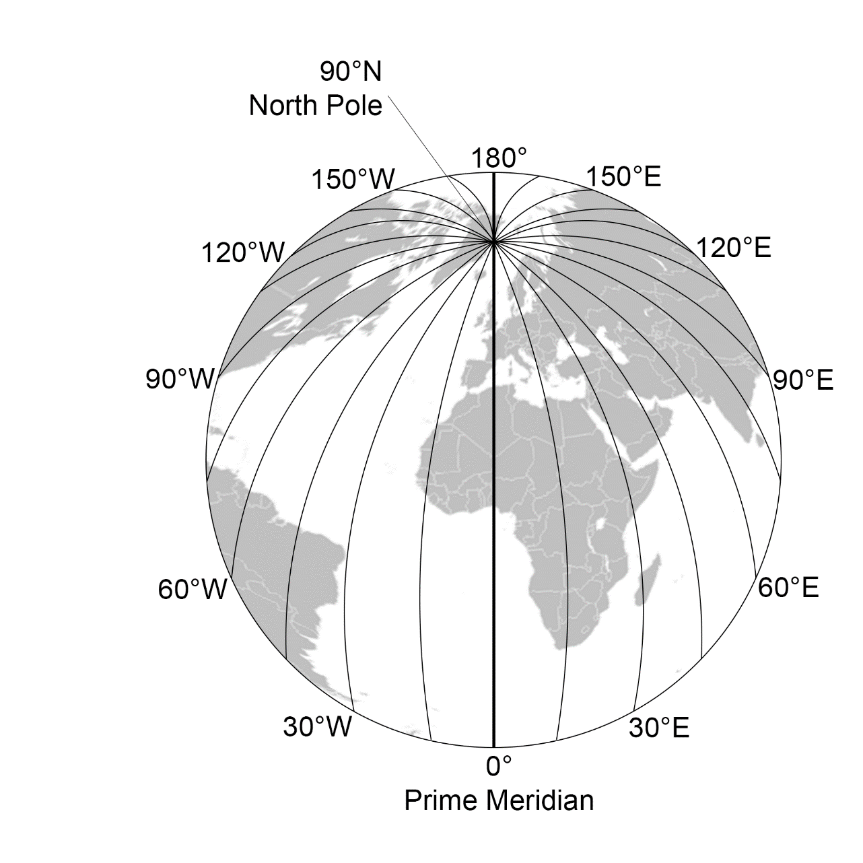

### 1.6.5 –Think-Pair-Share

Review the articles [Eight missing after landslide in Swiss Alps](https://www.theguardian.com/world/2017/aug/24/switzerland-landslide-in-swiss-alps-bondo), say police (The Guardian) and [Swiss Mountain moved 10cm a year before crashing down](https://www.swissinfo.ch/eng/life-aging/bondo-disaster_swiss-mountain-moved-10cms-a-year-before-crashing-down/43469572) (Swissinfo.ch). Use the information from the articles to conduct a [Think-Pair-Share](https://app.education.nsw.gov.au/digital-learning-selector/LearningActivity/Card/645) routine (Appendix 2) for the following questions:

1. What was the estimated volume of mud, rocks and dirt that flooded into the village of Bondo?
2. How did the automated warning system contribute to preventing further loss of life during the landslide?
3. What were the main factors that contributed to the instability of Piz Cengalo?

## Lesson 7 – location and features of mountain landforms

### 1.7.1 – mapping

Watch [BOLTSS and scale (4:06)](https://education.nsw.gov.au/teaching-and-learning/curriculum/hsie/hsie-curriculum-resources-k-12/hsie-7-10-curriculum-resources/boltss-and-scale).

Your teacher might provide you with an A3 map of the world or use Appendix 10 to locate and label each continent.

Use an atlas or [Google Earth](https://www.google.com.au/earth/) to locate and label on the map at least one mountain range per continent from the list below.

Identify in which hemisphere the mountain range is located.

Ensure your map includes a border, orientation, title, scale and source.

Mountain ranges around the world:

* Drakensberg Mountains (Africa) – Thabana Ntlenyana (3,482 m)
* Atlas Mountains (Africa) – Mt Toubkal (4,165 m)
* Ethiopian Highlands (Africa) – Ras Dashen (4,550 m)
* Ahaggar Mountains (Africa) – Mt Tahat (2,908 m)
* Fuji Volcanic Zone (Asia) – Mt Fuji (3,776 m)
* Himalayas (Asia) – Mt Everest (8,848 m)
* Zagros Mountains (Asia) – Mt Dena (4,409 m)
* Verkhoyansk Range (Asia) – Gora Mus-Khaya (2,409 m)
* The Urals (Europe and Asia border) – Mt Narodnaya (1,894 m)
* Tauras Mountains (Europe and Asia border) – Demirkazik (3,756 m)
* The Alps (Europe) – Mont Blanc (4,804 m)
* Rocky Mountains (North America) – Mt Elbert (4,401 m)
* Appalachian Mountains (North America) – Mt Mitchell (2,037 m)
* The Andes (South America) – Aconcagua (6,962 m)
* Brazilian Highlands (South America) – Pico da Neblina (2,994 m)
* Great Dividing Range (Oceania) – Mt Kosciusko (2,228 m)
* Flinders Ranges (Oceania) – St Mary Peak (1,171 m)
* Southern Ranges (Oceania) – Aoraki (3,724 m).

Identify the highest mountain (peak) for each mountain range marked on your map. Use appropriate mapping conventions for the height (black triangle, name of mountain, height in metres).

Watch [Latitude and longitude (4:24)](https://education.nsw.gov.au/teaching-and-learning/curriculum/hsie/hsie-curriculum-resources-k-12/hsie-7-10-curriculum-resources/latitude-and-longitude).

Use an atlas or [Google Earth](https://www.google.com.au/earth/) to locate and label the latitude and longitude for each mountain peak. If you are using Google Earth, switch to the 2D alternate map to locate latitude and longitude.

### 1.7.2 – climatic graphs

Watch [Climatic graphs (2:14)](https://education.nsw.gov.au/teaching-and-learning/curriculum/hsie/hsie-curriculum-resources-k-12/hsie-7-10-curriculum-resources/climatic-graphs-video) and review Figure 5. As a class, discuss the features of a climatic graph.

Figure 5 – annotated climatic graph

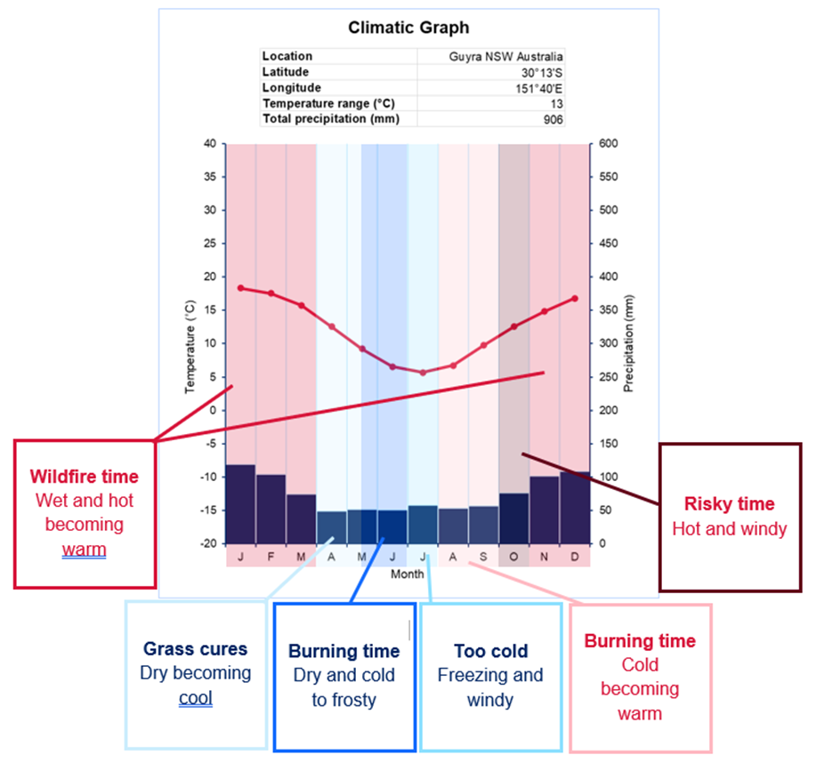

Use the climatic data provided by your teacher and Appendix 11 to construct a climatic graph.

Display your climatic graph in the classroom.

Review the climatic graphs displayed around the classroom.

Your teacher will allocate a climatic graph for you to assess. Use the marking criteria in Table 7 to provide peer feedback.

Table 7 – marking criteria

|  |  |  |  |
| --- | --- | --- | --- |
| Criteria | Yes | No | Comments |
| Title clear and concise |  |  |  |
| Axis labelled correctly |  |  |  |
| Climate graph presented |  |  |  |
| Scale of measurement on axis appropriate |  |  |  |
| Correct spelling |  |  |  |
| Climate graph neatly presented |  |  |  |

Compare the climatic graphs and/or data of your mountains to respond to the following discussion questions:

1. How does the altitude of a mountain range affect its climate?
2. What relationship can be observed between latitude and climate in mountain ranges?
3. Why is it important to consider both latitude and altitude when studying the climate of mountain ranges?

# Learning sequence 2 – human impacts on landscapes and landforms

## Lesson 1 – human impacts on landscapes and landforms

### 2.1.1 – brainstorm

Your teacher will allocate you to a small group. Use Appendix 12 to brainstorm responses to the following prompts:

* examples of ways people use and change landscapes
* the impact of human activities on the landscape.

### 2.1.2 – construct a pie chart

Using the data already provided in Table 8, convert percentages to degrees by multiplying the percentage by 3.6. We convert the percentages to degrees because we need to illustrate data as degrees of a circle. There are a total of 360 degrees in a circle. Whenever you have percentages, always check they add up to 100, then multiply by 3.6 to find the degrees to draw your pie chart.

Worked example:

45 x 3.6 = 162 then measure 162° in a circle to represent grazing native vegetation in a pie chart. You might like to watch [Drawing Pie Charts (6:48)](https://www.youtube.com/watch?v=p_nPxTRuLxo) and [Common graphs (2:58)](https://education.nsw.gov.au/teaching-and-learning/curriculum/hsie/hsie-curriculum-resources-k-12/hsie-7-10-curriculum-resources/common-graphs) for more information on pie charts.

Table 8 – land use in Australia

|  |  |  |
| --- | --- | --- |
| Land use | Percentage | Degrees |
| Grazing native vegetation | 45% | **162°** |
| Conservation | 23% |  |
| Cropland and horticulture | 4% |  |
| Forestry | 2% |  |
| Urban | 0.2% |  |
| Grazing modified pasture | 9% |  |
| Other | 18.8% |  |
| Total | 100% |  |

Using the degrees column in the previous table, construct a pie graph.

Title: __________________________

Conduct a peer assessment by swapping and checking your peers’ pie graphs against the marking criteria in Table 9. Where relevant, make suggestions for improvement.

Table 9 – peer assessment pie chart

|  |  |  |  |
| --- | --- | --- | --- |
| Criteria | Yes | No | Comments |
| Title clear and concise |  |  |  |
| Degrees calculated accurately |  |  |  |
| Pie graph presented |  |  |  |
| Degrees measured accurately for all land use categories |  |  |  |
| Correct spelling |  |  |  |
| Graph illustrated neatly |  |  |  |

Answer the following questions based on the pie graph you completed:

1. Identify the most prominent land use in Australia.
2. What percentage of land use is dedicated to conservation in Australia?
3. Why is it important to know the percentages associated with land use?
4. Explain how knowing the different percentages of land use in Australia inform our understanding of causes of land degradation.

## Lesson 2 – human impacts on landscapes and landforms

### 2.2.1 – human impacts to landscapes

You have 2 options for this activity:

* Option 1 – infographic illustrating human impacts on the landscape
* Option 2 – investigative study ‘Gully erosion in Northern Queensland’.

You will be required to complete a first draft for your chosen option. Submit to your teacher for feedback. Consider feedback and make recommended changes prior to final display to your peers.

**Option 1**

Create an [infographic](https://infogram.com/page/infographic) outlining the type of degradation, spatial distribution (where it is found), causes, impact, what is being done to mitigate (reduce) the land degradation and environmental impact. Refer to specific examples in your response. For example, wind erosion in the Willandra Lakes region. Choose from the following list of common land degradation issues present in Australia:

* wind erosion
* water erosion
* soil fertility decline
* soil acidity
* soil salinity.

You may like to use Figure 6 and access [Create Engaging Interactive Infographics](https://infogram.com/create/infographic) for advice on how to develop a good infographic.

Figure 6 – WAGOLL infographic

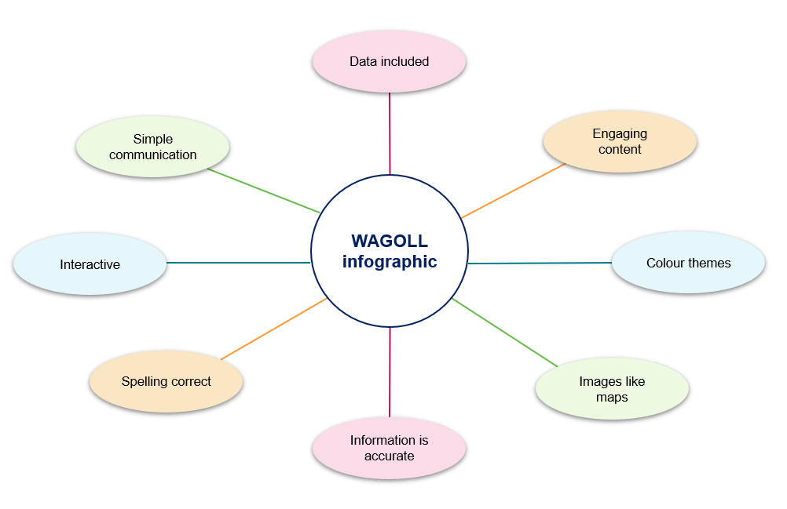

**Option 2**

Conduct an investigative case study of gully erosion in Northern Queensland.

**Note:** a case study aims to address the following questions:

* What happened?
* When did it happen?
* Where did it happen?
* Why did it happen?
* Who was affected by it happening?
* What actions are being taken?

Provide as much detail as possible in your response.

Use the following questions as headings and Greening Australia’s [Reef Aid](https://www.greeningaustralia.org.au/programs/reef-aid/) to complete a case study on land degradation in the Great Barrier Reef catchment areas. Your case study must address the following questions:

1. What happened?
2. When did it happen?
3. Where did it happen?
4. Why did it happen?
5. Who was affected by it happening?
6. What is being done to mitigate the land degradation and environmental impact?
7. How important is mitigating this land degradation issue to sustainability of the catchment?

### 2.2.2 – landscape degradation

Use the infographics and case studies displayed in your class gallery walk to complete the following learning activities:

1. Identify ways Australia’s landscape has been degraded and impacted by humans.
2. Identify ways people have managed land degradation in Australia.
3. Construct a well-reasoned paragraph on the cause and effect of land degradation common in Australia.

## Lesson 3 – human impacts on landscapes and landforms

### 2.3.1 – KWLH chart

Use Appendix 13 to complete a KWLH chart for landslides. Only complete the first 2 outlining what you already know about landslides (under the brain) and what you wonder about landslides (under the question mark). You will come back later and complete the last space, what you learned (under the light bulb) and how can I learn more (under the magnifying glass).

### 2.3.2 – backchannel discussion

Participate in a class backchannel discussion. Your teacher will give instructions on how to participate.

Backchannel discussion questions:

* What do you find most surprising about landslides?
* Identify some human activities that can trigger landslides? How do these activities contribute to the problem?
* Which prevention strategy do you think is most effective and why? Can you think of any other ways to prevent landslides that we have not discussed?
* You will be assigned a recent landslide event. Share your recent landslide event and describe one prevention measure used or proposed.
* What is one new thing you learned today about landslides or their prevention? Can we predict landslides to save lives?

### 2.3.3 – capacity matrix

Return to your capacity matrix and highlight any new learning you have about the concepts covered in the previous lessons. Check in with your teacher for a list if you are unable to recall.

### 2.3.4 – KWLH chart revisited

Return to your KWLH chart (Activity 2.3.1) and add notes on what you learnt in the lesson about landslides.

# Learning sequence 3 – value and protection of landscapes and landforms

## Lesson 1 – overview of the value of landscapes

### 3.1.1 – group work

Your teacher will allocate you to a group. Each group will be assigned one of the following categories:

* environmental
* economic
* recreational
* cultural.

In your group use the image of a landscape your teacher shared with the class to brainstorm ways that landscape is valued based on the category your group was allocated.

* Use Appendix 14 to record your group brainstorm.
* Add your brainstorm to the class concept map provided to you by your teacher.
* If your brainstorming session slows down and you need assistance or prompting, ask your teacher for one of the category prompting question envelopes to stimulate more discussion and ideas.

### 3.1.2 – short response questions

1. Identify a local landscape or landform.
2. Think about the ways we value landscapes and landforms that were discussed in the previous learning activity. What values can be applied to this landscape or landform?

### 3.1.3 – creating written texts

Use Figure 7 to write 1 to 2 paragraphs describing the key features of a topographic map.

Figure 7 – annotated topographic map

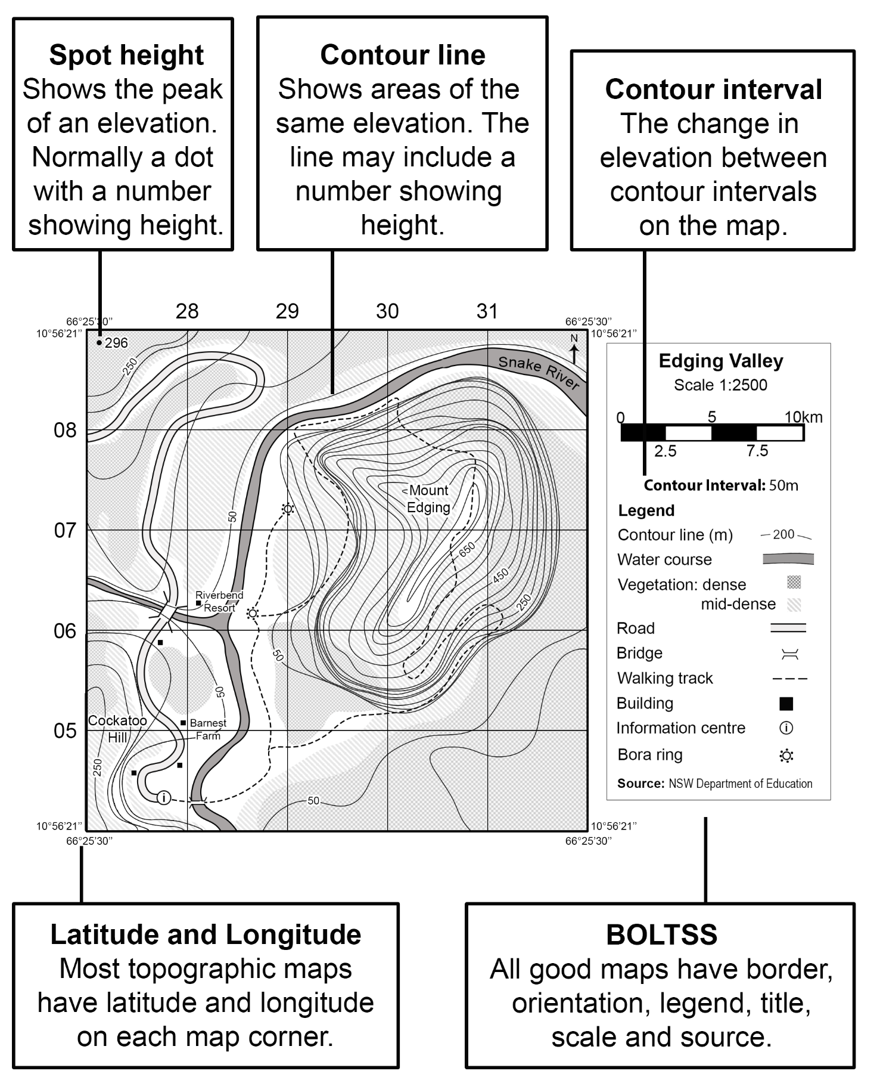

### 3.1.4 – determining contour intervals

Use Figure 8 to answer the following questions:

* Determine the contour interval of Diagrams A to D.
* Justify your answers to a partner.

Figure 8 – illustration of contour lines used on topographic maps

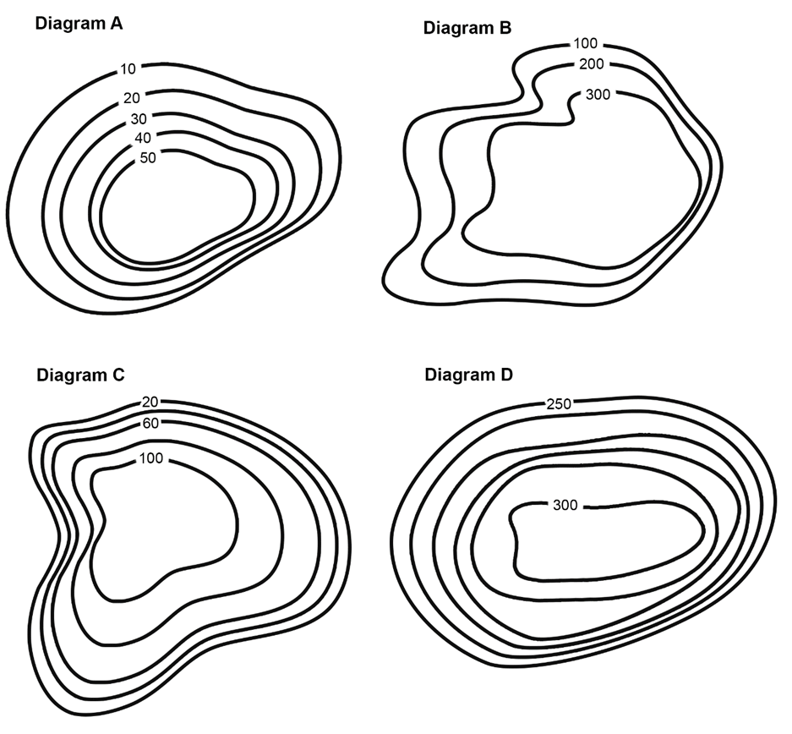

### 3.1.5 – exit ticket

Answer the following questions and share your responses with your teacher:

1. What are 4 key ways we value landscapes?
2. What are some key features on a topographic map?
3. What does a contour line on a topographic map show you?

## Lesson 2 – landscapes we value

### 3.2.1 – valuing landscapes and landforms

With a partner complete Table 10. Your teacher will provide you with suggested resources to support your response.

Table 10 – geographical value of Uluru

|  |  |  |
| --- | --- | --- |
| Geographical value | Definition | Explanation for how Uluru is valued |
| Environmental value |  |  |
| Economic value |  |  |
| Recreational value |  |  |
| Cultural value |  |  |

### 3.2.2 – capacity matrix revisited

Revisit your capacity matrix and identify your current understanding of environmental, economic, recreational and cultural value.

### 3.2.3 – topographic cross-sections

Topographic cross-sections are diagrams of a vertical slice of the landscape made using contour lines on a topographic map. They are used in geography to show the landscape profile. Figure 9 shows an annotated cross-section.

Discuss with a peer the key characteristics of a topographic cross-section.

Figure 9 – annotated cross-section

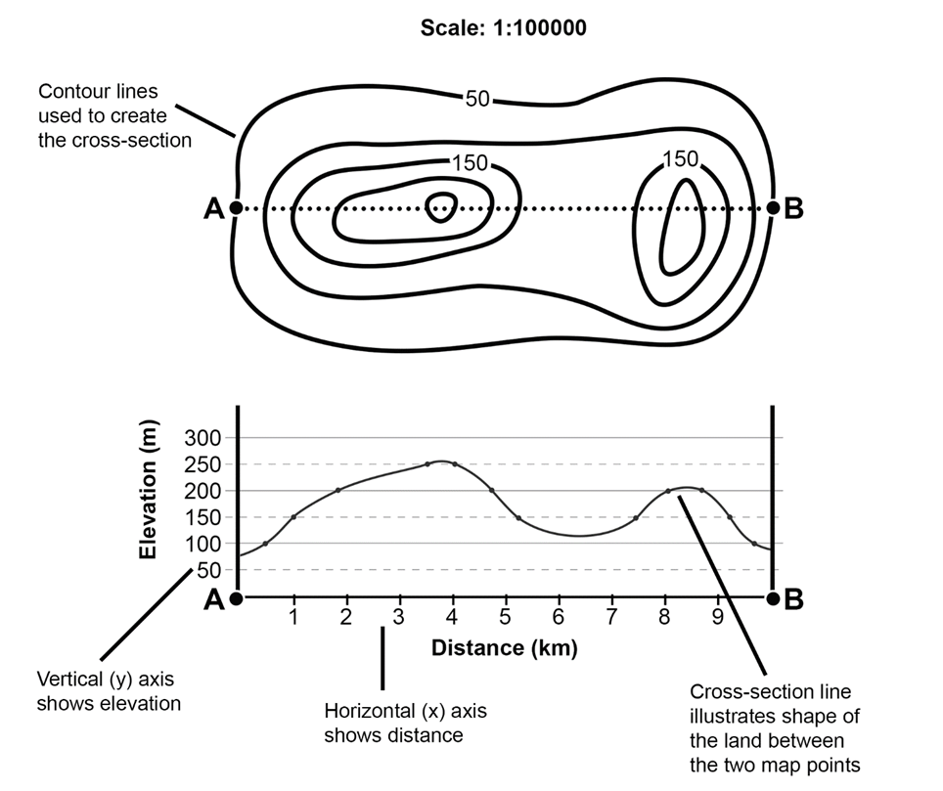

### 3.2.4 – construct a cross-section

Follow the steps below to construct cross-sections:

1. Locate points A and B on the map.
2. Place an edge of a sheet of paper along the transect between A and B. Write the heights of points A and B on the paper.
3. Work carefully from left to right; mark where each contour line meets the edge of the paper.
4. Record the height of each contour under the mark.
5. Use the contour heights to plot each point on the graph.
6. Starting from the left vertical axis, join the points with a smooth line.
7. Give the cross-section a title and label each axis.

Use Figure 10 to complete a topographic cross-section of Uluru.

Figure 10 – Uluru cross-section template

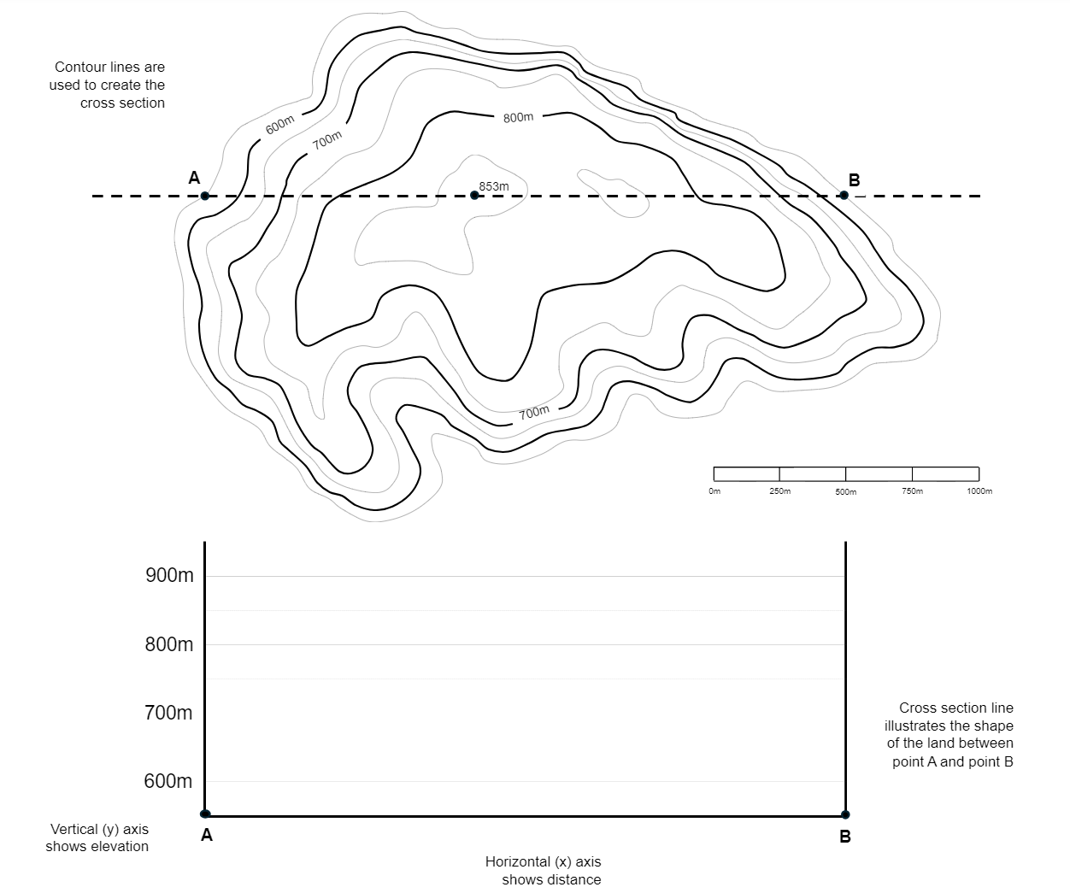

### 3.2.5 – traffic lights

Use the quick response traffic lights (Appendix 15) to reflect on your understanding of this lesson. The following questions can be used to prompt your responses.

* How confident are you in explaining how different landscapes and landforms are valued?
* How confident are you in explaining to a peer the value of Uluru?
* How confident are you in finding contour lines on topographic maps?
* How confident are you in drawing a cross-section?

## Lesson 3 – local landscapes we value

**Note:** teachers may consider a range of options for addressing local landscapes of value. Teachers will need to refer to the Landscapes and landforms program: Learning sequence 3 for instructions for this lesson. Teachers will need to amend this resource booklet to accommodate the individual school choice of learning activities.

When considering the local landscape to study it may be useful to identify and connect with the schools local AECG. The activities listed in Landscapes and landforms sample program – Learning sequence 3, Lesson 3 are a series of local landscape inquiry options.

Teachers may like to access [Geography 7–10 – thinking and working geographically – fieldwork](https://education.nsw.gov.au/teaching-and-learning/curriculum/hsie/planning-programming-and-assessing-hsie-7-10/planning-programming-assessing-geography-7-10), for more advice on conducting excursions and fieldwork. Teachers may like to connect with their local EEC to plan for and deliver a local fieldwork experience. The Landscapes and landforms teaching program and learning sequence provides options for delivering Lesson 3 – local landscapes we value. Teachers will need to adjust this section of the student resource booklet to accommodate chosen learning activities.

## Lesson 4 – Australia’s valuable landscapes, Mt Kosciuszko and the Australian Alps

### 3.4.1 – Mt Kosciuszko

Engage with [Geography: Landscapes and Landforms – Chapter 8: Mount Kosciuszko (6:12)](https://www.abc.net.au/education/digibooks/geography-landscapes-and-landforms/102231488?vcOpensOnLoad=true&vcPageId=102641926). Circle the correct response for each of the following multiple-choice questions:

1. What is the highest peak on mainland Australia?
2. Mount McClintock
3. Mt Kosciuszko
4. Mawson’s Peak
5. Blue Lake
6. Which of the following processes did NOT contribute to shaping the Great Dividing Range?
7. Uplift
8. Folding
9. Faulting
10. Volcanic eruptions
11. What is a cirque lake?
12. A lake formed by volcanic activity
13. A bowl-shaped lake formed by glacial erosion
14. A lake created by tectonic uplift
15. A man-made lake
16. Which convention listed the wetlands around Blue Lake as internationally important?
17. UNESCO World Heritage
18. Ramsar Convention
19. Australian National Heritage
20. International Wetland Society
21. What happens to water when it freezes, according to the weathering experiment?
22. It contracts and takes up less space
23. It expands and takes up more space
24. It remains the same volume
25. It turns into gas

Use Appendix 2 to Think-Pair-Share responses to the following questions:

1. Describe the processes that have shaped the landscapes around Mt Kosciuszko.
2. What Cultural significance does the area around Mt Kosciuszko hold for the Ngarigo people?
3. How do freezing and thawing contribute to the weathering of rocks?
4. Why are the Australian Alps considered a significant tourist destination?
5. Explain the significance of the Ramsar Convention in relation to the wetlands around Blue Lake.

### 3.4.2 – Mt Kosciuszko latitude and longitude

Using [Google Earth](https://earth.google.com/web/search/Mount+Kosciusko/@-36.45740275,148.26561634,2178.66787255a,3480.68578571d,35y,203.48406078h,0t,0r/data=CiwiJgokCXquFZMTYkdAEcLYY-ZH6UZAGVItmJizuyRAIbj6JX9lrSFAQgIIAToDCgEwQgIIAEoNCP___________wEQAA) Mt Kosciuszko, navigate to the 2D Map and identify the latitude and longitude for Mt Kosciuszko.

Use the PEEL template (Appendix 16) to write a paragraph that describes the location of Mt Kosciuszko using latitude and longitude.

### 3.4.3 – Mt Kosciuszko observation

Visit [360 Mount Kosciuszko Summit](https://www.360cities.net/image/summit-mount-kosciuszko-new-south-wales-australia) and discuss what you observed with a partner. Use Figure 11 to record your observations and assist in your contribution to the discussion.

Figure 11 – my observation template

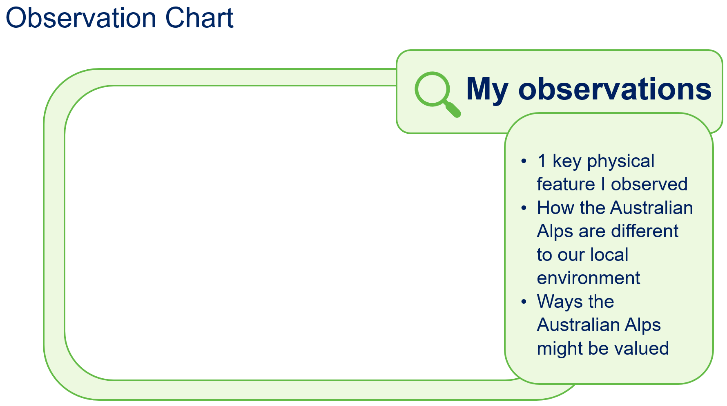

### 3.4.4 – how Mt Kosciuszko is valued

With a partner use the resources provided by your teacher to copy and complete Table 11.

Table 11 – how Mt Kosciuszko is valued

|  |  |
| --- | --- |
| Geographical value | Explanation for how Mt Kosciuszko is valued |
| Environmental value |  |
| Economic value |  |
| Recreational value |  |
| Cultural value |  |

### 3.4.5 – cross-section Mt Kosciuszko

Use Figure 12 to complete a topographic cross-section of Mt Kosciuszko.

Then, use Table 12 to assess a peer’s Mt Kosciuszko cross-section and provide feedback.

Table 12 – Mt Kosciusko cross-section marking criteria

|  |  |  |  |
| --- | --- | --- | --- |
| Criteria | Yes | No | Comments |
| Title clear and concise | ☐ | ☐ |  |
| A to B accurately measured and illustrated | ☐ | ☐ |  |
| X and Y axis appropriately labelled | ☐ | ☐ |  |
| Line graph used to represent a cross-section | ☐ | ☐ |  |
| Correct spelling | ☐ | ☐ |  |
| Cross-section illustrated neatly | ☐ | ☐ |  |

Figure 12 – Google Maps Mt Kosciuszko

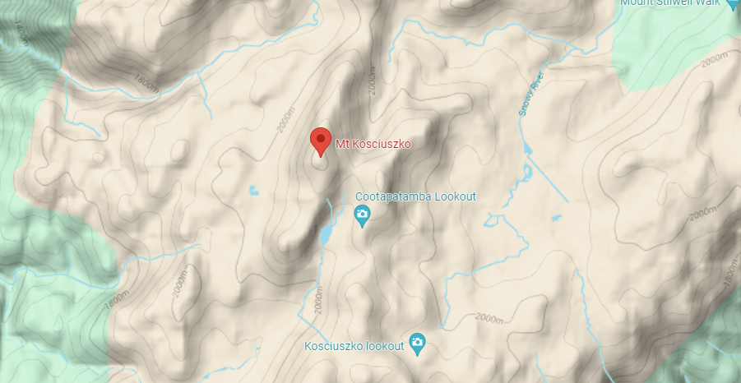

Map data © 2024 Google.

## Lesson 5 – valuable landscapes around the world

**Note:** teachers may consider a range of options for addressing valuable landscapes around the world. The following activities provide a variety of options. Teachers do not need to complete every option provided. A variety of options have been suggested to accommodate different school contexts. A full description and associated links and resources for the following lessons are provided in the [Geography (Stage 4) – sample program of learning – Landscapes and landforms](https://education.nsw.gov.au/teaching-and-learning/curriculum/hsie/planning-programming-and-assessing-hsie-7-10/planning-programming-assessing-geography-7-10).

The following lessons (5a to 5d) can be used by the teacher in a variety of ways:

Lesson 5a – valuable landscapes in Asia, Mt Fuji

Lesson 5b – valuable landscapes in Asia, Mt Everest

Lesson 5c – valuable landscapes in South America, Machu Picchu

Lesson 5d – valuable landscapes in Africa, Mt Kilimanjaro

There are 3 options detailed below.

**Option 1**

Select one lesson sequence from 5a to 5d to complete as a class.

Revisit the map developed in Learning Sequence 1 – Lesson 7 – location and features of mountain landforms and identify each of the mountains and ranges in lessons 5a to 5d.

**Option 2**

Complete lessons 5a to 5d as a [jigsaw](https://app.education.nsw.gov.au/digital-learning-selector/LearningActivity/Card/546), present your ideas and results to the class.

**Option 3**

Use the template from lessons 5a to 5d and apply this to a different mountain of interest. For example:

* Aoraki, Mt Ruapehu, Taranaki or Te Mata Peak (New Zealand)
* Mount Blanc, Mount Elbrus, Dykh-Tau, Ben Nevis, Piz Cengalo (Europe/Eurasia).

## Lesson 6 – valuable landscapes and landforms summative task

### 3.6.1 – cross-section local landform

If required, revisit [Cross-sections and transects video (2:53).](https://education.nsw.gov.au/teaching-and-learning/curriculum/hsie/hsie-curriculum-resources-k-12/hsie-7-10-curriculum-resources/cross-sections-and-transects) Use a local topographic map provided by your teacher to draw a cross-section of a local landscape or landform.

Use your cross-section to develop a transect that illustrates landscape and landform use and value. Ensure you include:

* environmental
* economic
* recreational
* cultural.

### 3.6.2 – valuing local landscapes

**Option 1**

Think about different places around the world. They can help us in many ways:

* making money (such as farming or tourism)
* taking care of nature (such as parks protecting animals)
* having fun (such as going on hikes or swimming)
* special to people (such as places with important traditions or history).

1. Can you name one place in your local area that does one of these things?
2. Can you name one place around the world that does one of these things?
3. Can some places do more than one of these things? Give an example from your local area and one from around the world.
4. Can you think of a time when using a place for more than one thing caused a problem? Explain what happened.

**Option 2**

Think about different places around the world. These places can do different things like:

* make money – economic benefits (such as farms or places where people go on vacation)
* take care of nature – environmental sustainability (such as parks that protect animals)
* have fun – recreational opportunities (such as hiking trails or swimming spots)
* special to people – Cultural significance (such as places with important traditions or history).

Think about HOW these places can do different things. For example:

* How do they help people make money? (farming or tourism)
* How do they help take care of nature? (like parks protecting animals)
* How can they provide fun activities? (like hiking or swimming)
* Why are they special to people? (like places with important traditions or history)

Write a response to this question: ‘How do landscapes around the world do many things at once?’

Use specific examples to explain how these values of making money, taking care of nature, having fun and being special to people) can:

* work well together in some places
* sometimes cause problems in other places.

**Option 3**

Write a long response to the question: ‘Discuss how landscapes around the world serve multiple roles by providing economic benefits, contributing to environmental sustainability, offering recreational opportunities and holding Cultural significance.’

Your response should:

* use a range of examples from specific landscapes around the world
* discuss the multiple roles across these landscapes, linking them to specific values
* consider how the interaction of multiple roles may create cohesion or conflict.

Use Table 13 to guide your final submission to your teacher.

Table 13 – marking rubric – Just an A

|  |  |
| --- | --- |
| Grade | Criteria |
| **A** | * Demonstrates extensive knowledge of economic, environmental, recreational and cultural value of landscapes and landforms * Displays sophisticated skills in assessing alignment and conflict in values in different regions around the world * Communicates comprehensive geographical information in a sophisticated and engaging manner, using a variety of strategies |

You may like to conduct a [C3B4ME](https://www.fractuslearning.com/c3b4me-self-directed-learners/) routine to assist you in working towards an A grade on this learning activity.

To complete a C3B4ME routine, seek assistance and approval from 3 other peers in your class, before submitting your final response.

# Learning sequence 4 – the importance of landscapes and landforms as Country

## Lesson 1 – Dreaming stories to explain the formation and significance of landscapes and landforms

### 4.1.1 – 3-2-1 routine

Review the ABC News article [How Gunditjmara words and traditions hold stories of Victoria’s rich volcanic history](https://www.abc.net.au/news/2020-03-21/indigenous-stories-from-times-of-volcanic-eruptions/12003576) provided by your teacher and complete a 3-2-1 thinking routine (Appendix 5). On sticky notes answer the following questions and attach to the whiteboard or where the teacher instructs:

* List 3 key points about how the Gunditjmara people’s stories and traditions hold information about Victoria’s volcanic history.
* Write down 2 questions you have after reading the article.
* Share 1 aspect of the article you found particularly interesting.

### 4.1.2 – storyboard

Use resources provided by your teacher to create a storyboard that shows the development of a landscape or landform.

Make sure you include the location of your Dreaming story on your storyboard and acknowledge all sources used in the development of your storyboard. Share your storyboard with the class.

### 4.1.3 – affinity diagram

Use an [affinity diagram](https://app.education.nsw.gov.au/digital-learning-selector/LearningActivity/Card/576?clearCache=3f9cc960-d0a1-b0fd-f85e-f965a503888f) or [brainstorming template](https://app.education.nsw.gov.au/digital-learning-selector/LearningActivity/Card/542?clearCache=65462396-948e-c155-b65e-b1384e7841b) to collate the themes presented across the different storyboards.

### 4.1.4 – mapping exercise

Use the information presented by the class about different Dreaming stories in conjunction with the [AIATSIS Map of Indigenous Australia](https://aiatsis.gov.au/explore/map-indigenous-australia) and a map of Australia (Appendix 1). Apply appropriate mapping conventions to identify the locations and Traditional Custodians of these stories. Make sure your map has a border, legend and title, shows the orientation, and refers to all the sources used.

### 4.1.5 – Think-Pair-Share

Your selected Dreaming story relates to specific landscapes and landforms on that Country.

Use Appendix 2 to Think-Pair-Share responses to the following questions:

* Are there any other monuments, landmarks or cultural practices linked to this landscape?
* How does this landscape contribute to the identity of the local community or nation?
* How has this landscape been represented in art, literature or music?
* What cultural festivals or ceremonies take place in this landscape? (if appropriate)
* How do local communities interact with and respect this landscape?

## Lesson 2 – Aboriginal and Torres Strait Islander Peoples’ responsibility to Country

### 4.2.1 – worldviews

Access [The Land Owns Us (6:14)](https://www.youtube.com/watch?v=w0sWIVR1hXw). In small groups, discuss Bob Randall’s view of Country and belonging. In your groups, complete a [Y-chart](https://app.education.nsw.gov.au/digital-learning-selector/LearningActivity/Card/599) (Appendix 17) for the description of land, including what the land looks, feels and sounds like.

You should use 2 different colours to identify between the different views you and Bob Randall have.

After you have completed the discussion and notes on the Y-chart, answer the following questions:

1. Explain the meaning of land and Country to Aboriginal and Torres Strait Islander Peoples.
2. Considering the strong connection Aboriginal and Torres Strait Islander Peoples have to Country, why is it important to consult with Traditional Custodians when making decisions about landscape management?

### 4.2.2 – short response questions

Read [Indigenous Protected Areas](https://www.niaa.gov.au/indigenous-affairs/environment/indigenous-protected-areas-ipas) (provided by your teacher) and view the map of Australia’s Indigenous Protected Areas. Answer the following questions:

1. What is an Indigenous Protected Area?
2. What roles do Aboriginal and Torres Strait Islander Peoples have in Indigenous Protected Areas?
3. How many Indigenous Protected Areas are there across Australia? Can you identify any local to your school or home?

### 4.2.3 – discussion

Access [Savanna Burning (7:33)](https://ictv.com.au/video/item/2675) and discuss as a class why the method of savanna burning is a good example of Traditional Knowledge. Consider if your class has any other examples of Traditional Knowledge relevant to your local area.

### 4.2.4 – short response questions

Access [Marine Turtle and Dugong monitoring on Wunambul Gaambera country (5:00)](https://ictv.com.au/video/item/2408) and answer the following questions:

1. In the video, the ranger talks about how he learnt about sacred sites. How is this different to how you are learning today?
2. What is the ‘Healthy Country Plan’ and what does it provide the rangers?
3. How do boat-based surveys work? Suggest why they are better than other forms of surveying turtles and dugongs.

### 4.2.5 – management and protection of Australia’s desert landscape

Work with a partner to assess the contribution of Aboriginal and Torres Strait Islander Peoples’ knowledge and management, to the protection and sustainability of Australia’s unique desert landscape. Copy and complete Table 14.

Table 14 – contribution of Aboriginal and Torres Strait Islander Peoples to management of land

|  |  |
| --- | --- |
| Contribution | Comments and notes |
| The value of traditional knowledge to desert management and protection |  |
| The quality of Aboriginal and Torres Strait Islander Peoples’ desert management and protection strategies |  |
| Outcomes of Aboriginal and Torres Strait Islander Peoples’ participation in desert management and protection |  |
| Results of Aboriginal and Torres Strait Islander Peoples’ participation in desert management and protection |  |

Conduct a peer feedback exercise. Using a Ladder of Feedback with your partner, move to work with another pair. You and your partner will follow these steps:

1. Read, listen or ask clarifying questions.
2. Identify the strengths.
3. Identify areas for improvement.
4. Suggest ways to improve.

Return to your desk with your partner. Discuss suggested ways to improve. Decide on and include any new changes required.

## Lesson 3 – landscapes and landforms as part of Country

### 4.3.1 – true or false

Your teacher will ask you a series of true or false questions. Place your hands on your head if you think the answer is true or on the desk if you think the answer is false.

1. Uluru is the largest [monolith](https://www.collinsdictionary.com/dictionary/english-word/monolith) in the world.
2. Uluru is located in South Australia.
3. The Traditional Custodians of Uluru are the Anangu peoples.
4. Uluru-Kata Tjuta is the largest tourism destination in Australia.
5. Uluru is not very important as a geological site.
6. Uluru first began under water.
7. Uluru is made of limestone.
8. Uluru is smaller than the Eiffel Tower.
9. Uluru is a UNESCO world heritage site.
10. Uluru is a mountain landform.

### 4.3.2 – Tjukurpa stories

In groups, your teacher will allocate you one of the Tjukurpa stories listed below:

* Mala story
* Kuniya and Liru story
* Lungkata story
* stories of Kata Tjuta.

Access the websites provided by your teacher and review the information.

Use a fishbone diagram from [Graphic organisers](https://app.education.nsw.gov.au/digital-learning-selector/LearningActivity/Card/599) to organise your thoughts and ideas.

At the conclusion of the activity your teacher will ask you to share your fishbone diagram in a jigsaw activity.

### 4.3.3 – describing Uluru

Watch the ABC Education video [How Uluru Came To Be (5:11)](https://www.abc.net.au/education/how-uluru-came-to-be/13503302). Use your prior learning and the video to complete a Y-chart (Appendix 17) to describe Uluru, including what the land looks, feels and sounds like.

### 4.3.4 – sketch and scribble geomorphological processes

Use the following shapes provided by your teacher to [sketch and squiggle](https://app.education.nsw.gov.au/digital-learning-selector/LearningActivity/Card/657) an annotated diagram to explain the geomorphological processes that shaped Uluru.

### 4.3.5 – multiple choice Uluru and Kata Tjuta

Engage with [Geography: Landscapes and Landforms – Chapter 6: Uluru and Kata Tjuta (6:13)](https://www.abc.net.au/education/digibooks/geography-landscapes-and-landforms/102231488?vcOpensOnLoad=true&vcPageId=102641910).

Circle the correct response for each of the following multiple-choice questions:

1. What primary geological processes have shaped Uluru and Kata Tjuta?
2. Earthquakes and volcanic eruptions
3. Weathering and erosion
4. Glaciation and sedimentation
5. Flooding and landslides
6. How long have Aboriginal people cared for Uluru and Kata Tjuta?
7. 10,000 years
8. 20,000 years
9. 30,000 years
10. 40,000 years
11. What is the traditional name for the creation period in Anangu culture?
12. Dreamtime
13. Tjukurpa
14. Songlines
15. Corroboree
16. What rock type primarily makes up Uluru?
17. Limestone
18. Granite
19. Arkose sandstone
20. Basalt
21. Which organisation recognised Uluru-Kata Tjuta National Park as a World Heritage site?
22. UNESCO
23. WWF
24. IUCN
25. UNEP

Use Appendix 2 to [Think-Pair-Share](https://app.education.nsw.gov.au/digital-learning-selector/LearningActivity/Card/645) responses to the following questions:

1. Describe the processes of weathering and erosion that shape Uluru and Kata Tjuta.
2. Who are the Anangu, and what is their significance to Uluru and Kata Tjuta?
3. Explain how the demonstration with sand dunes and boulders can help understand the geological processes at Uluru and Kata Tjuta.
4. What is the significance of the World Heritage listing for Uluru-Kata Tjuta National Park?
5. What are the positive and negative effects of tourism on Uluru and Kata Tjuta?

### 4.3.6 – do not climb Uluru

Before you begin this activity, your teacher will complete the first column of the [3-2-1 Bridge](https://thinkingpathwayz.weebly.com/321bridge.html#:~:text=Documenting%20Thinking) activity. Review the information provided by your teacher:

* [Please don’t climb](https://www.dcceew.gov.au/parks-heritage/national-parks/uluru-kata-tjuta-national-park/management-and-conservation/please-dont-climb#working-towards-closing-the-climb:~:text=Please%20don%27t%20climb-,Please%20don%27t%20climb,-Wanyu%20Ulurunya%20tatintja) (before the closing of Uluru)
* [Uluru Climb closure](https://parksaustralia.gov.au/uluru/discover/culture/uluru-climb/#:~:text=The%20Traditional%20Owners%20of%20Uluru%20ask%20you%20to,or%20been%20injured%20while%20attempting%20to%20climb%20Uluru.).

## Lesson 4 – landscapes and landforms on Country

### 4.4.1 – Cultural significance of landscapes and landforms

Use a brainstorm bubble (Appendix 12) to activate your prior knowledge of local landscapes and landforms and your understanding of the Cultural significance of landscapes and landforms for Aboriginal and or Torres Strait Islander Peoples.

Prompting question: ‘What are the significant landscapes and landforms in your local area?’

Select one of the landscapes or landforms identified in the brainstorm and complete the following activities:

* Use a topographic map to identify aspects of your chosen landscape or landform, such as latitude and longitude, and key features of the environment.
* Use the [Map of Indigenous Australia](https://aiatsis.gov.au/explore/map-indigenous-australia) to note the Traditional Custodians and Country of your landscape or landform, using the language of the Traditional Custodians where appropriate.

### 4.4.2 – photo sketch

Develop a photo sketch. You may like to revisit [Photo sketch video (2:06)](https://education.nsw.gov.au/teaching-and-learning/curriculum/hsie/hsie-curriculum-resources-k-12/hsie-11-12-curriculum-resources/photo-sketch) for instructions on how to draw a photo sketch.

Use a photo of a local landscape or landform provided by your teacher and complete the following steps to scaffold your photo sketch:

1. Using the gridlines as a guide, lightly draw the outline of the land and where relevant buildings and roads are located.
2. Draw in some of the details, such as fences, other roads, clouds, vegetation.
3. Add labels and a title.

Appendix 3 will assist you in drawing a photo sketch.

### 4.4.3 – field sketch

**Note:** the following learning activity will require fieldwork and a visit to the appropriate location illustrated in Activity 4.4.2 photo sketch.

Construct a field sketch of the local landscape or landform selected:

* Identify the type of landscape your field sketch illustrates.
* Describe the landscape drawn in your field sketch.
* Identify and list any landforms illustrated in your field sketch.
* Describe any human aspects illustrated in your field sketch.

You may like to revisit [Conducting a field sketch (4:50)](https://education.nsw.gov.au/teaching-and-learning/curriculum/hsie/hsie-curriculum-resources-k-12/hsie-7-10-curriculum-resources/conducting-a-field-sketch) for advice on drawing a field sketch.

Appendix 7 will assist you in drawing a field sketch.

### 4.4.4 – Dreaming stories

Research the Dreaming story(ies) associated with your chosen landscape or landform. Copy and complete Table 15, summarising the key information. Make sure you acknowledge any sources used.

Table 15 – a +1 note-taking routine

|  |  |  |  |
| --- | --- | --- | --- |
| Record key points from research in 3 minutes | Share responses with the person to your right (+1 elaboration +1 new idea) | Repeat +1 | Review your original responses and any new information |
|  |  |  |  |

Reflect and discuss with your teacher:

1. What did you find as you read the ideas of others?
2. How did it help you build on the thinking of others?
3. How did it help build your understanding of Dreaming story(ies) associated with your chosen landscape or landform?

### 4.4.5 – primary data collection

Design a series of interview questions related to the Cultural significance and management of your landscape or landforms. Work in small groups to complete Step 1:

* Ask as many questions about the Cultural significance and management of your landscape or landform. You might like to do this by ‘slamming’ down ideas on a sticky note.
* Do not stop to judge, discuss, edit or answer any questions.
* Write down every question precisely as it is asked.
* Turn any statement into a question.

Remain in your group to complete Step 2:

* Categorise questions as open-ended or closed questions.
* Challenge your small group to change questions from one type to another where appropriate.

Remain in your group to complete Step 3:

* Prioritise 3 questions.
* Discuss why you selected these priority questions.

Working on your own complete Step 4 reflecting on the question formulation technique:

* What did you learn?
* How can you use what you learned?

### 4.4.6 – long response

Write a long response to the question: ‘How does the Cultural significance of [chosen local landscape or landform] illustrate the importance of its formation and protection within the local Aboriginal and/or Torres Strait Islander Community?’

Your response should include:

* an introduction to the chosen landscape or landform, including its location and key features
* an explanation of the Cultural significance of the landscape or landform, referencing Dreaming stories and Traditional Knowledge (paragraph 1)
* a discussion on the methods used by the local Aboriginal and/or Torres Strait Islander community to protect and manage the landscape or landform (paragraph 2)
* specific examples illustrating the connection between Cultural significance, formation and protection efforts (paragraph 3)
* a conclusion summarising the importance of the landscape or landform within the local Community.

Use a series of [hamburger templates](https://www.readingrockets.org/classroom/classroom-strategies/paragraph-hamburger) (Appendix 18) to plan your response. This should include an introduction and conclusion. Refer to examples in each of your paragraphs.

Use Table 16 to guide your final submission to your teacher. You may like to conduct a [C3B4ME](https://www.teachertoolkit.co.uk/2024/05/19/c3b4me/?v=7885444af42e) routine to assist you in working towards an A grade on this learning activity.

To complete a C3B4ME routine seek assistance and approval from 3 other peers in your class before submitting your final response to the long response question.

Table 16 – marking criteria for A grade report

|  |  |
| --- | --- |
| Grade | Criteria |
| **A** | * Demonstrates extensive knowledge of the Cultural significance, formation and protection of the chosen local landscape or landform * Displays sophisticated skills to assess the Cultural significance, referencing Dreaming stories and traditional knowledge * Communicates comprehensive geographical information in a sophisticated and engaging manner, using a variety of strategies |

# Learning sequence 5 – geomorphic hazards

## Lesson 1 – nature of geomorphic hazards

### 5.1.1 – dictogloss

Your teacher will read a paragraph through twice. On the first dictation record key words you hear. On the second dictation record any other key facts or information. Use the key words and notes from the dictation to construct a paragraph that explains the difference between hazards and disasters.

### 5.1.2 – class brainstorm

In groups, or as a class, brainstorm different examples of natural hazards. Record your brainstorming using Appendix 12 or Appendix 14.

Using the class brainstorming list of natural hazards, categorise them under the following headings. Copy and complete Table 17.

Table 17 – types of hazards

|  |  |  |  |
| --- | --- | --- | --- |
| Geomorphic | Meteorological | Hydrological | Biological |
|  |  |  |  |

Use the mini whiteboard provided by your teacher to answer the question: ‘What are geomorphic hazards, and what are some examples of such hazards?’

### 5.1.3 – small- and large-scale maps

Watch [Introduction to maps (3:39)](https://education.nsw.gov.au/teaching-and-learning/curriculum/hsie/hsie-curriculum-resources-k-12/hsie-7-10-curriculum-resources/introduction-to-maps) and complete the following:

1. Identify the different types of maps used in geography.
2. Describe the difference between small- and large-scale maps.
3. For each of the maps provided by your teacher identify if they are small- or large-scale maps.

### 5.1.4 – mapping review

Review the map of ‘global seismic centres in 1975–99’ from [Britannica Kids – earthquake](https://kids.britannica.com/students/article/earthquake/106195/media) and answer the following questions:

1. Is the map of global seismic centres in 1975–99 a small- or large-scale map?
2. Which inhabited continent appears to be the least likely to be at risk of an earthquake?
3. Does anything about this map surprise you or have you asking additional questions?

### 5.1.5 – area and grid reference

Watch [Area and grid reference (3:32)](https://education.nsw.gov.au/teaching-and-learning/curriculum/hsie/hsie-curriculum-resources-k-12/hsie-11-12-curriculum-resources/area-and-grid-reference) (from 0:00 to 2:24). Then, review Figure 13 and answer the following questions:

1. What is located in the following area references on your map?

* AR0475
* AR0875
* AR0772

1. What is the area reference for:

* Maara Bay
* the bridge
* the main area of the swamp?

Figure 13 – illustration of eastings and northings

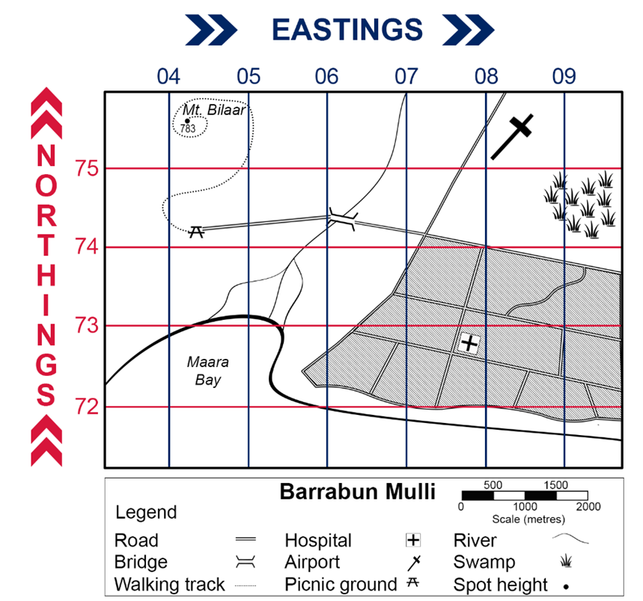

### 5.1.6 – Snake in the grass game

Play ‘Snake in the grass’.

Follow the instructions to participate in the game.

Mark snakes in the ‘My yard’ panel on your game sheet (Appendix 19) using the letters shown for each snake in the legend. Each snake must be marked in a straight horizontal or vertical line using one letter per grid square. An example is provided in Figure 14.

Figure 14 – Snake in the grass example

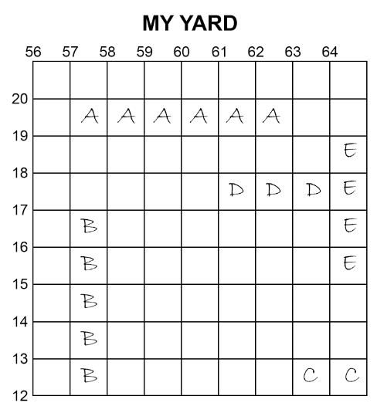

To decide who plays first:

* close your hand to make a fist
* count to 3
* on 3 use your fingers to show a number
* 0 – keep fist closed fist
* 1 – stick out your pointer finger
* 2 – stick out your pointer and middle fingers
* 3 – stick out your pointer, middle and ring fingers
* 4 – stick out all fingers except your thumb
* 5 – open your hand
* the first person to call the correct sum of the fingers becomes the first player.

On each turn:

* the player says an area reference
* the other player responds
* ‘Safe’ if the area reference is empty
* ‘Catch’ if the area reference has part of a snake. They put a cross over the grid square to show that part of the snake has been caught
* ‘You caught my [snake name]’ if the area reference was the last remaining grid square for that snake
* the player marks the result of their guess in ‘Opponent’s yard’ on their game sheet and ends their turn.

**Note:** if the area reference is not given correctly, such as the numbers are provided in an incorrect order, the player misses their turn.

The game continues until one player has caught all their opponent’s snakes. That player is the winner.

## Lesson 2 – volcanoes and the Ring of Fire

### 5.2.1 – making observations

Using 360 headsets or your desktop computer, access [360° Kamchatka Volcano Eruption | National Geographic (2:16)](https://youtu.be/o3a1fkLsNS4?si=uYNgVTeKsWf11PWS) and identify 3 key points of interest.

Using a KWLH chart (Appendix 13), identify what you already know about volcanoes. Only complete the first 2 columns outlining what you already know about volcanoes (under the brain) and what you wonder about volcanoes (under the question mark). You will come back later and complete the last 2 spaces, what you learned (under the light bulb) and how I can learn more (under the magnifying glass).

Watch [Volcanoes 101 | National Geographic (4:58)](https://youtu.be/VNGUdObDoLk?si=GC4MmteSdpchlme5) and add any new information to your KWLH chart.

### 5.2.2 – visual representations

Think carefully about what you know about the structure of volcanoes. Draw a sketch of a volcano. Do not look up parts of a volcano online or in a text. Instead, try to recall everything you know about the structure of volcanoes.

Share your diagram with a partner and add any other parts of a volcano you might have missed.

Visit [The Science of Volcanoes: How They Are Made – Infographic](https://graphicspedia.net/the-science-of-volcanoes-how-they-are-made-infographic/) and revisit your diagram. Add any details you may have missed.

### 5.2.3 – mapping Earth’s major volcanoes

On the world map (Appendix 10), illustrate the location of Earth’s major volcanoes.

With a partner discuss the following:

* Where are Earth’s major volcanoes located?
* How does the location of volcanoes align to the plate margins?
* What do you know about the Ring of Fire?

### 5.2.4 – the Ring of Fire

**Note:** revisit the WAGOLL infographic (Figure 6). You might also like to access [Create Engaging Interactive Infographics](https://infogram.com/create/infographic) for advice on how to develop a good infographic.

Use resources provided by your teacher to create an infographic that informs others about the Ring of Fire. Ensure you include answers to the following:

* Where is the Ring of Fire located?
* Why is the Ring of Fire located where it is?
* How does the Ring of Fire impact the landscape and landforms?
* How does the Ring of Fire impact people and places?

## Lessons 3a to 4b – investigation of a geomorphic hazard

**Note:** investigation of one type of geomorphic hazard that has occurred this century provides choice for teachers.

Two options, including Whakaari White Island and Shiveluch eruptions, can be taught consecutively based on student interest, individually to work effectively in school context or teachers may create their own option.

Teachers will need to update their own copy of the student resource book depending on choice of investigation.

## Lesson 5 – responses to and management of volcanoes

### 5.5.1 – engaging with area reference

Use Figure 15 to identify the area reference for:

* each of New Zealand’s North Island volcanoes, listed in the number key
* New Zealand’s North Island volcano groups, listed in the number key.

Figure 15 – North Island New Zealand

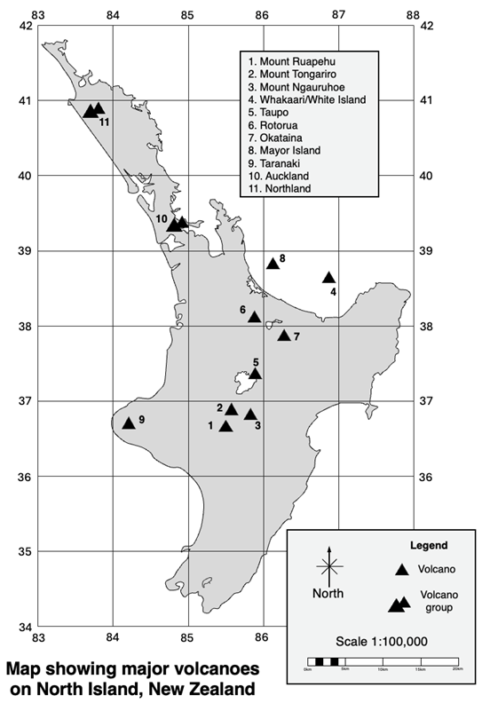

### 5.5.2 – impact of hazards on people and places

Your teacher will allocate you to work in a small group.

In your group choose one volcanic eruption from the following list that has significantly impacted people and places:

* Mount Ruang (Indonesia, 2024)
* Mauna Loa (Hawaii, 2022)
* Fagradalsfjall (Iceland, 2022)
* La Palma (Spain, 2021)
* Mount Nyiragongo (DR Congo, 2021)
* Hunga Tonga–Hunga Haʻapai (Tonga, 2022)

Develop an [affinity diagram](https://app.education.nsw.gov.au/digital-learning-selector/LearningActivity/Card/576) for the selected volcano that summarises the:

* immediate response to the disaster (Category 1)
* government action (Category 2)
* long-term measures that have been designed to reduce future impacts (Category 3).

### 5.5.3 – imagineering

Remaining in your group, create a map or plan for an imaginary small town near an active volcano.

You must give illustrative strategies for responding to and managing the impact of a possible eruption.

Your presentation must include a map of your location which applies the features of BOLTSS. This should include an area reference grid. Identify a minimum of 5 key locations related to your emergency plan using a 4-digit area code.

Your group plan should consider:

* evacuation routes and assembly points
* shelter locations (safe buildings or designated evacuation centres)
* communication strategies (emergency hotlines, social media, and so on)
* basic emergency supplies and resources needed (food, water, medical aid, and so on)
* any specific measures or adaptations based on the type of volcanic hazard experienced at the town, such as explosive eruptions, lava flows, ashfall, volcanic gas, pyroclastic flows or lahars.

Present your group plan and map to the class. Explain the decisions made and strategies undertaken.

You may need to answer questions from your class about your presentation and receive feedback from your peers.

### 5.5.4 – self-assessment

Revisit your KWLH chart (Activity 5.2.1) and complete the final column to demonstrate what you have learnt about volcanoes.

Complete the self-assessment sentence starters reflecting on the learning sequence for geomorphic hazards:

* Now I know …
* I now feel confident about …
* What I would like to know is …
* I was unsure about … but now I …

### 5.5.5 – multi-modal task

You are a team of scientists preparing an educational presentation on volcanic hazards for a museum exhibition.

Undertake the research component detailed in Table 18. Then, choose one or more components to undertake to demonstrate your understanding of volcanic hazards.

Table 18 – volcanic hazards multi-modal task options

|  |  |
| --- | --- |
| Component | Activity |
| Research | Conduct research on different types of volcanic hazards (for example, lava flows, pyroclastic flows, ashfall, lahars).  Describe each type of hazard, how it forms and its impact on the environment and communities.  Use reliable sources such as textbooks, websites and scientific articles. |
| Visual (art and design) | Create a visual representation of a volcanic hazard scenario. You can choose to draw, paint or create a digital artwork.  Ensure your artwork accurately depicts the features and dangers of the chosen hazard. |
| Written (language arts) | Write a descriptive paragraph or short essay explaining one specific volcanic hazard in detail.  Include information on its causes, effects and any historical examples, you can use the case study completed in class.  Use appropriate scientific vocabulary and clear, concise language. |
| Interactive (technology) | Prepare a short interactive presentation or simulation using an appropriate application.  Include visuals, text and videos or animations to explain your chosen volcanic hazard.  Ensure your presentation is engaging and informative for museum visitors. |
| Oral presentation (speaking and listening) | Present your findings and project components to the class.  Explain the volcanic hazard you chose, the process of creating your visual representation and key points from your research.  Answer questions from your classmates and teacher about volcanic hazards and your project. |

# Appendix 1 – blank outline map of Australia

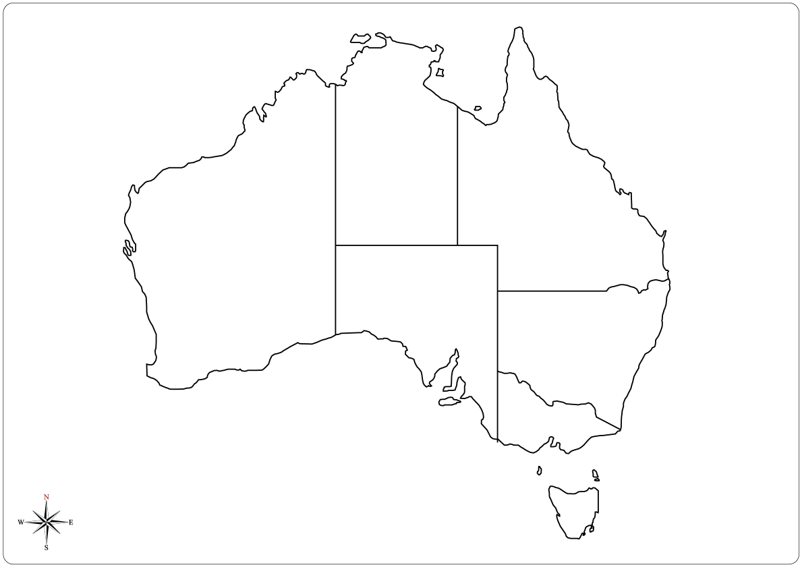

# Appendix 2 – Think-Pair-Share template

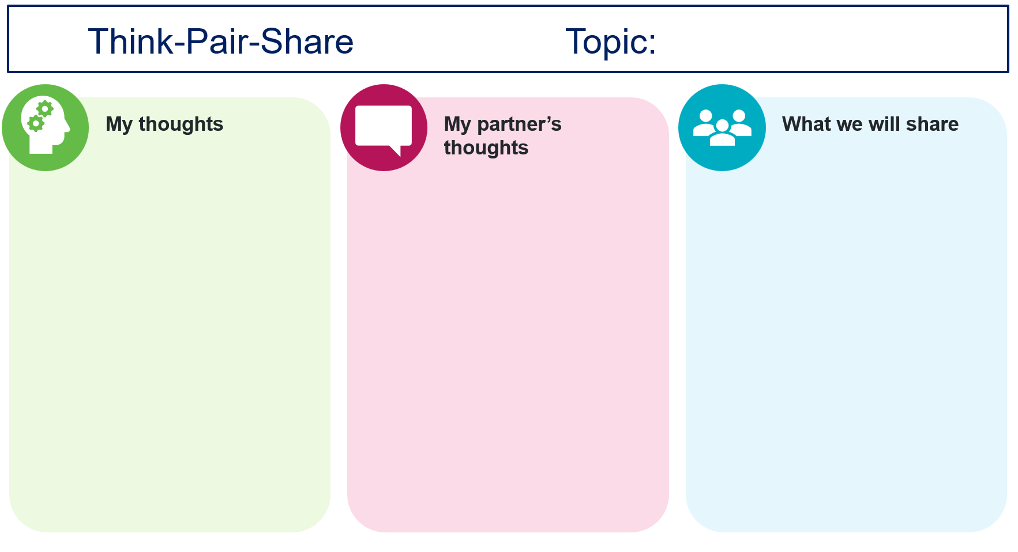

# Appendix 3 – photo sketch template

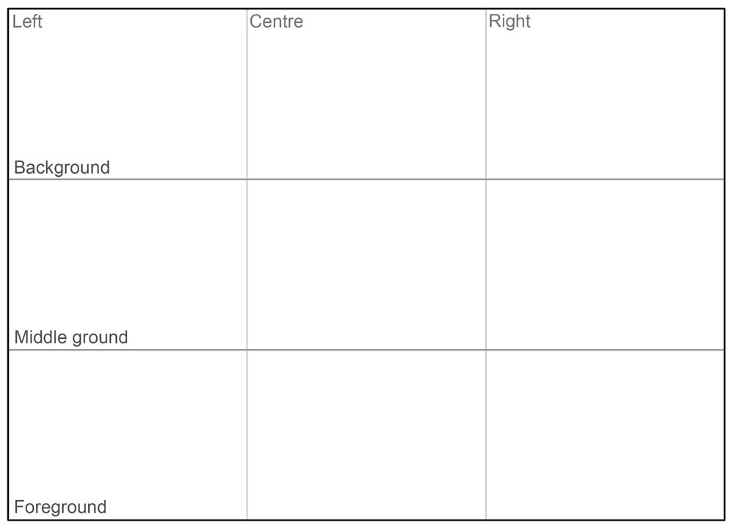

# Appendix 4 – TAG template

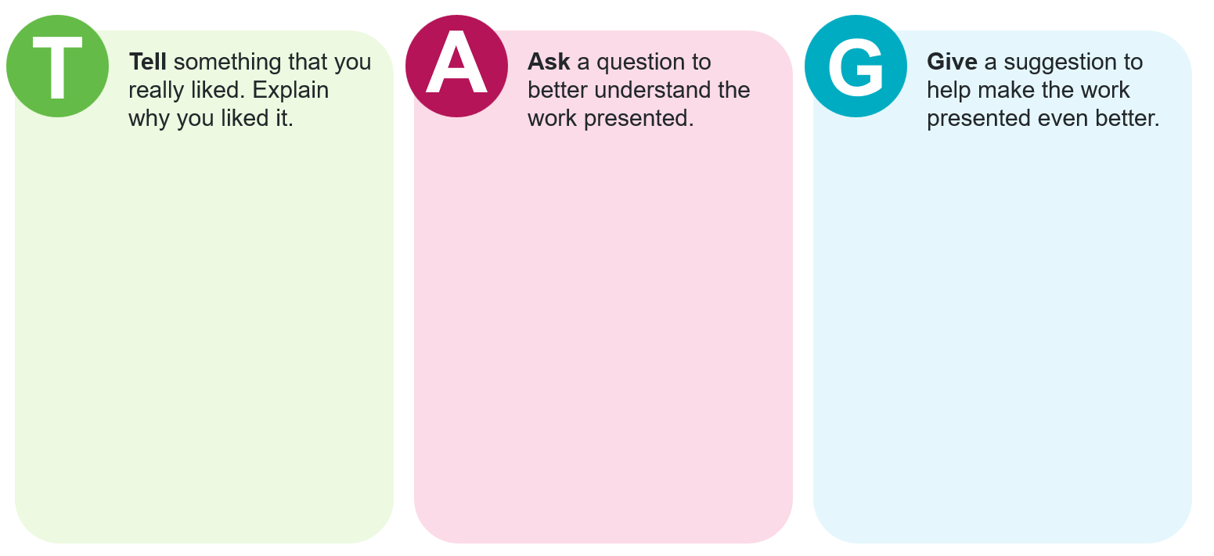

# Appendix 5 – 3-2-1 routine

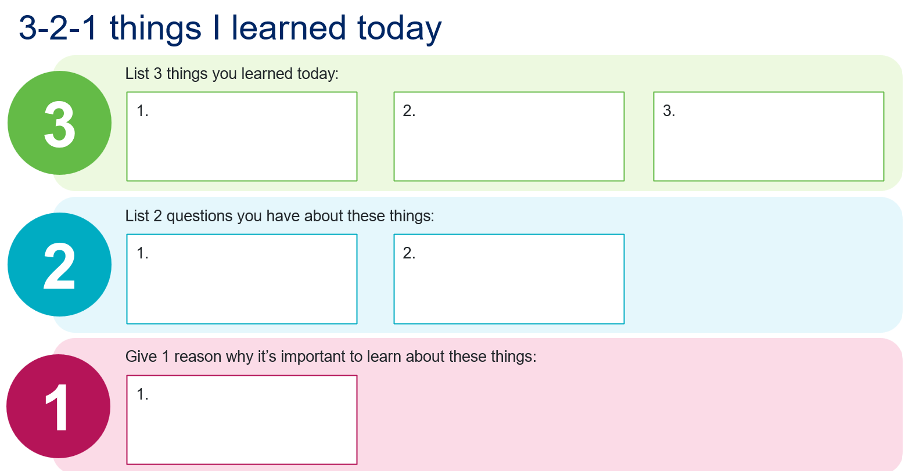

# Appendix 6 – blank outline map of Asia

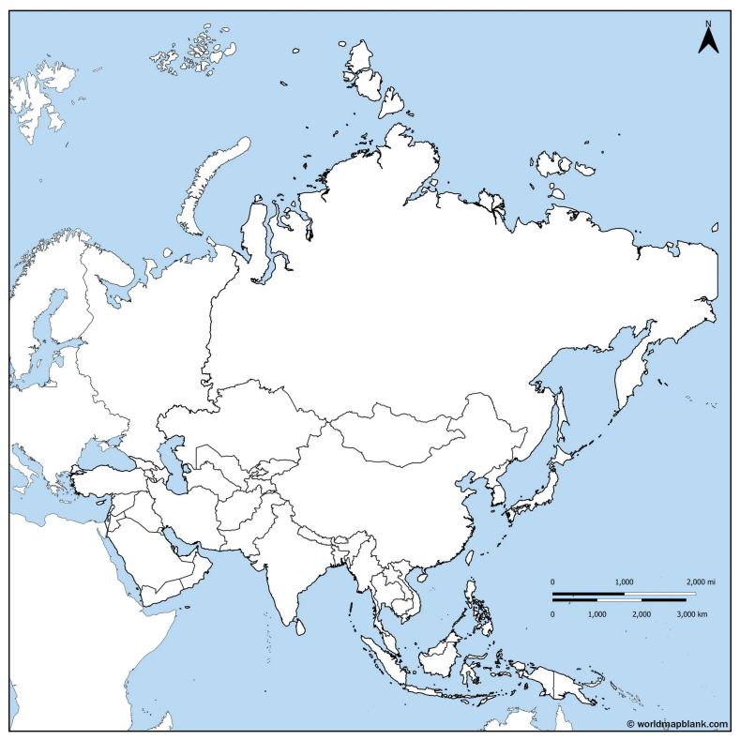

Source: [World Map Blank 2024](https://worldmapblank.com/maps-terms-of-use/)

# Appendix 7 – field sketch template

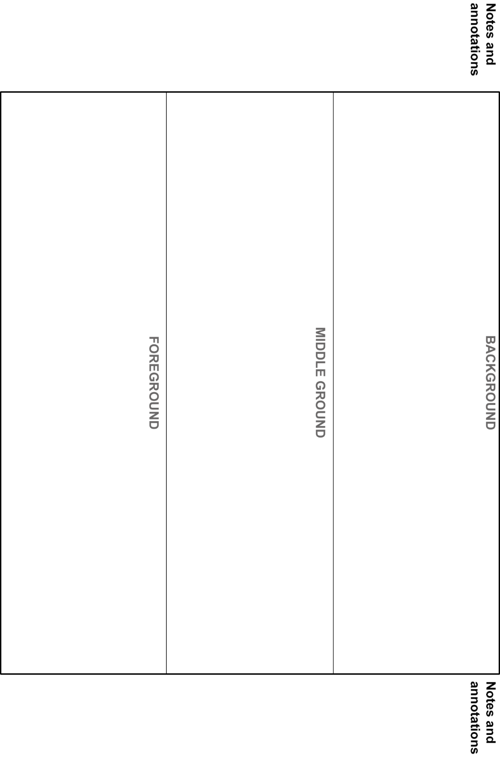

# Appendix 8 – KWL chart

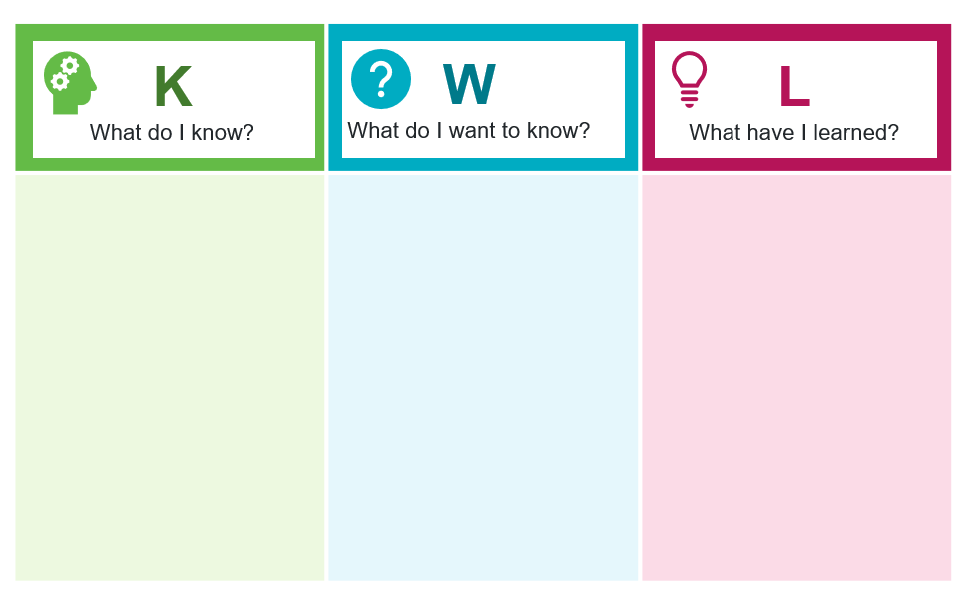

# Appendix 9 – Frayer diagram template

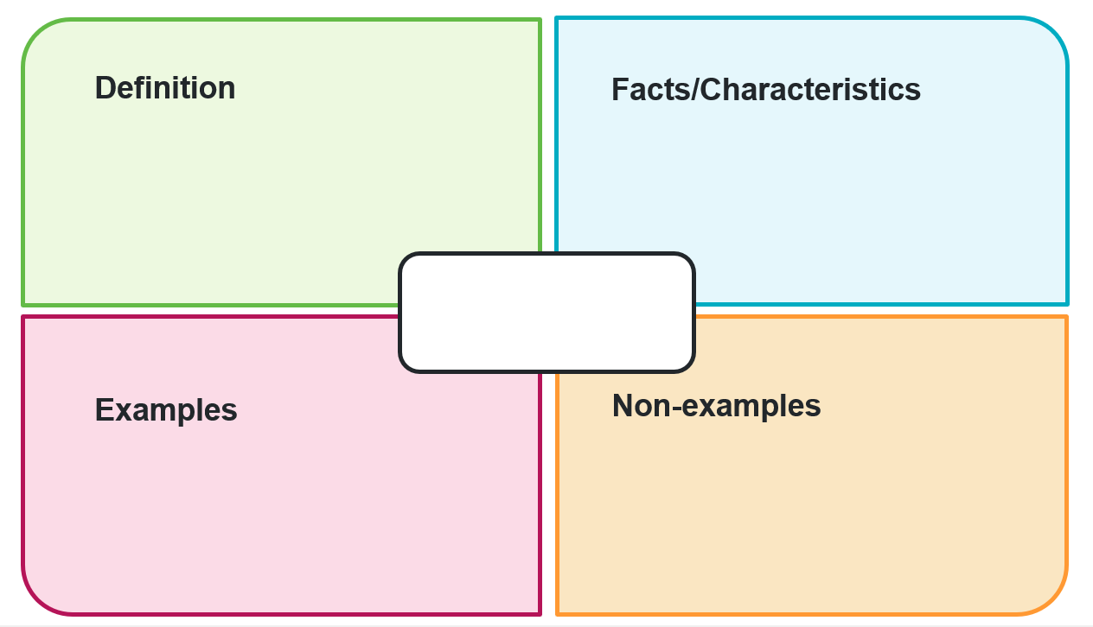

# Appendix 10 – blank world map

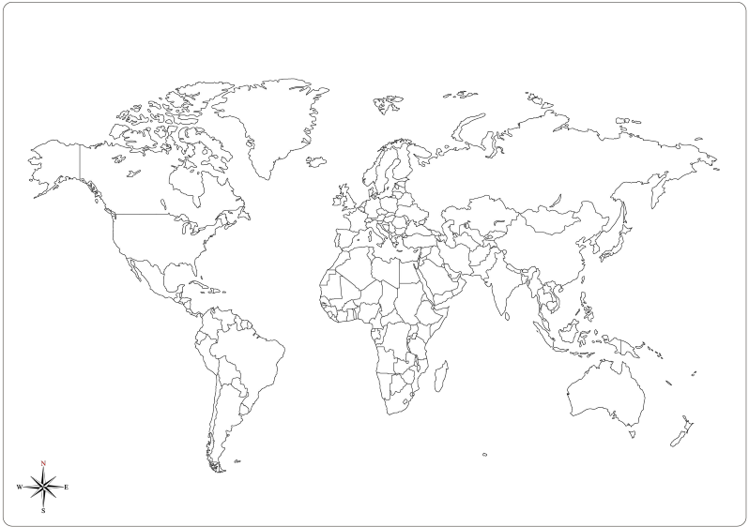

# Appendix 11 – climate graph template

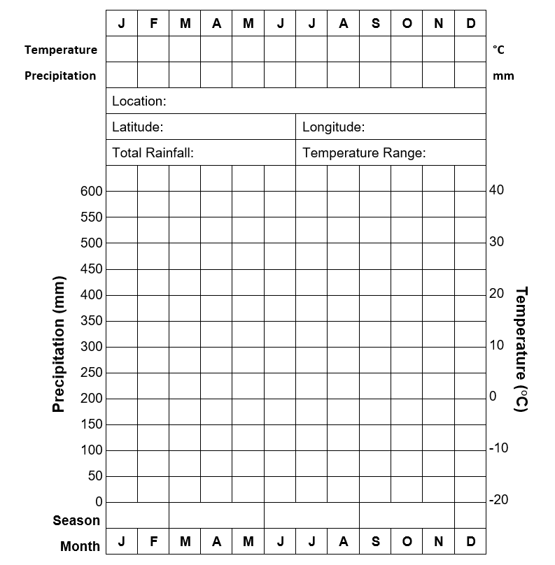

# Appendix 12 – brainstorming template

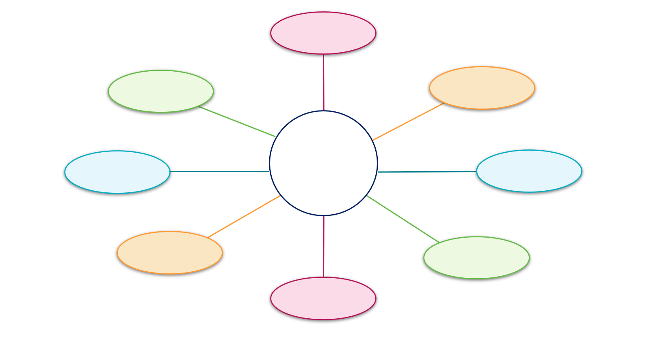

# Appendix 13 – KWLH chart

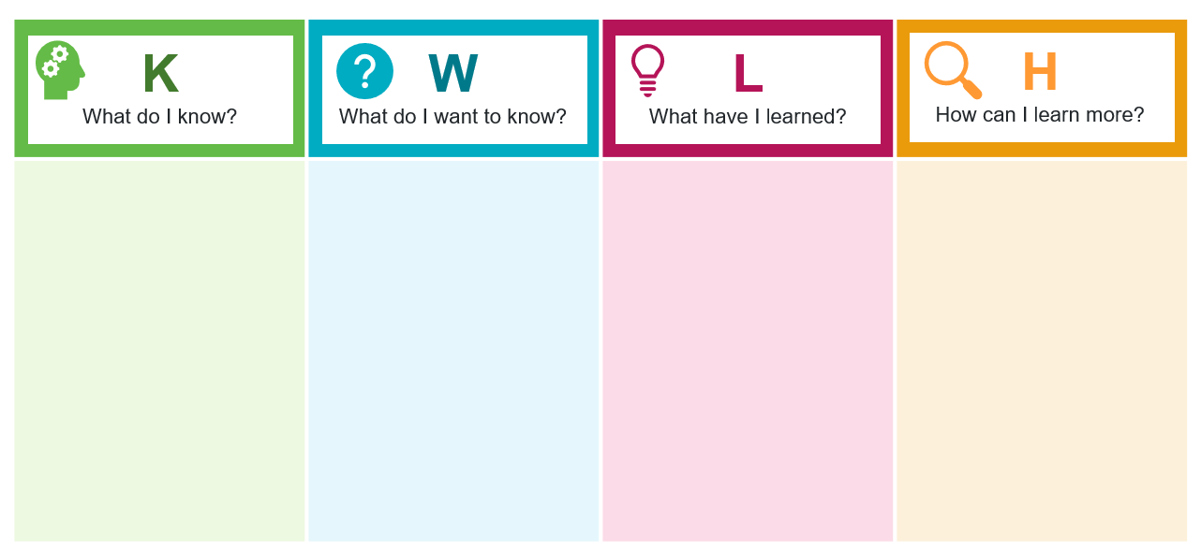

# Appendix 14 – group brainstorming template

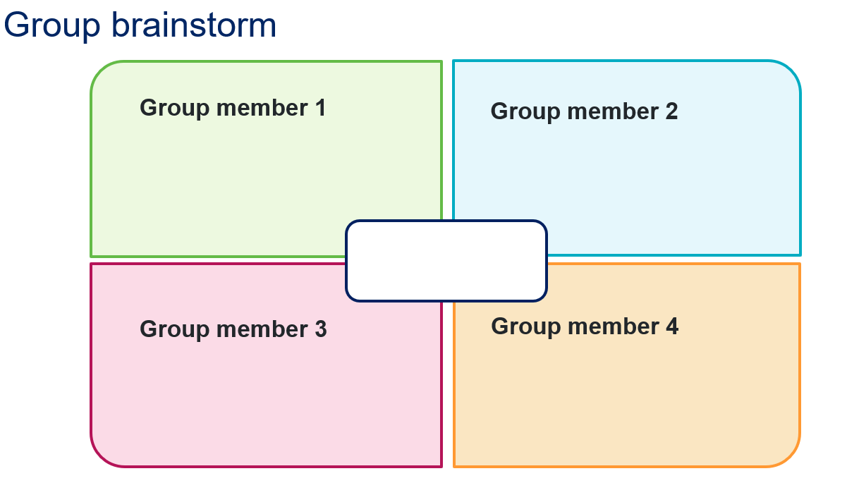

# Appendix 15 – traffic light reflection

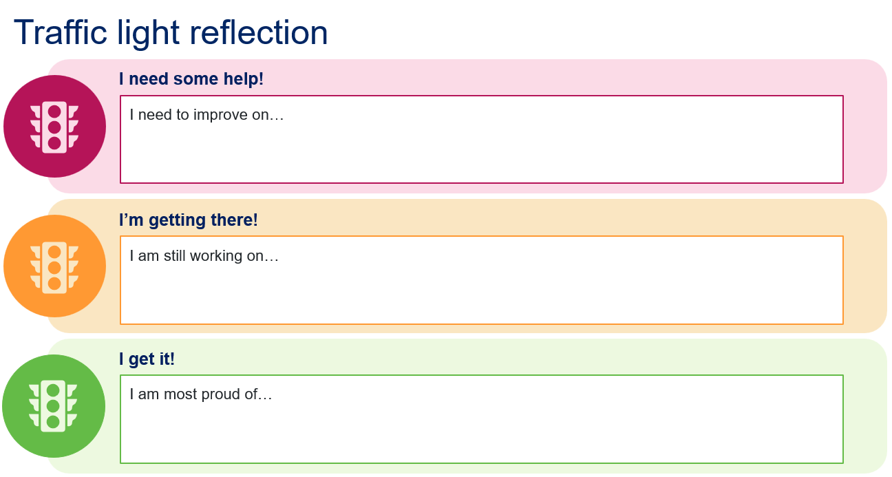

# Appendix 16 – PEEL paragraph template

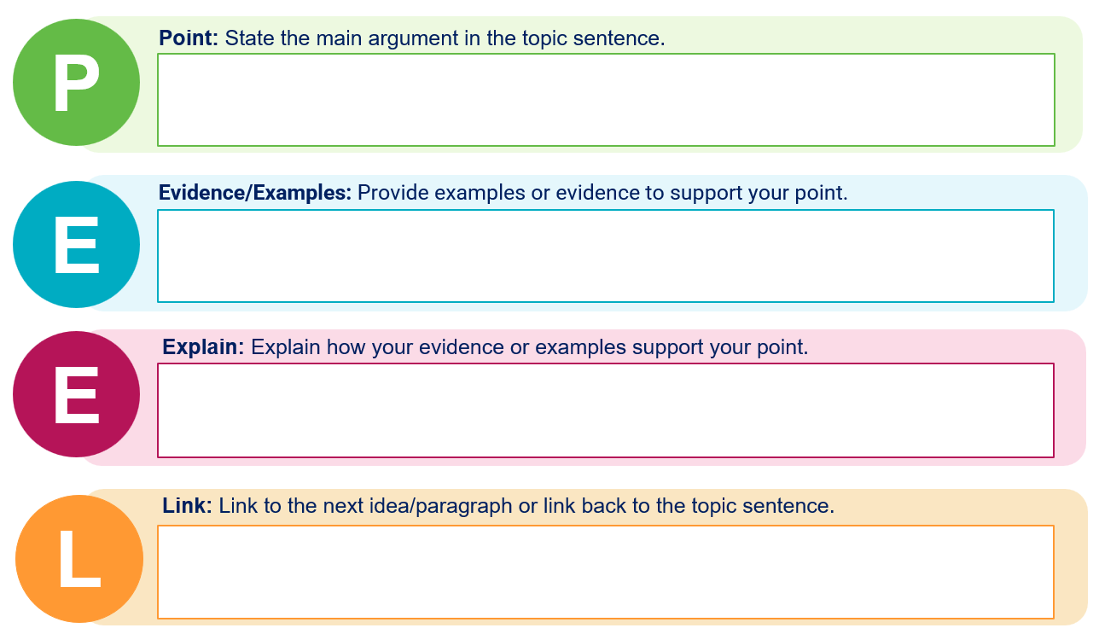

# Appendix 17 – Y-chart template

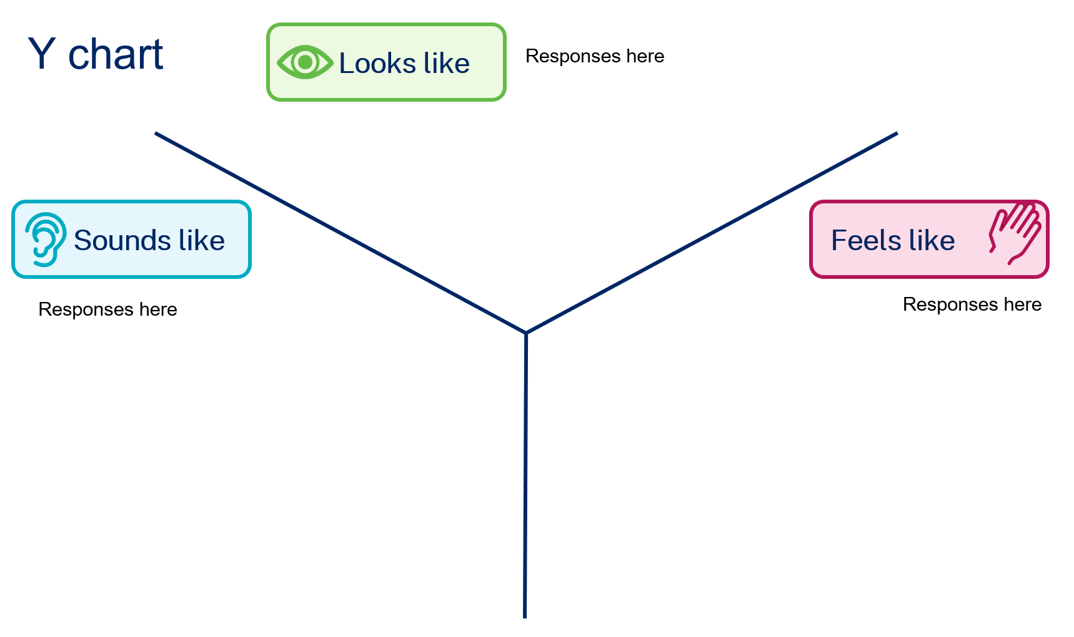

# Appendix 18 – hamburger planning template

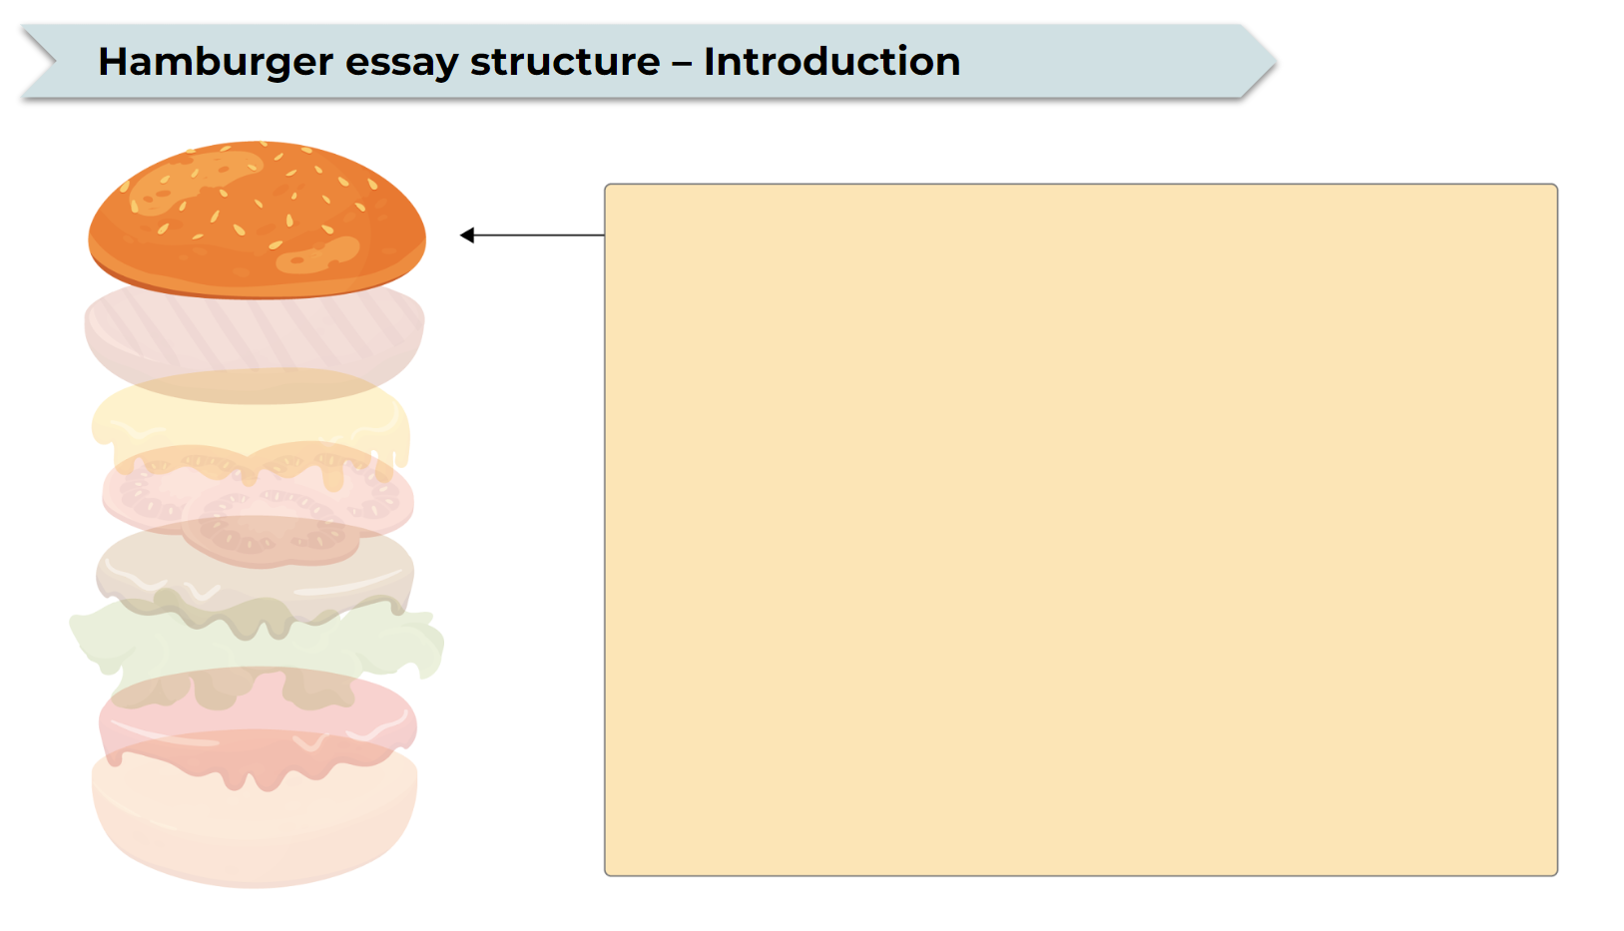

# Appendix 19 – Snake in the grass

Game sheet for snake in the grass. Top left has 9x9 grid squares for my yard. Bottom left has 9x9 grid squares for opponent's yard. Centre right has the legend:
6 As for Australian scrub python
5 Bs for Red–bellied black snake
2 Cs for Copperhead
3 Ds for Dugite
4 Es for Eastern brown snake.

# References

This resource contains NSW Curriculum and syllabus content. The NSW Curriculum is developed by the NSW Education Standards Authority. This content is prepared by NESA for and on behalf of the Crown in right of the State of New South Wales. The material is protected by Crown copyright.

Please refer to the NESA Copyright Disclaimer for more information <https://educationstandards.nsw.edu.au/wps/portal/nesa/mini-footer/copyright>.

NESA holds the only official and up-to-date versions of the NSW Curriculum and syllabus documents. Please visit the NSW Education Standards Authority (NESA) website <https://educationstandards.nsw.edu.au/> and the NSW Curriculum website [https://curriculum.nsw.edu.au](https://curriculum.nsw.edu.au/).

[Geography 7–10 Syllabus](https://curriculum.nsw.edu.au/learning-areas/hsie/geography-7-10-2024/overview) © NSW Education Standards Authority (NESA) for and on behalf of the Crown in right of the State of New South Wales, 2024.

**© State of New South Wales (Department of Education), 2025**

The copyright material published in this resource is subject to the *Copyright Act 1968* (Cth) and is owned by the NSW Department of Education or, where indicated, by a party other than the NSW Department of Education (third-party material).

Copyright material available in this resource and owned by the NSW Department of Education is licensed under a [Creative Commons Attribution 4.0 International (CC BY 4.0) license](https://creativecommons.org/licenses/by/4.0/).

[](https://creativecommons.org/licenses/by/4.0/)

This license allows you to share and adapt the material for any purpose, even commercially.

Attribution should be given to © State of New South Wales (Department of Education), 2025.

Material in this resource not available under a Creative Commons license:

* the NSW Department of Education logo, other logos and trademark-protected material
* material owned by a third party that has been reproduced with permission. You will need to obtain permission from the third party to reuse its material.

**Links to third-party material and websites**

Please note that the provided (reading/viewing material/list/links/texts) are a suggestion only and implies no endorsement, by the New South Wales Department of Education, of any author, publisher, or book title. School principals and teachers are best placed to assess the suitability of resources that would complement the curriculum and reflect the needs and interests of their students.

If you use the links provided in this document to access a third-party's website, you acknowledge that the terms of use, including licence terms set out on the third-party's website apply to the use which may be made of the materials on that third-party website or where permitted by the *Copyright Act 1968* (Cth). The department accepts no responsibility for content on third-party websites.