History Stage 5
Making a nation
Contents
Overview 3
Key inquiry questions 3
Outcomes 3
Learning sequence 1 – extension and effects of European settlement 5
Syllabus content 5
Learning intentions and success criteria 5
Mapping the expansion of European settlement in Australia 6
Europeans and the landscape 7
Contact experiences 9
Learning sequence 2 – living and working conditions in Australia 16
Syllabus content 16
Learning intentions and success criteria 16
General living conditions 17
Children in Australia at the turn of the twentieth century 18
Working conditions for men 20
Working conditions for women 21
Learning sequence 3 – experiences of non-Europeans in Australia 22
Syllabus content 22
Learning intentions and success criteria 22
South Sea Islanders coming to Australia 23
South Sea Islanders living and working in Australia 24
South Sea Islander contribution to development 26
Learning sequence 4 – developing Australian self-government and democracy 27
Syllabus content 27
Learning intentions and success criteria 27
The path to Federation 28
State and federal responsibilities 30
Consequences for women and First Australians 30
Learning sequence 5 – legislation 1901–1914 32
Syllabus content 32
Learning intentions and success criteria 32
Shaping an Australian society 33
Assessment task 37
Outcomes 37
Syllabus content 37
Concepts 37
Skills 38
Task 39
Marking criteria 40
Additional information 42
Support and alignment 42
Appendix 1 – working class housing 44
Appendix 2 – food handling 48
Appendix 3 – toilets 52
Appendix 4 – waste management 56
Appendix 5 – pest management 60
Appendix 6 – cleansing 63
Appendix 7 – working conditions 68
References 70
This resource has been developed to assist teachers in NSW Department of Education schools to create learning that is contextualised to their classroom. It can be used as a basis for the teacher’s own program, assessment, or scope and sequence, or be used as an example of how the new curriculum could be implemented. The resource has suggested timeframes that may need to be adjusted by the teacher to meet the needs of their students.

Overview
This program of learning addresses the syllabus content requirements for History Stage 5, Depth study 2 (Australia and Asia), elective choice (Making a nation).
This program of learning is designed to be completed in approximately 15 hours.

Key inquiry questions
- What were the changing features of the movement of peoples from 1750 to 1918?
- How did new ideas and technological developments contribute to change in this period?
- What was the origin, development, significance and long-term impact of imperialism in this period?

Outcomes
A student:
- HT5-1 explains and assesses the historical forces and factors that shaped the modern world and Australia
- HT5-2 sequences and explains the significant patterns of continuity and change in the development of the modern world and Australia
- HT5-4 explains and analyses the causes and effects of events and developments in the modern world and Australia
- HT5-7 explains different contexts, perspectives and interpretations of the modern world and Australia
- HT5-9 applies a range of relevant historical terms and concepts when communicating an understanding of the past
- HT5-10 selects and uses appropriate oral, written, visual and digital forms to communicate effectively about the past for different audiences
Related Life Skills outcomes: HTLS-3, HTLS-4, HTLS-6, HTLS-9, HTLS-11, HTLS-12, HTLS-13
History K–10 Syllabus © NSW Education Standards Authority (NESA) for and on behalf of the Crown in right of the State of New South Wales, 2012.

Learning sequence 1 – extension and effects of European settlement
This learning sequence will take approximately 3 hours to complete. Students will have opportunities to develop the historical skills comprehension: chronology, terms and concepts, and perspectives and interpretation, and their conceptual understanding of cause and effect, perspective and significance, as they progress through the sequence. Students may require support with elements of literacy, particularly historically contextual vocabulary, in this learning sequence. Activities can be adapted to local contexts to support the creation of culturally safe classrooms. Some activities can be adapted to asynchronous learning.

Syllabus content
The extension of settlement, including the effects of contact (intended and unintended) between European settlers in Australia and Aboriginal and Torres Strait Islander peoples.
Students:
- outline the expansion of European settlement on a map of Aboriginal Australia to 1900
- describe both the European impact on the landscape and how the landscape affected European settlement
- use a range of sources to describe contact experiences between European settlers and Indigenous peoples

Learning intentions and success criteria
Note: these learning intentions and success criteria are general and should be contextualised to suit your school and students’ needs.
Students will:
- know about the European impact on the landscape and how the landscape affected European settlement
- understand how European expansion interacted with First Nation Australians.
Students will be able to:
- outline the expansion of European settlement on a map of Aboriginal Australia to 1900
- describe both the European impact on the landscape and how the landscape affected European settlement
- use a range of sources to describe contact experiences between European settlers and Indigenous peoples.

Mapping the expansion of European settlement in Australia
Note: Table 1 can be modified to include British settlement of the local area and recognise the local custodians impacted, if relevant to the time period 1788 to 1900.
Use the AIATSIS map of Indigenous Australia to complete Table 1.
Table 1 – British settlements on Country
Name of British settlement | Date of Settlement | Aboriginal cultural group impacted
Sydney Cove (Sydney, NSW) | 1788
Risdon Cove/Sullivans Cove (Hobart, Tas) | 1803
Port Dalrymple (George Town, Tas) | 1804
Bathurst, NSW | 1815
Moreton Bay/Brisbane (Brisbane, QLD) | 1824/5
King George Sound (Albany, WA) | 1826
Swan River Colony (Perth, WA) | 1829
Port Phillip (Melbourne, Vic) | 1835
Holdfast Bay/Glenelg (Adelaide, SA) | 1836
Palmerston (Darwin, NT) | 1869
Access Australasia 1872: Australian Overland Telegraph Line, examine the map and the notes, and take part in a Think-Pair-Share routine to respond to the question: Why was the settlement at Palmerston (Darwin, NT) significant?
Review the AIATSIS map of Indigenous Australia and look at the map Australasia 1899. Construct a paragraph that outlines the extent of European settlement in Australia to 1900 in relation to Aboriginal and Torres Strait Islander Country.

Europeans and the landscape
Brainstorm as a class what you already know about the Australian landscape and European settlement. Create a Venn diagram to compare and contrast Australia’s landscape with that of the United Kingdom.
Use information from Arrival in Australia and Risdon Cove to identify why Botany Bay (NSW) and Risdon Cove (Tas) were rejected as settlement locations by the first European settlers.
Read the article Aboriginal people built water tunnels and complete the following activities.
- Identify the sources of information that Brad Moggridge has used as evidence for First Australians’ water management.
- Create a GIST statement to capture the main idea of the article.
- Gather information. Identify background knowledge and key vocabulary, including important vocabulary, unfamiliar vocabulary, and repeated vocabulary.
- Identify the topic. Use vocabulary to guide ideas and refine to a word, for example, dragonflies or a phrase, for example, The assassination of Archduke Franz Ferdinand
- Summarise the text by placing vocabulary into key points
- Top and tail sentences – check first and last sentences as these may reinforce the main idea.
- Use your thinking from GIST to create a short summary of the main idea.
Differentiation: the following activity is designed to extend high potential and gifted students in the intellectual domain. Students will apply their understand of the historical concept significance and their historical skill of perspective and interpretation as they create a storyboard. For more information on storyboards as learning tools, please see Facing history – Storyboard.
Using information from the article Gundagai flood and the video clip The Heroes of Gundagai (6:33) work in small groups to create either an annotated timeline, a storyboard or a children’s picture book that relates the significant events in the settlement, destruction and resettlement of Gundagai. Consider and reflect the perspective of the Wiradjuri people in your work.
In pairs or small groups, use the articles Australia’s Most Invasive Species, 1.3 Merino sheep introduced: ‘The sheep that killed kangaroos’ and On the sheep’s back and your own research to complete Table 2.
Table 2 – Australia’s most invasive species
Species | Date introduced | Reason introduced | Negative impacts
Brumby
Cane toad
Dromedary camel
European honey bee
European rabbit
Feral cat
Feral deer
Feral goat
Feral pig
Merino sheep
Red fox
Water buffalo
Take part in a Think-Pair-Share routine to consider why merino sheep are not included in the article Australia’s Most Invasive Species.
Reflect on what you know about the dates and location of European settlements. Brainstorm information relevant to the question: How did the Australian landscape impact European settlement?
Apply your understanding of Europeans and the landscape by completing the game What can a farm tell us about defining moments?

Contact experiences
Note: students will need to understand the meaning of ‘pastoral expansion’, ‘stockman’, ‘station’, ‘guerrilla war’, ‘defect’ as a verb and ‘defection’ as a noun to engage with the following activities.
Engage with Jandamarra (1870–1897) and How Jandamarra went from resistance fighter to a Bunuba legend and respond to the following questions:
- What natural feature of the landscape protected Bunuba territory from pastoral expansion?
- What skills or characteristics led to young Jandamarra having an excellent reputation as a stockman?
- Why did he move to Lillimooloora station?
- The source uses the phrase ‘dramatic defection’. From whose perspective did Jandamarra defect?
- What was the outcome of Jandamarra’s guerrilla war against white settlers?
- How does Jandamarra’s story reflect the impact of European settlement on First Nation Australians?
Create a Venn diagram to communicate the differences and similarities between the experiences of Pemulwuy and Jandamarra.
Differentiation: the following activity is designed to extend high potential and gifted students in the intellectual domain. The article The Career of a West Australian Native is a sophisticated text (see Australian Curriculum National Literacy Learning Progression – Appendix 6 – Text complexity), and may be challenging for some students to access. Resources to support the explicit teaching of literacy can be found on the department’s webpage Literacy – explicit teaching strategies in Stage 5. Table 3 is used for both The Career of a West Australian Native in this extension activity and Governor Arthur’s Proclamation to the Aborigines in the main learning sequence.
Read The Career of a West Australian Native, complete Table 3, and determine to what extent this source corroborates the information you read in Jandamarra (1870–1897).
How useful would this source be for an historian studying Aboriginal peoples’ resistance to European colonisation?
Examine the images of the artefact Governor Arthur’s Proclamation to the Aborigines (Proclamation Boards), complete Table 3 and answer the question that follows.
Table 3 – source analysis
Source question | Answer and evidence or example
Is the source primary or secondary?
When was it made?
What type of source is it?
Who created the source?
What perspective is reflected in the source?
Can you identify any bias in this source?
Who is the audience for this source?
What was the purpose of the source?
What explicit information is in this source?
What information is implicit in this source?
What historical events happened at the time that were important to the creation of this source?
Complete a PMI chart to evaluate how useful the Proclamation Boards could be for a historian studying contact experiences in colonial Australia. Use your PMI chart to create 2 to 3 sentences that summarise your opinion.
Engage with the article The Black Line and consider the following questions:
- Which historical events were important to the creation of the Proclamation Boards?
- Does this information change your interpretation of the Proclamation Boards?
- Go back to your PMI chart and add relevant information and ideas.
- Revise your 2 to 3 sentence summary to reflect the historical context of the Proclamation Boards.
Differentiation: the following activity is designed to extend high potential and gifted students in the intellectual domain. The source is a sophisticated text (see Australian Curriculum National Literacy Learning Progression – Appendix 6 – Text complexity) and may be challenging for some students to access. Students may require support to access the vocabulary, language and content. Resources to support the explicit teaching of literacy can be found on the department’s webpage Literacy – explicit teaching strategies in Stage 5.
Examine Source 1. Work in small groups to create a list of all the words or phrases used to describe the colonists (how they are feeling and acting) and the First Australians in Tasmania (how they are feeling and acting). Table 4 will help you to organise your lists.
What is the author’s aim?
What evidence suggests that Source 1 is biased?
How does identifying bias help you to understand the perspective reflected in Source 1?
How is Source 1 relevant to understanding The Black Line and the Proclamation Boards?
Source 1 – Colonial Times, Hobart Town: Friday, July 27, 1827 from Trove
When shall we have no more to notice the atrocities of the Aborigines? Never, until they are all exterminated, or removed from the Island. They are growing worse and worse; their numbers are increasing, and their vindictiveness against the whites is increasing also. We call upon the Authorities and our fellow Colonists, to look upon the following accounts, while at the same time, they bear in mind, the times out of number which we have recorded similar instances, and say is it not really horrible.
Last Friday, a tribe of these sable monsters attacked Captain Wood’s Grassy Hut, at the Clyde, formerly the residence of Mr Charles Rowcroft, which they stripped entirely of every moveable, taking away among other things, a sum of money ! ! ! By a miraculous chance, no lives were fortunately lost. On the following day, as a person named Holmes, was travelling on horseback, he was beset by these black furies, between Mr. Ransom’s and the Hunting Grounds, on the Abyssinia Tier; and pursued by them the whole day! He narrowly escaped with his life, being frequently compelled to dismount, in order to make his way through the woods, which at that place are remarkably thick. The tribes are very numerous in number in the neighbourhood of the Clyde and Shannon, and express the most determined vengeance against every white who happens to fall in their power. How can the Government, week after week, read recitals which we publish, and remain inert? It can proceed but from one of two causes – either a false feeling of humanity towards these ignorant barbarians, or a want of knowing what steps to take to prevent them.
We say they must be removed. We repeat it, they must be removed. Again, we reiterate, they must be removed; or they will be shot like quails, by the Settlers and Stockkeepers, in their own defence. Indeed, to such a height has the feeling of terror grown already, that no Settler, if he can avoid it, will suffer the blacks to come within gun-shot of him, or his residence. Therefore, we appeal to the Lieutenant Governor in Council, and ask—Is it not better that the blacks should be removed, than that they should be all shot, or that no week should pass over without the loss of a white Colonist. But perhaps, it may be asked how are they to be removed, and where to. We have said many times before to King’s Island, or some other Island in the Straits. And with reference how it is to be effected, we may say by free pardons and other indulgences among the prisoner population, who shall be instrumental in taking a given number, alive, and lodging them safe in confinement, in order for their embarkation. Let the blacks but once be proscribed thus; let the prisoner population, be but once called into energy, as volunteers in the service of the Government, and we hesitate not to say, that in six months more, there would not be a black at large in the Island, who cherished feelings or animosity towards the whites.-We give this hint, with our best wishes for its instant adoption
Table 4 – identifying bias in the Colonial Times article
First Australians | European colonists
Note: the following activity supports students to develop their understanding of the historical concept of contestability and historical skill perspectives and interpretations. Students will need to be allocated to groups. Each group will respond to the same source analysis questions however they will be issued with different evidence sets. The activity will be most effective if students are not aware that groups are working with different evidence sets. After allowing groups time to consider the source analysis questions, ask groups to share their thinking to the first question in a whole class discussion. Move onto the second question, and so on, until students realise that they are working with different evidence sets. Guide the class through a discussion of how source selection can impact interpretations and lead to contestability in history.
Evidence set 1: Significant Aboriginal women: Patyegarang; Patyegarang and how she preserved the Gadigal language
Evidence set 2: Tarenorerer (1800–1831); Companion to Tasmanian history – Walyer 1; Companion to Tasmanian history – Walyer 2
Evidence set 3: Biraban (?-c.1842); Reminiscences of Biraban or M’Gill and Patty by the Rev. Lancelot Threlkeld
Evidence set 4: William Buckley (1780–1856); William Buckley
Evidence set 5: John Henry Fleming (1816–1894); The Myall Creek Massacre Re-examined; The Twelfth Man
Your teacher will allocate you to a group and give you sources to engage with. Examine the sources and discuss the following questions with your group. Be prepared to share your thinking with the class.
- Based on these sources, how would you describe the experience of contact between European settlers and Indigenous peoples?
- What types of primary sources have been used to support this interpretation?
- What perspective is reflected in these sources?
- What perspective(s) are absent from these sources?
Note: a True for Who? thinking routine helps students evaluate how an issue looks from different points of view. The routine also helps students see how perspectives and interpretations can be supported by using evidence from a range of historical sources.
Take part in a True for Who? activity that reflects on the statement ‘Transportation and communication technologies greatly benefited people in Australia from 1788 to 1900’.

Learning sequence 2 – living and working conditions in Australia
This learning sequence will take approximately 3 hours to complete. Students will have opportunities to develop the historical skill of analysis and use of sources and their conceptual understanding of cause and effect and empathetic understanding as they progress through the sequence. Students may require support with elements of literacy, particularly historically contextual vocabulary, in this learning sequence. Activities can be adapted to local contexts to support the creation of culturally safe classrooms. Some activities can be adapted to asynchronous learning.

Syllabus content
Living and working conditions in Australia around the turn of the twentieth century (that is 1900).
Students:
- using a range of sources, investigate the living and working conditions of men, women and children around the turn of the twentieth century in Australia

Learning intentions and success criteria
Note: these learning intentions and success criteria are general and should be contextualised to suit your school and students’ needs.
Students will:
- know about the living and working conditions in Australia around the turn of the twentieth century (1900)
- understand that children, men and women had different experiences in this time period.
Students will be able to:
- analyse sources to investigate the living and working conditions of men, women and children around the turn of the twentieth century in Australia.

General living conditions
Note: the following learning actives use the See, Think, Wonder thinking routine to encourage students to make careful observations and thoughtful interpretations, stimulating their curiosity and setting the stage for further inquiry. The learning activities end with a combination of a See think wonder thinking routine and a Gallery walk. This will allow students to share their thinking with the class and engage critically with a large body of historical sources. More information about Gallery walks can be found at Facing History – Gallery walk. There are 6 collections of images included in the appendix of this document.
Engage with the information about Photographs taken during cleansing operations in quarantine areas, Sydney. In 6 groups, complete a See, Think, Wonder routine on one of the 6 collections of images that your teacher will give you. Record your routine as a visual display to include in a class Gallery walk.
Poor sanitation and public hygiene are strongly linked to the spread of disease. Review Defining moments – Bubonic plague and access, Photographs taken during cleansing operations in quarantine areas, Sydney and Prevention of Plague and create a concept map to explain why there were relatively few deaths in Australia during the third pandemic. You may like to consider the following elements:
- quarantine
- cleansing
- extermination.
Note: teachers will need to create a free account to access material on ABC iView. For video resources, closed captions should be turned on to allow accessibility for students who are hearing impaired.
Engage with Further Back In Time For Dinner – Episode 1: The 1900s (58:00) (from 6:34–22:24) and identify examples of English influence on Australian life, household tasks for men and household tasks for women. Table 5 will help you to organise your lists.
Table 5 – Australian lifestyle circa 1900
Examples of English influence on Australian life | Examples of tasks for men | Examples of tasks for women
The Ferone family were concerned about using the ‘dunny’. Examine the article Present and Past Family Life – Toilets and observe the 3 images of Australian made commodes. Conduct a See, Think, Wonder routine on these 3 images. Remember to reflect on the source information that is included under each image.

Children in Australia at the turn of the twentieth century
Note: a 3-2-1 Bridge thinking routine helps students understand their own process of learning by reflecting on a topic before and after a learning experience and considering how their thinking changed. This routine works well when students have some prior knowledge of the topic. At the conclusion of the activity, explain to students that their initial thinking is not right or wrong; it is just a starting point.
Participate in a 3-2-1 Bridge thinking routine about childhood in Australia at the turn of the twentieth century. Quickly record words and questions that reflect your current understanding of childhood in Australia at the turn of the twentieth century. Record these in the form of:
- 3 words or thoughts
- 2 questions
- 1 metaphor or simile.
Use the graph Child mortality rate (under five years old) in Australia from 1860 to 2020 to determine whether it would be significantly better to be born in Australia in 1865, 1886 or 1905.
Complete a Quick writes after engaging with the article Working class kids: The tough life colonial children faced.
Access the clip Growing Up In The Early 1900s – Episode 1: Mornings, Baths and Meals (3:59) and create a list of goods that would be available from street sellers (or hawkers), and consider: Which adult do you think would bathe first? How does the order of bathing reflect the status of different people within the family and society?
Access the clip Growing Up In The Early 1900s – Episode 2: School, Chores and Sleep (3:51) and take note of the life course expectations for boys and girls. What chores would be considered normal for children in the early 1900s? What pastimes would children engage in at the turn of the century and what additional responsibilities did Jim Youngein have as the son of a small business owner?
Access Further Back In Time For Dinner – Episode 1: The 1900s (58:00) (from 43:08–46:15), Growing up in the early 1900s - Going to School (1:34) and the information about compulsory attendance. Work in small groups to complete a Y-Chart on school in Australia c.1900.
Reflecting on the opinions Edwin Barnard expressed in the article Working class kids: The tough life colonial children faced, do you think that the experience of working class children is appropriately represented in Australian history?
- Brainstorm other groups whose perspectives may be underrepresented in history.
- What challenges do historians face when trying to investigate these perspectives?
Complete the 3-2-1 Bridge thinking routine about childhood in Australia at the turn of the twentieth century.
- Quickly record 3 words or thoughts, 2 questions and 1 metaphor or simile that reflects your current understanding of childhood in Australia at the turn of the twentieth century. Use the words and questions you think of first.
- Compare your first 3-2-1 with your second 3-2-1.
- Create the bridge between your thinking by making connections between your initial and new thinking, and explaining how and why your thinking shifted.

Working conditions for men
Note: the following activity uses the source analysis strategy Zoom out. A suggested image for use is the Portable steam engine driving a corn husker. Cropped and zoomed images can be found in the appendix of this document.
Your teacher will show you an image.
- Describe the image.
- What is happening?
- Who has created the image?
- What is the purpose of creating the image?
- What does it tell us as historians?
Your teacher will show you a second image. Work in small groups to make notes on the following:
- How has the meaning of the image changed?
- Have your predictions about the author and purpose of the image changed?
Your teacher will show you a final image. As a class, discuss:
- How the meaning has changed through each version?
- How the different images could be used for different purposes?
- Which image reflects ‘truth’?
Examine Underground mine face and miners and complete a Layers of inference analysis to consider what this source can tell you about working conditions for men in the 1900s.
Examine the article Eight-hour day and contribute to a True for Who? routine that reflects on the statement ‘Australians benefited from the Eight-hour day campaign’.

Working conditions for women
Access Further Back In Time For Dinner – Episode 1: The 1900s (58:00) (from 22:47–25:47 and 46:23–48:11), then describe the expected life course for girls in Australia c.1900.
The short stories The Career of Jessica, How I entertained an Editor at supper, and The Middiby Marriage were all written by women and published between 1901 and 1908. Use Table 6 to make notes about what you know or can infer from these sources.
Table 6 – source evidence for working women
Source name | Working as a wife | Working as a domestic servant | Working outside the home
The Career of Jessica
How I entertained an Editor at supper
The Middiby Marriage
Access Trade Unions: Women in the labour movement and use this extract to briefly explain why there were separate unions for men and women.
Access the clip First women’s union (3:02). As a class, brainstorm challenges that working women faced in Australia c.1900.
Note: the following activity could be completed using a range of digital tools, for example Google Jamboard or Mentimeter, a classroom whiteboard or large sheets of paper (A2 or butchers paper).
How did the lives of children, men and women change as a result of new ideas and technological developments in this period?
- For each group (children, men and women), brainstorm key words in response to this question. Your teacher will tell you how to record your thinking.
- Organise your thinking in a Triple Venn diagram to visually map the similarities and difference between the experiences of each group.

Learning sequence 3 – experiences of non-Europeans in Australia
This learning sequence will take approximately 2 hours to complete. Students will have opportunities to develop a range of historical skills, particularly analysis and use of sources and empathetic understanding, and their conceptual understanding of perspectives as they progress through the sequence. Students may require support with elements of literacy, particularly historically contextual vocabulary, in this learning sequence. Activities can be adapted to local contexts to support the creation of culturally safe classrooms. Some activities can be adapted to asynchronous learning.

Syllabus content
The experiences of non-Europeans in Australia prior to the 1900s (such as the Japanese, Chinese, South Sea Islanders, Afghans).
Students:
- explain why ONE of the non-European groups came to Australia
- describe how the chosen group lived and worked in Australia
- describe the contribution of non-European workers to Australia’s development to 1900

Learning intentions and success criteria
Note: these learning intentions and success criteria are general and should be contextualised to suit your school and students’ needs.
Students will:
- know about the experiences of South Sea Islanders in Australia prior to the 1900s
- understand the contribution of South Sea Islanders to the development of Australia.
Students will be able to:
- explain the contribution of South Sea Islanders in Australia, to 1900.

South Sea Islanders coming to Australia
Figure 1 – Map of Australia, New Zealand, Cook & Friendly Islands (1900)
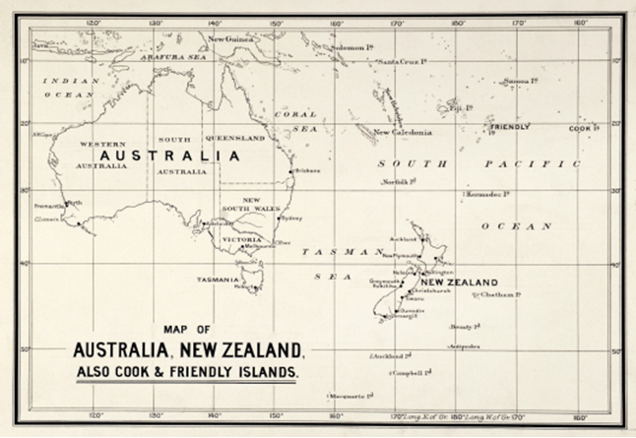
‘Map of Australia, New Zealand, Cook & Friendly Islands (1900)’ is available in the public domain.
Access Islander labourers.
- What changes between 1840 and 1868 led to a shortage of cheap labour?
- What 3 reasons led the sugar industry to believe that ‘coloured’ labour was necessary?
- Summarise the different attitudes towards the use of Islander labourers.
- Explain why attempts to regulate the rules around Pacific Islander labour were generally ineffective.
Source 2 – extract from Kanaka – A History of Melanesian Mackay, C. Moore
‘Kidnapping was common in the Solomons in the 1870s, mirroring the initial phase of the labour trade in the New Hebrides [now Vanuatu] in the 1860s … The Islanders often thought the men on the big ships wanted to barter … but when they tried to trade … their canoes were smashed and they were forced on board … Others were kidnapped from their canoes while they were fishing.’
Create a PEEL paragraph to explain why South Sea Islander people came to Australia prior to 1900. Use evidence from Source 2 and your understanding from the previous activities.

South Sea Islanders living and working in Australia
Figure 2 – “Our boys” Lillock and Peter c. 1877
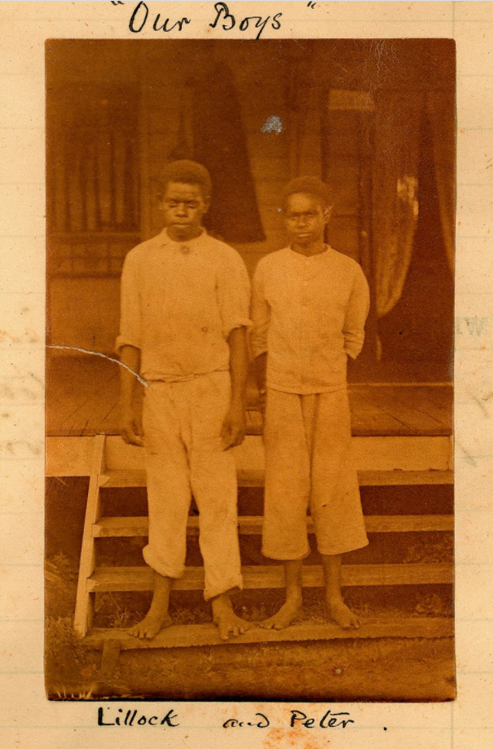
‘“Our boys” Lillock and Peter c. 1877’ from South Sea Islanders working at the Hollow.
Use the photograph (Figure 2) to:
- outline where and when the photograph was taken
- describe the boys’ clothing and appearance
- explain why you think the photograph was taken
- explain the significance of the label ‘our boys’.
Note: students will need to understand what mortality rate means for the next activity.
Examine Source 3 and complete the activities that follow.
Source 3 – Mortality rates 1868–1906, adapted from Australian South Sea Islanders in Queensland
The mortality rate for Pacific Islanders in their first year in Queensland was 81 per 1000. For ticket-holders (Pacific Islanders in Australia outside of the indenture system) mortality rates were 14 per 1000 – a similar rate to Europeans in Queensland.
- One argument, made at the time, in favour of using Islander labour is that white people were not suited to working in the tropical climate. Do the mortality rates support this?
- Complete a Think-Pair-Share to generate a list of possible reasons for the high mortality rate among Islanders.
Access the clip Blackbirding descendants fight for Australian South Sea Islander recognition (6:21) and respond to the following:
- How were many Islander workers treated by the ship captains and landowners?
- Landowners paid the equivalent to about $1000 for each South Sea Islander. How does this make you feel?
- Why was the recognition of the South Sea Islanders as a specific group by the Australian Federal Government in 1994 so important?

South Sea Islander contribution to development
Access the clip The Sugar Labour Trade (4:05). In it the Queensland Labour System is described as being the subject of ‘fierce controversy’.
- What was controversial about it?
- Where was most opposition located?
- What were the arguments for the continuation of the system?
Examine Australian South Sea Islanders and write 2 to 3 sentences summarising the contributions that South Sea Islanders have made to Australia.

Learning sequence 4 – developing Australian self-government and democracy
This learning sequence will take approximately 4 hours to complete. Students will have opportunities to develop a range of historical skills, particularly perspectives and interpretations, research, and explanation and communication and their conceptual understanding of continuity and change, cause and effect, perspectives and significance as they progress through the sequence. Students may require support with elements of literacy, particularly historically contextual vocabulary, in this learning sequence. Activities can be adapted to local contexts to support the creation of culturally safe classrooms. Some activities can be adapted to asynchronous learning.

Syllabus content
Key events and ideas in the development of Australian self-government and democracy, including women’s voting rights.
Students:
- explain how and why Federation (1901) was achieved
- outline state and federal responsibilities under the Australian Constitution
- discuss the consequences of the introduction of the Australian Constitution for the rights of women and Aboriginal people

Learning intentions and success criteria
Note: these learning intentions and success criteria are general and should be contextualised to suit your school and students’ needs.
Students will:
- know about the key events and ideas in the development of Australian self-government and democracy, including women’s voting rights
- understand how the introduction of the Australian Constitution impacted the rights of women and Aboriginal people.
Students will be able to:
- explain how and why Federation (1901) was achieved
- discuss how Federation contributed to change in Australia.

The path to Federation
Examine Secret ballot introduced. Your teacher will lead a class discussion based on the following questions:
- If you could not vote, how could you influence the electoral process? How is this reflected in the cartoon ‘Electioneering in the pub’?
- Prior to 1850, who could vote in the NSW Legislative Council elections? Approximately how much of Australia was included in the colony of NSW at this time?
- Why was voting eligibility extended to men who owned land worth more than £100 or who rented property for £10 or more each year?
- How did the Chartist movement and the Eureka Stockade influence electoral changes in the 1850s?
- Why did South Australia become known as the most liberal electorate in the world?
Access the clip Australia’s Federation - Behind the News (4:51) and summarise how federation was achieved using Cornell summary notes (4:04).
Use Getting it Together to understand the road to federation. Your teacher will assign you to a group representing a colony of Australia. Each group will research the road to federation for their colony. Complete Investigation 1 to Investigation 5 of Road to federation (see the resources linked below) and apply your understanding to create a brief group presentation outlining:
- the pros and cons of federation for your colony
- what your colony may need to negotiate as part of federation.
Resources
- NSW Road to federation
- QLD Road to federation
- SA Road to federation
- TAS Road to federation
- VIC Road to federation
- WA Road to federation
Use Table 7 to take notes on each colony as your peers make their presentation. Participate in a conference at the end of each presentation to clarify your understanding and to provide feedback on the presentation.
Table 7 – colonial pros and cons of Federation
Colony | Pros | Cons | Negotiation concerns
NSW
QLD
SA
TAS
VIC
WA
Use your Cornell summary notes, and your completed Table 7 to create an essay plan in response to the question ‘Why were the factors that promoted Federation greater than those that opposed it?’ Your plan will need a developed thesis statement and 3 to 4 paragraphs.
- Display your thesis statement and essay plan as part of a class gallery walk. Provide feedback on 3 of the exhibitions in the gallery walk. Your teacher will tell you how to do this.

State and federal responsibilities
Examine the information on the Division of Powers between Federal, State and Local.
- If there is a state or territory law that is in conflict with a federal law, which will be upheld?
- Which court of Australia resolves any disputes over the division or separation of powers?
Examine the poster Division of Powers and answer the following questions:
- Choose the 3 areas of federal responsibility that you think most impact on your life, and explain your choices.
- Choose the 3 areas of state responsibility that you think impact most on your life, and explain your choices.
- Reflect on the 7 areas of shared responsibility. Are you surprised by any of the responsibilities on this list? Explain why this overlap surprises you.
How often does the division or separation of powers impact on your daily life? Look at the table Who Does What? In the course of a normal day, are you more impacted by federal or state responsibilities and decisions?

Consequences for women and First Australians
Examine the painting and the engraving that depict the Duke of Cornwall and York opening the First Commonwealth Parliament of Australia on 9 May 1901, and describe the people you can see in these 2 images.
- Who is not represented in these celebrations?
- Why do you think they were excluded?
Engage with the Commonwealth of Australia Constitution Act Amendment to Section 127, page 24 and the answer provided to the question How did Federation affect Aboriginal and Torres Strait Islander people? Using these sources, what can you infer about the consequences of Federation for First Australians?
Examine the information included in Changing Policies Towards Aboriginal People – Protection. Apply your understanding of the Constitution to explain how colonial policies that focused on First Nation Australians were impacted by Federation.
Engage with Women’s suffrage and consider the impact of the Commonwealth Franchise Act (1902) on women in Australia.
- Create an infographic to communicate how women experienced different consequences due to their ethnicity and statehood.
Observe the information under the subheading Votes for Women 1902. Use the information and the resources available at How to interpret the meaning of political cartoons to decode the meaning of the Bulletin, July 1902 cartoon, ‘The Fall of Women’.
Research the role of Vida Goldstein in global suffrage movements. Create a Storyboard to communicate her most significant actions as a suffragist. Possible research resources include:
- Goldstein, Vida Jane
- Vida Goldstein and Maud Wood Park.
Take part in a True for Who? activity to reflect on the statement: ‘The new ideas that resulted in federation significantly changed the lives of Australians’.

Learning sequence 5 – legislation 1901–1914
This learning sequence will take approximately 3 hours to complete. Students will have opportunities to develop a range of historical skills, particularly comprehension: chronology, terms and concepts, analysis and use of sources and explanation and communication, and develop their conceptual understanding of continuity and change, significance, and contestability as they progress through the sequence. Students may require support with elements of literacy, particularly historically contextual vocabulary, and numeracy, particularly proportional thinking, in this learning sequence. Activities can be adapted to local contexts to support the creation of culturally safe classrooms. Some activities can be adapted to asynchronous learning.

Syllabus content
Legislation 1901 to 1914, including the Harvester Judgment, pensions and the Immigration Restriction Act.
Students:
- identify key features of the Harvester Judgment, pensions legislation and the Immigration Restriction Act and discuss what they reveal about the kind of society the Australian government aimed to create
- assess the impact of this legislation on Australian society in this period

Learning intentions and success criteria
Note: these learning intentions and success criteria are general and should be contextualised to suit your school and students’ needs.
Students will:
- know what the key features of the Harvester Judgment, pensions legislation and the Immigration Restriction Act are
- understand how the Harvester Judgment, pensions legislation and the Immigration Restriction Act contributed to change in Australia, to 1914.
Students will be able to:
- assess how legislation contributed to change in Australian society.

Shaping an Australian society
Note: this activity allows students to attempt a dictation test similar to the Dictation Test used by Immigration officials as part of the White Australia Policy. The languages other than English capacity of the class should be considered before choosing a language. Options include French: Family life, home and neighbourhood: Activity 1 – au téléphone (0:58), modern Greek: Family life, home and neighbourhood: Activity 1 – conversation (shopping) (1:54), Spanish: Family life, home and neighbourhood: Activity 1 (1:24) or another language that was spoken during the period (including English). An option for hearing impaired students is Sofie speaking Dutch sign language (1:00), remembering to turn off closed captions. When choosing a language, it is important to remember that the test was designed to exclude. It is not necessary to complete an entire dictation passage for students to have the opportunity to empathise with prospective migrants and their negative experience of the Immigration Restriction Act.
You are going to sit a dictation test. To pass, you must write out the passage dictated to you. The passage will have at least 50 words. You must not have any errors in spelling or grammar to pass this test. The passage will be read to you once, in full. It will then be repeated, with pauses, for you to write down.
- Reflect on how the test made you feel and how useful the test was to demonstrate your English language ability. What do you think the purpose of the test was? Your teacher will lead a class discussion to share thinking.
Examine the circular (original or transcript) and find 2 quotations that could be used as evidence to demonstrate that the Dictation Test was designed to be failed.
Note: the following numeracy activity targets Proportional Thinking at level PrT2 from the National Numeracy Learning Progressions 2020. The activity may need to be modified to support students to develop their numeracy skills and understanding. Teachers could model the first response: 1902 to 1903, the dictation test was used 805 times. 46 people passed. As a number sentence, this is the same as 46 ÷ 805 = 0.057. To convert to a percentage, times by 100. 46 ÷ 805 × 100 = 5.7%. So, between 1902 and 1903, only 5.7% of the 805 migrants who were deemed ‘undesirable’ passed the dictation test.
Examine the Educational value notes from Directions for applying the dictation test.
- What percentage of immigrants who sat the test between 1902 and 1903 passed?
- What percentage of immigrants who sat the test between 1904 and 1909 passed?
- What percentage of immigrants who sat the test between 1910 and 1927 passed?
- Briefly explain the pattern of continuity or change evident in your data.
- Why did Australia develop the Dictation Test instead of legislating a ban on non-European migrants?
Examine Immigration Restriction Act 1901 with a focus on sections 3(a to g) and the Pacific Island Labourers Act 1901.
- What do you notice about the people who were being excluded from the new nation state of Australia?
- What can you infer about why these people were being excluded?
- Consider how different groups of Australians were impacted by the Immigration Restriction Act 1901 and the Pacific Island Labourers Act 1901. Create a concept map to identify these groups and reflect on what aspects of life would have been impacted.
Access the clip Immigration Nation part 1 (55:11) (from 2:09–26:58) and complete a Quick write activity about the White Australia Policy.
How effective was the Dictation Test in achieving the aims of the White Australia Policy as set out in the Immigration Restriction Act 1901? Use an Extent Barometer template from Thinking skills to communicate your judgment.
Use the following resources and your own research to create an annotated timeline from 1904 to 1908 to communicate key legal and legislative features of the Harvester case.
- Commonwealth Conciliation and Arbitration Act 1904 (PDF 525 KB)
- The Excise Tariff 1906N
- Defining moments – Harvester Judgment
Note: the sources extract 1 and extract 2 of the Harvester case are sophisticated texts (see Australian Curriculum National Literacy Learning Progression – Appendix 6 – Text complexity) and may be challenging for some students to access. Students may require support to access the vocabulary, language and content. Resources to support the explicit teaching of literacy can be found at the department’s webpage Literacy – explicit teaching strategies in Stage 5.
Examine extract 1 and extract 2 of the Harvester case.
- How did Justice Higgins gather evidence to support his determination?
- What items did Justice Higgins think should be accessible on the minimum wage?
- What similarities and differences do you notice between your classes’ thoughts about what should be affordable on a minimum wage and Justice Higgins’ determination?
The Harvester Judgment was ultimately overturned in 1908 by the High Court of Australia, as the Constitution did not allow the Commonwealth to set wages or working conditions. However, in his role as President of the Conciliation and Arbitration Court, Justice Higgins always acted as if the Harvester Judgment was binding. This influenced federal awards and industrial disputes, and any state industrial issues that were referred to the Conciliation and Arbitration Court. Many state-based industrial relations bodies also used Justice Higgins’ research and logic and so the basic living wage determined by the Harvester case gradually became the foundation of the idea of a standard minimum wage in Australia.
Note: students will need to understand the terms ‘social security’ and ‘socialist democracy’ to complete the following activities.
Although the Constitution did not allow the Commonwealth to set wages or working conditions, there was provision for social security. Examine Section 51 in Chapter 1: The Parliament – Part V – Powers of the Parliament of the Australian Constitution and identify the types of social security that were embedded in the 1900 Constitution.
Use information from Age and invalid pensions to create an infographic that communicates when, how and why legislation was passed to enact Article 23, Part V, Ch1 of the Australian Constitution. You might consider the following when creating your infographic:
- Which groups in society cared for the elderly and infirm before the legislation?
- What economic event created media focus on the needs of the elderly and infirm?
- What limitations were put on who could access the pension?
Identify other social and political innovations that could be used as evidence that Australia was a socialist democracy.
Examine the concept of Australia as a working man’s paradise. To what extent did the Immigrations Restriction Act 1901, Harvester Judgment and the Invalid and Old-Age Pensions Act 1908 support the idea that Australia was a working man’s paradise?
Complete a True for Who? activity that draws on the class Perspective, Pros, Cons, Questions templates in response to the statement ‘Australia 1901 to 1914 was a workers’ paradise’.

Assessment task
Note: when using this task, ensure it is placed on the school template and follows all assessment requirements. This task requires students to apply the historical concepts of significance, and the historical skill of analysis and use of sources and explanation and communication, to respond to the key inquiry question: How did new ideas and technological developments contribute to change in this period? The specific syllabus content points from this depth study will vary as a result of student choice. Students can use sources that they have studied as part of these learning sequences. The product being assessed can be differentiated to allow all students to engage with representations of their knowledge and understanding.

Outcomes
- HT5-1 explains and assesses the historical forces and factors that shaped the modern world and Australia
- HT5-9 applies a range of relevant historical terms and concepts when communicating an understanding of the past
History K–10 Syllabus © NSW Education Standards Authority (NESA) for and on behalf of the Crown in right of the State of New South Wales, 2012.

Syllabus content
Key inquiry question:
How did new ideas and technological developments contribute to change in this period?

Concepts
Significance: the importance of an event, development, group or individual and their impact on their times and/or later periods, for example, the importance of the changes brought about by the Industrial Revolution; the importance of World War II on Australia’s relations with other countries.

Skills
Analysis and use of sources
- identify different types of sources
- identify the origin, content, context and purpose of primary and secondary sources
- process and synthesise information from a range of sources as evidence in an historical argument
Explanation and communication
- develop historical texts, particularly explanations and historical arguments that use evidence from a range of sources
- select and use a range of communication forms, such as oral, graphic, written and digital, to communicate effectively about the past for different audiences and different purposes.

Task
The National Museum of Australia (NMA) has invited you to be part of the curation team on a new project called ‘Making a Nation’. The brief for your role is to submit 3 primary sources from the period 1788 to 1914, along with the exhibition label that will help visitors to the museum understand how these sources communicate the impact of new ideas and technological developments on change in Australia.
You will need to:
- select one new idea or technological development as the focus of your exhibition
- select 3 primary sources that you think clearly reflect the impact of the new idea or technological development that you have chosen on change in Australia up to 1914
- your exhibition label for each source should
- identify the type, origin and purpose of each source
- explain what the source contributes to an understanding of the impact of the new idea or technological development on Australia up to 1914
- be presented in a consistent format, using historical terms and concepts appropriate for display in an NMA exhibition.
- assess the significance of the new idea or technological development on change in Australia up to 1914 by
- colouring in the extent barometer (Figure 3) to indicate the importance of your new idea or technological development on change in Australia up to 1914
Figure 3 – extent barometer
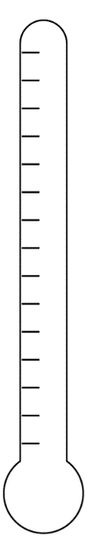
- choosing a modality word to accurately communicate your judgment.
- create an introduction to the exhibition that
- communicates your assessment of the significance of the new idea or technological development on change in Australia up to 1914
- use historical terms and concepts appropriate for display in an NMA exhibition.

Marking criteria
Mark | Marking criteria
A | - Makes a coherent judgment of the significance of a new idea or technological development on change in Australia  - Clearly explains how the selected sources demonstrate the impact of a new idea or technological development on change in Australia up to 1914  - Effectively applies a range of relevant historical terms and concepts appropriate for a museum display
B | - Makes a judgment of the significance of a new idea or technological development on change in Australia  - Explains how the selected sources relate to the impact of a new idea or technological development on change in Australia up to 1914  - Applies a range of relevant historical terms and concepts
C | - Attempts to make a judgment of the significance of a new idea or technological development on change in Australia  - Attempts to explain how the selected sources relate to the impact of a new idea or technological development on change in Australia up to 1914  - Uses historical terms and concepts
D | - Demonstrates basic understanding of the relationship between a new idea or technological development and change in Australia  - Selects and describes sources relevant to the impact of a new idea or technological development on change in Australia up to 1914  - Attempts to use historical terms or concepts
E | - Demonstrates elementary understanding of the relationship between new ideas or technologies and change in Australia  - Presents sources

Additional information
The information below can be used to support teachers when using this teaching resource for Stage 5 history.

Support and alignment
Resource evaluation and support: all curriculum resources are prepared through a rigorous process. Resources are periodically reviewed as part of our ongoing evaluation plan to ensure currency, relevance, and effectiveness. For additional support or advice contact the HSIE Curriculum team by emailing hsie@det.nsw.edu.au.
Explicit teaching: further advice to support explicit teaching is available on the Explicit teaching webpage. This includes the CESE Explicit teaching – Driving learning and engagement webpage.
Alignment to system priorities and/or needs: School Excellence Policy, Our Plan for NSW Public Education.
Alignment to the School Excellence Framework: this resource supports the School Excellence Framework elements of curriculum (curriculum provision) and effective classroom practice (lesson planning, explicit teaching).
Alignment to Australian Professional Teaching Standards: this resource supports teachers to address Australian Professional Teaching Standards 3.2.2, 3.3.2.
Consulted with: Curriculum and Reform, Inclusive Education, Multicultural Education, Aboriginal Outcomes and Partnerships and subject matter experts
NSW syllabus: History K–10 Syllabus © 2012 NESA
Syllabus outcomes: HT5-1, HT5-2, HT5-4, HT5-7, HT5-9, HT5-10
Author: HSIE Curriculum Team
Publisher: State of NSW, Department of Education
Resource: program of learning
Related resources: further resources to support history Stage 5 can be found on the HSIE K–12 curriculum page and the HSC hub.
Professional learning: relevant professional learning is available through the HSIE Statewide staffroom.
Creation date: January 2024
Rights: © State of New South Wales, Department of Education

Appendix 1 – working class housing
Figure 4 – Views taken during Cleansing Operations, Quarantine Area, Sydney, 1900, Vol. III, under the supervision of Mr George McCredie, F.I.A., N.S.W – No.1 Victoria Place, Sydney (NSW)
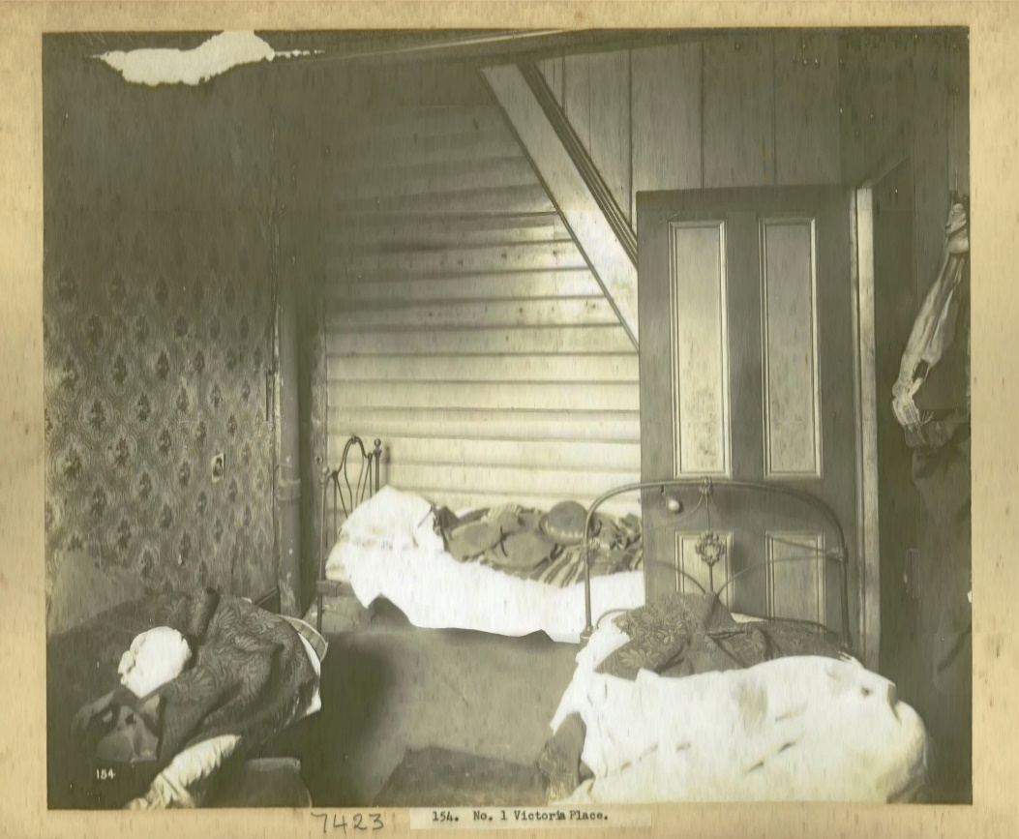
‘Views taken during Cleansing Operations, Quarantine Area, Sydney, 1900, Vol. III, under the supervision of Mr George McCredie, F.I.A., N.S.W – No.1 Victoria Place, Sydney (NSW)’, from the Museums of History New South Wales.
Figure 5 – Views taken during Cleansing Operations, Quarantine Area, Sydney, 1900, Vol. V, under the supervision of Mr George McCredie, F.I.A., N.S.W – Rear of No.54 Campbell Street, Sydney (NSW)
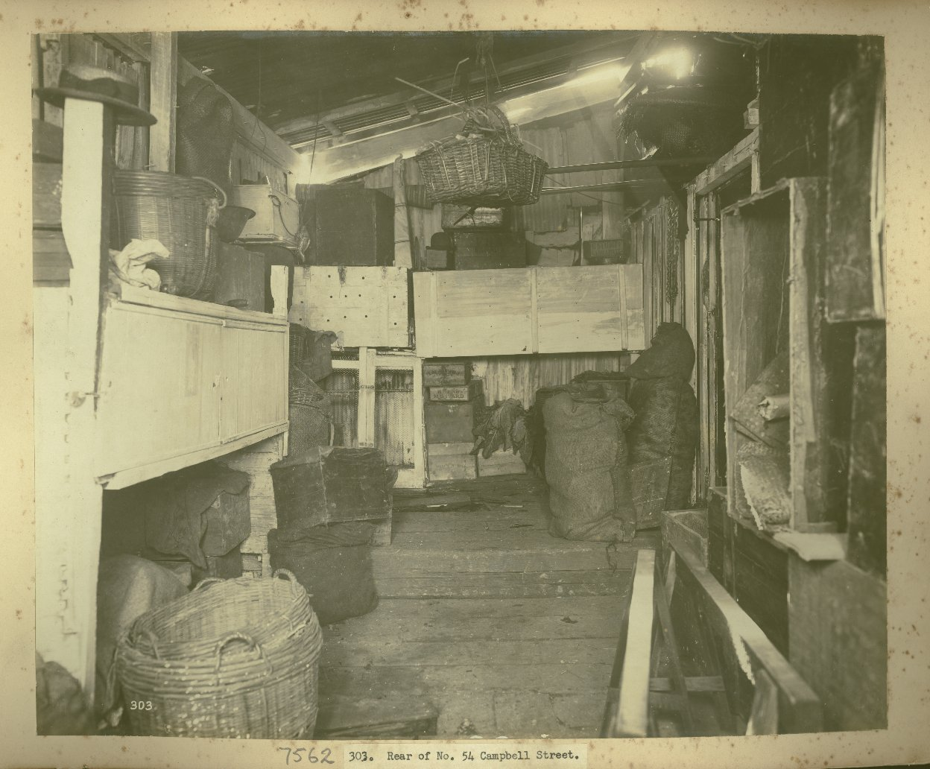
‘Views taken during Cleansing Operations, Quarantine Area, Sydney, 1900, Vol. V, under the supervision of Mr George McCredie, F.I.A., N.S.W – Rear of No.54 Campbell Street, Sydney (NSW)’, from the Museums of History New South Wales.
Figure 6 – Views taken during Cleansing Operations, Quarantine Area, Sydney, 1900, Vol. V, under the supervision of Mr George McCredie, F.I.A., N.S.W – Stables at the rear of No.30-32 Oxford Street, Sydney (NSW)
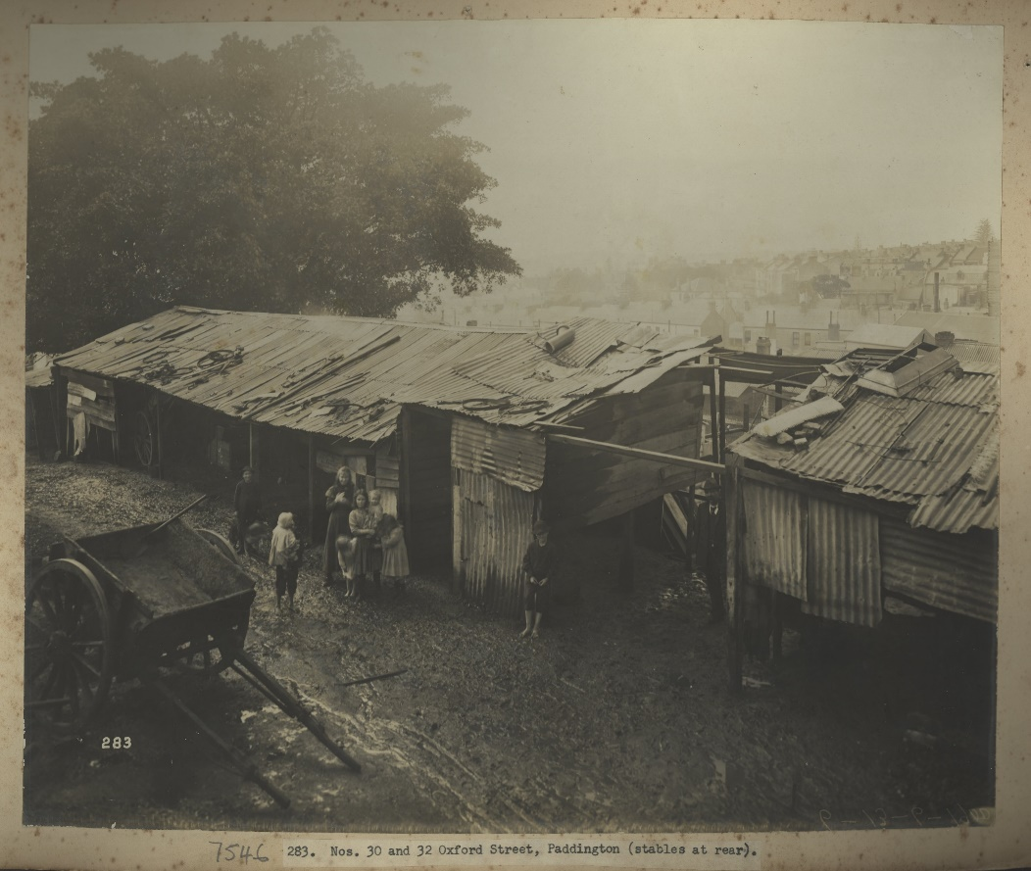
‘Views taken during Cleansing Operations, Quarantine Area, Sydney, 1900, Vol. V, under the supervision of Mr George McCredie, F.I.A., N.S.W – Stables at the rear of No.30-32 Oxford Street, Sydney (NSW)’, from the Museums of History New South Wales.
Figure 7 – Views taken during Cleansing Operations, Quarantine Area, Sydney, 1900, Vol. V, under the supervision of Mr George McCredie, F.I.A., N.S.W – Rear of N0.405 Pitt Street, Sydney
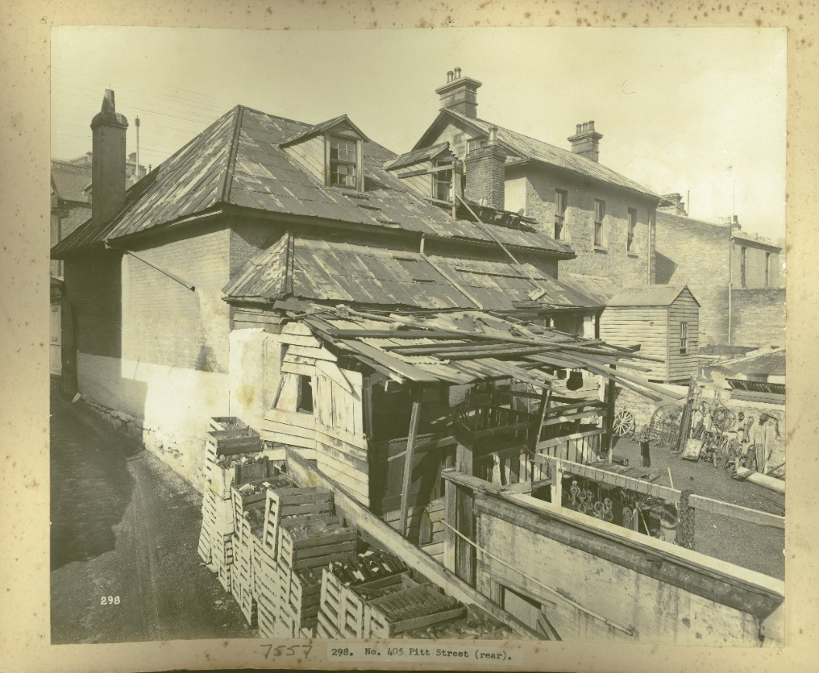
‘Views taken during Cleansing Operations, Quarantine Area, Sydney, 1900, Vol. V, under the supervision of Mr George McCredie, F.I.A., N.S.W – Rear of N0.405 Pitt Street, Sydney’, from the Museums of History New South Wales.

Appendix 2 – food handling
Figure 8 – Views taken during cleansing operations in quarantine areas, Sydney plates 265 – 330. Kitchen in No. 841 George Street, Sydney
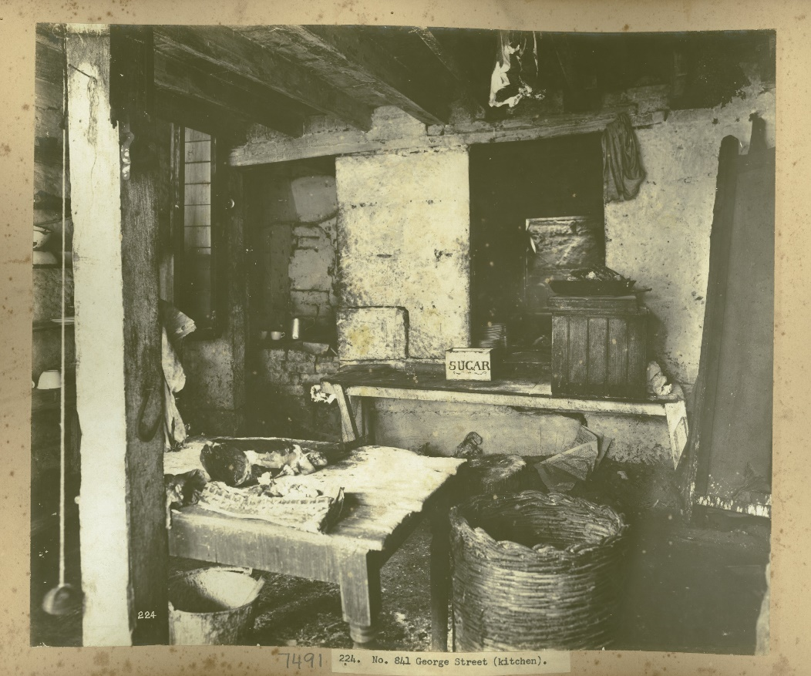
‘Views taken during cleansing operations in quarantine areas, Sydney plates 265 – 330. Kitchen in No. 841 George Street, Sydney’, from the Museums of History New South Wales.
Figure 9 – Views taken during cleansing operations in quarantine areas, Sydney plates 199 – 264 Sutton Forest Butchery, No.761 George Street, Sydney
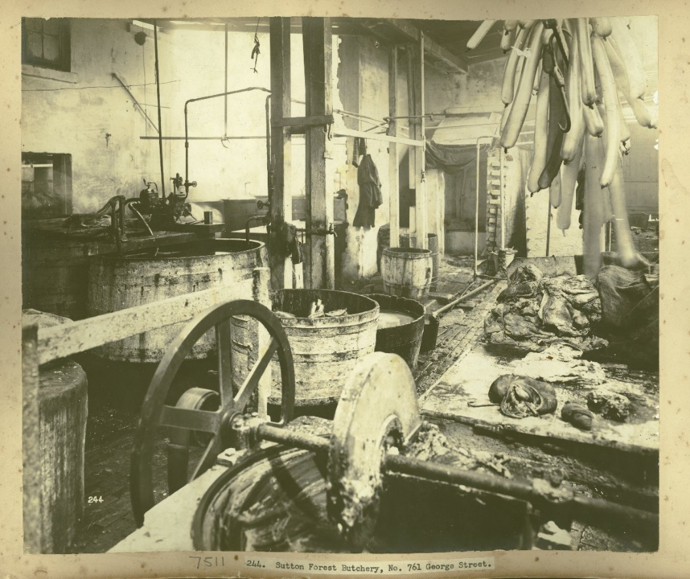
‘Views taken during cleansing operations in quarantine areas Sydney plates 199 – 264 Sutton Forest Butchery, No.761 George Street, Sydney’, from the Museums of History New South Wales.
Figure 10 – Views taken during Cleansing Operation, Quarantine Area, Sydney, 1900, Vol. III, under the supervision of Mr George McCredie, F.I.A., N.S.W – Rear of butchers yard and WC [toilet facilities]
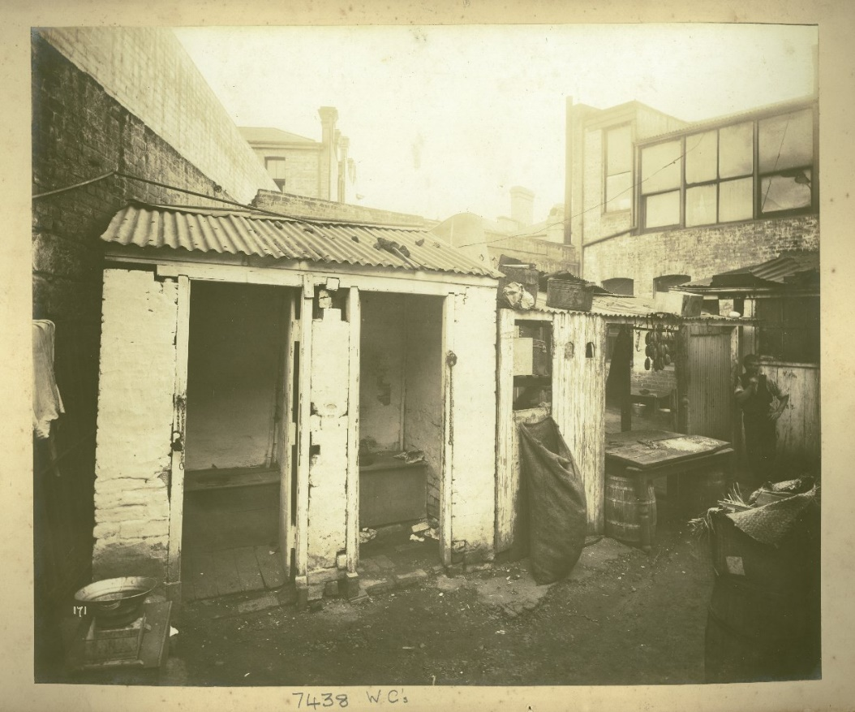
‘Views taken during Cleansing Operations, Quarantine Area, Sydney, 1900, Vol. III, under the supervision of Mr George McCredie, F.I.A., N.S.W – Rear of butchers yard and WC [toilet facilities]’, from the Museums of History New South Wales.
Figure 11 – Views taken during cleansing operations in quarantine areas, Sydney plates 133 – 198. Rear of 585 George St showing Weir’s Butcher Shop, Sydney
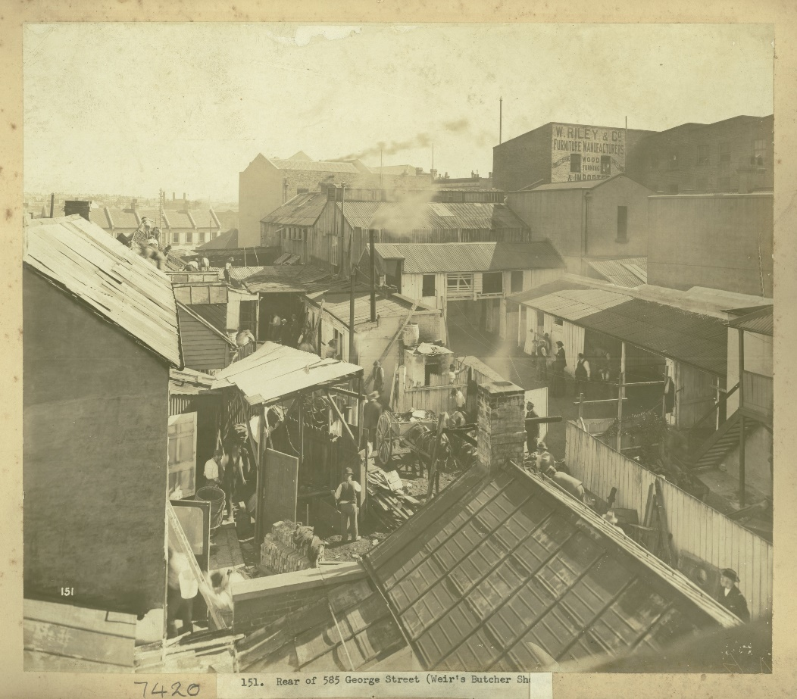
‘Views taken during cleansing operations in quarantine areas, Sydney plates 133 – 198. Rear of 585 George St showing Weir’s Butcher Shop, Sydney’, from the Museums of History New South Wales.

Appendix 3 – toilets
Figure 12 – Views taken during cleansing operations in quarantine areas, Sydney plates 133 – 198. Rear of No. 2 Walton Place, Sydney
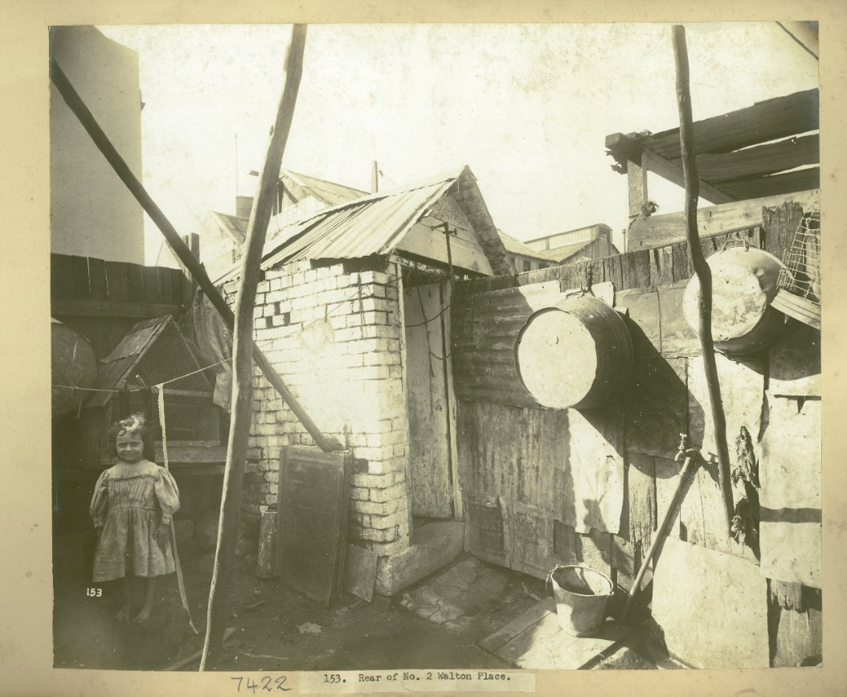
‘Views taken during cleansing operations in quarantine areas, Sydney plates 133 – 198. Rear of No. 2 Walton Place, Sydney’, from the Museums of History New South Wales.
Figure 13 – Views taken during Cleansing Operations, Quarantine Area, Sydney, 1900, Vol. III, under the supervision of Mr George McCredie, F.I.A., N.S.W – Rear of Alderson Street, Sydney (NSW)
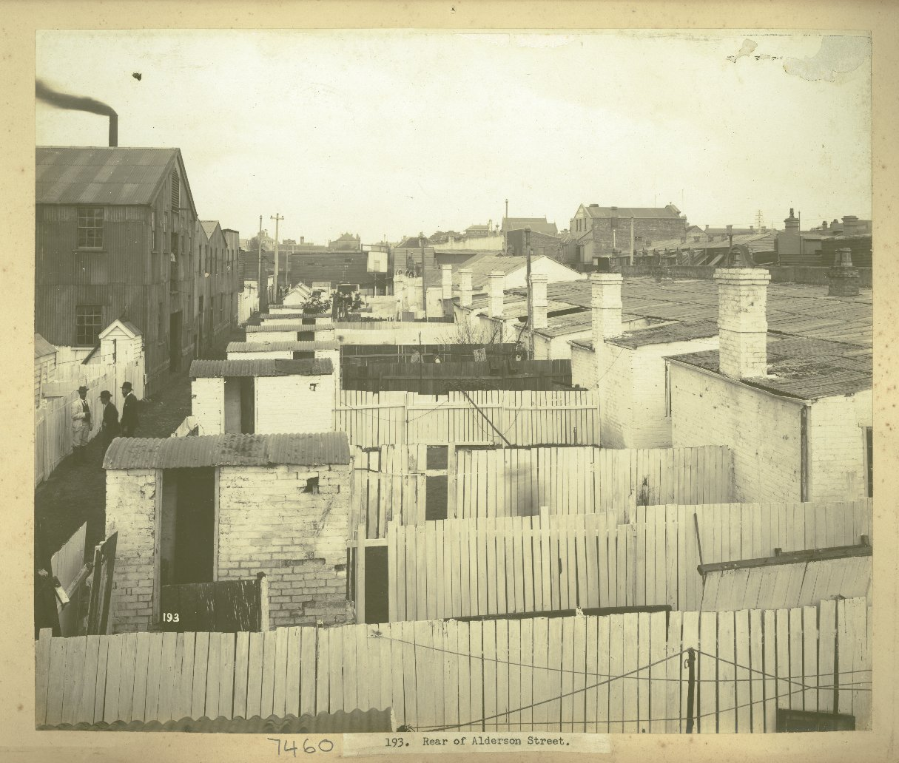
‘Views taken during Cleansing Operations, Quarantine Area, Sydney, 1900, Vol. III, under the supervision of Mr George McCredie, F.I.A., N.S.W – Rear of Alderson Street, Sydney (NSW)’, from the Museums of History New South Wales.
Figure 14 – Views taken during Cleansing Operations, Quarantine Area, Sydney, 1900, Vol. V, under the supervision of Mr George McCredie, F.I.A., N.S.W – Rear of 129 Gloucester Street, Sydney (NSW)
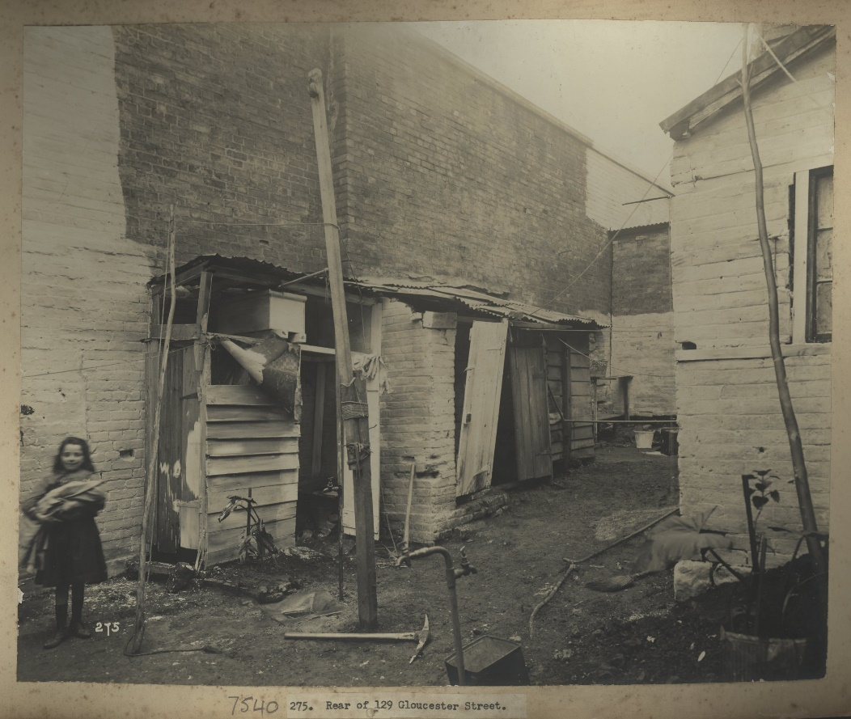
‘Views taken during Cleansing Operations, Quarantine Area, Sydney, 1900, Vol. V, under the supervision of Mr George McCredie, F.I.A., N.S.W – Rear of 129 Gloucester Street, Sydney (NSW)’, from the Museums of History New South Wales.
Figure 15 – Views taken during Cleansing Operations, Quarantine Area, Sydney, 1900, Vol. II, under the supervision of Mr George McCredie, F.I.A., N.S.W - Rear of No.16, Exeter Place, Sydney (NSW) - [showing toilet facilities]
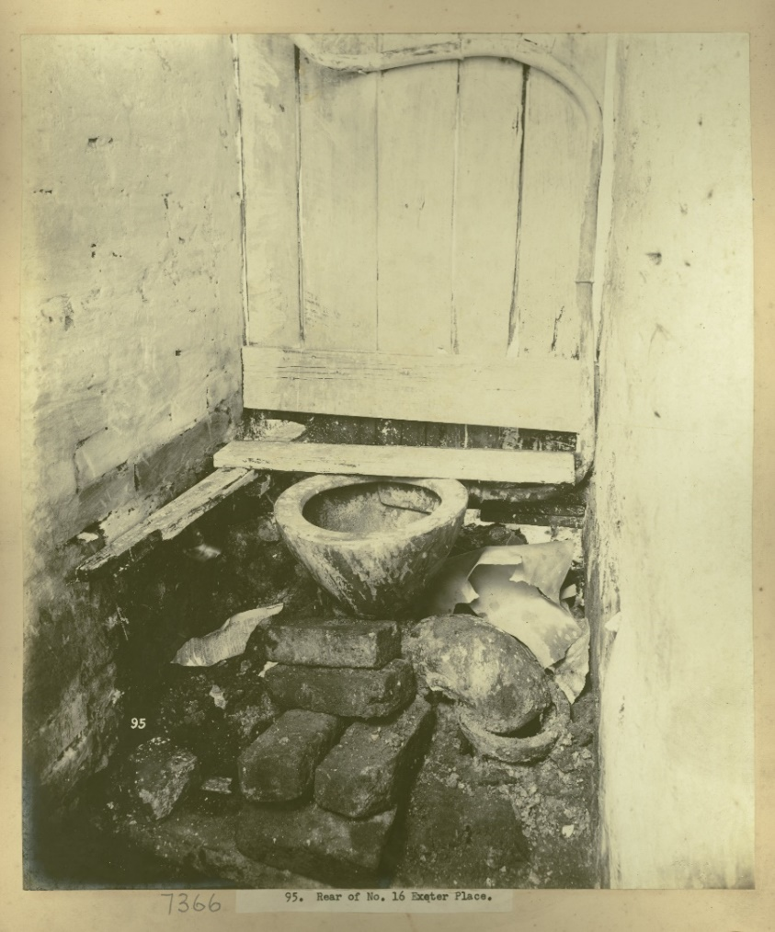
‘Views taken during Cleansing Operations, Quarantine Area, Sydney, 1900, Vol. II, under the supervision of Mr George McCredie, F.I.A., N.S.W - Rear of No.16, Exeter Place, Sydney (NSW) - [showing toilet facilities]’, from the Museums of History New South Wales.

Appendix 4 – waste management
Figure 16 – Views taken during Cleansing Operations, Quarantine Area, Sydney, 1900, Vol. IV, under the supervision of Mr George McCredie, F.I.A., N.S.W - Rear of No.115 York Street, Sydney (NSW)
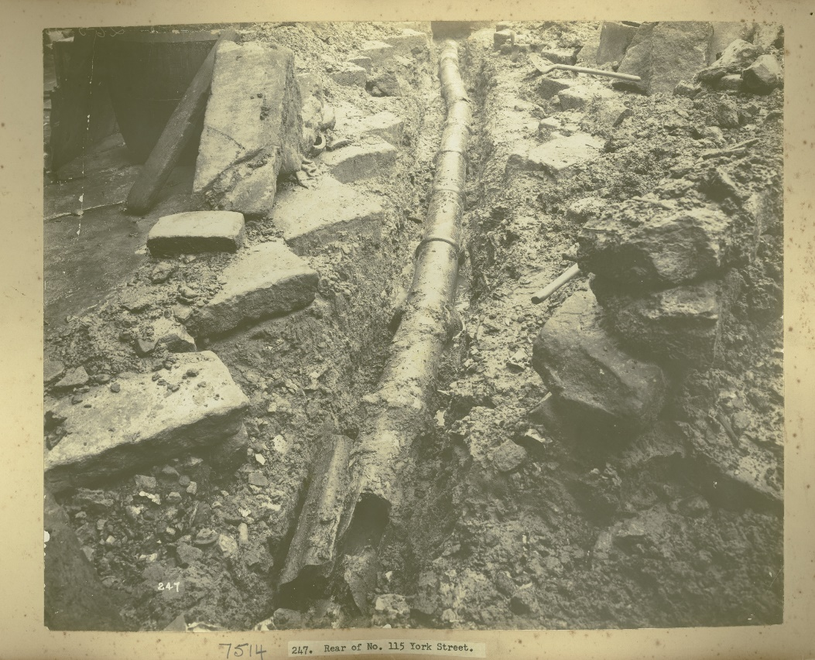
‘Views taken during Cleansing Operations, Quarantine Area, Sydney, 1900, Vol. IV, under the supervision of Mr George McCredie, F.I.A., N.S.W - Rear of No.115 York Street, Sydney (NSW)’, from the Museums of History New South Wales.
Figure 17 – Views taken during Cleansing Operations, Quarantine Area, Sydney, 1900, Vol. II, under the supervision of Mr George McCredie, F.I.A., N.S.W – Open trench in Washington Street, where bones, horns, and old piles were unearthed, Sydney (NSW)
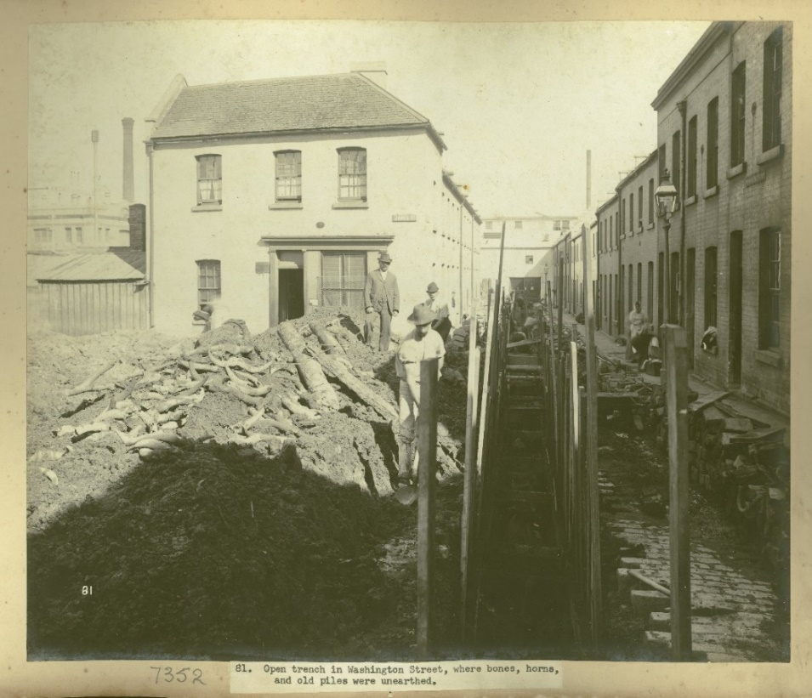
‘Views taken during Cleansing Operations, Quarantine Area, Sydney, 1900, Vol. II, under the supervision of Mr George McCredie, F.I.A., N.S.W – Open trench in Washington Street, where bones, horns, and old piles were unearthed, Sydney (NSW)’, from the Museums of History New South Wales.
Figure 18 – Views taken during Cleansing Operations, Quarantine Area, Sydney, 1900, Vol. II, under the supervision of Mr George McCredie, F.I.A., N.S.W - Rubbish tip, Campbell Street, Sydney (NSW)
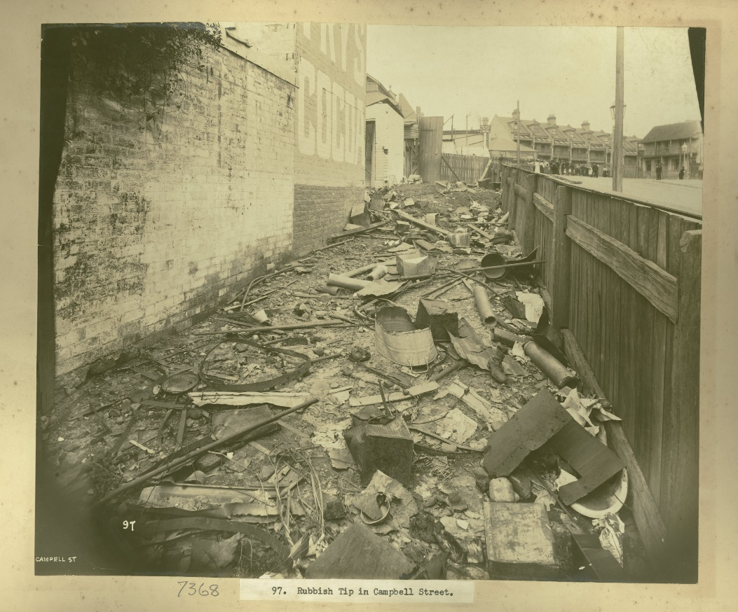
‘Views taken during Cleansing Operations, Quarantine Area, Sydney, 1900, Vol. II, under the supervision of Mr George McCredie, F.I.A., N.S.W - Rubbish tip, Campbell Street, Sydney (NSW)’, from the Museums of History New South Wales.
Figure 19 – Views taken during Cleansing Operations, Quarantine Area, Sydney, 1900, Vol. III, under the supervision of Mr George McCredie, F.I.A., N.S.W - Clearing the rubbish at Smith's Wharf
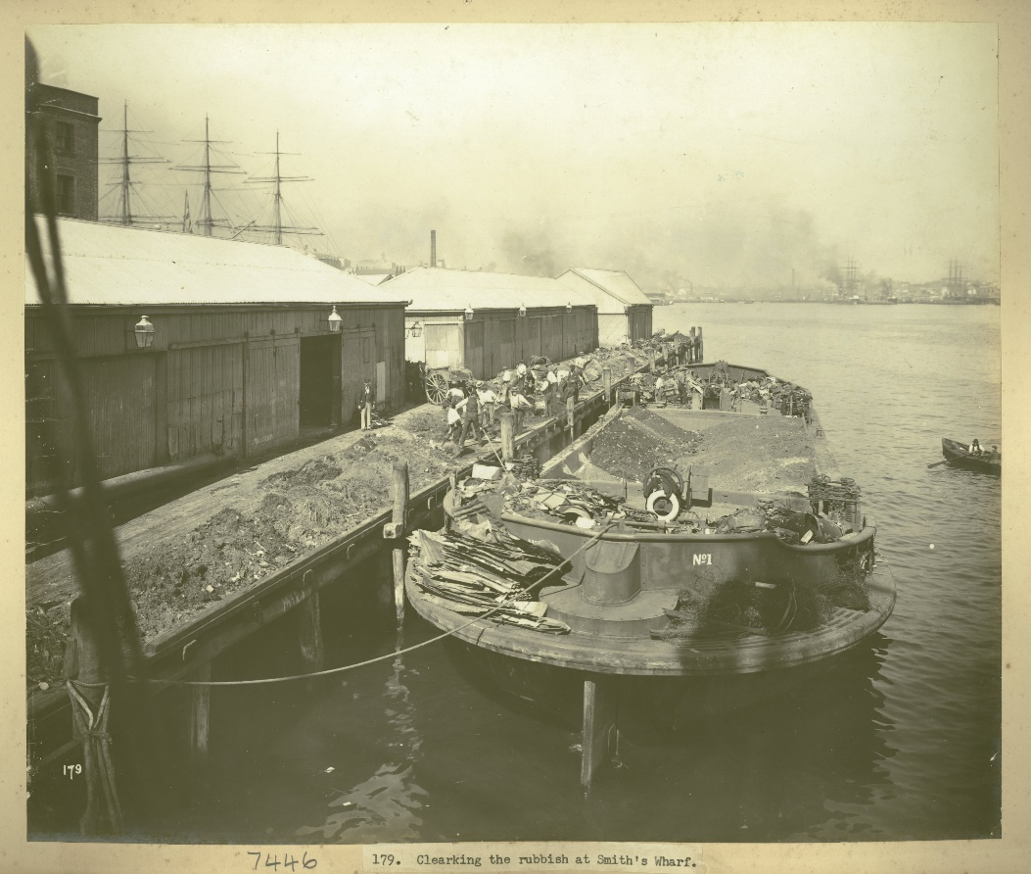
‘Views taken during Cleansing Operations, Quarantine Area, Sydney, 1900, Vol. III, under the supervision of Mr George McCredie, F.I.A., N.S.W - Clearing the rubbish at Smith's Wharf’, from the Museums of History New South Wales.

Appendix 5 – pest management
Figure 20 – Views taken during Cleansing Operations, Quarantine Area, Sydney, 1900, Vol. V, under the supervision of Mr George McCredie, F.I.A., N.S.W - A heap of rats
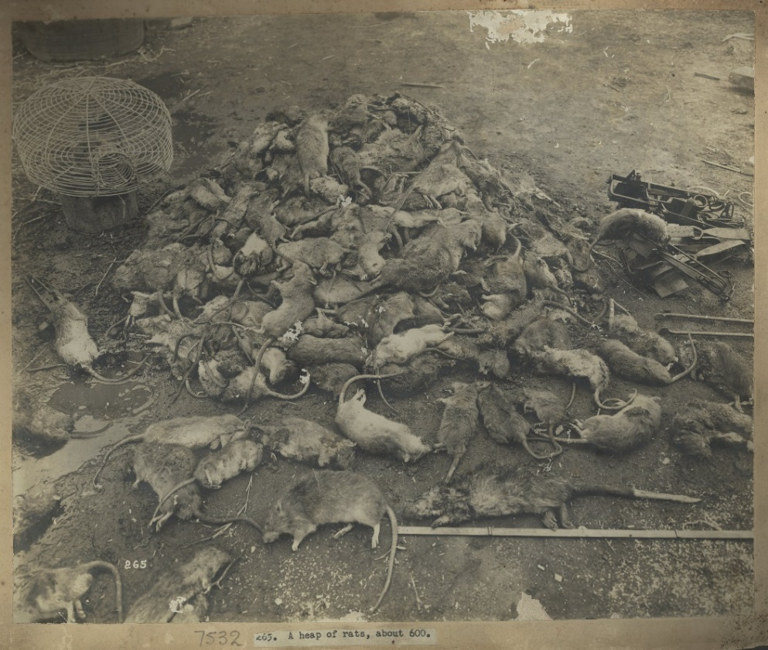
‘Views taken during Cleansing Operations, Quarantine Area, Sydney, 1900, Vol. V, under the supervision of Mr George McCredie, F.I.A., N.S.W - A heap of rats’, from the Museums of History New South Wales.
Figure 21 – Views taken during Cleansing Operations, Quarantine Area, Sydney, 1900, Vol. IV, under the supervision of Mr George McCredie, F.I.A., N.S.W - Professional Rat Catchers
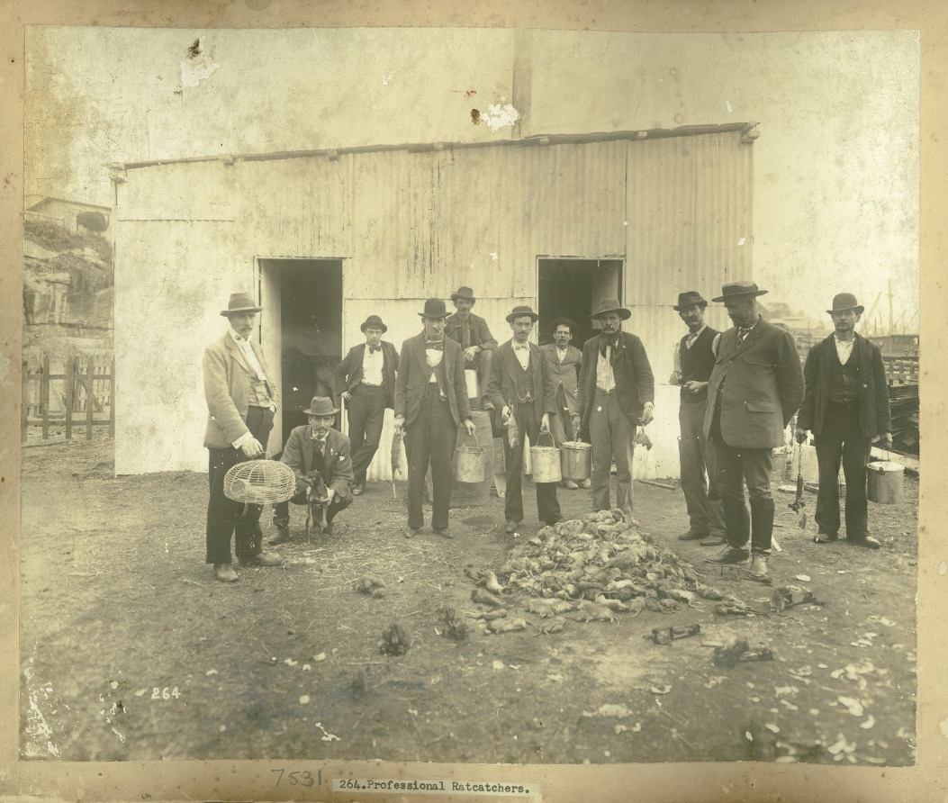
‘Views taken during Cleansing Operations, Quarantine Area, Sydney, 1900, Vol. IV, under the supervision of Mr George McCredie, F.I.A., N.S.W - Professional Rat Catchers’, from the Museums of History New South Wales.
Figure 22 – Views taken during Cleansing Operations, Quarantine Area, Sydney, 1900, Vol. V, under the supervision of Mr George McCredie, F.I.A., N.S.W - Incinerator used to dispose of dead rats
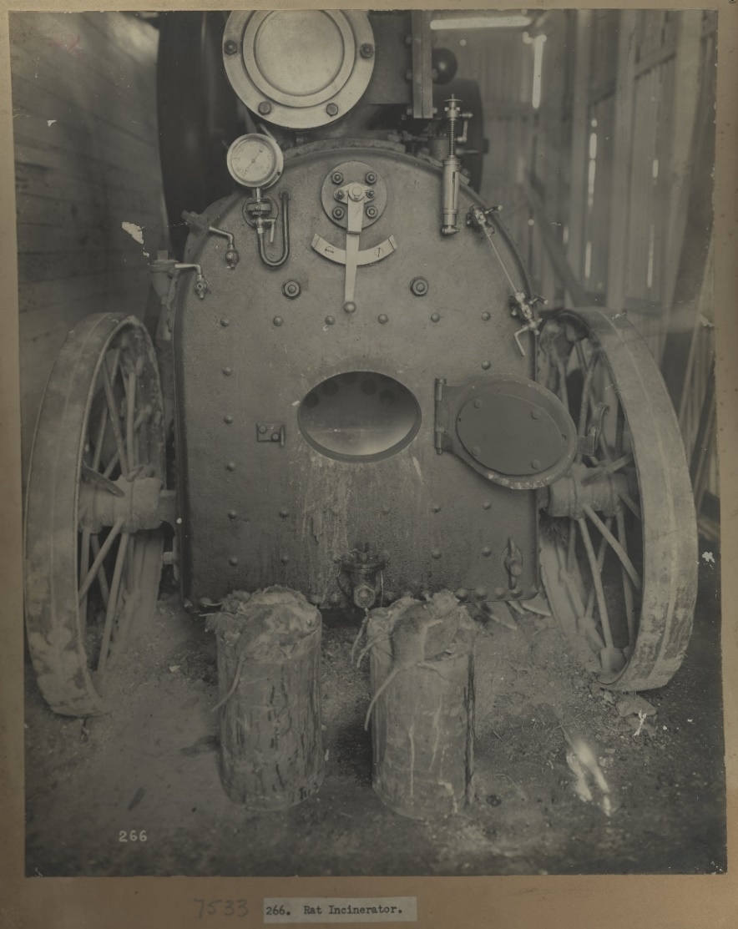
‘Views taken during Cleansing Operations, Quarantine Area, Sydney, 1900, Vol. V, under the supervision of Mr George McCredie, F.I.A., N.S.W - Incinerator used to dispose of dead rats’, from the Museums of History New South Wales.

Appendix 6 – cleansing
Figure 23 – Views taken during Cleansing Operations, Quarantine Area, Sydney, 1900, Vol. III, under the supervision of Mr George McCredie, F.I.A., N.S.W - No.'s 1-5 Blackburn Street, Sydney (NSW)
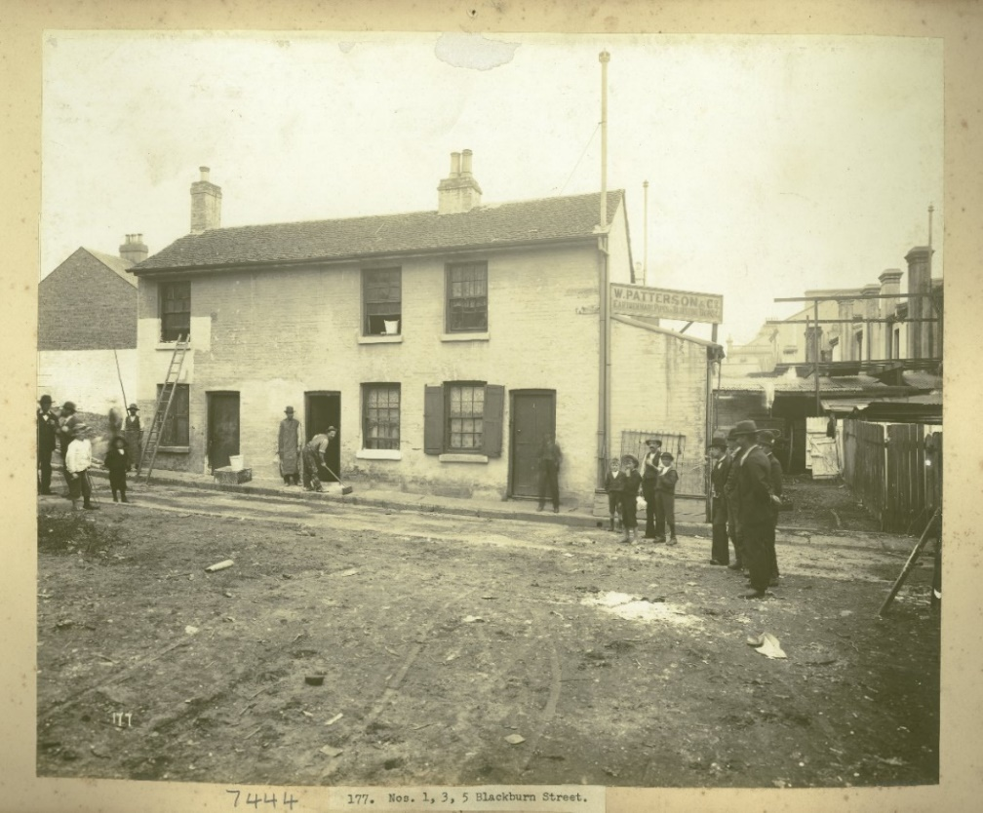
‘Views taken during Cleansing Operations, Quarantine Area, Sydney, 1900, Vol. III, under the supervision of Mr George McCredie, F.I.A., N.S.W - No.'s 1-5 Blackburn Street, Sydney (NSW)’, from the Museums of History New South Wales.
Figure 24 – Views taken during Cleansing Operations, Quarantine Area, Sydney, 1900, Vol. I, under the supervision of Mr George McCredie, F.I.A., N.S.W – Cleansing the streets (1)
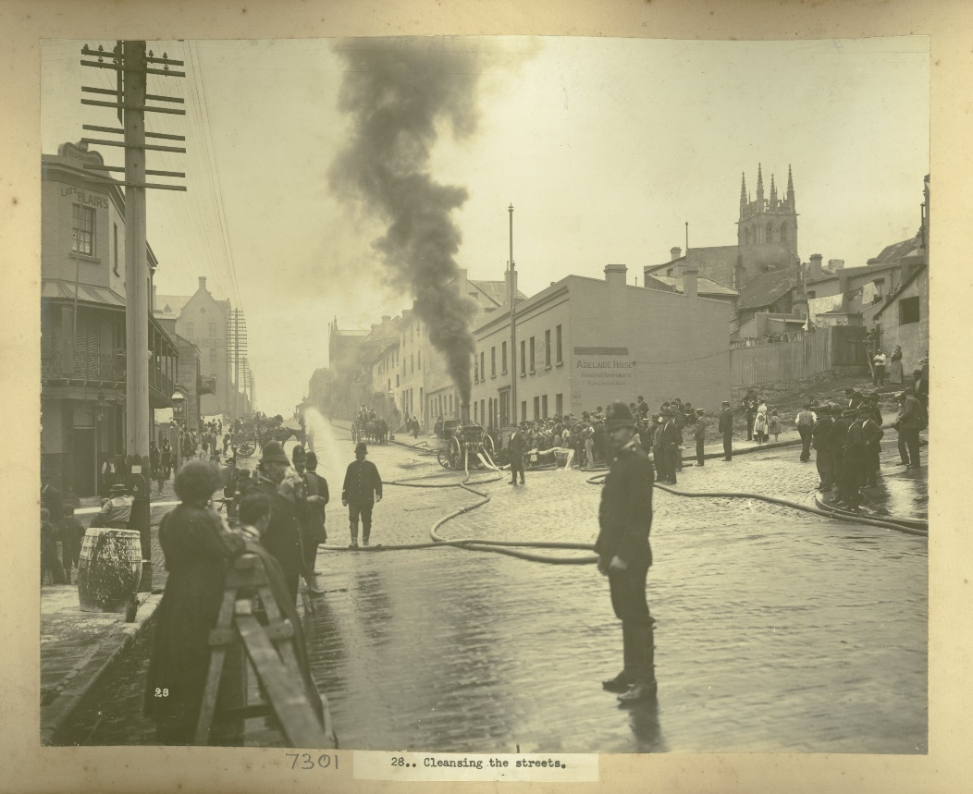
‘Views taken during Cleansing Operations, Quarantine Area, Sydney, 1900, Vol. I, under the supervision of Mr George McCredie, F.I.A., N.S.W – Cleansing the streets (1)’ from the Museums of History New South Wales.
Figure 25 – Views taken during Cleansing Operations, Quarantine Area, Sydney, 1900, Vol. I, under the supervision of Mr George McCredie, F.I.A., N.S.W - Cleansing the streets (2)
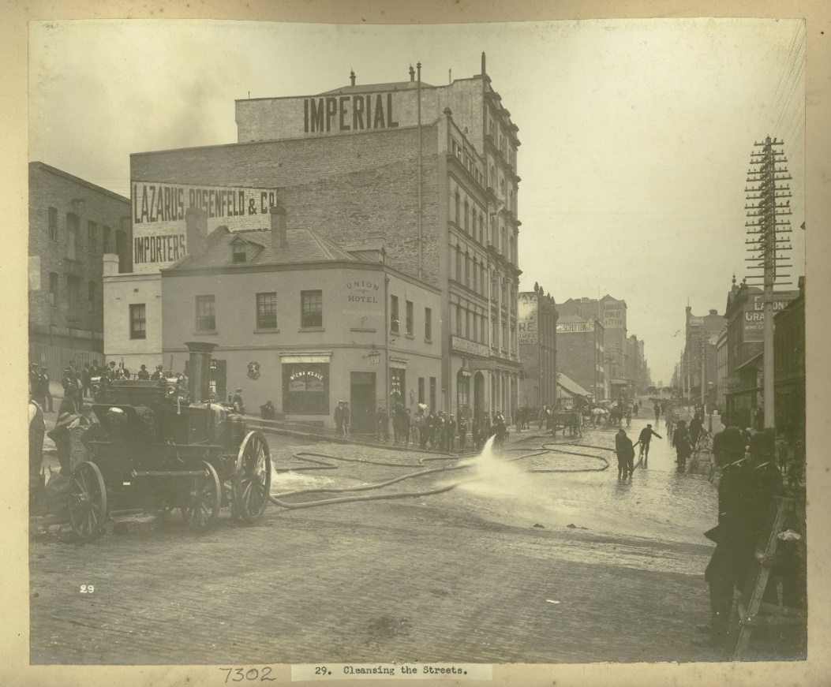
‘Views taken during Cleansing Operations, Quarantine Area, Sydney, 1900, Vol. I, under the supervision of Mr George McCredie, F.I.A., N.S.W - Cleansing the streets (2)’, from the Museums of History New South Wales.
Figure 26 – Views taken during Cleansing Operations, Quarantine Area, Sydney, 1900, Vol. II, under the supervision of Mr George McCredie, F.I.A., N.S.W - Cleansing the wharves
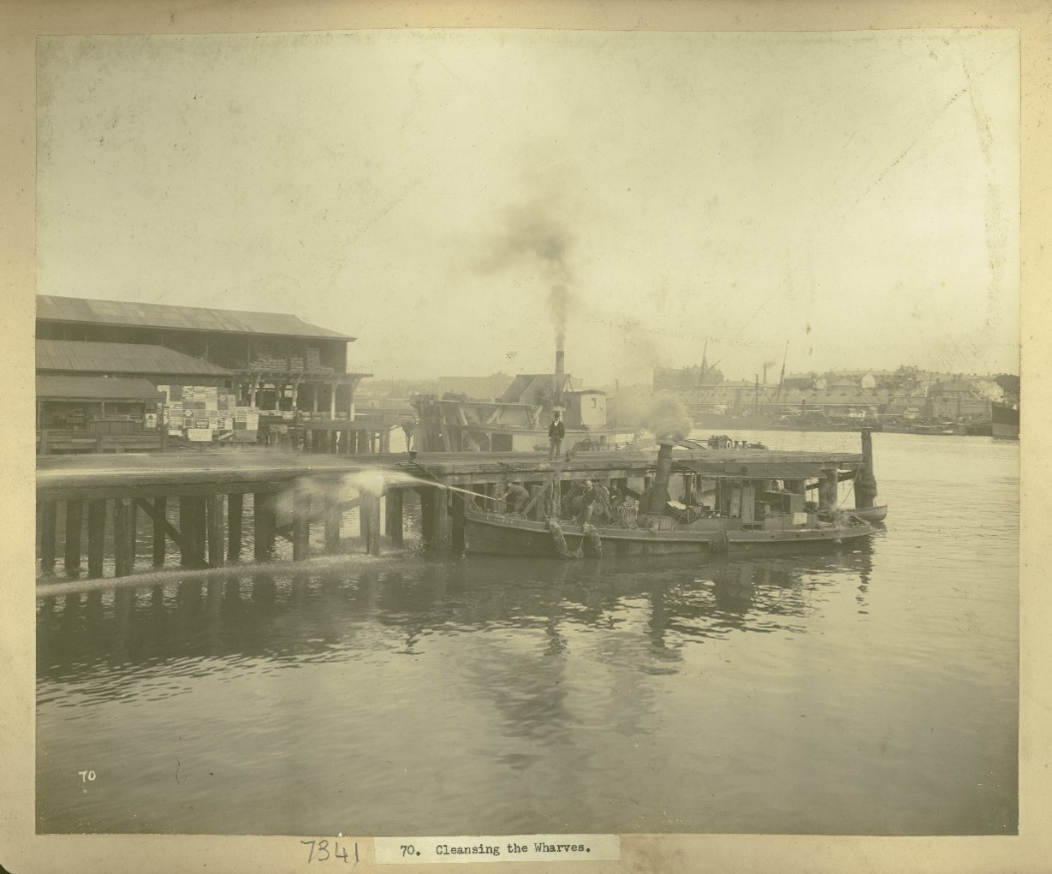
‘Views taken during Cleansing Operations, Quarantine Area, Sydney, 1900, Vol. II, under the supervision of Mr George McCredie, F.I.A., N.S.W - Cleansing the wharves’, from the Museums of History New South Wales.
Figure 27 – Views taken during Cleansing Operations, Quarantine Area, Sydney, 1900, Vol. II, under the supervision of Mr George McCredie, F.I.A., N.S.W - Exeter Place - demolished, Sydney (NSW)
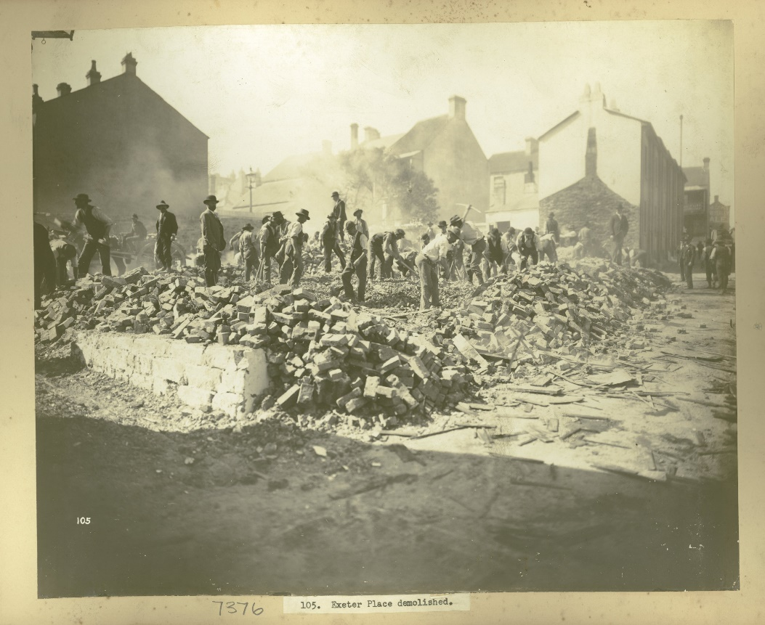
‘Views taken during Cleansing Operations, Quarantine Area, Sydney, 1900, Vol. II, under the supervision of Mr George McCredie, F.I.A., N.S.W - Exeter Place - demolished, Sydney (NSW)’ from the Museums of History New South Wales.

Appendix 7 – working conditions
Figure 28 – close up of Figure 30
Figure 29 – close up of Figure 30
Figure 30 – portable steam engine driving a corn husker
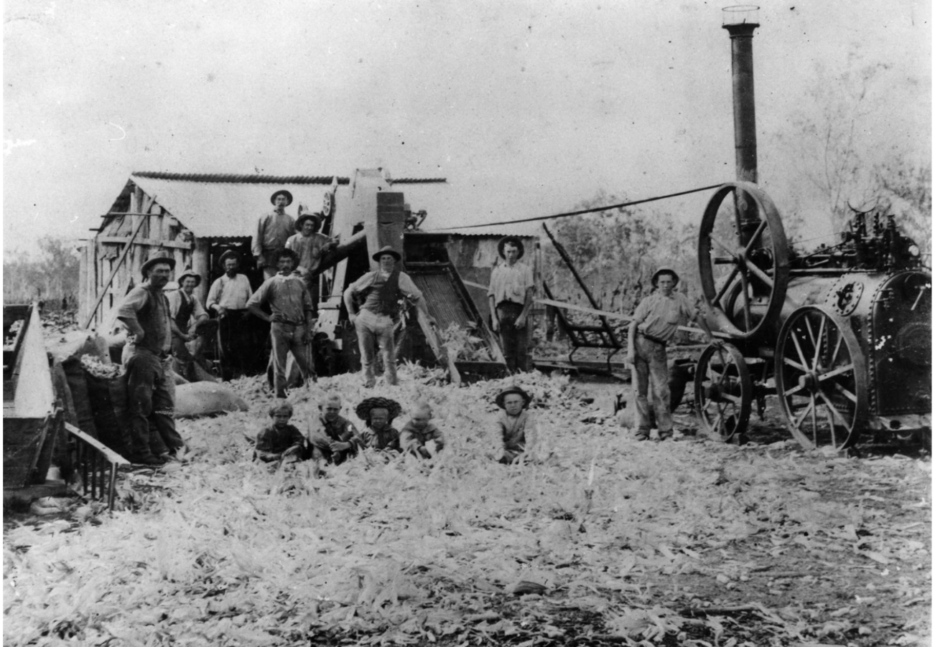
‘Portable steam engine driving a corn husker, Townson, Queensland’ from the State Library of Queensland.

References
This resource contains NSW Curriculum and syllabus content. The NSW Curriculum is developed by the NSW Education Standards Authority. This content is prepared by NESA for and on behalf of the Crown in right of the State of New South Wales. The material is protected by Crown copyright.
Please refer to the NESA Copyright Disclaimer for more information https://educationstandards.nsw.edu.au/wps/portal/nesa/mini-footer/copyright.
NESA holds the only official and up-to-date versions of the NSW Curriculum and syllabus documents. Please visit the NSW Education Standards Authority (NESA) website https://educationstandards.nsw.edu.au and the NSW Curriculum website https://curriculum.nsw.edu.au.
History K-10 Syllabus © NSW Education Standards Authority (NESA) for and on behalf of the Crown in right of the State of New South Wales, 2012.
ABC (n.d.a) ‘Growing Up In The Early 1900s – Episode 1: Mornings, Baths and Meals’ [video], ABC iView, accessed 15 February 2023.
—— (n.d.b) ‘Growing up in the early 1900s – Episode 2: School, Chores and Sleep’ [video], ABC iView, accessed 15 February 2023.
—— (2020) ‘Further Back In Time For Dinner – Episode 1: The 1900s’ [video], ABC iView, accessed 14 February 2023.
ABC Australia (25 August 2021) ‘Blackbirding descendants fight for Australian South Sea Islander recognition’ [video], ABC Australia, YouTube, accessed 15 February 2023.
Archives New Zealand (2015) Map of Australia, New Zealand, Cook & Friendly Islands (1900), Flickr, accessed 30 May 2022.
Aston T (10 November 1906) ‘The Middiby Marriage’, The Weekly Times, Trove website, accessed 15 February 2023.
Australian Curriculum, Assessment and Reporting Authority (ACARA) (n.d.) Australian Curriculum National Literacy Learning Progressions: Appendix 6 – Text complexity, , ACARA website, accessed 14 February 2023.
—— (2020) National Numeracy Learning Progression Version 3.0, ACARA website, accessed 24 February 2023.
Australian Electoral Commission (AEC) (n.d.) Activity 3: What were the factors that resulted in Federation?, AEC website, accessed 19 February 2023.
Australian Institute of Aboriginal and Torres Strait Islander Studies (AITSIS) (1996) Map of Indigenous Australia, AIATSIS website, accessed 14 February 2023.
Australian Law Reform Commission (2010) Changing Policies Towards Aboriginal People – Protection, Recognition of Aboriginal Customary Laws (ALRC Report 31), Australian Government, accessed 24 February 2023.
Australian Perspective (26 March 2016) ‘Immigration Nation – Part 1’ [video], Australian Perspective, YouTube, accessed 24 February 2023.
Australia’s Defining Moments Digital Classroom (n.d.a) 1.3 Merino sheep introduced: ‘The sheep that killed kangaroos’, Australia’s Defining Moments Digital Classroom website, accessed 14 February 2023.
—— (n.d.b) On the sheep’s back, Australia’s Defining Moments Digital Classroom website, accessed 14 February 2023.
—— (n.d.c) Women’s suffrage, Australia’s Defining Moments Digital Classroom website, accessed 24 February 2023.
—— (n.d.d) What can a farm tell us about defining moments?, Australia’s Defining Moments Digital Classroom website, accessed 14 February 2023.
Behind the News (21 March 2014) ‘Australia’s Federation – Behind the News’ [video], Behind the News, YouTube, accessed 19 February 2023.
Channel 10 (4 July 2021) ‘The Heroes of Gundagai, Stuff Everyone Should Know About Australia Season 2’ [video], Channel 10, YouTube, accessed 14 February 2023.
Clyde C (26 February 1908) The career of Jessica, Trove website, accessed 15 February 2023.
Colonial Times (27 July 1827) Hobart Town: Friday, July 27, 1827, Trove website, accessed 14 February 2023.
Commonwealth of Australia Constitution Act (1900a) Chapter 1: The Parliament – Part V – Powers of the Parliament, Parliamentary Education Office website, accessed 24 February 2023.
—— (1900b) Amendment to Section 127, Museum of Australian Democracy website, accessed 24 February 2023.
Commonwealth of Australia Conciliation and Arbitration Act (1904) Commonwealth Conciliation and Arbitration – No. 13 of 1904 [PDF 526 KB], Commonwealth of Australia Conciliation and Arbitration Act, accessed 24 February 2023.
Commonwealth of Australia Numbered Acts (1906) Excise Tariff (Amendment) No.15 of 1906, Commonwealth of Australia Numbered Acts website, accessed 24 February 2023.
Costello C (n.d.) PEEL Paragraph Writing, Virtual Library website, accessed 15 February 2023.
Crispin C and Sahni N (2018) Significant Aboriginal women: Patyegarang, Parramatta History and Heritage website, accessed 14 February 2023.
Davidson L (13 September 2021) 10 Facts About the Tolpuddle Martyrs, History Hit website, accessed 15 February 2023.
Degotardi J (1900) Photographs taken during cleansing operations in quarantine areas, Sydney [photographic series], Museums of History NSW (MHNSW) website, accessed 24 February 2023.
Department of Child Safety, Seniors and Disability Services (15 May 2022) Australian South Sea Islanders, Department of Child Safety, Seniors and Disability Services website, accessed 2 June 2022.
Department of Public Health (1900) Prevention of Plague: Instructions to Householders, issued by the NSW Department of Public Health, 1900, Australian Museum website, accessed 14 February 2023.
Di Gravio G (14 February 2020) Reminiscences of Biraban or M’Gill and Patty by the Rev. Lancelot Threlkeld, Hunter Living Histories website, accessed 14 February 2023.
Eddington D, King J and Ambrose K (n.d.a) Getting it Together: From Colonies to Federation, Museum of Australian Democracy website, accessed 15 February 2023.
—— (n.d.b) Road to Federation: NSW, Museum of Australian Democracy website, accessed 19 February 2023.
—— (n.d.c) Road to Federation: QLD, Museum of Australian Democracy website, accessed 19 February 2023.
—— (n.d.d) Road to Federation: SA, Museum of Australian Democracy website, accessed 19 February 2023.
—— (n.d.e) Road to Federation: TAS, Museum of Australian Democracy website, accessed 19 February 2023.
—— (n.d.f) Road to Federation: VIC, Museum of Australian Democracy website, accessed 19 February 2023.
—— (n.d.g) Road to Federation: WA, Museum of Australian Democracy website, accessed 19 February 2023.
Facing History & Ourselves (17 June 2017) Gallery Walk, Facing History & Ourselves resource library website, accessed 14 February 2023.
—— (12 May 2020) Storyboard, Facing History & Ourselves resource library website, accessed 14 February 2023.
Francis R (2014) Trade Unions, The Encyclopedia of Women and Leadership in Twentieth-Century Australia website, accessed 15 February 2023.
Franks R (n.d.) Governor Arthur’s Proclamation to the Aborigines, State Library of NSW (SL NSW) website accessed 14 February 2023.
Griffiths E (9 February 2017) Australia’s Most Invasive Species, culture trip website, accessed 14 February 2023.
Gunson N (1966) Biraban (? – c. 1842), Australian Dictionary of Biography website, accessed 14 February 2023.
Hamer P (27 August 2015) Unsophisticated and unsuited, National Library of New Zealand website, accessed 24 February 2023.
Higgins J (8 November 1907a) Harvester case: Ex parte H.V. McKay – extract 1, Fair Work Commission website, accessed 24 February 2023.
—— (8 November 1907b) Harvester case: Ex parte H.V. McKay – extract 2, Fair Work Commission website, accessed 24 February 2023.
History Skills (n.d.) How to interpret the meaning of political cartoons, History Skills website, accessed 24 February 2023.
Jenner G (host) and Morelle D (producer) (15 November 2020) ‘The Aztecs’ [podcast], You’re Dead to Me, BBC Sounds website, accessed 24 February 2023.
—— (28 November 2020) ‘Harriet Tubman’ [podcast], You’re Dead to Me, BBC Sounds website, accessed 24 February 2023.
—— (8 December 2020) ‘The Witch Craze’ [podcast], You’re Dead to Me, BBC Sounds website, accessed 24 February 2023.
John Curtin Prime Ministerial Library (JCPML) (2002) Working man’s paradise?, JCPML website, accessed 24 February 2023.
Keartland GA (15 June 1899) The career of a West Australian native, Trove website, accessed 14 February 2023.
Keith K (15 August 1901) How I entertained an editor at supper, Trove website, accessed 15 February 2023.
Kohen JL (2005) Pemulwuy (1750–1802), Australian Dictionary of Biography website, accessed 14 February 2023.
Learning Strategies Center Cornell (11 December 2019) ‘How to Use Cornell Notes’ [video], Learning Strategies Center Cornell, YouTube, accessed 19 February 2023.
Matson-Green VM (2005) Tarenorerer (1800–1831), Australian Dictionary of Biography website, accessed 14 February 2023.
McFarlane I (2006) Walyer [1], The Companion to Tasmanian History website, accessed 14 February 2023.
—— (2006) Walyer [2], The Companion to Tasmanian History website, accessed 14 February 2023.
McMurchy M, Nash M, Oliver M and Thornley J (1983) ‘For Love or Money: First Women’s Union’ [video], National Film and Sound Archive of Australia website, accessed 15 February 2023.
Microsoft (n.d) Annotated timeline, Microsoft Office Templates, accessed 14 February 2023.
Moore C (2013) Australian South Sea Islanders in Queensland – Stories from the Archives, Stories from the Archives – Queensland State Archives website, accessed 28 May 2024.
Moore C and Institute of Papua New Guinea Studies (1985) Kanaka: a history of Melanesian Mackay, The University of Queensland website, accessed 28 May 2024.
Moran A and McAllister J (11 March 2020) Patyegarang was Australia’s first teacher of Aboriginal language, colonisation-era notebooks show, ABC News, accessed 14 February 2023.
Museums of History NSW (24 April 2018) ‘Growing up in the early 1900s – going to school’ [video], Museums of History NSW, YouTube, accessed 15 February 2023.
National Archives of Australia (NAA) (n.d.) Pacific Island Labourers Act 1901, NAA website, accessed 24 February 2023.
—— (2010a) Directions for applying the dictation test from the Home and Territories Department, NAA website, accessed 24 February 2023.
—— (2010b) Immigration Restriction Act 1901, NAA website, accessed 24 February 2023.
National Museum of Australia (2 June 2016) ‘George Megalogenis discusses the eight-hour day’ [video], National Museum of Australia, YouTube, accessed 15 February 2023.
National Museum of Australia (NMA) (19 September 2022) Age and invalid pensions, Defining Moments NMA website, accessed 24 February 2023.
—— (20 September 2022) Eight-hour day, Defining Moments NMA website, accessed 15 February 2023.
—— (27 September 2022a) Gundagai flood, Defining Moments NMA website, accessed 14 February 2023.
—— (27 September 2022b) Islander labourers, Defining Moments NMA website, accessed 14 February 2023.
—— (28 September 2022) Harvester Judgment, Defining Moments NMA website, accessed 24 February 2023.
—— (29 September 2022a) Murray River irrigation begins, Defining Moments NMA website, accessed 14 February 2023.
—— (29 September 2022b) The Black Line, Defining Moments NMA website, accessed 14 February 2023.
—— (4 October 2022) Secret ballot introduced, Defining Moments NMA website, accessed 15 February 2023.
—— (18 November 2022) Pemulwuy, Defining Moments NMA website, accessed 14 February 2023.
—— (18 January 2023) Bubonic plague, Defining Moments NMA website, accessed 14 February 2023.
National Museums Liverpool (n.d.) Social unrest and income tax, National Museums Liverpool website, accessed 15 February 2023.
Newcastle University Library (n.d.) Compare and Contrast: Y-notes graphic organisers, Newcastle University Library website, accessed 15 February 2023.
—— (n.d.) Layers of Inference Diagram, Newcastle University Library website, accessed 15 February 2023.
Nuttall C (1902) The Opening, Commonwealth Parliament, 9 May 1901 [engraving], Parliament of Australia website, accessed 19 February 2023.
Obituaries Australia (25 August 1894) ‘John Henry Fleming (1816–1894)’, Windsor & Richmond Gazette (NSW), Obituaries Australia website, accessed 14 February 2023.
Old Treasury Building (n.d.) In the factory: sweating, Old Treasury Building website, accessed 15 February 2023.
O’Neill A (2019) Child mortality rate (under five years old) in Australia from 1860 to 2020, Statista website, accessed 15 February 2023.
Parliamentary Education Office (n.d.) How did Federation affect Aboriginal and Torres Strait Islander people?, Parliamentary Education Office website, accessed 24 February 2023.
Parliament of New South Wales (n.d.a) 1901 to 1918 – The Early Federal Period and the First World War: Votes for Women 1902, Parliament of New South Wales website, accessed 24 February 2023.
—— (n.d.b) The Roles and Responsibilities of Federal, State and Local governments: Who Does What?, Parliament of New South Wales website, accessed 19 February 2023.
Pedersen H (1990) Jandamarra (1870–1897), Australian Dictionary of Biography website, accessed 14 February 2023.
Project Zero (n.d.) See, Think, Wonder, Harvard Graduate School of Education, accessed 14 February 2023.
—— (2015a) 3-2-1 Bridge, Harvard Graduate School of Education, accessed 14 February 2023.
—— (2015b) True for who?, Harvard Graduate School of Education, accessed 14 February 2023.
Rawson C (c. 1877) "Our boys" Lillock and Peter, South Sea Islanders working at The Hollow, State Library of Queensland, accessed 30 May 2022.
Roberts T (1903) Opening of the First Parliament of the Commonwealth of Australia by His Royal Highness the Duke of Cornwall and York, 9 May 1901 [painting], Parliament of Australia website, accessed 19 February 2023.
Royal Historical Society Victoria (n.d.) Vida Goldstein and Maud Wood Park, Royal Historical Society Victoria website, accessed 24 February 2023.
Rule of Law Education Centre (n.d.) The Australian Constitution: Division of Powers between Federal, State and Local: Chapters V &VI, Rule of Law Education Centre website, accessed 19 February 2023.
Simpson M (18 July 2018) Present and Past Family Life – Toilets, The Powerhouse Museum website, accessed 14 February 2023.
Skatssoon J (15 March 2006) Aboriginal people built water tunnels, ABC Science Online website, accessed 14 February 2023.
Special Collections (6 July 2016) The Twelfth Man: John Fleming and the Myall Creek Massacre by Patricia Withycombe, Hunter Living Histories website, accessed 14 February 2023.
State Archives Collection (n.d.)Photographs taken during cleansing operations in quarantine areas, Sydney, Museums of History New South Wales website, accessed 14 February 2023.
State Library Victoria and Koorie Heritage Trust (n.d.) William Buckley, Victorian Collections website, accessed 14 February 2023.
Study Smarter (n.d.) A-Z of online resources, University of Western Australia website, accessed 19 February 2023.
Tedeschi M (4 June 2014) The Myall Creek Massacre re-examined, Traces website, accessed 14 February 2023.
The Writing Center University of North Carolina at Chapel Hill (n.d.) Thesis statements, The Writing Center website, accessed 19 February 2023.
Tipping MJ (1966) William Buckley (1780–1856), Australian Dictionary of Biography website, accessed 14 February 2023.
Tsiamis K (4 March 2018) ‘Working class kids: The tough life colonial children faced’, The Sunday Telegraph, accessed 15 February 2023.
Tutt P (8 October 2021) Teaching Kids to Give and Receive Quality Peer Feedback, Edutopia website, accessed 19 February 2023.
University of Queensland (n.d.) Cane to Community: Australian South Sea Islander Stories, University of Queensland website, accessed 15 February 2023.
Unknown creator (c. 1900) Timer-getter at work ca. 1900, State Library of Queensland Collections, accessed 15 February 2023.
Unknown creator (1900) Interior of the Astill & Freeman boot factory in Cordelia Street South, Brisbane, Queensland, 1900, State Library of Queensland Collections, accessed 15 February 2023.
Unknown author (c. 1905) Portable steam engine driving a corn husker, Townson, Queensland, State Library of Queensland Collections, accessed 24 February 2023.
NFSA (National Film and Sound Archives) (1995) ‘The Sugar Labour Trade’ [video], NFSA, NFSA website, accessed 15 February 2023.
Westera R (n.d.) Australasia 1872: Australian Overland Telegraph Line, OmniAtlas website, accessed 14 February 2023.
—— (n.d.) Australasia 1899: Second Samoan Civil War, OmniAtlas website, accessed 14 February 2023.
Wikipedia (19 February 2023) First Fleet, Wikipedia, accessed 24 February 2023.
—— (14 January 2023) Risdon Cove, Wikipedia, accessed 14 February 2023.
Wright C (n.d.) Goldstein, Vida Jane, The encyclopedia of women and leadership in twentieth-century Australia website, accessed 24 February 2023.
Ying W H W (c.1890 – c. 1920) Underground mine face and miners, State Library Victoria website, accessed 15 February 2023.

© State of New South Wales (Department of Education), 2024
The copyright material published in this resource is subject to the Copyright Act 1968 (Cth) and is owned by the NSW Department of Education or, where indicated, by a party other than the NSW Department of Education (third-party material).
Copyright material available in this resource and owned by the NSW Department of Education is licensed under a Creative Commons Attribution 4.0 International (CC BY 4.0) license.
This license allows you to share and adapt the material for any purpose, even commercially.
Attribution should be given to © State of New South Wales (Department of Education), 2024.
Material in this resource not available under a Creative Commons license:
- the NSW Department of Education logo, other logos and trademark-protected material
- material owned by a third party that has been reproduced with permission. You will need to obtain permission from the third party to reuse its material.
Links to third-party material and websites
Please note that the provided (reading/viewing material/list/links/texts) are a suggestion only and implies no endorsement, by the New South Wales Department of Education, of any author, publisher, or book title. School principals and teachers are best placed to assess the suitability of resources that would complement the curriculum and reflect the needs and interests of their students.
If you use the links provided in this document to access a third-party's website, you acknowledge that the terms of use, including licence terms set out on the third-party's website apply to the use which may be made of the materials on that third-party website or where permitted by the Copyright Act 1968 (Cth). The department accepts no responsibility for content on third-party websites.

