History Stage 5

Site study – Parramatta Female Factory

This resource was collaboratively developed by the Crown in right of the State of New South Wales, acting through the Department of Education and the Crown in right of the State of New South Wales, acting through [Museums of History NSW](https://mhnsw.au/learning/).

Contents

Outcomes 2

Objectives 2

Content 2

Learning sequence 1 – Parramatta Female Factory context and pre-site study 4

Learning intention 4

Success criteria 4

Prince Alfred Park 5

What was the Parramatta Female Factory and why was it important? 6

Learning sequence 2 – free settler 12

Learning intention 12

Success criteria 12

Ann Gordon 12

Learning sequence 3 – changing way of life (1750–1901) 15

Learning intention 15

Success criteria 15

References 25

This resource has been designed to support teachers by providing a range of tasks based on syllabus content. Tasks can be incorporated into context driven teaching and learning programs in full or can be used to supplement existing programs. All content is textbook non-specific to ensure equity.

## Outcomes

A student:

* **HT5-2** sequences and explains the significant patterns of continuity and change in the development of the modern world and Australia
* **HT5-6** uses relevant evidence from sources to support historical narratives, explanations and analyses of the modern world and Australia

[History K–10 Syllabus](https://educationstandards.nsw.edu.au/wps/portal/nesa/k-10/learning-areas/hsie/history-k-10) © NSW Education Standards Authority (NESA) for and on behalf of the Crown in right of the State of New South Wales, 2012.

## Objectives

Students:

* develop skills to undertake the process of historical inquiry.

## Content

**History Stage 5 – The making of the modern world**

**Topic 1b: Movement of peoples**

The experiences of slaves, convicts and free settlers upon departure, their journey abroad, and their reactions on arrival, including the Australian experience (ACDSEH083)

Students:

* select an individual slave sent to the Americas, or a convict or a free settler who came to Australia and use sources to construct the story of their experiences

Changes in the way of life of a group(s) of people who moved to Australia in this period, such as free settlers on the frontier in Australia (ACDSEH084)

Students:

* use a variety of sources to investigate and report on the changing way of life of ONE of the following:
* convicts
* emancipists
* free settlers

# Learning sequence 1 – Parramatta Female Factory context and pre-site study

**Note**: this resource provides more information than the time needed to cover the upcoming content points. As teachers plan their lessons, they are encouraged to choose activities suited to their specific contexts while ensuring they cover the necessary outcomes and content points. This flexibility will allow for tailored instruction that effectively meets the needs of students.

This learning sequence examines the Parramatta Female Factory Parramatta Female Factory, enhancing students’ historical understanding of the site.

## Learning intention

Students learn to:

* understand the historical significance of the Parramatta Female Factory.

## Success criteria

Students will be able to:

* identify the purpose and role of the Parramatta Female Factory
* explain the importance of the Parramatta Female Factory.

**Note:** a site study is an inquiry-based examination of an historically significant location. Site studies may include an investigation of the local area, or a visit to an archaeological site, museum, an Aboriginal site (issues of access and permission need to be appropriate to the site selected), a specific building, a monument, a local area, an open-air museum or a virtual site available through ICT.

Teachers must identify the objectives and outcomes relevant to the site study.

The following site study will focus on the Parramatta Female Factory Precinct located in North Parramatta. Prior to delivering the content, it may be of use to contextualise the site, its history and role in Australian society to enhance student engagement.

Throughout the resource there are links to learning strategies, most of these activities are stepped out in this document. The hyperlinks are provided to give more context on how to apply the learning strategies.

The following inquiry questions should be addressed:

1. What was the Parramatta Female Factory and why was it important?
2. What happened at the Parramatta Female Factory?
3. Who were some of the individuals connected to the Parramatta Female Factory?
4. How did the Parramatta Female Factory change overtime?
5. How reliable are the historical records and what perspectives do they offer?

Teachers should consider the [Controversial issues in schools policy](https://education.nsw.gov.au/policy-library/policies/pd-2002-0045) and ensure all material used is appropriate for individual classroom and school context.

## Prince Alfred Park

Read the information from [First Female Factory, Prince Alfred Square](https://historyandheritage.cityofparramatta.nsw.gov.au/blog/2015/08/12/the-first-female-factory-prince-alfred-square-1803-1821) and answer the following questions:

* What is the connection of Prince Alfred Square to the Parramatta Female Factory? (Sentence starter: Prince Alfred Square is connected to the Parramatta Female Factory because ...)
* Use a [Claim, Support, Question](https://pz.harvard.edu/resources/claim-support-question) thinking routine to answer the following:
* What were the main purposes of the Female Factory and how did these change over time? (For example, one purpose of the Parramatta Female Factory was to house women.)
* Use [First Female Factory, Prince Alfred Square](https://historyandheritage.cityofparramatta.nsw.gov.au/blog/2015/08/12/the-first-female-factory-prince-alfred-square-1803-1821) to identify evidence that supports your claim. (Find a quote in the resource that supports your findings.)
* What questions do you still have about the First Female Factory? (For example, how did the living conditions impact the women who stayed at the Parramatta Female Factory?)
* Swap your completed Claim, Support, Question thinking routine with a partner and complete a TAG feedback form.
* Tell something you liked about your peer’s response. (Sentence starter: I like that your claim mentioned …)
* Ask a question about your peer’s response. (For example, was the information supporting your claim from the resource provided?)
* Give your peer a suggestion that could improve their response. (For example, your claim could have been strengthened if it had directly quoted the resource provided.)

**Note: as demonstrated in the prior learning activities, the Parramatta Female Factory was first located at Prince Alfred Park. This resource will now focus on the second location of the site at 1 Fleet Street, North Parramatta.**

## What was the Parramatta Female Factory and why was it important?

**Source 1 – Parramatta Female Factory Precinct (1818–1848)**

Colonial authorities thought they had an answer to improve both the industriousness and morality of convict women through the construction of female factories, workhouses in which convict women not assigned to settlers, pregnant or being punished lived and worked. The Parramatta Female Factory was the first of eleven female convict factories established in the colony. From the factory’s early design stages, the desired dual role of simultaneously guarding the convict women from the colony and the colony from the convict women was apparent (Salt 1984, p. 46). In providing preliminary ideas for construction, Reverend Marsden wrote to Governor Macquarie (Kerr 1984, p. 42) explaining that:

*If the building should be all in one line there will require a very high wall to prevent the women from making their escape out and also to prevent other persons who had no business there from visiting the factory.*

Governor Macquarie agreed (Salt 1984, p. 70)

*So as to keep them [convict women] within it and prevent their having any Intercourse with the People of the Town, until such times as they should either be Married or Assigned as domestic Servants to Married persons.*

Francis Greenway, Sydney’s early prolific convict architect, implemented the spirit of Marsden and Macquarie’s ideas in the final plans and later construction of the Parramatta Female Factory, albeit with some competition between Greenway and Commissioner Bigge as to whether a 9 feet or 12 feet wall was a sufficient deterrent to prevent escapees and interlopers alike (Kerr 1984, p. 5). The initial construction does not to appear to have been very sound as major repairs and extensions were made during the operation of the factory (Salt, pp. 46 – 50).

Extract from ‘[Parramatta Female Factory (1818 – 1848)](https://www.dcceew.gov.au/parks-heritage/heritage/organisations/australian-heritage-council/national-heritage-assessments/parramatta-female-factory-precinct#daff-page-main:~:text=History%3A%20Parramatta%20Female%20Factory%20Precinct%20(PDF%20%2D%20487.35%20KB))’ by Australian Government – Department of Climate Change, Energy, the Environment and Water is licensed under CC BY 4.0.

* According to Source 1, what was the purpose of the Parramatta Female Factory?
* Source 1 states the Parramatta Female Factory was a workhouse. What is this?
* Do you think people were allowed to leave the Parramatta Female Factory? Why or why not (refer to the construction of a wall)?
* Is it correct to call the Parramatta Female Factory a gaol? Why or why not?

**Source 2 – former Female Factory northeast range**

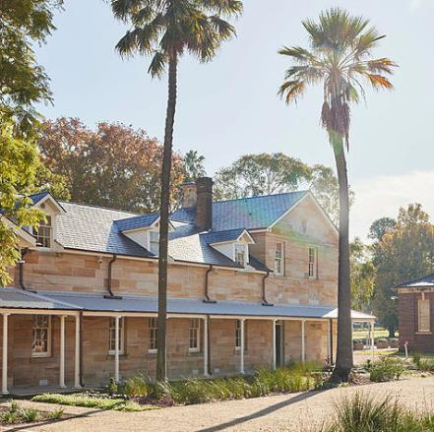

‘Former Female Factory northeast range’ by James Horan **©** State of New South Wales through Museums of History NSW.

**Source 3 – former Female Factory southwest range**

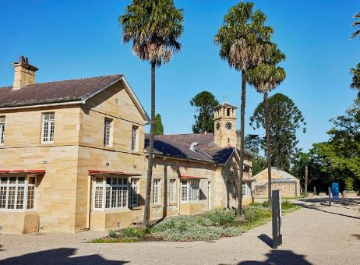

‘Former Female Factory southwest range’ by James Horan **©** State of New South Wales through Museums of History NSW.

* What structures or features are visible in Source 2 and Source 3, and how do they contribute to the identity of the site? Consider the vegetation, the windows, roofing, walking paths and trees.

**Note**: the penitentiary is the most intact and unchanged Female Factory building. It was the first building on the east coast of Australia built specifically for the punishment of convict women and is the only structure that housed substantial numbers of female convicts that still stands in Australia.

The veranda was added during the 1880s hospital era.

**Source 4 – Female Factory third class penitentiary dormitory 1825 – 1848 Penitentiary**

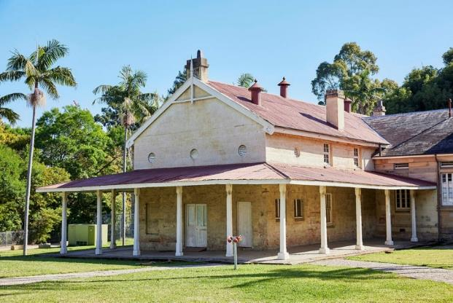

‘Female Factory third class penitentiary dormitory 1825 – 1848 Penitentiary’ by James Horan **©** State of New South Wales through Museums of History NSW.

* Brainstorm what activities might have taken place here. Elaborate on what ‘third class’, ‘penitentiary’ or ‘dormitory’ could indicate.
* What do you know about the Parramatta Female Factory?

**Source 5 – the old Female Factory complex repurposed as the Parramatta Lunatic Asylum**

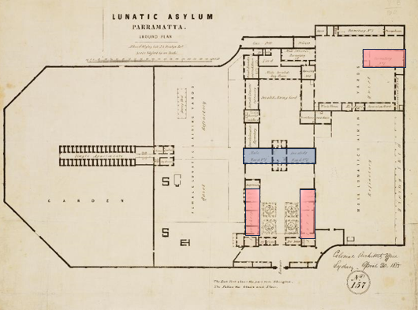

‘Paramatta Lunatic Asylum’ adapted from the State Library is licensed under CC By-NC.

* Use Source 5 and [Push to protect Parramatta Female Factory convict site from developers, call for world heritage listing](https://www.abc.net.au/news/2015-08-20/push-to-protect-parramatta-womens-factory-from-development/6711438) to assess how the purpose of the site changed overtime.
* With reference to [Parramatta Female Factory future secure with $54M grant](https://parramattatimes.com.au/news/parramatta-female-factory-future-secure-with-54m-grant/) discuss how you think the purpose of this site will change in the future.
* Why was the Parramatta Female Factory important? Provide evidence to support your idea.

**Note**: for the purpose of this task choose 5 images from [Parramatta Female Factory image gallery](https://historyandheritage.cityofparramatta.nsw.gov.au/parramatta-female-factory-bicentenary-1821-2021#:~:text=Our%20Parramatta%20Female%20Factory%20image%20gallery). Some images that you could choose from could include 2, 3, 6, 10, 11, 12, 13, 15, 17, 18, 19, 20 or 21.

**Source 6 – c1860s photograph showing the entrance to the former Female Factory main dormitory and the northeast and southwest ranges**

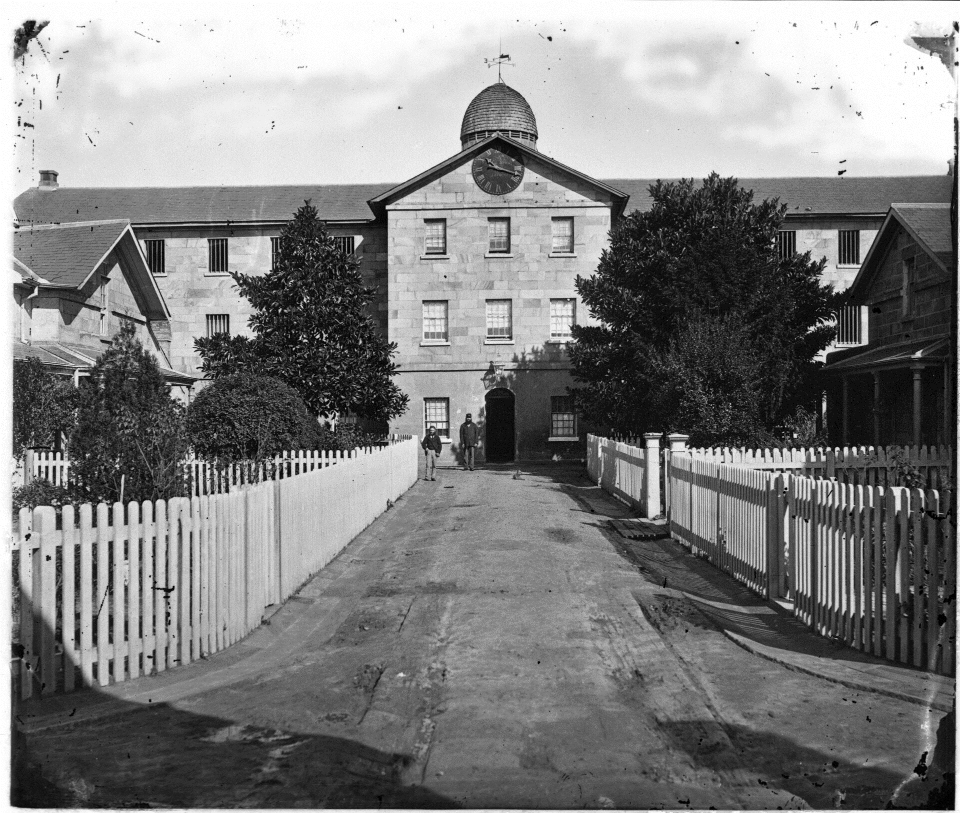

‘c1860s photograph showing the entrance to the former Female Factory main dormitory and the northeast and southwest ranges’ by City of Parramatta is licensed under CC By-NC.

* What clues do you think [Parramatta Female Factory image gallery](https://historyandheritage.cityofparramatta.nsw.gov.au/parramatta-female-factory-bicentenary-1821-2021#:~:text=Our%20Parramatta%20Female%20Factory%20image%20gallery) and Sources 2 to 6 reveal about the functions, activities and importance of the site. Use Table 1 to complete the activity.

Table 1 – Parramatta Female Factory image gallery source activity

|  |  |  |
| --- | --- | --- |
| Source | Functions or activities | Importance of site |
| Source 2 |  |  |
| Source 3 |  |  |
| Source 4 |  |  |
| Source 5 |  |  |
| Source 6 |  |  |
| Image 1 |  |  |
| Image 2 |  |  |
| Image 3 |  |  |
| Image 4 |  |  |
| Image 5 |  |  |

* Complete a PEEL paragraph that emphasises the importance of the Parramatta Female Factory.

# Learning sequence 2 – free settler

This learning sequence focuses on the life and journey of Ann Gordon.

## Learning intention

Students learn to:

* explore Ann Gordon's experiences during her departure, her time abroad, and her arrival in a new land.

## Success criteria

Students will be able to:

* research and construct Ann Gordon’s story
* use a variety of sources to gather information about Ann Gordon’s individual experiences
* clearly and accurately highlight Ann Gordon’s journey and her impact on Australian society.

## Ann Gordon

Using [Ann Gordon - Parramatta Female Factory Matron](https://www.youtube.com/watch?v=pAzUwxrJARo) (14:50) complete the tasks below:

* Use [Dictionary.com](https://www.dictionary.com/) to define the term ‘matron’.
* View the introduction ([0:00–0:54](https://youtu.be/pAzUwxrJARo?si=-4Odkya_1xFRFGbJ)) take notes and share your thoughts, impressions or questions.
* View Ann Gordon ([0:54–2:15](https://youtu.be/pAzUwxrJARo?si=-4Odkya_1xFRFGbJ&t=54)).
* Write a headline for this extract: ‘Parramatta Female Factory was both a workplace and a home for the many convict women who were not assigned as servants to settlers. It was a place of supervision but also of protection from the male population of the colony. Its penitentiary provided a means of enforcing moral and social standards upon the convict and free women. The inmates worked at a range of jobs from spinning, weaving, bonnet making to laundry and sewing. They were divided into three classes according to their crimes and behaviour. Separate work and privileges were allotted to the different classes.’
* [Storyboard](https://app.education.nsw.gov.au/digital-learning-selector/LearningActivity/Card/559?clearCache=9c70a3be-117a-b840-503b-998c2ae6dcd6) Ann Gordon’s life until her move to Parramatta.

**Note**: the character profile is to be created on word, [Canva](https://app.education.nsw.gov.au/digital-learning-selector/LearningTool/Card/653?clearCache=396aa68e-b6ab-b4d6-d5b-c1178d6f32e7) or [Adobe Express](https://www.adobe.com/express/create/poster#:~:text=The%20Adobe%20Express%20custom%20poster,to%20create%20your%20own%20posters.).

* View Parramatta Female Factory ([3:35–4:41](https://youtu.be/pAzUwxrJARo?t=215)).
* Create a character profile for Ann, highlighting her appointment as the matron, her salary, qualifications and a brief background. Ensure to include a profile picture and username for the profile.
* View Robert Gordon and Ann Gordon ([4:42–5:51](https://youtu.be/pAzUwxrJARo?si=Ygn2VS48gHfovqL_&t=282)).
* Complete a [Quadrant reflection chart](https://app.education.nsw.gov.au/digital-learning-selector/LearningActivity/Card/552?clearCache=aa99ce4f-80f7-8589-b18d-fb54bc9eed6a) based on Ann’s perspective on the following categories: responsibilities, challenges, feelings and achievements.
* View Hospital ([5:55–8:45](https://youtu.be/pAzUwxrJARo?si=qTOhMbTrjsbqV6bB&t=355)) and answer the following questions.
* How did the overcrowding in the Parramatta Female Factory impact Ann’s ability to maintain order and ensure the well-being of inmates?
* In what ways could Ann’s separation from her first-born daughter have influenced her emotional connection to other women facing family separation?
* Was the increase in inmates from 300 to over 600 women and children indicative of care or neglect on Ann’s part? Explain your reasoning.
* View Riots ([8:47–9:51](https://youtu.be/pAzUwxrJARo?t=527)).
* Create a visual [cause and effect chain](https://www.educationoasis.com/graphic-organizers/cause-effect-chain/) showcasing the factors that led to the riot.
* View Marriages ([9:51–11:54](https://youtu.be/pAzUwxrJARo?si=tNcEnNqMuRMGmRKo&t=591)) and complete a [PMI](https://app.education.nsw.gov.au/digital-learning-selector/LearningActivity/Card/551?clearCache=7e03f5f-f362-51e8-b390-631da28ab71e) chart for the organisation of marriages through the Parramatta Female Factory.
* Reflect on the positive aspects of marriage organisation in the Parramatta Female Factory.
* Explore the negative aspects of marriage organisation in the Parramatta Female Factory.
* Identify the interesting elements of marriage organisations in the Parramatta Female Factory.
* Reflect on the overall impact and significance of marriages within the context of the Parramatta Female Factory. Consider how it may have contributed to the lives of the women, the dynamics of the community and any long-term effects.
* View Personal life ([11:35–14:20](https://youtu.be/pAzUwxrJARo?t=695))
* Create a timeline of the significant events mentioned in this chapter of Ann Gordon’s life.

**Note**: for this task it is best to familiarise yourself with [Google Maps Platform](https://mapsplatform.google.com/) or [Mapmaker 4.0](https://www.arcgis.com/apps/instant/atlas/index.html?appid=0cd1cdee853c413a84bfe4b9a6931f0d).

* Use the following sources [Parramatta History and Heritage: Matron Ann Gordon](https://historyandheritage.cityofparramatta.nsw.gov.au/research-topics/female-factory/matron-ann-gordon), [Ann Gordon - Parramatta Female Factory Matron](https://www.youtube.com/watch?v=pAzUwxrJARo) (14:50) and [Google maps](https://maps.google.com/) to create an interactive map showcasing Ann Gordon’s journey from England throughout NSW. On your map:
* annotate significant events, dates and key locations.

**Note**: depending on your context it may be beneficial to read the letters as a class so that the common themes can be assessed collectively. The following could be used as an HPG task.

Use the following sources [Gordon Family Letters](https://freepages.rootsweb.com/~jray/genealogy/gordon/letters2.htm) (Letter 1, 2 and 3), [Parramatta History and Heritage: Matron Ann Gordon](https://historyandheritage.cityofparramatta.nsw.gov.au/research-topics/female-factory/matron-ann-gordon) and [Ann Gordon - Parramatta Female Factory Matron](https://www.youtube.com/watch?v=pAzUwxrJARo) (14:50) to create an infographic that:

* highlights the themes of resilience, hope, family and pursuit of opportunity during Ann Gordon’s life
* shows Ann Gordon’s economic, social and cultural impact on Australian society using a [triple Venn Diagram](https://upload.wikimedia.org/wikipedia/commons/e/ea/Venn3.svg).

# Learning sequence 3 – changing way of life (1750–1901)

This learning sequence looks at the experiences of the convict women connected to the site.

## Learning intention

Students learn to:

* explore the characteristics and experiences of convict women, create detailed profiles for specific individuals and reflect on the broader social and historical impacts on their lives.

## Success criteria

Students will be able to:

* use a source to summarise the common characteristics of convict women
* create profiles for individual women including key life events and changes overtime
* discuss how the shortage of women and the end of transportation affected opportunities for female convicts.

**Note:** the following sequence will be focusing on convicts and not emancipists or free settlers.

Please refer to the [Controversial issues in schools policy](https://education.nsw.gov.au/policy-library/policies/pd-2002-0045) and ensure all material used is appropriate for individual classroom and school context.

**Source 7 – extract from** [**Parramatta Female Factory (1818–1848)**](https://www.dcceew.gov.au/parks-heritage/heritage/organisations/australian-heritage-council/national-heritage-assessments/parramatta-female-factory-precinct#daff-page-main:~:text=History%3A%20Parramatta%20Female%20Factory%20Precinct%20(PDF%20%2D%20487.35%20KB)) **– ‘The Women of the Female Factory’**

… five thousand convict women went through the Parramatta Female Factory over three decades. These convict women equal approximately half of convict women that went through the factory system and around a fifth of convict women transported to the Australian colonies.

Convict women were almost exclusively born and raised in Britain (England, Wales, Scotland and Ireland) … approximately one half were from Ireland, (Shaw 1977, p.183; Oxley 1996, p. 255) … Approximately one third were from England with the Scots and the Welsh making up the remainder.

In Ireland, … convict women were largely born in the …, areas hit worst by the … Depression, … convict women were mainly born in the country, moved to the cities to find work, were found guilty of crimes and then transported to the colonies (Oxley 1996, p. 135) …

… English convict women were not reflective of broader society. In particular, domestic servants were over-represented in the female convict population (69%), not just compared to the general female population (50%), but also compared to workhouse women (48%) and women prisoners (48%) (Oxley 1996, pp. 168 – 169). Conversely, factory workers were under-represented in the convict population despite being also prone to criminality. … domestic servants were more likely to be transported than other professions (Salt 1984, pp. 17 – 21).

… convict women were potentially younger, healthier and more skilled than the population left behind. A study of female convicts arriving in New South Wales between 1826 to 1842 found that seventy percent were aged between 18 – 30 with a majority convicted of stealing or robbery (Oxley 1996, pp. 259 – 260) …

Most women (and men) in late 18th and early 19th Century Great Britain lived an economically insecure life. In particular, internal migrants and domestic servants lacked support networks and job security was largely non-existent.

Further, women were considered at the time to be at least partly responsible for … crimes committed against them; vulnerability was equated to immorality, particularly exposing domestic servants to being maligned and abused.

Extract from [Parramatta Female Factory (1818–1848)](https://www.dcceew.gov.au/parks-heritage/heritage/organisations/australian-heritage-council/national-heritage-assessments/parramatta-female-factory-precinct#daff-page-main:~:text=History%3A%20Parramatta%20Female%20Factory%20Precinct%20(PDF%20%2D%20487.35%20KB)) – ‘The Women of the Female Factory’ by Australian Government – Department of Climate Change, Energy, the Environment and Water is licensed under CC BY 4.0

* Create a bar chart showing the proportion of convict women from Ireland, England, Scotland and Wales. (Assume 8.5% each for Scotland and Wales.)
* Complete Table 2 to outline the common characteristics including professions, ages, nationalities and geographic origins, of convict women according to Source 7.

Table 2 – common characteristics of convict women

|  |  |
| --- | --- |
| Characteristic | Outline |
| Profession |  |
| Age range |  |
| Nationalities |  |
| Geographic origins |  |
| Other |  |

**Source 8 – extract from** [**Parramatta Female Factory (1818–1848)**](https://www.dcceew.gov.au/parks-heritage/heritage/organisations/australian-heritage-council/national-heritage-assessments/parramatta-female-factory-precinct#daff-page-main:~:text=History%3A%20Parramatta%20Female%20Factory%20Precinct%20(PDF%20%2D%20487.35%20KB)) **– ‘Life in the Female Factory’**

Within the Parramatta Female Factory, convict women were separated into classes based on a number of factors... This had major impact on their day-to-day lives (Salt 1984, pp. 70 – 74). The system was devised by colonial authorities to reward convict women for good behaviour and punish bad behaviour.

Convict women in the ‘First Class’ could earn money for the work they did, although some wages were kept until they left the factory (Salt 1984, pp. 71 – 73). ‘First Class’ women could also be assigned to work in private homes ... In the mid-1820s, these women were also given better food and clothes, as well as permission to attend Church and receive visitors … ‘First Class’ women could also marry, which was the official sanctioned* means to escape the factory …

‘Second Class’ convict women received less clothes and food, and could not be assigned or receive visitors. Colonial authorities** designed this class to protect convict women from the dangers of early colonial life … this involuntary protection regulated*** their lives while not always providing the safety and security promised.

In contrast, the ‘Third Class’ was created to protect the colony from the convict women ... The women of the ‘Third Class’ had committed crimes in the colony or broken the factory’s rules …For most of the factory period, ‘Third Class’ women were given less food and clothes than other women, and were kept in the worst of the accommodation. Their labour was often harder and they could keep none of their wages.

Work inside the factory for all classes largely revolved around the making of cloth and linen (Salt 1984, pp. 102 – 109). Other women worked on the operation of the factory itself, including in cooking and washing. Some of these services were extended to the public ... In addition, women could work as needleworkers or hat-makers ...

All female factory women suffered when the model of the female factory was superseded by reality, particularly in overcrowding and poor rations. Designed for 300 women, the actual number of women greatly exceeded the design after the mid-1820s. Estimates are difficult to certify, but it is likely that numbers largely varied between 400 and 1200 women over the lifespan of the factory (Salt 1984, pp. 50 – 53). In addition to the women, hundreds of children also lived at the factory with their mothers.

Extract from Parramatta Female Factory (1818–1848) – ‘Life in the Female Factory’ by Australian Government – Department of Climate Change, Energy, the Environment and Water is licensed under CC BY 4.0.

*sanctioned – officially approved

**colonial authorities – governing officials in colonies

***regulated – controlled according to rules

**Note**: you may want to have a short discussion with the class around the following tasks – wool picking, cloth scouring, carding, weaving, laundry for the military, needlework, cleaning and straw plaiting.

**Source 9 – extract from** [**Australia’s first purpose built female factory**](https://femalefactoryonline.org/about/history/parramatta-female-factory/) **by Michaela Ann Cameron**

**First-class Refuge, Labour Exchange, and Marriage Bureau**

For first-class women, the factory was chiefly a refuge and labour exchange. Typically, women of first-class status were newly arrived convicts needing accommodation and employment while awaiting assignment to a master. They received superior food and clothing, had visitation rights and the freedom to attend church while the tasks they performed were suited to their gender and station – wool picking, cloth scouring, carding, weaving, laundry for the military, needlework, cleaning and straw plaiting – and they could earn their own money for extra work they completed.

**Second-class Halfway House**

Second-class women were not yet eligible for assignment to a master for reasons ranging from motherhood to minor criminal offences committed while on assignment, and had inferior food and clothing as well as fewer rights and privileges than their first-class counterparts. Since this was a probationary class, many second-class citizens of the factory may have been recently promoted from third class as they transitioned from third-class prisoner to first-class employable servant.

**Third class prison**

For those belonging to the third class, the factory was unequivocally* a harsh women’s prison. Theoretically, third class was reserved for those guilty of what were then deemed serious crimes but analysis of evidence related to sentencing shows that what was considered a serious crime was often not consistent.

Since the factory’s opening in 1821, females of the criminal class were forced to complete hard labour more befitting male convicts, including breaking rocks for the construction of roadways. From 1826 women of the prison class also had their heads shaved. It was not long before individuals employed at the factory found a way to profit from this practice. At the time of Julia Allen’s incarceration** in June 1831, for example, ‘a traffic of a singular nature’ was being ‘carried on by some person attached to the Female Factory’ … ‘namely the sale of the women’s hair.’[12] Solitary confinement*** was also common with additional cells being commissioned**** for this purpose in the 1830s by Governor Gipps.

Extract from Australia’s first purpose built female factory by Michaela Ann Cameron © Female Factory Online 2014–2022, reproduced and made available for copying and communication by the State of New South Wales (Department of Education) with permission.

*unequivocally – certainly

**incarceration – confined in prison

***solitary confinement – isolation of a prisoner

****commissioned – authorised

* Use Source 8 and Source 9 to compare the impact of the class system on the day-to-day lives of convict women.
* Create a list of privileges and challenges faced by women in each class.
* Write a reflection on how the class system would influence the lives of women in one of the classes.

**Note:** this task could be completed individually or in a timelier manner where the class is divided into groups working on a source each.

**Source 10 – extract from Female Convict Biographies – Inmates of the Female Factory, Parramatta, 1804–1848**

**Catherine Black (1785–1858)**

**Confined in the Female Factory for a colonial sentence and escape to get her children**

Catherine Black (or Blake) was an Irish farm servant from County Kildare, who could sew, spin, wash laundry and make butter. In 1823, at age 39, Catherine was tried at the Dublin summer assizes* for stealing geese and hens and was sentenced to seven years transportation to NSW. Catherine was married, and on transportation, she bid farewell forever to her four children and husband in Dublin.

Arriving in the colony on Almorah in 1824, Catherine was transferred to the Female Factory, Parramatta. While resident there, in 1825, Catherine seems to have been selected for marriage by Irish Ticket of Leave convict William (Henry) Flanagan (arrived 1819 on Daphne). Catherine agreed to the match and they requested permission to marry. Despite Catherine having previously stated that she had a husband in Dublin, the colonial authorities somehow allowed them to wed. Henry also then received his Certificate of Freedom. But in June 1826, Catherine ran away from her assignment and was admitted to Sydney Gaol, ‘to be forwarded to Parramatta [Female Factory] to be dealt with’. Perhaps she was admitted to the hospital at the factory, because that year, she gave birth to Henry’s son John.

By 1828 Catherine, Henry and John were living in Sussex Street, Sydney. Two years later Catherine gave birth to a daughter, also named Catherine, and a son named William, who were probably twins. Also that year, in December, Catherine was granted her Certificate of Freedom. But by 1837 Catherine was back in trouble. She was held at Sydney Gaol for having stolen property in her possession, though she was found not guilty. And in early May 1838, Catherine was taken into custody for stealing a jacket and pair of shoes. Admitted to Sydney Gaol for trial, Catherine was then transferred to the factory and confined there with her eight-year-old daughter, Catherine.

In mid-1838 Catherine was convicted again, for stealing a parrot and cage, and was sent back to the factory for 12 months in third class. But after only one week, Catherine escaped by climbing over the wall, enjoying a few months of freedom before being captured in November. Brought before the bench again, she said she had escaped to be with her ‘orphan’ children, one of whom was dying of the ‘prevailing sickness’. Their father Henry seems to have been unavailable to provide for them, and they were probably living in the orphan institutions. Catherine was sentenced to two months’ hard labour in the third class in addition to her original sentence.

Catherine’s trouble continued in 1841, when she was charged for stealing a hat, but she was found not guilty. She was called up again in 1849, on a charge of drunkenness and obscene language and again on a charge of theft …

Extract from Female Convict Biographies – Inmates of the Female Factory, Parramatta, 1804–1848 by Dr Fiona Starr **©** State of New South Wales through Museums of History NSW.

*summer assizes – periodic court sessions during summer in England and Wales for serious criminal cases

**Source 11 – extract from Female Convict Biographies – Inmates of the Female Factory, Parramatta, 1804 – 1848**

**Catherine Ferrier 1779–1847**

**Confined in the Female Factory on a false charge**

Born in 1779 in Scotland, Catherine Ferrier and her partner Robert Stewart, were publicans* of the Russian Taproom in Canongate, Edinburgh, where they also ran a profitable, side business receiving stolen articles. But in 1817 the law caught up with them, they were hauled** into the Canongate Tolbooth gaol, and tried in June 1818. When they received their sentences to transportation for Life, ‘Neither of them seemed anywise affected’.

Robert Stewart arrived in Sydney on the Atlas in 1819, and was waiting for Catherine when she arrived in January 1820, on the Lord Wellington. They continued to live together, but soon parted – perhaps because Catherine had met Caleb Wilson, a free settler and dealer of George Street.

After she moved in with Caleb, further trouble began. Apparently disappointed and jealous, Robert made an official, false claim that Catherine was legally his wife, and was therefore committing bigamy***. Catherine swore to the court that she had never been married to Robert, but Robert’s word was accepted as truth, and in July 1822, Catherine was arrested and ‘removed forthwith to the Factory at Parramatta …’.

Later that year, Caleb Wilson petitioned Governor Brisbane to free Catherine, since he wanted to marry her. Catherine also petitioned**** for a Ticket of Leave and her son Alexander, a ‘free youth’ who had followed her to the colony, also petitioned for her release. But their pleas went unanswered.

While confined at the factory in 1823, Catherine gave birth to a daughter, Elizabeth. Desperate to see Catherine and their daughter, Caleb scaled the walls to try to gain entry, and was frequently seen wandering around the factory precinct in the evenings.

In January 1824, after spending about 17 months in the factory, Catherine was assigned as a servant to Robert Martin of Richmond. Finally, in 1826, Catherine and Caleb married, and by 1828, they were listed as General Dealers of George Street, Sydney. In 1829 Caleb petitioned for Catherine’s pardon, and in 1830, her Conditional Pardon was finally granted, allowing her to remain as a free woman in the colony, but not to return to Scotland.

Caleb died in 1838, aged 70, and Catherine died in 1847, aged 70.

Extract from Female Convict Biographies – Inmates of the Female Factory, Parramatta, 1804–1848 by Dr Fiona Starr **©** State of New South Wales through Museums of History NSW.

*publicans – manager of a pub or tavern

**hauled – transported forcefully

***bigamy – marrying a person while still legally married to another

****petitioned – formally requested or appealed

**Source 12 – extract from Ann Lambert (c1801–1881) Female Convict Biographies – Inmates of the Female Factory, Parramatta, 1804–1848**

**Ann Lambert (c1801–1881)**

**More than twelve stints in the Female Factory third class**

Born about 1801 in Strabane, County Tyrone, Ann Harris was a dairymaid and maid of all work, who was one of thousands of Irish who travelled to England in search of work and a better life. She stood just five feet tall (152cm), had dark brown hair, freckles and grey-blue eyes, and her mother tongue was probably Irish.

In Manchester, Ann met and married John Lambert, in 1825. But in 1829, Ann and her friend Margaret Kelly were found guilty of stealing a parcel of hatters’ trimmings from a Manchester warehouse. Both had previously been found guilty of theft, and this time they were sentenced to 14 years transportation. They were two of 128 female convicts who travelled to London from across England, wearing leg irons, on the outside of coaches in the severe winter weather, to be loaded onto the transport ship Roslin Castle, for departure in March 1830.

On arrival in Sydney, Ann was immediately assigned to work for Edward Sparke, who ran a butcher shop on the corner of King and Pitt streets. But Ann soon absconded, was arrested for drunkenness, and was sent to the Parramatta Female Factory for three months in the third class. Denied the standard issue uniform, Ann wore a rough woven striped jacket and skirt with a leather apron, and her hair was roughly cut. It was her first of more than 12 stints in the factory.

But the factory’s harsh conditions and treatment did not discourage Ann. While assigned to work at Mrs Howell’s laundry in 1833, Ann was returned to the government as ‘incorrigible’*. In 1834 she appeared in court for about the twentieth time on a similar charge. Police had found her in a public house in Goulburn Street, Sydney at ten o’clock one evening ‘while in the act of dancing an Irish jig.’ Ann was sent again to the third class for three months. After her release, she was almost immediately confined again, in Sydney Gaol, and after that, sentenced to another two months at the factory.

Ann made a request to marry an emancipated convict, William Cooper, but her request was declined as she still had a husband in England. Assigned to work in Maitland, she soon found herself in Newcastle Gaol in 1837, before being re-assigned. By 1839 she was committed to gaol from Dungog ‘with child’, to be returned to government for being ‘useless in her service’.

Ann was finally granted a Ticket of Leave in 1842 for Brisbane Waters, but it was cancelled due to drunkenness and insolence**. Ann received her Certificate of Freedom three years later, but was back in trouble by 1850, when she was convicted again for larceny and receiving and sentenced to six months’ hard labour at Darlinghurst Gaol. Her name is absent from the records in later decades, but she may be the Ann Lambert who died in Sydney in 1881.

Extract from Ann Lambert (c1801–1881) Female Convict Biographies – Inmates of the Female Factory, Parramatta, 1804–1848 by Dr Fiona Starr **©** State of New South Wales through Museums of History NSW.

*incorrigible – unable to be corrected or reformed

**insolence – rude or disrespectful behaviour

* Use Source 10 to 12 to create a profile for Catherine Black, Catherine Ferrier and Ann Lambert. In your profile include
* profession, age, nationality and geographic origin
* create a timeline of key life events
* report on the changing ways of their lives overtime.
* In small groups discuss the thoughts, feelings and questions you have about the stories of Catherine Black, Catherine Ferrier and Ann Lambert.
* Write a [PEEL](https://www.dymockstutoring.edu.au/how-to-write-a-peel-paragraph/) paragraph on one common theme that emerged in your groups.

**Source 13 – extract from Parramatta Female Factory** [Final days](https://atparramatta.com/discover/history-and-heritage/historical-places/parramatta-female-factory#:~:text=Final%20days,dedicated%20to%20convicts.)

**Source 14 – extract from** [Female Convicts](https://www.utas.edu.au/library/companion_to_tasmanian_history/F/Female%20convicts.htm#:~:text=The%20scarcity%20of,aspirations%20and%20behaviour%2C) **by Dianne Snowden**

**Note**: refer to the [Controversial issues in schools policy](https://education.nsw.gov.au/policy-library/policies/pd-2002-0045) and ensure all material used is appropriate for individual classroom and school context.

**Source 15 – extract from** [**Australia’s first purpose built female factory**](https://femalefactoryonline.org/about/history/parramatta-female-factory/)

**Post-factory history of the site**

When transportation ceased in 1840, the Parramatta Female Factory gradually became redundant*. By the end of that decade the last of the inmates earned their tickets of leave or freedom and only a few elderly, mentally or physically ill women remained. At this point, the site officially became the Parramatta Lunatic Asylum, housing free and convict men and women diagnosed as criminally insane and mentally disabled. However, it also continued to be multi-purpose to meet the needs of an ageing convict population accommodating those who were invalid or paralysed, the sick, the elderly, and paupers (again, both free and convict).

Extract from Australia’s first purpose built female factory by Michaela Ann Cameron © Female Factory Online 2014–2022, reproduced and made available for copying and communication by the State of New South Wales (Department of Education) with permission.

*redundant – no longer needed

* Use Sources 13 to 15 to engage in a [Think-Pair-Share](https://app.education.nsw.gov.au/digital-learning-selector/LearningActivity/Card/645?clearCache=28c9102-d740-1ccf-80fd-9dfc29fc4532) routine that addresses
* how the scarcity of women and the end of transportation influenced the opportunities for convict women in colonial society.

# References

This resource contains NSW Curriculum and syllabus content. The NSW Curriculum is developed by the NSW Education Standards Authority. This content is prepared by NESA for and on behalf of the Crown in right of the State of New South Wales. The material is protected by Crown copyright.

Please refer to the NESA Copyright Disclaimer for more information <https://educationstandards.nsw.edu.au/wps/portal/nesa/mini-footer/copyright>.

NESA holds the only official and up-to-date versions of the NSW Curriculum and syllabus documents. Please visit the NSW Education Standards Authority (NESA) website <https://educationstandards.nsw.edu.au> and the NSW Curriculum website <https://curriculum.nsw.edu.au>.

[History K–10 Syllabus](https://educationstandards.nsw.edu.au/wps/portal/nesa/k-10/learning-areas/hsie/history-k-10) © NSW Education Standards Authority (NESA) for and on behalf of the Crown in right of the State of New South Wales, 2012.

Australian Government (2016) [*Parramatta Female Factory Precinct, NSW*](https://www.dcceew.gov.au/parks-heritage/heritage/organisations/australian-heritage-council/national-heritage-assessments/parramatta-female-factory-precinct#daff-page-main:~:text=History%3A%20Parramatta%20Female%20Factory%20Precinct%20(PDF%20%2D%20487.35%20KB))*,* Department of Climate Change, Energy, the Environment and Water website, accessed 23 September 2024.

Cameron AM (2015) ‘[Prince Alfred Park, Parramatta](https://dictionaryofsydney.org/entry/prince_alfred_park_parramatta)’, *The Dictionary of Sydney*, State Library of NSW website, accessed 23 September 2024.

Cameron AM (2016) ‘[Australia’s first purpose-built female factory](https://femalefactoryonline.org/about/history/parramatta-female-factory/)’, *Parramatta Female Factory*, Female Factory Online website, accessed 23 September 2024.

City of Parramatta Council (n.d.) [*Parramatta Female Factory*](https://atparramatta.com/discover/history-and-heritage/historical-places/parramatta-female-factory#:~:text=Final%20days,dedicated%20to%20convicts.), atparramatta website, accessed 23 September 2024.

City of Parramatta Research and Collections (n.d.a) [*The First Female Factory, Prince Alfred Square, 1803 – 1821*](https://historyandheritage.cityofparramatta.nsw.gov.au/blog/2015/08/12/the-first-female-factory-prince-alfred-square-1803-1821), Parramatta History and Heritage website, accessed 23 September 2024.

City of Parramatta Research and Collections (n.d.b) [*Matron Ann Gordon*](https://historyandheritage.cityofparramatta.nsw.gov.au/research-topics/female-factory/matron-ann-gordon), Parramatta History and Heritage website, accessed 23 September 2024.

City of Parramatta Research and Collections (n.d.c) [*Parramatta Female Factory image gallery*](https://historyandheritage.cityofparramatta.nsw.gov.au/parramatta-female-factory-bicentenary-1821-2021#:~:text=Our%20Parramatta%20Female%20Factory%20image%20gallery), Parramatta History and Heritage website, accessed 23 September 2024.

Dictionary.com (2024) [*Dictionary.com*](https://www.dictionary.com/) [website], accessed 23 September 2024.

Gerathy S and Aird C (2015) [*Push to protect Parramatta Female Factory convict site from developers, call for world heritage listing*](https://www.abc.net.au/news/2015-08-20/push-to-protect-parramatta-womens-factory-from-development/6711438), ABC NEWS, accessed 11 October 2024.

Google Maps (n.d.) [*Google Maps*](https://maps.google.com/) [website], accessed 23 September 2024.

Google Maps Platform (n.d.) [*Google Maps Platform*](https://mapsplatform.google.com/) [website], accessed 23 September 2024.

Harvard Graduate School of Education (n.d.) [*Projecting Across Time*](https://pz.harvard.edu/resources/projecting-across-time), Project Zero, accessed 21 November 2022.

Harvard Graduate School of Education (2015a) [*Claim, Support, Question*](https://pz.harvard.edu/resources/claim-support-question), Project Zero, accessed 21 November 2022.

Harvard Graduate School of Education (2015b) [*Think, Feel, Care*](https://pz.harvard.edu/resources/think-feel-care), Project Zero, accessed 21 November 2022.

Harvard Graduate School of Education (2020) [*Unveiling Stories*](https://pz.harvard.edu/resources/unveiling-stories), Project Zero, accessed 21 November 2022.

Museums of History NSW (2024a) [*Museums of History New South Wales*](https://mhnsw.au/) [website], accessed 4 November 2024.

Museums of History NSW (2024b) [*Learning*](https://mhnsw.au/learning/), Museums of History New South Wales website, accessed 4 November 2024.

National Geographic (n.d.) [*Mapmaker 4.0*](https://www.arcgis.com/apps/instant/atlas/index.html?appid=0cd1cdee853c413a84bfe4b9a6931f0d) [website], accessed 23 September 2024.

Parramatta Heritage (19 February 2021) ‘[Ann Gordon - Parramatta Female Factory Matron](https://www.youtube.com/watch?v=pAzUwxrJARo)’ [video], *Paramatta Heritage*, YouTube, accessed 23 September 2024.

Parramatta Times (n.d.) [*Parramatta Female Factory future secure with $54M grant*](https://parramattatimes.com.au/news/parramatta-female-factory-future-secure-with-54m-grant/), Parramatta Times website, accessed 23 September 2024.

Snowden D (2006) [*Female Convicts*](https://www.utas.edu.au/library/companion_to_tasmanian_history/F/Female%20convicts.htm#:~:text=The%20scarcity%20of,aspirations%20and%20behaviour%2C), The Companion to Tasmanian History website, accessed 23 September 2024.

Starr F (n.d.) *Female Convict Biographies – Inmates of the Female Factory*, Parramatta, 1804 – 1848.

**© State of New South Wales (Department of Education), 2025**

The copyright material published in this resource is subject to the Copyright Act 1968 (Cth) and is owned by the NSW Department of Education or, where indicated, by a party other than the NSW Department of Education (third-party material).

Copyright material available in this resource and owned by the NSW Department of Education is licensed under a [Creative Commons Attribution 4.0 International (CC BY 4.0) license](https://creativecommons.org/licenses/by/4.0/).

[](https://creativecommons.org/licenses/by/4.0/)

This license allows you to share and adapt the material for any purpose, even commercially.

Attribution should be given to © State of New South Wales (Department of Education), 2025.

Material in this resource not available under a Creative Commons license:

* the NSW Department of Education logo, other logos and trademark-protected material
* material owned by a third party that has been reproduced with permission. You will need to obtain permission from the third party to reuse its material.

**Links to third-party material and websites**

Please note that the provided (reading/viewing material/list/links/texts) are a suggestion only and implies no endorsement, by the New South Wales Department of Education, of any author, publisher, or book title. School principals and teachers are best placed to assess the suitability of resources that would complement the curriculum and reflect the needs and interests of their students.

If you use the links provided in this document to access a third-party's website, you acknowledge that the terms of use, including licence terms set out on the third-party's website apply to the use which may be made of the materials on that third-party website or where permitted by the Copyright Act 1968 (Cth). The department accepts no responsibility for content on third-party websites.