# Geography Year 11 fieldwork – Human-environment interactions – floods in the Richmond-Windsor floodplain

**Note**: a comprehensive health and safety risk assessment is required for all school/work excursions and travel. Please visit [Excursions and travel](https://education.nsw.gov.au/inside-the-department/health-and-safety/risk-management/excursions-and-travel-health) for further guidance.

This resource includes topics that might be considered controversial or sensitive. Teachers are to respect the diverse views and experiences of all students, and approach discussions in a manner that is impartial, free from harassment and discrimination, supportive of students’ wellbeing needs, and aligned with the department’s [Code of Conduct policy](https://education.nsw.gov.au/policy-library/policies/pd-2004-0020-01), [Anti-racism policy](https://education.nsw.gov.au/policy-library/policies/pd-2005-0235), [Controversial issues in schools policy and procedures](https://education.nsw.gov.au/policy-library/policies/pd-2002-0045) and [Values in NSW public schools](https://education.nsw.gov.au/policy-library/policies/pd-2005-0131). Teachers should facilitate rational discourse and objective study while tailoring the content to meet the unique needs of their students. Where possible, teachers should consult with the school’s wellbeing team before using contexts that might be sensitive for some students. Controversial issues might be questions, subjects, topics or problems which create a difference of opinion, causing contention and debate within the school or the community. Controversial issues will differ across schools and communities.

## Syllabus focus area

This fieldwork resource is on the following syllabus focus area – **Human-environment interactions**

* Study 2: A contemporary hazard (floods in the Richmond-Windsor floodplain)

### Outcomes

A student:

* **GE-11-01** examines places, environments and natural and human phenomena, for their characteristics, spatial patterns, interactions and changes over time
* **GE-11-03** explains geographical opportunities and challenges, and varying perspectives and responses
* **GE-11-04** assesses responses and management strategies, at a range of scales, for sustainability
* **GE-11-07** applies geographical inquiry skills and tools, including spatial technologies, fieldwork, and ethical practices, to investigate places and environments
* **GE-11-08** applies mathematical ideas and techniques to analyse geographical data

[Geography 11–12 Syllabus](https://curriculum.nsw.edu.au/learning-areas/hsie/geography-11-12-2022/overview) © NSW Education Standards Authority (NESA) for and on behalf of the Crown in right of the State of New South Wales, 2022.

### Syllabus content

**Study 2: A contemporary hazard (floods)**

* Challenges, opportunities and responses

**Including:**

* changes to natural processes, systems and/or environments
* impacts on people and communities
* management at a range of scales
* varying perspectives
* The effectiveness of people and organisations in managing ONE contemporary hazard event at a selected place

## Background to location

This fieldwork case study provides an opportunity for students to gain an in-depth understanding of a contemporary hazard – floods in the Richmond-Windsor floodplain. The area provides an effective case study of a hazard because:

* the Richmond-Windsor floodplain has undergone significant changes in natural processes due to frequent flooding, which has altered the landscape, ecosystem and water flow patterns. These changes present both challenges, such as increased flood risks, and opportunities, including the development of advanced flood management systems
* it is safe, easily accessible by public transport, and can be explored within a single teaching day, allowing students to observe flood-prone areas and flood mitigation measures firsthand
* the fieldwork provides insights into flood management strategies implemented at various scales, from local community efforts to state and national government policies
* the residential environment, where flood risk significantly impacts housing and land use, contrasts with many students’ own residential backgrounds and lived experiences
* it provides links to further case study resources, including videos and media articles that can be used as pre- and post-fieldwork support
* the fieldwork can be supported and co-delivered by specialised Department of Geography staff at Environmental and Zoo Education Centres.

The Hawkesbury-Nepean catchment is the longest coastal catchment in NSW, covering approximately 21,400 square kilometres. Water captured across this catchment drains into the Hawkesbury River, which flows through the Richmond-Windsor floodplain (NSW Department of Primary Industries and Regional Development 2024).

The Hawkesbury River within the Richmond-Windsor floodplain is a significant social, environmental and economic asset. The Darkinjung and Darug People have been spiritually and culturally connected to Dyarubbin (the Darug name for the Hawkesbury River) for millennia (Duczynski 2024). As well as supporting a variety of plant and animal life, fresh water is extracted from the river for drinking and irrigation. The river supports agricultural, tourism, fishing and oyster industries that contribute substantially to the local economy and is used recreationally for camping, boating, water skiing, kayaking and swimming [(NSW Department of Water 2024).](https://water.dpie.nsw.gov.au/about-us/learn-about-water/basins-and-catchments/catchments/hawkesbury-nepean)

The Richmond-Windsor floodplain has a long history of flooding. The largest flood on record occurred in 1867 when the river level reached 19.7 metres above mean sea level at Windsor. The floodplain contains several towns including Richmond, Windsor, McGraths Hill and Pitt Town and as urban development expands across the region, flood exposure will continue to increase in the future (Infrastructure NSW 2017).

## Geographical investigation and/or questions

* Assess the impact of the March and July 2022 floods on the Richmond-Windsor floodplain.
* How effective has the management of flooding been in the Richmond-Windsor floodplain?

## Pre-fieldwork tasks

Students complete questions and activities prior to fieldwork.

### Pre-fieldwork task 1 – introduction to the Richmond-Windsor floodplain

**Objective:** investigate the physical and human geography of the Richmond-Windsor floodplain.

**Geographical questions**

1. Outline some of the ways Darug People connect with Dyarubbin (the Hawkesbury River) and the Richmond-Windsor floodplain.
2. Identify how flooding influences land use patterns in the Richmond-Windsor floodplain.

**Activities**

* Dyarubbin is the Darug name for the Hawkesbury River. Using the information provided in the State Library of New South Wales site [Dyarubbin](https://www.sl.nsw.gov.au/stories/dyarubbin/introduction/1), to create a [concept map](https://app.education.nsw.gov.au/digital-learning-selector/LearningActivity/Card/577?clearCache=629f54bb-896f-5512-845a-4df48baa4f41) showing the ways Darug People connect with Dyarubbin and its surrounding floodplains. The concept map should contain information about the resources Darug People obtain from the river and its surrounding floodplains, and their spiritual beliefs about the river and flooding events. [Canva for Education](https://t4l.schools.nsw.gov.au/resources/professional-learning-resources/canva-for-education.html?clearCache=ab4755c5-49e7-ab04-a13c-65937d4f781) could be used to create the concept map.
* Watch the video [Why floods are so dangerous in the Hawkesbury Nepean Valley (2:29)](https://www.youtube.com/watch?v=MWkacc74mdc&t=1s) and answer the following questions:

1. Name the weather event that precedes most flooding events in the Hawkesbury-Nepean Valley.
2. Which tributary contributed up to 70% of the water in major floods in the past 60 years?
3. Explain the ‘bathtub effect’.

|  |
| --- |
|  |

**Note**: answers to the questions above are in Appendix 1Appendix 1.

* Using Map 1 – NSW SES Map found in the Geographical Skills section on the [Secondary – Water in the World](https://www.ses.nsw.gov.au/for-schools/secondary/water-in-the-world/) website, and create a project in [Google Earth](https://www.google.com/intl/en/earth/) to gain a sense of the size of the catchment, its terrain, major rivers and tributaries and land use patterns around the Richmond-Windsor floodplain.

**Note**: use the [Google Earth project tutorial](https://www.google.com/earth/outreach/learn/create-a-map-or-story-in-google-earth-web/) to assist students through this process. Guide students through the process of creating their project in Google Earth. Walk students through the Google Earth interface, showing them how to open the platform, create a new project and use the tools to explore these features. Check for understanding to encourage critical thinking and ask questions like ‘What do you notice about the terrain and how it might affect water flow during a flood?’, ‘What role do land use patterns play in the potential for flooding in this area?’. After students have completed their projects, facilitate a class discussion to share their findings. Ask them to reflect on how the size, terrain and land use patterns of the catchment contribute to the flood hazard in the Richmond-Windsor area.

* Using the [NSW Flood Footprint Map](https://www.arcgis.com/apps/View/index.html?appid=52330db288ad45068d9845fd28001cb4), list the types of land uses in the flood footprint of the Richmond-Windsor floodplain. Search Windsor NSW or Richmond NSW to locate the floodplain. Use the layers feature of this map to remove or add the flood footprint when required.
* Using the same map, draw 2 précis maps of the Richmond-Windsor floodplain to show the relationship between flood prone areas and land uses. The first map should show the areas of land prone to flooding. The second map should show the different land uses.

**Note**: show students what a précis map is, emphasising its simplicity and focus on key features for example, location or size of features. Open the NSW Flood Footprint Map and demonstrate how to locate the Richmond-Windsor floodplain. Show students how to highlight flood-prone areas using the flood footprint layer and identify different land uses by observing the colour codes and map legend.

**Materials and equipment**

* Computer with internet access

### Pre-fieldwork task 2 – the impact of the March and July 2022 floods on the Richmond-Windsor floodplain

**Objective:** investigate the impact of the March and July 2022 floods on the Richmond-Windsor floodplain.

**Geographical question:** assess the impact of the March and July 2022 floods on people and communities in the Richmond-Windsor floodplain.

**Activities**

Access the [Hawkesbury-Nepean Valley Flood Risk Management Strategy – resources](https://www.nsw.gov.au/departments-and-agencies/nsw-reconstruction-authority/our-work/hawkesbury-nepean-valley-flood-risk-management/resources). Using the ‘Records of moderate and major floods at Windsor from 1794 – 2022 (graphic)’, respond to the following questions.

1. What is the highest recorded flood level at Windsor? In which month and year did this flood occur?
2. What height did river levels reach in March and July of 2022?
3. Explain the severity of the March and July 2022 floods in comparison to previous floods at Windsor.

**Note**: answers to the questions above are in Appendix 2Appendix 2.

* Using the [satellite images of the March 2021 floods](https://www.abc.net.au/news/2021-03-27/satellite-images-show-flood-damage-in-windsor/100029758) and the photographs provided in the [Hawkesbury-Nepean River March and July 2022 Floods Review](https://www.nsw.gov.au/departments-and-agencies/nsw-reconstruction-authority/our-work/hawkesbury-nepean-valley-flood-risk-management/resources) on pages 19, 37 and 55–58, complete a [See, Think, Wonder thinking routine](https://app.education.nsw.gov.au/digital-learning-selector/LearningActivity/Card/662?clearCache=cabe5afa-f317-305-fa4b-f05e072db0) for 5 or more photographs of flooding or flood damage.
* Read the ABC News article [Hawkesbury’s back-to-back, record-breaking floods are high on voters’ minds ahead of New South Wales election](https://www.abc.net.au/news/2023-03-03/hawkesbury-after-the-floods-and-ahead-of-the-nsw-election/102041104) and complete the following questions.

1. Describe the impact of the March 2021 and July 2022 floods on the Hawkesbury community. Provide specific examples from the article.

|  |
| --- |
|  |

1. List 3 strategies proposed in the article to manage future flooding events.

|  |  |
| --- | --- |
| Strategy 1: |  |
| Strategy 2: |  |
| Strategy 3: |  |

**Note**: answers to the questions Pre-fieldwork task 2 can be found in Appendix 2Appendix 2. Model the task by opening the NSW Flood Footprint Map and demonstrate how to search for Richmond or Windsor, NSW. Show students how to use the layers feature to toggle the flood footprint on and off. Identify key types of land uses (for example, residential, agricultural, industrial, commercial) visible on the map. Guide the students through the following steps: Search for **Windsor NSW** or **Richmond NSW** in the search bar to locate the floodplain. Use the layers feature to turn the flood footprint on and off. Look at the land use types within the flood footprint – point out various features like residential areas, farms, commercial properties or recreational areas. Teach students how to analyse different land uses based on visual cues such as zoning or land use colours on the map. Teacher to ask guiding questions like, ‘What type of land use do you see dominating this part of the floodplain?’ and ‘Why do you think certain land uses are more common in certain areas?’Appendix 2

**Materials and equipment**

* Computer with internet access

### Pre-fieldwork task 3 – the effectiveness of people and organisations in managing flooding in the Richmond-Windsor floodplain

**Objective:** investigate the use of education and development controls as a strategy for managing flooding in the Richmond-Windsor floodplain.

**Geographical questions**

1. Assess the effectiveness of the information from the SES website and the Hawkesbury Council Disaster and Emergency Dashboard in preparing people and communities for flooding in the Richmond-Windsor floodplain.
2. Assess the effectiveness of the current development controls and community infrastructure in preventing the hazard from becoming a disaster.

**Activities**

* Explore the SES [Hawkesbury-Nepean Floods website](https://www.ses.nsw.gov.au/hawkesbury-nepean-floods) and the [Hawkesbury Council Disaster and Emergency Dashboard](https://disaster.hawkesbury.nsw.gov.au/) including the various resources within them. (These can be found by scrolling to the bottom of the home page.)
* Complete a [SWOT analysis](https://app.education.nsw.gov.au/digital-learning-selector/LearningActivity/Card/660?clearCache=a02ecfda-3273-4c85-a7ab-eae8db2b373) of each website.
* To what extent does the information from the websites prepare the people and the communities for flooding in the Richmond-Windsor floodplain?
* The Hawkesbury City Council use [development control plans](https://www.hawkesbury.nsw.gov.au/plan-and-build/planning-policies/development-control-plan) to minimise the impact of flooding on homes within the Richmond-Windsor floodplain. For example, in flood prone parts of McGraths Hill, homes are required to be at least 2 storeys high, with lower levels designated for non-habitable use and constructed from flood-compatible materials, while living areas must be located on the top storey. Complete the following
* Using the website [realestate.com](https://aus01.safelinks.protection.outlook.com/?url=https%3A%2F%2Fus-west-2.protection.sophos.com%2F%3Fd%3Drealestate.com.au%26u%3DaHR0cHM6Ly93d3cucmVhbGVzdGF0ZS5jb20uYXUvc29sZC9pbi1tY2dyYXRoK3JvYWQsK21jZ3JhdGhzK2hpbGwvbGlzdC0x%26i%3DNTk1NDdmNWMyYjBiOGIxNzBhMWZlOTJh%26t%3DTktOU2pOSDc5TE9BUmNMZE5Ha2ptdW1BRlZvTzJ1aUM2MS9LbkRUemtyZz0%3D%26h%3D48fc36d91d094e94b54803680b8e8d57%26s%3DAVNPUEhUT0NFTkNSWVBUSVbIHhbEsSPECxLeSfri2daNzhXnkujhorxE0FcV8hgKcg&data=05%7C02%7Cadriana.carle1%40det.nsw.edu.au%7Ce401e4fa251e4646143e08dcb82c42cc%7C05a0e69a418a47c19c259387261bf991%7C0%7C0%7C638587747462043418%7CUnknown%7CTWFpbGZsb3d8eyJWIjoiMC4wLjAwMDAiLCJQIjoiV2luMzIiLCJBTiI6Ik1haWwiLCJXVCI6Mn0%3D%7C0%7C%7C%7C&sdata=tJajbzLJgP1SBQLoPw%2FmBvYM5ZZ7%2FvJW1gV4halflkk%3D&reserved=0), explore the design of some of these homes by searching McGrath Rd, McGraths Hill in the ‘sold’ section of the website.
* Write a list of arguments for and against the following statement: ‘People should be allowed to build in flood prone areas as long as they build flood proof homes.’
* Watch the clip [It will flood again (5:59)](https://www.youtube.com/watch?v=jo9VbKbMZ6o) and as a class discuss the effectiveness of Hawkesbury City Council development controls in managing floods and whether new home designs limit the impact of the floods. Points to consider
* What were the water levels recorded in the recent floods?
* How many houses were impacted by the floods?
* When were the council development controls implemented?
* How sufficient are the current development controls and community infrastructure in preventing the hazard from becoming a disaster?

**Materials and equipment**

* Computer with internet access

## Fieldwork tasks

### Site 1 – Windsor foreshore

**Objective:** investigate the impact of the March 2021 and July 2022 floods on the Windsor foreshore and the management strategies being used to mitigate the impacts of flooding.

**Geographical questions**

* How has flooding impacted the Windsor foreshore, including residents and business owners?
* Outline the strategies being used to mitigate the impact of flooding along the foreshore. Explain the effectiveness of these strategies.

**Activities**

* Use a GPS device or app such as [My Altitude](https://apps.apple.com/us/app/my-altitude/id465262694) or [My Elevation](https://play.google.com/store/apps/details?id=com.rdh.mulligan.myelevation&hl=en_AU) to determine the exact coordinates of the Windsor foreshore and height above sea level. In July of 2022, flood levels at Windsor reached 13.9 AHD (Australian Height Datum) which is approximately 13.9 metres above sea level. Discuss the implications of this for the foreshore.
* Walk along the Windsor foreshore Great River Walk between Howe Park and Thompson Square. Take photographs or sketches of damage caused to the foreshore during the 2022 floods. For example, erosion, uprooted trees, fenced-off damaged picnic tables and BBQs, dislodged paths and dislodged rock walls.
* Photos of the flood damage that occurred immediately following the July 2022 floods can be accessed using the following link. These can be used for comparison to the state of the foreshore today using the [Windsor flood damage – pictures and videos](https://hawkesburypost.com.au/windsor-flood-damage-pictures-and-videos/).

Figure 1 – an eroded bank along the Windsor foreshore

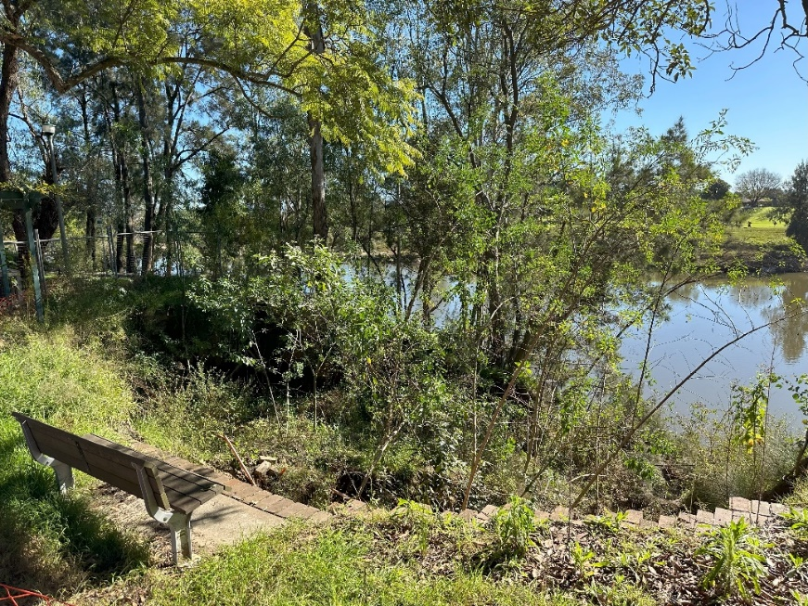

Image by Brewongle and Longneck Lagoon Environmental Education Centres is licensed under a [Creative Commons Attribution 4.0 International (CC BY 4.0) licence](http://creativecommons.org/licenses/by/4.0/).

Figure 2 – picnic areas damaged during the 2022 floods remain closed today

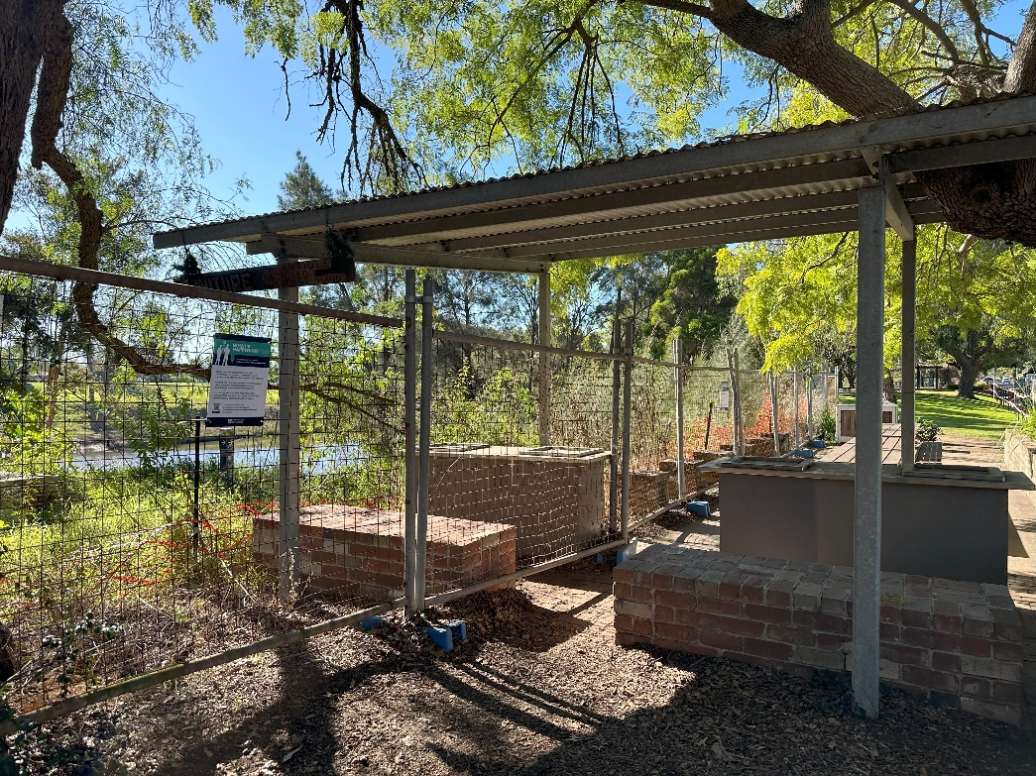

Image by Brewongle and Longneck Lagoon Environmental Education Centres is licensed under a [Creative Commons Attribution 4.0 International (CC BY 4.0) licence](http://creativecommons.org/licenses/by/4.0/).

* Take photographs or sketches of management strategies being used to mitigate the impacts of flooding, including rock walls, signs for the Howe Park Revegetation Project, riverbank vegetation, flood-proof structures and building materials, road flood signs and river level signs. In small groups, discuss the strengths and weaknesses of these strategies.

Figure 3 – a rock wall built along the Windsor foreshore

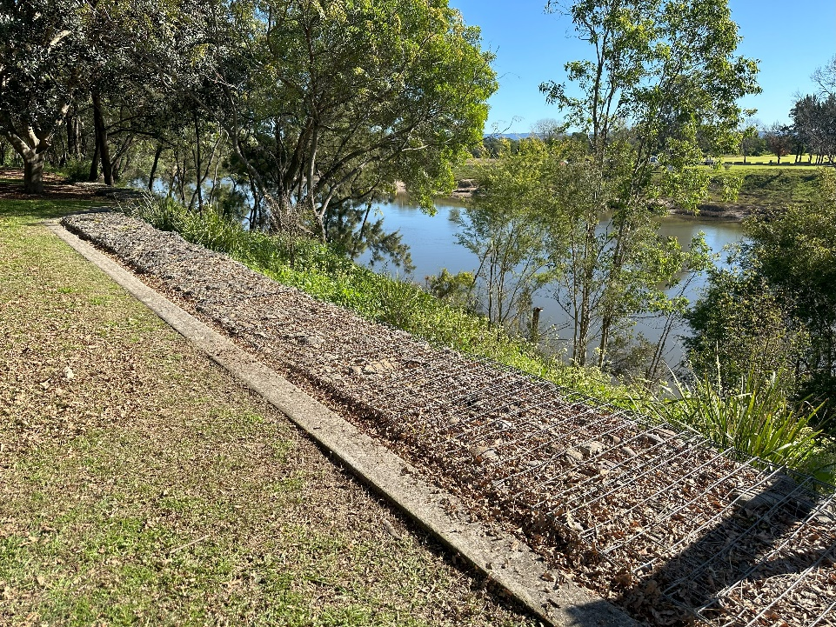

Image by Brewongle and Longneck Lagoon Environmental Education Centres is licensed under a [Creative Commons Attribution 4.0 International (CC BY 4.0) licence](http://creativecommons.org/licenses/by/4.0/).

Figure 4 – a sign describing the Howe Park revegetation project along the Windsor foreshore

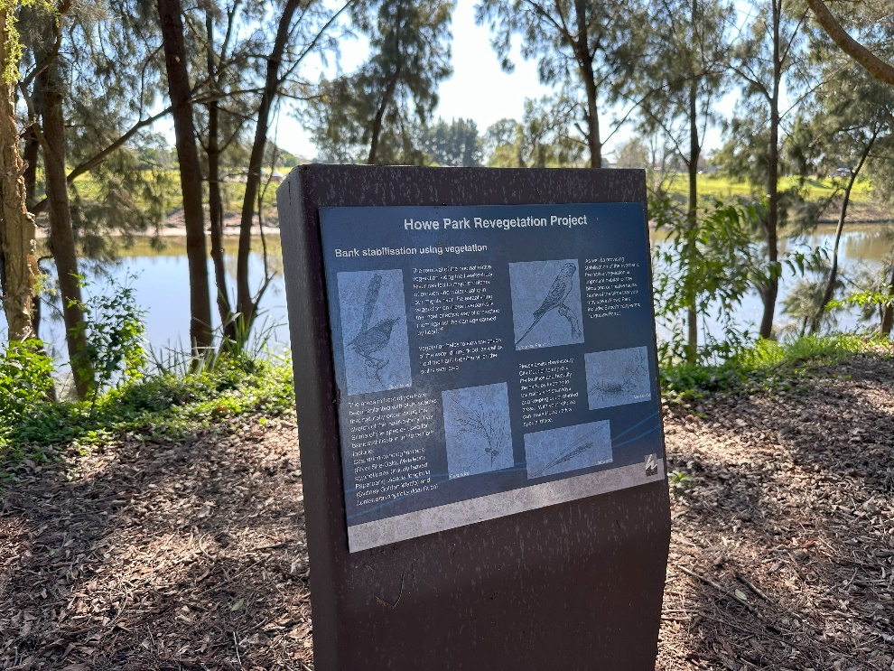

Image by Brewongle and Longneck Lagoon Environmental Education Centres is licensed under a [Creative Commons Attribution 4.0 International (CC BY 4.0) licence](http://creativecommons.org/licenses/by/4.0/).

Figure 5 – flood warning sign, Windsor foreshore

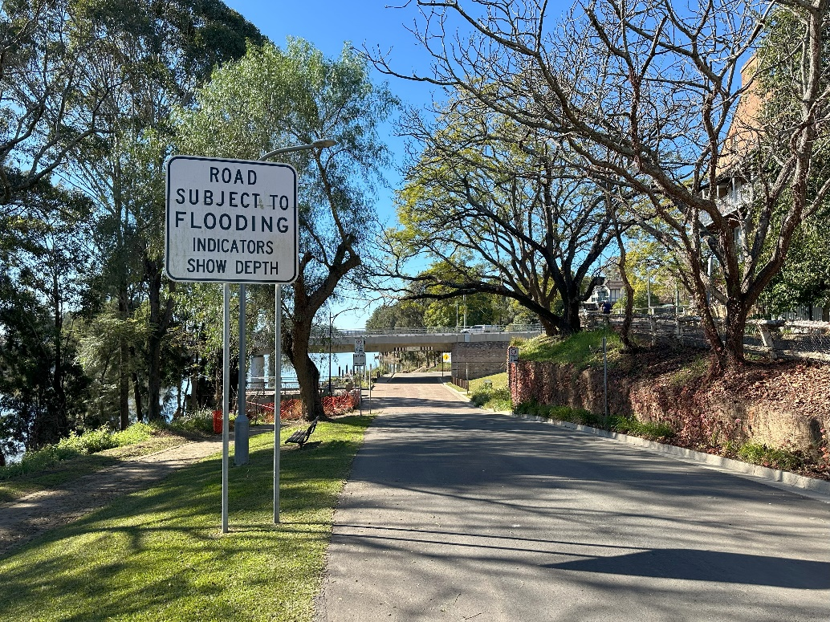

Image by Brewongle and Longneck Lagoon Environmental Education Centres is licensed under a [Creative Commons Attribution 4.0 International (CC BY 4.0) licence](http://creativecommons.org/licenses/by/4.0/).

Figure 6 – flood level signs, Thompson Square, Windsor

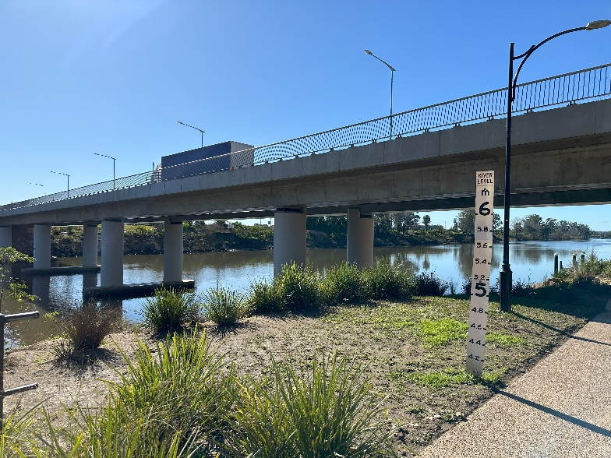

Image by Brewongle and Longneck Lagoon Environmental Education Centres is licensed under a [Creative Commons Attribution 4.0 International (CC BY 4.0) licence](http://creativecommons.org/licenses/by/4.0/).

* Conduct interviews with local residents and business owners. Gather personal accounts to understand the damage caused to the foreshore as a result of the floods and the impact of this damage on them and/or their businesses. Use [Collecting data](https://education.nsw.gov.au/teaching-and-learning/professional-learning/pl-resources/evaluation-resource-hub/collecting-data) to help you. Below are some example interview questions.
* The Windsor foreshore is the area of land along the banks of the Hawkesbury River at Windsor. It includes the Great River Walk. What changes or damage have you seen to the foreshore because of the 2022 floods?
* Has the damage to the foreshore impacted you or your business in any way? If so, provide examples.

**Materials and equipment**

* Camera or sketchbook
* GPS device
* Notepad and pen for interviews

### Site 2 – Thompson Square, Windsor

**Objective:** investigate the effectiveness of the Windsor Bridge replacement in withstanding flood events.

**Geographical question:** explain the Windsor Bridge replacement project as a strategy to reduce the impact of flooding events on residents and businesses within the Richmond-Windsor floodplain.

**Activities**

* Use a GPS device or appropriate app to determine the exact coordinates of the Windsor Bridge.
* Take photographs or sketch the Windsor Bridge and its surrounds. Include the remains of the old Windsor Bridge (the viewing platform to the left of the bridge) in the photographs or sketch to show the difference in height between the 2 bridges. The 2 bridges can be seen side-by-side in [Removal: works on both the old and new Windsor Bridges will continue](https://www.hawkesburygazette.com.au/story/6857122/works-on-windsor-bridge-removal-to-begin-next-month/) shortly before the demolition of the original bridge.

**Note**: instruct students not to join the site but just look at the photo.

Figure 7 – the remains of the old Windsor Bridge (the viewing platform) and the new Windsor Bridge

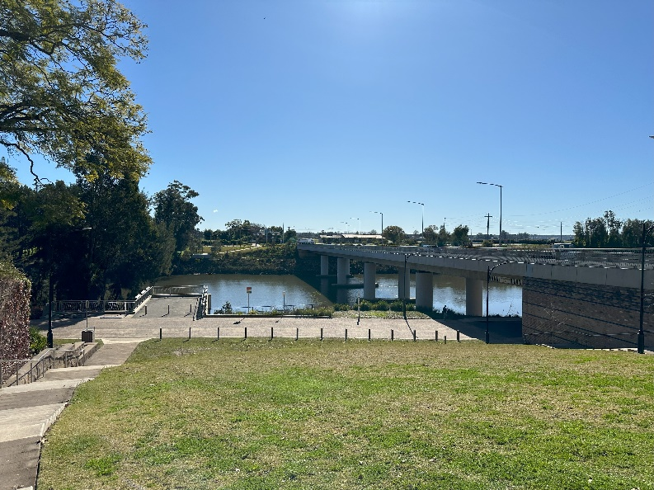

Image by Brewongle and Longneck Lagoon Environmental Education Centres is licensed under a [Creative Commons Attribution 4.0 International (CC BY 4.0) licence](http://creativecommons.org/licenses/by/4.0/).

* Use a GPS device or appropriate app to determine the height of the bridge at 2 different points: the first point on the Windsor side of the bridge (from the top of the stairs leading down to the river); the second point on the Wilberforce Rd side (near the roundabout). In pairs, discuss the implications for the difference in height between Wilberforce Rd and the Windsor end of the bridge.
* Continue to conduct interviews with local residents and business owners, building on previous interviews, to understand the impact that the Windsor Bridge replacement has had on residents and business owners within the Richmond-Windsor floodplain during flood events. Use [Collecting data](https://education.nsw.gov.au/teaching-and-learning/professional-learning/pl-resources/evaluation-resource-hub/collecting-data) to help you. Below is an example of an interview question.
* The new Windsor Bridge replacement was opened in May 2020. According to the [Roads & Maritime – frequently asked questions - February 2017 frequently asked questions](https://www.transport.nsw.gov.au/projects/current-projects/project-documents-windsor-bridge-replacement) document, the new bridge is ‘about three metres higher at the northern bank and six metres higher at the southern bank’ (page 2). How has this new, higher bridge impacted you or your business during flooding events?

**Materials and equipment**

* Camera or sketchbook
* GPS device
* Notepad and pen for interviews

### Site 3 – Governor Philip Park

**Objective:** understand the use of planning measures to reduce the impact of flooding on people and communities.

**Geographical question:** explain how development restrictions in flood prone areas within the Richmond-Windsor floodplain reduce the impact of flooding on people and communities.

**Activities**

* Use a GPS device or appropriate app to determine the exact coordinates of Governor Philip Park and height above sea level. In July of 2022, flood levels at Windsor reached 13.9 AHD (Australian Height Datum) which is approximately 13.9 metres above sea level. Explain the implications of this for this area.

|  |
| --- |
|  |

* Take photographs or sketches of the building materials used for any built structures within the low-lying areas around Governor Philip Park. Consider whether these materials are suitable for flood-prone areas and how they contribute to flood resilience. Take photographs or sketch the building materials used for any built structures within the low-lying areas in and around Governor Philip Park.

Figure 8 – a farm opposite Governor Philip Park

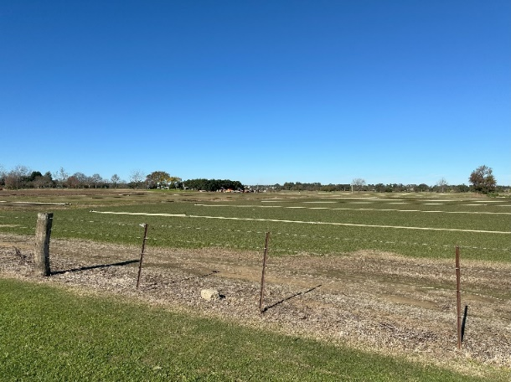

Image by Brewongle and Longneck Lagoon Environmental Education Centres is licensed under a [Creative Commons Attribution 4.0 International (CC BY 4.0) licence](http://creativecommons.org/licenses/by/4.0/).

Figure 9 – Governor Philip Park contains several BBQ areas free for the public to use

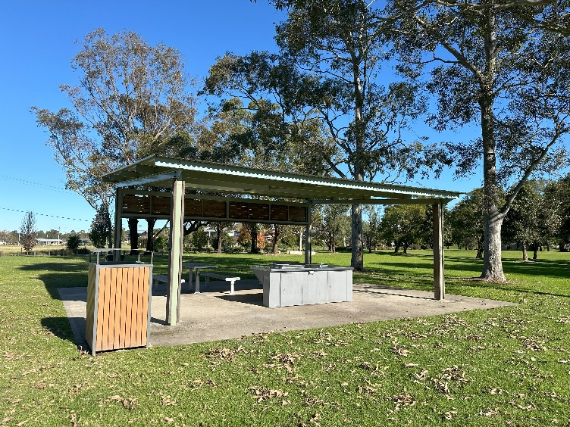

Image by Brewongle and Longneck Lagoon Environmental Education Centres is licensed under a [Creative Commons Attribution 4.0 International (CC BY 4.0) licence](http://creativecommons.org/licenses/by/4.0/).

* Complete a cross section showing changes in land height and draw a transect showing the land use between the Governor Philip Park boat ramp car park and the corner of Baker Street and George Street. Use a GPS device or app to assist you in calculating height. Discuss the differences in land use between flood prone areas and higher ground, and the differences in house designs between those on low ground and those on higher ground.

**Note**: explain what land use is and how it is visually represented along a transect line. Display an example of a transect and explain how to represent land height on one axis and land use on the other. Emphasise key land uses along the route (for example, parks, residential areas, commercial zones). Model the use of the tool by introducing the GPS device or the My Altitude app. Show students how to:

1. Open the app and locate the Governor Philip Park boat ramp car park and have students record the altitude at this location.
2. Walk the route towards Baker Street and George Street, noting changes in land height and land use. Record the data and organise it for drawing the transect. Include symbols for each change in land use along the transect (for example, parklands, farmland, residential, industrial) and create a legend or key to represent the change.
3. Instruct students to complete their transect by continuing to record altitude readings and identifying land uses as they move along the path. Ensure they draw their transects by plotting altitude on the y-axis and distance on the x-axis.
4. Encourage students to observe and record the differences in house designs between lower and higher ground. Are houses on lower ground elevated, or do they have flood-resistant features?
5. Provide step-by-step instructions including land height measurement. Guide students through recording the land height at various points along the transect. Use the GPS device or My Altitude app to demonstrate how to gather altitude readings.
6. Conduct land use observation as students walk along the transect route, help them observe and note the different land uses (for example, highlight parks, housing and commercial buildings).

Check for understanding and provide feedback. Ask students key questions such as ‘What changes in land height are you observing?’ and ‘What types of land uses do you see at lower elevations compared to higher ground?’

Provided below are a topographic map and a Google map.

Figure 10 – NSW topographic map, Google maps

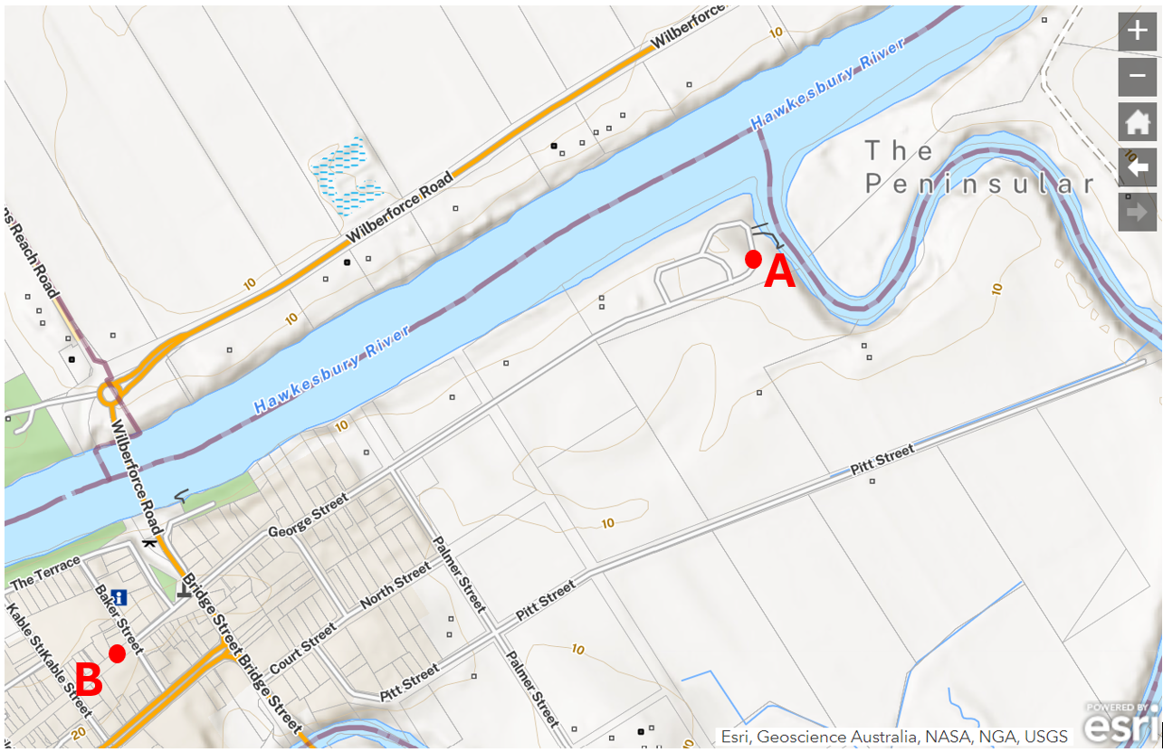

‘NSW topographic map’ by [Spatial Portal](https://portal.spatial.nsw.gov.au/portal/apps/sites/#/homepage/pages/map-viewers) is © 2020 Spatial Collaboration Portal.

Figure 11 – Google maps

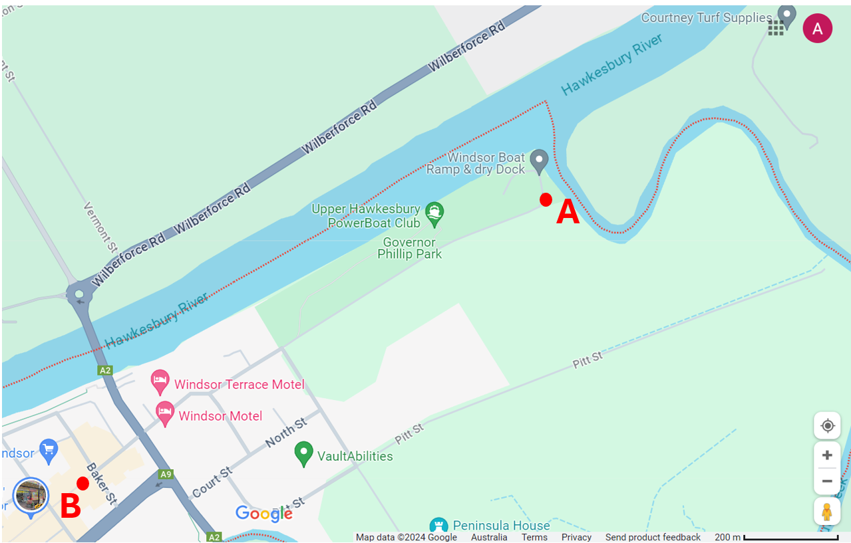

Map data by Google.

**Materials and equipment**

* Camera or sketchbook
* GPS device
* Notepad

### Site 4 – Yarramundi Reserve

**Objective:** investigate the impact of the 2021 and 2022 floods on Yarramundi Reserve.

**Geographical question:** outline how flooding has impacted Yarramundi Reserve.

**Activities**

* Use a GPS device or app such as My Altitude to determine the exact coordinates of Yarramundi Reserve. Walk along the various pathways within the reserve and take photographs or sketches of damage caused to the natural and built environment – for example, bent and uprooted trees, damaged signs, erosion, damaged pathways and damage to buildings. [Yarramundi Reserve](https://www.hawkesbury.org/name/yarramundi-reserve.html) contains images of the area before the 2021 and 2022 floods for comparison.
* Walk across Springwood Road to the Agnes Car Park, South of Yarramundi Reserve and take photographs or sketches of damage caused to the natural and built environment, for example, bent and broken trees, and damaged signs.

Figure 12 – an eroded bank and flood damaged footpath in Yarramundi Reserve

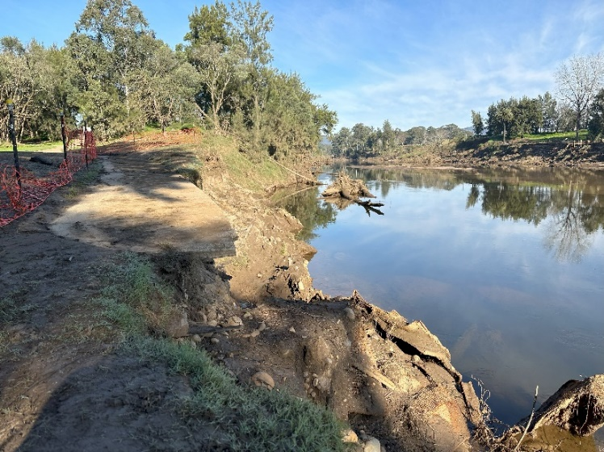

Image by Brewongle and Longneck Lagoon Environmental Education Centres is licensed under a [Creative Commons Attribution 4.0 International (CC BY 4.0) licence](http://creativecommons.org/licenses/by/4.0/).

Figure 13 – a flood-damaged sign in Yarramundi Reserve

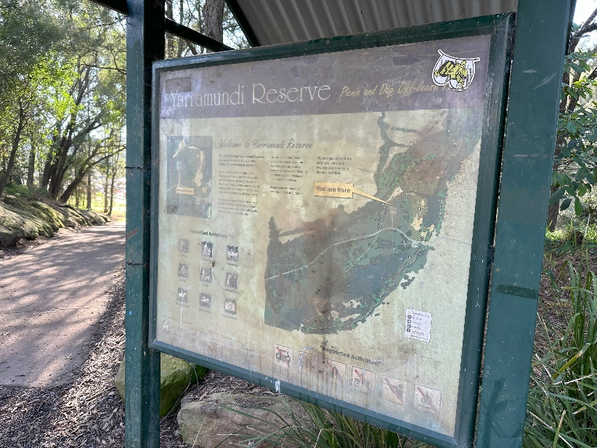

Image by Brewongle and Longneck Lagoon Environmental Education Centres is licensed under a [Creative Commons Attribution 4.0 International (CC BY 4.0) licence](http://creativecommons.org/licenses/by/4.0/).

Figure 14 – bent and broken trees in Yarramundi Reserve

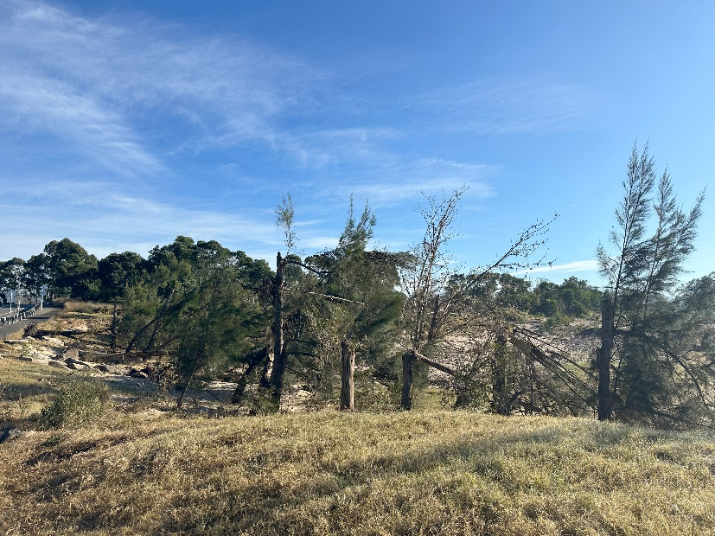

Image by Brewongle and Longneck Lagoon Environmental Education Centres is licensed under a [Creative Commons Attribution 4.0 International (CC BY 4.0) licence](http://creativecommons.org/licenses/by/4.0/).

Figure 15 – damaged trees and signs south of Springwood Road in Yarramundi Reserve

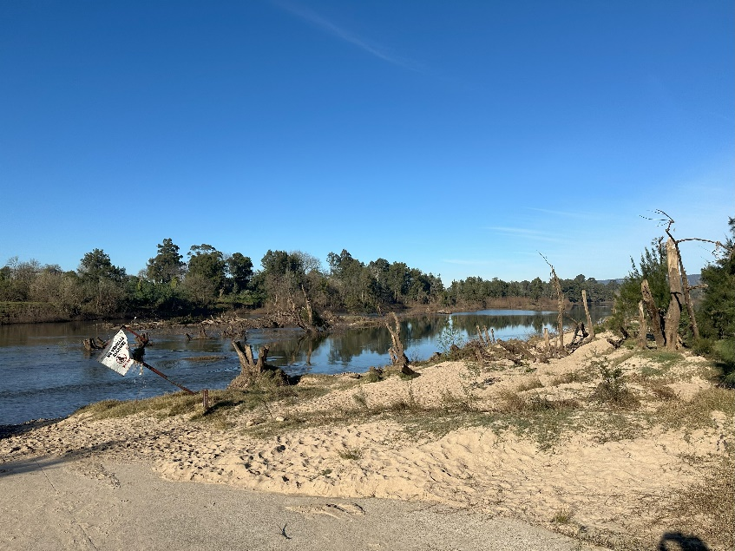

Image by Brewongle and Longneck Lagoon Environmental Education Centres is licensed under a [Creative Commons Attribution 4.0 International (CC BY 4.0) licence](http://creativecommons.org/licenses/by/4.0/).

**Materials and equipment**

* Camera or sketchbook
* GPS device
* Notepad

### Site 5 – a national park or well-vegetated area near school grounds

**Objective:** investigate the use of protected areas as a natural method for mitigating the impact of flooding events.

**Geographical question:** explain how maintaining natural vegetation reduces the potential damage caused by flooding events.

**Activities**

* Use a GPS device or app such as My Altitude to determine the exact coordinates of your location.
* Read [Explainer: How trees help protect us from flooding](https://forestsnews.cifor.org/87652/explainer-how-trees-help-protect-us-from-flooding?fnl=en) and [Trees: why they’re our greatest allies against floods – but also tragic victims](https://findanexpert.unimelb.edu.au/news/41224-trees--why-they're-our-greatest-allies-against-floods-%E2%80%93-but-also-tragic-victims).
* Explain the role that vegetation plays in the water cycle and in reducing the potential damage caused by flooding events.

|  |
| --- |
|  |

**Note**: use a visual representation or [How to measure infiltration rate (1:29)](https://www.youtube.com/watch?v=3PSroyhfXDM) or [How to make an infiltration ring from a can (3:08)](https://www.youtube.com/watch?v=Jk4Wo0M0c84) to introduce the concept of soil infiltration. Model the task by showing the class how to conduct a simple infiltration test. If possible, demonstrate using an infiltration ring or can in front of the class:

Push the infiltration ring into the soil and pour a known amount of water into the ring. Time how long it takes for the water to infiltrate the soil and record the results.

Ask questions to prompt thinking, like: ‘What differences do you expect to see between these 2 areas?’ and ‘How do you think vegetation affects the rate at which water infiltrates the soil?’ Discuss the implications of extensive land clearing and development within a catchment as large as the Hawkesbury-Nepean River catchment area.

* Conduct soil infiltration tests to compare the rates of infiltration between well vegetated areas and areas without vegetation, such as a worn path or cleared grassy area. (See Appendix 3 for detailed instructions.)

**Materials and equipment**

* Infiltration tube
* Wood plank
* Hammer
* Measuring cup
* Bucket for storing water
* Stopwatch or phone

## Post-fieldwork task

* Contribute to a shared class [Y chart](https://app.education.nsw.gov.au/digital-learning-selector/LearningActivity/Card/599?clearCache=c9dcc044-b487-1b8d-658c-459346ce198e) that responds to the question ‘How does flooding impact people and communities in the Richmond-Windsor floodplain?’ The Y chart should include information on
* preparing for flooding events
* during flooding events
* after flooding events.

**Note:** display a range of photographs taken during the fieldwork and provide students with sticky notes allowing them to annotate each image. Have students refer to the geographical questions when writing their annotations.

* Compile a list of the management strategies being used to mitigate the impact of flooding in the Richmond-Windsor area into a table. Complete a [SWOT analysis](https://app.education.nsw.gov.au/digital-learning-selector/LearningActivity/Card/660?clearCache=a02ecfda-3273-4c85-a7ab-eae8db2b373) for each strategy.
* Conduct research and investigate the different perspectives on raising the Warragamba Dam wall to mitigate the impact of flooding events in the future. Read the following articles to help you with your research
* [Behind the wall: When the levee breaks](https://www.abc.net.au/news/2021-03-27/warragamba-dam-raising-to-save-flooding-cost-others/13226472)
* [Raising Warragamba Dam Wall](https://npansw.org.au/2018/06/01/raising-warragamba-dam-wall/)
* [Raising Warragamba dam declared a critical project for NSW](https://www.waterpowermagazine.com/news/raising-warragamba-dam-declared-a-critical-project-for-nsw-10068885/?cf-view).

## Resources

**Materials list for fieldwork sites**

* Hats, sunscreen, sun protective clothing
* Water bottle
* Sturdy footwear
* First aid kits
* Camera or sketchbook
* Stopwatch or phone, GPS device or app such as My Altitude
* Notepad and pen
* Infiltration tube
* Wood plank
* Hammer
* Measuring cup and bucket for storing water

## Appendix 1 – pre-fieldwork activity 1 answers

* Watch the video [Why floods are so dangerous in the Hawkesbury Nepean Valley (2:29)](https://www.youtube.com/watch?v=MWkacc74mdc&t=1s) and answer the following questions.

1. Name the weather event that precedes most flooding events in the Hawkesbury-Nepean Valley. **Answer:** East Coast Low.
2. Which tributary contributed up to 70% of the water in major floods in the past 60 years? **Answer:** The Warragamba River.
3. Explain the ‘bathtub effect’. **Answer:** Natural ‘choke points’ where the river narrows slow flood water down as it flows out to sea. As a result, water backs up and starts filling the floodplain.

* Using the [NSW Flood Footprint Map](https://www.arcgis.com/apps/View/index.html?appid=52330db288ad45068d9845fd28001cb4), list the types of land uses in the flood footprint of the Richmond-Windsor floodplain. Search Windsor NSW or Richmond NSW to locate the floodplain. Use the layers feature of this map to remove or add the flood footprint when required. **Answer:** Land uses include agriculture, reserves, parks, sporting fields and golf courses.

## Appendix 2 – pre-fieldwork activity 2 answers

* Access the [Hawkesbury-Nepean River March and July 2022 Floods Review](https://www.nsw.gov.au/departments-and-agencies/nsw-reconstruction-authority/our-work/hawkesbury-nepean-valley-flood-risk-management/resources) using the Records of moderate and major floods at Windsor from 1794 – 2022 (graphic), respond to the following questions.

1. What is the highest recorded flood level at Windsor? In which month and year did this flood occur?**Answer:** 19.7 m. June 1867*.*
2. What height did river levels reach in March and July of 2022? **Answer:** March 13.8 m. July 13.9 m.
3. Explain the severity of the March and July 2022 floods in comparison to previous floods at Windsor. **Answer:** The March and July 2022 floods were the worst to occur in the Hawkesbury in 44 years. In 228 years of records, only 10 out of the 102 recorded floods reached a higher level of flooding than July 2022.

* Read the ABC News article [Hawkesbury’s back-to-back, record-breaking floods are high on voters’ minds ahead of New South Wales election](https://www.abc.net.au/news/2023-03-03/hawkesbury-after-the-floods-and-ahead-of-the-nsw-election/102041104) and complete the following questions.

1. Describe the impact of the March 2021 and July 2022 floods on the Hawkesbury community. Provide specific examples from the article. **Possible answers** (but not limited to): Homes and sheds inundated with water. When waters recede, they need to be cleaned and repaired. For example, sheds and homes in Pitt Town. Loss of crops, broken irrigation equipment and clean-up of weeds and debris on farms. For example, Turf farms at Wilberforce.
2. List 3 strategies proposed in the article to manage future flooding events. **Answer:** Raising the Warragamba Dam wall by 14 metres, upgrading evacuation routes and preventing development on the floodplain.

## Appendix 3 – fieldwork site 5 – infiltration test instructions

The purpose of this test is to compare the rates of water infiltration between a well-vegetated area and an area cleared of vegetation. Site 1 should be an area with abundant vegetation, such as a natural woodland or forest, while Site 2 should be a cleared area, such as a worn path or oval. Ensure the 2 sites are relatively close to one another to maintain similar soil types.

**Note**: allow students to work in groups, carrying out the same infiltration test at both sites. Remind them to ensure the tube is properly inserted and the timing is accurate. Instruct students to accurately record the time it takes for the water to infiltrate the soil at each site and calculate the average infiltration rate. Model the set-up before starting, demonstrate how to set up the experiment with the materials. Show students an infiltration tube, explaining how it can be made from a PVC pipe or tin can. Demonstrate how to ensure the tube can hold 300 ml of water. Explain that the 2 sites should be chosen close to each other to ensure similar soil types but with contrasting vegetation (one well-vegetated, the other cleared).

**Materials**

* Infiltration tube (this could be made from PVC pipe or a tin can. Ensure your tube has the capacity to store 300 ml of water).
* Wood plank (approximately 30 cm long) and hammer with a measuring cup (250 ml capacity).

**Instructions**

1. Insert the infiltration tube into the ground at Site 1. Use the hammer and the plank of wood to tap the tube at least 2 cm into the ground. This will ensure that water does not leak out from the sides of the tube.
2. Pour 250 ml of water into the tube and start your timer. Record the time it takes for the water to soak fully into the ground.
3. Repeat the test 2 to 3 times in nearby areas of Site 1 and record the average infiltration rate.
4. Move to Site 2 (the cleared area) and repeat the test, following the same process of pouring water and timing its absorption.

**Note**: once all groups have completed their tests, bring the class together to analyse the results. Facilitate a discussion around:

* Comparison of results: How did the infiltration rates differ between the vegetated and cleared sites?
* Impact of vegetation: Discuss why vegetation might lead to faster or slower infiltration and the role of roots, organic matter and soil structure in this process.
* Critical Thinking: ‘How might these results apply to real-world situations, such as managing water in urban or rural environments?’

## References

This resource contains NSW Curriculum and syllabus content. The NSW Curriculum is developed by the NSW Education Standards Authority. This content is prepared by NESA for and on behalf of the Crown in right of the State of New South Wales. The material is protected by Crown copyright.

Please refer to the NESA Copyright Disclaimer for more information <https://educationstandards.nsw.edu.au/wps/portal/nesa/mini-footer/copyright>.

NESA holds the only official and up-to-date versions of the NSW Curriculum and syllabus documents. Please visit the NSW Education Standards Authority (NESA) website <https://educationstandards.nsw.edu.au> and the NSW Curriculum website <https://curriculum.nsw.edu.au>.

[Geography 11–12 Syllabus](https://curriculum.nsw.edu.au/learning-areas/hsie/geography-11-12-2022/overview) © NSW Education Standards Authority (NESA) for and on behalf of the Crown in right of the State of New South Wales, 2022.

ABC News (2021) [*Satellite Images of Hawkesbury River flooding show true extent of NSW devastation,* ABC News website](https://www.abc.net.au/news/2021-03-27/satellite-images-show-flood-damage-in-windsor/100029758), accessed 8 August 2024.

ABC News (2023) [*Hawkesbury’s back-to-back, record-breaking floods are high on voters’ minds ahead of New South Wales election*](https://www.abc.net.au/news/2023-03-03/hawkesbury-after-the-floods-and-ahead-of-the-nsw-election/102041104), ABC News website, accessed 8 August 2024.

ArcGIS (2024) [*NSW Flood Footprint Map*](https://www.arcgis.com/apps/View/index.html?appid=52330db288ad45068d9845fd28001cb4), ArcGIS website, accessed 8 August 2024.

Coleman F (2020) [*Preparation for removal of old Windsor Bridge is set to begin in August*](https://www.hawkesburygazette.com.au/story/6857122/works-on-windsor-bridge-removal-to-begin-next-month/), Hawkesbury Gazette website, accessed 8 August 2024.

Duczynski M (2024) [*Dyarubbin*](https://www.sl.nsw.gov.au/stories/dyarubbin/chapter-6-sackville/6), State Library of New South Wales website, accessed 8 August 2024.

Geography Teacher (30 April 2020) [‘How to measure infiltration rate’](https://www.youtube.com/watch?v=3PSroyhfXDM) [video], *Geography Teacher*, YouTube, accessed 9 August 2024.

Geography Teacher (1 May 2020) [‘How to make an infiltration ring from a can’](https://www.youtube.com/watch?v=Jk4Wo0M0c84) [video], *Geography Teacher*, YouTube, accessed 9 August 2024.

Google Earth (2024) [*Google Earth*](https://www.google.com/intl/en/earth/) [website], accessed 8 August 2024.

Google Earth Outreach (2024) [*Create a map or story in Google Earth Web*](https://www.google.com/earth/outreach/learn/create-a-map-or-story-in-google-earth-web/), Google Earth Outreach website, accessed 8 August 2024.

Google Maps (2024) Map view at coordinates [(-33.848244,150.9319747](https://www.google.com/maps/@-33.848244,150.9319747,9z/data=!5m1!1e4?entry=ttu&g_ep=EgoyMDI0MDgyOC4wIKXMDSoASAFQAw%3D%3D)), accessed 8 August 2024.

Haron C (27 June 2024) [phone conversation and email correspondence] Flood Management Officer, Hawkesbury City Council.

Hawkesbury City Council (2024) [*Disaster and Emergency Dashboard*](https://disaster.hawkesbury.nsw.gov.au/), Hawkesbury City Council website, accessed 8 August 2024.

Hawkesbury People & Places (2022) [*Yarramundi Reserve*](https://www.hawkesbury.org/name/yarramundi-reserve.html), Hawkesbury People & Places website, accessed 9 August 2024.

Hawkesbury Post (2022) [*Windsor flood damage – pictures and videos*](https://hawkesburypost.com.au/windsor-flood-damage-pictures-and-videos/), Hawkesbury Post website, accessed 8 August 2024.

Infrastructure NSW (2017) [*Resilient Valley, Resilient Communities: Hawkesbury-Nepean Valley Flood Risk Management Strategy*](https://www.nsw.gov.au/sites/default/files/noindex/2023-10/infrastructure-nsw-resilient-valley-resilient-communities-2017-jan.pdf) [PDF 5.4 MB], Infrastructure NSW, accessed 23 August 2024.

Infrastructure NSW (2022) [*Hawkesbury-Nepean Valley Flood Risk Management Strategy – resources*](https://www.nsw.gov.au/departments-and-agencies/nsw-reconstruction-authority/our-work/hawkesbury-nepean-valley-flood-risk-management/resources), Infrastructure NSW, accessed 8 August 2024.

Infrastructure NSW (2023) [*Hawkesbury-Nepean River March and July 2022 Floods Review: Hydrology, Riverbank Erosion, and Flood Mitigation Scenarios*](https://www.infrastructure.nsw.gov.au/media/vl3jdi3t/hnv-river-mar-jul-2022-floods-review.pdf) [PDF 13.9 MB], Infrastructure NSW, accessed 8 August 2024.

Moore G (2022) [*Trees: why they’re our greatest allies against floods – but also tragic victims*](https://findanexpert.unimelb.edu.au/news/41224-trees--why-they're-our-greatest-allies-against-floods-%E2%80%93-but-also-tragic-victims), University of Melbourne website, accessed 9 August 2024.

NSW Department of Education (2023) [‘Collecting Data’](https://education.nsw.gov.au/teaching-and-learning/professional-learning/pl-resources/evaluation-resource-hub/collecting-data) *Evaluation Resource Hub*, NSW Department of Education website, accessed 8 August 2024.

NSW Department of Education (2024) ‘[Cross-sections and transects](https://education.nsw.gov.au/teaching-and-learning/curriculum/hsie/hsie-curriculum-resources-k-12/hsie-7-10-curriculum-resources/cross-sections-and-transects)’, *HSIE 7–10 curriculum resources*, NSW Department of Education website, accessed 8 August 2024.

NSW Department of Primary Industries and Regional Development (2024) [*Hawkesbury-Nepean catchment*](https://www.dpi.nsw.gov.au/fishing/habitat/your-catchment/hawkesbury-nepean), NSW Department of Primary Industries and Regional Development website, accessed 23 August 2024.

NSW Government Water (2024) [*Hawkesbury-Nepean*](https://water.dpie.nsw.gov.au/about-us/learn-about-water/basins-and-catchments/catchments/hawkesbury-nepean), NSW Government Water website, accessed 23 August 2024.

NSW Reconstruction Authority (2024) [*Hawkesbury-Nepean River Flood Study: Overview*](https://www.ses.nsw.gov.au/media/6829/2024-hnr-flood-study-overview_lr.pdf) [PDF 4.2 MB], NSW Reconstruction Authority, accessed 8 August 2024.

NSW SES (30 July 2019) [‘It will flood again’](https://www.youtube.com/watch?v=jo9VbKbMZ6o) [video], *NSW SES*, YouTube, accessed 16 October 2024.

NSW SES (14 December 2022) [‘Why floods are so dangerous in the Hawkesbury Nepean Valley’](https://www.youtube.com/watch?v=MWkacc74mdc&t=1s) [video], *NSW SES*, YouTube, accessed 8 August 2024.

NSW State Emergency Service (NSW SES) (2024) [*If you live or work in the Hawkesbury-Nepean Valley you are at risk of flood*](https://www.ses.nsw.gov.au/hawkesbury-nepean-floods), NSW SES website, accessed 8 August 2024.

NSW SES (2024) [*Map 1 – Hawkesbury-Nepean Location Map*](https://www.ses.nsw.gov.au/media/3366/geo-skills-map-1.pdf) [PDF 322 KB], NSW SES website, accessed 8 August 2024.

NSW Spatial Services (2020) [*Map viewers*](https://portal.spatial.nsw.gov.au/portal/apps/sites/#/homepage/pages/map-viewers), NSW Spatial Services website, accessed 8 August 2024.

realestate.com.au (2024) [*Sold Real Estate & Property in McGrath Rd, McGraths Hill, NSW 2756*](https://www.realestate.com.au/sold/in-mcgrath+road,+mcgraths+hill/list-1), realestate.com.au, accessed 8 August 2024.

Roads & Maritime (2017) [*Questions and answers: Windsor Bridge replacement project*](https://www.transport.nsw.gov.au/sites/default/files/media/documents/rww/projects/01documents/windsor-bridge-replacement/windsor-bridge-questions-and-answers.pdf) [PDF 147 KB], Roads & Maritime, accessed 8 August 2024.

State of New South Wales (Department of Education) (n.d.) [*Controversial issues in schools*](https://education.nsw.gov.au/policy-library/policies/pd-2002-0045), NSW Department of Education website, accessed 16 October 2024.

State of New South Wales (Department of Education) (n.d.) [*Digital Learning Selector*](https://app.education.nsw.gov.au/digital-learning-selector/LearningActivity/Browser?cache_id=4cf93), NSW Department of Education website, accessed 24 August 2023.

State of New South Wales (Department of Education) (2023) [*NSW Department of Education Code of Conduct*](https://education.nsw.gov.au/policy-library/policies/pd-2004-0020-01), NSW Department of Education website, accessed 16 October 2024.

State of New South Wales (Department of Education) (2024) [*Excursions and travel*](https://education.nsw.gov.au/inside-the-department/health-and-safety/risk-management/excursions-and-travel-health), NSW Department of Education website, accessed 16 October 2024.

Technology 4 Learning (2024) [*Canva for Education*](https://t4l.schools.nsw.gov.au/resources/professional-learning-resources/canva-for-education.html?clearCache=ab4755c5-49e7-ab04-a13c-65937d4f781), Technology 4 Learning website, accessed 8 August 2024.

Transport for NSW (2023) [*Windsor Bridge replacement*](https://www.transport.nsw.gov.au/projects/current-projects/windsor-bridge-replacement), Transport for NSW website, accessed 8 August 2024.

Wambui J and Evans M (2024) [*Explainer: How trees help protect us from flooding*](https://forestsnews.cifor.org/87652/explainer-how-trees-help-protect-us-from-flooding?fnl=en), Forests News website, accessed 9 August 2024.

**© State of New South Wales (Department of Education), 2024**

The copyright material published in this resource is subject to the *Copyright Act 1968* (Cth) and is owned by the NSW Department of Education or, where indicated, by a party other than the NSW Department of Education (third-party material).

Copyright material available in this resource and owned by the NSW Department of Education is licensed under a [Creative Commons Attribution 4.0 International (CC BY 4.0) license](https://creativecommons.org/licenses/by/4.0/).

[](https://creativecommons.org/licenses/by/4.0/)

This license allows you to share and adapt the material for any purpose, even commercially.

Attribution should be given to © State of New South Wales (Department of Education), 2024.

Material in this resource not available under a Creative Commons license:

* the NSW Department of Education logo, other logos and trademark-protected material
* material owned by a third party that has been reproduced with permission. You will need to obtain permission from the third party to reuse its material.

**Links to third-party material and websites**

Please note that the provided (reading/viewing material/list/links/texts) are a suggestion only and implies no endorsement, by the New South Wales Department of Education, of any author, publisher, or book title. School principals and teachers are best placed to assess the suitability of resources that would complement the curriculum and reflect the needs and interests of their students.

If you use the links provided in this document to access a third-party's website, you acknowledge that the terms of use, including licence terms set out on the third-party's website apply to the use which may be made of the materials on that third-party website or where permitted by the *Copyright Act 1968* (Cth). The department accepts no responsibility for content on third-party websites.