# Geography Year 11 fieldwork – People, patterns and processes – Millers Point and Dawes Point Village Precinct case study

**Note**: a comprehensive health and safety risk assessment is required for all school/work excursions and travel. Please visit [Excursions and travel](https://education.nsw.gov.au/inside-the-department/health-and-safety/risk-management/excursions-and-travel-health) for further guidance.

Controversial issues might be questions, subjects, topics or problems which create a difference of opinion, causing contention and debate within the school or the community. Controversial issues will differ across schools and communities.

In many of the topics covered within the HSIE syllabuses teachers are required to address controversial issues. Stage 6 geography has content that can be deemed controversial. As per the [Controversial Issues in Schools policy](https://education.nsw.gov.au/policy-library/policies/pd-2002-0045), teachers in HSIE must deliver lessons ensuring content is for ‘educational purposes consistent with the delivery of curriculum and provision of school programs and activities’.

The manner in which teachers approach the delivery of controversial issues in NSW public schools is guided by the Department of Education’s [Controversial Issues in Schools policy](https://education.nsw.gov.au/policy-library/policies/pd-2002-0045) and the [Code of Conduct policy](https://education.nsw.gov.au/policy-library/policies/pd-2004-0020-01). These documents call for a sensitive, objective and balanced approach to coverage of controversial issues. [Values in NSW public schools](https://education.nsw.gov.au/policy-library/policies/pd-2005-0131) is also a useful reference document which sets out the values to be promoted in classrooms.

## Syllabus focus area

This fieldwork resource is based on the following syllabus focus area – **People, patterns and processes**

* Study 3: Place and cultural change

### Outcomes

A student:

* **GE-11-01** examines places, environments and natural and human phenomena, for their characteristics, spatial patterns, interactions and changes over time
* **GE-11-02** explains geographical processes and influences, at a range of scales, that form and transform places and environments
* **GE-11-07** applies geographical inquiry skills and tools, including spatial technologies, fieldwork, and ethical practices, to investigate places and environments
* **GE-11-08** applies mathematical ideas and techniques to analyse geographical data
* **GE-11-09** communicates and applies geographical understanding, using geographical knowledge, concepts, terms and tools, in appropriate forms

[Geography 11–12 Syllabus](https://curriculum.nsw.edu.au/learning-areas/hsie/geography-11-12-2022/overview) © NSW Education Standards Authority (NESA) for and on behalf of the Crown in right of the State of New South Wales, 2022.

### Syllabus content

**Study 3: Place and cultural change**

* ONE place at a local or national scale

**Including:**

* the spatial and cultural characteristics of the place
* influences on the cultural identity of the place
* perceptions of, and responses to, cultural continuity and/or change
* opportunities to enhance environmental sustainability and/or human wellbeing

## Background to location

This fieldwork case study provides an opportunity for students to gain an in-depth understanding of a place that has undergone cultural change through the geographic process of urban rehabilitation, particularly through the process of gentrification. This process is strongly associated with:

* influences on Culture of Place
* mediums facilitating cultural change
* movement of people.

The area provides an effective case study of cultural change as it:

* has easily observed cultural change features
* is safe, easily accessible by public transport and can be covered in one teaching day
* is a unique and iconic residential environment contrasting with many students’ own residential backgrounds and lived experiences
* has an interesting and easy-to-understand social history, particularly through Housing NSW’s past policy of relocating 465 former public housing tenants from the area (movement of people)
* has links to the ‘Political power and contested spaces’ content through the former Housing NSW policy of relocating Millers Point and Dawes Point residents
* is supported by a detailed [student webpage](https://sites.google.com/education.nsw.gov.au/placeandculturalchange/home) that explains the syllabus content and provides links to further case study resources, including videos, media articles and academic papers that can be used as pre- and post-fieldwork support
* can be supported and co-delivered by specialised curriculum staff at the [Observatory Hill Environmental Education Centre](https://observatoryhilleec.schools.nsw.gov.au/).

## Geographical investigation and/or questions

What are the social, economic and environmental outcomes of gentrification in Millers Point and Dawes Point? How has gentrification impacted the ‘Culture of Place’ in these suburbs?

## Pre-fieldwork tasks

Students, complete activities and questions prior to fieldwork.

* You will be visiting [Millers Point and Dawes Point village precinct](https://sites.google.com/education.nsw.gov.au/placeandculturalchange/pre-fieldwork). Use Appendix 1 to research the area, including its physical and human geography or historical data.
* Analyse [maps and satellite images of Millers point and Dawes point village precinct](https://www.google.com/maps/@-33.8594501,151.1991011,16z?entry=ttu&g_ep=EgoyMDI0MTAwOS4wIKXMDSoASAFQAw%3D%3D) of the fieldwork location to get a sense of the terrain, land use patterns, and any notable geographic features.
* Pre-fieldwork questions and activities (answer Appendix 2).

1. Define ‘Culture of Place’.

|  |
| --- |
|  |

1. List 3 influences on ‘Culture of Place’?

|  |  |
| --- | --- |
|  |  |
|  |  |
|  |  |

1. Read the [Millers Point and Dawes Point](https://sites.google.com/education.nsw.gov.au/placeandculturalchange/pre-fieldwork) village precinct background information on the fieldwork study sites. What ‘medium facilitating cultural change’ has affected both suburbs the most?
2. Access the following historic film clips (and images) of the study sites to understand what it was like in the past, and their former Culture of Place.

* [In this inner-city suburb, one in three homes are empty](https://youtu.be/QqC1vR4XC1o?si=R5IqmXfAJ0Rh1Pyf)(4:53) – this documentary outlines the history and main issues of the suburb.
* [Who is Millers Point](https://youtu.be/pSE1nriyn0w?si=HCIILjLHkOp65VCE)? (19:06) – in 2012, 2 years prior to the NSW Public Housing’s privatisation, the City of Sydney commissioned a documentary with local public housing residents, sharing stories about themselves and their community, celebrating their community, highlighting their concerns and capturing the history and culture of the area.
* My Interview on [The Project](https://www.youtube.com/watch?v=TyoOPg6MDEo) about Millers Point (2:39) – a Channel 10 debate about the NSW Department of Housing’s decision to relocate public housing tenants from Millers Point.
* Visit the [Six Maps](https://maps.six.nsw.gov.au/) website to view current and historical (1943) maps of both suburbs. **Note:** select the base maps tab (top right) for a 1943 map. List 6 changes to the suburbs between 1943 and today.
* View the most recent [Australian Bureau of Statistics (ABS) data on Millers Point and/or Dawes Point](https://abs.gov.au/census/find-census-data/quickstats/2021/SAL12630) and construct a population pyramid. View the population, then use Quick Stats under the Spatial and cultural characteristics tab and describe the demographic profile of Millers Point (for example, what is the breakdown of the population? What is the shape of the pyramid? What does it tell geographers about the area?).
* View the base, satellite and terrain maps of both suburbs using [Google My Maps](https://app.education.nsw.gov.au/digital-learning-selector/LearningTool/Card/87?clearCache=ce0bfc47-cf8a-8aff-ccd9-a14f16cfdffd). Students construct their own Google fieldwork map by collecting data en-route using the Epicollect App and exporting this data to create an individual or class fieldwork map. Map should show features like social, economic and environmental outcomes. Provided is support to [create an epi-collect5 project](https://five.epicollect.net/more-create) and [exporting Epicollect5 data to Google MyMaps](https://docs.epicollect.net/web-application/import-and-export-projects).

All pre-fieldwork activities are found at Pre Fieldwork [Place and Cultural Change – Pre Fieldwork](https://sites.google.com/education.nsw.gov.au/placeandculturalchange/pre-fieldwork) webpage.

## Fieldwork tasks

Objectives of the fieldwork is to understand one place at a local scale including:

* the spatial and cultural characteristics of the place
* influences on the cultural identity of the place
* perceptions of, and responses to, cultural continuity and/or change
* opportunities to enhance environmental sustainability and/or human wellbeing.

**Fieldwork tasks** include map reading (orientation and mapping), conducting a land use transect, observation and recording, tallying short term rental accommodation, field sketching, collecting photographic evidence (including through a digital device and App), oblique angle photographic analysis and conducting surveys/interviews.

Geographical tools used include:

* maps (for pre-visit and on the day orientation to study sites)
* fieldwork (including data collection using observation and recording, tallying, interviewing, epicollect5 app for GPS positioning, observations and photographs, and/or digital cameras or mobile phones for photographic data collection)
* graphs and statistics (in pre-visit tasks, for example, constructing population pyramids or understanding short term rental charts)
* spatial technologies (using epicollect data to construct a fieldwork map of key gentrification outcomes
* visual representations (using photographs taken to display, visualise, analyse and communicate geographic data and information following the fieldwork).

### Activity 1 – orientation and mapping

**Map site 1** – start at Wynyard Station and walk through the Westpac Walk to Napoleon Plaza.

**Note:** toilets are available in the Westpac Plaza breezeway.

**Orientation and mapping:**

* using a CBD map, students describe the relative location of Millers Point and Dawes Point
* using a GPS, have students locate the exact coordinates of Napoleon Plaza
* using a map, students locate using grid or area references some major cultural features of both suburbs like the Sydney Observatory, Pier 8/9 Walsh Bay, Garrison Church, The Rosalyn Packer Theatre, Argyle Place, Clyne Reserve, Sydney Dance Company, Millers Point Community Centre or Fort St Public School
* using a topographic map, students calculate the height of Observatory Hill, the gradient from Observatory Hill to Walsh Bay and the aspect.

### Activity 2 – land use transect along Kent St

**Map site 2** – along Kent St

**Land use transect along Kent St**

From Napoleon Plaza, walk north along Kent St to the border of Millers Point at 183 Kent St. Students complete a transect as they walk further north along Kent St to identify the types of land uses observed. These could be classified as either:

* high rise residential
* low rise residential (terraces)
* commercial
* other.

Complete an analysis of transect data at the intersection of Kent St and Argyle St (or in nearby Argyle Place Park). For example, what is the most dominant land use type?

**Note:** the majority of terrace houses on the east and western side of Kent St were formerly NSW Department of Housing dwellings (see image below). What evidence is there that gentrification might have happened in this street? Other notable landmarks include the Fire Station, Historic Agar Steps (to Observatory Hill), The Langham Hotel, Public Tennis Courts (managed by Langham), Society of Australian Genealogists (at 2/379), Australian Institute of International Affairs in Glover Cottages, the Catholic Church.

For a map of the former NSW Public Housing dwellings prior to 2014 access the video [In this inner-city suburb, one in three homes are empty](https://www.youtube.com/watch?v=QqC1vR4XC1o) and scroll to 4:00 to see map.

### Activity 3 – Argyle Place – Culture of Place features

**Map site 3** – Argyle Place (outside Harry Jenson Hall) – toilets located on nearby Watson Rd

Walk along Kent St and the current Argyle Place location, students observe and describe ‘Culture of Place’ features observed using the CLASSHEN acronym:

* **C – Colour** (for example, vibrant, drab, dull, heritage colours).
* **L – Liveability** (for example, would this be a nice place to live? What makes it liveable?).
* **A – Architecture** (for example, historic, modern, uniform, varied).
* **S – Streetscape** (for example, roads, vegetation, pathways, public amenities, street furniture).
* **S – Street life** (for example, lively, busy, quiet, shops).
* **H – History** (for example, historical buildings, plaques, artifacts).
* **E – Energy** (for example, high energy – vibrant, exciting; low energy – boring, dull).
* **N – Noise** (for example, loud, quiet).

What other features could contribute to the suburb’s Culture of Place? For example, ethnicity, religion, income levels, natural vs urban environment, demographic profile.

|  |
| --- |
|  |

### Activity 4 – Argyle Place – impacts on Culture of Place

**Map site 4** – Munn Reserve (corner Argyle Pl and High St)

Students observe the adjacent Barangaroo development below High St, including the Barangaroo Metro Station. Access the Financial review article: [The Langham takes on giant developer in $2.4b Sydney Harbour stoush](https://www.afr.com/property/commercial/its-luxury-hotel-v-luxury-apartments-in-2-4b-barangaroo-stoush-20240314-p5fcev) and using the images below, discuss what impact the proposed development might have on High St Millers Point’s ‘Culture of Place’. The discussion should also focus on its historical links to the wharves and Sydney Harbour.

Figure 1 – current, and proposed views, looking south along High St

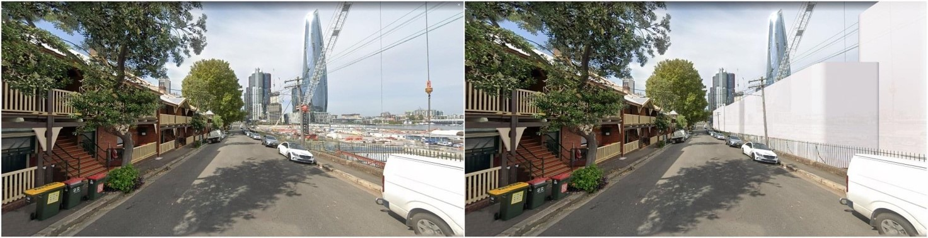

Image from Millers Point Community Resident Action Group.

Figure 2 – current, and proposed views, looking north along High St

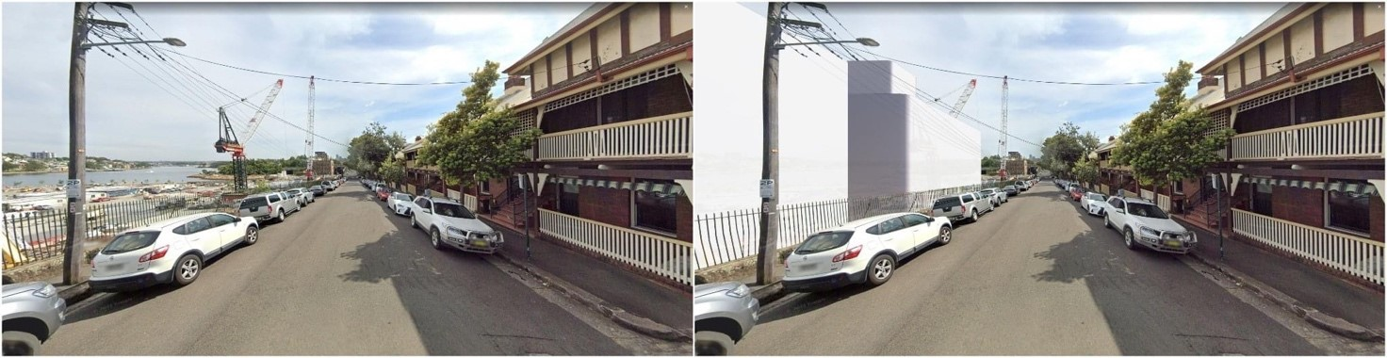

Image from Millers Point Community Resident Action Group.

View the historical image below of the former Darling Harbour wharves. Locate your current position and describe how the area has changed.

|  |
| --- |
|  |

Figure 3 – historical oblique aerial photograph of the city of Sydney

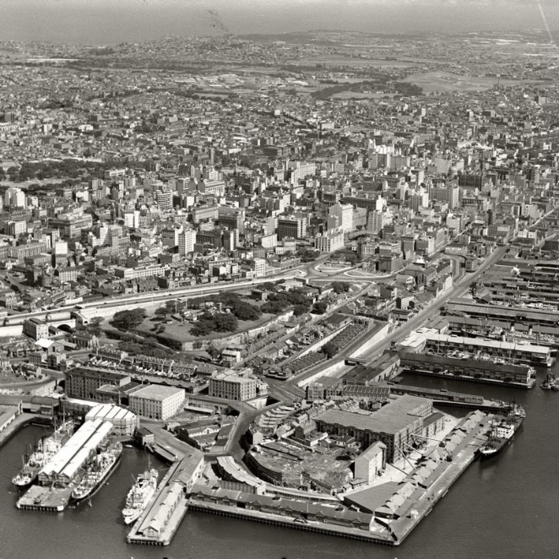

Image by AA Images is available in the [public domain](https://creativecommons.org/publicdomain/zero/1.0/).

Observe the memorial inscription on the top steps of Munn Reserve and have students write the paragraph. What does this memorial say about the former culture of Millers Point residents? (**Note**: for answer see fieldwork answer sheet.)

|  |
| --- |
|  |

### Activity 5 – field sketch looking south-east over southern Millers Point

**Map site 5** – Waranara Terrace – Barangaroo Reserve

Draw a field sketch of Millers Point looking SE from Waranara Terrace Barangaroo Reserve.

Figure 4 – students conducting field sketch from Millers Point looking south-east towards Waranara Terrace Barangaroo Reserve

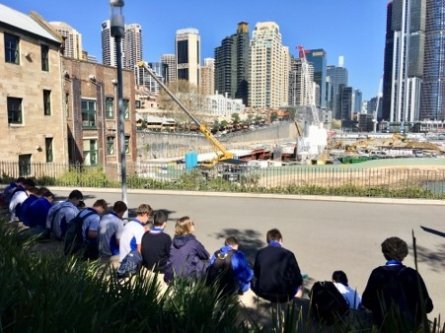

Image by Observatory Hill Environmental Education Centre is licensed under a [Creative Commons Attribution 4.0 International (CC BY 4.0) licence](http://creativecommons.org/licenses/by/4.0/).

Students use the following steps:

1. Sketch in the horizon and main landform features in the correct position on the grid.
2. Draw the human elements that can be seen, for example, The Langham Hotel.
3. Add a title and orientation (which way is North?).
4. Label the main features and add some brief notes to your sketch.

**Note**: this activity can also be done from Observatory Hill overlooking northern Millers Point and Dawes Point (as shown below).

Figure 5 – students completing a field sketch from Observatory Hill over northern Miller Point and Dawes Point

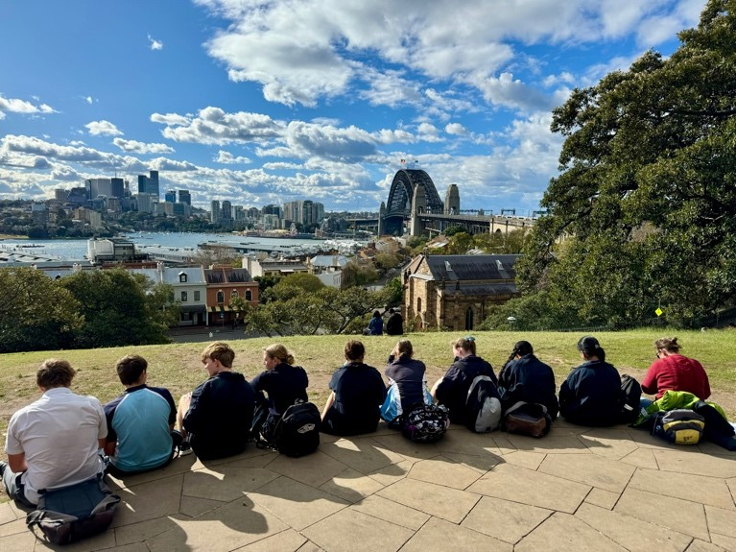

Image by Observatory Hill Environmental Education Centre is licensed under a [Creative Commons Attribution 4.0 International (CC BY 4.0) licence](http://creativecommons.org/licenses/by/4.0/).

### Activity 6 – estimating short-term rental accommodation

**Map Site 6** – Merriman St via Clyne Reserve to Dalgety Rd

According to the [City of Sydney Short-term accommodation review](https://www.cityofsydney.nsw.gov.au/research-reports/short-term-rental-accommodation-review), Millers Point has a high percentage of properties with short-term rentals, particularly in the Merriman St/Dalgety Rd area. This might influence its community and Culture of Place.

Starting from the corner of Bettington St and Merriman St, tally the percentage of short-term rentals to permanent residents using any observed evidence (for example, key lock boxes, linen storage boxes, evidence of guests – image below).

**Note:** many terraces in Dalgety Rd are rented through Airbnb under the name Harbourfront meets heritage chic near Barangaroo.

Figure 6 – key lock boxes, evidence of guest housing in Dalgety St

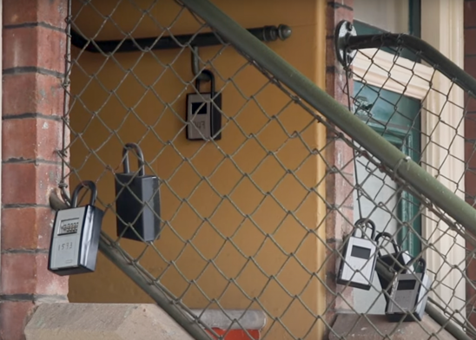

Image by Observatory Hill Environmental Education Centre is licensed under a [Creative Commons Attribution 4.0 International (CC BY 4.0) licence](http://creativecommons.org/licenses/by/4.0/).

Table 1 – tally of observed evidence, image from Observation Hill Education centre

|  |  |
| --- | --- |
| Approx. number of dwellings | Approx. number of short-term rentals |
|  |  |

Percentage of short-term rentals compared to total dwellings ____%. What does this indicate about the community of Millers Point in this area?

|  |
| --- |
|  |

What evidence is there that this part of Millers Point has undergone gentrification?

|  |
| --- |
|  |

### Activity 7 – adaptive reuse of heritage

**Map site 7** – Windmill St Walsh Bay Bond Stores

Figure 7 – former warehouses on Windmill St and Hickson Rd

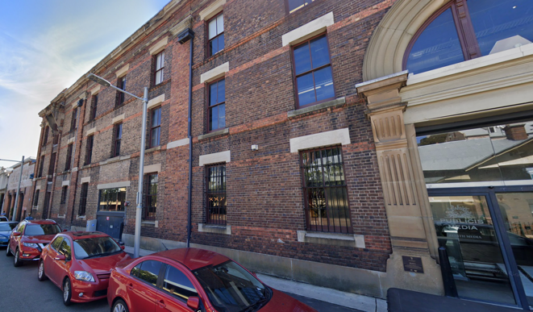

Image by Observatory Hill Environmental Education Centre is licensed under a [Creative Commons Attribution 4.0 International (CC BY 4.0) licence](http://creativecommons.org/licenses/by/4.0/).

How have the former warehouses on Windmill St and Hickson Rd been adaptively reused? What are the main types of commercial uses of the former Bond Stores today?

|  |
| --- |
|  |

**Note:** teachers might wish to contact one of the companies on Windmill St to talk to students about working in a former warehouse. Alternatively, the Roslyn Packer Theatre is open to the public.

### Activity 8 – Culture of Place assessment and photo study

**Map site 8** – Walsh Bay Foreshore Walk

Students use their devices to take photographs showing examples of Walsh Bay’s current Culture of Place, as well as additional photographs (see Appendix 4), that show evidence of the former working port and/or working-class culture. These images can also form part of any epicollect5 project data collection.

**Note:** public toilets are located on Wharf 3/4.

Students to conduct a public interview/survey about the area’s Culture of Place.

**Note**: construct a class interview, or ideally, students could develop their own questions prior to the fieldtrip.

Themes of interview questions could include:

* perspectives of residents/workers/visitors on the suburb’s ‘Culture of Place’
* perspectives on the process that changed the living culture (for example, Housing NSW’s privatisation of public housing)
* perspectives on the public’s view of the physical features of the precinct (for example, preserved heritage features)
* public understanding about the area’s environmental sustainability and/or human wellbeing features.

**Note:** it is important to discuss ethical techniques of data collection prior to any survey/interview.

General ethical protocols for collecting data usually involve:

* **Informed consent:** participants must be fully aware of the survey’s purpose, risks and benefits.
* **Confidentiality:** responses should be kept confidential and anonymous to maintain privacy.
* **Objectivity:** surveys should be free from bias and neutral in tone.
* **Transparency:** clearly disclose the survey’s purpose, sponsor and potential uses of the data.
* **Respect for participants:** avoid asking sensitive or intrusive questions and be mindful of cultural differences.
* **Avoidance of harm:** ensure that the survey does not cause physical, emotional or psychological harm.
* **Data security:** implement appropriate measures to protect respondents’ personal information.
* **Avoidance of deception:** be truthful about the survey’s purpose and not mislead participants.
* **Responsible data analysis:** analyse data accurately, avoid misinterpretation and report findings truthfully.

### Activity 9 – waterfront exhibition – natural and cultural heritage of Walsh Bay

**Map site 9** – Walsh Bay Pier 2/3

Students to observe and document (using mobile devices) evidence of the former ‘Culture of Place’ of the ‘working port’.

|  |
| --- |
|  |

### Activity 10 – the Public Housing Debate

Milton Terrace at the northern end of Lower Fort St was formerly owned by the NSW Department of Housing and occupied by public housing tenants. These terraces were sold to private individuals. Valhalla at 19 Lower Fort St, Dawes Point was bought for $4.25m and the owners have spent over $5 million restoring this property. Valhalla was featured in the ABC TV show Restoration Australia. NSW Dpt. of Housing claimed these houses were too expensive to maintain. Observe Valhalla and cross the street to Dawes Point Park. From here, the Sirius building is observed.

Although technically in The Rocks, the Sirius building was also included in the sale of public housing. It contained 165 residents in 79 apartments. The building sold for A$150 million to Sirius Developments Pty Ltd. On release $435 million worth of apartments were sold by developer JDH Capital in one weekend at a rate of $118,000 per square metre. The penthouse apartment alone was sold for $35M.

Option A: students explain the positive and negative aspects of the sale of public housing.

Option B: students to stand on a line with those opposed to the sale at one end, and those for the sale at the other, students to describe why they chose their position.

|  |
| --- |
|  |

### Activity 11 – Observatory Hill

**Map site 11** – Observatory Hill

From Dawes Point Park, walk south on Lower Fort St towards Observatory Hill observing the gentrified terrace housing en-route.

**Note**: most of the housing on this street was formerly owned by the Dept. of Housing and rented to tenants.

Students view Millers and Dawes Point. Students can either complete a second field sketch or recap on, and answer, the fieldwork questions and the geographical investigation below.

* What have been the social, economic and environmental outcomes of gentrification on Millers Point and Dawes Point, and how has gentrification affected both suburb’s ‘Culture of Place’.

## Post-fieldwork tasks

Activities might include:

* **Compile all data** – organise the data collected during the fieldwork, including field notes, photographs, surveys and interviews. Ensure it is organised in a way that makes analysis straightforward. If collecting class interview data, this should be collated in class.
* **Analyse the data** – use thematic analysis for qualitative data collected on the economic, social and environmental outcomes of the gentrification process.
* **Interpret the findings** – discuss what the data collected reveals about the Culture of Place of both suburbs, and the social, economic and environmental outcomes of the movement of people both in and out of the suburb through the process of gentrification.
* **Draw conclusions** – summarise the key insights gained from your fieldwork, particularly the effect of gentrification on a suburb’s Culture of Place.
* **Communicate and share findings** – prepare to share findings with class and/or teachers.

## Resources

Outline of resources needed for the fieldwork:

* Geographical tools and equipment – prepared epicollect5 project loaded onto student’s fully charged mobile phone, fieldwork maps, stimulus photographs, transect equipment, stimulus newspaper resources. Material and equipment
* photographic devices, for example, camera or charged mobile phone
* epicollect5 App loaded on phone
* GPS devices
* notepad and pen or pencil for interviews and field sketch
* compass (for field sketch orientation)
* historical and contemporary photographs for on-site analysis
* streetscapes transect template.
* Safety equipment – hats, sunscreen, water bottles, sturdy footwear and first aid kits. Food should be brought on the day although there are cafes en route. These get very busy however at lunchtime.
* Research materials – [OHEEC Place and Cultural Change Student Support Website](https://observatoryhilleec.schools.nsw.gov.au/secondary-programs/s6-people-patterns-and-processes.html) for access to previous research related to the fieldwork area and for pre- and post-fieldwork tasks.
* Transport and permissions – students will need a student opal card (not school opal card) to access the study site if travelling by train. Best start location is Wynyard Station. Exit location can be either Wynyard or Circular Quay.

If requiring access to enter private premisses, for example, businesses in former Bond Stores on Windmill St, access should be sought from the owner prior.

All references for source materials, videos, documents and website links can be found on the [Observatory Hill EEC website](https://observatoryhilleec.schools.nsw.gov.au/) under Secondary Programs/S6 - People, Patterns and Processes - Place and Cultural Change/Place and Cultural Change Fieldwork Support Website. Alternatively, they can be accessed from the [Education NSW Place and Cultural Change](https://sites.google.com/education.nsw.gov.au/placeandculturalchange/home) webpage.

Provided below is a Fieldwork Map or see the [virtual map](https://www.google.com/maps/d/edit?mid=16IPVak8Nkw6DgGazRS4Tieq1jRsTjTE&usp=sharing) here for more detail.

Figure 8 – Millers Point fieldwork map

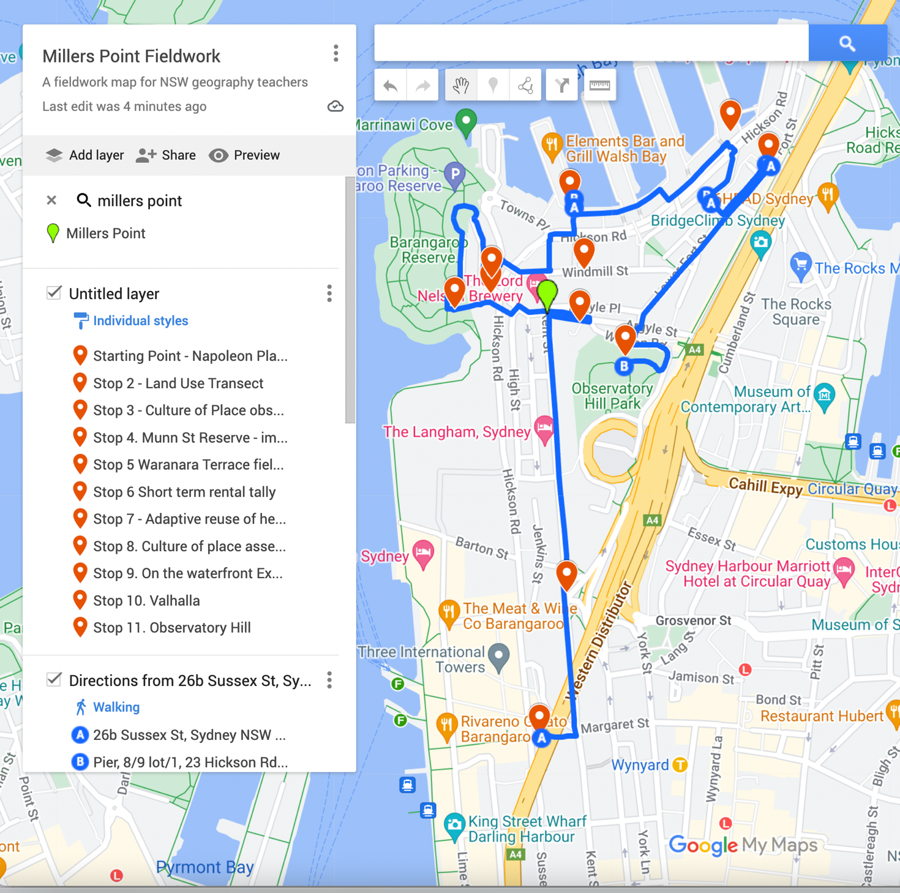

Map data by Google Maps.

## Appendix 1 – background information

### The spatial and cultural characteristics of the place

**Geographical setting**: a description of the fieldwork location’s physical geography, including climate, topography and significant natural features.

Millers Point and Dawes Point, though technically separate suburbs, share a similar identity due to their common geography and history. Their communities have traditionally been closely interconnected and have experienced the same geographic processes and social issues.

Millers Point is a small suburb, covering 50 hectares, located in the northern CBD of Sydney. It is bounded by Sydney Harbour to the north, Barangaroo to the west, and Dawes Point, Bradfield Highway and The Rocks to the east.

Dawes Point is one of the smallest suburbs in Sydney, covering just 0.1 square kilometres. It is situated in the northern CBD, bounded by Millers Point to the west and south, Sydney Harbour to the north, and the Bradfield Highway and The Rocks to the east.

The topography of both Millers Point and Dawes Point is characterised by steep, rocky peninsulas, which originally made settlement and the movement of goods difficult. For instance, until the Argyle Cut was created in 1846, directly linking Millers Point to The Rocks, the suburb could only be reached by climbing over a hill and using stairs. Over time, however, both suburbs’ original rocky shorelines and steep hillsides were excavated and levelled, often quarried for their sandstone or levelled for expanded port facilities.

Following the Bubonic Plague in 1901, the entire shoreline of Walsh Bay to the north and Darling Harbour to the west was excavated and levelled to transform the area into a modern shipping port. Shore sheds were built behind the new wharves and linked to large warehouses (Bond Stores) by a series of bridges. In the 1960s, the land on the western side of Millers Point (now known as Barangaroo) was completely levelled and reclaimed to create a large modern container terminal. The large cutting (cliff) running down the western side of Millers Point remains visible. Interestingly, the developers of the new Barangaroo Reserve have attempted to recreate the original rocky headland and shoreline from the early 1800s.

A significant natural feature in the area is Observatory Hill, located in the middle of Millers Point. This is the highest hill in the CBD, and due to its commanding position overlooking the harbour, it has been used since settlement for military and scientific purposes. Thanks to its location for catching prevailing winds, several windmills were positioned here, giving Millers Point its name. Being surrounded on 3 sides by Sydney Harbour, the peninsula has always had a strong maritime connection.

Possible pre-fieldwork questions:

* How are Millers Point and Dawes Point geographically connected, and what natural boundaries define these suburbs?
* Describe the significance of Sydney Harbour in the geographical setting of Millers Point and Dawes Point.
* What were the main challenges posed by the topography of Millers Point and Dawes Point in the early days of settlement?
* How did the creation of the Argyle Cut in 1846 impact the accessibility of Millers Point?
* What were the major changes made to the shoreline of Walsh Bay and Darling Harbour after the Bubonic Plague in 1901?
* Why is Observatory Hill considered a significant natural feature in Millers Point, and what roles has it played since settlement?
* What efforts have been made in recent years to recreate the original rocky headland and shoreline at Barangaroo Reserve?

**Cultural and historical context**: an overview of the history of the area, focusing on how it has shaped the current landscape and environmental practices.

Both suburbs are characterised by:

* heritage streetscapes and architecture
* residential terraces with a high percentage of short-term rental accommodation
* conserved and adaptively reused heritage buildings, for example, former wharves, bond stores or warehouses, now housing service industries like advertising and marketing agencies
* high socio-economic residents
* cultural entertainment facilities in Walsh Bay
* an inner city ‘cafe society’ lifestyle.

**Pre-European colonisation –** the Gadigal Aboriginal people of the Eora Nation lived along the southern side of Sydney Harbour (Warrane), including the area now known as Dawes Point (Ta-ra), Millers Point (Coodyee) and Observatory Hill. Campsites were usually located close to freshwater sources like the ‘Tank Stream’ and the shore, especially during summer when fish and shellfish were the main food sources.

The Gadigal people were very skilled at using the resources of the natural environment. Food was found in the harbour and along the shoreline using fishing lines made from the inner bark of the kurrajong and hibiscus trees and multi-pronged spears tipped with bone. The many varieties of fish and shellfish, such as oysters, mussels and cockles, were supplemented by gathering native seeds, vegetables and grubs, and by hunting birds and animals like possums, wombats and kangaroos.

Bark canoes (nawies) were made for fishing and transportation along the Parramatta River. Fish were often caught and cooked onboard the canoes using fires built on a clay base. With fish available all year round, there was little need to leave the coast for food. Observatory Hill would have provided a good vantage point to observe activities of other groups around the harbour.

**19th century Millers Point and Dawes Point** – with the completion of the first government windmill on today’s Observatory Hill in 1797, the area became known as Windmill Hill. By the 1820s, ex-convict John Leighton, or ‘Jack the Miller’, had 3 more wooden mills on the point, solidifying the area’s new name, Millers Point.

Up until the 1830s, Millers Point was a sparsely settled area shaped by the ‘cutting down’ of the area’s sandstone for building lots, road formation and port facilities. By the 1840s, a village began to take shape with workers’ cottages near the wharves and the fine houses of wharf owners and merchants on the elevated streets. However, with access to town still difficult, Millers Point remained isolated from, and socially a cut above, its neighbour, The Rocks. Access improved with the creation of the Argyle Cut in 1846.

By the 1850s, Millers Point was the most intensified maritime area in Sydney, with the fortunes of the people tied to the wharves. By 1861, there were 6 large warehouses in Millers Point, about 400 houses and a few hotels. Many of these original buildings remain, giving the area its distinctive heritage character. Many of the original warehouses have been adaptively reused, and the houses are still lived in.

**20th century Millers Point and Dawes Point** – the 1900 bubonic plague outbreak led the government to resume the wharves and the streets behind them, initiating a massive redevelopment project that included the construction of a bridge across the harbour. The new Sydney Harbour Trust oversaw the transformation of houses and wharves in Millers Point, cutting down cliffs, reorganising roads and building new finger wharves. The work began in 1910, was interrupted by the First World War, and was completed by 1924. By the 1970s, containerisation, requiring different cargo handling techniques, made the Walsh Bay Wharves obsolete. Between 2000 and 2010, they were redeveloped as a mixed commercial, residential and recreational precinct on the northern edge of Dawes Point and Millers Point by Walsh Bay Finances, a consortium of Mirvac and Transfield.

While Millers Point and Dawes Point are technically separate suburbs, their identities are similar. Due to their shared geography and history, their communities have traditionally been very closely interconnected. Houses in both suburbs have historically been known as part of either, or both, suburbs. To further complicate the naming, a few Dawes Point streets were only gazetted as Dawes Point as recently as April 1993. In addition, the waterfront area of both suburbs, now known as Walsh Bay, was developed between 2000 and 2010. As this area became wealthier, the new residents tried to separate themselves from the then public housing suburbs of Millers Point and Dawes Point by requesting an official government name change to the suburb of Walsh Bay. This has not happened and is presumably no longer an issue for the residents, given the gentrification of both suburbs. The precinct is often referred to as Walsh Bay.

Possible pre-fieldwork questions:

* What natural resources did the Gadigal people rely on for their food sources, and how did they use them?
* How did the Gadigal people use bark canoes (nawies), and what role did these canoes play in their daily lives?
* What led to the area known as Millers Point being named as such?
* Describe the transformation of Millers Point from a sparsely settled area to a maritime hub by the 1850s.
* How did the creation of the Argyle Cut in 1846 impact the development and accessibility of Millers Point?
* What were the primary reasons for the government’s redevelopment of Millers Point and Dawes Point in the early 20th century?
* How did containerisation in the 1970s affect the wharves in Walsh Bay?
* What changes occurred in the Walsh Bay area between 2000 and 2010, and who was responsible for these developments?

#### Influences on the cultural identity of the place – key factors causing cultural change

**State Conservation listing** – an important feature affecting the culture of both suburbs is their designation as a NSW State Conservation Area. The Millers Point Conservation Area was listed on the New South Wales State Heritage Register on April 2 1999. The listing declared that, as of October 29 2001, the Millers Point Conservation Area was an intact residential and maritime precinct of outstanding state and national significance. It contains buildings and civic spaces dating back to the 1830s and serves as an important example of nineteenth and early twentieth-century landscape adaptation. Conservation listing means that building modifications, including those to interiors, are limited. This has posed challenges for new owners wishing to modernise their homes.

**Housing NSW sale** – from 1986 to 2014, when Maritime Services Board (MSB) housing was transferred to Housing NSW, Millers Point and Dawes Point were characterised as close-knit communities living in rented public housing. The residents enjoyed living there, fostering a strong sense of community.

While residents maintained their homes, some urban decay occurred as the Department of Housing failed to properly maintain the aging homes. Some properties were left derelict, with the department arguing that they were too expensive to maintain. Urban decay refers to the decline in the quality of an urban area, including buildings and infrastructure, as well as the economic decline in the area. As tenancies ended, the department allowed some dwellings to fall into decay.

In March 2014, NSW Housing Minister Pru Goward announced plans to sell 206 heritage-listed properties in Millers Point and Dawes Point and to relocate 465 residents. Public housing residents were offered accommodation in other inner-city suburbs. The government cited the significant repair costs for decayed housing (urban decay) and the need to build more housing for approximately 57,000 people on the waiting list as reasons for the sale.

Residents were gradually moved from the area, though many resisted the move, claiming that the government was destroying their community and engaging in social cleansing (removing targeted social groups from an area).

By November 2018, after 4 years of sales, most public housing in Millers Point had been sold to private buyers and investors, raising $608 million. Housing NSW stated that the funds would be used to build more public housing to reduce the long wait list.

The new private owners have gentrified (conserved and restored) the housing, with many investors renting them out for short-term stays like Airbnb. As mentioned, the state conservation listing means building modifications are limited, resulting in a historic precinct with buildings and civic spaces showing little change since the 1830s. Additionally, the City of Sydney (local government) and the NSW Government (state government) have invested millions of dollars into the public infrastructure of the area, including new parks, street amenities, an upgraded community centre and a redeveloped primary school. Millers Point is now an example of a gentrified inner-city suburb.

**Walsh Bay – key factor causing cultural change – NSW Government led gentrification**

Walsh Bay, located at the northern end of Millers Point and Dawes Point, was redeveloped between 2000 and 2010. The former port had been derelict and abandoned for many years. In 1994, the NSW government, which owned the former port, decided to redevelop it, and a company called Walsh Bay Finances (a joint venture partnership between Mirvac and Transfield) won the development rights. Walsh Bay became one of the most significant urban renewal projects of a heritage precinct in Australia. Although many of the heritage buildings at Walsh Bay had deteriorated, any changes to the site were closely monitored by key stakeholders. Some controversial changes were made, such as the demolition of Wharf 6/7, which was developed into a purpose-built residential pier, a move opposed by the National Trust of NSW.

The area immediately behind the wharves was also redeveloped, including the Pottinger Street Terraces, Parbury Building and Towns Place, which now comprise residential apartments, a new public plaza and a 5-level office building. The former warehouses behind the wharves were converted into modern apartments, while the historic facades facing Hickson Road were preserved.

Warehouses (known as Bond Stores) on the southern side of Hickson Road were transformed into advertising offices, and a new state-of-the-art, 857-seat drama theatre was added, reinforcing the area’s long association with cultural groups such as the Bangarra Dance Theatre and the Sydney Theatre Company.

The redevelopment opened the waterfront to the public for the first time in a century. With numerous restaurants and cafes, the public can now enjoy walking along boardwalks and following historical paths through the development.

Possible pre-fieldwork questions:

* What is the significance of the Millers Point Conservation Area’s listing on the New South Wales State Heritage Register?
* How does the conservation listing impact the ability of homeowners in Millers Point to modify their properties?
* What historical periods are represented in the buildings and civic spaces of the Millers Point Conservation Area?
* What were the characteristics of the Millers Point and Dawes Point communities prior to the sale of public housing in 2014?
* How did the Department of Housing’s approach to maintaining homes contribute to urban decay in Millers Point?
* What were the main reasons given by the NSW government for selling 206 heritage-listed properties in Millers Point and Dawes Point?
* What were the key changes made to Walsh Bay during its redevelopment between 2000 and 2010?
* How did the NSW government and private developers manage the balance between heritage preservation and redevelopment in Walsh Bay?
* What role did cultural institutions like the Bangarra Dance Theatre and the Sydney Theatre Company play in the redevelopment of Walsh Bay?

#### Impacts of Political Tension/Conflict

In March 2014, the NSW Housing Minister, Pru Goward, announced plans to sell 206 heritage-listed properties in Millers Point and to relocate 465 residents. From 2014 to 2018, public housing tenants fought the government’s decision to evict and relocate them, claiming the government was destroying their community and engaging in social cleansing. The battle by Millers and Dawes Point residents to keep their homes involved prominent signage on most homes to inform the public about their situation. It also included street demonstrations, petitions to local members of parliament and reports to the government emphasising the importance of maintaining ‘living heritage’ and the benefits of housing low socio-economic residents in inner-city areas.

Possible pre-fieldwork questions:

* What were the key reasons behind the NSW Housing Minister’s decision to sell 206 heritage-listed properties in Millers Point in 2014?
* How did the residents of Millers and Dawes Point respond to the government’s plan to relocate them?
* What actions did the public housing tenants take to oppose their eviction and relocation between 2014 and 2018?
* Why did the residents believe that the government’s decision was an act of ‘social cleansing’?
* How did the use of prominent signage and public demonstrations contribute to the residents’ efforts to maintain their homes?

#### Opportunities for environmental sustainability and wellbeing

Although heritage buildings have been maintained, the Culture of Place in Millers Point and Dawes Point has changed considerably since 2018. Once considered a quiet public housing neighbourhood adjacent to a working port, it is now known as a gentrified inner-city suburb with high socio-economic residents. For many years prior to 2015, Housing NSW allowed several of its properties to become vacant, derelict and lacking effective maintenance, leading to evidence of urban decay in the area. These derelict and empty properties negatively influenced public perception of the area.

The development of the $10 billion Barangaroo project, adjacent to the suburb, has significantly impacted the environment and streetscape of Millers and Dawes Point. Major infrastructure work was undertaken to allow greater public access to Barangaroo, particularly along Argyle St from The Rocks.

Barangaroo’s new infrastructure and amenities are conveniently accessible to Millers and Dawes Point residents, including a new metro station, 11 hectares of new public parkland and a new cultural centre, ‘The Cutaway’, located under Barangaroo Reserve.

As wealthier people have moved to the area and council rates have increased, the City of Sydney has undertaken improvements in streetscaping (including the repair of historic structures), public park enhancements, e-vehicle charging stations, dedicated share car parking and public building improvements (such as the Millers Point Community Centre). The NSW government has also invested in the suburb, adding a new primary school, bus services and facilities.

The Walsh Bay redevelopment included several sustainability initiatives, such as recycling timber from demolished wharves for landscaping and architectural details, as well as renewable energy and water generation on the Walsh Bay Theatre wharf. This area had been decayed for decades and was not accessible to the public. The redevelopment has opened up a large area of foreshore land for public use, creating an important arts precinct along the waterfront. Overall, the gentrification of the area has led to pleasant and attractive streetscapes with conserved heritage features, attracting more social and cultural amenities than previously, as developers seek to capitalise on the heritage nature of the precinct.

Possible pre-fieldwork questions:

* How has the Culture of Place in Millers Point and Dawes Point changed since 2018?
* What factors have contributed to the shift from a quiet public housing neighbourhood to a gentrified inner-city suburb in Millers Point and Dawes Point?
* What role did the neglect and dereliction of Housing NSW properties play in the public perception of Millers Point and Dawes Point before 2015?
* How did urban decay manifest in Millers Point and Dawes Point, and what were its visible impacts?
* In what ways has the Barangaroo project affected the environment and streetscape of Millers Point and Dawes Point?
* What infrastructure changes were made to improve public access to Barangaroo from Millers Point and Dawes Point?
* How has the influx of wealthier residents influenced the urban landscape and amenities in Millers Point and Dawes Point?
* What specific improvements has the City of Sydney and the NSW government made in Millers Point and Dawes Point as a result of gentrification?
* What sustainability initiatives were implemented in the Walsh Bay redevelopment, and how have they contributed to the area’s transformation?
* How has the gentrification of Millers Point and Dawes Point affected the conservation of heritage features in the area?

Further information and links can be found on the [Place and Cultural Change](https://sites.google.com/education.nsw.gov.au/placeandculturalchange/home) website.

## Appendix 2 – pre-fieldwork answer sheet

1. **Answer:** Culture of Place describes the features of a place that give it its unique identity. It is the continuing interplay between political, physical, economic, social and technological forces that occur over time to create a unique place.
2. **Answers:**
3. the continuity of cultures in different places
4. the processes of diffusion, adoption and adaptation of culture
5. the mediums facilitating cultural change.
6. **Answer:** the movement of people
7. **Answers:**

* Walsh Bay Wharves have changed land use from port to commercial
* residential and recreational
* Barangaroo Reserve formally wool warehousing (Dalgetty St)
* the western pier at Walsh Bay has been demolished
* modern terrace housing has been built behind the Walsh Bay Wharves
* more vegetation (trees) in both suburbs
* a hall and Community Centre has been built on Argyle St.

## Appendix 3 – fieldwork answer sheet

**Activity 4 answer:** ‘The Millers Point Mob are we. We’re always getting up to mischief, wherever we might be.’ Full quote on nearby plaque states: ‘The Millers Point mob are we. We’re always up to mischief, wherever we might be. One day in the courtyard a copper said to me, “If you belong to the Millers Point mob, well come along with me.” He grabbed me by the collar and tried to run me in, I lifted up my hairy fist and hit him in the chin. How many eggs for breakfast, how many eggs for tea? A loaf of bread as big as your head and a lousy cup of tea.’ Judy Taylor, resident Housing NSW Millers Point Oral History Project 2005/6

**Activity 6 answer:** There is a more transient short-term population today compared to the long- term residents who formerly occupied the dwellings from the NSW Department of Housing.

Answer: Beautifully restored heritage buildings and palisade fencing on Dalgety St and Clyne Reserve on Merriman St has been upgraded.

**Activity 7 answer:** Media, marketing and advertising on Windmill St, and the Roslyn Packer Theatre underneath on Hickson Rd.

**Activity 9 answer:** Evidence might include Stevedores (‘wharfies’) loading cargo, Bubonic Plague images, Captain Robert Towns information, Historic images and maps of the working port.

**Activity 10 answer:**

* Positive – Historic houses have been saved from urban decay/blight and have improved the aesthetics of the historic streetscapes. The Dept of Housing raised $608m and work began on new public housing in 2015 and as of June 2022, 1,749 units have been completed and a further 149 were under construction as a result of the Millers Point sales.
* Negative – Former public housing tenants were evicted and relocated destroying the original community (social cleansing). The suburb of Millers Point is listed on the National Trust register and NSW State Heritage Register as a ‘living cultural landscape’ with ‘an unusually high and rare degree of social significance’. The listing was the first time a whole precinct, not just individual buildings, were protected under heritage law. The listing describes the precinct’s social significance, including ‘the continuing presence of descendants of the original workers, and its unity and authenticity as a distinct community’. This living culture is no longer evident. Hello

## Appendix 4 – additional images for Walsh Bay Foreshore Walk

Figure 9 – steam powered machinery for lifting cargo

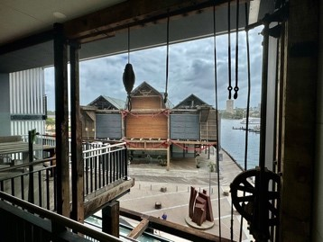

Image from Millers Point Community Resident Action Group.

Figure 10 – luxury apartments on redeveloped Warf 6/7

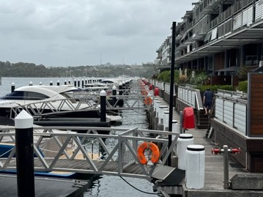

Image from Millers Point Community Resident Action Group.

## References

This resource contains NSW Curriculum and syllabus content. The NSW Curriculum is developed by the NSW Education Standards Authority. This content is prepared by NESA for and on behalf of the Crown in right of the State of New South Wales. The material is protected by Crown copyright.

Please refer to the NESA Copyright Disclaimer for more information <https://educationstandards.nsw.edu.au/wps/portal/nesa/mini-footer/copyright>.

NESA holds the only official and up-to-date versions of the NSW Curriculum and syllabus documents. Please visit the NSW Education Standards Authority (NESA) website <https://educationstandards.nsw.edu.au> and the NSW Curriculum website <https://curriculum.nsw.edu.au>.

[Geography 11–12 Syllabus](https://curriculum.nsw.edu.au/learning-areas/hsie/geography-11-12-2022/overview) © NSW Education Standards Authority (NESA) for and on behalf of the Crown in right of the State of New South Wales, 2022.

NSW Department of Education (n.d.) [*Observatory Hill Environmental Education Centre*](https://observatoryhilleec.schools.nsw.gov.au/) [website], accessed 16 October 2024.

Observatory Hill Environmental Education Centre (n.d.) [*Place and Cultural Change*](https://sites.google.com/education.nsw.gov.au/placeandculturalchange/home), Observatory Hill Environmental Education Centre website, accessed 16 October 2024.

State of New South Wales (Department of Education) (n.d.) [*Digital Learning Selector*](https://app.education.nsw.gov.au/digital-learning-selector/LearningActivity/Browser?cache_id=4cf93), NSW Department of Education website, accessed 16 October 2024.

State of New South Wales (Department of Education) (2023) [*Controversial issues in schools*](https://education.nsw.gov.au/policy-library/policies/pd-2002-0045), NSW Department of Education website, accessed 16 October 2024.

State of New South Wales (Department of Education) (2023) [*Excursions and travel*](https://education.nsw.gov.au/inside-the-department/health-and-safety/risk-management/excursions-and-travel-health), NSW Department of Education website, accessed 16 October 2024.

State of New South Wales (Department of Education) (2023) [*NSW Department of Education Code of Conduct*](https://education.nsw.gov.au/rights-and-accountability/department-of-education-code-of-conduct), NSW Department of Education website, accessed 16 October 2024.

**© State of New South Wales (Department of Education), 2024**

The copyright material published in this resource is subject to the *Copyright Act 1968* (Cth) and is owned by the NSW Department of Education or, where indicated, by a party other than the NSW Department of Education (third-party material).

Copyright material available in this resource and owned by the NSW Department of Education is licensed under a [Creative Commons Attribution 4.0 International (CC BY 4.0) license](https://creativecommons.org/licenses/by/4.0/).

[](https://creativecommons.org/licenses/by/4.0/)

This license allows you to share and adapt the material for any purpose, even commercially.

Attribution should be given to © State of New South Wales (Department of Education), 2024.

Material in this resource not available under a Creative Commons license:

* the NSW Department of Education logo, other logos and trademark-protected material
* material owned by a third party that has been reproduced with permission. You will need to obtain permission from the third party to reuse its material.

**Links to third-party material and websites**

Please note that the provided (reading/viewing material/list/links/texts) are a suggestion only and implies no endorsement, by the New South Wales Department of Education, of any author, publisher, or book title. School principals and teachers are best placed to assess the suitability of resources that would complement the curriculum and reflect the needs and interests of their students.

If you use the links provided in this document to access a third-party's website, you acknowledge that the terms of use, including licence terms set out on the third-party's website apply to the use which may be made of the materials on that third-party website or where permitted by the *Copyright Act 1968* (Cth). The department accepts no responsibility for content on third-party websites.