Vietnamese Stage 2

*Kết Bạn Qua Thư* (Penpals)

Contents

Unit overview 5

Stage 2 outcomes and content to be addressed 6

Learning map 9

Assessment 12

Assessment opportunities 13

Teaching and learning activities 14

Week 1 – introduce yourself 14

Activity 1 – learning map 15

Vocabulary 1 – introduction words 15

Activity 2 – Who am I? 16

Activity 3 – pass the ball 17

Activity 4 – written introduction 18

Week 2 *–* my family 20

Vocabulary 2 – family member names 20

Activity 1 – family tree 22

Activity 2 – Guess who? 23

Activity 3 – mixed up sentences 24

Activity 4 – puzzle 25

Week 3 –likes and dislikes 27

Vocabulary 3 – activities 28

Activity 1 – activities vocabulary 29

Activity 2 – bingo 30

Activity 3 – swap seats 31

Activity 4 – reading comprehension 32

Activity 5 – likes and dislikes 32

Week 4 –writing a letter 34

Vocabulary 4 – letter writing vocabulary 34

Activity 1 – letter writing format – pre-assessment of vocabulary 35

Activity 2 – scrambled letter relay race 36

Activity 3 – chain letter 37

Week 5 – assessment criteria and practice task 39

Activity 1 – discuss assessment task 39

Activity 2 – success criteria 40

Activity 3 – discuss the rubric 40

Activity 4 – practice task 41

Activity 5 – introducing family and activities in writing 42

Week 6 – communicative task – penpals 45

Activity 1 – bingo 46

Activity 2 – communicative task – penpals 46

Activity 3 – peer assessment 47

Week 7 – feedback and goal setting 49

Activity 1 – guess the activity 50

Activity 2 – self-assessment 50

Activity 3 – set learning goals 50

Week 8 – language review 52

Activity 1 – student questions 53

Activity 2 – vocabulary work 54

Activity 3 – grammar relay 54

Activity 4 – writing letters 54

Student resources 56

Resource 1 – writing template 56

Resource 2 – family members flashcards 58

Resource 3 – pieces of me 60

Resource 4 – activities flashcards 62

Resource 5 – bingo cards 64

Resource 6 – reading comprehension 68

Resource 7 – reading comprehension worksheet 69

Resource 8 – likes and dislikes 73

Resource 9 – likes and dislikes poster 75

Resource 10 – sample letter 76

Resource 11 – scrambled letter parts 78

Resource 12 – assessment task – Penpals 80

Outcomes 80

Task 80

Resource 13 – rubric – Penpals 82

Resource 14 – peer feedback strategy – TAG feedback slip 84

Resource 15 – learning goal form 85

Support and alignment 86

References 89

# Unit overview

**Stage**: 2

**Title**: Kết Bạn Qua Thư (Penpals)

**Description**: In this unit, students create simple sentences about themselves using modelled and descriptive language. Students use familiar vocabulary and formulaic phrases while applying Vietnamese language structures to write to a new pen friend introducing themselves.

**Duration**: This lesson sequence is designed to be completed over approximately 8 weeks.

**Student proficiency levels:** It is assumed that many Stage 2 students have been learning Vietnamese since Kindergarten and for many, their proficiency level will be Intermediate although some students will still be at the Beginner level. This unit is aimed at Intermediate students. Every classroom will be different and teachers will need to adapt to their context. Many Stage 2 classes may include a combination of Beginner, Intermediate and Advanced students. Assessment tasks and opportunities in this unit can be differentiated using the ‘Too hard?’ and ‘Too easy?’ suggestions.

# Stage 2 outcomes and content to be addressed

The table below outlines the focus area, outcomes and content points for Stage 2 students.

|  |  |
| --- | --- |
| Focus area and outcome | Content points |
| **Interacting**  A student:   * exchanges information in familiar contexts by selecting culturally appropriate modelled language **ML2-INT-01** | **Exchanging meaning in oral interactions in the target language**   * Share information about themselves to describe their personal world * Ask and answer modelled questions in a guided conversation * Express emotions and preferences * Interact in conversation with teacher and peers in familiar social contexts   **Applying knowledge of language systems to interact in the target language**   * Recognise and use modelled sounds, including pronunciation and intonation patterns and/or rhythms to interact * Select familiar vocabulary and formulaic phrases to interact * Use modelled sentence structures to interact   **Applying knowledge of the target language culture(s) to interact**   * Use modelled language structures and nonverbal communication that are appropriate to cultural practices |
| **Understanding texts**  A student:   * identifies and responds to information in texts to demonstrate understanding **ML2-UND-01** | **Understanding and responding to target language texts**   * Listen to, read and view information in texts on familiar themes * Use strategies to locate, organise, classify and sort information in texts for a range of purposes * Respond to texts through actions, visuals, written or spoken responses in the target language and/or English to demonstrate understanding and convey meaning   **Applying knowledge of language systems to understand and respond to target language texts**   * Identify and use knowledge of vocabulary and formulaic phrases from familiar themes to understand and respond to texts * Identify and use elements of grammar in familiar language patterns * Recognise modelled target language features and compare them with English features   **Developing intercultural understanding through target language texts**   * Respond to texts and identify connections between language and cultural practices and reflect on their own language(s) and culture(s) |
| **Creating texts**  A student:   * creates texts for familiar communicative purposes by selecting culturally appropriate modelled language **ML2-CRT-01** | **Creating spoken, written and multimodal texts in the target language**   * Create imaginative texts appropriate to context, purpose and audience using a series of modelled sentence structures and visuals to add meaning   **Applying knowledge of language systems to create texts in the target language**   * Use vocabulary, formulaic expressions or modelled phrases from familiar themes to create texts * Use elements of simple grammar patterns in modelled sentence structures to create texts * Use modelled structures and features of the target language writing system to create written texts   **Applying knowledge of the target language culture(s) to create texts**   * Select language appropriate to cultural practices to create texts |

[Modern Languages K–10 Syllabus](https://curriculum.nsw.edu.au/learning-areas/languages/modern-languages-k-10-2022/overview) © NSW Education Standards Authority (NESA) for and on behalf of the Crown in right of the State of New South Wales, 2022.

# Learning map

The creation of maps for learning is a planning process that incorporates Aboriginal intellectual tradition. Learning maps are a visual pathway of what students will learn.

Share the learning map with your students, briefly explaining the learning that will happen in each lesson. Provide students with a copy of the learning map or display the learning map in the classroom. This learning map can be adapted to Vietnamese by accessing a copy of *[Learning map – Kết Bạn Qua Thư (Penpals) Stage 2](https://education.nsw.gov.au/teaching-and-learning/curriculum/languages/languages-curriculum-resources-k-12/languages-curriculum-resources-k-6/penpals-vietnamese)*[.](https://education.nsw.gov.au/teaching-and-learning/curriculum/languages/languages-curriculum-resources-k-12/languages-curriculum-resources-k-6/penpals-vietnamese)

Figure 1 – Penpals learning map

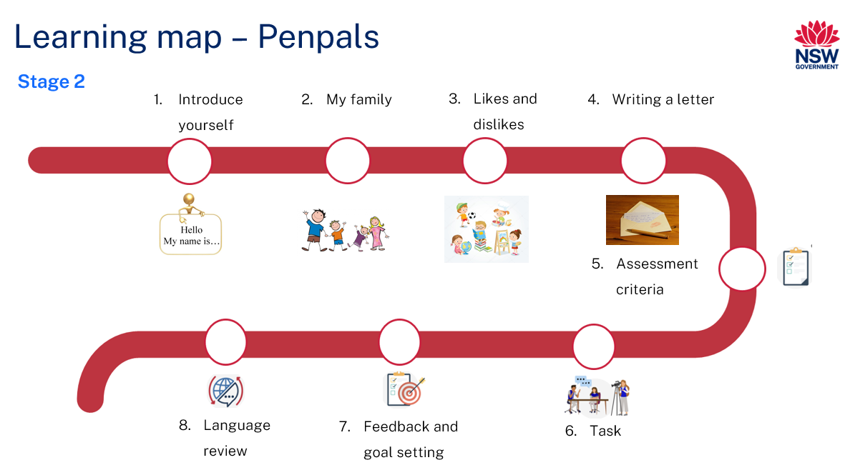

Figure 2 – *Kết Bạn Qua Thư* learning map

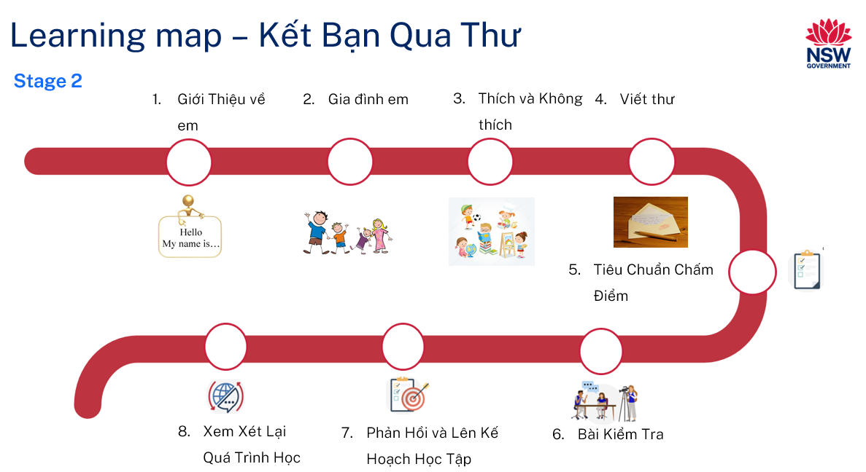

# Assessment

**Stage 2 communicative task**: Your school recently signed up for a new penpal program. Write to a penpal in Vietnam introducing yourself. Include information about your family, school and activities.

**Too hard?**

Provide a scaffold template for students with visuals and some key words.

**Too easy?**

Students to include questions and/or some additional facts about themselves.

**Context**: writing to a new penpal in a school in Vietnam

**Audience**: new penpal

**Purpose**: to introduce yourself to your penpal

## Assessment opportunities

The table below details assessment opportunities and differentiation ideas.

|  |  |  |
| --- | --- | --- |
| Assessment opportunities | Too hard? | Too easy? |
| **Week 2 – mixed-up sentences**  Students are shown mixed-up sentences on the screen and must rewrite the sentences correctly in the allotted time. They show the sentence to the class and if correct get a point for their group. | **Mixed-up sentences**  Allow students to access the correct sentences as a support. | **Mixed-up sentences**  Students create their own sentences and have peers put them in the correct order. |
| **Week 3 – reading comprehension**  Students read a short text and answer comprehension questions about the text. | **Reading comprehension**  Display key words, translated version and visual support. | **Reading comprehension**  Extend the text. Add more detail such as school, family, and where they live. |
| **Week 4 – chain letter**  Students take turns to write parts of a letter in small groups. | **Chain letter**  Display or hand out printed copies of prompts or sentence starters. | **Chain letter**  Have suggestions on the whiteboard of additional information students could include in their letter, for example, likes or dislikes. |

# Teaching and learning activities

## Week 1 – introduce yourself

The table below outlines the learning intentions and success criteria of the lesson, and materials that the teacher and students will need to complete the teaching and learning activities.

|  |  |
| --- | --- |
| Learning intentions and success criteria | Materials |
| Students will:   * give information about themselves * ask questions to find out basic information about another person.   Students can:   * say and write personal information in full sentences correctly in Vietnamese * ask other students questions about themselves. | * Resource 1 – writing template * [*Tôi là ai? – Who am I?*](https://education.nsw.gov.au/teaching-and-learning/curriculum/languages/languages-curriculum-resources-k-12/languages-curriculum-resources-k-6/penpals-vietnamese) PowerPoint book (Vietnamese) * [*Tôi là ai? – Who am I?*](https://education.nsw.gov.au/teaching-and-learning/curriculum/languages/languages-curriculum-resources-k-12/languages-curriculum-resources-k-6/penpals-vietnamese) PowerPoint book (English) * [*Tôi là ai? – Who am I?* (Beginners)](https://education.nsw.gov.au/teaching-and-learning/curriculum/languages/languages-curriculum-resources-k-12/languages-curriculum-resources-k-6/penpals-vietnamese) PowerPoint book (Vietnamese) * [*Tôi là ai? – Who am I?* (Beginners)](https://education.nsw.gov.au/teaching-and-learning/curriculum/languages/languages-curriculum-resources-k-12/languages-curriculum-resources-k-6/penpals-vietnamese) PowerPoint book (English) * Learning map * A soft ball * Vietnamese exercise books |

### Activity 1 – learning map

Explain and display the Learning map to give students a more detailed breakdown of lessons during the unit. Point out that the Learning map is a plan that may need to change.

### Vocabulary 1 – introduction words

The table below outlines the suggested vocabulary used throughout this learning sequence. It includes the Vietnamese words and phrases and their corresponding English translations.

|  |  |
| --- | --- |
| English | Vietnamese |
| you | bạn |
| I | tôi/mình |
| my | của tôi/của mình |
| your | của bạn |
| name | tên |
| age/years old | tuổi |
| grade | lớp |
| school | trường |
| study | học |
| at | ở |
| What’s your name? | Bạn tên gì? |
| How old are you? | Bạn bao nhiêu tuổi? |

### Activity 2 – Who am I?

**Note**: two versions of the book have been included. The language in the Beginners version is enough for students to complete the final task.

Have students sit on the floor and read the PowerPoint book [*Tôi là ai? – Who Am I?*](https://education.nsw.gov.au/teaching-and-learning/curriculum/languages/languages-curriculum-resources-k-12/languages-curriculum-resources-k-6/penpals-vietnamese)in Vietnamese. Ask the following questions in English to assess students’ prior knowledge:

* Can you tell me what this story is about?
* Who is the main character? What is his name? How old is he?
* What school does Tin go to?
* Who does he live with?
* How did Tin find out who he was?
* Are there any words that you don’t understand?
* What do you think would have happened if Tin didn’t ever remember who he was? (inferencing question)

**Note**: discuss the notion of ‘identity’ and what it is. Explain that identity is about who we are and how we see ourselves. It includes aspects such as our name, family, culture, and personal interests. Encourage students to share something that makes them unique or special.

### Activity 3 – pass the ball

1. Introduce the questions Bạn tên gì? Bạn bao nhiêu tuổi?(What’s your name? How old are you?). Say them aloud and have students repeat. Ask students if they are familiar with these questions.
2. Have students show a thumbs up if they know what they mean. Have those students tell the person next to them what they mean.
3. Choose a student to tell you what the questions mean in English. Have the class agree or disagree with thumbs up or down at their chests.
4. Introduce the sentences Em tên là …. Em … tuổi.(My name is …. I am … years old.) Say them aloud and have students repeat. Ask students if they are familiar with the sentences. Explain that this is how you would answer these questions.
5. Students pair up and practise asking and answering the questions. Once they have practised this a couple of times, they switch partners and repeat the process until they have become familiar with the questions and answers and have had a few turns at each.
6. Explain that now the class is going to play a game to practise what they have learned. Students sit in circles with 6 or 8 students.
7. The aim of the game is to pass the ball around the circle while the students take turns introducing themselves. One student will start the game by saying their name and age. For example, Em tên là …. Em … tuổi.(My name is …. I am … years old.)
8. The student then passes the ball to another student and asks, Bạn tên gì? (What’s your name?) then, after a response, Bạn bao nhiêu tuổi? (How old are you?).
9. The student receiving the ball will say their name and age before passing the ball to the next student who will ask the same question.
10. The game continues until everyone has had a turn.

**Note**: if it is too easy, ask students to say 1 or 2 sentences more about themselves, such as the school they go to, or personal interests. For example, Em học lớp Bốn ở trường Lawston (I am in fourth grade at Lawston Public School.)

### Activity 4 – written introduction

1. Model this introduction paragraph by writing it on the whiteboard: Xin chào! Em tên là Nam. Em mười tuổi. Em học lớp Bốn ở trường Lawston.(Hi! My name is Nam. I am ten years old. I am in Year 4 at Lawston Public School.)
2. In pairs, students practise saying this a few times.
3. Have students write an introduction about themselves in their workbooks using the above scaffolding.

**Note**: students of Beginner proficiency can complete Resource 1 – writing template by filling in the gaps. Students with Advanced proficiency can write 2 to 3 sentences more about themselves. For example, Bạn thân của em là Andy. Chúng mình thích chơi đá banh*.* (My best friend is Andy. We love playing soccer together.)

## Week 2 – my family

The table below outlines the learning intention and success criteria of the lesson, and materials that the teacher and students will need to complete the teaching and learning activities.

|  |  |
| --- | --- |
| Learning intention and success criteria | Materials |
| Students will talk and write about their family and where they live in Vietnamese.  Students can:   * use simple sentences to talk and write about family members in Vietnamese * say and write where they live and who they live with in Vietnamese. | * Resource 1 – writing template * Resource 2 – family members flashcards * Resource 3 – pieces of me * [PowerPoint: Mixed-up sentences](https://education.nsw.gov.au/teaching-and-learning/curriculum/languages/languages-curriculum-resources-k-12/languages-curriculum-resources-k-6/penpals-vietnamese) * Individual whiteboards * Timers * Whiteboard markers |

### Vocabulary 2 – family member names

The table below outlines the suggested vocabulary used throughout this learning sequence. It includes the Vietnamese words and phrases and their corresponding English translations.

|  |  |
| --- | --- |
| English | Vietnamese |
| family | gia đình |
| mum | má/mẹ |
| dad | ba/bố |
| grandpa | ông |
| grandma | bà |
| older brother | anh |
| older sister | chị |
| younger brother | em trai |
| younger sister | em gái |
| I live in | Em sống ở |
| and | và |
| I live with | Em sống với |

### Activity 1 – family tree

**Note**: review the language from the PowerPoint book [*Tôi là ai? – Who Am I?*](https://education.nsw.gov.au/teaching-and-learning/curriculum/languages/languages-curriculum-resources-k-12/languages-curriculum-resources-k-6/penpals-vietnamese) with the class prior to this lesson.

1. List the words from Vocabulary 2 – family member names on the whiteboard. Ask students if they know other family words and write them down.
2. Display images from Resource 2 – family members flashcards and have students help place each card next to the correct family member.
3. Draw and display a sample family tree (see Figure 3) and use the words on the whiteboard to label it. Model how to introduce each family member by verbally saying and writing down these example sentences: Em sống ở Fairfield với ba, mẹ, và em gái. Đây là mẹ em. Mẹ em tên là Thanh. (I live in Fairfield with my mum, dad, and my younger sister. This is my mum. Her name is Thanh).

Figure 3 – example of family tree

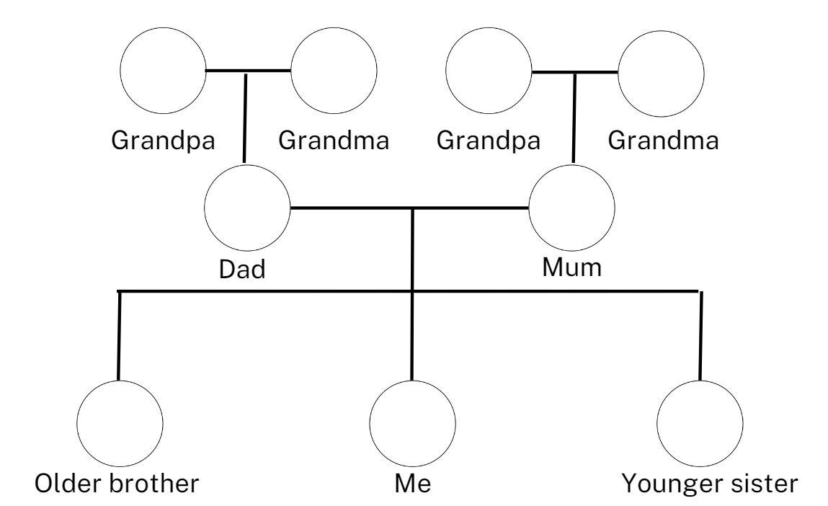

1. In their workbooks, students draw a family tree in Vietnamese using the image on the board as a guide and write their family’s information on it. Then in pairs, students take turns to introduce their family members to each other.

**Note**: a family tree is a chart that shows all the people in a family over generations and their relationship to one another. Some students will not be able to complete the displayed family tree template. Support students to include the important people in their lives, tell them the required Vietnamese words and add these to the word wall.

### Activity 2 – Guess who?

1. Ask students to pair up and share each other’s family trees. Student A thinks of one person in their family.
2. Student A gives clues about their family member in English for the other student to guess who that family member is. For example:

* This person is a boy (Người này là con trai)
* This person has long hair (Người này tóc dài)
* This person is 10 years old (Người này 10 tuổi)
* This person is younger than me (Người này nhỏ hơn bạn).

1. Student B then guesses who the family member is by saying ‘Is it your brother?’ in Vietnamese.
2. Once the clues are given the student must guess who the family member is. They must use the Vietnamese word for this. Each student has at least one turn each.
3. Students find a new partner and repeat.

**Note**: students with Beginner proficiency can refer to the displayed Resource 2 – family members flashcards when asking questions. Students with Advanced proficiency can give clues in Vietnamese.

### Activity 3 – mixed up sentences

1. Divide students into groups of 2 to 3 and hand out one mini whiteboard, marker and eraser per group.
2. Display the PowerPoint presentation, [Mixed-up sentences](https://education.nsw.gov.au/teaching-and-learning/curriculum/languages/languages-curriculum-resources-k-12/languages-curriculum-resources-k-6/penpals-vietnamese) one slide at a time.
3. Students work together and write the sentence in the correct order. They show the sentence to the class, and if correct, they get a point for their group.
4. The student writing in each group changes with each new slide. At the end, the team with the most points win.

**Note:** take photos of each sentence and note any common errors in writing that can be addressed in Week 8.

### Activity 4 – puzzle

1. Re-read [*Tôi là ai? – Who Am I?*](https://education.nsw.gov.au/teaching-and-learning/curriculum/languages/languages-curriculum-resources-k-12/languages-curriculum-resources-k-6/penpals-vietnamese)and show students Tin’s puzzle pieces.
2. Display and hand out Resource 3 – pieces of me to each student.
3. Model how to make a poster about themselves (see Figure 4).

Figure 4 – pieces of me

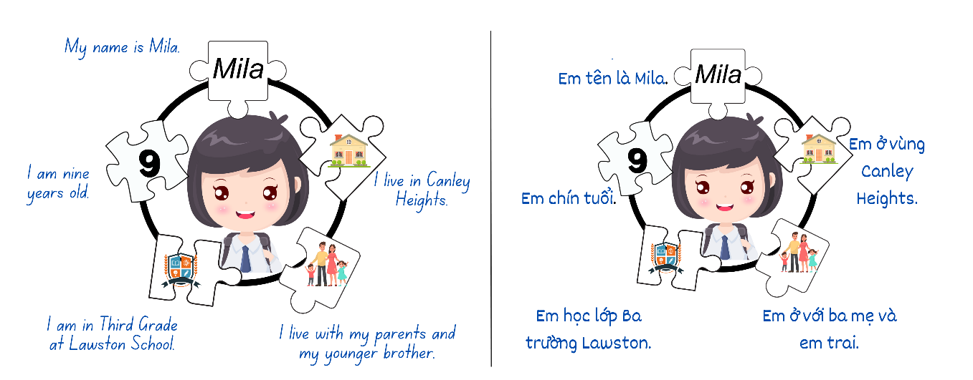

1. Students must write a sentence to match each puzzle piece. The sentences must include:

* Em tên là … (My name is …)
* Em … tuổi. (I am … years old.)
* Em học trường tiểu học … (I go to … Public School)
* Em sống ở … (I live in …)
* Em sống với … (I live with my …)

1. Students draw a picture on each puzzle piece to go with each sentence.

**Note**: Beginner students refer to Resource 1 – writing template when completing this task.

## Week 3 – likes and dislikes

The table below outlines the learning intention and success criteria of the lesson, and materials that the teacher and students will need to complete the teaching and learning activities.

|  |  |
| --- | --- |
| Learning intention and success criteria | Materials |
| Students will talk and write about activities in Vietnamese.  Students can:   * say and write what they like and don’t like to do * say and write what their family members like to do. | * Resource 2 –family members flashcards * Resource 4 – activities flash cards * Resource 5 – bingo cards * Resource 6 – reading comprehension * Resource 7 – reading comprehension worksheet * Resource 8 – likes and dislikes * Art paper * Chairs or cushions * Counters * Vietnamese exercise books |

### Vocabulary 3 – activities

The table below outlines the suggested vocabulary used throughout this learning sequence. It includes the Vietnamese words and phrases and their corresponding English translations.

|  |  |
| --- | --- |
| English | Vietnamese |
| drawing | vẽ |
| playing on the iPad | chơi iPad |
| playing soccer | chơi đá banh |
| watching television | coi Tivi |
| writing | viết |
| singing | hát |
| doing chores | làm việc nhà |
| doing homework | làm bài tập |
| reading | đọc sách |
| ‘running | chạy |
| I like | Em thích |
| I dislike/I don’t like | Em không thích |
| Who/Who likes | Ai/ Ai thích |

### Activity 1 – activities vocabulary

1. Display images from Resource 4 – activities flash cards one at a time. Say the words of each activity in English as they are placed on the board.
2. **Pre-assessment**: students look at Resource 2 –family members flashcards. Ask students to identify how many words they know in Vietnamese by answering the following questions, showing thumbs up at their chests:

* Do you know all the words?
* Do you know most of them?
* Do you know any of them?

1. Students [Think-Pair-Share](https://app.education.nsw.gov.au/digital-learning-selector/LearningActivity/Card/645) and tell their partners the words they know and report back to the class.
2. On the other side of the board, put the Vietnamese words for the activities one at a time in a random order. Model the pronunciation of each activity and have students imitate the pronunciation. Students match each word to an image.
3. Model and have students repeat the pronunciation of each word.

### Activity 2 – bingo

**Note**: students with Beginner proficiency can pair up with a partner when playing this game.

1. Hand out one card from Resource 5 – bingo cards per student and some counters. Let students know that they will be playing ‘Bingo’.
2. Choose a student to be the bingo caller. The student chooses a folded-up bingo card at random and calls out the activity on the bingo cards in Vietnamese. If the activity called out is on the bingo cards, students place a counter on that activity.
3. The caller says the activities one at a time. The winner is the first student who calls out ‘Bingo!’ when they hear all the activities on their card called out.
4. The winner becomes the next bingo caller.

**Note:** highlight to students that verbs in Vietnamese never change as opposed to English.

### Activity 3 – swap seats

1. This activity aims to revise what students have learned in previous lessons as well as to pre-assess their knowledge of new vocabulary.
2. Ask students to sit on chairs or cushions that have been set up to form a big circle. If weather and time permit, this activity can take place outside.
3. Introduce and model the language needed to ask a question. For example, Ai thích/ Ai không thích *…?* (Who likes/Who doesn’t like …?)
4. Say out loud and have students repeat the phrase several times until they are confident enough to use it.
5. Choose one student to start the game and stand in the middle of the circle. The student asks a positive question, for example:

* Ai thích làm bài tập? (Who likes homework?)
* Ai thích vẽ? (Who likes to draw?)

1. Students who answer yes to the questions must run and swap seats before the seats are fully occupied.
2. The student left standing will move to the middle of the circle and ask a new question.
3. After a few rounds, encourage students to try asking a negative question. For example: Ai không thích hát? (Who doesn’t like singing?)
4. The game continues until everyone has a turn at asking questions.

**Note**: display the questions and keywords to assist students with Beginner proficiency while they are playing the game. Students with Advanced proficiency can ask other questions about themselves (for example, ‘Who is 9 years old? Who lives with their grandmother?’).

### Activity 4 – reading comprehension

1. Display Resource 6 – reading comprehension.
2. Read the text aloud to students and ask them if they can identify some key words that they have learned.
3. Revise the words Em thích (I like) and Em không thích (I don’t like) if needed.
4. Hand out Resource 7 – reading comprehension worksheetto each student and go through the questions to ensure students know what they need to do.
5. Students complete worksheets and stick these in their workbooks.

**Note**: revise some vocabulary words for students with Beginner proficiency before asking them do this task.

### Activity 5 – likes and dislikes

1. Display Resource 8 – likes and dislikes and explain to students that they will create a poster about their likes and dislikes.
2. Explain that they need to write in full sentences in Vietnamese using learned vocabulary. Encourage students to include visuals.
3. Provide students with Resource 9 – likes and dislikes poster. Students create their own pictures and sentences of their likes and dislikes.
4. Students must start their sentences with Em thích (I like) and Em không thích (I don’t like).

**Note**: students can refer to Resource 4 – activities flashcards when completing this task. Sentence starters can be displayed if required.

**Evaluation**: students can describe one thing that they like and one thing that they don’t like to do.

## Week 4 – writing a letter

The table below outlines the learning intention and success criteria of the lesson, and materials that the teacher and students will need to complete the teaching and learning activities.

|  |  |
| --- | --- |
| Learning intention and success criteria | Materials |
| Students will write a letter in Vietnamese.  Students can:   * identify different parts of a letter and their purpose * use the correct form of address in Vietnamese when writing a letter. | * Resource 10 – sample letter * Resource 11 – scrambled letter parts * Adhesive putty * Butcher’s paper * Timer * Writing materials |

### Vocabulary 4 – letter writing vocabulary

The table below outlines the suggested vocabulary used throughout this learning sequence. It includes the Vietnamese words and phrases and their corresponding English translations.

|  |  |
| --- | --- |
| English | Vietnamese |
| dear | thân mến |
| date | ngày |
| sincerely | trân trọng |
| signature | chữ ký |
| friend | bạn |
| new | mới |
| I am in the | Em học lớp |

### Activity 1 – letter writing format – pre-assessment of vocabulary

1. Display Resource 10 – sample letteron the screen and hand out printed copies.
2. Read the letter aloud.
3. Ask students what they notice about the format of this letter. Emphasise different parts and their functions. For example:

* Ngày (Date): when the letter was written
* Lời chào (Greeting): how you address the person you are writing to, starting with ‘Dear…’
* Nội dung bức thư**/** (Body)**:** your message
* Kết thư (Closing): how you end the letter (for example, ‘Love’, ‘Sincerely’)
* Chữ ký (Signature): your name.

1. Explain to students the cultural context of writing a letter. For example:

* how to write the full date in Vietnamese
* how to address someone, using pronouns differently according to age. For example, Vietnamese has 3 words for ‘I’ – ‘mình’, ‘tôi’ or ‘con’
* how the language used is for a friendly and informal audience.

**Note:** there are different ways of saying ‘I’ in Vietnamese depending on who you are addressing. ‘Minh’ is used when you are speaking to a person on the same level as you (like a close friend). ‘Toi’ is used when you are speaking to someone you have just met and not sure of their age and ‘Con’ is when you are addressing someone that is older than you or a child addressing an adult.

### Activity 2 – scrambled letter relay race

1. Play a communicative game, ‘scrambled letter relay race’ with the class.
2. Group students into teams of 4 or 5 and provide each team with a copy of Resource 11 – scrambled letter parts and a piece of butcher’s paper to put up at the front of the room. They will also need adhesive putty for the letter parts.
3. Explain to the teams that their task is to work together in unscrambling and correctly assembling the parts of a letter.
4. The first student in each team must pick up the first part of the letter and stick it on their paper, then run back to their team.
5. The next student picks up the second part of the letter, runs and sticks it to their butcher’s paper and runs back to their team.
6. The relay continues until one team successfully unscrambles and assembles a complete and correct letter.
7. The winning team reads their letter aloud.

### Activity 3 – chain letter

1. Explain that you will now play a game in groups where you create a letter and each person adds a part to the letter until it is complete.
2. Choose 3 or 4 students in the class to demonstrate. Start off the letter with the date and have each student add a different part until complete.
3. Divide students in groups of 3 or 4 and hand out butcher’s paper (one per group). Each group is going to write their own letter based on the letter created in Activity 2 – scrambled letter relay race.
4. The first student in the group writes the first part of a letter (for example: Date …) at the top of the page.
5. The second student continues the letter by responding to the first student's writing (for example: Dear …).
6. The third student will then write the next piece of information (for example: My name is …).
7. Students take turns at adding a sentence or greeting until the letter is completed.
8. Finally, students take turns to read their group letters aloud.
9. Remind students of the importance of a letter's structure, including the greeting, body, closing and signature.

**Evaluation**: students can correctly identify parts of a letter.

## Week 5 – assessment criteria and practice task

The table below outlines the learning intention and success criteria of the lesson, and materials that the teacher and students will need to complete the teaching and learning activities.

|  |  |
| --- | --- |
| Learning intention and success criteria | Materials |
| Students will develop a clear understanding of the requirements of the assessment task.  Students can:   * suggest appropriate success criteria for the task. * say what they need to do to be successful in the task. | * Resource 12 – assessment task – Penpals * Resource 13 – rubric – Penpals * Learning map * Vietnamese exercise books |

### Activity 1 – discuss assessment task

1. To prepare students for the final task, review the Learning map and discuss the language that has been taught each week. Point out that, according to the learning map, the final task will be completed in Week 6.
2. Go through Resource 12 – assessment task – Penpals. Explain to students the context and audience of the task. Tell students that they will be writing letters to new penpals in Vietnam.
3. Explain that the purpose of the task is to introduce themselves and clearly highlight what information they are expected to have in their letters (for example, their names, age, school, grade, family and likes and dislikes).

### Activity 2 – success criteria

After looking at the assessment task, students [Think-Pair-Share](https://app.education.nsw.gov.au/digital-learning-selector/LearningActivity/Card/645) and suggest appropriate success criteria, such as:

I will be successful if I can:

* correctly use the letter formats including date, greeting, body, closing and signature
* write in Vietnamese using modelled sentence structures
* use learned vocabulary and correct grammar
* use correct pronouns and/or address the audience accordingly
* include personal information (name, age, school, grade, family and hobbies) in the letter.

### Activity 3 – discuss the rubric

1. Show students an unmarked rubric (see Resource 13 – rubric – Penpals). This may need to be adapted if the class has decided on different success criteria.
2. The teacher explains metalanguage such as accuracy, punctuation and vocabulary.
3. Students read and then discuss the ‘excellent’ column of the rubric in pairs. They then share their understanding of what is needed to be successful.
4. Point out and provide examples of what ‘excellent’ and ‘sound’ samples of task completion, accuracy, punctuation and vocabulary look and sound like.

### Activity 4 – practice task

1. Model this letter by writing it on the whiteboard (see Table 1).

Table 1 – model letters in Vietnamese and in English

|  |  |
| --- | --- |
| Vietnamese | English |
| Chào,  Tên mình là An.  Mình học lớp Ba.  Mình ở Lansvale. | Hi,  My name is An.  I am in Third grade.  I live in Lansvale. |

1. Have students discuss in pairs what is missing from the letter. Suggestions include likes and dislikes, and who they live with.
2. Ask students to share their thoughts and talk about what can be added to improve the letter. Encourage students to refer to [Resource 13 – rubric – Penpals](#_Resource_14_-).

**Note:** to reinforce other writing components, remove punctuation or add any grammar errors if needed so that students understand what the success criteria look like.

1. Students read and then discuss the ‘excellent’ column of the rubric in pairs. They then share their understanding of what is needed to be successful.
2. Point out and provide examples of what ‘excellent’ and ‘sound’ samples of task completion, fluency, accuracy, pronunciation and vocabulary look and sound like.

### Activity 5 – introducing family and activities in writing

1. Write the following sentence on the whiteboard: Đây là anh của em, Mark. Anh thích chơi đá banh. (This is my brother, Mark. He likes to play soccer.)
2. Ask students to read it aloud and explain what the sentence means in English. Students then copy the sentence into their Vietnamese workbooks.
3. Write the sentence Đây là … của em. … thích … (This is my …. He/she likes ...) on the board and ask students to write and complete the sentence in their workbooks.
4. Ask students to follow the pattern and independently write a sentence about one family member in their workbooks.
5. Ask students to write a paragraph to introduce themselves. The paragraph must include name, age, school, grade, activities, family and where they live (see Figure 5).

* My name is (name)
* I am (age) years old
* I go to (name of school) Public School
* I am in Year (grade in school)
* I live in (name of suburb)
* I like (likes)
* I don’t like (dislikes)
* I live with my (relationship of family members).

Figure 5 – introduce myself paragraph

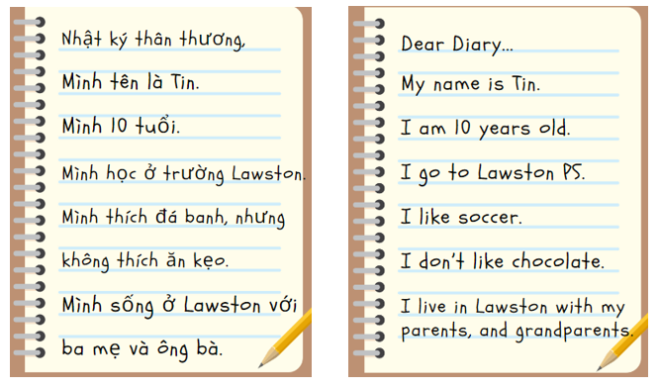

## Week 6 – communicative task – penpals

The table below outlines the learning intention and success criteria of the lesson, and materials that the teacher and students will need to complete the teaching and learning activities.

|  |  |
| --- | --- |
| Learning intention and success criteria | Materials |
| Students will write letters to their new penpals in Vietnam and introduce themselves.  Students can:   * correctly use the letter formats including date, greeting, body, closing and signature * write in Vietnamese using modelled sentence structures * use learned vocabulary and correct grammar * use correct pronouns and/or address the audience accordingly * include personal information (name, age, school, grade, family and activities) in the letter. | * [Resource 13 – rubric – Penpals](#_Resource_[#]:_Rubric) * Resource 14 – peer feedback strategy – TAG feedback slip * Blank paper |

### Activity 1 – bingo

In groups of 4 or 5, students create their own bingo cards featuring various words and phrases that have been taught throughout the unit.

Once the cards have been created, students play a game where they write down 5 of these words or phrases. A student calls the words or phrases out one at a time. The student who has all their words or phrases called out first wins the game. Play this till every student has a chance at calling out the phrases.

### Activity 2 – communicative task – penpals

Before writing, go through the Resource 13 – rubric – Penpals again and highlight the success criteria. Allow time for questions.

Students sit at their tables to write letters on blank pieces of paper. Once finished, students are encouraged to re-read their work, revise and edit before submitting.

**Note:** this task will be completed individually. Students with Beginner proficiency are provided a vocabulary list or samples of phrases to refer to if needed. See Table 2 and Table 3.

Table 2 – example vocabulary list

|  |  |  |
| --- | --- | --- |
| date = ngày | dear = thân mến | age = tuổi |
| name = tên | grade = lớp | sincerely = trân trọng |
| school = trường | family = gia đình | friend = bạn |

Table 3 – phrasing samples

|  |  |
| --- | --- |
| Mình tên là | (My name is …) |
| Mình học ở | (I study at …) |
| Mình thích | (I like…) |

### Activity 3 – peer assessment

In pairs, students use Resource 14 – peer feedback strategy – TAG feedback slip to give verbal feedback on each other’s writing. Explain that they need to give feedback using the criteria in Resource 13 – rubric – Penpals. For example:

* Tell them something they really liked and explain why.
* Example: I like how you used the correct letter format to include date, greeting, body, closing and signature.
* Ask a question to clarify or confirm something about the letter.
* Example: Did you include personal information like name, age, school, grade and family in your letter?
* Give a suggestion to make their classmates’ use of language even better.
* Example: Don’t forget to include things that you like to do in the letter.

## Week 7 – feedback and goal setting

The table below outlines the learning intention and success criteria of the lesson, and materials that the teacher and students will need to complete the teaching and learning activities.

|  |  |
| --- | --- |
| Learning intention and success criteria | Materials |
| Students will reflect on their task recordings to assess performance and set learning goals.  Students can:   * self-assess their completion of the task * set suitable learning goals based on previous learning goals and teacher, peer and self-assessment. | * Resource 4 – activities flashcards * Resource 13 – rubric – Penpals * Resource 15 – learning goal form * Individual whiteboards * Vietnamese exercise books * Writing materials |

**Note**: prior to this lesson, mark students’ writing against the rubric. If there is insufficient time, Weeks 7 and 8 can be swapped.

### Activity 1 – guess the activity

1. Split the class into small groups and give each group a whiteboard and marker. Have one student from each group come to the front to pick a flashcard from Resource 4 – activities flashcards.
2. The students with flashcards return to their groups and draw an image of the word on their flashcard onto the whiteboard. The rest of their group try to guess the word in Vietnamese. If they guess the word, the team wins a point.
3. Once the group has guessed the word from the drawing, have another student from each group come to the front and pick another flashcard.
4. Continue playing the game until each student has had a turn at drawing a picture on the whiteboard.

### Activity 2 – self-assessment

Students use Resource 13 – rubric – Penpals to self-assess their completed letter. Students then compare their self-assessment rubric with the teacher’s completed rubric.

### Activity 3 – set learning goals

**Note:** learning goals should be SMART: Specific, Measurable, Achievable, Realistic, Timely.

1. Students reflect on the teacher, peer and self-evaluation to set goals for the next phase of learning.
2. Example learning goals include:

* I now feel confident in reading and saying words related to my likes and dislike in Vietnamese.
* I will say sentences in Vietnamese using the correct word order.
* A next step for me to work on my spelling, especially Vietnamese tone marks.

1. Students record their learning goals using a copy of Resource 15 – learning goal form.

**Evaluation**: students set appropriate and achievable learning goals for their levels.

## Week 8 – language review

The table below outlines the learning intention and success criteria of the lesson, and materials that the teacher and students will need to complete the teaching and learning activities.

|  |  |
| --- | --- |
| Learning intention and success criteria | Materials |
| Students will reflect on and ask questions about the language taught in this unit.  Students can:   * ask questions about vocabulary, grammar or sentence structure they have used in this unit * use Vietnamese words they have learned to communicate with classmates. | * Resource 4 – activities flashcards * Resource 11 – scrambled letter parts * Poster boards or individual whiteboards * Sample letters * Sample letters with grammar errors * Swatters * Timer * Worksheets |

**Note:** over the course of the unit, gaps in student knowledge, misconceptions and misuse of language will have been identified. These observations are addressed using engaging and interactive activities and strategies. The activities below are examples and will need to be supplemented with activities to address your observations.

### Activity 1 – student questions

Remind students of the activities and tasks they have completed over the course of the unit. Give students time to [Think-Pair-Share](https://app.education.nsw.gov.au/digital-learning-selector/LearningActivity/Card/645) any questions they may have about any aspect of the language taught.

**Note:** set up different language stations for Activities 2 to 4 that will reinforce the grammar, vocabulary and letter formats taught in the unit. These activities can be adapted to suit students’ needs.

**Recommendations for setting up roaming activities**

* Set up class tables beforehand into small clusters designed to accommodate 3 to 5 students.
* Collect materials and have them ready for each activity.
* Have a list of students’ names on the activities that you want them to revise and place them on the tables. Ask students to tick off their names when they finish the activities. If you want everyone to revise everything, have the class list on each table.
* Let students know the time given for roaming activities (for example, 40 minutes). Students can roam to different stations in any order, as long as they complete the required tasks within the set time.

### Activity 2 – vocabulary work

**Suggested activities**

* **Word bingo**: students write 10 words from the vocabulary taught throughout the unit. A nominated student calls out the words from the list. The first student to tick off all words is the winner. The winner is the caller for the next game.
* **Act it out**: divide students into 2 teams, A and B. One student from Team A will act out an activity for Team B to guess. If students in Team B guess correctly and say the word in Vietnamese, Team B will win a point. If they guess incorrectly or are unable to say the word in Vietnamese, Team A wins a point. A student from Team B then will then act out an activity and Team A must guess what it is. Teams take turns to act out and guess. The first team to get to 10 points wins the game.
* **Swat it**: students form small circles in groups of 3 to 4. Hand out swatters. Place Resource 4 – activities flashcards on the floor in the middle of the group. One student will call out an activity and the remaining students will try to swat the correct card as quick as they can. The first student to swat the card correctly collects the card. The winner is the one who collects the most cards at the end.

### Activity 3 – grammar relay

* **Grammar relay**: divide the class into 2 teams. Adapt Resource 11 – scrambled letter parts so that the text contains various grammar errors. One member from each team will run to fix one error and come back to the team so that the next member can do the same. The winning team is the first one that fixes all the errors.

### Activity 4 – writing letters

This station will focus on reviewing the different parts of a letter.

* **Letter sorting**: write the names of the different parts of a letter on separate cards or pieces of paper. Mix them up. Each small group of students is given a set of shuffled letter parts. Instruct the students to work together to organize the letter parts into the correct order on their poster board or whiteboard. They should arrange the date, greeting, body, closing and signature in the proper sequence. To make it more competitive, you can time the groups to see which one can complete the task the quickest and most accurately.

# Student resources

## Resource 1 – writing template

|  |
| --- |
| **Tên:** _________________  Dùng những từ sau đây để viết câu hoàn chỉnh về mình:  school = trường grade = lớp  age = tuổi study = học  Xin chào!  Em tên là _______________________. (name)  Em _________________. (age)  Em học ____________________. (grade)  Em học ở __________________________. (school)  ________________________________________ |

|  |
| --- |
| **Name**: _________________  Use the following words to complete these sentences about yourself:  *school = [language] grade = [language]*  *age = [language] study = [language]*  Hello!  My name is _______________________. (name)  I am _________________. (age)  I study ____________________. (grade)  I study at _______________________. (school)  _____________________________________ |

## Resource 2 – family members flashcards

This resource can be adapted by replacing the text to suit your language.

|  |  |  |  |  |  |  |
| --- | --- | --- | --- | --- | --- | --- |
| Woman carrying child. |  | Smiling father standing with child on shoulders outdoors, in front of a house. |  | Smiling young girl. |  | Smiling young boy. |
| **mum** |  | **dad** |  | **younger sister** |  | **younger brother** |
|  |  |  |  |  |  |  |
| **Senior female sitting at kitchen table.** |  | Senior male wearing a hat and glasses. |  | A young woman. |  | A young man. |
| **grandma** |  | **grandpa** |  | **older sister** |  | **older brother** |

|  |  |  |  |  |  |  |
| --- | --- | --- | --- | --- | --- | --- |
| Woman carrying child. |  | Smiling father standing with child on shoulders outdoors, in front of with house. |  | Smiling young girl. |  | Smiling young boy. |
| **mẹ/má** |  | **ba/bố** |  | **em gái** |  | **em trai** |
|  |  |  |  |  |  |  |
| **Senior female sitting at kitchen table.** |  | Senior male wearing a hat and glasses. |  | A young woman. |  | A young man. |
| **bà** |  | **ông** |  | **chị** |  | **anh** |

## Resource 3 – pieces of me

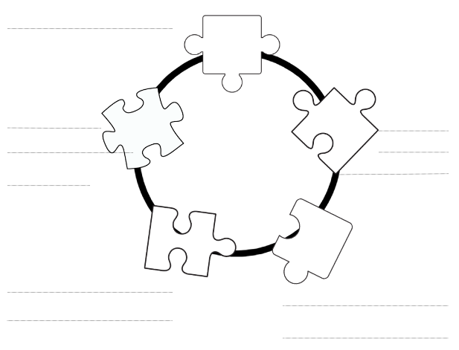

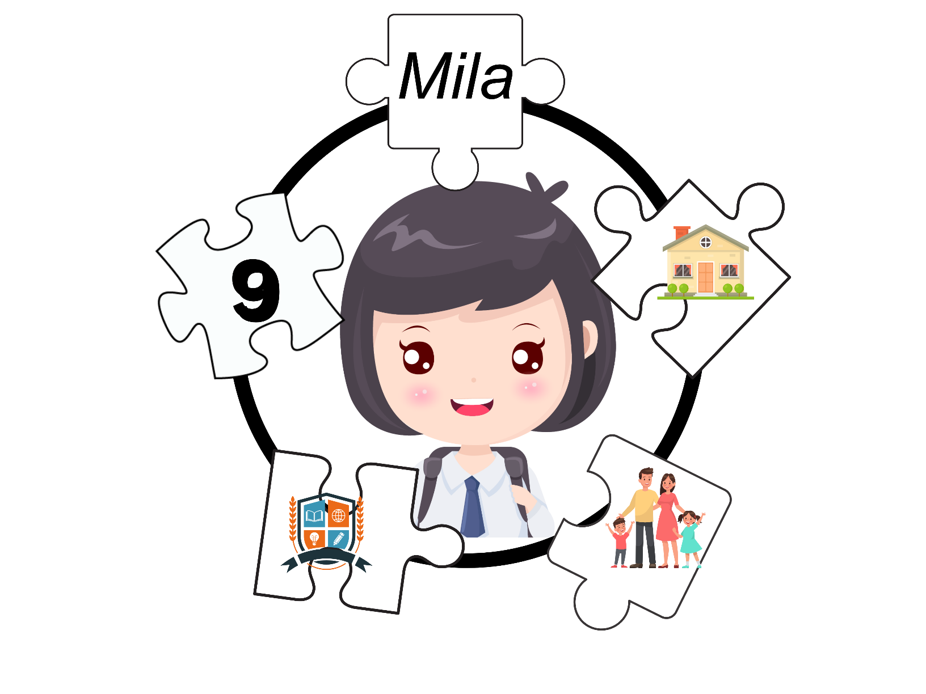

## Resource 4 – activities flashcards

This resource can be adapted by replacing the text to suit your language.

|  |  |  |  |  |  |  |  |  |
| --- | --- | --- | --- | --- | --- | --- | --- | --- |
| Two boys playing football. |  | A drawing of coloured pencils on a spiral notebook. |  | A cartoon of a child holding a tablet. |  | A cartoon of a child swimming in water. |  | A cartoon of a child writing on a book with a clock in the background. |
| **chơi đá banh** |  | **vẽ** |  | **chơi iPad** |  | **bơi** |  | **viết** |
|  |  |  |  |  |  |  |  |  |
| A cartoon of a child reading a book. |  | A group of children cleaning a house. |  | A cartoon of a child singing into a microphone. |  | A child sitting in a bean bag chair watching TV. |  | A cartoon of a child running. |
| **đọc sách** |  | **làm việc nhà** |  | **hát** |  | **coi Tivi** |  | **chạy** |

|  |  |  |  |  |  |  |  |  |
| --- | --- | --- | --- | --- | --- | --- | --- | --- |
| Two boys playing football. |  | A drawing of coloured pencils on a spiral notebook. |  | A cartoon of a child holding a tablet. |  | A cartoon of a child swimming in water. |  | A cartoon of a child writing on a book with a clock in the background. |
| **playing soccer** |  | **drawing** |  | **playing on the iPad** |  | **swimming** |  | **writing** |
|  |  |  |  |  |  |  |  |  |
| A cartoon of a child reading a book. |  | A group of children cleaning a house. |  | A cartoon of a child singing into a microphone. |  | A child sitting in a bean bag chair watching TV. |  | A cartoon of a child running. |
| **reading** |  | **doing chores** |  | **singing** |  | **watching TV** |  | **running** |

## Resource 5 – bingo cards

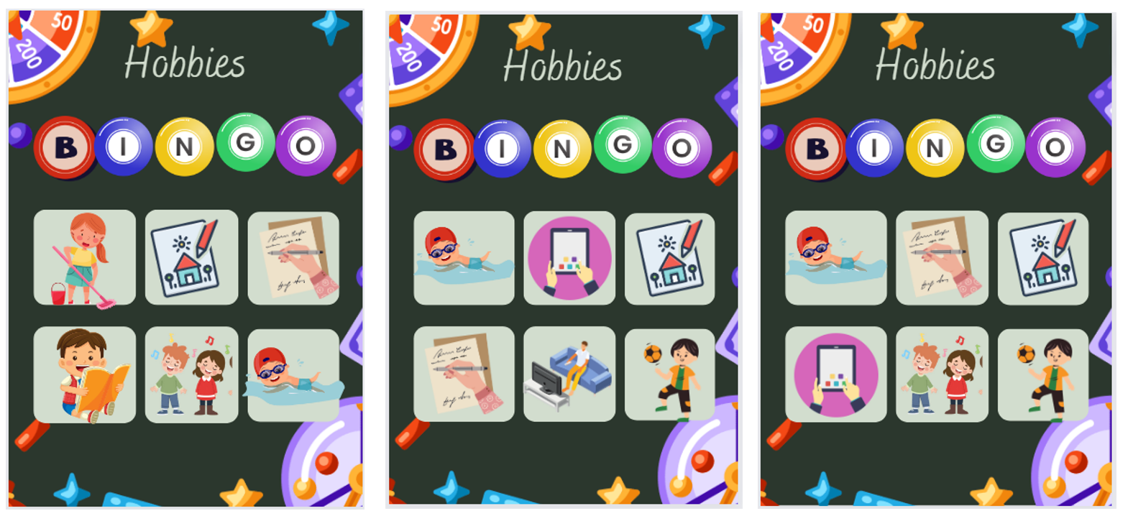

Bingo cards.


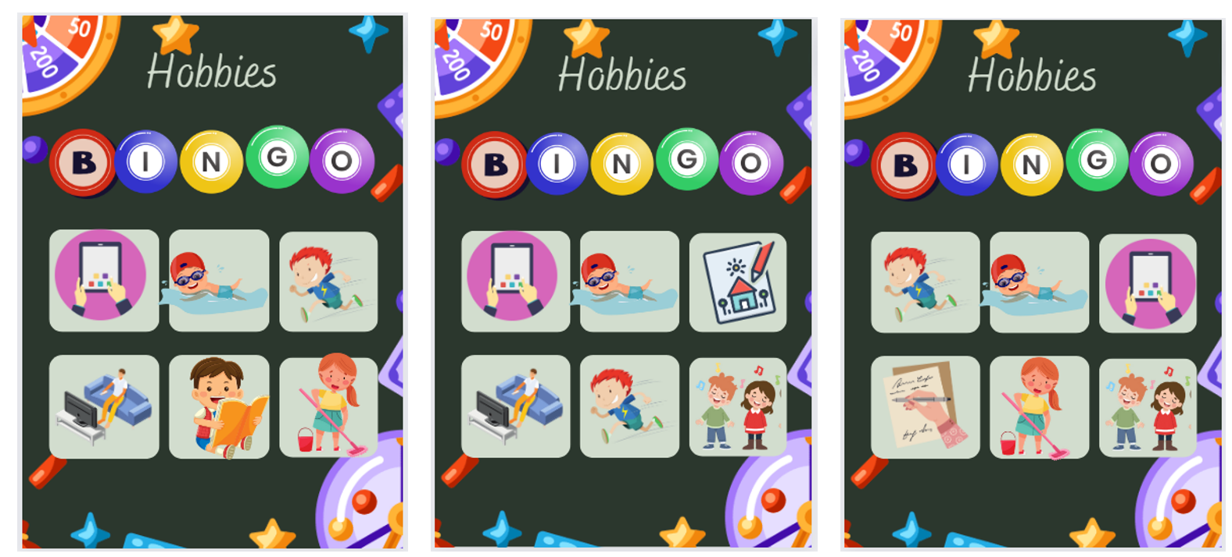

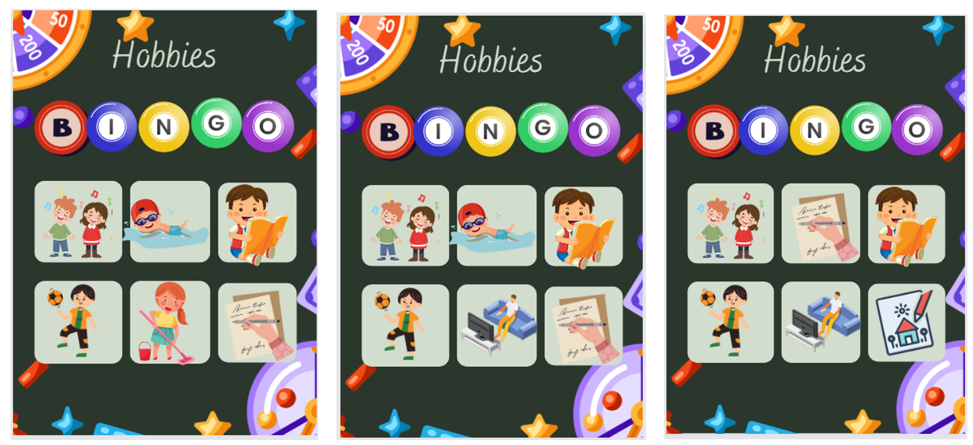

## Resource 6 – reading comprehension

Ba người bạn mới tên là Kim, Minh và Long.

**Kim:** Xin chào! Em tên là Kim. Em tám tuổi. Em thích đọc sách. Em không thích bơi.

**Minh:** Xin chào! Em tên là Minh. Em mười tuổi. Em thích bơi. Em không thích đá banh.

**Long:** Xin chào! Em là tên Long. Em chín tuổi. Em thích coi Tivi. Em không thích vẽ.

There are 3 new friends named Kim, Minh and Long.

**Kim:** Hello! My name is Kim. I am 8 years old. I like *reading.* I don’t like *swimming.*

**Minh:** Hello! My name is Minh. I am 10 years old. I like *swimming.* I don’t like *soccer*.

**Long:** Hello! My name is Long. I am 9 years old. I like *watching TV*. I don’t like *drawing.*

## Resource 7 – reading comprehension worksheet

**Tên:**________________________ **Lớp:** _________

**Đọc bài viết dưới đây rồi trả lời câu hỏi:**

Ba người bạn mới tên là Kim, Minh và Long.

**Kim**: Xin chào! Em tên là Kim. Em tám tuổi. Em thích đọc sách. Em không thích bơi.

**Minh**: Xin chào! Em tên là Minh. Em mười tuổi. Em thích bơi. Em không thích đá banh.

**Long**: Xin chào! Em là tên Long. Em chín tuổi. Em thích coi Tivi. Em không thích vẽ.

1. Điền thông tin thích hợp vào ô trống/Fill in the correct information in the table below:

|  |  |  |  |
| --- | --- | --- | --- |
| Tên/Name | Tuổi/Age | Thích/Like | Không thích/Dislike |
| Kim |  |  |  |
| Minh |  |  |  |
| Long |  |  |  |

1. Câu nào sau đây là đúng (Right)? Câu nào sai (Wrong)?

|  |  |  |
| --- | --- | --- |
| Statement | Right | Wrong |
| Kim thích đọc sách nhưng (but) không thích bơi. |  |  |
| Minh thích chơi banh. |  |  |
| Long không thích coi tivi nhưng (but) thích vẽ. |  |  |
| Kim và Minh thích bơi. |  |  |

1. Viết 1 câu hoàn chỉnh về sở thích của em (Write a completed sentence about your hobbies):

|  |
| --- |
|  |

**Name: ________________________ Class: _________**

**Read the following text and answer the questions below:**

There are 3 new friends named Kim, Minh and Long.

**Kim**: Hello! My name is Kim. I am 8 years old. I like reading. I don’t like swimming.

**Minh**: Hello! My name is Minh. I am 10 years old. I like swimming. I don’t like soccer.

 **Long**: Hello! My name is Long. I am 9 years old. I like watching TV. I don’t like drawing.

1. Fill in the correct information in the table below:

|  |  |  |  |
| --- | --- | --- | --- |
| Name | Age | Like | Dislike |
| Kim |  |  |  |
| Minh |  |  |  |
| Long |  |  |  |

1. Which of the following statements are right or wrong?

|  |  |  |
| --- | --- | --- |
| Statement | Right | Wrong |
| Kim likes reading but doesn’t like swimming. |  |  |
| Minh likes playing soccer. |  |  |
| Long doesn’t like watching Tivi but likes drawing. |  |  |
| Kim and Minh like swimming. |  |  |

1. Write a completed sentence about your hobbies:

|  |
| --- |
|  |

## Resource 8 – likes and dislikes

**Sở thích của em**

|  |  |
| --- | --- |
| **Thích** | **Không thích** |
| Two boys playing soccer.Em thích đá banh với bạn. | A child looking apprehensively at a swimming pool.  Em không thích bơi. |
| Em thích hát.A child singing into a microphone. |  |

**My hobbies**

|  |  |
| --- | --- |
| **Like** | **Dislike** |
| Two boys playing soccer.I like playing soccer with my friend. | A child looking apprehensively at a swimming pool.  I don’t like swimming. |
| I like singing.A child singing into a microphone. |  |

## Resource 9 – likes and dislikes poster

**Sở thích của em**

|  |  |
| --- | --- |
| **Thích** | **Không thích** |
|  |  |

## Resource 10 – sample letter

|  |
| --- |
| Ngày 19.10.2023  Bạn thân mến,  Mình tên là Hoa. Mình chín tuổi.  Hiện nay mình đang học lớp Ba ở trường tiểu học Lansvale.  Mình sống ở Fairfield với ba, mẹ và anh Hai. Nhà mình còn có nuôi một con chó.  Mình rất thích vẽ nhưng lại không thích chơi đá banh.  Rất vui được biết bạn!  Trân trọng,  Hoa |

|  |
| --- |
| Date: 19.10.2023  Dear friend,  My name is Hoa. I'm nine years old.  I am currently in Third grade at Lansvale Public School.  I live in Fairfield with my dad, mom and my older brother. My family also has a dog.  I really like drawing but I don't like playing soccer.  It’s nice to know you!  Sincerely,  Hoa |

## Resource 11 – scrambled letter parts

|  |  |  |
| --- | --- | --- |
| Mình tên là Kim. Mình 10 tuổi. Mình học trường tiểu học Williams. Mình sống với ba mẹ ở Canley Heights. Mình thích bơi. Còn bạn thì sao? |  | My name is Kim. I am 10 years old. I study at Williams Public School. I live in Canley Heights with my parents. I like swimming. How about you? |
| Trân trọng |  | Sincerely |
| Bạn thân mến, |  | Dear friend, |
| Kim |  | Kim |
| 24.11.2023 |  | 24.11.2023 |

|  |  |  |
| --- | --- | --- |
| Mình tên là William. Mình tám tuổi. Mình học trường tiểu học St Johns. Mình sống với ba mẹ ở Canley Vale. Mình thích đọc sách nhưng không thích đá banh. Rất vui được biết bạn! |  | My name is William. I am eight years old. I study at St Johns Public School. I live in Canley Vale with my parents. I like reading but don’t like playing soccer. It’s nice getting to know you! |
| Trân trọng |  | Sincerely |
| Bạn thân mến, |  | Dear friend, |
| William |  | William |
| 24.06.2023 |  | 24.06.2023 |

## Resource 12 – assessment task – Penpals

### Outcomes

You will be assessed on how well you:

* create texts for familiar communicative purposes by selecting culturally appropriate modelled language.

### Task

Your school recently signed up for a new penpal program. Write to a penpal in Vietnam introducing yourself. Include information about your family, school and activities.

|  |  |
| --- | --- |
| Too hard? | Too easy? |
| Write a letter to a penpal in Vietnam. Use a scaffold template with visuals and some key words. | Write a letter to a penpal in Vietnam. Include questions and some fun facts about yourself. |

#### Learning intention

Students will be able to write letters to their new penpal in Vietnam. They will introduce themselves including their name, age, school, family and personal interests.

#### Success criteria

You will write a letter to your new penpal in Vietnam to introduce yourself.

You will be successful if you can:

* correctly use the letter formats including date, greeting, body, closing and signature
* write in Vietnamese using modelled sentence structures
* use learned vocabulary and correct grammar
* use correct pronouns and/or address the audience accordingly
* include personal information (name, age, school, grade, family and activities) in the letter.

#### Task instructions

1. This writing task will be completed individually. You will be assessed on all criteria in the rubric. Refer to the Resource 13 – rubric – Penpals.
2. Following the task, you will self-assess your work by marking yourself using the same rubric. Then you will compare your self-assessed rubric with the teacher’s marked rubric.
3. Reflect on your performance and identify areas for improvements. Use this information to set a learning goal for the next stage of your learning journey.

## Resource 13 – rubric – Penpals

**Name:**

Table 4 – rubric for *Kết Bạn Qua Thư* (Penpals)

|  |  |  |  |  |  |
| --- | --- | --- | --- | --- | --- |
| Criteria | Excellent | Got it | Sort of | Getting there | Not yet |
| Communication | Your audience, your penpal friend, clearly understands what you want to communicate.  Successfully and thoroughly complete all of the following aspects of the task:   * introduce basic information (name, age, school and grade) * write about family (including family members) and where he/she lives * describe activities (likes and dislikes). | Your audience, your penpal friend, can understand what you want to communicate.  Successfully complete all of the following aspects of the task:   * introduce basic information (name, age, school and grade) * write about family (including family members) and where he/she lives * describe activities (likes and dislikes). | Your audience, your penpal friend, can mostly understand what you want to communicate.  Successfully complete most of the following aspects of the task:   * introduce basic information (name, age, school and grade) * write about family (including family members) and where he/she lives * describe activities (likes and dislikes). | Your audience, your penpal friend, struggles to understand what you want to communicate. However, communication is successful.  Did not complete all aspects of the task. | Your audience, your penpal friend, is unable to understand what you want to communicate.  Unable to complete any aspect of the task. |
| Grammar | Always write words in the correct grammatical order. | Usually write words in the correct grammatical order. | Make some grammar mistakes when writing simple sentences. | Rarely make sense when writing basic sentences. | Unable to be understood. |
| Punctuation | Correct punctuation throughout the whole letter. | Punctuation was used correctly most of the time. | Consistently make punctuation errors. | Punctuation was used a few times. | No punctuation used. |
| Vocabulary | Use learned vocabulary and pronouns correctly all the time. | Use learned vocabulary and pronouns correctly most of the time. | Make some mistakes when trying to use learned vocabulary and pronouns. | Make mistakes when trying to use learned vocabulary and pronouns. | Unable to use vocabulary in appropriate context. |

## Resource 14 – peer feedback strategy – TAG feedback slip

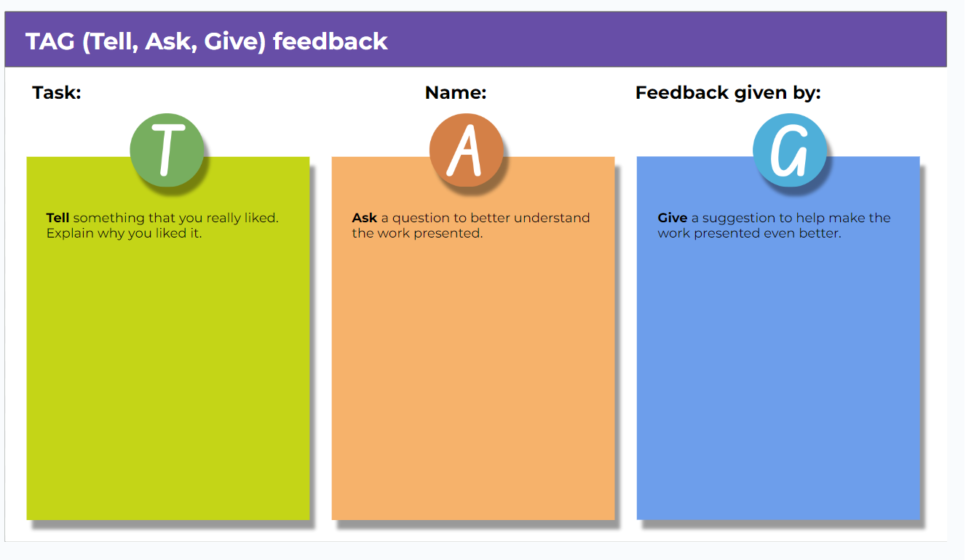

## Resource 15 – learning goal form

|  |  |
| --- | --- |
| Learning goal | Notes |
| My learning goal | I will pronounce [X] sound correctly in Vietnamese words and sentences. |
| The steps I will take | I will:   * say 5 different Vietnamese words with [X] sound every day * practise pronouncing words correctly by playing tongue twister games * record and listen to myself saying the sound in Vietnamese * practise the sound with my friends and ask for their feedback * listen and act on my teacher’s feedback. |
| Target date | Term [X], Week 8 |
| Target achieved | Term [X], Week …. |

# Support and alignment

**Resource evaluation and support**: all curriculum resources are prepared through a rigorous process. Resources are periodically reviewed as part of our ongoing evaluation plan to ensure currency, relevance, and effectiveness. For additional support or advice, contact the Primary Languages team by emailing [primlang@det.nsw.edu.au](mailto:primlang@det.nsw.edu.au).

**Alignment to system priorities and/or needs**: [School Excellence Policy](https://education.nsw.gov.au/policy-library/policies/pd-2016-0468)

**Alignment to the School Excellence Framework**: this resource supports the [School Excellence Framework](https://education.nsw.gov.au/policy-library/policies/pd-2016-0468) elements of curriculum (curriculum provision, teaching and learning programs) and effective classroom practice (lesson planning).

**Alignment to Australian Professional Teaching Standards**: this resource supports teachers to address [Australian Professional Teaching Standards](https://educationstandards.nsw.edu.au/wps/portal/nesa/teacher-accreditation/meeting-requirements/the-standards/proficient-teacher) 2.2.2, 3.2.2.

**Consulted with**: Curriculum, Secondary Learners, school-based staff and NESA subject matter experts. Advice from Aboriginal Outcomes and Partnerships, EAL/D, HPGE and Inclusive Education for Modern Languages Stage 3 Italian Mangiare in Ristorante has been considered in preparing this document.

**NSW syllabus**: Modern Languages K–10 Syllabus

**Syllabus outcomes**: ML2-INT-01, ML2-UND-01, ML2-CRT-01

**Author**: Primary Curriculum

**Publisher**: State of NSW, Department of Education

**Resource**: Unit

**Related resources**: further resources to support Stage 2 Modern Languages can be found on the [Languages K–6 curriculum page](https://education.nsw.gov.au/teaching-and-learning/curriculum/languages/planning-programming-and-assessing-languages-k-6).

**Professional learning**: relevant professional learning is available through [Primary Languages Networks (staff only)](https://teams.microsoft.com/l/team/19%3az18AANNDakIiZmi9dSLcfWx2Den_p0EiRqjP1B2_nYc1%40thread.tacv2/conversations?groupId=f062beb5-8af0-4ba5-87b3-bd45fa3f9767&tenantId=05a0e69a-418a-47c1-9c25-9387261bf991) on Teams

**Universal Design for Learning**: support the diverse learning needs of students using inclusive teaching and learning strategies. Some students may require more specific adjustments to allow them to participate on the same basis as their peers. For further advice see [Inclusive practice resources for primary school](https://education.nsw.gov.au/campaigns/inclusive-practice-hub/primary-school).

**Differentiation**: when using these resources in the classroom, it is important for teachers to consider the needs of all students in their class, including:

* **Aboriginal and Torres Strait Islander students**. Targeted [strategies](https://education.nsw.gov.au/teaching-and-learning/aec/aboriginal-education-in-nsw-public-schools) can be used to achieve outcomes for Aboriginal students in K–12 and increase knowledge and understanding of Aboriginal histories and cultures. Teachers should use students’ Personalised Learning Pathways to support individual student needs and goals.
* **EAL/D learners**. EAL/D learners may require scaffolding to support them to gain content knowledge, while providing extra time and assistance to master the English language required to engage with texts or complete classroom tasks. View some [samples of differentiating through scaffolding](https://education.nsw.gov.au/teaching-and-learning/curriculum/multicultural-education/english-as-an-additional-language-or-dialect/teaching-and-learning#Differentiation2).
* **Students with additional learning needs**. Learning adjustments enable students with disability and additional learning and support needs to access syllabus outcomes and content on the same basis as their peers. Teachers can use a range of [adjustments](https://education.nsw.gov.au/teaching-and-learning/disability-learning-and-support/personalised-support-for-learning/adjustments-to-teaching-and-learning) to ensure a personalised approach to student learning.
* **High potential and gifted learners**. [Assessing and identifying high potential and gifted learners](https://education.nsw.gov.au/teaching-and-learning/high-potential-and-gifted-education/supporting-educators/assess-and-identify#Assessment1) will help teachers decide which students may benefit from extension and additional challenge. In addition, the [Differentiation Adjustment Tool](https://education.nsw.gov.au/teaching-and-learning/high-potential-and-gifted-education/supporting-educators/implement/differentiation-adjustment-strategies) can be used to support the specific learning needs of high potential and gifted students.

**Creation date**: 1 May 2024

**Rights**: © State of New South Wales, Department of Education

# References

This resource contains NSW Curriculum and syllabus content. The NSW Curriculum is developed by the NSW Education Standards Authority. This content is prepared by NESA for and on behalf of the Crown in right of the State of New South Wales. The material is protected by Crown copyright.

Please refer to the NESA Copyright Disclaimer for more information <https://educationstandards.nsw.edu.au/wps/portal/nesa/mini-footer/copyright>.

NESA holds the only official and up-to-date versions of the NSW Curriculum and syllabus documents. Please visit the NSW Education Standards Authority (NESA) website <https://educationstandards.nsw.edu.au> and the NSW Curriculum website [https://curriculum.nsw.edu.au](https://curriculum.nsw.edu.au/).

[Modern Languages K–10 Syllabus](https://curriculum.nsw.edu.au/learning-areas/languages/modern-languages-k-10-2022/overview) © NSW Education Standards Authority (NESA) for and on behalf of the Crown in right of the State of New South Wales, 2022.

8 Ways (n.d.) [*8 Aboriginal Ways of Learning*](https://www.8ways.online/) [website], accessed 13 December 2022.

AITSL (Australian Institute for Teaching and School Leadership (2017) [‘Feedback Factsheet’](https://www.aitsl.edu.au/teach/improve-practice/feedback#:~:text=FEEDBACK-,Factsheet,-A%20quick%20guide), AITSL, accessed 8 November 2023.

Brookhart SM (2011) How to Assess Higher-Order Thinking Skills in Your Classroom, Hawker Brownlow Education, Victoria.

CESE (Centre for Education Statistics and Evaluation) (2020a) [*What works best: 2020 update*](https://education.nsw.gov.au/about-us/education-data-and-research/cese/publications/research-reports/what-works-best-2020-update), NSW Department of Education, accessed 8/11/2023.

CESE (Centre for Education Statistics and Evaluation) (2020b) [*What works best in practice*](https://education.nsw.gov.au/about-us/education-data-and-research/cese/publications/practical-guides-for-educators-/what-works-best-in-practice), NSW Department of Education, accessed 8/11/2023.

Conti G (28 May 2017) [From Target Language to Model Language – the mind shift that has transformed my teaching](https://gianfrancoconti.com/2017/05/28/from-target-language-to-model-language-the-mind-shift-that-has-enhanced-my-teaching/), The Language Gym, accessed 8 November 2023.

Conti G (28 September 2015) [‘16 tips for effective grammar teaching in the foreign language classroom’](https://gianfrancoconti.com/2015/09/28/new-post-16-tips-for-effective-grammar-teaching-in-the-foreign-language-classroom/), The Language Gym, accessed Day Month Year.

Henshaw FG and Hawkins MD (2022) Common Ground: Second Language Acquisition Theory Goes to the Classroom, Focus, Indianapolis, accessed 8 November 2023.

Jones J and Wiliam D (2014) Modern Foreign Languages Inside the Black Box: Assessment for Learning in the Modern Foreign Languages Classroom (Black P, Harrison C, Marshall B and Wiliam D, eds), Learning Sciences International, United States.

NESA (NSW Education Standards Authority) (2020) [*NSW Curriculum Review – final report*](https://www.nsw.gov.au/education-and-training/nesa/about/strategies-and-reforms/curriculum-reform/final-report), NESA, accessed 8 November 2023.

Rosenshine B (2012) [‘Principles of Instruction: Research-Based Strategies That All Teachers Should Know’](https://www.aft.org/periodical/american-educator/spring-2012/principles-instruction), American Educator, 36(1):12–19, 39, accessed 8 November 2023.

Smith S (2022) Becoming an Outstanding Languages Teacher, 2nd edn, Routledge, United Kingdom.

Wisniewski B, Zierer K and Hattie J (2020) [‘The Power of Feedback Revisited: A Meta-Analysis of Educational Feedback Research’](https://doi.org/10.3389/fpsyg.2019.03087), Frontiers In Psychology, 10(3087), doi:10.3389/fpsyg.2019.03087, accessed 8 November 2023.

Wiliam D (2013) [‘Assessment: The bridge between teaching and learning’](https://www.researchgate.net/publication/258423377_Assessment_The_bridge_between_teaching_and_learning), Voices from the Middle, 21(2):15–20, accessed 8 November 2023.

Wiliam D and Leahy S (2015) Embedding Formative Assessment: Practical Techniques for K–12 Classrooms, Learning Sciences International, United States.

**© State of New South Wales (Department of Education), 2024**

The copyright material published in this resource is subject to the Copyright Act 1968 (Cth) and is owned by the NSW Department of Education or, where indicated, by a party other than the NSW Department of Education (third-party material).

Copyright material available in this resource and owned by the NSW Department of Education is licensed under a [Creative Commons Attribution 4.0 International (CC BY 4.0) license](https://creativecommons.org/licenses/by/4.0/).

**[](https://creativecommons.org/licenses/by/4.0/)**

This license allows you to share and adapt the material for any purpose, even commercially. Attribution should be given to © State of New South Wales (Department of Education), 2024.

Material in this resource not available under a Creative Commons license:

* the NSW Department of Education logo, other logos and trademark-protected material
* material owned by a third party that has been reproduced with permission. You will need to obtain permission from the third party to reuse its material.

**Links to third-party material and websites**

Please note that the provided (reading/viewing material/list/links/texts) are a suggestion only and implies no endorsement, by the New South Wales Department of Education, of any author, publisher, or book title. School principals and teachers are best placed to assess the suitability of resources that would complement the curriculum and reflect the needs and interests of their students.

If you use the links provided in this document to access a third-party's website, you acknowledge that the terms of use, including licence terms set out on the third-party's website apply to the use which may be made of the materials on that third-party website or where permitted by the Copyright Act 1968 (Cth). The department accepts no responsibility for content on third-party websites.