# Revision of regular verb forms

## Activity 1 – conjugations

Complete the table below with the missing information, using the cues provided for each verb. The first one has been done for you as an example.

|  |  |  |  |  |
| --- | --- | --- | --- | --- |
| Verb stem | Person/form | Conjugation | Tense | Meaning |
| *amā* | **first person plural** | ***amāmus*** | **present** | **we love** |
| *amā* |  | *amābimus* | future |  |
| *amā* | first person plural |  |  | we loved |
| *amā* | infinitive | *amāvāre* | N/A |  |
| *curr* |  |  | present | they run |
| *curr* | singular | *currērunt* |  |  |
| *curr* | third person plural |  |  | they ran |
| *curr* |  |  | pluperfect | they had run |
| *hab* | third person singular | *habet* |  |  |
| *hab* | third person singular |  | perfect | he had |
| *hab* | third person singular |  | perfect/subjunctive mood | he will have had |
| *hab* | infinitive |  | N/A | to have |
| *cap* | first person singular |  | present | I am capturing |
| *cap\** |  | *cēpī* |  | I have captured |
| *cap\** | first person singular | *cēperam* | pluperfect |  |
| *cap* |  |  | N/A | to capture |
| *aud* | second person singular | *audiēbās* |  |  |
| *aud* | second person singular |  |  | you listened |
| *aud* | second person singular |  | future |  |
| *aud* |  | *audīte* |  |  |

* Be careful of the stem change in these conjugations!

## For the teacher

Remove this section before sharing this resource with students.

### Activity 1 – conjugations

|  |  |  |  |  |
| --- | --- | --- | --- | --- |
| Verb stem | Person/form | Conjugation | Tense | Meaning |
| *amā* | first person plural | *amāmus* | present | we love |
| *amā* | **first person plural** | *amābimus* | future | **we will love** |
| *amā* | first person plural | ***amāvimus*** | **perfect** | we loved |
| *amā* | infinitive | *amāvāre* | N/A | **to love** |
| *curr* | **third person plural** | ***currunt*** | present | they run |
| *curr* | singular | *curre* | **imperative** | **Run!** |
| *curr* | third person plural | ***currērunt*** | **perfect** | they ran |
| *curr* | **third person plural** | ***currerant*** | pluperfect | they had run |
| *hab* | third person singular | *habet* | **present** | **he has** |
| *hab* | third person singular | ***habuit*** | perfect | he had |
| *hab* | third person singular | ***habuerit*** | perfect/subjunctive mood | he will have had |
| *hab* | infinitive | ***habēre*** | N/A | to have |
| *cap* | first person singular | ***capiō*** | present | I am capturing |
| *cap\** | **first person singular** | *cēpī* | **perfect** | I have captured |
| *cap\** | first person singular | *cēperam* | pluperfect | **I had captured** |
| *cap* | **infinitive** | ***capere*** | N/A | to capture |
| *aud* | second person singular | *audiēbās* | **imperfect** | **you were listening** |
| *aud* | second person singular | ***audīvistī*** | **perfect** | you listened |
| *aud* | second person singular | ***audiet*** | future | **you will listen** |
| *aud* | **plural** | *audīte* | **imperative** | **Listen!** |

### Activity 2 – memory

Direct students to form pairs or groups of 3 or 4. Print and cut up enough sets of cards to provide each pair or group with their own set of cards. Alternatively, ask students to cut the cards up.

Students play memory-style activities, matching Latin verb conjugations with their English translations. Winners can be determined by group, with the student in each group with the most pairs at the end of the game being the winner. Or groups can race each other, with the winning group being the first to match all pairs.

#### Memory cards

|  |  |
| --- | --- |
| *amāmus* | we love |
| *amābimus* | we will love |
| *amāvimus* | we loved |
| *amāvāre* | to love |
| *currunt* | they run |
| *curre* | Run! |
| *currērunt* | they ran |
| *currerunt* | they had run |
| *habet* | he has |
| *habuit* | he had |
| *habuerit* | he will have had |
| *habēre* | to have |
| *capiō* | I am capturing |
| *cēpī* | I have captured |
| *cēperam* | I had captured |
| *capere* | to capture |
| *audiēbās* | you were listening |
| *audīvistī* | you listened |
| *audiet* | you will listen |
| *audīte* | Listen! |

### Activity 3 – word grab

Provide each pair or group with the Latin verb conjugations or their English translations, depending on what skill you would like the students to practise.

Direct students to place the set of cards they have been given at random, facing up on the desk. To begin the game announce the translation (English or Latin) you would like the students to identify. Students must be the first to identify and grab the card with the correct translation to win a point.

Alternatively, describe the Latin, for example, third person plural present tense. Students must be the first to identify the correct form of the correct verb from the cards on the table. Ensure that students have selected the correct conjugation for each round before proceeding to the next.

### Activity 4 – roll the dice

Provide students with mini whiteboards (or blank paper in plastic sleeves) and markers. Use the story cube templates or create your own dice using the [editable template](https://www.canva.com/design/DAGSTsGThFg/aeyBDWQ_Z1W-r_WjHTj-hA/edit?utm_content=DAGSTsGThFg&utm_campaign=designshare&utm_medium=link2&utm_source=sharebutton) or a website such as [virtual dice roller](https://flipsimu.com/dice-roller/). You will need 3 sets of dice. Each die will represent: the verb to be conjugated, the person and the tense required. Once all 3 dice have been rolled, students use the information to provide the correct conjugation of the verb given on their whiteboards, for example, second person plural, perfect tense, verb ‘to run’. The first student to provide the correct translation of the verb and in the form indicated wins the point.

Alternatively use the story cube templates or [the editable template](https://www.canva.com/design/DAGSTsGThFg/aeyBDWQ_Z1W-r_WjHTj-hA/edit?utm_content=DAGSTsGThFg&utm_campaign=designshare&utm_medium=link2&utm_source=sharebutton) to provide each group or pair of students with their own set of dice.

#### Story cube template – person

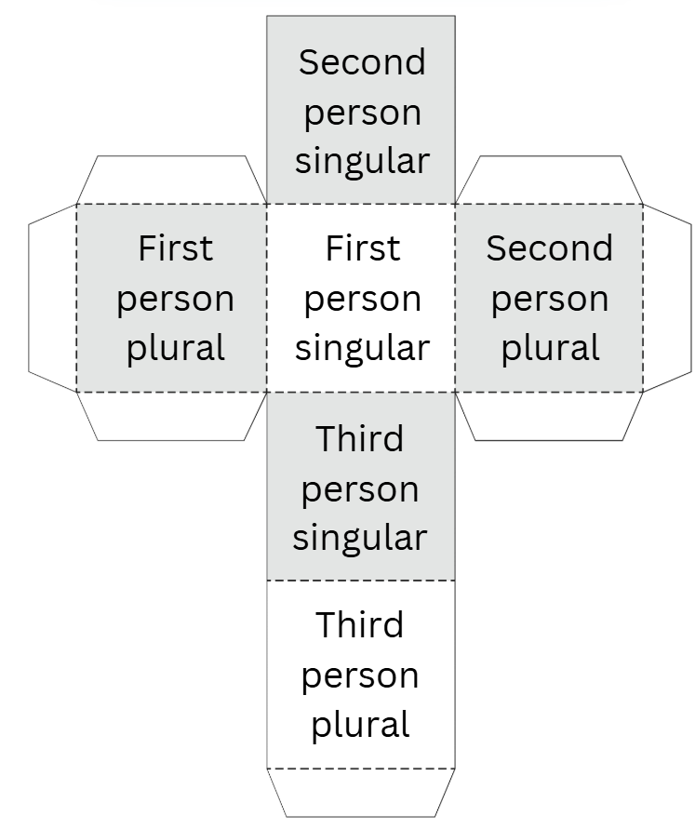

#### Story cube template – tense

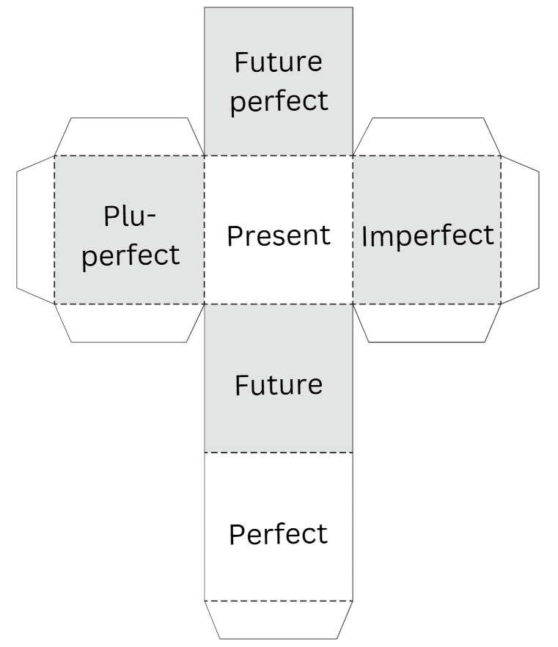

#### Story cube template – verb

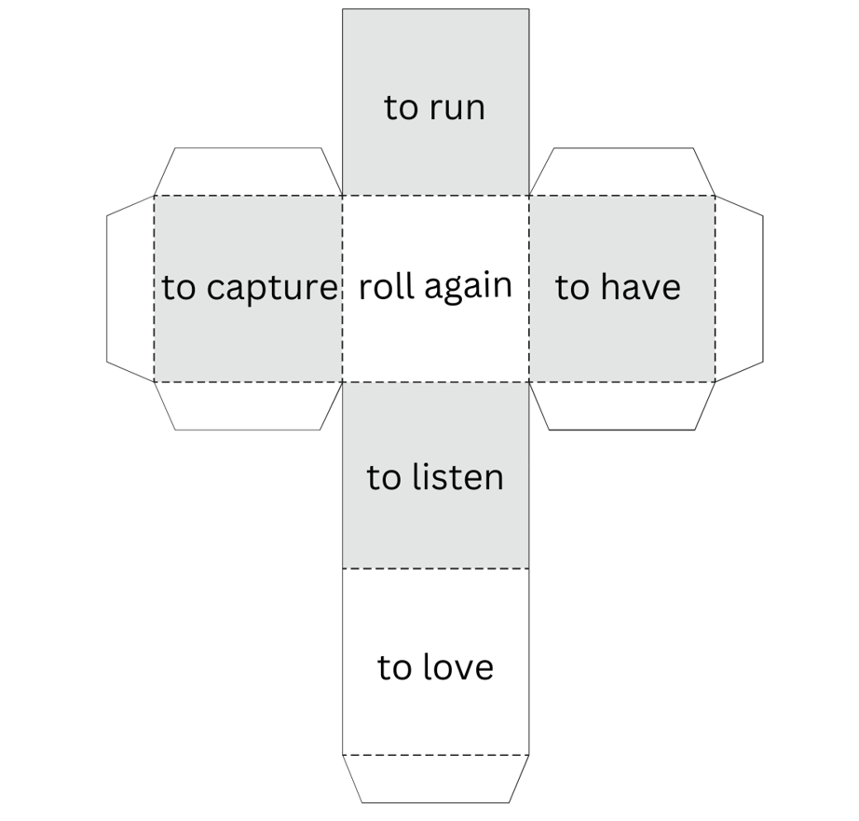

**© State of New South Wales (Department of Education), 2024**

The copyright material published in this resource is subject to the *Copyright Act 1968* (Cth) and is owned by the NSW Department of Education or, where indicated, by a party other than the NSW Department of Education (third-party material).

Copyright material available in this resource and owned by the NSW Department of Education is licensed under a [Creative Commons Attribution 4.0 International (CC BY 4.0) license](https://creativecommons.org/licenses/by/4.0/).

[](https://creativecommons.org/licenses/by/4.0/)

This license allows you to share and adapt the material for any purpose, even commercially.

Attribution should be given to © State of New South Wales (Department of Education), 2024.

Material in this resource not available under a Creative Commons license:

* the NSW Department of Education logo, other logos and trademark-protected material
* material owned by a third party that has been reproduced with permission. You will need to obtain permission from the third party to reuse its material.

**Links to third-party material and websites**

Please note that the provided (reading/viewing material/list/links/texts) are a suggestion only and implies no endorsement, by the New South Wales Department of Education, of any author, publisher, or book title. School principals and teachers are best placed to assess the suitability of resources that would complement the curriculum and reflect the needs and interests of their students.

If you use the links provided in this document to access a third-party's website, you acknowledge that the terms of use, including licence terms set out on the third-party's website apply to the use which may be made of the materials on that third-party website or where permitted by the *Copyright Act 1968* (Cth). The department accepts no responsibility for content on third-party websites.