Arabic Stage 3

(My shop) متجري

Contents

Unit overview 6

Stage 3 outcomes and content to be addressed 7

Learning map 11

Assessment 14

Assessment opportunities 15

Teaching and learning activities 17

Week 1 – setting up shop 17

Activity 1 – Learning map 18

Vocabulary 1 – types of shops 18

Activity 2 – pre-assessment 19

Activity 3 – shop vocabulary hotseat 19

Vocabulary 2 – shop items 20

Activity 4 – shop items 22

Activity 5 – Which item belongs? 23

Week 2 – describing items 25

Vocabulary 3 – shop items (plural) 26

Activity 1 – pre assessment 27

Vocabulary 4 – adjectives 29

Activity 2 – vocabulary 30

Activity 3 – labelling adjectives 31

Activity 4 – adjectives 32

Activity 5 – describing items 33

Week 3 – Why buy? 36

Vocabulary 4 – phrases 36

Activity 1 – Why buy? 37

Activity 2 – sentence builders 38

Activity 3 – cultural significance of shopping in Arabic-speaking countries 39

Vocabulary 5 – advertising 41

Activity 4 – advertising flyer 42

Week 4 – create an advertisement 43

Activity 1 – shopping trolley 43

Activity 2 – another visit to the bakery 44

Activity 3 – create an advertisement 45

Activity 4 – gallery walk 46

Activity 5 – advertise your own shop 46

Week 5 – assessment criteria and practice task 48

Activity 1 – word wall recall game 48

Activity 2 – assessment task 49

Activity 3 – success criteria 49

Activity 4 – discuss the rubric 50

Activity 5 – peer assessment 50

Activity 6 – promote your shop 51

Week 6 – communicative task – advertise your newly opened shop 52

Activity 1 – task preparation 53

Activity 2 – task set-up 53

Activity 3 – communicative task – advertise your newly opened shop 53

Activity 4 – peer feedback 54

Week 7 – feedback and goal setting 56

Activity 1 – odd one out 57

Activity 2 – self-assessment 57

Activity 3 – set learning goals 57

Activity 5 – My shop bingo! 58

Week 8 – language review 59

Activity 1 – student questions 60

Activity 2 – vocabulary voyage 60

Activity 3– word work 61

Activity 4 – grammar 61

Activity 4 – listening and responding 62

Student resources 63

Resource 1 – types of shops flashcards 63

Resource 2 – shop items flashcards 65

Resource 3 – brainstorm bubble 69

Resource 4 – shop items (plural) flashcards 70

Resource 5 – adjective flashcards 72

Resource 6 – colour wheel 78

Resource 7 – singular and plural sentence builder 79

Resource 8 – Oregano bakery advertisement 81

Resource 9 – gallery walk response form 83

Resource 10 – assessment task – My shop 84

Outcomes 84

Task 84

Learning intention 85

Success criteria 85

Task instructions 86

Resource 11 – rubric – My shop 87

Resource 12 – peer feedback strategy – TAG feedback slip 90

Resource 13 – learning goal form 91

Support and alignment 92

References 95

# Unit overview

**Stage**: 3

**Title**: (My shop) متجري

**Description**: In this unit, students create an advertisement to promote a shop they have planned. Students consider a theme for their store such as clothes, toys or sports equipment. They describe products in detail using modelled language, including features and price.

**Duration**: This lesson sequence is designed to be completed over approximately 8 weeks.

**Student proficiency levels**: The units and tasks in this document are aimed at Intermediate students. It is assumed that many Stage 3 students have been learning Arabic since Kindergarten and their proficiency level will be Intermediate. Every classroom will be different, and teachers will need to adapt to their context. Many classes may include a combination of Beginner, Intermediate and Advanced students. Assessment tasks and opportunities in this unit can be differentiated using the ‘Too hard?’ and ‘Too easy?’ suggestions.

**Note**: Arabic is a language that is read from right to left, unlike English which is read from left to right. As a result, there are some samples of English and Arabic text in this document where punctuation may appear incorrect in both. Please keep this in mind when using this document.

Stage 3 outcomes and content to be addressed

The table below outlines the focus area, outcomes and content points for Stage 3 students.

|  |  |
| --- | --- |
| Focus area and outcome | Content points |
| **Interacting**  A student:   * exchanges information and opinions in familiar contexts by using culturally appropriate rehearsed language **ML3-INT-01** | **Exchanging meaning in oral interactions in the target language**   * Understand and share information about themselves and their personal world * Ask and answer questions with familiar structures * Express and describe emotions and personal preferences * Address a new acquaintance and introduce themselves * Ask for clarification or repeat information to facilitate understanding in familiar interactions   **Applying knowledge of language systems to interact in the target language**   * Use key features of the sound system including pronunciation, intonation patterns, stress and/or rhythms to interact * Use familiar vocabulary to interact * Use modelled grammatical structures to interact   **Applying knowledge of the target language culture(s) to interact**   * Use language and nonverbal communication that are appropriate to cultural practices |
| **Understanding texts**  A student:   * identifies and responds to information and opinions in texts to demonstrate understanding **ML3-UND-01** | **Understanding and responding to target language texts**   * Listen to, read and view information and opinions in a range of texts on familiar themes * Use comprehension strategies to process information and opinions in texts * Respond in the target language and/or English to main points and specific information in familiar texts to explain understanding and express opinions   **Applying knowledge of language systems to understand and respond to target language texts**   * Identify and use the sounds of the target language to understand and respond to texts * Identify and use sound–symbol correspondences to understand and respond to texts * Use knowledge of vocabulary and phrases from familiar themes to understand and respond to texts * Use modelled sentence structures and grammar patterns to understand and respond to texts * Use familiar metalanguage to compare some target language structures and features with English * Recognise and use familiar structures and features of the target language writing system to understand and respond to texts   **Developing intercultural understanding through target language texts**   * Respond to texts and consider how language is connected with cultural practices and compare how this is evident in their own language(s), culture(s) and identity |
| **Creating texts**  A student:   * creates a range of texts for familiar communicative purposes by using culturally appropriate rehearsed language **ML3-CRT-01** | **Creating spoken, written and multimodal texts in the target language**   * Create informative texts appropriate to context, purpose and audience, sharing information about familiar themes * Create imaginative texts appropriate to context, purpose and audience using a series of sequenced sentences and visuals to express ideas on familiar themes   **Applying knowledge of language systems to create texts in the target language**   * Use pronunciation, intonation patterns, stress and/or rhythms to create spoken texts * Use sound–symbol correspondences to create written texts * Use relevant vocabulary, formulaic expressions or modelled phrases from familiar themes to create texts * Use a range of modelled sentence and grammatical structures to create texts * Select structures and features of the target language writing system to create written texts   **Applying knowledge of the target language culture(s) to create texts**   * Use language appropriate to cultural practices to create texts |

[Modern Languages K–10 Syllabus](https://curriculum.nsw.edu.au/learning-areas/languages/modern-languages-k-10-2022/overview) © NSW Education Standards Authority (NESA) for and on behalf of the Crown in right of the State of New South Wales, 2022.

# Learning map

The creation of maps for learning is a planning process that incorporates Aboriginal intellectual tradition. Learning maps are a visual pathway of what students will learn.

Share the learning map with your students, briefly explaining the learning that will happen in each lesson. Provide students with a copy of the learning map or display the learning map in the classroom. This learning map can be adapted to Arabic by accessing a copy of [*Learning map – (My shop) متجري (Stage 3)*](https://education.nsw.gov.au/content/dam/main-education/en/home/teaching-and-learning/curriculum/languages/documents/modern-languages-s3-arabic-learning-map-my-shop.pptx).

Figure 1 – My shop learning map

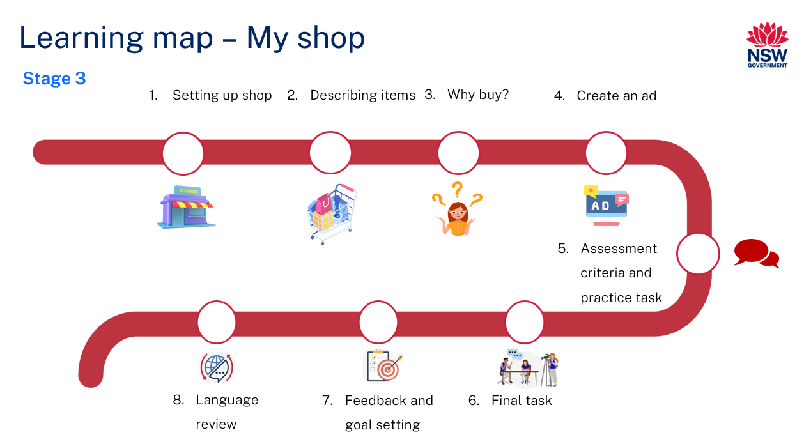

Figure 2 – متجري learning map

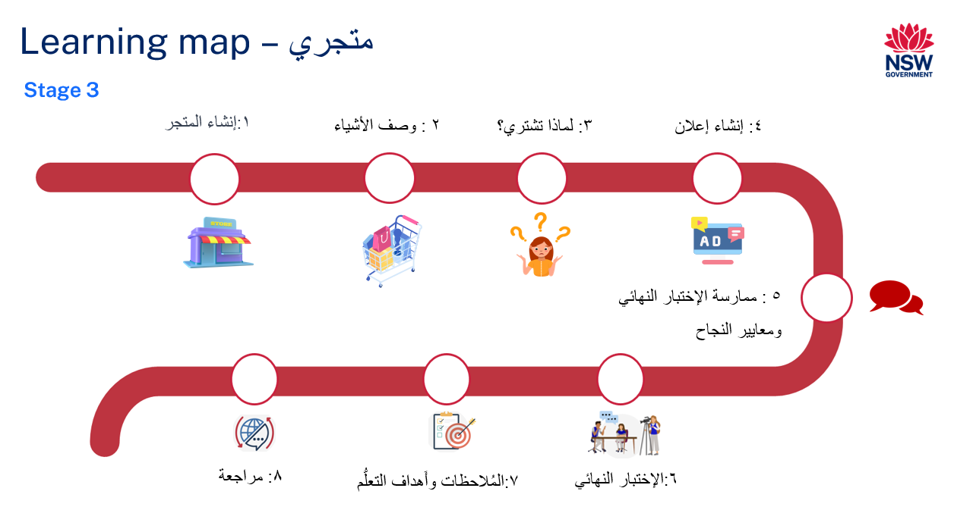

# Assessment

**Stage 3 communicative task**: You have opened a new shop. Create a spoken advertisement to promote your shop. Include a shop name, items that you sell and why people should buy your products.

**Too hard?**

Include a shop name and the type of items that you sell.

**Too easy?**

Include a shop name, 3 shop items that you sell and your new shop’s opening special offer.

**Context:** you have opened a new shop

**Audience:** potential customers

**Purpose:** to promote your shop

## Assessment opportunities

The table below details assessment opportunities and differentiation ideas.

|  |  |  |
| --- | --- | --- |
| Assessment opportunities | Too hard? | Too easy? |
| **Week 2 – labelling adjectives**  Students will use Resource 5 – adjective flashcards to correctly label images with adjectives. | **Labelling adjectives**  **Students to have access to the list of adjectives during the activity.** | **Labelling adjectives**  **Students to include additional adjectives not already on** Resource 5 – adjectives flashcards**.** |
| **Week 3 –****Why** **buy?**  In pairs, students will use Resource 7 – singular and plural sentence builder to create sentences explaining why customers should buy from their shop. | **Why buy?**  Students use the sentence builder to create singular sentences only. | **Why buy?**  Students should include additional adjectives and shop items not listed in the sentence builder for both singular and plural sentences. |
| **Week 4 – create an advertisement**  Students will create their own advertisement poster for a newly opened shop of their choice, including the shop's name, the type of items it sells, and a reason why customers should buy from their shop. | **Create an advertisement**  Students only include a shop name and the type of items they will sell. | **Create an advertisement**  Students include a shop name, 3 items sold at the shop, and their shop’s opening special offer. |
| **Week 5 –promote your shop**  Students will present their advertisement to classmates. | **Promote your shop**  Give students their completed shop advertisement flyers to guide their language during the advertisement of their shop. | **Promote your shop**  During their advertisement, students include their new shop’s opening special offer. |

# Teaching and learning activities

## Week 1 – setting up shop

The table below outlines the learning intention and success criteria of the lesson, and materials that the teacher and students will need to complete the teaching and learning activities.

|  |  |
| --- | --- |
| Learning intention and success criteria | Materials |
| Students will use vocabulary related to shops and shop items in Arabic.  Students can:   * correctly say the types of shops and shop items in Arabic. | * Resource 1 – types of shops flashcards * Resource 2 – shop items * Resource 3 – brainstorm bubble * Learning map * Arabic exercise books * Butchers paper * Writing materials |

### Activity 1 – Learning map

Explain and display the Learning map to give students a more detailed breakdown of lessons during the unit. Point out that the learning map is a plan that may need to change.

### Vocabulary 1 – types of shops

The table below outlines the suggested vocabulary for Activity 2, Activity 3 and Activity 4. It includes the original Arabic script, a Romanised version of the Arabic script, and the corresponding English translations.

|  |  |  |
| --- | --- | --- |
| English | Romanised Arabic | الترجمة الى اللغة العربية |
| electronics shop | matjar Ilktronyat | متجر إلكترونيات |
| dessert shop | matjar halawiyat | متجر حلويات |
| furniture shop | matjar athath | متجر أثاث |
| pharmacy | saydaliya | صيدلية |
| bakery | makhbaz | مخبز |
| clothing shop | matjar malabis | متجر ملابس |
| toy shop | matjar al'ab | متجر ألعاب |

### Activity 2 – pre-assessment

Show students the images from Resource 1 – types of shops flashcards. To gauge their familiarity with the vocabulary, ask students to give a thumbs-up near their chests as you ask the following questions:

* Do you recognise all the Arabic words for these images?
* Do you recognise most of them?
* Do you recognise any of them?

Read the words from Resource 1 – types of shops flashcards aloud and have students repeat each word after you say it.

**Note**: remind students with an Arabic speaking background that shop names in Modern Standard Arabic might vary from colloquial Arabic they hear at home. While discussing these differences, emphasise the use of Modern Standard Arabic in the classroom.

### Activity 3 – shop vocabulary hotseat

1. Play a communicative language learning game, ‘hotseat’, with the whole class to practise the vocabulary of types of shop names.
2. Divide the class into 2 teams. Select one player from each team to sit with their back to the board.
3. Write the word for an item in Arabic on the board, for example (bakery) مخبز
4. Students from each team will take turns giving clues in English to their teammate in the hotseat, without using the Arabic or English word written on the board; for example, this shop is known for its pastries. The first student in the hotseat to correctly say the word for bakery in Arabic earns a point for their team.

**Note:** students with Advanced proficiency can give clues in Arabic.

### Vocabulary 2 – shop items

**Note**: in the vocabulary table, some terms are unique to Arabic culture. For instance, 'Knafeh', ’Baklava’, ‘Namoua’ and ‘Kaak’ refer to popular desserts and have the same name in both English and Arabic. Like English, Arabic also has uncountable nouns that cannot be counted individually and are often used with quantifiers like 'some.' Examples of uncountable nouns in Arabic include:(knafeh) كنافة (baklava) بقلاوة and )bread) خبز

The table below outlines the suggested vocabulary for Activity 4 and Activity 5 It includes the original Arabic script, a Romanised version of the Arabic script, and the corresponding English translations.

|  |  |  |
| --- | --- | --- |
| English | Romanised Arabic | الترجمة الى اللغة العربية |
| television | tilfizyoon | تلفزيون |
| laptop | laptop | لابتوب |
| couch | kanaba | كنبة |
| dress | fustan | فستان |
| shirt | qamees | قميص |
| abaya | abayah | عباية |
| device | jihaz | جهاز |
| table | tawilah | طاولة |
| toy car | sayara lil’ab | سيارة للعب |
| basketball | kurat al-sallah | **كرة** السلة |
| kaak | kaʿk | كعك |
| baklava | baqlawa | بقلاوة |
| namoura | namoura | نمورة |
| medicine | duwa | دواء |
| bread | khubz | خبز |
| knafeh | kunafa | كنافة |

### Activity 4 – shop items

1. Display the images from Resource 2 – shop items flashcards with the words hidden to assess the class's prior knowledge of the vocabulary.
2. Give students a copy of Resource 3 – brainstorm bubble and ask them to list shop items they are familiar with in English. Advanced students may write the items in Arabic.
3. Have students pair up and engage in a [Think-Pair-Share](https://app.education.nsw.gov.au/digital-learning-selector/LearningActivity/Card/645) activity, where they discuss and share the words they have listed on their brainstorm bubble.
4. Reveal and read aloud the words from Resource 2 – shop items flashcards and have students repeat each word after you say it.
5. Model and drill the pronunciation of each word.
6. How many syllables are in the word (tilfizyoon)? تلفزيون There are 3 syllables (til-fiz-yoon- تل- فز- يون). Clap 3 times as you say each syllable loudly and clearly. Ask students to clap out the syllables with you.
7. Repeat this exercise for other vocabulary words with students.

### Activity 5 – Which item belongs?

1. In this activity, the class work together to categorise which items belong in each type of shop.
2. As you display each card from Resource 2 – shop items flashcards, students call out the item’s name in Arabic.
3. Discuss how some items, like (bread) خبز can be found in more than one shop, but for this activity, should be placed under the most obvious type of shop, such as the bakery.
4. After classifying all the items, create a list of shop names and shop items on a butcher’s paper to start a class word wall.
5. Students record the types of shops and shop items in their Arabic exercise books.
6. See the table below for suggested answers:

|  |  |  |  |  |  |  |
| --- | --- | --- | --- | --- | --- | --- |
| (toy shop) متجر الألعاب | )clothing shop( متجر الملابس | (bakery)المخبز | (pharmacy) الصيدلية | (furniture shop) متجر ألأثاث | (dessert shop) متجر الحلويات | (electronics shop) متجر إلا لكترونيات |
| سيارة للعب  (toy car)  كرة السلة  (basketball) | فستان  (dress)  عباية  (abaya)  قميص  (shirt) | خبز  (bread)  كعك  (kaak) | دواء  (medicine) | كنبة  (couch)  طاولة  (table) | كنافة  (knafeh)  نمورة  (namoura)  بقلاوة  (baklava) | تلفزيون  (television)  جهاز  (device)  لابتوب  (laptop) |

**Evaluation**: students can correctly pronounce the vocabulary words.

## Week 2 – describing items

The table below outlines the learning intention and success criteria of the lesson, and materials that the teacher and students will need to complete the teaching and learning activities.

|  |  |
| --- | --- |
| Learning intention and success criteria | Materials |
| Students will describe singular and plural shop items in Arabic.  Students can:   * use singular and plural forms of nouns to describe shop items in Arabic. * use adjectives to describe shop items in Arabic using the correct grammatical order and gender. | * Resource 4 – shop items (plural) flashcards * Resource 5 – adjective flashcards * Resource 6 – colour wheel * Arabic exercise books * Timer * Word wall * Writing materials |

### Vocabulary 3 – shop items (plural)

**Note**: in the vocabulary table, some terms are unique to Arabic culture. For example, 'Manaeesh' refers to a popular breakfast pizza and has the same name in both English and Arabic

The table below outlines the suggested vocabulary for Activity 1 and Activity 5. It includes the original Arabic script, a Romanised version of the Arabic script, and the corresponding English translations.

|  |  |  |
| --- | --- | --- |
| English | Romanised Arabic | الترجمة الى اللغة العربية |
| chairs | karāsī | كراسي |
| toiletries | mustalzimāt al-ḥammām | مستلزمات الحمام |
| vitamins | vitaminat | فيتامينات |
| manakeesh | manaqeesh | مناقيش |
| shoes | ahdhiah | أحذية |
| building blocks | muka'abat al-binaa | مكعبات البناء |
| soccer balls | kurāt al-qadam | كرات القدم |

**Note:** Arabic plural rules should be taught case by case. Unlike English, which typically forms plurals by adding '-s' or '-es,' Arabic has 2 main types of plurals: regular and irregular.

Regular plurals are formed by adding suffixes like 'ون', 'ين', or 'ات' to the singular noun. For example, 'vitamin' فيتامين becomes 'vitamins' فيتامينات by adding '-ات'.

Irregular plurals, on the other hand, involve changes to the entire structure of the word, affecting vowels and sometimes consonants. For example, the singular 'manoush' منقوشة becomes 'manakeesh' مناقيش in its plural form, showcasing a significant alteration in the word’s structure. These changes are not consistent and follow various patterns and rules. They are typically acquired through exposure and practise and should be taught on a case-by-case basis.

### Activity 1 – pre assessment

1. To pre assess students’ knowledge on their vocabulary. Ask students to recall other items that might be bought from different shops. Review Vocabulary 1 with the students. Then, in pairs ask them to think about the following questions in English or Arabic:

* What other items might you find in a bakery?
* What additional items might you find in a toy shop?
* Are there any other items you might find in a furniture shop besides a couch?

1. Have students engage in a [Think-Pair-Share](https://app.education.nsw.gov.au/digital-learning-selector/LearningActivity/Card/645) and discuss their answers.
2. Display Resource 4 – shop items (plural) flashcards. Model and drill the correct pronunciation of vocabulary.
3. Discuss what these words have in common and how they differ from Vocabulary 2.
4. Explain that regular plurals in Arabic are formed by adding suffixes like 'ون', 'ين', or 'ات'. Demonstrate examples such as (vitamins) فيتامينات and (soccer balls) كرات القدم on the board (see Figure 3).

Figure 3 – adding suffixes أت to regular plurals

(vitamins) فيتامين + ات = فيتامينات (vitamin)
(soccer balls)+ ات = كرات القدم  كرة قدم  (soccer ball).

1. Introduce irregular plurals, explaining that these require changes to the entire structure of the word. Demonstrate this using the example of (manoush) منقوشةand its plural form )manakeesh( مناقيش. Emphasise how the word's structure transforms from the singular to the plural. Highlight that this is only one of many ways of forming irregular plurals.
2. Model and add all plural shop items to the word wall and have students copy them into their Arabic exercise books.

### Vocabulary 4 – adjectives

The table below outlines the suggested vocabulary for Activity 2 and Activity 3. It includes the original Arabic script, a Romanised version of the Arabic script, and the corresponding English translations.

|  |  |  |
| --- | --- | --- |
| English | Romanised Arabic | لترجمة الى اللغة العربية |
| comfortable | murīh | مريح |
| helpful | mufīd | مفيد |
| strong | qawi | قوي |
| cheap | rakhis | رخيص |
| light | khafif | خفيف |
| heavy | thaqil | ثقيل |
| delicious | ladhidh | لذيذ |
| fresh | tazaj | طازج |
| shiny | lame | لامع |
| new | jadid | جديد |
| stylish | anīq | أنيق |

### Activity 2 – vocabulary

1. Show students Resource 5 – adjective flashcards and keep the words hidden to pre-assess their knowledge of vocabulary. To gauge their familiarity with the vocabulary, ask students to think about each image on the card. As you point to each image and call it out in English, encourage students to think about what the words might be in Arabic.
2. Have students pair up and engage in a [Think-Pair-Share](https://app.education.nsw.gov.au/digital-learning-selector/LearningActivity/Card/645) activity, where they discuss and share the Arabic words they are familiar with.
3. Reveal the words and model the correct pronunciation of each Arabic word. Have students repeat each word after you several times. Focus on words with tricky pronunciation, such as (fresh) طازج
4. Add the words to the word wall and have students record the vocabulary in their Arabic exercise books. As students record these words let them know that they will be using this vocabulary in the next activity.

### Activity 3 – labelling adjectives

**Note:** **prepare multiple sets of** Resource 5 – adjective flashcards **for this activity, ensuring the words are either hidden or removed.**

1. Provide pairs of students with a copy of the blank version of Resource 5 – adjective flashcards. Each group should try to correctly label each image with an adjective.
2. Start a timer. During this time, students should aim to label as many images as possible from memory. For example, students might label the image of the bread with the word (fresh) طازج
3. After completing the activity, reveal each flashcard using the blank copy of from Resource 5 – adjective flashcards, and ask students to call out the adjective for each image. For example, if the image of an arrow facing down is shown representing the flashcard for the word (cheap) رخيص, then students should call out the word.
4. If time permits, play a game of charades where students act out the adjectives for others to guess.

**Note:** allow students with Beginner proficiency, to use their Arabic exercise books or refer to the word wall for the duration of the activity. Students with Advanced proficiency should add more adjectives after they have labelled all the images.

### Activity 4 – adjectives

**Note:** remind students of the general rules for masculine and feminine adjective forms in Arabic. For example, the masculine form of ‘big’ كبير has no unique ending or may end with ي. On the other hand, the feminine form of ‘big’ كبيرة ends with ة (tāʾ marbūṭah).

Show students how to change the list of adjectives on the word wall to their feminine forms by adding a ة. Provide an example using one or 2 words (see Figure 4), then let students practise this in pairs with the rest of the adjectives, recording their answers in their Arabic exercise books.

Figure 4 – example of adding ة to a masculine word

 مفيد + ة = مفيدة
Mufid + ta marbuta = mufidah


Record the feminine adjectives beside the masculine word list onto the word wall. See examples below:

* comfortable مريح – مريحة
* helpful مفيد – مفيدة
* strong قوي – قوية
* cheap رخيص – رخيصة
* light خفيف – خفيفة
* heavy ثقيل – ثقيلة
* delicious لذيذ – لذيذة
* fresh طازج – طازجة
* shiny لامع – لامعة
* new جديد – جديدة
* stylish أنيق – أنيقة

**Note:** students with Advanced proficiency can write additional feminine adjectives not already on Resource 5 – adjectives flash cards.

### Activity 5 – describing items

**Note**: remind students that in Arabic, adjectives generally come after the nouns they describe, which is different from English. In Arabic, adjectives including colours, match the noun's gender. Refer to the table below for examples of masculine and feminine forms of colours.

|  |  |
| --- | --- |
| Feminine colours | Masculine colours |
| blue – zarqaa' – زرقاء | blue – azraq – أزرق |
| red –hamraa' – حمراء | red – ahmar – أحمر |
| green – khadraa' – خضراء | green – akhḍar – أخضر |
| grey – ramadiya – رمادية | grey – ramadi – رمادي |
| yellow – safraa' – صفراء | yellow – asfar – أصفر |
| purple – banafsajiya – بنفسجية | purple – banafsaji – بنفسجي |
| pink – zahriya – زهرية | pink – zahri – زهري |

1. Display Resource 6 – colour wheel on the board. Explain that in Arabic, adjectives, including colours, must agree with the gender of the noun they describe.
2. Go through each segment of the pie chart, pointing out that each colour is listed in both its masculine and feminine form.
3. Call out each colour in both its masculine and feminine forms, making sure to highlight the differences between them. Explain that in Arabic, adjectives change to match the gender of the noun. Use the masculine form with masculine nouns and the feminine form with feminine nouns. Provide an example for both masculine and feminine forms of a colour using Resource 6 – colour wheel.
4. For example, the word (shoes) حذاء is a masculine noun, so we use 'أخضر,' the masculine form of 'green,' resulting in حذاء أخضر. In contrast, for a feminine noun like (couch) كنبة, we use كنبة خضراء, where 'خضراء' is the feminine form of 'green’. Demonstrate both a masculine and feminine example to highlight the difference in how the form of the word ‘green’ in Arabic changes.
5. Play a quick round of colour drills with the class. For example, if you call out the masculine form of (red) أحمر in Arabic, students call out the feminine version of (red) حمراء in Arabic. Continue calling out colours in both masculine and feminine until all colours have been called from [Resource 6 – colour wheel](#_Resource_3:_Adjectives).
6. Direct students’ attention to the word wall where shop items (both singular and plural) and adjectives (both masculine and feminine) are displayed.
7. Do a class demonstration: select one noun and 2 adjectives (a colour and a describing word) from the word wall to form phrases such as (shiny green shoes)أحذية خضراء لامعة or (comfortable brown couch) كنبة بنية مريحة. Emphasise the agreement in gender between the adjective and the noun.
8. Each student takes turns within groups of 5 to come up with a different descriptive phrase with a shop item and 2 adjectives from the word wall.
9. After each student has made a phrase, they take turns to create silly phrases using the word wall, for example (delicious black shoes) أحذية سوداء لذيذة

**Note:** encourage students with advanced proficiency to use more than 2 adjectives and full sentences when describing each shop item.

## Week 3 – Why buy?

The table below outlines the learning intention and success criteria of the lesson, and materials that the teacher and students will need to complete the teaching and learning activities.

|  |  |
| --- | --- |
| Learning intention and success criteria | Materials |
| Students create sentences giving reasons as to why a customer should buy from their shop in Arabic.  Students can:   * write sentences in Arabic using nouns and adjectives in the correct order and gender * give reasons why a customer should buy from their shop, using the correct pronunciation. | * Resource 7 – singular and plural sentence builder * Arabic exercise books * Sticky notes * Word wall * Writing materials |

### Vocabulary 4 – phrases

The table below outlines the suggested vocabulary for Activity 2. It includes the original Arabic script, a Romanised version of the Arabic script, and the corresponding English translations.

|  |  |  |
| --- | --- | --- |
| English | Romanised Arabic | لترجمة الى اللغة العربية |
| You should buy | Yajib an tashtari | يجب أن تشتري |
| this | hatha (for masculine), hathihi (for feminine) | (feminine) هذا (masculine) هذه |
| because it is | li'annahu (masculine) li'annaha (feminine) | لأنه (masculine)  لأنها (feminine) |
| these | Hathihi | هذه |
| because they are | li'annaha | لأنها |

### Activity 1 – Why buy?

**Note:** in Arabic, non-human plural nouns are grammatically considered feminine singular. Hence, ‘لأنها’ is used for ‘because they are’ when referring to non-human objects, distinguishing from لأنهم used for human plurals.

1. Model the sentence using singular shop items from Vocabulary 2. For example (‘You should buy this baklava because it is delicious’.). يجب أن تشتري هذه البقلاوة لأنها لذيذة.
2. Introduce the plural phrase: You should buy these [items] because they are [adjective]. يجب أن تشتري هذه [اسم الأغراض] لأنها [صفة]
3. Model the sentence using plural shop items from Vocabulary 3. For example, (‘You should buy these building blocks because they are cheap’). يجب أن تشتري هذه المكعبات لأنها رخيصة.
4. Students self-assess their understanding of each phrase by raising their thumb up to their chest if they are familiar with the meaning of each phrase.
5. Explain that this phrase is used to give advice or suggestions about buying something based on its qualities. Highlight the role of adjectives in describing the item's qualities.
6. Display Resource 7 – singular and plural sentence builder. Model each phrase, and have students repeat after you, first as a class. Then, ask them to turn to a partner and repeat the phrase. Ensure students practise both the singular and plural forms.
7. Correct pronunciation as needed, and ensure students understand the meaning of the adjectives used.

### Activity 2 – sentence builders

**Note:** ensure students understand the importance of matching the noun and adjective in gender and number (plural/singular) in Arabic. Revisit Vocabulary 2, Vocabulary 3 and Vocabulary 4 to review the words taught over the past few weeks.

1. Explain to students that they will pretend to be shop owners and use the sentence builder to practise convincing buyers to purchase products from their shop.
2. Review the sentence structure with the class again and then distribute a copy of Resource 7 – singular and plural sentence builder to students.
3. In pairs, students use Resource 7 – singular and plural sentence builder to create sentences to explain why customers should buy from their shop.
4. Students walk around the room and practise different phrases with up to 5 other students, sharing a variety of singular and plural sentences.
5. Students then record their sentences in their Arabic exercise books.

**Evaluation:** use [Intentional observation checklist for communicative activities](https://education.nsw.gov.au/teaching-and-learning/curriculum/languages/languages-curriculum-resources-k-12/languages-curriculum-resources-k-6/intentional-observation-checklist) to make notes about student understanding of the target language, their pronunciation and use of gesture, facial expression and tone to support communication.

### Activity 3 – cultural significance of shopping in Arabic-speaking countries

**Note**: students will need access to devices to conduct the group research for this activity.

1. Show students images of various traditional markets (souks) from different Arabic-speaking countries. Display a mix of vibrant market scenes, local vendors, and traditional goods. Refer to the suggested images below:

Figure 5 – images of traditional markets (souks)

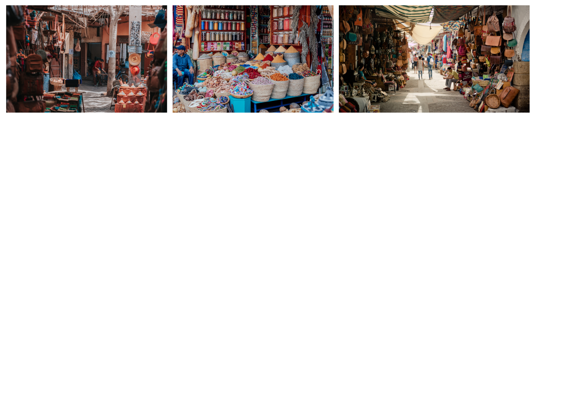

Images licensed under the [Canva Content License Agreement](https://www.canva.com/policies/content-license-agreement/).

1. Using the above images start a discussion with supporting questions, such as:

* What differences do you notice between these markets and shopping centres or markets in our country?
* A suggested response: traditional souks are outdoors unlike in Australia where shopping centres are enclosed.
* Can you identify any products that are different to what you may find here in Australia in these images?
* A suggested response: In the first image, there is a variety of spices and herbs that may not be as commonly found or as freshly available in Australian markets.

1. Keep the images from Figure 5 displayed on the board and ask students to take notes in their Arabic exercise books on the variety of products and buildings after the class discussion.

**Note**: to deepen students' understanding of shopping practices in Arabic-speaking countries, emphasise the historical and cultural aspects, particularly through the lens of souks (traditional markets) and folktales. For example, highlight the historical evolution of souks in the Arab world. These markets are not just shopping venues but vital aspects of social and economic life.

### Vocabulary 5 – advertising

The table below outlines the suggested vocabulary for Activity 4. It includes the original Arabic script, a Romanised version of the Arabic script, and the corresponding English translations.

|  |  |  |
| --- | --- | --- |
| English | Romanised Arabic | لترجمة الى اللغة العربية |
| advertisement | alan | إعلان |
| This is my new shop | hadha matjari aljadeed | هذا متجري الجديد |
| we sell | nabi | نبيع |

**Note**: remind students that in Arabic, to express possession or ownership similar to the English ‘my’ the Arabic language uses the suffix (yaa) ‘ي’. This suffix is attached to the end of the noun to indicate possession. For example, the word (shop) matjar متجر becomes (my shop) matjariمتجري

### Activity 4 – advertising flyer

**Note:** display the word wall for students to refer to.

Show the class a copy of Resource 7 – Oregano bakery advertisement. Put students into groups of 5 or 6 and provide each group with sticky notes and writing materials and ask them to answer the following questions in English or Arabic. Suggested questions include:

* What type of shop do you think this might be?
* What items do they sell, and what else do you think they would sell?
* What adjectives are used to describe these items?
* If you were to visit this bakery, which item would you like to try first, and why?

After reading the advertisement, have students discuss and share their responses to the above questions with the rest of the class.

## Week 4 – create an advertisement

The table below outlines the learning intention and success criteria of the lesson, and materials that the teacher and students will need to complete the teaching and learning activities.

|  |  |
| --- | --- |
| Learning intention and success criteria | Materials |
| Students design and present a shop advertisement.  Students can:   * use vocabulary from the word wall in their advertisement * talk about their type of shop and what it sells in Arabic * create an ad in Arabic using nouns and adjectives in the correct grammatical order and gender. | * Resource 8 – Oregano bakery advertisement * Resource 9 – gallery walk response form * A3 blank paper * Word wall * Writing materials |

### Activity 1 – shopping trolley

1. Play a communicative language learning game, ‘Shopping’ with the whole class to practise grammar and vocabulary.
2. Have students stand in a large circle.
3. Start the game with a simple sentence, such as, (This is my new shop and it sells…) Hatha matjari aljadid wayubee… هذا متجري الجديد ويبيع
4. The next student repeats the sentence and adds another product they sell to the list.
5. Continue around the circle, with each student repeating the growing list of items and adding one more.
6. The game continues until a student is unable to recall the correct sequence of items. Play the game again, in smaller groups if necessary, until all students have had an opportunity to participate.

### Activity 2 – another visit to the bakery

**Note**: these questions are different than those in the previous activity in Week 3, Activity 4; they require higher-order thinking skills rather than a repetition of what students already know from the bakery advertisement.

Display Resource 8 – Oregano bakery advertisement from the previous week. Have a quick recap session through a class discussion ask the following additional questions in English:

* Which item on this advertisement would you recommend to a friend, and why?
* What adjectives describe the bakery’s products, are they positive or negative adjectives?
* Can you think of additional adjectives that could be used to describe these items?

Have students pair up and engage in a [Think-Pair-Share](https://app.education.nsw.gov.au/digital-learning-selector/LearningActivity/Card/645) activity to discuss and share alternative Arabic adjectives to describe the items in the advertisement. Pairs then share their adjectives with the rest of the class.

### Activity 3 – create an advertisement

1. Organise students into groups of 8, assigning a different type of shop to each group member. Each student within the group will individually design an advertisement for the assigned shop.
2. Provide each student with writing materials and A3-sized blank paper.
3. Remind students to use the class word wall for vocabulary assistance.
4. Advise students to consider how colours, images, and font style can influence customer attraction to their shop in their advertisement designs.
5. Ask students in each group to individually create an advertisement for their newly assigned shop. The advertisement must include:

* the shop's name
* three types of items the shop sells
* a reason why customers should buy from their shop.

1. Ensure the advertisement created in this activity is kept for the practice task in Week 5.

**Note**: students with Beginner proficiency levels should include a shop name and the types of items they sell. Advanced proficiency students should include a shop name, 3 items sold at the shop, and their shop’s opening special offer.

### Activity 4 – gallery walk

Once students have completed their individual shop advertisements, organise a gallery walk within each group of 8. Instruct students to stick their advertisement to the wall, then walk around and view the different shop advertisement flyers created by their group members. Provide each student with a copy of Resource 9 – gallery walk response form. Ask students to select up to 3 shop advertisements from their group and fill in the response form based on their observations. Ensure all students have been given feedback on their advertisements. Encourage students to answer questions 1 to 3 in Arabic.

**Note:** Advanced students can answer all 4 questions in Arabic.Collect gallery walk response forms and hand them back to the students to reflect on or make improvements to their current shop advertisements.

### Activity 5 – advertise your own shop

1. Explain to students that they will individually decide on the type of shop of their choice and create an advertisement to promote their newly opened shop. This must be a different type of shop to the one in Activity 3.
2. Provide each student with writing materials and an A3-sized piece of blank paper.
3. Remind students to use the class word wall for vocabulary assistance and also remind them about the importance of using colours, images, and font style when designing their own shop advertisement.
4. Ask students to individually create an advertisement flyer for their newly opened shop. The advertisement must include:

* the shop's name
* three types of items the shop sells
* a reason why customers should buy from their shop.

## Week 5 – assessment criteria and practice task

The table below outlines the learning intention and success criteria of the lesson, and materials that the teacher and students will need to complete the teaching and learning activities.

|  |  |
| --- | --- |
| Learning intention and success criteria | Materials |
| Students will develop a clear understanding of the requirements of the assessment task.  Students can:   * suggest appropriate success criteria * explain what they need to do to be successful in the task. | * Resource 10 – assessment task – My shop * Resource 11 – rubric – My shop * Resource 12 – peer feedback strategy – TAG feedback slip * Student advertisements from Week 4 * Word wall |

### Activity 1 – word wall recall game

1. Divide the class into pairs and ask students to take it in turns to recall words from the word wall Vocabulary 1, Vocabulary 2 and Vocabulary 3, ensuring they don't repeat any words previously mentioned by their partner.
2. Student A faces away from the word wall and says words from it, one by one.
3. Student B watches and times. If Student A stops for more than 10 seconds or runs out of words, it is Student B's turn.
4. Student B then faces away from the word wall and continues calling out words that have not yet been called out by Student A.

### Activity 2 – assessment task

Hand out Resource 10 – assessment task – My shop.

Tell students that their communicative task is to create a spoken advertisement promoting their new shop. They should include the shop's name, the items they sell, and reasons why people should purchase their products. Point out that:

* the context of the task is that you have opened a new shop.
* the audience of the communication will be potential customers.
* the communicative purpose is to promote your shop.

### Activity 3 – success criteria

After looking at the assessment task, students [Think-Pair-Share](https://app.education.nsw.gov.au/digital-learning-selector/LearningActivity/Card/645) and suggest appropriate success criteria, such as:

I will be successful if I can:

* present my shop including its name, the type of items I sell and a reason why customers should buy from my shop
* use grammatically correct sentences with
* the correct order of words
* correct gender agreement of nouns and adjectives
* pronounce the words correctly
* speak in a well-paced manner without long pauses.

### Activity 4 – discuss the rubric

1. Show students an unmarked Resource 11 – rubric – My shop. This may need to be adapted if the class has decided on different success criteria.
2. Explain the metalanguage such as fluency, accuracy, pronunciation and vocabulary.
3. Students read and then discuss the ‘Got it’ column of the rubric in pairs. They then share their understanding of what is needed to be successful.
4. Point out and provide examples of what ‘excellent’, ‘got it’ and ‘sort of’ samples of task completion, fluency, accuracy, pronunciation and vocabulary look and sound like.

### Activity 5 – peer assessment

Confirm which [peer feedback strategy](https://app.education.nsw.gov.au/digital-learning-selector/LearningActivity/Card/549) will be used after the task, for example Resource 12 – peer feedback strategy – TAG feedback slip and discuss with students.

**Evaluation**: students give examples of what TAG feedback would sound like for this task.

### Activity 6 – promote your shop

Students present their advertisements made in Week 4 Activity 3. Each student will present their flyer to promote their newly opened shop to classmates. They should start with the phrase (This is my new shop…) هذا متجري الجديد, followed by the shop's name. Then, continue by listing the items for sale and giving a reason why people should come and buy the products. Emphasise the importance of clearly stating what the shop sells, using the phrase (‘We sell...') نبيع to introduce the products. Model and drill these phrases a few more times before students get started.

**Note:** provide students with Beginner proficiency with a copy of their partner’s completed advertisement to help with language during the presentation. Students with Advanced proficiency levels should include a new shop opening offer in their presentation.

## Week 6 – communicative task – advertise your newly opened shop

The table below outlines the learning intention and success criteria of the lesson, and materials that the teacher and students will need to complete the teaching and learning activities.

|  |  |
| --- | --- |
| Learning intention and success criteria | Materials |
| Students will promote their new shop to the class.  Students can:   * present their shop name, type of items they sell and give a reason why customers should buy from their shop * use grammatically correct sentences with * the correct order of words * correct gender agreement of nouns and adjectives. * pronounce the words correctly * speak in a well-paced manner without long pauses. | * Resource 12 – peer feedback strategy – TAG feedback slip * Recording device |

### Activity 1 – task preparation

Give students one more opportunity to read over their completed shop advertisement from Week 4 to help them prepare to the complete the task.

### Activity 2 – task set-up

**Note:** before recording interactions, check if any students do not have permission to be video recorded. Alternatives to video recording include audio recording or watching the interactions while taking notes and marking the rubric.

Divide students into pairs. Give each pair a few minutes to decide the order in which they will perform their roles. Students will then take turns pretending to be a shop owner, to promote their newly opened shop in Arabic.

**Suggested rotations:**

* **Role-play 1:** Student 1 – Shop owner, Student 2 –Camera operator/Peer assessor
* **Role-play 2:** Student 1 – Camera operator/Peer assessor, Student 2 – Shop owner.

### Activity 3 – communicative task – advertise your newly opened shop

**Note**: make sure to space students apart when filming. Demonstrate how to film using a recording device. Use microphones, if possible, to maximise sound quality. Highlight the importance of holding the recording device still by using a tripod or resting it on a table.

For this task, students will work in pairs and take turns in these roles:

* **Shop owner**: advertise your newly opened shop.
* **Peer assessor/Camera operator**: record the advertisement and give feedback.

**Example spoken advertisement:**

* **Shop owner:** This is my new shop 'Sweet Beirut'. We sell kanfeh, namoura, and baklava. You should buy these desserts because they are delicious and fresh. هذا متجري الجديد 'حلويات بيروت'. نبيع كنافة، نمورة، وبقلاوة. يجب أن تشتروا هذه الحلويات لأنها لذيذة وطازجة

**Note**: verbal and written feedback will be provided using the TAG feedback slip feedback strategy in the follow-up activity.

### Activity 4 – peer feedback

Confirm which peer feedback strategy will be used after the task, for example Resource 12 – peer feedback strategy – TAG feedback slip (Tell, Ask, Give) peer feedback slip. Explain what is required with this strategy and provide example feedback.

* Tell something they really liked and explain why.
* Example: I like how you pronounced all the words correctly and made your new shop sound interesting.
* Ask a question to clarify or confirm something from the spoken advertisement.
* Example: Did you use the correct gender adjectives when describing the shop items?
* Give a suggestion to make their classmates’ use of language even better.
* Example: use more facial expression and gesture when promoting your shop to show excitement.

## Week 7 – feedback and goal setting

**Note**: if there is insufficient time to mark the videos before Week 8, Weeks 7 and 8 can be swapped.

The table below outlines the learning intention and success criteria of the lesson, and materials that the teacher and students will need to complete the teaching and learning activities.

|  |  |
| --- | --- |
| Learning intention and success criteria | Materials |
| Students will reflect on their task recordings to assess performance and set learning goals.  Students can:   * self-assess their completion of the task * set suitable learning goals based on previous learning goals and teacher, peer- and self-assessment. | * Resource 11 – rubric – My shop (one teacher completed copy per student and one blank copy per student for self-assessment) * Resource 13 – learning goal form * Blank pieces of paper * Counters * Recorded student videos * Word wall |

**Note**:prior to this lesson, view each video and mark each student according to the criteria on Resource 11 – rubric – My shop!

### Activity 1 – odd one out

Use the word wall to play a class game for 2 or 3 rounds. Read aloud 3 Arabic words to the students, ensuring that 2 words belong to the same category and one is the odd one out. Students identify and call out the word that does not belong. Then, in groups of 5 or 6, have the students play several rounds of this game. See suggested examples below:

* shop, shoes, tall – متجر ، حذاء ، طويل
* eyes, bakery, pharmacy – عيون، مخبز، صيدلية
* bread, cheap, Monday –خبز، رخيص، الاثنين

### Activity 2 – self-assessment

Students watch the video of themselves completing the task and use the rubric to self-assess. Students compare their self-assessment rubric with the teacher’s completed rubric.

### Activity 3 – set learning goals

**Note:** learning goals should be SMART: Specific, Measurable, Achievable, Realistic, Timely.

1. Students reflect on the teacher, peer- and self-evaluation to set goals for the next phase of learning.
2. Example learning goals include:

* I now feel confident – in reading and saying words related to shopping in Arabic.
* I feel confused when – I must change the adjective endings depending on the gender in Arabic.
* A next step for me – to say a sentence in Arabic using the correct word order.

1. Students record their learning goals using a copy of Resource 13 – learning goal form.

### Activity 5 – My shop bingo!

1. Play a whole class communicative language learning game, such as bingo, to review Vocabulary 1, Vocabulary 2 and Vocabulary 3 previously taught.
2. Show students the word wall and ask them to make a bingo card by dividing a blank piece of paper into 6 squares and then writing 6 words from the word wall in each square.
3. Lead a whole-class game by calling out words from the word wall, ensuring to model the correct pronunciation.
4. Provide a handful of counters to each student. Each time a word is called out in Arabic, a counter must be placed on that word called on the bingo card. The winner is the first student to get a whole row of counters.

**Evaluation**: students set appropriate learning goals based on teacher, peer- and self-assessment.

## Week 8 – language review

**Note**: if there is insufficient time to mark the videos before Week 8, Weeks 7 and 8 can be swapped.

The table below outlines the learning intention and success criteria of the lesson, and materials that the teacher and students will need to complete the teaching and learning activities.

|  |  |
| --- | --- |
| Learning intention and success criteria | Materials |
| Students will reflect on and ask questions about the language taught in this unit.  Students can:   * ask questions about vocabulary, grammar or pronunciation they have used in this unit * use the language they have learned to communicate with classmates in Arabic. | * Resource 7 – singular and plural sentence builder * Resource 2 – shop items flashcards * Individual whiteboards * Sticky notes * Word wall * Writing materials |

**Note:** over the course of the unit, gaps in student knowledge, misconceptions and misuse of language will have been identified. These observations are addressed using engaging and interactive activities and strategies. The activities below are examples and will need to be supplemented with activities to address your observations.

### Activity 1 – student questions

Remind students of the activities and tasks they have completed over the course of the unit. Give students time to [Think-Pair-Share](https://app.education.nsw.gov.au/digital-learning-selector/LearningActivity/Card/645) any questions they may have about aspects of the language taught.

### Activity 2 – vocabulary voyage

1. Demonstrate the game 'vocabulary voyage' with the class for 2 or 3 rounds. As a whole class, play this communicative language learning game to practise grammar and vocabulary.
2. Have students stand in a large, open area, spaced apart from each other.
3. Call out different words from the class word wall.
4. The first student to correctly translate the word can take a step to 'tap' another student, who will then be 'out.'
5. The winner is the last person remaining in the game.
6. In groups of 5 or 6, have students play a few more rounds.

**Note**: set up different language stations for activities 2 to 4 that focus on reinforcing word work, grammar, listening and responding. These activities can be adapted to suit students’ needs. After a set time, students rotate in groups to a new station to complete activities with a different focus.

### Activity 3– word work

This station will focus on reviewing learned vocabulary.

* **Word pictures**: in pairs, students take turns drawing a word from the word wall without revealing it. Their partner guesses the word and then takes a turn.
* **Lie detector**: in pairs, students take turns writing a sentence from Resource 7– singular and plural sentence builder on an individual whiteboard. Their partner reads and translates the sentence, then guesses whether it's true or a lie.

### Activity 4 – grammar

This station will focus on grammar taught during the unit.

**Suggested activity**:

* **Shop and describe:** in pairs, each student should think of a type of shop and write the shop's name in Arabic on a sticky note, along with a list of 3 items that the shop sells. After writing, they should swap sticky notes with their partner. The partner will then write an adjective that describes each shop item, making sure the adjective agrees in gender with the noun.

**Evaluation**: use [Intentional observation checklist for communicative activities](https://education.nsw.gov.au/teaching-and-learning/curriculum/languages/languages-curriculum-resources-k-12/languages-curriculum-resources-k-6/intentional-observation-checklist) to make notes about student understanding of the target language, their pronunciation and use of gesture, facial expression and tone to support communication.

### Activity 5 – listening and responding

This station will focus on strengthening and reviewing listening and responding to texts skills.

**Suggested activity**:

* **Delayed dictation**: in pairs, one student says a word from Resource 2 – shop items flashcards and counts down from 5. After the countdown, the other student writes the word down. Then switch roles until all words have been called out.

**Note**: Advanced students say and write sentences.

# Student resources

## Resource 1 – types of shops flashcards

|  |  |  |  |  |  |  |
| --- | --- | --- | --- | --- | --- | --- |
| A display case with cake. |  | A room with couches and furniture. |  | A display case with food on shelves. |  | A group of black electronic devices. |
| متجر حلويات |  | متجر أثاث |  | مخبز |  | متجر إلكترونيات |
|  |  |  |  |  |  |  |
|  |  | A person holding a toy and a child in a store. |  | A room with shelves of medicine. |  | A store with clothes on the shelves. |
|  |  | **متجر ألعاب** |  | **صيدلية** |  | متجر ملابس |

|  |  |  |  |  |  |  |
| --- | --- | --- | --- | --- | --- | --- |
| A display case with cake. |  | A room with couches and furniture. |  | A display case with food on shelves. |  | A group of black electronic devices. |
| **dessert shop** |  | **furniture shop** |  | **bakery** |  | **electronics shop** |
|  |  |  |  |  |  |  |
|  |  | A person holding a toy and a child in a store. |  | A room with shelves of medicine. |  | A store with clothes on the shelves. |
|  |  | **toy shop** |  | **pharmacy** |  | **clothing shop** |

This resource can be adapted by replacing the text to suit your language.

## Resource 2 – shop items flashcards

|  |  |  |  |  |  |  |
| --- | --- | --- | --- | --- | --- | --- |
|  |  |  |  |  |  |  |
| فستان |  | دواء |  | كنافة |  | تلفزيون |
|  |  |  |  |  |  |  |
|  |  |  |  |  |  |  |
| خبز |  | عباية |  | طاولة |  | سيارة لعبة |

|  |  |  |  |  |  |  |
| --- | --- | --- | --- | --- | --- | --- |
|  |  |  |  |  |  |  |
| كنبة |  | كرة السلة |  | نمورة |  | قميص |
|  |  |  |  |  |  |  |
|  |  |  |  |  |  | An open laptop. |
| جهاز |  | بقلاوة |  | كعك |  | **لابتوب** |

This resource can be adapted by replacing the text to suit your language.

|  |  |  |  |  |  |  |
| --- | --- | --- | --- | --- | --- | --- |
|  |  |  |  |  |  |  |
| **dress** |  | **medicine** |  | **kanfeh** |  | **television** |
|  |  |  |  |  |  |  |
|  |  |  |  |  |  |  |
| **bread** |  | **abayah** |  | **table** |  | **toy car** |

|  |  |  |  |  |  |  |
| --- | --- | --- | --- | --- | --- | --- |
|  |  |  |  |  |  |  |
| **couch** |  | **basketball** |  | **namoura** |  | **shirt** |
|  |  |  |  |  |  |  |
|  |  |  |  |  |  | An open laptop. |
| **device** |  | **baklava** |  | **kaak** |  | **laptop** |

## Resource 3 – brainstorm bubble

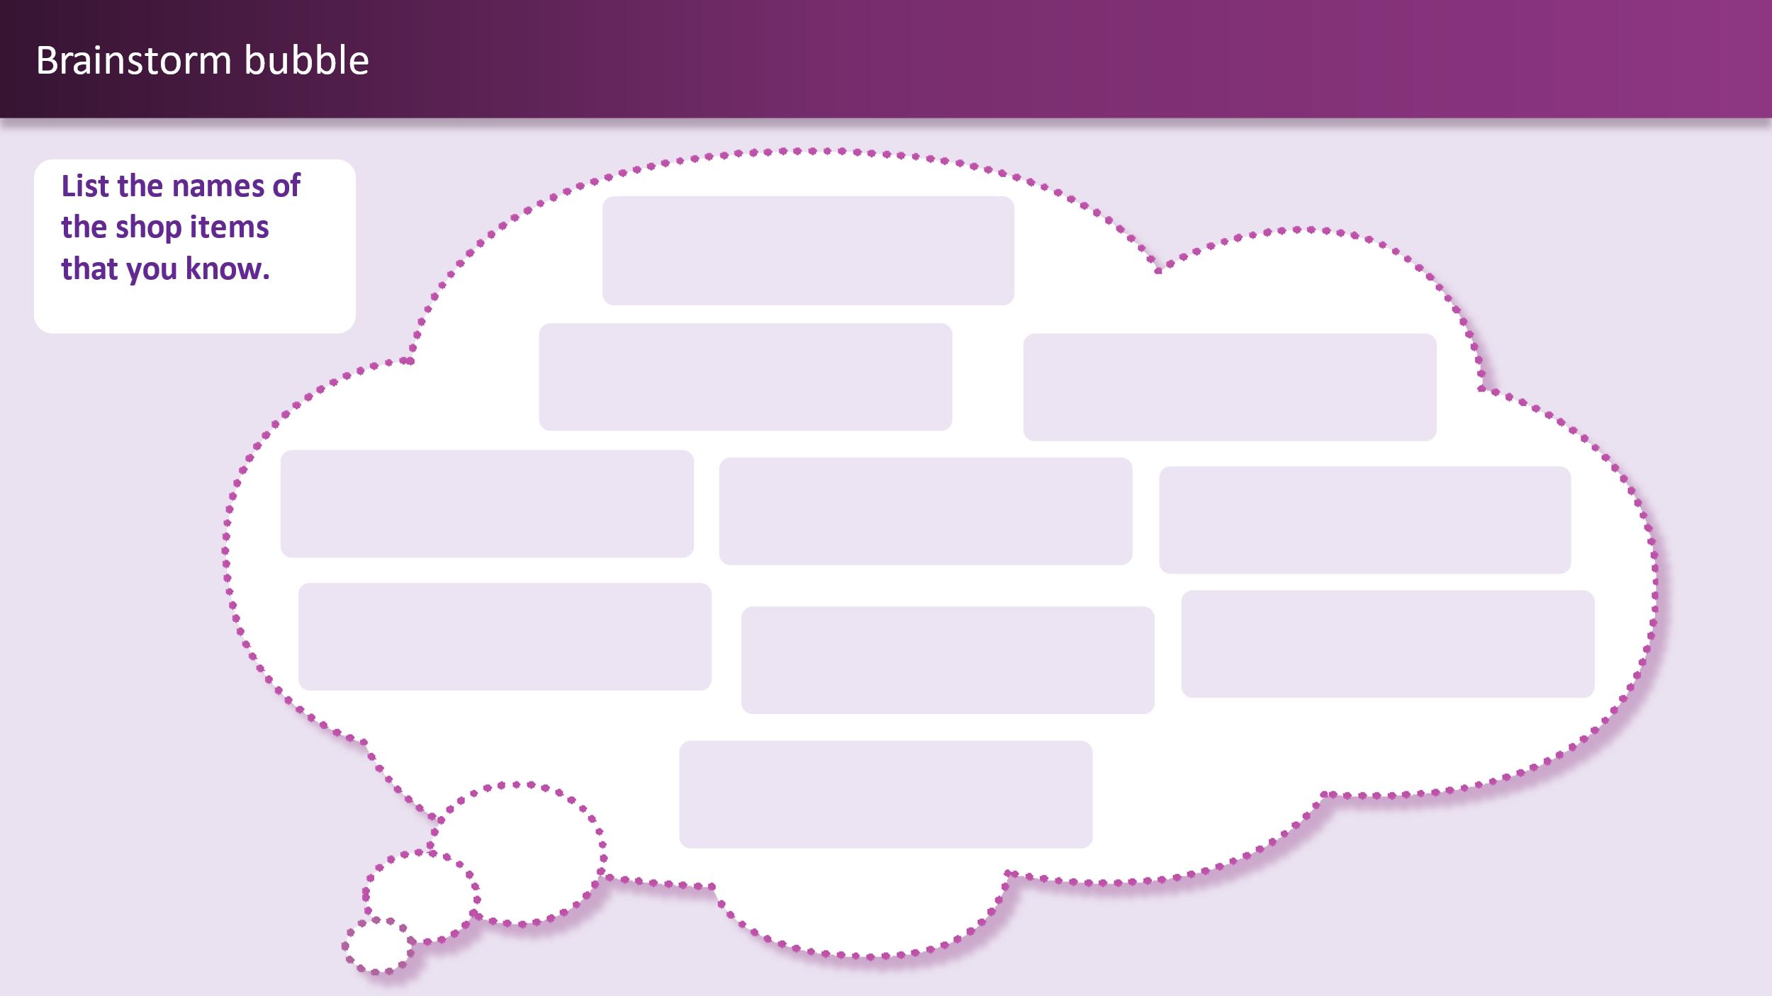

## Resource 4 – shop items (plural) flashcards

|  |  |  |  |  |  |  |
| --- | --- | --- | --- | --- | --- | --- |
|  |  | 2 soccer balls. |  |  |  |  |
| مكعبات البناء |  | كرات القدم |  | مناقيش |  | فيتامينات |
|  |  |  |  |  |  |  |
|  |  |  |  |  |  |  |
| كراسي |  | مستلزمات الحمام |  | أحذية |  |  |

|  |  |  |  |  |  |  |
| --- | --- | --- | --- | --- | --- | --- |
|  |  | 2 soccer balls. |  |  |  |  |
| **building blocks** |  | **soccer balls** |  | **manakeesh** |  | **vitamins** |
|  |  |  |  |  |  |  |
|  |  |  |  |  |  |  |
| **chairs** |  | **toiletries** |  | **shoes** |  |  |

This resource can be adapted by replacing the text to suit your language.

## Resource 5 – adjective flashcards

|  |  |  |  |  |  |  |
| --- | --- | --- | --- | --- | --- | --- |
|  |  |  |  |  |  |  |
| **مفيد** |  | **رخيص** |  | **قوي** |  | **لذيذ** |
|  |  |  |  |  |  |  |
|  |  |  |  |  |  |  |
| **طازج** |  | **أنيق** |  | **مريح** |  | **جديد** |

|  |  |  |  |  |  |  |
| --- | --- | --- | --- | --- | --- | --- |
|  |  |  |  |  |  |  |
| **ثقيل** |  | **خفيف** |  | **لامع** |  |  |

This resource can be adapted by replacing the text to suit your language.

|  |  |  |  |  |  |  |
| --- | --- | --- | --- | --- | --- | --- |
|  |  |  |  |  |  |  |
| **helpful** |  | **cheap** |  | **strong** |  | **tasty** |
|  |  |  |  |  |  |  |
|  |  |  |  |  |  |  |
| **fresh** |  | **stylish** |  | **comfortable** |  | **new** |

|  |  |  |  |  |  |  |
| --- | --- | --- | --- | --- | --- | --- |
|  |  |  |  |  |  |  |
| heavy |  | **light** |  | **shiny** |  |  |

This resource can be adapted by replacing the text to suit your language.

|  |  |  |  |  |  |  |
| --- | --- | --- | --- | --- | --- | --- |
|  |  |  |  |  |  |  |
|  |  |  |  |  |  |  |
|  |  |  |  |  |  |  |
|  |  |  |  |  |  |  |
|  |  |  |  |  |  |  |

|  |  |  |  |  |  |  |
| --- | --- | --- | --- | --- | --- | --- |
|  |  |  |  |  |  |  |
|  |  |  |  |  |  |  |

## Resource 6 – colour wheel

This resource can be adapted by replacing the text to suit your language. Use the [resource link](https://www.canva.com/design/DAF9S5rnaJM/_rug9eyGbDs16gewpumBjA/view?utm_content=DAF9S5rnaJM&utm_campaign=designshare&utm_medium=link&utm_source=publishsharelink&mode=preview) to tailor it to your preferred language.

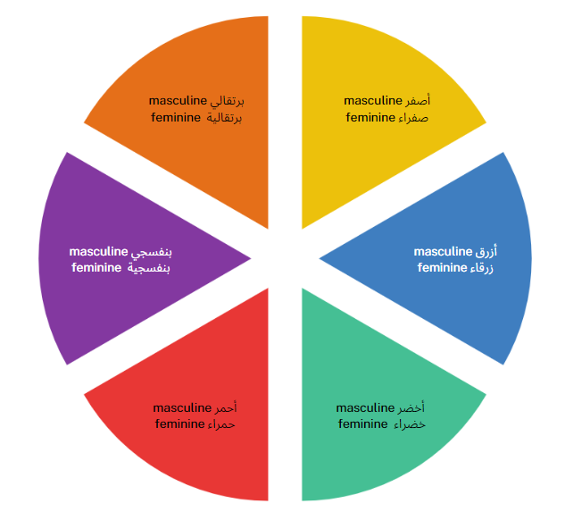

## Resource 7 – singular and plural sentence builder

**Singular**

|  |  |  |  |
| --- | --- | --- | --- |
| (adjective) | because it is | (item name) | You should buy this |
| (new) جديد – masculine  (tasty) لذيذ – masculine  (comfortable) مريحة – feminine  (helpful) مفيدة – feminine  (cheap) رخيصة – feminine | (masculine) لأنه  (feminine) لأنها | (television) التلفزيون – masculine  (bread) الخبز – masculine  (medicine) الدواء – masculine  (couch) الكنبة – feminine  (Knafeh) الكنافة – feminine | (masculine) يجب أن تشتري هذا  (feminine) يجب أن تشتري هذه |

**Plural**

|  |  |  |  |
| --- | --- | --- | --- |
| (adjective) | because they are | (item’s name) | You should buy these (plural) |
| (fresh) طازجة – feminine  (strong) قوية – feminine  (stylish) أنيقة – feminine  (new) جديدة – feminine  (light) خفيفة – feminine  (heavy) ثقيلة – feminine | li'annaha/ لأنها | (manakeesh) المناقيش – feminine  (chairs) الكراسي – feminine  (shoes) الأحذية – feminine  (toiletries) مستلزمات الحمام – feminine  )soccer balls) كرات القدم – feminine | Hādhī yajibu 'an tashtarūā/ يجب أن تشتروا هذه |

## Resource 8 – Oregano bakery advertisement

This resource can be used to teach multiple languages. Use the [resource link](https://www.canva.com/design/DAF9SxKlFg0/7Vgu4ZLBIYjWpGe2WOxvjQ/view?utm_content=DAF9SxKlFg0&utm_campaign=designshare&utm_medium=link&utm_source=publishsharelink&mode=preview) to tailor it to your preferred language.

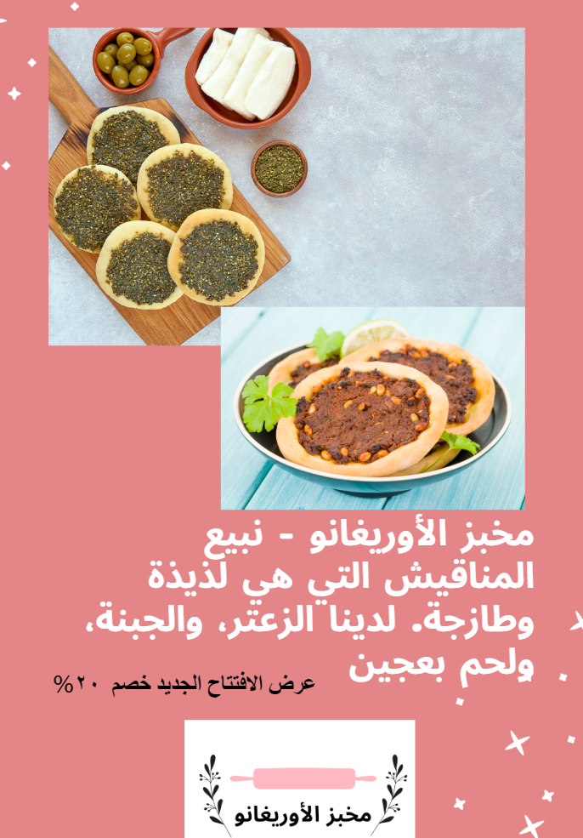

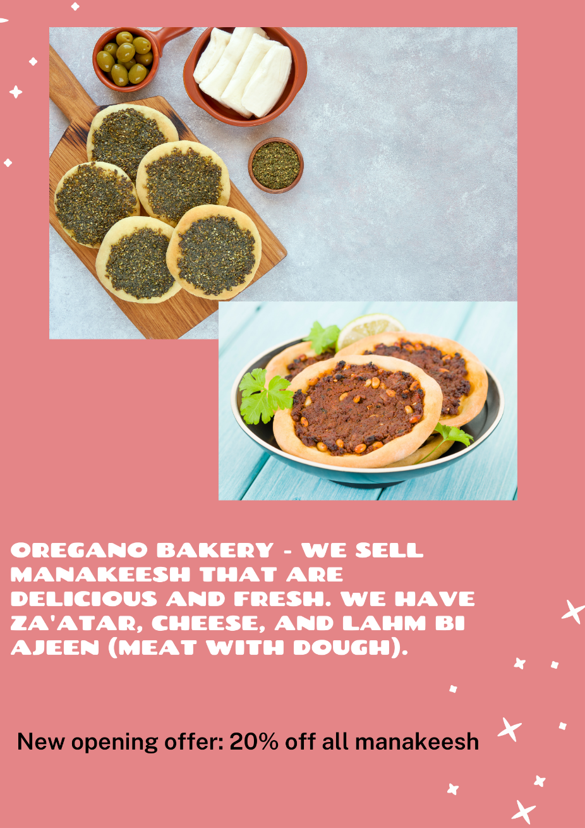

## Resource 9 – gallery walk response form

1. What is the name of the shop?
2. List 3 things the shop sells?
3. Why would you want to buy from this shop?
4. Provide a suggestion for the shop owner to make this shop advertisement better.

## Resource 10 – assessment task – My shop

### Outcomes

You will be assessed on how well you:

* create a range of texts for familiar communicative purposes by using culturally appropriate rehearsed language.

### Task

You have opened a new shop. Create a spoken advertisement to promote your shop. Include a shop name, items that you sell and why people should buy your products.

The table below outlines the communicative task students will need to complete.

|  |  |
| --- | --- |
| Too hard? | Too easy? |
| **My shop!**  Include a shop name and the type of items that you sell. | **My shop!**  Include a shop name, 3 shop items that you sell and your new shop’s opening special offer. |

### Learning intention

Students will advertise their new shop to the class, including their shop’s name, items the shop sells and a reason why customers should buy from this shop in Arabic.

**Advanced learners**

Students will provide a detailed description about their shop, including its name, type of items the shop sells reasons why customers should buy from their shop and their new shop’s opening offer.

### Success criteria

You will pretend to be an owner of a new shop. Your task is to advertise your new shop to customers so that they buy items from your newly opened shop.

You will be successful if you can:

* present your shop including its name, type of items you sell and a reason why customers should buy from your shop.
* use grammatically correct sentences with
* the correct order of words
* correct gender agreement of nouns and adjectives
* pronounce the words correctly
* speak in a well-paced manner without long pauses.

### Task instructions

For this task, students will work in pairs and take turns in these following roles:

* **Shop owner**: advertise your newly opened shop.
* **Peer assessor/Camera operator**: record the advertisement and give feedback.

Following the task, you will watch a recording of yourself completing the task. You can self-assess by marking yourself on the ‘My shop! assessment rubric’. Then compare the self-assessed rubric and the teacher marked rubric.

Reflect on your performance and identify areas for improvement. Use this information to set a learning goal for the next stage of your learning journey.

## Resource 11 – rubric – My shop

**Name:**

Table 1 – marking criteria

|  |  |  |  |  |  |
| --- | --- | --- | --- | --- | --- |
| Criteria | Excellent | Got it | Sort of | Not yet | Limited |
| Communication | Your audience, the customer, clearly understands what you want to communicate.  Successfully and thoroughly complete all of the following aspects of the task:   * describe your shop including * its name * type of items you sell * a reason why customers should buy from your shop. | Your audience, the customer, can understand what you want to communicate.  Successfully complete all of the following aspects of the task:   * describe your shop including * its name * type of items you sell * a reason why customers should buy from your shop. | Your audience, the customer, can mostly understand what you want to communicate.  Successfully complete most of the following aspects of the task:   * describe your shop including * its name * type of items you sell * a reason why customers should buy from your shop. | Your audience, the customer, struggles to understand what you want to communicate. However, communication is successful.  Do not complete all aspects of the task. | Your audience, the customer, is unable to understand what you want to communicate.  Unable to complete any aspect of the task. |
| Grammar | Always say Arabic words in the correct order when speaking:   * gender of nouns and adjectives agree. | Usually say Arabic words in the correct order when speaking:   * gender of nouns and adjectives agree. | Make some grammatical mistakes when speaking in Arabic:   * gender of nouns and adjectives agree. | Rarely make sense when speaking in Arabic. | Unable to be understood. |
| Pronunciation | Pronounce all words correctly. | Pronounce most words correctly. | Pronounce only a few words correctly. | Consistently make pronunciation errors. | Unable to be understood. |
| Fluency | Always speak with appropriate speed and expression confidently | Speak confidently with appropriate speed and expression most of the time. | Speak confidently with appropriate speed and expression some of the time | Don’t speak confidently. | Unable to be understood. |
| Vocabulary | Use the full range of vocabulary correctly and use relevant words to expand on the task. | Use expected vocabulary correctly to complete the task. | Make some mistakes when trying to use expected vocabulary. | Make many mistakes when trying to use expected vocabulary. | Unable to use vocabulary in appropriate context. |

## Resource 12 – peer feedback strategy – TAG feedback slip

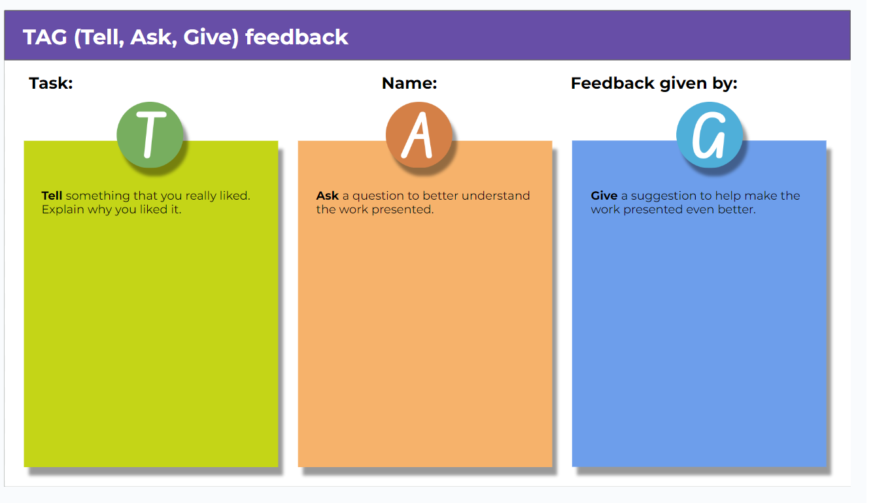

## Resource 13 – learning goal form

|  |  |
| --- | --- |
| Learning goal | Notes |
| My learning goal | I will pronounce [X] sound correctly in Arabic words and sentences. |
| The steps I will take | I will:   * say 5 different Arabic words with [X] sound every day * practise pronouncing words correctly by playing tongue-twister games * record and listen to myself saying the sound in Arabic * practise the sound with my friends and ask for their feedback * listen and act on my teacher’s feedback. |
| Target date | Term 2, Week 8 |
| Target achieved | Term 2, Week …. |

# Support and alignment

**Resource evaluation and support**: all curriculum resources are prepared through a rigorous process. Resources are periodically reviewed as part of our ongoing evaluation plan to ensure currency, relevance, and effectiveness. For additional support or advice, contact the Primary Languages team by emailing [primlang@det.nsw.edu.au](mailto:primlang@det.nsw.edu.au).

**Alignment to system priorities and/or needs**: [School Excellence Policy](https://education.nsw.gov.au/policy-library/policies/pd-2016-0468)

**Alignment to the School Excellence Framework**: this resource supports the [School Excellence Framework](https://education.nsw.gov.au/inside-the-department/directory-a-z/strategic-school-improvement/school-excellence-framework) elements of curriculum (curriculum provision, teaching and learning programs) and effective classroom practice (lesson planning).

**Alignment to Australian Professional Teaching Standards**: this resource supports teachers to address [Australian Professional Teaching Standards](https://educationstandards.nsw.edu.au/wps/portal/nesa/teacher-accreditation/meeting-requirements/the-standards/proficient-teacher) 2.2.2, 3.2.2.

**Consulted with**: Curriculum, Secondary Learners, school-based staff and NESA subject matter experts. Advice from Aboriginal Outcomes and Partnerships, EAL/D, HPGE and Inclusive Education for Modern Languages Stage 3 Italian Mangiare in Ristorante has been considered in preparing this document.

**NSW syllabus**: Modern Languages K–10 Syllabus

**Syllabus outcomes**: ML3-INT-01, ML3-UND-01, ML3-CRT-01

**Author**: Primary Curriculum

**Publisher**: State of NSW, Department of Education

**Resource**: unit

**Related resources**: further resources to support Stage 3 Modern Languages can be found on the [Languages K-6 curriculum page](https://education.nsw.gov.au/teaching-and-learning/curriculum/languages/planning-programming-and-assessing-languages-k-6).

**Professional learning**: relevant professional learning is available through [Primary Languages Statewide Staffroom](https://teams.microsoft.com/l/team/19%3az18AANNDakIiZmi9dSLcfWx2Den_p0EiRqjP1B2_nYc1%40thread.tacv2/conversations?groupId=f062beb5-8af0-4ba5-87b3-bd45fa3f9767&tenantId=05a0e69a-418a-47c1-9c25-9387261bf991) on Teams (staff only).

**Universal Design for Learning**: support the diverse learning needs of students using inclusive teaching and learning strategies. Some students may require more specific adjustments to allow them to participate on the same basis as their peers. For further advice see [Inclusive practice resources for primary school](https://education.nsw.gov.au/campaigns/inclusive-practice-hub/primary-school).

**Differentiation**: when using these resources in the classroom, it is important for teachers to consider the needs of all students in their class, including:

* **Aboriginal and Torres Strait Islander students**. Targeted [strategies](https://education.nsw.gov.au/teaching-and-learning/aec/aboriginal-education-in-nsw-public-schools) can be used to achieve outcomes for Aboriginal students in K-12 and increase knowledge and understanding of Aboriginal histories and cultures. Teachers should use students’ Personalised Learning Pathways to support individual student needs and goals.
* **EAL/D learners**. EAL/D learners may require scaffolding to support them to gain content knowledge, while providing extra time and assistance to master the English language required to engage with texts or complete classroom tasks. View some [samples of differentiating through scaffolding](https://education.nsw.gov.au/teaching-and-learning/curriculum/multicultural-education/english-as-an-additional-language-or-dialect/teaching-and-learning#Differentiation2).
* **Students with additional learning needs**. Learning adjustments enable students with disability and additional learning and support needs to access syllabus outcomes and content on the same basis as their peers. Teachers can use a range of [adjustments](https://education.nsw.gov.au/teaching-and-learning/disability-learning-and-support/personalised-support-for-learning/adjustments-to-teaching-and-learning) to ensure a personalised approach to student learning.
* **High potential and gifted learners**. [Assessing and identifying high potential and gifted learners](https://education.nsw.gov.au/teaching-and-learning/high-potential-and-gifted-education/supporting-educators/assess-and-identify#Assessment1) will help teachers decide which students may benefit from extension and additional challenge. In addition, the [Differentiation Adjustment Tool](https://education.nsw.gov.au/teaching-and-learning/high-potential-and-gifted-education/supporting-educators/implement/differentiation-adjustment-strategies) can be used to support the specific learning needs of high potential and gifted students.

**Creation date**: 25 January 2024

**Rights**: © State of New South Wales, Department of Education

# References

This resource contains NSW Curriculum and syllabus content. The NSW Curriculum is developed by the NSW Education Standards Authority. This content is prepared by NESA for and on behalf of the Crown in right of the State of New South Wales. The material is protected by Crown copyright.

Please refer to the NESA Copyright Disclaimer for more information <https://educationstandards.nsw.edu.au/wps/portal/nesa/mini-footer/copyright>.

NESA holds the only official and up-to-date versions of the NSW Curriculum and syllabus documents. Please visit the NSW Education Standards Authority (NESA) website <https://educationstandards.nsw.edu.au/wps/portal/nesa/home> and the NSW Curriculum website <https://curriculum.nsw.edu.au>.

[Modern Languages K–10 Syllabus](https://curriculum.nsw.edu.au/learning-areas/languages/modern-languages-k-10-2022/overview) © NSW Education Standards Authority (NESA) for and on behalf of the Crown in right of the State of New South Wales, 2022.

8 Ways (n.d.) [*8 Aboriginal Ways of Learning*](https://www.8ways.online/) [website], accessed 13 December 2022.

AITSL (Australian Institute for Teaching and School Leadership (2017) [‘Feedback Factsheet’](https://www.aitsl.edu.au/teach/improve-practice/feedback#:~:text=FEEDBACK-,Factsheet,-A%20quick%20guide), AITSL, accessed 21 March 2023.

Brookhart SM (2011) How to Assess Higher-Order Thinking Skills in Your Classroom, Hawker Brownlow Education, Victoria.

CESE (Centre for Education Statistics and Evaluation) (2020a) [*What works best: 2020 update*](https://education.nsw.gov.au/about-us/education-data-and-research/cese/publications/research-reports/what-works-best-2020-update), NSW Department of Education, accessed 21 March 2023.

CESE (Centre for Education Statistics and Evaluation) (2020b) [*What works best in practice*](https://education.nsw.gov.au/about-us/education-data-and-research/cese/publications/practical-guides-for-educators-/what-works-best-in-practice), NSW Department of Education, accessed 21 March 2023.

Conti G (28 September 2015) [‘16 tips for effective grammar teaching in the foreign language classroom’](https://gianfrancoconti.com/2015/09/28/new-post-16-tips-for-effective-grammar-teaching-in-the-foreign-language-classroom/), The Language Gym, accessed 21 March 2023.

Conti G (28 May 2017) [From Target Language to Model Language – the mind shift that has transformed my teaching](https://gianfrancoconti.com/2017/05/28/from-target-language-to-model-language-the-mind-shift-that-has-enhanced-my-teaching/), The Language Gym, accessed 10 March 2023.

Henshaw FG and Hawkins MD (2022) Common Ground: Second Language Acquisition Theory Goes to the Classroom, Focus, Indianapolis, accessed 10 March 2023.

Jones J and Wiliam D (2014) Modern Foreign Languages Inside the Black Box: Assessment for Learning in the Modern Foreign Languages Classroom (Black P, Harrison C, Marshall B and Wiliam D, eds), Learning Sciences International, United States.

NESA (NSW Education Standards Authority) (2020) [*NSW Curriculum Review – final report*](https://www.nsw.gov.au/education-and-training/nesa/about/strategies-and-reforms/curriculum-reform/final-report), NESA, NSW Government, accessed 10 March 2023.

Rosenshine B (2012) [‘Principles of Instruction: Research-Based Strategies That All Teachers Should Know’](https://www.aft.org/periodical/american-educator/spring-2012/principles-instruction), American Educator, 36(1):12–19, 39, accessed 10 March 2023.

Smith S (2022) Becoming an Outstanding Languages Teacher, 2nd edn, Routledge, United Kingdom.

Wisniewski B, Zierer K and Hattie J (2020) [‘The Power of Feedback Revisited: A Meta-Analysis of Educational Feedback Research’](https://doi.org/10.3389/fpsyg.2019.03087), Frontiers In Psychology, 10(3087), doi:10.3389/fpsyg.2019.03087, accessed 10 March 2023.

Wiliam D (2013) [‘Assessment: The Bridge between Teaching and Learning’](https://www.researchgate.net/publication/258423377_Assessment_The_bridge_between_teaching_and_learning), Voices from the Middle, 21(2):15–20, accessed 10 March 2023.

Wiliam D and Leahy S (2015) Embedding Formative Assessment: Practical Techniques for K–12 Classrooms, Learning Sciences International, United States.

**© State of New South Wales (Department of Education), 2024**

The copyright material published in this resource is subject to the Copyright Act 1968 (Cth) and is owned by the NSW Department of Education or, where indicated, by a party other than the NSW Department of Education (third-party material).

Copyright material available in this resource and owned by the NSW Department of Education is licensed under a [Creative Commons Attribution 4.0 International (CC BY 4.0) license](https://creativecommons.org/licenses/by/4.0/).

**[](https://creativecommons.org/licenses/by/4.0/)**

This license allows you to share and adapt the material for any purpose, even commercially. Attribution should be given to © State of New South Wales (Department of Education), 2024.

Material in this resource not available under a Creative Commons license:

* the NSW Department of Education logo, other logos and trademark-protected material
* material owned by a third party that has been reproduced with permission. You will need to obtain permission from the third party to reuse its material.

**Links to third-party material and websites**

Please note that the provided (reading/viewing material/list/links/texts) are a suggestion only and implies no endorsement, by the New South Wales Department of Education, of any author, publisher, or book title. School principals and teachers are best placed to assess the suitability of resources that would complement the curriculum and reflect the needs and interests of their students.

If you use the links provided in this document to access a third-party's website, you acknowledge that the terms of use, including licence terms set out on the third-party's website apply to the use which may be made of the materials on that third-party website or where permitted by the Copyright Act 1968 (Cth). The department accepts no responsibility for content on third-party websites.