Number cards 1 to 30
This resource is for the teacher. It provides the content and instructions you need to share with students.
Use the number cards provided or use the editable version on Canva.
Print and cut out the cards. The cards may be used throughout the unit in the following ways:
- Select students for activities at random and maintain student engagement. Give students a number card each. Call out a number in Indonesian at different points throughout activities. The student with the corresponding number card will be required to respond according to the activity.
- Form groups. Give students a number card each. Direct students to form groups based on the number cards, for example, 2 groups with odd numbers and even numbers, or multiple groups using number sequences, such as numbers 1 to 5, 5 to 10, 10 to 15, 15 to 20, 25 to 30.
- Revise the pronunciation of smaller numbers orally, using the cards as flashcards.
- Display in the classroom.
Laminate the number cards for ongoing use throughout the year.

Number cards 1 to 30
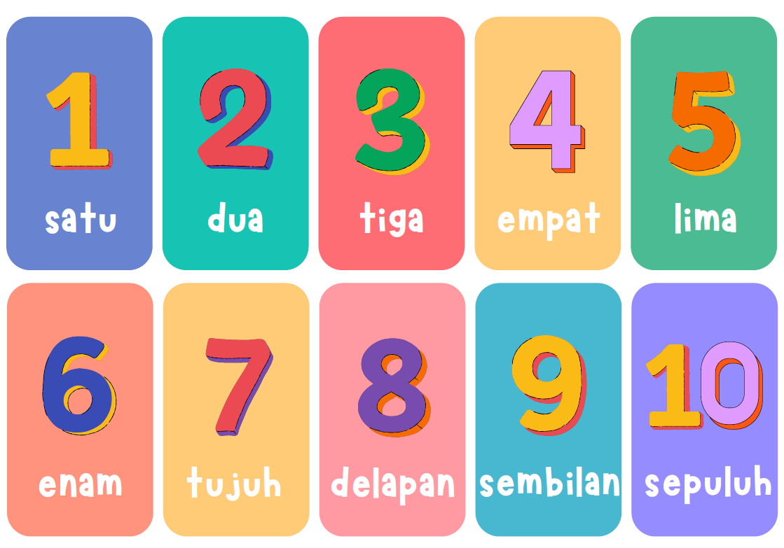
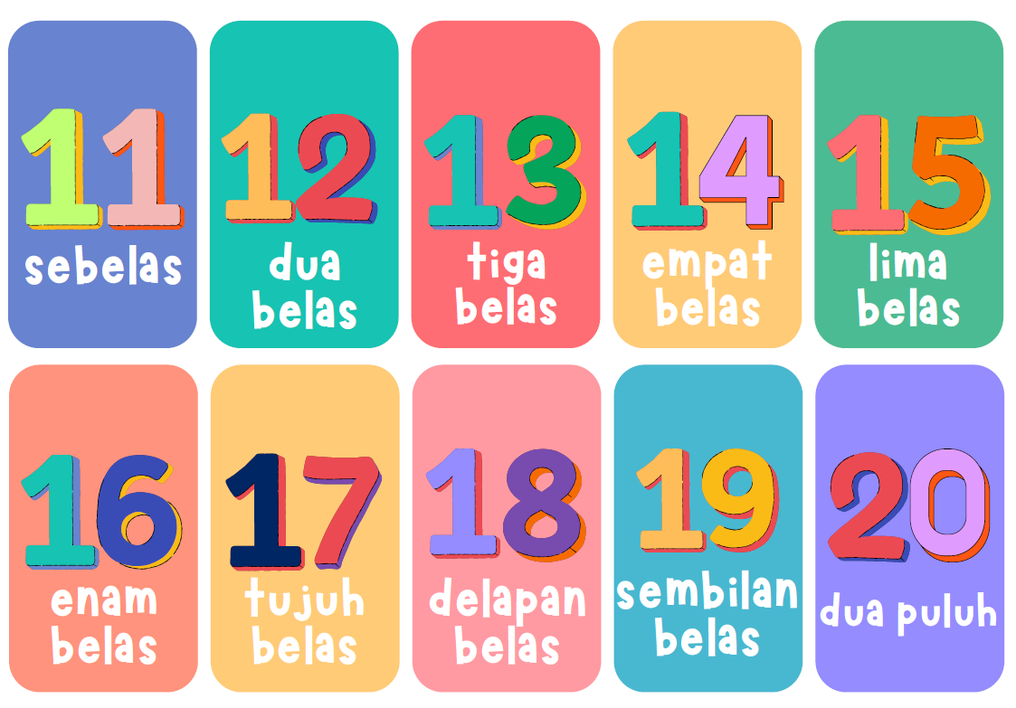
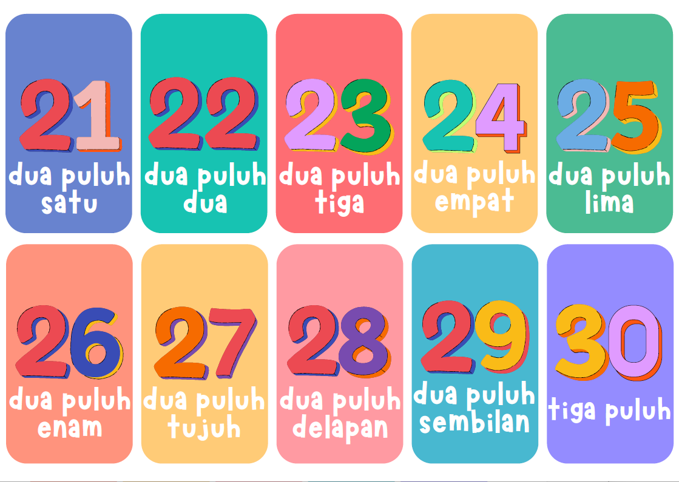

© State of New South Wales (Department of Education), 2024
The copyright material published in this resource is subject to the Copyright Act 1968 (Cth) and is owned by the NSW Department of Education or, where indicated, by a party other than the NSW Department of Education (third-party material).
Copyright material available in this resource and owned by the NSW Department of Education is licensed under a Creative Commons Attribution 4.0 International (CC BY 4.0) license.
This license allows you to share and adapt the material for any purpose, even commercially.
Attribution should be given to © State of New South Wales (Department of Education), 2024.
Material in this resource not available under a Creative Commons license:
- the NSW Department of Education logo, other logos and trademark-protected material
- material owned by a third party that has been reproduced with permission. You will need to obtain permission from the third party to reuse its material.
Links to third-party material and websites
Please note that the provided (reading/viewing material/list/links/texts) are a suggestion only and implies no endorsement, by the New South Wales Department of Education, of any author, publisher, or book title. School principals and teachers are best placed to assess the suitability of resources that would complement the curriculum and reflect the needs and interests of their students.
If you use the links provided in this document to access a third-party's website, you acknowledge that the terms of use, including licence terms set out on the third-party's website apply to the use which may be made of the materials on that third-party website or where permitted by the Copyright Act 1968 (Cth). The department accepts no responsibility for content on third-party websites.

