Auction game
This resource is for the teacher. It provides the content and instructions you need to share with students.
Use the ‘Auction item cards’ and ‘Indonesian currency sheet’ at the end of this resource, or use the editable versions on Canva (Auction item cards and Indonesian currency sheet).
Print the ‘Auction item cards’ to display to students as the ‘prizes’ they are bidding for during the auction.
Print and cut out the ‘Indonesian currency sheet’, ensuring there is enough for each student to receive 2 of each note denomination. This will mean each student has up to Rp 376.000 to spend during the game. It may be helpful to print an extra copy of the currency for the teacher to use as change.
Students participate in the auction as individuals. The goal of the game can vary depending on the focus of the activity and the class context. For example, the goal may be for every student to place at least 3 bids throughout the auction.
One-by-one, display each item to the class and open the bidding by saying a starting price. For example, Sepuluh ribu rupiah. Once the bidding is open, students make bids for the item if they want to buy it. To make their bid, students call out a higher price than the current bid, in Indonesian.
Moderate the fast-paced bidding, replicating an auction environment by repeating bids back to students in Indonesian and identifying whose bid is currently the highest. Accept bids only if they are said accurately. When there are no more bids, count to 3 (satu, dua, tiga) and say Jual! (Sold!). The student with the highest bid gets the prize. They must hand in the correct amount of money and say Ini uangnya. Return any change to the student and say Ini uang kembalinya.
To enable participation, consider implementing further rules. For example:
- All students need to bid at least 3 times during the auction.
- All students need to purchase something (ensure there are enough prizes to facilitate this).
- Instead of the whole class bidding at once, choose 3 to 4 students to outbid each other for each item.
- Allow students to ‘pool’ their money together to bid and purchase as a group.
The auction ends when there are no more prizes remaining.
Differentiation examples
Students with advanced proficiency and high potential and gifted students – encourage students to take on the role of auctioneer, allowing them to facilitate the bidding for each item and use additional phrases in the target language such as Tawaran dimulai and Tawaran yang paling tinggi adalah…
Students can use adjectives to describe the item they are bidding for or buying. For example, yang hijau, yang besar, yang modern.
Students requiring additional support – provide students with a list of large numbers in Indonesian to refer to during the activity. Students could be given the opportunity to bid first or last, with additional time provided to say their bid aloud.

Auction item cards
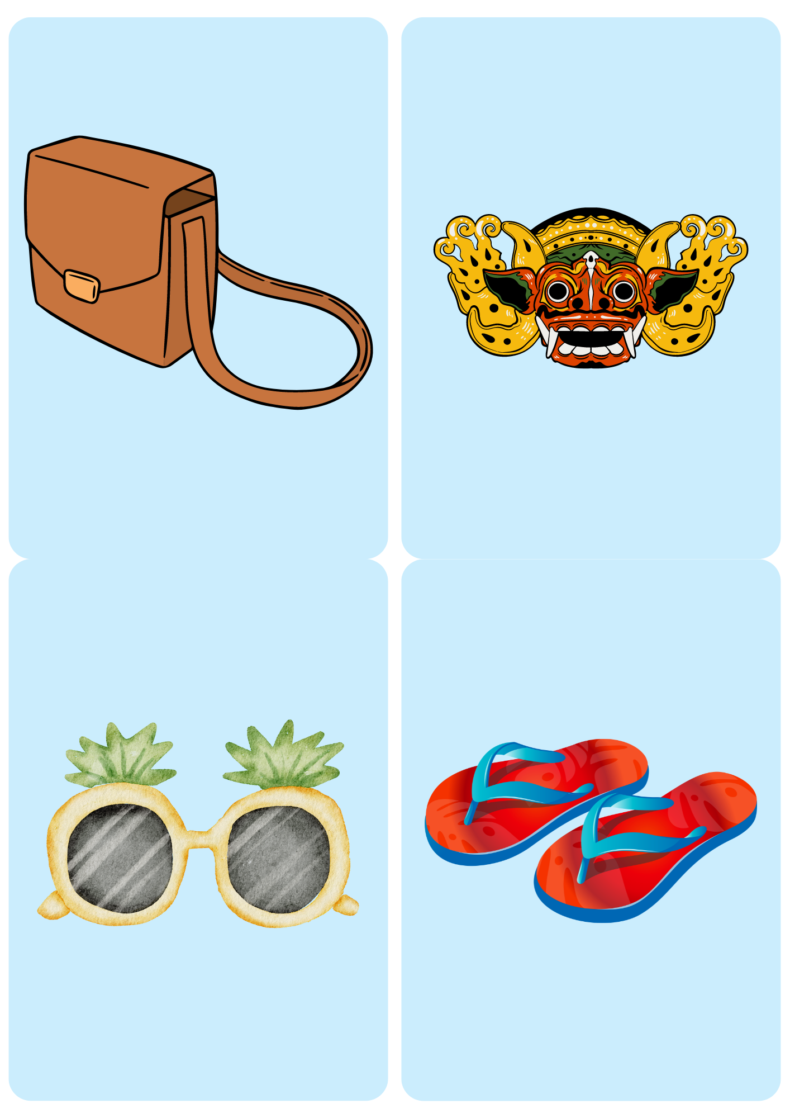
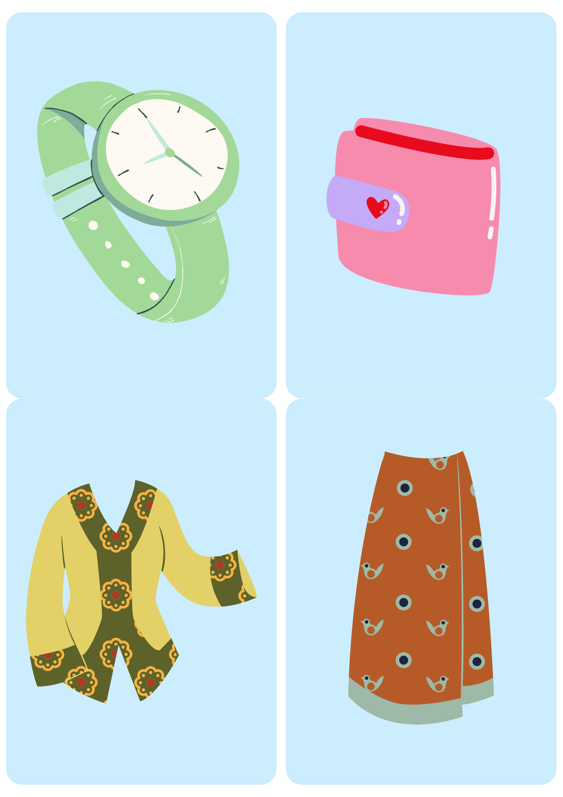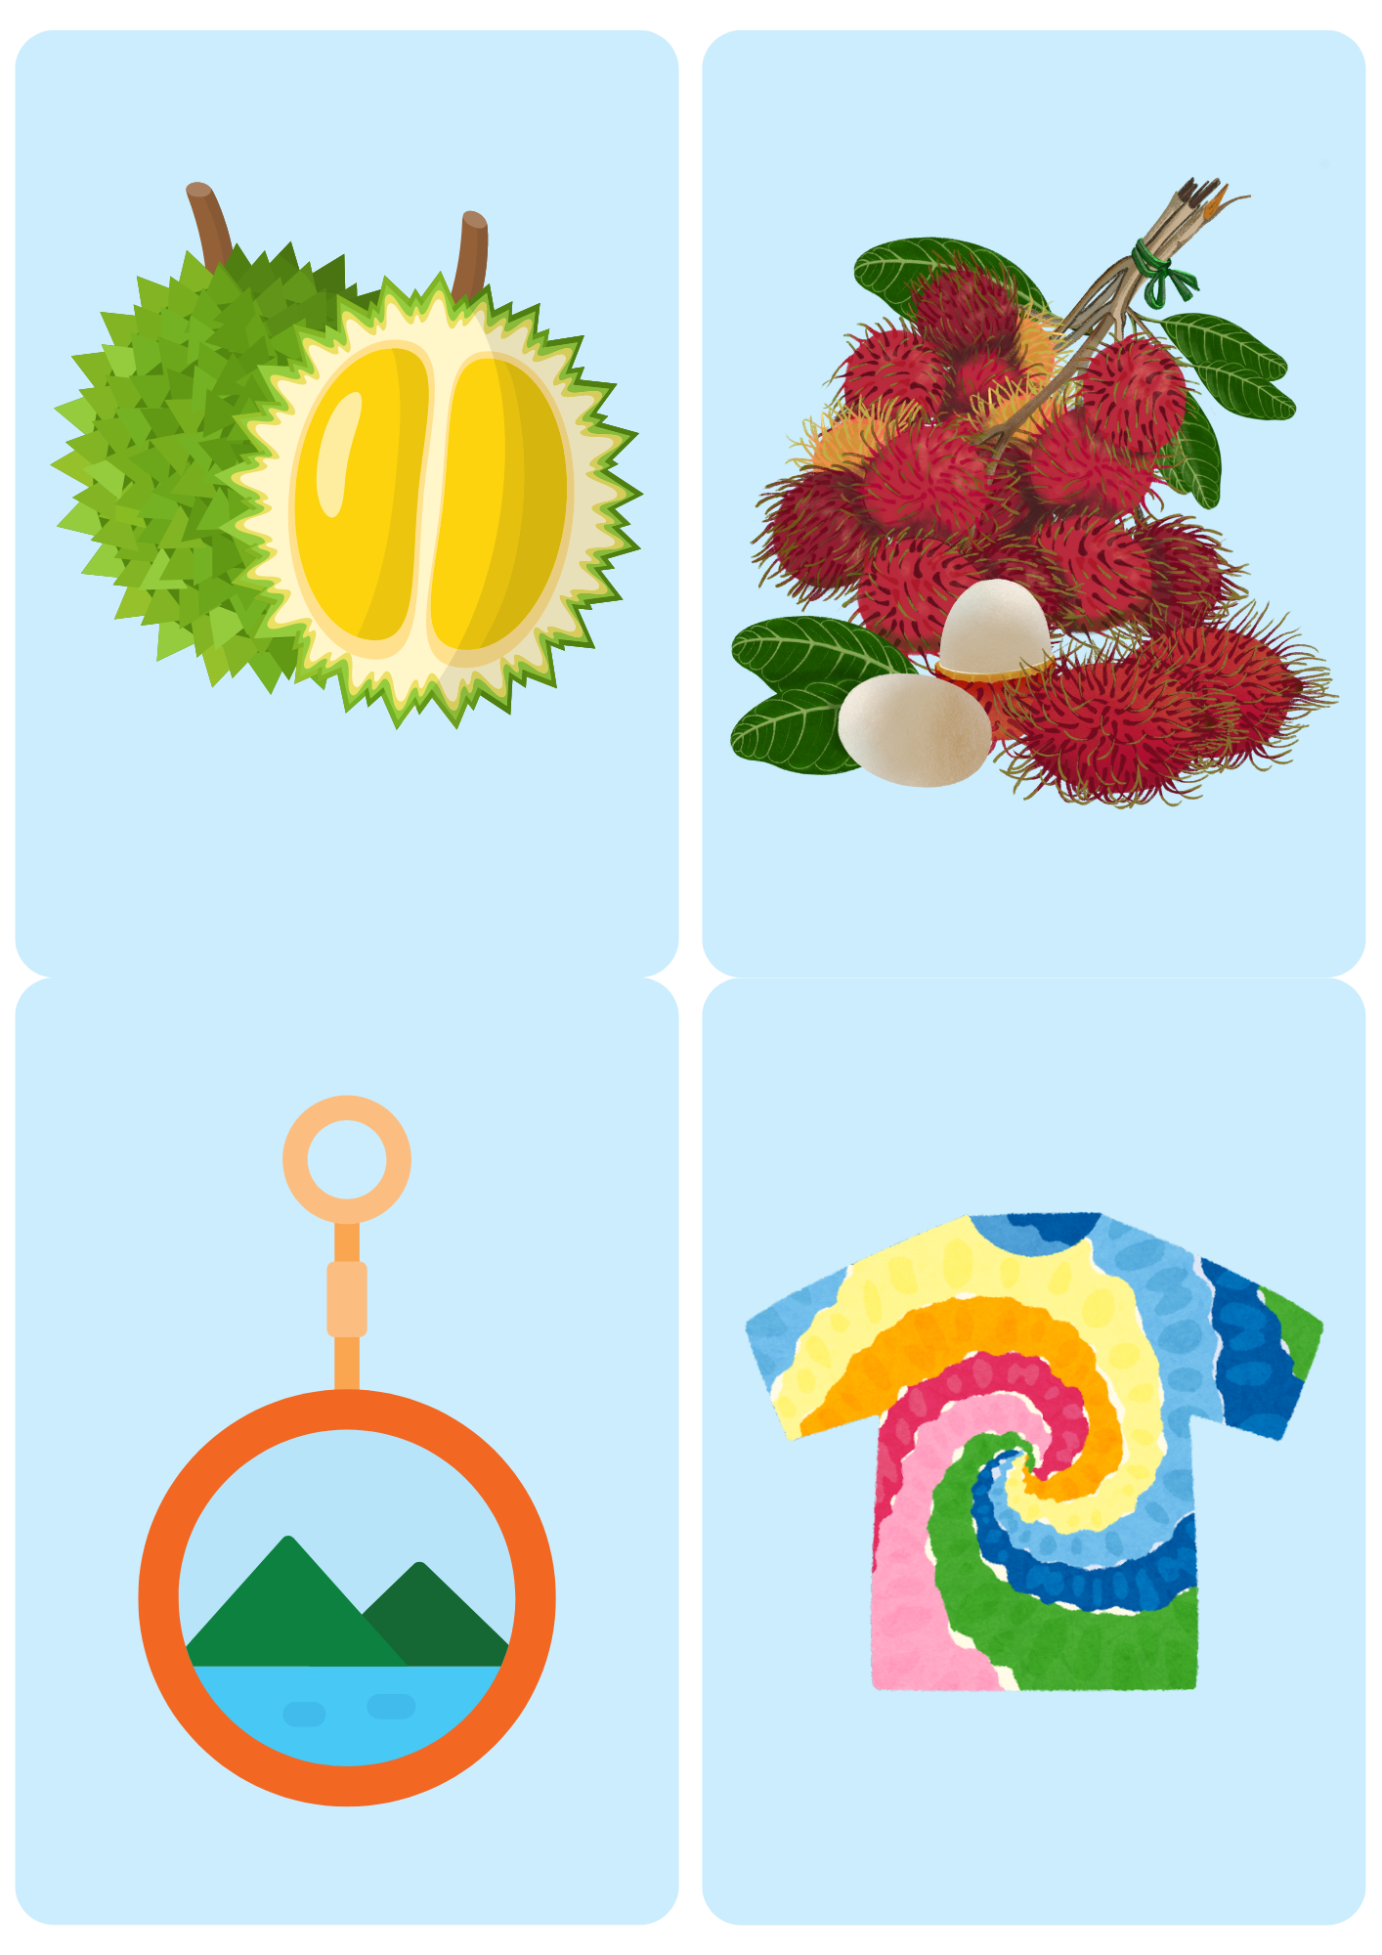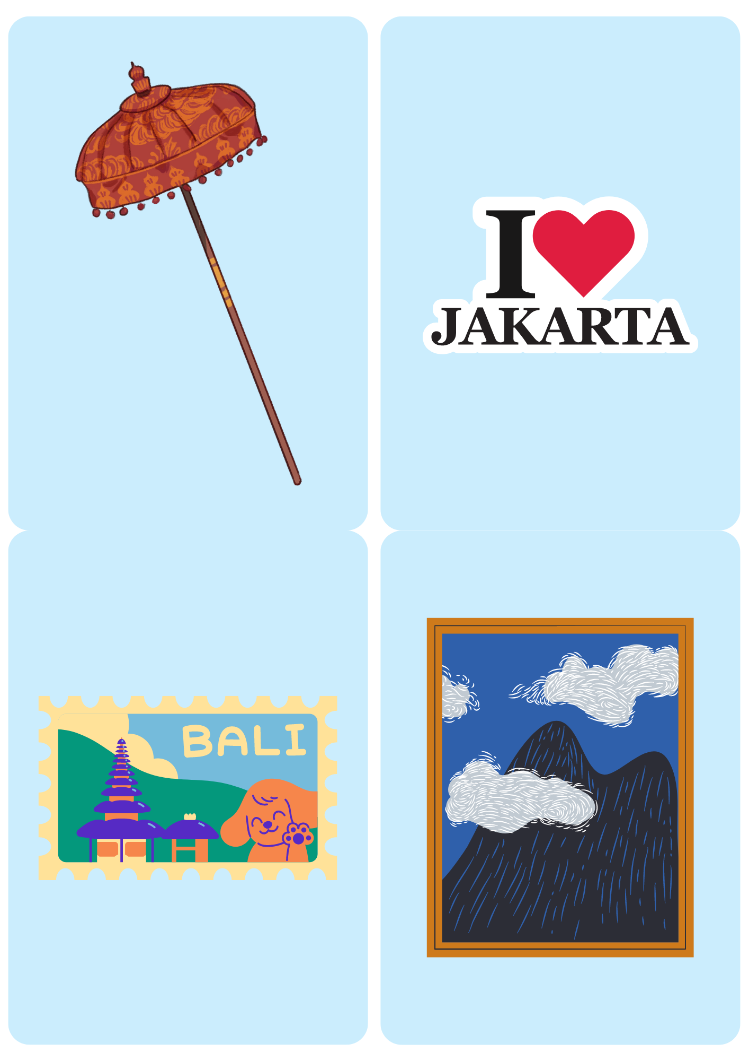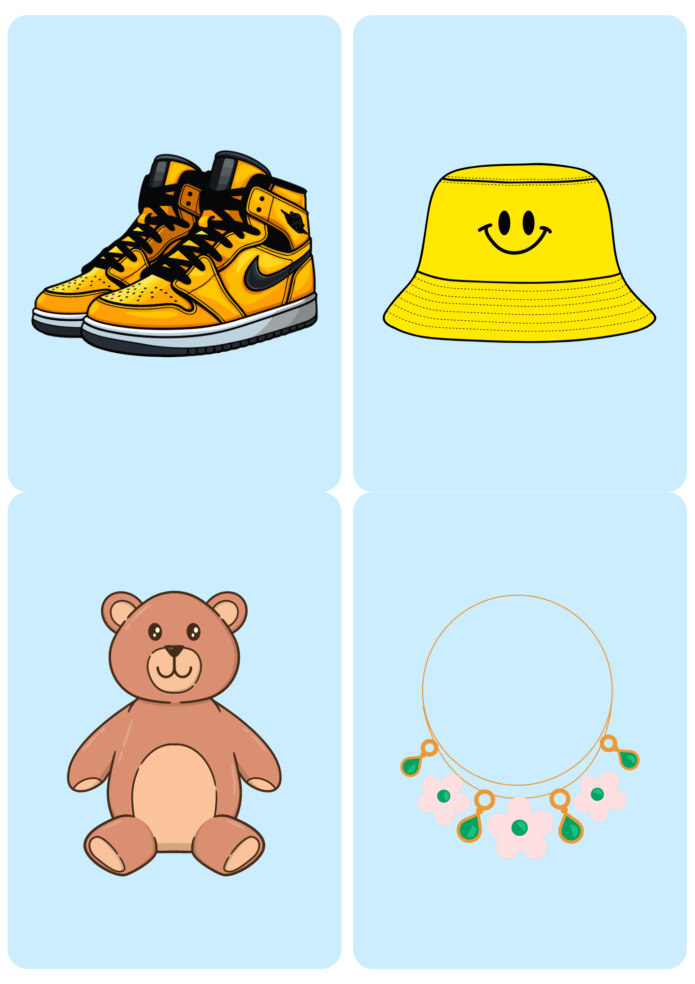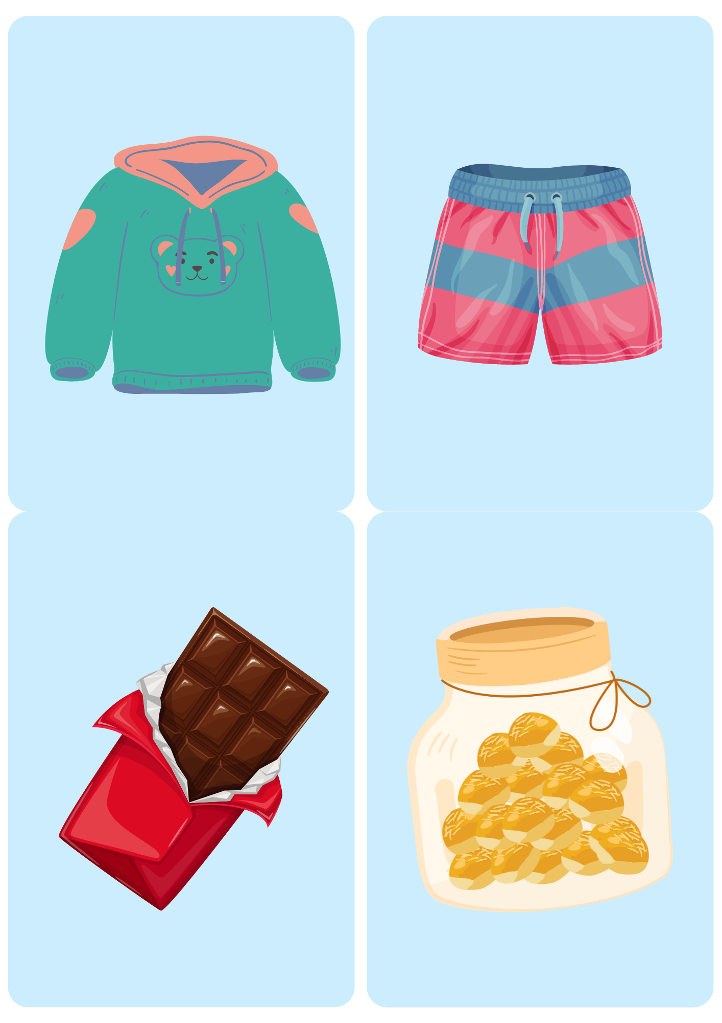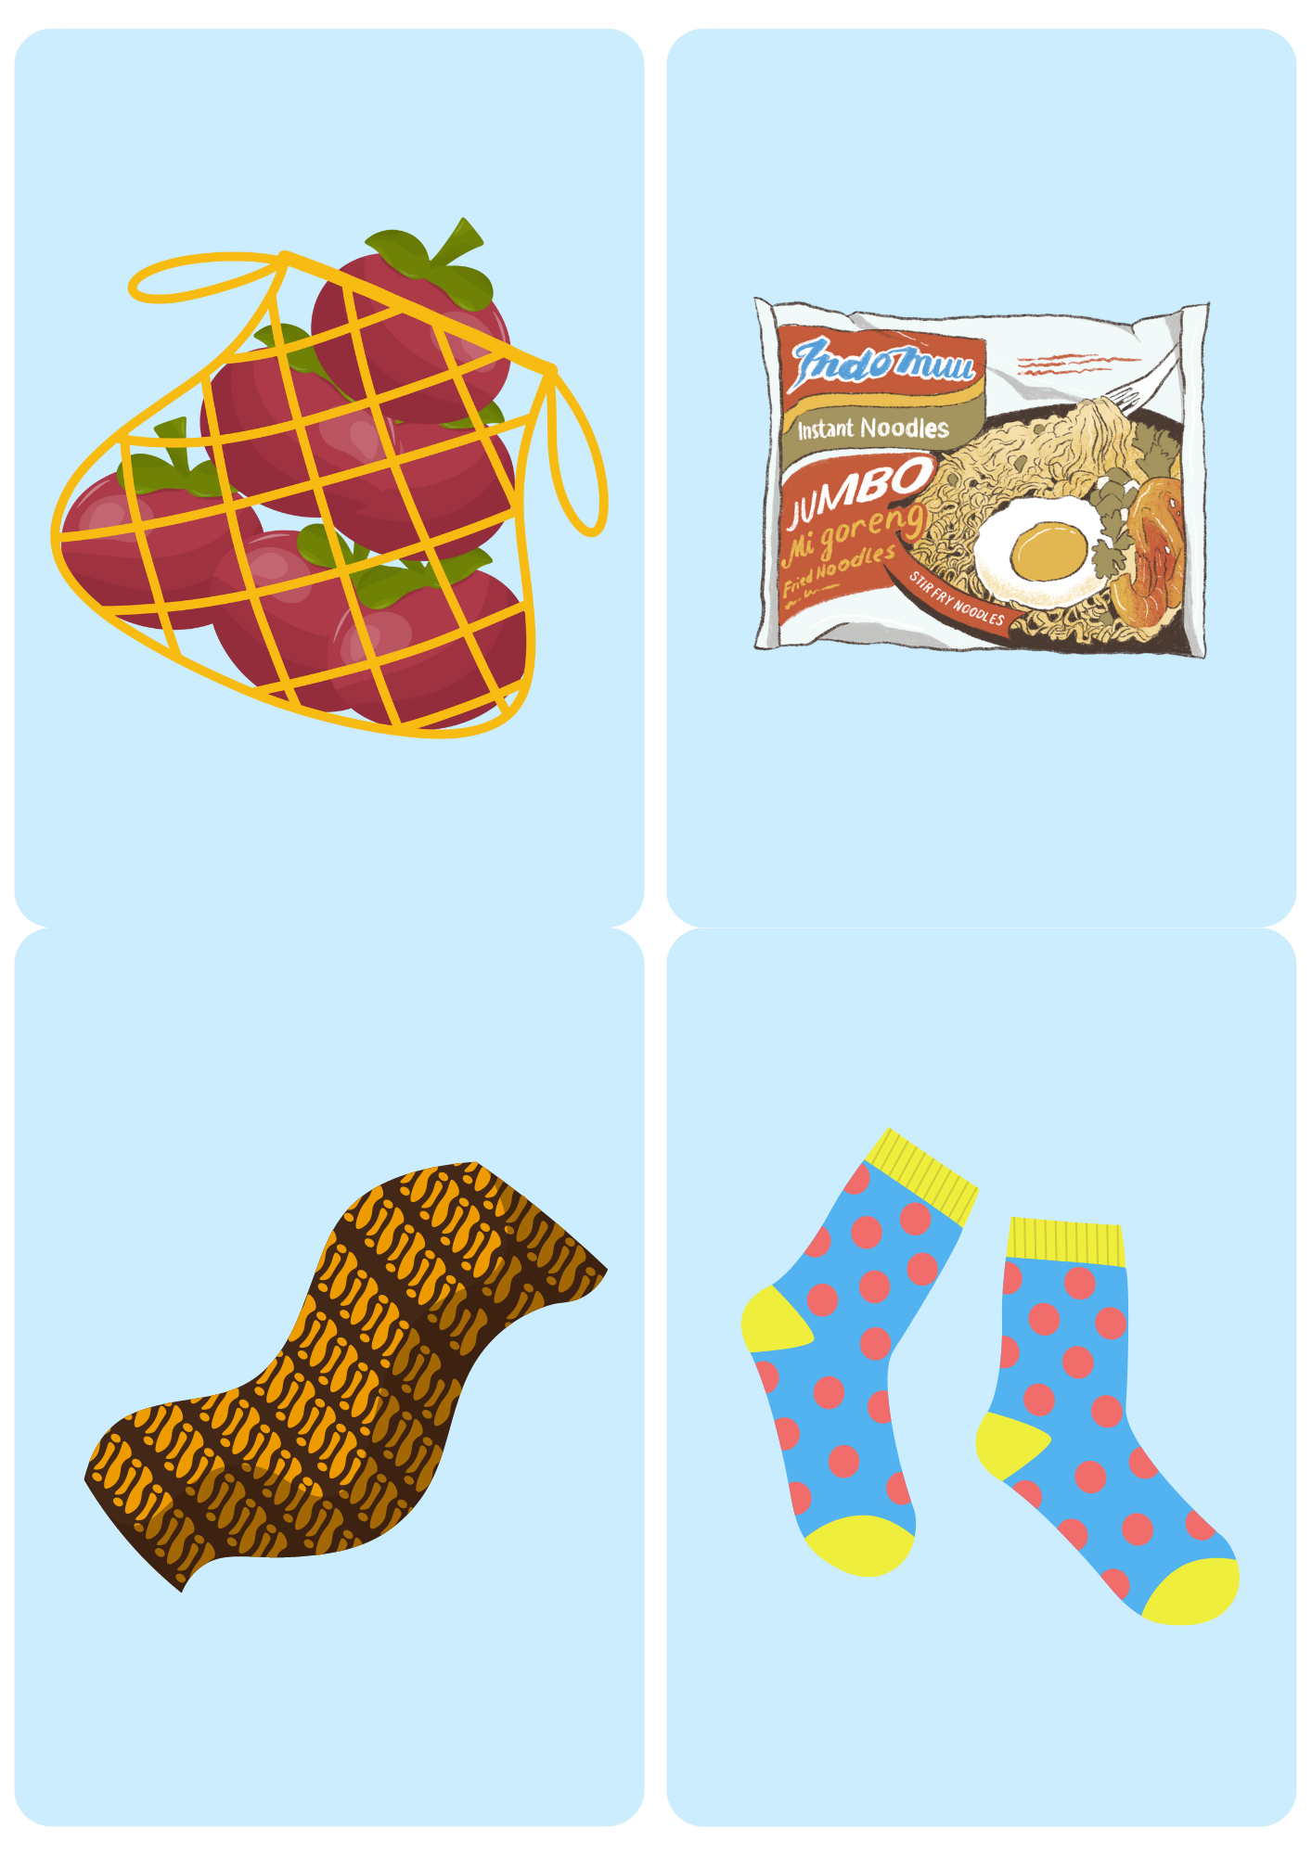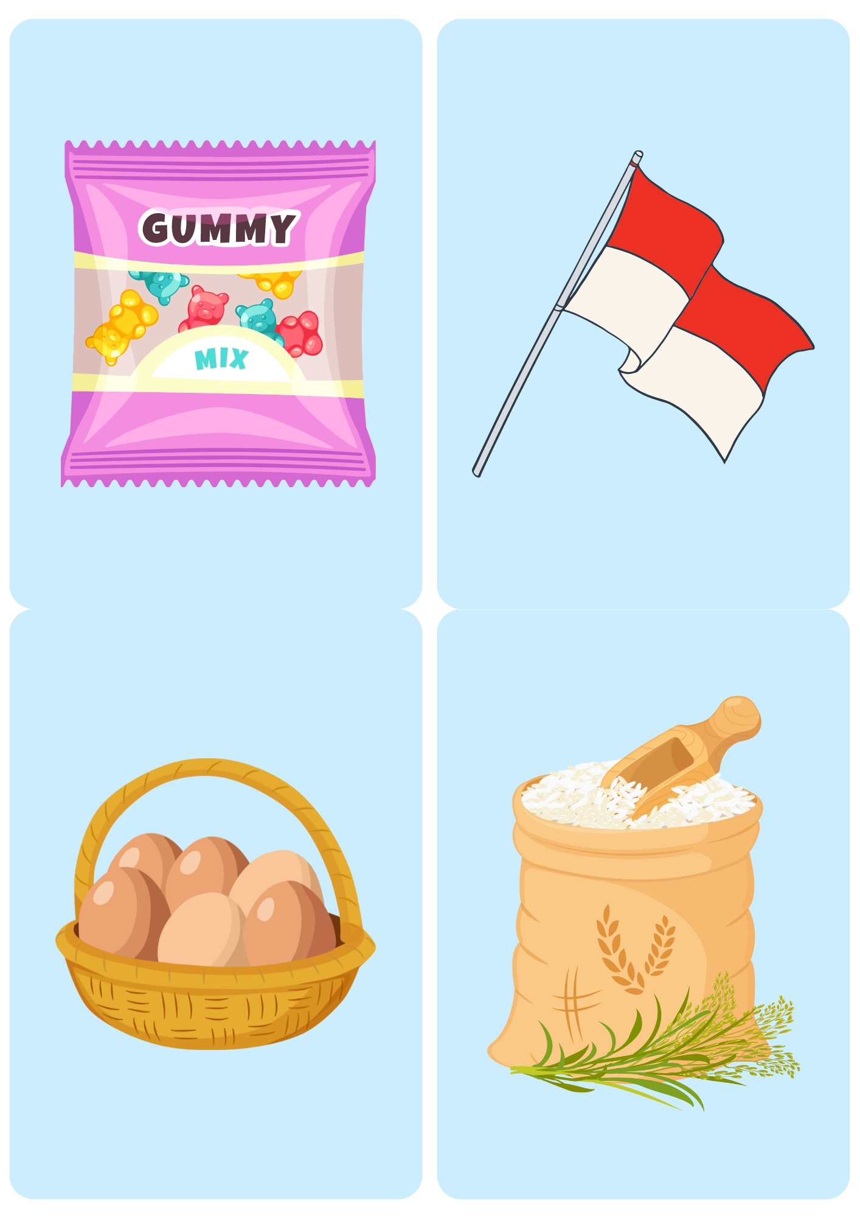

Indonesian currency sheet
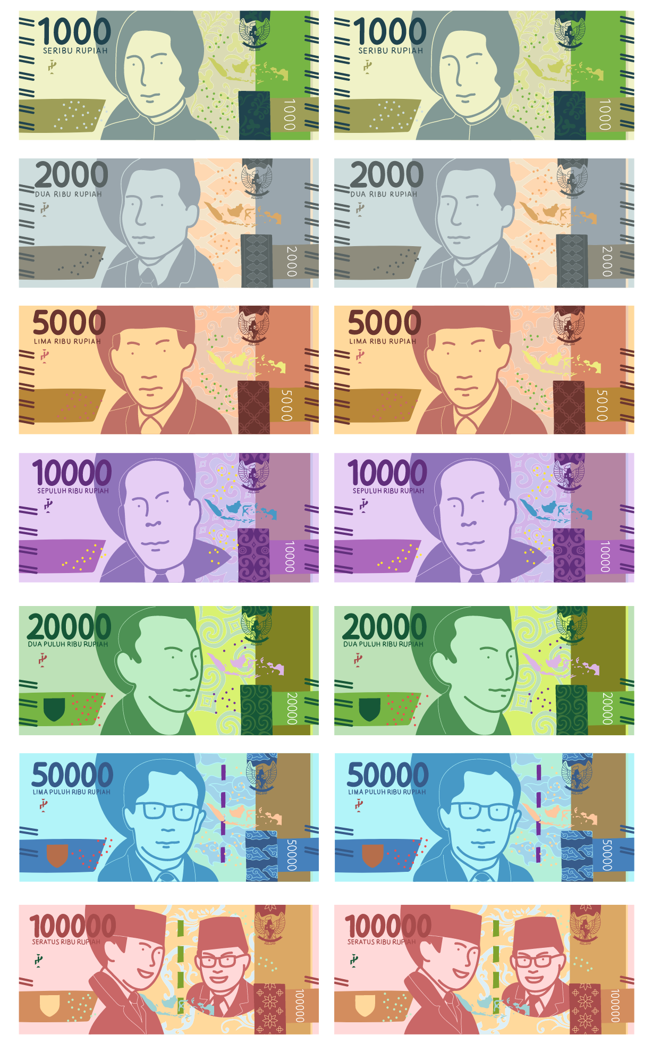

© State of New South Wales (Department of Education), 2024
The copyright material published in this resource is subject to the Copyright Act 1968 (Cth) and is owned by the NSW Department of Education or, where indicated, by a party other than the NSW Department of Education (third-party material).
Copyright material available in this resource and owned by the NSW Department of Education is licensed under a Creative Commons Attribution 4.0 International (CC BY 4.0) license.
This license allows you to share and adapt the material for any purpose, even commercially.
Attribution should be given to © State of New South Wales (Department of Education), 2024.
Material in this resource not available under a Creative Commons license:
- the NSW Department of Education logo, other logos and trademark-protected material
- material owned by a third party that has been reproduced with permission. You will need to obtain permission from the third party to reuse its material.
Links to third-party material and websites
Please note that the provided (reading/viewing material/list/links/texts) are a suggestion only and implies no endorsement, by the New South Wales Department of Education, of any author, publisher, or book title. School principals and teachers are best placed to assess the suitability of resources that would complement the curriculum and reflect the needs and interests of their students.
If you use the links provided in this document to access a third-party's website, you acknowledge that the terms of use, including licence terms set out on the third-party's website apply to the use which may be made of the materials on that third-party website or where permitted by the Copyright Act 1968 (Cth). The department accepts no responsibility for content on third-party websites.

