Bargaining story cubes
This resource is for the teacher. It provides the content and instructions you need to share with students.
Use the story cubes provided, or create your own using the template in this document or with the editable version on Canva.
Organise students into pairs, providing each pair with a set of cubes. There are 4 story cubes: souvenirs, prices, bargaining phrases for a seller and bargaining phrases for a buyer. The cubes can be used all at once or added progressively, as students become more confident with the vocabulary on each cube. The end goal is for students to have a short bargaining interaction.
Show students story cube 1 and story cube 2 and work with them to identify the questions they could ask about each cube, for example:
Cube 1: Mau beli apa?
Cube 2: Berapa harganya?
Show students story cube 3 and story cube 4 and work with them to identify the bargaining phrases indicated on each cube.

Sample conversation
To begin with, using the questions above as a scaffold, students interact in a shopping setting by asking questions and answering them using the prompts on the cubes.
Student A is the seller and Student B is the buyer.
Student A asks student B what they want to buy: Mau beli apa?
Student B rolls the ‘souvenirs’ cube to reveal the sunglasses symbol .
They identify the souvenir on the cube in Indonesian and say they want to buy it: Saya mau beli kacamata hitam.
Student B asks Student A: Berapa harganya?
Student A rolls the ‘prices’ cube and reveals the Rp 50,000 note .
They then reply appropriately with the price: Harganya lima puluh ribu rupiah.
Student A rolls the ‘seller’ cube and reveals the phrase .
Student B rolls the ‘buyer’ cube and reveals the phrase 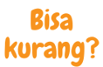.
The students proceed to form a conversation which incorporates both the phrases Saya rugi! and Bisa kurang?
Differentiation examples
The following strategies provide a starting point for how you can differentiate this activity for a range of learners. Adapt or design alternatives, to meet the needs of students in your class.
Students requiring additional support – consider including the Indonesian vocabulary on the cube, as well as providing the following scaffold:
Cube 1: Mau beli apa? Saya mau beli [name of souvenir].
Cube 2: Berapa harganya? Harganya [price].
High potential and gifted students – allow students to roll the cubes multiple times to add complexity to the conversation. For example, they want to buy 2 different souvenirs. Students may want to also design and add their own cubes, for example, with adjectives, colours, shopping places and opinions.

Story cubes
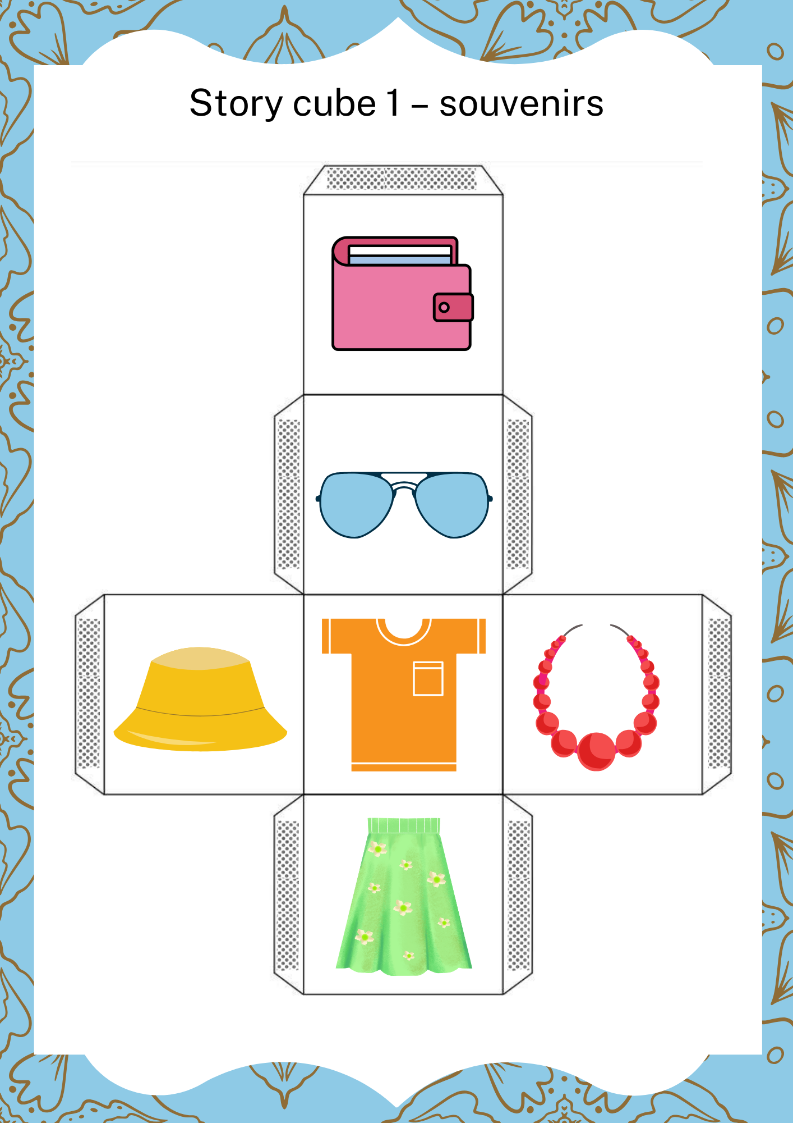
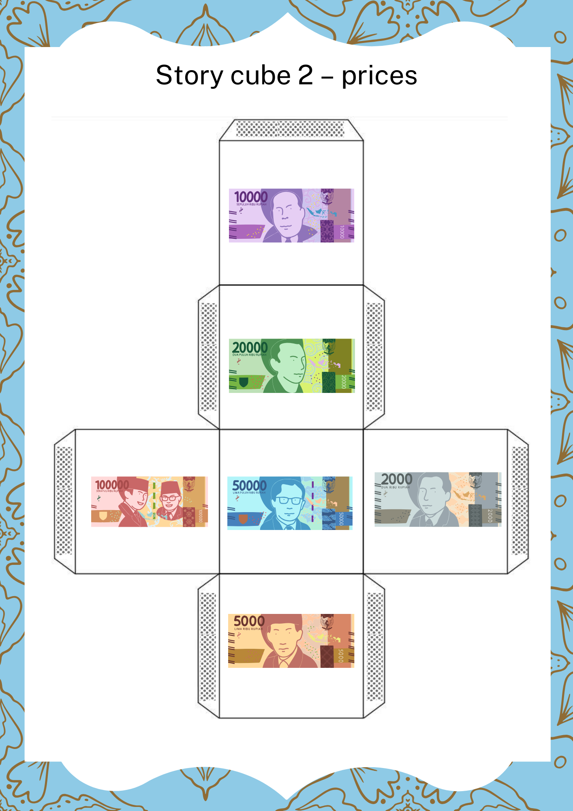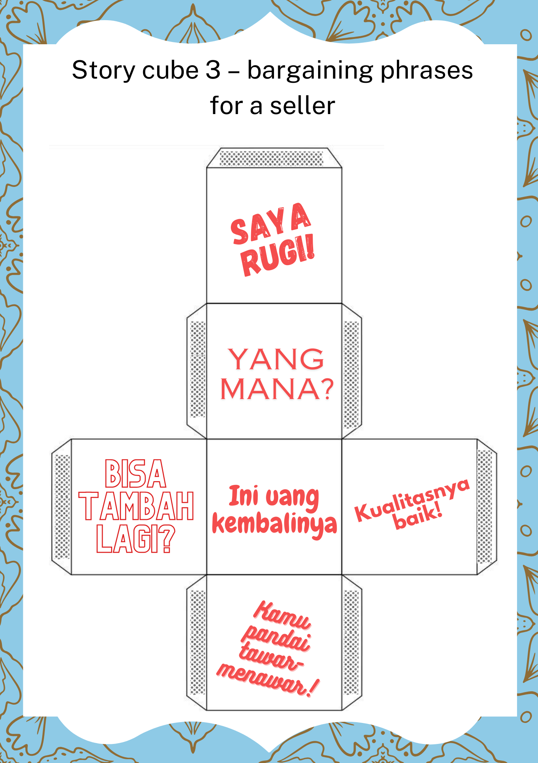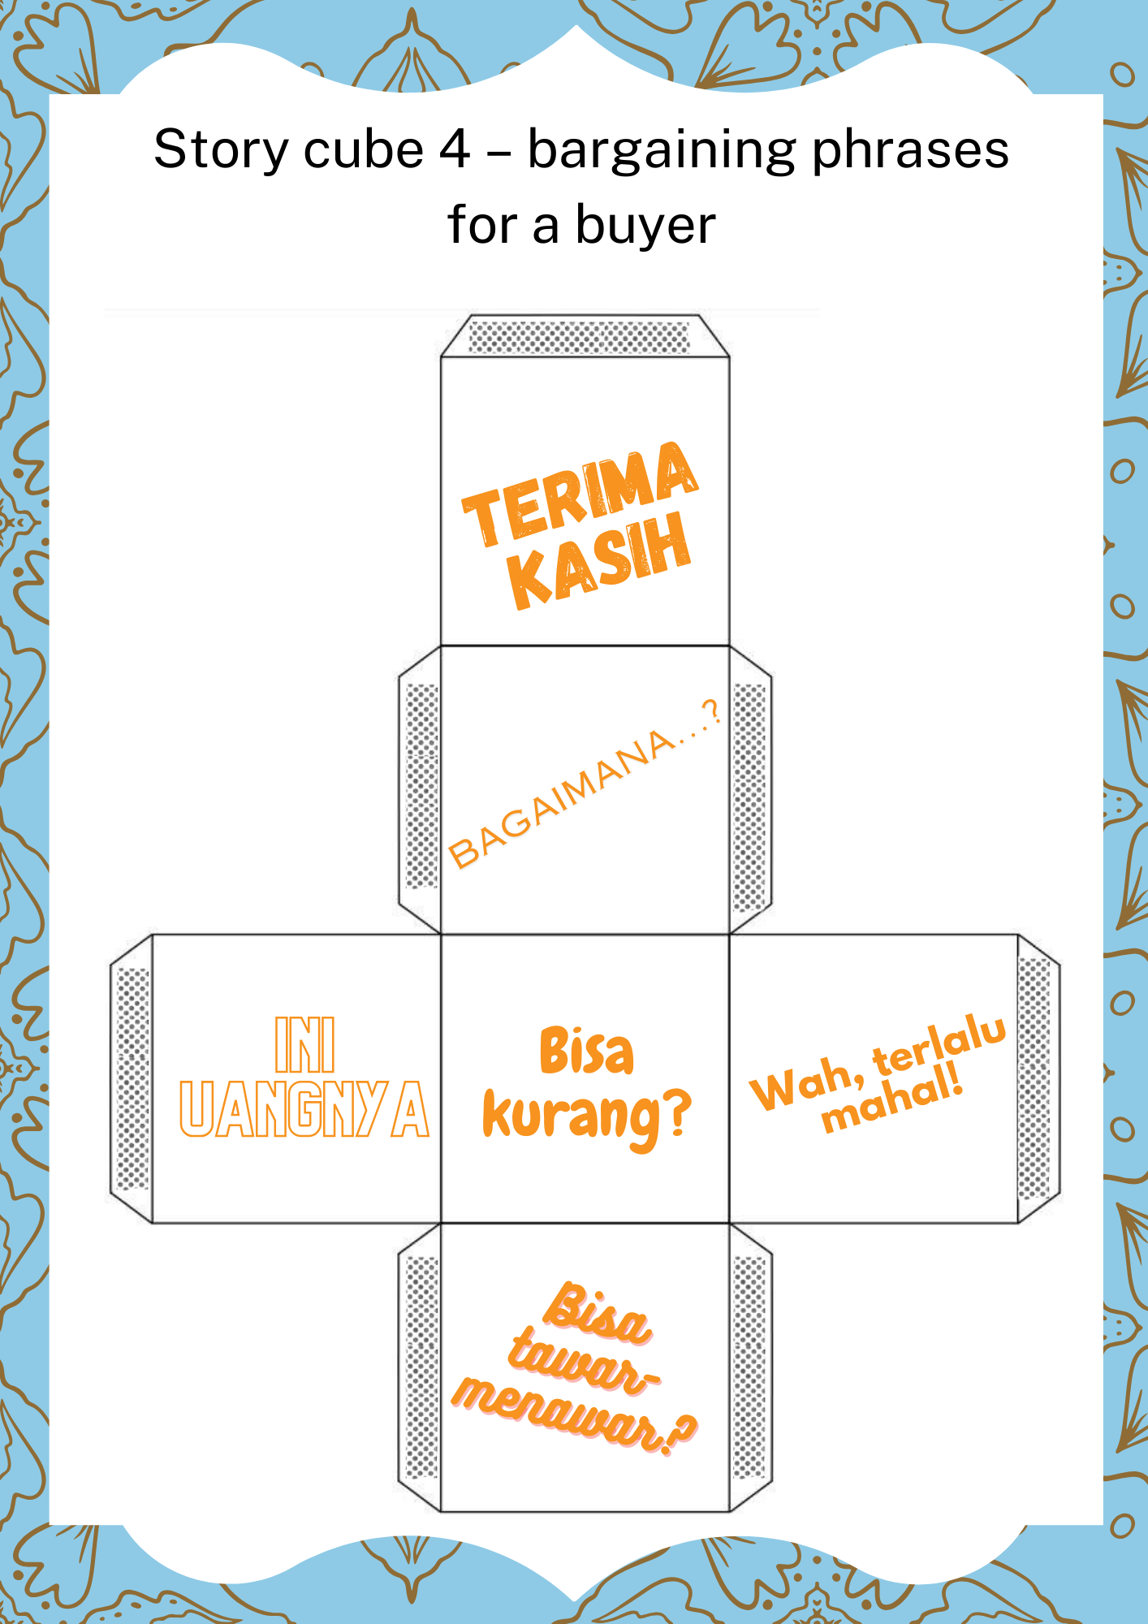

Blank story cube template
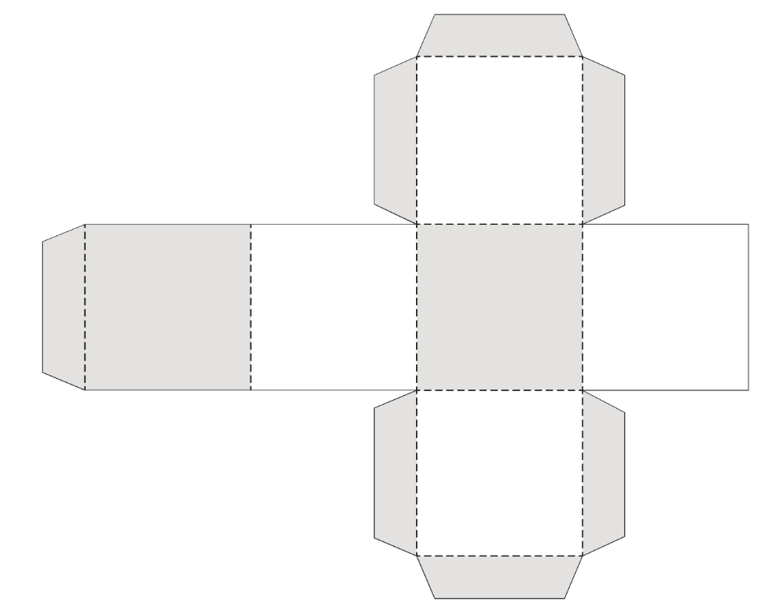

© State of New South Wales (Department of Education), 2024
The copyright material published in this resource is subject to the Copyright Act 1968 (Cth) and is owned by the NSW Department of Education or, where indicated, by a party other than the NSW Department of Education (third-party material).
Copyright material available in this resource and owned by the NSW Department of Education is licensed under a Creative Commons Attribution 4.0 International (CC BY 4.0) license.
This license allows you to share and adapt the material for any purpose, even commercially.
Attribution should be given to © State of New South Wales (Department of Education), 2024.
Material in this resource not available under a Creative Commons license:
- the NSW Department of Education logo, other logos and trademark-protected material
- material owned by a third party that has been reproduced with permission. You will need to obtain permission from the third party to reuse its material.
Links to third-party material and websites
Please note that the provided (reading/viewing material/list/links/texts) are a suggestion only and implies no endorsement, by the New South Wales Department of Education, of any author, publisher, or book title. School principals and teachers are best placed to assess the suitability of resources that would complement the curriculum and reflect the needs and interests of their students.
If you use the links provided in this document to access a third-party's website, you acknowledge that the terms of use, including licence terms set out on the third-party's website apply to the use which may be made of the materials on that third-party website or where permitted by the Copyright Act 1968 (Cth). The department accepts no responsibility for content on third-party websites.

