Chair swap game
This resource is for the teacher. It provides the content and instructions you need to share with students.
Use the ‘Revision sentence cards’ provided in this resource or use the editable version on Canva.
This is a revision game. To improve student engagement, this game may be played outside to allow for more space and the physical movement of students.
Print and cut out the cards. Arrange a circle of chairs, with enough chairs for all students in the class to be seated.
Distribute a card to each student in the class and tell them to keep their card hidden from others. Make sure there are 2 copies of each sentence distributed among the class.
Call out one of the revision sentences in Indonesian. The 2 students who have that sentence on their card must stand up and swap chairs as fast as they can. Repeat this process, calling out the revision sentences at a fast pace and in a random order.
To further develop understanding, once students demonstrate confidence, call out the sentences in English.
To give students practice at listening for different phrases, periodically collect, shuffle and redistribute the cards, so that each student has a new revision sentence card.
To make the game competitive, depending on your context, elimination rules can be introduced. For example:
- In the first round, each time a sentence is called out, the student who is the last one to get to their chair is eliminated and sits on the ground (if appropriate) near the teacher. The winner stands to the side and waits for the next round. This continues until all of the sentences have been called out.
- In the second round, new cards are distributed to the winners, who face off against each other in a smaller circle of chairs.
The elimination process and rounds continue until there are 2 final winners remaining.
Differentiation examples
The following strategies provide a starting point for how you can differentiate this activity for a range of learners. Adapt or design alternatives, to meet the needs of students in your class.
Students with advanced proficiency – before students are allowed to swap chairs, they must consider the question ‘What would you say next?’ and give a response to their sentence. For example, if the sentence is Saya mau ke pasar swalayan, the student could respond with the question Mau beli apa di pasar swalayan? This allows the student to place the sentence in the context of a broader conversation.
High potential and gifted students – when playing in Indonesian, before students are allowed to swap chairs, they must call out a translation of their sentence in English.
Students requiring additional support – students may work in pairs. Include Indonesian and English (or a supporting image) on cards to help determine meaning.

Revision sentence cards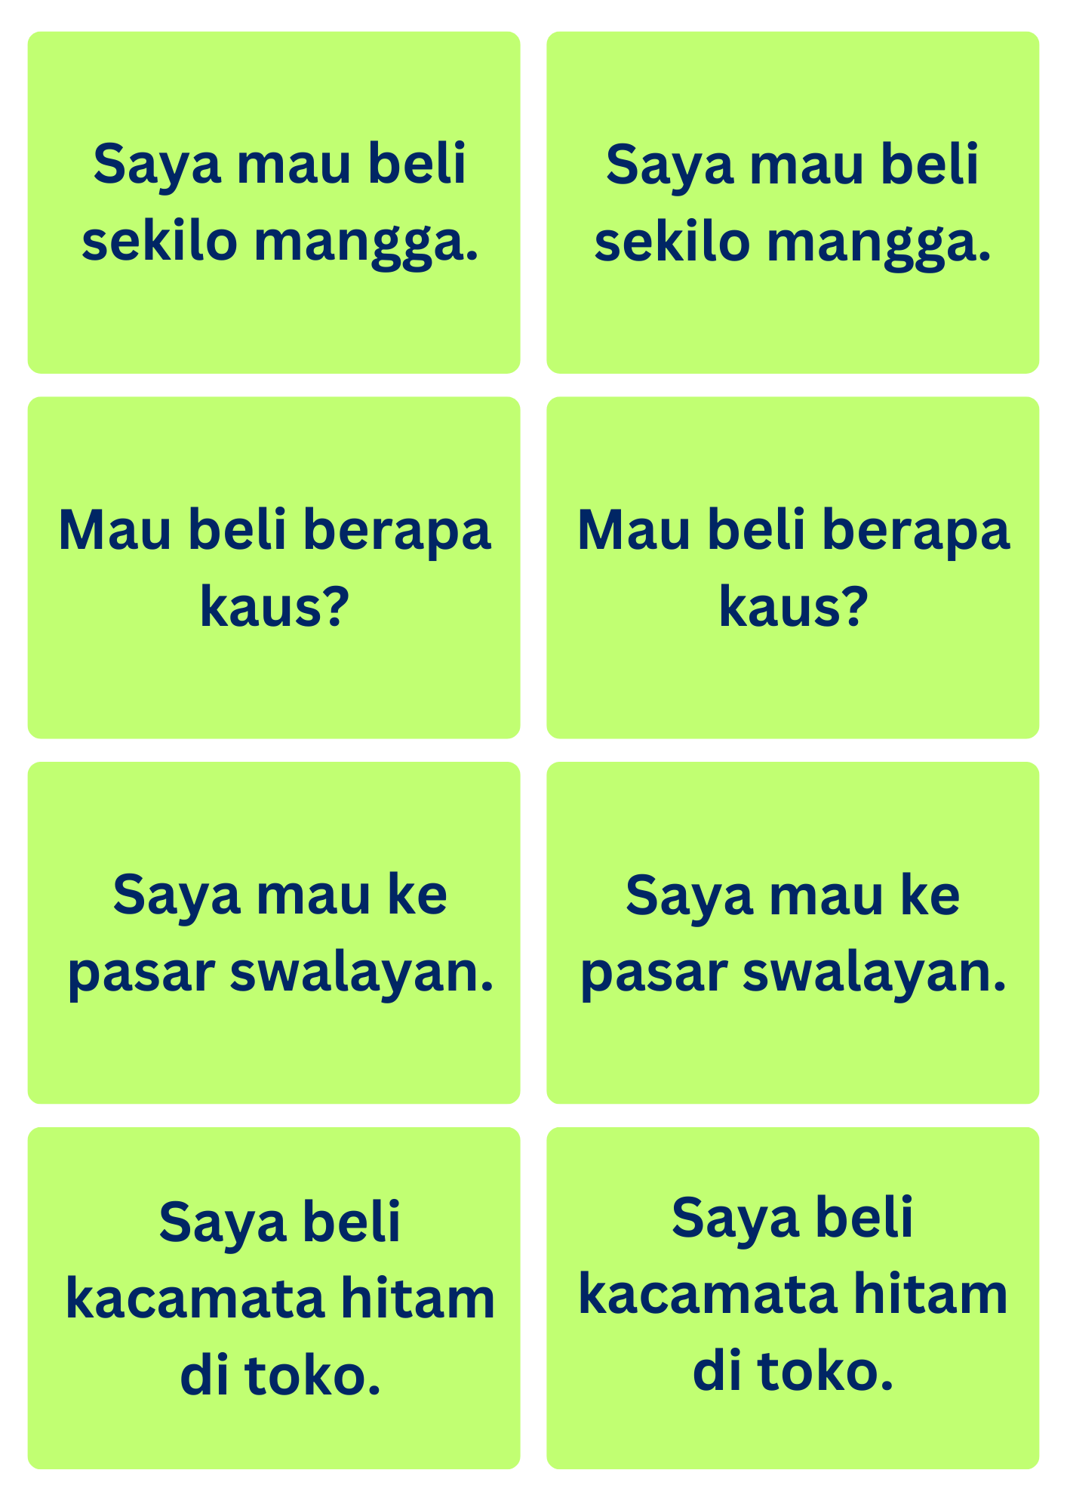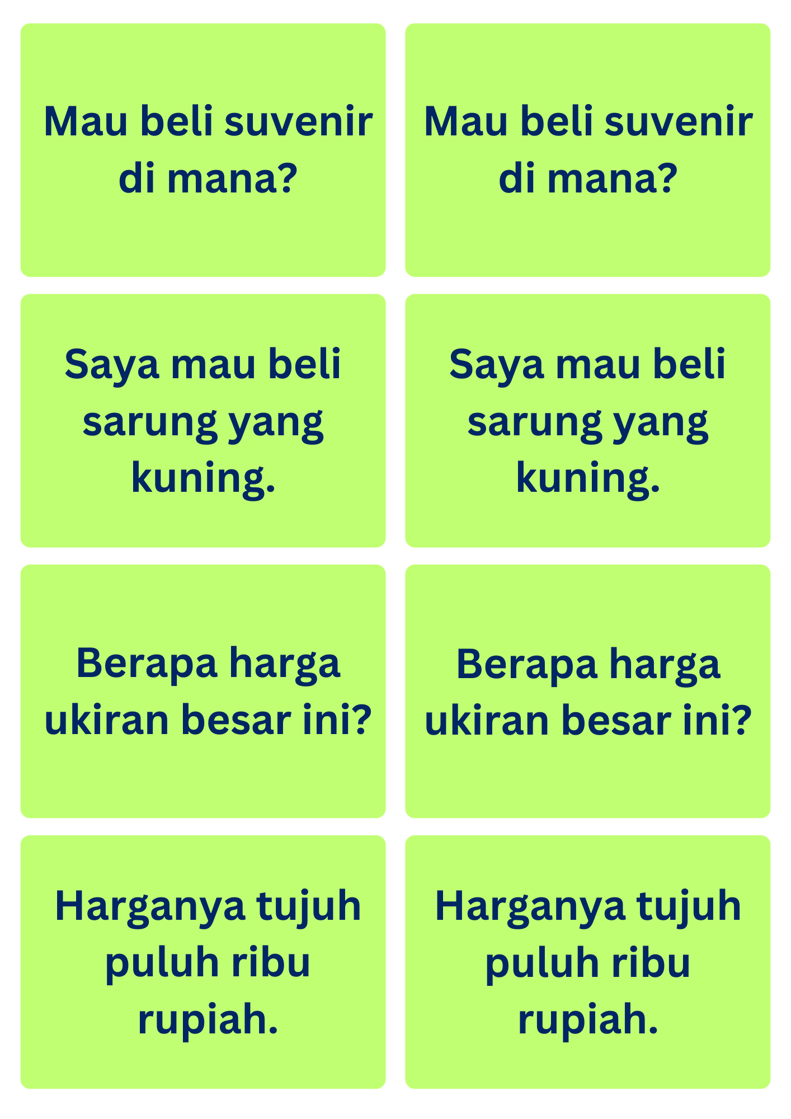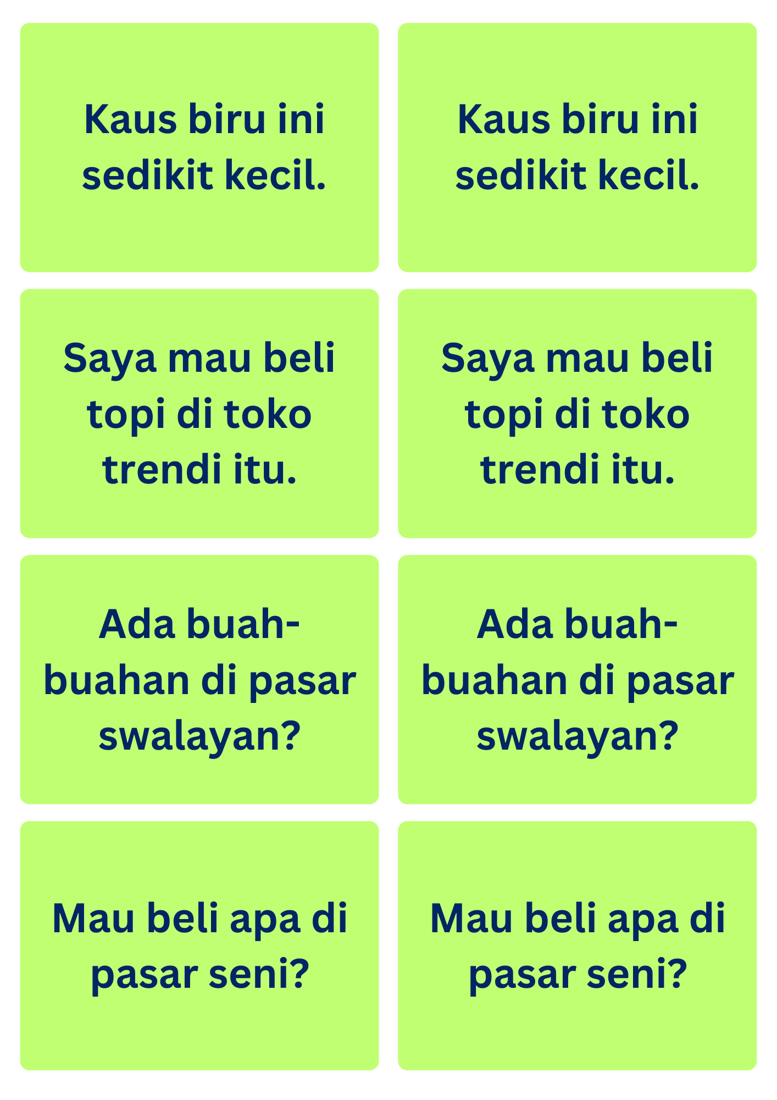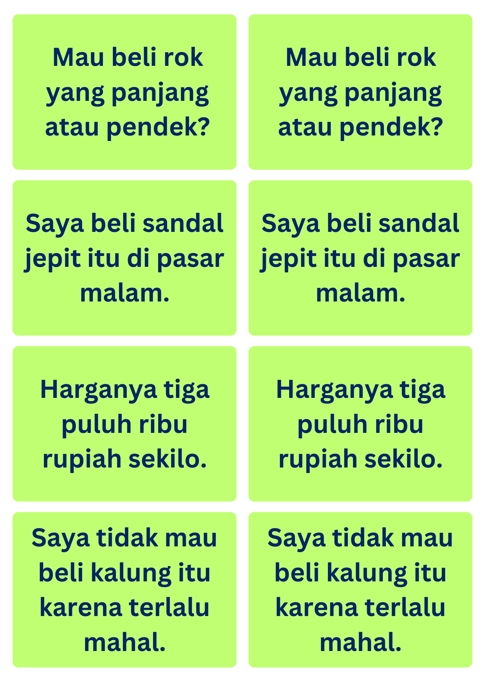
© State of New South Wales (Department of Education), 2024
The copyright material published in this resource is subject to the Copyright Act 1968 (Cth) and is owned by the NSW Department of Education or, where indicated, by a party other than the NSW Department of Education (third-party material).
Copyright material available in this resource and owned by the NSW Department of Education is licensed under a Creative Commons Attribution 4.0 International (CC BY 4.0) license.
This license allows you to share and adapt the material for any purpose, even commercially.
Attribution should be given to © State of New South Wales (Department of Education), 2024.
Material in this resource not available under a Creative Commons license:
- the NSW Department of Education logo, other logos and trademark-protected material
- material owned by a third party that has been reproduced with permission. You will need to obtain permission from the third party to reuse its material.
Links to third-party material and websites
Please note that the provided (reading/viewing material/list/links/texts) are a suggestion only and implies no endorsement, by the New South Wales Department of Education, of any author, publisher, or book title. School principals and teachers are best placed to assess the suitability of resources that would complement the curriculum and reflect the needs and interests of their students.
If you use the links provided in this document to access a third-party's website, you acknowledge that the terms of use, including licence terms set out on the third-party's website apply to the use which may be made of the materials on that third-party website or where permitted by the Copyright Act 1968 (Cth). The department accepts no responsibility for content on third-party websites.

