Charades
This resource is for the teacher. It provides the content and instructions you need to share with students.
Use the ‘Bargaining phrases charades playing cards’ provided in this resource or use the editable version on Canva.
This game can be played in pairs, small groups or as a class. Depending on the game style, print and cut out the cards, ensuring there is enough to play in pairs, small groups or as a class.
If playing as a class, split the class into 2 teams. Set a timer, for example, for 30 seconds or one minute. Have each team select an actor. The actor from each team picks up one card at a time from the card pile, being careful not to reveal the card to their team. The actor must act out each phrase quickly and accurately so that the players on their team can guess what phrase they are acting out. The team calls out their guesses in Indonesian. If the guess is correct, the actor says benar (correct). If it is incorrect, the actor says salah (incorrect). For each correct guess, the team earns a point.
The teams can move through several rounds, changing the actors each round and adding points to their tally. Once all students have had a turn at acting, the game ends. The team with the most points, wins.
Differentiation examples
The following strategies provide a starting point for how you can differentiate this activity for a range of learners. Adapt or design alternatives, to meet the needs of students in your class.
Students with advanced proficiency and high potential and gifted students – provide a copy of the playing cards with the phrases in English instead of Indonesian. This is an additional challenge, as the ‘actor’ must recognise the correct phrase as it is called out in Indonesian.
Students requiring additional support – provide a copy of the playing cards with the phrases in both Indonesian and English, so that the ‘actor’ can recognise the meaning of the phrases more quickly. For the students making guesses, provide a vocabulary list.

Bargaining phrases charades playing cards
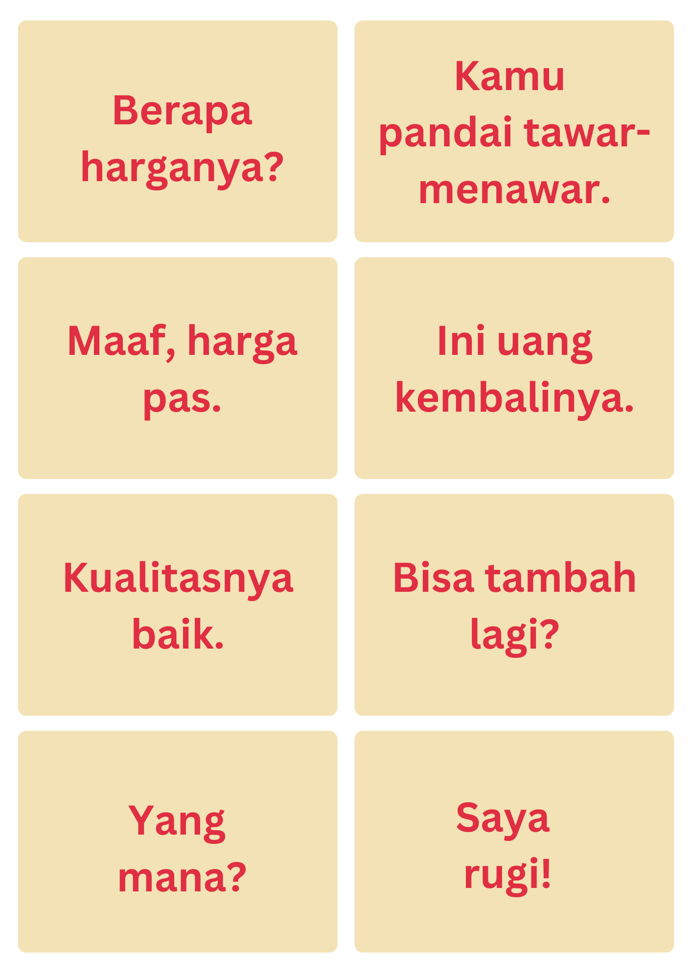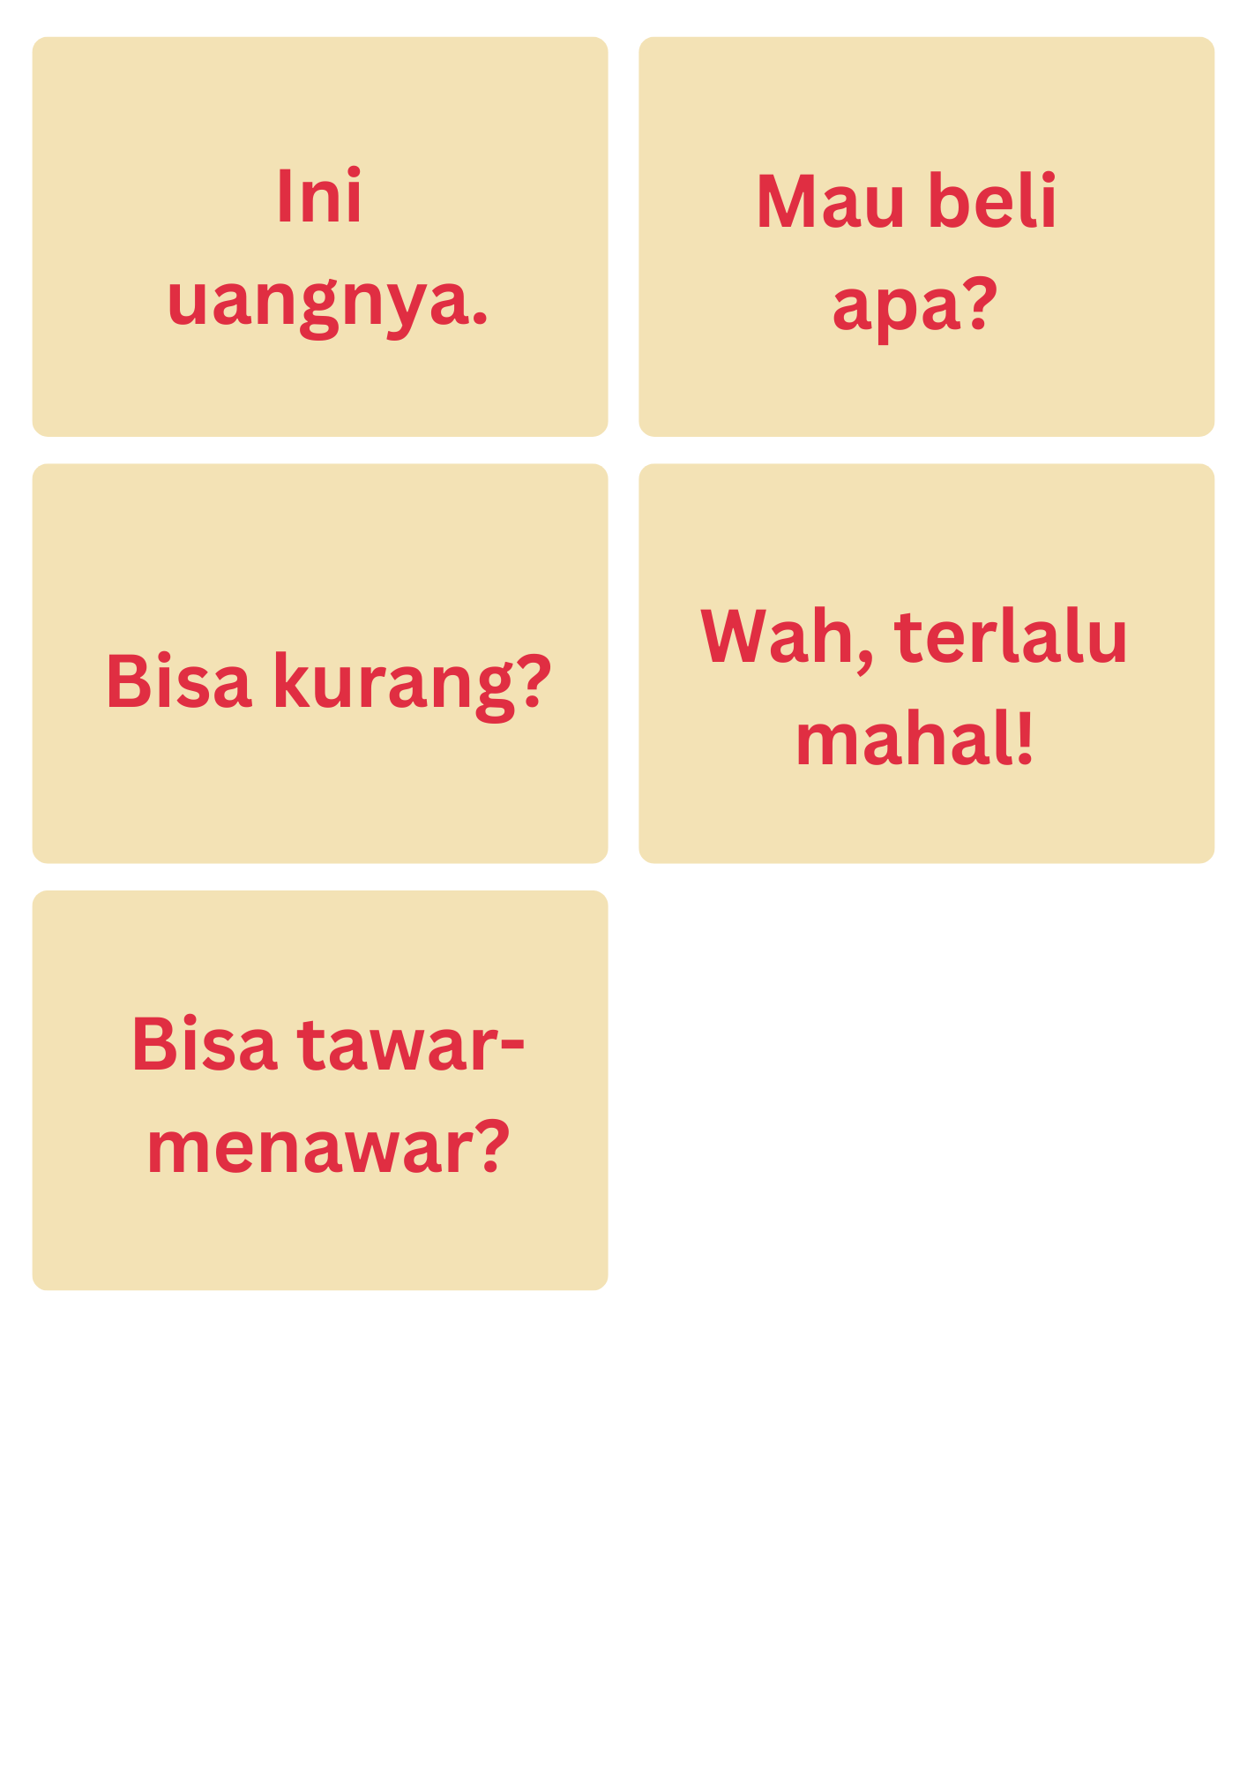

© State of New South Wales (Department of Education), 2024
The copyright material published in this resource is subject to the Copyright Act 1968 (Cth) and is owned by the NSW Department of Education or, where indicated, by a party other than the NSW Department of Education (third-party material).
Copyright material available in this resource and owned by the NSW Department of Education is licensed under a Creative Commons Attribution 4.0 International (CC BY 4.0) license.
This license allows you to share and adapt the material for any purpose, even commercially.
Attribution should be given to © State of New South Wales (Department of Education), 2024.
Material in this resource not available under a Creative Commons license:
- the NSW Department of Education logo, other logos and trademark-protected material
- material owned by a third party that has been reproduced with permission. You will need to obtain permission from the third party to reuse its material.
Links to third-party material and websites
Please note that the provided (reading/viewing material/list/links/texts) are a suggestion only and implies no endorsement, by the New South Wales Department of Education, of any author, publisher, or book title. School principals and teachers are best placed to assess the suitability of resources that would complement the curriculum and reflect the needs and interests of their students.
If you use the links provided in this document to access a third-party's website, you acknowledge that the terms of use, including licence terms set out on the third-party's website apply to the use which may be made of the materials on that third-party website or where permitted by the Copyright Act 1968 (Cth). The department accepts no responsibility for content on third-party websites.

