Dialogue prompts
This resource is for the teacher. It provides the content and instructions you need to share with students.
Use the dialogue prompts below or use the editable version on Canva.
Divide students into groups of 2 or 3 to create a written dialogue. Give each student a dialogue prompt, ensuring each group is given a different prompt which indicates the place, items to be purchased and prices for the dialogue. Encourage students to expand on their dialogue using any content from this unit (for example, opinions, justifications, asking which one, colours and adjectives) and previous units (for example, greetings and goodbyes). Encourage students to think creatively about how they can make their dialogue authentic.
While students are creating their texts, use the opportunity to provide informal feedback and, if required, adjust the learning sequence depending on student confidence. Once the dialogues are completed, students switch their dialogues with another group in the class. Students read the other group’s dialogue and make any corrections they notice are required. Then, the groups swap back and read through their peer’s feedback.
The final dialogues could be recorded or performed in front of the class.
Differentiation examples
Students with advanced proficiency – encourage students to expand on their prompt and provide additional language structures familiar to them.
High potential and gifted students – edit the prompts to provide the details in English, requiring students to recall all required vocabulary.
Students requiring additional support – provide students with a scaffolded sample dialogue as a model, before they create their own dialogue independently.

Dialogue prompts
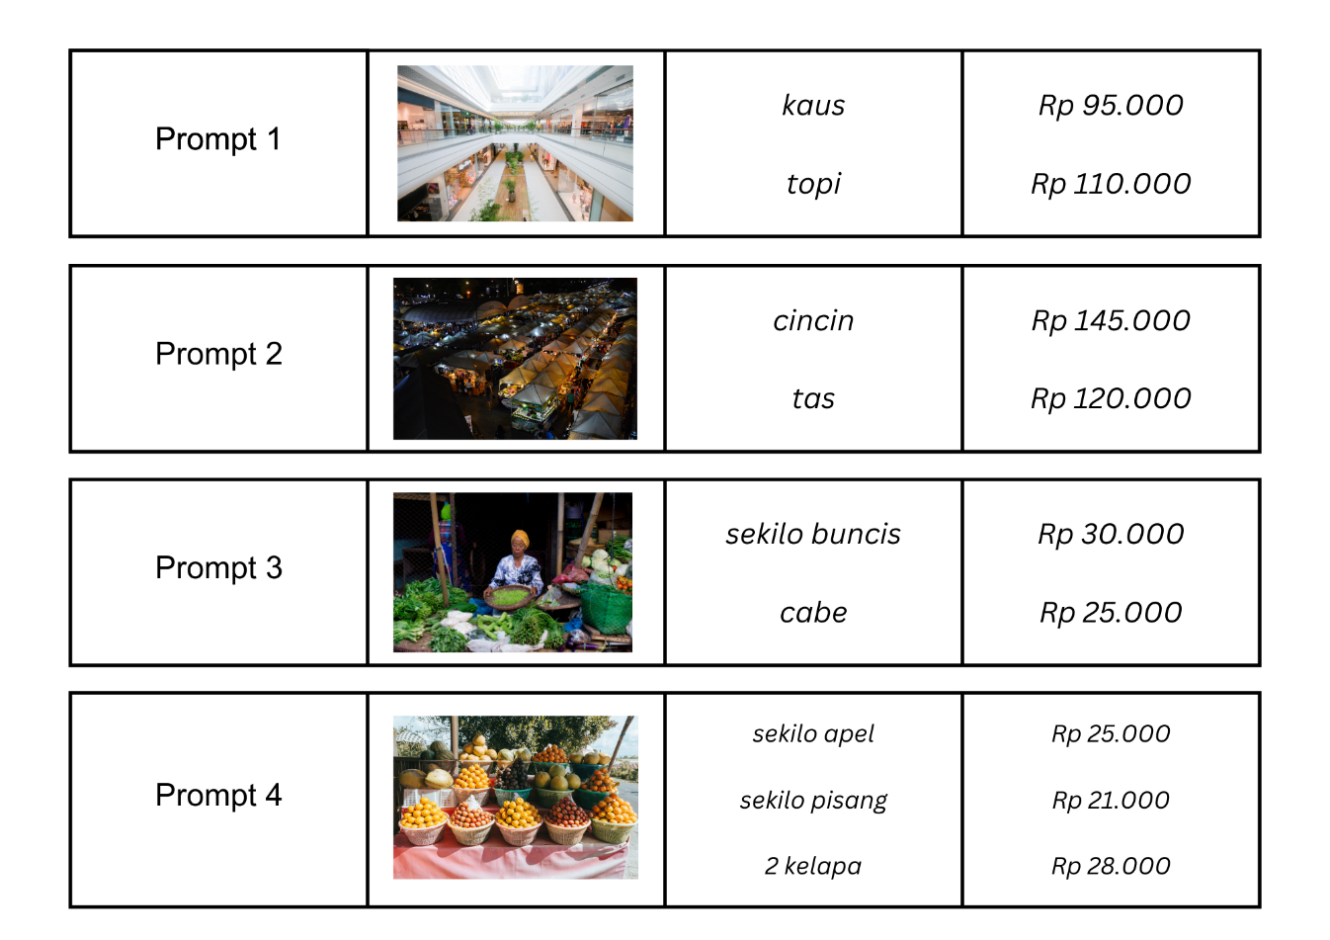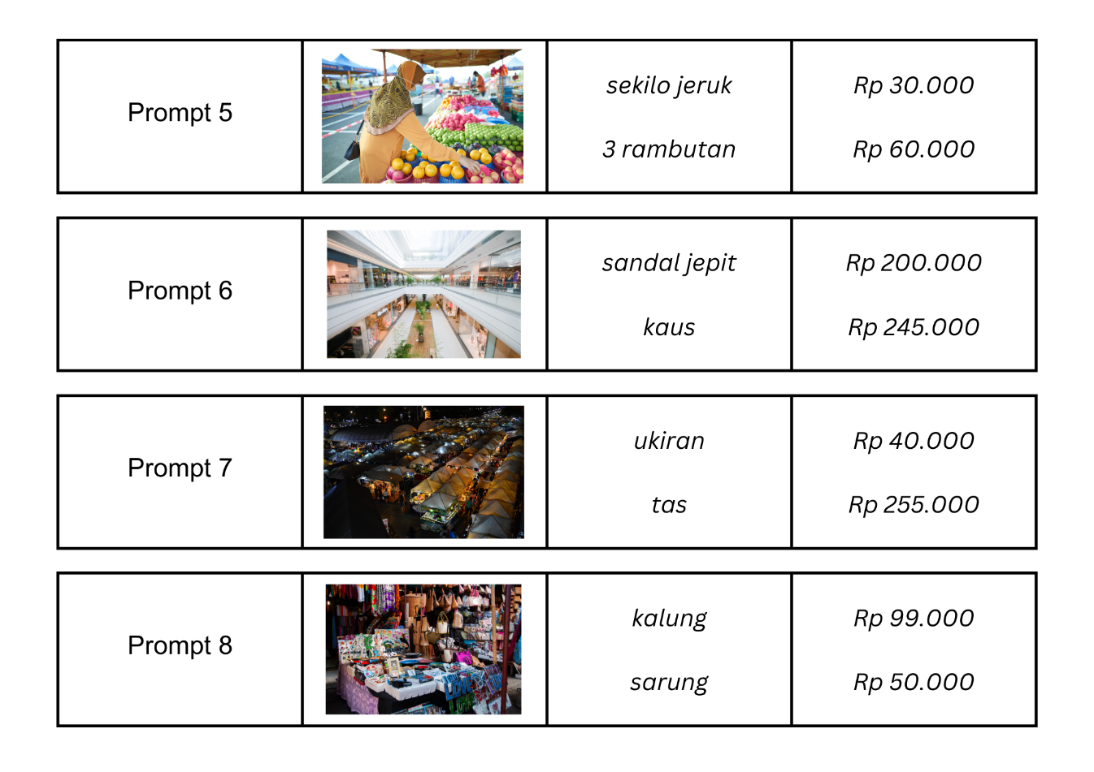
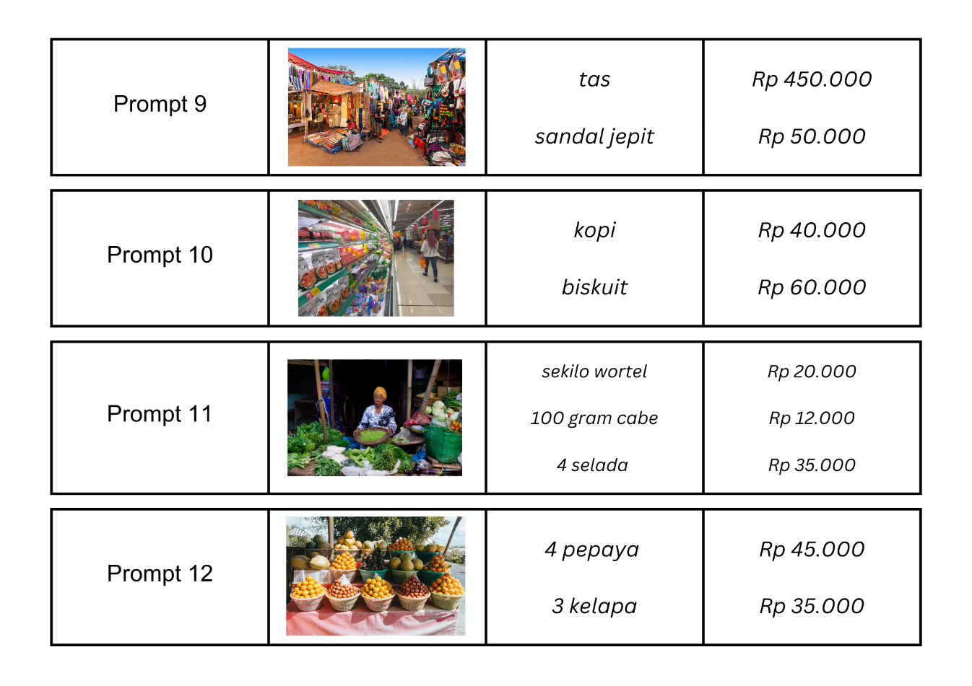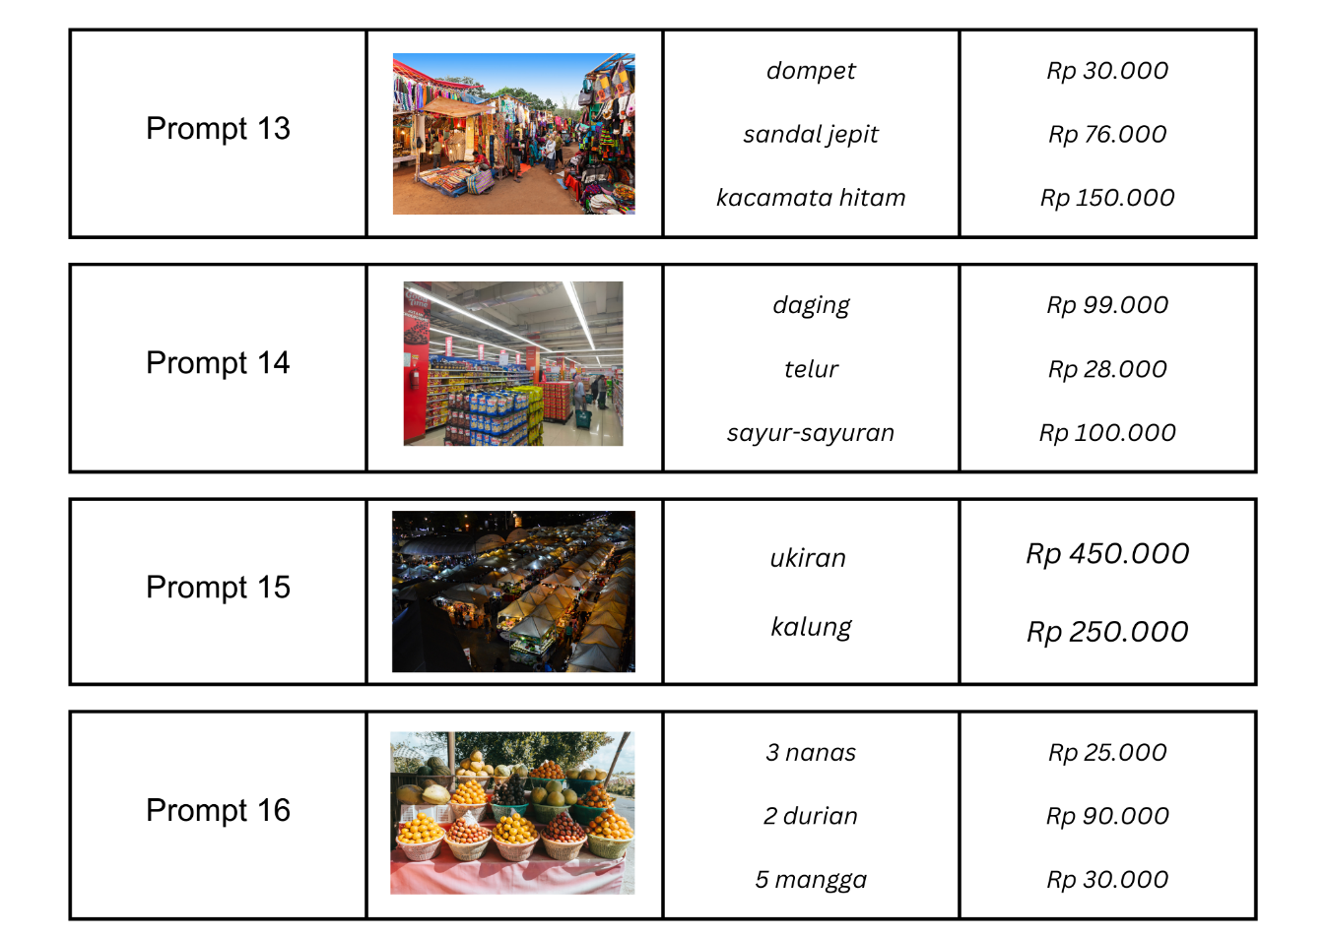

© State of New South Wales (Department of Education), 2024
The copyright material published in this resource is subject to the Copyright Act 1968 (Cth) and is owned by the NSW Department of Education or, where indicated, by a party other than the NSW Department of Education (third-party material).
Copyright material available in this resource and owned by the NSW Department of Education is licensed under a Creative Commons Attribution 4.0 International (CC BY 4.0) license.
This license allows you to share and adapt the material for any purpose, even commercially.
Attribution should be given to © State of New South Wales (Department of Education), 2024.
Material in this resource not available under a Creative Commons license:
- the NSW Department of Education logo, other logos and trademark-protected material
- material owned by a third party that has been reproduced with permission. You will need to obtain permission from the third party to reuse its material.
Links to third-party material and websites
Please note that the provided (reading/viewing material/list/links/texts) are a suggestion only and implies no endorsement, by the New South Wales Department of Education, of any author, publisher, or book title. School principals and teachers are best placed to assess the suitability of resources that would complement the curriculum and reflect the needs and interests of their students.
If you use the links provided in this document to access a third-party's website, you acknowledge that the terms of use, including licence terms set out on the third-party's website apply to the use which may be made of the materials on that third-party website or where permitted by the Copyright Act 1968 (Cth). The department accepts no responsibility for content on third-party websites.

