Food items playing cards
This resource is for the teacher. It provides the content and instructions you need to share with students.
Use the food items playing cards provided or use the editable version on Canva.
Print and cut out the cards, ensuring there is enough for each activity:
- one set per group for activity 1
- 4 sets per group for activity 2.
Laminate the cards for ongoing use throughout the unit.
The playing cards have several uses throughout the unit, including:
- activities 1 and 2
- to revise the pronunciation of food items, using the cards as flashcards
- as a classroom display (add the Indonesian word to each picture first, using the editable version on Canva).
Instructions for activities 1 and 2 are below.

Activity 1 – I went to the shops and I bought …
Print and cut out the cards, ensuring there is enough for each group to receive one set. Students work in groups of 5 to 6. The goal of the game is to be the first group to get through all of the cards correctly.
The cards are placed face down in the middle of the group. All groups start at the same time when the teacher calls Mulai!
The eldest student in the group begins by picking a card and showing it to the group. They say a sentence in Indonesian which starts with Saya ke toko (I went to the shops) and includes what they bought, based on the card they picked up. For example: Saya ke toko dan saya beli apel (I went to the shops, and I bought apples). They then hide the card from their group.
The next student in the group reveals a card and adds it to the original sentence. For example: Saya ke toko dan saya beli apel dan pisang (I went to the shops, and I bought apples and bananas). The student hides their card from the group as well.
Students go around the circle taking turns revealing cards and adding the food item to the sentence, being careful to remember and say all of the food items which were revealed previously.
Students with cards, who have already had their turn, will need to let their team know if their ‘card’ was forgotten, requiring them to actively listen in the game even after their turn is over. If a student makes a mistake on their turn, the cards are returned to the middle and shuffled, and the game starts again.
The goal of the game is to be the first group to get through all cards correctly and call out Sudah selesai!
Differentiation examples
Students with advanced proficiency – where possible, pair students with advanced proficiency together. Students include adjectives familiar to them in their response. For example, apel besar, pepaya kecil, pisang kuning. Their peers must try and remember the adjective in their response as well.
High potential and gifted students – encourage students to include additional phrases such as giliran saya (my turn) and giliran kamu (your turn) to enhance students’ interaction in the target language. They could also ask each other questions between each turn such as Kamu suka apel dan pisang?
Students requiring additional support – students could use their books or be given a sentence list to refer to during the activity. Students could be provided with playing cards which also have the Indonesian words on them to assist them in forming sentences with the correct vocabulary. They would draw from this pile when it is their turn. The words can be added by using the editable Canva link.

Activity 2 – Mancing
Print and cut out the cards, ensuring there is enough for each group to receive 4 sets. Students play in groups of 4.
Students start with 5 cards each, placing the remaining cards face down in a draw pile in the middle. The aim of the game is to collect the most pairs of items.
The youngest student in the group goes first. They ask a peer of their choice in Indonesian if they have a particular item, for example, Ada apel? (Do you have an apple?). If their peer is holding the requested card in their hand at the time, they must respond in the target language Ya, ada apel. Ini apel (Yes, I have an apple. Here’s the apple) and give their card to the peer who requested it. If they do not have the requested card, they must respond in Indonesian, Maaf, tidak ada apel. Mancing! (I don’t have an apple. Go fish!). If the student is told to Mancing! (Go fish!), they must pick up a card from the draw pile and add it to their hand.
The students take turns, moving clockwise in the circle. The game ends when the draw pile of cards runs out. Students count the number of pairs they have collected, and the student with the most pairs, wins.
For a shortened version, students all start with 4 cards. The aim of the game is to get 4 of a kind. Following the same structure as the full version of the game, students take turns asking each other if they have items, resulting in collecting cards or drawing from the draw pile. The first student to get 4 of a kind and place them down, wins.
Differentiation examples
Students with advanced proficiency and high potential and gifted students – encourage students to include additional phrases such as maaf (sorry), giliran saya (my turn), giliran kamu (your turn) and terima kasih (thank you) to enhance students interaction in the target language. They could also add a comment about the item as they are passing it on or collecting it such as Saya suka sekali… or Saya makan apel pagi ini.
Students requiring additional support – students could use their books or be given a sentence list to refer to during the activity.

Playing cards
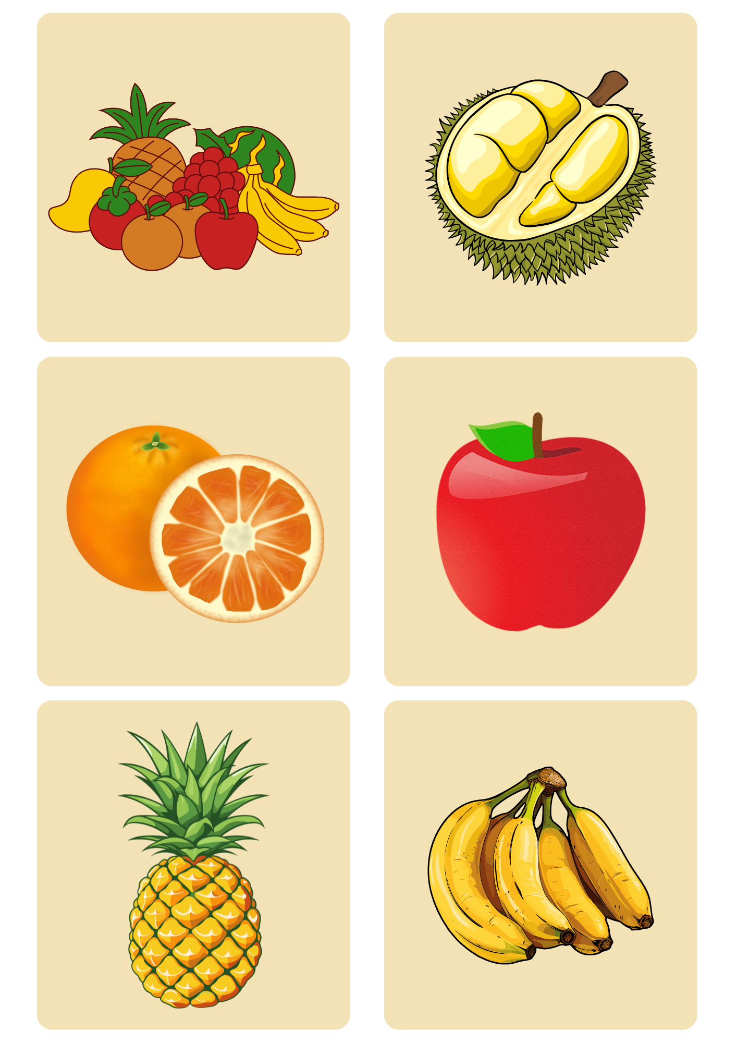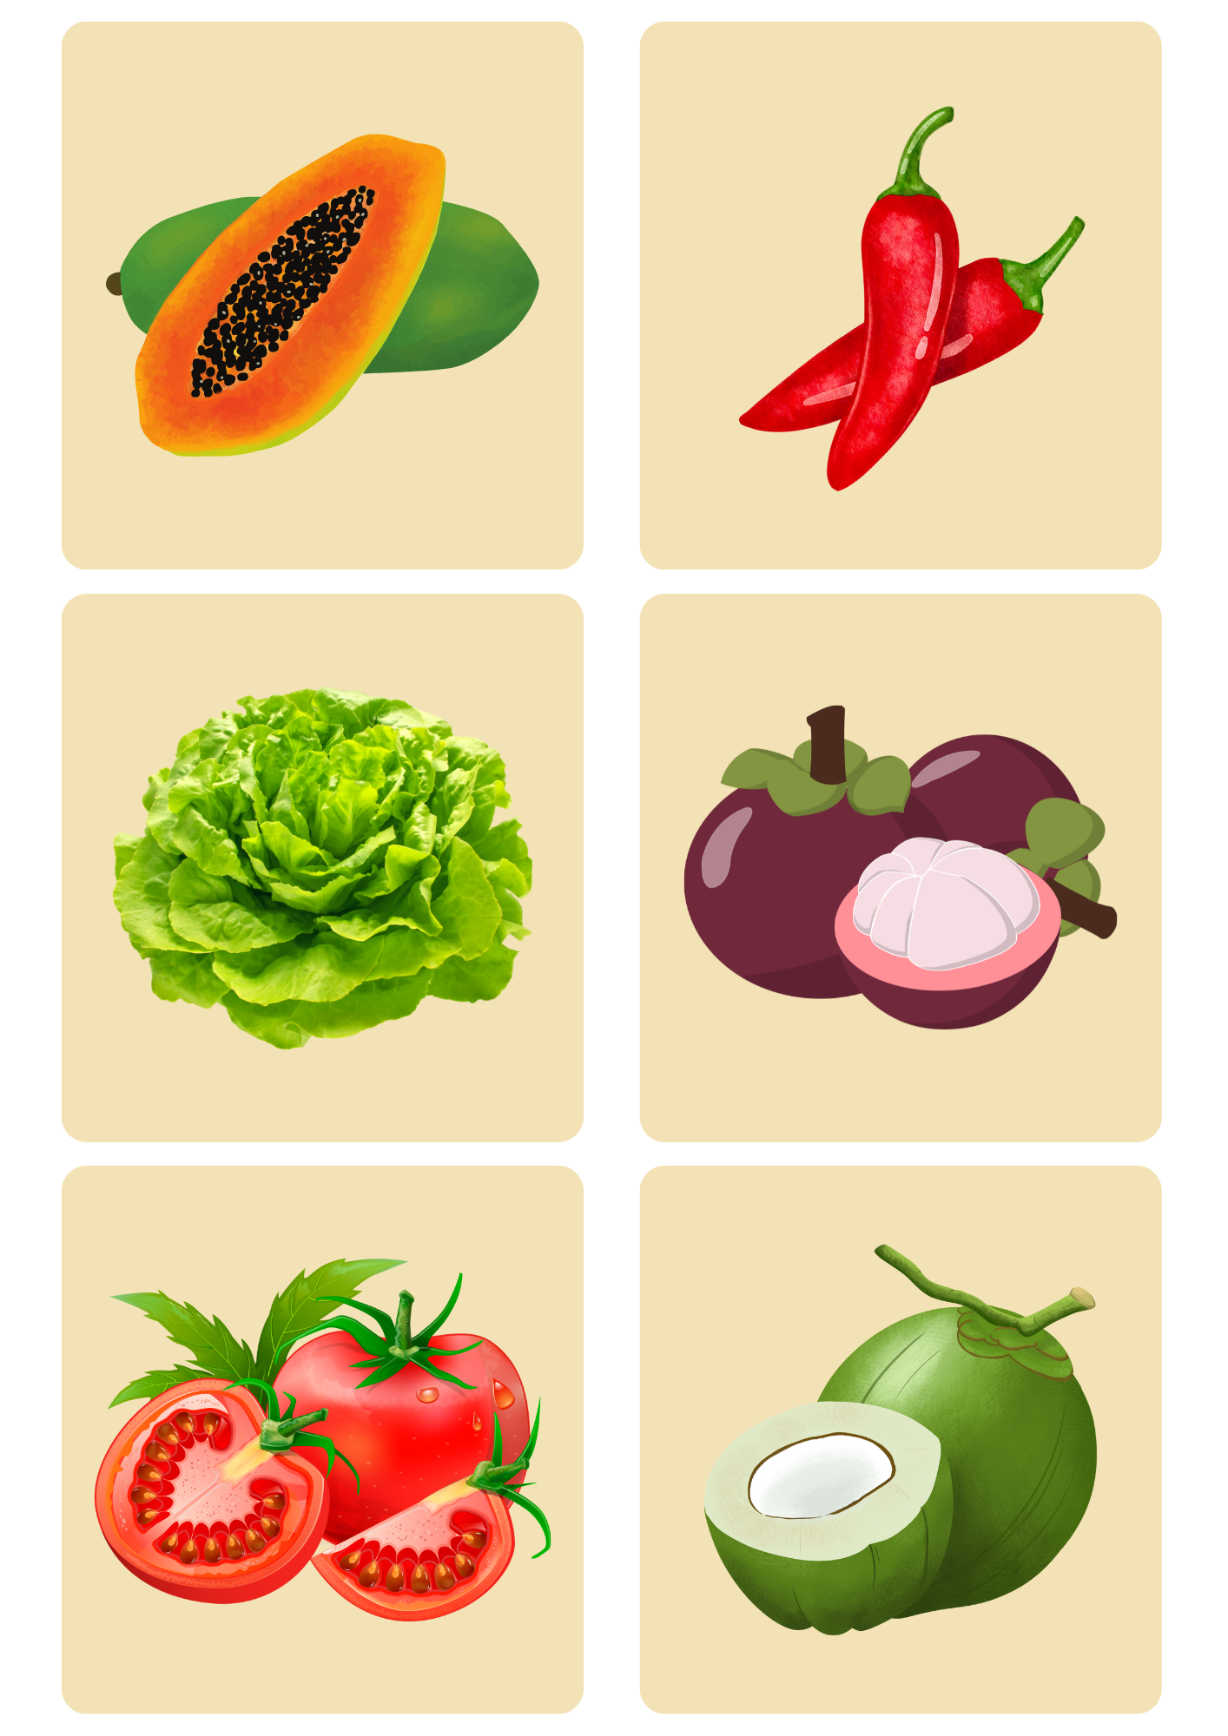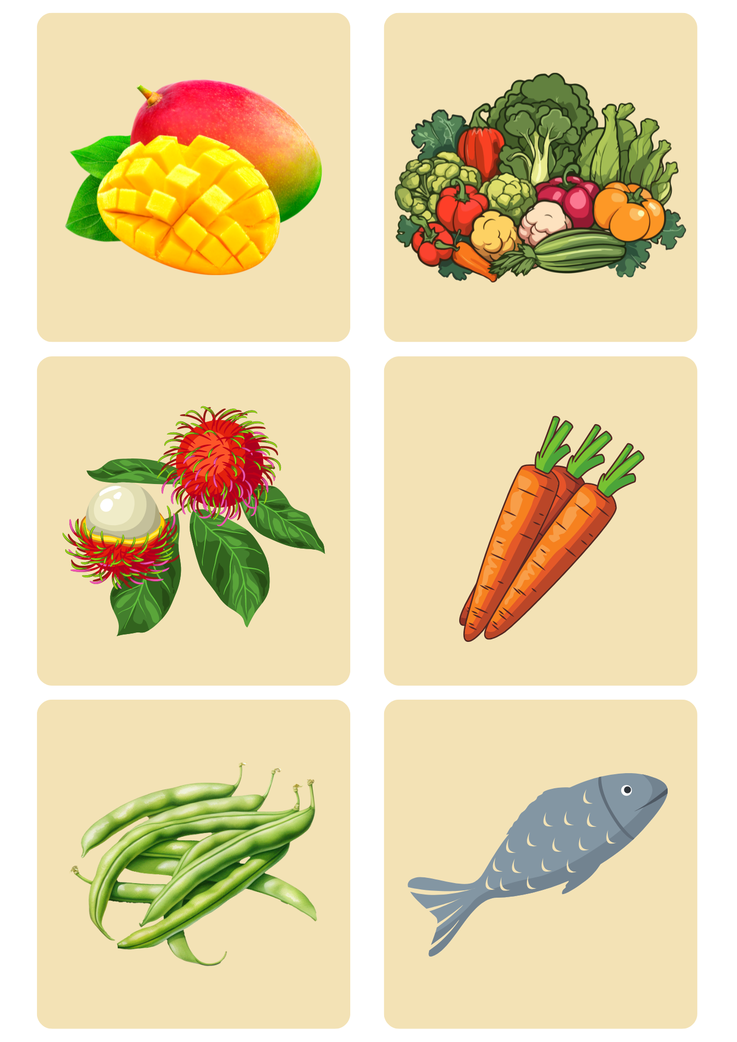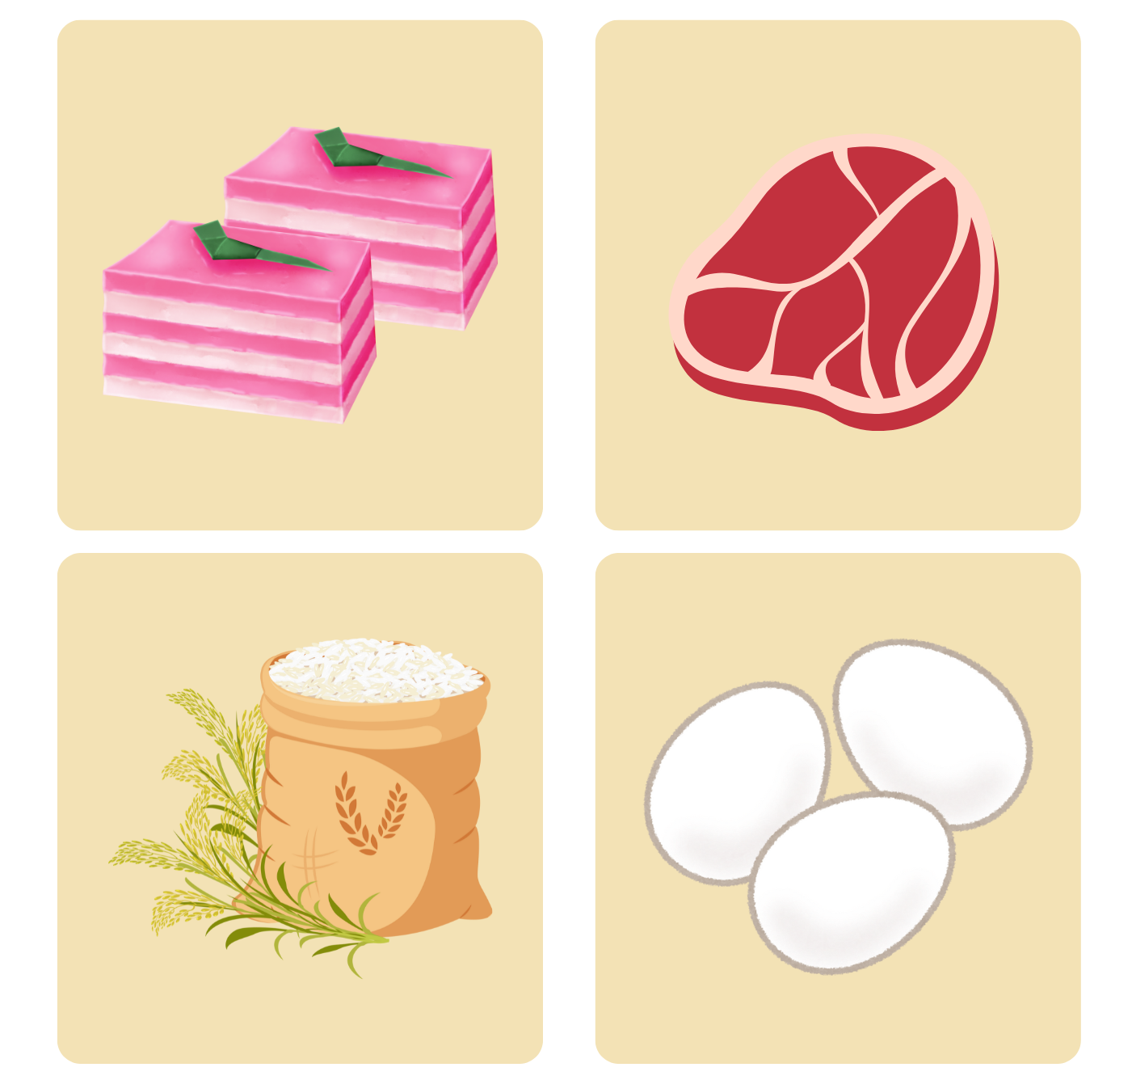

© State of New South Wales (Department of Education), 2024
The copyright material published in this resource is subject to the Copyright Act 1968 (Cth) and is owned by the NSW Department of Education or, where indicated, by a party other than the NSW Department of Education (third-party material).
Copyright material available in this resource and owned by the NSW Department of Education is licensed under a Creative Commons Attribution 4.0 International (CC BY 4.0) license.
This license allows you to share and adapt the material for any purpose, even commercially.
Attribution should be given to © State of New South Wales (Department of Education), 2024.
Material in this resource not available under a Creative Commons license:
- the NSW Department of Education logo, other logos and trademark-protected material
- material owned by a third party that has been reproduced with permission. You will need to obtain permission from the third party to reuse its material.
Links to third-party material and websites
Please note that the provided (reading/viewing material/list/links/texts) are a suggestion only and implies no endorsement, by the New South Wales Department of Education, of any author, publisher, or book title. School principals and teachers are best placed to assess the suitability of resources that would complement the curriculum and reflect the needs and interests of their students.
If you use the links provided in this document to access a third-party's website, you acknowledge that the terms of use, including licence terms set out on the third-party's website apply to the use which may be made of the materials on that third-party website or where permitted by the Copyright Act 1968 (Cth). The department accepts no responsibility for content on third-party websites.

