Larger number cards activities
This resource is for the teacher. It provides the content and instructions you need to share with students.
Use the larger number cards provided or use the editable version on Canva.
Laminate the larger number cards for ongoing use throughout the unit.
Print and cut out the cards, ensuring there is enough for each student to receive their own card.

Activity 1
Using the first set of number cards, which has the Indonesian words for the numbers, play a listening activity with students. Ensure all students are given their own card. Direct students to stand somewhere in the classroom. Students must listen to the instructions given by the teacher and move around the room accordingly, for example, line up in ascending or descending order, make groups of thousands, tens of thousands and millions or separate into groups to indicate prices which would be ‘more than or less than’ the cost of something, for example, 10 sarongs in Indonesia.

Activity 2
Using the second set of number cards, which has numerals only, play a listening activity with students. Ensure all students are given their own card. Direct students to stand up. Call out one large number at a time, in a random order. Students must listen for the corresponding number on their number card and line up in the correct order. Students use gestures and incorporate phrases such as Ini saya (It’s me) and Itu kamu (It’s you) while playing. This can be played multiple times to practise students’ listening skills.
Differentiation examples
Students with advanced proficiency
For the first activity, provide additional instructions to students with advanced proficiency in Indonesian, such as ‘add 10,000 to your number’ and instruct students to find their new place in the line or group.
For the second activity, encourage students to use Indonesian when indicating their position in the line. For example, nomor saya…, nomornya…
High potential and gifted students
For the first activity, encourage students to create their own instructions requiring students to consider what instructions and what situations are appropriate for larger numbers.
For the second activity, allow students to take turns leading the activity by calling out numbers in the target language, giving students an opportunity to practise their speaking skills and pronunciation.
Students requiring additional support
For both activities, students may work together in pairs or use their books or devices for support.

Larger number cards with words
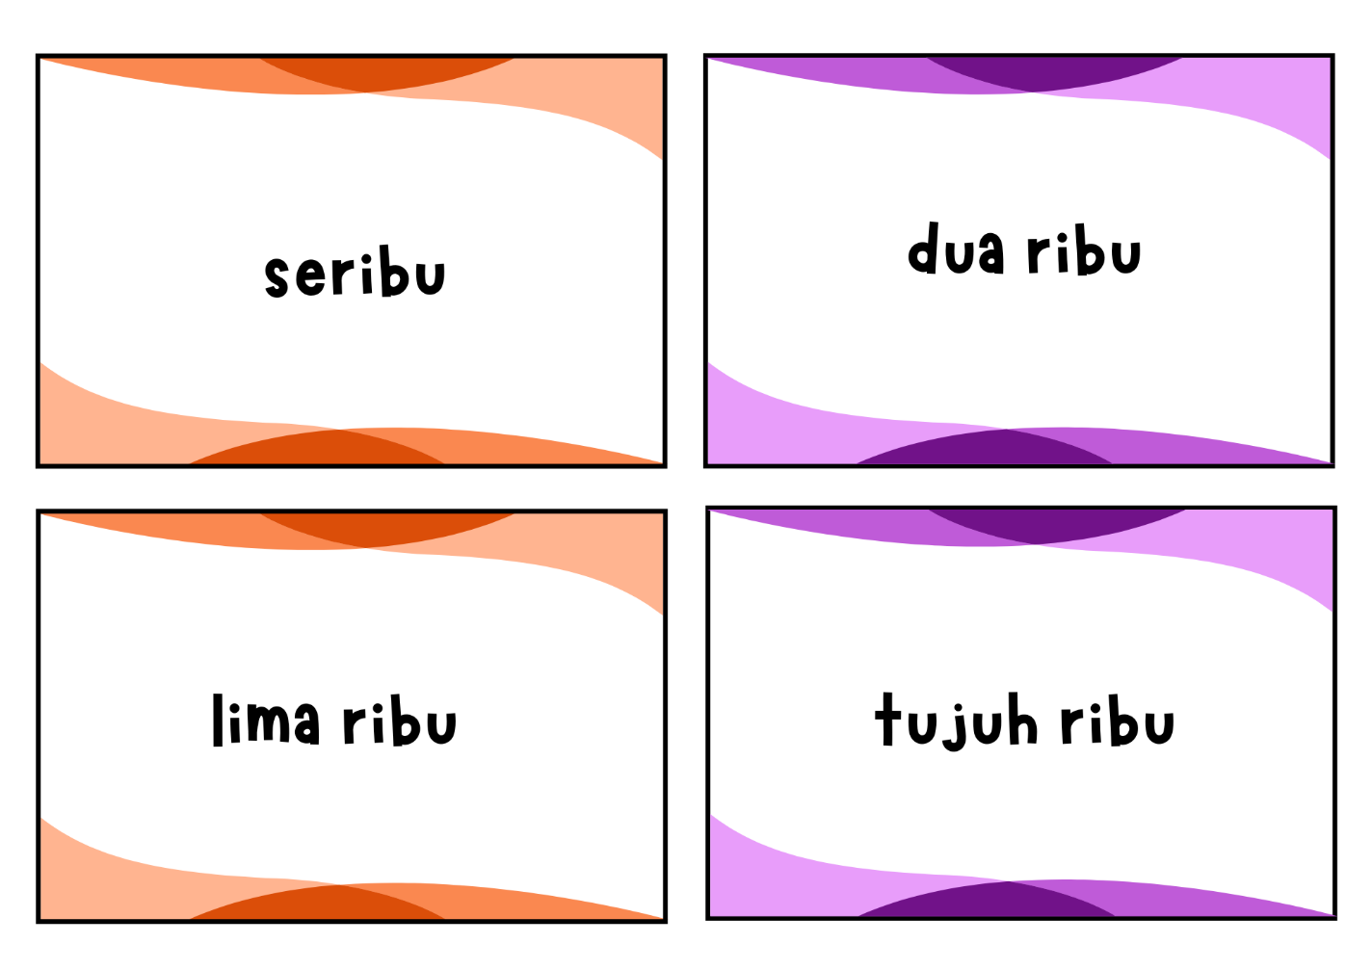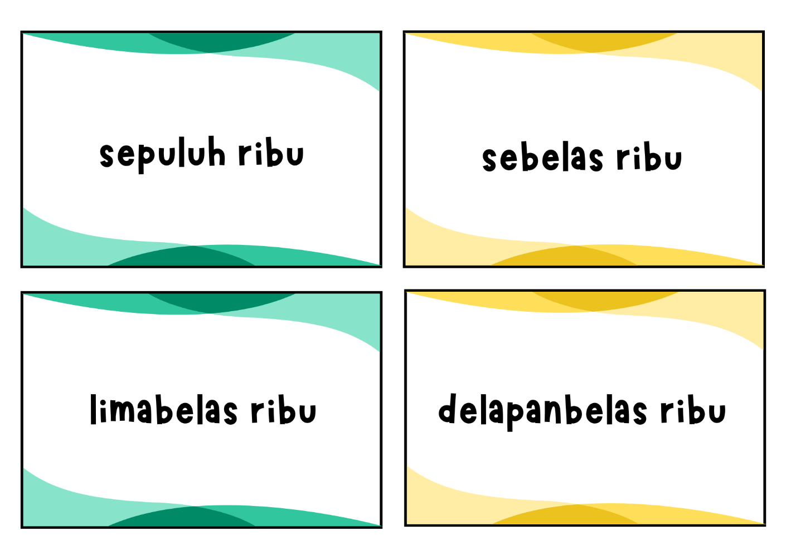
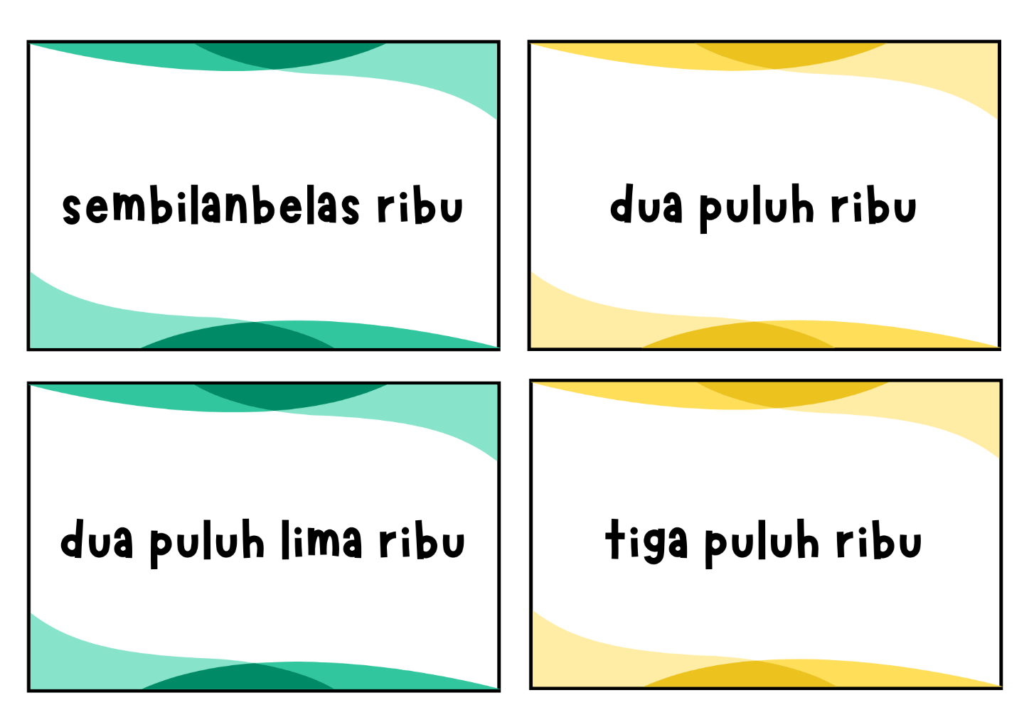
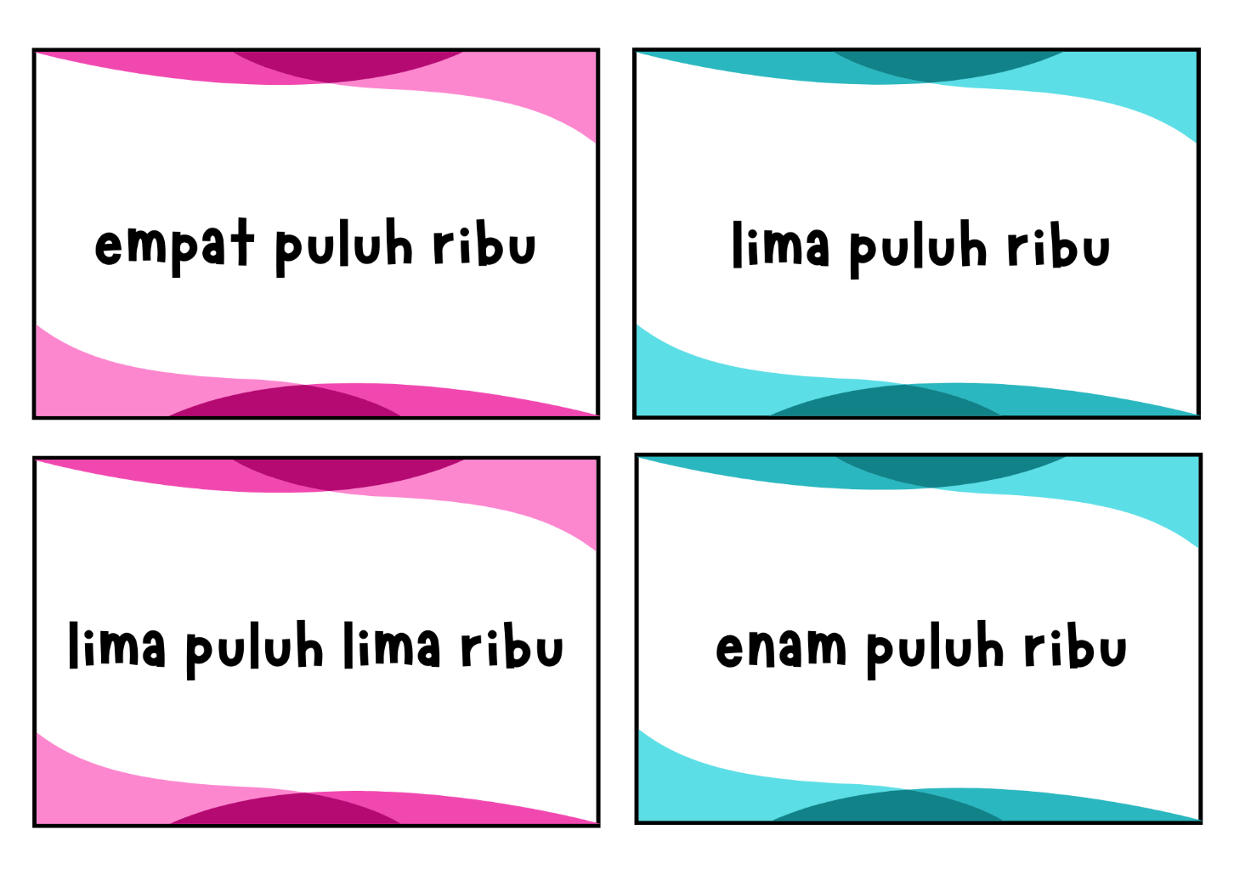
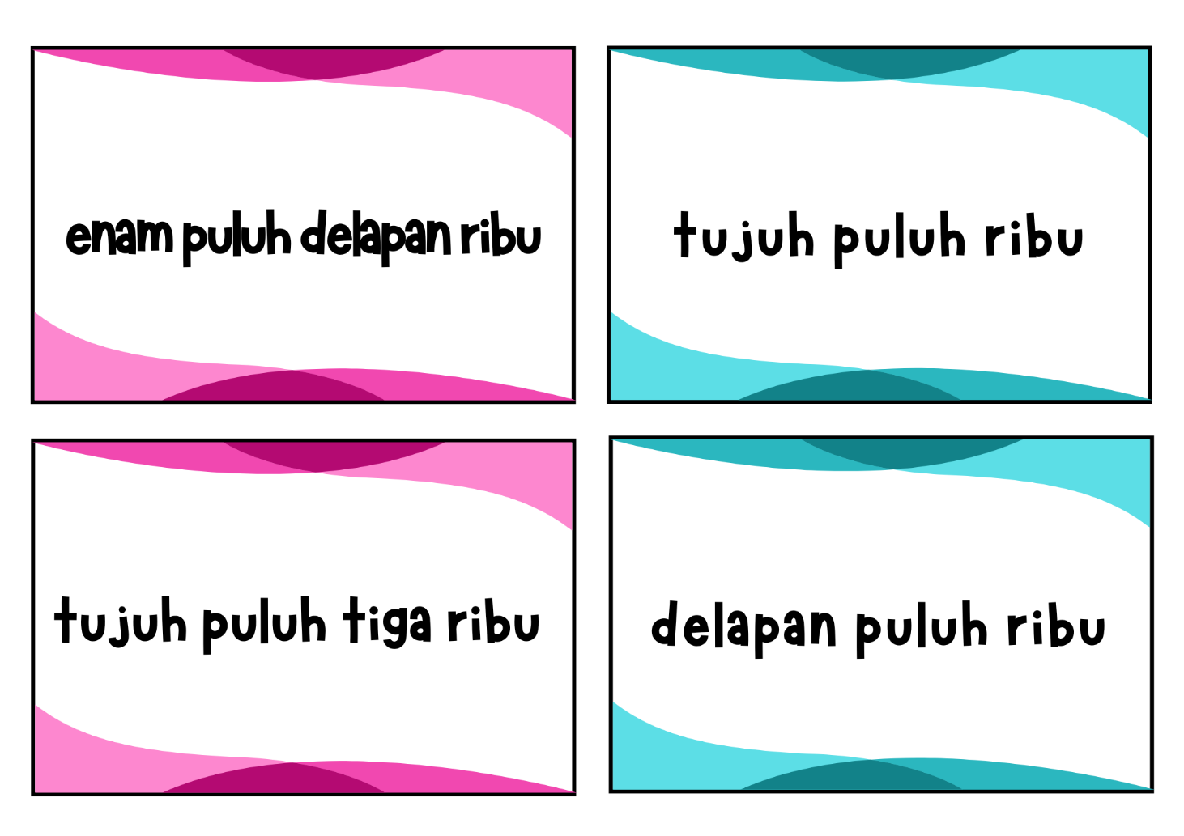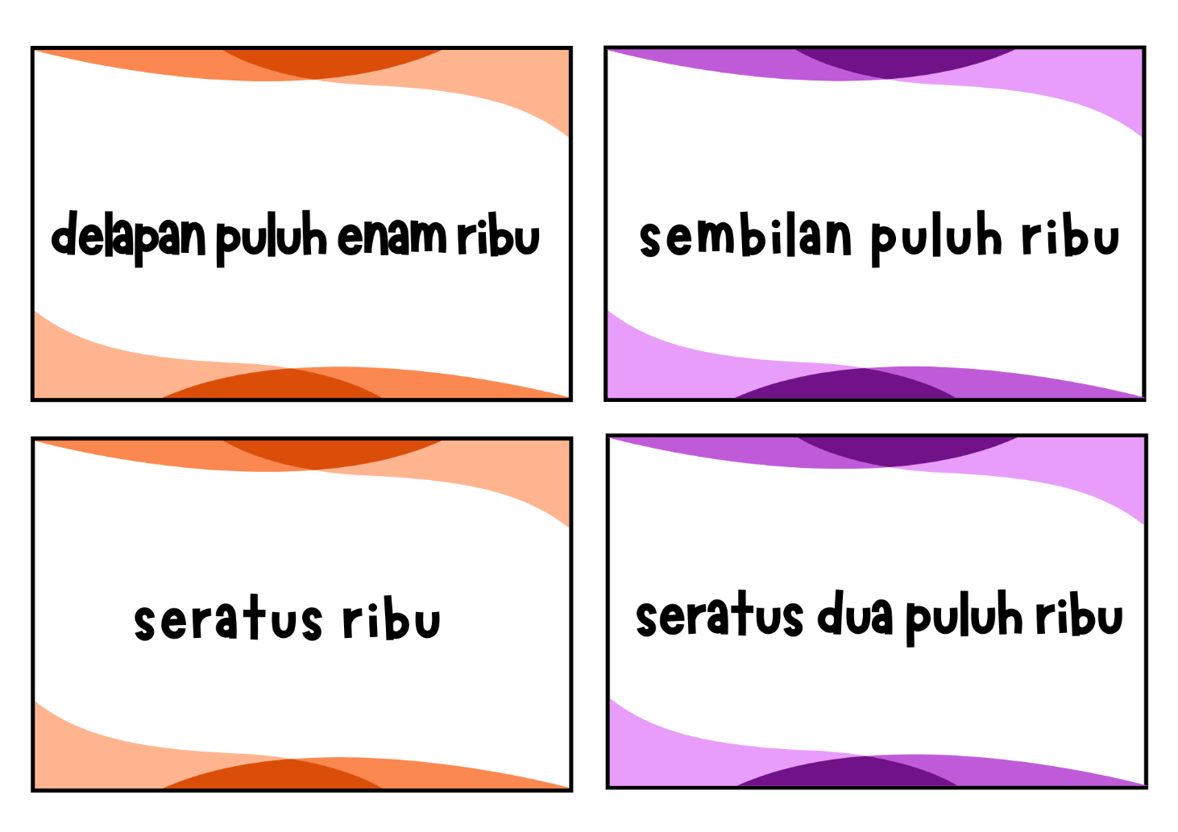
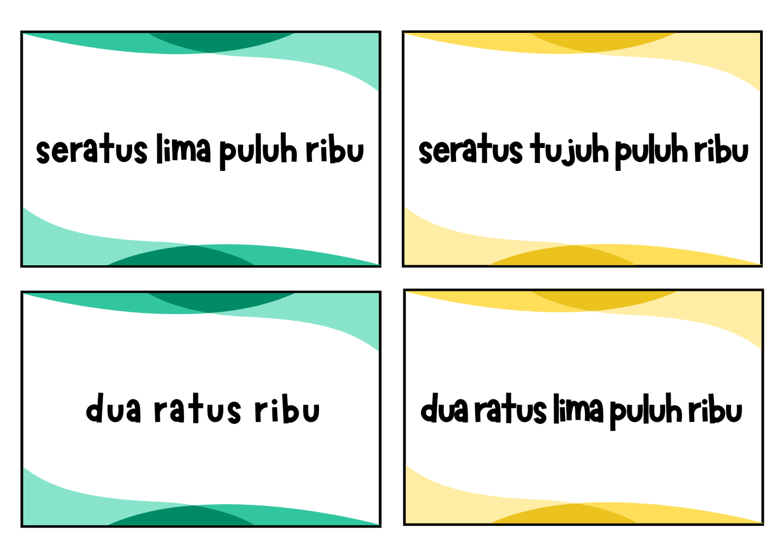
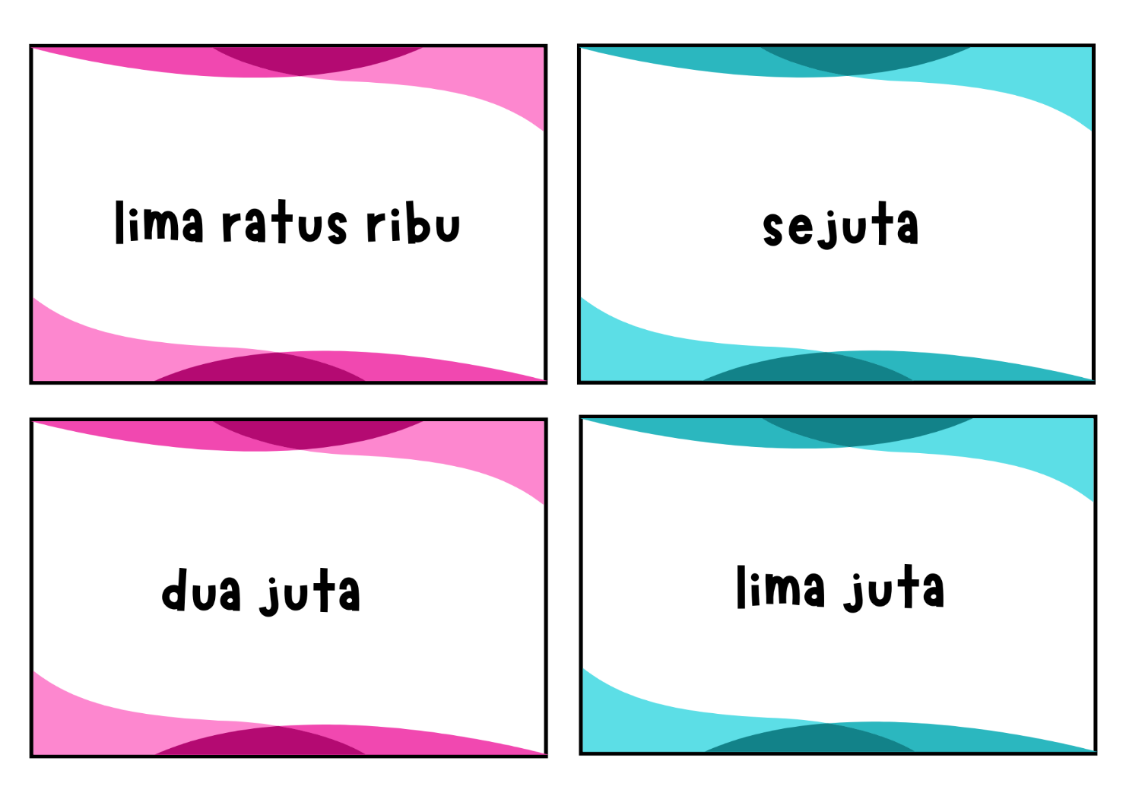

Larger number cards with numerals
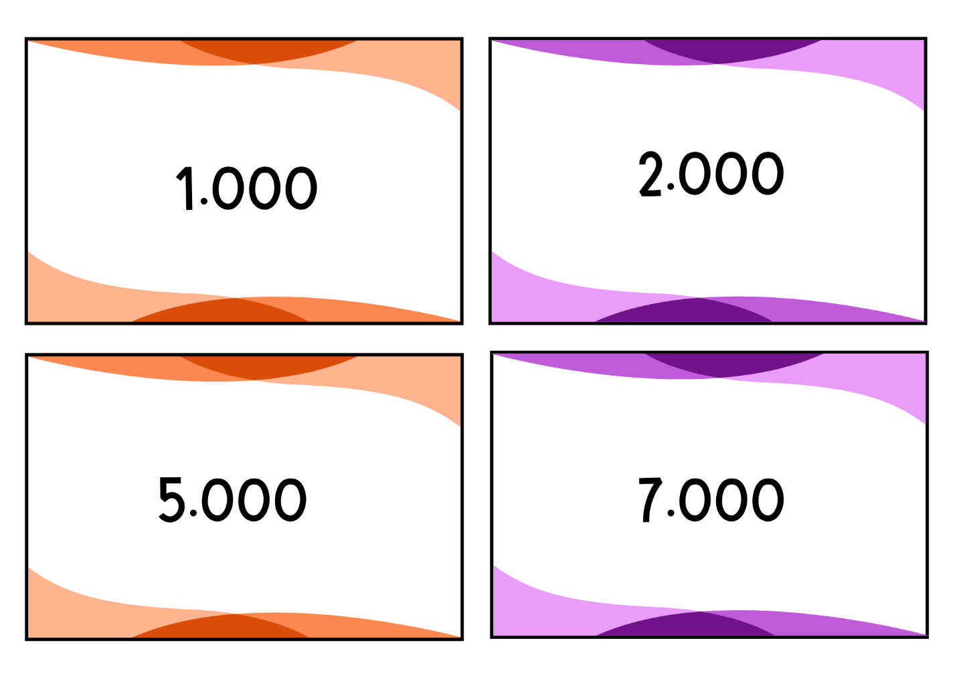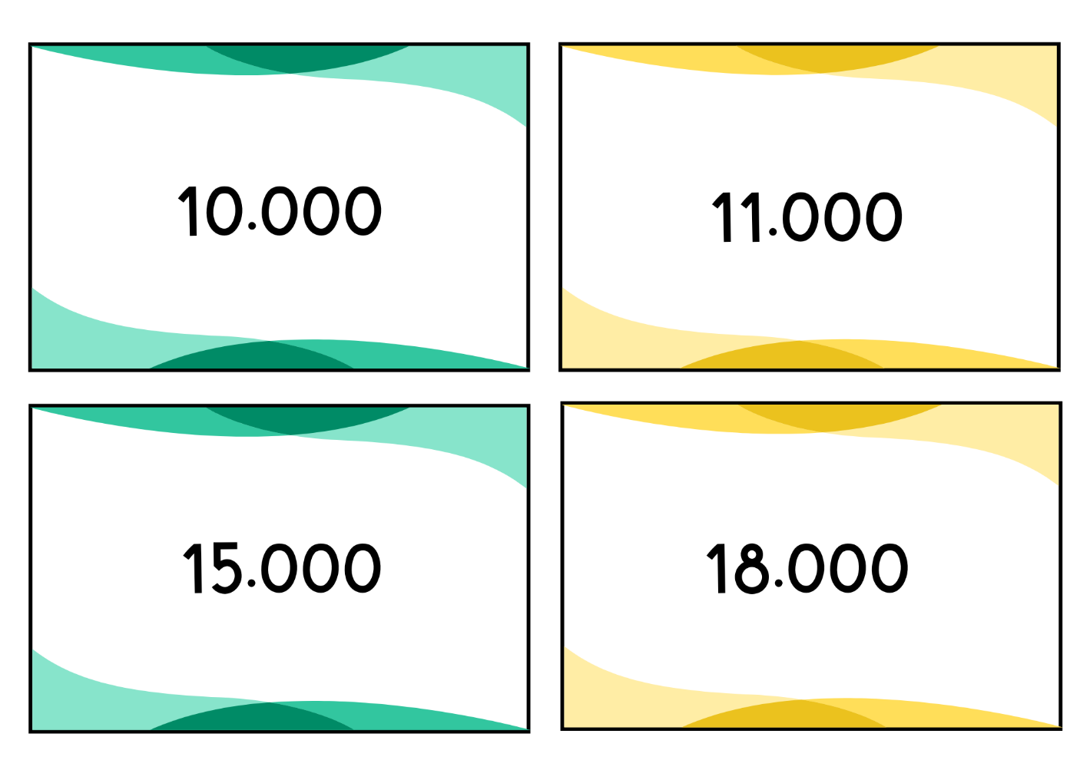
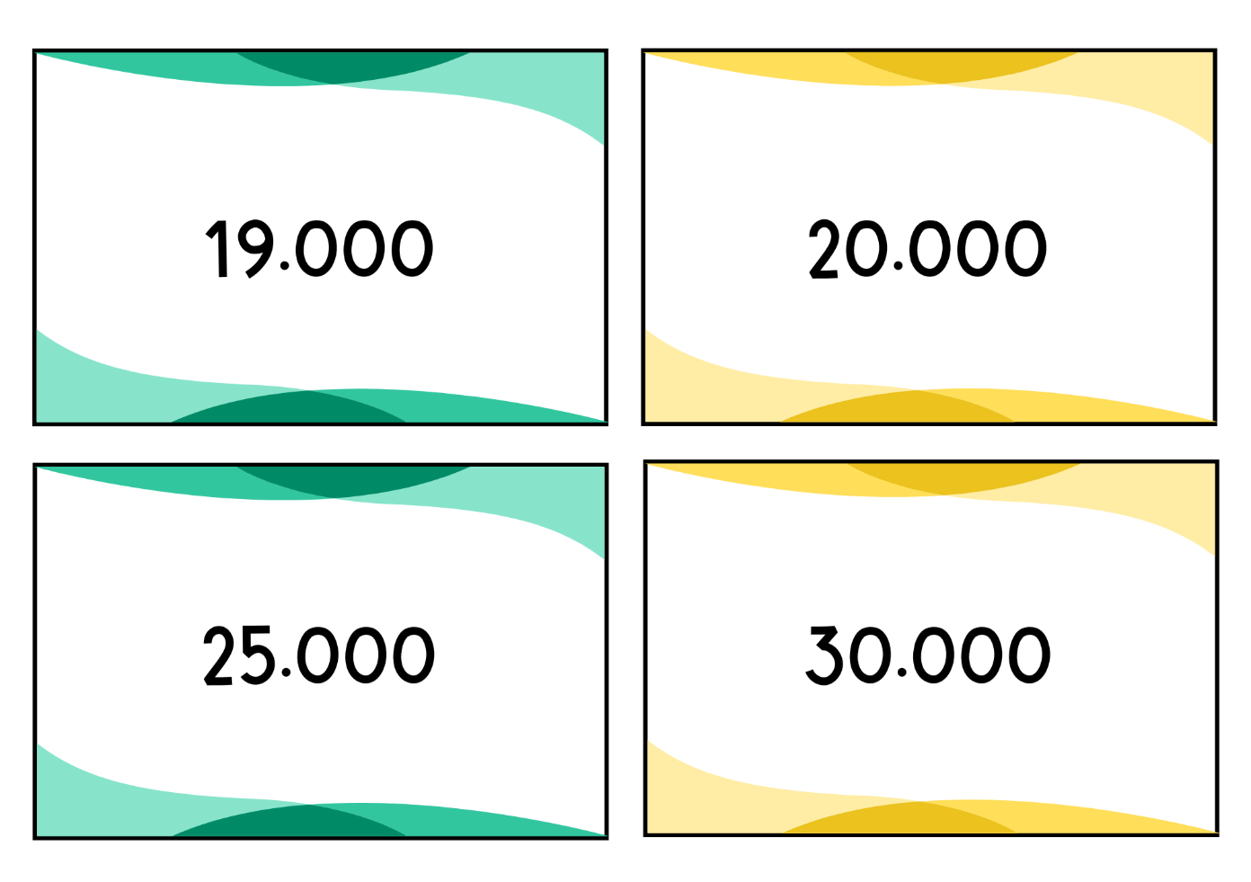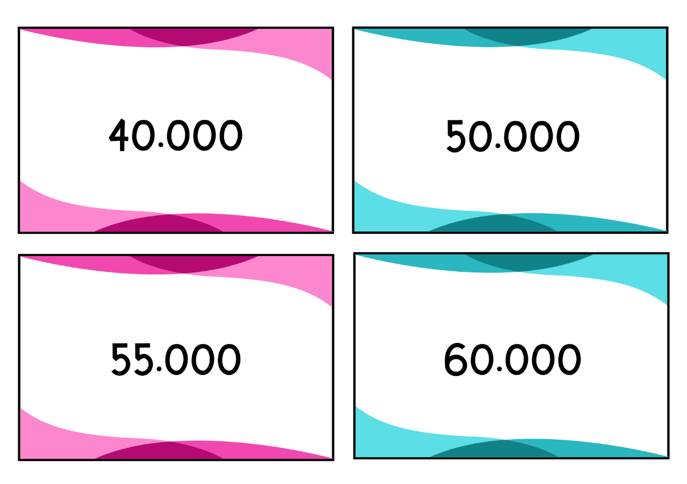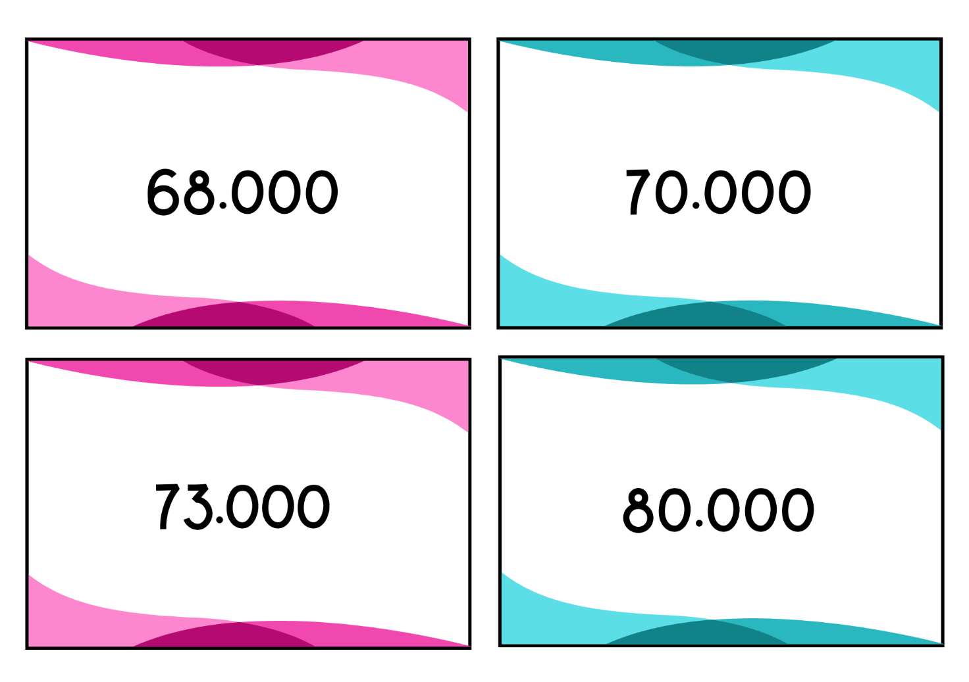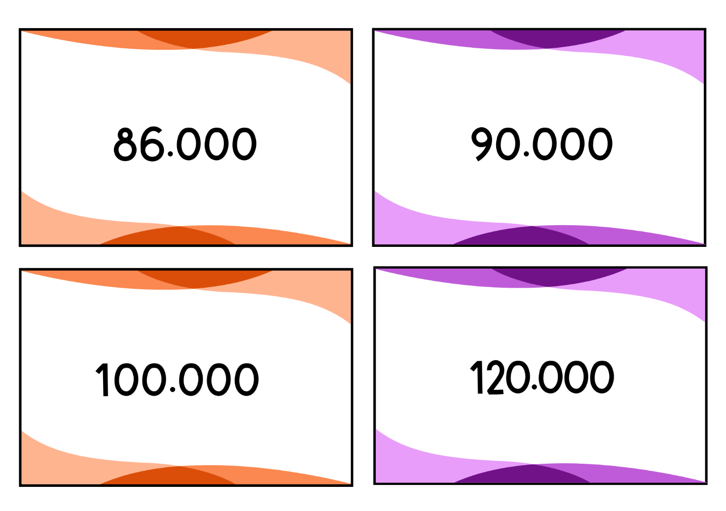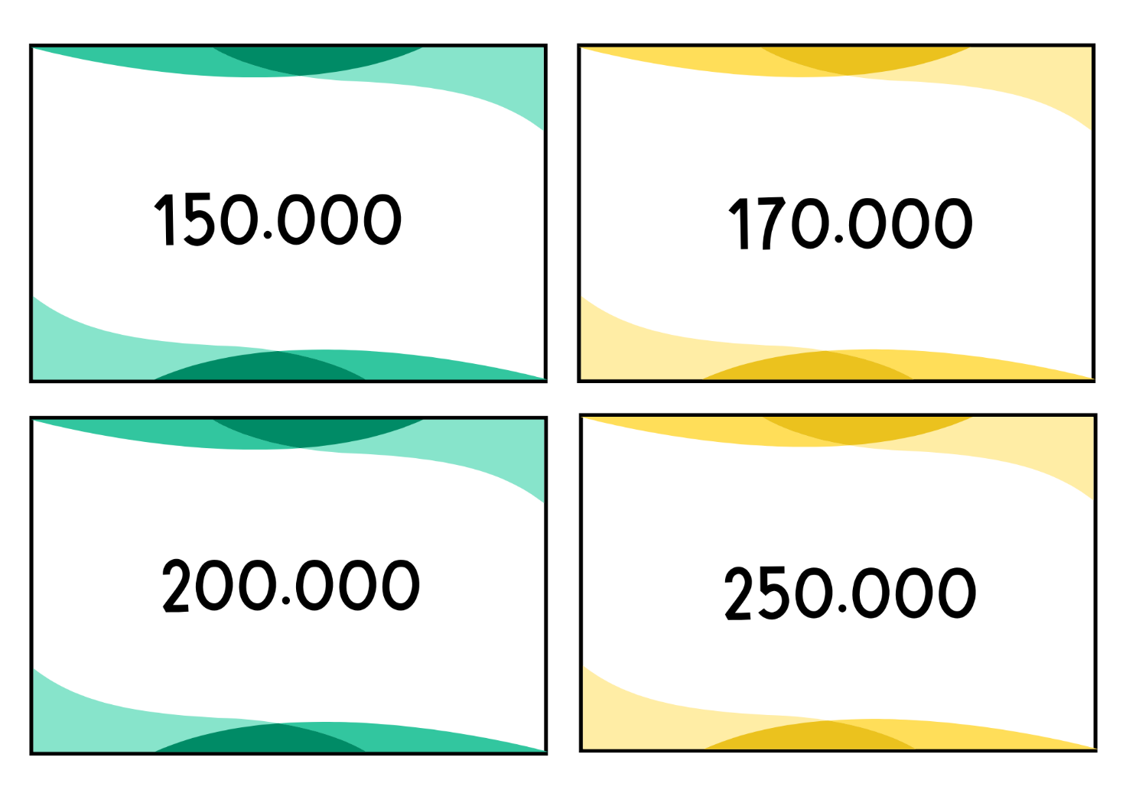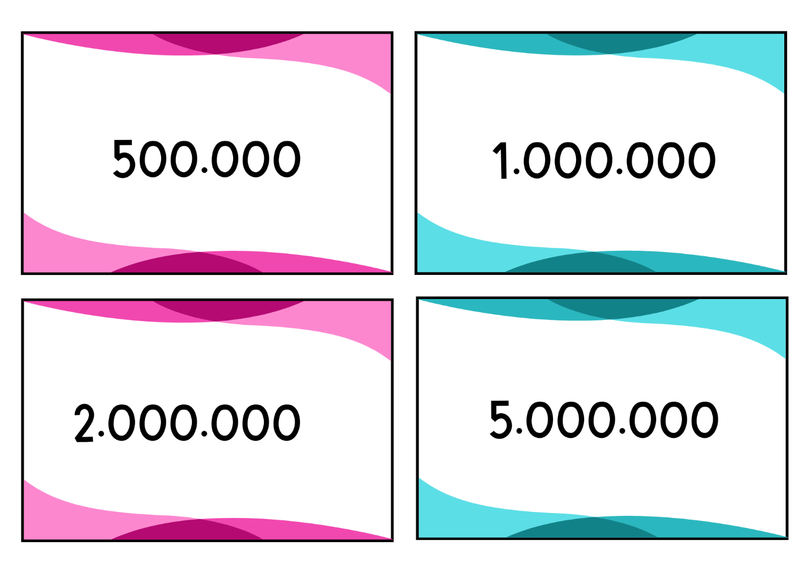
© State of New South Wales (Department of Education), 2024
The copyright material published in this resource is subject to the Copyright Act 1968 (Cth) and is owned by the NSW Department of Education or, where indicated, by a party other than the NSW Department of Education (third-party material).
Copyright material available in this resource and owned by the NSW Department of Education is licensed under a Creative Commons Attribution 4.0 International (CC BY 4.0) license.
This license allows you to share and adapt the material for any purpose, even commercially.
Attribution should be given to © State of New South Wales (Department of Education), 2024.
Material in this resource not available under a Creative Commons license:
- the NSW Department of Education logo, other logos and trademark-protected material
- material owned by a third party that has been reproduced with permission. You will need to obtain permission from the third party to reuse its material.
Links to third-party material and websites
Please note that the provided (reading/viewing material/list/links/texts) are a suggestion only and implies no endorsement, by the New South Wales Department of Education, of any author, publisher, or book title. School principals and teachers are best placed to assess the suitability of resources that would complement the curriculum and reflect the needs and interests of their students.
If you use the links provided in this document to access a third-party's website, you acknowledge that the terms of use, including licence terms set out on the third-party's website apply to the use which may be made of the materials on that third-party website or where permitted by the Copyright Act 1968 (Cth). The department accepts no responsibility for content on third-party websites.

