Smaller number revision
This resource is for the teacher. It provides the content and instructions you need to share with students.
Below is a range of activities which can be completed with students to revise smaller numbers
(0 to 20).
Choose to complete as many or as few activities as required with students, to consolidate prior learning. Detailed instructions for each activity are found below.
Some of the activities require the use of number cards. Use the smaller number playing cards provided or use the editable version on Canva.

Activity 1 – Memory
This game can be played in small groups or pairs. Ensure each group or pair receives one set of the numeral cards and one set of the number cards with Indonesian words. Students shuffle both sets of cards and place them face down, spread out across the desk. Students then take turns to turn 2 cards over. If the cards match, they keep that pair. If they don’t match, students place them back down on the table, in the same position. The student with the most pairs at the end of the game, wins. Encourage students to pronounce the numbers on the cards, as they turn them over.

Activity 2 – Grab it
This game can be played in small groups or pairs. Ensure each group or pair receives one set of the numeral cards only and places them face up on the desk. Call out a number in the target language. Students race each other to find the correct card, winning themselves a point. Then, the card is returned to the middle. The student in each group with the most points at the end of the game wins.

Activity 3 – Patterns
This game can be played in small groups or pairs. Ensure each group or pair is given a set of the number cards with Indonesian words. Students place cards face up on the desk. Call out what you would like each group to bring to the front. For example, all of the odd numbers, multiples of 3, the answer to simple sums, and so on. The group whose representative brings the correct response(s) to the front of the class first, wins a point for their team. This game can be played at desks, if preferred, with the teacher walking around checking answers.

Activity 4 – Liar
This game is played in small groups. Give each student in the group their own set of numeral cards. Students put all their cards face down on the desk, in the middle of the group, and mix them up. Each student then takes 20 cards, leaving no cards on the desk. Then, the ‘Liar’ game begins. The youngest student in each group goes first. Students must put down the cards in numerical order, face down on the desk, and must say that number out loud in Indonesian. For example, the first student should place the 1 card face down in the middle and say satu in Indonesian. Then, the next student must place the 2 card down and say dua in Indonesian. If a student doesn't have the next card in the sequence, they must put down another card and lie, saying the next number in the sequence, regardless of what is on their card. If at any point during the game, a student thinks another student is lying, they accuse them by saying Pembohong! (Liar!). If they are correct, then the student who lied must pick up all the cards in the middle. If a student accuses another student of being a liar, but they did not lie, then the accuser must pick up all the cards in the middle. As there are multiple sets of cards in play, the sequence returns to 1 after the 20 card is placed down. The sequence continues until one of the students has no cards left. The student who successfully discards all their cards in the middle first is the winner.

Activity 5 – Rip bingo
This game is a variation of bingo. The game is played individually, with students competing against their classmates. Students are given a blank strip of paper, approximately the size of one quarter of an A4 piece of paper. Students write down 5 numerals in one row on their paper. For example, 3, 12, 7, 8, 19. Begin calling out numbers in Indonesian. Students tear off the number they hear, but only if it is at either edge of the sequence on their strip of paper. If the number is not at the edge of their strip, students must wait and hope that the number gets called again later, once they have removed the numbers before or after it. If students have one number left, when their remaining number is called, they can tear their final number in half and win the game.

Activity 6 – Let’s say them all!
This game is played as a whole class. Students must count from 0 to 20, in Indonesian. The first student starts out by calling zero (nol) in Indonesian. Then, the next student must say one (satu) in Indonesian. The game is made challenging, as students must participate at random, but with no 2 students speaking at the same time. If 2 students call out at the same time, the game starts again from zero. Likewise, if a number is skipped, or mispronounced, the game starts again. Students are not permitted to use gestures or repeat the order that they have participated in previously. Each time the game begins again, a new student must start the sequence. The class ‘wins’ against the teacher if they can say the numbers 0 to 20 in sequential order correctly.

Activity 7 – What’s your number?
Students work individually for this activity using mini whiteboards. If mini whiteboards are not available, students can use a blank piece of paper. Say a pretend phone number, in Indonesian. Students must write the phone number in numeral format on their whiteboard. Once they have written the phone number correctly, they hold up their whiteboard. Students race against their peers to be the first student to write the phone number correctly and win a point. Depending on students’ level, switch from saying the phone number in Indonesian or English. If saying the phone number in English, students must write out the Indonesian word for each number.

Activity 8 – Move it and make it!
This game is best played outside. It functions not only as a great way to revise numbers, but also a brain break activity. Students find a space outside. Say 2 numbers in Indonesian. The first number represents how many students should be in each group. Be mindful of saying numbers which are easily formed based on the number of students in the class, so students are not left out. The second number represents the shape students should make. For example, if the numbers 3 and 10 are said, students must form groups of 3, and then in their groups, use their bodies to create the number 10.

Number playing cards – numerals
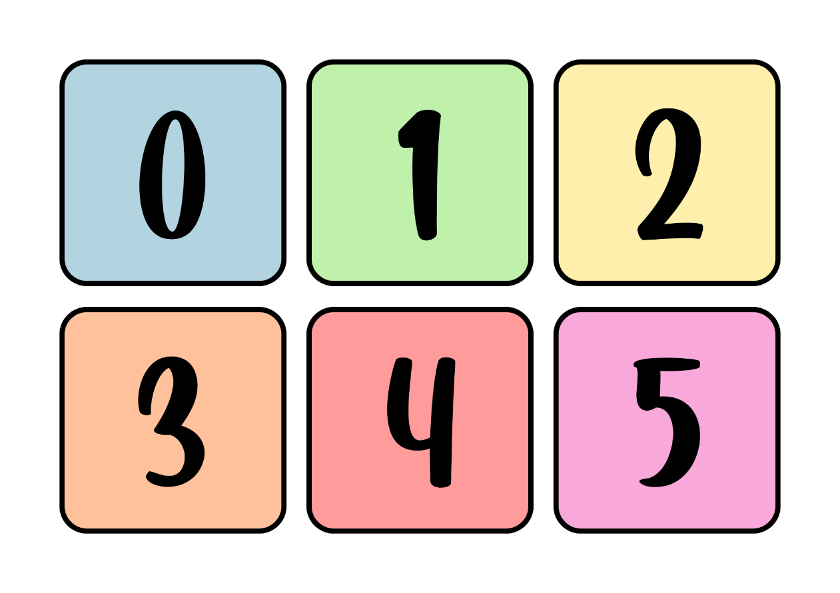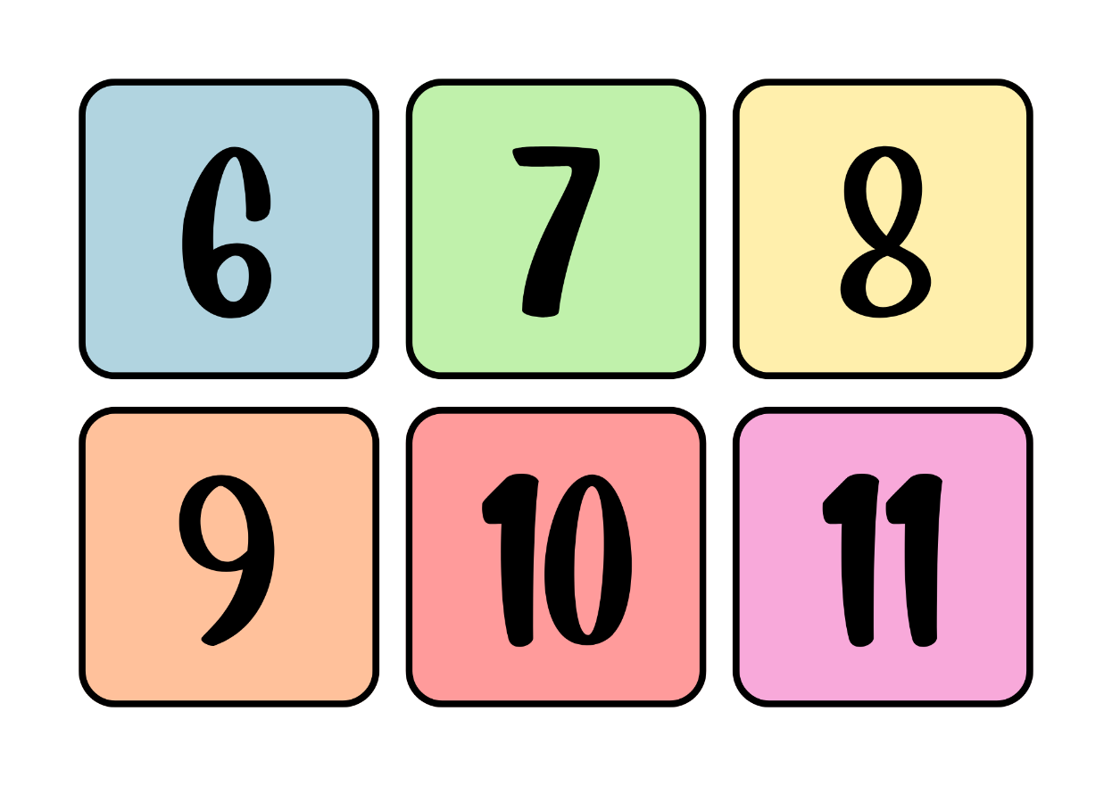
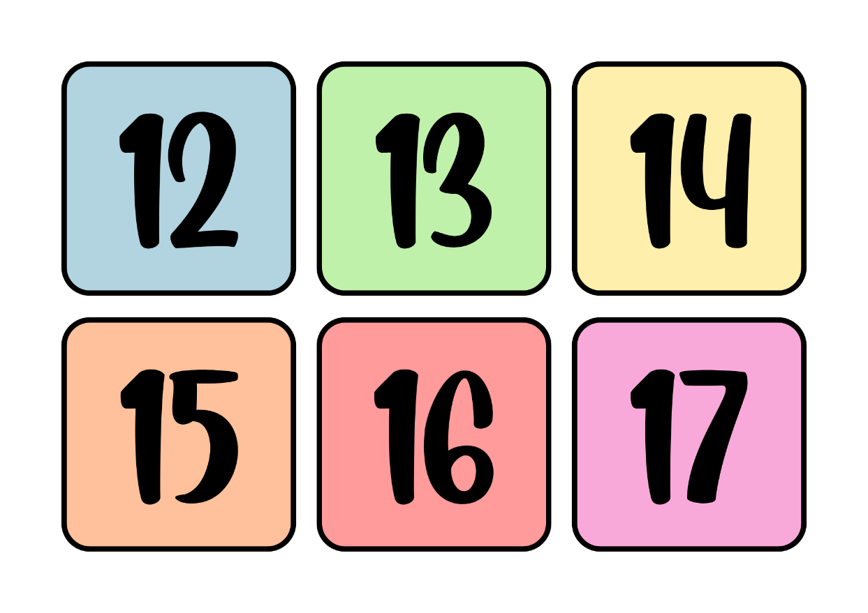
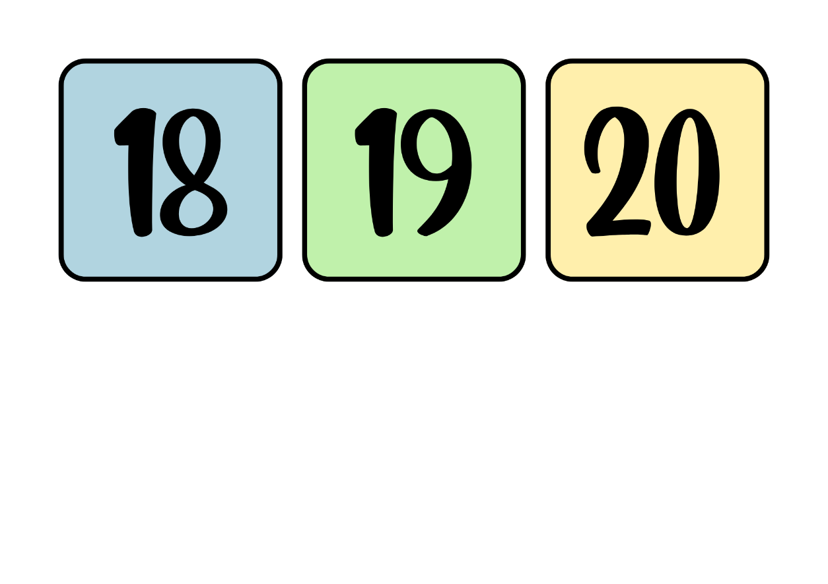

Number playing cards – Indonesian words
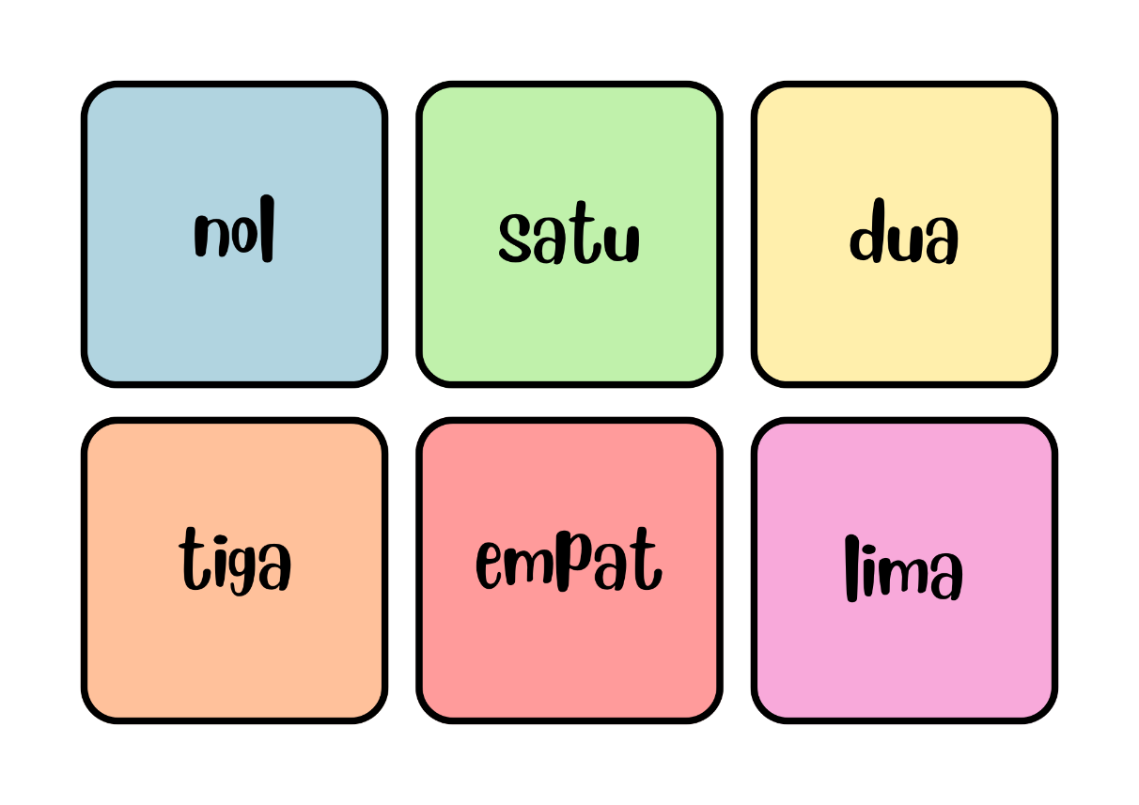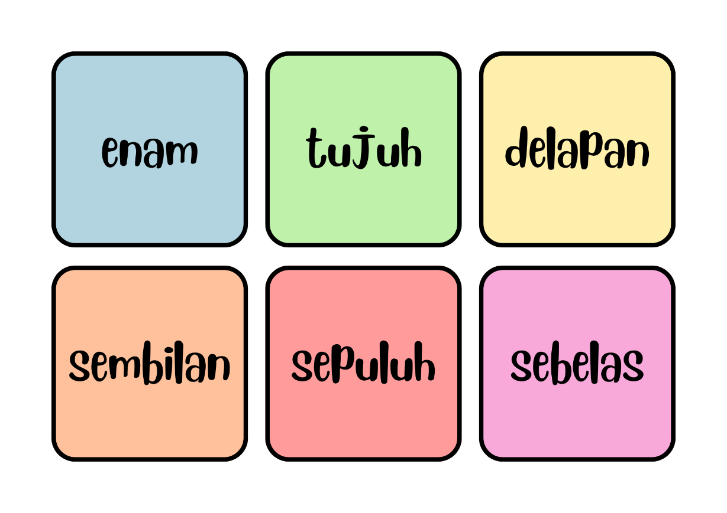

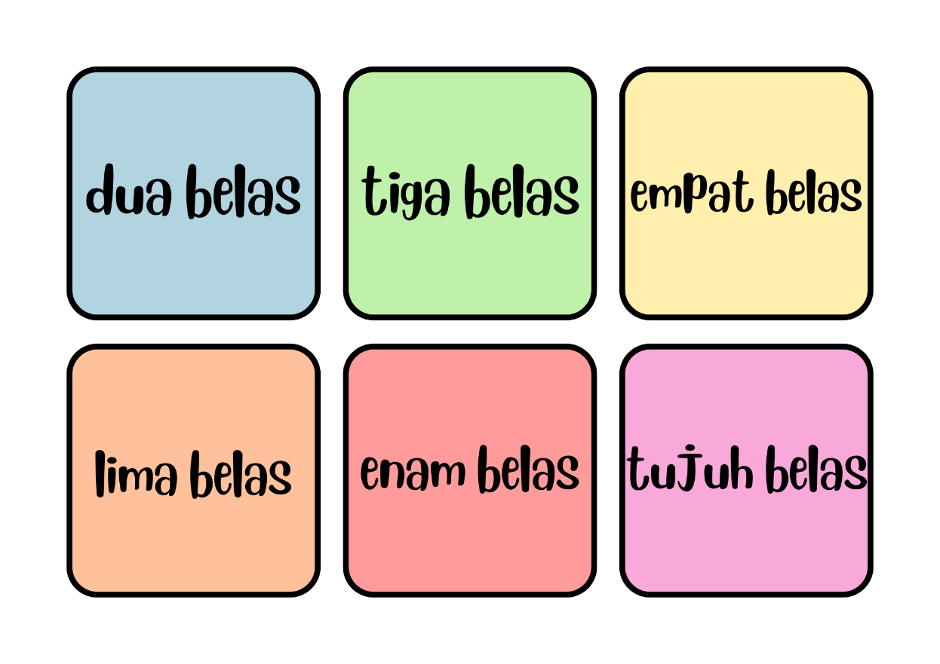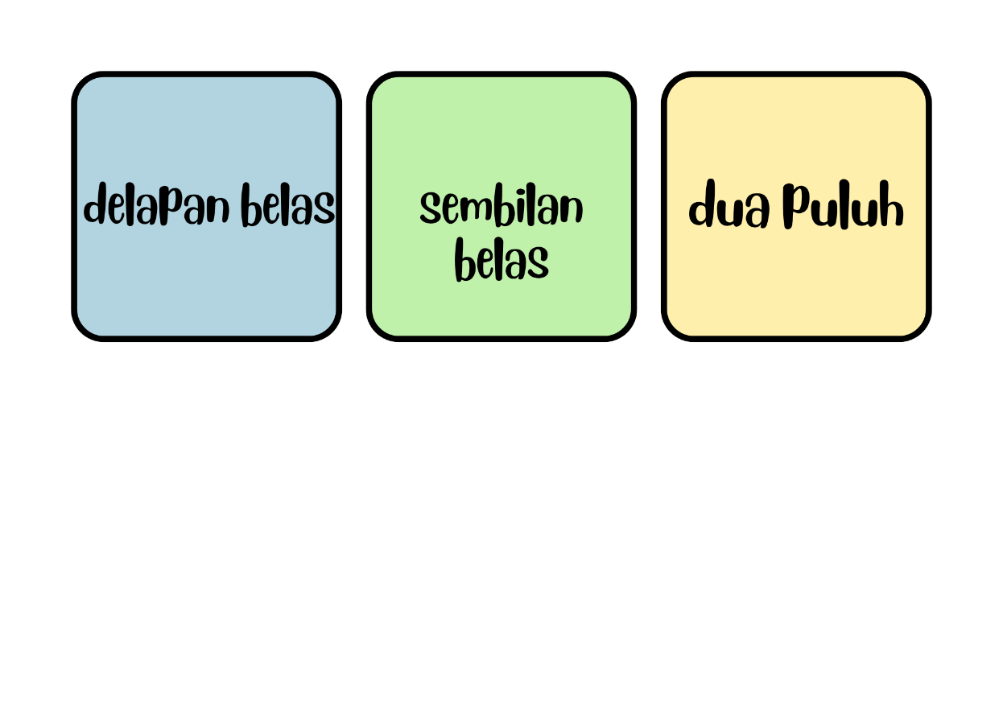

© State of New South Wales (Department of Education), 2024
The copyright material published in this resource is subject to the Copyright Act 1968 (Cth) and is owned by the NSW Department of Education or, where indicated, by a party other than the NSW Department of Education (third-party material).
Copyright material available in this resource and owned by the NSW Department of Education is licensed under a Creative Commons Attribution 4.0 International (CC BY 4.0) license.
This license allows you to share and adapt the material for any purpose, even commercially.
Attribution should be given to © State of New South Wales (Department of Education), 2024.
Material in this resource not available under a Creative Commons license:
- the NSW Department of Education logo, other logos and trademark-protected material
- material owned by a third party that has been reproduced with permission. You will need to obtain permission from the third party to reuse its material.
Links to third-party material and websites
Please note that the provided (reading/viewing material/list/links/texts) are a suggestion only and implies no endorsement, by the New South Wales Department of Education, of any author, publisher, or book title. School principals and teachers are best placed to assess the suitability of resources that would complement the curriculum and reflect the needs and interests of their students.
If you use the links provided in this document to access a third-party's website, you acknowledge that the terms of use, including licence terms set out on the third-party's website apply to the use which may be made of the materials on that third-party website or where permitted by the Copyright Act 1968 (Cth). The department accepts no responsibility for content on third-party websites.

