Ages and numbers

Activity 1
Write the Italian word for each number in the second column. In the third column, use this number in a sentence in response to the question Quanti anni hai? or Quanti hanni ha? to revise saying people’s ages. Use the prompt in the table: io (I), lui (he), lei (she), to formulate the correct response. The first 3 have been done for you as examples.
Remember to drop the vowel ‘a’ from the multiple of 10 before adding ‘uno’ or ‘otto’.
Number | Numero | Quanti anni hai?Quanti anni ha?
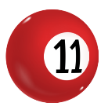 | undici | (io)  Ho undici anni.
 | due | (lei)  Ha due anni.
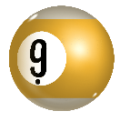 | nove | (lui)  Ha nove anni.
 |  | (io)
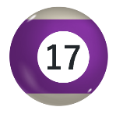 |  | (lui)
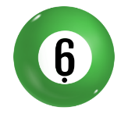 |  | (lei)
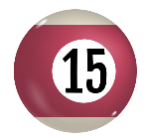 |  | (io)
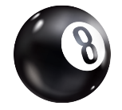 |  | (lui)
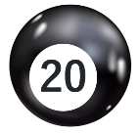 |  | (io)
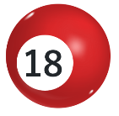 |  | (lui)
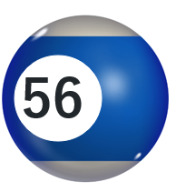 |  | (io)
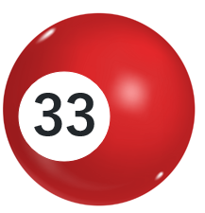 |  | (lui)
 |  | (lei)
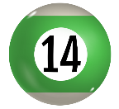 |  | (io)
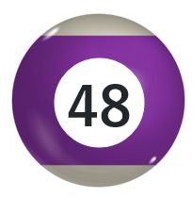 |  | (lui)
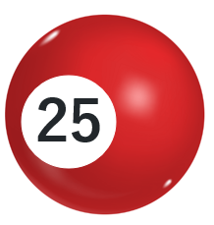 |  | (io)
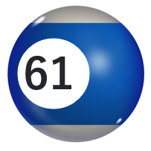 |  | (lei)
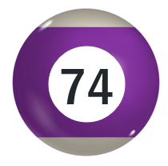 |  | (io)
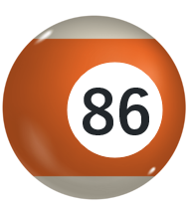 |  | (lui)
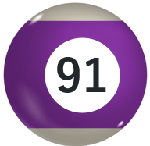 |  | (lei)

Activity 2
Write the next number in each sequence in Italian.
- uno, due, _________________________
- tre, sei, _________________________
- dodici, undici, _________________________
- sei, sette, _________________________
- due, quattro, _________________________
- cinque, sette, _________________________
- undici, ventidue, trentatre, _________________________
- cento, ottantacinque, settanta, _________________________
- sette, quattordici, _________________________, _________________________, trentacinque

Activity 3
Solve the following sums and write the answer in Italian.
- undici + cinquanta = _________________________
- sei + trenta = _________________________
- undici – cinque = _________________________
- quattro + quattordici = _________________________
- cinque + dodici = _________________________
- trentadue + quaranta = _________________________

For the teacher
Remove this section before sharing this resource with students.

Activity 1
Number | Numero | Quanti anni hai?Quanti anni ha?
 | undici | (io)  Ho undici anni.
 | due | (lei)  Ha due anni.
 | nove | (lui)  Ha nove anni.
 | quattro | (io)  Ho quattro anni.
 | diciassette | (lui)  Ha diciassette anni.
 | sei | (lei)  Ha sei anni.
 | quindici | (io)  Ho quindici anni.
 | otto | (lui)  Ha otto anni.
 | venti | (io)  Ho venti anni.
 | diciotto | (lui)  Ha diciotto anni.
 | cinquantasei | (io)  Ho cinquantasei anni.
 | trentatre | (lui)  Ha trentatre anni.
 | diciannove | (lei)  Ha diciannove anni.
 | quattordici | (io)  Ho quattordici anni.
 | quarantotto | (lui)  Ha quarantotto anni.
 | venticinque | (io)  Ho venticinque anni.
 | sessantuno | (lei)  Ha sessantuno anni.
 | settantaquattro | (io)  Ho settantaquattro anni.
 | ottantasei | (lui)  Ha ottantasei anni.
 | novantuno | (lei)  Ha novantuno anni.

Activity 2
- uno, due, tre
- tre, sei, nove
- dodici, undici, dieci
- sei, sette, otto
- due, quattro, sei (otto is also acceptable, if students doubled the numbers)
- cinque, sette, nove
- undici, ventidue, trentatre, quarantaquattro
- cento, ottantacinque, settanta, cinquantacinque
- sette, quattordici, ventuno, ventotto, trentacinque

Activity 3
- undici + cinquanta = sessantuno
- sei + trenta = trentasei
- undici – cinque = sedici
- quattro + quattordici = diciotto
- cinque + dodici = diciassette
- trentadue + quaranta = settantadue

© State of New South Wales (Department of Education), 2024
The copyright material published in this resource is subject to the Copyright Act 1968 (Cth) and is owned by the NSW Department of Education or, where indicated, by a party other than the NSW Department of Education (third-party material).
Copyright material available in this resource and owned by the NSW Department of Education is licensed under a Creative Commons Attribution 4.0 International (CC BY 4.0) license.
This licence allows you to share and adapt the material for any purpose, even commercially. Attribution should be given to © State of New South Wales (Department of Education), 2024.
Material in this resource not available under a Creative Commons licence:
- the NSW Department of Education logo, other logos and trademark-protected material
- material owned by a third party that has been reproduced with permission. You will need to obtain permission from the third party to reuse its material.
Links to third-party material and websites
Please note that the provided (reading/viewing material/list/links/texts) are a suggestion only and implies no endorsement, by the New South Wales Department of Education, of any author, publisher, or book title. School principals and teachers are best placed to assess the suitability of resources that would complement the curriculum and reflect the needs and interests of their students.
If you use the links provided in this document to access a third-party's website, you acknowledge that the terms of use, including licence terms set out on the third-party's website apply to the use which may be made of the materials on that third-party website or where permitted by the Copyright Act 1968 (Cth). The department accepts no responsibility for content on third-party websites.

