At the cinema – Al cinema

Activity 1
Use the movie timetable at Cinema Galassia to answer the following questions in Italian. The first one has been done for you as an example.
- Quale film c’è alle tre e un quarto mercoledì? Mercoledì alle tre e un quarto c’è Barbie.
- Quale film c’è alle nove e mezza venerdì?
- Quale film c’è alle cinque e venti sabato?
- Quale film c’è all’una domenica?
- Quale film c’è alle cinque e venti giovedì?
- Quale film c’è alle sette e dieci giovedì?
- Quale film c’è alle nove e mezza mercoledì?
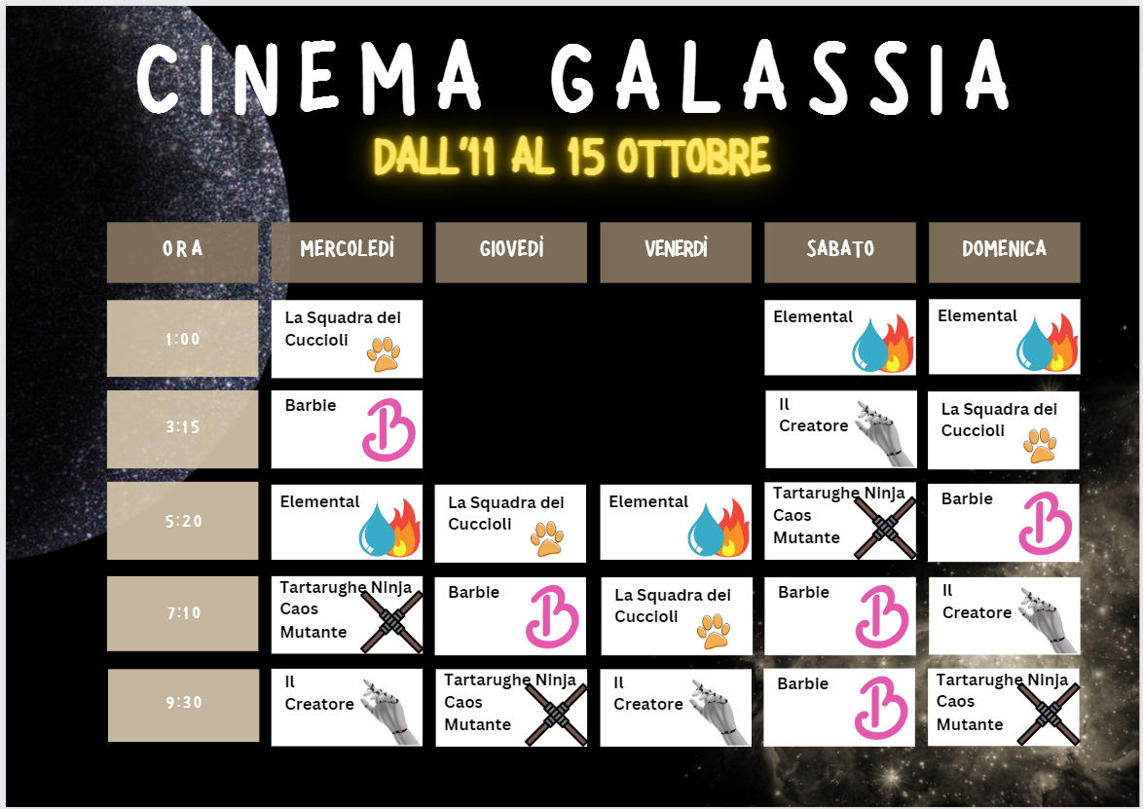

Activity 2
Use the timetable to answer the following questions with the correct time in Italian. The first one has been done for you as an example.
- A che ora comincia il film La Squadra dei Cuccioli mercoledì? Il film comincia all’una.
- A che ora comincia il film Elemental venerdì?
- A che ora comincia il film Il Creatore sabato?
- A che ora comincia il film Tartarughe Ninja Caos Mutante domenica?
- A che ora comincia il film Barbie giovedì?
- A che ora comincia il film Elemental mercoledì?

Activity 3
Choosing from the Cinema Galassia timetable, add 5 movie titles of your choosing in the ‘Film’ column in the table below. For each day of the week, choose a time to see the movie and add it to the ‘Ora’ column. When directed by your teacher, walk around the room until you are told to stop. Wait until your teacher indicates which one of you will ask the question first in each of your interactions (for example, the students nearest the back of the room, or the students in shorts). ‘Talk’ with the nearest person, taking turns to ask and answer what time and which film you have scheduled for each day of the week in the table using the questions Quale film c’è il [day of the week]? and A che ora comincia [film]? You will then be directed to ‘walk’ and repeat the process with the next person for the next day in the table. Continue this process until a time and a film have been filled in for each day.
Film | Giorno della settimana | Ora
 | lunedì
 | martedì
 | mercoledì
 | giovedì
 | venerdì
 | sabato
 | domenica

For the teacher
Remove this section before sharing this resource with students.
You can access an editable version of this resource to amend for your own context. Alternatively, an accessible version of the resource is provided in the table below:
ORA | MERCOLEDÌ | GIOVEDÌ | VENERDÌ | SABATO | DOMENICA
1:00 | La Squadra dei Cuccioli |  |  | Elemental | Elemental
3:15 | Barbie |  |  | Il Creatore | La Squadra dei Cuccioli
5:20 | Elemental | La Squadra dei Cuccioli | Elemental | Tartarughe Ninja Caos Mutante | Barbie
7:10 | Tartarughe Ninja Caos Mutante | Barbie | La Squadra dei Cuccioli | Barbie | Il Creatore
9:30 | Il Creatore | Tartarughe Ninja Caos Mutante | Il Creatore | Barbie | Tartarughe Ninja Caos Mutante

Activity 1
- Barbie
- Il Creatore
- Tartarughe Ninja Caos Mutante
- Elemental
- La Squadra dei Cuccioli
- Barbie
- Il Creatore

Activity 2
- Il film comincia all’una.
- Il film comincia alle cinque e venti.
- Il film comincia alle tre e un quarto.
- Il film comincia alle nove e mezza.
- Il film comincia alle sette e dieci.
- Il film comincia alle cinque e venti.
- Il film comincia alle nove e mezza.

© State of New South Wales (Department of Education), 2024
The copyright material published in this resource is subject to the Copyright Act 1968 (Cth) and is owned by the NSW Department of Education or, where indicated, by a party other than the NSW Department of Education (third-party material).
Copyright material available in this resource and owned by the NSW Department of Education is licensed under a Creative Commons Attribution 4.0 International (CC BY 4.0) license.
This license allows you to share and adapt the material for any purpose, even commercially.
Attribution should be given to © State of New South Wales (Department of Education), 2024.
Material in this resource not available under a Creative Commons license:
- the NSW Department of Education logo, other logos and trademark-protected material
- material owned by a third party that has been reproduced with permission. You will need to obtain permission from the third party to reuse its material.
Links to third-party material and websites
Please note that the provided (reading/viewing material/list/links/texts) are a suggestion only and implies no endorsement, by the New South Wales Department of Education, of any author, publisher, or book title. School principals and teachers are best placed to assess the suitability of resources that would complement the curriculum and reflect the needs and interests of their students.
If you use the links provided in this document to access a third-party's website, you acknowledge that the terms of use, including licence terms set out on the third-party's website apply to the use which may be made of the materials on that third-party website or where permitted by the Copyright Act 1968 (Cth). The department accepts no responsibility for content on third-party websites.

