At what time …? – A che ora…? profile cards

Activity 1
Your teacher will give you a profile card. Imagine you are the person on the card and write your answers to the following questions in Italian:
- Quanti anni hai?
- Dove abiti?
- Come vai a scuola?
- A che ora arrivi a scuola?
- A che ora torni a casa?
- A che ora mangi a scuola?

Activity 2 – find someone who…
In the ‘My answer’ column, write your answers from Activity 1. Next, interact with other class members using the questions from Activity 1 to find someone who has the same answer as you for each question. Write their name in the space provided in the table below. To ask about and say names, remember to use the Come ti chiami? Mi chiamo… structure.
Question | My answer | Matching person’s name

For the teacher
Remove this section before sharing this resource with students.
Print and cut out these cards prior to the activity. Provide each student with a different profile card.
Name: Luisa  Age: 15  City: Palermo  Arrive: 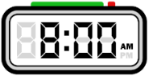  Eat: 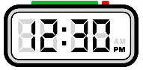  Leave: 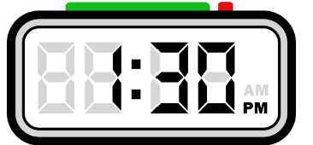  Transport: 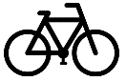 | Name: Jina  Age: 17  City: Palermo  Arrive: 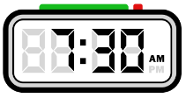  Eat:  Leave: 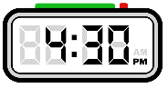  Transport: | Name: Alex  Age: 16  City: Palermo  Arrive:  Eat: 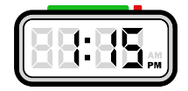  Leave: 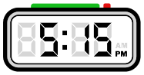  Transport:
Name: Hana  Age: 11  City: Milano  Arrive:  Eat: 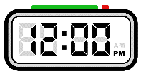  Leave:  Transport: | Name: Ella  Age:14  City: Milano  Arrive:  Eat:  Leave: 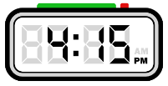  Transport: | Name: Alice  Age: 16  City: Milano  Arrive: 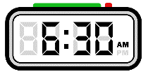  Eat: 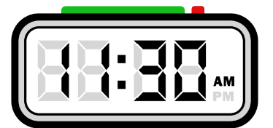  Leave:  Transport:

Name: Mitch  Age: 15  City: Bathurst  Arrive: 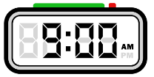  Eat: 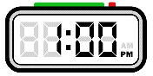  Leave:  Transport: | Name: Karim  Age: 14  City: Bathurst  Arrive: 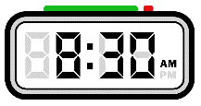  Eat:  Leave: 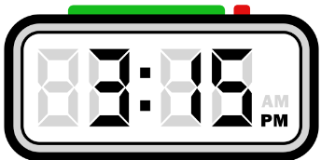  Transport: | Name: Beck  Age:13  City: Bathurst  Arrive:  Eat:  Leave:  Transport:
Name: Matilda  Age: 12  City: Wollongong  Arrive:  Eat:  Leave: 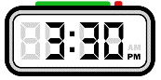  Transport: | Name: Pete  Age: 12  City: Wollongong  Arrive:  Eat:  Leave:  Transport: | Name: Indah  Age: 17  City: Wollongong  Arrive:  Eat:  Leave:  Transport:

Name: Issa  Age: 14  City: Roma  Arrive:  Eat:  Leave:  Transport: | Name: Annisa  Age: 15  City: Roma  Arrive:  Eat:  Leave:  Transport: | Name: Luca  Age: 16  City: Roma  Arrive:  Eat:  Leave:  Transport:
Name: Gianmarco  Age: 13  City: Siena  Arrive:  Eat:  Leave:  Transport: | Name: Pierre  Age: 12  City: Siena  Arrive:  Eat:  Leave:  Transport: | Name: Margot  Age: 14  City: Siena  Arrive:  Eat:  Leave:  Transport:

Name: Celine  Age: 15  City: Katoomba  Arrive:  Eat:  Leave:  Transport: | Name: Colette  Age: 16  City: Katoomba  Arrive:  Eat:  Leave:  Transport: | Name: Chen  Age: 17  City: Katoomba  Arrive:  Eat:  Leave:  Transport:
Name: Lin  Age: 13  City: Sydney  Arrive:  Eat:  Leave:  Transport: | Name: Ben  Age: 14  City: Sydney  Arrive:  Eat:  Leave:  Transport: | Name: Bai  Age: 15  City: Sydney  Arrive:  Eat:  Leave:  Transport:

Name: Huan  Age: 11  City: Napoli  Arrive:  Eat:  Leave:  Transport: | Name: Diego  Age: 13  City: Napoli  Arrive:  Eat:  Leave:  Transport: | Name: Gianna  Age: 12  City: Napoli  Arrive:  Eat:  Leave:  Transport:
Name: Maria  Age: 14  City: Newcastle  Arrive:  Eat:  Leave:  Transport: | Name: Sofia  Age: 11  City: Newcastle  Arrive:  Eat:  Leave:  Transport: | Name: Lola  Age: 16  City: Newcastle  Arrive:  Eat:  Leave:  Transport:

© State of New South Wales (Department of Education), 2024
The copyright material published in this resource is subject to the Copyright Act 1968 (Cth) and is owned by the NSW Department of Education or, where indicated, by a party other than the NSW Department of Education (third-party material).
Copyright material available in this resource and owned by the NSW Department of Education is licensed under a Creative Commons Attribution 4.0 International (CC BY 4.0) license.
This license allows you to share and adapt the material for any purpose, even commercially.
Attribution should be given to © State of New South Wales (Department of Education), 2024.
Material in this resource not available under a Creative Commons license:
- the NSW Department of Education logo, other logos and trademark-protected material
- material owned by a third party that has been reproduced with permission. You will need to obtain permission from the third party to reuse its material.
Links to third-party material and websites
Please note that the provided (reading/viewing material/list/links/texts) are a suggestion only and implies no endorsement, by the New South Wales Department of Education, of any author, publisher, or book title. School principals and teachers are best placed to assess the suitability of resources that would complement the curriculum and reflect the needs and interests of their students.
If you use the links provided in this document to access a third-party's website, you acknowledge that the terms of use, including licence terms set out on the third-party's website apply to the use which may be made of the materials on that third-party website or where permitted by the Copyright Act 1968 (Cth). The department accepts no responsibility for content on third-party websites.

