At what time …? – A che ora…?

Activity 1
Listen to the people talking about their school day. For each statement, tick the boxes with the correct information:
Number | Returns home, eats or arrives at school? | Time
1 | ☐ 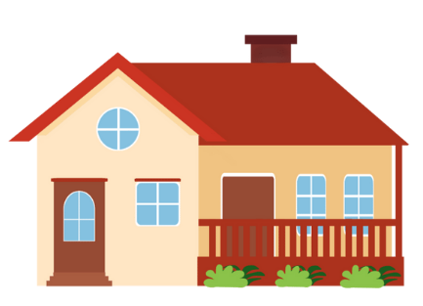  ☐  ☐ | ☐ 7:25  ☐ 7:20  ☐ 8:25
2 | ☐  ☐  ☐ | ☐ 1:00  ☐ 12:00  ☐ 11:00
3 | ☐  ☐  ☐ | ☐ 4:20  ☐ 3:25  ☐ 4:25
4 | ☐  ☐  ☐ | ☐ 7:30  ☐ 8:30  ☐ 9:30
5 | ☐  ☐  ☐ | ☐ 3:15  ☐ 4:00  ☐ 3:20
6 | ☐  ☐  ☐ | ☐ 1:10  ☐ 10:00  ☐ 1:25
7 | ☐  ☐  ☐ | ☐ 9:15  ☐ 4:00  ☐ 9:04
8 | ☐  ☐  ☐ | ☐ 5:20  ☐ 5:25  ☐ 5:05

Activity 2
Use the cues to write a sentence in response to the questions A che ora arrivi a scuola? A che ora torni a casa? A che ora mangi? Use the examples to help you.
Ora | Attività | Frase
7:30 |  | Arrivo a scuola alle sette e mezza.
8:15
8:25
9:00
12:30 |  | Mangio alle dodici e mezza.
1:10
12:00
1:25
3:25 |  | Torno a casa alle tre e venticinque.
4:20
5:15
5:00

Activity 3
Your teacher will provide you with 2 sets of cards – set 1, the ‘arrive at school/get home/eat’ cards and set 2, the ‘time’ cards.
Place the 2 piles of cards face down on the desk. Then use the cards as prompts to interact with each other, asking and responding to the questions. Student A asks: A che ora arrivi a scuola? A che ora mangi a scuola? A che ora torni a casa? Student B responds with the time indicated on the card they picked up. Place the used cards at the bottom of the pile. For example:
Student A draws and asks A che ora arrivi a scuola?
Student B draws 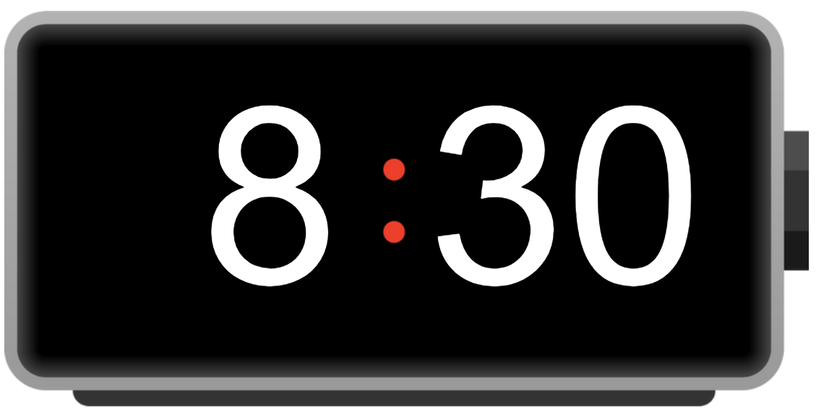 and responds Arrivo a scuola alle otto e mezza.

For the teacher
Remove this section before sharing this resource with students.

Activity 1

Audio file
At what time – Activity 1.mp3 (1:05)

Transcript
- Arrivo a scuola alle otto e venticinque.
- Mangio all’una.
- Torno a casa alle quattro e venticinque.
- Arrivo a scuola alle sette e mezza.
- Torno a casa alle tre e un quarto.
- Mangio all’una e dieci.
- Arrivo a scuola alle nove e un quarto.
- Torno a casa alle cinque e venticinque.
Number | Returns home, eats or arrives at school? | Time
1 | ☐  ☐  ☒ | ☐ 7:25  ☐ 7:20  ☒ 8:25
2 | ☐  ☒  ☐ | ☒ 1:00  ☐ 12:00  ☐ 11:00
3 | ☒  ☐  ☐ | ☐ 4:20  ☐ 3:25  ☒ 4:25
4 | ☐  ☐  ☒ | ☒ 7:30  ☐ 8:30  ☐ 9:30
5 | ☒  ☐  ☐ | ☒ 3:15  ☐ 4:00  ☐ 3:20
6 | ☐  ☒  ☐ | ☒ 1:10  ☐ 10:00  ☐ 1:25
7 | ☐  ☐  ☒ | ☒ 9:15  ☐ 4:00  ☐ 9:04
8 | ☒  ☐  ☐ | ☐ 5:20  ☒ 5:25  ☐ 5:05

Activity 2
Ora | Attività | Frase
7:30 |  | Arrivo a scuola alle sette e mezza.
8:15 |  | Arrivo a scuola alle otto e un quarto.
8:25 |  | Arrivo a scuola alle otto e venticinque.
9:00 |  | Arrivo a scuola alle nove.
12:30 |  | Mangio alle dodici e mezza.
1:10 |  | Mangio all’una e dieci.
12:00 |  | Mangio a mezzogiorno. or Mangio alle dodici.
1:25 |  | Mangio all'una e venticinque.
3:25 |  | Torno a casa alle tre e venticinque.
4:20 |  | Torno a casa alle quattro e venti.
5:15 |  | Torno a casa alle cinque e un quarto.
5:00 |  | Torno a casa alle cinque.

Activity 3
- Provide each group with the 2 sets of cards – set 1, the ‘arrive at school/get home/eat’ cards and set 2, the ‘time’ cards. You will need to cut these up in advance or ask the students to do it for you.
- Students form pairs or groups of 3. Students in a group of 3 can alternate asking and answering the questions.
- Students place the 2 piles of cards face down on the desk. They will use the cards as prompts to interact with each other, asking and responding to the questions. One student will pick up a card from set 1 and ask one of these questions, according to the image on the card: A che ora arrivi a scuola? A che ora mangi a scuola? A che ora torni a casa?
- Another student will then pick up a card from set 2 and respond to the question asked with a sentence using the time indicated on the card they pick up.
Students place the cards they have used at the bottom of the pile.
- Ask students to shuffle the cards and repeat the activity with a different partner if time permits.
Before starting the activity, model an example conversation:
Student A draws and asks A che ora arrivi a scuola?
Student B draws and responds Arrivo a scuola alle otto e mezza.

Cards – set 1 (arrive at school/get home/eat)

Cards – set 2 (time)
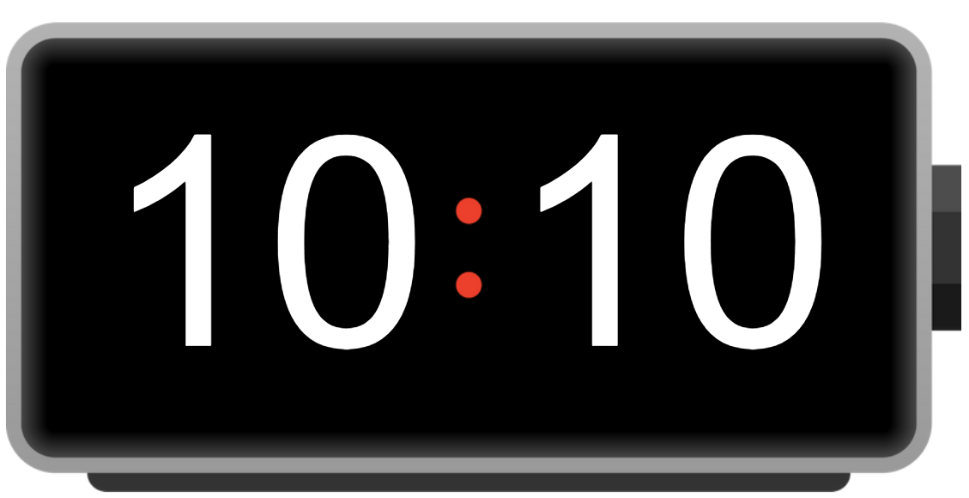 |  | 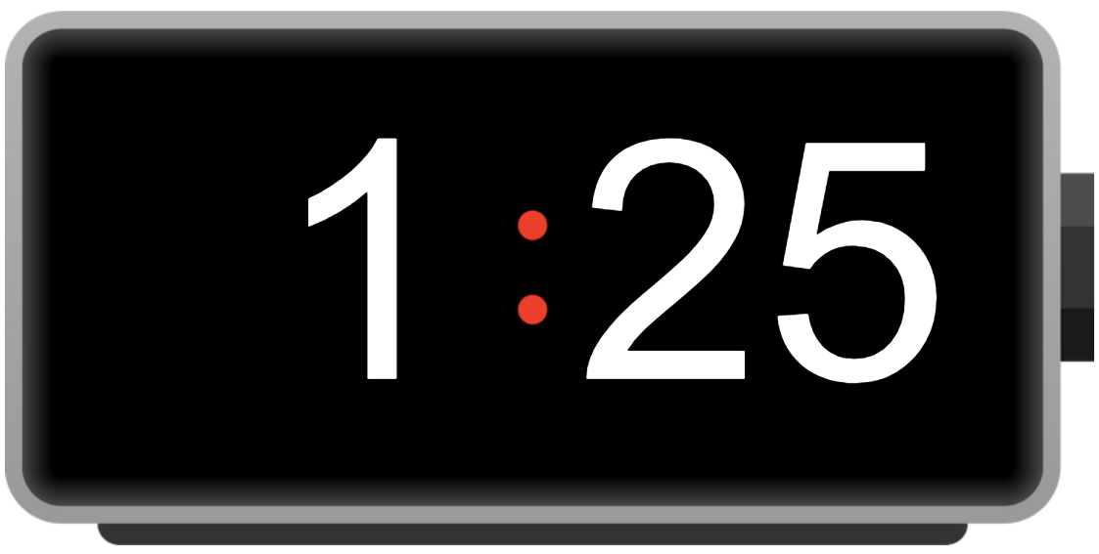
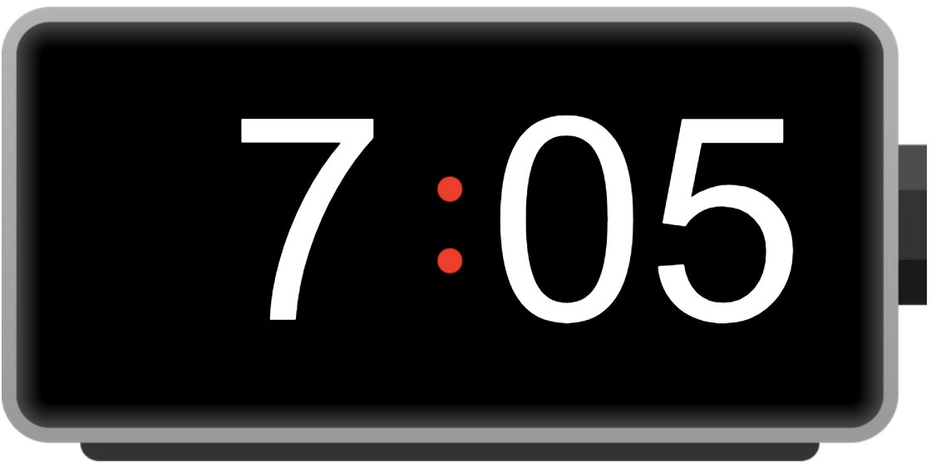 | 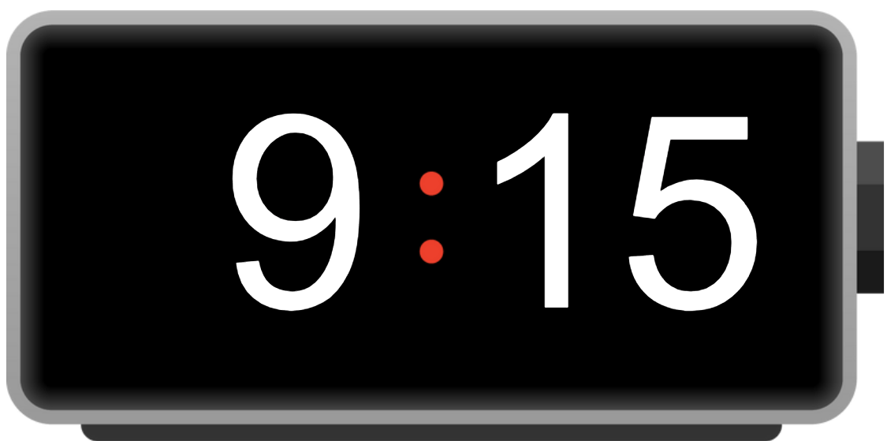 | 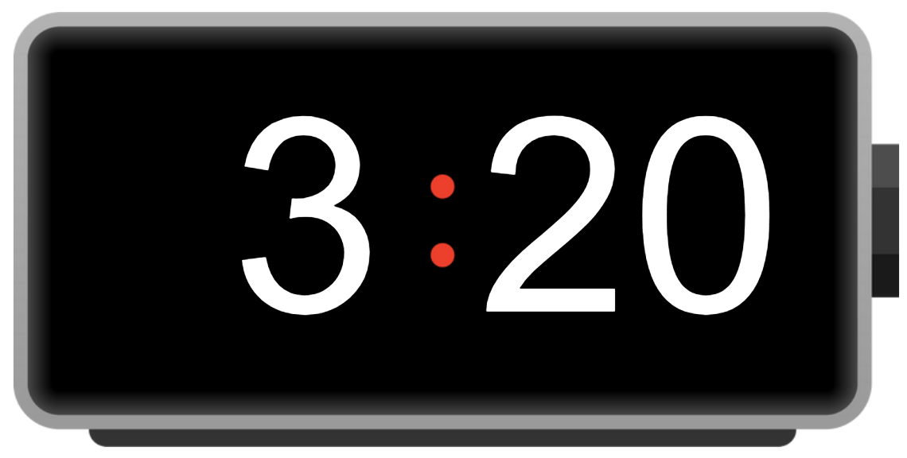
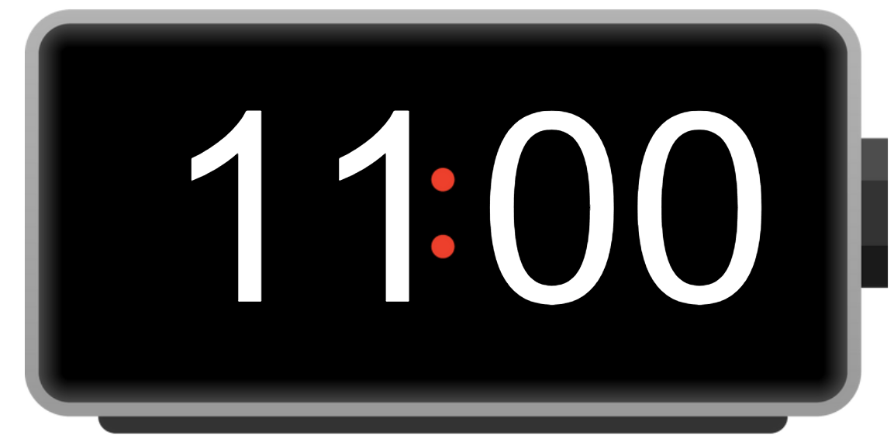 | 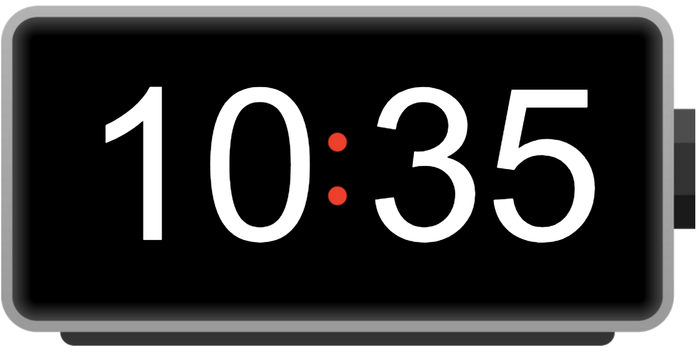 | 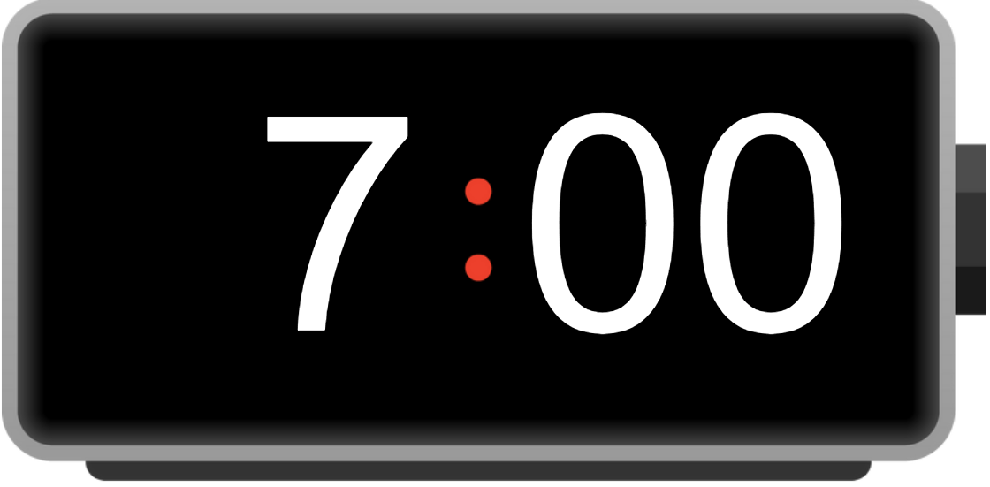
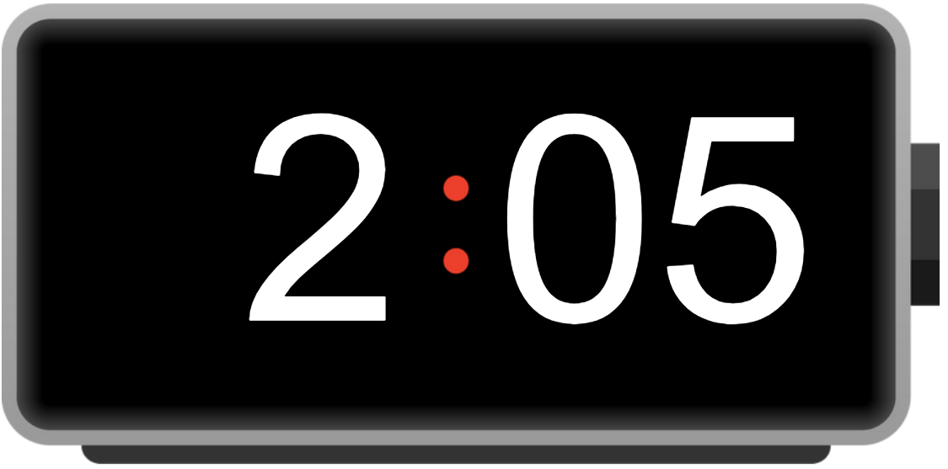 | 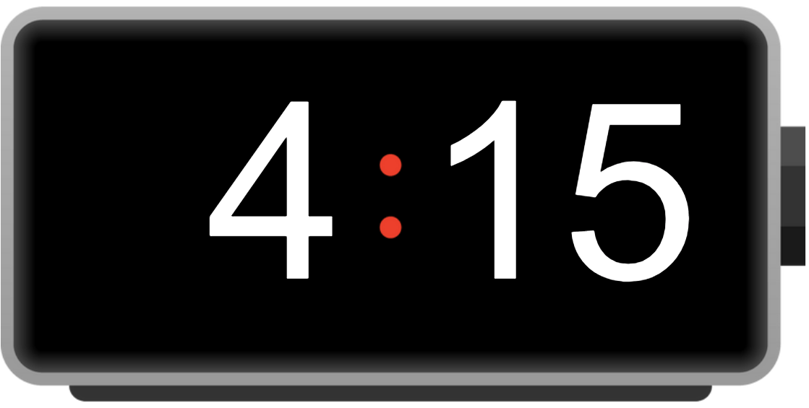 | 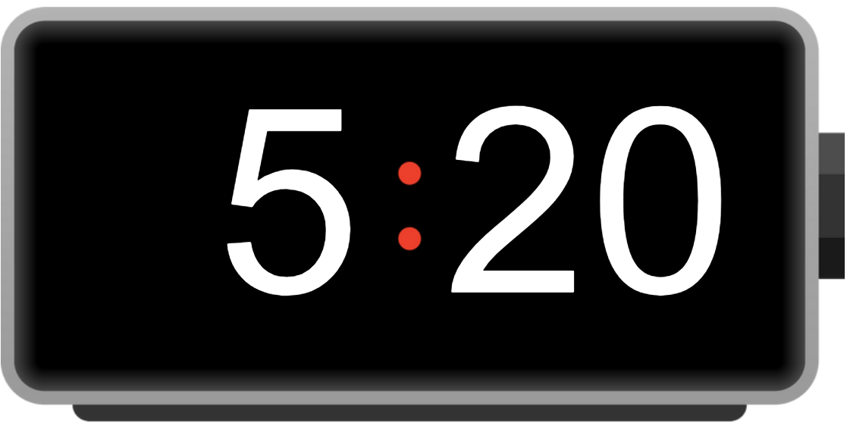
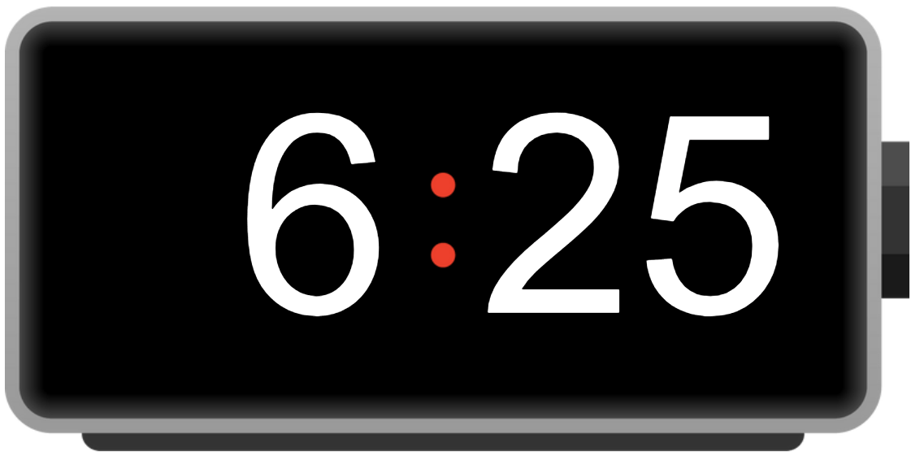 | 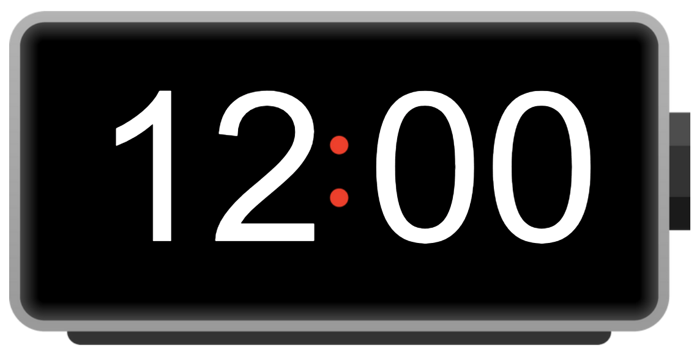 | 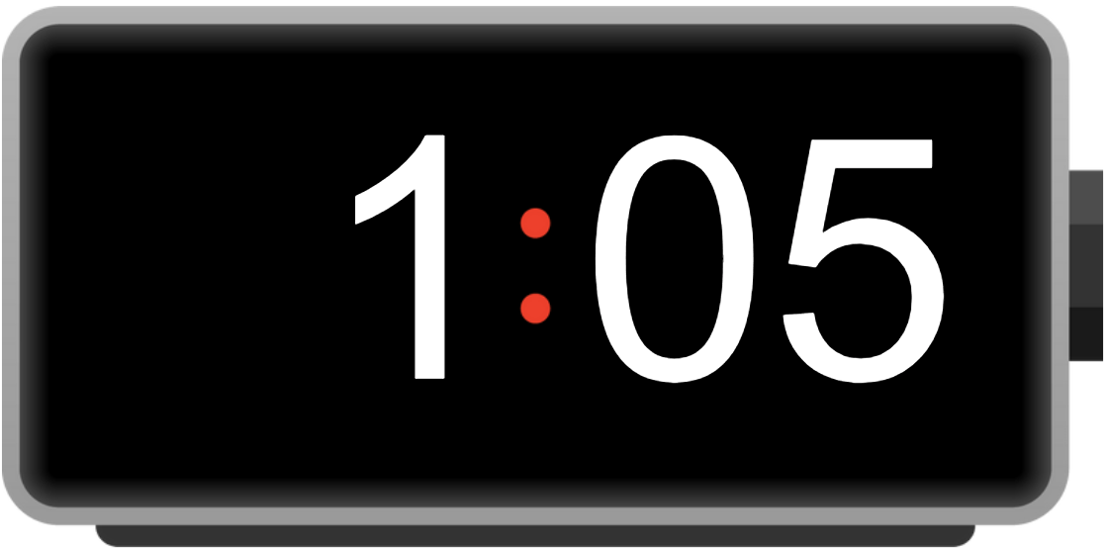
Differentiation examples
Students requiring additional support – provide students with slide 2 from the ‘Sentence builders’ resource (PPTX 1557 KB) to assist them to formulate sentences.

© State of New South Wales (Department of Education), 2024
The copyright material published in this resource is subject to the Copyright Act 1968 (Cth) and is owned by the NSW Department of Education or, where indicated, by a party other than the NSW Department of Education (third-party material).
Copyright material available in this resource and owned by the NSW Department of Education is licensed under a Creative Commons Attribution 4.0 International (CC BY 4.0) license.
This license allows you to share and adapt the material for any purpose, even commercially.
Attribution should be given to © State of New South Wales (Department of Education), 2024.
Material in this resource not available under a Creative Commons license:
- the NSW Department of Education logo, other logos and trademark-protected material
- material owned by a third party that has been reproduced with permission. You will need to obtain permission from the third party to reuse its material.
Links to third-party material and websites
Please note that the provided (reading/viewing material/list/links/texts) are a suggestion only and implies no endorsement, by the New South Wales Department of Education, of any author, publisher, or book title. School principals and teachers are best placed to assess the suitability of resources that would complement the curriculum and reflect the needs and interests of their students.
If you use the links provided in this document to access a third-party's website, you acknowledge that the terms of use, including licence terms set out on the third-party's website apply to the use which may be made of the materials on that third-party website or where permitted by the Copyright Act 1968 (Cth). The department accepts no responsibility for content on third-party websites.

