My school day – Il mio giorno di scuola

Activity 1
Read the blog posts from school students in Italy. Complete the table that follows in English with the required information from each post.
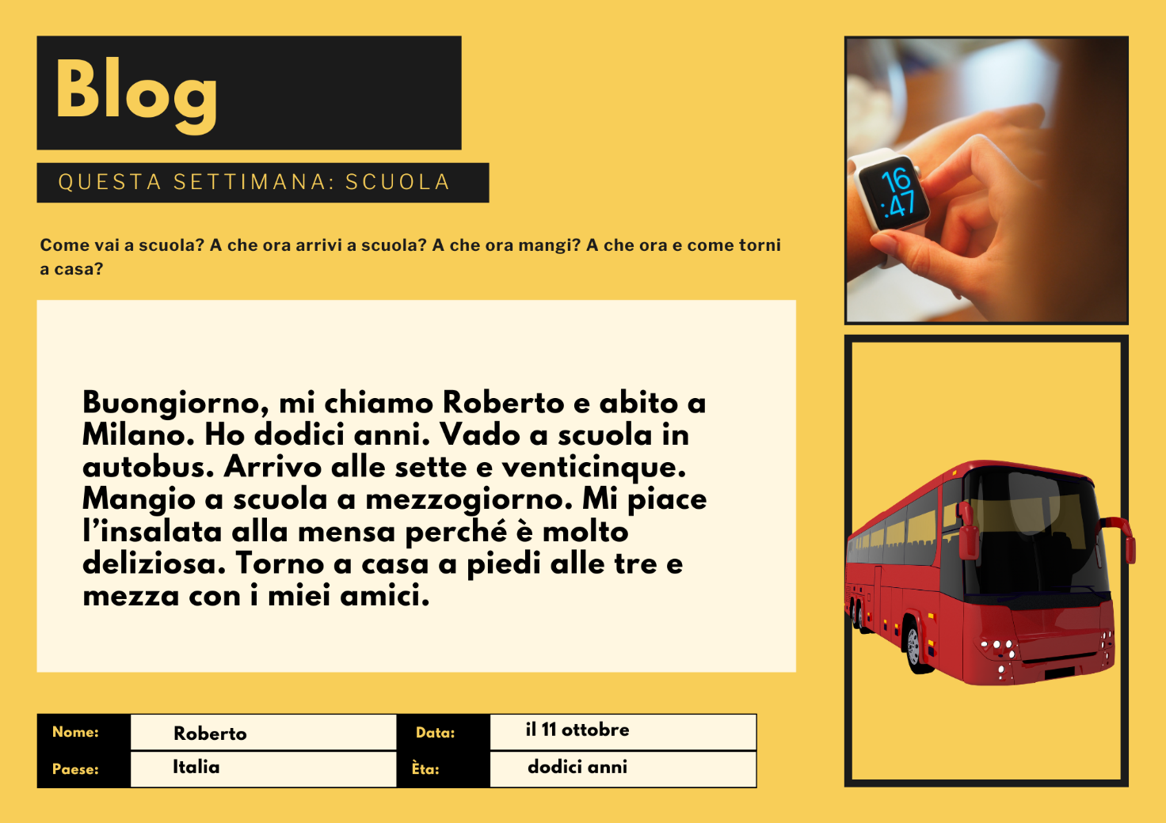
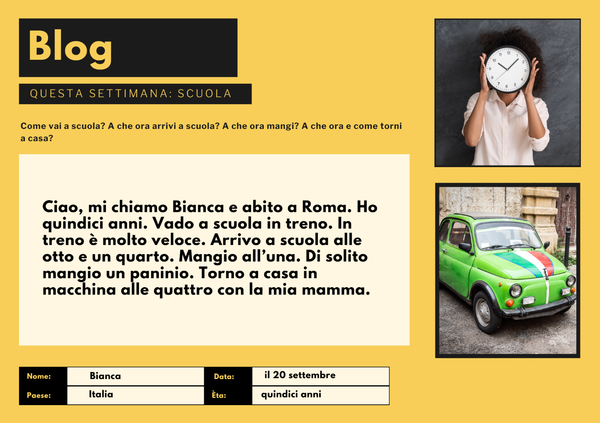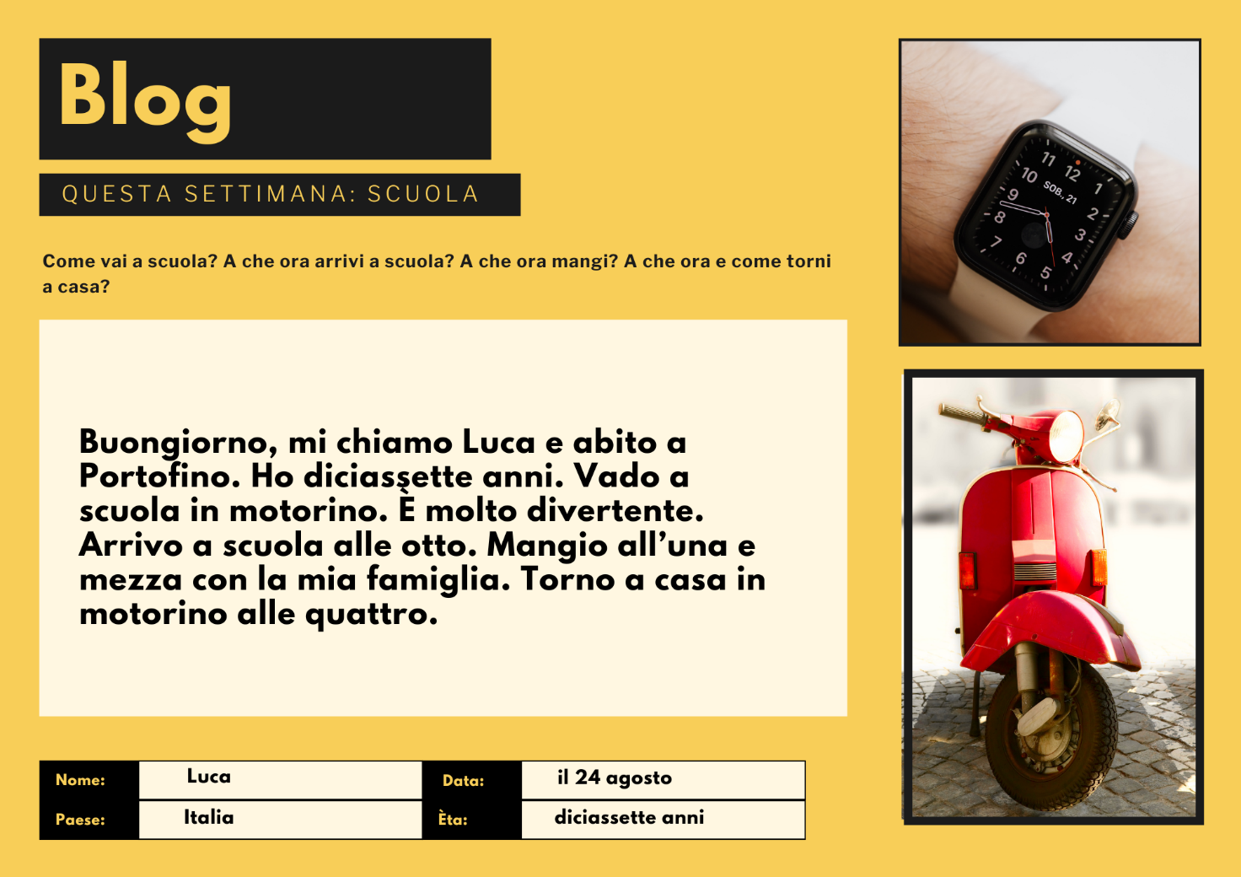
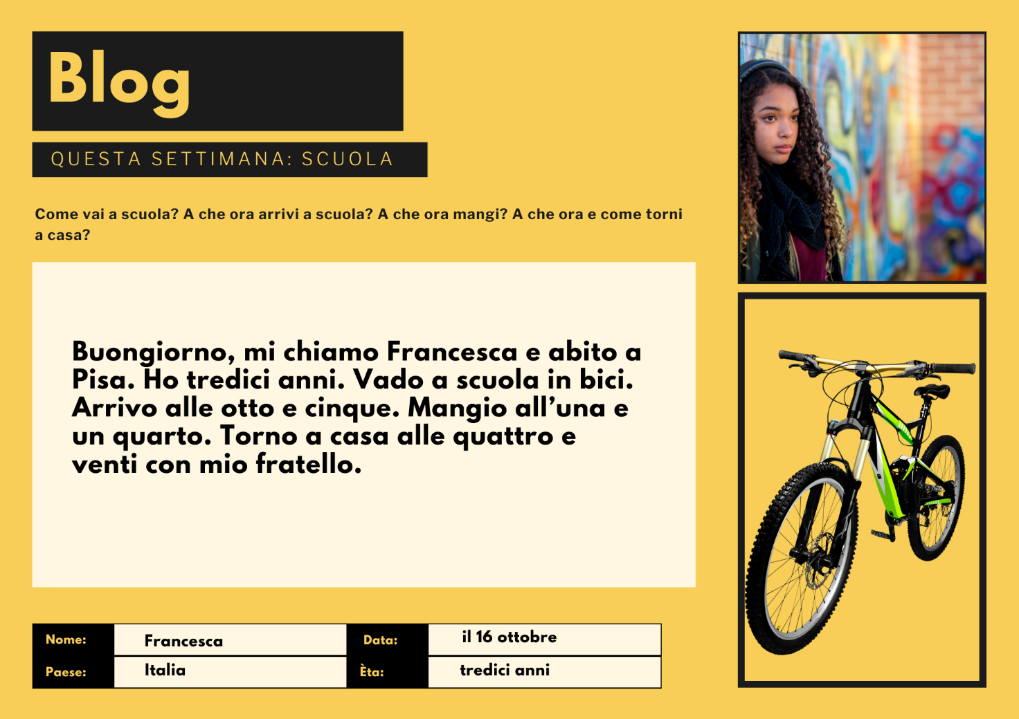
Name | Age | Town | Transportation | Arrives at school | Eats | Returns home

Activity 2
Re-read the blog posts and underline in the text all the modes of transport you can find. Write your answers here:

Activity 3
Listen to the people giving information about their school day in Italian. Complete the sentences with the correct form of transport in the space provided. Choose from: a piedi, in treno, in macchina, in autobus, in motorino, in bici.
- Arrivo a scuola _____________ alle otto.
- Torno a casa _____________.
- Arrivo a scuola alle nove _____________.
- Arrivo a scuola _____________ alle sette e mezza.
- Torno a casa _____________.
- Arrivo a scuola _____________ alle otto e venticinque.
- Torno a casa _____________ alle sette y un quarto.
- Arrivo a scuola _____________ alle otto e dieci.

Activity 4
Translate the sentences from Activity 3 into English.

Activity 5
Create your own blog post using the template provided.
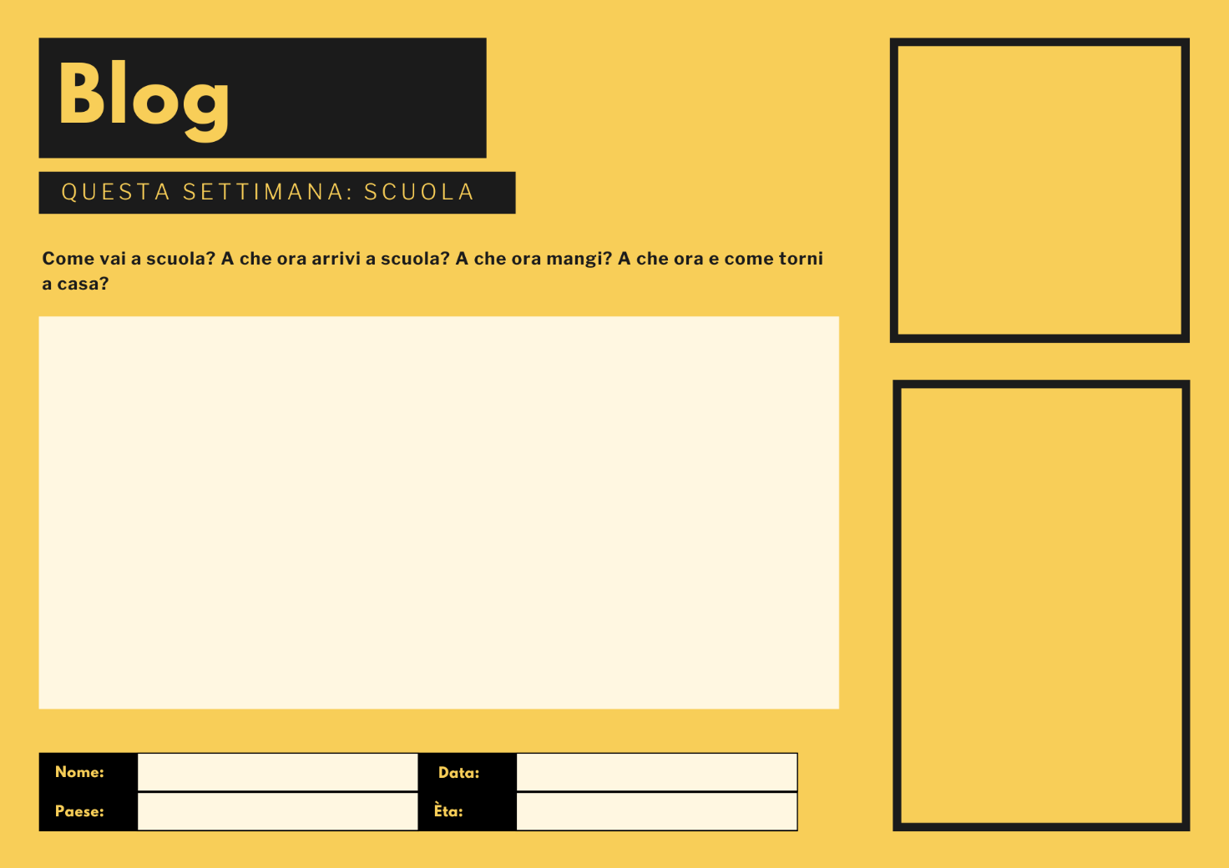

For the teacher
Remove this section before sharing this resource with students.

Activity 1
You can access an editable version of the resource, to amend for your own context. Alternately, an accessible version of the resource is provided below:
Nome | Paese | Data | Èta
Roberto | Italia | il 11 ottobre | dodici anni | Buongiorno, mi chiamo Roberto e abito a Milano. Ho dodici anni. Vado a scuola in autobus. Arrivo alle sette e venticinque. Mangio a scuola a mezzogiorno. Mi piace l’insalata alla mensa perché è molto deliziosa. Torno a casa a piedi alle tre e mezza con i miei amici.
Bianca | Italia | il 20 settembre | quindici anni | Ciao, mi chiamo Bianca e abito a Roma. Ho quindici anni. Vado a scuola in treno. In treno è molto veloce. Arrivo a scuola alle otto e un quarto. Mangio all’una. Di solito mangio un panino. Torno a casa in macchina alle quattro con la mia mamma.
Luca | Italia | il 24 agosto | diciassette anni | Buongiorno, mi chiamo Luca e abito a Portofino. Ho diciassette anni. Vado a scuola in motorino. È molto divertente. Arrivo a scuola alle otto. Mangio all’una e mezza con la mia famiglia. Torno a casa in motorino alle quattro.
Francesca | Italia | il 16 ottobre | tredici anni | Buongiorno, mi chiamo Francesca e abito a Pisa. Ho tredici anni. Vado a scuola in bici. Arrivo alle otto e cinque. Mangio all’una e un quarto. Torno a casa alle quattro e venti con mio fratello.

Name | Age | Town | Transportation | Arrives at school | Eats | Returns home
Roberto | 12 | Milan | bus | 7:25 | 12:00 | 3:30
Bianca | 15 | Rome | train | 8:15 | 1:00 | 4:00
Luca | 17 | Portofino | moped | 8:00 | 1:30 | 4:00
Francesca | 13 | Pisa | bike | 8:05 | 1:15 | 4:20

Activity 2
Roberto – in autobus, a piedi (by bus, on foot)
Bianca – in treno, in macchina (by train, by car)
Luca – in motorino (by motor scooter/moped)
Francesca – in bici (by bicycle)

Activity 3

Audio file
Il mio giorno di scuola – Activity 3.mp3 (0:57)

Transcript
- Arrivo a scuola in autobus alle otto.
- Torno a casa a piedi.
- Arrivo a scuola alle nove in motorino.
- Arrivo a scuola in treno alle sette e mezza.
- Torno a casa in macchina.
- Arrivo a scuola in bici alle otto e venticinque.
- Torno a casa a piedi alle sette e un quarto.
- Arrivo a scuola in macchina alle otto e dieci.

Activity 4
- I arrive at school by bus at 8 o’clock.
- I go home on foot (I walk home).
- I arrive at school at 9 o’clock by moped.
- I arrive at school by train at 7:30.
- I go home by car.
- I arrive at school by bike at 8:25.
- I get home on foot at 7:15 (I walk home at 7:15).
- I arrive at school by car at 8:10.

Activity 5
Differentiation examples
Students requiring additional support – provide a template (see example below) for students to complete with their own information.
High potential students and gifted students – use the information in the blog to create a role play or interaction to ask each other to share information about their school day. Students can ask additional questions such as Qual è il tuo mezzo di trasporto preferito? Preferisci l’autobus o il treno? Perché?
Advanced proficiency – students create their own blog post to be added to Activity 1 and Activity 2. This could be provided to other students to complete, as a challenge task.
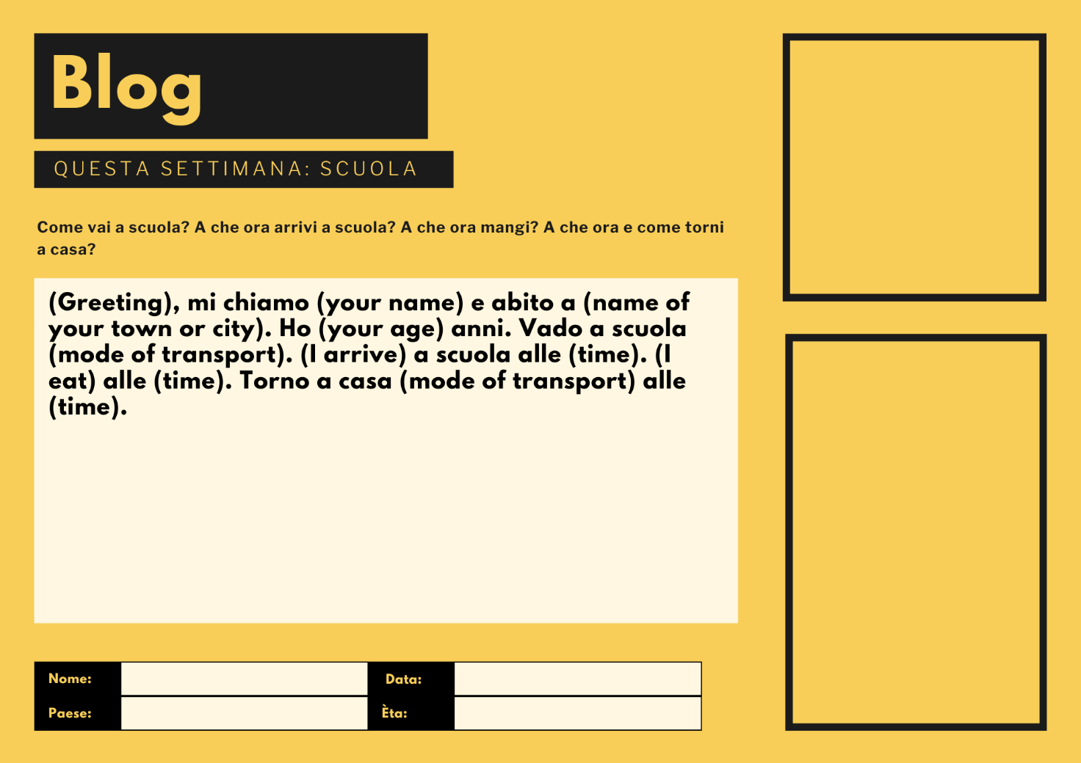

© State of New South Wales (Department of Education), 2024
The copyright material published in this resource is subject to the Copyright Act 1968 (Cth) and is owned by the NSW Department of Education or, where indicated, by a party other than the NSW Department of Education (third-party material).
Copyright material available in this resource and owned by the NSW Department of Education is licensed under a Creative Commons Attribution 4.0 International (CC BY 4.0) license.
This license allows you to share and adapt the material for any purpose, even commercially.
Attribution should be given to © State of New South Wales (Department of Education), 2024.
Material in this resource not available under a Creative Commons license:
- the NSW Department of Education logo, other logos and trademark-protected material
- material owned by a third party that has been reproduced with permission. You will need to obtain permission from the third party to reuse its material.
Links to third-party material and websites
Please note that the provided (reading/viewing material/list/links/texts) are a suggestion only and implies no endorsement, by the New South Wales Department of Education, of any author, publisher, or book title. School principals and teachers are best placed to assess the suitability of resources that would complement the curriculum and reflect the needs and interests of their students.
If you use the links provided in this document to access a third-party's website, you acknowledge that the terms of use, including licence terms set out on the third-party's website apply to the use which may be made of the materials on that third-party website or where permitted by the Copyright Act 1968 (Cth). The department accepts no responsibility for content on third-party websites.

