Mathematics 3–6 Multi-age – Year A – Unit 11
Our number system extends infinitely to very large and very small numbers

Contents
Unit description and duration 6
Syllabus outcomes 6
Stage 2 7
Stage 3 7
Working mathematically 7
Student prior learning 8
Lesson overview and resources 9
Lesson 1 17
Daily number sense – prove it – 10 minutes 17
Core lesson 1 – place value – 20 minutes 19
Core lesson 2 – creating large numbers – 25 minutes 23
Discuss and connect the mathematics – 10 minutes 26
Lesson 2 28
Daily number sense – How many? – 15 minutes 28
Core lesson – 40 minutes 30
Stage 2 task – representing numbers 30
Stage 3 task – decimals 33
Discuss and connect the mathematics – 15 minutes 37
Lesson 3 39
Daily number sense – multiplication problems – 15 minutes 39
Core lesson – 40 minutes 41
Stage 2 task 1 – let’s talk numbers – 10 minutes 41
Stage 2 task 2 – non-standard partitioning – 30 minutes 42
Stage 3 task – negative and positive integers 44
Consolidation and meaningful practice – 10 minutes 47
Lesson 4 50
Daily number sense – 15 minutes 50
Core lesson 1 – number visuals – 20 minutes 50
Core lesson 2 – factor table – 20 minutes 54
Consolidation and meaningful practice – 10 minutes 55
Lesson 5 57
Daily number sense – multiplying multiples – 15 minutes 57
Core lesson – 40 minutes 60
Stage 2 task – representing using non-standard partitioning 60
Stage 3 task 1 – decomposing strategies 62
Stage 3 task 2 – estimating reasonableness 65
Consolidation and meaningful practice – 15 minutes 67
Lesson 6 69
Daily number sense – place value partitioning – 15 minutes 69
Core lesson – 45 minutes 72
Stage 2 task – multiplication and division facts 72
Stage 3 task – area model to algorithm 76
Discuss and connect the mathematics – 10 minutes 78
Lesson 7 81
Daily number sense – number patterns – 15 minutes 81
Core lesson – 40 minutes 84
Stage 2 task – multiplication and division are related 84
Stage 3 task 1 – division with remainders – 10 minutes 87
Stage 3 task 2 – chipping away – 30 minutes 89
Consolidation and meaningful practice – 15 minutes 91
Lesson 8 94
Daily number sense – 15 minutes 94
Core lesson – 40 minutes 94
Stage 2 task – problem solving 94
Stage 3 task – division word problems 97
Discuss and connect the mathematics – 10 minutes 100
Resource 1 – prove it 103
Resource 2 – place value houses 104
Resource 3 – houses to billions 105
Resource 4 – MAB visual 106
Resource 5 – think board 107
Resource 6 – orange picking 108
Resource 7 – 7211 MAB visual 109
Resource 8 – MAB representations 110
Resource 9 – temperature cards 111
Resource 10 – money misconception 112
Resource 11 – non-standard partitioning match 113
Resource 12 – integer spinner 114
Resource 13 – visual patterns 115
Resource 14 – Stage 3 factor table 116
Resource 15 – Stage 2 number visuals 117
Resource 16 – blank factor table 118
Resource 17 – visual patterns 2 119
Resource 18 – student strategies 120
Resource 19 – convince me 121
Resource 20 – matching algorithms 122
Resource 21 – 2-digit algorithm 124
Resource 22 – array/fact family 125
Resource 23 – division with remainders 126
Resource 24 – problems to solve 127
Syllabus outcomes and content 128
Stage 2 128
Stage 3 134
References 141
Further reading 142

Unit description and duration
This unit develops the big idea that our number system extends infinitely to very large and very small numbers.
In this 2-week unit students are provided opportunities to:
- partition, rename, represent and order numbers up to 6 digits (Stage 2) or up to and including billions (Stage 3)
- interpret, compare, order and represent decimals up to thousandths (Stage 3)
- use partitioning and place value knowledge when multiplying and dividing
- see the inverse relationship between multiplication and division, using the associative and distributive properties of multiplication (Stage 2)
- use informal written strategies like the area model for multiplication and division problems and represent and solve division problems involving whole number remainders (Stage 3).
This multi-age unit is informed by the lessons in Stage 2 Year A Unit 11 and Stage 3 Year A Unit 11. Please refer to these units for additional lesson guidance.

Syllabus outcomes
- MAO-WM-01 develops understanding and fluency in mathematics through exploring and connecting mathematical concepts, choosing and applying mathematical techniques to solve problems, and communicating their thinking and reasoning coherently and clearly

Stage 2
- MA2-RN-01 applies an understanding of place value and the role of zero to represent numbers to at least tens of thousands
- MA2-MR-01 represents and uses the structure of multiplicative relations to 10 × 10 to solve problems

Stage 3
- MA3-RN-01 applies an understanding of place value and the role of zero to represent the properties of numbers
- MA3-RN-02 compares and orders decimals up to 3 decimal places
- MA3-MR-01 selects and applies appropriate strategies to solve multiplication and division problems

Working mathematically
In the Mathematics K–10 Syllabus, there is one overarching Working mathematically outcome (MAO-WM-01). The Working mathematically processes should be embedded within the concepts being taught. The Working mathematically processes present in the Mathematics K–10 Syllabus are:
- communicating
- understanding and fluency
- reasoning
- problem solving.
Mathematics K–10 Syllabus © NSW Education Standards Authority (NESA) for and on behalf of the Crown in right of the State of New South Wales, 2022.

Student prior learning
Before engaging in these teaching and learning activities, students would benefit from prior experience with:
- reading, representing, partitioning and ordering numbers up to thousands (Stage 2) or millions (Stage 3)
- interpreting, comparing, ordering and representing decimals (Stage 3)
- identifying and applying a variety of multiplication and division strategies to solve real-world problems.
In NSW classrooms there is a diverse range of students, including Aboriginal and/or Torres Strait Islander students, students learning English as an additional language or dialect, high potential and gifted students and students with disability. Some students may identify with more than one of these groups or possibly all of them. Refer to Curriculum planning for every student – advice for further information.

Lesson overview and resources
To cover the content of the syllabus across Stage 2 and Stage 3, some core lessons in the unit contain both a Stage 2 and a Stage 3 task. Teachers are encouraged to adapt and contextualise the units to meet the needs of their students.
The table below outlines the sequence and approximate timing of lessons, learning intentions and resources.
Lesson | Content | Duration and resources
Lesson 1  Daily number sense  Stage 2:  - Multiplicative relations A: Represent and solve problems involving multiplication fact families  Stage 3:  - Multiplicative relations A: Select and apply mental and written strategies to multiply 2- and 3-digit numbers by 2-digit numbers | Lesson core concept: reading and recording large numbers is a key component of place value.  Stage 2:  - Representing numbers using place value A: Whole numbers: Read, represent and order numbers to thousands  - Representing numbers using place value B: Whole numbers: Recognise and represent numbers that are 10, 100 and 1000 times as large  Stage 3:  - Represents numbers A: Whole numbers: Recognise, represent and order numbers in the millions  - Represents numbers A: Whole numbers: Apply place value to partition, regroup and rename numbers to 1 billion | Lesson duration: 65 minutes  - Resource 1 – prove it  - Resource 2 – place value houses  - Resource 3 – houses to billions  - Resource 4 – MAB visual  - 9-sided dice  - Individual whiteboards  - MAB materials  - Writing materials
Lesson 2  Daily number sense  Stage 2:  - Multiplicative relations A: Represent and solve problems involving multiplication fact families  Stage 3:  - Multiplicative relations A: Select and apply mental and written strategies to multiply 2- and 3-digit numbers by 2-digit numbers | Lesson core concept: collections of tens, hundreds and thousands are really useful (Stage 2) and the position of each digit in a number corresponds to its size (Stage 3).  Stage 2:  - Representing numbers using place value A: Whole numbers: Apply place value to partition and regroup numbers up to 4 digits  - Representing numbers using place value B: Whole numbers: Order numbers in the thousands  Stage 3:  - Represents numbers A: Decimals and percentages: Recognise that the place value system can be extended beyond hundredths | Lesson duration: 70 minutes  - Resource 5 – think board  - Resource 6 – orange picking  - 6-sided dice  - 9-sided dice  - Counters  - Individual whiteboards  - Pieces of cardboard  - Sticky notes
Lesson 3  Daily number sense  Stage 2:  - Multiplicative relations B: Operate with multiples of 10  Stage 3:  - Multiplicative relations A: Use partitioning and place value to multiply 2-, 3- and 4-digit numbers by one-digit numbers | Lesson core concept: numbers can be renamed in equivalent ways using place value (Stage 2) and negative numbers can be represented on a number line (Stage 3).  Stage 2:  - Representing numbers using place value A: Whole numbers: Apply place value to partition and regroup numbers up to 4 digits  Stage 3:  - Represents numbers B: Whole numbers: Locate and represent integers on a number line | Lesson duration: 65 minutes  - Resource 7 – 7211 MAB visual  - Resource 8 – MAB representations  - Resource 9 – temperature cards  - Resource 10 – money misconception  - Resource 11 – non-standard partitioning match  - Resource 12 – integer spinner  - Virtual manipulatives: Amplify Polypad – Number Tiles and Cubes  - 10-sided dice  - Individual whiteboards  - MAB materials (physical or virtual)  - Writing materials
Lesson 4  Daily number sense  - teacher-identified task based on student needs | Lesson core concept: multiplicative thinking is based on patterns and structures (Stage 2) and known number facts and strategies support multiplicative understanding (Stage 3).  Stage 2:  - Multiplicative relations A: Generate and describe patterns  - Multiplicative relations A: Use arrays to establish multiplication facts from multiples of 2 and 4, 5 and 10  Stage 3:  - Multiplicative relations A: Determine products and factors | Lesson duration: 65 minutes  - Resource 13 – visual patterns  - Resource 14 – Stage 3 factor table  - Resource 15 – Stage 2 number visuals  - Resource 16 – blank factor table  - Resource 17 – visual patterns 2  - Individual whiteboards  - Writing materials
Lesson 5  Daily number sense  Stage 2:  - Multiplicative relations B: Operate with multiples of 10  Stage 3:  - Multiplicative relations A: Use partitioning and place value to multiply 2-, 3- and 4-digit numbers by one-digit numbers | Lesson core concept: numbers can be changed and renamed and still maintain their value.  Stage 2:  - Representing numbers using place value A: Whole numbers: Apply place value to partition and regroup numbers up to 4 digits  Stage 3:  - Multiplicative relations A: Use partitioning and place value to multiply 2-, 3- and 4-digit numbers by one-digit numbers  - Multiplicative relations A: Use estimation and rounding to check the reasonableness of answers to calculations | Lesson duration: 70 minutes  - Resource 2 – place value houses  - Resource 11 – non-standard partitioning match  - Resource 18 – student strategies  - 1–10 dice (Stage 3 students – 3 per pair)  - Individual whiteboards  - MAB materials
Lesson 6  Daily number sense  Stage 2:  - Multiplicative relations B: Operate with multiples of 10  Stage 3:  - Multiplicative relations A: Use partitioning and place value to multiply 2-, 3- and 4-digit numbers by one-digit numbers | Lesson core concept: multiplication and division are related (Stage 2) and mathematicians use algorithms with understanding to solve multiplicative problems (Stage 3).  Stage 2:  - Multiplicative relations A: Recall multiplication facts of 2 and 4, 5 and 10 and related division facts  Stage 3:  - Multiplicative relations A: Select and apply mental and written strategies to multiply 2- and 3-digit numbers by 2-digit numbers | Lesson duration: 70 minutes  - Resource 19 – convince me  - Resource 20 – matching algorithms  - Resource 21 – 2-digit algorithm  - Counters  - Individual whiteboards  - Playing cards (number cards only)  - Writing materials
Lesson 7  Daily number sense  Stage 2:  - Multiplicative relations A: Generate and describe patterns  Stage 3:  - Multiplicative relations B: Represent and describe number patterns formed by multiples | Lesson core concept: multiplication and division are related and can be represented through fact families.  Stage 2:  - Multiplicative relations A: Recall multiplication facts of 2 and 4, 5 and 10 and related division facts  - Multiplicative relations B: Represent and solve word problems with number sentences involving multiplication or division  Stage 3:  - Multiplicative relations A: Represent and solve division problems with whole number remainders | Lesson duration: 70 minutes  - Resource 22 – array/fact family  - Resource 23 – division with remainders  - Individual whiteboards  - Writing materials
Lesson 8  Daily number sense  - teacher-identified task based on student needs | Lesson core concept: worded problems can be solved using multiplicative thinking.  Stage 2:  - Multiplicative relations A: Represent and solve problems involving multiplication fact families  - Multiplicative relations A: Use arrays to establish multiplication facts from multiples of 2 and 4, 5 and 10  Stage 3:  - Multiplicative relations A: Select and apply strategies to divide a number with 3 or more digits by a one-digit divisor | Lesson duration: 65 minutes  - Resource 24 – problems to solve  - Area model digital tool: Area Model Algebra  - Individual whiteboards  - Writing materials

Lesson 1
Core concept: reading and recording large numbers is a key component of place value.

Daily number sense – prove it – 10 minutes
Daily number sense activities for Lessons 1 to 3 ‘activate’ prior number knowledge and support the learning of new content in the unit. These activities can also assist teachers to identify the starting points for learning by revealing the extent of students’ existing knowledge.
The table below contains a suggested learning intention and success criteria. These are best co-constructed with students.
Daily number sense learning intention | Daily number sense success criteria
Students working towards Stage 2 outcomes are learning to:  - represent and solve problems involving multiplication fact families.  Students working towards Stage 3 outcomes are learning to:  - select and apply mental and written strategies to multiply 2- and 3-digit numbers by 2-digit numbers. | Students working towards Stage 2 outcomes can:  - describe multiplication problems using times as many.  Students working towards Stage 3 outcomes can:  - extend the area model to represent 2-digit by 2-digit multiplication.
- Display Resource 1 – prove it and read the scenario.
- Independently or in pairs, students work on whiteboards to determine how many carrot plants the farmer planted and discuss who is correct.
- Ask students to use diagrams, words or symbols to record their answer.
- Ask:
- How did you determine if the answer was correct?
- How did you record your thinking?
- Is there another way of working it out?
- Repeat these steps for the following scenarios:
- The teacher gives out 4 stickers before lunch. She gives out 3 times as many stickers after lunch. How many stickers does she hand out after lunch? How many does she hand out altogether?
- A baker baked 6 cupcakes in the morning. He bakes 4 times as many cupcakes in the afternoon. How many cupcakes does he bake that day?
Multi-age: students working towards Stage 3 outcomes should be given scenarios that require 2-digit by 2-digit multiplication. For example, a farmer planted 33 carrots on Monday and 15 times as many carrots on Tuesday. Students should use the area model to demonstrate their thinking.
This table details opportunities for assessment.
Assessment opportunities | Links
What to look for:  - Can Stage 2 students describe multiplication problems using times as many? [MAO-WM-01, MA2-MR-01]  - Can Stage 3 students extend the area model to represent 2-digit by 2-digit multiplication? [MAO-WM-01, MA3-MR-01] | Links to National Numeracy Learning Progressions (NNLP):  - Stage 2 – n/a  - Stage 3 – MuS7.  Links to suggested Interview for Student Reasoning (IfSR) tasks:  - Stage 2 – n/a  - Stage 3 – IfSR-MT: 3A.4.

Core lesson 1 – place value – 20 minutes
The table below contains suggested learning intentions and success criteria. These are best co-constructed with students.
Core concept learning intentions | Core concept success criteria
Students working towards Stage 2 outcomes are learning to:  - read, represent and order numbers to thousands  - recognise and represent numbers that are 10, 100 and 1000 times as large.  Students working towards Stage 3 outcomes are learning to:  - recognise, represent and order numbers in the millions  - apply place value to partition, regroup and rename numbers to 1 billion. | Students working towards Stage 2 outcomes can:  - read, represent and order numbers to 4-digits  - describe how multiplying a number by 10, 100 and 1000 changes the place value of its digits.  Students working towards Stage 3 outcomes can:  - name millions using the place value grouping of ones, tens and hundreds  - arrange numbers in the millions in ascending and descending order using place value  - round numbers to a specified place value  - recognise 1000 thousands is 1 million and 1000 millions is 1 billion.
- Display the numbers 275, 5722 and 2572.
- Ask students:
- Can you read these numbers?
- What do you notice about these numbers?
- Which number is the largest? How do you know?
- Which number is the smallest? How do you know?
- Display Resource 2 – place value houses and provide students with a copy.
- Remind students that each house is divided into hundreds, tens and ones. Extra houses are added as the number grows in size.
- Say the number 8361.
- Ask a student to write the numbers into the columns based on the place value of each digit.
- Say that the purpose of the place value houses is to assist in reading larger numbers. Discuss how this structure makes reading and recording large numbers easier.
- Read out a 4-digit number.
- Students record this number using Resource 2 – place value houses.
- Students turn and talk to a partner, comparing where they have written each number and discussing its relative value. For example, the number 3 is recorded in the hundreds column because the number 8361 contains 3 hundreds.
- Display the numbers 2, 7, 9 and 4. Explain that students are to create 2 different 4-digit numbers using these numbers.
- Students record their numbers using Resource 2 – place value houses.
- Students turn and talk to a partner, sharing their numbers and explaining the value of each numeral.
- Ask 2 students to share the 4-digit numbers they created with the class and list these on the whiteboard.
- Select a different student to order numbers in ascending order on the board, using place value knowledge to justify the order.
- As a class discuss the order of the numbers, adjusting as needed.
Multi-age: students working towards Stage 3 outcomes should read, represent and order numbers to 1 billion. A copy of Resource 3 – houses to billions can be used to support their thinking.
This table details opportunities for differentiation.
Too hard? | Too easy?
Stage 2 students cannot read, represent and order numbers to 4-digits.  - Reduce their number to a 2- or 3-digit number.  - Provide MAB materials to represent the numbers.  Stage 3 students cannot arrange numbers in the millions in ascending and descending order using place value.  - Provide the first and last number when placing numbers in descending order.  - Provide support materials such as number lines, hundreds charts and MAB to use when arranging large numbers. | Stage 2 students can read, represent and order numbers to 4-digits.  - Increase their number to a 5- or 6-digit number.  - Modify numbers to include a zero.  Stage 3 students can arrange numbers in the millions in ascending and descending order using place value.  - Research an international sporting event with large viewer ratings and place these numbers in ascending order.  - In pairs, students draw a ladder on a whiteboard. The aim of the game is to roll a 10-sided die to create 7-digit numbers and place them in order (either ascending or descending) between the rungs of the ladder. If a student creates a number that cannot be placed on the ladder or places a number in the wrong position, they miss a turn. The winner is the student with the most numbers on the ladder.

Core lesson 2 – creating large numbers – 25 minutes
- Display Resource 4 – MAB visual.
- Ask students:
- What do you notice?
- What is the value of the 5 in each of these numbers?
- How has the value of the 5 changed?
- Record numbers into Resource 2 – place value houses (see Figure 1).
Figure 1 – place value houses
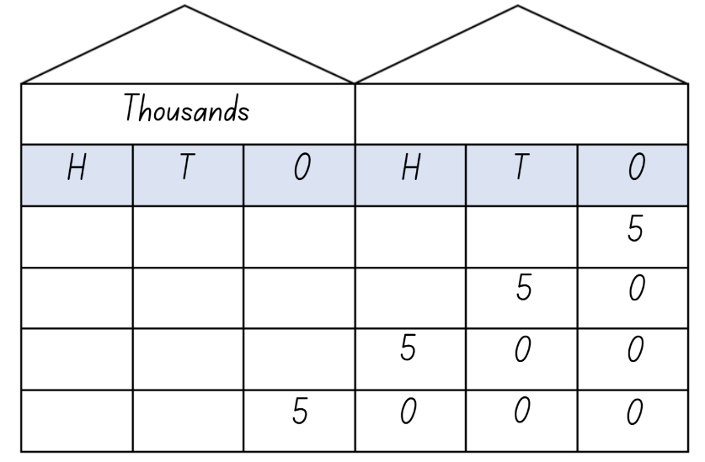
- Highlight how the MAB representation of each number becomes larger when its value changes. Emphasise how the value of the 5 changes as it is in a different place in each of the houses.
Note: explicitly make the connection between the different quantities and the size of the number, ensuring that students understand that changing the quantity value affects the number’s size. For example, 50 is 10 times as large as 5, but 500 is 100 times as large as 5.
- Ask students when they might see 5, 50, 500 or 5000 people in real life. For example, in their family, at a party, at the beach or watching a concert.
- Explain that, in pairs, students will be making a number which is 10, 100 and 1000 times larger than their original number.
- Assign each pair a number from 1–9 (excluding 5).
- Students use place value houses and MAB materials to make their assigned number 10 times, 100 times and 1000 times as large as their original number.
- Complete a gallery walk to observe other pairs representations.
Multi-age: students working towards Stage 3 outcomes use 9-sided dice to create 7-digit numbers. Students round these numbers to the nearest million and place in descending order.
This table details opportunities for differentiation.
Too hard? | Too easy?
Stage 2 students cannot describe how multiplying a number by 10, 100 and 1000 changes the place value of its digits.  - Provide MAB materials to create each of the numbers.  - Students explore making a number 10 times as large using MAB materials to demonstrate their thinking.  Stage 3 students cannot round numbers to a specified place value.  - Provide support materials such as number lines or hundreds charts to refer to when rounding large numbers.  - Model and practise rounding numbers with smaller numbers. | Stage 2 students can describe how multiplying a number by 10, 100 and 1000 changes the place value of its digits.  - Add 50 000 to the 10 000 place value house.  - Begin with a larger number, for example 11. Explain that 10 times as large is 110, 100 times as large is 1100, 1000 times as large is 11 000.  Stage 3 students can round numbers to a specified place value.  - Round each 7-digit number to the nearest 1000.  - Round each 7-digit number to the nearest 10 000.

Discuss and connect the mathematics – 10 minutes
- Ask Stage 2 students:
- What did you observe from the gallery walk?
- What did you notice about the numbers?
- Did you notice any patterns?
- Who had the largest number? How do you know?
- Ask Stage 3 students:
- What strategy did you use when rounding?
- How can you check that your answers are correct?
- Do you find it easier to place numbers in ascending or descending order? Why?
This table details opportunities for assessment.
Assessment opportunities | Links
What to look for:  - Can Stage 2 students read, represent and order numbers to 4 digits? [MAO-WM-01, MA2-RN-01]  - Can Stage 2 students describe how multiplying a number by 10, 100 and 1000 changes the place value of its digits?  [MAO-WM-01, MA2-RN-01]  - Can Stage 3 students name millions using the place value grouping of ones, tens and hundreds? [MAO-WM-01,  MA3-RN-01]  - Can Stage 3 students arrange numbers in the millions in ascending and descending order using place value?  [MAO-WM-01, MA3-RN-01]  - Can Stage 3 students round numbers to a specified place value? [MAO-WM-01, MA3-RN-01]  - Can Stage 3 students recognise 1000 thousands is 1 million and 1000 millions is 1 billion? [MAO-WM-01, MA3-RN-01] | Links to National Numeracy Learning Progressions (NNLP):  - Stage 2 – NPV5, NPV6  - Stage 3 – NPV6, NPV7.  Links to suggested Interview for Student Reasoning (IfSR) tasks:  - Stage 2 – IfSR-NP: 4B.2, 4C.5  - Stage 3 – n/a.

Lesson 2
Core concept: collections of tens, hundreds and thousands are really useful (Stage 2) and the position of each digit in a number corresponds to its size (Stage 3).

Daily number sense – How many? – 15 minutes
The table below contains a suggested learning intention and success criteria. These are best co-constructed with students.
Daily number sense learning intention | Daily number sense success criteria
Students working towards Stage 2 outcomes are learning to:  - represent and solve problems involving multiplication fact families.  Students working towards Stage 3 outcomes are learning to:  - select and apply mental and written strategies to multiply 2- and 3-digit numbers by 2-digit numbers. | Students working towards Stage 2 outcomes can:  - find the total of partially covered arrays.  Students working towards Stage 3 outcomes can:  - extend the area model to represent 2-digit by 2-digit multiplication.
- Students work in pairs.
- Give each pair 30 counters and a piece of cardboard.
- To set up the task, Student A rolls two 6-sided dice. The numbers rolled are used to make an array using counters, for example, 6 and 4. They then partially cover the array with the cardboard so that only the top of one row and one column can be seen (see Figure 2). Student A does this without being observed by Student B.
Figure 2 – partially covered array

- Student A shows the partially covered array to Student B.
- Student B uses the information they can see to record the total number of counters on their whiteboard as an array and a sentence, for example, 4 rows of 6 is 24.
- Student A uncovers the array and Student B counts the counters to check the accuracy of their answer.
- Repeat the activity with students swapping roles.
Multi-age: students working towards Stage 3 outcomes roll two 9-sided dice, using partitioning and the area model to multiply the 2 numbers. Students record their thinking on a whiteboard.
This table details opportunities for assessment.
Assessment opportunities | Links
What to look for:  - Can Stage 2 students find the total of partially covered arrays? [MAO-WM-01, MA2-MR-01]  - Can Stage 3 students extend the area model to represent 2-digit by 2-digit multiplication? [MAO-WM-01, MA3-MR-01] | Links to National Numeracy Learning Progressions (NNLP):  - Stage 2 – MuS5  - Stage 3 – MuS7.  Links to suggested Interview for Student Reasoning (IfSR) tasks:  - Stage 2 – IfSR-MT: 2A.1  - Stage 3 – IfSR-MT: 3A.4.

Core lesson – 40 minutes

Stage 2 task – representing numbers
The table below contains suggested learning intentions and success criteria. These are best co-constructed with students.
Core concept learning intentions | Core concept success criteria
Students working towards Stage 2 outcomes are learning to:  - apply place value to partition and regroup numbers up to 4 digits  - order numbers in the thousands. | Students working towards Stage 2 outcomes can:  - record numbers using standard place value form  - arrange numbers in the thousands in ascending and descending order.
- Ask students to identify different ways a number can be represented.
Note: ensure responses include MAB visuals, numerals/words, expanded notation, partitioning, place value houses, the value of each digit and real-life examples.
- Display the number 6048.
- Students show different ways this number could be represented and record their thinking on a whiteboard.
- As a group, discuss and share representations to create a class anchor chart (see Figure 3).
Figure 3 – sample class anchor chart
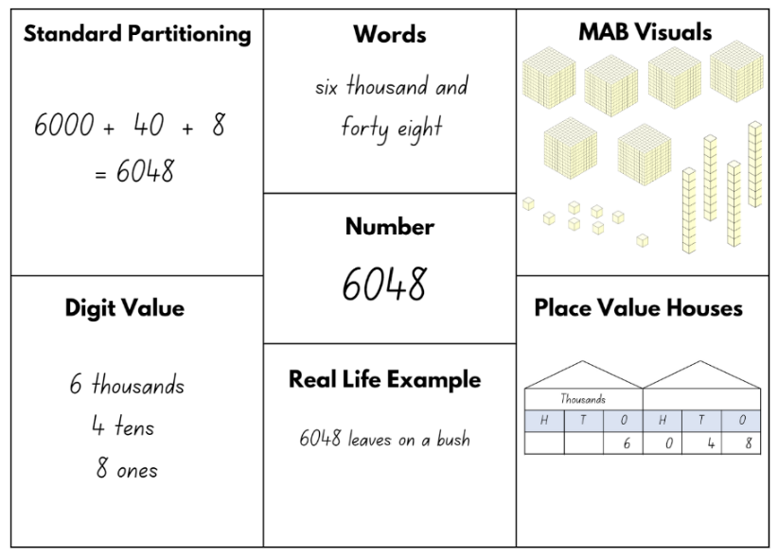
- Students roll a 9-sided die 4 times to create a 4-digit number.
- This number is used to complete Resource 5 – think board.
- Students find someone with the same value in the thousands column to share their think board with, discussing the different ways they have represented the number. If unsuccessful, students find someone with the same value in a different place value column to share their think board with.
- Students use their place value knowledge to justify why their think board representations are correct.
- Revise the concept of ascending and descending order by selecting 6 students to call out the numbers they created. List these on the whiteboard.
- As a class, arrange these numbers in ascending order. Discuss how the order will change if they are asked to place the numbers in descending order.
- Students form small groups and arrange their numbers in ascending and descending order and record it on a whiteboard.
This table details opportunities for differentiation.
Too hard? | Too easy?
Students cannot record numbers using standard place value form.  - Modify Resource 5 – think board to represent only MAB visuals, place value house and standard partitioning.  - Reduce the numbers to 2- or 3-digits.  - Support students using MAB materials to create each of the numbers. | Students can record numbers using standard place value form.  - Students use numbers in tens of thousands.  - Working in pairs, students write a 4-digit number on a whiteboard without showing their partner. They take turns to ask questions to guess their partner’s number. For example, students can ask if the number has a 4 in the hundreds place or if the numeral in the tens place is higher than 5. When they think they have enough information, students guess their partner’s number. This number can be recorded and represented using Resource 5 – think board.

Stage 3 task – decimals
The table below contains suggested learning intentions and success criteria. These are best co-constructed with students.
Core concept learning intentions | Core concept success criteria
Students working towards Stage 3 outcomes are learning to:  - recognise that the place value system can be extended beyond hundredths  - compare, order and represent decimals. | Students working towards Stage 3 outcomes can:  - interpret decimal notation for thousandths  - compare and order decimal numbers up to 3 decimal places  - interpret zero digit(s) at the end of a decimal.
This activity is an adaptation of Place value game from Mathematics K–6 resources by State of New South Wales (Department of Education).
- In pairs, students write 0 and 1 on individual sticky notes and place them spread out on a large surface. Students place 12 blank sticky notes in between to create a gameboard (see Figure 4).
Figure 4 – sticky note gameboard arrangement
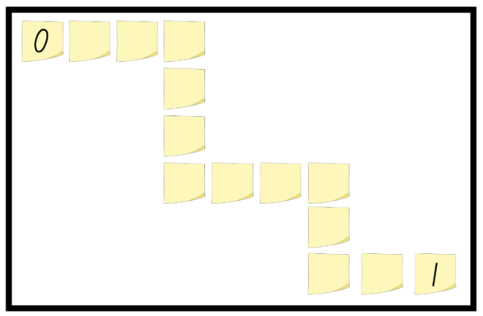
- Explain that the gameboard represents a number line and that the object of the game is to place decimals in the correct order.
- Student A rolls a die 3 times to create a decimal to 3 decimal places, for example, 0.342, and records the decimal on a blank sticky note (see Figure 5).
- Student A reads the decimal aloud to their partner. For example, 0.884 is read as eight hundred and eighty-four thousandths.
Figure 5 – gameboard with sample numbers
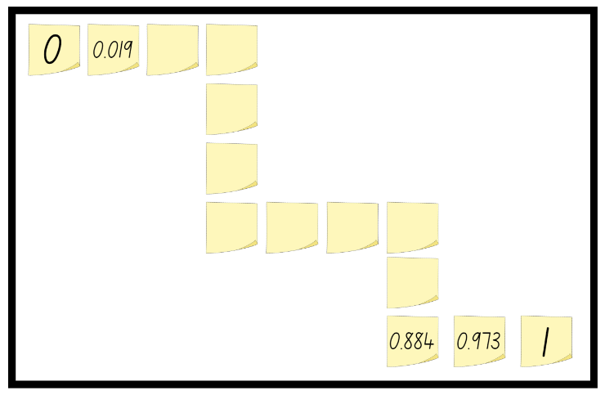
Note: 0.429 would be read as four hundred and twenty-nine thousandths. When there is a zero in the whole number place, students should not read the zero. The language emphasises the decimal fraction parts and makes a connection with common fractions.
- Student B has their turn and places their decimal on the gameboard. They read the decimal created aloud. If either player cannot place their decimal in the correct order on the gameboard, they miss that turn. The game continues until all the spaces are filled. The winner is the player who has the most decimals on the board.
- Pairs compare completed gameboards, checking for similarities.
- Students check that the decimals are in the correct order. Ask students to convince each other why their arrangement is correct.
- Pairs combine their sticky note decimals and place them in ascending order. They record these in their workbooks.
- Display Resource 6 – orange picking.
- In pairs, students use the information from the resource and their place value knowledge to answer the questions. They record their thinking in their workbooks.
- Share and discuss student responses.
This table details opportunities for differentiation.
Too hard? | Too easy?
Students cannot interpret decimal notation for thousandths.  - Support students to explore the concept of decimals by reducing the focus to tenths and hundredths.  - Play the game in a small group with teacher support, plotting the decimals in order on the gameboard. | Students can interpret decimal notation for thousandths.  - Explain that, when rolling the dice, only roll 2 numbers and assume the third number is always a zero. Students explain to a classmate how this impacts the position of the decimal on the gameboard.  - Students amend the gameboard to be from 1–10. Each turn they roll the die 4 times to create a number with a whole number and 3 decimal places. This number is recorded on a sticky note and placed in order on the gameboard.

Discuss and connect the mathematics – 15 minutes
- Ask Stage 2 students:
- Which way of representing a number is the easiest? Why?
- Does the size of the number affect your previous answer? Why or why not?
- Is it harder to place numbers in ascending or descending order? Why?
- Ask Stage 3 students:
- What information is helpful when ordering decimals?
- How do you determine the larger/smaller decimal with numbers that are very similar?
- What is the role of zero in each of these decimals?
This table details opportunities for assessment.
Assessment opportunities | Links
What to look for:  - Can Stage 2 students record numbers using standard place value form? [MAO-WM-01, MA2-RN-01]  - Can Stage 2 students arrange numbers in the thousands in ascending and descending order? [MAO-WM-01, MA2-RN-01]  - Can Stage 3 students interpret decimal notation for thousandths? [MAO-WM-01, MA3-RN-02]  - Can Stage 3 students compare and order decimal numbers up to 3 decimal places? [MAO-WM-01, MA3-RN-02]  - Can Stage 3 students interpret zero digit(s) at the end of a decimal? [MAO-WM-01, MA3-RN-01, MA3-RN-02] | Links to National Numeracy Learning Progressions (NNLP):  - Stage 2 – NPV4, NPV5, NPV6  - Stage 3 – NPV7, NPV8.  Links to suggested Interview for Student Reasoning (IfSR) tasks:  - Stage 2 – IfSR-AT: 3B.1  - Stage 3 – IfSR-PT: 1A.5, 1A.7.

Lesson 3
Core concept: numbers can be renamed in equivalent ways using place value (Stage 2) and negative numbers can be represented on a number line (Stage 3).

Daily number sense – multiplication problems – 15 minutes
The table below contains a suggested learning intention and success criteria. These are best co-constructed with students.
Daily number sense learning intention | Daily number sense success criteria
Students working towards Stage 2 outcomes are learning to:  - operate with multiples of 10.  Students working towards Stage 3 outcomes are learning to:  - use partitioning and place value to multiply 2-, 3- and 4-digit numbers by one-digit numbers. | Students working towards Stage 2 outcomes can:  - use multiplication facts with multiples of 10 to multiply a one-digit number by a multiple of 10.  Students working towards Stage 3 outcomes can:  - use mental strategies to multiply one-digit numbers by 10 and their multiples.
- Pose the following problem: Oscar rides his bike 38 km a day for a total of 5 days. How many kilometres does he ride in total?
- Ask students to record 2 different strategies for solving this problem on a whiteboard.
- Students share their strategies and solutions.
- Strategies may include:
- Rounding 38 up to 40 and multiplying that by 5, then subtracting 2 fives. For example, 38 × 5 = (40 × 5) - (2 × 5) = 190.
- Students use their knowledge of multiplying one-digit numbers with multiples of 10 to double the 5 and halve the 38. This will make 10 × 19 = 190.
- As different strategies arise, ask the students to explain why they chose to solve the problem in that way.
Multi-age: students working towards Stage 2 outcomes use a multiple of 10 for the daily total. For example, 40 km a day for 5 days.
This table details opportunities for assessment.
Assessment opportunities | Links
What to look for:  - Can Stage 2 students use multiplication facts with multiples of 10 to multiply a one-digit number by a multiple of 10?  [MAO-WM-01, MA2-MR-01]  - Can Stage 3 students use mental strategies to multiply one-digit numbers by 10 and their multiples? [MAO-WM-01, MA3-MR-01] | Links to National Numeracy Learning Progressions (NNLP):  - Stage 2 – MuS7  - Stage 3 – MuS7.  Links to suggested Interview for Student Reasoning (IfSR) tasks:  - Stage 2 – n/a  - Stage 3 – IfSR-MT: 3A.1, 3A.2, 3A.3.

Core lesson – 40 minutes

Stage 2 task 1 – let’s talk numbers – 10 minutes
The table below contains suggested learning intentions and success criteria. These are best co-constructed with students.
Core concept learning intentions | Core concept success criteria
Students are learning to:  - apply place value to partition and regroup numbers up to 4 digits. | Students can:  - record numbers using standard place value form  - partition numbers of up to 4 digits in non-standard forms.
- Display Resource 7 – 7211 MAB visual which shows the number 7211 using standard and non-standard partitioning.
- Ask:
- What do you notice?
- Are they the same or different values?
- How do you know?
Note: ensure the vocabulary of standard and non-standard partitioning is used.
- Ask students if these are all the possible ways of making this number using MAB materials.
- Provide students with virtual manipulatives, physical MAB materials or Resource 8 – MAB representations. They use these to represent 7211 in another way, using non-standard partitioning.

Stage 2 task 2 – non-standard partitioning – 30 minutes
- Write the number 2493 on the whiteboard.
- Use virtual manipulatives, physical MAB materials or Resource 8 – MAB representations to model the number displayed using non-standard partitioning.
- Ask students: Can you represent 2493 another way using non-standard partitioning?
- In pairs, students represent this number using MAB materials in a different non-standard form.
- Students complete a gallery walk, observing their classmates’ representations of the same number.
- During the gallery walk, ask students to consider:
- Did anyone represent this number the same way as you?
- What was the most efficient way to represent this number? Why?
- Did you see a representation that you would use next time?
- Select 3 different representations of the number 2493 completed by the students.
- Challenge students to convince the class that all these representations have the same value.
- Students use their knowledge of place value to justify why each of these representations has the same value.
This table details opportunities for differentiation.
Too hard? | Too easy?
Students cannot record numbers using standard place value form.  - Reduce numbers to 2- or 3-digits.  - Provide Resource 2 – place value houses to help highlight the change of digits.  Students cannot partition numbers of up to 4 digits in non-standard forms.  - Reduce numbers to 2- or 3-digits.  - Model the use of MAB materials to represent numbers when using non-standard partitioning. | Students can record numbers using standard place value form.  - Use 5- or 6-digit numbers.  - Challenge students to use a number with an internal zero.  Students can partition numbers of up to 4 digits in non-standard forms.  - Students work in pairs. Student A records a secret number then makes the number with MAB materials using non-standard partitioning. Student B works out what the secret number is. They swap roles and repeat.  - Students sit back-to-back, each with a whiteboard. Student A writes a 4-, 5- or 6-digit number on their whiteboard, reads it aloud and represents it using standard partitioning. Student B writes down the number they have heard and represents it using non-standard partitioning. Students compare results and swap roles.

Stage 3 task – negative and positive integers
The table below contains suggested learning intentions and success criteria. These are best co-constructed with students.
Core concept learning intentions | Core concept success criteria
Students are learning to:  - locate and represent integers on a number line. | Students can:  - recognise the location of negative whole numbers in relation to zero and place them on a number line  - use the term integer to describe positive and negative whole numbers and zero  - interpret integers in everyday contexts.
- Draw a number line on the whiteboard and mark zero at the halfway point. Ask what would be to the left if this was zero.
- Students turn and talk to a partner, discussing their ideas.
- As a class, share students’ thinking.
- Introduce the term integer. Discuss the concept of negative numbers that exist to the left of the zero.
Integer: a whole number, positive, negative or zero. For example, −3, −2, −1, 0, 1, 2…
Negative number: a number less than zero, written with a minus sign. These integers are read as, for example, negative 3, not minus 3.
Note: it is important to use the language of negative, not minus. For example, −3 would be read as negative 3.
- Give pairs of students a number from Resource 9 – temperature cards.
- Place the zero card somewhere in the classroom.
- Students arrange themselves in order based on their card’s value and its location compared to zero.
- Ask:
- What do you notice?
- Can you see a pattern?
- Can you see symmetry on our number line?
- What assumptions can be made from this number line?
- Read the temperatures aloud. Highlight that any temperature below zero is a negative number.
- Display Resource 10 – money misconception.
- Ask students to consider how to plot these amounts on a blank number line.
Note: highlight that in this scenario, owing is a negative value as that student has less than $0. Model the use of the vocabulary owing, in the red and debt.
- Students draw a blank number line in their workbooks, plotting these amounts in relation to zero (see Figure 6).
Figure 6 – money number line
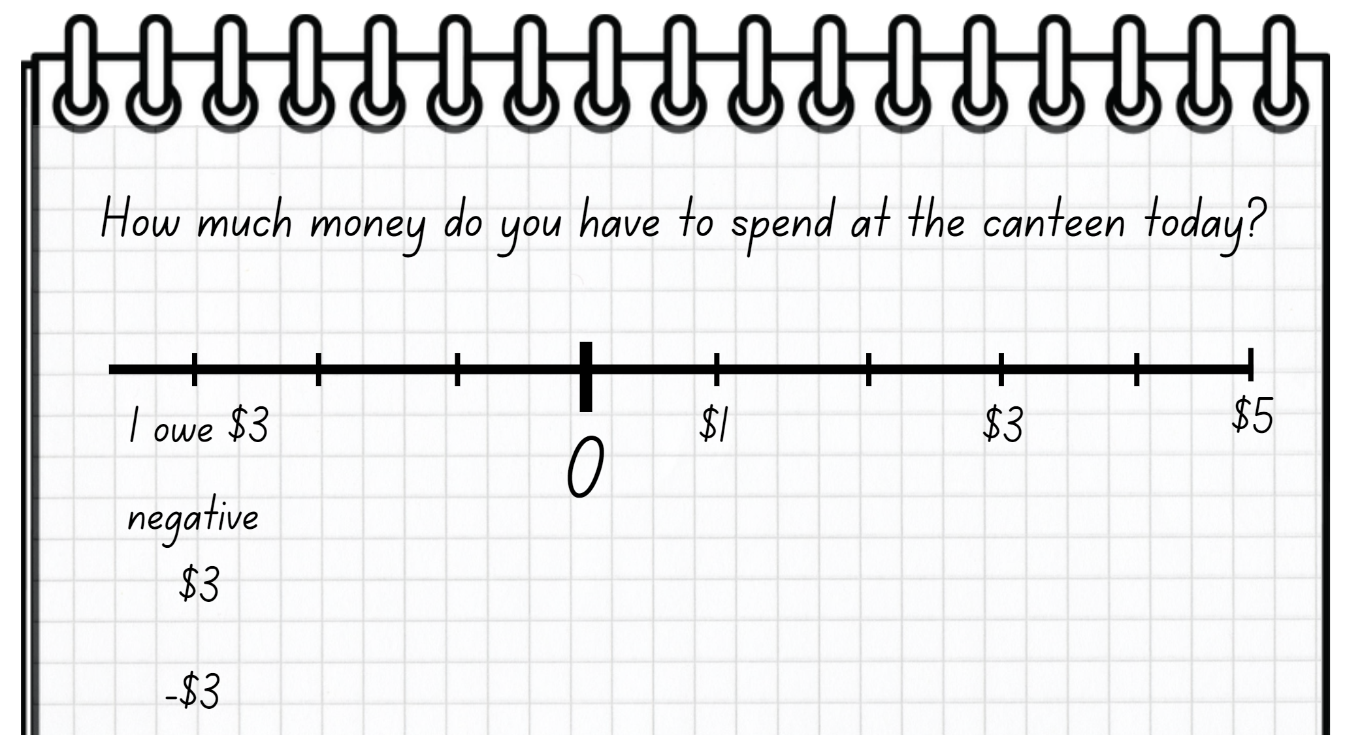
- Students compare their number line with a partner, justifying their choices.
This table details opportunities for differentiation.
Too hard? | Too easy?
Students cannot recognise the location of negative whole numbers in relation to zero and place them on a number line.  - Simplify the language when introducing the concept that negative is less than zero and positive is more than zero.  - Support students by modelling a simplified version of the task using a standard number line. | Students can recognise the location of negative whole numbers in relation to zero and place them on a number line.  - Use the blank temperature cards to extend beyond negative 10 or 10. Students create their own integers and plot on the number line relative to the zero.  - In pairs, students draw a number line on a whiteboard, marking zero in the middle. They also mark a counter with a ‘+’ (positive) on one side and a ‘−’ (negative) on the other side using a sticker or marker. Give students numbered cards 1–50 or direct them to Random number. Student A picks a numbered card. They then flip the counter to determine if that number will be positive or negative. Then they plot their number on the number line. Student B repeats the process. Students continue to take turns until one student has 3 numbers in a row.

Consolidation and meaningful practice – 10 minutes
- Display Resource 11 – non-standard partitioning match.
- As a class, discuss which number matches each of the non-standard forms.
- Ask Stage 2 students:
- How did you count the MAB visual representations?
- How can you explain this to someone else?
- Can you show another way to represent the same number?
- What happens if you try to represent this number without using thousands?
- Stage 2 students attempt to make one of the numbers a different way using non-standard partitioning.
- Stage 2 students turn and talk with a partner to compare their representations, justifying their choice of materials.
- In pairs, Stage 3 students draw a number line on a whiteboard, marking zero in the middle, 10 at the far right and negative 10 at the far left.
- Stage 3 students take it in turns to spin Resource 12 – integer spinner to determine if they are creating a negative or positive number. They then roll a 10-sided die and plot this number on the blank number line (see Figure 7).
Figure 7 – negative or positive game
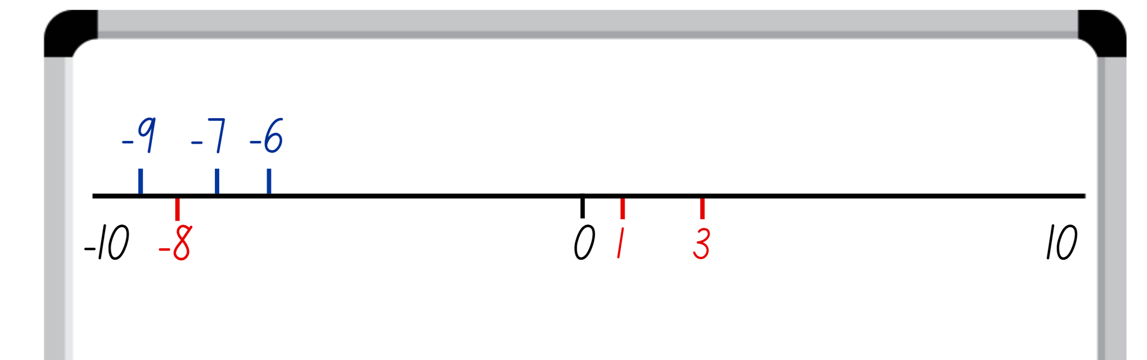
- If their number has already been placed on the number line, the player misses a turn.
- The winner is the player who has 3 integers in a row.
This table details opportunities for assessment.
Assessment opportunities | Links
What to look for:  - Can Stage 2 students record numbers using standard place value form? [MAO-WM-01, MA2-RN-01]  - Can Stage 2 students partition numbers of up to 4 digits in non-standard forms? [MAO-WM-01, MA2-RN-01]  - Can Stage 3 students recognise the location of negative whole numbers in relation to zero and place them on a number line? [MAO-WM-01, MA3-RN-01]  - Can Stage 3 students use the term integer to describe positive and negative whole numbers and zero? [MAO-WM-01,  MA3-RN-01]  - Can Stage 3 students interpret integers in everyday contexts? [MAO-WM-01, MA3-RN-01] | Links to National Numeracy Learning Progressions (NNLP):  - Stage 2 – NPV4, NPV5, NPV6  - Stage 3 – NPV9.  Links to suggested Interview for Student Reasoning (IfSR) tasks:  - Stage 2 – IfSR-AT: 3B.2, 3B.4  - Stage 3 – n/a.

Lesson 4
Core concept: multiplicative thinking is based on patterns and structures (Stage 2) and known number facts and strategies support multiplicative understanding (Stage 3).

Daily number sense – 15 minutes
- From a class need surfaced through formative assessment data, identify a short, focused activity that targets students’ knowledge, understanding and skills. Example activities may be drawn from the following resources:
- Mathematics K–6 resources
- Universal Resources Hub.

Core lesson 1 – number visuals – 20 minutes
The table below contains suggested learning intentions and success criteria. These are best co-constructed with students.
Core concept learning intentions | Core concept success criteria
Students working towards Stage 2 outcomes are learning to:  - generate and describe patterns  - use arrays to establish multiplication facts from multiples of 2 and 4, 5 and 10.  Students working towards Stage 3 outcomes are learning to:  - determine products and factors. | Students working towards Stage 2 outcomes can:  - recognise the significance of the final digit of a whole number in determining whether a given number is even or odd  - create and represent multiplicative structure, using the term multiples when connecting grouping to arrays.  Students working towards Stage 3 outcomes can:  - determine factors for a given whole number  - determine whether a number is prime, composite or neither (0 or 1).
This activity is an adaptation of Number visuals from Mathematics K–6 resources by State of New South Wales (Department of Education).
- Distribute Resource 13 – visual patterns to pairs of students.
- Ask:
- What do you notice?
- What are you wondering?
- What is the value of (teacher to identify one number pattern)?
- How do you know?
- How might the number visuals be represented as arrays?
- Can all the number visuals be represented as arrays? Why or why not?
- What patterns can you see?
- Pairs record the number each visual represents under the picture. They also record if the number is a prime or composite number and why. Ask students if they notice anything interesting about the way the numbers are shown.
Note: highlight that the circles represent odd and prime numbers: 5, 7, 11, 13, 17, 19, 23. All numbers that are divisible by 3 are represented as a triangle: 3, 9, 27.
Prime number: a prime number is a positive integer which has exactly 2 distinct factors, itself and one. Modelled as an array, it has only one row. Zero is not an integer and therefore is neither prime nor composite.
Composite number: a non-zero natural number that has a factor other than one and itself. For example, all even numbers besides 2 are composite numbers. Some odd numbers are composite (for example, 21) but not all are composite (for example, 11).
Multi-age: students working towards Stage 2 outcomes do not need to determine whether a number is prime, composite or neither. They should record if the number is odd or even and why.
This table details opportunities for differentiation.
Too hard? | Too easy?
Stage 2 students cannot recognise the significance of the final digit of a whole number in determining whether a given number is even or odd.  - Model how to use counters to check whether a given number is even or odd.  - Provide a multiplication chart and demonstrate the link between even numbers and the multiplication facts for 2.  Stage 3 students cannot determine whether a number is prime, composite or neither (0 or 1).  - Assist students by reducing the number of Resource 13 – visual patterns using only the top row. Add extra rows when students are ready.  - Support students by using counters to make the patterns and share into equal groups to determine if it is a prime or composite number. | Stage 2 students can recognise the significance of the final digit of a whole number in determining whether a given number is even or odd.  - Students record if the number is a multiple of 2, 4, 5 or 10.  - Ask: How many even numbers there are between 1 and 100? Can you explain your reasoning?  Stage 3 students can determine whether a number is prime, composite or neither (0 or 1).  - Students continue the pattern until they find the next 4 prime numbers.  - In pairs, students play ‘Celebrity heads’. Student A writes a number on a sticky note and places it on Student B’s head without them seeing. Student B asks questions about their number to try and determine what it is. When the student thinks they know the number, they can guess. If they guess correctly, students swap roles and repeat. Questions could include:  - Am I a prime number?  - Is 3 a factor of my number?  - Is my number a square number?

Core lesson 2 – factor table – 20 minutes
Product: the result of multiplying 2 or more numbers together, for example, 12 is the product of 4 × 3.
Factor: a number which divides another number without a remainder. For example, 1, 2, 3 and 6 are factors of 6 but 4 and 5 are not.
- Discuss the mathematical terms, product and factor.
- Students use their knowledge of multiplication and division to complete Resource 14 – Stage 3 factor table, using Resource 13 – visual patterns to complete the visual column.
Multi-age: students working towards Stage 2 outcomes do not need to use the terms product and factor. They use a copy of Resource 15 – Stage 2 number visuals.
This table details opportunities for differentiation.
Too hard? | Too easy?
Stage 2 students cannot create and represent multiplicative structure, using the term multiples when connecting grouping to arrays.  - Model the connection between even numbers, the multiplication facts for 2 and arrays.  - Provide counters for students to check their thinking.  Stage 3 students cannot determine factors for a given whole number.  - Assist students by providing more information within the table.  - Provide students with a multiplication facts chart to assist with determining factors. | Stage 2 students can create and represent multiplicative structure, using the term multiples when connecting grouping to arrays.  - Students record the number of arrays that can be formed.  - Students explain why an array cannot be formed.  Stage 3 students can determine factors for a given whole number.  - Students complete Resource 16 – blank factor table with larger numbers, creating their own number visuals for each product.  - Challenge students to use calculators to find factors of 3- and 4-digit numbers.

Consolidation and meaningful practice – 10 minutes
- Display Resource 17 – visual patterns 2.
- Ask students if they can identify the number represented.
- Students turn and talk to justify their answer, explaining what information they used to work it out.
- On whiteboards, students use the information they know and the visual patterns they have been using to create a pattern for a different number.
- Students show their number pattern to a classmate to see if they can determine what number it is, explaining what information they used to work it out.
This table details opportunities for assessment.
Assessment opportunities | Links
What to look for:  - Can Stage 2 students recognise the significance of the final digit of a whole number in determining whether a given number is even or odd? [MAO-WM-01, MA2-MR-01]  - Can Stage 2 students create and represent multiplicative structure, using the term multiples when connecting grouping to arrays? [MAO-WM-01, MA2-MR-01]  - Can Stage 3 students determine factors for a given whole number? [MAO-WM-01, MA3-MR-01]  - Can Stage 3 students determine whether a number is prime, composite or neither (0 or 1)? [MAO-WM-01, MA3-MR-01] | Links to National Numeracy Learning Progressions (NNLP):  - Stage 2 – MuS5  - Stage 3 – MuS6, MuS7.

Lesson 5
Core concept: numbers can be changed and renamed and still maintain their value.

Daily number sense – multiplying multiples – 15 minutes
Daily number sense activities for Lessons 5 to 7 ‘loop’ back to concepts and procedures covered in previous units to assist students to build an increasingly connected network of ideas. These concepts may differ from the core concepts being covered by the unit.
The table below contains a suggested learning intention and success criteria. These are best co-constructed with students.
Daily number sense learning intention | Daily number sense success criteria
Students working towards Stage 2 outcomes are learning to:  - operate with multiples of 10.  Students working towards Stage 3 outcomes are learning to:  - use partitioning and place value to multiply 2-, 3- and 4-digit numbers by one-digit numbers. | Students working towards Stage 2 outcomes can:  - use multiplication facts of 10 to multiply a one-digit number by a multiple of 10.  Students working towards Stage 3 outcomes can:  - use mental strategies to multiply one-digit numbers by multiples of 10 and 100.
This activity is an adaptation of Multiply Multiples 1 from NRICH by University of Cambridge.
- Display an equation where each square represents a missing digit (see Figure 8).
Figure 8 – equation with missing digits
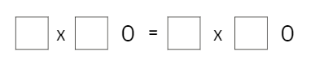
- Explain that each square represents a missing digit and that students need to work out different ways to balance the equation.
- Explain that one possible solution is 4 × 40 = 8 × 20.
- Students work in pairs to record as many solutions as possible. Remind students that both sides of the equation must be balanced. The equals sign represents balance or equivalence.
- Ask students to explore strategies such as place value partitioning, factorising and halving.
Note: students working towards Stage 2 outcomes focus on the task of multiplying by 10 and Stage 3 students toward the balancing of equations.
- Evaluate strategies by asking:
- Which strategy is the most efficient? Why?
- Do certain strategies work better for different equations? Why?
This table details opportunities for assessment.
Assessment opportunities | Links
What to look for:  - Can Stage 2 students use multiplication facts of 10 to multiply a one-digit number by a multiple of 10? [MAO-WM-01, MA2-MR-02]  - Can Stage 3 students use mental strategies to multiply one-digit numbers by multiples of 10 and 100? [MAO-WM-01, MA3-MR-01] | Links to National Numeracy Learning Progressions (NNLP):  - Stage 2 – MuS6, MuS7  - Stage 3 – MuS6, MuS7.  Links to suggested Interview for Student Reasoning (IfSR) tasks:  - Stage 2 – n/a  - Stage 3 – IfSR-MT: 3A.9.

Core lesson – 40 minutes

Stage 2 task – representing using non-standard partitioning
The table below contains suggested learning intentions and success criteria. These are best co-constructed with students.
Core concept learning intentions | Core concept success criteria
Students are learning to:  - apply place value to partition and regroup numbers up to 4 digits. | Students can:  - record numbers using standard place value form  - partition numbers of up to 4 digits in non-standard forms.
- Provide MAB materials and display the number 4536.
- Students sit back-to-back in pairs. Using the MAB materials, they represent 4536 using standard partitioning.
- Students turn back to their partner and compare representations. If their representations differ, they discuss which shows an accurate representation of standard partitioning for that number.
- Students return to sitting back-to-back. They represent 4536 using non-standard partitioning and record it on their whiteboard (see Figure 9).
Figure 9 – example of student work
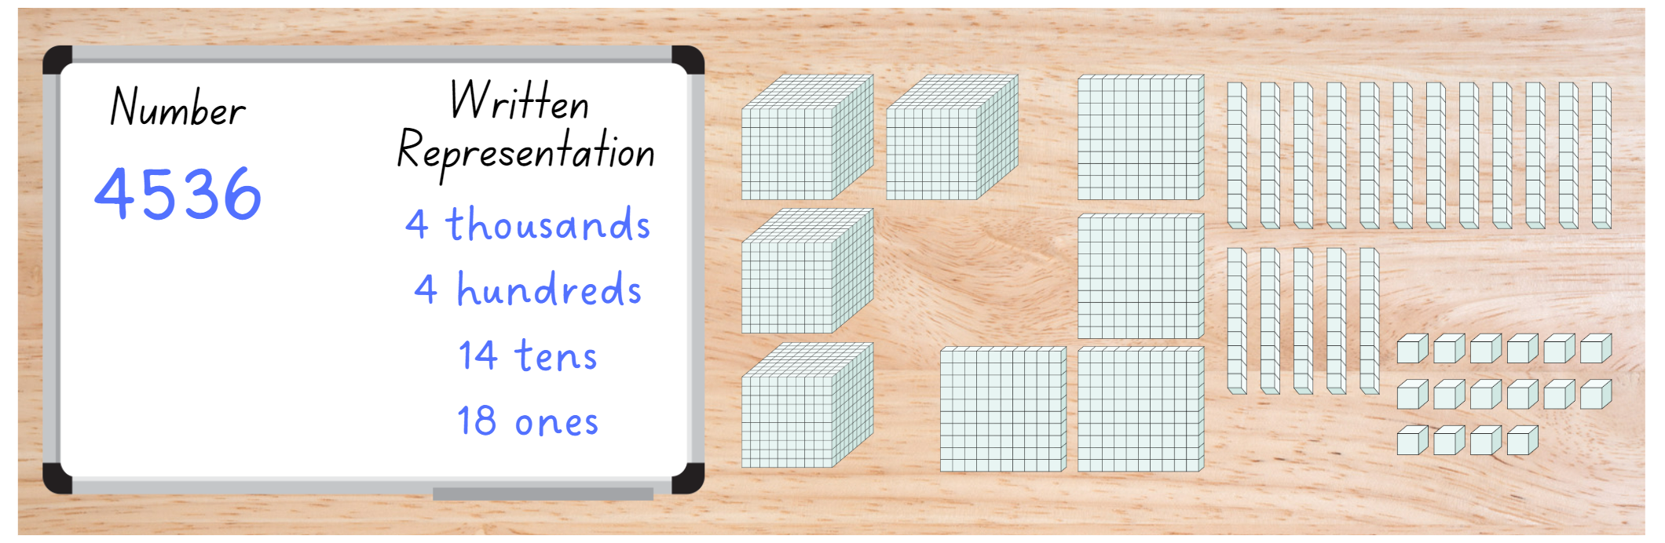
- In pairs, students discuss how their partitions are similar or different, how the representation can be counted and the most efficient way to partition the number.
- Students share their answers and reasoning with the class.
- Individually, students partition the number again using non-standard partitioning in a different way.
- Ask: Do the numbers have the same value when they are represented using standard and non-standard partitioning? (They do.)
- Discuss students’ responses.
This table details opportunities for differentiation.
Too hard? | Too easy?
Students cannot record numbers using standard place value form.  - Reduce the number to 2 or 3 digits.  - Provide Resource 2 – place value houses to help highlight the value of each digit.  Students cannot partition numbers of up to 4 digits in non-standard forms.  - Reduce the number to 2 or 3 digits.  - Model the use of MAB materials to represent numbers when using non-standard partitioning. | Students can record numbers using standard place value form.  - Increase the number to 5- or 6-digits.  - Challenge students to use a number with an internal zero.  Students can partition numbers of up to 4 digits in non-standard forms.  - Students create their own version of Resource 11 – non-standard partitioning match. Ask a classmate to solve it.  - Students sit back-to-back, each with a whiteboard. Student A writes a 4-, 5- or 6-digit number on their whiteboard, reads it aloud and represents it using standard partitioning. Student B writes down the number they have heard and represents it using non-standard partitioning. Students compare results, then swap roles and repeat.

Stage 3 task 1 – decomposing strategies
The table below contains suggested learning intentions and success criteria. These are best co-constructed with students.
Core concept learning intentions | Core concept success criteria
Students are learning to:  - use partitioning and place value to multiply 2-, 3- and 4-digit numbers by one-digit numbers  - use estimation and rounding to check the reasonableness of answers to calculations. | Students can:  - use informal written strategies such as the area model to solve multiplication and division problems  - use the distributive property with the area model to partition numbers in representing multiplication problems  - use estimation to check the reasonableness of answers to multiplication and division calculations.
This lesson builds on the learning in Mathematics 3–6 Multi-age Year A Unit 7, Lesson 3.
- Display Resource 18 – student strategies.
- Ask students:
- Can you explain each strategy?
- How are the strategies different?
- Can you show what ‘double, double and one’ would look like?
- Explain that Brett uses his understanding of place value to solve the problem. Ask students to explain what this might look like and suggest the most likely strategy Brett used.
- Once students have attempted to explain Brett’s strategy, explain how he partitioned 19 into tens and ones before multiplying each part by 5.
- Students use Brett’s strategy to solve the problem on their whiteboards (see Figure 10).
- Share and discuss solutions.
Figure 10 – Brett’s solution
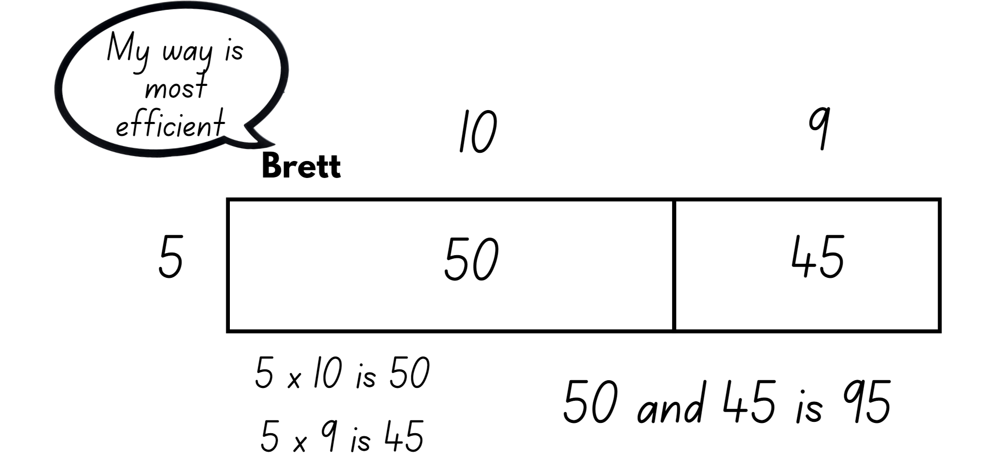
- Provide three 10-sided dice per pair of students. Students roll 3 dice to create a one- and 2-digit number that will be multiplied together. For example, 9 and 21 or 6 and 37.
- In their workbooks, students solve the multiplication problem using an efficient strategy.
- Next to each multiplication problem and the solution, students justify why they chose this strategy.
- Students roll the dice to create a new pair of numbers to multiply and solve.
This table details opportunities for differentiation.
Too hard? | Too easy?
Students cannot use informal written strategies such as the area model to solve multiplication and division problems.  - Support students by providing access to materials such as counters or area model digital tool.  - Provide students with a 10 × 10 multiplication facts chart to support their understanding. | Students can use informal written strategies such as the area model to solve multiplication and division problems.  - Challenge students to increase the numbers by using more dice to make 3- and 4-digit numbers.  - Students experiment creating 2 by 2-digit multiplication equations and representing them as area models and expanded algorithms.

Stage 3 task 2 – estimating reasonableness
- Display the problem 4 × 453 on the whiteboard.
- Ask:
- What is estimation and where might you use estimation in real life?
- What is rounding and how can it be useful?
- How can rounding be used to make it easier to estimate the answer?
- Can you use multiplication facts and estimation to determine what the answer will be larger than? For example, 4 × 4 is 16, therefore 4 × 453 would be more than 1600.
- Students work in pairs using whiteboards to show other ways to change the problem using estimation to make the problem easier (see Figure 11).
Figure 11 – estimating responses
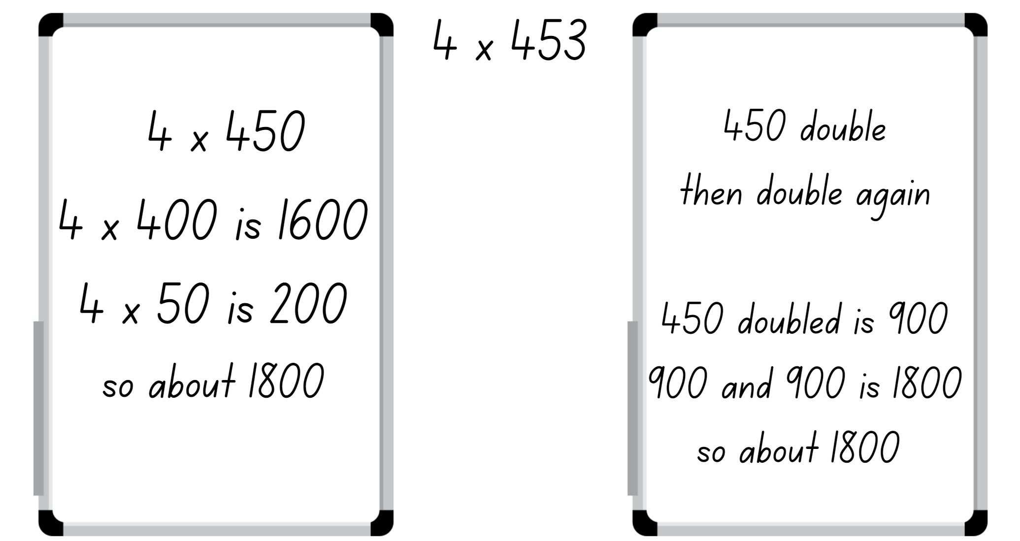
- Students share responses. Ensure they explain how they have used rounding to support their estimation.
- Ask students if their estimation would be considered reasonable.
This table details opportunities for differentiation.
Too hard? | Too easy?
Students cannot use estimation to check the reasonableness of answers to multiplication and division calculations.  - Reduce numbers to 2 digits.  - Provide visual representations, such as a number line, to identify and support the concept of rounding. | Students can use estimation to check the reasonableness of answers to multiplication and division calculations.  - Pose the word problem: 212 countries tune in to watch soccer. Each country has on average 92 765 viewers. What is a reasonable estimate is for the amount of people who watch soccer?  - Students create their own word problems with at least 4-digit numbers. They swap with a partner and round to determine a reasonable estimate, before solving.

Consolidation and meaningful practice – 15 minutes
- Stage 2 students choose a 4-digit number. They represent it in as many ways as possible.
- Stage 2 students turn and talk with a partner to compare representations, discussing strategies used for each different representation.
- Ask Stage 2 students:
- Are some representations easier to read? Why?
- Are some representations easier to create? Why?
- How would you explain this to someone else?
- Is your way the only correct way?
- Tell Stage 3 students that the answer to the question 4 × 453 is 1812.
- Ask Stage 3 students:
- If I estimate the answer as 2000, is this a reasonable estimation? Why or why not?
- Is a guess and an estimation the same thing? Explain your thinking.
This table details opportunities for assessment.
Assessment opportunities | Links
What to look for:  - Can Stage 2 students record numbers using standard place value form? [MAO-WM-01, MA2-RN-01]  - Can Stage 2 students partition numbers of up to 4 digits in non-standard forms? [MAO-WM-01, MA2-RN-01]  - Can Stage 3 students use informal written strategies such as the area model to solve multiplication and division problems?  [MAO-WM-01, MA3-MR-01]  - Can Stage 3 students use the distributive property with the area model to partition numbers in representing multiplication problems? [MAO-WM-01, MA3-MR-01]  - Can Stage 3 students use estimation to check the reasonableness of answers to multiplication and division calculations?  [MAO-WM-01, MA3-MR-01] | Links to National Numeracy Learning Progressions (NNLP):  - Stage 2 – NPV4, NPV5, NPV6  - Stage 3 – MuS6, MuS7.  Links to suggested Interview for Student Reasoning (IfSR) tasks:  - Stage 2 – IfSR-AT: 3B.2  - Stage 3 – IfSR-MT: 3A.1, 3A.2, 3A.3, 3A.9.

Lesson 6
Core concept: multiplication and division are related (Stage 2) and mathematicians use algorithms with understanding to solve multiplicative problems (Stage 3).

Daily number sense – place value partitioning – 15 minutes
The table below contains a suggested learning intention and success criteria. These are best co-constructed with students.
Daily number sense learning intention | Daily number sense success criteria
Students working towards Stage 2 outcomes are learning to:  - operate with multiples of 10.  Students working towards Stage 3 outcomes are learning to:  - use partitioning and place value to multiply 2-, 3- and 4-digit numbers by one-digit numbers. | Students working towards Stage 2 outcomes can:  - use multiplication facts with multiples of 10 to multiply a one-digit number by a multiple of 10.  Students working towards Stage 3 outcomes can:  - use the distributive property with partial products to solve problems by multiplying the hundreds, then the tens and then the ones.
- Pose the following problem: Charlie has saved $20 to buy herself a new scooter, but she needs 6 times this amount to buy it. How much does she need altogether?
- Illustrate the word problem for Stage 2 students by sketching Figure 12.
Figure 12 – bar model representation
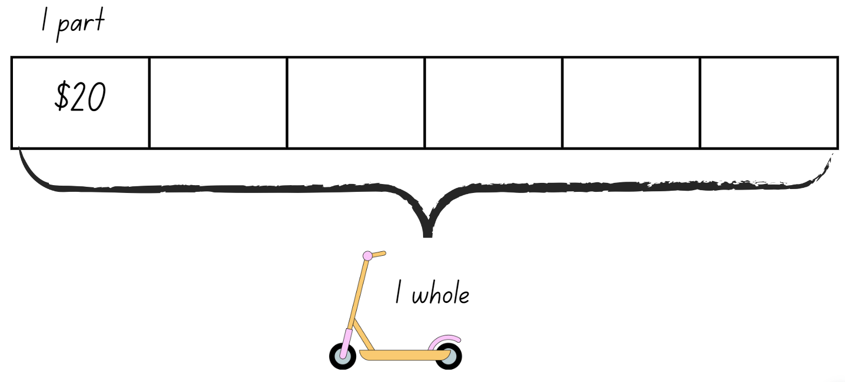
- Ask students the following questions:
- How can you use your knowledge of doubling, halving and place value partitioning to solve this problem?
- Why is this strategy useful for this problem?
- In pairs allow students to solve the problem using their knowledge of place value partitioning in multiplication (see Figure 13).
Figure 13 – place value partitioning
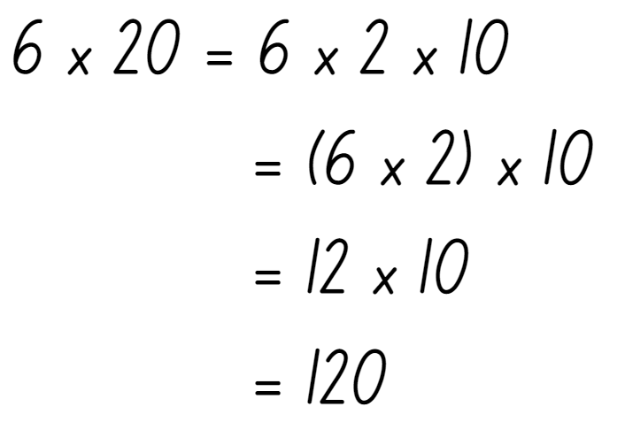
Note: students working towards Stage 2 outcomes should use multiplication strategies such as doubling or halving to solve the problem. For example, $20 can be halved to be $10 × 2. Guide Stage 3 students to consider place value as they partition to solve the problem.
- Allow students to share their answer and working out with the class.
- Pose the following problems to Stage 2 students:
- A packet of coloured pencils costs $10. How much would 4 packets cost?
- A bus carries 20 students. How many students will 4 buses carry?
- Pose the following problems to Stage 3 students:
- An armchair cost $462. How much would 4 armchairs cost?
- An orchard produces enough apples each season to fill 721 crates. How many crates would be filled in 3 years?
This table details opportunities for assessment.
Assessment opportunities | Links
What to look for:  - Can Stage 2 students use multiplication facts with multiples of 10 to multiply a one-digit number by a multiple of 10?  [MAO-WM-01, MA2-MR-02]  - Can Stage 3 students use the distributive property with partial products to solve problems by multiplying the hundreds, then the tens and then the ones? [MAO-WM-01, MA3-MR-01] | Links to National Numeracy Learning Progressions (NNLP):  - Stage 2 – MuS7, NPA4  - Stage 3 – MuS6, MuS7.  Links to suggested Interview for Student Reasoning (IfSR) tasks:  - Stage 2 – n/a  - Stage 3 – IfSR-MT: 3A.9.

Core lesson – 45 minutes

Stage 2 task – multiplication and division facts
The table below contains suggested learning intentions and success criteria. These are best co-constructed with students.
Core concept learning intentions | Core concept success criteria
Students working towards Stage 2 outcomes are learning to:  - recall multiplication facts of 2 and 4, 5 and 10 and related division facts. | Students working towards Stage 2 outcomes can:  - recognise and use the symbols for multiplied by (×), divided by (÷) and equals (=)  - link multiplication and division fact families using arrays  - model and apply the commutative property of multiplication.
- Display Resource 19 – convince me.
- Explain that students need to decide which student from the display has the correct answer. Students justify their choice.
- Students record their answer on a whiteboard. They include a justification of why they think that choice is correct.
- Students turn and talk to a partner to share and discuss their choices.
- If they are convinced by their partner that their choice is incorrect, they can change their answers at this time.
- As a group, discuss the fact that both students have represented the array correctly.
- Ask students:
- Is this the only array that can be made from this number of counters?
- How can we record these arrays differently?
Note: arrays are only ever read as ‘rows of’, not ‘columns of’.
- In small groups, give students 30 counters.
- Ask students:
- How can we represent this collection as an array?
- How can we record this as a written representation?
- Students arrange the counters into an array and record using diagrams and written representation in their workbooks. For example (see Figure 14).
Figure 14 – student working
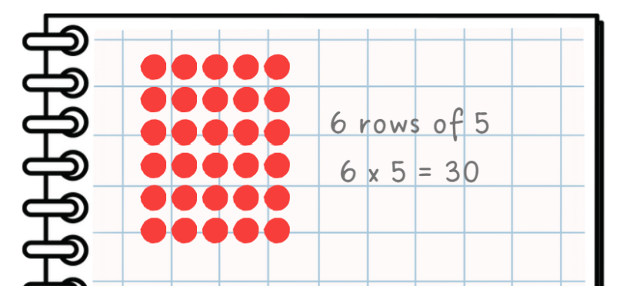
- As groups complete this task, ask students if they can use this information to work out anything else about the 30 counters.
Note: highlight the commutative property, for example, 30 is 3 rows of 10 and 10 rows of 3. The related division facts are 30 shared into 3 rows is 10 and 30 shared into 10 rows is 3. Identify that this process enables students to create a fact family for 30.
- Write the sentence stems on the whiteboard and model completing one example (see Figure 15).
Figure 15 – problems with student response
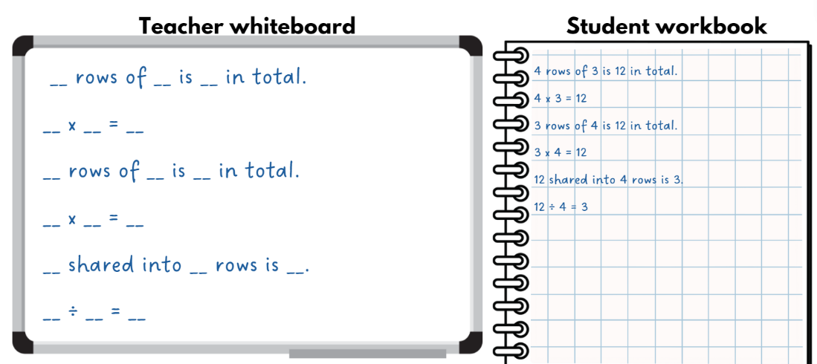
- Students repeat this activity in their workbooks or on whiteboards.
This table details opportunities for differentiation.
Too hard? | Too easy?
Students cannot link multiplication and division fact families using arrays.  - Reduce the number of counters students are manipulating to a smaller number, such as 6 or 10.  - Support students to use the manipulatives to create arrays and record fact families. | Students can link multiplication and division fact families using arrays.  - Students complete the problem: In the classroom we have tote tray holders. Each tote tray holder holds 12 tote trays. What can the tote tray holder look like? How many holders do you need for 36 tote trays? Draw and explain your thinking.  - In pairs, students use their knowledge of multiplication to give their partner a number which is their answer. This student then lists as many related fact family statements as they can. They show their partner and discuss, before swapping roles and repeating the process.

Stage 3 task – area model to algorithm
The table below contains suggested learning intentions and success criteria. These are best co-constructed with students.
Core concept learning intentions | Core concept success criteria
Students working towards Stage 3 outcomes are learning to:  - select and apply written strategies to multiply 2- and 3- digit numbers by 2-digit numbers. | Students working towards Stage 3 outcomes can:  - extend the area model to represent 2-digit by 2-digit multiplication  - use a multiplication algorithm with understanding.
- Display Resource 20 – matching algorithms.
- In pairs, students use the cards to match an area model representation to the corresponding algorithm.
- When complete, discuss the strategies the students used to determine a matching set.
- Ask questions, such as:
- Why do they match?
- How can you check your answer?
- Can you explain the process?
- Model 2-digit by 2-digit multiplication using an algorithm. For example, 24 × 15.
- Display Resource 21 – 2-digit algorithm.
- Revise the algorithm process by solving each example on the whiteboard. Students following along using their own whiteboard.
- Students play ‘Flip and multiply’. In pairs, they flip 4 playing cards and use them to create a 2-digit by 2-digit multiplication question.
- With a partner, students solve the problem using a 2-digit by 2-digit multiplication algorithm.
- Students share their solution with a partner, communicating their strategy and understanding.
Note: highlight the connection to place value in this strategy. For example, in 42 × 24 the second step is 40 × 4 = 160, not 4 × 4 = 16.
This table details opportunities for differentiation.
Too hard? | Too easy?
Students cannot use a multiplication algorithm with understanding.  - Support students to partition the multiplication problem and use the area model each time before using the algorithm.  - Provide questions for students using smaller numbers. | Students can use a multiplication algorithm with understanding.  - Students play ‘Flip and multiply’ using a 3-digit number multiplied by a 2-digit number. Ask if students can see the continuation of the process.  - Provide questions for students using larger numbers.

Discuss and connect the mathematics – 10 minutes
- Ask Stage 2 students:
- How are arrays read?
- How can arrays help show our multiplicative thinking?
- Why is it possible to make different arrays with the same number of counters?
- Can you explain how multiplication and division are related?
- Ask Stage 3 students:
- How does the area model compare to the written algorithm?
- When would you use the written algorithm? Why?
- Which strategy works best for you? Can you explain why?
- Why is it important to be able to use a variety of strategies when solving problems?
- Which strategy would you like to practise more? Why?
This table details opportunities for assessment.
Assessment opportunities | Links
What to look for:  - Can Stage 2 students recognise and use the symbols for multiplied by (×), divided by (÷) and equals (=)?  [MAO-WM-01, MA2-MR-01]  - Can Stage 2 students link multiplication and division fact families using arrays? [MAO-WM-01, MA2-MR-01]  - Can Stage 2 students model and apply the commutative property of multiplication? [MAO-WM-01, MA2-MR-01]  - Can Stage 3 students extend the area model to represent 2-digit by 2-digit multiplication? [MAO-WM-01, MA3-MR-01]  - Can Stage 3 students use a multiplication algorithm with understanding? [MAO-WM-01, MA3-MR-01] | Links to National Numeracy Learning Progressions (NNLP):  - Stage 2 – MuS5, MuS6  - Stage 3 – MuS7, MuS8.  Links to suggested Interview for Student Reasoning (IfSR) tasks:  - Stage 2 – n/a  - Stage 3 – IfSR-MT: 3A.4, 3A.5.

Lesson 7
Core concept: multiplication and division are related and can be represented through fact families.

Daily number sense – number patterns – 15 minutes
The table below contains a suggested learning intention and success criteria. These are best co-constructed with students.
Daily number sense learning intention | Daily number sense success criteria
Students working towards Stage 2 outcomes are learning to:  - generate and describe patterns.  Students working towards Stage 3 outcomes are learning to:  - represent and describe number patterns formed by multiples. | Students working towards Stage 2 outcomes can:  - model, describe and record patterns of multiples  - create and continue a variety of number patterns that increase or decrease by a constant amount.  Students working towards Stage 3 outcomes can:  - describe a pattern formed by multiples in words, in terms of multiplication rather than addition.
- Display the number pattern 5, 10, 15, 20, 25…
- Ask students what they see. Answers may include numbers going up by fives, add 5 every time, 5 times table or multiples of 5.
- Display the number pattern 8, 13, 18, 23, 28… and again ask students what they see. Draw students’ attention to the numbers still going up by 5, even though the starting number is different.
- Explain that the pattern is the same but the starting number has been shifted by 3.
- Display the following number patterns:
- 5, 9, 13, 17, 21…
- 111, 116, 121, 126, 131…
- 76, 86, 96, 106, 116…
- Stage 2 students explain to a partner how they worked out the pattern each time. They ask if this method will always work.
- Stage 2 students continue the number patterns to find the next 5 values.
- Display the following number patterns for Stage 3 students:
- 2, _, _, 16, _, _, _, 256 (× 2 each time)
- 200, _, _, 1600, _, _ (× 2 each time)
- 1, 3, 9, 27, 51, _, _, _ (× 3)
- Explain that these number patterns are based on multiplication. Stage 3 students explain to a partner the strategy they used to work out the missing values in the pattern. They ask if this method will always work.
- 2, _, _, 16, _, _, _, 256 (× 2 each time)
- 200, _, _, 1600, _, _ (× 2 each time)
- 1, 3, 9, 27, 51, _, _, _ (× 3)
- Stage 3 students continue the number patterns to find the next 3 values.
This table details opportunities for assessment.
Assessment opportunities | Links
What to look for:  - Can Stage 2 students model, describe and record patterns of multiples? [MAO-WM-01, MA2-MR-01]  - Can Stage 2 students create and continue a variety of number patterns that increase or decrease by a constant amount?  [MAO-WM-01, MA2-MR-01]  - Can Stage 3 students describe a pattern formed by multiples in words, in terms of multiplication rather than addition?  [MAO-WM-01, MA3-MR-01] | Links to National Numeracy Learning Progressions (NNLP):  - Stage 2 – NPA3, NPA4  - Stage 3 – NPA4, MuS6.  Links to suggested Interview for Student Reasoning (IfSR) tasks:  - Stage 2 – IfSR-NP: 4A.1, 4A.2  - Stage 3 – IfSR-MT: 3A.1, 3A.2, 3A.3.

Core lesson – 40 minutes

Stage 2 task – multiplication and division are related
The table below contains suggested learning intentions and success criteria. These are best co-constructed with students.
Core concept learning intentions | Core concept success criteria
Students are learning to:  - recall multiplication facts of 2 and 4, 5 and 10 and related division facts  - represent and solve word problems with number sentences involving multiplication or division. | Students can:  - link multiplication and division fact families using arrays  - model and apply commutative property of multiplication  - complete number sentences involving multiplication and division by calculating missing numbers.
- Display Resource 22 – array/fact family.
- Students turn and talk to decide which fact family triangle matches each array, using their knowledge of arrays and related facts.
- In pairs, students discuss and record the written representations related to each fact family on whiteboards.
- Select students to share one of their representations. They describe the strategies used to create it.
- Choose a number sentence and ask students to reframe it using the word ‘half’. For example, 8 ÷ 2 = 4 becomes half of 8 is 4.
- Draw Figure 16 and ask students which number is missing from the fact family.
Figure 16 – fact family triangle – 10
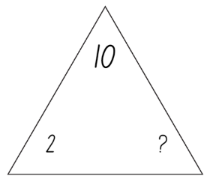
- Students use their multiplicative knowledge to justify their answer. Encourage the use of the concept ‘half’ in their response.
- Students record the fact family triangle for 10, the 2 arrays, the multiplication number sentences and the associated division number sentences (see Figure 17).
Figure 17 – student workbook recording
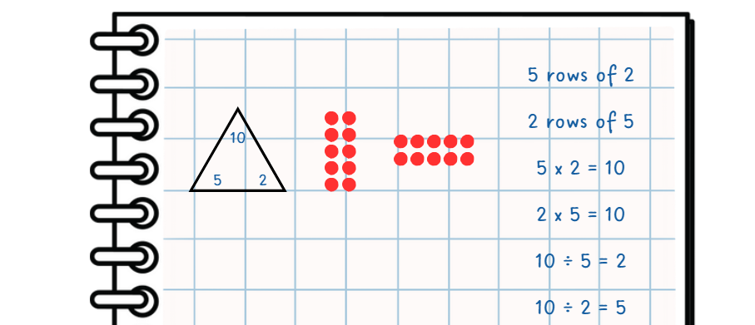
- Draw the fact family triangle for the number 30 with one missing value. For example, display the numbers 30 and 10 only.
- In pairs, students repeat the previous process to record the fact family triangle, 2 arrays, the multiplication number sentences and the associated division number sentences.
This table details opportunities for differentiation.
Too hard? | Too easy?
Students cannot complete number sentences involving multiplication and division by calculating missing numbers.  - Provide counters and support students to make an array to calculate missing numbers.  - Model strategies using support structures, such as using a set of pre-prepared multiplication fact families, to help students determine missing quantities. | Students can complete number sentences involving multiplication and division by calculating missing numbers.  - Students create their own missing value fact family triangle. They ask a classmate to solve it using 2 arrays and the associated multiplication and division number sentences.  - In pairs, students play ‘Mystery equation’ using multiplication (×) and division (÷). Student A draws 6 joined boxes on a whiteboard. On a different whiteboard, Student A creates a multiplication or division equation to fit the 6 boxes. Student B guesses the equation and writes it in the boxes. Student A places a tick above any correct numbers/symbols that are in the correct place, a circle above any correct numbers/symbols in the wrong place and a cross above any incorrect numbers/symbols (see Figure 18). Student B continues to guess until the correct equation is discovered.  Figure 18 – mystery equation  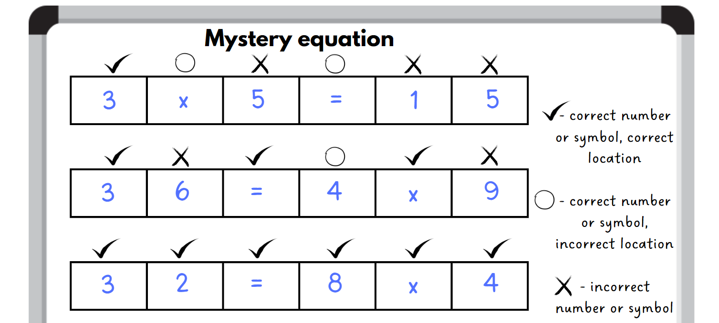

Stage 3 task 1 – division with remainders – 10 minutes
The table below contains suggested learning intentions and success criteria. These are best co-constructed with students.
Core concept learning intentions | Core concept success criteria
Students are learning to:  - represent and solve division problems with whole number remainders. | Students can:  - model division, including where the answer involves a remainder, using materials or diagrams  - use known multiplication fact families to solve division problems for which answers may include a remainder  - show the connection between division and multiplication involving the divisor and quotient.
- Display Resource 23 – division with remainders.
- Ask questions, such as:
- What do you notice?
- How can you show this array as a multiplication fact?
- How does this array show division?
- Why are there 2 dots on the right-hand side?
- Highlight that the remaining 2 dots cannot be shared equally between the 6 equal rows.
Quotient: the term used to describe the results of a division calculation. For example, 18 divided by 6 is 3, the quotient is 3.
Divisor: the number by which another number is divided. For example, 18 divided by 6 is 3, the divisor is 6.
- Students create their own array to represent 29 and record their responses. For each visual representation they write the division fact with the remainder (see Figure 19).
Figure 19 – array for 29
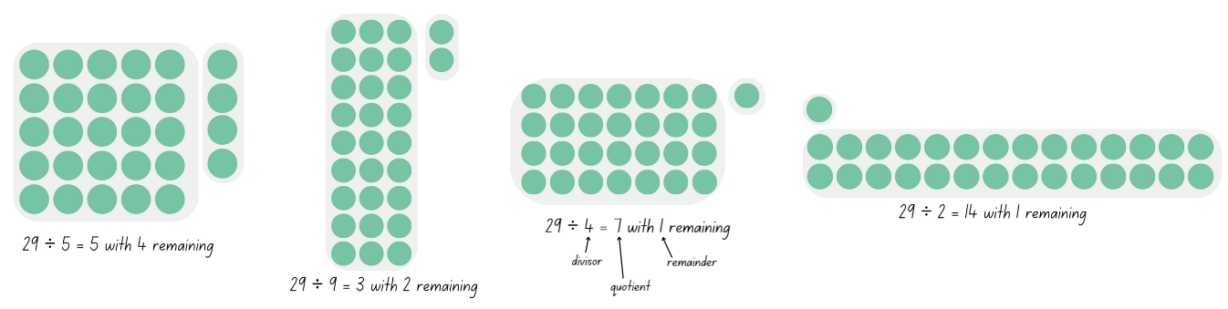
- Students complete a gallery walk to observe the different ways of representing the number 29.

Stage 3 task 2 – chipping away – 30 minutes
This activity is adapted from Division – Chipping away at the whole number (PDF 487 KB) by Vingerhoets. It is continued from Mathematics 3–6 Multi-age Year A Unit 7.
- Explain that they will be using the chipping away method where the answer may include a remainder.
- Show the problem 377 divided by 5.
- Ask students:
- What is a reasonable estimate for 377 divided by 5?
- Why may it be helpful to use multiples of 10?
- Prompt students to give suggestions of how they can ‘chip away’ at 377.
- Represent 377 divided by 5 using chipping away method, noting that there will be some remaining (see Figure 20).
Figure 20 – chipping away 377
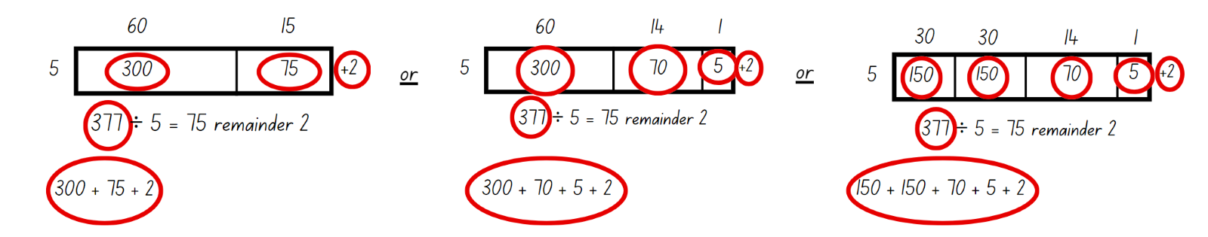
- Once the class has found a possible option of chipping away, students work in pairs on a whiteboard to show an alternative way of chipping away at 377.
This table details opportunities for differentiation.
Too hard? | Too easy?
Students cannot show the connection between division and multiplication involving the divisor and quotient.  - Model the use of concrete materials or diagrams to create visual patterns to determine remainders.  - Support students to use known multiplication facts to solve the division problems with the chipping away method. | Students can show the connection between division and multiplication involving the divisor and quotient.  - Challenge students to demonstrate how to chip away at a problem without using the visual model.  - Students create an instructional video on how multiplication fact families can be used to ‘chip away’ and solve division problems where the answer may include a remainder.

Consolidation and meaningful practice – 15 minutes
- On the whiteboard, draw the fact family triangle for 10 with multiples of 2 and 5, and 100 with multiples of 2 and 50 (see Figure 21).
Figure 21 – fact family 10 and 100
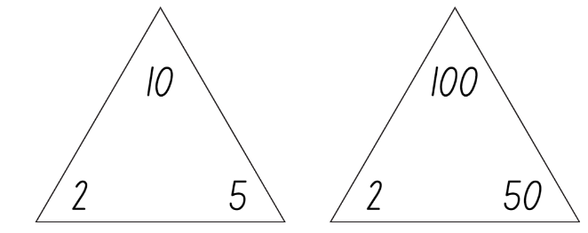
- Ask Stage 2 students:
- How has the fact family changed?
- Do you see a pattern?
- How many times larger is the total of the second triangle?
- Stage 3 students are to solve the following questions using the chipping away method:
- 137 ÷ 5
- 148 ÷ 3.
- Ask students to explain how they used their knowledge of multiplication to solve these questions.
This table details opportunities for assessment.
Assessment opportunities | Links
What to look for:  - Can Stage 2 students link multiplication and division fact families using arrays? [MAO-WM-01, MA2-MR-01]  - Can Stage 2 students model and apply commutative property of multiplication? [MAO-WM-01, MA2-MR-01]  - Can Stage 2 students complete number sentences involving multiplication and division by calculating missing number quantities? [MAO-WM-01, MA2-MR-01, MA2-MR-02]  - Can Stage 2 students recognise that doubling is multiplying by 2 and halving is dividing by 2? [MAO-WM-01, MA2-MR-01]  - Can Stage 3 students model division, including where the answer involves a remainder, using materials or diagrams?  [MAO-WM-01, MA3-MR-01]  - Can Stage 3 students use known multiplication fact families to solve division problems for which answers may include a remainder? [MAO-WM-01, MA3-MR-01]  - Can Stage 3 students show the connection between division and multiplication involving the divisor and quotient?  [MAO-WM-01, MA3-MR-01] | Links to National Numeracy Learning Progressions (NNLP):  - Stage 2 – MuS6, NPA4  - Stage 3 – MuS6, MuS7.  Links to suggested Interview for Student Reasoning (IfSR) tasks:  - Stage 2 – IfSR-NP/AT/MT: 2A.2, 2A.4, 2A.6  - Stage 3 – IfSR-MT: 3A.6, 3A.7.

Lesson 8
Core concept: worded problems can be solved using multiplicative thinking.

Daily number sense – 15 minutes
- From a class need surfaced through formative assessment data, identify a short, focused activity that targets students’ knowledge, understanding and skills. Example activities may be drawn from the following resources:
- Mathematics K–6 resources
- Universal Resources Hub.

Core lesson – 40 minutes

Stage 2 task – problem solving
The table below contains suggested learning intentions and success criteria. These are best co-constructed with students.
Core concept learning intentions | Core concept success criteria
Students working towards Stage 2 outcomes are learning to:  - use arrays to establish multiplication facts from multiples of 2 and 4, 5 and 10  - represent and solve problems involving multiplication fact families. | Students working towards Stage 2 outcomes can:  - recognise that doubling is multiplying by 2 and halving is dividing by 2  - describe multiplication problems using for each and times as many  - apply the inverse relationship of multiplication and division.
- Discuss the strategies students have learned during the previous 3 lessons. They turn and talk, recording their ideas.
- As students’ share their responses, highlight ‘groups of’, arrays, halving, doubling, ‘for each’, 10 times as many and fact families.
- Read the following problem: Larissa has some marbles and shares them equally into 4 groups. Each group receives 5 marbles.
- Ask:
- How many marbles will Larissa share with her friends?
- How can this problem be represented visually?
- How can this problem be represented using 2 different strategies?
- Divide the whiteboard into 2 and demonstrate how to record both strategies side-by-side on the whiteboard as students communicate their ideas (see Figure 22).
Figure 22 – Stage 2 word problem recording example
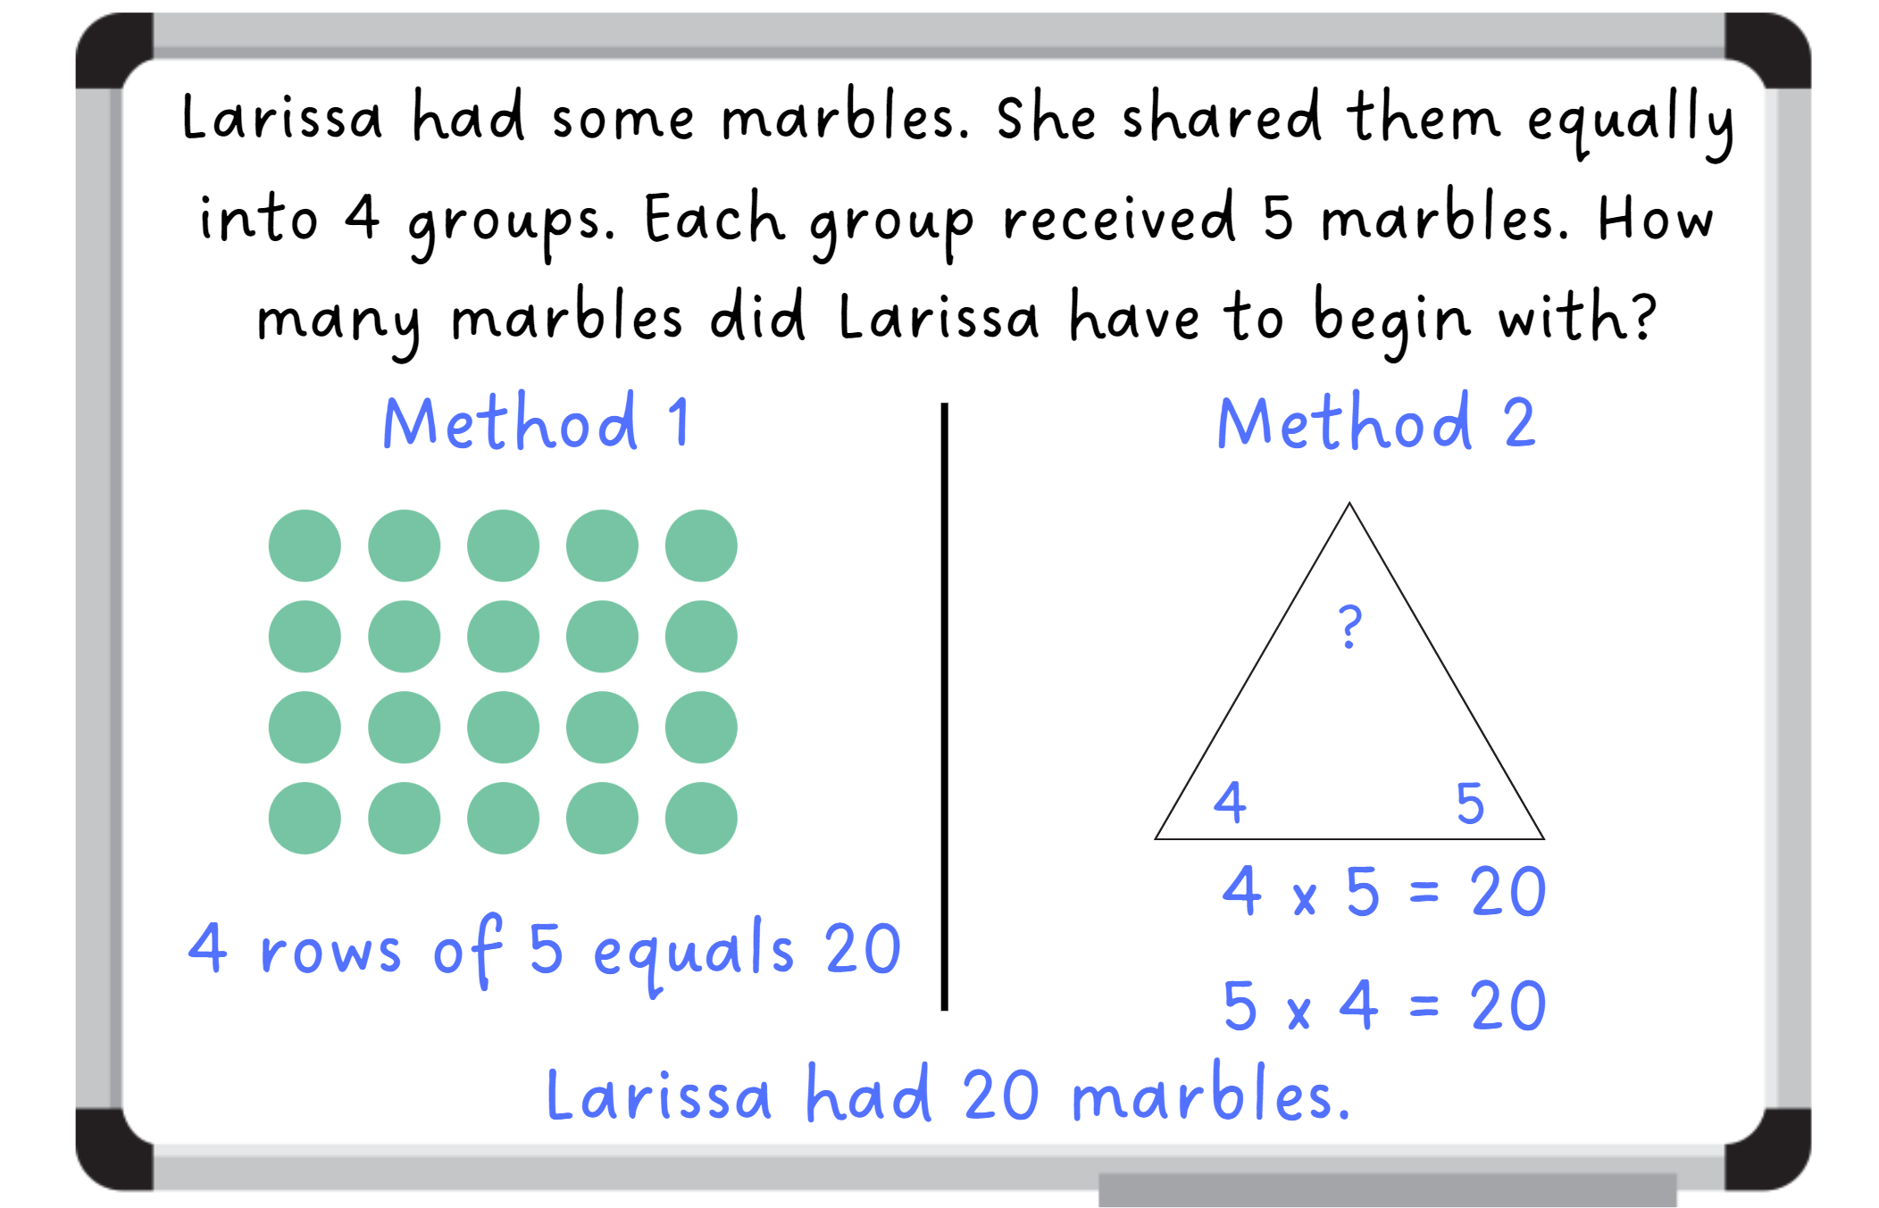
- Read the following problem: Madison and Rachael cook biscuits. Madison cooks 2 biscuits and Rachael cooks 20 times as many as Madison. How many biscuits does Rachael cook in total?
- Discuss the meaning of ‘20 times as many’ and link this explicitly to multiplication. Ask students how they might represent this problem using 2 different strategies.
- Students record 2 different strategies, as in the previous problem.
- Display Resource 24 – problems to solve.
- Students record their answers to the word problems using the same layout as before. Encourage them to represent their thinking in a variety of ways.
This table details opportunities for differentiation.
Too hard? | Too easy?
Stage 2 students cannot describe multiplication problems using for each and times as many.  - Use concrete materials to model the problem.  - Support students to select a strategy appropriate to their level of understanding. | Stage 2 students can describe multiplication problems using for each and times as many.  - Pose questions to the students, such as:  - The number 32 appears somewhere in a multiplicative word problem. What might the problem be?  - What strategies can you use to solve this problem efficiently?  - Can you create a different word problem that also uses the number 32?  - Students write a multiplicative word problem for a classmate and asks them to solve it.

Stage 3 task – division word problems
The table below contains suggested learning intentions and success criteria. These are best co-constructed with students.
Core concept learning intentions | Core concept success criteria
Students working towards Stage 3 outcomes are learning to:  - select and apply strategies to divide a number with 3 or more digits by a one-digit divisor. | Students working towards Stage 3 outcomes can:  - use knowledge of multiples to partition as appropriate and divide  - apply and record appropriate strategies to solve division word problems  - use and interpret remainders in solutions to division problems  - use digital technologies to divide whole numbers by one- and 2-digit divisors.
- Present this problem to the class: A builder has 112 nails in total and wants to divide them into 7 bags. How many will be in each bag?
- Model the problem as a class using the ‘chipping away’ method (see Figure 23).
Figure 23 – chipping away 112
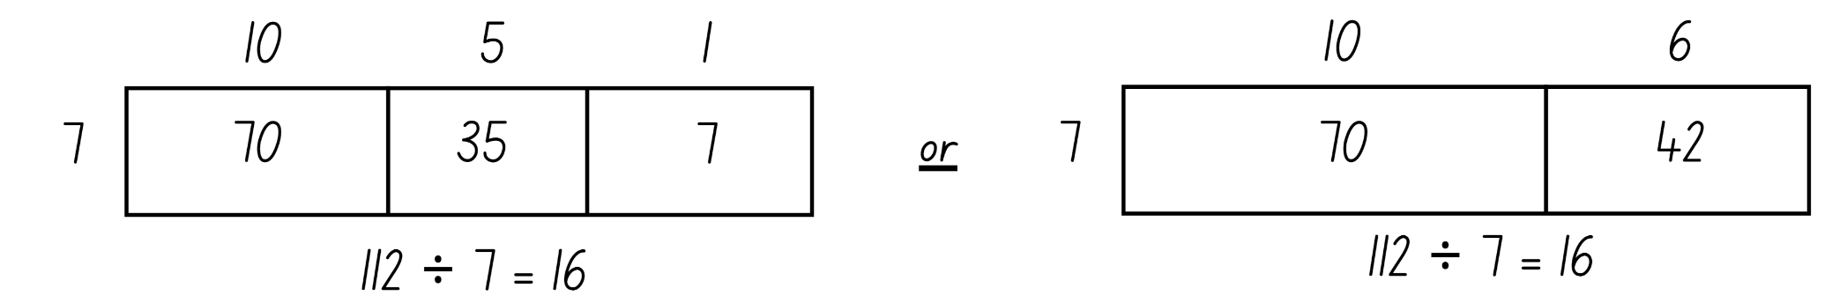
- Demonstrate how to use the online area model digital tool to solve this problem (see Figure 24).
Figure 24 – chipping away 112 area model
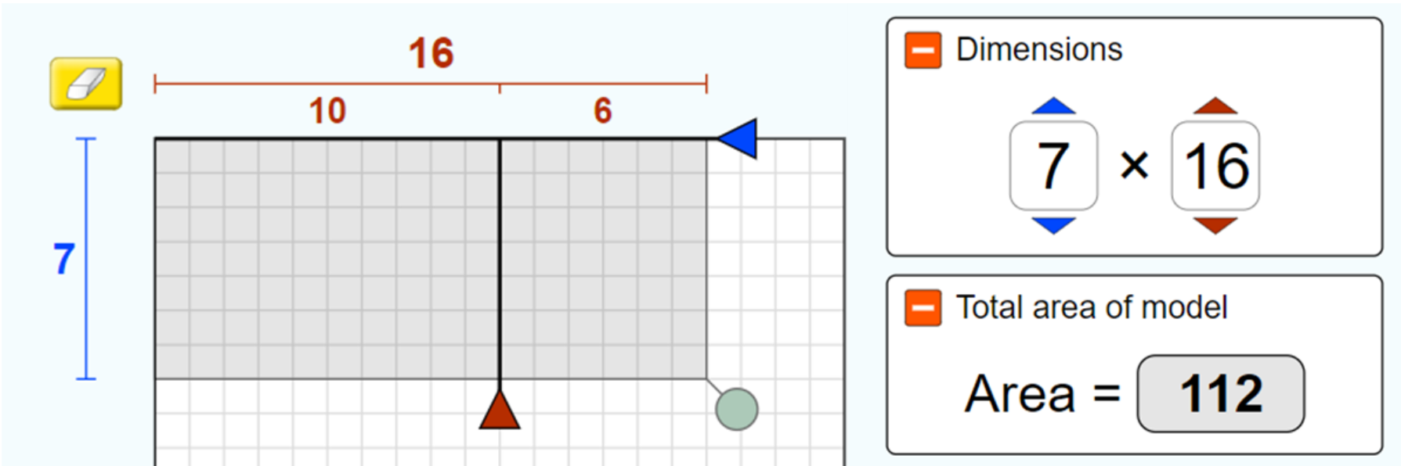
Image created using the simulation software at PhET Interactive Simulations, University of Colorado Boulder, licensed under CC-BY-4.0.
Note: the ‘total area of model’ represents the total being divided, the dimensions are the divisor and quotient.
- Highlight the partitioning tool to represent the ‘chipping away’ breakdown.
- Present the following problem: Our school took 144 students to the PSSA Netball Gala Day with Miss Fahey. We needed to make 9 equal netball teams. Find how many students were on each team.
- Allow students time to work on the solution using the ‘chipping away’ method.
- Continue the problem: On the morning of the gala day an extra 23 students registered to play. Miss Fahey could still only make 9 equal teams. Ask:
- How many are in each team now?
- How many are left over?
- Can you show the closest representation using the area model digital tool?
- Students use the area model digital tool to determine their answer and then draw area model representation with the remainders in their workbooks.
This table details opportunities for differentiation.
Too hard? | Too easy?
Students cannot apply and record appropriate strategies to solve division word problems.  - Use the area model digital tool to explore smaller numbers.  - Assist students by reducing the number they divide to 2-digits. | Students can apply and record appropriate strategies to solve division word problems.  - Use the area model digital tool to create word problems using larger numbers.  - Students give examples of inefficient strategies and provide reasons against their use.

Discuss and connect the mathematics – 10 minutes
- Select several student work samples.
- Ask students to identify and describe the strategies they used to solve the word problems and communicate their reasoning.
- Ask students:
- Are all strategies appropriate or efficient for all problems?
- Are some strategies better to solve certain problems?
- What strategy do you find the easiest to use? Why?
This table details opportunities for assessment.
Assessment opportunities | Links
What to look for:  - Can Stage 2 students recognise that doubling is multiplying by 2 and halving is dividing by 2? [MAO-WM-01, MA2-MR-01]  - Can Stage 2 students describe multiplication problems using for each and times as many? [MAO-WM-01, MA2-MR-01]  - Can Stage 2 students apply the inverse relationship of multiplication and division? [MAO-WM-01, MA2-MR-01]  - Can Stage 3 students use knowledge of multiples to partition as appropriate and divide? [MAO-WM-01, MA3-MR-01]  - Can Stage 3 students apply and record appropriate strategies to solve division word problems? [MAO-WM-01, MA3-MR-01]  - Can Stage 3 students use and interpret remainders in solutions to division problems? [MAO-WM-01, MA3-MR-01]  - Can Stage 3 students use digital technologies to divide whole numbers by one- and 2-digit divisors? [MAO-WM-01, MA3-MR-01] | Links to National Numeracy Learning Progressions (NNLP):  - Stage 2 – MuS5, MuS6, MuS7, InF2, InF6  - Stage 3 – MuS6, MuS7, MuS8.  Links to suggested Interview for Student Reasoning (IfSR) tasks:  - Stage 2 – IfSR-MT: 2A.5, 2A.10, 2A.12, 2A.13, 2A.14  - Stage 3 – IfSR-MT: 3A.6, 3A.7.

Resource 1 – prove it
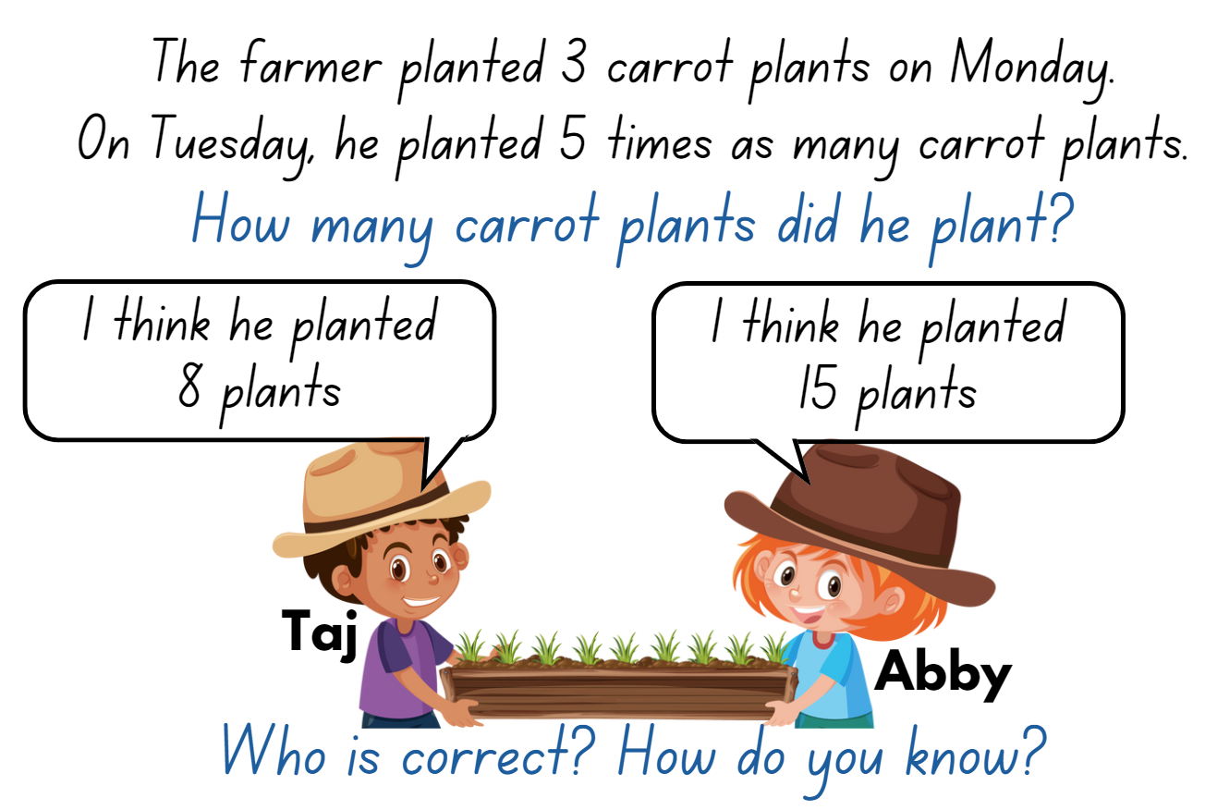

Resource 2 – place value houses
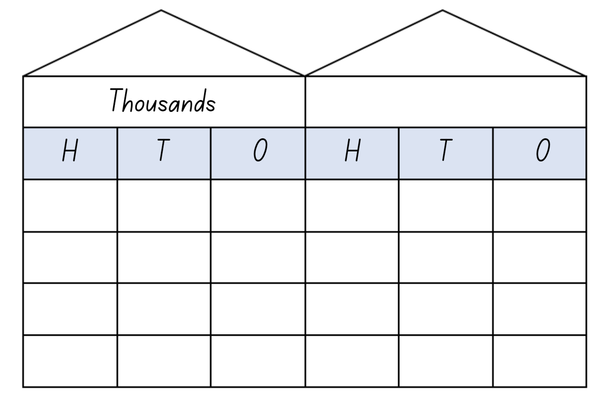

Resource 3 – houses to billions
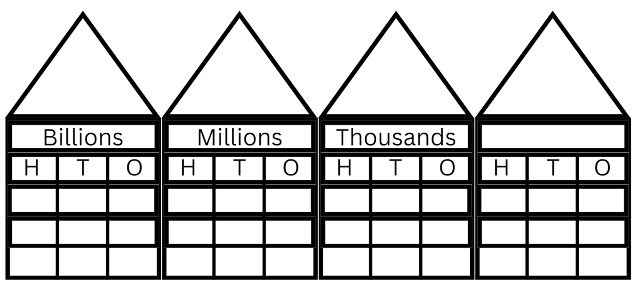

Resource 4 – MAB visual
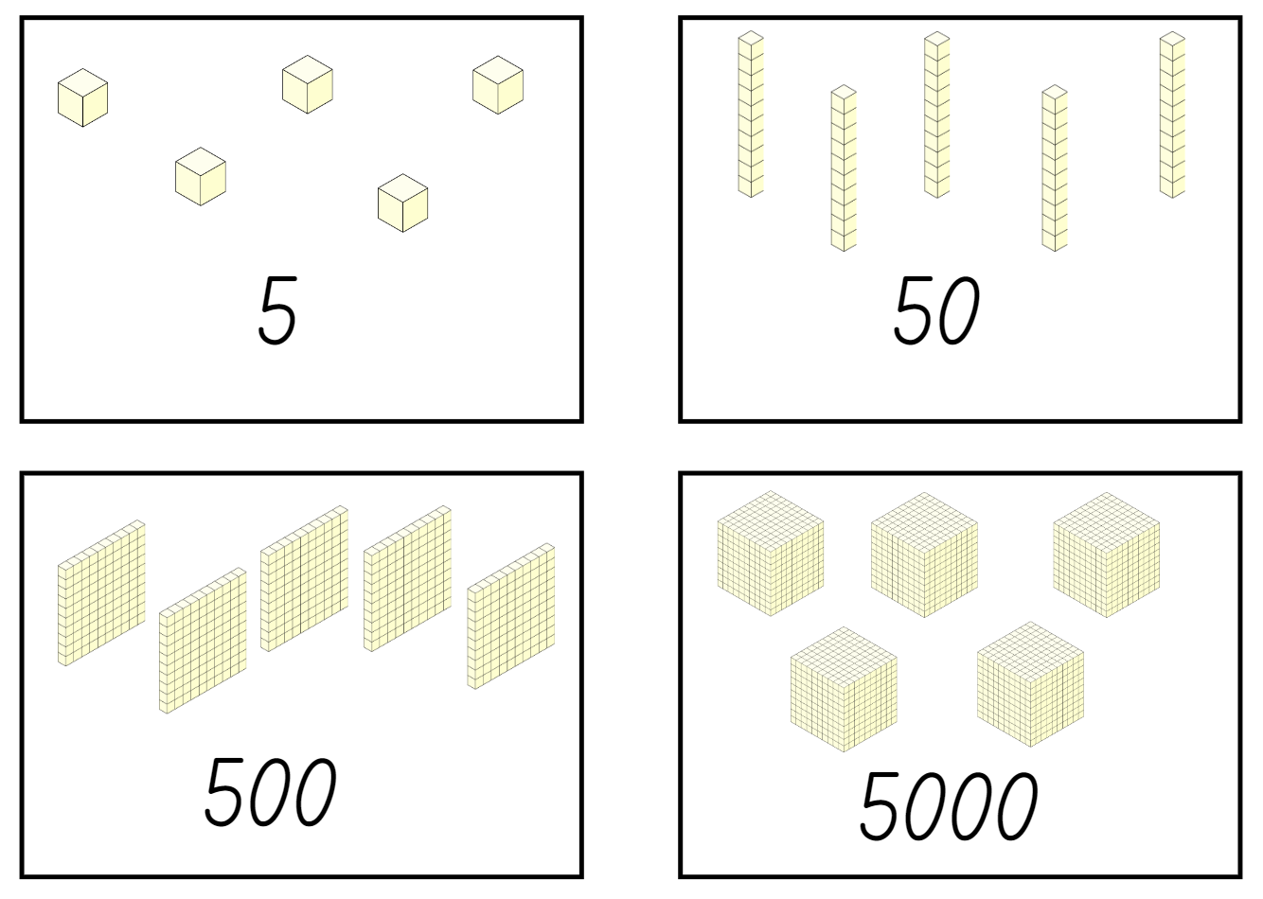

Resource 5 – think board
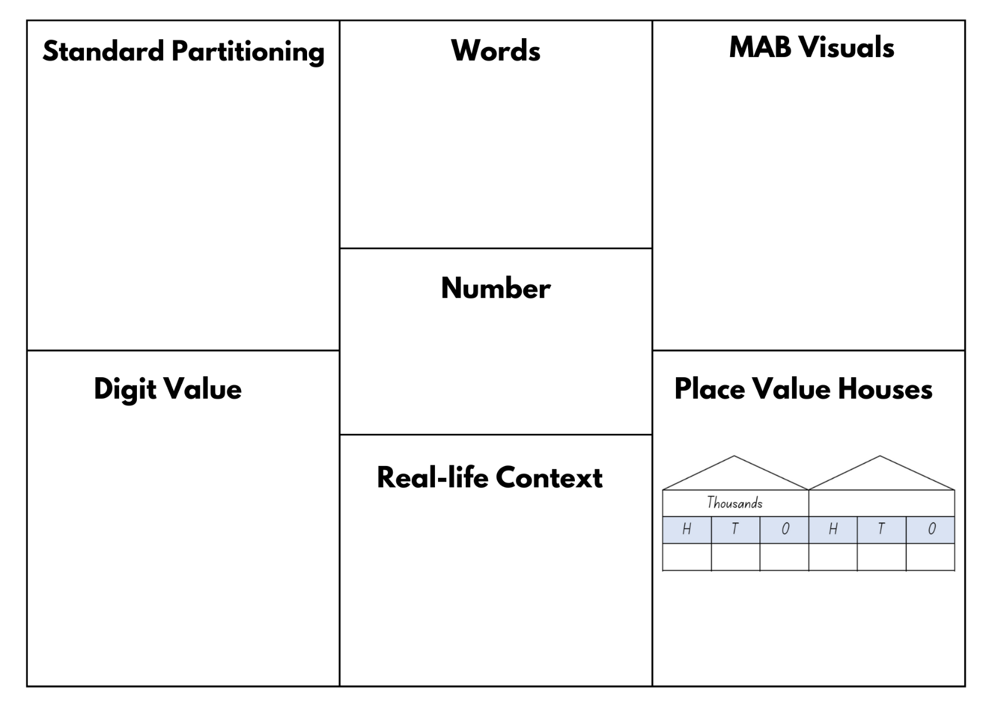

Resource 6 – orange picking
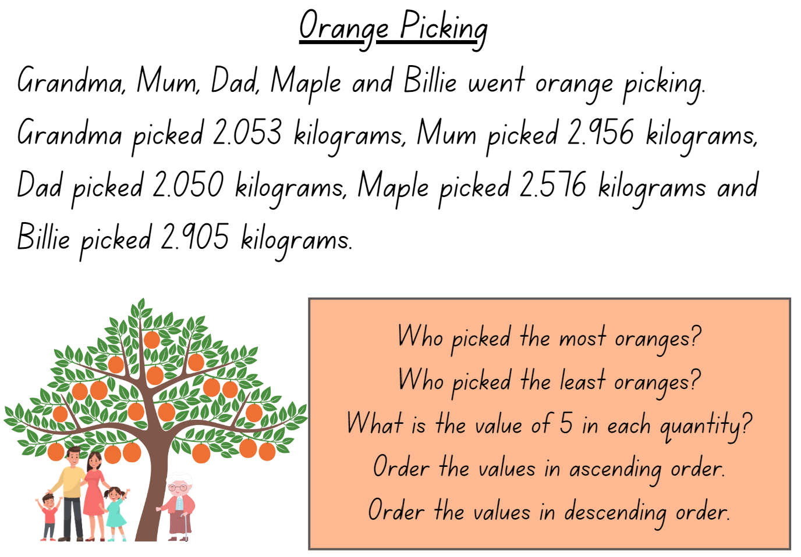

Resource 7 – 7211 MAB visual
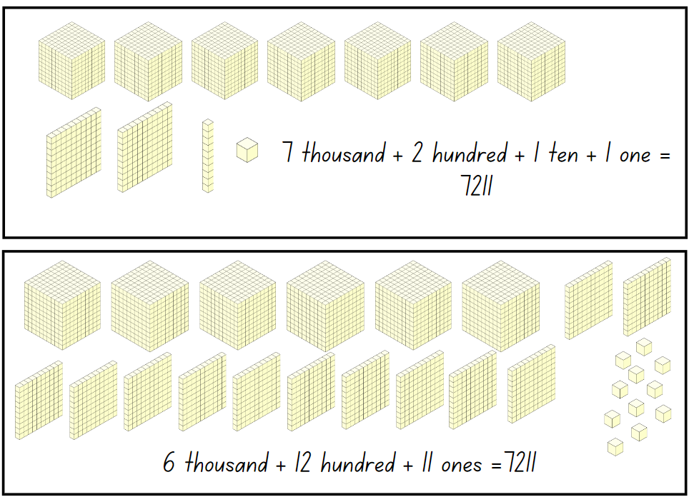

Resource 8 – MAB representations
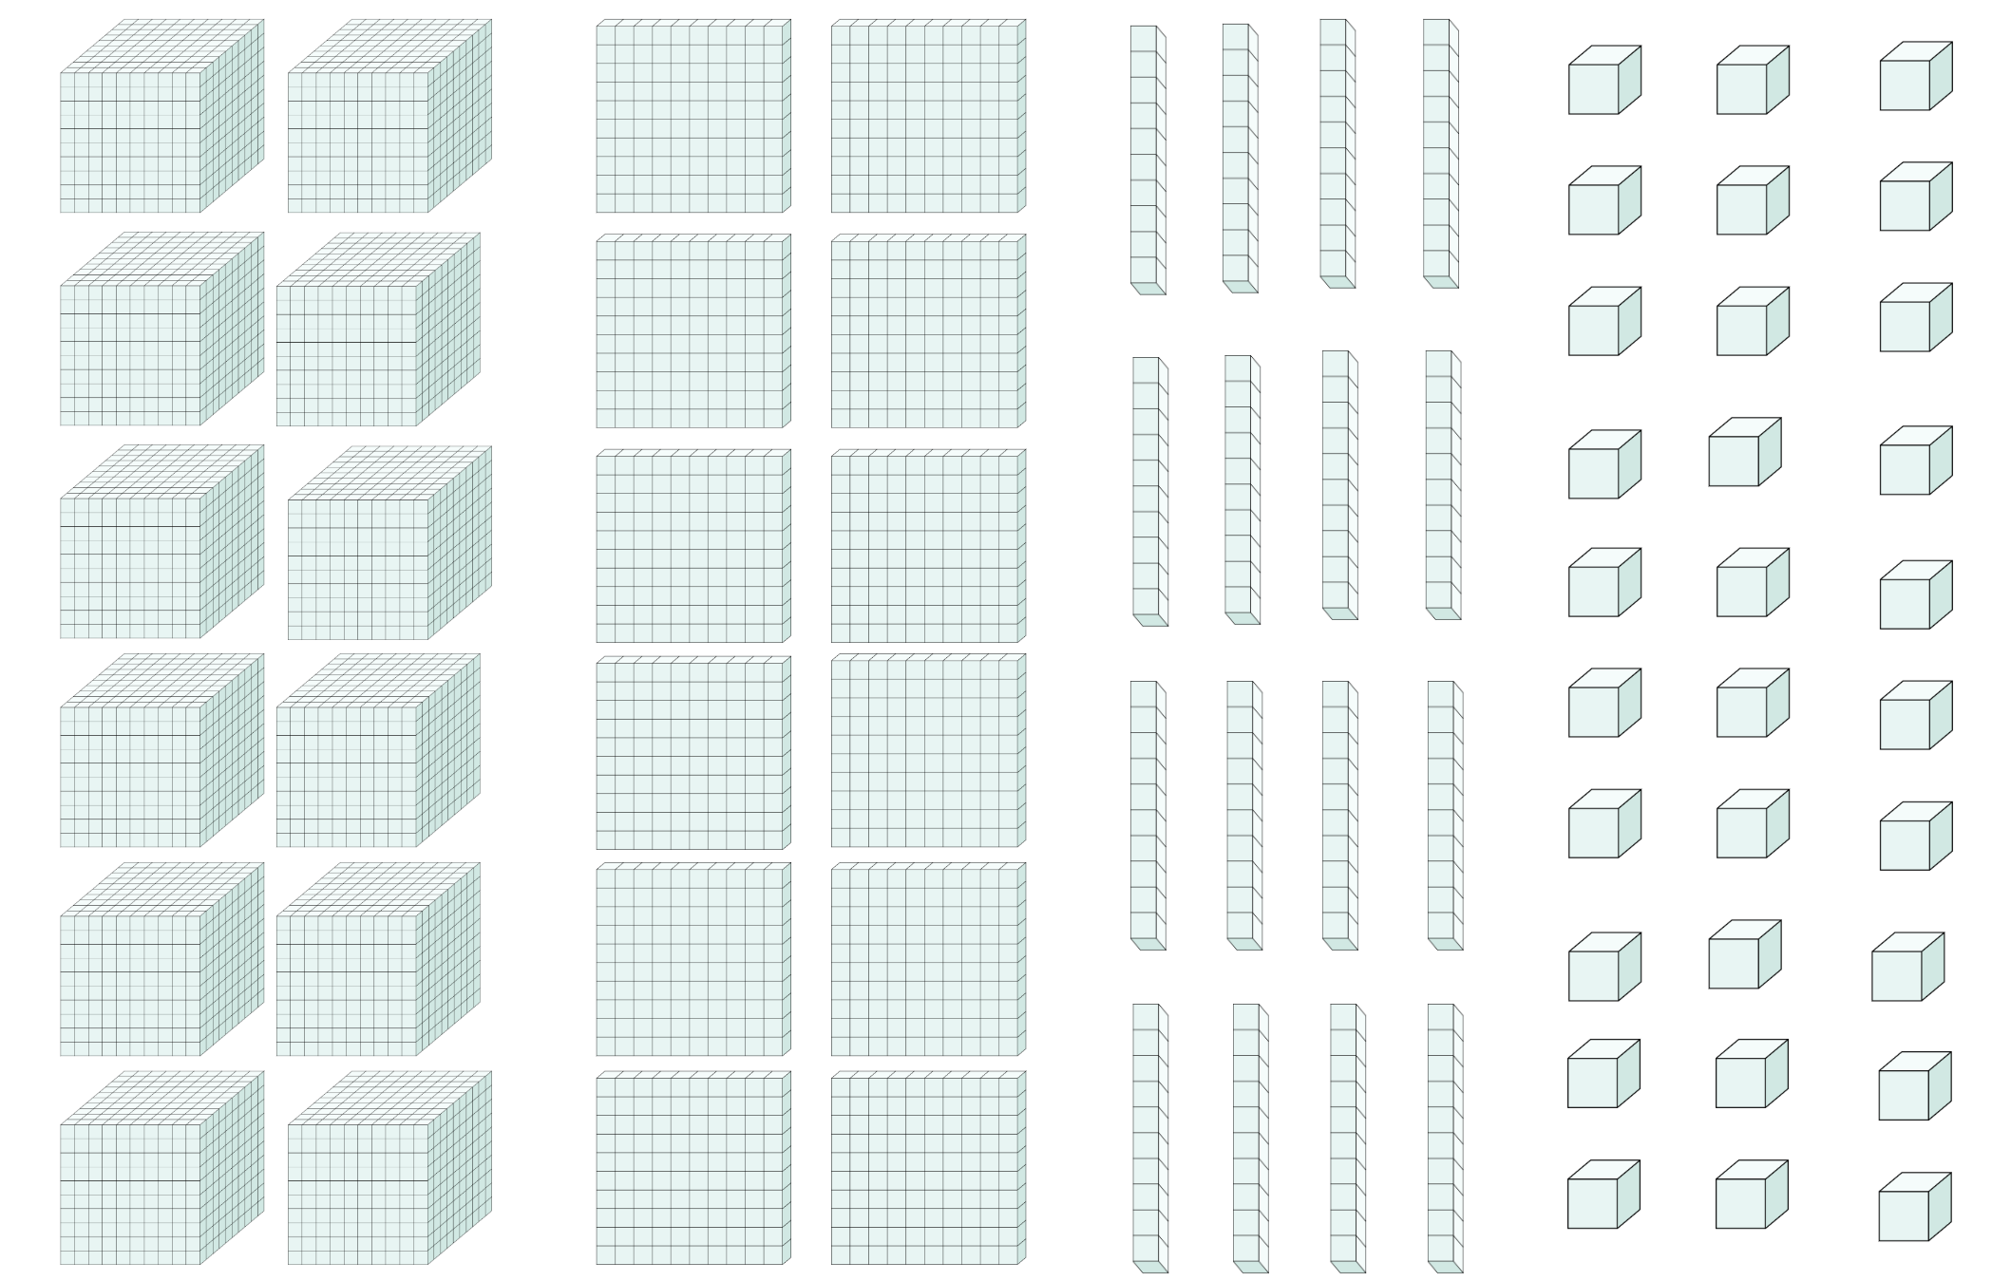

Resource 9 – temperature cards
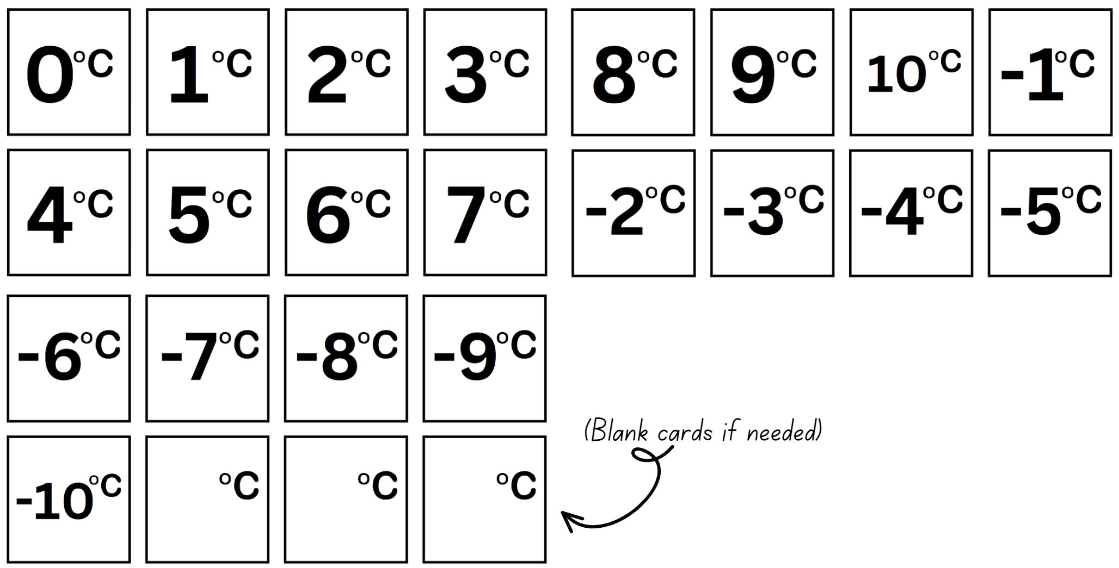

Resource 10 – money misconception
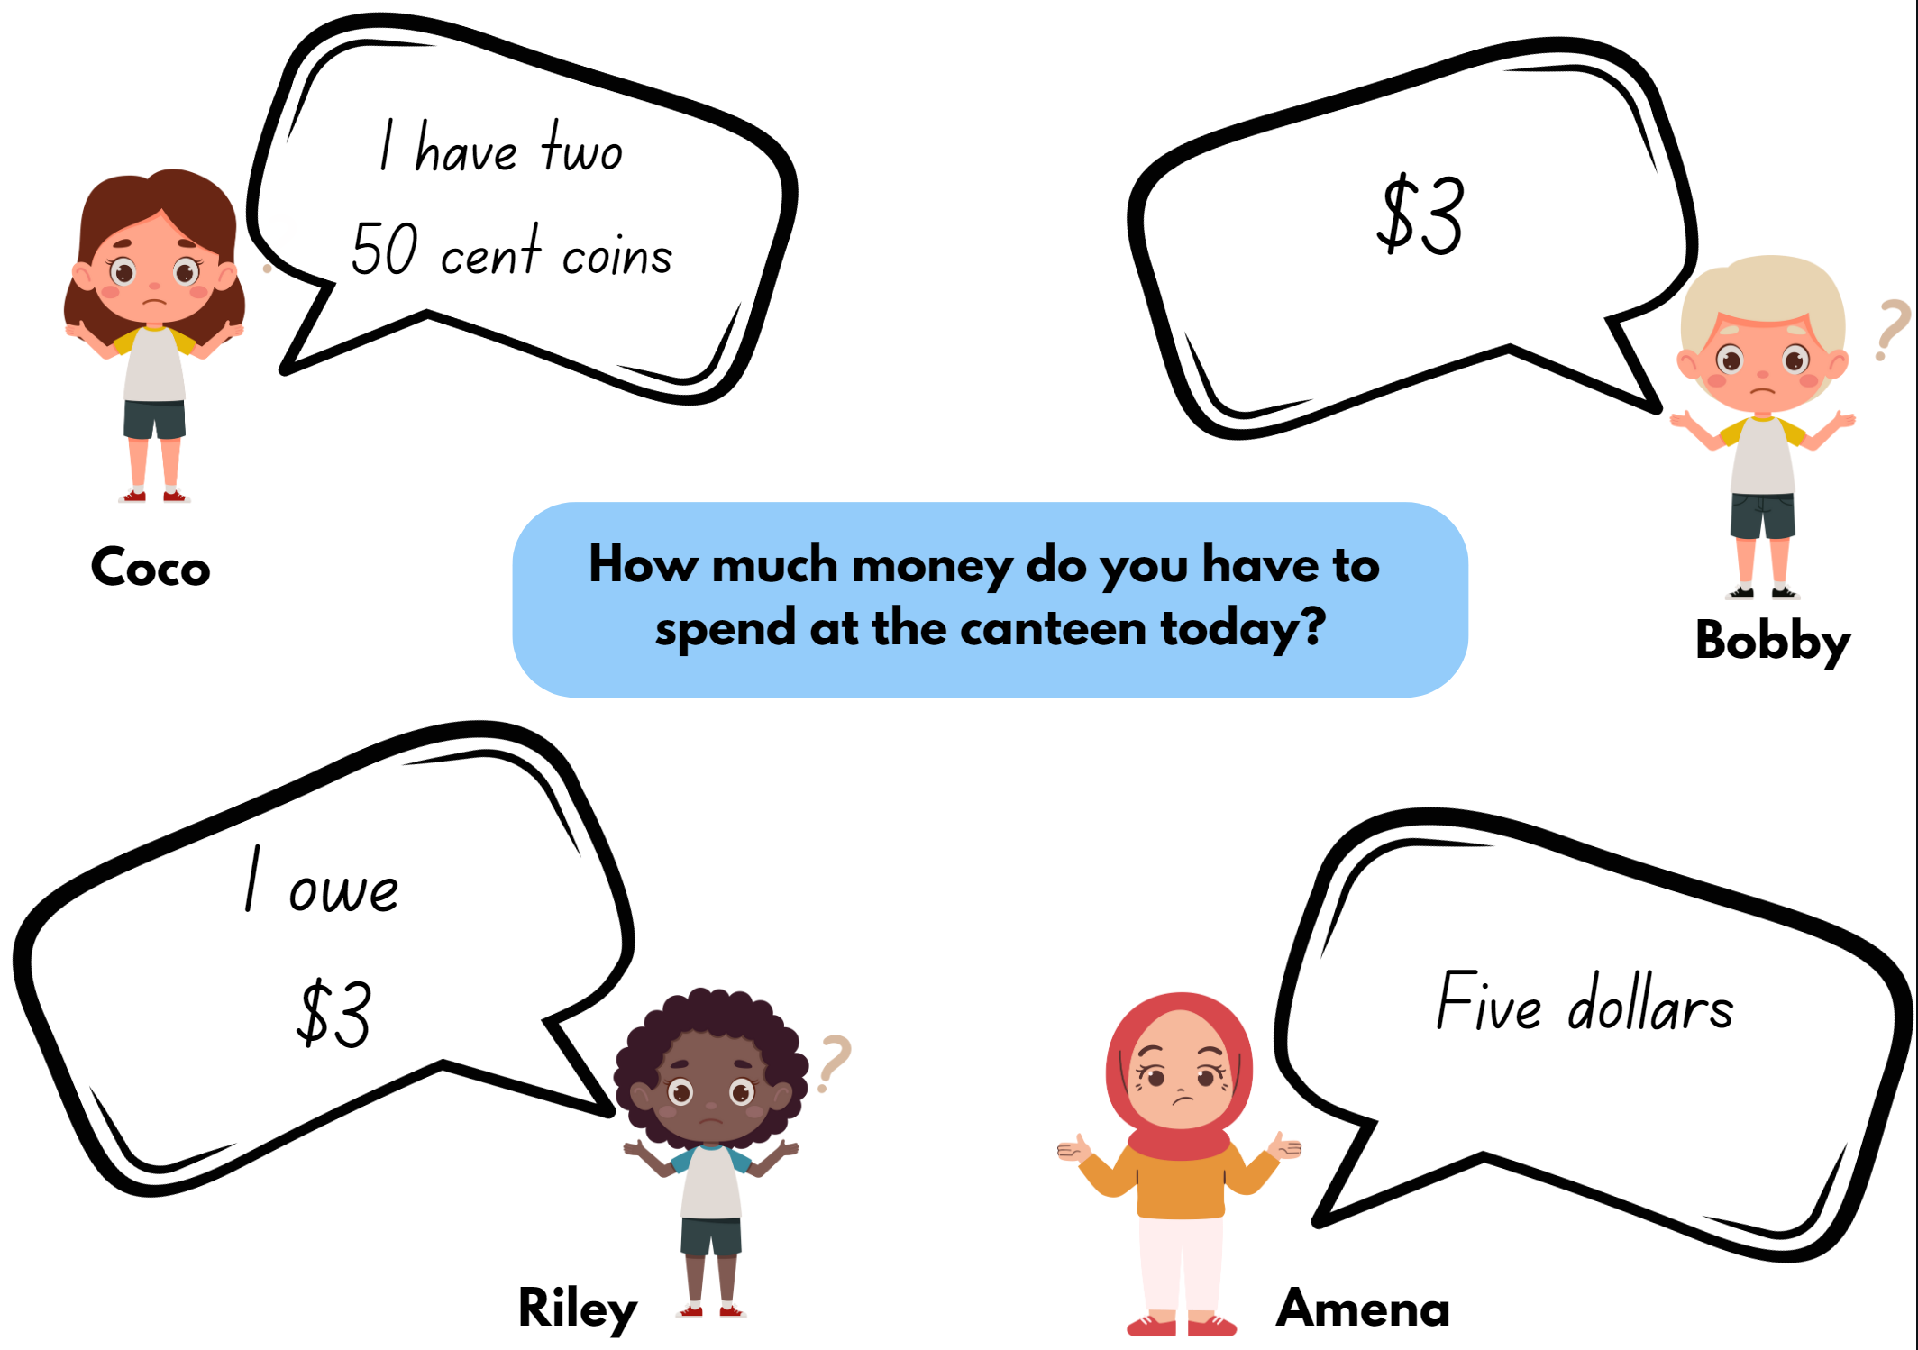

Resource 11 – non-standard partitioning match
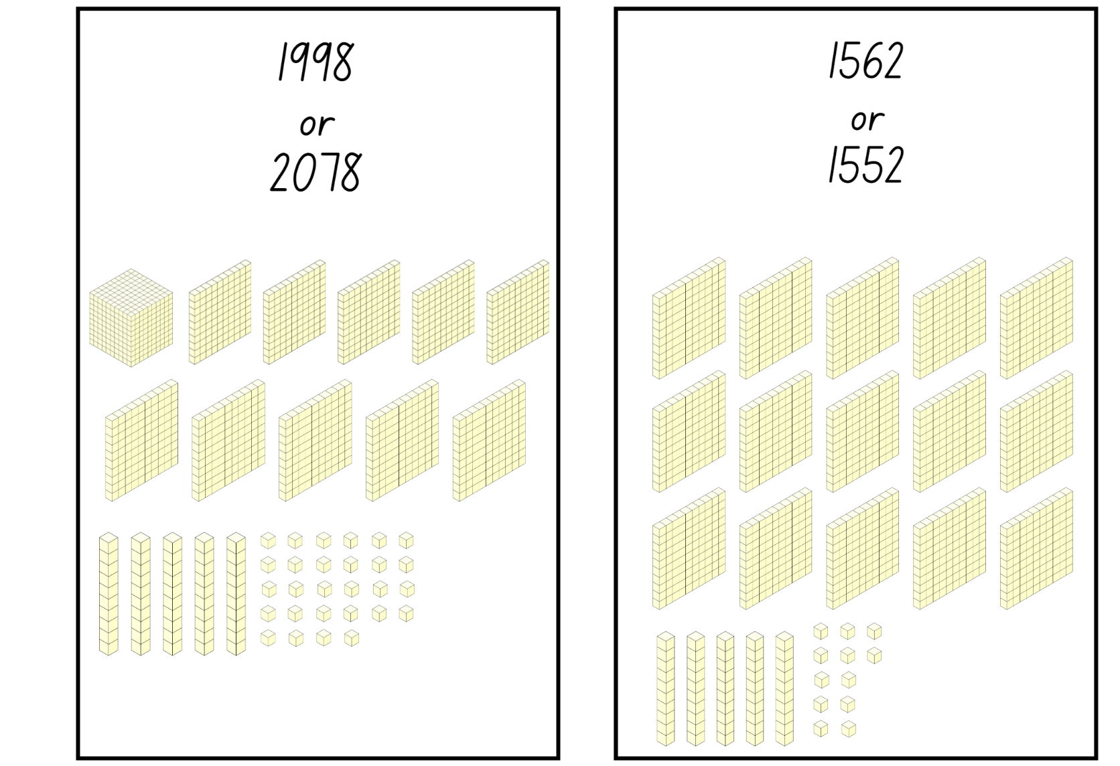

Resource 12 – integer spinner
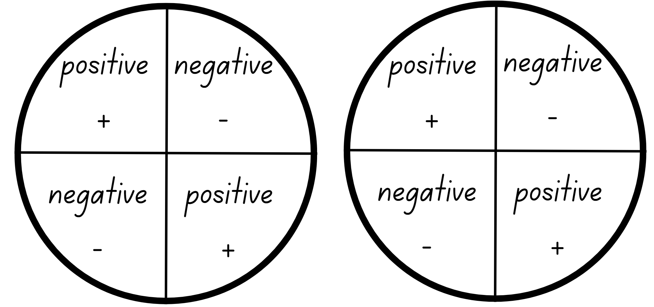

Resource 13 – visual patterns
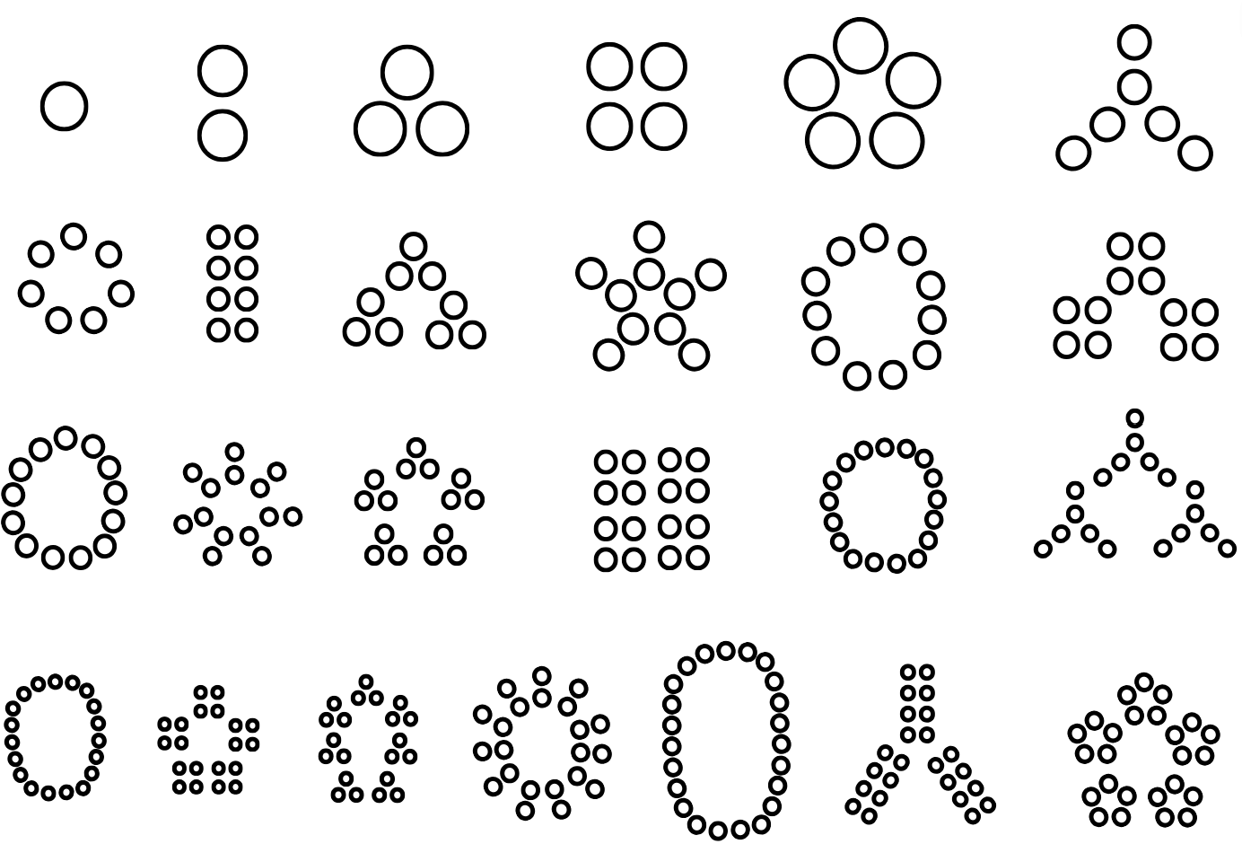
Adapted from Standford University (n.d).

Resource 14 – Stage 3 factor table
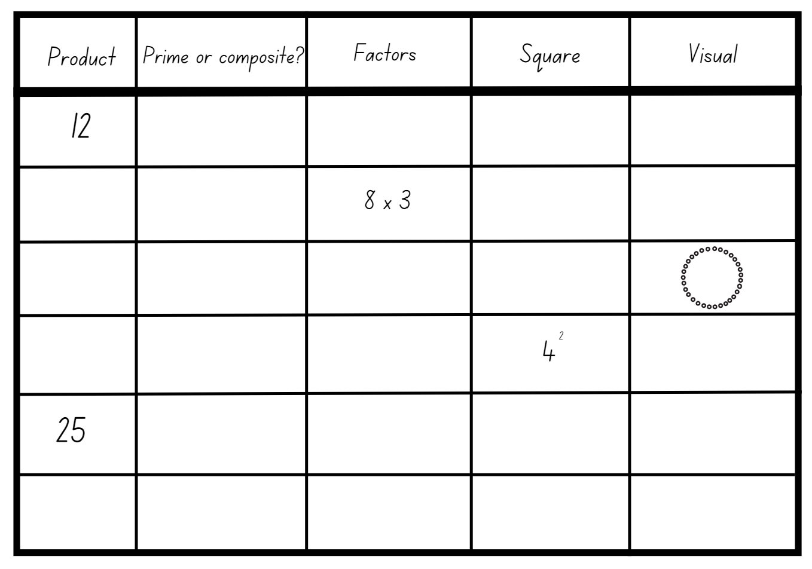

Resource 15 – Stage 2 number visuals
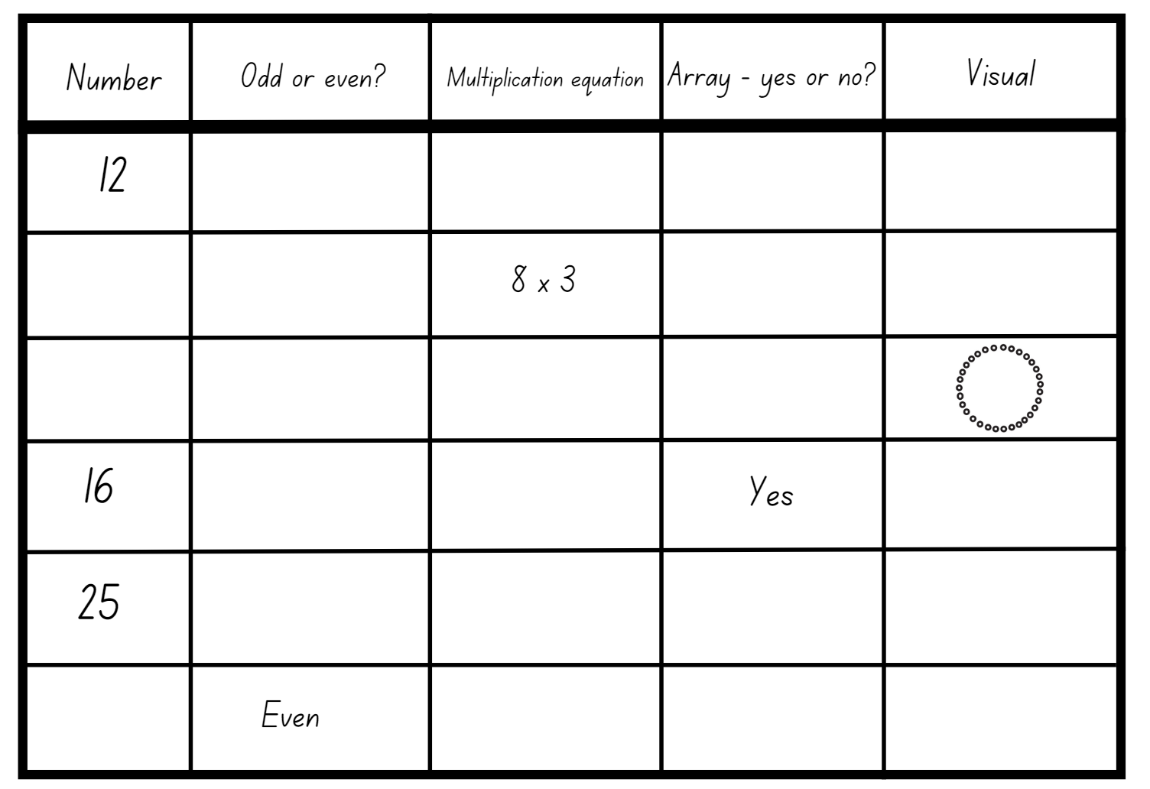

Resource 16 – blank factor table
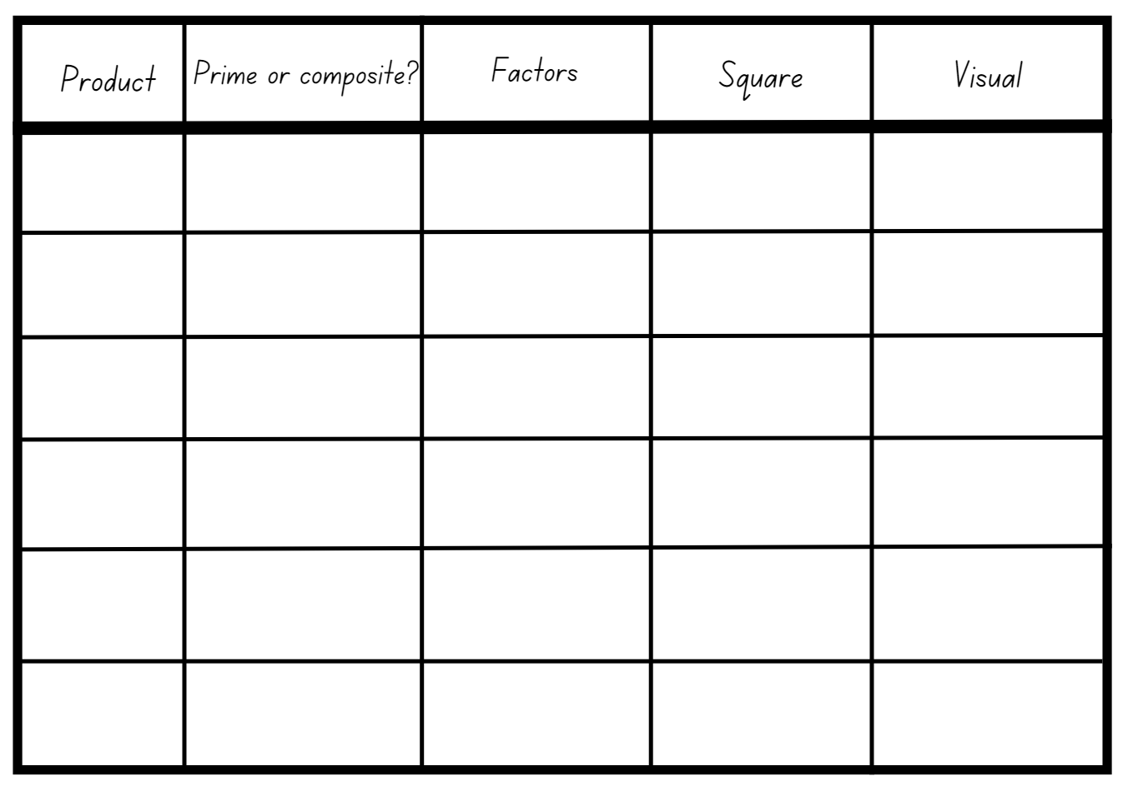

Resource 17 – visual patterns 2

Adapted from Standford University (n.d).

Resource 18 – student strategies
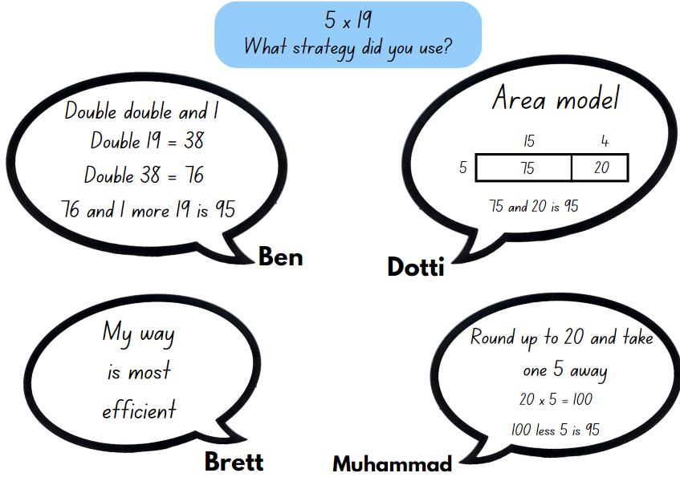

Resource 19 – convince me
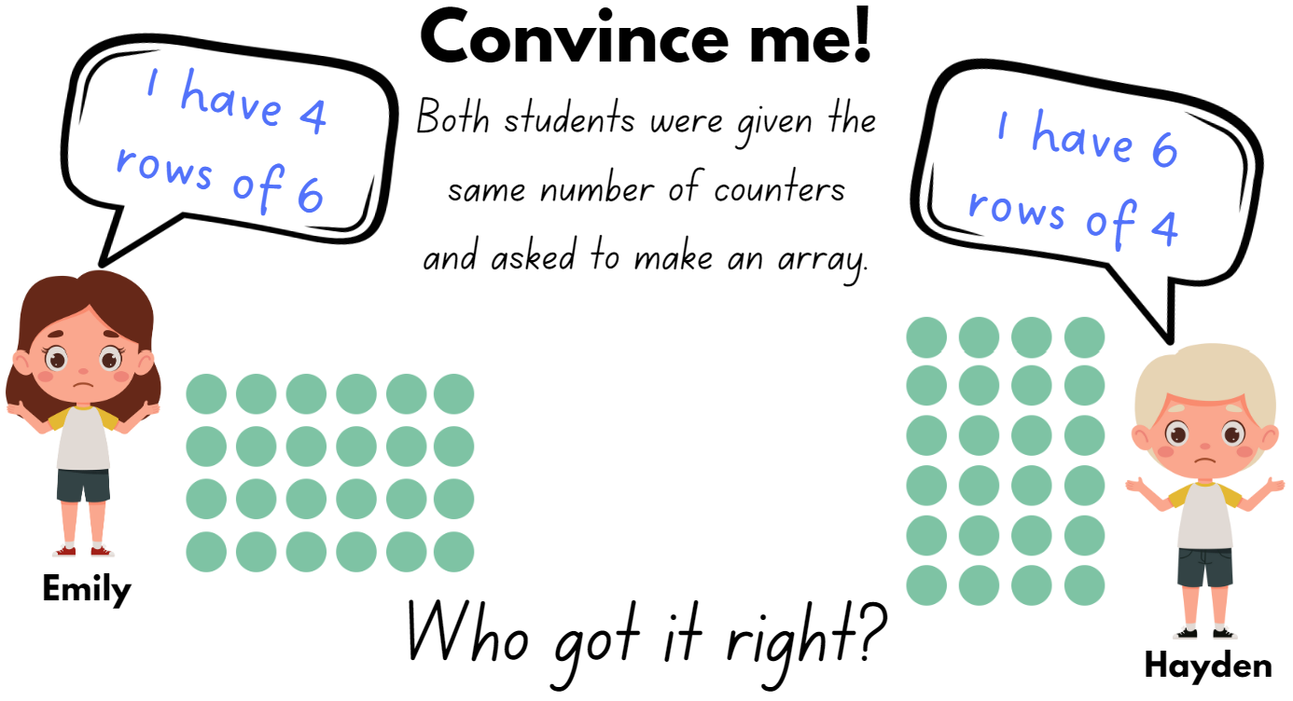

Resource 20 – matching algorithms
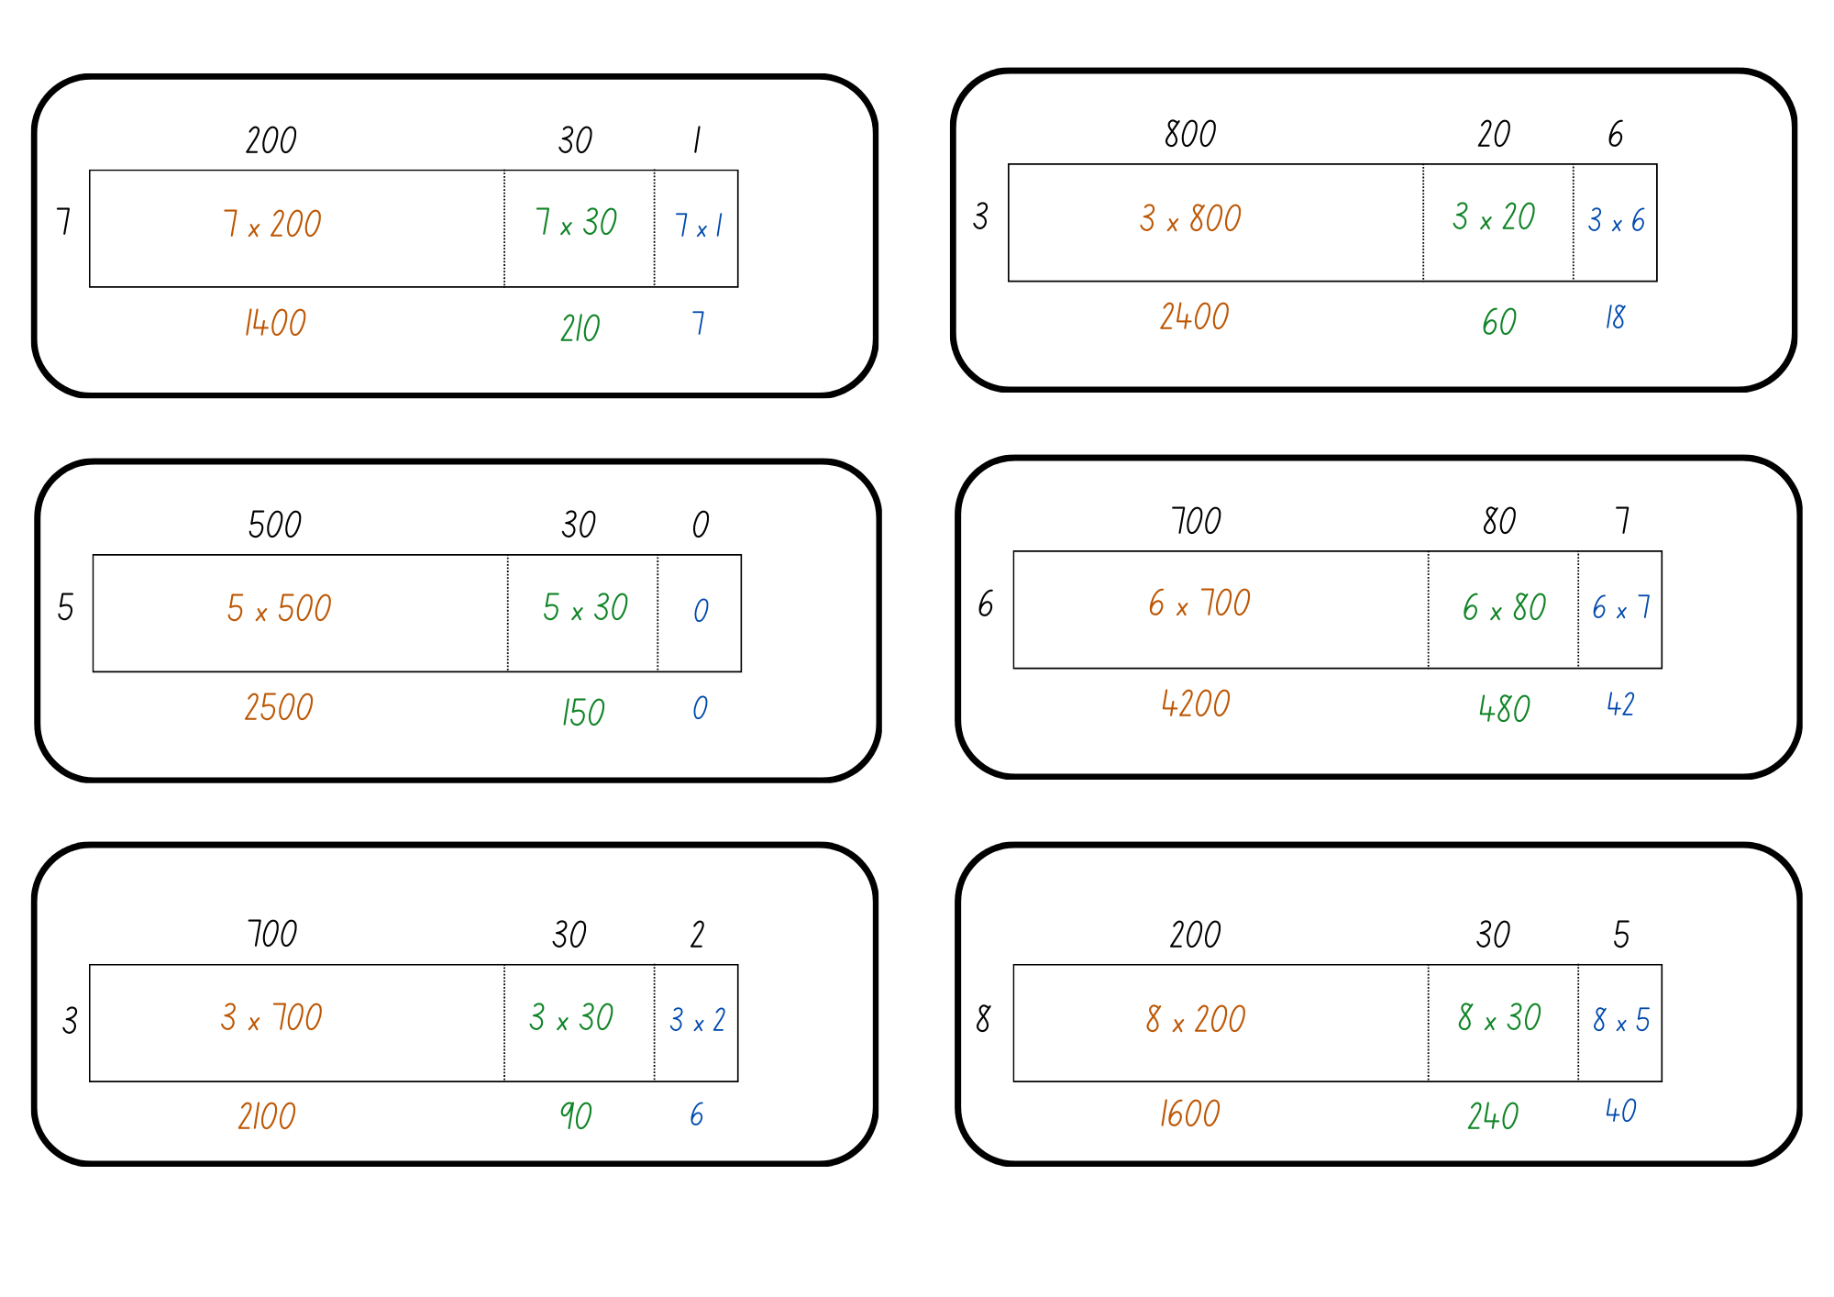
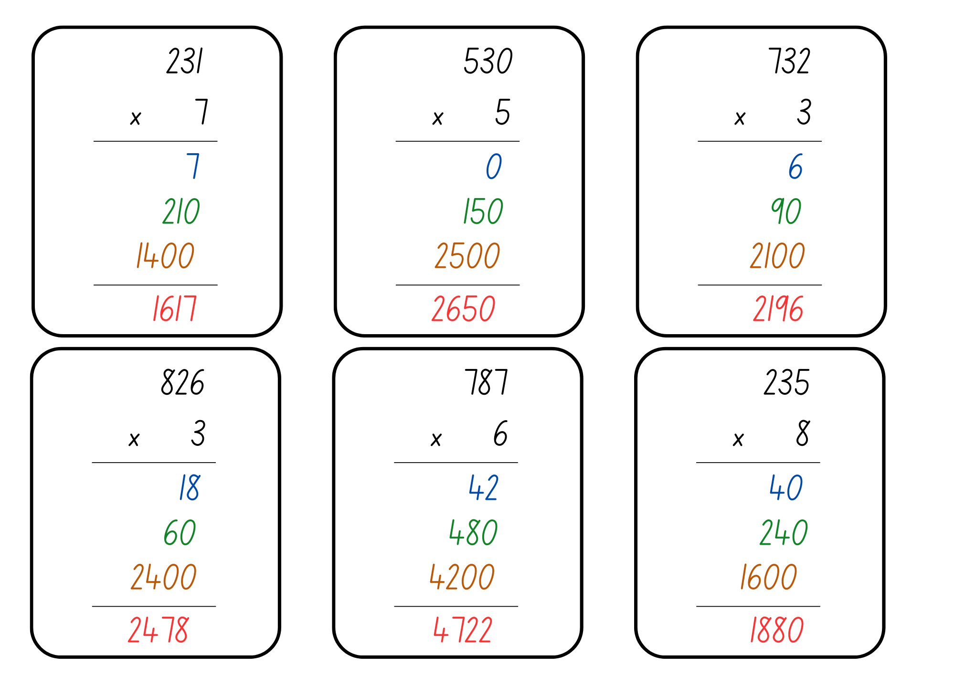

Resource 21 – 2-digit algorithm
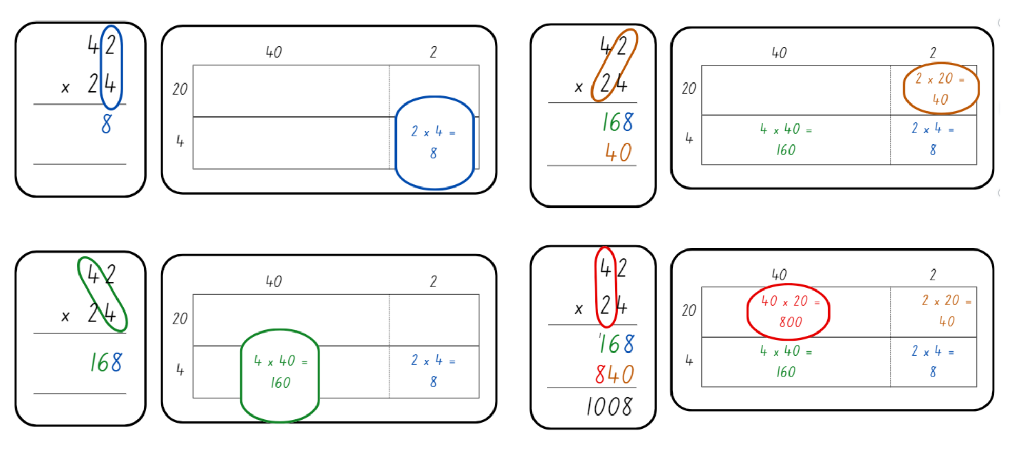

Resource 22 – array/fact family
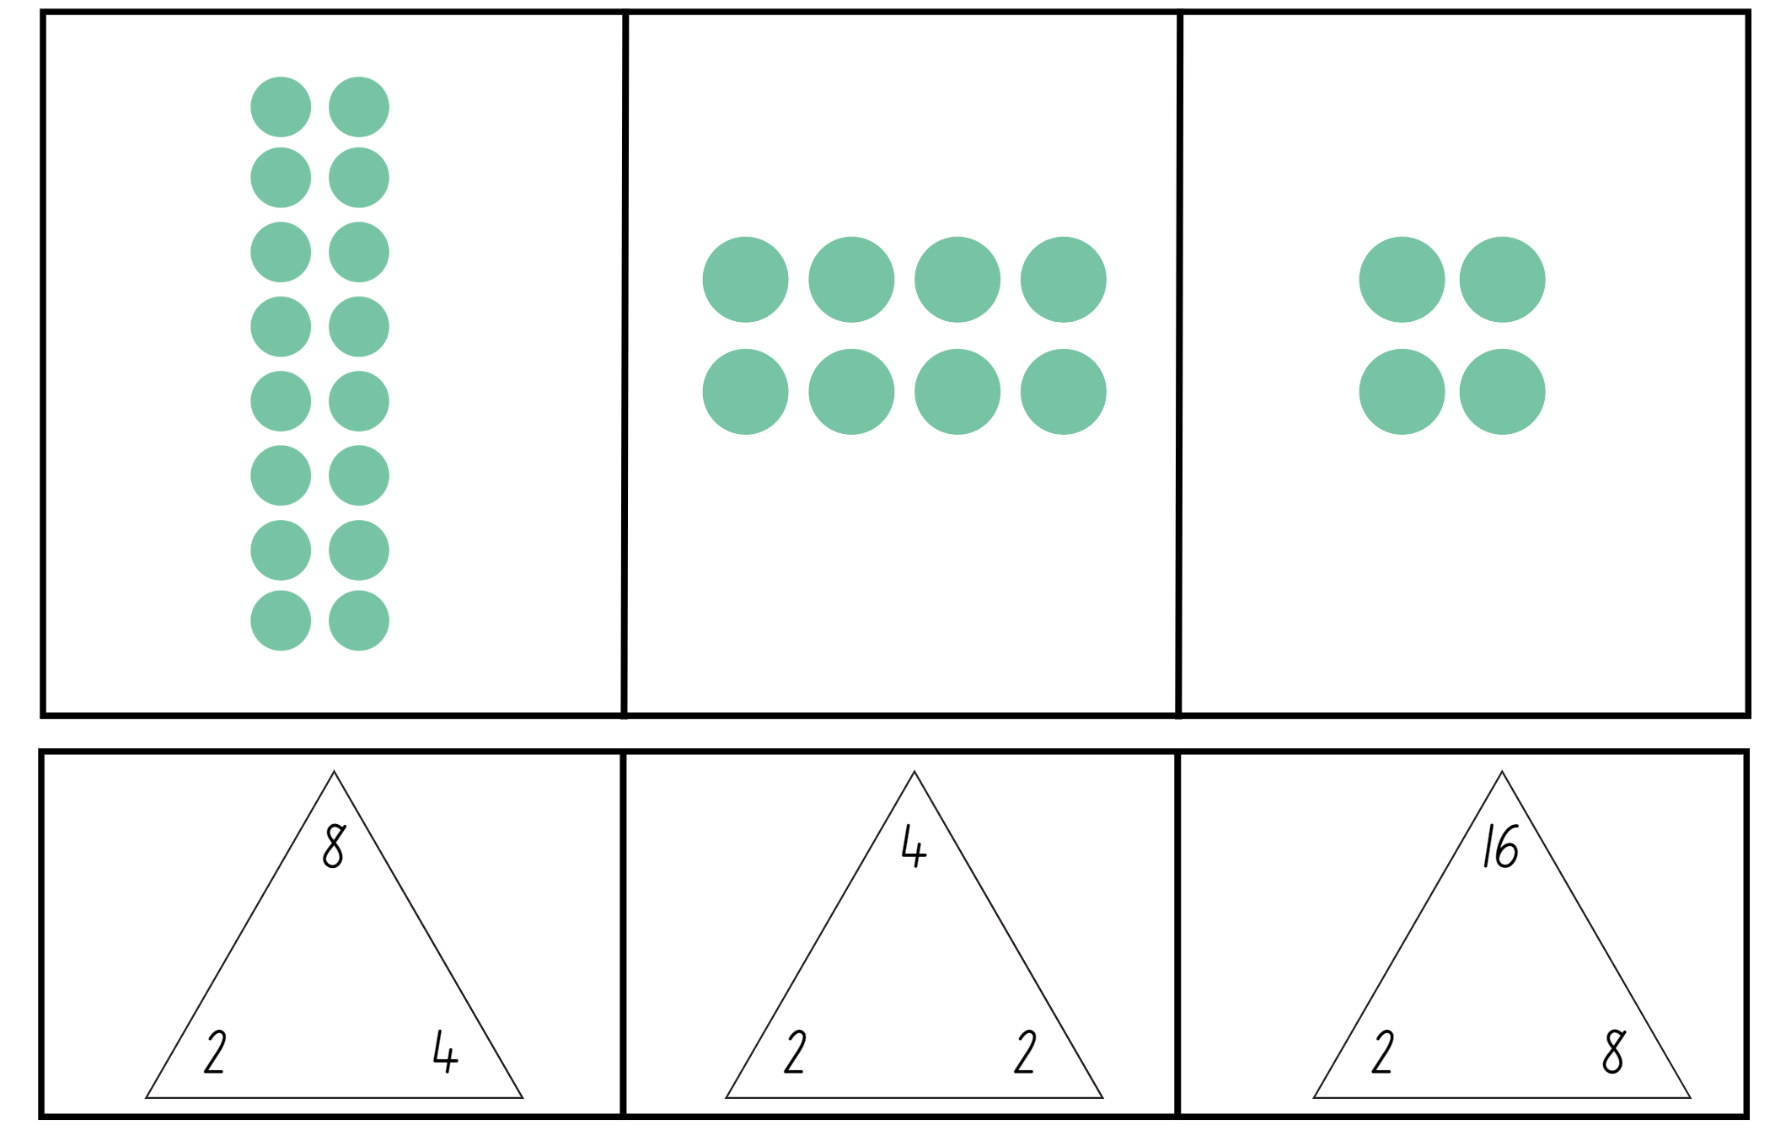

Resource 23 – division with remainders
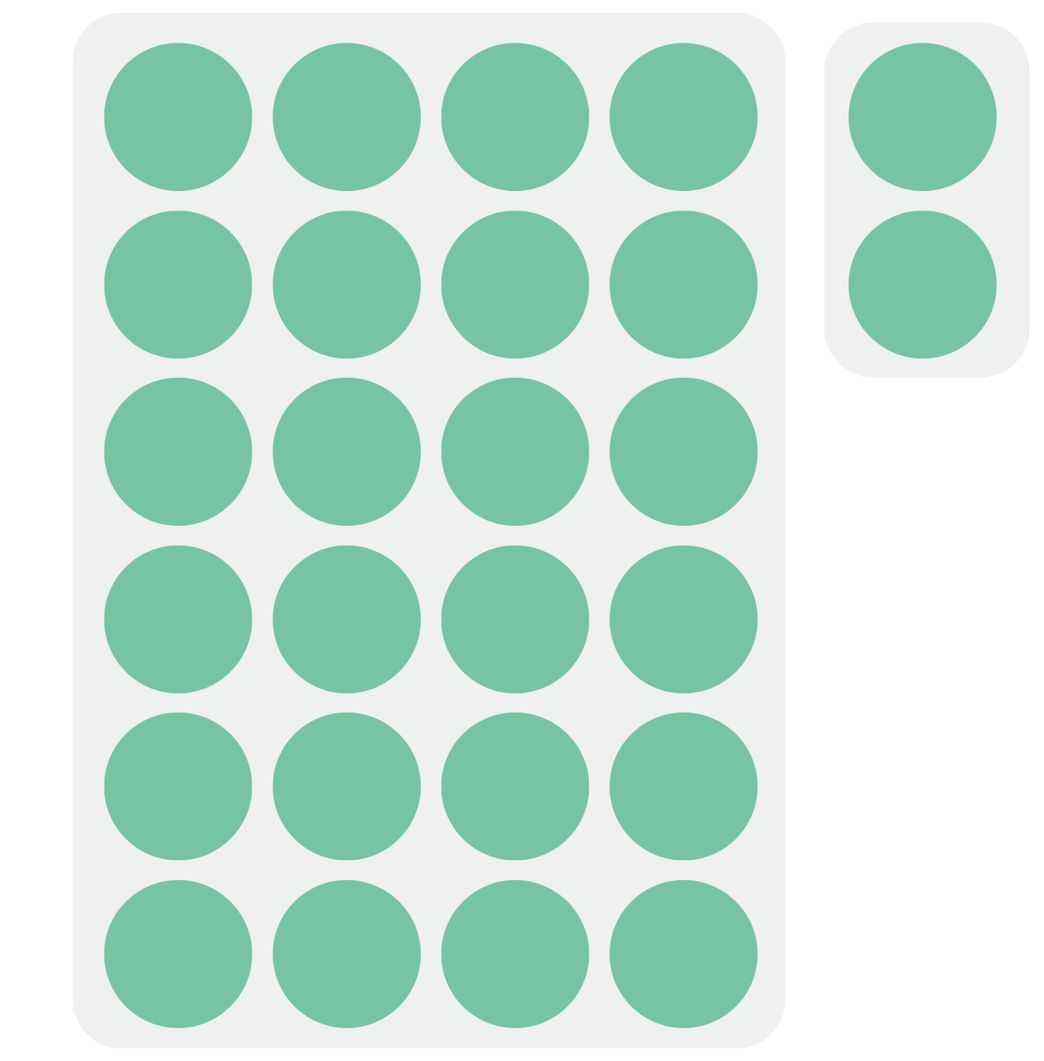

Resource 24 – problems to solve
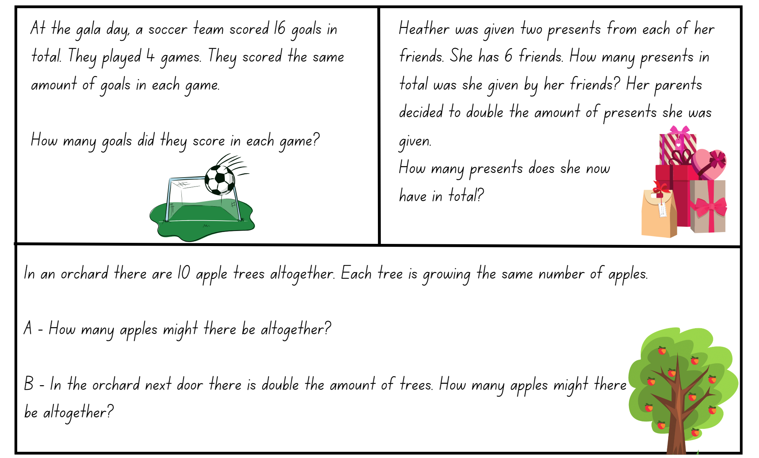

Syllabus outcomes and content

Stage 2
The table below outlines the syllabus outcomes and range of relevant syllabus content covered in this unit. Content is linked to National Numeracy Learning Progression (version 3).
Outcomes and content | 1 | 2 | 3 | 4 | 5 | 6 | 7 | 8
Representing numbers using place value A: Whole numbers: Read, represent and order numbers to thousands
MAO-WM-01, MA2-RN-01
- Group physical or virtual objects to show the structure of tens, hundreds and a thousand | x | x | x
- Regroup numbers flexibly, recognising one thousand as 10 hundreds and one hundred as 10 tens or 100 ones |  |  | x
- Compare and describe the relative size of numbers by positioning numbers on a number line (Reasons about quantity) |  | x
- Represent numbers up to and including thousands using physical or virtual manipulatives, words, numerals, diagrams and digital displays | x | x | x
- Read and order numbers of up to at least 4 digits | x | x
Representing numbers using place value A: Whole numbers: Apply place value to partition and regroup numbers up to 4 digits
MAO-WM-01, MA2-RN-01
- Record numbers using standard place value form |  | x | x |  | x
- Partition numbers of up to 4 digits in non-standard forms (Reasons about quantity) |  |  | x |  | x
Representing numbers using place value B: Whole numbers: Order numbers in the thousands
MAO-WM-01, MA2-RN-01
- Arrange numbers in the thousands in ascending and descending order | x | x
- Recognise and describe how rearranging digits changes the size of a number (Reasons about relations) | x
Representing numbers using place value B: Whole numbers: Recognise and represent numbers that are 10, 100 or 1000 times as large
MAO-WM-01, MA2-RN-01
- Recognise the number of tens, hundreds or thousands in a number | x
- Describe how making a number 10, 100 or 1000 times as large changes the place value of digits | x
Multiplicative relations A: Generate and describe patterns
MAO-WM-01, MA2-MR-01
- Model, describe and record patterns of multiples |  |  |  |  |  |  | x
- Create and continue a variety of number patterns that increase or decrease by a constant amount |  |  |  |  |  |  | x
- Recognise the significance of the final digit of a whole number in determining whether a given number is even or odd (Reasons about relations) |  |  |  | x
Multiplicative relations A: Use arrays to establish multiplication facts from multiples of 2 and 4, 5 and 10
MAO-WM-01, MA2-MR-01
- Create and represent multiplicative structure, using the term multiples when connecting grouping to arrays |  |  |  | x
- Recognise that doubling is multiplying by 2 and halving is dividing by 2 (Reasons about relations) |  |  |  |  |  |  | x | x
Multiplicative relations A: Recall multiplication facts of 2 and 4, 5 and 10 and related division facts
MAO-WM-01, MA2-MR-01
- Recognise and use the symbols for multiplied by (×), divided by (÷) and equals (=) |  |  |  |  |  | x | x | x
- Link multiplication and division fact families using arrays |  |  |  |  |  | x | x
- Generate multiplication fact families for multiples of 2 and 4, 5 and 10 |  |  |  |  |  |  | x
- Model and apply the commutative property of multiplication |  |  |  |  |  | x | x
Multiplicative relations A: Represent and solve problems involving multiplication fact families
MAO-WM-01, MA2-MR-01
- Describe multiplication problems using for each and times as many | x |  |  |  |  |  |  | x
- Find the total of partially covered arrays |  | x
- Apply the inverse relationship of multiplication and division (Reasons about relations) |  |  | x |  |  |  | x | x
Multiplicative relations B: Operate with multiples of 10
MA2-MR-01, MA2-MR-02
- Use multiplication facts with multiples of 10 to multiply a one-digit number by a multiple of 10 |  |  | x |  | x | x
- Apply the commutative and associative properties to multiply by multiples of 10 |  |  |  |  | x
Multiplicative relations B: Represent and solve word problems with number sentences involving multiplication or division
MA2-MR-01, MA2-MR-02
- Complete number sentences involving multiplication and division by calculating missing numbers (Reasons about relations) |  |  |  |  |  | x
- Represent and solve multiplication and division (both sharing and grouping) word problems using number sentences |  |  |  |  |  | x
Mathematics K–10 Syllabus © NSW Education Standards Authority (NESA) for and on behalf of the Crown in right of the State of New South Wales, 2022.

Stage 3
The table below outlines the syllabus outcomes and range of relevant syllabus content covered in this unit. Content is linked to National Numeracy Learning Progression (version 3).
Outcomes and content | 1 | 2 | 3 | 4 | 5 | 6 | 7 | 8
Represents numbers A: Whole numbers: Recognise, represent and order numbers in the millions
MAO-WM-01, MA3-RN-01
- Name millions using the place value grouping of ones, tens and hundreds | x
- Arrange numbers in the millions in ascending and descending order using place value | x
- Round numbers to a specified place value | x
Represents numbers A: Whole numbers: Apply place value to partition, regroup and rename numbers to 1 billion
MAO-WM-01, MA3-RN-01
- Recognise 1000 thousands is 1 million and 1000 millions is 1 billion | x
Represents numbers A: Decimals and percentages: Recognise that the place value system can be extended beyond hundredths
MAO-WM-01, MA3-RN-02
- Express thousandths as decimals |  | x
- Interpret decimal notation for thousandths |  | x
- Indicate the place value of digits in decimal numbers of up to 3 decimal places |  | x
Represents numbers A: Decimals and percentages: Compare, order and represent decimals
MAO-WM-01, MA3-RN-02
- Compare and order decimal numbers of up to 3 decimal places |  | x
- Interpret zero digit(s) at the end of a decimal |  | x
- Place decimal numbers of up to 3 decimal places on a number line |  | x
Represents numbers B: Whole numbers: Locate and represent integers on a number line
MAO-WM-01, MA3-RN-01
- Recognise the location of negative whole numbers in relation to zero and place them on a number line |  |  | x
- Use the term integers to describe positive and negative whole numbers and zero |  |  | x
- Interpret integers in everyday contexts |  |  | x
Multiplicative relations A: Determine products and factors
MAO-WM-01, MA3-MR-01
- Use the term product to describe the result of multiplying 2 or more numbers |  |  |  |  |  |  |  | x
- Model different ways to show a whole number as a product (Reasons about structure) |  |  |  |  |  |  |  | x
- Determine factors for a given whole number |  |  |  | x |  |  |  | x
- Determine whether a number is prime, composite or neither (0 or 1) |  |  |  | x
Multiplicative relations A: Use partitioning and place value to multiply 2-, 3- and 4-digit numbers by one-digit numbers
MAO-WM-01, MA3-MR-01
- Use mental strategies to multiply one-digit numbers by 10, 100, 1000 and their multiples |  |  | x |  | x | x
- Estimate the product of 2 numbers (one-digit by 2- or 3-digit numbers) using multiples of 10 or 100 |  |  |  |  | x | x | x
- Use informal written strategies such as the area model to solve multiplication and division problems |  |  |  |  | x
- Use the distributive property with the area model to partition numbers in representing multiplication problems |  |  |  |  | x |  | x
- Use the distributive property with partial products to solve problems by multiplying the hundreds, then the tens and then the ones |  |  |  |  | x | x
- Record the product of multiplying by a one-digit number using a formal algorithm |  |  |  |  | x
Multiplicative relations A: Select and apply mental and written strategies to multiply 2- and 3-digit numbers by 2-digit numbers
MAO-WM-01, MA3-MR-01
- Extend the area model to represent 2-digit by 2-digit multiplication | x | x |  |  |  | x
- Use a multiplication algorithm with understanding (Reasons about relations) |  |  |  |  |  | x
- Solve multiplication word problems |  |  | x
Multiplicative relations A: Represent and solve division problems with whole number remainders
MAO-WM-01, MA3-MR-01
- Model division, including where the answer involves a remainder, using materials or diagrams |  |  |  |  |  |  | x
- Record remainders in words to division problems |  |  |  |  |  |  | x
- Use known multiplication fact families to solve division problems for which answers may include a remainder |  |  |  |  |  |  | x
- Use the term quotient to describe the result of a division calculation |  |  |  |  |  |  | x
- Show the connection between division and multiplication involving the divisor and quotient |  |  |  |  |  |  | x
Multiplicative relations A: Select and apply strategies to divide a number with 3 or more digits by a one-digit divisor
MAO-WM-01, MA3-MR-01
- Use knowledge of multiples to partition as appropriate and divide |  |  |  |  |  |  | x | x
- Apply and record appropriate strategies to solve division word problems |  |  |  |  |  |  | x | x
- Use and interpret remainders in solutions to division problems |  |  |  |  |  |  |  | x
- Use digital technologies to divide whole numbers by one- and 2-digit divisors |  |  |  |  | x |  |  | x
Multiplicative relations A: Use estimation and rounding to check the reasonableness of answers to calculations
MAO-WM-01, MA3-MR-01
- Use estimation to check the reasonableness of answers to multiplication and division calculations |  |  |  |  | x
Multiplicative relations B: Represent and describe number patterns formed by multiples
MAO-WM-01, MA3-MR-01
- Describe a pattern formed by multiples in words, in terms of multiplication rather than addition |  |  |  |  |  |  | x
Mathematics K–10 Syllabus © NSW Education Standards Authority (NESA) for and on behalf of the Crown in right of the State of New South Wales, 2022.

References
This resource contains NSW Curriculum and syllabus content. The NSW Curriculum is developed by the NSW Education Standards Authority. This content is prepared by NESA for and on behalf of the Crown in right of the State of New South Wales. The material is protected by Crown copyright.
Please refer to the NESA Copyright Disclaimer for more information https://educationstandards.nsw.edu.au/wps/portal/nesa/mini-footer/copyright.
NESA holds the only official and up-to-date versions of the NSW Curriculum and syllabus documents. Please visit the NSW Education Standards Authority (NESA) website https://educationstandards.nsw.edu.au/wps/portal/nesa/home and the NSW Curriculum website https://curriculum.nsw.edu.au/.
Mathematics K–10 Syllabus © NSW Education Standards Authority (NESA) for and on behalf of the Crown in right of the State of New South Wales, 2022.
National Numeracy Learning Progression © Australian Curriculum, Assessment and Reporting Authority (ACARA) 2010 to present, unless otherwise indicated. This material was downloaded from the Australian Curriculum website (National Numeracy Learning Progression) (accessed 26 October 2023) and was not modified.
Stanford University (n.d) Number Visuals (3-5), youcubed website, accessed 22 February 2024
State of New South Wales (Department of Education) (2023) Hit it, NSW Department of Education website, accessed 11 August 2023.
State of New South Wales (Department of Education) (2023) Place value game, NSW Department of Education website, accessed 11 August 2023.
State of New South Wales (Department of Education) (2023) Number visuals, NSW Department of Education website, accessed 11 August 2023.
Toy Theater (2023) Random Number, Toy Theater website, accessed 11 August 2023.
University of Cambridge (n.d) Multiply Multiples 1, NRICH website, accessed 11 August 2023.
University of Colorado (2024) Area Model Algebra, Physics Education Technology (PhET) website, accessed 11 August 2023.
Vingerhoets R (2009) Division – Chipping away at the whole number (PDF 487 KB), Rob Vingerhoets Educational Consultancy website, accessed 11 August 2023.

Further reading
Siemon D, Warren E, Beswick K, Faragher R, Miller J, Horne M, Jazby D, Breed M, Clark J and Brady K (2022) Teaching Mathematics: Foundations to Middle Years, 3rd edn, Oxford University Press, Australia.
Van de Walle J, Karp K, Bay-Williams JM, Brass A, Bentley B, Ferguson S, Goff W, Livy S, Marshman M, Martin D, Pearn C, Prodromou T, Symons D and Wilkie K (2019) Primary and Middle Years Mathematics: Teaching Developmentally, 1st edn, Pearson Education, Australia.
© State of New South Wales (Department of Education), 2024
The copyright material published in this resource is subject to the Copyright Act 1968 (Cth) and is owned by the NSW Department of Education or, where indicated, by a party other than the NSW Department of Education (third-party material).
Copyright material available in this resource and owned by the NSW Department of Education is licensed under a Creative Commons Attribution 4.0 International (CC BY 4.0) license.

This license allows you to share and adapt the material for any purpose, even commercially.
Attribution should be given to © State of New South Wales (Department of Education), 2024.
Material in this resource not available under a Creative Commons license:
- the NSW Department of Education logo, other logos and trademark-protected material
- material owned by a third party that has been reproduced with permission. You will need to obtain permission from the third party to reuse its material.
Links to third-party material and websites
Please note that the provided (reading/viewing material/list/links/texts) are a suggestion only and implies no endorsement, by the New South Wales Department of Education, of any author, publisher, or book title. School principals and teachers are best placed to assess the suitability of resources that would complement the curriculum and reflect the needs and interests of their students.
If you use the links provided in this document to access a third-party's website, you acknowledge that the terms of use, including licence terms set out on the third-party's website apply to the use which may be made of the materials on that third-party website or where permitted by the Copyright Act 1968 (Cth). The department accepts no responsibility for content on third-party websites.

