Mathematics 3–6 Multi-age – Year A – Unit 16
Fractions represent multiple ideas and can be represented in different ways

Contents
Unit description and duration 7
Syllabus outcomes 7
Stage 2 8
Stage 3 8
Working mathematically 8
Student prior learning 9
Lesson overview and resources 11
Lesson 1 20
Daily number sense – representing fractions – 10 minutes 20
Core lesson – 45 minutes 24
Stage 2 task – halves, quarters and eighths 24
Stage 3 task – language and ordering fractions 28
Discuss and connect the mathematics – 10 minutes 34
Lesson 2 37
Daily number sense – recreating the whole – 15 minutes 37
Core lesson – 40 minutes 40
Stage 2 task – fractions on a line 40
Stage 3 task – ordering fractions 45
Consolidation and meaningful practice (Stage 2) – 15 minutes 51
Discuss and connect the mathematics (Stage 3) – 15 minutes 53
Lesson 3 55
Daily number sense – fractured fraction wall – 15 minutes 55
Core lesson – creating fractional parts – 45 minutes 57
Stage 2 task – fifthing strategy 60
Stage 3 task – tenths 63
Discuss and connect the mathematics – 10 minutes 68
Lesson 4 70
Daily number sense – 10 minutes 70
Core lesson – 50 minutes 70
Stage 2 task– fractions with related denominators 70
Stage 3 task – representing fractions and percentages 74
Discuss and connect the mathematics – 5 minutes 80
Lesson 5 82
Daily number sense – looking for squares – 10 minutes 82
Core lesson – 45 minutes 85
Stage 2 task – fraction wall game 85
Stage 3 task – fraction problems 93
Discuss and connect the mathematics – 10 minutes 96
Lesson 6 99
Daily number sense – using arrays – 10 minutes 99
Core lesson – 40 minutes 102
Stage 2 task – Which does not belong? 102
Stage 3 task – adding and subtracting fractions 105
Consolidation and meaningful practice (Stage 2) – 10 minutes 109
Consolidation and meaningful practice (Stage 3) – 10 minutes 109
Lesson 7 111
Daily number sense – Who is correct? – 10 minutes 111
Core lesson – 45 minutes 114
Stage 2 task – recreate the whole 114
Stage 3 task 1 – lines, areas and collections – 20 minutes 117
Stage 3 task 2 – collection problems – 25 minutes 120
Discuss and connect the mathematics – 5 minutes 121
Lesson 8 124
Daily number sense – 10 minutes 124
Core lesson – 50 minutes 124
Stage 2 task – fractions beyond a whole 124
Stage 3 task 1 – connecting fraction representations – 30 minutes 129
Stage 3 task 2 – fraction wars – 20 minutes 135
Discuss and connect the mathematics – 5 minutes 136
Resource 1 – Is it half? 138
Resource 2 – ‘Fraction Wars’ cards 139
Resource 3 – cards template 140
Resource 4 – Is Fred right? 141
Resource 5 – Is Max right? 142
Resource 6 – fraction puzzle 143
Resource 7 – Venn diagram fractions 144
Resource 8 – fractured fraction wall 1 145
Resource 9 – fractured fraction wall 2 146
Resource 10 – fraction wall 147
Resource 11 – fraction strip template 148
Resource 12 – folded strips 149
Resource 13 – gameboard and spinners 150
Resource 14 – comparing bar models 151
Resource 15 – gardening centre 152
Resource 16 – additive bar model 153
Resource 17 – Which doesn’t belong? 154
Resource 18 – more fraction models 155
Resource 19 – happy holidays 156
Resource 20 – word problems 157
Resource 21 – recreate the whole 158
Resource 22 – recreate the whole memory 159
Resource 23 – lines, areas and collections 162
Resource 24 – pin packets 163
Resource 25 – chocolate bars 164
Resource 26 – blocks of chocolate 165
Resource 27 – number line 0–1 166
Resource 28 – number line 0–2 167
Syllabus outcomes and content 168
Stage 2 168
Stage 3 172
References 176

Unit description and duration
This unit develops the big idea that fractions represent multiple ideas and can be represented in different ways.
In this 2-week unit, students are provided opportunities to:
- identify fractional parts and complementary parts of a length (Stage 2)
- model and represent unit fractions, and their multiples, to a complete whole on a number line (Stage 2)
- explore equivalence and multiplicative relationships of fractions (Stage 2)
- represent fractions using number lines, bar models, area models and discrete models (Stage 3)
- make connections between fractions, decimals and percentages (Stage 3)
- apply efficient mental and written strategies to solve addition and subtraction problems (Stage 3).
This multi-age unit is informed by the lessons in Stage 2 Year A Unit 16 and Stage 3 Year A Unit 16. Please refer to these units for additional lesson guidance.

Syllabus outcomes
- MAO-WM-01 develops understanding and fluency in mathematics through exploring and connecting mathematical concepts, choosing and applying mathematical techniques to solve problems, and communicating their thinking and reasoning coherently and clearly

Stage 2
- MA2-MR-01 represents and uses the structure of multiplicative relations to 10 × 10 to solve problems
- MA2-PF-01 represents and compares halves, quarters, thirds and fifths as lengths on a number line and their related fractions formed by halving (eighths, sixths and tenths)

Stage 3
- MA3-RN-03 determines percentages of quantities, and finds equivalent fractions and decimals for benchmark percentage values
- MA3-AR-01 selects and applies appropriate strategies to solve addition and subtraction problems
- MA3-MR-01 selects and applies appropriate strategies to solve multiplication and division problems
- MA3-RQF-01 compares and orders fractions with denominators of 2, 3, 4, 5, 6, 8 and 10
- MA3-RQF-02 determines $\frac{1}{2}$, $\frac{1}{4}$, $\frac{1}{5}$ and $\frac{1}{10}$ of measures and quantities

Working mathematically
In the Mathematics K–10 Syllabus, there is one overarching Working mathematically outcome (MAO-WM-01). The Working mathematically processes should be embedded within the concepts being taught. The Working mathematically processes present in the Mathematics K–10 Syllabus are:
- communicating
- understanding and fluency
- reasoning
- problem solving.
Mathematics K–10 Syllabus © NSW Education Standards Authority (NESA) for and on behalf of the Crown in right of the State of New South Wales, 2022.

Student prior learning
Before engaging in these teaching and learning activities, students would benefit from prior experience with:
- using concrete materials such as fraction strips and fraction walls to model, label and describe fractions (Stage 2)
- using representations, such as drawings, diagrams and/or words to explore a half, a quarter or an eighth, and explain their thinking (Stage 2)
- identifying and describing patterns (Stage 2)
- comparing and ordering fractions using number lines and bar models (Stage 3)
- understanding what happens when a fraction exceeds a whole (Stage 3)
- solving problems involving addition and subtraction of fractions with the same denominator (Stage 3).
In NSW classrooms there is a diverse range of students, including Aboriginal and/or Torres Strait Islander students, students learning English as an additional language or dialect, high potential and gifted students, and students with disability. Some students may identify with more than one of these groups or possibly all of them. Refer to Curriculum planning for every student – advice for further information.

Lesson overview and resources
To cover the content of the syllabus across Stage 2 and Stage 3, some core lessons in the unit contain both a Stage 2 and a Stage 3 task. Teachers are encouraged to adapt and contextualise the units to meet the needs of their students.
The table below outlines the sequence and approximate timing of lessons, learning intentions and resources.
Lesson | Content | Duration and resources
Lesson 1  Daily number sense  Stage 2:  - Partitioned fractions A: Model and represent unit fractions, and their multiples, to complete a whole on a number line  Stage 3:  - Representing quantity fractions A: Solve problems involving addition and subtraction of fractions with the same denominator | Lesson core concept: a fraction is part of a whole (Stage 2), and the importance of the whole as 1 and the language of fractions (Stage 3).  Stage 2:  - Partitioned fractions A: Model and represent unit fractions, and their multiples, to a complete whole on a number line  Stage 3:  - Representing quantity fractions A: Compare and order unit fractions | Lesson duration: 65 minutes  - Resource 1 – Is it half?  - Resource 2 – ‘Fraction Wars’ cards  - Resource 3 – cards template  - Masking tape  - Paper strips  - Scissors  - String  - Writing materials
Lesson 2  Daily number sense  Stage 2:  - Partitioned fractions A: Model and represent unit fractions, and their multiples, to complete a whole on a number line  Stage 3:  - Representing quantity fractions A: Solve problems involving addition and subtraction of fractions with the same denominator | Lesson core concept: bar models and fractions strips can be used to represent fractions (Stage 2), and fractions are formed by dividing a whole (Stage 3).  Stage 2:  - Multiplicative relations A: Generate and describe patterns  - Partitioned fractions A: Model and represent unit fractions, and their multiples, to a complete whole on a number line  Stage 3:  - Representing quantity fractions B: Compare common fractions with related denominators | Lesson duration: 70 minutes  - Resource 2 – ‘Fraction Wars’ cards  - Resource 3 – cards template  - Resource 4 – Is Fred right?  - Resource 5 – Is Max right?  - Resource 6 – fraction puzzle  - Resource 7 – Venn diagram fractions  - Glue  - Grid paper  - Individual whiteboards  - Paper strips  - Student workbooks  - Writing materials
Lesson 3  Daily number sense  Stage 2:  - Partitioned fractions A: Model and represent unit fractions, and their multiples, to complete a whole on a number line  Stage 3:  - Represents numbers B: Decimals and percentages: Make connections between benchmark fractions, decimals and percentages  - Representing quantity fractions A: Solve problems involving addition and subtraction of fractions with the same denominator | Lesson core concept: fractions can be represented as measures by partitioning length (Stage 2), and number lines are important models used to represent fractions and decimals (Stage 3).  Stage 2:  - Partitioned fractions A: Create fractional parts of a length using techniques other than repeated halving  - Partitioned fractions A: Model and represent unit fractions, and their multiples, to a complete whole on a number line  Stage 3:  - Represent numbers B: Decimals and percentages: Make connections between benchmark fractions, decimals and percentages | Lesson duration: 70 minutes  - Resource 3 – cards template  - Resource 8 – fractured fraction wall 1  - Resource 9 – fractured fraction wall 2  - Resource 10 – fraction wall  - Resource 11 – fraction strip template  - Resource 12 – folded strips  - Glue  - Grid paper  - Paper strips  - Student workbooks  - Thin card for fraction strips  - Writing materials
Lesson 4  Daily number sense  - teacher-identified task based on student needs | Lesson core concept: bar models and fractions strips can be used to represent fractions (Stage 2), and connections can be made between fractions, decimals and percentages (Stage 3).  Stage 2:  - Multiplicative relations A: Generate and describe patterns  - Partitioned fractions A: Create fractional parts of a length using techniques other than repeated halving  - Partitioned fractions A: Model and represent unit fractions, and their multiples, to a complete whole on a number line  Stage 3:  - Represent numbers B: Decimals and percentages: Make connections between benchmark fractions, decimals and percentages  - Represent numbers B: Decimals and percentages: Determine percentage discounts of 10%, 25% and 50% | Lesson duration: 65 minutes  - Resource 3 – cards template  - A4 paper  - Fraction Wars cards  - Glue  - Grid paper  - Individual whiteboards  - Paper strips  - Plastic sleeves  - Sticky notes  - Student workbooks  - Writing materials
Lesson 5  Daily number sense  Stage 2:  - Multiplicative relations A: Recall multiplication facts of 2 and 4, 5 and 10 and related division facts  Stage 3:  - Multiplicative relations A: Determine products and factors | Lesson core concept: fractions with related denominators can be equivalent (Stage 2), and bar models and fraction strips can be used to represent fractions (Stage 3).  Stage 2:  - Partitioned fractions A: Model and represent unit fractions, and their multiples, to a complete whole on a number line  - Partitioned fractions B: Model equivalent fractions as lengths  - Partitioned fractions B: Represent fractional quantities equal to and greater than one  Stage 3:  - Additive relations A: Apply efficient mental and written strategies to solve addition and subtraction problems  - Representing quantity fractions A: Solve problems involving addition and subtraction of fractions with the same denominator | Lesson duration: 65 minutes  - Resource 10 – fraction wall  - Resource 13 – gameboard and spinners  - Resource 14 – comparing bar models  - Resource 15 – gardening centre  - Resource 16 – additive bar model  - Individual whiteboards  - Paper clips  - Student workbooks  - Writing materials
Lesson 6  Daily number sense  Stage 2:  - Multiplicative relations A: Recall multiplication facts of 2 and 4, 5 and 10 and related division facts  Stage 3:  - Multiplicative relations A: Determine products and factors | Lesson core concept: fractions represent a multiplicative relationship (Stage 2), and mathematicians solve problems with fractions (Stage 3).  Stage 2:  - Multiplicative relations A: Generate and describe patterns  - Partitioned fractions B: Model equivalent fractions as lengths  Stage 3:  - Additive relations A: Apply efficient mental and written strategies to solve addition and subtraction problems  - Representing quantity fractions A: Solve problems involving addition and subtraction of fractions with the same denominator | Lesson duration: 60 minutes  - Resource 3 – cards template  - Resource 17 – Which doesn’t belong?  - Resource 18 – more fraction models  - Resource 19 – happy holidays  - Website: Polypad – The Mathematical Playground  - 10-sided dice  - Counters  - Fraction Wars cards  - Grid paper  - Individual whiteboards  - Student workbooks  - Writing materials
Lesson 7  Daily number sense  Stage 2:  - Multiplicative relations A: Recall multiplication facts of 2 and 4, 5 and 10 and related division facts  Stage 3:  - Multiplicative relations A: Determine products and factors | Lesson core concept: identifying a complementary fractional part is needed to complete one whole (Stage 2), and mathematicians solve problems with fractions (Stage 3).  Stage 2:  - Partitioned fractions A: Model and represent unit fractions, and their multiples, to a complete whole on a number line  Stage 3:  - Additive relations A: Apply efficient mental and written strategies to solve addition and subtraction problems  - Representing quantity fractions A: Solve problems involving addition and subtraction of fractions with the same denominator | Lesson duration: 60 minutes  - Resource 20 – word problems  - Resource 21 – recreate the whole  - Resource 22 – recreate the whole memory  - Resource 23 – lines, areas and collections  - Resource 24 – pin packets  - Individual whiteboards  - Writing materials
Lesson 8  Daily number sense  - teacher-identified task based on student needs | Lesson core concept: recreate fractional quantities equal to and greater than one (Stage 2), and mathematicians make connections between fractions, decimals and percentages (Stage 3).  Stage 2:  - Partitioned fractions A: Model and represent unit fractions, and their multiples, to a complete whole on a number line  - Partitioned fractions B: Represent fractional quantities equal to and greater than one  Stage 3:  - Represent numbers B: Decimals and percentages: Make connections between benchmark fractions, decimals and percentages  - Representing quantity fractions B: Compare common fractions with related denominators | Lesson duration: 65 minutes  - Resource 7 – Venn diagram fractions  - Resource 25 – chocolate bars  - Resource 26 – blocks of chocolate  - Resource 27 – number line 0–1  - Resource 28 – number line 0–2  - Fraction Wars cards  - Sticky notes  - Student workbooks  - Writing materials

Lesson 1
Core concept: a fraction is part of a whole (Stage 2), and the importance of the whole as 1 and the language of fractions (Stage 3).

Daily number sense – representing fractions – 10 minutes
Daily number sense activities for Lessons 1 to 3 ‘activate’ prior number knowledge and support the learning of new content in the unit. These activities can also assist teachers to identify the starting points for learning by revealing the extent of students’ existing knowledge.
The table below contains suggested learning intentions and success criteria. These are best co-constructed with students.
Daily number sense learning intentions | Daily number sense success criteria
Students working towards Stage 2 outcomes are learning to:  - model and represent unit fractions, and their multiples, to complete a whole on a number line.  Students working towards Stage 3 outcomes are learning to:  - solve problems involving addition and subtraction of fractions with the same denominator. | Students working towards Stage 2 outcomes can:  - model fractions with fraction strips for halves, quarters and eighths.  Students working towards Stage 3 outcomes can:  - represent the sum of fractions with the same denominator, recreating the whole, where the result may exceed one  - find the difference between fractions with the same denominator and interpret the answer.
- As a class, revise that the term ‘half’ can be used in everyday language as well as in the mathematics classroom.
- Students Think-Pair-Share to provide examples of the term ‘half’ being used in both contexts. For example, the phrases ‘half a sandwich’, ‘8-and-a-half years old’ and ‘half-back in a rugby league match’ are uses of the term ‘half’ in everyday language. ‘Half a length of wood’, ‘half a cup of flour’ and ‘half a collection of counters’ are precise mathematical terms which describe 2 equal-sized parts.
- Remind students that when the word ‘half’ is used in mathematics, it is a precise measurement which requires the creation of 2 equal-sized parts.
- Display Resource 1 – Is it half?.
- In pairs, students determine which of the examples accurately represent halves, justifying their choices.
- Give Stage 2 students a strip of paper and ask them to model half.
- Discuss the conditions that need to be present for their folding to be considered half, such as 2 equal parts and accurate folding.
- Provide Stage 2 pairs with writing materials. Students select one of the incorrect examples of half and draw a representation or write a sentence to justify why it is incorrect.
- Draw Stage 3 students’ attention to the fraction area model displayed on the whiteboard in Figure 1.
Figure 1 – fraction area model
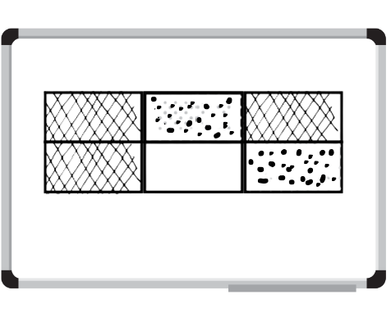
- Explain to Stage 3 students that the large rectangle represents a whole or 1, and that:
- each section represents one sixth ( $\frac{1}{6}$ )
- the dotted area can be named two-sixths ( $\frac{2}{6}$) or one-third ( $\frac{1}{3}$ )
- the hatched area can be named three-sixths ( $\frac{3}{6}$) or one-half ( $\frac{1}{2}$ ).
- Provide Stage 3 students with writing materials to record at least 4 addition or subtraction sentences that match the image on the whiteboard. Examples may include:
- $\frac{1}{6 }$ + $\frac{2}{6}$ + $\frac{3}{6}$ = 1
- $\frac{3}{6}$ + $\frac{2}{6}$ = $\frac{5}{6}$
- $\frac{3}{6}$ − $\frac{2}{6}$ = $\frac{1}{6}$
- $1-$ $\frac{1}{6}$ = $\frac{5}{6}$
- Select Stage 3 students to share their responses.
Note: for Stage 3 students, the expression ‘fraction greater than one’ is used instead of the term ‘improper fraction’ or ‘mixed numeral’.
This table details opportunities for assessment.
Assessment opportunities | Links
What to look for:  - Can Stage 2 students model fractions with fraction strips and diagrams for halves? [MAO-WM-01, MA2-PF-01]  - Can Stage 3 students represent the sum of fractions with the same denominator, recreating the whole, where the result may exceed one? [MAO-WM-01, MA3-RQF-01, MA3-RQF-02]  - Can Stage 3 students find the difference between fractions with the same denominator and interpret the answer? [MAO-WM-01, MA3-RQF-01, MA3-RQF-02] | Links to National Numeracy Learning Progressions (NNLP):  - Stage 2 – InF2, InF3, InF4  - Stage 3 – MuS6, MuS7.  Links to suggested Interview for Student Reasoning (IfSR) tasks:  - Stage 3 – IfSR-MT: 2A.7, 3A.8.

Core lesson – 45 minutes

Stage 2 task – halves, quarters and eighths
The table below contains a suggested learning intention and success criteria. These are best co-constructed with students.
Core concept learning intention | Core concept success criteria
Students working towards Stage 2 outcomes are learning to:  - model and represent unit fractions, and their multiples, to a complete whole on a number line. | Students working towards Stage 2 outcomes can:  - model fractions with fraction strips for halves, quarters and eighths.
Note: in Stage 2, fractions are represented by partitioning lengths. This enables students to measure with partitioned unit fractions. Stage 2 focuses on fractions with denominators of 2, 3, 4, 6 and 8, as well as 5 and 10. They are represented as measures by partitioning lengths.
- Prior to the lesson, place masking tape strips of various lengths around the classroom. These could be placed on tables, floors or walls. Ensure there are enough strips for pairs of students to each have one.
- Review student understanding of fractions.
- Remind students that fractions can be recorded in words or with symbols. Display the symbol for one-half (see Figure 2). Explain that the 2 shows how much the whole is (2 parts) and the 1 shows how many equal parts of the whole are selected (1 part).
Figure 2 – fraction notation
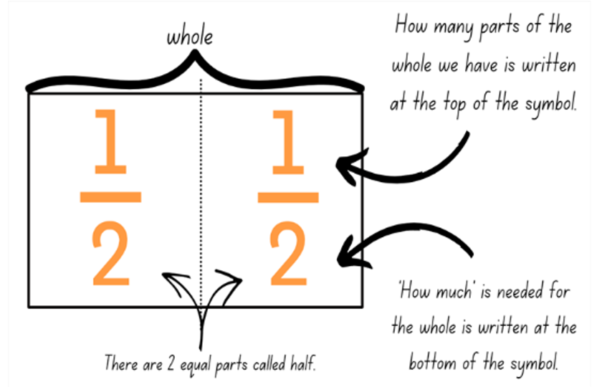
Note: use language that will assist students to develop early fraction ideas. For example, rather than saying ‘1 over 2’, ‘1 of 2’ or ‘1 on 2’ (describing the symbol only), refer to the fractional relationship by saying ‘one half of the whole strip’. The teaching advice states that the terms ‘numerator’ and ‘denominator’ are used in Stage 3.
- Remind students that to halve a length, 2 equal-sized parts must be created.
- Ask students to determine how they would find half of a length if they were unable to fold it.
- Students turn and talk to a partner to identify other ways to find half.
- In pairs, students choose one of the masking tape lengths. Pairs estimate half of the length without folding, by making a pencil mark and recording their initials where they believe the halfway point to be. Pairs should use visualisation to help them estimate halfway. Encourage students to justify their placement of the halfway mark.
Note: visualisation is used throughout this lesson as a technique to support student understanding of the thirding and fifthing strategy in Lesson 3.
- Each pair repeats this process for 4 other masking tape lengths.
- Regroup and ask:
- How did you estimate the halfway point on the masking tape strips?
- Did you find locating the halfway point on any of the strips challenging? Why or why not?
- Revise that half is the precise creation of 2 equal parts, so the marks recorded on each strip are estimations of the halfway point. To determine the precise halfway point, students use a piece of string to fold and check their estimates.
- Pairs cut a piece of string that is the same length as one of the masking tape strips. Using the string, pairs accurately measure and mark half by drawing a line with a marker or highlighter.
- Students complete a gallery walk to see where other pairs marked half on their lengths.
- Ask:
- How close were your estimates?
- What would you change to ensure greater accuracy next time?
- Revise that to find a quarter of a length, 4 equal-sized parts must be created.
- Pairs repeat steps 19 – 22 to indicate how the masking tape length could be partitioned into quarters, using a pencil.
- Regroup and ask:
- How did you determine where the masking tape strip would be partitioned into quarters?
- Did you use any different strategies to help you this time? Why or why not?
- How close were you to the correct partition lines?
- Students choose a new partner to work with. Each pair selects a masking tape strip they have not used previously.
- Using what they know about halves and quarters, pairs determine how the masking tape length could be partitioned into eighths and mark this with a pencil.
- Pairs check their partitions using a piece of string.
- Students join with another pair to identify their partitions and explain their thinking.
This table details opportunities for differentiation.
Too hard? | Too easy?
Students cannot model fractions with fraction strips for halves, quarters and eighths.  - Support students by modelling the use of other resources such as interlocking blocks or coloured rods, to identify the halfway point of the masking tape strip.  - Assist students by encouraging them to create halves by folding an equivalent paper strip into 2 equal parts to see the relationship between the parts and the whole length. | Students can model fractions with fraction strips for halves, quarters and eighths.  - Students make a poster describing the different ways of ensuring equal parts when making fractions. Strategies might include ensuring corners and edges are aligned when folding or placing parts on top of one another to check that they are equal.

Stage 3 task – language and ordering fractions
The table below contains a suggested learning intention and success criteria. These are best co-constructed with students.
Core concept learning intention | Core concept success criteria
Students working towards Stage 3 outcomes are learning to:  - compare and order unit fractions. | Students working towards Stage 3 outcomes can:  - compare unit fractions as numbers to the benchmark value of $\frac{1}{2}$  - compare and order unit fractions with denominators of 2, 3, 4, 5, 6, 8 and 10 by placing them on a number line.
- Explain that using mathematical words to communicate fraction concepts helps to organise and explain thinking more clearly. Being familiar with these words helps us to understand others and communicate our own ideas.
Note: the Mathematics K–10 Syllabus states that when Working mathematically, students need experience in relating their knowledge to the vocabulary and conceptual frameworks of mathematics (NESA 2022).
After playing the following game, display the words prominently and ask students to refer to the display when they communicate their thinking. The word list will be built on throughout the unit.
- Introduce the ‘Word Wizard’ game and explain the rules:
- The student selected to be the word wizard is given one target word and some banned words. The wizard describes the target word to the class without using the target word or the banned words in the description.
- The class tries to guess the word. If they do not succeed, the wizard makes a second, and then third attempt to define the word.
- After 3 failed attempts, the word wizard can choose a friend to help them work out one final clue.
- If the class still cannot guess, the teacher provides the word. (Possible definitions are included in Table 1.)
- After each word, a different student is selected to be the word wizard.
Table 1 – suggested word list
Word | Banned words | Possible definitions
unit fraction | numerator, top | One part of a whole that has been divided into equal parts.
whole | total, everything | All the parts, all of one thing, can be represented by the number 1 or 100%.
denominator | top, bottom, numerator | How many equal parts something has been divided into.  The number that represents the equal pieces required to make one whole in a fraction.
benchmark fraction | half, quarter, per cent, 0.5 | Common fractions used when measuring, comparing or ordering other fractions.
number line | points, marks | A line used to represent numbers (according to their distance from a zero point).  A line with numbers placed in their correct position.
equivalent fractions | equivalence, like | Fractions at the same point on the number line.  Fractions that are equal or have the same value even though they have different denominators.
Note: students are introduced to a game involving fraction cards. Throughout the unit, students build on these cards to engage with a range of activities. When drawing 0–1 number lines, ensure that the line extends beyond 1.
- Record on the board $\frac{1}{5}$, $\frac{1}{8}$, $\frac{1}{4}$, $\frac{1}{3}$, $\frac{1}{10}$, $\frac{1}{2}$ and draw an empty 0–1 number line.
- Ask students what they notice about these numbers (all fractions, different denominators, all unit fractions, all less than 1).
- Provide students with writing materials to draw a 0–1 number line.
- Students order the unit fractions by placing them on the number line. Circulate and observe student approaches.
- Explain that in the following discussion, students should make use of the wizard words on the display to communicate their ideas. Ask:
- Which were the first 2 fractions you placed on the number line? Why?
- Which was the last fraction you placed on the number line? Why?
- Which fraction would you advise not to start with?
- What do you notice about where the fractions are positioned on the number line?
- Do you notice a pattern as the fraction gets closer to zero? (The denominator gets larger as the whole has been split into a larger number of equal parts.)
- Regroup as a class and select students to place fractions on the number line on the board to create an accurate model. Encourage students to discuss and challenge the placement of fractional numbers if they are not accurate.
- Display Resource 2 – ‘Fraction Wars’ cards. Ask:
- What do you notice about the fractions? (They are all unit fractions.)
- Will changing the orientation of the card change the value of the fraction?
- What might be represented by the card with a squiggly line? (string, rope, lolly snake)
- What fraction is represented by the card with the squiggly line? How do you know?
- If you straighten the squiggly line, will the one-sixth ( $\frac{1}{6}$ ) fraction mark remain in the same position? Why?
- Explain that each student will get a ‘Fraction Wars’ starter pack to cut out. Over the course of the unit, students will make new fraction wars cards to extend their set and play different games.
- Display Resource 3 – cards template. Draw students’ attention to the card with 8 dots. Ask:
- How might you represent one-eighth ( $\frac{1}{8}$ ) on this card?
- What other unit fractions could you represent using these 8 dots?
- Can you rename your unit fraction using a different numerator?
Note: the Stage 2 Teaching advice for Partitioned fractions A states that using discrete models such as collections of objects can cause difficulty for students. Discrete models can reinforce the idea that fractions are 2 numbers (or 2 counts) rather than a single number. For example, students may incorrectly visualise 2 coloured dots and 6 black dots in a set of 8 dots as two-sixths rather than two-eighths (NESA 2024).
- Provide each student with Resource 2 – ‘Fraction Wars’ cards and Resource 3 – cards template.
- Students make a list of all the unit fractions represented on the pre-made cards. Using the template, students make 9 new cards which use the discrete model to represent the list of unit fractions.
Note: before cutting out their set, students initial the back of each card so they can be returned to the owner after each game.
- Introduce the game by explaining that ‘Fraction Wars’ is played between 2 students.
- In round one, players draw a 0–1 number line and mark the target number one-half ( $\frac{1}{2} )$ on the line.
- Students shuffle their own deck and take turns flipping over the top card of their pile and placing it face-up in front of them, so it is visible for both players.
- Each student locates the 2 fractions on their number line and the student with the card closest to one-half ( $\frac{1}{2} )$ wins the point and claims the cards.
- If both cards are equal in value, students mix them back in their pack.
- The student with the most cards at the end of the game wins. After round 1, both players note down the number of cards they have won.
- Students shuffle and re-distribute the cards to play round 2. When the cards are flipped, players place their fraction on a 0–1 number line. The player with the largest fraction wins.
- At the end of round 2, students add their round 1 points to their round 2 points to identify the winner. Students collect their own cards for future lesson activities.
This table details opportunities for differentiation.
Too hard? | Too easy?
Students cannot compare and order unit fractions on a number line.  - Students use a folded length of paper to find the unit fractions, then transfer them to the number line.  - Before the start of play, students complete a 0–1 number line and place unit fractions with denominators of 2, 3, 4, 6, 8 and 10 on it as a reference. | Students can compare and order unit fractions on a number line.  - Students play ‘Fraction Wars’ using different target numbers such as one-quarter or one-third.  - Students add non-unit fraction cards to their set and play the game.

Discuss and connect the mathematics – 10 minutes
- Ask Stage 2 students:
- Did you use any different strategies to help you this time? Why or why not?
- How close were you to the correct partition lines?
- How did you find eighths of a length?
- Were you able to find eighths of a length without folding?
- Highlight to Stage 2 students the relationship between halves, quarters and eighths, if not already uncovered in the class discussion. Ensure students understand that halves can be created by folding a strip and lining up the corners to create 2 parts. Quarters are created by halving a half. When quarters are halved, eighths are created.
- Ask Stage 3 students:
- Did having a card with a drawing or model of the fraction help you identify its size?
- Did you see any patterns or relationships that helped you identify the size of the fraction before you plotted it on the number line?
- Can you think of examples in daily life where you might need to use the benchmark fraction of one-half ( $\frac{1}{2} )$?
This table details opportunities for assessment.
Assessment opportunities | Links
What to look for:  - Can Stage 2 students model fractions with fraction strips for halves, quarters and eighths? [MAO-WM-01, MA2-PF-01]  - Can Stage 3 students compare unit fractions to the benchmark value of $\frac{1}{2}$? [MAO-WM-01, MA3-RQF-01]  - Can Stage 3 students compare and order unit fractions with denominators of 2, 3, 4, 5, 6, 8 and 10? [MAO-WM-01,  MA3-RQF-01] | Links to National Numeracy Learning Progressions (NNLP):  - Stage 2 – InF2, InF3, InF4  - Stage 3 – InF5, InF6, InF7.  Links to suggested Interview for Student Reasoning (IfSR) tasks:  - Stage 3 – IfSR-PT: 1A.2, 1A.3.

Lesson 2
Core concept: bar models and fractions strips can be used to represent fractions (Stage 2), and fractions are formed by dividing a whole (Stage 3).

Daily number sense – recreating the whole – 15 minutes
The table below contains suggested learning intentions and success criteria. These are best co-constructed with students.
Daily number sense learning intentions | Daily number sense success criteria
Students working towards Stage 2 outcomes are learning to:  - model and represent unit fractions, and their multiples, to complete a whole on a number line.  Students working towards Stage 3 outcomes are learning to:  - solve problems involving addition and subtraction of fractions with the same denominator. | Students working towards Stage 2 outcomes can:  - recreate the whole unit from a fractional part.  Students working towards Stage 3 outcomes can:  - represent the sum of fractions with the same denominator, recreating the whole, where the result may exceed one  - use diagrams, objects and mental strategies to subtract a unit fraction from any whole number including 1 (the complement principle).
- Display Resource 4 – Is Fred right? for Stage 2 students and Resource 5 – Is Max right? for Stage 3 students. Explain to Stage 3 students that the image in Max’s thought bubble represents a whole.
- Ask students to Think-Pair-Share with a partner and provide writing materials to record their reasoning using labelled diagrams.
- Ask Stage 2 students to consider:
- Is Fred correct? How do you know?
- What has Fred done incorrectly?
- If he is not correct, what would be the correct answer? How could you work it out?
- Ask Stage 3 students to consider:
- Is Max correct? How do you know?
- If four-sixths ( $\frac{4}{6}$ ) of the sections are dotted, what fraction is represented by the cross-hatched sections?
- How can you work out what fraction is represented by the white sections?
- Regroup Stage 2 students and draw a short line on the board. Ask students to solve:
- If this line is a quarter, what does the whole look like?
- If this line is an eighth, what does the whole look like?
- If this line is a half, what does the whole look like?
Note: for Stage 2 students ensure the consistent use of language that will assist them to develop early fraction ideas. For example, refer to the fractional relationship by saying ‘one quarter of the whole strip’, ‘one eighth of the whole strip’ and ‘one half of the whole strip’.
- Regroup Stage 3 students. Write the following equations on the board and ask students to solve:
- 2 − $\frac{6}{6}$ = _?
- 2 − $\frac{1}{3}$ = _?
- 2 − $\frac{2}{3}$ = _?
- Provide time for students to Think-Pair-Share with a partner. Select students to share their responses and explain their thinking.
This table details opportunities for assessment.
Assessment opportunities | Links
What to look for:  - Can Stage 2 students recreate the whole unit from a fractional part? [MAO-WM-01, MA2-PF-01]  - Can Stage 3 students represent the sum of fractions with the same denominator, recreating the whole, where the result may exceed one? [MAO-WM-01, MA3-RQF-01, MA3-RQF-02]  - Can Stage 3 students find the difference between fractions with the same denominator and interpret the answer? [MAO-WM-01, MA3-RQF-01, MA3-RQF-02] | Links to National Numeracy Learning Progressions (NNLP):  - Stage 2 – InF5  - Stage 3 – MuS6, MuS7.

Core lesson – 40 minutes

Stage 2 task – fractions on a line
The table below contains suggested learning intentions and success criteria. These are best co-constructed with students.
Core concept learning intentions | Core concept success criteria
Students working towards Stage 2 outcomes are learning to:  - model and represent unit fractions, and their multiples, to a complete whole on a number line  - generate and describe patterns. | Students working towards Stage 2 outcomes can:  - model fractions with fraction strips and diagrams for halves, quarters and eighths  - recreate the whole unit from a fractional part ($\frac{1}{2}$, $\frac{1}{4}$ and $\frac{1}{8}$)  - model, describe and record patterns of multiples.
Note: this lesson, along with others in this unit, expands upon the fraction folding activities that students have already encountered. Students need to have repeated opportunities to fold and manipulate fractional parts to ensure a thorough understanding of the part-part-whole relationship. This should include materials of different lengths.
When completing the paper folding activities throughout this unit of work, it is suggested (where possible) that students use paper with different coloured sides to help highlight proportion.
- Provide each student with 3 equal strips of paper. Ensure each strip of paper is a different colour.
- Students select one strip of paper and fold it in half. Remind students that the folds must be precise and produce 2 equal-sized parts.
- Using fraction notation, students identify and label each of the folded sections as one-half ( $\frac{1}{2}$ ).
- Students select the second paper strip and fold it in half and then half again to produce quarters.
- Using fraction notation, students identify and label each of the folded sections as one-quarter ( $\frac{1}{4}$ ).
- Ask students to use their knowledge of folding halves and quarters to fold the final strip into eighths.
- Using fraction notation, students identify and label each of the folded sections as one-eighth ( $\frac{1}{8}$ ).
- Place the 3 paper strips underneath each other (see Figure 3).
Figure 3 – three paper strips
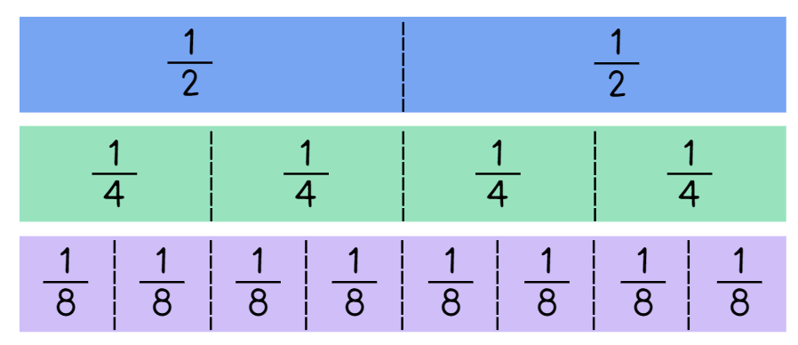
- Ask:
- How many halves make up the whole strip of paper?
- How many quarters make up the whole strip of paper?
- How many eighths make up the whole strip of paper?
- How can the same length strip have 2 halves but 8 eighths?
- Students glue the halves strip into their workbook or onto a piece of grid paper.
- Under the paper strip, students draw a number line that includes zero, one and an arrow to indicate that the number line continues. Students mark and label the fractions along the line (see Figure 4).
Figure 4 – student work sample 1
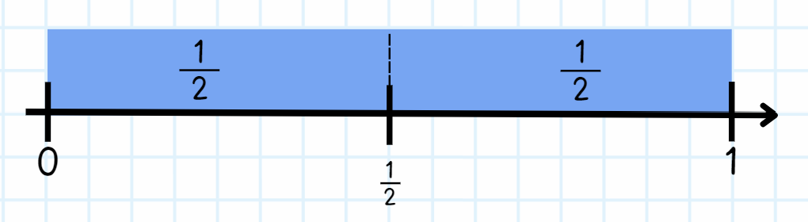
- Students repeat this process for the remaining 2 paper strips (see Figure 5).
Figure 5 – student work sample 2
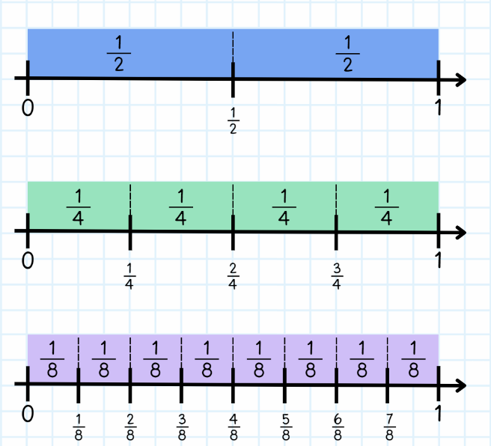
- Remind students that when they mark the paper strip, they are highlighting fractions on a line, when they draw the markers along the number line, they are highlighting fractions of a line.
- Ask the following questions:
- What patterns can you see when looking at the paper strips?
- Why do these patterns occur? (They occur because the parts are repeatedly halved).
- What would happen if the pattern continued? (There would be 16 parts in the next strip).
- What do you notice about the fractions $\frac{1}{2}$, $\frac{2}{4}$ and $\frac{4}{8}$?
- Can you see any other equivalent fractions?
Note: fractions of a length indicate a ‘part’ of a line or length and fractions as a number sit at a ‘point’ on a number line. This may be the first time students understand that there are numbers between zero and one.
- Revise the similarities and/or differences of fractions of a line (bar model) and on a line (number line).
This table details opportunities for differentiation.
Too hard? | Too easy?
Students cannot model fractions with fraction strips and diagrams for halves, quarters and eighths.  - Demonstrate the halving technique step-by-step for students to follow.  - Model fractions using concrete materials such as coloured rods.  - Students use a fraction wall to explore halves, quarters and eighths. | Students can model fractions with fraction strips and diagrams for halves, quarters and eighths.  - Students explore equivalence by folding strips of paper. They identify, create and label as many fractions equivalent to one-half as possible.

Stage 3 task – ordering fractions
The table below contains a suggested learning intention and success criteria. These are best co-constructed with students.
Core concept learning intention | Core concept success criteria
Students working towards Stage 3 outcomes are learning to:  - compare common fractions with related denominators. | Students working towards Stage 3 outcomes can:  - order fractions with related denominators using diagrams and number lines.
This activity is an adaptation of Fix It: An Activity for Ordering Fractions by Marilyn Burns Math.
- Play the ‘Word Wizard’ game introduced in Lesson 1. Remind students that using mathematical words to communicate fraction concepts helps to organise and explain thinking more clearly. Being familiar with these words helps us to understand others and communicate our ideas. After playing the game, add the new vocabulary to the word display and support students to refer to them throughout the lesson. See Table 2.
Table 2 – suggested word list
Word | Banned words | Possible definition
tenth | ordinal numbers (8th, 9th, 10th and so on), ‘one over ten’ | One part out of 10 equal parts, 0.1, 10% as a fraction, the denominator when a whole has been divided into 10 equal parts.
numerator | top, bottom, denominator | How many parts of the whole have been selected.  How many parts you have out of the total number of parts.
equal | like, similar | The same as, having the same amount or value.
fraction bar | top, bottom | The horizontal line in a fraction separating the numerator from the denominator, the vinculum, the line that represents division in a fraction.
ascending order | biggest, littlest, big, little | Arranged from the smallest to the largest value or amount.
related denominators | skip count | Fractions where the denominators are multiples of each other, fractions that are easy to compare, add and subtract.
- Write 3 sets of fractions on the board:
- Set A: $\frac{1}{6}$, $\frac{5}{6}$, $\frac{3}{6}$ (same denominators)
- Set B: $\frac{6}{10}$, $\frac{2}{5}$, $\frac{4}{5}$ (related denominators)
- Set C: $\frac{2}{3}$, $\frac{5}{8}$, $\frac{7}{10}$ (unrelated denominators).
- Students draw a number line for each set and order the fractions on the line. Ask:
- Which set was easier to order? Why? (Set A. When the fractional parts are the same for each fraction, the size of the fraction depends on the numerator.)
- What do you notice about the denominator of the fractions in Set B?
- Can you find an equivalent fraction for six-tenths ( $\frac{6}{10}$ ) in Set B so that all 3 fractions have the same denominator?
- How could you show this using a number line or diagram?
- Write 5 fractions with related denominators on the board in no particular order. Explain to students that their job is to place the set of fractions in ascending order.
- Students Think-Pair-Share to order the fraction set. When sharing their ideas with the class, encourage students to refer to the word list and/or represent their ideas using a diagram or model.
- Repeat this process for another set of fractions and ensure at least one of the fractions displayed is larger than 1.
- Explain that instead of continuing to solve puzzles, students will make a fraction puzzle for someone else to solve. Display Resource 6 – fraction puzzle and tell students they will be using these instructions to create fraction puzzle cards for the class. Students choose fractions with related denominators (2, 4 and 8, or 3 and 6, or 5 and 10).
- To solve a puzzle card, students must place the fractions on the card in ascending order and justify their thinking. The creator of the puzzle makes a solution sheet for classmates to check their answers.
- Model using Resource 6 – fraction puzzle to make a puzzle by:
- Writing 5 fractions purposefully out of order on the board.
- Checking the fractions meet the criteria of related denominators, denominators that fall between 1 and 10, and no fractions are equivalent to each other.
- Thinking aloud to re-write the fractions in ascending order.
- Checking the solution and recording their thinking for others to use as a solution sheet.
- Making a puzzle card by writing the 5 fractions out of order on an index card. Explain that it is important to write your name on the card so other students can get help or check their work by looking at your explanation (see Figure 6).
Figure 6 – fraction puzzle teacher solution model
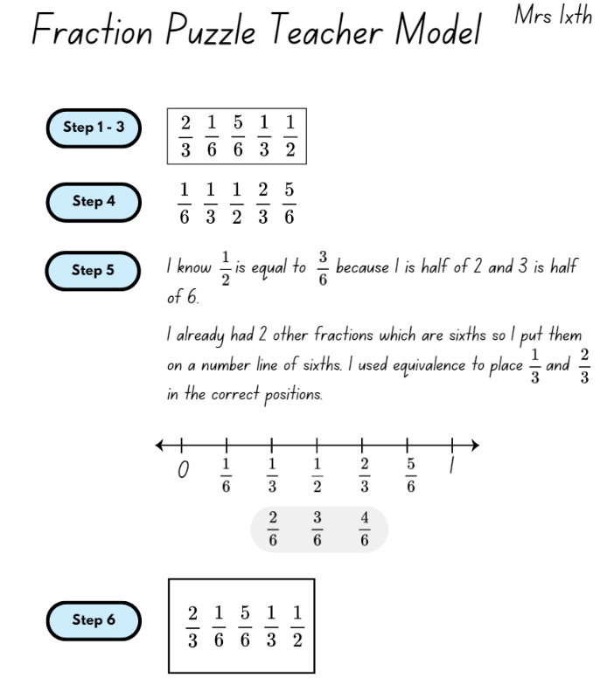
- Provide students with time to choose a fraction set and write a solution sheet. After checking the solution sheets, provide students with blank cards to record their fraction set as a puzzle set for others to solve (see Figure 7).
Figure 7 – fraction puzzle card
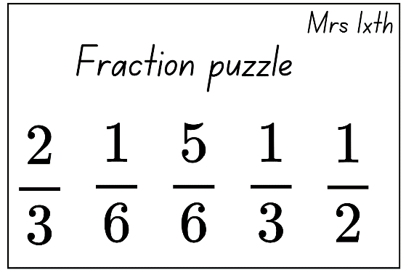
- Before students begin to solve other’s puzzles, remind them to use a separate sheet or individual whiteboard to copy the fractions out of order, rearrange them underneath in order, and record their thinking using words and diagrams, just as they did for their own puzzle. The individual puzzle cards can be collected and reused by other students in the class.
This table details opportunities for differentiation.
Too hard? | Too easy?
Students cannot order fractions with related denominators using number lines and diagrams.  - Students order unit fractions.  - Students use a folded length of paper to create the fractions before ordering the set. | Students can order fractions with related denominators using number lines and diagrams.  - Students make challenges using fractions with any denominator.  - Students make challenges where fractions are ordered according to their distance from one-half.

Consolidation and meaningful practice (Stage 2) – 15 minutes
- Provide students with a small strip of paper and writing materials.
- Ask students to represent their thinking by drawing labelled diagrams to answer the following questions:
- If the strip is one-half, how long is the whole?
- If your strip is one-quarter of the whole, how long is the whole?
- If your strip is one-eighth of the whole, label two-eighths ( $\frac{2}{8}$ ), four-eighths ( $\frac{4}{8}$ ), six-eighths ( $\frac{6}{8}$ ) and eight-eighths ( $\frac{8}{8}$ ) of the whole.
- If your strip represents 4 wholes, can you draw the length of one-whole?
- Students turn and talk to discuss and compare their diagrams.
This table details opportunities for differentiation.
Too hard? | Too easy?
Students cannot recreate the whole unit from a fractional part.  - Provide multiple equal paper strips for students to use to visualise the whole. Tape the pieces together so students can identify the fractional parts.  - Provide hands-on materials such as coloured rods to manipulate the fractional parts. | Students can recreate the whole unit from a fractional part.  - Students recreate the whole from non-unit fractions, for example three-quarters ( $\frac{3}{4 }$ ) or three-eighths ( $\frac{3}{8}$ ).  - In pairs, students select and label one fractional part. Their partner must identify the fractional part needed to recreate one whole. For example, if Student A selected one-quarter, Student B must identify three-quarters as the fractional part needed to recreate the whole.
This table details opportunities for assessment.
Assessment opportunities | Links
What to look for:  - Can Stage 2 students model fractions with fraction strips and diagrams for halves, quarters and eighths? [MAO-WM-01,  MA2-PF-01]  - Can Stage 2 students recreate the whole unit from a fractional part? [MAO-WM-01, MA2-PF-01]  - Can Stage 2 students model, describe and record patterns of multiples? [MAO-WM-01, MA2-PF-01] | Links to National Numeracy Learning Progressions (NNLP):  - Stage 2 – InF2, InF3, InF4, InF5.

Discuss and connect the mathematics (Stage 3) – 15 minutes
- Display Resource 2 – ‘Fraction Wars’ cards and Resource 3 – cards template. Discuss and name the different fraction representations such as symbols, words, discrete or area models.
- Draw 2 circles on the board. Label one circle as ‘fractions greater than or equal to $\frac{1}{2}$’ and the other circle as ‘fractions less than or equal to $\frac{1}{2}$’.
- Students turn and talk to a partner to brainstorm fractions for each circle.
- Select students to provide some example fractions for each circle and explain their reasoning.
- Students draw their own circles and label them. Allow students one minute to fill the circles with as many fractions as possible that match the labels.
- Regroup and select students to add to the circles on the board. Ask:
- In which circle did you place your first fraction? Why?
- Was one circle easier to complete? Why?
- Did you place any fractions that exceeded one? Why or why not?
- Were there any fractions which belong in both circles? (Yes, fractions equal to one-half.)
- Display Resource 7 – Venn diagram fractions. Explain that Venn diagrams are a tool mathematicians use to help organise similarities and differences about a topic.
- Discuss the areas of the Venn diagram and select students to suggest fractions for the areas A, B and C.
- Provide students with Resource 3 – cards template.
- Students choose 6 fractions from the Venn diagram to add to their fraction card set. The fractions must be non-unit fractions.
This table details opportunities for assessment.
Assessment opportunities | Links
What to look for:  - Can Stage 3 students order fractions with related denominators using diagrams and number lines? [MAO-WM-01, MA3-RQF-01] | Links to National Numeracy Learning Progressions (NNLP):  - Stage 3 – InF5, InF6, InF7.  Links to suggested Interview for Student Reasoning (IfSR) tasks:  - Stage 3 – IfSR-PT: 1A.2, 1A.3.

Lesson 3
Core concept: fractions can be represented as measures by partitioning length (Stage 2), and number lines are important models used to represent fractions and decimals (Stage 3).

Daily number sense – fractured fraction wall – 15 minutes
The table below contains suggested learning intentions and success criteria. These are best co-constructed with students.
Daily number sense learning intentions | Daily number sense success criteria
Students working towards Stage 2 outcomes are learning to:  - model and represent unit fractions, and their multiples, to complete a whole on a number line.  Students working towards Stage 3 outcomes are learning to:  - solve problems involving addition and subtraction of fractions with the same denominator  - make connections between benchmark fractions, decimals and percentages. | Students working towards Stage 2 outcomes can:  - determine the fractional part needed to make a whole.  Students working towards Stage 3 outcomes can:  - represent the sum of fractions with the same denominator, recreating the whole, where the result may exceed one  - recall commonly used equivalent percentages, decimals and fractions including $\frac{1}{2}$, $\frac{1}{4}$ and $\frac{3}{4}$.
- Display Resource 8 – fractured fraction wall 1 for Stage 2 students and Resource 9 – fractured fraction wall 2 for Stage 3 students.
- Think aloud, and ask Stage 2 students:
- How can this unfinished fraction wall be used to prove that each row represents one whole?
- How should each part be labelled?
- What strategy could you use to check your work?
- Think aloud, asking Stage 3 students:
- How can this unfinished fraction wall be used to show the connections between fractions, decimals and percentages?
- How should each part be labelled?
- What strategy could you use to check your work?
- In small groups, give students either Resource 8 – fractured fraction wall 1 or Resource 9 – fractured fraction wall 2 and writing materials. Explain that students will complete the fraction wall.
- Ask Stage 2 students:
- How many eighths make a whole?
- What do you notice about fifths and tenths?
- What do you notice about the size of each fraction piece? What happens as they get smaller?
- Stage 3 students use their fraction wall to record 2 different equations that equals one and a half. Select students to share their solutions.
This table details opportunities for assessment.
Assessment opportunities | Links
What to look for:  - Can Stage 2 students determine the fractional part needed to make a whole? [MAO-WM-01, MA2-PF-01]  - Can Stage 3 students represent the sum of fractions with the same denominator, recreating the whole, where the result may exceed one? [MAO-WM-01, MA3-RQF-01] | Links to National Numeracy Learning Progressions (NNLP):  - Stage 2 – InF3, InF4  - Stage 3 – InF7, InF8.

Core lesson – creating fractional parts – 45 minutes
The table below contains suggested learning intentions and success criteria. These are best co-constructed with students.
Core concept learning intentions | Core concept success criteria
All students are learning to:  - create fractional parts of a length using techniques other than repeated halving.  Students working towards Stage 2 outcomes are learning to:  - model and represent unit fractions, and their multiples, to a complete whole on a number line.  Students working towards Stage 3 outcomes are learning to:  - make connections between benchmark fractions and decimals. | All students can:  - create thirds and fifths of a length.  Students working towards Stage 2 outcomes can:  - describe fraction families formed by dividing the whole into the same total number of equal parts as having the same denominator.  Students working towards Stage 3 outcomes can:  - represent quantities and lengths as fractions and decimals.
This activity is an adaptation of ‘The thirding strategy’ and ‘The fifthing strategy’ from Teaching Mathematics: Foundation to Middle Years by Siemon et al.
- Pose the following question: We know how to fold halves, quarters and eighths. Can we use this information to help us fold thirds?
- Give students some paper strips and an opportunity to explore their ideas in small groups.
- Select students to share ideas with the class. If not already stated, explain that one-third is slightly less than half.
- Model and explain the thirding strategy to students: when folding the paper strip into thirds, you can visualise half. Then estimate a third as less than that and create your first fold. The rest of the strip can be folded in half into that fold. If you have not created 3 equal parts, adjust your first fold and try again (see Figure 8).
Figure 8 – folding thirds
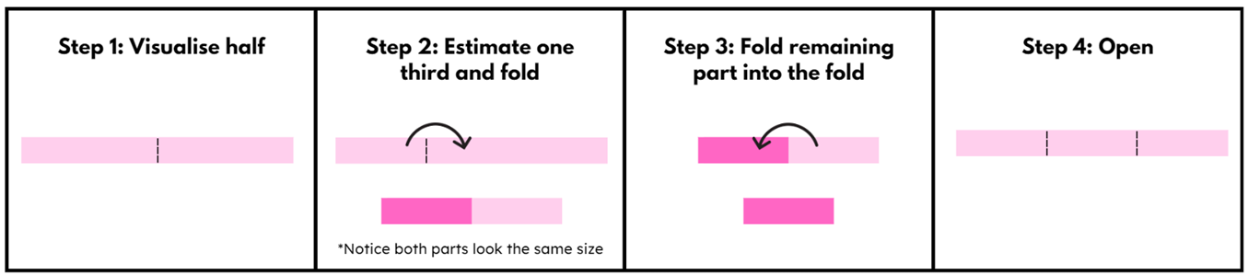
- Give students several opportunities to explore this method of folding thirds.
- Students trace the thirds fold lines and glue the thirds strip into their workbook or onto a piece of grid paper.
Multi-age: in Lesson 5, Stage 2 students will create sixths and tenths. It is important that they leave space beneath the thirds strip for the sixths and beneath the fifths strip for the tenths. This will help them recognise the equivalence between these fractions.
- Under the paper strip, students draw a number line that includes zero, one and an arrow to indicate that the number line continues (as in Lesson 2). Students mark and label the fractions $\frac{1}{3}$, $\frac{2}{3}$, $\frac{3}{3}$ along the line (see Figure 9).
Figure 9 – student work sample
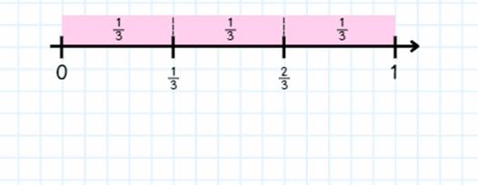

Stage 2 task – fifthing strategy
- Regroup Stage 2 students and pose the question: Can we use a similar strategy to the thirding strategy to create fifths?
- Give students some paper strips and an opportunity to explore their ideas in small groups.
- Select students to share ideas with the class. If not already stated, explain that one-fifth is slightly less than a quarter.
- Model and explain the fifthing strategy to students: when folding the paper strip into fifths, you can visualise quarters by estimating half and then half again. We can then estimate a fifth as less than the quarter and create our first fold. The rest of the strip can be folded in half into that fold and then folded in half into that fold again. If you have not created 5 equal parts, adjust your first fold and try again (see Figure 10).
Figure 10 – folding fifths
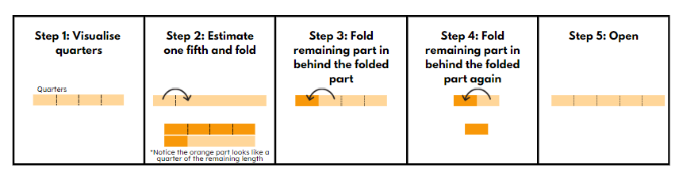
- Give students several opportunities to explore this method of folding fifths.
- Students trace the fifths fold lines and glue the fifths strip into their workbook or onto a piece of grid paper.
- As in Lesson 2, under the paper strip, students draw a number line that includes zero, one and an arrow to indicate the number line continues. Students mark and label the fractions $\frac{1}{5}$,$\frac{2}{5}$ ,$\frac{3}{5}$ ,$\frac{4}{5}$ ,$\frac{5}{5}$ along the line and label each part of the strip with $\frac{1}{5}$ (see Figure 11).
Figure 11 – student work sample
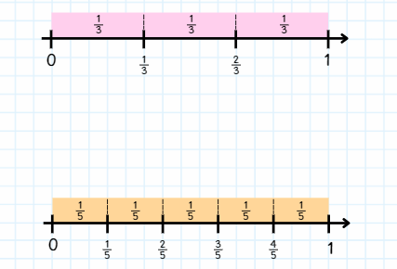
- Regroup students and revise their understanding of fraction families. For example, one-quarter, two-quarters, three-quarters and four-quarters.
- Display the following questions on the board:
- How did your knowledge of halves and quarters help you to make thirds and fifths?
- When looking at the thirds folded strip on the number line, are you able to identify the fraction family it belongs to?
- When looking at the fifths folded strip on the number line, are you able to identify the fraction family it belongs to?
- Do these fractions belong to the same fraction family? How do you know?
- Instruct students to look at their folded fraction strips on the number lines and record responses.
- Select students to share their responses.
This table details opportunities for differentiation.
Too hard? | Too easy?
Students cannot create thirds and fifths of a length.  - Support students to estimate half on a paper strip. Students place a pencil mark where they estimate a third to be prior to folding. Using the pencil marking as a guide, support students to make a third before halving the remaining strip. Students use a similar strategy for fifths by placing a pencil mark where they estimate fifths to be prior to folding.  - Students use Resource 10 – fraction wall to explore thirds and fifths. | Students can create thirds and fifths of a length.  - Students explore equivalence by folding strips of paper. They identify, create and label as many fractions equivalent to one-third as possible.

Stage 3 task – tenths
Note: teaching resources created and used in this lesson should be kept for subsequent lessons throughout this unit. Prior to the lesson, photocopy Resource 11 – fraction strip template onto thin card for each student.
- Introduce vocabulary to be used in this lesson, including ‘bar model’, ‘partition’, ‘benchmark decimal’ and ‘length’. Add these words to the word display from Lesson 1.
- Provide Resource 11 – fraction strip template. Pose the question: How can we use what we know about folding thirds and fifths to fold tenths?
- Ask students to fold the strip of paper into tenths so that the red horizontal line is partitioned into 10 parts.
- Students label each of the partitions using known fractions ( $\frac{1}{10} )$.
- Pose the following questions, partners turn and talk to answer:
- How do you know the strip represents tenths?
- What are some important things to consider when folding the strip? (Focus on equal parts, attending to the length of the red line.)
- Did you start by folding the strip into halves or fifths?
- Is there an efficient and accurate strategy to fold tenths of a strip?
- Select students who have made exemplar tenths of a strip to share their strategies with the class.
- If necessary, provide students with time to use the second strip in Resource 11 – fraction strip template to improve their folding and create more accurate representations of tenths.
- Students label each section as one-tenth ( $\frac{1}{10}$ ) (see Figure 12).
Figure 12 – labelled tenths strip
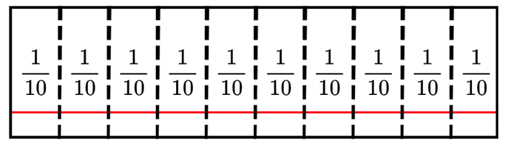
- Regroup students and display Resource 12 – folded strips.
Note: the Stage 2 Teaching advice for Partitioned fractions A reinforces the importance of connecting fraction strips to number lines as a tool for representational transfer. The number line is linked to the fraction strip by using it as a ruler to illustrate benchmark fractions of $\frac{1}{2}$ or $\frac{1}{4}$ (NESA 2024). Representational transfer occurs when tasks make use of a common representation, and the solution procedure is derived from the representation (Novick 1990). That is, the one method of representing a problem is used across different types of problems.
- Draw attention to the intersection between the red horizontal line and each fold on the strip.
- Ask:
- What do you know about the position on the line marked A?
- Is there a label that can be used for the point marked A? ( $\frac{1}{10}$ )
- Is there a label that can be used for the point marked B? ( $\frac{2}{10}$)
- Can you indicate the correct placement for five-tenths ( $\frac{5}{10}$ ) of the length?
- Is there another way to write five-tenths without using fraction symbols? (0.5)
- Provide students with individual whiteboards and writing materials to create 2 related number lines (see Figure 13).
Figure 13 – strips to lines
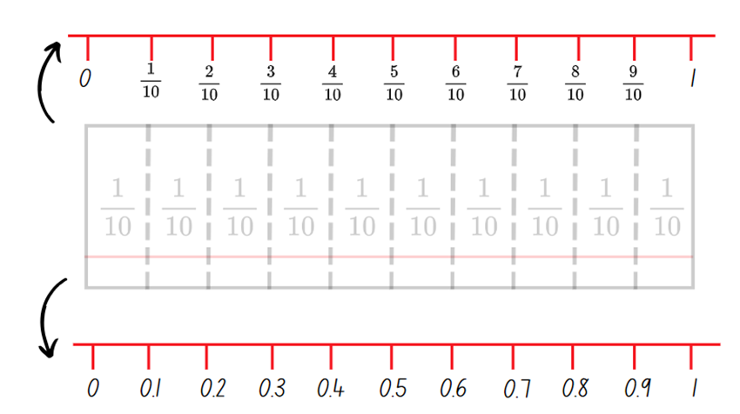
- Using the top edge of the cardboard strips, students record a number line from 0–1 and fractional increments from one-tenth ( $\frac{1}{10}$ ) to nine-tenths ( $\frac{9}{10}$ ) recorded on each fold.
- Students trace the bottom edge to record a number line from 0–1 and decimal notation in 0.1 increments.
Note: to support place value conceptual understanding, read 0.1 as ‘one-tenth’, connecting the decimal with common fractions.
- Students Think-Pair-Share what is the same and what is different about the 2 traced lines. (Same number of partitions, represent the same quantity, different ways of recording the same fraction.)
- Explain that the bar model and number line can be used interchangeably to represent quantities.
- Use Resource 3 – cards template for students to add 5 new cards to their ‘Fraction Wars’ set, representing decimal notation including benchmarks of 0.25 and 0.75.
This table details opportunities for differentiation.
Too hard? | Too easy?
Students cannot represent quantities and lengths as fractions and decimals.  - Provide students with a 20 cm paper strip. Students fold paper strips into halves and align the paper strip with a ruler to show that half of the 20 cm paper strip is 10 cm. Label the fold as $\frac{1}{2}$ or five-tenths (0.5). Repeat folding and labelling with various lengths of paper strips.  - Revise students’ understanding of the benchmark fractions and decimals. Students fold and label fraction strips and record these on a number line. Ask students if they can use the fraction strip and drawn number line to determine 0.5 of 20 cm, 0.25 of 20 cm and 0.75 of 20 cm. | Students can represent quantities and lengths as fractions and decimals.  - Provide students with 3 additional paper strips of equal lengths (for example 10 cm) to represent quarters, fifths and tenths. Students align each of the paper strips and create a number line to represent related fractions and decimals.  - Challenge students to fold a paper strip so that there are only 3 fold lines visible to indicate 0.2, $\frac{1}{2}$ and $\frac{3}{4}$. Students may use previous paper strips to assist.

Discuss and connect the mathematics – 10 minutes
- Display a piece of a paper strip and ask: What fraction of the whole might this strip of paper represent (see Figure 14)?
Figure 14 – example of a piece of paper strip
- Ask:
- If this strip was one-third, what would the whole look like?
- If this strip was one-eighth, what would the whole look like?
- What are some other possibilities?
- What do you need to know about fractions to help you explain your solutions?
- How can a number line help you?
This table details opportunities for assessment.
Assessment opportunities | Links
What to look for:  - Can Stage 2 students create thirds and fifths of a length?  [MAO-WM-01, MA2-PF-01]  - Can Stage 2 students describe fraction families formed by dividing the whole into the same total number of equal parts as having the same denominator? [MAO-WM-01, MA2-PF-01]  - Can Stage 3 students represent quantities and lengths as fractions and decimals? [MAO-WM-01, MA3-RN-01, MA3-RN-02,  MA3-RN-03] | Links to National Numeracy Learning Progressions (NNLP):  - Stage 2 – InF4  - Stage 3 – InF7, PrT2.

Lesson 4
Core concept: bar models and fractions strips can be used to represent fractions (Stage 2), and connections can be made between fractions, decimals and percentages (Stage 3).

Daily number sense – 10 minutes
- From a class need surfaced through formative assessment data, identify a short, focused activity that targets students’ knowledge, understanding and skills. Example activities may be drawn from the following resources:
- Mathematics K–6 resources
- Universal Resources Hub.

Core lesson – 50 minutes

Stage 2 task– fractions with related denominators
The table below contains suggested learning intentions and success criteria. These are best co-constructed with students.
Core concept learning intentions | Core concept success criteria
Students working towards Stage 2 outcomes are learning to:  - create fractional parts of a length using techniques other than repeated halving  - model and represent unit fractions, and their multiples, to a complete whole on a number line  - generate and describe patterns. | Students working towards Stage 2 outcomes can:  - create thirds and fifths of a length  - model fractions with fraction strips and diagrams  - model, describe and record patterns of multiples.
- Revise the folding of thirds and fifths from Lesson 3.
- Pose the question: When we halved quarters, we created eighths. When we halve thirds, what will happen? Ensure students understand that halving thirds will create sixths.
- Provide pairs with paper strips to explore ideas about how to create sixths.
- Select students to demonstrate and discuss how they went about folding their paper strip into 6 equal parts. Highlight that the most efficient method is to fold thirds and then fold in half again.
- Pose the question: Using our knowledge of halving quarters to make eighths and halving thirds to make sixths, how could tenths be made?
- Provide pairs with paper strips to explore ideas about how to create tenths.
- Select students to demonstrate and discuss how they folded their paper strip into 10 equal parts. Remind students that the most efficient method is to fold fifths and then fold in half again.
- Students glue the sixths and tenths strips into their workbook or onto a piece of grid paper, where they had left space in Lesson 3.
- As in Lesson 3, under each paper strip, students draw a number line that includes zero, one and an arrow to indicate that the number line continues. Students mark and label the fractions on the line (see Figure 15).
Figure 15 – student work sample
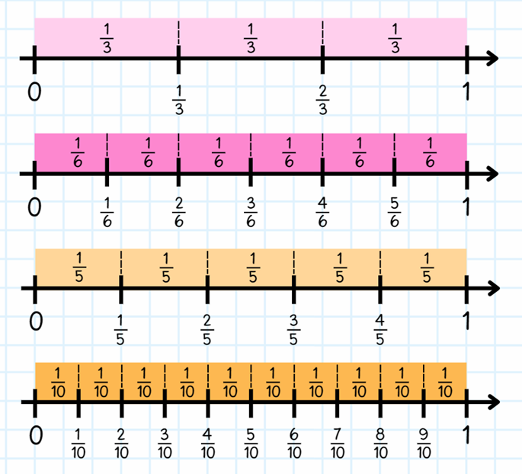
The table below outlines stimulus prompts to generate conversation about the topic, along with anticipated responses from students.
Prompts | Anticipated student responses
- What do you notice happens when you halve thirds? | - When you halve thirds, you end up with 6 parts – the number of parts doubles. The size of each part is halved.
- What do you notice happens when you halve fifths? | - When you halve fifths, you end up with 10 parts – the number of parts doubles. The size of each part is halved.
- How are thirds different to sixths? | - They differ in the number of equal parts that divide the whole. The size of each part is also different if the same sized whole is used to represent thirds and sixths.
- Refer students to the thirds and sixths strips in their workbook. Can you identify what is similar and different between one-third ( $\frac{1}{3}$ ) and two-sixths ( $\frac{2}{6}$ )? | - One-third and two-sixths are equivalent, but the number of parts needed are different because the size of the parts are different. When the same sized whole is used, one-third is the same as two-sixths.
This table details opportunities for differentiation.
Too hard? | Too easy?
Students cannot model fractions with fraction strips and diagrams.  - Model fractions using concrete materials such as coloured rods.  - Students use their fraction wall to explore thirds, fifths, sixths and tenths. | Students can model fractions with fraction strips and diagrams.  - Present students with story problems that involve fractions in realistic scenarios, such as sharing food among friends or dividing resources equally. Encourage them to solve the problems using fractions and explain their reasoning.  - Students explore equivalence by folding strips of paper. They identify, create and label as many fractions equivalent to one-third as possible.
- Regroup and ask students to prove that two-thirds ( $\frac{2}{3}$ ) is equivalent to four-sixths ( $\frac{4}{6}$ ), using concrete materials, diagrams and number lines to demonstrate their understanding.
- Students turn and talk to discuss their decisions and the strategies they used.
- Ask students to repeat the process to prove that three-fifths ( $\frac{3}{5}$ ) is equivalent to six-tenths ( $\frac{6}{10}$ ).
- Students share responses.

Stage 3 task – representing fractions and percentages
The table below contains suggested learning intentions and success criteria. These are best co-constructed with students.
Core concept learning intentions | Core concept success criteria
Students working towards Stage 3 outcomes are learning to:  - make connections between benchmark fractions, decimals and percentages  - determine percentage discounts of 10%, 25% and 50%. | Students working towards Stage 3 outcomes can:  - recall commonly used equivalent percentages, decimals and fractions including $\frac{1}{2}$ , $\frac{1}{4}$and $\frac{3}{4}$  - represent common percentages of quantities and lengths as fractions and decimals  - recognise that 10% is one-tenth of 100% and use this to find 10% of a quantity  - equate 10% to dividing by 10, 25% to finding a quarter by dividing by 4, and 50% to finding half.
- Introduce vocabulary to be used in this lesson, including ‘per cent’ and ‘benchmark per cent’. Add these words to the word display from Lesson 2.
- Draw and discuss the per cent symbol %.
- Revise folding a paper strip into fifths and halves to represent ( $\frac{1}{10}$).
- Ask: How can you determine 10% and 50% of the total length of a paper strip?
- Students turn and talk to discuss strategies.
- Provide individual whiteboards, writing materials and paper strips.
- Challenge students to record representations to support their reasoning (see Figure 16).
Figure 16 – student sample recording
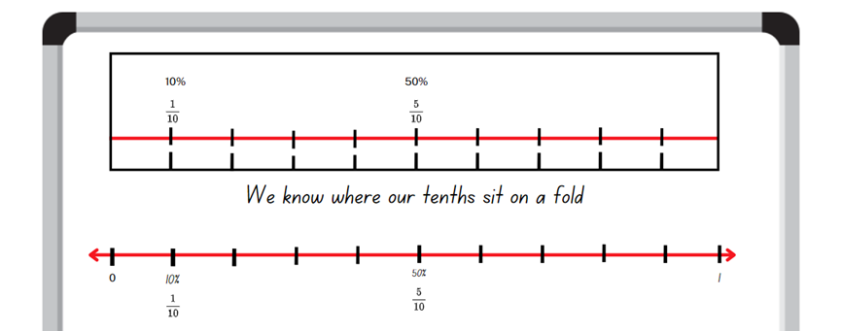
- Select pairs of students to share their representations with the class.
- Remind students that they have previously learnt about 10% as one-tenth ($\frac{1}{10} )$ and 50% as one-half ($\frac{1}{2} )$ in Stage 3 Unit 15.Demonstrate folding the A4 paper into tenths. Explicitly describe folding the paper into half then fifths to form a total of 10 smaller rectangles (see Figure 17).
Figure 17 – folds on A4 paper
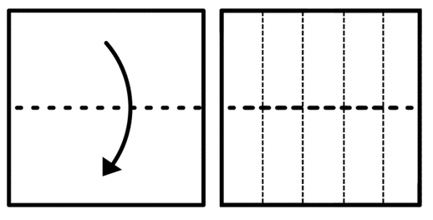
- Explain that this method of folding produces a 2 by 5 array.
- Provide pairs of students with a piece of A4 paper, plastic sleeves and whiteboard markers. Students insert the folded A4 sheet (see Figure 17) into a plastic sleeve.
- Using whiteboard markers and plastic sleeves, students demonstrate their understanding of 10%.
- Reinforce the idea that 10% is one-tenth and can be written as $\frac{1}{10}$ and 0.1.
- In pairs, students use whiteboard markers and plastic sleeves (with paper inserts) to record possible representations for:
- 10%, $\frac{1}{10}$ or 0.1
- 50%, $\frac{1}{2}$ or 0.5
- 20%, $\frac{1}{5}$ or 0.2.
- Regroup as a class and select students to share their representations.
- Challenge students to represent 25%, 0.25 or one-quarter ( $\frac{1}{4}$ ) and three-quarters ( $\frac{3}{4}$ ), 0.75 or 75% using folded paper. Explain that if one rectangle represents 10%, half of a rectangle represents 5%.
- Encourage students to justify their representations using vocabulary from the word display.
- Pose the problem: Oliver wants to buy a concert ticket to his favourite band. If he purchases the ticket in the next 24 hours, he gets a 10% discount on the full price of a ticket costing $100. What will he pay for the discounted ticket?
- Students use number lines or folded paper strips as fraction bars to solve the problem.
- After students have worked on their solution, ask:
- How much is the 10% discount of the ticket price?
- How could tools such as paper strips and bar models help Oliver calculate how much he could save with the discount?
- Can you use this knowledge to work out 20%, 50% and 25% of the price?
- What fractional knowledge will you need to check this? (25% is one-quarter)
- Can you use this knowledge to work out if 25% of $100 is the same as one-quarter ( $\frac{1}{4}$ ) of $100?
- Pose the problem: Joseph went for dinner with 4 friends. The total amount was $200. How much did each person have to pay for dinner?
- Students use number lines or folded paper strips as fraction bars to solve the problem.
- Explain that the group receives a 20% discount if they pay using cash. Ask:
- How much is the total cost if they decide to pay with cash?
- How much does each person pay?
- Was it easier to determine the 20% discount first and then the cost per person? Why?
- Was it easier to determine the total cost per person and then the 20% discount? Why?
- Select students to share solutions and strategies. If time allows, pose other problems or quantities that provide challenge to your students.
- Provide time for students to share the various visual representations of benchmark fractions and percentages of 10%, 20%, 25%, 50%, 75% and 100%.
- Students record these representations as additional cards for ‘Fraction Wars’ using Resource 3 – cards template.
This table details opportunities for differentiation.
Too hard? | Too easy?
Students cannot recall commonly used equivalent percentages, decimals and fractions including $\frac{1}{2}$, $\frac{1}{4}$ and $\frac{3}{4}$.  - Revise place value understanding with students by interpreting decimal notations as tenths and hundredths. Write various decimal numbers for students to recognise and partition before recording on a blank hundreds chart.  - Assist students in creating an anchor chart for benchmark percentages, decimals and fractions to be represented using fraction strips and number lines. Refer to the anchor chart as required. | Students can recall commonly used equivalent percentages, decimals and fractions including $\frac{1}{2}$, $\frac{1}{4}$ and $\frac{3}{4}$.  - Students solve percentage questions using quantities which are not multiples of 10, for example 85, 7, $22.  - Ask students to create a list of examples where they have seen or used benchmark percentages, decimals and fractions in daily life. For example, half-time in sports, health bars in computer games or 50% discounts.

Discuss and connect the mathematics – 5 minutes
- Regroup as a class and instruct students to find a partner.
- Provide pairs with a sticky note. Ask students to Think-Pair-Share and reflect on the lesson content, recording a statement, representation or diagram to share with the class that explains what equivalent fractions are.
- Select students to share recordings and display sticky notes for students to view.
This table details opportunities for assessment.
Assessment opportunities | Links
What to look for:  - Can Stage 2 students create thirds and fifths of a length?  [MAO-WM-01, MA2-PF-01]  - Can Stage 2 students model fractions with fraction strips and diagrams? [MAO-WM-01, MA2-PF-01]  - Can Stage 2 students model, describe and record patterns of multiples? [MAO-WM-01, MA2-PF-01]  - Can Stage 3 students recall commonly used equivalent percentages, decimals and fractions including $\frac{1}{2}$, $\frac{1}{4}$and $\frac{3}{4}$?  [MAO-WM-01, MA3-RN-03]  - Can Stage 3 students represent common percentages of quantities and lengths as fractions and decimals? [MAO-WM-01, MA3-RN-03]  - Can Stage 3 students recognise that 10% is one-tenth of 100% and use this to find 10% of a quantity? [MAO-WM-01,  MA3-RN-03]  - Can Stage 3 students equate 10% to dividing by 10, 25% to finding a quarter by dividing by 4, and 50% to finding half?  [MAO-WM-01, MA3-RN-03] | Links to National Numeracy Learning Progressions (NNLP):  - Stage 2 – InF2, InF3, InF4  - Stage 3 – PrT2, InF7, UuM8.  Links to suggested Interview for Student Reasoning (IfSR) tasks:  - Stage 3 – IfSR-PT: 2A.1, 2A.2, 2A.5, 2A.6.

Lesson 5
Core concept: fractions with related denominators can be equivalent (Stage 2), and bar models and fraction strips can be used to represent fractions (Stage 3).

Daily number sense – looking for squares – 10 minutes
Daily number sense activities for Lessons 5 to 7 ‘loop’ back to concepts and procedures covered in previous units to assist students to build an increasingly connected network of ideas. These concepts may differ from the core concepts being covered by the unit.
The table below contains suggested learning intentions and success criteria. These are best co-constructed with students.
Daily number sense learning intentions | Daily number sense success criteria
Students working towards Stage 2 outcomes are learning to:  - recall multiplication facts of 2 and 4, 5 and 10 and related division facts.  Students working towards Stage 3 outcomes are learning to:  - determine products and factors. | Students working towards Stage 2 outcomes can:  - recognise and use the symbols for multiplied by (×), divided by (÷) and equals (=)  - link multiplication and division fact families using arrays.  Students working towards Stage 3 outcomes can:  - model different ways to show a whole number as a product  - determine factors for a given whole number.
- Ask students to define square numbers.
- Discuss responses and provide an example if necessary, such as 3 × 3 = 9. Demonstrate by drawing an array of 3 × 3 for students to visualise the connection with its definition.
Square numbers: the result of multiplying a number by itself. For example, 3 × 3 = 9.
- Display the following numbers: 16, 22, 25 and 9. Ask students to prove which number is not a square number.
Multi-age: students working towards Stage 3 outcomes determine the factors for each number, recording their thinking by writing multiplicative statements to show each set of factors and their product. For example, 1 × 8 = 16, 2 × 8 = 16, 4 × 4 = 16.
Product: the result of multiplying 2 or more numbers together. For example, 12 is the product of 4 × 3.
Factors: a number which divides another number without a remainder. For example, 1, 2, 3 and 6 are factors of 6 but 4 and 5 are not.
- Students record their responses by including an array and a description linking multiplication and division fact families for each pair (see Figure 18).
Figure 18 – array example
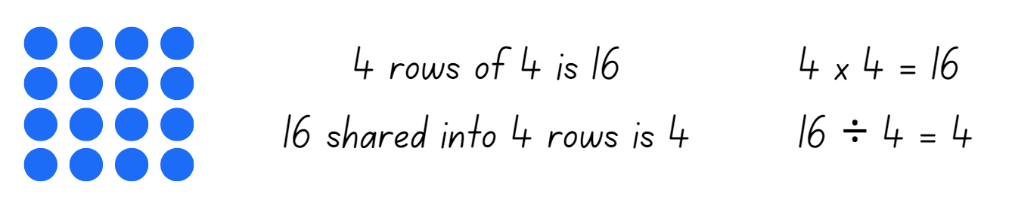
- Ask:
- Can you provide another example of a square number? Prove it. (Stage 2)
- What patterns do you notice with square numbers? (Stage 2)
- How do you know you have listed all the factors for each number? (Stage 3)
This table details opportunities for assessment.
Assessment opportunities | Links
What to look for:  - Can Stage 2 students recognise and use the symbols for multiplied by (×), divided by (÷) and equals (=)? [MAO-WM-01, MA2-MR-01, MA2-MR-02]  - Can Stage 2 students link multiplication and division fact families using arrays? [MAO-WM-01, MA2-MR-01, MA2-MR-02]  - Can Stage 3 students model different ways to show a whole number as a product? [MAO-WM-01, MA3-MR-01]  - Can Stage 3 students determine factors for a given whole number? [MAO-WM-01, MA3-MR-01] | Links to National Numeracy Learning Progressions (NNLP):  - Stage 2 – MuS5, MuS6  - Stage 3 – MuS6, MuS7.  Links to suggested Interview for Student Reasoning (IfSR) tasks:  - Stage 2 – IfSR-MT: 2A.9, 2A.10  - Stage 3 – IfSR-MT: 2A.7, 3A.8.

Core lesson – 45 minutes

Stage 2 task – fraction wall game
The table below contains suggested learning intentions and success criteria. These are best co-constructed with students.
Core concept learning intentions | Core concept success criteria
Students working towards Stage 2 outcomes are learning to:  - model and represent unit fractions, and their multiples, to a complete whole on a number line  - model equivalent fractions as lengths  - represent fractional quantities equal to and greater than one. | Students working towards Stage 2 outcomes can:  - represent fractions with the same-size whole to make valid comparisons (denominators of 2, 4 and 8; 3 and 6; 5 and 10)  - represent the equivalence of fractions with related denominators as lengths, using concrete materials, diagrams and number lines  - rename 2 halves, 3 thirds, 4 quarters, 5 fifths, 6 sixths, 8 eighths and 10 tenths as one whole
This activity is an adaptation of ‘Fraction wall game’ from Top Drawer Teachers by the Australian Government Department of Education, Employment and Workplace Relations.
- Display Resource 10 – fraction wall and ask how a fraction wall can help identify fractions that are equivalent.
- Encourage students to use fractional language for example, three-quarters instead of 3 out of 4. This is helpful for understanding fractional parts within the part-whole and greater than one, for example six-fifths.
- Highlight that the fraction wall enables students to ‘line up’ particularly difficult fractions to generate equivalent combinations, for example, lining up six-eights ( $\frac{6}{8}$ ) demonstrates its equivalence to three-quarters ( $\frac{3}{4}$).
- Explain that students will use Resource 13 – gameboard and spinners to form fractions and represent these on the fraction wall, attempting to colour in the whole gameboard.
- Model using a think aloud strategy to help students draw out equivalence. Ask how the fraction wall can be coloured to show two-eighths ( $\frac{2}{8}$ ) (see Figure 19).
Figure 19 – first attempt
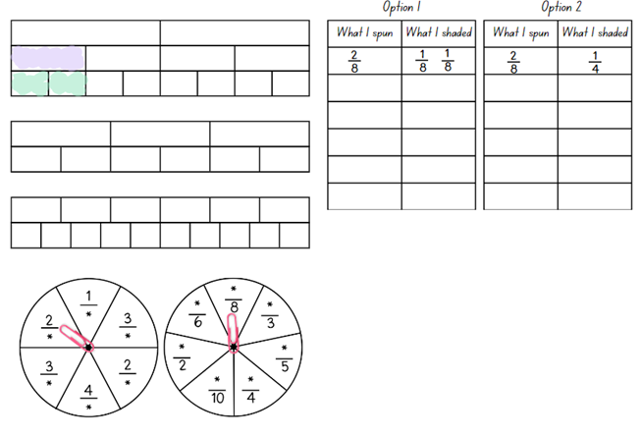
- Ask:
- Is there more than one way this could be done?
- What is the easiest option?
- What could you do if you didn’t have enough eighths?
- Could I use halves? Why or why not?
- Model another example, such as three-quarters ( $\frac{3}{4}$ ) and discuss the equivalent options on the gameboard (see Figure 20).
Figure 20 – second attempt
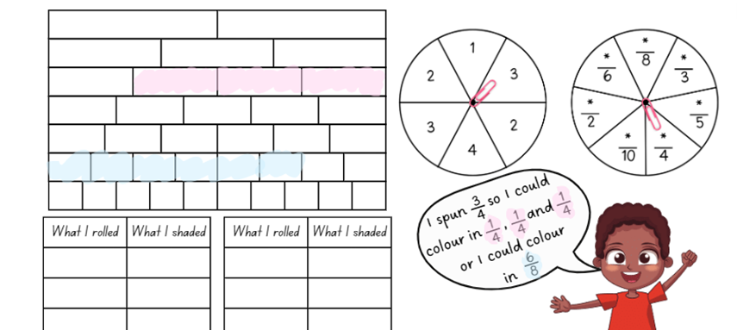
- In pairs, provide each student with Resource 13 – gameboard and spinners.
- Students take turns spinning the spinners and decide how to colour the fraction on their gameboard.
- Each pair decides what they shade on the wall, for example $\frac{4}{8}$, it could be $\frac{1}{2}$ or $\frac{4}{8}$ or $\frac{2}{4}$.
Note: remind Stage 2 students that fractions can be renamed, for example 2 halves, 3 thirds, 4 quarters, 5 fifths, 6 sixths, 8 eighths and 10 tenths as one whole.
- If a student is unable to take their turn, they simply pass. This may happen if a student spins a fraction greater than one or cannot colour the fraction spun. The winner is the first student who colours in their entire wall. However, the other player is encouraged to continue, with the support of the first player to fill their fraction wall if there is still time remaining.
- To finish off the game, students must roll exactly what they need. A larger fraction is not acceptable to finish, for example, if they need $\frac{1}{8}$ to finish and they roll $\frac{2}{4}$ (more than what is needed), they must miss a turn.
- Students record each turn on Resource 13 – gameboard and spinners (see Figure 21). Encourage students to use different colours for each choice made during the game. This helps with understanding each decision made at each stage of the game. For example, a student might have spun $\frac{1}{4}$, but shaded $\frac{1}{8}$and $\frac{1}{8}$.
Figure 21 – colour fraction gameboard
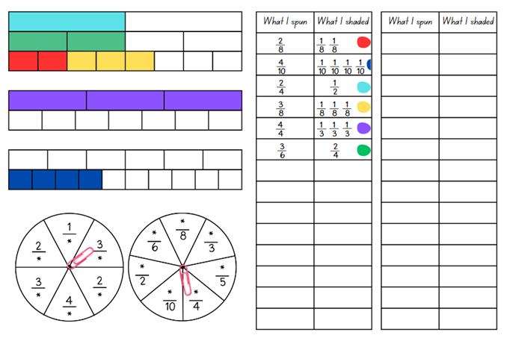
- Regroup and ask students to share and describe what they spun and what they shaded.
The table below outlines stimulus prompts to generate conversation about the topic, along with anticipated responses from students.
Prompts | Anticipated student responses
- How many thirds make one whole? | - Three-thirds.
- When you look at a fraction wall, how can you tell if 2 fractions are equivalent? | - If 2 fractions are the same length on the fraction wall, they are equivalent fractions.
- Can you give an example of a fraction family? | - An example of a fraction family is $\frac{1}{4}$, $\frac{2}{4}$, $\frac{3}{4}, \frac{4}{4}.$ I know they are a fraction family because these are all fractions where the whole has been divided into 4 equal parts.
- How can you use the fraction wall to compare fractions and see which one is bigger or smaller? | - If I am comparing unit fractions, I can look at the size of the pieces. If one fraction’s pieces are longer than another fraction’s pieces, then that fraction is bigger.  - If I am comparing other fractions, I can look at the length of each fraction. Even if the fractional parts look short, the fraction can still be bigger. For example, $\frac{9}{10}$is bigger than $\frac{3}{5} ,$even though each tenth is shorter than each fifth on the fraction wall.
- How could you extend your fraction wall to show a fraction larger than one whole? | - Four-thirds is 3 thirds and one third.  - Three-halves is 2 halves and one half$.$
- Why is it important to find equivalent fractions? Can you give an example? | - It helps us compare and operate with fractions more easily. For example, if you are baking and a recipe needs half a cup of flour, but you only have a one-quarter measuring cup, knowing two-quarters is equivalent to one-half helps you measure the right amount.
This table details opportunities for differentiation.
Too hard? | Too easy?
Students cannot represent the equivalence of fractions with related denominators as lengths, using concrete materials, diagrams and number lines.  - Use a set of fraction cards (for example, $\frac{1}{2}$, $\frac{1}{3}$, $\frac{1}{4}$, $\frac{2}{3}$, $\frac{2}{4}$) that support the representation of the fractions. The first student to complete a row wins the game.  - Provide a reduced fraction wall and in pairs students shade the fraction wall and the first student to complete a row wins the game. For example, students could use the top of the gameboard with only halves, quarters and eighths. | Students can represent the equivalence of fractions with related denominators as lengths, using concrete materials, diagrams and number lines.  - Students fold additional strips to extend their fraction wall with fractions using denominators of their own choosing. For example, twelfths and twentieths.  - Challenge students to create their own rules to fill the board and play with a partner using adjusted rules.

Stage 3 task – fraction problems
The table below contains suggested learning intentions and success criteria. These are best co-constructed with students.
Core concept learning intentions | Core concept success criteria
Students working towards Stage 3 outcomes are learning to:  - apply efficient mental and written strategies to solve addition and subtraction problems  - solve problems involving addition and subtraction of fractions with the same denominator. | Students working towards Stage 3 outcomes can:  - apply known strategies such as addition for subtraction  - solve word problems that involve fractions with the same denominator  - use diagrams, objects and mental strategies to subtract a unit fraction from any whole number including 1.
- Play the ‘Word Wizard’ game introduced in Lesson 1. Remind students that using mathematical words to communicate fraction concepts helps to organise and explain thinking more clearly. Being familiar with these words helps us to understand others and communicate our own ideas.
- Introduce target vocabulary to be used in this lesson. Other vocabulary from the word display can also be added as a review. See Table 3.
Table 3 – suggested word list
Word | Banned words | Possible definition
commutative property | turn around fact | Two numbers can be added or multiplied in any order and the solution will be the same.
subtraction | minus, take away, opposite | The difference between 2 numbers or a way of comparing them. The inverse of addition.
complement | compliment | The part required to form the whole. For example. $\frac{1}{4}$ is the complement of $\frac{3}{4}$.  Note: distinguish this from ‘compliment’.
bar model | bar, blocks | A diagram that shows parts of a whole.
- Display Resource 14 – comparing bar models. Ask how these models are the same and how they are different.
- Explain that the commutative property of addition and the complement principle of subtraction apply to whole numbers and to fractions.
Note: using the complement principle in Stage 3 is limited to the subtraction of unit fractions from whole numbers, including 1.
- Group students in threes to write addition and subtraction number sentences to accompany bar model 2 from Resource 14 – comparing bar models. Share and record student responses.
- Explain that students will be exploring different scenarios for adding and subtracting fractions with the same denominators. They will use the complement principle and make connections between fractions, decimals and percentages.
- Display and read Resource 15 – gardening centre. Support student understanding of the context words such as potting mix and fertiliser.
- Use the think aloud strategy to model appropriate use of vocabulary and to explore options for solving each question.
Note: not all students will require the strategies to be modelled. Also, note that questions 4, 5 and 6 from Resource 15 – gardening centre have more than one step and that questions 6 and 7 have multiple correct answers.
- Allow time for students to complete each question in Resource 15 – gardening centre, recording their answer in their workbook.
- Select students to share their responses using the vocabulary on the word display.
This table details opportunities for differentiation.
Too hard? | Too easy?
Students cannot solve word problems that involve fractions with the same denominator or use diagrams, objects and mental strategies to subtract a unit fraction from any whole number including one.  - Provide students with Resource 16 – additive bar model. Revise the complement principle and the commutative property of addition. Jointly construct other bar models, including fractions, and write matching number sentences.  - Guide students on how to fold and colour paper strips to represent each part of the problems on Resource 15 – gardening centre. | Students can solve word problems that involve fractions with the same denominator and use diagrams, objects and mental strategies to subtract a unit fraction from any whole number including one.  - Students draw fraction models to show the complement principle for fractions other than unit fractions, such as $\frac{4}{6}$ or $\frac{2}{10}$.  - Students write a set of instructions or make an instructional video for other students that explains complements and the usefulness of the complement principle.  - Students write word problems involving adding or subtracting fractional quantities with related denominators.

Discuss and connect the mathematics – 10 minutes
- Regroup as a class and display the fractions two-fifths ( $\frac{2}{5}$ ) (Stage 2) and seven-eights ( $\frac{7}{8}$ ) and nine-tenths ( $\frac{9}{10}$ ) (Stage 3).
- Provide student pairs with a whiteboard. Stage 2 students draw a strip to represent two-fifths ( $\frac{2}{5}$). All students draw a number line labelled 0– 1. Students indicate using a mark where the fractions lie. Ask:
- Can you identify other fractions that can be included on this number line? (Stage 2)
- Can you use the complement principle to justify which fraction, seven-eighths ( $\frac{7}{8}$ ) or nine-tenths ( $\frac{9}{10}$ ) is closest to one? (Stage 3) (The complement for each is a unit fraction. One-tenth is smaller than one-eighth, so nine-tenths ( $\frac{9}{10}$) is closest to one.)
Note: Stage 3 students may wish to repeat the discussion with other pairs or related groups of fractions, decimals and percentages such as: one-eighth ( $\frac{1}{8}$ ) and 50%; 75% and 0.5; or two-thirds ( $\frac{2}{3}$ ) and five-sixths ( $\frac{5}{6}$ ).
This table details opportunities for assessment.
Assessment opportunities | Links
What to look for:  - Can Stage 2 students represent fractions with the same-size whole to make valid comparisons (denominators of 2, 4 and 8; 3 and 6; 5 and 10)? [MAO-WM-01, MA2-PF-01]  - Can Stage 2 students represent the equivalence of fractions with related denominators as lengths, using concrete materials, diagrams and number lines? [MAO-WM-01, MA2-PF-01]  - Can Stage 2 students rename 2 halves, 3 thirds, 4 quarters, 5 fifths, 6 sixths, 8 eighths and 10 tenths as one whole?  [MAO-WM-01, MA2-PF-01]  - Can Stage 3 students apply known strategies such as addition for subtraction? [MAO-WM-01, MA3-AR-01]  - Can Stage 3 students solve word problems that involve fractions with the same denominator? [MAO-WM-01, MA3-RQF-01,  MA3-RQF-02]  - Can Stage 3 students use diagrams, objects and mental strategies to subtract a unit fraction from any whole number including 1 (the complement principle)? [MAO-WM-01, MA3-RQF-01,  MA3-RQF-02] | Links to National Numeracy Learning Progressions (NNLP):  - Stage 2 – InF3, InF4, InF5  - Stage 3 – AdS7, AdS8, InF7, InF8.  Links to suggested Interview for Student Reasoning (IfSR) tasks:  - Stage 3: IfSR-AT: 3A.3.

Lesson 6
Core concept: fractions represent a multiplicative relationship (Stage 2), and mathematicians solve problems with fractions (Stage 3).

Daily number sense – using arrays – 10 minutes
The table below contains suggested learning intentions and success criteria. These are best co-constructed with students.
Daily number sense learning intentions | Daily number sense success criteria
Students working towards Stage 2 outcomes are learning to:  - recall multiplication facts of 2 and 4, 5 and 10 and related division facts.  Students working towards Stage 3 outcomes are learning to:  - determine products and factors. | Students working towards Stage 2 outcomes can:  - recognise and use the symbols for multiplied by (×), divided by (÷) and equals (=)  - link multiplication and division fact families using arrays.  Students working towards Stage 3 outcomes can:  - determine factors for a given whole number  - determine whether a number is prime or composite.
- Roll two 10-sided dice and use the numbers rolled to form an array. For example, if 3 and 8 are rolled, an array of 3 eights is created.
- From the array, record multiplication and division number sentences (see Figure 22).
Figure 22 – array example
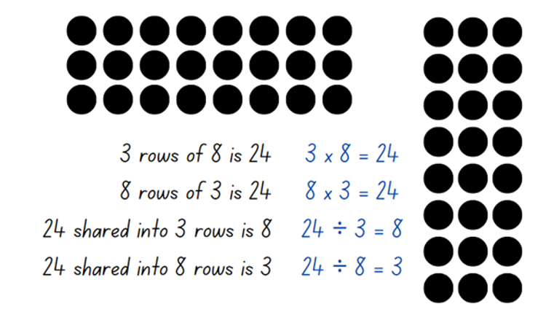
- Highlight to students:
- the link between multiplication and division
- the commutative property of multiplication.
- Once students are confident, provide them with two 10-sided dice, counters and their workbooks. Students record the array and their number sentences in their workbook.

Note: students may wish to use grid paper rather than counters to help draw arrays, particularly with larger arrays.
Multi-age: students working towards Stage 3 outcomes write the multiplicative statement to reflect the use of factors to result in a product, use the provided multiplicative statements to determine the product and whether the number is prime, composite or neither. Recording the arrays is optional.
- Select students to share and explain their answers.
This table details opportunities for assessment.
Assessment opportunities | Links
What to look for:  - Can Stage 2 students recognise and use the symbols for multiplied by (×), divided by (÷) and equals (=)? [MAO-WM-01, MA2-MR-01, MA2-MR-02]  - Can Stage 2 students link multiplication and division fact families using arrays? [MAO-WM-01, MA2-MR-01, MA2-MR-02]  - Can Stage 3 students determine factors for a given whole number? [MAO-WM-01, MA3-MR-01]  - Can Stage 3 students determine whether a number is prime or composite? [MAO-WM-01, MA3-MR-01] | Links to National Numeracy Learning Progressions (NNLP):  - Stage 2 – MuS6  - Stage 3 – MuS6, MuS7.  Links to suggested Interview for Student Reasoning (IfSR) tasks:  - Stage 2 – IfSR-MT: 2A.9, 2A.10  - Stage 3 – IfSR-MT: 2A.7, 3A.8.

Core lesson – 40 minutes

Stage 2 task – Which does not belong?
The table below contains suggested learning intentions and success criteria. These are best co-constructed with students.
Core concept learning intentions | Core concept success criteria
Students working towards Stage 2 outcomes are learning to:  - generate and describe patterns  - model equivalent fractions as lengths. | Students working towards Stage 2 outcomes can:  - model, describe and record patterns of multiples  - represent the equivalence of fractions with related denominators as lengths, using concrete materials, diagrams and number line.
Note: the fraction wall introduced in Lesson 5 will be used to reinforce the concepts covered in this lesson.
- Ask students to identify and record any fractions equivalent to one-half, one-third, one-quarter and one-fifth on an individual whiteboard by using concrete materials, diagrams or number lines (see Figure 23). Students may wish to use Resource 10 – fraction wall.
Figure 23 – equivalent fractions
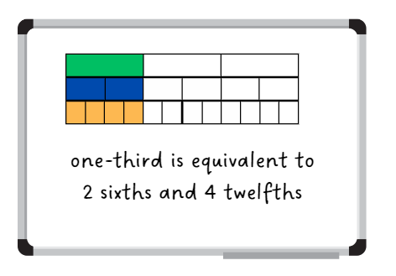
- Ask students what they notice about these groups of fractions. Highlight the multiplicative relationship between the equivalent fractions. For example, a student may reason that one-fifth ( $\frac{1}{5}$ ) is equivalent to two-tenths ( $\frac{2}{10}$ ) because if fifths were halved, each fifth would be equivalent to two-tenths ( $\frac{2}{10}$ ).
- Have students use the fraction wall or Polypad – The Mathematical Playground to identify any other equivalent fractions and record these in their workbooks. Encourage students to find equivalence for non-unit fractions such as two-thirds ( $\frac{2}{3}$ ), six-tenths ( $\frac{6}{10}$ ), and so on.
- Ask students to record any additional equivalent fractions that go beyond the fraction wall and justify their responses.
Note: although fractions with other denominators are not explicitly included in the syllabus, this activity highlights the multiplicative pattern of equivalent fractions.
- Provide students with Resource 17 – Which doesn’t belong?
- Select one example from Resource 17 – Which doesn’t belong?. Ask students to turn and talk to determine which fraction does not belong.
- Regroup and select students to share the strategies used to determine the answer.
- Provide pairs or small groups of students with Resource 17 – Which doesn’t belong? and writing materials. Students work together to determine the fraction that does not belong using concrete materials, diagrams or number lines.
- Regroup and ask students to explain and justify the answer for each card.
This table details opportunities for differentiation.
Too hard? | Too easy?
Students cannot represent the equivalence of fractions with related denominators as lengths, using concrete materials, diagrams and number lines.  - Students use fractions strips and number lines to manipulate the fractions when attempting to determine equivalent fractions.  - Provide students with paper strips to enable them to fold and partition the whole lengths into fractional parts prior to drawing the connecting number line. The edge of the paper strip could be used as the number line. | Students can represent the equivalence of fractions with related denominators as lengths, using concrete materials, diagrams and number lines.  - Students create their own series of cards and share then with their peers to justify why some fractions do not belong.

Stage 3 task – adding and subtracting fractions
The table below contains suggested learning intentions and success criteria. These are best co-constructed with students.
Core concept learning intentions | Core concept success criteria
Students working towards Stage 3 outcomes are learning to:  - apply efficient mental and written strategies to solve addition and subtraction problems  - solve problems involving addition and subtraction of fractions with the same denominator. | Students working towards Stage 3 outcomes can:  - solve word problems, including multistep problems  - solve word problems that involve fractions with the same denominator  - use diagrams, objects and mental strategies to subtract a unit fraction from any whole number including 1 (the complement principle).
- Revise the number lines from Lesson 3 and Lesson 4 that link benchmark fractions, decimal fractions and percentages, as seen in Figure 24.
Figure 24 – combined number line
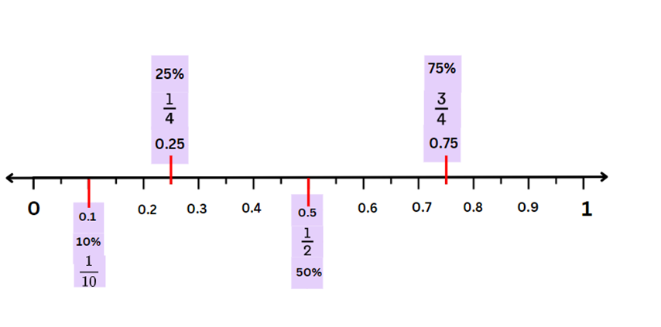
- Revise vocabulary from previous lessons and the word display.
- Display Resource 18 – more fraction models. Explain that for the discrete models, the collection of dots represents a whole. Each dot represents a fraction of the whole.
- Explain that for the 5-dot dice image, 5 can be seen as the whole collection, or 1. A relevant number sentence would be $\frac{1}{5}$ (the black dot) plus $\frac{4}{5}$ (the green dots) = $\frac{5}{5}$ (the whole collection), and not 1 + 4 = 5.
- Groups of students generate and record:
- addition sentences using the commutative property of addition
- subtraction sentences using the complement principle for each of the models displayed.
- Select groups to share responses.
- Provide students with the cards for the ‘Fraction Wars’ game from previous lessons.
- Students group cards into those that have a unit fraction complement and those that do not.
- If students cannot find a card in their set with a unit fraction complement, provide cards from Resource 3 – cards template for the student to make 3 new cards.
- Students select 3 cards with a unit fraction complement and represent each one using a bar model and a number line, showing where the complement unit fraction is in each representation (see Figure 25).
Figure 25 – fraction card complements
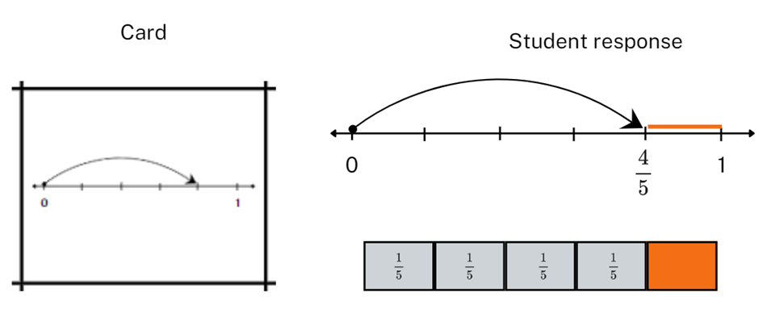
- Students then order the fraction cards from furthest and closest to one and explain their thinking.
- Encourage students to refer to the size of the complements when justifying the order of the cards.
- Explain that students will be exploring different scenarios for adding and subtracting fractions with the same denominators. They will use the complement principle and make connections between fractions, decimals and percentages.
- Display and read Resource 19 – happy holidays.
- Allow time for guided or independent practise using Resource 19 – happy holidays.
- Select students to share responses and strategies.
This table details opportunities for differentiation.
Too hard? | Too easy?
Students cannot solve word problems that involve fractions with the same denominator.  - Provide identical strips of paper for students to fold into fractions with denominators of 2, 4 and 8; 3 and 6; 5 and 10. Label each partition using fractional notation. Use the strips as rulers to make matching number lines (see Stage 2 Teaching advice for Partitioned fractions A).  - Provide identical strips of paper for students to fold into fractions with denominators of 2, 4 and 10. Label relevant partitions with benchmark decimals and percentages of 25% and 50%. Support students to make a connection between fractional notation for tenths, 0.1 and 10%. | Students can solve word problems that involve fractions with the same denominator.  - Present the equation $\frac{1}{3}$+$\frac{ 1}{6}$ =$\frac{1}{ 2}$. Ask students to explore this statement: The sum of 2-unit fractions is also a unit fraction. What are some examples where this statement is true and when it is not true? (Adapted from Sum of unit fractions inquiry by Blair.)  - Provide students with cards for the numbers 1, 3, 4, 5, 6 and 7 and a template with $\frac{}{}+\frac{}{}.$ Ask students to arrange the cards in the boxes so that when you add them the answer is as close to 1 as possible, but not equal to 1. (Adapted from ‘Construct a number’ in Clarke and Roche (2014).

Consolidation and meaningful practice (Stage 2) – 10 minutes
- Display Resource 10 – fraction wall. Ask Stage 2:
- What patterns do you notice on the fraction wall?
- Can you identify any patterns with equivalent fractions?
- What pattern is created when a whole is repeatedly halved?
- What patterns do you notice with equivalent fractions for one-half?

Consolidation and meaningful practice (Stage 3) – 10 minutes
- Display Resource 19 – happy holidays.
- Provide students with 4 blank cards from Resource 3 – cards template.
- Students use the fractions from the resource displayed to make 4 new cards for their ‘Fraction Wars’ pack.
This table details opportunities for assessment.
Assessment opportunities | Links
What to look for:  - Can Stage 2 students model, describe and record patterns of multiples? [MAO-WM-01, MA2-MR-01]  - Can Stage 2 students represent the equivalence of fractions with related denominators as lengths, using concrete materials, diagrams and number lines? [MAO-WM-01, MA2-PF-01]  - Can Stage 3 students represent the sum of fractions with the same denominator, recreating the whole, where the result may exceed one? [MAO-WM-01, MA3-RQF-01, MA3-RQF-02]  - Can Stage 3 students solve word problems that involve fractions with the same denominator? [MAO-WM-01,  MA3-RQF-01, MA3-RQF-02]  - Can Stage 3 students use diagrams, objects and mental strategies to subtract a unit fraction from any whole number including 1 (the complement principle)? [MAO-WM-01,  MA3-RQF-01, MA3-RQF-02] | Links to National Numeracy Learning Progressions (NNLP):  - Stage 2 – InF5, NPA3, NPA4  - Stage 3 – InF7, InF8.

Lesson 7
Core concept: identifying a complementary fractional part is needed to complete one whole (Stage 2), and mathematicians solve problems with fractions (Stage 3).

Daily number sense – Who is correct? – 10 minutes
The table below contains suggested learning intentions and success criteria. These are best co-constructed with students.
Daily number sense learning intentions | Daily number sense success criteria
Students working towards Stage 2 outcomes are learning to:  - recall multiplication facts of 2 and 4, 5 and 10 and related division facts.  Students working towards Stage 3 outcomes are learning to:  - determine products and factors. | Students working towards Stage 2 outcomes can:  - recognise and use the symbols for multiplied by (×), divided by (÷) and equals (=)  - generate multiplication fact families for multiples of 2 and 4, 5 and 10.  Students working towards Stage 3 outcomes can:  - determine factors for a given whole number  - determine whether a number is prime, composite or neither (0 or 1).
The Stage 2 activity is an adaptation of the National Assessment Program by ACARA.
- Display Resource 20 – word problems for Stage 2 students.
- In pairs, Stage 2 students solve and record their solutions on a whiteboard.
- Explain to Stage 3 students that you are thinking of a number. Some of its factors are 1, 2, 3 and 4. Ask: Which number could it be: 24, 48 or 71?
- Select Stage 3 students to share their understanding of factors.
- Stage 3 students turn and talk to determine the factors for 24, 48 and 71. Ask:
- Which answer is correct? 24, 48 or 71?
- Why is 71 not a possible answer?
- Why are 24 and 48 both correct?
- Is 71 a composite number? Why or why not?
- Stage 2 students turn and talk. Ask:
- How did you represent the problem using a number sentence?
- Can you explain the steps you took to solve the problems?
- How did your knowledge of fact families help you solve the problems?
This table details opportunities for assessment.
Assessment opportunities | Links
What to look for:  - Can Stage 2 students recognise and use the symbols for multiplied by (×), divided by (÷) and equals (=)? [MAO-WM-01, MA2-MR-01, MA2-MR-02]  - Can Stage 2 students generate multiplication fact families for multiples of 2 and 4, 5 and 10? [MAO-WM-01, MA2-MR-01,  MA2-MR-02]  - Can Stage 3 students determine factors for a given whole number? [MAO-WM-01, MA3-MR-01]  - Can Stage 3 students determine whether a number is prime, composite or neither (0 or 1)? [MAO-WM-01, MA3-MR-01] | Links to National Numeracy Learning Progressions (NNLP):  - Stage 2 – MuS6  - Stage 3 – MuS6, MuS7.  Links to suggested Interview for Student Reasoning (IfSR) tasks:  - Stage 2 – IfSR-MT: 2A.4, 2A.5, 2A.6  - Stage 3 – IfSR-MT: 2A.7, 3A.8.

Core lesson – 45 minutes

Stage 2 task – recreate the whole
The table below contains a suggested learning intention and success criteria. These are best co-constructed with students.
Core concept learning intention | Core concept success criteria
Students working towards Stage 2 outcomes are learning to:  - model and represent unit fractions, and their multiples, to a complete whole on a number line. | Students working towards Stage 2 outcomes can:  - determine the complementary fractional part needed to complete one whole (halves, quarters, eighths, thirds)  - recreate the whole unit from a fractional part ($\frac{1}{2} , \frac{1}{4}$ and $\frac{1}{8})$.
- Display Resource 21 – recreate the whole.
- Explain that a number line has been drawn underneath each red paper strip. Draw attention to the position of 0 and 1 on the number lines to indicate that each red strip represents a fractional part of a whole strip.
- Revise the term ‘complementary fraction’ as the unit fraction needed to create one whole.
- Discuss and model identifying the complementary fractional part for the example 9 tenths. Explain that one-tenth ( $\frac{1}{10} )$is the unit fraction that is complementary as they represent 2 fractional parts needed to complete one whole (see Figure 26).
Figure 26 – finding the complement
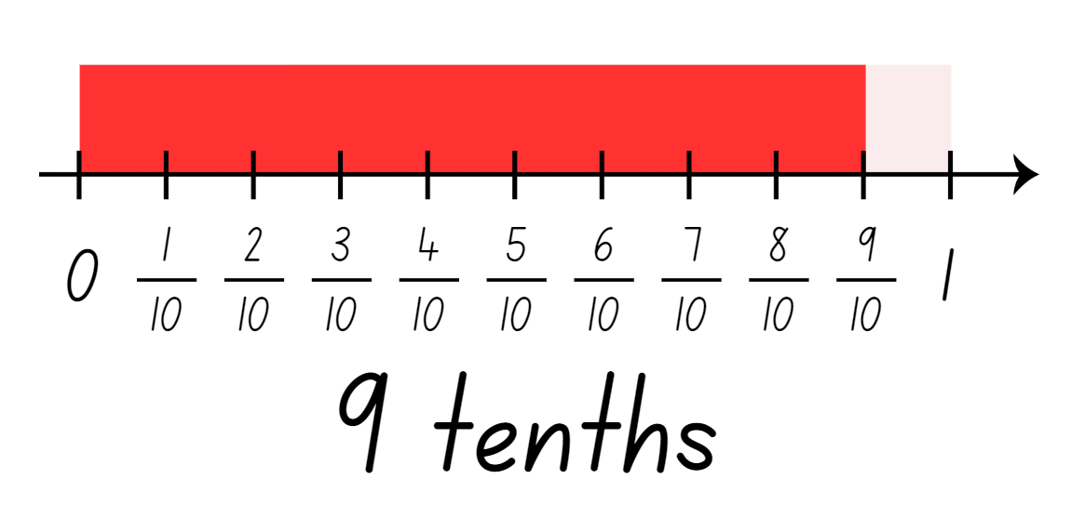
- Explain that sometimes the fractional part needed to create a whole unit is not a unit fraction. Ask: What fraction would be needed to recreate the whole from the fractions given?
- Students turn and talk to identify the fractional part needed for the other examples.
- Regroup and ask students how they used the number line to determine the fraction required to recreate the whole.
- In pairs, provide students Resource 22 – recreate the whole memory. Explain the following game instructions:
- Shuffle the cards and lay out all the cards face down in an array formation.
- Take turns flipping over 2 cards at a time, aiming to find pairs of fractions that will create a whole.
- Keep the cards and take another turn if the fractions on the cards make a whole.
- Flip the cards back over. The next player has a turn if the fractions do not make a whole.
- The game continues until all fractions have been matched.
- Regroup and discuss some of the fraction pairs.
This table details opportunities for differentiation.
Too hard? | Too easy?
Students cannot determine the complementary fractional part needed to complete one whole (halves, quarters, eighths, thirds).  - Model using Fraction number line to create a green bar and 4 orange quarter-bars. Remove one quarter-bar to demonstrate the complement.  - Support students to use a fraction wall to identify complementary unit fractional parts. | Students can determine the complementary fractional part needed to complete one whole (halves, quarters, eighths, thirds).  - Students find the non-unit fractional part used to recreate the whole. Express them as an equivalent fraction. For example, $\frac{3}{4}$ is $\frac{2}{8}$.

Stage 3 task 1 – lines, areas and collections – 20 minutes
The table below contains suggested learning intentions and success criteria. These are best co-constructed with students.
Core concept learning intentions | Core concept success criteria
Students working towards Stage 3 outcomes are learning to:  - apply efficient mental and written strategies to solve addition and subtraction problems  - solve problems involving addition and subtraction of fractions with the same denominator. | Students working towards Stage 3 outcomes can:  - solve word problems, including multistep problems  - solve word problems that involve fractions with the same denominator  - use diagrams, objects and mental strategies to subtract a unit fraction from any whole number including 1 (the complement principle).
- Revise vocabulary on the word display. Introduce vocabulary to be used in this lesson (see Table 4).
Table 4 – suggested word list
Word | Banned words | Possible definition
Linear model | line | A model that divides the length of the whole into equal lengths.
Area model | array, rectangle | A way of showing fractions of a two-dimensional shape.  A model that shows a whole shape split into equal parts.
Discrete model | collection, discreet, discrete | A way of showing fractions of a set of objects split into equal parts.  Note: distinguish its meaning from ‘discreet’.
- Display Resource 23 – lines, areas and collections.
- Students turn and talk to share their responses to the following true or false statements:
- From root to tip, plant 1 is 10% shorter than Plant 2.
- Four-tenths of plant 2 is below the soil.
- More than half of plant 1 is above the ground.
- For image B, 70% of squares have nothing on them.
- For image B, one-fifth of the squares have a star on them.
- For image C, $\frac{1}{3}$ of the coins are upside down.
- For image C, 70% of the coins are the right way up.
The table below outlines stimulus prompts to generate conversation about the topic, along with anticipated responses from students.
Prompts | Anticipated student responses
- Using the metre ruler as the common whole, what fraction, decimal or percentage statements or equations can we make about image A? | - The rulers are 10 squares each; $\frac{1}{2}$ , 50% or 0.5 of the squares are black or white.  - Plant 1 is $\frac{9}{10}$ of a ruler long; plant 2 is the length of a whole ruler.  - Plant 2 is $\frac{1}{10}$ of a ruler longer than plant 1.  - The roots of plant 1 are $\frac{1}{10}$ longer than the visible part of the plant.  - The roots of plant 2 are $\frac{2}{10}$ shorter than the visible part of the ground.  - For plant 2, 40% is below ground and 60% is above ground.
- What fraction, decimal or percentage statements or equations can we make about image B? | - $\frac{1}{10}$, 10% or 0.1 of the squares have a star on them.  - 20%, $\frac{2}{10}$, $\frac{1}{5}$ or 0.2 of the squares have dots.  - $\frac{1}{2}$, 50% or 0.5 of the squares are black or white.
- What fraction, decimal or percentage statements or equations can we make about image C? | - 100% of the collection are Australian coins.  - $\frac{7}{10}$, 0.7 or 70% of the coins are the right way up.  - $\frac{1}{2}$, 50% or 0.5 of the coins are either $1 or 5 cents.
- How are these 3 images the same? | - Each model uses tenths as a benchmark fraction, decimal or percentage.  - In each model there is a representation of one-half and one-tenth.
- How are these 3 images different? | - Image A uses a linear model of fractions.  - Image B uses an area model of fractions.  - Image C uses a discrete model of fractions (a collection of objects).

Stage 3 task 2 – collection problems – 25 minutes
- Display and read Resource 24 – pin packets.
- Explain that because pins are discrete (a collection of objects) and not continuous (like the linear or area models), this series of questions is most like image C from Resource 23 – lines, areas and collections.
- Make connections to the type of questions and the strategies for solving them used in Lesson 5 and Lesson 6.
- Allow time for students to complete each question in Resource 24 – pin packets with a partner or in a small group.
- Select students to share their responses using the appropriate vocabulary. Refer students to the word display as necessary.
This table details opportunities for differentiation.
Too hard? | Too easy?
Students cannot solve word problems that involve fractions with the same denominator.  - Guide students to construct a model pin packet using coloured counters, starting with 5 counters with the correct proportions. Students use the colour pattern to build the collection to a total of 90 counters and use the model to answer questions.  - Provide students with 2 orange and one red, one green and one blue counter. Provide students with a strip of paper and have them fold it into fifths. Students place a counter into each of the paper partitions to make connections between the linear and discrete models. | Students can solve word problems that involve fractions with the same denominator.  - Ask students to solve word problems that involve fractions with related denominators, such as 2, 4 and 8; 3 and 6; or 5 and 10.  - Students investigate the contents of a readily available packet of pins, paperclips, counters or coloured lollies. Ask students to write fraction addition and subtraction questions using that resource. (Note: students may need to adjust the numbers in the packet to better reflect the expectations of the Stage 3 syllabus.)

Discuss and connect the mathematics – 5 minutes
- Display these questions for discussions:
- How can you prove that $\frac{4}{5}$ and $\frac{1}{5}$ are complementary? (Stage 2)
- Can you create a word problem that matches the following number sentence: $\frac{1}{5}$ + $\frac{3}{5}$ = $\frac{4}{5}$? (Stage 3)
This table details opportunities for assessment.
Assessment opportunities | Links
What to look for:  - Can Stage 2 students determine the complementary fractional part needed to complete one whole (halves, quarters, eighths, thirds)? [MAO-WM-01, MA2-PF-01]  - Can Stage 2 students recreate the whole from a fractional part  ($\frac{1}{2}$ , $\frac{1}{4}$ and $\frac{1}{8}$)? [MAO-WM-01, MA2-PF-01]  - Can Stage 2 students represent the equivalence of fractions with related denominators as lengths, using concrete materials, diagrams and number lines? [MAO-WM-01, MA2-PF-01]  - Can Stage 3 students solve word problems, including multistep problems? [MAO-WM-01, MA3-AR-01]  - Can Stage 3 students solve word problems that involve fractions with the same denominator? [MAO-WM-01, MA3-RQF-01,  MA3-RQF-02]  - Can Stage 3 students use diagrams, objects and mental strategies to subtract a unit fraction from any whole number including 1 (the complement principle)? [MAO-WM-01, MA3-RQF-01,  MA3-RQF-02] | Links to National Numeracy Learning Progressions (NNLP):  - Stage 2 – InF5  - Stage 3 – AdS8, InF7, InF8.

Lesson 8
Core concept: recreate fractional quantities equal to and greater than one (Stage 2), and mathematicians make connections between fractions, decimals and percentages (Stage 3).

Daily number sense – 10 minutes
- From a class need surfaced through formative assessment data, identify a short, focused activity that targets students’ knowledge, understanding and skills. Example activities may be drawn from the following resources:
- Mathematics K–6 resources
- Universal Resources Hub.

Core lesson – 50 minutes

Stage 2 task – fractions beyond a whole
The table below contains suggested learning intentions and success criteria. These are best co-constructed with students.
Core concept learning intentions | Core concept success criteria
Students working towards Stage 2 outcomes are learning to:  - model and represent unit fractions, and their multiples, to a complete whole on a number line  - represent fractional quantities equal to and greater than one. | Students working towards Stage 2 outcomes can:  - recreate the whole unit from a fractional part ($\frac{1}{2},$ $\frac{1}{4},\frac{1}{3}$ and $\frac{1}{8}$)  - regroup fractional parts beyond one  - represent totals of halves, thirds, quarters and fifths that extend beyond one  - determine the relative location of one-quarter and one-half when a number line extends beyond one.
This activity is an adaptation of Fractions beyond one whole from BetterLesson by Valentine.
- Display Resource 25 – chocolate bars. Highlight the first piece of chocolate and explain that this represents one-quarter ( $\frac{1}{4}$ ) of a whole chocolate bar.
- Students turn and talk to discuss how the whole bar could be recreated from this fractional part. Model drawing and labelling how to recreate the whole (see Figure 27).
Figure 27 – sample of a whole
- Provide students with Resource 25 – chocolate bars to recreate the whole chocolate bar if the pieces represent one-quarter ($\frac{1}{4}$ ), one-third ( $\frac{1}{3}$ ) and one-fifth ( $\frac{1}{5}$ ) of the whole.
- Regroup and ask the following questions:
- What strategy did you use to determine the size of the whole chocolate bar?
- How did you know how many parts would be needed to make the whole chocolate bar?
- What do you know about fractions that helped you with this task?
- Display Resource 26 – blocks of chocolate and pose the questions in the table below. Model the first example, with students completing the following 2 in pairs or independently.
The table below outlines stimulus prompts to generate conversation about the topic, along with anticipated responses from students.
Prompts | Anticipated student responses
- If this is the whole chocolate bar, what might a chocolate bar 3 halves the size look like? | - Two halves make a whole, so 3 halves would be bigger than one.  - I know 2 halves make a whole. If I partition this chocolate bar into 2 equal parts, this helps me find the size of one-half.  - I can see after partitioning that I already have 2 halves. Now I just need to extend the bar by one more half. This is now 3 halves.
- How could 3 halves be renamed as a fraction greater than one? | - Three halves can also be renamed as 1$\frac{1}{2}$.
Note: fractions can be renamed in multiple ways. For example, 1$\frac{4}{5}$ can be renamed $\frac{9}{5}$. In the syllabus, the expression ‘fraction greater than one’ is used instead of the terms ‘improper fraction’ or ‘mixed numeral’.
- Provide Resource 26 – blocks of chocolate and discuss the following problems:
- If this is the whole chocolate bar, what might a chocolate bar $\frac{5}{4}$ the size look like? How could it be renamed?
- If this is the whole chocolate bar, what might a chocolate bar $\frac{7}{4}$ the size look like? How could it be renamed?
- Write $\frac{1}{2}$ and $\frac{1}{4}$ on the board and ask:
- Where would these fractions go on a number line marked with 0 and 1?
- What strategy can you use to determine their location? (Half is between 0 and 1. The line can be partitioned into 2 equal parts and then a quarter is half of a half.)
- How does the relationship between halves and quarters help you place them on a number line?
- In pairs, students locate one-quarter and one-half on the first number line from Resource 27 – number line 0–1.
- Display and examine Resource 28 – number line 0–2 and ask:
- Where would one go on this number line? How do you know?
- Where would halves and quarters be placed on the 0–2 number line?
- What is similar between the 2 number lines? What is different? (They both have 0, 1, $\frac{1}{2}$, $\frac{1}{4}$ marked. Half and one-quarter are between 0 and 1, however the second number line will need other fractions between 1 and 2).
- What fractions might go between 1 and 2?
- Where might $\frac{3}{2}$ go?
- How does renaming $\frac{3}{2}$ as a fraction greater than one, help you decide where it goes?
- Explain to students that they will locate and mark $\frac{3}{2}$, $\frac{5}{4}$ and $\frac{7}{4}$ on the number lines.
- Regroup as a class and ask:
- Where did you place $\frac{3}{2}$,$\frac{5}{4}$ and$\frac{7}{4}$?
- What strategies did you use to help you place these fractions?
- What do you know about fractions, halves and quarters that helped you with this task?
This table details opportunities for differentiation.
Too hard? | Too easy?
Students cannot regroup fractional parts beyond one.  - Provide strips of paper to represent each fractional part of the chocolate bar. Use the strips to model adding on the remaining fractions to make the whole bar. | Students can regroup fractional parts beyond one.  - Students draw and label their own fractional parts of chocolate bars, such as thirds, fifths or eighths. They swap with another student, who solves them by finding the size of a full bar or a bar larger than one.

Stage 3 task 1 – connecting fraction representations – 30 minutes
The table below contains suggested learning intentions and success criteria. These are best co-constructed with students.
Core concept learning intentions | Core concept success criteria
Students working towards Stage 3 outcomes are learning to:  - make connections between benchmark fractions, decimals and percentages  - compare common fractions with related denominators. | Students working towards Stage 3 outcomes can:  - recall commonly used equivalent percentages, decimals and fractions including $\frac{1}{2}$, $\frac{1}{4}$ and $\frac{3}{4}$  - compare and represent fractions with denominators of 2, 4 and 8; 3 and 6; 5 and 10 of a whole shape (area model) and a collection of objects (discrete model)  - record equivalent fractions using diagrams, words and fraction notation.
This activity is an adaptation of Venn Diagram Rich Tasks from the Mr Barton maths website by Barton.
- Play a game of ‘Word Wizard’ to revise fractional language covered in this unit.
- Review Resource 7 – Venn diagram fractions. Remind students that Venn diagrams are a tool mathematicians use to help to organise similarities and differences about a topic.
- Explain that students will use the Venn diagram structure to sort selected ‘Fraction Wars’ cards.
- Each group combines their 3 sets of cards. Students discard cards that are duplicates to create one set.
- Explain that, to make connections between the different representations of fractions, students will select and sort different fraction cards into categories.
- Guide students to follow these steps. Observe students’ level of competence in Working mathematically by their appropriate choice of strategy, representations and vocabulary.
- Step 1: find all the cards in the pack that represent (for example, a half).
- Step 2: sort those cards into 2 groups (for example, fractions or decimals).
Note: if students are not sure where a card should be placed, make a third pile. For an example, see Figure 28.
Figure 28 – select and sort example
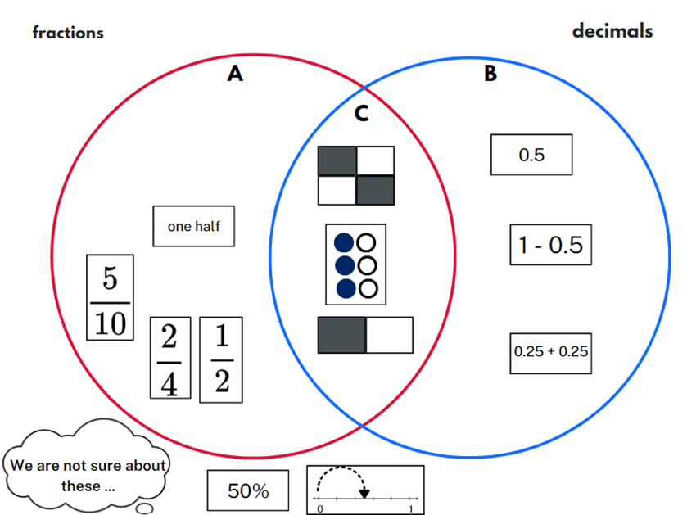
- Ask:
- How did you begin to think about this problem?
- Which cards were easiest to place? Why?
- Was there a card that was difficult for you to place? Which strategies did you use to decide where to place it?
- Are there any cards that could belong in more than one group? Explain.
- Are there any cards that you could not place into one of the groups? Why not?
- Are you able to identify a pattern or rule for this sort?
- What is the most interesting new card you could make to fit one of these sorts?
- Students reform their pack ready for another round.
- Repeat the steps with other prompts to target learning or assessment needs in your class. Suggested prompts and groupings are in the table below.
Steps | Possible prompts
- Step 1 – Find cards that ... | - represent a benchmark fraction, decimal or percentage  - have a complement of a unit fraction  - are complements of each other (that is, they add to one)  - have a difference of a unit fraction  - cannot be grouped with any other card  - have an area model.
- Step 2 – Sort the cards into 2 categories: | - decimals and percentages  - symbols and diagrams  - related denominators such as 2, 4 and 8; 3 and 6  - area model and discrete model  - are less than or equal to one-half; are more than or equal to one-half.
- After a few turns, students record a sort in their workbooks or using a digital device.
This table details opportunities for differentiation.
Too hard? | Too easy?
Students cannot recall commonly used equivalent percentages, decimals and fractions.  - Provide a set of 6 suitable cards for each selection and sort.  - Support students by limiting the sort cards to benchmark fractional amounts such as $\frac{1}{4}$; $\frac{1}{2}$ and $\frac{3}{4}$. | Students can recall commonly used equivalent percentages, decimals and fractions.  - Students add a third category to their original sort and move cards accordingly. Students identify any section of the sort where it is impossible to place a card.  - Students make their own selection and sort to present to a peer. The peer identifies the selection and sort, then confirms/challenges placement of cards.

Stage 3 task 2 – fraction wars – 20 minutes
- Play ‘Fraction Wars’ using the following prompts or allow students to set the rules for their own games.
- In round 1, players draw a 0–1 number line and mark the target number one-half ( $\frac{1}{2}$ ) on the line. Each student locates the 2 fractions on their number line and the student with the card furthest from one-half ( $\frac{1}{2}$ ) wins the point and claims the cards. If both cards are equal in value, students mix them back in their pack. The student with the most cards at the end of the game wins. After round 1, both players note down the number of cards they have won.
- In round 2, students repeat the game using an empty 0–1 number line. When the cards are flipped, players place their fraction on the number line and the player with the fraction closest to 1 wins.
- At the end of round 2, students add their totals from round 1 and round 2 to identify the winner.

Discuss and connect the mathematics – 5 minutes
- Regroup as a class and provide students with a sticky note. Explain that the exit ticket is a response to the following question: How would you explain to a friend what you understand about the fraction $\frac{7}{5}$?
This table details opportunities for assessment.
Assessment opportunities | Links
What to look for:  - Can Stage 2 students regroup fractional parts beyond one?  [MAO-WM-01, MA2-PF-01]  - Can Stage 2 students represent totals of halves, thirds, quarters and fifths that extend beyond one? [MAO-WM-01, MA2-PF-01]  - Can Stage 2 students determine the relative location of one-quarter and one-half when a number line extends beyond one? [MAO-WM-01, MA2-PF-01]  - Can Stage 2 students recreate the whole unit from a fractional part ($\frac{1}{2}$, $\frac{1}{3}$ and $\frac{1}{8}$)? [MAO-WM-01, MA2-PF-01]  - Can Stage 3 students recall commonly used equivalent percentages, decimals and fractions? [MAO-WM-01, MA3-RN-03]  - Can Stage 3 students record equivalent fractions using diagrams, words and fraction notation? [MAO-WM-01, MA3-RQF-01]  - Can Stage 3 students compare and represent fractions with denominators of 2, 4 and 8; 3 and 6; 5 and 10 of a whole shape (area model) and a collection of objects (discrete model)?  [MAO-WM-01, MA3-RQF-01, MA3-RQF-02] | Links to National Numeracy Learning Progressions (NNLP):  - Stage 2 – InF5, InF6  - Stage 3 – PrT2, InF5.  Links to suggested Interview for Student Reasoning (IfSR) tasks:  - Stage 3 – IfSR-PT: 2A.1.

Resource 1 – Is it half?
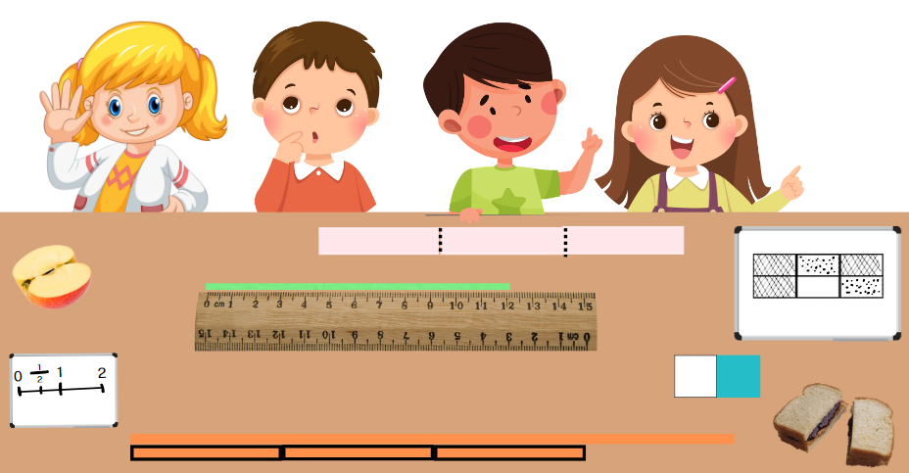

Resource 2 – ‘Fraction Wars’ cards
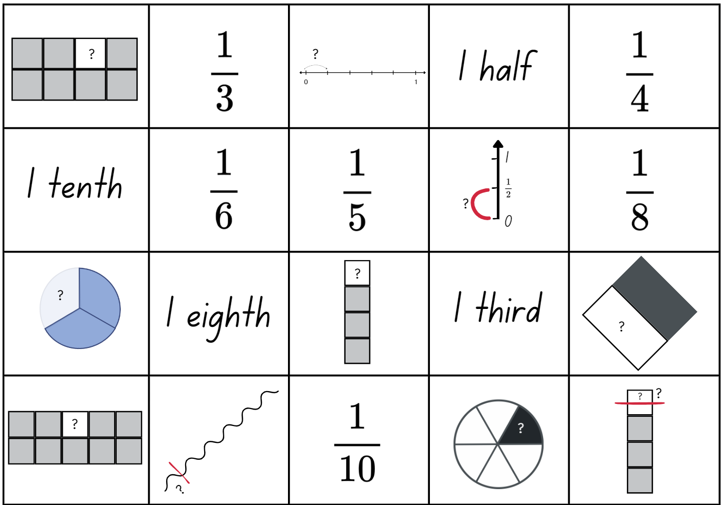

Resource 3 – cards template

Resource 4 – Is Fred right?
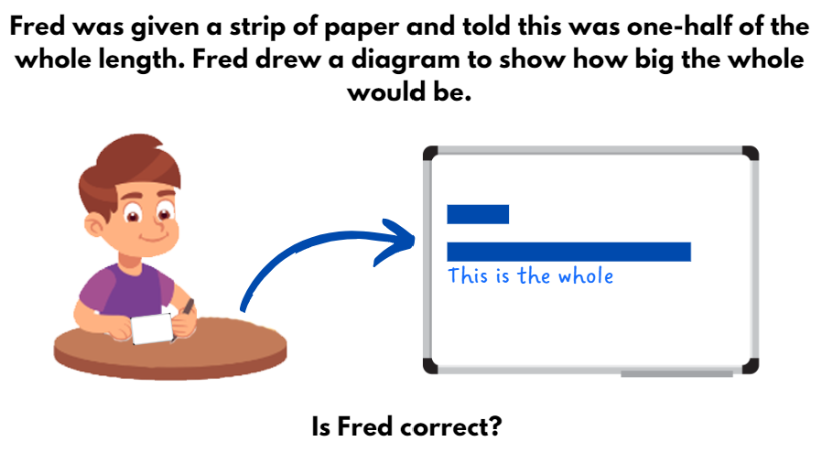

Resource 5 – Is Max right?
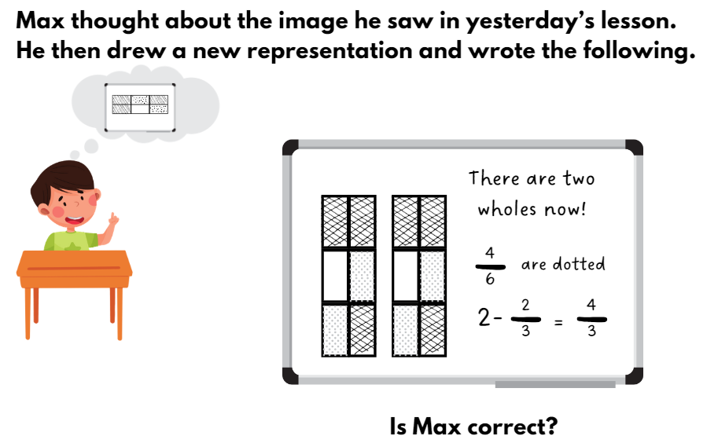

Resource 6 – fraction puzzle
- Pick 5 fractions with related denominators.
- Check that the fractions are not equivalent. For example, two-quarters ( $\frac{2}{4}$ ) and one-half ( $\frac{1}{2}$ ).
- Write the fractions out of order.
- Then write them in order.
- Record your thinking and check your work.
- Write a puzzle card.

Resource 7 – Venn diagram fractions
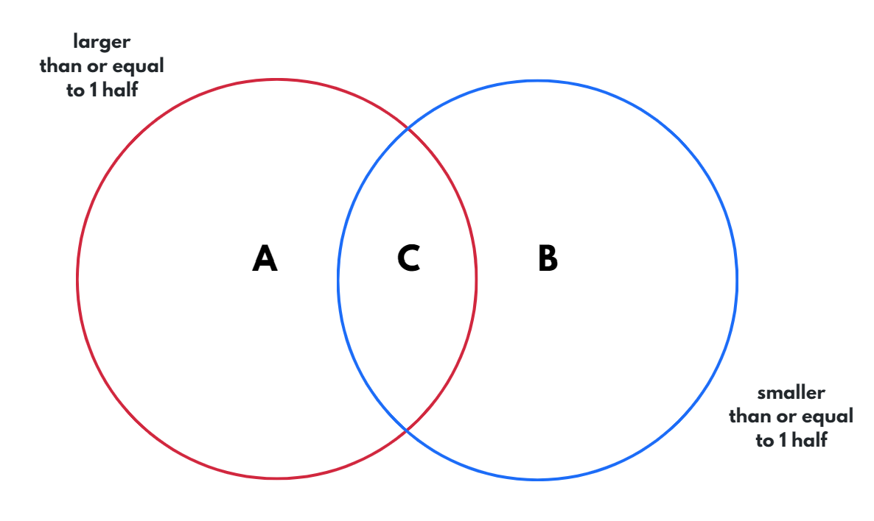

Resource 8 – fractured fraction wall 1
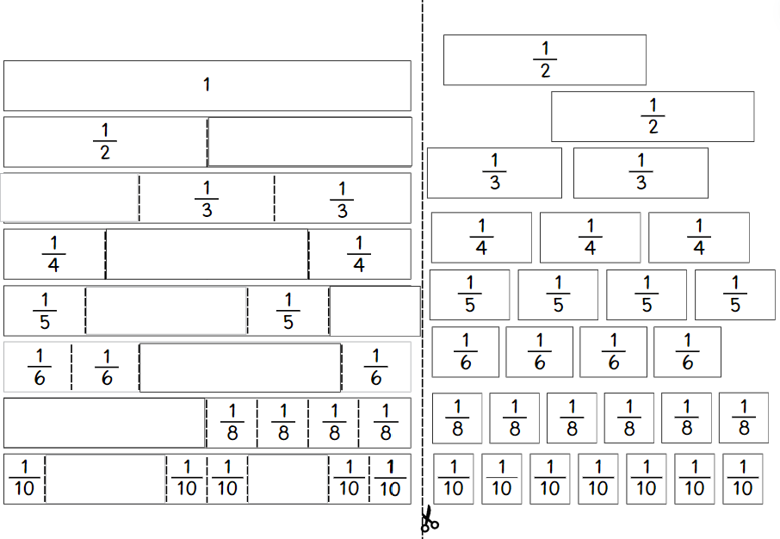

Resource 9 – fractured fraction wall 2
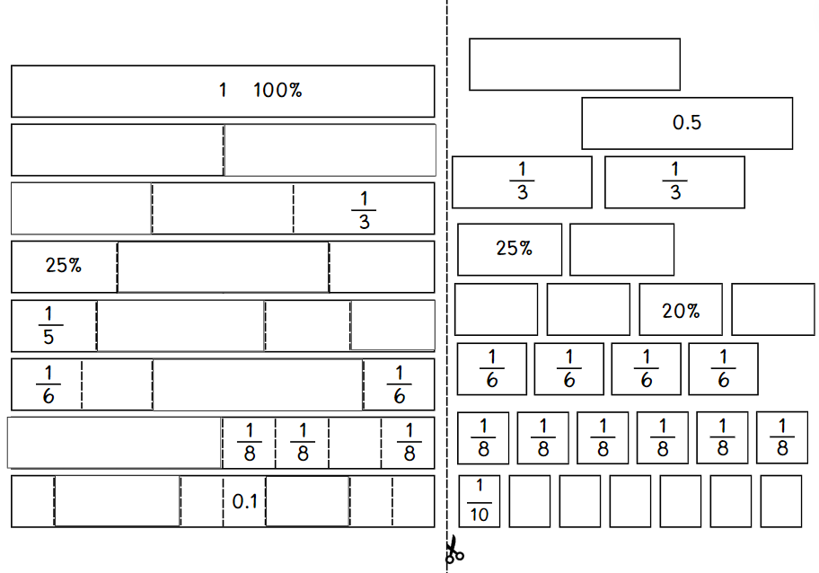

Resource 10 – fraction wall
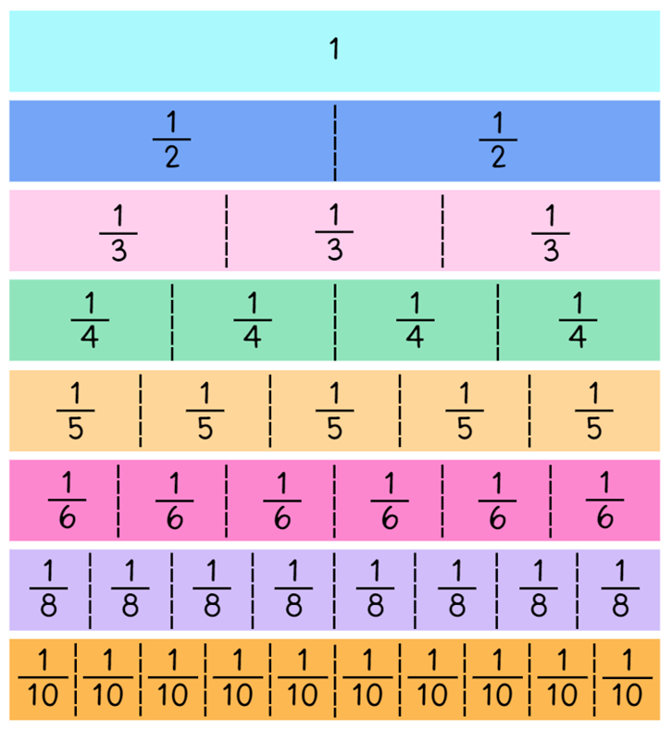

Resource 11 – fraction strip template

Resource 12 – folded strips
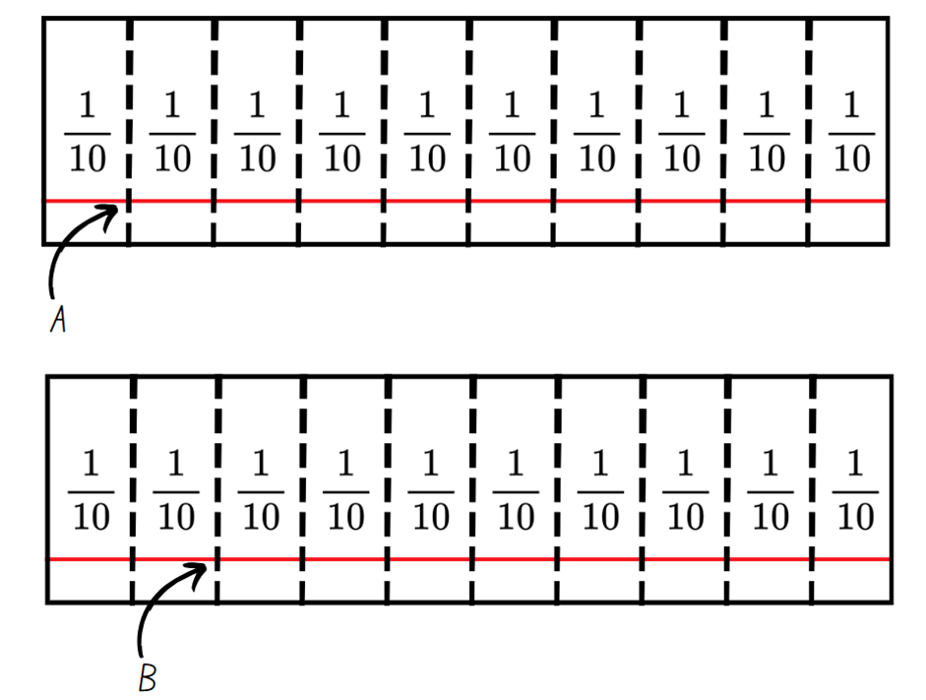

Resource 13 – gameboard and spinners
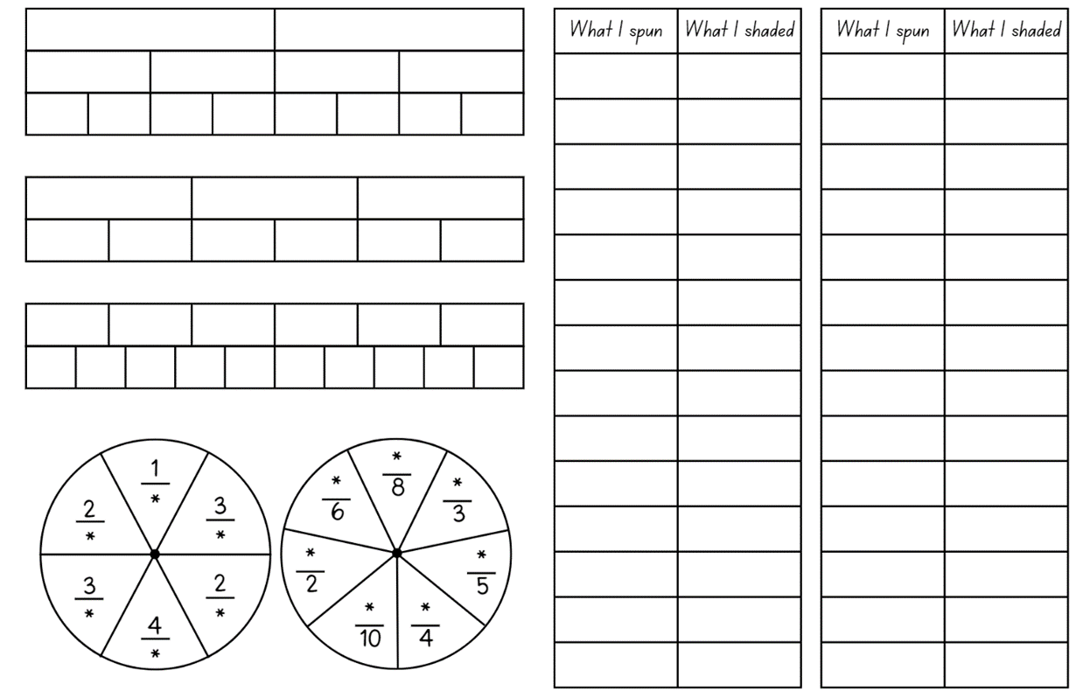

Resource 14 – comparing bar models
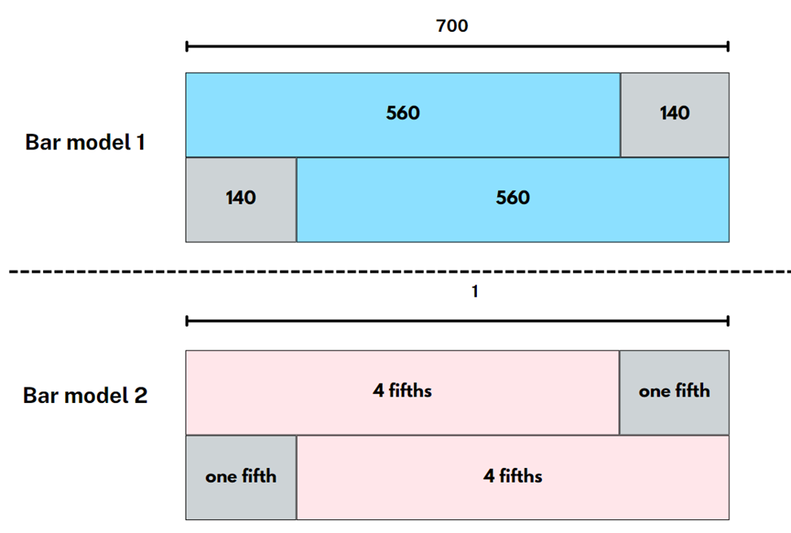

Resource 15 – gardening centre
The local gardening centre makes bags of potting mix. Answer these questions using a paper strip, a drawing, bar model or number line to show your thinking.
- One-fifth ( $\frac{1}{5}$ ) of each bag is sand. Three-fifths ( $\frac{3}{5}$ ) of each bag is compost. What fraction of each bag is made from compost and sand?
- Two gardeners have one open bag of potting mix each. One is four-fifths ( $\frac{4}{5}$ ) full and the other is three-fifths ( $\frac{3}{5}$ ) full. How much potting mix do the gardeners have altogether.
- A gardener has one bag of potting mix that is 75% full. They use half of a full bag to fill up their pots. How much would they now have left? Is it more or less than 20% of the bag?
- One-fifth ( $\frac{1}{5}$ ) of each bag is sand. Three-fifths ( $\frac{3}{5}$ ) of each bag is compost. If the rest of the bag is made from fertiliser, what fraction of each bag is made from fertiliser and sand?
- If each bag has a mass of 20 kg, how much would a bag weigh if one-tenth ( $\frac{1}{10}$ ) had been used?
- A gardener has used less than one-half of a full bag of potting mix. Draw a diagram or number line to show how much could remain in that bag.
- A gardener had 2 partly used bags of potting mix. The difference between the amount in one bag, and the amount in the other, was one-half ( $\frac{1}{2}$ ). How much might there be in each bag? Provide at least 3 possibilities.

Resource 16 – additive bar model
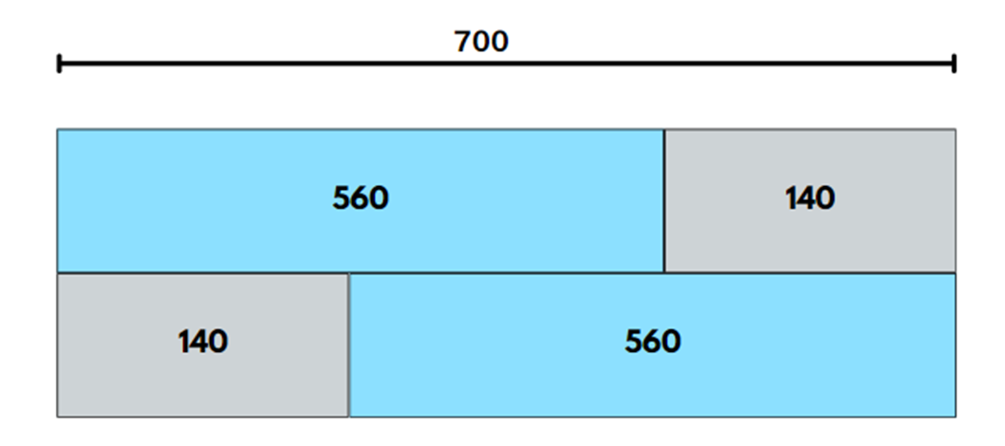

Resource 17 – Which doesn’t belong?
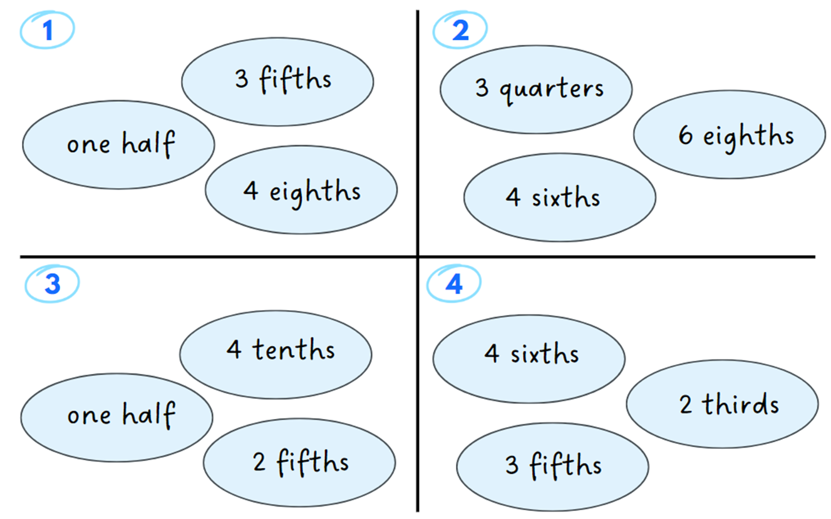

Resource 18 – more fraction models
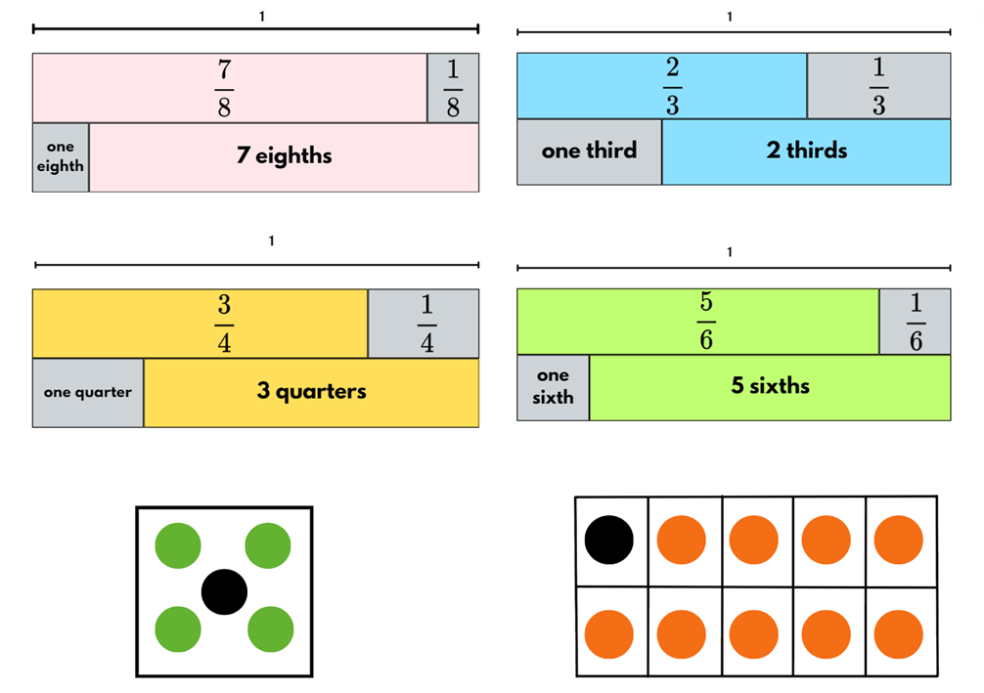

Resource 19 – happy holidays
A family is driving across New South Wales for a holiday. Answer these questions using a paper strip, a drawing, bar model or number line to show your thinking.
- On the first day, they drive two-eighths ( $\frac{2}{8}$ ) of the journey. The next day they drive a further five-eighths ( $\frac{5}{8}$ ) of the journey. How much of the journey have they completed? How much of the journey remains?
- On the first day they use two-fifths ( $\frac{2}{5}$ ) of a tank of petrol. The next day they use four-fifths ( $\frac{4}{5}$ ) of a tank. What fraction of a tank have they used so far on the trip?
- On the trip they listen to an audio book. On the first day they listen to 20% of the book. On the second day they listen to one-half ($\frac{1}{2}$ ) of the total book. How much of the book do they have left to listen to?
- On day 3 of the trip, the petrol tank is 70% full. If the family use 0.5 of a tank, would they have more or less than a quarter of the tank left?
- If the total trip was 800 kilometres, how far would the family have travelled after three-tenths ( $\frac{3}{10} )$of the journey?
- The audio book finished with less than a quarter of the journey remaining. Draw a diagram or number line to show how much of the journey could have remained when the audio book finished. Use fractions, decimals and percentages.
- Two families are on the same journey. The difference between them is three-eighths ( $\frac{3}{8}$ ) of the entire journey. How much of the journey might each family have completed? Provide at least 3 possibilities.

Resource 20 – word problems
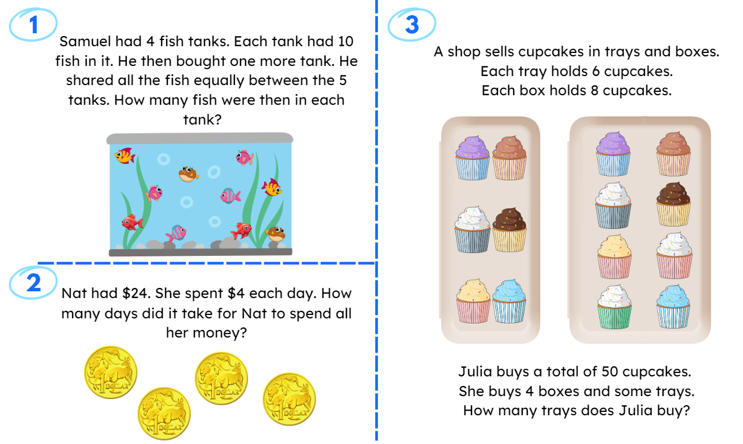

Resource 21 – recreate the whole
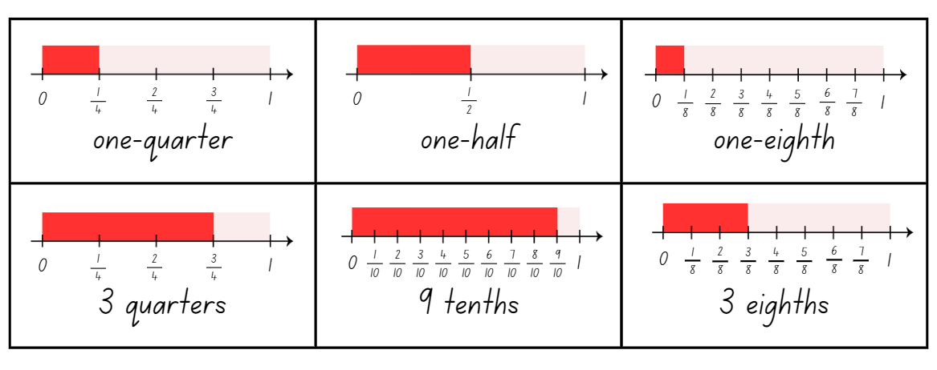

Resource 22 – recreate the whole memory
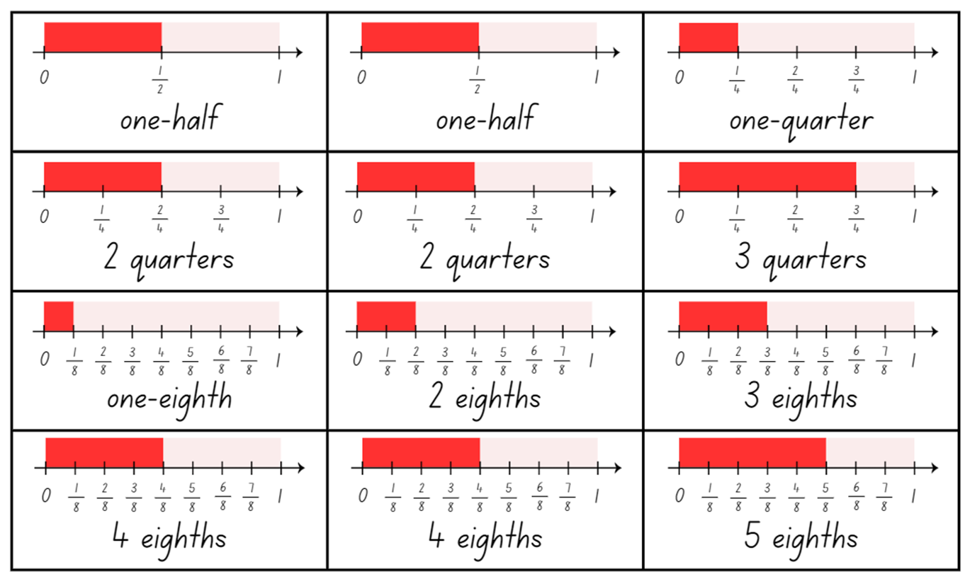

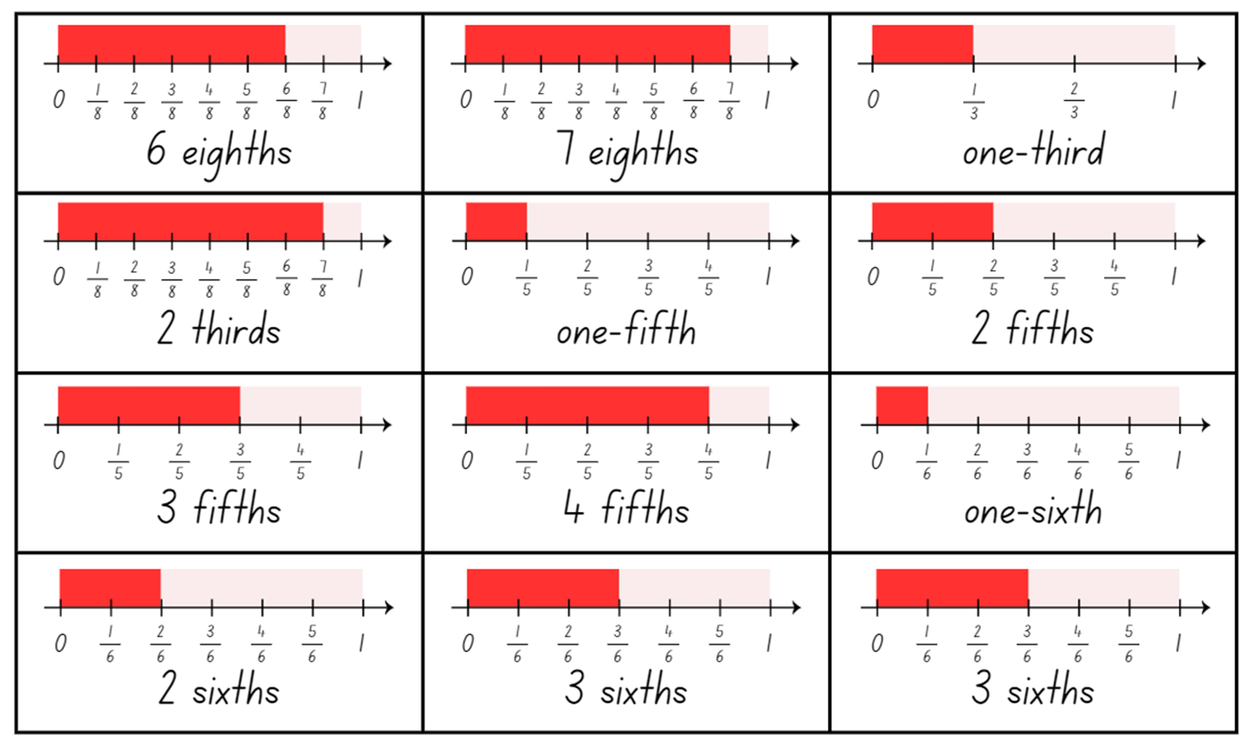

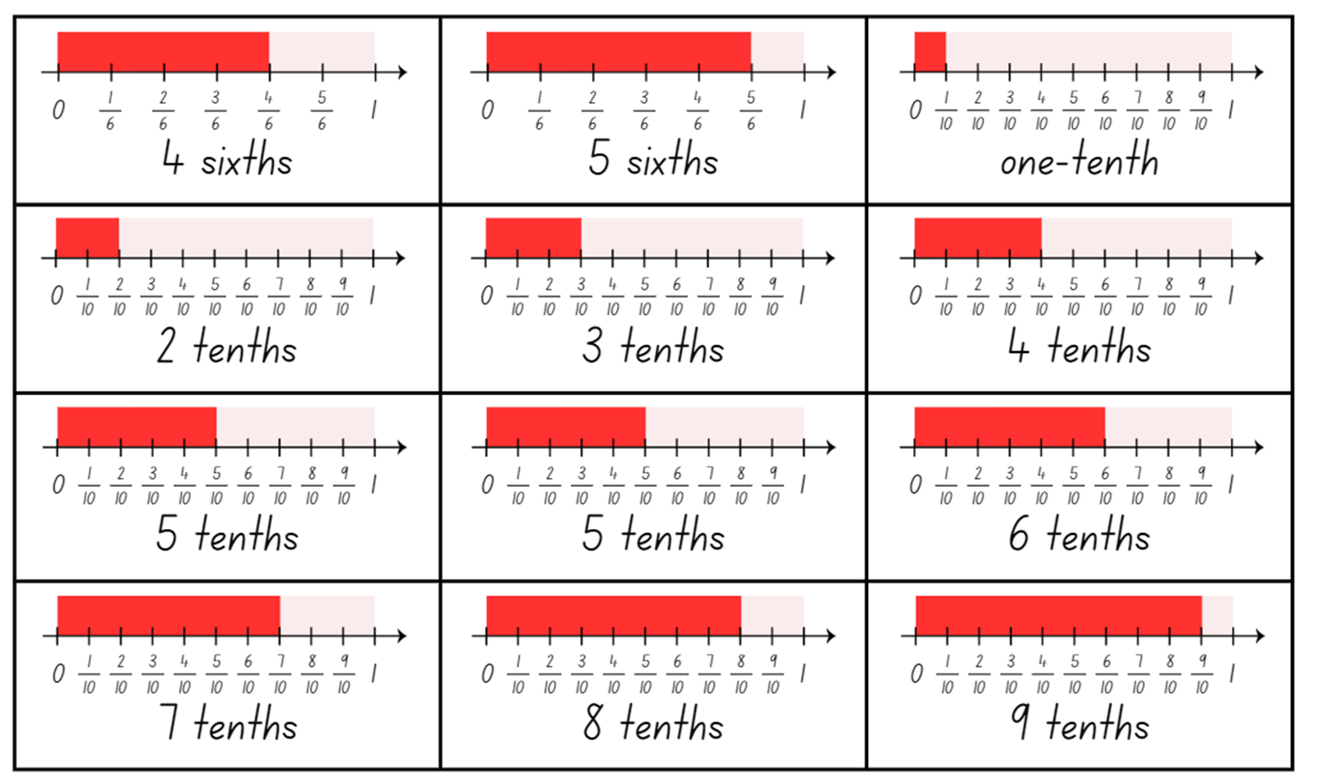

Resource 23 – lines, areas and collections
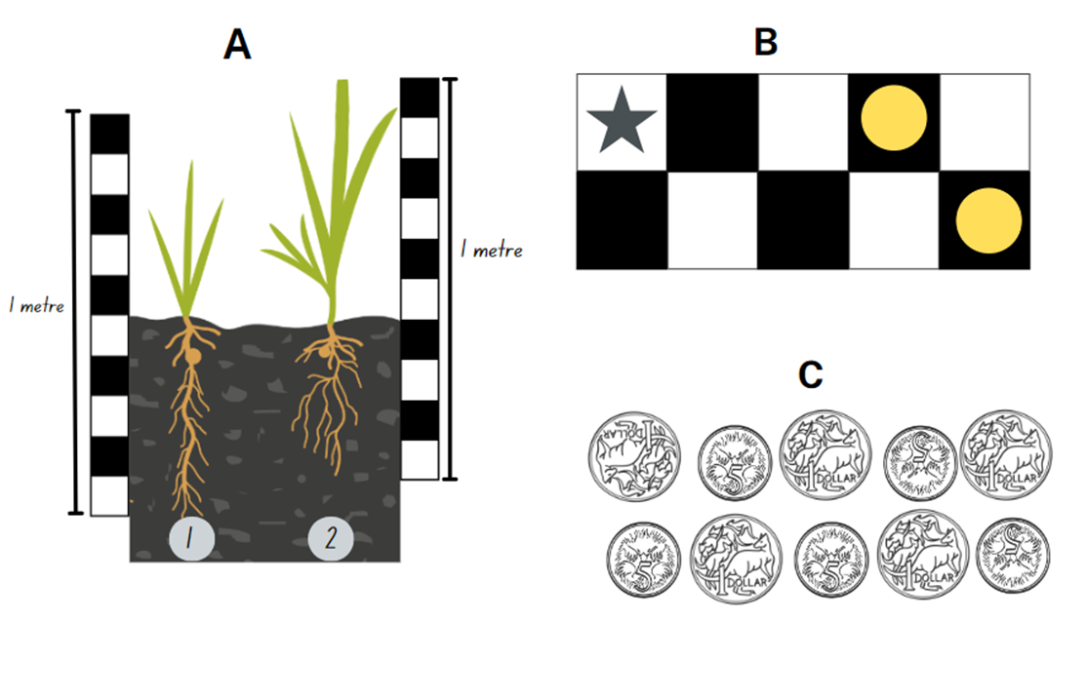

Resource 24 – pin packets
A teacher has some identical packets of pins. Two-fifths ($\frac{2}{5}$) of each packet are orange. The remaining pins are an equal share of red, green and blue. Answer these questions, showing your thinking.
- What fraction of the pins are blue?
- Some students use two-thirds ($\frac{2}{3}$) of a full packet to put up a wall display. How much of the packet would they have left? Could they use only 2 colours to put up their display? Explain why or why not.
- A teacher finds 2 open packets of pins in their desk drawer. One packet is eight-tenths ($\frac{8}{10}$) full. The second packet is half empty. What fraction of a packet does the teacher find altogether?
- If each packet has 90 pins in it, how many will there be of each colour?
- A teacher uses 36 pins to display student work. What fraction of the pins is still in the packet?
- A teacher finds a packet of pins that has split, spilling out more than half of the pins into the drawer. What fraction might remain in the packet?
- A teacher has 2 open packets of pins. The difference between the amount in one packet, and the amount in the other, is one-quarter ($\frac{1}{4} )$ of a whole packet. How much might there be in each bag? Provide at least 3 possibilities.

Resource 25 – chocolate bars
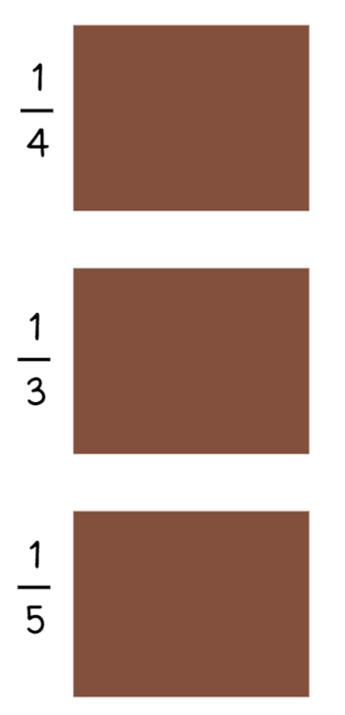

Resource 26 – blocks of chocolate

Resource 27 – number line 0–1

Resource 28 – number line 0–2

Syllabus outcomes and content

Stage 2
The table below outlines the syllabus outcomes and range of relevant syllabus content covered in this unit. Content is linked to National Numeracy Learning Progression (version 3).
Outcomes and content | 1 | 2 | 3 | 4 | 5 | 6 | 7 | 8
Multiplicative relations A: Generate and describe patterns
MAO-WM-01, MA2-MR-01
- Model, describe and record patterns of multiples |  | x |  | x |  | x
Multiplicative relations A: Recall multiplication facts of 2 and 4, 5 and 10 and related division facts
MAO-WM-01, MA2-MR-01
- Recognise and use the symbols for multiplied by (×), divided by (÷) and equals (=) |  |  |  |  | x | x | x
- Link multiplication and division fact families using arrays |  |  |  |  | x | x
- Generate multiplication fact families for multiples of 2 and 4, 5 and 10 |  |  |  |  |  |  | x
Partitioned fractions A: Create fractional parts of a length using techniques other than repeated halving
MAO-WM-01, MA2-PF-01
- Make thirds of a length |  |  | x | x
- Create fifths of a length |  |  | x | x
Partitioned fractions A: Model and represent unit fractions, and their multiples, to a complete whole on a number line
MAO-WM-01, MA2-PF-01
- Model fractions with fraction strips and diagrams for halves, quarters, eighths, thirds | x | x | x | x
- Describe fraction families formed by dividing the whole into the same total number of equal parts as having the same denominator |  |  | x |  | x
- Determine the complementary fractional part needed to complete one whole (halves, quarters, eighths, thirds) (Reasons about relations) |  |  |  |  |  |  | x
- Recreate the whole unit from a fractional part ($\frac{1}{2}$, $\frac{1}{4},$ $\frac{1}{3}$ and $\frac{1}{8}$) (Reversible reasoning) |  | x |  |  |  |  | x | x
Partitioned fractions B: Model equivalent fractions as lengths
MAO-WM-01, MA2-PF-01
- Represent the equivalence of fractions with related denominators as lengths, using concrete materials, diagrams and number lines |  |  |  |  | x | x
- Represent fractions with the same-size whole to make valid comparisons (denominators of 2, 4 and 8; 3 and 6; 5 and 10) |  |  |  |  | x
Partitioned fractions B: Represent fractional quantities equal to and greater than one
MAO-WM-01, MA2-PF-01
- Rename 2 halves, 3 thirds, 4 quarters, 5 fifths, 6 sixths, 8 eighths and 10 tenths as one whole |  |  |  |  | x |  |  | x
- Regroup fractional parts beyond one |  |  |  |  |  |  |  | x
- Represent totals of halves, thirds, quarters and fifths that extend beyond one |  |  |  |  |  |  |  | x
- Determine the relative location of one-quarter and one-half when a number line extends beyond one |  |  |  |  |  |  |  | x
Mathematics K–10 Syllabus © NSW Education Standards Authority (NESA) for and on behalf of the Crown in right of the State of New South Wales, 2022.

Stage 3
The table below outlines the syllabus outcomes and range of relevant syllabus content covered in this unit. Content is linked to National Numeracy Learning Progression (version 3).
Outcomes and content | 1 | 2 | 3 | 4 | 5 | 6 | 7 | 8
Represents numbers B: Decimals and percentages: Make connections between benchmark fractions, decimals and percentages
MAO-WM-01, MA3-RN-03
- Recall commonly used equivalent percentages, decimals and fractions including $\frac{1}{2}$, $\frac{1}{4}$ and $\frac{3}{4}$ |  |  | x | x |  |  |  | x
- Represent common percentages of quantities and lengths as fractions and decimals |  |  | x | x
- Recognise that 10% is one-tenth of 100% and use this to find 10% of a quantity (Reasons about relations) |  |  |  | x
Represents numbers B: Decimals and percentages: Determine percentage discounts of 10%, 25% and 50%
MAO-WM-01, MA3-RN-03
- Equate 10% to dividing by 10, 25% to finding a quarter by dividing by 4, and 50% to finding half |  |  |  | x
Additive relations A: Apply efficient mental and written strategies to solve addition and subtraction problems
MAO-WM-01, MA3-AR-01
- Solve word problems, including multistep problems |  |  |  |  |  | x | x
- Apply known strategies such as levelling, addition for subtraction, using constant difference, and bridging (Reasons about relations) |  |  |  |  | x
Multiplicative relations A: Determine products and factors
MAO-WM-01, MA3-MR-01
- Model different ways to show a whole number as a product (Reasons about structure) |  |  |  |  | x
- Determine factors for a given whole number |  |  |  |  | x | x | x
- Determine whether a number is prime, composite or neither (0 or 1) |  |  |  |  |  | x | x
Representing quantity fractions A: Recognise the role of the number 1 as representing the whole
MAO-WM-01, MA3-RQF-01
- Justify the need for fractions to refer to the number 1 as the common whole (Reasons about quantity) | x | x | x
Representing quantity fractions A: Compare and order common unit fractions
MAO-WM-01, MA3-RQF-01
- Compare unit fractions as numbers to the benchmark value $\frac{1}{2}$ | x
- Compare and order unit fractions with denominators of 2, 3, 4, 5, 6, 8 and 10 by placing them on a number line | x
Representing quantity fractions A: Solve problems involving addition and subtraction of fractions with the same denominator
MAO-WM-01, MA3-RQF-01, MA3-RQF-02
- Represent the sum of fractions with the same denominator, recreating the whole, where the result may exceed one |  | x | x |  | x | x | x
- Find the difference between fractions with the same denominator and interpret the answer |  |  |  |  | x | x | x
- Solve word problems that involve fractions with the same denominator |  |  |  |  | x | x | x
- Use diagrams, objects and mental strategies to subtract a unit fraction from any whole number including 1 (the complement principle) |  | x |  |  | x | x | x
Representing quantity fractions B: Compare common fractions with related denominators
MAO-WM-01, MA3-RQF-01, MA3-RQF-02
- Order common fractions with related denominators using diagrams and number lines |  | x
- Compare and represent fractions with denominators of 2, 4 and 8; 3 and 6; 5 and 10 of a whole shape (area model) and a collection of objects (discrete model) |  |  |  |  |  |  |  | x
- Record equivalent fractions using diagrams, words and fraction notation |  |  |  |  |  |  |  | x
Mathematics K–10 Syllabus © NSW Education Standards Authority (NESA) for and on behalf of the Crown in right of the State of New South Wales, 2022.

References
This resource contains NSW Curriculum and syllabus content. The NSW Curriculum is developed by the NSW Education Standards Authority. This content is prepared by NESA for and on behalf of the Crown in right of the State of New South Wales. The material is protected by Crown copyright.
Please refer to the NESA Copyright Disclaimer for more information https://educationstandards.nsw.edu.au/wps/portal/nesa/mini-footer/copyright.
NESA holds the only official and up-to-date versions of the NSW Curriculum and syllabus documents. Please visit the NSW Education Standards Authority (NESA) website https://educationstandards.nsw.edu.au and the NSW Curriculum website https://curriculum.nsw.edu.au/.
Mathematics K–10 Syllabus © NSW Education Standards Authority (NESA) for and on behalf of the Crown in right of the State of New South Wales, 2022.
National Numeracy Learning Progression © Australian Curriculum, Assessment and Reporting Authority (ACARA) 2010 to present, unless otherwise indicated. This material was downloaded from the Australian Curriculum website (National Numeracy Learning Progression) (accessed 27 May 2024) and was not modified.
ACARA (2023a) NAPLAN 2014 Final test, Numeracy, Year 3 test papers and answers [PDF 4.48 MB], NAPLAN, accessed 31 May 2024.
ACARA (2023b) NAPLAN 2015 Final test, Numeracy, Year 3 test papers and answers [PDF 2.89 MB], NAPLAN, accessed 31 May 2024.
Amplify Education (n.d.) Virtual manipulatives, Amplify Polypad website, accessed 29 May 2024.
Barton C (n.d.) ‘Venn Diagram Rich Tasks’, Venn Diagram Activities, Mr Barton maths website, accessed 27 May 2024.
Blair A (n.d.) ‘Sum of unit fractions inquiry’, Number prompts, Inquiry Maths website, accessed 27 May 2024.
Burns M (2015) Fix It: An Activity for Ordering Fractions, MB math website, accessed 22 May 2024.
Clarke D and Roche A (2009) ‘Students’ fraction comparison strategies as a window into robust understanding and possible pointers for instruction’, Educational Studies in Mathematics, 72(1):127–138, doi:10.1007/s10649-009-9198-9, accessed 26 February 2024.
Clarke D and Roche A (2014) ‘Colour in fractions’ in Clarke D and Roche A (eds) Engaging Maths: 25 favourite lessons, 2nd edn, Mathematics Teaching and Learning Centre, Australia.
Didax, Inc (2023) ‘Fraction number line’, Virtual Manipulatives, Didax website, accessed 31 May 2024.
ESA (Education Services Australia Ltd) and AAMT (The Australian Association of Mathematics Teachers) (n.d.) ‘Fraction wall game’, Fractions, Top Drawer Teachers: Resources for Teachers of Mathematics website, accessed 29 February 2024.
NESA (NSW Education Standards Authority) (2024) ‘Teaching advice for Partitioned fractions A’, Stage 2, NESA website, accessed 20 May 2024.
Siemon D, Warren E, Beswick K, Faragher R, Miller J, Horne M, Jazby D, Breed M, Clark J and Brady K (2022) Teaching Mathematics: Foundations to Middle Years, 3rd edn, Oxford University Press, Australia.
Valentine J (2024) ‘Fractions on a Number Line - Beyond One Whole’, Unit 9: Fractions, BetterLesson website, accessed 29 February 2024.

© State of New South Wales (Department of Education), 2024
The copyright material published in this resource is subject to the Copyright Act 1968 (Cth) and is owned by the NSW Department of Education or, where indicated, by a party other than the NSW Department of Education (third-party material).
Copyright material available in this resource and owned by the NSW Department of Education is licensed under a Creative Commons Attribution 4.0 International (CC BY 4.0) license.
This license allows you to share and adapt the material for any purpose, even commercially.
Attribution should be given to © State of New South Wales (Department of Education), 2024.
Material in this resource not available under a Creative Commons license:
- the NSW Department of Education logo, other logos and trademark-protected material
- material owned by a third party that has been reproduced with permission. You will need to obtain permission from the third party to reuse its material.
Links to third-party material and websites
Please note that the provided (reading/viewing material/list/links/texts) are a suggestion only and implies no endorsement, by the New South Wales Department of Education, of any author, publisher, or book title. School principals and teachers are best placed to assess the suitability of resources that would complement the curriculum and reflect the needs and interests of their students.
If you use the links provided in this document to access a third-party's website, you acknowledge that the terms of use, including licence terms set out on the third-party's website apply to the use which may be made of the materials on that third-party website or where permitted by the Copyright Act 1968 (Cth). The department accepts no responsibility for content on third-party websites.

