Mathematics 3–6 Multi-age – Year A – Unit 18
Questions can be asked and answered by interpreting data
Contents
Unit description and duration 7
Syllabus outcomes 7
Stage 2 8
Stage 3 8
Working mathematically 9
Student prior learning 9
Lesson overview and resources 14
Lesson 1 23
Daily number sense – missing value – 15 minutes 23
Core lesson 1 – language of chance – 10 minutes 26
Core lesson 2 – predicting and displaying randomly generated data – 35 minutes 31
Consolidation and meaningful practice – 15 minutes 38
Lesson 2 41
Daily number sense – number sentences – 10 minutes 41
Core lesson 1 – an equal chance – 25 minutes 43
Core lesson 2 – 30 minutes 46
Stage 2 task – predicted and actual outcomes 46
Stage 3 task – changing chance 48
Discuss and connect the mathematics – 5 minutes 52
Lesson 3 55
Daily number sense – number lines and integers – 10 minutes 55
Core lesson – 45 minutes 58
Stage 2 task – mystery lunch 58
Stage 3 task 1 – probabilities add to one 64
Stage 3 task 2 – data tables 69
Discuss and connect the mathematics – 15 minutes 70
Lesson 4 74
Daily number sense – 10 minutes 74
Core lesson 1 – 25 minutes 74
Stage 2 task 1 – dicey sums 74
Stage 3 task 1 – probability scales 77
Core lesson 2 – race to win and data tables – 20 minutes 81
Discuss and connect the mathematics – 10 minutes 85
Lesson 5 88
Daily number sense – more or less – 10 minutes 88
Stage 2 task 1 – chance events – 25 minutes 91
Stage 2 task 2 – spin a playground – 40 minutes 95
Stage 3 task 1 – interpreting timelines – 25 minutes 99
Stage 3 task 2 – creating timelines – 40 minutes 103
Discuss and connect the mathematics – 5 minutes 105
Lesson 6 107
Daily number sense – largest number wins – 15 minutes 107
Core lesson – playground investigation – 45 minutes 110
Stage 2 task – dot plot 114
Stage 3 task – categorical and numerical data 119
Discuss and connect the mathematics – 10 minutes 123
Lesson 7 126
Daily number sense – smallest to largest – 10 minutes 126
Core lesson – representing data – 50 minutes 128
Discuss and connect the mathematics – 10 minutes 135
Lesson 8 138
Daily number sense – 10 minutes 138
Core lesson 1 – interpreting data – 25 minutes 138
Core lesson 2 – misleading data – 20 minutes 141
Discuss and connect the mathematics – 15 minutes 144
Resource 1 – additive strategies 149
Resource 2 – bar models 153
Resource 3 – house group allocations 154
Resource 4 – column graph 155
Resource 5 – ‘Greedy Goat’ 156
Resource 6 – die outcomes 157
Resource 7 – integers 158
Resource 8 – chance scale 159
Resource 9 – mystery lunch 160
Resource 10 – lunch combinations 161
Resource 11 – 3B's lunch selections 162
Resource 12 – probability scales 163
Resource 13 – dice sums 164
Resource 14 – true or false 165
Resource 15 – race to win 166
Resource 16 – times as large 167
Resource 17 – more and less 168
Resource 18 – chance examples 169
Resource 19 – Which park equipment? 170
Resource 20 – mobile phone timeline 171
Resource 21 – place value cards 172
Resource 22 – thousandth more or less 173
Resource 23 – councillor’s email 174
Resource 24 – data cycle 175
Resource 25 – council survey criteria 176
Resource 26 – smallest to largest 177
Resource 27 – What’s missing? 178
Resource 28 – Rivenoak School’s results 179
Resource 29 – many-to-one displays 180
Resource 30 – best data representation 181
Resource 31 – council research 182
Resource 32 – interpreting data 1 183
Resource 33 – interpreting data 2 184
Resource 34 – interpreting data 3 185
Resource 35 – data display 1 186
Resource 36 – data display 2 187
Resource 37 – data display 3 188
Syllabus outcomes and content 189
Stage 2 189
Stage 3 194
References 200

Unit description and duration
This unit develops the big idea that questions can be asked and answered by interpreting data.
In this 2-week unit, students are provided opportunities to:
- use data in a spreadsheet to create column graphs (Stage 2)
- investigate how data can be interpreted and used to make decisions (Stage 2)
- conduct chance experiments and compare the predicted and actual results where the outcomes are equally likely (Stage 2)
- represent probabilities of outcomes of chance experiments using fractions, decimals and percentages, comparing predicted outcomes with observed results (Stage 3)
- describe, interpret and pose questions about data presented in tables, column graphs, line graphs and timelines (Stage 3)
- investigate how data representations can be misleading or biased (Stage 3).
This multi-age unit is informed by the lessons in Stage 2 Year A Unit 18 and Stage 3 Year A Unit 18. Please refer to these units for additional lesson guidance.

Syllabus outcomes
- MAO-WM-01 develops understanding and fluency in mathematics through exploring and connecting mathematical concepts, choosing and applying mathematical techniques to solve problems, and communicating their thinking and reasoning coherently and clearly

Stage 2
- MAO-WM-01 develops understanding and fluency in mathematics through exploring and connecting mathematical concepts, choosing and applying mathematical techniques to solve problems, and communicating their thinking and reasoning coherently and clearly
- MA2-RN-01 applies an understanding of place value and the role of zero to represent numbers to at least tens of thousands
- MA2-AR-01 selects and uses mental and written strategies for addition and subtraction involving 2- and 3-digit numbers
- MA2-AR-02 completes number sentences involving addition and subtraction by finding missing values
- MA2-DATA-01 collects discrete data and constructs graphs using a given scale
- MA2-DATA-02 interprets data in tables, dot plots and column graphs
- MA2-CHAN-01 records and compares the results of chance experiments.

Stage 3
- MAO-WM-01 develops understanding and fluency in mathematics through exploring and connecting mathematical concepts, choosing and applying mathematical techniques to solve problems, and communicating their thinking and reasoning coherently and clearly
- MA3-RN-01 applies an understanding of place value and the role of zero to represent the properties of numbers
- MA3-RN-02 compares and orders decimals up to 3 decimal places
- MA3-RN-03 determines percentages of quantities, and finds equivalent fractions and decimals for benchmark percentage values
- MA3-DATA-01 constructs graphs using many-to-one scales
- MA3-DATA-02 interprets data displays, including timelines and line graphs
- MA3-CHAN-01 conducts chance experiments and quantifies the probability

Working mathematically
In the Mathematics K–10 Syllabus, there is one overarching Working mathematically outcome (MAO-WM-01). The Working mathematically processes should be embedded within the concepts being taught. The Working mathematically processes present in the Mathematics K–10 Syllabus are:
- communicating
- understanding and fluency
- reasoning
- problem solving.
Mathematics K–10 Syllabus © NSW Education Standards Authority (NESA) for and on behalf of the Crown in right of the State of New South Wales, 2022.

Student prior learning
Before engaging in these teaching and learning activities, students would benefit from prior experience with:
- displaying and interpreting data using lists, tables, dot plots and column graphs (Stage 2)
- posing questions and collecting discrete data (Stage 2)
- predicting and describing possible outcomes from chance experiments (Stage 2)
- understanding that probability can be represented numerically between zero to one (Stage 3)
- creating random generators and recording possible outcomes using fractions (Stage 3)
- representing and interpreting data presented in tables, column graphs and line graphs, with and without the use of digital technologies (Stage 3).
In NSW classrooms there is a diverse range of students, including Aboriginal and/or Torres Strait Islander students, students learning English as an additional language or dialect, high potential and gifted students, and students with disability. Some students may identify with more than one of these groups or possibly all of them. Refer to Curriculum planning for every student – advice for further information.

Teachers can support student learning and reasoning in this unit by connecting language, representations and visualisation for chance (see Figure 1). This model of support is adapted from content provided by Adjunct Professor Marj Horne in Big Ideas to Start Strong across K–6 – Module 3 (NSW DoE 2023).
Figure 1 – pedagogical support – Stage 2 Chance
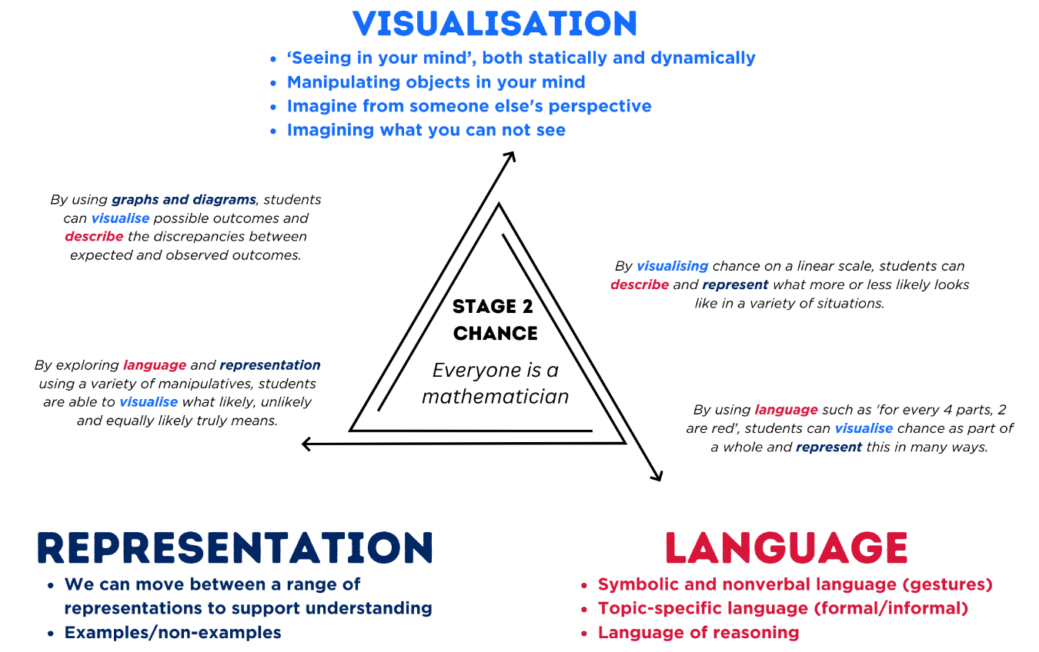
For each lesson on chance in this unit, students can enhance their understanding by using various representations or tools (see Figure 2). These can be constructed with students or provided as a resource.
Figure 2 – chance representations
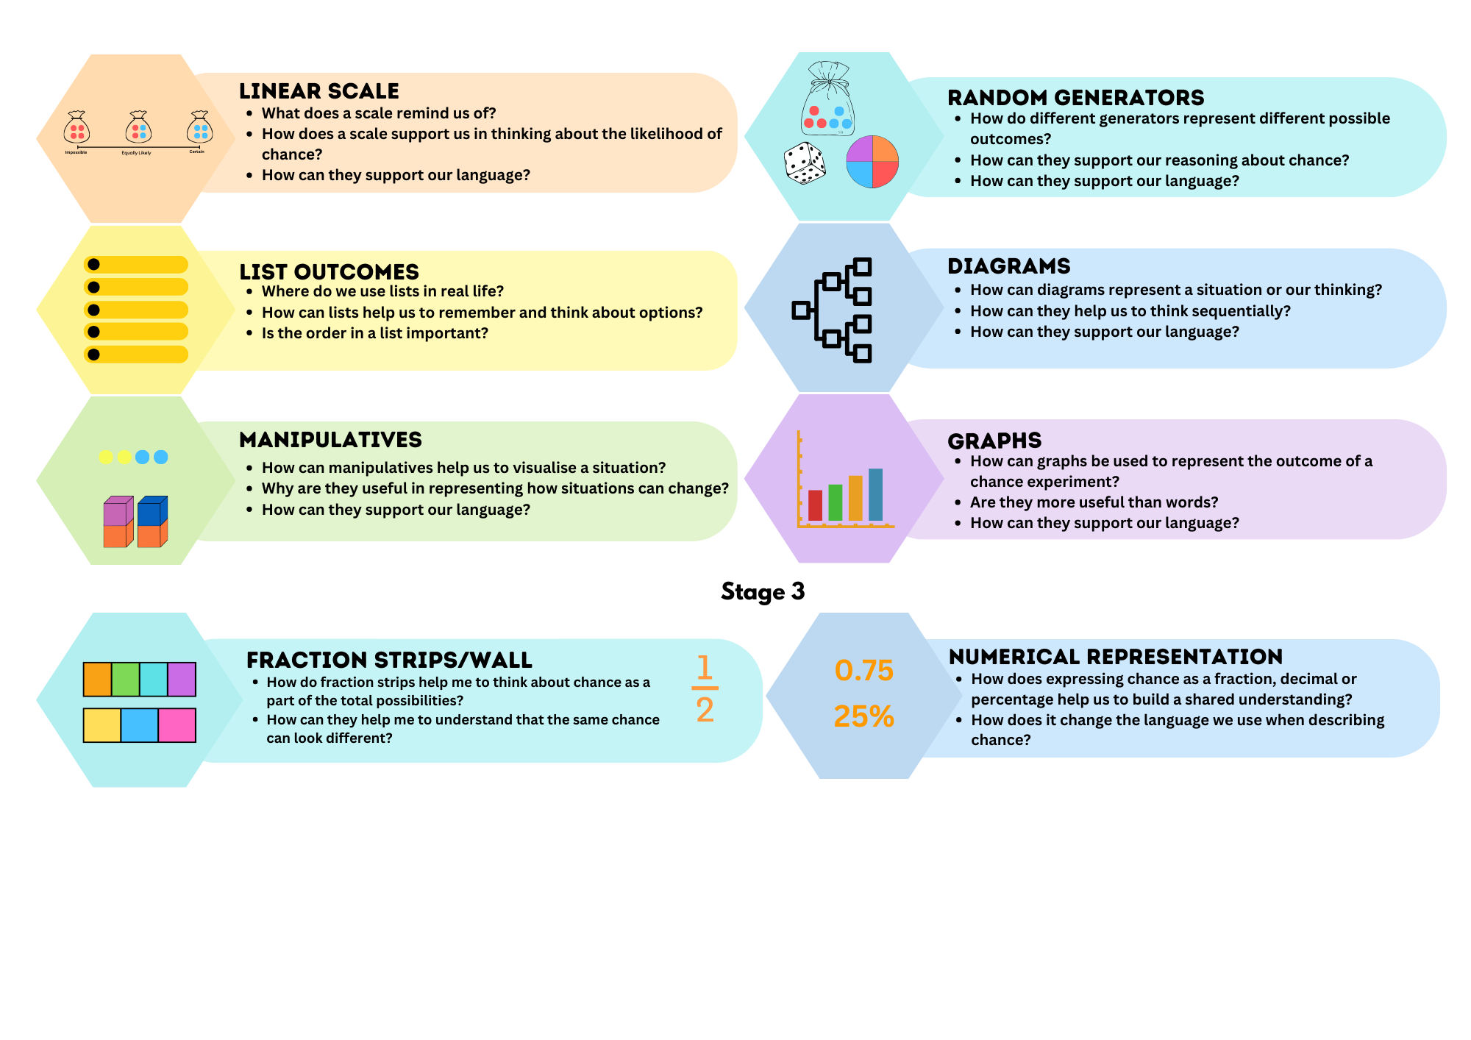
For each lesson on data in this unit and for Multi-age Year B Unit 18, the following definitions in Figure 3 build teacher understanding of the data types students are taught in Stage 3. The Stage 2 teaching advice states that students are not expected to classify the type of data they are collecting.
Figure 3 – data types
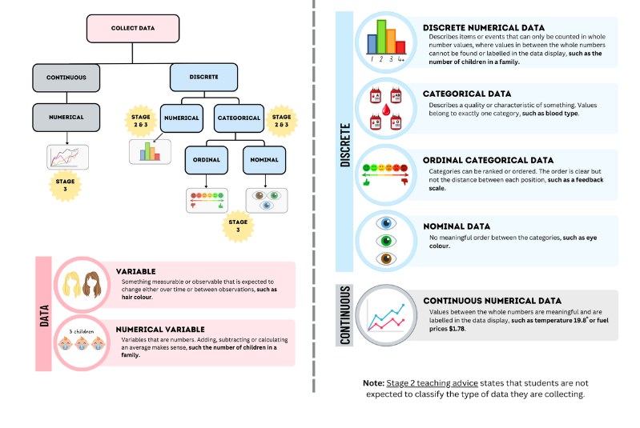

Lesson overview and resources
To cover the content of the syllabus across Stage 2 and Stage 3, some core lessons in the unit contain both a Stage 2 and a Stage 3 task. Teachers are encouraged to adapt and contextualise the units to meet the needs of their students.
The table below outlines the sequence and approximate timing of lessons, learning intentions and resources.
Lesson | Content | Duration and resources
Lesson 1  Daily number sense  Stage 2:  - Additive relations A: Recognise and explain the connection between addition and subtraction  Stage 3:  - Additive relations A: Apply efficient mental and written strategies to solve addition and subtraction problems | Lesson core concept: data from chance experiments can be collected, organised and recorded.  Stage 2:  - Chance A: Identify possible outcomes from chance experiments  - Chance B: Describe the likelihood of outcomes of chance events  - Data A: Organise and display data using tables and graphs  Stage 3:  - Chance A: List outcomes of chance experiments involving equally likely outcomes and represent probabilities  - Data A: Describe and interpret different datasets in context | Lesson duration: 75 minutes  - Resource 1 – additive strategies  - Resource 2 – bar models  - Resource 3 – house group allocations  - Resource 4 – column graph  - Digital spinner  - Digital devices  - Individual whiteboards  - Writing materials
Lesson 2  Daily number sense  Stage 2:  - Additive relations A: Recognise and explain the connection between addition and subtraction  Stage 3:  - Additive relations A: Apply efficient mental and written strategies to solve addition and subtraction problems | Lesson core concept: outcomes in chance experiments can be equally likely.  Stage 2:  - Chance A: Identify possible outcomes from chance experiments  - Chance B: Identify when events are affected by previous events  Stage 3:  - Data A: Choose and use appropriate tables and graphs  - Chance A: List outcomes of chance experiments involving equally likely outcomes and represent probabilities | Lesson duration: 70 minutes  - Resource 5 – ‘Greedy Goat’  - Resource 6 – die outcomes  - 6-sided dice  - 10-sided dice  - Coloured counters  - Individual whiteboards  - Probability scale anchor charts from Lesson 1 (Stage 2 and Stage 3)  - Writing materials
Lesson 3  Daily number sense  Stage 2:  - Represents numbers A: Whole numbers: Read, represent and order numbers to thousands  Stage 3:  - Represents numbers B: Whole numbers: Locate and represent integers on a number line | Lesson core concept: the chance of an event occurring is sometimes affected by previous events (Stage 2) and probability can be represented from zero to one (Stage 3).  Stage 2:  - Data A: Interpret and compare data  - Chance A: Identify possible outcomes from chance experiments  - Chance B: Identify when events are affected by previous events  Stage 3:  - Chance A: List outcomes of chance experiments involving equally likely outcomes and represent probabilities  - Chance B: Compare observed frequencies of outcomes with expected results | Lesson duration: 70 minutes  - Resource 7 – integers  - Resource 8 – chance scale  - Resource 9 – mystery lunch  - Resource 10 – lunch combinations  - Resource 11 – 3B's lunch selections  - Resource 12 – probability scales  - Bag to place counters in  - Green and red counters  - Individual whiteboards and markers  - Probability scale anchor charts from Lesson 1 (Stage 2 and Stage 3)  - Various dice  - Writing materials
Lesson 4  Daily number sense  - teacher-identified task based on student needs | Lesson core concept: chance experiment outcomes can be predicted, recorded and compared (Stage 2) and probability can be represented as a fraction (Stage 3).  Stage 2:  - Data A: Organise and display data using tables and graphs  - Chance A: Describe the likelihood of outcomes of chance events  - Chance B: Identify when events are affected by previous events  Stage 3:  - Represents numbers B: Make connections between benchmark fractions, decimals and percentages  - Chance A: List outcomes of chance experiments involving equally likely outcomes and represent probabilities  - Chance B: Compare observed frequencies of outcomes with expected results | Lesson duration: 65 minutes  - Resource 12 – probability scales  - Resource 13 – dice sums  - Resource 14 – true or false  - Resource 15 – race to win  - Website: Polypad or 2 large 6-sided dice  - 6-sided dice  - 10-sided dice  - Individual whiteboards and markers  - Probability scale anchor charts from Lesson 1 (Stage 2 and Stage 3)  - Round stickers  - Writing materials
Lesson 5  Daily number sense  Stage 2:  - Represents numbers B: Whole numbers: Recognise and represent numbers that are 10, 100 or 1000 times as large  Stage 3:  - Represents numbers A: Decimals and percentages: Recognise that the place value system can be extended beyond hundredths | Lesson core concept: mathematicians interpret, evaluate and explain real-world data and events.  Stage 2:  - Data A: Interpret and compare data  - Chance B: Describe the likelihood of outcomes of chance events  - Chance B: Identify when events are affected by previous events  Stage 3:  - Data A: Choose and use appropriate tables and graphs  - Data B: Interpret and compare a range of data displays | Lesson duration: 80 minutes  - Resource 16 – times as large  - Resource 17 – more and less  - Resource 18 – chance examples  - Resource 19 – Which park equipment?  - Resource 20 – mobile phone timeline (on A4 size paper and do not resize)  - Digital spinner  - Digital devices  - Rulers  - Student workbooks  - Writing materials
Lesson 6  Daily number sense  Stage 2:  - Represents numbers B: Whole numbers: Recognise and represent numbers that are 10, 100 or 1000 times as large  Stage 3:  - Represents numbers A: Decimals and percentages: Recognise that the place value system can be extended beyond hundredths | Lesson core concept: interpreting data helps us solve problems and ask new questions.  Stage 2:  - Data A: Interpret and compare data  - Data A: Organise and display data using tables and graphs  - Data B: Select and trial methods for data collection  Stage 3:  - Data A: Collect categorical and discrete numerical data by observation or survey | Lesson duration: 70 minutes  - Resource 19 – Which park equipment?  - Resource 21 – place value cards  - Resource 22 – thousandth more or less  - Resource 23 – councillor’s email  - Resource 24 – data cycle  - Resource 25 – council survey criteria  - 9-sided dice  - 10-sided dice  - Blue counters (one per student)  - Digital device or camera  - Individual whiteboards  - Masking tape  - Paper-based or digital applications: Microsoft Forms or Google Forms  - Red counters (one per student)  - Sticky notes  - Writing materials
Lesson 7  Daily number sense  Stage 2:  - Represents numbers B: Whole numbers: Recognise and represent numbers that are 10, 100 or 1000 times as large  Stage 3:  - Represents numbers A: Decimals and percentages: Recognise that the place value system can be extended beyond hundredths  - Represents numbers B: Decimals and percentages: Make connections between benchmark fractions, decimals and percentages | Lesson core concept: data is represented in different ways for different purposes.  Stage 2:  - Data A: Organise and display data using tables and graphs  - Data A: Interpret and compare data  - Data B: Construct and interpret data displays with many-to-one scales  Stage 3:  - Data A: Choose and use appropriate tables and graphs  - Data A: Describe and interpret different datasets in context | Lesson duration: 70 minutes  - Resource 24 – data cycle  - Resource 26 – smallest to largest  - Resource 27 – What’s missing?  - Resource 28 – Rivenoak School’s results  - Resource 29 – many-to-one displays  - Resource 30 – best data representation  - Digital devices with software such as Microsoft Excel or Google Sheets  - Writing materials
Lesson 8  Daily number sense  - teacher-identified task based on student needs | Lesson core concept: mathematicians interpret and evaluate the effectiveness of real-world data.  Stage 2:  - Data A: Interpret and compare data  - Data B: Construct and interpret data displays with many-to-one scales.  Stage 3:  - Data A: Describe and interpret different datasets in context  - Data B: Interpret data presented in digital media and elsewhere | Lesson duration: 70 minutes  - Resource 31 – council research  - Resource 32 – interpreting data 1  - Resource 33 – interpreting data 2  - Resource 34 – interpreting data 3  - Resource 35 – data display 1  - Resource 36 – data display 2  - Resource 37 – data display 3  - Video: How to spot a misleading graph (4:09)  - A4 paper  - Scissors  - Writing materials

Lesson 1
Core concept: data from chance experiments can be collected, organised and recorded.

Daily number sense – missing value – 15 minutes
Daily number sense activities for Lessons 1 to 3 ‘activate’ prior number knowledge and support the learning of new content in the unit. These activities can also assist teachers to identify the starting points for learning by revealing the extent of students’ existing knowledge.
The table below contains suggested learning intentions and success criteria. These are best co-constructed with students.
Daily number sense learning intentions | Daily number sense success criteria
Students working towards Stage 2 outcomes are learning to:  - recognise and explain the connection between addition and subtraction.  Students working towards Stage 3 outcomes are learning to:  - apply efficient mental and written strategies to solve addition and subtraction problems. | Students working towards Stage 2 outcomes can:  - use number relation principles to solve related problems  - demonstrate how addition and subtraction are inverse operations.  Students working towards Stage 3 outcomes can:  - solve word problems, including multistep problems.  - apply known strategies such as levelling, addition for subtraction, using constant difference, and bridging.
Note: Resource 1 – additive strategies is from Multi-age Year A Unit 15 and may already be printed and displayed as a class resource. This resource will be referred to in Daily number sense lessons 1 to 2.
- Provide students with the following problem: There are 58 students in Year 3. Thirty-nine of them spend lunch time on the oval playing ball games. The remaining students play under the covered outdoor learning area (COLA). How many students play under the COLA?
- Students Think-Pair-Share the strategies that could be used to find the missing value. Students may wish to refer to Resource 1 – additive strategies.
- Explain that a bar model can be an effective representation to find missing values and to check solutions using inverse operations.
Inverse operation: the operation that reverses the effect of another operation. Addition and subtraction are inverse operations. When you add 3 to 7 you get 10. If you then subtract 3, you get back to 7.
- Demonstrate drawing a bar model on the board to represent the solution to the word problem (see Figure 4).
Figure 4 – bar model matching word problem
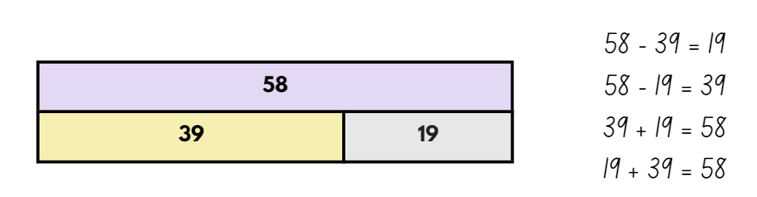
- Identify the related addition and subtraction number sentences that the bar model represents. Model thinking aloud, ‘If I know 39 + 19 = 58, then I know 58 − 19 = 39.’
- Display Resource 2 – bar models. In pairs, students solve the problems and record the related addition and subtraction number sentences on individual whiteboards.
Multi-age: students working towards Stage 3 outcomes should be provided with larger numbers and instructed to create word problems to represent equations to determine the missing number. Students may swap problems to solve, using a strategy of their choice.
- Regroup and select students to share responses.
This table details opportunities for assessment.
Assessment opportunities | Links
What to look for:  - Can Stage 2 students use number relation principles to solve related problems (Reasons about relations)?  [MAO-WM-01, MA2-AR-01, MA2-AR-02]  - Can Stage 2 students demonstrate how addition and subtraction are inverse operations? [MAO-WM-01, MA2-AR-01, MA2-AR-02]  - Can Stage 3 students solve word problems, including multistep problems? [MAO-WM-01, MA3-AR-01]  - Can Stage 3 students apply known strategies such as levelling, addition for subtraction, using constant difference, and bridging (Reasons about relations) [MAO-WM-01, MA3-AR-01] | Links to National Numeracy Learning Progressions (NNLP):  - Stage 2 – AdS7  - Stage 3 – AdS8.  Links to suggested Interview for Student Reasoning (IfSR) tasks:  - Stage 2 – IfSR-AT: 3A.1, 3A.3  - Stage 3 – IfSR-AT: 3A.4.

Core lesson 1 – language of chance – 10 minutes
The table below contains suggested learning intentions and success criteria. These are best co-constructed with students.
Core concept learning intentions | Core concept success criteria
Students working towards Stage 2 outcomes are learning to:  - identify possible outcomes from chance experiments  - describe the likelihood of outcomes of chance events  - organise and display data using tables and graphs.  Students working towards Stage 3 outcomes are learning to:  - list outcomes of chance experiments involving equally likely outcomes and represent probabilities  - describe and interpret different datasets in context. | Students working towards Stage 2 outcomes can:  - conduct experiments and compare the predicted and actual results where the outcomes are equally likely  - use the terms equally likely, likely and unlikely to describe the chance of everyday events occurring  - create a list or table to organise the data  - mark equal spaces (intervals) on axes, name and label axes and choose appropriate titles for column graphs.  Students working towards Stage 3 outcomes can:  - use the term probability to describe the numerical value of an outcome  - record all outcomes in chance experiments where each outcome is equally likely to occur  - discuss the imprecise meaning of commonly used chance words including possible, likely and unlikely  - describe and interpret data presented in tables, column graphs and line graphs.
- Draw a blank probability scale from 0–1 to be used as an anchor chart for discussions.
- Label zero as impossible and one as certain.
- Ask Stage 2 students to suggest where other commonly used terms to describe probability might be placed along the scale (see Figure 5).
Figure 5 – Stage 2 example probability scale
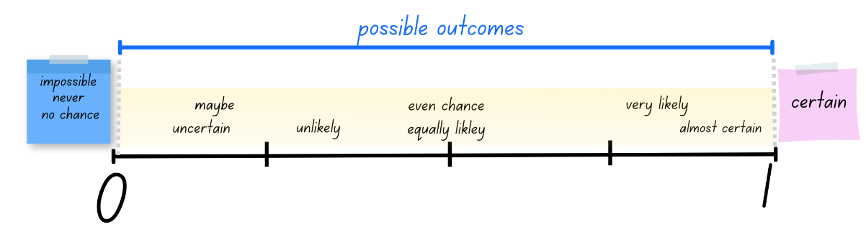
- Ask Stage 3 students to suggest where commonly used terms and numerical phrases would be placed along the scale. Ensure students are using fractional knowledge and precise language to justify their reasoning (see Figure 6).
Figure 6 – Stage 3 example probability scale
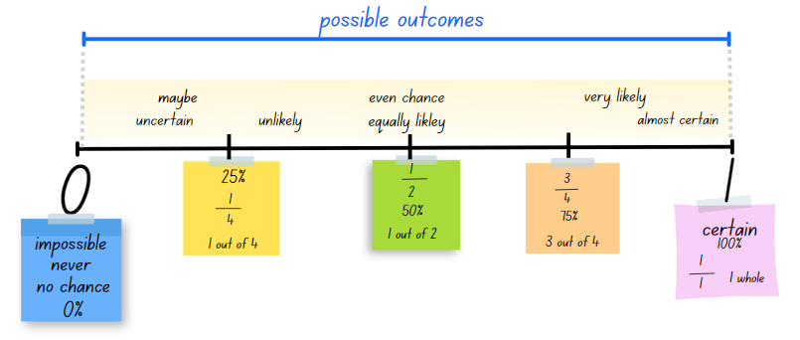
- Explain that colloquial terms can be misleading or provide an imprecise description of the probability of an event. For example, students may state that they will never go on a plane or that they always go to bed at 8:00 pm. Discuss how language may be exaggerated or describe a situation with 100% certainty, instead of accurately describing the chance of an event within a specific context.
- Point out the numerical phrases to Stage 3 students and explain that these convey a more precise description of probability. For example, 50% chance, 1 in 2, and 3 out of 4 are more exact than the terms ‘maybe’ or ‘almost certain’.
Note for Stage 3: to develop critical thinking skills and deepen their understanding of probability, students need to recognise that language used to describe chance can be mathematically misleading. Understanding probability requires students to recognise the range of possible outcomes, the likelihood of a specific outcome and the numerical value attributed to the outcome. This knowledge further supports students to develop skills and critical thinking when analysing and evaluating the chance of events in real life situations (Batanero et al. 2016).
- Students Think-Pair-Share with a partner to discuss an event that can be described as:
- 100% certain (sunrise and sunset)
- impossible (win the lottery without buying a ticket)
- equally likely for each person (flipping a coin to land on heads)
- three-quarters possible (Stage 3) (drawing a blue marble from a bag with 3 blue marbles and one red marble).
- Select students to share examples and record these on the anchor chart.
- Explain to Stage 3 students that mathematicians use the term probability to describe the numerical value that represents the likelihood of an outcome of a chance experiment. Share the syllabus definition of probability:
Probability (Stage 3 students): the chance of something happening shown on a scale from 0 and 1 (inclusive). For example, the probability that a fair coin toss will come up ‘heads’ is 0.5 (NESA 2022).
- Reinforce the boundaries of the scale – probability cannot be smaller than zero or higher than one.

Core lesson 2 – predicting and displaying randomly generated data – 35 minutes
Note: throughout the unit a digital spinner will be used for various chance experiments as a random generator. Use a website such as wheelofnames.com to create the spinners required for each lesson or activity.
- The school sports carnival is coming soon. Mr Goodfellow, the carnival organiser, has been told that 12 new students will arrive at the school before the carnival and must be placed into one of the 4 house groups. The office staff use a spinner to randomly assign the 12 new students a house group.
- Display the spinner.
- Enter the 4 outcomes (house groups) into the text box to the right of the spinner:
- Wombats (blue)
- Koalas (red)
- Emus (yellow)
- Kangaroos (green).
- Create a class definition for the term equally likely.
Equally likely: an event for which all outcomes have the same probability of occurring. For example, in tossing a fair coin, the outcome ‘head’ and the outcome ‘tail’ are equally likely (NESA 2022).
- Display Figure 5 for Stage 2 students and Figure 6 for Stage 3 students. Ask:
- What features of the spinner make the chance of each outcome equally likely?
- If I spin Kangaroos on my first spin, is it still equally likely that I could spin Kangaroos on my second spin? (Yes, when using this spinner, the chance of a certain outcome occurring resets after each spin. Each spin is independent of the next.)
- What is the numerical probability of each outcome? (Stage 3) ($\frac{1}{4}$, 25%, 1 out of 4)
- How does your knowledge of benchmark fractions on a number line help you with probability? (Stage 3)
- Ask students to Think-Pair-Share and predict how many students will be placed in each house group. Students record their predicted results in the ‘Class results’ table on Resource 3 – house group allocations.
- Select students to share their predictions and justify their choices.
- Spin the spinner 4 times, selecting the Close button after each spin to ensure the outcome remains on the spinner for subsequent spins.
- Students record tally marks for each spin in the ‘Class results’ table on Resource 3 – house group allocations.
- Discuss how the chance of one outcome (house group) being selected is not affected by previous spins. As the house groups are not removed after being selected, there is still an equal chance of each house group being spun and selected again. For example, if Child 1 lands on the blue house group, there is still an equal chance of Child 2 and Child 3 also being placed in the blue house group.
- Spin the spinner another 8 times and record tally marks to allocate a house group to all 12 students.
- Students analyse the ‘Class results’ table on Resource 3 – house group allocations to compare the predicted and actual results.
The table below outlines stimulus prompts to generate conversation about the topic, along with anticipated responses from students.
Prompts | Anticipated student responses
- Did your predicted results match the actual results? | - No. I predicted there would be 3 students in each house group, but the actual results were different.  - No. My predictions were different but as the chance experiment was random, it would be hard to predict exact results.  - Yes! My predictions matched the actual results, but I know this won’t happen every time.
- What are some potential issues that could arise if this random method of assigning students to house groups was always used? | - Numbers of students in each house could be very unbalanced. For example, the blue house group could have double the number of students that the yellow house group has. If a team has more students, they will more likely be the winning house.  - Siblings may be placed in separate houses if the random spinner was used.
- Is it possible for all 12 students to be placed in Wombats using this spinner. Why or why not? | - It is unlikely that all 12 students would be placed in the same house group using this spinner, but it is not impossible.  - There is an equal chance of each house group being selected on each spin, so it is possible that all 12 students will be placed in Wombats. I do not think it is likely.
- Explain that in pairs, students will conduct the experiment for a second time. Ask students to consider the class results and complete the prediction column in the ‘Our results’ table on Resource 3 – house group allocations.
- Provide pairs with digital devices and model setting up the spinner with the house groups.
Note: to ensure correct colour allocation, students need to enter the 4 house group names into the text box in the following order: Wombats, Koalas, Emus, Kangaroos.
- Pairs spin the spinner 12 times and record tally marks for each spin in the ‘Our results’ table on Resource 3 – house group allocations.
- Explain that results collected from a chance experiment can be organised and displayed into a column graph.
- Display Resource 3 – house group allocations and Resource 4 – column graph.
- Ask students to Think-Pair-Share and determine where the following titles would be added to the column graph for the class chance experiment:
- Number of students
- House groups
- House group allocations.
- Record the titles onto the blank lines on Resource 4 – column graph.
- Ask students to identify the labels that are missing from the axes.
- Model adding the house group names to the x-axis.
Note: when creating column graphs, the columns should not be joined as they represent discrete numerical data. When adding the house group names to the x-axis, ensure the labels are written within the width of 2 squares with a one square gap between each. Resource 4 – column graph can be enlarged to A3 if required.
- Using the grid as a guide, mark equal intervals on the y-axis and record the numbers 1–12.
- Refer to the class results on Resource 3 – house group allocations and model using this data to draw rectangular columns to represent the number of students assigned to each house group. Colour the column with the corresponding house group colour (see Figure 7).
Figure 7 – example column graph for house group allocations
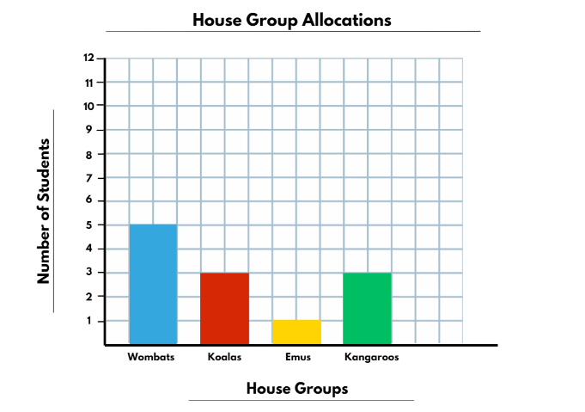
- Highlight the attributes of a column graph, including:
- an appropriate title
- equal spaces (intervals) on axes
- named and labelled axes
- rectangular bars of equal width, with spaces between them
- rectangular column heights that match the frequency of the category.
Note: opportunities to discuss how your school allocates students to sporting houses could be explored during this lesson, if applicable.
This table details opportunities for differentiation.
Too hard? | Too easy?
Stage 2 students cannot conduct experiments and compare the predicted and actual results where the outcomes are equally likely.  - Reduce the number of possible outcomes to 2 and ask students to predict the results if the chance experiment was conducted 10 times. Support students to conduct the experiment and compare the predicted and actual results.  Stage 3 students cannot use the term probability to describe the numerical value of an outcome.  - Explain that for a fair coin toss, the chance of a getting a head is $\frac{1}{2}$. Students brainstorm other situations where there are even chances such as a spinner with equal halves or rolling an even number on a die. Students represent this on a probability scale. | Stage 2 students can conduct experiments and compare the predicted and actual results where the outcomes are equally likely.  - Students predict the frequency of each number being rolled on a 6-sided die if rolled 20 times. Students conduct the experiment, record the actual results and compare these to their predictions.  Stage 3 students can use the term probability to describe the numerical value of an outcome.  - Challenge students to predict how many rolls it will take to roll a one using a 10-sided die. Students create a table and record the frequency of ones rolled after 5 rolls, 10 rolls, 15 rolls and so on. After completing the task, students write a statement about the observed probability of rolling a one after a selected number of rolls. For example, in 10 rolls, I rolled 2 ones. The observed probability was $\frac{2}{10}$.

Consolidation and meaningful practice – 15 minutes
- Distribute Resource 4 – column graph.
- Students create their own column graph using data from the ‘Our results’ table on Resource 3 – house group allocations.
Note: there are opportunities to extend this lesson further by having students compare their data with other pairs. Additionally, all results could be combined to create a larger set of data for analysis.
This table details opportunities for assessment.
Assessment opportunities | Links
What to look for:  - Can Stage 2 students conduct experiments and compare the predicted and actual results where the outcomes are equally likely? [MAO-WM-01, MA2-CHAN-01]  - Can Stage 2 students use the terms equally likely, likely and unlikely to describe the chance of everyday events occurring? [MAO-WM-01, MA2-CHAN-01]  - Can Stage 2 students create a list or table to organise the data? [MAO-WM-01, MA2-DATA-01]  - Can Stage 2 students mark equal spaces (intervals) on axes, name and label axes and choose appropriate titles for column graphs? [MAO-WM-01, MA2-DATA-01]  - Can Stage 3 students use the term probability to describe the numerical value of an outcome? [MAO-WM-01, MA3-CHAN-01]  - Can Stage 3 students record all outcomes in chance experiments where each outcome is equally likely to occur?  [MAO-WM-01, MA3-CHAN-01]  - Can Stage 3 students discuss the imprecise meaning of commonly used chance words including possible, likely and unlikely?  [MAO-WM-01, MA3-CHAN-01]  - Can Stage 3 students describe and interpret data presented in tables, column graphs and line graphs?  [MAO-WM-01, MA3-DATA-02] | Links to National Numeracy Learning Progressions (NNLP):  - Stage 2 – UnC2, UnC3, IRD3.  - Stage 3 – UnC2, UnC3, UnC4.

Lesson 2
Core concept: outcomes in chance experiments can be equally likely.

Daily number sense – number sentences – 10 minutes
The table below contains suggested learning intentions and success criteria. These are best co-constructed with students.
Daily number sense learning intentions | Daily number sense success criteria
Students working towards Stage 2 outcomes are learning to:  - recognise and explain the connection between addition and subtraction.  Students working towards Stage 3 outcomes are learning to:  - apply efficient mental and written strategies to solve addition and subtraction problems | Students working towards Stage 2 outcomes can:  - use number relation principles to solve related problems  - demonstrate how addition and subtraction are inverse operations.  Students working towards Stage 3 outcomes can:  - apply known strategies such as levelling, addition for subtraction, using constant difference and bridging.
- Record the numbers 28, 35, 14, 42, 21 on the board.
- Explain that students will use these numbers to identify as many related number sentences as possible.
- Ask how the number sentence 28 + 14 = 42 could be used to identify other related number sentences. For example, ‘Because I know 28 + 14 = 42, then I know 42 – 14 = 28.’
- Using only the numbers recorded on the board, students create as many number sentences as possible on individual whiteboards.
Multi-age: students working towards Stage 3 outcomes use the numbers 328, 994, 497, 825, 202. Select students to explain their thinking.
- Regroup and ask:
- Which of your number sentences show that addition and subtraction are inverse operations?
- Which of your number sentences show the commutative property?
This table details opportunities for assessment.
Assessment opportunities | Links
What to look for:  - Can Stage 2 students use number relation principles to solve related problems (Reasons about relations)?  [MAO-WM-01, MA2-AR-01, MA2-AR-02]  - Can Stage 3 students apply known strategies such as levelling, addition for subtraction, using constant difference and bridging (Reasons about relations)? [MAO-WM-01, MA3-AR-01] | Links to National Numeracy Learning Progressions (NNLP):  - Stage 2 – AdS7  - Stage 3 – AdS7, AdS8.  Links to suggested Interview for Student Reasoning (IfSR) tasks:  - Stage 2 – IfSR-AT: 3A.1, 3A.3  - Stage 3 – IfSR-AT: 3A.4.

Core lesson 1 – an equal chance – 25 minutes
The table below contains suggested learning intentions and success criteria. These are best co-constructed with students.
Core concept learning intentions | Core concept success criteria
Students working towards Stage 2 outcomes are learning to:  - identify possible outcomes from chance experiments  - identify when events are affected by previous events.  Students working towards Stage 3 outcomes are learning to:  - choose and use appropriate tables and graphs  - list outcomes of chance experiments involving equally likely outcomes and represent probabilities. | Students working towards Stage 2 outcomes can:  - predict the number of times each outcome might occur in a chance experiment involving a set number of trials  - conduct experiments and compare the predicted and actual results where the outcomes are equally likely  - identify and discuss events where the chance of one event occurring will not be affected by the occurrence of the other.  Students working towards Stage 3 outcomes can:  - tabulate collected data  - record all outcomes in chance experiments where each outcome is equally likely to occur  - discuss the imprecise meaning of commonly used chance words including possible, likely and unlikely.
This activity is an adaptation of Greedy Pig from NZ Maths by the University of Cambridge.
Note: when teaching probability through games, provide the opportunity for students to play multiple times. Repetition assists in the development of mathematical understanding, probabilistic reasoning associated with chance and helps address common misconceptions.
- Display Resource 5 – ‘Greedy Goat’ and the co-constructed probability scale anchor charts for Stage 2 and Stage 3 from Lesson 1.
- Explain that, as a whole class, students will be playing a dice game called ‘Greedy Goat’. Provide students with individual whiteboards and writing materials.
- Display and read Resource 5 – ‘Greedy Goat’. Students draw a score chart on their whiteboard or in their workbook.
- Play 3 to 5 rounds of the game. During each round, refer to the anchor chart and ask:
- What are all the possible numbers you can roll with a 10-sided die?
- How did you decide when to sit down and save your score?
- Was it equally likely for a 10 or a 1 to be rolled in one round?
- Is there anything about this game that is impossible or certain?
- How would you describe the chance of a one being rolled? (Equal chance as any other number for Stage 2 and 1 in 10 for Stage 3)
- What did you notice about this game?
- Write the term equally likely on the board. Students Think-Pair-Share and create a shared definition.
Equally likely: an event for which all outcomes have the same probability of occurring. For example, in tossing a fair coin, the outcome ‘head’ and the outcome ‘tail’ are equally likely (NESA 2022).
Note: students may have the misconception that equally likely means 50/50 or a 1 in 2 chance of occurring. This is not the case when there are more than 2 outcomes. For example, on a 10-sided die each outcome is equally likely; however each outcome only has a 1 in 10 chance of being rolled.
- After the whole class game, explain that students will play ‘Greedy Goat’ in small groups (3 to 4 players).
- Provide groups with a 10-sided die and individual whiteboards or workbooks. Students draw a score chart and select one person to roll the die.
- Allow time for students to play repeated rounds. Regroup and discuss:
- If you played 20 rounds, how many ones would you expect to roll? Explain.
- What number on the die was rolled the most and the least by your group?
- What numerical values can be used to describe a 1 out of 10 chance? What would it look like as a fraction? As a decimal? As a percentage? (Stage 3)

Core lesson 2 – 30 minutes

Stage 2 task – predicted and actual outcomes
Note: the Stage 2 Teaching advice for Chance B states that randomness can lead to unexpected outcomes. The ‘law of averages’ is a term sometimes used to describe the common mistaken belief that an outcome must occur as many times as its numerical probability suggests. This belief suggests that what has happened in the past will be balanced by what occurs next. The ‘law of averages’ misconception in this task may see students predict that each number will be rolled an equal number of times. Students need many opportunities to compare their expectations (what might happen) with actual outcomes (what does happen) to appreciate the variation that is experienced with random generators such as spinners and dice (NESA 2022b).
- Ask:
- If you rolled a 6-sided die, what are the chances of a one being rolled? What are the chances of a 6 being rolled? (Equally likely chance as the other numbers.)
- If you rolled a 6-sided die 6 times, how many times do you predict a one will be rolled? How many times do you predict a 6 will be rolled? Explain with reasoning. (Some students may predict that a one will be rolled once in 6 rolls, a 6 will be rolled once in 6 rolls and so on as there is an equally likely chance of each number being rolled. Some students may predict that there will be many variations to the results because of the random nature of rolling a die.)
- Roll a 6-sided die 6 times and record the numbers rolled. Ask:
- Are these results what you expected? Why or why not?
- What do you think would happen if we rolled the die another 6 times?
- Is there any way to predict that one number may be rolled more often than another number?
- Explain that students are going to conduct an experiment to see what happens when the die is rolled multiple times.
- Provide pairs of students with Resource 6 – die outcomes, coloured counters and a 6-sided die.
- In round 1, students place a counter on which number they predict will be rolled with the most frequency after 24 rolls, then roll, tally and total results.
- In round 2, students place a counter on which number they predict will be rolled with the most frequency after 60 rolls, then roll, tally and total results.
- In round 3, students place a counter on which number they predict will be rolled with the most frequency after 120 rolls, then roll, tally and total results.
- Ask:
- What do you notice? How do the results compare to your predictions?
- What do you think would happen after 600 rolls?
- Is there any certain way to predict which number will be rolled most often? (Students should appreciate the variation that is experienced with random generators such as spinners and dice. See the Stage 2 teaching advice above.)

Stage 3 task – changing chance
- After playing ‘Greedy Goat’, ask:
- Did you think it was certain or impossible that you could roll a one multiple times during the game? Explain.
- What is an instruction that can be changed so that the probability of scoring zero in a round is also changed? Explain.
- How would you test the change to make sure you are correct? How many rounds would you need to play to be sure you were right? What other things might you need to consider?
- Explain that in this lesson, students will explore whether changes to the rules of ‘Greedy Goat’ affect the probabilities of scoring zero in a round.
- Provide some examples of changes using the think aloud strategy, such as:
- How would the game change if the new rule was if you roll a 1 or a 10, your score is zero?
- How would playing with a 6-sided dice change the probability of scoring zero?
- If the new rule was that rolling an even number allows you to double your score, how might this change the game?
- As a class, brainstorm new rules and create a class list of possible modifications. Keep the list for use in Lesson 3.
- In small groups, students:
- select a modification idea from the class list and play ‘Greedy Goat’ using the new rule
- collect and record data in a table
- record an explanation of how the modified idea has changed the game. (Encourage students to use chance language and numerical phrases to justify their findings.)
- Model how students can record the data and an example of an explanation (see Figure 8).
Figure 8 – example of data and comment
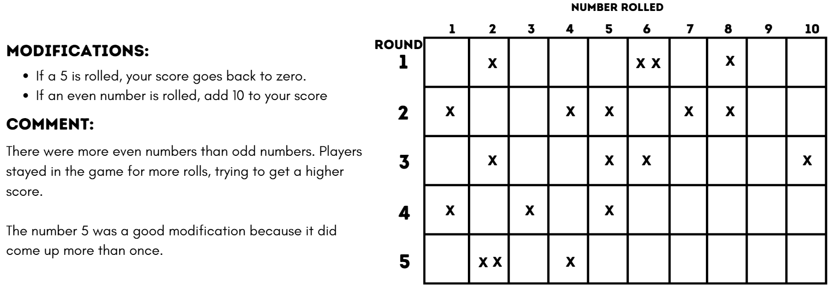
Note: student responses may include misconceptions such as past experiences influencing their view of chance and likelihood. For example, in Figure 8, students commented that choosing 5 was a good modification, even though the probability of rolling a 5 is equal to that of rolling a one. Such misconceptions should be addressed in discussions.
- Provide each group with a 10-sided die, a whiteboard and writing materials. In their groups, students explore and trial their modifications.
- Regroup as a class and discuss the following questions. Answers will vary depending on the modifications to the game.
The table below outlines stimulus prompts to generate conversation about the topic, along with anticipated responses from students.
Prompts | Anticipated student responses
- How did the rule change the way you played the game? | - There were more numbers that made you get a zero, so rounds finished quickly as people saved their points and opted out.  - We added a rule that doubled your score if you rolled a 6 or higher. People stayed in for longer to get higher scores.
- Did the modified instruction(s) change the probability of outcomes for players? Explain. | - We used two 6-sided dice. The rule was to roll 2 ones to get a zero score. The chance of rolling 2 ones at the same time is unlikely to happen.  - We had 2 penalties: roll a one means get zero and roll a 10 means halve your score. We noticed that players stopped and saved their score after fewer rolls of the die because there were now 2 numbers that could affect their score. That is a 2 out of 10 chance.
- How did you use the probability scale to inform your decision? | - We thought about the chances as a fraction and compared the probability of scoring zero in a round to the original game of ‘Greedy Goat’.
This table details opportunities for differentiation.
Too hard? | Too easy?
Stage 2 students cannot conduct experiments and compare the predicted and actual results where the outcomes are equally likely.  - Reduce the number of possible outcomes to 2 and ask students to predict the results if the chance experiment was conducted 10 times. Support students to conduct the experiment and compare the predicted and actual results.  Stage 3 students cannot record all outcomes in chance experiments where each outcome is equally likely to occur and/or tabulate collected data.  - Play a modified version of ‘Greedy Goat’. As a small group, model the collection and recording of the data.  - Provide students with a prepared data table. Guide each group on how to record the rolls for a modified version of ‘Greedy Goat’. | Stage 2 students can conduct experiments and compare the predicted and actual results where the outcomes are equally likely.  - Students use a digital spinner and digital devices to design an experiment to predict the frequency of 8 equally likely outcomes of their choice, occurring when the wheel is spun 20 times, 40 times or 60 times. Students conduct the experiment, record the actual results and compare these to their predictions.  Stage 3 students can record all outcomes in chance experiments where each outcome is equally likely to occur and tabulate collected data.  - Small groups of students explore What Does Random Look Like? by NRICH using data collected from 20 coin tosses and a ‘fake’ dataset.  - Students select 2 dice to investigate the probability of combined scores using the steps set out in A Bit of a Dicey Problem by NRICH.

Discuss and connect the mathematics – 5 minutes
- Display the co-constructed probability scale anchor charts from Lesson 1 (Stage 2 and Stage 3).
- As a class, select groups to share their experiences of the Stage 2 and Stage 3 tasks. Ask:
- How did your group record the results? What did you notice?
- If you played an additional 10 rolls (Stage 2) or 10 rounds (Stage 3), do you think the outcomes would be very different or similar? Explain.
- Which modification do you think caused the biggest change in probability in scoring zero in a round? How did it change? (Stage 3)
- How would playing 20 more rolls (Stage 2) or 20 rounds (Stage 3) or 100 more rolls (Stage 2) or 100 more rounds (Stage 3) make a difference? Explain.
This table details opportunities for assessment.
Assessment opportunities | Links
What to look for:  - Can Stage 2 students predict the number of times each outcome might occur in a chance experiment involving a set number of trials? [MAO-WM-01, MA2-CHAN-01]  - Can Stage 2 students conduct experiments and compare the predicted and actual results where the outcomes are equally likely? [MAO-WM-01, MA2-CHAN-01]  - Can Stage 2 students identify and discuss events where the chance of one event occurring will not be affected by the occurrence of the other?  [MAO-WM-01, MA2-CHAN-01]  - Can Stage 3 students tabulate collected data?  [MAO-WM-01, MA3-DATA-01]  - Can Stage 3 students record all outcomes in chance experiments where each outcome is equally likely to occur?  [MAO-WM-01, MA3-CHAN-01]  - Can Stage 3 students discuss the imprecise meaning of commonly used chance words including possible, likely and unlikely?  [MAO-WM-01, MA3-CHAN-01] | Links to National Numeracy Learning Progressions (NNLP):  - Stage 2 – UnC2, UnC3, IRD3  - Stage 3 – UnC2, UnC3, UnC4, IRD2.

Lesson 3
Core concept: the chance of an event occurring is sometimes affected by previous events (Stage 2) and probability can be represented from zero to one (Stage 3).

Daily number sense – number lines and integers – 10 minutes
The table below contains suggested learning intentions and success criteria. These are best co-constructed with students.
Daily number sense learning intentions | Daily number sense success criteria
Students working towards Stage 2 outcomes are learning to:  - read, represent and order numbers to thousands.  Students working towards Stage 3 outcomes are learning to:  - locate and represent integers on a number line. | Students working towards Stage 2 outcomes can:  - compare and describe the relative size of numbers by positioning numbers on a number line.  Students working towards Stage 3 outcomes can:  - recognise the location of negative whole numbers in relation to zero and place them on a number line  - use the term integers to describe positive and negative whole numbers and zero.
Note: integers are the negative and positive whole numbers and zero. Integers can be represented as a series, such as −3, −2, −1, 0, 1, 2, 3. Positive and negative numbers describe quantities having both magnitude and direction, for example, temperature above and below zero (Van De Walle et al. 2019). To further consolidate student understanding of negative and positive numbers, revise Lesson 4 in Multi-age Year A Unit 8.
- Display Resource 7 – integers and provide students with individual whiteboards and writing materials. Ask:
- What is the same or different between the number lines A and B?
- What do you notice about the numerals on each number line? Are they whole numbers? Explain.
- What role does the zero have in both number lines?
- What is the lowest number on each of the number lines?
- How far could the number line A be extended in either direction?
- Where would you see and use negative numbers in real life situations? (temperature, finance)
- Explain that integers are whole numbers and can be either positive or negative. Zero is an exception, as it is neither positive nor negative and has an important role as it sits in the middle, separating the negative and positive numbers.
- Draw student attention to Resource 7 – integers. Using their whiteboards, students draw the number line labelled A and extend the number line by recording the next 3 positive and negative integers. Ask the following questions:
- What strategy did you use to determine the next integers?
- How do you know you are correct?
Multi-age: students working towards Stage 2 outcomes could use an alternate number line that is labelled from 0–30. Students then place 5, 20 and 27 on the number line, justifying their choices.
This table details opportunities for assessment.
Assessment opportunities | Links
What to look for:  - Can Stage 2 students compare and describe the relative size of numbers by positioning numbers on a number line?  [MAO-WM-01, MA2-RN-01]  - Can Stage 3 students recognise the location of negative whole numbers in relation to zero and place them on a number line? [MAO-WM-01, MA3-RN-01]  - Can Stage 3 students use the term integers to describe positive and negative whole numbers and zero?  [MAO-WM-01, MA3-RN-01] | Links to National Numeracy Learning Progressions (NNLP):  - Stage 2 – NPV4  - Stage 3 – NPV9, CPr8.

Core lesson – 45 minutes

Stage 2 task – mystery lunch
The table below contains suggested learning intentions and success criteria. These are best co-constructed with students.
Core concept learning intentions | Core concept success criteria
Students working towards Stage 2 outcomes are learning to:  - interpret and compare data  - identify possible outcomes from chance experiments  - identify when events are affected by previous events. | Students working towards Stage 2 outcomes can:  - describe and interpret information presented in tally tables and column graphs  - record all possible combinations in a chance situation where the outcomes are equally likely  - identify and discuss events where the chance of one event occurring will not be affected by the occurrence of the other  - compare events where the chance of one event occurring is affected by the occurrence of the other.
- Display Resource 8 – chance scale. Ask students to turn and talk and determine where the following terms would be placed on the chance scale:
- impossible
- unlikely
- equally likely
- likely
- certain.
- Students share their decisions and justify their reasoning. Highlight the differences between ‘less likely’ and ‘least likely’, and ‘more likely’ and ‘most likely’.
- Students turn and talk and determine where the word ‘possible’ would be placed on the scale.
Note: ‘certain’ is the opposite of ‘impossible’. Anything that is not impossible, is possible. Therefore, ‘possible’ includes a scale of things that are more and less likely, equally likely and certain. ‘Impossible’ means that the outcome can never occur. ‘Certain’ means that it will definitely occur.
- Explain that anything that is not impossible, is possible. Demonstrate drawing a line to show that the word possible would be placed anywhere on the scale after impossible (see the purple line in Figure 9).
Figure 9 – chance scale
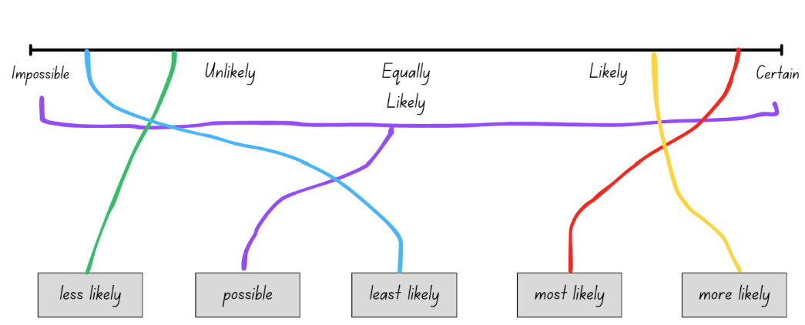
- Explain that at the Banksia Crescent Public School sporting carnival, the canteen is providing students with a mystery lunch.
- Display Resource 9 – mystery lunch. Explain to students that on the day of the sporting carnival, the canteen is offering 4 different food items and 2 different drink items. The students will visit the canteen and spin 2 random spinners to decide which food and drink item they will receive. Ask questions using the prompts in the table below.
The table below outlines stimulus prompts to generate conversation about the topic, along with anticipated responses from students.
Prompts | Anticipated student responses
- Which chance terms could be used to describe the likelihood of spinning a chicken burger for food? | - Equally likely  - Possible
- What is the chance of spinning water as the drink? | - Equally likely. There are 2 possible outcomes for drinks. Each child must receive one of the 2, water or apple juice.
- What is the chance of a student spinning avocado sushi? | - Equally likely, as there are 4 possible outcomes for food.
- Is it less likely to spin the vegetarian lasagne than the chicken burger? | - No, there is an equal chance of receiving each food item.
- If Amal is vegetarian, is there an equal chance of spinning a food she can eat? | - Yes, 2 out of the 4 outcomes are vegetarian: avocado sushi and vegetarian lasagne. There is an equal chance of spinning a vegetarian option or a non-vegetarian option.
- What could a spinner look like if the chance of Amal spinning a vegetarian option was certain? | - Amal needs a different spinner with only 2 options, avocado sushi and vegetarian lasagne, so the chance of receiving a vegetarian food is certain.  - Amal could have a spinner with 4 options: 2 avocado sushi and 2 vegetarian lasagnes.
- What is the likelihood of spinning orange juice? | - Impossible. There is no orange juice on the spinner, therefore it is not a possible outcome.
- Ask students to turn and talk and discuss why the term equally likely can be used to describe the chance of one out of 4 possible outcomes and the chance of one out of 2 possible outcomes.
- Explain that when using this spinner, the chance of a certain outcome occurring resets after each spin. Each spin is independent of the next. For example, 3 students in a row may spin and land on ‘hotdog’. The chance of spinning a hotdog on each spin remains equally likely.
- Pose the scenario: Archer visits the canteen and selects ‘spin’ on each of the random spinners. The outcomes of the spins were a chicken burger and an apple juice. This was one possible combination Archer could have received. What are some other possible combinations he could have received?
- Students Think-Pair-Share and record all other possible lunch combinations using writing materials.
- Regroup and select students to share their combinations.
- Display Resource 10 – lunch combinations. Explain that the table can be used to display the possible combinations of outcomes from the 2 spinners. The images in the grey row and column show the possible food and drink outcomes. The combination created is recorded in the white section of the table where the 2 outcomes meet.
- Model how to use the table in Resource 10 – lunch combinations to determine and record the possible combinations of this experiment (see Figure 10).
Figure 10 – lunch combinations table
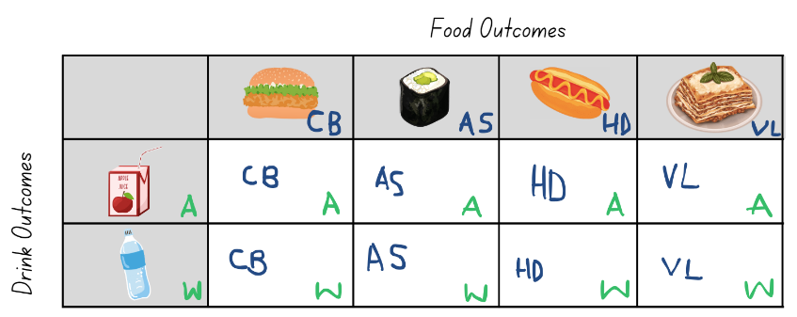
- Explain that on the day of the sporting carnival, class 3B visited the canteen and participated in the chance experiment. They created a graph to show the results.
- Distribute Resource 11 – 3B’s lunch selections. Students interpret the data display to complete the questions.
- Regroup to discuss answers.
This table details opportunities for differentiation.
Too hard? | Too easy?
Students cannot identify and discuss events where the chance of one event occurring will not be affected by the occurrence of the other.  - Students use the drink spinner only to conduct a chance experiment and record the results. Highlight that the chance of spinning water or apple juice is not affected by previous spins.  Students cannot describe and interpret information presented in tally tables and column graphs.  - Provide students with a tally table showing class 3B’s results. | Students can identify and discuss events where the chance of one event occurring will not be affected by the occurrence of the other.  - Students brainstorm a list of real-world examples where the chance of one event occurring will not be affected by the occurrence of the other. For example, a coin landing on heads 2 times in a row, rolling a 4 on a die 3 times in a row.  Students can describe and interpret information presented in tally tables and column graphs.  - Students create questions about the graph for their partner to answer.

Stage 3 task 1 – probabilities add to one
The table below contains suggested learning intentions and success criteria. These are best co-constructed with students.
Core concept learning intentions | Core concept success criteria
Students working towards Stage 3 outcomes are learning to:  - list outcomes of chance experiments involving equally likely outcomes and represent probabilities  - compare observed frequencies of outcomes with expected results. | Students working towards Stage 3 outcomes can:  - establish that the total of the probabilities of the outcomes of a chance experiment equals one  - distinguish between the frequency and the probability of an outcome.
- Revise the class anchor chart made in previous lessons.
- Display Resource 12 – probability scales.
- Discuss each fraction strip to establish that the total probabilities of the outcomes of a chance experiment equals one.
- Draw the 3 different spinners shown in Figure 11 on the whiteboard.
Figure 11 – different spinners
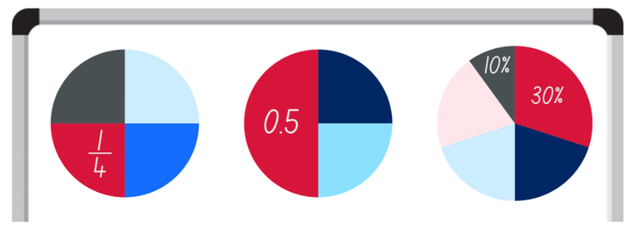
- Pose the following: Each spinner represents all the possible outcomes of a spin. How can you show that the total of the probabilities of the outcomes of a chance experiment equals one?
- Students Think-Pair-Share before providing responses using addition of fractional parts, the complement principle or the subtraction of unit fractions.
- Remind students of the game ‘Greedy Goat’ played in previous lesson. Ask the following questions:
- What is the probability of scoring zero by rolling a one? (One-tenth or 10%)
- What is the probability of scoring by rolling anything other than one? (nine-tenths or 90%)
- How can you represent that probability as a fraction strip and on a probability scale? (see Figure 12)
Figure 12 – ‘Greedy Goat’ probability
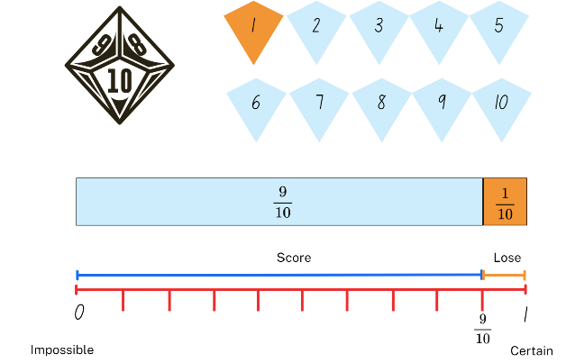
- Explain that the chance of scoring and the chance of scoring zero in a round add to one.
- Display and review the class list of modifications made to ‘Greedy Goat’ in Lesson 2.
- In pairs, students select 3 modifications to ‘Greedy Goat’ and represent the probability of scoring zero in a round in the modified game (see Figure 13).
Figure 13 – modified rules example
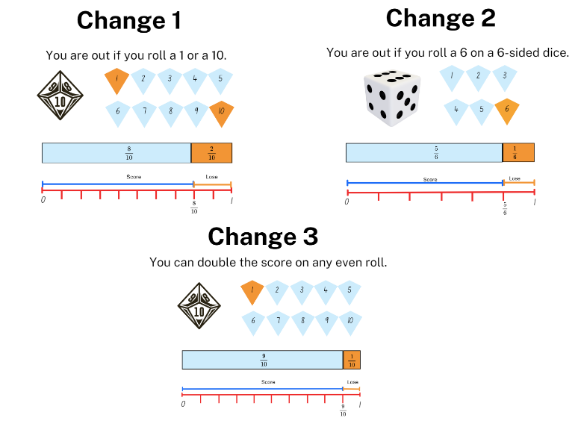
The table below outlines stimulus prompts to generate conversation about the topic, along with anticipated responses from students.
Prompts | Anticipated student responses
- Do the probabilities of all the outcomes still add to one in the modified game? | - Change 1 – yes; 20% + 80% = 100%.  - Change 2 – yes; $\frac{1}{6}$+ $\frac{5}{6}$= 1  - Change 3 – yes, 10% + 90% = 100%
- Did the changes in the rules change the probabilities of scoring zero in a round? Explain why or why not? | - Change 1 – there is now a 20% chance of scoring zero in a round That is twice as likely as the original game of 10%.  - Change 2 – there is now a $\frac{1}{6}$ probability of scoring zero in a round. That is a higher chance than $\frac{1}{10}$ probability from the original game.  - Change 3 – the chance of scoring zero in a round is still the same.
- Would the change in the rules change the way you play? Why or why not? | - Answers will vary depending on students' attitude to winning or losing.  - Change 1 – there is now a higher chance of scoring zero in a round so I would probably stop sooner than take my chances.  - Change 2 – there is now a higher chance of scoring zero in a round, but the other player has the same rules so I will play the same way.  - Change 3 – the chance of scoring zero in a round is still the same but I can get double points on even rolls so I am likely to take more rolls.

Stage 3 task 2 – data tables
- Students select a different modified game of ‘Greedy Goat’ than played previously.
- Students record the rule changes and represent the probability of scoring zero in a particular round on a probability scale.
- Students collect dice roll data from several games, choosing how to represent the data they collect.
- Students consider if the collected data matches the expected probability of the modified game and record their observations (see Figure 8).
This table details opportunities for differentiation.
Too hard? | Too easy?
Students cannot establish that the total of the probabilities of the outcomes of a chance experiment equals one and/or tabulate collected data.  - Provide students with up to 4 identical strips of paper. Label one of the strips with the numeral 1. Fold and label the others with benchmark partitions of halves, quarters and tenths respectively using fractions, decimals and percentages.  - Provide students with a large data table, for example A3 paper. Students use counters to track the rolls of the die during the game as a dot plot. Record the completed table using a digital device. | Students can establish that the total of the probabilities of the outcomes of a chance experiment equals one and tabulate collected data.  - Students learn the rules for the card game by viewing The King’s Tax Maths Game (4:00). Provide students with a pack of playing cards. After playing a few rounds, students represent the chances of drawing a score card, doubling their score or being taxed. (Russo 2020).  - Provide students with playing cards. Pose the following: Using a small deck of cards, you have a $\frac{1}{4}$ chance of choosing a picture card and a 50% chance of drawing an even number. What might the cards in the deck be? (Sullivan and Lilburn 2017)

Discuss and connect the mathematics – 15 minutes
- At the end of the sporting carnival described in the Stage 2 task, the canteen had 3 hotdogs and 3 avocado sushi rolls left over. The canteen manager placed each food item in a brown paper bag for 6 teachers to take home. The teachers will pick one brown paper bag at random.
- Record the 6 possible outcomes on the whiteboard.
- Explain that the first teacher has an equally likely chance of selecting a bag containing a hotdog or an avocado sushi. Ask Stage 3 students to record this as a fraction, decimal and percentage.
- Place 3 red and 3 green counters in a bag to represent the food items. Select one student to be the first teacher and choose a counter from the bag at random. Draw a line through the matching outcome listed on the board to show that the food item is no longer a possible outcome.
- Ask the following questions:
- Is there still an equally likely chance that the second teacher will select a bag containing a hotdog or an avocado sushi? Why or why not?
- What will happen to the probability of a hotdog or avocado sushi as each teacher selects their bag?
- Explain to students that sometimes in a chance experiment the chance of one event occurring is affected by the occurrence of the other. In this case, one of the food items is now less likely to occur than the other.
- Invite a second student to choose a counter at random. Draw a line through the matching outcome listed.
- Discuss the possible outcomes of the third and fourth teacher’s selections.
- Ask Stage 3 students, if the first 2 lunches are hotdogs, what is the probability that the third teacher selects a:
- hotdog?
- sushi?
- Ask Stage 3 students to record the probability of each outcome as a fraction, decimal and percentage and check that the probabilities add to one.
Note: Stage 3 students are expected to make connections between benchmark fractions, decimals and percentages including $\frac{1}{2}$, $\frac{1}{4}$, $\frac{3}{4}$ and $\frac{1}{10}$. Students are not expected to recall percentages and decimals for $\frac{1}{3}$ and $\frac{1}{6}$, although these may be investigated in an exploratory way. To support place value conceptual understanding, read 0.1 as one-tenth, connecting the decimal fraction with common fractions.
This table details opportunities for assessment.
Assessment opportunities | Links
What to look for:  - Can Stage 2 students record all possible combinations in a chance situation where the outcomes are equally likely?  [MAO-WM-01, MA2-CHAN-01]  - Can Stage 2 students identify and discuss events where the chance of one event occurring will not be affected by the occurrence of the other? [MAO-WM-01, MA2-CHAN-01]  - Can Stage 2 students compare events where the chance of one event occurring is affected by the occurrence of the other?  [MAO-WM-01, MA2-CHAN-01]  - Can Stage 2 students describe and interpret information presented in tally tables and column graphs? [MAO-WM-01, MA2-DATA-02]  - Can Stage 3 students establish that the total of the probabilities of the outcomes of a chance experiment equals one?  [MAO-WM-01, MA3-CHAN-01]  - Can Stage 3 students distinguish between the frequency and the probability of an outcome in a chance experiment? [MAO-WM-01, MA3-CHAN-01] | Links to National Numeracy Learning Progressions (NNLP):  - Stage 2 – UnC3 – UnC5, IRD3  - Stage 3 – UnC2, UnC3, UnC4.

Lesson 4
Core concept: chance experiment outcomes can be predicted, recorded and compared (Stage 2) and probability can be represented as a fraction (Stage 3).

Daily number sense – 10 minutes
- From a class need surfaced through formative assessment data, identify a short, focused activity that targets students’ knowledge, understanding and skills. Example activities may be drawn from the following resources:
- Mathematics K–6 resources
- Universal Resources Hub.

Core lesson 1 – 25 minutes

Stage 2 task 1 – dicey sums
The table below contains suggested learning intentions and success criteria. These are best co-constructed with students.
Core concept learning intentions | Core concept success criteria
Students working towards Stage 2 outcomes are learning to:  - organise and display data using tables and graphs  - describe the likelihood of outcomes of chance events  - identify when events are affected by previous events. | Students working towards Stage 2 outcomes can:  - construct column graphs (with scale intervals of 1) and dot plots using relevant software where appropriate  - compare the likelihood of obtaining particular outcomes in a simple chance experiment by predicting, conducting the experiment and comparing the results with the prediction  - identify and discuss events where the chance of one event occurring will not be affected by the occurrence of the other.
- Display 2 dice using Polypad, an alternative digital program or large physical dice.
- Ask students what the sum of the 2 dice could be.
- Students Think-Pair-Share and record possible outcomes using writing materials. For example, 1 + 2 = 3, 2 + 2 = 4, 2 + 3 = 5.
- Regroup and discuss the possible outcomes students recorded. Ask questions using the prompt table below.
The table below outlines stimulus prompts to generate conversation about the topic, along with anticipated responses from students.
Prompts | Anticipated student responses
- What is the chance of the outcome being 13? | - Thirteen is an impossible outcome. There are no 2 numbers on a 6-sided die that add to 13.
- Do the numbers on one die have an equally likely chance of being rolled? Why or why not? | - Yes, each number has an equal chance of being rolled. When rolling a die, the chance of a certain number occurring resets after each roll. Each roll is independent of the next. For example, the chance of rolling a number 6 will not be affected by previous rolls.
- Does each outcome (sum) have an equally likely chance of occurring? Why or why not? | - No, each outcome has a different likelihood of occurring. For example, 2 can only be an outcome if both dice land on one. This is less likely than an outcome of 4 where the dice could land on one and 3 or 2 and 2.
- Draw a horizontal line on the board to represent an x-axis. Make 12 equally spaced marks along the line and label with the numbers 1–12 underneath.
- Ask students to predict the outcome (sum) when 2 dice are rolled. Each student places a round sticker above the corresponding number to create a dot plot.
- Select students to justify their predictions.
Note: if round stickers are not available, a masking tape line on the classroom floor and counters can be used as an alternative. Ensure counters or stickers are a consistent shape and size.
- Roll the 2 dice and find the sum. Refer to the prediction dot plot and determine how many students correctly predicted the outcome (sum).
- Display Resource 13 – dice sums. Explain that the table shows the sum of 2 numbers. The numbers in the grey row and column show the possible outcomes when one die is rolled. The sum of the numbers is recorded in the square where the 2 numbers meet.
- Ask the following questions:
- What do you notice?
- What do you wonder?
- Display Resource 14 – true or false. Students turn and talk to determine whether the statements are true or false.
- Regroup and ask students to justify their decisions.

Stage 3 task 1 – probability scales
The table below contains suggested learning intentions and success criteria. These are best co-constructed with students.
Core concept learning intentions | Core concept success criteria
Students working towards Stage 3 outcomes are learning to:  - make connections between benchmark fractions, decimals and percentages  - list outcomes of chance experiments involving equally likely outcomes and represent probabilities  - compare observed frequencies of outcomes with expected results. | Students working towards Stage 3 outcomes can:  - recall commonly used equivalent percentages, decimals and fractions including $\frac{1}{2},$ $\frac{1}{4}$and $\frac{3}{4}$  - use the term probability to describe the numerical value that represents the likelihood of an outcome of a chance experiment  - represent probabilities of outcomes of chance experiments using fractions  - distinguish between the frequency and the probability of an outcome in a chance experiment.
Note: this lesson revisits chance content introduced in Lesson 6 of Multi-age Year A Unit 8 and fractions content from Multi-age Year A Unit 16.
- Display and revise the anchor chart co-constructed Lesson 1. Ask:
- What probability is represented by zero?
- What probability is represented by one?
- What is the opposite of ‘impossible’? (certain)
Probability: the chance of something happening shown on a scale from 0 and one (inclusive). For example, the probability that a fair coin toss will come up ‘heads’ is $\frac{1}{2}$ (NESA 2022).
- Display Resource 12 – probability scales.
- Remind students that fraction strips can also be used to represent probability.
- Provide students with individual whiteboards and markers. Ask students to represent the probability of each activity (and fraction strip) on a probability scale (see Figure 14).
Figure 14 – completed probability scales
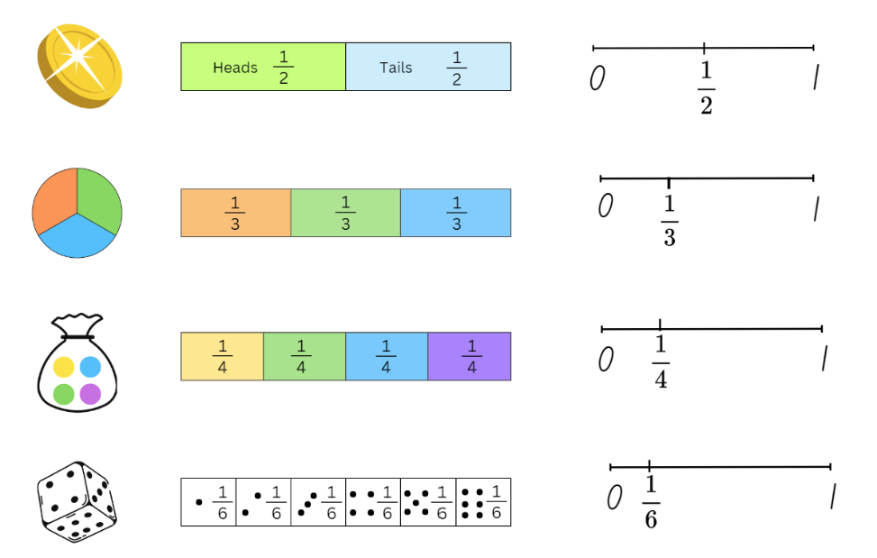
- Ask the following questions:
- What do you notice about the probability recorded on the scale?
- How does your knowledge of benchmark fractions on a number line help you with probability?
- What is the same about the fraction strip and the probability scale?
- Why does the probability scale start at 0 and end at 1?
- Remind students of the game ‘Greedy Goat’ that uses a 10-sided die. Ask:
- What is the probability of rolling any number on a 10-sided die?
- Can you represent this probability using a fraction strip?
- Can you represent this probability using a probability scale?
- Why does the fraction strip have 10 equal parts, but the probability scale only has one-tenth marked?
- Students Think-Pair-Share to draw a fraction strip and probability scale for a 10-sided die (see Figure 15).
Figure 15 – ‘Greedy Goat’ probabilities
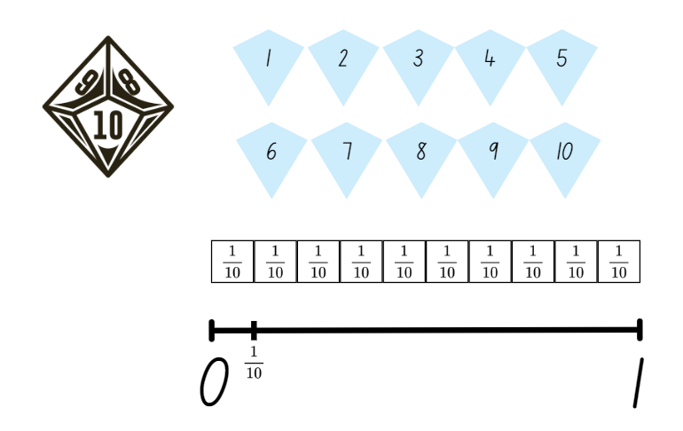

Core lesson 2 – race to win and data tables – 20 minutes
This activity is an adaptation of ‘Derby roleplay in the classroom’ from Seriously Fun Maths: The complete guide to motivational mathematics by Tuohilampi.
- Display Resource 15 – race to win to Stage 2. Explain that the ‘Race to win’ track has 12 lanes. In the game, the winning lane is determined by creating a column graph with horizontal bars.
- Explain the rules of the game:
- Roll 2 dice and find the sum.
- Colour one square in the numbered lane that matches the sum.
- Repeat until one lane reaches the finish line (see Figure 16).
Figure 16 – race to win gameboard example
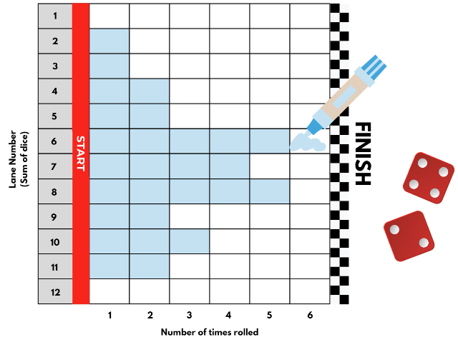
- Ask Stage 2 students to predict:
- Which lane is most likely to win the race?
- Which lane is least likely to win the race?
- Provide pairs with Resource 15 – race to win, two 6-sided dice and coloured markers.
- Pairs play ‘Race to win’ and determine the winning lane.
- Stage 2 students compare their ‘Race to win’ results with another pair. Ask the following questions:
- How did your predictions compare to the actual results?
- How are your results similar or different to the other pair’s results?
- Were there any surprises in how many times an outcome (sum) occurred?
- How many times did you need to roll the dice before a lane crossed the finish line?
- How is a column graph with horizontal bars like a column graph with vertical columns?
- Explain that Stage 3 students are going to investigate whether the probability of rolling any number on a 10-sided die matches what happens when you roll the die many times.
- Share the syllabus definition for frequency:
Frequency: the number of times that a particular value occurs in a data set. For example, when rolling a die 20 times, ‘the frequency of a 6’ means how many times the number 6 comes up (NESA 2022).
- Ask pairs of students to draw a data table with 10 columns, labelled 1–10.
- Explain that students are going to record data from each roll to contribute to a Stage 3 dataset.
- Provide pairs of students with a 10-sided die. Students roll the die 50 times and after each roll, record the number in a data table.
- Combine the data from each pair and create a table which shows the class Stage 3 data for students to view. Ask the following questions:
- What is the total number of rolls for the whole class?
- How often would you expect each number to be rolled? Why? (Total rolls ÷ 10, because there are 10 possible outcomes on the dice. Each outcome is equally likely. For example, with 50 rolls, to match probability, each outcome would occur 5 times.)
- Where do the class frequency results match the probability of rolling each number?
- Where do the class frequency results differ from the probability of rolling each number? Why is there a difference? (Dice are random)
- Which outcome had the lowest or highest frequency in your pair data? How does this compare to the whole class data? Why is there a difference?
This table details opportunities for differentiation.
Too hard? | Too easy?
Stage 2 students cannot compare the likelihood of obtaining particular outcomes in a simple chance experiment by predicting, conducting the experiment and comparing the results with the prediction.  - Support students to create a table to list all the possible outcomes when rolling one 6-sided die.  - Students make a tally of how many times each outcome occurred in the table Resource 13 – dice sums. Support students to record the frequency numerically and compare the likelihood of each outcome (sum) occurring. For example, the outcome of 2 occurs once and the outcome of 3 occurs twice, so 3 is more likely to occur as 3 is a larger number than 2.  Stage 3 students cannot represent probabilities of outcomes of chance experiments using fractions.  - Fold paper strips to match those shown on Resource 12 – probability scales. Use the strips to rule a line from 0–1, then label one fractional part, as shown in Figure 16 above.  - Complete Resource 12 – probability scales then cut it into 12 cards. Students match the cards with each other, explaining their reasoning. | Stage 2 students can compare the likelihood of obtaining particular outcomes in a simple chance experiment by predicting, conducting the experiment and comparing the results with the prediction.  - Provide students with two 9-sided dice. Students create a version of Resource 13 – dice sums using these dice.  - Students make statements using chance vocabulary to make predictions about the likelihood of particular outcomes (sums) when two 9-sided dice are rolled.  Stage 3 students can represent probabilities of outcomes of chance experiments using fractions.  - Students use a 1–10 die to investigate what outcomes have a probability of$\frac{1}{2}$ or $\frac{1}{5}$. Are there outcomes that have a probability of $\frac{1}{4}$? Why or why not? What dice in your classroom have outcomes with a probability of $\frac{1}{3}$ or $\frac{1}{4}$? Explain.  - Students draw a probability scale from 0–1. Write a list of words to describe a $\frac{1}{10}$ chance and/or a $\frac{9}{10}$chance. Share with the class.

Discuss and connect the mathematics – 10 minutes
- Select students from each stage to explain their learning. Ask the following questions:
- What was the task?
- What did you expect to happen?
- What happened?
- Why were there differences between predictions and results?
- Select students to explain similarities and differences between the Stage 2 and 3 tasks and results.
This table details opportunities for assessment.
Assessment opportunities | Links
What to look for:  - Can Stage 2 students construct column graphs (with scale intervals of 1) and dot plots using relevant software where appropriate? [MAO-WM-01, MA2-DATA-01]  - Can Stage 2 students compare the likelihood of obtaining particular outcomes in a simple chance experiment by predicting, conducting the experiment and comparing the results with the prediction? [MAO-WM-01, MA2-CHAN-01]  - Can Stage 2 students identify and discuss events where the chance of one event occurring will not be affected by the occurrence of the other? [MAO-WM-01, MA2-CHAN-01]  - Can Stage 3 students use the term probability to describe the numerical value that represents the likelihood of an outcome of a chance experiment? [MAO-WM-01, MA3-CHAN-01]  - Can Stage 3 students recall commonly used equivalent percentages, decimals and fractions including $\frac{1}{2}$, $\frac{1}{4}$ and $\frac{3}{4}$?  [MAO-WM-01, MA3-RN-03]  - Can Stage 3 students represent probabilities of outcomes of chance experiments using fractions?  [MAO-WM-01, MA3-CHAN-01]  - Can Stage 3 students distinguish between the frequency and the probability of an outcome in a chance experiment? [MAO-WM-01, MA3-CHAN-01] | Links to National Numeracy Learning Progressions (NNLP):  - Stage 2 – UnC2, UnC3, IRD3  - Stage 3 – PrT2, UnM8, IRD3, IRD4, IRD5, UnC4.

Lesson 5
Core concept: mathematicians interpret, evaluate and explain real-world data and events.

Daily number sense – more or less – 10 minutes
Daily number sense activities for Lessons 5 to 7 ‘loop’ back to concepts and procedures covered in previous units to assist students to build an increasingly connected network of ideas. These concepts may differ from the core concepts being covered by the unit.
The table below contains suggested learning intentions and success criteria. These are best co-constructed with students.
Daily number sense learning intentions | Daily number sense success criteria
Students working towards Stage 2 outcomes are learning to:  - recognise and represent numbers that are 10, 100 or 1000 times as large.  Students working towards Stage 3 outcomes are learning to:  - recognise that the place value system can be extended beyond hundredths. | Students working towards Stage 2 outcomes can:  - describe how making a number 10, 100 or 1000 times as large changes the place value of digits  - recognise the number of tens, hundreds or thousands in a number.  Students working towards Stage 3 outcomes can:  - express thousandths as decimals  - indicate the place value of digits in decimal numbers of up to 3 decimal places.
- Write the number 43 for Stage 2 and 4.329 for Stage 3 on the whiteboard.
- Students turn and talk to a partner to identify and record the value of each of the digit in the number. For example, for Stage 2 students, the 4 has a value of 4 tens and the 3 has a value of 3 ones. For Stage 3 students, the 4 has a value of 4 ones, the 3 has value of 3 tenths, the 2 has a value of 2 hundredths and the 9 has value of 9 thousandths.
- Stage 2 students identify and record the numbers 10, 100 and 1000 times larger than 43.
- Stage 3 students identify and record the number one thousandth larger and the number one thousandth smaller than 4.329.
- Discuss strategies used to complete this task.
- Display and read Resource 16 – times as large for Stage 2 students and Resource 17 – more and less for Stage 3 students.
- Stage 2 students complete the table to record numbers 10, 100 and 1000 times larger than each displayed number.
- Discuss with Stage 3 students the thousandth that comes before and after one. If needed, model how to record one as 1.000.
- Stage 3 students complete table to record the number one thousandth smaller and one thousandth larger than each displayed decimal number.
- Stage 2 students create a reflection in their workbooks to answer the following question using examples from the table: How does the number of tens in a number change when it is made 10, 100 or 1000 times larger? For example, 650 has 65 tens but when it becomes 6500, it has 650 tens.
- Select Stage 2 students to read their examples and share reasoning.
- Select Stage 3 students to say a chosen decimal number aloud and identify the ones, tenths, hundredths and thousandths. Ask the following questions:
- Which of the decimals on this page is the largest? How do you know?
- Which of the decimals on this page is the smallest? How do you know?
- Which of the decimals on this page is closest to a whole number? Explain your thinking.
This table details opportunities for assessment.
Assessment opportunities | Links
What to look for:  - Can Stage 2 students describe how making a number 10, 100 or 1000 times as large changes the place value of digits?  [MAO-WM-01, MA2-RN-01]  - Can Stage 3 students express thousandths as decimals?  [MAO-WM-01, MA3-RN-02]  - Can Stage 3 students indicate the place value of digits in decimal numbers of up to 3 decimal places? [MAO-WM-01, MA3-RN-02] | Links to National Numeracy Learning Progressions (NNLP):  - Stage 2 – NPV8, NPV9  - Stage 3 – NPV7, NPV8.  Links to suggested Interview for Student Reasoning (IfSR) tasks:  - Stage 2 – IfSR-NP: 4B.6  - Stage 3 – IfSR-NP: 4D.2.

Stage 2 task 1 – chance events – 25 minutes
The table below contains suggested learning intentions and success criteria. These are best co-constructed with students.
Core concept learning intentions | Core concept success criteria
Students working towards Stage 2 outcomes are learning to:  - interpret and compare data  - describe the likelihood of outcomes of chance events  - identify when events are affected by previous events. | Students working towards Stage 2 outcomes can:  - investigate how data is interpreted to make decisions  - compare the likelihood of obtaining particular outcomes in a simple chance experiment by predicting, conducting the experiment and comparing the results with the prediction  - compare events where the chance of one event occurring is affected by the occurrence of the other.
- Display Resource 18 – chance examples. Explain that the chance images can be organised into 2 categories: events that are affected by previous events and events that are not affected by previous events.
- In pairs, students select 2 chance images.
- Pairs discuss and determine which category the chance event belongs in.
The table below outlines stimulus prompts to generate conversation about the topic, along with anticipated responses from students.
Prompts | Anticipated student responses
- Flipping a coin | - The chance of the coin landing on heads is not affected by the previous flips. For example, if the coin lands on heads 3 times in a row, it still has an equal chance of landing on heads on the fourth flip.
- Selecting a card at random from a deck and keeping it | - Each card that is chosen at random affects the chance of another card being chosen. For example, if a Queen is drawn and removed from the deck, the chance of drawing another Queen is less likely.
- Rolling one die | - Rolling a 6 on the die does not affect the chance of rolling a 6 on the next roll. The chance of each number being rolled is not affected by previous events.
- Taking a lolly from the jar | - Removing a red lolly from the jar increases the chance of taking a yellow, green, pink or purple lolly next time. The chance of a lolly being chosen is affected by previous events.  - If one red, one yellow and 2 green lollies are removed from the jar, this will affect the colour of the fifth lolly to be removed. A green lolly can no longer be chosen at random.
- Name drawn out of a hat | - Each class member’s name is placed in a hat. Names are drawn at random to allocate class jobs. If Ella’s name is drawn out of the hat and she is allocated the class job of ‘lunch order collector’, she no longer has a chance of being allocated the job of ‘office monitor’. The previous event (her name being drawn for a specific job) affects future events of job allocations.
- Game of bingo | - Each number that is chosen at random affects the chance of another number being chosen. For example, if 16 is drawn, the chance of drawing another 16 is impossible.
- Carnival prize wheel | - The spinning wheel has 18 prizes (represented by a number). Each prize is equally likely to be selected on each spin. It is possible to land on the same prize 2 times in a row if the prize is not removed from the wheel. The carnival organisers would need multiple prize items to make sure the winners can collect their prize.
- Craft stick student selector | - If a craft stick with a student name stays out of the jar until all other names in the class have been selected, then this would affect the chance of which names would be called. For example, if Emma’s name was drawn first and removed from the jar, the remaining students have an increased likelihood of being drawn on the next selection. It would be impossible for Emma’s name to be drawn on the next selection.  - If a craft stick with a student name goes back into the jar after it has been drawn, the chance would not be affected. For example, if Harley’s name was drawn and put back in the jar, Harley has an equally likely chance of being drawn on the next selection.

Stage 2 task 2 – spin a playground – 40 minutes
Note: the spinner used in this lesson should be programmed prior to the lesson. To program the spinner, type the 10 equipment pieces: ninja course, spiderweb tower, swinging bridge, flying fox, table tennis, round net swing, rock climbing, twirly slide, bike/skate track and basketball court, into the text box. The ‘advanced mode’ option allows each outcome to be represented by a different colour, visually representing the equally likely probability of each category (see Figure 17).
Figure 17 – programmed spinner
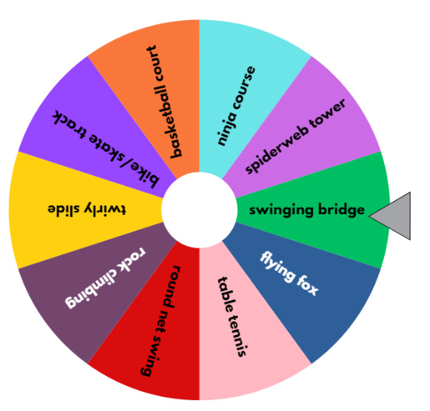
- Pose the scenario: The local playground equipment was damaged and cannot be used by community members. The council is looking to redevelop the park and their budget allows for 5 new pieces of playground equipment to be included in the park. There are 10 possibilities available: ninja course, spiderweb tower, swinging bridge, flying fox, table tennis, round net swing, rock climbing, twirly slide, bike/skate track and basketball court.
- Display Resource 19 – Which park equipment?
- One of the councillors decided that the quickest and easiest way to choose which 5 new pieces of playground equipment will be included in the park was to use a spinner.
- Display the pre-programmed spinner. Explain that the councillor will spin the wheel 5 times to determine the playground equipment.
- Students turn and talk to discuss whether they agree or disagree with the following statements:
- Elijah says that it is impossible for the result to be 5 of the same equipment pieces.
- Ahmed says that it is equally likely that each item could be selected in the park plan.
- Jen states that if the spinner lands on rock climbing, it is unlikely it will be selected again.
- Spin the spinner 5 times, selecting the Close button each time to ensure the outcome remains on the spinner for the following spins. Select the Results tab to view the results of the chance experiment.
- Ask the following questions:
- What problems might occur if a random spinner is used to determine the playground equipment?
- How could the spinner be changed so that each piece of equipment is only selected once?
- Explain that the spinner has the option to remove the selected playground equipment after each spin.
Note: this task allows students to conduct an experiment where the chance of one event occurring is affected by the occurrence of the other. When an outcome is not removed, the chance of each outcome occurring remains at 1 in 10. When an outcome is removed after each spin, although the remaining outcomes are equally likely, the likelihood increases to 1 in 9 for the second spin, 1 in 8 for the third spin and so on.
- Explain that by removing the selected outcome after each spin, it is impossible for the same piece of equipment to be selected more than once.
- Select Clear the list in the Results tab.
- Return to the main screen by selecting the Entries tab.
- Spin the spinner and select Remove to ensure the outcome is removed from the spinner prior to the next spin.
- Repeat 4 times. Select the Results tab to view the results of the chance experiment.
- Ask the following questions:
- How does removing an outcome after it has been randomly selected impact the overall results?
- After each spin, should the councillor keep or remove the selected outcome? Why?
- Students choose a chance event with no more than 8 variables that is affected by previous events. Examples could include taking a coloured lolly from a jar, drawing names out of a hat or being given a coloured ice block on a sports day.
- In pairs, students use digital devices and the spinner to conduct an experiment to randomly select 4 outcomes from their 8 variables. Remind students to choose the option to Remove the selected outcome after each spin. Select Results tab to see final results.
- Ask the following questions:
- What is the likelihood of each outcome being chosen on the first spin (1 in 8)
- What is the likelihood each outcome being chosen on the second spin (1 in 7)
- Can you predict the pattern for the remaining 2 outcomes? (1 in 6 and 1 in 5)
- If time permits, students repeat 4 times and compare results. A screenshot of this activity could be taken for assessment purposes.
- Students Think-Pair-Share to discuss what problems might arise for the council if the spinner method was used to select the new equipment. Answers could include:
- the park would not meet community needs and wants
- community members may not use the park as often
- the community may be upset that they were not consulted.
- Pose the following question: Is there a better way to choose the new equipment?
- Explain that another councillor decided to survey and collect data from 3 local primary schools. They presented the findings to the community at the town meeting. After analysing the data, the council decided to include a basketball court, ninja course, flying fox, rock climbing and bike/skate track.
- Ask students to turn and talk to determine which councillor’s strategy of developing the park plan was more effective, collecting and interpreting community data or using a spinner?
- Revise the benefits of collecting and interpreting data to make decisions.
Note: if time permits, students may like to design an aerial view plan for the park based on the results of their chance experiment.
This table details opportunities for differentiation.
Too hard? | Too easy?
Students cannot compare events where the chance of one event occurring is affected by the occurrence of the other.  - Reduce the number of outcomes added to the spinner to 4. Spin the spinner 2 times (without removing outcomes after each spin) and record the results. Reset the spinner. Spin the spinner another 2 times, removing the selected outcome after each spin. Record the results. Explore how the possible outcomes changed in each experiment. | Students can compare events where the chance of one event occurring is affected by the occurrence of the other.  - Students brainstorm a list of events where the chance of one event occurring is affected by the other. For example, selecting a King from a deck of cards after 2 Kings have already been drawn.

Stage 3 task 1 – interpreting timelines – 25 minutes
The table below contains suggested learning intentions and success criteria. These are best co-constructed with students.
Core concept learning intentions | Core concept success criteria
Stage 3 students are learning to:  - choose and use appropriate tables and graphs  - interpret and compare a range of data displays. | Stage 3 students can:  - recognise which types of data display are appropriate to represent data  - draw an accurate timeline using an appropriate scale  - interpret data on a timeline using the given scale.
Note: to ensure the scale is correct, print Resource 20 – mobile phone timeline on A4 size paper and do not resize.
- Provide each student with a copy of Resource 20 – mobile phone timeline. Ask the following questions:
- What information is being represented?
- What do you notice?
- What can we learn from this data?
- What is this type of data representation called?
- Explain that a timeline is a representation of events listed in chronological order. To make the timeline accurate, a many-to-one scale is used. For example, on Resource 20 – mobile phone timeline, the scale of 1 cm = 2 years is used.
- Students turn and talk with a partner to discuss the following questions. Ask:
- How can the date of an event be determined if there is no year or date labelled?
- How would you determine 5 years on the mobile phone timeline?
- How would you determine 20 years on the mobile phone timeline?
- Provide students with rulers and use the scale to mark out yearly increments along Resource 20 – mobile phone timeline.
- Display the following information for students to calculate and record the missing events on the timeline using the given scale:
- 1994 – the first smartphone
- 1992 – the first SMS
- 1999 – the first GPS
- 2000 – the first forward-facing camera
- 2009 – the first voice recognition
- 2012 – the first wireless charging.
- Students compare their completed timeline with a partner (see Figure 18).
Figure 18 – completed timeline
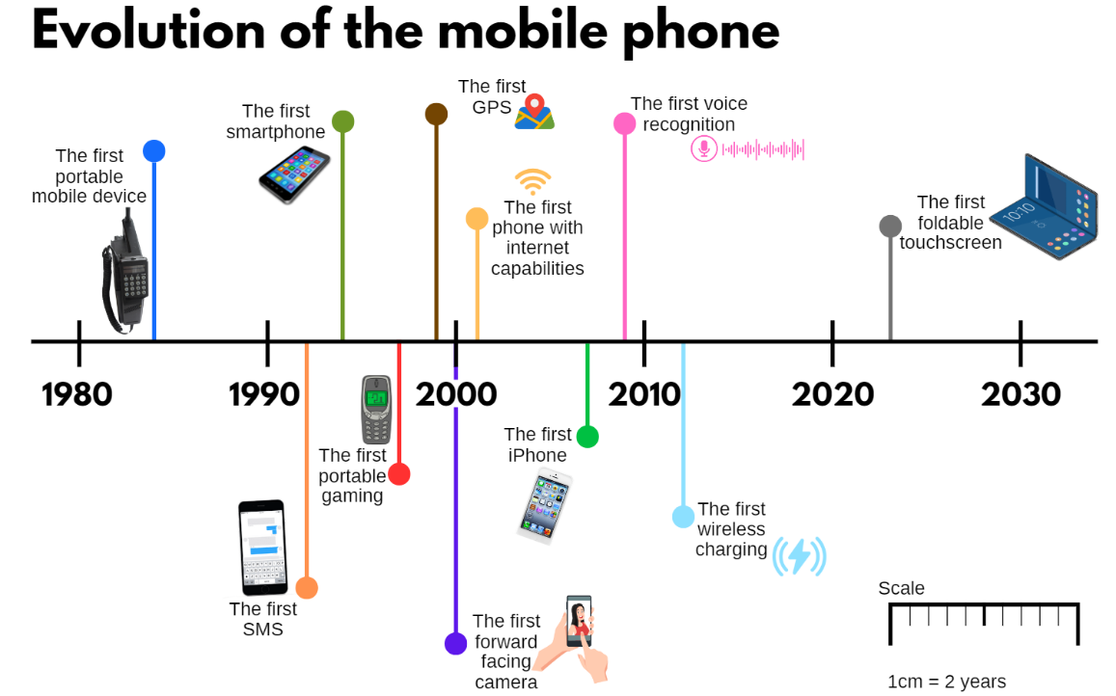
- Ask students the following questions:
- In what year did the first portable mobile device become available?
- When was it first possible to play games on a mobile device?
- Which decade has seen the most changes to mobile phones?
- How many years after the first portable mobile device became available was the first iPhone released?
- How many years after the first portable mobile device was available, did mobile phones begin using GPS?
- How many years before the first foldable touchscreen phone was a regular touchscreen mobile phone available?
- How many years would be represented by a section of the timeline that was 10 cm in length?
- How many years would be represented by a section of the timeline that was 7 cm in length? 11.5 cm?
Note: touchscreen capability was a feature of the first smartphone.

Stage 3 task 2 – creating timelines – 40 minutes
- Explain that students will be creating a scaled timeline for an area of interest. Suggested topics include: popular toys, video games, movies, film or book franchises, well-known brands, sporting teams, famous musicians, characters from films or TV shows and so on.
- Students research their chosen area of interest, identifying at least 5 major events.
- Remind students that on a scaled timeline, the intervals may be marked evenly, but events are placed using the scale according to time elapsed between events. The main purpose is to communicate time-related information.
- Students determine a scale that would be appropriate for their timeline.
- Ensure students understand that the important part of the timeline is the line and scaled markings. Decorations can be added later if time permits.
- Using rulers, students draw their timeline in their workbooks, adding at least 5 major events and a scale.
- Once completed, students turn and talk to compare their timeline with a partner. Discuss the following:
- How are your timelines similar?
- How are your timelines different?
- Was your scale appropriate? Did you need to adjust your scale for any reason?
- What did you learn about your chosen area of interest?
This table details opportunities for differentiation.
Too hard? | Too easy?
Students cannot draw an accurate timeline using an appropriate scale.  - Provide students with a timeline with the intervals already marked.  - Support students by reducing the number of events added to their timeline. | Students can draw an accurate timeline using an appropriate scale.  - Encourage students to use a digital application to create or design a timeline. Does this make it easier or harder to create a timeline? What tips would you give someone using this application to create a timeline for the first time?  - Challenge students to add more events to the timeline they created on an area of interest.

Discuss and connect the mathematics – 5 minutes
- Stage 3 students look at the 2 timelines they have used or created for this lesson. Ask Stage 3 students the following questions:
- Was a timeline the best way to display this data? Why or why not?
- Would a column graph be an appropriate way to display this data? Why or why not?
- What impacts the scale used in each timeline?
- What can be challenging when interpreting a timeline with a scale?
- Regroup and select Stage 2 students to share why it is important for the council to regularly collect data.
- Explain to Stage 2 students that councils make decisions by collecting and interpreting data on:
- population: age, gender and number of people in the local area
- water usage: average consumption per local area
- microchipped pets: household pets registered with the council
- library circulation: number of items circulated by council libraries
- recycle rate: the amount of waste collected by council that does not go to landfill and is usually recycled.
- Stage 2 student pairs select one of the above and provide reasons why it may be important for councils to collect data on these matters of interest.
This table details opportunities for assessment.
Assessment opportunities | Links
What to look for:  - Can Stage 2 students investigate how data is interpreted to make decisions? [MAO-WM-01, MA2-DATA-02]  - Can Stage 2 students compare the likelihood of obtaining particular outcomes in a simple chance experiment by predicting, conducting the experiment and comparing the results with the prediction? [MAO-WM-01, MA2-CHAN-01]  - Can Stage 2 students compare events where the chance of one event occurring is affected by the occurrence of the other?  [MAO-WM-01, MA2-CHAN-01]  - Can Stage 3 students recognise which types of data display are appropriate to represent data? [MAO-WM-01, MA3-DATA-01]  - Can Stage 3 students draw an accurate timeline using an appropriate scale? [MAO-WM-01, MA3-DATA-01]  - Can Stage 3 students interpret data on a timeline using the given scale? [MAO-WM-01, MA3-DATA-02] | Links to National Numeracy Learning Progressions (NNLP):  - Stage 2 – IRD3, UnC3  - Stage 3 – MeT4, IRD4.

Lesson 6
Core concept: interpreting data helps us solve problems and ask new questions.

Daily number sense – largest number wins – 15 minutes
The table below contains suggested learning intentions and success criteria. These are best co-constructed with students.
Daily number sense learning intentions | Daily number sense success criteria
Students working towards Stage 2 outcomes are learning to:  - recognise and represent numbers that are 10, 100 or 1000 times as large  Students working towards Stage 3 outcomes are learning to:  - recognise that the place value system can be extended beyond hundredths | Students working towards Stage 2 outcomes can:  - describe how making a number 10, 100 or 1000 times as large changes the place value of digits  - recognise the number of tens, hundreds or thousands in a number.  Students working towards Stage 3 outcomes can:  - express thousandths as decimals  - indicate the place value of digits in decimal numbers of up to 3 decimal places.
Note: prepare Resource 21 – place value cards for Stage 2 students and Resource 22 – thousandth more or less for Stage 3 students prior to the lesson by printing and cutting one set per small group (3 to 4 students).
- Randomly place cards from Resource 21 – place value cards for Stage 2 students and Resource 22 – thousandth more or less for Stage 3 students face down in the centre of the small group of players.
- Explain that the aim of the game is to make the largest number.
- Explain Stage 2 game rules:
- Players take turns to roll two 10-sided die and record the number rolled as a 2-digit number. For example, if a 6 and a 2 are rolled, the number 62 would be recorded.
- After each roll, the player flips over a card and makes the number rolled that many times as large. For example, if a 62 is rolled and the card flipped says ‘× 100’, it would become 6200.
- Repeat until each player has had a turn.
- The player with the largest number receives a point if they can read the number aloud correctly.
- Shuffle cards after each round of play.
- The player with the most points at the end of the game period, wins.
- Explain Stage 3 games rules:
- Players take turns to roll four 9-sided dice. Numbers rolled are used to make a number up to 3 decimal places. For example, if 4, 9, 8 and 3 are rolled, the student may make the number 9.843.
- After each roll, the player flips over a card and makes the number rolled either one thousandth more or less. For example, 9.843 would become either 9.842 or 9.844.
- Repeat until each player has had a turn.
- The player with the largest number receives a point if they can read the number aloud correctly.
- Remind Stage 3 students how decimals should be read aloud, for example, 9.843 is read as ‘9 and 843 thousandths’, not ‘nine point eight four three’.
- Shuffle cards after each round of play.
- The player with the most points at the end of the game period, wins.
- Provide small groups (3 to 4 students) with a pre-prepared card set of Resource 21 – place value cards and 10-sided dice for Stage 2 students, and Resource 22 – thousandth more or less and 9-sided dice for Stage 3 students to play the game.
- Regroup and share reflections. Ask Stage 2 students: How does making the number 10, 100 or 1000 times as large, change the place value of the digits? Select Stage 3 students to say a chosen decimal number aloud and identify the ones, tenths, hundredths and thousandths.
This table details opportunities for assessment.
Assessment opportunities | Links
What to look for:  - Can Stage 2 students recognise the number of tens, hundreds or thousands in a number? [MAO-WM-01, MA2-RN-01]  - Can Stage 2 students describe how making a number 10, 100 or 1000 times as large changes the place value of digits?  [MAO-WM-01, MA2-RN-01]  - Can Stage 3 students express thousandths as decimals?  [MAO-WM-01, MA3-RN-02]  - Can Stage 3 students indicate the place value of digits in decimal numbers of up to 3 decimal places? [MAO-WM-01, MA3-RN-02] | Links to National Numeracy Learning Progressions (NNLP):  - Stage 2 – NPV7, NPV8, NPV9  - Stage 3 – NPV7, NPV8.  Links to suggested Interview for Student Reasoning (IfSR) tasks:  - Stage 2 – IfSR-NP: 4B.6  - Stage 3 – IfSR-NP: 4D.2.

Core lesson – playground investigation – 45 minutes
The table below contains suggested learning intentions and success criteria. These are best co-constructed with students.
Core concept learning intentions | Core concept success criteria
Students working towards Stage 2 outcomes are learning to:  - interpret and compare data  - select and trial methods for data collection  - organise and display data using tables and graphs.  Students working towards Stage 3 outcomes are learning to:  - collect categorical and discrete numerical data by observation or survey. | Students working towards Stage 2 outcomes can:  - investigate how data is interpreted to make decisions  - refine survey questions as necessary after a small trial  - compare the effectiveness of different methods of collecting and recording data  - construct column graphs (with scale intervals of 1) and dot plots using relevant software where appropriate.  Students working towards Stage 3 outcomes can:  - pose and refine questions to construct a survey to obtain categorical or discrete numerical data about a matter of interest  - collect ordinal or nominal categorical data, and discrete numerical data through observation or by conducting surveys.
- Remind Stage 2 students and introduce Stage 3 students to the following scenario: The local playground equipment was damaged and cannot be used by community members. The council are looking to redevelop the park and their budget allows for 5 new pieces of playground equipment to be included in the park. There are 10 possibilities available: ninja course, spiderweb tower, swinging bridge, flying fox, table tennis, round net swing, rock climbing, twirly slide, bike/skate track and basketball court. Display Resource 19 – Which park equipment?
- Remind Stage 2 students and explain to Stage 3 students that a councillor decided to survey and collect data from 3 local primary schools. They presented the findings to the community at the town meeting. After analysing the data, the council decided to include a basketball court, ninja course, flying fox, rock climbing and bike/skate track.
- Explain that the councillor has contacted local teachers to check if the data is accurate. She is worried that the data on favourite playground equipment was from a range of ages. She wants to ask students from Year 3–6 what equipment they would like to be included in the park.
- Display Resource 23 – councillor’s email. Explain that the councillor has drafted an email and is deciding on the best question to use. She has narrowed it down to 3 possible survey questions. Ask the following questions using prompts from the table below:
The table below outlines stimulus prompts to generate conversation about the topic, along with anticipated responses from students.
Prompts | Anticipated student responses
- What are the benefits of each question and why? | - For the first question, new and interesting ideas could be shared. The number of responses is not limited. For example, someone could share 10 pieces of equipment and someone else could share 3 pieces of equipment.  - For the second question, there are 10 pieces of equipment which everyone can choose from. This would make collecting the data and interpreting the results easier.  - For the third question, new and interesting ideas could be shared. Asking for one response only means that a student would pick their absolute favourite.
- What are the limitations of each question and why? | - For the first question, the results could include over 50 different pieces of equipment. When the results are interpreted, there may only be one person who recorded a particular piece of equipment, even though many people might like it but did not think to record it.  - For the second question, there is a limit to the pieces of equipment and there is no option for you to share any other ideas.  - For the first and third questions, students could call a piece of equipment different names. For example, slide or slippery dip.  - For the second and third questions, having one response may not show enough difference between pieces of equipment.
- Explain that the councillor has decided to use the second question, ‘Which playground equipment would you like included in the park? Select one option.’
- Your class teacher has agreed to help the council in the following ways:
- Stage 2 students are tasked with providing feedback on the question ‘Which playground equipment would you like included in the park? Select one option’ by conducting a small trial with their class. This will enable the councillor to refine the survey question before using it with other schools (see Stage 2 task – dot plot).
- Stage 3 students are tasked with collecting data on 2 different questions to assist the council with park planning (see Stage 3 task – categorical and numerical data).
Note: use Resource 19 – Which park equipment? to develop a common understanding of the options council have provided, to ensure all students can make an informed decision. For example, if a student has no firsthand experience with a ninja course, another student’s experience may support their understanding of why it could be a good option for the park plan.

Stage 2 task – dot plot
- Stage 2 students make an x-axis with masking tape across the floor of the classroom. Label the axis by placing sticky notes with equipment names along the strip at equal intervals (see Figure 19).
Figure 19 – x-axis example
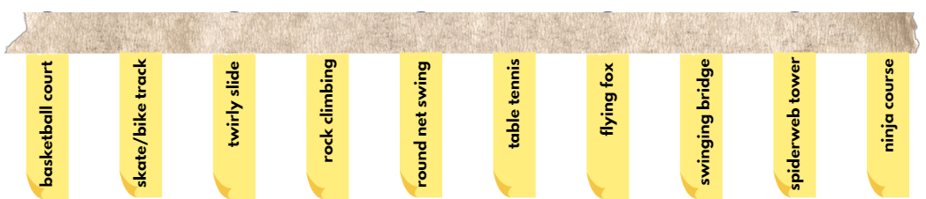
- Provide each student with a blue counter. Explain that the counters will be used to create a dot plot of student responses.
- Students place their counter above the playground equipment piece they would like included in the park plan (see Figure 20).
Note: all students in the class should do this, not just Stage 2 students to ensure maximum data responses.
Figure 20 – equipment choices dot plot example
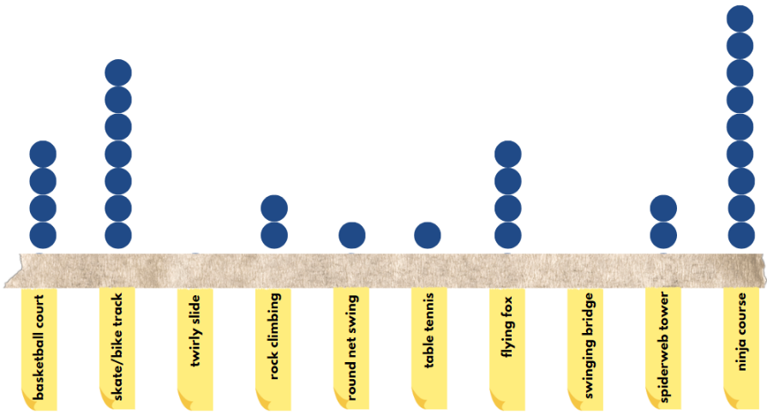
- View the class dot plot and ask the following questions using the prompts box below:
The table below outlines stimulus prompts to generate conversation about the topic, along with anticipated responses from students.
Prompts for Stage 2 | Anticipated Stage 2 responses
- Is a dot plot an effective way to gather and display our class data? | - Using counters to create a dot plot was a very quick way of collecting data for our class.  - The dot plot allows us to quickly see which playground equipment was the most popular. However, if we wanted to know how many students voted for each, it would require us to individually count each counter. A table or column graph would be easier to interpret.
- Would a dot plot be an effective way to gather and display data if 1000 people were surveyed? | - In a larger trial, this method of data collection would not be very effective or efficient. Counters could be knocked, not placed in a straight line or placed with inconsistent gaps between each one.  - No, it would not be an effective data collection method. There could be hundreds of dots for each piece of equipment. It would be hard to create. It would also be difficult to interpret because it would take a long time to count the number of total votes for each piece of equipment.
- Which playground equipment piece was most popular? | - Dependent on class results.
- Would our class data provide the council with enough information to inform the park plan? | - Our data only gives us information about what our class would like included in the plan. I think the council would need to ask more students in a larger trial to make the final decision.  - No one wants to play in a park with only one piece of equipment. By only allowing students to vote once, the council will determine the most popular piece of equipment. If the council are planning to develop a whole park, they should ask students to select more than one option.
- Do you predict the data would change if everyone were able to vote for 2 pieces of equipment? Why or why not? | - I think the data could change if we were allowed to vote twice. It would give the council more information about the different pieces of equipment that should be included in the park.  - The data might stay the same. For example, the same piece of equipment might still be the most popular. However, it would be more effective as it would better represent students’ preferences. This would help council to develop a plan that best suits the needs of the community.
- Provide each student with a red counter to add to the dot plot to indicate their second choice. Explain to students that they cannot vote for the same piece of equipment (see Figure 21).
Figure 21 – equipment choices dot plot example with 2 votes
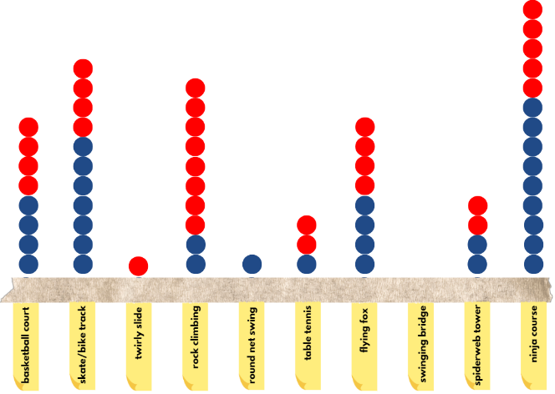
- Ask Stage 2 students the following questions:
- Did the results change by giving students a second vote?
- If the dot plot used the same-coloured counters for both preferences, how would this affect the data's interpretation?
- Take a photograph of the dot plot for use in Lesson 7.
This table details opportunities for differentiation.
Too hard? | Too easy?
Students cannot compare the effectiveness of different methods of collecting and recording data.  - Support students to transfer the data from the dot plot into a tally table. Ask students to determine which method of recording data they find easier to interpret and justify their response. | Students can compare the effectiveness of different methods of collecting and recording data.  - Students use the data from the dot plot to create a table with 3 columns next to the equipment options, labelled ‘first choice’, ‘second choice’ and ‘total.’ Students analyse results to determine if separating the data by order of choice is more or less effective than grouping together in the total.

Stage 3 task – categorical and numerical data
- Display Resource 24 – data cycle for Stage 3 students. Explain the different components of the data cycle: posing questions, collecting data, representing data and interpreting data.
- Explain that the council has previously used these 2 survey questions:
- What types of plants should be included in the park?
- How many times a week do you go to the park with your family?
- Stage 3 students turn and talk to discuss and record their responses to the survey questions on individual whiteboards.
- Regroup and select Stage 3 students to share their responses.
- Record student responses on the board underneath each survey question. Ask the following questions:
- Which of the survey questions had a wider range of responses? Why?
- How could the data about the plants be categorised? (trees, cacti, flowers, herbs)
- Would the data collected from these survey questions be helpful for the council? How?
- Would they need to collect other data to help them plan the new park?
- Explain that 2 different types of data were collected with the survey questions asked by the council. The question about plants collected categorical data. The question about visiting the park with the family collected discrete numerical data. Share the definition of categorical and discrete numerical data with students.
Categorical data: data that can be separated into distinct groups. For example, colour, gender, blood type.
Discrete numerical data: describes items or events that can only be counted in whole number values, where values in between the whole numbers cannot be found or labelled in the data display. For example, the number of children in a family.
Note: students in Stage 3 should develop an understanding of discrete numerical data and categorical data so that they are able to pose and refine questions accordingly. They are not expected to classify or describe data as numerical or categorical; this is an expectation of Stage 4 students.
This activity is designed to be completed over Lesson 6 and Lesson 7 of this unit. Students will be following the data cycle to pose questions, collect data, represent the data in several ways, and then interpret, analyse and draw conclusions from the data. While this activity has been written to follow the premise of local park, it could be changed to suit the school or class situation while still following the same sequence. Students are given the option of designing survey questions for parents. If students select this option, the survey could be administered through electronic distribution, by inviting community members into the classroom or surveying other teachers at school.
- Explain to Stage 3 students that the council has asked for their assistance to develop other survey questions to help them with their park planning. Display and read Resource 25 – council survey criteria. Explain that the recording form can be paper-based or digital.
- Provide small groups of Stage 3 students with writing materials, paper and Resource 25 – council survey criteria. Students brainstorm possible survey questions and create a draft of their recording form.
- Each group shares their questions and recording form with another group. Stage 3 students give feedback according to Resource 25 – council survey criteria and refine their survey questions based on feedback received.
- Stage 3 groups transfer their survey questions onto paper or into a digital format such as Microsoft Forms or Google Forms. Each student in the class completes the surveys created. If students have designed a survey for parents, they may choose to survey available staff members.
Note: if students choose to create their survey on paper, discuss survey collection methods with the class prior to Step 29. Students may wish to consider how they will keep track of who has been surveyed and how they will collate their data accurately.
- Stage 3 groups collect and view their survey data.
- Each group shares their data with another group for peer feedback using the ‘Two stars and a wish’ strategy, which can be recorded on an individual whiteboard (see Figure 22). Groups identify 2 things they liked about the survey and one thing they would like to change.
Figure 22 – two stars and a wish

- Students read feedback and refine their questions further, if required.
This table details opportunities for differentiation.
Too hard? | Too easy?
Students cannot pose and refine questions to construct a survey to obtain categorical or discrete numerical data about a matter of interest.  - Support students by providing a bank of questions to choose from.  - Brainstorm questions as a class or small group, discussing what makes some questions better for this activity than others. | Students can pose and refine questions to construct a survey to obtain categorical or discrete numerical data about a matter of interest.  - Create a second survey with questions about a different school/community issue, such as canteen food, school or community garden, excursion ideas and so on.  - Students administer their survey across multiple classes/cohorts in the school and present a summary of the data to the class.

Discuss and connect the mathematics – 10 minutes
- Stage 2 and Stage 3 students share questions posed and data collected with the whole class.
- Display Stage 2 dot plot and discuss the effectiveness of the question: ‘Which playground equipment would you like included in the park? Select one option’. Ask the following questions:
- Should the councillor only allow students to make one choice when completing the survey?
- How could the question be refined to ensure the park meets community needs?
- Is there any other feedback our class could give to the councillor?
- Display a sample of data collected by Stage 3 students. Ask the following questions:
- Does the data help the council with their park planning?
- Which survey questions would be the most helpful for the council? Why?
- Has there been enough data collected for the council to redesign their park? How do you know?
- If more data needs to be collected, what other questions should the council ask?
- Display Resource 24 – data cycle and discuss the data cycle and investigation so far. Ask Stage 3 students the following prompts:
- What part of the cycle have we completed so far?
- Was there anything you found challenging during these parts of the cycle?
- What do you think the next part of the cycle will look like for this investigation?
This table details opportunities for assessment.
Assessment opportunities | Links
What to look for:  - Can Stage 2 students investigate how data is interpreted to make decisions? [MAO-WM-01, MA2-DATA-02]  - Can Stage 2 students refine questions as necessary after a small trial? [MAO-WM-01, MA2-DATA-02]  - Can Stage 2 students compare the effectiveness of different methods of collecting and recording data? [MAO-WM-01,  MA2-DATA-02]  - Can Stage 2 students construct column graphs (with scale intervals of 1) and dot plots using relevant software where appropriate? [MAO-WM-01, MA2-DATA-01]  - Can Stage 3 students pose and refine questions to construct a survey to obtain categorical or discrete numerical data about a matter of interest? [MAO-WM-01, MA3-DATA-01]  - Can Stage 3 collect ordinal or nominal categorical data, and discrete numerical data through observation or by conducting surveys. [MAO-WM-01, MA3-DATA-01] | Links to National Numeracy Learning Progressions (NNLP):  - Stage 2 – IRD3.  - Stage 3 – IRD3, IRD4, IRD5.

Lesson 7
Core concept: data is represented in different ways for different purposes.

Daily number sense – smallest to largest – 10 minutes
The table below contains suggested learning intentions and success criteria. These are best co-constructed with students.
Daily number sense learning intentions | Daily number sense success criteria
Students working towards Stage 2 outcomes are learning to:  - recognise and represent numbers that are 10, 100 or 1000 times as large.  Students working towards Stage 3 outcomes are learning to:  - recognise that the place value system can be extended beyond hundredths  - make connections between benchmark fractions, decimals and percentages. | Students working towards Stage 2 outcomes can:  - recognise the number of tens, hundreds or thousands in a number.  Students working towards Stage 3 outcomes can:  - indicate the place value of digits in decimal numbers of up to 3 decimal places  - recall commonly used equivalent percentages, decimals and fractions including $\frac{1}{2}$, $\frac{1}{4}$, and $\frac{3}{4}$.
- Display Resource 26 – smallest to largest for Stage 2 students and Resource 27 – What’s missing? for Stage 3 students.
- Explain that the labelled sticky notes fell off the number line and need to be placed back on in order.
- Draw Stage 3 students’ attention to the percentages on some sticky notes. Students turn and talk to identify where 90% would be placed on the number line. Select students to explain their answer and reasoning.
- Provide students with writing materials to draw the number line and place the sticky notes in the correct position.
- Instruct students to read the number aloud as they place it on the number line. Remind Stage 3 students that the decimal 0.918 is read as ‘918 thousandths’, not ‘zero point nine one eight’.
- Students turn and talk with a partner to share strategies and their solution. Ask:
- Can you identify the place value for each of the digits in a chosen number, for example, 1800 for Stage 2 students and 0.901 for Stage 3 students?
- How can you check that you have placed the numbers in the correct order along the number line?
- How many tens, hundreds or thousands are in 6500? (Stage 2)
- Did you think differently to place the fraction and percentages (Stage 3)?
- Did you place all the sticky notes? Why or why not (Stage 3)?
This table details opportunities for assessment.
Assessment opportunities | Links
What to look for:  - Can Stage 2 students recognise the number of tens, hundreds or thousands in a number? [MAO-WM-01, MA2-RN-01]  - Can Stage 3 students indicate the place value of digits in decimal numbers of up to 3 decimal places? [MAO-WM-01, MA3-RN-02]  - Can Stage 3 students recall commonly used equivalent percentages, decimals and fractions including $\frac{1}{2}$, $\frac{1}{4}$, and $\frac{3}{4}$?  [MAO-WM-01, MA3-RN-03] | Links to National Numeracy Learning Progressions (NNLP):  - Stage 2 – NPV7  - Stage 3 – NPV7, NPV8, PrT2.  Links to suggested Interview for Student Reasoning (IfSR) tasks:  - Stage 2 – IfSR-NP: 4B.3, 4B.4  - Stage 3 – IfSR-NP: 4D.2, 4D.6.

Core lesson – representing data – 50 minutes
The table below contains suggested learning intentions and success criteria. These are best co-constructed with students.
Core concept learning intentions | Core concept success criteria
Students working towards Stage 2 outcomes are learning to:  - construct and interpret data displays with many-to-one scales  - organise and display data using tables and graphs  - interpret and compare data.  Students working towards Stage 3 outcomes are learning to:  - choose and use appropriate tables and graphs  - describe and interpret different datasets in context. | Students working towards Stage 2 outcomes can:  - use a given many-to-one scale to represent discrete data in column graphs  - construct column graphs (with scale intervals of 1) and dot plots using relevant software where appropriate  - use data in a spreadsheet to create column graphs with units on vertical axes that are in multiples  - investigate how data is interpreted to make decisions.  Students working towards Stage 3 outcomes can:  - recognise which types of data display are appropriate to represent data  - determine an appropriate scale (horizontal and vertical) to represent the data  - construct column graphs using a many-to-one scale, with and without the use of digital technologies  - determine the total number of data values represented in column graphs.
- Display Resource 24 – data cycle. Remind students about the parts of the cycle seen in Lesson 6.
- Brainstorm the different ways data can be displayed and for what purpose:
- picture graphs and dot plots – used to show a small number of data values, with one-to-one correspondence (refer to the photograph of the dot plot created in Lesson 6)
- column graphs – used to display categorical or discrete numerical data
- line graphs – used to display continuous data (Stage 3).
- Students examine the data they collected during Lesson 6 and determine which representation would be the most appropriate (column graph). Explain that the Lesson 6 data will be used to make a column graph later in the lesson but first the local council needs help again.
- After receiving feedback, the councillor refined the question and sent a survey to the Stage 2 and Stage 3 classes at Rivenoak Public School (RPS). Students were allowed to vote for 2 pieces of playground equipment to be included in the council’s plan.
- Display Resource 28 – Rivenoak School’s results. Ask:
- In what ways are the RPS results similar or different to our class results? (refer to the photograph of the dot plot created in Lesson 6)
- There were 320 votes submitted. How many students completed the survey? Justify your reasoning.
- How many more students voted for the ninja course than the basketball court?
- Based on our class data and Rivenoak’s data, which pieces of playground equipment do you think the council should include in the plan?
- Explain that the councillor needs to present this information to the local community at the town meeting. She would like to present the information in a column graph. She has asked students in the class to create the graphs using software such as Microsoft Excel or Google Sheets.
Note: a scale of many-to-one correspondence in a column graph or line graph means that one unit is used to represent more than one of what is being counted or measured. For example, 1 cm on the vertical axis could be used to represent 20 centimetres of body height.
- Remind students that a many-to-one column graph must include a title, axes names and labels and a scale.
- Demonstrate how to create a column graph in Microsoft Excel, using RPS’s data.
- Enter the data into a table (see Figure 23).
- Highlight the data.
- Select the Insert tab in the ribbon.
- Select the Insert Column or Bar Chart icon.
- Select Clustered Column from the 2D Column menu.
- Change the title to ‘Rivenoak PS results’ by double-clicking on the text.
- Right-click on the graph and select the Chart Elements icon.
- Select Axis Titles.
- Name the axes by double-clicking on the text.
Figure 23 – Rivenoak Public School’s results
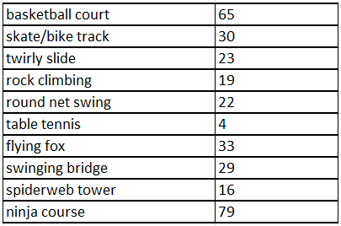
- Provide pairs with digital devices. Students repeat the modelled steps to create a column graph, with a many-to-one scale, using Rivenoak Public School’s data.
- Explain that the software automatically displays the information in a many-to-one scale with intervals of 10 on the y-axis. This can make comparing the data challenging.
- In the Chart Elements icon, select Data Labels to add the numerical total for each category to the graph (see Figure 24).
Figure 24 – Rivenoak Public School results column graph
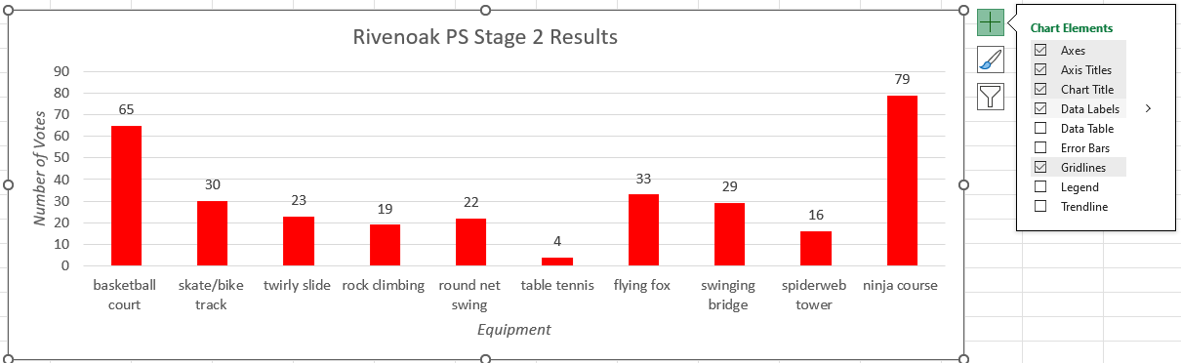
- Ask:
- Why is labelling each category with a total useful when interpreting this graph?
- Would a many-to-one scale with intervals of 5 be more appropriate for this data set? Why or why not?
- Students save their spreadsheet for future reference.
- Stage 3 students choose one of their datasets from Lesson 6 and Stage 2 students use the dot plot created in Lesson 6 to represent using a many-to-one scale column graph.
- Students turn and talk with a partner to discuss and compare their graphs (if possible, partner a Stage 2 and a Stage 3 student together).
- Ask students to identify:
- What is similar about their graphs?
- What is different about their graphs?
- What is the scale on your y-axis?
- How many people were surveyed to obtain the data for the data display? How do you know?
- Why is a scale of one not used for this data display?
- Would these datasets work using a line graph or timeline? Why or why not? (Stage 3)
This table details opportunities for differentiation.
Too hard? | Too easy?
Stage 2 students cannot use data in a spreadsheet to create column graphs with units on vertical axes that are in multiples.  - Students enter the class data from Lesson 6, into a table and column graph in Microsoft Excel or Google Sheets. Support students to create a column graph with scale intervals of one.  Stage 3 students cannot construct column graphs using a many-to-one scale, with and without the use of digital technologies.  - Reduce the size of the dataset students are expected to graph.  - Determine the many-to-one scale for students to use. | Stage 2 students can use data in a spreadsheet to create column graphs with units on vertical axes that are in multiples.  - Students explore how to change the many-to-one scale of their graph in Microsoft Excel or Google Sheets.  Stage 3 students can construct column graphs using a many-to-one scale, with and without the use of digital technologies.  - Students use the same dataset to create a horizontal column graph. Does this affect the way you read the graph?  - Students re-create their graph using a different scale. Discuss with a classmate how the scale impacts the interpretation of the data and the conclusions drawn from the graph.

Discuss and connect the mathematics – 10 minutes
- Display Resource 29 – many-to-one displays. Explain that both column graphs represent the same data, but the many-to-one scale is different.
- Students Think-Pair-Share. Ask the following questions:
- Which many-to-one scale would be the best for this data set?
- Which many-to-one scale would be the best to display the combined data of all Stage 2 and 3 students from multiple local schools?
- Is the table useful to help interpret the many-to-one scale? Why or why not?
- Display Resource 30 – best data representation. Ask the following questions:
- What do you notice about these data displays?
- What types of data displays can you observe here?
- How many people were surveyed to obtain the data for the data display? How do you know?
- Which data display is the most appropriate to represent the data collected? Why?
This table details opportunities for assessment.
Assessment opportunities | Links
What to look for:  - Can Stage 2 students use a given many-to-one scale to represent discrete data in column graphs?  [MAO-WM-01, MA2-DATA-01, MA2-DATA-02]  - Can Stage 2 students use data in a spreadsheet to create column graphs with units on vertical axes that are in multiples?  [MAO-WM-01, MA2-DATA-01, MA2-DATA-02]  - Can Stage 2 students construct column graphs (with scale intervals of 1) and dot plots using relevant software where appropriate? [MAO-WM-01, MA2-DATA-01]  - Can Stage 2 students investigate how data is interpreted to make decisions? [MAO-WM-01, MA2-DATA-02]  - Can Stage 3 students recognise which types of data display are appropriate to represent data? [MAO-WM-01, MA3-DATA-01]  - Can Stage 3 students determine an appropriate scale (horizontal and vertical) to represent the data?  [MAO-WM-01, MA3-DATA-01, MA3-DATA-02]  - Can Stage 3 students construct column graphs using a many-to-one scale, with and without the use of digital technologies?  [MAO-WM-01, MA3-DATA-01]  - Can Stage 3 students determine the total number of data values represented in column graphs? [MAO-WM-01, MA3-DATA-02] | Links to National Numeracy Learning Progressions (NNLP):  - Stage 2 – IRD3, IRD4  - Stage 3 – IRD3, IRD4, IRD5.

Lesson 8
Core concept: mathematicians interpret and evaluate the effectiveness of real-world data.

Daily number sense – 10 minutes
- From a class need surfaced through formative assessment data, identify a short, focused activity that targets students’ knowledge, understanding and skills. Example activities may be drawn from the following resources:
- Mathematics K–6 resources
- Universal Resources Hub.

Core lesson 1 – interpreting data – 25 minutes
The table below contains suggested learning intentions and success criteria. These are best co-constructed with students.
Core concept learning intentions | Core concept success criteria
Students working towards Stage 2 outcomes are learning to:  - interpret and compare data  - construct and interpret data displays with many-to-one scales.  Students working towards Stage 3 outcomes are learning to:  - describe and interpret different datasets in context  - interpret data presented in digital media and elsewhere. | Students working towards Stage 2 outcomes can:  - investigate how data is interpreted to make decisions  - describe and interpret information presented in tally tables and column graphs  - interpret and evaluate the effectiveness of various data displays found in media and in factual texts where displays represent data using a scale of many-to-one.  Students working towards Stage 3 outcomes can:  - describe and interpret data presented in tables, column graphs and line graphs  - interpret data representations found in digital media and in factual texts  - identify sources of possible bias in representations of data in the media  - identify misleading representations of data in the media.
- Ask students to think back to the park scenario from Lesson 5 and Lesson 6: The local playground equipment was damaged and cannot be used by community members. The council are looking to redevelop the park. In addition to the data examined previously, the council has been provided with a range of data that has been collected and represented by an external company. They have asked for assistance to interpret the range of data to ensure the new playground will meet community needs.
- Display Resource 31 – council research. Ask the following questions:
- What do you notice about the information the council collected?
- What do the data displays have in common?
- Which data display is easiest to interpret? Why?
- Draw attention to the many-to-one scale used in the ‘Favourite Playground Equipment’ and ‘Facilities and Infrastructure Priorities’ data displays. Remind students that when the equal spaces (intervals) represent more than one item or response, it is called a many-to-one scale.
Many-to-one scale: a scale of many-to-one uses one unit or interval to represent more than one item or response.
- Ask the following questions:
- Why do the equal spaces (intervals) on these data displays increase in fives and tens?
- When should data be presented using a many-to-one scale?
- What are some positives and negatives about using a many-to-one scale?
- Provide students with one of the following: Resource 32 – interpreting data 1, Resource 33 – interpreting data 2 or Resource 34 – interpreting data 3.
- Students find a partner that has the same data display. Pairs analyse and interpret the data display and discuss the questions.
- Allocate students to a new group, consisting of one representative for each data display. Each student shares their data display and answers with the group.
- Regroup and ask the following questions:
- What information can be interpreted from each data representation?
- How can this data help inform the council’s plan to redevelop the park?
- Does the council need to collect any further data to inform the park plan?

Core lesson 2 – misleading data – 20 minutes
This activity is an adaptation of How to spot a misleading graph on TED-Ed by Gaslowitz.
- View the video How to spot a misleading graph (4:09).
- Students Think-Pair-Share the strategies they noticed that were used to mislead people. Ensure students identify the manipulation of the data display labels, numbering, scale and context as the main ways data displays can be used to mislead.
- Display Resource 35 – data display 1. Ask the following questions:
- How could the data display be misleading?
- Which strategies could be used to make it misleading?
- Why might people want to make a display misleading?
- If you were going to explain to a younger student how data displays could be made to be misleading, what would you tell them?
- In pairs, ask students to identify the ways the data display has been manipulated.
- Select students to report back to the class, using examples from the data display to justify their choices (see Figure 25).
Figure 25 – student work examples
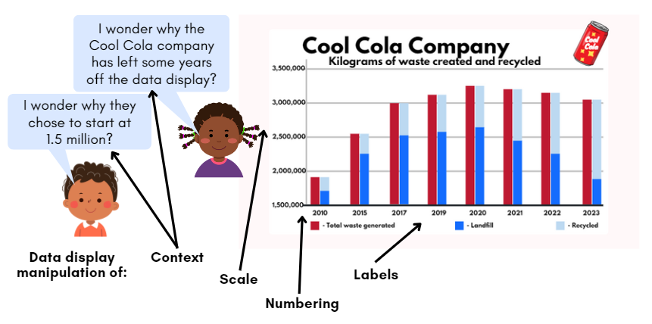
- Display Resource 36 – data display 2 to discuss and highlight the features of the accurate data display and contrast with the misleading data display shown in Resource 35 – data display 1.
Too hard? | Too easy?
Stage 2 students cannot investigate how data is interpreted to make decisions.  - Provide students with Resource 33 – interpreting data 2. Support students to count the tally marks and record the total numerically.  - Students reflect on their own playground equipment preferences as a 6–9-year-old child. Consider how a park designed for 6–9-year-olds would differ from a park designed for 0–4-year-olds.  Stage 3 students cannot identify misleading representations of data in the media.  - Explain the strategy used to mislead for each display and have students identify evidence where the strategy has been used on the data display.  - View BTN – World Statistics day (4:20). Students identify the different ways data can be manipulated. Pause the clip at each new data set to identify the way it is being used to mislead. | Stage 2 students can investigate how data is interpreted to make decisions.  - Students create their own questions for a peer to answer based on the data sets.  - Provide students with access to the local council website. They investigate whether there are any current community consultation projects.  Stage 3 students can identify misleading representations of data in the media.  - Students create a poster or digital resource to support other students to identify the ways data can be used to mislead.  - Challenge students to design a data display with at least one misleading element. Students show the data display to a classmate and ask them to identify the misleading element(s).

Discuss and connect the mathematics – 15 minutes
- Display Resource 36 – data display 2 for Stage 2 students and Resource 37 – data display 3 for Stage 3 students.
- In pairs, students cut a hole in an A4 piece of paper to place over the data display to ‘spotlight’ a portion of the data to show how data could be misrepresented and misinterpreted if only parts of the data is seen (see Figure 26 for Stage 2 examples and Figure 27 for Stage 3 examples).
Figure 26 – Stage 2 examples of spotlights
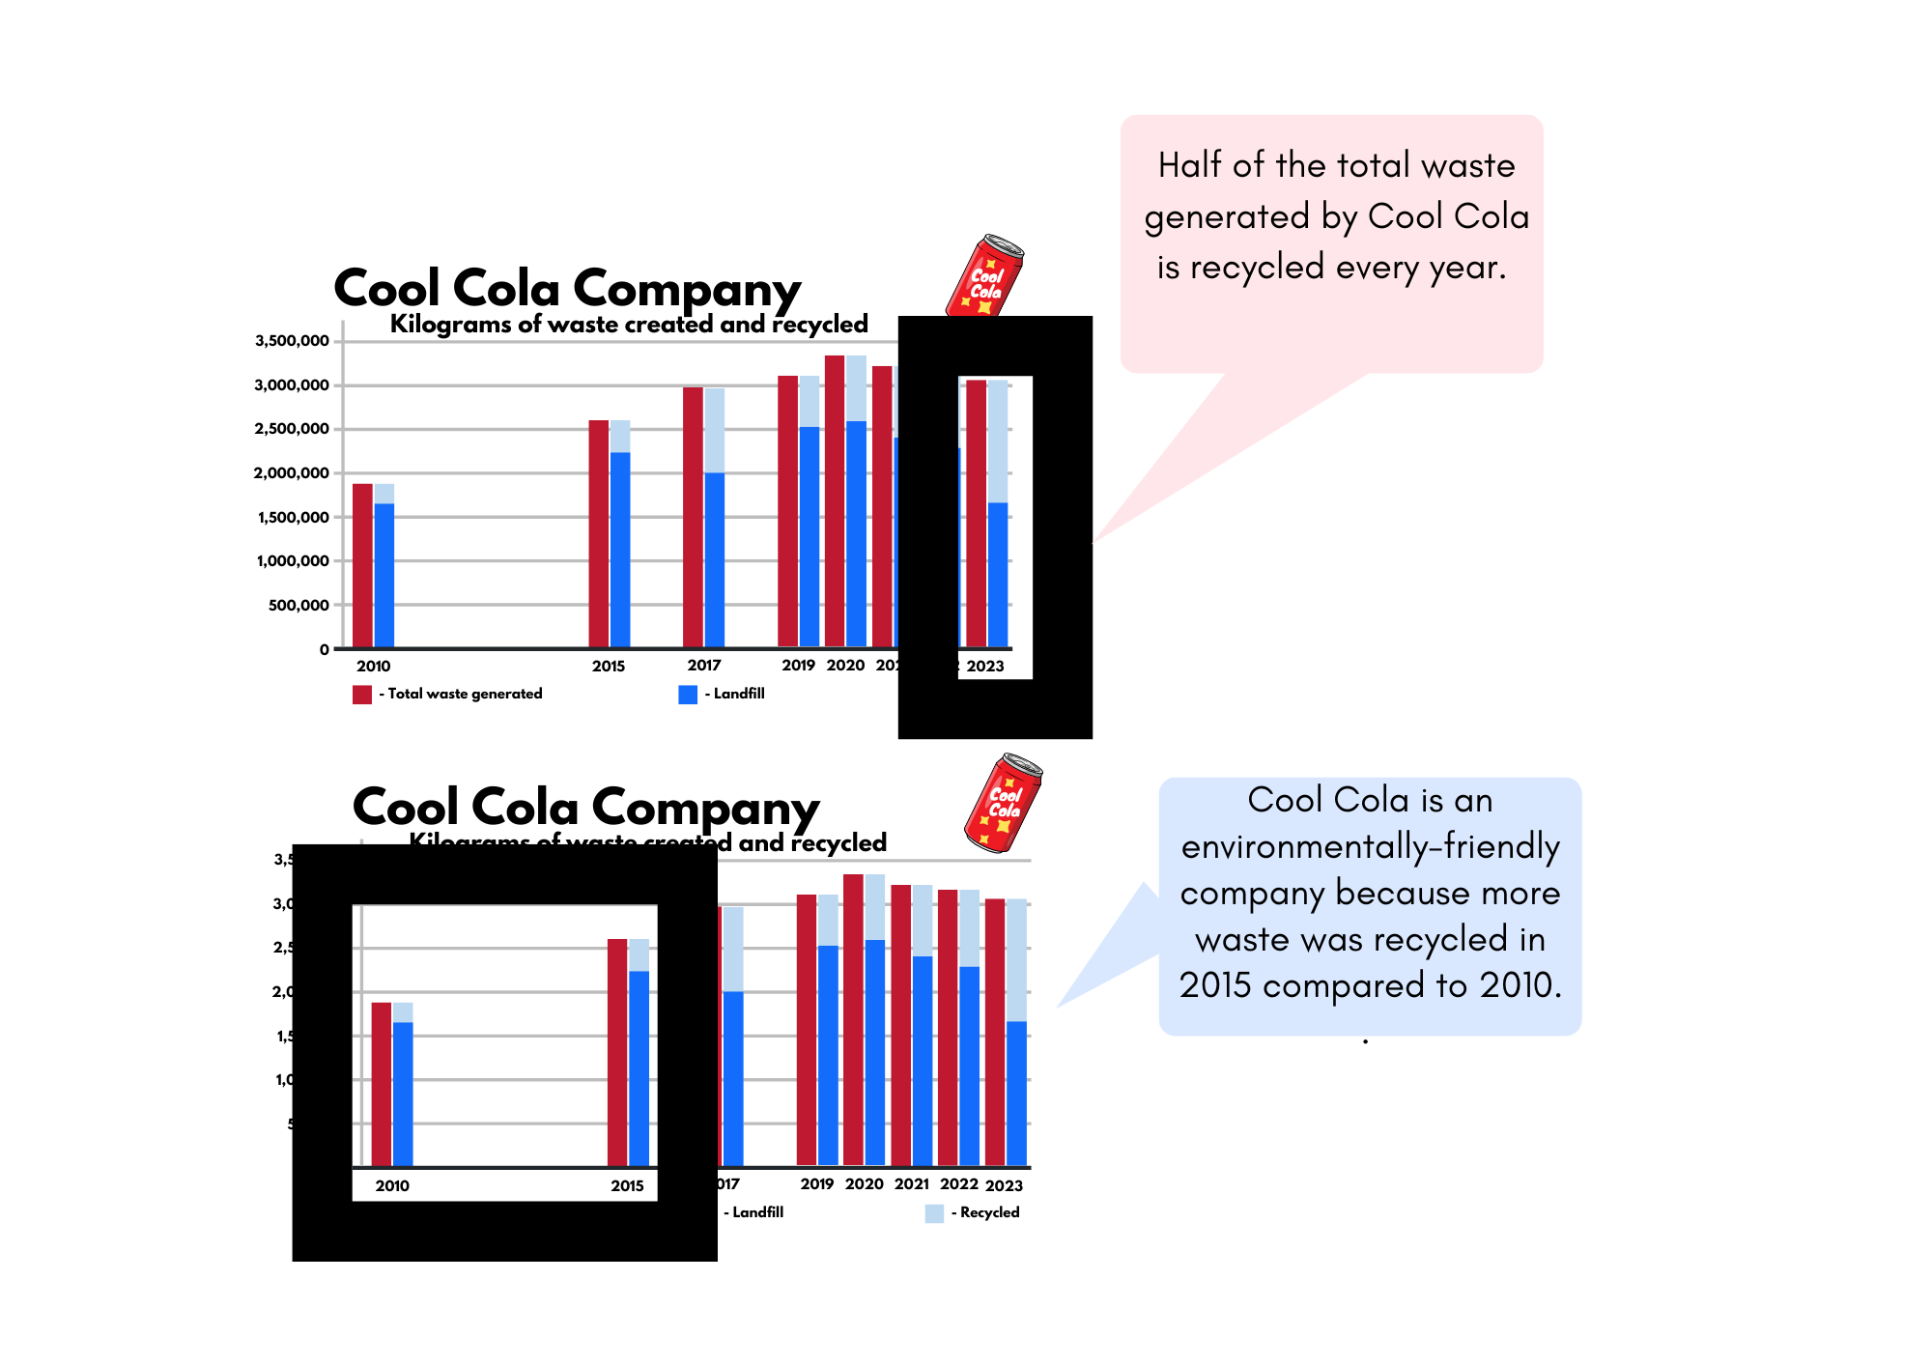
Figure 27 – Stage 3 examples of spotlights
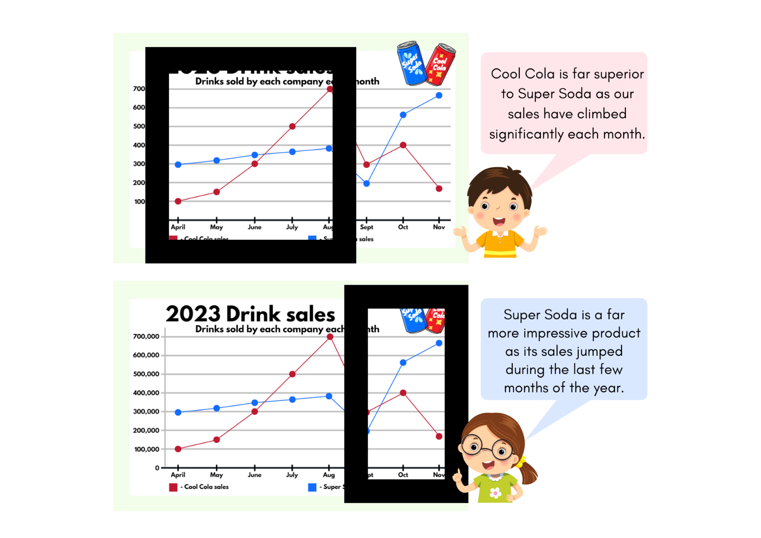
- Select pairs to indicate the portion of the data display they have chosen and justify how choosing that section shows how data can be misrepresented and misinterpreted. Ask the following questions:
- What advantages might there be to misrepresenting and misinterpreting data?
- Can you think of any examples you have noticed in the media or advertising?
- Ask students to be on the lookout for examples in advertising and media where data may be misrepresented and report back to the class in coming weeks.
This table details opportunities for assessment.
Assessment opportunities | Links
What to look for:  - Can Stage 2 students describe and interpret information presented in tally tables and column graphs? [MAO-WM-01, MA2-DATA-02]  - Can Stage 2 students investigate how data is interpreted to make decisions? [MAO-WM-01, MA2-DATA-02]  - Can Stage 2 students interpret and evaluate the effectiveness of various data displays found in media and in factual texts where displays represent data using a scale of many-to-one?  [MAO-WM-01, MA2-DATA-02]  - Can Stage 3 students describe and interpret data presented in tables, column graphs and line graphs?  [MAO-WM-01, MA3-DATA-02]  - Can Stage 3 students interpret data representations found in digital media and in factual texts? [MAO-WM-01, MA3-DATA-02]  - Can Stage 3 students identify sources of possible bias in representations of data in the media?  [MAO-WM-01, MA3-DATA-02]  - Can Stage 3 students identify misleading representations of data in the media? [MAO-WM-01, MA3-DATA-02] | Links to National Numeracy Learning Progressions (NNLP):  - Stage 2 – IRD3, IRD4.  - Stage 3 – IRD3, IRD4, IRD6.

Resource 1 – additive strategies
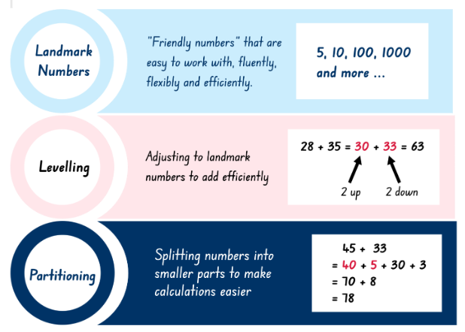
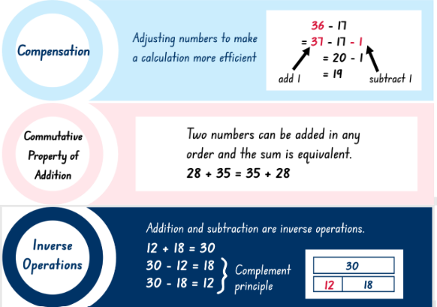
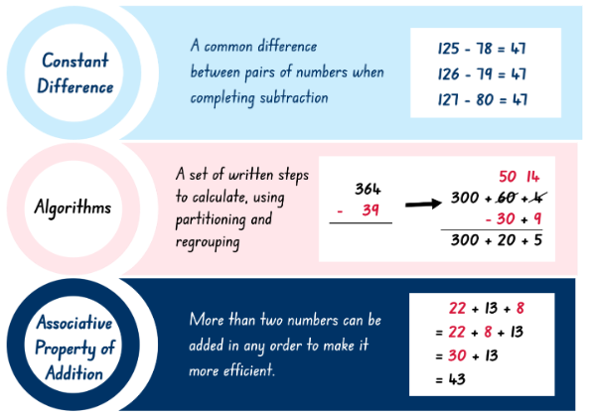
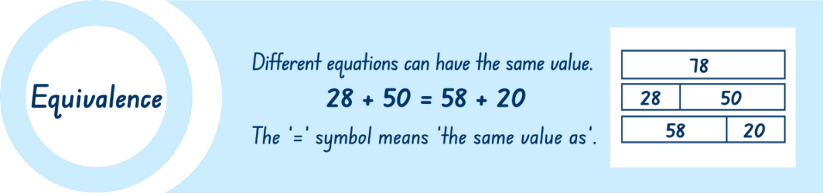

Resource 2 – bar models
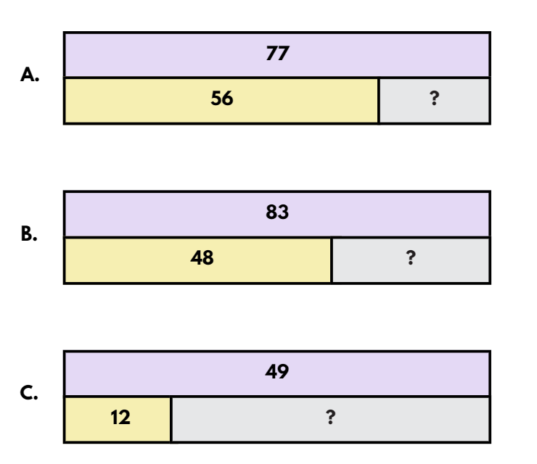

Resource 3 – house group allocations
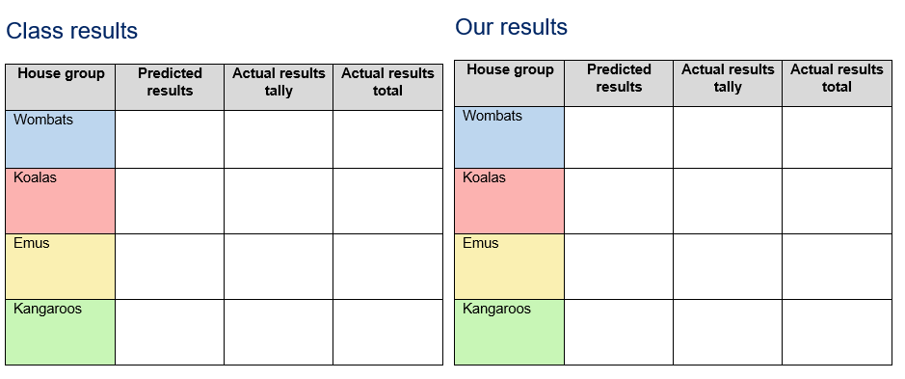

Resource 4 – column graph


Resource 5 – ‘Greedy Goat’
Greedy Goat
- One person is in charge of rolling a 10-sided die.
- For each round, the person rolls and calls out the number rolled.
- Players record the number on their score chart and add the number to the sum of the previous rolls.
- To save their score, players can decide to stop playing after each roll.
- The round ends when either:
- all players have chosen to save their score
- a 1 is rolled, in which case any remaining players score zero for that round.
- After 10 rounds, the player with the highest score is the Greedy Goat!
Score chart
Round | 1 | 2 | 3 | 4 | 5 | 6 | 7 | 8 | 9 | 10 | Total score
Number(s) rolled
Running total

Resource 6 – die outcomes
6-sided die | Predicted results 24 rolls | Actual results tally 24 rolls | Actual results total | Predicted results 60 rolls | Actual results tally 60 rolls | Actual results total | Predicted results 120 rolls | Actual results tally 120 rolls | Actual results total
1
2
3
4
5
6

Resource 7 – integers
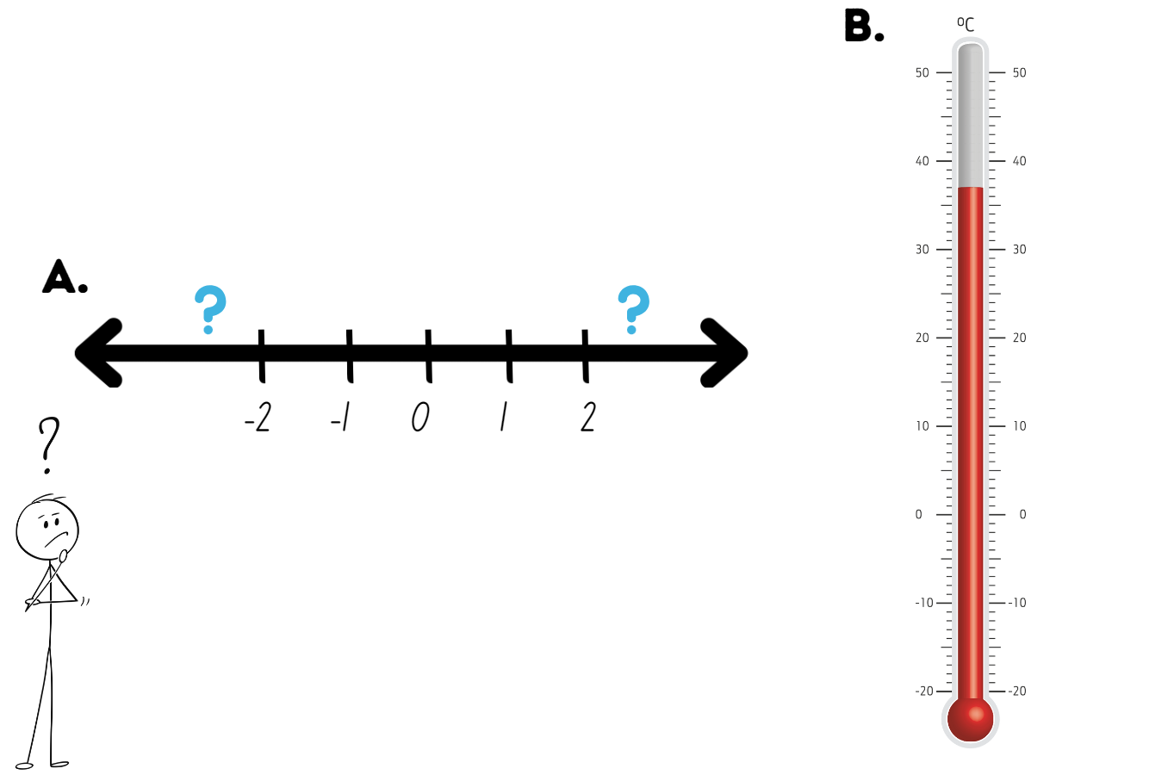

Resource 8 – chance scale
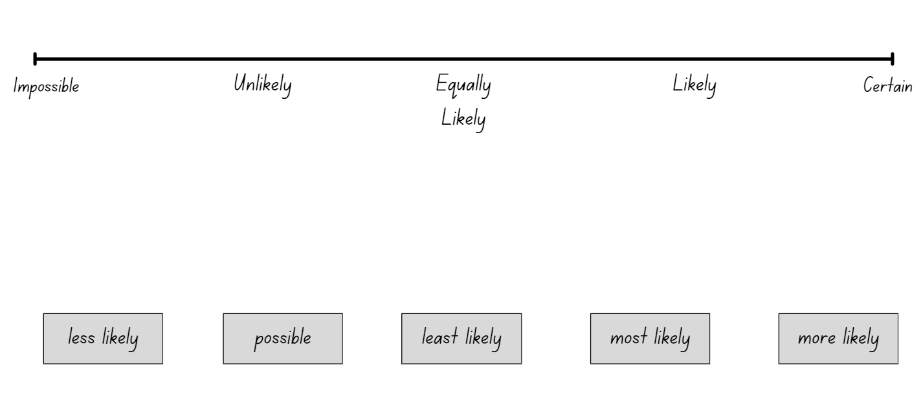

Resource 9 – mystery lunch
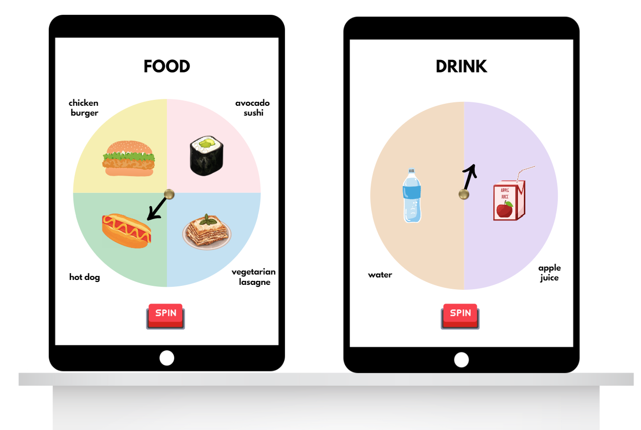

Resource 10 – lunch combinations
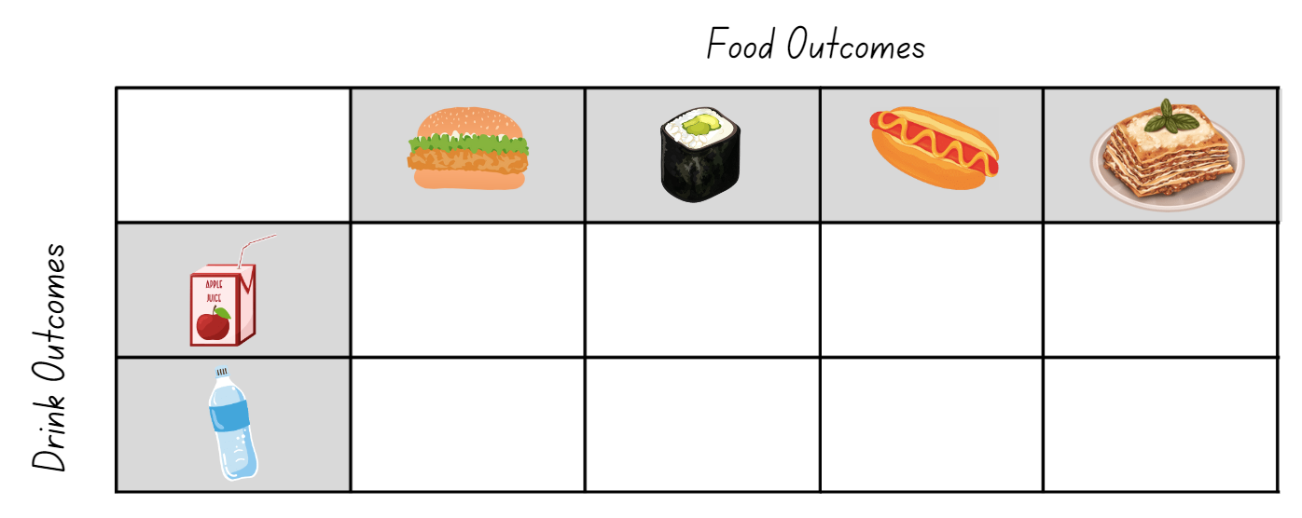

Resource 11 – 3B's lunch selections
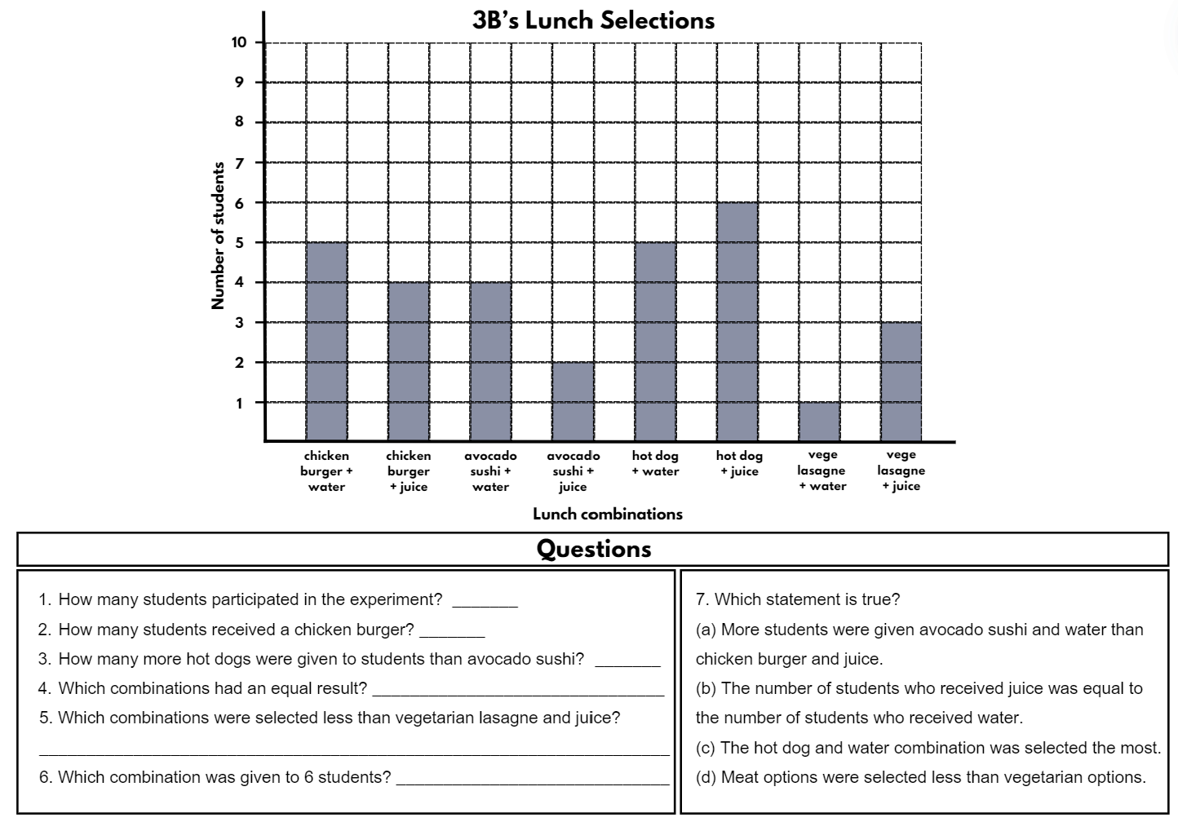

Resource 12 – probability scales
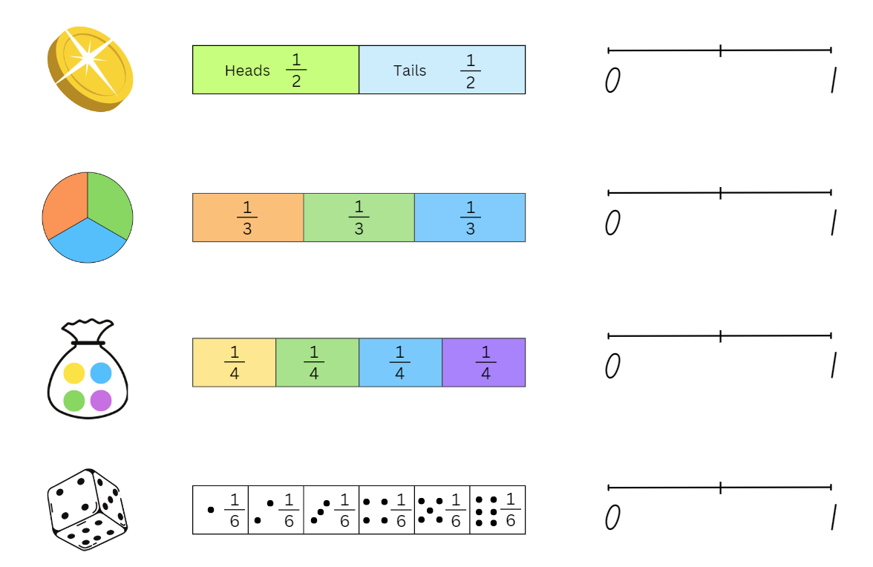

Resource 13 – dice sums
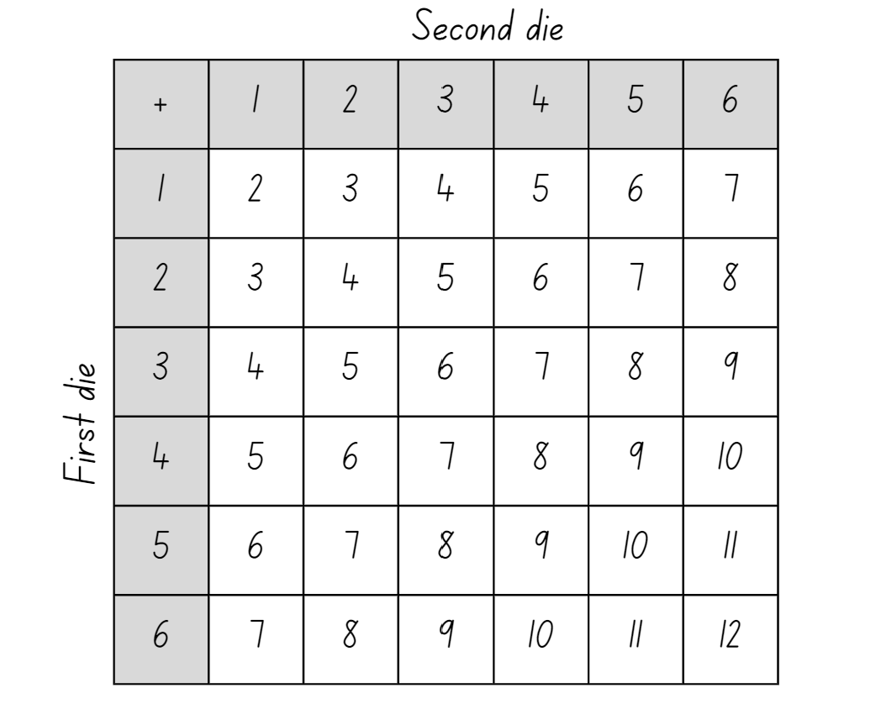

Resource 14 – true or false
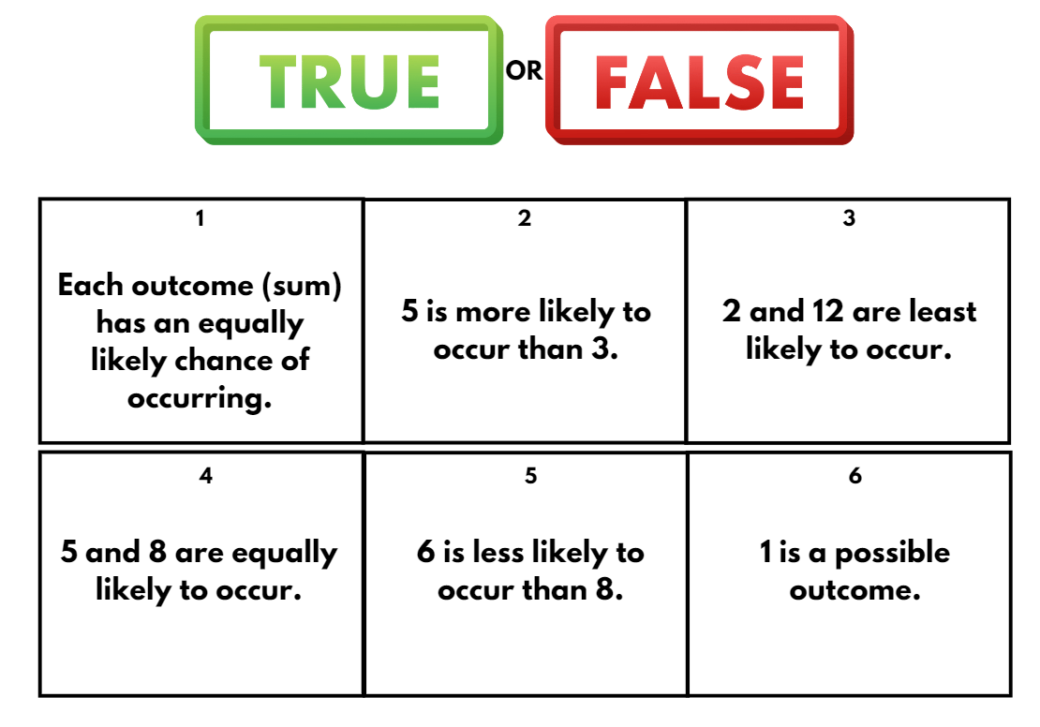

Resource 15 – race to win
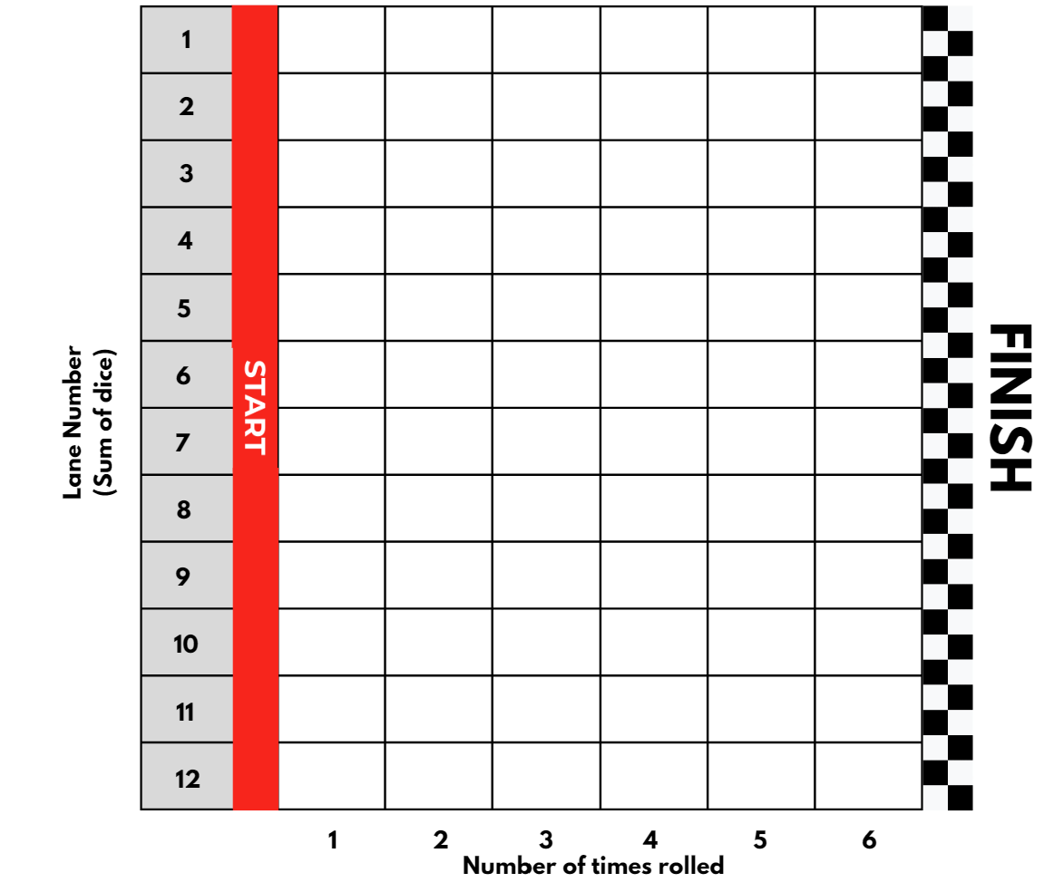

Resource 16 – times as large
Number | 10 times more | 100 times more | 1000 times more
65
78
92
18
49
33
27
50

Resource 17 – more and less
One thousandth less | Number | One thousandth more
 | 1
 | 0.5
 | 0.25
 | 0.6
 | 0.005
 | 0.75

Resource 18 – chance examples
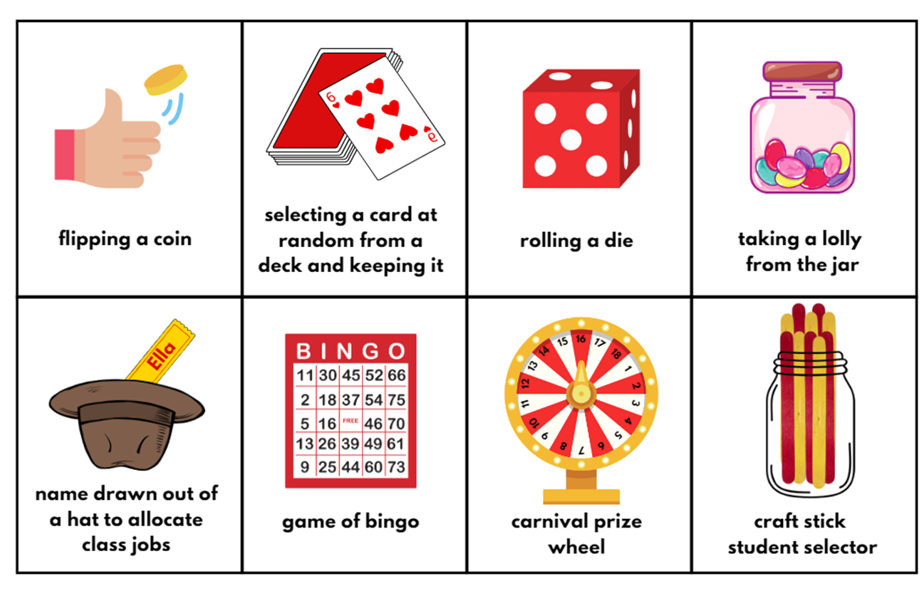

Resource 19 – Which park equipment?
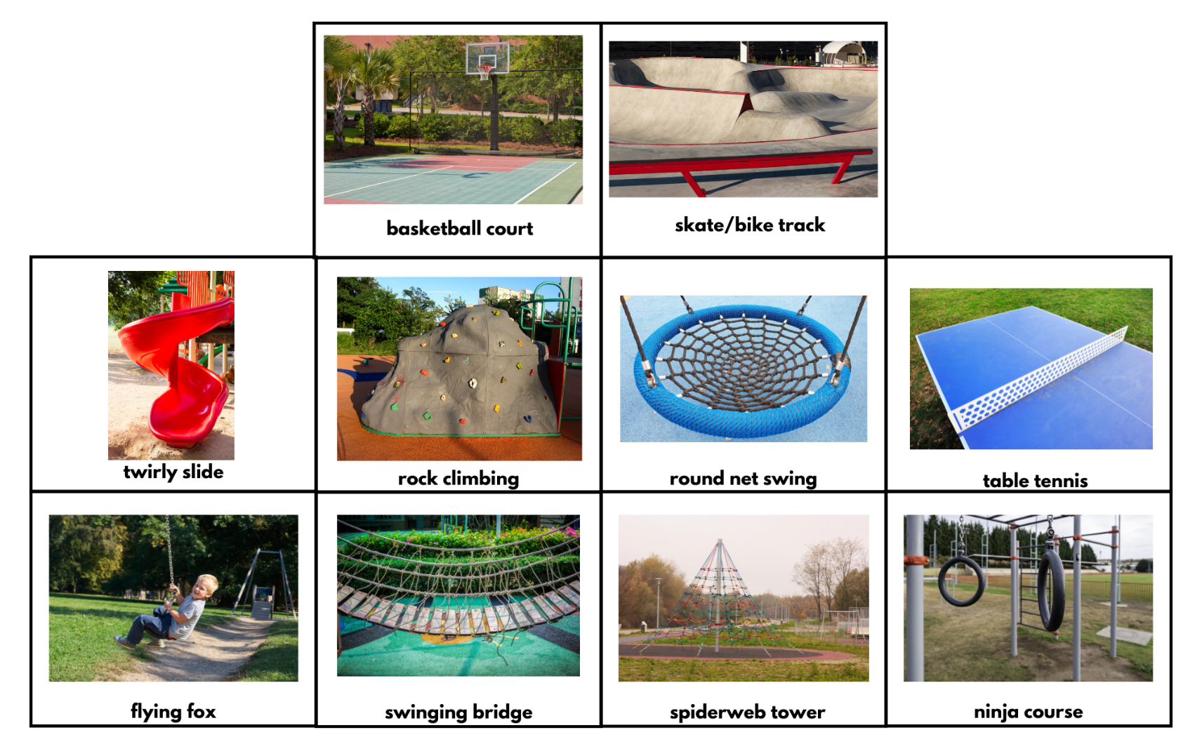

Resource 20 – mobile phone timeline
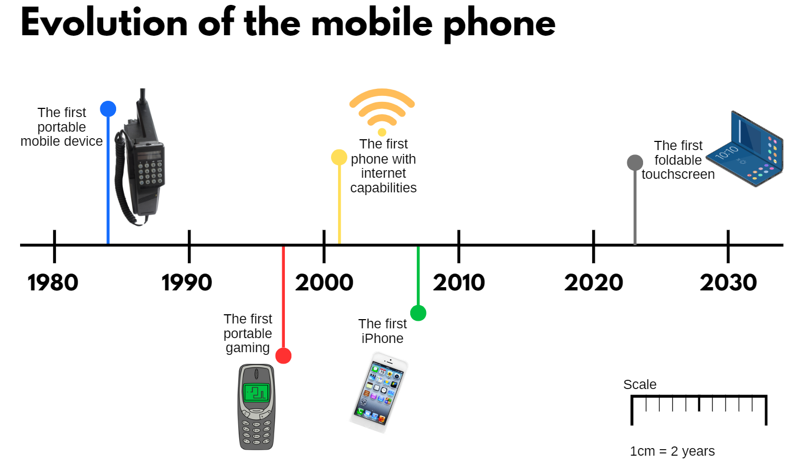

Resource 21 – place value cards
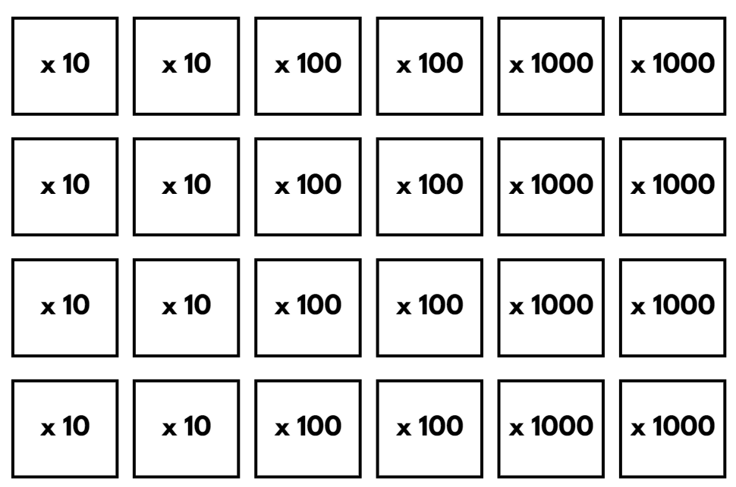

Resource 22 – thousandth more or less
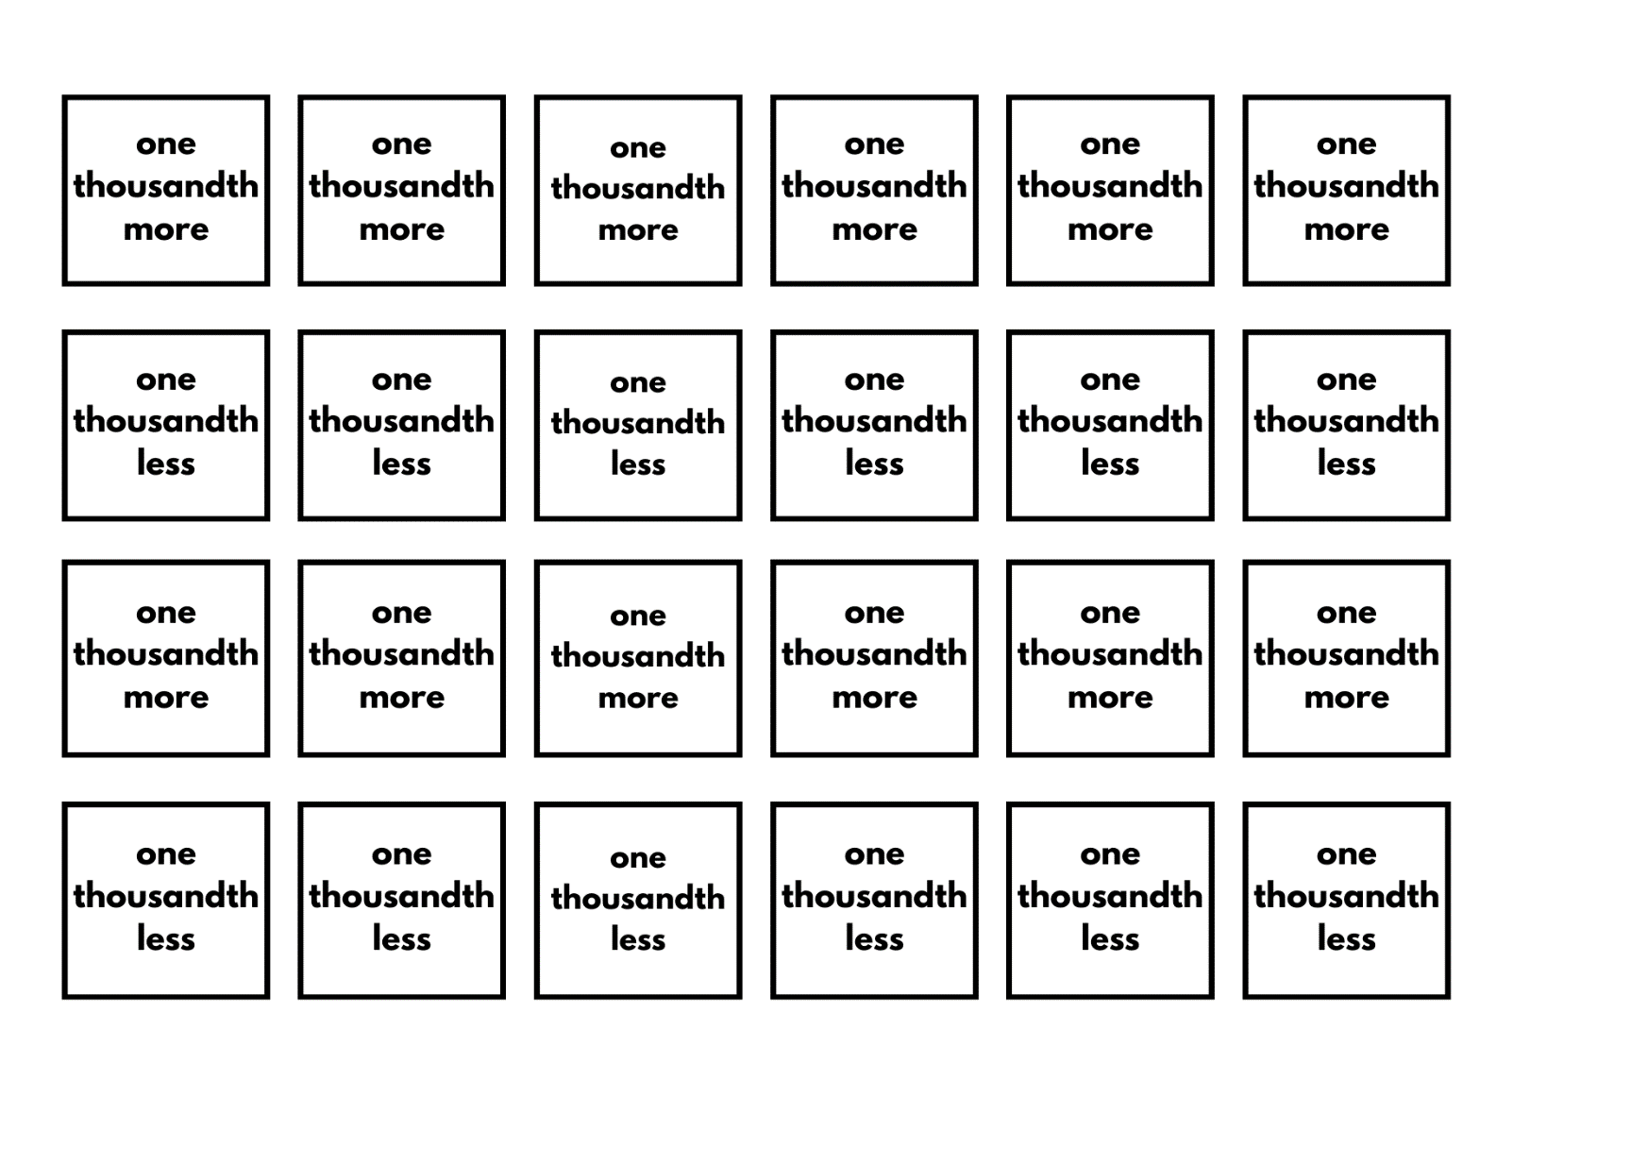

Resource 23 – councillor’s email
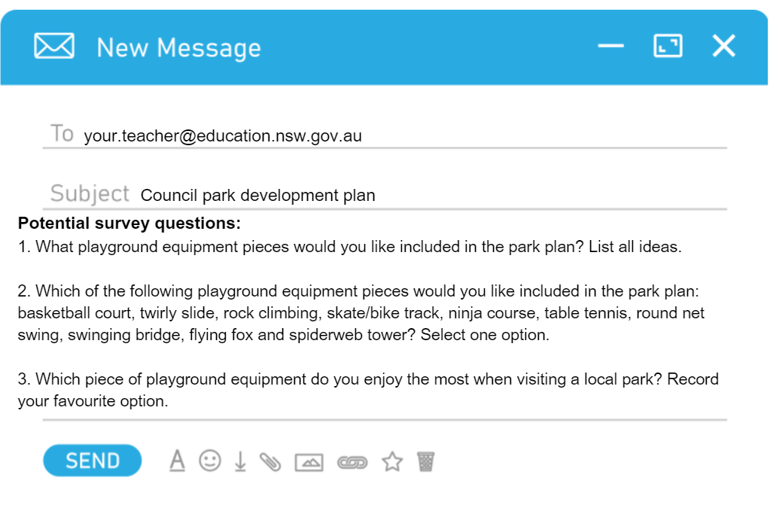

Resource 24 – data cycle
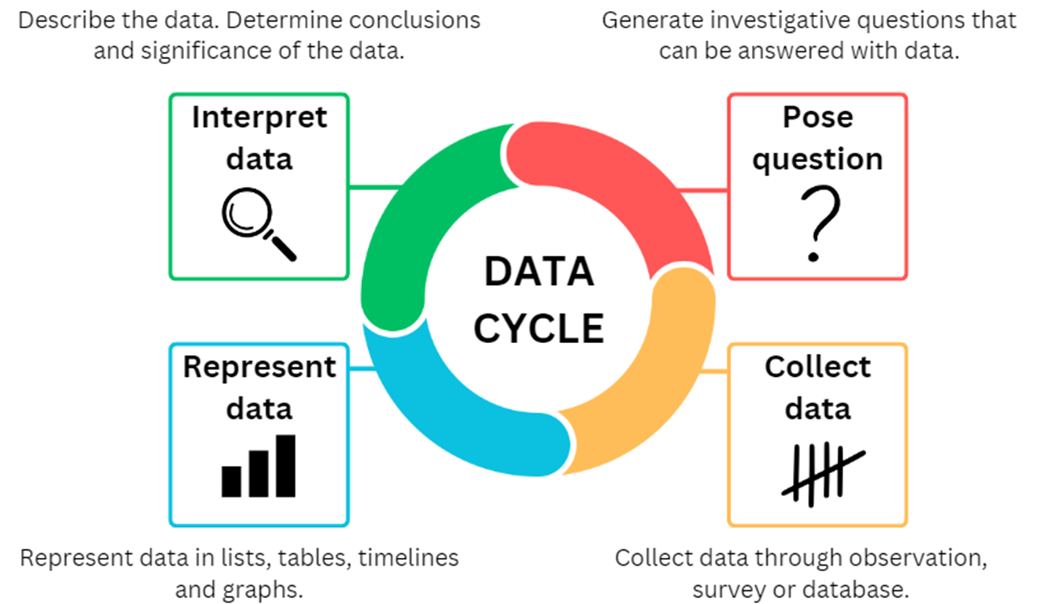

Resource 25 – council survey criteria
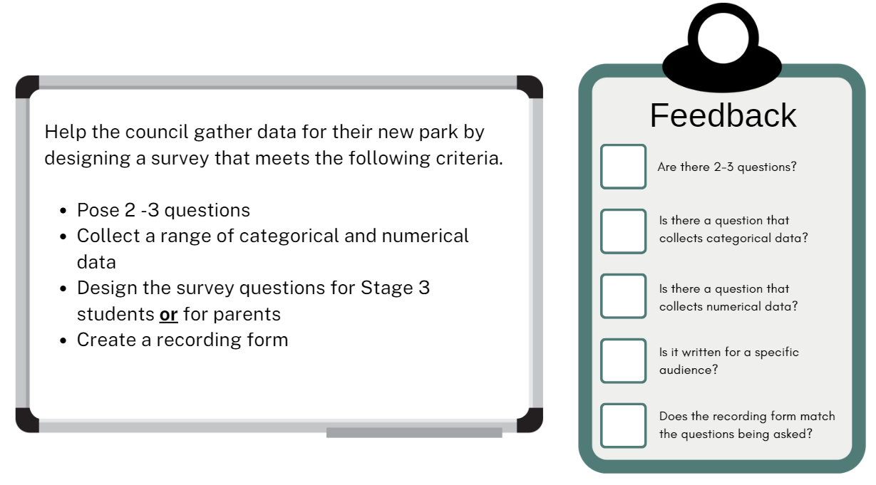

Resource 26 – smallest to largest
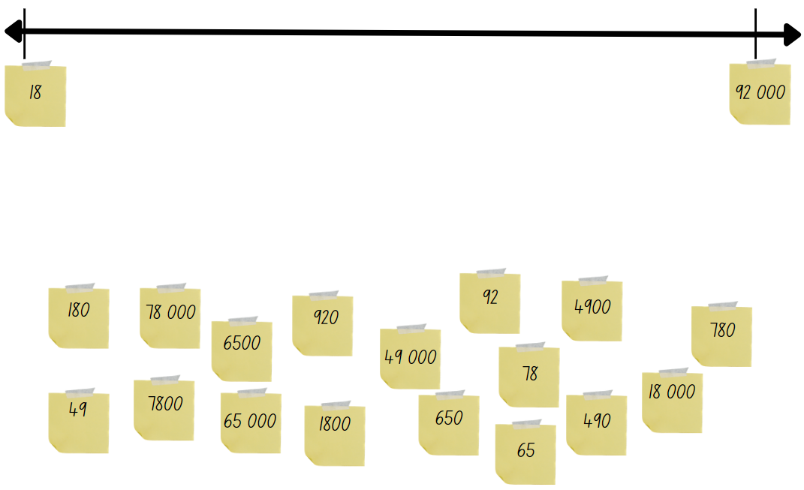

Resource 27 – What’s missing?
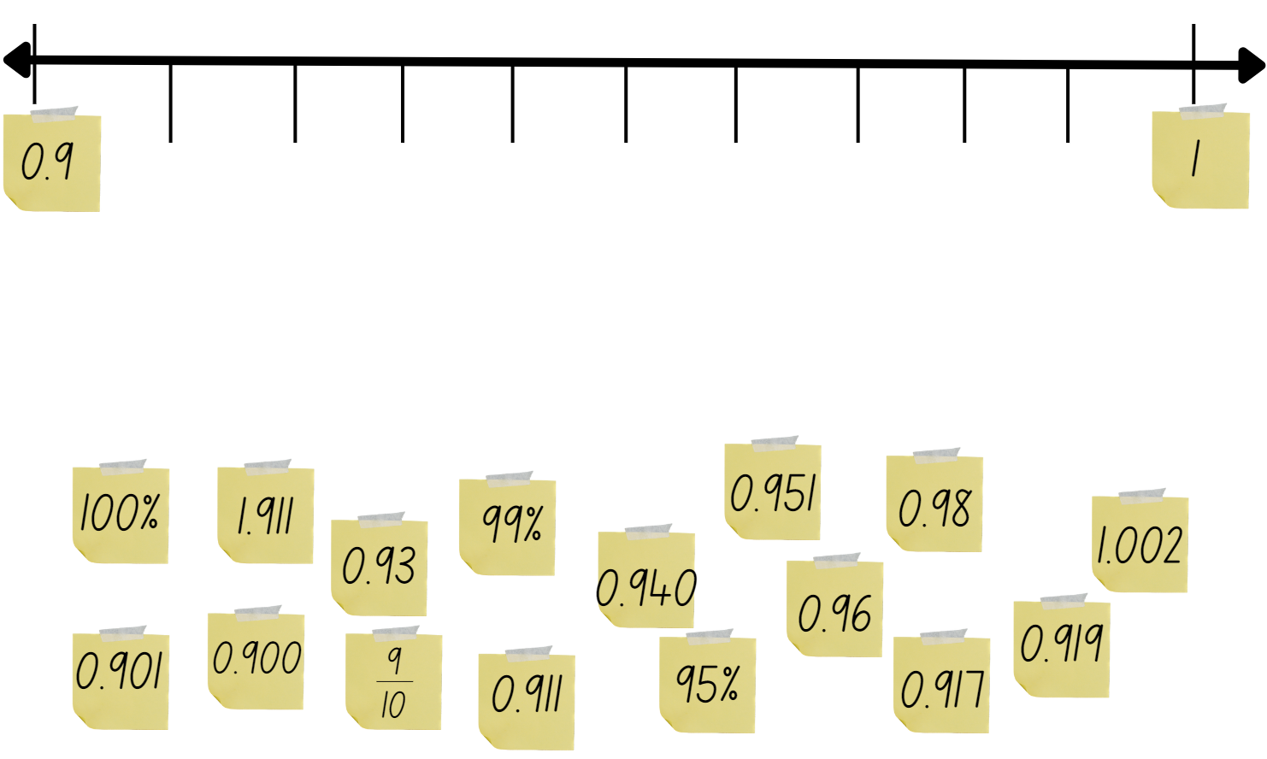

Resource 28 – Rivenoak School’s results
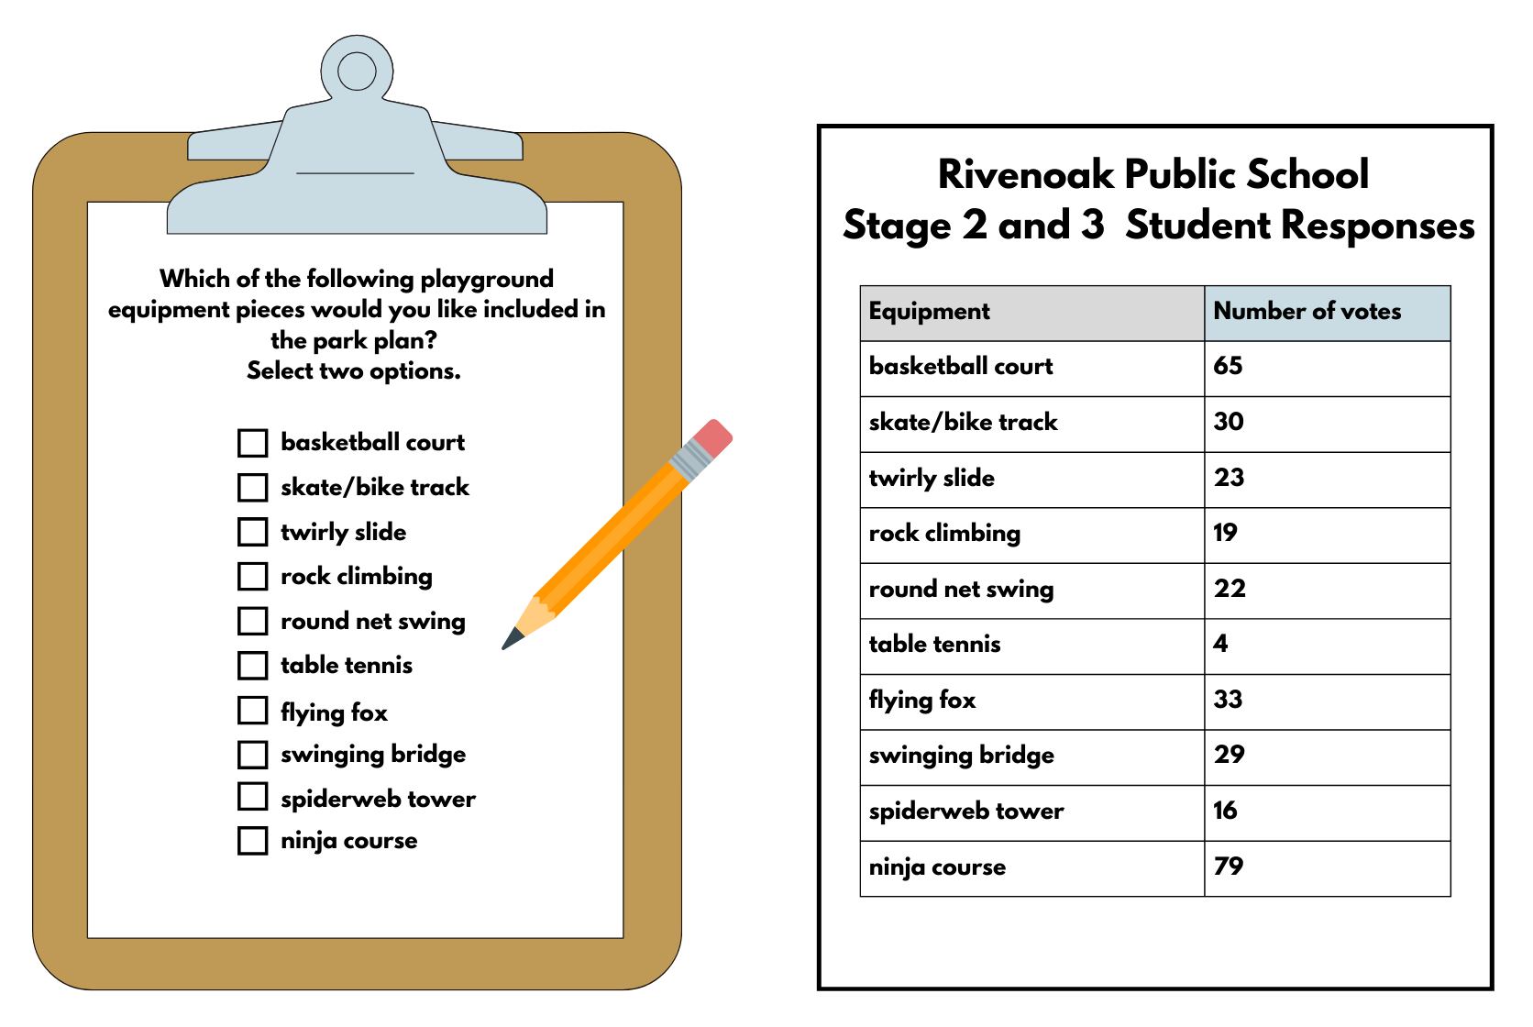

Resource 29 – many-to-one displays
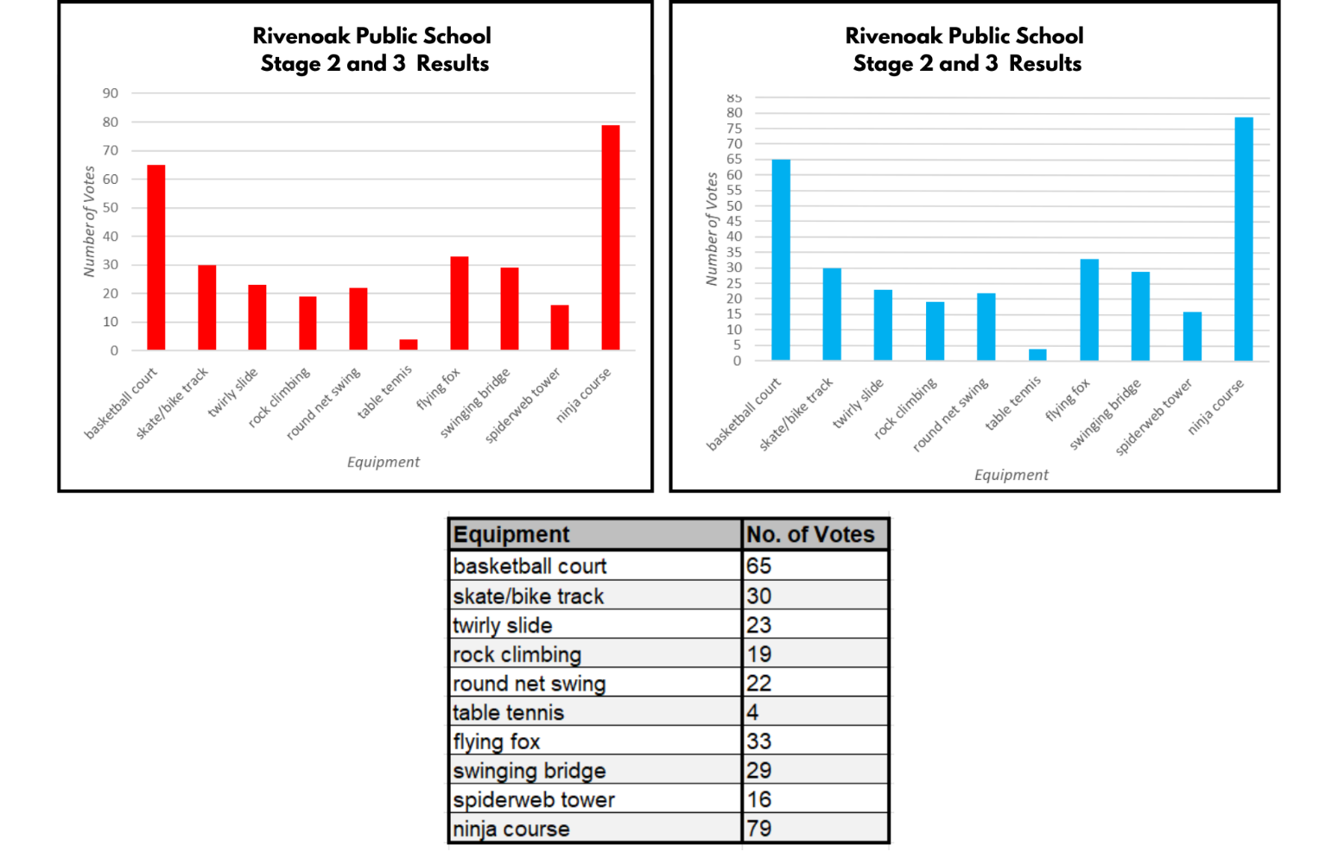

Resource 30 – best data representation
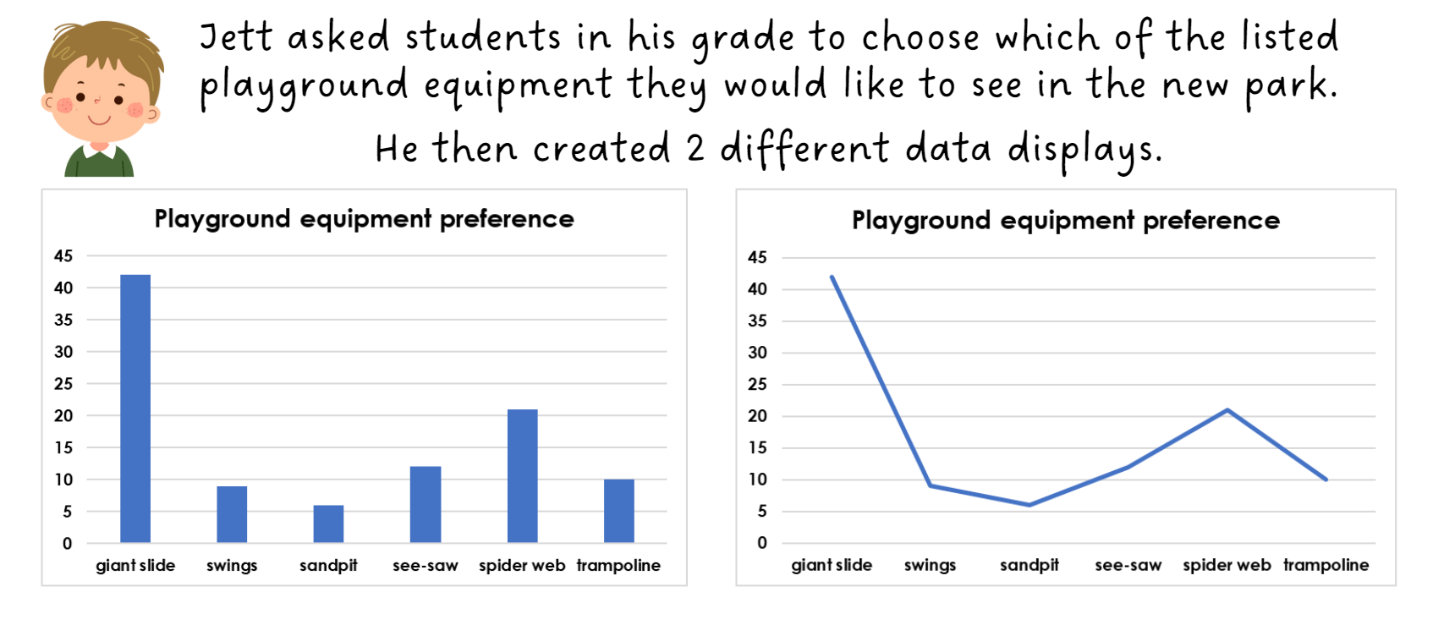

Resource 31 – council research
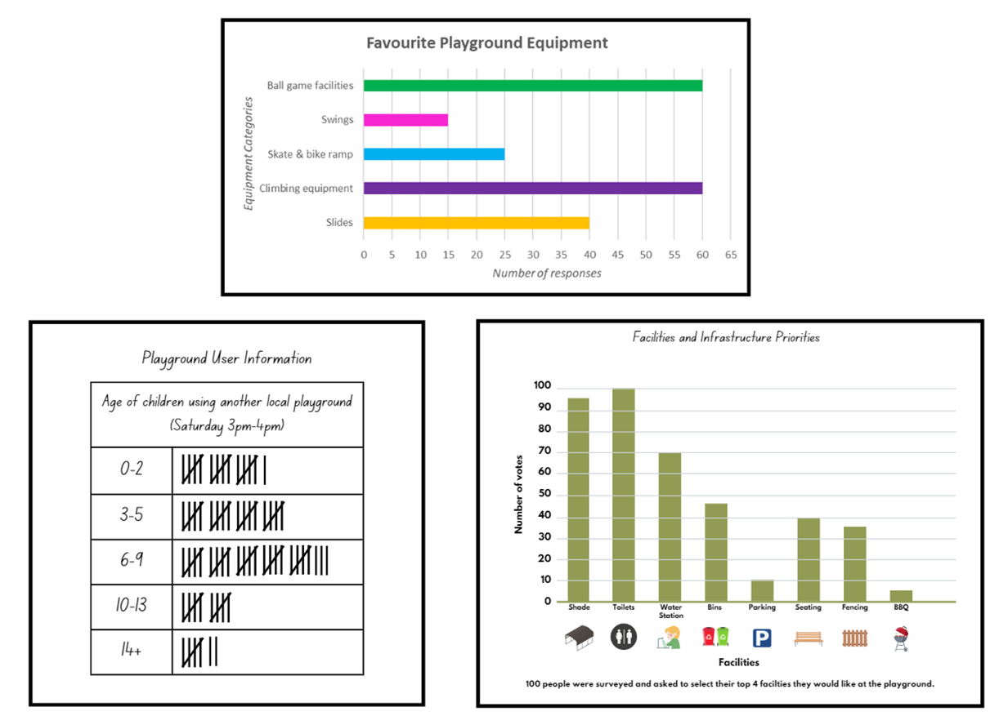

Resource 32 – interpreting data 1
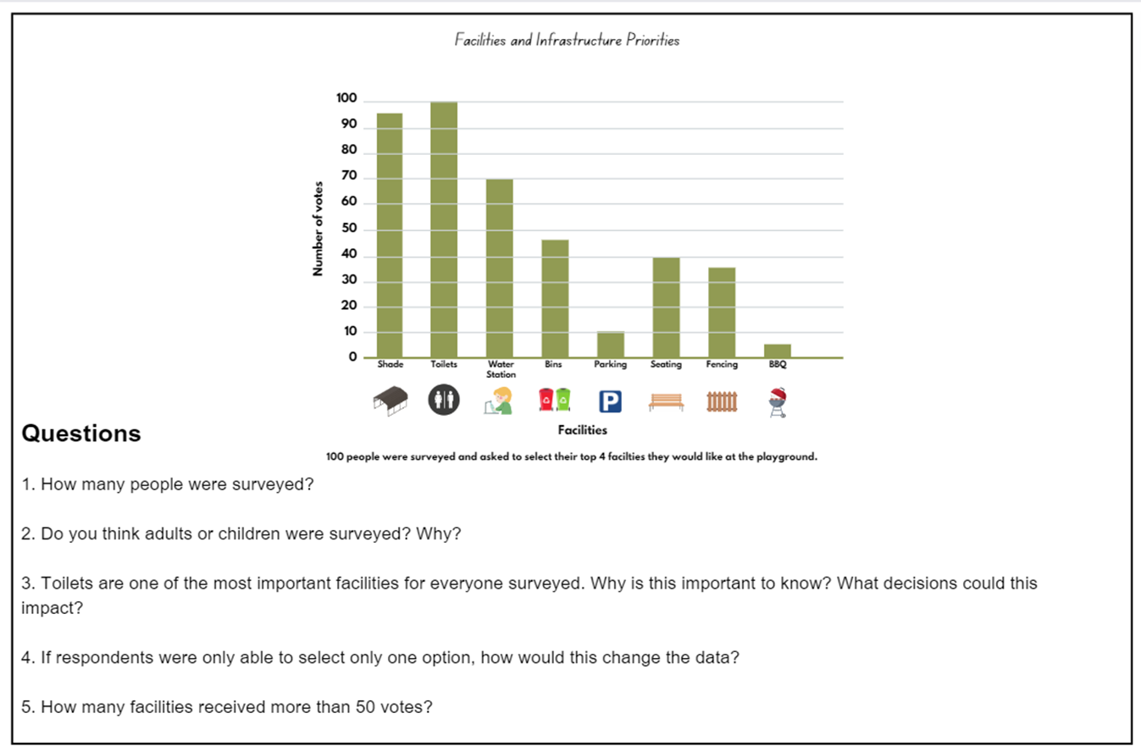

Resource 33 – interpreting data 2
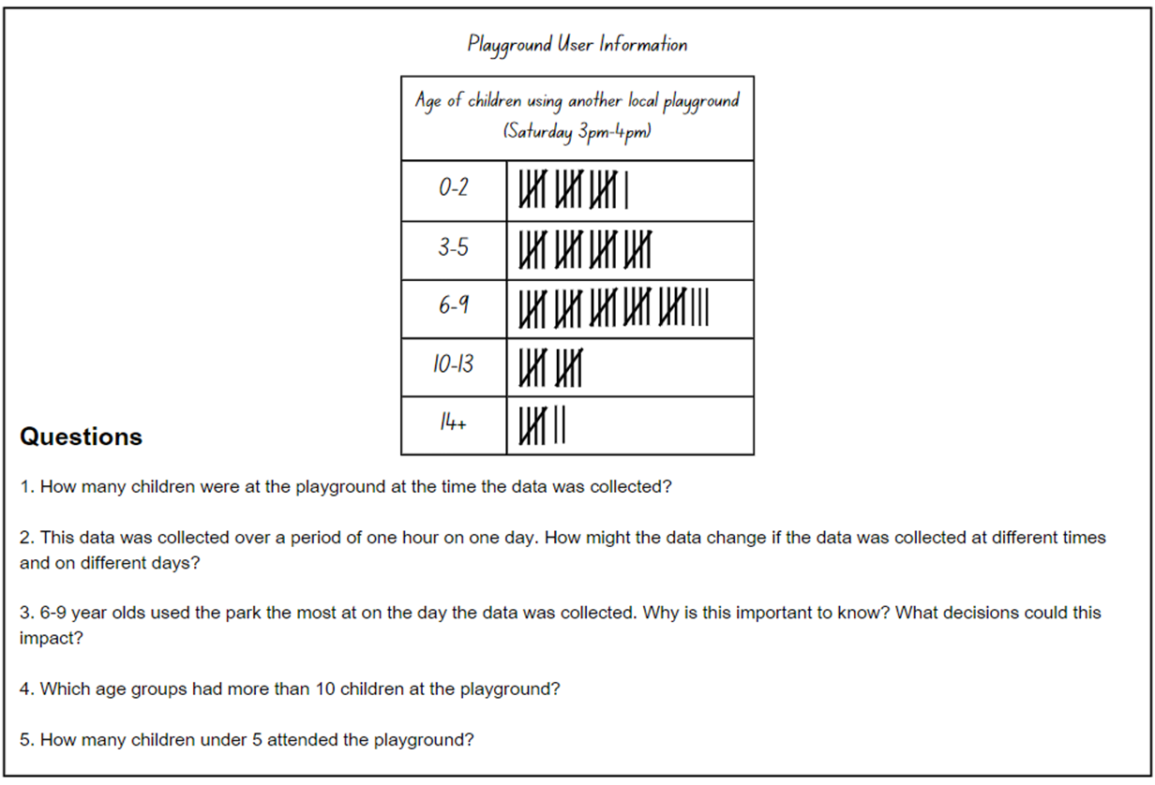

Resource 34 – interpreting data 3
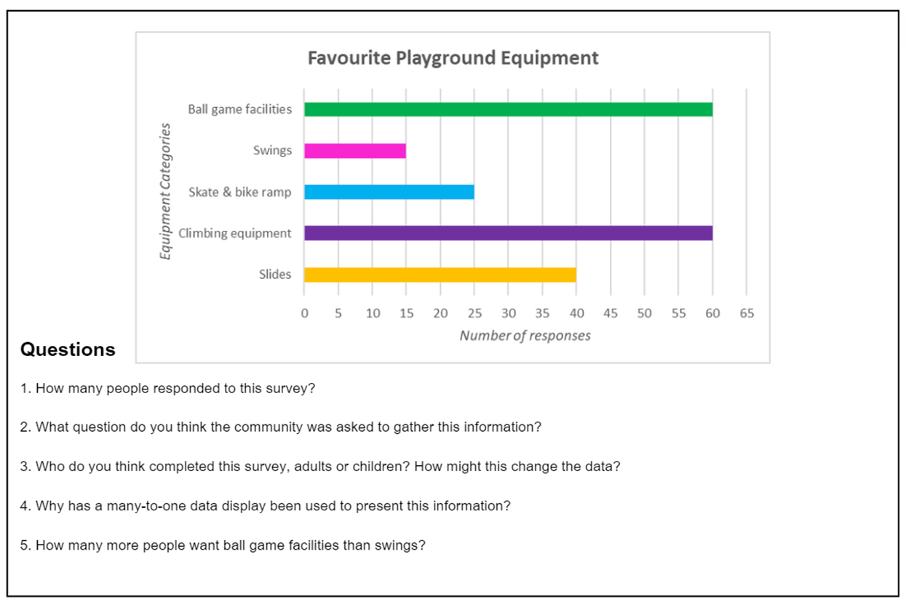

Resource 35 – data display 1
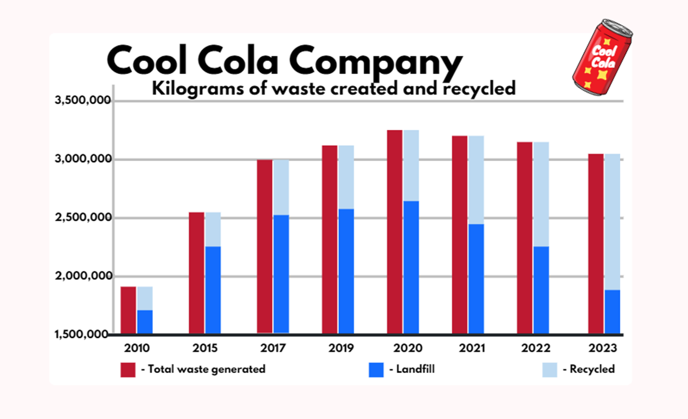

Resource 36 – data display 2
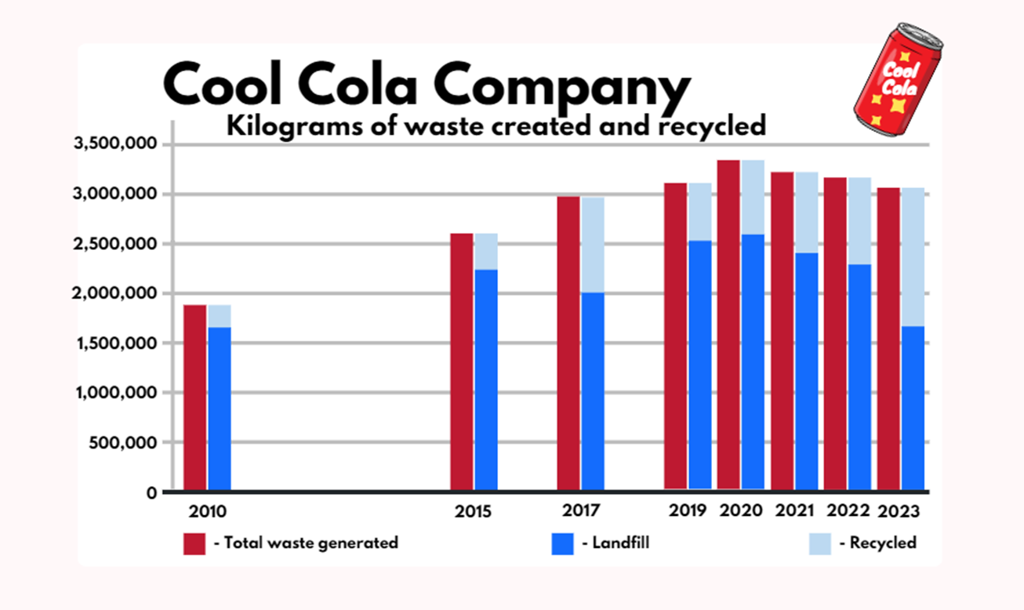

Resource 37 – data display 3
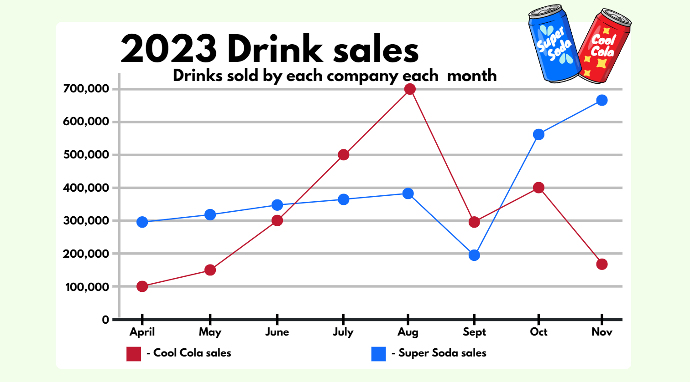

Syllabus outcomes and content

Stage 2
The table below outlines the syllabus outcomes and range of relevant syllabus content covered in this unit. Content is linked to National Numeracy Learning Progression (version 3).
Outcomes and content | 1 | 2 | 3 | 4 | 5 | 6 | 7 | 8
Representing numbers using place value A: Whole numbers: Read, represent and order numbers to thousands
MAO-WM-01, MA2-RN-01
- Compare and describe the relative size of numbers by positioning numbers on a number line (Reasons about quantity) |  |  | x
Representing numbers using place value B: Whole numbers: Recognise and represent numbers that are 10, 100 or 1000 times as large
MAO-WM-01, MA2-RN-01
- Recognise the number of tens, hundreds or thousands in a number
- Describe how making a number 10, 100 or 1000 times as large changes the place value of digits
Additive relations A: Recognise and explain the connection between addition and subtraction
MAO-WM-01, MA2-AR-01, MA2-AR-02
- Use number relation principles to solve related problems (Reasons about relations) | x | x
- Demonstrate how addition and subtraction are inverse operations | x | x
Data A: Organise and display data using tables and graphs
MAO-WM-01, MA2-DATA-01
- Create a list or table to organise the data | x
- Construct column graphs (with scale intervals of 1) and dot plots using relevant software where appropriate | x |  |  | x |  | x | x
- Mark equal spaces (intervals) on axes, name and label axes and choose appropriate titles for column graphs | x
Data A: Interpret and compare data
MAO-WM-01, MA2-DATA-01, MA2-DATA-02
- Describe and interpret information presented in tally tables and column graphs | x |  | x |  |  |  | x | x
- Investigate how data is interpreted to make decisions |  |  |  |  | x | x | x | x
Data B: Select and trial methods for data collection
MAO-WM-01, MA2-DATA-01, MA2-DATA-02
- Refine survey questions as necessary after a small trial |  |  |  |  |  | x
- Compare the effectiveness of different methods of collecting and recording data |  |  |  |  |  | x
Data B: Construct and interpret data displays with many-to-one scales
MAO-WM-01, MA2-DATA-01, MA2-DATA-02
- Use a given many-to-one scale to represent discrete data in column graphs |  |  |  |  |  |  | x
- Use data in a spreadsheet to create column graphs with units on vertical axes that are in multiples |  |  |  |  |  |  | x
- Interpret and evaluate the effectiveness of various data displays found in media and in factual texts where displays represent data using a scale of many-to-one |  |  |  |  | x |  |  | x
Chance A: Identify possible outcomes from chance experiments
MAO-WM-01, MA2-CHAN-01
- Use the term outcome to describe any possible result of a chance experiment |  | x | x
- Record all possible outcomes in a chance experiment where the outcomes are equally likely |  | x
- Record all possible combinations in a chance situation where the outcomes are equally likely |  |  | x
- Predict the number of times each outcome might occur in a chance experiment involving a set number of trials | x | x
- Conduct experiments and compare the predicted and actual results where the outcomes are equally likely | x | x
Chance B: Describe the likelihood of outcomes of chance experiments
MAO-WM-01, MA2-CHAN-01
- Use the terms equally likely, likely and unlikely to describe the chance of everyday events occurring | x | x | x | x
- Compare the likelihood of obtaining particular outcomes in a simple chance experiment by predicting, conducting the experiment and comparing the results with the prediction |  | x |  | x | x
Chance B: Identify when events are affected by previous events
MAO-WM-01, MA2-CHAN-01
- Identify and discuss events where the chance of one event occurring will not be affected by the occurrence of the other | x | x | x | x
- Compare events where the chance of one event occurring is affected by the occurrence of the other (Reasons about relations) |  |  | x |  | x
Mathematics K–10 Syllabus © NSW Education Standards Authority (NESA) for and on behalf of the Crown in right of the State of New South Wales, 2022.

Stage 3
The table below outlines the syllabus outcomes and range of relevant syllabus content covered in this unit. Content is linked to National Numeracy Learning Progression (version 3).
Outcomes and content | 1 | 2 | 3 | 4 | 5 | 6 | 7 | 8
Represents numbers A: Decimals and percentages: Recognise that the place value system can be extended beyond hundredths
MAO-WM-01, MA3-RN-01, MA3-RN-02
- Express thousandths as decimals |  |  |  |  | x | x
- Indicate the place value of digits in decimal numbers of up to 3 decimal places |  |  |  |  | x | x | x
Represents numbers A: Decimals and percentages: Compare, order and represent decimals
MAO-WM-01, MA3-RN-01, MA3-RN-02
- Place decimal numbers of up to 3 decimal places on a number line |  |  |  |  |  |  | x
Represents numbers B: Whole numbers: Locate and represent integers on a number line
MAO-WM-01, MA3-RN-01
- Recognise the location of negative whole numbers in relation to zero and place them on a number line |  |  | x
- Use the term integers to describe positive and negative whole numbers and zero |  |  | x
Represents numbers B: Decimals and percentages: Make connections between benchmark fractions, decimals and percentages
MAO-WM-01, MA3-RN-02, MA3-RN-03
- Recall commonly used equivalent percentages, decimals and fractions including $\frac{1}{2}$, $\frac{1}{4}$ and $\frac{3}{4}$. |  |  |  | x |  |  | x
Additive relations A: Apply efficient mental and written strategies to solve addition and subtraction problems
MAO-WM-01, MA3-AR-01
- Solve word problems, including multistep problems | x
- Apply known strategies such as levelling, addition for subtraction, using constant difference, and bridging (Reasons about relations) | x | x
Data A: Collect categorical and discrete numerical data by observation or survey
MAO-WM-01, MA3-DATA-01
- Pose and refine questions to construct a survey to obtain categorical or discrete numerical data about a matter of interest |  |  |  |  |  | x
- Collect ordinal or nominal categorical data, and discrete numerical data through observation or by conducting surveys |  |  |  |  |  | x
Data A: Choose and use appropriate tables and graphs
MAO-WM-01, MA3-DATA-01
- Tabulate collected data with and without the use of digital technologies such as spreadsheets |  | x | x
- Recognise which types of data display are appropriate to represent data (Statistical reasoning) |  |  |  |  | x |  | x
- Determine an appropriate scale (horizontal and vertical) to represent the data |  |  |  |  |  |  | x
- Construct column graphs using a many-to-one scale, with and without the use of digital technologies |  |  |  |  |  |  | x
- Draw an accurate timeline using an appropriate scale |  |  |  |  | x
Data A: Describe and interpret different datasets in context
MAO-WM-01, MA3-DATA-01, MA3-DATA-02
- Describe and interpret data presented in tables, column graphs and line graphs | x |  |  |  |  |  |  | x
- Determine the total number of data values represented in column graphs |  |  |  |  |  |  | x
Data B: Interpret and compare a range of data displays
MAO-WM-01, MA3-DATA-02
- Interpret data on a timeline using the given scale |  |  |  |  | x
Data B: Interpret data presented in digital media and elsewhere
MAO-WM-01, MA3-DATA-02
- Interpret data representations found in digital media and in factual texts |  |  |  |  |  |  |  | x
- Identify sources of possible bias in representations of data in the media (Statistical reasoning) |  |  |  |  |  |  |  | x
- Identify misleading representations of data in the media |  |  |  |  |  |  |  | x
Chance A: List outcomes of chance experiments involving equally likely outcomes and represent probabilities
MAO-WM-01, MA3-CHAN-01
- Use the term probability to describe the numerical value that represents the likelihood of an outcome of a chance experiment | x |  |  | x
- Record all outcomes in chance experiments where each outcome is equally likely to occur | x | x
- Represent probabilities of outcomes of chance experiments using fractions |  |  | x | x
- Establish that the total of the probabilities of the outcomes of a chance experiment equals one |  |  | x
- Discuss the imprecise meaning of commonly used chance words including possible, likely and unlikely | x | x
Chance B: Compare observed frequencies of outcomes with expected results
MAO-WM-01, MA3-CHAN-01
- Distinguish between the frequency of an outcome (the number of times it occurs) and the probability of an outcome in a chance experiment |  |  | x | x
Mathematics K–10 Syllabus © NSW Education Standards Authority (NESA) for and on behalf of the Crown in right of the State of New South Wales, 2022.

References
This resource contains NSW Curriculum and syllabus content. The NSW Curriculum is developed by the NSW Education Standards Authority. This content is prepared by NESA for and on behalf of the Crown in right of the State of New South Wales. The material is protected by Crown copyright.
Please refer to the NESA Copyright Disclaimer for more information https://educationstandards.nsw.edu.au/wps/portal/nesa/mini-footer/copyright.
NESA holds the only official and up-to-date versions of the NSW Curriculum and syllabus documents. Please visit the NSW Education Standards Authority (NESA) website https://educationstandards.nsw.edu.au and the NSW Curriculum website https://curriculum.nsw.edu.au.
Mathematics K–10 Syllabus © NSW Education Standards Authority (NESA) for and on behalf of the Crown in right of the State of New South Wales, 2022.
National Numeracy Learning Progression © Australian Curriculum, Assessment and Reporting Authority (ACARA) 2010 to present, unless otherwise indicated. This material was downloaded from the Australian Curriculum website (National Numeracy Learning Progression) (accessed 6 May 2024) and was not modified.
ABC (Australian Broadcasting Corporation) (20 October 2020) 'World Statistics Day' [video], BTN (Behind the News), ABC website, accessed 19 June 2024.
Amplify Education (2024) Polypad, Polypad website, accessed 19 June 2024.
Batanero C, Chernoff EJ, Engel J, Lee HS and Sánchez E (2016) Research on Teaching and Learning Probability (Kaiser G ed), SpringerOpen, Switzerland, accessed 3 April 2024.
Gaslowitz L (n.d.) ‘How to spot a misleading graph – Lea Gaslowitz’, Lessons, TED-Ed website, accessed 18 June 2024.
NESA (NSW Education Standards Authority) (2022a) ‘Glossary’, Mathematics K–10 Syllabus, NESA website, accessed 12 July 2024.
NESA (2022b) ‘Stage 2: Teaching advice for Chance B’, Mathematics K–10 Syllabus, NESA website, accessed 12 July 2024.
New Zealand Ministry of Education (n.d.) ‘Greedy Pig’, Resource Finder, NZ Maths website, accessed 12 June 2024.
Russo T (19 August 2020) 'The King’s Tax Maths Game' [video], Toby Russo, YouTube, accessed 18 June 2024.
Sullivan P and Lilburn P (2017) Open-Ended Maths Activities: Using ‘Good’ Questions to Enhance Learning in Mathematics, Revised edn, Oxford University Press ANZ, Great Britain.
Tuohilampi L (2022) Seriously Fun Maths: The complete guide to motivational mathematics, Amba Press, Melbourne.
University of Cambridge (n.d.a) What Does Random Look Like?, NRICH website, accessed 12 June 2024.
University of Cambridge (n.d.b) A Bit of a Dicey Problem, NRICH website, accessed 12 June 2024.
Van de Walle J, Karp K, Bay-Williams JM, Brass A, Bentley B, Ferguson S, Goff W, Livy S, Marshman M, Martin D, Pearn C, Prodromou T, Symons D and Wilkie K (2019) Primary and Middle Years Mathematics: Teaching Developmentally, 1st Australian edn, Pearson Education Australia, Melbourne.
wheelofnames.com (n.d.) Wheel of Names [website], accessed 12 June 2024.

© State of New South Wales (Department of Education), 2024
The copyright material published in this resource is subject to the Copyright Act 1968 (Cth) and is owned by the NSW Department of Education or, where indicated, by a party other than the NSW Department of Education (third-party material).
Copyright material available in this resource and owned by the NSW Department of Education is licensed under a Creative Commons Attribution 4.0 International (CC BY 4.0) license.

This license allows you to share and adapt the material for any purpose, even commercially.
Attribution should be given to © State of New South Wales (Department of Education), 2024.
Material in this resource not available under a Creative Commons license:
- the NSW Department of Education logo, other logos and trademark-protected material
- material owned by a third party that has been reproduced with permission. You will need to obtain permission from the third party to reuse its material.
Links to third-party material and websites
Please note that the provided (reading/viewing material/list/links/texts) are a suggestion only and implies no endorsement, by the New South Wales Department of Education, of any author, publisher, or book title. School principals and teachers are best placed to assess the suitability of resources that would complement the curriculum and reflect the needs and interests of their students.
If you use the links provided in this document to access a third-party's website, you acknowledge that the terms of use, including licence terms set out on the third-party's website apply to the use which may be made of the materials on that third-party website or where permitted by the Copyright Act 1968 (Cth). The department accepts no responsibility for content on third-party websites.

