Mathematics 3–6 Multi-age – Year A – Unit 19

Angles are the primary structural component of many shapes

Contents

Unit description and duration 7

Syllabus outcomes 7

Stage 2 8

Stage 3 8

Working mathematically 9

Student prior learning 9

Lesson overview and resources 11

Lesson 1 19

Daily number sense – place value representations – 10 minutes 19

Core lesson 1 – finding shapes – 10 minutes 22

Core lesson 2 – 35 minutes 24

Stage 2 task – exploring shapes 24

Stage 3 task – a trio of triangles 26

Consolidation and meaningful practice – 15 minutes 30

Lesson 2 33

Daily number sense – guess the number – 10 minutes 33

Core lesson 1 – listing features – 15 minutes 36

Core lesson 2 – 35 minutes 37

Stage 2 task – finding quadrilaterals 37

Stage 3 task – properties of triangles and quadrilaterals 39

Discuss and connect the mathematics – 10 minutes 41

Lesson 3 43

Daily number sense – partitioning numbers – 10 minutes 43

Core lesson 1 – taking turns – 25 minutes 45

Core lesson 2 – measuring angles – 25 minutes 50

Discuss and connect the mathematics – 10 minutes 53

Lesson 4 56

Daily number sense – 10 minutes 56

Core lesson – angles in sport – 40 minutes 56

Consolidation and meaningful practice – 20 minutes 63

Lesson 5 67

Daily number sense – completing the whole – 15 minutes 67

Core lesson 1 – angle art – 15 minutes 70

Core lesson 2 – NSW flight plans – 30 minutes 72

Discuss and connect the mathematics – 10 minutes 75

Lesson 6 78

Daily number sense – fractions memory – 15 minutes 78

Core lesson – Australian flight plans – 25 minutes 80

Consolidation and meaningful practice – 25 minutes 83

Lesson 7 87

Daily number sense – fractions and wholes – 15 minutes 87

Core lesson – 40 minutes 89

Stage 2 task – puzzled time 89

Stage 3 task – 24-hour time problems 94

Discuss and connect the mathematics – 10 minutes 96

Lesson 8 98

Daily number sense – 10 minutes 98

Core lesson – 40 minutes 98

Stage 2 task – passing time 98

Stage 3 task – time intervals and problems 102

Discuss and connect the mathematics – 10 minutes 105

Resource 1 – place value houses 107

Resource 2 – place value representations 108

Resource 3 – Stage 2 representations 109

Resource 4 – Stage 3 representations 110

Resource 5 – sorting shapes 111

Resource 6 – identifying triangles 112

Resource 7 – Which flag doesn’t belong? 113

Resource 8 – triangles and quadrilaterals 114

Resource 9 – investigating shapes 115

Resource 10 – street map 1 116

Resource 11 – street map 2 117

Resource 12 – properties of shapes 118

Resource 13 – taking turns 119

Resource 14 – angle measurers 120

Resource 15 – tangram art 121

Resource 16 – angle categories 122

Resource 17 – Munich Olympics 123

Resource 18 – using a protractor 124

Resource 19 – fractions 125

Resource 20 – whole pencils 126

Resource 21 – outback courier 127

Resource 22 – NSW flight paths 128

Resource 23 – ‘Fractions memory’ 130

Resource 24 – Australian flight paths 133

Resource 25 – a numberless protractor 134

Resource 26 – fractions of a whole 135

Resource 27 – worded problems 136

Resource 28 – blank clock 137

Resource 29 – clock records 138

Resource 30 – angles on clocks 139

Resource 31 – 24-hour time 140

Resource 32 – duration problems 141

Resource 33 – airline flight timetable 142

Resource 34 – decimal misconceptions 143

Resource 35 – train timetable 144

Resource 36 – timetable problems 145

Syllabus outcomes and content 146

Stage 2 146

Stage 3 150

References 154

Further reading 156

# Unit description and duration

This unit develops the big idea that angles are the primary structural component of many shapes.

In this 2-week unit, students are provided opportunities to:

* identify angles as measures of turn and compare angles to a right angle (Stage 2)
* compare and describe the features of two-dimensional shapes (Stage 2)
* represent and read analog time (Stage 2)
* classify two-dimensional shapes and describe their properties (Stage 3)
* estimate angles and use a protractor to measure, identify and compare angles using degrees (Stage 3)
* solve problems involving duration, using 12- and 24-hour time. (Stage 3)

This multi-age unit is informed by the lessons in [Stage 2 Year A Unit 19](https://education.nsw.gov.au/teaching-and-learning/curriculum/mathematics/planning-programming-and-assessing-mathematics-k-6/mathematics-3-6-units#:~:text=syllabus%20focus%20areas.-,Stage%202%20%E2%80%93%20Year%20A,-NSW%20students%20in) and [Stage 3 Year A Unit 19](https://education.nsw.gov.au/teaching-and-learning/curriculum/mathematics/planning-programming-and-assessing-mathematics-k-6/mathematics-3-6-units#:~:text=syllabus%20focus%20areas.-,Stage%203%20%E2%80%93%20Year%20A,-NSW%20students%20in). Please refer to these units for additional lesson guidance.

## Syllabus outcomes

* **MAO-WM-01** develops understanding and fluency in mathematics through exploring and connecting mathematical concepts, choosing and applying mathematical techniques to solve problems, and communicating their thinking and reasoning coherently and clearly

### Stage 2

* **MA2-RN-01 applies an understanding of place value and the role of zero to represent numbers to at least tens of thousands**
* **MA2-PF-01** **represents and compares halves, quarters, thirds and fifths as lengths on a number line and their related fractions formed by halving (eighths, sixths and tenths)**
* **MA2-GM-03** identifies angles and classifies them by comparing to a right angle
* **MA2-2DS-01** compares two-dimensional shapes and describes their features
* **MA2-NSM-02** represents and interprets analog and digital time in hours, minutes and seconds

### Stage 3

* **MA3-RN-01** applies an understanding of place value and the role of zero to represent the properties of numbers
* **MA3-RQF-01** compares and orders fractions with denominators of 2, 3, 4, 5, 6, 8 and 10
* **MA3-RQF-02** determines $\frac{1}{2},\frac{1}{4},\frac{1}{5}$ and $\frac{1}{10}$ of measures and quantities
* **MA3-GM-03** measures and constructs angles, and identifies the relationships between angles on a straight line and angles at a point
* **MA3-2DS-01** investigates and classifies two-dimensional shapes, including triangles and quadrilaterals based on their properties
* **MA3-NSM-02** measures and compares duration, using 12- and 24-hour time and am and pm notation

## Working mathematically

In the Mathematics K–10 Syllabus, there is one overarching Working mathematically outcome (**MAO-WM-01**). The Working mathematically processes should be embedded within the concepts being taught. The Working mathematically processes present in the Mathematics K–10 Syllabus are:

* communicating
* understanding and fluency
* reasoning
* problem solving.

[Mathematics K–10 Syllabus](https://curriculum.nsw.edu.au/learning-areas/mathematics/mathematics-k-10-2022/overview) © NSW Education Standards Authority (NESA) for and on behalf of the Crown in right of the State of New South Wales, 2022.

## Student prior learning

Before engaging in these teaching and learning activities, students would benefit from prior experience with:

* identifying and naming the parts of an angle (Stage 2)
* identifying, describing and comparing two-dimensional shapes (Stage 2)
* reading and representing analog time and solving problems involving quarter-hours and half-hours (Stage 2)
* describing and comparing two-dimensional shapes, including parallelograms, rectangles, rhombuses, squares, trapeziums and kites (Stage 3)
* recognising a right angle is 90°, a straight angle is 180° and an angle of revolution is 360° and measuring angles using a protractor (Stage 3)
* comparing 12- and 24-hour time systems and converting between them (Stage 3).

In NSW classrooms there is a diverse range of students, including Aboriginal and/or Torres Strait Islander students, students learning English as an additional language or dialect, high potential and gifted students and students with disability. Some students may identify with more than one of these groups or possibly all of them. Refer to [Curriculum planning for every student – advice](https://education.nsw.gov.au/teaching-and-learning/curriculum/planning-programming-and-assessing-k-12/advice-on-curriculum-planning-for-every-student-k-12) for further information.

# Lesson overview and resources

To cover the content of the syllabus across Stage 2 and Stage 3, some core lessons in the unit contain both a Stage 2 and a Stage 3 task. Teachers are encouraged to adapt and contextualise the units to meet the needs of their students.

The table below outlines the sequence and approximate timing of lessons, learning intentions and resources.

|  |  |  |
| --- | --- | --- |
| Lesson | Content | Duration and resources |
| **Lesson 1**  **Daily number sense**  **Stage 2**:   * **Representing numbers using place value A**: Whole numbers: Apply place value to partition and regroup numbers up to 4 digits   **Stage 3**:   * **Represents numbers A**: Whole numbers: Apply place value to partition, regroup and rename numbers to 1 billion | **Lesson core concept**: shapes have features that identify and classify them in more than one way.  **Stage 2**:   * **Two-dimensional spatial structure A**: 2D shapes: Compare and describe features of two-dimensional shapes   **Stage 3**:   * **Two-dimensional spatial structure A**: 2D shapes: Classify two-dimensional shapes and describe their properties | **Lesson duration**: 70 minutes   * Resource 1 – place value houses * Resource 2 – place value representations * Resource 3 – Stage 2 representations * Resource 4 – Stage 3 representations * Resource 5 – sorting shapes * Resource 6 – identifying triangles * A3 paper * Individual whiteboards * Rulers * Scissors * String (one metre per group of students) * Writing materials |
| **Lesson 2**  **Daily number sense**  **Stage 2**:   * **Representing numbers using place value A**: Whole numbers: Apply place value to partition and regroup numbers up to 4 digits   **Stage 3**:   * **Represents numbers A**: Whole numbers: Apply place value to partition, regroup and rename numbers to 1 billion | **Lesson core concept**: angles and sides help identify shapes (Stage 2) and measurement and symmetry can be used to compare the properties of triangles and quadrilaterals (Stage 3).  **Stage 2**:   * **Two-dimensional spatial structure A**: 2D shapes: Compare and describe features of two-dimensional shapes   **Stage 3**:   * **Two-dimensional spatial structure A**: 2D shapes: Classify two-dimensional shapes and describe their properties | **Lesson duration**: 70 minutes   * Resource 7 – Which flag doesn’t belong? * Resource 8 – triangles and quadrilaterals * Resource 9 – investigating shapes * Resource 10 – street map 1 * Resource 11 – street map 2 * Resource 12 – properties of shapes * Coloured markers * Isometric dot paper * Protractors * Rulers * Writing materials |
| **Lesson 3**  **Daily number sense**  **Stage 2**:   * **Representing numbers using place value A**: Whole numbers: Apply place value to partition and regroup numbers up to 4 digits   **Stage 3**:   * **Represents numbers A**: Whole numbers: Apply place value to partition, regroup and rename numbers to 1 billion | **Lesson core concept**: angles are used as a measure of turn.  **Stage 2**:   * **Geometric measure A**: Angles: Identify angles as measures of turn   **Stage 3**:   * **Geometric measure A**: Angles: Estimate, measure and compare angles using degrees | **Lesson duration**: 70 minutes   * Resource 13 – taking turns (in a plastic sleeve) * Resource 14 – angle measurers (printed on overhead transparency sheets) * Resource 15 – tangram art * Website: [Population by Country](https://www.worldometers.info/world-population/population-by-country/) * Eraser * Individual whiteboards * Writing materials |
| **Lesson 4**  **Daily number sense**   * teacher-identified task based on student needs | **Lesson core concept**: angles can be compared, estimated and measured.  **Stage 2**:   * **Geometric measure A**: Angles: Identify angles as measures of turn * **Geometric measure B**: Angles: Compare angles to a right angle   **Stage 3**:   * **Geometric measure A**: Angles: Estimate, measure and compare angles using degrees * **Geometric measure A**: Angles: Use a protractor to measure and identify types of angles | **Lesson duration**: 70 minutes   * Resource 14 – angle measurers * Resource 17 – Munich Olympics * Resource 18 – using a protractor * Interactive protractor, such as [Polypad – Geometry: Utensils](https://polypad.amplify.com/p#measuring) * Coloured pencils * Grid paper * Protractors * Rulers * Writing materials |
| **Lesson 5**  **Daily number sense**  **Stage 2**:   * **Partitioned fractions A**: Model and represent unit fractions, and their multiples, to a complete whole on a number line   **Stage 3**:   * **Representing quantity fractions A**: Solve problems involving addition and subtraction of fractions with the same denominator | **Lesson core concept**: angles can be created, estimated, measured and compared.  **Stage 2**:   * **Geometric measure A**: Angles: Identify angles as measures of turn * **Geometric measure B**: Angles: Compare angles to a right angle   **Stage 3**:   * **Geometric measure A**: Angles: Estimate, measure and compare angles using degrees * **Geometric measure A**: Angles: Use a protractor to measure and identify types of angles | **Lesson duration**: 70 minutes   * Resource 18 – using a protractor * Resource 19 – fractions * Resource 20 – whole pencils * Resource 21 – outback courier * Resource 22 – NSW flight paths (enlarged to A3) * Website: [Composition 8 (Komposition 8)](https://www.guggenheim.org/artwork/1924) by Kandinksy (artwork) * Rulers * Protractors * Writing materials |
| **Lesson 6**  **Daily number sense**  **Stage 2**:   * **Partitioned fractions A**: Model and represent unit fractions, and their multiples, to a complete whole on a number line   **Stage 3**:   * **Representing quantity fractions A**: Solve problems involving addition and subtraction of fractions with the same denominator | **Lesson core concept**: angles can be created, estimated, measured and compared to solve real-world problems.  **Stage 2**:   * **Geometric measure A**: Angles: Identify angles as measures of turn * **Geometric measure B**: Angles: Compare angles to a right angle   **Stage 3**:   * **Geometric measure A**: Angles: Estimate, measure and compare angles using degrees * **Geometric measure A**: Angles: Use a protractor to measure and identify types of angles | **Lesson duration**: 65 minutes   * Resource 23 – 'Fractions memory' * Resource 24 – Australian flight paths (copied back-to-back) * Resource 25 – a numberless protractor * Protractors * Rulers * Writing materials |
| **Lesson 7**  **Daily number sense**  **Stage 2**:   * **Partitioned fractions A**:Model and represent unit fractions, and their multiples, to a complete whole on a number line   **Stage 3**:   * **Representing quantity fractions A**: Solve problems involving addition and subtraction of fractions with the same denominator | **Lesson core concept**: clock hands make different angles at different times (Stage 2) and mental strategies can help to calculate the duration of events (Stage 3).  **Stage 2**:   * **Non-spatial measure A**: Time: Represent and read analog time   **Stage 3**:   * **Non-spatial measure B**: Time: Solve problems involving duration, using 12- and 24-hour time | **Lesson duration**: 65 minutes   * Resource 26 – fractions of a whole * Resource 27 – worded problems * Resource 28 – blank clock * Resource 29 – clock records * Resource 30 – angles on clocks * Resource 31 – 24-hour time * Resource 32 – duration problems * Resource 33 – airline flight timetable * Website: [Interactive Clock](https://toytheater.com/clock/) * Cardboard strips * Individual whiteboards * Split pins * Writing materials |
| **Lesson 8**  **Daily number sense**   * teacher-identified task based on student needs | **Lesson core concept**: 5-minute intervals on analog clocks are useful for reading the time (Stage 2) and commonly used time intervals and duration can be represented as decimals (Stage 3).  **Stage 2**:   * **Non-spatial measure A**: Time: Represent and read analog time   **Stage 3**:   * **Non-spatial measure B**: Time: Solve problems involving duration, using 12- and 24-hour time | **Lesson duration**: 60 minutes   * Resource 28 – blank clock * Resource 34 – decimal misconceptions * Resource 35 – train timetable * Resource 36 – timetable problems * Cardboard strips and split pins from Lesson 7 * Website: [Interactive Clock](https://toytheater.com/clock/) * 12-sided die * Analog clock * Individual whiteboards * Writing materials |

# Lesson 1

**Core concept**: shapes have features that identify and classify them in more than one way.

## Daily number sense – place value representations – 10 minutes

Daily number sense activities for Lessons 1 to 3 ‘activate’ prior number knowledge and support the learning of new content in the unit. These activities can also assist teachers to identify the starting points for learning by revealing the extent of students’ existing knowledge.

The table below contains a suggested learning intention and success criteria. These are best co-constructed with students.

|  |  |
| --- | --- |
| Daily number sense learning intention | Daily number sense success criteria |
| All students are learning to:   * apply place value to partition and regroup numbers. | Students working towards Stage 2 outcomes can:   * record numbers using standard place value form * partition numbers of up to 4-digits in non-standard form.   Students working towards Stage 3 outcomes can:   * recognise 1000 thousands is 1 million and 1000 millions is 1 billion * regroup numbers in different forms * partition numbers to 1 billion in non-standard forms. |

**Note**: number expanders or scaffolds such as Resource 1 – place value houses can assist students to rename and partition numbers into non-standard forms. When developing place value understanding, it is important to start at the ones columns, as ones are the building blocks of whole numbers. The next place value column to the left of the ones column is created by grouping 10 ones together. This process is repeated through more place value columns to the left as the number increases.

1. Display Resource 2 – place value representations.
2. Discuss each representation as a class and select students to share their reasoning.

The table below outlines stimulus prompts to generate conversation about the topic, along with anticipated responses from students.

|  |  |
| --- | --- |
| Prompts | Anticipated student responses |
| * Representation A | * Yes, it is accurate. The representation shows the standard place value partitioning of the number. |
| * Representation B | * Yes, it is accurate. The number has been regrouped and shown on a number expander. |
| * Representation C | * Yes, it is accurate. The number has been correctly represented in words. |
| * Representation D | * Yes, it is accurate. The representation shows a non-standard partition of the number. When I lined up the numbers with the place value houses, I still made the correct number. |

**Multi-age**:provide Stage 2 students with Resource 3 – Stage 2 representations and Stage 3 students with Resource 4 – Stage 3 representations.

1. Students [turn and talk](https://education.nsw.gov.au/teaching-and-learning/curriculum/literacy-and-numeracy/teaching-and-learning-resources/numeracy/talk-moves) to determine the accuracy of each representation, communicating and justifying their thinking.
2. Write a 4-digit number on the board for Stage 2 students and a 9-digit number on the board for Stage 3 students. Students work in pairs to record at least 2 different representations of the number on an individual whiteboard, using partitioning or regrouping in standard or non-standard forms.
3. Pairs swap with a different group to check the accuracy of the representation.

This table details opportunities for assessment.

|  |  |
| --- | --- |
| Assessment opportunities | Links |
| What to look for:   * Can Stage 2 students record numbers using standard place value form? **[MAO-WM-01, MA2-RN-01]** * Can Stage 2 students partition numbers of up to 4 digits in non-standard form? **[MAO-WM-01, MA2-RN-01]** * Can Stage 3 students recognise 1000 thousands is 1 million and 1000 millions is 1 billion? **[MAO-WM-01, MA3-RN-01]** * Can Stage 3 students regroup numbers in different forms?  **[MAO-WM-01, MA3-RN-01]** * Can Stage 3 students partition numbers to 1 billion in non-standard forms? **[MAO-WM-01, MA3-RN-01]** | Links to [National Numeracy Learning Progressions](https://www.australiancurriculum.edu.au/resources/national-literacy-and-numeracy-learning-progressions/version-3-of-national-literacy-and-numeracy-learning-progressions/) (NNLP):   * Stage 2 – NPV4, NPV5, NPV6 * Stage 3 – NPV6.   Links to suggested [Interview for Student Reasoning](https://education.nsw.gov.au/teaching-and-learning/curriculum/literacy-and-numeracy/assessment-resources/ifsr) (IfSR) tasks:   * Stage 2 – IfSR-NP: 4B.1, 4B.3, 4B.4, 4B.5. |

## Core lesson 1 – finding shapes – 10 minutes

The table below contains suggested learning intentions and success criteria. These are best co-constructed with students.

|  |  |
| --- | --- |
| Core concept learning intentions | Core concept success criteria |
| Students working towards Stage 2 outcomes are learning to:   * compare and describe features of two-dimensional shapes.   Students working towards Stage 3 outcomes are learning to:   * classify two-dimensional shapes and describe their properties. | Students working towards Stage 2 outcomes can:   * identify and describe polygons that have parallel sides and those that do not * identify quadrilaterals that have all sides equal in length * group quadrilaterals using one or more attributes.   Students working towards Stage 3 outcomes can:   * identify and classify triangles as equilateral, isosceles or scalene triangles * recognise that triangles and quadrilaterals can be classified in more than one way. |

This lesson is an adaptation from ‘*Polygon properties: What is possible?’* from Teaching Children Mathematics by Robichaux and Rodrigue. It revisits content covered in [Multi-age Year A Unit 16](https://education.nsw.gov.au/teaching-and-learning/curriculum/mathematics/planning-programming-and-assessing-mathematics-k-6/mathematics-3-6-units#tabs_727018652_copy_3:~:text=Unit%2016%20%E2%80%93%20Fractions%20represent%20multiple%20ideas%20and%20can%20be%20represented%20in%20different%20ways). The [Stage 2 – Teaching advice for Two-dimensional spatial structure A: Language](https://curriculum.nsw.edu.au/learning-areas/mathematics/mathematics-k-10-2022/content/stage-2/fae82874e2?show=advice) states that students are not expected to use the term 'polygon'. However, some students may explore other polygons and benefit from being introduced to the collective term (NESA 2022a).

1. Provide students with writing materials.
2. Remind students that a polygon is a closed, flat two-dimensional shape with straight sides. Polygons can have any number of sides.
3. Students [Think-Pair-Share](https://app.education.nsw.gov.au/digital-learning-selector/LearningActivity/Card/645) to list and sketch the names of polygons that they know. Jointly construct a class list.
4. Revise the origin of the word ‘quadrilateral’ and ‘triangle’.

**Quadrilateral:** originating from its Latin roots, meaning 4 sides.

**Triangle:** originating from its Latin roots triangulus, meaning 3-cornered. It is a closed shape with exactly 3 straight sides and 3 angles.

**Multi-age**: encourage Stage 2 students to identify any 3-sided polygon as a triangle. Ask Stage 3 students to recall the 3 types of triangles and discuss the definition of each. Allow Stage 3 students to review the origin of the words ‘equilateral’, ‘isosceles’ and ‘scalene’.

## Core lesson 2 – 35 minutes

### Stage 2 task – exploring shapes

**Note**: this instructional activity begins with exploration to build students’ capacity to identify and name various geometric features. Teachers monitor whether students can recall and apply relevant vocabulary, including parallel sides, length of sides and right angles. Once students can visualise and group geometric features, they are ready to define a given shape by integrating its unique set of features.

1. Provide each group with a large assortment of polygons that contains both irregular and regular shapes, such as Resource 5 – sorting shapes. Students cut out each tile to use the shape for sorting.
2. Ask students to sort the polygons in as many ways as possible (at least 4). Monitor student sorts and the vocabulary used within the groups.
3. Ask groups to explain sorting rules and to justify how they are certain they have sorted the shapes correctly for their nominated condition.
4. After approximately 10 minutes of sorting, ask a student from each group to prepare a ‘secret sort’ for their group. Members of the group identify the rule and any other shapes that comply with it.
5. Ask each group to sort and record shapes using lines of symmetry.
6. When complete, ask students to record 3 additional sorts based on:

* whether the shapes have parallel sides
* whether shapes have right angles
* the number of sides of the shape.

1. Ask groups to remove all polygons, except quadrilaterals, from their collection.
2. Using the class list, ask students to identify shapes that match the quadrilateral names on the list.
3. Select students to justify their responses referring to the length of sides, parallel sides and right angles.
4. Provide each group with 2 A3 sheets of paper and writing materials.
5. Ask groups to sort the quadrilaterals into at least 2 groups. Record the sort on one A3 sheet.
6. Groups sort the quadrilaterals again using a different condition. Record the sort on the second A3 sheet.

### Stage 3 task – a trio of triangles

1. Explain the origin of the words ‘equilateral’, ‘isosceles’ and ‘scalene’.

**Equilateral**: originating from the Latin words aequus, meaning equal, and ‘latus’ meaning side.

**Isosceles**: originating from the Greek word isos, meaning equals.

**Scalene**: originating from the Greek word skalenos, meaning uneven.

1. Highlight the connections between the word origins and the definitions discussed.

The table below outlines stimulus prompts to generate conversation about the topic, along with anticipated responses from students.

|  |  |
| --- | --- |
| Prompts | Anticipated student responses |
| * What connections can you make between the definition of an equilateral triangle and its origin words? | * The Latin wordsaequus, meaning equal and latus, meaning ‘side’. * An equilateral triangle has all sides equal in length and all angles equal is size. |
| * What connections can you make between the definition of an isosceles triangle and its origin word? | * The Greek word isos, meaning ‘equals’. Two sides are equal in length in an isosceles triangle. * An isosceles triangle has 2 equal acute angles. * An isosceles triangle has angles opposite the equal sides equal. |
| * What connections can you make between the definition of a scalene triangle and its origin word? | * All sides are different lengths in a scalene triangle. * Scalene triangles have no equal angles. That means you could say that all 3 angle measurements are unequal. |

**Note**: the definition of an angle as ‘the amount of turn between 2 straight arms, with the arms joined at a vertex’ may need to be revised. Revision on categories of angles may also be needed using Resource 3 – angle categories previously from [Multi-age Year A Unit 10](https://education.nsw.gov.au/teaching-and-learning/curriculum/mathematics/planning-programming-and-assessing-mathematics-k-6/mathematics-3-6-units#tabs_727018652_copy_1:~:text=Unit%2010%20%E2%80%93%20Angles%20are%20the%20primary%20structural%20component%20of%20many%20shapes) as a reference.

1. Provide Resource 6 – identifying triangles and a ruler to each student.
2. Students determine whether the triangles are equilateral, isosceles or scalene and record their findings on the resource. Be explicit about students annotating with the correct mathematical language to justify their reasoning (see Figure 1).

Figure 1 – example of student work sample

Six triangles labelled.

The first triangle is an equilateral triangle with text that reads: 3 equal acute angles and 3 equal side lengths.

The second is an isosceles triangle with text that reads: 2 sides equal in length, 3 acute angles and 2 equal acute angles opposite the equal side lengths.

The third is a scalene triangle with text that reads: 2 acute angles, right angle, all 3 sides are different in length.

The fourth is a scalene triangle with text that reads: 2 acute angles, obtuse angle, all 3 sides are different in length.

The fifth is an equilateral triangle with text that reads: 3 equal side lengths, 3 equal acute angles.

The sixth is an isosceles triangle with text that reads: 2 equal acute angles opposite the equal side lengths, right angle and 2 sides equal in length.

1. Regroup to discuss triangles being classified in more than one way.

The table below outlines stimulus prompts to generate conversation about the topic, along with anticipated responses from students.

|  |  |
| --- | --- |
| Prompts | Anticipated student responses |
| * Can an isosceles triangle be classified as a right-angled triangle? | * Yes. The 3 angles in an isosceles triangle can be a right angle and 2 equal acute angles opposite the equal side lengths. Therefore, an isosceles triangle can also be a right-angled triangle. |
| * Can a scalene triangle be classified as a right-angled triangle? | * Yes. The 3 angles in a scalene triangle can be a right angle and 2 acute angles. Therefore, a scalene triangle can also be a right-angled triangle. |
| * Can an equilateral triangle be classified as a right-angled triangle? | * No. There are 3 equal acute angles in an equilateral triangle. Therefore, an equilateral triangle cannot be classified as a right-angled triangle. |

**Note:** the [Stage 3 – Teaching advice for Two-dimensional spatial structure A: 2D shapes](https://curriculum.nsw.edu.au/learning-areas/mathematics/mathematics-k-10-2022/content/stage-3/fad7c142c4?show=advice) states that asking students how many right angles an isosceles triangle can have may lead to recognising that classifications do not need to be discrete. For example, some triangles can be described as right-angled isosceles triangles (NESA 2022b).

This table details opportunities for differentiation.

|  |  |
| --- | --- |
| Too hard? | Too easy? |
| Stage 2 students cannot identify and describe polygons that have parallel sides and those that do not.   * Provide students with a collection of pattern blocks to identify known quadrilaterals. Support students to describe each pattern block using the terms: parallel sides, angles, and corners.   Stage 3 students cannot identify and classify triangles as equilateral, isosceles or scalene triangles.   * Support students to use a ruler to measure the sides of each triangle. * Provide students a variety of equilateral, scalene and isosceles triangles to sort by their properties. | Stage 2 students can identify and describe polygons that have parallel sides and those that do not.   * Challenge students to visualise and predict what happens when 2 quadrilaterals are joined at the side to make a composite shape. They explore whether this always, sometimes or never results in another quadrilateral. For example, if 2 rectangles are joined at the side and the sides are not the same length, the composite figure will not be a quadrilateral.   Stage 3 students can identify and classify triangles as equilateral, isosceles or scalene triangles.   * Provide students with a 3 circle [Venn diagram](https://app.education.nsw.gov.au/digital-learning-selector/LearningActivity/Card/599) to compare the similarities and differences between different types of triangles. * Provide students with isometric dot paper to draw straight lines to form and name as many different types of triangles as possible. |

## Consolidation and meaningful practice – 15 minutes

This lesson is an adaptation of ‘Can you make...?’ from A Practical Guide to Transforming Primary Mathematics by Askew.

**Note**: this lesson needs to be done in an area where students have space to move around.

1. Provide groups of students with one metre lengths of string, knotted to form a loop.
2. Explain that they will be making various shapes with their string.
3. Ask the following questions:

* Can your group make a shape with 2 equal sides? What is the name of the shape made?
* Can your group make a shape with 3 equal sides? What is the name of the shape made?
* Can your group make a shape with 4 equal sides? What is the name of the shape made?

1. Ask Stage 2 students:

* Can your group make a shape with 2 parallel sides? What is the name of this shape made?
* Can your group make a shape with no parallel sides? What is the name of this shape made?

1. Ask Stage 3 students:

* Can your group make an isosceles triangle?
* How can you convince another group that your isosceles triangle has 2 equal sides?
* Is there another triangle that your group can make?
* What is different about the lengths of the sides of your triangle compared to the other 2 triangles?

This table details opportunities for assessment.

|  |  |
| --- | --- |
| Assessment opportunities | Links |
| What to look for:   * Can Stage 2 students identify and describe polygons that have parallel sides and those that do not? **[MAO-WM-01, MA2-2DS-01]** * **Can Stage 2 students identify quadrilaterals that have all sides equal in length? [MAO-WM-01, MA2-2DS-01]** * **Can Stage 2 students group quadrilaterals using one or more attributes? [MAO-WM-01, MA2-2DS-01]** * Can Stage 3 students identify and classify triangles as equilateral, isosceles or scalene triangles? **[MAO-WM-01, MA3-2DS-01]** * **Can Stage 3 students recognise that triangles and quadrilaterals can be classified in more than one way? [MAO-WM-01, MA3-2DS-01]** | Links to [National Numeracy Learning Progressions](https://www.australiancurriculum.edu.au/resources/national-literacy-and-numeracy-learning-progressions/version-3-of-national-literacy-and-numeracy-learning-progressions/) (NNLP):   * Stage 2 – UGP4, UGP6 * Stage 3 – UGP5, UGP6. |

# Lesson 2

**Core concept**: angles and sides help identify shapes (Stage 2) and measurement and symmetry can be used to compare the properties of triangles and quadrilaterals (Stage 3).

## Daily number sense – guess the number – 10 minutes

The table below contains a suggested learning intention and success criteria. These are best co-constructed with students.

|  |  |
| --- | --- |
| Daily number sense learning intention | Daily number sense success criteria |
| All students are learning to:   * apply place value to partition and regroup numbers. | Students working towards Stage 2 outcomes can:   * record numbers using standard place value form * partition numbers of up to 4 digits in non-standard form.   Students working towards Stage 3 outcomes can:   * regroup numbers in different forms. |

This activity is an adaptation of [Mastermind](https://education.nsw.gov.au/teaching-and-learning/curriculum/mathematics/mathematics-curriculum-resources-k-12/thinking-mathematically-resources/mathematics-s1-s3-mastermind) from [Thinking mathematically resources](https://education.nsw.gov.au/teaching-and-learning/curriculum/mathematics/mathematics-curriculum-resources-k-12/thinking-mathematically-resources) by State of New South Wales (Department of Education).

1. Explain game instructions for ‘Mastermind’:
2. In pairs, students write down a 4-digit number (Stage 2) and 7-digit number (Stage 3) without showing the other player.
3. Players take turns to guess their opponent’s numbers. Guessed numbers should be written down and read aloud using correct place value language. For example, 5237 would read ‘five thousand, two hundred and thirty-seven’.
4. After each guess, the player’s opponent identifies how many digits are correct, how many digits are correct but in the wrong place and which digits are incorrect by using symbols underneath the number. Students use a tick for the correct digit and place, a circle for the correct digit but incorrect place, and a cross for the incorrect digit. For example, for the number 5237, if the guess was 5246, there are 2 correct digits with one digit in the correct place, one in the incorrect place, and 2 incorrect digits (see Figure 2).

Figure 2 – ‘Mastermind’

Stage 2 with the number 5237 with circles, tick and cross beneath the number. Stage 3 with the number 6895237 with circles, ticks and crosses beneath the number.
The circles, ticks and crosses represent clues.


1. Players use this information to refine their guesses.
2. The player to correctly guess their opponent’s number using the fewest guesses is the winner.

**Note**: the level of difficulty can be changed by using numbers with fewer or more digits and by using numbers with internal zeros.

1. After the winner is determined, ask students to represent their number in at least 3 different forms. For example, writing in expanded notation in standard, non-standard forms or writing in words.
2. Regroup and share representations, discussing the reasons students recorded the different forms.

This table details opportunities for assessment.

|  |  |
| --- | --- |
| Assessment opportunities | Links |
| What to look for:   * Can Stage 2 students record numbers using standard place value form? **[MAO-WM-01, MA2-RN-01]** * Can Stage 2 students partition numbers of up to 4 digits in non-standard form**? [MAO-WM-01, MA2-RN-01]** * Can Stage 3 students regroup numbers in different forms? **[MAO-WM-01, MA3-RN-01]** | Links to [National Numeracy Learning Progressions](https://www.australiancurriculum.edu.au/resources/national-literacy-and-numeracy-learning-progressions/version-3-of-national-literacy-and-numeracy-learning-progressions/) (NNLP):   * Stage 2 – NPV4, NPV5, NPV6 * Stage 3 – NPV6.   Links to suggested [Interview for Student Reasoning](https://education.nsw.gov.au/teaching-and-learning/curriculum/literacy-and-numeracy/assessment-resources/ifsr) (IfSR) tasks:   * Stage 2 – IfSR-NP: 4B.1, 4B.3, 4B.4, 4B.5. |

## Core lesson 1 – listing features – 15 minutes

The table below contains suggested learning intentions and success criteria. These are best co-constructed with students.

|  |  |
| --- | --- |
| Core concept learning intentions | Core concept success criteria |
| Students working towards Stage 2 outcomes are learning to:   * compare and describe features of two-dimensional shapes.   Students working towards Stage 3 outcomes are learning to:   * classify two-dimensional shapes and describe their properties. | Students working towards Stage 2 outcomes can:   * identify and describe polygons that have parallel sides and those that do not * identify quadrilaterals that have all sides equal in length * group quadrilaterals using one or more attributes.   Students working towards Stage 3 outcomes can:   * compare side and angle properties of triangles and quadrilaterals using measurement and geometry * investigate the symmetry properties (line) of quadrilaterals * identify regular and irregular polygons. |

1. Display and read the class list of shapes in Lesson 1.
2. Revise the features of quadrilaterals and how these are used to identify and classify shapes.
3. Display Resource 7 – Which flag doesn’t belong?
4. Students [Think-Pair-Share](https://app.education.nsw.gov.au/digital-learning-selector/LearningActivity/Card/645) to identify the flag that does not belong.
5. Select students to communicate and reason about their decisions, referring to quadrilaterals and their features. Examples may include:

* The Kuwaiti flag does not belong because it is the only flag with trapeziums.
* The Jamaican flag does not belong because it does not have any quadrilaterals. The other 3 use quadrilaterals.
* The Italian flag does not belong because it only uses one type of shape. The others use a combination of shapes.
* The Korean flag does not belong because it has a circle and/or curved lines. The others use only straight lines.

1. Provide students with Resource 8 – triangles and quadrilaterals and Resource 9 – investigating shapes.
2. Students identify and investigate the two-dimensional shapes in Resource 8 – triangles and quadrilaterals and record their findings in Resource 9 – investigating shapes.
3. Regroup and ask students to discuss any similarities they noticed when recording the features of the two-dimensional shapes.

## Core lesson 2 – 35 minutes

### Stage 2 task – finding quadrilaterals

1. Ask students to identify and describe the features of the quadrilateral marked on Resource 10 – street map 1.
2. Encourage students to use appropriate vocabulary such as parallel, rectangle, features, side, opposite, length, angle and/or symmetry.
3. Provide students with Resource 11 – street map 2 and 3 coloured markers.
4. In pairs, students:

* use 3 colours to draw and identify 3 different polygons, including at least one quadrilateral
* discuss how the features of the polygons are the same and/or different.

1. Students join with another pair to:

* compare the 6 polygons identified
* identify any quadrilaterals that have all sides equal in length
* identify any right angles.

1. Regroup and ask:

* Were there similarities and/or differences in each of the outlines?
* Can every side of a quadrilateral be a different length?
* Can a rectangle have exactly one pair of parallel sides?
* How many quadrilaterals have 4 equal sides? (square, rhombus)
* Did anyone find a square- or rhombus-shaped walking track on the map? How do you know?
* Can a quadrilateral have exactly one right angle? What about exactly 3 right angles?

### Stage 3 task – properties of triangles and quadrilaterals

1. Revise the properties of triangles and quadrilaterals and how these can be used to classify shapes. Revise the definition of line symmetry, and regular and irregular shapes.

**Line symmetry**:a shape has line symmetry if matching parts are produced when it is folded along a line of symmetry. Each part represents the mirror image of the other.

**Regular shape**:a polygon with all sides and all interior angles equal.

**Irregular shape**:a polygon that does not have equal sides or equal angles.

1. Provide students with Resource 12 – properties of shapes and rulers.
2. Students use Resource 8 – triangles and quadrilaterals to identify and investigate additional properties of shapes and record their findings in Resource 12 – properties of shapes.

**Note**:students can either draw the lines of symmetry directly onto Resource 8 – triangles and quadrilaterals or cut out and fold the shapes to determine how many lines of symmetry each shape has.

1. Pose the conjecture: ‘Polygons with the same number of sides have the same number lines of symmetry.’ For example, a regular hexagon and an irregular hexagon.
2. Provide students with isometric dot paper, a ruler and writing materials.
3. In pairs, students draw a range of regular and irregular polygons to test the conjecture.

This table details opportunities for differentiation.

|  |  |
| --- | --- |
| Too hard? | Too easy? |
| Stage 2 students cannot identify and describe polygons that have parallel sides and those that do not.   * Provide students with tracing paper and a ruler. Guide students to trace streets to form quadrilaterals. Discuss which, if any, sides are parallel or of equal length.   Stage 3 students cannot identify regular and irregular polygons.   * Students practice drawing regular polygons only on the isometric dot paper. * Support students to identify the lines of symmetry in the regular polygons they have drawn. Refer to the original conjecture. Is there a pattern with the number of sides and the number of lines of symmetry? | Stage 2 students can identify and describe polygons that have parallel sides and those that do not.   * Provide students with copies of a local map or use [Google Maps](https://www.google.com/maps). Students identify, trace and describe routes and landmarks that make the shape of known quadrilaterals.   Stage 3 students can identify regular and irregular polygons.   * Students investigate the lines of symmetry in block capital letters or block numbers and record their findings. * Students identify the lines of symmetry in everyday objects. For example, company logos, car wheel covers, flowers. |

## Discuss and connect the mathematics – 10 minutes

1. Regroup as a class and ask:

* Can every side of a quadrilateral be a different length?
* Can a rectangle have exactly one pair of parallel sides?
* How many quadrilaterals have 4 equal sides? (square, rhombus)
* Can a quadrilateral have exactly one right angle? What about exactly 3 right angles?

1. Ask Stage 3 students:

* What were the differences between the side and angle properties of the regular and irregular polygons with the same number of sides?
* What did you notice when comparing the lines of symmetry of the regular and irregular polygons with the same number of sides?
* Why do you think there is a difference between the lines of symmetry? Explain your reasoning.

This table details opportunities for assessment.

|  |  |
| --- | --- |
| Assessment opportunities | Links |
| What to look for:   * Can Stage 2 students identify and describe polygons that have parallel sides and those that do not? **[MAO-WM-01, MA2-2DS-01]** * **Can Stage 2 students identify quadrilaterals that have all sides equal in length? [MAO-WM-01, MA2-2DS-01]** * **Can Stage 2 students group quadrilaterals using one or more attributes? [MAO-WM-01, MA2-2DS-01]** * Can Stage 3 students compare side and angle properties of triangles and quadrilaterals using measurement and symmetry? **[MAO-WM-01, MA3-2DS-01]** * **Can Stage 3 students investigate the symmetry properties (line) of quadrilaterals? [MAO-WM-01, MA3-2DS-01]** * **Can Stage 3 students identify regular and irregular polygons? [MAO-WM-01, MA3-2DS-01]** | Links to [National Numeracy Learning Progressions](https://www.australiancurriculum.edu.au/resources/national-literacy-and-numeracy-learning-progressions/version-3-of-national-literacy-and-numeracy-learning-progressions/) (NNLP):   * Stage 2 – UGP4, UGP6 * Stage 3 – UGP4, UGP5, UGP6. |

# Lesson 3

**Core concept**: angles are used as a measure of turn.

## Daily number sense – partitioning numbers – 10 minutes

The table below contains a suggested learning intention and success criteria. These are best co-constructed with students.

|  |  |
| --- | --- |
| Daily number sense learning intention | Daily number sense success criteria |
| All students are learning to:   * apply place value to partition and regroup numbers. | Students working towards Stage 2 outcomes can:   * record numbers using standard place value form * partition numbers of up to 4 digits in non-standard forms.   Students working towards Stage 3 outcomes can:   * recognise 1000 thousands is 1 million and 1000 millions is 1 billion * partition numbers to 1 billion in non-standard forms. |

1. Use the population of Saint Helena as an example to demonstrate standard partitioning of a number up to 4 digits. For example, 5252 can be partitioned as 5 thousands, 2 hundreds, 5 tens and 2 ones.

**Note**: according to [Population by Country](https://www.worldometers.info/world-population/population-by-country/), it was reported that in July 2024, the population of Saint Helena was 5252 (Worldometer 2023).

1. Ask the following questions:

* Can this number be partitioned without using thousands?
* How can you work this out?

1. Demonstrate regrouping thousands into hundreds. By regrouping 5252, the population of Saint Helena can be partitioned into 52 hundreds, 5 tens and 2 ones.
2. Ask the following questions:

* Can this number be partitioned without using hundreds?
* How can you work this out?

1. Access [Population by Country](https://www.worldometers.info/world-population/population-by-country/) to retrieve current population data for Montserrat (Stage 2) and India (Stage 3). Write the populations for both countries on the board.
2. Students represent each number in standard and non-standard partitioning on their individual whiteboards.
3. Students share their representations, explaining and checking the accuracy of the non-standard partitioning representations.

**Multi-age**: Stage 3 students [turn and talk](https://education.nsw.gov.au/teaching-and-learning/curriculum/literacy-and-numeracy/teaching-and-learning-resources/numeracy/talk-moves) to discuss possible ways to regroup 1 million and 1 billion. For example, 1 million is the same as 1000 thousand, 1 billion is the same as 1000 million.

This table details opportunities for assessment.

|  |  |
| --- | --- |
| Assessment opportunities | Links |
| What to look for:   * Can Stage 2 students record numbers using standard place value form? **[MAO-WM-01, MA2-RN-01]** * Can Stage 2 students partition numbers of up to 4 digits in non-standard forms? **[MAO-WM-01, MA2-RN-01]** * Can Stage 3 students recognise 1000 thousands is 1 million and 1000 millions is 1 billion? **[MAO-WM-01, MA3-RN-01]** * Can Stage 3 students partition numbers to 1 billion in non-standard forms? **[MAO-WM-01, MA3-RN-01]** | Links to [National Numeracy Learning Progressions](https://www.australiancurriculum.edu.au/resources/national-literacy-and-numeracy-learning-progressions/version-3-of-national-literacy-and-numeracy-learning-progressions/) (NNLP):   * Stage 2 – NPV4, NPV5, NPV6 * Stage 3 – NPV6.   Links to suggested [Interview for Student Reasoning](https://education.nsw.gov.au/teaching-and-learning/curriculum/literacy-and-numeracy/assessment-resources/ifsr) (IfSR) tasks:   * Stage 2 – IfSR-NP: 4B.1, 4B.3, 4B.4, 4B.5. |

## Core lesson 1 – taking turns – 25 minutes

The table below contains suggested learning intentions and success criteria. These are best co-constructed with students.

|  |  |
| --- | --- |
| Core concept learning intentions | Core concept success criteria |
| Students working towards Stage 2 outcomes are learning to:   * identify angles as measures of turn.   Students working towards Stage 3 outcomes are learning to:   * estimate, measure and compare angles using degrees. | Students working towards Stage 2 outcomes can:   * identify angles with 2 arms in practical situations * recognise an angle as the amount of turning between 2 arms * use the term right angle to describe a quarter-turn in a range of orientations.   Students working towards Stage 3 outcomes can:   * identify the arms and vertex of an angle where both arms are invisible, such as for rotations * explain how a protractor is formed and used to measure an angle * estimate and describe the size of angles using known angles as benchmarks * record angle measurements using the symbol for degrees (°). |

1. Remind students of previous learning activities related to angles.
2. Students [Think-Pair-Share](https://app.education.nsw.gov.au/digital-learning-selector/LearningActivity/Card/645) to answer:

* What is an angle?
* What do you remember about identifying, naming and measuring angles?

1. Select students to share responses and build a class anchor chart of student prior knowledge.
2. Share the definition of an angle.

**Angle**: formed by 2 straight lines meeting at a common endpoint, called the vertex. An angle can describe the amount of turn between its 2 arms.

1. Draw a right angle. Label the arms and vertex.
2. Explain that a right angle represents a quarter-turn and that it is a benchmark angle. Other angles can be compared to this.
3. Draw some examples with long arms on the whiteboard for students to describe or identify including acute, obtuse, reflex and straight angles.
4. Select students to describe each angle and to compare it to the benchmark.

**Note**: Stage 2 students need only identify and classify angles by comparing to a right angle. Stage 3 students should describe angles using degrees.

1. Use an eraser to confirm that changing the length of the arms does not change the size of the angles.
2. Model drawing an angle of revolution, where one arm overlaps exactly the other.
3. Ask Stage 3 students to identify where the vertex is and the amount of turn.
4. Display Resource 13 – taking turns.
5. Explain that the person in the centre of the grid will stand facing one of the classroom objects on the outer layers of the grid. They will then turn based on the instructions given.
6. Explain the example: The person is facing the window and makes a quarter-turn to the right to face the laptop.
7. Model placing a finger on the person and on the window. Encourage students to visualise the angle of turn starting at the window and finishing at the laptop. Trace the pathway showing the turn from the window to the laptop. Ask:

* Can the turn be described even if both arms are invisible?
* What type of angle was made from the quarter-turn? (right angle, 90° angle)
* What type of angle will be made by a half-turn? (straight angle, 180° angle)
* What type of angle will be made by a full rotation? (angle of revolution; 360°)

1. For Stage 2 students, model using a whiteboard marker to draw angle arms.
2. Provide students with Resource 13 – taking turns in a plastic sleeve. Ask students to place a finger from one hand on the person in the centre and a finger from their other hand on the object the person faces at the starting point. Provide marker pens so Stage 2 students can make the arms visible.

**Note**:moving the object finger as the person turns allows students to visualise the arms and vertex of an angle where both arms are invisible. This also provides an opportunity to check for understanding and provide effective feedback. For Stage 2 students to see the amount of turn, model drawing the angle arms using a whiteboard marker on Resource 13 – taking turns in a plastic sleeve. Ensure that marked lines are drawn from the centre of each grid square.

1. Read the following instructions, pausing after each to check student progress and address errors if required:
2. person starts by facing the laptop
3. make a quarter-turn to the right (easel)
4. make a half-turn to the left (window)
5. make a quarter-turn to the left (interactive whiteboard)
6. make half-of-a-quarter turn to the right (plant).
7. Ask the following questions:

* How could you describe the half-of-a-quarter turn? (It is an acute angle, half a right angle or a 45° angle)
* What instruction(s) will bring the person back to the starting point?

1. Repeat the activity, providing a different starting point and a different sequence of turns. Pause after each to check student progress and address errors if required.

## Core lesson 2 – measuring angles – 25 minutes

**Note**: Resource 14 – angle measurers include a numberless protractor from [Multi-age Year A Unit 10](https://education.nsw.gov.au/teaching-and-learning/curriculum/mathematics/planning-programming-and-assessing-mathematics-k-6/mathematics-3-6-units#tabs_727018652_copy_1:~:text=Unit%2010%20%E2%80%93%20Angles%20are%20the%20primary%20structural%20component%20of%20many%20shapes). Added to this is a tool for identifying right angles. Printing on overhead transparency sheets is recommended to measure and construct angles accurately. Paper can be used for copying but will limit students’ ability to view the angles while measuring.

1. Explain that in the turn-taking activity, angles without visible arms were described using fractional language, such as quarter or half turn. To measure and construct angles accurately and precisely, tools are required.
2. Display Resource 14 – angle measurers.
3. Students [Think-Pair-Share](https://app.education.nsw.gov.au/digital-learning-selector/LearningActivity/Card/645) responses to these prompts.

The table below outlines stimulus prompts to generate conversation about the topic, along with anticipated responses from students.

|  |  |
| --- | --- |
| Prompts | Anticipated student responses |
| * Stage 2 students: How can we use the red lines on the right-angle identifier to measure angles? | * Where the lines intersect, there are 4 right angles. * They can show if another angle is greater than, less than, equal to or about the same as a right angle. |
| * Stage 3 students: What do the intervals on the numberless protractor represent? | * In a full revolution, there are 360°. Each small interval line represents 1°. The medium intervals represent 5° and the long interval lines represent 10°. |
| * Stage 3 students: How do you measure an angle using a numberless protractor? | * You measure an angle by: * placing the centre point of the protractor on the vertex of the angle * rotating the protractor so that a long interval line aligns with an arm of the angle * reading the protractor carefully and accurately, counting the angle lines from one arm to the other * using the larger markings to count by multiples of 5° or 10° at a time. |

1. Revise the term ‘degree’ as the unit for measuring an angle.

**Degree**: a unit for measuring an angle. Angles are measured as a proportion of a full turn which is equivalent to 360 degrees, so that one degree is equal to $\frac{1}{360}$ of a full turn. Degrees are written as °.

1. Distinguish the meaning from other uses of degrees, such as for temperature, qualifications and burns.
2. Remind students how to record degrees using the symbol.
3. Display Resource 15 – tangram art and ask students what angles they see in the image. Ask:

* Before measuring with a protractor, are there any angles that you know the accurate measurement for? How?
* How could you use the known angles to help estimate the unknown angles?

1. Using the [think-aloud](https://evidenceforlearning.org.au/news/planning-a-think-aloud-in-mathematics) strategy, model estimating an unknown angle, then how to measure the angle using Resource 14 – angle measurers. Record on Resource 15 – tangram art.
2. Provide students with Resource 15 – tangram art to work individually or in pairs to estimate and measure angles, recording on the image.
3. Regroup to discuss findings and challenges, using the display of Resource 15 – tangram art to record angle measurements. If any discrepancies in measurements arise, ask students to remeasure and discuss.

This table details opportunities for differentiation.

|  |  |
| --- | --- |
| Too hard? | Too easy? |
| Stage 2 students cannot recognise an angle as the amount of turning between 2 arms.   * Provide students with a pipe cleaner or toothpicks to represent 2 arms. Students use the tool to form a vertex and adjust the amount of turn between each arm to match angles on the tangram art. Students compare these arms to the right-angle identifier.   Stage 3 students cannot record angle measurements using the symbol for degrees (°).   * Choose one angle on Resource 15 – tangram art. Guide students to estimate its size, using a right angle as a benchmark. Refer students to Resource 16 – angle categories for additional support. | Stage 2 students can recognise an angle as the amount of turning between 2 arms.   * Students use the numberless protractor to measure the number of degrees in angles found on the tangram art.   Stage 3 students can record angle measurements using the symbol for degrees (°).   * Students create their own design using pattern blocks and measure each angle. Swap with a partner to check each other’s measurements. |

## Discuss and connect the mathematics – 10 minutes

1. Regroup and display Resource 15 – tangram art. Ask:

* What angles did you recognise?
* What were some challenges of this activity?
* What strategies did you use to estimate angles?
* How are estimates useful when measuring angles?
* How did you ensure that your measurements were accurate?
* How are turns and angles related to each other?

This table details opportunities for assessment.

|  |  |
| --- | --- |
| Assessment opportunities | Links |
| What to look for:   * Can Stage 2 students identify angles with 2 arms in practical situations? **[MAO-WM-01, MA2-GM-03]** * Can Stage 2 students recognise an angle as the amount of turning between 2 arms? **[MAO-WM-01, MA2-GM-03]** * Can Stage 2 students use the term right angle to describe a quarter-turn in a range of orientations? **[MAO-WM-01, MA2-GM-03]** * Can Stage 3 students identify the arms and vertex of an angle where both arms are invisible, such as for rotations? **[MAO-WM-01, MA3-GM-03]** * Can Stage 3 students explain how a protractor is formed and used to measure an angle? **[MAO-WM-01, MA3-GM-03]** * Can Stage 3 students estimate and describe the size of angles using known angles as benchmarks? **[MAO-WM-01, MA3-GM-03]** * Can Stage 3 students record angle measurements using the symbol for degrees (°)? **[MAO-WM-01, MA3-GM-03]** | Links to [National Numeracy Learning Progressions](https://www.australiancurriculum.edu.au/resources/national-literacy-and-numeracy-learning-progressions/version-3-of-national-literacy-and-numeracy-learning-progressions/) (NNLP):   * Stage 2 – UuM4, UuM5, UuM6 * Stage 3 – UuM7, UuM8. |

# Lesson 4

**Core concept**: angles can be compared, estimated and measured.

## Daily number sense – 10 minutes

1. From a class need surfaced through formative assessment data, identify a short, focused activity that targets students’ knowledge, understanding and skills. Example activities may be drawn from the following resources:

* [Mathematics K–6 resources](https://education.nsw.gov.au/teaching-and-learning/curriculum/mathematics/mathematics-curriculum-resources-k-12/mathematics-k-6-resources)
* [Universal Resources Hub](https://resources.education.nsw.gov.au/home).

## Core lesson – angles in sport – 40 minutes

The table below contains suggested learning intentions and success criteria. These are best co-constructed with students.

|  |  |
| --- | --- |
| Core concept learning intentions | Core concept success criteria |
| Students working towards Stage 2 outcomes are learning to:   * identify angles as measures of turn * compare angles to a right angle.   Students working towards Stage 3 outcomes are learning to:   * estimate, measure and compare angles using degrees * use a protractor to measure and identify types of angles. | Students working towards Stage 2 outcomes can:   * identify angles with 2 arms in practical situations * compare angles and explain that the length of the arms does not affect the size of the angle * recognise and describe angles as less than, equal to, about the same as or greater than a right angle.   Students working towards Stage 3 outcomes can:   * measure angles of up to 360° using a protractor * create angles of up to 360° using a protractor * recognise that a right angle is 90°, a straight angle is 180° and an angle of revolution is 360° * identify and describe angle size in degrees for the classifications acute, obtuse and reflex. |

**Note**: this activity probes for 2 possible misconceptions. Both the [Stage 2](https://curriculum.nsw.edu.au/learning-areas/mathematics/mathematics-k-10-2022/content/stage-2/fae78c0853?show=advice) and [Stage 3](https://curriculum.nsw.edu.au/learning-areas/mathematics/mathematics-k-10-2022/content/stage-3/fa35c41b81?show=advice) Teaching advice for Geometric measure A state that students may mistakenly judge angle size based on the arm length (NESA 2022c, NESA 2022d). Also, some students may believe that right angles always open to the right.

1. Remind students of the taking turns activity from Lesson 3.
2. Draw or display a right angle open to the right-hand side. Identify the arms, vertex and the amount of turn between the arms.
3. Students [turn and talk](https://education.nsw.gov.au/teaching-and-learning/curriculum/literacy-and-numeracy/teaching-and-learning-resources/numeracy/talk-moves) to explain the relationship between a right angle and a quarter turn. Select students to share their responses.
4. Draw 3 more right angles in a range of orientations, including with different length arms or thickness (see Figure 3).

Figure 3 – right angle orientation

Four right angles in different orientations.

One has arms of equal length, with the angle facing to the right.

One has unequal arms, with the angle facing to the left.

One has unequal arms, with the angle facing down.

The final right angle has thick unequal arms and faces upwards and to the left.

1. Ask Stage 2 students:

* What difference does the arm length or thickness make to the size of the angle? Explain.
* What difference does the way an angle is facing make to the size of the angle? Explain.

1. Ask Stage 3 students:

* How many degrees are there in a right angle?
* How can knowing that there are 90° in a right angle help us estimate, measure and classify other angles such as acute, obtuse, straight and reflex angles?
* How are right angles, straight angles and angles of revolution related?

1. Explain that right angles can often be estimated quite accurately without having to measure them. This is why other angles are compared to right angles.
2. Tell students they will test this by estimating where to place their limbs to create angles greater or less than a right angle. Students:

* stand, move their arms, legs or neck into angles smaller than or equal to a right angle, then freeze
* wait a few seconds and then move their arms, legs or neck into angles larger than a right angle, then freeze.

1. Ask if it was challenging to estimate a right angle to create these positions.
2. Explain that understanding right angles is important in many areas, including sports. For example, defensive moves are usually created by closing your limbs to create angles less than a right angle. Opening your body to make larger angles greater than a right angle are the basis for offensive moves.
3. Students act out leg, foot and arm positions for sports they play and estimate whether the angles required are about the same, greater or less than a right angle. For example: dribbling a soccer ball, pivoting in a game of netball to throw the ball or playing handball and changing the angle of the bounce.
4. Discuss how the connection between sport and angles is used by the Olympic movement. People attending the Olympic Games may not speak one common language so signs to sporting events need to be understood without using words. Angles are used to provide every sport with its own pictogram.
5. Display Resource 17 – Munich Olympics. Students use their understanding of the angles used in different sports to match the pictogram to an Olympic sport (refer to Figure 4 for the answer key).
6. Facilitate discussion with the following prompts:

* Which sports can you identify from these pictograms?
* What aspects of the sport are represented by the angles?
* Are there any sports which do not have the body represented by at least one right angle? (Weightlifting – the right angle in that pictogram is made by the barbell)
* How many different orientations of a right angle can you identify in the pictograms?
* Where are there non-examples of angles? (curved lines or lines that do not intersect)

Figure 4 – labelled pictograms

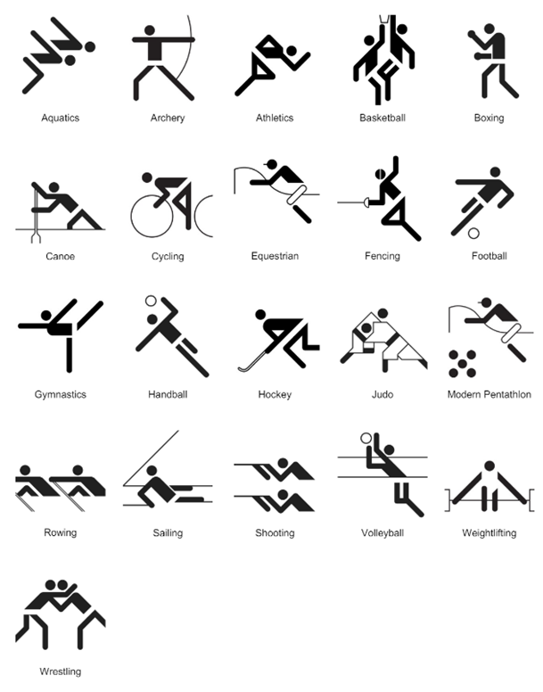

‘Munich 1972’ by Otl Aicher © 2017 International Olympic Committee.

1. Provide students with Resource 17 – Munich Olympics.

* Stage 2 students use 3 different colour pencils to mark at least 5 right angles, 5 angles less than a right angle and 5 angles greater than a right angle. Students compare and confirm each angle they have identified.
* Stage 3 students revise how to use a protractor by modelling using an interactive protractor, such as [Polypad – Geometry: Utensils](https://polypad.amplify.com/p#measuring). Provide students with protractors and Resource 18 – using a protractor. Students measure 2 acute, 2 obtuse, 2 right and 2 reflex angles on Resource 17 – Munich Olympics. Students check their measurements with a partner.

1. Regroup as a class. Ask all students to design a pictogram for the sport of their choice using only intersecting straight lines and circles. For the design:

* Stage 2 students draw each of the angles in their pictogram separately and mark the arms and vertex. Students then label the angle as greater than, less than or equal to a right angle.
* Stage 3 students include a 45°, a 90° and a 135° angle, created using a protractor.

1. Students share their pictogram and discuss the reasons why the angles in their pictogram are important for that sport.

This table details opportunities for differentiation.

|  |  |
| --- | --- |
| Too hard? | Too easy? |
| Stage 2 students cannot recognise and describe angles as less than, equal to, about the same as or greater than a right angle.   * Provide students with Resource 14 – angle measurers. Support students to use the right-angle identifier to locate angles in Resource 17 – Munich Olympics that are not right angles. Discuss whether the angles are less than or greater than a right angle.   Stage 3 students cannot measure and create angles of up to 360° using a protractor.   * Guide students to identify each part of a protractor. Ask students to overlay a transparency of Resource 14 – angle measurers onto a protractor. Identify the connections between the tools. | Stage 2 students can recognise and describe angles as less than, equal to, about the same as or greater than a right angle.   * Students explore how to use a numberless protractor and right-angle identifier to measure right angles. Students evaluate which tool is easier to use, providing reasons.   Stage 3 students can measure and create angles of up to 360° using a protractor.   * Use a digital device to find action photographs in an area of interest such as sport, gymnastics or dance. Represent angles in the images using degrees, diagrams and words. |

## Consolidation and meaningful practice – 20 minutes

1. Using grid paper, students write their first name using a lead pencil and a ruler to create straight lines (see Figure 5).

Figure 5 – student name example

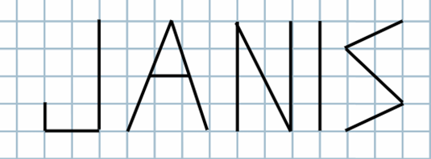

1. Stage 2 students identify angles that are equal to, less than or greater than a right angle.
2. Stage 3 students record the angles in their names, including reflex angles (see Figure 6).

Figure 6 – angles recorded

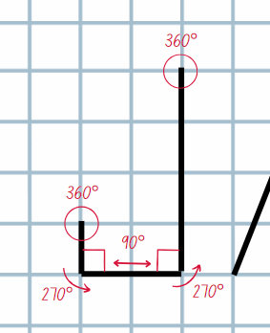

1. If time allows, repeat with a name or word of their choice, including their last name, nickname or favourite sports team.

This table details opportunities for assessment.

|  |  |
| --- | --- |
| Assessment opportunities | Links |
| What to look for:   * Can Stage 2 students identify angles with 2 arms in practical situations? **[MAO-WM-01, MA2-GM-03]** * Can Stage 2 students compare angles and explain that the length of the arms does not affect the size of the angle? **[MAO-WM-01, MA2-GM-03]** * Can Stage 2 students recognise and describe angles as less than, equal to, about the same as or greater than a right angle? **[MAO-WM-01, MA2-GM-03]** * Can Stage 3 students measure angles of up to 360° using a protractor? **[MAO-WM-01, MA3-GM-03]** * Can Stage 3 students create angles of up to 360° using a protractor? **[MAO-WM-01, MA3-GM-03]** * Can Stage 3 students recognise that a right angle is 90°, a straight angle is 180° and an angle of revolution is 360°? **[MAO-WM-01, MA3-GM-03]** * Can Stage 3 students identify and describe angle size in degrees for the classifications acute, obtuse and reflex? **[MAO-WM-01, MA3-GM-03]** | Links to [National Numeracy Learning Progressions](https://www.australiancurriculum.edu.au/resources/national-literacy-and-numeracy-learning-progressions/version-3-of-national-literacy-and-numeracy-learning-progressions/) (NNLP):   * Stage 2 – UuM4, UuM5, UuM6 * Stage 3 – UuM7, UuM8. |

# Lesson 5

**Core concept**: angles can be created, estimated, measured and compared.

## Daily number sense – completing the whole – 15 minutes

Daily number sense activities for Lessons 5 to 7 ‘loop’ back to concepts and procedures covered in previous units to assist students to build an increasingly connected network of ideas. These concepts may differ from the core concepts being covered by the unit.

The table below contains suggested learning intentions and success criteria. These are best co-constructed with students.

|  |  |
| --- | --- |
| Daily number sense learning intentions | Daily number sense success criteria |
| Students working towards Stage 2 outcomes are learning to:   * model and represent unit fractions, and their multiples, to a complete whole on a number line.   Students working towards Stage 3 outcomes are learning to:   * solve problems involving addition and subtraction of fractions with the same denominator. | Students working towards Stage 2 outcomes can:   * model fractions with fraction strips and diagrams for halves, quarters, eighths, thirds * recreate the whole unit from a fractional part.   Students working towards Stage 3 outcomes can:   * use diagrams, objects and mental strategies to subtract a unit fraction from any whole number including 1. |

**Note**: key ideas for Stage 2 fractions are outlined in the syllabus teaching advice and in the professional learning module [Analysing fractions](https://myplsso.education.nsw.gov.au/mylearning/catalogue/details/4fb7d05c-0938-ee11-8456-0003ff49608c) by the NSW Department of Education. The fraction cards on Resource 19 – fractions require cutting prior to starting the game.

1. Display Resource 20 – whole pencils. Explain that for each pencil, the unit fractional part is visible.
2. Provide pairs of students with Resource 19 – fractions and individual copies of Resource 20 – whole pencils.
3. Stage 2 students flip a card from Resource 19 – fractions to represent the revealed fractional part of a pencil and draw the hidden fractional part of each pencil on Resource 20 – whole pencils (see Figure 7).
4. Stage 3 students flip a card from Resource 19 – fractions to represent a fractional part of a whole pencil that has snapped off and represent the remaining part of a pencil using a number line.
5. Students identify:

* a complete whole for each pencil
* the longest and shortest pencils
* the missing fractional part for each pencil.

1. Select students to communicate their reasoning and their answers (see Figure 7 for Stage 2 students and Figure 8 for Stage 3 students).

Figure 7 – Stage 2 work sample

A pencil case. Poking out of the top of the case are 3 partially visible pencils.

Pencil 1 is marked as being one-third visible.

Pencil 2 is marked as being one-quarter visible. 

Pencil 3 is marked as being one-half visible.

Students have built up from the partially visible pencils to show how long the whole pencil would be. The first pencil shows a number line of three-thirds. The second pencil shows a number line of four-quarters. The third pencil shows a number line of two-halves.

Figure 8 – Stage 3 work sample

A pencil case. Poking out of the top of the case is a partially visible pencil. 

The pencil is marked as being one-third visible. 

A number line is drawn next to the pencil to indicate the subtraction of a third from 1 whole pencil. 

There is also a number sentence that reads: 1 – 1/3 = 2/3.

This table details opportunities for assessment.

|  |  |
| --- | --- |
| Assessment opportunities | Links |
| What to look for:   * Can Stage 2 students model fractions with fraction strips and diagrams for halves, quarters, eighths, thirds? **[MAO-WM-01, MA2-PF-01]** * **Can Stage 2 students recreate the whole unit from a fractional part? [MAO-WM-01, MA2-PF-01]** * Can Stage 3 students use diagrams, objects and mental strategies to subtract a unit fraction from any whole number including 1? **[MAO-WM-01, MA3-RQF-02]** | Links to [National Numeracy Learning Progressions](https://www.australiancurriculum.edu.au/resources/national-literacy-and-numeracy-learning-progressions/version-3-of-national-literacy-and-numeracy-learning-progressions/) (NNLP):   * Stage 2 – InF2, InF3, InF4 * Stage 3 – InF7, InF8.   Links to suggested Interview for Student Reasoning (IfSR) tasks:   * Stage 2 – IfSR – MT: 3B.2. |

## Core lesson 1 – angle art – 15 minutes

The table below contains suggested learning intentions and success criteria. These are best co-constructed with students.

|  |  |
| --- | --- |
| Core concept learning intentions | Core concept success criteria |
| Students working towards Stage 2 outcomes are learning to:   * identify angles as measures of turn * compare angles to a right angle.   Students working towards Stage 3 outcomes are learning to:   * estimate, measure and compare angles using degrees * use a protractor to measure and identify types of angles. | Students working towards Stage 2 outcomes can:   * use the term right angle to describe a quarter-turn in a range of orientations * compare angles to a right angle using informal means.   Students working towards Stage 3 outcomes can:   * record angle measurements using the symbol for degrees (°) * measure angles of up to 360° using a protractor * create angles of up to 360° using a protractor. |

1. Display the artwork [Composition 8 (Komposition 8)](https://www.guggenheim.org/artwork/1924) by Vasily Kandinsky, 1923. Explain to students that Kandinsky was a famous artist who used lines, shapes and colour to represent moods and feelings.
2. Tell students they will have some quiet time to view the painting. Ask:

* What do you notice about this painting?
* How does it make you feel?
* What shapes can you see?
* Do you think Kandinsky thought about the size of the angles when he was designing and creating this piece? Why or why not?
* Can you find angles that are smaller than, larger than or almost the same as a right angle?
* Where is the largest and smallest angle you can find?
* Can you see non-examples of angles? Where? (curves, intersecting curves, straight lines that do not intersect)
* Can you think of other examples in the creative arts where identifying the amount of turn between 2 arms is important? (dance movements, actors’ body language, embroidery stitching, camera angle and so on)

1. Students choose a favourite section of the painting and [turn and talk](https://education.nsw.gov.au/teaching-and-learning/curriculum/literacy-and-numeracy/teaching-and-learning-resources/numeracy/talk-moves) to describe it using appropriate geometric language.
2. Select students to share their responses. Prompt students for terms such as: angle, arm, vertex, vertices, amount of turn, circle, line, triangle, vertical, horizontal, parallel, orientation, rhombus, parallelogram, trapezium, quadrilateral.

## Core lesson 2 – NSW flight plans – 30 minutes

1. Display Resource 21 – outback courier. Explain that an outback courier needs to deliver freight to towns in NSW and flying to them is the fastest way. The courier’s first journey is from Moree to Broken Hill via Armidale, Cobar, Orange and Wagga Wagga. The pilot would like the angles of the turns to be measured.
2. Revise the link between a right angle and a quarter-turn.
3. Select Stage 2 students to describe angles as less than, greater than, equal to, about the same as or a right angle. Annotate each angle using the codes L, G, E and A.
4. Select Stage 3 students to identify and describe angles as acute, obtuse and reflex.
5. For Stage 3 students, demonstrate how to estimate and then measure an angle from Resource 21 – outback courier using a protractor and record using the degree symbol (°).

**Note**: provide Resource 18 – using a protractor for students that need revision on how to use a protractor correctly.

1. Display Resource 22 – NSW flight paths. Explain that there is a Stage 2 and Stage 3 version of this resource.
2. Read the instructions for each version (see Figure 9 for an example of Stage 3 estimates and measurements).

Figure 9 – student example measuring and recording angles

Map of NSW with towns marked and a flight path from Coffs Harbour to Moree, Newcastle, Dubbo, Wagga Wagga and Mildura.

The angles of each turn is estimated and then measured and recorded using the degree symbol.

1. Provide students with Resource 22 – NSW flight paths, a ruler and writing materials to create their flight plans. Provide Stage 3 students with a protractor.
2. Students compare angle labels and measurements with a partner. If any discrepancies in measurements arise, ask students to remeasure and discuss.

This table details opportunities for differentiation.

|  |  |
| --- | --- |
| Too hard? | Too easy? |
| Stage 2 students cannot use the term right angle to describe a quarter-turn in a range of orientations.   * Support students to fold different shaped pieces of paper as many times as required to make a right angle. They then trace the edge onto a second piece of paper to show a quarter-turn. Students repeat this process, each time placing the right angle in a different orientation.   Stage 3 students cannot measure angles of up to 360° using a protractor.   * Assist students with positioning the protractor, particularly with Steps 3 and 4 in Resource 18 – using a protractor. Help them to start counting from zero, holding the protractor steady to ensure accuracy. | Stage 2 students can use the term right angle to describe a quarter-turn in a range of orientations.   * Students design a flight path to visit 6 cities using only right angles. What challenges does using only one angle type present?   Stage 3 students can measure angles of up to 360° using a protractor.   * Students determine a flight plan with angles adding as closely to 360° as possible. |

## Discuss and connect the mathematics – 10 minutes

1. Regroup and summarise the lesson together, drawing out key mathematical ideas. Ask:

* Did you experience any challenges in this activity? How did you overcome them?
* Do you think that planes actually turn in the way shown on the map? Why or why not?
* Did you have a strategy to compare the flight path angles with right angles? Explain. (Stage 2)
* Did you have a strategy to estimate the flight path angles? Explain. (Stage 3)
* Were your estimations close to the recorded angle? Why or why not?
* How did you ensure that your measurements were accurate? (Stage 3)
* Was there an angle that surprised you when you recorded it?

This table details opportunities for assessment.

|  |  |
| --- | --- |
| Assessment opportunities | Links |
| What to look for:   * Can Stage 2 students use the term right angle to describe a quarter-turn in a range of orientations? **[MAO-WM-01, MA2-GM-03]** * Can Stage 2 students compare angles to a right angle using informal means? **[MAO-WM-01, MA2-GM-03]** * Can Stage 3 students record angle measurements using the symbol for degrees (°)? **[MAO-WM-01, MA3-GM-03]** * Can Stage 3 students measure angles of up to 360° using a protractor? **[MAO-WM-01, MA3-GM-03]** * Can Stage 3 students create angles of up to 360° using a protractor? **[MAO-WM-01, MA3-GM-03]** | Links to [National Numeracy Learning Progressions](https://www.australiancurriculum.edu.au/resources/national-literacy-and-numeracy-learning-progressions/version-3-of-national-literacy-and-numeracy-learning-progressions/) (NNLP):   * Stage 2 – UuM6 * Stage 3 – UuM7, UuM8. |

# Lesson 6

**Core concept**: angles can be created, estimated, measured and compared to solve real-world problems.

## Daily number sense – fractions memory – 15 minutes

The table below contains suggested learning intentions and success criteria. These are best co-constructed with students.

|  |  |
| --- | --- |
| Daily number sense learning intentions | Daily number sense success criteria |
| Students working towards Stage 2 outcomes are learning to:   * model and represent unit fractions, and their multiples, to a complete whole on a number line.   Students working towards Stage 3 outcomes are learning to:   * solve problems involving addition and subtraction of fractions with the same denominator. | Students working towards Stage 2 outcomes can:   * model fractions with fraction strips and diagrams for halves, quarters, eighths, thirds * determine the complementary fractional part needed to complete one whole.   Students working towards Stage 3 outcomes can:   * use diagrams, objects and mental strategies to subtract a unit fraction from any whole number including 1. |

This activity uses resources and concepts covered in [Multi-age Year A Unit 16](https://education.nsw.gov.au/teaching-and-learning/curriculum/mathematics/planning-programming-and-assessing-mathematics-k-6/mathematics-3-6-units#tabs_727018652_copy_3:~:text=Unit%2016%20%E2%80%93%20Fractions%20represent%20multiple%20ideas%20and%20can%20be%20represented%20in%20different%20ways). You may already have the cards for the ‘Fractions memory’ game to complete this learning activity.

1. Display Resource 23 – ‘Fractions memory’. Revise fraction complements to recreate the whole from a fractional part. For example, $\frac{1}{4}$ is the fractional complement of $\frac{3}{4}$.
2. Review the game instructions:
3. Shuffle the cards and lay out all the cards facedown in an array formation.
4. Players take turns flipping over 2 cards at a time, aiming to find pairs of fractions to make a whole.
5. Keep the cards and take another turn if the fractions create one whole.
6. Flip the cards back over and the next player has a turn if the fractions do not create a whole.
7. The game continues until all pairs of fractions have been matched.
8. To vary the activity, each player turns one card over at the same time and either:

* the player whose card requires the largest fraction to create the whole, keeps their card
* the player whose card requires the smallest fraction to create the whole, keeps their card
* the player whose fraction card is closest in size to one-half keeps their card.

This table details opportunities for assessment.

|  |  |
| --- | --- |
| Assessment opportunities | Links |
| What to look for:   * Can Stage 2 students model fractions with fraction strips and diagrams for halves, quarters, eighths, thirds? **[MAO-WM-01, MA2-PF-01]** * **Can Stage 2 students determine the complementary fractional part needed to complete one whole? [MAO-WM-01, MA2-PF-01]** * Can Stage 3 students use diagrams, objects and mental strategies to subtract a unit fraction from any whole number including 1? **[MAO-WM-01, MA3-RQF-02]** | Links to [National Numeracy Learning Progressions](https://www.australiancurriculum.edu.au/resources/national-literacy-and-numeracy-learning-progressions/version-3-of-national-literacy-and-numeracy-learning-progressions/) (NNLP):   * Stage 2 – InF2, InF3, InF4 * Stage 3 – InF7, InF8.   Links to suggested Interview for Student Reasoning (IfSR) tasks:   * Stage 2 – IfSR – MT: 3B.2. |

## Core lesson – Australian flight plans – 25 minutes

The table below contains suggested learning intentions and success criteria. These are best co-constructed with students.

|  |  |
| --- | --- |
| Core concept learning intentions | Core concept success criteria |
| Students working towards Stage 2 outcomes are learning to:   * identify angles as measures of turn * compare angles to a right angle.   Students working towards Stage 3 outcomes are learning to:   * estimate, measure and compare angles using degrees * use a protractor to measure and identify types of angles. | Students working towards Stage 2 outcomes can:   * use the term right angle to describe a quarter-turn in a range of orientations * recognise and describe angles as less than, equal to, about the same as or greater than a right angle.   Students working towards Stage 3 outcomes can:   * record angle measurements using the symbol for degrees (°) * measure angles of up to 360° using a protractor * create angles of up to 360° using a protractor. |

**Note**: Resource 24 – Australian flight paths should be copied back-to-back for each student prior to this lesson. Students are only required to use 3 of the 4 maps of Australia for the core lesson. The fourth map can be used for the ‘Too easy?’ differentiation activity.

1. Explain that the outback courier from Lesson 5 is now expanding their business to be Australia-wide and students will be creating 3 different flight paths using a map of Australia. Each flight path needs to include 6 towns (see Figure 10).

Figure 10 – Australian flight plan example

Map of Australia with towns marked and a flight path from Townsville to Brisbane (80 degrees), Broken Hill to Birdsville (82 degrees), Birdsville to Esperance (105 degrees), Esperance to Carnarvon (91 degrees) and Broome. 

The angles of each turn is measured and recorded using the degree symbol.

1. Explain that Stage 2 students will recognise and describe angles as less than, greater than, equal to, about the same as a right angle. Annotate each angle using the codes L, G, E and A. Stage 3 students will measure using a protractor and record using the degree symbol (°).
2. Provide students with Resource 24 – Australian flight paths and a ruler. Provide Stage 3 students with a protractor. Students create and either identify or measure angles on 3 different flight paths, individually or in pairs.
3. Students compare, discuss and check the identifications or measurements of a partner’s created flight path(s).

This table details opportunities for differentiation.

|  |  |
| --- | --- |
| Too hard? | Too easy? |
| Stage 2 Students cannot recognise and describe angles as less than, equal to, about the same as or greater than a right angle.   * Students use their right-angle tester or a right-angled pattern block to test the angles.   Stage 3 students cannot measure and create angles of up to 360° using a protractor.   * Students measure and record angles using Resource 25 – a numberless protractor. Assist students with positioning the protractor, particularly with Steps 3 and 4 in Resource 18 – using a protractor. * Reduce the number of angles included in the flight paths. | Stage 2 students can recognise and describe angles as less than, equal to, about the same as or greater than a right angle.   * Students create a flight path, including at least 4 towns using one of each of the angles: less than, equal to, about the same as or greater than a right angle.   Stage 3 students can measure and create angles of up to 360° using a protractor.   * Students measure and record the external angles of each turn. * Students create a flight path, including at least 4 towns using one of each of the angles: acute, obtuse, right and reflex. Students measure and record each angle. |

## Consolidation and meaningful practice – 25 minutes

1. Explain that the outback courier would like to rebrand with a new logo now that they are Australia-wide.
2. Students will design a new logo for the outback courier.
3. Stage 2 students’ logos must include:

* an angle less than a right angle
* an angle greater than a right angle
* an angle about the same as a right angle.

1. Stage 3 students’ logos must include:

* a perpendicular line
* a 30° angle
* an obtuse angle
* an acute angle (see Figure 11).

Figure 11 – logo example

A transport logo example showing an initial design, including a perpendicular line, an obtuse angle, an acute angle and a 30° angle.

To the right, the design has been shrunk and duplicated into 2 rows of 2.

The images are each rotated in 90 degree turns.

1. Stage 2 students use a ruler to design and create the logo. Stage 3 students use a protractor and a ruler to design and create the logo.

**Note:** students may also use [Canva](https://app.education.nsw.gov.au/digital-learning-selector/LearningTool/Card/653) to digitally create their logo.

1. Students conduct a [gallery walk](https://app.education.nsw.gov.au/digital-learning-selector/LearningActivity/Card/555). Ask:

* How did you ensure the logos included the 4 design requirements?
* Were there any design elements incorporated in a logo that were interesting or creative? Explain.
* Did you experience any challenges during this activity? How did you overcome them?

This table details opportunities for assessment.

|  |  |
| --- | --- |
| Assessment opportunities | Links |
| What to look for:   * Can Stage 2 students use the term right angle to describe a quarter-turn in a range of orientations? **[MAO-WM-01, MA2-GM-03]** * Can Stage 2 students recognise and describe angles as less than, equal to, about the same as or greater than a right angle? **[MAO-WM-01, MA2-GM-03]** * Can Stage 3 students record angle measurements using the symbol for degrees (°)? **[MAO-WM-01, MA3-GM-03]** * Can Stage 3 students measure angles of up to 360° using a protractor? **[MAO-WM-01, MA3-GM-03]** * Can Stage 3 students create angles of up to 360° using a protractor? **[MAO-WM-01, MA3-GM-03]** | Links to [National Numeracy Learning Progressions](https://www.australiancurriculum.edu.au/resources/national-literacy-and-numeracy-learning-progressions/version-3-of-national-literacy-and-numeracy-learning-progressions/) (NNLP):   * Stage 2 – UuM6 * Stage 3 – UuM7, UuM8. |

# Lesson 7

**Core concept**: clock hands make different angles at different times (Stage 2) and mental strategies can help to calculate the duration of events (Stage 3).

## Daily number sense – fractions and wholes – 15 minutes

The table below contains suggested learning intentions and success criteria. These are best co-constructed with students.

|  |  |
| --- | --- |
| Daily number sense learning intentions | Daily number sense success criteria |
| Students working towards Stage 2 outcomes are learning to:   * model and represent unit fractions, and their multiples, to a complete whole on a number line.   Students working towards Stage 3 outcomes are learning to:   * solve problems involving addition and subtraction of fractions with the same denominator. | Students working towards Stage 2 outcomes can:   * model fractions with fraction strips and diagrams for halves, quarters, eighths, thirds.   Students working towards Stage 3 outcomes can:   * solve word problems that involve fractions with the same denominator. |

**Note**: this activity explores a common misconception about fractions referred to as the double count. When working with fractions, students using the double-count strategy can lose sight of the whole and incorrectly interpret a part-whole situation as a ratio. For more information see  [Misunderstandings](https://topdrawer.aamt.edu.au/Fractions/Misunderstandings) on the [Top Drawer Teachers](https://topdrawer.aamt.edu.au/) website by Australian Association of Mathematics Teachers (AAMT).

1. Display and read Resource 26 – fractions of a whole.
2. Identify that the correct answer is C. Select students to explain why C is correct, providing reasons.
3. Explain that in an assessment, many students incorrectly chose B as the answer.
4. Students [Think-Pair-Share](https://app.education.nsw.gov.au/digital-learning-selector/LearningActivity/Card/645) to respond to:

* What misunderstanding do you think students who chose B had?
* What would you say to those students to help them?

1. Repeat the questions for responses A and D.
2. Display Resource 27 – worded problems.
3. Select students to justify which worded problem best reflects the fraction strip represented.

This table details opportunities for assessment.

|  |  |
| --- | --- |
| Assessment opportunities | Links |
| What to look for:   * Can Stage 2 students model fractions with fractions strips and diagrams for halves, quarters, eighths, thirds? **[MAO-WM-01, MA2-PF-01]** * Can Stage 3 students solve word problems that involve fractions with the same denominator? **[MAO-WM-01, MA3-RQF-02]** | Links to [National Numeracy Learning Progressions](https://www.australiancurriculum.edu.au/resources/national-literacy-and-numeracy-learning-progressions/version-3-of-national-literacy-and-numeracy-learning-progressions/) (NNLP):   * Stage 2 – InF3, InF4.   Links to suggested Interview for Student Reasoning (IfSR) tasks:   * Stage 2 – IfSR – MT: 3B.2. |

## Core lesson – 40 minutes

### Stage 2 task – puzzled time

The table below contains a suggested learning intention and success criteria. These are best co-constructed with students.

|  |  |
| --- | --- |
| Core concept learning intention | Core concept success criteria |
| Students working towards Stage 2 outcomes are learning to:   * read and represent analog time. | Students working towards Stage 2 outcomes can:   * identify 30 minutes as being half-hour and 60 minutes as an hour * connect the quarter-hour to 15 minutes * recognise that the position of the numerals on an analog timepiece often represents 2 different values * read time as past the hour to half-past and then towards the hour. |

1. Provide each student with Resource 28 – blank clock.
2. Students [turn and talk](https://education.nsw.gov.au/teaching-and-learning/curriculum/literacy-and-numeracy/teaching-and-learning-resources/numeracy/talk-moves) to discuss missing features of the clock face.
3. Review students’ understanding of an analog clock. Explain, if necessary, that an analog clock has several features, including a face, an hour hand and a minute hand. Some analog clocks have a third hand to represent the seconds.
4. Revise that there are 60 minutes in an hour, 30 minutes in half an hour and 15 minutes in a quarter of an hour.
5. Provide each student with 2 cardboard strips and a split pin. Ensure that one cardboard strip is longer than the other so that the strips can be used to represent the hour hand and minute hand on a clock.
6. Instruct students to position the hour hand at the number one and the minute hand at the number 12. Ask:

* What time is your clock showing?
* If a quarter of an hour had to pass until sport time, what time would sport be?
* Can you represent the change in time using your clocks?
* If the lunch break started three-quarters of an hour ago, what time did it start?

1. Instruct students to change the positioning of the 2 hands so that the hour hand points at the 12 and the minute hand points at the one. Ask:

* What is the same and different about the old and new placement of the hands on your clock?
* What time is your clock showing now?
* If your clock is running half an hour fast, what would the actual time be?
* If it was running 15 minutes slow, what would the actual time be?

1. Provide students with Resource 29 – clock records. Students take turns to make different times on their clocks for a partner to read.

* Partner A uses the angle tester to represent a time on Resource 28 – blank clock.
* Partner B reads the time represented and records it on Resource 29 – clock records.
* Partner B also records the time as past the hour to half-past or towards the hour.
* Partners then swap roles.

1. Read the statement: Jack looked at the clock in his classroom and described the time to his partner as ‘The two hands on the clock make a right angle’.
2. In pairs, students use their angle tester to determine possible times on the classroom clock. Ask:

* What are some of the possible times on the classroom clock? (9 o’clock and 3 o’clock)
* Why is it not possible for the clock to be showing half-past 9? (the angle between the 2 arms will be greater than a right angle)
* Why is it not possible for the clock to reflect a time that is quarter-past or quarter-to? (the angle between the 2 arms will be less than a right angle)

**Note**: on analog clocks, there are other times where the hands are at right angles, such as 1:51. However, it is not expected that students in Stage 2 identify all possibilities in this activity. Students may associate right angles as a quarter of an hour and identify 9:30 or 3:30 as possible times. It is important to identify these as incorrect responses as the hour hand and minute hands do not move independently. The hour hand rotates at a smaller measure of a turn in an hour (30°) and the minute hand rotates a larger measure of turn in an hour (360°). The [interactive clock](https://toytheater.com/clock/) may be a useful tool to demonstrate this.

1. Regroup and select students to share their responses.
2. Read the statement: The next day, Jack read the time on the clock again. This time, he described it as ‘In 30 minutes, the two hands on the clock will make a right angle’.
3. In pairs, students discuss all the possible times reflected on the classroom clock. Ask:

* What are some possible times reflected on the classroom clock? (8:30, half-past 8, 2:30 or half-past 2)
* How did you work this out?
* How many quarter-turns does it take for the minute hand to pass through 30 minutes?

1. Provide students with Resource 30 – angles on clocks.
2. Instruct students to find as many clock representations as possible to reflect a time when:

* the angle between the hour and minute hand is less than a right angle
* the angle between the hour and minute hand is greater than a right angle
* the angle between the hour and minute hand is about the same as a right angle.

This table details opportunities for differentiation.

|  |  |
| --- | --- |
| Too hard? | Too easy? |
| Students cannot connect the quarter-hour to 15 minutes.   * Teacher models and support students to make and read quarter times and to connect quarter of an hour to 15 minutes. * Provide students with Resource 28 – blank clock. Revise with students how many minutes are in an hour and have them mark the 15-minute intervals on the clock face. Support students to fold the clock face into half and then quarters. Students mark and count the number of 5-minute intervals represented in each quarter. | Students can connect the quarter-hour to 15 minutes.   * Students use a digital device to access the activity [Two Clocks](https://nrich.maths.org/4806) by NRICH. Students record the clock faces and their reasoning. * Provide students with the poster from [Clocks](https://nrich.maths.org/1812) by NRICH. Students work out the times displayed in each clock face and check with a mirror. Students create reflections of other times for a partner to solve. |

### Stage 3 task – 24-hour time problems

The table below contains a suggested learning intention and success criteria. These are best co-constructed with students.

|  |  |
| --- | --- |
| Core concept learning intention | Core concept success criteria |
| Students working towards Stage 3 outcomes are learning to:   * solve problems involving duration, using 12- and 24-hour time. | Students working towards Stage 3 outcomes can:   * use start and finish times to calculate the elapsed time of events * add and subtract time mentally using bridging strategies. |

1. Revise that 24-hour time is used to avoid confusion between am and pm. It is used by emergency services, airlines, military forces and public transport services for clear communication of time.
2. Display Resource 31 – 24-hour time. Record some of the bell times of the school day. For example, school begins at 8:55 am, recess ends at 11:20 am and lunch begins at 1:10 pm.
3. Provide students with individual whiteboards to write the 24-hour time for the bell times recorded on the board. For example, 08:55, 11:20 and 13:10.
4. Revise that a blank number line can be used to find the duration (difference between 2 times) using jumps.
5. Display Resource 32 – duration problems.
6. Draw an empty number line on the board. Use the [think-aloud](https://evidenceforlearning.org.au/news/planning-a-think-aloud-in-mathematics) strategy to model recording on the empty number line to solve the first problem (see Figure 12).

Figure 12 – blank number line demonstration

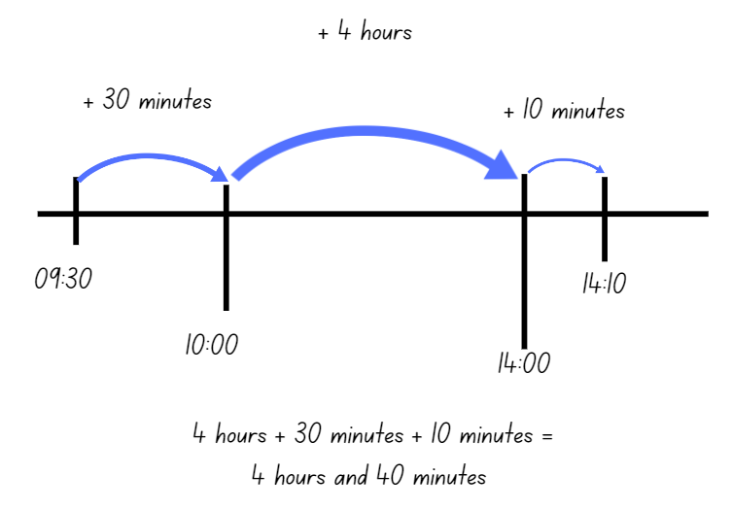

1. Students complete the remaining duration problems using jumps of time on a blank number line.
2. Select students to share and explain how they used the number line to find solutions. Ask:

* Did you find the empty number line useful for calculating elapsed time? Why or why not?
* Can you think of any other strategies you could use to calculate elapsed time?

1. Provide each student with a copy of Resource 33 – airline flight timetable.
2. Students practice the duration problems. Encourage students to add and subtract time mentally using bridging strategies.

**Note**:a blank number line can support students in transitioning to mental strategies.

This table details opportunities for differentiation.

|  |  |
| --- | --- |
| Too hard? | Too easy? |
| Stage 3 students cannot use start and finish times to calculate the elapsed time of events.   * Provide students with duration problems that only require jumps of hours from the ‘o’clock’. * Provide students with a hands-on clock that can be used to visually model the elapsed time. | Stage 3 students can start and finish times to calculate the elapsed time of events.   * Students mentally calculate the total duration of all flights in Resource 32 – duration problems. * Students create their own elapsed time question for a partner to solve. |

## Discuss and connect the mathematics – 10 minutes

1. Regroup as a class and select Stage 2 students to share their clock representations.
2. Use the [interactive clock](https://toytheater.com/clock/) to check whether students have classified their clock representations accurately.
3. Select Stage 3 students to share and justify their solutions to Resource 33 – airline flight timetable. Ask:

* Why is solving elapsed time a useful skill?
* What makes 24-hour time on a timetable an efficient way to communicate information?

This table details opportunities for assessment.

|  |  |
| --- | --- |
| Assessment opportunities | Links |
| What to look for:   * Can Stage 2 students identify 30 minutes as being half-hour and 60 minutes as an hour? **[MAO-WM-01, MA2-NSM-02]** * Can Stage 2 students connect the quarter-hour to 15 minutes? **[MAO-WM-01, MA2-NSM-02]** * Can Stage 2 students recognise that the position of the numerals on an analog timepiece often represents 2 different values? **[MAO-WM-01, MA2-NSM-02]** * Can Stage 2 students read time as past the hour to half-past and then towards the hour? **[MAO-WM-01, MA2-NSM-02]** * Can Stage 3 students use start and finish times to calculate the elapsed time of events? **[MAO-WM-01, MA3-NSM-02]** * Can Stage 3 students add and subtract time mentally using bridging strategies? **[MAO-WM-01, MA3-NSM-02]** | Links to [National Numeracy Learning Progressions](https://www.australiancurriculum.edu.au/resources/national-literacy-and-numeracy-learning-progressions/version-3-of-national-literacy-and-numeracy-learning-progressions/) (NNLP):   * Stage 2 – MeT2, MeT3 * Stage 3 – MeT4, MeT5. |

# Lesson 8

**Core concept**: 5-minute intervals on analog clocks are useful for reading the time (Stage 2) and commonly used time intervals and duration can be represented as decimals (Stage 3).

## Daily number sense – 10 minutes

1. From a class need surfaced through formative assessment data, identify a short, focused activity that targets students’ knowledge, understanding and skills. Example activities may be drawn from the following resources:

* [Mathematics K–6 resources](https://education.nsw.gov.au/teaching-and-learning/curriculum/mathematics/mathematics-curriculum-resources-k-12/mathematics-k-6-resources)
* [Universal Resources Hub](https://resources.education.nsw.gov.au/home).

## Core lesson – 40 minutes

### Stage 2 task – passing time

The table below contains a suggested learning intention and success criteria. These are best co-constructed with students.

|  |  |
| --- | --- |
| Core concept learning intention | Core concept success criteria |
| Students working towards Stage 2 outcomes are learning to:   * represent and read analog time. | Students working towards Stage 2 outcomes can:   * recognise that 5-minute intervals (corresponding to the hour markers) are used as benchmarks to read time on an analog clock * recognise that the position of the numerals on an analog timepiece often represents 2 different values * read analog clocks to the minute. |

**Note**: it is recommended to use existing classroom clocks for this activity. Remove batteries prior to the lesson so that the time displayed remains the same during class discussions. Ensure that digital time setting is also turned off when using the [Interactive Clock](https://toytheater.com/clock/).

1. Display a physical analog clock and an [interactive clock](https://toytheater.com/clock/).
2. Students [turn and talk](https://education.nsw.gov.au/teaching-and-learning/curriculum/literacy-and-numeracy/teaching-and-learning-resources/numeracy/talk-moves) and discuss what they notice is similar and/or different.
3. Select students to share their responses.
4. Draw students’ attention to the different numbers on the clocks and ask:

* What do each of the numbers represent?
* What do each of the lines between the numbers represent?
* Is there a time where both hands on the clock overlap?

1. Students use Resource 28 – blank clock, cardboard strips and split pins from Lesson 7 to create 11 o’clock, 1 o’clock and 4 o’clock.
2. Ask students to identify if the angles formed by the arms are greater than, less than or equal to a right angle.
3. Display 11 o’clock using an [interactive clock](https://toytheater.com/clock/). Ask students to predict what happens when the minute hand completes a quarter-turn.
4. Model moving the minute hand and ask students to count the number of 5-minute intervals that are passed.
5. Explain that a quarter-turn is the equivalent of 15 minutes.
6. Ask students to predict what happens when another quarter-turn is completed.

* What is the new time shown on the clock after 2 quarter-turns are completed?
* How do you know that this is 30 minutes or half-hour?
* How does your understanding of fractions assist you with this knowledge? (2 quarters make a half)

1. Provide pairs of students with a 12-sided die and individual copies of Resource 28 – blank clock.
2. In pairs, students take turns to roll the die twice. The numbers rolled will indicate the number on the clock face that either the minute hand or hour hand will point towards. For example, if students land on a 3 and 5, students may choose to point their hour hand at the number 3 and the minute hand at 5 or vice versa (see Figure 13).

Figure 13 – sample clock representation

Two analog clock faces using angle-testers with arms of different lengths to represent the minute and hour hands.

The first clock shows the minute hand pointing to 5 and the hour hand pointing to 3 as an approximation of 3:25.

The second clock shows the minute hand pointing to 3 and the hour hand pointing to 5 as an approximation of 5:15.

**Note**:the hour hand only points directly to the number when it is an o’clock time.

1. Students tell the time displayed on the clock face and determine the time if a quarter-turn is made using the minute hand.
2. Move around the room to check for student understanding during this activity.

This table details opportunities for differentiation.

|  |  |
| --- | --- |
| Too hard? | Too easy? |
| Students cannot recognise that the position of the numerals on an analog timepiece often represents 2 different values.   * Provide students with 2 individual copies of Resource 28 – blank clock. Support students to use one clock face to tell the time at hourly intervals and a second clock face as minutes. Assist students in writing the number of minutes next to the numbers in 5-minute intervals. | Students can recognise that the position of the numerals on an analog timepiece often represents 2 different values.   * Pose the problem: ‘A regular school day operates in 3 sessions and each session is broken up by a recess and lunch break. Session 1 runs from 9 o’clock to 10:30, session 2 runs from 11 o’clock to 1 o’clock, and session 3 runs from 1:30 to 3 o’clock. Jack read the time aloud during their recess break and said, “It is ten to”. What was the time? How do you know?’ Students write their own example of a riddle for their friends to solve. |

### Stage 3 task – time intervals and problems

The table below contains a suggested learning intention and success criteria. These are best co-constructed with students.

|  |  |
| --- | --- |
| Core concept learning intention | Core concept success criteria |
| Students working towards Stage 3 outcomes are learning to:   * solve problems involving duration, using 12- and 24-hour time. | Students working towards Stage 3 outcomes can:   * represent commonly used time intervals as decimals * solve a variety of problems involving duration, including where times are expressed in 12-hour and 24-hour notation. |

1. Explain that decimals can be used to represent commonly used time intervals.
2. Display Resource 34 – decimal misconceptions.
3. Students [turn and talk](https://education.nsw.gov.au/teaching-and-learning/curriculum/literacy-and-numeracy/teaching-and-learning-resources/numeracy/talk-moves), discussing whether they think Bec or David is correct, justifying their answer.
4. Select students to share their reasons.
5. Record the following time intervals on the board, one at a time:

* 5 hours and 15 minutes
* 3 hours and 30 minutes
* 7 hours and 45 minutes
* 6 hours.

1. Students convert the time intervals to decimals and record on individual whiteboards. Address any misconceptions and errors observed after each time interval is recorded.
2. Display Resource 35 – train timetable.
3. Pose the problem: Kylie had to travel from Sydney to Wauchope. How long is the journey? How could this time interval be converted into a decimal?
4. Students mentally calculate the answer, recording on their whiteboard.
5. Explain: Kylie’s train ride was 4 hours and 45 minutes long. Discuss that the 6 hours and 45 minutes can be represented as 6.75 hours in decimal notation, as 45 minutes is 0.75 or three-quarters of an hour.

**Note**: practice more converting times to decimals at this point if need arises.

1. Distribute Resource 36 – timetable problems. Students work independently to solve the problems and record their answer in decimal notation.

This table details opportunities for differentiation.

|  |  |
| --- | --- |
| Too hard? | Too easy? |
| Stage 3 students cannot mentally calculate elapsed time using bridging strategies.   * Model how to use an empty number line to calculate the time and represent their thinking. * Provide students with a hands-on clock that can be used to visually model the elapsed time. | Stage 3 students can mentally calculate elapsed time using bridging strategies.   * Students mentally calculate the duration of a trip from Sydney to Casino. If the train was delayed by 10 minutes at each stop along the way, what was the total duration? Students record the time in decimal notation. * Students create their own elapsed time questions for a partner to mentally solve. |

## Discuss and connect the mathematics – 10 minutes

1. Regroup as a class. Display a time on a virtual clock and have Stage 2 students read it. Repeat with different times, checking that students can tell the time to the minute.
2. Ask the following questions:

* When does the hour hand point directly to a number (or 5-minute interval marker)? (Stage 2)
* If one hand on a clock was pointed at 6, what time might it be? (Stage 2)
* If one hand on a clock was pointed at 10, what time might it be? (Stage 2)
* How do the hour and minute hands move differently over an hour? (speed and amount of turn) Why? (Stage 2)
* What is challenging about writing time intervals in decimal notation? (Stage 3)
* Which format of time is less confusing for timetables, 12-hour or 24-hour? Why? (Stage 3)
* Why is it important to read timetables correctly? (Stage 3)

This table details opportunities for assessment.

|  |  |
| --- | --- |
| Assessment opportunities | Links |
| What to look for:   * Can Stage 2 students recognise that 5-minute intervals (corresponding to the hour markers) are used as benchmarks to read time on an analog clock? **[MAO-WM-01, MA2-NSM-02]** * Can Stage 2 students recognise that the position of the numerals on an analog timepiece often represents 2 different values? **[MAO-WM-01, MA2-NSM-02]** * Can Stage 2 students read analog clocks to the minute? **[MAO-WM-01, MA2-NSM-02]** * Can Stage 3 students represent commonly used time intervals as decimals? **[MAO-WM-01, MA3-NSM-02]** * Can Stage 3 students solve a variety of problems involving duration, including where times are expressed in 12-hour and 24-hour notation? **[MAO-WM-01, MA3-NSM-02]** | Links to [National Numeracy Learning Progressions](https://www.australiancurriculum.edu.au/resources/national-literacy-and-numeracy-learning-progressions/version-3-of-national-literacy-and-numeracy-learning-progressions/) (NNLP):   * Stage 2 – MeT2, MeT3 * Stage 3 – MeT5. |

# Resource 1 – place value houses

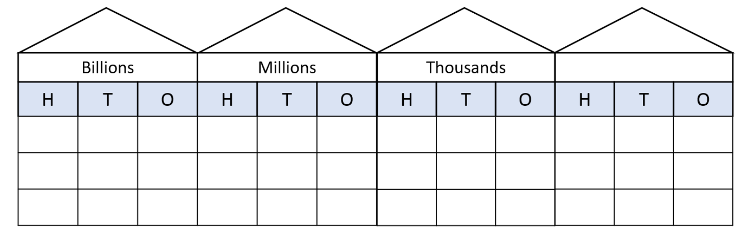

# Resource 2 – place value representations

Text reads: ‘Sam has recorded 4 ways to represent the number 8951.’

The 4 representations are: A) Expanded form with addition: 8000 + 900 + 50 + 1, B) Digit place value breakdown: 8 thousand 9 hundred 5 tens 1 one, C) Written in words: eight thousand, nine hundred and fifty one and D) Another expanded form with addition of non-standard partitioning: 8000 + 600 + 320 + 31.

Next to the number, a green check mark or red cross asks if the representations are accurate. Students are encouraged to verify and explain to a partner.

# Resource 3 – Stage 2 representations

Text reads: ‘Sam has recorded 4 ways to represent the number 9786.’

The 4 representations are: A) Expanded form with addition: 9000 + 700 + 80 + 6, B) Digit place value breakdown: 97 hundred 8 ten 6 one, C) Written in words: nine thousand, seven hundred and eighty-six and D) Another expanded form with addition inaccuracies: 5000 + 4500 + 180 + 6.

Next to the number, a green check mark or red cross asks if the representations are accurate. Students are encouraged to verify and explain to a partner.

# Resource 4 – Stage 3 representations

Text reads: ‘Sam has recorded 4 ways to represent the number 25 493 621.’ The 4 representations are: A) Expanded form with addition, B) Digit place value breakdown, C) Written in words and D) Another expanded form with addition inaccuracies.

Next to the number, a green check mark or red cross asks if the representations are accurate. Students are encouraged to verify and explain to a partner.

# Resource 5 – sorting shapes

A collection of 20 shapes organised in a 4 by 5 grid with dotted lines marked for cutting.

The shapes are: a triangle, a small square, a larger square presented on an angle, a rhombus, an oval, a rectangle, a shape with a right angle formed between 2 lines which are joined together by a wavy line, a parallelogram, a trapezium, a right-angled triangle, a regular hexagon, an irregular pentagon, a rectangle, a second shape formed by a right angle joined by a wavy line, an irregular octagon, a semi-circle, a curved rectangle, a regular pentagon, a circle and a second right-angled triangle.

# Resource 6 – identifying triangles

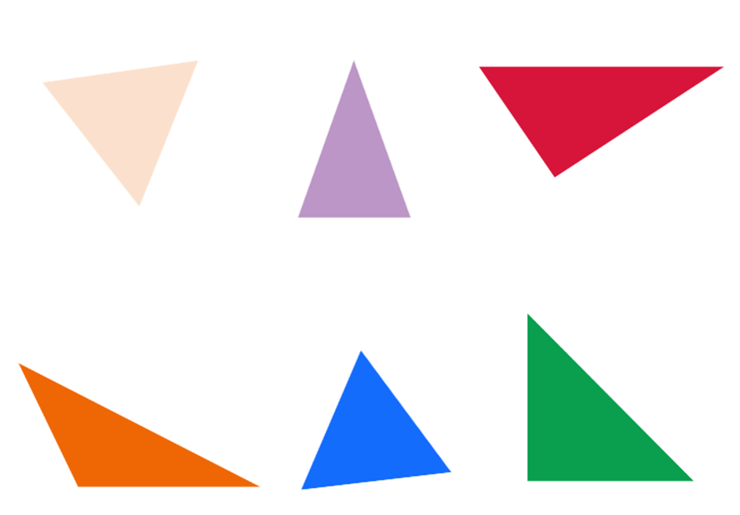

# Resource 7 – Which flag doesn’t belong?

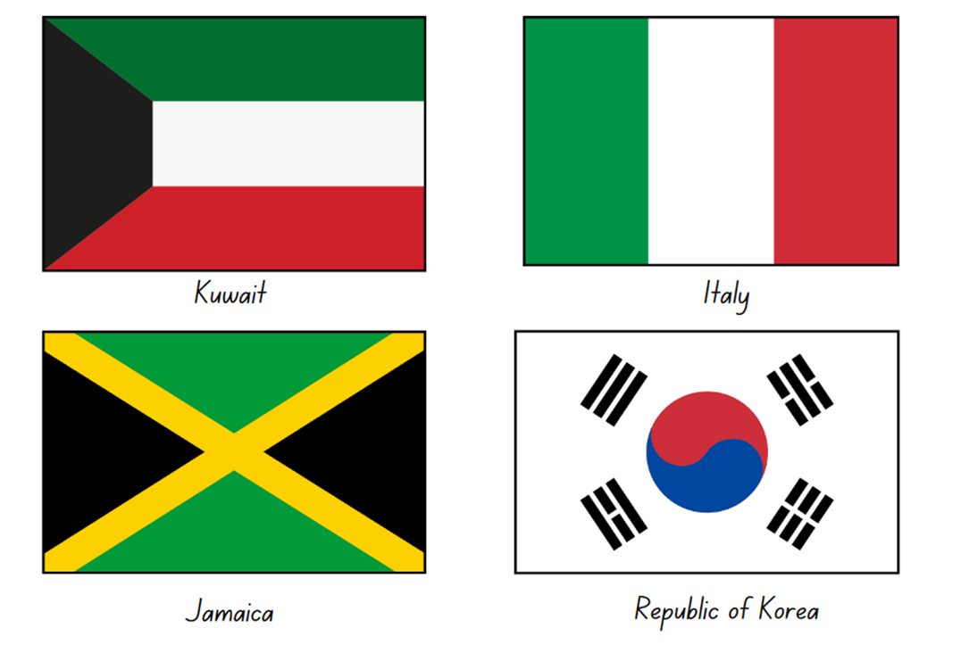

# Resource 8 – triangles and quadrilaterals

Various two-dimensional shapes. There are 3 triangles: isosceles, equilateral and scalene. 

There are also 6 quadrilaterals: square, parallelogram, kite, rhombus, rectangle and trapezium.

# Resource 9 – investigating shapes

|  |  |  |  |  |  |  |  |
| --- | --- | --- | --- | --- | --- | --- | --- |
| Sides | Triangle | Square | Rectangle | Rhombus | Parallelogram | Kite | Trapezium |
| ****Number of sides**** |  |  |  |  |  |  |  |
| ****Sets of parallel sides**** |  |  |  |  |  |  |  |

# Resource 10 – street map 1

A street map of part of a suburb showing an aerial view of streets, houses, parks and gardens. The street names are Florence Avenue, Timber Lane, Lawson Street, Citrus Road, Timber Circuit, Lemon Tree Road, Felton Lane, Sage Street, Faber Lane and Fullers Road.

There is one track marked in red that forms the shape of a rectangle.

# Resource 11 – street map 2

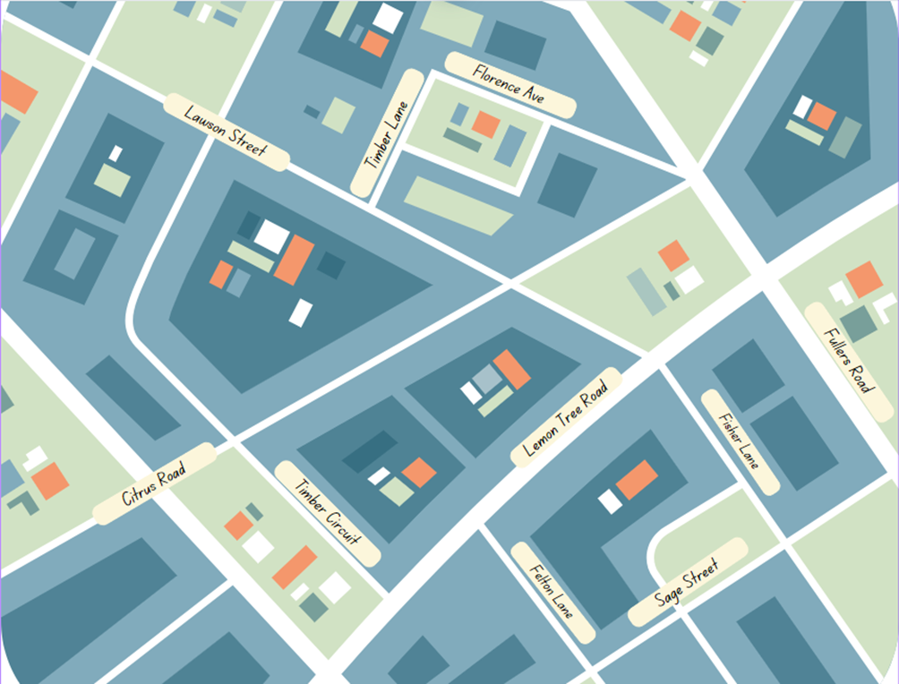

# Resource 12 – properties of shapes

|  |  |  |  |  |  |  |  |  |  |
| --- | --- | --- | --- | --- | --- | --- | --- | --- | --- |
| Properties | Equilateral triangle | Isosceles triangle | Scalene triangle | Square | Rectangle | Rhombus | Parallelogram | Kite | Trapezium |
| Properties of sides |  |  |  |  |  |  |  |  |  |
| Properties of angles |  |  |  |  |  |  |  |  |  |
| Line symmetry properties |  |  |  |  |  |  |  |  |  |

# Resource 13 – taking turns

A 5 by 5 grid featuring a variety of items. 

From the top-left corner around the edge of the grid clockwise is: a plant, a sink, a window, a cabinet, an open door, wall art, a laptop, a bean bag, a bookcase, a presentation board, an easel, a notebook, a desk with a clock, an armchair, a monitor with a stand and a pencil holder.

In the middle of the grid is an icon representing a person.

# Resource 14 – angle measurers

Two tools for working with angles.

The first tool is a right-angle identifier. It is a circle and inside, contains 2 red lines that intersect at right angles.

The second tool is a numberless protractor which is a 360° protractor without number markings.

# Resource 15 – tangram art



# Resource 16 – angle categories

Six examples of different-sized angles with a definition of each. These show an acute, right, obtuse, straight and reflex angle, as well as a revolution.

Right angle: 2 perpendicular straight lines or arms that meet at a vertex which makes a square. The text ‘Perpendicular’ is labelled on the arm pointing upwards.

Acute angle: 2 straight lines or arms that meet at a vertex, making an angle that is less than a right angle.

Obtuse angle: 2 straight lines or arms that meet at a vertex, making an angle that is greater than a right angle.

Straight angle: a straight line or arm.

Reflex angle: 2 straight lines or arms that meet at a vertex, making an angle that is greater than a straight angle but less than a revolution.

Angle of revolution: 2 straight lines or arms. One arm makes a complete turn, a full rotation.

# Resource 17 – Munich Olympics

Munich 1972 Olympic pictograms. In order, from left to right, the images show: 2 swimmers diving (aquatics), a single archer (archery), a single sprinter (athletics), 2 basketballers contesting (basketball), a single boxer (boxing), a single kayaker (canoe), a single cyclist (cycling), a person riding a stylized horse (equestrian), a single fencer (fencing), a single soccer player (football), a single gymnast balancing on one leg (gymnastics), a single person playing handball (handball), a single hockey player (hockey), 2 judo athletes engaging (judo), an equestrian rider jumping a hurdle represented by a 5-dice dot pattern (modern pentathlon), 2 rowers (rowing), a person on the parallel bars (sailing), 2 rifle shooters (shooting), a volleyball player spiking the ball (volleyball), a weightlifter preparing to lift (weightlifting) and 2 wrestlers engaging (wrestling).

The instructions for Stage 2 students read: Use different colours to mark: 5 right angles, 5 angles less than a right angle, 5 angles greater than a right angle.

The instructions for Stage 3 students read: Use a protractor to measure: 2 right angles, 2 straight angles, 2 acute angles, 2 obtuse angles, 2 reflex angles.

Adapted from ‘Munich 1972’ by Otl Aicher © 2017 International Olympic Committee.

# Resource 18 – using a protractor

Six steps for using a protractor to measure an angle.

Step 1: Get a clear and good-sized protractor. There is also an image of a protractor with an arrow pointing to the centre with text that reads ‘Centre point of the protractor’.

Step 2: Find an angle you want to measure. The angle is the amount of turn between the arms, shown in red. There is an angle with the labels: arm, angle and vertex.

Step 3: Place the protractor on the angle. Make sure to place the centre point of the protractor on the vertex of the angle. There is a protractor with an arrow pointing to the centre with text that reads ‘Place centre point of protractor on vertex of angle’. There are 2 arrows on the protractor positioned to form an angle and are pointing to 120° and 164°.

Step 4: Rotate the protractor so that the bottom line aligns with the bottom arm of the angle. There is a protractor with 2 arrows on it. The arrows are positioned to form an angle and are pointing at 135° and 180°.

Step 5: Read the protractor carefully and accurately starting from 0. Use your finger to trace the angle from the arm at 0 to the other arm. There is a protractor with 2 arrows on it. The arrows are positioned to form an angle and are pointing at 135° and 180°. There is also an arrow pointing to the arrow at 180°.

Step 6: If angle is facing the other way, use the top scale to read the angle. Always start from 0°. There is a protractor with 2 arrows on it. The arrows are positioned to form an angle and are pointing at 0° and 45°. There is also an arrow pointing at 0° with text that reads ‘Using the top scale (black numbers), you start from zero and this angle reads 45°.

# Resource 19 – fractions

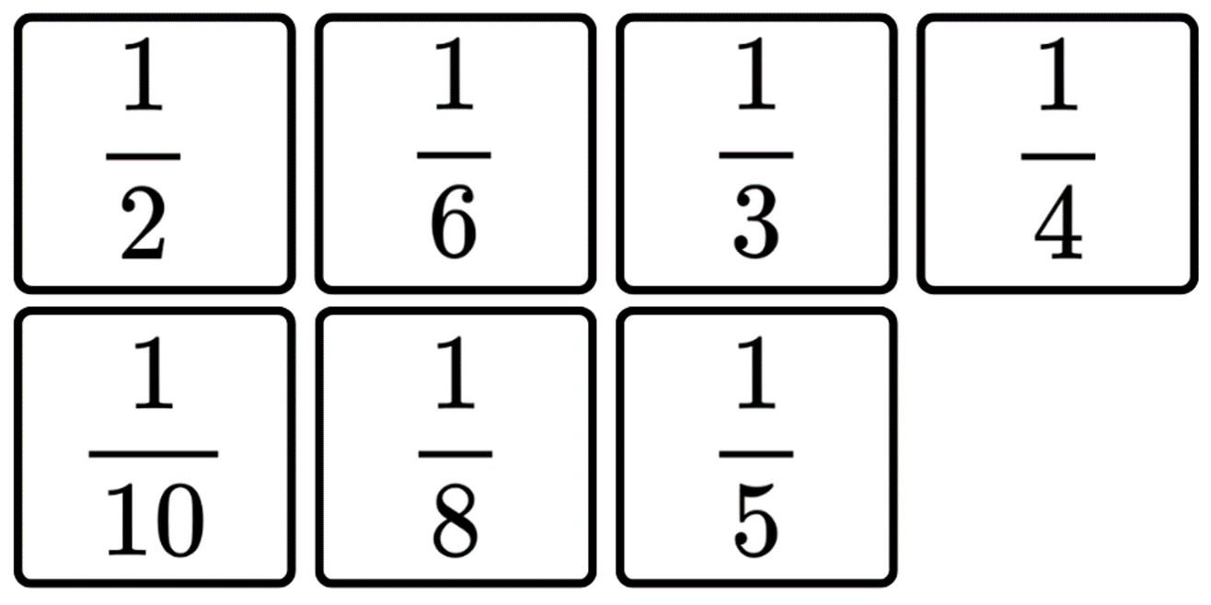

# Resource 20 – whole pencils

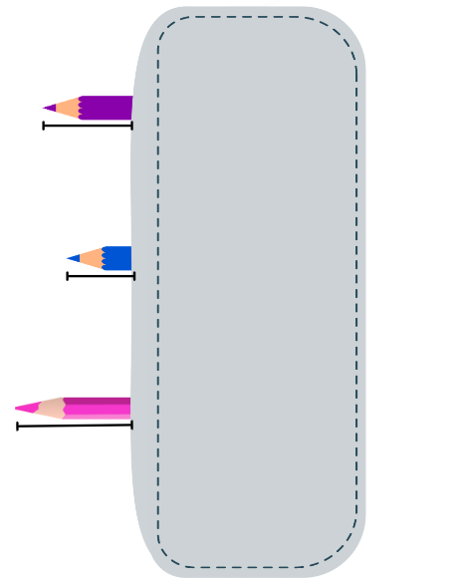

# Resource 21 – outback courier

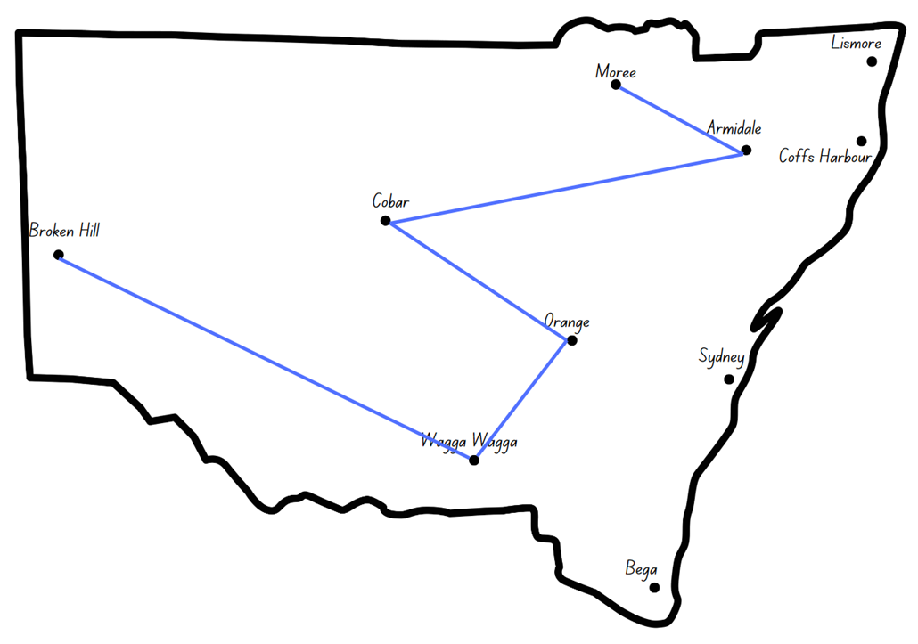

# Resource 22 – NSW flight paths

Outback courier – NSW flight plans for Stage 2. Instructions read: 1. Draw the flight plans. 2. Identify each angle using the following codes: L – less than a right angle, G – greater than a right angle, E – equal to a right angle, A – about the same as a right angle. 3. Share your plan with a peer and check each other’s work.

There are 3 maps of NSW with towns marked: Lismore, Moree, Armidale, Coff harbour, Cobar, Dubbo, Newcastle, Broken Hill, Orange, Sydney, Mildura, Wagga Wagga and Bega.

One map asks students to map a flight plan for Coffs Harbour to Broken Hill, via Lismore, Armidale, Moree and Orange.

The second map asks students to map a flight plan for Sydney to Armidale via Wagga Wagga, Orange and Broken Hill.

The third map asks students to map your own flight plan that covers 6 cities in NSW.


Outback courier – NSW flight plans for Stage 3. Instructions read: 1. Draw flight plan. 2. 1st colour: estimate and record the angle of the turns. 3. 2nd colour: measure and record the angle of the turns.

There are 3 maps of NSW with towns marked: Lismore, Moree, Armidale, Coff harbour, Cobar, Dubbo, Newcastle, Broken Hill, Orange, Sydney, Mildura, Wagga Wagga and Bega.

One map asks students to map a flight plan for Coffs Harbour to Broken Hill, via Lismore, Armidale, Moree and Orange.

The second map asks students to map a flight plan for Sydney to Armidale via Wagga Wagga, Orange and Broken Hill.

The third map asks students to map your own flight plan that covers 6 cities in NSW.


# Resource 23 – ‘Fractions memory’

Complementary fractions memory game. Twelve cards on a page, where each card displays a number line 0 to 1 and a bar model representation of the fraction. 

Fraction representations are: one-half, one-half, one-quarter, two-quarters, two-quarters, three-quarters, one-eighth, two-eighths, three-eighths, four-eights, four-eighths and five-eighths.

Complementary fractions memory game. Twelve cards on a page, where each card displays a number line 0 to 1 and a bar model representation of the fraction.

Fraction representations are: six-eighths, seven-eighths, one-third, two-thirds, one-fifth, two-fifths, three-fifths, four-fifths, one-sixth, two-sixths, three-sixths and three-sixths.

Complementary fractions memory game. Twelve cards on a page, where each card displays a number line 0 to 1 and a bar model representation of the fraction.

Fractional representations are: four-sixths, five-sixths, one-tenth, two-tenths, three-tenths, four-tenths, five-tenths, five-tenths, six-tenths, seven-tenths, eight-tenths and nine-tenths.

# Resource 24 – Australian flight paths

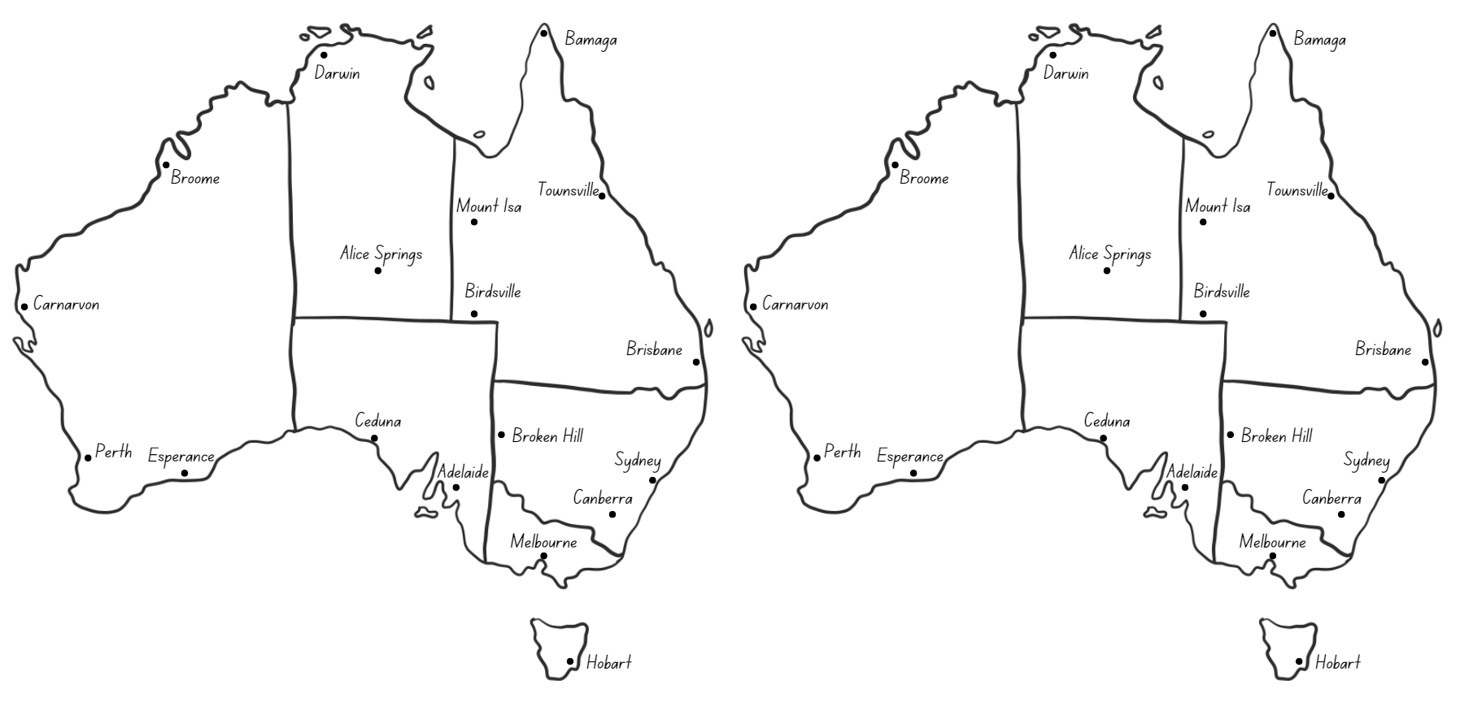

# Resource 25 – a numberless protractor

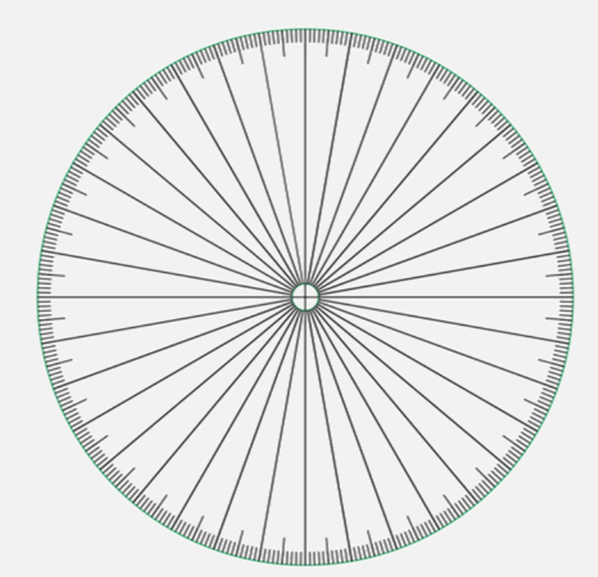

Adapted from Francome (2016).

# Resource 26 – fractions of a whole

A fraction strip in 8 parts, 3 of which are shaded blue and 5 of which are shaded orange. 

Above the strip is a question: What fraction of the strip is blue? 

Under the strip are 4 multiple-choice options. A reads ‘3’, B reads ‘3/5’, C reads ‘3/8' and D reads ‘8/3'.

# Resource 27 – worded problems

In a recent class assessment, students drew the following model to represent their working out.

Coloured fraction strip in 8 parts, 6 of which are shaded blue and 2 of which are shaded orange. 

Blue and orange parts of the strips represent fractions of the bag filled with corn, grains and wheat.

Which one of the following word problems best reflects their assessment question?

1. The local produce store makes bags of chicken feed. $\frac{2}{8}$ of each bag is corn. The rest of the bag is filled with grain and wheat. How much of the bag is not corn?
2. The local produce store makes bags of chicken feed. $\frac{1}{4}$ of each bag is corn. $\frac{2}{4}$ of each bag is filled with wheat. The rest of the bag is filled with grain. How much of the bag is filled with grain?
3. The local produce store makes bags of chicken feed. While moving their bags to the truck, the employee accidentally spilled $\frac{2}{3}$ of the bag. How much of the bag was left?

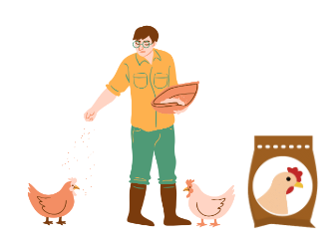

# Resource 28 – blank clock



# Resource 29 – clock records

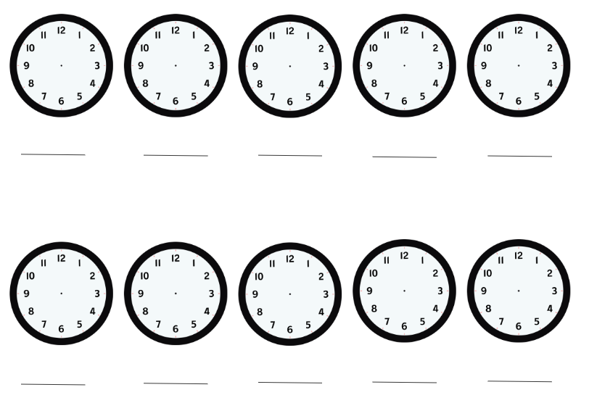

# Resource 30 – angles on clocks

Three sets of analog clock faces without hands, each with a space for students to record the time. 

Set 1 has 3 clock faces with the title: Less than a right angle. 

Set 2 has 3 clock faces with the title: Greater than a right angle. 

Set 3 has 2 clock faces with the title: About a right angle.

# Resource 31 – 24-hour time

An evenly spaced number line that represents time on a clock. The first half is labelled ‘am’ and the second half is labelled ‘pm’. The number line is marked with each hour from Midnight on the left, through to Midday/Noon at the centre, and Midnight on the far right.

The number line is marked with both 12- and 24- hour time, for example 12, 1, 2, 3 and so on up to 12 noon in the ‘am’ section, and from 00 to 24 in the ‘pm’ section.

Below the number line is a clock made of 2 circles. The inner circle shows a regular analogue clock with the clock arms indicating that it is 4 o’clock. The outer circle shows the 24-hour time around the clock from 13 to 24.

# Resource 32 – duration problems

|  |  |
| --- | --- |
| Duration problems | Answer |
| * A plane took off from Sydney at 09:30 and landed in Darwin at 14:10. What was the duration of the flight? |  |
| * A plane took off from Melbourne at 11:30 and stopped in Sydney for one hour and 45 minutes before landing in Brisbane at 15:25. How long was the flight time from Melbourne to Brisbane? |  |
| * A 4 hour and 10-minute flight from Perth to Hobart landed at 21:50. What time did it take off from Perth? |  |
| * Lisa had to be at the airport one hour and 30 minutes before her flight. If she landed at 17:30 and her flight was 6 hours and 15 minutes long, what time did she need to be at the airport? |  |

# Resource 33 – airline flight timetable

|  |  |  |  |  |  |
| --- | --- | --- | --- | --- | --- |
| Flight no. | Depart  Sydney | Arrive  Adelaide | Depart  Adelaide | Arrive  Perth | Total duration from Sydney to Perth (including stopover) |
| 1 | 06:30 | 08:30 | 10:00 | 13:30 |  |
| 2 | 08:40 | 10:40 | 12:10 | 15:40 |  |
| 3 | 10:50 | 12:50 | 14:20 | 17:50 |  |
| 4 | 11:30 | 13:50 | 15:20 | 18:50 |  |
| 5 | 14:00 | 16:00 | 17:30 | 21:00 |  |
| 6 | 15:50 | 17:50 | 19:20 | 22:50 |  |

# Resource 34 – decimal misconceptions

Decimal misconceptions for students to discuss who is correct, David or Bec.

Text reads: The class were asked to write how many hours and minutes are in 1.5 hours. David wrote: one hour and 30 minutes. Bec wrote: one hour and 50 minutes.

# Resource 35 – train timetable

|  |  |
| --- | --- |
| ****Destination**** | ****Departure time**** |
| Sydney | 07:00 |
| Gosford | 08:30 |
| Newcastle | 09:30 |
| Gloucester | 11:30 |
| Wauchope | 13:45 |
| Kempsey | 14:30 |
| Coffs Harbour | 16:00 |
| Grafton | 17:15 |
| Casino | 18:45 |

# Resource 36 – timetable problems

|  |  |
| --- | --- |
| ****Destination**** | Departure time |
| Sydney | 07:00 |
| Gosford | 08:30 |
| Newcastle | 09:30 |
| Gloucester | 11:30 |
| Wauchope | 13:45 |
| Kempsey | 14:30 |
| Coffs Harbour | 16:00 |
| Grafton | 17:15 |
| Casino | 18:45 |

1. If a passenger got on the train at Sydney and off at Gloucester, how long were they on the train?
2. Nadia travelled from Newcastle to Casino. How long was the journey?
3. Hugh went from Kempsey to Casino, but the train had to stop in Grafton for 1.5 hours. How long was his trip?
4. Phil got on the train at Wauchope and travelled to Coffs Harbour, but the train was delayed for 2 hours. How long was his trip?
5. Heidi travelled from Sydney to Gosford and back. She also had a 45-minute meeting. How long was she away from Sydney?

# Syllabus outcomes and content

## Stage 2

The table below outlines the [syllabus outcomes](https://curriculum.nsw.edu.au/learning-areas/mathematics/mathematics-k-10-2022/overview) and range of relevant syllabus content covered in this unit. Content is linked to [National Numeracy Learning Progression](https://www.australiancurriculum.edu.au/resources/national-literacy-and-numeracy-learning-progressions/version-3-of-national-literacy-and-numeracy-learning-progressions/) (version 3).

|  |  |  |  |  |  |  |  |  |
| --- | --- | --- | --- | --- | --- | --- | --- | --- |
| Outcomes and content | 1 | 2 | 3 | 4 | 5 | 6 | 7 | 8 |
| **Representing numbers using place value A**: Whole numbers: Apply place value to partition and regroup numbers up to 4 digits  **MAO-WM-01, MA2-RN-01** |  |  |  |  |  |  |  |  |
| * Record numbers using standard place value form | x | x | x |  |  |  |  |  |
| * Partition numbers of up to 4 digits in non-standard forms (Reasons about quantity) | x | x | x |  |  |  |  |  |
| **Partitioned fractions A**: Model and represent unit fractions, and their multiples, to a complete whole on a number line  **MAO-WM-01, MA2-PF-01** |  |  |  |  |  |  |  |  |
| * Model fractions with fraction strips and diagrams for halves, quarters, eighths, thirds |  |  |  |  | x | x | x |  |
| * Determine the complementary fractional part needed to complete one whole (halves, quarters, eighths, thirds) (Reasons about relations) |  |  |  |  |  | x |  |  |
| * Recreate the whole unit from a fractional part ( $\frac{1}{2}, \frac{1}{4},\frac{1}{3} and$ $\frac{1}{8}$) (Reversible reasoning) |  |  |  |  | x |  |  |  |
| **Geometric measure A**: Angles: Identify angles as measures of turn  **MAO-WM-01, MA2-GM-03** |  |  |  |  |  |  |  |  |
| * Identify angles with 2 arms in practical situations |  |  | x | x |  |  |  |  |
| * Recognise an angle as the amount of turning between 2 arms |  |  | x |  |  |  |  |  |
| * Compare angles and explain that the length of the arms does not affect the size of the angle (Reasons about spatial relations) |  |  |  | x |  |  |  |  |
| * Use the term right angle to describe quarter-turn in a range of orientations (Reasons about spatial orientation) |  |  | x |  | x | x |  |  |
| **Geometric measure B**: Angles: Compare angles to a right angle  **MAO-WM-01, MA2-GM-03** |  |  |  |  |  |  |  |  |
| * Compare angles to a right angle using an informal means |  |  |  |  | x |  |  |  |
| * Recognise and describe angles as less than, equal to, about the same as or greater than a right angle |  |  |  | x |  | x |  |  |
| **Two-dimensional spatial structure A**: 2D shapes: Compare and describe features of two-dimensional shapes  **MAO-WM-01, MA2-2DS-01** |  |  |  |  |  |  |  |  |
| * Identify and describe polygons that have parallel sides and those that do not | x | x |  |  |  |  |  |  |
| * Identify quadrilaterals that have all sides equal in length | x | x |  |  |  |  |  |  |
| * Group quadrilaterals using one or more attributes | x | x |  |  |  |  |  |  |
| **Non-spatial measure A**: Time: Represent and read analog time  **MAO-WM-01, MA2-NSM-02** |  |  |  |  |  |  |  |  |
| * Identify 30 minutes as being a half-hour and 60 minutes as an hour |  |  |  |  |  |  | x |  |
| * Connect the quarter-hour to 15 minutes |  |  |  |  |  |  | x |  |
| * Recognise that the position of the numerals on an analog timepiece often represents 2 different values |  |  |  |  |  |  | x | x |
| * Recognise that 5-minute intervals (corresponding to the hour markers) are used as benchmarks to read time on an analog clock |  |  |  |  |  |  |  | x |
| * Read time as past the hour to half-past and then towards the hour |  |  |  |  |  |  | x |  |
| * Read analog clocks to the minute |  |  |  |  |  |  |  | x |

[Mathematics K–10 Syllabus](https://curriculum.nsw.edu.au/learning-areas/mathematics/mathematics-k-10-2022/overview) © NSW Education Standards Authority (NESA) for and on behalf of the Crown in right of the State of New South Wales, 2022.

## Stage 3

The table below outlines the [syllabus outcomes](https://curriculum.nsw.edu.au/learning-areas/mathematics/mathematics-k-10-2022/overview) and range of relevant syllabus content covered in this unit. Content is linked to [National Numeracy Learning Progression](https://www.australiancurriculum.edu.au/resources/national-literacy-and-numeracy-learning-progressions/version-3-of-national-literacy-and-numeracy-learning-progressions/) (version 3).

|  |  |  |  |  |  |  |  |  |
| --- | --- | --- | --- | --- | --- | --- | --- | --- |
| Outcomes and content | 1 | 2 | 3 | 4 | 5 | 6 | 7 | 8 |
| **Represents numbers A**: Whole numbers: Apply place value to partition, regroup and rename numbers to 1 billion  **MAO-WM-01, MA2-RN-01** |  |  |  |  |  |  |  |  |
| * Recognise 1000 thousands is 1 million and 1000 millions is 1 billion | x |  | x |  |  |  |  |  |
| * Regroup numbers in different forms (Reasons about quantity) | x | x |  |  |  |  |  |  |
| * Partition numbers to 1 billion in non-standard forms | x |  | x |  |  |  |  |  |
| **Representing quantity fractions A**: Solve problems involving addition and subtraction of fractions with the same denominator  **MAO-WM-01, MA3-RQF-01, MA3-RQF-02** |  |  |  |  |  |  |  |  |
| * Solve word problems that involve fractions with the same denominator |  |  |  |  |  |  | x |  |
| * Use diagrams, objects and mental strategies to subtract a unit fraction from any whole number including 1 (the complement principle) |  |  |  |  | x | x |  |  |
| **Geometric measure A**: Angles: Estimate, measure and compare angles using degrees  **MAO-WM-01, MA3-GM-03** |  |  |  |  |  |  |  |  |
| * Identify the arms and vertex of an angle where both arms are invisible, such as for rotations |  |  | x |  |  |  |  |  |
| * Explain how a protractor is formed and used to measure an angle |  |  | x |  |  |  |  |  |
| * Estimate and describe the size of angles using known angles as benchmarks (Reasons about mental rotation) |  |  | x |  |  |  |  |  |
| * Record angle measurements using the symbol for degrees (°) |  |  | x |  | x | x |  |  |
| * Measure angles of up to 360° using a protractor |  |  |  | x | x | x |  |  |
| **Geometric measure A**:Angles: Use a protractor to measure and identify types of angles  **MAO-WM-01, MA3-GM-03** |  |  |  |  |  |  |  |  |
| * Create angles of up to 360° using a protractor |  |  |  | x | x | x |  |  |
| * Recognise that a right angle is 90°, a straight angle is 180° and an angle of revolution is 360° |  |  |  | x |  |  |  |  |
| * Identify and describe angle size in degrees for the classifications acute, obtuse and reflex |  |  |  | x |  |  |  |  |
| **Two-dimensional spatial structure A**: 2D shapes: Classify two-dimensional shapes and describe their properties  **MAO-WM-01, MA3-2DS-01** |  |  |  |  |  |  |  |  |
| * Identify and classify triangles as equilateral, isosceles or scalene triangles | x |  |  |  |  |  |  |  |
| * Recognise that triangles and quadrilaterals can be classified in more than one way (Reasons about spatial relations) | x |  |  |  |  |  |  |  |
| * Compare side and angle properties of triangles and quadrilaterals using measurement and symmetry |  | x |  |  |  |  |  |  |
| * Investigate the symmetry properties (line and rotational) of quadrilaterals |  | x |  |  |  |  |  |  |
| * Identify regular and irregular polygons |  | x |  |  |  |  |  |  |
| **Non-spatial measure B**: Time: Solve problems involving duration, using 12- and 24-hour time  **MAO-WM-01, MA3-NSM-02** |  |  |  |  |  |  |  |  |
| * **Use start and finish times to calculate the elapsed time of events** |  |  |  |  |  |  | x |  |
| * **Add and subtract time mentally using bridging strategies** |  |  |  |  |  |  | x |  |
| * Represent commonly used time intervals as decimals |  |  |  |  |  |  |  | x |
| * Solve a variety of problems involving duration, including where times are expressed in 12-hour and 24-hour notation |  |  |  |  |  |  |  | x |

[Mathematics K–10 Syllabus](https://curriculum.nsw.edu.au/learning-areas/mathematics/mathematics-k-10-2022/overview) © NSW Education Standards Authority (NESA) for and on behalf of the Crown in right of the State of New South Wales, 2022.

# References

This resource contains NSW Curriculum and syllabus content. The NSW Curriculum is developed by the NSW Education Standards Authority. This content is prepared by NESA for and on behalf of the Crown in right of the State of New South Wales. The material is protected by Crown copyright.

Please refer to the NESA Copyright Disclaimer for more information <https://educationstandards.nsw.edu.au/wps/portal/nesa/mini-footer/copyright>.

NESA holds the only official and up-to-date versions of the NSW Curriculum and syllabus documents. Please visit the NSW Education Standards Authority (NESA) website <https://educationstandards.nsw.edu.au> and the NSW Curriculum website [https://curriculum.nsw.edu.au](https://curriculum.nsw.edu.au/).

[Mathematics K–10 Syllabus](https://curriculum.nsw.edu.au/learning-areas/mathematics/mathematics-k-10-2022/overview) © NSW Education Standards Authority (NESA) for and on behalf of the Crown in right of the State of New South Wales, 2022.

[National Numeracy Learning Progression](https://www.australiancurriculum.edu.au/resources/national-literacy-and-numeracy-learning-progressions/version-3-of-national-literacy-and-numeracy-learning-progressions/) © Australian Curriculum, Assessment and Reporting Authority (ACARA) 2010 to present, unless otherwise indicated. This material was downloaded from the [Australian Curriculum](http://www.australiancurriculum.edu.au/) website (National Numeracy Learning Progression) (accessed 15 July 2024) and was not modified.

AAMT (Australian Association of Mathematics Teachers) (n.d.) ‘[Misunderstandings](https://topdrawer.aamt.edu.au/Fractions/Misunderstandings)’, Fractions, Top Drawer Teachers website, accessed 19 July 2024.

Askew M (2016) A Practical Guide to Transforming Primary Mathematics: Activities and tasks that really work, 1st edn, Routledge, Oxon.

Francome T (2016) ‘[Empty protractor](https://atm.org.uk/Mathematics-Teaching-Journal-Archive/Mathematics-Teaching-253/97346)’, Mathematics Teaching, Association of Teachers of Mathematics, accessed 9 August 2024.

International Olympic Committee (2017)[*The Sports Pictograms of the Olympic Summer Games from Tokyo 1964 to Rio 2016* [PDF 4.98 MB]](https://stillmed.olympic.org/media/Document%20Library/OlympicOrg/Factsheets-Reference-Documents/Games/Pictograms/Reference-document-The-Sports-Pictograms-of-the-OG-from-Tokyo-1964-to-Rio-2016.pdf), The Olympic Studies Centre, International Olympic Committee, accessed 19 July 2024.

NESA (NSW Education Standards Authority) (2022a) ‘[Stage 2 – Teaching advice for Two-dimensional spatial structure A: Language](https://curriculum.nsw.edu.au/learning-areas/mathematics/mathematics-k-10-2022/content/stage-2/fae82874e2?show=advice)’, Mathematics K–10 Syllabus: Content, NESA website, accessed 7 August 2024.

——(2022b) ‘[Stage 3 – Teaching advice for Two-dimensional spatial structure A: 2D shapes](https://curriculum.nsw.edu.au/learning-areas/mathematics/mathematics-k-10-2022/content/stage-3/fad7c142c4?show=advice)’, Mathematics K–10 Syllabus: Content, NESA website, accessed 7 August 2024.

——(2022c) ‘[Stage 2 – Teaching advice for Geometric measure A: Misconceptions with angles](https://curriculum.nsw.edu.au/learning-areas/mathematics/mathematics-k-10-2022/content/stage-2/fae82874e2?show=advice)’, Mathematics K–10 Syllabus: Content, NESA website, accessed 7 August 2024.

——(2022d) ‘[Stage 3 – Teaching advice for Geometric measure A: Measuring angles](https://curriculum.nsw.edu.au/learning-areas/mathematics/mathematics-k-10-2022/content/stage-3/fa35c41b81?show=advice)’, Mathematics K–10 Syllabus: Content, NESA website, accessed 8 August 2024.

Robichaux RR and Rodrigue PR (2010) ‘Polygon properties: What is possible?’, Teaching Children Mathematics, 16(9):524–531, doi:10.5951/TCM.16.9.0514

State of New South Wales (Department of Education) (2023) *‘*[*Mastermind*](https://education.nsw.gov.au/teaching-and-learning/curriculum/mathematics/mathematics-curriculum-resources-k-12/thinking-mathematically-resources/mathematics-s1-s3-mastermind)*’*, Thinking mathematically resources, NSW Department of Education website, accessed 19 July 2024.

——(2024) ‘[Analysing fractions](https://myplsso.education.nsw.gov.au/mylearning/catalogue/details/4fb7d05c-0938-ee11-8456-0003ff49608c)’, Mathematics 3–6, My Professional Learning website, accessed 15 May 2024.

——(2024) ‘[The role of place value](https://myplsso.education.nsw.gov.au/mylearning/catalogue/details/4fb7d05c-0938-ee11-8456-0003ff49608c)’, Mathematics 3-6, My Professional Learning website, accessed 15 May 2024.

Toy Theater (2024) ‘[Interactive clock | Telling Time](https://toytheater.com/clock/)’, Time Manipulatives, Toy Theater website, accessed 19 July 2024.

University of Cambridge (n.d.) [*Clocks*](https://nrich.maths.org/1812), NRICH website, accessed 19 July 2024.

University of Cambridge (n.d.) [*Two Clocks*](https://nrich.maths.org/4806), NRICH website, accessed 19 July 2024.

Worldometer (2023) ‘[Population by Country](https://www.worldometers.info/world-population/population-by-country/)’, Population, Worldometer website, accessed 7 August 2024.

## Further reading

Thinkport Maryland Public Television and Great Blue Hill (WGBH) Educational Foundation (n.d.) ['Angles in Soccer | Thinkport' [video]](https://www.pbslearningmedia.org/resource/mmpt-math-g-anglessoccer/angles-in-soccer/), PBS LearningMedia, PBS LearningMedia website, accessed 19 July 2024.

Van de Walle J, Karp K, Bay-Williams JM, Brass A, Bentley B, Ferguson S, Goff W, Livy S, Marshman M, Martin D, Pearn C, Prodromou T, Symons D and Wilkie K (2019) Primary and Middle Years Mathematics: Teaching Developmentally, 1st Australian edn, Pearson Education Australia, Melbourne.

**© State of New South Wales (Department of Education), 2024**

The copyright material published in this resource is subject to the Copyright Act 1968 (Cth) and is owned by the NSW Department of Education or, where indicated, by a party other than the NSW Department of Education (third-party material).

Copyright material available in this resource and owned by the NSW Department of Education is licensed under a [Creative Commons Attribution 4.0 International (CC BY 4.0) license](https://creativecommons.org/licenses/by/4.0/).

[](https://creativecommons.org/licenses/by/4.0/)

This license allows you to share and adapt the material for any purpose, even commercially.

Attribution should be given to © State of New South Wales (Department of Education), 2024.

Material in this resource not available under a Creative Commons license:

* the NSW Department of Education logo, other logos and trademark-protected material
* material owned by a third party that has been reproduced with permission. You will need to obtain permission from the third party to reuse its material.

**Links to third-party material and websites**

Please note that the provided (reading/viewing material/list/links/texts) are a suggestion only and implies no endorsement, by the New South Wales Department of Education, of any author, publisher, or book title. School principals and teachers are best placed to assess the suitability of resources that would complement the curriculum and reflect the needs and interests of their students.

If you use the links provided in this document to access a third-party's website, you acknowledge that the terms of use, including licence terms set out on the third-party's website apply to the use which may be made of the materials on that third-party website or where permitted by the Copyright Act 1968 (Cth). The department accepts no responsibility for content on third-party websites.