Mathematics 3–6 Multi-age – Year B – Unit 12
Understanding relationships between the properties of 2D shapes helps visualise and organise spaces in the world
Contents
Unit description and duration 7
Syllabus outcomes 7
Stage 2 8
Stage 3 8
Working mathematically 9
Student prior learning 9
Lesson overview and resources 11
Lesson 1 20
Daily number sense – pattern spins – 10 minutes 20
Core lesson 1 – finding symmetry – 20 minutes 24
Core lesson 2 – 30 minutes 27
Stage 2 task – symmetry hunt 27
Stage 3 task – symmetry in objects 28
Discuss and connect the mathematics – 10 minutes 31
Lesson 2 32
Daily number sense – the missing spin – 10 minutes 32
Core lesson 1 – rearranging shapes – 20 minutes 33
Core lesson 2 – 25 minutes 38
Stage 2 task – creating more new shapes 38
Stage 3 task – rearranging triangles 39
Discuss and connect the mathematics – 5 minutes 41
Lesson 3 43
Daily number sense – baking problems – 15 minutes 43
Core lesson 1 – tile patterns – 25 minutes 47
Core lesson 2 – 15 minutes 51
Stage 2 task – tessellating patterns 51
Stage 3 task – manipulating patterns 52
Discuss and connect the mathematics – 15 minutes 53
Lesson 4 57
Daily number sense – 10 minutes 57
Core lesson – 40 minutes 57
Stage 2 task – flags 57
Stage 3 task – area of composite figures 60
Consolidation and meaningful practice – 10 minutes 66
Lesson 5 68
Daily number sense – coins – 10 minutes 68
Core lesson – 40 minutes 71
Stage 2 task – area clues 71
Stage 3 task – area of parallelogram 75
Discuss and connect the mathematics – 10 minutes 78
Lesson 6 81
Daily number sense – 5 notes – 10 minutes 81
Core lesson – 40 minutes 84
Stage 2 task – connecting area and perimeter 84
Stage 3 task – area of a triangle 87
Discuss and connect the mathematics – 20 minutes 92
Lesson 7 95
Daily number sense – pens or pencils – 10 minutes 95
Core lesson – 50 minutes 97
Stage 2 task – largest area 97
Stage 3 task – area of composite figures 101
Discuss and connect the mathematics – 10 minutes 105
Lesson 8 108
Daily number sense – 10 minutes 108
Core lesson – 40 minutes 108
Stage 2 task – largest handball space 108
Stage 3 task – playground design 112
Discuss and connect the mathematics – 20 minutes 115
Resource 1 – 7-way spinner 119
Resource 2 – Stage 2 table 120
Resource 3 – Stage 3 table 121
Resource 4 – symmetry or not? 122
Resource 5 – out and about 123
Resource 6 – out and about 2 124
Resource 7 – symmetry hunt 125
Resource 8 – missing spin 1 126
Resource 9 – missing spin 2 127
Resource 13 – 7 sixes 128
Resource 10 – paper rectangles (Stage 2) 129
Resource 11 – paper rectangles (Stage 3) 130
Resource 12 – triangle reflection grid 131
Resource 14 – a baking problem 1 132
Resource 15 – a baking problem 2 133
Resource 16 – tile patterns 134
Resource 17 – tile shapes 135
Resource 18 – classifying polygons 136
Resource 19 – transforming polygons 137
Resource 20 – flags 138
Resource 21 – tessellations in nature 139
Resource 22 – area clues 140
Resource 23 – areas clues 2 141
Resource 24 – garden area investigation 142
Resource 25 – parallelogram on grid 143
Resource 26 – 4 parallelograms and a grid 144
Resource 27 – 12 squares 145
Resource 28 – triangles 146
Resource 29 – area of triangles 147
Resource 30 – money problem 148
Resource 31 – largest slice 149
Resource 32 – composite figures 150
Resource 33 – composite figures 2 151
Resource 34 – sample playgrounds 152
Resource 35 – playground items 153
Resource 36 – area problems 155
Syllabus outcomes and content 156
Stage 2 156
Stage 3 162
References 167

Unit description and duration
This unit develops the big idea that understanding relationships between the properties of 2D shapes helps visualise and organise spaces in the world.
In this 2-week unit, students are provided opportunities to:
- combine and split common shapes to create other common two-dimensional shapes
- transform two-dimensional and composite figures by reflecting, translating, and rotating
- measure and compare the areas of shapes using the grid structure and familiar metric units of area
- explore and manipulate polygons to understand the properties of regular and irregular shapes
- examine the relationship between the area of a parallelogram and the area of a triangle
- apply their knowledge of 2D space to calculate the area of composite shapes.
This multi-age unit is informed by the lessons in Stage 2 Year B Unit 32 and Stage 3 Year B Unit 32. Please refer to these units for additional lesson guidance.

Syllabus outcomes
- MAO-WM-01 develops understanding and fluency in mathematics through exploring and connecting mathematical concepts, choosing and applying mathematical techniques to solve problems, and communicating their thinking and reasoning coherently and clearly

Stage 2
- MA2-AR-01 selects and uses mental and written strategies for addition and subtraction involving 2- and 3-digit numbers
- MA2-MR-01 represents and uses the structure of multiplicative relations to 10 × 10 to solve problems
- MA2-MR-02 completes number sentences involving multiplication and division by finding missing values
- MA2-2DS-01 compares two-dimensional shapes and describes their features
- MA2-2DS-02 performs transformations by combining and splitting two-dimensional shapes
- MA2-2DS-03 estimates, measures and compares areas using square centimetres and square metres

Stage 3
- MA3-AR-01 selects and applies appropriate strategies to solve addition and subtraction problems
- MA3-MR-01 selects and applies appropriate strategies to solve multiplication and division problems
- MA3-2DS-01 investigates and classifies two-dimensional shapes, including triangles and quadrilaterals based on their properties
- MA3-2DS-02 selects and uses the appropriate unit to calculate areas, including areas of rectangles
- MA3-2DS-03 combines, splits and rearranges shapes to determine the area of parallelograms and triangles

Working mathematically
In the Mathematics K–10 Syllabus, there is one overarching Working mathematically outcome (MAO-WM-01). The Working mathematically processes should be embedded within the concepts being taught. The Working mathematically processes present in the Mathematics K–10 Syllabus are:
- communicating
- understanding and fluency
- reasoning
- problem solving.
Mathematics K–10 Syllabus © NSW Education Standards Authority (NESA) for and on behalf of the Crown in right of the State of New South Wales, 2022.

Student prior learning
Before engaging in these teaching and learning activities, students would benefit from prior experience with:
- describing and comparing features of two-dimensional shapes
- exploring transformations through combining and splitting two-dimensional shapes
- learning how to estimate and find area using standard units of measurement
- exploring and manipulating polygons to understand the properties of triangles and quadrilaterals
- combining, splitting and rearranging shapes to form composite shapes
- selecting and using the appropriate unit to calculate the area of a rectangle.
In NSW classrooms there is a diverse range of students, including Aboriginal and/or Torres Strait Islander students, students learning English as an additional language or dialect, high potential and gifted students and students with disability. Some students may identify with more than one of these groups or possibly all of them. Refer to Curriculum planning for every student – advice for further information.

Lesson overview and resources
To cover the content of the syllabus across Stage 2 and Stage 3, some core lessons in the unit contain both a Stage 2 and a Stage 3 task. Teachers are encouraged to adapt and contextualise the units to meet the needs of their students.
The table below outlines the sequence and approximate timing of lessons, learning intentions and resources.
Lesson | Content | Duration and resources
Lesson 1  Daily number sense  Stage 2:  - Multiplicative relations B: Use number properties to find related multiplication facts  Stage 3:  - Multiplicative relations B: Represent and describe number patterns formed by multiples | Lesson core concept: simple shapes can be found in art, science and nature.  Stage 2:  - Two-dimensional spatial structure A: 2D shapes: Transform shapes by reflecting, translating and rotating  Stage 3:  - Two-dimensional spatial structure A: 2D shapes: Classify two-dimensional shapes and describe their properties | Lesson duration: 70 minutes  - Resource 1 – 7-way spinner  - Resource 2 – Stage 2 table  - Resource 3 – Stage 3 table  - Resource 4 – symmetry or not  - Resource 5 – out and about  - Resource 6 – out and about 2  - Resource 7 – symmetry hunt  - Website: Rotational Symmetry  - Counters  - Pattern blocks  - Writing materials
Lesson 2  Daily number sense  Stage 2:  - Multiplicative relations B: Use number properties to find related multiplication facts  Stage 3:  - Multiplicative relations B: Represent and describe number patterns formed by multiples | Lesson core concept: simple shapes can be found hiding in more complex shapes.  Stage 2:  - Two-dimensional spatial structure A: 2D shapes: Transform shapes by reflecting, translating and rotating  - Two-dimensional spatial structure B: 2D shapes: Create symmetrical patterns and shapes  Stage 3:  - Two-dimensional spatial structure B: 2D shapes: Dissect two-dimensional shapes and rearrange them using translations, reflections and rotations | Lesson duration: 60 minutes  - Resource 8 – missing spin 1  - Resource 9 – missing spin 2  - Resource 10 – paper rectangles (Stage 2)  - Resource 11 – paper rectangles (Stage 3)  - Resource 12 – triangle reflection grid  - Digital device  - Pattern blocks  - Scissors  - Writing materials
Lesson 3  Daily number sense  Stage 2:  - Multiplicative relations B: Use number properties to find related multiplication facts  Stage 3:  - Multiplicative relations B: Represent and describe number patterns formed by multiples | Lesson core concept: there are hidden tessellating patterns in art, science and nature.  Stage 2:  - Two-dimensional spatial structure A: 2D shapes: Transform shapes by reflecting, translating and rotating  - Two-dimensional spatial structure B: 2D shapes: Create symmetrical patterns and shapes  Stage 3:  - Two-dimensional spatial structure A: 2D shapes: Classify two-dimensional shapes and describe their properties  - Two-dimensional spatial structure B: 2D shapes: Dissect two-dimensional shapes and rearrange them using translations, reflections and rotations | Lesson duration: 70 minutes  - Resource 13 – 7 sixes  - Resource 14 – a baking problem 1  - Resource 15 – a baking problem 2  - Resource 16 – tile patterns  - Resource 17 – tile shapes  - Resource 18 – classifying polygons  - Resource 19 – transforming polygons  - A4 paper  - Counters  - Grid paper  - Individual whiteboards  - Pattern blocks (optional)  - Scissors  - Writing materials
Lesson 4  Daily number sense  - teacher-identified task based on student needs | Lesson core concept: rotation of a shape can be measured in fractions of a turn (Stage 2) and parts of a composite figure can be split, duplicated and rotated to find the total area (Stage 3).  Stage 2:  - Two-dimensional spatial structure A: 2D shapes: transform shapes by reflecting, translating and rotating  - Two-dimensional spatial structure B: 2D shapes: Create symmetrical patterns and shapes  Stage 3:  - Two-dimensional spatial structure B: Find the area of composite figures | Lesson duration: 60 minutes  - Resource 20 – flags  - Resource 21 – tessellations in nature  - A4 paper  - Coloured pencils  - Scissors  - Square pattern blocks  - Writing materials
Lesson 5  Daily number sense  Stage 2:  - Additive relations B: Apply addition and subtraction to familiar contexts, including money and budgeting  Stage 3:  - Additive relations B: Choose and use efficient strategies to solve addition and subtraction problems | Lesson core concept: grids can support the measurement of area and parts of a composite figure can be split, duplicated and rotated to find the total area.  Stage 2:  - Multiplicative relations B: Use the structure of the area model to represent multiplication and division  - Multiplicative relations B: Operate with multiples of 10  - Two-dimensional spatial structure B: Area: Measure the areas of shapes using the grid structure  Stage 3:  - Two-dimensional spatial structure B: 2D shapes: Dissect two-dimensional shapes and rearrange them using translations, reflections and rotations  - Two-dimensional spatial structure B: Area: Calculate the area of a parallelogram using subdivision and rearrangement | Lesson duration: 60 minutes  - Resource 22 – area clues  - Resource 23 – area clues 2  - Resource 24 – garden area investigation  - Resource 25 – parallelogram on grid  - Resource 26 – 4 parallelograms and a grid  - One of each coin: $2, $1, 50c, 20c, 10c, 5c  - Scissors  - Writing materials
Lesson 6  Daily number sense  Stage 2:  - Additive relations B: Apply addition and subtraction to familiar contexts, including money and budgeting  Stage 3:  - Additive relations B: Choose and use efficient strategies to solve addition and subtraction problems | Lesson core concept: rectangles with the same area can have different perimeters and the known area of a shape can be used to help calculate the area of other shapes.  Stage 2:  - Multiplicative relations B: Use the structure of the area model to represent multiplication and division  - Two-dimensional spatial structure B: Area: Measure the areas of shapes using the grid structure  Stage 3:  - Two-dimensional spatial structure B: Area: Determine the area of a triangle | Lesson duration: 70 minutes  - Resource 27 – 12 squares  - Resource 28 – triangles  - Resource 29 – area of triangles  - 1 cm grid paper, geoboards or virtual geoboards  - 30 cm rulers  - Scissors  - Writing materials
Lesson 7  Daily number sense  Stage 2:  - Additive relations B: Apply addition and subtraction to familiar contexts, including money and budgeting  Stage 3:  - Additive relations B: Choose and use efficient strategies to solve addition and subtraction problems | Lesson core concept: estimation is useful to check the reasonableness of answers and there are many ways to dissect a shape to determine its area.  Stage 2:  - Multiplicative relations A: Represent and solve problems involving multiplication fact families  - Multiplicative relations B: Use the structure of the area model to represent multiplication and division  - Two-dimensional spatial structure B: Area: Measure the areas of shapes using the grid structure  - Two-dimensional spatial structure B: Area: Compare surfaces using familiar metric units of area  Stage 3:  - Two-dimensional spatial structure B: Area: Find the area of composite figures  - Two-dimensional spatial structure B: Area: Determine the area of a triangle | Lesson duration: 70 minutes  - Resource 30 – money problem  - Resource 31 – largest slice  - Resource 32 – composite figures  - Resource 33 – composite figures 2  - Clear plastic grid overlay – class set  - Individual whiteboards  - Rulers – class set  - Writing materials
Lesson 8  Daily number sense  - teacher-identified task based on student needs | Lesson core concept: relationships between the attributes of shapes can help us visualise, organise and design the world around us.  Stage 2:  - Multiplicative relations B: Use the structure of the area model to represent multiplication and division  - Multiplicative relations B: Use number properties to find related multiplication facts  - Multiplicative relations B: Represent and solve word problems with number sentences involving multiplication or division  - Two-dimensional spatial structure B: Area: Compare surfaces using familiar metric units of area  Stage 3:  - Two-dimensional spatial structure B: Area: Find the area of composite figures  - Two-dimensional spatial structure B: Area: Determine the area of a triangle | Lesson duration: 70 minutes  - Resource 34 – sample playgrounds  - Resource 35 – playground items  - Resource 36 – area problems  - Chalk  - Metre rulers  - Writing materials

Lesson 1
Core concept: simple shapes can be found in art, science and nature.

Daily number sense – pattern spins – 10 minutes
Daily number sense activities for Lessons 1 to 3 ‘activate’ prior number knowledge and support the learning of new content in the unit. These activities can also assist teachers to identify the starting points for learning by revealing the extent of students’ existing knowledge.
The table below contains suggested learning intentions and success criteria. These are best co-constructed with students.
Daily number sense learning intentions | Daily number sense success criteria
Students working towards Stage 2 outcomes are learning to:  - use number properties to find related multiplication facts.  Students working towards Stage 3 outcomes are learning to:  - represent and describe number patterns formed by multiples. | Students working towards Stage 2 outcomes can:  - use the commutative property of multiplication.  Students working towards Stage 3 outcomes can:  - use a given geometric pattern involving multiples to create a table of values.
- Provide pairs of students with a copy of Resource 1 – 7-way spinner and writing materials.
- In pairs, students spin the spinner twice to generate 2 different digits for use.
Multi-age: provide Stage 2 students with Resource 2 – Stage 2 table and Stage 3 students with Resource 3 – Stage 3 table.
- Stage 2 students record the first and second number as spin 1 and spin 2 respectively. The numbers are factors to determine the total number of counters required.
- Ask Stage 2 students to record different array arrangements to represent the product of their spun numbers (see Figure 1).
Figure 1 – possible Stage 2 student response
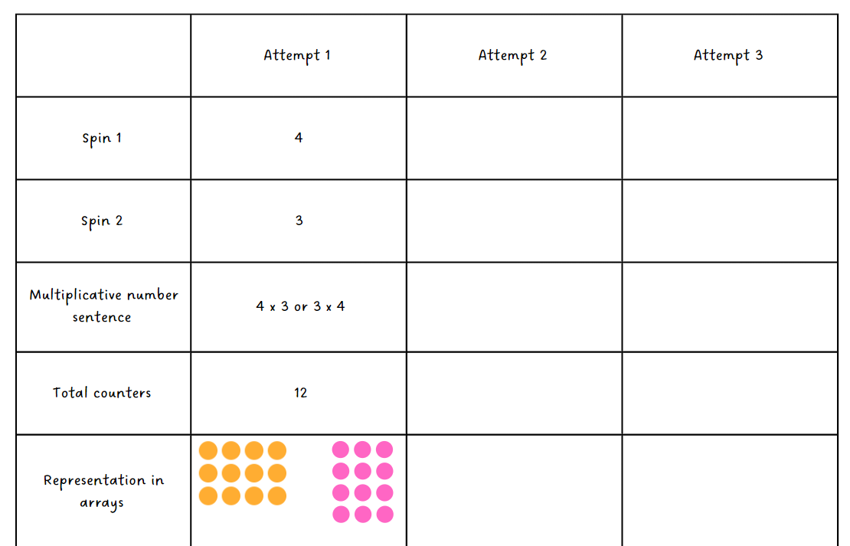
- Students turn and talk to discuss similarities and differences between their representations.
- In pairs, students repeat steps 3 to 6.
- Stage 3 students record the first and second number respectively as number of shapes and number of sides for each shape.
- Ask Stage 3 students to continue the values in the table, keeping the same number of sides for each shape to create a geometric pattern (see Figure 2).
Figure 2 – possible Stage 3 student response
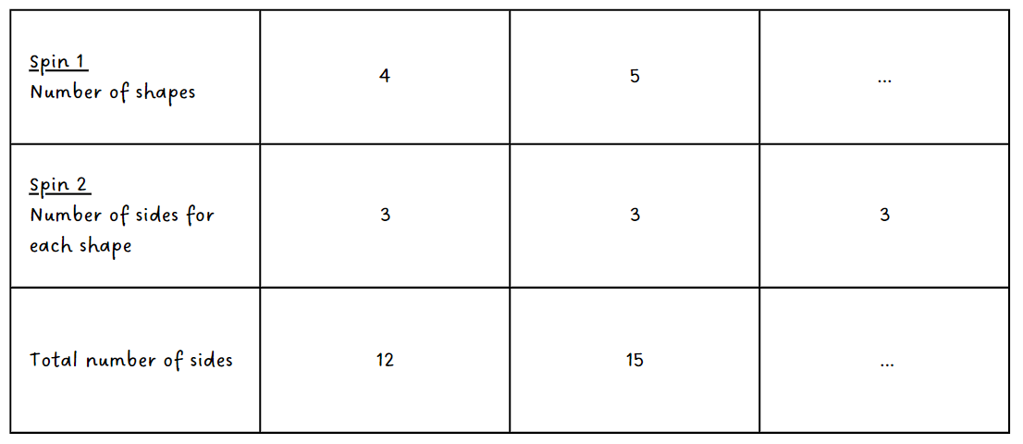
- Ask Stage 3 students to estimate the total number of sides for 30 shape and 50 shapes. Students turn and talk to discuss the number patterns observed.

This table details opportunities for assessment.
Assessment opportunities | Links
What to look for:  - Can Stage 2 students use the commutative property of multiplication? [MAO-WM-01, MA2-MR-01]  - Can Stage 3 students use a given geometric pattern involving multiples to create a table of values? [MAO-WM-01, MA3-MR-01] | Links to National Numeracy Learning Progressions (NNLP):  - Stage 2 – MuS6  - Stage 3 – NPA5.  Links to suggested Interview for Student Reasoning (IfSR) tasks:  - Stage 2 – IfSR-MT: 2A.9.

Core lesson 1 – finding symmetry – 20 minutes
The table below contains suggested learning intentions and success criteria. These are best co-constructed with students.
Core concept learning intentions | Core concept success criteria
Students working towards Stage 2 outcomes are learning to:  - transform shapes by reflecting, translating, and rotating.  Students working towards Stage 3 outcomes are learning to:  - classify two-dimensional shapes and describe their properties. | Students working towards Stage 2 outcomes can:  - identify lines of symmetry in pictures, artefacts, designs and the environment.  Students working towards Stage 3 outcomes can:  - investigate the symmetry properties (line and rotational) of polygons  - identify regular and irregular polygons.
- Display the word symmetry and discuss what it means.
Symmetry: an object or shape has symmetry or is symmetrical when one half is the mirror image of the other half.
- Display Resource 4 – symmetry or not. As a class, identify images that contain:
- one line of symmetry
- more than one line of symmetry
- no symmetry.
Multi-age: provide Stage 2 students with Resource 5 – out and about and Stage 3 students with Resource 6 – out and about 2.
- In pairs, students draw lines of symmetry on provided resources, before comparing ideas with another pair. Support use of terminology and identify any misconceptions about symmetry.
Note: some pictures will give the idea of symmetry, even if they are not ‘perfect.’ For example, flowers or wheel covers on a car have small features such as petals or tyre valves that disrupt the symmetry (Siemon 2020).
- Support students to recognise that a different view of images on provided resources can show symmetry. Explain that some shapes or objects give the idea of symmetry but may have some features that mean they do not have perfect symmetry (see Figure 3).
Figure 3 – front view of slide that can show symmetry
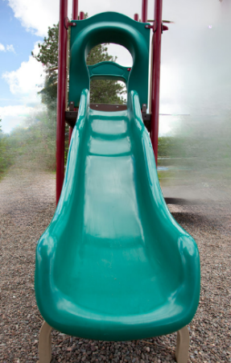
Note: the window and basketball hoop on Resource 5 – out and about have line symmetry. The school logo would be symmetrical without the tassel and the door would be symmetrical without the handle. The slide is symmetrical but needs to be visualised from the back or front. The recycling logo does not have line symmetry. It can be discussed as a non-example. It does have rotational symmetry. Rotational symmetry is a Stage 3 concept. The term can be introduced and discussed if appropriate to your class context.
- Provide students with a range of pattern blocks and writing materials.
Multi-age: provide Stage 2 students with pattern blocks including triangles and quadrilaterals. Provide Stage 3 students with a range of pattern blocks including pentagons and hexagons.
- Revise the properties of provided pattern blocks and ask students to work in pairs to classify the pattern blocks in as many ways as possible. For example, by number of sides, number of angles, symmetrical or not symmetrical.
- Select pairs of students to share their thinking and discuss the ways that the shapes have been classified. Ask if there is a correct way to classify the pattern blocks.

Core lesson 2 – 30 minutes

Stage 2 task – symmetry hunt
- Provide students with Resource 7 – symmetry hunt.
- Explain that students will go on a symmetry scavenger hunt within the classroom environment.
- In pairs, students capture images of items to match as many statements as possible in Resource 7 – symmetry hunt.
- Students share their images and sketches with their partner to justify their images.

Stage 3 task – symmetry in objects
- Introduce the term ‘polygon’, explaining that it refers to a shape with 3 or more straight sides.
Polygon: a plane shape bounded by 3 or more line segments.
- Revise lines of symmetry and rotational symmetry, including definitions and examples where appropriate.
Line of symmetry: a shape has line symmetry if matching parts are produced when it is folded along a line of symmetry. Each part represents the mirror image of the other.
Rotational symmetry: a shape has rotational symmetry if an outline of the figure can be rotated or turned about its centre to match its original shape.
- Display an image of a regular pentagon and a regular octagon. Ask:
- What is the same and/or different between both shapes?
- Are they symmetrical or non-symmetrical shapes?
- How many lines of symmetry do they have?
- How do you know this?
- Pose the conjecture: the number of lines of symmetry in a regular shape is equal to the number of sides.
- Students work in pairs to investigate at least 2 more regular polygons to test the conjecture.
- Select students to share their results. Correct and discuss any discrepancies.
- Ask students if the same conjecture applies to irregular shapes.
- Students work in pairs and investigate at least 3 irregular polygons to test the conjecture.
- Select students share their results. Correct and discuss any discrepancies.
- Display interactive Rotational Symmetry and demonstrate using the resource by dragging the vertices to form a square.
Note: select show/hide rotation to move the degree slider to rotate the shape. There is also an alternative feature on Rotational Symmetry to change the polygon according to the number of sides and vertices. This feature explores regular polygons.
- Rotate the square to complete a full rotation (360°) demonstrating how the tool can be used. Rotate the square a second time and ask the students to count the number of times the square matches its original stencil.
- Remind students that the order of symmetry is the number of times a shape matches the original exactly in one full rotation. Clarify that a square can be turned 4 times and match its original shape exactly. It has a rotational symmetry order of 4.
Order of symmetry: this is the number of times a shape matches the original in one full rotation.
- Pose the conjecture: the rotational symmetry order of a regular shape is equal to the number of sides.
- Ask students to work in pairs and use the interactive Rotational Symmetry website, pattern blocks or paper shapes to investigate at least 2 more regular polygons to test the conjecture.
- Select students to share their results. Correct and discuss any discrepancies.
- Allow students time to investigate the rotational symmetry property of a variety of irregular polygons by tracing the outline of objects in the environment.
This table details opportunities for differentiation.
Too hard? | Too easy?
Stage 2 students cannot identify lines of symmetry in pictures, artefacts, designs and the environment.  - Model folding paper squares and triangles to find and draw lines of symmetry. Students repeat the process with squares and triangles of different sizes.  - Stage 3 students cannot investigate the symmetry properties (line and rotational) of polygons.  - Support students to construct and cut out polygons on paper. Draw an ‘x’ in the centre of each shape. Model how the shape can be rotated and count the number of times the shape matches the original. | Stage 2 students can identify lines of symmetry in pictures, artefacts, designs and the environment.  - Students classify their scavenger hunt findings focusing on additional attributes. For example, these objects have 2 lines of symmetry, and these have 2 pairs of equal sides.  - Stage 3 students can investigate the symmetry properties (line and rotational) of polygons.  - Challenge students to draw a polygon that has one line of symmetry and an order of rotational symmetry of one (for example, a kite).

Discuss and connect the mathematics – 10 minutes
- Students take turns to ask symmetry questions about shapes and objects in the classroom. For example:
- I see a red shape with 2 lines of symmetry. What is it? A red book.
- I see a white shape with black markings and there are so many lines of symmetry I can’t count them all. What is it? The classroom clock.
This table details opportunities for assessment.
Assessment opportunities | Links
What to look for:  - Can Stage 2 students identify lines of symmetry in pictures, artefacts, designs, and the environment? [MAO-WM-01,  MA2-2DS-02]  - Can Stage 3 students investigate the symmetry properties (line and rotational) of polygons? [MAO-WM-01, MA3-2DS-01]  - Can Stage 3 students identify regular and irregular polygons? [MAO-WM-01, MA3-2DS-01] | Links to National Numeracy Learning Progressions (NNLP):  - Stage 2 – UGP3  - Stage 3 – UPG4-5.

Lesson 2
Core concept: simple shapes can be found hiding in more complex shapes.

Daily number sense – the missing spin – 10 minutes
The table below contains suggested learning intentions and success criteria. These are best co-constructed with students.
Daily number sense learning intentions | Daily number sense success criteria
Students working towards Stage 2 outcomes are learning to:  - use number properties to find related multiplication facts.  Students working towards Stage 3 outcomes are learning to:  - represent and describe number patterns formed by multiples. | Students working towards Stage 2 outcomes can:  - use the commutative property of multiplication.  Students working towards Stage 3 outcomes can:  - use a given geometric pattern involving multiples to create a table of values.
- Display Resource 8 – missing spin 1 for Stage 2 students and Resource 9 – missing spin 2 for Stage 3 students.
- Students use given values in the table to determine the missing numbers. Ask students:
- How does your knowledge of commutative properties of multiplication help you in determining the missing value?
- How does your knowledge of multiples help you in determining the missing value?
- Is there more than one way to find the missing value? Explain your strategy.
This table details opportunities for assessment.
Assessment opportunities | Links
What to look for:  - Can Stage 2 students use the commutative property of multiplication? [MAO-WM-01, MA2-MR-01, MA2-MR-02]  - Can Stage 3 students use a given geometric pattern involving multiples to create a table of values? [MAO-WM-01, MA3-MR-01] | Links to National Numeracy Learning Progressions (NNLP):  - Stage 2 – MuS6  - Stage 3 – NPA5.  Links to suggested Interview for Student Reasoning (IfSR) tasks:  - Stage 2 – IfSR-MT: 2A.9.

Core lesson 1 – rearranging shapes – 20 minutes
The table below contains suggested learning intentions and success criteria. These are best co-constructed with students.
Core concept learning intentions | Core concept success criteria
Students working towards Stage 2 outcomes are learning to:  - create two-dimensional shapes that result from combining and splitting common shapes.  Students working towards Stage 3 outcomes are learning to:  - dissect two-dimensional shapes and rearrange them using translations, reflections and rotation. | Students working towards Stage 2 outcomes can:  - combine common two-dimensional shapes to form other common shapes  - split a given shape into 2 or more common shapes and describe the result  - record the arrangements of common shapes used to create other shapes.  Students working towards Stage 3 outcomes can:  - use the terms translate, reflect, and rotate to describe transformations of two-dimensional shapes  - dissect and rearrange one shape to make another  - recognise that translations, reflections or rotations change the position and orientation but not the size of shapes.
This activity is an adaptation of ‘Two-piece shapes’ from Primary and Middle Years Mathematics by Van de Walle et al.
- As a class, revise and discuss the terms symmetry and tessellation and with Stage 3 students revise the terms reflection, rotation and translation. Use pattern blocks and examples identified in the classroom as needed to further support student understanding.
Symmetry: an object or shape has symmetry or is symmetrical when one half is the mirror image of the other half.
Tessellation: a repeated shape that fits together over a flat surface without any spaces or overlaps.
Translation: in a translation (slide) every point on the original image moves in the same direction for the same distance to transform the new image.
Reflection: a reflection (flip) requires a line of reflection. A reflection is a transformation in which an object is flipped across the line of reflection.
Rotation: a rotation (turn) requires a centre of rotation (a point) and a degree of rotation, for example, 90 degrees or a quarter turn.
- Provide pairs of students with a digital device, Resource 10 – paper rectangles (Stage 2) or Resource 11 – paper rectangles (Stage 3) and scissors. Students cut out the rectangle.
- Explain that new shapes can be made by combining or partitioning existing shapes.
- Have Stage 2 pair cut along the diagonal dotted line, creating 2 identical triangles. Explain that there are rules when creating new shapes. Only sides of the same length can be matched up and must be matched up exactly (see Figure 4). Have students rearrange the 2 triangles into different shapes and use a digital device to photograph each new shape which will be shared with the class.
Figure 4 – creating new shapes
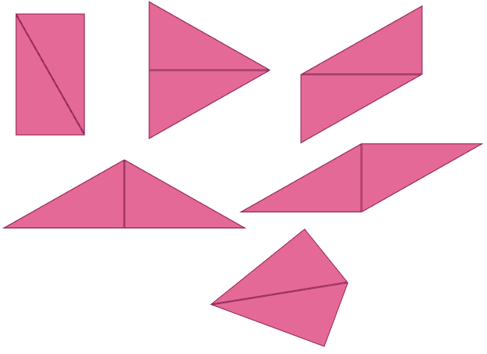
- Ask Stage 3 pairs to fold their rectangle in half along both the crease lines creating 4 smaller equally sized rectangles. Challenge pairs to problem solve, make and cut out 4 smaller triangles and 2 larger triangles (see Figure 5).
Figure 5 – examples of solutions
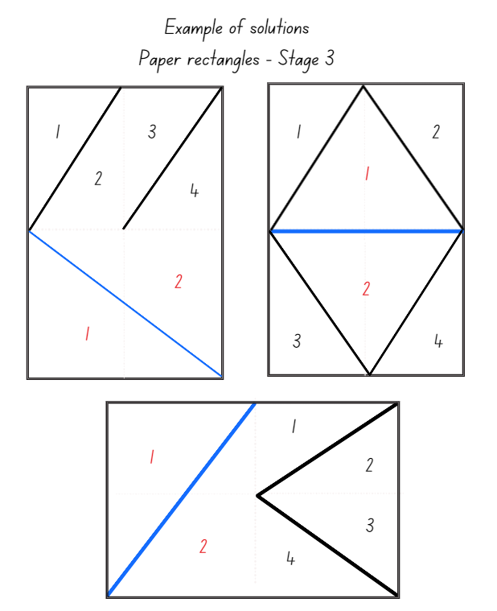
- As a class discuss:
- How did you know that the orientation of your triangles was correct? (Stage 2)
- Were there any new shapes that were more challenging to make? (Stage 2)
- What did you notice about your triangles? (Stage 3)
- Explain how you knew that your strategy would make 2 large and 4 smaller triangles? (Stage 3)

Core lesson 2 – 25 minutes
Stage 2 task – creating more new shapes
- Students use pattern blocks or attribute blocks to create new shapes. They record each new shape and write a describing sentence (see Figure 6). For example:
- 3 triangles can make a trapezium.
- 2 squares can make a rectangle.
- 2 trapeziums can make a hexagon.
Figure 6 – student examples
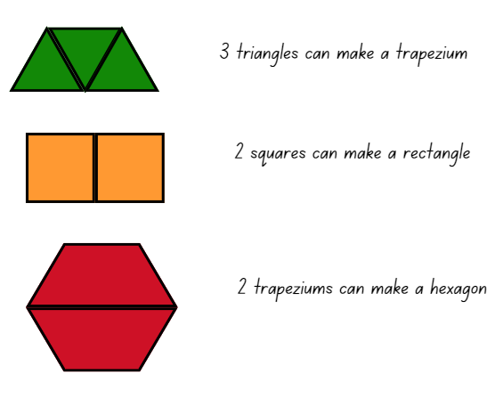
This table details opportunities for differentiation.
Too hard? | Too easy?
Stage 2 students cannot combine common two-dimensional shapes to form other common shapes.  - Make sure triangles have been cut correctly and are the same size.  - Make sure the same lengths are being matched up.  - Model 2 of the shapes and then students create some more. | Stage 2 students can combine common two-dimensional shapes to form other common shapes.  - Students experiment by making more shapes. They use 4 triangles to create familiar shapes and match up lengths that are not the same size.
Stage 3 task – rearranging triangles
- Provide each student with Resource 12 – triangle reflection grid and instruct students to cut out the black triangle. Students can write their name on the triangle to help recognise reflection, rotation and translation of the triangle.
- Students rotate, reflect or translate the right-angled triangle onto Resource 12 – triangle reflection grid as many times as required to fill the rectangle with the area of 24 squares.
- Students trace the triangle movements as they fill the rectangle (see Figure 7).
Figure 7 – sample grid with traced triangles
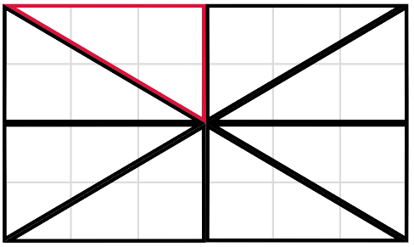
- Pairs of students turn and talk to identify a strategy to find the area of one triangle. Ask students how the grid might be used to help find the area.
Note: it is sufficient for students to learn that area is conserved after reflection, rotation, or translation. Students will explore area calculations in later lessons. The printed size of the grid will dictate whether area can be expressed in square centimetres, or as the number of grid squares.
- Students share how they used rotation, reflection or translation to fill the rectangle, and the strategy to determine the area of one triangle.
This table details opportunities for differentiation.
Too hard? | Too easy?
Students cannot recognise that translations, reflections or rotations change the position and orientation but not the size of shapes.  - Mark the cut-out triangle from Resource 12 – triangle reflection grid with a capital ‘B’. Ensure the B is visible on both sides of the paper, with the reversed image visible on one side. Use this to support understanding of reflection, rotation and translation.  - Have students cut out a completed version of Resource 12 – triangle reflection grid or Figure 7. Overlay triangles to demonstrate conservation of shape. | Students can recognise that translations, reflections or rotations change the position and orientation but not the size of shapes.  - Students use a combination of rotations, translations or reflections to draw a triangle with a new orientation. Student A provides the drawing and Student B must identify which movements have been used to arrive at the triangle’s new orientation.  - Students create a trapezium, parallelogram, 2 different rectangles by rotating, reflecting, and translating their cut-out triangle. Students calculate the area of each shape.

Discuss and connect the mathematics – 5 minutes
- Regroups as a class and discuss:
- Can you identify a new shape that has the most lines of symmetry? Explain. (Stage 2)
- Are there any new shapes that have no symmetry? Explain. (Stage 2)
- As you positioned the triangles, was there an efficient way to recognise each of the movements? (Stage 3)
- What did you notice about the area of one triangle? (Stage 3)
- How can the grid be used to find the area of multiple triangles? (Stage 3)

This table details opportunities for assessment.
Assessment opportunities | Links
What to look for:  - Can Stage 2 students combine common two-dimensional shapes to form other common shapes? [MAO-2DS-02, MA2-2DS-02]  - Can Stage 2 students split a given shape into 2 or more common shapes and describe the result? [MAO-2DS-02, MA2-2DS-02]  - Can Stage 2 students record the arrangements of common shapes used to create other shapes? [MAO-2DS-02,  MA2-2DS-02]  - Can Stage 3 students use the terms translate, reflect, and rotate to describe transformations of two-dimensional shapes?  [MAO-WM-01, MA3-2DS-01]  - Can Stage 3 students dissect and rearrange one shape to make another? [MAO-WM-01, MA3-2DS-02]  - Can Stage 3 students recognise that translations, reflections or rotations change the position and orientation but not the size of shapes? [MAO-WM-01, MA3-2DS-01] | Links to National Numeracy Learning Progressions (NNLP):  - Stage 2 – UGP5-6  - Stage 3 – UGP5-6.

Lesson 3
Core concept: there are hidden tessellating patterns in art, science and nature.

Daily number sense – baking problems – 15 minutes
The table below contains suggested learning intentions and success criteria. These are best co-constructed with students.
Daily number sense learning intentions | Daily number sense success criteria
Students working towards Stage 2 outcomes are learning to:  - use number properties to find related multiplication facts.  Students working towards Stage 3 outcomes are learning to:  - represent and describe number patterns formed by multiples. | Students working towards Stage 2 outcomes can:  - use flexible partitioning within multiplication.  Students working towards Stage 3 outcomes can:  - describe a pattern formed by multiples in words, in terms of multiplication rather than addition  - determine a rule describing the relationship between the bottom number and the top number in a table.
- Display Resource 13 – 7 sixes and explain that when problem solving using multiplication, one strategy is to apply known number patterns to make finding a multiplication fact easier.
- State that a baker arranges a quantity of cupcakes on a baking tray marked out with a grid. He can see that there are 7 sixes and is wondering how a known fact can be used to make finding a multiplication fact easier.
- Using Resource 13 – 7 sixes, model on the grid the different ways of using a known fact and partitioning. For example, 7 × 6 can be solved by adding 6 × 6 to one more 6 or finding 7 × 5 and adding one more 7 (see Figure 8).
Figure 8 – different ways to find a multiplication fact
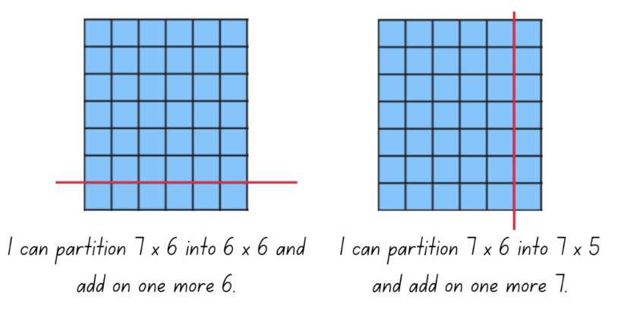
- Display Resource 14 – a baking problem 1 for Stage 2 students and Resource 15 – a baking problem 2 for Stage 3 students. Provide pairs of students with grid paper, a whiteboard, writing materials and counters.
- Explain to Stage 2 students that they will record solutions using arrays on the grid paper.
- Explain to Stage 3 students that they will record solutions using arrays on the grid paper as well as a table of values. (It is optional to revise Daily number sense Lesson 2 for Stage 3 students to further support problem solving strategies). See Figure 9 and Figure 10 for possible solutions.
Figure 9 – examples of possible solutions (Stage 2)
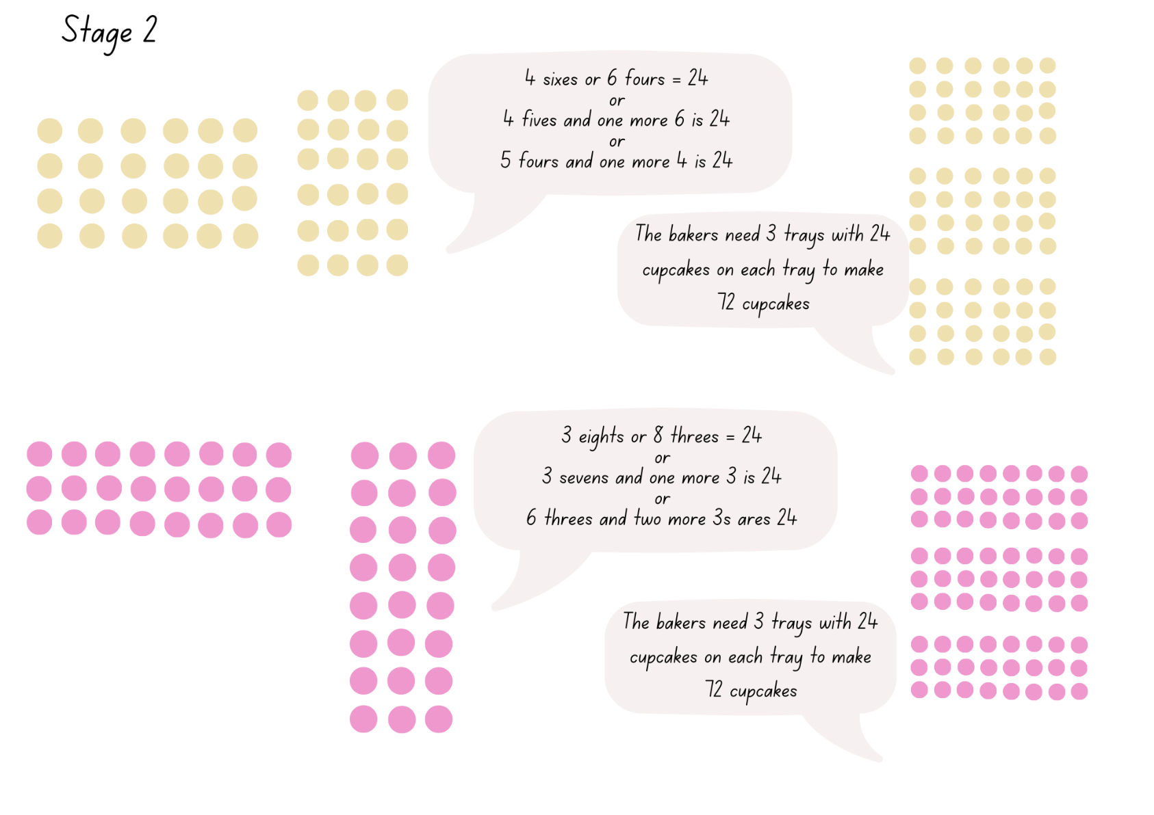
Figure 10 – examples of possible solutions (Stage 3)
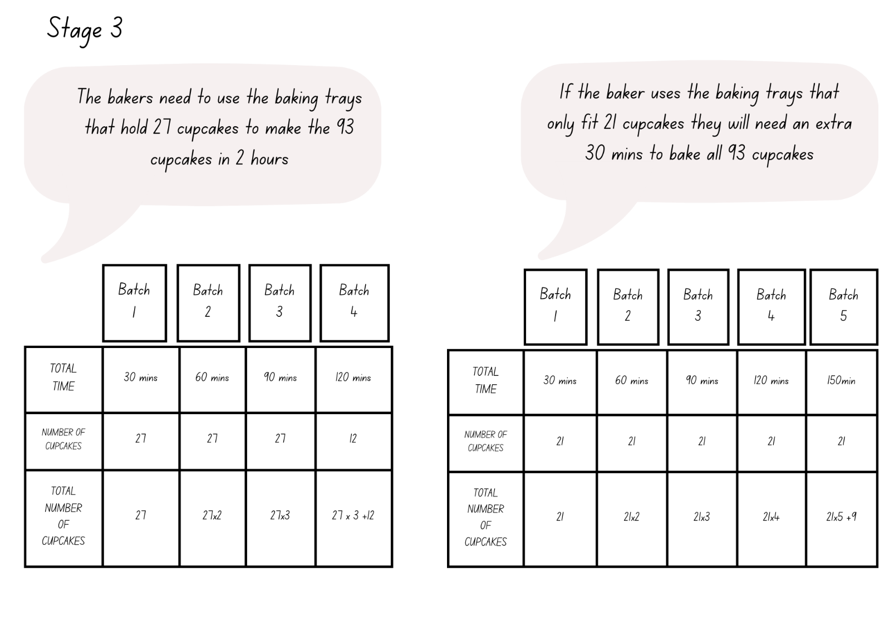
- As a class discuss:
- How did you know what the problem was asking you to solve?
- What strategy was most useful?
- How did you know your solution was correct?
- Can you explain how arrays and/or a table of values are useful when problem solving?
This table details opportunities for assessment.
Assessment opportunities | Links
What to look for:  - Can Stage 2 students use flexible partitioning within multiplication? [MAO-WM-01, MA2-MR-01]  - Can Stage 3 students describe a pattern formed by multiples in words, in terms of multiplication rather than addition?  [MAO-WM-01, MA3-MR-01]  - Can Stage 3 students determine a rule describing the relationship between the bottom number and the top number in the table? [MAO-WM-01, MA3-MR-01] | Links to National Numeracy Learning Progressions (NNLP):  - Stage 2 – MuS7  - Stage 3 – NPA4, NPA5.

Core lesson 1 – tile patterns – 25 minutes
The table below contains suggested learning intentions and success criteria. These are best co-constructed with students.
Core concept learning intentions | Core concept success criteria
Students working towards Stage 2 outcomes are learning to:  - transform shapes by reflecting, translating and rotating  - create symmetrical patterns and shapes.  Students working towards Stage 3 outcomes are learning to:  - classify two-dimensional shapes and describe their properties  - dissect two-dimensional shapes and rearrange them using translations, reflections and rotation. | Students working towards Stage 2 outcomes can:  - identify lines of symmetry in pictures, designs, and the environment  - apply and describe amounts of rotation including half-turns, quarter-turns and three-quarter-turns when creating designs  - create and record tessellating designs by reflecting, translating and rotating triangles, quadrilaterals or other chosen shapes.  Students working towards Stage 3 outcomes can:  - compare side and angle properties of triangles and quadrilaterals using measurement and symmetry  - identify regular and irregular polygons  - use the terms translate, reflect and rotate to describe transformations of two-dimensional shapes  - recognise that translations, reflections or rotations change the position and orientation but not the size of shapes.
This activity is an adaptation of ‘Tile it’ from Mindset Mathematics, Grade 4 by Boaler et al.
- Explain that for thousands of years, tiles have been used for practical purposes in built environments. However, they are often also artforms. Some have drawn inspiration from the natural world.
- Revise the term symmetry and identify examples of symmetry in the classroom.
Symmetry: an object or shape has symmetry or is symmetrical when one half is the mirror image of the other half.
- Discuss the terms tessellation, reflect, rotation and translation with students, providing examples with pattern blocks as needed.
Tessellation: a repeated shape that fits together over a flat surface without any spaces or overlaps.
Translation: in a translation (slide) every point on the original image moves in the same direction for the same distance to transform the new image.
Reflection: a reflection (flip) requires a line of reflection. A reflection is a transformation in which an object is flipped across the line of reflection.
Rotation: a rotation (turn) requires a centre of rotation (a point) and a degree of rotation, for example, 90 degrees or a quarter-turn.
- Display an enlarged copy of Resource 16 – tile patterns. Ask:
- What shapes can you see?
- Are there any shapes you do not recognise? How can you describe those?
- Do you think any patterns have been inspired by the natural world?
- Are there any examples of tessellations visible in these tile patterns?
- What transformations do you see? What examples of translation, reflection and rotation can you see?
- How many different shapes do each of these tile patterns use?
- As a class, look at the core shape(s) from each pattern in Resource 16 – tile patterns, for example, a hexagon and a rectangle. Identify and draw on lines of symmetry.
Multi-age: provide Stage 2 students with Resource 17 – tile shapes and Stage 3 students with Resource 18 – classifying polygons.
- Ask Stage 2 students to predict which shapes:
- will not tessellate
- can be used to make tessellations with one shape
- can be used to make tessellations with 2 shapes.
- Ask Stage 3 students:
- What is a regular polygon, irregular polygon and non-polygon?
- Can you identify the polygons and give reasons why they meet the definition of a polygon? For example, a triangle is a polygon because it has 3 straight sides that are connected to make a closed shape.
- What properties can we use to categorise polygons? For example, number of sides, number of angles, diagonals, lines of symmetry, regular and irregular. Ensure students recognise that triangles and quadrilaterals can be classified in more than one way.
- Are these polygons regular, irregular or not a polygon? Why?
- Students justify their reasoning with their partner.

Core lesson 2 – 15 minutes

Stage 2 task – tessellating patterns
- Pairs of students choose and cut out one or 2 shapes from Resource 17 – tile shapes. Have students repeatedly draw around these to make a tessellation on A4 paper. Pattern blocks can be used for this activity but will not provide as much choice. Ask:
- Are you rotating, translating, or reflecting your shape(s) to make your tessellation?
- Could your pattern continue in every direction without ending? (This proves it is a tessellation.)
- Have students write a description about their tessellation that includes:
- The name(s) of the shape(s) used.
- Whether they use reflection (flip), translation (slide) or rotation (turn).
- Whether it is quarter, half, or three-quarter rotation where rotation has been used.
- If their tessellation uses one shape or 2.
- Whether their tessellation has any lines of symmetry.

Stage 3 task – manipulating patterns
- In pairs, students draw or make regular and irregular polygons on grid paper, a geoboard or a virtual geoboard. Students record the properties of each shape.
- Distribute Resource 19 – transforming polygons and display a quadrilateral on GeoGebra Classic. Demonstrate translating, reflecting and rotating the shape. Students:
- draw the shape and list its properties
- draw the shape rotated 90 degrees
- draw the shape reflected
- draw the shape translated
- identify if the properties of the shape stayed the same when rotated, reflected and translated
- identify if the size of the shape stayed the same when rotated, reflected and translated.
This table details opportunities for differentiation.
Too hard? | Too easy?
Stage 2 students cannot create and record tessellating designs by reflecting, translating, and rotating triangles, quadrilaterals or other chosen shapes.  - Model how to translate a rectangle to make a tessellation and have students copy the modelled example.  - Model how to translate and rotate an equilateral triangle to make a hexagon and continue the tessellation. Students copy the modelled example.  Stage 3 students cannot recognise that translations, reflections or rotations change the position and orientation but not the size of shapes.  - Students explore regular polygons only.  - Students use grid paper to draw and cut out shapes before translating, reflecting and rotating them. | Stage 2 students can create and record tessellating designs by reflecting, translating and rotating triangles, quadrilaterals or other chosen shapes.  - Students find digital images of tessellations and describe how mathematical transformations have been used to create tessellations.  - Investigate why some shapes tessellate and others do not by exploring where the corners of shapes meet.  Stage 3 students can recognise that translations, reflections or rotations change the position and orientation but not the size of shapes.  - Students investigate 2 transformations at once (for example, rotation and reflection)  - Students investigate the changes to polygons that do change the size of the shape.

Discuss and connect the mathematics – 15 minutes
- Regroup as a class and ask students to share their designs with a small group.
- Ask Stage 2 students to identify:
- which tessellations used translation, reflection, rotation
- a tessellation using one shape
- a tessellation using 2 shapes.
- Ask Stage 3 students:
- What happens to a shape when it is rotated? (Its orientation changes)
- What happens to a shape when it is reflected? (Its orientation changes)
- What happens to a shape when it is translated? (Its position changes)
- Does changing a polygon’s orientation or position affect its properties?
- Does changing a polygon’s orientation or position affect its size?
- What would affect the size of a polygon?
Note: the teaching advice for Stage 2 states that students should develop an appreciation that any triangle will tessellate. In general, for a shape to tessellate, each of its interior angles must be a factor of 360°. It is not an expectation that Stage 2 students develop this understanding.

This table details opportunities for assessment.
Assessment opportunities | Links
What to look for:  - Can Stage 2 students identify lines of symmetry in pictures, designs, and the environment? [MAO-WM-01, MA2-2DS-02]  - Can Stage 2 students create and record tessellating designs by reflecting, translating and rotating triangles, quadrilaterals or other chosen shapes? [MAO-WM-01, MA2-2DS-02]  - Can Stage 2 students apply and describe amounts of rotation when creating designs? [MAO-WM-01, MA2-2DS-02]  - Can Stage 3 students compare side and angle properties of triangles and quadrilaterals using measurement and symmetry? [MAO-WM-01, MA3-2DS-01]  - Can Stage 3 students identify regular and irregular polygons? [MAO-WM-01, MA3-2DS-01]  - Can Stage 3 students use the terms translate, reflect and rotate to describe transformations of two-dimensional shapes?  [MAO-WM-01, MA3-2DS-01]  - Can Stage 3 students recognise that translations, reflections or rotations change the position and orientation but not the size of shapes? [MAO-WM-01, MA3-2DS-01] | Links to National Numeracy Learning Progressions (NNLP):  - Stage 2 – UGP3-6  - Stage 3 – UGP4-6.

Lesson 4
Core concept: rotation of a shape can be measured in fractions of a turn (Stage 2) and parts of a composite figure can be split, duplicated and rotated to find the total area (Stage 3).

Daily number sense – 10 minutes
- From a class need surfaced through formative assessment data, identify a short, focused activity that targets students’ knowledge, understanding and skills. Example activities may be drawn from the following resources:
- Mathematics K–6 resources
- Universal Resources Hub.

Core lesson – 40 minutes

Stage 2 task – flags
The table below contains suggested learning intentions and success criteria. These are best co-constructed with students.
Core concept learning intentions | Core concept success criteria
Students working towards Stage 2 outcomes are learning to:  - transform shapes by reflecting, translating, and rotating  - create symmetrical patterns and shapes. | Students working towards Stage 2 outcomes can:  - identify lines of symmetry in pictures, designs and the environment  - create and record tessellating designs by reflecting, translating and rotating triangles or quadrilaterals  - apply and describe amounts of rotation, including half-turns, quarter-turns and three-quarter-turns, when creating designs.
- Tell students that a flag is a visual symbol used for identification. Ask how the Australian, Aboriginal and Torres Strait Islander flags can be recognised. Explain that flags often have mathematical elements in their designs.
- Display Resource 20 – flags and allow time for students to turn and talk. Ask:
- Do any of these flags have lines of symmetry?
- What examples of tessellation can you see on these flags?
- Can you find any examples of reflection, translation or rotation on these flags? (see Figure 11).
Figure 11 – mathematical elements in flag designs
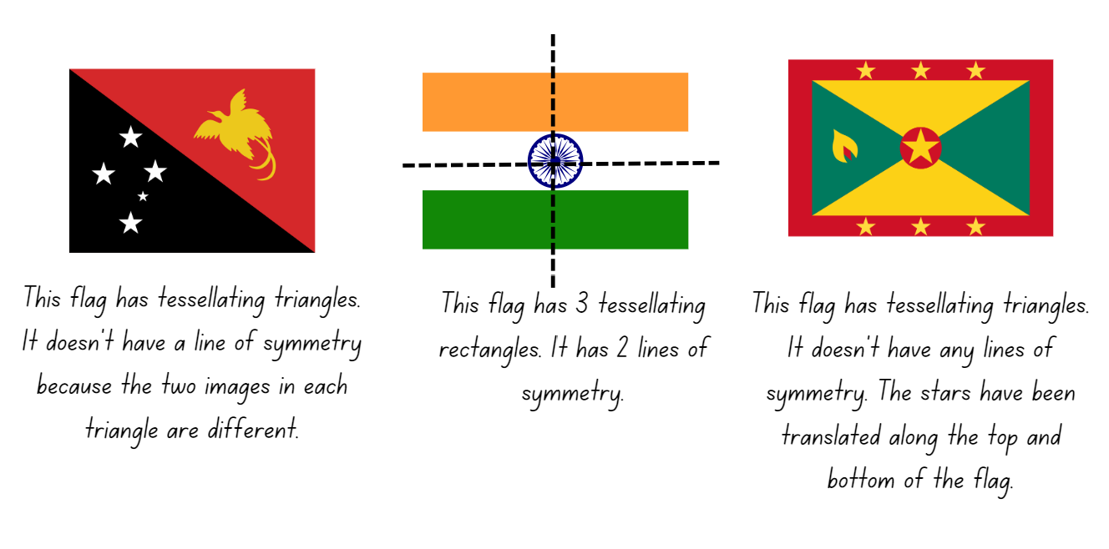
- Discuss ideas as a class.
- Provide small groups of students with A4 paper to plan and design a class flag. Explain that the design must include elements of symmetry, tessellation, and rotation. Students may wish to include examples of reflection and translation in their design. Students will also need to consider use of colours and/or symbols that represent the class.
Note: this activity could connect data collection syllabus outcomes if students survey the class about colours and/or symbols.
- Display the flags. Each group reports on the symmetry, mathematical transformations used (translation, reflection, rotation) to create it, use of colour and/or symbols. With the elements of rotation, students specify whether quarter, half, or three-quarter turns are used. Discuss whether the tessellation on each flag can continue in every direction and whether there are lines of symmetry in each flag.
This table details opportunities for differentiation.
Too hard? | Too easy?
Stage 2 students cannot create and record tessellating designs by reflecting, translating, and rotating triangles or quadrilaterals.  - Support students to use a rectangle that is one-third of an A4 sheet of paper as a stencil. Students draw around this and slide the rectangle down until they reach the end of the first rectangle and draw around it again. Students repeat the process until they have created a flag with 3 segments that tessellate.  - Students make choices about which 3 colours to use for their flag. They explain their thinking to a friend. | Stage 2 students can create and record tessellating designs by reflecting, translating and rotating triangles or quadrilaterals.  - Students look at flags of the world and categorise them into groups depending on how many mathematical transformations have been used in each design.  - Students research different types of flags. For example, country, sports teams, groups of people, decorative. Students identify the types of mathematical transformations used, lines of symmetry and tessellations in the designs.

Stage 3 task – area of composite figures
The table below contains a suggested learning intention and success criteria. These are best co-constructed with students.
Core concept learning intention | Core concept success criteria
Students working towards Stage 3 outcomes are learning to:  - find the area of composite figures. | Students working towards Stage 3 outcomes can:  - find different ways to calculate the area of a composite L-shape figure.
- Provide pairs or small groups of students with 10 square pattern blocks and explain that each block represents an area of one square metre.
- Students use the blocks to make shapes with an area of 10 square metres. Students find as many combinations as possible and record their findings.
- Select groups to share their results and what they notice.
Note: it does not matter which way the shape is formed. If it is a quadrilateral, or an octagon, the shape has the same area and same number of squares.
- Display a composite L-shaped figure (see Figure 12) and explain that students are to work in pairs or small groups to find different ways to calculate the area. Remind students that the area of a rectangle is found by multiplying the number of units of length by the number of units of width and that the result of multiplying 2 numbers is called the product.
Figure 12 – composite L shape
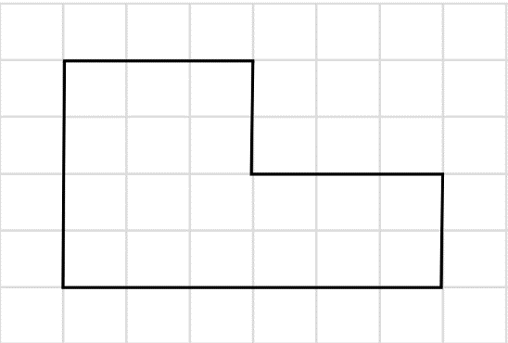
Note: remind students to record area in square centimetres (cm²), square metres (m²) and square kilometres (km²).
- Select groups to share their thinking. Ensure that each of the following strategies are modelled by either students or the teacher:
- partitioning (see Figure 13).
Figure 13 – composite shape with partitioning
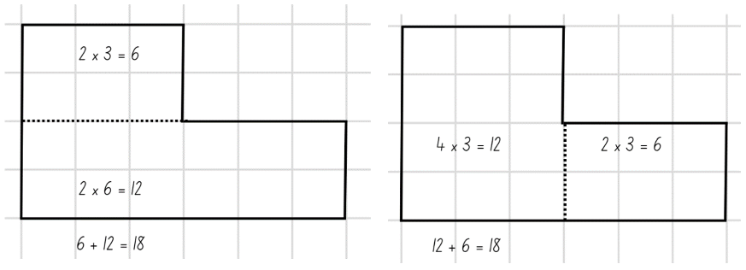
- dissecting and translating (see Figure 14).
Figure 14 – composite shape with dissecting and translating
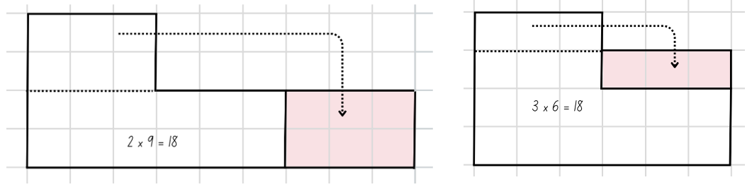
- duplicating and rotating (see Figure 15).
Figure 15 – composite shape with duplication and rotation
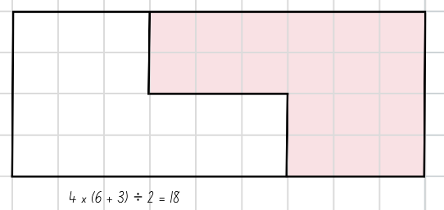
- Discuss the activity, asking questions such as:
- Which strategy do you prefer? Why?
- Which strategy do you think is the most efficient? Why?
- What units did you use to record the area of the composite shapes?
- When might it be necessary to calculate the area of a composite shape?
- What knowledge or skills did you need to be able to complete the task?
This activity is an adaptation of ‘Composite shapes’ from Challenging Mathematical Tasks by Sullivan.
- In pairs or small groups have students draw a composite L-shaped figure with an area of 60 cm² on a whiteboard or in workbooks. Students provide at least 2 possible solutions. For example, see Figure 16.
Figure 16 – example of a composite shape with possible solution
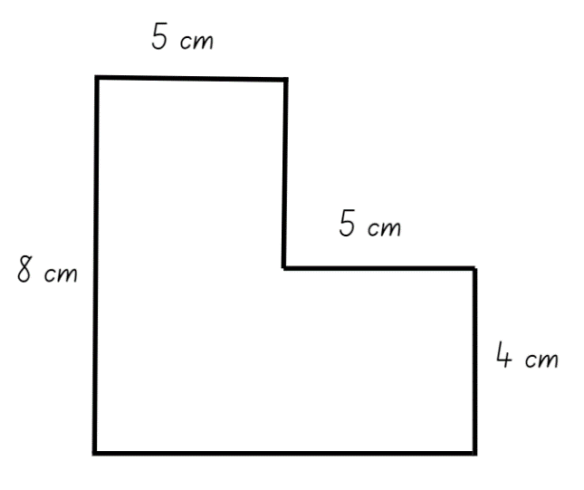
- Provide time for students to conduct a gallery walk and discuss similarities and differences between solutions. Ask:
- What strategy did you use?
- How did you use factors to draw your shapes?
- How do you know your answer is correct?
- How many ways can you check?
- What might your answer look like if the area had to be 30 cm²?
This table details opportunities for differentiation.
Too hard? | Too easy?
Stage 3 students cannot find different ways to calculate the area of a composite L-shape figure.  - Demonstrate how to draw a rectangle with an area of 40 cm² by using a pair of factors to determine the length of the sides.  - Students draw a rectangle with an area of 20 cm² by using a pair of factors to determine the length of the sides. Join the rectangles together to create a composite L-shaped figure that has an area of 60 cm². | Stage 3 students can find different ways to calculate the area of a composite L-shape figure.  - Ask students how many different rectangles can be made with an area of 60 cm² and how they know that all possibilities have been found (12).  - Challenge students to find the shortest possible perimeter for a composite L-shaped figure that has an area of 60 cm².

Consolidation and meaningful practice – 10 minutes
- Display Resource 21 – tessellations in nature. Explain that these are examples of tessellations in the natural world. Ask students to describe and guess what they are (for example, snake scales, honeycomb, onion skin cells, leaf patterns, rock pavement patterns and fish scales). Ask Stage 3 students if there are any examples of patterns that resemble tessellating composite shapes.
This table details opportunities for assessment.
Assessment opportunities | Links
What to look for:  - Can Stage 2 students identify lines of symmetry in designs and the environment? [MAO-WM-01, MA2-2DS-02]  - Can Stage 2 students create and record tessellating designs by reflecting, translating and rotating triangles or quadrilaterals? [MAO-WM-01, MA2-2DS-02]  - Can Stage 2 students apply and describe amounts of rotation, including half-turns, quarter-turns and three-quarter-turns, when creating designs? [MAO-WM-01, MA2-2DS-02]  - Can Stage 3 students find different ways to calculate the area of a composite L-shape figure? [MAO-WM-01, MA3-2DS-02,  MA3-2DS-03] | Links to National Numeracy Learning Progressions (NNLP):  - Stage 2 – UGP3-6  - Stage 3 – UuM7, UuM10.

Lesson 5
Core concept: grids can support the measurement of area and parts of a composite figure can be split, duplicated and rotated to find the total area.

Daily number sense – coins – 10 minutes
Daily number sense activities for Lessons 5 to 7 ‘loop’ back to concepts and procedures covered in previous units to assist students to build an increasingly connected network of ideas. These concepts may differ from the core concepts being covered by the unit.
The table below contains suggested learning intentions and success criteria. These are best co-constructed with students.
Daily number sense learning intentions | Daily number sense success criteria
Students working towards Stage 2 outcomes are learning to:  - apply addition and subtraction to familiar contexts, including money and budgeting.  Students working towards Stage 3 outcomes are learning to:  - choose and use efficient strategies to solve addition and subtraction problems. | Students working towards Stage 2 outcomes can:  - reflect on a chosen strategy for solving a problem, considering whether it can be improved  - interpret problems involving money as requiring either addition or subtraction.  Students working towards Stage 3 outcomes can:  - solve multistep word problems, including problems that require more than one operation  - compare, evaluate and communicate strategies used to solve addition and subtraction problems.
This activity is an adaptation of Five coins from NRICH by University of Cambridge.
- Brainstorm what coins there are in Australian currency. Show examples if needed.
- Pose the following problem: Amir has one of each coin. He wants to buy a pair of shorts that costs $9.50. Ask students:
- How much money does Amir have?
- How much more does he need to buy the shorts?
- What strategy can you use to calculate this?
- Students turn and talk and record their thinking and strategies used.
- Discuss the strategies used, highlighting that addition and subtraction can be used to calculate the difference in money. Amir can subtract $3.85 from $9.50 or start at $3.85 and count up to $9.50 to find the difference.
- Pose the following problem to students: The shorts have gone on sale at half-price. Ask students:
- How much will the shorts cost now?
- What strategy can you use to calculate half-price?
- What strategy can be used to work out how much more money Amir needs?
- How can addition or subtraction be used to solve this problem?
- Is your chosen strategy effective?
- Students share their ideas with a partner and reflect on whether their strategy is effective and whether it can be improved.
Multi-age: provide Stage 3 students with problems involving more than one item that needs to be bought and other discounts. For example, a pair of shorts and a shirt at 25% off.
This table details opportunities for assessment.
Assessment opportunities | Links
What to look for:  - Can Stage 2 students interpret problems involving money as requiring either addition or subtraction? [MAO-WM-01,  MA2-AR-01]  - Can Stage 2 students reflect on a chosen strategy for solving a problem, considering whether it can be improved? [MAO-WM-01, MA2-AR-01]  - Can Stage 3 students solve multistep word problems, including problems that require more than one operation? [MAO-WM-01, MA3-AR-01]  - Can Stage 3 students compare, evaluate and communicate strategies used to solve addition and subtraction problems? [MAO-WM-01, MA3-AR-01] | Links to National Numeracy Learning Progressions (NNLP):  - Stage 2 – AdS8, UnM6, UnM7  - Stage 3 – AdS7, AdS8, MuS8.  Links to suggested Interview for Student Reasoning (IfSR) tasks:  - Stage 3 – IfSR-AT: 3A.5.

Core lesson – 40 minutes

Stage 2 task – area clues
The table below contains suggested learning intentions and success criteria. These are best co-constructed with students.
Core concept learning intentions | Core concept success criteria
Students working towards Stage 2 outcomes are learning to:  - measure the areas of shapes using the grid structure  - use the structure of the area model to represent multiplication and division  - operate with multiples of 10. | Students working towards Stage 2 outcomes can:  - measure the areas of rectangles and right-angled triangles using a square-centimetre grid overlay  - estimate the areas of shapes found in the environment using efficient strategies (non-count-by-one) with a grid overlay  - create and represent multiplicative structure, moving from arrays to partially covered area models  - use multiplication facts with multiples of 10 to multiply a one-digit number by a multiple of 10.
- Tell students to use what they have learnt so far about shapes to solve other problems with shapes.
- Display Resource 22 – area clues. Ask students to turn and talk in pairs to discuss:
- How many squares are there in total in the red square? (There are 16 squares).
- How can you be sure of your answer? (There are 4 rows of 4 squares. 4 × 4 = 16).
- Students share their thinking. Revise that an array structure can be used to help find the area of shapes.
- Ask students what the area of the red triangle might be. Students turn and talk to share their thinking with their partner.
- Select students to share their thinking, for example:
- The red triangle looks about half the size of the red square, so the area would be about half.
- You could count the whole squares, then put together some of the partial squares to make whole squares. Then, count the total.
- The triangle is the square array cut in half, so the area would be half of the square array. Half of 16 = 8 squares.
- Test student thinking and confirm that the red triangle has half the area of the red square.
- Repeat the process for the blue rectangle in Resource 22 – area clues.
- Pose the thought: the area of a triangle is always half the area of the rectangle/square with the same length and width.
- Provide pairs of students with a copy of Resource 23 – area clues 2. Explain that they will be working to test the conjecture. Students work with their partner to use the grid in the image to find the areas of the rectangles, then use this information to find the areas of the corresponding right-angled triangles.
- Discuss student findings and confirm that:
- The areas of rectangles can be used to find the areas of right-angled triangles with the same length and width, by halving them.
- Grids can be used as an array structure to measure the area of shapes.
- Display Resource 24 – garden area investigation and explain that Nadia is getting advice from a landscaper on designing garden beds around her house. The landscaper needs to know the area of each garden bed to order enough soil and materials as well as how many grid squares each garden bed covers.
- Ask students to estimate the area of one garden in grid squares, explaining their reasoning.
- Model how to use the grid squares to find the area of one of the garden beds on Resource 24 – garden area investigation using a logical sequence. For example:
- First, see if there is an array that can be made as an efficient way to find a large part of the shape’s area. Calculate the total of this array.
- Next, look for any smaller arrays that can be made and find the area. Add these to the total counted so far.
- Then, count any remaining complete or partial grid squares and add these to the total. A whiteboard marker can be used to mark which grid squares have already been counted.
- Compare this partial total to the original estimate. Discuss whether the estimate can be refined based on this new information.
- Combine partial squares that together make whole squares. Add these to the total.
- Compare the final total to the estimate, considering what information influenced this prediction.
- Provide pairs of students with Resource 24 – garden area investigation. For each garden students:
- Estimate the area in grid squares.
- Use the grid to look for an array that can be made to efficiently find part of the shape’s area.
- Consider refining their original estimate.
- Combine partial squares that together would make whole grid squares. Add these to the total.
- Compare the final total to the estimate.
This table details opportunities for differentiation.
Too hard? | Too easy?
Stage 2 students cannot estimate the areas of shapes found in the environment using efficient strategies (non-count-by-one) with a grid overlay.  - Support students to estimate the area of the garden, then align their grid with the outline. Show how to find arrays within the shape and use these to efficiently calculate a large part of the area. Students revise their estimates.  - Model how to combine remaining full/partial squares to create complete grid squares. Add these to the total to find the area of the shape in grid squares. | Stage 2 students can estimate the areas of shapes found in the environment using efficient strategies (non-count-by-one) with a grid overlay.  - Students sketch their own garden bed outline for another student to estimate and measure.  - In pairs, students take the total area of the garden beds and rearrange the squares to create a rectangular area array.

Stage 3 task – area of parallelogram
The table below contains suggested learning intentions and success criteria. These are best co-constructed with students.
Core concept learning intentions | Core concept success criteria
Students working towards Stage 3 outcomes are learning to:  - dissect two-dimensional shapes and rearrange them using translations, reflections and rotations  - calculate the area of a parallelogram using subdivision and rearrangement. | Students working towards Stage 3 outcomes can:  - dissect and rearrange one shape to make another  - recognise that translations, reflections or rotations change the position and orientation but not the size of shapes  - show how to transform a parallelogram into a rectangle to find its area  - record, using words, a method for finding the area of any parallelogram.
- Display Resource 25 – parallelogram on grid and revise the properties of parallelograms. Remind students that opposite sides are parallel and of equal length, and in the parallelogram in the resource, the height is 5 squares and the width is 7 squares.
- Provide students with Resource 25 – parallelogram on grid to estimate the area of the parallelogram. The dotted lines may support student thinking.
- Prompt students with the following questions:
- Are there familiar shapes within the parallelogram that can help find the total area?
- Can we use our knowledge of dissecting shapes to help find the area?
- How might the grid help to find the area of the parallelogram?
- Pairs of students turn and talk to estimate or calculate the area of the parallelogram.
- Regroup and select students to share their strategies. Use displayed Resource 25 – parallelogram on grid to affirm or clarify their thinking.
Note: emphasise that a parallelogram can be subdivided and rearranged to form a rectangle. Encourage students to use terms such as translate, rotate and reflect when referring to the movement of the subdivided triangle.
- Use the students’ ideas and strategies to co-create a method for finding the area of any parallelogram.
- Provide Resource 26 – 4 parallelograms and a grid to pairs of students. Students to work in pairs to find the area of each parallelogram, using scissors to cut out the parallelograms.
Note: students may trial different orientations of the parallelogram to determine the most efficient strategy (See Figure 17).
Figure 17 – parallelograms overlaid on grid
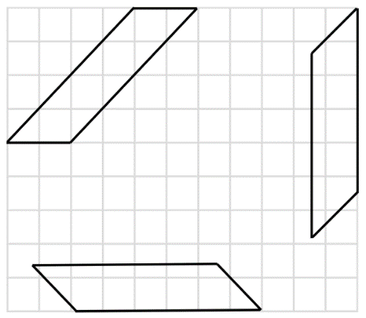
- Regroup Stage 3 students and ask:
- What strategy did you use to find the area of each parallelogram?
- What was the most efficient strategy?
- Did the orientation of the parallelogram change the area?
- Did you notice any differences when determining the area of the 4 parallelograms?
This table details opportunities for differentiation.
Too hard? | Too easy?
Stage 3 students cannot dissect and rearrange one shape to make another.  - Use Resource 25 – parallelogram on grid to model dissecting and translating the triangle from the parallelogram to form a rectangle.  - Students cut out the shapes and translate the triangle to form a rectangle. | Stage 3 students can dissect and rearrange one shape to make another.  - Challenge pairs of students to examine how a parallelogram can be divided into 2 triangles and determine the relationship between the area of a triangle and parallelogram.  - Students share ideas with other pairs of students to compare and justify their thinking.

Discuss and connect the mathematics – 10 minutes
- Regroup as a class and summarise the lesson together drawing out key mathematical ideas. Ask:
- What did you notice when measuring the areas of the garden beds? (Stage 2)
- Why do you think some students got different measurements for the same garden bed? (Stage 2)
- Now that the area of each garden bed has been decided, Nadia would like 10 of each garden bed. How many grid squares will each type of garden bed cover now? (Stage 2)
- Did you subdivide all the parallelograms in the same way? Explain your answer. (Stage 3)
- How did your knowledge of rotating, reflecting and translating help you with today's task? (Stage 3)
- How are the height and width of a parallelogram related to its area? (Stage 3)
- How did you find the most efficient strategy for finding the area of a parallelogram? (Stage 3)
- What did you notice about the relationship between triangles and parallelograms? (Stage 3)
This table details opportunities for assessment.
Assessment opportunities | Links
What to look for:  - Can Stage 2 students measure the areas of rectangles and right-angled triangles using a square-centimetre grid overlay?  [MAO-WM-01, MA2-2DS-03]  - Can Stage 2 students estimate the areas of shapes found in the environment using efficient strategies (non-count-by-one) with a grid overlay? [MAO-WM-01, MA2-2DS-03]  - Can Stage 2 students create and represent multiplicative structure, moving from arrays to partially covered area models? [MAO-WM-01, MA2-MR-01]  - Can Stage 2 students use multiplication facts with multiples of 10 to multiply a one-digit number by a multiple of 10?  [MAO-WM-01, MA2-MR-01]  - Can Stage 3 students dissect and rearrange one shape to make another? [MAO-WM-01, MA3-2DS-01]  - Can Stage 3 students recognise that translations, reflections or rotations change the position and orientation but not the size of shapes? [MAO-WM-01, MA3-2DS-01]  - Can Stage 3 students show how to transform a parallelogram into a rectangle to find its area and use words to describe a method for finding the area of any parallelogram? [MAO-WM-01,  MA3-2DS-03] | Links to National Numeracy Learning Progressions (NNLP):  - Stage 2 – MuS5, MuS6, UuM5-7, UGP6  - Stage 3 – UuM7, UuM10.  Links to suggested Interview for Student Reasoning (IfSR) tasks:  - Stage 2 – IfSR-MT: 2A.12, 2A.13, 2A.14.

Lesson 6
Core concept: rectangles with the same area can have different perimeters and the known area of a shape can be used to help calculate the area of other shapes.

Daily number sense – 5 notes – 10 minutes
The table below contains suggested learning intentions and success criteria. These are best co-constructed with students.
Daily number sense learning intentions | Daily number sense success criteria
Students working towards Stage 2 outcomes are learning to:  - apply addition and subtraction to familiar contexts, including money and budgeting.  Students working towards Stage 3 outcomes are learning to:  - choose and use efficient strategies to solve addition and subtraction problems. | Students working towards Stage 2 outcomes can:  - interpret problems involving money as requiring either addition or subtraction  - reflect on a chosen strategy for solving a problem, considering whether it can be improved.  Students working towards Stage 3 outcomes can:  - solve multistep word problems, including problems that require more than one operation  - compare, evaluate and communicate strategies used to solve addition and subtraction problems.
- Samira has one of each note of Australian currency ($100, $50, $20, $10, and $5), six $2 coins and nine 50c coins. She wants to buy a skateboard that costs $225. Ask students:
- How much money does Samira have?
- How can she work out how much more money she needs?
- Will she use subtraction, addition, or a combination of both?
- Provide pairs with individual whiteboards to find a solution.
- Share solutions and ask which strategy is most effective and why.
- Samira’s auntie pays her $8 for doing some gardening and then Samira finds another 50c coin in her pocket. Ask:
- How much money does Samira need now to buy the skateboard?
- Is the same strategy still the most effective? Why or why not?
Multi-age: provide students working towards Stage 3 outcomes with a problem involving more than one item that is to be bought. For example, a skateboard and a helmet.
This table details opportunities for assessment.
Assessment opportunities | Links
What to look for:  - Can Stage 2 students interpret problems involving money as requiring either addition or subtraction? [MAO-WM-01,  MA2-AR-01]  - Can Stage 2 students reflect on a chosen strategy for solving a problem, considering whether it can be improved?  [MAO-WM-01, MA2-AR-01]  - Can Stage 3 students solve multistep word problems, including problems that require more than one operation?  [MAO-WM-01, MA3-AR-01]  - Can Stage 3 students compare, evaluate and communicate strategies used to solve addition and subtraction problems? [MAO-WM-01, MA3-AR-01] | Links to National Numeracy Learning Progressions (NNLP):  - Stage 2 – AdS8, UnM6, UnM7  - Stage 3 – AdS7, AdS8, MuS8.  Links to suggested Interview for Student Reasoning (IfSR) tasks:  - Stage 3 – IfSR-AT: 3A.5.

Core lesson – 40 minutes

Stage 2 task – connecting area and perimeter
The table below contains suggested learning intentions and success criteria. These are best co-constructed with students.
Core concept learning intentions | Core concept success criteria
Students working towards Stage 2 outcomes are learning to:  - measure the areas of shapes using the grid structure  - represent and solve problems involving multiplication fact families  - use the structure of the area model to represent multiplication and division. | Students working towards Stage 2 outcomes can:  - measure the areas of rectangles and right-angled triangles using a square-centimetre grid overlay  - recognise that rectangles with different side lengths can have the same area  - create and represent multiplicative structure, moving from arrays to partially covered area models.
This activity is an adaptation of ‘Connecting area and perimeter’ from Mindset Mathematics, Grade 3 by Boaler et al.
- Show students a set of 12 square tiles, sticky notes or squares printed on card and cut out from Resource 27 – 12 squares.
- Ask students what rectangles can be made using all 12 tiles. Students turn and talk to a partner.
- Discuss ideas and have students move the tiles to create several different rectangles using all 12 tiles.
- Revise the term ‘perimeter’. Explain the meaning of the Latin word ‘peri’ meaning around and ‘metron’ meaning measure.
Perimeter: the outer edge, or dimensions, of a flat shape or area.
- Students turn and talk to a partner. Ask:
- Do all the rectangles made with the 12 tiles have the same area?
- Do all the rectangles made with the 12 tiles have the same perimeter?
- What strategies can be used to calculate the perimeter?
- Display Resource 27 – 12 squares. Explain that students will be investigating the following questions:
- Do all rectangles made with the same area have the same perimeter? Why or why not?
- If they do not have the same perimeter, what is the shortest perimeter possible for a particular area? What is the longest?
- Provide pairs of students with grid paper and an area to investigate. For example, an area between 10 and 36 square units, ensuring an appropriate level of challenge.
- Students investigate how rectangles with the same area can have different perimeters. Have students draw these shapes on grid paper, for example, shapes that have different arrangements of 24 cm². Students find the perimeter for each shape, then annotate their diagram to include the area, the side lengths and the perimeter (see Figure 18).
Figure 18 – student example of area and perimeter
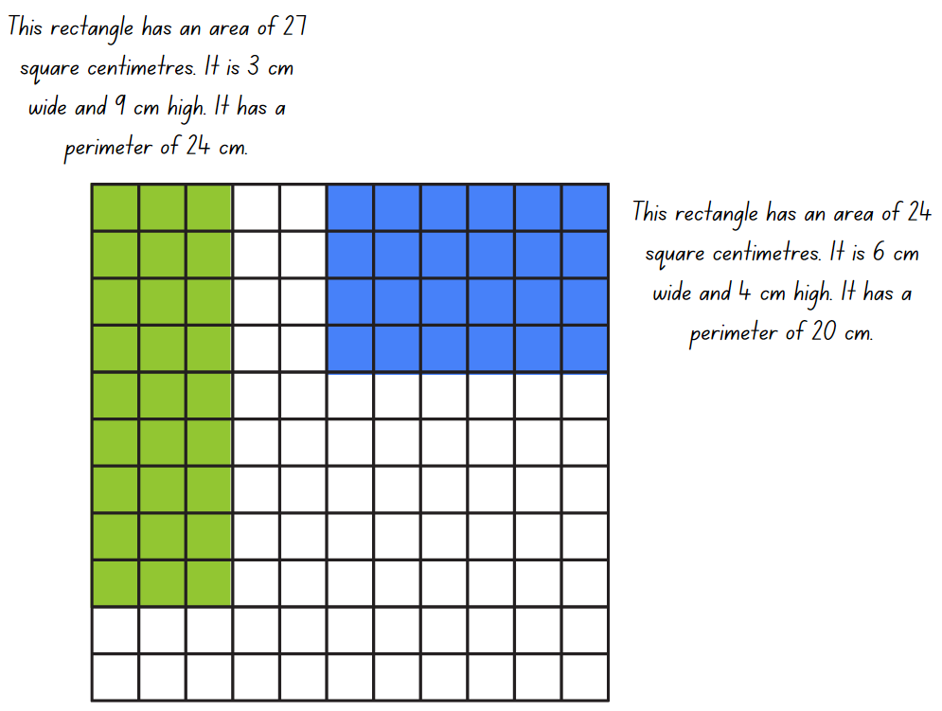
- After creating several areas and identifying that shapes with the same area can have different perimeters, challenge students to create as many rectangles with the same area and different perimeters as possible. Students represent and annotate each of these on their grid paper.
- Students then choose a different area to investigate and compare whether there are more or less possibilities than the previous area investigated.
- Students cut their rectangles out and display them on a wall, ordered from ‘shortest perimeter’ to ‘longest perimeter.’
This table details opportunities for differentiation.
Too hard? | Too easy?
Stage 2 students cannot recognise that rectangles with different side lengths can have the same area.  - Model the use of the square tiles or sticky notes to make a rectangle with a smaller area, for example, 6 squares. Support students to record the area and perimeter, then rearrange the squares into a different rectangle. Ask students to identify the new perimeter and compare it to the previous result.  - Support students to use 8 squares to explore other rectangular arrangements that have different perimeter measurements. | Stage 2 students can recognise that rectangles with different side lengths can have the same area.  - Students investigate the longest perimeter possible using their number of squares by making irregular polygons, for example an L-shaped hexagon.  - Students choose one of their rectangles and add another row to it, recording the new area and perimeter. Challenge students to continue adding rows and recording the results, looking to see if there is a pattern created. Students describe the pattern using words and numerals.

Stage 3 task – area of a triangle
The table below contains a suggested learning intention and success criteria. These are best co-constructed with students.
Core concept learning intention | Core concept success criteria
Students working towards Stage 3 outcomes are learning to:  - determine the area of a triangle. | Students working towards Stage 3 outcomes can:  - investigate the area of a triangle by comparing it to the area of a parallelogram with the same base length and height  - establish the relationship between the area of a triangle and the area of a parallelogram formed by duplicating and rotating the triangle  - record, using words, a method for finding the area of any triangle.
This lesson is an adaptation of Triangles from NZ Maths by the New Zealand Ministry of Education.
Note: for this activity grid paper, geoboards or virtual geoboards can be used.
- Provide each student with grid paper or a geoboard. Students cut a rectangle out of the grid paper or make a rectangle on the geoboard, ensuring that its base length and height are whole square amounts. Depending on student ability, limit the size of the rectangle.
- Students work out the area of their rectangle. Ask:
- What is the area of your rectangle?
- What units did you use to record your answer?
- What method did you use to calculate your area?
- Students rule a line from one corner of their rectangle to the diagonally opposite corner (see Figure 19). Ensure students see the 2 right-angled triangles they have created.
Figure 19 – grid paper with diagonal line from one corner to opposite corner
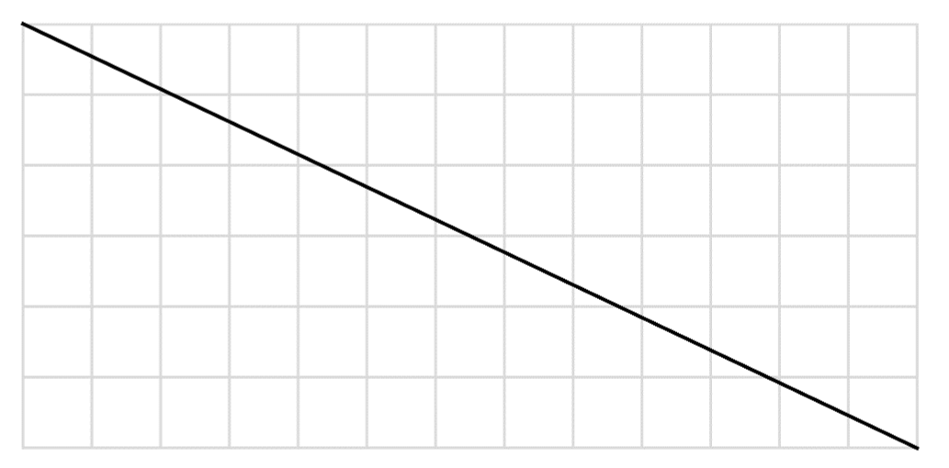
- Ask the following questions:
- Can a right-angled triangle be duplicated and transformed to create a rectangle?
- How did you transform the triangle to form a rectangle?
- What does this tell you about the relationship between the area of the right-angled triangle and the area of the rectangle?
- Students use the area of the rectangle to determine the area of each triangle. Ask:
- What do you notice about the area of the triangles? (The 2 triangles have the same area.)
- How does the area of the triangle compare to the area of the rectangle? (The area of each triangle is half the area of the rectangle.)
- Can you describe a rule for the area of a right-angled triangle?
Note: if students worked out the areas by counting, ask them to use multiplication to check their counting.
- In pairs, students experiment with different rectangles to see that the rule holds true for any rectangle.
- Students draw a right-angled triangle on their grid paper or geoboard.
- Students duplicate the right-angled triangle to make a rectangle, work out the area of the completed rectangle and that of the triangle.
- Students to repeat for multiple triangles, checking answers with a partner. Ask:
- What is the relationship between the triangle and the rectangle?
- Does your rule work for every right-angled triangle?
- How do you know?
- Students record a rule for the area of right-angled triangles in their own words.
- Provide students with Resource 28 – triangles.
- Ask students what information will be needed to work out the area of each triangle. It is likely that students will say the length of 2 sides is needed.
- Discuss why knowing the length of 2 sides does not work. Emphasise that in a non-right-angled triangle the height is not equal to either of the sides.
Note: the height of a triangle is the distance from the highest vertex, straight down to the base (or the perpendicular height).
- Students to work in pairs and use what has been learnt about the area of a parallelogram in Lesson 5 to find the area of each of the triangles. Encourage students to duplicate and rotate the triangle by folding the grid paper in half, drawing a triangle on the folded paper and cutting it out, making 2 identical copies. Students to use the copies to fit the triangles together into a parallelogram.
Note: students should realise that a triangle can be doubled to make a parallelogram then rearranged to a rectangle.
- To ensure a method that will work for any triangle, students are to draw a new triangle on grid paper and use the method to determine the area of the triangle.
- As a class, discuss the relationship between the area of a triangle and parallelogram. Ask:
- Can you describe a rule for the area of any triangle? The area of a triangle is half the area of a parallelogram with the same base and height.
- How do you know the rule works for every triangle?
- Are there any clever tricks to make the mathematics easier? Divide one of the sides by 2 before multiplying.

This table details opportunities for differentiation.
Too hard? | Too easy?
Stage 3 students cannot determine the area of a triangle by comparing it to the area of a parallelogram with the same base length and height.  - Support students to draw each triangle onto grid paper. Students to duplicate and rotate the triangle to form a parallelogram on the grid paper before calculating the area.  - Students only calculate the area of right-angled triangles. | Stage 3 students can determine the area of a triangle by comparing it to the area of a parallelogram with the same base length and height.  - Students sketch and label a right-angled triangle that has an area of 12 cm².  - Students sketch and label a non-right-angled triangle that has an area of 24 cm².  - Students explore how many different triangles they can draw with the same base length and height.

Discuss and connect the mathematics – 20 minutes
- Provide Stage 3 students with Resource 29 – area of triangles and additional grid paper. Students find the area of each triangle. Encourage students to draw the corresponding parallelogram around the triangle to work out the area of the parallelogram first.
- While Stage 3 students are working independently, Stage 2 students go on a gallery walk of the displayed rectangles and discuss the results.
- Ask Stage 2 students:
- What do you notice about the area and perimeter of each rectangle?
- How did you know you had found all the possibilities for an area?
- Is there anything else you have noticed?
- Ask Stage 3 students:
- What was the area of the triangle?
- How did you calculate the area?
- Did you use the same method for all the triangles? Why or why not?
This table details opportunities for assessment.
Assessment opportunities | Links
What to look for:  - Can Stage 2 students measure the areas of rectangles and right-angled triangles using a square-centimetre grid overlay?  [MAO-WM-01, MA2-2DS-03]  - Can Stage 2 students recognise that rectangles with different side lengths can have the same area? [MAO-WM-01, MA2-2DS-03]  - Can Stage 2 students create and represent multiplicative structure, moving from arrays to area models?  [MAO-WM-01, MA2-MR-01]  - Can Stage 3 students investigate the area of a triangle by comparing it to the area of a parallelogram with the same base length and height? [MAO-WM-01, MA3-2DS-02, MA3-2DS-03]  - Can Stage 3 students establish the relationship between the area of a triangle and the area of a parallelogram formed by duplicating and rotating the triangle? [MAO-WM-01, MA3-2DS-02,  MA3-2DS-03]  - Can Stage 3 students record, using words, a method for finding the area of any triangle? [MAO-WM-01, MA3-2DS-03] | Links to National Numeracy Learning Progressions (NNLP):  - Stage 2 – MuS5, MuS6, UuM5-7, UGP6  - Stage 3 – UuM10.  Links to suggested Interview for Student Reasoning (IfSR) tasks:  - Stage 2 – IfSR-MT: 2A.12, 2A.13, 2A.14.

Lesson 7
Core concept: estimation is useful to check the reasonableness of answers and there are many ways to dissect a shape to determine its area.

Daily number sense – pens or pencils – 10 minutes
The table below contains a suggested learning intention and success criteria. These are best co-constructed with students.
Daily number sense learning intention | Daily number sense success criteria
All students are learning to:  - apply addition and subtraction to familiar contexts, including money and budgeting. | All students can:  - use estimation to check the validity of solutions to addition and subtraction problems, including those involving money.
This activity is an adaptation of Plenty of Pens from NRICH by University of Cambridge.
- Display Resource 30 – money problem. Discuss the key information with students: $5, 40 items, pens for 15c and pencils for 10c.
- Explain that Lisa must decide whether she can buy at least 40 items with the money available.
- Ask students how rounding and estimation can be used to think quickly. Students turn and talk, recording thinking on individual whiteboards. Some examples of student thinking might include:
- I can double 15c to get 30c and double again to get 60c. That gives me 4 pens and another 30c makes 6 pens for about 90c.
- I could buy about 10 pencils for a dollar.
- I can get about 6 pens for $1 and about 40 pencils for $4.
- I can get about 40 pencils for $4 so I know I can buy the minimum number needed. Then I can buy a few pens with the last dollar.
- Discuss whether Lisa can buy a minimum of 40 items with the $5. Share the strategies used and which are most effective.
This table details opportunities for assessment.
Assessment opportunities | Links
What to look for:  - Can students use rounding and estimation to check approximately how many of each item could be purchased? [MAO-WM-01,  MA2-AR-01, MA3-AR-01] | Links to National Numeracy Learning Progressions (NNLP):  - Stage 2 – AdS8, UnM6, UnM7  - Stage 3 – NPV6, AdS8.  Links to suggested Interview for Student Reasoning (IfSR) tasks:  - Stage 3 – IfSR-AT: 3A.5.

Core lesson – 50 minutes

Stage 2 task – largest area
The table below contains suggested learning intentions and success criteria. These are best co-constructed with students.
Core concept learning intentions | Core concept success criteria
Students working towards Stage 2 outcomes are learning to:  - compare surfaces using familiar metric units of area  - use the structure of the area model to represent multiplication and division  - represent and solve problems involving multiplication fact families. | Students working towards Stage 2 outcomes can:  - recognise that rectangles with different side lengths can have the same area  - estimate before measuring to determine the larger of 2 rectangular areas in square centimetres  - create and represent multiplicative structure, moving from arrays to area models  - describe multiplication problems using for each and times as many.
- Revise areas and perimeters of rectangles from Lesson 6.
- Display Resource 31 – largest slice and explain that Dinesh helps his dad make a chocolate chip slice. After it cools, it is challenging to cut because there are a lot of chocolate chunks inside it. The slices are not all an even size and Dinesh’s dad has let him choose 2 slices for afternoon tea.
- Dinesh loves chocolate chip slice and wants to get the 2 largest slices possible but is not sure which to choose. Tell students they will be helping Dinesh choose the 2 largest slices.
- Students turn and talk with a partner to estimate which are the largest slices.
- Discuss estimates and the reasoning for these as a class. Explain that estimation is useful to check the reasonableness of a calculated answer.
The table below outlines stimulus prompts to generate conversation about the topic, along with anticipated responses from students.
Prompts | Anticipated student responses
- What can you use to help you estimate which slices are the largest? | - We can use the length and width of the shapes to estimate which slices are the largest.  - We can imagine there is a grid on the slices and estimate how many squares there are in each slice.
- How can you find out which slices are the largest? | - We can find the area of each slice and compare them.  - This reminds me of the ‘12 squares’ in Lesson 6. We can count how many square centimetres there are in each row and column, then use it to make an array. This will tell us how many square centimetres there are in each slice.
- How can you accurately measure the area of each slice? | - We can measure the length and width of each slice and multiply them together to find how many square centimetres there are in each.
- Ask students to refine their estimates, based on the reasoning of other students.
- Model how to measure the area of one slice. Create the array structure using the yellow square centimetre provided, a ruler and/or a clear plastic grid overlay.
- Discuss how the measurements are also the factors, then identify the multiplication number sentence that describes the array.
- Provide pairs of students with Resource 31 – largest slice, a ruler and/or a clear plastic grid overlay or the yellow centimetre square to find the area of each slice. Students record the multiplication number sentence that describes the array.
- Students work with their partner to find the 2 largest slices of chocolate chip slice for Dinesh. Ask:
- Which 2 slices you would recommend Dinesh choose?
- Is this the same as your estimate, or different?
- Students share their area measurements with the class. Display how each of these can be recorded as a multiplication number sentence. Discuss any differences in findings and agree on an accurate area for each slice.
- Remind students that estimation is useful to check the reasonableness of a calculated answer. As a class, confirm the 2 biggest pieces of chocolate slice that Dinesh should choose.
- Ask students if any rectangles had different lengths and widths but the same areas.
- Display an example and write the corresponding multiplication number sentences. Discuss how these can have different measurements or factors, but the same area. Draw a grid overlay to identify the array structure of rows and columns to highlight the length and width.
- Explain that students will be making some pieces of slice that have the same areas but different side lengths.
- Students work in pairs and choose one piece of slice from Resource 31 – largest slice to focus on. Using writing materials and grid paper, students create diagrams of new slices that have the same area, but different side lengths, recording a corresponding multiplication number sentence for each new example.
This table details opportunities for differentiation.
Too hard? | Too easy?
Stage 2 students cannot estimate before measuring to determine the larger of 2 rectangular areas and/or create and represent multiplicative structure, moving from arrays to partially covered area models.  - Model how to measure the area of one slice. Create the array structure using centimetre squares, a ruler and/or a clear plastic grid overlay. Identify the multiplication number sentence that describes the array structure.  - Support students to measure a different slice, using the resources and techniques modelled. | Stage 2 students can estimate before measuring to determine the larger of 2 rectangular areas and create and represent multiplicative structure, moving from arrays to partially covered area models.  - Students choose one piece of slice and draw other slices that have the same area but different perimeters.  - Challenge students to find which of the pieces has an area that can be recreated with the most different perimeters.

Stage 3 task – area of composite figures
The table below contains suggested learning intentions and success criteria. These are best co-constructed with students.
Core concept learning intentions | Core concept success criteria
Students working towards Stage 3 outcomes are learning to:  - find the area of composite figures  - determine the area of a triangle. | Students working towards Stage 3 outcomes can:  - find different ways to calculate the area of a composite figure  - investigate the area of a triangle by comparing it to the area of a parallelogram with the same base length and height  - establish the relationship between the area of a triangle and the area of a parallelogram formed by duplicating and rotating the triangle.
- Display Resource 32 – composite figures. Explain that it is not to scale. Ask students what they notice and wonder.
- Revise calculating the area of a composite figure from Lesson 4, including using partitioning and dissecting and rearranging. Ask:
- Can the area of this shape be calculated? Why or why not?
- How might the missing measurements be determined?
- Is it possible to accurately determine all the missing measurements? Why or why not?
- Students work in pairs or small groups to determine what the area of the composite figure might be, giving more than one possible answer. Ensure that students record their thinking, including multiplication strategies.
- Select students to share their thinking. Highlight strategies used and reasons for the different areas given. Ask questions, such as:
- What values did you use for the missing measurements? Why?
- How did you partition the composite figure? Why?
- What multiplication strategies did you use? Why? Can you think of a strategy that is more efficient?
- Would you use different multiplication strategies if the sides were longer? Why?
- Display Resource 33 – composite figure 2. Students work in pairs or small groups to explore different ways to calculate the area and record their thinking. Challenge students to calculate the area by partitioning the figure into:
- rectangles (see Figure 20)
- rectangles and triangles (see Figure 21)
- rectangles, triangles and at least one parallelogram (see Figure 22).
Figure 20 – shape partitioned into rectangles
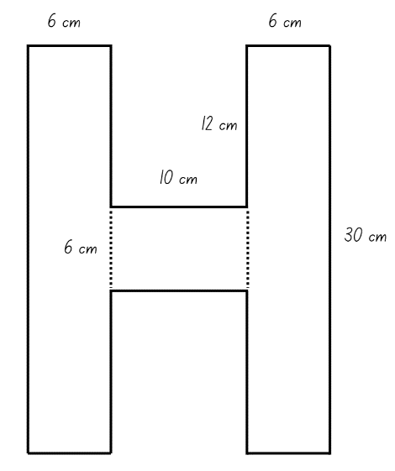
Figure 21 – shape partitioned into rectangles and triangles
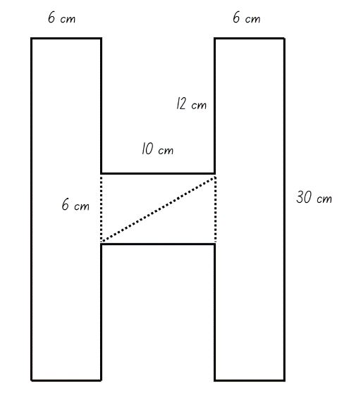
Figure 22 – shape partitioned into rectangles, triangles and at least one parallelogram
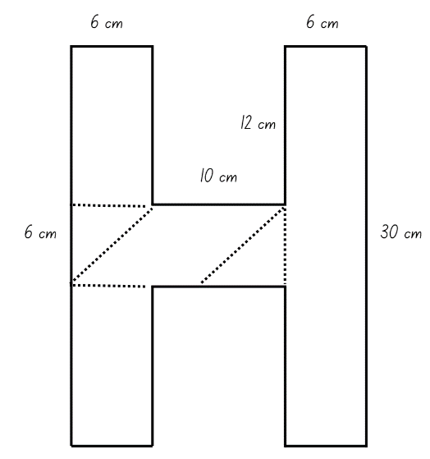
This table details opportunities for differentiation.
Too hard? | Too easy?
Stage 3 students cannot partition and calculate the area of a composite figure.  - Model partitioning the composite figure into rectangles. Ask students if they could partition it in a different way.  - Change the length of the sides so the numbers are smaller. | Stage 3 students can partition and calculate the area of a composite figure.  - Students partition the composite figure in multiple ways.  - Students create, partition and calculate the area of a different letter, such as E, K or Z.

Discuss and connect the mathematics – 10 minutes
- Regroup as a class and summarise the lesson together drawing out key mathematical ideas. Ask students how the factors of an area can be used to find all the possibilities.
- Pose the problems for Stage 2 students:
- Dinesh’s dad makes a new slice that is 4 times as large as the biggest slice. What would its area be?
- Dinesh wants to share a slice so that there is the same amount for each of his 3 friends. Choose one of the pieces of slice and find how much each will get. Which slices will leave no remainders?
- Select Stage 3 students to share their thinking. Ask:
- How many shapes did you partition the composite figure into? Are there other ways to do it?
- How did you calculate the area of the smaller shapes?
- What multiplication strategies did you use? Why?
- What was the most efficient strategy for calculating the area of the composite figure? Why?

This table details opportunities for assessment.
Assessment opportunities | Links
What to look for:  - Can Stage 2 students estimate before measuring to determine the size of rectangles? [MAO-WM-01, MA2-2DS-03]  - Can Stage 2 students recognise that rectangles with different side lengths can have the same area? [MAO-WM-01, MA2-2DS-03]  - Can Stage 2 students create and represent multiplicative structure, moving from arrays to area models?  [MAO-WM-01, MA2-MR-01]  - Can Stage 2 students describe multiplication problems using for each and times as many? [MAO-WM-01, MA2-MR-01]  - Can Stage 3 students find different ways to calculate the area of a composite figure? [MAO-WM-01, MA3-2DS-02, MA3-2DS-03]  - Can Stage 3 students investigate the area of a triangle by comparing it to the area of a parallelogram with the same base length and height? [MAO-WM-01, MA3-2DS-02, MA3-2DS-03]  - Can Stage 3 students establish the relationship between the area of a triangle and the area of a parallelogram formed by duplicating and rotating the triangle? [MAO-WM-01, MA3-2DS-02,  MA3-2DS-03] | Links to National Numeracy Learning Progressions (NNLP):  - Stage 2 – MuS5, MuS6, UnM6, UuM7, UGP6  - Stage 3 – UuM7, UuM10.  Links to suggested Interview for Student Reasoning (IfSR) tasks:  - Stage 2 – IfSR-MT: 2A.1, 2A.12, 2A.13, 2A.14, 2A.3.

Lesson 8
Core concept: relationships between the attributes of shapes can help us visualise, organise and design the world around us.

Daily number sense – 10 minutes
- From a class need surfaced through formative assessment data, identify a short, focused activity that targets students’ knowledge, understanding and skills. Example activities may be drawn from the following resources:
- Mathematics K–6 resources
- Universal Resources Hub.

Core lesson – 40 minutes

Stage 2 task – largest handball space
The table below contains suggested learning intentions and success criteria. These are best co-constructed with students.
Core concept learning intentions | Core concept success criteria
Students working towards Stage 2 outcomes are learning to:  - compare surfaces using familiar metric units of area  - use the structure of the area model to represent multiplication and division  - use number properties to find related multiplication facts  - represent and solve word problems with number sentences involving multiplication or division. | Students working towards Stage 2 outcomes can:  - estimate before measuring to determine the larger of 2 rectangular areas in square metres  - create and represent multiplicative structure, moving from arrays to area models  - generate and recall multiplication fact families up to 10 × 10  - represent and solve multiplication and division (both sharing and grouping) word problems using number sentences.
Note: in this activity, students are comparing the sizes of different playing areas in the school. The lesson refers to paved surfaces for handball, but this can be adapted for grass areas and other activities depending on the school context and interests of the students. If square metres made from paper have been created and used in previous lessons, they can be used again in this lesson. Otherwise, these could be made prior to the lesson.
- Students will be using knowledge learnt about comparing the areas of chocolate slices in Lesson 7 to help compare large areas.
- Ask students to estimate how many square metres will cover the surface of the classroom floor.
- Model how to find the area by measuring the length and width of the classroom to the nearest metre. Represent the measurements in a diagram on the whiteboard and draw gridlines to show the square metres.
- Compare the area of the classroom to the students’ estimates.
- Discuss looking for an outdoor area big enough for the whole class to play handball. This space will need to be larger than the area of the classroom.
- Ask students to think about suitable spaces. Explain that students will measure the area of each of these spaces with a partner in the same way that the classroom’s area was measured, record their findings and compare the area to the area of the classroom. The area will need:
- a paved/hard surface so the handball can bounce
- enough space to make as many handball courts as possible
- to be safe for students to play.
The table below outlines stimulus prompts to generate conversation about the topic, along with anticipated responses from students.
Prompts | Anticipated student responses
- How can you find the areas of large spaces in the playground? | - We can count how many metre squares there are in each row and column, then use it to make an array. This will tell us how many metre squares there are in each area.  - We can measure the length and width of each area, then multiply them together to find how many metre squares there are in each.
- What can you use to measure each area accurately? | - We can use metre squares, metre rulers, chalk and/or markers to record the length and width of each area.
- What can you do if the area is not a rectangle but is an irregular shape? | - We can cut the area into some smaller areas that are rectangles and find their areas. Then we add these together to find the total.
- Students turn and talk with a partner about strategies to find the areas of large spaces in the playground.
- In pairs or small groups, students explore school spaces that may be appropriate for handball by using square metres, metre rulers, chalk and/or markers to record the length and width of each area. They record their findings and write a multiplication number sentence to find the area of each space.
This table details opportunities for differentiation.
Too hard? | Too easy?
Stage 2 students cannot estimate before measuring to determine the larger of 2 rectangular areas in square metres or represent and solve multiplication and division (both sharing and grouping) word problems using number sentences.  - Model how to mark out and measure an area using square metres, metre rulers, chalk and/or markers.  - Show students how to use these measurements to record as a multiplication number sentence.  - Support students to mark out and measure a different area, using the resources and techniques modelled. | Stage 2 students can estimate before measuring to determine the larger of 2 rectangular areas in square metres or represent and solve multiplication and division (both sharing and grouping) word problems using number sentences.  - Tell students that each individual handball court needs an area of 2 square metres for each player. Students use their recordings to find how many 2 square metre handball courts will fit in each of the 2 areas.  - Students draw a diagram of the handball courts in the area.

Stage 3 task – playground design
The table below contains suggested learning intentions and success criteria. These are best co-constructed with students.
Core concept learning intentions | Core concept success criteria
Students working towards Stage 3 outcomes are learning to:  - calculate areas of familiar shapes and composite figures  - use estimation and rounding to check the reasonableness of answers to calculations  - use partitioning and place value to multiply 2-, 3- and 4-digit numbers by one-digit numbers. | Students working towards Stage 3 outcomes can:  - find different ways to calculate the area of rectangles, parallelograms, triangles and composite figures  - use informal written strategies such as the area model to solve multiplication and division problems  - use estimation to check the reasonableness of answers to multiplication and division calculations.
Note: in this activity, students are exploring the size requirements for playgrounds in and outside of the school grounds. Students can explore school spaces, or the activity can be adapted to other play spaces depending on the school context and interests of the students.
- Display Resource 34 – sample playgrounds and ask students to identify familiar shapes in each playground. For example, rectangles, parallelograms, and triangles.
- Introduce playground design by identifying and describing common features of a playground and discussing the size requirements of each item. For example, describe the size of the swing and the cleared area around the swing.
- Help students recognise design principles by asking:
- What do you notice about the layout of the structures and empty spaces?
- How did the designer consider the needs of the user? (For example, age of user, shade requirements, seating requirements, accessibility, fences and access).
- Do the objects in the playground fit neatly into geometric shapes?
- What shapes, including composite shapes, can you identify?
- What measurements would you need to know to design a playground?
- How could estimation be used in playground design?
- Provide students with 1 cm grid paper and Resource 35 – playground items. Explain that students have been asked to design a playground for the local council.
- Explain that the playground must meet the following requirements:
- The playground can be any shape, but the items in the playground must have a total area of 250 square metres.
- The design must include a range of shapes, such as rectangles, triangles and composite figures.
- The playground must include a slide, climbing frame, toilet, swings, picnic table and grass area.
- The playground may include optional items such as a cubby house, large and small trees, paved areas and a sand pit.
- Discuss and determine appropriate dimensions for each playground item on Resource 35 – playground items. For example, see Figure 23.
Figure 23 – sample playground item dimensions
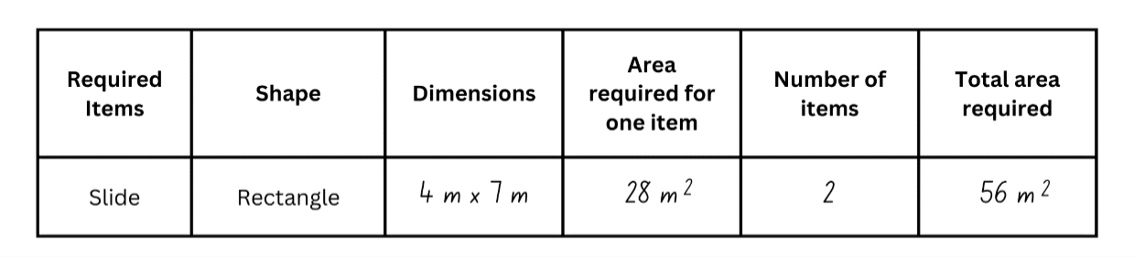
- Brainstorm other items that could be added to the playground designs, particularly objects that could be represented by composite shapes.
- Remind students that objects can be placed in any orientation and to consider the space required around each piece of equipment. For example, the slide should not be placed directly in front of the swings.
- In pairs, students:
- Calculate the area required for each item.
- Determine the total number of items possible while meeting the criteria of the playground design. Encourage students to use estimation to determine whether more than one of each item can be included.
- Calculate the total area of the items in the playground. Remind students that the total area cannot exceed 250 m².
- Draw the playground design on the grid paper, using a scale of 1 cm² = 1 m².
This table details opportunities for differentiation.
Too hard? | Too easy?
Stage 3 students cannot find different ways to calculate the area of rectangles, parallelograms, triangles and composite figures.  - Encourage students to cut out shapes that represent each item and move them around the grid paper to help visualise the design.  - Model partitioning the composite figures and calculating the area of each shape. | Stage 3 students can find different ways to calculate the area of rectangles, parallelograms, triangles and composite figures.  - Students investigate other possible item dimensions that would result in the same area.  - Students calculate how much grass is required to fill the remaining areas of the playground.

Discuss and connect the mathematics – 20 minutes
- Regroup as a class and discuss how the area for different play spaces can be measured.
- Select students to share their responses with the class. Encourage students to refer to their designs of handball surfaces and playground.
- Provide pairs of Stage 2 students with Resource 36 – area problems.
- Students choose and solve a problem and discuss their solutions with another pair.
- While Stage 2 students are working independently, Stage 3 students go on a gallery walk to look at other playground designs.
- Ask Stage 3 students:
- Did you see a design feature that you would like to add to your playground design?
- What shape did you find easiest to calculate the area of? What method did you use to calculate the area?
- What shape did you find most challenging to calculate the area of? Why?
- How did estimation help you plan your playground?
- How did you ensure that your items did not exceed 250 m²?
- What was challenging about this activity? How did you overcome these challenges?
This table details opportunities for assessment.
Assessment opportunities | Links
What to look for:  - Can Stage 2 students estimate and measure the larger of 2 rectangular areas in square metres? [MAO-WM-01, MA2-2DS-03]  - Can Stage 2 students create and represent multiplicative structure, moving from arrays to area models?  [MAO-WM-01, MA2-MR-01]  - Can Stage 2 students generate and recall multiplication fact families up to 10 × 10? [MAO-WM-01, MA2-MR-01]  - Can Stage 2 students represent and solve multiplication and division (both sharing and grouping) word problems using number sentences? [MAO-WM-01, MA2-MR-01]  - Can Stage 3 students find different ways to calculate the area of rectangles, parallelograms, triangles and composite figures? [MAO-WM-01, MA3-2DS-02, MA3-2DS-03]  - Can Stage 3 students use informal written strategies such as the area model to solve multiplication and division problems?  [MAO-WM-01, MA3-MR-01]  - Can Stage 3 students use estimation to check the reasonableness of answers to multiplication and division calculations?  [MAO-WM-01, MA3-MR-01] | Links to National Numeracy Learning Progressions (NNLP):  - Stage 2 – MuS5, MuS6, UuM6-7, UGP6  - Stage 3 – UuM6, UuM7, UuM10, MuS6.  Links to suggested Interview for Student Reasoning (IfSR) tasks:  - Stage 2 – IfSR-MT: 2A.3  - Stage 3 – IfSR-MT: 3A.1, 3A.2, 3A.3.

Resource 1 – 7-way spinner
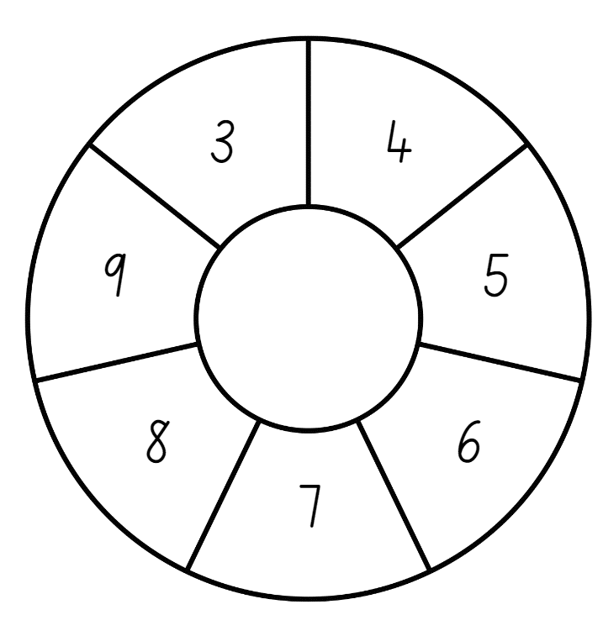

Resource 2 – Stage 2 table
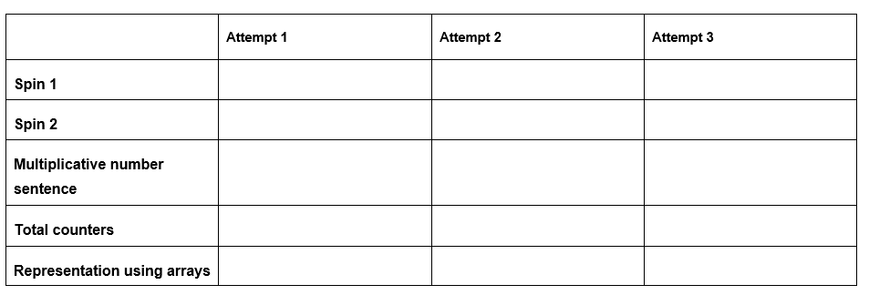

Resource 3 – Stage 3 table
Spin 1:
Number of shapes
Spin 2:
Number of sides for each shape
Total number of sides

Resource 4 – symmetry or not?
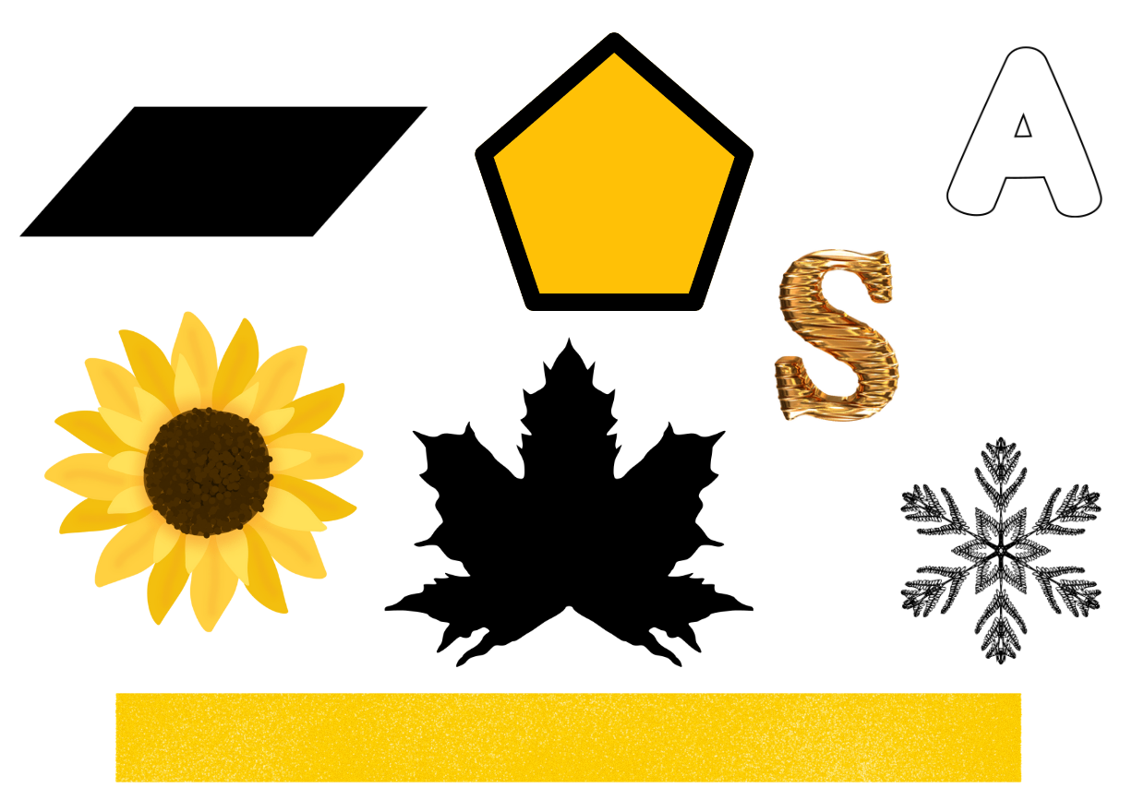

Resource 5 – out and about
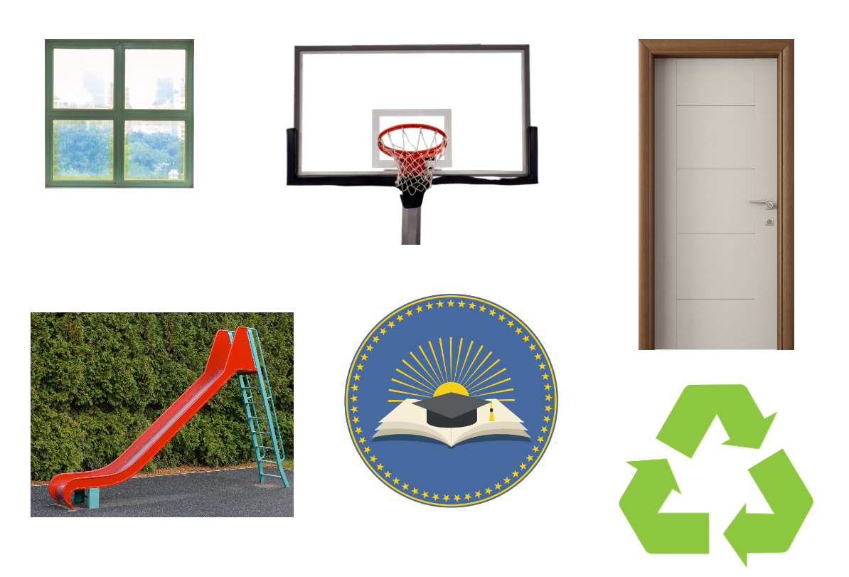

Resource 6 – out and about 2
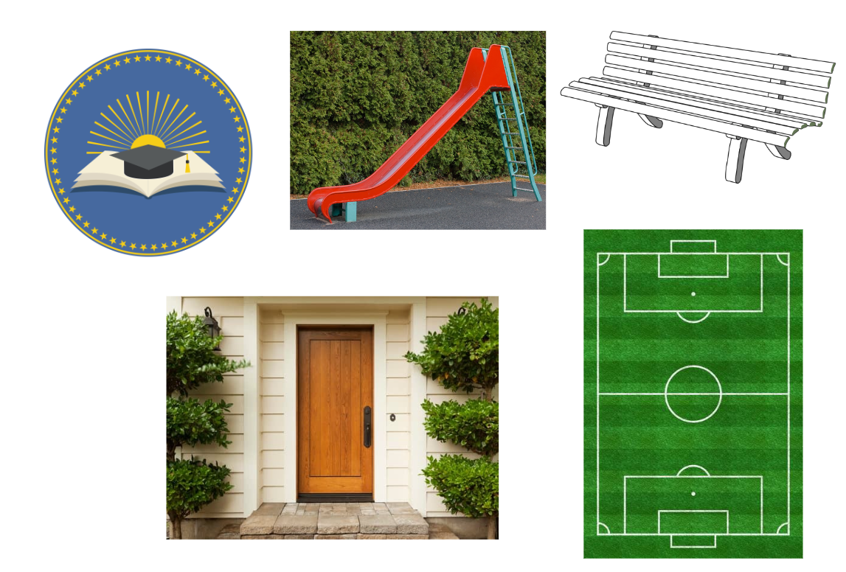

Resource 7 – symmetry hunt
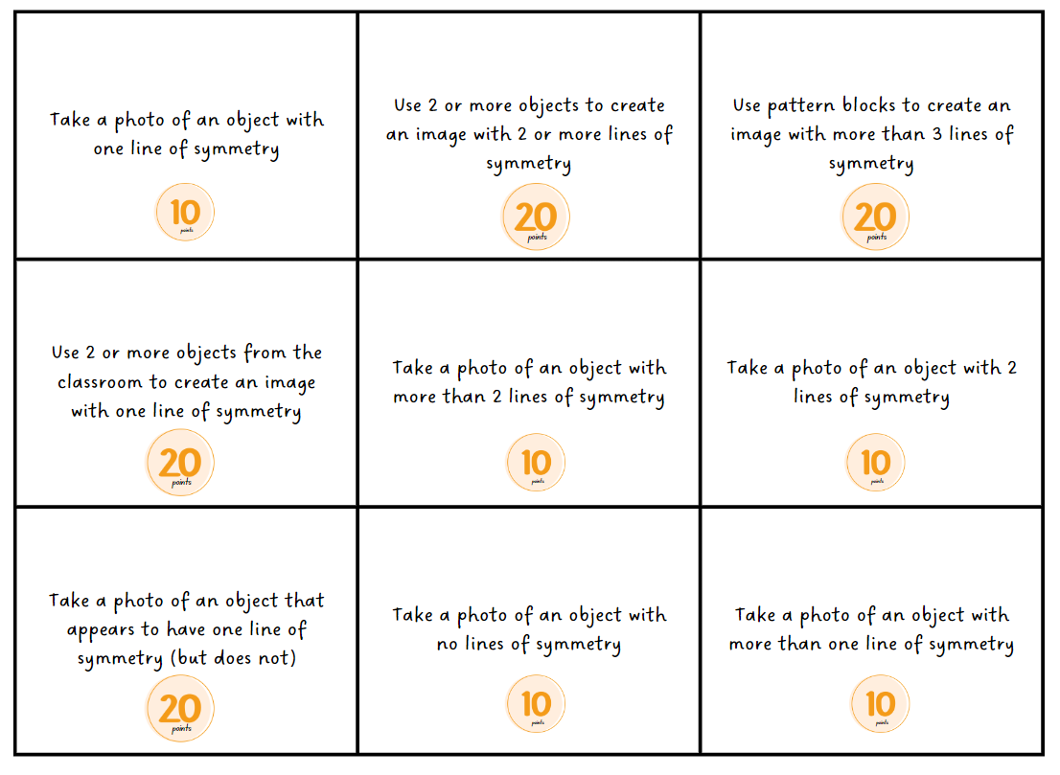

Resource 8 – missing spin 1
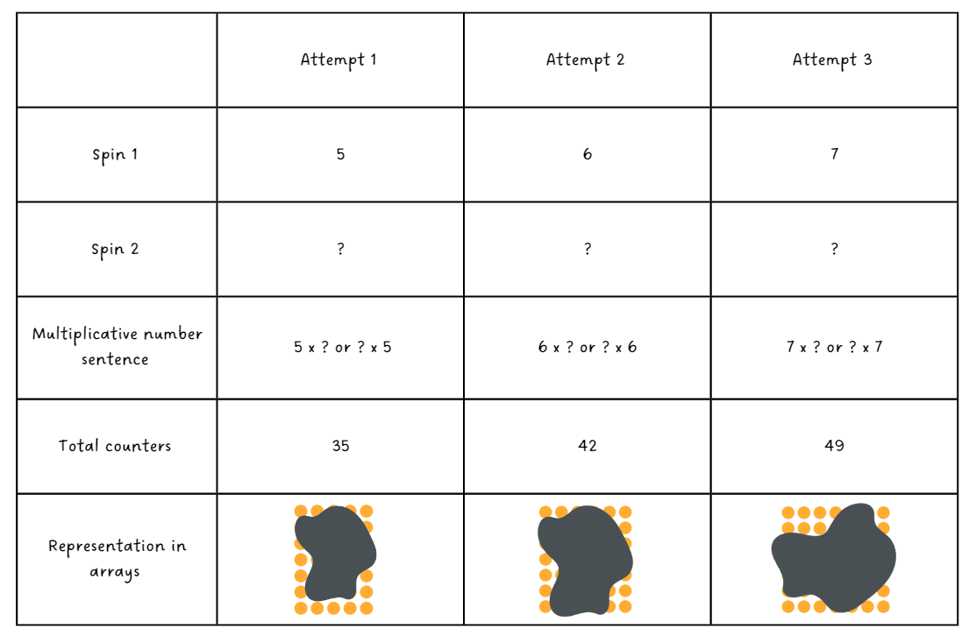

Resource 9 – missing spin 2
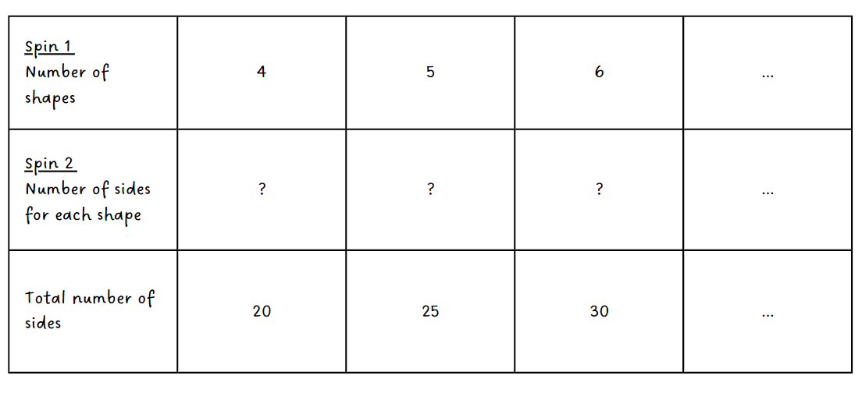

Resource 13 – 7 sixes
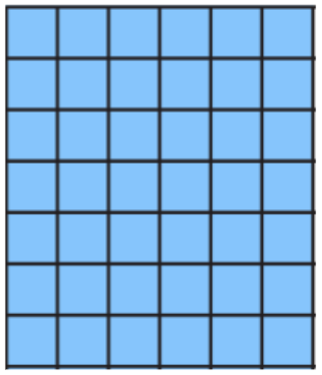

Resource 10 – paper rectangles (Stage 2)
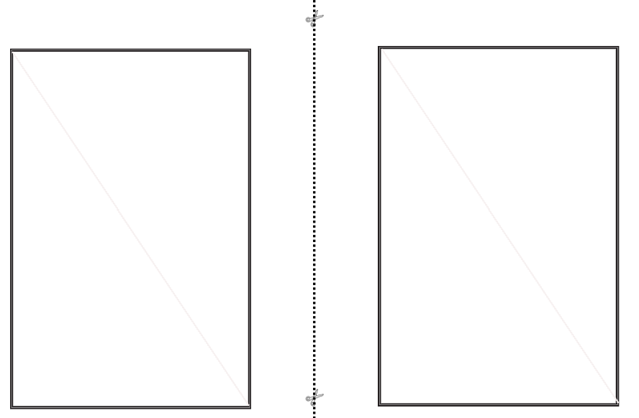

Resource 11 – paper rectangles (Stage 3)
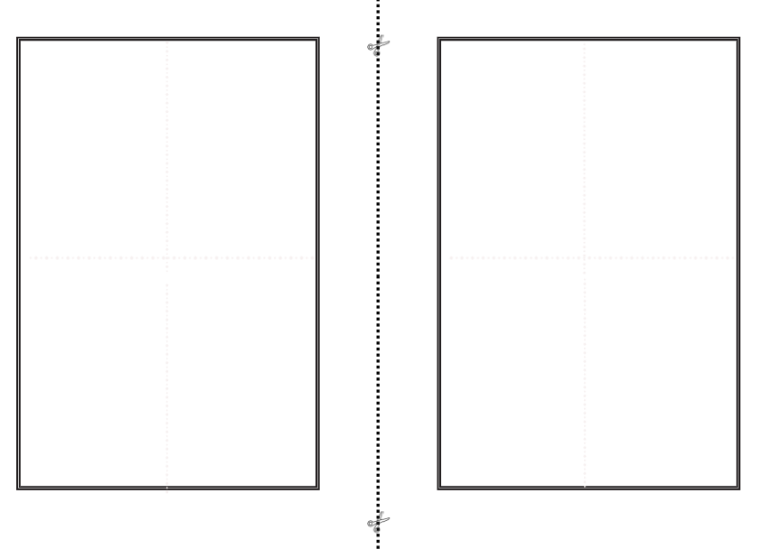

Resource 12 – triangle reflection grid
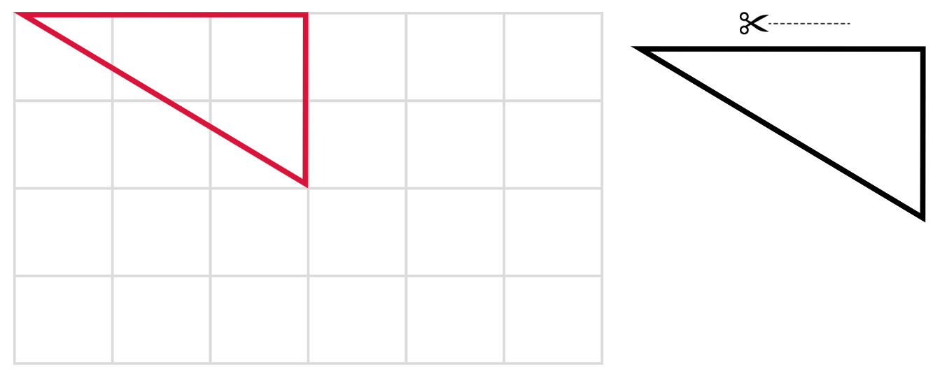

Resource 14 – a baking problem 1
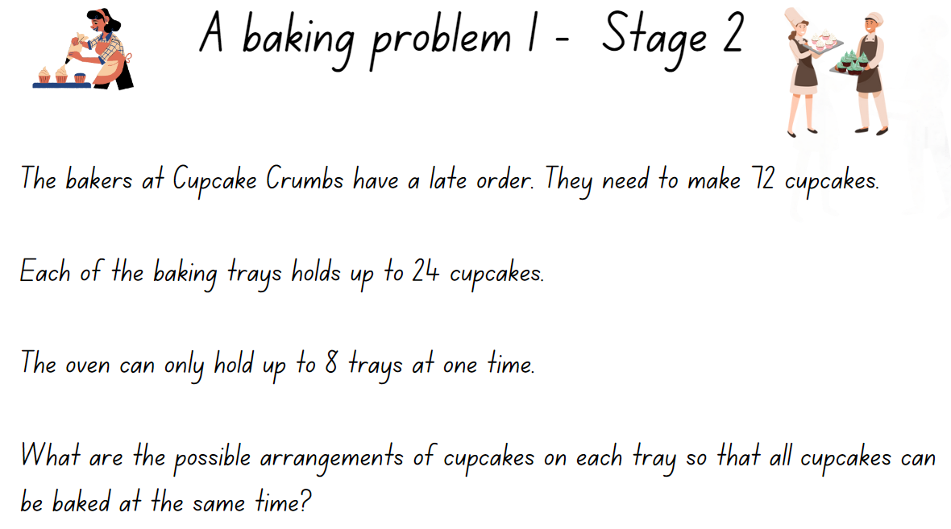

Resource 15 – a baking problem 2
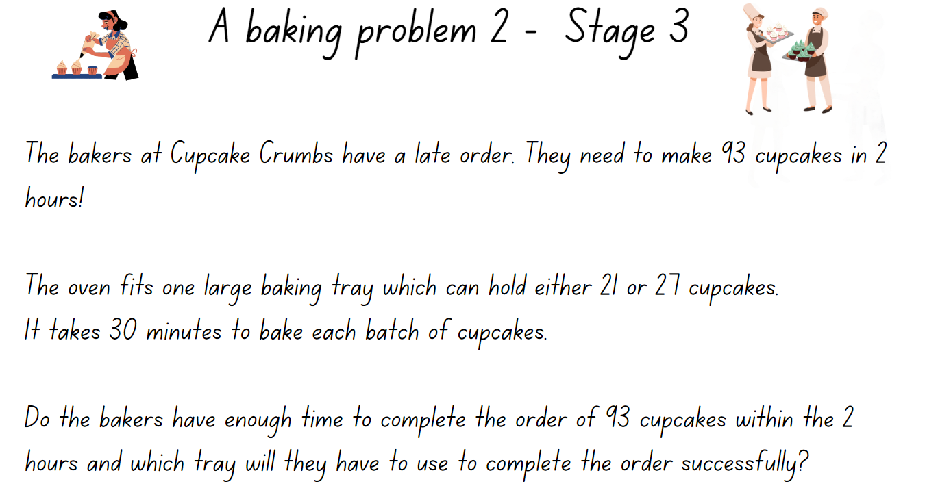

Resource 16 – tile patterns
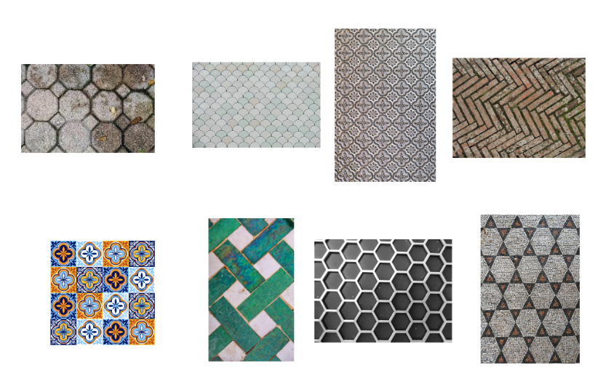

Resource 17 – tile shapes


Resource 18 – classifying polygons
Shape | Regular polygon | Irregular polygon | Not a polygon | Justification

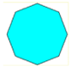



Resource 19 – transforming polygons
Polygon | Properties | Polygon rotated 90 degrees | Polygon reflected | Polygon translated | Did the properties stay the same? | Did the size stay the same?
 | Sides: 2 pairs of equal sides  Angles: 2 pairs of equal angles  Lines of symmetry: none |  |  |  | Yes | Yes
Sides:
Angles:
Lines of symmetry:
Other:
Sides:
Angles:
Lines of symmetry:
Other:
Sides:
Angles:
Lines of symmetry:
Other:

Resource 20 – flags
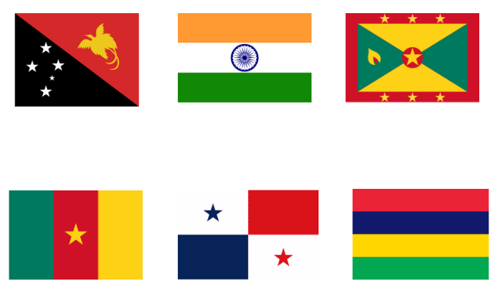

Resource 21 – tessellations in nature
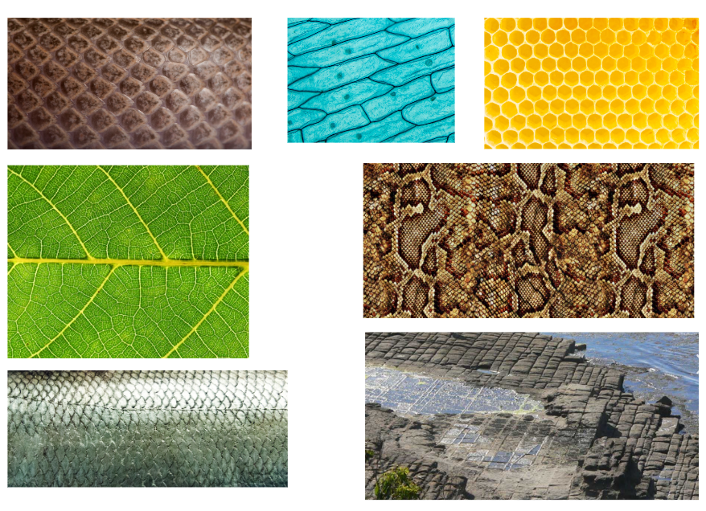

Resource 22 – area clues
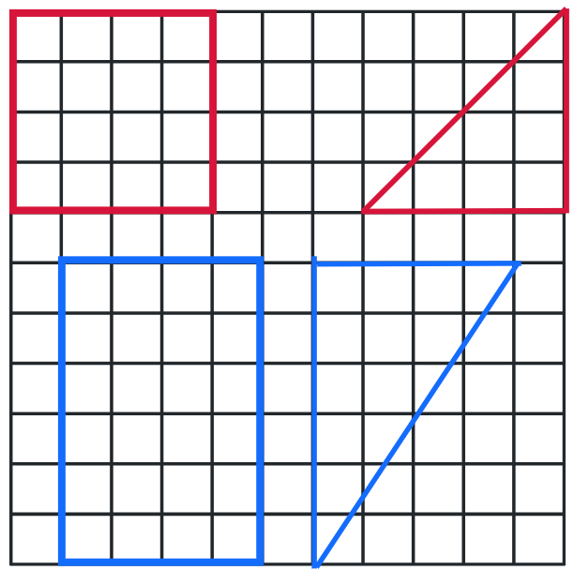

Resource 23 – areas clues 2
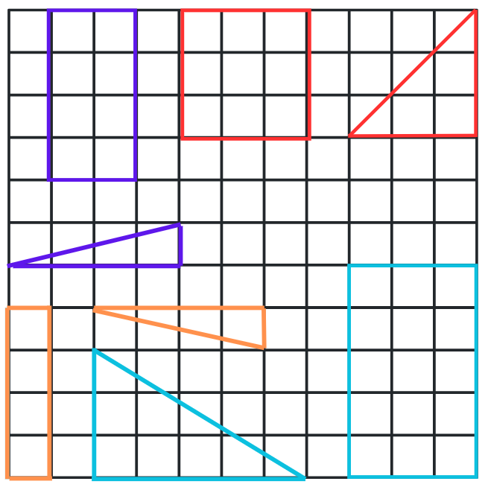

Resource 24 – garden area investigation
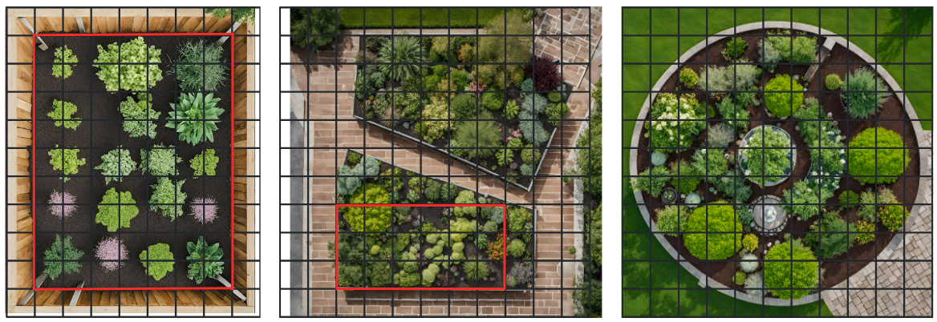

Resource 25 – parallelogram on grid
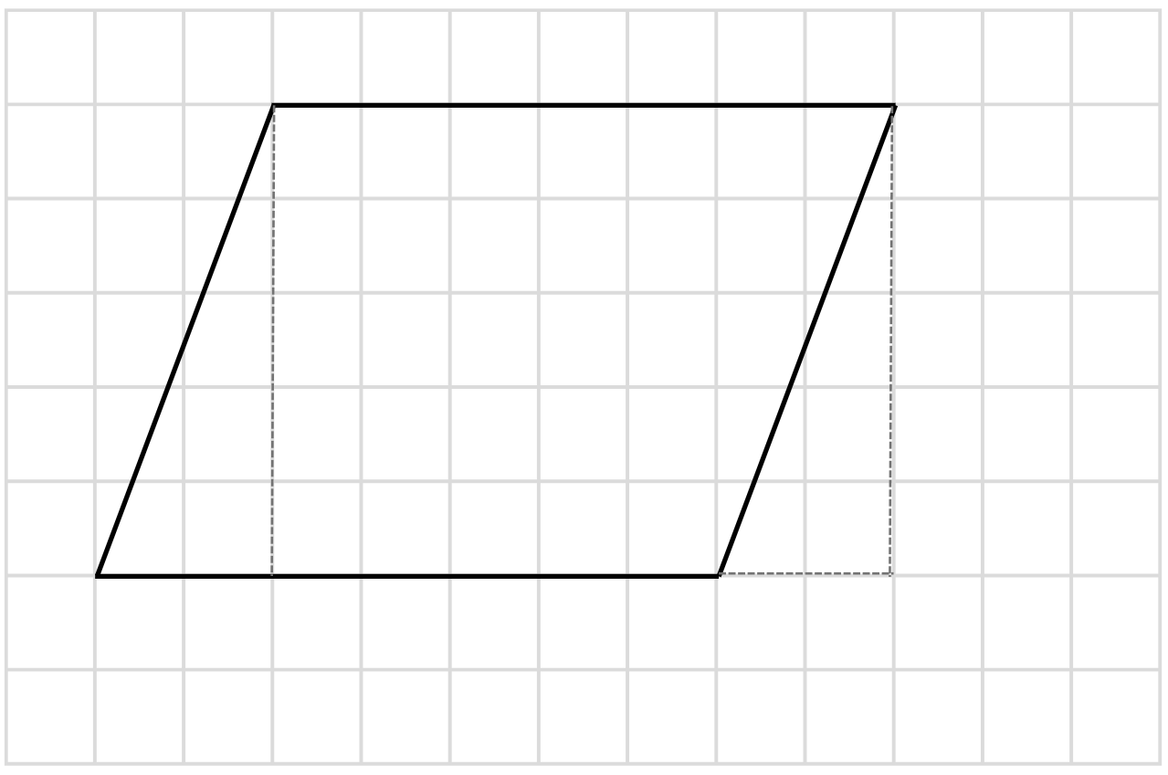

Resource 26 – 4 parallelograms and a grid
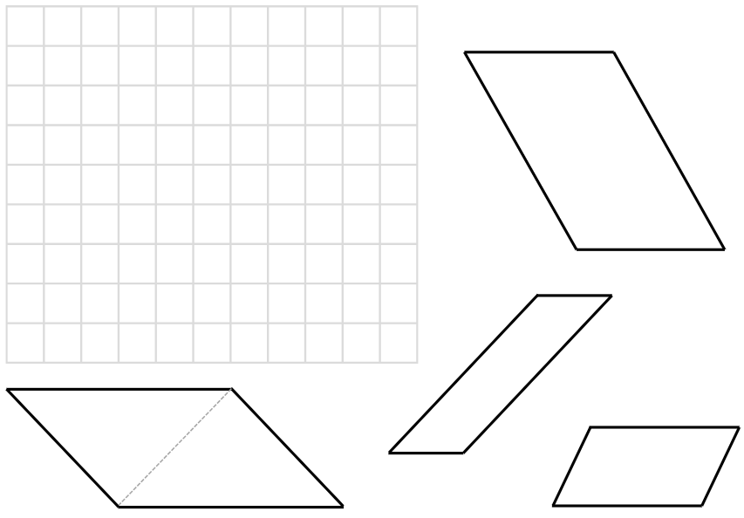

Resource 27 – 12 squares
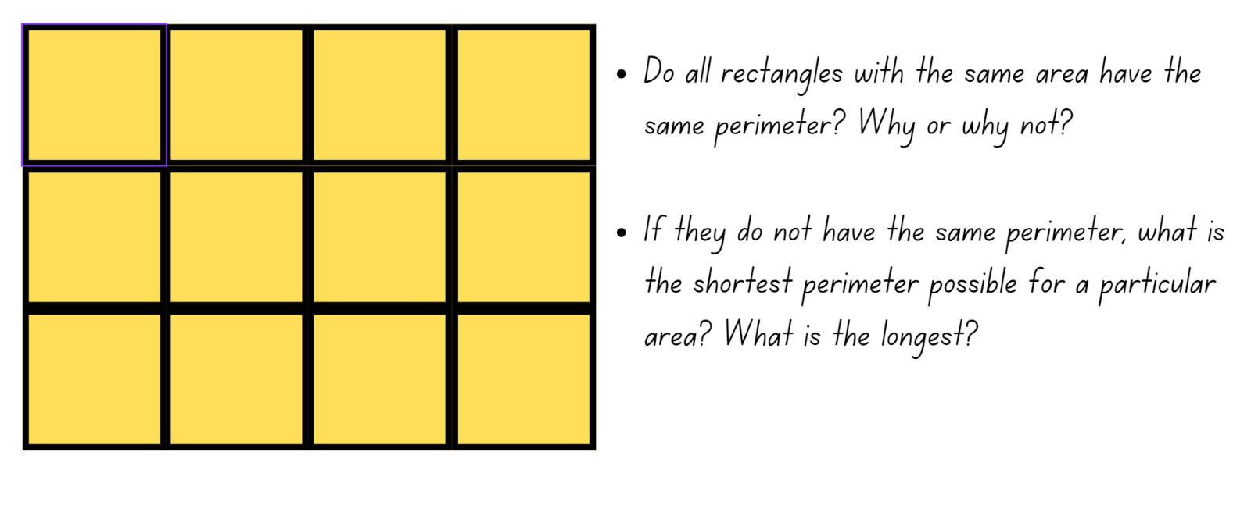

Resource 28 – triangles
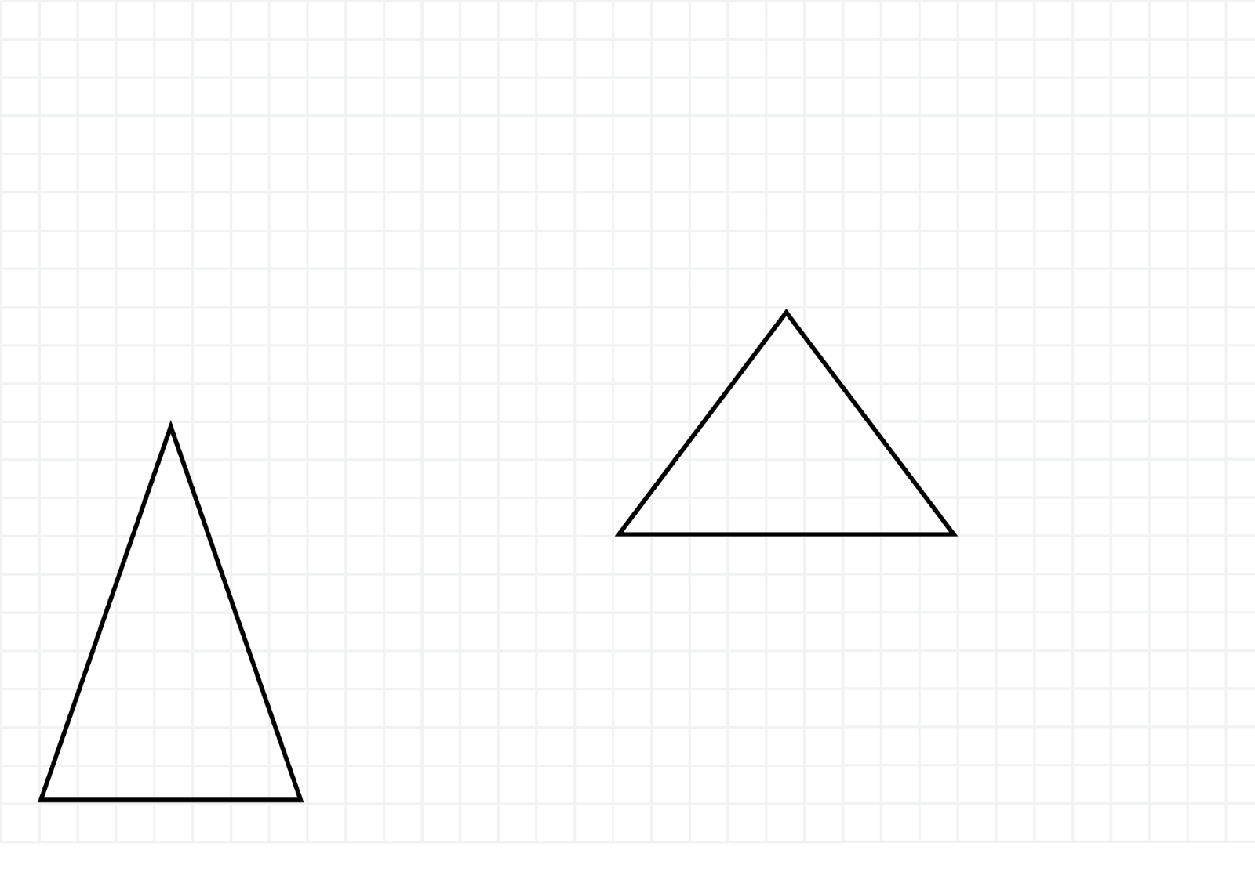

Resource 29 – area of triangles
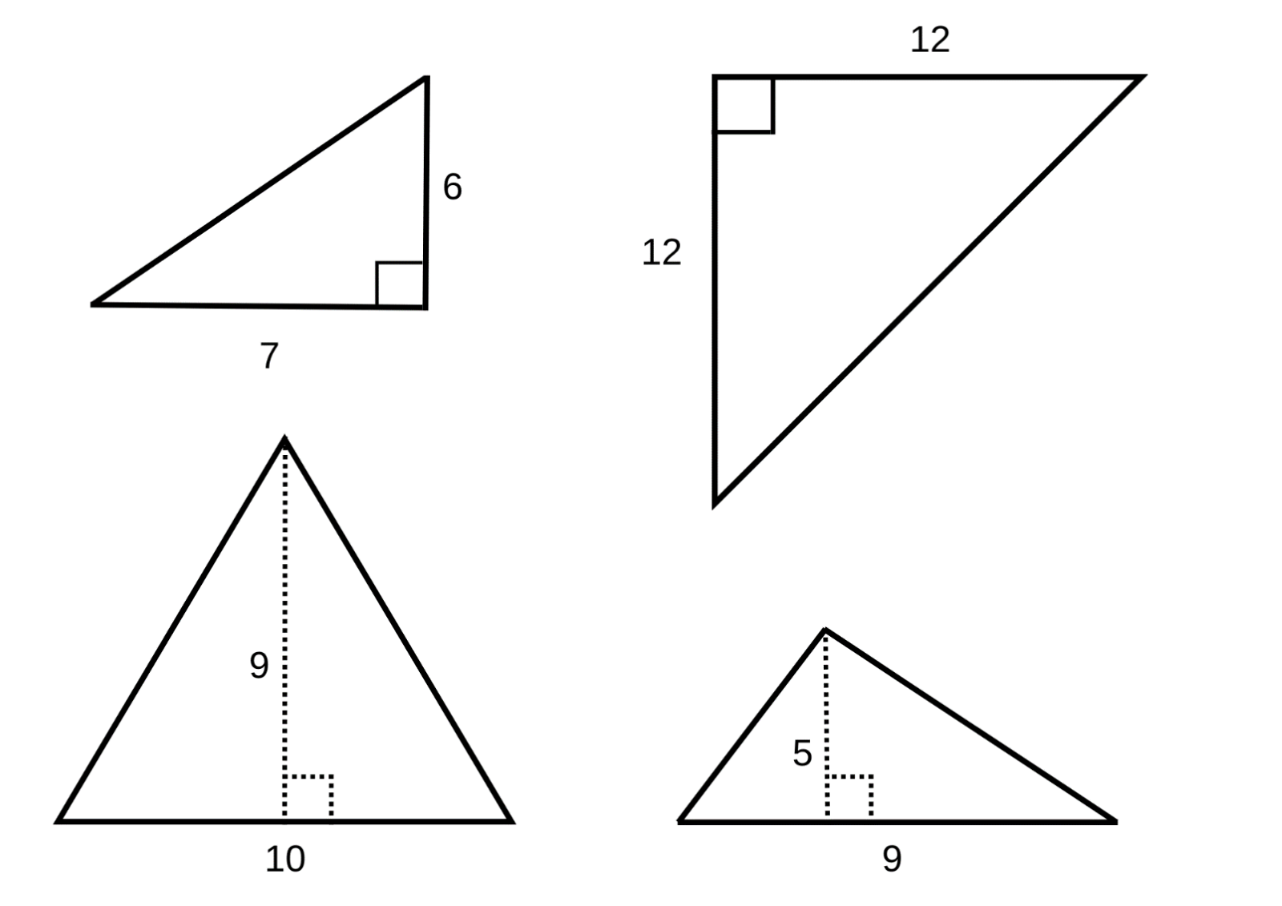

Resource 30 – money problem
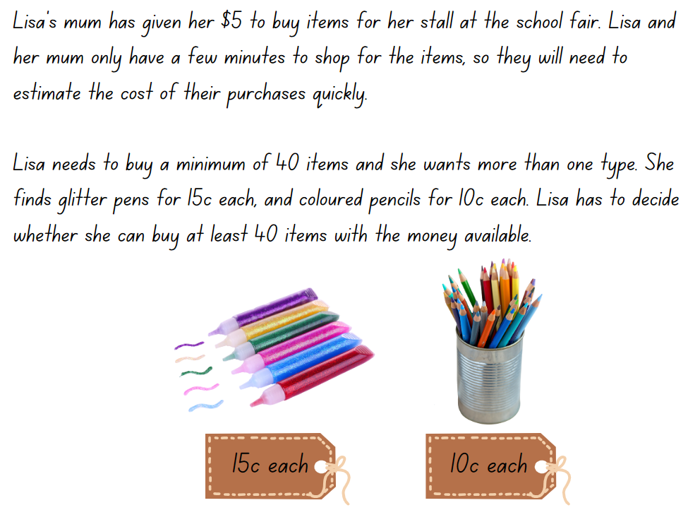

Resource 31 – largest slice
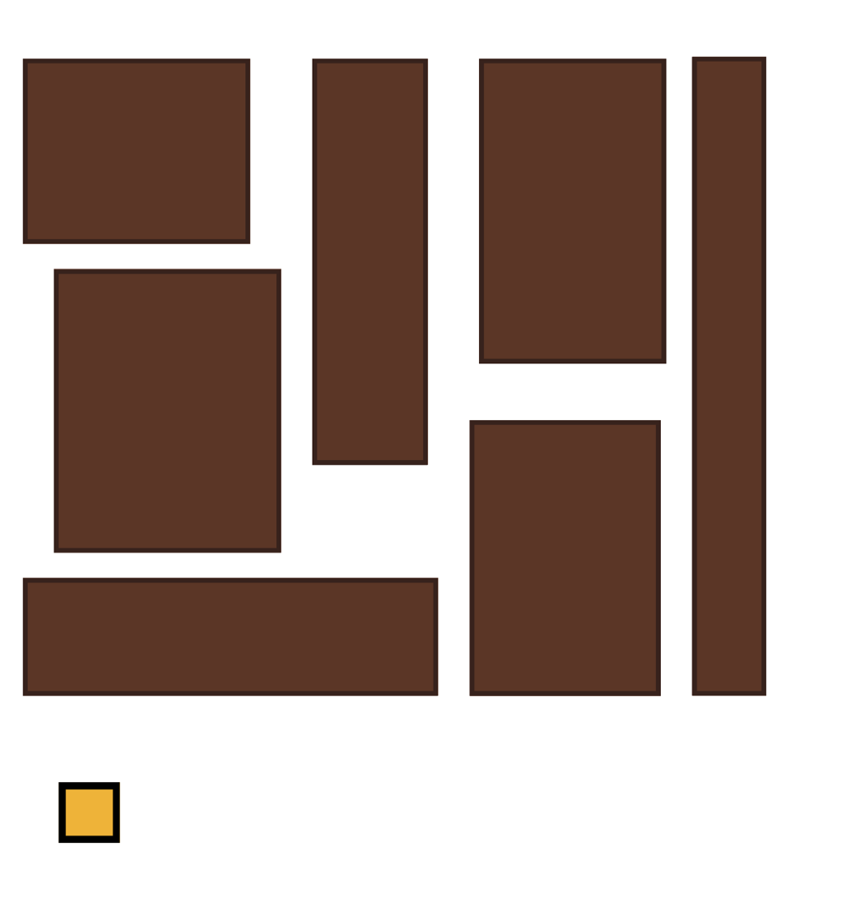

Resource 32 – composite figures
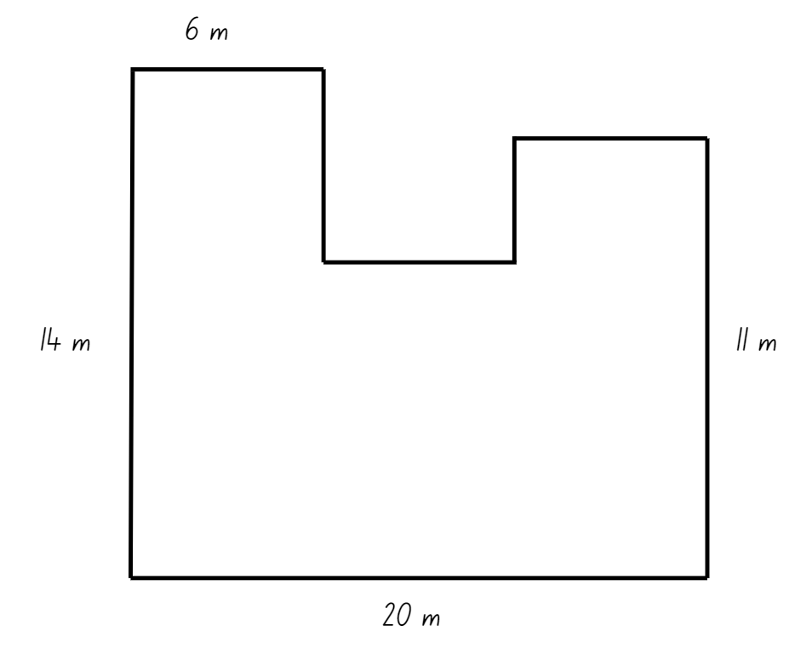

Resource 33 – composite figures 2
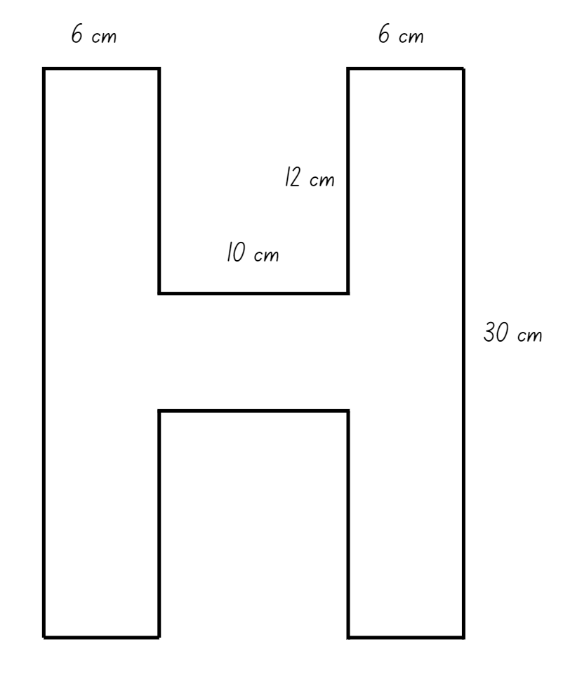

Resource 34 – sample playgrounds
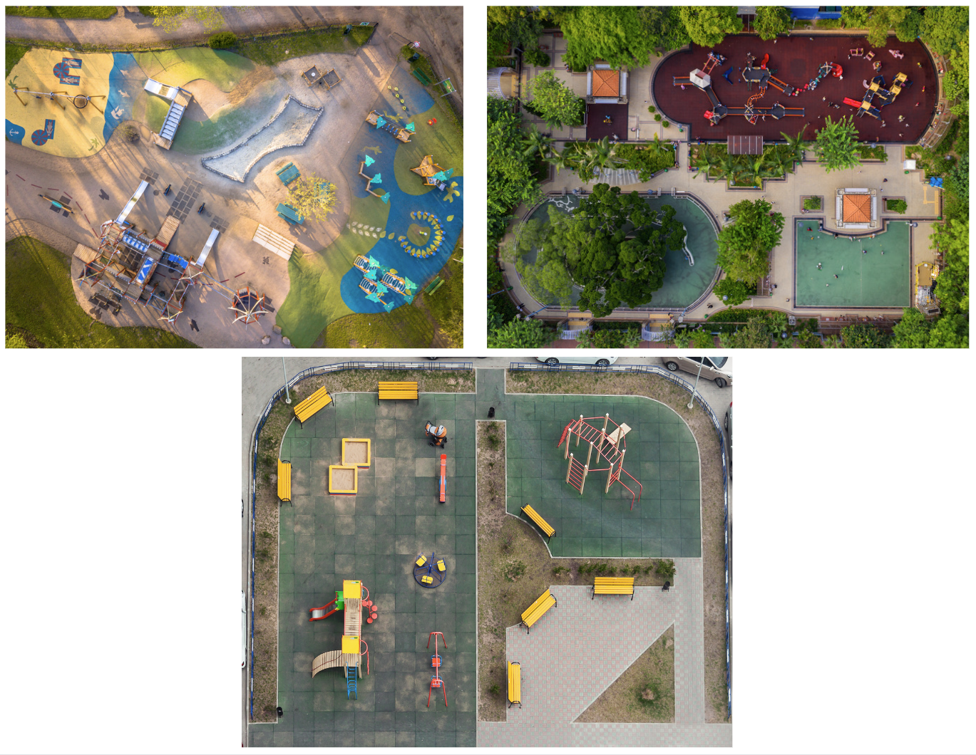

Resource 35 – playground items
Required items | Shape | Dimensions | Area required for one item | Number of items | Total area required
Slide | Rectangle
Climbing frame | Triangle
Toilet | Parallelogram
Swings | Square
Picnic table | Rectangle
Grass area | Composite L shape
Cubby house | Octagon
Large trees | Triangle
Small trees | Rectangle
Paved area | Composite
Sandpit | Square
Own choice (oval, bike track)

Resource 36 – area problems
No. | Problem
1 | Arjuna’s bedroom is 5 metres long and 6 metres wide. What is the area of carpet in his bedroom?
2 | I am thinking of a shape with an area of 36 square tiles. Use your knowledge of multiplication fact families to find what this shape would look like if it has:  - 4 square tiles in each row  - 6 square tiles in each row  - 12 square tiles in each row.
3 | Chandrika’s family are laying some new pavers on their driveway. Each tile is half a metre wide and a metre long. How many will they need to cover their driveway if it is 8 metres long and 6 metres wide?
4 | I am thinking of a shape with an area of 20 square tiles. What might this shape look like?
5 | Draw some shapes that have an area of 30 square centimetres.
6 | My granny bought a square rug and each side measures 1 metre. When she got home it would not fit in the hallway so she cut the rug and joined the pieces together again to make a shape that would fit. What might her rug look like now?

Syllabus outcomes and content

Stage 2
The table below outlines the syllabus outcomes and range of relevant syllabus content covered in this unit. Content is linked to National Numeracy Learning Progression (version 3).
Outcomes and content | 1 | 2 | 3 | 4 | 5 | 6 | 7 | 8
Additive relations B: Apply addition and subtraction to familiar contexts, including money and budgeting
MAO-WM-01, MA2-AR-01
- Use estimation to check the validity of solutions to addition and subtraction problems, including those involving money |  |  |  |  |  |  | x
- Reflect on a chosen strategy for solving a problem, considering whether it can be improved |  |  |  |  | x | x
- Interpret problems involving money as requiring either addition or subtraction |  |  |  |  | x | x
Multiplicative relations A: Represent and solve problems involving multiplication fact families
MAO-WM-01, MA2-RN-01
- Describe multiplication problems using for each and times as many |  |  |  |  |  |  | x
Multiplicative relations B: Use the structure of the area model to represent multiplication and division
MAO-WM-01, MA2-RN-01, MA2-MR-02
- Create and represent multiplicative structure, moving from arrays to partially covered area models |  |  |  |  | x | x | x | x
Multiplicative relations B: Use number properties to find related multiplication facts
MAO-WM-01, MA2-RN-01, MA2-MR-02
- Use the commutative property of multiplication | x | x
- Use flexible partitioning within multiplication (Reasons about relations) |  |  | x
- Generate and recall multiplication fact families up to 10 × 10 |  |  |  |  |  |  |  | x
Multiplicative relations B: Operate with multiples of 10
MAO-WM-01, MA2-RN-01, MA2-MR-02
- Use multiplication facts with multiples of 10 to multiply a one-digit number by a multiple of 10 |  |  |  |  | x
Multiplicative relations B: Represent and solve word problems with number sentences involving multiplication or division
MAO-WM-01, MA2-RN-01, MA2-MR-02
- Represent and solve multiplication and division (both sharing and grouping) word problems using number sentences |  |  |  |  |  |  |  | x
Two-dimensional spatial structure A: 2D shapes: Transform shapes by reflecting, translating and rotating
MAO-WM-01, MA2-2DS-02, MA2-2DS-03
- Identify lines of symmetry in pictures, artefacts, designs and the environment | x |  | x | x
- Draw lines of symmetry on given shapes and identify quadrilaterals that do not have lines of symmetry |  |  | x
- Create and record tessellating designs by reflecting, translating and rotating triangles |  |  | x | x
- Apply and describe amounts of rotation including half-turns, quarter-turns and three-quarter-turns when creating designs |  |  | x | x
Two-dimensional spatial structure B: 2D shapes: Create two-dimensional shapes that result from combining and splitting common shapes
MAO-WM-01, MA2-2DS-02, MA2-2DS-03
- Combine common two-dimensional shapes, including quadrilaterals, to form other common shapes or designs |  | x
- Split a given shape into 2 or more common shapes and describe the result |  | x
- Record the arrangements of common shapes used to create other shapes |  | x
Two-dimensional spatial structure B: 2D shapes: Create symmetrical patterns and shapes
MAO-WM-01, MA2-2DS-02, MA2-2DS-03
- Create and record tessellating designs by reflecting, translating and rotating triangles or quadrilaterals |  |  | x | x
- Apply and describe amounts of rotation, including half-turns, quarter-turns and three-quarter-turns, when creating designs |  |  | x | x
Two-dimensional spatial structure B: Area: Measure the areas of shapes using the grid structure
MAO-WM-01, MA2-2DS-02, MA2-2DS-03
- Measure the areas of rectangles and right-angled triangles using a square-centimetre grid overlay |  |  |  |  | x | x
- Estimate the areas of shapes found in the environment using efficient strategies (non-count-by-one) with a grid overlay |  |  |  |  | x | x | x
- Recognise that rectangles with different side lengths can have the same area |  |  |  |  |  | x | x
Two-dimensional spatial structure B: Area: Compare surfaces using familiar metric units of area
MAO-WM-01, MA2-2DS-02, MA2-2DS-03
- Estimate before measuring to determine the larger of 2 rectangular areas in square centimetres |  |  |  |  |  |  | x
- Estimate before measuring to determine the larger of 2 rectangular areas in square metres |  |  |  |  |  |  |  | x
Mathematics K–10 Syllabus © NSW Education Standards Authority (NESA) for and on behalf of the Crown in right of the State of New South Wales, 2022.

Stage 3
The table below outlines the syllabus outcomes and range of relevant syllabus content covered in this unit. Content is linked to National Numeracy Learning Progression (version 3).
Outcomes and content | 1 | 2 | 3 | 4 | 5 | 6 | 7 | 8
Additive relations A: Use estimation and place value understanding to determine the reasonableness of solutions
MAO-WM-01, MA3-AR-01
- Use estimation to check the reasonableness of solutions to addition and subtraction calculations |  |  |  |  |  |  | x
Additive relations B: Choose and use efficient strategies to solve addition and subtraction problems
MAO-WM-01, MA3-AR-01
- Solve multistep word problems, including problems that require more than one operation |  |  |  |  | x | x
- Compare, evaluate and communicate strategies used to solve addition and subtraction problems |  |  |  |  | x | x
Multiplicative relations A: Determine products and factors
MAO-WM-01, MA3-MR-01
- Use the term product to describe the result of multiplying 2 or more numbers |  |  |  | x
- Determine factors for a given whole number |  |  |  | x
Multiplicative relations A: Use partitioning and place value to multiply 2-, 3- and 4-digit numbers by one-digit numbers
MAO-WM-01, MA3-MR-01
- Use informal written strategies such as the area model to solve multiplication and division problems |  |  |  |  |  |  | x | x
- Record the product of multiplying by a one-digit number using a formal algorithm |  |  |  |  |  |  | x | x
Multiplicative relations A: Use estimation and rounding to check the reasonableness of answers to calculations
MAO-WM-01, MA3-MR-01
- Use estimation to check the reasonableness of answers to multiplication and division calculations | x
Multiplicative relations B: Represent and describe number patterns formed by multiples
MAO-WM-01, MA3-MR-01
- Use a given geometric pattern involving multiples to create a table of values | x | x
- Describe a pattern formed by multiples in words, in terms of multiplication rather than addition |  |  | x
- Determine a rule describing the relationship between the bottom number and top number in a table (Algebraic reasoning) |  |  | x
Two-dimensional spatial structure A: 2D shapes: Classify two-dimensional shapes and describe their properties
MAO-WM-01, MA3-2DS-01
- Compare side and angle properties of triangles and quadrilaterals using measurement and symmetry |  |  | x
- Investigate the symmetry properties (line and rotational) of quadrilaterals | x
- Identify regular and irregular polygons | x |  | x
Two-dimensional spatial structure B: 2D shapes: Dissect two-dimensional shapes and rearrange them using translations, reflections and rotations
MAO-WM-01, MA3-2DS-01, MA3-2DS-02, MA3-2DS-03
- Use the terms translate, reflect and rotate to describe transformations of two-dimensional shapes |  | x | x
- Dissect and rearrange one shape to make another |  | x |  |  | x
- Recognise that translations, reflections or rotations change the position and orientation but not the size of shapes (Reasons about spatial orientation) |  | x | x |  | x
Two-dimensional spatial structure B: Area: Find the area of composite figures
MAO-WM-01, MA3-2DS-01, MA3-2DS-02, MA3-2DS-03
- Find different ways to calculate the area of a composite L-shape figure |  |  |  | x |  |  | x | x
Two-dimensional spatial structure B: Area: Calculate the area of a parallelogram using subdivision and rearrangement
MAO-WM-01, MA3-2DS-01, MA3-2DS-02, MA3-2DS-03
- Show how to transform a parallelogram into a rectangle to find its area |  |  |  |  | x
- Record, using words, a method for finding the area of any parallelogram |  |  |  |  | x
Two-dimensional spatial structure B: Area: Determine the area of a triangle
MAO-WM-01, MA3-2DS-01, MA3-2DS-02, MA3-2DS-03
- Investigate the area of a triangle by comparing it to the area of a parallelogram with the same base length and height |  |  |  |  |  | x | x | x
- Establish the relationship between the area of a triangle and the area of a parallelogram formed by duplicating and rotating the triangle |  |  |  |  |  | x | x
- Record, using words, a method for finding the area of any triangle |  |  |  |  |  | x
Mathematics K–10 Syllabus © NSW Education Standards Authority (NESA) for and on behalf of the Crown in right of the State of New South Wales, 2022.

References
This resource contains NSW Curriculum and syllabus content. The NSW Curriculum is developed by the NSW Education Standards Authority. This content is prepared by NESA for and on behalf of the Crown in right of the State of New South Wales. The material is protected by Crown copyright.
Please refer to the NESA Copyright Disclaimer for more information https://educationstandards.nsw.edu.au/wps/portal/nesa/mini-footer/copyright.
NESA holds the only official and up-to-date versions of the NSW Curriculum and syllabus documents. Please visit the NSW Education Standards Authority (NESA) website https://educationstandards.nsw.edu.au/wps/portal/nesa/home and the NSW Curriculum website https://curriculum.nsw.edu.au/.
Mathematics K–10 Syllabus © NSW Education Standards Authority (NESA) for and on behalf of the Crown in right of the State of New South Wales, 2022.
National Numeracy Learning Progression © Australian Curriculum, Assessment and Reporting Authority (ACARA) 2010 to present, unless otherwise indicated. This material was downloaded from the Australian Curriculum website (National Numeracy Learning Progression) (accessed 18 January 2024) and was not modified.
Boaler J, Munson J and Williams C (2017) Mindset Mathematics: Visualizing and Investigating Big Ideas, Grade 3, Jossey-Bass, San Francisco.
Boaler J, Munson J and Williams C (2017) Mindset Mathematics: Visualizing and Investigating Big Ideas, Grade 4, Jossey-Bass, San Francisco.
New Zealand Ministry of Education (n.d.) ‘Triangles’, Resources, NZ Maths website, accessed 15 January 2024.
Siemon D, Beswick K, Brady K, Clark J, Faragher R, Warren E (2020) Teaching Mathematics – Foundations to Middle years, 3rd edn, Oxford University Press, Melbourne.
Sullivan P (2018) Challenging Mathematical Tasks, Oxford University Press, South Melbourne.
University of Cambridge (n.d.) Plenty of Pens, NRICH website, accessed 15 January 2024.
University of Cambridge (n.d.) 5 coins, NRICH website, accessed 15 January 2024.
Van de Walle J, Karp K, Bay-Williams JM, Brass A, Bentley B, Ferguson S, Goff W, Livy S, Marshman M, Martin D, Pearn C, Prodromou T, Symons D and Wilkie K (2019) Primary and Middle Years Mathematics: Teaching Developmentally, 1st Australian edn, Pearson Education Australia, Melbourne.

© State of New South Wales (Department of Education), 2024
The copyright material published in this resource is subject to the Copyright Act 1968 (Cth) and is owned by the NSW Department of Education or, where indicated, by a party other than the NSW Department of Education (third-party material).
Copyright material available in this resource and owned by the NSW Department of Education is licensed under a Creative Commons Attribution 4.0 International (CC BY 4.0) license.

This license allows you to share and adapt the material for any purpose, even commercially.
Attribution should be given to © State of New South Wales (Department of Education), 2024.
Material in this resource not available under a Creative Commons license:
- the NSW Department of Education logo, other logos and trademark-protected material
- material owned by a third party that has been reproduced with permission. You will need to obtain permission from the third party to reuse its material.
Links to third-party material and websites
Please note that the provided (reading/viewing material/list/links/texts) are a suggestion only and implies no endorsement, by the New South Wales Department of Education, of any author, publisher, or book title. School principals and teachers are best placed to assess the suitability of resources that would complement the curriculum and reflect the needs and interests of their students.
If you use the links provided in this document to access a third-party's website, you acknowledge that the terms of use, including licence terms set out on the third-party's website apply to the use which may be made of the materials on that third-party website or where permitted by the Copyright Act 1968 (Cth). The department accepts no responsibility for content on third-party websites.

