Mathematics 3–6 Multi-age – Year B – Unit 16
Fractions represent multiple ideas and can be represented in different ways

Contents
Unit description and duration 7
Syllabus outcomes 7
Stage 2 8
Stage 3 8
Working mathematically 9
Student prior learning 9
Lesson overview and resources 11
Lesson 1 19
Daily number sense – tower building – 10 minutes 19
Core lesson 1 – fractions as part of a whole – 10 minutes 22
Core lesson 2 – comparing fractions – 30 minutes 25
Discuss and connect the mathematics – 10 minutes 31
Lesson 2 34
Daily number sense – fractional parts beyond one – 10 minutes 34
Core lesson 1 – vertical fraction walls – 30 minutes 36
Core lesson 2 –15 minutes 43
Stage 2 task – comparing equivalent fractions 43
Stage 3 task – comparing fractions, decimals and percentages 45
Consolidation and meaningful practice – 15 minutes 47
Lesson 3 50
Daily number sense – fraction line beyond one – 10 minutes 50
Core lesson – 40 minutes 52
Stage 2 task – from bar models to number lines 52
Stage 3 task 1 – exploring one-tenth 56
Stage 3 task 2 – recording fractions, decimals and percentages 59
Consolidation and meaningful practice – 10 minutes 61
Lesson 4 64
Daily number sense – 10 minutes 64
Core lesson – 40 minutes 64
Stage 2 task – fraction lines beyond one 64
Stage 3 task 1 – rectangle fractions 70
Stage 3 task 2 – equal parts of the whole 72
Consolidation and meaningful practice – 15 minutes 75
Lesson 5 79
Daily number sense – number patterns using geometric shapes – 10 minutes 79
Core lesson – 40 minutes 83
Stage 2 task – making, naming and recording tenths 83
Stage 3 task – mixed bag of lollies 88
Consolidation and meaningful practice – 15 minutes 90
Lesson 6 96
Daily number sense – not following the rule – 10 minutes 96
Core lesson – 40 minutes 99
Stage 2 task – making, naming and recording hundredths 99
Stage 3 task – closest to the whole 104
Discuss and connect the mathematics – 10 minutes 107
Lesson 7 111
Daily number sense – number pattern – 15 minutes 111
Core lesson – 40 minutes 114
Stage 2 task – fractions and decimals – 40 minutes 114
Stage 3 task 1 – adding and subtracting fractions – 25 minutes 117
Stage 3 task 2 – adding and subtracting fraction problems – 15 minutes 119
Consolidation and meaningful practice – 10 minutes 122
Lesson 8 126
Daily number sense – 10 minutes 126
Core lesson – 35 minutes 126
Stage 2 task – become the teacher 126
Stage 3 task – equal or unequal chance 130
Consolidation and meaningful practice – 15 minutes 133
Resource 1 – Zainab’s work sample 136
Resource 2 – fraction comparisons 137
Resource 3 – mathematical reasoning prompts 138
Resource 4 – the whole strip 139
Resource 5 – student non-example 140
Resource 6 – equivalent fractions 141
Resource 7 – tape diagrams 142
Resource 8 – water jugs 1 143
Resource 9 – water jugs 2 144
Resource 10 – representing tenths 145
Resource 11 – 100 grid 146
Resource 12 – blank 100 grids 147
Resource 13 – whole water jug 148
Resource 14 – 10% sale 149
Resource 15 – 0–2 number lines 150
Resource 16 – fraction patterns 151
Resource 17 – rectangle fractions 152
Resource 18 – area model fractions 153
Resource 19 – partitioning hexagons 154
Resource 20 – Harry’s hexagons 155
Resource 21 – fraction wall 156
Resource 22 – 8 equal parts 157
Resource 23 – representations 1 158
Resource 24 – representations 2 159
Resource 25 – representations beyond 1 160
Resource 26 – tape diagram example 161
Resource 27 – lolly shop cards 162
Resource 28 – decimal and fraction cards 163
Resource 29 – fraction cards 164
Resource 30 – cards in order 165
Resource 31 – tenths and hundredths 166
Resource 32 – hundredths number line 167
Resource 33 – hundredths 168
Resource 34 – fractions 169
Resource 35 – Maths Busters decimals 170
Resource 36 – number line 0–3 171
Resource 37 – missing symbols 172
Resource 38 – fraction problems 173
Resource 39 – student misconceptions 174
Resource 40 – equal and unequal spinners 175
Resource 41 – gameboard 176
Resource 42 – fractions spinners 177
Syllabus outcomes and content 178
Stage 2 178
Stage 3 182
References 187

Unit description and duration
This unit develops the big idea that fractions represent multiple ideas and can be represented in different ways.
In this 2-week unit students are provided opportunities to:
- explore equivalence and multiplicative relationships of fractions (Stage 2)
- represent fractional quantities equal to and greater than one on a number line (Stage 2)
- make connections between fractions and decimal notation (Stage 2)
- make connections between benchmark fractions, decimals and percentages (Stage 3)
- compare common fractions with related denominators (Stage 3)
- solve problems involving addition and subtraction of fractions with related denominators (Stage 3).
This multi-age unit is informed by the lessons in Stage 2 Year B Unit 36 and Stage 3 Year B Unit 36. Please refer to these units for additional lesson guidance.

Syllabus outcomes
- MAO-WM-01 develops understanding and fluency in mathematics through exploring and connecting mathematical concepts, choosing and applying mathematical techniques to solve problems, and communicating their thinking and reasoning coherently and clearly

Stage 2
- MAO-WM-01 develops understanding and fluency in mathematics through exploring and connecting mathematical concepts, choosing and applying mathematical techniques to solve problems, and communicating their thinking and reasoning coherently and clearly
- MA2-RN-02 represents and compares decimals up to 2 decimal places using place value
- MA2-AR-02 completes number sentences involving addition and subtraction by finding missing values
- MA2-MR-01 represents and uses the structure of multiplicative relations to 10 × 10 to solve problems
- MA2-PF-01 represents and compares halves, quarters, thirds and fifths as lengths on a number line and their related fractions formed by halving (eighths, sixths and tenths)

Stage 3
- MAO-WM-01 develops understanding and fluency in mathematics through exploring and connecting mathematical concepts, choosing and applying mathematical techniques to solve problems, and communicating their thinking and reasoning coherently and clearly
- MA3-RN-03 determines percentages of quantities, and finds equivalent fractions and decimals for benchmark percentage values
- MA3-AR-01 selects and applies appropriate strategies to solve addition and subtraction problems
- MA3-MR-01 selects and applies appropriate strategies to solve multiplication and division problems
- MA3-RQF-01 compares and orders fractions with denominators of 2, 3, 4, 5, 6, 8 and 10
- MA3-RQF-02 determines $\frac{1}{2},\frac{1}{4},\frac{1}{5}$and $\frac{1}{10}$ of measures and quantities
- MA3-CHAN-01 conducts chance experiments and quantifies the probability

Working mathematically
In the Mathematics K–10 Syllabus, there is one overarching Working mathematically outcome (MAO-WM-01). The Working mathematically processes should be embedded within the concepts being taught. The Working mathematically processes present in the Mathematics K–10 Syllabus are:
- communicating
- understanding and fluency
- reasoning
- problem solving.
Mathematics K–10 Syllabus © NSW Education Standards Authority (NESA) for and on behalf of the Crown in right of the State of New South Wales, 2022.

Student prior learning
Before engaging in these teaching and learning activities, students would benefit from prior experience with:
- creating fractional and complementary parts of a length (Stage 2)
- modelling, labelling and describing fractions through fraction strips and fraction walls (Stage 2)
- recreating the whole from a fractional part (Stage 2)
- recognising the role of the number one as representing the whole (Stage 3)
- comparing and representing fractions of a whole shape and a collection of objects (Stage 3)
- solving word problems involving addition and subtraction of fractions and fractional quantities of whole numbers (Stage 3).
In NSW classrooms there is a diverse range of students, including Aboriginal and/or Torres Strait Islander students, students learning English as an additional language or dialect, high potential and gifted students and students with disability. Some students may identify with more than one of these groups or possibly all of them. Refer to Curriculum planning for every student – advice for further information.

Lesson overview and resources
To cover the content of the syllabus across Stage 2 and Stage 3, some core lessons in the unit contain both a Stage 2 and a Stage 3 task. Teachers are encouraged to adapt and contextualise the units to meet the needs of their students.
The table below outlines the sequence and approximate timing of lessons, learning intentions and resources.
Lesson | Content | Duration and resources
Lesson 1  Daily number sense  Stage 2:  - Partitioned fractions A: Model and represent unit fractions, and their multiples, to complete a whole on a number line  - Partitioned fractions B: Represent fractional quantities equal to and greater than one  Stage 3:  - Representing quantity fractions B: Use equivalence to add and subtract fractional quantities | Lesson core concept: a fraction is part of a whole.  Stage 2:  - Partitioned fractions B: Model equivalent fractions as lengths  Stage 3:  - Representing quantity fractions A: Recognise the role of the number 1 as representing the whole  - Representing quantity fractions B: Build up to the whole from a given fractional part | Lesson duration: 60 minutes  - Resource 1 – Zainab’s work sample  - Resource 2 – fraction comparisons  - Resource 3 – mathematical reasoning prompts  - Website: Fractions  - Digital devices  - Individual whiteboards  - Writing materials
Lesson 2  Daily number sense  Stage 2:  - Partitioned fractions B: Represent fractional quantities equal to and greater than one  Stage 3:  - Representing quantity fractions B: Use equivalence to add and subtract fractional quantities | Lesson core concept: equivalent fractions (Stage 2 and Stage 3), decimals and fractions (Stage 3) can be represented as measures by partitioning length.  Stage 2:  - Multiplicative relations A: Generate and describe patterns  - Partitioned fractions B: Model equivalent fractions as lengths  Stage 3:  - Represents numbers B: Decimals and percentages: make connections between benchmark fractions, decimals and percentages. | Lesson duration: 70 minutes  - Resource 4 – the whole strip  - Resource 5 – student non-example  - Resource 6 – equivalent fractions  - Resource 7 – tape diagrams  - Website: Polypad fraction bars  - Digital devices  - Writing materials
Lesson 3  Daily number sense  Stage 2:  - Partitioned fractions B: Represent fractional quantities equal to and greater than one  Stage 3:  - Representing quantity fractions B: Use equivalence to add and subtract fractional quantities | Lesson core concept: number lines are important models used to represent fractions (Stage 2) and connections can be made between fractions, decimals and percentages using number lines and diagrams (Stage 3).  Stage 2:  - Multiplicative relations B: Investigate number sequences involving related multiples  - Partitioned fractions A: Model and represent unit fractions, and their multiples, to a complete whole on a number line  Stage 3:  - Represents numbers B: Decimals and percentages: Make connections between benchmark fractions, decimals and percentages | Lesson duration: 60 minutes  - Resource 8 – water jugs 1  - Resource 9 – water jugs 2  - Resource 10 – representing tenths  - Resource 11 – 100 grid  - Resource 12 – blank 100 grids  - Resource 13 – whole water jug  - Resource 14 – 10% sale  - Individual whiteboards  - Writing materials
Lesson 4  Daily number sense  - teacher-identified task based on student needs | Lesson core concept: there are fractions between any 2 whole numbers on a number line (Stage 2) and fractions of a whole shape can be compared and represented (Stage 3).  Stage 2:  - Multiplicative relations A: Generate and describe patterns  - Partitioned fractions B: Represent fractional quantities equal to and greater than one  Stage 3:  - Representing quantity fractions B: Compare common fractions with related denominators | Lesson duration: 65 minutes  - Resource 15 – 0–2 number lines  - Resource 16 – fraction patterns  - Resource 17 – rectangle fractions  - Resource 18 – area model fractions  - Resource 19 – partitioning hexagons  - Resource 20 – Harry’s hexagons  - Resource 21 – fraction wall  - Resource 22 – 8 equal parts  - Individual whiteboards  - Writing materials
Lesson 5  Daily number sense  Stage 2:  - Multiplicative relations A: Generate and describe patterns  Stage 3:  - Multiplicative relations B: Represent and describe number patterns formed by multiples | Lesson core concept: fractions can be represented in different ways.  Stage 2:  - Representing numbers using place value B: Decimals: Extend the application of the place value system from whole numbers to tenths and hundredths  - Partitioned fractions B: Represent fractional quantities equal to and greater than one  Stage 3:  - Representing quantity fractions B: Compare common fractions with related denominators  - Representing quantity fractions B: Find fractional quantities of whole numbers (halves, quarters, fifths and tenths) | Lesson duration: 65 minutes  - Resource 23 – representations 1  - Resource 24 – representations 2  - Resource 25 – representations beyond 1  - Resource 26 – tape diagram example  - Resource 27 – lolly shop cards  - Resource 28 – decimal and fraction cards  - Resource 29 – fraction cards  - Resource 30 – cards in order  - Glue  - Individual whiteboards  - Paper strips  - Playing cards  - Writing materials
Lesson 6  Daily number sense  Stage 2:  - Multiplicative relations A: Generate and describe patterns  Stage 3:  - Multiplicative relations B: Represent and describe number patterns formed by multiples. | Lesson core concept: comparisons can be made between fractions (Stage 2) and complement principles can help find the difference (Stage 3).  Stage 2:  - Representing numbers using place value B: Decimals: Make connections between fractions and decimal notation  - Partitioned fractions B: Model equivalent fractions as lengths  Stage 3:  - Representing quantity fractions A: Solve problems involving addition and subtraction of fractions with the same denominator  - Representing quantity fractions B: Use equivalence to add and subtract fractional quantities | Lesson duration: 60 minutes  - Resource 31 – tenths and hundredths  - Resource 32 – hundredths number line  - Resource 33 – hundredths  - Resource 34 – fractions  - Resource 35 – Maths Busters decimals  - Digital devices  - Individual whiteboards  - Writing materials
Lesson 7  Daily number sense  Stage 2:  - Multiplicative relations A: Generate and describe patterns  Stage 3:  - Multiplicative relations B: Represent and describe number patterns formed by multiples | Lesson core concept: fractions can be compared and used to solve problems.  Stage 2:  - Partitioned fractions B: Model equivalent fractions as lengths  - Partitioned fractions B: Represent fractional quantities equal to and greater than one  Stage 3:  - Representing quantity fractions B: Use equivalence to add and subtract fractional quantities | Lesson duration: 65 minutes  - Resource 36 – number line 0–3  - Resource 37 – missing symbols  - Resource 38 – fraction problems  - Writing materials
Lesson 8  Daily number sense  - teacher-identified task based on student needs | Lesson core concept: mathematicians solve problems with fractions.  Stage 2:  - Representing numbers using place value B: Make connections between fractions and decimal notation  - Partitioned fractions B: Represent fractional quantities equal to and greater than one  Stage 3:  - Chance B: create random generators and describe probabilities using fractions. | Lesson duration: 60 minutes  - Resource 39 – student misconceptions  - Resource 40 – equal and unequal spinners  - Resource 41 – gameboard  - Resource 42 – fractions spinners  - 24 interlocking cubes (12 red, 8 green and 4 blue)  - Counters  - Digital devices  - Individual whiteboards  - Opaque bag  - Paper clips  - Writing materials

Lesson 1
Core concept: a fraction is part of a whole.

Daily number sense – tower building – 10 minutes
Daily number sense activities for Lessons 1 to 3 ‘activate’ prior number knowledge and support the learning of new content in the unit. These activities can also assist teachers to identify the starting points for learning by revealing the extent of students’ existing knowledge.
The table below contains suggested learning intentions and success criteria. These are best co-constructed with students.
Daily number sense learning intentions | Daily number sense success criteria
Students working towards Stage 2 outcomes are learning to:  - model and represent unit fractions, and their multiples, to complete a whole on a number line  - represent fractional quantities equal to and greater than one.  Students working towards Stage 3 outcomes are learning to:  - use equivalence to add and subtract fractional quantities. | Students working towards Stage 2 outcomes can:  - determine the complementary fractional part needed to complete one whole (halves, quarters, eighths, thirds)  - rename 2 halves, 3 thirds, 4 quarters, 5 fifths, 6 sixths, 8 eighths and 10 tenths as one whole.  Students working towards Stage 3 outcomes can:  - solve word problems involving adding or subtracting fractional quantities with related denominators.
- Pose the following problem to Stage 2: Gabby built one-third ( $\frac{1}{3}$ ) of a tower. What fraction of the tower is still to be built? How can this be represented using a fraction strip?
- Pose the following problem to Stage 3: Gabby built one-third ( $\frac{1}{3}$ ) of the tower with 18 bricks. Robbie built three-sixths ( $\frac{3}{6}$ ) of the tower. How many bricks has Robbie built the tower with? What fraction of the tower is still to be built? How many bricks will be needed after Gabby and Robbie’s fractional parts have been built to make the whole tower?
- Students solve the problem by drawing bar models and number lines on individual whiteboards. See Figure 1 (Stage 2) and Figure 2 (Stage 3).
Figure 1 – possible Stage 2 student recording
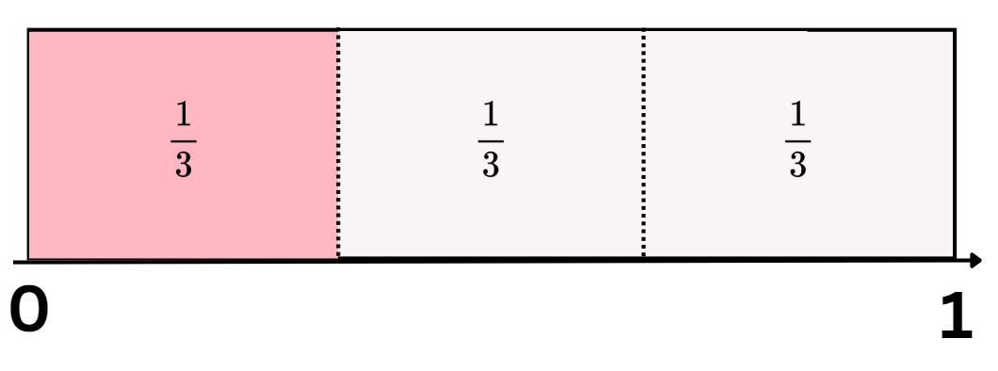
Figure 2 – possible Stage 3 student recording
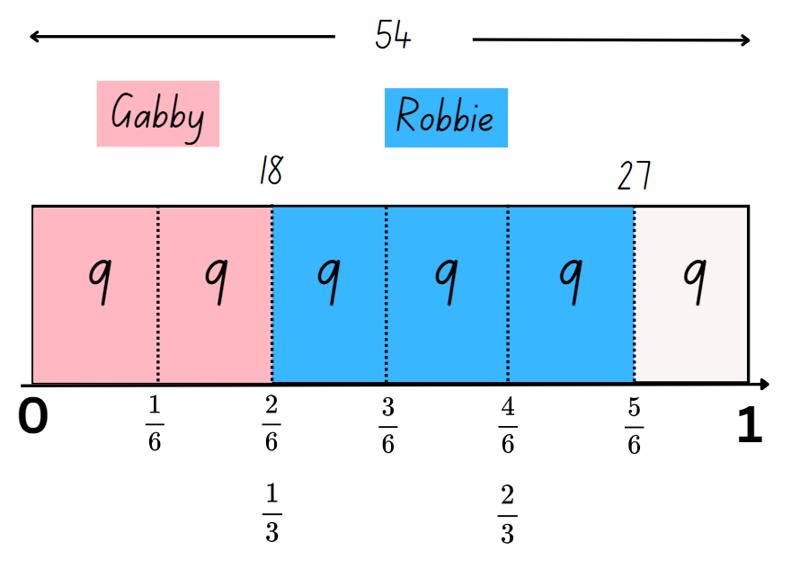
- Ask Stage 2 students:
- What is the complement to one-third ( $\frac{1}{3}$ )?
- How many thirds make a whole?
- How could you represent the problem if Gabby had two-eighths ( $\frac{2}{8}$ ) of a tower?
- What is the complement to two-eighths ( $\frac{2}{8}$ )?
This table details opportunities for assessment.
Assessment opportunities | Links
What to look for:  - Can Stage 2 determine the complementary fractional part needed to complete one whole (halves, quarters, eighths, thirds) (Reasons about relations)? [MAO-WM-01, MA2-PF-01]  - Can Stage 2 students rename 2 halves, 3 thirds, 4 quarters, 5 fifths, 6 sixths, 8 eighths and 10 tenths as one whole?  [MAO-WM-01, MA2-PF-01]  - Can Stage 3 students solve word problems involving adding or subtracting fractional quantities with related denominators?  [MAO-WM-01, MA3-RQF-02] | Links to National Numeracy Learning Progressions (NNLP):  - Stage 2 – InF4  - Stage 3 – InF8.  Links to suggested Interview for Student Reasoning (IfSR) tasks:  - Stage 3 – IfSR-MT: 4B.1.

Core lesson 1 – fractions as part of a whole – 10 minutes
The table below contains suggested learning intentions and success criteria. These are best co-constructed with students.
Core concept learning intentions | Core concept success criteria
Students working towards Stage 2 outcomes are learning to:  - model equivalent fractions as lengths.  Students working towards Stage 3 outcomes are learning to:  - recognise the role of the number 1 as representing the whole  - build up to the whole from a given fractional part. | Students working towards Stage 2 outcomes can:  - recognise the need to have equal wholes to compare partitioned fractions  - represent fractions with the same-size whole to make valid comparisons (denominators of 2, 4 and 8; 3 and 6; 5 and 10).  Students working towards Stage 3 outcomes can:  - compare halves and quarters of different sized wholes  - justify the need for fractions to refer to the number 1 as the common whole  - generate the whole quantity from non-unit fractional parts such as quarters, eighths, thirds, sixths, fifths and tenths.
Note: some students may think that one-quarter ( $\frac{1}{4}$ ) will always represent a smaller amount than one-half ( $\frac{1}{2}$ ). The following problem highlights this misconception and shows the importance of considering the size of each whole, before determining the size of each fraction.
- Pose the following problem to Stage 3: Ms Brunetta sent half of the students she was supervising to help set up for the sports carnival. Mrs Kew sent a quarter of the students she was supervising to help set up for the sports carnival. Mrs Kew said she sent more students to help. How could she be correct?
- Stage 3 record as many possible answers to the problem as they can on individual whiteboards. For example, if Mrs Kew was supervising 60 students, a quarter of 60 is 15. If Ms Brunetta was supervising 20 students, half of 20 is 10.
- Allow Stage 3 students to share their reasoning for the answers they have recorded.
- Discuss the importance of the size of the whole in determining which fraction amount is the largest. Revise that when there are different-sized wholes, the size of the fractional parts is dependent on the whole.
- Display Resource 1 – Zainab’s work sample to Stage 2. Explain that Zainab says these 2 bar models prove that one-quarter ( $\frac{1}{4}$ ) is equal to one-half ( $\frac{1}{2}$ ). Ask Stage 2 students:
- Do you agree or disagree with Zainab? Why or why not?
- What do you notice about the 2 bar models?
- What might Zainab have misunderstood to make this statement? (The need for same sized wholes to compare the size of fractional parts).
- Stage 2 students use an individual whiteboard to draw how Zainab should change her bar models to make a more accurate comparison.
Note: this is an opportunity for formative assessment which could guide the next steps in the lesson.

Core lesson 2 – comparing fractions – 30 minutes
- Display Fractions by The Math Learning Center. Select the second icon from the left on the bottom navigation pane to add rectangular fraction bars to the workspace.
- Create 2 fraction bars showing quarters and 2 fraction bars showing eighths.
- Position the fraction bars so that one representing quarters is above one representing eighths.
- Use the arrows on the fraction bars to change the sizes of the wholes. Create an example where quarters and eighths are represented on different-sized wholes. Make a second example where they are on the same-sized whole (see Figure 3).
Figure 3 – non-example and example of same sized whole
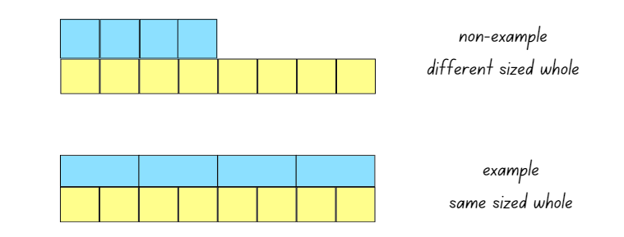
- Explain that to compare the fractional parts of a length, the same-sized whole is required. For example, to compare one-quarter ( $\frac{1}{4}$ ) and one-eighth ( $\frac{1}{8}$ ), the same-sized whole is required.
- Model creating a fraction wall displaying halves, thirds, quarters, fifths, sixths, eighths and tenths using Fractions ensuring that each whole is equal in length to one another.
- Students recreate the modelled fraction wall on their own device using Fractions.
Note: fraction notation can be added to the side of each bar by selecting the fourth icon from the left on the bottom navigation pane. Fractional parts of each bar can be coloured by using the sixth icon from the left on the bottom navigation pane. The fraction notation will change to match the number of coloured segments for each fraction bar. The pen or text tools on the right-hand side navigation pane can be used to record student thinking.
- Colour fractional parts to represent equivalence to one-half. Use fraction notation and the equals sign to show equivalence (see Figure 4).
Figure 4 – coloured fractional parts equivalent to one-half
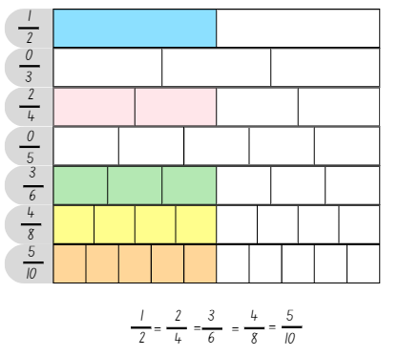
- Ask: Is it possible to represent a fraction equivalent to one-half using thirds or fifths on the fraction wall?
- Explain that when a whole is partitioned into an odd number of parts, for example thirds or fifths, there is no equivalent fraction to one-half.
- Students take a screenshot of the workspace to record fractions equivalent to one-half.
- Fraction walls are reset by students. They click on the coloured fractional parts to return them to white.
- Display the fractions below. Stage 2 use colours on the fraction wall to identify equivalent fractions. Stage 3 students use colours on the fraction wall to identify fractional parts needed to build up to the whole. For example, if the fraction shaded is $\frac{3}{8}$, then $\frac{5}{8}$ are needed to build up to the whole. Stage 3 students identify the total of the whole as for example,$\frac{8}{8}$.
- $\frac{2}{3}$
- $\frac{4}{5}$
- $\frac{1}{4}$.
- Students share the equivalent fractions identified (Stage 2) and the fractional parts needed to build up to the whole (Stage 3).
- Draw the symbols for greater than $>$and less than $<$on the board for Stage 2 students. Explain that these symbols can be used to record comparisons between numbers.
Note: less than $<$ and greater than $>$ symbols are not specifically referenced in the Mathematics K–10 Syllabus but are important symbols for students to understand. This lesson provides an opportunity to use these symbols in context.
- Model comparing partitioned fractions by colouring $\frac{3}{4}$ and $\frac{7}{8}$ on the fraction wall using Fractions.
- Discuss the use of the less than $<$ and greater than $>$ symbols with Stage 2.
- Ask Stage 2: Which fraction is smaller? Stage 2 record this on the workspace using the symbol for less than $<$ (see Figure 5).
Figure 5 – example for Stage 2 using the less than symbol to compare partitioned fractions
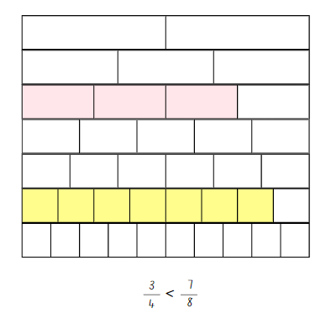
- Stage 2 compare fractions by representing and recording greater than, less than or equal to number sentences on Resource 2 – fraction comparisons.
- Stage 3 students draw 6 bars in their workbooks, where each bar represents one. Students use the fraction wall on Fractions to select fractional quantities and represent this on the bar in their workbooks. Identify the fraction needed to build up to the whole. Record the number equation to represent the fractional parts (see Figure 6). Repeat to complete the other 5 bars.
Figure 6 – example of Stage 3 responses
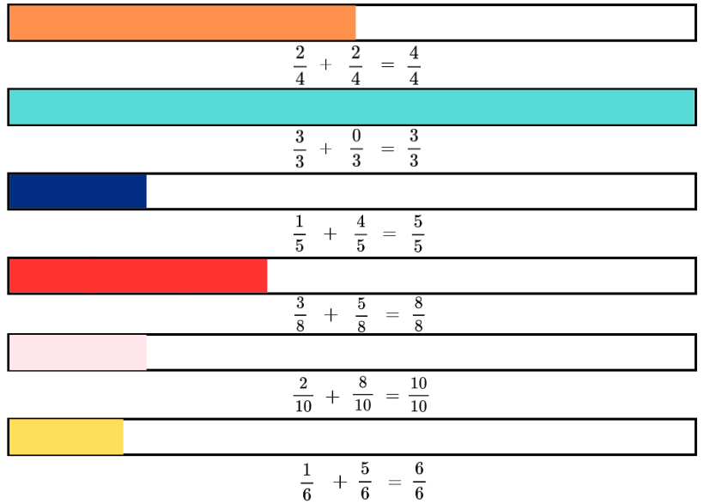
- Stage 3 conduct a gallery walk to compare their recordings with others, checking for accuracy. Ask:
- Did anyone shade the same fraction of the whole as you? What is it?
- Are there any recordings you saw that you do not agree with? If so, justify your reasoning and explain how you would help this student with their thinking.
- Are there any equivalent fractions shaded? If so, what are they? For example, $\frac{1}{5}$ and $\frac{2}{10}$.
- Revise with Stage 3 that when there are different sized wholes, the size of the fractional parts is dependent on the whole. For example, when comparing half of Ms Brunetta’s students to a quarter of Mrs Kew’s students, the size of each fractional part was dependent on the size of the different wholes.
- Explain to Stage 3 that the number ‘one’ represents the common whole for the task they completed. The common whole enables all the fractional quantities to be compared, ordered, added or subtracted.
- Ask Stage 3 to record as many fractional quantities as possible with different denominators that can be combined to make one (the common whole). For example, two-quarters ( $\frac{2}{4}$ ) and three-sixths ( $\frac{3}{6}$ ).
This table details opportunities for differentiation.
Too hard? | Too easy?
Stage 2 students cannot represent fractions with the same-size whole to make valid comparisons (denominators of 2, 4 and 8; 3 and 6; 5 and 10).  - Students make comparisons between fractional amounts with denominators of 2, 4 and 8 only. They discuss and compare the unit fractions.  - Students use 2 different length strips of paper to repeatedly halve them, creating eighths. They colour one-eighth on both strips and compare the size of the fractional part.  Stage 3 students cannot generate the whole quantity from non-unit fractional parts such as quarters, eighths, thirds, sixths, fifths and tenths.  - Provide students with strips of paper and support them to equally fold their strips into the fractional parts. For example, folding the fraction strip in half and in half again to represent quarters.  - Provide students with a fraction wall created on Fractions by The Math Learning Center to assist students with identifying equivalent fractions of the whole. | Stage 2 students can represent fractions with the same-size whole to make valid comparisons (denominators of 2, 4 and 8; 3 and 6; 5 and 10).  - Students make comparisons by plotting fractions on a number line.  - Challenge students to create number sentences using 2 or more greater than or less than symbols. For example, $\frac{1}{2}$ $> \frac{1}{4}$ $>$ $\frac{1}{8}$.  Stage 3 students can generate the whole quantity from non-unit fractional parts such as quarters, eighths, thirds, sixths, fifths and tenths.  - Provide students with opportunities to explore fractions with different denominators. For example, 7, 9, 11 and 12.  - Challenge students to write a problem with non-unit fractional parts with different sized whole. For example, Mr Ford sent two-quarters ( $\frac{2}{4}$ ) of his class to the hall. Mr Holden sent three-eighths ( $\frac{3}{8}$ ) of his class to the hall. Mr Holden said that he sent more students. How could he be correct? Students swap with a partner to solve.

Discuss and connect the mathematics – 10 minutes
- Display the fraction wall for Stage 2 students on Fractions used at the start of the lesson.
- Stage 2 students turn and talk to identify any fractions greater than three-quarters ( $\frac{3}{4}$).
- Record Stage 2 responses on the board. Ask: What did you notice? (There is more than one fractional amount that is greater than three-quarters.)
- Display Resource 3 – mathematical reasoning prompts for Stage 3 students and explain that these questions can be used to reflect on their mathematical thinking when solving problems.
- Pose the following problem to Stage 3 students: Fred laid three-quarters ( $\frac{3}{4}$) of the edging for a garden bed and Ted laid one-half ( $\frac{1}{2}$) of the edging for a garden bed. Ted said he has laid more edging than Fred. How could he be correct?
- Stage 3 students share their solution, while also explaining their reasoning. Use Resource 3 – mathematical reasoning prompts to facilitate the discussion.
This table details opportunities for assessment.
Assessment opportunities | Links
What to look for:  - Can Stage 2 students recognise the need to have equal wholes to compare partitioned fractions? [MAO-WM-01, MA2-PF-01]  - Can Stage 2 students represent fractions with the same-size whole to make valid comparisons (denominators of 2, 4 and 8; 3 and 6; 5 and 10)? [MAO-WM-01, MA2-PF-01]  - Can Stage 3 students compare halves and quarters of different-sized wholes? [MAO-WM-01, MA3-RQF-02]  - Can Stage 3 students justify the need for fractions to refer to the number 1 as the common whole? [MAO-WM-01, MA3-RQF-02]  - Can Stage 3 students generate the whole quantity from non-unit fractional parts such as quarters, eighths, thirds, sixths, fifths and tenths? [MAO-WM-01, MA3-RQF-01, MA3-RQF-02] | Links to National Numeracy Learning Progressions (NNLP):  - Stage 2 and Stage 3 – InF5.  Links to suggested Interview for Student Reasoning (IfSR) tasks:  - Stage 2 – IfSR-MT: 3B.3.

Lesson 2
Core concept: equivalent fractions (Stage 2 and Stage 3), decimals and fractions (Stage 3) can be represented as measures by partitioning length.

Daily number sense – fractional parts beyond one – 10 minutes
The table below contains suggested learning intentions and success criteria. These are best co-constructed with students.
Daily number sense learning intentions | Daily number sense success criteria
Students working towards Stage 2 outcomes are learning to:  - represent fractional quantities equal to and greater than one.  Students working towards Stage 3 outcomes are learning to:  - use equivalence to add and subtract fractional quantities. | Students working towards Stage 2 outcomes can:  - regroup fractional parts beyond one.  Students working towards Stage 3 outcomes can:  - represent fractional quantities with the same or related denominators to add and subtract fractions.
- Draw a rectangular strip on the board and explain that the strip represents a whole length.
- Students Think-Pair-Share how a strip equal to 3 halves the length of the original whole could be created.
- Draw a strip the same length as the whole and model partitioning it in half. Draw an additional half-length to represent 3 halves. Record the fractional notation next to the strip as three-halves ( $\frac{3}{2}$ ). Explain that 3 halves can also be renamed as one and a half ( $1\frac{1}{2}$ ).
Note: fractions can be renamed in multiple ways. For example, $1\frac{4}{5}$ can be renamed $\frac{9}{5}$ or $\frac{18}{10}$ or $1\frac{8}{10}$ . In the syllabus, the expression ‘fraction greater than one’ is used instead of the terms ‘improper fraction’ or ‘mixed numeral’.
- Provide students with Resource 4 – the whole strip. Students continue the strip by drawing to represent 6 quarters, 5 thirds and 7 sixths the length of the whole. Record the fractional notation next to each strip. For example, $\frac{6}{4}$ = $1\frac{2}{4}$; $\frac{5}{3}$ = $1\frac{2}{3}$; $\frac{7}{6}$ = $1\frac{1}{6}$.
- Stage 3 students use the second and third fraction strips on Resource 4 – the whole strip to work out the difference between $\frac{5}{3}$and $\frac{7}{6}$.
- Regroup and ask students to share their work with a peer. Ask:
- Are your drawings the same length as a classmate’s?
- What strategy did you use to determine how long the strip needed to be?
- What strategy did you use to determine the difference between $\frac{5}{3}$and $\frac{7}{6}$? (Stage 3)
- How did your knowledge of equivalent fractions help you solve this problem? (Stage 3)
This table details opportunities for assessment.
Assessment opportunities | Links
What to look for:  - Can Stage 2 students regroup fractional parts beyond one?  [MAO-WM-01, MA2-PF-01]  - Can Stage 3 students represent fractional quantities with the same or related denominators to add and subtract fractions?  [MAO-WM-01, MA3-RQF-02] | Links to National Numeracy Learning Progressions (NNLP):  - Stage 2 – InF5  - Stage 3 – InF8.  Links to suggested Interview for Student Reasoning (IfSR) tasks:  - Stage 3 – IfSR-MT: 4B.1, 4B.2.

Core lesson 1 – vertical fraction walls – 30 minutes
The table below contains suggested learning intentions and success criteria. These are best co-constructed with students.
Core concept learning intentions | Core concept success criteria
Students working towards Stage 2 outcomes are learning to:  - generate and describe patterns  - model equivalent fractions as lengths.  Students working towards Stage 3 outcomes are learning to:  - make connections between benchmark fractions, decimals and percentages. | Students working towards Stage 2 outcomes can:  - model, describe and record patterns of multiples  - represent the equivalence of fractions with related denominators as lengths, using concrete materials, diagrams and number lines.  Students working towards Stage 3 outcomes can:  - recognise that the symbol % means percent and 100% is the whole amount  - recall commonly used equivalent percentages, decimals and fractions including, $\frac{1}{2}$, $\frac{1}{4}$, and $\frac{3}{4}$  - represent common percentages of quantities and lengths as fractions and decimals.
- Display Polypad fraction bars and create a vertical fraction wall showing one-whole, halves, quarters and eighths (see Figure 7).
Note: this may be the first time students have seen a vertical fraction wall and number line. To create it, first build a horizontal fraction wall, then click and highlight it. Rotate the entire wall 90 degrees to the left using the black circle attached to the top bar. When creating a vertical number line, zero should be placed at the bottom and one should be placed at the top. Connections can be made to a thermometer, height measurement, measuring jugs or other scaled instruments.
Figure 7 – example of a vertical fraction wall and number line
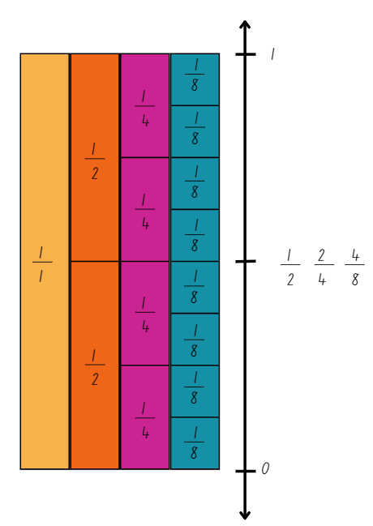
- Using the construction and drawing tools, create a number line to the right of the vertical fraction wall. Make it slightly longer than the whole. Label 0 and 1 in line with the start and end of the fraction wall. Draw arrows at either end to indicate that the number line continues.
- Make a mark at the halfway point. Ask students to identify any fractions that could be placed on the number line at this point. Record the fraction notation for $\frac{1}{2}$, $\frac{2}{4}$ and $\frac{4}{8}$. (see Figure 7).
- Using a digital device, Stage 2 students use Polypad fraction bars to create their own vertical fraction wall representing halves, thirds, fifths, sixths and tenths and number line from 0–1.
- Stage 2 identify and record the equivalent fractions for the following on their number line (see Figure 8).
- $\frac{1}{5}$
- $\frac{4}{6}$
- $\frac{8}{10}$
- $\frac{1}{3}$.
Figure 8 – example Stage 2 recording of equivalent fractions on a vertical number line
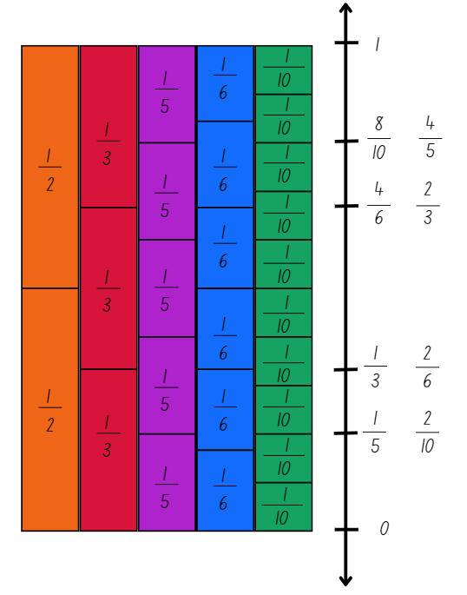
- Using a digital device, Stage 3 use Polypad fraction bars to create their own vertical fraction wall representing halves, quarters and tenths and a number line from 0–1.
- Model the features on Polypad fraction bars that convert fractions to percentages and decimals.
- Revise for Stage 3 that a percentage can be written as a fraction out of 100. Revise that fractions and percentages can also be shown as decimals.
- Use Polypad fraction bars to model the examples, $\frac{20}{100}$ = 20% = 0.2, $\frac{60}{100}$ = 60% = 0.6 and $\frac{80}{100}$= 80% = 0.8.
- Stage 3 use Polypad fraction bars to create a vertical fraction, percentage and decimal wall for a whole, halves and quarters and number line from 0–1.
- Stage 3 identify and record the equivalent fractions, percentages and decimals for the following on their number line (see Figure 9).
- $\frac{1}{4}$
- $\frac{1}{2}$
- $\frac{3}{4}$.
Figure 9 – example Stage 3 recording of equivalent fractions, percentages and decimals on a vertical number line
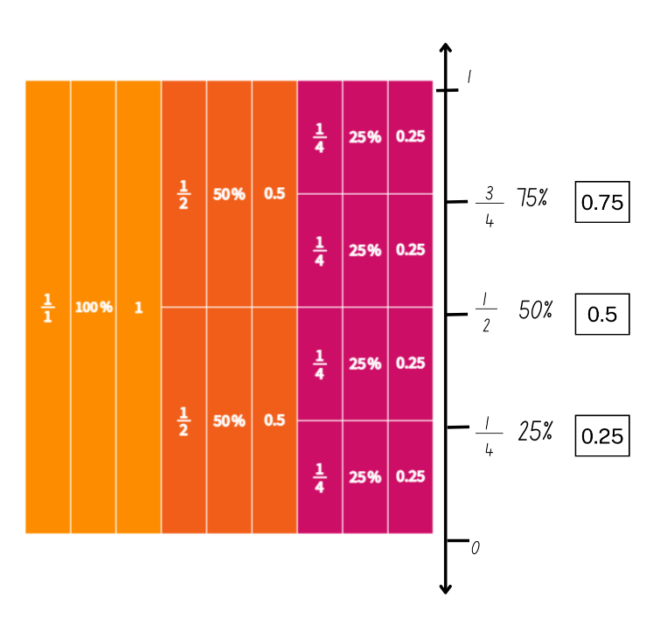
- Students take a screenshot of their models and number lines to record their work.
Note: monitor student work screenshots from Polypad fraction bars as a formative assessment opportunity.

Core lesson 2 –15 minutes

Stage 2 task – comparing equivalent fractions
- Select students to share the equivalent fractions they identified.
- Record these equivalent fractions on the board using the equal symbol. For example, $\frac{8}{10}$= $\frac{4}{5}$, $\frac{4}{6}$= $\frac{2}{3}$.
- Students Think-Pair-Share using the questions from the prompt table.
The table below outlines stimulus prompts to generate conversation about the topic, along with anticipated responses from students.
Prompts | Anticipated responses
- Consider the fractions $\frac{8}{10}$= $\frac{4}{5}$ and $\frac{4}{6}$ = $\frac{2}{3}$. What patterns do you notice between these equivalent fractions? | - When I represent $\frac{2}{3}$on a bar, I can make the thirds into sixths by halving. For every third there are 2 sixths $\frac{1}{3}$= $\frac{2}{6}$. So, $\frac{2}{3}$ = $\frac{4}{6}$, $\frac{3}{3}$ = $\frac{6}{6}$, $\frac{4}{3}$ = $\frac{8}{6}$ and so on.  - When I represent $\frac{4}{5}$ on a bar, I can make the fifths into tenths by halving. For every fifth there are 2 tenths $\frac{1}{5}$=$\frac{2}{10}$. So, $\frac{2}{5}$= $\frac{4}{10}$, $\frac{3}{5}$= $\frac{6}{10}$, $\frac{4}{5}$ = $\frac{8}{10}$ and so on.  - In the example $\frac{8}{10}$= $\frac{4}{5}$, I can see a pattern of halving. The number of parts we have (numerator) are 8 or 4 and the number of parts in the whole (denominator) are 10 or 5. Four is half of 8 and 5 is half of 10. This pattern works for $\frac{4}{6}$= $\frac{2}{3}$ as well.
- Do you notice the same patterns with the equivalent fractions $\frac{1}{2}$, $\frac{3}{6}$ and $\frac{5}{10}$? | - For each fraction, the number of fractional parts we have (numerator) is always half the total number of parts that makes up the whole (denominator). For example, in $\frac{3}{6}$, 3 is half of 6.  - When I represent these fractions on a bar model, the number of parts the whole has been partitioned into (halves, sixths and tenths) can be halved. Each fraction $\frac{1}{2}$, $\frac{3}{6}$ and $\frac{5}{10}$ represents half of the whole.  - I realised that if the whole is partitioned into an even number of parts, you could always find an equivalent fraction to half. If the whole is partitioned into an odd number of parts, there is no equivalent fraction to half. For example, I can’t represent an equivalent fraction using fifths or thirds.
Note: fractions represent the relationship between multiplication and division. They are a comparison of the fractional part to the whole.

Stage 3 task – comparing fractions, decimals and percentages
- Refer to the screenshot of students’ models on Polypad fraction bars and number line ask: Why did you record the fractions, decimals and percentages on the number line in this way?
- Students justify their reasoning by recording their thinking.
- Students turn and talk with a partner and read aloud the fractions, decimals and percentages they recorded. When reading decimals aloud, ask students to use the word ‘and’ to connect the decimal fraction with the whole number. For example, ‘zero and 5 tenths’. Students then share why they recorded the fractions, decimals and percentages in this way on their sheet.
Note: to support place value and fractional understanding, 0.25 would be read as ‘twenty-five hundredths’. Interpreting decimals used in different contexts can change the way that students read them. In the context of measuring timber, it is appropriate to read the decimal 2.75 as ‘two point seven five metres’. Without a relevant context, encourage students to read the decimal as ‘two and seventy-five hundredths’.
- Display Resource 5 – student non-example. Explain that a student has competed this activity and produced the following sample. Ask:
- Do you agree with the part the student has identified as 50%? Why or why not?
- How would you help the student find 50% of the bar model? For example, folding the bar model in half.
- Do you agree with $\frac{1}{2}$ being placed in that position on the number line? Why or why not?
- How could you help this student to see the connection between five-tenths, half and 50%?
- Do you agree with the student’s thinking that the more numbers after the decimal numbers, the bigger the number is?
- How could you help this student with their place value understanding? (More numbers after the decimal point doesn’t always make a larger decimal)
Note: the Stage 3 Teaching advice for Representing numbers using place value B states that when students first encounter decimals, the most common misconception identified is the belief that longer decimals are always larger decimals. A student who believes that longer decimals are always larger will indicate that 0.25 is larger than 0.5 (NESA 2024a).
This table details opportunities for differentiation.
Too hard? | Too easy?
Stage 2 students cannot represent and describe patterns modelled as lengths for equivalent fractions.  - Provide coloured rods to model equivalent fraction lengths. Support students to name and label the equivalent fractions.  - Support students to use their fraction wall. Identify equivalent lengths and fractions beginning with halves, quarters and eighths.  Stage 3 students cannot recall commonly used equivalent percentages, decimals and fractions including $\frac{1}{2}$, $\frac{1}{4}$, and $\frac{3}{4}$.  - Provide students with a strip of paper and support them to fold the paper strip in half and half again and label the folds $\frac{1}{2}$, $\frac{1}{4}$, and $\frac{3}{4}$.  - Support students with their understanding of percentages being written as a fraction out of 100. Assist students to record the benchmark percentages with their equivalent fractions with a denominator of 100. For example, 25% = $\frac{25}{100}$, 50% = $\frac{50}{100}$ and 75% = $\frac{75}{100}$. | Stage 2 students can represent and describe patterns modelled as lengths for equivalent fractions.  - Students explore patterns and equivalent fractions, including ninths and twelfths.  - Challenge students to create an equivalent fraction pattern with missing elements for a partner to solve.  Stage 3 students can recall commonly used equivalent percentages, decimals and fractions including $\frac{1}{2}$, $\frac{1}{4}$, and $\frac{3}{4}$.  - Students draw a 0–2 number line and place the following fractions, decimals and percentages on the number line: 0.3, 0.9, 1.2, 2.0, 1$\frac{2}{3}$, $\frac{6}{8}$, 1$\frac{5}{6}$, $\frac{5}{5}$, 30% and 100%.  - Play Matching Fractions, Decimals and Percentages from NRICH. Students can self-select from 5 levels of challenge and try to beat their own best times.

Consolidation and meaningful practice – 15 minutes
- Display Resource 6 – equivalent fractions for Stage 2 students. Students write the number sentences on Polypad fraction bars using the drawing tool.
- Ask Stage 2 students:
- How did your knowledge of multiples help you solve the problems?
- Can you think of another equivalent fraction for one of the number sentences? For example, $\frac{1}{4}$= $\frac{2}{8}$ = $\frac{3}{12}$.
Note: although twelfths are not explicitly included in the syllabus, the example highlights the multiplicative pattern of equivalent fractions.
- Discuss with Stage 3 students that percentages can be used to find an amount of a quantity. For example, 25% of 120 equals 30, 50% of 120 equals 60 and 75% of 120 equals 90.
- Provide Stage 3 with Resource 7 – tape diagrams. Stage 3 calculate 25%, 50% and 75% of each of the quantities and record the number at the correct position. For example, 25% of 180 = 45, 50% of 180 = 90 and 75% of 180 = 135 (see Figure 10).
Figure 10 – tape diagram example
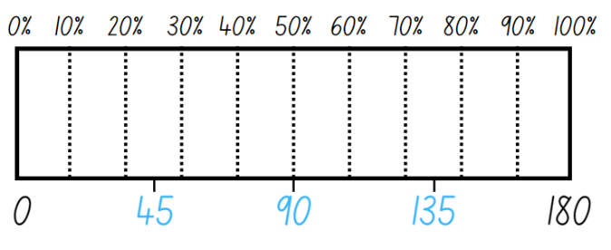
- Once Stage 3 students have calculated all solutions for each quantity, ask:
- What strategy did you use to find the different percentages of the given quantities?
- Is it helpful to know how to work out common percentages, like 50%, to work out other benchmark percentages including 25% and 75%?
- Is there a more efficient strategy that was just shared that you would use next time?
- Did you see connections between any of the answers you recorded? For example, 180 = 100% of 180 on the first tape diagram, 180 = 75% of 240 on the second tape diagram and 180 = 50% of 360 on the last tape diagram.
This table details opportunities for assessment.
Assessment opportunities | Links
What to look for:  - Can Stage 2 students model, describe and record patterns of multiples? [MAO-WM-01, MA2-MR-01]  - Can Stage 2 students model represent the equivalence of fractions with related denominators as lengths, using concrete materials, diagrams and number lines? [MAO-WM-01,  MA2-PF-01]  - Can Stage 3 students recognise that the symbol % means percent and 100% is the whole amount? [MAO-WM-01, MA3-RN-03]  - Can Stage 3 students recall commonly used equivalent percentages, decimals and fractions including $\frac{1}{2}$, $\frac{1}{4}$, and $\frac{3}{4}$?  [MAO-WM-01, MA3-RN-03]  - Can Stage 3 students represent common percentages of quantities and lengths as fractions and decimals? [MAO-WM-01, MA3-RN-03] | Links to National Numeracy Learning Progressions (NNLP):  - Stage 2 – NPA3, NPA4, InF5.  - Stage 3 – PrT1, PrT2, UnM8, InF7.  Links to suggested Interview for Student Reasoning (IfSR) tasks:  - Stage 2 – IfSR-MT: 3B.3.

Lesson 3
Core concept: number lines are important models used to represent fractions (Stage 2) and connections can be made between fractions, decimals and percentages using number lines and diagrams (Stage 3).

Daily number sense – fraction line beyond one – 10 minutes
The table below contains suggested learning intentions and success criteria. These are best co-constructed with students.
Daily number sense learning intentions | Daily number sense success criteria
Students working towards Stage 2 outcomes are learning to:  - represent fractional quantities equal to and greater than one.  Students working towards Stage 3 outcomes are learning to:  - use equivalence to add and subtract fractional quantities. | Students working towards Stage 2 outcomes can:  - represent totals of halves, thirds, quarters and fifths that extend beyond one.  Students working towards Stage 3 outcomes can:  - represent fractional quantities with the same or related denominators to add and subtract fractions.
- Draw a number line on the board and label it 0–2. Ask:
- What does a number line from 0–2 tell us? (There are 2 wholes; and fractions bigger than one can also be placed on this number line.)
- Where would one be placed on this number line? (In between 0 and 2. It must be exactly halfway.)
- Students use writing materials to draw a 0–2 number line and label the position of 0, 1 and 2.
- Students record the following fractions on their number line:
- $\frac{3}{5}$
- $1\frac{4}{5}$
- $\frac{7}{5}$.
Multi-age: encourage Stage 2 to partition the number line into fifths from 0–2 before plotting the fractions.
- Ask students if any fractions could be renamed and to record them on their number line ($1\frac{4}{5}$ could be renamed 9 fifths and 7 fifths could be renamed as $1\frac{2}{5}$).
- Stage 3 students to work out the difference between each of the plotted fractions.
This table details opportunities for assessment.
Assessment opportunities | Links
What to look for:  - Can Stage 2 students represent totals of halves, thirds, quarters and fifths that extend beyond one? [MAO-WM-01, MA2-PF-01]  - Can Stage 3 students represent fractional quantities with the same or related denominators to add and subtract fractions?  [MAO-WM-01, MA3-RQF-02] | Links to National Numeracy Learning Progressions (NNLP):  - Stage 2 – InF5  - Stage 3 – InF8.  Links to suggested Interview for Student Reasoning (IfSR) tasks:  - Stage 3 – IfSR-MT: 4B.1, 4B.2.

Core lesson – 40 minutes

Stage 2 task – from bar models to number lines
The table below contains suggested learning intentions and success criteria. These are best co-constructed with students.
Core concept learning intentions | Core concept success criteria
Students are learning to:  - investigate number sequences involving related multiples  - model and represent unit fractions, and their multiples, to a complete a whole on a number line. | Students can:  - investigate number patterns involving related multiples  - determine the complementary fractional part needed to complete one whole (halves, quarters, eighths, thirds)  - recreate the whole unit from a fractional part ($\frac{1}{2}$ ,$\frac{1}{4}$, $\frac{1}{3}$ and $\frac{1}{8}$).
This activity is an adaption of Unit Fractions from National Centre for Excellence in the Teaching of Mathematics by the Tribal Group PLC.
- Display Resource 8 – water jugs 1. Explain that it shows a water jug that is one-quarter full. One-quarter can be represented on a bar model or a number line.
- Model recording one-quarter $( \frac{1}{4}$ ) on the bar models and number lines (see Figure 11).
Figure 11 – example of recordings for $\frac{1}{4}$
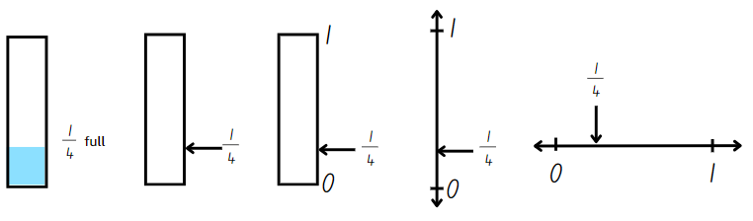
- Ask: How much more water is needed to fill the jug if it is currently one-quarter ( $\frac{1}{4}$ ) full?
- Explain that a complementary fraction is the fractional part needed to complete the whole. Record three-quarters ( $\frac{3}{4}$ ) as the complement on the right-hand side of Resource 8 – water jugs 1.
- Select students to model completing the second example showing half on the class display.
- Provide students with Resource 9 – water jugs 2. Students label each representation for the first and second jugs with the appropriate fraction. They then record the complementary fraction for each.
- Regroup and explain that for the third jug, students need to use the fractional part one-eighth ( $\frac{1}{8}$ ) to recreate the whole jug.
- Students explain the steps they take to recreate the whole on Resource 9 – water jugs 2. They record their thinking in words, diagrams or number lines.
- Regroup and select students with different methods of recreating the whole to share their process with the class. Reflect on the efficiency and accuracy of the methods used.
- Pose the following question: A jug is one-quarter ( $\frac{1}{4}$ ) full. How could this be represented as an equivalent fraction using eighths?
- Students Think-Pair-Share using the questions from the prompt table.
The table below outlines stimulus prompts to generate conversation about the topic, along with anticipated responses from students.
Prompts | Anticipated student responses
- How did you solve the task? | - I knew that eighths are made when I halve quarters (repeated halving). There was $\frac{1}{4}$ and I halved it. It gave me 2 parts which is $\frac{2}{8}$.
- What did you visualise or draw to solve this task? | - I visualised partitioning a line into 4 and 8 parts. I could see that two-eighths would be the same as one-quarter.
- Write the statements below on the board. Students Think-Pair-Share and determine whether they are true or false.
- If a jug is $\frac{2}{8}$ full, I need $\frac{3}{4}$ to make it full.
- If a jug is $\frac{4}{6}$ full, the complementary fraction is $\frac{2}{3}$.
- Students share their thinking and justify their responses, linking back to patterns of multiples.
This table details opportunities for differentiation.
Too hard? | Too easy?
Students cannot determine the complementary fractional part needed to complete one whole (halves, quarters, eighths, thirds).  - Students refer to a fraction wall to determine the complementary fraction required to fill each jug.  - Provide students with a small strip of paper. They use it to iterate the fractional parts required to create the whole. | Students can determine the complementary fractional part needed to complete one whole (halves, quarters, eighths, thirds).  - Students find the complementary fraction with related denominators. For example, the complementary fraction of $\frac{1}{2}$ = $\frac{2}{4}$, $\frac{3}{6}$, $\frac{4}{8}$.  - Challenge students to represent 4 halves, 8 fifths and 5 thirds on bar models and number lines.

Stage 3 task 1 – exploring one-tenth
The table below contains a suggested learning intention and success criteria. These are best co-constructed with students.
Core concept learning intention | Core concept success criteria
Students are learning to:  - make connections between benchmark fractions, decimals and percentages. | Students can:  - recall commonly used equivalent percentages, decimals and fractions including $\frac{1}{2}$, $\frac{1}{4}$ and $\frac{3}{4}$  - represent common percentages of quantities as fractions and decimals  - recognise that 10% is one-tenth of 100% and use this to find 10% of a quantity.
This activity is an adaptation of ‘Hundredths and percentages’ from Teaching Mathematics: Foundation to Middle Years by Siemon et al.
- Draw a rectangle with ‘one whole’ written inside (see Figure 12). Ask: How could you break up one whole into tenths?
Figure 12 – one whole
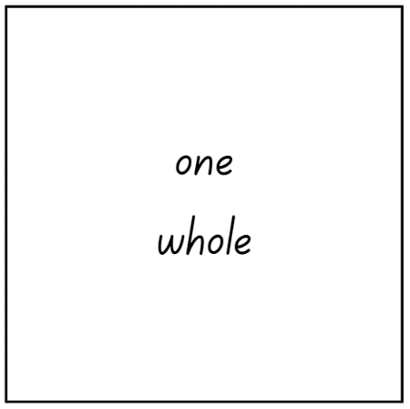
Note: the Stage 3 Teaching advice for Represents numbers B states that benchmark fraction values are extended to include one-tenth (10%, 0.1) (NESA 2024b).
- Students record their thinking on individual whiteboards and then turn and talk to share their representations with a partner.
- Display Resource 10 – representing tenths. Discuss that the image shows how the one whole is partitioned into 10 equal pieces. Explain that one-tenth is 10% of 100% and this can be used to find 10% of a quantity.
- Display Resource 11 – 100 grid. Ask:
- How could one-tenth be recorded as a fraction?
- Is there more than one way one-tenth could be written as a fraction?
- How could one-tenth be recorded as a decimal?
- How could one-tenth be recorded as a percentage?
- Select students to share their thinking and record responses given on the whiteboard (see Figure 13).
Figure 13 – possible student responses
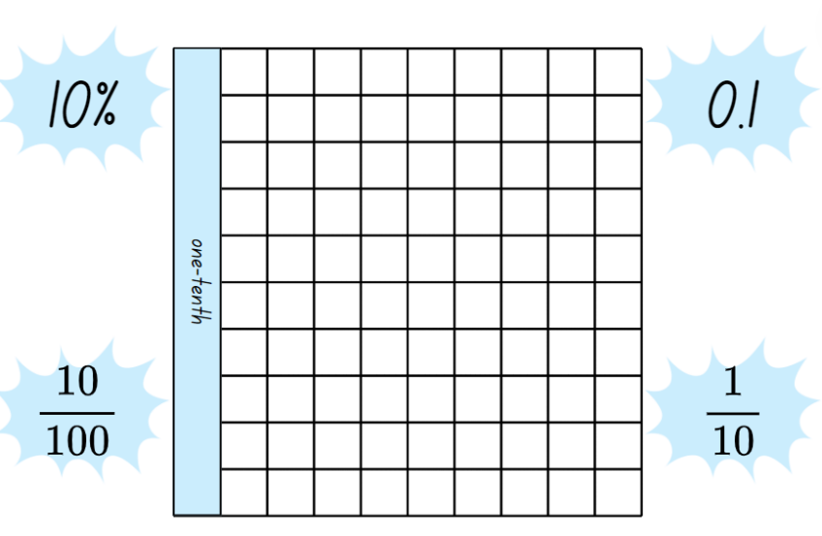
- Revise that a percentage can be written as a fraction out of 100. For example, $\frac{10}{100}$.
Note: one-tenth can be expressed as a decimal with hundredths. The Stage 3 Teaching advice for Represents numbers A states that the role of zero as a place holder assists in understanding how we say and write decimals. Zero is written in the ones place in a decimal to reduce the risk of misreading the decimal as a whole number (NESA 2024c). For example, the number 0.1 has the same value as 0.10. The link between hundredths and per cent can be made using a hundredths diagram (Siemon et al. 2021).

Stage 3 task 2 – recording fractions, decimals and percentages
- Ask students to recall benchmark fractions. For example, $\frac{1}{4}$, $\frac{1}{2}$and $\frac{3}{4}.$ Revise that benchmark fractions are used as a reference point.
Note: it is important that students develop a robust understanding of the equivalent representations of benchmark values (Fuchs et al. 2017). Students should know that 0.5 equals one-half ( $\frac{1}{2}$ ) and 0.5 is not one-fifth ( $\frac{1}{5}$ ).
- Provide students with Resource 12 – blank 100 grids. Ask students to represent given benchmark fractions on each of the grids provided, and record the representations on the grids as fractions, decimals and a percentage (see Figure 14).
Figure 14 – possible student recordings
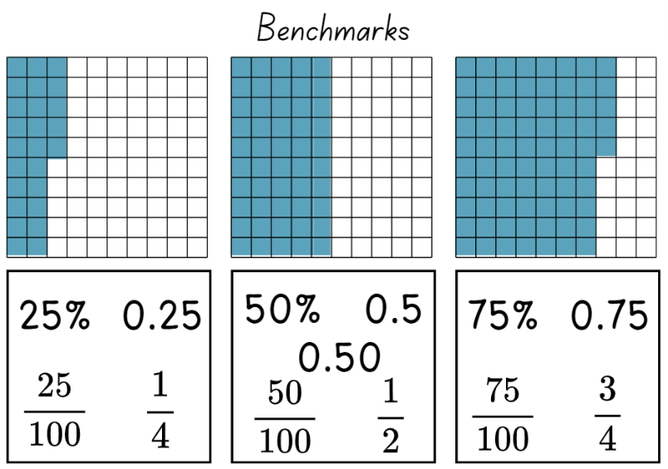
- Students go on a gallery walk. Ask:
- Were the representations similar to yours?
- Do you notice anything different to yours?
- Were there any fraction or decimal recordings you noticed that you did not consider?
This table details opportunities for differentiation.
Too hard? | Too easy?
Students cannot represent common percentages of quantities and lengths as fractions and decimals.  - Support students to focus on 50% as the benchmark percentage. Assist them to recognise $\frac{1}{2}$ and 0.5 in relation to the hundreds grid.  - Use MAB materials as a visual representation to support student understanding of fractions, decimals and percentages. | Students can represent common percentages of quantities and lengths as fractions and decimals.  - Provide another copy of Resource 12 – blank 100 grids and ask students to select non-benchmark fractions to record on the sheet.  - Students play an interactive game where percentages are used on a 10 × 10 grid. For example, Playground Percentages from ABC Education.

Consolidation and meaningful practice – 10 minutes
- Provide Stage 2 students with a copy of Resource 13 – whole water jug. Students recreate the whole unit from the given fractional amount by drawing the whole jug and labelling the number line.
- Discuss with Stage 3 students how the base-10 number system makes it easy to find 10% of a quantity, and 10% reflects one-tenth ( $\frac{1}{10}$ ) of the total. For example, 10% of 150 is 15. Explain that 10% is also dividing by 10.
- Display Resource 14 – 10% sale for Stage 3 students. Ask Stage 3 students to find 10% of the price of each item, recording their answers on individual whiteboards.
- Once Stage 3 students have calculated 10% of each item, challenge them to find 40%, 60% and 90% of the price of each item using the benchmark of 10% to assist.
- All students turn and talk to share their answers with a partner, explaining the process they used to solve their task.
- Ask:
- How does this task prove that the size of the fractional parts is dependent on the size of the whole? (Stage 2)
- Did you use or discover efficient ways to calculate 40%, 60% or 90% of the total price? (Stage 3)
This table details opportunities for assessment.
Assessment opportunities | Links
What to look for:  - Can Stage 2 students investigate number patterns involving related multiples? [MAO-WM-01, MA2-MR-01]  - Can Stage 2 students determine the complementary fractional part needed to complete one whole (halves, quarters, eighths, thirds) (Reasons about relations)? [MAO-WM-01, MA2-PF-01]  - Can Stage 2 students recreate the whole unit from a fractional part ($\frac{1}{2}$ ,$\frac{1}{4}$, $\frac{1}{3}$ and $\frac{1}{8}$)? [MAO-WM-01, MA2-PF-01]  - Can Stage 3 students recall commonly used equivalent percentages, decimals and fractions including $\frac{1}{2}$, $\frac{1}{4}$, and $\frac{3}{4}$?  [MAO-WM-01, MA3-RN-03]  - Can Stage 3 students represent common percentages of quantities as fractions and decimals? [MAO-WM-01, MA3-RN-03]  - Can Stage 3 students recognise that 10% is one-tenth of 100% and use this to find 10% of a quantity? [MAO-WM-01, MA3-RN-03] | Links to National Numeracy Learning Progressions (NNLP):  - Stage 2: NPA3, NPA4, InF5  - Stage 3: PrT2, UuM8, InF7.  Links to suggested Interview for Student Reasoning (IfSR) tasks:  - Stage 2: IfSR-NP: 4A.1-4A.3.

Lesson 4
Core concept: there are fractions between any 2 whole numbers on a number line (Stage 2) and fractions of a whole shape can be compared and represented (Stage 3).

Daily number sense – 10 minutes
- From a class need surfaced through formative assessment data, identify a short, focused activity that targets students’ knowledge, understanding and skills. Example activities may be drawn from the following resources:
- Mathematics K–6 resources
- Universal Resources Hub.

Core lesson – 40 minutes

Stage 2 task – fraction lines beyond one
The table below contains suggested learning intentions and success criteria. These are best co-constructed with students.
Core concept learning intentions | Core concept success criteria
Students are learning to:  - generate and describe patterns  - represent fractional quantities equal to and greater than one. | Students can:  - create and continue a variety of number patterns that increase or decrease by a constant amount  - represent totals of halves, thirds, quarters and fifths that extend beyond one  - determine the relative location of one-quarter and one-half when a number line extends beyond one.
- Explain that fractions expand our number system. They provide an infinite set of numbers between any 2 whole numbers. This allows for the number system to be very precise.
- Draw a number line from 0–2 on the board. Record $1\frac{1}{2}$ on the number line by segmenting the section between 1 and 2 into half.
- Identify $1\frac{1}{4}$ on the number line by halving the line between 1 and $1\frac{1}{2}$. Ask:
- Is it possible to rename $1\frac{1}{2}$ and $1\frac{1}{4}$? (Yes. Record $\frac{3}{2}$ and $\frac{5}{4}$ on the number line.)
- Can you identify any additional numbers that come between 1 and 2?
- Students Think-Pair-Share to identify additional numbers that come between 1 and 2.
- Provide pairs with Resource 15 – 0–2 number lines. Students partition the number lines and record the fractions to match the titles (see Figure 15).
Figure 15 – student work sample
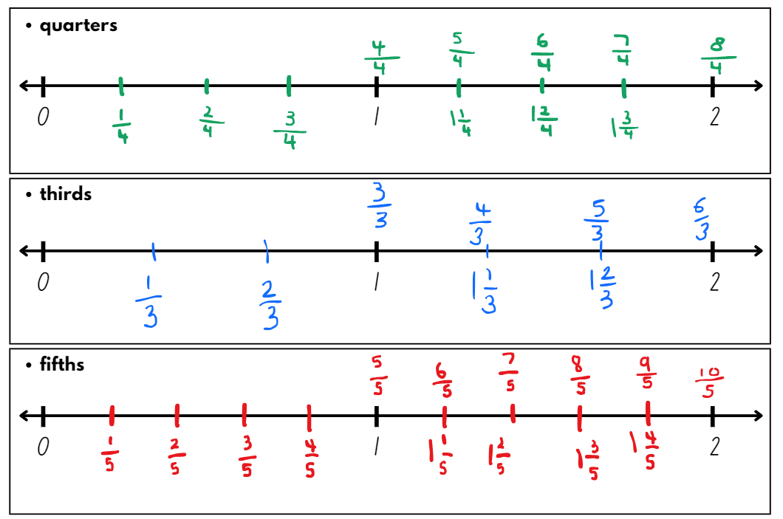
- Students name and record the fractions in multiple ways. For example, $\frac{7}{5}$ and $1\frac{2}{5}$.
- Regroup and select a student work sample to display for discussion.
- Students Think-Pair-Share using the questions from the prompt table.
The table below outlines stimulus prompts to generate conversation about the topic, along with anticipated responses from students.
Prompts | Anticipated student responses
- How could the numbers 1 and 2 be renamed on the number lines? | - 1 could be renamed 3 thirds, 4 quarters or 5 fifths and 2 could be renamed 6 thirds, 8 quarters and 10 fifths.
- How did finding half help you find quarters, thirds or fifths? | - I visualised half of the halves to locate quarters.  - I knew from practising the thirding strategy that thirds were smaller than halves and could visualise the markings for thirds.  - I looked at a fraction wall and saw that the position of $\frac{1}{2}$ is halfway between $\frac{2}{5}$ and $\frac{3}{5}$.  - I visualised 5 equal parts in between 0 and 1 and 1 and 2 and made marks on the number line to make fifths.
- How could you use your knowledge of related multiples to find additional fractions between 0–2? (Try using, eighths, sixths or tenths.) | - I could add eighths to my number line marked in quarters by halving the quarters.  - I know that 10 is a multiple of 5 so I could find tenths on the number line partitioned into fifths. I would halve each fifth to place tenths on the number line.
- Refer to the 0–2 number line on the board. Record the fractions between 1 and 2 in fifths on the number line.
- Display Resource 16 – fraction patterns underneath or next to the number line.
- Students Think-Pair-Share using the questions from the prompt table.
The table below outlines stimulus prompts to generate conversation about the topic, along with anticipated responses from students.
Prompts | Anticipated student responses
- Can you see any patterns? | - When I read the table horizontally, the numbers in each row are increasing by one-fifth.  - When I read the table vertically, the fraction in the first row has been renamed in the second row.
- How can you compare the fractions in the first row to one? | - The numbers in the first row represent a whole and an additional fractional part.
- How can you compare the fractions in the second row to one? | - In the second row, the number of parts we have is greater than the number of parts the whole has been partitioned into. For example, 6 fifths is one whole and one extra fifth.  - $\frac{10}{5}$ represents 2 wholes because double 5 is 10.
- What would come next in each pattern? | - $2\frac{1}{5}$  - $\frac{11}{5}$
This table details opportunities for differentiation.
Too hard? | Too easy?
Students cannot create and continue a variety of number patterns that increase or decrease by a constant amount.  - Provide students with interlocking cubes to physically represent each fractional amount in the pattern.  Students cannot determine the relative location of one-quarter and one-half when a number line extends beyond one.  - Provide 2 paper strips of equal length and fold each into quarters. Students paste the first strip on a piece of paper. They draw a number line 0–1 using the edge of the strip, labelling the position of halves and quarters. Students paste the second strip to the right of the first, ensuring no gaps between the strips. They extend the number line to 2 and label the additional halves and quarters between 1 and 2. | Students can create and continue a variety of number patterns that increase or decrease by a constant amount.  - Students create and continue fraction number patterns involving sixths, eighths or tenths.  Students can determine the relative location of one-quarter and one-half when a number line extends beyond one.  - Students determine the relative location for fifths, sixths, eighths and tenths on a number line that extends beyond one.  - Challenge students to create number lines that extend between 2 consecutive 2-digit numbers. For example, between 11 and 12.

Stage 3 task 1 – rectangle fractions
The table below contains a suggested learning intention and success criteria. These are best co-constructed with students.
Core concept learning intention | Core concept success criteria
Students are learning to:  - compare common fractions with related denominators. | Students can:  - subdivide the area of a rectangle by both length and width to represent the multiplicative relationship between common fractions  - compare and represent fractions with denominators of 2, 4 and 8; 3 and 6; 5 and 10 of a whole shape.
Note: the Stage 3 Teaching advice for Representing quantity fractions B states that students need opportunities to actively explore different ways to divide the areas of shapes. For example, subdividing rectangles by both length and width can help develop an understanding of how to produce equivalent fractions, and how to create a common denominator. Subdividing the shape emphasises the relationship between the denominators of the component fractions. Subdividing shapes establishes a better understanding of the area model of fractions than simply counting shaded parts (NESA 2024a).
This concept was introduced in Stage 3 Unit 16.
- Display Resource 17 – rectangle fractions. Tell students that the first yellow rectangle is the whole and each rectangle is equal to one. Ask: What fraction does the blue squares represent in each rectangle?
- Students record their thinking on individual whiteboards. Ask students to recreate each of the rectangles, subdivide the area and record equivalent fractions as they can see represented.
- Regroup and explain that the rectangle can be divided into equal 8 squares arranged as 2 by 4 and therefore the blue squares represent:
- two eighths or one quarter of the first rectangle
- four eighths, 2 quarters or one-half of the second rectangle
- six eighths or 3 quarters of the third triangle.
- Model the subdivision of the rectangles on the board (see Figure 16).
Figure 16 – subdividing rectangles
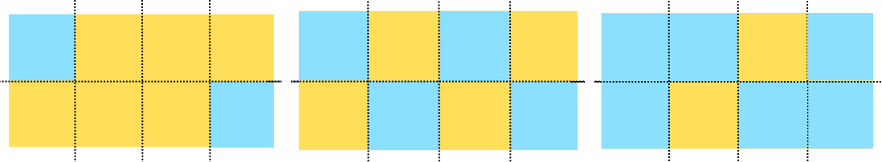
- Students turn and talk to discuss the connections between fractions and division.
Note: the Stage 3 Teaching advice for Multiplicative relations B states that fraction notation brings together a division problem with its solution. For example, 1 divided by 2 is half ($\frac{1}{2}$) just as 2 divided by 4 is 2 quarters ($\frac{2}{4}$). An area model can be used to represent dividing that area of shapes. This can be reinforced by describing fractions as divisions. Instead of describing one-half as ‘1 over 2’ or 3-quarters as ‘3 over 4’ introduce the language of division: ‘1 divided by 2’ or ‘3 divided by 4’ (NESA 2024d).

Stage 3 task 2 – equal parts of the whole
This activity is an adaptation of ‘Equal parts of the whole’ in Challenging Mathematical Tasks by Sullivan.
- Provide students with Resource 18 – area model fractions. Explain that their task is to determine the fractions represented by different colours of the whole shapes.
- Students record the fractions represented next to each shape. Encourage them to also record any equivalent fractions (see Figure 17).
Figure 17 – example of a student recording
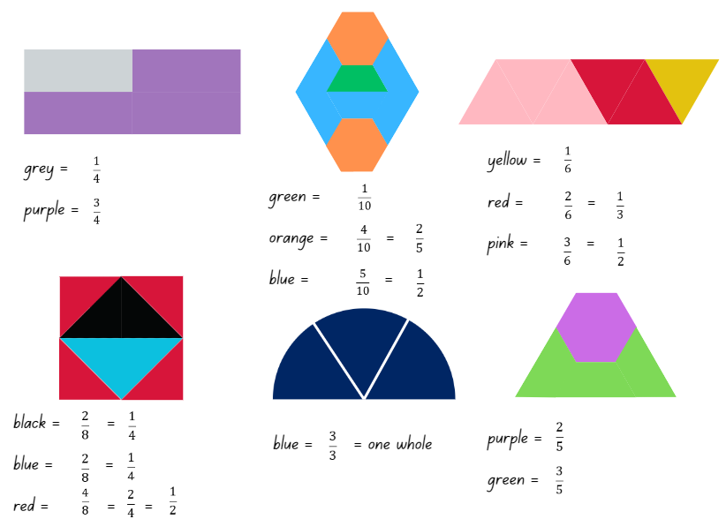
This activity is an adaptation of ‘Partitioning geometric shapes’ in Teaching Mathematics: Foundation to Middle Years by Siemon et al.
- Provide students with Resource 19 – partitioning hexagons.
- Students equally partition the hexagons in as many ways as they can.
Note: a common misconception is that students will focus on the ‘number of parts’ without appreciating that these parts need to be equal in size or amount. Students may also believe that fractional parts in area models need to be congruent and fail to recognise that parts can look different but still be equivalent in area (Australian Academy of Science n.d.).
- Students turn and talk with a partner to share and explain their thinking. Ask:
- Did you have any partitioned hexagons that looked like your partner’s?
- Did your partner have any partitioned hexagons that looked different to yours? Can you describe the difference?
- How many equal parts did you partition your hexagons into? For example, 2, 3, 4 or 6 equal parts.
- Display Resource 20 – Harry’s hexagons. Explain to students that Harry was asked to partition the hexagons into equal parts. Ask:
- Which hexagons did Harry equally partition?
- Did any of Harry’s equally partitioned hexagons match any of your partitioned hexagons? Which ones?
- Did Harry equally partition any of the hexagons in a way you didn’t think of? Which ones?
- Are there any hexagons that Harry partitioned into unequal parts? (Yes, the hexagon unequally partitioned into 8 parts.)
- Is there a way that Harry could partition a hexagon into 8 equal parts?
This table details opportunities for differentiation.
Too hard? | Too easy?
Students cannot compare and represent fractions with denominators of 2, 4 and 8; 3 and 6; 5 and 10 of a whole shape.  - Provide students with pattern blocks to recreate the whole shapes and manipulate the fractional parts of the whole.  - Provide students with Resource 21 – fraction wall to assist with comparing fractions with related and equivalent denominators. | Students can compare and represent fractions with denominators of 2, 4 and 8; 3 and 6; 5 and 10 of a whole shape.  - Pose the problem: I made a shape with 2 trapeziums and 2 triangles. The shape I made has the common whole of one. What fractions could I make?  - Students design their own fractional shapes. They swap their shapes with a partner and determine the fractions covered by each colour of the shape.

Consolidation and meaningful practice – 15 minutes
- Stage 2 refer to their number lines and name a fraction:
- close to zero
- close to $1\frac{1}{4}$
- close to $\frac{8}{5}$.
- Ask Stage 2 students to share their thinking and check for understanding.
- Write the following problem on the board for Stage 2 students: Kevin says there is a fraction between $1\frac{2}{4}$ and $1\frac{3}{4}$. Is he correct?
- Stage 2 students turn and talk with a partner. Students discuss whether Kevin’s thinking is correct or incorrect. Students can refer to the fraction wall or draw a diagram to help solve this task.
- Challenge Stage 3 students to think of a way to partition a hexagon into 8 equal parts. Ask them to draw an extra hexagon on Resource 19 – partitioning hexagons and allow time to explore equally partitioning the hexagon, checking student recordings.
- Provide Stage 3 students with Resource 22 – 8 equal parts. Ask if the grid under the hexagon is helpful to identify where the equal partitions would be on the shape. Students record their equal partitioning using coloured pencils (see Figure 18).
Figure 18 – student example of a hexagon equally partitioned
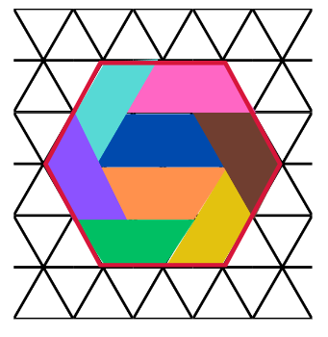
- Stage 3 students turn and talk, comparing their equal partitioning with a partner.
Note: if students are unable to equally partition the hexagon into 8 parts, display Resource 22 – 8 equal parts and model equally partitioning the shape, as in Figure 18.
This table details opportunities for assessment.
Assessment opportunities | Links
What to look for:  - Can Stage 2 students create and continue a variety of number patterns that increase or decrease by a constant amount?  [MAO-WM-01, MA2-MR-01]  - Can Stage 2 students represent totals of halves, thirds, quarters and fifths that extend beyond one? [MAO-WM-01, MA2-PF-01]  - Can Stage 2 students determine the relative location of one-quarter and one-half when a number line extends beyond one? [MAO-WM-01, MA2-PF-01]  - Can Stage 3 students subdivide the area of a rectangle by both length and width to represent the multiplicative relationship between common fractions? [MAO-WM-01, MA3-RQF-01]  - Can Stage 3 students compare and represent fractions with denominators of 2, 4 and 8; 3 and 6; 5 and 10 of a whole shape? [MAO-WM-01, MA3-RQF-01] | Links to National Numeracy Learning Progressions (NNLP):  - Stage 2 – NPA3, InF5, InF6  - Stage 3 – InF5.  Links to suggested Interview for Student Reasoning (IfSR) tasks:  - Stage 3 – IfSR-PT: 1A.11, 1A.12.

Lesson 5
Core concept: fractions can be represented in different ways.

Daily number sense – number patterns using geometric shapes – 10 minutes
Daily number sense activities for Lessons 5 to 7 ‘loop’ back to concepts and procedures covered in previous units to assist students to build an increasingly connected network of ideas. These concepts may differ from the core concepts being covered by the unit.
The table below contains suggested learning intentions and success criteria. These are best co-constructed with students.
Daily number sense learning intentions | Daily number sense success criteria
Students working towards Stage 2 outcomes are learning to:  - generate and describe patterns.  Students working towards Stage 3 outcomes are learning to:  - represent and describe number patterns formed by multiples. | Students working towards Stage 2 outcomes can:  - model, describe and record patterns of multiples  - create and continue a variety of number patterns that increase or decrease by a constant amount.  Students working towards Stage 3 outcomes can:  - use a given geometric pattern involving multiples to create a table of values  - determine a rule describing the relationship between the bottom number and the top number in a table.
This activity is an adaption from Talking about Patterns & Algebra: Early Stage 1 to Stage 3 (PDF 3.28 KB) by State of NSW (Department of Education and Training Curriculum K–12 Directorate).
- Draw Table 1 on the board, and a hexagon for Stage 3 students, and a triangle for Stage 2 students.
Table 1 – shapes and sides
Number of shapes | 1 | 2 | 3 | 4 | 5 | 6 | 7 | 8 | 9 | 10
Number of sides
- Ask: How many sides are there? Record the number 6 (Stage 3) and the number 3 (Stage 2) below the diagram, in the first box of Table 1.
- Draw another hexagon (Stage 3) and triangle (Stage 2) next to the first one and pose the question: I have drawn another hexagon/triangle, how many sides have I drawn altogether? Record the number 12 (Stage 3) and the number 6 (Stage 2) below the second diagram and in the second box of the table.
- Students continue the sequence to the tenth term and record it in a table (see Table 1).
- Discuss the pattern as a class using the prompts from the table below.
The table below outlines stimulus prompts to generate conversation about the topic, along with anticipated responses from students.
Prompts | Anticipated student responses
- How many ways can you describe the pattern? | - The numbers in the pattern are increasing by 6 (Stage 3) or 3 (Stage 2).  - The pattern is made up of numbers that are multiples of 6 (Stage 3) or 3 (Stage 2).  - Stage 3: The third number in the pattern is 3 × 6 and the fourth number in the pattern is 4 × 6 and it continues.  - Stage 2: The third number in the pattern is 3 × 3 and the fourth number in the pattern is 4 × 3 and it continues.
- How does the table help determine the relationship between the number of shapes and the number of sides? | - Stage 3: The table helps me see that I do not need to add 6 to continue the pattern. I can see that if I take the number of shapes and multiply it by 6 it will give me the number of sides.  - Stage 2: The table helps me see that I do not need to add 3 to continue the pattern. I can see that if I take the number of shapes and multiply it by 3 it will give me the number of sides.  - Stage 3: For every new hexagon, the sides increase by 6. I can say for every hexagon, there are 6 more sides.  - Stage 2: For every new triangle, the sides increase by 3. I can say for every triangle, there are 6 more sides.
- Stage 3 only: Can you create a rule using multiplication to determine the number of sides for any given number of shapes? Highlight that the number of shapes multiplied by 6 always determines the number of sides. | Stage 3: The rule is: number of shapes × 6 = number of sides.
This table details opportunities for assessment.
Assessment opportunities | Links
What to look for:  - Can Stage 2 students model, describe and record patterns of multiples [MAO-WM-01, MA2-MR-01]  - Can Stage 2 students create and continue a variety of number patterns that increase or decrease by a constant amount  [MAO-WM-01, MA2-MR-01]  - Can Stage 3 students use a given geometric pattern involving multiples to create a table of values? [MAO-WM-01, MA3-MR-01]  - Can Stage 3 students determine a rule describing the relationship between the bottom number and the top number in a table? [MAO-WM-01, MA3-MR-01] | Links to National Numeracy Learning Progressions (NNLP):  - Stage 2 – NPA3, NPA4  - Stage 3 – NPA5.

Core lesson – 40 minutes

Stage 2 task – making, naming and recording tenths
The table below contains suggested learning intentions and success criteria. These are best co-constructed with students.
Core concept learning intentions | Core concept success criteria
Students are learning to:  - extend the application of the place value system from whole numbers to tenths and hundredths  - represent fractional quantities equal to and greater than one. | Students can:  - recognise that 10-tenths is recorded as 1.0 and regroup when using decimal notation  - represent and compare tenths as decimals using linear representations  - regroup fractional parts beyond one.
This activity is an adaptation of ‘The fifthing strategy’ from Teaching Mathematics: Foundation to middle years by Siemon et al and Partitioning by Siemon.
- Model folding a paper strip into fifths by visualising quarters. Then, estimate a fifth as less than one-quarter ($\frac{1}{4}$ ). Use the fifth to create the first fold.
- The rest of the strip can be folded in half, then half again. If 5 equal partitions are not created, adjust the first fold and try again (see Figure 19).
Figure 19 – folding fifths
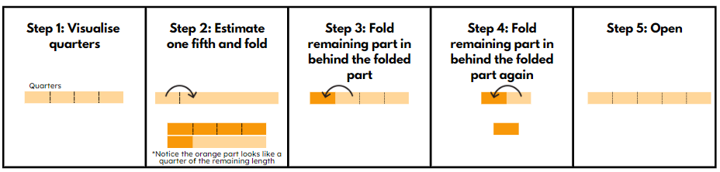
- Students explore this method of folding fifths.
- Ask:
- How did you know that the strip had been accurately partitioned into fifths? (The 5 parts are equal in size.)
- How can 10 equal parts or tenths be made from a strip folded into fifths? (The fifths can be folded in half to make tenths).
- How are tenths and fifths related multiplicatively? (10 is a multiple of five so tenths are related to fifths).
- When working with whole numbers, double 5 is 10. Why doesn’t this work for fractions? (The denominator shows how many parts one whole has been partitioned into. The larger the denominator, the smaller each part is. Tenths are smaller than fifths.)
Note: fractions behave differently to whole numbers. Students often have a misconception that any time multiplication is used as an operation, it will result in a larger number. This is not the case where multiplication involves a fraction. This results in a smaller number.
- Students fold their strip of paper to produce tenths.
- Draw a 0–1 number line on the board. Partition the line into 5 equal parts and model halving the fifths to create tenths.
- Label the number line in tenths. For example, $\frac{1}{10}$, $\frac{2}{10}$, $\frac{3}{10}$, $\frac{4}{10}$ and so on.
- Write 0.1 on the number line at the same point as $\frac{1}{10}$. Explain that even though decimals and fractions are recorded differently, they are equivalent. Both the decimal 0.1 and the fraction $\frac{1}{10}$ are read as ‘one-tenth’.
- Record the decimals 0.3, 0.5 and 0.8 on the number line. Ask:
- How would these be read? (three-tenths, five-tenths and eight-tenths)
- Can 0.5 be read as a half? Why or why not? (Yes, because five-tenths is equivalent to a half.)
- Students turn and talk about their answer, explaining their reasoning.
- Select students to record the remaining decimals on the number line.
- Display Resource 23 – representations 1. Model how to make, name and record three-tenths ( $\frac{3}{10}$ ) (see Figure 20).
Figure 20 – example of modelling and recording tenths
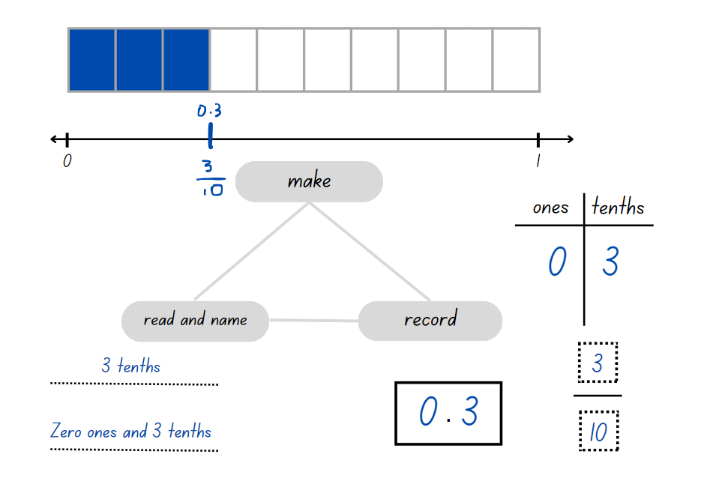
- Provide students with 2 copies of Resource 24 – representations 2.
- Students glue their strip of paper with fold lines indicating tenths at the top of Resource 24 – representations 2. They draw a number line underneath the strip. Students label their number line with decimals and fractions as tenths.
- Students complete Resource 24 – representations 2 for:
- 4 tenths
- 5 tenths
- 9 tenths
- 10 tenths.
- Regroup and ask students to share what they noticed when making, naming and recording 10 tenths. Identify that 5 tenths is a half, and 10 tenths is a whole.
- Write the numbers $1\frac{4}{10}$ and 1.4 on the board. Ask: What do you notice? What do these numbers indicate? (They are both one whole and 4 tenths.)
- Draw a number line 0–2 on the board and ask where $1\frac{4}{10}$ or 1.4 would be placed.
- Using Resource 25 – representations beyond 1, students make, name and record the multiple ways $1\frac{4}{10}$ or 1.4 can be represented.
This table details opportunities for differentiation.
Too hard? | Too easy?
Students cannot represent and compare tenths as decimals using linear representations.  - Support students to connect the partitioned fraction strip on Resource 24 – representations 2 to the number line below, representing five-tenths and ten-tenths only. | Students can represent and compare tenths as decimals using linear representations.  - Students use a number line to compare the decimals 2.1, 1.8, 0.9 and 0.3.  - Challenge students to choose some decimals for a partner to represent on a number line.

Stage 3 task – mixed bag of lollies
The table below contains suggested learning intentions and success criteria. These are best co-constructed with students.
Core concept learning intentions | Core concept success criteria
Students are learning to:  - compare common fractions with related denominators  - find fractional quantities of whole numbers. | Students can:  - order common fractions with related denominators using diagrams and number lines  - compare and represent fractions with denominators of 2, 4 and 8; 3 and 6; 5 and 10 of a whole shape (area model) and a collection of objects (discrete model)  - calculate quarters and fifths of whole numbers that are multiples of the denominator, using a tape diagram.
- Explain that in Lesson 2, students used a tape diagram to calculate the percentages of a quantity. Discuss that tape diagrams can also be used to find fractions of a quantity.
- Revisit tape diagrams by displaying Resource 26 – tape diagram example. Explain that $\frac{1}{5}$ of 30 is 6. Ask students to explain how to find four fifths ( $\frac{4}{5}$ ) of 30.
- Shade in parts on the tape diagram as students identify them, asking them to explain their reasoning. For example, ‘You can multiply 4 by 6 to get the answer of 24’.
- Pose the following question: There were 3 apple trees in the garden. Each tree had 12 apples on it. What is $\frac{1}{4}$of the total of the apples?
- Students record their thinking on an individual whiteboard using a tape diagram. Ask:
- What do we need to do prior to working out how much one-quarter ( $\frac{1}{4}$ ) is?
- How do multiplication and division help you solve this problem?
- Provide pairs of students with Resource 27 – lolly shop cards and a deck of cards with only the aces, twos, fours and fives. Remove all other cards. To play round one of the game:
- Place the lolly shop cards in one pile.
- Place the playing cards into a pile.
- Player 1 flips over 2 cards. The highest number will be the denominator. For example, if 5 and 2 are flipped the fraction will be two-fifths
( $\frac{2}{5}$ ).
- Player 1 then flips over a lolly shop card and calculates the fraction using a tape diagram.
- Player 2 repeats the same steps.
- If there is a remainder, the player loses a turn.
- Continue until all the cards have been used. The winner is the player with the most lollies after all the cards have been played.
- For a second round, students play with a different partner and now include the 3, 6 and 8 cards; only the 7s, 9s and picture cards are removed.

Consolidation and meaningful practice – 15 minutes
- Draw 2 number lines on the board with the decimals for Stage 2 students (Figure 21) and fractions for Stage 3 students (Figure 22).
Figure 21 – non-example number line with decimals (Stage 2)
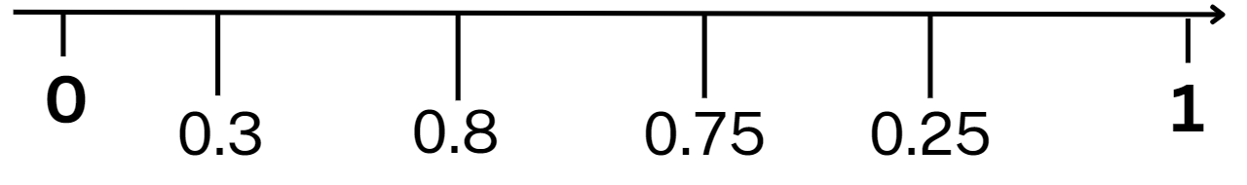
Figure 22 – non-example number line with fractions (Stage 3).
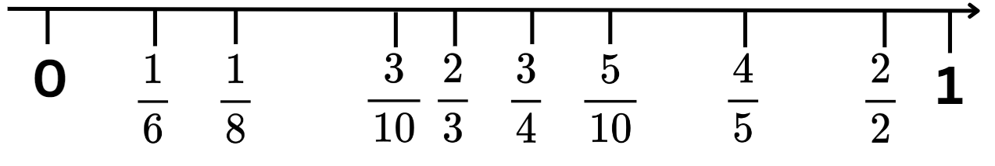
- Students turn and talk about what they notice in the image. Select students to share and explain, recording responses on the board.
The table below outlines stimulus prompts to generate conversation about the topic, along with anticipated responses from students.
Prompts | Anticipated student responses
- Do you think these decimals are in the correct order? Why or why not? If not, where do they belong? (Stage 2)  - Do you think these fractions are in the correct order? Why or why not? If not, where do they belong? (Stage 3) | - 0.8 is larger than 0.25 so should be at the other end of the number line (Stage 2).  - 0.75 is less than 0.8 so they should swap places (Stage 2).  - $\frac{1}{6}$ is larger than $\frac{1}{8}$ so should be closer to 1 (Stage 3).  - $\frac{3}{10}$ and $\frac{5}{10}$ are too close together and there is not enough space for $\frac{4}{10}$ (Stage 3).  - $\frac{4}{5}$ and $\frac{3}{4}$ are not equivalent and shouldn’t be in the same point on the number line (Stage 3).  - $\frac{2}{2}$ is equal to 1 so should be on top of the number 1.  - $\frac{5}{10}$ is equal to half so should be in the middle.
- Provide pairs of Stage 2 students with Resource 28 – decimal and fraction cards and pairs of Stage 3 students with Resource 29 – fraction cards.
- Students draw an empty number line from 0–1 on their individual whiteboards and record the correct order of numbers.
- Students turn and talk, justifying their reasoning for the ordering of the fractions and/or decimals.
- Display Resource 30 – cards in order and discuss the correct number order and strategies to ensure accuracy.
- Ask:
- Which decimal or fraction did you place first on the number line? Why?
- Which decimal or fraction did you place last? Why?
- Were the decimals or fractions in the same order as yours? Why or why not?
- Is there anything you noticed about the numbers on the number line?
- Which fractions have related denominators? (Stage 3)
- Did you see any equivalent numbers on the number line?
This table details opportunities for differentiation.
Too hard? | Too easy?
Stage 2 students cannot order the decimals on the number line  - Support students to match fractions to their decimals using their folded paper strip.  - Support students to order the decimal number cards on their labelled folded paper strip.  Stage 3 students cannot compare and represent fractions with denominators of 2, 4 and 8; 3 and 6; 5 and 10 of a whole shape (area model) and a collection of objects (discrete model).  - Support students to use only benchmark fractions when playing the lolly shop game. For example, $\frac{1}{4}$, $\frac{1}{2}$, $\frac{3}{4}$.  - Provide students with unit fractions only while playing the lolly shop game. For example, $\frac{1}{3},\frac{1}{5},\frac{1}{6},\frac{1}{8}$ and $\frac{1}{10}.$ | Stage 2 students can order the numbers on the number line  - Challenge students to create decimal number cards that sit exactly halfway between the existing cards. For example, 1.8 sits between 1.7 and 1$\frac{9}{10}$.  - Have students exchange their new cards for a partner to review.  Stage 3 students can compare and represent fractions with denominators of 2, 4 and 8; 3 and 6; 5 and 10 of a whole shape (area model) and a collection of objects (discrete model).  - Challenge students to play the game again expressing remainders as decimals and percentages.  - Pose the problem: Four-tenths ( $\frac{4}{10}$ ) of Taylor’s marbles are red. One-quarter ( $\frac{1}{4}$ ) of her marbles are blue. She has 6 more red marbles than blue marbles. How many marbles does she have altogether? How did you work out the answer? (see Figure 23).  Figure 23 – marbles answer  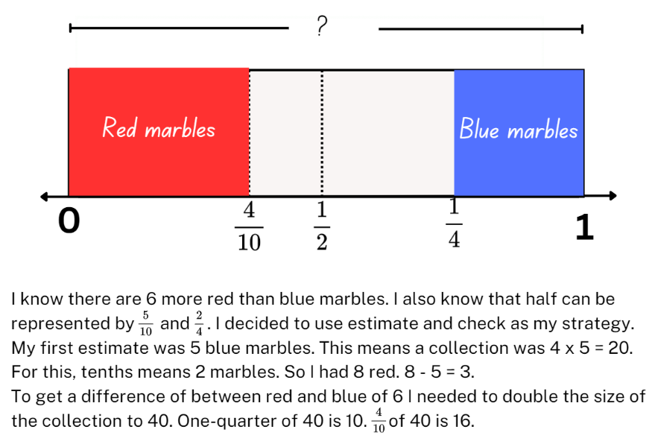
This table details opportunities for assessment.
Assessment opportunities | Links
What to look for:  - Can Stage 2 students recognise that 10-tenths is recorded as 1.0 and regroup when using decimal notation? [MAO-WM-01,  MA2-RN-02]  - Can Stage 2 students represent and compare tenths as decimals using linear representations? [MAO-WM-01, MA2-RN-02]  - Can Stage 2 students regroup fractional parts beyond one?  [MAO-WM-01, MA2-PF-01]  - Can Stage 3 students order common fractions with related denominators using diagrams and number lines? [MAO-WM-01, MA3-RQF-01]  - Can Stage 3 students compare and represent fractions with denominators of 2, 4 and 8; 3 and 6; 5 and 10 of a whole shape (area model) and a collection of objects (discrete model)?  [MAO-WM-01, MA3-RQF-01, MA3-RQF-02]  - Can Stage 3 students calculate quarters and fifths of whole numbers that are multiples of the denominator, using a tape diagram? [MAO-WM-01, MA3-RQF-01, MA3-RQF-02] | Links to National Numeracy Learning Progressions (NNLP):  - Stage 2 – NPV6, InF5  - Stage 3 – InF5, InF6, InF8.  Links to suggested Interview for Student Reasoning (IfSR) tasks:  - Stage 2 – IfSR-NP: 4D.3, 4D.7, 4D.8  - Stage 3 – IfSR-PT: 1A.9.

Lesson 6
Core concept: comparisons can be made between fractions (Stage 2) and complement principles can help find the difference (Stage 3).

Daily number sense – not following the rule – 10 minutes
The table below contains suggested learning intentions and success criteria. These are best co-constructed with students.
Daily number sense learning intentions | Daily number sense success criteria
Students working towards Stage 2 outcomes are learning to:  - generate and describe patterns.  Students working towards Stage 3 outcomes are learning to:  - represent and describe number patterns formed by multiples. | Students working towards Stage 2 outcomes can:  - model, describe and record patterns of multiples  - create and continue a variety of number patterns that increase or decrease by a constant amount.  Students working towards Stage 3 outcomes can:  - describe a pattern formed by multiples in words, in terms of multiplication rather than addition  - determine a rule describing the relationship between the bottom number and the top number in a table.
- Draw the following table of values on the board. See Table 2 (Stage 2) and Table 3 (Stage 3).
Table 2 – torches and batteries (Stage 2)
Torches | 1 | 2 | 3 | 4 | 5 | 6 | 7
Total batteries needed | 4 | 8 | 12 | 14 | 20 | 24 | 28
Table 3 – torches and batteries (Stage 3)
Torches | 1 | 3 | 7 | 2 | 4
Total batteries needed | 3 | 8 | 21 | 6 | 12
- Explain that there is an error in the table of values. Students turn and talk to identify the error.
- Select students to share their ideas with the class. Ask:
- Which value is incorrect in the table?
- How did you determine the error?
- Ask Stage 3 students:
- What is the multiplication rule describing the relationship between the bottom number and the top number in the table?
- Did the order make a difference?
- Students record the table of values in their workbook with the error corrected. Students describe the pattern formed by the multiples in the table.
- Students then create their own table of values with an error and swap with a partner to solve.
This table details opportunities for assessment.
Assessment opportunities | Links
What to look for:  - Can Stage 2 students model, describe and record patterns of multiples [MAO-WM-01, MA2-MR-01]  - Can Stage 2 students create and continue a variety of number patterns that increase or decrease by a constant amount  [MAO-WM-01, MA2-MR-01]  - Can Stage 3 students describe a pattern formed by multiples in words, in terms of multiplication rather than addition?  [MAO-WM-01, MA3-MR-01]  - Can Stage 3 students determine a rule describing the relationship between the bottom number and the top number in a table? [MAO-WM-01, MA3-MR-01] | Links to National Numeracy Learning Progressions (NNLP):  - Stage 2 – NPA3, NPA4  - Stage 3 – NPA4, NPA5.

Core lesson – 40 minutes

Stage 2 task – making, naming and recording hundredths
The table below contains suggested learning intentions and success criteria. These are best co-constructed with students.
Core concept learning intentions | Core concept success criteria
Students are learning to:  - make connections between fractions and decimal notation  - model equivalent fractions as lengths. | Students can:  - compare and order decimals of up to 2 decimal places  - make connections between fractions and decimal notation for key benchmark values  - represent the equivalence of fractions with related denominators as lengths, using concrete materials, diagrams and number lines.
Note: the concepts explored in this lesson were introduced in Stage 2 Unit 31.
- Draw a number line 0–1 on the board.
- Model marking fifths on the number line. Halve each fifth and make a mark to indicate tenths. Record tenths on the line using decimal notation.
- Pose the following problem: Bianca says that decimals could be placed on the number line between two-tenths ( $\frac{2}{10}$) and three-tenths ( $\frac{3}{10}$). Is this true?
- Students turn and talk and determine whether this statement is true.
- Display Resource 31 – tenths and hundredths. Explain that hundredths can also be placed on a number line in between tenths.
- Ask:
- If there are 10 tenths between any 2 whole numbers, how many hundredths would be between any 2 whole numbers?
- If tenths are represented with one numeral after the decimal point, how would hundredths be represented as decimals?
- How would hundredths be represented on a 0.2–0.3 number line in decimal notation? (Record the values for hundredths between 0.2 and 0.3 on Resource 31 – tenths and hundredths.)
- How are decimals with hundredths read? (For example, 0.27 is named as 27 hundredths).
- How are hundredths written as a fraction? (Highlight for students that the language of hundredths gives a clue to the fractional notation.)
Note: to support place value conceptual understanding, 5.37 would be read as ‘five and thirty-seven hundredths’. The word ‘and’ connects the decimal fraction with the whole number and makes a connection with common fractions.
- Write $\frac{1}{10}$ = $\frac{10}{100}$ on the board and ask whether this statement is true. Ensure students understand that these are equivalent fractions.
- Display Resource 32 – hundredths number line. Ask:
- What do you notice about this number line?
- How can you use the number line to prove that $\frac{1}{10}$ $=$ $\frac{10}{100}$?
- Where would 0.5 (read as 50 hundredths) be placed on this number line? How can we name this as a fraction? ($\frac{1}{2}$ or $\frac{50}{100}$)
- Where would 0.25 (read as 25 hundredths) be placed on this number line? How can we name this as a fraction? ($\frac{1}{ 4}$ or $\frac{25}{100}$)
- Display Resource 33 – hundredths and model making, naming and recording 25 hundredths (see Figure 24).
Figure 24 – example of modelling and recording hundredths
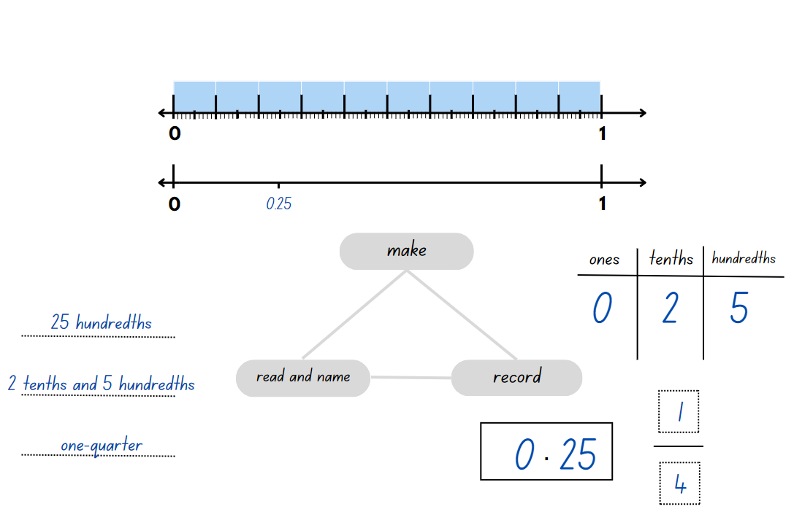
Note: when students first encounter decimals, the most common misconception is the belief that longer decimals are always larger decimals. A student who believes this will indicate that 0.75 is larger than 0.8. To reduce this misconception, establish the benchmark values $\frac{1}{2}$ = 0.5 and $\frac{1}{4}$ = 0.25. Then prompt students to pay particular attention to the digit in the tenths place as shown on a length divided into tenths.
- Students make, name and record 50 hundredths (0.5) and 75 hundredths (0.75) on Resource 33 – hundredths.
- Regroup and select students to share their work.
- Ask:
- Is 0.5 less than, equal to or greater than 0.50? (It is equal to, as both represent 5 tenths and 50 hundredths which are equivalent.)
- Is 75 hundredths $<$, = or $>$ 7 tenths and 5 hundredths? (It is equal to, as 75 hundredths are made up of 7 tenths and 5 hundredths.)
- Which is larger, 0.5 or 0.25? How do you know? (0.5 is larger as it represents 5 tenths. 0.25 represents 2 tenths and 5 hundredths.)
- Record the amounts below on the board. Students compare and order the numbers by placing them on a 0–1 number line:
- 0.25
- $\frac{2}{5}$
- 0.8
- $\frac{5}{10}$
- $\frac{75}{100}$.
This table details opportunities for differentiation.
Too hard? | Too easy?
Students cannot compare and order decimals of up to 2 decimal places.  - Refer to Resource 32 – hundredths number line to locate the decimal amounts of 0.25, 0.5 and 0.75 to support students’ understanding.  Students cannot make connections between fractions and decimal notation for key benchmark values.  - Students use Polypad – Virtual Manipulatives to make a fraction wall using fraction bars labelled with halves and quarters. They add fraction bars labelled with the equivalent decimals of 0.25 and 0.5. | Students can compare and order decimals of up to 2 decimal places.  - Students create a number line to locate and compare the numbers 2.25, 1.5, 1 $\frac{3}{4}$ and 2 $\frac{1}{2}$.  Students can make connections between fractions and decimal notation for key benchmark values.  - Challenge students to prove why 0.75 is equivalent to $\frac{3}{4}$. They use number lines or diagrams to record their thinking.

Stage 3 task – closest to the whole
The table below contains suggested learning intentions and success criteria. These are best co-constructed with students.
Core concept learning intentions | Core concept success criteria
Students are learning to:  - solve problems involving addition and subtraction of fractions with the same denominator  - use equivalence to add and subtract fractional quantities. | Students can:  - use diagrams, objects and mental strategies to subtract a unit fraction from any whole number including 1 (the complement principle)  - represent fractional quantities with the same or related denominators to add and subtract fractions.
- Demonstrate how to play ‘Closest to the whole’, by playing against the class:
- One player rolls a 9-sided die to get the starting whole number.
- Both players flip a card from Resource 34 – fractions. The card determines the fraction that will be subtracted from the starting whole number.
Note: if the 9-sided dice have zero, explain to students that it will represent 10 for this game.
- Players draw a number line on an individual whiteboard. They mark the fractional parts and record the solution above it (see Figure 25).
Figure 25 – closest to whole example
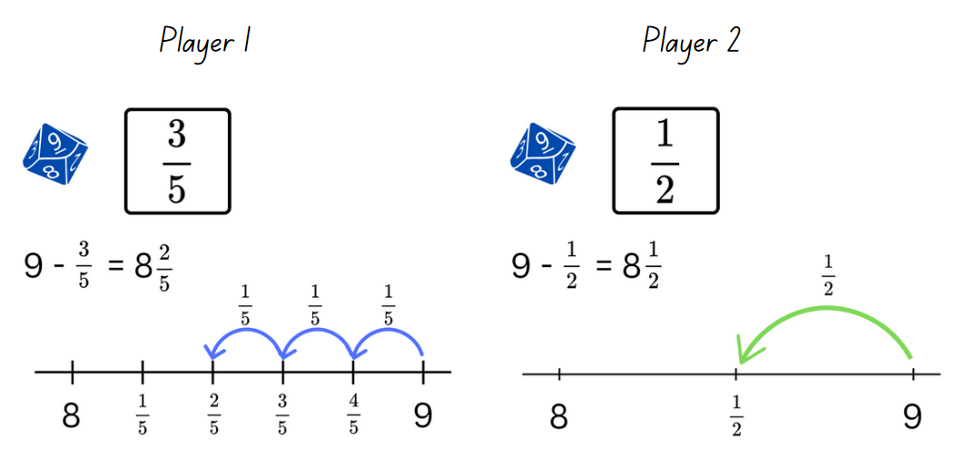
- Players discuss who is the closest to the number one less than the starting number. That player receives a point.
- Players continue taking turns rolling the die to get the starting whole. The first player to get 11 points wins.
- Once students are confident playing the game, provide individual whiteboards, a copy of Resource 34 – fractions and a 9-sided die.
This table details opportunities for differentiation.
Too hard? | Too easy?
Students cannot use diagrams, objects and mental strategies to subtract a unit fraction from any whole number including one (the complement principle).  - Provide students with only $\frac{1}{2}$, $\frac{1}{4}$ and $\frac{1}{3}$ cards from Resource 34 – fractions to support their knowledge of these unit fractions.  - Provide concrete materials, such as number chart and counters. Support students to represent the parts of the fraction, then subtract from the starting whole number. | Students can use diagrams, objects and mental strategies to subtract a unit fraction from any whole number including one (the complement principle).  - Challenge students to explain their reasoning, using a drawing or representation to justify why they are closest to the whole.  - Students select 2 cards from Resource 34 – fractions and subtract them from the starting whole number. The player closest to a whole who can justify their answer, wins.

Discuss and connect the mathematics – 10 minutes
- Display Resource 35 – Maths Busters decimals. Explain that the Maths Busters team received an email from Banjo. He is asking for help to prove or disprove Rebecca’s statements.
- In pairs, students reason and justify their thinking to prove or disprove each number sentence. They decide whether Banjo’s statements: ‘longer decimals are always larger decimals’, and ‘fractions with larger denominators are always larger fractions’, are true or false.
Note: Stage 2 students discuss decimals and Stage 3 students discuss the fractions.
The table below outlines number sentence prompts to generate conversation about the topic, along with anticipated responses from students.
Number sentence prompts | Anticipated student responses
0.75 > 0.8 | - 0.75 represents 75 hundredths. 0.8 represents 8 tenths which is equivalent to 80 hundredths. This number sentence is false and proves that Rebecca’s statement is false. 75 is a bigger whole number than 8, so maybe Rebecca thought 0.75 was a larger decimal. She thinks decimals behave the same way as whole numbers.  - In 0.75 (75 hundredths) there are 7 tenths and 5 hundredths. In 0.8 there are 8 tenths. 8 tenths is greater than 7 tenths. Rebecca’s statement is false.
0.25 > 0.7 | - 0.7 is greater than 0.25. Rebecca’s statement is incorrect.  - In 0.25 there are 2 tenths and 5 hundredths. In 0.7 there are 7 tenths. 7 tenths is greater than 2 tenths. This proves that Rebecca’s statement is false.
0.40 > 0.4 | - The extra zero in 0.40 just means there are 4 tenths and zero hundredths. 0.40 and 0.4 are equivalent, so this number sentence is false and proves that Rebecca is incorrect, and her statement is a myth.
$\frac{1}{3}$ > $\frac{1}{8}$ | - Rebecca is correct because one-third of a whole is larger than one-eighth of a whole.
$\frac{1}{85}$ > $\frac{1}{8}$ | - Rebecca is incorrect because one eighty-fifth of a whole is much smaller than one-eighth of a whole.
$\frac{1}{6}$ > $\frac{1}{5}$ | - Rebecca is incorrect because one-sixth of a whole is smaller than one-fifth of a whole.
$\frac{1}{10}$ > $\frac{1}{4}$ | - Rebecca is incorrect because one-tenth of a whole is much smaller than one-quarter of a whole.
This table details opportunities for differentiation.
Assessment opportunities | Links
What to look for:  - Can Stage 2 students compare and order decimals of up to 2 decimal places? [MAO-WM-01, MA2-RN-02]  - Can Stage 2 students make connections between fractions and decimal notation for key benchmark values? [MAO-WM-01,  MA2-RN-02]  - Can Stage 2 students represent the equivalence of fractions with related denominators as lengths, using concrete materials, diagrams and number lines? [MAO-WM-01, MA2-PF-01]  - Can Stage 3 students use diagrams, objects and mental strategies to subtract a unit fraction from any whole number including 1 (the complement principle)? [MAO-WM-01, MA3-RQF-02]  - Can Stage 3 students represent fractional quantities with the same or related denominators to add and subtract fractions?  [MAO-WM-01, MA3-RQF-02] | Links to National Numeracy Learning Progressions (NNLP):  - Stage 2 – NPV6, NPV7, InF5, InF6  - Stage 3 – InF7, InF8.  Links to suggested Interview for Student Reasoning (IfSR) tasks:  - Stage 2 – IfSR-NP: 4D.3, 4D.4, 4D.7, 4D.8.

Lesson 7
Core concept: fractions can be compared and used to solve problems.

Daily number sense – number pattern – 15 minutes
The table below contains suggested learning intentions and success criteria. These are best co-constructed with students.
Daily number sense learning intentions | Daily number sense success criteria
Students working towards Stage 2 outcomes are learning to:  - generate and describe patterns.  Students working towards Stage 3 outcomes are learning to:  - represent and describe number patterns formed by multiples. | Students working towards Stage 2 outcomes can:  - model, describe and record patterns of multiples  - create and continue a variety of number patterns that increase or decrease by a constant amount.  Students working towards Stage 3 outcomes can:  - determine a rule describing the relationship between the bottom number and the top number in a table.
This activity is an adaptation of Fencing the freeway (PDF 70 KB) by the State of Victoria (DEECD).
- Explain that a deer farmer wants to fence the paddock to keep the deer safe. Draw the following table of values that represents the fencing requirements. See Table 4 for Stage 2 and Table 5 for Stage 3.
- Explain to Stage 2 that for every one metre of fencing, the farmer will need 5 wire clips.
Table 4 –fencing and wire clips (Stage 2)
Length of fencing (metres) | 1 | 2 | 3 | 4 | 5 | 10 | 12
Number of wire clips | 5 | 10 | 15 | 20 | 25 | ... | ...
- Explain to Stage 3 that the farmer will need a post for every 3 metres of fencing and one at each end.
Table 5 –fencing and posts (Stage 3)
Length of fencing (metres) | 3 | 6 | 9 | 12 | 15 | 27
Number of posts | 2 | 3 | 4 | 5 | 6 | ...
- Ask if Stage 3 can identify the rule to describe the relationship between the length of fencing and number of posts. If not identified, explain that in this example, the number of posts required is determined by:
- the total length of fencing ÷ 3 + 1 starting post
- −1 starting post × 3 posts.
- Ask Stage 2:
- Can you explain the pattern?
- How could you use the term multiples to help you describe the pattern in the number of wire clips needed?
- Stage 2 calculate the number of wire clips needed for 10 and 12 metres of fence to complete the table in their workbooks.
- Stage 3 calculate the number of posts needed for 27 metres of fence to complete the table in their workbooks.
- Stage 2 then calculate and record the number of wire clips needed for the following lengths:
- 8 metres of fencing (45 wire clips)
- 11 metres of fencing (55 wire clips)
- 20 metres of fencing (100 wire clips).
- Stage 3 then calculate and record the number of posts of length of fence needed for the following:
- 90 metres of fencing (31 posts)
- 240 metres of fencing (81 posts)
- 72 posts (25 posts).
- Regroup as a class and select students to share and justify their calculations.
This table details opportunities for assessment.
Assessment opportunities | Links
What to look for:  - Can Stage 2 students model, describe and record patterns of multiples? [MAO-WM-01, MA2-MR-01]  - Can Stage 2 students create and continue a variety of number patterns that increase or decrease by a constant amount?  [MAO-WM-01, MA2-MR-01]  - Can Stage 3 students determine a rule describing the relationship between the bottom number and the top number in a table? [MAO-WM-01, MA3-MR-01] | Links to National Numeracy Learning Progressions (NNLP):  - Stage 2 – NPA3, NPA4  - Stage 3 – NPA5.

Core lesson – 40 minutes

Stage 2 task – fractions and decimals – 40 minutes
The table below contains suggested learning intentions and success criteria. These are best co-constructed with students.
Core concept learning intentions | Core concept success criteria
Students are learning to:  - model equivalent fractions as lengths  - represent fractional quantities equal to and greater than one. | Students can:  - represent the equivalence of fractions with related denominators as lengths, using concrete materials, diagrams and number lines  - determine the relative location of one-quarter and one-half when a number line extends beyond one.
- Display and provide students with a copy of Resource 36 – number line 0–3.
- Explain that fractional amounts can also be represented in decimal notation. They can also be renamed to represent fractional quantities equal to and greater than one.
- Students complete Resource 36 – number line 0–3 by:
- recording the equivalent decimal notation for each fraction on the grey cards in the second row
- renaming and recording these on the white cards in the third row (see Figure 26).
Figure 26 – example of number line 0-3
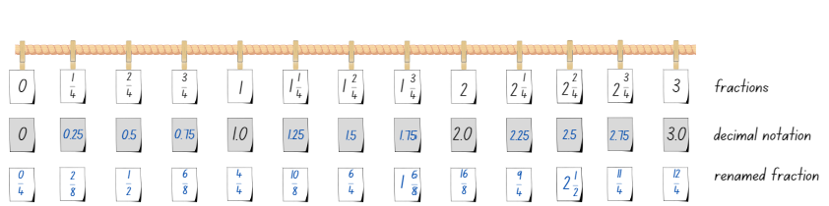
- Regroup as a class and ask students to compare their work with a partner.
- Students share their responses about the renamed fractions. Ensure they understand that equivalent fractions can be renamed in multiple ways. There can be more than one correct way of representing the amount.
- Using Resource 36 – number line 0–3, students identify a number:
- between 2 and 3
- very close to 3
- as a decimal between 2 and 3
- equivalent to 0.75.
- Provide copies of Resource 37 – missing symbols. Students use the less or greater than and equal symbols to make each number sentence true.
- Students use Resource 37 – missing symbols to create and record 2 number sentences with missing symbols for a partner to solve.

Stage 3 task 1 – adding and subtracting fractions – 25 minutes
The table below contains a suggested learning intention and success criteria. These are best co-constructed with students.
Core concept learning intention | Core concept success criteria
Students are learning to:  - use equivalence to add and subtract fractional quantities. | Students can:  - solve word problems involving adding or subtracting fractional quantities with related denominators  - represent fractional quantities with the same or related denominators to add and subtract fractions.
This activity is an adaptation of ‘Addition and Subtraction’ from Primary and Middle Years Mathematics: Teaching Developmentally by Van de Walle et al.
- Write the problem: Dan runs 2 $\frac{1}{2}$ kilometres a day. If he just passed the 1 $\frac{1}{4}$ kilometre mark, how far does he still need to go?
- Model a think-aloud on how to read the problem, find the important information and what operation is required to solve (see Figure 27).
Figure 27 – think aloud example
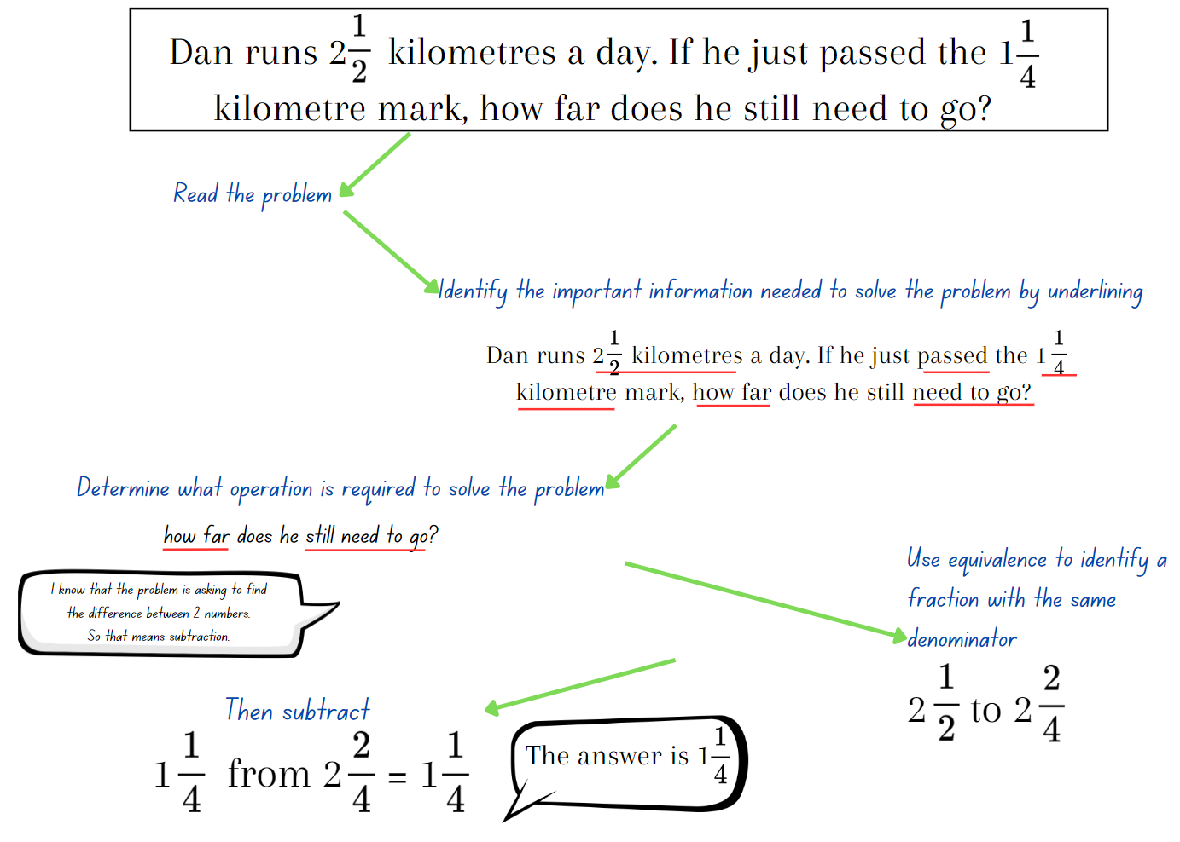
- Provide students with Resource 38 – fraction problems. Remind students to follow the steps as modelled in the think aloud, as the problems may be either addition or subtraction.
- Regroup as a class and ask:
- How did you work out what operation the problem was asking you to use?
- How did you use equivalence to identify a fraction with the same denominator?
- Did you find subtracting or adding more challenging? Explain your reasoning.

Stage 3 task 2 – adding and subtracting fraction problems – 15 minutes
This activity is adapted from ‘Gardening together’ from Primary and Middle Years Mathematics: Teaching Developmentally by Van de Walle et al.
- Pose the problem: Annie, Ben, Crystal, Danica, Hank and Fletcher are each given a portion of the school garden for spring planting. The portions are:
- Annie = $\frac{1}{4}$
- Ben = $\frac{1}{8}$
- Crystal = $\frac{3}{16}$
- Danica = $\frac{1}{16}$
- Hank = $\frac{1}{4}$
- Fletcher = $\frac{1}{8}$.
Note: the expectation for Stage 3 students is to add and subtracting fractional quantities with the related denominators of 4 and 8. The related denominator of 16 was previously explored in Stage 3 Year A Unit 24 Lesson 3. If students are finding it challenging to work with fractions with the denominator of 16 in this task, it can be adapted to include fractions with denominators of 4 and 8 only. For example, Crystal and Danica can have a one-eighth ( $\frac{1}{8}$ ) portion of the garden each instead.
- The students decided to work together and combine their parts. What fraction of the garden will each of the following groups have if they combine their portions of the garden? The groups are:
- Ben and Danica
- Annie and Crystal
- Fletcher and Hank
- Crystal, Fletcher and Annie.
- Students draw the garden in their answers in their workbook, labelling it to explain their thinking.
Note: some students may require the area model to help with solving the problem. Draw a large empty rectangle on a piece of paper and assist students with partitioning it into the required portions.
- Regroup as a class and ask:
- Which group had the biggest portion of the garden?
- Which group had the smallest portion of the garden?
- How did you use equivalence to identify a fraction with the same denominator in the problem?
This table details opportunities for differentiation.
Too hard? | Too easy?
Stage 2 students cannot represent the equivalence of fractions with related denominators as lengths, using concrete materials, diagrams and number lines.  - Model using paper strips to create a fraction wall, supporting students to identify equivalent fractions. They draw a number line underneath each strip as they build the fraction wall and label the equivalent fractions. Students glue their fraction wall into their workbooks.  Stage 3 students cannot solve word problems involving adding or subtracting fractional quantities with related denominators.  - Support students to draw a bar model to represent the word problem. Assist them to shade and label the bar model to solve the problem.  - Provide students with problems that contain fractions with the same denominator. For example, Francis ate $\frac{3}{8}$ of a pizza and then $\frac{4}{8}$ of the pizza. How much pizza did he eat? | Stage 2 students can represent the equivalence of fractions with related denominators as lengths, using concrete materials, diagrams and number lines.  - Ask: Can you prove that $\frac{16}{10}$ and $1\frac{3}{5}$ are equivalent fractions? Students use Polypad – Virtual Manipulatives to create a representation proving that $\frac{16}{10}$ and $1\frac{3}{5}$ are equivalent fractions.  Stage 3 students can solve word problems involving adding or subtracting fractional quantities with related denominators.  - Ask students to create their own fraction word problems. Students swap problems with a partner and solve each other’s problems by using diagrams and fractional notation.  - Provide students with the equation: ? $\frac{?}{?}$ + ? $\frac{?}{?}$ = 7. Explain to students that all the missing digits in this question are different. What might the missing digits be?

Consolidation and meaningful practice – 10 minutes
This activity is an adaption of ‘What's the split?’ from Maths Teaching Circles by Epstein.
- Draw the fractions and decimals as shown in Figure 28 for Stage 2.
Figure 28 – fractions and decimals (Stage 2)
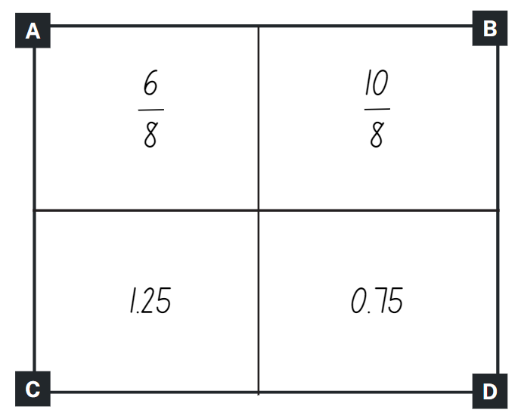
- Stage 2 students sort the 4 representations into 2 groups.
- Select Stage 2 students to share their groupings and provide justification for their choices.
Note: the 2 groups do not need to be equal. For example, one group may have one representation and the other group may have 3. Students must be able to reason as to why they have organised the representations into each group. This task is dependent on students’ ability to reason and provide justifications for their choices.
The table below outlines possible solutions, along with anticipated responses from Stage 2.
Possible Stage 2 solutions | Anticipated Stage 2 responses
- Group 1: A and B. Group 2: C and D. | - A and B are written in fraction notation. C and D are written in decimal notation.
- Group 1: B and C. Group 2: A and D. | - B and C both exceed one whole.  - A and D are equivalent as $\frac{6}{8}$ is the same as 0.75. B and C are equivalent as $\frac{10}{8}$ is the same as 1.25.
This activity is an adaptation of ‘Adding and Subtracting Fractions’ from Challenging Mathematical Tasks by Sullivan.
- Pose the following problem to Stage 3 students: I did a fraction addition question on the computer, but when I printed it out some of the numbers did not print. What might the missing numbers be?
- Write the following equation on the board for Stage 3 students: 2 $\frac{?}{4}$ + $\frac{?}{8}$ = 3$.$
- Stage 3 students record as many possibilities as they can think of on individual whiteboards. For example, 2$\frac{1}{4}$ + $\frac{6}{8}$ = 3, 2 $\frac{3}{4}$ + $\frac{2}{8}$ = 3, 2 $\frac{2}{4}$ + $\frac{4}{8}$ = 3.
- Allow Stage 3 students to turn and talk, then share and explain their answers. Record student responses and test using the bar model method.
This table details opportunities for differentiation.
Assessment opportunities | Links
What to look for:  - Can Stage 2 students represent the equivalence of fractions with related denominators as lengths, using concrete materials, diagrams and number lines? [MAO-WM-01, MA2-PF-01]  - Can Stage 2 students determine the relative location of one-quarter and one-half when a number line extends beyond one? [MAO-WM-01, MA2-PF-01]  - Can Stage 3 students solve word problems involving adding or subtracting fractional quantities with related denominators?  [MAO-WM-01, MA3-RQF-02]  - Can Stage 3 students represent fractional quantities with the same or related denominators to add and subtract fractions?  [MAO-WM-01, MA3-RQF-02] | Links to National Numeracy Learning Progressions (NNLP):  - Stage 2 – InF5, InF6.  - Stage 3 – InF8.  Links to suggested Interview for Student Reasoning (IfSR) tasks:  - Stage 2 – IfSR-NP: 4D.3, 4D.4, 4D.7, 4D.8.  - Stage 3 – IfSR-MT: 4B.1.

Lesson 8
Core concept: mathematicians solve problems with fractions.

Daily number sense – 10 minutes
- From a class need surfaced through formative assessment data, identify a short, focused activity that targets students’ knowledge, understanding and skills. Example activities may be drawn from the following resources:
- Mathematics K–6 resources
- Universal Resources Hub.

Core lesson – 35 minutes

Stage 2 task – become the teacher
The table below contains suggested learning intentions and success criteria. These are best co-constructed with students.
Core concept learning intentions | Core concept success criteria
Students are learning to:  - make connections between fractions and decimal notation  - represent fractional quantities equal to and greater than one. | Students can:  - compare and order decimals of up to 2 decimal places  - represent totals of halves, thirds, quarters and fifths that extend beyond one.
- Display Resource 39 – student misconceptions. Explain that 3 students from Oceanview Public School completed a task similar to the one in Lesson 4, but they made some mistakes.
- Students Think-Pair-Share to discuss what they notice.
- In pairs, students select either Estelle, Jaxon or Samuel’s work sample.
- Ask pairs to consider:
- What mistakes has the student made and why might this have happened?
- If you were the teacher, how would you explain and support the student to correct their mistakes?
- Pairs use writing materials or digital devices to answer these questions. Encourage the use of mathematical vocabulary and detailed explanations.
- If available, students create a recording to explain their diagrams and number lines, using digital devices with a voiceover function.
Note: this is an opportunity for formative assessment. It can provide information on student progress and inform future teaching.
The table below identifies possible misconceptions to address for each student as well as ways to support their understanding.
Student | Possible misconceptions to address and ways to support student understanding
Estelle | - Estelle understands that the fractional pieces increase by the same amount each time. She understands that beyond one, fractions are represented as one whole and a fractional part, for example $1\frac{1}{3}$. Estelle has misunderstood how many parts the line has been partitioned into (thirds instead of quarters). This may be because there are 3 lines marked in between each whole number.  - Estelle may benefit from further support finding fractions of a line, segmenting a strip of paper and labelling each fractional part ‘one-quarter’, prior to finding fractions on a line. By looking at the number of segments, rather than the number of marks made, she may be supported to correctly identify the fractions. Pasting the strip on a piece of paper and drawing a number line directly below may support Estelle to see the relationship between 4 quarters and one whole.
Jaxon | - Jaxon has correctly labelled the number line from zero to one. He has misunderstood how to represent fractional quantities equal to and greater than one. Jaxon’s work sample indicates that he is unable to correctly label fractions on a number line that extends beyond one. He also needs support renaming 4 quarters as one whole.  - Jaxon may benefit from being provided with 2 strips of paper, both folded into quarters. It may be useful for him to label the fractional parts of the strip, then transfer this to a number line. Being able to physically see one whole, and then an additional whole, Jaxon can be supported to represent fractions on a number line that extends beyond one.
Samuel | - Samuel has misunderstood how many parts the line has been partitioned into (thirds instead of quarters). He also has a misunderstanding around tenths and hundredths, as he has labelled the number line from 1–2 in hundredths.  - Samuel may benefit from seeing 2 number lines that illustrate $\frac{1}{2}$ is the same as 0.5, $\frac{1}{4}$ is the same as 0.25 and $\frac{3}{4}$ is the same as 0.75. Connecting fraction strips showing tenths to a number line marked in hundredths, may further support him to understand tenths and hundredths.
- Students participate in a gallery walk to view the tutorials or explanations.
- Regroup and ask:
- What did you find challenging about explaining how to correct the misconceptions to the student?
- What is something another group did well in their explanation that could help Estelle, Jaxon or Samuel?
- What advice would you give someone who is learning about fractions for the first time?

Stage 3 task – equal or unequal chance
The table below contains suggested learning intentions and success criteria. These are best co-constructed with students.
Core concept learning intentions | Core concept success criteria
Students are learning to:  - create random generators and describe probabilities using fractions. | Students can:  - record the outcomes for chance experiments where the outcomes are not equally likely to occur and assign probabilities to the outcomes using fractions  - use knowledge of benchmark fractions, decimals and percentages to assign probabilities to the likelihood of outcomes.
- Revise students' knowledge of chance and equal chance by asking what activities have an equal chance outcome. Remind students that the total of the probabilities of the outcomes in a chance experiment equals one.
- Students turn and talk, discussing activities that have equal chance outcomes. Select students to share and explain their answers. If not discussed, highlight that flipping a heads or tails has an equal chance and rolling a die has equal chance outcomes. Ask:
- How do I record the fraction of flipping a heads or tails? ( $\frac{1}{2}$ )
- How is the chance of flipping a coin recorded with decimals and percentages? (0.5 and 50%)
- How is the chance of rolling a 6 on a die recorded with fractions? ($\frac{1}{6}$ )
- Place 24 interlocking cubes in an opaque bag; 12 red, 8 green and 4 blue. Tell students the total number of cubes and how many of each colour there are.
- Students turn and talk discussing the fraction, decimals and percentages of each colour in the bag. Select students to share and explain their thinking, recording the answers on the board. For example, red = $\frac{1}{2}$, 0.50 and 50%.
- Students draw Table 6 in the workbook and discuss the predicted outcome. For example, red should be selected more often than green and blue. It is more likely that red will occur than green and blue.
Table 6 – colour of cubes
Colour selected | Number of cubes
Red
Green
Blue
- Choose several students to select a cube from the bag and record the colour selected using tally marks.
- Discuss the results and see if it matches predictions.
- Display and provide students with Resource 40 – equal and unequal spinners. Explain that they will create both an equal and unequal chance spinner and each spinner must have purple, red, green, blue and orange sections. For the unequal chance spinner, students can choose the fractional part for each colour.
- Once students have created their spinners, they record the fraction, decimals and percentages of each colour and predict the outcome of using spinners in a game. For example, purple = $\frac{1}{5}$, 20% and 0.2.
This table details opportunities for differentiation.
Too hard? | Too easy?
Stage 2 students cannot compare and order decimals of up to 2 decimal places.  - In small groups, present a jumbled sequence of decimals using sticky notes, such as 0.15, 0.35, 0.45, 0.25. Support students to use Polypad – number tiles and cubes to create visual representations for each decimal amount, then correctly sequence these in ascending order.  Stage 2 students cannot represent totals of halves, thirds, quarters and fifths that extend beyond one.  - Place sticky notes with fractions, $\frac{1}{4}$, $\frac{2}{4}$, $\frac{3}{4}$ on a masking tape line that is labelled 0–1. Display sticky notes with $\frac{5}{4}$, $\frac{6}{4}$, $\frac{7}{4}$ and $\frac{8}{4}$. Students problem solve what needs to be done to the masking tape number line to include all the additional fractions.  Stage 3 students cannot create random generators and describe probabilities using fractions, decimals and percentages.  - Support students to create a random generator spinner with only 3 colours with one colour being more than the half.  - Students describe the probabilities of only half. Support students to recognise that half is $\frac{1}{2}$ in fractions, 0.5 in decimals and 50%. | Stage 2 students can compare and order decimals of up to 2 decimal places.  - Students play Spiralling decimals from NRICH.  Stage 2 students can represent totals of halves, thirds, quarters and fifths that extend beyond one.  - Students represent totals of sixths, eighths and tenths on a number line 0–3. They then rename the fractional amount beyond one in multiple ways. For example, $\frac{8}{6}$ and $1\frac{2}{6}$.  Stage 3 students can create random generators and describe probabilities using fractions, decimals and percentages.  - Play Mystery Spinner Challenge from ABC Education. Students recreate a mystery spinner to try and match the results on the graph.  - Conduct an experiment: Cup toss. Predict out of 20 tosses what fraction, decimal and percentage of tosses will be upside down, right-side up and on its side. Record the results of the experiment and compare to initial predictions.

Consolidation and meaningful practice – 15 minutes
- Provide stage-based pairs of students with Resource 41 – gameboard and counters.
- Tell Stage 3 that they will use their created spinners to play the game. One student will use the equal chance spinner and the partner will use the unequal chance spinner.
- Stage 3 players take turns spinning for the colour that they will move to next. For example, if player one spins red, they will move to the next red box along the gameboard. The winner is the first player to spin green to land on the finish box.
- Provide Stage 2 students with Resource 42 – fractions spinners.
- Tell Stage 2 that they will use their spinners to play the game. Pairs use the halves spinner to begin. Players take turns to spin and move their counter on the gameboard, moving one space for every half ( $\frac{1}{2}$ ) represented by the fraction or decimal shown. For example, if a player spins 1.5, the player would move ahead 3 spaces. The winner is the first player to land on or go past the finish box.
- When the first game is finished, pairs repeat the game using the quarters spinner. Players move one space for every quarter ( $\frac{1}{4}$ ) represented by the fraction or decimal shown. For example, if a player spins three-quarters$( \frac{3}{4}$ ), the player would move ahead 3 spaces.
- Once Stage 3 have played the game, ask:
- Did the equal or unequal spinner player win?
- Was the outcome the same as you predicted?
- Did having different spinners make a difference to the game? Why or why not?
- Would the outcome of the game always be the same? Explain.
- Once Stage 2 have played both games, ask:
- What did you need to understand about fractions and decimals to play this game?
- Can you explain your thinking when playing this game?
This table details opportunities for assessment.
Assessment opportunities | Links
What to look for:  - Can Stage 2 students compare and order decimals of up to 2 decimal places? [MAO-WM-01, MA2-RN-02]  - Can Stage 2 students represent totals of halves, thirds, quarters and fifths that extend beyond one? [MAO-WM-01, MA2-PF-01]  - Can Stage 3 students record the outcomes for chance experiments where the outcomes are not equally likely to occur and assign probabilities to the outcomes using fractions?  [MAO-WM-01, MA3-CHAN-01]  - Can Stage 3 students use knowledge of benchmark fractions, decimals and percentages to assign probabilities to the likelihood of outcomes? [MAO-WM-01, MA3-CHAN-01] | Links to National Numeracy Learning Progressions (NNLP):  - Stage 2 – NPV6, NPV7, InF5  - Stage 3 – UnC4, InF6, PrT3.  Links to suggested Interview for Student Reasoning (IfSR) tasks:  - Stage 2 – IfSR-NP: 4D.3, 4D.4, 4D.8.

Resource 1 – Zainab’s work sample
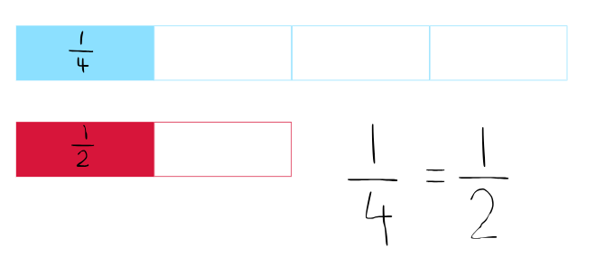

Resource 2 – fraction comparisons
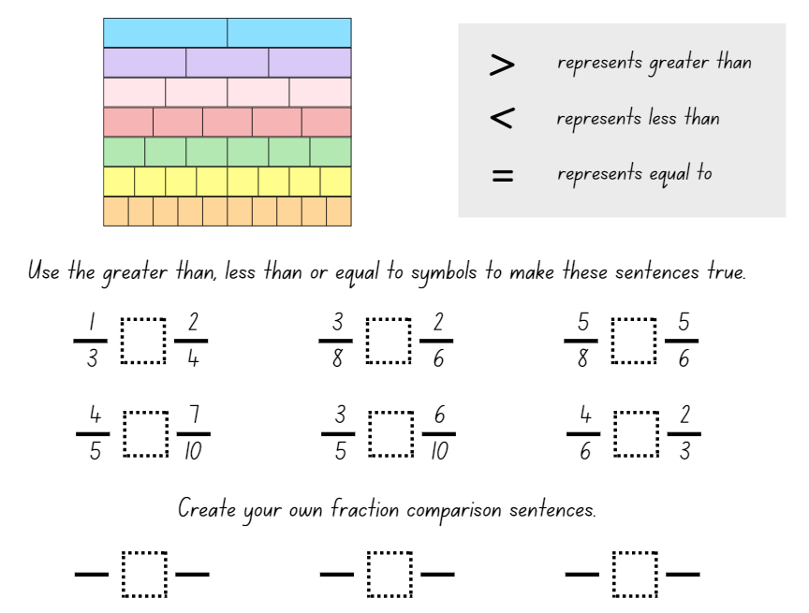

Resource 3 – mathematical reasoning prompts
Questions to prompt mathematical reasoning | Questions for collaborative reasoning | Questions to make connections with mathematical reasoning | Questions to reflect on mathematical reasoning
- What is this problem about?  - Could you reword that in a simpler way?  - How did you begin to think about this problem?  - What is another way you could solve this problem?  - How could you prove ______?  - Can you break the problem into parts? What would the parts be?  - How could you organise your thinking? | - What strategy did you use? Can you convince us why it makes sense?  - What do others think about this?  - Did anyone get a different answer?  - How would you explain this to someone who was away today? | - Did you see any mathematical connections or relationships?  - What ideas have we explored before that were useful in solving this problem?  - Is there a pattern? Is there a general rule?  - What was one thing you learned (or two, or more)?  - What were the mathematical ideas in this problem?  - What are the variables in this problem? What stays constant? | - Is this a reasonable answer? Does it make sense?  - Why do you think that? Why is that true?  - Will that strategy always work?  - Can you draw a picture or make a model to show that?  - Does anyone want to revise his or her answer?  - How were you sure your answer was right?
Adapted from Kersaint (2017).

Resource 4 – the whole strip
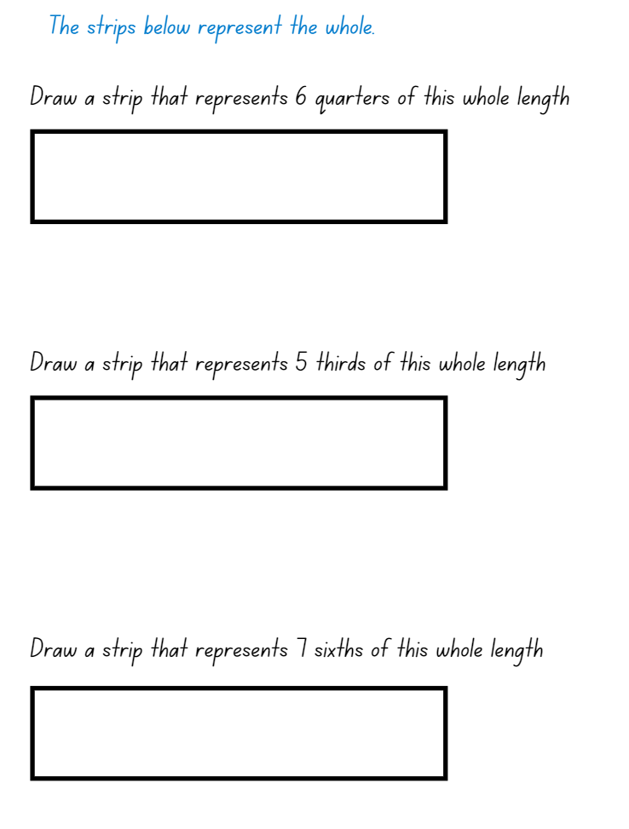

Resource 5 – student non-example
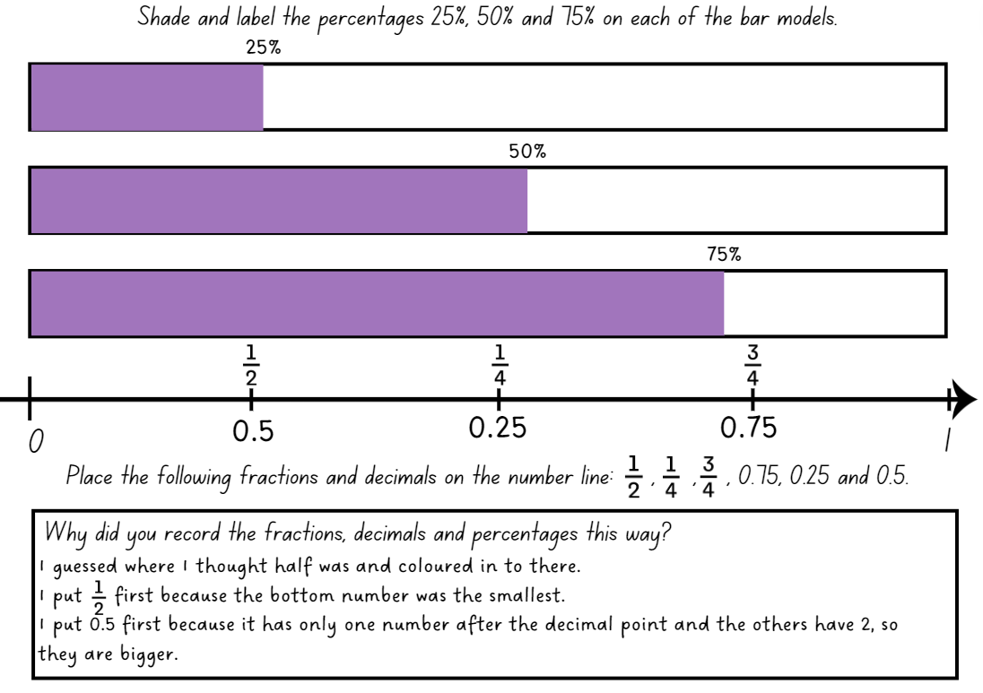

Resource 6 – equivalent fractions
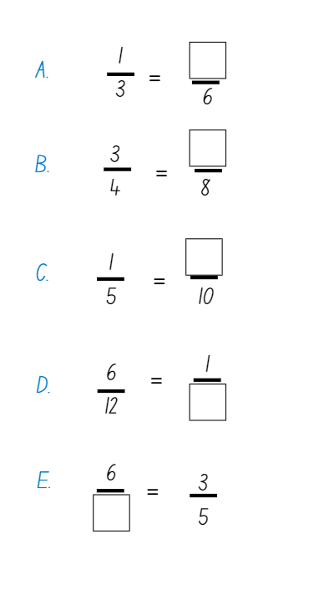

Resource 7 – tape diagrams
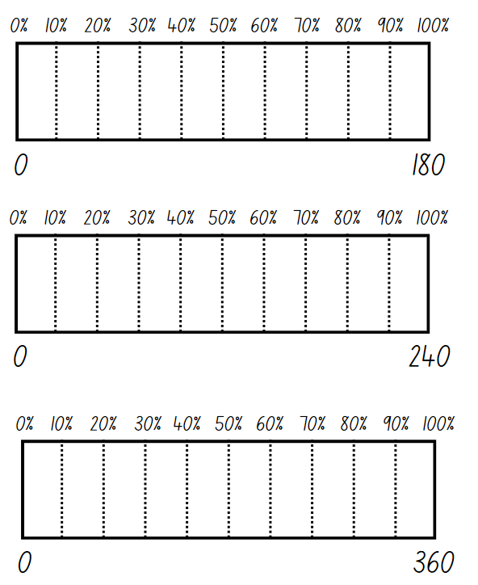

Resource 8 – water jugs 1
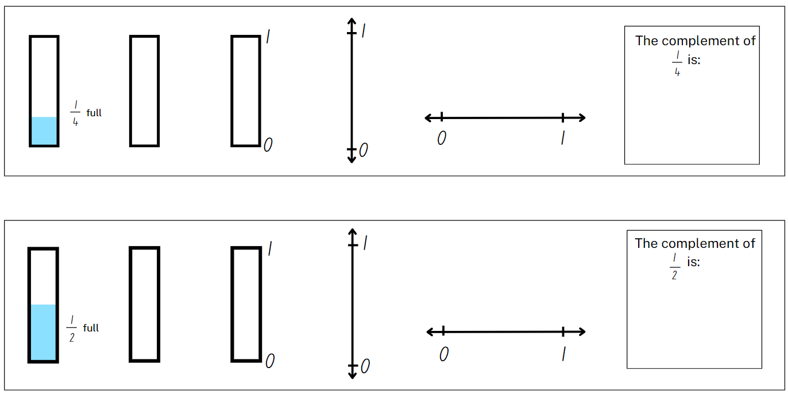

Resource 9 – water jugs 2
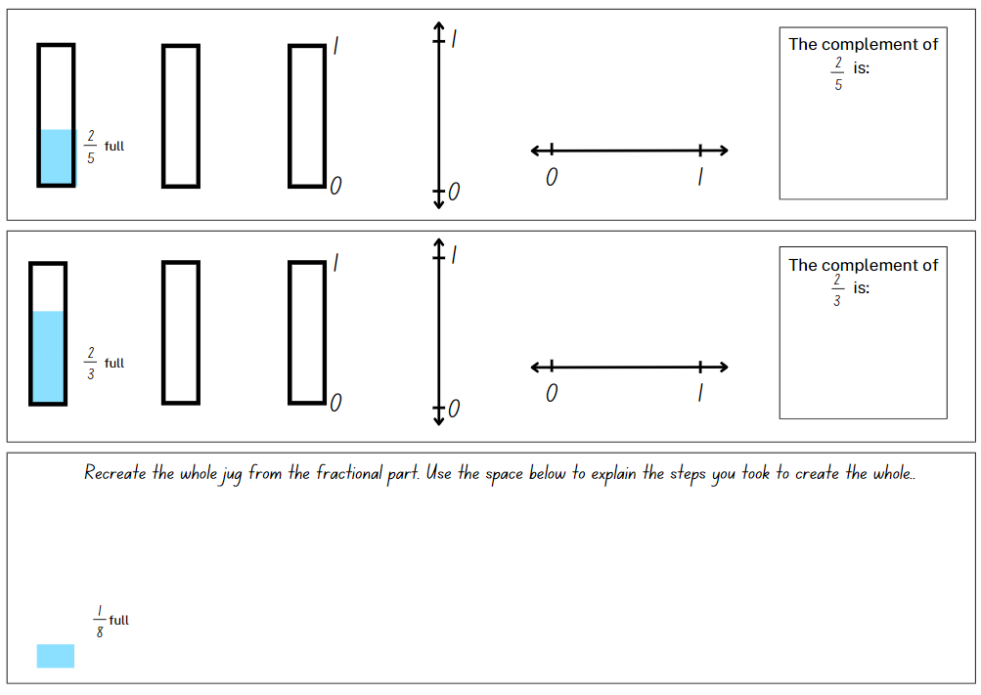

Resource 10 – representing tenths
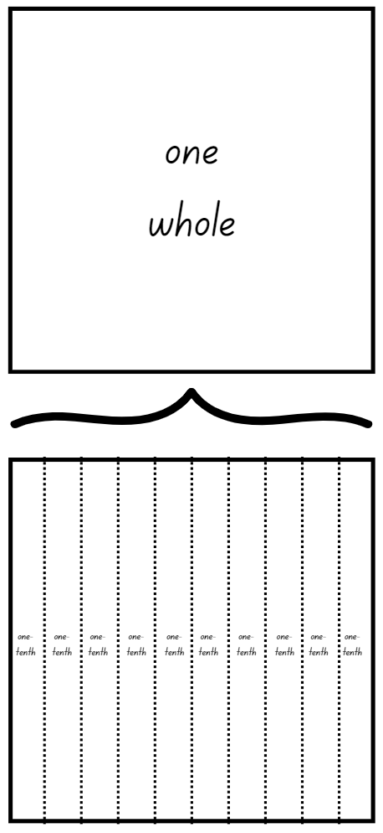

Resource 11 – 100 grid
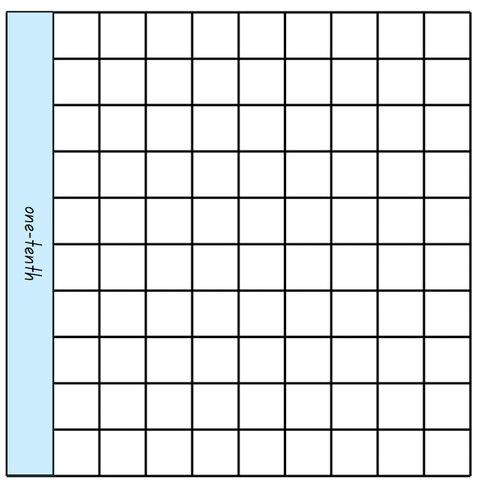

Resource 12 – blank 100 grids
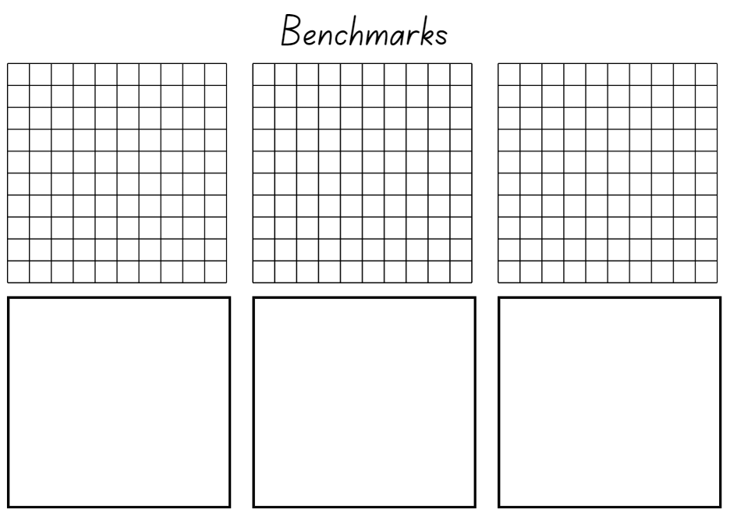

Resource 13 – whole water jug
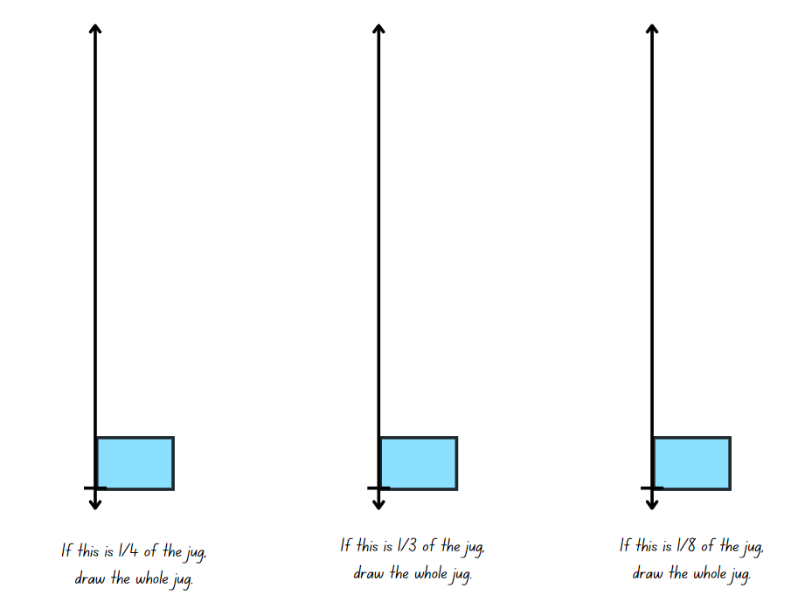

Resource 14 – 10% sale
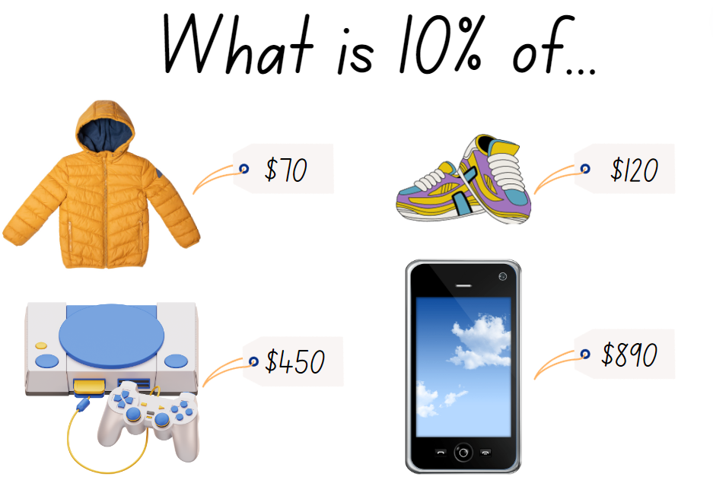

Resource 15 – 0–2 number lines
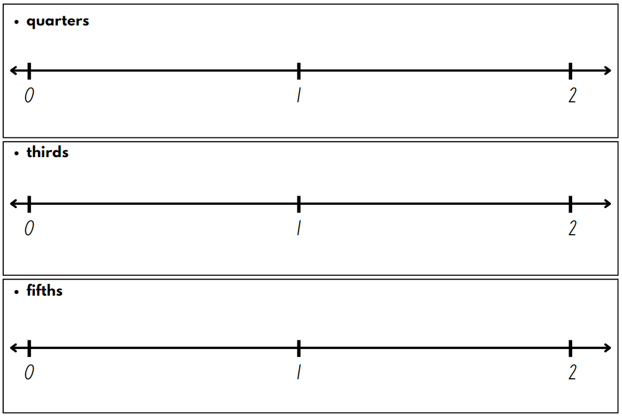

Resource 16 – fraction patterns
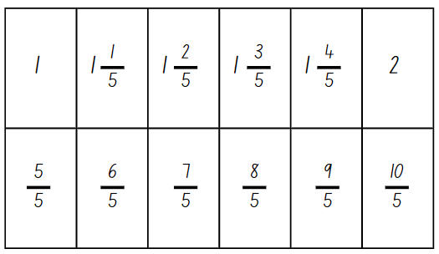

Resource 17 – rectangle fractions
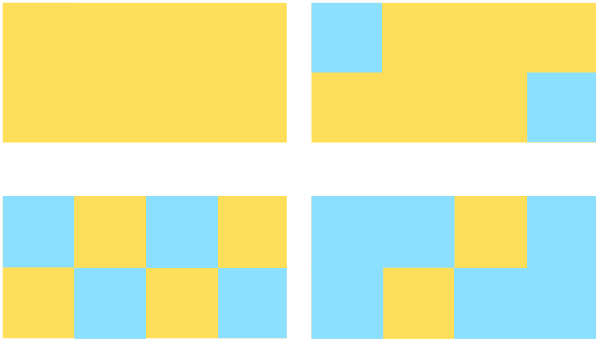

Resource 18 – area model fractions
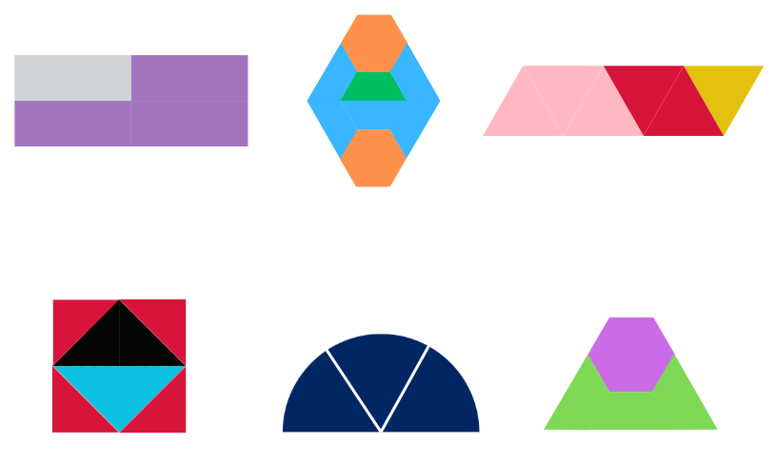

Resource 19 – partitioning hexagons
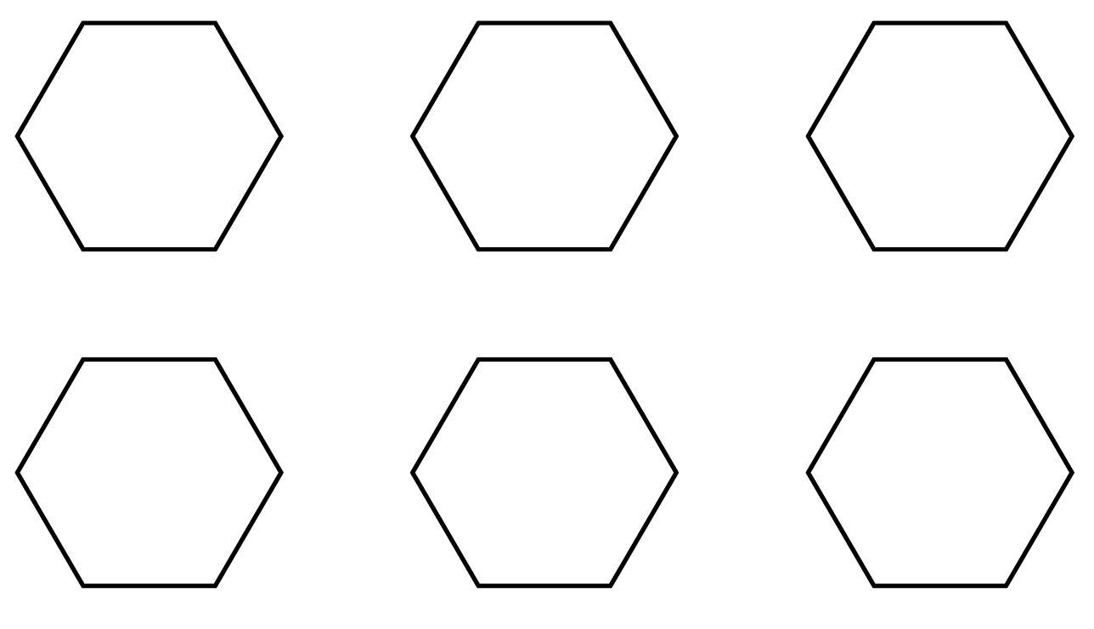

Resource 20 – Harry’s hexagons
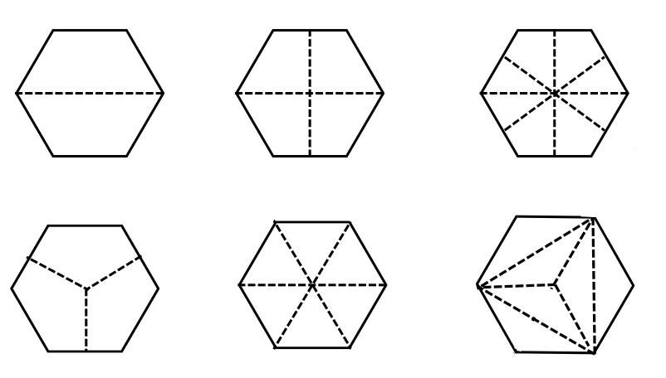

Resource 21 – fraction wall
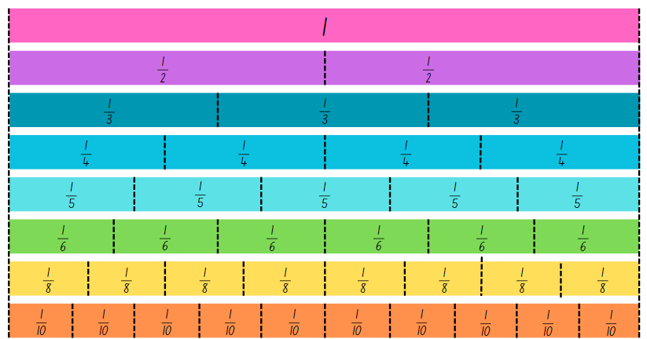

Resource 22 – 8 equal parts
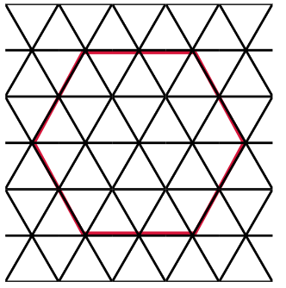

Resource 23 – representations 1
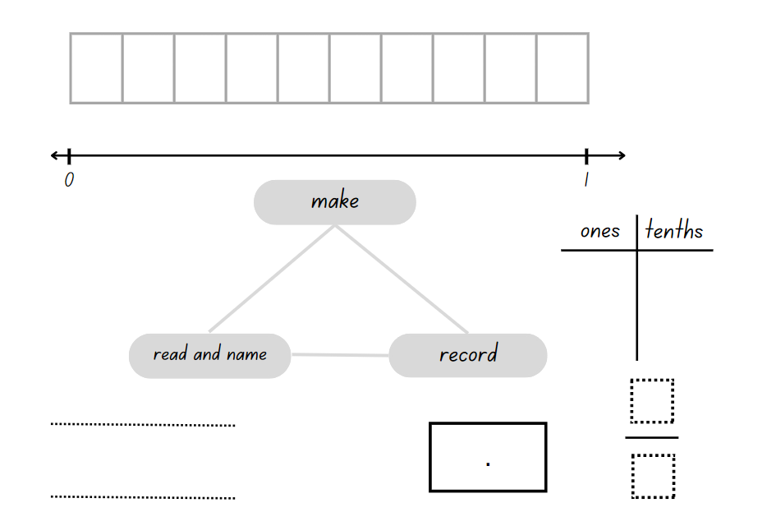

Resource 24 – representations 2
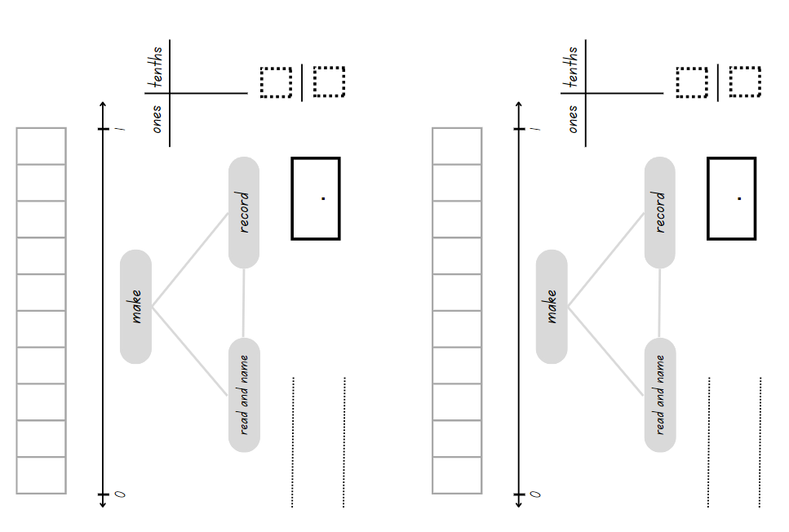

Resource 25 – representations beyond 1
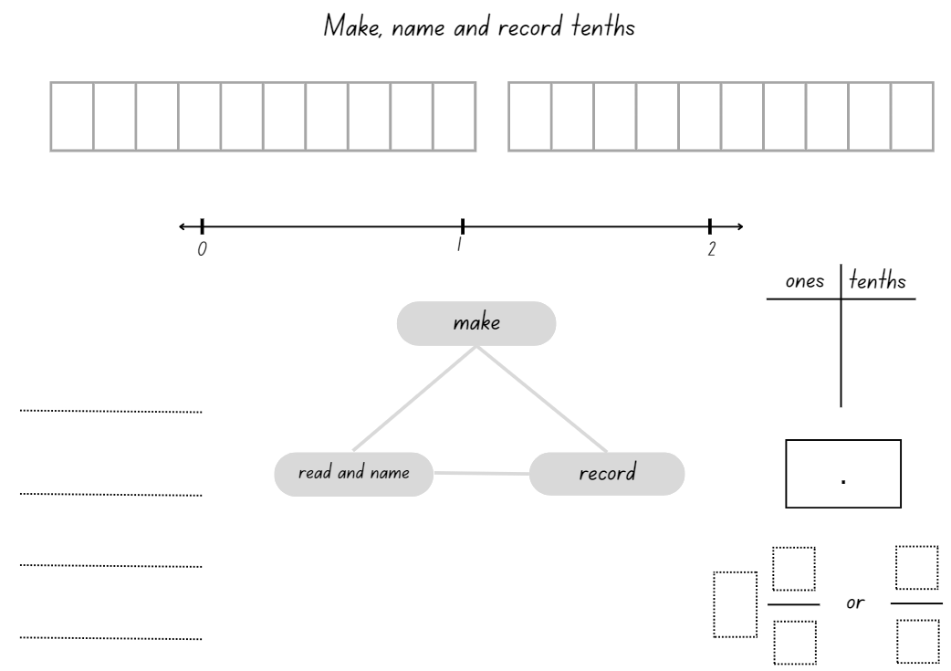

Resource 26 – tape diagram example
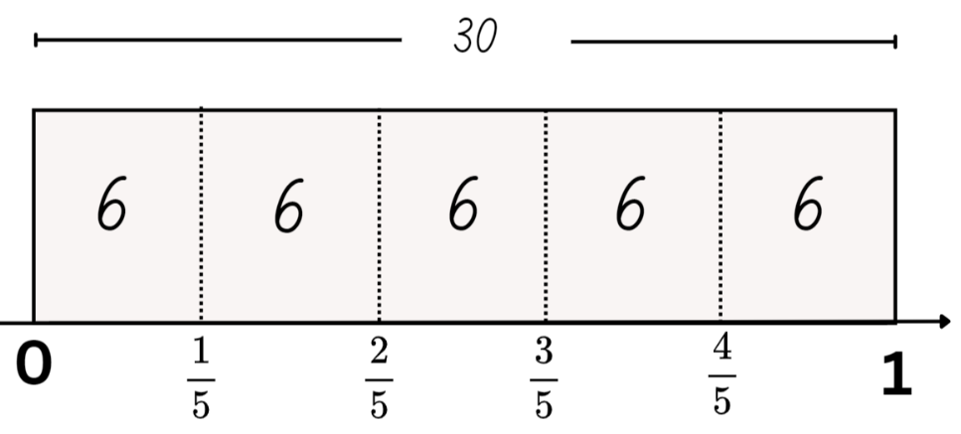

Resource 27 – lolly shop cards
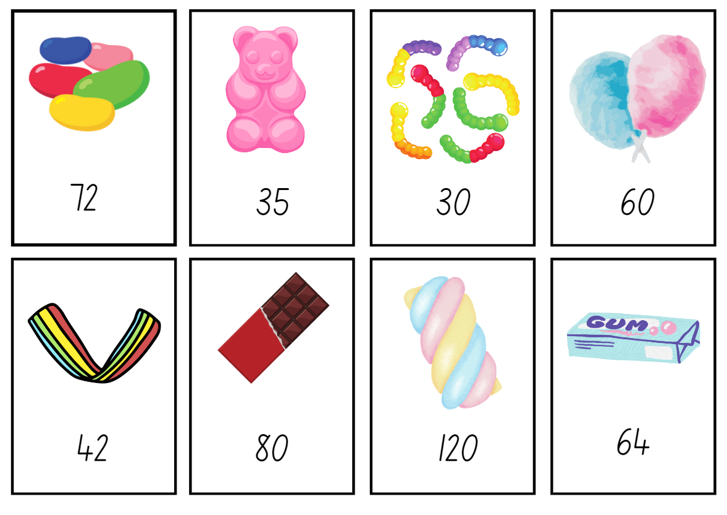

Resource 28 – decimal and fraction cards
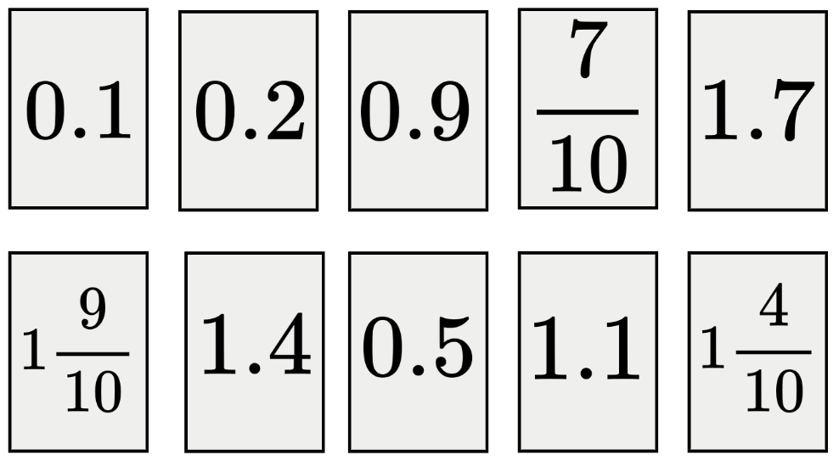

Resource 29 – fraction cards
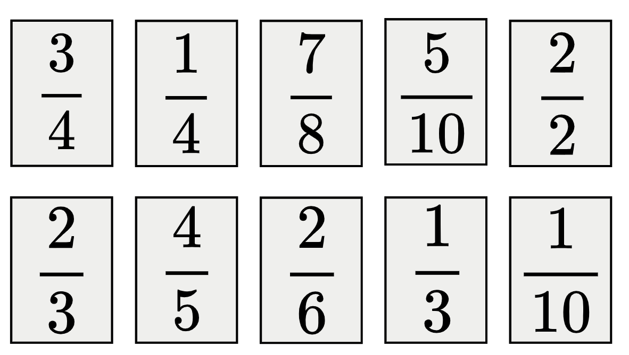

Resource 30 – cards in order
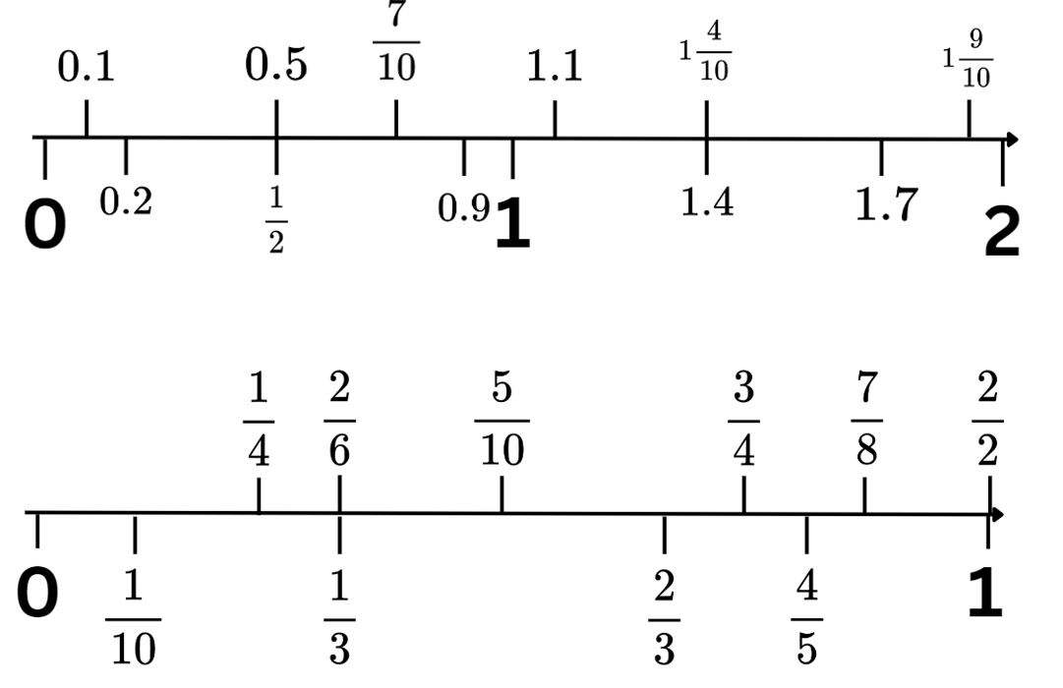

Resource 31 – tenths and hundredths
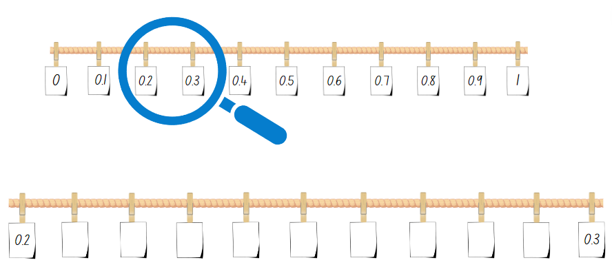

Resource 32 – hundredths number line
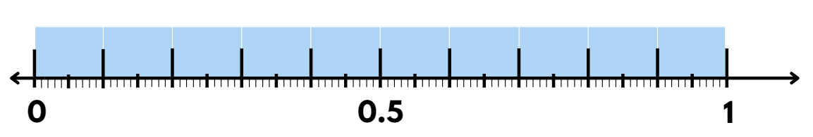

Resource 33 – hundredths
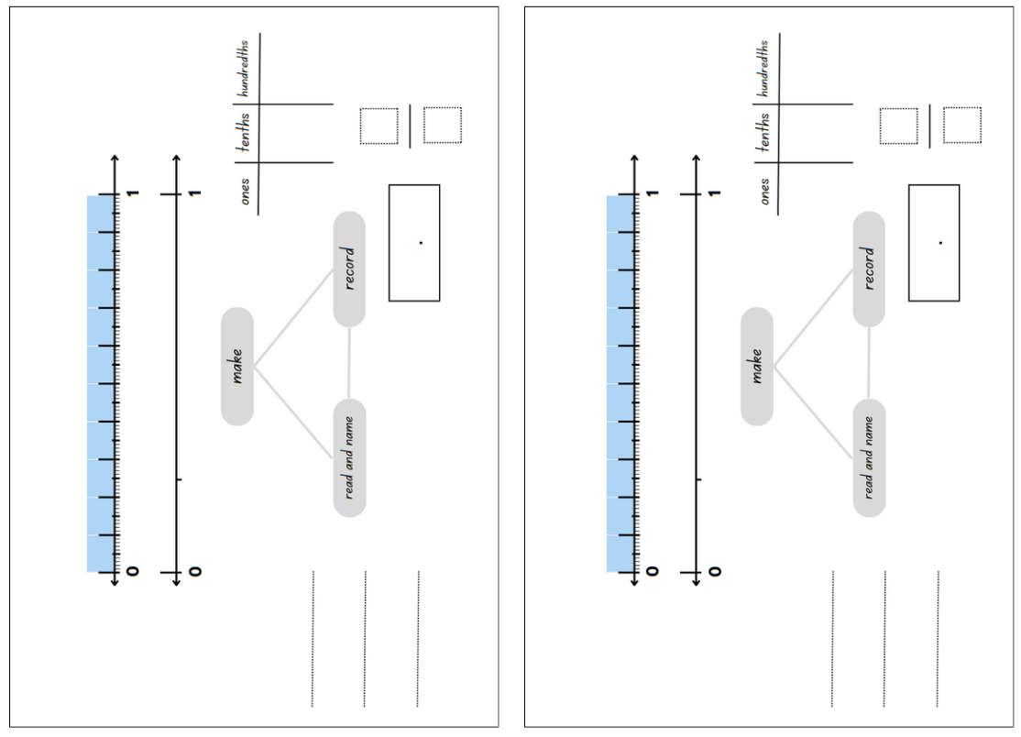

Resource 34 – fractions
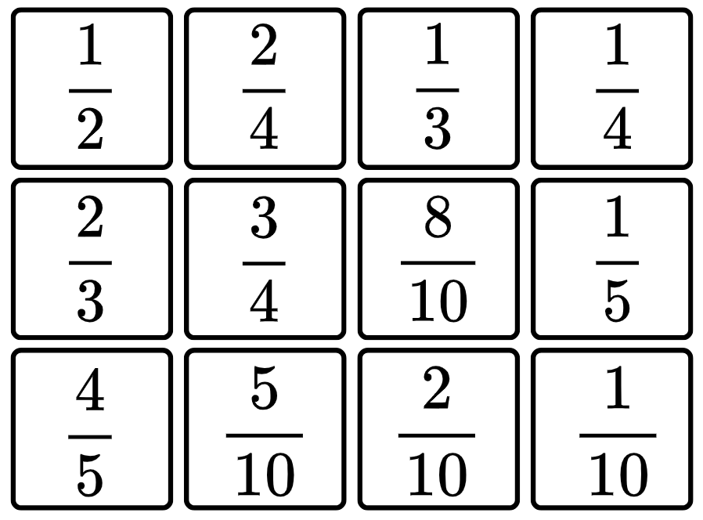

Resource 35 – Maths Busters decimals
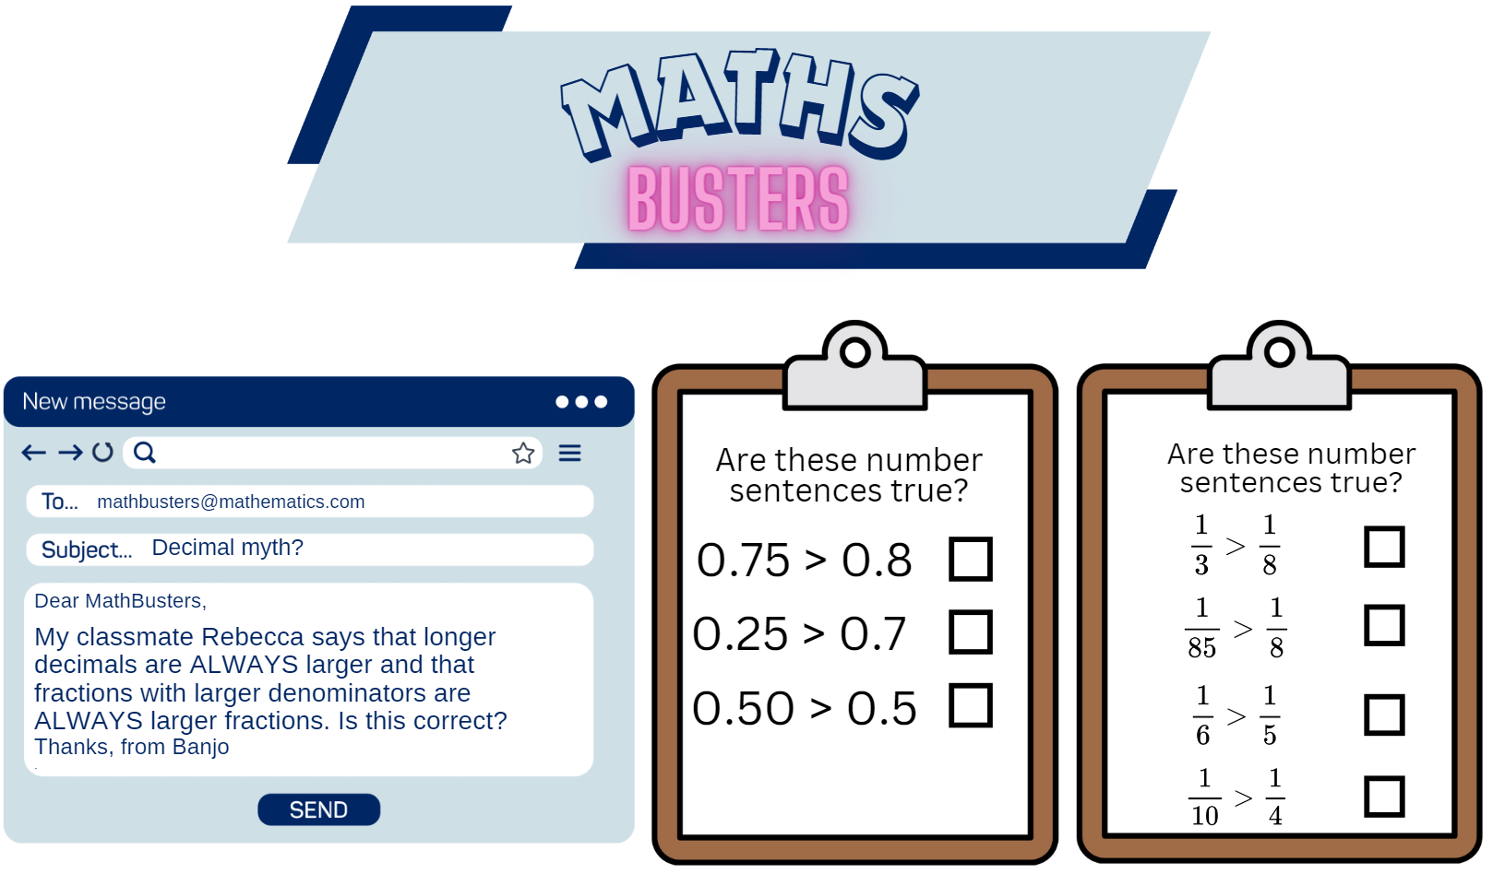

Resource 36 – number line 0–3
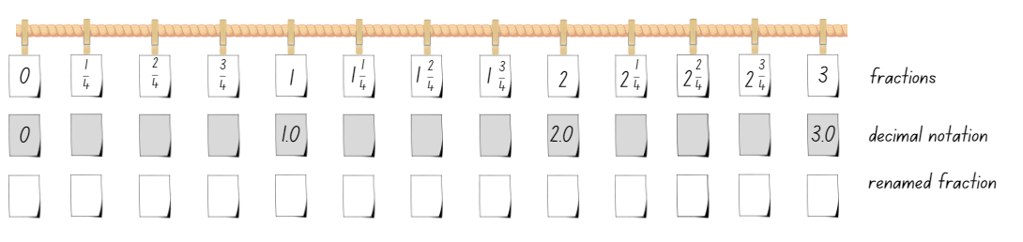

Resource 37 – missing symbols
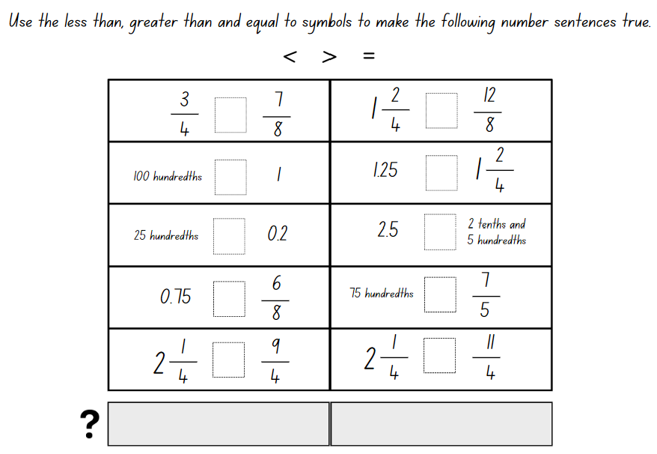

Resource 38 – fraction problems
Natalia ran 2 $\frac{1}{2}$ kilometres on Friday, 3 $\frac{3}{4}$ kilometres on Saturday and 4 $\frac{3}{4}$ kilometres on Sunday. How many kilometres did she run over 3 days?

Nancy picked 1 $\frac{5}{6}$ kilograms of snow peas and Brooke picked 1 $\frac{2}{4}$ kilograms. Who picked the most snow peas? How much more did they pick?

In measuring the wood needed for a picture frame, Liz worked out that she needed 2 pieces that were 5 $\frac{1}{5}$ centimetres and 2 pieces that were 7 $\frac{7}{10}$ centimetres. What length of wood does she need to build her picture frame?

Resource 39 – student misconceptions
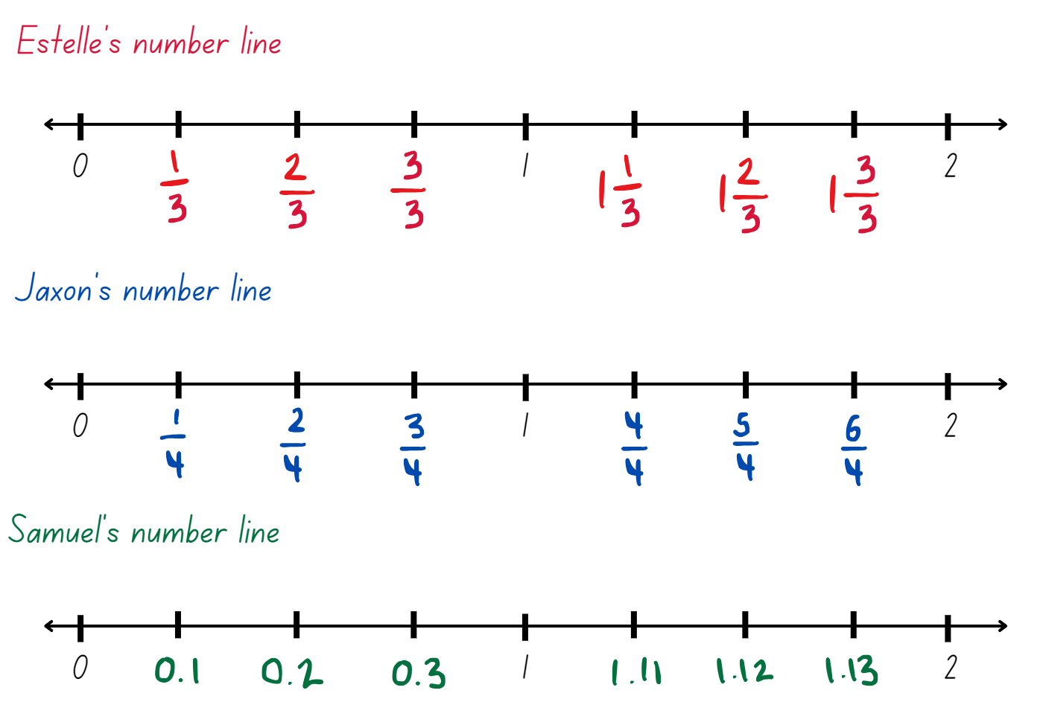

Resource 40 – equal and unequal spinners
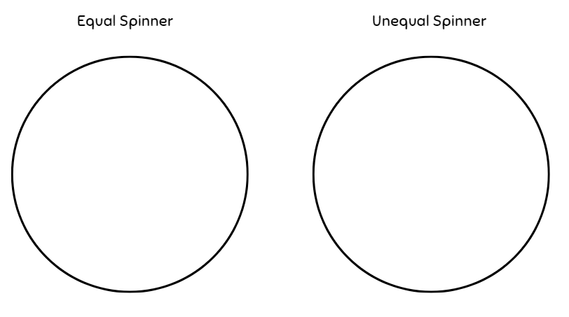

Resource 41 – gameboard
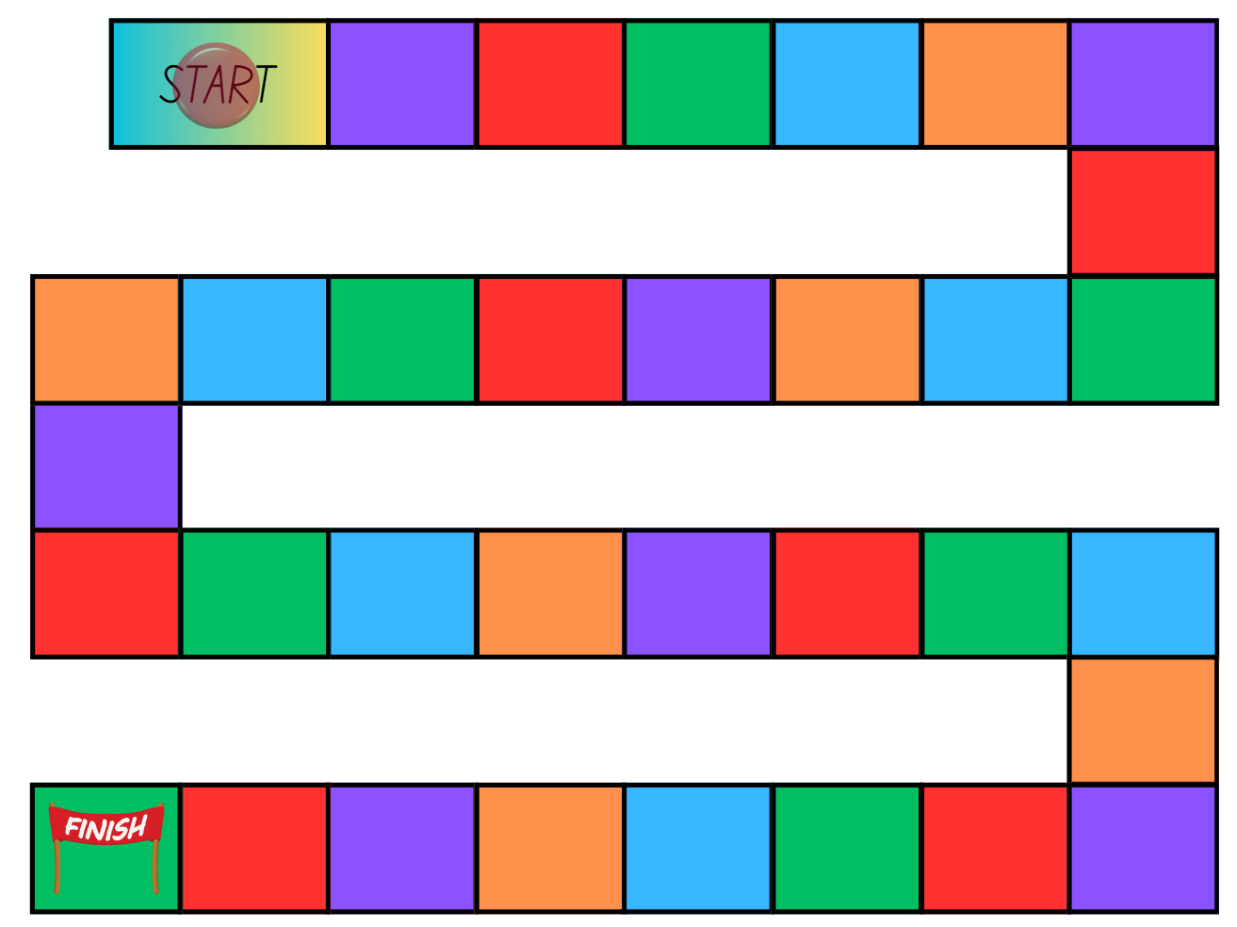

Resource 42 – fractions spinners
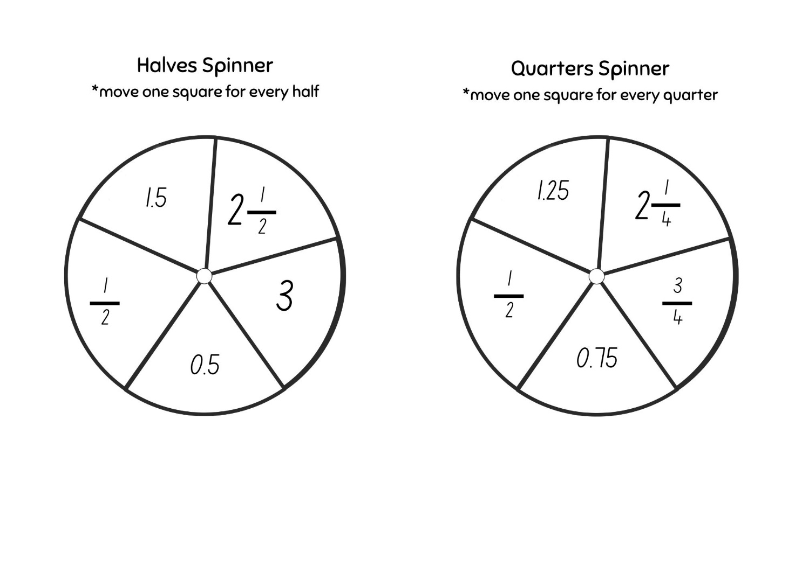

Syllabus outcomes and content

Stage 2
The table below outlines the syllabus outcomes and range of relevant syllabus content covered in this unit. Content is linked to National Numeracy Learning Progression (version 3).
Outcomes and content | 1 | 2 | 3 | 4 | 5 | 6 | 7 | 8
Representing numbers using place value B: Decimals: Extend the application of the place value system from whole numbers to tenths and hundredths
MAO-WM-01, MA2-RN-02
- Recognise that 10-tenths is recorded as 1.0 and regroup when using decimal notation |  |  |  |  | x | x
- Represent and compare tenths as decimals using linear representations (Reasons about relations) |  |  |  |  | x | x
Representing numbers using place value B: Decimals: Make connections between fractions and decimal notation
MAO-WM-01, MA2-RN-02
- Compare and order decimals of up to 2 decimal places |  |  |  |  | x | x | x | x
- Make connections between fractions and decimal notation for key benchmark values (Reasons about relations) |  |  |  |  | x | x | x | x
Multiplicative relations A: Generate and describe patterns
MAO-WM-01, MA2-MR-01
- Model, describe and record patterns of multiples |  | x |  |  | x | x | x
- Create and continue a variety of number patterns that increase or decrease by a constant amount |  |  |  | x | x | x | x
Multiplicative relations B: Investigate number sequences involving related multiples
MAO-WM-01, MA2-MR-01
- Investigate number patterns involving related multiples |  |  | x | x
Partitioned fractions A: Model and represent unit fractions, and their multiples, to a complete whole on a number line
MAO-WM-01, MA2-PF-01
- Determine the complementary fractional part needed to complete one whole (halves, quarters, eighths, thirds) (Reasons about relations) | x |  | x
- Recreate the whole unit from a fractional part ($\frac{1}{2}$ , $\frac{1}{4},\frac{1}{3}$ and $\frac{1}{8}$ ) (Reversible reasoning) |  |  | x
Partitioned fractions B: Model equivalent fractions as lengths
MAO-WM-01, MA2-PF-01
- Represent the equivalence of fractions with related denominators as lengths, using concrete materials, diagrams and number lines |  | x | x | x |  | x | x
- Recognise the need to have equal wholes to compare partitioned fractions (Reasoning about relations) | x
- Represent fractions with the same-size whole to make valid comparisons (denominators of 2, 4 and 8; 3 and 6; 5 and 10) | x | x
Partitioned fractions B: Represent fractional quantities equal to and greater than one
MAO-WM-01, MA2-PF-01
- Rename 2 halves, 3 thirds, 4 quarters, 5 fifths, 6 sixths, 8 eighths and 10 tenths as one whole | x | x | x | x
- Regroup fractional parts beyond one |  | x |  |  | x
- Represent totals of halves, thirds, quarters and fifths that extend beyond one |  |  |  | x |  |  |  | x
- Determine the relative location of one-quarter and one-half when a number line extends beyond one |  |  |  | x |  |  | x
Mathematics K–10 Syllabus © NSW Education Standards Authority (NESA) for and on behalf of the Crown in right of the State of New South Wales, 2022.

Stage 3
The table below outlines the syllabus outcomes and range of relevant syllabus content covered in this unit. Content is linked to National Numeracy Learning Progression (version 3).
Outcomes and content | 1 | 2 | 3 | 4 | 5 | 6 | 7 | 8
Represents numbers B: Decimals and percentages: Make connections between benchmark fractions, decimals and percentages
[MAO-WM-01, MA3-RN-03]
- Recognise that the symbol % means percent and 100% is the whole amount |  | x
- Recall commonly used equivalent percentages, decimals and fractions including $\frac{1}{2}$, $\frac{1}{4}$, and $\frac{3}{4}$ |  | x | x
- Represent common percentages of quantities and lengths as fractions and decimals |  | x | x
- Recognise that 10% is one-tenth of 100% and use this to find 10% of a quantity (Reasons about relations) |  |  | x
Multiplicative relations B: Represent and describe number patterns formed by multiples
[MAO-WM-01, MA3-MR-01]
- Use a given geometric pattern involving multiples to create a table of values |  |  |  |  | x
- Describe a pattern formed by multiples in words, in terms of multiplication rather than addition |  |  |  |  |  | x
- Determine a rule describing the relationship between the bottom number and the top number in a table (Algebraic reasoning) |  |  |  |  | x | x | x
Representing quantity fractions A: Recognise the role of the number 1 as representing the whole
[MAO-WM-01, MA3-RQF-01, MA3-RQF-02]
- Compare halves and quarters of different sized wholes | x
- Justify the need for fractions to refer to the number 1 as the common whole (Reasons about quantity) | x
Representing quantity fractions A: Solve problems involving addition and subtraction of fractions with the same denominator
[MAO-WM-01, MA3-RQF-01, MA3-RQF-02]
- Use diagrams, objects and mental strategies to subtract a unit fraction from any whole number including 1 (the complement principle) |  |  |  |  |  | x
Representing quantity fractions B: Compare common fractions with related denominators
[MAO-WM-01, MA3-RQF-01, MA3-RQF-02]
- Order common fractions with related denominators using diagrams and number lines |  |  |  |  | x
- Subdivide the area of a rectangle by both length and width to represent the multiplicative relationship between common fractions |  |  |  | x
- Compare and represent fractions with denominators of 2, 4 and 8; 3 and 6; 5 and 10 of a whole shape (area model) and a collection of objects (discrete model) |  |  |  | x | x
Representing quantity fractions B: Build up to the whole from a given fractional part
[MAO-WM-01, MA3-RQF-01, MA3-RQF-02]
- Generate the whole quantity from non-unit fractional parts such as quarters, eighths, thirds, sixths, fifths and tenths (Reversible reasoning) | x
Representing quantity fractions B: Use equivalence to add and subtract fractional quantities
[MAO-WM-01, MA3-RQF-01, MA3-RQF-02]
- Solve word problems involving adding or subtracting fractional quantities with related denominators | x |  |  |  |  |  | x
- Represent fractional quantities with the same or related denominators to add and subtract fractions (Reasons about relations) |  | x | x |  |  | x | x
Representing quantity fractions B: Find fractional quantities of whole numbers (halves, quarters, fifths and tenths)
[MAO-WM-01, MA3-RQF-01, MA3-RQF-02]
- Calculate quarters and fifths of whole numbers that are multiples of the denominator, using a tape diagram |  |  |  |  | x
Chance B: Create random generators and describe probabilities using fractions
[MAO-WM-01, MA3-CHAN-01]
- Record the outcomes for chance experiments where the outcomes are not equally likely to occur and assign probabilities to the outcomes using fractions (denominators of 2, 3, 4, 5, 6, 8 and 10) |  |  |  |  |  |  |  | x
- Use knowledge of benchmark fractions, decimals and percentages to assign probabilities to the likelihood of outcomes |  |  |  |  |  |  |  | x
Mathematics K–10 Syllabus © NSW Education Standards Authority (NESA) for and on behalf of the Crown in right of the State of New South Wales, 2022.

References
This resource contains NSW Curriculum and syllabus content. The NSW Curriculum is developed by the NSW Education Standards Authority. This content is prepared by NESA for and on behalf of the Crown in right of the State of New South Wales. The material is protected by Crown copyright.
Please refer to the NESA Copyright Disclaimer for more information https://educationstandards.nsw.edu.au/wps/portal/nesa/mini-footer/copyright.
NESA holds the only official and up-to-date versions of the NSW Curriculum and syllabus documents. Please visit the NSW Education Standards Authority (NESA) website https://educationstandards.nsw.edu.au and the NSW Curriculum website https://curriculum.nsw.edu.au.
Mathematics K–10 Syllabus © NSW Education Standards Authority (NESA) for and on behalf of the Crown in right of the State of New South Wales, 2022.
National Numeracy Learning Progression © Australian Curriculum, Assessment and Reporting Authority (ACARA) 2010 to present, unless otherwise indicated. This material was downloaded from the Australian Curriculum website (National Numeracy Learning Progression) (accessed 10 May 2024) and was not modified.
ABC (2024) Playground Percentages, ABC Education website, accessed 23 May 2024.
ABC (Australian Broadcasting Corporation) (2024) Mystery Spinner: Challenge, ABC Education website, accessed 23 May 2024.
Amplify Education (n.d.) Polypad, Amplify website, accessed 23 May 2024.
Australian Academy of Science (n.d.) What you need to know about fractions [PDF 420 KB], reSolve website, accessed 29 February 2024.
Epstein M (5 November 2020, updated 5 June 2021) ‘Exploring the Edges of Mathematical Ideas’, Mathematics Education, accessed 23 May 2024.
Fuchs LS, Malone AS, Schumacher RF, Namkung J and Wang A (2017) 'Fraction intervention for students with mathematics difficulties: Lessons learned from five randomized controlled trials', Journal of Learning Disabilities, 50(6):631–639, doi:10.1177/0022219416677249.
Kersaint G (2017) 100 questions that promote mathematical discourse [PDF 1.09 MB], Curriculum Associates, LLC, accessed 23 May 2024.
NESA (NSW Education Standards Authority) (2024a) ‘Teaching advice for Representing numbers using place value B’, Stage 3, NESA website, accessed 6 June 2024.
——(2024b) ‘Teaching advice for Represents numbers B’, Stage 3, NESA website, accessed 6 June 2024.
——(2024c) ‘Teaching advice for Represents numbers A’, Stage 3, NESA website, accessed 6 June 2024.
——(2024d) ‘Teaching advice for Multiplicative relations B’, Stage 3, NESA website, accessed 6 June 2024.
Siemon D (2002) Partitioning – The missing link in building fraction knowledge and confidence [PDF 103 KB], RMIT University, Victoria, Australia.
Siemon D, Warren E, Beswick K, Faragher R, Miller J, Horne M, Jazby D, Breed M, Clark J and Brady K (2021) Teaching Mathematics: Foundations to Middle Years, 3rd edn, Oxford University Press Australia and New Zealand.
State of NSW (Department of Education and Training Curriculum K–12 Directorate) (2010) Talking about Patterns & Algebra: Early Stage 1 to Stage 3 [PDF 3.28 MB], NSW Education and Training, accessed 15 May 2024.
State of Victoria (DEECD) (2008) Fencing the freeway [PDF 69.7 KB], DEECD, accessed 1 March 2024.
Sullivan P (2018) Challenging Mathematical Tasks: Unlocking the potential of all students, Oxford University Press, Australia and New Zealand.
The Maths Learning Centre (2005–2024) Fractions, Math Learning Centre website, accessed 23 May 2024.
Tribal Group PLC (n.d.) ‘Unit Fractions’, Year 3 curriculum map, National Centre for Excellence in the Teaching of Mathematics (NCETM) website, accessed 23 May 2024.
University of Cambridge (n.d.) Matching Fractions, Decimals and Percentages, NRICH website, accessed 23 May 2024.
University of Cambridge (n.d.) Spiralling Decimals, NRICH website, accessed 23 May 2024.
Van de Walle J, Karp K, Bay-Williams JM, Brass A, Bentley B, Ferguson S, Goff W, Livy S, Marshman M, Martin D, Pearn C, Prodromou T, Symons D and Wilkie K (2019) Primary and Middle Years Mathematics: Teaching Developmentally, 1st Australian edn, Pearson Education Australia, Melbourne.
.
© State of New South Wales (Department of Education), 2024
The copyright material published in this resource is subject to the Copyright Act 1968 (Cth) and is owned by the NSW Department of Education or, where indicated, by a party other than the NSW Department of Education (third-party material).
Copyright material available in this resource and owned by the NSW Department of Education is licensed under a Creative Commons Attribution 4.0 International (CC BY 4.0) license.
This license allows you to share and adapt the material for any purpose, even commercially.
Attribution should be given to © State of New South Wales (Department of Education), 2024.
Material in this resource not available under a Creative Commons license:
- the NSW Department of Education logo, other logos and trademark-protected material
- material owned by a third party that has been reproduced with permission. You will need to obtain permission from the third party to reuse its material.
Links to third-party material and websites
Please note that the provided (reading/viewing material/list/links/texts) are a suggestion only and implies no endorsement, by the New South Wales Department of Education, of any author, publisher, or book title. School principals and teachers are best placed to assess the suitability of resources that would complement the curriculum and reflect the needs and interests of their students.
If you use the links provided in this document to access a third-party's website, you acknowledge that the terms of use, including licence terms set out on the third-party's website apply to the use which may be made of the materials on that third-party website or where permitted by the Copyright Act 1968 (Cth). The department accepts no responsibility for content on third-party websites.

