Mathematics 3–6 Multi-age – Year B – Unit 18

Questions can be asked and answered by interpreting data

Contents

Unit description and duration 8

Syllabus outcomes 9

Stage 2 9

Stage 3 9

Working mathematically 10

Student prior learning 10

Lesson overview and resources 12

Lesson 1 20

Daily number sense – farmer’s market – 15 minutes 20

Core lesson – 40 minutes 23

Stage 2 – categorising games 23

Stage 3 – chance of winning 28

Discuss and connect the mathematics (Stage 2) – 10 minutes 33

Discuss and connect the mathematics (Stage 3) – 10 minutes 33

Lesson 2 36

Daily number sense – lolly shop – 10 minutes 36

Core lesson – 40 minutes 38

Stage 2 task 1 – creating a survey 38

Stage 2 task 2 – conducting a survey 41

Stage 3 – mystery spinner 42

Discuss and connect the mathematics (Stage 2) – 10 minutes 47

Discuss and connect the mathematics (Stage 3) – 10 minutes 48

Lesson 3 51

Daily number sense – post office problems – 15 minutes 51

Core lesson – 40 minutes 54

Stage 2 task 1 – organising and displaying data 54

Stage 2 task 2 – interpreting the data 59

Stage 3 task – scissors, paper, rock 60

Discuss and connect the mathematics – 10 minutes 66

Lesson 4 69

Daily number sense – 10 minutes 69

Core lesson – 40 minutes 69

Stage 2 task 1 – tossing one coin 69

Stage 2 task 2 – tossing 2 coins 72

Stage 3 task 1 – fair and unfair games 74

Consolidation and meaningful practice (Stage 2) – 15 minutes 78

Consolidation and meaningful practice (Stage 3) – 15 minutes 79

Lesson 5 82

Daily number sense – place the digit – 10 minutes 82

Core lesson 1 – lucky duck – 15 minutes 85

Core lesson 2 – 25 minutes 88

Stage 2 task – ducks are out 88

Stage 3 task – mystery bag 90

Discuss and connect the mathematics (Stage 2) – 15 minutes 94

Discuss and connect the mathematics (Stage 3) – 15 minutes 95

Lesson 6 100

Daily number sense – mixed-up decimals – 15 minutes 100

Core lesson – 40 minutes 103

Stage 2 task 1 – spin the spinner 103

Stage 2 task 2 – spinner games 105

Stage 3 task 1 – data in the media 107

Stage 3 task 2 – misleading graphs 110

Discuss and connect the mathematics (Stage 2) – 5 minutes 112

Discuss and connect the mathematics (Stage 3) – 5 minutes 112

Lesson 7 114

Daily number sense – decimal dash – 15 minutes 114

Core lesson – 40 minutes 116

Stage 2 task 1 – constructing and comparing data 116

Stage 2 task 2 – evaluating a data set 120

Stage 3 task – Great Barrier Reef data 122

Discuss and connect the mathematics (Stage 2) – 5 minutes 125

Discuss and connect the mathematics (Stage 3) – 5 minutes 125

Lesson 8 127

Daily number sense – 10 minutes 127

Core lesson – 45 minutes 127

Stage 2 task – mystery graphs 129

Stage 3 task – comparing and interpreting data 131

Discuss and connect the mathematics – 10 minutes 134

Resource 1 – farmer’s market cards 136

Resource 2 – room maze 137

Resource 3 – lolly shop 138

Resource 4 – spinners 139

Resource 5 – mystery spinner 140

Resource 6 – Dataville Public School survey 141

Resource 7 – SPR instructions 142

Resource 8 – game outcomes 143

Resource 9 – SPR recording sheet 1 144

Resource 10 – chance representations 145

Resource 11 – coin toss recording sheet 146

Resource 12 – SPR recording sheet 2 147

Resource 13 – number cards 148

Resource 14 – recording table 149

Resource 15 – bag recording sheet 150

Resource 16 – Raph’s maths book 151

Resource 17 – reef fish samples 152

Resource 18 – mixed-up decimals 1 153

Resource 19 – mixed-up decimals 2 154

Resource 20 – blank and game spinner 155

Resource 21 – data types 156

Resource 22 – average global temperatures 157

Resource 23 – misleading graphs 158

Resource 24 – decimal cards 1 161

Resource 25 – decimal cards 2 162

Resource 26 – gaming devices graph 163

Resource 27 – interpreting data displays 164

Resource 28 – alternative holiday destinations 168

Resource 29 – reef visitors 169

Resource 30 – visitors data sheet 170

Resource 31 – barrier reef weather 171

Resource 32 – school travel graph 172

Resource 33 – mystery graphs 173

Resource 34 – column graph checklist 178

Resource 35 – coral bleaching data 179

Resource 36 – comparing graphs 180

Resource 37 – rising sea temperatures A 181

Resource 38 – data information sheet 182

Resource 39 – rising sea temperatures B 183

Syllabus outcomes and content 184

Stage 2 184

Stage 3 189

References 194

Further reading 196

# Unit description and duration

This unit develops the big idea that questions can be asked and answered by interpreting data.

In this 2-week unit, students are provided opportunities to:

* conduct a survey and collect, organise and display data using tables and graphs (Stage 2)
* compare the likelihood of obtaining particular outcomes in a simple chance experiment by predicting, conducting the experiment and comparing the results with the prediction (Stage 2)
* interpret and evaluate the effectiveness of various data displays found in media where displays represent data using a scale of many-to-one (Stage 2)
* create random generators and describe probabilities using fractions (Stage 3)
* conduct chance experiments with both small and large numbers of trials and compare observed frequencies with expected results (Stage 3)
* interpret and compare a range of data displays, including data presented in digital media and elsewhere (Stage 3).

This multi-age unit is informed by the lessons in [Stage 2 Year B Unit 38](https://education.nsw.gov.au/teaching-and-learning/curriculum/mathematics/planning-programming-and-assessing-mathematics-k-6/mathematics-3-6-units#tabs_727018652_copy3:~:text=DOCX%201.6%20MB)-,Stage%202%20%E2%80%93%20Year%20B,-NSW%20students%20in) and [Stage 3 Year B Unit 38](https://education.nsw.gov.au/teaching-and-learning/curriculum/mathematics/planning-programming-and-assessing-mathematics-k-6/mathematics-3-6-units#tabs_727018652_copy3:~:text=DOCX%203.4%20MB)-,Stage%203%20%E2%80%93%20Year%20B,-NSW%20students%20in). Please refer to these units for additional lesson guidance.

## Syllabus outcomes

* **MAO-WM-01** develops understanding and fluency in mathematics through exploring and connecting mathematical concepts, choosing and applying mathematical techniques to solve problems, and communicating their thinking and reasoning coherently and clearly

### Stage 2

* **MA2-RN-02** represents and compares decimals up to 2 decimal places using place value
* **MA2-AR-01** selects and uses mental and written strategies for addition and subtraction involving 2- and 3-digit numbers
* **MA2-DATA-01** collects discrete data and constructs graphs using a given scale
* **MA2-DATA-02** interprets data in tables, dot plots and column graphs
* **MA2-CHAN-01** records and compares the results of chance experiments

### Stage 3

* **MA3-RN-02** compares and orders decimals up to 3 decimal places
* **MA3-RQF-02** determines $\frac{1}{2}$, $\frac{1}{4}$, $\frac{1}{5}$ and $\frac{1}{10}$ of measures and quantities
* **MA3-DATA-01** constructs graphs using many-to-one scales
* **MA3-DATA-02** interprets data displays, including timelines and line graphs
* **MA3-CHAN-01** conducts chance experiments and quantifies the probability

## Working mathematically

In the Mathematics K–10 Syllabus, there is one overarching Working mathematically outcome (**MAO-WM-01**). The Working mathematically processes should be embedded within the concepts being taught. The Working mathematically processes present in the Mathematics K–10 Syllabus are:

* communicating
* understanding and fluency
* reasoning
* problem solving.

[Mathematics K–10 Syllabus](https://curriculum.nsw.edu.au/learning-areas/mathematics/mathematics-k-10-2022/overview) © NSW Education Standards Authority (NESA) for and on behalf of the Crown in right of the State of New South Wales, 2022.

## Student prior learning

Before engaging in these teaching and learning activities, students would benefit from prior experience with:

* selecting and trialling methods for data collection (Stage 2)
* predicting and describing possible outcomes from chance experiments (Stage 2)
* constructing and interpreting data displays with many-to-one scales (Stage 2)
* representing and interpreting data presented in tables, column graphs and line graphs (Stage 3)
* interpreting and comparing data through measure of central tendency such as range and mode (Stage 3)
* predicting and describing possible outcomes from chance experiments (Stage 3).

In NSW classrooms there is a diverse range of students, including Aboriginal and/or Torres Strait Islander students, students learning English as an additional language or dialect, high potential and gifted students, and students with disability. Some students may identify with more than one of these groups or possibly all of them. Refer to [Curriculum planning for every student – advice](https://education.nsw.gov.au/teaching-and-learning/curriculum/planning-programming-and-assessing-k-12/advice-on-curriculum-planning-for-every-student-k-12) for further information.

# Lesson overview and resources

To cover the content of the syllabus across Stage 2 and Stage 3, some core lessons in the unit contain both a Stage 2 and a Stage 3 task. Teachers are encouraged to adapt and contextualise the units to meet the needs of their students.

The table below outlines the sequence and approximate timing of lessons, learning intentions and resources.

|  |  |  |
| --- | --- | --- |
| Lesson | Content | Duration and resources |
| **Lesson 1**  **Daily number sense**  **Stage 2**:   * **Additive relations B**: Apply addition and subtraction to familiar contexts, including money and budgeting   **Stage 3**:   * **Representing quantity fractions B**: Find fractional quantities of whole numbers (halves, quarters, fifths and tenths) | **Lesson core concept**: questions give meaning to data (Stage 2) and random generators produce data with variation (Stage 3).  **Stage 2**:   * **Data A**: Collect discrete data   **Stage 3**:   * **Chance B**: Create random generators and describe probabilities using fractions | **Lesson duration**: 65 minutes   * Resource 1 – farmer’s market cards * Resource 2 – room maze * 6-sided dice * Individual whiteboards * Student workbooks * Writing materials |
| **Lesson 2**  **Daily number sense**  **Stage 2**:   * **Additive relations B: Apply addition and subtraction to familiar contexts, including money and budgeting**   **Stage 3**:   * **Representing quantity fractions B**: Find fractional quantities of whole numbers (halves, quarters, fifths and tenths) | **Lesson core concept**: collecting data requires a skilful approach (Stage 2) and mathematicians describe probabilities using fractions (Stage 3).  **Stage 2**:   * **Data A**: Organise and display data using tables and graphs * **Data B**: Select and trial methods for data collection   **Stage 3**:   * **Data A**:Collect categorical and discrete numerical data by observation or surveys * **Data B**: Create random generators and describe probabilities using fractions | **Lesson duration**: 60 minutes   * Resource 3 – lolly shop * Resource 4 – spinners * Resource 5 – mystery spinner * Paper clips * Student workbooks * Writing materials |
| **Lesson 3**  **Daily number sense**  **Stage 2**:   * **Additive relations B**: Apply addition and subtraction to familiar contexts, including money and budgeting   **Stage 3**:   * **Additive relations A:** Apply efficient mental and written strategies to solve addition and subtraction problems | **Lesson core concept**: graphs are a communication tool (Stage 2) and expected and observed probabilities describe possible outcomes (Stage 3).  **Stage 2**:   * **Data A**: Interpret and compare data * **Data B**: Construct and interpret data displays with many-to-one scales   **Stage 3**:   * **Chance B**: Compare observed frequencies of outcomes with expected results * **Chance B**: Conduct chance experiments with both small and large numbers of trials | **Lesson duration**: 65 minutes   * Resource 6 – Dataville Public School survey * Resource 7 – SPR instructions * Resource 8 – game outcomes * Resource 9 – SPR recording sheet 1 * Survey data from Lesson 2 * Digital devices * Grid paper * Individual whiteboards * [Microsoft Excel](https://app.education.nsw.gov.au/digital-learning-selector/LearningTool/Card/105) or [Google Sheets](https://app.education.nsw.gov.au/digital-learning-selector/LearningTool/Card/69) * Sticky notes * Writing materials |
| **Lesson 4**  **Daily number sense**   * teacher-identified task based on student needs | **Lesson core concept**: data displays can be used to record and compare the outcomes of chance events (Stage 2) and expected and observed probabilities describe possible outcomes (Stage 3).  **Stage 2**:   * **Chance A**: Identify possible outcomes from chance experiments   **Stage 3**:   * **Chance B**: Compare observed frequencies of outcomes with expected results * **Chance B**: Conduct chance experiments with both small and large numbers of trials | **Lesson duration**: 65 minutes   * Resource 10 – chance representations * Resource 11 – coin toss recording sheet * Resource 12 – SPR recording sheet 2 * Video: [Catalyst: How to win at rock-paper-scissors (3:08)](https://www.abc.net.au/education/catalyst-how-to-win-at-rock-paper-scissors/13720728) from ABC Education * Calculators * Coins * Writing materials |
| **Lesson 5**  **Daily number sense**  **Stage 2**:   * **Representing numbers using place value B**: Decimals: Extend the application of the place value system from whole numbers to tenths and hundredths   **Stage 3**:   * **Representing numbers A:** Decimals and percentages: Compare, order and represent decimals | **Lesson core concept**: the outcomes of events can be affected by other events (Stage 2) and repeated trials identify data variation (Stage 3).  **Stage 2**:   * **Chance B**: Describe the likelihood of outcomes of chance events * **Chance B:** Identify when events are affected by previous events   **Stage 3**:   * **Data A:** Choose and use appropriate tables and graphs * **Chance B**: Conduct chance experiments with both small and large numbers of trials | **Lesson duration**: 65 minutes   * Resource 13 – number cards * Resource 14 – recording table * Resource 15 – bag recording sheet (enlarged onto A3 paper) * Resource 16 – Raph’s maths book * Resource 17 – reef fish samples * 20-sided dice * Coloured counters * Individual whiteboards * Paper bags * Strips of paper * Writing materials |
| **Lesson 6**  **Daily number sense**  **Stage 2**:   * **Representing whole numbers using place value B**: Decimals: Extend the application of the place value system from whole numbers to tenths and hundredths   **Stage 3**:   * **Representing numbers A:** Decimals and percentages: Compare, order and represent decimals | **Lesson core concept**: the outcome of chance experiments can be predicted and recorded (Stage 2) and mathematicians critically interpret and evaluate real-world data (Stage 3).  **Stage 2**:   * **Chance B**: Describe the likelihood of outcomes of chance events   **Stage 3**:   * **Data B**: Interpret data presented in digital media and elsewhere | **Lesson duration**: 60 minutes   * Resource 18 – mixed-up decimals 1 * Resource 19 – mixed-up decimals 2 * Resource 20 – blank and game spinner * Resource 21 – data types * Resource 22 – average global temperatures * Resource 23 – misleading graphs * Individual whiteboards * Paper clips * Student workbooks * Writing materials |
| **Lesson 7**  **Daily number sense**  **Stage 2**:   * **Representing whole numbers using place value B: Decimals: Extend the application of the place value system from whole numbers to tenths and hundredths**   **Stage 3**:   * **Representing numbers A:** Decimals and percentages: Compare, order and represent decimals | **Lesson core concept**: interpreting data helps us solve problems and ask new questions (Stage 2) and data is used in everyday contexts and influences daily practices (Stage 3).  **Stage 2**:   * **Data A**: interpret and compare data * **Data B**: construct and interpret data displays with many-to-one scales   **Stage 3**:   * **Data B**: Interpret and compare a range of data displays * **Data B:** Interpret data presented in digital media and elsewhere | **Lesson duration**: 60 minutes   * Resource 24 – decimal cards 1 * Resource 25 – decimal cards 2 * Resource 26 – gaming devices graph * Resource 27 – interpreting data displays * Resource 28 – alternative holiday destinations * Resource 29 – reef visitors * Resource 30 – visitors data sheet (on A3 paper) * Resource 31 – barrier reef weather * Paper * Writing materials |
| **Lesson 8**  **Daily number sense**   * teacher-identified task based on student needs | **Lesson core concept**: mathematicians interpret and evaluate the effectiveness of real-world data (Stage 2) and statistical reasoning helps mathematicians interpret and make inferences about real-world data (Stage 3).  **Stage 2**:   * **Data B: select and trial methods for data collection** * **Data B: construct and interpret data displays with many-to-one scales**   **Stage 3**:   * **Data B: Interpret and compare a range of data displays** * **Data B: Interpret data presented in digital media and elsewhere** | **Lesson duration**: 65 minutes   * Resource 32 – school travel graph * Resource 33 – mystery graphs * Resource 34 – column graph checklist * Resource 35 – coral bleaching data * Resource 36 – comparing graphs * Resource 37 – rising sea temperatures A * Resource 38 – data information sheet (on A3 paper) * Resource 39 – rising sea temperatures B * Video: [How Scientists Are Restoring The Great Barrier Reef | Travel + Leisure (7:32)](https://www.youtube.com/watch?v=8hknaJQRh8s) (watch from 1:22 to 4:22) * **Writing materials** |

# Lesson 1

**Core concept**: questions give meaning to data (Stage 2) and random generators produce data with variation (Stage 3).

## Daily number sense – farmer’s market – 15 minutes

Daily number sense activities for Lessons 1 to 3 ‘activate’ prior number knowledge and support the learning of new content in the unit. These activities can also assist teachers to identify the starting points for learning by revealing the extent of students’ existing knowledge.

The table below contains suggested learning intentions and success criteria. These are best co-constructed with students.

|  |  |
| --- | --- |
| Daily number sense learning intentions | Daily number sense success criteria |
| Stage 2 students are learning to:   * apply addition and subtraction to familiar contexts, including money and budgeting.   Stage 3 students are learning to:   * find fractional quantities of whole numbers (halves, quarters, fifths and tenths). | Stage 2 students can:   * use estimation to check the validity of solutions to addition and subtraction problems, including those involving money.   Stage 3 students can:   * calculate quarters and fifths of whole numbers that are multiples of the denominator, using a tape diagram. |

1. Provide all students with Resource 1 – farmer’s market cards and individual whiteboards, and Stage 3 students with a 6-sided die.

**Note**: Stage 2 students will use individual whiteboards after they have estimated quantities.

1. Pose the following problem to Stage 2 students: You have $9 to spend at the farmer’s market. What combination of items from the top row of Resource 1 – farmer’s market cards do you estimate that you could buy?
2. Remind Stage 2 students to use rounding to estimate the cost of the items.
3. Stage 2 students [turn and talk](https://education.nsw.gov.au/teaching-and-learning/curriculum/literacy-and-numeracy/teaching-and-learning-resources/numeracy/talk-moves) to share their thinking.
4. Remind Stage 3 students how to play ‘Farmer’s Market’ which was introduced in [Stage 3 Unit 24](https://education.nsw.gov.au/teaching-and-learning/curriculum/mathematics/planning-programming-and-assessing-mathematics-k-6/mathematics-3-6-units#:~:text=DOCX%202.4%20MB)-,Unit%2024%20%E2%80%93%20Fractions%20represent%20multiple%20ideas%20and%20can%20be%20represented%20in%20different%20ways,-Representing%20quantity%20fractions):
5. Have the bottom row of cards from Resource 1 – farmer’s market cards face up.
6. Player 1 rolls the 6-sided die. This will be the denominator for the unit fraction. For example, if a 5 is rolled, the fraction would be $\frac{1}{5}$. If a 1 is rolled, roll again.
7. Choose a produce card.
8. Calculate the fraction of the produce you have picked. For example, if the card is 20 lemons, calculate $\frac{1}{5}$ of 20 = 4.
9. Draw a tape diagram to record the fractional thinking.

**Note**: a tape diagram is a type of bar model used in previous units.

1. Once a produce card has been used, flip it over. It can no longer be used in this round.
2. Player 2 repeats the same steps.
3. If a player rolls a denominator that cannot be used on the cards without a remainder, they miss their turn.
4. Continue until all the cards have been used.
5. The winner is the player with the largest collection of produce items.
6. Ask Stage 2 students:

* How did you estimate which items you could buy?
* Do you think $9 would be enough money to buy all the items listed? If not, select 4 items to purchase and calculate the change from $9.
* Can you estimate how much money you would need to purchase all the items listed?

1. Ask Stage 2 students to use individual whiteboards to check the validity of their calculations.

This table details opportunities for assessment.

|  |  |
| --- | --- |
| Assessment opportunities | Links |
| What to look for:   * Can Stage 2 students use estimation to check the validity of solutions to addition and subtraction problems, including those involving money? **[MAO-WM-01, MA2-AR-01]** * Can Stage 3 students calculate quarters and fifths of whole numbers that are multiples of the denominator, using a tape diagram? **[MAO-WM-01, MA3-RQF-02]** | Links to [National Numeracy Learning Progressions](https://www.australiancurriculum.edu.au/resources/national-literacy-and-numeracy-learning-progressions/version-3-of-national-literacy-and-numeracy-learning-progressions/) (NNLP):   * Stage 2 – AdS8, UnM6, UnM7 * Stage 3 – InF8. |

## Core lesson – 40 minutes

### Stage 2 – categorising games

The table below contains a suggested learning intention and success criteria. These are best co-constructed with students.

|  |  |
| --- | --- |
| Core concept learning intention | Core concept success criteria |
| Students working towards Stage 2 outcomes are learning to:   * collect discrete data. | Students working towards Stage 2 outcomes can:   * pose questions about a matter of interest to obtain information that can be recorded in categories * predict and create a list of categories for efficient data collection in relation to a matter of interest. |

**Note**: the activity in Lesson 2 – Core lesson: Stage 2 task 2, requires students to survey peers from other classes. Ensure that classroom visits have been prearranged. Interruptions can be minimised by assigning each group to a single class or grade. Teachers may also conduct the survey on a different day due to the time involved.

1. Revise students’ understanding of ‘data’. Explain that data can be collected from many sources. For example, through observations, surveys, votes and questionnaires.
2. Students [turn and talk](https://education.nsw.gov.au/teaching-and-learning/curriculum/literacy-and-numeracy/teaching-and-learning-resources/numeracy/talk-moves) to discuss types of data previously explored in Stage 2.
3. Select students to share their understanding of types of data representations.
4. Pose the scenario: Year 6 are holding a fundraiser. Our class has been invited to organise games on the day.
5. Write the following questions on the board:

* What games would you like to play at the fundraiser?
* Which type of game would you like to play at the fundraiser: sports games, guessing games or other games?

1. Students [turn and talk](https://education.nsw.gov.au/teaching-and-learning/curriculum/literacy-and-numeracy/teaching-and-learning-resources/numeracy/talk-moves) to discuss their responses to the questions.
2. Regroup as a class and record student responses to each question. Ask:

* Which question provided a wider range of responses?
* When might it be useful to have a wide range of responses?
* Which question provided options for people to choose from?
* When might it be useful to limit answers to a few options?

1. Explain that a question such as ‘What games would you like to play at the fundraiser?’ is an open-ended question that will provide multiple responses. A closed question such as ‘Which type of game would you like to play at the fundraiser: sports games, guessing games or other games?’ provides clearer data on people’s preferences by limiting answers to a few options.
2. Students [turn and talk](https://education.nsw.gov.au/teaching-and-learning/curriculum/literacy-and-numeracy/teaching-and-learning-resources/numeracy/talk-moves) to brainstorm games that would fall into each category in the closed question.
3. Draw a table with 3 empty columns with the headings: sports games, guessing games and other games. Explain that the suggested games must be placed in one of the 3 columns. Highlight that sorting the games into categories provides an efficient way of organising collected data.
4. Students share their responses, recording the games under the appropriate category (see Table 1).

Table 1 – example of category game sort table

|  |  |  |
| --- | --- | --- |
| Sports games | Guessing games | Other games |
| Footy toss | Jellybean jar | Prize wheel |
| Basketball shooting | Matching teacher baby photos | Lucky dip |
| Ring toss | Lucky number | Bingo |
| Soccer shoot-out | Potluck | Coin toss |
| Obstacle circuit | How heavy? | Memory |
| Disco dance-off | Two truths and a lie | Paper aeroplane competition |

1. Survey the class on the following question: Which category of game would you prefer to organise at the fundraiser?
2. Explain that students will vote by raising their hand. Each student can only vote for one category.
3. Display the class results using tally marks.
4. Discuss the results of the survey. Ask:

* Which category of game would the students in the class prefer to organise?
* Would this method of collecting data be suitable for surveying 100 students? Why?
* Do the results of this survey help you decide which game to organise?

1. Pose the question: Which sports game would you like to organise at the fundraiser: footy toss, basketball shooting, ring toss, soccer shoot-out, obstacle circuit or disco dance-off?

**Note**: the question can be changed to reflect the most popular category of game from the class survey data. For example, which guessing game or other game would you like to organise at the fundraiser?

1. Explain that students will be voting again by raising their hand. Each student can only vote once.
2. Tally and display the class results. Students [turn and talk](https://education.nsw.gov.au/teaching-and-learning/curriculum/literacy-and-numeracy/teaching-and-learning-resources/numeracy/talk-moves) to discuss the following questions. Ask:

* Which sports game would the most people like to organise?
* Has there been enough data collected to decide which games should be organised for the fundraiser?
* What other data might need to be collected? (The favourite games from other students in the school.)
* Who do we need to collect data from? (Students from other classes could be surveyed.)
* What is the best way of collecting the data? (Discuss several possible methods of collecting data from students across the school.)

This table details opportunities for differentiation.

|  |  |
| --- | --- |
| Too hard? | Too easy? |
| Students cannot pose questions about a matter of interest to obtain information that can be recorded in categories.   * Model the process of generating questions and categorising information in a small group. Provide opportunities for guided practice before students work independently. * Develop categorisation skills by sorting objects into different categories based on given criteria. For example, use the categories: living or non-living things and animals or non-animals. | Students can pose questions about a matter of interest to obtain information that can be recorded in categories.   * Students choose a topic of interest for their own survey. Topics can range from preferences in food, entertainment or hobbies. They design survey questions that gather information that can be categorised into groups or themes. Encourage them to include a mix of closed-ended and open-ended questions. The survey can then be used to collect data from friends. |

### Stage 3 – chance of winning

The table below contains a suggested learning intention and success criteria. These are best co-constructed with students.

|  |  |
| --- | --- |
| Core concept learning intention | Core concept success criteria |
| Students working towards Stage 3 outcomes are learning to:   * create random generators and describe probabilities using fractions. | Students working towards Stage 3 outcomes can:   * record the outcomes for chance experiments where the outcomes are not equally likely to occur and assign probabilities to the outcomes using fractions * use knowledge of benchmark fractions, decimals and percentages to assign probabilities to the likelihood of outcomes. |

This lesson is an adaptation of ‘Keys to a new car’ from Primary and Middle Years Mathematics: Teaching Developmentally by Van de Walle et al.

1. Display Resource 2 – room maze. Pose the following problem: You are in a game show and can win a trip to Disneyland. To win, you need to make it through the maze to the room with the tickets.

**Note**: the tickets can be placed in either Room A or Room B. The results may look random but can be described mathematically using fractions or percentages.

1. Explain that at the start and at each fork, the spinner must be spun and the coloured path followed. Once either room has been reached, the game is over, there is no going backwards.
2. Ask: In which room should you place the ticket to have the best chance of winning the trip?
3. Allow students time to think and then [turn and talk](https://education.nsw.gov.au/teaching-and-learning/curriculum/literacy-and-numeracy/teaching-and-learning-resources/numeracy/talk-moves) about which room they would select and why.
4. Select students to share their choice of room and explain their thinking. Use the following prompt box to facilitate discussions.

The table below outlines stimulus prompts to generate conversation about the topic, along with anticipated responses from students.

|  |  |
| --- | --- |
| Prompts | Anticipated student responses |
| * Why did you select Room A? | * Because it had 3 lines and 3 arrows going into it, while Room B only had 2 of each. It looks like there are more options to get to Room A.   **Note**: this is an incorrect response as the student has not taken a probability view but a counting view. |
| * Why did you select Room B? | * There is more red on the 3 spinners so that must mean that Room B would have the better chance. |
| * Did the start spinner impact your room decision? | * The start spinner had mostly red, and only smaller blue or orange parts. So, I picked Room B. |
| * Can you represent the probability of each option on the start spinner as a fraction? | $\frac{1}{2}$* red travelling to Fork 1, $\frac{1}{4}$ orange travelling to Fork 2 and $\frac{1}{4}$ blue travelling straight to Room A. |
| * What about the spinners at Fork 1 and Fork 2? | * Fork 1 has $\frac{3}{4}$ to Room B and $\frac{1}{4}$ to Room A. * Fork 2 has $\frac{3}{4}$ to Room B and $\frac{1}{4}$ to Room A. |

1. Explain that students will record the probabilities of the start spinner using an area model. Instruct students to draw a large rectangle in their workbooks and represent and label the fractional part (see Figure 1).

Figure 1 – starting probabilities

An area model of a rectangle divided into one half and 2 quarters. The half is labelled Fork 1. 

One quarter is labelled Room A and the other quarter is labelled Fork 2.

1. Once students have represented the starting probabilities, instruct them to further subdivide the area model in Figure 1 to show the Fork 1 and Fork 2 probabilities, colouring the parts to show the probability for each room (see Figure 2).

Figure 2 – room possibilities

A rectangle divided into 16 cells to represent the probability of reaching 2 rooms depending on which fork is taken. It shows that Room A will be reached 7 out of 16 times and Room B will be reached 9 out of 16 times.


1. Once students have represented Fork 1 and Fork 2 probabilities, they calculate the chance of ending in each room.

**Note**: Stage 3 students are not expected to multiply fractions. Emphasise that calculations can be completed by counting the sections for each room in the completed area model. For example, students will end in Room A $\frac{7}{16}$ of the time and Room B $\frac{9}{16}$ of the time.

This table details opportunities for differentiation.

|  |  |
| --- | --- |
| Too hard? | Too easy? |
| Students cannot record the outcomes for chance experiments where the outcomes are not equally likely to occur and assign probabilities to the outcomes using fractions.   * Revisit spinners where the outcomes are equally likely. Model to students how to record outcomes and assign probabilities. * Support students to recognise probability as a fraction. Record the denominator as the total number of possible outcomes and the numerator as the number of times that each outcome occurred. | Students can record the outcomes for chance experiments where the outcomes are not equally likely to occur and assign probabilities to the outcomes using fractions.   * Students create their own version of the game with spinners and a prize, swapping with a partner to solve. * Challenge students to represent the problem in a different way. For example, by using a tree diagram. |

## Discuss and connect the mathematics (Stage 2) – 10 minutes

1. Pose the statement: Closed-ended questions resulting in tally marks are more effective than open-ended questions when collecting data.
2. Students [turn and talk](https://education.nsw.gov.au/teaching-and-learning/curriculum/literacy-and-numeracy/teaching-and-learning-resources/numeracy/talk-moves) to discuss and create examples of open-ended and closed-ended questions.

## Discuss and connect the mathematics (Stage 3) – 10 minutes

1. Regroup and summarise the lesson together. To draw out key mathematical ideas, ask:

* Did you select the room with the best chance of winning the ticket?
* Were the results what you expected? Why or why not?
* Did using the area model to represent the expected outcomes help?
* Do you know another way to present the problem other than an area model?
* How could you change the chance of winning by modifying the spinners?

This table details opportunities for assessment.

|  |  |
| --- | --- |
| Assessment opportunities | Links |
| What to look for:   * Can Stage 2 students pose questions about a matter of interest to obtain information that can be recorded in categories?  **[MAO-WM-01, MA2-DATA-01]** * Can Stage 2 students predict and create a list of categories for efficient data collection in relation to a matter of interest?  **[MAO-WM-01, MA2-DATA-01]** * Can Stage 3 students record the outcomes for chance experiments where the outcomes are not equally likely to occur and assign probabilities to the outcomes using fractions?  **[MAO-WM-01, MA3-CHAN-01]** * Can Stage 3 students use knowledge of benchmark fractions, decimals and percentages to assign probabilities to the likelihood of outcomes? **[MAO-WM-01, MA3-CHAN-01]** | Links to [National Numeracy Learning Progressions](https://www.australiancurriculum.edu.au/resources/national-literacy-and-numeracy-learning-progressions/version-3-of-national-literacy-and-numeracy-learning-progressions/) (NNLP):   * Stage 2 – IRD2, IRD3 * Stage 3 – UnC4, InF6, PrT3. |

# Lesson 2

**Core concept**: collecting data requires a skilful approach (Stage 2) and mathematicians describe probabilities using fractions (Stage 3).

## Daily number sense – lolly shop – 10 minutes

The table below contains suggested learning intentions and success criteria. These are best co-constructed with students.

|  |  |
| --- | --- |
| Daily number sense learning intentions | Daily number sense success criteria |
| Students working towards Stage 2 outcomes are learning to:   * apply addition and subtraction to familiar contexts, including money and budgeting.   Students working towards Stage 3 outcomes are learning to:   * find fractional quantities of whole numbers (halves, quarters, fifths and tenths). | Students working towards Stage 2 outcomes can:   * use estimation to check the validity of solutions to addition and subtraction problems, including those involving money.   Students working towards Stage 3 outcomes can:   * find $\frac{1}{2}$, $\frac{1}{4}$, $\frac{1}{5}$ and $\frac{1}{10}$ of collections using a tape diagram. |

**Note**: prior to the lesson, prepare Resource 3 – lolly shop to ensure that Stage 2 students use the top row of cards and Stage 3 use the bottom row of cards.

1. Provide students with either the Stage 2 or Stage 3 section of Resource 3 – lolly shop and writing materials to record and share solutions.
2. Pose the problem to Stage 2 students: Meggie has $25 to spend at the lolly shop to purchase treats for her birthday party. She wants to buy a variety of treats and has decided on 2 bags of jellybeans, 3 bags of gummy bears, 2 chocolate bars and one bag of lollipops. Can you estimate if Meggie has enough money to purchase these items?
3. Remind Stage 2 students to use rounding to estimate the cost of the items to find if Meggie has enough money.
4. Students [turn and talk](https://education.nsw.gov.au/teaching-and-learning/curriculum/literacy-and-numeracy/teaching-and-learning-resources/numeracy/talk-moves) to share their thinking. Ask Stage 2 students:

* How did you estimate the total of Meggie’s purchases?
* Would $25 be enough money to buy all the items listed?
* What other variety of treats could Meggie buy with $25?

1. Pose the problem to Stage 3 students: The shopkeeper needs to replace some of the lollies in the jars. He needs to add an extra $\frac{1}{2}$ of the quantity of sour straps, an extra $\frac{1}{10}$ of the quantity of sour worms, an extra $\frac{1}{4}$ of the rainbow marshmallows and an extra $\frac{1}{5}$ of the gummy bears. How much of each lolly will he need?
2. Stage 3 students calculate the fraction for each solution by drawing a bar model or a tape diagram to record their fractional thinking.
3. Students [turn and talk](https://education.nsw.gov.au/teaching-and-learning/curriculum/literacy-and-numeracy/teaching-and-learning-resources/numeracy/talk-moves) to share their thinking. Ask Stage 3 students:

* How did you know that your solutions were accurate?
* What strategy did you use to accurately show your fractional thinking when drawing a bar model or tape diagram?

**Multi-age**: for Stage 3 students, this activity is similar to the farmer’s market in Lesson 1, building on quarters and fifths.

This table details opportunities for assessment.

|  |  |
| --- | --- |
| Assessment opportunities | Links |
| What to look for:   * Can Stage 2 students use estimation to check the validity of solutions to addition and subtraction problems, including those involving money? **[MAO-WM-01, MA2-AR-01]** * Can Stage 3 students find $\frac{1}{2}$, $\frac{1}{4}$, $\frac{1}{5}$ and $\frac{1}{10}$ of collections using a tape diagram? **[MAO-WM-01, MA3-RQF-02]** | Links to [National Numeracy Learning Progressions](https://www.australiancurriculum.edu.au/resources/national-literacy-and-numeracy-learning-progressions/version-3-of-national-literacy-and-numeracy-learning-progressions/) (NNLP):   * Stage 2 – AdS8 * Stage 3 – InF8. |

## Core lesson – 40 minutes

### Stage 2 task 1 – creating a survey

The table below contains suggested learning intentions and success criteria. These are best co-constructed with students.

|  |  |
| --- | --- |
| Core concept learning intentions | Core concept success criteria |
| Students working towards Stage 2 outcomes are learning to:   * organise and display data using tables and graphs * select and trial methods for data collection. | Students working towards Stage 2 outcomes can:   * create a list or table to organise the data * create a survey and related recording sheet, considering the appropriate organisation of categories for data collection * conduct a survey or make observations to collect categorical or numerical data. |

**Note**: the activity in Lesson 2 – Core lesson: Stage 2 task 2, requires students to survey peers from other classes. Ensure that classroom visits have been prearranged. Interruptions can be minimised by assigning each group to a single class or grade. Teachers may also conduct the survey on a different day due to the time involved.

1. Remind students that in core Lesson 1, they discussed which games should be organised for the fundraiser. It was found that more data needed to be collected to decide. This will be done by conducting a whole-school survey.

**Note**: the number of students surveyed will depend on your school’s context. Surveys could also be conducted by classes, grades or stages only.

1. Explain that the Year 6 teachers have seen the category game sort table from Lesson 1. They have selected 10 potential games for the event:

* Footy toss
* Obstacle circuit
* Ring toss
* Disco dance-off
* Jellybean jar guessing competition
* Matching teacher baby photos competition
* Lucky number
* Prize wheel
* Lucky dip
* Coin toss.

1. Explain that only 5 of these games can be chosen for our class to organise on the day.
2. Students brainstorm the best survey question to identify the 5 most popular games for the fundraiser.
3. Students share their thinking and determine an agreed survey question. For example, ‘Which 3 games do you prefer out of the 10 listed?’
4. Students consider how many responses they should gather from each student. For example, one choice, 2 choices, 3 choices. As a class, decide on how many selections each student can make when surveyed. For example, 3 choices because they will want to try more than one game.
5. Explain that the survey responses will be recorded using tally marks on a recording sheet designed by students.
6. Remind students that the total number of tally marks must match the total number of responses gathered from each student surveyed. Complete the survey in one session to avoid duplication of responses.
7. Students copy the final survey question and create a recording sheet in their workbooks. For example, it could have a list of the activities written vertically with space for tally marks next to each one.

### Stage 2 task 2 – conducting a survey

1. In groups, students conduct their survey on another class in the school.

**Note**: the responses from the survey will be collated and represented in Lesson 3.

This table details opportunities for differentiation.

|  |  |
| --- | --- |
| Too hard? | Too easy? |
| Students cannot create a survey and related recording sheet, considering the appropriate organisation of categories for data collection.   * Provide a bank of questions for students to choose from. * Provide the response format and categories for students’ questions.   Stage 2 students cannot conduct a survey or make observations to collect categorical or numerical data.   * Support students to approach another class and explain the purpose of their survey. * Model how to ask the first student the survey question and record the responses using tally marks on the recording sheet. Support students to survey the rest of the students in that class. | Students can create a survey and related recording sheet, considering the appropriate organisation of categories for data collection.   * Students create their survey in [Microsoft Forms](https://app.education.nsw.gov.au/digital-learning-selector/LearningTool/Card/108) or [Google Forms](https://app.education.nsw.gov.au/digital-learning-selector/LearningTool/Card/89). * Students develop additional survey questions and recording sheets to ensure they are clear, concise and effective in gathering the desired information.   Stage 2 students can conduct a survey or make observations to collect categorical or numerical data.   * Students consider how they can administer their survey in [Microsoft Forms](https://app.education.nsw.gov.au/digital-learning-selector/LearningTool/Card/108) or [Google Forms](https://app.education.nsw.gov.au/digital-learning-selector/LearningTool/Card/89) to other students. They negotiate a suitable time and method for this with the teachers from other classes. |

### Stage 3 – mystery spinner

The table below contains suggested learning intentions and success criteria. These are best co-constructed with students.

|  |  |
| --- | --- |
| Core concept learning intentions | Core concept success criteria |
| Students working towards Stage 3 outcomes are learning to:   * collect categorical and discrete numerical data by observations or surveys * create random generators and describe probabilities using fractions. | Students working towards Stage 3 outcomes can:   * collect data through observations * create random generators to follow specified probabilities or proportions * record the outcomes for chance experiments where the outcomes are not equally likely to occur and assign probabilities to the outcomes using fractions * use knowledge of benchmark fractions, decimals and percentages to assign probabilities to the likelihood of outcomes. |

This lesson is an adaptation of ‘Mystery Spinner’ from Mathematics Assessment for Learning: Rich Tasks and Work Samples by Downton et al.

1. Display Resource 4 – spinners and ask:

* What is similar about the spinners?
* What is different about the spinners?
* Is the likelihood of landing on green the same on each spinner? Explain.

1. Explain that a mystery spinner will now be used. Students are to record the outcomes of the spins using tally marks.
2. Use Resource 5 – mystery spinner, a paper clip and a pen and call out the results of 10 spins. Make sure students cannot see the spinner.
3. Students use the data they collect to draw a spinner in their workbook that could produce the observed frequency (see Figure 3).

Figure 3 – observed frequency

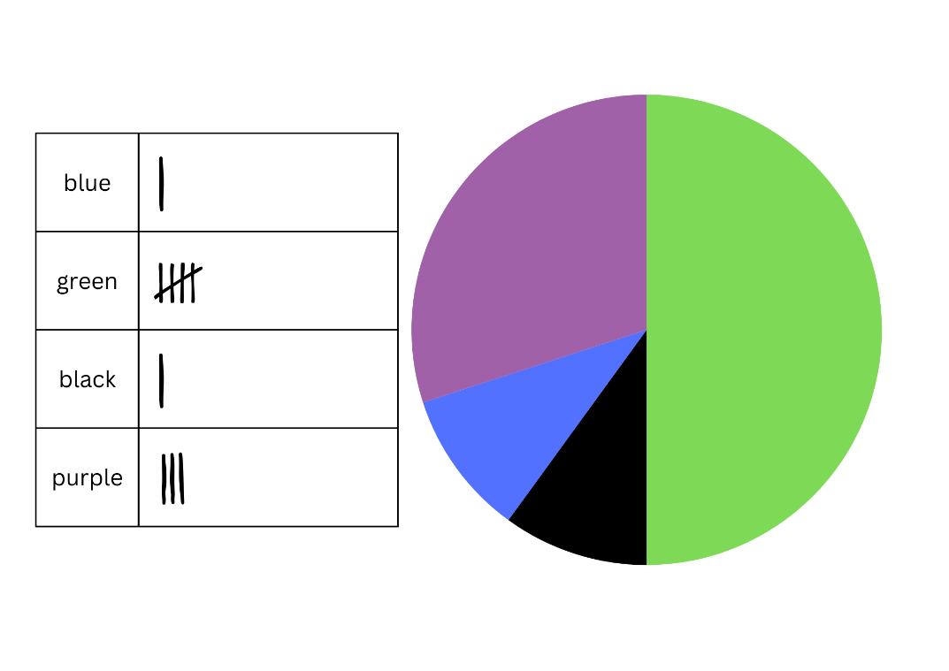

**Note**: spinners do not need to be exact, as drawing a spinner by hand can be difficult.

1. Select students to share their spinner. Ask:

* Why have you drawn your spinner in that way? (Students are to explain how the proportions resulted from the observed frequency of spins.)
* Could you describe the chance of spinning each colour using a fraction? (The total outcomes of the spinner should add to one, as the total of the probabilities of the outcomes equal one.)

1. Explain that a further 10 spins will be made and added to the existing tally marks. Call out another 10 spins from the mystery spinner.
2. Students use the collected data from the total of 20 spins to draw a new spinner below the first spinner.
3. Once students have drawn the spinner from 20 mystery spins, they label the parts of spinner with both fractions and percentages (see Figure 4). Highlight that the outcomes of the spinner should add to one, as the total of the probabilities of the outcomes equal one.

Figure 4 – labelled spinner

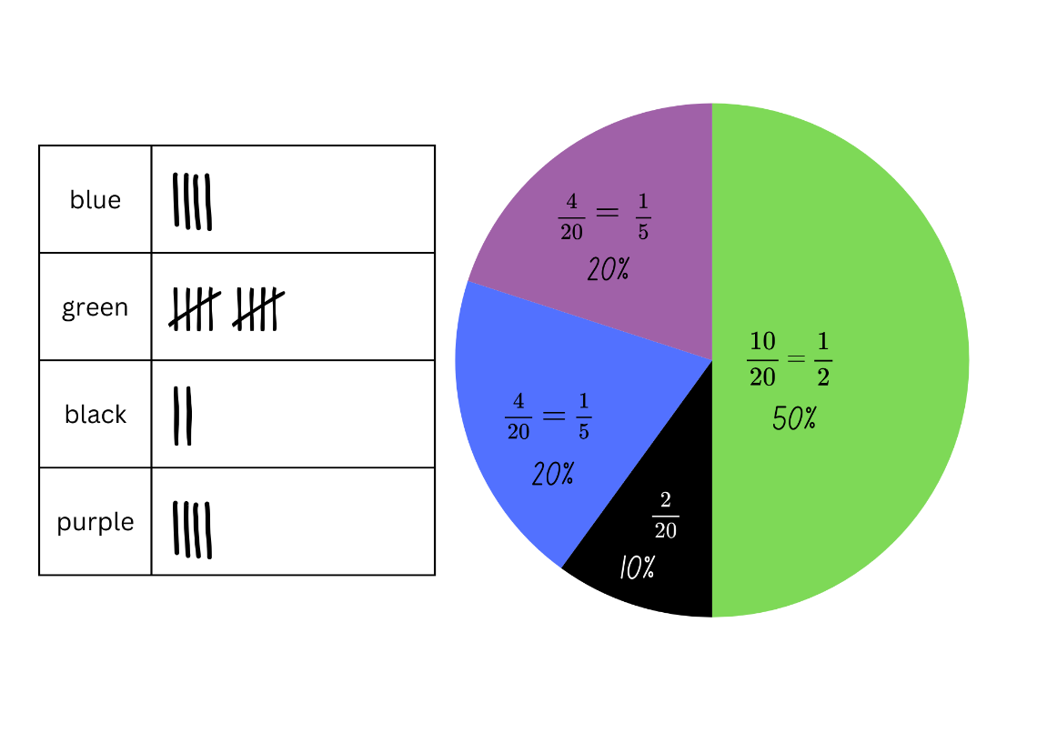

This table details opportunities for differentiation.

|  |  |
| --- | --- |
| Too hard? | Too easy? |
| Stage 3 students cannot collect data to create a spinner and describe probabilities using fractions and decimals.   * Provide students with a prefilled data set using tally marks for 10 spins, using just 2 colours. Model how to use the data to create the required spinner. Repeat with a data set including 3 colours. * Assist students to create fractions for each part of the spinner. Highlight that there were 20 spins so 20 is the whole. Identify that this is represented by the denominator, while the number recorded with tally marks will be the numerator. Support students to create equivalent fractions as in Figure 4. | Stage 3 students can collect data to create a spinner and describe probabilities using fractions and decimals.   * Play [Mystery Spinner: Challenge](https://www.abc.net.au/education/mystery-spinner-challenge/13828198) from ABC Education. Students recreate a mystery spinner to try and match the results on the graph. * Students conduct an experiment: Predict how often a bottle-top lid thrown into the air 20 times will land upside down, right-side up or on its side. They record their prediction on a probability scale as a fraction, decimal or percentage. After tossing the lid, they record the observed frequency and compare to initial predictions. |

## Discuss and connect the mathematics (Stage 2) – 10 minutes

1. Students reflect on the process of conducting the survey. Ask:

* Were there any challenges in collecting the data?
* Did you find it hard to get students to answer your questions? What did you do to make it easier?
* What did you learn from the process of conducting the survey?
* Which strategies were the most helpful when collecting the data?
* What would you do differently next time? Explain.

## Discuss and connect the mathematics (Stage 3) – 10 minutes

1. Display the mystery spinner to the class and ask:

* What fraction of the total is represented by each section of the mystery spinner? How did you calculate this?
* How close was the mystery spinner to your final spinner?
* What was different? What was similar?
* How did your understanding of probability help to create your mystery spinner?
* How many spins would be enough to make a strong prediction? Is 20 enough?
* If this activity was repeated with a different mystery spinner, would your knowledge of probability help you to create a spinner that is closer?
* Could a mystery spinner with 4-quarters result in the collected data? Why or why not?

This table details opportunities for assessment.

|  |  |
| --- | --- |
| Assessment opportunities | Links |
| What to look for:   * Can Stage 2 students create a list or table to organise the data? **[MAO-WM-01, MA2-DATA-01]** * Can Stage 2 students create a survey and related recording sheet, considering the appropriate organisation of categories for data collection? **[MAO-WM-01, MA2-DATA-01]** * Can Stage 2 students conduct a survey or make observations to collect categorical or numerical data?  **[MAO-WM-01, MA2-DATA-01]** * Can Stage 3 students can students collect data through observations? **[MAO-WM-01, MA3-DATA-01]** * Can Stage 3 students create random generators to follow specified probabilities or proportions?  **[MAO-WM-01, MA3-CHAN-01]** * Can Stage 3 students record the outcomes for chance experiments where the outcomes are not equally likely to occur and assign probabilities to the outcomes using fractions?  **[MAO-WM-01, MA3-CHAN-01]** * Can Stage 3 students use knowledge of benchmark fractions, decimals and percentages to assign probabilities to the likelihood of outcomes? **[MAO-WM-01, MA3-CHAN-01]** | Links to [National Numeracy Learning Progressions](https://www.australiancurriculum.edu.au/resources/national-literacy-and-numeracy-learning-progressions/version-3-of-national-literacy-and-numeracy-learning-progressions/) (NNLP):   * Stage 2 – IRD2, IRD3 * Stage 3 – UnC4, InF6, PrT3. |

# Lesson 3

**Core concept**: graphs are a communication tool (Stage 2) and expected and observed probabilities describe possible outcomes (Stage 3).

## Daily number sense – post office problems – 15 minutes

The table below contains suggested learning intentions and success criteria. These are best co-constructed with students.

|  |  |
| --- | --- |
| Daily number sense learning intentions | Daily number sense success criteria |
| Stage 2 students are learning to:   * apply addition and subtraction to familiar contexts, including money and budgeting.   Stage 3 students are learning to:   * apply efficient mental and written strategies to solve addition and subtraction problems. | Stage 2 students can:   * reflect on a chosen strategy for solving a problem, considering whether it can be improved * interpret problems involving money as requiring either addition or subtraction.   Stage 3 students can:   * solve word problems, including multistep problems. |

1. Pose the problem: Mike is helping his Mum and Dad for the day at the post office. Mike’s first customer is buying a birthday card for $4.25 and a set of stamps for $12. The customer gives Mike a $20 note. How much change does he need to give back to the customer?
2. Pose the following to Stage 3 students: The customer did not want coins in the change but instead wanted to receive a $5 note as change. The customer gave Mike extra coins to make up the difference. How much extra money did the customer give Mike so that his change was exactly $5?
3. Students record their thinking on individual whiteboards.

**Note**: monitor the different strategies that students use to solve the problem. For example, the shopkeeper’s method or other addition and subtraction methods. Make a note of the students who have used different strategies to share with the class in the next step.

1. Students share the strategies they used to solve the problem.
2. Students reflect on their chosen strategy. Encourage them to consider whether their strategy or a different strategy shared by a student would be more effective to solve the problem.
3. Pose the problem: Mike’s next customer is buying a notepad for $2.90, coloured markers for $4.20 and a pair of scissors for $4.50. The customer gives Mike $15.
4. Revise the ‘shopkeeper’ method of counting change from the price of an item to the value of the amount tendered to pay for it. Explain that this is a counting on strategy. For example, if a customer gave a $5 note for a packet of chips costing $2.75, a shopkeeper could count the $2.25 change as:

* $2.80 (providing 5c)
* $3.00 (providing 20c)
* $5.00 (providing $2).

1. Use the shopkeeper method to help Mike work out the change he needs to give back to the customer.
2. Remind students to consider whether to use the same strategy as before or if they are going to choose a more effective strategy.
3. Students record their thinking on individual whiteboards. They [turn and talk](https://education.nsw.gov.au/teaching-and-learning/curriculum/literacy-and-numeracy/teaching-and-learning-resources/numeracy/talk-moves) to share the strategy they chose to use this time. Students explain the reason for their choice.

This table details opportunities for assessment.

|  |  |
| --- | --- |
| Assessment opportunities | Links |
| What to look for:   * Can Stage 2 students reflect on a chosen strategy for solving a problem, considering whether it can be improved?  **[MAO-WM-01, MA2-AR-01]** * Can Stage 2 students interpret problems involving money as requiring either addition or subtraction? **[MAO-WM-01, MA2-AR-01]** * Can Stage 3 students interpret and solve multistep word problems? **[MAO-WM-01, MA3-AR-01]** | Links to [National Numeracy Learning Progressions](https://www.australiancurriculum.edu.au/resources/national-literacy-and-numeracy-learning-progressions/version-3-of-national-literacy-and-numeracy-learning-progressions/) (NNLP):   * Stage 2 – AdS8, UnM6 * Stage 3 – AdS8. |

## Core lesson – 40 minutes

### Stage 2 task 1 – organising and displaying data

The table below contains suggested learning intentions and success criteria. These are best co-constructed with students.

|  |  |
| --- | --- |
| Core concept learning intentions | Core concept success criteria |
| Stage 2 students are learning to:   * interpret and compare data * construct and interpret data displays with many-to-one scales. | Stage 2 students can:   * describe and interpret information presented in tally tables and column graphs * use a given many-to-one scale to represent discrete data in column graphs * use data in a spreadsheet to create column graphs with units on vertical axes that are in multiples. |

1. Discuss ways that the survey data collected from Lesson 2 can be presented to organise games for the Year 6 fundraiser. For example, the data could be organised using tables, dot plots or column graphs.
2. Provide students with grid paper and writing materials to create a data display for the data they collected.
3. In groups, students conduct a [gallery walk](https://app.education.nsw.gov.au/digital-learning-selector/LearningActivity/Card/555) to view the various data collected across the range of classes or grades. Ask:

* Which data representation models were easiest to read? Why?
* What are the advantages and disadvantages of each data representation model?
* Are there any similarities or differences between the results of the survey?
* How do the preferred game choices vary among different survey results?
* Were the survey results what you were expecting?
* How might the results of this survey help plan the Year 6 fundraiser next year?

1. Collate each group’s data to create a table of whole-school data. Students identify what the 5 most popular fundraiser games in the school are.
2. Explain that students will be entering the whole-school data into a Microsoft Excel spreadsheet. Ensure they know that the 10 game options are on the x-axis and the number of student votes is on the y-axis.

**Note:** Google Sheets can be used instead of Microsoft Excel, depending on school context.

1. Demonstrate how to enter data into a table in Microsoft Excel. Explain that this can also be called a spreadsheet (see Table 2).

Table 2 – example of spreadsheet data entry

|  |  |
| --- | --- |
| Fundraiser games | Total votes |
| Footy toss | 74 |
| Obstacle circuit | 51 |
| Ring toss | 36 |
| Disco dance-off | 64 |
| Jellybean jar guessing competition | 42 |
| Matching teacher baby photos competition | 63 |
| Lucky number | 38 |
| Prize wheel | 65 |
| Lucky dip | 64 |
| Coin toss | 43 |

1. Students enter the data into their own [Microsoft Excel](https://app.education.nsw.gov.au/digital-learning-selector/LearningTool/Card/105) spreadsheet.
2. Demonstrate how to create a column graph from the data in a spreadsheet. For example, in Microsoft Excel highlight the data. Then select the **Insert** tab in the ribbon, select **Insert Column or Bar Chart** icon and select **Clustered Column in 2D-Column**.
3. Demonstrate how to add titles to the axes by clicking on the graph and selecting the **Chart Elements** icon.
4. Remind students that the title of the graph should reflect the reason for conducting the survey. Students add titles, including to each of the axes, in the graph in their spreadsheet (see Figure 5).

Figure 5 – example of graphed survey data

A column graph representing student votes for Year 6 Fundraiser Games. 

Game options and total votes are: Footy toss = 74, Obstacle circuit = 51, Ring toss = 36, Disco dance-off = 64, Jellybean jar guessing competition = 42, Matching teacher baby photos competition = 63, Lucky number = 38, Prize wheel = 65, Lucky dip = 64 and Coin toss = 43.

1. Draw attention to the numbers on the vertical axis. Ask:

* What do the numbers represent? (They represent the number of things being counted. This is called a many-to-one scale and is used in column graphs.)
* Why are the numbers increasing by 10 each time, instead of increasing by ones? (There won’t be enough space to include every single number from 1–80. This is why a many-to-one scale is used in column graphs.)

**Note:** if students have had prior experience using Microsoft Excel, demonstrating how to enter data and create a column graph will not be required.

### Stage 2 task 2 – interpreting the data

1. Display Resource 6 – Dataville Public School survey. Explain that this school completed the same survey and collated their results in a table. Ask:

* What were the top 3 games voted at Dataville PS?
* Are the most popular games at Dataville PS the same as our school? Why do you think that might be?
* Were there any games that received a lot of votes at one school but very few at the other? Why do you think there was such a difference?
* Are there any other similarities or differences between the data from Dataville PS and our school?
* Does Dataville PS have more or less students than our school? How do you know?

This table details opportunities for differentiation.

|  |  |
| --- | --- |
| Too hard? | Too easy? |
| Students cannot use data in a spreadsheet to create column graphs with units on vertical axes that are in multiples.   * Support students with entering the survey data into a spreadsheet in [Microsoft Excel](https://app.education.nsw.gov.au/digital-learning-selector/LearningTool/Card/105) or [Google Forms](https://app.education.nsw.gov.au/digital-learning-selector/LearningTool/Card/89). * Model how to use this data to create column graphs with units on vertical axes that are in multiples. Highlight the need for titles on both axes, as well as a title for the graph that states its purpose. | Students can use data in a spreadsheet to create column graphs with units on vertical axes that are in multiples.   * Students create a column graph with horizontal bars in [Microsoft Excel](https://app.education.nsw.gov.au/digital-learning-selector/LearningTool/Card/105) or [Google Forms](https://app.education.nsw.gov.au/digital-learning-selector/LearningTool/Card/89). They use the small sample from the survey data to enter predicted data across the grade, stage or school (depending on school context). * Ask: What might the data look like if every school in Australia had similar data? There are approximately 6000 primary schools in Australia (Statista 2024). Students calculate these new amounts and display them in a graph. |

### Stage 3 task – scissors, paper, rock

The table below contains suggested learning intentions and success criteria. These are best co-constructed with students.

|  |  |
| --- | --- |
| Core concept learning intentions | Core concept success criteria |
| Stage 3 students are learning to:   * compare observed frequencies of outcomes with expected results * conduct chance experiments with both small and large numbers of trials. | Stage 3 students can:   * distinguish between and compare the frequency of an outcome and the probability of an outcome in a chance experiment * explain why observed frequencies of outcomes in chance experiments may differ from expected frequencies, and how this relates to randomness * determine and discuss the differences between the expected probabilities and the observed probabilities after both small and large numbers of trials. |

**Note**: Scissors, Paper, Rock is a learning sequence completed over Lesson 3 and Lesson 4 of this unit. Students investigate expected and observed outcomes and explore the effect of randomness on chance experiments. Chance B has a high vocabulary demand on students (see the word list in [Teaching advice for Chance B](https://curriculum.nsw.edu.au/learning-areas/mathematics/mathematics-k-10-2022/content/stage-3/fa6dbbaafc?show=advice)). The activities provide support for students to engage with and use content-specific vocabulary.

1. Display Resource 7 – SPR instructions and explain the rules of Scissors, Paper, Rock (SPR).
2. Introduce a class tournament by viewing a game of SPR online. Alternatively, 2 students can model some introductory games to establish or refresh the rules before all students play.
3. Ask: Do you think winning Scissors, Paper, Rock is based on chance? Why or why not? Students [turn and talk](https://education.nsw.gov.au/teaching-and-learning/curriculum/literacy-and-numeracy/teaching-and-learning-resources/numeracy/talk-moves) to discuss.
4. Provide some information about SPR: the game originated in China and has been played for over 2000 years, making it one of the oldest games in the world. Many people think it has remained popular because it is based on chance, which makes it a fair method of choosing between 2 people.
5. Draw a probability scale on the board. Select students to estimate the probability of winning and explain their thinking.
6. Ask how mathematicians might work out whether winning SPR is based on chance. If not elicited by students, discuss:

* predicting the likelihood of a win, loss or draw by listing and comparing all possible SPR outcomes
* communicating the likelihood of winning a game of SPR on a probability scale
* comparing predictions about how often people win, lose and draw SPR to the frequency of these outcomes in real life games.

1. Display Resource 8 – game outcomes and explain how the table lists all possible outcomes of the game. Provide students with thinking time to review the table. Ask:

* What is the total number of possible outcomes for the game?
* How many possible ways does each player win, lose or draw the game?

1. Revise the term ‘expected frequency’ as the number of times a particular outcome, in this case winning or losing, is predicted to happen in a chance experiment.
2. Using Resource 8 – game outcomes, students identify:

* the expected frequency of winning, losing and drawing SPR
* the expected probability, for example, winning a game 3 out of 9 times can be represented as having a probability of 33% or $\frac{1}{3}$.

1. Provide students with Resource 9 – SPR recording sheet 1. Students enter the expected frequency and probability values into Table 3 of Resource 9 – SPR recording sheet 1. Ask:

* Is one outcome more likely than the others?
* Does this change your thinking about whether SPR is a game of chance or skill? Explain your thinking.
* Is there a 50/50 chance of winning if losing, winning and drawing are all equally likely outcomes? Why or why not? (Where there are 3 equally likely outcomes, the chance of one of them occurring is one-third rather than one-half or 50/50.)

1. Explain that students will carry out a probability experiment. Each game of SPR played during the experiment is called a trial.
2. In groups of 3, students run 21 trials of SPR. Two students in each group are players and one is the recorder. Using Table 1 on Resource 9 – SPR recording sheet 1, the recorder notes down the number of:

* wins for Player 1 and Player 2
* draws.

1. Students enter the group’s observed frequency for each outcome into Table 3 of Resource 9 – SPR recording sheet 1.
2. Discuss the findings and encourage students to use topic-specific vocabulary, such as outcome, trial, experiment, observed frequency and expected frequency. Ask:

* What were the outcomes of your experiment?
* Does each outcome appear an equal number of times as predicted by the expected frequency?
* Why might the expected frequency and the observed frequency be the same or different?

1. The recorder from each group calls out their results and the data from the whole class is collated in Table 2 of Resource 9 – SPR recording sheet 1.
2. Model calculating the average of the observed frequency by adding the results in each column and dividing the total by the number of groups.
3. Students record the average observed frequency of class trials in their probability table.

**Note**: Stage 3 students are not expected to calculate the mean of a set of data. This is a Stage 4 syllabus outcome. In this activity, teachers calculate the mean to provide students with the average of a data set produced by their class. It is likely that there will be less variation in the class dataset but not certain. Varying outcomes for observed frequency should be considered when planning the lesson.

1. Students compare the expected frequency of winning 21 games to the observed frequency from the class trials. Explore the variations by using the prompt box below.

The table below outlines stimulus prompts to generate conversation about the topic, along with anticipated responses from students.

|  |  |
| --- | --- |
| Prompts | Anticipated student responses |
| * Is the data from the class or group trials equal to the expected frequency? Why or why not? | * No, we can’t always predict the exact outcomes of chance events. The outcome of chance events is random. |
| * Why might the data from the class trials be closer to the expected frequency? | * Data has been collected from more trials and the more you have, the more accurate the result of the experiment becomes. It is called the law of large numbers. |
| * Why might the data from the group trials be closer to the expected frequency? | * The outcomes of the trials are random and sometimes a result will appear more often by chance. |
| * How do the observed frequencies of winning compare to your original guess? | * They were close, the evidence supports my prediction. * They didn’t really reflect my prediction; I wonder what would happen if we did more trials. * They weren’t the same, I think it depends on who is playing. |

This table details opportunities for differentiation.

|  |  |
| --- | --- |
| Too hard? | Too easy? |
| Students cannot distinguish between the frequency of an outcome and the probability of an outcome in a chance experiment.   * Support students to revise and compare the definition of frequency (the number of times an outcome occurs in an experiment) and probability (the chance that an outcome will occur in an experiment ordered on a scale from 0 to 1). * Students distinguish between frequency and probability in a simpler chance experiment with fewer variables such as tossing a coin. | Students can distinguish between the frequency of an outcome and the probability of an outcome in a chance experiment.   * Students investigate other ways of representing and calculating probability in this experiment such as tree diagrams. * Students compare the probabilities from 2 experiments. Pose a scenario: In one experiment, a coin is dropped 600 times. In another experiment, a coin is dropped 6000 times. Students discuss how they think the probabilities from these 2 experiments will compare and explain their thinking. |

## Discuss and connect the mathematics – 10 minutes

1. Regroup as a class and distribute sticky notes to each student to use as an exit slip. Ask students to answer the following questions:

* What kinds of graphs might use a many-to-one scale? Why? (Stage 2)
* Why is it important to use accurate data when making decisions? (Stage 2)
* What are some benefits of representing data digitally, instead of just writing it down or drawing it on paper? How might it make it easier for others to understand? (Stage 2)
* What are the different ways you can communicate the likelihood of an event occurring? (For example, commonly used chance words, expected and observed frequency, expected and observed probability.) (Stage 3)
* Which of these options do you prefer? Why? (Stage 3)
* When would it be important to use mathematics to communicate the probability or frequency of a real-world event? Why? (Stage 3)

This table details opportunities for assessment.

|  |  |
| --- | --- |
| Assessment opportunities | Links |
| What to look for:   * Can Stage 2 students describe and interpret information presented in tally tables and column graphs? **[MAO-WM-01, MA2-DATA-01]** * Can Stage 2 students use a given many-to-one scale to represent discrete data in column graphs? **[MAO-WM-01, MA2-DATA-01]** * Can Stage 2 students use data in a spreadsheet to create column graphs with units on vertical axes that are in multiples?  **[MAO-WM-01, MA2-DATA-02]** * Can Stage 3 students distinguish between and compare the frequency of an outcome and the probability of an outcome in a chance experiment? **[MAO-WM-01, MA3-CHAN-01]** * Can Stage 3 students explain why observed frequencies of outcomes in chance experiments may differ from expected frequencies, and how this relates to randomness?  **[MAO-WM-01, MA3-CHAN-01]** * Can Stage 3 students determine and discuss the differences between the expected probabilities and the observed probabilities after both small and large numbers of trials?  **[MAO-WM-01, MA3-CHAN-01]** | Links to [National Numeracy Learning Progressions](https://www.australiancurriculum.edu.au/resources/national-literacy-and-numeracy-learning-progressions/version-3-of-national-literacy-and-numeracy-learning-progressions/) (NNLP):   * Stage 2 – IRD3 * Stage 3 – UnC2, UnC3, UnC4, UnC5. |

# Lesson 4

**Core concept**: data displays can be used to record and compare the outcomes of chance events (Stage 2) and expected and observed probabilities describe possible outcomes (Stage 3).

## Daily number sense – 10 minutes

1. From a class need surfaced through formative assessment data, identify a short, focused activity that targets students’ knowledge, understanding and skills. Example activities may be drawn from the following resources:

* [Mathematics K–6 resources](https://education.nsw.gov.au/teaching-and-learning/curriculum/mathematics/mathematics-curriculum-resources-k-12/mathematics-k-6-resources)
* [Universal Resources Hub](https://resources.education.nsw.gov.au/home).

## Core lesson – 40 minutes

### Stage 2 task 1 – tossing one coin

The table below contains a suggested learning intention and success criteria. These are best co-constructed with students.

|  |  |
| --- | --- |
| Core concept learning intention | Core concept success criteria |
| Students working towards Stage 2 outcomes are learning to:   * identify possible outcomes from chance experiments. | Students working towards Stage 2 outcomes can:   * record all possible outcomes in a chance experiment where the outcomes are equally likely * predict the number of times each outcome might occur in a chance experiment involving a set number of trials * conduct experiments and compare the predicted and actual results where the outcomes are equally likely. |

**Note**: for each lesson on chance in this unit, Stage 2 students can enhance their understanding by using various representations or tools. These representations and tools can be collaboratively constructed with students or provided as a resource. See Resource 10 – chance representations.

1. Revise the meaning of the word ‘outcome’ where it refers to any possible result of a situation. Discuss situations with different possible outcomes, such as weather, sport, card games or board games.
2. Explain that in mathematics, the term ‘outcome’ has a specific meaning. Share the syllabus definition of outcome.

**Outcome**: a possible result from an experiment or trial.

1. Discuss outcomes of random events, such as rolling dice, spinning a spinner, dealing cards from a deck, taking coloured counters from a bag.

**Event**: situations that occur in the everyday context. In the context of probability, this refers to the set of possible outcomes.

1. Display a coin. Ask students to identify all possible outcomes when a single coin is tossed.
2. Explain that in the event of a single coin toss, there are 2 possible outcomes, heads or tails.

The table below outlines stimulus prompts to generate conversation about the topic, along with anticipated responses from students.

|  |  |
| --- | --- |
| Prompts | Anticipated student responses |
| * What does it mean by ‘an equally likely chance’ of an outcome? | * There is one head and one tail, so it is equally likely that I flip heads or tails. * One outcome is heads. * One outcome is tails. |
| * Is it equally likely for the coin to land on a heads or tails? | * There is a 1 in 2 chance that I toss a head, which is the same for tails. |
| * Can you predict if it is equally likely for the coin to land on heads or tails if the coin is tossed 6 times? | * It is equally likely for the coin to land on heads or tails in any given toss. * Each coin toss is not affected by the previous coin toss, so it is equally likely every time we toss it. * After a few coin tosses, it might not seem equally likely. (Randomness can lead to variations where one outcome appears more frequently than the other over a short series of tosses). * Over many trials, the results should be an equal number of heads and tails. |
| * Predict the outcomes of 10 repeated coin tosses given that there is an equal chance for the coin to land on heads or tails? | * We can expect that approximately half of them will land on heads and the other half on tails. * A coin toss is a random event, so it is possible that the actual outcomes may vary. For example, 6 heads and 4 tails, or 3 heads and 7 tails. |

### Stage 2 task 2 – tossing 2 coins

1. Ask students to name all possible combinations when tossing 2 coins. Record the 4 outcomes on the board. They are:

* HH (2 heads)
* HT (one head, one tail)
* TH (one tail, one head)
* TT (2 tails).

1. Explain that students will be playing a game called ‘2-coin toss’:
2. This is a game for 3 players.
3. Each student tosses 2 coins.
4. Player 1 wins if there are 2 heads.
5. Player 2 wins if there are 2 tails.
6. Player 3 wins if there is one of each.
7. Provide 2 coins for each group. Students predict the possible outcomes on Resource 11 – coin toss recording sheet for 9 rounds.
8. Groups of students toss 2 coins and record the outcome for each round.
9. After playing, ask:

* After 9 rounds, what do you predict the result of your tenth toss will be?
* Did each of the players have the same chance of winning?
* If not, how could the rules be changed so each player has an equal chance of winning? Options include
* if there are 4 players in the game, Player 1 wins if they get HH, Player 2 wins if they get TT, Player 3 wins if they get HT and Player 4 wins if they get TH.
* if there are only 2 players in the game, Player 1 wins if they have 2 of the same coin (HH or TT) and Player 2 wins if they have 2 different coins (HT or TH).

This table details opportunities for differentiation.

|  |  |
| --- | --- |
| Too hard? | Too easy? |
| Students cannot record all possible outcomes in a chance experiment where the outcomes are equally likely.   * Support students to play the game, describing the outcomes using the language of chance. | Students can record all possible outcomes in a chance experiment where the outcomes are equally likely.   * In pairs or small groups determine all possible outcomes when tossing 3 coins instead of 2. * Students design their own fair coin toss game and explain it to another peer. They play the game to determine if it is a fair. |

### Stage 3 task 1 – fair and unfair games

The table below contains suggested learning intentions and success criteria. These are best co-constructed with students.

|  |  |
| --- | --- |
| Core concept learning intentions | Core concept success criteria |
| Students working towards Stage 3 outcomes are learning to:   * compare observed frequencies of outcomes with expected results * conduct chance experiments with both small and large numbers of trials. | Students working towards Stage 3 outcomes can:   * use the term frequency to describe the number of times a particular outcome occurs in a chance experiment * discuss the fairness of simple games involving chance and the idea of randomness * determine and discuss the differences between the expected probabilities and the observed probabilities after both small and large numbers of trials. |

1. Tell students they will continue to explore probability and chance through Scissors, Paper, Rock. Remind them that many people think SPR has remained popular because it is based on chance and this makes it a fair method of choosing between 2 people.
2. Ask: ‘What do you think makes a game fair?’ If not elicited, explain that a fair game means there is an equal chance of winning or losing.
3. If SPR were a fair game, what would be the probability of winning, losing and drawing?
4. Ask students to look at the data they collected from their experiment in Lesson 3. Ask:

* Did you observe students winning, losing and drawing an equal number of times in Test 1?
* Does that mean the game is fair? Why or why not?
* What would happen if we repeated the test and increased the number of trials?
* Apart from the number of trials, what else might contribute to an unequal distribution of outcomes in the game?

1. Explain that for all possibilities to have an equal chance of occurring, the choice of hand gesture must be random.
2. Ask students if they sometimes use a strategy to choose their hand gesture, for example, depending on their own or their partner’s choices in the previous round. How might that affect whether the outcomes occur randomly?
3. Students run a second experiment (Test 2) to determine whether random hand gestures produce observed probabilities closer to the expected probability. Explain that the players will close their eyes to ensure their choice of gesture is random and not based on a strategy related to their partner’s choice. Random generators such as dice or spinners could also be used to select the hand gesture.
4. In groups of 3, students complete Test 2 by conducting another 21 trials of SPR, this time with their eyes closed. The recorder should not tell the players who wins each game.
5. Provide students with Resource 12 – SPR recording sheet 2. The recorder notes the outcome of each game in Table 1 of Resource 12 – SPR recording sheet 2.
6. After all trials are completed, students compare their group’s observed frequency of winning, losing and drawing in Test 2 to the expected frequency. Ask:

* Did playing with closed eyes affect the observed frequency of the game’s outcomes? How?
* Did anyone win more games in Test 1 than in Test 2? What did you do differently?

1. The recorder from each group calls out their results so the whole-class data can be collated in Table 2 of Resource 12 – SPR recording sheet 2.
2. Calculate the average of the observed frequency for each outcome by adding the results in each column and dividing the total by the number of groups. Students record the data.

**Note**: students are not expected to calculate the mean of a set of data until Stage 4. In this activity, teachers calculate the mean to provide students with the average of a dataset produced by their own class.

1. Provide students with a calculator. As a class, work out the observed probability of the class data set.
2. Students calculate the observed probabilities for Test 1 and Test 2 and record them in the table.
3. Focusing on the results from Test 2, students [Think-Pair-Share](https://app.education.nsw.gov.au/digital-learning-selector/LearningActivity/Card/645) to discuss:

* Which is closer to the expected probability – the observed probability of the combined class trials or your individual group’s trials?
* What might be the reason for this?
* What would happen if we kept increasing the number of trials?

**Note**: it is likely that there will be less variation in the larger class dataset but not certain. Varying outcomes for observed frequency should be considered while planning the lesson.

1. Students compare the data from Test 1 and Test 2 and [Think-Pair-Share](https://app.education.nsw.gov.au/digital-learning-selector/LearningActivity/Card/645) to discuss the following questions:

* Is the class’s observed probability of winning the same in Test 1 and Test 2? What reasons might there be for this?
* Is playing the game with your eyes open or closed more likely to produce a fair game? Why or why not?
* Can you think of other ways to make the game fair?

This table details opportunities for differentiation.

|  |  |
| --- | --- |
| Too hard? | Too easy? |
| Students cannot discuss the fairness of simple games involving chance and the idea of randomness.   * Clarify the content-specific definition of fairness in probability as a game where there are equal chances of winning and losing. Compare this to the common understanding of everyone being treated equally. * Discuss suggestions for identifying whether a game is fair such as listing the possible events and possible outcomes using informal diagrams. | Students can discuss the fairness of simple games involving chance and the idea of randomness.   * Students investigate other games involving chance, such as throwing dice, and answer the questions: * Is the game fair? * How do we know it is fair? * What is the probability of winning? * How do we know that this is the probability? |

## Consolidation and meaningful practice (Stage 2) – 15 minutes

1. Groups change the rules of the game by choosing one of 2 options they would like to use. The options are:

* 4 players in the game
* 2 players in the game.

1. Once the rule has been decided upon, groups play the game again, recording the results on individual whiteboards.
2. Regroup after 10 rounds and ask:

* Were your overall results same or different to the first time? How?
* Did the change of rules affect the outcomes achieved? Can you explain how?
* Can you predict what might happen if you were to toss the coin 50 times?

## Consolidation and meaningful practice (Stage 3) – 15 minutes

1. Watch the clip from ABC Education’s [Catalyst: How to win at rock-paper-scissors (3:08)](https://www.abc.net.au/education/catalyst-how-to-win-at-rock-paper-scissors/13720728). Ask:

* After exploring the probability of winning SPR, have you changed your mind about whether it is a game of skill or chance?
* Many people say SPR has remained popular over 2000 years because it is a game of chance. Do you agree?
* How can a mathematical understanding of chance help you decide whether a game is fair to all players?

This table details opportunities for assessment.

|  |  |
| --- | --- |
| Assessment opportunities | Links |
| What to look for:   * Can Stage 2 students record all possible combinations in a chance experiment where the outcomes are equally likely?  **[MAO-WM-01, MA2-CHAN-01]** * Can Stage 2 students predict the number of times each outcome might occur in a chance experiment involving a set number of trials? **[MAO-WM-01, MA2-CHAN-01]** * Can Stage 2 students conduct experiments and compare the predicted and actual results where the outcomes are equally likely? **[MAO-WM-01, MA2-CHAN-01]** * Can Stage 3 students use the term frequency to describe the number of times a particular outcome occurs in a chance experiment? **[MAO-WM-01, MA3-CHAN-01]** * Can Stage 3 students discuss the fairness of simple games involving chance and the idea of randomness? **[MAO-WM-01, MA3-CHAN-01]** * Can Stage 3 students determine and discuss the differences between the expected probabilities and the observed probabilities after both small and large numbers of trials? **[MAO-WM-01, MA3-CHAN-01]** | Links to [National Numeracy Learning Progressions](https://www.australiancurriculum.edu.au/resources/national-literacy-and-numeracy-learning-progressions/version-3-of-national-literacy-and-numeracy-learning-progressions/) (NNLP):   * Stage 2 – UnC2, UnC3, CPr8 * Stage 3 – UnC2, UnC3, UnC5. |

# Lesson 5

**Core concept**: the outcomes of events can be affected by other events (Stage 2) and repeated trials identify data variation (Stage 3).

## Daily number sense – place the digit – 10 minutes

Daily number sense activities for Lessons 5 to 7 ‘loop’ back to concepts and procedures covered in previous units to assist students to build an increasingly connected network of ideas. These concepts may differ from the core concepts being covered by the unit.

The table below contains suggested learning intentions and success criteria. These are best co-constructed with students.

|  |  |
| --- | --- |
| Daily number sense learning intentions | Daily number sense success criteria |
| Stage 2 students are learning to:   * extend the application of the place value system from whole numbers to tenths and hundredths.   Stage 3 students are learning to:   * compare, order and represent decimals. | Stage 2 students can:   * order decimals representing tenths and hundredths, describing their relative size.   Stage 3 students can:   * compare and order decimal numbers of up to 3 decimal places. |

This activity is an adaptation of [Place the Digits](https://nzmaths.co.nz/resource/place-digits) from [NZ Maths](https://nzmaths.co.nz/) by New Zealand Ministry of Education.

1. Provide pairs of students with an individual whiteboard and Resource 13 – number cards.

**Note**: revisit the impact zero has on a number when it is in different place value positions. The placement of the zero in these examples changes how we say, write and understand decimals. For example, 0.78, 7.08 or 7.80.

1. The objective of the game is to make the largest decimal after drawing 3 cards (Stage 2) and 4 cards (Stage 3). Explain that to play the game:
2. Each player needs to draw a game board on their whiteboard (see Figure 6).
3. Player 1 draws a card from the deck and records the digit in the ones, tenths or hundredths column (Stage 2) or ones, tenths, hundredths or thousandths column (Stage 3).
4. Player 1 returns the drawn card to the bottom of the deck before the next player draws a card and records their digit. Repeat until each player has drawn 3 cards (Stage 2) and 4 cards (Stage 3).
5. Before concluding each round, players must say their decimal aloud. For example, 2.45 is read aloud as 2 and 45 hundredths.
6. The winner gets one point for making the largest decimal.

Figure 6 – place the digit gameboard

Two blank gameboards to play ‘Place the digit’ game for teaching place value concepts. 

The gameboards are labelled 'Place the digit game board Stage 2' and 'Place the digit gameboard Stage 3.' 

Each gameboard has columns labelled: Ones, decimal point, Tenths and Hundredths. 

The Stage 3 gameboard adds an extra column labelled Thousandths.

1. After a few rounds, explain that there is an adjustment to the rules of the game. Once players have filled all columns, they can choose to trade one of the digits from either the ones, tenths or hundredths column (Stage 2) or tenths, hundredths and thousandths column (Stage 3) and can draw a new card, trying to make an even larger decimal.
2. Students play the game to make the smallest decimal possible after drawing 3 cards.

This table details opportunities for assessment.

|  |  |
| --- | --- |
| Assessment opportunities | Links |
| What to look for:   * Can Stage 2 students order decimals representing tenths and hundredths, describing their relative size?  **[MAO-WM-01, MA2-RN-02]** * Can Stage 3 students compare and order decimal numbers of up to 3 decimal places? **[MAO-WM-01, MA3-RN-02]** | Links to [National Numeracy Learning Progressions](https://www.australiancurriculum.edu.au/resources/national-literacy-and-numeracy-learning-progressions/version-3-of-national-literacy-and-numeracy-learning-progressions/) (NNLP):   * Stage 2 – NPV4, NPV5, NPV6 * Stage 3 – NPV8.   Links to suggested [Interview for Student Reasoning](https://education.nsw.gov.au/teaching-and-learning/curriculum/literacy-and-numeracy/assessment-resources/ifsr) (IfSR) tasks:   * Stage 2 – IfSR-NP: 4D.1, 4D.2 * Stage 3 – IfSR-NP: 4D.6. |

## Core lesson 1 – lucky duck – 15 minutes

The table below contains suggested learning intentions and success criteria. These are best co-constructed with students.

|  |  |
| --- | --- |
| Core concept learning intentions | Core concept success criteria |
| Students working towards Stage 2 outcomes are learning to:   * describe the likelihood of outcomes of chance events * identify when events are affected by previous events.   Students working towards Stage 3 outcomes are learning to:   * choose and use appropriate tables and graphs * conduct chance experiments with both small and large numbers of trials. | Students working towards Stage 2 outcomes can:   * use the terms equally likely, likely and unlikely to describe the chance of everyday events occurring * compare the likelihood of obtaining particular outcomes in a simple chance experiment by predicting, conducting the experiment and comparing the results with the prediction * identify and discuss events where the chance of one event occurring will not be affected by the occurrence of the other * compare events where the chance of one event occurring is affected by the occurrence of the other.   Students working towards Stage 3 outcomes can:   * tabulate collected data with and without the use of digital technologies such as spreadsheets * determine the likely make up of a large collection of objects by sampling objects and returning them to the collection before the next sample. |

**Multi-age**: the purpose of this lesson for Stage 3 students is to use various trial sizes to find the composition of an unknown collection, recognising that larger trials enhance accurate predictions. This lesson revisits content introduced in Lesson 8 of [Multi-age Year B Unit 8](https://education.nsw.gov.au/teaching-and-learning/curriculum/mathematics/planning-programming-and-assessing-mathematics-k-6/mathematics-3-6-units#tabs_727018652_copy__9327342931:~:text=Unit%208%20%E2%80%93%20Visual%20representations%20help%20understand%20aspects%20of%20our%20world%20(chance%20and%20position)).

For **Part 2 of the core lesson**, Stage 3 students will require pre-prepared paper bags. Each bag will contain 10 strips of paper. Each strip has the name of one of 4 different student names written on it so some names will be repeated (for example, 4 × Harry, 3 × Miriam, 2 × Jia, 1 × Kevin). All bags have the same contents. Keep one bag as the teaching example bag.

1. Pose the conjecture: There are events where the chance of one event occurring will not be affected by the occurrence of the other.
2. Students [turn and talk](https://education.nsw.gov.au/teaching-and-learning/curriculum/literacy-and-numeracy/teaching-and-learning-resources/numeracy/talk-moves) to discuss if the statement is true or false.
3. Ask students to identify an event where the statement proves to be true. For example, you have a jar of red and blue marbles. If you pick a red marble and place it back into the jar, it does not change the chances of picking a blue or red marble next time.
4. Explain that students are going to play ‘Lucky duck’ at the Year 6 fundraiser. There are 20 ducks swimming in the pond, each labelled with a number from 1–20 underneath. If an even numbered duck is selected from the pool, students win a prize. Ask:

* What are the chances of getting an even number?
* What are the chances of getting an odd number?
* How many times do you predict an even number will be drawn if I play this game 10 times?

1. Provide students with writing materials and ask them to predict and record the numbers they think will be drawn over a series of 10 draws.
2. To select the first duck out of the pond, roll a 20-sided dice. Record the number rolled, as this represents the outcome.
3. Explain that the duck has been returned to the pond. Ask: Do you think there is still an equal chance of drawing an even or odd number duck after the first selection? Why or why not?
4. Repeat this process 10 times and record the outcome of each draw. Ask:

* Do the results of the 10 draws match your prediction?
* Can you explain why it is equally likely for an even or odd duck to be selected from the pond?
* Is this a fair game?

## Core lesson 2 – 25 minutes

### Stage 2 task – ducks are out

1. Say that there has been a change in the rules for the ‘Lucky duck’ game. Due to a limited number of prizes, once a duck is selected, it will be taken out of the pond.
2. Explain that the goal is still to select a duck with an even number to win a prize. However, once a duck has been selected, it is removed from the pond. There are still 20 ducks in the pond, each labelled with a number from 1–20 underneath. Ask:

* What are the chances of selecting an even numbered duck in the first round?
* If an even numbered duck is drawn in the first round, do the chances of drawing an even numbered duck change in the second round?

1. Provide students with a brown paper bag, 10 red counters (for even ducks) and 10 green counters (for odd ducks) and individual whiteboards.
2. Display Resource 14 – recording table. Using the example provided, model how to record the likelihood of drawing a red counter (even number) for each round as they complete the experiment. Remind them that after each draw, the counter is not returned to the bag.
3. Using Resource 14 – recording table, students record the likelihood of drawing a red counter (even number) for each round of the experiment.
4. Regroup as a class and ask:

* How did the chance of drawing a red counter (even number) change after each round?
* How did removing the counters each round change the probability of winning a prize?
* Do you think it became more or less challenging to win as the game continued? Why?
* Does removing the duck after it has been selected make the game fair? Why or why not?
* Why might the ‘Lucky duck’ stall owner decide to remove the duck after it has been selected in the game?

This table details opportunities for differentiation.

|  |  |
| --- | --- |
| Too hard? | Too easy? |
| Students cannot compare events where the chance of one event occurring is affected by the occurrence of the other.   * Display 5 red counters and 5 green counters. Support students to identify the probability of drawing a red counter. Remove a red counter so that there are 9 counters left. Support students to identify that there are 9 possibilities and 4 of them are red. * Support students to complete the investigation using just 10 counters. | Students can compare events where the chance of one event occurring is affected by the occurrence of the other.   * Add extra rules or conditions to the game to increase complexity. For example, there are 20 ducks and to win, a duck with an even number that is also a multiple of 3 must be selected to win. How does the probability change each round? * Challenge students to make their own rules. They complete the experiment and record how the probability changes throughout the experiment. |

### Stage 3 task – mystery bag

1. Explain to students that in the ‘Lucky duck’ game, they knew specific facts, such as the total number of ducks and the numbers assigned to each duck. However, this task is about a mystery bag.
2. Display the example paper bag and tell the students that it contains 10 slips of paper. On each slip is a name of a student in the class. A student’s name may be in the bag more than once. Keep the names and the proportions of names unknown to the students.
3. Explain that students will be trying to determine which names are in the bag by running different numbers of trials. Ask:

* How might you determine which names and how many of each name might be in the bag? Why do you think that?
* If you know that there are 10 names in the bag, what number of draws or trials could you start with to make a reasonable prediction? Why do you think that?

1. Provide groups of 4 or 5 students with Resource 15 – bag recording sheet enlarged onto A3 paper and a paper bag. Ensure it has the same names and proportions as the displayed paper bag.
2. Each group removes one name out of the paper bag (without looking inside it) and records it on the first fraction strip on Resource 15 – bag recording sheet.
3. The name is returned to the bag and students remove a second name (without looking inside). They record their selection, then repeat the process for a total of 10 times.
4. Each group transfers their data from the fraction strip into the table on Resource 15 – bag recording sheet. This records the frequency that each different name was removed from the bag.
5. Remind students that frequency means how often a particular outcome occurs. Some groups might randomly select strips of paper that show examples of multiple different names, while other groups’ random selections might show a smaller range of names.
6. Using the observed frequencies from the 10 trials, students predict the names and number of names in each bag. Ask the following questions:

* Are 10 trials enough to make an accurate prediction? How could we make a more accurate prediction?
* How many trials do you think you need to make an accurate prediction? Why do you think this?

1. Students repeat the process of removing names to complete their remaining fraction strips on Resource 15 – bag recording sheet. They complete the tally chart on Resource 15 – bag recording sheet to keep track of the observed frequency of each name as it is removed.
2. Ask students to now make predictions of the contents of the bag. They justify the reasons for their predictions to a partner.
3. Draw and label a class recording table on the board (see Table 3).

**Note**: the number of total trials completed by the class will vary depending on the number of groups in the class.

Table 3 – class recording table

Based on 1000 trials completed as a class, complete the names and tally the frequency.

|  |  |
| --- | --- |
| 1000 trials | Frequency |
|  |  |
|  |  |
|  |  |
|  |  |
|  |  |
|  |  |
|  |  |
|  |  |

1. Explain that students will now combine each group’s data and record the combined data in the table displayed on the board.
2. Using this combined data, students make predictions about the variety of different names in the bag and how many of each name there might be. They discuss with a partner if and why their predictions have changed.
3. Reveal the contents of the bag to the students. Discuss:

* Were your predictions correct? Why or why not?
* How was it different from making predictions in the previous ‘Lucky duck’ task?
* How did uncertainty about the distribution of names impact your prediction? Explain.
* Is it always better to conduct large numbers of trials in a chance experiment? Why or why not?
* Can you think of occasions in everyday life where people make probability predictions based on gathering data from sampling? (For example, polls at election time or shopping recommendations using social media browsing.)
* What other real-world scenarios can you think of where sampling replacement can be used? (For example, tagging wildlife for environmental research.)
* Why do you think sampling with replacement would be used in these situations?

This table details opportunities for differentiation.

|  |  |
| --- | --- |
| Too hard? | Too easy? |
| Students cannot determine the likely make up of a large collection of objects, by sampling objects and returning them to the collection before the next sample.   * Reduce the number of variables for the students. For example, adjust the number of student names used and number of names in the bag. * Review how sampling provides a clue to the likelihood of the total number of names in the bag. | Students can determine the likely make up of a large collection of objects, by sampling objects and returning them to the collection before the next sample.   * Students design and test a small, medium and large number of trials that would be appropriate using a bag containing 8, 15 or 20 names. * Students represent the number of names recorded as fractions from each trial. They compare this to the actual amount in the bag and reflect on the trial that provided the greatest accuracy. |

## Discuss and connect the mathematics (Stage 2) – 15 minutes

1. Provide students with a range of coloured counters, individual whiteboards and writing materials.
2. Display Resource 16 – Raph’s maths book.
3. Challenge students to analyse Raph's results and work out the number of coloured counters in his bag.
4. Explain that Raph had some coloured counters in a bag. The colours are red, blue and green. In between each of his draws, his friend looks into the bag to confirm the remaining colours. Without knowing the specific quantities of each colour, can you use Raph's results to determine the number of red, blue, and green counters in the bag?
5. Students [Think-Pair-Share](https://app.education.nsw.gov.au/digital-learning-selector/LearningActivity/Card/645) to solve the problem. They use Raph’s results to work out what coloured counters were in his bag. Ask:

* How many counters were in the bag at the start of the experiment?
* How many counters were in the bag after 9 draws?
* Using the information from draw 1–9, what is the most likely outcome for draw 10?

1. Select students to share their ideas and strategies.

## Discuss and connect the mathematics (Stage 3) – 15 minutes

**Note**: the Stage 3 [Teaching advice for Chance B](https://curriculum.nsw.edu.au/learning-areas/mathematics/mathematics-k-10-2022/content/stage-3/fa6dbbaafc?show=advice#:~:text=Teaching%20advice%20for%20Chance%20B) states that Monte Carlo methods or Monte Carlo experiments are the names given to using repeated random sampling to approximate the theoretical probability. These chance experiments are useful in situations where we are uncertain about or cannot calculate the theoretical probabilities. For example, using collected data to approximate the likelihood of each landing position when tossing a paper cup (NESA 2022).

1. Explain to students that scientists use sampling with replacement (Monte Carlo methods) to determine the number of different species of fish that live in the Great Barrier Reef. According to the Australian Institute of Marine Science (n.d.), the core survey reef sample comprises of 2 components:

* Manta tow surveys, which collect information in a standard reef slope habitat around the perimeter of each reef. A snorkel diver is towed behind a small boat to make direct observation on the condition of corals. The survey boat stops every couple of minutes and the snorkel diver reports back to the recorder on the boat about coral cover and other important information about the reef.
* Fixed site surveys, in which reef fish, animals and plants on the reef surface are surveyed at three sites, in a habitat that is the same across reefs.

1. Display Resource 17 – reef fish samples. Discuss that the resource shows 4 samples of different species of fish collected from one of the reefs in the Southern Great Barrier Reef in January. Each sample included 25 fish and were taken from the same reef.
2. The first sample taken consisted of 10 clownfish, 6 parrotfish, 4 pufferfish, 3 surgeonfish and 2 lionfish. The fish were counted and immediately returned to the reef. Explain that this process was repeated another 3 times as shown in Resource 17 – reef fish samples.
3. Use the following prompt box to facilitate a discussion around the collected samples and the Monte Carlo method.

The table below outlines stimulus prompts to generate conversation about the topic, along with anticipated responses from students.

|  |  |
| --- | --- |
| Prompts | Anticipated student responses |
| * If another 4 samples of 25 fish were collected in the same area in another 2 weeks’ time, what similarities do you think there could be? | * I think there will be more clownfish than any other fish because each sample had the highest number of them. * There would be a similar amount of parrotfish because there was a consistent amount collected from each sample (6, 8, 6, 8). * There could be low numbers of pufferfish. The first sample contained 4 and the last sample only contained one. |
| * If a sample of another 25 fish were collected from a different reef, at a different time, do you think there would be similarities to the sample previously collected? What could make this sample varied? | * I think the results would be the same because the numbers and species were consistent in all 4 samples already taken. * I think they would be different. The sample could vary depending on the location of the reef, for example, if it were taken from a reef located in the northern part. * The climate could make a difference to the number of species of fish being found and therefore the number that is counted. |
| * A total of 100 fish were collected over these 4 samples, what is the overall percentage of: * clownfish * parrotfish * surgeonfish * lionfish * pufferfish? | * Clownfish accounted for 40% of the sample. * Parrotfish accounted for 28% of the sample. * Surgeonfish accounted for 12% of the sample. * There were equal amounts of pufferfish and lionfish found. They each accounted for 10% of the sample. |
| * Is collecting 25 fish from each sample enough to make an accurate prediction? How can we make a more accurate prediction? | * No. It could be the same fish that were being selected because they were released back into the reef immediately after being counted. * No. I think there needs to be more samples collected as the Great Barrier Reef is quite large and has many different reefs in different areas. * I think more consecutive samples need to be collected. |
| * What sample size do you think needs to be collected to make an accurate prediction? | * Instead of a total of 100 fish collected, it could be double the number of fish in each sample and double the number of samples. * I think larger samples over a longer amount of time would be more accurate. * The Great Barrier Reef is already collecting data in 2 different ways to assist them to get a more accurate prediction. These are the manta tow surveys and the fixed reef surveys. |

This table details opportunities for assessment.

|  |  |
| --- | --- |
| Assessment opportunities | Links |
| What to look for:   * Can Stage 2 students use the terms equally likely, likely and unlikely to describe the chance of everyday events occurring? **[MAO-WM-01, MA2-CHAN-01]** * Can Stage 2 students compare the likelihood of obtaining particular outcomes in a simple chance experiment by predicting, conducting the experiment and comparing the results with the prediction? **[MAO-WM-01, MA2-CHAN-01]** * Can Stage 2 students identify and discuss events where the chance of one event occurring will not be affected by the occurrence of the other? **[MAO-WM-01, MA2-CHAN-01]** * Can Stage 2 students compare events where the chance of one event occurring is affected by the occurrence of the other?  **[MAO-WM-01, MA2-CHAN-01]** * Can Stage 3 students tabulate collected data with and without the use of digital technologies such as spreadsheets?  **[MAO-WM-01, MA3-DATA-01]** * Can Stage 3 students determine the likely make up of a large collection of objects, by sampling objects and returning them to the collection before the next sample? **[MAO-WM-01, MA3-CHAN-01]** | Links to [National Numeracy Learning Progressions](https://www.australiancurriculum.edu.au/resources/national-literacy-and-numeracy-learning-progressions/version-3-of-national-literacy-and-numeracy-learning-progressions/) (NNLP):   * Stage 2 – UnC3 * Stage 3 – IRD3, IRD4, IRD5, IRD7. |

# Lesson 6

**Core concept**: the outcome of chance experiments can be predicted and recorded (Stage 2) and mathematicians critically interpret and evaluate real-world data (Stage 3).

## Daily number sense – mixed-up decimals – 15 minutes

The table below contains suggested learning intentions and success criteria. These are best co-constructed with students.

|  |  |
| --- | --- |
| Daily number sense learning intentions | Daily number sense success criteria |
| Students working towards Stage 2 outcomes are learning to:   * extend the application of the place value system from whole numbers to tenths and hundredths.   Students working towards Stage 3 outcomes are learning to:   * compare, order and represent decimals. | Students working towards Stage 2 outcomes can:   * locate and order decimals representing tenths and hundredths on a number line, describing their relative size * express decimals as both tenths and hundredths.   Students working towards Stage 3 outcomes can:   * place decimal numbers of up to 3 decimal places on a number line. |

1. Display Resource 18 – mixed-up decimals 1 for Stage 2 and Resource 19 – mixed-up decimals 2 for Stage 3. Explain that the printer has broken and the decimal points did not print properly.
2. Explain that the decimals need to be ordered and placed in ascending order on a number line.
3. Provide individual whiteboards, Resource 18 – mixed-up decimals 1 for Stage 2 students and Resource 19 – mixed-up decimals 2 for Stage 3 students. Using the appropriate displayed resource, ask:

* How many possibilities are there for where the decimal point can go in each of the numbers? (Stage 2 and Stage 3)
* How could the numbers be arranged on a number line? Are there a variety of ways to arrange them so that they are in ascending order? Explain.
* What do you need to know about decimals when placing them in ascending order on a number line? Explain.

1. Discuss possible strategies and solutions to arrange the decimals on a number line in ascending order, expressing tenths and hundredths as decimals for Stage 2 students and tenths, hundredths and thousandths for Stage 3 students.
2. Ensure students justify their reasoning by explaining:

* how the markers are equally spaced on each of the number lines
* that the decimal point is consistently placed to show the place value for each digit
* that the decimals are recorded in ascending order (see Figure 7).

Figure 7 – examples of solutions

Two number lines and the title 'Possible solutions' for Stages 2 and 3, displayed with numerical progressions on number lines, illustrating different solution sets for each stage in a computational problem.

Stage 2 has 2 number lines. The first number line is divided into 10 equal parts and shows the numbers evenly spaced from 3.70 to 3.80. 

The second number line is divided into 10 equal parts and shows the numbers evenly spaced from 37.0 to 38.0.

Stage 3 has 3 number lines. The first number line is divided into 10 equal parts and shows the numbers evenly spaced from 3.700 to 3.800. 

The second number line is divided into 10 equal parts and shows the numbers evenly spaced from 37.00 to 38.00. 

The third number line is divided into 10 equal parts and shows the numbers evenly spaced from 370.0 to 380.0.

1. Each student selects a decimal on the number line and renames it in multiple ways. For example, 3.73 is 3 and 7 tenths and 3 hundredths or 3 and 73 hundredths or for Stage 3 students, 3.705 is 3 and 7 tenths and 5 thousandths or 3 and 705 thousandths.

This table details opportunities for assessment.

|  |  |
| --- | --- |
| Assessment opportunities | Links |
| What to look for:   * Can Stage 2 students use the decimal point as a marker to identify the position of the ones digit when expressing tenths as decimals? **[MAO-WM-01, MA2-RN-02]** * Can Stage 2 students represent and compare tenths as decimals using linear representations? **[MAO-WM-01, MA2-RN-02]** * Can Stage 2 students express decimals as both tenths and hundredths? **[MAO-WM-01, MA2-RN-02]** * Can Stage 3 students place decimal numbers of up to 3 decimal places on a number line? **[MAO-WM-01, MA3-RN-02]** | Links to [National Numeracy Learning Progressions](https://www.australiancurriculum.edu.au/resources/national-literacy-and-numeracy-learning-progressions/version-3-of-national-literacy-and-numeracy-learning-progressions/) (NNLP):   * Stage 2 – NPV6, NPV7 * Stage 3 – PrT1, PrT2, UnM8.   Links to suggested [Interview for Student Reasoning](https://education.nsw.gov.au/teaching-and-learning/curriculum/literacy-and-numeracy/assessment-resources/ifsr) (IfSR) tasks:   * Stage 2 – IfSR-NP: 4D.3, 4D.4 * Stage 3 – IfSR-NP: 4D.4, 4D.6. |

## Core lesson – 40 minutes

### Stage 2 task 1 – spin the spinner

The table below contains a suggested learning intention and success criteria. These are best co-constructed with students.

|  |  |
| --- | --- |
| Core concept learning intention | Core concept success criteria |
| Students working towards Stage 2 outcomes are learning to:   * describe the likelihood of outcomes of chance events. | Students working towards Stage 2 outcomes can:   * use the terms equally likely, likely and unlikely to describe the chance of everyday events occurring * compare the likelihood of obtaining particular outcomes in a simple chance experiment by predicting, conducting the experiment and comparing the results with the prediction. |

This lesson is an adaptation of [I’m Spinning](https://nzmaths.co.nz/resource/i-m-spinning) from [NZ Maths](https://nzmaths.co.nz/) by New Zealand Ministry of Education.

1. Tell students that you are unable to decide on the colour of paper to use for the fundraiser advertisement posters. A spinner will be used to decide on the colour.
2. Explain that students will be testing some spinners to see if they are fair to use.
3. Provide pairs of students with a blank spinner pre-cut from Resource 20 – blank and game spinner, a paper clip and a pencil. They fill in each section of the spinner with a different colour they prefer, for example, red, blue, purple.
4. Using the example colours, red, blue and purple, before spinning the spinner, ask:

* What are the chances of getting red?
* What are the chances of getting green?
* Is the chance of getting red the same as blue?
* How many times do you predict the spinner will land on red?

1. Students record their predictions for the number of times their spinner will land on each colour if 15 spins are completed.
2. Students test their spinners and keep track of the results using a tally chart.
3. Regroup and ask:

* Did your predictions match your outcomes?
* Are these spinners fair? How do you know?
* What would an unfair spinner look like?

### Stage 2 task 2 – spinner games

1. Display the game spinner from Resource 20 – blank and game spinner and tell students they are going to play a spinner game. To play the game:
2. Decide who will be Player A and Player B.
3. If the spinner lands on yellow, Player A receives 2 points and Player B receives one point.
4. If the spinner lands on red or green, Player B receives 2 points and Player A receives one point.
5. The first player to score 20 points wins.
6. Ask: Can you predict which player is most likely to win the game? Why? (Player B because they have more chances of scoring 2 points with each spin than Player A does. Player A can only score 2 points from yellow.)
7. Provide pairs of students with a pre-cut game spinner from Resource 20 – blank and game spinner, a paper clip and a pencil to play the game.
8. After playing one round, ask:

* Were your predictions correct about the winning player?
* Do you think the game is fair? Why or why not? (The game is not fair because Player A has less chance of scoring points from each spin.)
* Can you describe the chance of each player winning the game? (Player A has a 2 in 6 chance of scoring 2 points from each spin. Player B has 4 in 6 chances to score 2 points from each spin.)
* How could the rules be changed to make the game fair? (Three players can be involved in the game with each player only scoring a point from one colour.)

This table details opportunities for differentiation.

|  |  |
| --- | --- |
| Too hard? | Too easy? |
| Students cannot compare the likelihood of obtaining particular outcomes in a simple chance experiment by predicting, conducting the experiment and comparing the results with the prediction.   * Provide students with a modification of the blank spinner from Resource 20 – blank and game spinner to show 2 parts with blue and one part yellow. Player A can only score points if it lands on blue and Player B can only score points if it lands on yellow. | Students can compare the likelihood of obtaining particular outcomes in a simple chance experiment by predicting, conducting the experiment and comparing the results with the prediction.   * Students create their own spinner to use in a modified game with a greater number of possibilities. They decide on their own rules for scoring points. |

### Stage 3 task 1 – data in the media

The table below contains a suggested learning intention and success criteria. These are best co-constructed with students.

|  |  |
| --- | --- |
| Core concept learning intention | Core concept success criteria |
| Students working towards Stage 3 outcomes are learning to:   * interpret data presented in digital media and elsewhere. | Students working towards Stage 3 outcomes can:   * interpret data representations found in digital media and in factual texts * identify sources of possible bias in representations of data in the media * identify misleading representations of data in the media. |

**Note**: for each lesson on data, students can enhance their understanding by using consistent definitions such as those on Resource 21 – data types.

1. Discuss how data representations in the media can often be biased and sometimes misleading.

**Bias**: systematic favouring of certain outcomes more than others, due to unfair influence (knowingly or otherwise).

1. Highlight that there are various influences on data collection and representation, such as who created or paid for the data collection, and whether the representation is part of an advertisement.
2. Discuss elements of effective and misleading data representations in the media. Students record this in their workbook using a [T-chart](https://app.education.nsw.gov.au/digital-learning-selector/LearningActivity/Card/599). See Table 4 for possible responses.

Table 4 – data representations in the media

|  |  |
| --- | --- |
| Effective data representations in the media: | Misleading data representations in the media: |
| * accurately represent the whole data set * grab the reader’s attention * show trends or changes * are easy to read and understand * have a title and labels * uses colour or patterns to show differences. | * use incorrect displays for the data type * manipulate the axes or scale * use uneven intervals on the axes * leave out relevant data * have missing units or axes labels * exaggerate or minimise differences between numerical values. |

1. Explain that students will be examining 2 displays of climate data and looking for the elements of effective and/or misleading representation.
2. Provide the context that a one-degree global change in temperature is significant because it takes a vast amount of heat to warm all the earth’s oceans, atmosphere and land by that much. The last Ice Age was associated with a 2- to 4-degree drop in temperature, so small changes can be important.
3. Display Resource 22 – average global temperatures. Students use the class [T-chart](https://app.education.nsw.gov.au/digital-learning-selector/LearningActivity/Card/599) to assess each graph. Ask:

* What do you notice first about the graph labelled ‘Average global temperature A’?
* What do you notice first about the graph labelled ‘Average global temperature B’?
* What numbers do you see?
* Describe the shape of the graphs using words and numbers.
* How does the scale of the vertical axis change how you think about the data? (Graph B highlights small changes in temperature by starting at 13° and having a smaller range of intervals.)
* What information seems to be most important in Graph A? What information seems most important in Graph B?
* What is each graph trying to tell you?
* Could either graph be misleading? Why or why not? Explain.
* What do you wonder about
* Who made each graph?
* Why each graph was made?

### Stage 3 task 2 – misleading graphs

1. Provide one graph from Resource 23 – misleading graphs to pairs, ensuring a mix of all graphs across the class.
2. Explain that students need to:

* identify whether the data in the graph is poorly displayed and/or misleading
* if misleading, discuss how and why
* recreate the graph in their workbook.

1. Select students to share both their misleading graph and recreated efficient graph. They explain the elements they changed and why.
2. Prompt the class to ask clarifying questions:

* What did you identify as poorly displayed and/or misleading in the graph?
* What did you change so the graph was a true representation?
* Would you use a different type of graph to represent the same data?

**Note**: the graphs on Resource 23 – misleading graphs contain various elements that could be improved. The ‘Test scores 2017’ graph contains a repeated percentage, a missing label on the y-axis and it is not known what the different colours represent. The ‘Student’s favourite colour’ graph has clear labels; however the colours in the columns do not match the labels. The ‘Kids are missing way too much school!’ graph has uneven intervals on the y-axis, the data for January is included when students are on holidays and the title of the graph shows bias.

This table details opportunities for differentiation.

|  |  |
| --- | --- |
| Too hard? | Too easy? |
| Students cannot identify sources of possible bias and misleading representation of data in the media.   * Support students to identify which elements of the graph are misleading and explain why. * Provide simplified data representations with only one misleading element for students to identify and fix. | Students can identify sources of possible bias and misleading representation of data in the media.   * Challenge students to examine current media and advertising material for real-life examples of misleading data and possible source of bias. * Students create and conduct a survey from peers in the class that will provide biased data. |

## Discuss and connect the mathematics (Stage 2) – 5 minutes

1. Students draw 2 spinners in their workbook. The first spinner must represent equally likely chances of outcomes. The second spinner must represent an unequal chance of outcomes.
2. Choose several spinners to share with the class. Ask:

* How can you know if a spinner would have an equally likely chance?
* What changes did you make to design a spinner that displayed an unequal chance of outcomes?
* Is there a way to design a spinner that has a certain chance of spinning red?

## Discuss and connect the mathematics (Stage 3) – 5 minutes

1. Regroup and summarise the lesson together, drawing out key mathematical ideas. Ask:

* What are some positive and negative uses of data representations in the media and factual texts?
* What are some of the common problems with the way data is represented in the media? What are some possible consequences?
* Why are some data representations misleading?
* How do you identify potentially misleading representations?
* Will you look at data representations in the media and factual texts differently now? Why or why not?

This table details opportunities for assessment.

|  |  |
| --- | --- |
| Assessment opportunities | Links |
| What to look for:   * Can Stage 2 students use the terms equally likely, likely and unlikely to describe the chance of everyday events occurring? **[MAO-WM-01, MA2-CHAN-01]** * Can Stage 2 students compare the likelihood of obtaining particular outcomes in a simple chance experiment by predicting, conducting the experiment and comparing the results with the prediction? **[MAO-WM-01, MA2-CHAN-01]** * Can Stage 3 students interpret data representations found in digital media and in factual texts? **[MAO-WM-01, MA3-DATA-02]** * Can Stage 3 students identify sources of possible bias in representations of data in the media?  **[MAO-WM-01, MA3-DATA-02]** * Can Stage 3 students identify misleading representations of data in the media? **[MAO-WM-01, MA3-DATA-02]** | Links to [National Numeracy Learning Progressions](https://www.australiancurriculum.edu.au/resources/national-literacy-and-numeracy-learning-progressions/version-3-of-national-literacy-and-numeracy-learning-progressions/) (NNLP):   * Stage 2 – UnC3 * Stage 3 – IRD4, IRD5, IRD6. |

# Lesson 7

**Core concept**: interpreting data helps us solve problems and ask new questions (Stage 2) and data is used in everyday contexts and influences daily practices (Stage 3).

## Daily number sense – decimal dash – 15 minutes

The table below contains suggested learning intentions and success criteria. These are best co-constructed with students.

|  |  |
| --- | --- |
| Daily number sense learning intentions | Daily number sense success criteria |
| Students working towards Stage 2 outcomes are learning to:   * extend the application of the place value system from whole numbers to tenths and hundredths.   Students working towards Stage 3 outcomes are learning to:   * compare, order and represent decimals. | Students working towards Stage 2 outcomes can:   * locate and order decimals representing tenths and hundredths on a number line, describing their relative size.   Students working towards Stage 3 outcomes can:   * place decimal numbers of up to 3 decimal places on a number line. |

1. Explain that the aim of ‘Decimal dash’ is to practise locating and ordering decimals on a number line. It will also reinforce students’ understanding of relative sizes of decimals.
2. In pairs, provide students with Resource 24 – decimal cards 1 for Stage 2 students and Resource 25 – decimal cards 2 for Stage 3 students.
3. Using an individual whiteboard or paper, students draw a large number line and label key intervals. For example, 0, 1, 2, ..., 10.
4. Students shuffle the cards and split them in 2 equal piles.
5. Students turn a card over from their pile and record the decimal on their number line.
6. A point is given for every correct placement. If a student does not agree with the placement of the card, they ask their partner to justify their placements by explaining the relative size of the decimals.
7. Reshuffle the cards and play again.
8. Regroup as a class and ask:

* What patterns did you notice while placing decimals on the number line?
* Can you share any strategies you used to accurately position the decimals?
* What challenges did you encounter while placing decimals on the number line?
* How did you overcome these challenges during the game?

This table details opportunities for assessment.

|  |  |
| --- | --- |
| Assessment opportunities | Links |
| What to look for:   * Can Stage 2 students locate and order decimals representing tenths and hundredths on a number line, describing their relative size? **[MAO-WM-01, MA2-RN-02]** * Can Stage 3 students place decimal numbers of up to 3 decimal places on a number line? **[MAO-WM-01, MA3-RN-02]** | Links to [National Numeracy Learning Progressions](https://www.australiancurriculum.edu.au/resources/national-literacy-and-numeracy-learning-progressions/version-3-of-national-literacy-and-numeracy-learning-progressions/) (NNLP):   * Stage 2 – NPV6, NPV7 * Stage 3 – PrT1, PrT2, UnM8.   Links to suggested [Interview for Student Reasoning](https://education.nsw.gov.au/teaching-and-learning/curriculum/literacy-and-numeracy/assessment-resources/ifsr) (IfSR) tasks:   * Stage 2 – IfSR-NP: 4D.4 * Stage 3 – IfSR-NP: 4D.6. |

## Core lesson – 40 minutes

### Stage 2 task 1 – constructing and comparing data

The table below contains suggested learning intentions and success criteria. These are best co-constructed with students.

|  |  |
| --- | --- |
| Core concept learning intentions | Core concept success criteria |
| Students working towards Stage 2 outcomes are learning to:   * interpret and compare data * construct and interpret data displays with many-to-one scales. | Students working towards Stage 2 outcomes can:   * describe and interpret information presented in tally tables and column graphs * interpret and evaluate the effectiveness of various data displays found in media and in factual texts where displays represent data using a scale of many-to-one. |

1. Ask students to brainstorm a list of gaming devices they have at home. For example, gaming consoles, mobile phones, smart watches, tablets, VR headsets, laptops and desktop computers.
2. Draw a table on the board and record the number of gaming devices each student has at home. For example, see Table 5.

Table 5 – example of data recording

|  |  |
| --- | --- |
| ****Number of gaming devices in the home**** | ****Number of students**** |
| 1 | 1 |
| 2 | 3 |
| 3 | 6 |
| 4 | 6 |
| 5 | 5 |
| 6 | 4 |
| 7 or more | 4 |

The table below outlines stimulus prompts to generate conversation about the topic, along with anticipated responses from students.

|  |  |
| --- | --- |
| Prompts | Anticipated student responses |
| * Is this an effective way to collect and record this data? Why or why not? | * Yes, because the table makes it clear the number of gaming devices each student in our class has in their home. * No, because there are 4 students in our class who said they had 7 or more gaming devices, but we don’t know the exact number of devices they have. They may have 8 or 12. |
| * Is there another way we could collect and record this data to make it more accurate? Explain your thinking. | * Students could have specified each type of each gaming devices they have in their home. * The data could be displayed in a column graph rather than a table. This would make it easier to compare the total number of students for each category. |

1. Model how to create a class column graph of the gaming data for students.

**Note**: [Microsoft Excel](https://app.education.nsw.gov.au/digital-learning-selector/LearningTool/Card/105) or [Google Sheets](https://app.education.nsw.gov.au/digital-learning-selector/LearningTool/Card/69) can be used to compile and analyse the class data.

1. Display Resource 26 – gaming devices graph. Explain that this graph represents 100 individual responses in Australia.
2. Students compare the class column graph with Resource 26 – gaming devices graph. Ask:

* Are there any differences in the number of gaming devices owned by students in our class, compared to the broader survey?
* How do scales on graphs help us understand data? Can you give an example?
* What are some similarities and differences you notice when comparing the scales on the 2 different graphs?
* Why is it important to pay attention to the scale when interpreting a graph?
* Can you explain why knowing the number of people surveyed is important when comparing the scales in graphs?
* How can you ensure you interpret a graph's data accurately, when comparing graphs with different scales?

### Stage 2 task 2 – evaluating a data set

1. Provide small groups or pairs of students with Resource 27 – interpreting data displays.
2. Explain that students will look at data provided by [IGEA -– Interactive Games and Entertainment Association Australia (PDF 12.4 MB)](https://igea.net/wp-content/uploads/2023/08/IGEA_AP2023_FINAL_REPORT.pdf).
3. Students evaluate how effectively each data display presents the information about the types of gaming devices in homes. Ask:

* What data is being displayed?
* How is the column graph representation similar and different to the picture graph?
* Which is easier to interpret? Why?
* What do you notice about the labels on the axes of the graphs? Are they clear and easy to understand?
* How would you compare the lengths of the bars in the column graph?
* Which display, do you think provided the most accurate representation of the data collected? Explain.
* What are some modifications you would suggest that could be made to improve each of the data displays?
* Why is it important for a data display to have a key or legend? Can you explain what the key tells us in the graphs?
* If 1000 people were surveyed, which display do you think would best to represent the data? Why?

1. In pairs, students write 3 questions about Resource 27 – interpreting data displays to be answered by another pair of students. Alternatively, students answer the following questions:

* Which type of gaming device are the most common in households?
* How does the range of gaming devices compare to what you expected?
* Are there any types of gaming devices that are less common or missing from the data? Why do you think that might be?

1. Invite students to share their questions and answers with the class.

This table details opportunities for differentiation.

|  |  |
| --- | --- |
| Too hard? | Too easy? |
| Students cannot interpret and evaluate the effectiveness of various data displays found in media and in factual texts where displays represent data using a scale of many-to-one.   * Prompt students to analyse and compare the features of each display on Resource 27 – interpreting data displays. For example, students consider factors, such as the title, axis labels, scale and overall clarity of the information presented. | Students can interpret and evaluate the effectiveness of various data displays found in media and in factual texts where displays represent data using a scale of many-to-one.   * Provide larger or more complex data sets for analysis. This can include data with multiple variables, data collected over longer periods of time, or data from different sources that need to be integrated and analysed together. Students label and annotate the interesting features they identify. * Present students with real-world data sources for them to apply data analysis skills and answer complex problems or make recommendations. This could involve analysing data related to environmental issues, economic trends, or public health issues. |

### Stage 3 task – Great Barrier Reef data

The table below contains suggested learning intentions and success criteria. These are best co-constructed with students.

|  |  |
| --- | --- |
| Core concept learning intentions | Core concept success criteria |
| Students working towards Stage 3 outcomes are learning to:   * interpret and compare a range of data displays * interpret data presented in digital media and elsewhere. | Students working towards Stage 3 outcomes can:   * interpret side-by-side column graphs for 2 categorical variables * interpret data representations found in digital media and in factual texts. |

1. Explain that data displays are visual representations of information, such as graphs or tables. They help readers understand and interpret data.

**Note**: the Stage 3 [Teaching advice for Data B](https://curriculum.nsw.edu.au/learning-areas/mathematics/mathematics-k-10-2022/content/stage-3/fa0c228e92?show=advice&ta_scroll=no#:~:text=Teaching%20advice%20for%20Data%20B) states the types of data that could be selected for interpretation include census data, environmental audits of resources such as water and energy, and sports statistics (NESA 2022).

1. Discuss that according to the Great Barrier Reef Foundation (2024), coral bleaching describes a natural process where corals lose their vibrant colours and turn white. This happens when corals are under stress due to an environmental disturbance. Coral bleaching is usually triggered by heat stress caused by increased water temperatures and ultraviolet (UV) radiation. It can occur due to other factors such as changes in water quality.
2. Display Resource 28 – alternative holiday destinations. Tell students they will be interpreting side-by-side column graphs with 2 categorical (different) variables.
3. Explain that this graph shows the percentage of tourists from various countries who would consider alternative holiday destinations (either within Australia or abroad) if coral bleaching continues to destroy the Great Barrier Reef. Ask:

* What do you notice about the data?
* Which country has the most people who would choose to travel to different destinations within Australia? Which country had the least?
* Which country had the most people who would choose to travel to other countries if coral bleaching continued to occur in the Great Barrier Reef? Which country had the least?
* What is the percentage difference between the people in each country wanting to visit other destinations within Australia compared to travelling to other countries?
* Is there anything that surprised you about this data?
* Who might find this data useful? Why?
* How else could this data be represented?
* Why do you think coral bleaching contributes to tourists deciding not to visit the Great Barrier Reef?
* Why do you think China has the largest number of tourists who will choose to visit other destinations within Australia instead of travelling to another country?
* Why would you use a side-by-side column graph to display this data?
* Is there a better way to display this data?

1. Display Resource 29 – reef visitors. Place Stage 3 students in groups of 3 or 4 and provide an A3 copy of Resource 30 – visitors data sheet. Explain that they will be completing the sheet, providing as much detail as possible.
2. Once completed, students [turn and talk](https://education.nsw.gov.au/teaching-and-learning/curriculum/literacy-and-numeracy/teaching-and-learning-resources/numeracy/talk-moves) with another group to discuss the similarities and differences between their answers.
3. Regroup and discuss answers to each question on students' data sheet. Ask:

* Were there any similarities or differences about the answers collected in your groups?
* Does the data support different interpretations?
* Can you see any patterns or trends?
* Do you think using a side-by-side column graph would be the most effective way to represent this data?
* Who might collect this data about tourists visiting the Great Barrier Reef?
* What might this data be used for?

This table details opportunities for differentiation.

|  |  |
| --- | --- |
| Too hard? | Too easy? |
| Students cannot interpret side-by-side column graphs for 2 categorical variables.   * Ask questions related to only one variable in each graph. * Support students to focus on one column before comparing domestic and international visitors. | Students can interpret side-by-side column graphs for 2 categorical variables.   * Students brainstorm examples of their own questions to ask about the Great Barrier Reef data. * Students create their own data about a topic of interest. They represent this in a side-by-side column graph. |

## Discuss and connect the mathematics (Stage 2) – 5 minutes

1. Regroup and ask:

* What were some of the advantages and disadvantages you identified when using any of the 4 displays?
* How would you order the data displays from most to least effective? Why?

## Discuss and connect the mathematics (Stage 3) – 5 minutes

1. Regroup and display Resource 31 – barrier reef weather. Ask:

* What do you notice about this data? How else could this data have been represented?
* Do you think this data would impact tourism to the area? Why or why not?
* Do you have any wonderings about the data?
* Who would find this data useful and why?

This table details opportunities for assessment.

|  |  |
| --- | --- |
| Assessment opportunities | Links |
| What to look for:   * Can Stage 2 students describe and interpret information presented in tally tables and column graphs? **[MAO-WM-01, MA2-DATA-02]** * Can Stage 2 students interpret and evaluate the effectiveness of various data displays found in media and in factual texts where displays represent data using a scale of many-to-one?  **[MAO-WM-01, MA2-DATA-02]** * Can Stage 3 students interpret side-by-side column graphs for 2 categorical variables? **[MAO-WM-01, MA3-DATA-02]** * Can Stage 3 students interpret data representations found in digital media and in factual texts? **[MAO-WM-01, MA3-DATA-02]** | Links to [National Numeracy Learning Progressions](https://www.australiancurriculum.edu.au/resources/national-literacy-and-numeracy-learning-progressions/version-3-of-national-literacy-and-numeracy-learning-progressions/) (NNLP):   * Stage 2 – IRD3, IRD4 * Stage 3 – IRD4, IRD5. |

# Lesson 8

**Core concept**: mathematicians interpret and evaluate the effectiveness of real-world data (Stage 2) and statistical reasoning helps mathematicians interpret and make inferences about real-world data (Stage 3).

## Daily number sense – 10 minutes

1. From a class need surfaced through formative assessment data, identify a short, focused activity that targets students’ knowledge, understanding and skills. Example activities may be drawn from the following resources:

* [Mathematics K–6 resources](https://education.nsw.gov.au/teaching-and-learning/curriculum/mathematics/mathematics-curriculum-resources-k-12/mathematics-k-6-resources)
* [Universal Resources Hub](https://resources.education.nsw.gov.au/home).

## Core lesson – 45 minutes

The table below contains suggested learning intentions and success criteria. These are best co-constructed with students.

|  |  |
| --- | --- |
| Core concept learning intentions | Core concept success criteria |
| Students working towards Stage 2 outcomes are learning to:   * select and trial methods for data collection * construct and interpret data displays with many-to-one scales.   Students working towards Stage 3 outcomes are learning to:   * interpret and compare a range of data displays * interpret data presented in digital media and elsewhere. | Students working towards Stage 2 outcomes can:   * compare the effectiveness of different methods of collecting and recording data * interpret and evaluate the effectiveness of various data displays found in media and in factual texts where displays represent data using a scale of many-to-one.   Students working towards Stage 3 outcomes can:   * interpret and compare different displays in terms of the shape of the distribution, including the range and the most frequent value (mode) * interpret data representations found in digital media and in factual texts. |

**Multi-age**: the purpose of this lesson for Stage 2 students is to analyse the effectiveness of various data displays in communicating information. It can be used as an assessment tool of students’ understanding and learning of data interpretation.

1. Display Resource 32 – school travel graph and provide pairs with writing materials. Ask:

* What does the data display represent?
* How clear and understandable is the display?
* Does the display effectively communicate the information presented?
* Is there any information missing?

1. Students [turn and talk](https://education.nsw.gov.au/teaching-and-learning/curriculum/literacy-and-numeracy/teaching-and-learning-resources/numeracy/talk-moves) with a partner to discuss and record 3 improvements that would enhance the data display, making it clearer and more effective.
2. Select students to share their ideas and record examples.

### Stage 2 task – mystery graphs

1. Provide groups of students with a copy of Resource 33 – mystery graphs.
2. Students choose 2 data displays to carefully examine and compare. They answer the following questions by annotating each of the graphs from Resource 33 – mystery graphs. Ask:

* What does the data display represent?
* How clear and understandable is the display?
* What information is missing?
* Does the display effectively communicate the information presented?
* Are there any improvements that could improve the data display’s clarity or effectiveness? For example, by adding headings or labels.
* What are the advantages and disadvantages for using each display?
* Which graph do you think is the most efficient? Why?
* Would the data representation be more effective if displayed in a different way? For example, by using a dot plot or table.

1. Students find another peer or group to compare their ideas.
2. Regroup and discuss:

* What are the different ways we can collect data? (for example, counting, measuring, surveys and observation)
* How does the way we organise data affect the information we can learn from it? (tables, graphs, categories can show patterns or relationships that may not be so obvious)
* Why might we choose to study only part of a group, and what are the potential advantages and disadvantages of this approach?

This table details opportunities for differentiation.

|  |  |
| --- | --- |
| Too hard? | Too easy? |
| Students cannot interpret and evaluate the effectiveness of various data displays found in media and in factual texts where displays represent data using a scale of many-to-one.   * Provide students with Resource 34 – column graph checklist to support their analysis of a column graph on Resource 33 – mystery graphs. Model how to use the checklist to look for missing features. | Students can interpret and evaluate the effectiveness of various data displays found in media and in factual texts where displays represent data using a scale of many-to-one.   * Show students examples of data displays from media sources, scientific articles or research studies. They critically evaluate the effectiveness of each display in conveying information. |

### Stage 3 task – comparing and interpreting data

1. Explain that the spread of data can be shown on a graph or in a table. The analysis of this data is sometimes called ‘statistics’. In statistics:

* the spread of data is called the distribution
* the range of the data refers to how far it is spread out between the highest and the lowest data points
* the mode relates to the most frequently occurring data point.

1. Display Resource 35 – coral bleaching data. Explain that the data display shows the coral bleaching of both the northern and southern sections of the Great Barrier Reef.
2. Revisit the coral bleaching description from Lesson 7. Students [turn and talk](https://education.nsw.gov.au/teaching-and-learning/curriculum/literacy-and-numeracy/teaching-and-learning-resources/numeracy/talk-moves) to discuss what they notice about the data display.
3. Regroup and ask:

* What is the data telling us?
* What type of graph is this?
* What is the range of this data set?
* What is the mode of this data set?
* Do you think this graph would be the best way to represent this data? Why or why not?
* Based on this data, what do you think may happen to the coral in the Great Barrier Reef in the next 10 years?
* Do you have any other wonderings about this data?
* Who might find this data useful?

1. Display Resource 36 – comparing graphs. Ask:

* Which data representation is easiest to interpret? Why?
* Which data representation provides the most information? Explain why.

1. Watch [How Scientists are Restoring the Great Barrier Reef | Travel + Leisure (7:32)](https://www.youtube.com/watch?v=8hknaJQRh8s) (1:22–4:22) about the restoration of coral on the Great Barrier Reef. Ask:

* What are scientists doing to help maintain coral in the Great Barrier Reef?
* Does the information from the video support the data in the graphs about coral bleaching we saw? Why or why not?
* Does the information in the video change your opinion about what could happen to the coral in the Great Barrier Reef in the next 10 years? Why or why not?
* How could the data about reef revitalisation from the video be collected and displayed?

1. Display Resource 37 – rising sea temperatures A. Remind students of the context of small rises in temperature provided in Lesson 6. Explain that a one-degree global change in sea temperature is significant, as it will increase sea levels, and impact ecological systems and biodiversity.
2. Small groups use an A3 copy of Resource 38 – data information sheet to answer the questions, providing as much detail as possible.
3. Regroup and select students to present their findings. Ask the following questions:

* What is the range of the data?
* What is the mode of the data?
* What overall conclusions can be made about rising temperatures in the Great Barrier Reef based on this data?
* Do you have any other wonderings about the data?
* Was this graph an effective way to display the data? Why or why not?
* How else could this data be represented?

This table details opportunities for differentiation.

|  |  |
| --- | --- |
| Too hard? | Too easy? |
| Students cannot interpret and compare data representations found in digital media and in factual texts.   * Provide students with a simpler graph, Resource 39 – rising sea temperatures B. Support them to describe the data points and the scale used. | Students can interpret and compare data representations found in digital media and in factual texts.   * Challenge students to predict the sea water temperature over the next 10 years. They continue the line graph and give reasons for their predictions. * Students write 3 questions about Resource 37 – rising sea temperatures A. They swap questions with a partner, discussing their responses and comparing their reasoning. |

## Discuss and connect the mathematics – 10 minutes

1. Regroup as a class and ask:

* What role do data displays play in effectively communicating information?
* What do you think is the most effective way to organise and display data so that we can learn from the information? Explain
* When interpreting data, how does analysing displays, finding patterns and drawing conclusions help us to understand the information meaningfully? (Stage 2)
* When comparing and discussing the threats to the Great Barrier Reef, do you think the data was represented effectively to show the decline over time? (Stage 3)

This table details opportunities for assessment.

|  |  |
| --- | --- |
| Assessment opportunities | Links |
| What to look for:   * Can Stage 2 students compare the effectiveness of different methods of collecting and recording data?  **[MAO-WM-01, MA2-DATA-02]** * Can Stage 2 students interpret and evaluate the effectiveness of various data displays found in media and in factual texts where displays represent data using a scale of many-to-one?  **[MAO-WM-01, MA2-DATA-02]** * Can Stage 3 students interpret and compare different displays in terms of the shape of the distribution, including the range and the most frequent value (mode)? **[MAO-WM-01, MA3-DATA-02]** * Can Stage 3 students interpret data representations found in digital media and in factual texts? **[MAO-WM-01, MA3-DATA-02]** | Links to [National Numeracy Learning Progressions](https://www.australiancurriculum.edu.au/resources/national-literacy-and-numeracy-learning-progressions/version-3-of-national-literacy-and-numeracy-learning-progressions/) (NNLP):   * Stage 2 – IRD4 * Stage 3 – IRD4, IRD5. |

# Resource 1 – farmer’s market cards

Cards with images of fruit and vegetables. The first 5 cards have a price written above the images and the last 5 cards have a number above the images. The images are:

$1.10 for carrots.

$1.40 for broccoli.

$1.85 for lemons.

$2.50 for strawberries.

$2.90 for grapes.

36 corn cobs.

40 grapes.

48 broccoli florets.

24 oranges.


# Resource 2 – room maze

Room maze resource. There are 3 spinners. Fork 1 spinner – a circle with 75% shaded red and 25% shaded blue. The arrow is pointing to blue.

Start spinner – a circle with 50% shaded red, 25% shaded orange and 25% shaded blue.

Fork 2 spinner with 75% shaded red and 25% shaded blue. The arrow is pointing to red.
There is a maze showing that Room A leads to Fork 1, start and Fork 2. Room B leads to Fork 1 and Fork 2.

# Resource 3 – lolly shop

Lolly shop cards with pictures of lollies and numbers underneath.

There are:

A bag of jelly beans for $2.50.

A bag of gummy bears for $3.50.

A chocolate bar for $5.00.

A bag of lollipops for $4.50.

42 sour straps.

50 worms.

72 marshmallows.

65 gummy bears.

# Resource 4 – spinners

Four pie charts representing spinners.

Pie chart 1 shows three-quarters green, one-eighth orange and one-eighth purple.

Pie chart 2 shows one-quarter orange, one quarter blue, one-eighth purple and three-eighths green.

Pie chart 3 shows one-quarter orange, one-quarter purple, one-quarter green and one-quarter blue.

Pie chart 4 shows one-half green, one-sixth blue, one-sixth purple and one-sixth orange.

# Resource 5 – mystery spinner

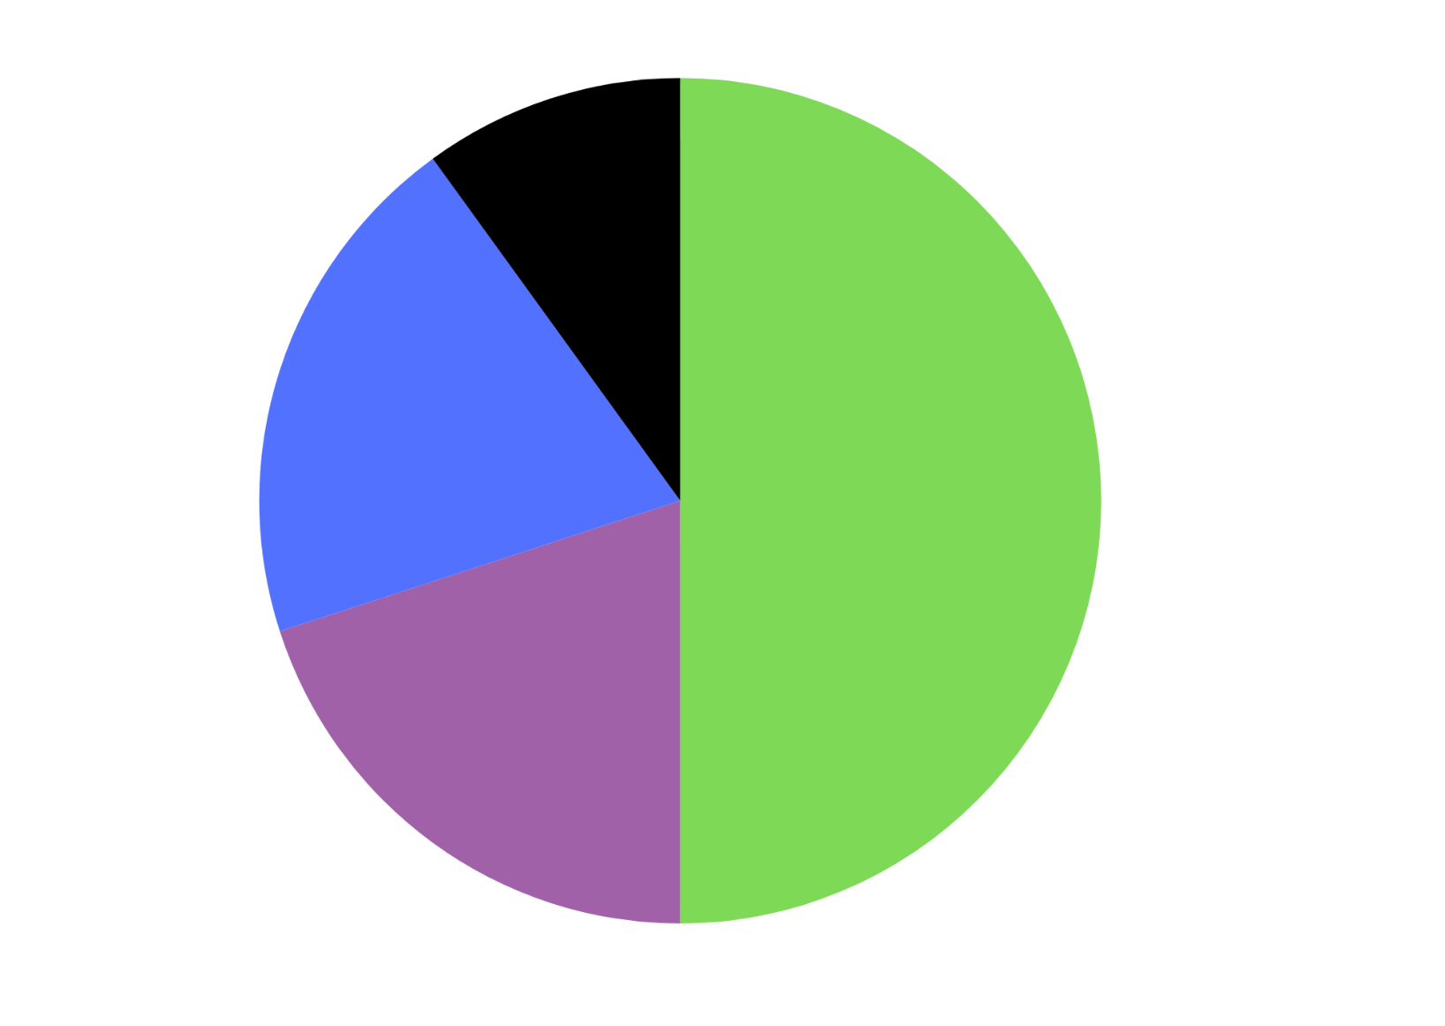

# Resource 6 – Dataville Public School survey

|  |  |
| --- | --- |
| ****Potential fundraiser games**** | ****Student votes**** |
| Footy toss | 75 |
| Obstacle circuit | 60 |
| Ring toss | 13 |
| Disco dance-off | 84 |
| Jellybean jar guessing competition | 38 |
| Matching teacher baby photos competition | 68 |
| Lucky number | 23 |
| Prize wheel | 93 |
| Lucky dip | 88 |
| Coin toss | 24 |

# Resource 7 – SPR instructions

|  |  |
| --- | --- |
| **Scissors – Paper – Rock**  Two players face each other and choose a hand gesture to represent either Scissors, Paper or Rock.  The hand gestures are made by the players on the count of 3 or by chanting Scissor, Paper, Rock.  The winner of the turn is determined by the following:   * Scissors beats Paper (scissors cut paper) * Paper beats Rock (paper covers rock) * Rock beats Scissors (rock blunts scissors) * If both players choose the same gesture, the turn is a draw. | **Diagram for Scissors - Paper - Rock. Scissors is 2 fingers extended, paper is an open hand and rock is a closed fist. Scissors beats paper, which beats rock. Rock beats scissors.** |

# Resource 8 – game outcomes

A table showing the possible outcomes of a game of Scissors-Paper-Rock. The possible outcomes are as follows:

Player 1 and Player 2, both rock = draw.

Player 1 paper, Player 2 rock = Player 1 wins.

Player 1 scissors, Player 2 rock = Player 2 wins.

Player 1 rock, Player 2 scissors = Player 2 wins.

Player 1 paper, Player 2 paper  = draw.
Player 1 scissors, Player 2 paper = Player 1 wins.

Player 1 rock, Player 2 scissors = Player 1 wins.

Player 1 paper, Player 2 scissors = Player 2 wins.

Both player 1 and 2 rock = draw.

# Resource 9 – SPR recording sheet 1

Recording sheet with 3 separate tables for trials and observed frequency.

Table 1 is labelled Test 1: Observed Frequency: Group. There are columns for: Player 1 win, Player 2 Win and Draw. There is space for 21 trials and a row for totals.

Table 2 is labelled Test 1: Observed Frequency – class. There are columns for Player 1 win, Player 2 Win and Draw. There is space for 12 groups to record their data. The final row has space for the mean to be calculated.

Table 3 is labelled Probability Table with rows for Expected probability, Expected frequency, Observed Frequency Group and Observed Frequency Class with columns for Player 1 win, Player 2 Win and Draw.

# Resource 10 – chance representations

Representations to enhance students’ understanding of chance:

Linear scale – What does a scale remind us of? How does a scale support us in thinking about the likelihood of chance? How can they support our language?

List outcomes – Where do we use lists in real life? How can lists help us to remember and think about options? Is the order in a list important?

Manipulatives – How can manipulatives help us to visualise a situation? Why are they useful in representing how situations can change? How can they support our language?

Random generators – How do different generators represent different possible outcomes? How can they support our reasoning about chance? How can they support our language?

Diagrams – How can diagrams represent a situation or our thinking? How can they help us to think sequentially? How can they support our language?

Graphs – How can graphs be used to represent the outcome of a chance experiment?  Are they more useful than words? How can they support our language?

# Resource 11 – coin toss recording sheet

A recording sheet for the game '2-coin toss'. The recording sheet is broken up into 3 sections, one for each player. 

There are 9 rounds of the game. Each player records a prediction for each round and the outcome that occurred in each round. 

There is a column to record points for each player.

# Resource 12 – SPR recording sheet 2

Recording sheet with 3 separate tables for trials and observed frequency.

Table 1 is labelled Test 2: Observed Frequency: Group. There are columns for: Player 1 win, Player 2 Win and Draw. There is space for 21 trials and a row for totals.

Table 2 is labelled Test 1: Observed Frequency – class. There are columns for Player 1 win, Player 2 Win and Draw. There is space for 12 groups to record their data. The final row has space for the mean to be calculated.

Table 3 is labelled Probability Table – Test 1 versus Test 2 with rows for Expected Probability, Expected Frequency, Observed Probability for the Class in Test 1, Observed Probability for the Class in Test 2, Observed Probability for the Group in Test 1 and Observed Probability for the Group in Test 2. There are columns for Player 1 win, Player 2 Win and Draw.

# Resource 13 – number cards

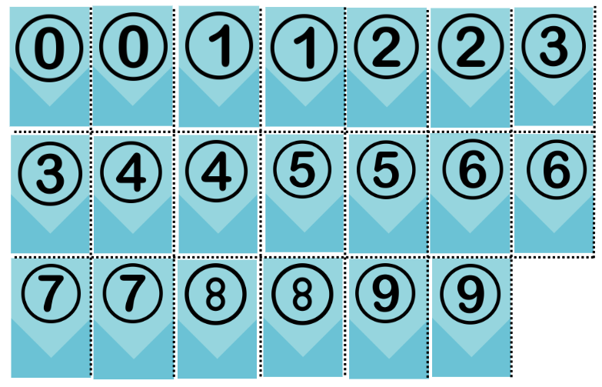

# Resource 14 – recording table

|  |  |  |
| --- | --- | --- |
| Round | Chance of drawing a red (even) counter | Counter drawn (outcome) |
| **Example** | **10 in 20 chance (equally likely)** | **Red (even number)** |
| 1 |  |  |
| 2 |  |  |
| 3 |  |  |
| 4 |  |  |
| 5 |  |  |
| 6 |  |  |
| 7 |  |  |
| 8 |  |  |
| 9 |  |  |
| 10 |  |  |
| 11 |  |  |
| 12 |  |  |

# Resource 15 – bag recording sheet

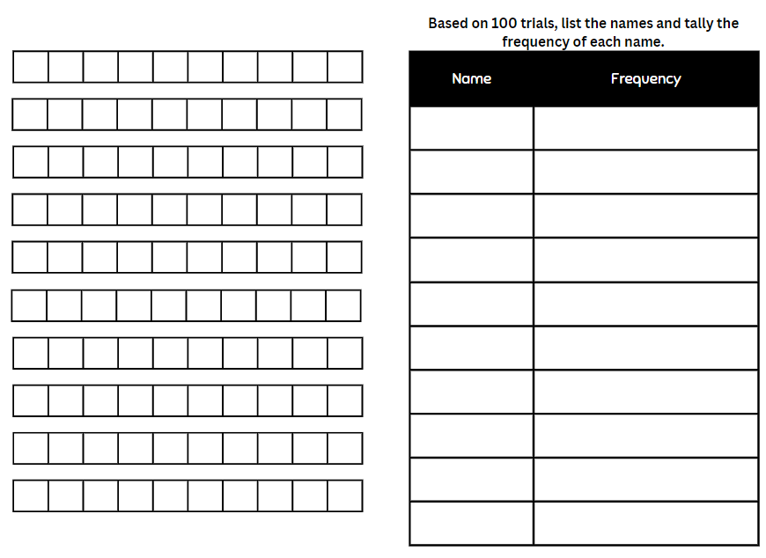

# Resource 16 – Raph’s maths book

An example of a student workbook to record a chance lesson and responses. Columns included are Event, Counters in bag and Colour drawn.

Event 1 – Counters in bag are Red, Blue, Green and Colour drawn is Red.

Event 2 – Counters in bag are Red, Blue, Green and Colour drawn is Green.

Event 3 – Counters in bag are Red, Blue, Green and Colour drawn is Green.

Event 4 – Counters in bag are Red, Blue, Green and Colour drawn is Red.

Event 5 – Counters in bag are Red, Blue, Green and Colour drawn is Red.

Event 6 – Counters in bag are Blue and Green and Colour drawn is Blue.

Event 7 – Counters in bag are Blue and Green and Colour draw is Green.

Event 8 – Counters in bag are Blue and Colour drawn is Blue.

Event 9 – Counters in bad are Blue and Colour drawn is Blue.

Event 10 has been left blank.

# Resource 17 – reef fish samples

Four boxes with different samples of fish taken from the Great Barrier reef. 

Sample 1 has 10 clownfish, 4 pufferfish, 6 parrotfish, 3 surgeonfish and 2 lionfish. 

Sample 2 shows 13 clownfish, 2 pufferfish, 8 parrotfish and 2 lionfish.

Sample 3 shows 8 clownfish, 3 pufferfish, 6 parrotfish, 4 surgeonfish and 4 lionfish.

Sample 4 shows 9 clownfish, 1 pufferfish, 8 parrotfish, 5 surgeonfish and 2 lionfish.

# Resource 18 – mixed-up decimals 1

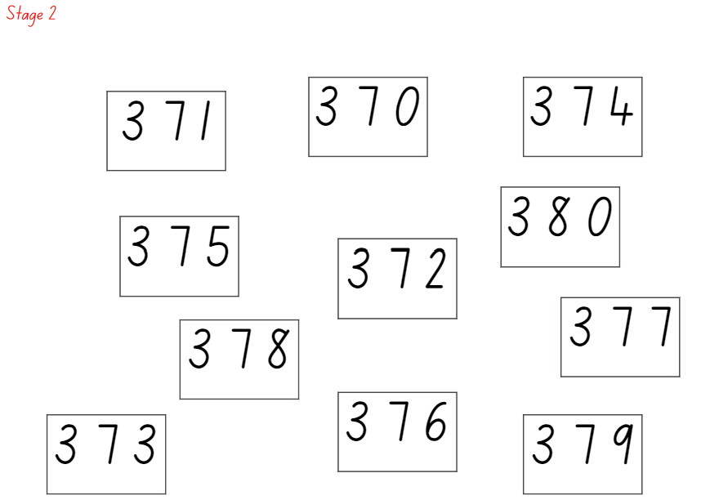

# Resource 19 – mixed-up decimals 2

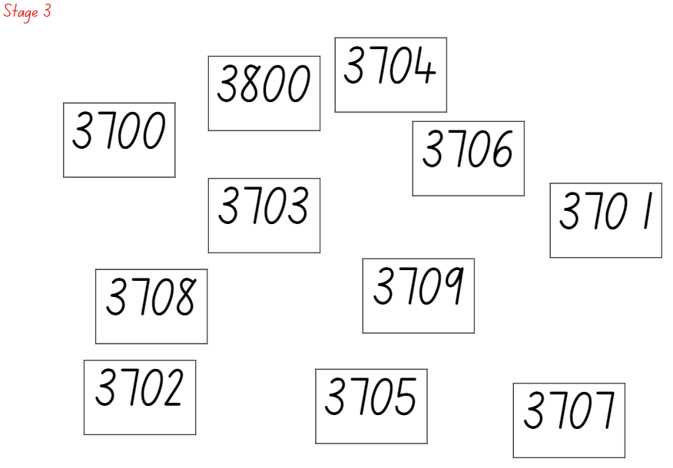

# Resource 20 – blank and game spinner

Two spinners. On the left is a blank circle spinner broken into 3 equal parts. 

Between the 2 spinners, there is a vertical dotted line with an image of scissors for students to cut along. 

To the right of the vertical dotted line is a spinner with 6 equal-sized segments. Two are labelled red, 2 are labelled green and 2 are labelled yellow.

# Resource 21 – data types

A multi-part resource that includes a flow diagram and a series of representations and descriptions of different data types. 

The flow diagram begins with a tile that says ‘Collect Data’. The diagram then splits into 2.

On the left-hand side is a tile for continuous data, followed by a tile for numerical data and an image of a line graph. This element has a note to say that it is for Stage 3.

The right-hand side of the flow chart begins with a tile that says ‘Discrete’. ‘Discrete’ is then separated into 2 more tiles called ‘Numerical’ and ‘Categorical’. Both of these are annotated to say that they are for Stage 2 and Stage 3. The numerical tile is linked to an image of a column graph.

The ‘Categorical’ tile is further split into tiles labelled ordinal and nominal. Both of these data types are annotated to say that they are for Stage 3. ‘Ordinal’ is linked to an image of a Likert scale. ‘Nominal’ is linked to an image of 3 eyes of different colour.

There are 7 additional elements to represent and describe different terms used in the syllabus. There are 3 types of data classifications: data, discrete and continuous. 

The Data classification contains the Variable and Numerical variable elements.

Variable – Something measurable or observable that is expected to change either over time or between observations, such as hair colour.

Numerical variable – Variables that are numbers. Adding, subtracting or calculating an average makes sense, such as the number of children in a family.

The Discrete classification contains the Discrete numerical data, Categorical data, Ordinal categorical data and Nominal data elements.

Discrete numerical data – Describes items or events that can only be counted in whole number values, where number where values in between the whole numbers cannot be found or labelled in the data display, such as the number of children in a family.

Categorical data – Describes a quality or characteristic of something. Values belong to exactly one category, such as blood type. 

Ordinal categorical data – Categories can be ranked or ordered. The order is clear but not the distance between each position, such as a feedback scale. 

Nominal data – No meaningful order between the categories, such as eye colour. 

The Continuous classification contains the Continuous numerical data element.

Continuous numerical data – Values between the whole numbers are meaningful and are labelled in the data display, such as temperature 19.8° or fuel prices $1.78.

The resource has the following note:

Stage 2 teaching advice states that students are not expected to classify the type of data they are collecting.

# Resource 22 – average global temperatures

Two graphs labelled 'Average global temperature A' and 'Average global temperature B' showing average global temperatures from 1900 to 2000. 

Graph A has a range from 0 to 30 degrees and Graph B has a range of 13 to 17 degrees.

# Resource 23 – misleading graphs

A side-by-side column graph displaying test scores over the months of the year 2017. 

It is intentionally misleading and inaccurate. This includes a missing label and a repeated percentage. 

The y-axis, named ‘Grades’, starts at 80% and is labelled 81%, 82%, 83%, 84%, 84%. 

The x-axis, named ‘Test date’, is labelled February, April, May, June.

Column graph showing students' favourite colours. The colours are blue, green, red, purple and pink. 

The y-axis is labelled 0, 5, 10, 15, 20, 25. 

The x-axis is labelled blue with a green column, green with a red column, red with a blue column, purple with a pink column and pink with a purple column. 

The misleading representation is that the colours of each column do not match the label.

Column graph showing days kids are missing from school. 

Months are November, December, January, February and March. 

The number range is from 0 to 30, represented in increments of 5.

# Resource 24 – decimal cards 1

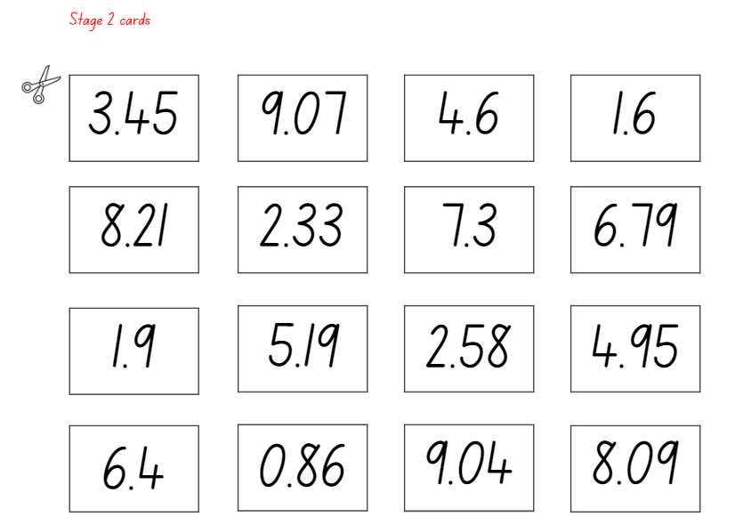

# Resource 25 – decimal cards 2

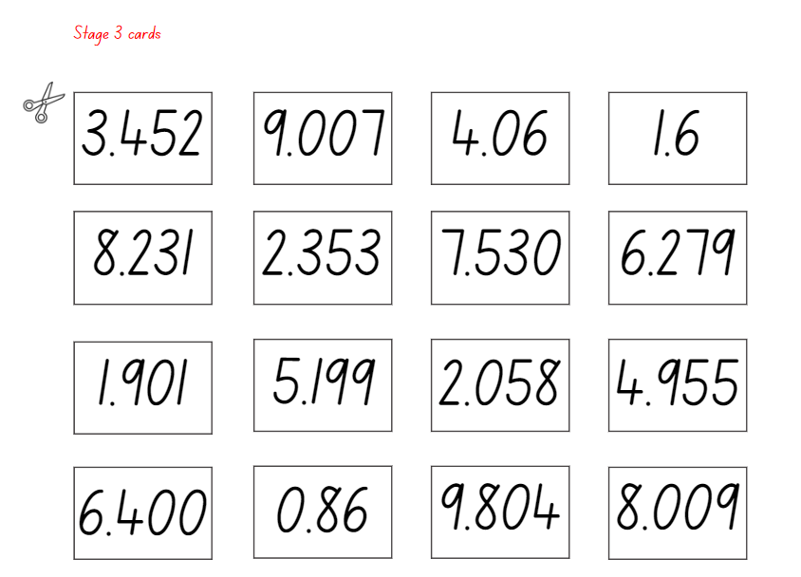

# Resource 26 – gaming devices graph

A graph labelled 'Number of gaming devices in each household'. 

The y-axis is labelled 'number of people' and the x-axis is labelled 'gaming devices per home'. 

The column 1 gaming devices is under 25 people. 

The column 2 gaming devices is 25 people. 

The column 3 gaming devices is over 20 people. 

The column 4 gaming devices is 15 people. 

The column 5 gaming devices is between 5 and 10 people and the column 6 gaming devices is over 5 people.

Data sourced and adapted from Brand et al. (2023).

# Resource 27 – interpreting data displays

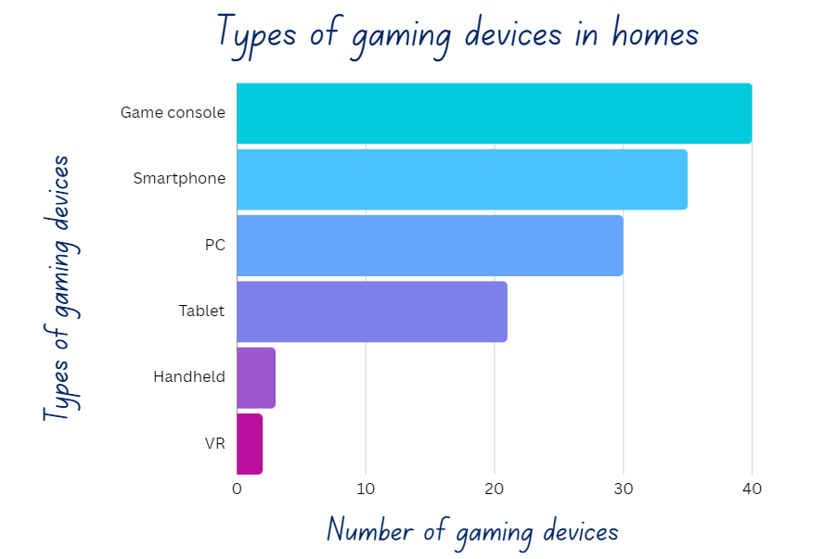

Data sourced and adapted from Brand et al. (2023).

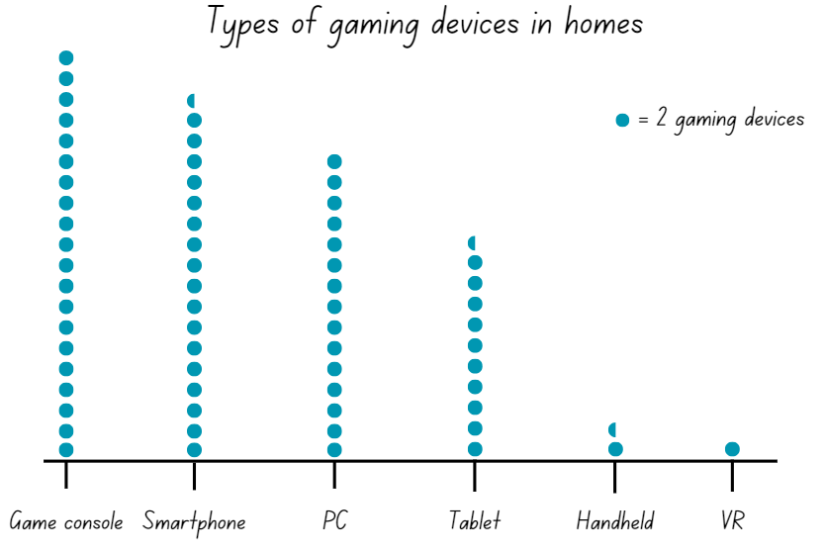

Data sourced and adapted from Brand et al. (2023).

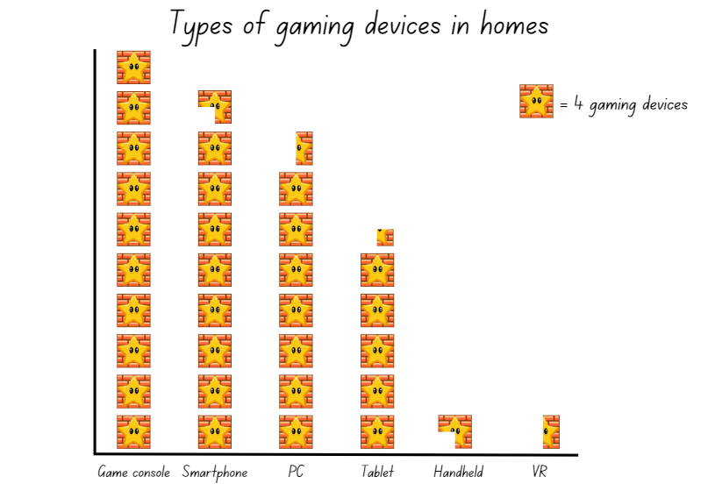

Data sourced and adapted from Brand et al. (2023).

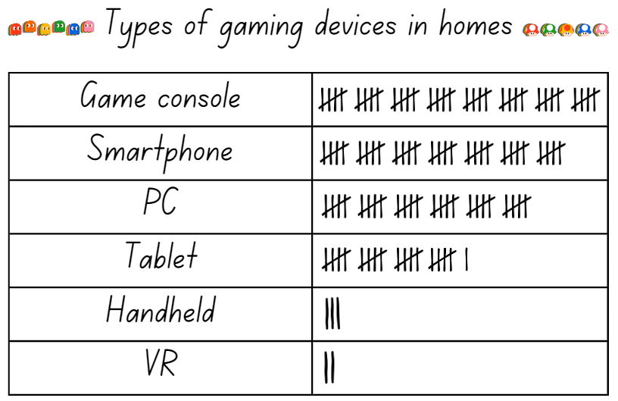

Data sourced and adapted from Brand et al. (2023).

# Resource 28 – alternative holiday destinations

Side-by-side column graph of the percentage of tourists visiting Australia, and the percentage of tourists visiting other countries.

Australia has 70% wanting to visit other destinations within Australia and 30% would go to other countries. 

USA has 45% wanting to visit other destinations within Australia and 55% would go to other countries. 

England had 40% wanting to visit other destinations within Australia and 60% would go to other countries. 

China had 60% wanting to visit other destinations within Australia and 40% would go to other countries.


# Resource 29 – reef visitors

Side-by-side column graph showing visitors to the Great Barrier Reef.

2014 – six million domestic and one million international visitors.

2015 – 6.2 million domestic and 1.2 million international visitors.

2016 – 6.3 million domestic and 1.3 international visitors.

2017– 7 million domestic and 1.5 million international visitors.

2018 – 7.1 million domestic and 1.7 million international visitors.

2019 – 7.5 million domestic and 1.8 million international visitors.

2020 – 1 million domestic and 300 thousand international visitors.

2021 – 2.5 million domestic and 500 thousand international visitors.

2022 – 4 million domestic and 2.5 million international visitors.

2023 – 6 million domestic and 5 million international visitors.

# Resource 30 – visitors data sheet

|  |  |
| --- | --- |
| Questions | Answers |
| Which years saw the most visitors visit the reef? Why do you think that was? |  |
| Why do you think there was a decline in both international and domestic visitors in 2020 and 2021? |  |
| What do you think the decline in visitors means for Australia? |  |
| Why do you think there has been increase of international visitors in 2023? |  |
| Based on the data we have seen, what do you think may happen to the number of tourists visiting the Great Barrier Reef? Why? |  |

# Resource 31 – barrier reef weather

Side-by-side graph of days of sun and days of rain over the year at the Great Barrier Reef.

January – 16 days of sun and 15 days of rain.

February – 11 days of sun and 17 days of rain.

March – 20 days of sun and 11 days of rain.

April – 24 days of sun and 6 days of rain.

May – 28 days of sun and 3 days of rain.

June – 28 days of sun and 2 days of rain.

July – 29 days of sun and 2 days of rain.

August – 30 days of sun and 1 day of rain.

September – 28 days of sun and 2 days of rain.

October – 27 days of sun and 3 days of rain.

November – 22 days of sun and 8 days of rain.

December – 20 days of sun and 11 days of rain.

# Resource 32 – school travel graph

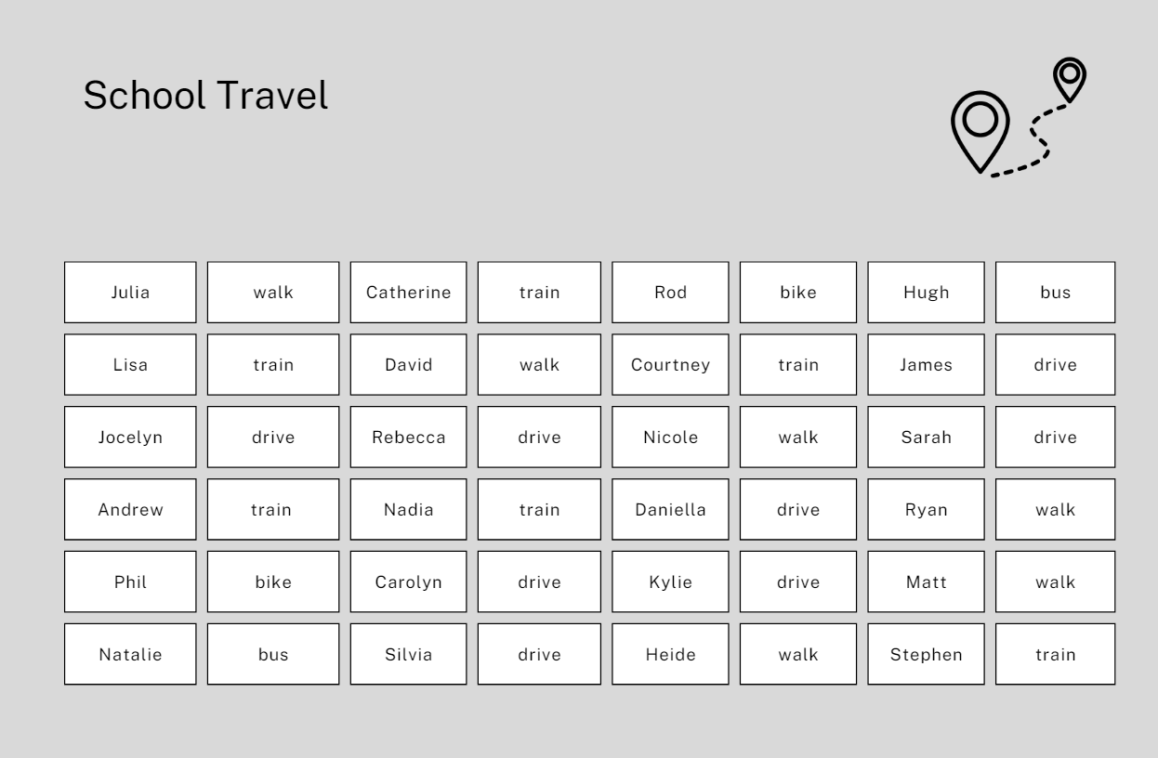

# Resource 33 – mystery graphs

|  |  |
| --- | --- |
| ****Features**** | ****Number of devices**** |
| iPad | 28 |
| Mini iPad | 7 |
| Mobile phone | 3 |
| Tablet | 15 |
| Laptop computer | 43 |
| Desktop computer | 14 |
| Gaming console | 55 |

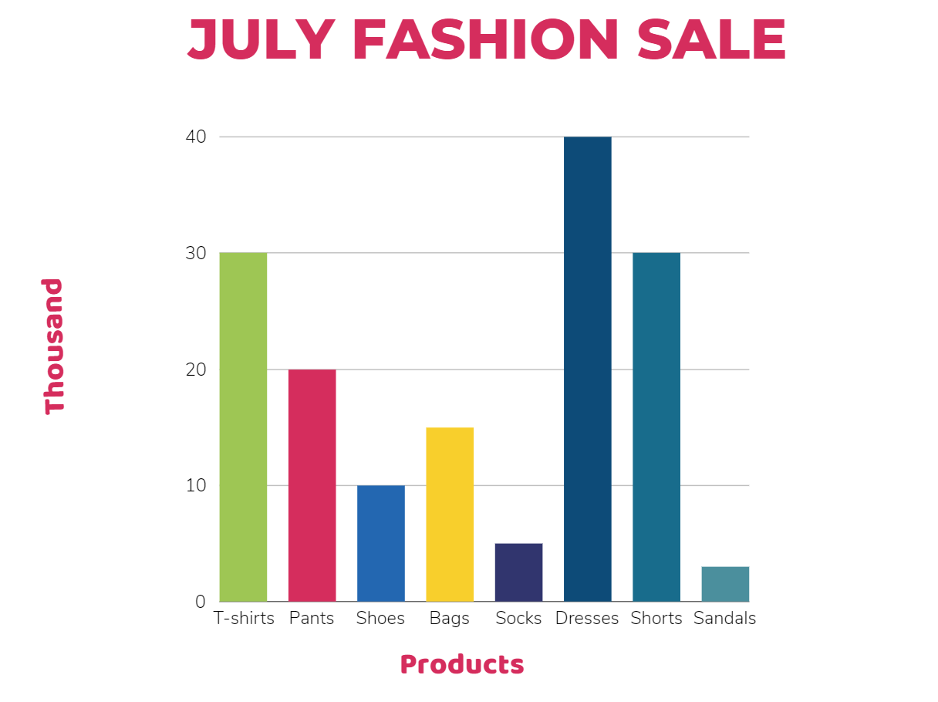

Bar chart titled 'Attendance' showing yearly attendance from 2019 to 2022. Each year has 3 bars: teal, dark blue, and green. Values range from 0 to 20. 

2019 bars represent: teal 5, dark blue 10, and green 5. 

2020 bars represent: teal 8, dark blue 8, and green 4. 

2021 bars represent: teal 15, dark blue 10, and green 5. 

2022 bars represent: teal 10, dark blue 14, and green 8.

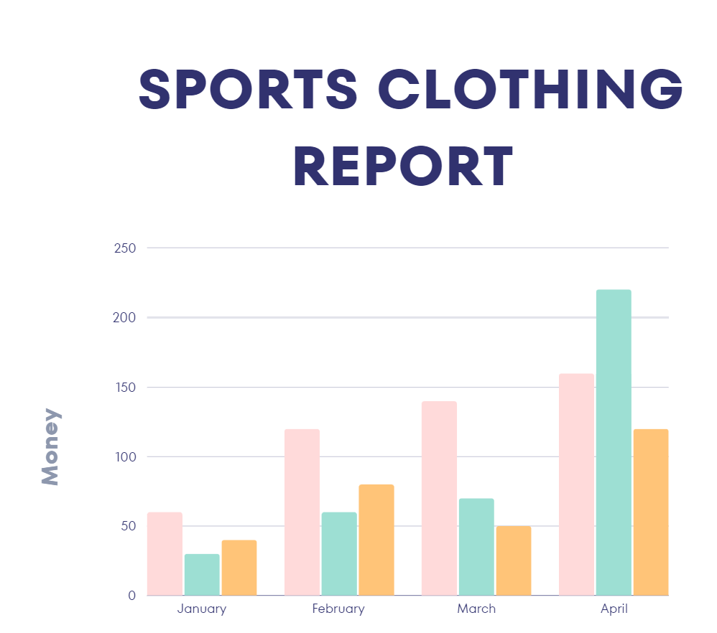

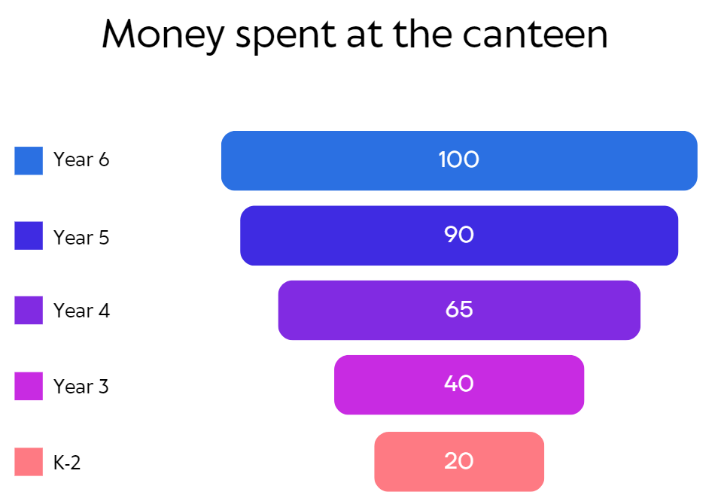

# Resource 34 – column graph checklist

Column graph checklist with ‘Yes’ and ‘No’ tick boxes for the following statements:

Do I have a title?

Are my intervals evenly spaced?

Do my axes have names and labels?

Are my columns equal widths with spaces between them?

Do my column heights line up to the correct value?

# Resource 35 – coral bleaching data

A line graph displaying coral bleaching data. The numbers of coral bleached in each year are as follows:

1350 in 2006.

1350 in 2008.

1680 in 2010.

1900 in 2012.

2450 in 2014.

2650 in 2016.

2950 in 2018.

3200 in 2020.

# Resource 36 – comparing graphs

Two side-by-side graphs: a line graph and column graph representing the rate of coral bleaching on the Great Barrier Reef.

The x-axis in the line graph shows the date as years, ranging from 2006 to 2020 and the y-axis represents the number of coral bleached ranging from 0 to 3500.

The x-axis in the column graph shows the date as years, ranging from 2006 to 2020 and the y-axis represents the number of coral bleached ranging from 0 to 3500.

# Resource 37 – rising sea temperatures A

Column graph showing rising sea temperatures. 

The x-axis shows a timeline from 1910 to 2020 at 10 year intervals and the y-axis shows degrees in Celsius from −1 to 1 degree.

# Resource 38 – data information sheet

|  |  |
| --- | --- |
| Questions | Answers |
| Which year saw the largest increase in sea temperatures? |  |
| Which year saw the largest decrease in sea temperatures? |  |
| Who might use this data about rising sea temperatures? |  |
| In which year did the timeline begin and end? |  |
| If the same data was collected for the next 10 years, what do you think it would tell us? |  |

# Resource 39 – rising sea temperatures B

Column graph showing rising sea temperatures. 

The x-axis shows a timeline from 1940 to 2020 at 5 year intervals and the y-axis shows degrees in Celsius from −1 to 1 degree.

# Syllabus outcomes and content

## Stage 2

The table below outlines the [syllabus outcomes](https://curriculum.nsw.edu.au/learning-areas/mathematics/mathematics-k-10-2022/overview) and range of relevant syllabus content covered in this unit. Content is linked to [National Numeracy Learning Progression](https://www.australiancurriculum.edu.au/resources/national-literacy-and-numeracy-learning-progressions/version-3-of-national-literacy-and-numeracy-learning-progressions/) (version 3).

|  |  |  |  |  |  |  |  |  |
| --- | --- | --- | --- | --- | --- | --- | --- | --- |
| Outcomes and content | 1 | 2 | 3 | 4 | 5 | 6 | 7 | 8 |
| **Representing numbers using place value B**: Decimals: Extend the application of the place value system from whole numbers to tenths and hundredths  **[MAO-WM-01, MA2-RN-02]** |  |  |  |  |  |  |  |  |
| * Use the decimal point as a marker to identify the position of the ones digit when expressing tenths as decimals |  |  |  |  |  | x |  |  |
| * Express decimals as both tenths and hundredths |  |  |  |  |  | x |  |  |
| * Locate and order decimals representing tenths and hundredths on a number line, describing their relative size |  |  |  |  | x | x | x |  |
| **Additive relations B**: Apply addition and subtraction to familiar contexts, including money and  budgeting  **[MAO-WM-01, MA2-AR-01]** |  |  |  |  |  |  |  |  |
| * Use estimation to check the validity of solutions to addition and subtraction problems, including those involving money | x | x |  |  |  |  |  |  |
| * Reflect on a chosen strategy for solving a problem, considering whether it can be improved |  |  | x |  |  |  |  |  |
| * Interpret problems involving money as requiring either addition or subtraction |  |  | x |  |  |  |  |  |
| **Data A**: Collect discrete data  **[MAO-WM-01, MA2-DATA-01]** |  |  |  |  |  |  |  |  |
| * Pose questions about a matter of interest to obtain information that can be recorded in categories | x |  |  |  |  |  |  |  |
| * Predict and create a list of categories for efficient data collection in relation to a matter of interest | x |  |  |  |  |  |  |  |
| **Data A**: Organise and display data using tables and graphs  **[MAO-WM-01, MA2-DATA-01]** |  |  |  |  |  |  |  |  |
| * Create a list or table to organise the data |  | x |  |  |  |  |  |  |
| **Data A**: Interpret and compare data  **[MAO-WM-01, MA2-DATA-02]** |  |  |  |  |  |  |  |  |
| * Describe and interpret information presented in tally tables and column graphs |  |  | x |  |  |  | x |  |
| **Data B**: Select and trial methods for data collection  **[MAO-WM-01, MA2-DATA-01]** |  |  |  |  |  |  |  |  |
| * Create a survey and related recording sheet, considering the appropriate organisation of categories for data collection |  | x |  |  |  |  |  |  |
| * Conduct a survey or make observations to collect categorical or numerical data |  | x |  |  |  |  |  |  |
| * Compare the effectiveness of different methods of collecting and recording data |  |  |  |  |  |  |  | x |
| **Data B**: Construct and interpret data displays with many-to-one scales  **[MAO-WM-01, MA2-DATA-01, MA2-DATA-02]** |  |  |  |  |  |  |  |  |
| * Use a given many-to-one scale to represent discrete data in column graphs |  |  | x |  |  |  |  |  |
| * Use data in a spreadsheet to create column graphs with units on vertical axes that are in multiples |  |  | x |  |  |  |  |  |
| * Interpret and evaluate the effectiveness of various data displays found in media and in factual texts where displays represent data using a scale of many-to-one |  |  |  |  |  |  | x | x |
| **Chance A**: Identify possible outcomes from chance experiments  **[MAO-WM-01, MA2-CHAN-01]** |  |  |  |  |  |  |  |  |
| * Record all possible outcomes in a chance experiment where the outcomes are equally likely |  |  |  | x |  |  |  |  |
| * Predict the number of times each outcome might occur in a chance experiment involving a set number of trials (Probabilistic reasoning) |  |  |  | x |  |  |  |  |
| * Conduct experiments and compare the predicted and actual results where the outcomes are equally likely |  |  |  | x |  |  |  |  |
| **Chance B**: Describe the likelihood of outcomes of chance events  **[MAO-WM-01, MA2-CHAN-01]** |  |  |  |  |  |  |  |  |
| * Use the terms equally likely, likely and unlikely to describe the chance of everyday events occurring |  |  |  |  | x | x |  |  |
| * Compare the likelihood of obtaining particular outcomes in a simple chance experiment by predicting, conducting the experiment and comparing the results with the prediction |  |  |  |  | x | x |  |  |
| **Chance B**: Identify when events are affected by previous events  **[MAO-WM-01, MA2-CHAN-01]** |  |  |  |  |  |  |  |  |
| * Identify and discuss events where the chance of one event occurring will not be affected by the occurrence of the other |  |  |  |  | x |  |  |  |
| * Compare events where the chance of one event occurring is affected by the occurrence of the other (Reasons about relations) |  |  |  |  | x |  |  |  |

[Mathematics K–10 Syllabus](https://curriculum.nsw.edu.au/learning-areas/mathematics/mathematics-k-10-2022/overview) © NSW Education Standards Authority (NESA) for and on behalf of the Crown in right of the State of New South Wales, 2022.

## Stage 3

The table below outlines the [syllabus outcomes](https://curriculum.nsw.edu.au/learning-areas/mathematics/mathematics-k-10-2022/overview) and range of relevant syllabus content covered in this unit. Content is linked to [National Numeracy Learning Progression](https://www.australiancurriculum.edu.au/resources/national-literacy-and-numeracy-learning-progressions/version-3-of-national-literacy-and-numeracy-learning-progressions/) (version 3).

|  |  |  |  |  |  |  |  |  |
| --- | --- | --- | --- | --- | --- | --- | --- | --- |
| Outcomes and content | 1 | 2 | 3 | 4 | 5 | 6 | 7 | 8 |
| **Represents numbers A**: Decimals and percentages: Compare, order and represent decimals  **[MAO-WM-01, MA3-RN-02]** |  |  |  |  |  |  |  |  |
| * Compare and order decimal numbers of up to 3 decimal places |  |  |  |  | x |  |  |  |
| * Place decimal numbers of up to 3 decimal places on a number line |  |  |  |  |  | x | x |  |
| **Additive relations A**: Apply efficient mental and written strategies to solve addition and subtraction problems  **[MAO-WM-01, MA3-AR-01]** |  |  |  |  |  |  |  |  |
| * Solve word problems, including multistep problems |  |  | x |  |  |  |  |  |
| **Representing quantity fractions B**: Find fractional quantities of whole numbers (halves,  quarters, fifths and tenths)  **[MAO-WM-01, MA3-RQF-02]** |  |  |  |  |  |  |  |  |
| * Calculate quarters and fifths of whole numbers that are multiples of the denominator, using a tape diagram | x |  |  |  |  |  |  |  |
| * Find $\frac{1}{2}$, $\frac{1}{4}$, $\frac{1}{5}$ and $\frac{1}{10}$ of collections, expressing remainders as decimals |  | x |  |  |  |  |  |  |
| **Data A**: Collect categorical and discrete numerical data by observation or survey  **[MAO-WM-01, MA3-DATA-01, MA3-DATA-02]** |  |  |  |  |  |  |  |  |
| * Collect ordinal or nominal categorical data, and discrete numerical data through observation or by conducting surveys |  | x |  |  |  |  |  |  |
| **Data A**: Choose and use appropriate tables and graphs  **[MAO-WM-01, MA3-DATA-01, MA3-DATA-02]** |  |  |  |  |  |  |  |  |
| * Tabulate collected data with and without the use of digital technologies such as spreadsheets |  |  |  |  | x |  |  |  |
| **Data B**: Interpret and compare a range of data displays  **[MAO-WM-01, MA3-DATA-01, MA3-DATA-02]** |  |  |  |  |  |  |  |  |
| * Interpret side-by-side column graphs for 2 categorical variables |  |  |  |  |  |  | x |  |
| * Interpret and compare different displays in terms of the shape of the distribution, including the range and the most frequent value (mode) |  |  |  |  |  |  |  | x |
| **Data B**: Interpret data presented in digital media and elsewhere  **[MAO-WM-01, MA3-DATA-01, MA3-DATA-02]** |  |  |  |  |  |  |  |  |
| * Interpret data representations found in digital media and in factual texts |  |  |  |  |  | x | x | x |
| * Identify sources of possible bias in representations of data in the media (Statistical reasoning) |  |  |  |  |  | x |  |  |
| * Identify misleading representations of data in the media |  |  |  |  |  | x |  |  |
| **Chance B**: Compare observed frequencies of outcomes with expected results  **[MAO-WM-01, MA3-CHAN-01]** |  |  |  |  |  |  |  |  |
| * Use the term frequency to describe the number of times a particular outcome occurs in a chance experiment |  |  |  | x |  |  |  |  |
| * Distinguish between the frequency of an outcome (the number of times it occurs) and the probability of an outcome in a chance experiment |  |  | x |  |  |  |  |  |
| * Compare the expected frequencies of outcomes of chance experiments with observed frequencies, including where the outcomes are not equally likely |  |  | x |  |  |  |  |  |
| * Discuss the fairness of simple games involving chance and the idea of randomness |  |  |  | x |  |  |  |  |
| * Explain why observed frequencies of outcomes in chance experiments may differ from expected frequencies, and how this relates to randomness |  |  | x |  |  |  |  |  |
| **Chance B**: Create random generators and describe probabilities using fractions  **[MAO-WM-01, MA3-CHAN-01]** |  |  |  |  |  |  |  |  |
| * Create random generators to follow specified probabilities or proportions |  | x |  |  |  |  |  |  |
| * Record the outcomes for chance experiments where the outcomes are not equally likely to occur and assign probabilities to the outcomes using fractions (denominators of 2, 3, 4, 5, 6, 8 and 10) | x | x |  |  |  |  |  |  |
| * Use knowledge of benchmark fractions, decimals and percentages to assign probabilities to the likelihood of outcomes | x | x |  |  |  |  |  |  |
| **Chance B**: Conduct chance experiments with both small and large numbers of trials  **[MAO-WM-01, MA3-CHAN-01]** |  |  |  |  |  |  |  |  |
| * Determine and discuss the differences between the expected probabilities and the observed probabilities after both small and large numbers of trials |  |  | x | x |  |  |  |  |
| * Determine the likely make up of a large collection of objects, by sampling objects and returning them to the collection before the next sample (sampling with replacement) |  |  |  |  | x |  |  |  |

[Mathematics K–10 Syllabus](https://curriculum.nsw.edu.au/learning-areas/mathematics/mathematics-k-10-2022/overview) © NSW Education Standards Authority (NESA) for and on behalf of the Crown in right of the State of New South Wales, 2022.

# References

This resource contains NSW Curriculum and syllabus content. The NSW Curriculum is developed by the NSW Education Standards Authority. This content is prepared by NESA for and on behalf of the Crown in right of the State of New South Wales. The material is protected by Crown copyright.

Please refer to the NESA Copyright Disclaimer for more information <https://educationstandards.nsw.edu.au/wps/portal/nesa/mini-footer/copyright>.

NESA holds the only official and up-to-date versions of the NSW Curriculum and syllabus documents. Please visit the NSW Education Standards Authority (NESA) website <https://educationstandards.nsw.edu.au> and the NSW Curriculum website [https://curriculum.nsw.edu.au](https://curriculum.nsw.edu.au/).

[Mathematics K–10 Syllabus](https://curriculum.nsw.edu.au/learning-areas/mathematics/mathematics-k-10-2022/overview) © NSW Education Standards Authority (NESA) for and on behalf of the Crown in right of the State of New South Wales, 2022.

[National Numeracy Learning Progression](https://www.australiancurriculum.edu.au/resources/national-literacy-and-numeracy-learning-progressions/version-3-of-national-literacy-and-numeracy-learning-progressions/) © Australian Curriculum, Assessment and Reporting Authority (ACARA) 2010 to present, unless otherwise indicated. This material was downloaded from the [Australian Curriculum](http://www.australiancurriculum.edu.au/) website (National Numeracy Learning Progression) (accessed 26 June 2024) and was not modified.

ABC (Australian Broadcasting Corporation) (19 January 2022) ['Catalyst: How to win at rock-paper-scissors' [video]](https://www.abc.net.au/education/catalyst-how-to-win-at-rock-paper-scissors/13720728)*,* Catalyst, ABC Education website, **accessed 17 June 2024.**

ABC (2022) ‘[Mystery Spinner: Challenge](https://www.abc.net.au/education/mystery-spinner-challenge/13828198)’, Games, ABC Education website, accessed 17 June 2024.

**AIMS (Australian Institute of Marine Science) (n.d.) ‘**[Reef monitoring sampling methods](https://www.aims.gov.au/research-topics/monitoring-and-discovery/monitoring-great-barrier-reef/reef-monitoring-sampling-methods)**’,** Monitoring the Great Barrier Reef**, AIMS website, accessed 17 June 2024.**

Brand JE, Wilson T, Jervis J and Huggins P (2023) [*Australia Plays 2023* [PDF 12.4 MB]](https://igea.net/wp-content/uploads/2023/08/IGEA_AP2023_FINAL_REPORT.pdf), **IGEA** (Interactive Games and Entertainment Association**), accessed 17 June 2024.**

Downton A, Knight R, Clarke D and Lewis G (2015) Mathematics Assessment for Learning: Rich Tasks & Work Samples, 3rd edn, Australian Catholic University and Catholic Education Office, Melbourne.

Great Barrier Reef Foundation (7 March 2024) [‘What is coral bleaching?’](https://www.barrierreef.org/news/explainers/what-is-coral-bleaching), News, Great Barrier Reef Foundation website, accessed 19 July 2024.

NESA (NSW Education Standards Authority) (2022) ‘[Stage 3: Teaching advice for Chance B](https://curriculum.nsw.edu.au/learning-areas/mathematics/mathematics-k-10-2022/content/stage-3/fa6dbbaafc?show=advice)’, Mathematics K–10 Syllabus, NESA website, accessed 10 July 2024.

NESA (2022) ‘[Stage 3: Teaching advice for Data B](https://curriculum.nsw.edu.au/learning-areas/mathematics/mathematics-k-10-2022/content/stage-3/fa0c228e92?show=advice&ta_scroll=no#:~:text=Teaching%20advice%20for%20Data%20B)’, Mathematics K–10 Syllabus, NESA website, accessed 10 July 2024.

New Zealand Ministry of Education (n.d.)‘[I’m Spinning](https://nzmaths.co.nz/resource/i-m-spinning)’, Resource Finder, NZ Maths website, accessed 17 June 2024.

New Zealand Ministry of Education (n.d.) ‘[Place the Digits](https://nzmaths.co.nz/resource/place-digits)’, Resource Finder, NZ Maths website, accessed 17 June 2024.

Statista (2024) [*Number of primary and secondary schools in Australia in 2022, by state*](https://www.statista.com/statistics/612199/australia-primary-and-secondary-schools/#:~:text=Primary%20and%20secondary%20schools%20Australia%202022%20by%20state&text=In%202022%2C%20there%20were%20nearly,schools%20in%20New%20South%20Wales.), Statista website, accessed 21 June 2024.

Sullivan P (2021) Building Engagement in Middle Years Mathematics, 1st edn, Oxford University Press Australia and New Zealand, Melbourne.

Travel + Leisure (6 December 2019) ['How Scientists Are Restoring The Great Barrier Reef | Travel + Leisure' [video]](https://www.youtube.com/watch?v=8hknaJQRh8s), Travel + Leisure, YouTube, accessed 17 June 2024.

**Van de** Walle **J, Karp K, Bay-Williams JM, Brass A, Bentley B, Ferguson S, Goff W, Livy S, Marshman M, Martin D, Pearn C, Prodromou T, Symons D and Wilkie K (2019)** Primary and Middle Years Mathematics: Teaching Developmentally**, 1st Australian edn, Pearson Education Australia, Melbourne.**

## Further reading

Camper Champ (2023) ‘[*Queensland Tourism Statistics*](https://camperchamp.com.au/statistics/australia/queensland-tourism/#how-many-people-visited-queensland-in-2021)’, Australian Travel Statistics: Statistics by Location, Camper Champ website, accessed 17 June 2024.

TravelOnline (n.d.) [*Great Barrier Reef Weather & Climate*](https://www.great-barrier-reef.com/great-barrier-reef-weather.html), Great-Barrier-Reef.com, accessed 17 June 2024.

Li T, Huang J, Du H, Liu X, Zhong C and Lin S (2022) ‘[Coral bleaching from a nutrient perspective is understudied: A bibliometric survey’](https://www.frontiersin.org/journals/marine-science/articles/10.3389/fmars.2022.926783/full), Frontiers in Marine Science, 9, doi:10.3389/fmars.2022.926783, accessed 17 June 2024.

Siemon D, Warren E, Beswick K, Faragher R, Miller J, Horne M, Jazby D, Breed M, Clark J and Brady K (2020) Teaching Mathematics: Foundation to Middle Years, 3rd edn, Oxford University Press Australia and New Zealand.

Sullivan P and Lilburn P (2017) Open-Ended Maths Activities: Using ‘Good’ Questions to Enhance Learning in Mathematics, Revised edn, Oxford University Press ANZ, Great Britain.

Swann T and Campbell R (20 June 2016) ‘[Great Barrier Reef Bleached: Coral Bleaching, the Great Barrier Reef and potential impacts of tourism](https://australiainstitute.org.au/report/great-barrier-bleached/)’, *The Australia Institute*, accessed 17 June 2024.

Taylor L (13 May 2013) ‘[Great Barrier Reef is at risk even if it doesn't make Unesco's danger list](https://www.theguardian.com/environment/planet-oz/2013/may/13/great-barrier-reef-unesco-danger)’, The Guardian, accessed 17 June 2024.

The Nature Conservancy (2024) ‘[Status of Coral Reefs](https://reefresilience.org/stressors/reefs-are-at-risk/)’, Threats, Reef Resilience Network website, accessed 17 June 2024.

**© State of New South Wales (Department of Education), 2024**

The copyright material published in this resource is subject to the Copyright Act 1968 (Cth) and is owned by the NSW Department of Education or, where indicated, by a party other than the NSW Department of Education (third-party material).

Copyright material available in this resource and owned by the NSW Department of Education is licensed under a [Creative Commons Attribution 4.0 International (CC BY 4.0) license](https://creativecommons.org/licenses/by/4.0/).

[](https://creativecommons.org/licenses/by/4.0/)

This license allows you to share and adapt the material for any purpose, even commercially.

Attribution should be given to © State of New South Wales (Department of Education), 2024.

Material in this resource not available under a Creative Commons license:

* the NSW Department of Education logo, other logos and trademark-protected material
* material owned by a third party that has been reproduced with permission. You will need to obtain permission from the third party to reuse its material.

**Links to third-party material and websites**

Please note that the provided (reading/viewing material/list/links/texts) are a suggestion only and implies no endorsement, by the New South Wales Department of Education, of any author, publisher, or book title. School principals and teachers are best placed to assess the suitability of resources that would complement the curriculum and reflect the needs and interests of their students.

If you use the links provided in this document to access a third-party's website, you acknowledge that the terms of use, including licence terms set out on the third-party's website apply to the use which may be made of the materials on that third-party website or where permitted by the Copyright Act 1968 (Cth). The department accepts no responsibility for content on third-party websites.