Mathematics 3–6 Multi-age – Year B – Unit 19
Angles are the primary structural component of many shapes

Contents
Unit description and duration 8
Syllabus outcomes 8
Stage 2 9
Stage 3 9
Working mathematically 10
Student prior learning 10
Lesson overview and resources 12
Lesson 1 20
Daily number sense – place value game – 15 minutes 20
Core lesson – theme park schedule – 40 minutes 24
Discuss and connect the mathematics – 10 minutes 29
Lesson 2 31
Daily number sense – number line misconceptions – 10 minutes 31
Core lesson 1 – digital time – 25 minutes 34
Core lesson 2 – 25 minutes 37
Stage 2 task – 12-hour time 37
Stage 3 task – 24-hour time 38
Discuss and connect the mathematics – 10 minutes 39
Lesson 3 42
Daily number sense – be the teacher – 15 minutes 42
Core lesson – shape transformations – 45 minutes 45
Discuss and connect the mathematics – 10 minutes 49
Lesson 4 52
Daily number sense – 10 minutes 52
Core lesson – design and make – 40 minutes 52
Discuss and connect the mathematics – 10 minutes 56
Lesson 5 58
Daily number sense – fraction problems – 10 minutes 58
Core lesson 1 – all about angles – 10 minutes 62
Core lesson 2 – Ferris wheel angles – 30 minutes 64
Discuss and connect the mathematics – 10 minutes 68
Lesson 6 71
Daily number sense – fraction inquiry– 10 minutes 71
Core lesson 1 – investigating angles – 10 minutes 74
Core lesson 2 – theme park map – 35 minutes 77
Discuss and connect the mathematics – 10 minutes 82
Lesson 7 85
Daily number sense – fraction memory – 15 minutes 85
Core lesson – 40 minutes 87
Stage 2 task – Ferris wheels around the world 87
Stage 3 task – design a rollercoaster 1 90
Discuss and connect the mathematics – 20 minutes 92
Lesson 8 95
Daily number sense – 10 minutes 95
Core lesson – 40 minutes 95
Stage 2 task – design a Ferris wheel 95
Stage 3 task – design a rollercoaster 2 98
Discuss and connect the mathematics – 20 minutes 101
Resource 1 – place value gameboard 104
Resource 2 – integer gameboard 105
Resource 3 – theme park schedule 106
Resource 4 – time remaining 107
Resource 5 – theme park questions 108
Resource 6 – A–F number line 109
Resource 7 – Maggie’s diary 110
Resource 8 – 12-hour time 111
Resource 9 – time intervals 112
Resource 10 – recording time 113
Resource 11 – time memory 115
Resource 12 – day plan (Stage 2) 117
Resource 13 – 24-hour timetable 118
Resource 14 – day plan (Stage 3) 119
Resource 15 – Ollie’s number line 120
Resource 16 – Mel’s number line 121
Resource 17 – Charlie’s number line 122
Resource 18 – theme park signs 123
Resource 19 – transformations 124
Resource 20 – rotating patterns 125
Resource 21 – demolition derby truck 126
Resource 22 – blank number lines 127
Resource 23 – blank tape diagram 128
Resource 24 – Ferris wheel 1 129
Resource 25 – all about angles 130
Resource 26 – Are they correct? 131
Resource 27 – park map (Stage 2) 132
Resource 28 – park map (Stage 3) 133
Resource 29 – using a protractor 134
Resource 30 – types of angles 135
Resource 31 – fraction memory (Stage 2) 136
Resource 32 – fraction memory (Stage 3) 138
Resource 33 – fraction wall 140
Resource 34 – Ferris wheels 2 141
Resource 35 – investigation criteria 142
Resource 36 – rollercoasters 143
Resource 37 – designing for thrill 144
Resource 38 – designing for safety 145
Resource 39 – Ferris wheel criteria 146
Resource 40 – student work sample 147
Resource 41 – peer feedback 148
Resource 42 – feedback criteria 149
Syllabus outcomes and content 150
Stage 2 150
Stage 3 154
References 159

Unit description and duration
This unit develops the big idea that angles are the primary structural component of many shapes.
In this 2-week unit, students are provided opportunities to:
- recognise and describe angles as less than, equal to, about the same as or greater than a right angle (Stage 2)
- investigate angles on a straight line, angles at a point and the relationships formed by the intersection of straight lines (Stage 3)
- interpret digital time displays and determine the time remaining until the next hour to solve problems involving duration, using 12- and 24-hour time
- combine and split common shapes to create other common two-dimensional shapes and rearrange them using translations, reflections and rotations.
This multi-age unit is informed by the lessons in Stage 2 Year B Unit 39 and Stage 3 Year B Unit 39. Please refer to these units for additional lesson guidance.

Syllabus outcomes
- MAO-WM-01 develops understanding and fluency in mathematics through exploring and connecting mathematical concepts, choosing and applying mathematical techniques to solve problems, and communicating their thinking and reasoning coherently and clearly

Stage 2
- MA2-RN-01 applies an understanding of place value and the role of zero to represent numbers to at least tens of thousands
- MA2-PF-01 represents and compares halves, quarters, thirds and fifths as lengths on a number line and their related fractions formed by halving (eighths, sixths and tenths)
- MA2-GM-03 identifies angles and classifies them by comparing to a right angle
- MA2-2DS-01 compares two-dimensional shapes and describes their features
- MA2-2DS-02 performs transformations by combining and splitting two-dimensional shapes
- MA2-NSM-02 represents and interprets analog and digital time in hours, minutes and seconds

Stage 3
- MA3-RN-01 applies an understanding of place value and the role of zero to represent the properties of numbers
- MA3-RQF-02 determines $\frac{1}{2}$, $\frac{1}{4}$, $\frac{1}{5}$ and $\frac{1}{10}$ of measures and quantities
- MA3-GM-03 measures and constructs angles, and identifies the relationships between angles on a straight line and angles at a point
- MA3-2DS-01 investigates and classifies two-dimensional shapes, including triangles and quadrilaterals based on their properties
- MA3-NSM-02 measures and compares duration, using 12- and 24-hour time and am and pm notation

Working mathematically
In the Mathematics K–10 Syllabus, there is one overarching Working mathematically outcome (MAO-WM-01). The Working mathematically processes should be embedded within the concepts being taught. The Working mathematically processes present in the Mathematics K–10 Syllabus are:
- communicating
- understanding and fluency
- reasoning
- problem solving.
Mathematics K–10 Syllabus © NSW Education Standards Authority (NESA) for and on behalf of the Crown in right of the State of New South Wales, 2022.

Student prior learning
Before engaging in these teaching and learning activities, students would benefit from prior experience with:
- representing and reading analog and digital time
- describing and comparing angles in relation to right angles (Stage 2)
- recognising that a right angle is 90°, a straight angle is 180° and an angle of revolution is 360° and measuring angles using a protractor
(Stage 3)
- using the terms translate, reflect and rotate to describe transformations of two-dimensional shapes and creating two-dimensional shapes that result from combining and splitting common shapes and describing the result.
In NSW classrooms there is a diverse range of students, including Aboriginal and/or Torres Strait Islander students, students learning English as an additional language or dialect, high potential and gifted students and students with disability. Some students may identify with more than one of these groups or possibly all of them. Refer to Curriculum planning for every student – advice for further information.

Lesson overview and resources
To cover the content of the syllabus across Stage 2 and Stage 3, some core lessons in the unit contain both a Stage 2 and a Stage 3 task. Teachers are encouraged to adapt and contextualise the units to meet the needs of their students.
The table below outlines the sequence and approximate timing of lessons, learning intentions and resources.
Lesson | Content | Duration and resources
Lesson 1  Daily number sense  Stage 2:  - Represents numbers using place value B: Whole numbers: Order numbers in the thousands  Stage 3:  - Represents numbers B: Whole numbers: Locate and represent integers on a number line | Lesson core concept: knowing there are 60 minutes in an hour helps to read and calculate time while mental strategies can assist in determining the duration of events.  Stage 2:  - Non-spatial measure B: Time: Represent and interpret digital time displays  Stage 3:  - Non-spatial measure B: Time: Solve problems involving duration, using 12- and 24-hour time | Lesson duration: 65 minutes  - Resource 1 – place value gameboard  - Resource 2 – integer gameboard  - Resource 3 – theme park schedule  - Resource 4 – time remaining  - Resource 5 – theme park questions  - Website: Interactive Clock  - 10-sided dice  - Digital devices  - Paperclips  - Writing materials
Lesson 2  Daily number sense  Stage 2:  - Partitioned fractions B: Represent fractional quantities equal to and greater than one  Stage 3:  - Represents numbers B: Whole numbers: Locate and represent integers on a number line | Lesson core concept: am and pm notation distinguish between times in the morning and evening (Stage 2) and events can be scheduled in 12- and/or 24-hour time (Stage 3).  Stage 2:  - Non-spatial measure B: Time: Use am and pm notation  Stage 3:  - Non-spatial measure B: Time: Solve problems involving duration, using 12- and 24-hour time | Lesson duration: 70 minutes  - Resource 3 – theme park schedule  - Resource 6 – A–F number line  - Resource 7 – Maggie's diary  - Resource 8 – 12-hour time  - Resource 9 – time intervals  - Resource 10 – recording time  - Resource 11 – time memory  - Resource 12 – day plan (Stage 2)  - Resource 13 – 24-hour timetable  - Resource 14 – day plan (Stage 3)  - Writing materials
Lesson 3  Daily number sense  Stage 2:  - Partitioned fractions B: Represent fractional quantities equal to and greater than one  Stage 3:  - Represents numbers B: Whole numbers: Locate and represent integers on a number line | Lesson core concept: two-dimensional shapes can be cut and rearranged to create new shapes.  Stage 2:  - Two-dimensional spatial structure B: 2D shapes: Create two-dimensional shapes that result from combining and splitting common shapes  - Two-dimensional spatial structure B: 2D shapes: Create symmetrical patterns and shapes  Stage 3:  - Two-dimensional spatial structure B: 2D shapes: Dissect two-dimensional shapes and rearrange them using translations, reflections and rotations | Lesson duration: 70 minutes  - Resource 15 – Ollie’s number line  - Resource 16 – Mel’s number line  - Resource 17 – Charlie’s number line  - Resource 18 – theme park signs  - Website: Interactive pattern shapes  - Website: Polypad  - Digital devices  - Pattern blocks  - Writing materials
Lesson 4  Daily number sense  - teacher-identified task based on student needs | Lesson core concept: objects can be designed by rotating, reflecting and translating two-dimensional shapes.  Stage 2:  - Two-dimensional spatial structure B: 2D shapes: Create symmetrical patterns and shapes  Stage 3:  - Two-dimensional spatial structure B: 2D shapes: Dissect two-dimensional shapes and rearrange them using translations, reflections and rotations | Lesson duration: 60 minutes  - Resource 19 – transformations  - Resource 20 – rotating patterns  - Resource 21 – demolition derby truck  - Website: Interactive pattern shapes  - Digital devices  - Isometric graph paper  - Pattern blocks  - Writing materials
Lesson 5  Daily number sense  Stage 2:  - Partitioned fractions B: Represent fractional quantities equal to and greater than one  Stage 3:  - Represent quantity fractions B: Find fractional quantities of whole numbers (halves, quarters, fifths and tenths) | Lesson core concept: angles can be found in the world around us.  Stage 2:  - Geometric measure B: Angles: Compare angles to a right angle  Stage 3:  - Geometric measure B: Angles: Investigate angles on a straight line and angles at a point  - Geometric measure B: Angles: Investigate the relationships formed by the intersection of straight lines | Lesson duration: 60 minutes  - Resource 22 – blank number lines  - Resource 23– blank tape diagram  - Resource 24 – Ferris wheel 1  - Resource 25 – all about angles  - Resource 26 – Are they correct?  - Pictures of Ferris wheels  - Split pins  - Writing materials
Lesson 6  Daily number sense  Stage 2:  - Partitioned fractions B: Represent fractional quantities equal to and greater than one  Stage 3:  - Represent quantity fractions B: Find fractional quantities of whole numbers (halves, quarters, fifths and tenths) | Lesson core concept: angles in our environment can be compared to a right angle and described in relation to quarter-turns (Stage 2) and adjacent angles are formed when lines intersect (Stage 3).  Stage 2:  - Geometric measure B: Angles: Compare angles to a right angle  Stage 3:  - Geometric measure A: Angles: Estimate, measure and compare angles using degrees  - Geometric measure B: Angles: Investigate the relationships formed by the intersection of straight lines | Lesson duration: 65 minutes  - Resource 25 – all about angles  - Park map (Stage 2)  - Park map (Stage 3)  - Resource 29 – using a protractor  - Resource 30 – types of angles  - Protractor or right-angle tester  - Rulers  - Tracing paper  - Writing materials
Lesson 7  Daily number sense  Stage 2:  - Partitioned fractions B: Represent fractional quantities equal to and greater than one  Stage 3:  - Representing quantity fractions B: Find fractional quantities of whole numbers (halves, quarters, fifths and tenths). | Lesson core concept: mathematicians can identify different types of angles, recognise various shapes and understand their properties in everyday contexts (Stage 2) and designing allows us to investigate angles and their relationships (Stage 3).  Stage 2:  - Two-dimensional spatial structure B: 2D shapes: Create two-dimensional shapes that result from combining and splitting common shapes  - Two-dimensional spatial structure B: 2D shapes: Create symmetrical patterns and shapes  - Geometric measure B: Angles: Compare angles to a right angle  Stage 3:  - Geometric measure A: Angles: Use a protractor to measure and identify types of angles  - Geometric measure B: Angles: Investigate the relationships formed by the intersection of straight lines | Lesson duration: 75 minutes  - Resource 31 – fraction memory (Stage 2)  - Resource 32 – fraction memory (Stage 3)  - Resource 33 – fraction wall  - Resource 34 – Ferris wheels 2  - Resource 35 – investigation criteria  - Resource 36 – rollercoasters  - Resource 37 – designing for thrill  - Resource 38 – designing for safety  - Website: Video clips  - Website: Canva or PowerPoint  - Digital device  - Pattern blocks  - Poster paper  - Writing materials
Lesson 8  Daily number sense  - teacher-identified task based on student needs | Lesson core concept: mathematicians plan and create designs to solve problems (Stage 2) and designing allows us to investigate angles and their relationships (Stage 3).  Stage 2:  - Two-dimensional spatial structure B: 2D shapes: Create two-dimensional shapes that result from combining and splitting common shapes  - Two-dimensional spatial structure B: 2D shapes: Create symmetrical patterns and shapes  - Geometric measure B: Angles: Compare angles to a right angle  Stage 3:  - Geometric measure A: Angles: Use a protractor to measure and identify types of angles  - Geometric measure B: Angles: Investigate the relationships formed by the intersection of straight lines. | Lesson duration: 70 minutes  - Resource 37 – designing for thrill  - Resource 38 – designing for safety  - Resource 39 – Ferris wheel criteria  - Resource 40 – student work sample  - Resource 41 – peer feedback  - Resource 42 – feedback criteria  - Digital device  - Pattern blocks  - Poster paper  - Protractors  - Writing materials

Lesson 1
Core concept: knowing there are 60 minutes in an hour helps to read and calculate time while mental strategies can assist in determining the duration of events.

Daily number sense – place value game – 15 minutes
Daily number sense activities for Lessons 1 to 3 ‘activate’ prior number knowledge and support the learning of new content in the unit. These activities can also assist teachers to identify the starting points for learning by revealing the extent of students’ existing knowledge.
The table below contains suggested learning intentions and success criteria. These are best co-constructed with students.
Daily number sense learning intentions | Daily number sense success criteria
Students working towards Stage 2 outcomes are learning to:  - order numbers in the thousands.  Students working towards Stage 3 outcomes are learning to:  - locate and represent integers on a number line. | Students working towards Stage 2 outcomes can:  - arrange numbers in the thousands in ascending order.  Students working towards Stage 3 outcomes can:  - recognise the location of negative whole numbers in relation to zero and place them on a number line.  - use the term integers to describe positive and negative whole numbers and zero.
This lesson is an adaptation of The place value game from Mathematics K–6 resources by State of New South Wales (Department of Education).
Multi-age: Stage 2 students use Resource 1 – place value gameboard to order numbers from 10 000 to 100 000. Stage 3 students use Resource 2 – integer gameboard to place negative and positive integers on the gameboard in relation to zero.
- Provide pairs of Stage 2 students with five 10-sided dice and Resource 1 – place value gameboard.
- Students roll the dice to create a 5-digit number. For example, 6, 2, 8, 3 and 9 could be recorded as 62 389, 36 892, 29 863, 38 269, 93 628 or 39 286. They record their chosen number in the most appropriate position between 10 000 and 100 000 (see Figure 1).
Figure 1 – Stage 2 gameboard example
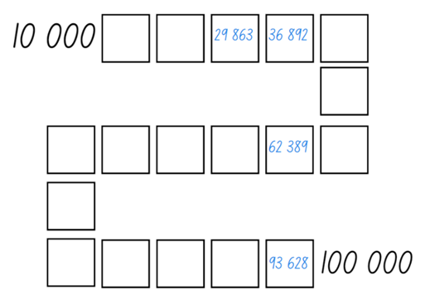
- If numbers cannot be placed, students miss their turn. Play continues until all boxes are filled.
Integer: a whole number, positive, negative or zero, for example 3, -2, -1, 0, 1, 2 ...
Negative number: a number less than zero, written with a minus sign. These integers are read as, for example, ‘negative 3’, not ‘minus 3’.
- Stage 3 students revise the definition of integers and negative numbers.
- Provide pairs with two 10-sided dice, a paperclip and Resource 2 – integer gameboard.
- Students roll the dice and create a 2-digit integer. For example, if 5 and 3 are rolled, they could make 53 or 35. Students then spin the spinner to determine if their integer is positive or negative. Players record their integer in the most appropriate position between -99 and 99 (see Figure 2).
Figure 2 – Stage 3 gameboard example
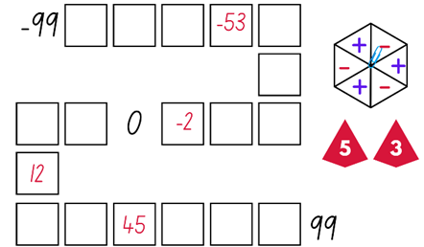
- If the integer cannot be placed on the gameboard, students miss their turn. Play continues until all boxes are filled.
Note: this game can also be played as a whole class. Using a reusable sleeve for the gameboard will allow students to play multiple games.
This table details opportunities for assessment.
Assessment opportunities | Links
What to look for:  - Can Stage 2 students arrange numbers in the thousands in ascending order? [MAO-WM-01, MA2-RN-02]  - Can Stage 3 students recognise the location of negative whole numbers in relation to zero and place them on a number line? [MAO-WM-01, MA3-RN-01]  - Can Stage 3 students use the term integers to describe positive and negative whole numbers and zero?  [MAO-WM-01, MA3-RN-01] | Links to National Numeracy Learning Progressions (NNLP):  - Stage 2 – NPV6  - Stage 3 – NPV9.

Core lesson – theme park schedule – 40 minutes
The table below contains suggested learning intentions and success criteria. These are best co-constructed with students.
Core concept learning intentions | Core concept success criteria
Students working towards Stage 2 outcomes are learning to:  - represent and interpret digital time displays.  Students working towards Stage 3 outcomes are learning to:  - solve problems involving duration, using 12- and 24-hour time. | Students working towards Stage 2 outcomes can:  - read or set the time on digital devices to the minute or second, recognising there are 60 seconds in one minute  - determine the time remaining until the next hour on a digital clock.  Students working towards Stage 3 outcomes can:  - use start and finish times to calculate the elapsed time of events  - add and subtract time mentally using bridging strategies.
- Display the interactive clock ensuring the digital display is also shown. Manipulate the clock hands to display 6:55 am or 5 minutes to 7:00 am.
- Revise that analog clocks have hands (hour and minute and sometimes seconds), and digital clocks display numbers or digits (hour and minute display) separated by a colon. Revise that the hour is always to the left of the colon and is read first, followed by the minutes which are represented to the right of the colon.
- Model how to determine the time remaining until the next hour on the interactive clock. Draw students’ attention to the 5 one-minute intervals on the analog clock between the 11 and the 12 that indicate that there are 5 minutes until the next hour, 7:00.
- Ask students to Think-Pair-Share how the time remaining until the next hour can be determined on a digital clock.
- Display Resource 3 – theme park schedule. Explain that Maggie was viewing a theme park’s daily shows and events schedule to plan her day.
- Students turn and talk and share what they notice about the schedule. For example, some of the times for the shows overlap.
- Ask the following questions:
- What time does the theme park open and close? How do you know?
- If Maggie wants to see the laser show, what time should she be seated in the arena?
- If the animal show finishes at 10:50 am, how many minutes are remaining until the next hour? What is the elapsed time of this event?
Elapsed time: the amount of time between the start time and the end time of an activity or event. For example, my piano lesson starts at 10 past 4 and goes until a quarter to 5. The lesson is 35 minutes long.
- In pairs, students read the times for each show or event to their partner. For example, ‘The daredevil acrobatics starts at 4 o’clock in the afternoon and ends at four thirty-five’.
- Highlight that the laser show ends at 8:35 pm. Ask:
- How many minutes are remaining until the next hour?
- What is another way of saying this time?
- Explain that a blank number line can be used to round the time remaining until the next hour and elapsed time of events, using jumps.
- Draw a number line on the board marked with the times 11:40 am to 1:10 pm.
- Demonstrate how to use an empty number line to round the remaining time until the next hour and elapsed time by bridging to the closest hour (see Figure 3).
- Model how to:
- round the remaining minutes from the current time to the next whole hour first, using one or more jumps
- use jumps to add any whole hours, if needed
- add remaining minutes needed to get to the final time, using one or more jumps.
Figure 3 – number line example
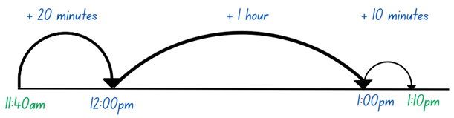
- Provide Stage 2 students with Resource 4 – time remaining. Students record the time remaining until the next hour for each of the events based on their finishing time.
- Display Resource 3 – theme park schedule and provide Stage 3 students with Resource 5 – theme park questions.
- Stage 3 students work in pairs to mentally use the ZOOM strategy or a blank number line to find the elapsed time of events and round to the nearest hour (see Figure 4).
Figure 4 – the ZOOM strategy
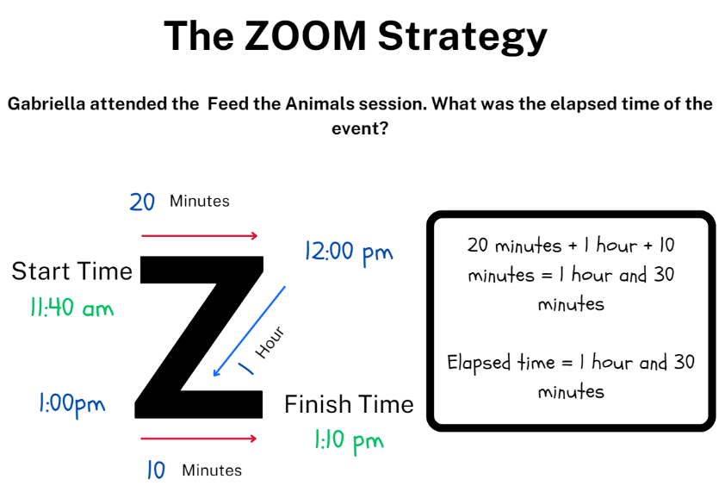
Note: if the elapsed time has a finish time that is on the hour, students will not need to use the final line of the ZOOM strategy as there are no remaining minutes to add. Stage 3 students may need to revise the ZOOM strategy which is referenced in Multi-age Year B Unit 10 Lesson 7.
This table details opportunities for differentiation.
Too hard? | Too easy?
Stage 2 students cannot determine the time remaining until the next hour on a digital clock.  - Students use the interactive clock to set the time and count the minute intervals until the next hour.  - Ask students to draw a number line 1–60 to represent the 60 minutes in an hour. Make the marks for multiples of 5 slightly longer, like every fifth minute on an analog clock. Demonstrate marking the minutes from a digital display on the number line. For example, for 1:20 pm, place a mark at 20 and then use the number line to model ‘jumps’ to determine the minutes remaining to get to 60.  Stage 3 students cannot use start and finish times to calculate the elapsed time of events.  - Provide students with a copy of the ZOOM strategy or a blank number line and whiteboards to record their thinking.  - Assist students by modifying the times on the timetable or the questions so that students only need to calculate elapsed time to the nearest hour. | Stage 2 students can determine the time remaining until the next hour on a digital clock.  - Ask students to determine the duration of the events listed on Resource 3 – theme park schedule.  - Students determine the number of minutes remaining until a given time off the hour from the finishing times on Resource 4 – time remaining. For example, determine the number of minutes between the dance spectacular finishing (11:55 am) and 20 minutes past the next hour.  Stage 3 students can use start and finish times to calculate the elapsed time of events.  - Challenge students to mentally calculate the total number of hours that events run throughout the day.  - Students create their own elapsed time questions for a partner to solve using a blank number line or the ZOOM strategy.

Discuss and connect the mathematics – 10 minutes
- Regroup and ask the following questions:
- What strategy did you use to calculate the elapsed time or time remaining until the next hour? Why was that strategy the most effective?
- Are there any other strategies you could have used?
- Why would it be important to understand strategies for working out elapsed time of events and time remaining until the next hour?
- What makes timetables an efficient way to communicate information?
- Did you find rounding to the nearest hour challenging? Why or why not?
- When could rounding to the nearest hour be helpful?
This table details opportunities for assessment.
Assessment opportunities | Links
What to look for:  - Can Stage 2 students read or set the time on digital devices to the minute or second, recognising there are 60 seconds in one minute? [MAO-WM-01, MA2-NSM-02]  - Can Stage 2 students determine the time remaining until the next hour on a digital clock? [MAO-WM-01, MA2-NSM-02]  - Can Stage 3 students use start and finish times to calculate the elapsed time of events? [MAO-WM-01, MA3-NSM-02]  - Can Stage 3 students use mental strategies to calculate elapsed time using bridging strategies? [MAO-WM-01, MA3-NSM-02] | Links to National Numeracy Learning Progressions (NNLP):  - Stage 2 – MeT3  - Stage 3 – MeT4, MeT5.

Lesson 2
Core concept: am and pm notation distinguish between times in the morning and evening (Stage 2) and events can be scheduled in 12- and/or 24-hour time (Stage 3).

Daily number sense – number line misconceptions – 10 minutes
The table below contains suggested learning intentions and success criteria. These are best co-constructed with students.
Daily number sense learning intentions | Daily number sense success criteria
Students working towards Stage 2 outcomes are learning to:  - represent fractional quantities equal to and greater than one.  Students working towards Stage 3 outcomes are learning to:  - locate and represent integers on a number line. | Students working towards Stage 2 outcomes can:  - determine the relative location of one-quarter and one-half when a number line extends beyond one.  Students working towards Stage 3 outcomes can:  - recognise the location of negative whole numbers in relation to zero and place them on a number line  - use the term integers to describe positive and negative whole numbers and zero.
Multi-age: Stage 2 students use Resource 6 – A–F number line to determine the relative location of one-quarter and one-half when a number line extends beyond one. Stage 3 students use Resource 6 – A–F number line to locate and represent integers on a number line.
- Display Resource 6 – A–F number line on the board.
- Pose the following problems:
- Stage 2: Students were asked to label $\frac{1}{4}$ and $\frac{1}{2}$ on the number line and Saylor placed $\frac{1}{4}$ at B and $\frac{1}{2}$ at C. Is she correct? Why or why not?
- Stage 3: Students were asked to identify what integers could be placed on the number line at each point. Jesse placed zero at A and -1 at B. Is he correct? Why or why not?
- Students turn and talk to discuss, providing justification for their reasoning.
- Provide students with whiteboards and ask them to draw the number line with the fractions $\frac{1}{4}$ and $\frac{1}{2}$ (Stage 2) and integers (Stage 3) labelled correctly.
- Regroup and ask the following questions:
- What did you label differently to Saylor and Jesse? Why?
- Where did you place $\frac{1}{4}$ and $\frac{1}{2}$ on the number line? Why did you choose those positions? (Stage 2)
- What other fractions could you place on the number line to show that $\frac{1}{4}$ and $\frac{1}{2}$ are in the correct position? (Stage 2)
- What did you need to consider when placing the zero and -1 on the number line? (Stage 3)
- What other integers could you place on the number line to show that zero and -1 are in the correct position? (Stage 3)
Note: student answers may vary depending on the placement of other integers and fractions on the number line. Students will need to reason and justify their responses accordingly.
This table details opportunities for assessment.
Assessment opportunities | Links
What to look for:  - Can Stage 2 students determine the relative location of one-quarter and one-half when a number line extends beyond one? [MAO-WM-01, MA2-PF-01]  - Can Stage 3 students recognise the location of negative whole numbers in relation to zero and place them on a number line? [MAO-WM-01, MA3-RN-01]  - Can Stage 3 students use the term integers to describe positive and negative whole numbers and zero?  [MAO-WM-01, MA3-RN-01] | Links to National Numeracy Learning Progressions (NNLP):  - Stage 2 – InF6  - Stage 3 – NPV9.

Core lesson 1 – digital time – 25 minutes
The table below contains suggested learning intentions and success criteria. These are best co-constructed with students.
Core concept learning intentions | Core concept success criteria
Students working towards Stage 2 outcomes are learning to:  - use am and pm notation.  Students working towards Stage 3 outcomes are learning to:  - solve problems involving duration, using 12- and 24-hour time. | Students working towards Stage 2 outcomes can:  - record times using the colon notation with am and pm to distinguish between morning and evening  - relate the terms midday or noon and midnight to am and pm  - relate analog notation to digital notation for time.  Students working towards Stage 3 outcomes can:  - represent commonly used time intervals as decimals  - solve a variety of problems involving duration, including where times are expressed in 12-hour and 24-hour notation.
- Display Resource 7 – Maggie’s diary and explain that Maggie wrote a diary entry about her day at the theme park.
- Ask students to read the diary entry and turn and talk to a partner to identify any time-specific vocabulary.
- Display Resource 8 – 12-hour time. Revise that am and pm notation are used to communicate whether a time is before or after noon. Explain that ‘am’ notation is used to distinguish times in the 12 hours before noon (12 o’clock midnight to 11:59 am) and ‘pm’ notation is used to distinguish times in the 12 hours after noon (12 o’clock midday to 11:59 pm).
- Record identified vocabulary on the board. Organise the terms into the 2 categories, ‘am’ and ‘pm’, drawing attention to midnight in the ‘am’ category and midday and noon in the ‘pm’ category.
Note: although the terms ‘dawn’, ‘dusk’, ‘sunrise’ and ‘sunset’ are not included as syllabus vocabulary for Stage 2 Non-spatial measure, it is beneficial for students to expand on the syllabus terms ‘midday’, ‘noon’ and ‘midnight’ to identify and record times in the morning and evening with am and pm notation. Some students will benefit from explicit explanation of the terms ‘dawn’, ‘dusk’, ‘sunrise’ and ‘sunset’ in order to identify appropriate times for each, however, many students will already have prior knowledge and real-life connections to these terms. The following definitions have been sourced from Oxford Learner’s Dictionaries:
Dawn: the time of day when light first appears.
Sunrise: the time when the sun first appears in the sky in the morning.
Sunset: the time when the sun goes down and night begins.
Dusk: the time of day when the light has almost gone, but it is not yet dark.
(Oxford University Press 2024)
- Display Resource 9 – time intervals. Discuss the clock with students and what each shaded section represents.
- Explain to students that the base-10 system is not used with time. One whole is equal to 60, so half an hour is 30 minutes, and a quarter of an hour is 15 minutes (the bar model shows this equivalence).
- Ask Stage 2 students: How many minutes in an hour, half an hour, a quarter of an hour?
- Ask Stage 3 students:
- How can a half and a quarter be written as a decimal?
- Is 30 minutes equal to 0.3 or 0.5 hours? Why?
- Provide Stage 2 students with Resource 10 – recording time. Students record an approximate time for each of the terms using colon notation with am or pm, analog and digital notation (see Figure 5).
Figure 5 – sample recording time
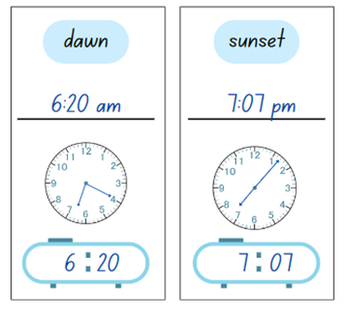
- Provide pairs of Stage 3 students with copies of Resource 11 – time memory.
- Students cut out the cards, shuffle the cards and place them face down.
- Student A selects one card and then selects another card. If the cards match, the student keeps the 2 cards and has another turn. If there is no match the student returns the cards face down and Student B takes a turn.
- Play continues until there are no cards left. The player with the greatest number of cards at the end of the game wins.

Core lesson 2 – 25 minutes

Stage 2 task – 12-hour time
- Display Resource 3 – theme park schedule.
- Pose the problem: Travis wants to watch the animal show and have lunch at 12:30 pm, how long after the show finishes does he have to wait until lunch?
- Students calculate the answer using an empty number line that was introduced Lesson 1.
- Provide students with a copy of Resource 12 – day plan (Stage 2).
- Explain to students that they will be planning a day at the theme park. The day needs to include at least 4 events from the timetable. Times are filled in using am and pm notation.
- Students work individually or with a partner to plan their daily schedules and determine the intervals between each event.

Stage 3 task – 24-hour time
- Revisit 24-hour time. Explain that 24-hour time is used to avoid confusion between am and pm.
- Display Resource 13 – 24-hour timetable.
- Pose the following problem: Shaireen had just finished watching the character parade and wants to stay to watch the laser show. How long does she have to wait? How can this be represented using decimal notation?
- Students calculate the answer. Remind students to use the ZOOM strategy or an empty number line from Lesson 1.
- Provide students with a copy of Resource 14 – day plan (Stage 3).
- Explain to students that they will be planning a day at the theme park. The day needs to include at least 4 events from the timetable. Times are filled in using 24-hour time notation.
- Students work individually or with a partner to plan their daily schedules and determine the intervals between each event.
This table details opportunities for differentiation.
Too hard? | Too easy?
Stage 2 students cannot record times using the colon notation with am and pm to distinguish between morning and evening.  - Provide students with a timeline representing the two 12-hour periods in a day, starting and ending at midnight with midday marked at the midway point. Support students to place the time terms on the timeline, explaining that all terms that are placed on the first half of the timeline between midnight and midday are recorded in colon notation with am.  Stage 3 students cannot solve a variety of problems involving duration, including where times are expressed in 12-hour and 24-hour notation.  - Support students by reducing the number of events they include in their daily plan.  - Assist students by supporting them to use the ZOOM strategy from Lesson 1 and modelling its use. | Stage 2 students can record times using the colon notation with am and pm to distinguish between morning and evening.  - Students create a schedule of events and activities in their day using am and pm notation. For example, 7:03 am wake up, 7:20 am breakfast, 7:45 am brush teeth and so on.  Stage 3 students can solve a variety of problems involving duration, including where times are expressed in 12-hour and 24-hour notation.  - Explain to students they only have 3 hours at the theme park. What shows or activities would they do to make the most of their time and get as close to 3 hours as possible?  - Students use Resource 13 – 24-hour timetable to create problems for a partner to solve.

Discuss and connect the mathematics – 10 minutes
- Students turn and talk to discuss their daily schedules and the intervals between each event.
- Regroup and ask the following questions:
- Were there particular activities that you chose to schedule in the morning? Why? (Stage 2)
- What things did you think about when scheduling your activities? (Stage 2)
- Did you find it challenging to remember when a time should be recorded as am or pm? (Stage 2)
- Was it easier or more difficult to plan a schedule using 24-hour time? (Stage 3)
- What was easier about using 24-hour time? What was more challenging? Explain your thinking. (Stage 3)
- When would it be more appropriate to use a 24-hour timetable? (Stage 3)
- Have you seen a 24-hour timetable in your everyday life? Why was it in this format? (Stage 3)
This table details opportunities for assessment.
Assessment opportunities | Links
What to look for:  - Can Stage 2 students record times using the colon notation with am and pm to distinguish between morning and evening?  [MAO-WM-01, MA2-NSM-02]  - Can Stage 2 students relate the terms midday or noon and midnight to am and pm? [MAO-WM-01, MA2-NSM-02]  - Can Stage 2 students relate analog notation to digital notation for time? [MAO-WM-01, MA2-NSM-02]  - Can Stage 3 students represent commonly used time intervals as decimals? [MAO-WM-01, MA3-NSM-02]  - Can Stage 3 students solve a variety of problems involving duration, including where times are expressed in 12-hour and 24-hour notation? [MAO-WM-01, MA3-NSM-02] | Links to National Numeracy Learning Progressions (NNLP):  - Stage 2 – MeT3, MeT4  - Stage 3 – MeT5.

Lesson 3
Core concept: two-dimensional shapes can be cut and rearranged to create new shapes.

Daily number sense – be the teacher – 15 minutes
The table below contains suggested learning intentions and success criteria. These are best co-constructed with students.
Daily number sense learning intentions | Daily number sense success criteria
Students working towards Stage 2 outcomes are learning to:  - represent fractional quantities equal to and greater than one.  Students working towards Stage 3 outcomes are learning to:  - locate and represent integers on a number line. | Students working towards Stage 2 outcomes can:  - represent totals of halves, thirds, quarters and fifths that extend beyond one.  Students working towards Stage 3 outcomes can:  - recognise the location of negative whole numbers in relation to zero and place them on a number line.
- Display Resource 15 – Ollie’s number line for Stage 2 students.
- Explain that a teacher asked their class to label a 0–2 number line with as many fractions as they could. Ollie completed the task; however he made some mistakes.
- Display Resource 16 – Mel’s number line for Stage 3 students
- Explain that the teacher asked the class to label a blank number line from −100 to 100 with zero marked in the middle. Mel completed the task; however, she made some mistakes.
- Students Think-Pair-Share to discuss what they notice. Ask:
- What mistakes did Ollie make? Why do you think he made them? (Stage 2)
- What advice would you give Ollie about fractions? (Stage 2)
- What mistakes did Mel make? Why do you think she made them? (Stage 3)
- If you were the teacher, how would you support Mel to correct her mistakes? (Stage 3)
- Display Resource 17 – Charlie’s number line for Stage 2 students and explain that Charlie labelled a 0–3 number line with as many fractions as she could.
- Ask students to identify Charlie’s mistakes and record the correct way of labelling the 0–3 number line on an individual whiteboard.
- Regroup and select Stage 2 students to correctly draw and label the 0–3 number line on the board.
- Tell Stage 3 students to draw a blank number line on an individual whiteboard and to help Mel accurately plot the integers.
- Ask students to provide a record of an accurate number line with integers from −100 to 100 and to justify their reasoning (see Figure 6).
Figure 6 – Mel's new number line
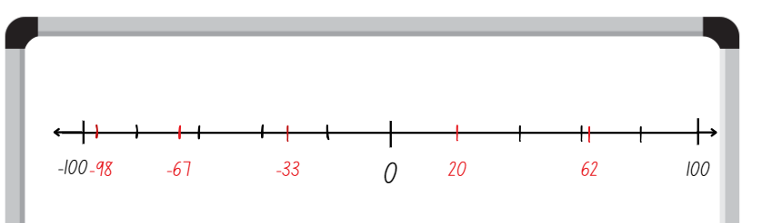
This table details opportunities for assessment.
Assessment opportunities | Links
What to look for:  - Can Stage 2 students represent totals of halves, thirds, quarters and fifths that extend beyond one? [MAO-WM-01, MA2-PF-01]  - Can Stage 3 students recognise the location of negative whole numbers in relation to zero and place them on a number line? [MAO-WM-01, MA3-RN-01] | Links to National Numeracy Learning Progressions (NNLP):  - Stage 2 – INF5  - Stage 3 – NVP9.

Core lesson – shape transformations – 45 minutes
The table below contains suggested learning intentions and success criteria. These are best co-constructed with students.
Core concept learning intentions | Core concept success criteria
Students working towards Stage 2 outcomes are learning to:  - create two-dimensional shapes that result from combining and splitting common shapes  - create symmetrical patterns and shapes.  Students working towards Stage 3 outcomes are learning to:  - dissect two-dimensional shapes and rearrange them using translations, reflections and rotations. | Students working towards Stage 2 outcomes can:  - combine common two-dimensional shapes, including quadrilaterals, to form other common shapes or designs  - split a given shape into 2 or more common shapes and describe the result  - apply and describe amounts of rotation, including half-turns, quarter-turns and three-quarter turns, when creating designs.  Students working towards Stage 3 outcomes can:  - use the terms translate, reflect and rotate to describe transformations of two-dimensional shapes  - dissect and rearrange one shape to make another.
- Revise the terms translation, reflection and rotation.
Translation: in a translation (slide) every point on the original image moves in the same direction for the same distance to transform the new image.
Reflection: a reflection (flip) requires a line of reflection. A reflection is a transformation in which an object is flipped across the line of reflection.
Rotation: a rotation (turn) requires a centre of rotation (a point) and a degree of rotation, for example, 90 degrees or a quarter turn.
- Display Resource 18 – theme park signs.
- Explain that the owners of the theme park wish to design new ride signs, reusing the existing signage to avoid waste. They have asked your class to identify any smaller shapes that could be created by splitting the existing signs into new shapes.
- Students use a ruler to draw lines, splitting each shape into 2 or more common shapes.
- Provide students with scissors to cut the signs into smaller shapes which can be rearranged into as many new shapes as possible.
- Students record their thinking about how the new shapes have been rearranged (see Figure 7).
Figure 7 – student work example
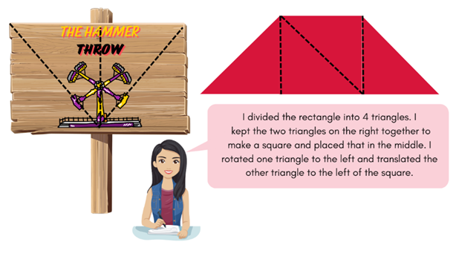
- Students conduct a gallery walk to see the differences and similarities between the new shapes they have made.
- Regroup and select students to share their splitting solutions.
- Display interactive pattern shapes. Explain that the owners cut the existing signs into shapes on the left and they require support combining these shapes into new signs.
- Model how to combine shapes using different amounts of rotation, including half-turns, quarter-turns and three-quarter turns, to make a new common shape using interactive pattern shapes. For example, use 3 green triangles to make a trapezium.
- Use the text tool on the right-hand side navigation pane to add text to the workspace. Record the sentence: ‘3 green triangles make a trapezium’.
- Provide students with a digital device. Students experiment with the interactive pattern shapes and create as many common shapes as possible with 2 or more pattern blocks.
- Students use the text tool to record sentences describing the combining of shapes used to make the new shapes (see Figure 8).
Figure 8 – creating new shapes
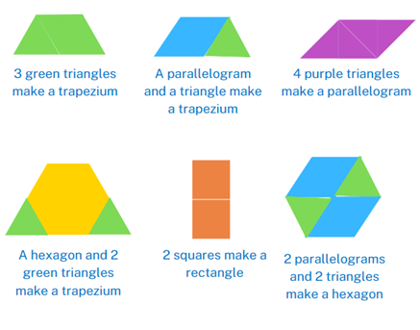
Note: student work can be saved by selecting the share icon on the bottom navigation pane.
This table details opportunities for differentiation.
Too hard? | Too easy?
Stage 2 students cannot combine common two-dimensional shapes, including quadrilaterals, to form other common shapes or designs.  - Provide students with pattern blocks to allow them to physically manipulate the shapes into new common shapes. Students manipulate the pattern blocks to make a singular shape. For example, find as many ways to create a trapezium as possible.  Stage 3 students cannot dissect and rearrange one shape to make another.  - Model how to dissect and rearrange a rectangle to make another shape. Encourage students to remake the rectangle and then rearrange that to make a different shape. | Stage 2 students can combine common two-dimensional shapes, including quadrilaterals, to form other common shapes or designs.  - Students use the terms translate, reflect and rotate to describe the transformations of the two-dimensional shapes used to create the new shape. For example, ‘I translated 2 green triangles and rotated the third to create a trapezium.’  Stage 3 students can dissect and rearrange one shape to make another.  - Challenge students to rearrange a polygon using a combination of rotations, translations or reflections. Encourage students to use Polypad to investigate dissecting and rearranging a shape to make another.

Discuss and connect the mathematics – 10 minutes
- Students participate in a gallery walk to view their peers’ shape combinations.
- Regroup and ask the following questions:
- Which designs would be most suitable for the theme park owners to use for their signs? Why?
- Did anyone create a pentagon? Which shapes were used to create it?
- Which pattern block was the most difficult to use to create a new shape? Why?
- Did you have to rotate and reflect the pieces to make a new shape?
- Why do you think there were no shapes with round edges, for example circles or ovals, to choose from?
This table details opportunities for assessment.
Assessment opportunities | Links
What to look for:  - Can Stage 2 students combine common two-dimensional shapes, including quadrilaterals, to form other common shapes or designs? [MAO-WM-01, MA2-2DS-02]  - Can Stage 2 students split a given shape into 2 or more common shapes and describe the result? [MAO-WM-01, MA2-2DS-02]  - Can Stage 2 students apply and describe amounts of rotation, including half-turns, quarter-turns and three-quarter turns, when creating designs? [MAO-WM-01, MA2-2DS-02]  - Can Stage 3 students use the terms translate, reflect, and rotate to describe transformations of two-dimensional shapes?  [MAO-WM-01, MA3-2DS-01]  - Can Stage 3 students dissect and rearrange one shape to make another? [MAO-WM-01, MA3-2DS-02] | Links to National Numeracy Learning Progressions (NNLP):  - Stage 2 – UGP5, UGP6  - Stage 3 – UGP5, UGP6.

Lesson 4
Core concept: objects can be designed by rotating, reflecting and translating two-dimensional shapes.

Daily number sense – 10 minutes
- From a class need surfaced through formative assessment data, identify a short, focused activity that targets students’ knowledge, understanding and skills. Example activities may be drawn from the following resources:
- Mathematics K–6 resources
- Universal Resources Hub.

Core lesson – design and make – 40 minutes
The table below contains suggested learning intentions and success criteria. These are best co-constructed with students.
Core concept learning intentions | Core concept success criteria
Students working towards Stage 2 outcomes are learning to:  - create symmetrical patterns and shapes.  Students working towards Stage 3 outcomes are learning to:  - dissect two-dimensional shapes and rearrange them using translations, reflections and rotations. | Students working towards Stage 2 outcomes can:  - apply and describe amounts of rotation, including half-turns, quarter-turns and three-quarter turns, when creating designs.  Students working towards Stage 3 outcomes can:  - use the terms translate, reflect and rotate to describe transformations of two-dimensional shapes  - recognise that translations, reflections or rotations change the position and orientation but not the size of shapes.
- Display Resource 19 – transformations and revise the terms translation, reflection and rotation from Lesson 3.
- Ask the following questions:
- Why does the triangle have a black dot in the corner? How is this helpful?
- Have the quarter-turn, half-turn and three-quarter turns been rotated clockwise or anti-clockwise? How do you know?
- Display Resource 20 – rotating patterns. Ask students to Think-Pair-Share which rotation description matches each pattern and justify their reasoning. If necessary, provide students with pattern blocks to support their investigation.
- Model creating each pattern from Resource 20 – rotating patterns using interactive pattern shapes to confirm whether the descriptions were accurately matched to the patterns. Whilst creating the patterns, use the think-aloud strategy. For example, ‘When I make a quarter-turn rotation, I rotate it in a clockwise direction one-quarter of a full rotation.’
- In pairs, students use a digital device and the interactive pattern shapes website to experiment with translating, reflecting and rotating various two-dimensional shapes. Encourage students to describe the transformations to their partner as they work. Ensure students understand how to translate, reflect and rotate a variety of shapes.
Note: when using interactive pattern shapes follow these steps to rotate the shapes. Drag a shape onto the workspace. Select the shape. Select and drag the rotate button at the top of the shape to rotate the shape by a quarter-turn, half-turn or three-quarter turn. The grey line from the rotate button to the shape can help guide students to make an appropriate turn.
- Ask students to create 3 patterns by rotating shapes by a quarter-turn, half-turn or three-quarter turn using interactive pattern shapes. Students describe their pattern using the text tool (see Figure 9).
Figure 9 – transformation patterns
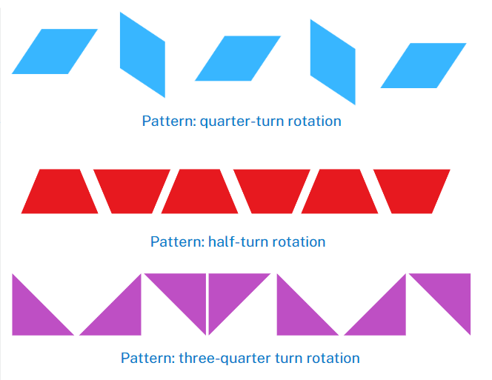
- Display Resource 21 – demolition derby truck.
- Explain that the owner of the theme park is looking for a new design for one of their demolition derby trucks. They would like a design that includes various two-dimensional shapes that have been rotated, reflected and translated. This is an example of one of the designs they already have of one of their trucks.
- Model how to add the truck template to the interactive pattern shapes workspace by selecting the outline library icon and clicking on the image of the truck.
Note: the outline library icon is represented by a boat image in the bottom left-hand corner. To locate the truck icon, move the scroll bar to the far right. To rotate the shapes, drag an additional shape onto the workspace. Select the additional shape and select and drag the rotate button at the top of the shape to rotate the shape by a quarter-turn, half-turn or three-quarter turn.
- Students create their own demolition derby truck by manipulating shapes using the interactive pattern shapes website. They write a description of how the two-dimensional shapes were used to create their design, using the terminology of rotating, reflecting and translating.
Note: students can save their designs by selecting the share icon on the bottom navigation pane.
This table details opportunities for differentiation.
Too hard? | Too easy?
Stage 2 students cannot apply and describe amounts of rotation, including half-turns, quarter-turns and three-quarter turns, when creating designs.  - Students use pattern blocks to recreate the patterns from Resource 20 – rotating patterns, physically manipulating the shapes by rotating the pattern blocks.  Stage 3 students cannot use the terms translate, reflect and rotate to describe transformations of two-dimensional shapes.  - Provide students with pattern blocks to create their demolition derby designs. Support students to convert their ideas onto the interactive pattern shapes website, using the terms translate, reflect and rotate. | Stage 2 students can apply and describe amounts of rotation, including half-turns, quarter-turns and three-quarter turns, when creating designs.  - Students use isometric graph paper to draw a range of shapes that have been rotated, reflected and translated. Students describe the transformation using mathematical language.  Stage 3 students can use the terms translate, reflect and rotate to describe transformations of two-dimensional shapes.  - Challenge students to use the interactive pattern shapes website to create their own carnival stall and ride using two-dimensional shapes that have been translated, reflected and rotated.

Discuss and connect the mathematics – 10 minutes
- Students participate in a gallery walk to view their peers’ designs. Ask:
- How are the designs different or similar to each other?
- How have the two-dimensional shapes been transformed?
- Students turn and talk with a partner to share their designs. Ask:
- Was it easier to translate, rotate or reflect the two-dimensional shapes to create your demolition derby truck? Which one did you use the most?
- Did the size of the shapes change when the position and orientation of the shapes changed? Why or why not?
This table details opportunities for assessment.
Assessment opportunities | Links
What to look for:  - Can Stage 2 students apply and describe amounts of rotation, including half-turns, quarter-turns and three-quarter turns, when creating designs? [MAO-WM-01, MA2-2DS-02]  - Can Stage 3 students use the terms translate, reflect, and rotate to describe transformations of two-dimensional shapes?  [MAO-WM-01, MA3-2DS-01]  - Can Stage 3 students recognise that translations, reflections or rotations change the position and orientation but not the size of shapes? [MAO-WM-01, MA3-2DS-01] | Links to National Numeracy Learning Progressions (NNLP):  - Stage 2 – UGP4, UGP5, UGP6  - Stage 3 – UGP5, UGP6.

Lesson 5
Core concept: angles can be found in the world around us.

Daily number sense – fraction problems – 10 minutes
Daily number sense activities for Lessons 5 to 7 ‘loop’ back to concepts and procedures covered in previous units to assist students to build an increasingly connected network of ideas. These concepts may differ from the core concepts being covered by the unit.
The table below contains suggested learning intentions and success criteria. These are best co-constructed with students.
Daily number sense learning intentions | Daily number sense success criteria
Students working towards Stage 2 outcomes are learning to:  - represent fractional quantities equal to and greater than one.  Students working towards Stage 3 outcomes are learning to:  - find fractional quantities of whole numbers (halves, quarters, fifths and tenths). | Students working towards Stage 2 outcomes can:  - represent totals of halves, thirds, quarters and fifths that extend beyond one  - determine the relative location of one-quarter and one-half when a number line extends beyond one.  Students working towards Stage 3 outcomes can:  - solve word problems involving a fraction of a quantity.
Multi-age: Stage 2 students use Resource 22 – blank number lines to find fractional quantities equal to and greater than one. Stage 3 students use Resource 23 – blank tape diagram to solve word problems involving fractions of a quantity.
- Display Resource 22 – blank number lines for Stage 2 students.
- Draw attention to the fact that there are 3 different sized number lines, as indicated by the position of the 1 on each line which represents one whole.
- Pose the following scenario: Two students were dividing their number lines into quarters. Jack said he would draw 4 lines in between each whole number and Harriet said she would draw 3. Ask:
- Who is correct and why?
- How many quarters are there in 2 wholes?
- Can you draw a number line to prove it?
- Provide students with individual whiteboards. Explain that they need to copy the 3 number lines and partition each number line into quarters by marking equal spaces between each whole number.
- Students label the following fractions on the appropriate number line:
- $\frac{1}{4}$
- $1\frac{3}{4}$
- $2\frac{3}{4}$
- $\frac{7}{4}$
- $\frac{3}{4}$.
- Pose the following problem for Stage 3 students: Gigi went to the party shop to buy balloons for the Year 6 farewell. The shop only had $\frac{3}{5}$ of the number of purple balloons she was after. They offered her 24 gold balloons to complete her order. How many balloons did she buy in total?
- Display Resource 23 – blank tape diagram.
- Provide students with individual whiteboards. Explain that they need to solve the problem and justify their answer using a tape diagram.
- Regroup and select students to share their strategies and solutions. Ask:
- How did you split the problem into parts to solve it?
- What fraction of the balloons is 24?
- What is $\frac{1}{5}$ of the total amount?
- How many purple balloons did Gigi buy?
- What was the total amount of balloons?
- Was using the tape diagram helpful when solving this problem? Why or why not? (see Figure 10)
Figure 10 – tape diagram sample
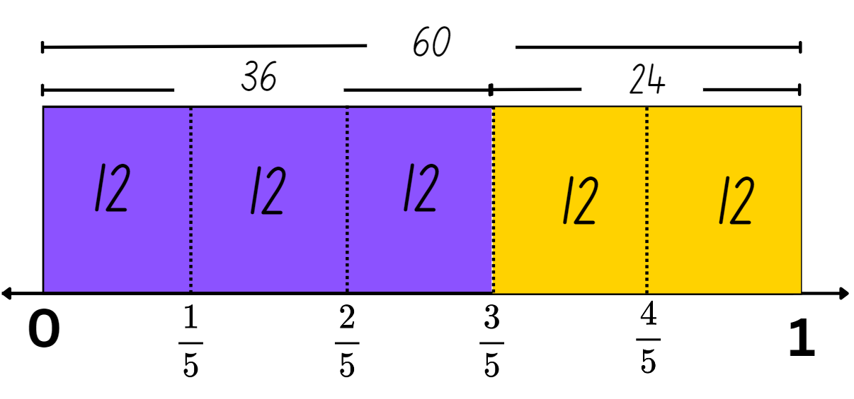
This table details opportunities for assessment.
Assessment opportunities | Links
What to look for:  - Can Stage 2 students represent totals of halves, thirds, quarters and fifths that extend beyond one? [MAO-WM-01, MA2-PF-01]  - Can Stage 2 students determine the relative location of one-quarter and one-half when a number line extends beyond one? [MAO-WM-01, MA2-PF-01]  - Can Stage 3 students solve word problems involving a fraction of a quantity? [MAO-WM-01, MA3-RQF-02] | Links to National Numeracy Learning Progressions (NNLP):  - Stage 2 – InF5, InF6  - Stage 3 – InF8.

Core lesson 1 – all about angles – 10 minutes
The table below contains suggested learning intentions and success criteria. These are best co-constructed with students.
Core concept learning intentions | Core concept success criteria
Students working towards Stage 2 outcomes are learning to:  - compare angles to a right angle.  Students working towards Stage 3 outcomes are learning to:  - investigate angles on a straight line and angles at a point  - investigate the relationships formed by the intersection of straight lines. | Students working towards Stage 2 outcomes can:  - recognise and describe angles as less than, equal to, about the same as or greater than a right angle  - describe angles in comparison to quarter-turns as acute, right, obtuse, straight, reflex or a revolution.  Students working towards Stage 3 outcomes can:  - recognise right angles, angles on a straight line and angles at a point embedded in diagrams  - identify angle types formed by the intersection of straight lines, including right angles (90°), angles on a straight line (add to 180°) and angles at a point that form an angle of revolution (add to 360°)  - recognise that perpendicular lines intersect at right angles (90°)  - investigate angles at a point and establish that they form an angle of revolution and add to 360°.
Note: Resource 24 – Ferris wheel 1 should be copied onto A4 card to make it easier to move when using a split pin. Stage 2 students may use a simple 'angle tester' throughout the lesson. It can be made by placing a pipe-cleaner inside a straw and bending the straw to form 2 arms.
- Provide students with individual whiteboards.
- Ask students to represent and record what they know about angles (see Figure 11).
Figure 11 – student work sample
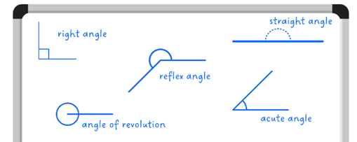
Multi-age: this is a formative assessment opportunity to guide Lessons 5–8. The focus in Stage 2 angles is on comparison to a quarter turn or a right angle. Assigning a numerical value in degrees to measure angles of any size, is not introduced until Stage 3.
- Display Resource 25 – all about angles. In pairs, students compare their answers, discussing their representations. Ask:
- Did you record all the different types of angles? How do you know?
- Can you identify the vertex and the arms in each angle?
- What is the difference between a reflex and an obtuse angle?
- Can you see any of these angles in our classroom?

Core lesson 2 – Ferris wheel angles – 30 minutes
- Show pictures or diagrams of Ferris wheels online and ask students if they know how they work.
- Briefly explain that the main component of a Ferris wheel is the large circular wheel. This wheel is mounted on a central axis called the axle. The axle is usually supported by a sturdy frame or structure, allowing the wheel to rotate freely. Attached to the outer rim of the Ferris wheel are passenger cabins.
- Provide and display Resource 24 – Ferris wheel 1. Student cut the arrows from the resource and attach them to the Ferris wheel with split pins.
- Ask students to identify the arms and vertex of an angle on the Ferris wheel. Demonstrate how angles are created as the Ferris wheel rotates in a clockwise direction. Ensure students recognise the arrows as the arms and the angle as the amount of turning between the 2 arms.
- Students identify different types of angles on the Ferris wheel. Stage 2 students can describe the angles as less than, equal to, about the same as or greater than a right angle. Stage 3 students can identify the different angles, recognising that right angles are 90° and straight angles add to 180° (see Figure 12).
Figure 12 – angle of turn
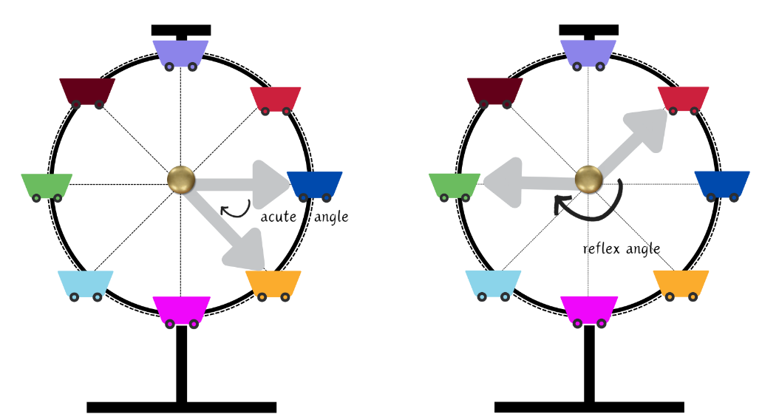
- Pose the following questions:
- When all lines meet at one point, what is the angle that is formed? (Stage 2)
- How many degrees is this angle? (Stage 3)
Note: ensure Stage 3 students understand that angles that form around a point are called a revolution and the sum of these angles is 360°.
- Ask students to use their arrow arms and split pin to demonstrate the angle of turn for the questions in the table below.
The table below outlines stimulus prompts to generate conversation about the topic, along with anticipated responses from students.
Prompts | Anticipated student responses
- Describe the angle made by the arms when the arrows are pointing to the purple cart and pink cart? | - Stage 2 students: It is a straight angle which is greater than a right angle.  - Stage 3 students: It is a straight angle which is 180°.
- Describe the angle made by the arms when the arrows are pointing to the dark blue cart and orange cart? | - Stage 2 students: It is an acute angle which is less than a right angle and less than a quarter turn.  - Stage 3 students: It is an acute angle measuring 45°. The vertex is intersecting the right angle in half. Half of 90° is 45°.
- Describe the angle made by the arms when the arrows are pointing to the pink cart and then the second arrow turns clockwise to the red cart? | - Stage 2 students: It is a reflex angle which is greater than a right angle.  - Stage 3 students: It is a reflex angle. The angle measurement is 225°. For each angle between carts, the vertex is intersecting the right angle in half, making each angle is 45°. The pink cart to the purple cart is 180°, so 180° plus 45° is 225° or 5 times 45° is 225°
- If the purple cart starts at the top and the Ferris wheel makes a clockwise quarter-turn, identify the new position of the purple cart. | - The purple cart will be in the original position of the dark blue cart.
- If the Ferris wheel makes a full turn so that the purple cart at the top moves clockwise and returns to the top again, what is this called? | - Stage 2 students: It is a full turn and called a revolution.  - Stage 3 students: It is an angle of revolution. The angle formed by the cart’s movement measures 360°.
- In pairs, students pose their own questions regarding the carts’ angles using the language of turn.
This table details opportunities for differentiation.
Too hard? | Too easy?
Stage 2 students cannot recognise and describe angles as less than, equal to, about the same as or greater than a right angle.  - Provide students with a template of a right angle or an ‘angle tester.’ Students use this as a reference when using the resource to help recognise and describe the angles.  Stage 3 students cannot recognise right angles, angles on a straight line and angles at a point embedded in diagrams.  - Provide students with Resource 25 – all about angles to support their ability to recognise angles. | Stage 2 students can recognise and describe angles as less than, equal to, about the same as or greater than a right angle.  - Students complete an ‘angle hunt.’ They find examples of angles in their classroom or playground such as, corners of books, intersections of lines on a basketball court and angles in letters of the alphabet. Students take pictures or draw these examples and describe the angles as less than, equal to, about the same as, or greater than a right angle.  Stage 3 students can recognise right angles, angles on a straight line and angles at a point embedded in diagrams.  - Using their demolition truck design from Lesson 4, students identify, and label angles embedded within their image.

Discuss and connect the mathematics – 10 minutes
- Display Resource 26 – Are they correct?
- Ask students to Think-Pair-Share if they agree with Megan’s answer (Stage 2) or Harrison’s answer (Stage 3), justifying their reasoning.

Multi-age: Stage 2: for each letter, 8 angles can be made that are greater than a right angle. For example angles: A–E, A–F, A–G, A–H, A–I, A–J, A–K, A–L are all obtuse or reflex angles. There are 96 angles greater than a right angle on the Ferris wheel image. Megan’s answer of 36 is due to her calculating the obtuse angles only and not the reflex angles extending beyond the straight angle.
Stage 3: there are three equal angles within the right angles on the Ferris wheel, therefore each angle formed by adjacent letters is 30°. Angle G-F would be 30° so Harrison’s estimation of 50° is incorrect as the shaded angle is smaller than 30°.
This table details opportunities for assessment.
Assessment opportunities | Links
What to look for:  - Can Stage 2 students recognise and describe angles as less than, equal to, about the same as or greater than a right angle?  [MAO-WM-01, MA2-GM-03]  - Can Stage 2 students describe angles in comparison to quarter-turns as acute, right, obtuse, straight, reflex or a revolution? [MAO-WM-01, MA2-GM-03]  - Can Stage 3 students recognise right angles, angles on a straight line and angles at a point embedded in diagrams?  [MAO-WM-01, MA3-GM-03]  - Can Stage 3 students recognise that perpendicular lines intersect at right angles (90°)? [MAO-WM-01, MA3-GM-03]  - Can Stage 3 students investigate angles at a point and establish that they form an angle of revolution and add to 360°?  [MAO-WM-01, MA3-GM-03] | Links to National Numeracy Learning Progressions (NNLP):  - Stage 2 – UuM6, UuM7  - Stage 3 – UuM8, UGP5, UGP6.

Lesson 6
Core concept: angles in our environment can be compared to a right angle and described in relation to quarter-turns (Stage 2) and adjacent angles are formed when lines intersect (Stage 3).

Daily number sense – fraction inquiry– 10 minutes
The table below contains suggested learning intentions and success criteria. These are best co-constructed with students.
Daily number sense learning intentions | Daily number sense success criteria
Students working towards Stage 2 outcomes are learning to:  - represent fractional quantities equal to and greater than one.  Students working towards Stage 3 outcomes are learning to:  - find fractional quantities of whole numbers (halves, quarters, fifths and tenths). | Students working towards Stage 2 outcomes can:  - determine the relative location of one-quarter and one-half when a number line extends beyond one.  Students working towards Stage 3 outcomes can:  - calculate quarters and fifths of whole numbers that are multiples of the denominator, using a tape diagram.
This activity is an adaptation of Fraction of a number inquiry from Inquiry Maths by Hindle.
- Write the following on the board: $\frac{6}{4}$ = $1\frac{2}{4}$ or $1\frac{1}{2}$(Stage 2), $\frac{2}{5}$ of 40 = $\frac{4}{5}$ of 20 (Stage 3).
- Discuss strategies that would prove whether each equation is true or false.
- Provide students with whiteboards. Explain that they need to determine whether the equation is true or false and justify their answer using a number line (Stage 2) or tape diagram (Stage 3).
- Students turn and talk sharing their diagrams and reasoning.
- Regroup and ask the following questions:
- Is each equation true or false? Explain your reasoning.
- How did you place these fractions on the number line? (Stage 2)
- What knowledge did you need to draw on to identify and label $\frac{6}{4}$? (Stage 2, see Figure 13)
- Was using the tape diagram helpful to figure out the fraction of the quantity? Why or why not? (Stage 3, see Figure 14)
- Is there another way you could have solved this problem? (Stage 3)
- Do you see any connections to other mathematical concepts?
Figure 13 – number line sample
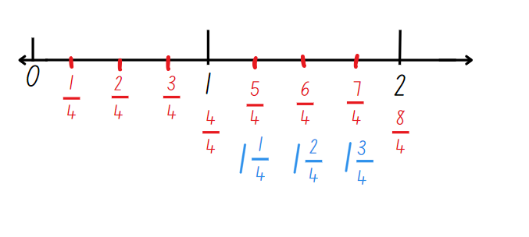
Figure 14 – tape diagram sample
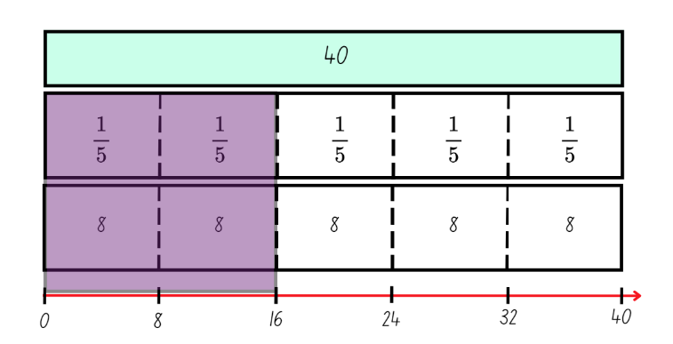
This table details opportunities for assessment.
Assessment opportunities | Links
What to look for:  - Can Stage 2 students determine the relative location of one-quarter and one-half when a number line extends beyond one? [MAO-WM-01, MA2-PF-01]  - Can Stage 3 students calculate quarters and fifths of whole numbers that are multiples of the denominator, using a tape diagram? [MAO-WM-01, MA3-RQF-02] | Links to National Numeracy Learning Progressions (NNLP):  - Stage 2 – InF5  - Stage 3 – InF8.

Core lesson 1 – investigating angles – 10 minutes
The table below contains suggested learning intentions and success criteria. These are best co-constructed with students.
Core concept learning intentions | Core concept success criteria
Students working towards Stage 2 outcomes are learning to:  - compare angles to a right angle.  Students working towards Stage 3 outcomes are learning to:  - estimate, measure and compare angles using degrees  - investigate the relationships formed by the intersection of straight lines. | Students working towards Stage 2 outcomes can:  - recognise and describe angles as less than, equal to, about the same as or greater than a right angle  - describe angles in comparison to quarter-turns as acute, right, obtuse, straight, reflex or a revolution.  Students working towards Stage 3 outcomes can:  - measure angles of up to 360° using a protractor  - investigate adjacent angles that form a right angle and establish that they add to 90°  - investigate adjacent angles on a straight line and establish that they add to 180°  - investigate angles at a point and establish that they form an angle of revolution and add to 360°.
Adjacent angles: angles that share a vertex and an arm. They do not overlap.
Multi-age: Stage 2 students will use Resource 27 – park map (Stage 2) to describe angles in comparison to quarter-turns as acute, right, obtuse, straight, reflex or a revolution. Stage 3 students will use Resource 28 – park map (Stage 3) to investigate adjacent angles that form a right angle, straight angle and an angle of revolution.
- Revisit Resource 25 – all about angles. Highlight for Stage 3 students the adjacent angle.
- Draw a right angle on the board with an intersecting line. Label one of the angles as 60° (see Figure 15).
Figure 15 – adjacent angle example
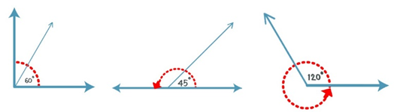
- Ask Stage 2 students:
- What is the name of the angle formed?
- What angle has the intersecting line formed?
- Ask Stage 3 students:
- How many degrees in a right angle?
- What is the measurement of the adjacent angle in degrees?
- How do you know?
- What if I changed the size of the angle to 45°?
- Repeat these steps with a straight angle and an angle of revolution (see Figure 15).

Core lesson 2 – theme park map – 35 minutes
- Provide students with Resource 27 – park map (Stage 2) and Resource 28 – park map (Stage 3).
- Highlight angles a–h on the map, the roads (blue solid lines) and the walking paths (pink dotted lines).
- Explain that Stage 2 students are going to identify and label the angles as acute, obtuse, right, straight, reflex and revolution.
- Stage 3 students are going to calculate and record the size of the adjacent angles in degrees.
- Students work in pairs to record the angles in their workbooks.
- Regroup and ask Stage 2 students:
- How did you know if an angle was acute or obtuse?
- How is a reflex angle different to an obtuse angle?
- What angle is formed by all the blue roads?
- Ask Stage 3 students:
- How did you know the size of the adjacent angle?
- Did you notice anything about the relationship between the angle on the straight line and the angle at a point?
- How would you describe the 2 lines that make a right angle? (perpendicular lines)
- How could you check your answer? Is there a tool we could use?
Multi-age: all students will complete the following task using the criteria set below. Stage 2 are to measure their angles with a right-angle tester (square pattern block or pipe-cleaner inside a straw) and label their angles as acute, obtuse, right, straight and reflex. Stage 3 are to measure their angles with a protractor and label their angles in degrees. While modelling the correct use of a protractor for Stage 3 students, allow Stage 2 students to begin the task.
- Provide Stage 2 students with tracing paper and explain that they are going to record their trip to the theme park by tracing their path as they visit all the attractions.
Note: ensure students are using a ruler to trace their paths. Lines will need to connect to create a vertex for labelling and measuring angles later in the lesson.
- Students will need to:
- start at the entrance next to the gift shop
- go on at least 4 rides
- have lunch in the food court
- watch at least one show.
- Before Stage 3 students begin the task, display Resource 29 – using a protractor and revise how to measure angles.
- Guide students in measuring angles from the map, ensuring they are using the protractor correctly. Determine whether the measurements recorded earlier were correct.
- Provide Stage 3 students with tracing paper and remind them of the criteria for tracing their paths set above.
- Once all students have traced their path, ask them to lift the tracing paper to reveal a page of intersecting lines and angles.
- Stage 2 students measure the angles using a right-angle tester and label the angles on the tracing paper (see Figure 16).
Figure 16 – Stage 2 work sample
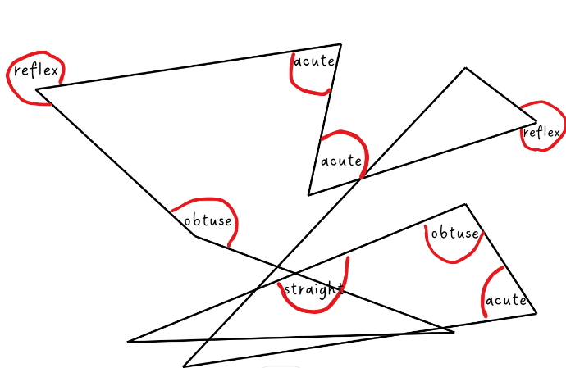
- Stage 3 students measure the angles using a protractor and label them on the tracing paper (see Figure 17).
Figure 17 – Stage 3 work sample
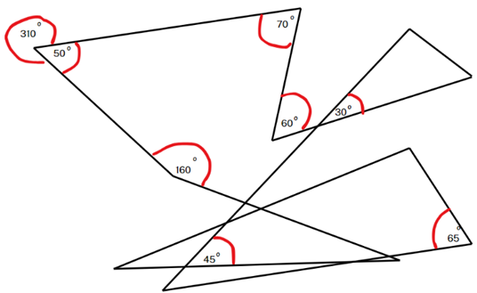
This table details opportunities for differentiation.
Too hard? | Too easy?
Stage 2 students cannot describe angles in comparison to quarter-turns as acute, right, obtuse, straight, reflex or a revolution.  - Reduce the criteria for the students when tracing their path on the map, ensuring they only have 3 or 4 angles to measure. Provide students with Resource 30 – types of angles to support their ability to identify angles.  Stage 3 students cannot create and identify angles of up to 360° using a protractor.  - Provide the students with a right-angle tester (square pattern block or pipe-cleaner inside a straw) and allow them to compare the angles as more than or less than 90°. Students record the angles as obtuse and acute angles. Provide students with Resource 25 – all about angles to support their ability to identify angles. | Stage 2 students can describe angles in comparison to quarter-turns as acute, right, obtuse, straight, reflex or a revolution.  - Challenge students to create a path that meets a set criteria. For example, a path that contains 3 acute angles, 3 obtuse angles and 2 straight angles.  Stage 3 students can create and identify angles of up to 360° using a protractor.  - Using a digital platform such as Canva, students create their own map and use the line feature to create various types of angles. Students measure and record angles on the map.

Discuss and connect the mathematics – 10 minutes
- Join pairs or groups together to share and compare their paths. Ask each group to:
- discuss the attractions that were visited on the map
- show that all the places listed on the criteria were visited
- determine which angle type was the most and least common
- discuss any angles that were challenging to measure.
This table details opportunities for assessment.
Assessment opportunities | Links
What to look for:  - Can Stage 2 students recognise and describe angles as less than, equal to, about the same as or greater than a right angle?  [MAO-WM-01, MA2-GM-03]  - Can Stage 2 students describe angles in comparison to quarter-turns as acute, right, obtuse, straight, reflex or a revolution? [MAO-WM-01, MA2-GM-03]  - Can Stage 3 students create and identify angles of up to 360° using a protractor? [MAO-WM-01, MA3-GM-03]  - Can Stage 3 students investigate adjacent angles that form a right angle and establish that they add to 90°?  [MAO-WM-01, MA3-GM-03]  - Can Stage 3 students investigate adjacent angles on a straight line and establish that they add to 180°?  [MAO-WM-01, MA3-GM-03]  - Can Stage 3 students investigate angles at a point and establish that they form an angle of revolution and add to 360°?  [MAO-WM-01, MA3-GM-03] | Links to National Numeracy Learning Progressions (NNLP):  - Stage 2 – UuM6, UuM7  - Stage 3 – UuM8, UGP5, UGP6.

Lesson 7
Core concept: mathematicians can identify different types of angles, recognise various shapes and understand their properties in everyday contexts (Stage 2) and designing allows us to investigate angles and their relationships (Stage 3).

Daily number sense – fraction memory – 15 minutes
The table below contains suggested learning intentions and success criteria. These are best co-constructed with students.
Daily number sense learning intentions | Daily number sense success criteria
Students working towards Stage 2 outcomes are learning to:  - represent fractional quantities equal to and greater than one.  Students working towards Stage 3 outcomes are learning to:  - find fractional quantities of whole numbers (halves, quarters, fifths and tenths). | Students working towards Stage 2 outcomes can:  - represent totals of halves and quarters that extend beyond one.  Students working towards Stage 3 outcomes can:  - find $\frac{1}{2}$ and $\frac{1}{4}$ of collections, expressing remainders as decimals.
Multi-age: Stage 2 students use Resource 31 – fraction memory (Stage 2) to match equivalent fractions, including fractions that extend beyond one. Stage 3 students use Resource 32 – fraction memory (Stage 3) to match halves and quarters of a quantity where all the answers have a remainder of .5.
- Display Resource 33 – fraction wall. Highlight for Stage 2 students the equivalence between benchmark fractions, including fractions that extend beyond one. For example, $1\frac{1}{2}$ is equivalent to $\frac{6}{4}$ and $\frac{3}{2}$.
- Explain that students will be playing a memory game where they will match equivalent fractions.
- For Stage 3 students, highlight equivalence between benchmark fractions and decimals. Review that $\frac{1}{2}$ is expressed as 0.5 when written as a decimal. Repeat with $\frac{1}{4}$ as 0.25, $\frac{3}{4}$ as 0.75, $1\frac{1}{4}$ as 1.25, $1\frac{1}{2}$ as 1.5 and $1\frac{3}{4}$ as 1.75.
- Explain that Stage 3 students will be calculating $\frac{1}{2}$ and $\frac{1}{4}$ of numbers where each of the answers will have a remainder. Remind students that $\frac{1}{4}$ is equal to a half of a half.
- Model how to apply this concept to fractions of a collection. For example, to calculate $\frac{1}{4}$ of 10, we can calculate $\frac{1}{2}$ of 10 is 5 and then $\frac{1}{2}$ of 5 is $2\frac{1}{2}$, which can be expressed as 2.5.
- Provide pairs with Resource 31 – fraction memory (Stage 2) and Resource 32 – fraction memory (Stage 3).
- Students cut out the cards, shuffle the cards and place them face down.
- Student A selects one card and then selects another card. If the cards match, the student keeps the 2 cards and has another turn. If there is no match the student returns the cards face down and Student B takes a turn.
- Play continues until there are no cards left. The player with the greatest number of cards at the end of the game wins.
This table details opportunities for assessment.
Assessment opportunities | Links
What to look for:  - Can Stage 2 students represent totals of halves and quarters that extend beyond one? [MAO-WM-01, MA2-PF-01]  - Can Stage 3 students find $\frac{1}{2}$ and $\frac{1}{4}$ of collections, expressing remainders as decimals? [MAO-WM-01, MA3-RQF-02] | Links to National Numeracy Learning Progressions (NNLP):  - Stage 2 – InF5, InF6  - Stage 3 – InF8.

Core lesson – 40 minutes

Stage 2 task – Ferris wheels around the world
The table below contains suggested learning intentions and success criteria. These are best co-constructed with students.
Core concept learning intentions | Core concept success criteria
Students working towards Stage 2 outcomes are learning to:  - create two-dimensional shapes that result from combining and splitting common shapes  - create symmetrical patterns and shapes  - compare angles to a right angle. | Students working towards Stage 2 outcomes can:  - record the arrangements of common shapes used to create other shapes  - apply and describe amounts of rotation, including half-turns, quarter-turns and three-quarter-turns, when creating designs  - recognise and describe angles as less than, equal to, about the same as or greater than a right angle  - describe angles in comparison to quarter-turns as acute, right, obtuse, straight, reflex or a revolution.
- Explain that the owners of the theme park would like to construct a new Ferris wheel and are seeking new design ideas. To achieve this, they have requested that our class conduct research on existing Ferris wheels around the world and create a new Ferris wheel design for the park.
- Provide a brief history of Ferris wheels, starting with the original Ferris Wheel designed by George Washington Gale Ferris Jr for the 1893 Chicago World's Columbian Exposition.
- Display Resource 34 – Ferris wheels 2 and inform students that these are 6 famous Ferris wheels from around the world. Divide students into pairs or small groups and assign each group a Ferris wheel to research. Some examples of possible websites include:
- Luna Park (Sydney)
- London Eye (London)
- Melbourne Star (Melbourne)
- High Roller (Las Vegas)
- Singapore Flyer (Singapore)
- Tianjin Eye (Tianjin, China)
- Display Resource 35 – investigation criteria. Discuss the key features the students are going to investigate and present to their peers.
- Students work in pairs or small groups and display their investigation data using digital devices, posters or other methods.
This table details opportunities for differentiation.
Too hard? | Too easy?
Students cannot apply and describe amounts of rotation, including half-turns, quarter-turns and three-quarter-turns in two-dimensional shapes.  - Provide students with pattern blocks and support them to physically rotate the shapes by half-turns, quarter-turns and three-quarter turns.  - In pairs, students complete a ‘rotation hunt’ around their classroom or playground to find objects that can be rotated. They take pictures or draw these objects and apply different amounts of rotation to them (for example, rotating a door handle a quarter-turn to open the door or clock hands rotating to tell a specific time). | Students can apply and describe amounts of rotation, including half-turns, quarter-turns and three-quarter-turns.  - Students research geometric art designs and describe amounts of rotation, including half-turns, quarter-turns, and three-quarter-turns. They create examples using two dimensional shapes by drawing or using a digital platform such as Canva.

Stage 3 task – design a rollercoaster 1
Core concept learning intentions | Core concept success criteria
Students working towards Stage 3 outcomes are learning to:  - use a protractor to measure and identify types of angles  - investigate the relationships formed by the intersection of straight lines. | Students working towards Stage 3 outcomes can:  - create and identify angles of up to 360° using a protractor  - recognise that perpendicular lines intersect at right angles (90°)  - investigate adjacent angles that form a right angle and establish that they add to 90° and on a straight line and establish that they add to 180°  - investigate angles at a point and establish that they form an angle of revolution and add to 360°.
Note: this design task is planned to be completed over Lesson 7 and Lesson 8 of this unit. Groups can work at their own pace, with teacher assistance when required. The expectation is that students will work through the success criteria across the 2 lessons.
- Pose the following scenario: The theme park has decided a new rollercoaster will bring in more customers. They have asked you to design this. You will have 2 tasks to complete during the design process. The first task will involve designing for thrill. The second task will involve designing for safety.
- Brainstorm what makes an exciting rollercoaster. Show the class Resource 36 – rollercoasters, including video clips of rollercoasters. Discuss the features that are common and uncommon within these examples. Encourage students to find their own examples to discuss with the class.
- Display and read Resource 37 – designing for thrill and Resource 38 – designing for safety. Clarify any elements of the task as needed.
Note: the design task can be approached in a way that suit the needs of your class. This could mean providing students with both resources and allowing them to work through them at their own pace or giving the resources one at a time and bringing the students back together when ready to move on to the next task. Monitor students, providing feedback, support and challenge where required. These tasks could be completed on paper or using digital software such as Canva or PowerPoint.
- Working in pairs or groups of 3, provide students with copies of Resource 37 – designing for thrill and Resource 38 – designing for safety.
- Students work through the design tasks.
This table details opportunities for differentiation.
Too hard? | Too easy?
Students cannot create and identify angles of up to 360° using a protractor.  - Assist students to identify the angle they are going to measure. It could be shaded in or highlighted to make it clearer to see.  - Support students to align their protractor accurately, then count the number of degrees in the angle starting from 0°. | Students can create and identify angles of up to 360° using a protractor.  - Use digital software such as Canva or PowerPoint to create a line artwork. Students print their artwork and use a protractor to calculate the angles created by the lines.  - Challenge students to find images of rollercoasters in books or on the internet. Ask students to categorise, measure and record the size of the angles in one of the rollercoasters. Have students determine which type of angle is most common and reflect on why.

Discuss and connect the mathematics – 20 minutes
- Students share their investigations and rollercoaster designs to another pair or group in their stage.
- After 10 minutes regroup as a whole class and ask the following questions:
- Did you find anything challenging?
- How many different types of angles did you identify? (Stage 2)
- Which criteria do you think is the most important for Ferris wheel designers to consider? Why? (Stage 2)
- Which strategies have you used to design the rollercoaster, while making sure to include the appropriate angles? (Stage 3)
- Were you able to solve any calculations mentally? (Stage 3)
- Have you checked your solutions using more than one method? (Stage 3)
This table details opportunities for assessment.
Assessment opportunities | Links
What to look for:  - Can Stage 2 students record the arrangements of common shapes used to create other shapes?  [MAO-WM-01, MA2-2DS-02]  - Can Stage 2 students apply and describe amounts of rotation, including half-turns, quarter-turns and three-quarter-turns, when creating designs? [MAO-WM-01, MA2-2DS-02]  - Can Stage 2 students recognise and describe angles as less than, equal to, about the same as or greater than a right angle?  [MAO-WM-01, MA2-GM-03]  - Can Stage 2 students describe angles in comparison to quarter-turns as acute, right, obtuse, straight, reflex or a revolution? [MAO-WM-01, MA2-GM-03]  - Can Stage 3 students create and identify angles of up to 360° using a protractor? [MAO-WM-01, MA3-GM-03]  - Can Stage 3 students recognise that perpendicular lines intersect at right angles (90°)? [MAO-WM-01, MA3-GM-03]  - Can Stage 3 students investigate adjacent angles that form a right angle and establish that they add to 90° and on a straight line and establish that they add to 180°? [MAO-WM-01, MA3-GM-03]  - Can Stage 3 students investigate angles at a point and establish that they form an angle of revolution and add to 360°?  [MAO-WM-01, MA3-GM-03] | Links to National Numeracy Learning Progressions (NNLP):  - Stage 2 – UuM6, UuM7, UGP4, UGP5, UGP6  - Stage 3 – UuM8, UGP5, UGP6.

Lesson 8
Core concept: mathematicians plan and create designs to solve problems (Stage 2) and designing allows us to investigate angles and their relationships (Stage 3).

Daily number sense – 10 minutes
- From a class need surfaced through formative assessment data, identify a short, focused activity that targets students’ knowledge, understanding and skills. Example activities may be drawn from the following resources:
- Mathematics K–6 resources
- Universal Resources Hub.

Core lesson – 40 minutes

Stage 2 task – design a Ferris wheel
The table below contains suggested learning intentions and success criteria. These are best co-constructed with students.
Core concept learning intentions | Core concept success criteria
Students working towards Stage 2 outcomes are learning to:  - create two-dimensional shapes that result from combining and splitting common shapes  - create symmetrical patterns and shapes  - compare angles to a right angle. | Students working towards Stage 2 outcomes can:  - record the arrangements of common shapes used to create other shapes  - apply and describe amounts of rotation, including half-turns, quarter-turns and three-quarter-turns, when creating designs  - recognise and describe angles as less than, equal to, about the same as or greater than a right angle  - describe angles in comparison to quarter-turns as acute, right, obtuse, straight, reflex or a revolution.
- Review the key features from the Ferris wheels researched in Lesson 7.
- Explain that today's lesson will provide students with the opportunity to create a new Ferris wheel design for the theme park. Display and discuss Resource 39 – Ferris wheel criteria.
- Display Resource 40 – student work sample. Ask students to review the design criteria and determine whether it has been met.
- Provide students with writing materials or a digital device to plan their design.
- Tell students they have 15 minutes for the initial design process. During this time, focus on brainstorming ideas, sketching their design, and outlining a plan.
- After the 15 minutes, students share their design with a peer for feedback.
- Students review Resource 39 – Ferris wheel criteria to ensure their peer’s design meets the criteria.
- Provide Resource 41 – peer feedback. Students identify 2 positive aspects of the students work and provide one suggestion for improvement or a question that encourages further thinking.
- Students read feedback and refine their design further, if required.
- Students include a detailed diagram of the Ferris wheel with clearly labelled parts and a brief description next to each label. Students describe the shape transformations and the angles included in their design.
- Monitor progress as students work, providing feedback, supporting and challenging students where needed.
Note: this task can be used to assess students' understanding of angles and two-dimensional shapes transformations, through practical application. By reviewing their designs and reflections, teachers can evaluate their ability to apply these concepts effectively. Teachers can consider assessing both, final designs and working mathematically outcomes.
This table details opportunities for differentiation.
Too hard? | Too easy?
Students cannot describe angles in comparison to quarter-turns as acute, right, obtuse, straight, reflex or a revolution, when creating designs.  - Students identify and label right angles using an angle-tester.  - Support students to compare angles they can see in the classroom to quarter-turns and describe them as acute, right, obtuse, straight, reflex or a revolution. | Students can describe angles in comparison to quarter-turns as acute, right, obtuse, straight, reflex or a revolution, when creating designs.  - Challenge students to manipulate shapes to add complexities to their design.  - Students use a digital platform or design apps to create their designs such, as Canva or interactive pattern shapes.

Stage 3 task – design a rollercoaster 2
The table below contains suggested learning intentions and success criteria. These are best co-constructed with students.
Core concept learning intentions | Core concept success criteria
Students working towards Stage 3 outcomes are learning to:  - use a protractor to measure and identify types of angles  - investigate the relationships formed by the intersection of straight lines. | Students working towards Stage 3 outcomes can:  - create and identify angles of up to 360° using a protractor  - identify angle types formed by the intersection of straight lines, including right angles (90°), angles on a straight line (add to 180°) and angles at a point that form an angle of revolution (add to 360°)  - recognise that perpendicular lines intersect at right angles (90°)  - investigate adjacent angles that form a right angle and establish that they add to 90° and on a straight line and establish that they add to 180°  - investigate angles at a point and establish that they form an angle of revolution and add to 360°.
Note: Lesson 8 is a continuation of Lesson 7 – a 2-lesson design task. You may like to start your lesson with feedback from Lesson 7, including a review of any challenges you noticed students facing.
- Students return to their pairs or groups and continue with their design task.
- Monitor progress as students work, providing feedback, supporting and challenging students where needed.
- Regroup and display Resource 42 – feedback criteria.
- Discuss the criteria that will be used to assess elements for the student's rollercoaster designs.
- Students swap their designs with another pair or group.
- Using Resource 42– feedback criteria, students assess the other pairs or groups design, providing feedback on areas they have completed well and areas for improvement (see Figure 18).
Figure 18 – student work example
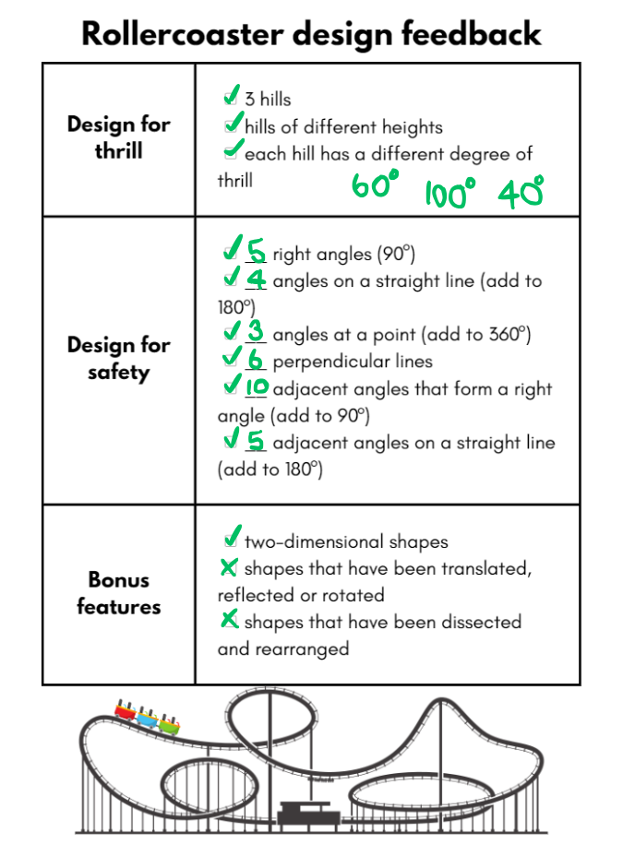
- Students return the designs and feedback to their original owners.
- Members of each pair or group review the feedback provided and make changes to their design where needed.
This table details opportunities for differentiation.
Too hard? | Too easy?
Students cannot identify angle types formed by the intersection of straight lines, including right angles (90°), angles on a straight line (add to 180°) and angles at a point that form an angle of revolution (add to 360°).  - Assist students to use 2 craft sticks to create a right angle. Use this angle identifier to confirm that an angle has 90°. They could also use one craft stick to identify a straight angle (180°).  - Support students to highlight or colour one type of angle at a time. | Students can identify angle types formed by the intersection of straight lines, including right angles (90°), angles on a straight line (add to 180°) and angles at a point that form an angle of revolution (add to 360°).  - Use digital software such as Canva or PowerPoint to create the support structure for each hill.  - Challenge students to use digital software such as Canva or PowerPoint to create a poster to identify the different angle types needed within their safety structure.

Discuss and connect the mathematics – 20 minutes
- Students participate in a gallery walk to view their peers’ designs. Each group explains and justifies their design choices.
- Regroup and reflect on the process. Ask each group the following questions:
- How did you use feedback to improve your design?
- Did your design meet all the design criteria?
- Did you have any difficulties during the design process? How did you overcome them?
- Where have you been flexible in your thinking?
- Can you provide an example of when you were accurate and efficient to solve the task? (Stage 3)
- What are 2 connections you can make about angles? (Stage 3)
This table details opportunities for assessment.
Assessment opportunities | Links
What to look for:  - Can Stage 2 students record the arrangements of common shapes used to create other shapes?  [MAO-WM-01, MA2-2DS-02]  - Can Stage 2 students apply and describe amounts of rotation, including half-turns, quarter-turns and three-quarter-turns, when creating designs? [MAO-WM-01, MA2-2DS-02]  - Can Stage 2 students recognise and describe angles as less than, equal to, about the same as or greater than a right angle?  [MAO-WM-01, MA2-GM-03]  - Can Stage 2 students describe angles in comparison to quarter-turns as acute, right, obtuse, straight, reflex or a revolution? [MAO-WM-01, MA2-GM-03]  - Can Stage 3 students create and identify angles of up to 360° using a protractor? [MAO-WM-01, MA3-GM-03]  - Can Stage 3 students identify angle types formed by the intersection of straight lines, including right angles (90°), angles on a straight line (add to 180°) and angles at a point that form an angle of revolution (add to 360°)? [MAO-WM-01, MA3-GM-03]  - Can Stage 3 students recognise that perpendicular lines intersect at right angles (90°)? [MAO-WM-01, MA3-GM-03]  - Can Stage 3 students investigate adjacent angles that form a right angle and establish that they add to 90° and on a straight line and establish that they add to 180°? [MAO-WM-01, MA3-GM-03]  - Can Stage 3 students investigate angles at a point and establish that they form an angle of revolution and add to 360°?  [MAO-WM-01, MA3-GM-03] | Links to National Numeracy Learning Progressions (NNLP):  - Stage 2 – UuM6, UuM7, UGP4, UGP5, UGP6  - Stage 3 – UuM8, UGP5, UGP6.

Resource 1 – place value gameboard
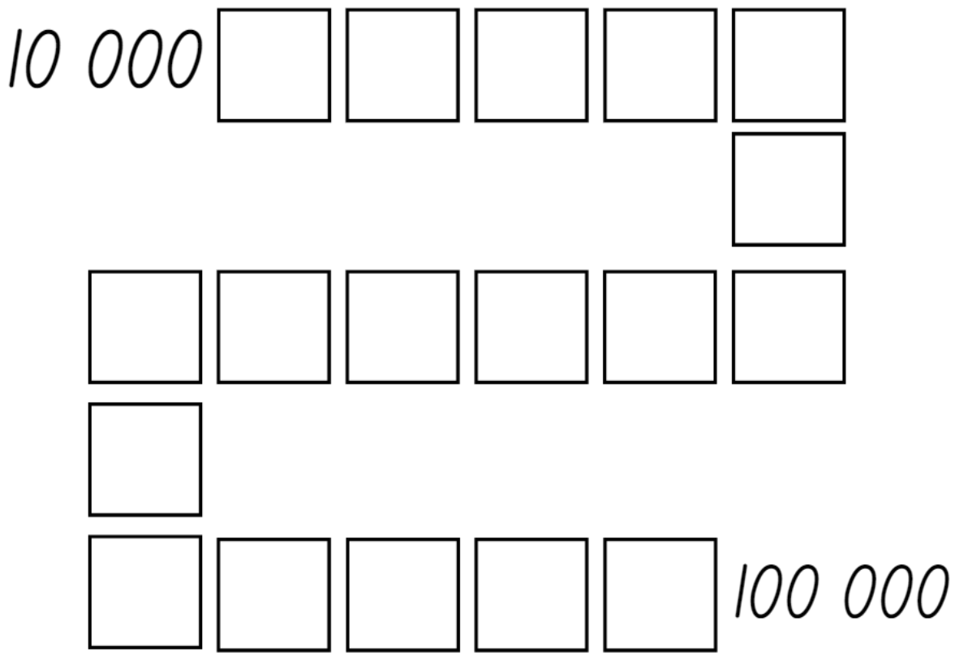

Resource 2 – integer gameboard
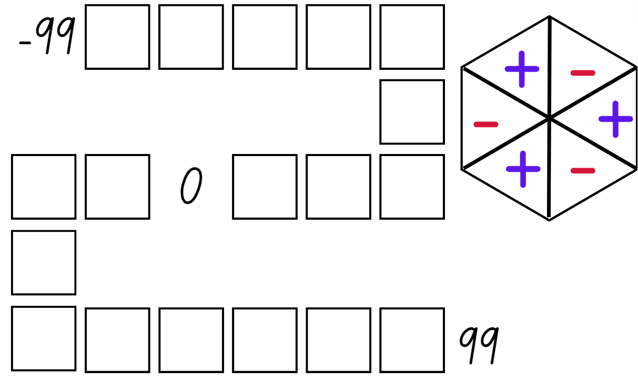

Resource 3 – theme park schedule
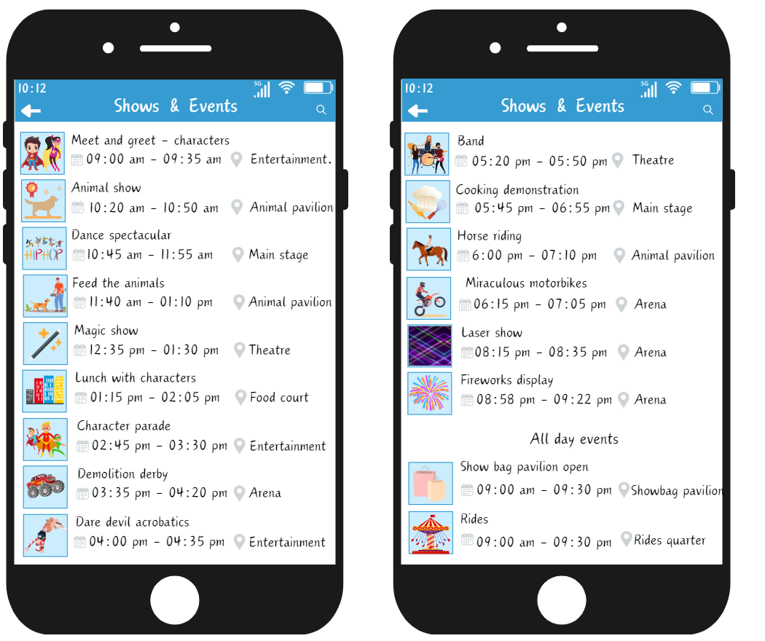

Resource 4 – time remaining
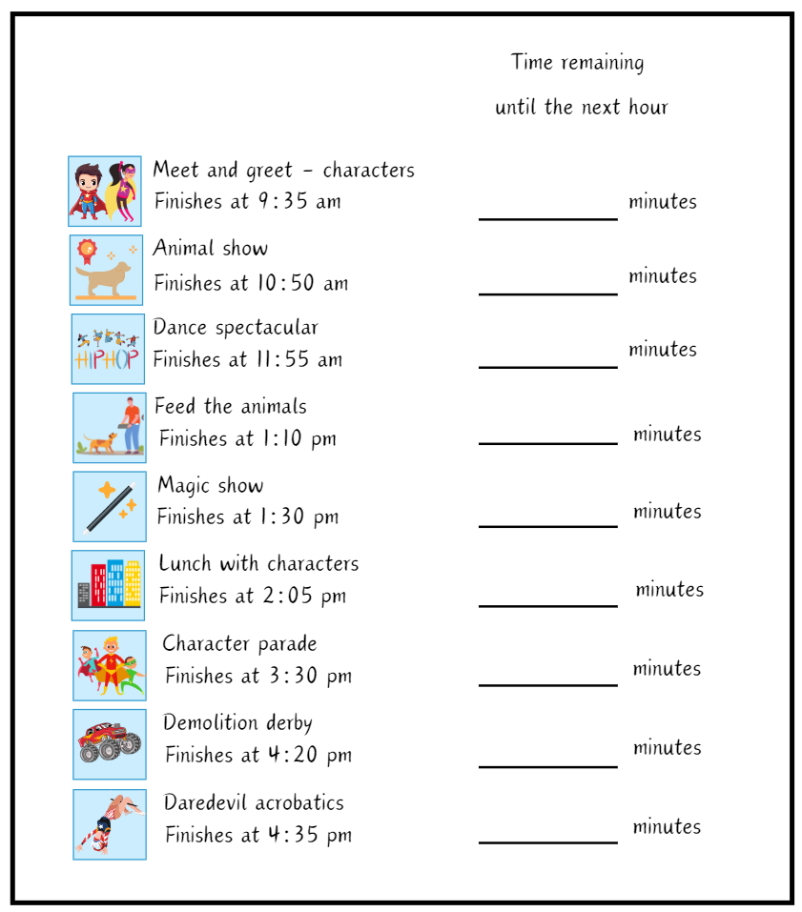

Resource 5 – theme park questions
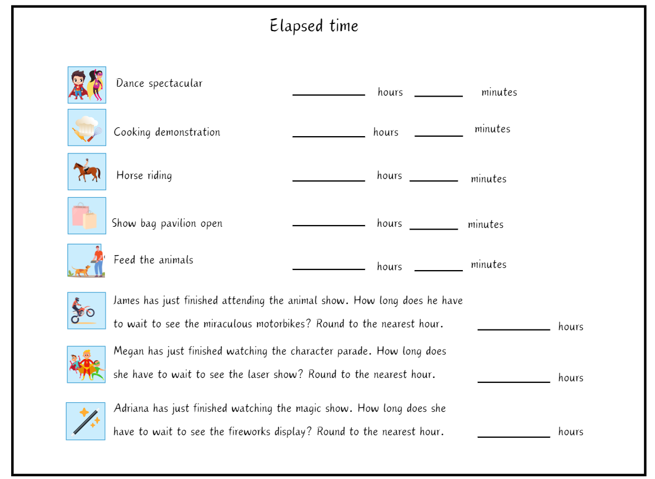

Resource 6 – A–F number line
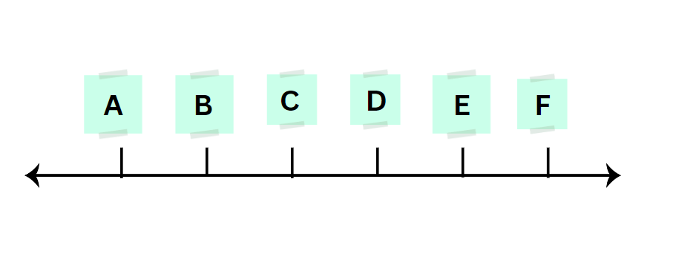

Resource 7 – Maggie’s diary
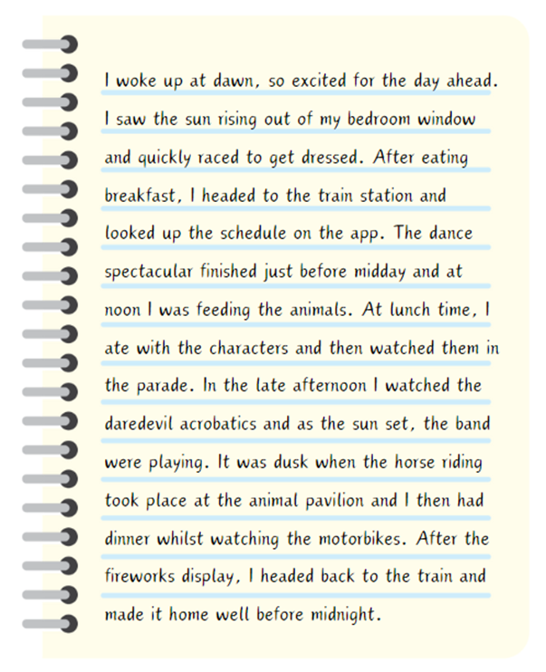

Resource 8 – 12-hour time
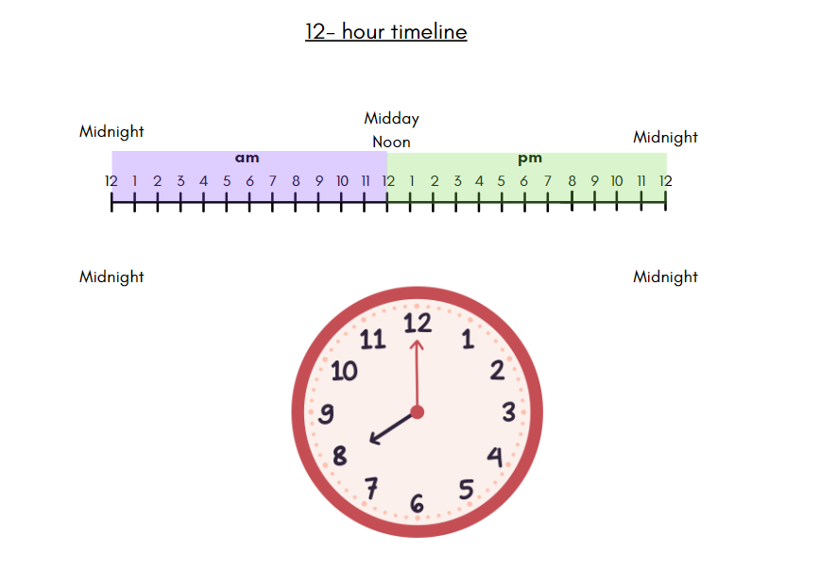

Resource 9 – time intervals
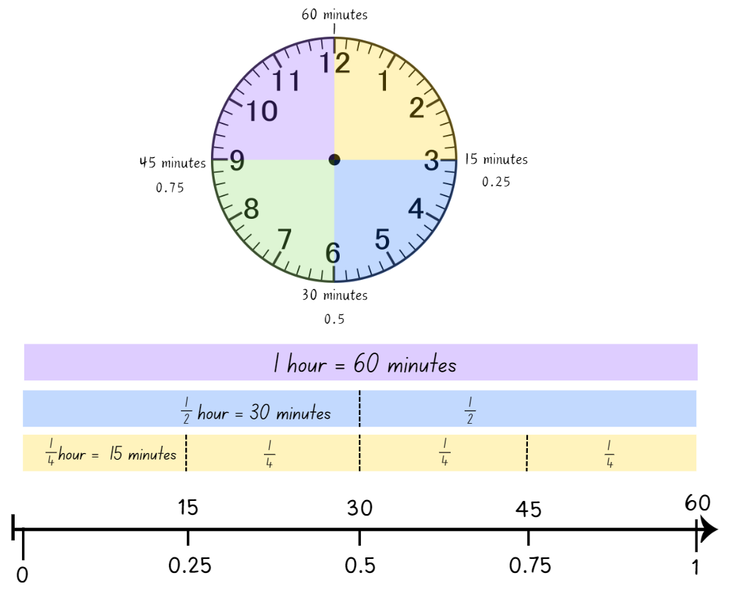

Resource 10 – recording time
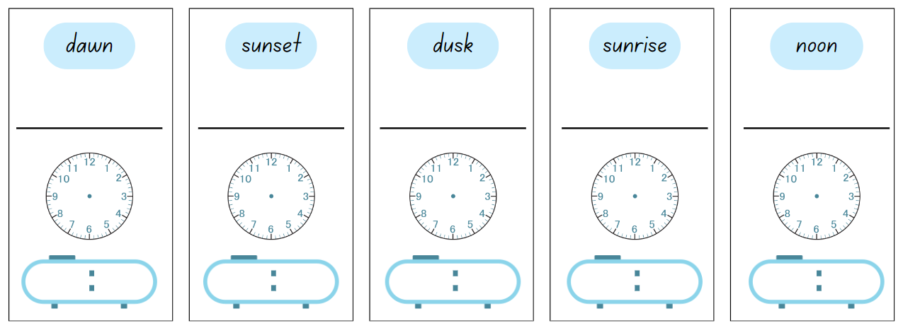
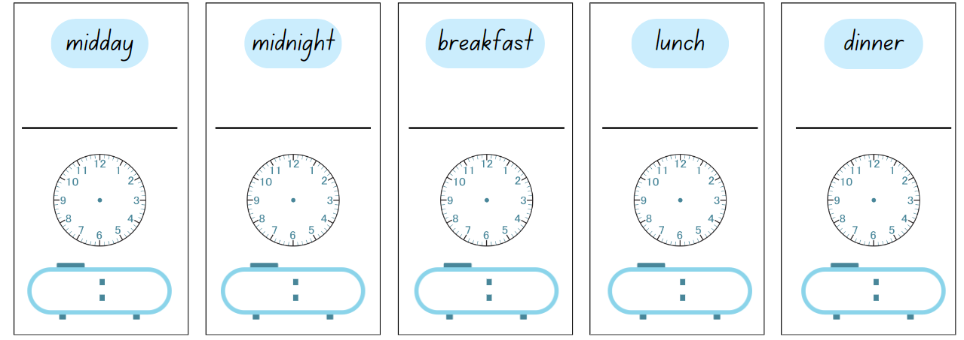

Resource 11 – time memory
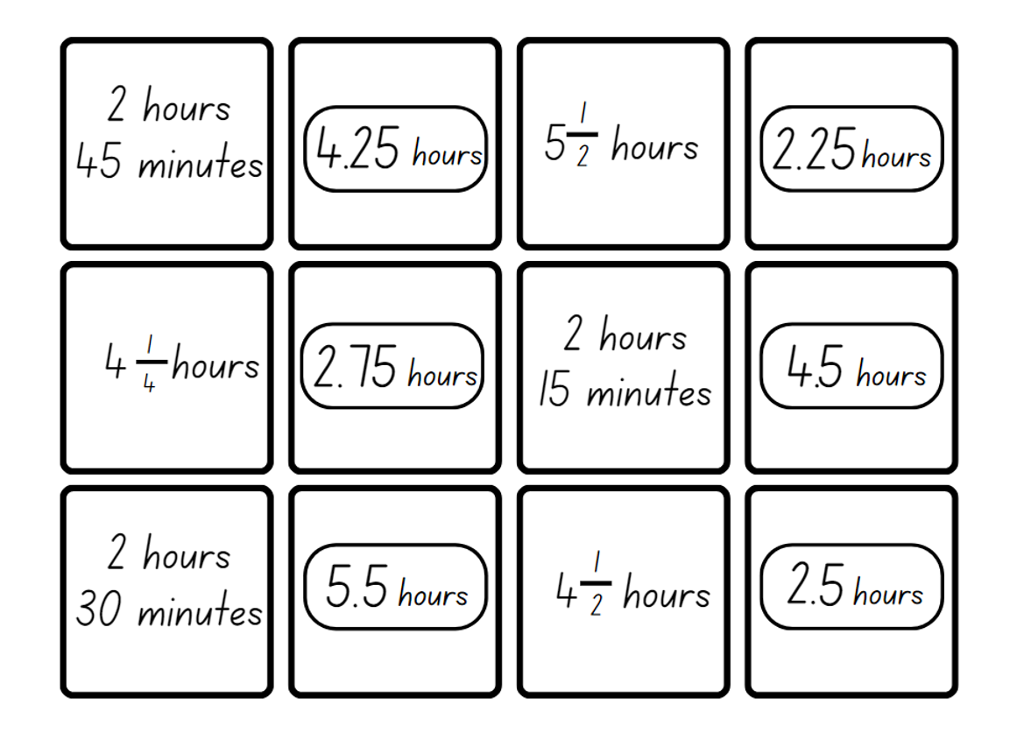
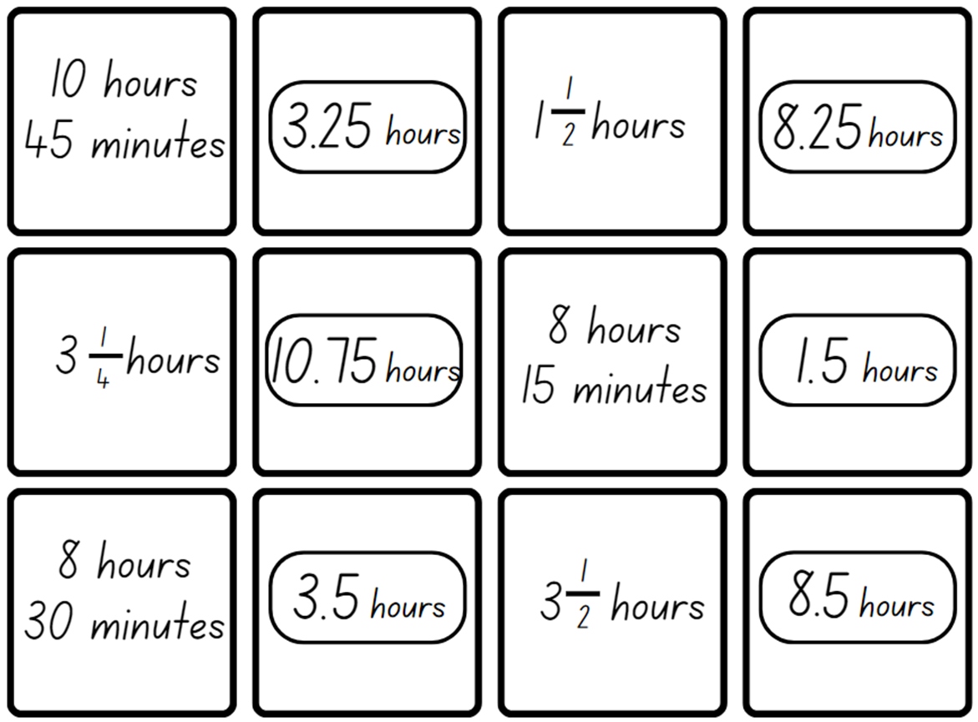

Resource 12 – day plan (Stage 2)
Activity | Start | Finish | Time until the next hour | Time between activities | Duration of activity

Resource 13 – 24-hour timetable
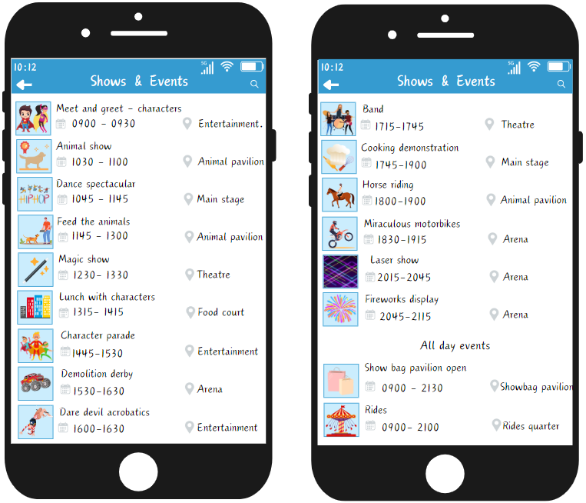

Resource 14 – day plan (Stage 3)
Activity | Start | Finish | Activity time elapsed | Decimal notation | Time between activities | Decimal notation

Resource 15 – Ollie’s number line
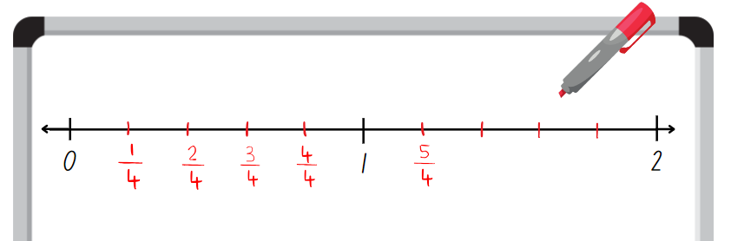

Resource 16 – Mel’s number line
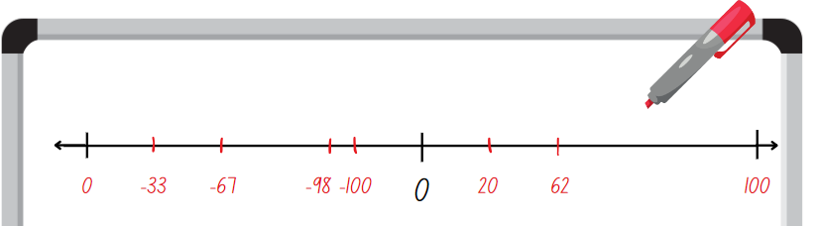

Resource 17 – Charlie’s number line
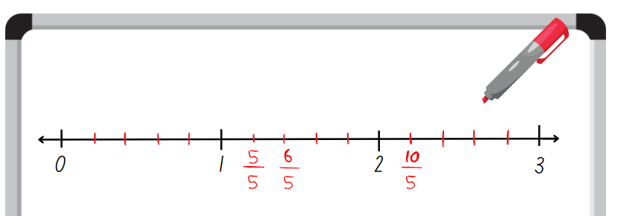

Resource 18 – theme park signs
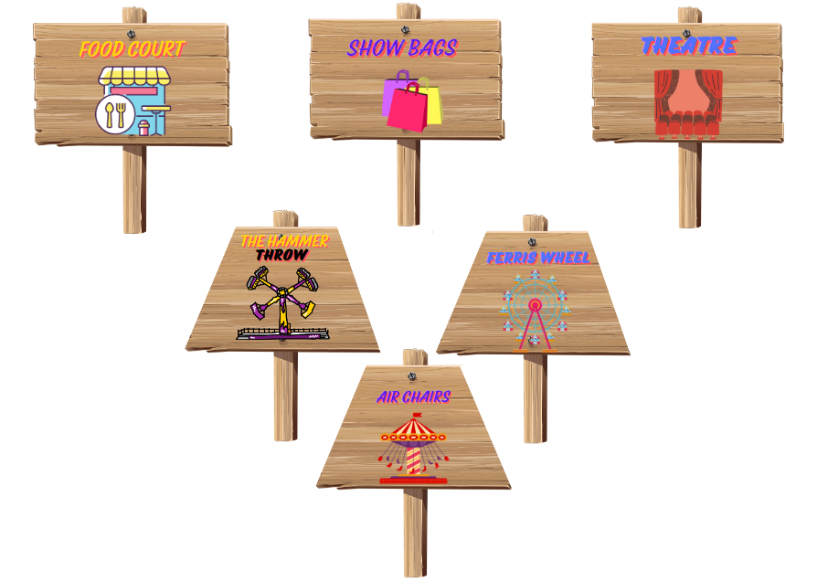

Resource 19 – transformations
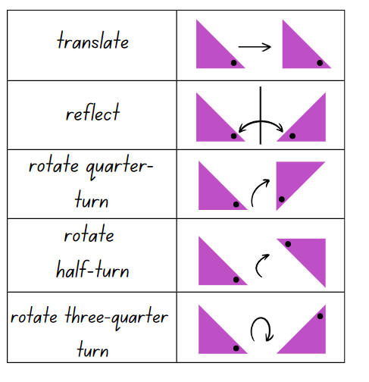

Resource 20 – rotating patterns
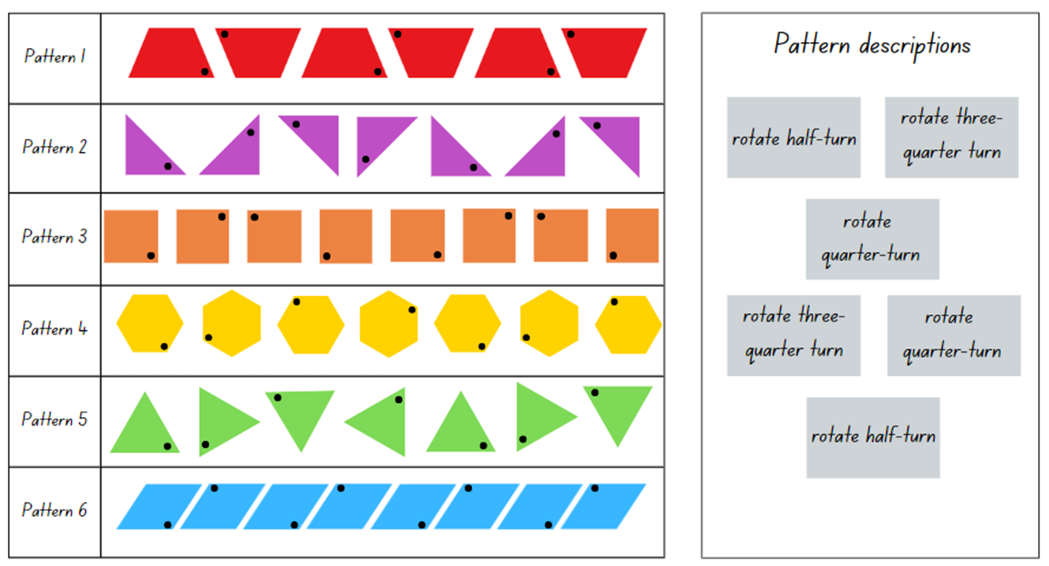

Resource 21 – demolition derby truck
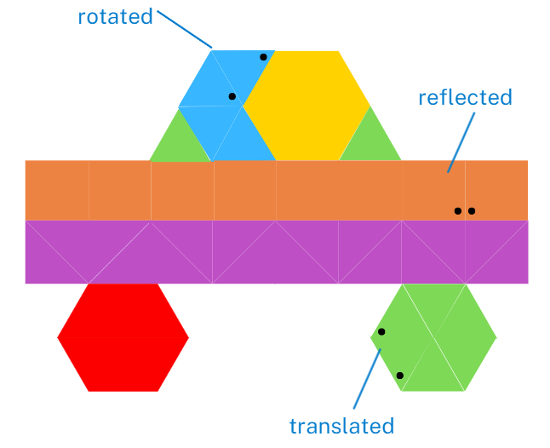

Resource 22 – blank number lines
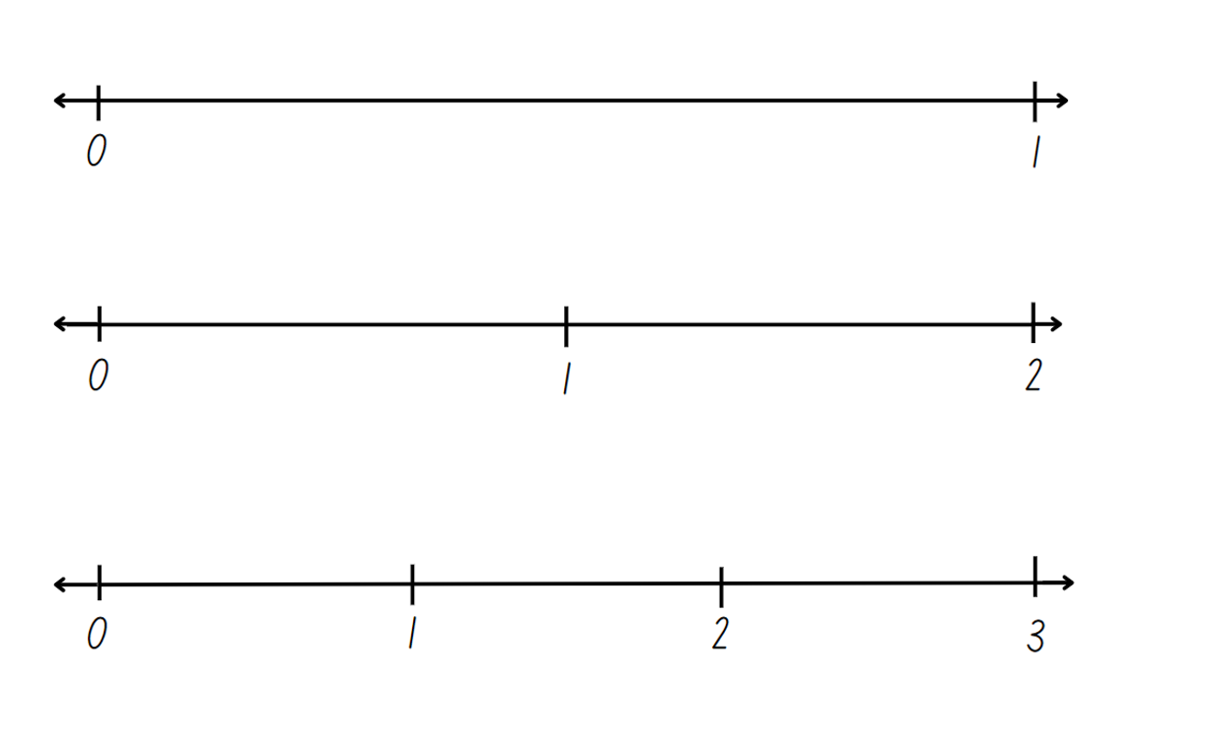

Resource 23 – blank tape diagram
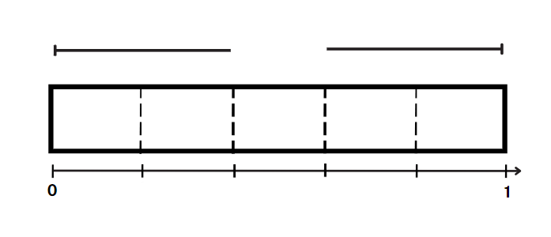

Resource 24 – Ferris wheel 1
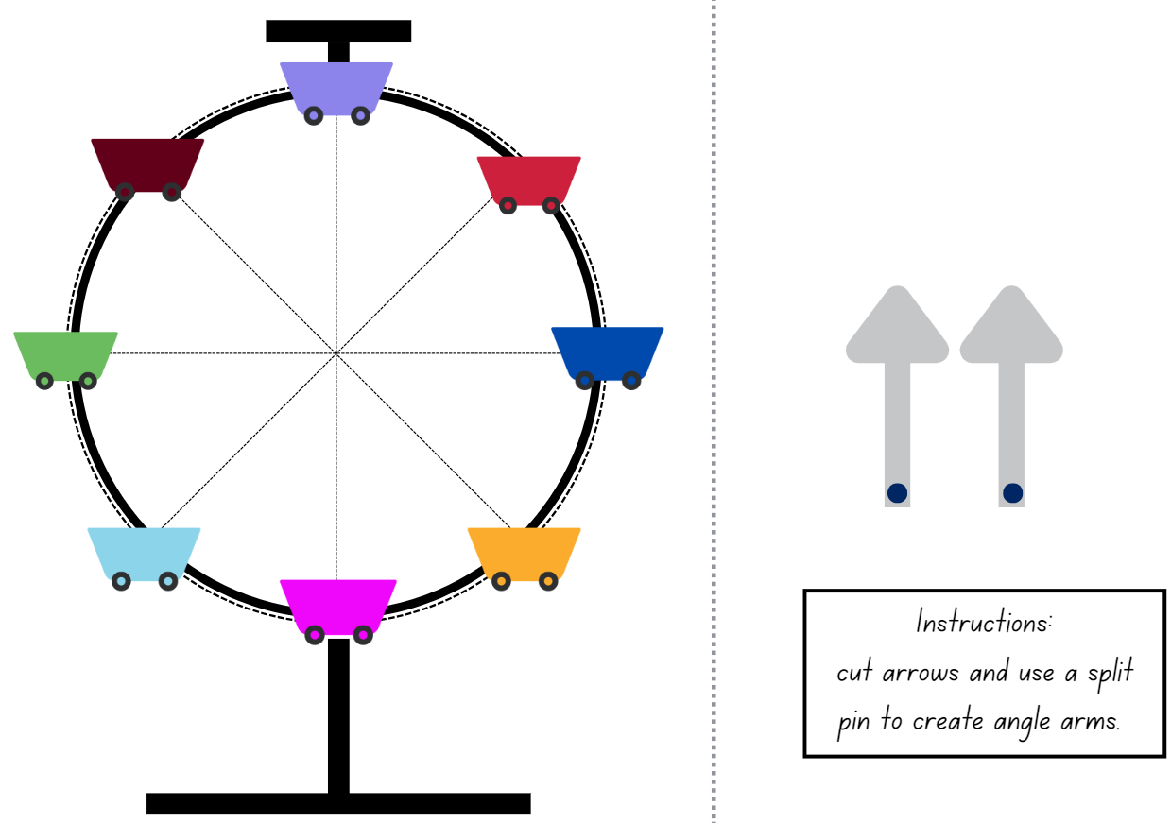

Resource 25 – all about angles
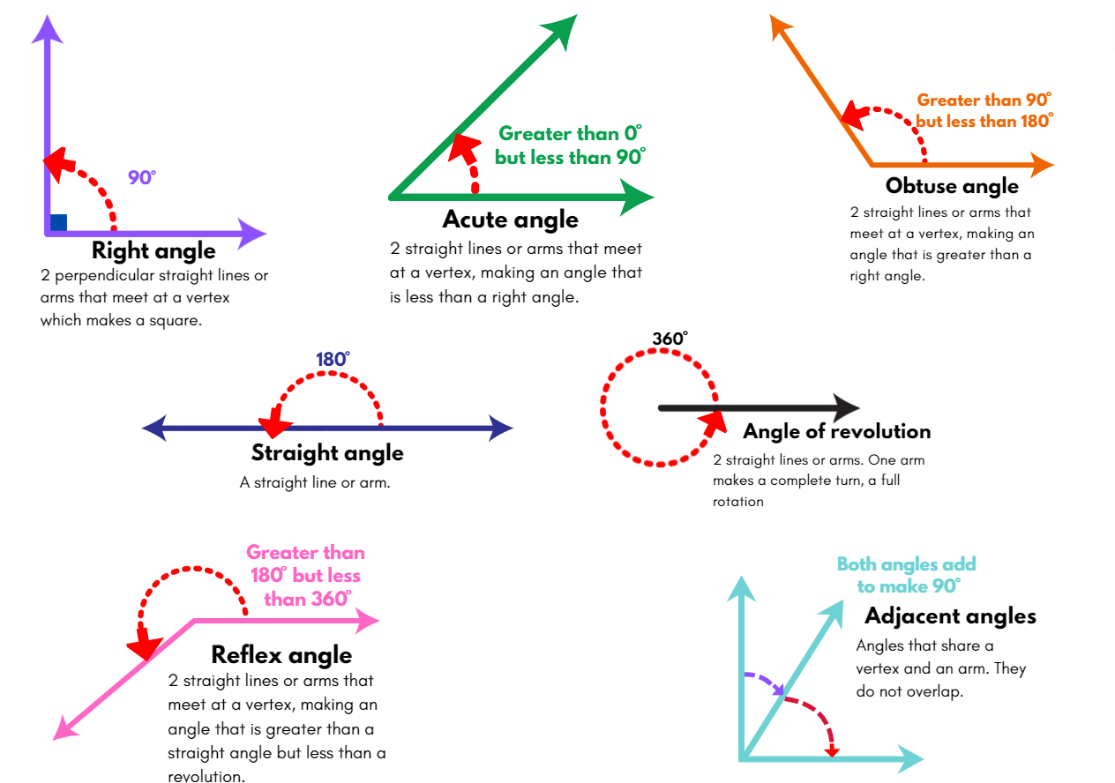

Resource 26 – Are they correct?
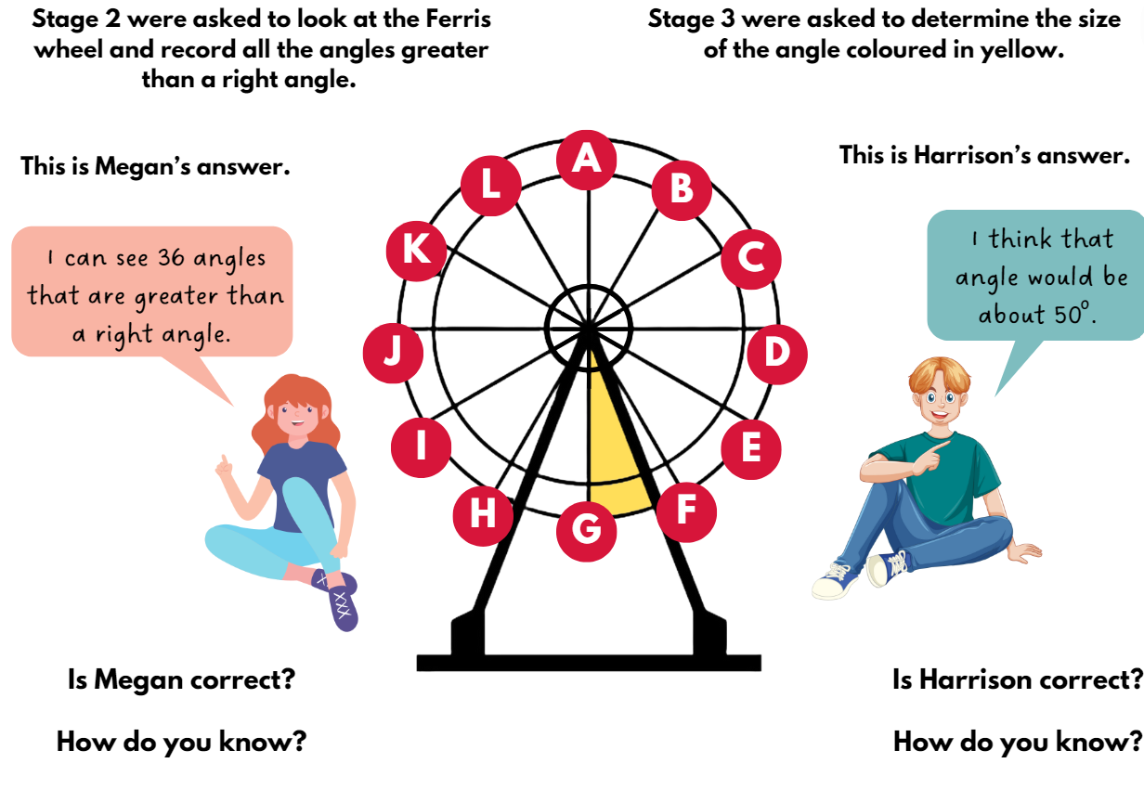

Resource 27 – park map (Stage 2)
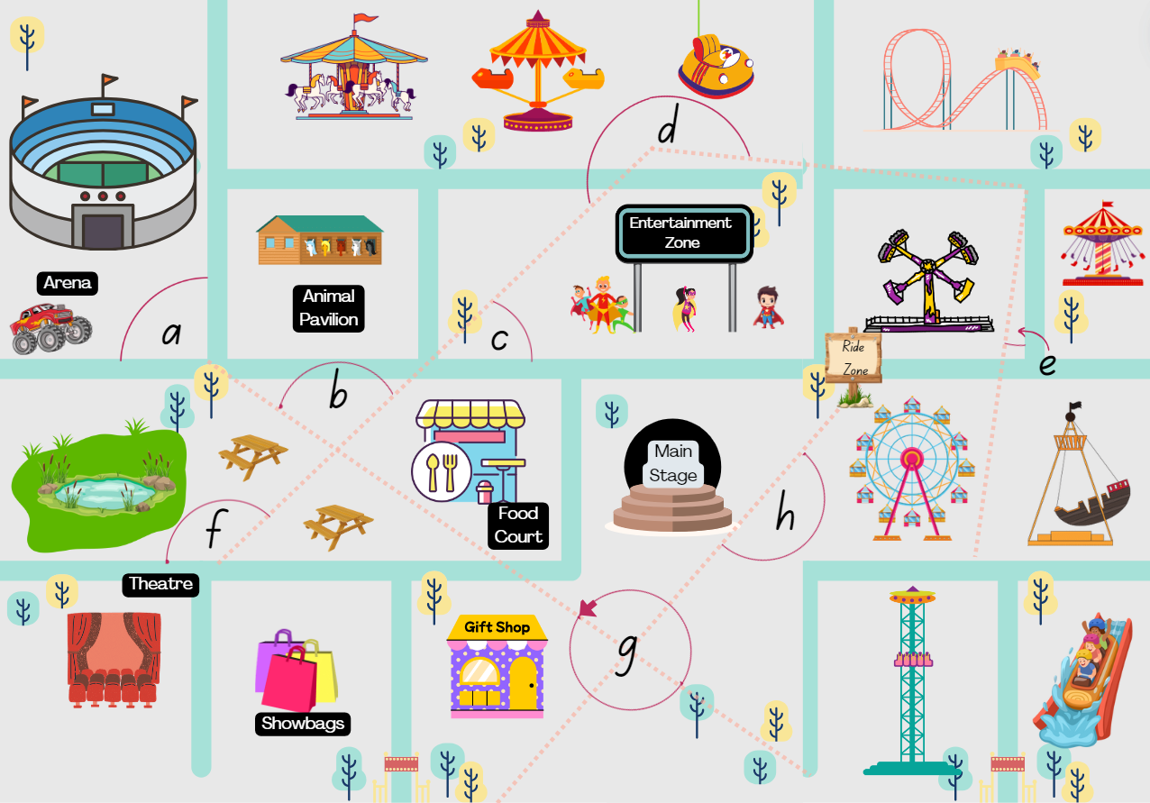

Resource 28 – park map (Stage 3)
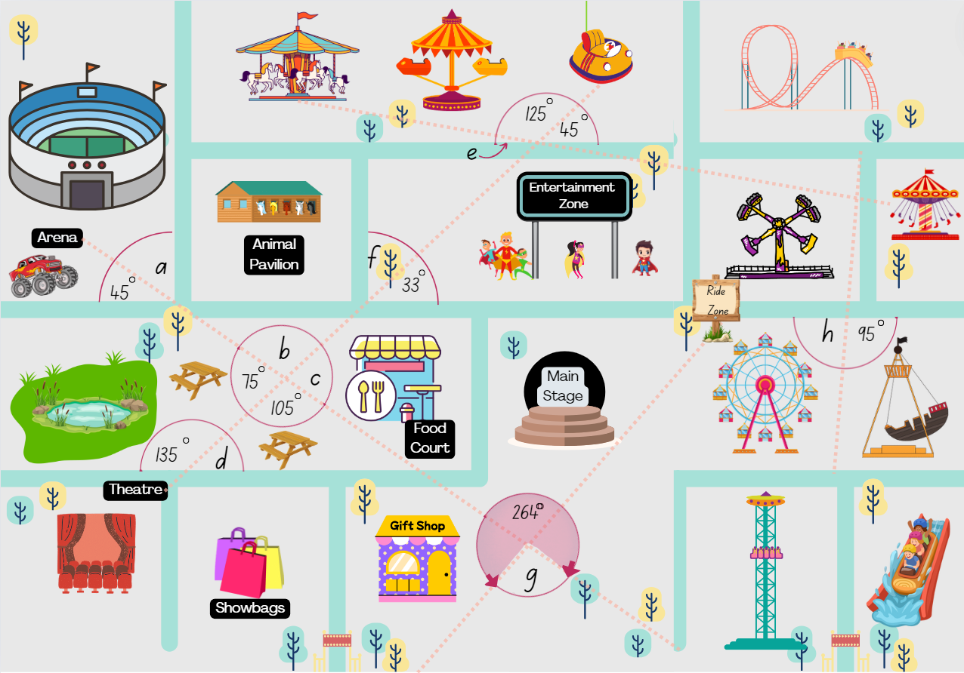

Resource 29 – using a protractor
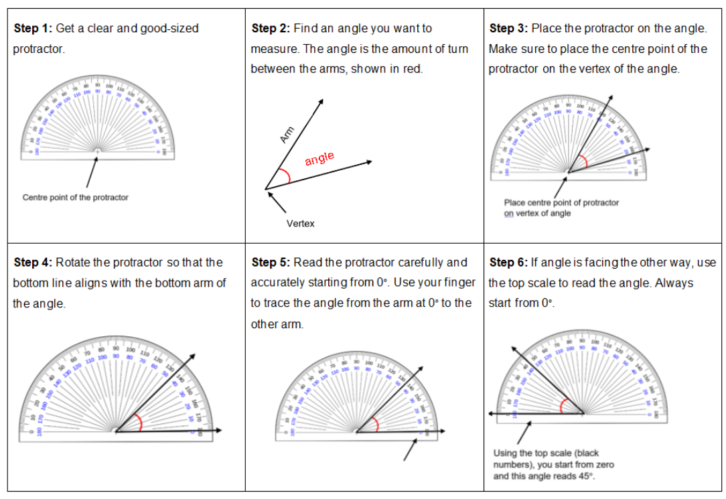

Resource 30 – types of angles
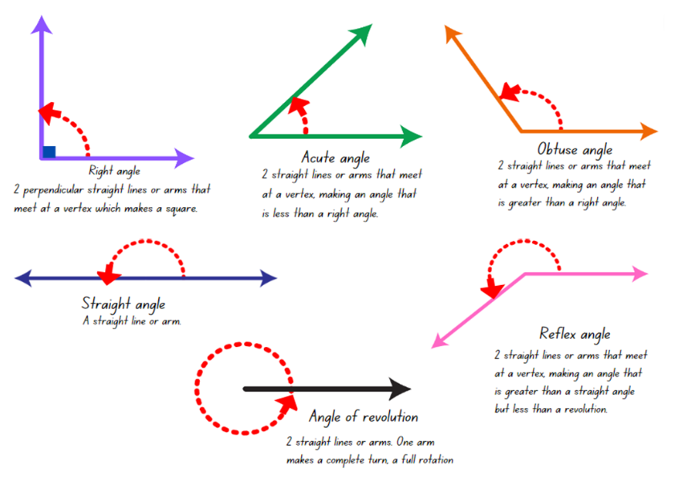

Resource 31 – fraction memory (Stage 2)
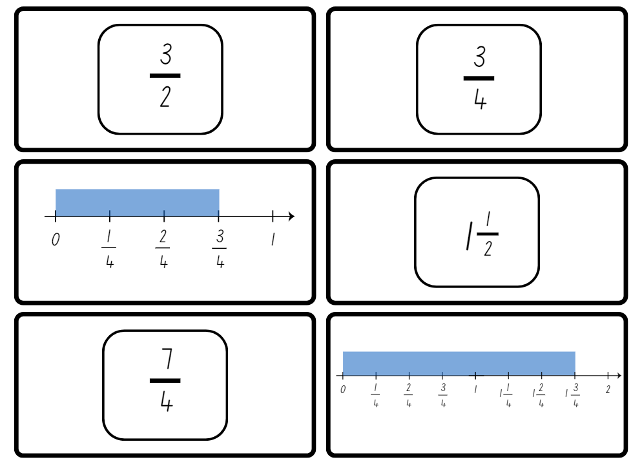

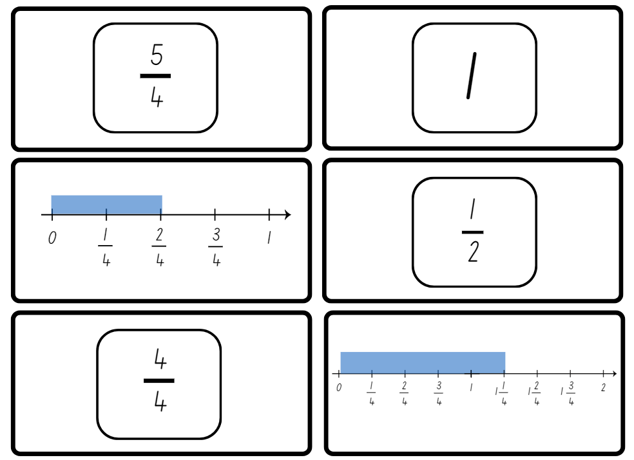

Resource 32 – fraction memory (Stage 3)
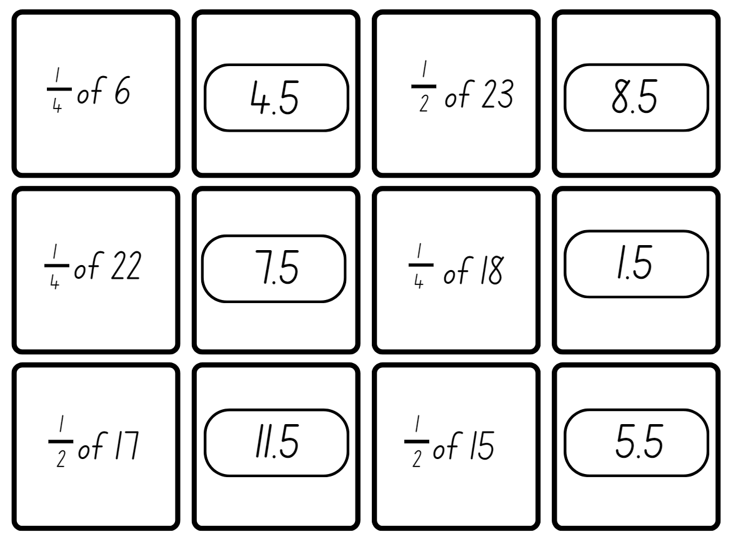

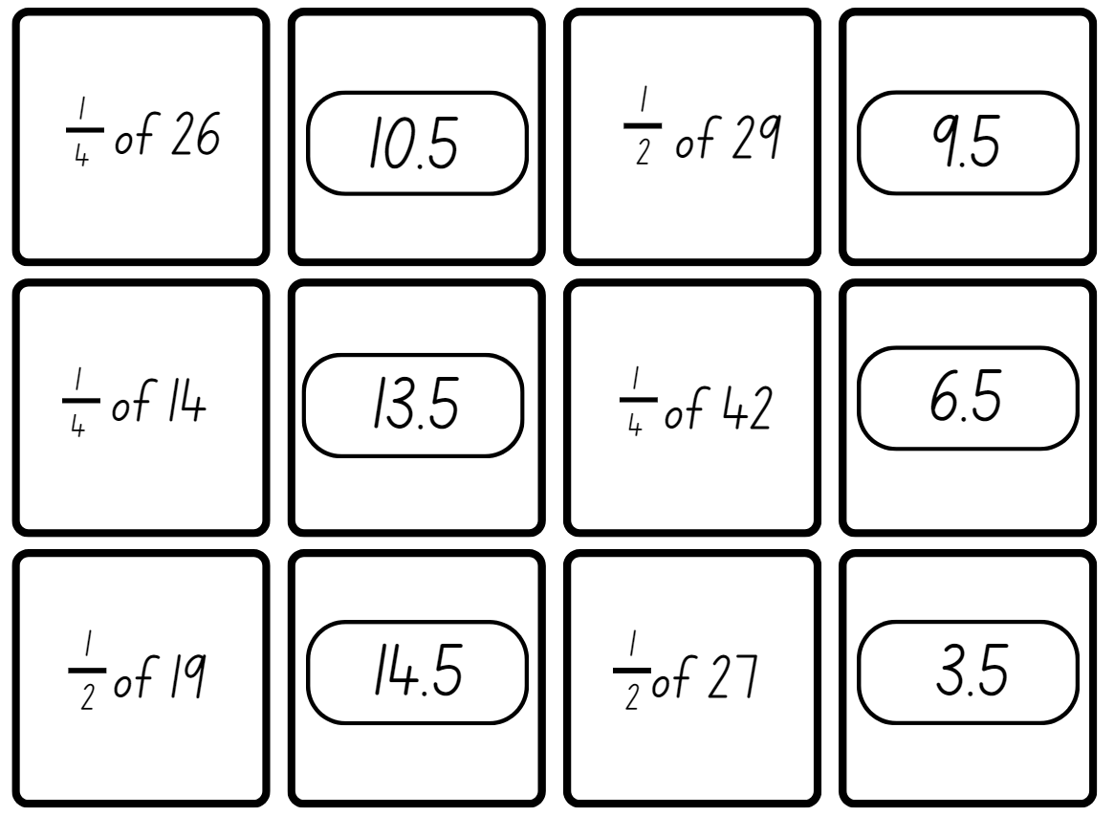

Resource 33 – fraction wall
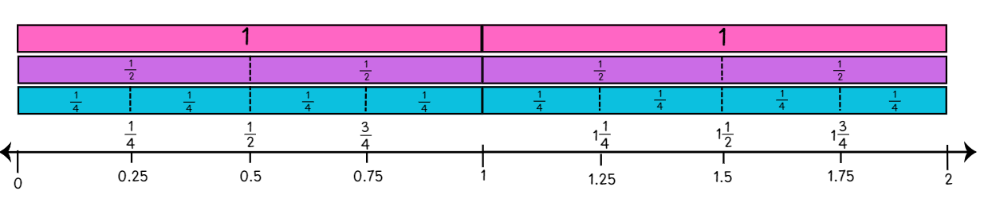

Resource 34 – Ferris wheels 2
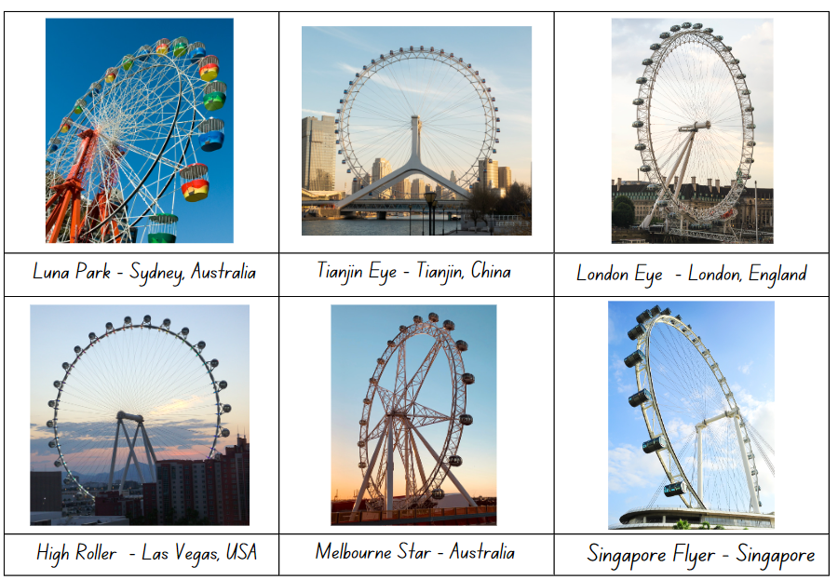

Resource 35 – investigation criteria
Two-dimensional shapes | - Include common shapes and shapes that have been used to create other shapes by splitting or combining.  - Include shapes that have been rotated, reflected or translated.
Angles | - Create angles that are less than, equal to or about the same as or greater than a right angle.  - Describe the angles in comparison to quarter-turns.
Interesting features | - Create interesting or defining features.
Time | - Include long it takes for the Ferris wheel to make a full rotation, quarter-turn, half-turn and three-quarter turn and record in hours and minutes.
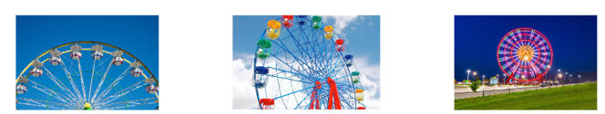

Resource 36 – rollercoasters
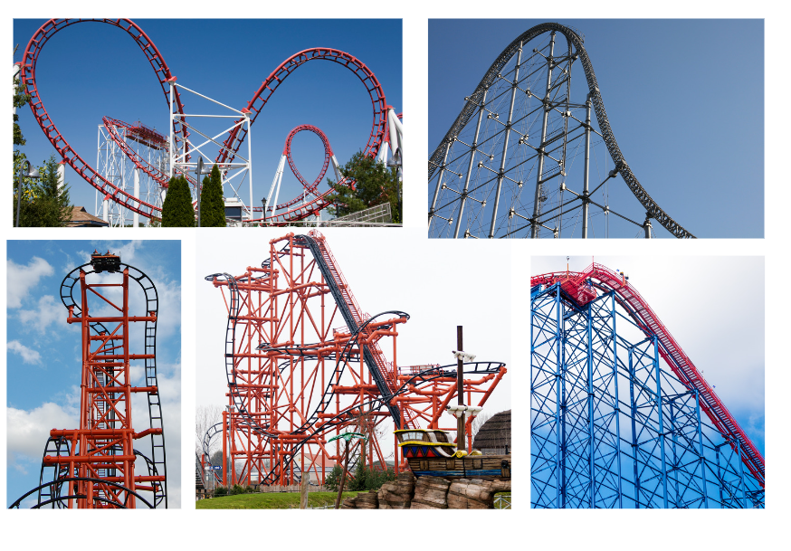

Resource 37 – designing for thrill
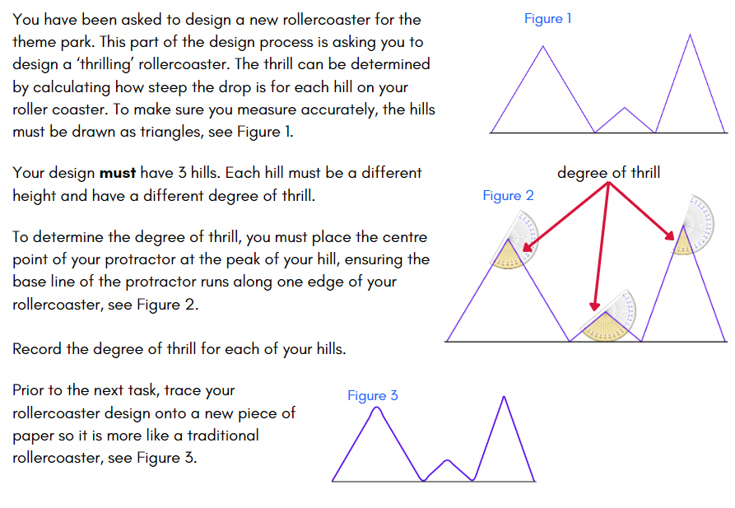

Resource 38 – designing for safety
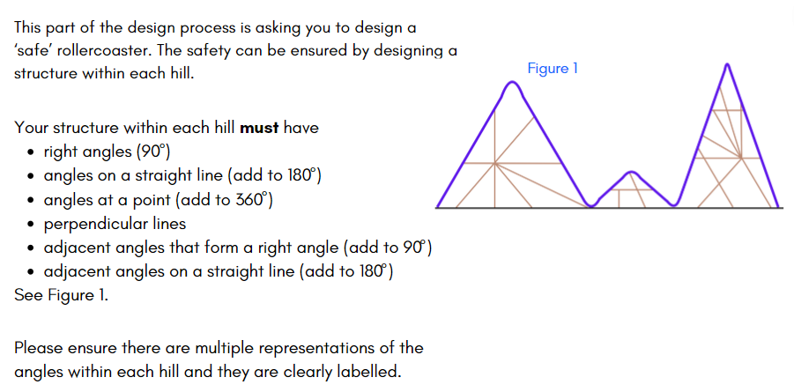

Resource 39 – Ferris wheel criteria
Design criteria must include:
Basic structure | - various two-dimensional shapes (triangles, parallelograms, hexagons, and squares)  - arrangements of common shapes used to create other shapes on the Ferris wheel  - shapes that have been rotated, reflected or translated.
Unique features and design | - unique design elements that involve interesting shapes that have been combined and split to form common shapes, such as star shapes or hexagonal cabins  - angles in the Ferris wheel design that are less than, equal to, about the same as or greater than a right angle.
Capacity and size | - the total number of cabins and calculate how many people can ride if each cabin is at its full capacity.
Time | - how long it takes for your Ferris wheel to make a full rotation, quarter-turn, half-turn and three-quarter turn.
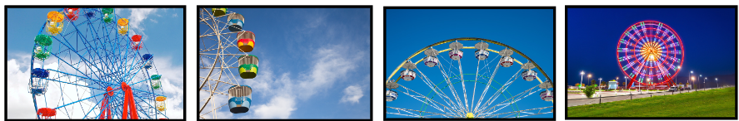

Resource 40 – student work sample
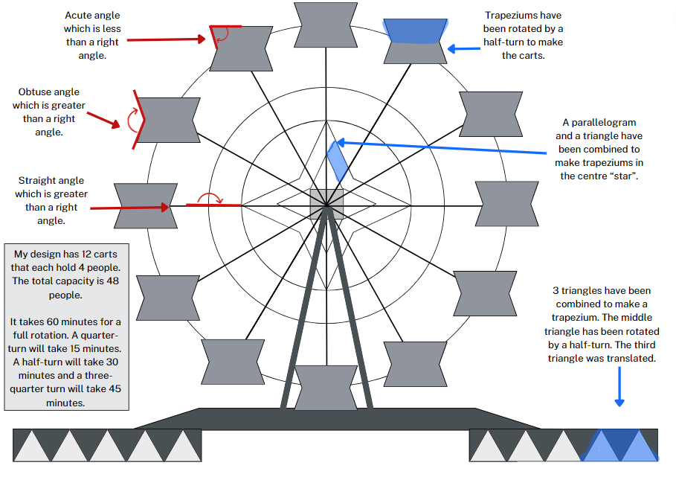

Resource 41 – peer feedback
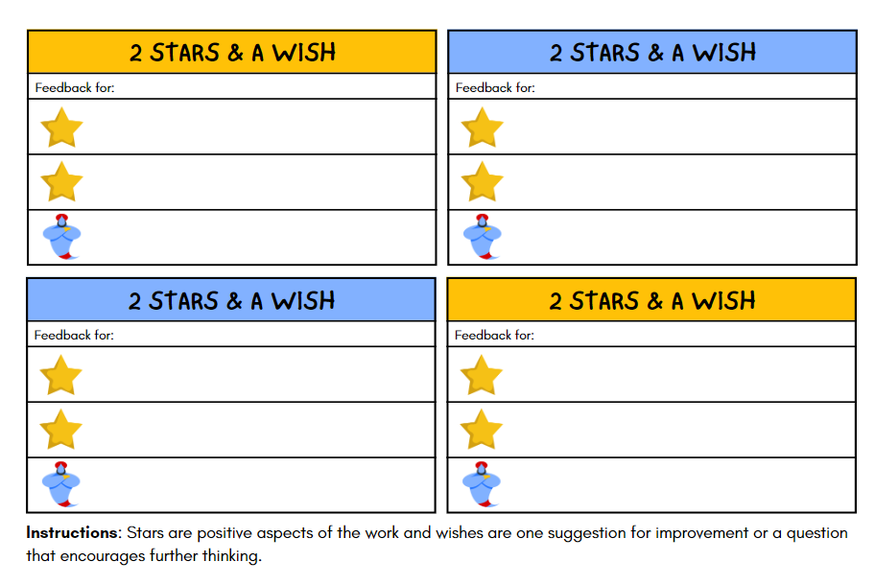

Resource 42 – feedback criteria
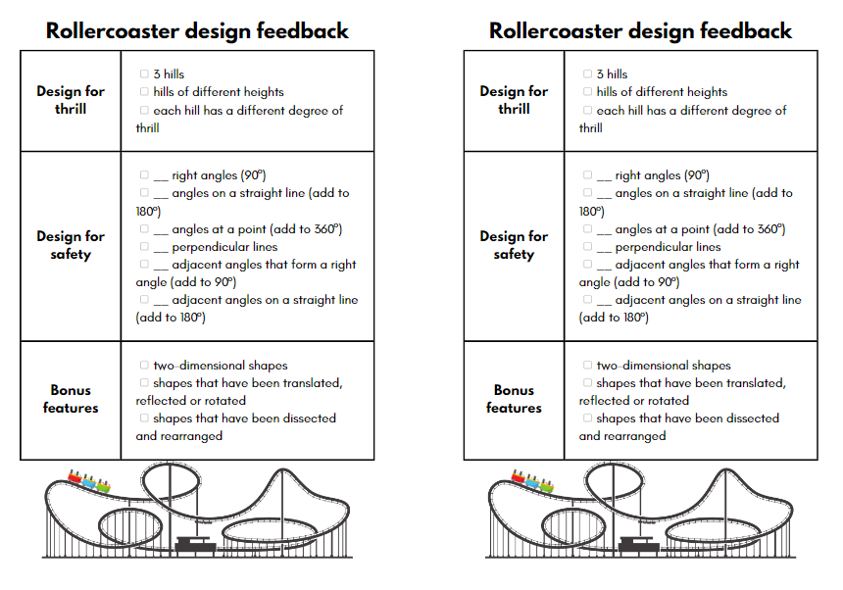

Syllabus outcomes and content

Stage 2
The table below outlines the syllabus outcomes and range of relevant syllabus content covered in this unit. Content is linked to National Numeracy Learning Progression (version 3).
Outcomes and content | 1 | 2 | 3 | 4 | 5 | 6 | 7 | 8
Representing numbers using place value B: Whole numbers: Order numbers in the thousands
[MAO-WM-01, MA2-RN-01]
- Arrange numbers in the thousands in ascending and descending order | x
Partitioned fractions B: Represent fractional quantities equal to and greater than one
[MAO-WM-01, MA2-PF-01]
- Represent totals of halves, thirds, quarters and fifths that extend beyond one |  |  | x |  | x |  | x
- Determine the relative location of one-quarter and one-half when a number line extends beyond one |  | x |  |  | x | x
Geometric measure B: Compare angles to a right angle
[MAO-WM-01, MA2-GM-03]
- Recognise and describe angles as less than, equal to, about the same as or greater than a right angle |  |  |  |  | x | x | x | x
- Describe angles in comparison to quarter-turns as acute, right, obtuse, straight, reflex or a revolution |  |  |  |  | x | x | x | x
Two-dimensional spatial structure B: Create two-dimensional shapes that result from combining and splitting common shapes
[MAO-WM-01, MA2-2DS-01, MA2-2DS-02]
- Combine common two-dimensional shapes, including quadrilaterals, to form other common shapes or designs |  |  | x
- Split a given shape into 2 or more common shapes and describe the result |  |  | x
- Record the arrangements of common shapes used to create other shapes |  |  | x |  |  |  | x | x
Two-dimensional spatial structure B: Create symmetrical patterns and shapes
[MAO-WM-01, MA2-2DS-02]
- Apply and describe amounts of rotation, including half-turns, quarter-turns and three-quarter-turns, when creating designs |  |  | x | x |  |  | x | x
Non-spatial measure B: Time: Represent and interpret digital time displays
[MAO-WM-01, MA2-NSM-02]
- Read or set the time on digital devices to the minute or second, recognising there are 60 seconds in one minute | x
- Determine the time remaining until the next hour on a digital clock | x
Non-spatial measure B: Time: Use am and pm notation
[MAO-WM-01, MA2-NSM-02]
- Record times using the colon notation with am and pm to distinguish between morning and evening |  | x
- Relate the terms midday or noon and midnight to am and pm |  | x
- Relate analog notation to digital notation for time |  | x
Mathematics K–10 Syllabus © NSW Education Standards Authority (NESA) for and on behalf of the Crown in right of the State of New South Wales, 2022.

Stage 3
The table below outlines the syllabus outcomes and range of relevant syllabus content covered in this unit. Content is linked to National Numeracy Learning Progression (version 3).
Outcomes and content | 1 | 2 | 3 | 4 | 5 | 6 | 7 | 8
Representing numbers B: Whole numbers: Locate and represent integers on a number line
[MAO-WM-01, MA3-RN-01]
- Recognise the location of negative whole numbers in relation to zero and place them on a number line | x | x | x
- Use the term integers to describe positive and negative whole numbers and zero | x | x
Representing quantity fractions B: Find fractional quantities of whole numbers (halves, quarters, fifths and tenths)
[MAO-WM-01, MA3-RQF-02]
- Calculate quarters and fifths of whole numbers that are multiples of the denominator, using a tape diagram |  |  |  |  |  | x
- Solve word problems involving a fraction of a quantity |  |  |  |  | x
- Find $\frac{1}{2}$, $\frac{1}{4}$, $\frac{1}{5}$ and $\frac{1}{10}$ of collections, expressing remainders as decimals |  |  |  |  |  |  | x
Geometric measure A: Angles: Estimate, measure and compare angles using degrees
[MAO-WM-01, MA3-GM-03]
- Measure angles of up to 360° using a protractor |  |  |  |  |  | x | x | x
Geometric measure A: Angles: Use a protractor to measure and identify types of angles
[MAO-WM-01, MA3-GM-03]
- Create angles of up to 360° using a protractor |  |  |  |  |  |  | x | x
Geometric measure B: Angles: Investigate angles on a straight line and angles at a point
[MAO-WM-01, MA3-GM-03]
- Recognise right angles, angles on a straight line and angles at a point embedded in diagrams (Reasons about spatial orientation) |  |  |  |  | x
- Identify the vertex and arms of angles formed by intersecting lines |  |  |  |  | x | x
Geometric measure B: Angles: Investigate the relationships formed by the intersection of straight lines
[MAO-WM-01, MA3-GM-03]
- Identify angle types formed by the intersection of straight lines, including right angles (90°), angles on a straight line (add to 180°) and angles at a point that form an angle of revolution (add to 360°) |  |  |  |  | x |  | x | x
- Recognise that perpendicular lines intersect at right angles (90°) |  |  |  |  | x |  | x | x
- Investigate adjacent angles that form a right angle and establish that they add to 90° |  |  |  |  |  | x | x | x
- Investigate adjacent angles on a straight line and establish that they add to 180° |  |  |  |  |  | x | x | x
- Investigate angles at a point and establish that they form an angle of revolution and add to 360° |  |  |  |  | x | x | x | x
Two-dimensional spatial structure B: 2D shapes: Dissect two-dimensional shapes and rearrange them using translations, reflections and rotations
[MAO-WM-01, MA3-2DS-01]
- Use the terms translate, reflect and rotate to describe transformations of two-dimensional shapes |  |  | x | x
- Dissect and rearrange one shape to make another |  |  | x
- Recognise that translations, reflections or rotations change the position and orientation but not the size of shapes (Reasons about spatial orientation) |  |  |  | x
Non-spatial measure B: Time: Solve problems involving duration, using 12- and 24-hour time
[MAO-WM-01, MA3-NSM-02]
- Use start and finish times to calculate the elapsed time of events | x
- Add and subtract time mentally using bridging strategies | x
- Represent commonly used time intervals as decimals |  | x
- Solve a variety of problems involving duration, including where times are expressed in 12-hour and 24-hour notation |  | x
Mathematics K–10 Syllabus © NSW Education Standards Authority (NESA) for and on behalf of the Crown in right of the State of New South Wales, 2022.

References
This resource contains NSW Curriculum and syllabus content. The NSW Curriculum is developed by the NSW Education Standards Authority. This content is prepared by NESA for and on behalf of the Crown in right of the State of New South Wales. The material is protected by Crown copyright.
Please refer to the NESA Copyright Disclaimer for more information https://educationstandards.nsw.edu.au/wps/portal/nesa/mini-footer/copyright.
NESA holds the only official and up-to-date versions of the NSW Curriculum and syllabus documents. Please visit the NSW Education Standards Authority (NESA) website https://educationstandards.nsw.edu.au/wps/portal/nesa/home and the NSW Curriculum website https://curriculum.nsw.edu.au/.
Mathematics K–10 Syllabus © NSW Education Standards Authority (NESA) for and on behalf of the Crown in right of the State of New South Wales, 2022.
National Numeracy Learning Progression © Australian Curriculum, Assessment and Reporting Authority (ACARA) 2010 to present, unless otherwise indicated. This material was downloaded from the Australian Curriculum website (National Numeracy Learning Progression) (accessed 9 July 2024) and was not modified.
Amplify Education (2024) Amplify Polypad, Amplify Polypad website, accessed 20 May 2024.
Headout Inc (n.d.) Top 15 facts about the London Eye that you must know, London Tickets by Headout website, accessed 19 June 2024.
Hindle H (n.d.) 'Fraction of a number inquiry’, Number prompts: Fractions, Inquiry Maths website, accessed 20 May 2024.
Kiddle.co (2024a) George Washington Gale Ferris Jr. facts for kids, Kiddle Encyclopedia website, accessed 5 July 2024.
——(2024b) High Roller (Ferris wheel) facts for kids, Kiddle Encyclopedia website, accessed 5 July 2024.
——(2024c) Luna Park Sydney facts for kids, Kiddle Encyclopedia website, accessed 5 July 2024.
——(2024d) Melbourne Star facts for kids, Kiddle Encyclopedia website, accessed 5 July 2024.
——(2024e) Singapore Flyer facts for kids, Kiddle Encyclopedia website, accessed 5 July 2024.
Oxford University Press (2024) Oxford Learner’s Dictionaries, Oxford Learner's Dictionaries website, accessed 20 May 2024.
State of New South Wales (Department of Education) (2023) ‘Place value game’, Mathematics K–6 resources, NSW Department of Education website, accessed 20 May 2024.
The Math Learning Center (2024) Pattern shapes, Math Learning Center website, accessed 20 May 2024.
Toddler Fun Learning (18 August 2017) 'Rollercoasters For Children | Gecko's Real Vehicles' [video], Toddler Fun Learning, YouTube, accessed 15 July 2024.
Toy Theater (2001–2024) ‘Interactive Clock’, Time manipulatives, Toy Theater website, accessed 20 May 2024.
Travel China Guide (1998-2024) Tianjin Eye (Tientsin Eye), Travel China Guide website, accessed 19 June 2024
Van de Walle J, Karp K, Bay-Williams JM, Brass A, Bentley B, Ferguson S, Goff W, Livy S, Marshman M, Martin D, Pearn C, Prodromou T, Symons D and Wilkie K (2019) Primary and Middle Years Mathematics: Teaching Developmentally, 1st Australian edn, Pearson Education Australia, Melbourne.

© State of New South Wales (Department of Education), 2024
The copyright material published in this resource is subject to the Copyright Act 1968 (Cth) and is owned by the NSW Department of Education or, where indicated, by a party other than the NSW Department of Education (third-party material).
Copyright material available in this resource and owned by the NSW Department of Education is licensed under a Creative Commons Attribution 4.0 International (CC BY 4.0) license.

This license allows you to share and adapt the material for any purpose, even commercially.
Attribution should be given to © State of New South Wales (Department of Education), 2024.
Material in this resource not available under a Creative Commons license:
- the NSW Department of Education logo, other logos and trademark-protected material
- material owned by a third party that has been reproduced with permission. You will need to obtain permission from the third party to reuse its material.
Links to third-party material and websites
Please note that the provided (reading/viewing material/list/links/texts) are a suggestion only and implies no endorsement, by the New South Wales Department of Education, of any author, publisher, or book title. School principals and teachers are best placed to assess the suitability of resources that would complement the curriculum and reflect the needs and interests of their students.
If you use the links provided in this document to access a third-party's website, you acknowledge that the terms of use, including licence terms set out on the third-party's website apply to the use which may be made of the materials on that third-party website or where permitted by the Copyright Act 1968 (Cth). The department accepts no responsibility for content on third-party websites.

