Mathematics Stage 2 – Unit 14
What needs to be measured determines the unit of measurement
Contents
Unit description and duration 5
Syllabus outcomes 5
Working mathematically 6
Student prior learning 6
Lesson overview and resources 8
Lesson 1 15
Daily number sense – 10 times bigger – 10 minutes 15
Core lesson 1 – the gram – 15 minutes 17
Core lesson 2 – measuring – 30 minutes 19
Consolidation and meaningful practice – 15 minutes 21
Lesson 2 23
Daily number sense – 100 times as large – 10 minutes 23
Core lesson – the kilogram – 35 minutes 25
Discuss and connect the mathematics – 10 minutes 27
Lesson 3 29
Daily number sense – place value challenge – 10 minutes 29
Core lesson 1 – comparing the kilogram – 25 minutes 30
Core lesson 2 – recognising formal units to measure mass – 20 minutes 33
Discuss and connect the mathematics – 10 minutes 35
Lesson 4 37
Daily number sense – 10 minutes 37
Core lesson – recipe challenge– 40 minutes 37
Discuss and connect the mathematics – 10 minutes 39
Lesson 5 41
Daily number sense – thirds – 10 minutes 41
Core lesson – exploring the millimetre – 40 minutes 43
Consolidation and meaningful practice – 10 minutes 45
Lesson 6 47
Daily number sense – fifths – 10 minutes 47
Core lesson – using your shoe as a benchmark – 50 minutes 49
Discuss and connect the mathematics – 10 minutes 53
Lesson 7 55
Daily number sense – Who is winning? – 10 minutes 55
Core lesson – benchmarking a metre – 50 minutes 57
Discuss and connect the mathematics – 10 minutes 59
Lesson 8 61
Daily number sense – 10 minutes 61
Core lesson – investigating small measurements – 55 minutes 61
Investigation task 1 – 15 minutes 63
Investigation task 2 – 15 minutes 65
Investigation task 3 – 15 minutes 66
Discuss and connect the mathematics – 10 minutes 68
Resource 1 – 10 times bigger 70
Resource 2 – recording table 71
Resource 3 – recipe example 72
Resource 4 – fruit recording 73
Resource 5 – fruit salad recipe 74
Resource 6 – ruler 75
Resource 7 – millimetre ruler 76
Resource 8 – measuring objects 77
Resource 9 – shoe measuring 78
Resource 10 – Who is winning? 79
Resource 11 – measuring in strides 80
Resource 12 – investigating small measurements 81
Syllabus outcomes and content 82
References 86
Further reading 87

Unit description and duration
This unit develops the big idea that what needs to be measured determines the unit of measurement.
In this 2-week unit students are provided opportunities to:
- estimate, measure and compare the masses of objects using kilograms and grams
- represent and compare decimals up to 2 decimal places using place value
- measure and compare lengths of objects using metres (m), centimetres (cm) and millimetres (mm).

Syllabus outcomes
- MAO-WM-01 develops understanding and fluency in mathematics through exploring and connecting mathematical concepts, choosing and applying mathematical techniques to solve problems, and communicating their thinking and reasoning coherently and clearly
- MA2-RN-01 applies an understanding of place value and the role of zero to represent numbers to at least tens of thousands
- MA2-RN-02 represents and compares decimals up to 2 decimal places using place value
- MA2-PF-01 represents and compares halves, quarters, thirds and fifths as lengths on a number line and their related fractions formed by halving (eighths, sixths and tenths)
- MA2-GM-02 measures and estimates lengths in metres, centimetres and millimetres
- MA2-NSM-01 estimates, measures and compares the masses of objects using kilograms and grams

Working mathematically
In the Mathematics K–10 Syllabus, there is one overarching Working mathematically outcome (MAO-WM-01). The Working mathematically processes should be embedded within the concepts being taught. The Working mathematically processes present in the Mathematics K–10 Syllabus are:
- communicating
- understanding and fluency
- reasoning
- problem solving.
Mathematics K–10 Syllabus © NSW Education Standards Authority (NESA) for and on behalf of the Crown in right of the State of New South Wales, 2022.

Student prior learning
Before engaging in these teaching and learning activities, students would benefit from prior experience with:
- comparing the masses of objects using an equal-arm balance
- estimating mass by referring to the number and type of uniform informal unit used and checking by measuring
- measuring and comparing lengths of objects using uniform informal units, metres, centimetres and millimetres.
In NSW classrooms there is a diverse range of students, including Aboriginal and/or Torres Strait Islander students, students learning English as an additional language or dialect, high potential and gifted students and students with disability. Some students may identify with more than one of these groups or possibly all of them. Refer to Curriculum planning for every student – advice for further information.

Lesson overview and resources
The table below outlines the sequence and approximate timing of lessons, learning intentions and resources.
Lesson | Content | Duration and resources
Lesson 1  Daily number sense learning intention:  - recognise and represent numbers that are 10, 100 or 1000 times larger than a given number | Lesson core concept: the context determines the most suitable standard unit – sometimes a gram is too small.  Core concept learning intention:  - use scaled instruments to measure and compare masses | Lesson duration: 70 minutes  - Resource 1 – 10 times bigger  - 9-sided dice  - 10 g, 100 g and 500 g items  - Digital devices for photographs  - Equal-arm balances (one per pair)  - Everyday objects that are labelled with kilograms and grams, such as a packet of flour, biscuits, tea or a chocolate bar  - Metric weights  - Modelling clay  - Resealable bags  - Writing materials
Lesson 2  Daily number sense learning intention:  - recognise and represent numbers that are 10, 100 or 1000 times larger than a given number | Lesson core concept: mass (like time) is invisible, but it can still be estimated and measured using standard units.  Core concept learning intention:  - compare objects using the kilogram | Lesson duration: 55 minutes  - Resource 2 – recording table  - 1 kg metric weights  - 2 × 500 g resealable bags  - A variety of small objects such as pebbles, paint bottles and pompoms  - A4 paper for signs  - Digital devices (one per pair)  - Equal-arm balances (one per group)  - Individual whiteboards  - Interactive place value chart  - Writing materials
Lesson 3  Daily number sense learning intention:  - recognise and represent numbers that are 10, 100 or 1000 times larger than a given number | Lesson core concept: the mass of an object is not always related to the amount of space the object fills.  Core concept learning intention:  - compare objects using the kilogram | Lesson duration: 65 minutes  - Resource 2 – recording table  - 1 kg of rice, lentils, beans or flour (one per group)  - A cotton ball  - A pebble  - A table tennis ball and a golf ball  - A box labelled ‘1 kg’  - Digital devices (one per pair)  - Digital scales (one per group)  - Equal-arm balances (one per station)  - Interactive place value chart  - Mixing bowls (one per group)  - Variety of pantry items such as cereal, canned food, oats, biscuits or tea  - Writing materials
Lesson 4  Daily number sense learning intention:  - teacher-identified task based on student needs | Lesson core concept: formal units of measure are important.  Core concept learning intention:  - use scaled instruments to measure and compare masses | Lesson duration: 60 minutes  - Resource 3 – recipe example  - Resource 4 – fruit recording  - Resource 5 – fruit salad recipe  - Digital scales (one per group)  - Selection of fruits and vegetables  - Variety of recipe examples  - Writing materials
Lesson 5  Daily number sense learning intention:  - create fractional parts of a length | Lesson core concept: when comparing and ordering measurements, standard units can be renamed in equivalent ways.  Core concept learning intention:  - measure and compare objects using millimetres and centimetres | Lesson duration: 60 minutes  - Resource 6 – ruler  - Resource 7 – millimetre ruler  - Resource 8 – measuring objects  - Fraction strips  - Grid paper  - Writing materials
Lesson 6  Daily number sense learning intention:  - create fractional parts of a length using techniques other than repeated halving | Lesson core concept: estimation of length is guided by using known lengths as benchmarks.  Core concept learning intention:  - measure and compare objects using metres, centimetres and millimetres  - use scaled instruments to measure and compare lengths | Lesson duration: 70 minutes  - Resource 7 – millimetre ruler  - Resource 9 – shoe measuring  - 30 cm rulers  - Fraction strips  - Writing materials
Lesson 7  Daily number sense learning intention:  - create fractional parts of length using techniques other than repeated halving | Lesson core concept: accurate benchmarks help in estimating lengths and other measures.  Core concept learning intention:  - measure and compare objects using metres | Lesson duration: 70 minutes  - Resource 10 – Who is winning?  - Resource 11 – measuring in strides  - Identical length fraction strips  - Individual whiteboards  - Masking tape  - Metre rulers  - Paper strips  - Trundle wheels  - Writing materials
Lesson 8  Daily number sense learning intention:  - teacher-identified task based on student needs | Lesson core concept: the context determines the most suitable standard unit.  Core concept learning intention:  - measure and compare objects using centimetres and millimetres | Lesson duration: 65 minutes  - Resource 12 – investigating small measurements  - 30 cm rulers  - A4 sheets of paper  - Modelling clay  - Quantities of small items such as paper clips, rubber bands, paintbrushes, counters, pieces of cord or string, coins, erasers, pencil cases, zippers and buttons.  - Scissors  - Writing materials

Lesson 1
Core concept: the context determines the most suitable standard unit – sometimes a gram is too small.

Daily number sense – 10 times bigger – 10 minutes
Daily number sense activities for Lessons 1 to 3 ‘activate’ prior number knowledge and support the learning of new content in the unit. These activities can also assist teachers to identify the starting points for learning by revealing the extent of students’ existing knowledge.
The table below contains a suggested learning intention and success criteria. These are best co-constructed with students.
Daily number sense learning intention | Daily number sense success criteria
Students are learning to:  - recognise and represent numbers that are 10, 100 or 1000 times larger than a given number. | Students can:  - recognise the numbers of tens, hundreds or thousands in a number  - describe how making a number 10, 100 or 1000 times as large changes the place value of the digits.
- Provide students with Resource 1 – 10 times bigger and a 9-sided die.
- Students roll the die and record the number rolled. Students then record the numbers that are 10, 100 and 1000 times larger than the number rolled.
- Students repeat the activity 4 more times and identify the number of tens, hundreds or thousands in the number.
- Students create a reflection in their workbooks how making the number 10, 100 or 1000 times as large changes the place value of the digits.
This table details opportunities for assessment.
Assessment opportunities | Links
What to look for:  - Can students recognise the numbers of tens, hundreds or thousands in a number? [MAO-WM-01, MA2-RN-01]  - Can students describe how making a number 10, 100 or 1000 times as large changes the place value of the digits?  [MAO-WM-01, MA2-RN-01] | Links to National Numeracy Learning Progressions (NNLP):  - NPV7.

Core lesson 1 – the gram – 15 minutes
Note: the terms 'weigh' and 'weight' are common in everyday language and are acceptable for students to use; however, ‘mass’ is the preferred mathematical language for this unit. Weight is a force that changes with gravity, while mass remains constant. Mass is measured in grams, kilograms and tonnes so the correct expression is that an object has a mass of one kilogram. To further support students and reduce confusion between mass and volume, it is important to display contrasting materials such as a large piece of foam and a small piece of iron or steel so that students realise that the larger volume does not necessarily have the larger mass.
The table below contains a suggested learning intention and success criteria. These are best co-constructed with students.
Core concept learning intention | Core concept success criteria
Students are learning to:  - use scaled instruments to measure and compare masses. | Students can:  - recognise the need for a formal unit smaller than the kilogram  - identify objects that have a mass less than one kilogram  - record masses using the abbreviation for grams (g) and kilograms (kg)  - find objects that have an estimated mass of more than, less than and about the same as one kilogram.
- As a class, brainstorm and record students’ responses on an anchor chart. Ask:
- What are some things that you weigh?
- Why is it important to weigh objects?
- Where have you seen objects being weighed?
- What tools or devices are used to weigh objects?
- As a class, discuss measuring devices that can be used to measure mass. Record suggestions on the class anchor chart to be referred to during the lesson.
- Select students to share their experiences or ideas about suggested measuring devices and how they work to measure mass.
- Explain the need for formal units of measurement and identify formal units of measurement for mass, including kilograms and grams. Display the words ‘kilogram’ and ‘gram’ and ask students if they know what the abbreviation for each word is. Ensure students understand that when measuring the mass of objects, it is essential to select the unit of measurement that would be most appropriate for that specific object. For example, kilograms (kg) are most useful when measuring the mass of heavier objects such as a person and grams (g) are most useful when measuring the mass of lighter objects such as an orange.
- Display some everyday objects that are labelled with kilograms and grams such as a packet of flour, biscuits, tea or a chocolate bar. Discuss the different masses displayed on the packaging. Select students to heft and compare the mass, identifying and ordering the items from lightest to heaviest.
- Ask students what they know about one gram and what it might feel like. As a class, brainstorm some objects in the classroom that would have a mass of approximately one gram. Use an equal-arm balance and a gram weight to test the selected objects. Ask:
- What is the same or different for each of the objects that had a mass of one gram?
- What is the same or different for each of the objects that had a mass that was more than one gram?
- What was most challenging about estimating for one gram?
- Which object did you estimate correctly? Explain your strategy. Which object was incorrect? Do you now know why?

Core lesson 2 – measuring – 30 minutes
- Provide pairs of students with modelling clay and explain that they will make a clay ball that has a mass of one gram. Students use an equal-arm balance with a metric (gram) weight to check if their estimates are correct.
- Explain to students that they will use the one-gram clay ball to help them estimate and make a new clay ball that is 10 times the mass of the first ball (10 grams). Students then make a third clay ball that is 100 times the mass of the first ball (100 grams) or 10 × 10 grams (100 grams).
- As a class, discuss strategies used to estimate and make the clay balls that had a mass that was 10 times and 100 times more than one gram.
- Explain to students that they have investigated one gram, 10 grams and 100 grams. Ask what 1000 times one gram would be or 10 × 100 grams.
- Using an equal-arm balance and metric weights, select students to model how one kilogram is, for example, 10 × 100-gram metric weights.
- Select students to find an object they think has a mass of one kilogram. Using an equal-arm balance and the metric weights, students check their selected object. Ask:
- What strategy did you use to pick your object?
- How close was your estimate?
- Provide small groups of students with a resealable bag and a digital device to record findings. Explain that students need to find 3 objects in the classroom that together have a mass of less than one kilogram. Students use an equal-arm balance to check their estimates and record results as a photograph to be displayed in the classroom.
- Students repeat the process of finding 3 objects that together have a mass that is more than one kilogram.
- Students repeat the process of finding 3 objects that together have a mass that is about the same as one kilogram.
- As a class, discuss the strategies used to decide which objects to select. Ask:
- What attribute of the object helped the most to decide if it had the mass you needed? For example, the shape, the height or the length.
- Was there a choice you made that surprised you and did the object have a mass that was more or less than your estimate?
- Which was easier to find when combining the weights of 3 objects: 3 objects that were less than one kilogram or 3 objects that were more than one kilogram? Why?
This table details opportunities for differentiation.
Too hard? | Too easy?
Students cannot find objects that have an estimated mass of more than, less than and about the same as one kilogram.  - Students heft the 100 g metric weight and find an object in the classroom that has the same mass. Repeat the process with 10 grams.  - Students find 2 objects in the classroom and use hefting to determine which is the heaviest and if it is more or less than one kilogram. Students use an equal-arm balance to check. | Students can find objects that have an estimated mass of more than, less than and about the same as one kilogram.  - In small groups, students find 5 objects that together have a mass less than one kilogram. Repeat the process for more than one kilogram.  - Students complete What’s My Weight? from NRICH, recording their working in their workbook.

Consolidation and meaningful practice – 15 minutes
- Display 10 grams, 100 grams and 500 gram items. Explain to students that they would need 10 items weighing 10 grams to make the same mass as the 100 gram item, then 50 of those to make the 500 gram item.
- Provide students with a resealable bag. Students find objects in the classroom that they estimate, when combined, have a mass of 10 grams, 100 grams or 500 grams. Students place the items in their resealable bag and swap their bag with a partner.
- Provide pairs of students with their workbooks and an equal-arm balance and weights. Students check the mass of their partner’s bag and record the findings in their workbook.
- Select students to share their items and discuss how close their estimation was.
Note: keep 2 resealable bags containing objects that have a mass of 500 grams for Lesson 2.
This table details opportunities for assessment.
Assessment opportunities | Links
What to look for:  - Can students identify objects that have a mass less than one kilogram? [MAO-WM-01, MA2-NSM-01]  - Can students record masses using the abbreviation for grams (g) and kilograms (kg) [MAO-WM-01, MA2-NSM-01]  - Can students find objects that have an estimated mass of more than, less than and about the same as 1 kg?  [MAO-WM-01, MA2-NSM-01] | Links to National Numeracy Learning Progressions (NNLP):  - UuM4  - UuM6.

Lesson 2
Core concept: mass (like time) is invisible, but it can still be estimated and measured using standard units.

Daily number sense – 100 times as large – 10 minutes
The table below contains a suggested learning intention and success criteria. These are best co-constructed with students.
Daily number sense learning intention | Daily number sense success criteria
Students are learning to:  - recognise and represent numbers that are 10, 100 or 1000 times larger than a given number. | Students can:  - recognise the numbers of tens, hundreds or thousands in a number  - describe how making a number 10, 100 or 1000 times as large changes the place value of the digits.
- Display the interactive place value chart and use the digit cards to make a single digit number such as 7. Ask:
- What number would be 10 times larger?
- What number would be 100 times larger?
- What number would be 1000 times larger?
- What happened to the place value of the digit 7 as you made it 10, 100 and 1000 times bigger?
- Now display a 2-digit number, such as 65, and repeat the process. Ensure students are naming the number correctly as the place value changes for each digit. Select students to state how many tens, hundreds and thousands there are. For example, 65 has 6 tens and 5 ones or 65 ones. 6500 has 65 hundreds or 6 thousands and 5 hundreds or 6500 ones.
- Provide students with individual whiteboards and display a new 2-digit number. Ask students to record the number that is 10, 100 and 100 times larger.
- As a class, name the place value for each of the digits, stating how many ones, tens, hundreds and thousands there are.
This table details opportunities for assessment.
Assessment opportunities | Links
What to look for:  - Can students recognise the numbers of tens, hundreds or thousands in a number? [MAO-WM-01, MA2-RN-01]  - Can students describe how making a number 10, 100 or 1000 times as large changes the place value of the digits?  [MAO-WM-01, MA2-RN-01] | Links to National Numeracy Learning Progressions (NNLP):  - NPV7  - NPV8, NPV9.  Links to suggested Interview for Student Reasoning (IfSR) tasks:  - IfSR-NP: 4B.6

Core lesson – the kilogram – 35 minutes
The table below contains a suggested learning intention and success criteria. These are best co-constructed with students.
Core concept learning intention | Core concept success criteria
Students are learning to:  - compare objects using the kilogram. | Students can:  - identify familiar objects that have a mass of about a kilogram  - find objects that have an estimated mass of more than, less than and about the same as one kilogram and check by comparing to a 1 kg mass.
Note: prior to the lesson, place a variety of objects around the classroom that can be held, directly compared, and explored for their size, shape and density. For example, wool, paint, toys, pompoms and rocks or pebbles. During the lesson, students will need to move to labelled areas that display signs stating ‘less than 1 kg’, ‘about the same as 1 kg’ and ‘more than 1 kg’.
- Display the 2 × 500 gram resealable bags from Lesson 1. Place them on one side of an equal-arm balance with a one-kilogram weight on the other side. Ask:
- What do you notice about the equal-arm balance?
- Why are the arms equal?
- How many grams are equal to one kilogram? How do you know?
- What do you know about 500 grams?
- Record on the board ‘1000 grams is the same as one kilogram’. Discuss that 500 grams is half a kilogram.
- Instruct students to search the room to find an object that they estimate to be one kilogram.
- Students return with their object. Select a student to show their object to the class. Give the student the one-kilogram weight and ask them to compare it to the mass of their object by hefting. Explain that there are 3 designated labelled areas in the classroom, less than one kilogram, about the same as one kilogram and more than one kilogram. Ask the student to take their object to the labelled area that is most suitable and justify their decision.
- Model this process with another student.
- Provide small groups with a one-kilogram weight and ask students to make a comparison with the mass of their object and to then move to the labelled area that is most suitable.
- Students turn and talk to a partner to explain their decision.
- Provide students with Resource 2 – recording table. In small groups, each student uses an equal-arm balance to compare their object to a one-kilogram weight. Students record the object name on Resource 2 – recording table after they have determined if their object is more, less or about the same mass as one kilogram (kg).
- As a group, students find 3–4 different objects in the classroom that they estimate, when combined, have a mass of one kilogram.
- Provide students with writing materials. Using an equal-arm balance, students check the combined mass of their objects and record the results by drawing or naming their objects and the combined mass.
- Groups share their findings with the class.
This table details opportunities for differentiation.
Too hard? | Too easy?
Students cannot compare objects using the kilogram.  - Provide students with a 1 kg weight when finding objects around to room to heft and compare.  - Direct students to 1 kg objects in the classroom suitable to complete the task. | Students can compare objects using the kilogram.  - Challenge students to combine 6 to 7 objects that, when weighed together, equal 1 kg.  - Find 5 different objects that together have a mass of 2 kg.

Discuss and connect the mathematics – 10 minutes
- Brainstorm and record ideas of what could be measured in kilograms. Ask:
- Why do we need a kilogram as a unit of measure?
- How many grams are in a kilogram?
- Why are some items measured in grams and not kilograms?
- Why do supermarkets sell items by kilograms?
- Did the mass of a selected object surprise you? Was it lighter or heavier than you thought?
- Did you face any challenges? How did you overcome these challenges?
This table details opportunities for assessment.
Assessment opportunities | Links
What to look for:  - Can students identify familiar objects that have a mass of about a kilogram? [MAO-WM-01, MA2-NSM-01]  - Can students find objects that have an estimated mass of more than, less than and about the same as one kilogram and check by comparing to a metric 1 kg weight? [MAO-WM-01, MA2-NSM-01] | Links to National Numeracy Learning Progressions (NNLP):  - UuM4.

Lesson 3
Core concept: the mass of an object is not always related to the amount of space the object fills.

Daily number sense – place value challenge – 10 minutes
The table below contains a suggested learning intention and success criteria. These are best co-constructed with students.
Daily number sense learning intention | Daily number sense success criteria
Students are learning to:  - recognise and represent numbers that are 10, 100 or 1000 times larger than a given number. | Students can:  - recognise the numbers of tens, hundreds or thousands in a number  - describe how making a number 10, 100 or 1000 times as large changes the place value of the digits.
- In pairs, students use a digital device and the interactive place value chart to play ‘Place value challenge’.
- Player 1 creates a 2-digit number and gives the digital device to Player 2, who makes the number that is 10 times larger and correctly names the number.
- Player 2 then returns the digital device to Player 1, who makes the number that is 100 times larger than the first number, naming the number.
- Player 2 then makes the number that is 1000 times larger, naming the number.
- The next round, Player 2 begins the game by creating a new 2-digit number.
- After a few rounds, instruct students to start with a 3-digit number and then a 4-digit number.
This table details opportunities for assessment.
Assessment opportunities | Links
What to look for:  - Can students recognise the numbers of tens, hundreds or thousands in a number? [MAO-WM-01, MA2-RN-01]  - Can students describe how making a number 10, 100 or 1000 times as large changes the place value of the digits?  [MAO-WM-01, MA2-RN-01] | Links to National Numeracy Learning Progressions (NNLP):  - NPV7  - NPV8, NPV9.  Links to suggested Interview for Student Reasoning (IfSR) tasks:  - IfSR-NP: 4B.6

Core lesson 1 – comparing the kilogram – 25 minutes
The table below contains a suggested learning intention and success criteria. These are best co-constructed with students.
Core concept learning intention | Core concept success criteria
Students are learning to:  - compare objects using the kilogram. | Students can:  - find objects that have an estimated mass of more than, less than and about the same as one kilogram and check by comparing to a 1 kg mass  - recognise the need for a formal unit to measure mass  - record masses using the abbreviation for kilograms (kg) and grams (g).
This activity is an adaptation of Noah’s Mystery Parcel from NZ Maths by New Zealand Ministry of Education.
Note: a box labelled ‘1 kg’ and a variety of pantry items such as: cereal, canned food, oats, biscuits or tea are needed for this lesson.
- Show students a box labelled ‘1 kg’. Explain that this box arrived in the post with the label torn off. Ask:
- What could be inside?
- Why do you think that?
- Display a pebble and a cotton ball and highlight that even though the cotton ball might be bigger, it does not mean that it is heavier than the pebble. Explain that because an object is large, it does not necessarily mean that it is heavier or has a greater mass. Little objects do not always have a lighter or smaller mass.
- Revise the definition of ‘mass’ from Lesson 1. Discuss that an accurate estimation of the mass of an object or a collection of objects needs you to consider more than just the shape, size or amount of space that the object or collection of objects takes up.
- Display a table tennis ball and a golf ball and ask:
- What do you see?
- What do you know about these 2 balls?
- Just by looking at these 2 balls, how do you know that their mass is different if they are the same shape and size?
- Set up stations around the classroom, each with a set of pantry items that are different shapes, sizes, equal-arm balances and various masses so that students can compare them with a 1 kg mass.
- Students lift the objects and decide whether they are heavier, lighter or about the same as 1 kilogram, using a 1 kilogram metric weight to compare. Encourage students to discuss their thoughts with each other and share their estimations. Students record their estimations on Resource 2 – recording table.
- Students draw a line in their workbooks and write the name of each pantry item, ordering them from lightest to heaviest in mass. Label each end of the line with the words ‘lightest mass’ and ‘heaviest mass’.
- Emphasise the key idea that an object's size doesn't always determine its mass. For example, a box of cereal may be lighter than a can of tomatoes. Comparing with a standard mass like one kilogram and an equal-arm balance can help us understand and estimate the mass of different objects. Ask:
- How did you make your estimation?
- Did the mass of any objects surprise you? How?
- How could you explain the mass of one kilogram to a friend?

Core lesson 2 – recognising formal units to measure mass – 20 minutes
- Students sit in a circle. One by one, students lift some of the pantry objects and share their thoughts on which items are heavier and lighter. Highlight that words like ‘light’ and ‘heavy’ can be different for each person. Discuss that this is why we need a standard unit of measurement. Kilograms and grams are a standard unit of mass.
- Select 3–4 students to estimate and pour one kilogram of rice, lentils, beans or flour into a cooking bowl. Use a scale to measure the estimated mass. Ask:
- What do you notice about the student’s bowls?
- Do the bowls have different amounts? Why is that?
- What could be used to ensure we all have equal amount of rice/lentils/beans/flour?
- Why is it important that we ensure that the correct amount of rice, lentils, beans or flour is poured into the bowl?
- Discuss that, to ensure their estimates are accurate, students will need to measure the mass of the rice, lentils, beans or flour in a recipe.
- Demonstrate how to use a scale to record mass. Discuss that when using any measuring instrument, students must know how to read the scale and check that the scale always starts from zero for accuracy. This is called ‘zeroing’. Ask:
- Why is starting from zero important?
- Do I make sure it is at zero with or without the bowl?
- What tasks or activities can be affected if the mass is incorrect?
- Place students into groups and ask them to estimate pouring target amounts of rice, lentils, beans or flour into bowls.
- Groups measure their rice, lentils, beans or flour on the scales and record exactly what is shown on the scale in workbooks. For example, 900 gr or 1 kg and 200 g.
Note: connecting decimal representations to the metric system occurs in the Stage 3 component of the syllabus. In Stage 2, students are expected to record mass of 1.2 kg as 1 kg and 200 grams.
This table details opportunities for differentiation.
Too hard? | Too easy?
Students cannot find objects that have an estimated mass of more than, less than and about the same as one kilogram and check by comparing to a 1 kg mass.  - Provide students with a one kilogram weight when finding objects around the room to heft and compare.  - Provide students with one kilogram of flour in a resealable bag. | Students can find objects that have an estimated mass of more than, less than and about the same as one kilogram and check by comparing to a 1 kg mass.  - Challenge students to combine 6 or 7 items that when weighed together equal one kilogram and 200 grams.  - Estimate and measure one-and-a-half kilograms of flour.

Discuss and connect the mathematics – 10 minutes
- Regroup as a class and summarise the lesson together, drawing out key mathematical ideas. Ask:
- Why do we need a kilogram unit to measure items?
- How many grams are in a kilogram?
- Why do we need scales to measure the mass of items?
- What are some examples of where you have seen scales used?
This table details opportunities for assessment.
Assessment opportunities | Links
What to look for:  - Can students identify familiar objects that have a mass of about a kilogram? [MAO-WM-01, MA2-NSM-01]  - Can students find objects that have an estimated mass of more than, less than and about the same as one kilogram and check by comparing to a 1 kg mass? [MAO-WM-01, MA2-NSM-01]  - Can students recognise the need for a formal unit to measure mass? [MAO-WM-01, MA2-NSM-01]  - Can students record masses using the abbreviation for kilograms (kg) and grams (g)? [MAO-WM-01, MA2-NSM-01] | Links to National Numeracy Learning Progressions (NNLP):  - UuM4  - NPV6.

Lesson 4
Core concept: formal units of measure are important

Daily number sense – 10 minutes
- From a class need surfaced through formative assessment data, identify a short, focused activity that targets students’ knowledge, understanding and skills. Example activities may be drawn from the following resources:
- Mathematics K–6 resources
- Universal Resources Hub.

Core lesson – recipe challenge– 40 minutes
The table below contains a suggested learning intention and success criteria. These are best co-constructed with students.
Core concept learning intention | Core concept success criteria
Students are learning to:  - use scaled instruments to measure and compare masses. | Students can:  - identify familiar objects that can be measured in grams  - measure and record masses using the abbreviation for grams (g)  - relate 1000 grams to 1 kg  - interpret commonly used fractions of a kilogram, including $\frac{1}{2}$and relate these to the number of grams.
- Ask students:
- What household items can be measured in kilograms and grams?
- Where are measurements of mass often found?
- Display a variety of recipes that include measurements in grams and kilograms or display Resource 3 – recipe example. Discuss why it is important to have a standard unit of measurement when following a recipe.
- Draw students’ attention to using (g) as an abbreviation for grams and (kg) as an abbreviation for kilograms.
- Display Resource 4 – fruit recording and a variety of fruits and vegetables. Model weighing a selection of fruits, recording results in the table. Use the demonstration to highlight that 10 × 100 g = 1000 g. Discuss with students that half a kilogram is 500 grams.
- Students use Resource 5 – fruit salad recipe to create their own healthy fruit salad recipe. Challenge students to have a total mass of under 500 grams.
This table details opportunities for differentiation.
Too hard? | Too easy?
Students cannot measure and record mass in grams (g).  - Use an equal-arm balance with a metric weight to demonstrate balance.  - Select one piece of fruit and model using the scales and recording the mass in the table. | Students can measure and record mass in grams (g).  - Challenge students to create a recipe with an exact mass. For example, 1 kilogram and 250 grams.  - Have students investigate and identify the number of grams in a quarter of a kilogram.

Discuss and connect the mathematics – 10 minutes
- Conduct a gallery walk of student recipes.
- Ask:
- What similarities did you notice between recipes?
- What differences were there between recipes?
- How did you calculate the total mass?
- What were the heaviest pieces of fruit or vegetables? Was this expected?
- Which were the lightest pieces of fruit or vegetables? Was this expected?
Note: the fruit could be used after the lesson to make a healthy fruit salad for the class to eat. Discuss the need for food hygiene and ensure that hands are washed carefully, or gloves are worn, and that preparation surfaces are clean.
This table details opportunities for assessment.
Assessment opportunities | Links
What to look for:  - Can students identify familiar objects that can be measured in grams? [MAO-WM-01, MA2-NSM-01]  - Can students measure and record masses using the abbreviation for grams (g)? [MAO-WM-01, MA2-NSM-01]  - Can students relate 1000 grams to 1 kg?  [MAO-WM-01, MA2-NSM-01]  - Can students interpret commonly used fractions of a kilogram, including $\frac{1}{2}$and relate these to the number of grams?  [MAO-WM-01, MA2-NSM-01] | Links to National Numeracy Learning Progressions (NNLP):  - NPV6.

Lesson 5
Core concept: when comparing and ordering measurements, standard units can be renamed in equivalent ways.

Daily number sense – thirds – 10 minutes
Daily number sense activities for Lessons 5 to 7 ‘loop’ back to concepts and procedures covered in previous units to assist students to build an increasingly connected network of ideas. These concepts may differ from the core concepts being covered by the unit.
The table below contains a suggested learning intention and success criteria. These are best co-constructed with students.
Daily number sense learning intention | Daily number sense success criteria
Students are learning to:  - create fractional parts of a length. | Students can:  - make thirds of a length by comparing to the half.
This activity is an adaptation of the ‘Thirding strategy’ from Teaching Mathematics: Foundations to Middle Years by Siemon et al.
- Display a number line from zero to one with $\frac{1}{2}$ marked. Provide students with a fraction strip and writing materials.
- Revise ‘a half’ and that 2 halves make a whole.
- As a class, discuss strategies to make thirds and where the $\frac{1}{3}$ would be placed on the number line. Ask if $\frac{1}{3}$ is more or less than $\frac{1}{2}$ and how students know.
- Use the fraction strip to make folds and explain the ‘thirding strategy’ to students as follows:
- estimate half on the fraction strip
- estimate a $\frac{1}{3}$ as something less than half, leaving room for 2 more equal parts
- halve the remaining part, making 3 equal parts in total.
- Students draw a number line representing their fraction strip with thirds marked.
- Select students to share and explain their strategies and as a class, label the number line with thirds.
- As a class count aloud $\frac{1}{3}$ , $\frac{2}{3}$ , $\frac{3}{3}$ is one whole.
This table details opportunities for assessment.
Assessment opportunities | Links
What to look for:  - Can students make thirds of a length by comparing to the half? [MAO-WM-01, MA2-PF-01]  - Can students explain their reasoning using a fraction strip or number line to find thirds? [MAO-WM-01, MA2-PF-01] | Links to National Numeracy Learning Progressions (NNLP):  - InF4  - InF2, InF3, InF4.

Core lesson – exploring the millimetre – 40 minutes
The table below contains a suggested learning intention and success criteria. These are best co-constructed with students.
Core concept learning intention | Core concept success criteria
Students are learning to:  - measure and compare objects using millimetres and centimetres. | Students can:  - recognise the need for a formal unit smaller than the centimetre to measure length  - identify that there are 10 millimetres in one centimetre  - use the millimetre as a unit to measure lengths with a ruler  - record lengths using the abbreviation for millimetres (mm).
- Display Resource 6 – ruler and highlight that there are longer lines on the ruler with smaller lines in between. Students turn and talk about what these lines represent. Share student responses.
- Explain that there are 2 units of measurement on the ruler, millimetres and centimetres. The lines labelled with numbers represent centimetres and the lines without numbers represent millimetres. Emphasise that millimetres are smaller than centimetres and that there are 10 millimetres in one centimetre.
- Write the words ‘millimetre’ and ‘centimetre’ on the board. Explain and demonstrate that mathematicians use the abbreviations mm and cm when they record measurement in these units.
- Discuss why students would need to measure objects in millimetres instead of centimetres and vice versa.
- Display Resource 7 – millimetre ruler. Count the markers in between zero and one centimetre. Discuss how there are 10 millimetres in every one centimetre.
- Give each student a 10 centimetre strip of centimetre grid paper and have them draw lines and markings to create a millimetre ruler. Help students label each centimetre and the corresponding millimetre markings.
Note: students need to put 9 markings to show 10 mm on their ruler. Explain that the marking from the previous whole number is included as a millimetre mark.
- Provide students with Resource 8 – measuring objects. Objects should be measured in both centimetres and millimetres using their handmade rulers and a standard 30 cm ruler. Remind students to start from zero when using a ruler, like zeroing on digital scales, and to use the abbreviations mm and cm when recording measurements.
This table details opportunities for differentiation.
Too hard? | Too easy?
Students cannot measure and compare objects using millimetres and centimetres.  - Provide a ruler for students to check their millimetre and centimetre markings when creating their own ruler.  - Support students to only measure items in millimetres to save confusion with changing units. | Students can measure and compare objects using millimetres and centimetres.  - Measure larger objects that require the students to convert from millimetres to centimetres.  - Record objects that have been measured using a decimal.

Consolidation and meaningful practice – 10 minutes
- Students work in pairs to decide whether the following statements are true or false:
- My teacher is between 100 millimetres and 1000 millimetres tall.
- An ant is about 10 millimetres long.
- A sausage is about 30 millimetres long.
- 500 millimetres is the same as 5 metres.
- Students discuss and justify their answers with the whole class.
This table details opportunities for assessment.
Assessment opportunities | Links
What to look for:  - Can students recognise the need for a formal unit smaller than the centimetre to measure length? [MAO-WM-01, MA2-GM-02]  - Can students identify that there are 10 millimetres in one centimetre? [MAO-WM-01, MA2-GM-02]  - Can students use the millimetre as a unit to measure lengths with a ruler? [MAO-WM-01, MA2-GM-02]  - Can students record lengths using the abbreviation for millimetres (mm). [MAO-WM-01, MA2-GM-02] | Links to National Numeracy Learning Progressions (NNLP):  - n/a.

Lesson 6
Core concept: estimation of length is guided by using known lengths as benchmarks.

Daily number sense – fifths – 10 minutes
The table below contains a suggested learning intention and success criteria. These are best co-constructed with students.
Daily number sense learning intention | Daily number sense success criteria
Students are learning to:  - create fractional parts of a length using techniques other than repeated halving. | Students can:  - make thirds of a length  - make fifths of a length.
This activity is an adaptation of the ‘Fifthing strategy’ from Teaching Mathematics: Foundations to Middle Years by Siemon et al.
- Provide students with a fraction strip and writing materials. Revise the strategies for identifying thirds in Lesson 5.
- Students fold the fraction strip to show thirds, using the halfway point as a reference.
- Ask students to consider how they could show fifths on their fraction strip. Ask:
- Would a fifth be larger or smaller than a third? How do you know?
- Would a fifth be larger or smaller than a quarter? How do you know?
- How can you use quarters on your fraction strip to find fifths?
- Explain the ‘fifthing strategy’ to students. Have students:
- estimate half, then estimate one-quarter
- estimate one-fifth as something slightly less than one-quarter
- as 4 more equal parts are needed, halve and halve again the remaining part
- fold to create 5 equal parts in total.
- After folding and checking for 5 equal fifths, students draw a number line that represents their folded fraction strip. They label the parts of the number line to show $\frac{1}{5 },$ $\frac{2}{5}$ , $\frac{3}{5}$ , $\frac{4}{5}$ , $\frac{5}{5}$ or one whole.
- Select students to share their strategies. As a class, count aloud $\frac{1}{5} ,$ $\frac{2}{5}$ , $\frac{3}{5}$ , $\frac{4}{5}$ , $\frac{5}{5}$ is one whole.
This table details opportunities for assessment.
Assessment opportunities | Links
What to look for:  - Can students make thirds of a length? [MAO-WM-01, MA2-PF-01]  - Can students make fifths of a length? [MAO-WM-01, MA2-PF-01]  - Can students explain their reasoning using a fraction strip or number line? [MAO-WM-01, MA2-PF-01] | Links to National Numeracy Learning Progressions (NNLP):  - InF4  - InF2, InF3, InF4.

Core lesson – using your shoe as a benchmark – 50 minutes
The table below contains a suggested learning intention and success criteria. These are best co-constructed with students.
Core concept learning intention | Core concept success criteria
Students are learning to:  - measure and compare objects using metres, centimetres and millimetres  - use scaled instruments to measure and compare lengths. | Students can:  - measure and record lengths and distances using a combination of metres and centimetres  - estimate lengths and distances using known lengths as benchmarks, in centimetres and check by measuring  - record lengths using the abbreviation for centimetres (cm).
This activity is an adaptation of ‘Put Your Foot In It’ from Mathematics Assessment for Learning: Rich Tasks and Work Samples by Downton et al.
Note: a benchmark is a standard against which something can be compared or measured. Students need to develop personal benchmarks with which to estimate lengths and other measures.
- Students check their shoe size. Record class shoe sizes using tally marks on the board.
- Tell students to trace the sole of their shoe and then cut it out (see Figure 1).
Figure 1 – student shoe outline
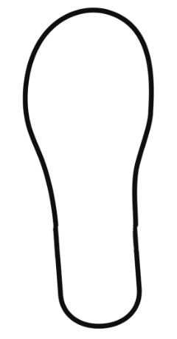
- Once students have cut-out their shoeprint, ask:
- If we did not have a ruler, how could we use our shoe size to measure objects?
- Would this be a consistent measuring device?
- What could go wrong with this way of measuring?
- What would be some of the challenges when using different types of shoes?
- How can we ensure accuracy?
- Revise how there are 2 units of measurement on a ruler, millimetres and centimetres. Display Resource 7 – millimetre ruler from the previous lesson. The lines that are labelled with numbers represent centimetres and the other lines represent millimetres. Emphasise that millimetres are smaller than centimetres and that there are 10 millimetres in one centimetre.
- Students use a 30 cm ruler to measure the length of their shoe cut-out. Write the measurement on the cut-out. Remind students to use the abbreviation for centimetres (cm) when recording (see Figure 2).
Figure 2 – measuring shoe with ruler
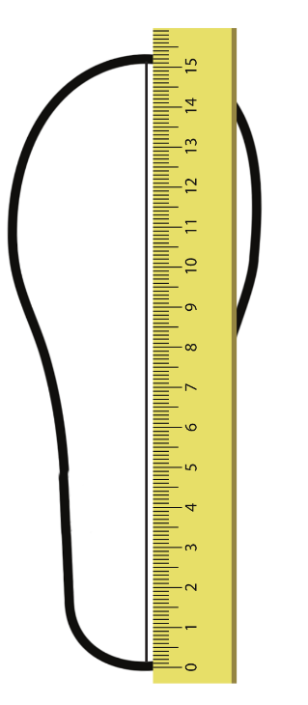
Note: when students record their shoe size measurement, round up or down to the nearest centimetre.
- Model how to estimate and then use a shoe cut-out to measure the length of a classroom table by placing the cut-out end-to-end with no overlaps or gaps. Record on Resource 9 – shoe measuring. Demonstrate how to convert the shoe cut-out measurement into centimetres. Students use their shoe cut-out to measure objects outside of the classroom such as a lunch seat, handball court and a step. Record the amount of shoe lengths on Resource 9 – shoe measuring.
- Return to the classroom. Students convert the amount of shoe lengths for each item they measured into centimetres.
This table details opportunities for differentiation.
Too hard? | Too easy?
Students cannot measure and compare objects using centimetres.  - Support students by modelling how to measure using their shoe cut-out by making 2 shoe cut-outs so they can measure end-to-end.  - Provide concrete materials to help with adding when converting the amount of shoe lengths into centimetres. | Students can measure and compare objects using centimetres.  - Students record their shoe size in centimetres and millimetres and then use these measurements to measure the length of objects.  - Combine measurements of objects to find the total length. For example, a seat and a step.

Discuss and connect the mathematics – 10 minutes
- Regroup students with their completed Resource 9 – shoe measuring. Ask:
- How did you convert your shoe lengths into cm?
- How did you keep track of the count? What strategies did you use?
- Did 2 different shoe lengths result in the same centimetre measurement? Why or why not?
- Was there anything that surprised you?
- What were some challenges that arose from measuring with shoe lengths?
- What shoe size would be the best for measuring the length of the classroom?
This table details opportunities for assessment.
Assessment opportunities | Links
What to look for:  - Can students measure and record lengths and distances using centimetres? [MAO-WM-01, MA2-GM-02]  - Can students estimate lengths and distances using known lengths as benchmarks, in centimetres and check by measuring?  [MAO-WM-01, MA2-GM-02]  - Can students record lengths using the abbreviation for centimetres (cm)? [MAO-WM-01, MA2-GM-02] | Links to National Numeracy Learning Progressions (NNLP):  - UuM6.

Lesson 7
Core concept: accurate benchmarks help in estimating lengths and other measures.

Daily number sense – Who is winning? – 10 minutes
The table below contains a suggested learning intention and success criteria. These are best co-constructed with students.
Daily number sense learning intention | Daily number sense success criteria
Students are learning to:  - create fractional parts of length using techniques other than repeated halving. | Students can:  - make thirds of a length  - create fifths of a length.
This activity is an adaptation of ‘Who is winning?’ from Primary and Middle Years Mathematics: Teaching Developmentally by Van de Walle et al.
- Provide pairs of students with multiple paper strips and writing materials. Revise how to identify thirds and fifths of a length from Lesson 5 and Lesson 6.
- Display Resource 10 – Who is winning? and explain that the 4 students are in a race. The fractions show how much of the race they have already completed.
- Provide pairs of students with identical length fraction strips for each runner and an individual whiteboard to draw a number line.
- With their partner, students use a fraction strip to mark and represent the fraction distance for each student. Students then compare the fractional representations for each runner and then use the number line to locate each person’s position in the race and determine who is winning the race.
- Select students to share and explain their strategies used to identify and represent the position of each fraction.
This table details opportunities for assessment.
Assessment opportunities | Links
What to look for:  - Can students make thirds of a length? [MAO-WM-01, MA2-PF-01]  - Can students create fifths of a length? [MAO-WM-01, MA2-PF-01]  - Can students explain their reasoning of how to find fractions of a length? [MAO-WM-01, MA2-PF-01] | Links to National Numeracy Learning Progressions (NNLP):  - InF4  - InF2, InF3, InF4.

Core lesson – benchmarking a metre – 50 minutes
The table below contains a suggested learning intention and success criteria. These are best co-constructed with students.
Core concept learning intention | Core concept success criteria
Students are learning to:  - measure and compare objects using metres. | Students can:  - measure and record lengths and distances using a combination of metres and centimetres  - estimate lengths and distances using known lengths as benchmarks in metres and check by measuring  - compare and order lengths and distances using metres.
This activity is an adaptation of Making benchmarks: Length from NZ Maths by New Zealand Ministry of Education.
- Place a piece of masking tape on the carpet that is one metre in length without telling the students that it is equal to a metre. Ask:
- How long do you think this tape is? Why?
- How did you come up with that estimate?
- What is something that you know is a similar length to this strip?
- How can we check the accuracy of our estimations?
- Using equipment that we have in our room, which method will provide us with the most accurate answer? (metre ruler)
- Model how to measure the strip of masking tape using a metre ruler. Record the measurement using the abbreviation for metre (m).
- Discuss with students what they could do to measure if they did not have access to a metre ruler. What personal benchmarks could they use to measure lengths in metres? Examples may include: a stride, length of their leg or a wide leg stance. Ask:
- Which suggestion would be easier?
- Which suggestion would be practical to use? Why or why not?
- Students check their stride against the metre tape on the floor to get a known metre benchmark.
- Explain to students that they will estimate how far they can travel around the playground from a specified location with a set number of strides. For example, ‘After 20 strides from my classroom door, I can get to the library.’
- Provide students with Resource 11 – measuring in strides to make estimations and record their strides. Provide small groups with a trundle wheel to measure and check the distance using metres and centimetres.
Note: students need to understand and be convinced that one rotation of a trundle wheel is one metre. If there is not access to enough metre rules or trundle wheels, consider measuring and pre-cutting string or ribbon to one metre.
- Discuss the differences between student estimations and the actual measurements. Ask:
- Were your estimations close to the measurements? Why or why not?
- How did using the trundle wheel help you measure accurately?
This table details opportunities for differentiation.
Too hard? | Too easy?
Students cannot measure and compare objects using metres and centimetres.  - Support students with a list of examples to choose from that they could use as a personal benchmark.  - Provide markers when using the trundle wheel to keep track of how many metres it was to the set destination. | Students can measure and compare objects using metres and centimetres.  - Combine measurements of 2 destinations to find the total length.  - Challenge students to think about what personal benchmarks they can use for half a metre.

Discuss and connect the mathematics – 10 minutes
- With students, brainstorm other examples of where the metre unit of measurement is used. For example, 50 m swimming pool, cricket pitch, football field, length of a house.
- Discuss why smaller units of measurement, such as millimetres and centimetres, would not be practical for measuring the length of these examples.
This table details opportunities for assessment.
Assessment opportunities | Links
What to look for:  - Can students measure and record lengths and distances using a combination of metres and centimetres?  [MAO-WM-01, MA2-GM-02]  - Can students estimate lengths and distances using known lengths as benchmarks in metres and check by measuring?  [MAO-WM-01, MA2-GM-02]  - Can students compare and order lengths and distances using metres? [MAO-WM-01, MA2-GM-02] | Links to National Numeracy Learning Progressions (NNLP):  - UuM6.

Lesson 8
Core concept: the context determines the most suitable standard unit.

Daily number sense – 10 minutes
- From a class need surfaced through formative assessment data, identify a short, focused activity that targets students’ knowledge, understanding and skills. Example activities may be drawn from the following resources:
- Mathematics K–6 resources
- Universal Resources Hub.

Core lesson – investigating small measurements – 55 minutes
The table below contains a suggested learning intention and success criteria. These are best co-constructed with students.
Core concept learning intention | Core concept success criteria
Students are learning to:  - measure and compare objects using centimetres and millimetres. | Students can:  - measure and record lengths and distances using a combination of centimetres and millimetres  - compare and order lengths and distances using centimetres and millimetres  - record lengths using the abbreviation for centimetres (cm) and millimetres (mm).
Note: this lesson is going to be an investigation. Prior to the lesson, prepare quantities of small items such as paper clips, rubber bands, paintbrushes, counters, pieces of cord or string, coins, erasers, pencil cases, zippers and buttons.
- Revise previous lessons and discuss the units of measurement explored, including metre (m), centimetre (cm) and millimetre (mm). Ask:
- What do you know about millimetres, centimetres and metres?
- What are some measuring devices we use to measure metres? Centimetres? Millimetres?
- How do you know which measuring device to use?
- What are some objects you can measure in metres? Centimetres? Millimetres?
- What strategies did you use to make accurate estimations for measurements?

Investigation task 1 – 15 minutes
- Students will explore a variety of small items to investigate measuring accurately in millimetres and centimetres.
- Provide students with a 30 cm ruler, various small items and Resource 12 – investigating small measurements.
- Students use the ruler to measure the width and length of (number) small items.
- Students decide whether millimetres or centimetres is the most suitable unit to use to record each measurement. Record measurements on Resource 12 – investigating small measurements. Remind students to use the abbreviation ‘mm’ when recording measurements in millimetres and ‘cm’ when recording measurements in centimetres (see Figure 3).
Figure 3 – example of recordings
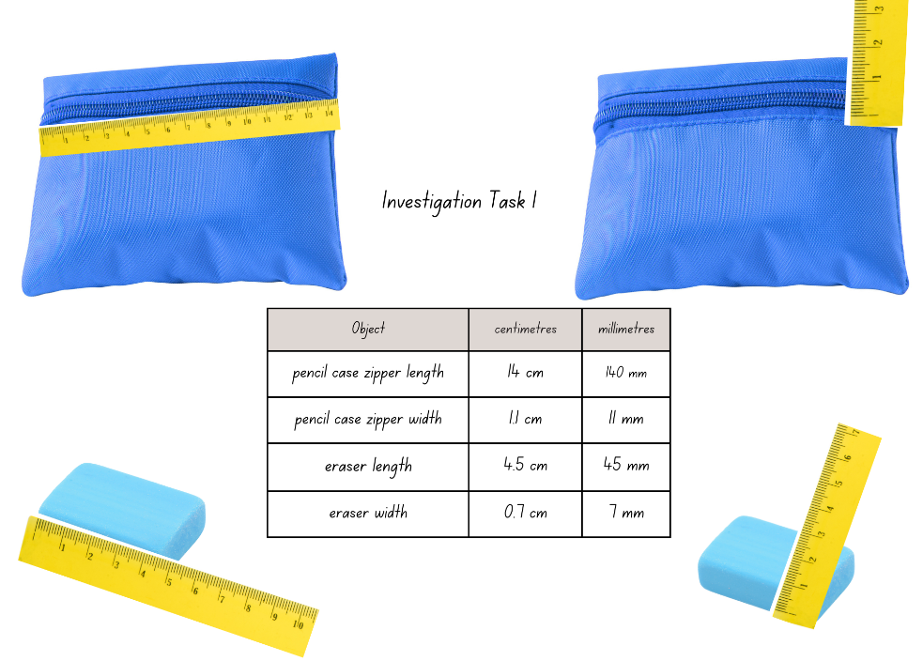
- In pairs, students turn and talk sharing results, challenges and strategies.

Investigation task 2 – 15 minutes
- Provide each student with a small piece of modelling clay, a ruler and Resource 12 – investigating small measurements to record findings.
- Explain that students will use the modelling clay to shape the thinnest and longest possible snake that is one whole piece, with no joins. Students will measure the width of their snake, recording the measurement using the correct abbreviation for millimetres (mm) and record the length of their snake using the correct abbreviation for centimetres (cm) and/or millimetres (mm) (see Figure 4).
Figure 4 – example of recordings
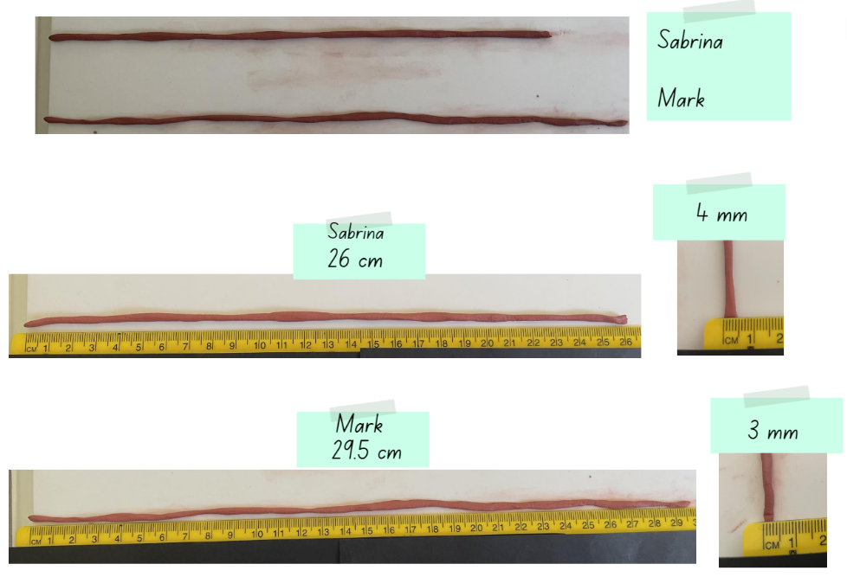
- In pairs, students turn and talk sharing results, challenges and strategies.

Investigation task 3 – 15 minutes
- Provide students with a 30 cm ruler and an A4 piece of paper.
- Students will challenge themselves to cut as many 7 centimetre long strips from an A4 piece of paper as they can (see Figure 5).
Figure 5 – examples of strategies and recordings
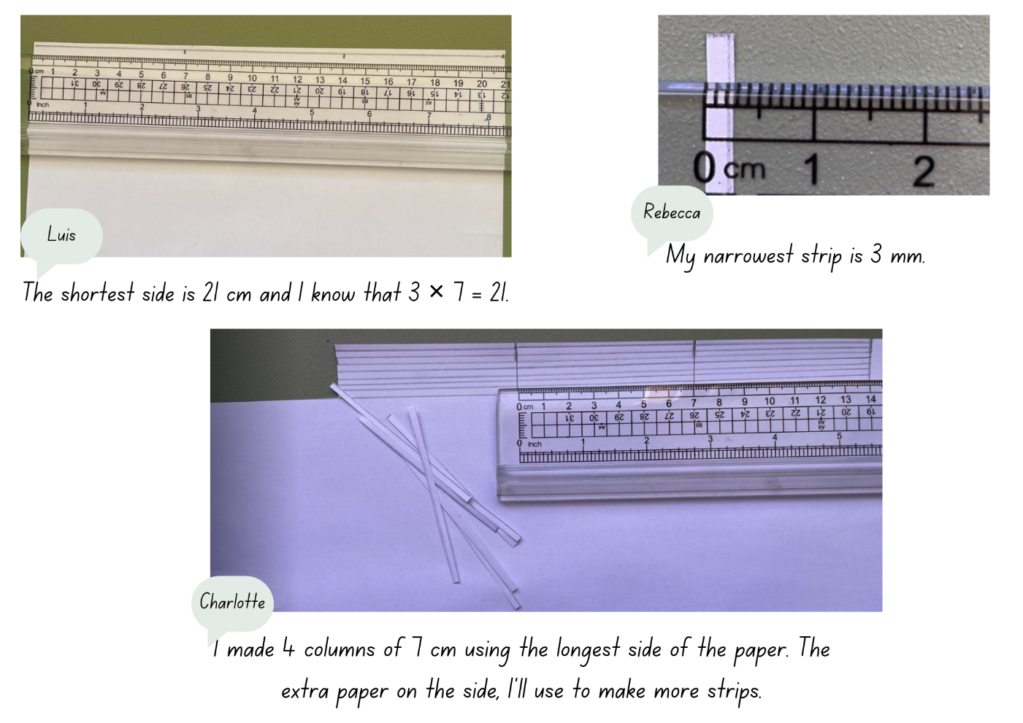
- As a group, students share how many paper strips they were able to cut. Ask:
- What was the largest number of strips cut?
- What was the smallest number of strips cut?
- What do you notice about the width of the paper strips?
- Did you change your strategy as you were working through the task?
- How would you do the task differently next time?
- Estimate the total length of your paper strips if all the strips were placed end-to-end?
- Students will measure the width of their narrowest paper strip, recording the measurement using the correct abbreviation for millimetres (mm), and record the estimated length of all the paper strips placed end-to-end using the correct abbreviation for centimetres (cm) on Resource 12 – investigating small measurements.
This table details opportunities for differentiation.
Too hard? | Too easy?
Students cannot measure and compare objects using centimetres and millimetres.  - Support students to use a ruler to mark the 7 cm strips on the A4 paper prior to cutting.  - Give students various pre-cut paper strips to measure the width and record them in millimetres. | Students can measure and compare objects using centimetres and millimetres.  - Provide students with an A4 sheet of paper and challenge them to cut as many 4.5 cm long strips.  - With a partner or in small groups, challenge students to combine the paper strips end-to-end and record the total length in metres, centimetres and millimetres.

Discuss and connect the mathematics – 10 minutes
- Students display their clay snakes, paper strips and recording sheets and go on a gallery walk. Ask:
- How long was the longest clay snake? What was the object that had a width that was less than 2 millimetres? What was the width of the narrowest paper strip?
- Did you notice a relationship between the length and the width of the longest clay snake?
- Which task was the most challenging and why?
- If you were going to do the task again, what would you do differently?
- Are you wondering anything else about measurement?
- Pose the following challenge students: ‘Last week, Josh made a modelling clay snake that was 25 centimetres long.’ Ask how else he could have recorded his measurement.
- Record student suggestions on the class anchor chart and ask them to explain their response.
This table details opportunities for assessment.
Assessment opportunities | Links
What to look for:  - Can students measure and record lengths and distances using a combination of centimetres and millimetres?  [MAO-WM-01, MA2-GM-02]  - Can students compare and order lengths and distances using centimetres and millimetres? [MAO-WM-01, MA2-GM-02]  - Can students record lengths using the abbreviation for centimetres (cm) and millimetres (mm)? [MAO-WM-01, MA2-GM-02] | Links to National Numeracy Learning Progressions (NNLP):  - UuM6.

Resource 1 – 10 times bigger
Die rolls | Number rolled | × 10 | × 100 | × 1000
Example | 6 | 60 | 600 | 6000
Roll 1
Roll 2
Roll 3
Roll 4
Roll 5

Resource 2 – recording table
Less than a kilogram (kg) | About a kilogram (kg) | More than a kilogram (kg)

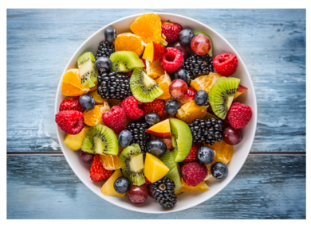
Resource 3 – recipe example
Traditional fruit salad recipe
Ingredients:
- 600 g pineapple, peeled and chopped
- 800 g of rockmelon, chopped
- 250 g of strawberries, diced
- 200 g red seedless grapes
- 150 g of mandarin
- 4 passionfruits, halved
- 1 teaspoon of lime juice.
Method:
Place pineapple, rockmelon, strawberries, grapes, mandarins, passionfruit pulp and lime juice into a large glass or ceramic bowl. Toss to combine and serve.

Resource 4 – fruit recording
Fruit or vegetable | Grams (g)
Example: Apple | 200 g

Resource 5 – fruit salad recipe
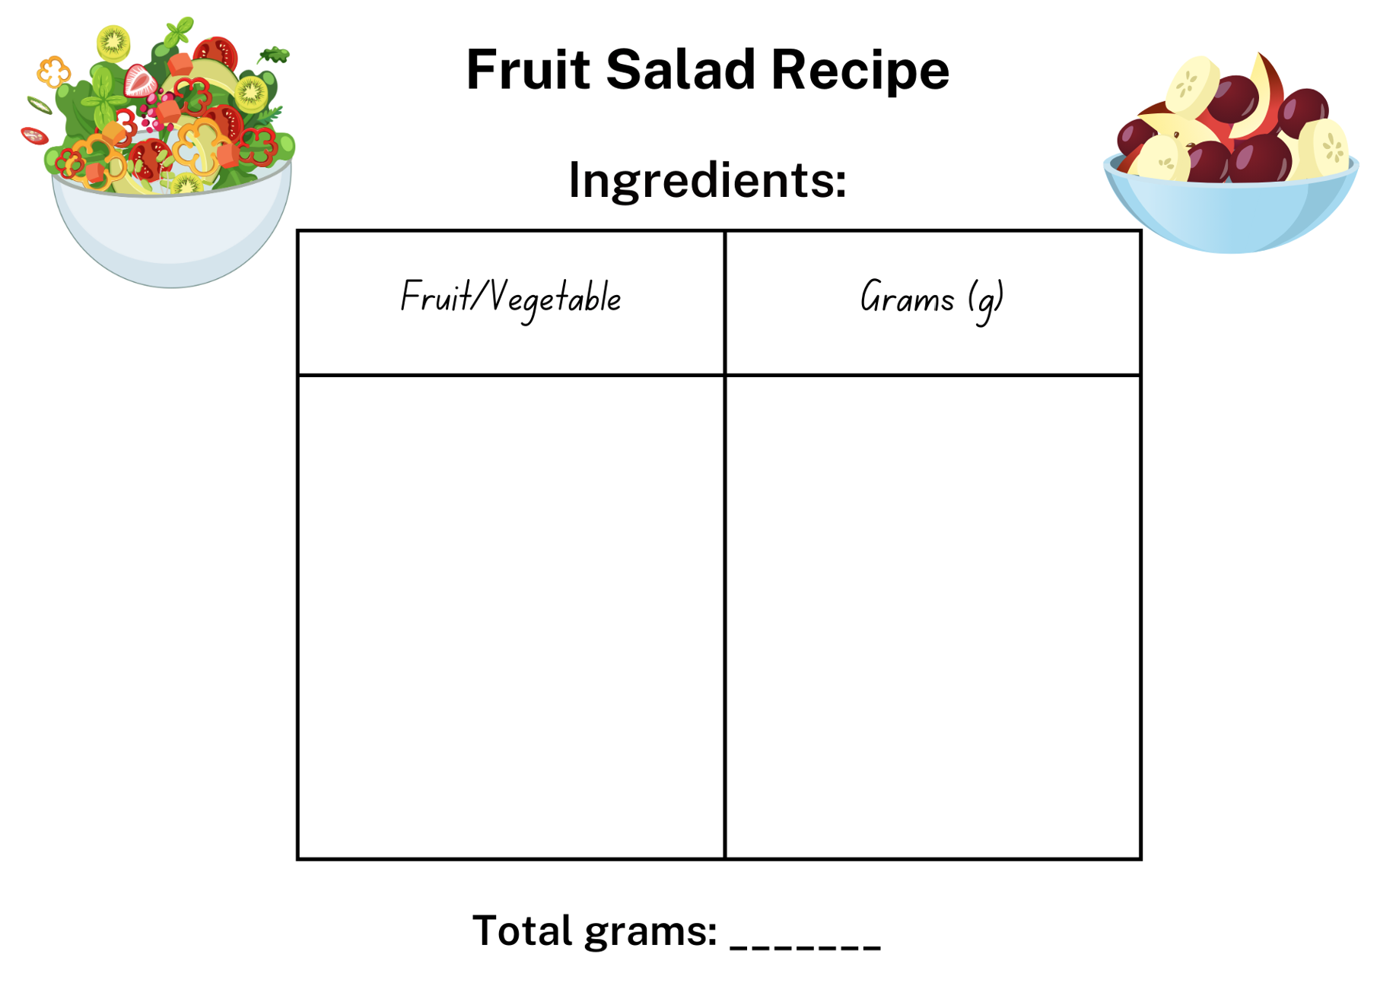

Resource 6 – ruler
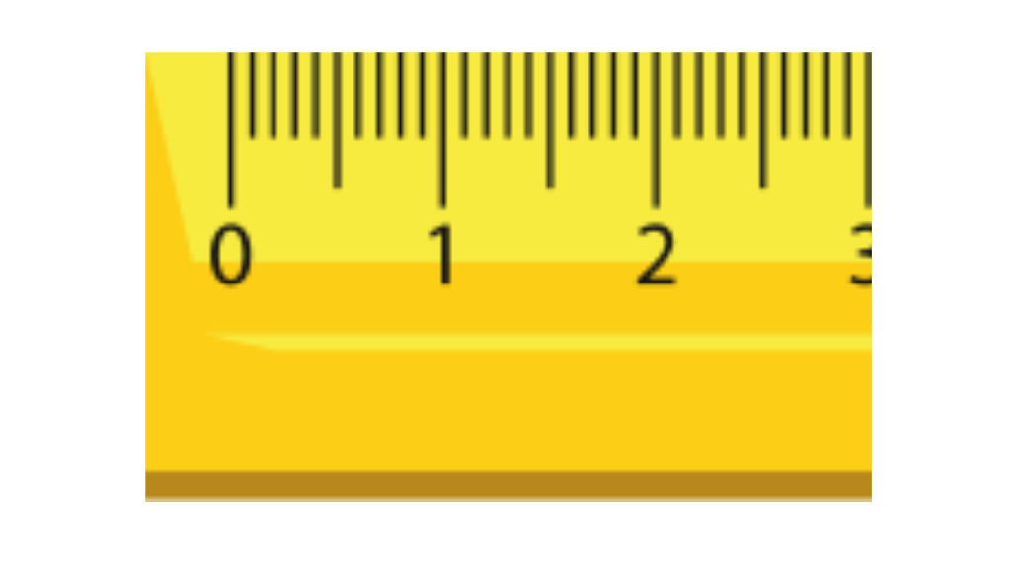

Resource 7 – millimetre ruler
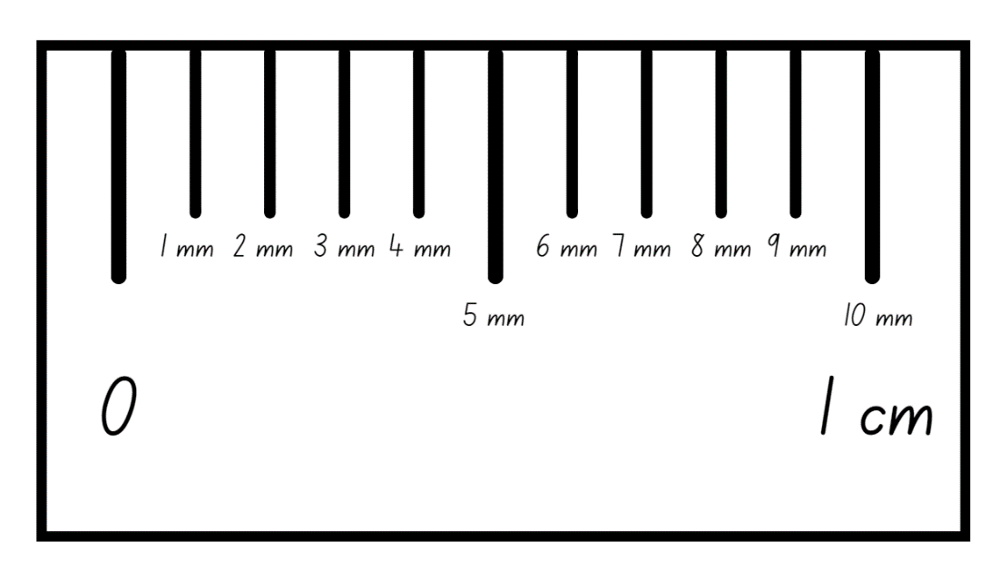

Resource 8 – measuring objects
Object | My ruler (mm) | My ruler (cm) | Ruler (mm) | Ruler (cm)
Pencil
Glue stick
Paper clip
Exercise book

Resource 9 – shoe measuring
Object being measured | Estimation of number of shoes | Number of shoe lengths | Actual length

Resource 10 – Who is winning?
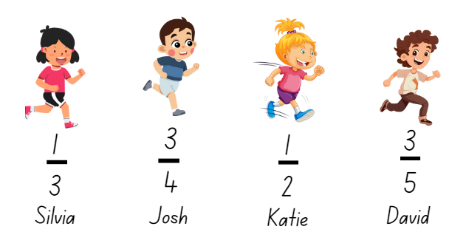

Resource 11 – measuring in strides
Set number of strides | Estimated destination | Actual number of strides | Trundle wheel measurement
15
55
24

Resource 12 – investigating small measurements
Investigation task 1
Object | Centimetres | Millimetres
Investigation task 2
Recording | Centimetres | Millimetres
Snake length
Snake width
Investigation task 3
Recording | Centimetres | Millimetres
The width of the narrowest paper strip
Estimated length of all the paper strips end-to-end

Syllabus outcomes and content
The table below outlines the syllabus outcomes and range of relevant syllabus content covered in this unit. Content is linked to National Numeracy Learning Progression (version 3).
Outcomes and content | 1 | 2 | 3 | 4 | 5 | 6 | 7 | 8
Representing numbers using place value B: Whole numbers: Recognise and represent numbers that are 10, 100 or 1000 times as large
[MAO-WM-01, MA2-RN-01]
- Recognise the number of tens, hundreds or thousands in a number | x | x | x
- Describe how making a number 10, 100 or 1000 times as large changes the place value of digits | x | x | x
Partitioned fractions A: Create fractional parts of a length using techniques other than repeated halving
[MAO-WM-01, MA2-PF-01]
- Make thirds of a length |  |  |  |  | x | x | x
- Create fifths of a length |  |  |  |  | x | x | x
Geometric measure A: Length: Measure and compare objects using metres, centimetres and millimetres
[MAO-WM-01, MA2-GM-02]
- Measure and record lengths and distances using a combination of metres and centimetres |  |  |  |  |  |  | x
- Estimate lengths and distances using known lengths as benchmarks, in metres and centimetres and check by measuring |  |  |  |  |  | x | x
- Compare and order lengths and distances using metres and centimetres |  |  |  |  |  | x | x
- Recognise the need for a formal unit smaller than the centimetre to measure length |  |  |  |  | x |  |  | x
- Identify that there are 10 millimetres in one centimetre |  |  |  |  | x |  |  | x
- Use the millimetre as a unit to measure lengths with a ruler |  |  |  |  | x |  |  | x
- Record lengths using the abbreviation for millimetres (mm) |  |  |  |  | x |  |  | x
Geometric measure B: Length: Use scaled instruments to measure and compare lengths
[MAO-WM-01, MA2-GM-02]
- Select and use an appropriate scaled instrument to measure lengths and distances |  |  |  |  |  |  | x
- Select and use an appropriate unit to estimate, measure and compare lengths and distances |  |  |  |  |  |  | x
- Convert between metres and centimetres, and between centimetres and millimetres |  |  |  |  | x
Non-spatial measure A: Mass: Compare objects using the kilogram
[MAO-WM-01, MA2-NSM-01]
- Recognise the need for a formal unit to measure mass | x | x | x | x
- Identify familiar objects that have a mass of about one kilogram | x | x | x
- Record masses using the abbreviation for kilograms (kg) | x |  | x | x
- Find objects that have an estimated mass of more than, less than and about the same as one kilogram and check by comparing to a 1 kg mass | x | x | x
Non-spatial measure B: Mass: Use scaled instruments to measure and compare masses
[MAO-WM-01, MA2-NSM-01]
- Recognise the need for a formal unit smaller than the kilogram | x |  |  | x
- Use a scaled instrument to relate 1000 grams to one kilogram |  |  | x | x
- Identify familiar objects that could be measured in grams | x |  |  | x
- Measure and record mass in grams (g) using a scaled instrument | x |  |  | x
- Compare 2 or more objects by mass measured in kilograms and grams using a set of scales |  |  | x
- Interpret commonly used fractions of a kilogram, including $\frac{1}{2},$ $\frac{1}{4}$, $\frac{3}{4}$ and relate these to the number of grams |  |  |  | x
Mathematics K–10 Syllabus © NSW Education Standards Authority (NESA) for and on behalf of the Crown in right of the State of New South Wales, 2022.

References
This resource contains NSW Curriculum and syllabus content. The NSW Curriculum is developed by the NSW Education Standards Authority. This content is prepared by NESA for and on behalf of the Crown in right of the State of New South Wales. The material is protected by Crown copyright.
Please refer to the NESA Copyright Disclaimer for more information https://educationstandards.nsw.edu.au/wps/portal/nesa/mini-footer/copyright.
NESA holds the only official and up-to-date versions of the NSW Curriculum and syllabus documents. Please visit the NSW Education Standards Authority (NESA) website https://educationstandards.nsw.edu.au/wps/portal/nesa/home and the NSW Curriculum website https://curriculum.nsw.edu.au/.
Mathematics K–10 Syllabus © NSW Education Standards Authority (NESA) for and on behalf of the Crown in right of the State of New South Wales, 2022.
National Numeracy Learning Progression © Australian Curriculum, Assessment and Reporting Authority (ACARA) 2010 to present, unless otherwise indicated. This material was downloaded from the Australian Curriculum website (National Numeracy Learning Progression) accessed 11 September 2023 and was not modified.
Downton, A, Knight R, Clarke D and Lewis G (2015) Mathematics Assessment for Learning: Rich Tasks and Work Samples, 3rd edn, Mathematics Teaching and Learning Centre, Australian Catholic University and Catholic Education office, Melbourne.
New Zealand Ministry of Education (n.d.) ‘Making benchmarks: Length’, Resource, NZ Maths website, accessed 30 August 2023.
New Zealand Ministry of Education (n.d.) ‘Noah’s Mystery Parcel’, Resource, NZ Maths website, accessed 30 August 2023.
Siemon D, Warren E, Beswick K, Faragher R, Miller J, Horne Marj, Jazby D, Breed M, Clark J, Brady K (2020) Teaching Mathematics: Foundations to Middle Years, 3rd edn, Oxford University Press Australia and New Zealand.
Toy Theater (2001–2023) ‘Place Value Chart’, Place Value Manipulatives, Toy Theater website, accessed 29 August 2023.
University of Cambridge (n.d.) What’s My Weight?, NRICH website, accessed 29 August 2023.
Van de Walle J, Karp K, Bay-Williams JM, Brass A, Bentley B, Ferguson S, Goff W, Livy S, Marshman M, Martin D, Pearn C, Prodromou T, Symons D and Wilkie K (2019) Primary and Middle Years Mathematics: Teaching Developmentally, 1st Australian edn, Pearson Education Australia, Melbourne.

Further reading
Australian Government Department of Education (2020) 'Measurement: Jump!’, Teaching resources, reSolve: Maths by Inquiry website, accessed 31 August 2023.

© State of New South Wales (Department of Education), 2024
The copyright material published in this resource is subject to the Copyright Act 1968 (Cth) and is owned by the NSW Department of Education or, where indicated, by a party other than the NSW Department of Education (third-party material).
Copyright material available in this resource and owned by the NSW Department of Education is licensed under a Creative Commons Attribution 4.0 International (CC BY 4.0) license.
This license allows you to share and adapt the material for any purpose, even commercially.
Attribution should be given to © State of New South Wales (Department of Education), 2024.
Material in this resource not available under a Creative Commons license:
- the NSW Department of Education logo, other logos and trademark-protected material
- material owned by a third party that has been reproduced with permission. You will need to obtain permission from the third party to reuse its material.
Links to third-party material and websites
Please note that the provided (reading/viewing material/list/links/texts) are a suggestion only and implies no endorsement, by the New South Wales Department of Education, of any author, publisher, or book title. School principals and teachers are best placed to assess the suitability of resources that would complement the curriculum and reflect the needs and interests of their students.
If you use the links provided in this document to access a third-party's website, you acknowledge that the terms of use, including licence terms set out on the third-party's website apply to the use which may be made of the materials on that third-party website or where permitted by the Copyright Act 1968 (Cth). The department accepts no responsibility for content on third-party websites.

