Mathematics Stage 2 – Unit 19

Angles are the primary structural component of many shapes

Contents

Unit description and duration 5

Syllabus outcomes 5

Working mathematically 6

Student prior learning 6

Lesson overview and resources 8

Lesson 1 13

Daily number sense – Which is closest? – 15 minutes 13

Core lesson – features of shapes – 40 minutes 15

Consolidation and meaningful practice – 10 minutes 19

Lesson 2 21

Daily number sense – Which is closest? – 15 minutes 21

Core lesson – walking tracks – 40 minutes 23

Discuss and connect the mathematics – 10 minutes 25

Lesson 3 27

Daily number sense – Which is closest? – 15 minutes 27

Core lesson – angles all around – 25 minutes 28

Discuss and connect the mathematics – 15 minutes 34

Lesson 4 36

Daily number sense – 10 minutes 36

Core lesson – angle as turn – 35 minutes 36

Discuss and connect the mathematics – 10 minutes 44

Lesson 5 46

Daily number sense – completing a whole – 15 minutes 46

Core lesson – square corners – 30 minutes 49

Discuss and connect the mathematics – 10 minutes 52

Lesson 6 54

Daily number sense – fractions of a whole – 10 minutes 54

Core lesson 1 – angle capture – 20 minutes 55

Core lesson 2 – sides and angles – 20 minutes 58

Consolidation and meaningful practice – 10 minutes 59

Lesson 7 61

Daily number sense – fractions and wholes – 15 minutes 61

Core lesson 1 – making time – 20 minutes 63

Core lesson 2 – puzzled times – 20 minutes 65

Discuss and connect the mathematics – 10 minutes 67

Lesson 8 69

Daily number sense – 10 minutes 69

Core lesson – passing time – 35 minutes 69

Discuss and connect the mathematics – 10 minutes 73

Resource 1 – Which is closest? 75

Resource 2 – sorting shapes 76

Resource 3 – city map 77

Resource 4 – Which flag doesn’t belong? 78

Resource 5 – street map 1 79

Resource 6 – street map 2 80

Resource 7 – Munich Olympics 81

Resource 8 – whole pencils 82

Resource 9 – octagon 83

Resource 10 – what angles measure 84

Resource 11 – fractions of a whole 85

Resource 12 – shapes 86

Resource 13 – cards 87

Resource 14 – game instructions 89

Resource 15 – ‘Fractions memory’ 90

Resource 16 – blank clock 93

Resource 17 – clock records 94

Resource 18 – angles on clocks 95

Syllabus outcomes and content 96

References 100

# Unit description and duration

This unit introduces the big idea that angles are the primary structural component of many shapes.

In this 2-week unit students are provided opportunities to:

* identify angles as measures of turn and compare angles to a right angle
* compare and describe the features of two-dimensional shapes
* represent and read analog time.

## Syllabus outcomes

* **MAO-WM-01** develops understanding and fluency in mathematics through exploring and connecting mathematical concepts, choosing and applying mathematical techniques to solve problems, and communicating their thinking and reasoning coherently and clearly
* **MA2-RN-01 applies an understanding of place value and the role of zero to represent numbers to at least tens of thousands**
* **MA2-PF-01** **represents and compares halves, quarters, thirds and fifths as lengths on a number line and their related fractions formed by halving (eighths, sixths and tenths)**
* **MA2-GM-03** identifies angles and classifies them by comparing to a right angle
* **MA2-2DS-01** compares two-dimensional shapes and describes their features
* **MA2-NSM-02** represents and interprets analog and digital time in hours, minutes and seconds

## Working mathematically

In the Mathematics K–10 Syllabus, there is one overarching Working mathematically outcome (**MAO-WM-01**). The Working mathematically processes should be embedded within the concepts being taught. The Working mathematically processes present in the Mathematics K–10 Syllabus are:

* communicating
* understanding and fluency
* reasoning
* problem solving.

[Mathematics K–10 Syllabus](https://curriculum.nsw.edu.au/learning-areas/mathematics/mathematics-k-10-2022/overview) © NSW Education Standards Authority (NESA) for and on behalf of the Crown in right of the State of New South Wales, 2022.

## Student prior learning

Before engaging in these teaching and learning activities, students would benefit from prior experience with:

* identifying and naming the parts of an angle
* identifying, describing and comparing two-dimensional shapes
* reading and representing analog time and solving problems involving quarter-hours and half-hours.

In NSW classrooms there is a diverse range of students, including Aboriginal and/or Torres Strait Islander students, students learning English as an additional language or dialect, high potential and gifted students, and students with disability. Some students may identify with more than one of these groups or possibly all of them. Refer to [Curriculum planning for every student – advice](https://education.nsw.gov.au/teaching-and-learning/curriculum/planning-programming-and-assessing-k-12/advice-on-curriculum-planning-for-every-student-k-12) for further information.

# Lesson overview and resources

The table below outlines the sequence and approximate timing of lessons, learning intentions and resources.

|  |  |  |
| --- | --- | --- |
| Lesson | Content | Duration and resources |
| **Lesson 1**  **Daily number sense learning intention**:   * apply place value to partition and regroup numbers up to 4 digits | **Lesson core concept**: shapes have features that identify them.  **Core concept learning intention**:   * compare and describe features of two-dimensional shapes | **Lesson duration**: 65 minutes   * Resource 1 – Which is closest? * Resource 2 – sorting shapes * Resource 3 – city map * A3 paper * Rulers * Scissors * Writing materials |
| **Lesson 2**  **Daily number sense learning intention**:   * apply place value to partition and regroup numbers up to 4 digits | **Lesson core concept**: angles and sides help identify shapes.  **Core concept learning intention**:   * compare and describe features of two-dimensional shapes | **Lesson duration**: 65 minutes   * Resource 1 – Which is closest? * Resource 4 – Which flag doesn’t belong? * Resource 5 – street map 1 * Resource 6 – street map 2 * Coloured markers * Writing materials |
| **Lesson 3**  **Daily number sense learning intention**:   * apply place value to partition and regroup numbers up to 4 digits | **Lesson core concept**: angles are a measure of turn.  **Core concept learning intention**:   * identify angles as measures of turn | **Lesson duration**: 55 minutes   * Resource 1 – Which is closest? * Website: [Composition 8 (Komposition 8)](https://www.guggenheim.org/artwork/1924) by Vasily Kandinksy (artwork) * 2 pencils of the same length for each student * Writing materials |
| **Lesson 4**  **Daily number sense learning intention**:   * teacher-identified task based on student needs | **Lesson core concept**: mathematicians find and create angles in everyday activities.  **Core concept learning intentions**:   * identify angles as measures of turn * compare angles to a right angle | **Lesson duration**: 55 minutes   * Resource 7 – Munich Olympics * Video: [Angles in soccer (1:58)](https://www.pbslearningmedia.org/resource/mmpt-math-g-anglessoccer/angles-in-soccer/) * Cardboard strips * Split pins * Writing materials |
| **Lesson 5**  **Daily number sense learning intention**:   * model and represent unit fractions, and their multiples, to a complete whole on a number line | **Lesson core concept**: all angles can be compared to right angles  **Core concept learning intentions**:   * identify angles as measures of turn * compare angles to a right angle | **Lesson duration**: 55 minutes   * Resource 8 – whole pencils * Resource 9 – octagon * Resource 10 – what angles measure * A4 paper * Coloured pencils * Student workbook * Writing materials |
| **Lesson 6**  **Daily number sense learning intention**:   * model and represent unit fractions, and their multiples, to a complete whole on a number line | **Lesson core concept**: angles can be estimated and compared.  **Core concept learning intentions**:   * identify angles as measures of turn * compare angles to a right angle | **Lesson duration**: 60 minutes   * Resource 11 – fractions of a whole * Resource 12 – shapes (printed on A3) * Resource 13 – cards (printed on A4) * Resource 14 – game instructions * Scissors * String * Transparent coloured counters * Writing materials |
| **Lesson 7**  **Daily number sense learning intention**:   * model and represent unit fractions, and their multiples, to a complete whole on a number line | **Lesson core concept**: clock hands make different angles at different times.  **Core concept learning intention**:   * read and represent analog time | **Lesson duration**: 65 minutes   * Resource 15 – ‘Fractions memory' * Resource 16 – blank clock * Resource 17 – clock records * Resource 18 – angles on clocks * Website: [Interactive Clock](https://toytheater.com/clock/) * Angle testers from Lesson 4 * Writing materials |
| **Lesson 8**  **Daily number sense learning intention**:   * teacher-identified task based on student needs | **Lesson core concept**: five-minute intervals on analog clocks are useful for reading the time.  **Core concept learning intention**:   * read and represent analog time | **Lesson duration**: 55 minutes   * Resource 16 – blank clock * Website: [Interactive Clock](https://toytheater.com/clock/) * 12-sided die * Analog clock * Angle testers from Lesson 4 * Writing materials |

# Lesson 1

**Core concept**: shapes have features that identify them.

## Daily number sense – Which is closest? – 15 minutes

Daily number sense activities for Lessons 1 to 3 ‘activate’ prior number knowledge and support the learning of new content in the unit. These activities can also assist teachers to identify the starting points for learning by revealing the extent of students’ existing knowledge.

The table below contains a suggested learning intention and success criteria. These are best co-constructed with students.

|  |  |
| --- | --- |
| Daily number sense learning intention | Daily number sense success criteria |
| Students are learning to:   * apply place value to partition and regroup numbers up to 4 digits. | Students can:   * record numbers using standard place value form * partition numbers of up to 4 digits in non-standard forms. |

This activity is an adaptation of [As Close As It Gets](https://www.mathisfigureoutable.com/ascloseasitgets) from [Maths is Figure-Out-Able!](https://www.mathisfigureoutable.com/) by Harris. Key ideas for Stage 2 place value are outlined in the syllabus teaching advice and in the professional learning module [The role of place value](https://myplsso.education.nsw.gov.au/mylearning/catalogue/details/4fb7d05c-0938-ee11-8456-0003ff49608c) from [My Professional Learning](https://myplsso.education.nsw.gov.au/pages/custom-pages_home?menu=home) by the NSW Department of Education

1. Provide students with writing materials, such as individual whiteboards.
2. Display Resource 1 – Which is closest?
3. Identify that each card has a target number and read aloud card 1.
4. Draw a number line on the board and demonstrate positioning the target number on an empty number line, then each of the multiple-choice options to establish which is closest.
5. Use card 1 to demonstrate how to rename the target number using non-standard partitions such as 42 hundreds and 96 ones, or 429 tens and 6 ones.
6. Students use card 2 to [Think-Pair-Share](https://app.education.nsw.gov.au/digital-learning-selector/LearningActivity/Card/645) and read the numbers aloud. They position each of the numbers on a number line to establish which is closest.
7. All students show their responses. Select students to justify their answer using place value language.
8. Explain that for card 3, the target number has been deleted.
9. Students record at least 2 target numbers that would make more than one of the responses correct. For example, 7050, 7125 or 7175.
10. Select students to communicate and reason about their responses.
11. Students use cards 4 and 5 to record the target number in standard and non-standard place value form.
12. Students [Think-Pair-Share](https://app.education.nsw.gov.au/digital-learning-selector/LearningActivity/Card/645) to select and record the non-standard partition that is closest to the target number.
13. Check for understanding by observing student responses. Select students to justify their answer.
14. Explain that for card 6, the target number has been deleted.
15. Students record at least 2 target numbers that would make more than one of the responses correct.
16. Select students to communicate and reason about their responses.

This table details opportunities for assessment.

|  |  |
| --- | --- |
| Assessment opportunities | Links |
| What to look for:   * Can students record numbers using standard place value form? **[MAO-WM-01, MA2-RN-01]** * Can students partition numbers of up to 4 digits in non-standard forms**? [MAO-WM-01, MA2-RN-01]** | Links to [National Numeracy Learning Progressions](https://www.australiancurriculum.edu.au/resources/national-literacy-and-numeracy-learning-progressions/version-3-of-national-literacy-and-numeracy-learning-progressions/) (NNLP):   * NPV4, NPV5.   Links to suggested [Interview for Student Reasoning](https://education.nsw.gov.au/teaching-and-learning/curriculum/literacy-and-numeracy/assessment-resources/ifsr) (IfSR) tasks:   * IfSR-NP: 4B.3, 4B.4, 4B.5. |

## Core lesson – features of shapes – 40 minutes

The table below contains a suggested learning intention and success criteria. These are best co-constructed with students.

|  |  |
| --- | --- |
| Core concept learning intention | Core concept success criteria |
| Students are learning to:   * compare and describe features of two-dimensional shapes. | Students can:   * identify and describe polygons that have parallel sides and those that do not * identify quadrilaterals that have all sides equal in length * group quadrilaterals using one or more attributes. |

This lesson is adapted from ‘Polygon properties: What is possible?’ from Teaching Children Mathematics by Robichaux and Rodrigue. It revisits content covered in [Stage 2 Unit 12](https://education.nsw.gov.au/teaching-and-learning/curriculum/mathematics/planning-programming-and-assessing-mathematics-k-6/mathematics-3-6-units#tabs_7270186522:~:text=Unit%2012%20%E2%80%93%20Understanding%20relationships%20between%20the%20properties%20of%202D%20shapes%20helps%20visualise%20and%20organise%20spaces%20in%20the%20world). The [Stage 2 – Teaching advice for Two-dimensional spatial structure A: Language](https://curriculum.nsw.edu.au/learning-areas/mathematics/mathematics-k-10-2022/content/stage-2/fae82874e2?show=advice) states that students are not expected to use the term 'polygon'. However, some students may explore other polygons and benefit from being introduced to the collective term (NESA 2022a).

1. Provide students with writing materials.
2. Remind students that a polygon is a closed, flat two-dimensional shape with straight sides. Polygons can have any number of sides.
3. Students [Think-Pair-Share](https://app.education.nsw.gov.au/digital-learning-selector/LearningActivity/Card/645) to list and sketch the names of polygons that they know. Jointly construct a class list.
4. Remind students that the term ‘quadrilateral’ comes from Latin, meaning ‘4 sides’.
5. Students [Think-Pair-Share](https://app.education.nsw.gov.au/digital-learning-selector/LearningActivity/Card/645) to identify quadrilaterals on the class list. Add any new shape names if they arise.
6. Organise students into small groups.
7. Provide each group with a large assortment of polygons that contains both irregular and regular shapes, such as Resource 2 – sorting shapes. Students cut out each tile to use the shape for sorting.
8. Ask students to sort the polygons in as many ways as possible (at least 4). Monitor student sorts and the vocabulary used within the groups.
9. Ask groups to explain sorting rules and to justify how they are certain they have sorted the shapes correctly for their nominated condition.
10. After approximately 10 minutes of sorting, ask a student from each group to prepare a ‘secret sort’ for their group. Members of the group identify the rule and any other shapes that comply with it.
11. Ask each group to sort and record shapes using lines of symmetry.
12. When complete, ask students to record 3 additional sorts based on:

* whether the shapes have parallel sides
* whether shapes have right angles
* the number of sides of the shape.

**Note**: this instructional activity begins with exploration to build students’ capacity to identify and name various geometric features. Teachers monitor whether students can recall and apply relevant vocabulary, including parallel sides, length of sides and right angles. Once students can visualise and group geometric features, they are ready to define a given shape by integrating its unique set of features.

1. Ask groups to remove all polygons, except quadrilaterals, from their collection.
2. Using the class list, ask students to identify shapes that match the quadrilateral names on the list.
3. Select students to justify their responses, referring to the length of sides, parallel sides and right angles.
4. Provide each group with 2 × A3 sheets of paper and writing materials.
5. Ask groups to sort the quadrilaterals into at least 2 groups. Record the sort on one A3 sheet of paper.
6. Groups sort the quadrilaterals again using a different condition. Record the sort on the second A3 sheet of paper.
7. Students conduct a [gallery walk](https://app.education.nsw.gov.au/digital-learning-selector/LearningActivity/Card/555) to identify the rule for each sort.

This table details opportunities for differentiation.

|  |  |
| --- | --- |
| Too hard? | Too easy? |
| Students cannot identify and describe polygons that have parallel sides and those that do not.   * Provide students with a collection of pattern blocks to identify known quadrilaterals. Support students to describe each pattern block using the terms: parallel sides, angles and corners. | Students can identify and describe polygons that have parallel sides and those that do not.   * Challenge students to visualise and predict what happens when 2 quadrilaterals are joined at the side to make a composite shape. They explore whether this ‘always’, ‘sometimes’ or ‘never’ results in another quadrilateral. For example, if 2 rectangles are joined at the side and the sides are not the same length, the composite figure will not be a quadrilateral. |

## Consolidation and meaningful practice – 10 minutes

1. Provide students with individual copies of Resource 3 – city map, writing materials and a ruler.
2. In pairs, students identify and trace over the map using a ruler to identify and create:

* some streets that are parallel
* five different polygons with parallel sides
* five polygons that do not have parallel sides
* some quadrilaterals with sides that are equal in length
* polygons with more than 4 sides
* non-examples of polygons, such as shapes with curved sides or open shapes.

This table details opportunities for assessment.

|  |  |
| --- | --- |
| Assessment opportunities | Links |
| What to look for:   * Can students identify and describe polygons that have parallel sides and those that do not? **[MAO-WM-01, MA2-2DS-01]** * Can students identify quadrilaterals that have all sides equal in length? **[MAO-WM-01, MA2-2DS-01]** * Can students group quadrilaterals using one or more attributes? **[MAO-WM-01, MA2-2DS-01]** | Links to [National Numeracy Learning Progressions](https://www.australiancurriculum.edu.au/resources/national-literacy-and-numeracy-learning-progressions/version-3-of-national-literacy-and-numeracy-learning-progressions/) (NNLP):   * UGP4, UGP6. |

# Lesson 2

**Core concept**: angles and sides help identify shapes.

## Daily number sense – Which is closest? – 15 minutes

The table below contains a suggested learning intention and success criteria. These are best co-constructed with students.

|  |  |
| --- | --- |
| Daily number sense learning intention | Daily number sense success criteria |
| Students are learning to:   * apply place value to partition and regroup numbers up to 4 digits. | Students can:   * record numbers using standard place value form * partition numbers of up to 4 digits in non-standard forms. |

This activity is an adaptation of [As Close As It Gets](https://www.mathisfigureoutable.com/ascloseasitgets) from [Maths is Figure-Out-Able!](https://www.mathisfigureoutable.com/) by Harris.

1. Provide pairs of students with writing materials, such as individual whiteboards.
2. Display and revise Resource 1 – Which is closest?
3. Display a new 4-digit target number. Students record the number in standard place value form and one option for non-standard place value form, then compare with a partner.
4. In pairs, students write 4 multiple-choice options for that target number using a mixture of 4-digit numbers in standard place value form and non-standard partitions.
5. Students present their 4 multiple-choice options for another pair to answer and explain. Pairs then swap roles, checking each other’s responses and reasoning.
6. Regroup and select students to share their 4 multiple-choice options to the class to respond to.
7. Repeat with a new 4-digit number.

This table details opportunities for assessment.

|  |  |
| --- | --- |
| Assessment opportunities | Links |
| What to look for:   * Can students record numbers using standard place value form? **[MAO-WM-01, MA2-RN-01]** * Can students partition numbers of up to 4 digits in non-standard forms? **[MAO-WM-01, MA2-RN-01]** | Links to [National Numeracy Learning Progressions](https://www.australiancurriculum.edu.au/resources/national-literacy-and-numeracy-learning-progressions/version-3-of-national-literacy-and-numeracy-learning-progressions/) (NNLP):   * NPV4, NPV5.   Links to suggested [Interview for Student Reasoning](https://education.nsw.gov.au/teaching-and-learning/curriculum/literacy-and-numeracy/assessment-resources/ifsr) (IfSR) tasks:   * IfSR-NP: 4B.3, 4B.4, 4B.5. |

## Core lesson – walking tracks – 40 minutes

The table below contains a suggested learning intention and success criteria. These are best co-constructed with students.

|  |  |
| --- | --- |
| Core concept learning intention | Core concept success criteria |
| Students are learning to:   * compare and describe features of two-dimensional shapes. | Students can:   * identify and describe polygons that have parallel sides and those that do not * identify quadrilaterals that have all sides equal in length * group quadrilaterals using one or more attributes. |

1. Display and read the class list of shapes made in Lesson 1.
2. Display Resource 4 – Which flag doesn’t belong?
3. Students [Think-Pair-Share](https://app.education.nsw.gov.au/digital-learning-selector/LearningActivity/Card/645) to identify the flag that does not belong.
4. Select students to communicate and reason about their decisions, referring to quadrilaterals and their features. Examples may include:

* The Kuwaiti flag does not belong because it is the only flag with trapeziums.
* The Jamaican flag does not belong because it does not have any quadrilaterals. The other 3 use quadrilaterals.
* The Italian flag does not belong because it only uses one type of shape. The others use a combination of shapes.
* The Korean flag does not belong because it has a circle and/or curved lines. The others use only straight lines.

1. Display Resource 5 – street map 1.
2. Ask students to identify and describe the features of the quadrilateral marked on the map.
3. Encourage students to use appropriate vocabulary such as parallel, rectangle, features, side, opposite, length, angle and/or symmetry.
4. Provide students with Resource 6 – street map 2 and 3 coloured markers.
5. In pairs, students:

* use 3 colours to draw and identify 3 different polygons (one of the polygons must be a quadrilateral)
* discuss how they are the same and/or different.

1. Students join with another pair to:

* compare the 6 polygons identified
* identify any quadrilaterals that have all sides equal in length
* identify any right angles
* identify parallel and non-parallel sides.

This table details opportunities for differentiation.

|  |  |
| --- | --- |
| Too hard? | Too easy? |
| Students cannot identify and describe polygons that have parallel sides and those that do not.   * Provide students with tracing paper and a ruler. Guide students to trace streets to form quadrilaterals. Discuss which, if any, sides are parallel or of equal length. | Students can identify and describe polygons that have parallel sides and those that do not.   * Provide students with copies of a local map or use [Google Maps](https://app.education.nsw.gov.au/digital-learning-selector/LearningTool/Card/124). Students identify, trace and describe routes and landmarks that make the shape of known quadrilaterals. |

## Discuss and connect the mathematics – 10 minutes

1. Regroup and display Resource 6 – street map 2.
2. Select students to identify and describe the different polygons outlined, referring to parallel and non-parallel sides.
3. Ask:

* Were there similarities and/or differences in each of the outlines?
* Can every side of a quadrilateral be a different length?
* Can a rectangle have exactly one pair of parallel sides?
* How many quadrilaterals have 4 equal sides? (square, rhombus)
* Did anyone find a square- or rhombus-shaped walking track on the map? How do you know?
* Can a quadrilateral have exactly one right angle? What about exactly 3 right angles?

This table details opportunities for assessment.

|  |  |
| --- | --- |
| Assessment opportunities | Links |
| What to look for:   * Can students identify and describe polygons that have parallel sides and those that do not? **[MAO-WM-01, MA2-2DS-01]** * Can students identify quadrilaterals that have all sides equal in length? **[MAO-WM-01, MA2-2DS-01]** * Can students group quadrilaterals using one or more attributes? **[MAO-WM-01, MA2-2DS-01]** | Links to [National Numeracy Learning Progressions](https://www.australiancurriculum.edu.au/resources/national-literacy-and-numeracy-learning-progressions/version-3-of-national-literacy-and-numeracy-learning-progressions/) (NNLP):   * UGP4, UGP6. |

# Lesson 3

**Core concept**: angles are a measure of turn.

## Daily number sense – Which is closest? – 15 minutes

The table below contains a suggested learning intention and success criteria. These are best co-constructed with students.

|  |  |
| --- | --- |
| Daily number sense learning intention | Daily number sense success criteria |
| Students are learning to:   * apply place value to partition and regroup numbers up to 4 digits. | Students can:   * record numbers using standard place value form * partition numbers of up to 4 digits in non-standard forms. |

1. Provide students with writing materials, such as individual whiteboards.
2. Display and revise Resource 1 – Which is closest?
3. Explain that students select their own target number.
4. Students write 4 multiple-choice options for that target number using a mixture of numbers in standard place value form and non-standard partitions.
5. Allow students to decide if they would prefer to complete the task independently or with a partner.

**Note**: consider challenging students to select target numbers up to 6 digits or decimals up to 2 decimal places, expressing numbers as both tenths and hundredths.

1. Students present their questions for peers to answer and explain. Students then swap roles, checking each other’s responses and reasoning.
2. Select students to share their questions for the class to respond to.

This table details opportunities for assessment.

|  |  |
| --- | --- |
| Assessment opportunities | Links |
| What to look for:   * Can students record numbers using standard place value form? **[MAO-WM-01, MA2-RN-01]** * Can students partition numbers of up to 4 digits in non-standard forms? **[MAO-WM-01, MA2-RN-01]** | Links to [National Numeracy Learning Progressions](https://www.australiancurriculum.edu.au/resources/national-literacy-and-numeracy-learning-progressions/version-3-of-national-literacy-and-numeracy-learning-progressions/) (NNLP):   * NPV4, NPV5.   Links to suggested [Interview for Student Reasoning](https://education.nsw.gov.au/teaching-and-learning/curriculum/literacy-and-numeracy/assessment-resources/ifsr) (IfSR) tasks:   * IfSR-NP: 4B.3, 4B.4, 4B.5. |

## Core lesson – angles all around – 25 minutes

The table below contains a suggested learning intention and success criteria. These are best co-constructed with students.

|  |  |
| --- | --- |
| Core concept learning intention | Core concept success criteria |
| Students are learning to:   * identify angles as measures of turn. | Students can:   * identify angles with 2 arms in practical situations * recognise an angle as the amount of turning between 2 arms. |

**Note**: Lesson 3 to Lesson 6 builds on content found in [Stage 2 Unit 10](https://education.nsw.gov.au/teaching-and-learning/curriculum/mathematics/planning-programming-and-assessing-mathematics-k-6/mathematics-3-6-units#tabs_7270186521:~:text=Unit%2010%20%E2%80%93%20Angles%20are%20the%20primary%20structural%20component%20of%20many%20shapes). Lesson 3 is designed to challenge the misconception that angles measure the space between the arms rather than the measure of turn. Students are provided with opportunities to create and identify dynamic angles to support their understanding that angles change their size when the position of the arms change.

1. Provide students with 2 pencils of the same length. Model making 2 moveable arms by aligning the pencils at the base (intersect).
2. Students place their pencils one on top of the other. Refer to this as the starting position. Explain that the pencils represent intersecting straight lines that students can turn. After each turn, students ‘re-turn’ the pencils to the starting position.

**Intersecting lines**: two or more lines that cross or meet at a common point.

1. Ask students to turn one pencil a very small amount, then halfway around, then all the way around.
2. Remind students to focus carefully on the amount of turn between the 2 intersecting lines.
3. Ask students what mathematical term is used to describe the amount of turn. Elicit or provide the term ‘angle’.
4. Draw 5 different examples using simple lines to represent the pencils or model with pencils. Represent a starting position, angles less than a right angle, more than a right angle and 2 non-examples (for examples of these positions, see Figure 1). Do not include the text when recreating the figures on the board.

Figure 1 – angles

A series of drawings to represent angles and non-examples of angles. The first image shows 2 lines completely aligned. It is labelled as the starting position.

The second image shows 2 lines forming an acute angle. This is labelled as less than a right angle.

The next image shows 2 lines that do not form a vertex. This is labelled as a non-example.

The next image shows 2 lines forming an obtuse angle with a label that says more than a right angle.

The final image shows 2 lines joined at the base with a curved line. This is labelled as curved join – not an angle.

1. Students [turn and talk](https://education.nsw.gov.au/teaching-and-learning/curriculum/literacy-and-numeracy/teaching-and-learning-resources/numeracy/talk-moves) to consider the questions:

* Do all pairs of pencils show at least one angle? Explain your thinking.
* How many angles do you see altogether?

1. Using their pencils, students turn either one or both arms to reflect the angle of the following objects. Remind students that the focus is on creating an amount of turn which matches the angle as closely as possible. Students move their pencils back to the starting position before making the next angle.
2. Ask students to recreate the angle of:

* the corner of a book
* the hands on the clock at this moment in time
* the space between their little finger and their ring finger when the fingers are stretched apart
* the space between scissor blades when they are fully open.

1. Have students focus on their pencil models and ask:

* What is the mathematical term for the point where 2 straight lines intersect or meet? (vertex)
* What is the mathematical term for the straight lines that form the vertex? (arms)
* Which angles needed the greatest and the least amount of turn to recreate?
* If you had to help another student recreate these angles as accurately as possible, what advice would you give them? (Make sure pencils intersect, focus on the angle by visualising the amount of turn the arm must make, trace the angle first and so on)

**Vertex**: where 2 straight sides of a two-dimensional shape meet.

1. Students search for examples of intersecting straight lines where:

* one or both arms move over time to create a changing angle (clock, shadows, door and so on)
* only one arm is visible and the other must be imagined (an open door or gate where there is no line to indicate the closed position, the angle of a playground slide or swing, the angle of the top of a poster on the wall compared to the imagined horizon).

1. Students choose at least 3 examples from their angle hunt and record them as labelled diagrams (see Figure 2). Students draw and label the angle, not the object. Remind students that mathematical pictures and drawings should be clear, accurate and labelled correctly but don’t need a lot of detail.

Figure 2 – angle hunt

Two labelled diagrams to show how angle arms and vertices can be used to represent angles in everyday objects.

The first diagram is an open door. The arms are drawn over the top of the door and the doorway. The arms are connected at a vertex where the door hinges would be.

The second diagram is of a child on a playground swing. The arms are drawn over the rope of the swing and over an imaginary vertical line from the top of the swing to the ground, representing the angle of swing compared to the starting point.

1. When the diagrams have been completed, ask:

* Who found the largest angle? The smallest angle?
* When could it be important to measure small angles or small amounts of turn in everyday life? (GPS navigation, building furniture and so on)
* When could it be important to measure large angles or large amounts of turn in everyday life? (Designing rooftops for houses, setting the angle for designing laptop screen openings and so on)

This table details opportunities for differentiation.

|  |  |
| --- | --- |
| Too hard? | Too easy? |
| Students cannot identify angles with 2 arms in practical situations.   * Students trace the corners of 3 different pattern blocks to identify arms, vertices and non-examples such as curved lines. Students order angles from largest to smallest. * Students use different coloured chalk to mark the angle of the classroom door in different positions, including a right angle. Guide students to describe the angles as larger and smaller than a right angle. | Students can identify angles with 2 arms in practical situations.   * Students respond to this statement: ‘After school, I noticed the wall clock had stopped. The hands made an angle smaller than a right angle. What are 5 possible times the clock could show? What are 5 times that the clock would not show?’ * Play a barrier game where students draw a closed shape with 6 lines and at least one right angle. The students then describe the shape for others to draw. Students compare the original with the ‘copy’. |

## Discuss and connect the mathematics – 15 minutes

1. Display the artwork [Composition 8 (Komposition 8)](https://www.guggenheim.org/artwork/1924) by Vasily Kandinsky, 1923. Explain to students that Kandinsky was a famous artist who used lines, shapes, and colour to represent moods and feelings.
2. Tell students they will have some quiet time to view the painting. Ask:

* What do you notice about this painting?
* How does it make you feel?
* What shapes can you see?
* Do you think Kandinsky thought about the size of the angles when he was designing and creating this piece? Why or why not?
* Where is the largest and smallest angle you can find?
* Can you see non-examples of angles? Where? (curves, intersecting curves, straight lines that do not intersect)
* Can you think of other examples in the creative arts where identifying the amount of turn between 2 arms is important? (dance movements, actors’ body language, embroidery stitching, stage design, camera angle and so on)

1. Students choose a favourite section of the painting and describe it using appropriate geometric language. Prompt students for terms such as: angle, arm, vertex, vertices, amount of turn, circle, line, triangle, vertical, horizontal, parallel, orientation, rhombus, parallelogram, trapezium, quadrilateral.

This table details opportunities for assessment.

|  |  |
| --- | --- |
| Assessment opportunities | Links |
| What to look for:   * Can students identify angles with 2 arms in practical situations? **[MAO-WM-01, MA2-GM-03]** * Can students recognise an angle as the amount of turning between 2 arms? **[MAO-WM-01, MA2-GM-03]** | Links to [National Numeracy Learning Progressions](https://www.australiancurriculum.edu.au/resources/national-literacy-and-numeracy-learning-progressions/version-3-of-national-literacy-and-numeracy-learning-progressions/) (NNLP):   * UuM4, UuM5. |

# Lesson 4

**Core concept**: mathematicians find and create angles in everyday activities.

## Daily number sense – 10 minutes

1. From a class need surfaced through formative assessment data, identify a short, focused activity that targets students’ knowledge, understanding and skills. Example activities may be drawn from the following resources:

* [Mathematics K–6 resources](https://education.nsw.gov.au/teaching-and-learning/curriculum/mathematics/mathematics-curriculum-resources-k-12/mathematics-k-6-resources)
* [Universal Resources Hub](https://resources.education.nsw.gov.au/home).

## Core lesson – angle as turn – 35 minutes

The table below contains suggested learning intentions and success criteria. These are best co-constructed with students.

|  |  |
| --- | --- |
| Core concept learning intentions | Core concept success criteria |
| Students are learning to:   * identify angles as measures of turn * compare angles to a right angle. | Students can:   * identify angles with 2 arms in practical situations * compare angles and explain that the length of the arms does not affect the size of the angle * recognise and describe angles as: less than, equal to, about the same as or greater than a right angle. |

1. Provide students with 3 pairs of cardboard strips and 3 split pins. Each pair of cardboard strips should be a different length (see Figure 3).

Figure 3 – angle tester

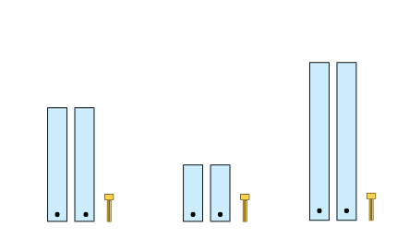

1. Students create 3 angle testers by placing same-sized strips on top of each other and fastening them with a split pin.

**Note**: keep the angle testers to use again in Lesson 7 and Lesson 8.

1. Ask students to:

* place the angle testers in order from the smallest to largest
* move the arms of their 3 angle testers to represent a quarter-turn.

1. Pose the question: If I asked you to order the angle testers from smallest to largest now, would the order change?
2. Select a student to share the order of their angle testers. Ask:

* Who agrees with this student? Who disagrees?
* Who can explain why they have or have not changed the order of their angle testers?
* Who has the same answer but a different way to explain it?

1. Students take the middle-sized arm angle tester and cut one of its arms in half, leaving the other arm the original length. Have students place the 3 angle testers in front of them in the following positions (see Figure 4):

* the long-arm angle tester forms a horizontal line
* the short-arm angle tester is opened and faces right
* the middle-sized arm angle tester is opened and faces left.

Figure 4 – angle lengths

Three angle-testers in different orientations. The first image shows an angle-tester opened out to represent a straight angle of 180°.

The second tester shows a right angle facing to the right.

The third tester shows a right angle facing to the left. The third tester has arms of different lengths.

The other 2 testers have arms of equal length.

1. Ask students: Do all the angle testers show an angle? How do you know?
2. Provide time for students to [turn and talk](https://education.nsw.gov.au/teaching-and-learning/curriculum/literacy-and-numeracy/teaching-and-learning-resources/numeracy/talk-moves). Select students to share their answers with the class, identifying and explaining where the angles are.

**Note**: this activity probes for 2 possible misconceptions. The teaching advice states that students may mistakenly judge one angle greater than another based on the arm length (NESA 2022b). Also, students may believe that right angles always open to the right.

1. Explain that right angles can often be estimated quite accurately without having to measure them. This is why other angles are compared to right angles.
2. Tell students they will test this by estimating where to place their limbs to create angles greater than or less than a right angle. Students:

* stand, move their arms, legs or neck into angles smaller than or equal to a right angle, then freeze
* wait a few seconds and then move their arms, legs or neck into angles larger than a right angle and freeze.

1. Ask: Was it challenging to estimate a right angle to create these positions? Why or why not?
2. Explain that understanding right angles is important in many areas, including sports. For example, defensive moves are usually created by closing your limbs to create angles less than a right angle. Opening your body to make larger angles greater than a right angle are the basis for offensive moves.
3. Students act out leg and arm positions for sports they play and estimate whether the angles required are about the same, greater than or less than a right angle. For example:

* making a football travel over a long distance
* dribbling a soccer ball
* pivoting in a game of netball to throw the ball
* playing handball and changing the angle of the bounce.

1. Discuss how the connection between sport and angles is used by the Olympic movement. People attending the Olympic Games do not speak one common language, so signs to sporting events need to be understood without using words. Angles are used to provide every sport with its own pictogram. People use the angles alone to identify the sport.
2. Display Resource 7 – Munich Olympics. Students use their understanding of the angles used in different sports to match the pictogram to an Olympic sport (refer to Figure 5 for the answer key).
3. Facilitate discussion with the following prompts:

* Which sports can you identify from these pictograms?
* What aspects of the sport are represented by the angles?
* Are there any sports which do not have the body represented by at least one right angle? (Weightlifting – the right angle in that pictogram is made by the barbell)
* How many different orientations of a right angle can you identify in the pictograms?
* Why do you think the graphic designer, Otl Aicher, chose right angles as the key design feature of his pictograms?

Figure 5 – labelled pictograms

In order, from left to right, the images show: 2 swimmers diving (aquatics), a single archer (archery), a single sprinter (athletics), 2 basketballers contesting (basketball), a single boxer (boxing), a single kayaker (canoe), a single cyclist (cycling), a person riding a stylized horse (equestrian), a single fencer (fencing), a single soccer player (football), a single gymnast balancing on one leg (gymnastics), a single person playing handball (handball), a single hockey player (hockey), 2 judo athletes engaging (judo), an equestrian rider jumping a hurdle represented by a 5-dice dot pattern (modern pentathlon), 2 rowers (rowing), a person on the parallel bars (sailing), 2 rifle shooters (shooting), a volleyball player spiking the ball (volleyball), a weightlifter preparing to lift (weightlifting) and 2 wrestlers engaging (wrestling).


[‘Munich 1972’](https://stillmed.olympic.org/media/Document%20Library/OlympicOrg/Factsheets-Reference-Documents/Games/Pictograms/Reference-document-The-Sports-Pictograms-of-the-OG-from-Tokyo-1964-to-Rio-2016.pdf) by Otl Aicher © 2017 International Olympic Committee.

1. Ask students to design a pictogram for the sport of their choice. They:

* create a pictogram using only intersecting straight lines and circles
* draw each of the angles in their pictogram separately and mark the arms and vertex
* label the angle as greater than, less than or equal to a right angle
* share the pictogram they created with another student and ask them to identify the sport
* discuss the reasons why the angles in the pictogram are important for that sport.

This table details opportunities for differentiation.

|  |  |
| --- | --- |
| Too hard? | Too easy? |
| Students cannot compare angles and explain that the length of the arms does not affect the size of the angle.   * Use 2 one metre rulers to represent an angle tester with very long arms. Position a cardboard angle tester on top of the rulers. Identify the angle as greater than, less than or about equal to a right angle. Turn one of the arms and identify new angles. | Students can compare angles and explain that the length of the arms does not affect the size of the angle.   * Explain that Resource 7 – Munich Olympics were a milestone in Olympic design because every pictogram was made from only 2 types of angles, right angles and angles which are equal to half a right angle. Students review the pictograms and decide if they agree only 2 types of angles were used. |

## Discuss and connect the mathematics – 10 minutes

1. Regroup and view: [Angles in soccer (1:58)](https://www.pbslearningmedia.org/resource/mmpt-math-g-anglessoccer/angles-in-soccer/). Pause the video at various timeframes and ask students to identify angles as about equal to, less than or greater than a right angle. This might include the intersection of imagined lines between 2 players or a player and the ball, or the angle of the legs of players as they kick or pass the ball.
2. In the video clip, the head coach says it’s important for players to be able to estimate the proper angles of passes and throw-ins or the best angle of a shot to beat the goalkeeper. Ask:

* Do you agree?
* How could an understanding of angles help you improve your performance in a sport you play?
* Did a focus on sport and movement help you think about angles as an amount of turn?
* How would you explain what you learned about angles to someone who was away today?

This table details opportunities for assessment.

|  |  |
| --- | --- |
| Assessment opportunities | Links |
| What to look for:   * Can students identify angles with 2 arms in practical situations? **[MAO-WM-01, MA2-GM-03]** * Can students compare angles and explain that the length of the arms does not affect the size of the angle?  **[MAO-WM-01, MA2-GM-03]** * Can students recognise and describe angles as less than, equal to, about the same as or greater than a right angle?  **[MAO-WM-01, MA2-GM-03]** | Links to [National Numeracy Learning Progressions](https://www.australiancurriculum.edu.au/resources/national-literacy-and-numeracy-learning-progressions/version-3-of-national-literacy-and-numeracy-learning-progressions/) (NNLP):   * UuM4, UuM5. |

# Lesson 5

**Core concept**: all angles can be compared to right angles.

## Daily number sense – completing a whole – 15 minutes

Daily number sense activities for Lessons 5 to 7 ‘loop’ back to concepts and procedures covered in previous units to assist students to build an increasingly connected network of ideas. These concepts may differ from the core concepts being covered by the unit.

The table below contains a suggested learning intention and success criteria. These are best co-constructed with students.

|  |  |
| --- | --- |
| Daily number sense learning intention | Daily number sense success criteria |
| Students are learning to:   * model and represent unit fractions, and their multiples, to a complete whole on a number line. | Students can:   * model fractions with fraction strips and diagrams for halves, quarters, eighths, thirds * recreate the whole unit from a fractional part. |

Key ideas for Stage 2 fractions are outlined in the syllabus teaching advice and in the professional learning module [Analysing fractions](https://myplsso.education.nsw.gov.au/mylearning/catalogue/details/4fb7d05c-0938-ee11-8456-0003ff49608c) from [My Professional Learning](https://myplsso.education.nsw.gov.au/pages/custom-pages_home?menu=home) by the NSW Department of Education.

1. Display Resource 8 – whole pencils. Explain that for each pencil, the unit fractional part is visible.
2. Provide each student with one copy of the pencils and case from Resource 8 – whole pencils.
3. To check for understanding, students draw the hidden fractional part of each pencil and identify:

* a complete whole for each pencil
* the longest and shortest pencils
* the missing fractional part for each pencil.

1. Select students to communicate their reasoning and their answers (see Figure 6).

Figure 6 – completed whole pencils

A pencil case. Poking out of the top of the case are 3 partially visible pencils.

Pencil 1 is marked as being one-third visible. 

Pencil 2 is marked as being one-quarter visible. 

Pencil 3 is marked as being one-half visible.

Students have built up from the partially visible pencils to show how long the whole pencil would be. The first pencil shows a number line of three-thirds. The second pencil shows a number line of four-quarters. The third pencil shows a number line of two-halves.

This table details opportunities for assessment.

|  |  |
| --- | --- |
| Assessment opportunities | Links |
| What to look for:   * Can students model fractions with fraction strips and diagrams for halves, quarters, eighths, thirds? **[MAO-WM-01, MA2-PF-01]** * Can students recreate the whole unit from a fractional part? **[MAO-WM-01, MA2-PF-01]** | Links to [National Numeracy Learning Progressions](https://www.australiancurriculum.edu.au/resources/national-literacy-and-numeracy-learning-progressions/version-3-of-national-literacy-and-numeracy-learning-progressions/) (NNLP):   * InF3. |

## Core lesson – square corners – 30 minutes

The table below contains suggested learning intentions and success criteria. These are best co-constructed with students.

|  |  |
| --- | --- |
| Core concept learning intentions | Core concept success criteria |
| Students are learning to:   * identify angles as measures of turn * compare angles to a right angle. | Students can:   * use the term right angle to describe a quarter-turn in a range of orientations * compare angles to a right angle using informal means. |

1. Draw 2 right angles on the board and label them ‘angle A’ and ‘angle B’. The length of the arms on both angles should be the same. Ask students if the angles are the same size.
2. Extend the arms of angle B so they are noticeably longer than the arms on angle A. Reduce the arms on angle A so they are shorter. Ask:

* Are the angles still equal? Why or why not?
* What do we call an angle made with a quarter-turn?
* How can we be sure it is exactly a quarter-turn?

1. Explain that students will make a right-angle tester. Provide half an A4 sheet to each student and have students:

* make a roughly rounded shape by ripping the corners and sides off the sheet (the shape should have a ripped perimeter edge)
* draw a dot in the centre of their paper
* fold the paper in half, then and half again to create a folded right-angle corner (see Figure 7).

Figure 7 – right-angle tester

A 3-part diagram to show how to make a right-angle tester.

Step one reads ‘Rip paper into rounded shape.’ It shows a rough circle with a dot in the middle and a dotted line across its circumference.

Step 2 reads ‘Fold in half.’ It shows an approximate semicircle with a dotted line vertically through the middle.

Step 3 reads ‘Halve again to make a right angle.’ It shows a shape that approximates the quarter of a circle with rough edges.

**Note**: the perimeter of the paper is ripped because using a precisely defined shape such as a circle or square may encourage students to identify a right angle as a quarter of the total area of the paper, rather than as a measure of turn.

1. Ask students to unfold their right-angled corner and count the number of right angles they see.
2. Remind students that a right angle is equal to a quarter-turn. By folding the paper into quarters that turn around a central point, they have made a very precise right-angle tester.
3. Students join their right-angle tester with 3 classmates to check that it is equal to a quarter-turn and that 4 quarter-turns equal one whole turn.
4. Students use their angle testers from Lesson 4 to model each of the following angles:

* a right angle
* three quarter-turns
* an angle slightly less than a right angle
* two quarter-turns
* an angle slightly greater than a right angle.

1. Students trace each angle into their workbook and check their angle estimates using their right-angle tester.
2. Provide Resource 9 – octagon. Students use their right-angle tester and different coloured pencils to identify and trace over:

* right angles
* angles greater than a right angle
* angles less than a right angle
* angles that are the same size.

This table details opportunities for differentiation.

|  |  |
| --- | --- |
| Too hard? | Too easy? |
| Students cannot use the term right angle to describe a quarter-turn in a range of orientations.   * Students make 3 more right-angle checkers and trace over the folds, so they are visible. Students intersect the vertices to visualise 4 quarter-turns as one rotation. Remind students of the term ‘right angle’ to describe the quarter-turn. | Students can use the term right angle to describe a quarter-turn in a range of orientations.   * Students design a line drawing of a piece of playground equipment utilising only straight lines and angles. The aim is to use as many angles in different orientations as possible. |

## Discuss and connect the mathematics – 10 minutes

1. Display Resource 10 – what angles measure. Tell students that when the teacher asked the question ‘What do angles measure?’, he got many different answers. Discuss the students’ answers in the resource using the following prompts:

* Angles measure the size of the vertex. (Jimmy is wrong because the vertex is the point at which the lines intersect, whereas the angle is the amount of turn between the 2 arms.)
* Angles measure the space between 2 arms. (Lydia is wrong because the amount of space between 2 arms can change depending on the length of the arms. The angle is the amount of turn or rotation between 2 arms.)
* Angles measure degrees. (Tully is wrong because degrees are the unit of measurement. Degrees can be used to measure angles, but angles do not measure degrees. For example, a length does not measure centimetres, even though centimetres can be used to measure a length.)
* Angles measure the length of the arms. (Iluka is wrong because whether the arms of a right angle are 2 km long or 2 mm long, the angle will remain a right angle. Right angles measure an amount of turn.)

**Note**: each of the displayed answers is incorrect and represents a common misconception. A correct answer would include an understanding of an angle as a measure of turn between 2 arms.

This table details opportunities for assessment.

|  |  |
| --- | --- |
| Assessment opportunities | Links |
| What to look for:   * Can students use the term right angle to describe a quarter-turn in a range of orientations? **[MAO-WM-01, MA2-GM-03]** * Can students compare angles to a right angle using informal means? **[MAO-WM-01, MA2-GM-03]** | Links to [National Numeracy Learning Progressions](https://www.australiancurriculum.edu.au/resources/national-literacy-and-numeracy-learning-progressions/version-3-of-national-literacy-and-numeracy-learning-progressions/) (NNLP):   * UuM6. |

# Lesson 6

**Core concept**: angles can be estimated and compared.

## Daily number sense – fractions of a whole – 10 minutes

The table below contains a suggested learning intention and success criteria. These are best co-constructed with students.

|  |  |
| --- | --- |
| Daily number sense learning intention | Daily number sense success criteria |
| Students are learning to:   * model and represent unit fractions, and their multiples, to a complete whole on a number line. | Students can:   * model fractions with fraction strips and diagrams for halves, quarters, eighths, thirds. |

This activity explores a common misconception about fractions referred to as the double count. When working with fractions, students using the double-count strategy can lose sight of the whole and incorrectly interpret a part-whole situation as a ratio. For more information, see [Misunderstandings](https://topdrawer.aamt.edu.au/Fractions/Misunderstandings) on the [Top Drawer Teachers](https://topdrawer.aamt.edu.au/) website by Australian Association of Mathematics Teachers (AAMT).

1. Display and read Resource 11 – fractions of a whole.
2. Identify that the correct answer is C. Select students to communicate and reason why C is correct.
3. Explain that in an assessment, many students incorrectly chose B as the answer. Students [Think-Pair-Share](https://app.education.nsw.gov.au/digital-learning-selector/LearningActivity/Card/645) to respond to:

* What misunderstanding do you think students who chose B had?
* What would you say to those students to help them?

1. Repeat the questions for responses A and D.
2. Provide student with writing materials. Ask students to draw at least 2 other fraction strips for $\frac{3}{8}$ that are different to that presented in Resource 11 – fractions of a whole.

This table details an opportunity for assessment.

|  |  |
| --- | --- |
| Assessment opportunity | Links |
| What to look for:   * Can students model fractions with fraction strips and diagrams for halves, quarters, eighths, thirds? **[MAO-WM-01, MA2-PF-01]** | Links to [National Numeracy Learning Progressions](https://www.australiancurriculum.edu.au/resources/national-literacy-and-numeracy-learning-progressions/version-3-of-national-literacy-and-numeracy-learning-progressions/) (NNLP):   * InF3. |

## Core lesson 1 – angle capture – 20 minutes

The table below contains suggested learning intentions and success criteria. These are best co-constructed with students.

|  |  |
| --- | --- |
| Core concept learning intentions | Core concept success criteria |
| Students are learning to:   * identify angles as measures of turn * compare angles to a right angle. | Students can:   * use the term right angle to describe a quarter-turn in a range of orientations * recognise and describe angles as less than, equal to, about the same as or greater than a right angle. |

This activity is an adaptation of [Polygon Capture: A Geometry Game (PDF 57 KB)](https://illuminations.nctm.org/uploadedFiles/Content/Lessons/Resources/6-8/665-AS-GameRules.pdf) from[National Council of Teachers of Mathematics (NCTM)](https://www.nctm.org/) by National Council of Teachers of Mathematics.

1. Explain that students will be playing a game called ‘Angles in shapes’. The game is played in pairs.
2. Provide each pair with a pile of transparent counters in 2 different colours, one copy of Resource 12 – shapes printed on A3 and an A4 copy of Resource 13 – cards.
3. Students cut out the cards, putting the side cards (‘S’ cards) to the side to be used in Core lesson 2.
4. Students place Resource 12 – shapes in front of them and organise the angle cards (‘A’ cards) face down into a stack.
5. Explain that each ‘A’ card provides clues about angles and the aim of the game is to capture shapes that match those angle clues.
6. Display and read aloud Resource 14 – game instructions.
7. Model the game by playing a few rounds of ‘teacher against the class’.
8. While playing the game, model using geometric language such as: angle, quarter-turn, amount of turning, arm, vertex and right angle. Encourage students to do this when they play.

This table details opportunities for differentiation.

|  |  |
| --- | --- |
| Too hard? | Too easy? |
| Students cannot use the term right angle to describe a quarter-turn in a range of orientations.   * Students play a supported version of the game with the teacher. * Students work in pairs to separate the shapes into groups based on the rule: rectangles and non-rectangles. Students use their right-angle tester to confirm that rectangles have 4 right angles. Students orient the rectangles in various ways and confirm that the angle remains a quarter of a turn. Have students identify right angles in the shape group named ‘non-rectangles’. | Students can use the term right angle to describe a quarter-turn in a range of orientations.   * Students write additional clue cards to increase the challenge of the game. * Students work in pairs, with one student separating the shapes into groups based on some rule or rules and the other student trying to deduce the rules. For example, rectangles and non-rectangles or polygons with equal sides but not equal angles. |

## Core lesson 2 – sides and angles – 20 minutes

**Note**: in Core lesson 1, students sorted cards by identifying different-sized angles in different orientations. Core lesson 2 increases in complexity by requiring students to attend to 2 geometric elements simultaneously, angles and sides, and analyse their interrelationship.

1. Introduce students to the set of side cards (‘S’ cards) in Resource 13 – cards. Revisit the vocabulary including: parallel, quadrilateral, parallelogram, opposite, length, vertex (vertices), features, orientation and side.
2. Reset to play the game again. Students organise the ‘S’ cards facedown in a stack next to the ‘A’ cards.
3. The game is played in the same way except that players will use one angle card and one side card on their turn. Only shapes that match both cards can be captured.
4. Players can challenge each other’s captures. If a shape was chosen incorrectly, the counter must be removed.
5. Introduce the ‘wild card’ if not already in play. The wild card can be included at the discretion of the teacher and acts as an extending prompt. If a player gets this card, they must make a strategic decision about both the angle and side features to capture the largest number of remaining shapes.

This table details opportunities for differentiation.

|  |  |
| --- | --- |
| Too hard? | Too easy? |
| Students cannot recognise and describe angles as less than, equal to, about the same as or greater than a right angle.   * Students use their right-angle tester or a right-angled pattern block to test the shapes. They sort them into 3 groups: less than, equal to or greater than a right angle. | Students can recognise and describe angles as less than, equal to, about the same as or greater than a right angle.   * Students design their own shapes to add to their set. They identify shapes that might be more difficult to capture, such as a kite or a hexagon. |

## Consolidation and meaningful practice – 10 minutes

1. Provide pairs of students with a piece of string. One student stretches the string out in front of them and the other student uses their finger to move the string into a right angle. Ask:

* Does your finger always need to be in the same place on the string to make a right angle?
* Can you keep your finger still and shift the string to make a right angle?
* In how many different directions can you move the string to make a right angle?
* Can you shift your finger so the angle is no longer a right angle?
* Can you make the angle larger than a right angle?
* Can you make it less than a right angle?

This table details opportunities for assessment.

|  |  |
| --- | --- |
| Assessment opportunities | Links |
| What to look for:   * Can students use the term right angle to describe a quarter-turn in a range of orientations? **[MAO-WM-01, MA2-GM-03]** * Can students recognise and describe angles as less than, equal to, about the same as or greater than a right angle? **[MAO-WM-01, MA2-GM-03]** | Links to [National Numeracy Learning Progressions](https://www.australiancurriculum.edu.au/resources/national-literacy-and-numeracy-learning-progressions/version-3-of-national-literacy-and-numeracy-learning-progressions/) (NNLP):   * UuM6. |

# Lesson 7

**Core concept**: clock hands make different angles at different times.

## Daily number sense – fractions and wholes – 15 minutes

The table below contains a suggested learning intention and success criteria. These are best co-constructed with students.

|  |  |
| --- | --- |
| Daily number sense learning intention | Daily number sense success criteria |
| Students are learning to:   * model and represent unit fractions, and their multiples, to a complete whole on a number line. | Students can:   * model fractions with fraction strips and diagrams for halves, quarters, eighths, thirds * determine the complementary fractional part needed to complete one whole. |

This activity uses resources and concepts covered in [Stage 2 Unit 16](https://education.nsw.gov.au/teaching-and-learning/curriculum/mathematics/planning-programming-and-assessing-mathematics-k-6/mathematics-3-6-units#tabs_7270186523:~:text=Unit%2016%20%E2%80%93%20Fractions%20represent%20multiple%20ideas%20and%20can%20be%20represented%20in%20different%20ways). You may already have the cards for the ‘Fractions memory game’ to complete this learning activity.

1. Display Resource 15 – 'Fractions memory'. Revise fraction complements to recreate the whole from a fractional part.
2. Review the game instructions:
3. Shuffle the cards and lay out all the cards facedown in an array formation.
4. Players take turns flipping over 2 cards at a time, aiming to find pairs of fractions to make a whole.
5. Keep the cards and take another turn if the fractions create one whole.
6. Flip the cards back over and the next player has a turn if the fractions do not create a whole.
7. The game continues until all pairs of fractions have been matched.
8. To vary the activity, each player turns one card over at the same time and either:

* the player whose card requires the largest fraction to create the whole, keeps their card
* the player whose card requires the smallest fraction to create the whole, keeps their card
* the player whose fraction card is closest in size to one-half keeps their card.

This table details opportunities for assessment.

|  |  |
| --- | --- |
| Assessment opportunities | Links |
| What to look for:   * Can students model fractions with fraction strips and diagrams for halves, quarters, eighths, thirds? **[MAO-WM-01, MA2-PF-01]** * Can students determine the complementary fractional part needed to complete one whole? **[MAO-WM-01, MA2-PF-01]** | Links to [National Numeracy Learning Progressions](https://www.australiancurriculum.edu.au/resources/national-literacy-and-numeracy-learning-progressions/version-3-of-national-literacy-and-numeracy-learning-progressions/) (NNLP):   * InF3. |

## Core lesson 1 – making time – 20 minutes

The table below contains a suggested learning intention and success criteria. These are best co-constructed with students.

|  |  |
| --- | --- |
| Core concept learning intention | Core concept success criteria |
| Students are learning to:   * read and represent analog time. | Students can:   * identify 30 minutes as being half-hour and 60 minutes as an hour * connect the quarter-hour to 15 minutes * recognise that the position of the numerals on an analog timepiece often represents 2 different values * read time as past the hour to half-past and then towards the hour. |

1. Provide students with individual copies of Resource 16 – blank clock.
2. Students [turn and talk](https://education.nsw.gov.au/teaching-and-learning/curriculum/literacy-and-numeracy/teaching-and-learning-resources/numeracy/talk-moves) to discuss missing features of the clock face.
3. Review students’ understanding of an analog clock.
4. Explain that an analog clock has several features, including a face, an hour hand and a minute hand. Some analog clocks have a third hand to represent the seconds.
5. Revise that there are 60 minutes in an hour.
6. Ask students to use halving to determine that there are 30 minutes in half an hour and 15 minutes in a quarter of an hour.
7. Students will use an angle tester from Lesson 4. The angle tester with different sized arms can represent the hour hand and minute hand best.
8. Instruct students to position the hour hand at the number one and the minute hand at the number 12. Ask:

* What time is your clock showing?
* If a quarter of an hour had to pass until sport time, what time would sport be?
* Can you represent the change in time using your clocks?
* If the lunch break started three-quarters of an hour ago, what time did it start?

1. Instruct students to change the positioning of the 2 hands so that the hour hand points at the 12 and the minute hand points at the one. Ask:

* What is the same and different about the old and new placement of the hands on your clock?
* What time is your clock showing now?
* If your clock is running half an hour fast, what would the actual time be?
* If it was running 15 minutes slow, what would the actual time be?

1. Provide students with individual copies of Resource 17 – clock records.
2. Students take turns to make different times on their clocks for a partner to read.
3. Partner A uses the angle tester to represent a time on Resource 16 – blank clocks.
4. Partner B reads the time represented and records it on Resource 17 – clock records.
5. Partner B also records the time as past the hour to half-past or towards the hour.
6. Partners then swap roles.

## Core lesson 2 – puzzled times – 20 minutes

1. Read the statement: Jack looked at the clock in his classroom and described the time to his partner as ‘The two hands on the clock make a right angle’.
2. In pairs, students use their angle tester to determine possible times on the classroom clock. Ask:

* What are some of the possible times on the classroom clock? (9 o’clock and 3 o’clock)
* Why is it not possible for the clock to be showing half-past 9? (the angle between the 2 arms will be greater than a right angle)
* Why is it not possible for the clock to reflect a time that is quarter-past or quarter-to? (the angle between the 2 arms will be less than a right angle)

**Note**: on analog clocks, there are other times where the hands are at right angles such as 1:51. However, it is not expected that students in Stage 2 identify all possibilities in this activity. Students may associate right angles as a quarter of an hour and identify 9:30 or 3:30 as possible times. It is important to identify these as incorrect responses as the hour hand and minute hands do not move independently. The hour hand rotates at a smaller measure of a turn in an hour (30°) and the minute hand rotates a larger measure of turn in an hour (360°). The [interactive clock](https://toytheater.com/clock/) may be a useful tool to demonstrate this.

1. Regroup and select students to share their responses.
2. Read the statement: The next day, Jack read the time on the clock again. This time, he described it as ‘In 30 minutes, the two hands on the clock will make a right angle’.
3. In pairs, students discuss all the possible times reflected on the classroom clock. Ask:

* What are some possible times reflected on the classroom clock? (8:30, half-past 8, 2:30 or half-past 2)
* How did you work this out?
* How many quarter-turns does it take for the minute hand to pass through 30 minutes?

1. Provide students with Resource 18 – angles on clocks.
2. Instruct students to find as many clock representations as possible to reflect a time when:

* the angle between the hour and minute hand is less than a right angle
* the angle between the hour and minute hand is greater than a right angle
* the angle between the hour and minute hand is about the same as a right angle.

This table details opportunities for differentiation.

|  |  |
| --- | --- |
| Too hard? | Too easy? |
| Students cannot connect the quarter-hour to 15 minutes.   * Teacher models and supports students to make and read quarter times and to connect quarter of an hour to 15 minutes. * Provide students with Resource 16 – blank clock. Revise with students how many minutes are in an hour and have them mark the 15-minute intervals on the clock face. Support students to fold the clock face into half and then quarters. Students mark and count the number of 5-minute intervals represented in each quarter. | Students can connect the quarter-hour to 15 minutes.   * Students use a digital device to access the activity [Two Clocks](https://nrich.maths.org/4806) by NRICH. Students record the clock faces and their reasoning. * Provide students with a copy of the poster from [Clocks](https://nrich.maths.org/1812) by NRICH. Students work out the times displayed in each clock face and check with a mirror. Students create reflections of other times for a partner to solve. |

## Discuss and connect the mathematics – 10 minutes

1. Regroup as a class and select students to share their clock representations.
2. Use the [interactive clock](https://toytheater.com/clock/) to check whether students have classified their clock representations accurately.

This table details opportunities for assessment.

|  |  |
| --- | --- |
| Assessment opportunities | Links |
| What to look for:   * Can students identify 30 minutes as being half-hour and 60 minutes as an hour? **[MAO-WM-01, MA2-NSM-02]** * Can students connect the quarter-hour to 15 minutes?  **[MAO-WM-01, MA2-NSM-02]** * Can students recognise that the position of the numerals on an analog timepiece often represents 2 different values?  **[MAO-WM-01, MA2-NSM-02]** * Can students read time as past the hour to half-past and then towards the hour? **[MAO-WM-01, MA2-NSM-02]** | Links to [National Numeracy Learning Progressions](https://www.australiancurriculum.edu.au/resources/national-literacy-and-numeracy-learning-progressions/version-3-of-national-literacy-and-numeracy-learning-progressions/) (NNLP):   * MeT2, MeT3. |

# Lesson 8

**Core concept**: five-minute intervals on analog clocks are useful for reading the time.

## Daily number sense – 10 minutes

1. From a class need surfaced through formative assessment data, identify a short, focused activity that targets students’ knowledge, understanding and skills. Example activities may be drawn from the following resources:

* [Mathematics K–6 resources](https://education.nsw.gov.au/teaching-and-learning/curriculum/mathematics/mathematics-curriculum-resources-k-12/mathematics-k-6-resources)
* [Universal Resources Hub](https://resources.education.nsw.gov.au/home).

## Core lesson – passing time – 35 minutes

The table below contains a suggested learning intention and success criteria. These are best co-constructed with students.

|  |  |
| --- | --- |
| Core concept learning intention | Core concept success criteria |
| Students are learning to:   * read and represent analog time. | Students can:   * recognise that 5-minute intervals (corresponding to the hour markers) are used as benchmarks to read time on an analog clock * recognise that the position of the numerals on an analog timepiece often represents 2 different values * read analog clocks to the minute. |

**Note**: it is recommended to use existing classroom clocks for this activity. Remove batteries prior to the lesson so that the time displayed remains the same during class discussions. If using an [interactive clock](https://toytheater.com/clock/), ensure that the digital time setting is turned off.

1. Display a physical analog clock and an [interactive clock](https://toytheater.com/clock/).
2. Students [turn and talk](https://education.nsw.gov.au/teaching-and-learning/curriculum/literacy-and-numeracy/teaching-and-learning-resources/numeracy/talk-moves) and discuss what they notice is similar and/or different.
3. Select students to share their responses.
4. Draw students’ attention to the different numbers on the clocks and ask:

* What do each of the numbers represent?
* What do each of the lines between the numbers represent?
* Is there a time where both hands on the clock overlap?

1. Students use Resource 16 – blank clock and angle testers from Lesson 4 to create 11 o’clock, 1 o’clock and 4 o’clock.
2. Ask students to identify if the angles formed by the arms are greater than, less than or equal to a right angle.
3. Display 11 o’clock using an [interactive clock](https://toytheater.com/clock/). Ask students to predict what happens when the minute hand completes a quarter-turn.
4. Model moving the minute hand and ask students to count the number of 5-minute intervals that are passed.
5. Explain that a quarter-turn is the equivalent of 15 minutes.
6. Ask students to predict what happens when another quarter-turn is completed.

* What is the new time shown on the clock after 2 quarter-turns are completed?
* How do you know that this is 30 minutes or half an hour?
* How does your understanding of fractions assist you with this knowledge? (2 quarters make a half)

1. Provide pairs of students with a 12-sided die and individual copies of Resource 16 – blank clock.
2. In pairs, students take turns to roll the die twice. The numbers rolled will indicate the number on the clock face that either the minute hand or hour hand will point towards. For example, if students land on a 3 and 5, students may choose to point their hour hand at the number 3 and the minute hand at 5or vice versa (see Figure 8).

Figure 8 – sample clock representation

Two analog clock faces using angle-testers with arms of different lengths to represent the minute and hour hands.

The first clock shows the minute hand pointing to 5 and the hour hand pointing to 3 as an approximation of 3:25.

The second clock shows the minute hand pointing to 3 and the hour hand pointing to 5 as an approximation of 5:15.

**Note**:the hour hand only points directly to the number when it is an o’clock time.

1. Students tell the time displayed on the clock face and determine the time if a quarter-turn is made using the minute hand.
2. Move around the room to check for student understanding during this activity.

This table details opportunities for differentiation.

|  |  |
| --- | --- |
| Too hard? | Too easy? |
| Students cannot recognise that the position of the numerals on an analog timepiece often represents 2 different values.   * Provide students with 2 individual copies of Resource 16 – blank clock. Support students to use one clock face to tell the time at hourly intervals and a second clock face as minutes. Assist students in writing the number of minutes next to the numbers in 5-minute intervals. | Students can recognise that the position of the numerals on an analog timepiece often represents 2 different values.   * Pose the problem: ‘A regular school day operates in 3 sessions and each session is broken up by a recess and a lunch break. Session 1 runs from 9 o’clock to 10:30, session 2 runs from 11 o’clock to 1 o’clock and session 3 runs from 1:30 to 3 o’clock. Jack read the time aloud during their recess break and said, “It is ten to”. What was the time? How do you know?’ Students write their own example of a riddle for their friends to solve. |

## Discuss and connect the mathematics – 10 minutes

1. Regroup as a class.
2. Display a time on an [interactive clock](https://toytheater.com/clock/) and have students read it. Repeat with different times, checking that students can tell the time to the minute.
3. Ask:

* When does the hour hand point directly to a number (or 5-minute interval marker)?
* If one hand on a clock was pointed at 6, what time might it be?
* If one hand on a clock was pointed at 10, what time might it be?
* How do the hour and minute hands move differently over an hour? (speed and amount of turn) Why?

This table details opportunities for assessment.

|  |  |
| --- | --- |
| Assessment opportunities | Links |
| What to look for:   * Can students recognise that 5-minute intervals (corresponding to the hour markers) are used as benchmarks to read time on an analog clock? **[MAO-WM-01, MA2-NSM-02]** * Can students recognise that the position of the numerals on an analog timepiece often represents 2 different values?  **[MAO-WM-01, MA2-NSM-02]** * Can students read analog clocks to the minute? **[MAO-WM-01, MA2-NSM-02]** | Links to [National Numeracy Learning Progressions](https://www.australiancurriculum.edu.au/resources/national-literacy-and-numeracy-learning-progressions/version-3-of-national-literacy-and-numeracy-learning-progressions/) (NNLP):   * MeT2, MeT3. |

# Resource 1 – Which is closest?

Six rectangular cards each titled ‘Which number is closest?’ 

Card 1 has the target number 4296. The multiple-choice answers provided are: a) 4290, b) 5000, c) 4300 and d) 4156.

Card 2 has the target number 9931. The multiple-choice answers provided are a) 9900, b) 9920, c) 9831 and d) 9940.

Card 3 has the target number blacked out. The multiple-choice answers provided are: a) 7000, b) 7150, c) 7100 and d) 7200.

Card 4 has the target number 200. The multiple choice answers provided are: a) 18 tens, b) 14 tens + 40, c) 30 tens − 80 and d) 9 tens plus 130.

Card 5 has the target number 6598. The multiple-choice answers provided are: a) 65 hundreds, b) 67 hundreds, c) 64 hundreds + 13 tens and d) 652 tens.

Card 6 has the target number blacked out. The multiple-choice answers provided are: a) 35 hundreds, b) 36 hundreds, c) 34 hundreds + 17 tens and d) 359 tens.

# Resource 2 – sorting shapes

A collection of 20 shapes organised in a 4 by 5 grid with dotted lines marked for cutting.

The shapes are: a triangle, a small square, a larger square presented on an angle, a rhombus, an oval, a rectangle, a shape with a right angle formed between 2 lines which are joined together by a wavy line, a parallelogram, a trapezium, a right-angled triangle, a regular hexagon, an irregular pentagon, a rectangle, a second shape formed by a right angle joined by a wavy line, an irregular octagon, a semi-circle, a curved rectangle, a regular pentagon, a circle and a second right-angled triangle.

# Resource 3 – city map

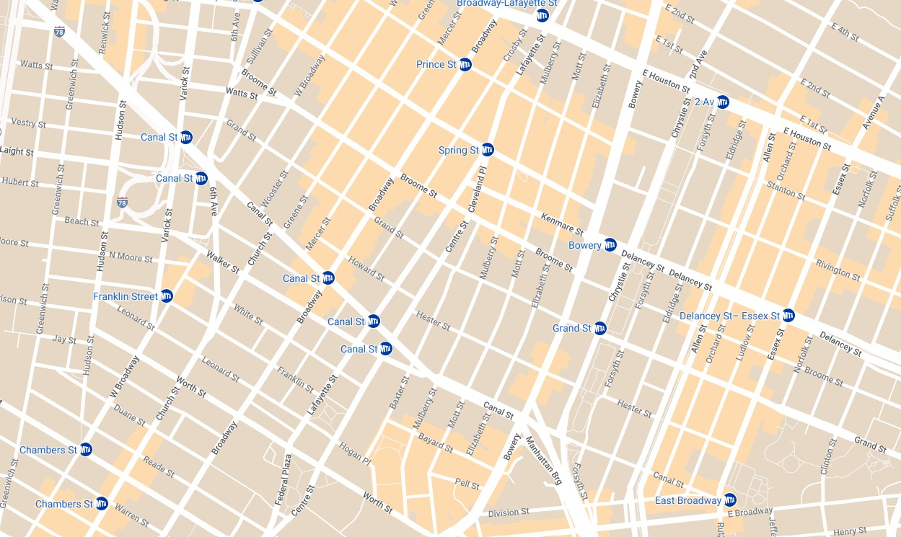

Map data by Google and INEGI.

# Resource 4 – Which flag doesn’t belong?

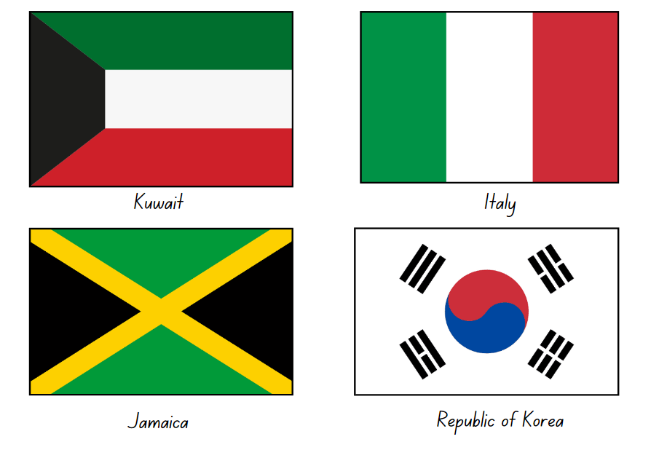

# Resource 5 – street map 1

A street map of part of a suburb showing an aerial view of streets, houses, parks and gardens. The street names are Florence Avenue, Timber Lane, Lawson Street, Citrus Road, Timber Circuit, Lemon Tree Road, Felton Lane, Sage Street, Faber Lane and Fullers Road.

There is one track marked in red that forms the shape of a rectangle.

# Resource 6 – street map 2

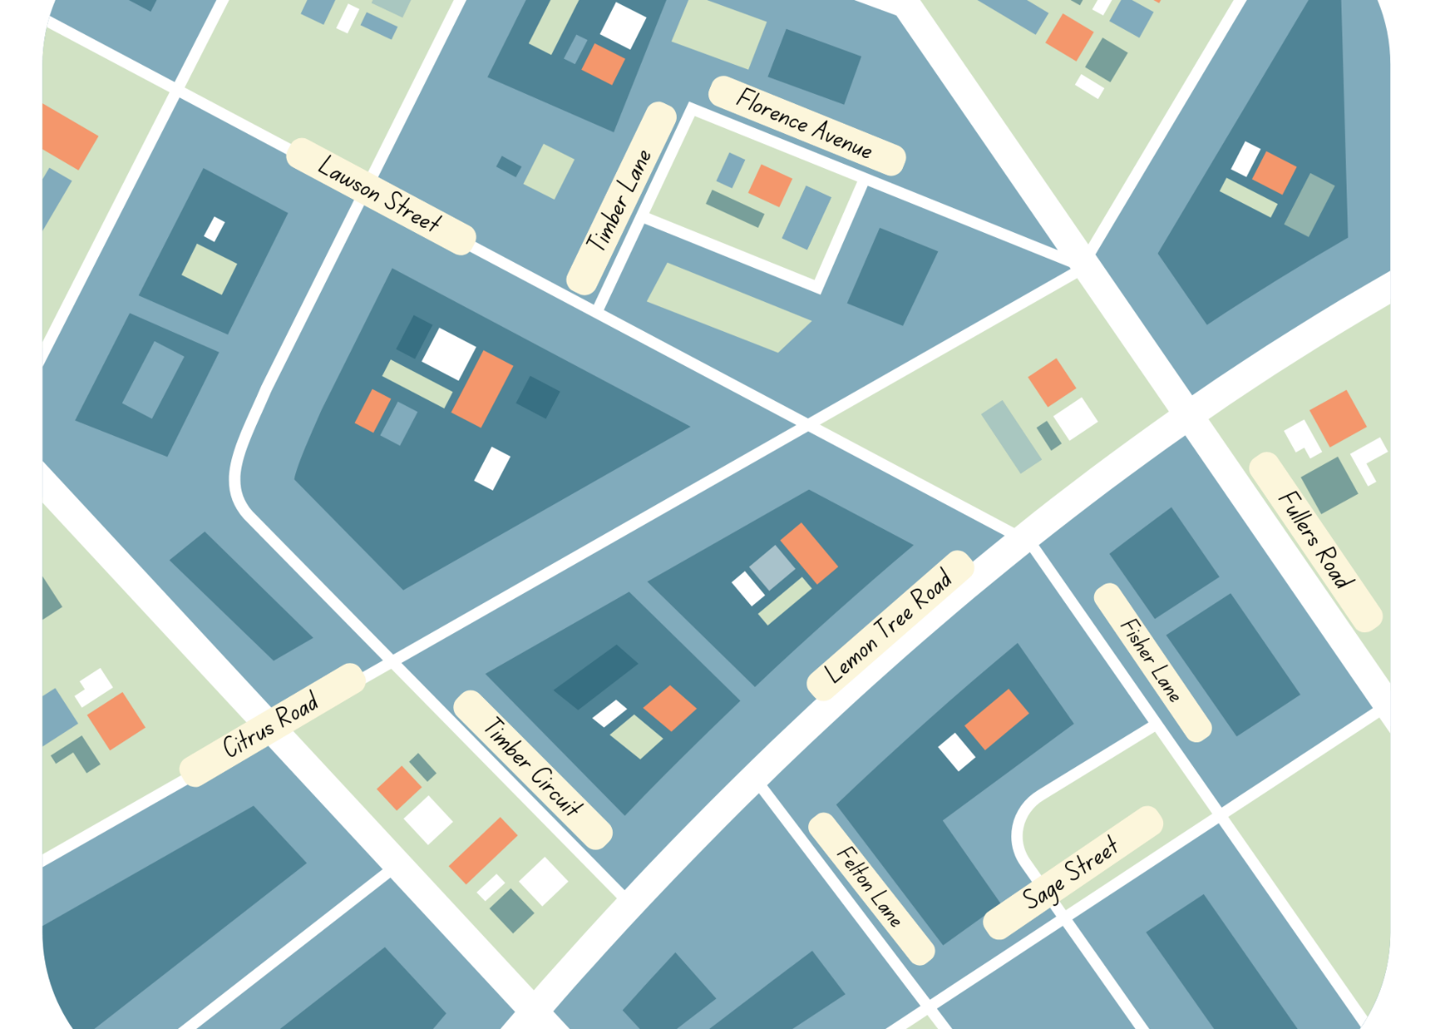

# Resource 7 – Munich Olympics

Munich 1972 Olympic pictograms. In order, from left to right, the images show: 2 swimmers diving (aquatics), a single archer (archery), a single sprinter (athletics), 2 basketballers contesting (basketball), a single boxer (boxing), a single kayaker (canoe), a single cyclist (cycling), a person riding a stylized horse (equestrian), a single fencer (fencing), a single soccer player (football), a single gymnast balancing on one leg (gymnastics), a single person playing handball (handball), a single hockey player (hockey), 2 judo athletes engaging (judo), an equestrian rider jumping a hurdle represented by a 5-dice dot pattern (modern pentathlon), 2 rowers (rowing), a person on the parallel bars (sailing), 2 rifle shooters (shooting), a volleyball player spiking the ball (volleyball), a weightlifter preparing to lift (weightlifting) and 2 wrestlers engaging (wrestling).


Adapted from ‘Munich 1972’ by Otl Aicher © 2017 International Olympic Committee.

# Resource 8 – whole pencils

Two identical pencil cases. Poking out of the top of each of the cases are 3 partially visible pencils. 

The first pencil is marked as being one-third visible. 
The second pencil is marked as being one-quarter visible. 
The third pencil is marked as being one-half visible.

# Resource 9 – octagon

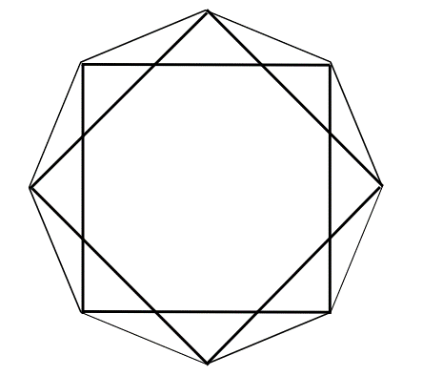

# Resource 10 – what angles measure

A teacher asking the question: What do angles measure?

Jimmy answers: Angles measure the size of the vertex.

Lydia answers: Angles measure the space between 2 arms.

Tully answers: Angles measure degrees.

Iluka answers: Angles measure the length of the arms.

The following questions appear in a prompt box:

Do you agree or disagree with any of the answers? Why? How would you answer this question?

# Resource 11 – fractions of a whole

A fraction strip in 8 parts, 3 of which are shaded blue and 5 of which are shaded orange. 

Above the strip is a question: What fraction of the strip is blue? 

Under the strip are 4 multiple-choice options. A reads ‘3’, B reads ‘3/5’, C reads ‘3/8' and D reads ‘8/3'.

# Resource 12 – shapes

A large rectangle encompasses a series of different shapes, each labelled with a letter. 

There are a number of small spaces that are not labelled and do not form part of the shapes game.

The shapes are as follows: A is a large triangle, B is a large triangle, C is a small triangle, D is a square, E is a rectangle, F is a trapezium, G is a large square, H is an irregular quadrilateral, I is a parallelogram, J is a parallelogram, K is a trapezium, L is an irregular quadrilateral, M is an irregular quadrilateral, N is a rhombus, O is a quadrilateral in the shape of a Chevron, P is a trapezium, Q is a small triangle, S is a hexagon and T is a rectangle. 

# Resource 13 – cards

|  |  |  |  |
| --- | --- | --- | --- |
| **A**  Angles are all right angles. | **A**  At least one angle is less than quarter-turn. | **A**  At least 2 angles are less than a right angle. | **A**  At least one angle is a right angle. |
| **A**  No angle is a right angle. | **A**  All angles are equal. | **A**  At least one angle is greater than a right angle. | **A**  Opposite angles are equal. |

|  |  |  |  |
| --- | --- | --- | --- |
| **S**  No pairs of sides are parallel. | **S**  All sides are equal length. | **S**  It is a quadrilateral. | **S**  Only one pair of sides is parallel. |
| **S**  All pairs of sides are parallel. | **S**  All pairs of opposite sides are equal in length. | **S**  The shape has an even number of vertices. | **Wild card**  Pick your own side AND angle feature. |

# Resource 14 – game instructions

**How to play ‘Shape Capture’**:

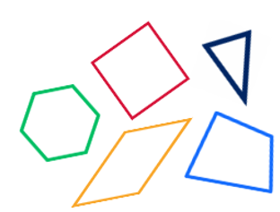

1. Player 1 turns over a card and places a counter on the matching shapes.
2. If Player 1 misses any shapes, Player 2 can capture these before turning over a new card and capturing matching shapes.
3. If no shapes can be captured, the player turns over another card. If still no shapes can be captured, the turn is over.
4. Play until 2 or fewer shapes remain. Shuffle the cards and use them again if necessary.
5. The player with the most shapes at the end of the game is the winner.

# Resource 15 – ‘Fractions memory’

Complementary fractions memory game. Twelve cards on a page, where each card displays a number line 0 to 1 and a bar model representation of the fraction. 

Fraction representations are: one-half, one-half, one-quarter, two-quarters, two-quarters, three-quarters, one-eighth, two-eighths, three-eighths, four-eights, four-eighths and five-eighths.

Complementary fractions memory game. Twelve cards on a page, where each card displays a number line 0 to 1 and a bar model representation of the fraction.

Fraction representations are: six-eighths, seven-eighths, one-third, two-thirds, one-fifth, two-fifths, three-fifths, four-fifths, one-sixth, two-sixths, three-sixths and three-sixths.

Complementary fractions memory game. Twelve cards on a page, where each card displays a number line 0 to 1 and a bar model representation of the fraction.

Fractional representations are: four-sixths, five-sixths, one-tenth, two-tenths, three-tenths, four-tenths, five-tenths, five-tenths, six-tenths, seven-tenths, eight-tenths and nine-tenths.

# Resource 16 – blank clock

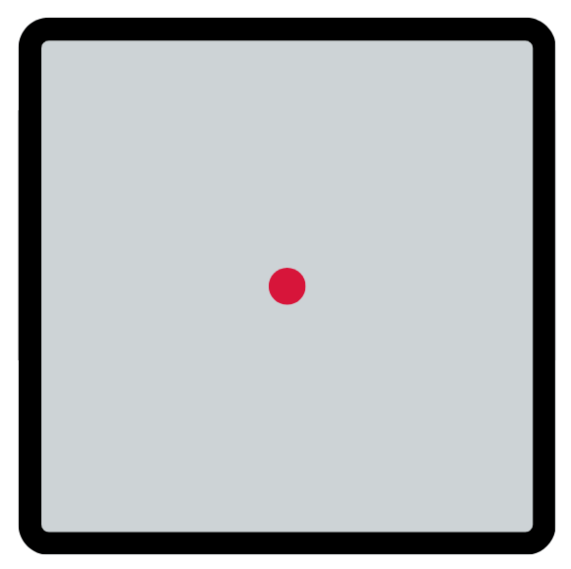

# Resource 17 – clock records

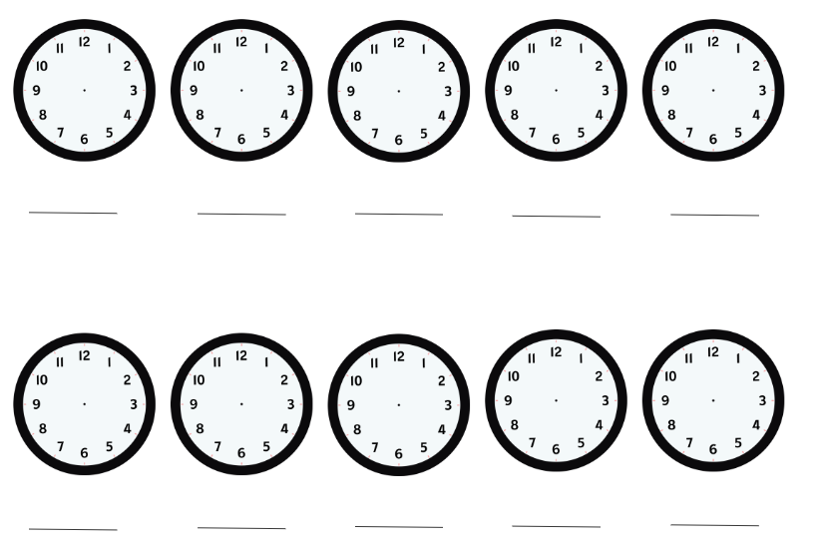

# Resource 18 – angles on clocks

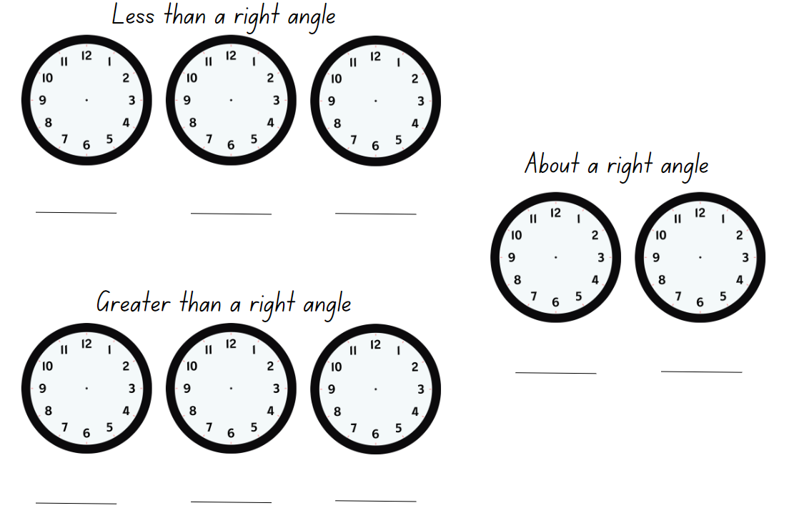

# Syllabus outcomes and content

The table below outlines the [syllabus outcomes](https://curriculum.nsw.edu.au/learning-areas/mathematics/mathematics-k-10-2022/overview) and range of relevant syllabus content covered in this unit. Content is linked to [National Numeracy Learning Progression](https://www.australiancurriculum.edu.au/resources/national-literacy-and-numeracy-learning-progressions/version-3-of-national-literacy-and-numeracy-learning-progressions/) (version 3).

|  |  |  |  |  |  |  |  |  |
| --- | --- | --- | --- | --- | --- | --- | --- | --- |
| Outcomes and content | 1 | 2 | 3 | 4 | 5 | 6 | 7 | 8 |
| **Representing numbers using place value A**: Whole numbers: Apply place value to partition and regroup numbers up to 4 digits  **MAO-WM-01, MA2-RN-01** |  |  |  |  |  |  |  |  |
| * Record numbers using standard place value form | x | x | x |  |  |  |  |  |
| * Partition numbers of up to 4 digits in non-standard forms (Reasons about quantity) | x | x | x |  |  |  |  |  |
| **Partitioned fractions A**: Model and represent unit fractions, and their multiples, to a complete whole on a number line  **MAO-WM-01, MA2-PF-01** |  |  |  |  |  |  |  |  |
| * Model fractions with fraction strips and diagrams for halves, quarters, eighths, thirds |  |  |  |  | x | x | x |  |
| * Determine the complementary fractional part needed to complete one whole (halves, quarters, eighths, thirds) (Reasons about relations) |  |  |  |  |  |  | x |  |
| * Recreate the whole unit from a fractional part ( $\frac{1}{2}, \frac{1}{4}, \frac{1}{3} and$ $\frac{1}{8}$) (Reversible reasoning) |  |  |  |  | x |  |  |  |
| **Geometric measure A**: Angles: Identify angles as measures of turn  **MAO-WM-01, MA2-GM-03** |  |  |  |  |  |  |  |  |
| * Identify angles with 2 arms in practical situations |  |  | x | x |  |  |  |  |
| * Recognise an angle as the amount of turning between 2 arms |  |  | x | x |  |  |  |  |
| * Compare angles and explain that the length of the arms does not affect the size of the angle (Reasons about spatial relations) |  |  |  | x |  |  |  |  |
| * Use the term right angle to describe quarter-turn in a range of orientations (Reasons about spatial orientation) |  |  |  |  | x | x |  |  |
| **Geometric measure B**: Angles: Compare angles to a right angle  **MAO-WM-01, MA2-GM-03** |  |  |  |  |  |  |  |  |
| * Compare angles to a right angle using an informal means |  |  |  |  | x |  |  |  |
| * Recognise and describe angles as less than, equal to, about the same as or greater than a right angle |  |  |  | x |  | x |  |  |
| **Two-dimensional spatial structure A**: 2D shapes: Compare and describe features of two-dimensional shapes  **MAO-WM-01, MA2-2DS-01** |  |  |  |  |  |  |  |  |
| * Identify and describe polygons that have parallel sides and those that do not | x | x |  |  |  |  |  |  |
| * Identify quadrilaterals that have all sides equal in length | x | x |  |  |  |  |  |  |
| * Group quadrilaterals using one or more attributes | x | x |  |  |  |  |  |  |
| **Non-spatial measure A**: Time: Represent and read analog time  **MAO-WM-01, MA2-NSM-02** |  |  |  |  |  |  |  |  |
| * Identify 30 minutes as being a half-hour and 60 minutes as an hour |  |  |  |  |  |  | x |  |
| * Connect the quarter-hour to 15 minutes |  |  |  |  |  |  | x |  |
| * Recognise that the position of the numerals on an analog timepiece often represents 2 different values |  |  |  |  |  |  | x | x |
| * Recognise that 5-minute intervals (corresponding to the hour markers) are used as benchmarks to read time on an analog clock |  |  |  |  |  |  |  | x |
| * Read time as past the hour to half-past and then towards the hour |  |  |  |  |  |  | x |  |
| * Read analog clocks to the minute |  |  |  |  |  |  |  | x |

[Mathematics K–10 Syllabus](https://curriculum.nsw.edu.au/learning-areas/mathematics/mathematics-k-10-2022/overview) © NSW Education Standards Authority (NESA) for and on behalf of the Crown in right of the State of New South Wales, 2022.

# References

This resource contains NSW Curriculum and syllabus content. The NSW Curriculum is developed by the NSW Education Standards Authority. This content is prepared by NESA for and on behalf of the Crown in right of the State of New South Wales. The material is protected by Crown copyright.

Please refer to the NESA Copyright Disclaimer for more information <https://educationstandards.nsw.edu.au/wps/portal/nesa/mini-footer/copyright>.

NESA holds the only official and up-to-date versions of the NSW Curriculum and syllabus documents. Please visit the NSW Education Standards Authority (NESA) website <https://educationstandards.nsw.edu.au> and the NSW Curriculum website [https://curriculum.nsw.edu.au](https://curriculum.nsw.edu.au/).

[Mathematics K–10 Syllabus](https://curriculum.nsw.edu.au/learning-areas/mathematics/mathematics-k-10-2022/overview) © NSW Education Standards Authority (NESA) for and on behalf of the Crown in right of the State of New South Wales, 2022.

[National Numeracy Learning Progression](https://www.australiancurriculum.edu.au/resources/national-literacy-and-numeracy-learning-progressions/version-3-of-national-literacy-and-numeracy-learning-progressions/) © Australian Curriculum, Assessment and Reporting Authority (ACARA) 2010 to present, unless otherwise indicated. This material was downloaded from the [Australian Curriculum](http://www.australiancurriculum.edu.au/) website (National Numeracy Learning Progression) (accessed 15 May 2024) and was not modified.

AAMT (Australian Association of Mathematics Teachers) (n.d.) ‘[Misunderstandings](https://topdrawer.aamt.edu.au/Fractions/Misunderstandings)’, Fractions, Top Drawer Teachers website, accessed 15 May 2024.

Harris P (2024) [*As Close As It Gets*](https://www.mathisfigureoutable.com/ascloseasitgets), Math is Figure-Out-Able! website, accessed 4 July 2024.

Harris P (2024) [*Math is Figure-Out-Able!*](https://www.mathisfigureoutable.com/) [website], accessed 4 July 2024.

International Olympic Committee (2017)[*The Sports Pictograms of the Olympic Summer Games from Tokyo 1964 to Rio 2016* [PDF 4.98 MB]](https://stillmed.olympic.org/media/Document%20Library/OlympicOrg/Factsheets-Reference-Documents/Games/Pictograms/Reference-document-The-Sports-Pictograms-of-the-OG-from-Tokyo-1964-to-Rio-2016.pdf), The Olympic Studies Centre, International Olympic Committee, accessed 23 May 2024.

NCTM (National Council of Teachers of Mathematics) (n.d.) [*National Council of Teachers of Mathematics*](https://www.nctm.org/) [website], accessed 4 July 2024.

NCTM (2008) [*Polygon Capture: A Geometry Game* [PDF 57 KB]](https://illuminations.nctm.org/uploadedFiles/Content/Lessons/Resources/6-8/665-AS-GameRules.pdf), NCTM, accessed 9 May 2024.

NESA (NSW Education Standards Authority) (2022a) ‘[Stage 2 – Teaching advice for Two-dimensional spatial structure A: Language](https://curriculum.nsw.edu.au/learning-areas/mathematics/mathematics-k-10-2022/content/stage-2/fae82874e2?show=advice)’, Mathematics K–10 Syllabus: Content, NESA website, accessed 8 August 2024.

NESA (2022b) ‘[Stage 2 – Teaching advice for Geometric measure A: Misconceptions with angles](https://curriculum.nsw.edu.au/learning-areas/mathematics/mathematics-k-10-2022/content/stage-2/fae82874e2?show=advice)’, Mathematics K–10 Syllabus: Content, NESA website, accessed 8 August 2024.

Robichaux RR and Rodrigue PR (2010) ‘Polygon properties: What is possible?’, *Teaching Children Mathematics*, 16(9):524–531, doi:10.5951/TCM.16.9.0514, accessed 19 June 2024.

State of New South Wales (Department of Education) (2024) ‘[Analysing fractions](https://myplsso.education.nsw.gov.au/mylearning/catalogue/details/4fb7d05c-0938-ee11-8456-0003ff49608c)’, Mathematics 3–6, My Professional Learning website, accessed 15 May 2024.

State of New South Wales (Department of Education) (2024) ‘[The role of place value](https://myplsso.education.nsw.gov.au/mylearning/catalogue/details/4fb7d05c-0938-ee11-8456-0003ff49608c)’, Mathematics 3-6, My Professional Learning website, accessed 15 May 2024.

Thinkport Maryland Public Television and Great Blue Hill (WGBH) Educational Foundation (n.d.) ['Angles in Soccer | Thinkport' [video]](https://www.pbslearningmedia.org/resource/mmpt-math-g-anglessoccer/angles-in-soccer/), PBS LearningMedia, PBS LearningMedia website, accessed 27 May 2024.

Toy Theater (2024) ‘[Interactive clock | Telling Time](https://toytheater.com/clock/)’, Time Manipulatives, Toy Theater website, accessed 19 May 2024.

University of Cambridge (n.d.a) [*Clocks*](https://nrich.maths.org/1812), NRICH website, accessed 19 June 2024.

University of Cambridge (n.d.b) [*Two Clocks*](https://nrich.maths.org/4806), NRICH website, accessed 19 June 2024.

**© State of New South Wales (Department of Education), 2024**

The copyright material published in this resource is subject to the Copyright Act 1968 (Cth) and is owned by the NSW Department of Education or, where indicated, by a party other than the NSW Department of Education (third-party material).

Copyright material available in this resource and owned by the NSW Department of Education is licensed under a [Creative Commons Attribution 4.0 International (CC BY 4.0) license](https://creativecommons.org/licenses/by/4.0/).

[](https://creativecommons.org/licenses/by/4.0/)

This license allows you to share and adapt the material for any purpose, even commercially.

Attribution should be given to © State of New South Wales (Department of Education), 2024.

Material in this resource not available under a Creative Commons license:

* the NSW Department of Education logo, other logos and trademark-protected material
* material owned by a third party that has been reproduced with permission. You will need to obtain permission from the third party to reuse its material.

**Links to third-party material and websites**

Please note that the provided (reading/viewing material/list/links/texts) are a suggestion only and implies no endorsement, by the New South Wales Department of Education, of any author, publisher, or book title. School principals and teachers are best placed to assess the suitability of resources that would complement the curriculum and reflect the needs and interests of their students.

If you use the links provided in this document to access a third-party's website, you acknowledge that the terms of use, including licence terms set out on the third-party's website apply to the use which may be made of the materials on that third-party website or where permitted by the Copyright Act 1968 (Cth). The department accepts no responsibility for content on third-party websites.