Mathematics Stage 2 – Unit 20

Our number system extends infinitely to very large and very small numbers

Contents

Unit description and duration 5

Syllabus outcomes 5

Working mathematically 6

Student prior learning 6

Lesson overview and resources 8

Lesson 1 14

Daily number sense – King’s tax – 15 minutes 14

Core lesson 1 – treasure map – 20 minutes 16

Core lesson 2 – creating a map – 20 minutes 19

Consolidation and meaningful practice – 15 minutes 21

Lesson 2 23

Daily number sense – dice addition – 10 minutes 23

Core lesson – super summer sale – 40 minutes 25

Discuss and connect the mathematics – 10 minutes 27

Lesson 3 30

Daily number sense – dice difference – 10 minutes 30

Core lesson 1 – 10, 100, 1000 times as large – 20 minutes 32

Core lesson 2 – ‘Epic money’ game – 20 minutes 36

Consolidation and meaningful practice – 20 minutes 39

Lesson 4 42

Daily number sense – 10 minutes 42

Core lesson 1 – revising strategies – 15 minutes 42

Core lesson 2 – ‘Closest to 100’ – 25 minutes 45

Discuss and connect the mathematics – 10 minutes 47

Lesson 5 49

Daily number sense – ‘Hit it 9999’ – 15 minutes 49

Core lesson 1 – associative property of addition – 15 minutes 51

Core lesson 2 – equivalent equations – 30 minutes 53

Discuss and connect the mathematics – 10 minutes 56

Lesson 6 57

Daily number sense – ‘Mastermind’ – 10 minutes 57

Core lesson 1 – complement principle – 15 minutes 59

Core lesson 2 – addition and subtraction dominoes – 30 minutes 61

Discuss and connect the mathematics – 10 minutes 62

Lesson 7 64

Daily number sense – place value game – 15 minutes 64

Core lesson 1 – arrays – if I know this then I know ... – 30 minutes 66

Core lesson 2 – missing values – 15 minutes 69

Consolidation and meaningful practice – 10 minutes 71

Lesson 8 73

Daily number sense – 10 minutes 73

Core lesson – multiplication and division fact families – 45 minutes 73

Discuss and connect the mathematics – 5 minutes 75

Resource 1 – treasure map 77

Resource 2 – landmarks 78

Resource 3 – create a map 79

Resource 4 – dollars and cents 80

Resource 5 – super summer sale 81

Resource 6 – money problems 82

Resource 7 – place value visual 83

Resource 8 – place value houses 84

Resource 9 – spinners 85

Resource 10 – cards 86

Resource 11 – ‘Epic money’ game 87

Resource 12 – partitioning $473 88

Resource 13 – additive strategies poster 89

Resource 14 – number sentence board 90

Resource 15 – True or false? 91

Resource 16 – complement principle 92

Resource 17 – dominoes 93

Resource 18 – adapted dominoes 94

Resource 19 – blank dominoes 95

Resource 20 – place value game 96

Resource 21 – array cards 97

Resource 22 – 3 arrays 98

Resource 23 – Creature Cards problem 99

Resource 24 – recording grid 100

Syllabus outcomes and content 102

References 107

# Unit description and duration

This unit develops the big idea that our number system extends infinitely to very large and very small numbers.

In this 2-week unit students are provided opportunities to:

* represent and partition numbers using place value
* select strategies to efficiently solve problems in addition, subtraction, multiplication and division
* create a simple map and mark locations using the structure of a grid.

## Syllabus outcomes

* **MAO-WM-01** develops understanding and fluency in mathematics through exploring and connecting mathematical concepts, choosing and applying mathematical techniques to solve problems, and communicating their thinking and reasoning coherently and clearly
* **MA2-RN-01** applies an understanding of place value and the role of zero to represent numbers to at least tens of thousands
* **MA2-AR-01** selects and uses mental and written strategies for addition and subtraction involving 2- and 3-digit numbers
* **MA2-AR-02** completes number sentences involving addition and subtraction by finding missing values
* **MA2-MR-01** represents and uses the structure of multiplicative relations to 10 × 10 to solve problems
* **MA2-MR-02** completes number sentences involving multiplication and division by finding missing values
* **MA2-GM-01** uses grid maps and directional language to locate positions and follow routes

## Working mathematically

In the Mathematics K–10 Syllabus, there is one overarching Working mathematically outcome (**MAO-WM-01**). The Working mathematically processes should be embedded within the concepts being taught. The Working mathematically processes present in the Mathematics K–10 Syllabus are:

* communicating
* understanding and fluency
* reasoning
* problem solving.

[Mathematics K–10 Syllabus](https://curriculum.nsw.edu.au/learning-areas/mathematics/mathematics-k-10-2022/overview) © NSW Education Standards Authority (NESA) for and on behalf of the Crown in right of the State of New South Wales, 2022.

## Student prior learning

Before engaging in these teaching and learning activities, students would benefit from prior experience with:

* partitioning, rearranging and regrouping numbers
* solving problems using written and mental addition and subtraction calculations, and multiplication and division facts, including representing equivalent amounts of money
* interpret simple maps by identifying objects in different locations.

In NSW classrooms there is a diverse range of students, including Aboriginal and/or Torres Strait Islander students, students learning English as an additional language or dialect, high potential and gifted students, and students with disability. Some students may identify with more than one of these groups or possibly all of them. Refer to [Curriculum planning for every student – advice](https://education.nsw.gov.au/teaching-and-learning/curriculum/planning-programming-and-assessing-k-12/advice-on-curriculum-planning-for-every-student-k-12) for further information.

# Lesson overview and resources

The table below outlines the sequence and approximate timing of lessons, learning intentions and resources.

|  |  |  |
| --- | --- | --- |
| Lesson | Content | Duration and resources |
| **Lesson 1**  **Daily number sense learning intention**:   * select strategies flexibly to solve addition and subtraction problems of up to 3 digits | **Lesson core concept**: map locations can be identified by using grid references.  **Core concept learning intentions**:   * locate positions on grid maps * create and interpret grid maps | **Lesson duration**: 70 minutes   * Resource 1 – treasure map * Resource 2 – landmarks * Resource 3 – create a map * Counters * Digital devices * Grid paper or grid book * Individual whiteboards * Playing cards or an [[online card generator](https://toytheater.com/playing-cards/)](https://www.random-ize.com/cards/1.php) * Scissors and glue * Writing materials |
| **Lesson 2**  **Daily number sense learning intention**:   * select strategies flexibly to solve addition and subtraction problems of up to 3 digits | **Lesson core concept**: money values can be represented in different ways.  **Core concept learning intention**:   * represent money values in multiple ways | **Lesson duration:** 60 minutes   * Resource 4 – dollars and cents * Resource 5 – super summer sale * Resource 6 – money problems * 9-sided dice * Individual whiteboards * Play money (notes or coins) * Writing materials |
| **Lesson 3**  **Daily number sense learning intentions**:   * select strategies flexibly to solve addition and subtraction problems of up to 3 digits | **Lesson core concept**: numbers can be renamed in equivalent ways using place value.  **Core concept learning intentions**:   * apply place value to partition and regroup numbers up to 4 digits * recognise and represent numbers that are 10, 100 or 1000 times as large | **Lesson duration:** 70 minutes   * Resource 7 – place value visual * Resource 8 – place value house * Resource 9 – spinners * Resource 10 – cards * Resource 11 – ‘Epic money’ game * Resource 12 – partitioning $473 * Website: [Super Spinner](http://www.superteachertools.com/spinner/spinner.php?title=Super+Spinner&directions=Click+the+wheel+below+to+spin%3A&colorscheme=color1&labels=100%2C10%2C1000%2C10%2C100%2C1000%2C10%2C100%2C1000%2C10) * Individual whiteboards * 9-sided dice * MAB materials * Writing materials |
| **Lesson 4**  **Daily number sense learning intention**:   * teacher-identified task based on student needs | **Lesson core concept**: numbers can be built up or taken apart in a variety of ways to make the numbers easier to work with.  **Core concept learning intention**:   * select strategies flexibly to solve addition and subtraction problems of up to 3 digits | **Lesson duration**: 60 minutes   * Resource 13 – additive strategies poster * Individual whiteboards * Playing cards * Writing materials |
| **Lesson 5**  **Daily number sense learning intention**:   * read, represent and order numbers to thousands | **Lesson core concept**: the equals sign identifies a relationship in mathematics.  **Core concept learning intention**:   * use the principle of equality | **Lesson duration**: 70 minutes   * Resource 14 – number sentence board * Resource 15 – True or false? * 9-sided dice * Individual whiteboards * Playing cards * Writing materials |
| **Lesson 6**  **Daily number sense learning intention**:   * read, represent and order numbers to thousands | **Lesson core concept**: addition and subtraction are connected.  **Core concept learning intention**:   * recognise and explain the connection between addition and subtraction * select strategies flexibly to solve addition and subtraction problems of up to 3 digits. | **Lesson duration**: 65 minutes   * Resource 13 – additive strategies poster * Resource 16 – complement principle * Resource 17 – dominoes * Resource 18 – adapted dominoes * Resource 19 – blank dominoes * Individual whiteboards * MAB materials * Sticky notes * Writing materials |
| **Lesson 7**  **Daily number sense learning intention**:   * read, represent and order numbers to thousands | **Lesson core concept**: multiplication and division are related.  **Core concept learning intention**:   * recall multiplication facts of 2 and 4, 5 and 10 and related division facts | **Lesson duration**: 70 minutes   * Resource 20 – place value game * Resource 21 – array cards * Resource 22 – 3 arrays * 6-sided dice * 9-sided dice * Individual whiteboard and markers * Writing materials |
| **Lesson 8**  **Daily number sense learning intention**:   * teacher-identified task based on student needs | **Lesson core concept**: number properties can be used to solve multiplication problems.  **Core concept learning intentions**:   * recall multiplication facts of 2 and 4, 5 and 10 and related division facts * use number properties to find related multiplication facts | **Lesson duration**: 60 minutes   * Resource 23 – Creature Cards problem * Resource 24 – recording grid * Individual whiteboards * Writing materials |

# Lesson 1

**Core concept**: map locations can be identified by using grid references.

## Daily number sense – King’s tax – 15 minutes

Daily number sense activities for Lessons 1 to 3 ‘activate’ prior number knowledge and support the learning of new content in the unit. These activities can also assist teachers to identify the starting points for learning by revealing the extent of students’ existing knowledge.

The table below contains a suggested learning intention and success criteria. These are best co-constructed with students.

|  |  |
| --- | --- |
| Daily number sense learning intention | Daily number sense success criteria |
| Students are learning to:   * select strategies flexibly to solve addition and subtraction problems of up to 3 digits. | Students can:   * apply known mental strategies to add. |

This activity is an adaptation of ‘[Unpacking game mechanics: Five types of whole-class mathematical games: King’s Tax](https://www.researchgate.net/publication/378964831_Unpacking_game_mechanics_Five_types_of_whole-class_mathematical_games)’ from Australian Primary Mathematics Classroom by Russo and Russo.

**Note**: the game is to be played as a whole class. You may choose to use a deck of cards or an [online card generator](https://toytheater.com/playing-cards/).

1. Provide students with individual whiteboards and ask them to stand up to start the game.
2. One card is drawn from the pack. This is the amount of money that has been earned. For example, if a 5 is turned over, the class has earned $5.
3. After each turn, students choose whether they will ‘bank’ their money (by sitting down and recording their amount on their whiteboard) or whether to play on. The players who stay in, continue to add to their money.
4. The following rules apply:
5. If a Jack is turned over, the players receive $15.
6. If a Queen is turned over, the amount is doubled for that round (For example, if 6 is turned over, the players receive $12).
7. If a King is turned over, he collects his taxes. Anyone who is still standing loses their money for that round.
8. A round ends after the King collects his taxes or if nobody is left standing.
9. After 4 rounds, students add up the amount they have banked. The winner is the student with the most money in their bank.
10. Ask students:

* What strategy did you use to add your money?
* Did you use the same strategy each time? Why or why not?
* Was one strategy more efficient than another one you tried?

This table details an opportunity for assessment.

|  |  |
| --- | --- |
| Assessment opportunity | Links |
| What to look for:   * Can students apply known mental strategies to add? **[MAO-WM-01, MA2-AR-01]** | Links to [National Numeracy Learning Progressions](https://www.australiancurriculum.edu.au/resources/national-literacy-and-numeracy-learning-progressions/version-3-of-national-literacy-and-numeracy-learning-progressions/) (NNLP):   * AdS7.   Links to suggested [Interview for Student Reasoning](https://education.nsw.gov.au/teaching-and-learning/curriculum/literacy-and-numeracy/assessment-resources/ifsr) (IfSR) tasks:   * IfSR-AT: 3A.1, 3A.2, 3A.3. |

## Core lesson 1 – treasure map – 20 minutes

The table below contains suggested learning intentions and success criteria. These are best co-constructed with students.

|  |  |
| --- | --- |
| Core concept learning intentions | Core concept success criteria |
| Students are learning to:   * locate positions on grid maps * create and interpret grid maps. | Students can:   * use the array (row and column) structure of grid maps to locate position, horizontal before vertical * create simple maps and plans from an aerial view, labelling grid references * identify and mark locations on maps and plans, given their grid references. |

This activity is an adaptation of ‘Treasure Island’ from Engaging maths: 25 Favourite lessons by Clarke and Roche.

**Note**: there is an option for students to complete the activities in this lesson digitally. Teachers can choose whether to print the resources or allow students to complete the activities on a laptop or digital device.

1. Display Resource 1 – treasure map. Ask:

* What landmarks can you see on the treasure map?
* What view of the map is shown?
* Which directions are indicated horizontally?
* Which directions are indicated vertically?
* How do we locate landmarks on a map using grid references?

1. Explain that when using grid-reference systems, such as those found on maps, the horizontal component of direction is named first, followed by the vertical component.

**Grid references** locate a unique square region on a map rather than a single point.

1. Identify landmarks on the map and model finding the location of the swamp and rocky mound using grid references. Discuss landmarks that cross over multiple grid references such as the mountains and the river.
2. Ask the following questions:

* What position on the map is the rowboat?
* Which landmark is at grid reference G5?
* What position on the map is Black Bay?

1. Provide students with Resource 1 – treasure map and Resource 2 – landmarks.
2. Students cut out the landmarks and paste them onto the treasure map at the given location.
3. Students compare their maps with a partner or small group.

## Core lesson 2 – creating a map – 20 minutes

1. Provide students with Resource 3 – create a map.
2. Using Resource 3 – create a map, students begin by labelling the horizontal axis with letters and the vertical axis with numbers.

**Note**: students may use any grid paper (or a grid book) and rule the horizontal and vertical axis themselves.

1. Explain to students they are going to create their own treasure map. They must:
2. draw an outline of an island from an aerial view
3. mark 8 landmarks on the map
4. record the landmarks’ grid references in the table
5. mark an ‘X’ where buried treasure is hidden.
6. Students work independently to create their map (see Figure 1).

Figure 1 – map example

A map of a treasure island. There is a grid overlaying the island. The horizontal line has letters from A to K and the vertical line has numbers from 1 to 11.

Grid references are as follows: message in a bottle at B6, a palm tree at D9, a shipwreck at C1, a mountain at E3, an X marks the spot at F9, a lake at G5, a crab at I8, a hut at I4 and a whale at J1.

To the right of the map is a 2 by 8 table containing images and their grid references. These match the references on the map.

This table details opportunities for differentiation.

|  |  |
| --- | --- |
| Too hard? | Too easy? |
| Students cannot identify and mark locations on maps and plans, given their grid references.   * Encourage students to use rulers to cross reference the row and column of the grid, supporting them to mark the landmarks at their given location. * Reduce the number of landmarks for the students to locate and/or mark on the treasure map. | Students can identify and mark locations on maps and plans, given their grid references.   * Students choose a landmark on their treasure map and describe a route to another location on their map using directional language and grid references. * Students engage with the interactive activity [Treasure Hunt](https://nrich.maths.org/problems/treasure-hunt) from [NRICH](https://nrich.maths.org/). Challenge students to use coordinates to identify the location of treasure, with the minimum number of guesses possible. |

## Consolidation and meaningful practice – 15 minutes

1. Students form pairs, ensuring they join with someone who has not seen their treasure map.
2. Explain they are going to play a barrier game. They need to find the hidden treasure on their partner’s map.
3. Students sit facing each other with a barrier between them, concealing their treasure map. Provide counters.
4. Students take turns calling out a grid reference.
5. Students mark the ‘searched' location on their own map with a counter.
6. The game continues until the location of the buried treasure is identified on one of the treasure maps.

This table details opportunities for assessment.

|  |  |
| --- | --- |
| Assessment opportunities | Links |
| What to look for:   * **Can students use the array (row and column) structure of grid maps to locate position, horizontal before vertical? [MAO-WM-01, MA2-GM-01]** * Can students create simple maps and plans from an aerial view, labelling grid references? **[MAO-WM-01, MA2-GM-01]** * Can students identify and mark locations on maps and plans, given their grid references? **[MAO-WM-01, MA2-GM-01]** | Links to [National Numeracy Learning Progressions](https://www.australiancurriculum.edu.au/resources/national-literacy-and-numeracy-learning-progressions/version-3-of-national-literacy-and-numeracy-learning-progressions/) (NNLP):   * PoL5. |

# Lesson 2

## Daily number sense – dice addition – 10 minutes

**Core concept**: money values can be represented in different ways.

The table below contains a suggested learning intention and success criteria. These are best co-constructed with students.

|  |  |
| --- | --- |
| Daily number sense learning intention | Daily number sense success criteria |
| Students are learning to:   * select strategies flexibly to solve addition and subtraction problems of up to 3 digits. | Students can:   * apply known mental strategies to add * represent solutions to addition problems, including word problems, using an empty number line or bar model. |

1. Revise mental strategies to add 2 numbers together, including bridging the decades.
2. Provide each student with an individual whiteboard and ask them to draw an empty number line and a bar model (see Figure 2).

Figure 2 – empty number line and bar model

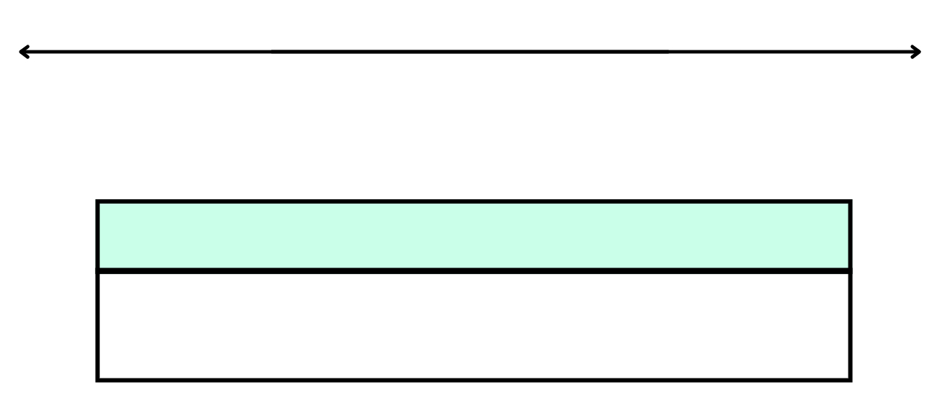

1. Working in pairs, students roll 3 dice.
2. Students use the numbers rolled to form two 3-digit numbers, for example, 264 and 426.
3. The aim is to use mental strategies to calculate the sum of the 2 numbers. Students then represent their solution using a bar model or number line (see Figure 3).

Figure 3 – dice addition example

Number line with the numbers 426, 430, 630, 690. There is a +4 jump from 426 to 430, a +200 jump from 430 to 630 and a +60 jump from 630 to 690.

The bar model below has 690 in the top and 426 and 264 split in the bottom.

1. Ask the following questions:

* Which strategy did you use? Explain why.
* Can you explain your representation to a partner?

1. Students roll the dice again and repeat the activity

This table details opportunities for assessment.

|  |  |
| --- | --- |
| Assessment opportunities | Links |
| What to look for:   * Can students apply known mental strategies to add? **[MAO-WM-01, MA2-AR-01]** * Can students represent solutions to addition problems, including word problems, using an empty number line or bar model? **[MAO-WM-01, MA2-AR-01]** | Links to [National Numeracy Learning Progressions](https://www.australiancurriculum.edu.au/resources/national-literacy-and-numeracy-learning-progressions/version-3-of-national-literacy-and-numeracy-learning-progressions/) (NNLP):   * AdS6, AdS7.   Links to suggested [Interview for Student Reasoning](https://education.nsw.gov.au/teaching-and-learning/curriculum/literacy-and-numeracy/assessment-resources/ifsr) (IfSR) tasks:   * IfSR-AT: 3A.3. |

## Core lesson – super summer sale – 40 minutes

The table below contains a suggested learning intention and success criteria. These are best co-constructed with students.

|  |  |
| --- | --- |
| Core concept learning intention | Core concept success criteria |
| Students are learning to:   * represent money values in multiple ways. | Students can:   * recognise the relationship between dollars and cents * represent equivalent amounts of money using different denominations * perform calculations with money, including finding change. |

1. Display Resource 4 – dollars and cents.
2. Highlight the coins in each piggy bank and the statements made by Zac and Gigi.
3. Students [turn and talk](https://education.nsw.gov.au/teaching-and-learning/curriculum/literacy-and-numeracy/teaching-and-learning-resources/numeracy/talk-moves) to determine who has more money.
4. Ask pairs to share their reasoning with the class.
5. Explain to students that Zac and Gigi’s statements may be true in other circumstances, but in this example, the amounts are equivalent.
6. Provide students with individual whiteboards. Ask them to divide the whiteboard in half vertically, and to label one side with ‘Zac’ and the other side with ‘Gigi’.
7. Explain that students are going to record $5 in coins on each side. On Zac’s side, they will record the amount with the least number of coins possible and on Gigi’s side, they will record the amount using exactly 10 coins.
8. Select students to share their solutions.
9. Discuss how they could change each side so that Zac’s statement is true or Gigi’s statement is true.
10. Display Resource 5 – super summer sale. Highlight the items for sale and the new reduced prices underneath. Explain that the catalogue will be used to answer questions.
11. Provide students with Resource 5 – super summer sale and Resource 6 – money problems.

**Note**: ensure a collection of play money notes and coins are available for students who require concrete materials to perform the calculations.

1. Students work in pairs to record solutions to the problems in their workbook.

This table details opportunities for differentiation.

|  |  |
| --- | --- |
| Too hard? | Too easy? |
| Students cannot perform calculations with money, including finding change.   * Support students by using play money and modelling the shopkeeper’s method or counting on strategy to calculate change. * Round the amounts to the nearest dollar and have students perform calculations with whole dollars. | Students can perform calculations with money, including finding change.   * Students work through the catalogue and calculate the difference between the original price and the reduced price for each item. * Students use a catalogue from their favourite shop to create problems for a partner to answer. |

## Discuss and connect the mathematics – 10 minutes

1. Regroup to share solutions to the money problems, modelling multiple variations and strategies.

**Note**: teachers have the option of facilitating this discussion as a whole class or allowing students to share their solutions in small groups.

1. Ask the following questions:

* Which strategy did you use to determine the greatest number of notes and/or coins?
* Which strategy did you use when adding the amounts?
* Did you use the same strategy for all questions, or did you select different strategies? Why?
* Which question(s) could you use the addition for subtraction strategy (shopkeeper’s method)? Why is this an effective strategy?

This table details opportunities for assessment.

|  |  |
| --- | --- |
| Assessment opportunities | Links |
| What to look for:   * Can students recognise the relationship between dollars and cents? **[MAO-WM-01, MA2-AR-01]** * Can students represent equivalent amounts of money using different denominations? **[MAO-WM-01, MA2-AR-01]** * **Can students perform calculations with money, including finding change? [MAO-WM-01, MA2-AR-01]** | Links to [National Numeracy Learning Progressions](https://www.australiancurriculum.edu.au/resources/national-literacy-and-numeracy-learning-progressions/version-3-of-national-literacy-and-numeracy-learning-progressions/) (NNLP):   * UnM2-UnM6. |

# Lesson 3

**Core concept**: numbers can be renamed in equivalent ways using place value.

## Daily number sense – dice difference – 10 minutes

The table below contains suggested learning intentions and success criteria. These are best co-constructed with students.

|  |  |
| --- | --- |
| Daily number sense learning intentions | Daily number sense success criteria |
| Students are learning to:   * select strategies flexibly to solve addition and subtraction problems of up to 3 digits. | Students can:   * apply known mental strategies to subtract * represent solutions to subtraction problems, including word problems, using an empty number line or bar model. |

1. Provide each student with an individual whiteboard and ask them to draw an empty number line and a bar model (see Figure 4).

Figure 4 – empty number line and bar model



1. Working in pairs, students roll 3 dice.
2. Students use the numbers rolled to form two 3-digit numbers, for example, 827 and 278.
3. The aim is to use mental strategies to calculate the difference between the 2 numbers. Students then represent their solution using a bar model or number line (see Figure 5).
4. Ask the following questions:

* Which strategy did you use? Explain why.
* Can you explain your representation to a partner?

Figure 5 – dice difference example

Number line with the numbers 278, 280, 820 and 827. There is a −7 jump from 827 to 820, a −540 jump from 820 to 280 and a −2 jump from 280 to 278.

The bar model has 827 in the top and 278 and 549 split in the bottom.

1. Students roll the dice again and repeat the activity.

This table details opportunities for assessment.

|  |  |
| --- | --- |
| Assessment opportunities | Links |
| What to look for:   * Can **students** apply known mental strategies to subtract**? [MAO-WM-01, MA2-AR-01]** * Can **students** represent solutions to subtraction problems, including word problems, using an empty number line or bar model**? [MAO-WM-01, MA2-AR-01]** | Links to [National Numeracy Learning Progressions](https://www.australiancurriculum.edu.au/resources/national-literacy-and-numeracy-learning-progressions/version-3-of-national-literacy-and-numeracy-learning-progressions/) (NNLP):   * AdS6, AdS7.   Links to suggested [Interview for Student Reasoning](https://education.nsw.gov.au/teaching-and-learning/curriculum/literacy-and-numeracy/assessment-resources/ifsr) (IfSR) tasks:   * IfSR-AT: 3A.3. |

## Core lesson 1 – 10, 100, 1000 times as large – 20 minutes

The table below contains suggested learning intentions and success criteria. These are best co-constructed with students.

|  |  |
| --- | --- |
| Core concept learning intentions | Core concept success criteria |
| Students are learning to:   * apply place value to partition and regroup numbers up to 4 digits * recognise and represent numbers that are 10, 100 or 1000 times as large. | Students can:   * partition numbers of up to 4 digits in non-standard forms * describe how making a number 10, 100 or 1000 times as large changes the place value of digits. |

1. Display Resource 7 – place value visual. Ask students to explain how making a number 10 times, 100 times or 1000 times larger changes the place value of the digits.
2. Remind students that the MAB representation of each number becomes larger when its value changes. Emphasise how the value of the 5 changes as it is in a different place in each of the houses.
3. Display Resource 8 – place value houses. Model how the value changes in larger numbers, such as 53 made 10 times larger, 128 made 100 times larger and 64 made 1000 times larger.

**Note**: model language and reasoning that supports understanding of the multiplicative relationship between place value positions, such as moving the digit from the tens to the thousands place makes it a hundred times larger. It is important to correct language such as ‘add a zero’, ‘take 2 zeros away’ or ‘move the decimal place to the left or right’. This language leads to conceptual misunderstandings about place value.

1. Check for individual student understanding by asking prompting questions from the table below.

The table below outlines stimulus prompts to generate conversation about the topic, along with anticipated responses from students.

|  |  |
| --- | --- |
| Prompts | Anticipated student responses |
| * What is 10 times 987? * What happens to the place value of the number? | * 9870 * When 987 is made 10 times as large, the 9 in the hundreds place becomes a 9 in the thousands place, the 8 in the tens place becomes an 8 in the hundreds place and the 7 in the ones place represents the number of tens in the tens place. All the values increase by 10 times as large. |
| * What is 100 times 81? * What happens to the place value of the number? | * 8100 * When 81 is made 100 times as large, the value of the digit in each place increases by a hundred times. The 80 becomes 8000 and the 1 becomes 100, making the number 8100. |
| * What is 1000 times 3? * What happens to the place value of the number? | * 3000 * When 3 is made 1000 times larger, the 3 is now in the thousands place which represents 3000. |

1. Provide students with individual whiteboards, two 6-sided dice and Resource 9 – spinners and Resource 10 – cards. Ask them to create a 3 × 3 bingo board on their whiteboard.
2. Explain that students will be playing bingo. They will be filling the bingo board with numbers that are 10, 100 and 1000 times larger than the 2-digit number rolled with the dice, for example, if they roll a 5 and a 4 and then spin a 10, the number they would record on the bingo board is 54 times 10, which is 540 (see Figure 6).

Figure 6 – bingo board example

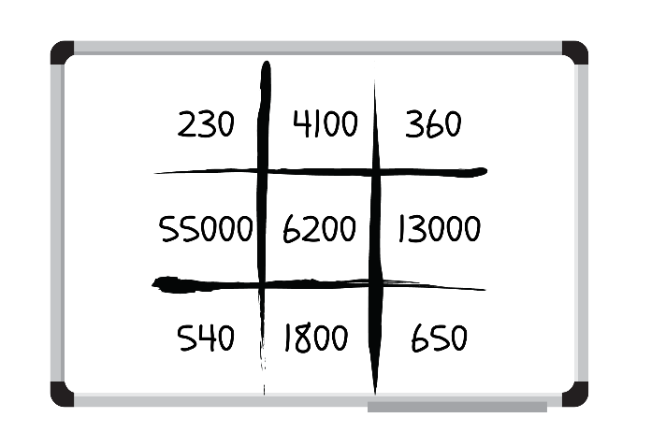

1. Students take turns rolling the dice and using the spinner to fill their gameboards with 9 different numbers.
2. Students record all the numbers on both gameboards on Resource 10 – cards and shuffle them into a pile facedown.
3. Students draw one card at a time and mark off the numbers on their bingo board.
4. The winner is the first student to mark off 3 numbers in a row.

**Note**: teachers may differentiate by choosing only one dice or the number of sides to the die. The game may be played as a whole class or in pairs. A [digital spinner](http://www.superteachertools.com/spinner/spinner.php?title=Super+Spinner&directions=Click+the+wheel+below+to+spin%3A&colorscheme=color1&labels=100%2C10%2C1000%2C10%2C100%2C1000%2C10%2C100%2C1000%2C10) may be used to reduce the number of resources to be printed and created.

## Core lesson 2 – ‘Epic money’ game – 20 minutes

This activity is an adaptation of [Our epic Monopoly game: Exploring non-standard partitioning using money](https://www.researchgate.net/publication/364307525_Our_epic_Monopoly_game_Exploring_non-standard_partitioning_using_money) from Prime Number by Wang and Russo.

1. Display Resource 11 – ‘Epic money’ game.
2. Explain to students: Nash is playing a board game with his brother and sister. The goal is to earn the most amount of money. The game uses only $100, $10 and $1 notes.

**Note**: explain to students that the board game only includes notes so for this activity, $1 is represented by a note rather than a coin.

1. Prompt students using questions about each total.

The table below outlines stimulus prompts to generate conversation about the topic, along with anticipated responses from students.

|  |  |
| --- | --- |
| Prompts | Anticipated student responses |
| * How much does each child have? How do you know? | * Nash and Flynn have the same amount – $210. * Ava has $343. |
| * Before adding the amounts, who did you think had earned the most money? Explain your reasoning. | * I thought Ava had earned more because she has more $100 notes plus a few of the other notes as well. * I thought Flynn had earned more than Nash because he has the largest number of notes. |
| * Can the children exchange their notes for other notes with an equal value? | * Flynn could swap his ten $10 notes for a $100 note. |

1. Display Resource 8 – place value houses. Model how the money is equivalent by representing the standard partitioning of 210 (2 hundreds and a 10) and non-standard partitioning (111 tens and 1 hundred, one 10 and 100 ones) (see Figure 7).

Figure 7 – modelling place value houses

Place value house template with columns for the hundred thousands, ten thousands and one thousand, hundreds, tens and ones.

The first row contains the number 210. In the next row, there is a one in the hundreds, 11 in the tens and zero in the ones.

In the third row, there is a one in the hundreds, a one in the tens and 100 in the ones.

In the final row, there is a zero in the hundreds, 11 in the tens and 100 in the ones.

1. Provide students with Resource 12 – partitioning $473. Pose the following scenario: The children played the game for 4 more hours. Nash finished with $473.
2. Ask the following questions:

* What notes might he have had?
* Is there another solution? How many solutions can you find?
* Can you identify a standard and non-standard partitioning solution? Explain your answer.

1. Students [Think-Pair-Share](https://app.education.nsw.gov.au/digital-learning-selector/LearningActivity/Card/645) and record their understanding.

This table details opportunities for differentiation.

|  |  |
| --- | --- |
| Too hard? | Too easy? |
| Students cannot partition numbers of up to 4 digits in non-standard forms.   * Allow students to partition a 2-digit number. Pose the question: Ava finished the game with $37. What notes might she have had? * Provide students with MAB materials and place value houses to support their understanding. | Students can partition numbers of up to 4 digits in non-standard forms.   * Challenge students to partition a 4-digit number. Pose the question: Flynn finished the game with $2711. What notes might he have had? * Students engage with [Wishball: whole numbers](https://www.scootle.edu.au/ec/viewing/L867/index.html) on a digital device. Challenge students to reach the target number in 20 turns or less. |

## Consolidation and meaningful practice – 20 minutes

This activity is an adaptation of [Our epic Monopoly game: Exploring non-standard partitioning using money: Place Value Battles](https://www.researchgate.net/publication/364307525_Our_epic_Monopoly_game_Exploring_non-standard_partitioning_using_money) from Prime Numbers by Wang and Russo.

1. Group students into 2 to 4 teams. Appoint one student ‘Quiz Master’.

**Note**: the teacher may choose to assign themselves the job of ‘Quiz Master’ to ensure steady flow of the game and accurate calculation of non-standard partitioning.

1. Provide students with MAB materials and whiteboards.
2. Explain that the Quiz Master will roll three 9-sided dice. From the numbers rolled, they will create a 3-digit number, for example, 526.
3. The Quiz Master makes the number with MAB materials using standard partitioning as a reference for the class.
4. The teams discuss different ways of renaming the number using non-standard partitioning. For example, 4 hundreds, 3 tens and 96 ones or 3 hundreds, 14 tens and 86 ones. Each team records their renamed number (see Figure 8).

Figure 8 – place value battle

‘Place Value Battle’ gameboard example. There are 2 whiteboards labelled Team A and Team B.

Each gameboard has columns for the hundreds, tens and ones.
The example that has been rolled is 526.
Teams have recorded alternative ways that 526 can be partitioned, for example, Team A has recorded 4 hundreds, 3 tens and 96 ones. The team that records the highest numbers in each column (hundreds, tens and ones), will score a point. In the example given, Team A has scored 2 points.

1. The Quiz Master checks each team’s representation to ensure it is equivalent to the original number.
2. Beginning with the hundreds column, each team reveals their renamed number to the Quiz Master. Teams receive a point for having the highest number recorded in a column. For example, in Figure 8, Team A won the hundreds battle, Team B won the tens battle and Team A won the ones battle. Team A receives 2 points and Team B receives one point.
3. The game continues until one of the teams scores 11 points.

This table details opportunities for assessment.

|  |  |
| --- | --- |
| Assessment opportunities | Links |
| What to look for:   * Can students describe how making a number 10, 100 or 1000 times as large changes the place value of digits? **[MAO-WM-01, MA2-RN-01]** * Can students partition numbers of up to 4 digits in non-standard forms? **[MAO-WM-01, MA2-RN-01]** | Links to [National Numeracy Learning Progressions](https://www.australiancurriculum.edu.au/resources/national-literacy-and-numeracy-learning-progressions/version-3-of-national-literacy-and-numeracy-learning-progressions/) (NNLP):   * NPV5, NPV6, NPV8, NPV9.   Links to suggested [Interview for Student Reasoning](https://education.nsw.gov.au/teaching-and-learning/curriculum/literacy-and-numeracy/assessment-resources/ifsr) (IfSR) tasks:   * IfSR-NP: 4B.1, 4B.3 - 4B.5. |

# Lesson 4

**Core concept**: numbers can be built up or taken apart in a variety of ways to make the numbers easier to work with.

## Daily number sense – 10 minutes

1. From a class need surfaced through formative assessment data, identify a short, focused activity that targets students’ knowledge, understanding and skills. Example activities may be drawn from the following resources:

* [Mathematics K–6 resources](https://education.nsw.gov.au/teaching-and-learning/curriculum/mathematics/mathematics-curriculum-resources-k-12/mathematics-k-6-resources)
* [Universal Resources Hub](https://resources.education.nsw.gov.au/home).

## Core lesson 1 – revising strategies – 15 minutes

The table below contains a suggested learning intention and success criteria. These are best co-constructed with students.

|  |  |
| --- | --- |
| Core concept learning intention | Core concept success criteria |
| Students are learning to:   * select strategies flexibly to solve addition and subtraction problems of up to 3 digits. | Students can:   * use the compensation strategy to add and subtract * apply the levelling and constant difference strategies * compare and evaluate strategies used to solve addition and subtraction problems, reasoning which strategy may be most efficient. |

**Note**: the purpose of this lesson is to focus on the compensation strategy, and the levelling and constant difference strategies. Students may find different strategies more efficient; however, this can guide rich mathematical discussion as to which strategies are the most effective.

1. Revise the compensation strategy, and the levelling and constant difference strategies.
2. Review strategies in Resource 13 – additive strategies poster if needed and discuss.

**Compensation strategy**: relates to adjusting numbers to make a calculation more efficient, for example, 36 − 17 is the same as 37 – 17 − 1.

**Levelling**: is adjusting to landmark numbers to add efficiently, for example, 28 + 35 is the same as 30 + 33.

**Constant difference**: is a common difference between pairs of numbers when completing subtraction, for example, 125 – 78 = 126 – 79 = 127 – 80.

1. Write 27 + 34 and 126 − 58 on the board. Ask students to [Think-Pair-Share](https://app.education.nsw.gov.au/digital-learning-selector/LearningActivity/Card/645) how they could solve the problems.
2. Regroup and ask students prompting questions from the table below.

The table below outlines stimulus prompts to generate conversation about the topic, along with anticipated responses from students.

|  |  |
| --- | --- |
| Prompts | Anticipated student responses |
| * What strategy did you use to solve 27 + 34? | * I added 3 to 27 to make 30, which then made the problem 30 + 34. This made 64. Then I subtracted 3 from 64 to get the answer of 61. (compensation strategy) * I know that 27 + 34 is the same as 30 + 31. I subtracted 3 from 34 and added it to 27 to make 30. I then added the 1 left over. (levelling) * I added 20 and 30 to make 50 and then I added 7 and 4 together which equalled 11. I then added 50 and 11 together to get the total of 61. (partitioning) |
| * What strategy did you use to solve 126 − 58? | * I know that 126 − 58 is the same as 128 – 60. I added 2 to 126 and 58 so that one of the numbers was easier to work with. This kept the difference between the 2 numbers the same. That gave me the answer of 68. (constant difference) * I added 2 to 58 to make the problem 126 − 60. That equals 66 and then I added on 2 more to get 68. (compensation strategy) |

1. Ask the following questions:

* When is the compensation strategy an efficient strategy to use? Explain your thinking.
* Can you give an example of when the compensation strategy would not be the most efficient?
* When is the constant difference strategy an efficient strategy to use? Explain your thinking.
* Can you give an example of when the constant difference strategy would not be the most efficient?
* When is the levelling strategy an efficient strategy to use? Explain your thinking.

## Core lesson 2 – ‘Closest to 100’ – 25 minutes

This activity is an adaptation of [Closest to 100 (additive strategies)](https://education.nsw.gov.au/teaching-and-learning/curriculum/mathematics/mathematics-curriculum-resources-k-12/thinking-mathematically-resources/mathematics-s2-s3-closest-to-100) from [Thinking mathematically resources](https://education.nsw.gov.au/teaching-and-learning/curriculum/mathematics/mathematics-curriculum-resources-k-12/thinking-mathematically-resources) by the State of New South Wales (Department of Education).

**Note**: encourage students to focus on using subtraction during the game.

1. Explain to students that the first 2 times they play the game, they can only use the compensation strategy, levelling or constant difference strategies. In the rounds following, students use the most efficient strategy they know.
2. Explain the rules for ‘Closest to 100’:
3. The aim of the game is to use addition or subtraction to get close to a total of 100.
4. Provide pairs of students with an individual whiteboard and playing cards, Ace to 10. Ace is equal to one.
5. Student A shuffles the cards and puts them in a central pile. Student B takes 6 cards and places them face up for everyone to see.
6. Each card can only be used once, and it can be used to form a 2-digit number or a 3-digit number. These numbers can either be added or subtracted to get as close as possible to 100. Not all cards need to be used.
7. Students record their number sentences and thinking on a whiteboard, demonstrating their use of the compensation strategy, levelling or constant difference strategies to obtain answers. For example, if the cards flipped are 6, 6, 2, 9, A and 3, Student A may choose to create 66 + 29 = 95. Student A records their thinking (see Figure 9).

Figure 9 – card example

Card example showing 4 playing cards and 2 boxes. The playing cards show two 6 of spades cards plus a 2 of spades and a 9 of hearts card that equals 95. The ‘9’ and the ‘5’ have been written in separate boxes.

To the right of the playing cards and boxes is a whiteboard showing the equation 66 + 29 =.

Underneath the equation, is a second equation that reads 70 + 25 = 95. On top of the number 70, it says +4. On top of the number 25, it says −4.

1. Student B may choose to use 129 – 36 = 93 and record their thinking (see Figure 10).

Figure 10 – card example 2

Card example showing 5 playing cards and 2 boxes. The playing cards show an Ace of hearts, a 2 of spades and a 9 of hearts minus a 3 of spades and 6 of spades equals 93. The ‘9’ and the ‘3’ have been written in separate boxes.

To the right of the playing cards and boxes is a whiteboard showing the number sentence 129 − 36 =.

1. Players score zero points if they can get exactly 100. Players score points based on the difference between their total and 100. For example, a total of 94 would score 6 points.
2. The winner of the game is the player with the lowest number of points.
3. Students repeat the game.

This table details opportunities for differentiation.

|  |  |
| --- | --- |
| Too hard? | Too easy? |
| Students cannot use the compensation strategy to add and subtract.   * Students add a 2-digit and a one-digit number to reach a different target number. * Provide students with concrete materials such as MAB materials, to solve the number sentences. | Students can use the compensation strategy to add and subtract.   * Students flip 6 cards to and create two 3-digit numbers, with the aim to get as close to 1000 as possible. * Challenge students to use 2 or more numbers to reach the target number using the 6 cards flipped, for example, 66 + 29 + 3 = 98. |

## Discuss and connect the mathematics – 10 minutes

1. Regroup and ask:

* Was it difficult when you were only able to use 2 strategies to solve the equations?
* Did you always use the same strategies to solve the problems?
* What strategy did you use to help you get closest to 100?
* What strategies were the most efficient overall? Explain your thinking.

This table details opportunities for assessment.

|  |  |
| --- | --- |
| Assessment opportunities | Links |
| What to look for:   * Can students solve addition and subtraction problems using the compensation strategy? **[MAO-WM-01, MA2-AR-01]** * Can students apply the leveling strategy to addition problems? **[MAO-WM-01, MA2-AR-01]** * Can students apply the constant difference strategy to subtraction problems? **[MAO-WM-01, MA2-AR-01]** * Can students compare and evaluate strategies used to solve addition and subtraction problems, reasoning which strategy may be most efficient? **[MAO-WM-01, MA2-AR-01]** | Links to [National Numeracy Learning Progressions](https://www.australiancurriculum.edu.au/resources/national-literacy-and-numeracy-learning-progressions/version-3-of-national-literacy-and-numeracy-learning-progressions/) (NNLP):   * AdS7, AdS8.   Links to suggested [Interview for Student Reasoning](https://education.nsw.gov.au/teaching-and-learning/curriculum/literacy-and-numeracy/assessment-resources/ifsr) (IfSR) tasks:   * IfSR-AT: 3A.2 - 3A.4 |

# Lesson 5

**Core concept**: the equals sign identifies a relationship in mathematics.

## Daily number sense – ‘Hit it 9999’ – 15 minutes

Daily number sense activities for Lessons 5 to 7 ‘loop’ back to concepts and procedures covered in previous units to assist students to build an increasingly connected network of ideas. These concepts may differ from the core concepts being covered by the unit.

The table below contains a suggested learning intention and success criteria. These are best co-constructed with students.

|  |  |
| --- | --- |
| Daily number sense learning intention | Daily number sense success criteria |
| Students are learning to:   * read, represent and order numbers to thousands. | Students can:   * represent numbers up to thousands using numerals * read and order numbers of up to at least 4 digits. |

This activity is an adaptation of [Hit it (3-digit numbers)](https://education.nsw.gov.au/teaching-and-learning/curriculum/mathematics/mathematics-curriculum-resources-k-12/thinking-mathematically-resources/mathematics-s1-s2-hit-it) from [Thinking mathematically resources](https://education.nsw.gov.au/teaching-and-learning/curriculum/mathematics/mathematics-curriculum-resources-k-12/thinking-mathematically-resources) by the State of New South Wales (Department of Education).

1. Provide pairs with markers, an individual whiteboard and a 9-sided die.
2. Students draw a gameboard on their whiteboard with 4 place value labels and 4 lines to represent the 4 digits (see Figure 11).

Figure 11 – ‘Hit it’ sample

‘Hit it 9999’ gameboard showing 2 whiteboards labelled ‘Student A’ and ‘Student B’. Each whiteboard has 4 place value labels for the thousands, hundreds, tens and ones columns, and 4 lines to represent each of the 4 digits rolled. Three rows of numbers have been completed, with 2 empty rows to fill in.
Student A has rolled 8741, 2968 and 8939.
Student B has rolled 5331, 9418 and 7839.
For each row, the student who has rolled the highest number scores a point.

1. Students take turns to roll the die. After each roll, write the number on one of the lines. Once the 4 blank lines are full, players read their number and identify which number is the closest to 9999. This player wins a point.
2. The player with the most points after 5 rounds is declared the winner.

This table details opportunities for assessment.

|  |  |
| --- | --- |
| Assessment opportunities | Links |
| What to look for:   * Can students represent numbers up to thousands using numerals? **[MAO-WM-01, MA2-RN-01]** * Can students read and order numbers of up to at least 4 digits? **[MAO-WM-01, MA2-RN-01]** | Links to [National Numeracy Learning Progressions](https://www.australiancurriculum.edu.au/resources/national-literacy-and-numeracy-learning-progressions/version-3-of-national-literacy-and-numeracy-learning-progressions/) (NNLP):   * NPV4 - NPV6.   Links to suggested [Interview for Student Reasoning](https://education.nsw.gov.au/teaching-and-learning/curriculum/literacy-and-numeracy/assessment-resources/ifsr) (IfSR) tasks:   * IfSR-NP: 4B.2, 4B.5, 4C.1, 4C.5. |

## Core lesson 1 – associative property of addition – 15 minutes

The table below contains a suggested learning intention and success criteria. These are best co-constructed with students.

|  |  |
| --- | --- |
| Core concept learning intention | Core concept success criteria |
| Students are learning to:   * use the principle of equality | Students can:   * recognise equal differences and record them in number sentences * use the equals sign to mean 'the same as', rather than to perform an operation * apply the associative property of addition to forming multiples of 10. |

**Associative property**:more than 2 numbers can be added in any order to make it more efficient. For example, bridging to multiples of 10 (22 +3 + 8 is the same as 22 + 8 + 13).

1. Write the number sentence 53 + 24 + 17 on the board. Students complete the number sentence and record solutions on whiteboards. Observe if students use multiples of 10 to obtain their answer.
2. Regroup and select students to share the different strategies used, including bridging the decades.

**Note:** if the bridging the decades strategy was not used by any students in the class, use the [think-aloud](https://evidenceforlearning.org.au/news/planning-a-think-aloud-in-mathematics) strategy to model before moving on.

1. Revisit that using the associative property of addition to form multiples of 10 is a useful strategy, for example, 62 + 15 + 8 = 62 + 8 = 70 + 15 = 85. Explain that using place value understanding flexibly makes it is easier to solve 62 + 8 = 70 and then add on 15.
2. Using this strategy, students solve the following problems on their whiteboards.

* 67 + 29 + 13 = _
* 23 + 34 + 56 = _
* 51 + 17 + 33 = _.

1. Regroup and discuss.

## Core lesson 2 – equivalent equations – 30 minutes

This activity is an adaptation of ‘[Let's Play: The Same As](https://www.researchgate.net/publication/360321217_Let's_Play_The_Same_As)’ from Prime Number by Russo.

1. Discuss the term ‘equal differences’.
2. Write 18 − 11 on the board. Ask:

* What is the difference between 18 and 11?
* What is another number sentence that has a difference of 7?
* Is there more than one possibility?
* How can the equals sign be used to show that 2 number sentences have equal differences?

1. If not discussed by students, model how the equals sign can be used to record equal differences. For example, 18 – 11 = 9 − 2.
2. Write 23 − 14 on the board. Students record on individual whiteboards other number sentences that show equal differences.
3. Provide students with playing cards (Jack = 17, Queen = 18, King = 19, Joker = 20 and Ace can be 1 or 21) and Resource 14 – number sentence board.
4. Explain the rules of the game to students:

**Note**:encourage students to use both addition and subtraction during the game.

1. Student A turns over 4 cards, placing them face up on the board.
2. Student A uses the cards to try to make a number sentence that is true. For example, Student A picks up a King and places the cards in one of the slots and reads out the number sentence, stating whether it is true or not. For example, ‘Ten plus nineteen is not the same as eighteen plus three’ (see Figure 12).

Figure 12 – cards flipped example

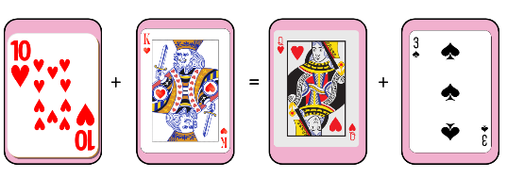

1. Student A can continue to place cards in various orders to see if they can make a sentence that is true. If they cannot, it is Student B’s turn.
2. Student B flips over 4 different cards and states whether their sentence is true or not. Student B continues to place cards in various orders to see if they can make a sentence that is true. If they cannot, it is Student A’s turn.
3. Students record number sentences on their whiteboards.
4. The game ends once a player has 5 equivalent number sentences.
5. Regroup and ask:

* What was easy or challenging about the game?
* How many times did you have to draw 4 cards to create a number sentence that was true?
* Which strategy did you use that was the most efficient to obtain the answer?

This table details opportunities for differentiation.

|  |  |
| --- | --- |
| Too hard? | Too easy? |
| Students cannot recognise equal differences and record them in number sentences.   * Assist students by lowering the value of the picture cards. * Students use concrete materials such as MAB to model the number sentence. | Students can recognise equal differences and record them in number sentences   * Challenge students to flip 6 number cards and make two 2-digit numbers. These numbers are used to create a number sentence that is true. * Provide students with Resource 15 – True or false? Ask students to decide if the number sentences are true or false. Challenge students to determine how they could make the false statements true. |

## Discuss and connect the mathematics – 10 minutes

1. Ask students:

* When is the associative property of addition to bridging to multiples of 10 an efficient strategy to use? Explain your thinking.
* When could this be an inefficient strategy to use?
* When could this strategy be helpful to use in real life situations?

This table details an opportunity for assessment.

|  |  |
| --- | --- |
| Assessment opportunity | Links |
| What to look for:   * Can students recognise and record equal number sentences? **[MAO-WM-01, MA2-AR-01]** | Links to [National Numeracy Learning Progressions](https://www.australiancurriculum.edu.au/resources/national-literacy-and-numeracy-learning-progressions/version-3-of-national-literacy-and-numeracy-learning-progressions/) (NNLP):   * AdS7, AdS8.   Links to suggested [Interview for Student Reasoning](https://education.nsw.gov.au/teaching-and-learning/curriculum/literacy-and-numeracy/assessment-resources/ifsr) (IfSR) tasks:   * IfSR-AT: 3A.2 - 3A.4 |

# Lesson 6

**Core concept**: addition and subtraction are connected.

## Daily number sense – ‘Mastermind’ – 10 minutes

The table below contains a suggested learning intention and success criteria. These are best co-constructed with students.

|  |  |
| --- | --- |
| Daily number sense learning intention | Daily number sense success criteria |
| Students are learning to:   * read, represent and order numbers to thousands. | Students can:   * represent numbers up to thousands using numerals * read and order numbers of up to at least 4 digits. |

This activity is an adaptation of [Mastermind](https://education.nsw.gov.au/teaching-and-learning/curriculum/mathematics/mathematics-curriculum-resources-k-12/thinking-mathematically-resources/mathematics-s1-s3-mastermind) from [Thinking mathematically resources](https://education.nsw.gov.au/teaching-and-learning/curriculum/mathematics/mathematics-curriculum-resources-k-12/thinking-mathematically-resources) by the State of New South Wales (Department of Education).

1. In pairs, each student records a 4-digit number, with no repeated digits, on a sticky note. Students draw up their gameboard on individual whiteboards (see Figure 13).

Figure 13 – ‘Mastermind’ gameboard

There is a sticky note with the number 4892 on it. To the right of the sticky note is a whiteboard showing 3 columns titled: Guess, Digits and Places. 

The first guess reads: 2859 in the Guess column, 2 in the Digits column and 1 in the Places column. 

The second guess reads: 3865 in the Guess column, 1 in the Digits column and 1 in the Places column.

The third guess reads: 1894 in the Guess column, 2 in the Digits column and 2 in the Places column.

1. Students take turns to guess their partner’s 4-digit number. Partners record the guess, the number of digits that are correct and the number of digits that are in the right place (see Figure 13). Students then use this information to refine their guesses.
2. The first student to correctly guess their partner’s number is the winner.

**Note**: this activity can be adapted by using 2-, 3- or 5-digit numbers.

This table details opportunities for assessment.

|  |  |
| --- | --- |
| Assessment opportunities | Links |
| What to look for:   * Can students represent numbers up to thousands using numerals**? [MAO-WM-01, MA2-RN-01]** * Can students read and order numbers of up to at least 4 digits? **[MAO-WM-01, MA2-RN-01]** | Links to [National Numeracy Learning Progressions](https://www.australiancurriculum.edu.au/resources/national-literacy-and-numeracy-learning-progressions/version-3-of-national-literacy-and-numeracy-learning-progressions/) (NNLP):   * NPV4 - NPV6.   Links to suggested [Interview for Student Reasoning](https://education.nsw.gov.au/teaching-and-learning/curriculum/literacy-and-numeracy/assessment-resources/ifsr) (IfSR) tasks:   * IfSR-NP: 4B.2, 4C.5. |

## Core lesson 1 – complement principle – 15 minutes

The table below contains suggested learning intentions and success criteria. These are best co-constructed with students.

|  |  |
| --- | --- |
| Core concept learning intentions | Core concept success criteria |
| Students are learning to:   * recognise and explain the connection between addition and subtraction * select strategies flexibly to solve addition and subtraction problems of up to 3 digits. | Students can:   * use the complement principle of addition and subtraction * compare and evaluate strategies used to solve addition and subtraction problems, reasoning which strategy may be most efficient. |

1. Display Resource 16 – complement principle. Revise the complement principle using the worked example 89 − 67 = ?

**Complement principle**: highlights the inverse relationship between addition and subtraction. That is 3 + 4 = 7 implies 7 − 4 = 3. The most challenging of the complement principle is recognising that a − b = c means a − c = b. The number of steps of algebraic reasoning needed to appreciate why the 2 forms are equivalent makes substantial demands on working memory. The use of the complement principle requires recognising that when 2 numbers are added, subtracting either number from the total produces its complement, that is, the number required to make a group complete.

1. Students complete the additional questions on individual whiteboards, identifying the complement principle.
2. Students share their thinking and discuss responses.
3. Ask the following questions:

* How does the complement principle help you make connections between addition and subtraction?
* Can you explain to a partner the relationship between addition and subtraction?

This table details an opportunity for assessment.

|  |  |
| --- | --- |
| Assessment opportunity | Links |
| What to look for:   * Can students use the complement principle of addition and subtraction? **[MAO-WM-01, MA2-AR-01]** | Links to [National Numeracy Learning Progressions](https://www.australiancurriculum.edu.au/resources/national-literacy-and-numeracy-learning-progressions/version-3-of-national-literacy-and-numeracy-learning-progressions/) (NNLP):   * AdS7. |

## Core lesson 2 – addition and subtraction dominoes – 30 minutes

1. Revisit Resource 13 – additive strategies poster.
2. Place students in pairs or groups of 3.
3. Provide each pair or group with Resource 17 – dominoes.
4. Students use known strategies for addition and subtraction to join the dominoes, ensuring that each number sentence that is joined is true (see Figure 14).

Figure 14 – domino example

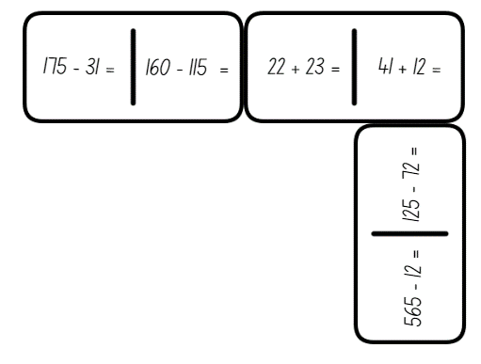

1. Students record the strategies used in their workbook. Explain that the game continues until all dominoes have been used.
2. Ask the following questions:

* Which strategy was the most efficient to solve the problem? Why?
* How did you decide what strategy to use each time? Was it always the most efficient? Why or why not?
* What advice would you give to another student if they did not know which strategy would be the most efficient to use?

This table details opportunities for differentiation.

|  |  |
| --- | --- |
| Too hard? | Too easy? |
| Students cannot compare and evaluate strategies used to solve addition and subtraction problems and cannot reason which strategy may be most efficient.   * Provide students with Resource 18 – adapted dominoes to complete. * Provide students with MAB materials to model solving equations. | Students can compare and evaluate strategies used to solve addition and subtraction problems, reasoning which strategy may be most efficient.   * Provide students with Resource 19 – blank dominoes. Students create their own for a partner to complete. * Students solve the problem of [Amy’s Dominoes](https://nrich.maths.org/problems/amys-dominoes) from [NRICH](https://nrich.maths.org). |

## Discuss and connect the mathematics – 10 minutes

1. Students revise the strategies used in their workbook and create an annotation explaining why they choose that strategy for that number sentence.
2. Have students share their strategy and justification with a different partner.

This table details an opportunity for assessment.

|  |  |
| --- | --- |
| Assessment opportunity | Links |
| What to look for:   * Can students compare and evaluate strategies used to solve addition and subtraction problems, reasoning which strategy may be most efficient? **[MAO-WM-01, MA2-AR-01]** | Links to [National Numeracy Learning Progressions](https://www.australiancurriculum.edu.au/resources/national-literacy-and-numeracy-learning-progressions/version-3-of-national-literacy-and-numeracy-learning-progressions/) (NNLP):   * AdS6, AdS7. |

# Lesson 7

**Core concept**: multiplication and division are related.

## Daily number sense – place value game – 15 minutes

The table below contains a suggested learning intention and success criteria. These are best co-constructed with students.

|  |  |
| --- | --- |
| Daily number sense learning intention | Daily number sense success criteria |
| Students are learning to:   * read, represent and order numbers to thousands. | Students can:   * read and order numbers of up to at least 4 digits. |

This activity is an adaptation of the [Place value game](https://education.nsw.gov.au/teaching-and-learning/curriculum/mathematics/mathematics-curriculum-resources-k-12/thinking-mathematically-resources/mathematics-s1-s3-place-value-game) from [Thinking mathematically resources](https://education.nsw.gov.au/teaching-and-learning/curriculum/mathematics/mathematics-curriculum-resources-k-12/thinking-mathematically-resources) by the State of New South Wales (Department of Education).

1. Explain that the aim of the game is to order 4-digit numbers in ascending order on a gameboard.
2. Provide pairs with four 9-sided dice and Resource 20 – place value game, for each player.
3. Students roll the dice and create a 4-digit number. For example, 6, 2, 8, 3 could be recorded as 6238, 3682, 2863, 3826, 3628 and so on. Players record their chosen number in the most appropriate position between 1000 and 10 000 (see Figure 15).

Figure 15 – gameboard example

A place value game board with the starting number 1000 and a pathway of blank boxes to the ending number 10 000. The number 5000 is placed in the middle of the path.

As an example of playing the game, the number 2354 has been placed in the fourth box, 4689 in the ninth box, 6239 in the twelfth box and 8556 in the fifteenth box.

1. If numbers cannot be placed, students miss their turn. Play continues until all boxes are filled.

**Note**: the game can also be played as a whole class. It is recommended to use dice that have a zero. It is important that students understand the role of zero in changing the value of the 4-digit numbers created. Using a reusable sleeve for the gameboard and non-permanent markers will allow students to play multiple games.

This table details an opportunity for assessment.

|  |  |
| --- | --- |
| Assessment opportunity | Links |
| What to look for:   * Can students read and order numbers of up to at least 4 digits? **[MAO-WM-01, MA2-RN-01]** | Links to [National Numeracy Learning Progressions](https://www.australiancurriculum.edu.au/resources/national-literacy-and-numeracy-learning-progressions/version-3-of-national-literacy-and-numeracy-learning-progressions/) (NNLP):   * NPV5, NPV6.   Links to suggested [Interview for Student Reasoning](https://education.nsw.gov.au/teaching-and-learning/curriculum/literacy-and-numeracy/assessment-resources/ifsr) (IfSR) tasks:   * IfSR-NP: 4B.2, 4C.5. |

## Core lesson 1 – arrays – if I know this then I know ... – 30 minutes

The table below contains a suggested learning intention and success criteria. These are best co-constructed with students.

|  |  |
| --- | --- |
| Core concept learning intention | Core concept success criteria |
| Students are learning to:   * recall multiplication facts of 2 and 4, 5 and 10 and related division facts. | Students can:   * link multiplication and division fact families using arrays * generate multiplication fact families for multiples of 2 and 4, 5 and 10 * model and apply the commutative property of multiplication. |

1. Give each student an individual whiteboard and marker.
2. Draw a 4 × 3 array on the whiteboard (see Figure 16).

Figure 16 – array example



1. Pose the question: If I know 4 × 3 = 12, what else do I know?
2. Students record all fact family information they know from this array on a whiteboard. For example, students would record 4 × 3 = 12, 3 × 4 = 12, 12 ÷ 4 = 3 and 12 ÷ 3 = 4.
3. Select students to share their answers and reasoning.
4. Ask the following questions:

* What do you notice? Can you spot any patterns?
* How many facts can you record about the array?
* How are the multiplication and division facts related? (inverse operations)
* What do you notice about both the division facts?
* Is this the only array that can be made from 12 dots?

1. In pairs, students cut up Resource 21 – array cards and place them facedown in a central pile.
2. Students take turns to flip the top card. Both students record the fact family for the array shown. They also record the alternative array arrangement, where the array is rotated (see Figure 17).

Figure 17 – student work sample

A card containing an array consisting of 2 rows of 4. 

To the right of the card is a whiteboard that has the inverse array of 4 rows of 2 and the following number sentences written on it: 4 × 2 = 8, 2 × 4 = 8, 8 ÷ 2 = 4 and 8 ÷ 4 = 2.

1. Students compare their recordings, discussing the relationship between the multiplication and division facts and the commutative property.

**Commutative property**:commutativity (commutative property) of addition or multiplication means that 2 numbers can be added or multiplied in any order and the solution will be the same. ‘Commutative law’, ‘commutativity’ and ‘turn-around facts’ are interchangeable terms.

1. Regroup and ask:

* When you rotated the array, did the number of dots change?
* How can knowing the multiplication fact help you solve division problems?
* Is there another way you could represent fact families? (fact family triangles)

## Core lesson 2 – missing values – 15 minutes

1. Provide pairs with two 6-sided dice and an individual whiteboard each.
2. Student A closes their eyes or turns their back. Student B rolls 2 dice.
3. Student B multiplies the numbers together and says the game chant. For example, after rolling a 3 and 4, Student B would say, ‘Twelve is the product to be precise, so guess the numbers on the dice.’
4. Student B then covers the dice using their hand. Student A opens their eyes or turns back to face Student B.
5. Student A uses their fact family knowledge to determine 2 numbers that would have that product. In the example above, Student A could guess either 3 and 4 or 6 and 2.
6. Once Student A has guessed the correct numbers, both students use these numbers to write the fact family multiplication and division equations (see Figure 18).

Figure 18 – student work example

There is a whiteboard with 2 dice. One die shows 3 dots and the other die shows 4 dots. 

Next to the dice are the equations 3 × 4 = 12, 4 × 3 = 12, 12 ÷ 3 = 4 and 12 ÷ 4 = 3.

1. Students share and compare equations, acknowledging the idea that ‘If I know this, then I also know this’. For example, ‘If I know 3 times 4 is 12, then I also know 12 divided by 3 is 4.’

This table details opportunities for differentiation.

|  |  |
| --- | --- |
| Too hard? | Too easy? |
| Students cannot model and apply the commutative property of multiplication.   * Provide students with counters to make and rotate the arrays to find the multiplication facts. Encourage students to separate the arrays into equal groups to recognise the related division fact. * Reduce the number of cards or the size of the arrays on the cards they are using. | Students can model and apply the commutative property of multiplication.   * Challenge students to play ‘Blockout’ in groups of 2 to 4. Players choose a colour each, then take turns rolling the dice and colouring in a rectangle given by the dice rolls. For example, if you roll a 2 and a 5, you can shade in a 2 × 5 (or 5 × 2) rectangle on the gameboard (a piece of grid paper). No one can colour in a square that has already been coloured. If there is no room to fit the rectangle you rolled on the board, you pass. If all players pass in a row, the game is over. An electronic version of the game can be found on [Polypad](https://mathigon.org/polypad/JQHDndMjUbbTPA). * In pairs, students play ‘[3 in a row](https://www.lovemaths.me/operations-36)’ by Michael Minas. While playing the game, students can record their number sentences on a whiteboard as many ways as they can. |

## Consolidation and meaningful practice – 10 minutes

This activity is an adaptation of ‘Use arrays’ from Multiplication and division by White Rose Education.

1. Display Resource 22 – 3 arrays.
2. Ask students to determine which student has the correct answer, justifying their selection. Students record their responses on individual whiteboards.
3. In pairs, students compare their answers.
4. Select students to share their answers and justifications.
5. Ask the following questions:

* How are the arrays in the image different?
* What fact families could be seen in the arrays?
* What could be done to the arrays to make them all the same?
* Why are arrays useful?
* Where can arrays be seen in everyday life?

This table details opportunities for assessment.

|  |  |
| --- | --- |
| Assessment opportunities | Links |
| What to look for:   * Can students link multiplication and division fact families using arrays? **[MAO-WM-01, MA2-MR-01, MA2-MR-02]** * Can students generate multiplication fact families for multiples of 2 and 4, 5 and 10? **[MAO-WM-01, MA2-MR-01, MA2-MR-02]** * Can students model and apply the commutative property of multiplication? **[MAO-WM-01, MA2-MR-01, MA2-MR-02]** | Links to [National Numeracy Learning Progressions](https://www.australiancurriculum.edu.au/resources/national-literacy-and-numeracy-learning-progressions/version-3-of-national-literacy-and-numeracy-learning-progressions/) (NNLP):   * MuS5.   Links to suggested [Interview for Student Reasoning](https://education.nsw.gov.au/teaching-and-learning/curriculum/literacy-and-numeracy/assessment-resources/ifsr) (IfSR) tasks:   * IfSR-MT: 1A.9, 2A.1, 2A.3-2A.4, 2A.6, 2A.12. |

# Lesson 8

**Core concept**: number properties can be used to solve multiplication problems.

## Daily number sense – 10 minutes

1. From a class need surfaced through formative assessment data, identify a short, focused activity that targets students’ knowledge, understanding and skills. Example activities may be drawn from the following resources:

* [Mathematics K–6 resources](https://education.nsw.gov.au/teaching-and-learning/curriculum/mathematics/mathematics-curriculum-resources-k-12/mathematics-k-6-resources)
* [Universal Resources Hub](https://resources.education.nsw.gov.au/home).

## Core lesson – multiplication and division fact families – 45 minutes

The table below contains suggested learning intentions and success criteria. These are best co-constructed with students.

|  |  |
| --- | --- |
| Core concept learning intentions | Core concept success criteria |
| Students are learning to:   * recall multiplication facts of 2 and 4, 5 and 10 and related division facts * use number properties to find related multiplication facts. | Students can:   * link multiplication and division fact families using arrays * use the commutative property of multiplication * generate and recall multiplication fact families up to 10 × 10. |

1. Display Resource 23 – Creature Cards problem. Read through the problem and discuss the strategies students may use to complete the recording grid.
2. Pose the scenario: Kilian has 12 Creature Cards he wants to attach to page 12. How could he arrange the cards?
3. Students record their arrangement ideas and multiplication and division fact families on individual whiteboards.
4. Select students to share their answers and justifications.
5. Provide students with Resource 24 – recording grid.
6. Independently or in pairs, students complete Resource 24 – recording grid, ensuring they record the array and multiplication and division fact families for each appropriate number.

**Note**: Resource 24 – recording grid may be best printed as an A3 size to allow for easier recording of larger arrays.

This table details opportunities for differentiation.

|  |  |
| --- | --- |
| Too hard? | Too easy? |
| Students cannot generate and recall multiplication fact families up to 10 × 10.   * Support students to use concrete materials to represent the arrays, starting with the range 1 to 20 on Resource 24 – recording grid. Once the array has been created, model how to write a corresponding multiplication and division number sentence. * Assist students by reducing the size of the grid on Resource 24 – recording grid. | Students can generate and recall multiplication fact families up to 10 × 10.   * In groups of 3, students place playing cards in a pile, facedown. Student A and Student B pick up a card each and hold it facing out on their forehead. These students **do not** look at their own card. Student C multiplies the numbers on the 2 cards they can see and calls out the answer. Students A and B must work out from the answer, the value of the card on their forehead. The game is repeated with the players swapping their roles. * In pairs, students play Scissors, Paper, Rock. As they say the final word such as scissors, paper, **rock**, they reveal a number with their fingers. For example, Student A may hold up 6 fingers and Student B may hold up 3. The calculation that needs to be solved is 6 × 3. The first student to get the correct answer gets a point. Repeat. |

## Discuss and connect the mathematics – 5 minutes

1. Regroup and referring to Resource 24 – recording grid, ask:

* Have you created the same array for each number as your classmates? Why or why not?
* Why can some numbers only be represented one way, whereas other numbers have multiple options?
* Do you notice any patterns in the numbers that can be represented in several different ways?

This table details opportunities for assessment.

|  |  |
| --- | --- |
| Assessment opportunities | Links |
| What to look for:   * Can students link multiplication and division fact families using arrays? **[MAO-WM-01, MA2-MR-01]** * Can students use the commutative property of multiplication? **[MAO-WM-01, MA2-MR-01]** * Can students generate and recall multiplication fact families up to 10 × 10? **[MAO-WM-01, MA2-MR-01]** | Links to [National Numeracy Learning Progressions](https://www.australiancurriculum.edu.au/resources/national-literacy-and-numeracy-learning-progressions/version-3-of-national-literacy-and-numeracy-learning-progressions/) (NNLP):   * MuS6, MuS7.   Links to suggested [Interview for Student Reasoning](https://education.nsw.gov.au/teaching-and-learning/curriculum/literacy-and-numeracy/assessment-resources/ifsr) (IfSR) tasks:   * IfSR-MT: 2A.3, 2A.9. |

# Resource 1 – treasure map

A map of a treasure island. There is a grid overlaying the island. The horizontal line has letters from A to L and the vertical line has numbers from one to 7.

Grid references are as follows: mountains at D6 and E6, a swamp at D2, a rocky mound at F3, a treasure chest at G5, palm trees at G2 and  a rowboat at H3.

There is a river running from D6 through D4, then turning through E4, F4, F3, G3, H3 an exiting the island at H4. Black Bay is at H2 to I2 and Blue Bay is at C6 to D6.

# Resource 2 – landmarks

The instruction reads: Cut out and paste the landmarks on the map at their grid references.

There is a table containing images and their grid references below: a shipwreck at I5, a castle at D2, a shark at C5, a blue lighthouse at J2, a lake at G4, a hill at F5, a waterfall at D4 and a red lighthouse at C6.

# Resource 3 – create a map

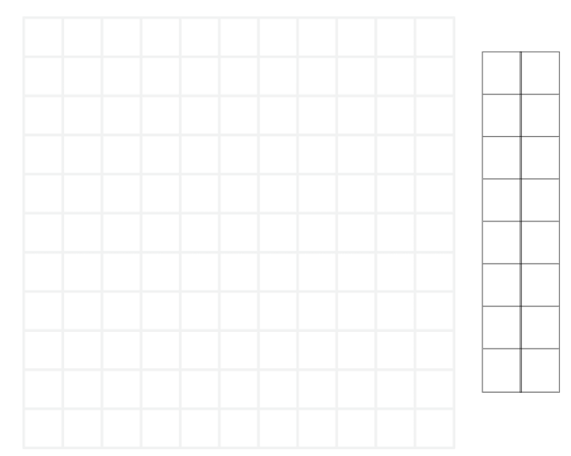

# Resource 4 – dollars and cents

There are 2 children sitting, Zac and Gigi. They both have speech bubbles coming from their mouths.

Zac’s says: ‘I have more money because I have got gold coins and they're worth more!’

Gigi’s says: ‘I have more money because I have 10 coins and you only have 2!’

Underneath Zac is a piggy bank containing two $1.00 coins.

Underneath GiGi is a piggy bank containing: two 50 cent coins, three 20 cent coins, three 10 cent coins and two 5 cent coins.

In the centre of the image, there is text that reads ‘Who has more money?’

# Resource 5 – super summer sale

A Super Summer Sale catalogue with discounts from 10–50% off. 

The sale prices for the items that have been reduced by 50% are:
Tennis paddles $10.
Flamingo float $7.50.
Beach umbrella $60.

The sale prices for the items that have been reduced by 25% are:
Beach ball $7.50.
Cricket set $18.75.
Fishing rod $22.50.

The sale prices for the items that have been reduced by 10% are:
Beach toys $10.80.
Stand-up paddleboard $162.
Snorkel set $13.50.

# Resource 6 – money problems

1. Narlah wanted to buy the beach toys. Represent and record 5 different ways she could make $10.80 with notes and coins. Which combination did you record that used the least number of notes and/or coins and the most number of notes and/or coins?
2. Maddox bought the cricket set. What would his change be from $20?
3. Piper has $25. What could she buy from the super summer sale? Try and find more than one possibility.
4. Elle, Eve and Chloe want to combine their money to buy the paddleboard. Elle has $60, Eve has $55 and Chloe has $35. Do they have enough money? How do you know? What is the difference between their combined money and the cost of the paddleboard?
5. Vacation care needs to order supplies for their beach day during the school holidays. They have a budget of $250. What would you suggest they buy? (Remember, they may need more than one of each item.)

# Resource 7 – place value visual

Four boxes containing MAB materials and place value houses side-by-side.

Each box contains a number and the equivalent number of MAB materials. The numbers 5, 50, 500 and 5000 are represented.

The place value houses contain a number increasing by 10 in each row from 5 to 5000. For example, 5, 50, 500, 5000.

# Resource 8 – place value houses

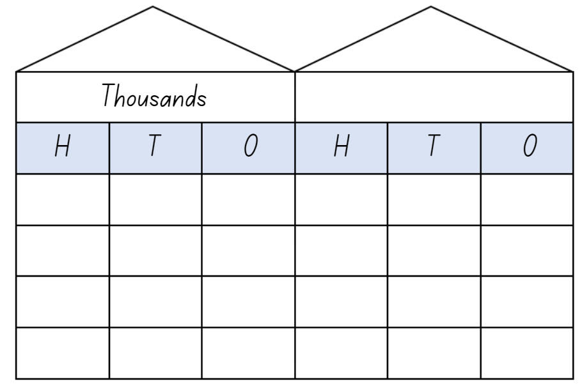

# Resource 9 – spinners

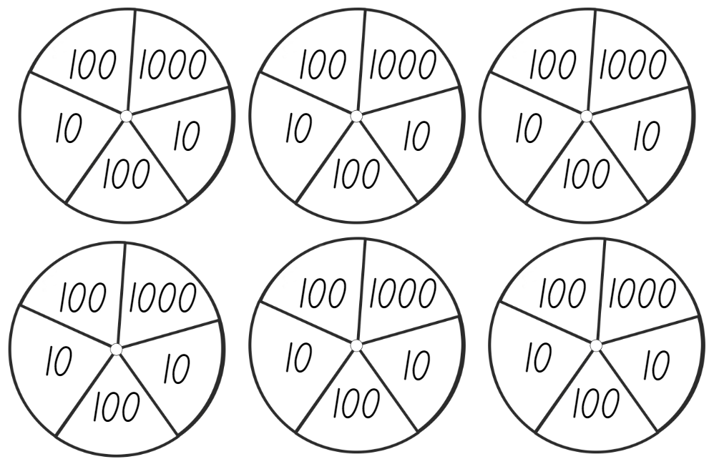

# Resource 10 – cards

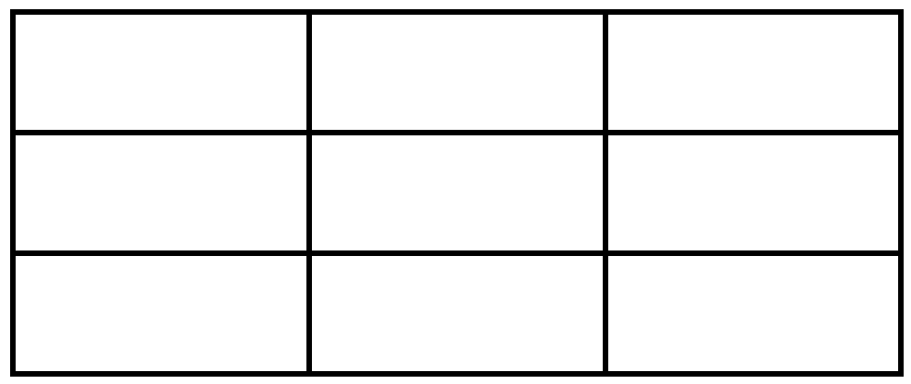

# Resource 11 – ‘Epic money’ game

There are 3 children: Nash, Flynn and Ava. Underneath the children are piles of money.

Nash has two $100 notes and a $10 note.

Flynn has one $100 note and eleven $10 notes.

Ava has three $100 notes, four $10 notes and three $1.00 notes.

# Resource 12 – partitioning $473

A Frayer model with 3 sections: 2 smaller equal sections at the top and a larger section at the bottom. 

The amount $473 is written in the centre.

The instructions read: Can you find different ways to make $473 with $100, $10 and $1 notes?

# Resource 13 – additive strategies poster

A poster listing 10 types of additive strategies as follows:
1. Compensation – adjusting numbers to make a calculation more efficient. 
2. Commutative property of addition – two numbers can be added in any order and the sum is equivalent. 
3. Constant difference – a common difference between pairs of numbers when completing subtraction. 
4. Inverse operations – addition and subtraction are inverse operations. 
5. Equivalence - different equations can have the same value. 
6. Landmark numbers – ‘friendly numbers’ that are easy to work with fluently, flexibly and efficiently. 
7. Levelling – adjusting to landmark numbers to add efficiently. 
8. Partitioning – splitting numbers into smaller parts to make calculations easier. 
9. Algorithms – a set of written steps to calculate, using partitioning and regrouping.
10. Associative property of addition – more than two numbers can be added in any order to make it more efficient. 


# Resource 14 – number sentence board

Empty number sentences. Space for the numbers are in the shape or size of a playing card.

The order is: card + card = card + card and in the second row, the order is: card − card = card − card.

# Resource 15 – True or false?

|  |  |  |
| --- | --- | --- |
| 569 + 365 = 651 + 283  True or false? | 191 + 711 = 679 + 134  True or false? | 4124 + 3641 = 2048 + 5717  True or false? |
| 428 + 798 = 568 + 658  True or false? | 5564 + 1457 = 5148 + 2085  True or false? | 2887 + 3564 = 4013 + 2438  True or false? |

# Resource 16 – complement principle

Four bar models. The first bar model has the number 89 in the top bar and 67 + 22 split in the bottom. Next to the model is text that reads: If 89 − 22 = 67, what is 89 − 67?

The second bar model has the number 76 in the top bar and blank + 36 split in the bottom.

The third bar model has the number 55 in the top bar and 45 + blank split in the bottom.

The fourth bar model has the number 97 in the top bar and blank + 33 split in the bottom.

The instruction reads: Write addition and subtraction number sentences using the complement principal.

# Resource 17 – dominoes

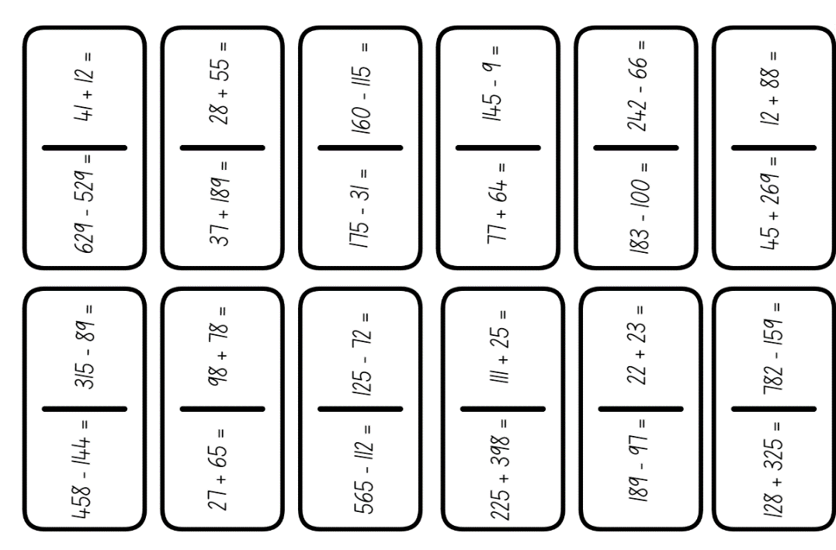

# Resource 18 – adapted dominoes

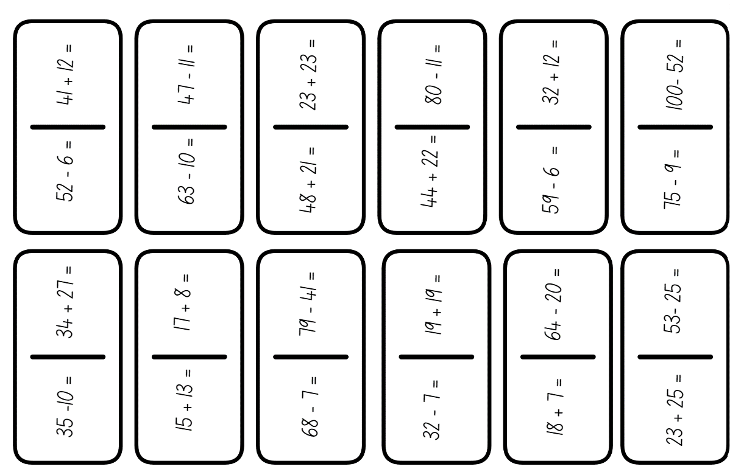

# Resource 19 – blank dominoes

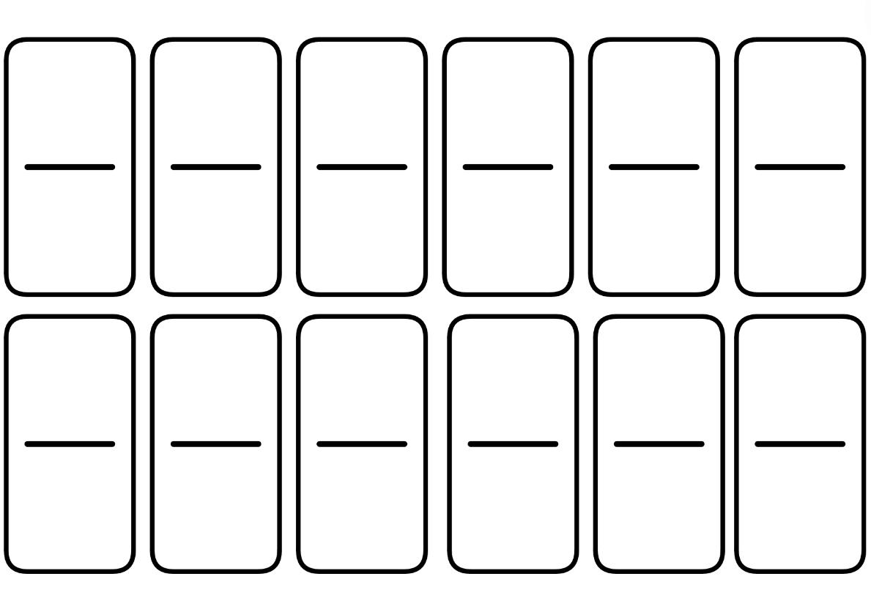

# Resource 20 – place value game

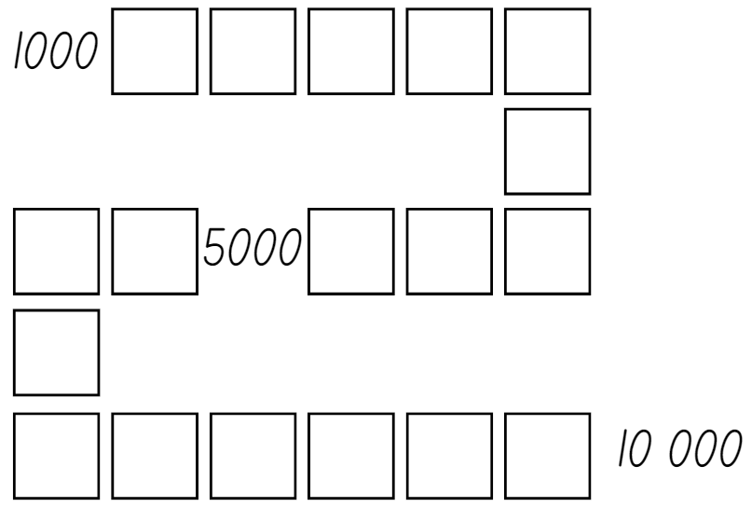

# Resource 21 – array cards

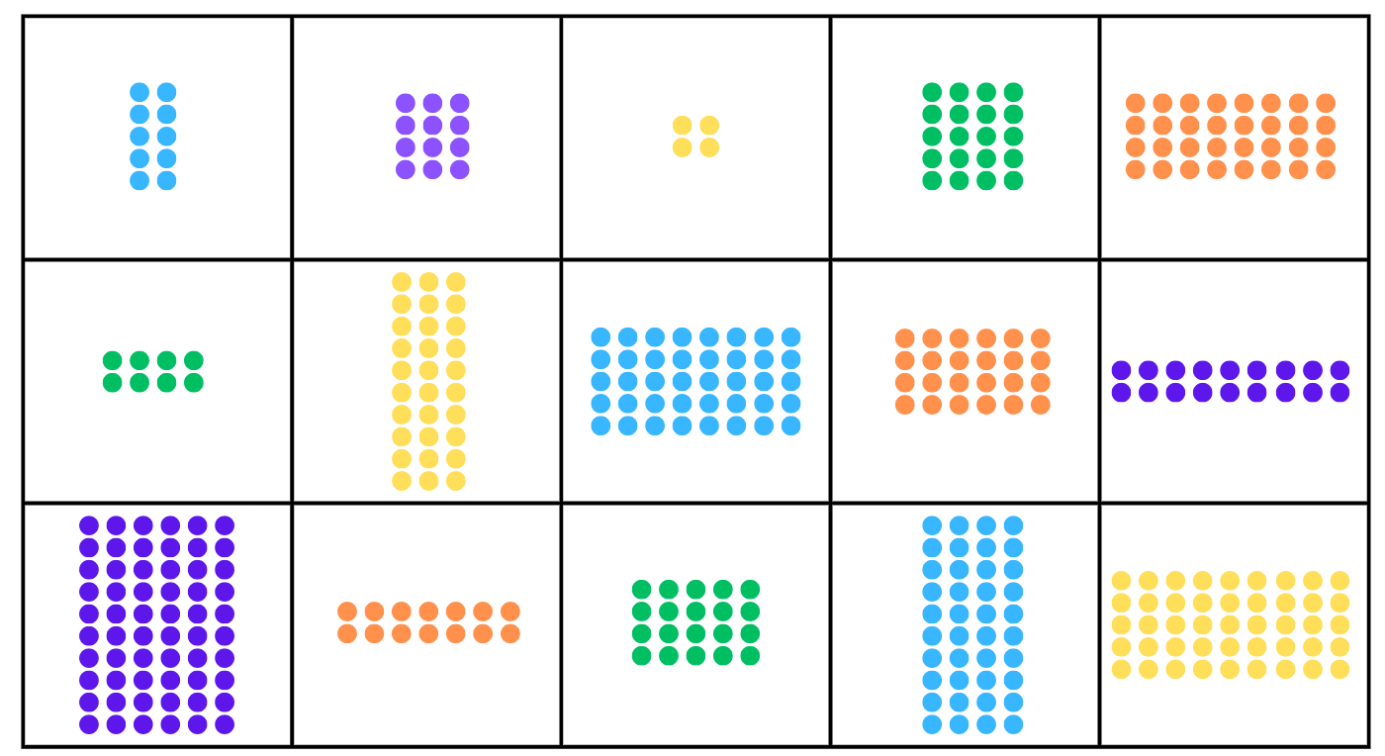

# Resource 22 – 3 arrays

The title reads: The students were shown these 3 arrays. A: 8 by 3, B: 3 by 5 and C: 5 by 3.
They were asked which array is the odd one out. 

Dom has a speech bubble that says: A is the odd one out because its total isn't 15.

Samira has a speech bubble that says: B is the odd one out because it has not got 3 rows.

The text below reads: There is a question asking: Who is correct?

# Resource 23 – Creature Cards problem

An illustrated guide on using a ‘Creature Cards’ collector’s album to display and organise trading cards. 

It includes rules for placing cards and a multiplication and division facts example page layout.

The rules are as follows:
⦁ the page number indicates the amount of cards that can be attached to the page
⦁ each page must contain an array at least 2 rows high and 2 columns wide
⦁ the maximum array size for the collectors album is 100.
⦁ pages used must be recorded on the recording page. It must include the array and both the multiplication and division facts.

Students must determine which pages of the collectors album can be used, what the array could look like and record the relevant multiplication and division facts.

# Resource 24 – recording grid

|  |  |  |  |  |  |  |  |  |  |
| --- | --- | --- | --- | --- | --- | --- | --- | --- | --- |
| 1 | 2 | 3 | 4 | 5 | 6 | 7 | 8 | 9 | 10 |
| 11 | 12 | 13 | 14 | 15 | 16 | 17 | 18 | 19 | 20 |
| 21 | 22 | 23 | 24 | 25 | 26 | 27 | 28 | 29 | 30 |
| 31 | 32 | 33 | 34 | 35 | 36 | 37 | 38 | 39 | 40 |
| 41 | 42 | 43 | 44 | 45 | 46 | 47 | 48 | 49 | 50 |
| 51 | 52 | 53 | 54 | 55 | 56 | 57 | 58 | 59 | 60 |
| 61 | 62 | 63 | 64 | 65 | 66 | 67 | 68 | 69 | 70 |
| 71 | 72 | 73 | 74 | 75 | 76 | 77 | 78 | 79 | 80 |
| 81 | 82 | 83 | 84 | 85 | 86 | 87 | 88 | 89 | 90 |
| 91 | 92 | 93 | 94 | 95 | 96 | 97 | 98 | 99 | 100 |

# Syllabus outcomes and content

The table below outlines the [syllabus outcomes](https://curriculum.nsw.edu.au/learning-areas/mathematics/mathematics-k-10-2022/overview) and range of relevant syllabus content covered in this unit. Content is linked to [National Numeracy Learning Progression](https://www.australiancurriculum.edu.au/resources/national-literacy-and-numeracy-learning-progressions/version-3-of-national-literacy-and-numeracy-learning-progressions/) (version 3).

|  |  |  |  |  |  |  |  |  |
| --- | --- | --- | --- | --- | --- | --- | --- | --- |
| Outcomes and content | 1 | 2 | 3 | 4 | 5 | 6 | 7 | 8 |
| **Representing numbers using place value A**: Whole numbers: Read, represent and order numbers to thousands  **MAO-WM-01, MA2-RN-01** |  |  |  |  |  |  |  |  |
| * Represent numbers up to and including thousands using physical or virtual manipulatives, words, numerals, diagrams and digital displays |  |  | x |  | x | x |  |  |
| * Read and order numbers of up to at least 4 digits |  |  | x |  | x | x | x |  |
| **Representing numbers using place value A**: Whole numbers: Apply place value to partition and regroup numbers up to 4 digits  **MAO-WM-01, MA2-RN-01** |  |  |  |  |  |  |  |  |
| * Partition numbers of up to 4 digits in non-standard forms (Reasons about quantity) |  |  | x |  |  |  |  |  |
| **Representing numbers using place value B**: Whole numbers: Recognise and represent numbers that are 10, 100 or 1000 times as large  **MAO-WM-01, MA2-RN-01** |  |  |  |  |  |  |  |  |
| * Describe how making a number 10, 100 or 1000 times as large changes the place value of digits |  |  | x |  |  |  |  |  |
| **Additive relations A**: Use the principle of equality  **MAO-WM-01, MA2-AR-01** |  |  |  |  |  |  |  |  |
| * Recognise equal differences and record them in number sentences |  |  |  |  | x |  |  |  |
| * Use the equals sign to mean 'the same as', rather than to perform an operation |  |  |  |  | x |  |  |  |
| * Apply the associative property of addition to forming multiples of 10 (Reasons about relations) |  |  |  |  | x |  |  |  |
| **Additive relations A**: Recognise and explain the connection between addition and subtraction  **MAO-WM-01, MA2-AR-01** |  |  |  |  |  |  |  |  |
| * Use the complement principle of addition and subtraction (Reasons about relations) |  |  |  |  |  | x |  |  |
| **Additive relations A**: Select strategies flexibly to solve addition and subtraction problems of up to 3 digits  **MAO-WM-01, MA2-AR-01** |  |  |  |  |  |  |  |  |
| * Apply known mental strategies that use partitioning to add and subtract, such as bridging the decades | x | x | x |  | x | x |  |  |
| * Use the compensation strategy to add and subtract (Reasons about relations) |  |  |  | x | x | x |  |  |
| * Apply the levelling and constant difference strategies (Reasons about relations) |  |  |  | x | x | x |  |  |
| * Represent solutions to addition and subtraction problems, including word problems, using an empty number line or bar model |  | x | x |  |  |  |  |  |
| * Compare and evaluate strategies used to solve addition and subtraction problems, reasoning which strategy may be most efficient |  |  |  | x | x | x |  |  |
| **Additive relations A**: Represent money values in multiple ways  **MAO-WM-01, MA2-AR-01, MA2-AR-02** |  |  |  |  |  |  |  |  |
| * Recognise the relationship between dollars and cents |  | x |  |  |  |  |  |  |
| * Represent equivalent amounts of money using different denominations |  | x |  |  |  |  |  |  |
| * Perform calculations with money, including finding change |  | x |  |  |  |  |  |  |
| **Multiplicative relations A**: Recall multiplication facts of 2 and 4, 5 and 10 and related division facts  **MAO-WM-01, MA2-MR-01, MA2-MR-02** |  |  |  |  |  |  |  |  |
| * Link multiplication and division fact families using arrays |  |  |  |  |  |  | x | x |
| * Generate multiplication fact families for multiples of 2 and 4, 5 and 10 |  |  |  |  |  |  | x |  |
| * Model and apply the commutative property of multiplication |  |  |  |  |  |  | x | x |
| **Multiplicative relations B**: Use number properties to find related multiplication facts  **MAO-WM-01, MA2-MR-01, MA2-MR-02** |  |  |  |  |  |  |  |  |
| * Use the commutative property of multiplication |  |  |  |  |  |  | x | x |
| * Generate and recall multiplication fact families up to 10 × 10 |  |  |  |  |  |  | x | x |
| **Geometric measure A**: Position: Locate positions on grid maps  **MAO-WM-01, MA2-GM-01** |  |  |  |  |  |  |  |  |
| * Use the array (row and column) structure of grid maps to locate position, horizontal before vertical | x |  |  |  |  |  |  |  |
| **Geometric measure B**: Position: Create and interpret grid maps  **MAO-WM-01, MA2-GM-01** |  |  |  |  |  |  |  |  |
| * Create simple maps and plans from an aerial view, labelling grid references | x |  |  |  |  |  |  |  |
| * Identify and mark locations on maps and plans, given their grid references | x |  |  |  |  |  |  |  |

[Mathematics K–10 Syllabus](https://curriculum.nsw.edu.au/learning-areas/mathematics/mathematics-k-10-2022/overview) © NSW Education Standards Authority (NESA) for and on behalf of the Crown in right of the State of New South Wales, 2022.

# References

This resource contains NSW Curriculum and syllabus content. The NSW Curriculum is developed by the NSW Education Standards Authority. This content is prepared by NESA for and on behalf of the Crown in right of the State of New South Wales. The material is protected by Crown copyright.

Please refer to the NESA Copyright Disclaimer for more information <https://educationstandards.nsw.edu.au/wps/portal/nesa/mini-footer/copyright>.

NESA holds the only official and up-to-date versions of the NSW Curriculum and syllabus documents. Please visit the NSW Education Standards Authority (NESA) website <https://educationstandards.nsw.edu.au> and the NSW Curriculum website [https://curriculum.nsw.edu.au](https://curriculum.nsw.edu.au/).

[Mathematics K–10 Syllabus](https://curriculum.nsw.edu.au/learning-areas/mathematics/mathematics-k-10-2022/overview) © NSW Education Standards Authority (NESA) for and on behalf of the Crown in right of the State of New South Wales, 2022.

[National Numeracy Learning Progression](https://www.australiancurriculum.edu.au/resources/national-literacy-and-numeracy-learning-progressions/version-3-of-national-literacy-and-numeracy-learning-progressions/) © Australian Curriculum, Assessment and Reporting Authority (ACARA) 2010 to present, unless otherwise indicated. This material was downloaded from the [Australian Curriculum](http://www.australiancurriculum.edu.au/) website (National Numeracy Learning Progression) (accessed 13 June 2024) and was not modified.

Amplify Education, Inc (2024) [*Polypad*](https://polypad.amplify.com/p/JQHDndMjUbbTPA), Amplify website, accessed 13 August 2024.

Clarke D and Roche A (2014) Engaging Maths: 25 favourite lessons*,* 2nd edn, Mathematics Teaching and Learning Centre, Australian Catholic University and Catholic Education office.

Education Services Australia Ltd (2016)[*Wishball: whole numbers*](https://www.scootle.edu.au/ec/viewing/L867/index.html), Scootle website, accessed 13 June 2024.

Minas M (n.d.) ‘[3 in a Row](https://www.lovemaths.me/operations-36)’, Operations Games (3-6), Love Maths, accessed 18 June 2024.

Russo J (2022) ‘[Let's Play: The Same As](https://www.researchgate.net/publication/360321217_Let's_Play_The_Same_As)’, Prime Number*, 37*(2):14–15, accessed 13 June 2024.

Russo J and Russo T (2023) ‘[Unpacking game mechanics: Five types of whole-class mathematical games](https://www.researchgate.net/publication/378964831_Unpacking_game_mechanics_Five_types_of_whole-class_mathematical_games)’, Australian Primary Mathematics Classroom*,* 28(3):8–16, accessed 13 June 2024.

State of New South Wales (Department of Education) (2024a) ‘[Closest to 100 (additive strategies)](https://education.nsw.gov.au/teaching-and-learning/curriculum/mathematics/mathematics-curriculum-resources-k-12/thinking-mathematically-resources/mathematics-s2-s3-closest-to-100)’, Thinking mathematically resources, NSW Department of Education website, accessed 13 August 2024.

——(2024b) [‘Hit it (3-digit numbers)](https://education.nsw.gov.au/teaching-and-learning/curriculum/mathematics/mathematics-curriculum-resources-k-12/thinking-mathematically-resources/mathematics-s1-s2-hit-it)’, Thinking mathematically resources, NSW Department of Education website, accessed 13 August 2024.

——(2024c) ‘[Mastermind](https://education.nsw.gov.au/teaching-and-learning/curriculum/mathematics/mathematics-curriculum-resources-k-12/thinking-mathematically-resources/mathematics-s1-s3-mastermind)’, Thinking mathematically resources, NSW Department of Education website, accessed 13 August 2024.

——(2024d) ‘[Place value game](https://education.nsw.gov.au/teaching-and-learning/curriculum/mathematics/mathematics-curriculum-resources-k-12/thinking-mathematically-resources/mathematics-s1-s3-place-value-game)’, Thinking mathematically resources, NSW Department of Education website, accessed 13 August 2024.

Super Teacher Tools (2009–2024)[*Super Spinner*](http://www.superteachertools.com/spinner/spinner.php?title=Super+Spinner&directions=Click+the+wheel+below+to+spin%3A&colorscheme=color1&labels=100%2C10%2C1000%2C10%2C100%2C1000%2C10%2C100%2C1000%2C10)*,* Super Teacher Tools website, accessed 26th June 2024*.*

Toy Theater (2001–2024)‘[*Playing Cards*](https://toytheater.com/playing-cards/)’, Probability Manipulatives, Toy Theater website, accessed 26th June 2024.

University of Cambridge (n.d.a)[*Amy’s Dominoes*](https://nrich.maths.org/problems/amys-dominoes), NRICH website, accessed 13 June 2024.

University of Cambridge (n.d.b) [*Treasure Hunt*](https://nrich.maths.org/problems/treasure-hunt),NRICH website, accessed 13 June 2024.

Wang E and Russo J (2022) ‘[Our epic Monopoly game: Exploring non-standard partitioning using money](https://www.researchgate.net/publication/364307525_Our_epic_Monopoly_game_Exploring_non-standard_partitioning_using_money)’, Prime Number, 37(4):21–23, accessed 13 June 2024.

White Rose Education (2022) ‘Use arrays’, Number: Multiplication and division, White Rose Education.

**© State of New South Wales (Department of Education), 2024**

The copyright material published in this resource is subject to the *Copyright Act 1968* (Cth) and is owned by the NSW Department of Education or, where indicated, by a party other than the NSW Department of Education (third-party material).

Copyright material available in this resource and owned by the NSW Department of Education is licensed under a [Creative Commons Attribution 4.0 International (CC BY 4.0) license](https://creativecommons.org/licenses/by/4.0/).

**[](https://creativecommons.org/licenses/by/4.0/)**

This license allows you to share and adapt the material for any purpose, even commercially.

Attribution should be given to © State of New South Wales (Department of Education), 2024.

Material in this resource not available under a Creative Commons license:

* the NSW Department of Education logo, other logos and trademark-protected material
* material owned by a third party that has been reproduced with permission. You will need to obtain permission from the third party to reuse its material.

**Links to third-party material and websites**

Please note that the provided (reading/viewing material/list/links/texts) are a suggestion only and implies no endorsement, by the New South Wales Department of Education, of any author, publisher, or book title. School principals and teachers are best placed to assess the suitability of resources that would complement the curriculum and reflect the needs and interests of their students.

If you use the links provided in this document to access a third-party's website, you acknowledge that the terms of use, including licence terms set out on the third-party's website apply to the use which may be made of the materials on that third-party website or where permitted by the *Copyright Act 1968* (Cth). The department accepts no responsibility for content on third-party websites.