Mathematics Stage 2 – Unit 32

Understanding relationships between the properties of 2D shapes helps visualise and organise spaces in the world

Contents

Unit description and duration 5

Syllabus outcomes 5

Working mathematically 6

Student prior learning 6

Lesson overview and resources 8

Lesson 1 14

Daily number sense – How many ways to describe an array? – 10 minutes 14

Core lesson – finding symmetry – 45 minutes 15

Discuss and connect the mathematics – 10 minutes 18

Lesson 2 21

Daily number sense – multiplication fact families – 10 minutes 21

Core lesson 1 – creating shapes – 25 minutes 22

Core lesson 2 – creating more new shapes – 15 minutes 25

Discuss and connect the mathematics – 15 minutes 26

Lesson 3 29

Daily number sense – finding multiplication facts – 15 minutes 29

Core lesson – tile patterns – 45 minutes 31

Discuss and connect the mathematics – 5 minutes 34

Lesson 4 37

Daily number sense – 10 minutes 37

Core lesson – flags – 45 minutes 37

Consolidation and meaningful practice – 5 minutes 41

Lesson 5 42

Daily number sense – coins – 10 minutes 42

Core lesson 1 – area clues – 20 minutes 44

Core lesson 2 – garden area investigation – 20 minutes 47

Discuss and connect the mathematics – 10 minutes 49

Consolidation and meaningful practice – 10 minutes 51

Lesson 6 52

Daily number sense – 5 notes – 10 minutes 52

Core lesson – connecting area and perimeter – 40 minutes 54

Discuss and connect the mathematics – 10 minutes 57

Lesson 7 60

Daily number sense – stationery or stickers – 10 minutes 60

Core lesson 1 – largest chocolate slice – 30 minutes 62

Core lesson 2 – the same areas – 20 minutes 65

Discuss and connect the mathematics – 10 minutes 66

Lesson 8 68

Daily number sense – 10 minutes 68

Core lesson – largest handball space – 40 minutes 68

Discuss and connect the mathematics – 10 minutes 72

Consolidation and meaningful practice – 10 minutes 73

Resource 1 – Symmetry or not? 74

Resource 2 – out and about 75

Resource 3 – paper rectangles 76

Resource 4 – 7 sixes 77

Resource 5 – tile patterns 78

Resource 6 – tile shapes 79

Resource 7 – flags 80

Resource 8 – tessellations in nature 81

Resource 9 – area clues 82

Resource 10 – area clues 2 83

Resource 11 – garden area investigation 84

Resource 12 – torn shapes 85

Resource 13 – 12 squares 86

Resource 14 – prize problem 87

Resource 15 – the largest slice 88

Resource 16 – area problems 89

Syllabus outcomes and content 91

References 97

# Unit description and duration

This unit develops the big idea that understanding relationships between properties of two-dimensional shapes helps visualise and organise spaces in the world.

In this 2-week unit students are provided opportunities to:

* combine and split common shapes to create other common two-dimensional shapes
* transform shapes by reflecting, translating, and rotating
* measure and compare the areas of shapes using the grid structure and familiar metric units of area.

## Syllabus outcomes

* **MAO-WM-01** Develops understanding and fluency in mathematics through exploring and connecting mathematical concepts, choosing, and applying mathematical techniques to solve problems, and communicating their thinking and reasoning coherently and clearly
* **MA2-AR-01** selects and uses mental and written strategies for addition and subtraction involving 2- and 3-digit numbers
* **MA2-MR-01** represents and uses the structure of multiplicative relations to 10 × 10 to solve problems
* **MA2-MR-02** completes number sentences involving multiplication and division by finding missing values
* **MA2-2DS-01** compares two-dimensional shapes and describes their features
* **MA2-2DS-02** performs transformations by combining and splitting two-dimensional shapes
* **MA2-2DS-03** estimates, measures, and compares areas using square centimetres and square metres

## Working mathematically

In the Mathematics K–10 Syllabus, there is one overarching Working mathematically outcome (**MAO-WM-01**). The Working mathematically processes should be embedded within the concepts being taught. The Working mathematically processes present in the Mathematics K–10 Syllabus are:

* communicating
* understanding and fluency
* reasoning
* problem solving.

[Mathematics K–10 Syllabus](https://curriculum.nsw.edu.au/learning-areas/mathematics/mathematics-k-10-2022/overview) © NSW Education Standards Authority (NESA) for and on behalf of the Crown in right of the State of New South Wales, 2022.

## Student prior learning

Before engaging in these teaching and learning activities, students would benefit from prior experience with:

* describing and comparing features of two-dimensional shapes
* exploring transformations through combining and splitting two-dimensional shapes
* learning how to estimate and find area using standard units of measurement.

In NSW classrooms there is a diverse range of students, including Aboriginal and/or Torres Strait Islander students, students learning English as an additional language or dialect, high potential and gifted students and students with disability. Some students may identify with more than one of these groups or possibly all of them. Refer to [Curriculum planning for every student – advice](https://education.nsw.gov.au/teaching-and-learning/curriculum/planning-programming-and-assessing-k-12/advice-on-curriculum-planning-for-every-student-k-12) for further information.

## Lesson overview and resources

The table below outlines the sequence and approximate timing of lessons, learning intentions and resources.

|  |  |  |
| --- | --- | --- |
| Lesson | Content | Duration and resources |
| **Lesson 1**  **Daily number sense learning intention:**   * use number properties to find related multiplication facts | **Lesson core concept**: simple shapes can be found in more complex shapes.  **Core concept learning intention**:   * transform shapes by reflecting, translating, and rotating | **Lesson duration**: 65 minutes   * Resource 1 – Symmetry or not? * Resource 2 – out and about? * 10-sided dice * Counters or grid paper * Writing materials |
| **Lesson 2**  **Daily number sense learning intention:**   * use number properties to find related multiplication facts | **Lesson core concept**: new shapes can be made by combining or splitting existing shapes.  **Core concept learning intention**:   * create two-dimensional shapes that result from combining and splitting common shapes | **Lesson duration**: 65 minutes   * Resource 3 – paper rectangles * 10-sided dice * Counters or grid paper * Glue * Multiplication grids as needed * Poster cardboard (optional) * Scissors * Writing materials |
| **Lesson 3**  **Daily number sense learning intention:**   * use number properties to find related multiplication facts | **Lesson core concept**: art, science and nature have tessellating patterns.  **Core concept learning intentions**:   * transform shapes by reflecting, translating, and rotating * create symmetrical patterns and shapes | **Lesson duration**: 70 minutes   * Resource 4 – 7 sixes * Resource 5 – tile patterns * Resource 6 – tile shapes (printed on card) * A4 paper * Counters as necessary * Grid paper * Scissors * Pattern blocks (optional) * Writing materials |
| **Lesson 4**  **Daily number sense learning intention:**   * teacher-identified task based on student needs | **Lesson core concept**: rotation of a shape can be measured in fractions of a turn.  **Core concept learning intentions**:   * transform shapes by reflecting, translating, and rotating * create symmetrical patterns and shapes | **Lesson duration**: 60 minutes   * Resource 7 – flags * Resource 8 – tessellations in nature * A4 paper * Coloured pencils * Writing materials |
| **Lesson 5**  **Daily number sense learning intention:**   * apply addition and subtraction to familiar contexts, including money and budgeting | **Lesson core concept**: grids can support the measurement of area in rectangles and triangles.  **Core concept learning intentions**:   * measure the areas of shapes using the grid structure * use the structure of the area model to represent multiplication and division | **Lesson duration**: 70 minutes   * Resource 9 – area clues * Resource 10 – area clues 2 * Resource 11 – garden area investigation * Resource 12 – torn shapes * One of each coin: $2, $1, 50c, 20c, 10c, 5c * Writing materials |
| **Lesson 6**  **Daily number sense learning intention:**   * apply addition and subtraction to familiar contexts, including money and budgeting | **Lesson core concept**: rectangles with the same area can have different perimeters.  **Core concept learning intentions**:   * measure the areas of shapes using the grid structure * represent and solve problems involving multiplication fact families * use the structure of the area model to represent multiplication and division | **Lesson duration**: 60 minutes   * Resource 13 – 12 squares * Grid paper * Writing materials |
| **Lesson 7**  **Daily number sense learning intention:**   * apply addition and subtraction to familiar contexts, including money and budgeting | **Lesson core concept**: estimation is useful to check the reasonableness of answers.  **Core concept learning intentions**:   * compare surfaces using familiar metric units of area * represent and solve problems involving multiplication fact families * use the structure of the area model to represent multiplication and division | **Lesson duration**: 60 minutes   * Resource 14 – prize problem * Resource 15 – the largest slice * Clear plastic grid overlay (class set) * Grid paper * Individual whiteboards * Rulers (class set) * Writing materials |
| **Lesson 8**  **Daily number sense learning intention:**   * teacher-identified task based on student needs | **Lesson core concept**: multiplication arrays can be a useful way to calculate area.  **Core concept learning intentions**:   * compare surfaces using familiar metric units of area * use the structure of the area model to represent multiplication and division * use number properties to find related multiplication facts * represent and solve word problems with number sentences involving multiplication or division | **Lesson duration**: 70 minutes   * Resource 16 – area problems * Chalk/markers * Metre rulers (class set) * Metre squares (class set) * Writing materials |

# Lesson 1

**Core concept**: simple shapes can be found in more complex shapes.

## Daily number sense – How many ways to describe an array? – 10 minutes

Daily number sense activities for Lessons 1 to 3 ‘activate’ prior number knowledge and support the learning of new content in the unit. These activities can also assist teachers to identify the starting points for learning by revealing the extent of students’ existing knowledge.

The table below contains a suggested learning intention and success criteria. These are best co-constructed with students.

|  |  |
| --- | --- |
| Daily number sense learning intention | Daily number sense success criteria |
| Students are learning to:   * use number properties to find related multiplication facts. | Students can:   * use the commutative property of multiplication. |

1. In pairs, students roll two 10-sided dice. Partner A rolls the dice and uses the numbers rolled to make an array with counters or draw the array on grid paper. For example, a student rolls a 2 and a 6 and makes an array of 2 sixes.
2. Partner B uses the commutative property to make the matching array for the numbers rolled. For example, 6 twos.
3. Pairs label their array with the corresponding multiplication sentences to show the commutative property. For example, 6 × 2 = 2 × 6.
4. Students repeat the process using different numbers by rolling the dice.

This table details opportunities for assessment.

|  |  |
| --- | --- |
| Assessment opportunities | Links |
| What to look for:   * Can students use the commutative property of multiplication? **[MAO-WM-01, MA2-MR-01]** | Links to [National Numeracy Learning Progressions](https://www.australiancurriculum.edu.au/resources/national-literacy-and-numeracy-learning-progressions/version-3-of-national-literacy-and-numeracy-learning-progressions/) (NNLP):   * MuS6.   Links to suggested [Interview for Student Reasoning](https://education.nsw.gov.au/teaching-and-learning/curriculum/literacy-and-numeracy/assessment-resources/ifsr) (IfSR) tasks:   * IfSR-MT: 2A.9 |

## Core lesson – finding symmetry – 45 minutes

The table below contains a suggested learning intention and success criteria. These are best co-constructed with students.

|  |  |
| --- | --- |
| Core concept learning intention | Core concept success criteria |
| Students are learning to:   * transform shapes by reflecting, translating, and rotating. | Students can:   * identify lines of symmetry in pictures, artefacts, designs, and the environment. |

1. Display the word ‘symmetry’ and discuss what it means.

**Symmetry:** an object or shape has symmetry or is symmetrical when one half is the mirror image of the other half.

1. Display Resource 1 – Symmetry or not? As a class, look for images that contain:

* one line of symmetry
* more than one line of symmetry
* no symmetry.

1. With a partner, students identify lines of symmetry on Resource 2 – out and about, before comparing ideas with another pair. Support use of terminology and identify any misconceptions about symmetry.

**Note:** some pictures will give the idea of symmetry, even if they are not ‘perfect.’ For example, flowers or wheel covers on a car have small features such as petals or tyre valves that disrupt the symmetry (Siemon 2020).

1. Support students to recognise that a different view of the slide on Resource 2 – out and about could show symmetry (see Figure 1). Support students to see that some shapes or objects give the idea of symmetry but may have small features that mean they do not have perfect symmetry.

Figure 1 – front view of slide that can show symmetry

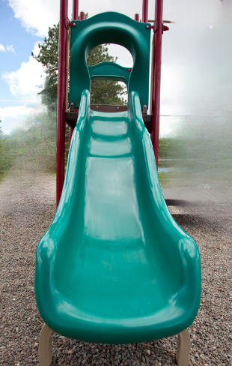

© rustycanuck via [Canva.com](https://www.canva.com/)

**Note:** the window and basketball hoop on Resource 2 – out and about have line symmetry. The school logo would be symmetrical without the tassel and the door would be symmetrical without the handle. The slide is symmetrical but needs to be visualised from the back or front. The recycling logo does not have line symmetry. It can be discussed as a non-example. It does have rotational symmetry. Rotational symmetry is a Stage 3 concept. The term can be introduced and discussed if appropriate to your class context.

1. In small groups, take students for a symmetry scavenger hunt around school, sketching or photographing views of objects and places that contain symmetry.
2. Back in the classroom, each group shares their images and ideas about symmetry with another group.

This table details opportunities for differentiation.

|  |  |
| --- | --- |
| Too hard? | Too easy? |
| Students cannot identify symmetry in drawings or real-life objects.   * Model folding paper squares and triangles to find and draw lines of symmetry. * Students repeat the process with squares and triangles of different sizes. * Students repeat the process with other shapes; for example, rectangles and trapeziums. | Students can identify symmetry in drawings and real-life objects.   * Students classify their scavenger hunt findings focussing on additional attributes. For example, these objects have 2 lines of symmetry, and these have 2 pairs of equal sides. |

## Discuss and connect the mathematics – 10 minutes

1. Students take turns to ask symmetry questions about shapes and objects in the classroom. For example:

* I see a red object with 2 lines of symmetry. What is it?
* I see a white object with black markings and there are so many lines of symmetry I can’t count them all. What is it?

This table details opportunities for assessment.

|  |  |
| --- | --- |
| Assessment opportunities | Links |
| What to look for:   * Can students identify lines of symmetry in pictures, artefacts, designs, and the environment? **[MAO-WM-01, MA2-2DS-02]** | Links to [National Numeracy Learning Progressions](https://www.australiancurriculum.edu.au/resources/national-literacy-and-numeracy-learning-progressions/version-3-of-national-literacy-and-numeracy-learning-progressions/) (NNLP):   * UGP3. |

# Lesson 2

**Core concept**: new shapes can be made by combining or splitting existing shapes.

## Daily number sense – multiplication fact families – 10 minutes

The table below contains a suggested learning intention and success criteria. These are best co-constructed with students.

|  |  |
| --- | --- |
| Daily number sense learning intention | Daily number sense success criteria |
| Students are learning to:   * use number properties to find related multiplication facts. | Students can:   * generate and recall multiplication fact families up to 10 × 10. |

1. In pairs, students roll two 10-sided dice and use the dice rolls to make an array with counters or draw the array on grid paper. For example, students roll a 3 and a 4 and make an array of 3 fours.
2. Pairs label their array to show related multiplication and division facts. Students each write a multiplication and division number sentence. For example, Partner A writes 3 × 4 = 12, 12 ÷ 3 = 4 and Partner B writes 4 × 3 = 12, 12 ÷ 4 = 3 (see Figure 2).

Figure 2 – multiplication and division facts

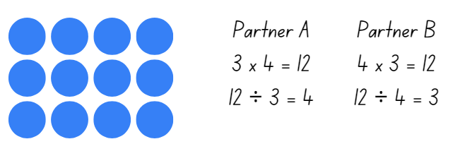

1. Students repeat the process using different numbers by rolling the dice.

This table details opportunities for assessment.

|  |  |
| --- | --- |
| Assessment opportunities | Links |
| What to look for:   * Can students generate and recall multiplication fact families up to 10 × 10? **[MAO-WM-01, MA2-MR-01]** | Links to [National Numeracy Learning Progressions](https://www.australiancurriculum.edu.au/resources/national-literacy-and-numeracy-learning-progressions/version-3-of-national-literacy-and-numeracy-learning-progressions/) (NNLP):   * MuS6. |

## Core lesson 1 – creating shapes – 25 minutes

The table below contains a suggested learning intention and success criteria. These are best co-constructed with students.

|  |  |
| --- | --- |
| Core concept learning intention | Core concept success criteria |
| Students are learning to:   * create two-dimensional shapes that result from combining and splitting common shapes. | Students can:   * combine common two-dimensional shapes to form other common shapes * split a given shape into 2 or more common shapes and describe the result * record the arrangements of common shapes used to create other shapes. |

This activity is an adaptation of ‘Two-piece shapes’ from Primary and Middle Years Mathematics: Teaching Developmentally by Van de Walle et al.

1. Provide pairs of students with Resource 3 – paper rectangles, scissors and glue. Students cut out the rectangles which must all be the same size.
2. Explain that new shapes can be made by combining or partitioning existing shapes.
3. Have students fold each rectangle on both diagonals and cut on the folds. Each pair should end up with 12 identical triangles.
4. Explain to students that there are rules when creating new shapes. Only sides of the same length can be matched up and they must be matched up exactly (see Figure 3).

Figure 3 – creating new shapes

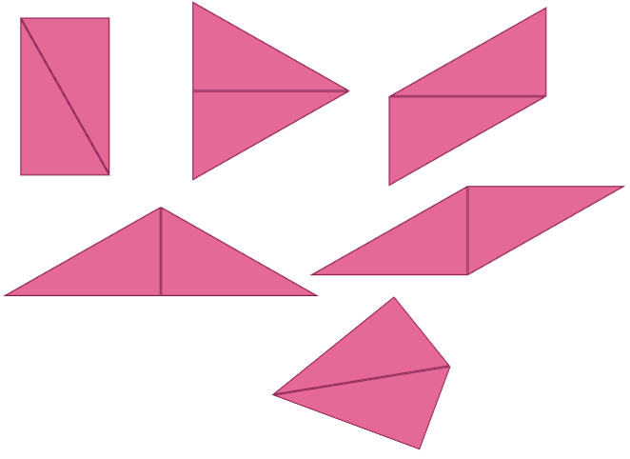

1. Students rearrange the triangles into different shapes using 2 triangles at a time. This includes making the original rectangle. They glue each new shape made onto cardboard to create a poster.
2. Students write the names of any shapes they recognise.
3. Once posters are finished, pairs present their shapes.

## Core lesson 2 – creating more new shapes – 15 minutes

1. Students use pattern blocks or attribute blocks to create new shapes. They record each new shape and write a describing sentence (see Figure 4). For example:

* 3 triangles can make a trapezium.
* 2 squares can make a rectangle.
* 2 trapeziums can make a hexagon.

Figure 4 – pattern blocks creating new shapes

3 triangles arranged to make a trapezium.
2 squares arranged to make a rectangle.
2 trapeziums arranged to make a hexagon.

This table details opportunities for differentiation.

|  |  |
| --- | --- |
| Too hard? | Too easy? |
| Students cannot combine common two-dimensional shapes to form other common shapes.   * Make sure triangles have been cut correctly and are the same size. * Make sure the same lengths are being matched up. * Model 2 of the shapes and then students create some more. | Students can combine common two-dimensional shapes to form other common shapes.   * Students experiment by making more shapes. They use 4 triangles to create familiar shapes and match up lengths that are not the same size. |

## Discuss and connect the mathematics – 15 minutes

1. Groups look at images collected in the Lesson 1 scavenger hunt. Ask students to discuss and annotate images that can be split into 2 or more shapes (see Figure 5). Some examples might be:

* A rectangular door can be split into 2 right angled triangles.
* The painting of the sun on the wall can be split into 2 semi-circles.
* The office building can be split into a square and a trapezium.
* Our school logo can be split into a rectangle and a parallelogram.

Figure 5 – real world images split into shapes

A door with a diagonal line showing a split into two right angled triangles.
A mural with a sun in the middle. The sun has a line through the middle showing how it can be split into 2 semi-circles. 

**Note:** in this activity, students are not looking for symmetry although some of the shapes may have symmetry.

This table details opportunities for assessment.

|  |  |
| --- | --- |
| Assessment opportunities | Links |
| What to look for:   * Can students combine common two-dimensional shapes to form other common shapes? **[MAO-2DS-02, MA2-2DS-02]** * Can students split a given shape into 2 or more common shapes and describe the result? **[MAO-2DS-02, MA2-2DS-02]** * Can students record the arrangements of common shapes used to create other shapes? **[MAO-2DS-02, MA2-2DS-02]** | Links to [National Numeracy Learning Progressions](https://www.australiancurriculum.edu.au/resources/national-literacy-and-numeracy-learning-progressions/version-3-of-national-literacy-and-numeracy-learning-progressions/) (NNLP):   * UGP5, UGP6. |

# Lesson 3

**Core concept**: art, science and nature have tessellating patterns.

## Daily number sense – finding multiplication facts – 15 minutes

The table below contains a suggested learning intention and success criteria. These are best co-constructed with students.

|  |  |
| --- | --- |
| Daily number sense learning intention | Daily number sense success criteria |
| Students are learning to:   * use number properties to find related multiplication facts. | Students can:   * use flexible partitioning within multiplication. |

1. Display Resource 4 – 7 sixes. Using grid paper, model different ways of partitioning. Encourage students to use known facts to make finding a multiplication fact easier. For example, 7 × 6 can be solved by adding 6 × 6 to one more 6, or finding 7 × 5 and adding one more 7 (see Figure 6).

Figure 6 – different ways to find a multiplication fact

7 sixes in an array and partitioned in two different ways.
The first image shows 7x6 partitioned in 6x6 and add on one more 6. 
The second image shows 7x6 partitioned into 7x5 and add on onre more 7

1. In pairs, students take turns to nominate a multiplication fact hard to recall. Provide students with grid paper to construct the array and record how partitioning can make recall easier. Some students may require concrete materials such as counters.

This table details opportunities for assessment.

|  |  |
| --- | --- |
| Assessment opportunities | Links |
| What to look for:   * Can students use flexible partitioning within multiplication?  **[MAO-WM-01, MA2-MR-01]** | Links to [National Numeracy Learning Progressions](https://www.australiancurriculum.edu.au/resources/national-literacy-and-numeracy-learning-progressions/version-3-of-national-literacy-and-numeracy-learning-progressions/) (NNLP):   * MuS7. |

## Core lesson – tile patterns – 45 minutes

The table below contains suggested learning intentions and success criteria. These are best co-constructed with students.

|  |  |
| --- | --- |
| Core concept learning intentions | Core concept success criteria |
| Students are learning to:   * transform shapes by reflecting, translating, and rotating * create symmetrical patterns and shapes. | Students can:   * identify lines of symmetry in pictures, designs, and the environment * draw lines of symmetry on given shapes * apply and describe amounts of rotation including half-turns, quarter-turns and three-quarter-turns when creating designs * create and record tessellating designs by reflecting, translating, and rotating triangles, quadrilaterals, or other chosen shapes. |

This activity is an adaptation of ‘Tile it’ from *Mindset Mathematics Grade 4* by Boaler et al.

1. Explain that for thousands of years, tiles have been used for practical purposes in built environments. However, they are often also artforms. Some have drawn inspiration from the natural world.
2. Revise the term symmetry and identify examples of symmetry in the classroom.

**Symmetry:** an object or shape has symmetry or is symmetrical when one half is the mirror image of the other half.

1. Discuss the terms tessellation, reflect, rotation and translation with students, providing examples with pattern blocks as needed.

**Tessellation: a repeated shape that fits together over a flat surface without any spaces or overlaps.**

**Translation:** in a translation (slide) every point on the original image moves in the same direction for the same distance to transform the new image.

**Reflection:** a reflection (flip) requires a line of reflection. A reflection is a transformation in which an object is flipped across the line of reflection.

**Rotation:** a rotation (turn) requires a centre of rotation (a point) and a degree of rotation, for example, 90 degrees or a quarter turn.

1. Display Resource 5 – tile patterns. Ask students:

* What common two-dimensional shapes can you see?
* Are there any shapes you do not recognise? How can you describe those?
* Do you think any patterns have been inspired by the natural world?
* Are there any examples of tessellations visible in these tile patterns?
* What transformations do you see? What examples of translation, reflection and rotation can you see?
* How many different shapes do each of these tile patterns use?

1. As a class, look at the core shape(s) from each pattern in Resource 5 – tile patterns, for example, a hexagon and rectangle. Identify and draw on lines of symmetry.
2. Give pairs of students Resource 6 – tile shapes printed on card. Ask students to predict which shapes:

* will not tessellate
* can be used to make tessellations with one shape
* can be used to make tessellations with 2 shapes.

1. Students justify their reasoning with their partner.
2. Pairs of students choose and cut out one or 2 shapes from Resource 6 – tile shapes. Have students repeatedly draw around these to make a tessellation on A4 paper. Pattern blocks can be used for this activity but will not provide as much choice.
3. Ask students:

* Are you rotating, translating, or reflecting your shape(s) to make your tessellation?
* Could your pattern continue in every direction without ending? (This proves it is a tessellation).

1. Have students write a description about their tessellation that includes:

* the name(s) of the shape(s) used
* whether they use reflection (flip), translation (slide) or rotation (turn)
* where it is quarter, half, or three-quarter rotation where rotation has been used
* if their tessellation uses one shape or 2
* whether their tessellation has any lines of symmetry.

1. Students go on a [gallery walk](https://app.education.nsw.gov.au/digital-learning-selector/LearningActivity/Card/555) to compare their tessellation to others.

This table details opportunities for differentiation.

|  |  |
| --- | --- |
| Too hard? | Too easy? |
| Students cannot use translation, reflection, or rotation to create a tessellation.   * Model how to translate a rectangle to make a tessellation and have students copy. * Model how to translate and rotate an equilateral triangle to make a hexagon and continue the tessellation. Students copy. | Students can use translation, reflection, or rotation to create a tessellation.   * Students find digital images of tessellations and describe how mathematical transformations have been used to create tessellations. * Investigate why some shapes tessellate and others do not by exploring where the corners of shapes meet. |

## Discuss and connect the mathematics – 5 minutes

1. Using the tessellation display from the gallery walk, ask students to identify:

* which tessellations used translation, reflection, rotation
* a tessellation using one shape
* a tessellation using 2 shapes.

1. Ask students:

* Are your predictions about the tile shapes that tesselate correct?
* Which of these shapes can tesselate by themselves? (Triangles, squares, and hexagons)
* What do you notice about the shapes that can tessellate by themselves?

**Note**: the teaching advice for Stage 2 states that students should develop an appreciation that any triangle will tessellate. In general, for a shape to tessellate, each of its interior angles must be a factor of 360°. It is not an expectation that Stage 2 students develop this understanding.

This table details opportunities for assessment.

|  |  |
| --- | --- |
| Assessment opportunities | Links |
| What to look for:   * Can students identify lines of symmetry in pictures, designs, and the environment? **[MAO-WM-01, MA2-2DS-02]** * Can students draw lines of symmetry on given shapes? **[MAO-WM-01, MA2-2DS-02]** * Can students apply and describe amounts of rotation when creating designs? **[MAO-WM-01, MA2-2DS-02]** * Can students create and record tessellating designs by reflecting, translating, and rotating triangles, quadrilaterals, or other chosen shapes? **[MAO-WM-01, MA2-2DS-02]** | Links to [National Numeracy Learning Progressions](https://www.australiancurriculum.edu.au/resources/national-literacy-and-numeracy-learning-progressions/version-3-of-national-literacy-and-numeracy-learning-progressions/) (NNLP):   * UGP3, UGP4, UGP5, UGP6. |

# Lesson 4

**Core concept**: rotation of a shape can be measured in fractions of a turn.

## Daily number sense – 10 minutes

1. From a class need surfaced through formative assessment data, identify a short, focused activity that targets students’ knowledge, understanding and skills. Example activities may be drawn from the following resources:

* [Mathematics K–6 resources](https://education.nsw.gov.au/teaching-and-learning/curriculum/mathematics/mathematics-curriculum-resources-k-12/mathematics-k-6-resources)
* [Universal Resources Hub](https://resources.education.nsw.gov.au/home).

## Core lesson – flags – 45 minutes

The table below contains suggested learning intentions and success criteria. These are best co-constructed with students.

|  |  |
| --- | --- |
| Core concept learning intentions | Core concept success criteria |
| Students are learning to:   * transform shapes by reflecting, translating, and rotating * create symmetrical patterns and shapes. | Students can:   * identify lines of symmetry in pictures, designs, and the environment * create and record tessellating designs by reflecting, translating, and rotating triangles or quadrilaterals * apply and describe amounts of rotation, including half-turns, quarter-turns and three-quarter-turns, when creating designs. |

1. Tell students that a flag is a visual symbol used for identification. Ask how the Australian, Aboriginal and Torres Strait Islander flags can be recognised. Explain that flags often have mathematical elements in their designs.
2. Display Resource 7 – flags. Students [turn and talk](https://education.nsw.gov.au/teaching-and-learning/curriculum/literacy-and-numeracy/teaching-and-learning-resources/numeracy/talk-moves). Ask students:

* Do any of these flags have lines of symmetry?
* What examples of tessellation can you see on these flags?
* Can you find any examples of reflection, translation, or rotation on these flags? See Figure 7.

Figure 7 – mathematical elements in flag designs

Three flags with descriptions underneath. 
The first flag is labelled: This flag has tessellating triangles. It doesn’t have a line of symmetry because the two images in each triangle are different.
The second flag is labelled: This flag has 3 tessellating rectangles. It has 2 lines of symmetry.
The third flag is labelled: This flag has tessellating triangles. It doesn’t have any lines of symmetry. The stars have been translated along the top and bottom of the flag.

1. Discuss ideas as a class.
2. Provide small groups of students with A4 paper to plan and design a class flag. Explain that the design must include elements of symmetry, tessellation, and rotation. Students may wish to include examples of reflection and translation in their design. Students will also need to consider use of colours and/or symbols that represent the class.

**Note:** this activity could connect data collection syllabus outcomes if students survey the class about colours and/or symbols.

1. Display the flags. Each group reports on the symmetry, mathematical transformations used (translation, reflection, rotation) to create it, use of colour and/or symbols. With the elements of rotation, students specify whether quarter, half, or three-quarter turns are used. Discuss whether the tessellation on each flag can continue in every direction and whether there are lines of symmetry in each flag.

This table details opportunities for differentiation.

|  |  |
| --- | --- |
| Too hard? | Too easy? |
| Students cannot use reflection, translation, or rotation to design a flag.   * Support students to use a rectangle that is one-third of an A4 sheet of paper as a stencil. Students draw around this and slide the rectangle down until they reach the end of the first rectangle and draw around it again. Students repeat the process until they have created a flag with 3 segments that tessellate. * Students make choices about which 3 colours to use for their flag. They explain their thinking to a friend. | Students can use reflection, translation, or rotation to design a flag.   * Students look at flags of the world and categorise them into groups depending on how many mathematical transformations have been used in each design. * Students research different types of flags. For example, country, sports teams, groups of people, decorative. Students identify the types of mathematical transformations used, lines of symmetry and tessellations in the designs. |

This table details opportunities for assessment.

|  |  |
| --- | --- |
| Assessment opportunities | Links |
| What to look for:   * Can students identify lines of symmetry in designs and the environment? **[MAO-WM-01, MA2-2DS-02]** * Can students create and record tessellating designs by reflecting, translating, and rotating triangles or quadrilaterals?  **[MAO-WM-01, MA2-2DS-02]** * Can students apply and describe amounts of rotation, including half-turns, quarter-turns and three-quarter-turns, when creating designs? **[MAO-WM-01, MA2-2DS-02]** | Links to [National Numeracy Learning Progressions](https://www.australiancurriculum.edu.au/resources/national-literacy-and-numeracy-learning-progressions/version-3-of-national-literacy-and-numeracy-learning-progressions/) (NNLP):   * UGP3, UGP4, UGP5, UGP6. |

## Consolidation and meaningful practice – 5 minutes

1. Display Resource 8 – tessellations in nature. Explain that these are examples of tessellations in the natural world. Ask students to describe and guess what they are (snake scales, honeycomb, onion skin cells and fish scales).

# Lesson 5

**Core concept**: grids can support the measurement of area in rectangles and triangles.

## Daily number sense – coins – 10 minutes

Daily number sense activities for Lessons 5 to 7 ‘loop’ back to concepts and procedures covered in previous units to assist students to build an increasingly connected network of ideas. These concepts may differ from the core concepts being covered by the unit.

The table below contains a suggested learning intention and success criteria. These are best co-constructed with students.

|  |  |
| --- | --- |
| Daily number sense learning intention | Daily number sense success criteria |
| Students are learning to:   * apply addition and subtraction to familiar contexts, including money and budgeting. | Students can:   * interpret problems involving money as requiring either addition or subtraction * reflect on a chosen strategy for solving a problem, considering whether it can be improved. |

This activity is an adaptation of [Five Coins](https://nrich.maths.org/142) from [NRICH](https://nrich.maths.org/frontpage) by University of Cambridge.

1. Brainstorm with students what coins there are in Australian currency. Show examples.
2. Pose the following problem: Amir has one of each coin. He wants to buy a pair of shorts that costs $9.50. Ask students:

* How much money does Amir have?
* How much more does he need to buy the shorts?
* What strategy can you use to calculate this?

1. Students [turn and talk](https://education.nsw.gov.au/teaching-and-learning/curriculum/literacy-and-numeracy/teaching-and-learning-resources/numeracy/talk-moves) and record their thinking and strategies used.
2. Discuss the strategies used. Explain that addition and subtraction can be used to calculate the difference in money. Amir can subtract $3.85 from $9.50 or start at $3.85 and count up to $9.50 to find the difference.
3. Pose the following problem to students: The shorts have gone on sale at half price. Ask students:

* How much will the shorts cost now?
* What strategy can you use to calculate half price?
* What strategy can be used to work out how much more money Amir needs?
* How much more money does Amir need now?
* How can addition or subtraction be used to solve this problem?
* Is your chosen strategy effective?

1. Students share their ideas with a partner and reflect on whether their strategy is effective and whether it can be improved.

This table details opportunities for assessment.

|  |  |
| --- | --- |
| Assessment opportunities | Links |
| What to look for:   * Can students interpret problems involving money as requiring either addition or subtraction? **[MAO-WM-01, MA2-AR-01]** * Can students reflect on a chosen strategy for solving a problem, considering whether it can be improved?  **[MAO-WM-01, MA2-AR-01]** | Links to [National Numeracy Learning Progressions](https://www.australiancurriculum.edu.au/resources/national-literacy-and-numeracy-learning-progressions/version-3-of-national-literacy-and-numeracy-learning-progressions/) (NNLP):   * AdS8, UnM6, UuM7. |

## Core lesson 1 – area clues – 20 minutes

The table below contains suggested learning intentions and success criteria. These are best co-constructed with students.

|  |  |
| --- | --- |
| Core concept learning intentions | Core concept success criteria |
| Students are learning to:   * measure the areas of shapes using the grid structure * use the structure of the area model to represent multiplication and division * operate with multiples of 10. | Students can:   * measure the areas of rectangles and right-angled triangles using a square-centimetre grid overlay * estimate the areas of shapes found in the environment using efficient strategies (non-count-by-one) with a grid overlay * create and represent multiplicative structure, moving from arrays to area models * use multiplication facts with multiples of 10 to multiply a one-digit number by a multiple of 10. |

1. Tell students to use what they have learnt so far about shapes to solve other problems with shapes.
2. Display Resource 9 – area clues. Ask students to turn and talk in pairs to discuss:

* How many squares are there in total in the red square? (There are 16 squares).
* How can you be sure of your answer? (There are 4 rows of 4 squares. 4 × 4 = 16).

1. Students share their thinking. Revise that an array structure can be used to help find the area of shapes.
2. Ask students what the area of the red triangle might be. Students turn and talk to share their thinking with their partner.
3. Students share their thinking, for example:

* The red triangle looks about half the size of the red square, so the area would be about half.
* You could count the whole squares, then put together some of the partial squares to make whole squares. Then, count the total.
* The triangle is the square array cut in half, so the area would be half of the square array. Half of 16 = 8 squares.

1. Test student thinking and confirm that the red triangle has half the area of the red square.
2. Repeat the process for the blue rectangle in Resource 9 – area clues.
3. Pose the thought: the area of a triangle is always half the area of the rectangle/square with the same length and width.
4. Provide pairs of students with a copy of Resource 10 – area clues 2. Explain that they will be working to test the conjecture. Students work with their partner to use the grid in the image to find the areas of the rectangles, then use this information to find the areas of the corresponding right-angled triangles.
5. Discuss student findings and confirm that:

* The areas of rectangles can be used to find the areas of right-angled triangles with the same length and width, by halving them.
* Grids can be used as an array structure to measure the area of shapes.

## Core lesson 2 – garden area investigation – 20 minutes

1. Display Resource 11 – garden area investigation and explain that Nadia is getting advice from a landscaper on designing garden beds around her house. The landscaper needs to know the area of each garden bed to order enough soil and materials as well as how many grid squares each garden bed covers.
2. Ask students to estimate the area of one garden in grid squares, explaining their reasoning.
3. Model how to use the grid squares to find the area of one of the garden beds on Resource 11 – garden area investigation using a logical sequence. For example:
4. First, see if there is an array that can be made as an efficient way to find a large part of the shape’s area. Calculate the total of this array.
5. Next, look for any smaller arrays that can be made and find the area. Add these to the total counted so far.
6. Then, count any remaining complete or partial grid squares and add these to the total. A whiteboard marker can be used to mark which grid squares have already been counted.
7. Compare this partial total to the original estimate. Discuss whether the estimate can be refined based on this new information.
8. Combine partial squares that together make whole squares. Add these to the total.
9. Compare the final total to the estimate, considering what information influenced this prediction.
10. Provide pairs of students with a copy of Resource 11 – garden area investigation. For each garden students:
11. estimate the area in grid squares
12. use the grid to look for an array that can be made to efficiently find part of the shape’s area
13. consider refining their original estimate
14. combine partial squares that together would make whole grid squares and add these to the total
15. compare the final total to the estimate.

This table details opportunities for differentiation.

|  |  |
| --- | --- |
| Too hard? | Too easy? |
| Students cannot estimate and/or measure the areas of shapes using a grid overlay.   * Support students to estimate the area of the garden, then align their grid with the outline. Show how to find arrays within the shape and use these to efficiently calculate a large part of the area. Students revise their estimates. * Model how to combine remaining full/partial squares to create complete grid squares. Add these to the total to find the area of the shape in grid squares. | Students can estimate and measure the areas of shapes using a grid overlay.   * Students sketch their own garden bed outline for another student to estimate and measure. * In pairs, students take the total area of the garden beds and rearrange the squares to create a rectangular area array. |

## Discuss and connect the mathematics – 10 minutes

1. As a class, discuss the area measurements of the garden beds.

The table below outlines stimulus prompts to generate conversation about the topic, along with anticipated responses from students.

|  |  |
| --- | --- |
| Prompts | Anticipated student responses |
| * What did you notice when measuring the areas of the garden beds? | * Measuring the area of the garden beds is challenging because they are irregular shapes. * It is easier to measure the area of regular shapes with straight edges. |
| * Why do you think some students got different measurements for the same garden bed? | * Some students got different measurements for the same garden bed. * Our estimates became more accurate as we went. * Irregular shapes are more difficult to measure than regular shapes. |
| * Now that the area of each garden bed has been decided, Nadia would like 10 of each garden bed. How many grid squares will each type of garden bed cover now? | * There are likely to be a range of measurements, but they should still be similar. |

This table details opportunities for assessment.

|  |  |
| --- | --- |
| Assessment opportunities | Links |
| What to look for:   * Can students measure the areas of rectangles and right-angled triangles using a square-centimetre grid overlay? **[MAO-WM-01, MA2-MR-01, MA2-2DS-03]** * Can students estimate the areas of shapes found in the environment using efficient strategies (non-count-by-one) with a grid overlay? **[MAO-WM-01, MA2-MR-01, MA2-2DS-03]** * Can students create and represent multiplicative structure, moving from arrays to area models? **[MAO-WM-01, MA2-MR-01, MA2-2DS-03]** * **Can students** use multiplication facts with multiples of 10 to multiply a one-digit number by a multiple of 10? **[MAO-WM-01, MA2-MR-01]** | Links to [National Numeracy Learning Progressions](https://www.australiancurriculum.edu.au/resources/national-literacy-and-numeracy-learning-progressions/version-3-of-national-literacy-and-numeracy-learning-progressions/) (NNLP):   * MuS5,6, UuM5, UuM6, UuM7, UGP6.   Links to suggested [Interview for Student Reasoning](https://education.nsw.gov.au/teaching-and-learning/curriculum/literacy-and-numeracy/assessment-resources/ifsr) (IfSR) tasks:   * IfSR-MT: 2A.12, 2A.13, 2A.14. |

## Consolidation and meaningful practice – 10 minutes

This activity is an adaptation of [Torn Shapes](https://nrich.maths.org/4963) from [NRICH](https://nrich.maths.org/frontpage) by University of Cambridge.

1. Display Resource 12 – torn shapes. Explain that Jason's group cut out rectangles from centimetre squared paper. Then the group tore a piece out of some of their shapes to make a puzzle for the other groups to do.
2. Ask students to work out how many squares there were in each shape before the part was torn out.
3. Discuss strategies used by students to find the solutions.

# Lesson 6

**Core concept**: rectangles with the same area can have different perimeters.

## Daily number sense – 5 notes – 10 minutes

The table below contains a suggested learning intention and success criteria. These are best co-constructed with students.

|  |  |
| --- | --- |
| Daily number sense learning intention | Daily number sense success criteria |
| Students are learning to:   * apply addition and subtraction to familiar contexts, including money and budgeting. | Students can:   * interpret problems involving money as requiring either addition or subtraction * reflect on a chosen strategy for solving a problem, considering whether it can be improved. |

1. Samira has one of each note of Australian currency ($100, $50, $20, $10, and $5), six $2 coins and nine 50c coins. She wants to buy a skateboard that costs $225. Ask students:

* How much money does Samira have?
* How can she work out how much more money she needs?
* Will she use subtraction, addition, or a combination of both?

1. In pairs students [turn and talk](https://education.nsw.gov.au/teaching-and-learning/curriculum/literacy-and-numeracy/teaching-and-learning-resources/numeracy/talk-moves) to find a solution.
2. Share solutions and ask which strategy is most effective and why.
3. Samira’s aunty pays her $8 for doing some gardening and then Samira finds another 50c coin in her pocket. Ask students:

* How much money does Samira need now to buy the skateboard?
* Is the same strategy still the most effective? Why or why not?

This table details opportunities for assessment.

|  |  |
| --- | --- |
| Assessment opportunities | Links |
| What to look for:   * Can students interpret problems involving money as requiring either addition or subtraction? **[MAO-WM-01, MA2-AR-01]** * Can students reflect on a chosen strategy for solving a problem, considering whether it can be improved?  **[MAO-WM-01, MA2-AR-01]** | Links to [National Numeracy Learning Progressions](https://www.australiancurriculum.edu.au/resources/national-literacy-and-numeracy-learning-progressions/version-3-of-national-literacy-and-numeracy-learning-progressions/) (NNLP):   * AdS8, UnM6, UnM7. |

## Core lesson – connecting area and perimeter – 40 minutes

The table below contains suggested learning intentions and success criteria. These are best co-constructed with students.

|  |  |
| --- | --- |
| Core concept learning intentions | Core concept success criteria |
| Students are learning to:   * measure the areas of shapes using the grid structure * represent and solve problems involving multiplication fact families * use the structure of the area model to represent multiplication and division. | Students can:   * measure the areas of rectangles and right-angled triangles using a square-centimetre grid overlay * recognise that rectangles with different side lengths can have the same area * create and represent multiplicative structure, moving from arrays to area models. |

This activity is an adaptation of ‘Connecting area and perimeter’ from *Mindset mathematics Grade 3*, by Boaler et al.

1. Show students a set of 12 square tiles, sticky notes or squares printed on card and cut out from Resource 13 – 12 squares.
2. Ask students what rectangles can be made using all 12 tiles. Students turn and talk to a partner.
3. Discuss ideas and have students move the tiles to create several different rectangles using all 12 tiles.
4. Revise the term ‘perimeter’. Explain to students the meaning of the Latin word ‘peri’ meaning around and ‘metron’ meaning measure.

**Perimeter:** the outer edge, or dimensions, of a flat shape or area.

1. Students turn and talk to a partner. Ask students:

* Do all the rectangles made with the 12 tiles have the same area?
* Do all the rectangles made with the 12 tiles have the same perimeter?
* What strategies can be used to calculate the perimeter?

1. Display Resource 13 – 12 squares. Explain to students they will be investigating the following questions:

* Do all rectangles made with the same area have the same perimeter? Why or why not?
* If they do not have the same perimeter, what is the shortest perimeter possible for a particular area? What is the longest?

1. Provide pairs of students with grid paper and an area to investigate. For example, an area between 10 and 36 square units, ensuring an appropriate level of challenge.
2. Students investigate how rectangles with the same area can have different perimeters. Have students draw these shapes on grid paper, for example, shapes that have different arrangements of 24 square centimetres. Students find the perimeter for each shape, then annotate their diagram to include the area, the side lengths, and the perimeter (see Figure 8).

Figure 8 – student example of area and perimeter

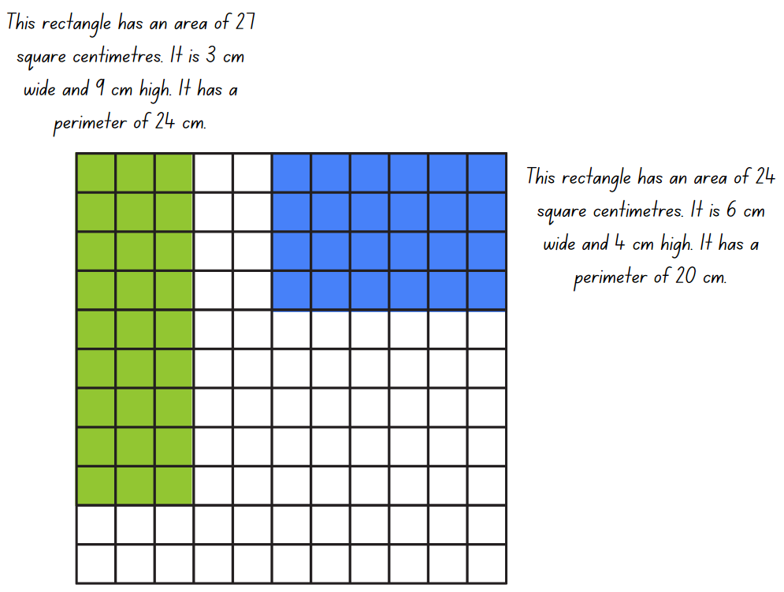

1. After creating several areas and identifying that shapes with the same area can have different perimeters, challenge students to create as many rectangles with the same area and different perimeters as possible. Students represent and annotate each of these on their grid paper.
2. Students then choose a different area to investigate and compare whether there are more or less possibilities than the previous area investigated.
3. Students cut their rectangles out and display them on a wall, ordered from ‘shortest perimeter’ to ‘longest perimeter’.

This table details opportunities for differentiation.

|  |  |
| --- | --- |
| Too hard? | Too easy? |
| Students cannot recognise that rectangles with different side lengths can have the same area by using multiplicative structure, arrays, and area models.   * Model the use of the square tiles or sticky notes to make a rectangle with a smaller area, for example, 6 squares. Support students to record the area and perimeter, then rearrange the squares into a different rectangle. Ask students to identify the new perimeter and compare it to the previous result. * Support students to use 8 squares to explore other rectangular arrangements that have different perimeter measurements. | Students can recognise that rectangles with different side lengths can have the same area by using multiplicative structure, arrays, and area models.   * Students investigate the longest perimeter possible using their number of squares by making irregular polygons, for example an ‘L’ shaped hexagon. * Students choose one of their rectangles and add another row to it, recording the new area and perimeter. Challenge students to continue adding rows and recording the results, looking to see if there is a pattern created. Students describe the pattern using words and numerals. |

## Discuss and connect the mathematics – 10 minutes

1. As a class, go on a [gallery walk](https://app.education.nsw.gov.au/digital-learning-selector/LearningActivity/Card/555) of the displayed rectangles and discuss the results.

The table below outlines stimulus prompts to generate conversation about the topic, along with anticipated responses from students.

|  |  |
| --- | --- |
| Prompts | Anticipated student responses |
| * What do you notice about the area and perimeter of each rectangle? | * Rectangles with different side lengths can have the same area. * Rectangles with the same area can have perimeters of different lengths. * Two rectangles can have the same area but look different. |
| * How did you know you had found all the possibilities for an area? | * If I know that there are more numbers that can be multiplied to make a number, then there are other arrays that can be made to represent a particular area. This new area could also have a different perimeter. |
| * Is there anything else you have noticed? | * Long, thin areas often have a longer perimeter than the same area with a more even length and width. For example, 30 square centimetres in a row has a perimeter of 62 centimetres. 30 square centimetres in 5 rows of 6 has a perimeter of 22 centimetres. |

This table details opportunities for assessment.

|  |  |
| --- | --- |
| Assessment opportunities | Links |
| What to look for:   * Can students measure the areas of rectangles and right-angled triangles using a square-centimetre grid overlay?  **[MAO-WM-01, MA2-MR-01, MA2-2DS-03]** * Can students recognise that rectangles with different side lengths can have the same area?  **[MAO-WM-01, MA2-MR-01, MA2-2DS-03]** * Can students use the equals sign to record equivalent number relationships involving multiplication?  **[MAO-WM-01, MA2-MR-01, MA2-2DS-03]** * Can students create and represent multiplicative structure, moving from arrays to area models?  **[MAO-WM-01, MA2-MR-01, MA2-2DS-03]** | Links to [National Numeracy Learning Progressions](https://www.australiancurriculum.edu.au/resources/national-literacy-and-numeracy-learning-progressions/version-3-of-national-literacy-and-numeracy-learning-progressions/) (NNLP):   * MuS5, MuS6, UuM5, UuM6, UuM7, UGP6.   Links to suggested [Interview for Student Reasoning](https://education.nsw.gov.au/teaching-and-learning/curriculum/literacy-and-numeracy/assessment-resources/ifsr) (IfSR) tasks:   * IfSR-MT: 2A.12, 2A.13, 2A.14. |

# Lesson 7

**Core concept**: estimation is useful to check the reasonableness of answers.

## Daily number sense – stationery or stickers – 10 minutes

The table below contains a suggested learning intention and success criteria. These are best co-constructed with students.

|  |  |
| --- | --- |
| Daily number sense learning intention | Daily number sense success criteria |
| Students are learning to:   * apply addition and subtraction to familiar contexts, including money and budgeting. | Students can:   * use estimation to check the validity of solutions to addition and subtraction problems, including those involving money. |

This activity is an adaptation of [Plenty of Pens](https://nrich.maths.org/1117) from [NRICH](https://nrich.maths.org/frontpage) by University of Cambridge.

1. Display Resource 14 – prize problem. Discuss the key information with students: $5, 40 prizes, pens for 16c and pencils for 11c.
2. Explain that Lisa must decide whether she can buy at least 40 prizes with the money available.
3. Ask students how they can use rounding and estimation to think quickly. Students [turn and talk](https://education.nsw.gov.au/teaching-and-learning/curriculum/literacy-and-numeracy/teaching-and-learning-resources/numeracy/talk-moves), recording their thinking on individual whiteboards. Some examples of student thinking might include:

* 16c is close to 15c, I can double that to get 30c and double again to get 60c. That gives me 4 pens and another 30c makes 6 pens for about 90c.
* 11c is about 10c so I could buy about 10 for a dollar.
* I can get about 6 pens for $1 and about 40 pencils for $4.
* I can get about 40 pencils for $4 so I know I can buy the minimum number needed. Then I can buy a few pens with the last dollar.

1. Discuss whether Lisa can buy a minimum of 40 prizes with the $5. Share the strategies used and which are most effective.

This table details opportunities for assessment.

|  |  |
| --- | --- |
| Assessment opportunities | Links |
| What to look for:   * Can students use rounding and estimation to check approximately how many of each item could be purchased?  **[MAO-WM-01, MA2-AR-01]** | Links to [National Numeracy Learning Progressions](https://www.australiancurriculum.edu.au/resources/national-literacy-and-numeracy-learning-progressions/version-3-of-national-literacy-and-numeracy-learning-progressions/) (NNLP):   * AdS8, UnM6, UnM7. |

## Core lesson 1 – largest chocolate slice – 30 minutes

The table below contains suggested learning intentions and success criteria. These are best co-constructed with students.

|  |  |
| --- | --- |
| Core concept learning intentions | Core concept success criteria |
| Students are learning to:   * compare surfaces using familiar metric units of area * represent and solve problems involving multiplication fact families * use the structure of the area model to represent multiplication and division. | Students can:   * estimate before measuring to determine the larger of 2 rectangular areas in square centimetres * recognise that rectangles with different side lengths can have the same area * create and represent multiplicative structure, moving from arrays to area models * describe multiplication problems using for each and times as many. |

1. Revise areas and perimeters of rectangles from Lesson 6.
2. Display Resource 15 – the largest slice and explain that Dinesh helps his dad make a chocolate chip slice. After it cools, it is challenging to cut because there are a lot of chocolate chunks inside it. The slices are not all an even size and Dinesh’s dad has let him choose 2 slices for afternoon tea.
3. Dinesh loves chocolate slice and wants to get the 2 largest slices possible but is not sure which to choose. Tell students they will be helping Dinesh choose the 2 largest slices.
4. Students turn and talk with a partner to estimate which are the largest slices.
5. Discuss estimates and the reasoning for these as a class. Explain that estimation is useful to check the reasonableness of a calculated answer.

The table below outlines stimulus prompts to generate conversation about the topic, along with anticipated responses from students.

|  |  |
| --- | --- |
| Prompts | Anticipated student responses |
| * What can you use to help you estimate which slices are the largest? | * We can use the length and width of the shapes to estimate which slices are the largest. * We can imagine there is a grid on the slices and estimate how many squares there are in each slice. |
| * How can you find out which slices are the largest? | * We can find the area of each slice and compare them. * This reminds me of the ‘12 squares’ in Lesson 6. We can count how many square centimetres there are in each row and column, then use it to make an array. This will tell us how many square centimetres there are in each slice. |
| * How can you accurately measure the area of each slice? | * We can measure the length and width of each slice and multiply them together to find how many square centimetres there are in each. |

1. Ask students to refine their estimates, based on the reasoning of other students.
2. Model how to measure the area of one slice. Create the array structure using the yellow square centimetre provided, a ruler and/or a clear plastic grid overlay.
3. Discuss how the measurements are also the factors, then identify the multiplication number sentence that describes the array.
4. Provide pairs of students with a copy of Resource 15 – the largest slice, a ruler and/or a clear plastic grid overlay or the yellow centimetre grid to find the area of each slice. Students record the multiplication number sentence that describes the array.
5. Students work with their partner to find the 2 largest slices of chocolate chip slice for Dinesh. Ask:

* Which 2 slices would you recommend Dinesh choose?
* Is this the same as your estimate, or different?

1. Students share their area measurements with the class. Display how each of these can be recorded as a multiplication number sentence. Discuss any differences in findings and agree on an accurate area for each slice.
2. Remind students that estimation is useful to check the reasonableness of a calculated answer. As a class, confirm the 2 biggest pieces of chocolate slice that Dinesh should choose.

This table details opportunities for differentiation.

|  |  |
| --- | --- |
| Too hard? | Too easy? |
| Students cannot estimate before measuring to determine the larger of 2 rectangular areas and/or create and represent multiplicative structure, moving from arrays to partially covered area models*.*   * Model to students how to measure the area of one slice. Create the array structure using centimetre squares, a ruler and/or a clear plastic grid overlay. Identify the multiplication number sentence that describes the array structure. * Support students to measure a different slice, using the resources and techniques modelled. | Students can estimate before measuring to determine the larger of 2 rectangular areas and create and represent multiplicative structure, moving from arrays to partially covered area models.   * Students choose one piece of slice and draw other slices that have the same area but different perimeters. * Challenge students to find which of the pieces has an area that can be re-created with the most different perimeters. |

## Core lesson 2 – the same areas – 20 minutes

1. Ask students if they found any rectangles that had different lengths and widths but the same areas.
2. Display an example and write the corresponding multiplication number sentences. Discuss how these can have different measurements or factors, but the same area. Draw a grid overlay to identify the array structure of rows and columns to highlight the length and width.
3. Explain to students that they will be making some pieces of slice that have the same areas but different side lengths.
4. Students work in pairs and choose one piece of slice from Resource 15 – the largest slice to focus on. Using writing materials and grid paper, students create diagrams of new slices that have the same area, but different side lengths, recording a corresponding multiplication number sentence for each new example.

## Discuss and connect the mathematics – 10 minutes

1. As a class, go on a [gallery walk](https://app.education.nsw.gov.au/digital-learning-selector/LearningActivity/Card/555).
2. Ask students how the factors of an area can be used to find all the possibilities.
3. Pose the problems:

* Dinesh’s dad makes a new slice that is 4 times as large as the biggest slice. What would its area be?
* Dinesh wants to share a slice so that there is the same amount for each of his 3 friends. Choose one of the pieces of slice and find how much each will get. Which slices will leave no remainders?

1. Identify the area that can be made with the most combinations of length and width.

This table details opportunities for assessment.

|  |  |
| --- | --- |
| Assessment opportunities | Links |
| What to look for:   * Can students estimate before measuring to determine the size of rectangles? **[MAO-WM-01, MA2-MR-01, MA2-2DS-03]** * Can students recognise that rectangles with different side lengths can have the same area?  **[MAO-WM-01, MA2-MR-01, MA2-2DS-03]** * Can students create and represent multiplicative structure, moving from arrays to area models?  **[MAO-WM-01, MA2-MR-01, MA2-2DS-03]** * **Can students** describe multiplication problems using for each and times as many? **[MAO-WM-01, MA2-MR-01]** | Links to [National Numeracy Learning Progressions](https://www.australiancurriculum.edu.au/resources/national-literacy-and-numeracy-learning-progressions/version-3-of-national-literacy-and-numeracy-learning-progressions/) (NNLP):   * MuS5, MuS6, UnM6, UnM7, UGP6.   Links to suggested [Interview for Student Reasoning](https://education.nsw.gov.au/teaching-and-learning/curriculum/literacy-and-numeracy/assessment-resources/ifsr) (IfSR) tasks:   * IfSR-MT: 2A.1, 2A.12, 2A.13, 2A.14, 2A.3. |

# Lesson 8

**Core concept**: multiplication arrays can be a useful way to calculate area.

## Daily number sense – 10 minutes

1. From a class need surfaced through formative assessment data, identify a short, focused activity that targets students’ knowledge, understanding and skills. Example activities may be drawn from the following resources:

* [Mathematics K–6 resources](https://education.nsw.gov.au/teaching-and-learning/curriculum/mathematics/mathematics-curriculum-resources-k-12/mathematics-k-6-resources)
* [Universal Resources Hub](https://resources.education.nsw.gov.au/home).

## Core lesson – largest handball space – 40 minutes

The table below contains suggested learning intentions and success criteria. These are best co-constructed with students.

|  |  |
| --- | --- |
| Core concept learning intentions | Core concept success criteria |
| Students are learning to:   * compare surfaces using familiar metric units of area * use the structure of the area model to represent multiplication and division * use number properties to find related multiplication facts * represent and solve word problems with number sentences involving multiplication or division. | Students can:   * estimate before measuring to determine the larger of 2 rectangular areas in square metres * create and represent multiplicative structure, moving from arrays to area models * generate and recall multiplication fact families up to 10 × 10 * represent and solve multiplication and division (both sharing and grouping) word problems using number sentences. |

**Note:** in this activity, students are comparing the sizes of different playing areas in the school. The lesson refers to paved surfaces for handball, but this can be adapted for grassed areas and other activities depending on the school context and interests of the students. If square metres made from paper have been created and used in previous lessons, they can be used again in this lesson. Otherwise, these could be made prior to the lesson.

1. Students will be using knowledge learnt about comparing the areas of chocolate slices in Lesson 7 to help compare large areas.
2. Ask students to estimate how many square metres will cover the surface of the classroom floor.
3. Model how to find the area by measuring the length and width of the classroom to the nearest metre. Represent the measurements in a diagram on the whiteboard and draw gridlines to show the square metres.
4. Compare the area of the classroom to the students’ estimates.
5. Discuss looking for an outdoor area big enough for the whole class to play handball. This space will need to be larger than the area of the classroom.
6. Ask students to think about suitable spaces. Explain that students will measure the area of each of these spaces with a partner in the same way that the classroom’s area was measured, record their findings and compare the area to the area of the classroom. The area will need:

* a paved/hard surface so the handball can bounce
* enough space to make as many handball courts as possible
* to be safe for students to play.

1. Students [turn and talk](https://education.nsw.gov.au/teaching-and-learning/curriculum/literacy-and-numeracy/teaching-and-learning-resources/numeracy/talk-moves) with a partner about strategies to find the areas of large spaces in the playground.

The table below outlines stimulus prompts to generate conversation about the topic, along with anticipated responses from students.

|  |  |
| --- | --- |
| Prompts | Anticipated student responses |
| * How can you find the areas of large spaces in the playground? | * We can count how many metre squares there are in each row and column, then use it to make an array. This will tell us how many metre squares there are in each area. * We can measure the length and width of each area, then multiply them together to find how many metre squares there are in each. |
| * What can you use to measure each area accurately? | * We can use metre squares, metre rulers, chalk and/or markers to record the length and width of each area. |
| * What can you do if the area isn’t a rectangle, but is an irregular shape? | * We can cut the area into some smaller areas that are rectangles and find their areas. Then we add these together to find the total. |

1. As a class, explore the school to measure and compare several outdoor spaces that may be appropriate for handball.
2. In pairs or small groups, students use square metres, metre rulers, chalk and/or markers to record the length and width of each area. They record their findings and write a multiplication number sentence to find the area of each space.

This table details opportunities for differentiation.

|  |  |
| --- | --- |
| Too hard? | Too easy? |
| Students cannot estimate and measure the larger of 2 rectangular areas or complete number sentences involving multiplication and division by calculating missing numbers.   * Model how to mark out and measure an area using square metres, metre rulers, chalk and/or markers. * Show students how to use these measurements to record as a multiplication number sentence. * Support students to mark out and measure a different area, using the resources and techniques modelled. | Students can estimate and measure the larger of 2 rectangular areas or complete number sentences involving multiplication and division by calculating missing numbers.   * Tell students that each individual handball court needs an area of 2 square metres for each player. Students use their recordings to find how many 2 square metre handball courts will fit in each of the 2 areas. * Students draw a diagram of the handball courts in the area. |

## Discuss and connect the mathematics – 10 minutes

1. Discuss the measurements of each space and the areas calculated. Discuss any differences in findings and determine an agreed area for each space, with students sharing their measurements and recordings with the class.
2. Ask students to discuss which space will be best for the class game of handball, providing their reasoning. This may include the size, but also the arrangement of the area and the playing surface.
3. Students vote on which area will be best for a whole-class game of handball.
4. Decide with the students the best time in the week to mark out the lines in chalk and play a whole-class game of handball.

This table details opportunities for assessment.

|  |  |
| --- | --- |
| Assessment opportunities | Links |
| What to look for:   * Can students estimate and measure the larger of 2 rectangular areas in square metres?  **[MAO-WM-01, MA2-MR-01, MA2-2DS-03]** * Can students create and represent multiplicative structure, moving from arrays to area models?  **[MAO-WM-01, MA2-MR-01, MA2-2DS-03]** * Can students generate and recall multiplication fact families up to 10 × 10? **[MAO-WM-01, MA2-MR-01]** * **Can students** represent and solve multiplication and division (both sharing and grouping) word problems using number sentences? **[MAO-WM-01, MA2-MR-01]** | Links to [National Numeracy Learning Progressions](https://www.australiancurriculum.edu.au/resources/national-literacy-and-numeracy-learning-progressions/version-3-of-national-literacy-and-numeracy-learning-progressions/) (NNLP):   * MuS5, MuS6, UnM6, UnM7, UGP6.   Links to suggested [Interview for Student Reasoning](https://education.nsw.gov.au/teaching-and-learning/curriculum/literacy-and-numeracy/assessment-resources/ifsr) (IfSR) tasks:   * IfSR-MT: 2A.3. |

## Consolidation and meaningful practice – 10 minutes

1. Provide pairs of students with a copy of Resource 16 – area problems.
2. Students choose and solve a problem separately and then discuss their solutions.
3. Repeat the process.

# Resource 1 – Symmetry or not?

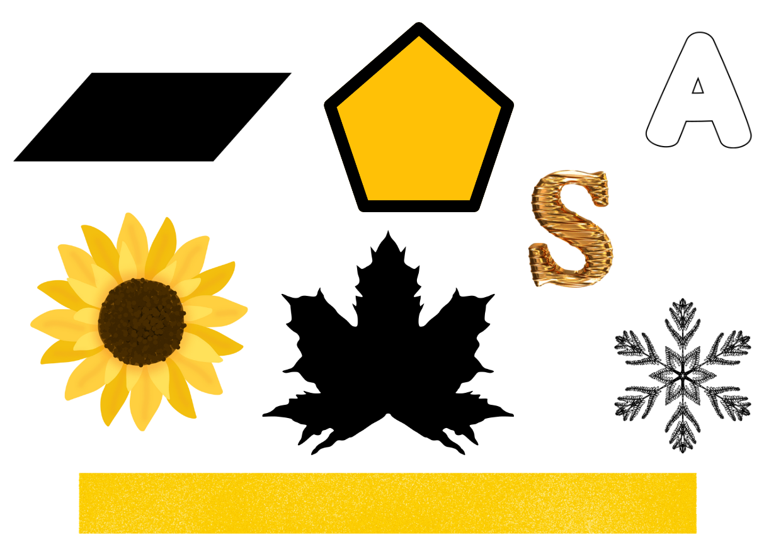

# Resource 2 – out and about

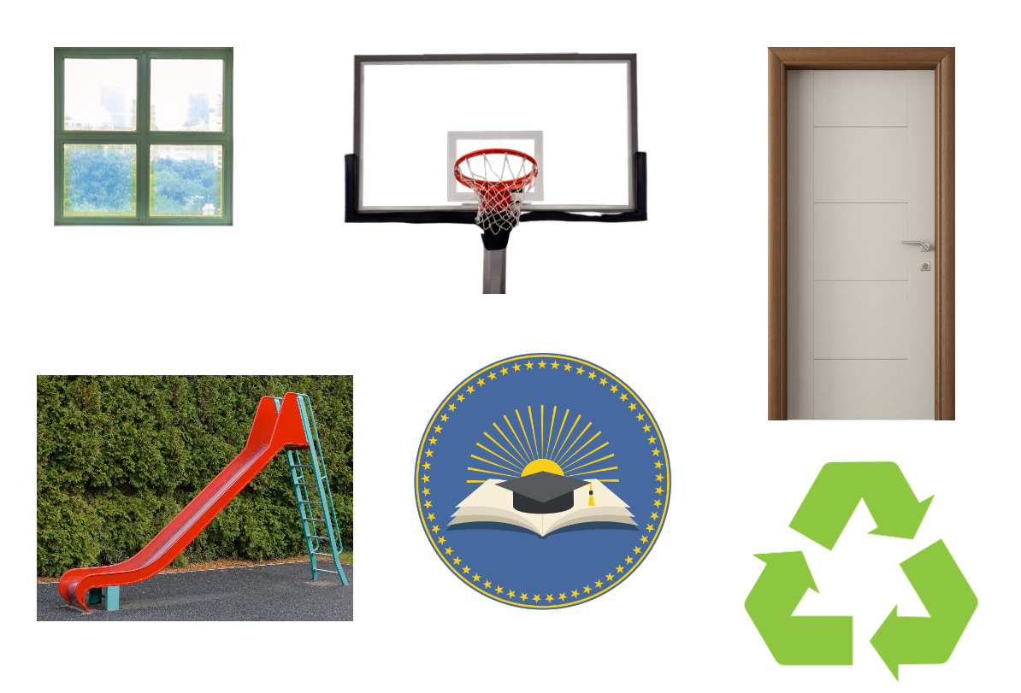

# Resource 3 – paper rectangles

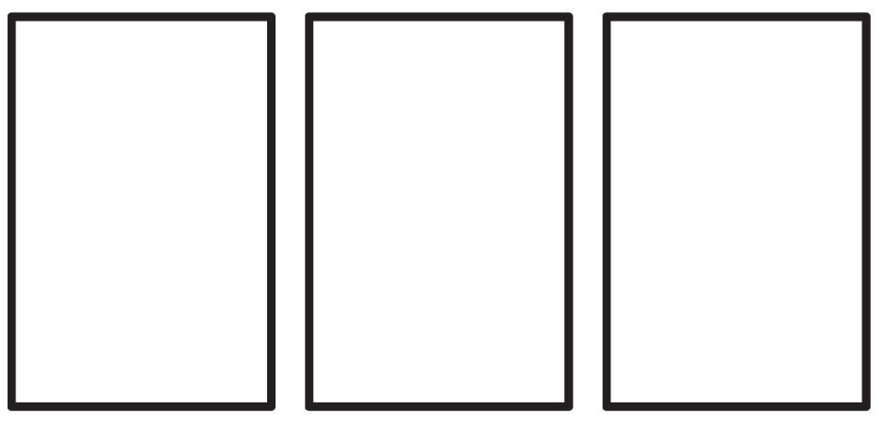

# Resource 4 – 7 sixes

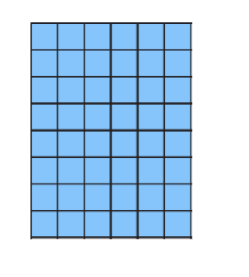

# Resource 5 – tile patterns

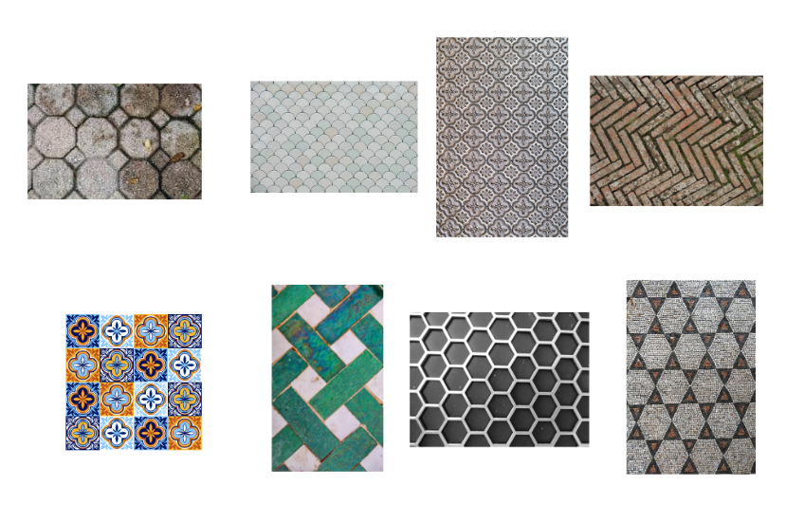

# Resource 6 – tile shapes



# Resource 7 – flags

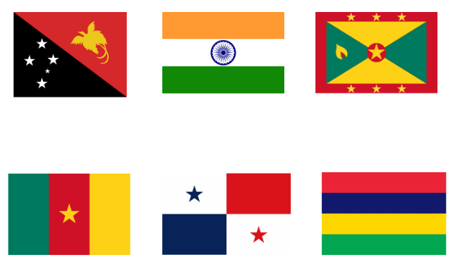

# Resource 8 – tessellations in nature

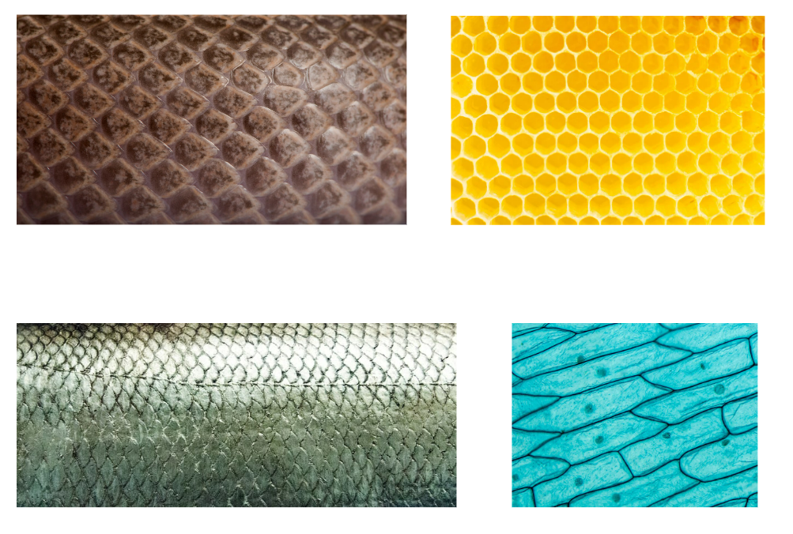

# Resource 9 – area clues

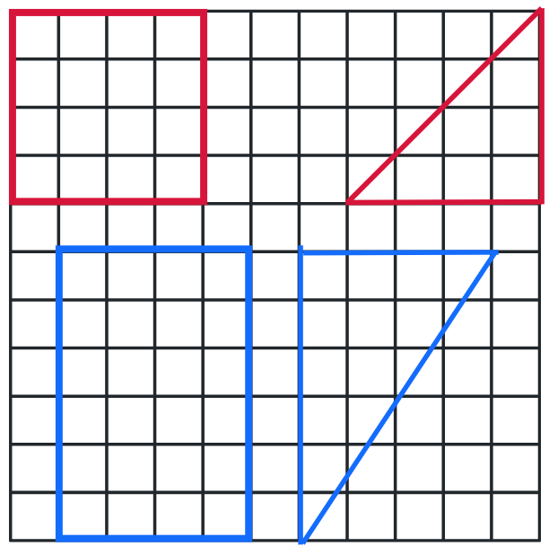

# Resource 10 – area clues 2

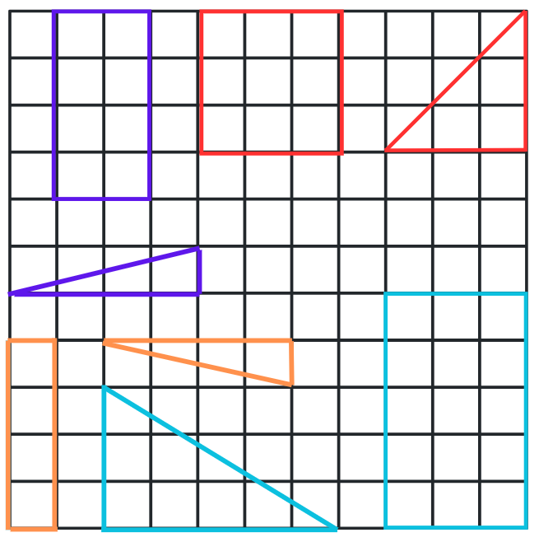

# Resource 11 – garden area investigation

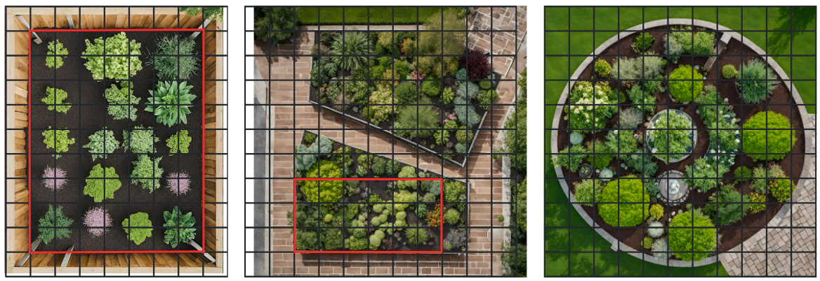

# Resource 12 – torn shapes

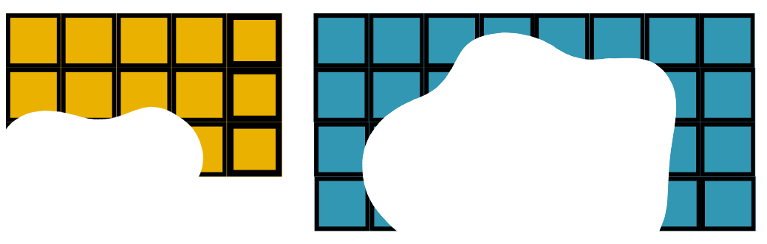

# Resource 13 – 12 squares

A yellow 4 by 3 grid with questions written to the right.
Do all rectangles with the same area have the same perimeter? Why or why not?
If they do not have the same perimeter, what is the shortest perimeter possible for a particular area? What is the longest?

# Resource 14 – prize problem

Lisa’s mum has given her $5 to buy prizes for her stall at the school fair. Lisa and her mum only have a few minutes to shop for the prizes, so they will need to estimate the cost of their purchases quickly. 
Lisa needs to buy a minimum of 40 prizes and she wants more than one type of prize. She finds glitter pens for 16c each, and coloured pencils for 11c each. Lisa has to decide whether she can buy at least 40 prizes with the money available. 

# Resource 15 – the largest slice

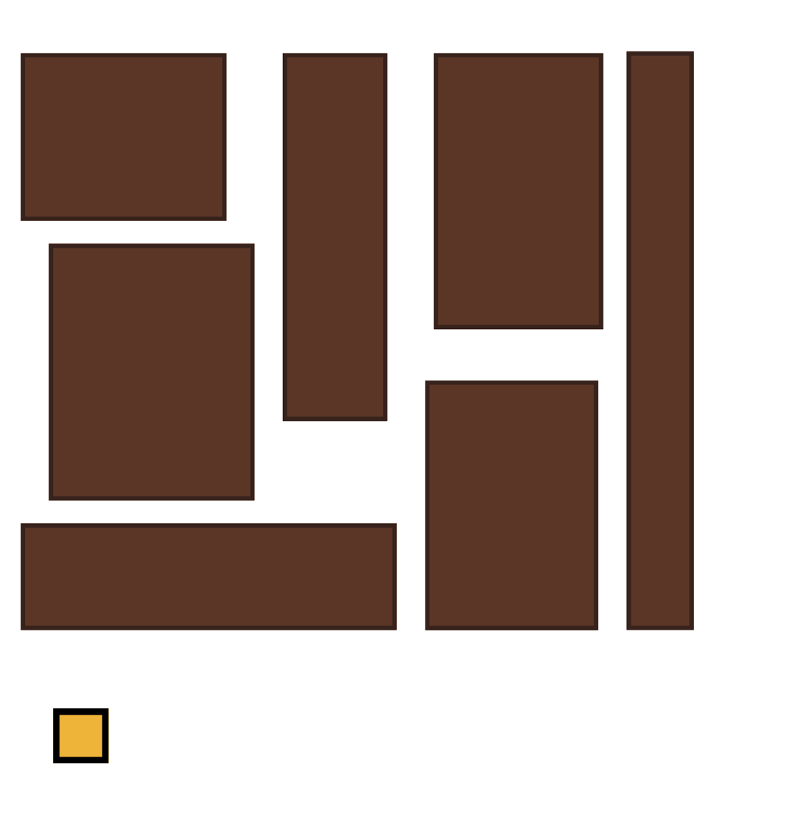

# Resource 16 – area problems

|  |  |
| --- | --- |
| No. | Problem |
| 1 | Arjuna’s bedroom is 5 metres long and 6 metres wide. What is the area of carpet in his bedroom? |
| 2 | I am thinking of a shape with an area of 36 square tiles. Use your knowledge of multiplication fact families to find what this shape would look like if it has:   * 4 square tiles in each row * 6 square tiles in each row * 12 square tiles in each row * 9 square tiles in each row. |
| 3 | Chandrika’s family are laying some new pavers on their driveway. Each tile is half a metre wide and a metre long. How many will they need to cover their driveway if it is 8 metres long and 6 metres wide? |
| 4 | I am thinking of a shape with an area of 20 square tiles. What might this shape look like? |
| 5 | Draw some shapes that have an area of 30 square centimetres. |
| 6 | My granny bought a square rug and each side measures 1 metre. When she got home it would not fit in the hallway so she cut the rug and joined the pieces together again to make a shape that would fit. What might her rug look like now? |

# Syllabus outcomes and content

The table below outlines the [syllabus outcomes](https://curriculum.nsw.edu.au/learning-areas/mathematics/mathematics-k-10-2022/overview) and range of relevant syllabus content covered in this unit. Content is linked to [National Numeracy Learning Progression](https://www.australiancurriculum.edu.au/resources/national-literacy-and-numeracy-learning-progressions/version-3-of-national-literacy-and-numeracy-learning-progressions/) version (3).

|  |  |  |  |  |  |  |  |  |
| --- | --- | --- | --- | --- | --- | --- | --- | --- |
| Outcomes and content | 1 | 2 | 3 | 4 | 5 | 6 | 7 | 8 |
| **Additive relations B:** Apply addition and subtraction to familiar contexts, including money and budgeting  **[MAO-WM-01, MA2-AR-01]** |  |  |  |  |  |  |  |  |
| * Use estimation to check the validity of solutions to addition and subtraction problems, including those involving money |  |  |  |  |  |  | x |  |
| * Reflect on a chosen strategy for solving a problem, considering whether it can be improved |  |  |  |  | x | x |  |  |
| * Interpret problems involving money as requiring either addition or subtraction |  |  |  |  | x | x |  |  |
| **Multiplicative relations A**: Represent and solve problems involving multiplication fact families  **[MAO-WM-01, MA2-MR-01, MA2-MR-02]** |  |  |  |  |  |  |  |  |
| * Describe multiplication problems using *for each* and ti*mes as many* |  |  |  |  |  |  | x |  |
| * Find the total of partially covered arrays |  |  |  |  | x |  |  |  |
| * Apply the inverse relationship of multiplication and division (Reasons about relations) | x |  |  |  |  |  |  |  |
| **Multiplicative relations B:** Use the structure of the area model to represent multiplication and division  **[MAO-WM-01, MA2-MR-01, MA2-MR-02]** |  |  |  |  |  |  |  |  |
| * Create and represent multiplicative structure, moving from arrays to partially covered area models |  |  |  |  | x | x | x | x |
| **Multiplicative relations B:** Use number properties to find related multiplication facts  **[MAO-WM-01, MA2-MR-01, MA2-MR-02]** |  |  |  |  |  |  |  |  |
| * Use the commutative property of multiplication | x |  |  |  |  |  | x | x |
| * Use flexible partitioning within multiplication (Reasons about relations) |  |  | x |  |  |  |  |  |
| * Generate and recall multiplication fact families up to 10 x 10 |  | x |  |  |  |  |  | x |
| **Multiplicative relations B:** Operate with multiples of 10  **[MAO-WM-01, MA2-MR-01, MA2-MR-02]** |  |  |  |  |  |  |  |  |
| * **Use multiplication facts with multiples of 10 to multiply a one-digit number by a multiple of 10** |  |  |  |  | x |  |  |  |
| **Multiplicative relations B:** Represent and solve word problems with number sentences involving multiplication or division  **[MAO-WM-01, MA2-MR-01, MA2-MR-02]** |  |  |  |  |  |  |  |  |
| * Use the equals sign to record equivalent number relationships involving multiplication (Reasons about relations) |  |  |  |  |  |  |  | x |
| * Complete number sentences involving multiplication and division by calculating missing numbers (Reasons about relations) |  |  |  |  |  |  |  | x |
| * Represent and solve multiplication and division (both sharing and grouping) word problems using number sentences |  |  |  |  |  |  |  | x |
| **Two-dimensional spatial structure A:** 2D shapes: Transform shapes by reflecting, translating, and rotating  **[MAO-WM-01, MA2-2DS-02]** |  |  |  |  |  |  |  |  |
| * Identify lines of symmetry in pictures, artefacts, designs, and the environment | x |  | x | x |  |  |  |  |
| * Draw lines of symmetry on given shapes and identify quadrilaterals that do not have lines of symmetry | x |  | x |  |  |  |  |  |
| * Create and record tessellating designs by reflecting, translating, and rotating triangles |  |  | x | x |  |  |  |  |
| * Apply and describe amounts of rotation including half-turns, quarter-turns and three-quarter-turns when creating designs |  |  | x | x |  |  |  |  |
| **Two-dimensional spatial structure B:** 2D shapes: Create two-dimensional shapes that result from combining and splitting common shapes  **[MAO-WM-01, MA2-2DS-01, MA2-2DS-02]** |  |  |  |  |  |  |  |  |
| * Combine common two-dimensional shapes, including quadrilaterals, to form other common shapes or designs |  | x |  |  |  |  |  |  |
| * Split a given shape into 2 or more common shapes and describe the result |  | x |  |  |  |  |  |  |
| * Record the arrangements of common shapes used to create other shapes |  | x |  |  |  |  |  |  |
| **Two-dimensional spatial structure B:** 2D shapes: Create symmetrical patterns and shapes  **[MAO-WM-01, MA2-2DS-01, MA2-2DS-02]** |  |  |  |  |  |  |  |  |
| * Create and record tessellating designs by reflecting, translating, and rotating triangles or quadrilaterals |  |  | x | x |  |  |  |  |
| * Apply and describe amounts of rotation, including half-turns, quarter-turns and three-quarter-turns, when creating design |  |  |  | x |  |  |  |  |
| ****Two-dimensional spatial structure B:**** Area: Measure the areas of shapes using the grid structure  ****[MAO-WM-01, MA2-2DS01, MA2-2DS-03]**** |  |  |  |  |  |  |  |  |
| * Measure the areas of rectangles and right-angled triangles using a square-centimetre grid overlay |  |  |  |  | x | x | x | x |
| * Estimate the areas of shapes found in the environment using efficient strategies (non-count-by-one) with a grid overlay |  |  |  |  | x |  | x | x |
| * Recognise that rectangles with different side lengths can have the same area |  |  |  |  |  | x | x |  |
| ****Two-dimensional spatial structure B:**** Area: Compare surfaces using familiar metric units of area  ****[MAO-WM-01, MA2- 2DS-01, MA2-2DS-03]**** |  |  |  |  |  |  |  |  |
| * Estimate before measuring to determine the larger of 2 rectangular areas in square centimetres |  |  |  |  |  |  | x |  |
| * Estimate before measuring to determine the larger of 2 rectangular areas in square metres |  |  |  |  |  |  |  | x |

[Mathematics K–10 Syllabus](https://curriculum.nsw.edu.au/learning-areas/mathematics/mathematics-k-10-2022/overview) © NSW Education Standards Authority (NESA) for and on behalf of the Crown in right of the State of New South Wales, 2022.

# References

This resource contains NSW Curriculum and syllabus content. The NSW Curriculum is developed by the NSW Education Standards Authority. This content is prepared by NESA for and on behalf of the Crown in right of the State of New South Wales. The material is protected by Crown copyright.

Please refer to the NESA Copyright Disclaimer for more information <https://educationstandards.nsw.edu.au/wps/portal/nesa/mini-footer/copyright>.

NESA holds the only official and up-to-date versions of the NSW Curriculum and syllabus documents. Please visit the NSW Education Standards Authority (NESA) website <https://educationstandards.nsw.edu.au/wps/portal/nesa/home> and the NSW Curriculum website <https://curriculum.nsw.edu.au/>.

[Mathematics K–10 Syllabus](https://curriculum.nsw.edu.au/learning-areas/mathematics/mathematics-k-10-2022/overview) © NSW Education Standards Authority (NESA) for and on behalf of the Crown in right of the State of New South Wales, 2022.

[National Numeracy Learning Progression](https://www.australiancurriculum.edu.au/resources/national-literacy-and-numeracy-learning-progressions/version-3-of-national-literacy-and-numeracy-learning-progressions/) © Australian Curriculum, Assessment and Reporting Authority (ACARA) 2010 to present, unless otherwise indicated. This material was downloaded from the [Australian Curriculum](http://www.australiancurriculum.edu.au/) website (National Numeracy Learning Progression) (accessed 7 November 2023) and was not modified.

Boaler J, Munson J, Williams C (2017) Mindset mathematics: Visualizing and Investigating Big Ideas, Grade 3*,* Jossey-Bass: San Francisco.

Boaler J, Munson J, Williams C (2017) Mindset mathematics: Visualizing and Investigating Big Ideas, Grade 4*,* Jossey-Bass: San Francisco.

Siemon D, Beswick K, Brady K, Clark J, Faragher R, Warren E (2020) *Teaching Mathematics – Foundations to Middle years*, 3rd edn. Oxford University Press, Melbourne.

University of Cambridge (n.d.) [*Five Coins*](https://nrich.maths.org/142), NRICH website, accessed 21 September 2023.

University of Cambridge (n.d.) [*Plenty of Pens*](https://nrich.maths.org/1117), NRICH website, accessed 21 September 2023.

Van de Walle J, Karp K, Bay-Williams JM, Brass A, Bentley B, Ferguson S, Goff W, Livy S, Marshman M, Martin D, Pearn C, Prodromou T, Symons D and Wilkie K (2019) Primary and Middle Years Mathematics: Teaching Developmentally, 1st Australian edn, Pearson Education Australia, Melbourne.

**© State of New South Wales (Department of Education), 2024**

The copyright material published in this resource is subject to the *Copyright Act 1968* (Cth) and is owned by the NSW Department of Education or, where indicated, by a party other than the NSW Department of Education (third-party material).

Copyright material available in this resource and owned by the NSW Department of Education is licensed under a [Creative Commons Attribution 4.0 International (CC BY 4.0) license.](https://creativecommons.org/licenses/by/4.0/)

**[](https://creativecommons.org/licenses/by/4.0/)**

This license allows you to share and adapt the material for any purpose, even commercially.

Attribution should be given to © State of New South Wales (Department of Education), 2024.

Material in this resource not available under a Creative Commons license:

* the NSW Department of Education logo, other logos and trademark-protected material
* material owned by a third party that has been reproduced with permission. You will need to obtain permission from the third party to reuse its material.

**Links to third-party material and websites**

Please note that the provided (reading/viewing material/list/links/texts) are a suggestion only and implies no endorsement, by the New South Wales Department of Education, of any author, publisher, or book title. School principals and teachers are best placed to assess the suitability of resources that would complement the curriculum and reflect the needs and interests of their students.

If you use the links provided in this document to access a third-party's website, you acknowledge that the terms of use, including licence terms set out on the third-party's website apply to the use which may be made of the materials on that third-party website or where permitted by the *Copyright Act 1968* (Cth). The department accepts no responsibility for content on third-party websites.