Mathematics Stage 2 – Unit 38

Questions can be asked and answered by interpreting data

Contents

Unit description and duration 5

Syllabus outcomes 5

Working mathematically 6

Student prior learning 6

Lesson overview and resources 10

Lesson 1 15

Daily number sense – canteen estimation – 15 minutes 15

Core lesson – categorising games – 40 minutes 16

Discuss and connect the mathematics – 10 minutes 21

Lesson 2 23

Daily number sense – Meggie’s money – 10 minutes 23

Core lesson 1 – creating a survey – 20 minutes 24

Core lesson 2 – conducting a survey – 25 minutes 27

Discuss and connect the mathematics – 5 minutes 28

Lesson 3 30

Daily number sense – post office problems – 15 minutes 30

Core lesson 1 – organising and displaying data – 25 minutes 32

Core lesson 2 – interpreting the data – 10 minutes 37

Discuss and connect the mathematics – 10 minutes 38

Lesson 4 40

Daily number sense – 10 minutes 40

Core lesson 1 – tossing one coin – 10 minutes 40

Core lesson 2 – tossing 2 coins – 35 minutes 43

Consolidation and meaningful practice – 15 minutes 45

Lesson 5 48

Daily number sense – place the digit – 10 minutes 48

Core lesson 1 – lucky duck – 15 minutes 50

Core lesson 2 – ducks are out – 25 minutes 52

Discuss and connect the mathematics – 15 minutes 54

Lesson 6 56

Daily number sense – mixed-up decimals – 15 minutes 56

Core lesson 1 – spin the spinner – 15 minutes 58

Core lesson 2 – spinner games – 30 minutes 60

Discuss and connect the mathematics – 5 minutes 62

Lesson 7 64

Daily number sense – decimal dash – 15 minutes 64

Core lesson 1 – constructing and comparing data – 20 minutes 66

Core lesson 2 – evaluating a data set – 20 minutes 69

Discuss and connect the mathematics – 10 minutes 71

Lesson 8 73

Daily number sense – 10 minutes 73

Core lesson – mystery graphs – 45 minutes 73

Discuss and connect the mathematics – 5 minutes 76

Resource 1 – Dataville Public School survey 78

Resource 2 – chance representations 79

Resource 3 – recording sheet 80

Resource 4 – place the digits 81

Resource 5 – number cards 82

Resource 6 – recording table 83

Resource 7 – Raph's maths book 84

Resource 8 – mixed-up decimals 85

Resource 9 – blank spinner 86

Resource 10 – game spinner 87

Resource 11 – decimal cards 88

Resource 12 – gaming devices graph 89

Resource 13 – interpreting data displays 90

Resource 14 – school travel graph 94

Resource 15 – mystery graphs 95

Resource 16 – column graph checklist 101

Syllabus outcomes and content 102

References 108

Further reading 109

# Unit description and duration

This unit develops the big idea that questions can be asked and answered by interpreting data.

In this 2-week unit students are provided opportunities to:

* conduct a survey and collect, organise and display data using tables and graphs
* compare the likelihood of obtaining particular outcomes in a simple chance experiment by predicting, conducting the experiment and comparing the results with the prediction
* interpret and evaluate the effectiveness of various data displays found in media where displays represent data using a scale of many-to-one.

## Syllabus outcomes

* **MAO-WM-01** develops understanding and fluency in mathematics through exploring and connecting mathematical concepts, choosing and applying mathematical techniques to solve problems, and communicating their thinking and reasoning coherently and clearly
* **MA2-RN-02** represents and compares decimals up to 2 decimal places using place value
* **MA2-AR-01** selects and uses mental and written strategies for addition and subtraction involving 2- and 3-digit numbers
* **MA2-DATA-01** collects discrete data and constructs graphs using a given scale
* **MA2-DATA-02** interprets data in tables, dot plots and column graphs
* **MA2-CHAN-01 records and compares the results of chance experiments**

## Working mathematically

In the Mathematics K–10 Syllabus, there is one overarching Working mathematically outcome (**MAO-WM-01**). The Working mathematically processes should be embedded within the concepts being taught. The Working mathematically processes present in the Mathematics K–10 Syllabus are:

* communicating
* understanding and fluency
* reasoning
* problem solving.

[Mathematics K–10 Syllabus](https://curriculum.nsw.edu.au/learning-areas/mathematics/mathematics-k-10-2022/overview) © NSW Education Standards Authority (NESA) for and on behalf of the Crown in right of the State of New South Wales, 2022.

## Student prior learning

Before engaging in these teaching and learning activities, students would benefit from prior experience with:

* selecting and trialling methods for data collection
* predicting and describing possible outcomes from chance experiments
* constructing and interpreting data displays with many-to-one scales.

In NSW classrooms there is a diverse range of students, including Aboriginal and/or Torres Strait Islander students, students learning English as an additional language or dialect, high potential and gifted students, and students with disability. Some students may identify with more than one of these groups or possibly all of them. Refer to [Curriculum planning for every student – advice](https://education.nsw.gov.au/teaching-and-learning/curriculum/planning-programming-and-assessing-k-12/advice-on-curriculum-planning-for-every-student-k-12) for further information.

Teachers can support student learning and reasoning in this unit by connecting language, representations and visualisation for chance (see Figure 1). This model of support is adapted from content provided by Adjunct Professor Marj Horne in [Big Ideas to Start Strong across K–6 – Module 3](https://education.nsw.gov.au/teaching-and-learning/curriculum/mathematics/professional-learning-mathematics-k-12/mathematics-k-6-professional-learning-catalogue/big-ideas-to-start-strong-across-k6) (NSW DoE 2023).

Figure 1 – pedagogical support

A poster titled Stage 2 Chance – Everyone is a mathematician. 
Around a central triangle are 3 headings: Visualisation, Language and Representation
For Visualisation, there are 4 statements:
'Seeing in your mind', both statically and dynamically;
Manipulating objects in your mind; 
Imagine from someone else's perspective;
Imagining what you can not see. 
For Language, there are 3 points:
Symbolic and non-verbal language (gestures);
Topic-specific language (formal/informal);
Language of reasoning. 
For Representation, there are 2 points:
We can move between a range of representations to support understanding; 
Examples/non-examples.
There are 4 additional statements on the poster:
By using graphs and diagrams, students can visualise possible outcomes and describe the discrepancies between expected and observed outcomes.
By exploring language and representation using a variety of manipulatives, students are able to visualise what likely, unlikely and equally likely truly means.
By visualising chance on a linear scale, students can describe and represent what more or less likely looks like in a variety of situations.
By using language such as 'for every 4 parts, 2 are red', students can visualise chance as part of a whole and represent this in many ways.


For each lesson on data in the unit, the following definitions in Figure 2 build teacher understanding of the data types students are taught in Stage 3. The Stage 2 teaching advice states that students are not expected to classify the type of data they are collecting.

Figure 2 – data types

A multi-part resource that includes a flow diagram and a series of representations and descriptions of different data types. 
The flow diagram begins with a tile that says ‘collect data’. The diagram then splits into 2.  
On the left-hand side is a tile for continuous data, followed by a tile for numerical data and an image of a line graph. This element has a note to say that it is for Stage 3. 
The right-hand side of the flow chart begins with a tile that says discrete. Discrete is then separated into 2 more tiles called numerical and categorical. Both of these are annotated to say that they are for Stage 2 and 3. The numerical tile is linked to an image of a column graph. 
The categorical tile is further split into tiles labelled ordinal and nominal. Both of these data types are annotated to say that they are for stage 3. Ordinal is linked to an image of a Likert scale. Nominal is linked to an image of 3 eyes of different colour.  
There are 7 additional elements to represent and describe different terms used in the syllabus. 
Variable - something measurable or observable that is expected to change either over time or between observations, such as hair colour. 
Numerical variable - variables that are numbers. Adding, subtracting or calculating an average makes sense such as the number of children in a family. 
Discrete numerical data - describes items or events that can only be counted in whole number values, where number where values in between the whole numbers cannot be found or labelled in the data display such as the number of children in the family. 
Categorical data - describes the quality or characteristic of something. Values belong to exactly 1 category, such as blood type. 
Ordinal categorical data - categories can be ranked or ordered. The order is clear but not the distance between each position such as a feedback scale. Nominal data - no meaningful order between the categories such as eye colour. 
Continuous numerical data - values between the whole numbers are meaningful and are labelled in the data display such as temperature 19.8° or fuel prices $1.78. 
The resource has the following note: 
Stage 2 teaching advice states that students are not expected to classify the type of data they are collecting. 


# Lesson overview and resources

The table below outlines the sequence and approximate timing of lessons, learning intentions and resources.

|  |  |  |
| --- | --- | --- |
| Lesson | Content | Duration and resources |
| **Lesson 1**  **Daily number sense learning intention:**   * apply addition and subtraction to familiar contexts, including money and budgeting | **Lesson core concept**: questions give meaning to data.  **Core concept learning intention**:   * collect discrete data | **Lesson duration**: 65 minutes   * Writing materials |
| **Lesson 2**  **Daily number sense learning intention:**   * apply addition and subtraction to familiar contexts, including money and budgeting | **Lesson core concept**: collecting data requires a skilful approach.  **Core concept learning intentions**:   * organise and display data using tables and graphs * select and trial methods for data collection | **Lesson duration**: 60 minutes   * Microsoft Forms or Google Forms * Writing materials |
| **Lesson 3**  **Daily number sense learning intention:**   * apply addition and subtraction to familiar contexts, including money and budgeting | **Lesson core concept**: graphs are a communication tool.  **Core concept learning intentions**:   * interpret and compare data * construct and interpret data displays with many-to-one scales | **Lesson duration**: 60 minutes   * Resource 1 – Dataville Public School survey * Grid paper * Individual whiteboards * Microsoft Excel or Google Sheets * Sticky notes * Survey data from Lesson 2 * Writing materials |
| **Lesson 4**  **Daily number sense learning intention:**   * teacher-identified task based on student needs | **Lesson core concept**: data displays can be used to record and compare the outcomes of chance events.  **Core concept learning intention**:   * identify possible outcomes from chance experiments | **Lesson duration**: 70 minutes   * Resource 2 – chance representations * Resource 3 – recording sheet * Coins * Individual whiteboards * Writing materials |
| **Lesson 5**  **Daily number sense learning intention:**   * extend the application of the place value system from whole numbers to tenths and hundredths | **Lesson core concept**: the outcomes of events can be affected by other events.  **Core concept learning intentions**:   * describe the likelihood of outcomes of chance events * identify when events are affected by previous events | **Lesson duration**: 65 minutes   * Resource 4 – place the digits * Resource 5 – number cards * Resource 6 – recording table * Resource 7 – Raph’s maths book * 20-sided dice * Brown paper bags * Coloured counters * Individual whiteboards * Writing materials |
| **Lesson 6**  **Daily number sense learning intention:**   * extend the application of the place value system from whole numbers to tenths and hundredths | **Lesson core concept**: the outcome of chance experiments can be predicted and recorded.  **Core concept learning intention**:   * describe the likelihood of outcomes of chance events | **Lesson duration**: 65 minutes   * Resource 8 – mixed-up decimals * Resource 9 – blank spinner * Resource 10 – game spinner * 6-sided dice * Individual whiteboards * Paper clips * Writing materials |
| **Lesson 7**  **Daily number sense learning intention:**   * extend the application of the place value system from whole numbers to tenths and hundredths | **Lesson core concept**: interpreting data helps us solve problems and ask new questions.  **Core concept learning intentions**:   * interpret and compare data * construct and interpret data displays with many-to-one scales | **Lesson duration**: 65 minutes   * Resource 11 – decimal cards * Resource 12 – gaming devices graph * Resource 13 – interpreting data displays * Microsoft Excel or Google Sheets * Writing materials |
| **Lesson 8**  **Daily number sense learning intention:**   * teacher-identified task based on student needs | **Lesson core concept**: mathematicians interpret and evaluate the effectiveness of real-world data.  **Core concept learning intentions**:   * select and trial methods for data collection * construct and interpret data displays with many-to-one scales | **Lesson duration**: 60 minutes   * Resource 14 – school travel graph * Resource 15 – mystery graphs * Resource 16 – column graph checklist * Writing materials |

# Lesson 1

**Core concept**: questions give meaning to data.

## Daily number sense – canteen estimation – 15 minutes

Daily number sense activities for Lessons 1 to 3 ‘activate’ prior number knowledge and support the learning of new content in the unit. These activities can also assist teachers to identify the starting points for learning by revealing the extent of students’ existing knowledge.

The table below contains a suggested learning intention and success criteria. These are best co-constructed with students.

|  |  |
| --- | --- |
| Daily number sense learning intention | Daily number sense success criteria |
| Students are learning to:   * apply addition and subtraction to familiar contexts, including money and budgeting. | Students can:   * use estimation to check the validity of solutions to addition and subtraction problems, including those involving money. |

1. Pose the problem: You have $9 to spend at the canteen. A drink costs $2.60, a packet of popcorn costs $1.40, a sausage roll costs $4.55 and tomato sauce costs 50 cents. What items do you estimate that you could buy?
2. Remind students to use rounding to estimate the cost of the items.
3. Students [turn and talk](https://education.nsw.gov.au/teaching-and-learning/curriculum/literacy-and-numeracy/teaching-and-learning-resources/numeracy/talk-moves) to share their thinking. Ask:

* How did you estimate which items you could buy?
* Do you think $9 would be enough money to buy all the items listed? If not, what item would you choose not to purchase from the list given? Why?
* Can you estimate how much money you would need to purchase all the items listed?

1. Provide students with individual whiteboards to check the validity of their calculations.

This table details opportunities for assessment.

|  |  |
| --- | --- |
| Assessment opportunities | Links |
| What to look for:   * Can students use estimation to check the validity of solutions to addition and subtraction problems, including those involving money? **[MAO-WM-01, MA2-AR-01]** | Links to [National Numeracy Learning Progressions](https://www.australiancurriculum.edu.au/resources/national-literacy-and-numeracy-learning-progressions/version-3-of-national-literacy-and-numeracy-learning-progressions/) (NNLP):   * AdS8 * UnM6, UnM7. |

## Core lesson – categorising games – 40 minutes

The table below contains a suggested learning intention and success criteria. These are best co-constructed with students.

|  |  |
| --- | --- |
| Core concept learning intention | Core concept success criteria |
| Students are learning to:   * collect discrete data. | Students can:   * pose questions about a matter of interest to obtain information that can be recorded in categories * predict and create a list of categories for efficient data collection in relation to a matter of interest. |

**Note**: the activity in Lesson 2 Core lesson 2 requires students to survey peers from other classes. Ensure that classroom visits have been prearranged. Interruptions can be minimised by assigning each group to a single class or grade. Teachers may also conduct the survey on a different day due to the time involved.

1. Revise students’ understanding of ‘data’. Explain that data can be collected from many sources. For example, through observations, surveys, votes and questionnaires.
2. Students [turn and talk](https://education.nsw.gov.au/teaching-and-learning/curriculum/literacy-and-numeracy/teaching-and-learning-resources/numeracy/talk-moves) to discuss types of data previously explored in Stage 2.
3. Select students to share their understanding of types of data representations.
4. Pose the scenario: Year 6 are holding a fundraiser. Our class has been invited to organise games on the day.
5. Write the following questions on the board:

* What games would you like to play at the fundraiser?
* Which type of game would you like to play at the fundraiser: sports games, guessing games or other games?

1. Students [turn and talk](https://education.nsw.gov.au/teaching-and-learning/curriculum/literacy-and-numeracy/teaching-and-learning-resources/numeracy/talk-moves) to discuss their responses to the questions.
2. Regroup as a class and record student responses to each question. Ask:

* Which question provided a wider range of responses?
* When might it be useful to have a wide range of responses?
* Which question provided options for people to choose from?
* When might it be useful to limit answers to a few options?

1. Explain that a question such as ‘What games would you like to play at the fundraiser?’ is an open-ended question that will provide multiple responses. A closed question such as ‘Which type of game would you like to play at the fundraiser: sports games, guessing games or other games?’ provides clearer data on people’s preferences by limiting answers to a few options.
2. Students [turn and talk](https://education.nsw.gov.au/teaching-and-learning/curriculum/literacy-and-numeracy/teaching-and-learning-resources/numeracy/talk-moves) to brainstorm games that would fall into each category in the closed question.
3. Draw a table with 3 empty columns with the headings: sports games, guessing games and other games. Explain that the suggested games must be placed in one of the 3 columns. Highlight that sorting the games into categories provides an efficient way of organising collected data.
4. Students share their responses, recording the games under the appropriate category (see Table 1).

Table 1 – example of category game sort table

|  |  |  |
| --- | --- | --- |
| Sports games | Guessing games | Other games |
| Footy toss | Jellybean jar | Prize wheel |
| Basketball shooting | Matching teacher baby photos | Lucky dip |
| Ring toss | Lucky number | Bingo |
| Soccer shoot-out | Potluck | Coin toss |
| Obstacle circuit | How heavy? | Memory |
| Disco dance-off | Two truths and a lie | Paper aeroplane competition |

1. Survey the class on the following question: Which category of game would you prefer to organise at the fundraiser?
2. Explain that students will vote by raising their hand. Each student can only vote for one category.
3. Display the class results using tally marks.
4. Discuss the results of the survey. Ask:

* Which category of game would the students in the class prefer to organise?
* Would this method of collecting data be suitable for surveying 100 students? Why?
* Do the results of this survey help you decide which game to organise?

1. Pose the question: Which sports game would you like to organise at the fundraiser: footy toss, basketball shooting, ring toss, soccer shoot-out, obstacle circuit or disco dance-off?

**Note**: the question can be changed to reflect the most popular category of game from the class survey data. For example, which guessing game or other game would you like to organise at the fundraiser?

1. Explain that students will be voting again by raising their hand. Each student can only vote once.
2. Tally and display the class results. Students [turn and talk](https://education.nsw.gov.au/teaching-and-learning/curriculum/literacy-and-numeracy/teaching-and-learning-resources/numeracy/talk-moves) to discuss the following questions. Ask:

* Which sports game would the most people like to organise?
* Has there been enough data collected to decide which games should be organised for the fundraiser?
* What other data might need to be collected? (The favourite games from other students in the school.)
* Who do we need to collect data from? (Students from other classes could be surveyed.)
* What is the best way of collecting the data? (Discuss several possible methods of collecting data from students across the school.)

## Discuss and connect the mathematics – 10 minutes

1. Pose the statement: closed-ended questions resulting in tally marks are more effective than open-ended questions when collecting data.
2. Students [turn and talk](https://education.nsw.gov.au/teaching-and-learning/curriculum/literacy-and-numeracy/teaching-and-learning-resources/numeracy/talk-moves) to discuss and create examples of open-ended and closed-ended questions.

This table details opportunities for differentiation.

|  |  |
| --- | --- |
| Too hard? | Too easy? |
| Students cannot pose questions about a matter of interest to obtain information that can be recorded in categories.   * Model the process of generating questions and categorising information in a small group. Provide opportunities for guided practice before students work independently. * Develop categorisation skills by sorting objects into different categories based on given criteria. For example, use the categories: living or non-living things and animals or non-animals. | Students can pose questions about a matter of interest to obtain information that can be recorded in categories.   * Students choose a topic of interest for their own survey. Topics can range from preferences in food, entertainment or hobbies. They design survey questions that gather information that can be categorised into groups or themes. Encourage them to include a mix of closed-ended and open-ended questions. The survey can then be used to collect data from friends. |

This table details opportunities for assessment.

|  |  |
| --- | --- |
| Assessment opportunities | Links |
| What to look for:   * Can students pose questions about a matter of interest to obtain information that can be recorded in categories? **[MAO-WM-01, MA2-DATA-01]** * Can students predict and create a list of categories for efficient data collection in relation to a matter of interest? **[MAO-WM-01, MA2-DATA-01]** | Links to [National Numeracy Learning Progressions](https://www.australiancurriculum.edu.au/resources/national-literacy-and-numeracy-learning-progressions/version-3-of-national-literacy-and-numeracy-learning-progressions/) (NNLP):   * IRD2, IRD3. |

# Lesson 2

**Core concept**: collecting data requires a skilful approach.

## Daily number sense – Meggie’s money – 10 minutes

The table below contains a suggested learning intention and success criteria. These are best co-constructed with students.

|  |  |
| --- | --- |
| Daily number sense learning intention | Daily number sense success criteria |
| Students are learning to:   * apply addition and subtraction to familiar contexts, including money and budgeting. | Students can:   * use estimation to check the validity of solutions to addition and subtraction problems, including those involving money. |

1. Pose the problem: Meggie’s friend gave her $30 for her birthday. Meggie wants to buy a pencil case for $4.50, a pair of sunglasses for $6.25, a boardgame for $15 and a lollipop for 75c. Can you estimate if Meggie has enough money to purchase these items?
2. Remind students to use rounding to estimate the cost of the items to find if Meggie has enough money.
3. Students [turn and talk](https://education.nsw.gov.au/teaching-and-learning/curriculum/literacy-and-numeracy/teaching-and-learning-resources/numeracy/talk-moves) to share their thinking. Ask:

* How did you estimate the total of Meggie’s purchases?
* Would $30 be enough money to buy all the items listed?
* Can you estimate how much change Meggie would get from $30 if she purchased all the items listed?

1. Provide students with individual whiteboards to check the validity of their calculations.

This table details opportunities for assessment.

|  |  |
| --- | --- |
| Assessment opportunities | Links |
| What to look for:   * Can students use estimation to check the validity of solutions to addition and subtraction problems, including those involving money? **[MAO-WM-01, MA2-AR-01]** | Links to [National Numeracy Learning Progressions](https://www.australiancurriculum.edu.au/resources/national-literacy-and-numeracy-learning-progressions/version-3-of-national-literacy-and-numeracy-learning-progressions/) (NNLP):   * AdS8 * UnM6, UnM7. |

## Core lesson 1 – creating a survey – 20 minutes

The table below contains suggested learning intentions and success criteria. These are best co-constructed with students.

|  |  |
| --- | --- |
| Core concept learning intentions | Core concept success criteria |
| Students are learning to:   * organise and display data using tables and graphs * select and trial methods for data collection. | Students can:   * create a list or table to organise the data * create a survey and related recording sheet, considering the appropriate organisation of categories for data collection * conduct a survey or make observations to collect categorical or numerical data. |

**Note**: the activity in Lesson 2 Core lesson 2, requires students to survey peers from other classes. Ensure that classroom visits have been prearranged. Interruptions can be minimised by assigning each group to a single class or grade. Teachers may also conduct the survey on a different day due to the time involved.

1. Remind students that in Lesson 1, they discussed which games should be organised for the fundraiser. It was found that more data needed to be collected to decide. This will be done by conducting a whole-school survey.

**Note**: the number of students surveyed will depend on your school’s context. Surveys could also be conducted by classes, grades or stages only.

1. Explain that the Year 6 teachers have seen the category game sort table from Lesson 1. They have selected 10 potential games for the event:

* Footy toss
* Obstacle circuit
* Ring toss
* Disco dance-off
* Jellybean jar guessing competition
* Matching teacher baby photos competition
* Lucky number
* Prize wheel
* Lucky dip
* Coin toss.

1. Explain that only 5 of these games can be chosen for our class to organise on the day.
2. Students brainstorm the best survey question to identify the 5 most popular games for the fundraiser.
3. Students share their thinking and determine an agreed survey question. For example, ‘Which 3 games do you prefer out of the 10 listed?’
4. Students consider how many responses they should gather from each student. For example, 1 choice, 2 choices, 3 choices. As a class, decide on how many selections each student can make when surveyed. For example, 3 choices because they will want to try more than one game.
5. Explain that the survey responses will be recorded using tally marks on a recording sheet designed by students.
6. Remind students that the total number of tally marks must match the total number of responses gathered from each student surveyed. Each student will provide 3 game choices. Complete the survey in one session to avoid duplication of responses.
7. Students copy the final survey question and create a recording sheet in their workbooks. For example, it could have a list of the activities written vertically with space for tally marks next to each one.

## Core lesson 2 – conducting a survey – 25 minutes

1. In groups, students conduct their survey on another class in the school.

**Note**: the responses from the survey will be collated and represented in Lesson 3.

This table details opportunities for differentiation.

|  |  |
| --- | --- |
| Too hard? | Too easy? |
| Students cannot create a survey and related recording sheet, considering the appropriate organisation of categories for data collection.   * Provide a bank of questions for students to choose from. * Provide the response format and categories for students’ questions.   Students cannot conduct a survey or make observations to collect categorical or numerical data.   * Support students to approach another class and explain the purpose of their survey. * Model how to ask the first student the survey question and record the responses using tally marks on the recording sheet. Support students to survey the rest of the students in that class. | Students can create a survey and related recording sheet, considering the appropriate organisation of categories for data collection.   * Students create their survey in [Microsoft Forms](https://app.education.nsw.gov.au/digital-learning-selector/LearningTool/Card/108) or [Google Forms](https://app.education.nsw.gov.au/digital-learning-selector/LearningTool/Card/89). * Students develop additional survey questions and recording sheets to ensure they are clear, concise and effective in gathering the desired information.   Students can conduct a survey or make observations to collect categorical or numerical data.   * Students consider how they can administer their survey in [Microsoft Forms](https://app.education.nsw.gov.au/digital-learning-selector/LearningTool/Card/108) or [Google Forms](https://app.education.nsw.gov.au/digital-learning-selector/LearningTool/Card/89) to other students. They negotiate a suitable time and method for this with the teachers from other classes. * Students share their survey in [Microsoft Forms](https://app.education.nsw.gov.au/digital-learning-selector/LearningTool/Card/108) or [Google Forms](https://app.education.nsw.gov.au/digital-learning-selector/LearningTool/Card/89) with other students. This could be done with more than one class. |

## Discuss and connect the mathematics – 5 minutes

1. Students reflect on the process of conducting the survey. Ask:

* Were there any challenges in collecting the data?
* Did you find it hard to get students to answer your questions? What did you do to make it easier?
* What did you learn from the process of conducting the survey?

This table details opportunities for assessment.

|  |  |
| --- | --- |
| Assessment opportunities | Links |
| What to look for:   * **Can students** create a list or table to organise the data?  **[MAO-WM-01, MA2-DATA-01]** * Can students create a survey and related recording sheet, considering the appropriate organisation of categories for data collection? **[MAO-WM-01, MA2-DATA-01]** * Can students conduct a survey or make observations to collect categorical or numerical data? **[MAO-WM-01, MA2-DATA-01]** | Links to [National Numeracy Learning Progressions](https://www.australiancurriculum.edu.au/resources/national-literacy-and-numeracy-learning-progressions/version-3-of-national-literacy-and-numeracy-learning-progressions/) (NNLP):   * IRD2, IRD3. |

# Lesson 3

**Core concept**: graphs are a communication tool.

## Daily number sense – post office problems – 15 minutes

The table below contains a suggested learning intention and success criteria. These are best co-constructed with students.

|  |  |
| --- | --- |
| Daily number sense learning intention | Daily number sense success criteria |
| Students are learning to:   * apply addition and subtraction to familiar contexts, including money and budgeting. | Students can:   * reflect on a chosen strategy for solving a problem, considering whether it can be improved * interpret problems involving money as requiring either addition or subtraction. |

1. Pose the problem: Mike is helping his Mum and Dad for the day at the post office. Mike’s first customer is buying a birthday card for $4.25 and a set of stamps for $12. The customer gives Mike a $20 note. How much change does he needs to give back to the customer?
2. Students record their thinking on individual whiteboards.

**Note**: monitor the different strategies that students use to solve the problem. For example, the shopkeeper’s method or other addition and subtraction methods. Make a note of the students who have used different strategies to share with the class in the next step.

1. Students share the strategies they used to solve the problem.
2. Students reflect on their chosen strategy. Encourage them to consider whether their strategy or a different strategy shared by a student would be more effective to solve the problem.
3. Pose the problem: Mike’s next customer is buying a notepad for $2.90, coloured markers for $4.20 and a pair of scissors for $4.50. The customer gives Mike $15.
4. Revise the ‘shopkeeper’ method of counting change from the price of an item to the value of the amount tendered to pay for it. Explain that this is a counting on strategy. For example, if a customer gave a $5 note for a packet of chips costing $2.75, a shopkeeper could count the $2.25 change as:

* $2.80 (providing 5c)
* $3.00 (providing 20c)
* $5.00 (providing $2).

1. Use the shopkeeper method to help Mike work out the change he needs to give back to the customer.
2. Remind students to consider whether to use the same strategy as before or if they are going to choose a more effective strategy.
3. Students record their thinking on individual whiteboards. They [turn and talk](https://education.nsw.gov.au/teaching-and-learning/curriculum/literacy-and-numeracy/teaching-and-learning-resources/numeracy/talk-moves) to share the strategy they chose to use this time. Students explain the reason for their choice.

This table details opportunities for assessment.

|  |  |
| --- | --- |
| Assessment opportunities | Links |
| What to look for:   * Can students reflect on a chosen strategy for solving a problem, considering whether it can be improved? **[MAO-WM-01,  MA2-AR-01]** * Can students interpret problems involving money as requiring either addition or subtraction? **[MAO-WM-01, MA2-AR-01]** | Links to [National Numeracy Learning Progressions](https://www.australiancurriculum.edu.au/resources/national-literacy-and-numeracy-learning-progressions/version-3-of-national-literacy-and-numeracy-learning-progressions/) (NNLP):   * AdS8 * UnM6, UnM7. |

## Core lesson 1 – organising and displaying data – 25 minutes

The table below contains suggested learning intentions and success criteria. These are best co-constructed with students.

|  |  |
| --- | --- |
| Core concept learning intentions | Core concept success criteria |
| Students are learning to:   * interpret and compare data * construct and interpret data displays with many-to-one scales. | Students can:   * describe and interpret information presented in tally tables and column graphs * use a given many-to-one scale to represent discrete data in column graphs * use data in a spreadsheet to create column graphs with units on vertical axes that are in multiples. |

1. Discuss ways that the data collected from Lesson 2 can be presented to organise games for the Year 6 fundraiser. For example, the data could be organised using tables, dot plots or column graphs.
2. Provide students with grid paper and writing materials. They create a data display for the data they collected.
3. In groups, students conduct a [gallery walk](https://app.education.nsw.gov.au/digital-learning-selector/LearningActivity/Card/555) to view the various data collected across the range of classes or grades. Ask:

* Which data representation models were easiest to read? Why?
* What are the advantages and disadvantages of each data representation model?
* Are there any similarities or differences between the results of the survey?
* How do the preferred game choices vary among different survey results?
* Were the survey results what you were expecting?
* How might the results of this survey help plan the Year 6 fundraiser next year?

1. Collate each group’s data to create a table of whole-school data. Students identify what the 5 most popular fundraiser games in the school are.
2. Explain that students will be entering the whole-school data into a Microsoft Excel spreadsheet. Ensure they know that the 10 game options are on the x-axis and the number of student votes is on the y-axis.

**Note:** Google Sheets can be used instead of Microsoft Excel, depending on school context.

1. Demonstrate how to enter data into a table in Microsoft Excel. Explain that this can also be called a spreadsheet. For example, see Table 2.

Table 2 – example of spreadsheet data entry

|  |  |
| --- | --- |
| Fundraiser games | Total votes |
| Footy toss | 74 |
| Obstacle circuit | 51 |
| Ring toss | 36 |
| Disco dance-off | 64 |
| Jellybean jar guessing competition | 42 |
| Matching teacher baby photos competition | 63 |
| Lucky number | 38 |
| Prize wheel | 65 |
| Lucky dip | 64 |
| Coin toss | 43 |

1. Students enter the data into their own Microsoft Excel spreadsheet.
2. Demonstrate how to create a column graph from the data in a spreadsheet. For example, in Microsoft Excel highlight the data. Then select the **Insert** tab in the ribbon, select **Insert Column** or **Bar Chart icon** and select **Clustered Column in 2D-Column**.
3. Demonstrate how to add titles to the axes by clicking on the graph and selecting the **Chart Elements** icon.
4. Remind students that the title of the graph should reflect the reason for conducting the survey. Students add titles, including to each of the axes, in the graph in their spreadsheet (see Figure 3).

Figure 3 – example of graphed survey data

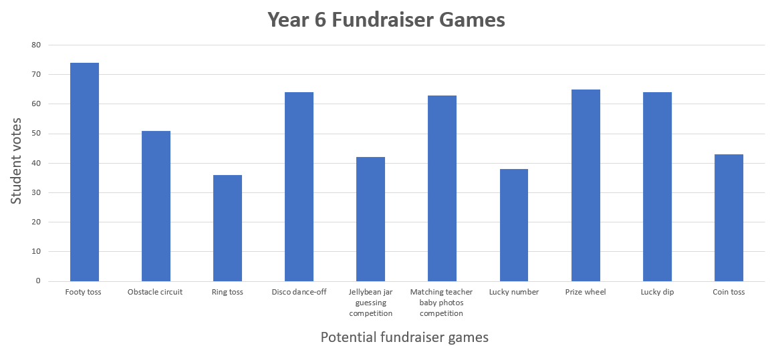

1. Draw attention to the numbers on the vertical axis. Ask:

* What do the numbers represent? (They represent the number of things being counted. This is called a many-to-one scale and is used in column graphs.)
* Why are the numbers increasing by 10 each time, instead of increasing by ones? (There won’t be enough space to include every single number from 1–80. This is why a many-to-one scale is used in column graphs.)

**Note**: if students have had prior experience using Microsoft Excel, demonstrating how to enter data and create a column graph will not be required.

## Core lesson 2 – interpreting the data – 10 minutes

1. Display Resource 1 – Dataville Public School survey. Explain that this school completed the same survey and collated their results in a table. Ask:

* What were the top 3 games voted at Dataville PS?
* Are the most popular games at Dataville PS the same as our school? Why do you think that might be?
* Were there any games that received a lot of votes at one school but very few at the other? Why do you think there was such a difference?
* Are there any other similarities or differences between the data from Dataville PS and our school?
* Does Dataville PS have more students or less students than our school? How do you know?

This table details opportunities for differentiation.

|  |  |
| --- | --- |
| Too hard? | Too easy? |
| Students cannot use data in a spreadsheet to create column graphs with units on vertical axes that are in multiples.   * Support students with entering the survey data into a spreadsheet in Microsoft Excel or Google Forms. * Model how to use this data to create column graphs with units on vertical axes that are in multiples. Highlight the need for titles on both axes, as well as a title for the graph that states its purpose. | Students can use data in a spreadsheet to create column graphs with units on vertical axes that are in multiples.   * Students create a column graph with horizontal bars in Microsoft Excel or Google Forms. They use the small sample from the survey data to enter predicted data across the grade, stage or school (depending on school context). * Ask: What might the data look like if every school in Australia had similar data? There are approximately 6000 primary schools in Australia (Statista 2024). Students calculate these new amounts and display them in a graph. |

## Discuss and connect the mathematics – 10 minutes

1. Distribute sticky notes to each student to use as an exit slip. Ask students to answer the following questions:

* What kind of graphs might use a many-to-one scale? Why?
* What are some benefits of using computers or tablets to show our data instead of just writing it down or drawing it on paper? How might it make it easier for others to understand?
* Why is it important to use accurate data when making decisions?

This table details opportunities for assessment.

|  |  |
| --- | --- |
| Assessment opportunities | Links |
| What to look for:   * Can students describe and interpret information presented in tally tables and column graphs? **[MAO-WM-01, MA2-DATA-01]** * Can students use a given many-to-one scale to represent discrete data in column graphs? **[MAO-WM-01, MA2-DATA-01]** * Can students use data in a spreadsheet to create column graphs with units on vertical axes that are in multiples? **[MAO-WM-01, MA2-DATA-02]** | Links to [National Numeracy Learning Progressions](https://www.australiancurriculum.edu.au/resources/national-literacy-and-numeracy-learning-progressions/version-3-of-national-literacy-and-numeracy-learning-progressions/) (NNLP):   * IRD3. |

# Lesson 4

**Core concept**: data displays can be used to record and compare the outcomes of chance events.

## Daily number sense – 10 minutes

1. From a class need surfaced through formative assessment data, identify a short, focused activity that targets students’ knowledge, understanding and skills. Example activities may be drawn from the following resources:

* [Mathematics K–6 resources](https://education.nsw.gov.au/teaching-and-learning/curriculum/mathematics/mathematics-curriculum-resources-k-12/mathematics-k-6-resources)
* [Universal Resources Hub](https://resources.education.nsw.gov.au/home).

## Core lesson 1 – tossing one coin – 10 minutes

The table below contains a suggested learning intention and success criteria. These are best co-constructed with students.

|  |  |
| --- | --- |
| Core concept learning intention | Core concept success criteria |
| Students are learning to:   * identify possible outcomes from chance experiments. | Students can:   * record all possible outcomes in a chance experiment where the outcomes are equally likely * predict the number of times each outcome might occur in a chance experiment involving a set number of trials * conduct experiments and compare the predicted and actual results where the outcomes are equally likely. |

For each lesson on chance in this unit, students can enhance their understanding by using various representations or tools. These representations and tools can be collaboratively constructed with students or provided as a resource. See Resource 2 – chance representations.

1. Revise the meaning of the word ‘outcome’ where it refers to any possible result of a situation. Discuss situations with different possible outcomes, such as weather, sport, card games or board games.
2. Explain that in mathematics, the term ‘outcome’ has a specific meaning. Share the syllabus definition of outcome.

**Outcome:** a possible result from an experiment or trial.

1. Discuss outcomes of random events, such as rolling dice, spinning a spinner, dealing cards from a deck, taking coloured counters from a bag.

**Event:** situations that occur in the everyday context. In the context of probability, this refers to the set of possible outcomes.

1. Display a coin. Ask students to identify all possible outcomes when a single coin is tossed.
2. Explain that in the event of a single coin toss, there are 2 possible outcomes, heads or tails.

The table below outlines stimulus prompts to generate conversation about the topic, along with anticipated responses from students.

|  |  |
| --- | --- |
| Prompts | Anticipated student responses |
| * What does it mean by ‘an equally likely chance’ of an outcome? | * There is one head and one tail, so it is equally likely that I flip heads or tails. * One outcome is heads. * One outcome is tails. |
| * Is it equally likely for the coin to land on heads or tails? | * There is a 1 in 2 chance that I toss a head, which is the same for tails. |
| * Can you predict if it is equally likely for the coin to land on heads or tails if the coin is tossed 6 times? | * It is equally likely for the coin to land on heads or tails in any given toss. * Each coin toss is not affected by the previous coin toss, so it is equally likely every time we toss it. * After a few coin tosses it might not seem equally likely. (Randomness can lead to variations where one outcome appears more frequently than the other over a short series of tosses.) * Over many trials, the results should be an equal number of heads and tails. |
| * Predict the outcomes of 10 repeated coin tosses given that there is an equal chance for the coin to land on heads or tails? | * We can expect that approximately half of them will land on heads and the other half on tails. * A coin toss is a random event, so it is possible that the actual outcomes may vary. For example, 6 heads and 4 tails, or 3 heads and 7 tails. |

## Core lesson 2 – tossing 2 coins – 35 minutes

This activity is an adaptation of ‘Tossing two coins’ from Building Engagement in the Middle Years by Sullivan.

1. Ask students to name all possible combinations when tossing 2 coins. Record the 4 outcomes on the board. They are:

* HH (2 heads)
* HT (one head, one tail)
* TH (one tail, one head)
* TT (2 tails).

1. Explain that students will be playing a game called ‘2-coin toss’. The rules of the game are:
2. This is a game for 3 players.
3. Each student tosses 2 coins.
4. Player 1 wins if there are 2 heads.
5. Player 2 wins if there are 2 tails.
6. Player 3 wins if there is one of each.
7. Provide 2 coins for each group. Students predict the possible outcomes on Resource 3 – recording sheet for 9 rounds.
8. Groups of students toss 2 coins and record the outcome for each round.
9. After playing, ask:

* After 9 rounds, what do you predict the result of your tenth toss will be?
* Did each of the players have the same chance of winning?
* If not, how could the rules be changed so each player has an equal chance of winning? Options include
* if there are 4 players in the game, Player 1 wins if they get HH, Player 2 wins if they get TT, Player 3 wins if they get HT and Player 4 wins if they get TH.
* if there are only 2 players in the game, Player 1 wins if they have 2 of the same coin (HH or TT) and Player 2 wins if they have 2 different coins (HT or TH).

This table details opportunities for differentiation.

|  |  |
| --- | --- |
| Too hard? | Too easy? |
| Students cannot record all possible outcomes in a chance experiment where the outcomes are equally likely.   * Review the possible outcomes of tossing 2 coins, listing them on the board. Demonstrate the game ‘2-coin toss’ with the whole class, ensuring students understand the rules. * Support students to play the game, describing the outcomes using the language of chance. | Students can record all possible outcomes in a chance experiment where the outcomes are equally likely.   * In pairs or small groups determine all possible outcomes when tossing 3 coins instead of 2. * Students design their own fair coin toss game and explain it to another peer. They play the game to determine if it is fair. |

## Consolidation and meaningful practice – 15 minutes

1. Groups change the rules of the game by choosing one of 2 options they would like to use. The options are:

* 4 players in the game
* 2 players in the game.

1. Once the rule has been decided upon, groups play the game again, recording the results on individual whiteboards.
2. Regroup after 10 rounds and ask:

* Were your overall results the same or different to the first time? How?
* Did the change of rules affect the outcomes achieved? Can you explain how?
* Can you predict what might happen if you were to toss the coin 50 times?

This table details opportunities for assessment.

|  |  |
| --- | --- |
| Assessment opportunities | Links |
| What to look for:   * Can students record all possible combinations in a chance experiment where the outcomes are equally likely? **[MAO-WM-01, MA2-CHAN-01]** * Can students predict the number of times each outcome might occur in a chance experiment involving a set number of trials? **[MAO-WM-01, MA2-CHAN-01]** * Can students conduct experiments and compare the predicted and actual results where the outcomes are equally likely? **[MAO-WM-01, MA2-CHAN-01]** | Links to [National Numeracy Learning Progressions](https://www.australiancurriculum.edu.au/resources/national-literacy-and-numeracy-learning-progressions/version-3-of-national-literacy-and-numeracy-learning-progressions/) (NNLP):   * UnC2, UnC3 * CPr8. |

# Lesson 5

**Core concept**: the outcomes of events can be affected by other events.

## Daily number sense – place the digit – 10 minutes

Daily number sense activities for Lessons 5 to 7 ‘loop’ back to concepts and procedures covered in previous units to assist students to build an increasingly connected network of ideas. These concepts may differ from the core concepts being covered by the unit.

The table below contains a suggested learning intention and success criteria. These are best co-constructed with students.

|  |  |
| --- | --- |
| Daily number sense learning intention | Daily number sense success criteria |
| Students are learning to:   * extend the application of the place value system from whole numbers to tenths and hundredths. | Students can:   * distinguish between the role of zero in various positions. |

This activity is an adaptation of [Place the Digits](https://nzmaths.co.nz/resource/place-digits) from [NZ Maths](https://nzmaths.co.nz/) by New Zealand Ministry of Education.

1. Provide pairs of students with Resource 4 – place the digits and Resource 5 – number cards.

**Note**: revisit the impact zero has on a number when it is in different place value positions. The placement of the zero in these examples changes how we say, write and understand decimals. For example, 0.78, 7.08 or 7.80.

1. The objective of the game is to make the largest decimal after drawing 3 cards. Explain that to play the game:
2. Player 1 draws a card from the deck and records the digit in the ones, tenths or hundredths column on Resource 4 – place the digits.
3. Player 1 returns the drawn card to the bottom of the deck before the next player draws a card and records their digit. Repeat until each player has drawn 3 cards.
4. Before concluding each round, players must say their decimal aloud. For example, 2.45 is read aloud as 2 and 45 hundredths.
5. The winner gets one point for making the largest decimal.
6. After a few rounds, explain that there is an adjustment to the rules of the game. Once players have filled all 3 columns, they can choose to trade one of the digits from either the ones, tens or hundredths column and can draw a new card, trying to make an even larger decimal.
7. Students play the game to make the smallest decimal possible after drawing 3 cards.

**Note**: to allow for Resource 4 – place the digits to be used multiple times, place the game board in a plastic sleeve and provide students with non-permanent markers and an eraser.

This table details opportunities for assessment.

|  |  |
| --- | --- |
| Assessment opportunities | Links |
| What to look for:   * Can students distinguish between the role of zero in various positions? **[MAO-WM-01, MA2-RN-02]** | Links to [National Numeracy Learning Progressions](https://www.australiancurriculum.edu.au/resources/national-literacy-and-numeracy-learning-progressions/version-3-of-national-literacy-and-numeracy-learning-progressions/) (NNLP):   * NPV4, NPV5, NPV6.   Links to suggested [Interview for Student Reasoning](https://education.nsw.gov.au/teaching-and-learning/curriculum/literacy-and-numeracy/assessment-resources/ifsr) (IfSR) tasks:   * IfSR-NP: 4B.6. |

## Core lesson 1 – lucky duck – 15 minutes

The table below contains suggested learning intentions and success criteria. These are best co-constructed with students.

|  |  |
| --- | --- |
| Core concept learning intentions | Core concept success criteria |
| Students are learning to:   * describe the likelihood of outcomes of chance events * identify when events are affected by previous events. | Students can:   * use the terms equally likely, likely and unlikely to describe the chance of everyday events occurring * compare the likelihood of obtaining particular outcomes in a simple chance experiment by predicting, conducting the experiment and comparing the results with the prediction * identify and discuss events where the chance of one event occurring will not be affected by the occurrence of the other * compare events where the chance of one event occurring is affected by the occurrence of the other. |

1. Pose the conjecture: There are events where the chance of one event occurring will not be affected by the occurrence of the other.
2. Students [turn and talk](https://education.nsw.gov.au/teaching-and-learning/curriculum/literacy-and-numeracy/teaching-and-learning-resources/numeracy/talk-moves) to discuss if the statement is true or false.
3. Ask students to identify an event where the statement proves to be true. For example, you have a jar of red and blue marbles. If you pick a red marble and place it back into the jar, it does not change the chances of picking a blue or red marble next time.
4. Explain that students are going to play ‘Lucky duck’ at the Year 6 fundraiser. There are 20 ducks swimming in the pond, each labelled with a number from 1–20 underneath. If an even numbered duck is selected from the pool, students win a prize. Ask:

* What are the chances of getting an even number?
* What are the chances of getting an odd number?
* How many times do you predict an even number will be drawn if I play this game 10 times?

1. To select the first duck out of the pond, roll a 20-sided dice. Record the number rolled, as this represents the outcome.
2. Explain that the duck has been returned to the pond. Ask: Do you think there is still an equal chance of drawing an even or odd number duck after the first selection? Why or why not?
3. Repeat this process 10 times and record the outcome of each draw. Ask:

* Do the results of the 10 draws match your prediction?
* Can you explain why it is equally likely for an even or odd duck to be selected from the pond?
* Is this a fair game?

## Core lesson 2 – ducks are out – 25 minutes

1. Say that there has been a change in the rules for the ‘Lucky duck’ game. Due to a limited number of prizes, once a duck is selected, it will be taken out of the pond.
2. Explain that the goal is still to select a duck with an even number to win a prize. However, once a duck has been selected, it is removed from the pond. There are still 20 ducks in the pond, each labelled with a number from 1–20 underneath. Ask:

* What are the chances of selecting an even numbered duck in the first round?
* If an even numbered duck is drawn in the first round, do the chances of drawing an even numbered duck change in the second round?

1. Provide students with a brown paper bag, 10 red counters (for even ducks), 10 green counters (for odd ducks) and whiteboards.
2. Display Resource 6 – recording table. Using the example provided, model how to record the likelihood of drawing a red counter (even number) for each round as they complete the experiment. Remind them that after each draw, the counter is not returned to the bag.
3. Using Resource 6 – recording table, students record the likelihood of drawing a red counter (even number) for each round of the experiment.
4. Regroup as a class and ask:

* How did the chance of drawing a red counter (even number) change after each round?
* How did removing the counters each round change the probability of winning a prize?
* Do you think it became more or less challenging to win as the game continued?
* Does removing the duck after it has been selected make the game fair? Why or why not?
* Why might the ‘Lucky duck’ stall owner decide to remove the duck after it has been selected in the game?

This table details opportunities for differentiation.

|  |  |
| --- | --- |
| Too hard? | Too easy? |
| Students cannot compare events where the chance of one event occurring is affected by the occurrence of the other.   * Display 5 red counters and 5 green counters. Support students to identify the probability of drawing a red counter. Remove a red counter so that there are 9 counters left. Support students to identify that there are 9 possibilities and 4 of them are red. * Support students to complete the investigation using just 10 counters. | Students can compare events where the chance of one event occurring is affected by the occurrence of the other.   * Add extra rules or conditions to the game to increase complexity. For example, there are 20 ducks and to win, a duck with an even number that is also a multiple of 3, must be selected. How does the probability change each round? * Challenge students to make their own rules. They complete the experiment and record how the probability changes throughout the experiment. |

## Discuss and connect the mathematics – 15 minutes

1. Provide students with a range of coloured counters, individual whiteboards and writing materials.
2. Display Resource 7 – Raph’s maths book.
3. Challenge students to analyse Raph's results and work out the number of coloured counters in his bag.
4. Explain that Raph had some coloured counters in a bag. The colours are red, blue and green. In between each of his draws, his friend looks into the bag to confirm the remaining colours. Without knowing the specific quantities of each colour, can you use Raph's results to determine the number of red, blue and green counters in the bag?
5. Students [Think-Pair-Share](https://app.education.nsw.gov.au/digital-learning-selector/LearningActivity/Card/645) to solve the problem. They use Raph’s results to work out what coloured counters were in his bag.
6. Ask students:

* How many counters were in the bag at the start of the experiment?
* How many counters were in the bag after 9 draws?
* Using the information from draws 1–9, what is the most likely outcome for draw 10?

1. Select students to share their ideas and strategies.

This table details opportunities for assessment.

|  |  |
| --- | --- |
| Assessment opportunities | Links |
| What to look for:   * Can students use the terms equally likely, likely and unlikely to describe the chance of everyday events occurring? **[MAO-WM-01, MA2-CHAN-01]** * Can students compare the likelihood of obtaining particular outcomes in a simple chance experiment by predicting, conducting the experiment and comparing the results with the prediction? **[MAO-WM-01, MA2-CHAN-01]** * Can students identify and discuss events where the chance of one event occurring will not be affected by the occurrence of the other? **[MAO-WM-01, MA2-CHAN-01]** * Can students compare events where the chance of one event occurring is affected by the occurrence of the other? **[MAO-WM-01, MA2-CHAN-01]** | Links to [National Numeracy Learning Progressions](https://www.australiancurriculum.edu.au/resources/national-literacy-and-numeracy-learning-progressions/version-3-of-national-literacy-and-numeracy-learning-progressions/) (NNLP):   * UnC3. |

# Lesson 6

**Core concept**: the outcome of chance experiments can be predicted and recorded.

## Daily number sense – mixed-up decimals – 15 minutes

The table below contains a suggested learning intention and success criteria. These are best co-constructed with students.

|  |  |
| --- | --- |
| Daily number sense learning intention | Daily number sense success criteria |
| Students are learning to:   * extend the application of the place value system from whole numbers to tenths and hundredths. | Students can:   * use the decimal point as a marker to identify the position of the ones digit when expressing tenths as decimals * represent and compare tenths as decimals using linear representations * express decimals as both tenths and hundredths. |

1. Display Resource 8 – mixed-up decimals. Explain that the printer has broken and the decimal points did not print properly.
2. Explain that the decimals need to be placed in ascending order on a number line.
3. Provide students with Resource 8 – mixed-up decimals and individual whiteboards, asking:

* How many possibilities are there for where the decimal point can go in each of the numbers?
* How could the numbers be arranged on a number line? Explain.

1. As a class, discuss possible strategies and solutions to arrange the decimals on a number line.
2. Ensure students justify their reasoning by explaining:

* how the markers are equally spaced on the number line
* that the decimal point is consistently placed to show the place value for each digit
* that the decimals are recorded in ascending order (see Figure 5).

Figure 4 – examples of solutions

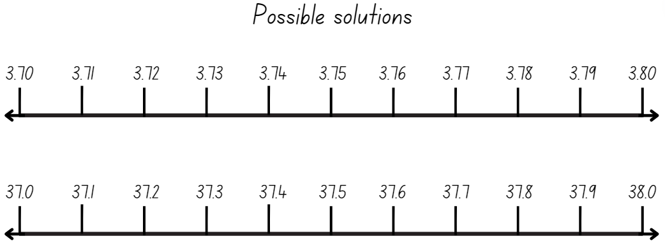

1. Each student selects a decimal on the number line and renames it in multiple ways. For example, 37.3 is 3 tens, 7 ones and 3 tenths or 37 and 3 tenths or 3.73 is 3 and 7 tenths and 3 hundredths or 3 and 73 hundredths.

This table details opportunities for assessment.

|  |  |
| --- | --- |
| Assessment opportunities | Links |
| What to look for:   * Can students use the decimal point as a marker to identify the position of the ones digit when expressing tenths as decimals? **[MAO-WM-01, MA2-RN-02]** * Can students represent and compare tenths as decimals using linear representations? **[MAO-WM-01, MA2-RN-02]** * Can students express decimals as both tenths and hundredths? **[MAO-WM-01, MA2-RN-02]** | Links to [National Numeracy Learning Progressions](https://www.australiancurriculum.edu.au/resources/national-literacy-and-numeracy-learning-progressions/version-3-of-national-literacy-and-numeracy-learning-progressions/) (NNLP):   * NPV6, NPV7.   Links to suggested [Interview for Student Reasoning](https://education.nsw.gov.au/teaching-and-learning/curriculum/literacy-and-numeracy/assessment-resources/ifsr) (IfSR) tasks:   * IfSR-NP: 4B.6. |

## Core lesson 1 – spin the spinner – 15 minutes

The table below contains a suggested learning intention and success criteria. These are best co-constructed with students.

|  |  |
| --- | --- |
| Core concept learning intention | Core concept success criteria |
| Students are learning to:   * describe the likelihood of outcomes of chance events. | Students can:   * use the terms equally likely, likely and unlikely to describe the chance of everyday events occurring * compare the likelihood of obtaining particular outcomes in a simple chance experiment by predicting, conducting the experiment and comparing the results with the prediction. |

This lesson is an adaptation of [I’m Spinning](https://nzmaths.co.nz/resource/i-m-spinning) from [NZ Maths by New Zealand Ministry of Education.](https://nzmaths.co.nz/)

1. Tell students that you are unable to decide on the colour of paper to use for the fundraiser advertisement posters. A spinner will be used to decide on the colour.
2. Explain that students will be testing some spinners to see if they are fair to use.
3. Provide pairs of students with Resource 9 – blank spinner, a paper clip and a pencil. They fill in each section of the spinner with a different colour they prefer, for example, red, blue, purple.
4. Before spinning the spinner, ask:

* What are the chances of getting red? (likely)
* What are the chances of getting green? (unlikely)
* Is the chance of getting red the same as blue?
* How many times do you predict the spinner will land on red?

1. Students record their predictions for the number of times their spinner will land on each colour if 15 spins are completed.
2. Students test their spinners and keep track of the results using a tally chart.
3. Regroup as a class and ask:

* Did your predictions match your outcomes?
* Are these spinners fair? How do you know?
* What would an unfair spinner look like?

## Core lesson 2 – spinner games – 30 minutes

1. Display Resource 10 – game spinner and tell students they are going to play a spinner game. To play the game:
2. Decide who will be Player A and player B.
3. Both players are entitled to score points depending on the colour.
4. If the spinner lands on yellow, Player A receives 2 points and Player B receives one point.
5. If the spinner lands on red or green, Player B receives 2 points and Player A receives one point.
6. The first player to score 20 points wins.
7. Ask: Can you predict which player is most likely to win the game? Why? (Player B because they have more chances of scoring 2 points with each spin than Player A does. Player A can only score 2 points from yellow.)
8. Provide pairs of students with Resource 10 – game spinner, a paper clip and a pencil to play the game.
9. After playing one round, ask:

* Were your predictions correct about the winning player? Why?
* Do you think the game is fair? Why or why not? (The game is not fair because Player A has less chance of scoring points from each spin.)
* Can you describe the chance of each player winning the game? (Player A has a 2 in 6 chance of scoring 2 points from each spin. Player B has 4 in 6 chances to score 2 points from each spin.)
* How could the rules be changed to make the game fair? (Three players can be involved in the game with each player only scoring a point from one colour.)

This table details opportunities for differentiation.

|  |  |
| --- | --- |
| Too hard? | Too easy? |
| Students cannot compare the likelihood of obtaining particular outcomes in a simple chance experiment by predicting, conducting the experiment and comparing the results with the prediction.   * Provide students with a modification of Resource 9 – blank spinner to show 2 parts with 2 possible outcomes. Repeat the activity with 2 colours such as blue and yellow. Player A can only score points if it lands on blue and Player B can only score points if it lands on yellow. | Students can compare the likelihood of obtaining particular outcomes in a simple chance experiment by predicting, conducting the experiment and comparing the results with the prediction.   * Students create their own spinner to use in a modified game with a greater number of possibilities. They decide on their own rules for scoring points. |

## Discuss and connect the mathematics – 5 minutes

1. Students to draw 2 spinners in their workbook. The first spinner must represent equally likely chances of outcomes. The second spinner must represent an unequal chance of outcomes.
2. Choose several spinners to share with the class. Ask:

* How can you know if a spinner would have an equally likely chance?
* What changes did you make to design a spinner that displayed an unequal chance of outcomes?
* Is there a way to design a spinner that has a certain chance of spinning red? For example, a 4 in 10 chance of spinning red?

This table details opportunities for assessment.

|  |  |
| --- | --- |
| Assessment opportunities | Links |
| What to look for:   * Can students use the terms equally likely, likely and unlikely to describe the chance of everyday events occurring? **[MAO-WM-01, MA2-CHAN-01]** * Can students compare the likelihood of obtaining particular outcomes in a simple chance experiment by predicting, conducting the experiment and comparing the results with the prediction? **[MAO-WM-01, MA2-CHAN-01]** | Links to [National Numeracy Learning Progressions](https://www.australiancurriculum.edu.au/resources/national-literacy-and-numeracy-learning-progressions/version-3-of-national-literacy-and-numeracy-learning-progressions/) (NNLP):   * UnC3. |

# Lesson 7

**Core concept**: interpreting data helps us solve problems and ask new questions.

## Daily number sense – decimal dash – 15 minutes

The table below contains a suggested learning intention and success criteria. These are best co-constructed with students.

|  |  |
| --- | --- |
| Daily number sense learning intention | Daily number sense success criteria |
| Students are learning to:   * extend the application of the place value system from whole numbers to tenths and hundredths. | Students can:   * express decimals as both tenths and hundredths * locate and order decimals representing tenths and hundredths on a number line, describing their relative size * distinguish between the role of zero in various positions. |

1. Explain that the aim of ‘Decimal dash’ is to practise locating and ordering decimals on a number line. It will also reinforce students’ understanding of relative sizes of decimals.
2. In small groups provide students with Resource 11 – decimal cards.
3. Using a whiteboard or paper, students draw a large number line and label key intervals. For example, 0, 1, 2, ..., 10.
4. Students shuffle the cards and split them in 2 equal piles.
5. Students turn a card over from their pile and record the decimal on their number line.
6. For every correct placement, a student gets a point. If a student does not agree with the placement of the card, they ask their partner to justify their placements by explaining the relative size of the decimals.
7. Reshuffle the cards and play again.
8. Regroup as a class and ask:

* What patterns did you notice while placing decimals on the number line?
* Can you share any strategies you used to accurately position the decimals?
* What challenges did you encounter while placing decimals on the number line?
* How did you overcome these challenges during the game?

This table details opportunities for assessment.

|  |  |
| --- | --- |
| Assessment opportunities | Links |
| What to look for:   * Can students express decimals as both tenths and hundredths? **[MAO-WM-01, MA2-RN-02]** * Can students locate and order decimals representing tenths and hundredths on a number line, describing their relative size?  **[MAO-WM-01, MA2-RN-02]** * Can students distinguish between the role of zero in various positions? **[MAO-WM-01, MA2-RN-02]** | Links to [National Numeracy Learning Progressions](https://www.australiancurriculum.edu.au/resources/national-literacy-and-numeracy-learning-progressions/version-3-of-national-literacy-and-numeracy-learning-progressions/) (NNLP):   * NPV4, NPV5, NPV6, NPV7, NPV8.   Links to suggested [Interview for Student Reasoning](https://education.nsw.gov.au/teaching-and-learning/curriculum/literacy-and-numeracy/assessment-resources/ifsr) (IfSR) tasks:   * IfSR-NP: 4B.6. |

## Core lesson 1 – constructing and comparing data – 20 minutes

The table below contains suggested learning intentions and success criteria. These are best co-constructed with students.

|  |  |
| --- | --- |
| Core concept learning intentions | Core concept success criteria |
| Students are learning to:   * interpret and compare data * construct and interpret data displays with many-to-one scales. | Students can:   * describe and interpret information presented in tally tables and column graphs * interpret and evaluate the effectiveness of various data displays found in media and in factual texts where displays represent data using a scale of many-to-one. |

1. Ask students to brainstorm a list of gaming devices they have at home. For example, gaming consoles, mobile phones, smart watches, tablets, VR headsets, laptops and desktop computers.
2. Draw a table on the board and record the number of gaming devices each student has at home. For example, see Table 3.

Table 3 – example of data recording

|  |  |
| --- | --- |
| Number of gaming devices in the home | Number of students |
| 1 | 1 |
| 2 | 3 |
| 3 | 6 |
| 4 | 6 |
| 5 | 5 |
| 6 | 4 |
| 7 or more | 4 |

The table below outlines stimulus prompts to generate conversation about the topic, along with anticipated responses from students.

|  |  |
| --- | --- |
| Prompts | Anticipated student responses |
| * Is this an effective way to collect and record this data? Why or why not? | * Yes, because the table makes it clear the number of gaming devices each student in our class has in their home. * No, because there are 4 students in our class who said they had 7 or more gaming devices, but we don’t know the exact number of devices they have. They may have 8 or 12. |
| * Is there another way we could collect and record this data to make it more accurate? Explain your thinking. | * Students could have specified each type of gaming device they have in their home. * The data could be displayed in a column graph rather than a table. This would make it easier to compare the total number of students for each category. |

1. Model how to create a class column graph of the gaming data for students.

**Note**: Microsoft Excel or Google Sheets can be used to compile and analyse the class data.

1. Display Resource 12 – gaming devices graph. Explain that this graph represents 100 individual responses in Australia.
2. Students compare the class column graph with Resource 12 – gaming devices graph. Ask:

* Are there any differences in the number of gaming devices owned by students in our class, compared to the broader survey?
* How do scales on graphs help us understand data? Can you give an example?
* What are some similarities and differences you notice when comparing the scales on the 2 different graphs?
* Why is it important to pay attention to the scale when interpreting a graph?
* Can you explain why knowing the number of people surveyed is important when comparing the scales in graphs?
* How can you ensure you interpret a graph's data accurately, when comparing graphs with different scales?

## Core lesson 2 – evaluating a data set – 20 minutes

1. Provide small groups or pairs of students with Resource 13 – interpreting data displays.
2. Explain that students will look at data provided by [IGEA -– Interactive Games and Entertainment Association Australia (PDF 12.4 MB)](https://igea.net/wp-content/uploads/2023/08/IGEA_AP2023_FINAL_REPORT.pdf).
3. Students evaluate how effectively each data display presents the information about the types of gaming devices in homes. Ask:

* What data is being displayed?
* How is the column graph representation similar and different to the picture graph?
* Which is easier to interpret? Why?
* What do you notice about the labels on the axes of the graphs? Are they clear and easy to understand?
* How would you compare the lengths of the bars in the column graph?
* Why is it important for a data display to have a key or legend? Can you explain what the key tells us in the graphs?
* If 1000 people were surveyed, which display do you think would best to represent the data? Why?

1. In pairs, students write 3 questions about Resource 13 – interpreting data displays to be answered by another pair of students. Alternatively, students answer the following questions:

* Which type of gaming device is the most common in households?
* How does the range of gaming devices compare to what you expected?
* Are there any types of gaming devices that are less common or missing from the data? Why do you think that might be?

1. Invite students to share their questions and answers with the class.

This table details opportunities for differentiation.

|  |  |
| --- | --- |
| Too hard? | Too easy? |
| Students cannot interpret and evaluate the effectiveness of various data displays found in media and in factual texts where displays represent data using a scale of many-to-one.   * Set up a [gallery walk](https://app.education.nsw.gov.au/digital-learning-selector/LearningActivity/Card/555) in the classroom with different data displays around the room. Prompt students to analyse and compare the features of each display. For example, students consider factors such as the title, axis labels, scale and overall clarity of the information presented. * Provide data display templates with elements added, such as table headings or graph axes names and labels. Support students to interpret the information presented on each graph. | Students can interpret and evaluate the effectiveness of various data displays found in media and in factual texts where displays represent data using a scale of many-to-one.   * Provide larger or more complex data sets for analysis. This can include data with multiple variables, data collected over longer periods of time, or data from different sources that need to be integrated and analysed together. Students label and annotate the interesting features they identify. * Present students with real-world data sources for them to apply data analysis skills and answer complex problems or make recommendations. This could involve analysing data related to environmental issues, economic trends or public health issues. |

## Discuss and connect the mathematics – 10 minutes

1. Regroup as a class. Ask:

* What were some of the advantages and disadvantages you identified when using any of the 4 displays?
* How would you order the data displays from most to least effective? Why?

This table details opportunities for assessment.

|  |  |
| --- | --- |
| Assessment opportunities | Links |
| What to look for:   * Can students interpret and evaluate the effectiveness of various data displays found in media and in factual texts where displays represent data using a scale of many-to-one? **[MAO-WM-01, MA2-DATA-02]** * Can students describe and interpret information presented in tally tables and column graphs? **[MAO-WM-01, MA2-DATA-02]** | Links to [National Numeracy Learning Progressions](https://www.australiancurriculum.edu.au/resources/national-literacy-and-numeracy-learning-progressions/version-3-of-national-literacy-and-numeracy-learning-progressions/) (NNLP):   * IRD3, IRD4. |

# Lesson 8

**Core concept**: mathematicians interpret and evaluate the effectiveness of real-world data.

## Daily number sense – 10 minutes

1. From a class need surfaced through formative assessment data, identify a short, focused activity that targets students’ knowledge, understanding and skills. Example activities may be drawn from the following resources:

* [Mathematics K–6 resources](https://education.nsw.gov.au/teaching-and-learning/curriculum/mathematics/mathematics-curriculum-resources-k-12/mathematics-k-6-resources)
* [Universal Resources Hub](https://resources.education.nsw.gov.au/home).

## Core lesson – mystery graphs – 45 minutes

The table below contains suggested learning intentions and success criteria. These are best co-constructed with students.

|  |  |
| --- | --- |
| Core concept learning intentions | Core concept success criteria |
| Students are learning to:   * select and trial methods for data collection * construct and interpret data displays with many-to-one scales. | Students can:   * compare the effectiveness of different methods of collecting and recording data * interpret and evaluate the effectiveness of various data displays found in media and in factual texts where displays represent data using a scale of many-to-one. |

**Note**: the purpose of this lesson is to analyse the effectiveness of various data displays in communicating information. It can be used as an assessment tool of students’ understanding and learning of data interpretation.

1. Display Resource 14 – school travel graph. Ask:

* What does the data display represent?
* How clear and understandable is the display?
* Does the display effectively communicate the information presented?

1. Provide groups of students with a copy of Resource 15 – mystery graphs.
2. Students choose 2 data displays to carefully examine and compare. They answer the following questions by annotating each of the graphs from Resource 15 – mystery graphs. Ask:

* What does the data display represent?
* How clear and understandable is the display?
* What information is missing?
* Does the display effectively communicate the information presented?
* Are there any changes that could be made to improve the data display’s clarity or effectiveness? For example, by adding headings or labels.
* What are the advantages and disadvantages for using each display?
* Which graph do you think is the most efficient? Why?
* Would the data representation be more effective if displayed in a different way? For example, by using a dot plot or table.

1. Students find another peer or group to compare their ideas.
2. Regroup as class and discuss:

* How many people were surveyed? Is this enough information to make a decision?
* What are the different ways we can collect data? (for example, counting, measuring, surveys and observation)
* How does the way we organise data affect the information we can learn from it? (tables, graphs, categories can show patterns or relationships that may not be so obvious)
* Why might we choose to study only part of a group, and what are the potential advantages and disadvantages of this approach?

This table details opportunities for differentiation.

|  |  |
| --- | --- |
| Too hard? | Too easy? |
| Students cannot interpret and evaluate the effectiveness of various data displays found in media and in factual texts where displays represent data using a scale of many-to-one.   * Provide students with Resource 16 – column graph checklist to support their analysis of the data sets. Model how to use the checklist to look for missing features. * Provide guidance by discussing the features of each display type. Support them to identify features that are helpful in data. | Students can interpret and evaluate the effectiveness of various data displays found in media and in factual texts where displays represent data using a scale of many-to-one.   * Show students examples of data displays from media sources, scientific articles or research studies. They critically evaluate the effectiveness of each display in conveying information. * Students identify strengths and weaknesses of the displays and suggest improvements for clarity and accuracy. |

## Discuss and connect the mathematics – 5 minutes

1. Students reflect on the following statements:

* Data displays play a crucial role in effectively communicating information.
* Well-designed data displays can make information easier to understand and interpret.

1. Discuss how interpretation of data involves analysing data displays, identifying patterns and drawing meaningful conclusions.

This table details opportunities for assessment.

|  |  |
| --- | --- |
| Assessment opportunities | Links |
| What to look for:   * Can students compare the effectiveness of different methods of collecting and recording data? **[MAO-WM-01, MA2-DATA-02]** * Can students interpret and evaluate the effectiveness of various data displays found in media and in factual texts where displays represent data using a scale of many-to-one? **[MAO-WM-01, MA2-DATA-02]** | Links to [National Numeracy Learning Progressions](https://www.australiancurriculum.edu.au/resources/national-literacy-and-numeracy-learning-progressions/version-3-of-national-literacy-and-numeracy-learning-progressions/) (NNLP):   * IRD4. |

# Resource 1 – Dataville Public School survey

|  |  |
| --- | --- |
| **Potential fundraiser games** | **Student votes** |
| Footy toss | 75 |
| Obstacle circuit | 60 |
| Ring toss | 13 |
| Disco dance-off | 84 |
| Jellybean jar guessing competition | 38 |
| Matching teacher baby photos competition | 68 |
| Lucky number | 23 |
| Prize wheel | 93 |
| Lucky dip | 88 |
| Coin toss | 24 |

# Resource 2 – chance representations

Representations to enhance students’ understanding of chance:

Linear scale – What does a scale remind us of? How does a scale support us in thinking about the likelihood of chance? How can they support our language?

List outcomes – Where do we use lists in real life? How can lists help us to remember and think about options? Is the order in a list important?

Manipulatives – How can manipulatives help us to visualise a situation? Why are they useful in representing how situations can change? How can they support our language?

Random generators – How do different generators represent different possible outcomes? How can they support our reasoning about chance? How can they support our language?

Diagrams – How can diagrams represent a situation or our thinking? How can they help us to think sequentially? How can they support our language?

Graphs – How can graphs be used to represent the outcome of a chance experiment?  Are they more useful than words? How can they support our language?

# Resource 3 – recording sheet

A recording sheet for the game '2-coin toss'. The recording sheet is broken up into 3 sections, one for each player. 

There are 9 rounds of the game. Each player records a prediction for each round and the outcome that occurred in each round. 

There is a column to record points for each player.

# Resource 4 – place the digits

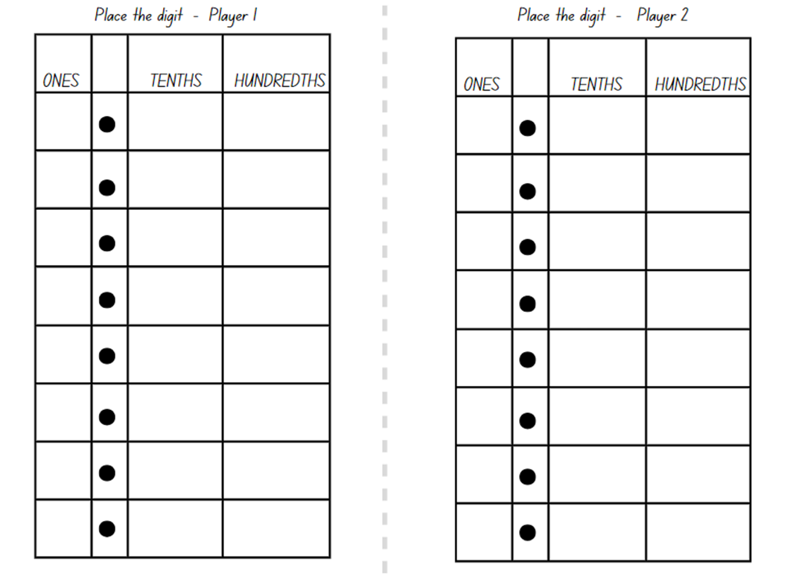

# Resource 5 – number cards

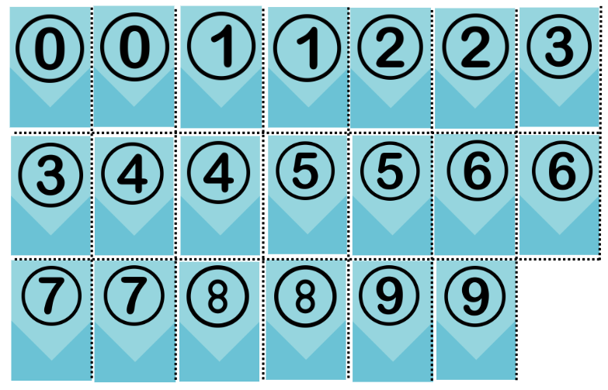

# Resource 6 – recording table

|  |  |  |
| --- | --- | --- |
| Round | Chance of drawing a red (even) counter | Counter drawn (outcome) |
| **Example** | **10 in 20 chance (equally likely)** | **Red (even number)** |
| 1 |  |  |
| 2 |  |  |
| 3 |  |  |
| 4 |  |  |
| 5 |  |  |
| 6 |  |  |
| 7 |  |  |
| 8 |  |  |
| 9 |  |  |
| 10 |  |  |
| 11 |  |  |
| 12 |  |  |

# Resource 7 – Raph's maths book

An example of a student workbook to record a chance lesson and responses. Columns included are Event, Counters in bag and Colour drawn.

Event 1 – Counters in bag are Red, Blue, Green and Colour drawn is Red.

Event 2 – Counters in bag are Red, Blue, Green and Colour drawn is Green.

Event 3 – Counters in bag are Red, Blue, Green and Colour drawn is Green.

Event 4 – Counters in bag are Red, Blue, Green and Colour drawn is Red.

Event 5 – Counters in bag are Red, Blue, Green and Colour drawn is Red.

Event 6 – Counters in bag are Blue and Green and Colour drawn is Blue.

Event 7 – Counters in bag are Blue and Green and Colour draw is Green.

Event 8 – Counters in bag are Blue and Colour drawn is Blue.

Event 9 – Counters in bad are Blue and Colour drawn is Blue.

Event 10 has been left blank.

# Resource 8 – mixed-up decimals

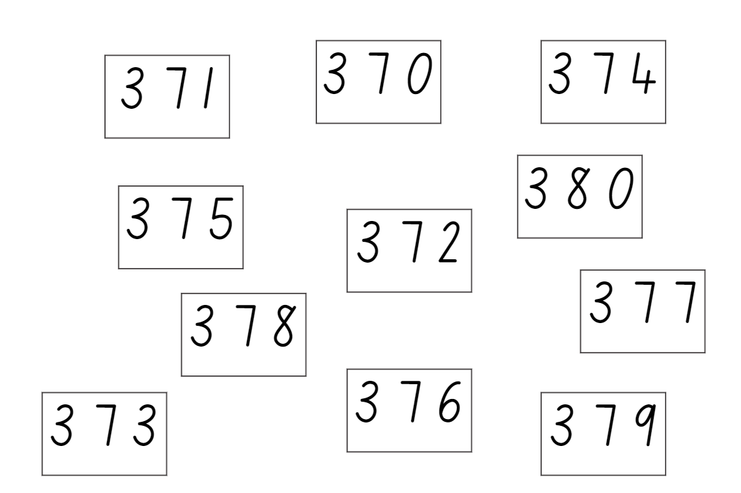

# Resource 9 – blank spinner

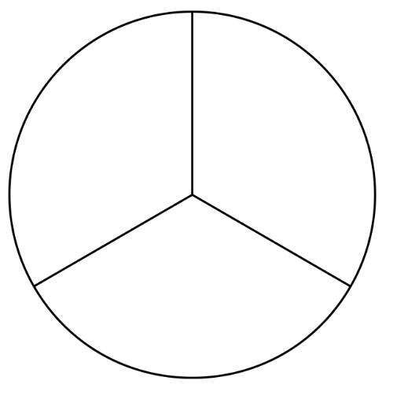

# Resource 10 – game spinner

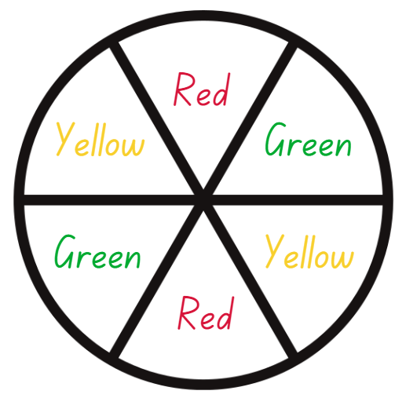

# Resource 11 – decimal cards

A group of 16 decimals up to 2 decimal places in boxes for students to arrange: 3.45, 9.07, 4.6, 1.6, 8.21, 2.33, 7.3, 6.79, 1.9, 5.19, 2.58, 4.95, 6.4, 0.86, 9.04, 8.09.


# Resource 12 – gaming devices graph

A graph labelled 'Number of gaming devices in each household'. 

The y-axis is labelled 'number of people' and the x-axis is labelled 'gaming devices per home'. 

The column 1 gaming devices is under 25 people. 

The column 2 gaming devices is 25 people. 

The column 3 gaming devices is over 20 people. 

The column 4 gaming devices is 15 people. 

The column 5 gaming devices is between 5 and 10 people and the column 6 gaming devices is over 5 people.

Data sourced and adapted from Brand et al. (2023).

# Resource 13 – interpreting data displays

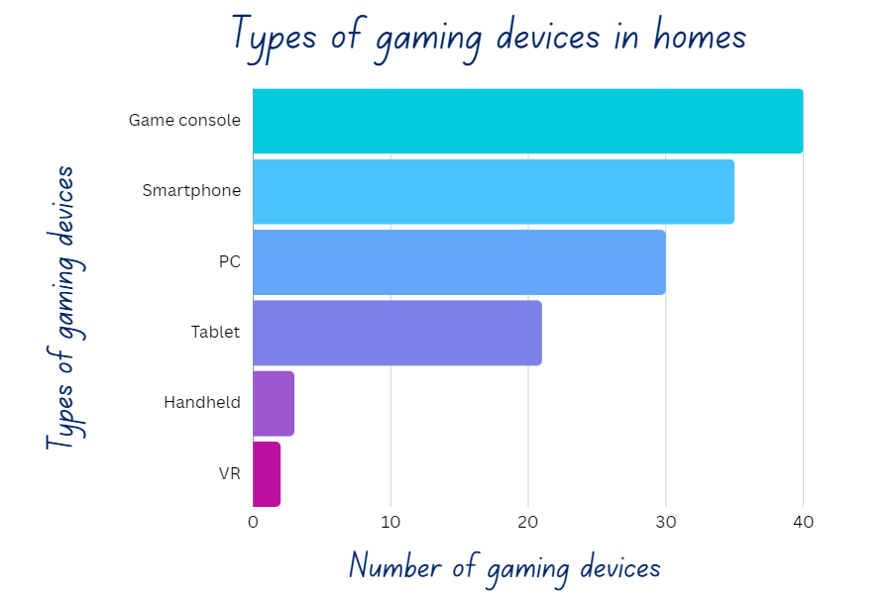

Data sourced and adapted from Brand et al. (2023).

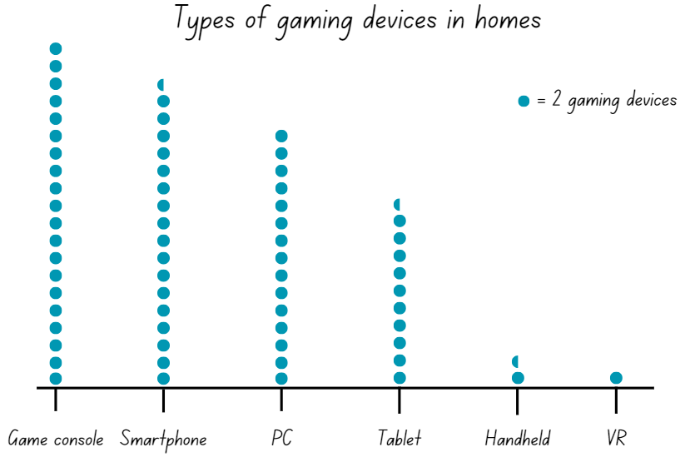

Data sourced and adapted from Brand et al. (2023).

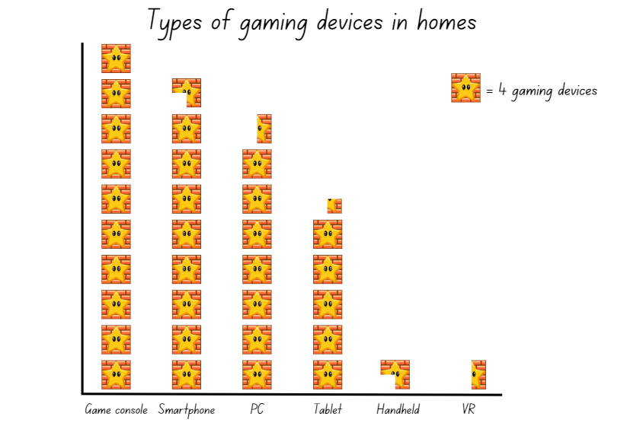

Data sourced and adapted from Brand et al. (2023).

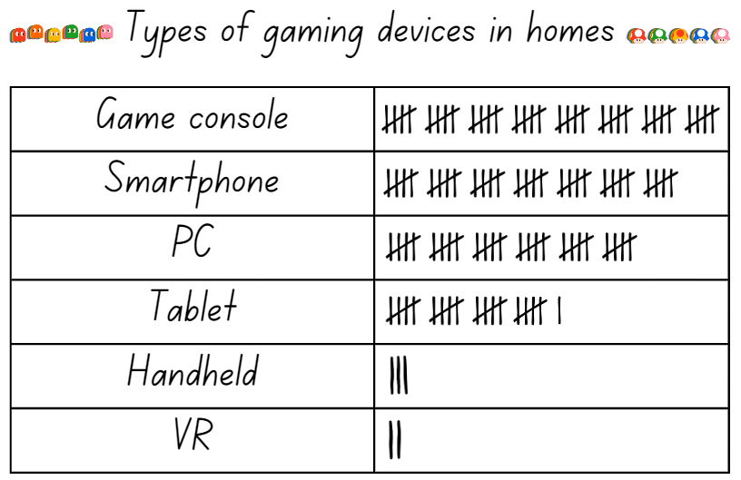

Data sourced and adapted from Brand et al. (2023).

# Resource 14 – school travel graph

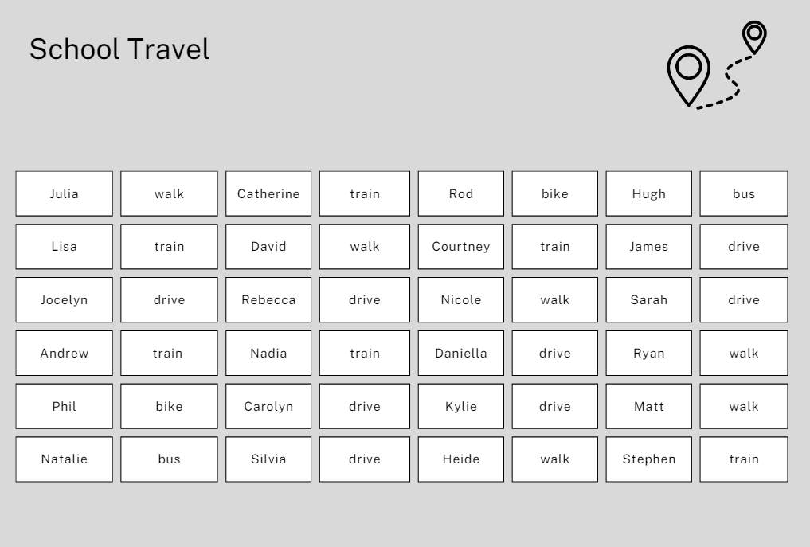

# Resource 15 – mystery graphs

|  |  |
| --- | --- |
| ****Features**** | ****Number of devices**** |
| iPad | 28 |
| Mini iPad | 7 |
| Mobile phone | 3 |
| Tablet | 15 |
| Laptop computer | 43 |
| Desktop computer | 14 |
| Gaming console | 55 |

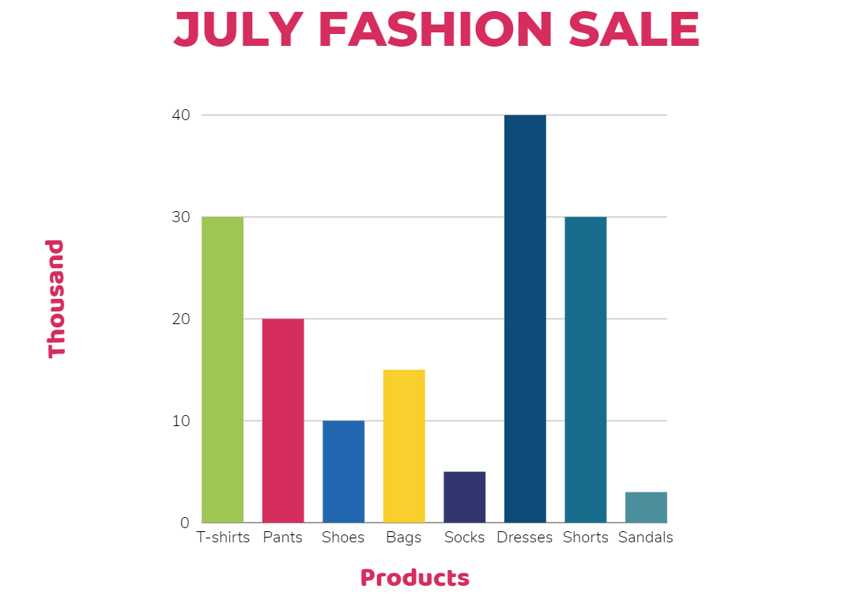

A dot plot graph titled 'Books read in a month by teachers in class'. The data spans from Kindergarten to Year 6. Each dot is equal to 2. 
K = 16, Year 1 = 12, Year 2 = 10, Year 3 = 8, Year 4 = 6, Year 5 = 4, Year 6 = 2.


Bar chart titled 'Attendance' showing yearly attendance from 2019 to 2022. Each year has 3 bars: teal, dark blue, and green. Values range from 0 to 20. 
2019 bars represent: teal 5, dark blue 10, and green 5. 
2020 bars represent: teal 8, dark blue 8, and green 4. 
2021 bars represent: teal 15, dark blue 10, and green 5. 
2022 bars represent: teal 10, dark blue 14, and green 8.

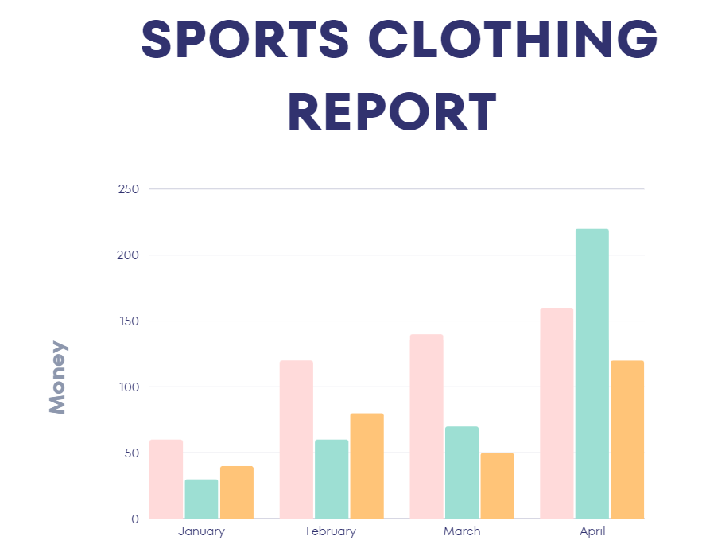

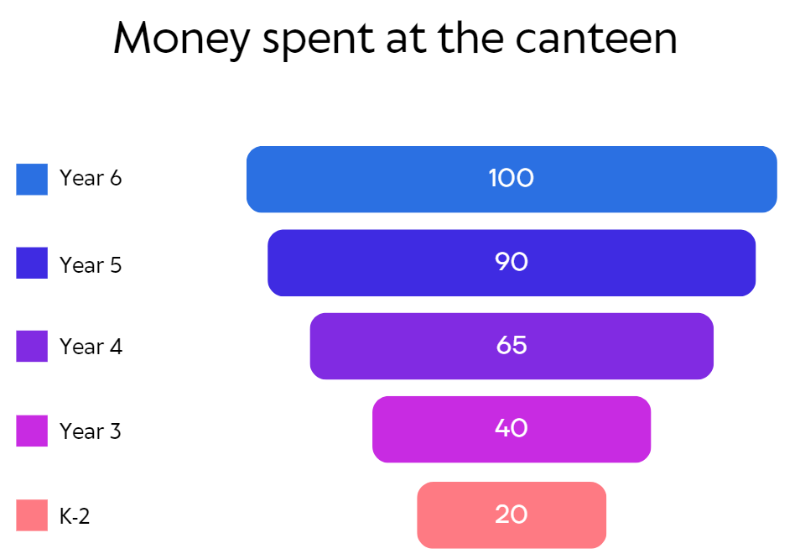

# Resource 16 – column graph checklist

Column graph checklist with ‘Yes’ and ‘No’ tick boxes for the following statements:

Do I have a title?

Are my intervals evenly spaced?

Do my axes have names and labels?

Are my columns equal widths with spaces between them?

Do my column heights line up to the correct value?

# Syllabus outcomes and content

The table below outlines the [syllabus outcomes](https://curriculum.nsw.edu.au/learning-areas/mathematics/mathematics-k-10-2022/overview) and range of relevant syllabus content covered in this unit. Content is linked to [National Numeracy Learning Progression](https://www.australiancurriculum.edu.au/resources/national-literacy-and-numeracy-learning-progressions/version-3-of-national-literacy-and-numeracy-learning-progressions/) (version 3).

|  |  |  |  |  |  |  |  |  |
| --- | --- | --- | --- | --- | --- | --- | --- | --- |
| Outcomes and content | 1 | 2 | 3 | 4 | 5 | 6 | 7 | 8 |
| **Representing numbers using place value B**: Decimals: Extend the application of the place value system from whole numbers to tenths and hundredths  **MAO-WM-01, MA2-RN-02** |  |  |  |  |  |  |  |  |
| * Use the decimal point as a marker to identify the position of the ones digit when expressing tenths as decimals |  |  |  |  |  | x |  |  |
| * Represent and compare tenths as decimals using linear representations (Reasons about relations) |  |  |  |  |  | x |  |  |
| * Express decimals as both tenths and hundredths |  |  |  |  |  | x | x |  |
| * Locate and order decimals representing tenths and hundredths on a number line, describing their relative size |  |  |  |  |  |  | x |  |
| * Distinguish between the role of zero in various positions |  |  |  |  | x |  | x |  |
| **Additive relations B**: Apply addition and subtraction to familiar contexts, including money and budgeting  **MAO-WM-01, MA2-AR-01** |  |  |  |  |  |  |  |  |
| * Use estimation to check the validity of solutions to addition and subtraction problems, including those involving money | x | x |  |  |  |  |  |  |
| * Reflect on a chosen strategy for solving a problem, considering whether it can be improved |  |  | x |  |  |  |  |  |
| * Interpret problems involving money as requiring either addition or subtraction |  |  | x |  |  |  |  |  |
| **Data A**: Collect discrete data  **MAO-WM-01, MA2-DATA-01** |  |  |  |  |  |  |  |  |
| * Pose questions about a matter of interest to obtain information that can be recorded in categories | x |  |  |  |  |  |  |  |
| * Predict and create a list of categories for efficient data collection in relation to a matter of interest | x |  |  |  |  |  |  |  |
| **Data A**: Organise and display data using tables and graphs  **MAO-WM-01, MA2-DATA-01** |  |  |  |  |  |  |  |  |
| * Create a list or table to organise the data |  | x |  |  |  |  |  |  |
| **Data A**: Interpret and compare data  **MAO-WM-01, MA2-DATA-02** |  |  |  |  |  |  |  |  |
| * Describe and interpret information presented in tally tables and column graphs |  |  | x |  |  |  | x |  |
| **Data B**: Select and trial methods for data collection  **MAO-WM-01, MA2-DATA-01** |  |  |  |  |  |  |  |  |
| * Create a survey and related recording sheet, considering the appropriate organisation of categories for data collection |  | x |  |  |  |  |  |  |
| * Refine survey questions as necessary after a small trial | x |  |  |  |  |  |  |  |
| * Conduct a survey or make observations to collect categorical or numerical data |  | x |  |  |  |  |  |  |
| * Compare the effectiveness of different methods of collecting and recording data |  |  |  |  |  |  |  | x |
| **Data B**: Construct and interpret data displays with many-to-one scales  **MAO-WM-01, MA2-DATA-01, MA2-DATA-02** |  |  |  |  |  |  |  |  |
| * Use a given many-to-one scale to represent discrete data in column graphs |  |  | x |  |  |  |  |  |
| * Use data in a spreadsheet to create column graphs with units on vertical axes that are in multiples |  |  | x |  |  |  |  |  |
| * Interpret and evaluate the effectiveness of various data displays found in media and in factual texts where displays represent data using a scale of many-to-one |  |  |  |  |  |  | x | x |
| **Chance A**: Identify possible outcomes from chance experiments  **MAO-WM-01, MA2-CHAN-01** |  |  |  |  |  |  |  |  |
| * Record all possible outcomes in a chance experiment where the outcomes are equally likely |  |  |  | x |  |  |  |  |
| * Predict the number of times each outcome might occur in a chance experiment involving a set number of trials (Probabilistic reasoning) |  |  |  | x |  |  |  |  |
| * Conduct experiments and compare the predicted and actual results where the outcomes are equally likely |  |  |  | x |  |  |  |  |
| **Chance B**: Describe the likelihood of outcomes of chance events  **MAO-WM-01, MA2-CHAN-01** |  |  |  |  |  |  |  |  |
| * Use the terms equally likely, likely and unlikely to describe the chance of everyday events occurring |  |  |  |  | x | x |  |  |
| * Compare the likelihood of obtaining particular outcomes in a simple chance experiment by predicting, conducting the experiment and comparing the results with the prediction |  |  |  |  | x | x |  |  |
| **Chance B**: Identify when events are affected by previous events  **MAO-WM-01, MA2-CHAN-01** |  |  |  |  |  |  |  |  |
| * Identify and discuss events where the chance of one event occurring will not be affected by the occurrence of the other |  |  |  |  | x |  |  |  |
| * Compare events where the chance of one event occurring is affected by the occurrence of the other (Reasons about relations) |  |  |  |  | x |  |  |  |

[Mathematics K–10 Syllabus](https://curriculum.nsw.edu.au/learning-areas/mathematics/mathematics-k-10-2022/overview) © NSW Education Standards Authority (NESA) for and on behalf of the Crown in right of the State of New South Wales, 2022.

# References

This resource contains NSW Curriculum and syllabus content. The NSW Curriculum is developed by the NSW Education Standards Authority. This content is prepared by NESA for and on behalf of the Crown in right of the State of New South Wales. The material is protected by Crown copyright.

Please refer to the NESA Copyright Disclaimer for more information <https://educationstandards.nsw.edu.au/wps/portal/nesa/mini-footer/copyright>.

NESA holds the only official and up-to-date versions of the NSW Curriculum and syllabus documents. Please visit the NSW Education Standards Authority (NESA) website <https://educationstandards.nsw.edu.au> and the NSW Curriculum website [https://curriculum.nsw.edu.au](https://curriculum.nsw.edu.au/).

[Mathematics K–10 Syllabus](https://curriculum.nsw.edu.au/learning-areas/mathematics/mathematics-k-10-2022/overview) © NSW Education Standards Authority (NESA) for and on behalf of the Crown in right of the State of New South Wales, 2022.

[National Numeracy Learning Progression](https://www.australiancurriculum.edu.au/resources/national-literacy-and-numeracy-learning-progressions/version-3-of-national-literacy-and-numeracy-learning-progressions/) © Australian Curriculum, Assessment and Reporting Authority (ACARA) 2010 to present, unless otherwise indicated. This material was downloaded from the [Australian Curriculum](http://www.australiancurriculum.edu.au/) website (National Numeracy Learning Progression) (accessed 4 April 2024) and was not modified.

Brand JE, Wilson T, Jervis J and Huggins P (2023) [*Australia Plays 2023* [PDF 12.4 MB]](https://igea.net/wp-content/uploads/2023/08/IGEA_AP2023_FINAL_REPORT.pdf), **IGEA** (Interactive Games and Entertainment Association**),** accessed 2 April 2024.

New Zealand Ministry of Education (n.d.)‘[I’m Spinning](https://nzmaths.co.nz/resource/i-m-spinning)’, Resource Finder, NZ Maths website, accessed 3 May 2024.

New Zealand Ministry of Education (n.d.) ‘[Place the Digits](https://nzmaths.co.nz/resource/place-digits)’, Resource Finder, NZ Maths website, accessed 2 April 2024.

Statista (2024)[Number of primary and secondary schools in Australia in 2022, by state](https://www.statista.com/statistics/612199/australia-primary-and-secondary-schools/#:~:text=Primary%20and%20secondary%20schools%20Australia%202022%20by%20state&text=In%202022%2C%20there%20were%20nearly,schools%20in%20New%20South%20Wales.), Statista website, accessed 28 March 2024.

Sullivan P (2021) Building Engagement in Middle Years Mathematics, 1st edn, Oxford University Press Australia and New Zealand, Melbourne.

## Further reading

Siemon D, Warren E, Beswick K, Faragher R, Miller J, Horne M, Jazby D, Breed M, Clark J and Brady K (2020) Teaching Mathematics: Foundation to Middle Years, 3rd edn, Oxford University Press Australia and New Zealand.

Sullivan P and Lilburn P (2017) Open-Ended Maths Activities: Using ‘Good’ Questions to Enhance Learning in Mathematics, Revised edn, Oxford University Press ANZ, Great Britain.

**© State of New South Wales (Department of Education), 2024**

The copyright material published in this resource is subject to the *Copyright Act 1968* (Cth) and is owned by the NSW Department of Education or, where indicated, by a party other than the NSW Department of Education (third-party material).

Copyright material available in this resource and owned by the NSW Department of Education is licensed under a [Creative Commons Attribution 4.0 International (CC BY 4.0) license.](https://creativecommons.org/licenses/by/4.0/)

**[](https://creativecommons.org/licenses/by/4.0/)**

This license allows you to share and adapt the material for any purpose, even commercially.

Attribution should be given to © State of New South Wales (Department of Education), 2024.

Material in this resource not available under a Creative Commons license:

* the NSW Department of Education logo, other logos and trademark-protected material
* material owned by a third party that has been reproduced with permission. You will need to obtain permission from the third party to reuse its material.

**Links to third-party material and websites**

Please note that the provided (reading/viewing material/list/links/texts) are a suggestion only and implies no endorsement, by the New South Wales Department of Education, of any author, publisher, or book title. School principals and teachers are best placed to assess the suitability of resources that would complement the curriculum and reflect the needs and interests of their students.

If you use the links provided in this document to access a third-party's website, you acknowledge that the terms of use, including licence terms set out on the third-party's website apply to the use which may be made of the materials on that third-party website or where permitted by the *Copyright Act 1968* (Cth). The department accepts no responsibility for content on third-party websites.