Mathematics Stage 2 – Unit 39

Angles are the primary structural component of many shapes

Contents

Unit description and duration 5

Syllabus outcomes 5

Working mathematically 6

Student prior learning 6

Lesson overview and resources 8

Lesson 1 14

Daily number sense – expanded form – 15 minutes 14

Core lesson – digital displays – 40 minutes 15

Discuss and connect the mathematics – 10 minutes 19

Lesson 2 21

Daily number sense – renaming numbers – 10 minutes 21

Core lesson – Maggie’s diary – 40 minutes 23

Discuss and connect the mathematics – 10 minutes 27

Lesson 3 29

Daily number sense – let’s talk numbers – 15 minutes 29

Core lesson – shape transformations – 45 minutes 31

Discuss and connect the mathematics – 10 minutes 35

Lesson 4 37

Daily number sense – 10 minutes 37

Core lesson – creating patterns – 35 minutes 37

Discuss and connect the mathematics – 10 minutes 40

Lesson 5 42

Daily number sense – blank number lines– 10 minutes 42

Core lesson 1 – design and make – 30 minutes 45

Core lesson 2 – looking for angles – 20 minutes 48

Discuss and connect the mathematics – 10 minutes 50

Lesson 6 52

Daily number sense – fraction line beyond 1 – 10 minutes 52

Core lesson – Ferris wheel – 40 minutes 54

Discuss and connect the mathematics – 10 minutes 57

Lesson 7 59

Daily number sense – be the teacher – 10 minutes 59

Core lesson – Ferris wheels around the world – 30 minutes 61

Discuss and connect the mathematics – 30 minutes 63

Lesson 8 65

Daily number sense – 10 minutes 65

Core lesson – design a Ferris wheel – 40 minutes 65

Discuss and connect the mathematics – 10 minutes 68

Resource 1 – expanded form memory 70

Resource 2 – theme park schedule 72

Resource 3 – time remaining 73

Resource 4 – incorrect clocks 74

Resource 5 – Maggie’s diary 75

Resource 6 – recording time 76

Resource 7 – student number expander 78

Resource 8 – number expander worksheet 79

Resource 9 – theme park signs 80

Resource 10 – splitting trapeziums 81

Resource 11 – transformations 82

Resource 12 – rotating patterns 83

Resource 13 – blank number lines 84

Resource 14 – demolition derby design 85

Resource 15 – angle names 86

Resource 16 – angles matching cards 87

Resource 17 – number line 90

Resource 18 – Ferris wheel 1 91

Resource 19 – Ollie’s misconceptions 92

Resource 20 – Charlie’s misconceptions 93

Resource 21 – Ferris wheels 2 94

Resource 22 – investigation criteria 95

Resource 23 – Ferris wheel criteria 96

Resource 24 – student example Ferris wheel 97

Resource 25 – two stars and a wish 98

Syllabus outcomes and content 99

References 103

# Unit description and duration

This unit develops the big idea that angles are the primary structural component of many shapes.

In this 2-week unit students are provided opportunities to:

* recognise and describe angles as less than, equal to, about the same as or greater than a right angle
* interpret digital time displays and determine the time remaining until the next hour
* combine and split common shapes to create other common two-dimensional shapes

## Syllabus outcomes

* **MAO-WM-01** develops understanding and fluency in mathematics through exploring and connecting mathematical concepts, choosing and applying mathematical techniques to solve problems, and communicating their thinking and reasoning coherently and clearly
* **MA2-RN-01** applies an understanding of place value and the role of zero to represent numbers to at least tens of thousands
* **MA2-PF-01** represents and compares halves, quarters, thirds and fifths as lengths on a number line and their related fractions formed by halving (eighths, sixths and tenths)
* **MA2-GM-03** identifies angles and classifies them by comparing to a right angle
* **MA2-2DS-01** compares two-dimensional shapes and describes their features
* **MA2-2DS-02** performs transformations by combining and splitting two-dimensional shapes
* **MA2-NSM-02** represents and interprets analog and digital time in hours, minutes and seconds

## Working mathematically

In the Mathematics K–10 Syllabus, there is one overarching Working mathematically outcome (**MAO-WM-01**). The Working mathematically processes should be embedded within the concepts being taught. The Working mathematically processes present in the Mathematics K–10 Syllabus are:

* communicating
* understanding and fluency
* reasoning
* problem solving.

[Mathematics K–10 Syllabus](https://curriculum.nsw.edu.au/learning-areas/mathematics/mathematics-k-10-2022/overview) © NSW Education Standards Authority (NESA) for and on behalf of the Crown in right of the State of New South Wales, 2022.

## Student prior learning

Before engaging in these teaching and learning activities, students would benefit from prior experience with:

* transforming shapes by reflecting, translating, and rotating
* representing and reading analog and digital time
* describing and comparing angles in relation to right angles.

In NSW classrooms there is a diverse range of students, including Aboriginal and/or Torres Strait Islander students, students learning English as an additional language or dialect, high potential and gifted students, and students with disability. Some students may identify with more than one of these groups or possibly all of them. Refer to [Curriculum planning for every student – advice](https://education.nsw.gov.au/teaching-and-learning/curriculum/planning-programming-and-assessing-k-12/advice-on-curriculum-planning-for-every-student-k-12) for further information.

# Lesson overview and resources

The table below outlines the sequence and approximate timing of lessons, learning intentions and resources.

|  |  |  |
| --- | --- | --- |
| Lesson | Content | Duration and resources |
| **Lesson 1**  **Daily number sense learning intention:**   * apply place value to partition, regroup and rename numbers up to 6 digits | **Lesson core concept**: knowing there are 60 minutes in an hour helps to read and calculate time.  **Core concept learning intention**:   * represent and interpret digital time displays | **Lesson duration**: 65 minutes   * Resource 1– expanded form memory * Resource 2 – theme park schedule * Resource 3 – time remaining * Resource 4 – incorrect clocks * Website: [Interactive Clock](https://toytheater.com/clock/) * Digital devices * Scissors * Writing materials |
| **Lesson 2**  **Daily number sense learning intention:**   * apply place value to partition, regroup and rename numbers up to 6 digits | **Lesson core concept**: am and pm notation distinguish between times in the morning and evening.  **Core concept learning intention**:   * use am and pm notation | **Lesson duration**: 60 minutes   * Resource 5 – Maggie’s diary * Resource 6 – recording time * 10-sided dice (0-9) * Individual whiteboards * MAB materials * Website: [Sunset and Sunrise times](https://sunrise-sunset.org/) * Whiteboard markers * Writing materials |
| **Lesson 3**  **Daily number sense learning intention:**   * apply place value to partition, regroup and rename numbers up to 6 digits | **Lesson core concept**: two-dimensional shapes can be split or combined to create new shapes.  **Core concept learning intention**:   * create two-dimensional shapes that result from combining and splitting common shapes | **Lesson duration**: 70 minutes   * Resource 7 – student number expander * Resource 8 – number expander worksheet * Resource 9 – theme park signs * Resource 10 – splitting trapeziums * Website: [Interactive pattern shapes](https://apps.mathlearningcenter.org/pattern-shapes/) * 10-sided (0-9) die * Digital devices * Rulers * Writing materials |
| **Lesson 4**  **Daily number sense learning intention:**   * teacher-identified task based on student needs | **Lesson core concept**: two-dimensional shapes can be reflected, translated and rotated.  **Core concept learning intention**:   * create symmetrical patterns and shapes | **Lesson duration**: 55 minutes   * Resource 11 – transformations * Resource 12 – rotating patterns * Website: [Interactive pattern shapes](https://apps.mathlearningcenter.org/pattern-shapes/) * Digital devices * Pattern blocks |
| **Lesson 5**  **Daily number sense learning intention:**   * represent fractional quantities equal to and greater than one | **Lesson core concept**: create symmetrical patterns and shapes while comparing angles with a right angle.  **Core concept learning intentions**:   * compare and describe features of two-dimensional shapes * create symmetrical patterns and shapes * compare angles to a right angle | **Lesson duration**: 70 minutes   * Resource 13 – blank number lines * Resource 14 – demolition derby design * Resource 15 – angle names * Resource 16 – angles matching cards * Website: [Interactive pattern shapes](https://apps.mathlearningcenter.org/pattern-shapes/) * Digital devices |
| **Lesson 6**  **Daily number sense learning intention:**   * represent fractional quantities equal to and greater than one | **Lesson core concept**: angles in our environment can be compared to a right angle and described in relation to quarter-turns.  **Core concept learning intention**:   * compare angles to a right angle | **Lesson duration**: 60 minutes   * Resource 17 – number line * Resource 18 – Ferris wheel 1 * A4 card * Split pins |
| **Lesson 7**  **Daily number sense learning intention:**   * represent fractional quantities equal to and greater than one | **Lesson core concept**: mathematicians can identify different types of angles, recognise various shapes and understand their properties in everyday contexts.  **Core concept learning intentions**:   * create two-dimensional shapes that result from combining and splitting common shapes * create symmetrical patterns and shapes * compare angles to a right angle | **Lesson duration**: 70 minutes   * Resource 19 – Ollie’s misconceptions * Resource 20 – Charlie’s misconceptions * Resource 21 – Ferris wheels 2 * Resource 22 – investigation criteria * Digital device * Individual whiteboards * Poster paper * Writing materials |
| **Lesson 8**  **Daily number sense learning intention:**   * teacher-identified task based on student needs | **Lesson core concept**: mathematicians plan and create designs to solve problems.  **Core concept learning intentions**:   * create two-dimensional shapes that result from combining and splitting common shapes * create symmetrical patterns and shapes * compare angles to a right angle | **Lesson duration**: 60 minutes   * Resource 23 – Ferris wheel criteria * Resource 24 – student example Ferris wheel * Resource 25 –- two stars and a wish * Digital device * Writing materials |

# Lesson 1

**Core concept**: knowing there are 60 minutes in an hour helps to read and calculate time.

## Daily number sense – expanded form – 15 minutes

Daily number sense activities for Lessons 1 to 3 ‘activate’ prior number knowledge and support the learning of new content in the unit. These activities can also assist teachers to identify the starting points for learning by revealing the extent of students’ existing knowledge.

The table below contains a suggested learning intention and success criteria. These are best co-constructed with students.

|  |  |
| --- | --- |
| Daily number sense learning intention | Daily number sense success criteria |
| Students are learning to:   * apply place value to partition, regroup and rename numbers up to 6 digits. | Students can:   * use place value to expand the number notation. |

1. Record the number 285 379 on the board. Students [turn and talk](https://education.nsw.gov.au/teaching-and-learning/curriculum/literacy-and-numeracy/teaching-and-learning-resources/numeracy/talk-moves) to verbally expand the number using standard partitioning.
2. Record the number sentence 400 000 + 30 000 + 2000 + 500 + 50 + 2 on the board. Students turn and talk to regroup and rename the 6-digit number.
3. Explain that students will play a memory game, matching each number to its corresponding expanded notation.
4. Provide pairs with Resource 1 – expanded form memory. Students cut out the cards, shuffle them and place them face down.
5. Student A selects 2 cards. If the cards match, the student keeps them and has another turn. If there is no match the student returns the cards face down and Student B takes a turn.
6. Play continues until there are no cards left. The student with the greatest number of cards at the end of the game wins.

This table details an opportunity for assessment.

|  |  |
| --- | --- |
| Assessment opportunity | Links |
| What to look for:   * Can students use place value to expand the number notation? **[MAO-WM-01, MA2-RN-01]** | Links to [National Numeracy Learning Progressions](https://www.australiancurriculum.edu.au/resources/national-literacy-and-numeracy-learning-progressions/version-3-of-national-literacy-and-numeracy-learning-progressions/) (NNLP):   * NPV5, NPV6. |

## Core lesson – digital displays – 40 minutes

The table below contains a suggested learning intention and success criteria. These are best co-constructed with students.

|  |  |
| --- | --- |
| Core concept learning intention | Core concept success criteria |
| Students are learning to:   * represent and interpret digital time displays. | Students can:   * read or set the time on digital devices to the minute or second, recognising there are 60 seconds in one minute * determine the time remaining until the next hour on a digital clock. |

1. Display the [interactive clock](https://toytheater.com/clock/), ensuring the digital display is also shown. Manipulate the clock hands to display 6:55 am or 5 minutes to 7:00 am.
2. Revise that analog clocks have hands (hour and minute, and sometimes seconds), and digital clocks display numbers or digits (hour and minute display separated by a colon. The hour is always to the left of the colon and is read first, followed by the minutes which are represented to the right of the colon).
3. Model determining the time remaining until the next hour on the [interactive clock](https://toytheater.com/clock/). Draw students’ attention to the 5 one-minute intervals on the analog clock between the 11 and the 12 that indicate that there are 5 minutes until the next hour, 7:00.
4. Ask students to [Think-Pair-Share](https://app.education.nsw.gov.au/digital-learning-selector/LearningActivity/Card/645) how the time remaining until the next hour can be determined on a digital clock.

**Note:** digital clocks permit students to read times easily, but they do not relate very well to benchmark times. To know that a digital reading of 7:58 is nearly 8:00, the student must know that there are 60 minutes in an hour, that 58 is close to 60 and that 2 minutes is not a very long time. The analog clock shows ‘close to’ times visually without the need for understanding large numbers or how many minutes are in an hour (Van de Walle et al. 2019).

1. Demonstrate moving the minute hand on the [interactive clock](https://toytheater.com/clock/) in one-minute intervals from 6:55 until 7:00 and ask students to pay attention to the digital clock in the middle of the screen. Ask students:

* What did you notice?
* Why do you think the digital clock changed from 6:59 to 7:00 instead of 6:59 to 6:60?

1. Display Resource 2 – theme park schedule. Explain that Maggie was viewing a theme park’s daily shows and events schedule to plan her day.
2. Students turn and talk and share what they notice about the schedule. Ask:

* What time does the theme park open and close? How do you know?
* What time was it when Maggie viewed the schedule?
* If Maggie wants to see the laser show, what time should she be seated in the arena?
* If the animal show finishes at 10:50 am, how many minutes are remaining until the next hour?

1. In pairs, students read the times for each show or event to their partner. For example, ‘The daredevil acrobatics starts at 4 o’clock in the afternoon and ends at four thirty-five’.
2. Highlight that the laser show ends at 8:35 pm. Ask:

* How many minutes are remaining until the next hour? (25 minutes)
* What is another way of saying this time? (25 minutes to 9)

1. Provide students with Resource 3 – time remaining. Students record the time remaining until the next hour for each of the events based on their finishing time.
2. Regroup and select students to share the strategies they used to determine to time remaining. For example, ‘The magic show finished at 1:30 pm, so I skip counted in fives to work out the difference between 30 and 60 which was 30 minutes’ or ‘Lunch with the characters finished at 2:05 pm, so I knew there were 55 minutes until the next hour, as only 5 minutes had passed since the last hour’.
3. Provide pairs of students with digital devices. Students use the [interactive clock](https://toytheater.com/clock/) to create the finishing time for each event and check their answers.
4. In pairs, students set the clock to a time of their choice and their partner reads the time and determines the time remaining until the next hour. Students swap roles and repeat.

This table details opportunities for differentiation.

|  |  |
| --- | --- |
| Too hard? | Too easy? |
| Students cannot determine the time remaining until the next hour on a digital clock.   * Students use the [interactive clock](https://toytheater.com/clock/) to set the time and count the minute intervals until the next hour. * Ask students to draw a number line from 1–60 to represent the 60 minutes in an hour. Make the marks for multiples of 5 slightly longer, like every fifth minute on an analog clock. Demonstrate marking the minutes from a digital display on the number line. For example, for 1:20 pm, place a mark at 20 and then use the number line to model ‘jumps’ to determine the minutes remaining to get to 60. | Students can determine the time remaining until the next hour on a digital clock.   * Ask students to determine the duration of the events listed on Resource 2 – theme park schedule. * Students determine the number of minutes remaining until a given time (off the hour) from the finishing times on Resource 3 – time remaining. For example, determine the number of minutes between the dance spectacular finishing (11:55 am) and 20 minutes past the next hour. |

## Discuss and connect the mathematics – 10 minutes

1. Display Resource 4 – incorrect clocks. Explain to students that both times represented are incorrect.
2. Students turn and talk to discuss the 2 digital times and provide reasons as to why each is incorrect.

The table below outlines stimulus prompts to generate conversation about the topic, along with anticipated responses from students.

|  |  |
| --- | --- |
| Prompts | Anticipated student responses |
| * A: 06:85 | * The minutes indicated on this clock are incorrect. It is not possible to have 85 minutes as there are only 60 minutes in an hour, so only numbers between 00 and 59 can be recorded for the minutes. * I think the numerals representing minutes in clock A have been swapped around and it should be 6:58. 6:58 means 58 minutes past 6, or 2 minutes to 7 which is a real time on a digital clock. |
| * B: 45:10 | * On a digital clock the hours are always to the left of the colon and are read first. On a 12-hour digital clock in 12-hour time, the largest number that can be represented on the left-hand side is 12. It is not possible for a clock to show 45 hours. * Maybe this clock has the minutes and hours in the wrong positions, and it should read 10:45. |

1. Regroup as a class and select students to share their thinking.

This table details opportunities for assessment.

|  |  |
| --- | --- |
| Assessment opportunities | Links |
| What to look for:   * Can students read or set the time on digital devices to the minute or second, recognising there are 60 seconds in one minute? **[MAO-WM-01, MA2-NSM-02]** * Can students determine the time remaining until the next hour on a digital clock? **[MAO-WM-01, MA2-NSM-02]** | Links to [National Numeracy Learning Progressions](https://www.australiancurriculum.edu.au/resources/national-literacy-and-numeracy-learning-progressions/version-3-of-national-literacy-and-numeracy-learning-progressions/) (NNLP):   * MeT3. |

# Lesson 2

**Core concept**: am and pm notation distinguish between times in the morning and evening.

## Daily number sense – renaming numbers – 10 minutes

The table below contains a suggested learning intention and success criteria. These are best co-constructed with students.

|  |  |
| --- | --- |
| Daily number sense learning intention | Daily number sense success criteria |
| Students are learning to:   * apply place value to partition, regroup and rename numbers up to 6 digits. | Students can:   * partition numbers of up to 6 digits in non-standard forms. |

1. Provide students with a 10-sided (0–9) die and a whiteboard.
2. Students roll the die 5 times to generate a 5-digit number.
3. Students record their 5-digit number on their whiteboard in expanded notation.
4. Students then use non-standard partitioning to regroup and rename their number in 2 different ways (see Figure 1).

Figure 1 – student work sample

A whiteboard with the number 48 236 written on the top line with five 10-sided dice next to it.
Three number sentences have been written below:
40000 + 8000 + 200 + 30 + 6. 
48 thousands +22 tens +16 ones. 
30 thousands +182 hundreds +36 ones.

1. Students [Think-Pair-Share](https://app.education.nsw.gov.au/digital-learning-selector/LearningActivity/Card/645) to see if they can identify another way to partition their partner’s number using non-standard partitioning.

**Note:** teachers may choose to use 4-, 5- or 6-digit numbers for this activity depending on student understanding of partitioning numbers using standard and non-standard forms. Students can use MAB materials to demonstrate their understanding of non-standard forms.

This table details an opportunity for assessment.

|  |  |
| --- | --- |
| Assessment opportunity | Links |
| What to look for:   * Can students partition numbers of up to 6 digits in non-standard forms? **[MAO-WM-01, MA2-RN-01]** | Links to [National Numeracy Learning Progressions](https://www.australiancurriculum.edu.au/resources/national-literacy-and-numeracy-learning-progressions/version-3-of-national-literacy-and-numeracy-learning-progressions/) (NNLP):   * NPV7. |

## Core lesson – Maggie’s diary – 40 minutes

The table below contains suggested learning intentions and success criteria. These are best co-constructed with students.

|  |  |
| --- | --- |
| Core concept learning intentions | Core concept success criteria |
| Students are learning to:   * use am and pm notation. | Students can:   * record times using the colon notation with am and pm to distinguish between morning and evening * relate the terms midday or noon and midnight to am and pm * relate analog notation to digital notation for time. |

1. Display Resource 5 – Maggie’s diary and explain that Maggie wrote a diary entry about her day at the theme park.
2. Ask students to read the diary entry and [turn and talk](https://education.nsw.gov.au/teaching-and-learning/curriculum/literacy-and-numeracy/teaching-and-learning-resources/numeracy/talk-moves) with a partner to identify any time-specific vocabulary.
3. Revise that am and pm notation are used to communicate whether a time is before or after noon. Explain that am notation is used to distinguish times in the 12 hours before noon (12:00 am midnight to 11:59 am) and pm notation is used to distinguish times in the 12 hours after noon (12:00 pm midday to 11:59 pm).
4. Record identified vocabulary on the board. Organise the terms into the 2 categories, ‘am’ and ‘pm’, drawing attention to midnight in the ‘am’ category and midday and noon in the ‘pm’ category.

**Note:** although the terms ‘dawn’, ‘dusk’, ‘sunrise’ and ‘sunset’ are not included as syllabus vocabulary for Stage 2 Non-spatial measure, it is beneficial for students to expand on the syllabus terms ‘midday’, ‘noon’ and ‘midnight’ to identify and record times in the morning and evening with am and pm notation. Some students will benefit from explicit explanation of the terms ‘dawn’, ‘dusk’, ‘sunrise’ and ‘sunset’ in order to identify appropriate times for each, however, many students will already have prior knowledge and real-life connections to these terms. The following definitions have been sourced from [Oxford Learner’s Dictionaries](https://www.oxfordlearnersdictionaries.com/):

* **Dawn**: the time of day when light first appears.
* **Sunrise**: the time when the sun first appears in the sky in the morning.
* **Sunset**: the time when the sun goes down and night begins.
* **Dusk**: the time of day when the light has almost gone, but it is not yet dark.

(Oxford University Press 2024)

1. Ask students turn and talk to brainstorm any other terms used to describe parts of the day that could be added to the am and pm categories. Record student responses on the board.
2. Students [Think-Pair-Share](https://app.education.nsw.gov.au/digital-learning-selector/LearningActivity/Card/645) approximate times, in am and pm notation, that match each of the terms listed on the board. Ask:

* Is there only one correct time for the term sunrise? Why or why not?
* Would 9:04 am be a reasonable estimate for dawn? Why or why not?
* Could the time for sunrise be 6:32 pm? Why or why not?
* If I estimate that the sun sets at 5:56 pm, what would be a reasonable time estimate for the term ‘dusk’?

**Note:** there are multiple times that can represent some of the vocabulary terms. For example, the term ‘dawn’ could be recorded as 5:08 am, 6:23 am or anytime between depending on the time of year. Students should be encouraged to make reasonable estimates when matching a time to each term. Further investigation into the times the sun rises and sets during different seasons in the local area using [Sunset and sunrise times](https://sunrise-sunset.org/) or similar could be an opportunity for rich discussion.

1. Provide students with Resource 6 – recording time. Students record an approximate time for each of the terms using colon notation with am or pm, analog and digital notation (see Figure 2).

Figure 2 – student work sample

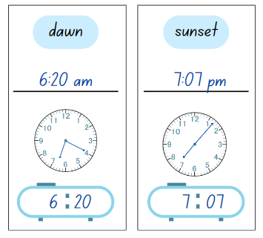

This table details opportunities for differentiation.

|  |  |
| --- | --- |
| Too hard? | Too easy? |
| Students cannot record times using the colon notation with am and pm to distinguish between morning and evening.   * Provide students with a timeline representing the two 12-hour periods in a day, starting and ending at midnight, with midday marked at the midway point. Support students to place the time terms on the timeline, explaining that all terms that are placed on the first half of the timeline between midnight and midday are recorded in colon notation with am. * Provide students with cards that have times recorded using colon notation with am and pm. Students match the timecards to the terms on Resource 6 – recording time. | Students can record times using the colon notation with am and pm to distinguish between morning and evening.   * Students record patterns in time over a 24-hour period. For example, 11:17 am, 11:37 am, 12:12 pm, 12:37 pm. * Students create a schedule of events and activities in their day using am and pm notation. For example, 7:03 am wake up, 7:20 am breakfast, 7:45 am brush teeth and so on. |

## Discuss and connect the mathematics – 10 minutes

1. Ask students to compare their times for each of the terms with a partner, justifying the time they recorded. For example, ‘I wrote 7:15 am for breakfast because my alarm goes off at 7:00 am and I eat breakfast as soon as I get dressed.’
2. Students provide peer feedback to their partner, ensuring the recorded times are reasonable estimates and the analog and digital times are recorded correctly.

This table details opportunities for assessment.

|  |  |
| --- | --- |
| Assessment opportunities | Links |
| What to look for:   * Can students record times using the colon notation with am and pm to distinguish between morning and evening? **[MAO-WM-01, MA2-NSM-02]** * Can students relate the terms midday or noon and midnight to am and pm? **[MAO-WM-01, MA2-NSM-02]** * Can students relate analog notation to digital notation for time? **[MAO-WM-01, MA2-NSM-02]** | Links to [National Numeracy Learning Progressions](https://www.australiancurriculum.edu.au/resources/national-literacy-and-numeracy-learning-progressions/version-3-of-national-literacy-and-numeracy-learning-progressions/) (NNLP):   * MeT3, MeT4. |

# Lesson 3

**Core concept**: two-dimensional shapes can be split or combined to create new shapes.

## Daily number sense – let’s talk numbers – 15 minutes

The table below contains a suggested learning intention and success criteria. These are best co-constructed with students.

|  |  |
| --- | --- |
| Daily number sense learning intention | Daily number sense success criteria |
| Students are learning to:   * apply place value to partition, regroup and rename numbers up to 6 digits. | Students can:   * use place value to expand the number notation * partition numbers of up to 6 digits in non-standard forms. |

1. Display Resource 7 – student number expander and explain to students that Mark used a number expander to partition a 6-digit number in a standard and non-standard form.
2. Ask:

* What do you notice?
* Can you think of another way Mark could partition his number in non-standard forms?

1. Provide students with a 10-sided (0–9) die, writing materials and Resource 8 – number expander worksheet.
2. Students roll the die 6 times to generate a 6-digit number.
3. Students use the 6-digit number to complete Resource 8 – number expander worksheet.
4. Students [Think-Pair-Share](https://app.education.nsw.gov.au/digital-learning-selector/LearningActivity/Card/645) with a partner to see if they can identify another way to partition their partner’s number using non-standard partitioning.

**Note:** teachers may choose to use 3- or 4- or 5-digit numbers for this activity depending on student understanding of partitioning numbers using standard and non-standard forms. The Daily number sense activity from Lesson 2 may assist teachers to make this judgement on differentiation.

This table details opportunities for assessment.

|  |  |
| --- | --- |
| Assessment opportunities | Links |
| What to look for:   * Can students use place value to expand the number notation? **[MAO-WM-01, MA2-RN-01]** * **Can students partition numbers of up to 6 digits in non-standard forms? [MAO-WM-01, MA2-RN-01]** | Links to [National Numeracy Learning Progressions](https://www.australiancurriculum.edu.au/resources/national-literacy-and-numeracy-learning-progressions/version-3-of-national-literacy-and-numeracy-learning-progressions/) (NNLP):   * NPV6, NPV7. |

## Core lesson – shape transformations – 45 minutes

The table below contains suggested learning intentions and success criteria. These are best co-constructed with students.

|  |  |
| --- | --- |
| Core concept learning intentions | Core concept success criteria |
| Students are learning to:   * create two-dimensional shapes that result from combining and splitting common shapes. | Students can:   * combine common two-dimensional shapes, including quadrilaterals, to form other common shapes or designs. * split a given shape into 2 or more common shapes and describe the result. * record the arrangements of common shapes used to create other shapes. |

1. Display Resource 9 – theme park signs.
2. Explain that the owners of the theme park wish to design new ride signs, reusing the existing signage to avoid waste. They have asked your class to identify any smaller shapes that could be created by splitting the existing trapezium signs into new shapes.
3. Provide students with Resource 10 – splitting trapeziums. Students use a ruler to draw lines, splitting each trapezium into 2 or more common shapes. Students describe the common shapes created and record the description next to each trapezium (see Figure 3).

Figure 3 – student work sample for splitting trapeziums

A student work sample shows 6 trapeziums, organised into 3 rows of 2, partitioned into smaller shapes with a description next to each. 
The top left the trapezium has been divided by a vertical line down the middle. The left hand side has been coloured blue and the right hand side has been coloured yellow. The text 'split into 2 smaller trapeziums’ is recorded to the right of the trapezium.
The first trapezium in the second row has had 2 vertical lines drawn from the top corners to the base of the shape creating 2 yellow triangles and one blue square. The text ‘split into 2 triangles and one rectangle’ has been recorded to the right of the trapezium. 
The first trapezium in the third row has a horizontal line drawn from the top left corner to the bottom right corner of the trapezium. The text to the right of the trapezium reads ‘split into 2 triangles’. The bottom triangle is coloured red and the top triangle has been coloured yellow.
In the second column, the first trapezium has had a horizontal line drawn a third of the way from the base of the shape. The partition creates 2 trapeziums. The top trapezium is coloured blue and the bottom trapezium is coloured yellow. The text ‘split into 2 trapeziums’ is recorded to the right of the shape.
In the second column, second row, the trapezium has been partitioned into 2 triangles and 2 rectangles. Two vertical lines drawn from the top corners to the base of the shape creating 2 yellow triangles and one square. The square has a horizontal line drawn across the centre to create 2 rectangles, the top coloured blue and the bottom red. The text to the right states ‘split into 2 triangles and 2 rectangles’.
The trapezium in the third row, second column has been partitioned into 3 triangles with 2 diagonal lines from the top corners meeting the centre of the base line. The 3 triangles are coloured red, blue and yellow. The text to the right states ‘split into 3 triangles’.


1. Regroup and select students to share their splitting solutions.
2. Draw the top 2 examples from Figure 3 on the board. Ask:

* What shapes have been created in these examples? (trapeziums)
* What are some features that help classify each of these shapes as trapeziums? (They are all quadrilaterals that have at least one pair of parallel lines.)
* Are there any other ways of creating 2 or more trapeziums by splitting the original trapezium? (Diagonal lines from top to base, multiple horizontal lines.)

1. Display [interactive pattern shapes](https://apps.mathlearningcenter.org/pattern-shapes/). Explain that the owners cut the existing signs into shapes on the left and they require support combining these shapes into new signs.
2. Model how to combine shapes to make a new common shape using [interactive pattern shapes](https://apps.mathlearningcenter.org/pattern-shapes/), for example using 3 green triangles to make a trapezium.
3. Use the text tool on the right-hand side navigation pane to add text to the workspace and record the sentence: ‘3 green triangles make a trapezium’.
4. Provide students with a digital device. Students experiment with the [interactive pattern shapes](https://apps.mathlearningcenter.org/pattern-shapes/) and create as many common shapes as possible with 2 or more pattern blocks.
5. Students use the **text** tool to record sentences describing the combining of shapes used to make the new shapes (see Figure 4).

Figure 4 – creating new shapes

On the interactive pattern website workspace, 6 shapes have been created by combining smaller shapes. In the top row, 3 equilateral triangles have been combined to make a trapezium. Text below reads: '3 green triangles make a trapezium'.
The second shape in the first row, combines a parallelogram and an equilateral triangle to make a trapezium. Underneath the shape, the text 'a parallelogram and a triangle make a trapezium' is recorded.
In the top row, four triangles have been combined to make a parallelogram. Underneath this, the text ‘4 purple triangles make a parallelogram’ has been recorded. 
In the second row, 2 equilateral triangles and 1 hexagon have been combined to make a trapezium. The text, ‘a hexagon and 2 green triangles make a trapezium’ is recorded underneath.
In the second row, second column 2 squares have been positioned one on top of the other to make a rectangle. The text underneath states: ‘2 squares make a rectangle.’
The final shape in the second row has 2 parallelograms and 2  equilateral triangles that make a hexagon. The text below reads: ‘2 parallelograms and 2 triangles make a hexagon.’

1. Student work can be saved by selecting the **share** icon on the bottom navigation pane.

This table details opportunities for differentiation.

|  |  |
| --- | --- |
| Too hard? | Too easy? |
| Students cannot combine common two-dimensional shapes, including quadrilaterals, to form other common shapes or designs.   * Provide students with pattern blocks to allow them to physically manipulate the shapes into new common shapes. * Students manipulate the pattern blocks to make a singular shape. For example, find as many ways to create a trapezium as possible. | Students can combine common two-dimensional shapes, including quadrilaterals, to form other common shapes or designs.   * Students use the terms translate, reflect and rotate to describe the transformations of the two-dimensional shapes used to create the new shape. For example, ‘I translated 2 green triangles and rotated the third to create a trapezium.’ |

## Discuss and connect the mathematics – 10 minutes

1. Students participate in a [gallery walk](https://app.education.nsw.gov.au/digital-learning-selector/LearningActivity/Card/555) to view their peers’ shape combinations.
2. Regroup as a class and ask:

* Which designs would be most suitable for the theme park owners to use for their signs? Why?
* Did anyone create a pentagon? Which shapes were used to create it?
* Which pattern block was the most difficult to use to create a new shape? Why?
* Why do you think there were no shapes with round edges, for example circles or ovals, to choose from?

This table details opportunities for assessment.

|  |  |
| --- | --- |
| Assessment opportunities | Links |
| What to look for:   * Can students combine common two-dimensional shapes, including quadrilaterals, to form other common shapes or designs? **[MAO-WM-01, MA2-2DS-02]** * Can students split a given shape into 2 or more common shapes and describe the result? **[MAO-WM-01, MA2-2DS-02]** * Can students record the arrangements of common shapes used to create other shapes? **[MAO-WM-01, MA2-2DS-02]** | Links to [National Numeracy Learning Progressions](https://www.australiancurriculum.edu.au/resources/national-literacy-and-numeracy-learning-progressions/version-3-of-national-literacy-and-numeracy-learning-progressions/) (NNLP):   * UGP5, UGP6. |

# Lesson 4

**Core concept**: two-dimensional shapes can be reflected, translated and rotated.

## Daily number sense – 10 minutes

1. From a class need surfaced through formative assessment data, identify a short, focused activity that targets students’ knowledge, understanding and skills. Example activities may be drawn from the following resources:

* [Mathematics K–6 resources](https://education.nsw.gov.au/teaching-and-learning/curriculum/mathematics/mathematics-curriculum-resources-k-12/mathematics-k-6-resources)
* [Universal Resources Hub](https://resources.education.nsw.gov.au/home).

## Core lesson – creating patterns – 35 minutes

The table below contains suggested learning intentions and success criteria. These are best co-constructed with students.

|  |  |
| --- | --- |
| Core concept learning intentions | Core concept success criteria |
| Students are learning to:   * create symmetrical patterns and shapes. | Students can:   * apply and describe amounts of rotation, including half-turns, quarter-turns and three-quarter turns, when creating designs. |

1. Display Resource 11 – transformations and revise the terms translate, reflect, rotate and tessellate.

**Tessellation:** a repeated shape that fits together over a flat surface without any spaces or overlaps.

**Translation:** in a translation (slide) every point on the original image moves in the same direction for the same distance to transform the new image.

**Reflection:** a reflection (flip) requires a line of reflection. A reflection is a transformation in which an object is flipped across the line of reflection.

**Rotation:** a rotation (turn) requires a centre of rotation (a point) and a degree of rotation, for example, 90 degrees or a quarter-turn.

1. Ask students:

* Why does the triangle have a black dot in the corner? How is this helpful?
* Have the quarter-turn, half-turn and three-quarter turns been rotated clockwise or anti-clockwise? How do you know?

1. Display Resource 12 – rotating patterns. Ask students to [Think-Pair-Share](https://app.education.nsw.gov.au/digital-learning-selector/LearningActivity/Card/645) which rotation description matches each pattern and justify their reasoning. If necessary, provide students with pattern blocks to support their investigation.
2. Model creating each pattern from Resource 12 – rotating patterns using [interactive pattern shapes](https://apps.mathlearningcenter.org/pattern-shapes/) to confirm whether the descriptions were accurately matched to the patterns. Whilst creating the patterns, use the think-aloud strategy. For example, ‘When I make a quarter-turn rotation, I rotate it in a clockwise direction one-quarter of the full rotation.’

**Note**: when using [interactive pattern shapes](https://apps.mathlearningcenter.org/pattern-shapes/), follow these steps to rotate the shapes.

To rotate the shapes, drag an additional shape onto the workspace. Select the additional shape and click and drag the **rotate button** at the top of the shape to rotate the shape by a quarter-turn, half-turn or three-quarter turn.

1. Provide students with digital devices and ask them to create 3 patterns by rotating shapes by a quarter, half or three-quarter turn using [interactive pattern shapes](https://apps.mathlearningcenter.org/pattern-shapes/). Students describe their pattern using the text tool (see Figure 5).

Figure 5 – transformation patterns

Three patterns have been created by rotating the shapes on the interactive patter shape website.
In the first patten, a parallelogram has been rotated by a quarter-turn 4 times. The text: 'Pattern: quarter-turn rotation' is recorded underneath the pattern.
In the second pattern, a trapezium has been rotated by a half-turn 5 times. The text: 'Pattern: half-turn rotation' is recorded underneath.
In the third pattern, a right-angled triangle has been rotated by a three-quarter turn 6 times. The text: 'Pattern: three-quarter turn rotation' is recorded underneath.


1. Regroup and select students to recreate their patterns on the board, describing how they rotated the shapes to create the pattern.

This table details opportunities for differentiation.

|  |  |
| --- | --- |
| Too hard? | Too easy? |
| Students cannot apply and describe amounts of rotation, including half-turns, quarter-turns and three-quarter turns, when creating designs.   * Provide students with pattern blocks and support them to physically rotate the shapes by half-turns, quarter-turns and three-quarter turns. * Students use pattern blocks to recreate the patterns from Resource 12 – rotating patterns, physically manipulating the shapes by rotating the pattern blocks. | Students can apply and describe amounts of rotation, including half-turns, quarter-turns and three-quarter turns, when creating designs.   * Students create patterns of shapes that have been rotated, translated and reflected. * Students use isometric graph paper to draw a range of shapes that have been rotated, reflected and translated and describe the transformation using mathematical language. |

## Discuss and connect the mathematics – 10 minutes

1. Ask students:

* What was challenging about creating the patterns?
* Emily said that a reflected shape always looks the same as when the shape has been rotated a half-turn. Do you agree or disagree?

This table details an opportunity for assessment.

|  |  |
| --- | --- |
| Assessment opportunity | Links |
| What to look for:   * Can students apply and describe amounts of rotation, including half-turns, quarter-turns and three-quarter turns, when creating designs? **[MAO-WM-01, MA2-2DS-02]** | Links to [National Numeracy Learning Progressions](https://www.australiancurriculum.edu.au/resources/national-literacy-and-numeracy-learning-progressions/version-3-of-national-literacy-and-numeracy-learning-progressions/) (NNLP):   * UGP4, UGP5, UGP6. |

# Lesson 5

**Core concept**: create symmetrical patterns and shapes while comparing angles with a right angle.

## Daily number sense – blank number lines– 10 minutes

Daily number sense activities for Lessons 5 to 7 ‘loop’ back to concepts and procedures covered in previous units to assist students to build an increasingly connected network of ideas. These concepts may differ from the core concepts being covered by the unit.

The table below contains a suggested learning intention and success criteria. These are best co-constructed with students.

|  |  |
| --- | --- |
| Daily number sense learning intention | Daily number sense success criteria |
| Students are learning to:   * represent fractional quantities equal to and greater than one. | Students can:   * represent totals of halves, thirds, quarters and fifths that extend beyond one * determine the relative location of one-quarter and one-half when a number line extends beyond one. |

1. Display Resource 13 – blank number lines.
2. Draw attention to the fact that there are 3 different-sized number lines, as indicated by the position of the 1 on each line which represents one whole.
3. Pose the following scenario: Two students were dividing their number lines into quarters. Jack said he would draw 4 lines in between each whole number and Harriet said she would draw 3. Ask the following questions:

* Who is correct and why?
* How many quarters are there in 2 wholes?
* Can you draw a number line to prove it?

1. Students copy the 3 number lines from the board and partition each number line into quarters by marking equal spaces between each whole number.
2. Students label the following fractions on each number line:

$\frac{1}{4}$

$1 \frac{3}{4}$

$1 \frac{1}{4}$

$\frac{7}{4}$

* $\frac{3}{4}$.

Figure 6 – fractions work sample

A whiteboard containing 3 number lines. Each number line has been notched with lines representing quarters. 
The first number line is from 0-1 and the fractional notation for ¼ and ¾ has been recorded in the appropriate location.
The second number line is from 0-2 and has been marked with ¼, ¾, 1, 1 ¼ and 1 ¾ with 7/4 written beneath it.
The third number line is from 0-3 and has been marked with ¼, ¾, 1, 1 ¼ and 1 ¾ with 7/4 written beneath it. The notches representing quarters between the numbers 2 and 3 have been left blank.

1. Regroup and ask students to compare their fraction number lines with a partner (see Figure 6). Ask:

* Did you place the fractions at the same points on the number lines as your partner?
* How could 2 be renamed as a fraction?
* How can $1 \frac{3}{4}$ be renamed? ( $\frac{7}{4}$).

This table details opportunities for assessment.

|  |  |
| --- | --- |
| Assessment opportunities | Links |
| What to look for:   * Can students represent totals of halves, thirds, quarters and fifths that extend beyond one? **[MAO-WM-01, MA2-PF-01]** * Can students determine the relative location of one-quarter and one-half when a number line extends beyond one **[MAO-WM-01, MA2-PF-01]** | Links to [National Numeracy Learning Progressions](https://www.australiancurriculum.edu.au/resources/national-literacy-and-numeracy-learning-progressions/version-3-of-national-literacy-and-numeracy-learning-progressions/) (NNLP):   * InF5, InF6. |

## Core lesson 1 – design and make – 30 minutes

The table below contains suggested learning intentions and success criteria. These are best co-constructed with students.

|  |  |
| --- | --- |
| Core concept learning intentions | Core concept success criteria |
| Students are learning to:   * compare and describe features of two-dimensional shapes * create symmetrical patterns and shapes * compare angles to a right angle. | Students can:   * identify right angles in shapes * create and record tessellating designs by reflecting, translating and rotating triangles or quadrilaterals * recognise and describe angles as less than, equal to, about the same as or greater than a right angle * describe angles in comparison to quarter-turns as acute, right, obtuse, straight, reflex or a revolution. |

1. Display Resource 14 – demolition derby design and explain that a driver of the theme park’s demolition derby event has created a tessellating design for her new truck.
2. Model a think aloud of the transformations the driver has used for 4 of the shapes included in the tessellation. For example:

* The bottom blue parallelogram has been translated.
* Three-quarter turns were used to rotate the orange square.
* The bottom trapezium has been rotated a half-turn.
* The purple triangles have been reflected to make a pattern across the base of the truck.

1. Model how to add the truck template to the [interactive pattern shapes](https://apps.mathlearningcenter.org/pattern-shapes/) workspace by selecting the **outline library** icon and selecting the image of the truck.

**Note**: the outline library icon is represented by a boat image in the bottom left-hand corner. To locate the truck icon, move the scroll bar to the far right.

1. Students create their own tessellating design on the truck template using the pattern blocks. The design can include any shapes, if the shapes fit together without any spaces or overlays. Students must describe the transformation of 3 of the shapes and label them using the line and text tool (see Figure 7).

Figure 7 – demolition derby truck

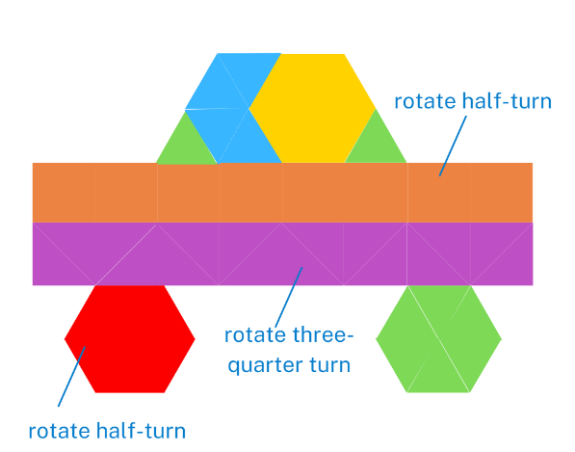

1. Student work can be saved by selecting the **share** icon on the bottom navigation pane.
2. Select students to share their truck design and describe the transformations used to create the tessellation.

## Core lesson 2 – looking for angles – 20 minutes

1. Revise prior knowledge on angles. Ask students to draw or identify 6 different types of angles. Draw students’ attention to recognising angles as less than, equal to, about the same as or greater than a right angle. Model for students angles in comparison to quarter turns.

**Note:** this is an opportunity for formative assessment to guide Lessons 5 to 8. The focus in Stage 2 angles is on comparison to a quarter-turn or a right angle. Right angles play an important role in construction. A simple 'angle tester' can be made by placing a pipe-cleaner inside a straw and bending the straw to form 2 arms. Assigning a numerical value in degrees to measure angles of any size is not introduced until Stage 3.

1. Display Resource 15 – angle names and provide students with the opportunity to amend or add to their descriptions. Create a class anchor chart.
2. Display Resource 14 – demolition derby design and ask students to [Think-Pair-Share](https://app.education.nsw.gov.au/digital-learning-selector/LearningActivity/Card/645) the angles they notice within the design.
3. Model label and describe an acute, right, obtuse, straight and reflex angle on Resource 14 – demolition derby design. See Figure 8.

Figure 8 – student sample with angles

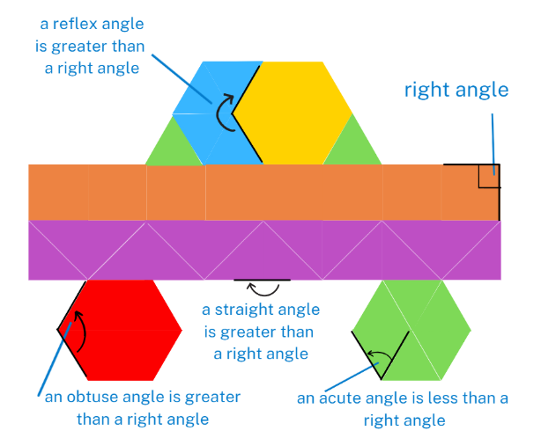

1. Provide students with Resource 14 – demolition derby design and ask students to identify, label and describe the angles within the design.

This table details opportunities for differentiation.

|  |  |
| --- | --- |
| Too hard? | Too easy? |
| Students cannot create and record tessellating designs by reflecting, translating and rotating triangles or quadrilaterals.   * Provide students with a rectangular template and concrete pattern blocks to create a tessellating pattern.   Students cannot describe angles in comparison to quarter-turns as acute, right, obtuse, straight, reflex or a revolution.   * Students identify and label right angles using an angle tester and write simple statements. | Students can create and record tessellating designs by reflecting, translating and rotating triangles or quadrilaterals.   * Students complete [Tessellating Transformations](https://nrich.maths.org/4965) from NRICH, creating tessellating designs using 6 connected equilateral triangles as the tessellating shape.   Students can describe angles in comparison to quarter-turns as acute, right, obtuse, straight, reflex or a revolution.   * Students create their own demolition truck template and ask a peer to identify the angle within their design. |

## Discuss and connect the mathematics – 10 minutes

1. Provide Resource 16 – angles matching cards.
2. In small groups or pairs, students shuffle and distribute the cards face down.
3. Players pick one card from each type (name, description, and picture). They check if the cards match correctly. If the cards match, they keep the set and get another turn. If they do not match, they place the cards back face down.
4. The student with the most sets of correctly matched cards at the end wins.

This table details opportunities for assessment.

|  |  |
| --- | --- |
| Assessment opportunities | Links |
| What to look for:   * Can students create and record tessellating designs by reflecting, translating and rotating triangles or quadrilaterals? **[MAO-WM-01, MA2-2DS-02]** * Can students recognise and describe angles as less than, equal to, about the same as or greater than a right angle?  **[MAO-WM-01, MA2-GM-03]** * Can students describe angles in comparison to quarter-turns as acute, right, obtuse, straight, reflex or a revolution? **[MAO-WM-01, MA2-GM-03]** * Can students identify right angles in shapes **[MAO-WM-01,  MA2-2DS-02]** | Links to [National Numeracy Learning Progressions](https://www.australiancurriculum.edu.au/resources/national-literacy-and-numeracy-learning-progressions/version-3-of-national-literacy-and-numeracy-learning-progressions/) (NNLP):   * UuM6. |

# Lesson 6

**Core concept**: angles in our environment can be compared to a right angle and described in relation to quarter-turns.

## Daily number sense – fraction line beyond 1 – 10 minutes

The table below contains a suggested learning intention and success criteria. These are best co-constructed with students.

|  |  |
| --- | --- |
| Daily number sense learning intention | Daily number sense success criteria |
| Students are learning to:   * represent fractional quantities equal to and greater than one. | Students can:   * determine the relative location of one-quarter and one-half when a number line extends beyond one. |

1. Provide students with a copy of Resource 17 – number line.
2. Ask students to use the numbers provided on the number line to determine the location of the following fractions:

$\frac{1}{4}$

$1\frac{3}{4}$

$\frac{1}{2}$

$1\frac{2}{4}$

* $\frac{5}{4}$.

1. Students record the fractions on their number line. Ask:

* How did you place these fractions on the number line? (First identifying where 1 is placed on the number line, visualising half and half again to find quarters.)
* What knowledge did you need to draw on to identify and label $\frac{5}{4}$? (Renaming and regrouping fractions equal to and greater than one.)
* How could the fraction $\frac{5}{4}$ be renamed? ($1\frac{1}{4}$)
* Can you place any additional fractions on this number line?

1. Regroup and ask students to compare the position of the fractions on their number lines with a partner.

This table details an opportunity for assessment.

|  |  |
| --- | --- |
| Assessment opportunity | Links |
| What to look for:   * Can students determine the relative location of one-quarter and one-half when a number line extends beyond one? **[MAO-WM-01, MA2-PF-01]** | Links to [National Numeracy Learning Progressions](https://www.australiancurriculum.edu.au/resources/national-literacy-and-numeracy-learning-progressions/version-3-of-national-literacy-and-numeracy-learning-progressions/) (NNLP):   * InF5. |

## Core lesson – Ferris wheel – 40 minutes

The table below contains suggested learning intentions and success criteria. These are best co-constructed with students.

|  |  |
| --- | --- |
| Core concept learning intentions | Core concept success criteria |
| Students are learning to:   * compare angles to a right angle. | Students can:   * recognise and describe angles as less than, equal to, about the same as or greater than a right angle * describe angles in comparison to quarter-turns as acute, right, obtuse, straight, reflex or a revolution. |

**Note**: Resource 18 – Ferris wheel 1 should be copied onto A4 card to make it easier to move when using a split pin.

1. Show pictures or diagrams of Ferris wheels online and ask students if they know how they work.
2. Briefly explain that the main component of a Ferris wheel is the large circular wheel. This wheel is mounted on a central axis called the axle. The axle is usually supported by a sturdy frame or structure, allowing the wheel to rotate freely. Attached to the outer rim of the Ferris wheel are passenger cabins.
3. Provide and display Resource 18 – Ferris wheel 1.
4. Ask students to identify the arms and vertex of an angle on the Ferris wheel. Students can describe the angles as less than, equal to, about the same as or greater than a right angle.
5. Ensure students recognise an angle as the amount of turning between 2 arms. Student cut the arms from the resource and attach it to the Ferris wheel.
6. Discuss and explain an angle of turn is an amount of turning between 2 arms. Students need to understand that angles are made by turning from one direction to another (see Figure 9).

Figure 9 – angle of turn

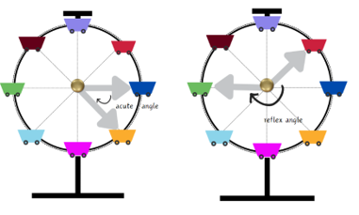

1. Demonstrate how angles are created as the Ferris wheel rotates in a clockwise direction. Ask students to use their arrow arms and split pin to demonstrate the angle of turn for the following questions:

* Describe the angle made by the arms when the arrows are pointing to the purple cart and pink cart? (a straight angle which is greater than a right angle)
* Describe the angle made by the arms when the arrows are pointing to the pink cart and then the second arrow turns clockwise to the red cart? (a reflex angle which is greater than a right angle)
* Describe the angle made by the arms when the arrows are pointing to the dark blue cart and orange cart? (an acute angle which is less than a right angle and less than a quarter-turn)
* If the Ferris wheel makes a clockwise quarter-turn from the original starting position, identify the new location of the purple cart. (the purple cart will be in the original position of the dark blue cart)

1. In pairs, students write their own questions about the carts’ angles using the language of turn Resource 18 – Ferris wheel 1.
2. Pairs of students swap questions and answer them.

This table details opportunities for differentiation.

|  |  |
| --- | --- |
| Too hard? | Too easy? |
| Students cannot recognise and describe angles as less than, equal to, about the same as or greater than a right angle.   * Provide students with a template of a right angle to reference when using the resource to help recognise and describe the angles. * Use concrete materials such as different coloured counters placed on a whiteboard in the shape of a Ferris wheel and allow students to manipulate the counters to simulate the rotation/movement of a Ferris wheel. | Students can recognise and describe angles as less than, equal to, about the same as or greater than a right angle.   * Students complete an ‘angle hunt’. They find examples of angles in their classroom or playground such as, corners of books, intersections of lines on a basketball court and angles in letters of the alphabet. Students take pictures or draw these examples and describe the angles as less than, equal to, about the same as, or greater than a right angle. * In pairs students present their findings from the angle hunt, explaining how they determined the type of each angle. Encourage students to ask questions and discuss each other’s findings. |

## Discuss and connect the mathematics – 10 minutes

1. Revise the concept that an angle of turn is an amount of turning between 2 arms. Students need to understand that angles are made by turning from one direction to another.
2. Pose the statement: Megan recorded all the angles greater than a right angle that can be made when looking at the position of the carts on the stationary Ferris wheel in Resource 18 – Ferris wheel 1. For example, the angle created by the arms connecting the purple and orange cart. She counted 48 angles greater than a right angle. Is Megan correct?
3. Ask students to [Think-Pair-Share](https://app.education.nsw.gov.au/digital-learning-selector/LearningActivity/Card/645) if they agree with the statement, justifying their reasoning.

This table details opportunities for assessment.

|  |  |
| --- | --- |
| Assessment opportunities | Links |
| What to look for:   * Can students recognise and describe angles as less than, equal to, about the same as or greater than a right angle? **[MAO-WM-01,** **MA2-GM-03]** * Can students describe angles in comparison to quarter-turns as acute, right, obtuse, straight, reflex or a revolution? **[MAO-WM-01, MA2-GM-03]** | Links to [National Numeracy Learning Progressions](https://www.australiancurriculum.edu.au/resources/national-literacy-and-numeracy-learning-progressions/version-3-of-national-literacy-and-numeracy-learning-progressions/) (NNLP):   * UuM6, UuM7. |

# Lesson 7

**Core concept**: mathematicians can identify different types of angles, recognise various shapes and understand their properties in everyday contexts.

## Daily number sense – be the teacher – 10 minutes

The table below contains a suggested learning intention and success criteria. These are best co-constructed with students.

|  |  |
| --- | --- |
| Daily number sense learning intention | Daily number sense success criteria |
| Students are learning to:   * represent fractional quantities equal to and greater than one. | Students can:   * represent totals of halves, thirds, quarters and fifths that extend beyond one. |

1. Display Resource 19 – Ollie’s misconceptions. Explain that a teacher asked their class to label a 0–2 number line with as many fractions as they could. Ollie completed the task, however he made some mistakes.
2. Students [Think-Pair-Share](https://app.education.nsw.gov.au/digital-learning-selector/LearningActivity/Card/645) to discuss what they notice. Ask students prompting questions from the table below to generate discussion.

|  |  |
| --- | --- |
| Prompts | Anticipated student responses |
| * What mistakes did Ollie make and why do you think he made them? | * Ollie has incorrectly labelled the fractions as quarters rather than fifths. It looks like he was confused by the 4 equal-spaced marks that were recorded between the whole numbers. * Ollie wrote $\frac{5}{4}$ instead of $1\frac{1}{5}$ or $\frac{6}{5}$. Ollie may not realise how to rename five-fifths as one whole. |
| * If you were the teacher, how would you explain and support Ollie to correct his mistakes? | * Ollie may need help to identify fifths as fractional parts created when a number line is partitioned into 5 equal parts. * He may need help representing fractional quantities greater than one. |

1. Display Resource 20 – Charlie’s misconceptions. Explain that Charlie labelled a 0–3 number line with as many fractions as she could.
2. Ask students to identify Charlie’s mistakes and record the correct way of labelling the 0–3 number line on an individual whiteboard.
3. Regroup and select students to correctly draw and label the 0–3 number line on the board.

This table details an opportunity for assessment.

|  |  |
| --- | --- |
| Assessment opportunity | Links |
| What to look for:   * Can students represent totals of halves, thirds, quarters and fifths that extend beyond one? **[MAO-WM-01, MA2-PF-01]** | Links to [National Numeracy Learning Progressions](https://www.australiancurriculum.edu.au/resources/national-literacy-and-numeracy-learning-progressions/version-3-of-national-literacy-and-numeracy-learning-progressions/) (NNLP):   * INF5. |

## Core lesson – Ferris wheels around the world – 30 minutes

The table below contains suggested learning intentions and success criteria. These are best co-constructed with students.

|  |  |
| --- | --- |
| Core concept learning intentions | Core concept success criteria |
| Students are learning to:   * create two-dimensional shapes that result from combining and splitting common shapes * create symmetrical patterns and shapes * compare angles to a right angle. | Students can:   * record the arrangements of common shapes used to create other shapes * apply and describe amounts of rotation, including half-turns, quarter-turns and three-quarter-turns, when creating designs * recognise and describe angles as less than, equal to, about the same as or greater than a right angle * describe angles in comparison to quarter-turns as acute, right, obtuse, straight, reflex or a revolution. |

1. Explain that the owners of the theme park would like to construct a new Ferris wheel and are seeking new design ideas. To achieve this, they have requested that our class conduct research on existing Ferris wheels around the world and create a new Ferris wheel design for the park.
2. Provide a brief history of Ferris wheels, starting with the original [Ferris Wheel designed by George Washington Gale Ferris Jr.](https://kids.kiddle.co/George_Washington_Gale_Ferris_Jr.) for the 1893 Chicago World's Columbian Exposition.
3. Display Resource 21 – Ferris wheels 2 and inform students that these are 6 famous Ferris wheels from around the world. Divide students into small groups and assign each group a Ferris wheel to research. Some examples of possible websites include:

* [Luna Park (Sydney)](https://kids.kiddle.co/Luna_Park_Sydney)
* [London Eye (London)](https://www.london-tickets.co.uk/london-eye-facts/)
* [Melbourne Star (Melbourne)](https://kids.kiddle.co/Melbourne_Star)
* [High Roller (Las Vegas)](https://kids.kiddle.co/High_Roller_(Ferris_wheel))
* [Singapore Flyer (Singapore)](https://kids.kiddle.co/Singapore_Flyer)
* [Tianjin Eye (Tianjin, China)](https://www.travelchinaguide.com/attraction/tianjin/eye.htm)

1. Display Resource 22 – investigation criteria. Discuss the key features the students are going to investigate and present to their peers.
2. Students work in small groups and display their investigation data using digital devices, posters or other methods.

This table details opportunities for differentiation.

|  |  |
| --- | --- |
| Too hard? | Too easy? |
| Students cannot apply and describe amounts of rotation, including half-turns, quarter-turns and three-quarter-turns in two-dimensional shapes.   * Provide students with pattern blocks and support them to physically rotate the shapes by half-turns, quarter-turns and three-quarter turns * In pair, students complete a ‘rotation hunt’ around their classroom or playground to find objects that can be rotated. They take pictures or draw these objects and apply different amounts of rotation to them (for example, rotating a door handle a quarter-turn to open the door or clock turning to tell a specific time). | Students can apply and describe amounts of rotation, including half-turns, quarter-turns and three-quarter-turns.   * Students research geometric art designs and describe amounts of rotation, including half-turns, quarter-turns, and three-quarter-turns. They create examples using two dimensional shapes by drawing or using a digital platform such as [Canva.](https://www.canva.com/) |

## Discuss and connect the mathematics – 30 minutes

1. Students present their investigation tasks to the class. Ask:

* What challenges did you have during the investigation?
* How many different types of angles did you identify?
* Which criteria do you think is the most important for Ferris wheel designers to consider? Why?

This table details opportunities for assessment.

|  |  |
| --- | --- |
| Assessment opportunities | Links |
| What to look for:   * Can students record the arrangements of common shapes used to create other shapes? **[MAO-WM-01, MA2-2DS-02]** * Can students apply and describe amounts of rotation, including half-turns, quarter-turns and three-quarter-turns, when creating designs? **[MAO-WM-01, MA2-2DS-02]** * Can students recognise and describe angles as less than, equal to, about the same as or greater than a right angle? **[MAO-WM-01, MA2-GM-03]** * Can students describe angles in comparison to quarter-turns as acute, right, obtuse, straight, reflex or a revolution? **[MAO-WM-01,** **MA2-GM-03]** | Links to [National Numeracy Learning Progressions](https://www.australiancurriculum.edu.au/resources/national-literacy-and-numeracy-learning-progressions/version-3-of-national-literacy-and-numeracy-learning-progressions/) (NNLP):   * UuM6, UuM7 * UGP4, UGP5, UGP6. |

# Lesson 8

**Core concept**: mathematicians plan and create designs to solve problems.

## Daily number sense – 10 minutes

1. From a class need surfaced through formative assessment data, identify a short, focused activity that targets students’ knowledge, understanding and skills. Example activities may be drawn from the following resources:

* [Mathematics K–6 resources](https://education.nsw.gov.au/teaching-and-learning/curriculum/mathematics/mathematics-curriculum-resources-k-12/mathematics-k-6-resources)
* [Universal Resources Hub](https://resources.education.nsw.gov.au/home).

## Core lesson – design a Ferris wheel – 40 minutes

The table below contains suggested learning intentions and success criteria. These are best co-constructed with students.

|  |  |
| --- | --- |
| Core concept learning intentions | Core concept success criteria |
| Students are learning to:   * create two-dimensional shapes that result from combining and splitting common shapes * create symmetrical patterns and shapes * compare angles to a right angle. | Students can:   * record the arrangements of common shapes used to create other shapes * apply and describe amounts of rotation, including half-turns, quarter-turns and three-quarter-turns, when creating designs * recognise and describe angles as less than, equal to, about the same as or greater than a right angle * describe angles in comparison to quarter-turns as acute, right, obtuse, straight, reflex or a revolution. |

1. Review the key features from the Ferris wheels researched in Lesson 7. Explain that today's lesson will provide students with the opportunity to create a new Ferris wheel design for the theme park. Display and discuss Resource 23 – Ferris wheel criteria.
2. Display Resource 24 – student example Ferris wheel. Ask students to review the design criteria and determine whether it has been met.
3. Provide students with writing materials or a digital device to plan their design.
4. Tell students they have 15 minutes for the initial design process. During this time, focus on brainstorming ideas, sketching their design, and outlining a plan.
5. After the 15 minutes, students share their design with a peer for feedback.
6. Students review Resource 23 – Ferris wheel criteria to ensure their peer’s design meets the criteria.
7. Provide Resource 25 – two stars and a wish to give feedback. Students identify 2 positive aspects of the students work and provide one suggestion for improvement or a question that encourages further thinking.
8. Students read feedback and refine their design further, if required.
9. Students include a detailed diagram of the Ferris wheel with clearly labelled parts and a brief description next to each label. Students describe the shape transformations and the angles included in their design.
10. Monitor progress as students work, providing feedback, supporting and challenging students where needed.

**Note**: this task can be used to assess students' understanding of angles and two-dimensional shapes transformations, through practical application. By reviewing their designs and reflections, teachers can evaluate their ability to apply these concepts effectively. Teachers can consider assessing both, final designs and Working mathematically outcomes.

This table details opportunities for differentiation.

|  |  |
| --- | --- |
| Too hard? | Too easy? |
| Students cannot describe angles in comparison to quarter-turns as acute, right, obtuse, straight, reflex or a revolution, when creating designs.   * Students identify and label right angles using an angle-tester. * Brainstorm examples angles in comparison to quarter-turns as acute, right, obtuse, straight, reflex or a revolution that students can see in the classroom. | Students can describe angles in comparison to quarter-turns as acute, right, obtuse, straight, reflex or a revolution, when creating designs.   * Challenge students to manipulate shapes to add complexities to their design. * Students use a digital platform or design apps to create their designs such, as [Canva](https://www.canva.com/) or [interactive pattern shapes](https://apps.mathlearningcenter.org/pattern-shapes/). |

## Discuss and connect the mathematics – 10 minutes

1. Students participate in a gallery walk to view their peers’ designs.
2. Regroup and reflect on the process. Ask each group the following questions:

* How did you use that feedback to improve your design?
* Did your design meet all design criteria?
* Did you have any difficulties during the design process? How did you overcome them?
* What did you learn from this design task, and how might you apply this knowledge to other projects?

This table details opportunities for assessment.

|  |  |
| --- | --- |
| Assessment opportunities | Links |
| What to look for:   * Can students record the arrangements of common shapes used to create other shapes? **[MAO-WM-01, MA2-2DS-02]** * Can students apply and describe amounts of rotation, including half-turns, quarter-turns and three-quarter-turns, when creating designs? **[MAO-WM-01, MA2-2DS-02]** * Can students recognise and describe angles as less than, equal to, about the same as or greater than a right angle? **[MAO-WM-01, MA2-GM-03]** * Can students describe angles in comparison to quarter-turns as acute, right, obtuse, straight, reflex or a revolution? **[MAO-WM-01,** **MA2-GM-03]** | Links to [National Numeracy Learning Progressions](https://www.australiancurriculum.edu.au/resources/national-literacy-and-numeracy-learning-progressions/version-3-of-national-literacy-and-numeracy-learning-progressions/) (NNLP):   * UuM6, UuM7 * UGP4, UGP5, UGP6. |

# Resource 1 – expanded form memory

Memory game cards with various numbers on them in standard and expanded form. The first row contains the numbers 586 742, 32 583 and 4637. The second row expands these into hundreds of thousands, tens of thousands, thousands, hundreds, tens and ones.
The third row contains the numbers 6067, 986 and 725. The fourth row expands these numbers into thousands, hundreds, tens and ones.


Memory game cards with various numbers on them in standard and expanded form. The first row contains the numbers 564 986, 12 456 and 6362. The second row expands these into hundreds of thousands, tens of thousands, thousands, hundreds, tens and ones.
The third row contains the numbers 658, 7508 and 893. The fourth row expands these numbers into thousands, hundreds, tens and ones.


# Resource 2 – theme park schedule

Two images of mobile phones displaying ‘Shows & events’ for a theme park schedule. 
On the first phone:
Meet and greet characters, 9:00 am – 9:35 am in the entertainment pavilion. 
Animal show, 10:20 am – 10:50 am at the animal pavilion. 
The dance spectacular, 10:45 am – 11:55 am on the main stage. 
Feed the animals, 11:40 am – 1:10 pm in the animal pavilion.
Magic show, 12:35 pm – 1:30 pm at the theatre.
Lunch with the characters 1:15 pm – 2:05 pm at the food court.
Character parade, 2:45pm – 3:30pm at the entertainment pavilion. 
Demolition derby 3:35 pm – 4:20 pm at the arena.
Daredevil acrobatics, 4:00 pm – 4:35 pm at the entertainment pavilion.

On the second phone:
Band, 5:20 pm – 5:50 pm at the theatre.
Cooking demonstration, 5:45 pm – 6:55pm at the main stage.
Horse riding, 6:00 pm – 7:10 pm at the animal pavilion.
Miraculous motorbikes, 6:15 pm – 7:05 pm at the arena.
Laser show, 8:15 pm – 8:35 pm at the arena.
Fireworks display, 8:58 pm – 9:22 pm at the arena.
All day events:
Show bag pavilion open, 9:00 am – 9:30 pm at the showbag pavilion.
Rides, 9:00 am – 9:30 pm at the rides quarter.


# Resource 3 – time remaining

A timetable for students to record the minutes remaining until the next hour for the following events:
Meet and greet - characters, finishes at 9:35 am. 
Animal show finishes at 10:50 am. 
The dance spectacular finishes at 11:55 am.
Feed the animals, finishes at 1:10 pm.
Magic show, finishes at 1:30 pm.
Lunch with the characters finishes at 2:05 pm.
Character parade, finishes at 3:30pm. 
Demolition derby finishes at 4:20 pm.
Dare devil acrobatics, finishes at 4:35 pm.


# Resource 4 – incorrect clocks

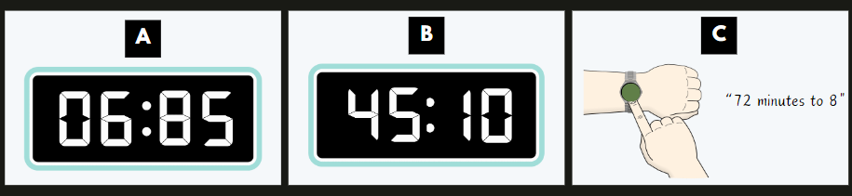

# Resource 5 – Maggie’s diary

A notebook page with the diary entry: 
I woke up at dawn, so excited for the day ahead. I saw the sun rising out of my bedroom window and quickly raced to get dressed. After eating breakfast, I headed to the train station and looked up the schedule on the app. The dance spectacular finished just before midday and at noon I was feeding the animals. At lunch time, I ate with the characters and then watched them in the parade. In the late afternoon I watched the daredevil acrobatics and as the sun set, the band were playing. It was dusk when the horse riding took place at the animal pavilion and I then had dinner whilst watching the motorbikes. After the fireworks display, I headed back to the train and made it home well before midnight.


# Resource 6 – recording time

A student worksheet requiring the students to record the time for 5 terms in am/pm notation, on an analog and digital clock.
The time terms are recorded at the top of each text box in a blue oval. The terms are: dawn, sunset, dusk, sunrise, noon.


A student worksheet requiring the students to record the time for 5 terms in am/pm notation, on an analog and digital clock.
The time terms are recorded at the top of each text box in a blue oval. The terms are: midday, midnight, breakfast, lunch and dinner.


# Resource 7 – student number expander

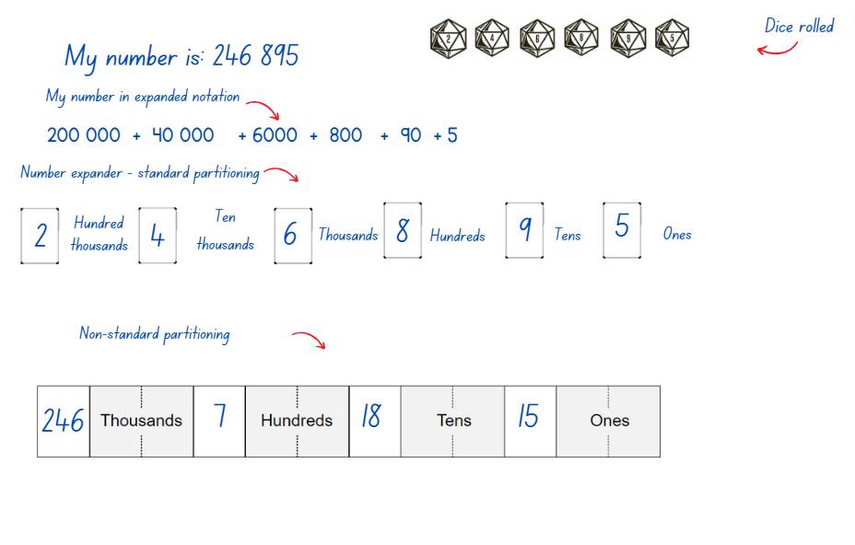

# Resource 8 – number expander worksheet

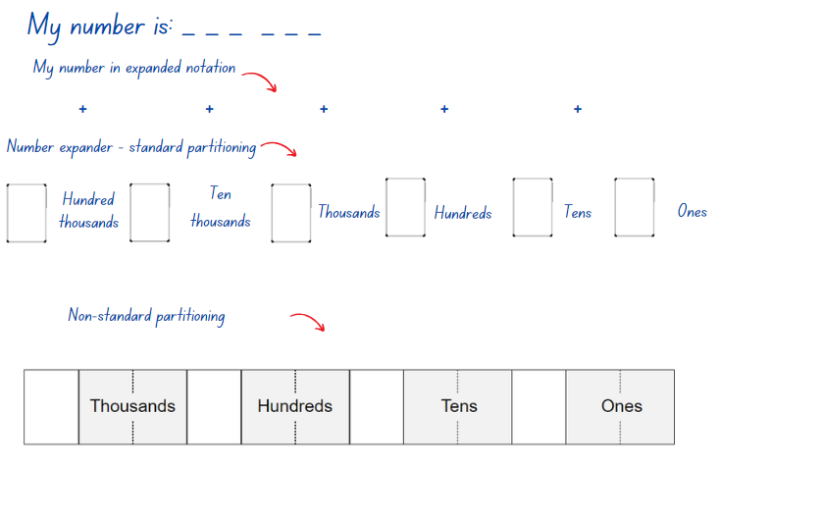

# Resource 9 – theme park signs

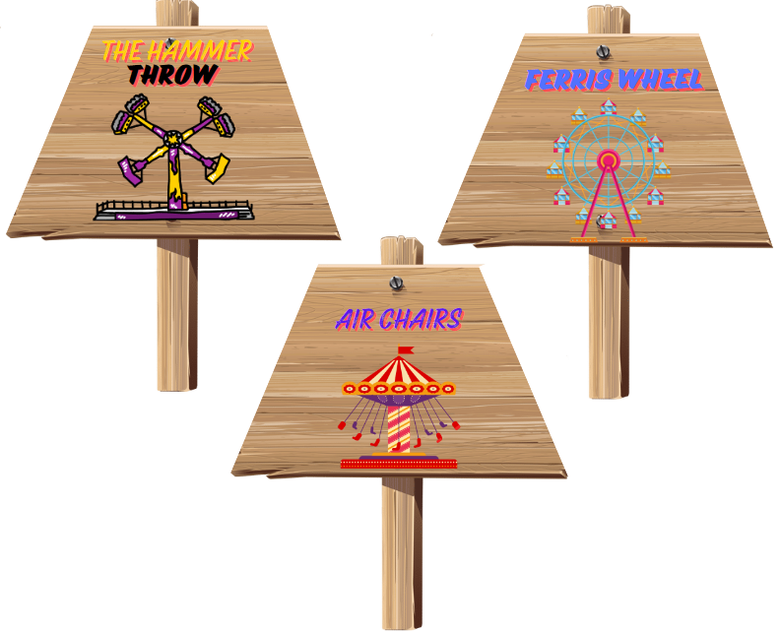

# Resource 10 – splitting trapeziums

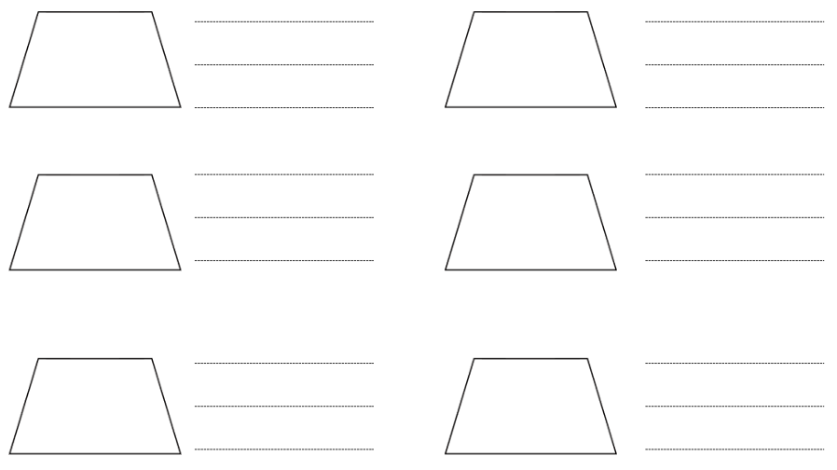

# Resource 11 – transformations

A table with 5 rows and 2 columns. In the first column, transformation terms are recorded in each table cell: Translate, reflect, rotate quarter-turn, rotate half-turn and rotate three-quarter turn. 
In the second column, 2 purple right-angled triangles have been represented in each table cell to demonstrate each transformation with an arrow.  


# Resource 12 – rotating patterns

Six transformation patterns of 2D shapes are displayed in the table on the left-hand side. 
Pattern 1 is a red trapezium pattern where the trapezium has been rotated by a half turn each time. 
Pattern 2 is a purple right-angled triangle pattern where the triangle has been rotated by a three-quarter turn each time. 
Pattern 3 is an orange square pattern where the square has been rotated by a three-quarter turn each time. 
Pattern 4 is a yellow hexagon pattern where the hexagon has been rotated by a quarter-turn each time. 
Pattern 5 is a green equilateral triangle pattern where the triangle has been rotated by a quarter-turn each time. 
Pattern 6 is a blue parallelogram pattern where the parallelogram has been rotated by a half-turn each time. 
On the right, a text box entitled ‘Pattern descriptions’ has 6 description labels in grey text boxes. The labels read: rotate half-turn, rotate quarter-turn and rotate three-quarter turn and there are 2 of each label.


# Resource 13 – blank number lines

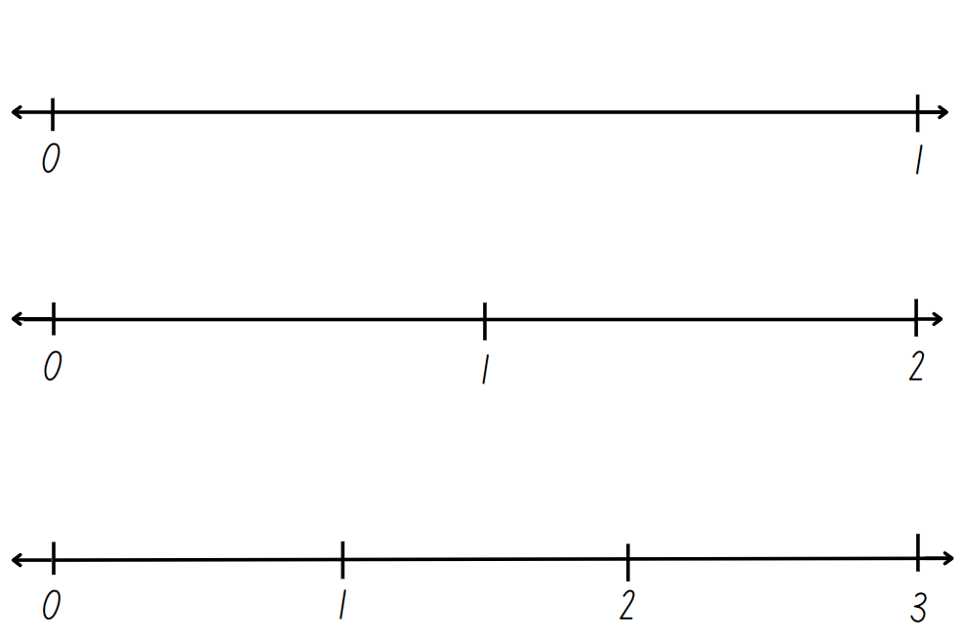

# Resource 14 – demolition derby design

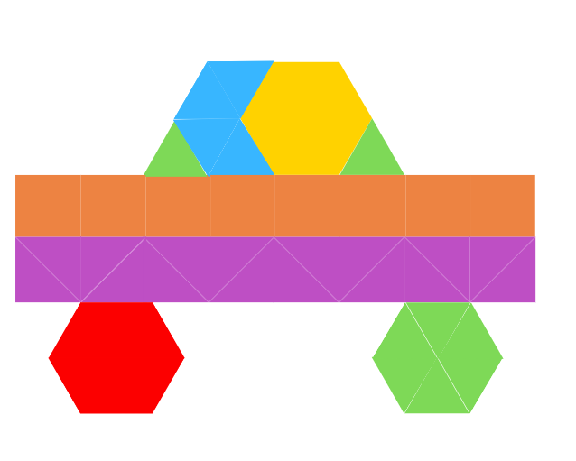

# Resource 15 – angle names

Six examples of different-sized angles with a definition of each. These show an acute, right, obtuse, straight and reflex angle, as well as a revolution.
Right angle: 2 perpendicular straight lines or arms that meet at a vertex which makes a square.
Acute angle: 2 straight lines or arms that meet at a vertex, making an angle that is less than a right angle.
Obtuse angle: 2 straight lines or arms that meet at a vertex, making an angle that is greater than a right angle.
Straight angle: a straight line or arm:
Reflex angle: 2 straight lines or arms that meet at a vertex, making an angle that is greater than a straight angle but less than a revolution.
Angle of revolution: 2 straight lines or arms. One arm makes a complete turn, a full rotation


# Resource 16 – angles matching cards

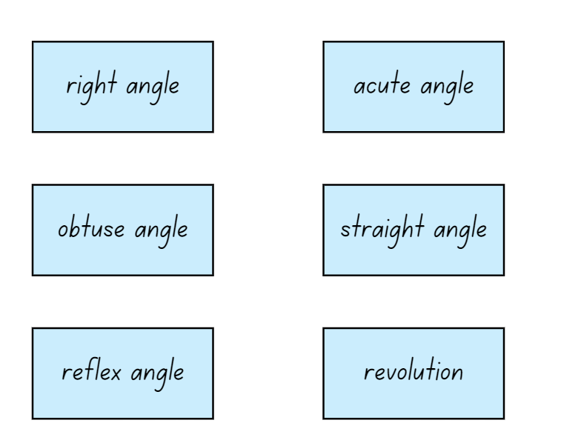

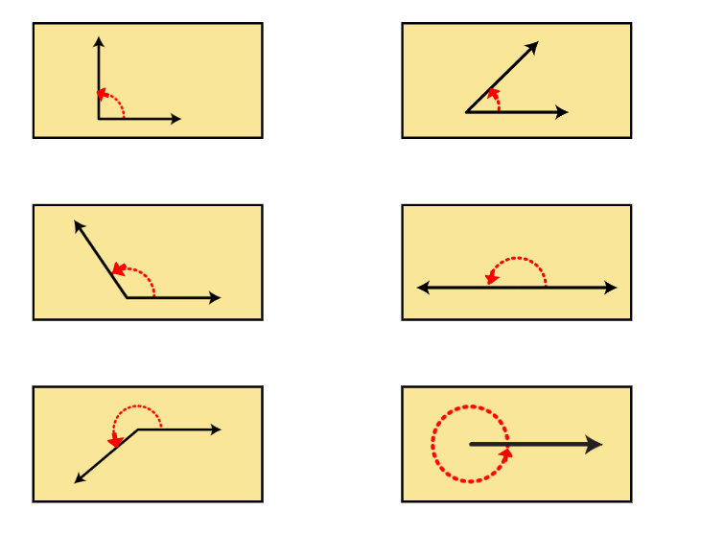

Memory cards to match to angle images. 
Card 1: An angle that is exactly a quarter turn.
Card 2: An angle that is less than a quarter turn.
Card 3: An angle that is greater than a quarter turn but less than a half turn.
Card 4: An angle that is exactly a half turn.
Card 5: An angle greater than a half turn but less than a full rotation. 
Card 6: An angle that makes a complete turn, a full rotation.


# Resource 17 – number line

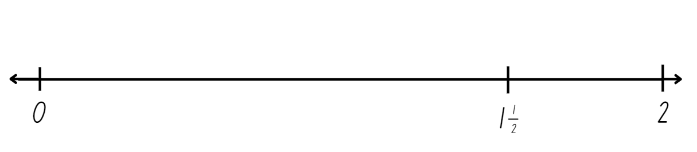

# Resource 18 – Ferris wheel 1

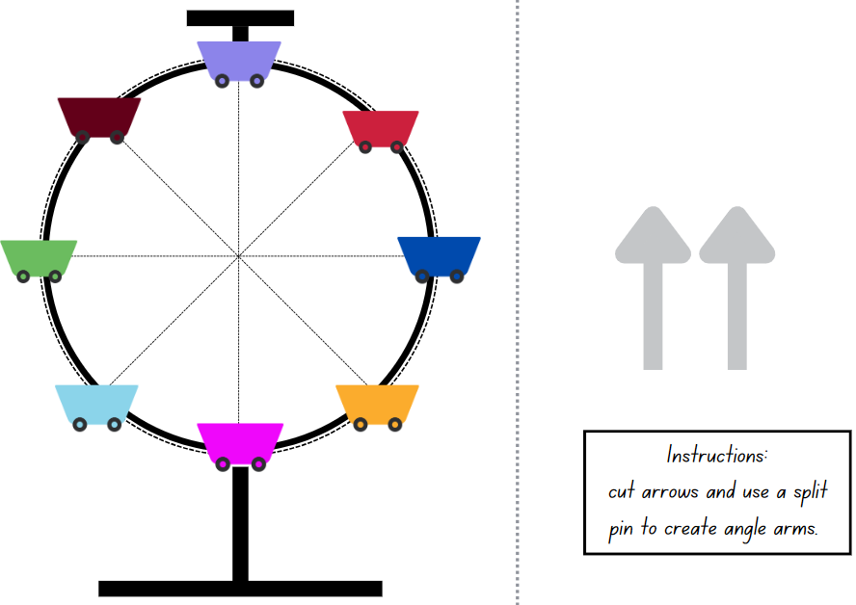

# Resource 19 – Ollie’s misconceptions

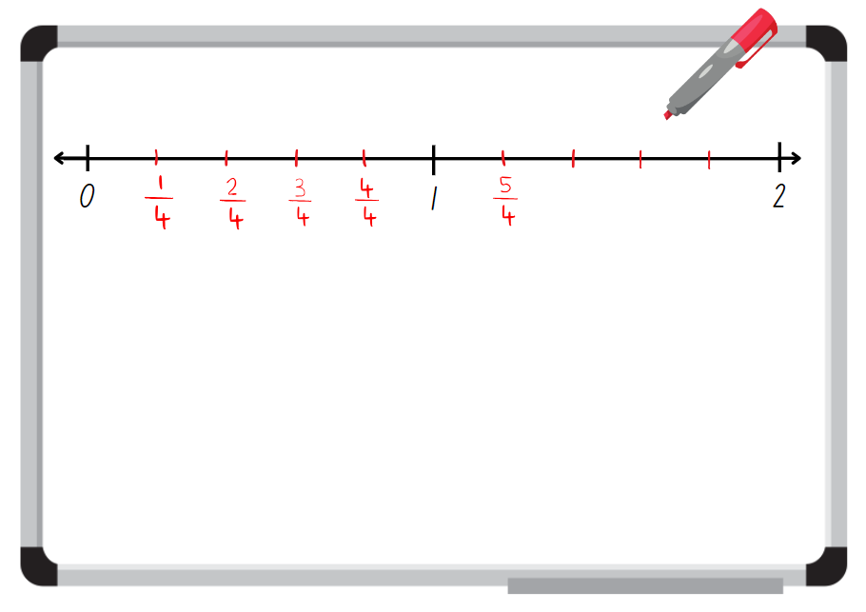

# Resource 20 – Charlie’s misconceptions

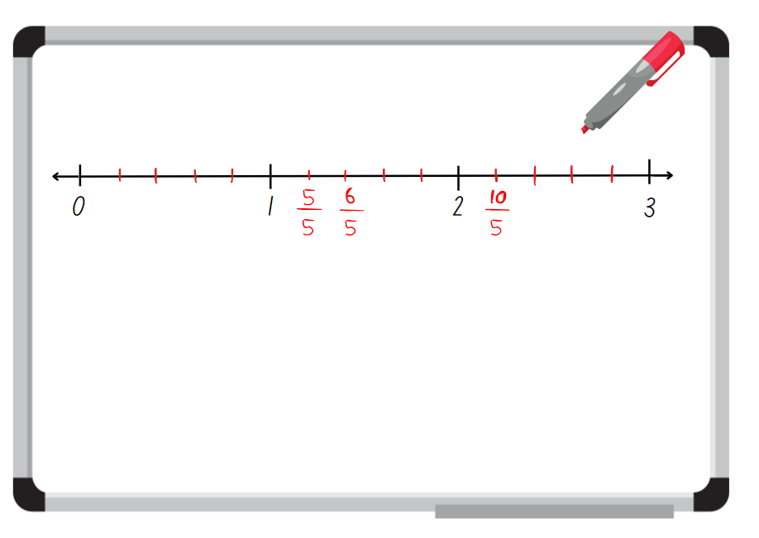

# Resource 21 – Ferris wheels 2

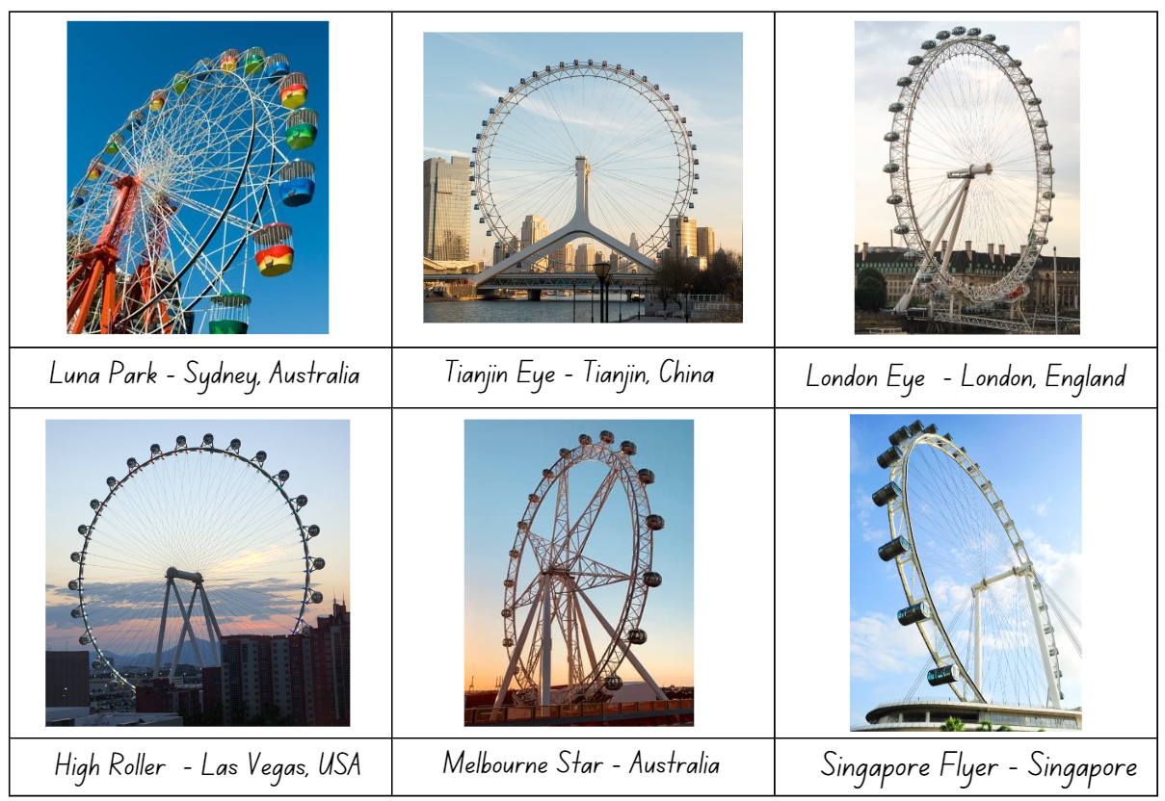

# Resource 22 – investigation criteria

**Investigation criteria**

|  |  |
| --- | --- |
| **Two-dimensional shapes** | * Identify common shapes and shapes that have been used to create other shapes by splitting or combining. * Describe amounts of rotation on shapes. |
| **Angles** | * Identify and describe angles in the Ferris wheel that are less than, equal to or about the same as or greater than a right angle. * Describe the angles in the Ferris wheel in comparison to quarter-turns. |
| **Interesting features** | * Identify and describe any interesting or defining features of the Ferris wheel design. |
| **Time** | * Research how long it takes for the Ferris wheel to make a full rotation, quarter-turn, half-turn and three-quarter turn and record in hours and minutes. |

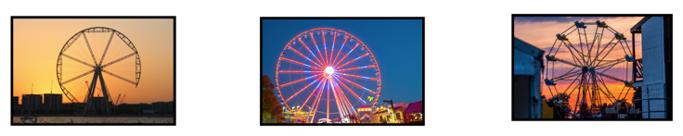

# Resource 23 – Ferris wheel criteria

**Design criteria must include:**

|  |  |
| --- | --- |
| **Basic structure** | * various two-dimensional shapes (triangles, parallelograms, hexagons, and squares) * arrangements of common shapes used to create other shapes on the Ferris wheel * shapes that have been rotated, reflected or translated. |
| **Unique features and design** | * unique design elements that involve interesting shapes that have been combined and split to form common shapes, such as star shapes or hexagonal cabins * angles in the Ferris wheel design that are less than, equal to, about the same as or greater than a right angle. |
| **Capacity and size** | * the total number of cabins and calculate how many people can ride if each cabin is at its full capacity. |
| **Time** | * how long it takes for your Ferris wheel to make a full rotation, quarter-turn, half-turn and three-quarter turn. |

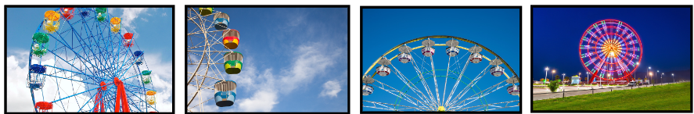

# Resource 24 – student example Ferris wheel

A sample completed student Ferris wheel design with shapes and angles labelled. 
There is a box that states ‘My design has 12 carts that each hold 4 people. The total capacity is 48 people. It takes 60 minutes for a full rotation. A quarter-turn will take 15 minutes. A half-turn will take 30 minutes and a three-quarter turn will take 45 minutes.’
A straight angle is drawn on the image with the label ‘Straight angle which is greater than a right angle.’
An obtuse angle is drawn on the end of one of the carts and labelled ‘Obtuse angle which is greater than a right angle’. 
An acute angle is drawn on the end of one of the carts and labelled ‘Acute angle which is less than a right angle.’
One trapezium has been cut in half and shaded. It is labelled ‘Trapeziums have been rotated by a half-turn to make the carts’.
A parallelogram in the interior of the Ferris wheel has been highlighted and labelled with ‘A parallelogram and a triangle have been combined to make trapeziums in the centre star’. 
At the bottom of the resource 2 triangles have been highlighted with the label ‘3 triangles have been combined to make a trapezium. The middle triangle has been rotated by a half-turn. The third triangle was translated.’


# Resource 25 – two stars and a wish

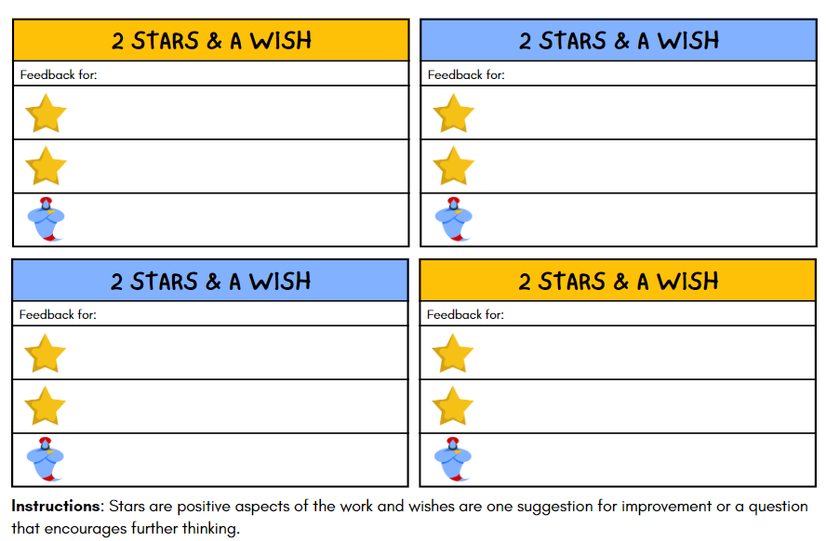

# Syllabus outcomes and content

The table below outlines the [syllabus outcomes](https://curriculum.nsw.edu.au/learning-areas/mathematics/mathematics-k-10-2022/overview) and range of relevant syllabus content covered in this unit. Content is linked to [National Numeracy Learning Progression](https://www.australiancurriculum.edu.au/resources/national-literacy-and-numeracy-learning-progressions/version-3-of-national-literacy-and-numeracy-learning-progressions/) (version 3).

|  |  |  |  |  |  |  |  |  |
| --- | --- | --- | --- | --- | --- | --- | --- | --- |
| Outcomes and content | 1 | 2 | 3 | 4 | 5 | 6 | 7 | 8 |
| **Representing numbers using place value B**: Apply place value to partition, regroup and rename numbers up to 6 digits  **[MAO-WM-01, MA2-RN-01]** |  |  |  |  |  |  |  |  |
| * use place value to expand the number notation | x | x |  |  |  |  |  |  |
| * partition numbers of up to 6 digits in non-standard forms |  | x | x |  |  |  |  |  |
| **Partitioned fractions B**: Represent fractional quantities equal to and greater than one  **[MAO-WM-01, MA2-PF-01]** |  |  |  |  |  |  |  |  |
| * represent totals of halves, thirds, quarters and fifths that extend beyond one |  |  |  |  | x |  | x |  |
| * determine the relative location of one-quarter and one-half when a number line extends beyond one |  |  |  |  | x | x | x |  |
| **Geometric measure B**: Compare angles to a right angle  **[MAO-WM-01, MA2-GM-03]** |  |  |  |  |  |  |  |  |
| * recognise and describe angles as less than, equal to, about the same as or greater than a right angle |  |  |  |  | x | x | x | x |
| * describe angles in comparison to quarter-turns as acute, right, obtuse, straight, reflex or a revolution |  |  |  |  | x | x | x | x |
| **Two-dimensional spatial structure A:** Compare and describe features of two-dimensional shapes  **[MAO-WM-01, MA2-2DS-01, MA2-2DS-02]** |  |  |  |  |  |  |  |  |
| * identify right angles in shapes |  |  |  |  | x | x | x | x |
| **Two-dimensional spatial structure B:** Create two-dimensional shapes that result from combining and splitting common shapes  **[MAO-WM-01, MA2-2DS-02]** |  |  |  |  |  |  |  |  |
| * combine common two-dimensional shapes, including quadrilaterals, to form other common shapes or designs |  |  | x |  |  |  |  |  |
| * split a given shape into 2 or more common shapes and describe the result |  |  | x |  |  |  |  | x |
| * record the arrangements of common shapes used to create other shapes |  |  | x |  |  |  | x | x |
| **Two-dimensional spatial structure B**: Create symmetrical patterns and shapes  **[MAO-WM-01, MA2-2DS-02]** |  |  |  |  |  |  |  |  |
| * create and record tessellating designs by reflecting, translating and rotating triangles or quadrilaterals |  |  |  |  | x |  |  | x |
| * apply and describe amounts of rotation, including half-turns, quarter-turns and three-quarter-turns, when creating designs |  |  |  | x |  |  |  | x |
| **Non-spatial measure B**: Time: Represent and interpret digital time displays  **[MAO-WM-01, MA2-NSM-02]** |  |  |  |  |  |  |  |  |
| * read or set the time on digital devices to the minute or second, recognising there are 60 seconds in one minute | x | x |  |  |  |  |  |  |
| * recognise that the hour is read first in a digital display | x |  |  |  |  |  |  |  |
| * determine the time remaining until the next hour on a digital clock | x |  |  |  |  |  |  |  |
| **[Non-spatial measure B**: Time: Use am and pm notation  **[MAO-WM-01, MA2-NSM-02]** |  |  |  |  |  |  |  |  |
| * record times using the colon notation with am and pm to distinguish between morning and evening |  | x |  |  |  |  | x | x |
| * relate the terms midday or noon and midnight to am and pm |  | x |  |  |  |  |  |  |
| * relate analog notation to digital notation for time |  | x |  |  |  |  |  |  |

[Mathematics K–10 Syllabus](https://curriculum.nsw.edu.au/learning-areas/mathematics/mathematics-k-10-2022/overview) © NSW Education Standards Authority (NESA) for and on behalf of the Crown in right of the State of New South Wales, 2022.

# References

This resource contains NSW Curriculum and syllabus content. The NSW Curriculum is developed by the NSW Education Standards Authority. This content is prepared by NESA for and on behalf of the Crown in right of the State of New South Wales. The material is protected by Crown copyright.

Please refer to the NESA Copyright Disclaimer for more information <https://educationstandards.nsw.edu.au/wps/portal/nesa/mini-footer/copyright>.

NESA holds the only official and up-to-date versions of the NSW Curriculum and syllabus documents. Please visit the NSW Education Standards Authority (NESA) website <https://educationstandards.nsw.edu.au> and the NSW Curriculum website [https://curriculum.nsw.edu.au](https://curriculum.nsw.edu.au/).

[Mathematics K–10 Syllabus](https://curriculum.nsw.edu.au/learning-areas/mathematics/mathematics-k-10-2022/overview) © NSW Education Standards Authority (NESA) for and on behalf of the Crown in right of the State of New South Wales, 2022.

[National Numeracy Learning Progression](https://www.australiancurriculum.edu.au/resources/national-literacy-and-numeracy-learning-progressions/version-3-of-national-literacy-and-numeracy-learning-progressions/) © Australian Curriculum, Assessment and Reporting Authority (ACARA) 2010 to present, unless otherwise indicated. This material was downloaded from the [Australian Curriculum](http://www.australiancurriculum.edu.au/) website (National Numeracy Learning Progression) (accessed 20 May 2024) and was not modified.

Headout Inc (n.d.) [*Top 15 facts about the London Eye that you must know*](https://www.london-tickets.co.uk/london-eye-facts/), London Tickets by Headout website, accessed 19 June 2024.

Kiddle.co (2024a) [*George Washington Gale Ferris Jr. facts for kids*](https://kids.kiddle.co/George_Washington_Gale_Ferris_Jr.), Kiddle Encyclopedia website, accessed 19 June 2024.

——(2024b) [*High Roller (Ferris wheel) facts for kids*](https://kids.kiddle.co/High_Roller_(Ferris_wheel)), Kiddle Encyclopedia website, accessed 19 June 2024.

——(2024c) [*Luna Park Sydney facts for kids*](https://kids.kiddle.co/Luna_Park_Sydney), Kiddle Encyclopedia website, accessed 19 June 2024.

——(2024d) [*Melbourne Star facts for kids*](https://kids.kiddle.co/Melbourne_Star), Kiddle Encyclopedia website, accessed 19 June 2024.

——(2024e) [*Singapore Flyer facts for kids*](https://kids.kiddle.co/Singapore_Flyer), Kiddle Encyclopedia website, accessed 19 June 2024.

Oxford University Press (2024) [*Oxford Learner’s Dictionaries*](https://www.oxfordlearnersdictionaries.com/), Oxford Learner's Dictionaries website, accessed 20 May 2024.

Sunrise-Sunset (2014–2024) [*Sunset and Sunrise times*](https://sunrise-sunset.org/), Sunrise Sunset website, accessed 20 May 2024.

The Math Learning Center (2024) [*Pattern shapes*](https://apps.mathlearningcenter.org/pattern-shapes/), Math Learning Center website, accessed 20 May 2024.

Toy Theater (2001–2024) ‘[Interactive Clock](https://toytheater.com/clock/)’, Time manipulatives, Toy Theater website, accessed 20 May 2024.

Travel China Guide (1998-2024) [*Tianjin Eye (Tientsin Eye)*](https://www.travelchinaguide.com/attraction/tianjin/eye.htm), Travel China Guide website, accessed 19 June 2024

University of Cambridge (n.d.) [*Tessellating Transformations*](https://nrich.maths.org/4965), NRICH website, accessed 20 May 2024.

Van de Walle J, Karp K, Bay-Williams JM, Brass A, Bentley B, Ferguson S, Goff W, Livy S, Marshman M, Martin D, Pearn C, Prodromou T, Symons D and Wilkie K (2019) Primary and Middle Years Mathematics: Teaching Developmentally, 1st Australian edn, Pearson Education Australia, Melbourne.

**© State of New South Wales (Department of Education), 2024**

The copyright material published in this resource is subject to the *Copyright Act 1968* (Cth) and is owned by the NSW Department of Education or, where indicated, by a party other than the NSW Department of Education (third-party material).

Copyright material available in this resource and owned by the NSW Department of Education is licensed under a [Creative Commons Attribution 4.0 International (CC BY 4.0) license](https://creativecommons.org/licenses/by/4.0/).

**[](https://creativecommons.org/licenses/by/4.0/)**

This license allows you to share and adapt the material for any purpose, even commercially.

Attribution should be given to © State of New South Wales (Department of Education), 2024.

Material in this resource not available under a Creative Commons license:

* the NSW Department of Education logo, other logos and trademark-protected material
* material owned by a third party that has been reproduced with permission. You will need to obtain permission from the third party to reuse its material.

**Links to third-party material and websites**

Please note that the provided (reading/viewing material/list/links/texts) are a suggestion only and implies no endorsement, by the New South Wales Department of Education, of any author, publisher, or book title. School principals and teachers are best placed to assess the suitability of resources that would complement the curriculum and reflect the needs and interests of their students.

If you use the links provided in this document to access a third-party's website, you acknowledge that the terms of use, including licence terms set out on the third-party's website apply to the use which may be made of the materials on that third-party website or where permitted by the *Copyright Act 1968* (Cth). The department accepts no responsibility for content on third-party websites.