Mathematics Stage 3 – Unit 12
Understanding relationships between the properties of 2D shapes helps visualise and organise spaces in the world

Contents
Unit description and duration 4
Syllabus outcomes 4
Working mathematically 5
Student prior learning 5
Lesson overview and resources 8
Lesson 1 14
Daily number sense – population totals – 10 minutes 14
Core lesson – making and identifying triangles – 50 minutes 16
Discuss and connect the mathematics – 10 minutes 19
Lesson 2 21
Daily number sense – partitioning numbers – 10 minutes 21
Core lesson 1 – reviewing types of triangles – 20 minutes 23
Core lesson 2 – classifying quadrilaterals – 20 minutes 24
Discuss and connect the mathematics – 10 minutes 26
Lesson 3 29
Daily number sense – dicey digits – 10 minutes 29
Core lesson – symmetry in shapes – 30 minutes 30
Discuss and connect the mathematics – 10 minutes 33
Lesson 4 35
Daily number sense – 10 minutes 35
Core lesson – rotational symmetry – 40 minutes 35
Discuss and connect the mathematics – 10 minutes 38
Lesson 5 40
Daily number sense – dicey estimates – 10 minutes 40
Core lesson – finding the area of rectangles – 40 minutes 42
Discuss and connect the mathematics – 10 minutes 45
Lesson 6 47
Daily number sense – estimating calculations – 10 minutes 47
Core lesson – thinking about rectangles – 40 minutes 48
Discuss and connect the mathematics – 10 minutes 51
Lesson 7 53
Daily number sense – estimating the reasonableness – 10 minutes 53
Core lesson – exploring hectares – 40 minutes 54
Discuss and connect the mathematics – 10 minutes 58
Lesson 8 60
Daily number sense – 10 minutes 60
Core lesson – perimeter and area – 45 minutes 60
Discuss and connect the mathematics – 5 minutes 64
Resource 1 – making equilateral triangles 66
Resource 2 – square and rhombus 67
Resource 3 – quadrilaterals 68
Resource 4 – triangles and quadrilaterals 69
Resource 5 – Omar’s invisible arrays 70
Resource 6 – rectangle overlay 71
Resource 7 – Joe’s vegetable garden 72
Syllabus outcomes and content 73
References 79

Unit description and duration
This unit introduces the big idea that understanding relationships between the properties of 2D shapes helps visualise and organise spaces in the world.
In this 2-week unit students are provided opportunities to:
- explore, describe and classify triangles and quadrilaterals according to their properties
- investigate the symmetry properties (line and rotational) of triangles and quadrilaterals
- establish an understanding of the relationship between the properties of two-dimensional shapes, area and perimeter.

Syllabus outcomes
- MAO-WM-01 develops understanding and fluency in mathematics through exploring and connecting mathematical concepts, choosing and applying mathematical techniques to solve problems, and communicating their thinking and reasoning coherently and clearly
- MA3-RN-01 applies an understanding of place value and the role of zero to represent the properties of numbers
- MA3-AR-01 selects and applies appropriate strategies to solve addition and subtraction problems
- MA3-MR-01 selects and applies appropriate strategies to solve multiplication and division problems
- MA3-2DS-01 investigates and classifies two-dimensional shapes, including triangles and quadrilaterals based on their properties
- MA3-2DS-02 selects and uses the appropriate unit to calculate areas, including areas of rectangles

Working mathematically
In the Mathematics K–10 Syllabus, there is one overarching Working mathematically outcome (MAO-WM-01). The Working mathematically processes should be embedded within the concepts being taught. The Working mathematically processes present in the Mathematics K–10 Syllabus are:
- communicating
- understanding and fluency
- reasoning
- problem solving.
Mathematics K–10 Syllabus © NSW Education Standards Authority (NESA) for and on behalf of the Crown in right of the State of New South Wales, 2022.

Student prior learning
Before engaging in these teaching and learning activities, students would benefit from prior experience with:
- applying informal written strategies to multiply 2- and 3-digit numbers by one- and 2-digit numbers
- comparing and describing features of two-dimensional shapes
- using square centimetres to measure and estimate the areas of squares and rectangles.

In NSW classrooms there is a diverse range of students, including Aboriginal and/or Torres Strait Islander students, students learning English as an additional language or dialect, high potential and gifted students and students with disability. Some students may identify with more than one of these groups or possibly all of them. Refer to Curriculum planning for every student – advice for further information.

Lesson overview and resources
The table below outlines the sequence and approximate timing of lessons, learning intentions and resources.
Lesson | Content | Duration and resources
Lesson 1  Daily number sense learning intention:  - apply place value to partition, regroup and rename numbers to 1 billion | Lesson core concept: triangles can be classified and compared based on their properties.  Core concept learning intentions:  - classify two-dimensional shapes and describe their properties  - measure and compare angles using degrees | Lesson duration: 70 minutes  - Resource 1 – making equilateral triangles  - Website: National, state and territory population overview  - A4 or rectangular paper  - Anchor chart  - Individual whiteboards  - Protractors  - Ruler  - Scissors  - Square paper  - Writing materials
Lesson 2  Daily number sense learning intention:  - apply place value to partition, regroup and rename numbers to 1 billion | Lesson core concept: triangles and quadrilaterals can be classified in more than one way.  Core concept learning intentions:  - classify two-dimensional shapes and describe their properties  - measure and compare angles using degrees | Lesson duration: 60 minutes  - Resource 2 – square and rhombus  - Resource 3 – quadrilaterals  - Website: Countries in the world by population (2024)  - Anchor chart  - Individual whiteboards  - Interactive geoboard  - Protractors  - Rulers  - Writing materials
Lesson 3  Daily number sense learning intention:  - apply place value to partition, regroup and rename numbers to 1 billion | Lesson core concept: measurement and symmetry can be used to compare the properties of triangles and quadrilaterals.  Core concept learning intention:  - classify two-dimensional shapes and describe their properties | Lesson duration: 50 minutes  - Resource 4 – triangles and quadrilaterals  - 10-sided dice  - Anchor chart  - Individual whiteboards  - Isometric dot paper  - Rulers  - Scissors  - Writing materials
Lesson 4  Daily number sense learning intention:  - teacher-identified task based on student needs | Lesson core concept: quadrilaterals can have line and rotational symmetry.  Core concept learning intention:  - classify two-dimensional shapes and describe their properties | Lesson duration: 60 minutes  - Anchor chart  - Digital devices  - Interactive Rotational Symmetry
Lesson 5  Daily number sense learning intention:  - use estimation and place value understanding to determine the reasonableness of solutions | Lesson core concept: the area of a rectangle can be measured and recorded using standard metric units.  Core concept learning intentions:  - calculate the areas of rectangles using familiar metric units  - determine products and factors  - use partitioning and place value to multiply 2-, 3- and 4-digit numbers by one-digit numbers | Lesson duration: 60 minutes  - Resource 5 – Omar’s invisible arrays  - Resource 6 – rectangle overlay  - 10-sided dice  - Individual whiteboards  - Rectangular items (for example, book, pencil case, recess container)  - Square centimetre grid paper  - Writing materials
Lesson 6  Daily number sense learning intention:  - use estimation and place value understanding to determine the reasonableness of solutions | Lesson core concept: the length, width and area of a rectangle are related.  Core concept learning intentions:  - calculate the areas of rectangles using familiar metric units  - determine products and factors | Lesson duration: 60 minutes  - Writing materials
Lesson 7  Daily number sense learning intention:  - use estimation and place value understanding to determine the reasonableness of solutions | Lesson core concept: the context determines the most suitable standard unit for measuring area, sometimes a square metre is too small.  Core concept learning intentions:  - use hectares and square kilometres as units of measurement for area  - use estimation and rounding to check the reasonableness of answers to calculations  - select and apply strategies to solve problems involving multiplication and division with whole numbers | Lesson duration: 60 minutes  - Google Maps  - Digital devices  - Writing materials
Lesson 8  Daily number sense learning intention:  - teacher-identified task based on student needs | Lesson core concept: two rectangles may have the same perimeter but different areas or may have the same area but different perimeters.  Core concept learning intentions:  - calculate the areas of rectangles using familiar metric units  - determine products and factors  - select and apply strategies to solve problems involving multiplication and division with whole numbers | Lesson duration: 60 minutes  - Resource 7 – Joe’s vegetable garden  - Square centimetre grid paper  - Writing materials

Lesson 1
Core concept: triangles can be classified and compared based on their properties.

Daily number sense – population totals – 10 minutes
Daily number sense activities for Lessons 1 to 3 ‘activate’ prior number knowledge and support the learning of new content in the unit. These activities can also assist teachers to identify the starting points for learning by revealing the extent of students’ existing knowledge.
The table below contains a suggested learning intention and success criteria. These are best co-constructed with students.
Daily number sense learning intention | Daily number sense success criteria
Students are learning to:  - apply place value to partition, regroup and rename numbers to 1 billion. | Students can:  - regroup numbers in different forms.
Note: prior to this lesson, source your school enrolment numbers for K–6.
- Have students use standard partitioning to record the total number of students enrolled at their school on a whiteboard. For example, 252 students can be recorded as 2 hundreds, 5 tens and 2 ones, or written as 200 + 50 + 2.
- Introduce students to the National, state and territory population overview website to find the total population for New South Wales.
- Write the total population for New South Wales on the board and ask students to partition the number before recording the number in as many different forms as possible (see Figure 1).
Figure 1 – recording numbers
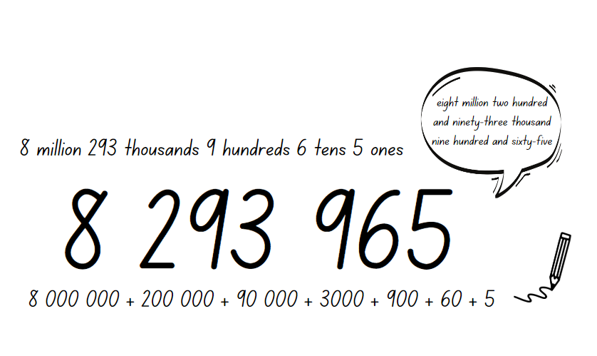
- Repeat the activity for another state or territory.
This table details opportunities for assessment.
Assessment opportunities | Links
What to look for:  - Can students regroup numbers in different forms?  [MAO-WM-01, MA3-RN-01] | Links to National Numeracy Learning Progressions (NNLP):  - NPV6.

Core lesson – making and identifying triangles – 50 minutes
The table below contains suggested learning intentions and success criteria. These are best co-constructed with students.
Core concept learning intentions | Core concept success criteria
Students are learning to:  - classify two-dimensional shapes and describe their properties  - measure and compare angles using degrees. | Students can:  - identify and classify triangles as equilateral, isosceles or scalene triangles  - measure angles using a protractor.
This activity is an adaptation of Making Maths: Equilateral Triangle Folding from NRICH by University of Cambridge.
- Provide individual students with a sheet of A4 paper and demonstrate how to create an equilateral triangle. Students follow along during the demonstration (see Resource 1 – making equilateral triangles).
- Provide students with scissors, a piece of square paper and a sheet of A4 coloured paper.
- Demonstrate how to fold both pieces of paper on the diagonal and cut along each fold line to form 2 triangles.
- Allow students time to follow along with each step using their A4 paper.
- Explain to students that these shapes are all triangles because they are closed shapes with exactly 3 straight sides and 3 angles. However, they can be classified differently.
- Provide pairs of students with a ruler and writing materials. Ask students:
- What is the same about these shapes?
- What is different about these shapes?
- How would you describe each triangle?
- Students turn and talk to discuss and measure, then record their ideas on each of the 3 triangles.
- Regroup and select students to share their ideas.
- Explain that students created an equilateral, isosceles and scalene triangle. Write the beginning of a shared definition of each type of triangle on an anchor chart.
Equilateral triangle: a 3-sided polygon where all sides are equal in length.
Isosceles triangle: a 3-sided polygon where 2 sides are equal in length.
Scalene triangle: a 3-sided polygon where all sides are different lengths.
- Explain to students that the first triangle created is an equilateral triangle. An isosceles triangle was made by cutting the square and a scalene triangle was made by cutting the A4 paper.
- Using the origin of the word ‘triangle’, explain to students that a triangle can be identified and classified according to its side lengths and its angles.
Triangle: a word originating from its Latin roots ‘triangulus’ meaning 3-cornered; a closed shape with exactly 3 straight sides and 3 angles.
- Demonstrate how to use a protractor and revise the types of known angles: acute, obtuse and right-angle.
- Provide students with protractors to measure and record the angles of each of the 3 folded triangles.
This table details opportunities for differentiation.
Too hard? | Too easy?
Students cannot identify and classify triangles as equilateral, isosceles or scalene.  - Support students to use a ruler and measure the sides of each triangle.  - Support students to use a protractor to measure the angles of each triangle.  - Provide students a variety of equilateral, scalene and isosceles triangles to sort by lengths. | Students can identify and classify triangles as equilateral, isosceles or scalene.  - Provide students with a Venn diagram to compare the similarities and differences between different types of triangles.  - Provide students with isometric dot paper to draw straight lines to form and name as many different types of triangles as possible.

Discuss and connect the mathematics – 10 minutes
- As a class, ask students:
- What do you notice about the angles in an equilateral triangle?
- What do you notice about the angles in the isosceles triangle?
- What do you notice about the angles in the scalene triangle?
- What types of angles do you see in each of these triangles?
- Do any of these triangles have a right angle?
- Explain to students that some triangles can also be classified as right-angled triangles. Students turn and talk to determine if there are triangles that can be classified in more than one way.
- Students may notice that the isosceles and scalene triangles from the Core lesson have right-angles.
- Add additional information regarding angles to the definitions on the anchor chart and display.
Equilateral triangles: have 3 equal angles. All angles are acute.
Isosceles triangles: have 2 equal acute angles. The angles opposite the equal sides are equal. An isosceles triangle can be a right-angled triangle if the third angle is 90° and the 2 equal angles are 45°.
Scalene triangles: have no equal angles. A scalene triangle can be a right-angled triangle if one of its angles measures 90°.
This table details opportunities for assessment.
Assessment opportunities | Links
What to look for:  - Can students identify and classify triangles as equilateral, isosceles or scalene triangles? [MAO-WM-01, MA3-2DS-01]  - Can students measure angles using a protractor? [MAO-WM-01, MA3-GM-03] | Links to National Numeracy Learning Progressions (NNLP):  - UGP5, UGP6  - UuM7, UuM8.

Lesson 2
Core concept: triangles and quadrilaterals can be classified in more than one way.

Daily number sense – partitioning numbers – 10 minutes
The table below contains a suggested learning intention and success criteria. These are best co-constructed with students.
Daily number sense learning intention | Daily number sense success criteria
Students are learning to:  - apply place value to partition, regroup and rename numbers to 1 billion. | Students can:  - partition numbers to 1 billion in non-standard forms  - recognise 1000 thousands is 1 million and 1000 millions is 1 billion.
- Review understanding of regrouping numbers from Lesson 1.
- Explain that place value can be applied to numbers using standard and non-standard forms.
- Use the population of the United States of America (USA) as an example to demonstrate standard partitioning of a number up to 1 billion. For example, 339 996 563 can be partitioned as 339 millions, 996 thousands, 5 hundreds, 6 tens and 3 ones.
Note: according to Countries in the world by population (2024), it is reported that in July 2023 the population of the USA was 339 996 563.
- Ask students:
- Can this number be partitioned without using the word thousands?
- How can you work this out?
- Demonstrate regrouping thousands into hundreds. By regrouping 339 996 563, the population of the USA can be partitioned into 339 millions, 9965 hundreds, 6 tens and 3 ones.
- Access Countries in the world by population (2024) to retrieve current population data for Australia and Japan.
- Write the populations for Australia and Japan on the board.
- Students represent each number in standard and non-standard partitioning on individual whiteboards. Have students share their solutions and discuss their reasoning.
- Ask students to name 1 million in a different way. For example, 1 million is the same as 1000 thousand.
- Ask students to rename 1 billion in a different way. For example, 1 billion is the same as 1000 million.
This table details opportunities for assessment.
Assessment opportunities | Links
What to look for:  - Can students partition numbers to 1 billion in non-standard forms? [MAO-WM-01, MA3-RN-01]  - Can students recognise 1000 thousands is 1 million and 1000 millions is 1 billion? [MAO-WM-01, MA3-RN-01] | Links to National Numeracy Learning Progressions (NNLP):  - NPV6.

Core lesson 1 – reviewing types of triangles – 20 minutes
The table below contains suggested learning intentions and success criteria. These are best co-constructed with students.
Core concept learning intentions | Core concept success criteria
Students are learning to:  - classify two-dimensional shapes and describe their properties  - measure and compare angles using degrees. | Students can:  - identify and classify triangles as equilateral, isosceles or scalene triangles  - recognise that triangles and quadrilaterals can be classified in more than one way  - identify regular and irregular polygons  - measure angles using a protractor.
- Review class anchor chart from Lesson 1.
- Provide students with digital technology to access an interactive geoboard to create a variety of triangles.
- In pairs, students discuss the different types of triangles created and classify them into equilateral, isosceles and scalene.
- Ask students if it is possible to make an equilateral triangle on the geoboard? Why or why not?
Note: it is not possible to make an equilateral triangle using a geoboard as the pegs are directly underneath each other. Although it may look like the sides are equal, a right angle is formed, which means that it is not an equilateral triangle. Encourage students to use a ruler to check the side lengths of each triangle when classifying.

Core lesson 2 – classifying quadrilaterals – 20 minutes
- Display Resource 2 – square and rhombus and ask students:
- What are the names of these shapes?
- What are some statements to describe the shapes?
- What is the same about the shapes? (Both shapes have 4 sides, and all sides are equal in length.)
- What is different about the shapes? (The square has 4 right angles, but the rhombus does not.)
- Can the rhombus be classified as square? (No, because the rhombus does not have right angles).
- Can a rhombus ever be classified as a square? (Yes, if the rhombus has right angles).
- Explain to students that the words regular and irregular can also be used to describe these shapes. Share the definition of regular and irregular shapes with students.
Regular shape: a polygon with all sides and all interior angles equal.
Irregular shape: a polygon that does not have equal sides or equal angles.
- Ask students if the rhombus in Resource 2 – square and rhombus is considered a regular or irregular polygon.
- Pose the following conjectures to students:
- All quadrilaterals can be classified in more than one way.
- All quadrilaterals are irregular polygons.
- Provide pairs of students with Resource 3 – quadrilaterals, protractors, rulers and writing materials.
- Students work in pairs to measure the sides and angles of the shapes, identifying and naming known quadrilaterals on Resource 3 – quadrilaterals.
- Encourage students to compare properties listed and consider:
- Can quadrilaterals be classified in more than one way?
- Are they regular or irregular polygons? How do you know?
This table details opportunities for differentiation.
Too hard? | Too easy?
Students cannot recognise that triangles and quadrilaterals can be classified in more than one way.  - Support students to identify and name the quadrilaterals on Resource 3 – quadrilaterals. Model how to use rulers and protractors to measure the sides and angles.  - Support students to describe the quadrilaterals on Resource 3 – quadrilaterals. Use strategies such as colour coding to assist students in identifying similar properties in different quadrilaterals. | Students can recognise that triangles and quadrilaterals can be classified in more than one way.  - Students use an interactive geoboard to create irregular quadrilaterals. Students test conjectures on their quadrilaterals and record findings using a 2-set Venn diagram.  - Pose the conjecture that a square can be classified in 4 ways. Provide students with a multi-set Venn diagram to test the conjecture.

Discuss and connect the mathematics – 10 minutes
- Regroup as a class and select students to share their observations.
- Ask students:
- Can quadrilaterals be classified in more than one way?
- Which quadrilaterals can be classified in more than one way?
- Are all quadrilaterals irregular polygons?
- Record student responses on an anchor chart.
Note: a square can also be classified as a rectangle (4 straight sides, 2 sets of parallel lines, 4 right angles), a parallelogram (2 sets of parallel lines, 2 sets of equal opposite angles), and a rhombus (4 equal sides).
This table details opportunities for assessment.
Assessment opportunities | Links
What to look for:  - Can students identify and classify triangles as equilateral, isosceles or scalene triangles? [MAO-WM-01, MA3-2DS-01]  - Do students recognise that triangles and quadrilaterals can be classified in more than one way? [MAO-WM-01, MA3-2DS-01]  - Can students identify regular and irregular polygons?  [MAO-WM-01, MA3-2DS-01]  - Can students measure angles using a protractor?  [MAO-WM-01, MA3-GM-03] | Links to National Numeracy Learning Progressions (NNLP):  - UGP5, UGP6  - UuM7, UuM8.

Lesson 3
Core concept: measurement and symmetry can be used to compare the properties of triangles and quadrilaterals.

Daily number sense – dicey digits – 10 minutes
The table below contains a suggested learning intention and success criteria. These are best co-constructed with students.
Daily number sense learning intention | Daily number sense success criteria
Students are learning to:  - apply place value to partition, regroup and rename numbers to 1 billion. | Students can:  - partition numbers to 1 billion in non-standard forms  - recognise 1000 thousands is 1 million and 1000 millions is 1 billion.
- Write a 9-digit number on the board.
- Ask students to record 2 different ways the number can be renamed on their whiteboards.
- Select students to share ideas. Revise 1000 thousands is 1 million and 1000 millions is 1 billion.
- Provide pairs of students with a 10-sided die. Pairs roll the die 9 times to generate a 9-digit number and record this at the top of their whiteboard.
- Challenge students to rename their number in as many ways as possible using standard and non-standard partitioning.
- Repeat by rolling another 9-digit number.
This table details opportunities for assessment.
Assessment opportunities | Links
What to look for:  - Can students partition numbers to 1 billion in non-standard forms? [MAO-WM-01, MA3-RN-01]  - Can students recognise 1000 thousands is 1 million and 1000 millions is 1 billion? [MAO-WM-01, MA3-RN-01] | Links to National Numeracy Learning Progressions (NNLP):  - NPV6.

Core lesson – symmetry in shapes – 30 minutes
The table below contains a suggested learning intention and success criteria. These are best co-constructed with students.
Core concept learning intention | Core concept success criteria
Students are learning to:  - classify two-dimensional shapes and describe their properties. | Students can:  - compare side and angle properties of triangles and quadrilaterals using measurement and symmetry  - investigate the symmetry properties of quadrilaterals.
- Display the anchor chart created in Lesson 1 and Lesson 2.
- Revise the properties of triangles and quadrilaterals and how these properties can help classify the shapes.
- Write the definition for lines of symmetry on the board.
Line of symmetry: a shape has line symmetry if matching parts are produced when it is folded along a line of symmetry. Each part represents the mirror image of the other.
- Display and provide pairs with Resource 4 – triangles and quadrilaterals, rulers, scissors and writing materials. Students work together to identify and draw lines of symmetry on each shape.
- Ask students to cut the triangles and quadrilaterals and group them according to the number of lines of symmetry (see Figure 2). Remind students that it is only a line of symmetry if both sides of the shape are identical and overlap. Students may wish to check by folding the shapes to determine whether their lines of symmetry are accurate.
Figure 2 – symmetry sorting
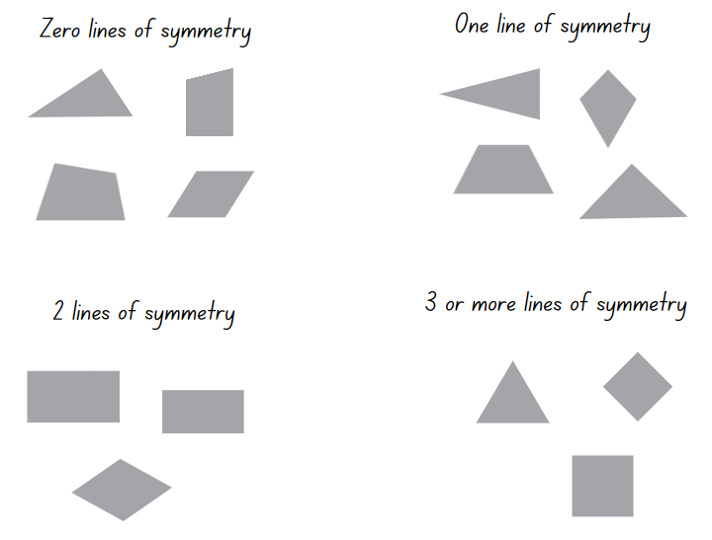
- Regroup as a class. Ask students:
- Do the shapes in each group have anything in common?
- Why do you think some shapes have no lines of symmetry?
- What do you notice about the angles of the shape on either side of the line of symmetry?
- Can you draw an irregular quadrilateral that has more than 2 lines of symmetry? Why or why not?
- Can you predict how many lines of symmetry a shape will have according to its properties?
- Which quadrilaterals have diagonals as lines of symmetry?
Note: the square and rhombus have diagonal lines of symmetry. Diagonal lines on other quadrilaterals are not lines of symmetry.
- Pose the conjecture: Squares and rhombuses always have diagonal lines of symmetry regardless of the orientation or size.
- Provide students with isometric paper and rulers. Students draw a range of squares and rhombuses to test the conjecture.
This table details opportunities for differentiation.
Too hard? | Too easy?
Students cannot investigate the symmetry properties of triangles and quadrilaterals.  - Assist students to find the lines of symmetry by folding paper triangles and quadrilaterals. Cut along the folded line and compare both halves.  - Support students to fold each shape (Resource 4 – triangles and quadrilaterals) and draw the lines of symmetry, checking that both sides of the fold line are matching parts. | Students can investigate the symmetry properties of quadrilaterals.  - Students create additional quadrilaterals using physical or virtual manipulatives to investigate lines of symmetry. For example, an interactive geoboard.  - Students identify lines of symmetry on regular and irregular polygons with more than 4 sides.

Discuss and connect the mathematics – 10 minutes
- Ask students:
- Do squares and rhombuses always have diagonals as lines of symmetry? (Yes.)
- Which type of triangle has diagonals as lines of symmetry? (Equilateral triangle.)
- What is similar about the properties of shapes that have diagonals as lines of symmetry? (They have equal angles and equal sides.)
- Add the lines of symmetry to the triangles and quadrilaterals on the class anchor chart.
This table details opportunities for assessment.
Assessment opportunities | Links
What to look for:  - Can students compare side and angle properties of triangles and quadrilaterals using measurement and symmetry?  [MAO-WM-01, MA3-2DS-01]  - Can students investigate the symmetry properties of quadrilaterals? [MAO-WM-01, MA3-2DS-01] | Links to National Numeracy Learning Progressions (NNLP):  - UGP4, UGP5, UGP6.

Lesson 4
Core concept: quadrilaterals can have line and rotational symmetry.

Daily number sense – 10 minutes
- From a class need surfaced through formative assessment data, identify a short, focused activity that targets students’ knowledge, understanding and skills. Example activities may be drawn from the following resources:
- Mathematics K–6 resources
- Universal Resources Hub.

Core lesson – rotational symmetry – 40 minutes
The table below contains a suggested learning intention and success criteria. These are best co-constructed with students.
Core concept learning intention | Core concept success criteria
Students are learning to:  - classify two-dimensional shapes and describe their properties. | Students can:  - investigate the symmetry properties (rotational) of quadrilaterals.
- Use the anchor chart to revise students’ understanding of regular and irregular polygons and properties for each quadrilateral.
- Display interactive Rotational Symmetry website and demonstrate using the resource by dragging the vertices to form a square.
Note: select Show/Hide Rotation to move the degree slider to rotate the shape. There is also an alternative feature on Rotational Symmetry to change the polygon according to the number of sides and vertices. This feature explores regular polygons.
- Select students to complete a checklist according to the properties of quadrilaterals from the class anchor chart to confirm if the polygon formed is a square, asking:
- Does the shape have 4 straight sides?
- Does the shape have 4 right angles?
- Does the shape have 4 lines of symmetry?
- Rotate the square to complete a full rotation (360°) to demonstrate how the tool can be used. Rotate the square a second time and ask the students to count the number of times the square matches to its original stencil.
- Explain that the order of symmetry is the number of times a shape exactly matches the original in one full rotation. Clarify that a square can be turned 4 times and match its original shape exactly. It has a rotational symmetry order of 4.
Rotational symmetry: a shape has rotational symmetry if an outline of the figure can be rotated or turned about its centre to match its original shape.
Order of symmetry: this is the number of times a shape matches the original in one full rotation.
- Model the use of Rotational Symmetry to manipulate a square into a rectangle.
- Ask students to complete a check of the properties of rectangles to confirm the polygon formed is a rectangle:
- Does the shape have 4 straight sides?
- Does the shape have 4 right angles?
- Does the shape have 2 lines of symmetry?
- Does the shape have 2 sets of parallel lines?
- Rotate the shape to complete a full rotation and ask students to count the number of times the shape matches its original rectangle. A rectangle has a rotational symmetry order of 2.
- Ask students:
- How are the properties of a square and rectangle the same? (They are both quadrilaterals with 4 right angles and 2 sets of parallel lines).
- How are the properties of a square and rectangle different? (The square has 4 lines of symmetry while the rectangle has 2 lines of symmetry).
- Pose the conjecture: The number of lines of symmetry on a shape help to predict its rotational symmetry order.
- Provide pairs of students with access to interactive Rotational Symmetry to test the conjecture on quadrilaterals.
This table details opportunities for differentiation.
Too hard? | Too easy?
Students cannot investigate the symmetry properties (rotational) of quadrilaterals.  - Assist students to create a rhombus on the interactive Rotational Symmetry and count the number of times the red dot matches with the blue, indicating rotational symmetry.  - Support students to construct and cut out quadrilaterals using paper. Provide students with a split pin and insert it in the middle of the shape. Model how the shape can be rotated and count the number of times the shape matches the original. | Students can investigate the symmetry properties (rotational) of quadrilaterals.  - Ask students to create regular and irregular quadrilaterals. Students explore line and rotational symmetry for quadrilaterals created and record this in books.  - Provide students with the problem Shady Symmetry. Challenge students to make patterns with rotational symmetry but no lines of symmetry.

Discuss and connect the mathematics – 10 minutes
- Regroup as a class. Ask students:
- Do the lines of symmetry on a quadrilateral help predict its rotational symmetry order? (In some quadrilaterals, the square, rectangle and rhombus have the same number of lines of symmetry as their rotational symmetry order. The parallelogram is different because it has no lines of symmetry and a rotational symmetry order of 2.)
- Which quadrilaterals do not have rotational symmetry? (Trapezium and kite.)
- Record rotational symmetry findings on the class anchor chart.
This table details opportunities for assessment.
Assessment opportunities | Links
What to look for:  - Can students investigate the symmetry properties (rotational) of quadrilaterals? [MAO-WM-01, MA3-2DS-01] | Links to National Numeracy Learning Progressions (NNLP):  - UGP4, UGP5.

Lesson 5
Core concept: the area of a rectangle can be measured and recorded using standard metric units.

Daily number sense – dicey estimates – 10 minutes
Daily number sense activities for Lessons 5 to 7 ‘loop’ back to concepts and procedures covered in previous units to assist students to build an increasingly connected network of ideas. These concepts may differ from the core concepts being covered by the unit.
The table below contains a suggested learning intention and success criteria. These are best co-constructed with students.
Daily number sense learning intention | Daily number sense success criteria
Students are learning to:  - use estimation and place value understanding to determine the reasonableness of solutions. | Students can:  - round numbers appropriately when obtaining estimates to numerical calculations.
- Write an addition number sentence on the board. For example, 569 + 429.
- Ask students how rounding the numbers can help estimate the answer to the number sentence provided. Students turn and talk.
- Select a variety of student ideas to share with the class.
- Record a number sentence that reflects how the numbers can be rounded. Ask students to solve the rounded number sentence to determine an appropriate estimate (see Figure 3).
Figure 3 – rounding to support estimation
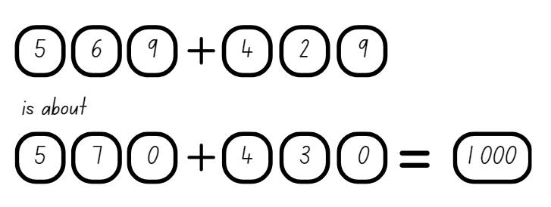
- Provide pairs of students with a 10-sided die and individual whiteboards.
- Students roll the die 6 times to generate and record a number sentence. Students record the rounded number sentence and estimate on their whiteboards.
- Students repeat the process.
Note: the number of die rolls may vary for students to provide appropriate differentiation opportunities.
This table details opportunities for assessment.
Assessment opportunities | Links
What to look for:  - Can students round numbers appropriately when obtaining estimates to numerical calculations? [MAO-WM-01, MA3-AR-01] | Links to National Numeracy Learning Progressions (NNLP):  - NPV6, NPV7.

Core lesson – finding the area of rectangles – 40 minutes
The table below contains suggested learning intentions and success criteria. These are best co-constructed with students.
Core concept learning intentions | Core concept success criteria
Students are learning to:  - calculate the areas of rectangles using familiar metric units  - determine products and factors  - use partitioning and place value to multiply 2-, 3- and 4-digit numbers by one-digit numbers. | Students can:  - recognise the importance of using the same units of length on the sides of rectangles to create ‘square units’  - calculate areas of rectangles in square centimetres (cm²)  - use the term product to describe the result of multiplying 2 or more numbers  - use informal written strategies such as the area model to solve multiplication problems.
Note: the teaching advice for Stage 3 is that students need to move on from counting individual squares to determine the area of shapes. When calculating the area of a rectangle, students need to find how many squares fit in one row and multiply this by the number of rows that make up the width. This lesson uses a grid overlay behind rectangles to encourage strategies other than count-by-ones.
- Revise the definition of area with students.
Area: the amount of surface inside a closed flat (two-dimensional) shape.
- Display Resource 5 – Omar’s invisible arrays. Explain that Omar is trying to find the area of the rectangle. Ask students:
- Will Omar’s strategy give him an accurate measurement? Why or why not? (No, because his arrays are not equal.)
- What suggestions can you give Omar to measure the area accurately?
- Display Resource 6 – rectangle overlay. Ask students whether this will give an accurate measurement for the area of the rectangle.
- Students turn and talk and discuss strategies to determine the area of the rectangle in square centimetres.
- Revise that multiplying 2 numbers together gives a product. Explain that in this example, multiplying 6 and 12 gives a product of 72. This is also the area of the rectangle and is recorded as 72 square centimetres.
- Explain to students that square centimetres can be written as cm² and is still read as square centimetres. The abbreviation makes it easier to record measurements. Write 72 cm² on the board for students to see.
- Explain to students that they will be using square centimetre grid paper to help measure the area of rectangular items in the classroom.
- Model placing a rectangular item such as a book onto square centimetre grid paper. Ask students how they can calculate the area of the item.
- Students turn and talk and discuss strategies for calculating the area.
- Revise strategies such as the area model to multiply numbers.
- Explain that students will be using this method to calculate the area of other rectangular items in the classroom.
- Students work in pairs to measure the area of other rectangular items in the classroom. For example, recess container, pencil case, notebook. Encourage students to select appropriate multiplication strategies to determine the area of the items being measured.
- Students record their measurements and areas in a table. Ensure that the abbreviation cm² is used to record the area (see Table 1).
Table 1 – recorded measurements
Item in classroom | Length (cm) | Width (cm) | Area (cm²)
Recess container | 10 cm | 15 cm | 150 cm²
This table details opportunities for differentiation.
Too hard? | Too easy?
Students cannot calculate areas of rectangles in square centimetres (cm²).  - Support students to trace around the item being measured onto the square centimetre grid paper. Remove the item and assist students to identify the array within the outline.  - Support students to partition the array into multiples that they are familiar with and determine the total area. | Students can calculate areas of rectangles in square centimetres (cm²).  - Students determine the area of larger items in the classroom such as a table, whiteboard or door.  - Pose the following question to students: A rectangle has an area of 128 cm². What are the possible dimensions?

Discuss and connect the mathematics – 10 minutes
- Select students to share different multiplication strategies used to calculate the area of the items in the class.
- Ask students:
- Which strategy do you use the most today?
- Is this the most efficient strategy?
- How do you decide which strategy to use when multiplying numbers?
This table details opportunities for assessment.
Assessment opportunities | Links
What to look for:  - Can students recognise the importance of using the same units of length on the sides of rectangles to create ‘square units’?  [MAO-WM-01, MA3-2DS-02]  - Can students calculate areas of rectangles in square centimetres (cm²)? [MAO-WM-01, MA3-2DS-02]  - Can students use the term product to describe the result of multiplying 2 or more numbers? [MAO-WM-01, MA3-MR-01]  - Can students use informal written strategies such as the area model to solve multiplication problems?  [MAO-WM-01, MA3-MR-01] | Links to National Numeracy Learning Progressions (NNLP):  - UuM6, UuM7  - MuS6.

Lesson 6
Core concept: the length, width and area of a rectangle are related.

Daily number sense – estimating calculations – 10 minutes
The table below contains a suggested learning intention and success criteria. These are best co-constructed with students.
Daily number sense learning intention | Daily number sense success criteria
Students are learning to:  - use estimation and place value understanding to determine the reasonableness of solutions. | Students can:  - use place value understanding to check for errors in calculations.
- Write the algorithm 204 + 204 + 204 = 702.
- Students turn and talk. Ask students:
- Is the answer reasonable? Why or why not?
- What error has this person made when calculating?
- What would be a reasonable estimate? Why?
- Write the algorithm 2005 + 2005 + 2005 = 6105 and ask students if the answer is reasonable.
- Students turn and talk and repeat the discussion from before.
This table details opportunities for assessment.
Assessment opportunities | Links
What to look for:  - Can students use place value understanding to check for errors in calculations? [MAO-WM-01, MA3-AR-01] | Links to National Numeracy Learning Progressions (NNLP):  - NPV5, NPV6  - AdS8.

Core lesson – thinking about rectangles – 40 minutes
The table below contains suggested learning intentions and success criteria. These are best co-constructed with students.
Core concept learning intentions | Core concept success criteria
Students are learning to:  - calculate the areas of rectangles using familiar metric units  - determine products and factors. | Students can:  - establish the relationship between the lengths, widths and areas of rectangles  - calculate areas of rectangles in square metres (m²)  - determine factors for a given whole number.
- Explain that Grove Town council are designing a multi-purpose sporting field. The length of the field is 26 metres and the width of the field is 9 metres. The town planner estimates that 250 square metres of turf is needed to cover the field.
- Students turn and talk. Ask students:
- How can this information be presented as a diagram?
- Is this an accurate estimate? How do you know?
- What is the actual area of the field?
- How do the measurements of the field help you calculate the area?
- What strategy can you use to calculate the area?
- As a class, revisit the understanding that the area of a rectangle can be determined by multiplying the length and width.
- Explain that the length and width are the factors. When the factors are multiplied together, it results in the product. The product is also the area of the rectangle.
- Explain that square metres can be written as m² and is still read as square metres. The abbreviation makes it easier to record measurements. Write 234 m² on the board for students to see.
- Write the following problem on the board: The council is planning 2 rectangular sporting fields. The difference in area between the 2 fields is 32 m².
- Ask students:
- What can the area of the 2 fields be?
- What strategy can be used to determine the length and width of these areas?
- If the area of a field is 20 m², what can the length and width be? Is there more than one answer?
- Students work in pairs to explore the possible areas and dimensions of the fields. Students record their ideas in a table listing the area of each rectangle and the possible dimensions (see Table 2).
Table 2 – possible dimensions
Area 1 | Possible dimensions | Area 2 | Possible dimensions
20 m² | 1 m × 20 m, 2 m × 10 m, 4 m × 5 m | 52 m² | 1 m × 52 m, 2 m × 26 m, 4 m × 13 m
This table details opportunities for differentiation.
Too hard? | Too easy?
Students cannot determine factors for a given whole number.  - Provide students with the area 24 m². Support students to use a multiplication chart to determine the factors. Some students may benefit from using counters to create arrays and recognise the factors.  - Pose the following question to students: The difference in area between the 2 fields is 10 m². What might the dimensions be? Provide students with a multiplication chart or counters to solve this problem. | Students can determine factors for a given whole number.  - Pose the following question to students: If the area of the field is less than 500 m², what is the area that will provide the most possibilities for the width and length of the rectangle?  - Pose the following question to students: If the length and width of the field are not whole metres, what can the dimensions be?

Discuss and connect the mathematics – 10 minutes
- Regroup as a class and ask students:
- Which area gives you the most possibilities for the length and width of the rectangle?
- How does your knowledge of factors help you with this task?
- What other strategies can you use to help you find all the possibilities?
- How are the length and width of a rectangle related to its area?
- What are the dimensions of a rectangle that has an area of 23 m²? Is there more than one possibility? How do you know?
This table details opportunities for assessment.
Assessment opportunities | Links
What to look for:  - Can students identify the relationship between the lengths, widths and areas of rectangles? [MAO-WM-01, MA3-2DS-02]  - Can students calculate areas of rectangles in square metres (m²)? [MAO-WM-01, MA3-2DS-02]  - Can students determine factors for a given whole number?  [MAO-WM-01, MA3-MR-01] | Links to National Numeracy Learning Progressions (NNLP):  - UuM6, UuM7.

Lesson 7
Core concept: the context determines the most suitable standard unit for measuring area, sometimes a square metre is too small.

Daily number sense – estimating the reasonableness – 10 minutes
The table below contains a suggested learning intention and success criteria. These are best co-constructed with students.
Daily number sense learning intention | Daily number sense success criteria
Students are learning to:  - use estimation and place value understanding to determine the reasonableness of solutions. | Students can:  - use estimation to check the reasonableness of solutions to addition and subtraction calculations.
- Display an addition number sentence such as 1438 + 129 = 1567.
- Ask students:
- Is the answer reasonable? How do you know? (Yes, because if I round the numbers to 1400 + 100, I can see the answer of the original number sentence should be 1500 or larger.)
- What would be an unreasonable answer? Why?
- Provide students with a subtraction number sentence such as 1895 – 1125 = 1029.
- Ask students:
- Is the answer reasonable? How do you know? (No, the answer would be less than 1000 because 1000 is being subtracted from the starting number which only has one thousand.)
- What would be a reasonable answer? Why? (800, because I can round 1895 to 1900 and 1125 to 1100. 1900 – 1100 = 800.)
- In pairs, students write an equation and repeat the process.
This table details opportunities for assessment.
Assessment opportunities | Links
What to look for:  - Can students use estimation to check the reasonableness of solutions to addition and subtraction calculations?  [MAO-WM-01, MA3-AR-01] | Links to National Numeracy Learning Progressions (NNLP):  - NPV6  - AdS8.

Core lesson – exploring hectares – 40 minutes
The table below contains suggested learning intentions and success criteria. These are best co-constructed with students.
Core concept learning intentions | Core concept success criteria
Students are learning to:  - use hectares and square kilometres as units of measurement for area  - use estimation and rounding to check the reasonableness of answers to calculations  - select and apply strategies to solve problems involving multiplication and division with whole numbers. | Students can:  - recognise the need for formal units larger than the square metre and identify situations where square kilometres and hectares are used for measuring area  - record areas using square kilometres and hectares  - use estimation to check the reasonableness of answers to multiplication calculations  - select and use efficient strategies to multiply whole numbers of up to 4 digits by one- and 2-digit numbers.
Note: the Stage 3 teaching advice recommends supporting students to establish a real reference for the square kilometre and the hectare to give meaning to the size of the unit. For example, locating an area of one square kilometre or an area of one hectare on a local map.
- Draw a rectangle and label the sides 50 m by 200 m. Demonstrate multiplying 50 by 200 to find the area.
- Highlight that this rectangle has an area of 10 000 square metres or 10 000 m². Explain to students that this measurement is called a hectare and can be written as ‘ha’ and one hectare is equal to 10 000 m².
Note: the word ‘hectare’ comes from the Greek word ‘hekaton’ meaning one hundred. Hectares are often used to describe the area of land.
- Ask students to turn and talk and consider why an area might be measured in hectares rather than square metres.
- Use Google Maps to view an aerial satellite image of a school or suburb. Draw students’ attention to the scale and ask how this can be used to estimate the area of a space within a school or suburb.
- Demonstrate using the Measure Map tool in Google Maps to measure the length and width of a space that is approximately one hectare in area.
- Step 1: search for your school or suburb in the ‘Search Google Maps’ field.
- Step 2: select ‘Layers’ and choose to view the satellite image.
- Step 3: select ‘Layers’ and click on ’more’ and then ‘measure’.
- Step 4: measure the side length of the space by clicking once at the point you wish to measure from and again at the end of the length.
- Step 5: repeat Step 4 to find the width measurement.
Note: try to find a space that has an area about the same size as a hectare to allow students to establish a real reference to give meaning to the size of the unit.
- Ask students to consider how rounding and estimating can be useful when multiplying to determine whether a space is larger than, smaller than or about the same size as a hectare.
- Pose the conjecture: A school oval measuring 57 m by 182 m will be about the size as a hectare. Ask students to use rounding to determine whether this is a reasonable estimate.
- Ask students to brainstorm some examples of spaces that are measured in hectares. For example, many sports fields, such as full-size rugby pitches are about one hectare in area.
- In pairs, allow students to explore the Google Maps satellite image of the local area and identify spaces that are larger than, smaller than or about the same size as a hectare.
- Students measure the side lengths using the Measure Map tool, estimate the area by rounding the dimensions and record their findings in a table (see Table 3).
Table 3 – investigating hectares
Local community spaces | Side length in metres | Side width in metres | Rounded multiplication sentence | Estimated area in square metres | Larger, smaller or about the same size as a hectare
Oakleigh Oval | 112 m | 90 m | 100 m × 100 m | 10 000 m² | About one hectare
Village Shopping Centre | 135 m | 198 m | 135 m × 200 m | 27 000 m² | Larger than one hectare
This table details opportunities for differentiation.
Too hard? | Too easy?
Students cannot identify situations where hectares are used for measuring areas and/or cannot record areas using hectares.  - Support students to measure one square metre and 100 square metres to build awareness of larger areas.  - Support students to use a trundle wheel to measure the length and width of a given area of school (about a hectare). Model how to use these dimensions to find and record the area. | Students can identify situations where hectares are used for measuring areas and can record areas using hectares.  - Students investigate how many 15 m by 28 m basketball courts Grove Town council can build in one hectare.  - Pose the following question to students: What are some possible dimensions of rectangles with an area of one hectare?  - Students research how closely body parts were related to measurements in history. For example, hand, foot, pace, yard, span, lick.

Discuss and connect the mathematics – 10 minutes
- Explain that an even larger unit to measure area is a square kilometre.
- Draw a diagram of a square with the given dimensions 1000 m by 1000 m.
- Model finding the area by calculating 1000 × 1000. This square has an area of 1 000 000 square metres or 1 000 000 m².
- Revise that 1000 metres is one kilometre so the area inside this square will be one square kilometre which can be written as km².
- Demonstrate measuring an area of one square kilometre using the Measure Map tool from Google Maps.
- Ask students to predict how many hectares fit into a square kilometre and justify their thinking.
This table details opportunities for assessment.
Assessment opportunities | Links
What to look for:  - Can students recognise the need for formal units larger than the square metre and identify situations where square kilometres and hectares are used for measuring area?  [MAO-WM-01, MA3-2DS-02]  - Can students record areas using square kilometres and hectares? [MAO-WM-01, MA3-2DS-02]  - Can students use estimation to check the reasonableness of answers to multiplication calculations?  [MAO-WM-01, MA3-MR-01]  - Can students select and use efficient strategies to multiply whole numbers of up to 4 digits by one- and 2-digit numbers?  [MAO-WM-01, MA3-MR-01] | Links to National Numeracy Learning Progressions (NNLP):  - UuM6, UuM7  - MuS6.

Lesson 8
Core concept: two rectangles may have the same perimeter but different areas or may have the same area but different perimeters.

Daily number sense – 10 minutes
- From a class need surfaced through formative assessment data, identify a short, focused activity that targets students’ knowledge, understanding and skills. Example activities may be drawn from the following resources:
- Mathematics K–6 resources
- Universal Resources Hub.

Core lesson – perimeter and area – 45 minutes
The table below contains suggested learning intentions and success criteria. These are best co-constructed with students.
Core concept learning intentions | Core concept success criteria
Students are learning to:  - calculate the areas of rectangles using familiar metric units  - determine products and factors  - select and apply strategies to solve problems involving multiplication and division with whole numbers. | Students can:  - recognise that rectangles with the same area may have different dimensions  - investigate and compare the areas of rectangles that have the same perimeter  - determine factors for a given whole number  - select and use efficient strategies to multiply whole numbers of up to 4 digits by one- and 2-digit numbers.
- Students turn and talk. Ask students:
- What is the difference between perimeter and area?
- What strategies can you use to calculate the perimeter of a shape?
- What strategies can you use to calculate the area of a shape?
- Ensure that students have a common understanding of perimeter and area.
Perimeter: the distance around the boundary of a two-dimensional shape. Calculating the perimeter of a shape is equal to the sum of the length of all sides.
- Display Resource 7 – Joe’s vegetable garden. Ask students:
- What are the dimensions of a rectangle that use all 40 metres of fencing?
- What strategy can you use to work out the dimensions of the rectangle?
- What will the area of the rectangle be?
- Are there other possibilities?
- Students work in pairs to investigate possible dimensions for a vegetable garden that uses 40 metres of fencing. Students record ideas in a table which lists the dimensions of the rectangle and the area formed (see Table 4).
Table 4 – dimensions of the vegetable garden
Length of vegetable garden (m) | Width of vegetable garden (m) | Total area (m²)
18 m | 2 m | 36 m²
- Regroup as a class and discuss the different rectangles created.
- How are the rectangles the same? (They have the same perimeter or amount of fencing used.)
- How are the rectangles different? (They have different areas.)
- Which rectangle has the biggest area?
- Which rectangle has the smallest area?
- What patterns do you notice in your answers?
- Have you worked out all the possibilities? How do you know?
- Pose the following conjecture: Two rectangles can have the same area, but different perimeters.
- Provide pairs of students with square centimetre grid paper and writing materials to test this conjecture. Students may benefit from being given an area to explore such as 28 cm², 36 cm² or 43 cm².
Note: to highlight the importance of factors in determining the dimensions of a rectangle with a set area, students should be provided with several areas to explore including numbers that are prime, composite and square.
- Regroup as a class and select students to share the dimensions for different areas explored. Ask students:
- Can 2 rectangles have the same area but different perimeter?
- What strategy can you use to work out the possible dimensions of each rectangle?
- Have you got all the possibilities for the areas you have explored? How can you be sure?
- Are there any areas that only have one possible perimeter? Why does this area only have one possibility? (It is a prime number which only has 2 factors.)
- Are there any areas that made a square? Why might this happen? (It is a square number which is formed by multiplying a number by itself. This means that the length and width will be the same and form a square.)
This table details opportunities for differentiation.
Too hard? | Too easy?
Students cannot investigate and compare the areas and perimeters of rectangles.  - Provide students with square centimetre grid paper and work with a smaller perimeter such as 20 metres. Support students to use the grids to represent a metre. Ask questions such as, if the length of the rectangle is 5 metres, what can the other dimensions be?  - Assist students in finding factor pairs for areas and record these on a whiteboard for student reference. Students record the factor pairs as dimensions for a rectangle. | Students can investigate and compare the areas and perimeters of rectangles.  - Revise students’ understanding of benchmark fractions and decimals (0.5 as $\frac{1}{2}$ or 0.25 as $\frac{1}{4}$). Encourage students to apply this understanding to a metre. If 0.5 m means 50 cm, ask students to investigate measurements to reflect decimals.  - Pose the following question to students: Is it possible for a rectangle to have the same area and perimeter? How many possibilities can you find? Are there any patterns that you notice? See Can They Be Equal? for more detail.

Discuss and connect the mathematics – 5 minutes
- Discuss with students:
- How does your knowledge of factors help with determining the dimensions of the rectangle?
- What mathematical knowledge do you use to determine the perimeter and area of rectangles?
This table details opportunities for assessment.
Assessment opportunities | Links
What to look for:  - Do students recognise that rectangles with the same area may have different dimensions? [MAO-WM-01, MA3-2DS-02]  - Can students investigate and compare the areas of rectangles that have the same perimeter? [MAO-WM-01, MA3-2DS-02]  - Can students determine factors for a given whole number?  [MAO-WM-01, MA3-MR-01]  - Can students select and use efficient strategies to multiply whole numbers of up to 4 digits by one- and 2-digit numbers?  [MAO-WM-01, MA3-MR-01] | Links to National Numeracy Learning Progressions (NNLP):  - MuS6, MuS7  - UuM6, UuM7  - UGP6.

Resource 1 – making equilateral triangles
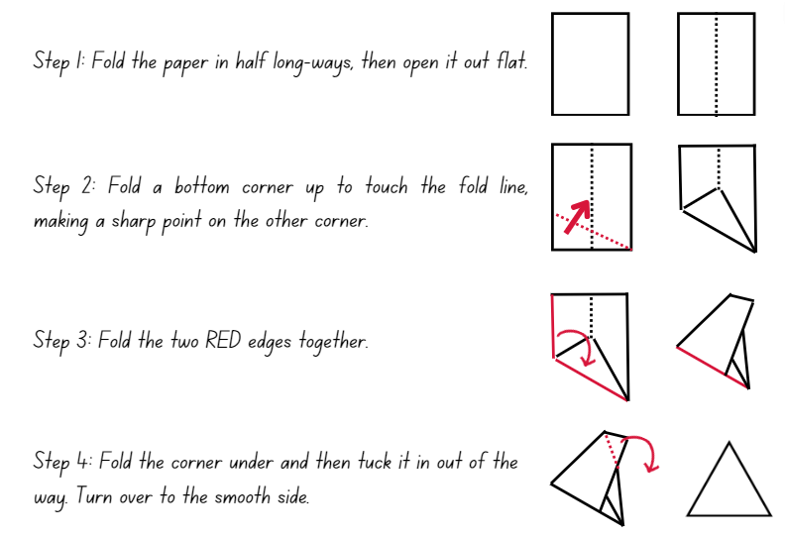
Adapted from Making Maths: Equilateral Triangles Folding by University of Cambridge (n.d)

Resource 2 – square and rhombus
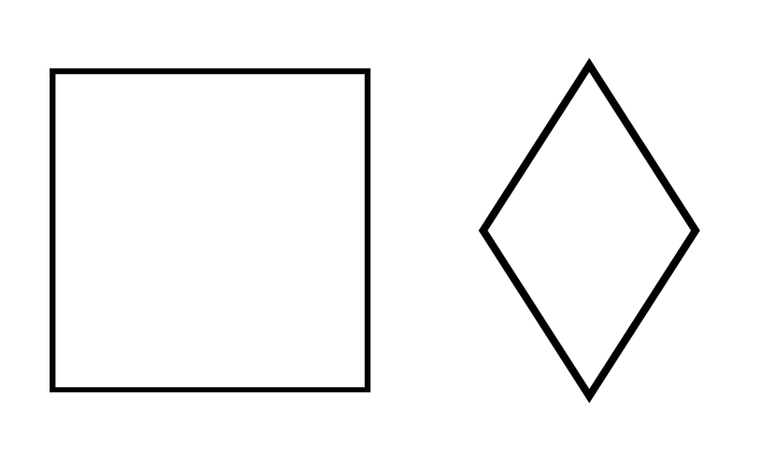

Resource 3 – quadrilaterals
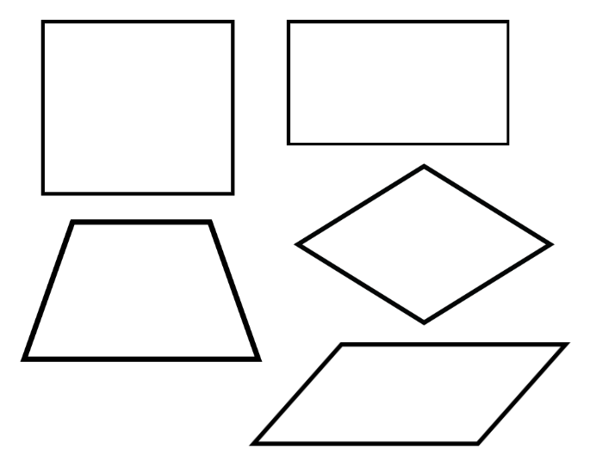

Resource 4 – triangles and quadrilaterals

Resource 5 – Omar’s invisible arrays

Resource 6 – rectangle overlay
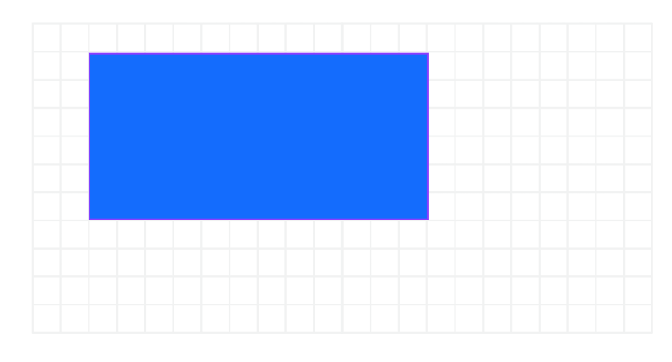

Resource 7 – Joe’s vegetable garden
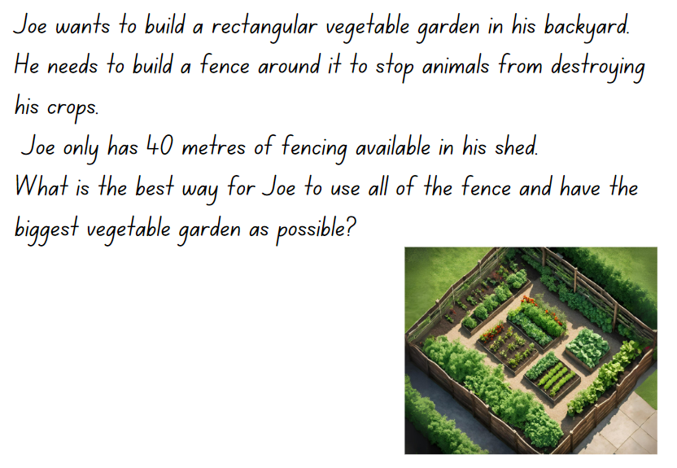

Syllabus outcomes and content
The table below outlines the syllabus outcomes and range of relevant syllabus content covered in this unit. Content is linked to National Numeracy Learning Progression (version 3).
Outcomes and content | 1 | 2 | 3 | 4 | 5 | 6 | 7 | 8
Represents numbers A: Whole numbers: Apply place value to partition, regroup and rename numbers to 1 billion
[MAO-WM-01, MA3-RN-01]
- Recognise 1000 thousands is 1 million and 1000 millions is 1 billion |  | x | x
- Regroup numbers in different forms (Reasons about quantity) | x | x
- Partition numbers to 1 billion in non-standard forms | x | x | x
Additive relations A: Use estimation and place value understanding to determine the reasonableness of solutions
[MAO-WM-01, MA3-AR-01]
- Round numbers appropriately when obtaining estimates to numerical calculations |  |  |  |  | x |  | x
- Use place value understanding to check for errors in calculations |  |  |  |  |  | x
- Use estimation to check the reasonableness of solutions to addition and subtraction calculations |  |  |  |  | x | x | x
Multiplicative relations A: Determine products and factors
[MAO-WM-01, MA3-MR-01]
- Use the term product to describe the result of multiplying 2 or more numbers |  |  |  |  | x
- Determine factors for a given whole number |  |  |  |  |  | x |  | x
Multiplicative relations A: Use partitioning and place value to multiply 2-, 3- and 4-digit numbers by one-digit
[MAO-WM-01 MA3-MR-01]
- Use informal written strategies such as the area model to solve multiplication and division problems |  |  |  |  | x
- Estimate the product of 2 numbers (one-digit by 2- or 3-digit numbers) using multiples of 10 or 100 |  |  |  |  |  |  | x
Multiplicative relations A: Use estimation and rounding to check the reasonableness of answer to calculations
[MAO-WM-01, MA3-MR-01]
- Use estimation and rounding to check the reasonableness of answers to multiplication and division calculations |  |  |  |  |  |  | x
Multiplicative relations B: Select and apply strategies to solve problems involving multiplication and division with whole numbers
[MAO-WM-01, MA3-MR-01]
- Select and use efficient strategies to multiply whole numbers of up to 4 digits by one- and 2-digit numbers |  |  |  |  | x |  | x | x
Geometric measure A: Angles: Estimate, measure and compare angles using degrees
[MAO-WM-01, MA3-GM-03]
Measure angles of up to 360° using a protractor | x | x
Two-dimensional spatial structure: 2D shapes: Classify two-dimensional shapes and describe their properties
[MAO-WM-01, MA3-2DS-01, MA3-2DS-02]
- Identify and classify triangles as equilateral, isosceles or scalene triangles | x | x
- Recognise that triangles and quadrilaterals can be classified in more than one way (Reasons about spatial relations) | x | x
- Compare side and angle properties of triangles and quadrilaterals using measurement and symmetry | x | x | x | x
- Investigate the symmetry properties (line and rotational) of quadrilaterals |  |  | x | x
- Identify regular and irregular polygons |  | x
Two-dimensional spatial structure A: Area: Use hectares and square kilometres as units of measurement for area
[MAO-WM-01, MA3-2DS-01, MA3-2DS-02]
- Recognise the need for formal units larger than the square metre |  |  |  |  |  |  | x
- Identify situations where square kilometres and hectares are used for measuring area |  |  |  |  |  |  | x
- Equate one hectare to the area of a square with side lengths of 100 m, ie 10 000 square metres = 1 hectare (ha) |  |  |  |  |  |  | x
- Record areas using square kilometres and hectares |  |  |  |  |  |  | x
Two-dimensional spatial structure A: Area: Calculate the areas of rectangles using familiar metric units
[MAO-WM-01, MA3-2DS-01, MA3-2DS-02]
- Recognise the importance of using the same units of length on the sides of rectangles to create ‘square units’ |  |  |  |  | x
- Establish the relationship between the lengths, widths and areas of rectangles |  |  |  |  | x | x | x | x
- Record, using words, the method for finding the area of any rectangle |  |  |  |  | x
- Calculate areas of rectangles in square centimetres (cm²), square metres (m²) and square kilometres (km²) |  |  |  |  | x | x | x | x
- Recognise that rectangles with the same area may have different dimensions |  |  |  |  |  | x |  | x
- Investigate and compare the areas of rectangles that have the same perimeter |  |  |  |  |  |  |  | x
Mathematics K–10 Syllabus © NSW Education Standards Authority (NESA) for and on behalf of the Crown in right of the State of New South Wales, 2022.

References
This resource contains NSW Curriculum and syllabus content. The NSW Curriculum is developed by the NSW Education Standards Authority. This content is prepared by NESA for and on behalf of the Crown in right of the State of New South Wales. The material is protected by Crown copyright.
Please refer to the NESA Copyright Disclaimer for more information https://educationstandards.nsw.edu.au/wps/portal/nesa/mini-footer/copyright.
NESA holds the only official and up-to-date versions of the NSW Curriculum and syllabus documents. Please visit the NSW Education Standards Authority (NESA) website https://educationstandards.nsw.edu.au/wps/portal/nesa/home and the NSW Curriculum website https://curriculum.nsw.edu.au/.
Mathematics K–10 Syllabus © NSW Education Standards Authority (NESA) for and on behalf of the Crown in right of the State of New South Wales, 2022.
National Numeracy Learning Progression © Australian Curriculum, Assessment and Reporting Authority (ACARA) 2010 to present, unless otherwise indicated. This material was downloaded from the Australian Curriculum website (National Numeracy Learning Progression) (accessed 2 November 2023) and was not modified.
Robinson J (2024) Rotational Symmetry, GeoGebra website, accessed 8 November 2023.
Siemon D, Warren E, Beswick K, Faragher R, Miller J, Horne M, Jazby D, Breed M, Brady K, Clark J (2021) Teaching Mathematics: Foundations to Middle Years, 3rd edn, Oxford University Press, Australia.
University of Cambridge (n.d) Can They Be Equal?, NRICH website, accessed 8 November 2023.
University of Cambridge (n.d) Making Maths: Equilateral Triangles Folding, NRICH website, accessed 7 November 2023.
University of Cambridge (n.d) Shady Symmetry, NRICH website, accessed 8 November 2023.
Worldometer (2023) Countries in the world by population (2024), Worldometer website, accessed 13 November 2023.

© State of New South Wales (Department of Education), 2024
The copyright material published in this resource is subject to the Copyright Act 1968 (Cth) and is owned by the NSW Department of Education or, where indicated, by a party other than the NSW Department of Education (third-party material).
Copyright material available in this resource and owned by the NSW Department of Education is licensed under a Creative Commons Attribution 4.0 International (CC BY 4.0) license.
This license allows you to share and adapt the material for any purpose, even commercially.
Attribution should be given to © State of New South Wales (Department of Education), 2024.
Material in this resource not available under a Creative Commons license:
- the NSW Department of Education logo, other logos and trademark-protected material
- material owned by a third party that has been reproduced with permission. You will need to obtain permission from the third party to reuse its material.
Links to third-party material and websites
Please note that the provided (reading/viewing material/list/links/texts) are a suggestion only and implies no endorsement, by the New South Wales Department of Education, of any author, publisher, or book title. School principals and teachers are best placed to assess the suitability of resources that would complement the curriculum and reflect the needs and interests of their students.
If you use the links provided in this document to access a third-party's website, you acknowledge that the terms of use, including licence terms set out on the third-party's website apply to the use which may be made of the materials on that third-party website or where permitted by the Copyright Act 1968 (Cth). The department accepts no responsibility for content on third-party websites.

