Mathematics Stage 3 – Unit 19

Angles are the primary structural component of many shapes

Contents

Unit description and duration 5

Syllabus outcomes 5

Working mathematically 6

Student prior learning 6

Lesson overview and resources 8

Lesson 1 14

Daily number sense – place value representations – 10 minutes 14

Core lesson 1 – a trio of triangles – 30 minutes 17

Core lesson 2 – shape shifters – 15 minutes 22

Consolidation and meaningful practice – 10 minutes 23

Lesson 2 25

Daily number sense – guess the number – 10 minutes 25

Core lesson – properties of triangles and quadrilaterals – 30 minutes 27

Consolidation and meaningful practice – 20 minutes 31

Lesson 3 35

Daily number sense – partitioning numbers – 10 minutes 35

Core lesson 1 – taking turns – 15 minutes 37

Core lesson 2 – measuring angles – 20 minutes 40

Consolidation and meaningful practice – 15 minutes 43

Lesson 4 46

Daily number sense – 10 minutes 46

Core lesson – using a protractor – 30 minutes 46

Consolidation and meaningful practice – 20 minutes 50

Lesson 5 53

Daily number sense – stock feed store – 10 minutes 53

Core lesson – NSW flight plans – 40 minutes 54

Discuss and connect the mathematics – 10 minutes 57

Lesson 6 59

Daily number sense – closest to the whole – 15 minutes 59

Core lesson – Australian flight plans – 25 minutes 61

Consolidation and meaningful practice – 20 minutes 63

Lesson 7 66

Daily number sense – road trip – 10 minutes 66

Core lesson 1 – 24-hour time – 10 minutes 67

Core lesson 2 – bridging strategy – 15 minutes 68

Consolidation and meaningful practice – 25 minutes 70

Lesson 8 72

Daily number sense – 10 minutes 72

Core lesson 1 – time intervals – 10 minutes 72

Core lesson 2 – timetable problems – 30 minutes 74

Discuss and connect the mathematics – 10 minutes 75

Resource 1 – place value houses 77

Resource 2 – place value representations 78

Resource 3 – angle categories 79

Resource 4 – identifying triangles 80

Resource 5 – triangles and quadrilaterals 81

Resource 6 – properties of shapes 82

Resource 7 – taking turns 83

Resource 8 – a numberless protractor 84

Resource 9 – tangram art 85

Resource 10 – using a protractor 86

Resource 11 – measuring angles 87

Resource 12 – angle tally 88

Resource 13 – stock feed store 89

Resource 14 – outback courier 90

Resource 15 – NSW flight paths 91

Resource 16 – fractions 92

Resource 17 – Australian flight paths 93

Resource 18 – road trip 95

Resource 19 – 24-hour time 96

Resource 20 – duration problems 97

Resource 21 – airline flight timetable 98

Resource 22 – decimal misconceptions 99

Resource 23 – train timetable 100

Resource 24 – timetable problems 101

Syllabus outcomes and content 102

References 106

# Unit description and duration

This unit develops the big idea that angles are the primary structural component of many shapes.

In this 2-week unit students are provided opportunities to:

* classify two-dimensional shapes and describe their properties
* estimate angles and use a protractor to measure, identify and compare angles using degrees
* solve problems involving duration, using 12- and 24-hour time.

## Syllabus outcomes

* **MAO-WM-01** develops understanding and fluency in mathematics through exploring and connecting mathematical concepts, choosing and applying mathematical techniques to solve problems, and communicating their thinking and reasoning coherently and clearly
* **MA3-RN-01** applies an understanding of place value and the role of zero to represent the properties of numbers
* **MA3-RQF-01** compares and orders fractions with denominators of 2, 3, 4, 5, 6, 8 and 10
* **MA3-RQF-02** determines $\frac{1}{2},\frac{1}{4},\frac{1}{5}$ and $\frac{1}{10}$ of measures and quantities
* **MA3-GM-03** measures and constructs angles, and identifies the relationships between angles on a straight line and angles at a point
* **MA3-2DS-01** investigates and classifies two-dimensional shapes, including triangles and quadrilaterals based on their properties
* **MA3-NSM-02** measures and compares duration, using 12- and 24-hour time and am and pm notation

## Working mathematically

In the Mathematics K–10 Syllabus, there is one overarching Working mathematically outcome (**MAO-WM-01**). The Working mathematically processes should be embedded within the concepts being taught. The Working mathematically processes present in the Mathematics K–10 Syllabus are:

* communicating
* understanding and fluency
* reasoning
* problem solving.

[Mathematics K–10 Syllabus](https://curriculum.nsw.edu.au/learning-areas/mathematics/mathematics-k-10-2022/overview) © NSW Education Standards Authority (NESA) for and on behalf of the Crown in right of the State of New South Wales, 2022.

## Student prior learning

Before engaging in these teaching and learning activities, students would benefit from prior experience with:

* describing and comparing two-dimensional shapes, including parallelograms, rectangles, rhombuses, squares, trapeziums and kites
* recognising that a right angle is 90°, a straight angle is 180° and an angle of revolution is 360° and measuring angles using a protractor
* comparing 12- and 24-hour time systems and converting between them.

In NSW classrooms there is a diverse range of students, including Aboriginal and/or Torres Strait Islander students, students learning English as an additional language or dialect, high potential and gifted students, and students with disability. Some students may identify with more than one of these groups or possibly all of them. Refer to [Curriculum planning for every student – advice](https://education.nsw.gov.au/teaching-and-learning/curriculum/planning-programming-and-assessing-k-12/advice-on-curriculum-planning-for-every-student-k-12) for further information.

# Lesson overview and resources

The table below outlines the sequence and approximate timing of lessons, learning intentions and resources.

|  |  |  |
| --- | --- | --- |
| Lesson | Content | Duration and resources |
| **Lesson 1**  **Daily number sense learning intention:**   * apply place value to partition, regroup and rename numbers to 1 billion | **Lesson core concept**: triangles and quadrilaterals can be classified in more than one way.  **Core concept learning intention**:   * classify two-dimensional shapes and describe their properties | **Lesson duration**: 65 minutes   * Resource 1 – place value houses * Resource 2 – place value representations * Resource 3 – angle categories * Resource 4 – identifying triangles * Individual whiteboards * Rulers * String (2 metres per group of students) * Writing materials |
| **Lesson 2**  **Daily number sense learning intention**:   * apply place value to partition, regroup and rename numbers to 1 billion | **Lesson core concept**: measurement and symmetry can be used to compare the properties of triangles and quadrilaterals.  **Core concept learning intention**:   * classify two-dimensional shapes and describe their properties | **Lesson duration**: 60 minutes   * Resource 1 – place value houses * Resource 5 – triangles and quadrilaterals * Resource 6 – properties of shapes * Isometric dot paper * Rulers * Writing materials |
| **Lesson 3**  **Daily number sense learning intention**:   * apply place value to partition, regroup and rename numbers to 1 billion | **Lesson core concept**: angles are used as a measure of turn.  **Core concept learning intention**:   * estimate, measure and compare angles using degrees | **Lesson duration**: 60 minutes   * Resource 7 – taking turns * Resource 8 – a numberless protractor * Resource 9 – tangram art * Website: [Population by Country](https://www.worldometers.info/world-population/population-by-country/) * A4 card or a digital device * Individual whiteboards * Plastic sleeve * Polyvinyl acetate (PVA) glue * Toothpicks * Writing materials |
| **Lesson 4**  **Daily number sense learning intention**:   * teacher-identified task based on student needs | **Lesson core concept**: angles can be estimated and measured using protractors.  **Core concept learning intentions**:   * estimate, measure and compare angles using degrees * use a protractor to measure and identify types of angles | **Lesson duration**: 60 minutes   * Resource 10 – using a protractor * Resource 11 – measuring angles * Resource 12 – angle tally * Interactive protractor, such as [Polypad – Geometry: Utensils](https://polypad.amplify.com/p#measuring) * Grid paper * Protractors * Rulers * Writing materials |
| **Lesson 5**  **Daily number sense learning intention**:   * solve problems involving addition and subtraction of fractions with the same denominator | **Lesson core concept**: angles can be created and measured to solve problems.  **Core concept learning intentions**:   * estimate, measure and compare angles using degrees * use a protractor to measure and identify types of angles | **Lesson duration**: 60 minutes   * Resource 10 – using a protractor * Resource 13 – stock feed store * Resource 14 – outback courier * Resource 15 – NSW flight paths * Protractors * Rulers * Writing materials |
| **Lesson 6**  **Daily number sense learning intention**:   * solve problems involving addition and subtraction of fractions with the same denominator | **Lesson core concept**: angles can be created and measured to solve real-world problems.  **Core concept learning intentions**:   * estimate, measure and compare angles using degrees * use a protractor to measure and identify types of angles | **Lesson duration**: 60 minutes   * Resource 16 – fractions * Resource 17 – Australian flight paths (copied back-to-back) * 9-sided dice * Individual whiteboards * Protractors * Rulers * Scissors * Writing materials |
| **Lesson 7**  **Daily number sense learning intention**:   * solve problems involving addition and subtraction of fractions with the same denominator | **Lesson core concept**: mental strategies can help to calculate the duration of events.  **Core concept learning intention**:   * solve problems involving duration, using 12- and 24-hour time | **Lesson duration**: 60 minutes   * Resource 18 – road trip * Resource 19 – 24-hour time * Resource 20 – duration problems * Resource 21 – airline flight timetable * Writing materials |
| **Lesson 8**  **Daily number sense learning intention**:   * teacher-identified task based on student needs | **Lesson core concept**: commonly used time intervals and duration can be represented as decimals.  **Core concept learning intention**:   * solve problems involving duration, using 12- and 24-hour time | **Lesson duration**: 60 minutes   * Resource 22 – decimal misconceptions * Resource 23 – train timetable * Resource 24 – timetable problems * Individual whiteboards * **Writing materials** |

# Lesson 1

**Core concept**: triangles and quadrilaterals can be classified in more than one way.

## Daily number sense – place value representations – 10 minutes

Daily number sense activities for Lessons 1 to 3 ‘activate’ prior number knowledge and support the learning of new content in the unit. These activities can also assist teachers to identify the starting points for learning by revealing the extent of students’ existing knowledge.

The table below contains a suggested learning intention and success criteria. These are best co-constructed with students.

|  |  |
| --- | --- |
| Daily number sense learning intention | Daily number sense success criteria |
| Students are learning to:   * apply place value to partition, regroup and rename numbers to 1 billion. | Students can:   * recognise 1000 thousands is 1 million and 1000 millions is 1 billion * regroup numbers in different forms * partition numbers to 1 billion in non-standard forms. |

**Note**: number expanders or place values houses, such as Resource 1 – place value houses, can be used to assist students to rename and partition numbers into non-standard forms. When applying place value understanding, it is important to start at the ones column, as ones are the building blocks of whole numbers. The next place value column to the left of the ones column is created by grouping 10 ones together. This process is repeated through more place value columns to the left as the number increases.

1. Display Resource 2 – place value representations.
2. Students [turn and talk](https://education.nsw.gov.au/teaching-and-learning/curriculum/literacy-and-numeracy/teaching-and-learning-resources/numeracy/talk-moves) to determine the accuracy of each representation, communicating and justifying their thinking.
3. Discuss each representation as a class, selecting students to share their reasoning.

The table below outlines stimulus prompts to generate conversation about the topic, along with anticipated responses from students.

|  |  |
| --- | --- |
| Prompts | Anticipated student responses |
| * Representation A | * Yes, it is accurate. The representation shows the standard place value partitioning of the number. |
| * Representation B | * Yes, it is accurate. The number has been regrouped and shown on a number expander. I looked carefully at the 2-digit numbers and regrouped. For example, I knew that 54 hundred thousand is equal to 5 million and 4 hundred thousand. The 5 million would then add to the 20 million, making it 25 million. |
| * Representation C | * No, it isn’t accurate. The number represents twenty-five million, not two hundred and fifty million. These are different. |
| * Representation D | * Yes, it is accurate. The representation shows a non-standard partition of the number. When I lined up the numbers with the place value houses, I still made the correct number. I thought that the 450 000 and 43 000 were not going to work but they did. |

1. Write a 9-digit number on the board. Students work in pairs to record at least 2 different representations of the number on an individual whiteboard, using partitioning or regrouping in standard or non-standard forms.
2. Pairs swap with a different group to check the accuracy of the representations.

This table details opportunities for assessment.

|  |  |
| --- | --- |
| Assessment opportunities | Links |
| What to look for:   * Can students recognise 1000 thousands is 1 million and 1000 millions is 1 billion? **[MAO-WM-01, MA3-RN-01]** * Can students regroup numbers in different forms?  **[MAO-WM-01, MA3-RN-01]** * Can students partition numbers to 1 billion in non-standard forms? **[MAO-WM-01, MA3-RN-01]** | Links to [National Numeracy Learning Progressions](https://www.australiancurriculum.edu.au/resources/national-literacy-and-numeracy-learning-progressions/version-3-of-national-literacy-and-numeracy-learning-progressions/) (NNLP):   * NPV6. |

## Core lesson 1 – a trio of triangles – 30 minutes

The table below contains a suggested learning intention and success criteria. These are best co-constructed with students.

|  |  |
| --- | --- |
| Core concept learning intention | Core concept success criteria |
| Students are learning to:   * classify two-dimensional shapes and describe their properties. | Students can:   * identify and classify triangles as equilateral, isosceles or scalene triangles * recognise that triangles and quadrilaterals can be classified in more than one way. |

**Note**: groups of 4 students will need 2metre lengths of string, knotted to form a loop. It is recommended to have this prepared prior to the lesson.

1. Revise the origin of the word ‘triangle’, explaining that different types of triangles can be identified and classified according to the side lengths and angles.

**Triangle**: originating from its Latin roots, triangulus, meaning 3-cornered. A closed shape with exactly 3 straight sides and 3 angles.

**Note**: in Lesson 1 of [Stage 3 Year A Unit 12](https://education.nsw.gov.au/teaching-and-learning/curriculum/mathematics/planning-programming-and-assessing-mathematics-k-6/mathematics-3-6-units#tabs_727018652_copy_11581087072:~:text=Unit%2012%20%E2%80%93%20Understanding%20relationships%20between%20the%20properties%20of%202D%20shapes%20helps%20visualise%20and%20organise%20spaces%20in%20the%20world), an anchor chart was created. You may choose to refer to it or add to the chart in this lesson.

1. Ask students to recall the 3 types of triangles and discuss the definition of each, highlighting the similarities and differences in the properties.

**Equilateral triangle**: a 3-sided polygon where all sides are equal in length. They have 3 equal angles. All the angles are acute.

**Isosceles triangle**: a 3-sided polygon where 2 sides are equal in length. They have 2 equal acute angles. The angles opposite the equal sides are equal.

**Scalene triangle**: a 3-sided polygon where all sides are different lengths. They have no equal angles.

1. Explain the origin of the words ‘equilateral’, ‘isosceles’ and ‘scalene’. Highlight the connections between the word origins and the definitions discussed. This additional information could be added to the anchor chart.

**Equilateral**: **originating from the Latin words,** aequus**, meaning ‘equal’ and** latus**, meaning ‘side’.**

**Isosceles**:originating from the Greek word, isos, **meaning ‘equals’.**

**Scalene:** originating from the Greek word, skalenos, meaning ‘**uneven’.**

The table below outlines stimulus prompts to generate conversation about the topic, along with anticipated responses from students.

|  |  |
| --- | --- |
| Prompts | Anticipated student responses |
| * What connections can you make between the definition of an equilateral triangle and its origin words? | * **T**he **Latin words,** aequus**, meaning ‘equal’ and** latus**, meaning ‘side’.** * An equilateral triangle has all sides equal in length and all angles equal in size. |
| * What connections can you make between the definition of an isosceles triangle and its origin word? | * The Greek word, isos, **meaning ‘equals’.** Two sides are equal in length in an isosceles triangle. * An isosceles triangle has 2 equal acute angles. * An isosceles triangle has equal angles opposite the equal sides. |
| * What connections can you make between the definition of a scalene triangle and its origin word? | * All sides are different lengths in a scalene triangle. * Scalene triangles have no equal angles. That means you could say that all 3 angle measurements are unequal. |

**Note**: the definition of an angle as ‘the amount of turn between 2 straight arms, with the arms joined at a vertex’ may need to be revised. Revision on categories of angles may also be needed using Resource 3 – angle categories previously from [Stage 3 Year A Unit 10](https://education.nsw.gov.au/teaching-and-learning/curriculum/mathematics/planning-programming-and-assessing-mathematics-k-6/mathematics-3-6-units#tabs_727018652_copy_11581087071:~:text=Unit%2010%20%E2%80%93%20Angles%20are%20the%20primary%20structural%20component%20of%20many%20shapes), as a reference.

1. Provide Resource 4 – identifying triangles and a ruler to each student.
2. Students determine whether the triangles are equilateral, isosceles or scalene and record their findings on the resource. Be explicit about students annotating with the correct mathematical language to justify their reasoning (see Figure 1).

Figure 1 – example of student work sample

Six triangles labelled.

The first triangle is an equilateral triangle with text that reads: 3 equal acute angles and 3 equal side lengths.

The second is an isosceles triangle with text that reads: 2 sides equal in length, 3 acute angles and 2 equal acute angles opposite the equal side lengths.

The third is a scalene triangle with text that reads: 2 acute angles, right angle, all 3 sides are different in length.

The fourth is a scalene triangle with text that reads: 2 acute angles, obtuse angle, all 3 sides are different in length.

The fifth is an equilateral triangle with text that reads: 3 equal side lengths, 3 equal acute angles.

The sixth is an isosceles triangle with text that reads: 2 equal acute angles opposite the equal side lengths, right angle and 2 sides equal in length.

1. Regroup to discuss triangles being classified in more than one way.

The table below outlines stimulus prompts to generate conversation about the topic, along with anticipated responses from students.

|  |  |
| --- | --- |
| Prompts | Anticipated student responses |
| * Can an isosceles triangle be classified as a right-angled triangle? | * Yes. The 3 angles in an isosceles triangle can be a right angle and 2 equal acute angles opposite the equal side lengths. Therefore, an isosceles triangle can also be a right-angled triangle. |
| * Can a scalene triangle be classified as a right-angled triangle? | * Yes. The 3 angles in a scalene triangle can be a right angle and 2 acute angles. Therefore, a scalene triangle can also be a right-angled triangle. |
| * Can an equilateral triangle be classified as a right-angled triangle? | * No. There are 3 equal acute angles in an equilateral triangle. Therefore, an equilateral triangle cannot be classified as a right-angled triangle. |

**Note**: the [Stage 3 – Teaching advice for Two-dimensional spatial structure A: 2D shapes](https://curriculum.nsw.edu.au/learning-areas/mathematics/mathematics-k-10-2022/content/stage-3/fad7c142c4?show=advice) states that asking students how many right angles an isosceles triangle can have may lead to recognising that classifications do not need to be discrete. For example, some triangles can be described as right-angled isosceles triangles (NESA 2022).

## Core lesson 2 – shape shifters – 15 minutes

This lesson is an adaptation of ‘Can you make ...?’ from A Practical Guide to Transforming Primary Mathematics: Activities and tasks that really work by Askew.

**Note**: this lesson needs to be done in an area where students have space to move around.

1. Provide each group of 4 students with 2 metre lengths of string, knotted to form a loop. Explain they will be making various shapes with their string. Ask the following questions:

* Can your group make a shape with 3 equal sides?
* What is the name of the shape made?
* Can your group make an isosceles triangle?
* How can you convince another group that your isosceles triangle has 2 equal sides?
* Is there another triangle that your group can make?
* What is different about the lengths of the sides of your triangle compared to the other 2?
* Can your group make a shape with 4 equal sides?
* What is the name of the shape your group has made?
* Can your group make a shape with 2 equal sides?
* What is the name of the shape your group has made?

This table details opportunities for differentiation.

|  |  |
| --- | --- |
| Too hard? | Too easy? |
| Students cannot identify and classify triangles as equilateral, isosceles or scalene triangles.   * Support students to use a ruler to measure the sides of each triangle. * Provide students a variety of equilateral, scalene and isosceles triangles to sort by their properties. | Students can identify and classify triangles as equilateral, isosceles or scalene triangles.   * Provide students with a 3 circle [Venn diagram](https://app.education.nsw.gov.au/digital-learning-selector/LearningActivity/Card/599) to compare the similarities and differences between different types of triangles. * Provide students with isometric dot paper to draw straight lines to form and name as many different types of triangles as possible. |

## Consolidation and meaningful practice – 10 minutes

This activity is an adaptation of ‘True or false?’ from Primary and Middle Years Mathematics: Teaching Developmentally by Van de Walle et al.

1. Explain that some statements will be made about quadrilaterals. If students agree the statement is true, they move to the right side of the room. If they believe the statement is false, they move to the left side of the room.
2. Pose the following true or false statements:

* Another way to classify a rhombus is as a parallelogram.
* A trapezium cannot be classified as a quadrilateral.
* A square can be classified as a rectangle.

1. As students decide whether the statements are true or false, select some students to present an argument to support their decision. For example, ‘Another way to classify a rhombus is as a parallelogram. True. A rhombus has opposite sides that are parallel. Therefore, a rhombus can be classified as a parallelogram’.

This table details opportunities for assessment.

|  |  |
| --- | --- |
| Assessment opportunities | Links |
| What to look for:   * Can students identify and classify triangles as equilateral, isosceles or scalene triangles? **[MAO-WM-01, MA3-2DS-01]** * Can students recognise that triangles and quadrilaterals can be classified in more than one way? **[MAO-WM-01, MA3-2DS-01]** | Links to [National Numeracy Learning Progressions](https://www.australiancurriculum.edu.au/resources/national-literacy-and-numeracy-learning-progressions/version-3-of-national-literacy-and-numeracy-learning-progressions/) (NNLP):   * UGP5, UGP6. |

# Lesson 2

**Core concept**: measurement and symmetry can be used to compare the properties of triangles and quadrilaterals.

## Daily number sense – guess the number – 10 minutes

The table below contains a suggested learning intention and success criteria. These are best co-constructed with students.

|  |  |
| --- | --- |
| Daily number sense learning intention | Daily number sense success criteria |
| Students are learning to:   * apply place value to partition, regroup and rename numbers to 1 billion. | Students can:   * regroup numbers in different forms. |

This activity is an adaptation of [Mastermind](https://education.nsw.gov.au/teaching-and-learning/curriculum/mathematics/mathematics-curriculum-resources-k-12/thinking-mathematically-resources/mathematics-s1-s3-mastermind) from [Thinking mathematically resources](https://education.nsw.gov.au/teaching-and-learning/curriculum/mathematics/mathematics-curriculum-resources-k-12/thinking-mathematically-resources) by State of New South Wales (Department of Education).

1. Explain the game instructions for ‘Mastermind’:
2. In pairs, students write down a 7-digit number without showing the other player.
3. Players take turns to guess their opponent’s 7-digit number. Guessed numbers should be written down and read aloud using correct place value language. For example, 6 719 243 would be read ‘six million, seven hundred and nineteen thousand, two hundred and forty-three'.
4. After each guess, the player’s opponent identifies which digits are correct, which digits are correct but in the wrong place, and which digits are incorrect, by using symbols underneath the number. Players use a tick for the correct digit, place a circle for the correct digit but incorrect place, and a cross for the incorrect digit. For example, for the number 6 719 243, if the guess was 6 895 237, there are 2 correct digits in the correct place, 3 correct digits but in the incorrect place and 2 incorrect digits (see Figure 2).

Figure 2 – ‘Mastermind’

The number 6895237 with circles, ticks and crosses beneath the numbers.
There is a tick below 6, a cross below 8, a circle below 9, a cross below 5, a tick below 2 and circles below the numbers 3 and 7.

1. Players use this information to refine their guesses.
2. The player to correctly guess their opponent’s number using the fewest guesses is the winner.

**Note**: the level of difficulty can be changed by using numbers with fewer or more digits and by using numbers with internal zeros.

1. After the winner is determined, ask students to regroup their number in at least 3 different forms. For example, writing in expanded notation in standard or non-standard forms, or writing in words. Number expanders or place values houses, such as Resource 1 – place value houses, can be used to assist students to rename and partition numbers into non-standard forms
2. Regroup and share representations, communicating the reasons students recorded the different forms.

This table details an opportunity for assessment.

|  |  |
| --- | --- |
| Assessment opportunity | Links |
| What to look for:   * Can students regroup numbers in different forms?  **[MAO-WM-01, MA3-RN-01]** | Links to [National Numeracy Learning Progressions](https://www.australiancurriculum.edu.au/resources/national-literacy-and-numeracy-learning-progressions/version-3-of-national-literacy-and-numeracy-learning-progressions/) (NNLP):   * NPV6. |

## Core lesson – properties of triangles and quadrilaterals – 30 minutes

The table below contains a suggested learning intention and success criteria. These are best co-constructed with students.

|  |  |
| --- | --- |
| Core concept learning intention | Core concept success criteria |
| Students are learning to:   * classify two-dimensional shapes and describe their properties. | Students can:   * compare side and angle properties of triangles and quadrilaterals using measurement and symmetry * investigate the symmetry properties (line) of quadrilaterals * identify regular and irregular polygons. |

1. Revise the properties of triangles and quadrilaterals and how these can be used to classify shapes. Revise the definition of line symmetry.

**Line symmetry**: a shape has line symmetry if matching parts are produced when it is folded along a line of symmetry. Each part represents the mirror image of the other.

1. Provide students with Resource 5 – triangles and quadrilaterals, Resource 6 – properties of shapes and rulers.
2. Students identify and investigate the two-dimensional shapes in Resource 5 – triangles and quadrilaterals and record their findings in Resource 6 – properties of shapes (see Table 1).

Table 1 – example of a student recording

|  |  |  |  |  |  |  |  |  |  |
| --- | --- | --- | --- | --- | --- | --- | --- | --- | --- |
| Properties | Equilateral triangle | Isosceles triangle | Scalene triangle | Square | Rectangle | Rhombus | Parallelogram | Kite | Trapezium |
| Properties of sides | 3 equal sides | 2 sides equal in length | All 3 sides are different in length | 4 equal sides  2 pairs of parallel lines | 2 pairs of equal sides  2 pairs of parallel lines | 4 equal sides  2 pairs of parallel lines | Opposite sides are equal  2 pairs of parallel lines | 2 pairs of equal sides | Opposite sides are parallel |
| Properties of angles | 3 equal acute angles | 2 equal acute angles opposite the equal side lengths | No angles equal  2 acute angles | 4 equal right angles | 4 equal right angles | 2 pairs of equal angles | Opposite angles are equal | One pair of opposite angles are equal | Opposite angles are equal |
| Line symmetry properties | 3 lines of symmetry | One line of symmetry | No lines of symmetry | 4 lines of symmetry | 2 lines of symmetry | 2 lines of symmetry | No lines of symmetry | One line of symmetry | One line of symmetry |

**Note**: students can either draw the lines of symmetry directly onto Resource 5 – triangles and quadrilaterals or cut out and fold the triangles and quadrilaterals to determine how many lines of symmetry each shape has.

1. Regroup and ask students to discuss any similarities they noticed when recording the properties of the two-dimensional shapes on Resource 5 – triangles and quadrilaterals.

The table below outlines stimulus prompts to generate conversation about the topic, along with anticipated responses from students.

|  |  |
| --- | --- |
| Prompts | Anticipated student responses |
| * What comparisons can you make between the properties of the sides of the triangles and quadrilaterals? | * The equilateral triangle, square and rhombus have all sides equal. * The rectangle and kite have 2 pairs of equal sides. * The isosceles triangle has 2 sides equal in length and the parallelogram has opposite sides that are equal. * The square, rectangle and rhombus have 2 pairs of parallel lines. |
| * What comparisons can you make between the properties of the angles of the triangles and quadrilaterals? | * The square and rectangle have 4 equal right angles. * The isosceles triangle and scalene triangle both have 2 acute angles. * The parallelogram and trapezium have opposite angles that are equal. |
| * What comparisons can you make between the line symmetry properties of the triangles and quadrilaterals? | * The square has 4 lines of symmetry. * The isosceles triangle, kite and trapezium have one line of symmetry. * The scalene triangle and parallelogram have no lines of symmetry. |

This table details opportunities for differentiation.

|  |  |
| --- | --- |
| Too hard? | Too easy? |
| Students cannot compare side and angle properties of triangles and quadrilaterals using measurement and symmetry.   * Support students to recognise the properties of triangles and quadrilaterals by measuring the sides of each of the two-dimensional shapes on Resource 5 – triangles and quadrilaterals to determine if they are equal or unequal. * Assist students to find the lines of symmetry by providing larger versions of the shapes from Resource 5 – triangles and quadrilaterals and folding the two-dimensional shapes to identify the mirror image. | Students can compare side and angle properties of triangles and quadrilaterals using measurement and symmetry.   * Pose the question: ‘Do irregular and regular quadrilaterals have the same properties?’ Ask students to compare their findings to the recordings they made on Resource 6 – properties of shapes. * Provide students with protractors to measure and record the angles in each of the two-dimensional shapes on Resource 5 – triangles and quadrilaterals. |

## Consolidation and meaningful practice – 20 minutes

1. Revise the definitions for regular and irregular shapes.

**Regular shape**: a polygon with all sides and all interior angles equal.

**Irregular shape**: a polygon that does not have equal sides or equal angles.

1. Pose the conjecture: 'Polygons with the same number of sides have the same number of lines of symmetry’. For example, a regular hexagon and an irregular hexagon.
2. Provide students with isometric dot paper and a ruler. Students draw a range of regular and irregular polygons to test the conjecture (see Figure 3).

Figure 3 – possible student recording

Two shapes on isometric dot paper. The first is a regular hexagon with 6 lines of symmetry marked. 

The second is an irregular hexagon in an L shape.

1. Regroup to allow for students to share their findings. Ask the following questions:

* Which regular and irregular polygons did you investigate?
* What were the differences between the side and angle properties of the regular and irregular polygons with the same number of sides?
* What did you notice when comparing the lines of symmetry of the regular and irregular polygons with the same number of sides?
* Why do you think there is a difference between the lines of symmetry? Explain your reasoning.

This table details opportunities for differentiation.

|  |  |
| --- | --- |
| Too hard? | Too easy? |
| Students cannot identify regular and irregular polygons.   * Students practice drawing regular polygons only on the isometric dot paper. * Support students to identify the lines of symmetry in the regular polygons they have drawn. Refer to the original conjecture. Is there a pattern with the number of sides and the number of lines of symmetry? | Students can identify regular and irregular polygons.   * Students investigate the lines of symmetry in block capital letters or blocks numbers and record their findings. * Students identify the lines of symmetry in everyday objects. For example, company logos, car wheel covers, flowers. |

This table details opportunities for assessment.

|  |  |
| --- | --- |
| Assessment opportunities | Links |
| What to look for:   * Can students compare side and angle properties of triangles and quadrilaterals using measurement and symmetry?  **[MAO-WM-01, MA3-2DS-01]** * Can students investigate the symmetry properties (line and rotational) of quadrilaterals? **[MAO-WM-01, MA3-2DS-01]** * **Can students identify regular and irregular polygons?  [MAO-WM-01, MA3-2DS-01]** | Links to [National Numeracy Learning Progressions](https://www.australiancurriculum.edu.au/resources/national-literacy-and-numeracy-learning-progressions/version-3-of-national-literacy-and-numeracy-learning-progressions/) (NNLP):   * UGP4, UGP5, UGP6. |

# Lesson 3

**Core concept**: angles are used as a measure of turn.

## Daily number sense – partitioning numbers – 10 minutes

The table below contains a suggested learning intention and success criteria. These are best co-constructed with students.

|  |  |
| --- | --- |
| Daily number sense learning intention | Daily number sense success criteria |
| Students are learning to:   * apply place value to partition, regroup and rename numbers to 1 billion. | Students can:   * recognise 1000 thousands is 1 million and 1000 millions is 1 billion * partition numbers to 1 billion in non-standard forms. |

1. Use the population of Indonesia as an example to demonstrate standard partitioning of a number up to 1 billion. For example, 277 534 122 can be partitioned as 277 millions, 534 thousands, 1 hundreds, 2 tens and 2 ones.

**Note**: according to [Population by Country](https://www.worldometers.info/world-population/population-by-country/), it was reported that in July 2023, the population of Indonesia was 277 534 122 (Worldometer 2023).

1. Ask the following questions:

* Can this number be partitioned without using thousands?
* How can you work this out?

1. Demonstrate regrouping thousands into hundreds. By regrouping 277 534 122, the population of Indonesia can be partitioned into 277 millions, 5341 hundreds, 2 tens and 2 ones or 22 ones.
2. Ask the following questions:

* Can this number be partitioned without using hundreds?
* How can you work this out?

1. Access [Population by Country](https://www.worldometers.info/world-population/population-by-country/) to retrieve current population data for Vietnam and Mexico. Write the populations for both countries on the board.
2. Students write each number in standard and non-standard partitioning on individual whiteboards.
3. Students share their answers, explaining and checking the accuracy of the non-standard partitioning.
4. Students [turn and talk](https://education.nsw.gov.au/teaching-and-learning/curriculum/literacy-and-numeracy/teaching-and-learning-resources/numeracy/talk-moves) to discuss possible ways toregroup 1 million and 1 billion. For example, 1 million is the same as 1000 thousand. 1 billion is the same as 1000 million.

This table details opportunities for assessment.

|  |  |
| --- | --- |
| Assessment opportunities | Links |
| What to look for:   * Can students recognise 1000 thousands is 1 million and 1000 millions is 1 billion? **[MAO-WM-01, MA3-RN-01]** * Can students partition numbers to 1 billion in non-standard forms? **[MAO-WM-01, MA3-RN-01]** | Links to [National Numeracy Learning Progressions](https://www.australiancurriculum.edu.au/resources/national-literacy-and-numeracy-learning-progressions/version-3-of-national-literacy-and-numeracy-learning-progressions/) (NNLP):   * NPV6. |

## Core lesson 1 – taking turns – 15 minutes

The table below contains a suggested learning intention and success criteria. These are best co-constructed with students.

|  |  |
| --- | --- |
| Core concept learning intention | Core concept success criteria |
| Students are learning to:   * estimate, measure and compare angles using degrees. | Students can:   * identify the arms and vertex of an angle where both arms are invisible, such as for rotations * explain how a protractor is formed and used to measure an angle * estimate and describe the size of angles using known angles as benchmarks * record angle measurements using the symbol for degrees (°). |

1. Revise that an angle is the amount of turn between 2 straight arms with the arms joined at a vertex. Remind students that not all angles have arms that can be seen, sometimes one arm is invisible. For example, when turning from one point to another, the amount of turn could be shown by comparing the starting and finishing point.
2. Display Resource 7 – taking turns in a plastic sleeve and explain that the person in the centre of the grid will stand facing one of the classroom objects on the outer layers of the grid. They will then turn based on the instructions given.
3. Explain the example: the person is facing the window and turns to the right to face the laptop.
4. Model placing a finger on the person and on the window. Encourage students to visualise the angle of turn starting at the window and finishing at the laptop. Trace the pathway showing the turn from the window to the laptop. Ask the following questions:

* Can the turn be described even if both arms are invisible? (quarter-turn)
* What type of angle was made from the quarter-turn? (right angle, 90° angle) Draw the angle arms with a whiteboard marker.
* What type of angle will be made by a half-turn, turning from facing the window to facing the easel? (straight angle, 180° angle)

1. Provide students Resource 7 – taking turns. Ask students to place a finger from one hand on the person in the centre and a finger from their other hand on the object the person faces at the starting point.

**Note**: moving the object finger as the person turns allows students to visualise the arms and vertex of an angle where both arms are invisible. This also provides an opportunity to check for understanding and provide effective feedback. If students require further support to see the amount of turn, model drawing the angle arms using a whiteboard marker on Resource 7 – taking turns in a plastic sleeve. Ensure that marked lines are drawn from the centre of each grid square.

1. Read the following instructions, pausing after each to check student progress and address errors if required:
2. person starts by facing the laptop
3. make a quarter-turn to the right (easel)
4. make a half-turn to the left (window)
5. make a quarter-turn to the left (interactive whiteboard)
6. make half-of-a-quarter turn to the right (plant).
7. Ask the following questions:

* How could you describe the half-of-a-quarter turn? (It is an acute angle, half a right angle or a 45° angle)
* What instruction(s) will bring the person back to the starting point again?

1. Repeat the activity. Read the following instructions, pausing after each to check student progress and addressing errors if required:
2. person starts by facing the bookshelf
3. make a half-turn to the right (plant)
4. make a quarter-turn to the left (teacher desk)
5. make half-of-a-quarter-turn to the left (easel).
6. Ask the following questions:

* Was starting from the bookshelf easier, harder or the same as starting from the window or the laptop? Why?
* Where would a quarter-turn be from the sink? (the artwork or the chair) How do you know?

This table details opportunities for differentiation.

|  |  |
| --- | --- |
| Too hard? | Too easy? |
| Students cannot identify the arms and vertex of an angle where both arms are invisible, such as for rotations.   * Provide students with a whiteboard marker, wipe and Resource 7 – taking turns in a plastic sleeve. Students can draw the arms of the turn for each step to visualise. * Focus the instructions on quarter-turn, half-turn and full-turn using the window, laptop, easel and interactive whiteboard as the starting points. | Students can identify the arms and vertex of an angle where both arms are invisible, such as for rotations.   * Students create 2 sets of instructions for Resource 7 – taking turns that would start with the person facing the artwork and end with them facing the shapes poster. Each series needs to have 5 turns. * Discuss the angle created by half-of-a-quarter turn. How could you describe a quarter of a quarter-turn? What would be the size of that angle? |

## Core lesson 2 – measuring angles – 20 minutes

**Note**: Resource 8 – a numberless protractor is from [Stage 3 Year A Unit 10](https://education.nsw.gov.au/teaching-and-learning/curriculum/mathematics/planning-programming-and-assessing-mathematics-k-6/mathematics-3-6-units#tabs_727018652_copy_11581087071:~:text=Unit%2010%20%E2%80%93%20Angles%20are%20the%20primary%20structural%20component%20of%20many%20shapes) and may already be printed as a class resource. Printing on overhead transparency sheets is recommended to measure and construct angles accurately. Paper can be used for copying but will limit students’ ability to view the angles while measuring.

1. Explain that when classifying two-dimensional shapes and describing properties in previous lessons, angles were one of the features used to categorise the shapes. In the turn-taking activity, angles without visible arms were described using fractional language, such as quarter- or half-turn. To measure and construct angles accurately and precisely, tools are required.
2. Revise the term ‘degree’ as the unit for measuring an angle.

**Degree**: a unit for measuring an angle. Angles are measured as a proportion of a full turn which is equivalent to 360 degrees, so that one degree is equal to $\frac{1}{360}$ of a full turn. Degrees are written as °.

1. Distribute Resource 8 – a numberless protractor to pairs of students.
2. Students [Think-Pair-Share](https://app.education.nsw.gov.au/digital-learning-selector/LearningActivity/Card/645) prior knowledge of a numberless protractor and how it can measure angles accurately.

The table below outlines stimulus prompts to generate conversation about the topic, along with anticipated responses from students.

|  |  |
| --- | --- |
| Prompts | Anticipated student responses |
| * What do the intervals represent? | * In a full revolution, there are 360°. Each small interval line represents one degree. The medium intervals represent 5° and the long interval lines represent 10°. |
| * How do you measure an angle using a numberless protractor? | * You measure an angle by * placing the centre point of the protractor on the vertex of the angle * rotating the protractor so that a long interval line aligns with an arm of the angle * reading the protractor carefully and accurately, counting the angle lines from one arm to the other * using the larger markings to count by multiples of 5° or 10° at a time. |

1. Display Resource 9 – tangram art and ask students what angles they see in the image. Ask the following questions:

* Before measuring with a protractor, are there any angles that you know the accurate measurement for? How?
* How could you use the known angles to help estimate the unknown angles?

1. Using the [think-aloud](https://evidenceforlearning.org.au/news/planning-a-think-aloud-in-mathematics) strategy, model estimating an unknown angle, then how to measure the angle using Resource 8 – a numberless protractor. Record on Resource 9 – tangram art.
2. Provide students with Resource 9 – tangram art to work on individually or in pairs to estimate and measure angles, recording on the image.
3. Regroup to discuss findings and challenges, using the display of Resource 9 – tangram art to record angle measurements. If any discrepancies in measurements arise, ask students to remeasure and discuss.

This table details opportunities for differentiation.

|  |  |
| --- | --- |
| Too hard? | Too easy? |
| Students cannot estimate and describe the size of angles using known angles as benchmarks.   * Choose one angle to start with on Resource 9 – tangram art and assist students to name it and estimate its size, using a right angle as a benchmark. Refer students to Resource 3 – angle categories. | Students can estimate and describe the size of angles using known angles as benchmarks.   * Create problems to solve with a partner, using a format similar to: ‘If the known angle was 87°, what would the external angle on the straight line be?’ Record solutions using numbers, diagrams and words. |

## Consolidation and meaningful practice – 15 minutes

1. In pairs or individually, students draw or use coloured toothpicks to create an image that includes:

* a perpendicular line
* a 45° angle
* a 30° angle
* a 215° angle
* a 250° angle.

1. Students glue the toothpicks in place on an A4 card or take a photo of their image using a digital device.
2. Swap images with a partner or pair for peer-feedback on image criteria and accuracy of angles.
3. Regroup and discuss:

* What were some challenges of this activity?
* How did you ensure that your measurements were accurate?
* What strategy did you use to create the 45° angle? (half a right-angle)
* What strategy did you use to create the 30° angle? (an acute angle, used a protractor)
* What strategy did you use to create the 250° angle? (180° straight line angle plus 70° or estimated a bit more than 90° less than a full revolution)

This table details opportunities for assessment.

|  |  |
| --- | --- |
| Assessment opportunities | Links |
| What to look for:   * Can students identify the arms and vertex of an angle where both arms are invisible, such as for rotations?  **[MAO-WM-01, MA3-GM-03]** * **Can students** explain how a protractor is formed and used to measure an angle? **[MAO-WM-01, MA3-GM-03]** * Can students estimate and describe the size of angles using known angles as benchmarks? **[MAO-WM-01, MA3-GM-03]** * Can students record angle measurements using the symbol for degrees (°)? **[MAO-WM-01, MA3-GM-03]** | Links to [National Numeracy Learning Progressions](https://www.australiancurriculum.edu.au/resources/national-literacy-and-numeracy-learning-progressions/version-3-of-national-literacy-and-numeracy-learning-progressions/) (NNLP):   * UuM5-UuM8. |

# Lesson 4

**Core concept**: angles can be estimated and measured using protractors.

## Daily number sense – 10 minutes

1. From a class need surfaced through formative assessment data, identify a short, focused activity that targets students’ knowledge, understanding and skills. Example activities may be drawn from the following resources:

* [Mathematics K–6 resources](https://education.nsw.gov.au/teaching-and-learning/curriculum/mathematics/mathematics-curriculum-resources-k-12/mathematics-k-6-resources)
* [Universal Resources Hub](https://resources.education.nsw.gov.au/home).

## Core lesson – using a protractor – 30 minutes

The table below contains suggested learning intentions and success criteria. These are best co-constructed with students.

|  |  |
| --- | --- |
| Core concept learning intentions | Core concept success criteria |
| Students are learning to:   * estimate, measure and compare angles using degrees * use a protractor to measure and identify types of angles. | Students can:   * measure angles of up to 360° using a protractor * create angles of up to 360° using a protractor * recognise that a right angle is 90°, a straight angle is 180° and an angle of revolution is 360° * identify and describe angle size in degrees for the classifications acute, obtuse and reflex. |

**Note**: Resource 10 – using a protractor is from [Stage 3 Year A Unit 10](https://education.nsw.gov.au/teaching-and-learning/curriculum/mathematics/planning-programming-and-assessing-mathematics-k-6/mathematics-3-6-units#tabs_727018652_copy_11581087071:~:text=Unit%2010%20%E2%80%93%20Angles%20are%20the%20primary%20structural%20component%20of%20many%20shapes) and may already be printed as a class resource.

1. Display an interactive protractor, such as [Polypad – Geometry: Utensils](https://polypad.amplify.com/p#measuring). Ask the following questions:

* What are the similarities and differences between a numberless protractor and a protractor?
* What are the benefits or limitations of each?

1. Display Resource 10 – using a protractor, revising steps involved in using a protractor accurately.
2. Using the **Construction Tools** in [Polypad](https://polypad.amplify.com/p#measuring), draw 2 lines to create an acute angle. Model how to measure and record the angle.
3. Draw lines to create an obtuse angle and a right angle in a non-standard orientation (see Figure 4). Select students to measure and record the angle.

Figure 4 – obtuse and right angle in a non-standard orientation

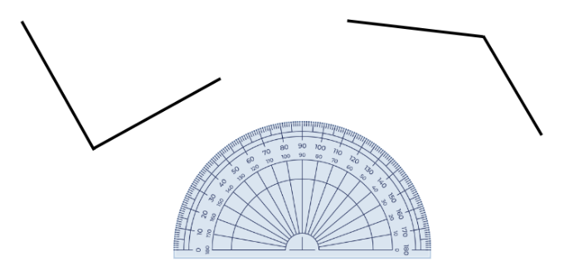

1. Draw lines to create a reflex angle. Explain that when an angle is created, internal and external angles can be measured. In this example, there is an acute angle and a reflex angle. Students [turn and talk](https://education.nsw.gov.au/teaching-and-learning/curriculum/literacy-and-numeracy/teaching-and-learning-resources/numeracy/talk-moves) to determine strategies to measure an angle larger than 180° (reflex angle).
2. Share responses, modelling the strategy on the displayed angles and recording the 2 angle measurements (see Figure 5).

Figure 5 – internal and external angles

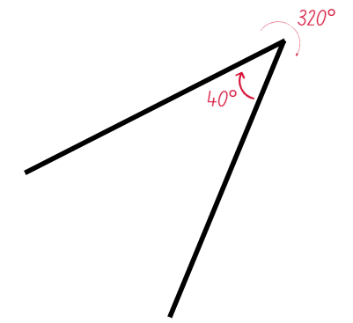

The table below outlines stimulus prompts to generate conversation about the topic, along with anticipated responses from students.

|  |  |
| --- | --- |
| Prompts | Anticipated student responses |
| * What do you notice about the relationship between the internal and external angles? | * They add to make 360° or an angle of revolution. |
| * How can I use this knowledge to help me know the size of an angle that is tricky to measure with a normal protractor? | * I could measure the corresponding angle and subtract it from 360° to find the size of the tricky angle. |
| * If there was an additional arm attached to the vertex, how would this relationship change? | * One of the current angles would be split into 2 smaller angles. All angles would still combine to make an angle of revolution or 360°. |

1. Provide students with Resource 11 – measuring angles and a protractor. Students measure and record angles individually.
2. Regroup and discuss answers.
3. Model how to create the following angles, highlighting the importance of using a ruler to draw straight lines:

* a 15° angle
* a 150° angle
* a 265° angle.

1. Students practice measuring and drawing the following angles in their workbooks:

* a 35° angle
* a 120° angle
* a 290° angle.

1. Students swap with a partner to check accuracy and receive peer feedback.

This table details opportunities for differentiation.

|  |  |
| --- | --- |
| Too hard? | Too easy? |
| Students cannot measure and create angles of up to 360° using a protractor.   * Revise how to measure and draw simpler angles, including right angles and straight-line angles. Students measure and record angles using Resource 8 – a numberless protractor. | Students can measure and create angles of up to 360° using a protractor.   * Explore angles in sport, such as leaps and flips in gymnastics or break-dancing dance moves. Represent the angles using numbers, diagrams and words. |

## Consolidation and meaningful practice – 20 minutes

1. Using grid paper, students write their first name using a lead pencil and a ruler to create straight lines (see Figure 6).

Figure 6 – student name example

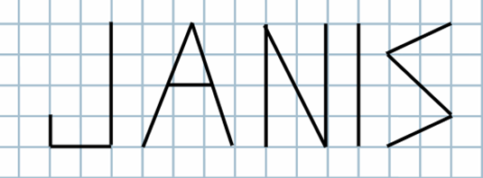

1. Students measure and record the angles in their names (see Figure 7).

Figure 7 – angles recorded

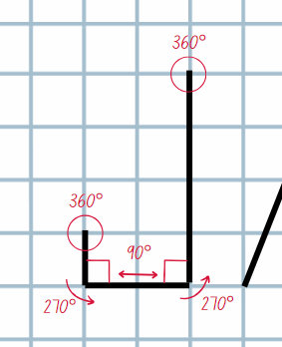

1. Provide students with Resource 12 – angle tally. Students use a tally table to determine how many angle types appear in their name.
2. If time allows, repeat with a name or word of their choice, including their last name, nickname or favourite sports team.

This table details opportunities for assessment.

|  |  |
| --- | --- |
| Assessment opportunities | Links |
| What to look for:   * Can students measure angles of up to 360° using a protractor? **[MAO-WM-01, MA3-GM-03]** * Can students create angles of up to 360° using a protractor? **[MAO-WM-01, MA3-GM-03]** * Can students recognise that a right angle is 90°, a straight angle is 180° and an angle of revolution is 360°?  **[MAO-WM-01, MA3-GM-03]** * Can students identify and describe angle size in degrees for the classifications acute, obtuse and reflex?  **[MAO-WM-01, MA3-GM-03]** | Links to [National Numeracy Learning Progressions](https://www.australiancurriculum.edu.au/resources/national-literacy-and-numeracy-learning-progressions/version-3-of-national-literacy-and-numeracy-learning-progressions/) (NNLP):   * UuM7-UuM8. |

# Lesson 5

**Core concept**: angles can be created and measured to solve problems.

## Daily number sense – stock feed store – 10 minutes

Daily number sense activities for Lessons 5 to 7 ‘loop’ back to concepts and procedures covered in previous units to assist students to build an increasingly connected network of ideas. These concepts may differ from the core concepts being covered by the unit.

The table below contains a suggested learning intention and success criteria. These are best co-constructed with students.

|  |  |
| --- | --- |
| Daily number sense learning intention | Daily number sense success criteria |
| Students are learning to:   * solve problems involving addition and subtraction of fractions with the same denominator. | Students can:   * solve word problems that involve fractions with the same denominator * use diagrams, objects and mental strategies to subtract a unit fraction from any whole number including 1. |

1. Display and read Resource 13 – stock feed store. Support student understanding of the context words.
2. Use the [think-aloud](https://evidenceforlearning.org.au/news/planning-a-think-aloud-in-mathematics) strategy to model a solution for problem one.

**Note**: questions 3 and 4 from Resource 13 – stock feed store have more than one step.

1. Students complete each question in Resource 13 – stock feed store, recording answers and representations in their workbook.
2. Select students to share and justify their solutions. Record representations of strategies on the board.

This table details opportunities for assessment.

|  |  |
| --- | --- |
| Assessment opportunities | Links |
| What to look for:   * Can students solve word problems that involve fractions with the same denominator? **[MAO-WM-01, MA3-RQF-02]** * Can students use diagrams, objects and mental strategies to subtract a unit fraction from any whole number including 1?  **[MAO-WM-01, MA3-RQF-02]** | Links to [National Numeracy Learning Progressions](https://www.australiancurriculum.edu.au/resources/national-literacy-and-numeracy-learning-progressions/version-3-of-national-literacy-and-numeracy-learning-progressions/) (NNLP):   * InF7, InF8. |

## Core lesson – NSW flight plans – 40 minutes

The table below contains suggested learning intentions and success criteria. These are best co-constructed with students.

|  |  |
| --- | --- |
| Core concept learning intentions | Core concept success criteria |
| Students are learning to:   * estimate, measure and compare angles using degrees * use a protractor to measure and identify types of angles. | Students can:   * record angle measurements using the symbol for degrees (°) * measure angles of up to 360° using a protractor * create angles of up to 360° using a protractor. |

1. Display Resource 14 – outback courier. Explain that an outback courier needs to deliver freight to towns in NSW and flying to them is the fastest way. The courier’s first journey is from Moree to Broken Hill via Armidale, Cobar, Orange and Wagga Wagga. The pilot would like the angles of the turns to be measured.
2. Demonstrate how to estimate and then measure an angle from Resource 14 – outback courier using a protractor and record using the degree symbol (°).

**Note**: provide Resource 10 – using a protractor for students that need revision on how to use a protractor correctly.

1. Provide students with Resource 14 – outback courier and a protractor. Students estimate and then measure all the angles and record using the degree symbol.
2. Regroup and share answers, recording on the displayed Resource 14 – outback courier. If any discrepancies in measurements arise, ask students to remeasure and discuss.
3. Display Resource 15 – NSW flight paths and explain to students that they will create 3 flight plans for the outback courier, from:

* Sydney to Armidale via Wagga Wagga, Orange and Broken Hill
* Wagga Wagga to Lismore, via Bega, Cobar and Coffs Harbour
* Coffs Harbour to Broken Hill, via Lismore, Armidale, Moree and Orange.

1. For each flight plan, students need to estimate and record the flight path in one colour, then measure the angle of the turns and record using the degree symbol in a different colour (see Figure 8).

Figure 8 – student example measuring and recording angles

Map of NSW with towns marked and a flight path from Coffs Harbour to Moree, Newcastle, Dubbo, Wagga Wagga and Mildura.

The angles of each turn is estimated and then measured and recorded using the degree symbol.

1. Provide students with Resource 15 – NSW flight paths, a protractor, a ruler and writing materials to create their flight plans.
2. Students compare angle measurements with a partner to check for understanding.

This table details opportunities for differentiation.

|  |  |
| --- | --- |
| Too hard? | Too easy? |
| Students cannot measure and create angles of up to 360° using a protractor.   * Students measure and record angles using Resource 8 – a numberless protractor. * Assist students with positioning the protractor, particularly with Steps 3 and 4 in Resource 10 – using a protractor. Help them to start counting from zero, holding the protractor steady to ensure accuracy. | Students can measure and create angles of up to 360° using a protractor.   * Students measure and record the external angles of each turn. * Students determine a flight plan with angles adding as closely to 360° as possible. |

## Discuss and connect the mathematics – 10 minutes

1. Regroup and summarise the lesson together, drawing out key mathematical ideas. Ask the following questions:

* How did you ensure that your measurements were accurate?
* Did you have a strategy to create and measure your flight paths? Explain.
* Were your estimations close to the recorded angle?
* Was there an angle that surprised you when you recorded it?

This table details opportunities for assessment.

|  |  |
| --- | --- |
| Assessment opportunities | Links |
| What to look for:   * Can students record angle measurements using the symbol for degrees (°)? **[MAO-WM-01, MA3-GM-03]** * Can students measure angles of up to 360° using a protractor? **[MAO-WM-01, MA3-GM-03]** * Can students create angles of up to 360° using a protractor? **[MAO-WM-01, MA3-GM-03]** | Links to [National Numeracy Learning Progressions](https://www.australiancurriculum.edu.au/resources/national-literacy-and-numeracy-learning-progressions/version-3-of-national-literacy-and-numeracy-learning-progressions/) (NNLP):   * UuM7, UuM8. |

# Lesson 6

**Core concept**: angles can be created and measured to solve real-world problems.

## Daily number sense – closest to the whole – 15 minutes

The table below contains a suggested learning intention and success criteria. These are best co-constructed with students.

|  |  |
| --- | --- |
| Daily number sense learning intention | Daily number sense success criteria |
| Students are learning to:   * solve problems involving addition and subtraction of fractions with the same denominator. | Students can:   * use diagrams, objects and mental strategies to subtract a unit fraction from any whole number. |

**Note**:fraction cards onResource 16 – fractions require cutting out prior to starting the game.

1. Provide pairs with Resource 16 – fractions, a 9-sided die and 2 individual whiteboards.

**Note**: if the 9-sided dice have zero, explain to students that it will represent 10 for this game.

1. Explain the game:
2. One player rolls the die to get the starting whole number. Both players flip a card from Resource 16 – fractions. The card determines the unit fraction that will be subtracted from the whole number.
3. Each player draws a number line on their whiteboard, marking the fractional parts and recording the solution as a subtraction (see Figure 9).

Figure 9 – closest to whole example

A whiteboard with Player 1 marked, and below it is a 9-sided die and the fraction half. 

The equation: 9 − 1/2 = 8 ½ is displayed. There is also a number line with 8 and 9 marked and half marked between them. There is an arrow representing a jump back from 9 to the 1/2 marked on the number line.

The whiteboard also displays Player 2 marked and below it is a 9-sided die and the fraction 1/5.

The equation: 9 − 1/5 = 8 4/5. There is a number line with 8 and 9 marked, and 1/5, 2/5, 3/5 and 4/5 are marked between them. There is an arrow representing a jump back from 9 to the 4/5 marked on the number line.


1. Players identify which answer is closest to the starting whole number and award that player a point.
2. Repeat until a player reaches 11 points and is declared the winner.

This table details an opportunity for assessment.

|  |  |
| --- | --- |
| Assessment opportunity | Links |
| What to look for:   * Can students use diagrams, objects and mental strategies to subtract a unit fraction from any whole number?  **[MAO-WM-01, MA3-RQF-02]** | Links to [National Numeracy Learning Progressions](https://www.australiancurriculum.edu.au/resources/national-literacy-and-numeracy-learning-progressions/version-3-of-national-literacy-and-numeracy-learning-progressions/) (NNLP):   * InF7, InF8. |

## Core lesson – Australian flight plans – 25 minutes

The table below contains suggested learning intentions and success criteria. These are best co-constructed with students.

|  |  |
| --- | --- |
| Core concept learning intentions | Core concept success criteria |
| Students are learning to:   * estimate, measure and compare angles using degrees * use a protractor to measure and identify types of angles. | Students can:   * record angle measurements using the symbol for degrees (°) * measure angles of up to 360° using a protractor * create angles of up to 360° using a protractor. |

**Note**: Resource 17 – Australian flight paths should be copied back-to-back for each student prior to the lesson. Students are only required to use 3 of the 4 maps of Australia for the core lesson. The fourth map can be used for the ‘Too easy?’ differentiation activity.

1. Explain that the outback courier from Lesson 5 is now expanding their business to be Australia-wide and students will be creating 3 different flight paths using a map of Australia. Each flight path needs to include 6 towns (see Figure 10).

Figure 10 – Australian flight plan example

Map of Australia with towns marked and a flight path from Townsville to Brisbane (80 degrees), Broken Hill to Birdsville (82 degrees), Birdsville to Esperance (105 degrees), Esperance to Carnarvon (91 degrees) and Broome. 

The angles of each turn is measured and recorded using the degree symbol.

1. Provide students with Resource 17 – Australian flight paths, a protractor and a ruler. Students create and measure 3 different flight paths, individually or in pairs.
2. Students compare, discuss and check the measurements of a partner’s created flight path(s).

This table details opportunities for differentiation.

|  |  |
| --- | --- |
| Too hard? | Too easy? |
| Students cannot measure and create angles of up to 360° using a protractor.   * Students measure and record angles using Resource 8 – a numberless protractor. Assist students with positioning the protractor, particularly with Steps 3 and 4 in Resource 10 – using a protractor. * Reduce the number of angles included in the flight paths. | Students can measure and create angles of up to 360° using a protractor.   * Students measure and record the external angles of each turn. * Students create a flight path, including at least 4 towns using one of each of the angles: acute, obtuse, right and reflex. Students measure and record each angle. |

## Consolidation and meaningful practice – 20 minutes

1. Explain that the outback courier would like to rebrand with a new logo now that they are Australia-wide.
2. Students will design a new logo for the outback courier. The logo must include:

* a perpendicular line
* a 30° angle
* an obtuse angle
* an acute angle (see Figure 11).

Figure 11 – logo example

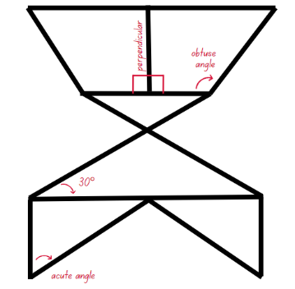

1. Students use a protractor and a ruler to design and create the logo.

**Note**: students could use technology or an app, such as [Canva](https://app.education.nsw.gov.au/digital-learning-selector/LearningTool/Card/653), to digitally create their logo.

1. Students conduct a [gallery walk](https://app.education.nsw.gov.au/digital-learning-selector/LearningActivity/Card/555). Ask:

* Can you identify the 4 design requirements?
* Were there any design elements incorporated in a logo that were interesting or creative? Explain.
* Did you experience any challenges during this activity? How did you overcome them?

This table details opportunities for assessment.

|  |  |
| --- | --- |
| Assessment opportunities | Links |
| What to look for:   * Can students record angle measurements using the symbol for degrees (°)? **[MAO-WM-01, MA3-GM-03]** * Can students measure angles of up to 360° using a protractor? **[MAO-WM-01, MA3-GM-03]** * Can students create angles of up to 360° using a protractor? **[MAO-WM-01, MA3-GM-03]** | Links to [National Numeracy Learning Progressions](https://www.australiancurriculum.edu.au/resources/national-literacy-and-numeracy-learning-progressions/version-3-of-national-literacy-and-numeracy-learning-progressions/) (NNLP):   * UuM7, UuM8. |

# Lesson 7

**Core concept**: mental strategies can help to calculate the duration of events.

## Daily number sense – road trip – 10 minutes

The table below contains a suggested learning intention and success criteria. These are best co-constructed with students.

|  |  |
| --- | --- |
| Daily number sense learning intention | Daily number sense success criteria |
| Students are learning to:   * solve problems involving addition and subtraction of fractions with the same denominator. | Students can:   * solve word problems that involve fractions with the same denominator. |

1. Display and read Resource 18 – road trip. Support student understanding of the context words.
2. Provide students with Resource 18 – road trip. Students complete each question, recording solutions using a bar model or drawing.
3. Select students to share, justifying their solutions and strategies to the problems.
4. Record representations of solutions on the board.

This table details an opportunity for assessment.

|  |  |
| --- | --- |
| Assessment opportunity | Links |
| What to look for:   * Can students solve word problems that involve fractions with the same denominator? **[MAO-WM-01, MA3-RQF-02]** | Links to [National Numeracy Learning Progressions](https://www.australiancurriculum.edu.au/resources/national-literacy-and-numeracy-learning-progressions/version-3-of-national-literacy-and-numeracy-learning-progressions/) (NNLP):   * N/A. |

## Core lesson 1 – 24-hour time – 10 minutes

The table below contains a suggested learning intention and success criteria. These are best co-constructed with students.

|  |  |
| --- | --- |
| Core concept learning intention | Core concept success criteria |
| Students are learning to:   * solve problems involving duration, using 12- and 24-hour time. | Students can:   * use start and finish times to calculate the elapsed time of events * add and subtract time mentally using bridging strategies. |

1. Revise that 24-hour time is used to avoid confusion between am and pm. It is used by emergency services, airlines, military forces and public transport services for clear communication of time.
2. Display Resource 19 – 24-hour time. Record some of the bell times of the school day. For example, school begins at 8:55 am, recess ends at 11:20 am and lunch begins at 1:10 pm.
3. Provide students with whiteboards to write the 24-hour time for the bell times. For example, 08:55, 11:20 and 13:10.
4. Practice saying the 24-hour times aloud, ‘zero eight fifty-five hours’, ‘eleven twenty hours’, ‘thirteen ten hours’.

## Core lesson 2 – bridging strategy – 15 minutes

1. Revise that a blank number line can be used to find the duration (difference between 2 times) using jumps.
2. Display Resource 20 – duration problems.
3. Draw an empty number line on the board. Use the [think-aloud](https://evidenceforlearning.org.au/news/planning-a-think-aloud-in-mathematics) strategy to model recording on the empty number line to solve the first problem (see Figure 12).

Figure 12 – blank number line demonstration

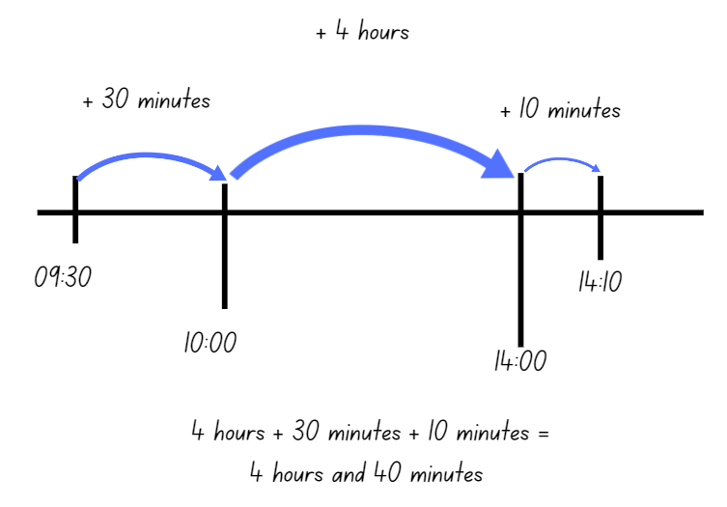

1. Students complete the remaining duration problems using jumps of time on a blank number line.
2. Select students to share and explain how they used the number line to find solutions. Ask:

* Did you find the empty number line useful for calculating elapsed time? Why or why not?
* Can you think of any other strategies you could use to calculate elapsed time?

This table details opportunities for differentiation.

|  |  |
| --- | --- |
| Too hard? | Too easy? |
| Students cannot use start and finish times to calculate the elapsed time of events.   * Provide students with duration problems that only require jumps of hours or half hours from the ‘o’clock’. * Provide students with a hands-on clock that can be used to visually model the elapsed time. | Students can start and finish times to calculate the elapsed time of events.   * Students mentally calculate the total duration of all flights in Resource 20 – duration problems. * Students create their own elapsed time question for a partner to solve. |

## Consolidation and meaningful practice – 25 minutes

1. Provide each student with a copy of Resource 21 – airline flight timetable.
2. Students practice the duration problems. Encourage students to add and subtract time mentally using bridging strategies.

**Note**: a blank number line can support students in transitioning to mental strategies.

1. Select students to share and justify their solutions. Ask:

* Why is solving elapsed time a useful skill?
* What makes 24- hour time on a timetable an efficient way to communicate information?
* Why is it important to read timetables correctly?

This table details opportunities for assessment.

|  |  |
| --- | --- |
| Assessment opportunities | Links |
| What to look for:   * Can students use start and finish times to calculate the elapsed time of events? **[MAO-WM-01, MA3-NSM-02]** * Can students add and subtract time mentally using bridging strategies? **[MAO-WM-01, MA3-NSM-02]** | Links to [National Numeracy Learning Progressions](https://www.australiancurriculum.edu.au/resources/national-literacy-and-numeracy-learning-progressions/version-3-of-national-literacy-and-numeracy-learning-progressions/) (NNLP):   * MeT4, MeT5. |

# Lesson 8

**Core concept**: commonly used time intervals and duration can be represented as decimals.

## Daily number sense – 10 minutes

1. From a class need surfaced through formative assessment data, identify a short, focused activity that targets students’ knowledge, understanding and skills. Example activities may be drawn from the following resources:

* [Mathematics K–6 resources](https://education.nsw.gov.au/teaching-and-learning/curriculum/mathematics/mathematics-curriculum-resources-k-12/mathematics-k-6-resources)
* [Universal Resources Hub](https://resources.education.nsw.gov.au/home).

## Core lesson 1 – time intervals – 10 minutes

The table below contains a suggested learning intention and success criteria. These are best co-constructed with students.

|  |  |
| --- | --- |
| Core concept learning intention | Core concept success criteria |
| Students are learning to:   * solve problems involving duration, using 12- and 24-hour time. | Students can:   * represent commonly used time intervals as decimals * solve a variety of problems involving duration, including where times are expressed in 12-hour and 24-hour notation. |

1. Explain that decimals can be used to represent commonly used time intervals.
2. Display Resource 22 – decimal misconceptions. Students [turn and talk](https://education.nsw.gov.au/teaching-and-learning/curriculum/literacy-and-numeracy/teaching-and-learning-resources/numeracy/talk-moves), discussing whether they think Bec or David is correct, justifying their answer.
3. Select students to share and communicate their reasoning.
4. Record the following time intervals on the board, one at a time:

* 5 hours and 15 minutes
* 3 hours and 30 minutes
* 7 hours and 45 minutes
* 6 hours.

1. Students convert the time intervals to decimals and record their answers on individual whiteboards. Check for understanding, address any misconceptions and errors observed after each time interval is recorded.

## Core lesson 2 – timetable problems – 30 minutes

1. Display Resource 23 – train timetable.
2. Pose the problem: Kylie had to travel from Sydney to Wauchope. How long is the journey? How could this time interval be converted into a decimal?
3. Students mentally calculate the answer, recording it on their whiteboard.
4. Explain: Kylie’s train ride was 6 hours and 45 minutes long. Explain that 6 hours and 45 minutes can be represented as 6.75 hours in decimal notation, as 45 minutes is 0.75 or three-quarters of an hour.

**Note**: practice more converting times to decimals at this point if need arises.

1. Distribute Resource 24 – timetable problems. Students work independently to solve the problems and record their answer in decimal notation.

This table details opportunities for differentiation.

|  |  |
| --- | --- |
| Too hard? | Too easy? |
| Students cannot mentally calculate elapsed time using bridging strategies.   * Model how to use an empty number line to calculate the time and represent their thinking. * Provide students with a hands-on clock that can be used to visually model the elapsed time. | Students can mentally calculate elapsed time using bridging strategies.   * Students mentally calculate the duration of a trip from Sydney to Casino. If the train was delayed by 10 minutes at each stop along the way, what was the total duration? Students record the time in decimal notation. * Students create their own elapsed time questions for a partner to mentally solve. |

## Discuss and connect the mathematics – 10 minutes

1. Regroup and ask students to share the solutions. Ask:

* What is challenging about writing time intervals in decimal notation?
* Which format of time is less confusing for timetables, 12-hour or 24-hour? Why?
* Why is it important to read timetables correctly?

This table details opportunities for assessment.

|  |  |
| --- | --- |
| Assessment opportunities | Links |
| What to look for:   * Can students represent commonly used time intervals as decimals? **[MAO-WM-01, MA3-NSM-02]** * Can students solve a variety of problems involving duration, including where times are expressed in 12-hour and 24-hour notation? **[MAO-WM-01, MA3-NSM-02]** | Links to [National Numeracy Learning Progressions](https://www.australiancurriculum.edu.au/resources/national-literacy-and-numeracy-learning-progressions/version-3-of-national-literacy-and-numeracy-learning-progressions/) (NNLP):   * MeT5. |

# Resource 1 – place value houses

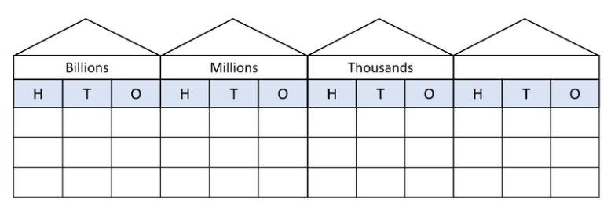

# Resource 2 – place value representations

Text reads: ‘Sam has recorded 4 ways to represent the number 25 493 621.’ The 4 representations are: A) Expanded form with addition, B) Digit place value breakdown, C) Written in words and D) Another expanded form with addition inaccuracies.

Next to the number, a green check mark or red cross asks if the representations are accurate. Students are encouraged to verify and explain to a partner.

# Resource 3 – angle categories

Seven angle categories.

The first is a right angle with text that reads: 2 perpendicular straight lines or arms that meet at a vertex which makes a square.

The second is an acute angle with text that reads: 2 straight lines or arms that meet at a vertex, making an angle that is less than a right angle.

The third is an obtuse angle with text that reads: 2 straight lines or arms that meet at a vertex, making an angle that is greater than a right angle.

The fourth is perpendicular with a red line meeting a blue line at 90 degrees.

The fifth is a reflex angle with text that reads: 2 straight lines or arms that meet at a vertex, making an angle that is greater than a straight angle but less than a revolution.

The sixth is a straight angle with text that reads: A straight line or arm.

The seventh is an angle of revolution text that reads: 2 straight lines or arms. One arm makes a complete turn, a full rotation.

# Resource 4 – identifying triangles



# Resource 5 – triangles and quadrilaterals

Various two-dimensional shapes. There are 3 triangles: isosceles, equilateral and scalene. 

There are also 6 quadrilaterals: square, parallelogram, kite, rhombus, rectangle and trapezium.

# Resource 6 – properties of shapes

|  |  |  |  |  |  |  |  |  |  |
| --- | --- | --- | --- | --- | --- | --- | --- | --- | --- |
| Properties | Equilateral triangle | Isosceles triangle | Scalene triangle | Square | Rectangle | Rhombus | Parallelogram | Kite | Trapezium |
| Properties of sides |  |  |  |  |  |  |  |  |  |
| Properties of angles |  |  |  |  |  |  |  |  |  |
| Line symmetry properties |  |  |  |  |  |  |  |  |  |

# Resource 7 – taking turns

A 5 by 5 grid featuring a variety of items. 

From the top-left corner around the edge of the grid clockwise is: a plant, a sink, a window, a cabinet, an open door, wall art, a laptop, a bean bag, a bookcase, a presentation board, an easel, a notebook, a desk with a clock, an armchair, a monitor with a stand and a pencil holder.

In the middle of the grid is an icon representing a person.

# Resource 8 – a numberless protractor

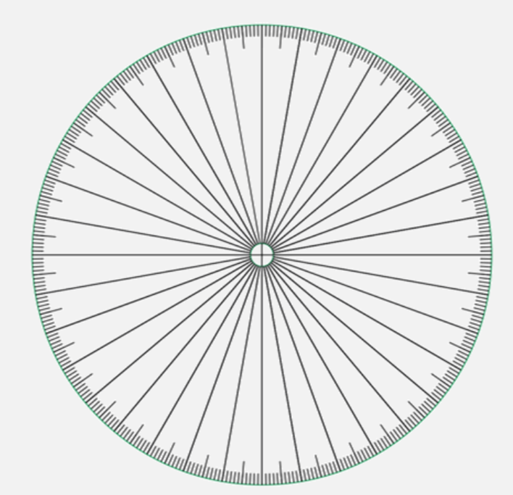

Adapted from Francome (2016).

# Resource 9 – tangram art



# Resource 10 – using a protractor

Six steps for using a protractor to measure an angle.

Step 1: Get a clear and good-sized protractor. There is also an image of a protractor with an arrow pointing to the centre with text that reads ‘Centre point of the protractor’.

Step 2: Find an angle you want to measure. The angle is the amount of turn between the arms, shown in red. There is an angle with the labels: arm, angle and vertex.

Step 3: Place the protractor on the angle. Make sure to place the centre point of the protractor on the vertex of the angle. There is a protractor with an arrow pointing to the centre with text that reads ‘Place centre point of protractor on vertex of angle’. There are 2 arrows on the protractor positioned to form an angle and are pointing to 120° and 164°.

Step 4: Rotate the protractor so that the bottom line aligns with the bottom arm of the angle. There is a protractor with 2 arrows on it. The arrows are positioned to form an angle and are pointing at 135° and 180°.

Step 5: Read the protractor carefully and accurately starting from 0. Use your finger to trace the angle from the arm at 0 to the other arm. There is a protractor with 2 arrows on it. The arrows are positioned to form an angle and are pointing at 135° and 180°. There is also an arrow pointing to the arrow at 180°.

Step 6: If angle is facing the other way, use the top scale to read the angle. Always start from 0°. There is a protractor with 2 arrows on it. The arrows are positioned to form an angle and are pointing at 0° and 45°. There is also an arrow pointing at 0° with text that reads ‘Using the top scale (black numbers), you start from zero and this angle reads 45°.

# Resource 11 – measuring angles

Six question cards with various angles labelled ‘a’, ‘b’ and/or ‘c’ that students need to measure the internal and external angle and record. 

Each card contains text that reads ‘a =’, ‘b =’ and/or ‘c =’ with blank space for answers.

# Resource 12 – angle tally

|  |  |  |  |  |  |  |
| --- | --- | --- | --- | --- | --- | --- |
| Angle classification | Tally | Total |  | Angle classification | Tally | Total |
| acute angle |  |  |  | acute angle |  |  |
| right angle |  |  |  | right angle |  |  |
| obtuse angle |  |  |  | obtuse angle |  |  |
| reflex angle |  |  |  | reflex angle |  |  |
| angle of revolution |  |  |  | angle of revolution |  |  |
| straight angle |  |  |  | straight angle |  |  |

# Resource 13 – stock feed store

The local produce store makes bags of chicken feed.

Answer these questions using a paper strip, a drawing, bar model or number line to show your thinking.

1. $\frac{5}{8}$ of each bag is corn. $\frac{3}{8}$ of each bag is wheat. What fraction of each bag is made from corn and wheat?
2. Two farmers have one open bag of chicken feed each. One is $\frac{5}{6}$ full and the other is $\frac{4}{6}$ full. How much chicken feed do the farmers have altogether?
3. A farmer has one bag of chicken feed that is 75% full. They use half of a full bag to feed their chickens. How much would they now have left?
4. If each bag has a mass of 20 kg, how much would a bag weigh if $\frac{2}{10}$ had been used?
5. A farmer has used less than one-third of a full bag of chicken feed. Draw a diagram or number to show how much could remain in that bag.

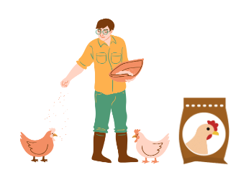

# Resource 14 – outback courier

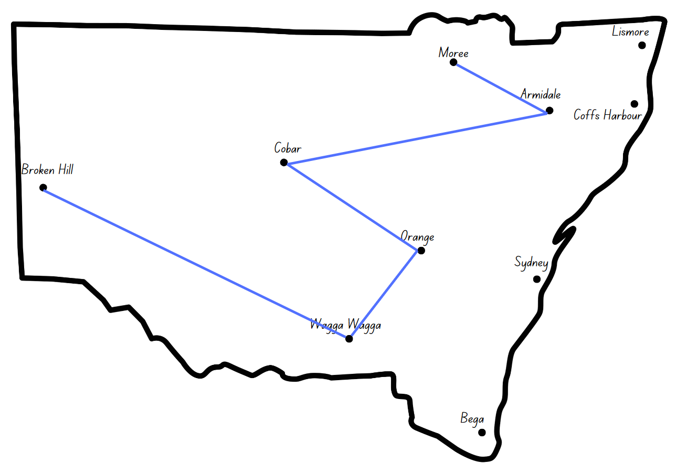

# Resource 15 – NSW flight paths

Outback courier – NSW flight plans. Instructions read: 1. Draw flight plan. 2. 1st colour: estimate and record the angle of the turns. 3. 2nd colour: measure and record the angle of the turns. 

There are 3 maps of NSW with towns marked: Lismore, Moree, Armidale, Coff harbour, Cobar, Dubbo, Newcastle, Broken Hill, Orange, Sydney, Mildura, Wagga Wagga and Bega.

One map is titled Sydney to Armidale via Wagga Wagga, Orange and Broken Hill. Another map is titled Coffs Harbour to Broken Hill via Lismore, Armidale, Moree and Orange. The last map is titled Wagga Wagga to Lismore via Bega, Cobar and Coffs Harbour.

# Resource 16 – fractions

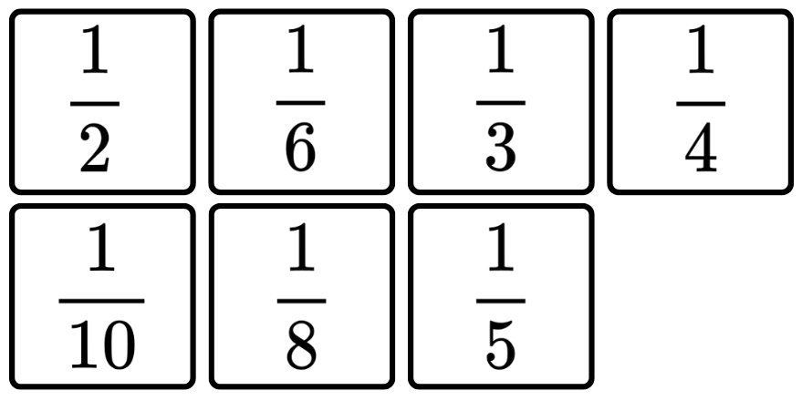

# Resource 17 – Australian flight paths

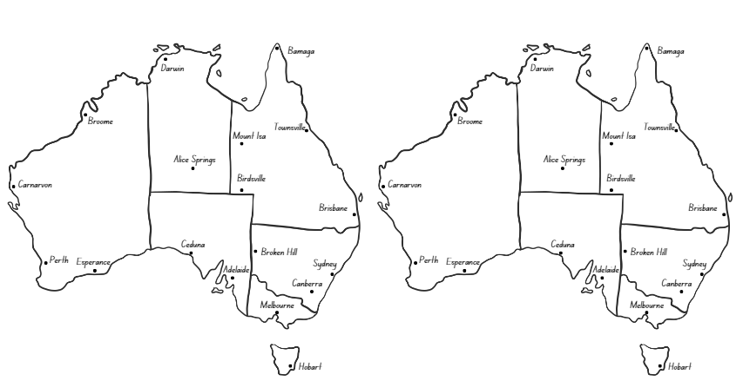



# Resource 18 – road trip

A family is driving across New South Wales.

Answer these questions, representing your thinking with either a bar model or a drawing.

1. On the first day, they drive two-fifths of the journey. The next day they drive a further $\frac{2}{5}$ of the journey. How much of the journey have they completed? How much of the journey remains?
2. On the first day, they use three-sixths of a tank of petrol. The next day, they use $\frac{2}{6}$ of a tank. What fraction of a tank have they used so far on the trip?
3. At the start of the third day, the tank is $\frac{7}{10}$ full. If the family use half of a tank of petrol that day, how much fuel is left?
4. If the total trip was 1000 kilometres, how far would the family have travelled after four-tenths of the journey?



# Resource 19 – 24-hour time

An evenly spaced number line that represents time on a clock. The first half is labelled ‘am’ and the second half is labelled ‘pm’. The number line is marked with each hour from Midnight on the left, through to Midday/Noon at the centre, and Midnight on the far right. 
The number line is marked with both 12- and 24- hour time, for example 12, 1, 2, 3 and so on up to 12 noon in the ‘am’ section, and from 00 to 24 in the ‘pm’ section. 
Below the number line is a clock made of 2 circles. The inner circle shows a regular analogue clock with the clock arms indicating that it is 4 o’clock. The outer circle shows the 24-hour time around the clock from 13 to 24.

# Resource 20 – duration problems

|  |  |
| --- | --- |
| Duration problems | Answer |
| * A plane took off from Sydney at 09:30 and landed in Darwin at 14:10. What was the duration of the flight? |  |
| * A plane took off from Melbourne at 11:30 and stopped in Sydney for one hour and 45 minutes before landing in Brisbane at 15:25. How long was the flight time from Melbourne to Brisbane? |  |
| * A 4 hour and 10-minute flight from Perth to Hobart landed at 21:50. What time did it take off from Perth? |  |
| * Lisa had to be at the airport one hour and 30 minutes before her flight. If she landed at 17:30 and her flight was 6 hours and 15 minutes long, what time did she need to be at the airport? |  |

# Resource 21 – airline flight timetable

|  |  |  |  |  |  |
| --- | --- | --- | --- | --- | --- |
| Flight no. | Depart  Sydney | Arrive  Adelaide | Depart  Adelaide | Arrive  Perth | Total duration from Sydney to Perth (including stopover) |
| 1 | 06:30 | 08:30 | 10:00 | 13:30 |  |
| 2 | 08:40 | 10:40 | 12:10 | 15:40 |  |
| 3 | 10:50 | 12:50 | 14:20 | 17:50 |  |
| 4 | 11:30 | 13:50 | 15:20 | 18:50 |  |
| 5 | 14:00 | 16:00 | 17:30 | 21:00 |  |
| 6 | 15:50 | 17:50 | 19:20 | 22:50 |  |

# Resource 22 – decimal misconceptions

Decimal misconceptions for students to discuss who is correct, David or Bec.

Text reads: The class were asked to write how many hours and minutes are in 1.5 hours. David wrote: one hour and 30 minutes. Bec wrote: one hour and 50 minutes.

# Resource 23 – train timetable

|  |  |
| --- | --- |
| ****Destination**** | ****Departure time**** |
| Sydney | 07:00 |
| Gosford | 08:30 |
| Newcastle | 09:30 |
| Gloucester | 11:30 |
| Wauchope | 13:45 |
| Kempsey | 14:30 |
| Coffs Harbour | 16:00 |
| Grafton | 17:15 |
| Casino | 18:45 |

# Resource 24 – timetable problems

|  |  |
| --- | --- |
| ****Destination**** | Departure time |
| Sydney | 07:00 |
| Gosford | 08:30 |
| Newcastle | 09:30 |
| Gloucester | 11:30 |
| Wauchope | 13:45 |
| Kempsey | 14:30 |
| Coffs Harbour | 16:00 |
| Grafton | 17:15 |
| Casino | 18:45 |

1. If a passenger got on the train at Sydney and off at Gloucester. How long were they on the train?
2. Nadia travelled from Newcastle to Casino. How long was the journey?
3. Hugh went from Kempsey to Casino, but the train had to stop in Grafton for 1.5 hours. How long was his trip?
4. Phil got on the train at Wauchope and travelled to Coffs Harbour, but the train was delayed for 2 hours. How long was his trip?
5. Heidi travelled from Sydney to Gosford and back. She also had a 45-minute meeting. How long was she away from Sydney?

# Syllabus outcomes and content

The table below outlines the [syllabus outcomes](https://curriculum.nsw.edu.au/learning-areas/mathematics/mathematics-k-10-2022/overview) and range of relevant syllabus content covered in this unit. Content is linked to [National Numeracy Learning Progression](https://www.australiancurriculum.edu.au/resources/national-literacy-and-numeracy-learning-progressions/version-3-of-national-literacy-and-numeracy-learning-progressions/) (version 3).

|  |  |  |  |  |  |  |  |  |
| --- | --- | --- | --- | --- | --- | --- | --- | --- |
| Outcomes and content | 1 | 2 | 3 | 4 | 5 | 6 | 7 | 8 |
| **Represents numbers A**: Whole numbers: Apply place value to partition, regroup and rename numbers to 1 billion  **[MAO-WM-01, MA2-RN-01]** |  |  |  |  |  |  |  |  |
| * Recognise 1000 thousands is 1 million and 1000 millions is 1 billion | x |  | x |  |  |  |  |  |
| * Regroup numbers in different forms (Reasons about quantity) | x | x |  |  |  |  |  |  |
| * Partition numbers to 1 billion in non-standard forms | x |  | x |  |  |  |  |  |
| **Representing quantity fractions A**: Solve problems involving addition and subtraction of fractions with the same denominator  **[MAO-WM-01, MA3-RQF-01, MA3-RQF-02]** |  |  |  |  |  |  |  |  |
| * Solve word problems that involve fractions with the same denominator |  |  |  |  | x |  | x |  |
| * Use diagrams, objects and mental strategies to subtract a unit fraction from any whole number including 1 (the complement principle) |  |  |  |  | x | x |  |  |
| **Geometric measure A**: Angles: Estimate, measure and compare angles using degrees  **[MAO-WM-01, MA3-GM-03]** |  |  |  |  |  |  |  |  |
| * Identify the arms and vertex of an angle where both arms are invisible, such as for rotations |  |  | x |  |  |  |  |  |
| * Explain how a protractor is formed and used to measure an angle |  |  | x |  |  |  |  |  |
| * Estimate and describe the size of angles using known angles as benchmarks (Reasons about mental rotation) |  |  | x |  |  |  |  |  |
| * Record angle measurements using the symbol for degrees (°) |  |  | x |  | x | x |  |  |
| * Measure angles of up to 360° using a protractor |  |  |  | x | x | x |  |  |
| **Geometric measure A**:Angles: Use a protractor to measure and identify types of angles  **[MAO-WM-01, MA3-GM-03]** |  |  |  |  |  |  |  |  |
| * Create angles of up to 360° using a protractor |  |  |  | x | x | x |  |  |
| * Recognise that a right angle is 90°, a straight angle is 180° and an angle of revolution is 360° |  |  |  | x |  |  |  |  |
| * Identify and describe angle size in degrees for the classifications acute, obtuse and reflex |  |  |  | x |  |  |  |  |
| **Two-dimensional spatial structure A**: 2D shapes: Classify two-dimensional shapes and describe their properties  **[MAO-WM-01, MA3-2DS-01]** |  |  |  |  |  |  |  |  |
| * Identify and classify triangles as equilateral, isosceles or scalene triangles | x |  |  |  |  |  |  |  |
| * Recognise that triangles and quadrilaterals can be classified in more than one way (Reasons about spatial relations) | x |  |  |  |  |  |  |  |
| * Compare side and angle properties of triangles and quadrilaterals using measurement and symmetry |  | x |  |  |  |  |  |  |
| * Investigate the symmetry properties (line and rotational) of quadrilaterals |  | x |  |  |  |  |  |  |
| * Identify regular and irregular polygons |  | x |  |  |  |  |  |  |
| **Non-spatial measure B**: Time: Solve problems involving duration, using 12- and 24-hour time  **[MAO-WM-01, MA3-NSM-02]** |  |  |  |  |  |  |  |  |
| * **Use start and finish times to calculate the elapsed time of events** |  |  |  |  |  |  | x |  |
| * **Add and subtract time mentally using bridging strategies** |  |  |  |  |  |  | x |  |
| * Represent commonly used time intervals as decimals |  |  |  |  |  |  |  | x |
| * Solve a variety of problems involving duration, including where times are expressed in 12-hour and 24-hour notation |  |  |  |  |  |  |  | x |

[Mathematics K–10 Syllabus](https://curriculum.nsw.edu.au/learning-areas/mathematics/mathematics-k-10-2022/overview) © NSW Education Standards Authority (NESA) for and on behalf of the Crown in right of the State of New South Wales, 2022.

# References

This resource contains NSW Curriculum and syllabus content. The NSW Curriculum is developed by the NSW Education Standards Authority. This content is prepared by NESA for and on behalf of the Crown in right of the State of New South Wales. The material is protected by Crown copyright.

Please refer to the NESA Copyright Disclaimer for more information <https://educationstandards.nsw.edu.au/wps/portal/nesa/mini-footer/copyright>.

NESA holds the only official and up-to-date versions of the NSW Curriculum and syllabus documents. Please visit the NSW Education Standards Authority (NESA) website <https://educationstandards.nsw.edu.au> and the NSW Curriculum website [https://curriculum.nsw.edu.au](https://curriculum.nsw.edu.au/).

[Mathematics K–10 Syllabus](https://curriculum.nsw.edu.au/learning-areas/mathematics/mathematics-k-10-2022/overview) © NSW Education Standards Authority (NESA) for and on behalf of the Crown in right of the State of New South Wales, 2022.

[National Numeracy Learning Progression](https://www.australiancurriculum.edu.au/resources/national-literacy-and-numeracy-learning-progressions/version-3-of-national-literacy-and-numeracy-learning-progressions/) © Australian Curriculum, Assessment and Reporting Authority (ACARA) 2010 to present, unless otherwise indicated. This material was downloaded from the [Australian Curriculum](http://www.australiancurriculum.edu.au/) website (National Numeracy Learning Progression) (accessed 23 May 2024) and was not modified.

Askew M (2016) A Practical Guide to Transforming Primary Mathematics: Activities and tasks that really work, 1st edn, Routledge, Oxon.

Francome T (2016) ‘[Empty protractor](https://atm.org.uk/Mathematics-Teaching-Journal-Archive/Mathematics-Teaching-253/97346)’, Mathematics Teaching, Association of Teachers of Mathematics, accessed 2 August 2024.

NESA (NSW Education Standards Authority) (2022) ‘[Stage 3 – Teaching advice for Two-dimensional spatial structure A: 2D shapes](https://curriculum.nsw.edu.au/learning-areas/mathematics/mathematics-k-10-2022/content/stage-3/fad7c142c4?show=advice)’, Mathematics K–10 Syllabus: Content, NESA website, accessed 7 August 2024.

State of New South Wales (Department of Education) (2024) ‘[Mastermind](https://education.nsw.gov.au/teaching-and-learning/curriculum/mathematics/mathematics-curriculum-resources-k-12/thinking-mathematically-resources/mathematics-s1-s3-mastermind)’, Thinking mathematically resources, NSW Department of Education website, accessed 23 May 2024.

Van de Walle J, Karp K, Bay-Williams JM, Brass A, Bentley B, Ferguson S, Goff W, Livy S, Marshman M, Martin D, Pearn C, Prodromou T, Symons D and Wilkie K (2019) Primary and Middle Years Mathematics: Teaching Developmentally, 1st Australian edn, Pearson Education Australia, Melbourne.

Worldometer (2023) ‘[Population by Country](https://www.worldometers.info/world-population/population-by-country/)’, Population, Worldometer website, accessed 5 August 2024.

**© State of New South Wales (Department of Education), 2024**

The copyright material published in this resource is subject to the Copyright Act 1968 (Cth) and is owned by the NSW Department of Education or, where indicated, by a party other than the NSW Department of Education (third-party material).

Copyright material available in this resource and owned by the NSW Department of Education is licensed under a [Creative Commons Attribution 4.0 International (CC BY 4.0) license](https://creativecommons.org/licenses/by/4.0/).

[](https://creativecommons.org/licenses/by/4.0/)

This license allows you to share and adapt the material for any purpose, even commercially.

Attribution should be given to © State of New South Wales (Department of Education), 2024.

Material in this resource not available under a Creative Commons license:

* the NSW Department of Education logo, other logos and trademark-protected material
* material owned by a third party that has been reproduced with permission. You will need to obtain permission from the third party to reuse its material.

**Links to third-party material and websites**

Please note that the provided (reading/viewing material/list/links/texts) are a suggestion only and implies no endorsement, by the New South Wales Department of Education, of any author, publisher, or book title. School principals and teachers are best placed to assess the suitability of resources that would complement the curriculum and reflect the needs and interests of their students.

If you use the links provided in this document to access a third-party's website, you acknowledge that the terms of use, including licence terms set out on the third-party's website apply to the use which may be made of the materials on that third-party website or where permitted by the Copyright Act 1968 (Cth). The department accepts no responsibility for content on third-party websites.