Mathematics Stage 3 – Unit 20

Our number system extends infinitely to very large and very small numbers

Contents

Unit description and duration 5

Syllabus outcomes 5

Working mathematically 6

Student prior learning 6

Lesson overview and resources 8

Lesson 1 13

Daily number sense – decimal order – 10 minutes 13

Core lesson – integer bingo – 35 minutes 15

Discuss and connect the mathematics – 10 minutes 19

Lesson 2 21

Daily number sense – decimal order 2 – 10 minutes 21

Core lesson – estimation fun – 40 minutes 24

Discuss and connect the mathematics – 10 minutes 27

Lesson 3 29

Daily number sense – decimal ladder – 15 minutes 29

Core lesson – What strategy? – 20 minutes 32

Consolidation and meaningful practice – 25 minutes 36

Lesson 4 39

Daily number sense – 10 minutes 39

Core lesson – percentages in action – 20 minutes 39

Consolidation and meaningful practice – 25 minutes 43

Lesson 5 45

Daily number sense – What’s in the box? – 10 minutes 45

Core lesson – sale shopping – 35 minutes 47

Discuss and connect the mathematics – 10 minutes 50

Lesson 6 52

Daily number sense – rearrange arrays – 10 minutes 52

Core lesson – factorising numbers – 40 minutes 54

Discuss and connect the mathematics – 10 minutes 57

Lesson 7 59

Daily number sense – factors and multiples – 10 minutes 59

Core lesson – division as a fraction – 40 minutes 61

Discuss and connect the mathematics – 10 minutes 65

Lesson 8 67

Daily number sense – 10 minutes 67

Core lesson – camp mapping – 40 minutes 67

Consolidation and meaningful practice – 15 minutes 71

Resource 1 – decimal mix-up 73

Resource 2 – integer number line 74

Resource 3 – additive strategies 75

Resource 4 – What strategy? 76

Resource 5 – Frayer model 77

Resource 6 – bar models 78

Resource 7 – percentages jigsaw 79

Resource 8 – multiplication box 80

Resource 9 – 2-way radios 81

Resource 10 – super camping sale 82

Resource 11 – multiplicative properties 83

Resource 12 – camper breakfast problem 84

Resource 13 – Hugo, Jeremy, Rana 85

Resource 14 – word problems 86

Resource 15 – 100 grid 87

Resource 16 – Wanda’s ponder 88

Resource 17 – dividing jellybeans 89

Resource 18 – matching representations 90

Resource 19 – Which is equivalent? 91

Resource 20 – dividing wafers 92

Resource 21 – ‘Matching’ game 93

Resource 22 – camp adventure map 94

Resource 23 – camp adventure map 2 95

Resource 24 – blank Cartesian plane 96

Resource 25 – map design criteria 97

Syllabus outcomes and content 98

References 103

# Unit description and duration

This unit develops the big idea that our number system extends infinitely to very large and very small numbers.

In this 2-week unit students are provided opportunities to:

* recognise that negative whole numbers can result from subtraction
* make connections between benchmark fractions, decimals and percentages
* select and apply appropriate strategies to solve addition, subtraction, multiplication and division problems.

## Syllabus outcomes

* **MAO-WM-01** develops understanding and fluency in mathematics through exploring and connecting mathematical concepts, choosing and applying mathematical techniques to solve problems, and communicating their thinking and reasoning coherently and clearly
* **MA3-RN-01 applies an understanding of place value and the role of zero to represent the properties of numbers**
* **MA3-RN-02 compares and orders decimals up to 3 decimal places**
* **MA3-RN-03** determines percentages of quantities, and finds equivalent fractions and decimals for benchmark percentage values
* **MA3-AR-01 selects and applies appropriate strategies to solve addition and subtraction problems**
* **MA3-MR-01 selects and applies appropriate strategies to solve multiplication and division problems**
* **MA3-MR-02** constructs and completes number sentences involving multiplicative relations, applying the order of operations to calculations
* **MA3-GM-01** locates and describes points on a coordinate plane
* **MA3-2DS-02** selects and uses the appropriate unit to calculate areas, including areas of rectangles

## Working mathematically

In the Mathematics K–10 Syllabus, there is one overarching Working mathematically outcome (**MAO-WM-01**). The Working mathematically processes should be embedded within the concepts being taught. The Working mathematically processes present in the Mathematics K–10 Syllabus are:

* communicating
* understanding and fluency
* reasoning
* problem solving.

[Mathematics K–10 Syllabus](https://curriculum.nsw.edu.au/learning-areas/mathematics/mathematics-k-10-2022/overview) © NSW Education Standards Authority (NESA) for and on behalf of the Crown in right of the State of New South Wales, 2022.

## Student prior learning

Before engaging in these teaching and learning activities, students would benefit from prior experience with:

* locating and representing integers on a number line
* determining percentage discounts of 10%, 25% and 50%
* choosing and using efficient strategies to solve addition and subtraction problems.

In NSW classrooms there is a diverse range of students, including Aboriginal and/or Torres Strait Islander students, students learning English as an additional language or dialect, high potential and gifted students, and students with disability. Some students may identify with more than one of these groups or possibly all of them. Refer to [Curriculum planning for every student – advice](https://education.nsw.gov.au/teaching-and-learning/curriculum/planning-programming-and-assessing-k-12/advice-on-curriculum-planning-for-every-student-k-12) for further information.

# Lesson overview and resources

The table below outlines the sequence and approximate timing of lessons, learning intentions and resources.

|  |  |  |
| --- | --- | --- |
| Lesson | Content | Duration and resources |
| **Lesson 1**  **Daily number sense learning intention**:   * compare, order and represent decimals | **Lesson core concept**: negative whole numbers can result from subtraction.  **Core concept learning intention**:   * locate and represent integers on a number line | **Lesson duration**: 55 minutes   * Resource 1 – decimal mix-up * Resource 2 – integer number line * Website: [Dice](https://toytheater.com/dice/) * 10-sided (0–9) dice (2 per pair) * Individual whiteboards and markers * Writing materials |
| **Lesson 2**  **Daily number sense learning intention**:   * compare, order and represent decimals | **Lesson core concept**: rounding helps estimate and verify the reasonableness of numerical calculations.  **Core concept learning intention**:   * use estimation and place value understanding to determine the reasonableness of solutions | **Lesson duration**: 60 minutes   * 10-sided (0–9) dice * Calculators * Student workbooks * Writing materials |
| **Lesson 3**  **Daily number sense learning intention**:   * compare, order and represent decimals | **Lesson core concept**: identify efficient subtraction strategies and use place value for addition estimation.  **Core concept learning intentions**:   * apply efficient mental and written strategies to solve addition and subtraction problems * use estimation and place value understanding to determine the reasonableness of solutions | **Lesson duration**: 60 minutes   * Resource 3 – additive strategies * Resource 4 – What strategy? * Resource 5 – Frayer model * Playing cards or [interactive playing cards](https://toytheater.com/playing-cards/) * Individual whiteboards and markers * Writing materials |
| **Lesson 4**  **Daily number sense learning intention**:   * teacher-identified task based on student needs | **Lesson core concept**: represent percentages as fractions and decimals and find any quantity.  **Core concept learning intention**:   * make connections between benchmark fractions, decimals and percentages | **Lesson duration**: 55 minutes   * Resource 6 – bar models * Resource 7 – percentages jigsaw * Individual whiteboards * Writing materials |
| **Lesson 5**  **Daily number sense learning intention**:   * determine products and factors | **Lesson core concept**: benchmark percentages help to determine percentage discounts.  **Core concept learning intention**:   * determine percentage discounts of 10%, 25% and 50% | **Lesson duration**: 55 minutes   * Resource 8 – multiplication box * Resource 9 – 2-way radios * Resource 10 – super camping sale * Individual whiteboards * Student workbooks * Writing materials |
| **Lesson 6**  **Daily number sense learning intentions**:   * determine products and factors * calculate the areas of rectangles using familiar metric units | **Lesson core concept**: factorising numbers aids mental multiplication.  **Core concept learning intention**:   * select and apply mental and written strategies to multiply 2- and 3-digit numbers by 2-digit numbers | **Lesson duration**: 60 minutes   * Resource 11 – multiplicative properties * Resource 12 – camper breakfast problem * Resource 13 – Hugo, Jeremy, Rana * Resource 14 – worded problems * Individual whiteboards * Writing materials |
| **Lesson 7**  **Daily number sense learning intention**:   * determine products and factors | **Lesson core concept**: division can be recorded using fractions.  **Core concept learning intention**:   * use equivalent number sentences involving multiplication and division to find unknown quantities | **Lesson duration**: 60 minutes   * Resource 15 – 100 grid * Resource 16 – Wanda’s ponder * Resource 17 – dividing jellybeans * Resource 18 – matching representations * Resource 19 – Which is equivalent? * Resource 20 – dividing wafers * Resource 21 – ‘Matching’ game * Website: [Factors and Multiples Game](https://nrich.maths.org/games/factors-and-multiples-game) (interactive gameboard) * Digital devices * Individual whiteboards * Writing materials |
| **Lesson 8**  **Daily number sense learning intention**:   * teacher-identified task based on student needs | **Lesson core concept**: the Cartesian plane is useful when identifying specific coordinates.  **Core concept learning intention**:   * explore the Cartesian coordinate system | **Lesson duration**: 65 minutes   * Resource 22 – camp adventure map * Resource 23 – camp adventure map 2 * Resource 24 – blank Cartesian plane * Resource 25 – map design criteria * Sticky notes * Writing materials |

# Lesson 1

**Core concept**: negative whole numbers can result from subtraction.

## Daily number sense – decimal order – 10 minutes

Daily number sense activities for Lessons 1 to 3 ‘activate’ prior number knowledge and support the learning of new content in the unit. These activities can also assist teachers to identify the starting points for learning by revealing the extent of students’ existing knowledge.

The table below contains a suggested learning intention and success criteria. These are best co-constructed with students.

|  |  |
| --- | --- |
| Daily number sense learning intention | Daily number sense success criteria |
| Students are learning to:   * compare, order and represent decimals. | Students can:   * compare and order decimal numbers of up to 3 decimal places. |

1. Display Resource 1 – decimal mix-up.
2. Explain that the decimals have been all mixed up on the number line. Ask students to discuss the correct placement of each decimal.
3. Ask the following questions:

* Harriet says that 0.204 is larger than 0.21 because it has 3 digits after the decimal point. Is this correct? Is it always, sometimes or never a good way of thinking when ordering decimals?
* Why do you think that some students might place 0.01 before the zero on the number line?

1. Students draw the number line on individual whiteboards and record each decimal at the correct point on the number line. Encourage students to provide justification to explain their placement of the decimals.
2. To check for understanding, ask:

* Which decimal did you place on the number line first? Why?
* How did you know where to place 0.899?
* Which decimal is the smallest? How close is it to 0?

1. Draw the 0–1 number line on the board and model recording the decimals at the correct point on the number line. Allow students to check that their placement of the decimals is correct.

This table details an opportunity for assessment.

|  |  |
| --- | --- |
| Assessment opportunity | Links |
| What to look for:   * Can students compare and order decimal numbers of up to 3 decimal places? **[MAO-WM-01, MA3-RN-02]** | Links to [National Numeracy Learning Progressions](https://www.australiancurriculum.edu.au/resources/national-literacy-and-numeracy-learning-progressions/version-3-of-national-literacy-and-numeracy-learning-progressions/) (NNLP):   * NPV8.   Links to suggested [Interview for Student Reasoning](https://education.nsw.gov.au/teaching-and-learning/curriculum/literacy-and-numeracy/assessment-resources/ifsr) (IfSR) tasks:   * IfSR-NP: 4D.6 * IfSR-PT: 1A.4, 1A.5. |

## Core lesson – integer bingo – 35 minutes

The table below contains a suggested learning intention and success criteria. These are best co-constructed with students.

|  |  |
| --- | --- |
| Core concept learning intention | Core concept success criteria |
| Students are learning to:   * locate and represent integers on a number line. | Students can:   * use the term integers to describe positive and negative whole numbers and zero * recognise that negative whole numbers can result from subtraction. |

This task is an adaptation of [Salamander Shoot Out – 10 to 10](https://www.math-salamanders.com/math-addition-games.html#:~:text=PDF%20version-,Salamander%20Shoot%20Out%20to%2010,-Salamander%20Shoot%2Dout) from [Math Salamanders](https://www.math-salamanders.com/).

1. Review the terms integer, positive numbers, negative numbers and whole numbers.

**Integer**:a whole number, positive, negative or zero. For example, −3, −2, −1, 0, 1, 2 …

**Negative number**:a number less than zero, written with a minus sign. These integers are read as, for example, ‘negative 3’, not ‘minus 3’.

1. Display Resource 2 – integer number line. To check for understanding, ask:

* What does the word integer mean? (a whole number, positive, negative or zero)
* What do we call the numbers to the left of the zero on this number line? (negative numbers)
* How do we read −5? (negative 5).

1. Display an [interactive dice](https://toytheater.com/dice/) and select the option to roll 2 blue 10-sided dice. Use the 2 numbers rolled to create a subtraction that results in a negative number.
2. Model using the number line and the jump strategy to solve the subtraction. For example, 3 − 5 = −2 (see Figure 1).

Figure 1 – jump strategy

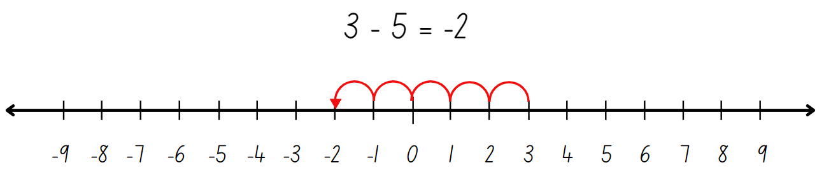

1. Provide students with a copy of Resource 2 – integer number line in a plastic sleeve and a whiteboard marker. Alternatively, students recreate the number line −9 to 9 on their whiteboards.
2. Roll the [interactive dice](https://toytheater.com/dice/) and use the 2 numbers rolled to create a subtraction sentence.
3. Students use the number line to solve the subtraction and record the number sentence.

**Note**: ensure negative numbers result from the subtraction. For example, if a 3 and 4 are rolled, arrange the numbers 3 − 4 = rather than 4 − 3 = to ensure students are exposed to negative whole numbers that result from subtraction.

1. Repeat 3 to 5 times. Monitor student responses, check for understanding and provide feedback as necessary.
2. In pairs, students play a game of ‘Integer subtraction bingo’.
3. Explain the rules:
4. Each student draws a 3 × 3 gameboard grid and records a number between −9 and 9 in each square.
5. At least 6 of the numbers recorded must be negative numbers.
6. Students take turns to roll two 10-sided dice (0–9) and create a subtraction number sentence.
7. The dice can be arranged in any order. For example, if a 1 and 8 are rolled, 1 − 8 or 8 − 1 could be recorded.
8. Students use a −9 to 9 number line as a representation to solve the subtraction.
9. The number sentence is recorded on each student's whiteboard and the answer is crossed out if it appears on their gameboard (see Figure 2).

Figure 2 – gameboard example

A whiteboard with various subtraction problems. There is a 3 by 3 grid filled with numbers with some of the numbers crossed out.

There are mathematical equations displayed to the right of the grid. 

There are 2 dice under the grid, labelled with the numbers 7 and 8.

There is also a number line at the bottom which has been used for solving problems.


1. The winner is the first student to cross out every integer on their gameboard.
2. Provide pairs with two 10-sided dice (0–9), individual whiteboards and markers.
3. Students play the game multiple times, changing the numbers on their gameboard each round.

This table details opportunities for differentiation.

|  |  |
| --- | --- |
| Too hard? | Too easy? |
| Students cannot recognise that negative whole numbers can result from subtraction.   * Show students examples of number lines representing negative and positive integers. For example, thermometers that record sub-zero temperatures. Model solving a subtraction equation using the jump strategy by recording the one-degree jumps on the thermometer. * Provide students with 6-sided dice to play ‘Subtraction bingo’, −6 to 6. Students use concrete materials to model the subtraction before recording the number sentence. | Students can recognise that negative whole numbers can result from subtraction.   * Provide students with 20-sided dice to play ‘Subtraction bingo’. Students may record numbers from −20 to 20 on their gameboard. * Students research everyday contexts where integers are placed on a number line. For example, temperatures, money (profit and loss), location (above or below sea level). Students create subtraction word problems for each context. For example, ‘It was 3 degrees in Canberra. Thredbo’s temperature was 7 degrees colder. What is the temperature in Thredbo?’ |

## Discuss and connect the mathematics – 10 minutes

1. Regroup and ask:

* When did the answers of your subtraction result in negative whole numbers? (When the number subtracted was larger than the starting number.)
* What is a mental strategy that would help with subtraction resulting in negative numbers? (Subtract to zero first, then subtract the next part.)

1. After communicating and reasoning about mental strategies, provide students with further examples to practice:

* 1 − 6 = _
* 3 − 7 = _
* 2 − 9 = _
* 4 − 5 = _
* 5 − 11 = _.

This table details opportunities for assessment.

|  |  |
| --- | --- |
| Assessment opportunities | Links |
| What to look for:   * Can students use the term integers to describe positive and negative whole numbers and zero? **[MAO-WM-01, MA3-RN-01]** * Can students recognise that negative whole numbers can result from subtraction? **[MAO-WM-01, MA3-RN-01]** | Links to [National Numeracy Learning Progressions](https://www.australiancurriculum.edu.au/resources/national-literacy-and-numeracy-learning-progressions/version-3-of-national-literacy-and-numeracy-learning-progressions/) (NNLP):   * NPV9. |

# Lesson 2

**Core concept**: rounding helps estimate and verify the reasonableness of numerical calculations.

## Daily number sense – decimal order 2 – 10 minutes

The table below contains a suggested learning intention and success criteria. These are best co-constructed with students.

|  |  |
| --- | --- |
| Daily number sense learning intention | Daily number sense success criteria |
| Students are learning to:   * compare, order and represent decimals. | Students can:   * compare and order decimal numbers of up to 3 decimal places. |

This task is an adaptation of ‘[Greater Than](https://www.lovemaths.me/number-36)’ from [Love Maths](https://www.lovemaths.me/) by Minas.

1. Provide pairs with four 10-sided (0–9) dice and writing materials.
2. Students draw up one shared gameboard grid with 4 columns and 7 rows. Label each column: ones, tenths, hundredths and thousandths. A decimal point should be placed at the right-hand side of each cell in the ones column (see Figure 3).

Figure 3 – gameboard grid

A table with 4 columns titled: ones, tenths, hundredths and thousandths.

A decimal point is in each row of the ‘ones’ column. There are 6 empty rows below the heading row for students to record their decimal numbers.

1. Explain the rules of the game:
2. Students take turns to complete the table by arranging numbers with 3 decimal places in descending order from the top of the table to the bottom.
3. Student A rolls four 10 sided-dice (0–9) and arranges the digits in any order. For example, if 3, 5, 2 and 0 are rolled, the numbers 3.520, 0.235 or 5.023 could all be created.
4. Student A records a number in a row of their choice and reads the decimal aloud. For example, 5.023 would be read as 5 and 23 thousandths.
5. Student B rolls the dice and records a new decimal number in the table in a row above or below their partner’s number, ensuring the decimals are in descending order (see Figure 4).

Figure 4 – gameplay example

A student work sample of the table with 4 columns titled: ones, tenths, hundredths and thousandths.

Students have taken turns rolling 4 dice and recording a number combination in the table. 

Two rows have been left blank. To the right of the table are 4 dice, showing the number 2, 1, 6 and 4.

A list of possible 4-digit numbers that could be made from those numbers has been listed below. There are arrows pointing to the blank rows where students could record their chosen 4-digit number.

1. During each turn, students communicate their reasoning about the number they made and the placement of the number within the table.
2. Students continue to take turns to fill the table and read their decimal aloud. If a student cannot place their number in the table in descending order, they miss their turn.

This table details an opportunity for assessment.

|  |  |
| --- | --- |
| Assessment opportunity | Links |
| What to look for:   * Can students compare and order decimal numbers of up to 3 decimal places? **[MAO-WM-01, MA3-RN-02]** | Links to [National Numeracy Learning Progressions](https://www.australiancurriculum.edu.au/resources/national-literacy-and-numeracy-learning-progressions/version-3-of-national-literacy-and-numeracy-learning-progressions/) (NNLP):   * NPV8.   Links to suggested [Interview for Student Reasoning](https://education.nsw.gov.au/teaching-and-learning/curriculum/literacy-and-numeracy/assessment-resources/ifsr) (IfSR) tasks:   * IfSR-NP: 4D.6 * IfSR-PT: 1A.4, 1A.5. |

## Core lesson – estimation fun – 40 minutes

The table below contains a suggested learning intention and success criteria. These are best co-constructed with students.

|  |  |
| --- | --- |
| Core concept learning intention | Core concept success criteria |
| Students are learning to:   * use estimation and place value understanding to determine the reasonableness of solutions. | Students can:   * round numbers appropriately when obtaining estimates to numerical calculations * use estimation to check the reasonableness of solutions to addition and subtraction calculations. |

1. Pose the following problem: ‘A school camp needs approximately 140 snacks a week, which is 7280 for the year, for students that visit the campsite. The school camp coordinators, Sarah and Jack, bought 4582 muesli bars and 2691 packets of pretzels.’ Estimate the total number of snack supplies they bought for the school camp and determine if this amount is reasonable based on the weekly need.

Many procedures used when rounding numbers emphasise the digit values more than the units of ten and hundred, for example, rounding up if the last digit is 5 or more. Instead of teaching procedures for rounding to the nearest 10 or 100, place the emphasis on:

* developing the quantity value of numbers
* identifying the nearest 10 or 100 to a number.

1. Explain that numbers can be rounded to the nearest ten, hundred, thousand, ten thousand or even million, depending on the context and the level of precision required. For example, if you are estimating a budget, rounding to the nearest thousand might be appropriate, while rounding to the nearest hundred or ten might be better for estimating quantities of items. For example, with the numbers 4582 and 2691:

* rounding to the nearest ten would give you 4580 and 2690 (7270)
* rounding to the nearest hundred would give you 4600 and 2700 (7300)
* rounding to the nearest thousand would give you 5000 and 3000 (8000).

1. Explain that rounding to the nearest ten (resulting in an estimate of 7270) is an accurate estimation method when dealing with specific quantities. The close match between the actual total number of snacks purchased (7273) and the estimated total (7270) confirms the reasonableness of the solution within this context.
2. Introduce the task ‘Dice toss estimation challenge’. Explain that the purpose of this task is to use place value understanding to accurately estimate the result of an addition or subtraction number sentence.
3. In pairs, students need four 10-sided dice (0–9), calculators, individual whiteboards or workbooks to record their answers. State the following instructions:
4. Students roll four 10-sided dice (0–9) twice and form two 4-digit numbers.
5. Use the numbers to create 2 addition and 2 subtraction number sentences. Students estimate the answers without using a calculator.

**Note**: when choosing to subtract, ensure that the first number is larger than the second number to avoid negative results.

1. After both students have made their estimates, they record the strategy used.
2. Students then use a calculator to check the answers.
3. Students draw a table in their workbooks and record their work (see Table 1).

Table 1 – student work sample

|  |  |  |  |  |
| --- | --- | --- | --- | --- |
| Addition or subtraction number sentence | Estimation – rounding to the nearest ten | Estimation – rounding to the nearest hundred | Estimation – rounding to the nearest thousand | Calculator answer |
| For example: 4892 − 3718 = | 4890 − 3720 = 1170 | 4900 − 3700 = 1200 | 5000 − 4000 = 1000 | 1174 |
|  |  |  |  |  |

1. After recording their results, students can analyse the table of information and compare the accuracy of their estimates and identify patterns or strategies that lead to more accurate estimates.

This table details opportunities for differentiation.

|  |  |
| --- | --- |
| Too hard? | Too easy? |
| Students cannot round numbers appropriately when obtaining estimates to numerical calculations.   * Teacher provides a target number, for example, 800. Students create two 2- or 3-digit numbers using dice. Students arrange the numbers on the dice and use estimation to create an addition or subtraction number sentence that results in a total as close as possible to the target number. | Students can round numbers appropriately when obtaining estimates to numerical calculations.   * Students design their own estimation game to share with peers. * Repeat the ‘Dice toss estimation challenge’ with an additional dice so students can form 5-digit numbers. Provide a target number of 20 000 for the game. Students try to reach as close as they can to the target number by using estimation when adding or subtracting. |

## Discuss and connect the mathematics – 10 minutes

1. Regroup and discuss the following scenarios. Students identify if rounding to the nearest ten, hundred or thousand will be reasonable to help with estimating. Estimate the:

* total cost of items in a shopping cart (tens). When shopping, you might want to quickly estimate if you have enough money to buy everything in your cart without having to calculate the exact total.
* cost of building a house (thousands). When planning a construction project, an estimate in thousands can help in budgeting and financial planning.
* population of a small town (thousands). For purposes like planning community resources or events, an estimate in thousands can provide a good sense of scale without needing an exact count.
* driving distance for a road trip (hundreds). Knowing the approximate distance in hundreds of kilometres can help you plan for fuel stops and travel time.
* number of pencils needed for a class of students (tens). Estimating in tens can ensure you have a sufficient supply without over-purchasing.
* number of attendees for a school event (hundreds). This helps in arranging adequate seating, food and other resources.

This table details opportunities for assessment.

|  |  |
| --- | --- |
| Assessment opportunities | Links |
| What to look for:   * Can students round numbers appropriately when obtaining estimates to numerical calculations? **[MAO-WM-01, MA3-AR-01]** * Can students use estimation to check the reasonableness of solutions to addition and subtraction calculations? **[MAO-WM-01, MA3-AR-01]** | Links to [National Numeracy Learning Progressions](https://www.australiancurriculum.edu.au/resources/national-literacy-and-numeracy-learning-progressions/version-3-of-national-literacy-and-numeracy-learning-progressions/) (NNLP):   * NPV5, NPV6, NPV7 * AdS8. |

# Lesson 3

**Core concept**: identify efficient subtraction strategies and use place value for addition estimation.

## Daily number sense – decimal ladder – 15 minutes

The table below contains a suggested learning intention and success criteria. These are best co-constructed with students.

|  |  |
| --- | --- |
| Daily number sense learning intention | Daily number sense success criteria |
| Students are learning to:   * compare, order and represent decimals. | Students can:   * compare and order decimal numbers of up to 3 decimal places. |

This task is an adaptation of [Place Value Pickle: Decimals](https://www.mmmathmania.com/copy-of-fractions-final#:~:text=%22Place%20Value%20Pickle%3A%20Decimals%22) from [MMMathMania](https://www.mmmathmania.com/).

**Note**: if playing cards are not available, students may like to use [interactive playing cards](https://toytheater.com/playing-cards/) for this game.

1. Provide groups of 2 or 3 students with writing materials and playing cards with the tens, Kings and Jacks removed. Aces are assigned the value of one and Queens are zero.
2. Model a demonstration game against 2 students to explain the rules. To set up the gameboard:
3. Each player draws a ladder with 10 rungs on their whiteboard.
4. On each rung, record a zero and decimal point on the left-hand side (see Figure 5).

Figure 5 – ladder example

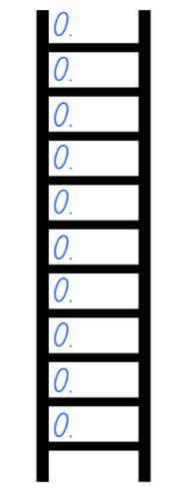

1. State that the aim of the game is to record decimal numbers on each ladder rung, in order, from smallest (bottom rung) to largest (top rung).
2. Explain that during each round, players may turn over a maximum of 3 cards to make a decimal number between zero and one. If a red card is drawn; however, the player does not draw any further cards for that turn. For example, if a black 3 of spades was drawn, followed by a red 6 of hearts, the player does not draw any further cards. The player then decides whether to make and record the decimal 0.36 or 0.63. If 3 black cards were drawn, all 3 numbers would be used to create a number with 3 decimal places.
3. Demonstrate turning over the cards, deciding how to order the numerals and strategically place the decimal number on the ladder. When the decimal number is placed on the ladder, the decimal number is read aloud. For example, 0.53 is read as 53 hundredths.
4. Students take turns to draw cards, create and read the decimal number and decide where to record it on their ladders.
5. If a student cannot place their decimal number on an appropriate rung, they miss their turn and play passes to the next player.
6. The first player to order and record a decimal number on all 10 ladder rungs is the winner (see Figure 6).

Figure 6 – gameplay example with 3 players

Three ladders with 10 evenly spaced rungs, containing decimals on each rung. Each ladder represents a different students’ game. 

The first ladder has a 'winner' banner at the bottom of it.

1. Groups of 2 or 3 students play the game and take turns recording decimal numbers on their ladders.

This table details an opportunity for assessment.

|  |  |
| --- | --- |
| Assessment opportunity | Links |
| What to look for:   * Can students compare and order decimal numbers of up to 3 decimal places? **[MAO-WM-01, MA3-RN-02]** | Links to [National Numeracy Learning Progressions](https://www.australiancurriculum.edu.au/resources/national-literacy-and-numeracy-learning-progressions/version-3-of-national-literacy-and-numeracy-learning-progressions/) (NNLP):   * NPV8.   Links to suggested [Interview for Student Reasoning](https://education.nsw.gov.au/teaching-and-learning/curriculum/literacy-and-numeracy/assessment-resources/ifsr) (IfSR) tasks:   * IfSR-NP: 4D.6 * IfSR-PT: 1A.4, 1A.5. |

## Core lesson – What strategy? – 20 minutes

The table below contains suggested learning intentions and success criteria. These are best co-constructed with students.

|  |  |
| --- | --- |
| Core concept learning intentions | Core concept success criteria |
| Students are learning to:   * apply efficient mental and written strategies to solve addition and subtraction problems * use estimation and place value understanding to determine the reasonableness of solutions. | Students can:   * apply known strategies such as levelling, addition for subtraction, using constant difference, and bridging * identify efficient and inefficient multidigit subtraction strategies * use place value understanding to check for errors in calculations * use estimation to check the reasonableness of solutions to addition and subtraction calculations. |

1. Display Resource 3 – additive strategies poster. Review each strategy on the poster and discuss how each one helps to identify different ways to solve problems efficiently.
2. Remind students that when they work with numbers, the aim is to be flexible, efficient and accurate.
3. Display Resource 4 – What strategy? on the board.
4. Discuss the various strategies the 2 students used to determine their answers, such as levelling, addition for subtraction, constant difference, and bridging. Students identify the most efficient strategy and explain why one strategy is more efficient than the other.
5. Display the following questions and provide students with Resource 5 – Frayer model. Tell students they will use this model to show their thinking when solving one of the problems.

* 12 645 − 4597 =  _?
* _? − 7093 = 474
* 2007 − 428 = _?

1. Students record one equation in the centre box and use 3 different strategies to solve it in the surrounding boxes. They circle the most efficient strategy and explain their reasoning why the circled strategy was the most efficient.

The table below outlines stimulus prompts to generate conversation about the topic, along with anticipated responses from students.

|  |  |
| --- | --- |
| Prompts | Anticipated student responses |
| * 12 645 − 4597 = _? | * I would use constant difference: adjust both numbers to make subtraction easier, ensuring the difference between them remains constant. * 12 645 + 3 = 12 648 and 4597 + 3 = 4600 * New equation: 12 648 – 4600 = 8 048. |
| * _? − 7093 = 474 | * I would use inverse operations 7093 + 474 = _? * Then I would use either a mental or written strategy such bridging (7093 + 7 + 467). * New equation: 7093 + 7 + 467 = 7567. |
| * 2027 − 418 = _? | * I would use partitioning: splitting numbers into smaller parts to make calculations easier. * (2000 + 27) − (400 + 18) = (2000 − 400) + (27 − 18) = 1600 + 9 = 1609 * I would use landmark numbers that are easy to work with, fluently, flexibly and efficiently. * 2027 − 400 = 1627 then 1627 − 18 = 1609. * I would draw a number line and use the jump strategy to solve this subtraction. I would first make four 100 jumps from 2027 to 1627. Then I would make one 10 jump, landing on 1617. Finally, I would make one 8 jump, which gives me the answer of 1609. |

1. Regroup and revise the strategies used. Ask students to communicate their reasoning and choice of strategy. Check for correct answers.
2. Check for understanding by asking:

* When would you choose to use a mental strategy over a written strategy?
* When would levelling be an efficient strategy?
* When would an algorithm be an efficient strategy?
* How can you check your answer after solving a subtraction equation to ensure it is correct?

This table details opportunities for differentiation.

|  |  |
| --- | --- |
| Too hard? | Too easy? |
| Students cannot identify efficient and inefficient multidigit subtraction strategies.   * Provide students with equations using 2-digit numbers to solve. They identify an appropriate flexible, mental strategy. For example, partitioning numbers. * Provide students with MAB materials to assist with modelling addition and subtraction. | Students can identify efficient and inefficient multidigit subtraction strategies.   * Students write example equations to demonstrate understanding of when each mental and written strategy would be the most efficient. * Ask students to create word problems and share with their peers. They solve the problems, reflecting on the most efficient strategies used. |

## Consolidation and meaningful practice – 25 minutes

This activity is an adaptation of [Additive strategies: Task 5: Closest to 100](https://education.nsw.gov.au/teaching-and-learning/curriculum/literacy-and-numeracy/teaching-and-learning-resources/numeracy/explicit-teaching-strategies/stage-3/numbers-and-algebra/additive#:~:text=Task%205%3A%20Closest%20to%20100) from [Stage 3 Numbers and algebra](https://education.nsw.gov.au/teaching-and-learning/curriculum/literacy-and-numeracy/teaching-and-learning-resources/numeracy/explicit-teaching-strategies/stage-3/numbers-and-algebra) by the State of New South Wales (Department of Education).

1. Explain that students they will be using various additive strategies and estimating to solve addition equations in the game ‘Closest to 1000’. Students work in pairs against another pair of students to allow for mathematical conversations.
2. Provide players with playing cards with the 10, Jack, Queen and King removed. Place the cards in a central pile. One player takes 6 cards and places them face up for everyone to see.
3. The goal is to make two 3-digit numbers that, when added together, get as close to 1000 as possible. Each card can only be used once.

**Note**: students should use estimation strategies to check validity of solutions.

1. For each round, players record their working out to calculate their total. Points are equal to the difference between their total and 1000. For example, if a team created 912, they would score 88 points. Teams score zero points if they can reach exactly 1000.
2. After multiple rounds, teams add their cumulative points in their workbook. The winner is the team with the lowest point score at the end.
3. Regroup and ask:

* What did you notice when you were playing ‘Closest to 1000’?
* What strategy did you find most efficient? Why?
* What strategy did you find least efficient? Why?
* How did estimation help you?

**Note**: encourage students to share reasoning for their ideas. Highlight different ideas that promote the understanding that different strategies can be more efficient for different problems.

This table details opportunities for assessment.

|  |  |
| --- | --- |
| Assessment opportunities | Links |
| What to look for:   * Can students apply known strategies such as levelling, addition for subtraction, using constant difference, and bridging? **[MAO-WM-01, MA3-AR-01]** * Can students identify efficient and inefficient multidigit subtraction strategies? **[MAO-WM-01, MA3-AR-01]** * Can students use estimation and place value understanding to solve addition problems? **[MAO-WM-01, MA3-AR-01]** | Links to [National Numeracy Learning Progressions](https://www.australiancurriculum.edu.au/resources/national-literacy-and-numeracy-learning-progressions/version-3-of-national-literacy-and-numeracy-learning-progressions/) (NNLP):   * AdS8.   Links to suggested [Interview for Student Reasoning](https://education.nsw.gov.au/teaching-and-learning/curriculum/literacy-and-numeracy/assessment-resources/ifsr) (IfSR) tasks:   * IfSR-NP: 4C.6-4C.7 * IfSR-AT: 3A.4. |

# Lesson 4

**Core concept**: represent percentages as fractions and decimals and find any quantity.

## Daily number sense – 10 minutes

1. From a class need surfaced through formative assessment data, identify a short, focused activity that targets students’ knowledge, understanding and skills. Example activities may be drawn from the following resources:

* [Mathematics K–6 resources](https://education.nsw.gov.au/teaching-and-learning/curriculum/mathematics/mathematics-curriculum-resources-k-12/mathematics-k-6-resources)
* [Universal Resources Hub](https://resources.education.nsw.gov.au/home).

## Core lesson – percentages in action – 20 minutes

The table below contains a suggested learning intention and success criteria. These are best co-constructed with students.

|  |  |
| --- | --- |
| Core concept learning intention | Core concept success criteria |
| Students are learning to:   * make connections between benchmark fractions, decimals and percentages. | Students can:   * represent common percentages of quantities and lengths as fractions and decimals * recognise that 10% is one-tenth of 100% and use this to find 10% of a quantity. |

1. Review that the % symbol means ‘percent’ and that 100% means the whole amount.
2. Explain that percentages are often used for presenting data, discount sales, bank interest rates and taxes. Percentages are another way of expressing fractions. Discuss where students have seen the percentage symbol, for example, at the supermarket, in advertisements and so on.
3. Explain that fractions, decimals and percentages are all different ways to represent the same value. Highlight the relationship between fractions, decimals and percentages by drawing a bar model, representing one-quarter on the board. Label $\frac{1}{4}$ as equivalent to 0.25 and 25%.
4. State that ‘25 percent’ means 25 out of 100 or $\frac{25}{100}.$ Read the decimal 0.25 as ‘twenty-five hundredths’ and record as $\frac{25}{100}$. Link to one-quarter of 100 is 25.
5. Display Resource 6 – bar models. Ask:

* What percentage of each bar is shaded?
* Which one is easy to know?
* What fraction of each bar is shaded?
* How could you record this as an equivalent decimal?

1. Students solve the following questions using a bar model to represent their thinking (see Figure 7):

* 50% of $200
* 25% of $160
* 75% of $300.

Figure 7 – bar model sample

Two bar model examples of $160. The first bar model is divided into two $80 parts.

The second bar model is underneath the first and is divided into four $40 sections, with one section highlighted in green to illustrate that 25% of $160 equals $40.

The sentence: 25% of $160 = $40 is written under the bar models.

1. Check for understanding by asking students to explain their thinking and strategies used to determine the answers.
2. Explain that 10% is one-tenth of 100%, so it can be found by dividing a quantity by 10.
3. Demonstrate the relationship between 10% to dividing by 10. For example, write 10% of 100 = 10, 10% of 50 = 5 and 10% of 200 = 20 on the board.
4. Students practice by finding 10% and recording their answers on individual whiteboards:

* 300
* 70
* 550
* 45.

1. To extend student thinking, ask students to consider how to calculate 20% is of each quantity.

**Note**: our base-10 number system makes it easy to find 10% of a quantity. For example, 10% of 150 is 15, so 20% of 150 is 2 lots of 15, 30% is 3 lots of 15 and so on.

1. Regroup as a class and pose the following problem: a camping store has a box of 110 key rings. The store wants to put 90% of the key rings on display. How many key rings will be put on display?
2. Explain that thinking about 10% of the quantity will be helpful. Students represent their thinking using a bar model.

This table details opportunities for differentiation.

|  |  |
| --- | --- |
| Too hard? | Too easy? |
| Students cannot represent common percentages of quantities and lengths as fractions and decimals.   * Model a connection between the bar model with a specific length, for example, 10 cm or 100 cm. Support students to calculate a given percentage of that length. Students can fold a strip if needing more concrete support. * Provide a 100 grid and ask students to colour various benchmark fractions, decimals and percentages. | Students can represent common percentages of quantities and lengths as fractions and decimals.   * Pose the following scenario: you are preparing for a camping trip with an $800 budget. Use a digital device to research the prices of camping gear such as: a tent, a sleeping bag and a backpack, checking for discounts. Add up the costs after applying any discounts. Write down the discounts as fractions and decimals. Investigate what percentage of your budget each item costs, showing it as a fraction and a decimal. |

## Consolidation and meaningful practice – 25 minutes

1. Use Resource 7 – percentages jigsaw to demonstrate how to solve the percentage problems and connect the corresponding jigsaw tiles.
2. In pairs or small groups, students collaborate to solve the percentages jigsaw.
3. To check for understanding ask:

* What is 50% of 220?
* What is 10% of 60?
* What is 25% of 300?
* What strategies did you use to calculate the percentages on the puzzle pieces?
* Which percentage calculations did you solve first?
* Were there any challenging percentage calculations? Explain your thinking and your strategy.

This table details opportunities for assessment.

|  |  |
| --- | --- |
| Assessment opportunities | Links |
| What to look for:   * Can students represent common percentages of quantities and lengths as fractions and decimals? **[MAO-WM-01, MA3-RN-03]** * Can students recognise that 10% is one-tenth of 100% and use this to find 10% of a quantity (Reasons about relations)? **[MAO-WM-01, MA3-RN-03]** | Links to [National Numeracy Learning Progressions](https://www.australiancurriculum.edu.au/resources/national-literacy-and-numeracy-learning-progressions/version-3-of-national-literacy-and-numeracy-learning-progressions/) (NNLP):   * InF7 * PrT2 * UnM8.   Links to suggested [Interview for Student Reasoning](https://education.nsw.gov.au/teaching-and-learning/curriculum/literacy-and-numeracy/assessment-resources/ifsr) (IfSR) tasks:   * IfSR-PT: 2A.1 |

# Lesson 5

**Core concept**: benchmark percentages help to determine percentage discounts.

## Daily number sense – What’s in the box? – 10 minutes

Daily number sense activities for Lessons 5 to 7 ‘loop’ back to concepts and procedures covered in previous units to assist students to build an increasingly connected network of ideas. These concepts may differ from the core concepts being covered by the unit.

The table below contains a suggested learning intention and success criteria. These are best co-constructed with students.

|  |  |
| --- | --- |
| Daily number sense learning intention | Daily number sense success criteria |
| Students are learning to:   * determine products and factors. | Students can:   * determine factors for a given whole number. |

This activity is an adaptation of [What’s in the Box?](https://nrich.maths.org/problems/whats-box) from [NRICH](https://nrich.maths.org/) by the University of Cambridge.

1. Display Resource 8 – multiplication box and pose the scenario: I placed 4 numbers into a box. The mystery number inside the box multiplied my numbers and 4 new numbers came out. The new numbers that came out were 96, 36, 60 and 48.
2. Ask: What were my 4 numbers?
3. Students [Think-Pair-Share](https://app.education.nsw.gov.au/digital-learning-selector/LearningActivity/Card/645) to explain what they understand about the problem and strategies they would use to solve it.
4. Students record the 4 numbers on individual whiteboards.
5. To check for understanding, ask:

* What was the mystery number?
* Are there any other possibilities? How do you know?
* Could you check your answer using division?
* Can you generate a multiplicative fact family triangle for each of the numbers?

1. In pairs, students create a similar problem. Students choose a set of 4 numbers that will be placed in a box and a new mystery number as the multiplier.
2. Swap with another pair to solve the problem.

This table details an opportunity for assessment.

|  |  |
| --- | --- |
| Assessment opportunity | Links |
| What to look for:   * Can students determine factors for a given whole number?  **[MAO-WM-01, MA3-MR-01]** | Links to [National Numeracy Learning Progressions](https://www.australiancurriculum.edu.au/resources/national-literacy-and-numeracy-learning-progressions/version-3-of-national-literacy-and-numeracy-learning-progressions/) (NNLP):   * MuS6, MuS7.   Links to suggested [Interview for Student Reasoning](https://education.nsw.gov.au/teaching-and-learning/curriculum/literacy-and-numeracy/assessment-resources/ifsr) (IfSR) tasks:   * IfSR-MT: 2A.7. |

## Core lesson – sale shopping – 35 minutes

The table below contains a suggested learning intention and success criteria. These are best co-constructed with students.

|  |  |
| --- | --- |
| Core concept learning intention | Core concept success criteria |
| Students are learning to:   * determine percentage discounts of 10%, 25% and 50%. | Students can:   * equate 10% to dividing by 10, 25% to finding a quarter by dividing by 4, and 50% to finding half * calculate the sale price of an item after a discount of 10%, 25% and 50%. |

1. Review previous lesson including strategies to find common percentages of quantities.
2. Display Resource 9 – 2-way radios. Pose the scenario: Juno was looking to buy some 2-way radios for her camping trip. The original price was $80, and she wanted to work out the sale price from the local shop, online store and garage sale.

**Note**: the term ‘recommended retail price’ or RRP is referred to in the resources for this lesson. The recommended retail price (RRP) refers to the price the manufacturer suggests that the retailer should sell an item for.

1. Explain that when calculating the sale price, the percentage of the total price must first be determined and then subtracted from the original price.
2. Ask students to [Think-Pair-Share](https://app.education.nsw.gov.au/digital-learning-selector/LearningActivity/Card/645) and calculate 10%, 25% and 50% of $80. Prompt students to share the strategies they used to determine 10%, 25% and 50% of $80.

The table below outlines stimulus prompts to generate conversation about the topic, along with anticipated responses from students.

|  |  |
| --- | --- |
| Prompts | Anticipated student responses |
| * How did you calculate 10% of $80? | * I knew 10% meant one-tenth of the total amount, so I divided 80 by 10. 10% of 80 is 8, so the saving would be $8. |
| * How did you find 25%? | * 25% is the same as one-quarter. To find one-quarter, I can halve and halve again. I can halve 80 which is 40 and then halve again which is 20. If the discount is 25 $\%$ off, Juno would save $20. |
| * How did you determine 50% of $80? | * Finding 50% of a quantity, is the same as finding half. I know half of 80 is 40. A 50% saving would be $40. |

1. Model subtracting the savings from the original amount to determine the sale price. For example, a price after a 25% discount is found by calculating $80 − $20 = $60.
2. Display Resource 10 – super camping sale. Explain that Juno also saw that there was a sale at the local camping store. She had saved $300 from her birthday and Eid celebrations and wanted to know what she could purchase.
3. Students work through the following questions:

* How much money is saved on each item during this sale?
* What is the sale price of each item?
* What different combinations of items could Juno afford?
* If you were Juno, which items would you purchase with your $300?

1. Students record the savings, sale prices and combinations in their workbooks. Provide a calculator for checking answers, if required.

This table details opportunities for differentiation.

|  |  |
| --- | --- |
| Too hard? | Too easy? |
| Students cannot calculate the sale price of an item after a discount of 10%, 25% and 50%.   * Demonstrate how to find 10%, 25% and 50% off an item worth $100, $200 and $300 by dividing by 10, 4 and 2 and subtracting that amount from the total. * Use tape diagrams to represent the total cost of $100, $200 and $300. Model how to partition the bars into 10, 4 and 2 equal parts to find the percentages. | Students can calculate the sale price of an item after a discount of 10%, 25% and 50%.   * Students calculate the price for each item if there was a 15%, 20% or 75% discount. Students record the strategies used to determine the discount using words and/or diagrams. * Students determine the discount Juno received if she purchased all 9 items at their sale prices. |

## Discuss and connect the mathematics – 10 minutes

1. Students record a reflection in their workbooks, outlining the steps required to calculate the sale price of an item after a percentage discount.
2. Regroup and ask:

* If dividing by 10 equates to 10% of the total price, how would you determine 20% of an amount? (divide by 10 and then double)
* How could you use your understanding of 10%, to calculate a discount of 90%? (divide by 10 and subtract from the original amount)
* How could the strategies used to calculate a discount of 25% help to determine the sale price of an item after a discount of 75%? (find 25% and then multiply by 3 or use the complement principle of 25% and 75%)

This table details opportunities for assessment.

|  |  |
| --- | --- |
| Assessment opportunities | Links |
| What to look for:   * Can students equate 10% to dividing by 10, 25% to finding a quarter by dividing by 4, and 50% to finding half?  **[MAO-WM-01, MA3-RN-03]** * Can students calculate the sale price of an item after a discount of 10%, 25% and 50%? **[MAO-WM-01, MA3-RN-03]** | Links to [National Numeracy Learning Progressions](https://www.australiancurriculum.edu.au/resources/national-literacy-and-numeracy-learning-progressions/version-3-of-national-literacy-and-numeracy-learning-progressions/) (NNLP):   * PrT1, PrT2 * UnM8.   Links to suggested [Interview for Student Reasoning](https://education.nsw.gov.au/teaching-and-learning/curriculum/literacy-and-numeracy/assessment-resources/ifsr) (IfSR) tasks:   * IfSR-PT: 2A.5, 2A.8. |

# Lesson 6

**Core concept**: factorising numbers aids mental multiplication.

## Daily number sense – rearrange arrays – 10 minutes

The table below contains suggested learning intentions and success criteria. These are best co-constructed with students.

|  |  |
| --- | --- |
| Daily number sense learning intentions | Daily number sense success criteria |
| Students are learning to:   * determine products and factors * calculate the areas of rectangles using familiar metric units. | Students can:   * determine factors for a given whole number * recognise that rectangles with the same area may have different dimensions. |

1. Review the terms *factor* and *product*.

**Factor**: a number which divides another number without a remainder. For example, 1, 2, 3 and 6 are factors of 6 but 4 and 5 are not.

**Product**:the result of multiplying 2 or more numbers together, for example, 12 is the product of 4 × 3.

1. Pose the question: A rectangular space has an area of 48 $m^{2}$ . What could the length and width dimensions be?
2. Students [turn and talk](https://education.nsw.gov.au/teaching-and-learning/curriculum/literacy-and-numeracy/teaching-and-learning-resources/numeracy/talk-moves) and record possible solutions on an individual whiteboard. For example, 48 $m^{2}$  as 6 m by 8 m, 12 m by 4 m or 2 m by 24 m.
3. To check for understanding ask:

* How many possibilities are there?
* How did multiplication or division help you with this problem?
* How could the words product and factor describe the numbers you have used and their relationship with each other?

1. Explain that the factors of 48 are 1, 2, 3, 4, 6, 8, 12, 16, 24 and 48. For example, 48 is a product of 6 × 8 and 12 × 4.
2. Pose the question: If I have a rectangular area of 84 $m^{2}$ , what could the width and length dimensions be?
3. Students record their thinking using the area model or number sentences.
4. To check for understanding ask:

* How did you work out the factors of 84? Explain your thinking.
* How many possibilities are there to solve this?

This table details opportunities for assessment.

|  |  |
| --- | --- |
| Assessment opportunities | Links |
| What to look for:   * Can students determine factors for a given whole number?  **[MAO-WM-01, MA3-MR-01]** * Can students recognise that rectangles with the same area may have different dimensions? **[MAO-WM-01, MA3-2DS-02]** | * Links to [National Numeracy Learning Progressions](https://www.australiancurriculum.edu.au/resources/national-literacy-and-numeracy-learning-progressions/version-3-of-national-literacy-and-numeracy-learning-progressions/) (NNLP): * MuS6, MuS7.   Links to suggested [Interview for Student Reasoning](https://education.nsw.gov.au/teaching-and-learning/curriculum/literacy-and-numeracy/assessment-resources/ifsr) (IfSR) tasks:   * IfSR-MT: 2A.7. |

## Core lesson – factorising numbers – 40 minutes

The table below contains a suggested learning intention and success criteria. These are best co-constructed with students.

|  |  |
| --- | --- |
| Core concept learning intention | Core concept success criteria |
| Students are learning to:   * select and apply mental and written strategies to multiply 2- and 3-digit numbers by 2-digit numbers. | Students can:   * factorise numbers to aid mental multiplication * solve multiplication word problems. |

1. Pose this problem: A camp organiser needs to set up 25 tents. Each tent requires 15 stakes to secure it to the ground. How many stakes are needed in total?
2. Display Resource 11 – multiplicative properties.
3. Explain that the number sentences represented in the grey rectangles are possible solutions to the problem. Each one is an example of the multiplicative properties: commutative, associative and distributive.
4. Ask students to [Think-Pair-Share](https://app.education.nsw.gov.au/digital-learning-selector/LearningActivity/Card/645) and match each multiplicative property to the number sentence A, B or C, and provide reasons for their choices.
5. Highlight that the associative property may support working flexibly when factorising. For example, to determine the factors of 40, 5 × 8 is the same as 5 × (2 × 4), which is the same as (5 × 2) × 4 which becomes 10 × 4. This helps to find 5, 8, 2, 4 and 10 as factors of 40 (as well as 1, 40 and 20).
6. Display Resource 12 – camper breakfast problem.

The table below outlines stimulus prompts to generate conversation about the topic, along with anticipated responses from students.

|  |  |
| --- | --- |
| Prompts | Anticipated student responses |
| * What is the key information that will help solve the problem? | * 15 campers * Each camper ate 2 cups of cereal every morning * Each cup contained 40 grams of cereal |
| * What information is not needed to solve the problem? | * I did not need to think about the 3 types of cereal to answer the question. |

1. Display Resource 13 – Hugo, Jeremy, Rana.
2. Students consider the ways these students solved the camper breakfast problem. Ask:

* Which student’s approach do you think is efficient?
* Which multiplicative properties have been represented in the students’ solutions? (Rana used the commutative property to multiply 10 by 15 before multiplying by 8. Jeremy and Rana have both represented the associative property, by starting with 15 × 80 rather than 15 × 40 × 2)
* How did Hugo, Jeremy and Rana use factorisation to help them solve the problem?
* Can you think of another way to use factorisation to aid mental multiplication for this question?

1. Provide students with Resource 14 – word problems. Students can work individually or in small groups to solve the problems. Students record 2 ways to solve each problem.
2. Regroup and select students to share answers and strategies, highlighting solution methods that used factorisation.

This table details opportunities for differentiation.

|  |  |
| --- | --- |
| Too hard? | Too easy? |
| Students cannot factorise numbers to aid mental multiplication.   * Use concrete materials, like blocks or counters, to demonstrate how factors work. For example, show how 12 can be represented as 2 rows of 6 counters or 3 rows of 4 counters. * Students determine all the factors for each problem prior to deciding on a solution method. | Students can factorise numbers to aid mental multiplication.   * Students create their own multiplicative word problems using 2- and 3-digit numbers for a partner to solve. * Students create word problems where factorisation is unable to be used to aid mental multiplication and justify their reasoning. |

## Discuss and connect the mathematics – 10 minutes

1. To check for understanding, ask students to solve 24 × 16 = _ using a strategy with factorisation on their whiteboard.
2. As a class discuss:

* Is factorisation helpful to solve this problem? Why or why not? (both numbers have multiple factors which offers lots of flexible options)
* What other strategies could be used to aid mental computation to solve this problem? (24 × 10 = 240 and 24 × 6 = 144. 240 + 144 = 384 or 24 × 2 × 2 × 2 × 2)
* Which strategy would be considered most efficient? Explain your reasoning and justification.

This table details opportunities for assessment.

|  |  |
| --- | --- |
| Assessment opportunities | Links |
| What to look for:   * Can students factorise numbers to aid mental multiplication? **[MAO-WM-01, MA3-MR-01]** * Can students solve multiplication word problems?  **[MAO-WM-01, MA3-MR-01]** | Links to [National Numeracy Learning Progressions](https://www.australiancurriculum.edu.au/resources/national-literacy-and-numeracy-learning-progressions/version-3-of-national-literacy-and-numeracy-learning-progressions/) (NNLP):   * MuS6, MuS7   Links to suggested [Interview for Student Reasoning](https://education.nsw.gov.au/teaching-and-learning/curriculum/literacy-and-numeracy/assessment-resources/ifsr) (IfSR) tasks:   * IfSR-MT: 2A.7. |

# Lesson 7

**Core concept**: division can be recorded using fractions.

## Daily number sense – factors and multiples – 10 minutes

The table below contains a suggested learning intention and success criteria. These are best co-constructed with students.

|  |  |
| --- | --- |
| Daily number sense learning intention | Daily number sense success criteria |
| Students are learning to:   * determine products and factors. | Students can:   * determine factors or multiples for a given whole number. |

This activity is an adaptation of [Factors and Multiples Game](https://nrich.maths.org/games/factors-and-multiples-game) from [NRICH](https://nrich.maths.org/) by the University of Cambridge.

**Note**: this game can be played on the [Factors and Multiples Game](https://nrich.maths.org/games/factors-and-multiples-game) interactive gameboard if digital devices are available.

1. Provide pairs of students with Resource 15 – 100 grid.
2. Explain that the aim of the game is to try and make it a challenge for the other player to pick a number that is a factor or multiple of the number given.
3. Player A chooses an even number that is less than 50 and crosses it out on the grid. Player B chooses a number that is a factor or multiple of their partner’s number.
4. Players continue to take turns to cross out numbers, at each stage choosing a number that is a factor or multiple of the number just crossed out by the other player. The first player who is unable to cross out a number ends the game (see Figure 8).

Figure 8 – factors and multiples game

A hundreds chart with 8 numbers crossed, 4 numbers for Student A, and 4 numbers for Student B.
There is a 3 column table to the left indicating the numbers that Student A and Student B have crossed out, and students have noted whether that number is a factor or multiple.

This table details an opportunity for assessment.

|  |  |
| --- | --- |
| Assessment opportunity | Links |
| What to look for:   * Can students determine factors or multiples for a given whole number? **[MAO-WM-01, MA3-MR-01]** | Links to [National Numeracy Learning Progressions](https://www.australiancurriculum.edu.au/resources/national-literacy-and-numeracy-learning-progressions/version-3-of-national-literacy-and-numeracy-learning-progressions/) (NNLP):   * MuS6, MuS7.   Links to suggested [Interview for Student Reasoning](https://education.nsw.gov.au/teaching-and-learning/curriculum/literacy-and-numeracy/assessment-resources/ifsr) (IfSR) tasks:   * IfSR-MT: 2A.7. |

## Core lesson – division as a fraction – 40 minutes

The table below contains a suggested learning intention and success criteria. These are best co-constructed with students.

|  |  |
| --- | --- |
| Core concept learning intention | Core concept success criteria |
| Students are learning to:   * use equivalent number sentences involving multiplication and division to find unknown quantities. | Students can:   * recognise that division can be recorded using fractions. |

1. Display Resource 16 – Wanda’s ponder and explain that Wanda overheard Walter state: ‘Three divided by four can be represented as the fraction three-quarters.’ Ask:

* Do you agree with Walter? Why or why not?
* Can you justify your thinking using a model or drawing?
* Do you have any questions or wonderings about Walter’s statement?

1. Explain that mathematical concepts and ideas are expressed in a variety of representations, including symbolic forms. The fraction bar and the division symbol ($÷$) both represent the process of division.

**Note**: the term ‘fraction bar’ is recommended to describe the line between the numerator and denominator. Other Latin terms for the fraction bar include the solidus (/) and vinculum. In Stage 1, fractions are introduced through equal sharing problems. In Stage 2 and Stage 3, students connect the words and symbols for fractions to the parts created in the process of solving problems. The concept of a fraction is then based on the process of division, rather than counting parts. This lays a strong foundation for understanding fractions as indicating division and fractions as numbers.

1. Display Resource 17 – dividing jellybeans.
2. Ask students to [Think-Pair-Share](https://app.education.nsw.gov.au/digital-learning-selector/LearningActivity/Card/645) what they notice.
3. Highlight that 20 divided by 5 can also be represented as twenty-fifths. In both instances, the answer is 4. (20 $÷$ 5 = 4 and $\frac{20}{5}$ = 4 wholes)
4. Display Resource 18 – matching representations.
5. Students [turn and talk](https://education.nsw.gov.au/teaching-and-learning/curriculum/literacy-and-numeracy/teaching-and-learning-resources/numeracy/talk-moves) to match the blue division representations with the pink fractional representations.
6. Students record their responses on individual whiteboards (see Figure 9).

Figure 9 – student sample matching

A whiteboard with 7 division equations on the left, an equals sign in the middle and a fraction written aligning to each problem on the right.

The equations are: 12 divided by 4 equals twelve-fourths, 3 divided by 4 equals three-fourths, 20 divided by 5 equals twenty-fifths, 9 divided by 4 equals nine-fourths , 15 divided by 5 equals fifteen-fifths, 16 divided by 4 equals sixteen-fourths and 8 divided by 3 equals eight-thirds.


1. Display Resource 19 – Which is equivalent? Individually or in pairs, students identify the correct answer for each question and create a scenario which matches.
2. Regroup and select students to share their thinking.

The table below outlines stimulus prompts, along with anticipated responses from students.

|  |  |
| --- | --- |
| Prompts | Anticipated student responses |
| * Which equation is equivalent to $\frac{1}{4}$? | * C (1 ÷ 4) is the correct answer because the fraction one-quarter is the same as one divided by 4. If I had one sandwich and I needed to share it with 4 people, I would divide it by 4. Each person would receive one-quarter of the sandwich. |
| * Which equation is equivalent to $\frac{8}{5}$? | * 8 ÷ 5 or C is the equivalent equation. They tried to trick us with A (5 ÷ 8), but the equivalent to that would be $\frac{5}{8}$ not $\frac{8}{5}$. If there were 8 jelly snakes and they needed to be shared among 5 children, each child would receive $\frac{8}{5}$ which is also equivalent to $1\frac{3}{5}$. That means each child would get one whole snake and $\frac{3}{5}$ of another snake. |
| * Which fraction is equivalent to 5 $÷$ 4? | * B ($\frac{5}{4}$) is equivalent to 5 ÷ 4. I first thought C and D could be a correct answer, but then realised five-quarters is equivalent to $1\frac{1}{4}$, not 1 $\frac{4}{5}$ or 1 $\frac{5}{4}$. If this was referring to pizzas, there would be 5 pizzas to be shared between 4 people. Each person would get five-quarters or one whole pizza and an additional one-quarter. |
| * Which fraction is equivalent to 5 $÷$ 6? | * B ($\frac{5}{6}$) is the same as 5 ÷ 6. It cannot be C as 5 ÷ 6 will be smaller than one whole. 5 ÷ 6 could represent 6 friends who are sharing 5 chocolate bars. Each friend would get $\frac{5}{6}$ of a chocolate bar. |

1. Display Resource 20 – dividing wafers. Students [Think-Pair-Share](https://app.education.nsw.gov.au/digital-learning-selector/LearningActivity/Card/645):

* What do you notice?
* What do you wonder?
* How could this resource support Wanda to understand Walter’s statement?

This table details opportunities for differentiation.

|  |  |
| --- | --- |
| Too hard? | Too easy? |
| Students cannot recognise that division can be recorded using fractions.   * Provide students with a strip of paper to represent a whole. Ask students to fold the paper into quarters by repeatedly halving. Record 1 ÷ 4 on the board to represent 1 whole being divided into 4 equal parts. Ask students to refer to the strip of paper to identify what the answer to 1 ÷ 4 could be. 1 ÷ 4 = $\frac{1}{4}$. Repeat with eighths, sixths and tenths. | Students can recognise that division can be recorded using fractions.   * Students create division problems where the answer is recorded as a fraction. Students record the division equation and the word problem in their workbooks. For example, If there were 4 pizzas shared equally between 5 people, how much pizza does each person receive? Each person receives $\frac{4}{5}$ of a pizza. This could be recorded as 4 ÷ 5. |

## Discuss and connect the mathematics – 10 minutes

1. Provide each student with one card from Resource 21 – ‘Matching’ game.
2. Select one student to start by reading their card aloud. The student that has the matching statement then reads their card aloud. Play continues until all students have read their cards aloud.

This table details an opportunity for assessment.

|  |  |
| --- | --- |
| Assessment opportunity | Links |
| What to look for:   * Can students recognise that division can be recorded using fractions? **[MAO-WM-01, MA3-MR-01, MA3-MR-02]** | Links to [National Numeracy Learning Progressions](https://www.australiancurriculum.edu.au/resources/national-literacy-and-numeracy-learning-progressions/version-3-of-national-literacy-and-numeracy-learning-progressions/) (NNLP):   * InF6. |

# Lesson 8

**Core concept**: the Cartesian plane is useful when identifying specific coordinates.

## Daily number sense – 10 minutes

1. From a class need surfaced through formative assessment data, identify a short, focused activity that targets students’ knowledge, understanding and skills. Example activities may be drawn from the following resources:

* [Mathematics K–6 resources](https://education.nsw.gov.au/teaching-and-learning/curriculum/mathematics/mathematics-curriculum-resources-k-12/mathematics-k-6-resources)
* [Universal Resources Hub](https://resources.education.nsw.gov.au/home).

## Core lesson – camp mapping – 40 minutes

The table below contains a suggested learning intention and success criteria. These are best co-constructed with students.

|  |  |
| --- | --- |
| Core concept learning intention | Core concept success criteria |
| Students are learning to:   * explore the Cartesian coordinate system. | Students can:   * recognise that the grid-map reference system gives the area of a location and the number plane identifies a specific point * identify that in the coordinate system, the lines are numbered, not the spaces. |

**Note**: [Stage 3 Year A Unit 8](https://education.nsw.gov.au/teaching-and-learning/curriculum/mathematics/mathematics-curriculum-resources-k-12/mathematics-k-6-resources/mathematics-stage-3-year-a-unit-08) provides the pre-requisite experiences necessary to access the learning in this lesson. The visual representation of the library ladder from Lesson 2 will support students to make a connection with reading the x-coordinate first, then the y-coordinate, to describe the location using the (x, y) coordinate system.

1. Display Resource 22 – camp adventure map.
2. In pairs, students use positional language to answer the following questions.

The table below outlines stimulus prompts to generate conversation about the topic, along with anticipated responses from students.

|  |  |
| --- | --- |
| Prompts | Anticipated student responses |
| * What do you notice about the map? | * The 4-quadrant Cartesian coordinate plane is used on the map. * It has a key for the activities and the amenities. * There is a compass showing the N, E, S, W orientation. |
| * How would I read this map? | * I should say something like (2, 4), but the position of the activities look more aligned to the grid map reference system than the Cartesian coordinate system. * The locations of the activities have not been placed on a specific point on the number plane. |
| * How could this map be improved? | * The x-axis and y-axis are not labelled on the map. * Each location should be placed on the intersecting point of the horizontal (x-axis) and vertical (y-axis) number line to allow coordinates to be represented by a pair of numbers. |

1. Display Resource 23 – camp adventure map 2.
2. Ask students to consider the following statement: Max said that the position of the hiking was (2, −2). What could have led to Max’s incorrect identification of the location?
3. Emphasise the need to reference the x-coordinate first, then the y-coordinate, for example, the hiking is positioned at (−2, 2).
4. Students [turn and talk](https://education.nsw.gov.au/teaching-and-learning/curriculum/literacy-and-numeracy/teaching-and-learning-resources/numeracy/talk-moves) to identify the coordinates of each of the activities and amenities listed in the key.
5. In pairs, students create a camp adventure map to use in a game.
6. Provide pairs with Resource 24 – blank Cartesian plane and writing materials.
7. Display and explain Resource 25 – map design criteria.
8. Regroup and ask:

* Did you have any difficulties during the design process? How did you overcome them?
* What did you think about when placing locations or activities on your camp map?
* How do you know if you have plotted the point correctly?

This table details opportunities for differentiation.

|  |  |
| --- | --- |
| Too hard? | Too easy? |
| Students cannot recognise that the grid-map reference system gives the area of a location and the number plane identifies a specific point.   * Provide students Resource 23 – camp adventure map 2 to assist with identifying and plotting single points in the first quadrant. * Students use a highlighting system that relate to a colour-coded x- and y-axis to support the order of the coordinates. | Students can recognise that the grid-map reference system gives the area of a location and the number plane identifies a specific point.   * Students translate or reflect one of the locations over a line, resulting in a mirror image. Students describe changes to the location’s coordinates when a point is translated or reflected across an axis. * Students investigate patterns if the y-coordinate was always double the x-coordinate. For example, students explore what would happen if it were 4 times the x-coordinate. |

## Consolidation and meaningful practice – 15 minutes

1. In pairs, students use their camp adventure maps to play a game of ‘Campground secret spot.’
2. Explain the following rules to the game.
3. Each student records the coordinates of a secret location on a sticky note without showing it to their partner.
4. Begin with Student A. They have 5 attempts to guess their partner’s secret location by providing a pair of coordinates, for example, (2, −2).
5. Students must mark their coordinate guesses on the map with a coloured pencil.
6. Student B responds by indicating whether the guessed x- or y-coordinate is correct and if the guess is in the correct quadrant. For example, if the guessed coordinates are (2, −2) and the correct location of the item is (1, −2), Student B would say that the y-coordinate is correct, but the x-coordinate is not. Additionally, they would confirm if the guess is in the correct quadrant.
7. After both students have had their 5 attempts, they reveal their secret location’s coordinates. The student whose guess is closest to the secret location wins.
8. If a student correctly guesses the coordinates before using all 5 attempts, they are automatically the winner.

This table details opportunities for assessment.

|  |  |
| --- | --- |
| Assessment opportunities | Links |
| What to look for:   * Can students recognise that the grid-map reference system gives the area of a location and the number plane identifies a specific point? **[MAO-WM-01, MA3-GM-01]** * Can students identify that in the coordinate system the lines are numbered, not the spaces? **[MAO-WM-01, MA3-GM-01]** | Links to [National Numeracy Learning Progressions](https://www.australiancurriculum.edu.au/resources/national-literacy-and-numeracy-learning-progressions/version-3-of-national-literacy-and-numeracy-learning-progressions/) (NNLP):   * n/a. |

# Resource 1 – decimal mix-up

A zero to one number line with 6 sticky notes pegged onto it. 0.01 is pegged to the left of the zero at the beginning of the number line.

To the right of the zero, the following decimals follow in this order: 0.899, 0.21, 0.36, 0.5, 0.204 and 0.56.

# Resource 2 – integer number line

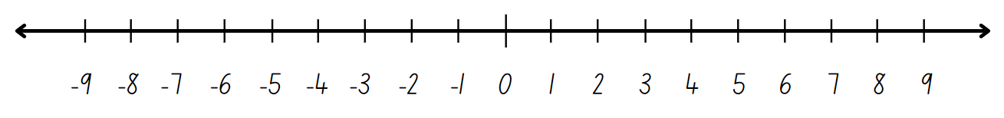

# Resource 3 – additive strategies

A poster listing 10 types of additive strategies as follows:
1. Compensation – adjusting numbers to make a calculation more efficient. 
2. Commutative property of addition – two numbers can be added in any order and the sum is equivalent. 
3. Constant difference – a common difference between pairs of numbers when completing subtraction. 
4. Inverse operations – addition and subtraction are inverse operations. 
5. Equivalence - different equations can have the same value. 
6. Landmark numbers – ‘friendly numbers’ that are easy to work with fluently, flexibly and efficiently. 
7. Levelling – adjusting to landmark numbers to add efficiently. 
8. Partitioning – splitting numbers into smaller parts to make calculations easier. 
9. Algorithms – a set of written steps to calculate, using partitioning and regrouping.
10. Associative property of addition – more than two numbers can be added in any order to make it more efficient. 


# Resource 4 – What strategy?

Two children, Peco and Nada, are each holding 2 open books, displaying 2 different math equations.

The first equation is 4988 + 955. Peco use the levelling strategy to solve the equation. Nada used the bridging strategy.

The second equation is 5009 − 3997. Peco used addition for subtraction, and Nada used the constant difference strategy to solve the equation. 

Detailed examples of the calculations have been displayed in the books.


# Resource 5 – Frayer model

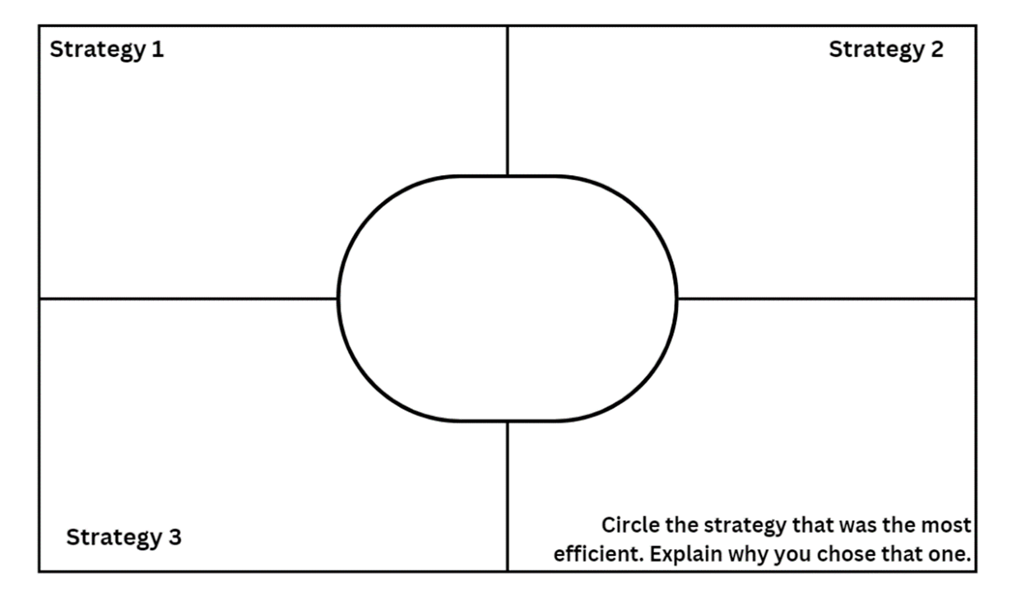

# Resource 6 – bar models

Four horizontal bar models labeled A, B, C and D, partially shaded in different colours.

A is three-quarters blue, B is one-quarter yellow, C has all 4 quarters shaded red and D is two-quarters green.

Written at the bottom of the image are 3 questions: What percentage of each bar is shaded? What fraction of each bar is shaded? How could you record this as an equivalent decimal?

# Resource 7 – percentages jigsaw

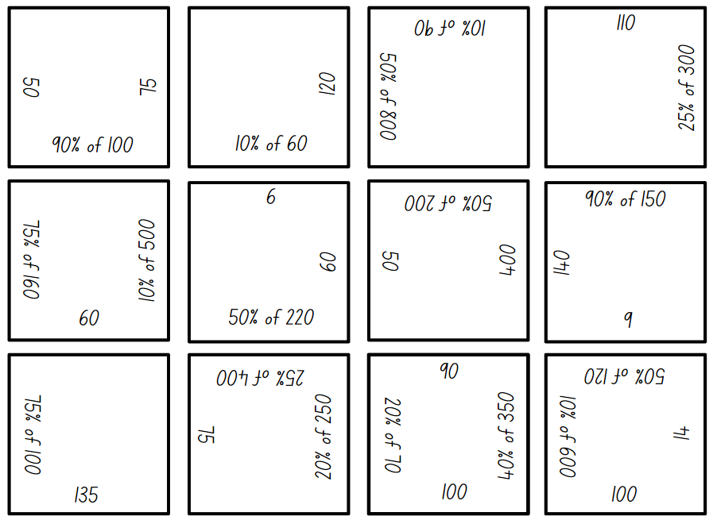

# Resource 8 – multiplication box

A box with a multiplication symbol and a question mark on the front of it. There are 4 question marks with an arrow pointing into the box.

An arrow at the bottom of the box points to 4 numbers: 96, 36, 60, and 48.

There are 2 questions to the right of the box that read: What 4 numbers were placed in the box to begin with? What is the mystery number in the box that is multiplying all 4 numbers?

# Resource 9 – 2-way radios

Promotional graphic showing a pair of 2-way radios with the recommended retail price of $80. 

A local shop is advertising 10% off all products, an online store is advertising 25% off all products and a garage sale is advertising 50% off all products.

# Resource 10 – super camping sale

A Super Camping Sale catalogue with discounts from 10–50% off. Students are to calculate the discounted price after being shown the recommended retail price (RRP).

The RRP prices for the items that have been reduced by 50% are:
Camp stove and kettle $166.
Drone $370.
Fishing rod $248.

The RRP prices for the items that have been reduced by 25% are:
Instant pop-up tent $280.
Sleeping bag and camp bed $140.
Portable speaker $180.

The RRP prices for the items that have been reduced by 10% are:
Deluxe camp chair $120.
Stand-up paddleboard $380.
Kayak $360.

# Resource 11 – multiplicative properties

Three equations:
A. 25 × 15 = (5 × 5) × (3 × 5)
B. (25 × 10) + (25 × 5)
C. 25 × 15 = 15 × 25.

Underneath the equations are explanations for 3 multiplicative strategies.

1. Commutative property: Commutative property related to multiplication means that two numbers can be multiplied in any order and the product is the same, 4 × 6 = 6 × 4. Commutative law, commutativity and turn-around facts are interchangeable terms.

2. Associative property: The associative property applies when more than 2 numbers are added or multiplied, the result is unchanged regardless of how they are grouped or associated. For example, 6 × 3 × 2 can be calculated as 18 × 2 or 6 × 6 or 12 × 3.

3. Distributive property: This allows us to distribute a given number in the operation to solve the multiplication more easily. Multiplying the sum of two or more numbers is the same as multiplying the addends separately.

For example, 7 × 3 is the same as the sum of 5 × 3 and 2 × 3. The 7 has been partitioned (distributed).

# Resource 12 – camper breakfast problem

Camp Adventure has 15 campers for breakfast each morning. They serve breakfast with 3 different kinds of cereal. If each camper eats 2 cups of cereal, and each cup contains 40 grams of cereal, how many grams of cereal are needed for breakfast each morning?

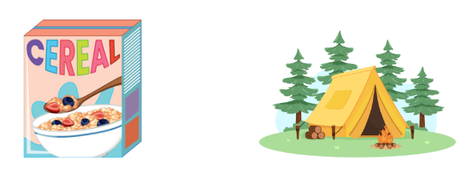

# Resource 13 – Hugo, Jeremy, Rana

Three students holding whiteboards with different methods to solve the camper breakfast problem. 

Hugo used the factors of 40 to solve 15 × 40 × 2, Jeremy used doubling and halving to solve 15 × 80 and Rana used factors of 80 to solve 15 × 80.

The multiplication problem has been written in expanded notation on each whiteboard for each strategy used.

# Resource 14 – word problems

|  |  |
| --- | --- |
| 1. A class of students are going on a camping trip to celebrate the end of the school year. The cost will be $65 for a student to camp per night. The students are planning to stay for 12 nights. How much will the trip cost for each student if they stay for 12 nights? | 1. A group of 15 students have volunteered to help clean up a local campsite after a big storm. The campsite manager is extremely grateful and has decided to give each student $220 for their hard work. If each student receives $220, how much money in total will the campsite manager pay the group? |
| 1. 22 students are preparing for a big hiking challenge during their camping trip. The students have to hike 180 metres of elevation to reach the top of a nearby hill. The teacher wants to calculate the total elevation gain for the entire class once all students have reached the top. What is the total elevation for all 22 students combined? | 1. A team of 14 explorers are embarking on a camping expedition. Each explorer needs to carry 40 kilograms of supplies, including food, water and equipment. If each explorer carries 40 kilograms of supplies, what is the total weight of all the supplies the team will be carrying? |
| 1. A group of Scouts is setting up a campsite for their annual camping competition. They have 18 tents and each tent can accommodate 15 Scouts. How many Scouts can the campsite accommodate in total if all tents are full? | 1. A group of 13 explorers are setting up their campsite. Each explorer is responsible for measuring 22 metres of the safety perimeter needed for their designated camping area. How many meters of safety perimeter will the entire group measure for their camping area? If the safety perimeter was rectangular, what would be the dimensions of the camping area? |

# Resource 15 – 100 grid

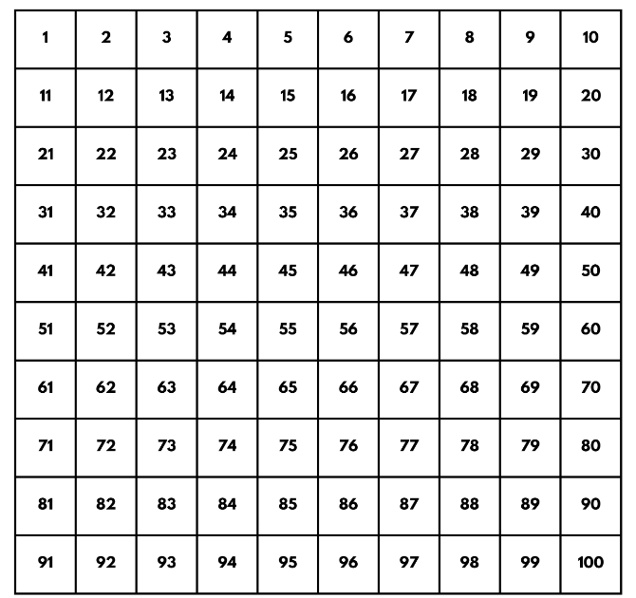

# Resource 16 – Wanda’s ponder

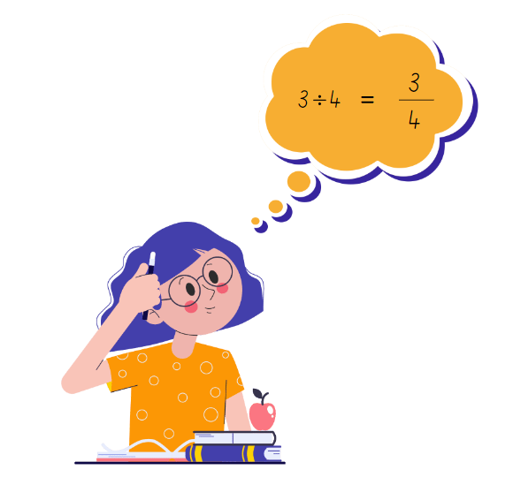

# Resource 17 – dividing jellybeans

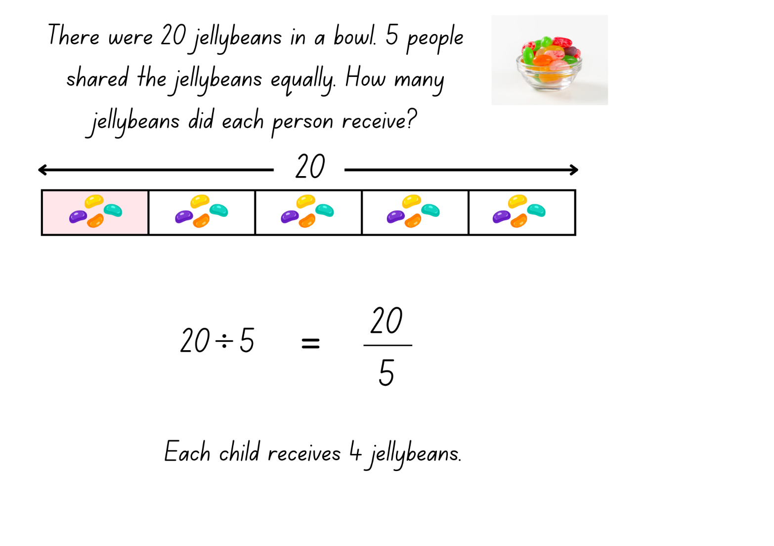

# Resource 18 – matching representations

A worksheet featuring division problems and simplified fractions.

The left-hand column, highlighted in blue, contains the following division problems: A: 12 ÷ 4, B: 3 ÷ 4, C: 20 ÷ 5, D: 9 ÷ 4, E: 15 ÷ 5, F: 16 ÷ 4 and G: 8 ÷ 3.

The right-hand column, highlighted in pink, contains the following simplified fractions: A: 20/5, B: 9/4, C: 3/4, D: 12/4, E: 16/4, F: 15/5 and G: 8/3.

# Resource 19 – Which is equivalent?

Four problems asking for equivalent equations or fractions.

Problem 1 reads: Which equation is equivalent to 1/4? A: 4 ÷ 1 B: 3 ÷ 4 C: 1 ÷ 4 D: 2 ÷ 4.

Problem 2 reads: Which equation is equivalent to 8/5? A: 5 ÷ 8, B: 10 ÷ 4, C: 8 ÷ 5, and D: 4 ÷ 5.

Problem 3 reads: Which fraction is equivalent to 5 divided by 4? A: 4/5, B: 5/4, C: 1 and 4/5 and D: 1 and 5/4. 

Problem 4 reads: Which fraction is equivalent to 5 divided by 6? A: 6/5, B: 5/6, C 1 and 1/6 and D: 1/5.

# Resource 20 – dividing wafers

A mathematical diagram showing how 3 wafers can be divided equally among 4 children, with each child receiving 3/4 of a wafer.

The problem at the top of the image is: There were 3 wafers left in a packet. How could the wafers be shared equally amongst 4 children?

Written at the bottom of the diagram is 3 divided by 4 equals 3/4. Each child gets 3 quarters of a wafer.

# Resource 21 – ‘Matching’ game

|  |  |  |  |  |  |
| --- | --- | --- | --- | --- | --- |
| **I have 12 thirds.**  Who has 25 divided by 5? | **I have 25 fifths.**  Who has 3 ÷ 2? | **I have 3 halves.**  Who has 24 divided by 4? | **I have 24 quarters.**  Who has 15 thirds? | **I have 15 ÷ 3.**  Who has 8 halves? | **I have 8 divided by 2.**  Who has 18 halves? |
| **I have 18 ÷ 2.**  Who has 20 quarters? | **I have 20 divided by 4.**  Who has 9 thirds? | **I have 9 divided by 3.**  Who has 20 divided by 5? | **I have 20 fifths.**  Who has 6 divided by 2? | **I have 6 halves.**  Who has 10 fifths? | **I have 10 divided by 5.**  Who has 30 fifths? |
| **I have 30 divided by 5.**  Who has 35 fifths? | **I have 35 ÷ 5.**  Who has 28 quarters? | **I have 28 divided by 4.**  Who has 42 ÷ 6? | **I have 42 sixths.**  Who has 48 sixths? | **I have 48 divided by 6.**  Who has 50 tenths? | **I have 50 divided by 10.**  Who has 12 ÷ 4? |
| **I have 12 quarters.**  Who has 21 divided by 3? | **I have 21 thirds.**  Who has 5 divided by 2? | **I have 5 halves.**  Who has 8 divided by 3? | **I have 8 thirds.**  Who has 12 divided by 2? | **I have 12 halves.**  Who has 4 ÷ 4? | **I have 4 quarters.**  Who has 10 tenths? |
| **I have 10 ÷ 10.**  Who has 6 divided by 3? | **I have 6 thirds.**  Who has 5 divided by 5? | **I have 5 fifths.**  Who has 7 divided by 3? | **I have 7 thirds.**  Who has 14 divided by 2? | **I have 14 halves.**  Who has 24 divided by 2? | **I have 24 halves.**  Who has 12 divided by 3? |

# Resource 22 – camp adventure map

A camp adventure map divided into a grid with various symbols.

The map includes icons for canoeing in the square near −3, −2, archery in the square near −1, −1, campfire in the square near 2, 4, campground in the square near 3, −1, camp kitchen in the square near 1, 1, hiking in the square near −2, 2 and toilets in the square near −1, −4. 

A compass rose indicates directions. Coordinates range from −5 to 5 on both axes.

# Resource 23 – camp adventure map 2

A camp adventure map divided into a grid with various symbols.

The map includes icons for canoeing at −3, −2, archery at −1, −1, campfire at 2, 4, campground at 3, −1, camp kitchen at 1, 1, hiking at −2, 2 and toilets at −1, −4.

A compass rose indicates directions. Coordinates range from −5 to 5 on both axes.

# Resource 24 – blank Cartesian plane

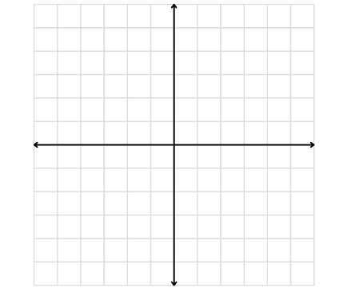

# Resource 25 – map design criteria

|  |  |
| --- | --- |
| Map design feature | Criteria |
| Clear and descriptive title | * Provide a title that accurately reflects the content and purpose of the map |
| Cartesian plane | * Use a Cartesian plane to organise and plot items accurately * Ensure both axes are accurately labelled with appropriate intervals * Use a key to label a location or activity |
| Items of interest in all 4 quadrants | * Place at least one location or activity in each of the 4 quadrants of the Cartesian plane |
| Compass | * Include a compass to indicate direction |

# Syllabus outcomes and content

The table below outlines the [syllabus outcomes](https://curriculum.nsw.edu.au/learning-areas/mathematics/mathematics-k-10-2022/overview) and range of relevant syllabus content covered in this unit. Content is linked to [National Numeracy Learning Progression](https://www.australiancurriculum.edu.au/resources/national-literacy-and-numeracy-learning-progressions/version-3-of-national-literacy-and-numeracy-learning-progressions/) (version 3).

|  |  |  |  |  |  |  |  |  |
| --- | --- | --- | --- | --- | --- | --- | --- | --- |
| Outcomes and content | 1 | 2 | 3 | 4 | 5 | 6 | 7 | 8 |
| **Represents numbers A**: Decimals and percentages: Compare, order and represent decimals  **MAO-WM-01, MA3-RN-02** |  |  |  |  |  |  |  |  |
| * Compare and order decimal numbers of up to 3 decimal places | x | x | x |  |  |  |  |  |
| **Represents numbers B**: Whole numbers: Locate and represent integers on a number line  **MAO-WM-01, MA3-RN-01** |  |  |  |  |  |  |  |  |
| * Use the term integersto describe positive and negative whole numbers and zero | x |  |  |  |  |  |  |  |
| * Recognise that negative whole numbers can result from subtraction (Reasons about quantity) | x |  |  |  |  |  |  |  |
| **Represents numbers B**: Decimals and percentages: Make connections between benchmark fractions, decimals and percentages  **MAO-WM-01, MA3-RN-03** |  |  |  |  |  |  |  |  |
| * Represent common percentages of quantities and lengths as fractions and decimals |  |  |  | x |  |  |  |  |
| * Recognise that 10% is one-tenth of 100% and use this to find 10% of a quantity (Reasons about relations) |  |  |  | x | x |  |  |  |
| **Represents numbers B**: Decimals and percentages: Determine percentage discounts of 10%, 25% and 50%  **MAO-WM-01, MA3-RN-03** |  |  |  |  |  |  |  |  |
| * Equate 10% to dividing by 10, 25% to finding a quarter by dividing by 4, and 50% to finding half |  |  |  | x | x |  |  |  |
| * Calculate the sale price of an item after a discount of 10%, 25% and 50% |  |  |  |  | x |  |  |  |
| **Additive relations A**: Apply efficient mental and written strategies to solve addition and subtraction problems  **MAO-WM-01, MA3-AR-01** |  |  |  |  |  |  |  |  |
| * Apply known strategies such as levelling, addition for subtraction, using constant difference, and bridging (Reasons about relations) |  |  | x |  |  |  |  |  |
| * Identify efficient and inefficient multidigit subtraction strategies |  |  | x |  |  |  |  |  |
| **Additive relations A**: Use estimation and place value understanding to determine the reasonableness of solutions  **MAO-WM-01, MA3-AR-01** |  |  |  |  |  |  |  |  |
| * Round numbers appropriately when obtaining estimates to numerical calculations |  | x |  |  |  |  |  |  |
| * Use place value understanding to check for errors in calculations |  |  | x |  |  |  |  |  |
| * Use estimation to check the reasonableness of solutions to addition and subtraction calculations |  | x | x |  |  |  |  |  |
| **Multiplicative relations A**: Determine products and factors  **MAO-WM-01, MA3-MR-01** |  |  |  |  |  |  |  |  |
| * Determine factors for a given whole number |  |  |  |  | x | x | x |  |
| **Multiplicative relations A**: Select and apply mental and written strategies to multiply 2- and 3-digit numbers by 2-digit numbers  **MAO-WM-01, MA3-MR-01** |  |  |  |  |  |  |  |  |
| * Factorise numbers to aid mental multiplication |  |  |  |  |  | x |  |  |
| * Solve multiplication word problems |  |  |  |  |  | x |  |  |
| **Multiplicative relations B**: Use equivalent number sentences involving multiplication and division to find unknown quantities  **MAO-WM-01, MA3-MR-01, MA3-MR-02** |  |  |  |  |  |  |  |  |
| * Recognise that division can be recorded using fractions |  |  |  |  |  |  | x |  |
| **Geometric measure A**: Position: Explore the Cartesian coordinate system  **MAO-WM-01, MA3-GM-01** |  |  |  |  |  |  |  |  |
| * Recognise that the grid-map reference system gives the area of a location and the number plane identifies a specific point |  |  |  |  |  |  |  | x |
| * Identify that in the coordinate system the lines are numbered, not the spaces |  |  |  |  |  |  |  | x |
| Two-dimensional spatial structure A: Area: Calculate the areas of rectangles using familiar metric units  MAO-WM-01, MA3-2DS-02 |  |  |  |  |  |  |  |  |
| * Recognise that rectangles with the same area may have different dimensions |  |  |  |  |  | x |  |  |

[Mathematics K–10 Syllabus](https://curriculum.nsw.edu.au/learning-areas/mathematics/mathematics-k-10-2022/overview) © NSW Education Standards Authority (NESA) for and on behalf of the Crown in right of the State of New South Wales, 2022.

# References

This resource contains NSW Curriculum and syllabus content. The NSW Curriculum is developed by the NSW Education Standards Authority. This content is prepared by NESA for and on behalf of the Crown in right of the State of New South Wales. The material is protected by Crown copyright.

Please refer to the NESA Copyright Disclaimer for more information <https://educationstandards.nsw.edu.au/wps/portal/nesa/mini-footer/copyright>.

NESA holds the only official and up-to-date versions of the NSW Curriculum and syllabus documents. Please visit the NSW Education Standards Authority (NESA) website <https://educationstandards.nsw.edu.au> and the NSW Curriculum website [https://curriculum.nsw.edu.au](https://curriculum.nsw.edu.au/).

[Mathematics K–10 Syllabus](https://curriculum.nsw.edu.au/learning-areas/mathematics/mathematics-k-10-2022/overview) © NSW Education Standards Authority (NESA) for and on behalf of the Crown in right of the State of New South Wales, 2022.

[National Numeracy Learning Progression](https://www.australiancurriculum.edu.au/resources/national-literacy-and-numeracy-learning-progressions/version-3-of-national-literacy-and-numeracy-learning-progressions/) © Australian Curriculum, Assessment and Reporting Authority (ACARA) 2010 to present, unless otherwise indicated. This material was downloaded from the [Australian Curriculum](http://www.australiancurriculum.edu.au/) website (National Numeracy Learning Progression) accessed 13 June 2024 and was not modified.

Math Salamanders Limited (2010–2024) ‘[Salamander Shoot Out to 10’](https://www.math-salamanders.com/math-addition-games.html#:~:text=PDF%20version-,Salamander%20Shoot%20Out%20to%2010,-Salamander%20Shoot%2Dout), Math Salamanders Limited, accessed 13 June 2024.

Minas M (n.d.) ‘[Greater than](https://www.lovemaths.me/number-36)’, Number Games (3–6), Love Maths, accessed 13 June 2024.

MMMathMania (2021) ‘[Place Value Pickle: Decimals](https://www.mmmathmania.com/copy-of-fractions-final#:~:text=%22Place%20Value%20Pickle%3A%20Decimals%22)’, MMMathMania, accessed 13 June 2024.

State of New South Wales (Department of Education) (2023) ‘[Additive strategies: Task 5: Closest to 100](https://education.nsw.gov.au/teaching-and-learning/curriculum/literacy-and-numeracy/teaching-and-learning-resources/numeracy/explicit-teaching-strategies/stage-3/numbers-and-algebra/additive#:~:text=Task%205%3A%20Closest%20to%20100)’, Stage 3 numbers and algebra, NSW Department of Education website, accessed 13 June 2024.

Toy Theater (2001–2024) ‘[Dice](https://toytheater.com/dice/)’, Probability Manipulatives, Toy Theater website, accessed 13 June 2024.

Toy Theater (2001–2024) ‘[Playing Cards](https://toytheater.com/playing-cards/)’, Probability Manipulatives, Toy Theater website, accessed 13 June 2024.

University of Cambridge (n.d.) [*Factors and Multiples Game*](https://nrich.maths.org/games/factors-and-multiples-game), NRICH website, accessed 30 May 2025.University of Cambridge (n.d.) [*What’s in the Box?*](https://nrich.maths.org/5576), NRICH website, accessed 30 May 2024.

**© State of New South Wales (Department of Education), 2024**

The copyright material published in this resource is subject to the *Copyright Act 1968* (Cth) and is owned by the NSW Department of Education or, where indicated, by a party other than the NSW Department of Education (third-party material).

Copyright material available in this resource and owned by the NSW Department of Education is licensed under a [Creative Commons Attribution 4.0 International (CC BY 4.0) license](https://creativecommons.org/licenses/by/4.0/).

**[](https://creativecommons.org/licenses/by/4.0/)**

This license allows you to share and adapt the material for any purpose, even commercially.

Attribution should be given to © State of New South Wales (Department of Education), 2024.

Material in this resource not available under a Creative Commons license:

* the NSW Department of Education logo, other logos and trademark-protected material
* material owned by a third party that has been reproduced with permission. You will need to obtain permission from the third party to reuse its material.

**Links to third-party material and websites**

Please note that the provided (reading/viewing material/list/links/texts) are a suggestion only and implies no endorsement, by the New South Wales Department of Education, of any author, publisher, or book title. School principals and teachers are best placed to assess the suitability of resources that would complement the curriculum and reflect the needs and interests of their students.

If you use the links provided in this document to access a third-party's website, you acknowledge that the terms of use, including licence terms set out on the third-party's website apply to the use which may be made of the materials on that third-party website or where permitted by the *Copyright Act 1968* (Cth). The department accepts no responsibility for content on third-party websites.