Mathematics Stage 3 – Unit 31

Our number system extends infinitely to very large and very small numbers

Contents

Unit description and duration 5

Syllabus outcomes 5

Working mathematically 6

Student prior learning 6

Lesson overview and resources 8

Lesson 1 12

Daily number sense – inverse operations (part 1) – 10 minutes 12

Core lesson – billions – 30 minutes 14

Consolidation and meaningful practice – 20 minutes 17

Lesson 2 18

Daily number sense – inverse operations (part 2) – 10 minutes 18

Core lesson – decimal target practice – 35 minutes 20

Discuss and connect the mathematics – 20 minutes 23

Lesson 3 25

Daily number sense – multiply and divide – 10 minutes 25

Core lesson 1 – equivalent fractions, decimals and percentages – 15 minutes 26

Core lesson 2 – Would you rather? – 20 minutes 28

Consolidation and meaningful practice – 20 minutes 29

Lesson 4 31

Daily number sense – 10 minutes 31

Core lesson – number patterns using geometric shapes – 40 minutes 31

Consolidation and meaningful practice – 10 minutes 35

Lesson 5 37

Daily number sense – powers of 10 – 20 minutes 37

Core lesson – known facts – 40 minutes 41

Discuss and connect the mathematics – 10 minutes 43

Lesson 6 45

Daily number sense – powers of 10 – 20 minutes 45

Core lesson – rate word problems – 40 minutes 48

Consolidation and meaningful practice – 10 minutes 52

Lesson 7 53

Daily number sense – moving digits – 10 minutes 53

Core lesson – multiplying and dividing with decimals – 45 minutes 54

Discuss and connect the mathematics – 10 minutes 57

Lesson 8 59

Daily number sense – 10 minutes 59

Core lesson – equivalent number sentences – 35 minutes 59

Consolidation and meaningful practice – 15 minutes 63

Resource 1 – streaming views 65

Resource 2 – non-standard partitioning 66

Resource 3 – matching game 67

Resource 4 – True or false? 69

Resource 5 – place value thousandths 70

Resource 6 – chocolate bar 71

Resource 7 – Would you rather? 72

Resource 8 – problems to solve 73

Resource 9 – powers of 10 75

Resource 10 – number slider 76

Resource 11 – Divide or multiply? 78

Resource 12 – equivalent number sentence 79

Resource 13 – number equivalence 80

Resource 14 – smiley problem 81

Syllabus outcomes and content 82

References 88

Further reading 90

# Unit description and duration

This unit develops the big idea that the number system extends infinitely to very large and very small numbers.

In this 2-week unit students are provided opportunities to:

* recognise, represent and order numbers in the millions
* make connections between benchmark fractions, decimals and percentages
* develop flexible methods of computation in multiplication and division.

## Syllabus outcomes

* **MAO-WM-01** develops understanding and fluency in mathematics through exploring and connecting mathematical concepts, choosing and applying mathematical techniques to solve problems, and communicating their thinking and reasoning coherently and clearly
* **MA3-RN-01** applies an understanding of place value and the role of zero to represent the properties of numbers
* **MA3-RN-02** compares and orders decimals up to 3 decimal places
* **MA3-RN-03** determines percentages of quantities, and finds equivalent fractions and decimals for benchmark percentage values
* **MA3-MR-01** selects and applies appropriate strategies to solve multiplication and division problems

## Working mathematically

In the Mathematics K–10 Syllabus, there is one overarching Working mathematically outcome (**MAO-WM-01**). The Working mathematically processes should be embedded within the concepts being taught. The Working mathematically processes are:

* communicating
* understanding and fluency
* reasoning
* problem solving.

[Mathematics K–10 Syllabus](https://curriculum.nsw.edu.au/learning-areas/mathematics/mathematics-k-10-2022/overview) © NSW Education Standards Authority (NESA) for and on behalf of the Crown in right of the State of New South Wales, 2022.

## Student prior learning

Before engaging in these teaching and learning activities, students would benefit from prior experience with:

* identifying, describing and applying multiplicative patterns
* partitioning, renaming, representing and ordering numbers up to 6-digits
* applying place value knowledge to recognise, name and order decimals to hundredths.

In NSW classrooms there is a diverse range of students, including Aboriginal and/or Torres Strait Islander students, students learning English as an additional language or dialect, high potential and gifted students and students with disability. Some students may identify with more than one of these groups or possibly all of them. Refer to [Curriculum planning for every student – advice](https://education.nsw.gov.au/teaching-and-learning/curriculum/planning-programming-and-assessing-k-12/advice-on-curriculum-planning-for-every-student-k-12) for further information.

# Lesson overview and resources

The table below outlines the sequence and approximate timing of lessons, learning intentions and resources.

|  |  |  |
| --- | --- | --- |
| Lesson | Content | Duration and resources |
| **Lesson 1**  **Daily number sense learning intention**:   * use equivalent number sentences involving multiplication and division to find unknown quantities | **Lesson core concept**: numbers can be renamed in a variety of equivalent ways.  **Core concept learning intention**:   * apply place value to partition, regroup and rename numbers to 1 billion | **Lesson duration**: 60 minutes   * Resource 1 – streaming views * Resource 2 – non-standard partitioning * Resource 3 – matching game * Individual whiteboards * Writing materials |
| **Lesson 2**  **Daily number sense learning intention**:   * use equivalent number sentences involving multiplication and division to find unknown quantities | **Lesson core concept**: the place value system can be extended.  **Core concept learning intention**:   * compare and order decimals | **Lesson duration**: 65 minutes   * Resource 4 – True or false? * Resource 5 – place value thousandths * 10-sided dice * Writing materials |
| **Lesson 3**  **Daily number sense learning intention**:   * use equivalent number sentences involving multiplication and division to find unknown quantities | **Lesson core concept**: connections can be made between benchmark fractions, decimals and percentages.  **Core concept learning intention**:   * make connections between benchmark fractions, decimals and percentages | **Lesson duration**: 65 minutes   * Resource 6 – chocolate bar * Resource 7 – Would you rather? * Writing materials |
| **Lesson 4**  **Daily number sense learning intention**:   * teacher-identified task based on student needs | **Lesson core concept**: number patterns can be multiplicative.  **Core concept learning intention**:   * represent and describe number patterns formed by multiples | **Lesson duration**: 60 minutes   * Writing materials |
| **Lesson 5**  **Daily number sense learning intention**:   * multiply and divide decimals by powers of 10 | **Lesson core concept**: known number facts and strategies support multiplicative understanding.  **Core concept learning intention**:   * use partitioning and place value to multiply 2-, 3- and 4-digit numbers by one-digit numbers | **Lesson duration**: 70 minutes   * Calculators or [online calculator](https://www.online-calculator.com/full-screen-calculator/) * Writing materials |
| **Lesson 6**  **Daily number sense learning intention**:   * multiply and divide decimals by powers of 10 | **Lesson core concept**: flexible methods of computation in multiplication and division involve composing and decomposing numbers.  **Core concept learning intention**:   * select and apply strategies to solve problems involving multiplication and division with whole numbers | **Lesson duration**: 60 minutes   * Resource 8 – problems to solve * Calculators or [online calculator](https://www.online-calculator.com/full-screen-calculator/) * Writing materials |
| **Lesson 7**  **Daily number sense learning intention**:   * multiply and divide decimals by powers of 10 | **Lesson core concept**: decimals can be divided and multiplied by powers of 10.  **Core concept learning intention**:   * divide and multiply decimals by the powers of 10 | **Lesson duration**: 65 minutes   * Resource 9 – powers of 10 * Resource 10 – number slider * Resource 11 – Divide or multiply? * Website: [Moving Digit Cards](https://www.topmarks.co.uk/Flash.aspx?f=MovingDigitCards) * Writing materials |
| **Lesson 8**  **Daily number sense learning intention**:   * teacher-identified task based on student needs | **Lesson core concept**: understanding equivalence can help determine unknown quantities.  **Core concept learning intention**:   * use equivalent number sentences involving multiplication and division to find unknown quantities | **Lesson duration**: 60 minutes   * Resource 12 – equivalent number sentence * Resource 13 – number equivalence * Resource 14 – smiley problem * Individual whiteboards * Writing materials |

# Lesson 1

**Core concept**: numbers can be renamed in a variety of equivalent ways.

## Daily number sense – inverse operations (part 1) – 10 minutes

Daily number sense activities for Lessons 1 to 3 ‘activate’ prior number knowledge and support the learning of new content in the unit. These activities can also assist teachers to identify the starting points for learning by revealing the extent of students’ existing knowledge.

The table below contains a suggested learning intention and success criteria. These are best co-constructed with students.

|  |  |
| --- | --- |
| Daily number sense learning intention | Daily number sense success criteria |
| Students are learning to:   * use equivalent number sentences involving multiplication and division to find unknown quantities. | Students can:   * identify and use inverse operations to assist with the solution of number sentences. |

1. Pose the following problem to the students: Ava planted 21 rows of 15 trees. How many trees did she plant?
2. Ask:

* How would you solve this problem?
* What is the answer?

1. Once students have worked out that this problem requires multiplying 21 and 15 and the answer is 315, pose the following questions:

* What is the inverse operation to multiplication?
* How can this problem be changed so that division is required to solve it, instead of multiplication?

1. In pairs, ask if they can use the 315 trees to create a division problem, reminding them that if they know that 21 × 15 is 315, they can use the inverse operation to help create this new problem.
2. Students share their new problem with the class. Answers may include:

* Ava planted 315 trees in 21 straight rows. How many trees were in each row?
* Ava planted 315 trees so that each row contained 15 trees. How many rows were there?

This table details an opportunity for assessment.

|  |  |
| --- | --- |
| Assessment opportunity | Links |
| What to look for:   * Can students identify and use inverse operations to assist with the solution of number sentences? **[MAO-WM-01, MA3-MR-01,  MA3-MR-02]** | Links to [National Numeracy Learning Progressions](https://www.australiancurriculum.edu.au/resources/national-literacy-and-numeracy-learning-progressions/version-3-of-national-literacy-and-numeracy-learning-progressions/) (NNLP):   * NPA3, NPA4, MuS7.   Links to suggested [Interview for Student Reasoning](https://education.nsw.gov.au/teaching-and-learning/curriculum/literacy-and-numeracy/assessment-resources/ifsr) (IfSR) tasks:   * IfSR-MT: 3A.10. |

## Core lesson – billions – 30 minutes

The table below contains a suggested learning intention and success criteria. These are best co-constructed with students.

|  |  |
| --- | --- |
| Core concept learning intention | Core concept success criteria |
| Students are learning to:   * apply place value to partition, regroup and rename numbers to 1 billion. | Students can:   * recognise 1000 thousands is 1 million and 1000 millions is 1 billion * regroup and rename numbers in different forms. |

1. Display Resource 1 – streaming views. Ask students what they can interpret from this information.
2. In pairs, students select 3 numbers to read and record on individual whiteboards. Ask:

* Who has the number with the greatest value?
* Who has the number that is the closest to a billion?
* Who has the number that is the closest to a million?
* Who has the number that is the closest to 50 million?
* Who has the number that is the closest to half a million?
* Where else could we see billions used?

1. Display Resource 2 – non-standard partitioning.
2. Model how to find the value of a number shown in Resource 2 – non-standard partitioning. Record the place value parts of the number on the whiteboard (see Figure 1).

Figure 1 – recording place value parts of unknown number

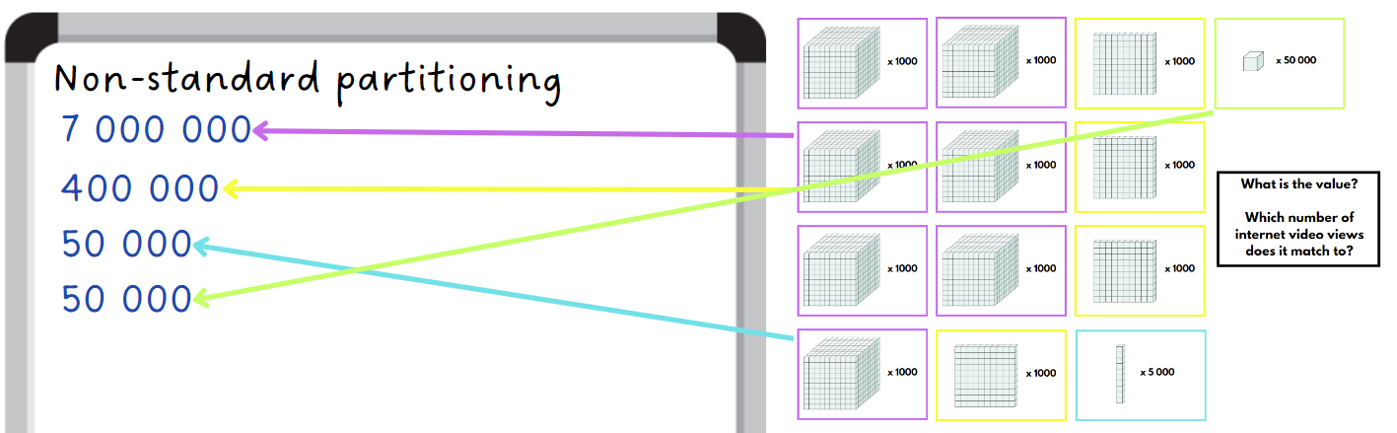

1. Students think about which value from Resource 1 – streaming views is equivalent to the number displayed on Resource 2 – non-standard partitioning. They use their place value knowledge to convince another class member that they are correct.
2. Discuss which number students think it is equivalent to. Ask several students to explain their reasoning.
3. Tell students that they will play a game in pairs. They will be matching cards that rename numbers in a variety of equivalent ways.
4. Students use copies of Resource 3 – matching game to match the cards that represent equivalent numbers.
5. After playing the game, complete a [gallery walk](https://app.education.nsw.gov.au/digital-learning-selector/LearningActivity/Card/555) with the class. Students see if card arrangements have the same matches as theirs, discussing any answers that may differ.

This table details opportunities for differentiation.

|  |  |
| --- | --- |
| Too hard? | Too easy? |
| Students cannot regroup and rename numbers in different forms.   * Assist students by reducing the size of their numbers. * Support students by using materials such as MAB materials, labelled place value houses or number lines to identify and name their number. | Students can regroup and rename numbers in different forms.   * Research other things that can be recorded using billions. For example, stars in the galaxy or ants in a colony. Rename these numbers using equivalent amounts of millions or hundred thousands. * Provide students with the following scenario: they have one billion dollars that they can donate to 7 different charities. Ask them to consider which charities they would choose, how much each might need and why. |

## Consolidation and meaningful practice – 20 minutes

1. Using Resource 3 – matching game, students order their number cards in descending order (see Figure 2).

Figure 2 – matching cards descending order

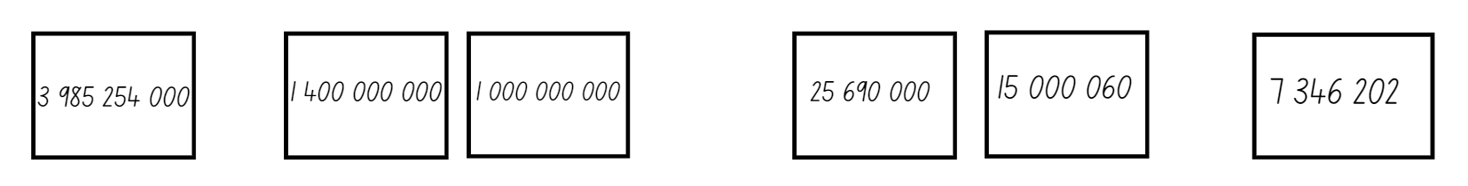

1. In pairs, students take turns to read their numbers aloud. Each partner must listen to ensure the numbers have been placed in the correct order.

This table details opportunities for assessment.

|  |  |
| --- | --- |
| Assessment opportunities | Links |
| What to look for:   * Can students recognise 1000 thousands is 1 million and 1000 millions is 1 billion? **[MAO-WM-01, MA3-RN-01]** * Can students regroup and rename numbers in different forms? **[MAO-WM-01, MA3-RN-01]** | Links to [National Numeracy Learning Progressions](https://www.australiancurriculum.edu.au/resources/national-literacy-and-numeracy-learning-progressions/version-3-of-national-literacy-and-numeracy-learning-progressions/) (NNLP):   * NPV6. |

# Lesson 2

**Core concept**: the place value system can be extended.

## Daily number sense – inverse operations (part 2) – 10 minutes

The table below contains a suggested learning intention and success criteria. These are best co-constructed with students.

|  |  |
| --- | --- |
| Daily number sense learning intention | Daily number sense success criteria |
| Students are learning to:   * use equivalent number sentences involving multiplication and division to find unknown quantities. | Students can:   * identify and use inverse operations to assist with the solution of number sentences. |

1. Draw a rectangle on the whiteboard marking one side as 7 m and the area in the middle as 119 m2 (see Figure 3).

Figure 3 – rectangle for whiteboard

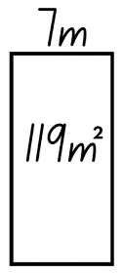

1. Write 7 m × __ m = 119 m2 on the board.
2. Ask:

* Which operation would you use to help solve this problem?
* What is the answer?

1. Allow students time to [Think-Pair-Share](https://app.education.nsw.gov.au/digital-learning-selector/LearningActivity/Card/645). Explain that division is needed to solve the problem.
2. In pairs, students create a word problem to go with Figure 3. For example, the rectangular playground has an area of 119 m2 and one side is 7 m long. How long is the other side?
3. Students write another problem with the same playground area context where the inverse operation (multiplication) is required.

This table details an opportunity for assessment.

|  |  |
| --- | --- |
| Assessment opportunity | Links |
| What to look for:   * Can students identify and use inverse operations to assist with the solution of number sentences? **[MAO-WM-01, MA3-MR-01,  MA3-MR-02]** | Links to [National Numeracy Learning Progressions](https://www.australiancurriculum.edu.au/resources/national-literacy-and-numeracy-learning-progressions/version-3-of-national-literacy-and-numeracy-learning-progressions/) (NNLP):   * NPA3, NPA4, MuS7.   Links to suggested [Interview for Student Reasoning](https://education.nsw.gov.au/teaching-and-learning/curriculum/literacy-and-numeracy/assessment-resources/ifsr) (IfSR) tasks:   * IfSR-MT: 3A.10. |

## Core lesson – decimal target practice – 35 minutes

The table below contains a suggested learning intention and success criteria. These are best co-constructed with students.

|  |  |
| --- | --- |
| Core concept learning intention | Core concept success criteria |
| Students are learning to:   * compare and order decimals. | Students can:   * express thousandths as decimals * interpret decimal notation for thousandths * interpret zero digit(s) at the end of a decimal. |

This lesson is an adaptation of ‘Target Practice’ from [*Resources and Workbook for PMSS PL Block Three – Cohort 5* (PDF 4.5 MB)](https://arc.educationapps.vic.gov.au/04b725e0-6f9a-433d-bbd2-1805777989ea/PMSS%20PL%20Block%20THREE%20Workbook.pdf.rsf) by Siemon.

1. Draw a table with 5 rows and 3 columns for students to copy. The 3 column headings are ‘I rolled’, ‘Target’ and ‘Decimal Made’.
2. Write 4 decimals in the target column, for example, 3.8, 2.1, 0.9 and 6.4. Explain that these are the 4 target numbers and students copy these into the table in their workbooks.
3. To play the game, students roll a 10-sided dice 4 times to create a decimal to 3 decimal places, for example, 2.137. The aim is to get as close to the target number in that row without going over. Students record this in their workbooks (see Figure 4).

Figure 4 – target practice workbook example

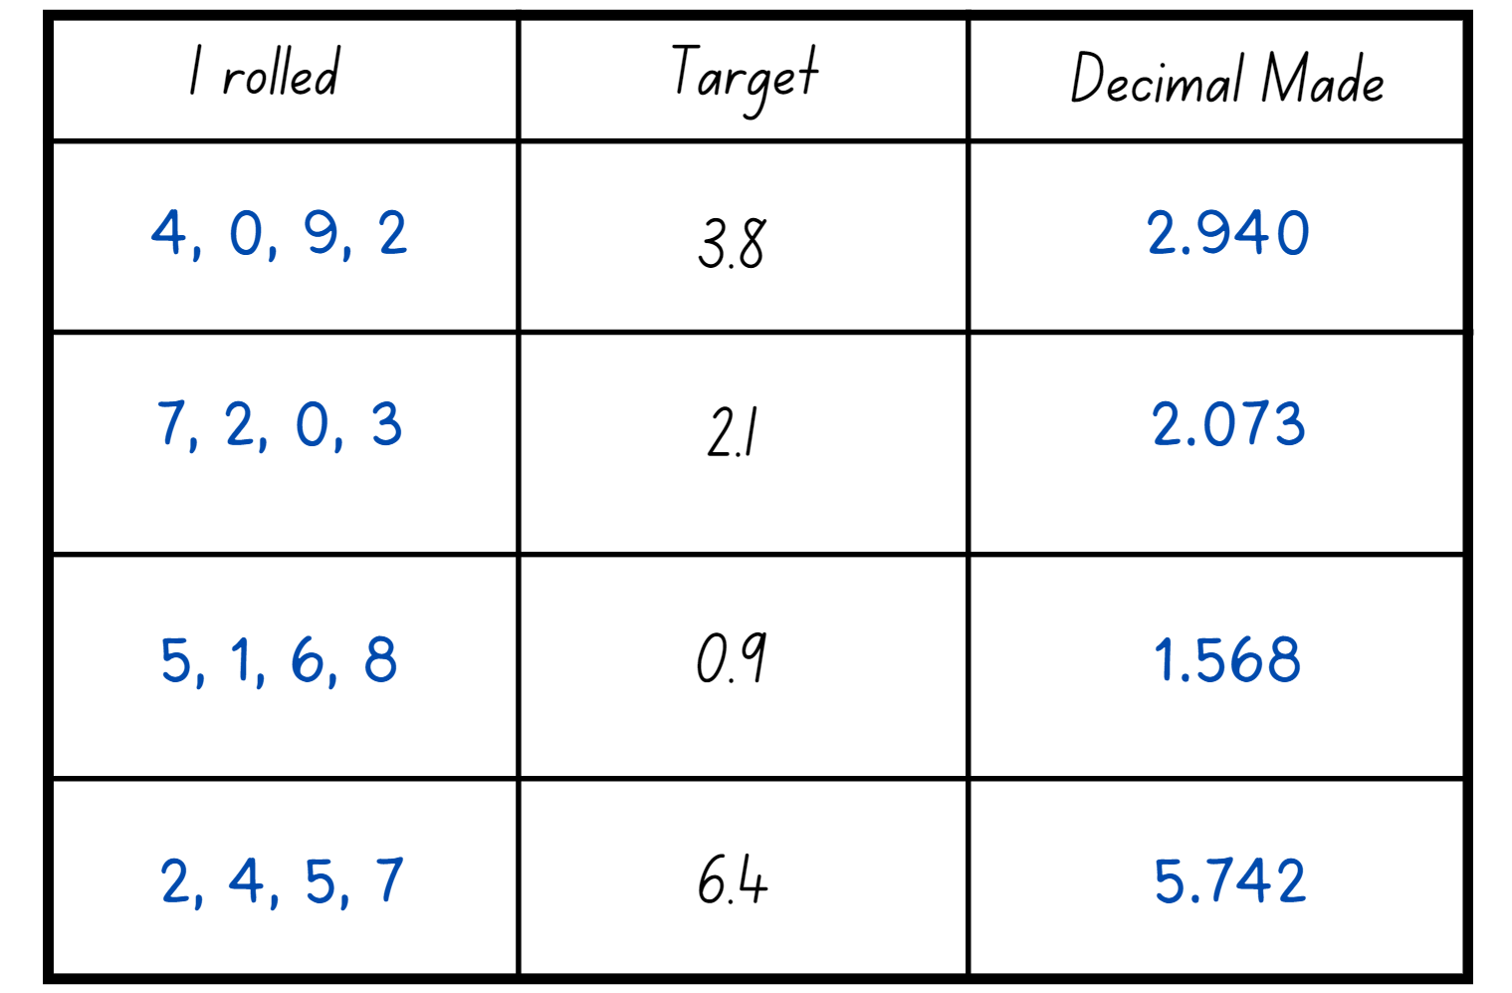

1. Students compare their results with a partner and discuss who got the closest to each target decimal. Students justify their answers and circle the decimal if it was the closest to the target.
2. In pairs, list the decimals created by both partners in ascending order.
3. Students swap with another pair to check answers.
4. Display Resource 4 – True or false?.
5. For each scenario, students discuss whether it is true or false, justifying their thinking.
6. Individually or in pairs, students design their own true or false questions relating to decimals in the thousandths.
7. Students share their questions with a partner or pair. Individuals or pairs answer the new questions, justifying their thinking.

This table details opportunities for differentiation.

|  |  |
| --- | --- |
| Too hard? | Too easy? |
| Students cannot express thousandths as decimals.   * Support students by reducing the number of decimals places they are using to tenths and hundredths. * Assist students by providing support materials such as labelled place value houses or number lines to assist in placing the decimals in order. | Students can express thousandths as decimals.   * Modify the target decimal to include decimals to the hundredth or thousandth. * Challenge students to play the ladder game using decimals. In pairs, students draw a ladder on a whiteboard. The aim of the game is to roll a 10-sided die 4 times to create a number with 3 decimal places and place them in order (either ascending or descending) between the rungs of the ladder. If a student creates a number that cannot be placed on the ladder or places a number in the wrong position, they miss a turn. The winner is the student with the most numbers on the ladder. |

## Discuss and connect the mathematics – 20 minutes

1. Display Resource 5 – place value thousandths.
2. Ask students if the number 274 is larger than this decimal.
3. Students [turn and talk](https://education.nsw.gov.au/teaching-and-learning/curriculum/literacy-and-numeracy/teaching-and-learning-resources/numeracy/talk-moves), justifying their thinking. Students then share their thinking with the class.
4. Ask:

* What do you notice about the tenths, hundredths and thousandths columns?
* If we replaced the 5 in the thousandths column with a zero, would this increase or decrease the value of the number?
* If we replaced the 6 in the hundredths column with a zero, would this increase or decrease the value of the number?
* How is the role of zero different when placed at the end of a decimal compared to when it’s used in the middle of a decimal?

**Note**: highlight the relationship between fractions and decimals, as well as the role of the zero when placed at the end of a decimal. For example, 0.170 has the same value as 0.17.

This table details opportunities for assessment.

|  |  |
| --- | --- |
| Assessment opportunities | Links |
| What to look for:   * Can students express thousandths as decimals? **[MAO-WM-01, MA3-RN-02]** * Can students interpret decimal notation for thousandths?  **[MAO-WM-01, MA3-RN-02]** * Can students interpret zero digit(s) at the end of a decimal? **[MAO-WM-01, MA3-RN-01, MA3-RN-02]** | Links to [National Numeracy Learning Progressions](https://www.australiancurriculum.edu.au/resources/national-literacy-and-numeracy-learning-progressions/version-3-of-national-literacy-and-numeracy-learning-progressions/) (NNLP):   * NPV7, NPV8. |

# Lesson 3

**Core concept**: connections can be made between benchmark fractions, decimals and percentages.

## Daily number sense – multiply and divide – 10 minutes

The table below contains a suggested learning intention and success criteria. These are best co-constructed with students.

|  |  |
| --- | --- |
| Daily number sense learning intention | Daily number sense success criteria |
| Students are learning to:   * use equivalent number sentences involving multiplication and division to find unknown quantities. | Students can:   * complete number sentences that involve more than one operation by calculating missing numbers. |

This activity is an adaptation of [Multiply and Divide Within a Hundred 1](https://www.openmiddle.com/multiply-and-divide-within-a-hundred-1/) from [Open Middle](https://www.openmiddle.com/) by Kaplinsky.

1. Draw Figure 5 on the whiteboard.

Figure 5 – multiply and divide equation

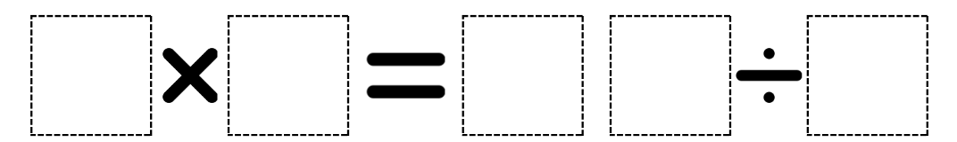

1. In pairs, students use digits 2–9 (only once each), placing a digit in each box to make 2 correct and equal equations. For example, 3 × 6 = 72 ÷ 4.
2. As a class, share and compare solutions. Ask to identify the strategies they used and justify their choices.

This table details an opportunity for assessment.

|  |  |
| --- | --- |
| Assessment opportunity | Links |
| What to look for:   * Can students complete number sentences that involve more than one operation by calculating missing numbers? **[MAO-WM-01, MA3-MR-01, MA3-MR-02]** | Links to [National Numeracy Learning Progressions](https://www.australiancurriculum.edu.au/resources/national-literacy-and-numeracy-learning-progressions/version-3-of-national-literacy-and-numeracy-learning-progressions/) (NNLP):   * NPA3, MuS8. |

## Core lesson 1 – equivalent fractions, decimals and percentages – 15 minutes

The table below contains a suggested learning intention and success criteria. These are best co-constructed with students.

|  |  |
| --- | --- |
| Core concept learning intention | Core concept success criteria |
| Students are learning to:   * make connections between benchmark fractions, decimals and percentages. | Students can:   * recall commonly used equivalent percentages, decimals and fractions, including $\frac{1}{2}$, $\frac{1}{4}$, and $\frac{3}{4}$. * recognise that 10% is one-tenth of 100% and use this to find 10% of a quantity. |

This lesson is an adaptation of ‘Benchmark Problems’ from [Part 2: Proportional thinking with fractions, decimals and percentages (PDF 1237 KB)](https://education.nsw.gov.au/content/dam/main-education/en/home/teaching-and-learning/curriculum/literacy-and-numeracy/teaching-and-learning-resources/numeracy/proportional-thinking-part-2.pdf) by State of New South Wales (Department of Education).

1. Draw a rectangle on the whiteboard and explain that it represents a computer download bar. Ask where they may have seen this and what it shows.
2. Ask a student to fill the download bar to represent a download which is only 25% complete. Ask how this could be represented as a fraction and decimal. Record these representations in line with the 25% mark.
3. Select another student to fill the download bar to represent a download that is $\frac{3}{4}$ completed.
4. Explain that this represents a download that is $\frac{3}{4}$ complete. Ask if there is another way to describe the download bar. Highlight that it could be $\frac{3}{4}$ complete, which is 75% and 0.75, or $\frac{1}{4}$ still to be completed, which is 25% and 0.25 to go. Include these fractions, decimals and percentages on the download bar.

## Core lesson 2 – Would you rather? – 20 minutes

1. Ask if students would rather have 20% of a chocolate bar or 0.4 of the same-sized chocolate bar.
2. Allow students time to [turn and talk](https://education.nsw.gov.au/teaching-and-learning/curriculum/literacy-and-numeracy/teaching-and-learning-resources/numeracy/talk-moves) with a partner. They can represent and explain their thinking by writing or drawing images on whiteboards (see Figure 6).

Figure 6 – example of chocolate bar representations

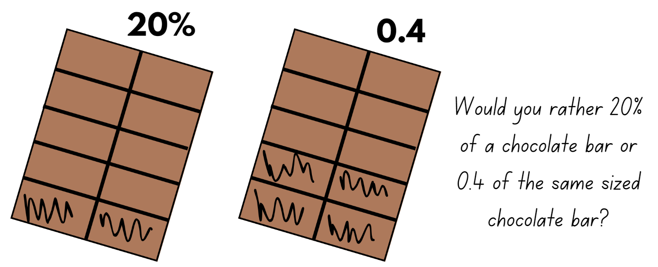

1. Ask pairs to identify the portion they would prefer and discuss how they came to the decision.
2. Display Resource 6 – chocolate bar. Discuss the different responses of each of the students, taking the opportunity to highlight the connection between 10% equalling $\frac{1}{10}$ and using this knowledge to find 10% of any quantity.
3. In pairs, students complete Resource 7 – Would you rather? discussing and then writing the justification for their choices.

This table details opportunities for differentiation.

|  |  |
| --- | --- |
| Too hard? | Too easy? |
| Students cannot recall commonly used equivalent percentages, decimals and fractions including $\frac{1}{2}$, $\frac{1}{4}$, and $\frac{3}{4}$.   * Provide students with grids or fraction strips divided into halves, quarters and tenths. * Support students by providing manipulatives for them use to make the equivalent percentages, decimals and fractions. Model how these resources can be used to represent the amounts. | Students can recall commonly used equivalent percentages, decimals and fractions including $\frac{1}{2}$, $\frac{1}{4}$, and $\frac{3}{4}$.   * Ask to find 10% of each of their preferred ‘Would you rather?’ answers. * Challenge students to develop a ‘Memory match’ game using equivalent percentages, decimals and fractions. Students use cardboard squares to record the equivalent percentages, decimals and fractions. Place all cards upside down. Students alternate turning over 3 cards. Students who turn over the equivalent percentage, decimal and fraction can keep the cards. If no match is made, the cards are turned back over. The game continues until all matches are made. |

## Consolidation and meaningful practice – 20 minutes

1. Students create their own Resource 7 – Would you rather? scenarios.
2. Students share and complete the new scenarios in small groups.

This table details opportunities for assessment.

|  |  |
| --- | --- |
| Assessment opportunities | Links |
| What to look for:   * Can students recall commonly used equivalent percentages, decimals and fractions, including $\frac{1}{2}$, $\frac{1}{4}$, and $\frac{3}{4}$? **[MAO-WM-01,  MA3-RN-01, MA3-RN-02, MA3-RN-03]** * Can students recognise that 10% is one-tenth of 100% and use this to find 10% of a quantity? **[MAO-WM-01, MA3-RN-01, MA3-RN-02, MA3-RN-03]** | Links to [National Numeracy Learning Progressions](https://www.australiancurriculum.edu.au/resources/national-literacy-and-numeracy-learning-progressions/version-3-of-national-literacy-and-numeracy-learning-progressions/) (NNLP):   * PrT2, UnM8. |

# Lesson 4

**Core concept**: number patterns can be multiplicative.

## Daily number sense – 10 minutes

1. From a class need surfaced through formative assessment data, identify a short, focused activity that targets students’ knowledge, understanding and skills. Example activities may be drawn from the following resources:

* [Mathematics K–6 resources](https://education.nsw.gov.au/teaching-and-learning/curriculum/mathematics/mathematics-curriculum-resources-k-12/mathematics-k-6-resources)
* [Universal Resources Hub](https://resources.education.nsw.gov.au/home).

## Core lesson – number patterns using geometric shapes – 40 minutes

The table below contains a suggested learning intention and success criteria. These are best co-constructed with students.

|  |  |
| --- | --- |
| Core concept learning intention | Core concept success criteria |
| Students are learning to:   * represent and describe number patterns formed by multiples. | Students can:   * use a given geometric pattern involving multiples to create a table of values * determine a rule describing the relationship between the bottom number and the top number in a table. |

This lesson is an adaptation from [*Talking about Patterns & Algebra: Early Stage 1 to Stage 3*](https://education.nsw.gov.au/teaching-and-learning/curriculum/mathematics/mathematics-curriculum-resources-k-12/mathematics-k-6-resources/talking-about-patterns-and-algebra) by State of NSW Department of Education and Training.

1. Draw an 8-sided shape on the board. Ask students: How many sides are there? Record the number 8 below the diagram.
2. Replicate the same shape next to the first one and pose the question: I have drawn another one of these shapes next to the first, how many sides have I drawn altogether? Record the number 16 below the second diagram.
3. Students continue the sequence to the tenth term and record it in a table (see Figure 7).

Figure 7 – table example

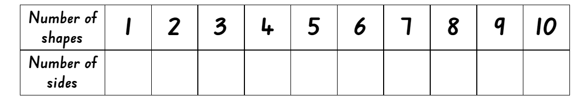

1. Discuss the features of the pattern as a class.

The table below outlines stimulus prompts to generate conversation about the topic, along with anticipated responses from students.

|  |  |
| --- | --- |
| Prompts | Anticipated student responses |
| * How many ways can you describe the pattern? | * The numbers in the pattern are increasing by 8. * The pattern is made up of numbers that are multiples of 8. The third number in the pattern is 3 × 8 and the fourth number in the pattern is 4 × 8 and it continues. |
| * How many sides will there be if there are 15 shapes? How did you work it out? | * There would be 120 sides if there were 15 shapes. * I know this because one shape has 8 sides so 15 shapes means that I multiply 15 and 8 together. I can use repeated doubling to work this out. Double 15 is 30, double 30 is 60 and double 60 is 120. |
| * If there are 360 sides altogether, how many shapes will there be? How did you work it out? | * There would be 45 shapes. * I worked it out by dividing 360 by 8. I could use repeated halving, or I also know that 320 ÷ 8 = 40 and 40 ÷ 8 = 5 so 360 ÷ 8 = 45. |
| * How does the table help determine the relationship between the number of shapes and the number of sides? | * The table helps me see that I don’t need to add 8 to continue the pattern. I can see that if I take the number of shapes and multiply it by 8, it will give me the number of sides. |
| * Can you create a rule using multiplication to determine the number of sides for any given number of shapes? Highlight that the number of shapes multiplied by 8 always determines the number of sides. | * The rule is: number of shapes × 8 = number of sides. |

1. Students choose a multi-sided two-dimensional shape to create their own pattern. They investigate the number sequence based on the total number of sides and record the data in a table.

This table details opportunities for differentiation.

|  |  |
| --- | --- |
| Too hard? | Too easy? |
| Students cannot use a given geometric pattern involving multiples to create a table of values.   * Continue the pattern using a triangle or a square. Model drawing a diagram on the board and continue the pattern, recording the results. * Support students to use concrete materials to recreate their own pattern, for example, craft sticks, toothpicks or cut-up straws. Guide them in using a table to record their pattern. | Students can use a given geometric pattern involving multiples to create a table of values.   * Challenge students to use a hexadecagon (a 16-sided shape) to create patterns and record results in a table. Describe the relationship between the bottom and top numbers in a table. * Play the counting game ‘Multiples’. In pairs, students select a target number and then a unit multiple that will allow them to reach their target number. The goal is to be the player who says or records the target number. On their turn, players can count on by saying the next 1, 2 or 3 numbers in the counting sequence (see Figure 8).   Figure 8 – example of counting game – ‘Multiples’  A whiteboard with the target number of 85 written at the top. A demonstration of the game is written on the board using green and blue writing to indicate the different players' turns. |

## Consolidation and meaningful practice – 10 minutes

1. Using the data from the last activity, students create a written multiplication rule describing the relationship between the bottom number and the top number in their table.
2. Students swap with a partner and attempt to draw and describe the geometric pattern.
3. Students share their drawings and descriptions with the class.

This table details opportunities for assessment.

|  |  |
| --- | --- |
| Assessment opportunities | Links |
| What to look for:   * Can students use a given geometric pattern involving multiples to create a table of values? **[MAO-WM-01, MA3-MR-01]** * Can students determine a rule describing the relationship between the bottom number and the top number in a table? **[MAO-WM-01, MA3-MR-01]** | Links to [National Numeracy Learning Progressions](https://www.australiancurriculum.edu.au/resources/national-literacy-and-numeracy-learning-progressions/version-3-of-national-literacy-and-numeracy-learning-progressions/) (NNLP):   * NPA4, NPA5. |

# Lesson 5

**Core concept**: known number facts and strategies support multiplicative understanding.

## Daily number sense – powers of 10 – 20 minutes

Daily number sense activities for Lessons 5 to 7 ‘loop’ back to concepts and procedures covered in previous units to assist students to build an increasingly connected network of ideas. These concepts may differ from the core concepts being covered by the unit.

The table below contains a suggested learning intention and success criteria. These are best co-constructed with students.

|  |  |
| --- | --- |
| Daily number sense learning intention | Daily number sense success criteria |
| Students are learning to:   * multiply and divide decimals by powers of 10. | Students can:   * compare the relative place value of digits to multiply a decimal by powers of 10. |

This activity is an adaptation of [Tens Time](https://nzmaths.co.nz/resource/tens-time) from [NZ Maths](https://nzmaths.co.nz/) by the New Zealand Ministry of Education.

1. Use a calculator that students can see, such as a [full screen calculator](https://www.online-calculator.com/full-screen-calculator/). Enter 6 on the calculator and ask what will happen if the number 6 is multiplied by 10. Press the **×** **10** keys to reveal the answer.
2. Show that pressing the **= button** again will multiply the number again by 10. Ask what they notice each time the number is multiplied by 10.
3. Explain that every time the number is multiplied by 10, the place value of the digit 6 moves from the tens to the hundreds and so on. Each time it is multiplied by 10, the digit moves one spot to the left each time.
4. Draw a place value table from thousands to thousandths. Record the number 6 in the ones column. Explain this was the number the calculator pattern started with.
5. Record the pattern created each time the number was multiplied by 10 in the corresponding column. Draw arrows to show how each time the number was multiplied it became 10 times larger.
6. Explain that this table helps determine the relative size of the numbers. For example, 600 is 100 × 6. This can be seen with the 2 arrows, which shows that is has been multiplied by 10 twice, which is equivalent to 100 (see Figure 9).

Figure 9 – multiplying by powers of 10 pattern in a table

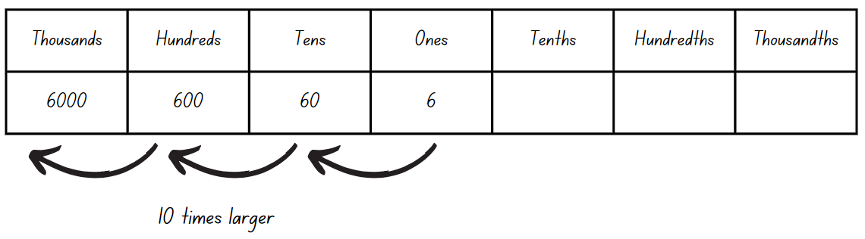

1. Provide small groups of students with calculators. Students choose a single-digit number and record what happens to the number each time it is multiplied by 10 in a table.
2. Ask:

* What might happen if we started with a 2-digit number?
* What might happen if we started with a decimal with one decimal place?
* What might happen if we started with a decimal with 2 decimal places?

1. Small groups of students investigate patterns that are created when a decimal is multiplied by powers of 10. Students record the patterns in a table.
2. Ask:

* What happened to the decimal as it was multiplied by 10?
* What happened to the decimal point as it was multiplied by 10?
* Did the numbers in each place value column move to the left or right as it was multiplied by 10?
* What operation would make the numbers in each place value column move to the right?
* What is the relationship between your starting decimal and another number in your pattern?

1. Explain that using the table helps compare the size of numbers in relation to each other. For example, if the starting decimal was 0.45, 4.5 is 10 × 0.45, because it has moved once to the left (see Figure 10).

Figure 10 – multiplying 0.45 by powers of 10 in a table

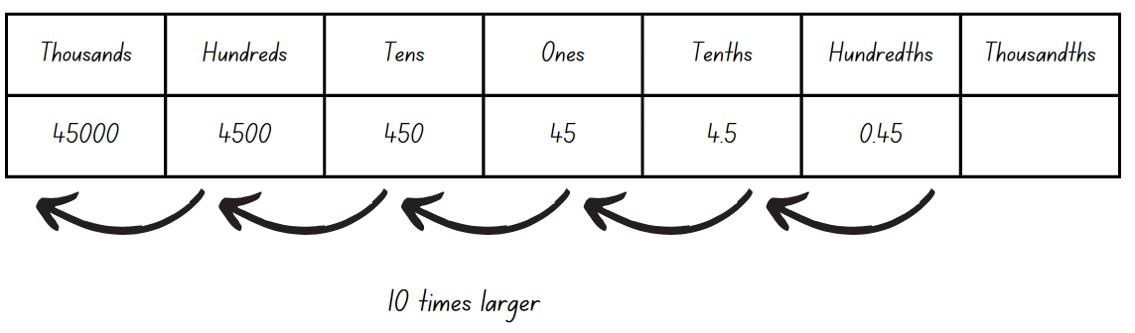

1. Students record their starting decimal and its relationship to another number in their table on an exit slip.

This table details an opportunity for assessment.

|  |  |
| --- | --- |
| Assessment opportunity | Links |
| What to look for:   * Can students compare the relative place value of digits to multiply a decimal by powers of 10? **[MAO-WM-01, MA3-MR-02]** | Links to [National Numeracy Learning Progressions](https://www.australiancurriculum.edu.au/resources/national-literacy-and-numeracy-learning-progressions/version-3-of-national-literacy-and-numeracy-learning-progressions/) (NNLP):   * NPV8, MuS9.   Links to suggested [Interview for Student Reasoning](https://education.nsw.gov.au/teaching-and-learning/curriculum/literacy-and-numeracy/assessment-resources/ifsr) (IfSR) tasks:   * IfSR-MT: 4A.1, 4A.2, 4A.3, 4A.4. |

## Core lesson – known facts – 40 minutes

The table below contains a suggested learning intention and success criteria. These are best co-constructed with students.

|  |  |
| --- | --- |
| Core concept learning intention | Core concept success criteria |
| Students are learning to:   * use partitioning and place value to multiply 2-, 3- and 4-digit numbers by one-digit numbers. | Students can:   * use informal written strategies such as the area model to solve multiplication and division problems * use the distributive property with the area model to partition numbers in representing multiplication problems * record the product of multiplying by a one-digit number using a formal algorithm. |

This activity is an adaptation from Open-ended maths activities: Using ‘Good’ Questions to Enhance Learning in Mathematics by Sullivan and Lilburn.

1. Explain that some problems can have more than one solution. Using strategies such as the area model can help us to find different solutions. Display the following open-ended problems:

* Use the numbers 6, 5 and 4 in the number sentence _ _ × _. How many different answers can you get?
* Use the numbers 6, 5, 4 and 0 in the number sentence _ _ × _ _. How many different answers can you get?
* Use the numbers 6, 5, 4 and 0 in the number sentence _ _ _ × _. How many different answers can you get?
* Use the numbers 6, 5, 4, 3 and 0 in the number sentence _ _ _ _ × _. How many different answers can you get?
* Students work independently to solve the following question: ♥ × Δ = 1140.

1. Students work in pairs, recording the problem and the strategy used to solve each problem. Encourage them to use a variety of strategies, for example, area model, partitioning using place value and formal algorithm (see Figure 11).

Figure 11 – student strategies

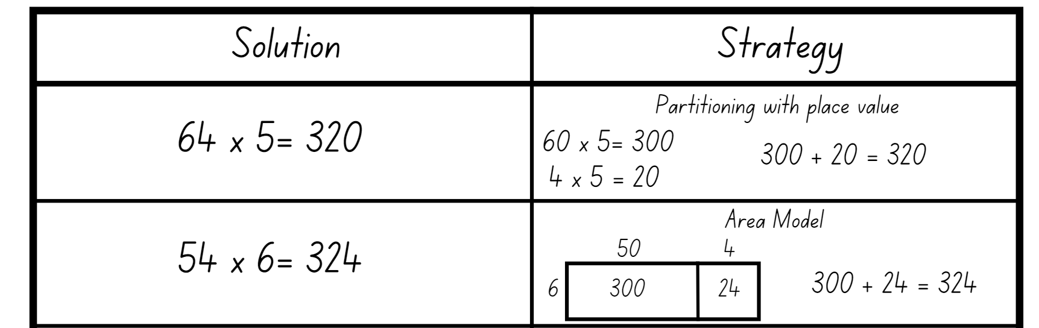

This table details opportunities for differentiation.

|  |  |
| --- | --- |
| Too hard? | Too easy? |
| Students cannot use informal written strategies such as the area model to solve multiplication and division problems.   * Provide students with multiplication fact tables for up to 10 × 10 to support ease of recall. * Students can use the [area model digital tool](https://phet.colorado.edu/sims/html/area-model-algebra/latest/area-model-algebra_en.html) to solve multiplication problems. | Students can use informal written strategies such as the area model to solve multiplication and division problems.   * Students create their own open-ended multiplication questions to share with a partner. * Challenge students by increasing the number of digits up to 3- and 4- digits by 3-digits. |

## Discuss and connect the mathematics – 10 minutes

1. Students display their solutions to the problems and complete a [gallery walk](https://app.education.nsw.gov.au/digital-learning-selector/LearningActivity/Card/555).
2. Ask questions:

* What strategies do you notice?
* Did anyone use the same strategy as you?
* Did anyone use a different strategy you would like to use next time? If so, what is it?

This table details opportunities for assessment.

|  |  |
| --- | --- |
| Assessment opportunities | Links |
| What to look for:   * Can students use informal written strategies such as the area model to solve multiplication and division problems?  **[MAO-WM-01, MA3-MR-01]** * Can students use the distributive property with the area model to partition numbers in representing multiplication problems?  **[MAO-WM-01, MA3-MR-01]** * Can students record the product of multiplying by a one-digit number using a formal algorithm? **[MAO-WM-01, MA3-MR-01]** | Links to [National Numeracy Learning Progressions](https://www.australiancurriculum.edu.au/resources/national-literacy-and-numeracy-learning-progressions/version-3-of-national-literacy-and-numeracy-learning-progressions/) (NNLP):   * MuS6, MuS7, MuS8.   Links to suggested [Interview for Student Reasoning](https://education.nsw.gov.au/teaching-and-learning/curriculum/literacy-and-numeracy/assessment-resources/ifsr) (IfSR) tasks:   * IfSR-MT: 3A.1, 3A.2, 3A.3. |

# Lesson 6

**Core concept**: flexible methods of computation in multiplication and division involve composing and decomposing numbers.

## Daily number sense – powers of 10 – 20 minutes

The table below contains a suggested learning intention and success criteria. These are best co-constructed with students.

|  |  |
| --- | --- |
| Daily number sense learning intention | Daily number sense success criteria |
| Students are learning to:   * multiply and divide decimals by powers of 10. | Students can:   * compare the relative place value of digits to divide a decimal by powers of 10. |

This activity is an adaptation of [Tens Time](https://nzmaths.co.nz/resource/tens-time) from [NZ Maths](https://nzmaths.co.nz/) by the New Zealand Ministry of Education.

1. Use a calculator that students can see, such as [full screen calculator](https://www.online-calculator.com/full-screen-calculator/). Enter 600 on the calculator and ask what will happen if the number is divided by 10. Press the **÷ 10** keys to reveal the answer. Show that pressing the **= button** again will divide the number again by 10. Ask what they notice each time the number is divided by 10.
2. Explain that every time the number is divided by 10, the place value of the digit 6 moves from the hundreds to the tens and so on. Each time it is divided by 10, the digit moves one spot to the right each time.
3. Draw a place value table from thousands to thousandths. Record the number 600 in the hundreds column.
4. Explain this was the number that the calculator pattern started with. Record the pattern created each time the number was divided by 10 in the corresponding column. Draw arrows to show how each time the number was divided it became 10 times smaller.
5. Explain that this table helps determine the relative size of the numbers. For example, 0.6 is $\frac{1}{1000}$ of 600. This can be seen with the 3 arrows, which shows that is has been divided by 10 three times, which is equivalent to $\frac{1}{1000}$, see Figure 12.

Figure 12 – dividing 600 by powers of 10

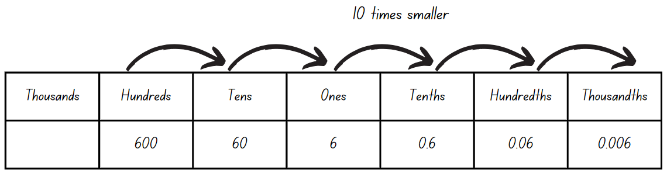

1. Provide small groups of students with calculators. Students choose whole numbers or decimals and record what happens to the number each time it is divided by 10 in a table.
2. Ask:

* What happened to whole numbers as it was divided by 10?
* What happened to decimals as it was divided by 10?
* What happened to the decimal point as it was divided by 10?
* Did the numbers in each place value column move to the left or right as it was divided by 10?
* What is the relationship between your starting number and another number in your pattern?

1. Say that using the table helps compare the size of numbers in relation to each other. For example, if the starting decimal was 0.45, 0.045 is $\frac{1}{10}$ of 0.45, because it has moved once to the left.
2. Students record their starting number and its relationship to another number in their table on an exit slip.

This table details an opportunity for assessment.

|  |  |
| --- | --- |
| Assessment opportunity | Links |
| What to look for:   * Can students compare the relative place value of digits to divide a decimal by powers of 10? **[MAO-WM-01, MA3-MR-02]** | Links to [National Numeracy Learning Progressions](https://www.australiancurriculum.edu.au/resources/national-literacy-and-numeracy-learning-progressions/version-3-of-national-literacy-and-numeracy-learning-progressions/) (NNLP):   * NPV8, MuS9.   Links to suggested [Interview for Student Reasoning](https://education.nsw.gov.au/teaching-and-learning/curriculum/literacy-and-numeracy/assessment-resources/ifsr) (IfSR) tasks:   * **IfSR-MT**: 4A.5. |

## Core lesson – rate word problems – 40 minutes

The table below contains suggested a learning intention and success criteria. These are best co-constructed with students.

|  |  |
| --- | --- |
| Core concept learning intention | Core concept success criteria |
| Students are learning to:   * select and apply strategies to solve problems involving multiplication and division with whole numbers. | Students can:   * select and use efficient strategies to multiply whole numbers of up to 4 digits by one- and 2-digit numbers * solve word problems involving rates using multiplication and division. |

This lesson is an adaptation of ‘Best Value*’* in *Challenging Mathematical Tasks: Unlocking the Potential for All Students* by Sullivan.

1. Share the following problem: Jake has 4 books. Harry has 5 times as many books as Jake. Can you use a bar model to represent how many books they have?

**Note:** multiplicative comparison problems use expressions like times as many or times as much to express a comparison. Mathematical tools and representations, for example bar models, assist students in representing the relationship between the units of ‘4 books’. The bar model in Figure 13 demonstrates the idea of scaling up, and how this is related to multiplication. It assists a student to answer a ‘How many more books...’ question as well as a ‘How many books altogether...’ question. It can also be used to show that multiplying 4 by 5 is the same as dividing 20 by 4.

Figure 13 – books bar model

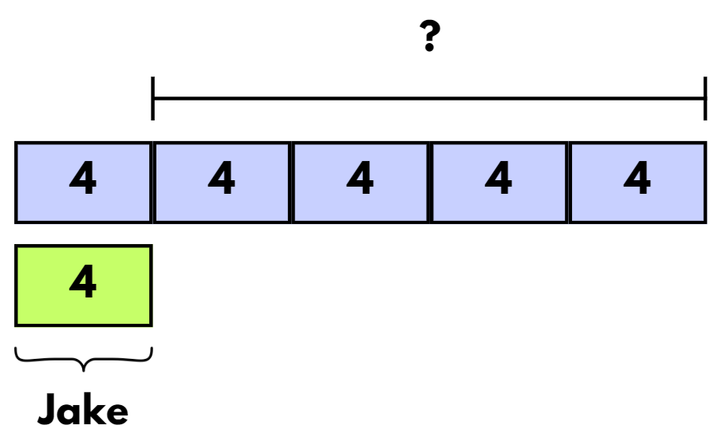

1. Students work with a partner to use a bar model to find a solution to the problem.
2. Share several examples of students’ work with the class and discuss the features. Ask: Are there any other ways we could represent a solution to the problem? (For example, table of values, ratio tables, tape diagrams or number lines).
3. Explain that multiplicative comparison problems use expressions including times as many or times as much to describe comparisons. Identify the mathematical tools and representations we can use to solve these problems, including table of values, ratio tables, tape diagrams or number lines.
4. Display Resource 8 – problems to solve and draw students’ attention to the first 2 problems:

* Justine cleans 72 classrooms in 3 days. How many classrooms can Justine clean in 6 days? How many classrooms can Justine clean in 10 days?
* Carmel cleans $\frac{1}{3}$ less. How many classrooms does Carmel clean in 3 days? 6 days? 10 days?

1. In pairs, students discuss tools they could use to find solutions.
2. With suggestions from the class, demonstrate the use of bar models, table of values, ratio tables, tape diagrams and number lines to solve the problem (see Figure 14). Ask for student contributions during this explanation.

Figure 14 – different tools to solve problems

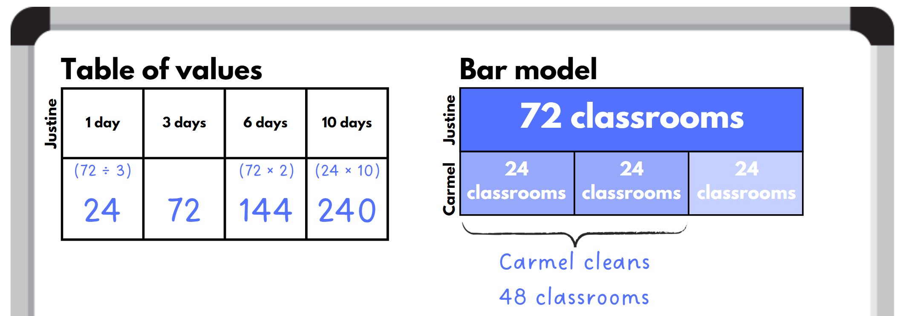

1. Students use 2 different ways to calculate the answer to the following problems in their workbooks. Encourage the students to use a range of strategies to represent and answer the problems, including the use of tools and representations such as bar models, ratio tables, tape diagrams and number lines that were used during the previous example.
2. Provide students with copies of Resource 8 – problems to solve, to complete problems 3, 4 and 5.
3. Students share their solutions with a partner, using their calculations to justify their answers.
4. Ask:

* Which mathematical tools and representations did you use to find your solutions?
* What mathematical operations were you using to find the solutions?
* Can you represent each solution in a table of values or as a number sentence?

This table details opportunities for differentiation.

|  |  |
| --- | --- |
| Too hard? | Too easy? |
| Students cannot solve word problems involving rates using multiplication and division.   * Support students to use visual representations such as bar models, tape diagrams or lines to solve the problems. * Guide students to find the value of one unit in each problem, then use it to find the total amount. | Students can solve word problems involving rates using multiplication and division.   * Students solve this problem from [APSMO](https://apsmo.edu.au/problems/eclairs-and-doughnuts/): At a store, one doughnut and 2 eclairs cost $4.00. Two doughnuts and 3 eclairs cost $6.50. Three doughnuts and one eclair cost $4.50. How much will Geoff pay for one eclair and one doughnut? * Challenge students to create word problems for their classmates. Students swap and solve the problems. Discuss the strategies they used. |

## Consolidation and meaningful practice – 10 minutes

1. Students work on problems 6 and 7 in Resource 8 – problems to solve. Encourage them to try showing their solution using a different mathematical representation.
2. Share students’ solutions with the class and discuss the strategies they used.
3. Ask: Have you seen another student using a strategy that you thought was useful? What did they do?

This table details opportunities for assessment.

|  |  |
| --- | --- |
| Assessment opportunities | Links |
| What to look for:   * Can students select and use efficient strategies to multiply whole numbers of up to 4 digits by one- and 2-digit numbers?  **[MAO-WM-01, MA3-MR-01]** * Can students solve word problems involving rates using multiplication and division? **[MAO-WM-01, MA3-MR-01]** | Links to [National Numeracy Learning Progressions](https://www.australiancurriculum.edu.au/resources/national-literacy-and-numeracy-learning-progressions/version-3-of-national-literacy-and-numeracy-learning-progressions/) (NNLP):   * MuS7, MuS8, PrT4. |

# Lesson 7

**Core concept**: decimals can be divided and multiplied by powers of 10.

## Daily number sense – moving digits – 10 minutes

The table below contains a suggested learning intention and success criteria. These are best co-constructed with students.

|  |  |
| --- | --- |
| Daily number sense learning intention | Daily number sense success criteria |
| Students are learning to:   * multiply and divide decimals by powers of 10. | Students can:   * use mental strategies to divide decimal numbers by powers of 10 * compare the relative place value of digits when dividing decimals by powers of 10. |

This lesson is an adaptation of [Moving Digit Cards](https://www.topmarks.co.uk/Flash.aspx?f=MovingDigitCards) from [Topmarks Online Ltd](https://www.topmarks.co.uk/).

1. Show students the resource [Moving Digit Cards](https://www.topmarks.co.uk/Flash.aspx?f=MovingDigitCards) and ask:

* What is the effect of dividing a decimal by 10?
* What would be the effect of dividing the same decimal by 100?
* What is the effect of multiplying the same decimal by 10?
* What would be the effect of multiplying the same decimal by 100?

1. Working in pairs, students use [Moving Digit Cards](https://www.topmarks.co.uk/Flash.aspx?f=MovingDigitCards) to identify numbers and decimals to complete Resource 9 – powers of 10.

This table details opportunities for assessment.

|  |  |
| --- | --- |
| Assessment opportunities | Links |
| What to look for:   * Can students use mental strategies to divide decimal numbers by powers of 10? **[MAO-WM-01, MA3-MR-02]** * Can students compare the relative place value of digits to multiply and divide a decimal by powers of 10? **[MAO-WM-01,  MA3-MR-02]** | Links to [National Numeracy Learning Progressions](https://www.australiancurriculum.edu.au/resources/national-literacy-and-numeracy-learning-progressions/version-3-of-national-literacy-and-numeracy-learning-progressions/) (NNLP):   * NPV8, MuS9.   Links to suggested [Interview for Student Reasoning](https://education.nsw.gov.au/teaching-and-learning/curriculum/literacy-and-numeracy/assessment-resources/ifsr) (IfSR) tasks:   * IfSR-MT: 4A.3, 4A.4, 4A.5. |

## Core lesson – multiplying and dividing with decimals – 45 minutes

The table below contains a suggested learning intention and success criteria. These are best co-constructed with students.

|  |  |
| --- | --- |
| Core concept learning intention | Core concept success criteria |
| Students are learning to:   * multiply and divide decimals by the powers of 10. | Students can:   * use mental strategies to multiply and divide benchmark decimals * compare the relative place value of digits to multiply and divide a decimal by powers of 10. |

This lesson has been adapted from ‘Dividing by 10, 100 and 1000’ in [*Multiplying and dividing decimals*](https://resources.education.nsw.gov.au/api/v1/blob-store/dXJoX3JlYWRpbmdhbmRudW1lcmFjeV8xNEx1QTRVQkZHVURld2kwYXZPaA===/TXVsdGlwbHlpbmcgYW5kIGRpdmlkaW5nIGRlY2ltYWxzLmRvY3g==?versionid=) *(DOCX 687 KB)* by State of New South Wales (Department of Education).

1. Ask students to explain how multiplication and division are related. They can use numbers to describe the relationship. For example:

* Division is the inverse of multiplication. 3 × 2 is 6 and so 6 ÷ 3 = 2.
* When a zero is added to the end of a number it becomes 10 times larger. Adding a zero to 50 makes 500.

1. Explain that they will be making a tool to represent multiplication and division with decimals.
2. Students use Resource 10 – number slider to create a number slider.
3. In small groups, students investigate the use of the number slider and to determine how the slider can be used to show the concept of multiplying and dividing by the powers of 10 (10, 100, 1000).

**Note:** ensure students understand that when representing 0.5 and moving the slider one place to the right, they have divided the number by 10. This creates the decimal 0.05, which is 10 times smaller than 0.5. Identify that adding the zero digits into the previous place value enable these numbers to hold their positions.

1. Students complete Resource 11 – Divide or multiply? using their Resource 10 – number slider to investigate multiplying and dividing by the powers of 10 (see Figure 15).

Figure 15 – multiply or divide example table

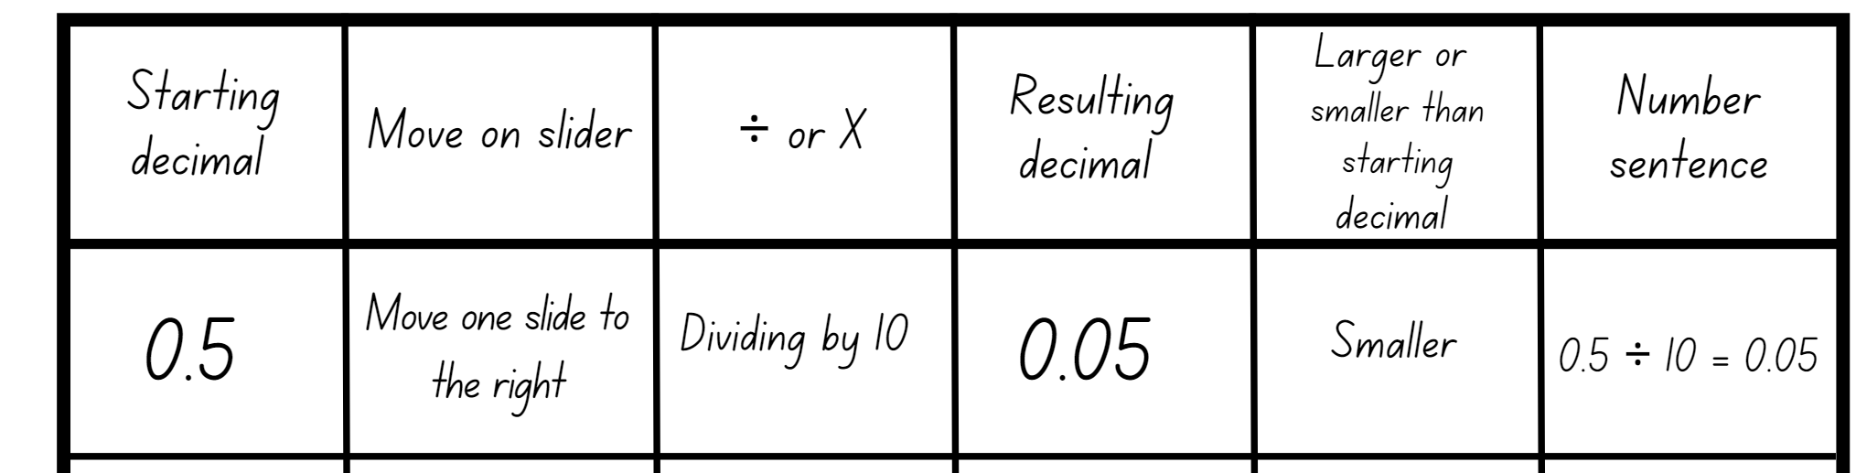

This table details opportunities for differentiation.

|  |  |
| --- | --- |
| Too hard? | Too easy? |
| Students cannot compare the relative place value of digits to multiply and divide a decimal by powers of 10.   * Use a tens, hundreds or thousands grid to visually compare the relative place value of digits when multiplying and dividing. * Students use calculators to investigate and record patterns when multiplying and dividing decimals by powers of 10 (10, 100, 1000). | Students can compare the relative place value of digits to multiply and divide a decimal by powers of 10.   * Working in pairs, students give their partner a decimal number. The partner shows 2 different ways they can create this decimal using either multiplication or division. For example, 7.5 divided by 10, 750 divided by 1000. * Challenge students to investigate the inverse nature of multiplication and division by identifying as many facts as they can using the one piece of information. For example, using 0.75 we know that 0.75 times 10 is 7.5 and 7.5 divided by 10 is 0.75. |

## Discuss and connect the mathematics – 10 minutes

1. Looking at previous task, ask:

* What do you notice about the table?
* Can you explain what happens when you move your slider to the left? Can you give an example?
* Can you explain what happens when you move your slider to the right? Can you give an example?
* Using the word ‘divide’, how could you explain the use of the slider to someone else?
* What are you still wondering?

This table details opportunities for assessment.

|  |  |
| --- | --- |
| Assessment opportunities | Links |
| What to look for:   * Can students use mental strategies to multiply benchmark decimals? **[MAO-WM-01, MA3-MR-01]** * Can students compare the relative place value of digits to multiply and divide a decimal by powers of 10? **[MAO-WM-01,  MA3-MR-01]** | Links to [National Numeracy Learning Progressions](https://www.australiancurriculum.edu.au/resources/national-literacy-and-numeracy-learning-progressions/version-3-of-national-literacy-and-numeracy-learning-progressions/) (NNLP):   * NPV8, MuS9.   Links to suggested [Interview for Student Reasoning](https://education.nsw.gov.au/teaching-and-learning/curriculum/literacy-and-numeracy/assessment-resources/ifsr) (IfSR) tasks:   * IfSR-MT: 4A.3, 4A.4, 4A.5, 4A.6. |

# Lesson 8

**Core concept**: understanding equivalence can help determine unknown quantities.

## Daily number sense – 10 minutes

1. From a class need surfaced through formative assessment data, identify a short, focused activity that targets students’ knowledge, understanding and skills. Example activities may be drawn from the following resources:

* [Mathematics K–6 resources](https://education.nsw.gov.au/teaching-and-learning/curriculum/mathematics/mathematics-curriculum-resources-k-12/mathematics-k-6-resources)
* [Universal Resources Hub](https://resources.education.nsw.gov.au/home).

## Core lesson – equivalent number sentences – 35 minutes

The table below contains a suggested learning intention and success criteria. These are best co-constructed with students.

|  |  |
| --- | --- |
| Core concept learning intentions | Core concept success criteria |
| Students are learning to:   * use equivalent number sentences involving multiplication and division to find unknown quantities. | Students can:   * complete number sentences that involve more than one operation by calculating missing numbers. * identify and use inverse operations to assist with the solution of number sentences. |

1. Display Resource 12 – equivalent number sentence. Ask the students what they notice about the number sentence.
2. Using whiteboards, students determine the missing values.
3. Ask questions such as:

* What are the missing values? How do you know?
* What strategies did you use to determine the missing values?
* How many possibilities are there?
* Can you prove it?
* Is it possible for the same number to appear in both the missing value boxes?
* What is the fact family in this problem?
* Is there more than one fact family? How?
* What is the fact family represented by the left-hand side of the equation?
* What is the fact family represented by the right-hand side of the equation?
* What do the 2 fact families have in common?
* How do the factors of 40 and multiples of 5 help with this problem?

1. Explain that the value of each number sentence must be a factor of 40 and a multiple of 5. Explain that it must be a multiple of 5 because of the × after the 5 and a factor of 40 because of the ÷ after the 40.
2. Display Resource 13 – number equivalence.
3. Using whiteboards, students determine what is missing. Ask:

* What was the first symbol you put into the number sentence?
* How did placing the ‘=’ sign help you work out which other symbols were missing from the number sentence?
* How did the size of the numbers help you work out which symbols were missing from the number sentence?

**Note:** encourage a conversation about the ‘=’ sign being positioned in the middle of the number sentence. Identify that it represents equivalence rather than an answer.

1. Provide students with the following number sentence: 50 × 7 = _? ÷ _?
2. Ask:

* What does the value of the division sentence need to be to make this an equivalent number sentence?
* What would the missing number be if the number sentence was 50 × 7 = _? ÷ 1?
* What are some other possibilities for the missing values 50 × 7 = _? ÷ _?
* What are some different values that could appear in the multiplication sentence so that it is equivalent to 350?

1. Students work independently to record their ideas.
2. Ask:

* How did multiplication help with the missing values in the division sentence?
* What patterns do you notice in the division sentences?

1. Using the number 350, students create a balanced equation using multiplication and division. For example, 50 × 7 = 2800 ÷ 8.
2. In pairs, students share their answer and determine if they have represented 350 as an equivalent number sentence in similar or different ways.
3. Repeat the process with the number 324, however this time encourage students to not repeat the use of a number throughout the number sentence. For example: 108 × 3 = 648 ÷ 2.
4. Using the number 840, make as many balanced equations as possible.
5. Class to share their answers and discuss responses.

This table details opportunities for differentiation.

|  |  |
| --- | --- |
| Too hard? | Too easy? |
| Students cannot complete number sentences that involve more than one operation by calculating missing numbers.   * Modify the equations so there is less missing information. * Support students with concrete materials, such as counters, to model the different operations required to determine the missing values. | Students can complete number sentences that involve more than one operation by calculating missing numbers.   * Increase the digits in the equation to 4-digitis. * Students complete similar problems at [Solvemoji](https://www.solvemoji.com/). |

## Consolidation and meaningful practice – 15 minutes

1. Display Resource 14 – smiley problem. Ask students to use the information given to work out this equivalent number sentence.
2. Ask:

* What information helped you to solve these problems?
* What operations helped you to solve these problems?
* How do you know your answer is correct?

This table details opportunities for assessment.

|  |  |
| --- | --- |
| Assessment opportunities | Links |
| What to look for:   * Can students complete number sentences that involve more than one operation by calculating missing numbers? **[MAO-WM-01, MA3-MR-01]** * Can students identify and use inverse operations to assist with the solution of number sentences? **[MAO-WM-01, MA3-MR-01]** | Links to [National Numeracy Learning Progressions](https://www.australiancurriculum.edu.au/resources/national-literacy-and-numeracy-learning-progressions/version-3-of-national-literacy-and-numeracy-learning-progressions/) (NNLP):   * NPA3, NPA4, MuS7, MuS8.   Links to suggested [Interview for Student Reasoning](https://education.nsw.gov.au/teaching-and-learning/curriculum/literacy-and-numeracy/assessment-resources/ifsr) (IfSR) tasks:   * IfSR-NP/AT/MT: 3A.8, 3A.9, 3A.10. |

# Resource 1 – streaming views

|  |  |  |
| --- | --- | --- |
| Video name | Total views | Publication date |
| Baby whale dance | **13 billion** | **2023** |
| Ya Ya cup song | **79 000 000 000** | **2018** |
| Jangnam star | **67 345 897 001** | **1999** |
| Let it grow | **1 billion and 500 million** | **2000** |
| Good blood | **55 879 091** | **2022** |
| Wheels on the trike | **Seven and a half million** | **2015** |
| Woko woko hey | **999 998** | **2002** |

# Resource 2 – non-standard partitioning

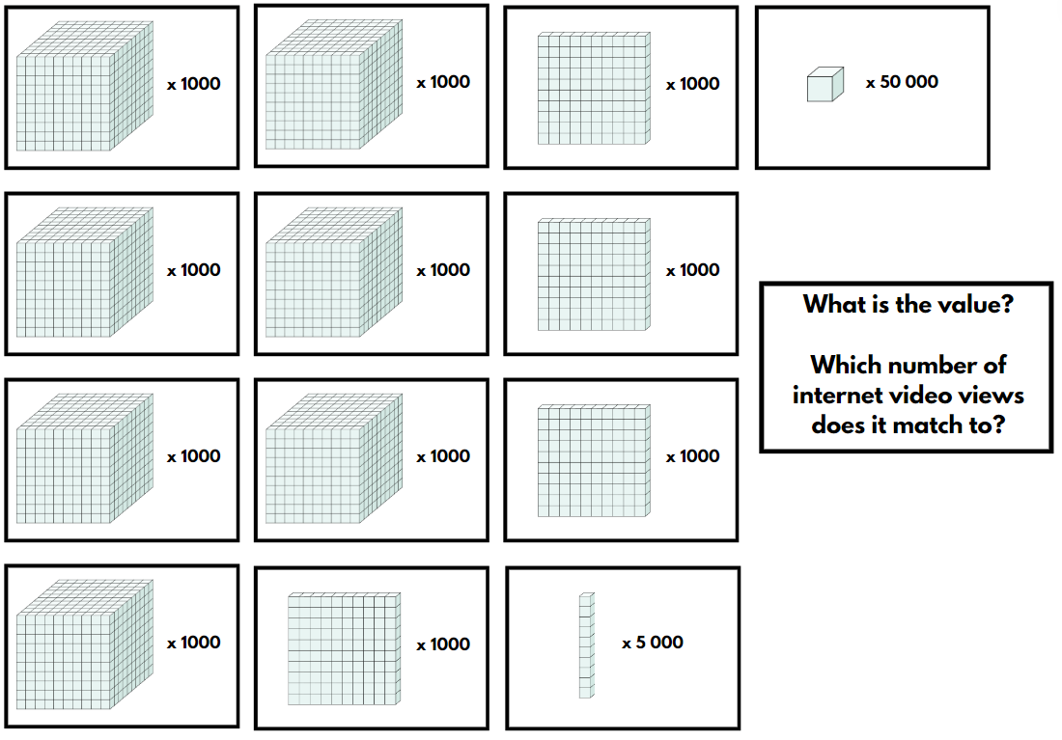

# Resource 3 – matching game

|  |  |  |  |  |
| --- | --- | --- | --- | --- |
| **7 346 202** |  | **Two million less than nine million three hundred and forty six thousand two hundred and two.** |  | **The company earned a profit of over seven million this financial year.** |
|  |  |  |  |  |
| **1 000 000 000** |  | **one billion** |  | **The song had about nine hundred and ninety million views.** |
|  |  |  |  |  |
| **15 000 060** |  | **The value of the tens is 60.** |  | **The band’s world tour has 30 million tickets for sale. Approximately 50% of tickets have been sold so far.** |

|  |  |  |  |  |
| --- | --- | --- | --- | --- |
| **3 985 254 000** |  | **The value of the hundred thousands is 200 000.** |  | **The road upgrade budget was four billion dollars. The government was commended for coming in under budget.** |
|  |  |  |  |  |
| **25 690 000** |  | **When rounded to the nearest 100 000, the value of the hundred thousand is 700 000.** |  | **The Australian population in 2023** |
|  |  |  |  |  |
| **1 400 000 000** |  | **14 hundred million** |  | **The Chinese population is double 700 million.** |

# Resource 4 – True or false?

Five blue speech bubbles. Each speech bubble contains statements. Students are asked to consider if they are true or false. Statements are:
- Money can be represented as $276.891.
- Her average score per basketball game was 13.5.
- The nurse measured the boys temperature and it was 37.872 degrees.
- I purchased 90.234 L of petrol.
- I spent $0.99 at the supermarket.

# Resource 5 – place value thousandths

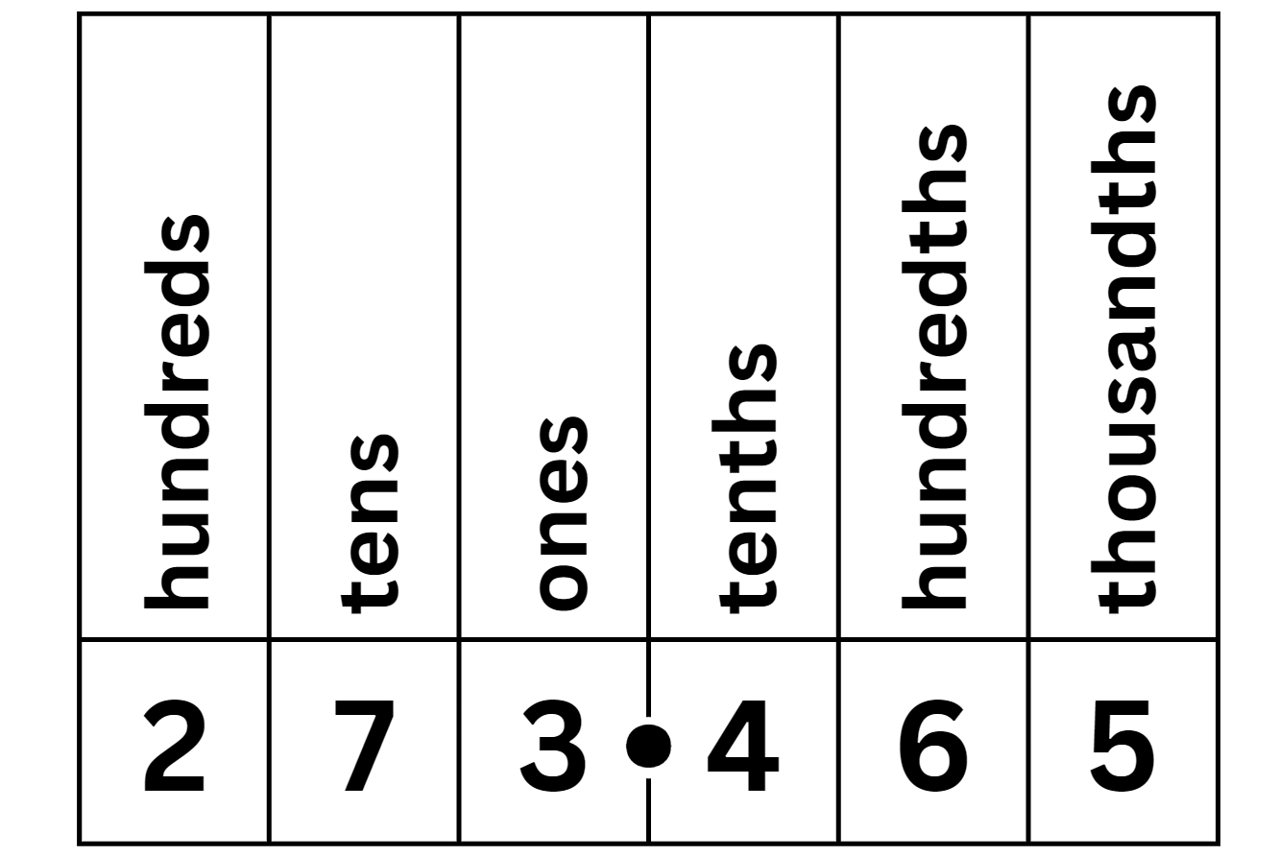

# Resource 6 – chocolate bar

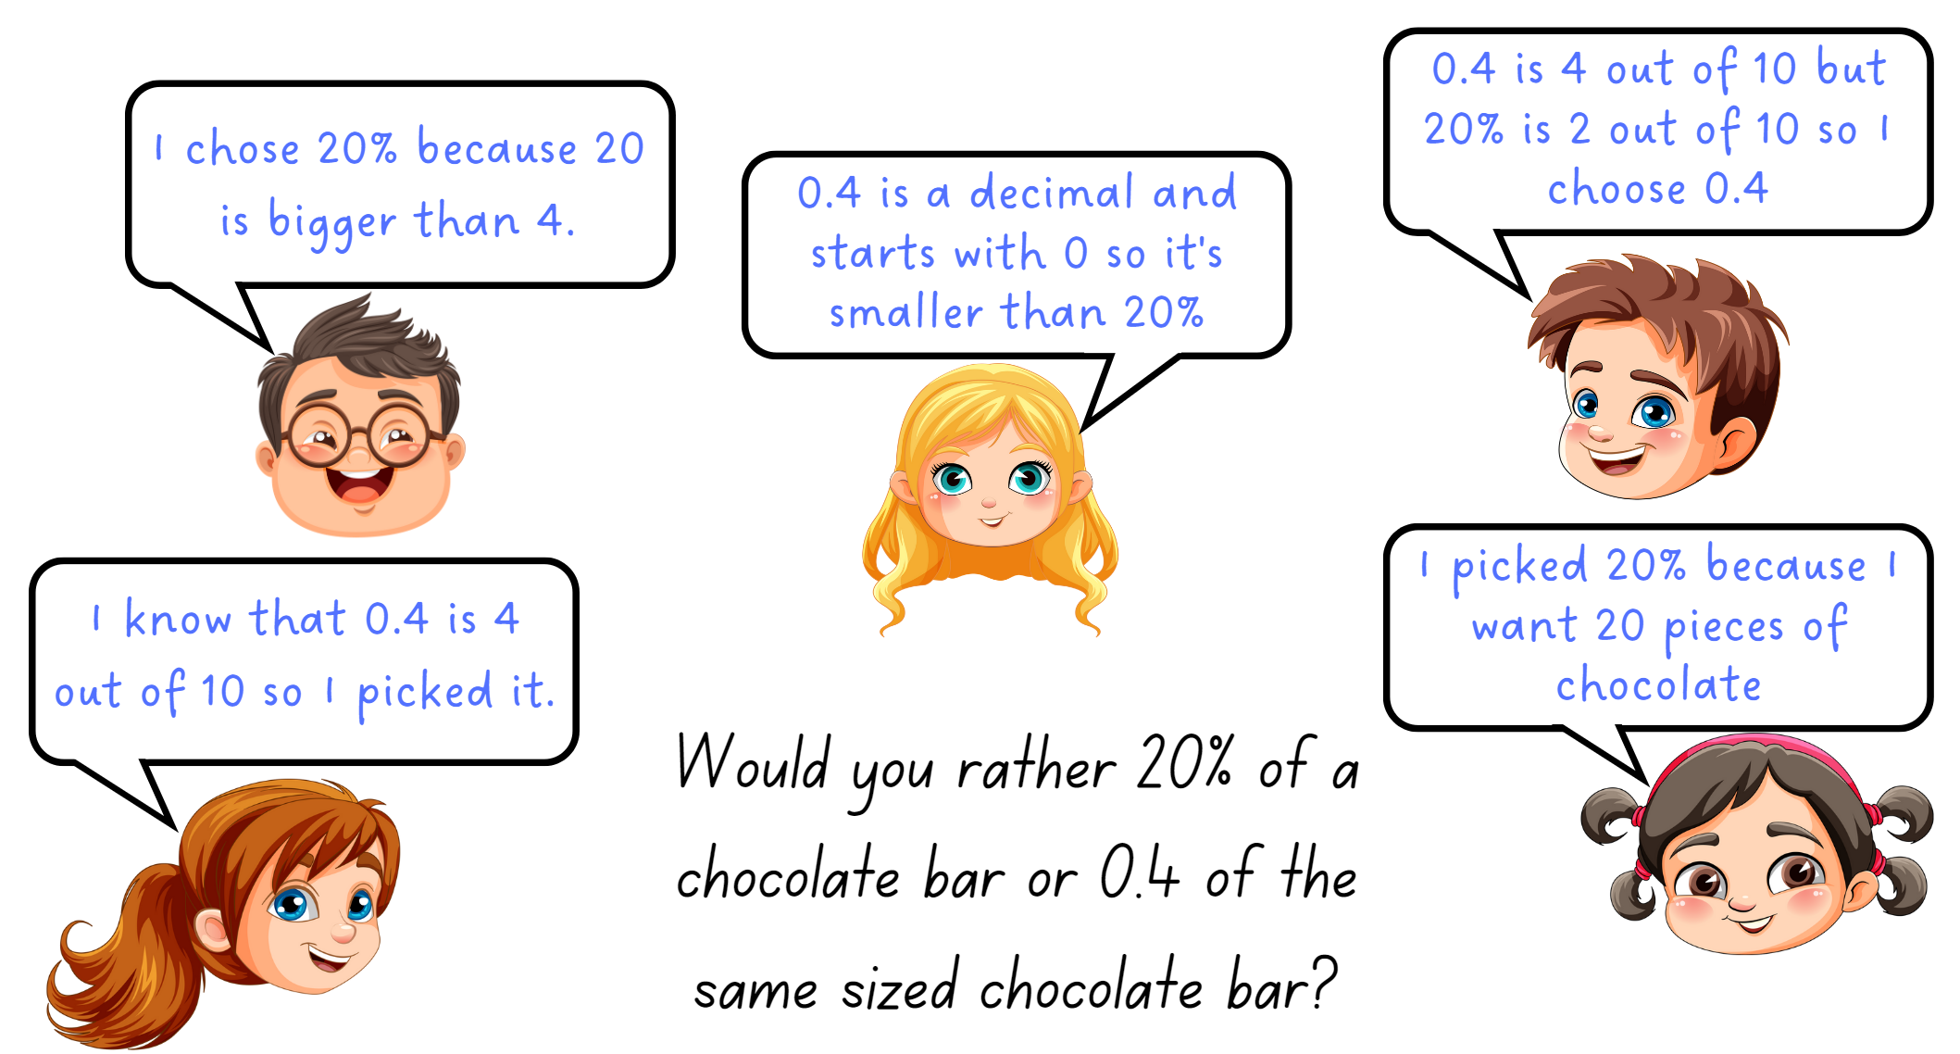

# Resource 7 – Would you rather?

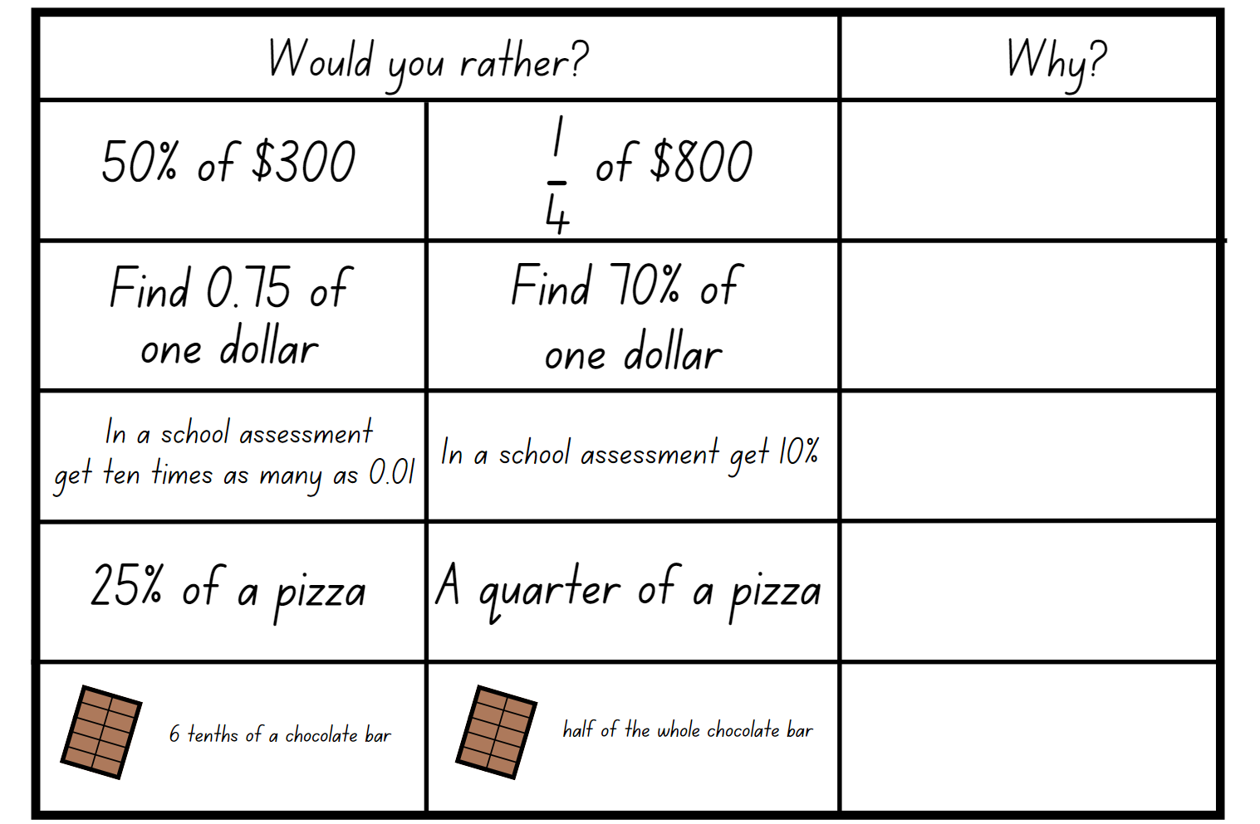

# Resource 8 – problems to solve

|  |
| --- |
| 1. Justine cleans 72 classrooms in 3 days. How many classrooms can Justine clean in 6 days? How many classrooms can Justine clean in 10 days? |
| 1. Carmel cleans less. How many classrooms does Carmel clean in 3 days? 6 days? 10 days? |
| 1. Cases of 24 water bottles cost $40. It is also possible to buy single bottles for $1.90 each. If I want to buy 24 bottles of water, which is the better deal? |
| 1. The school bell rings 8 times per day on school days. How many times does it ring in a week? How many times does it ring in an 11-week term? How many times would it ring in the 11-week term if there were 3 pupil free days? |
| 1. Stella and Siena each have a part-time job. Stella earns $17.50 per hour and Sienna earns $23 per hour. On Saturday Stella worked for 4 hours and Sienna worked one hour less. Who took home the most pay? |
| 1. I solved a division problem, and the answer was 8. What could the question be? |
| 1. When I was trying to work out my division problem with the answer of 8, I used two 2-digit numbers. What could the question be? |

# Resource 9 – powers of 10

Four number sentences with missing values. The first sentence asks: (blank) is 10 times (blank).
The second sentence asks: (blank) is 100 times (blank).
The third sentence asks: (blank) is 1/10 of (blank).
The fourth sentence asks: (blank) is 1/100 of (blank).

# Resource 10 – number slider

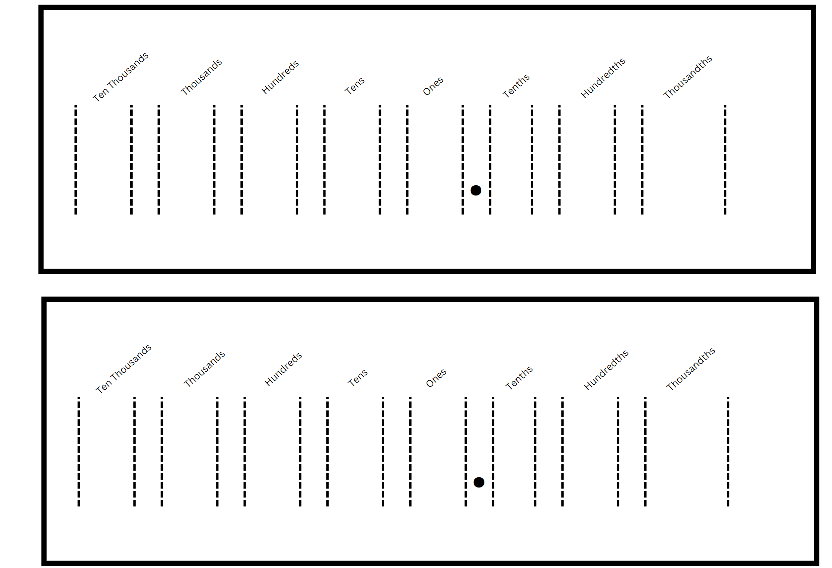

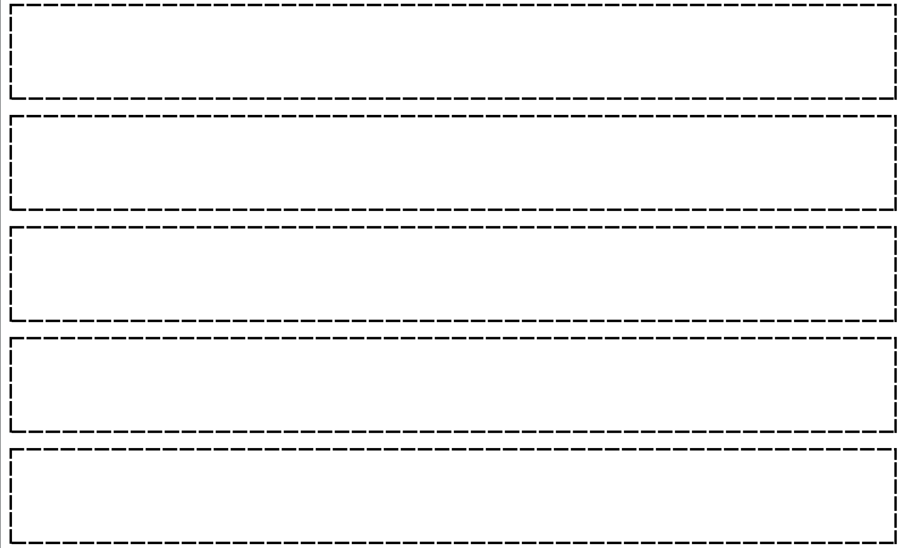

# Resource 11 – Divide or multiply?

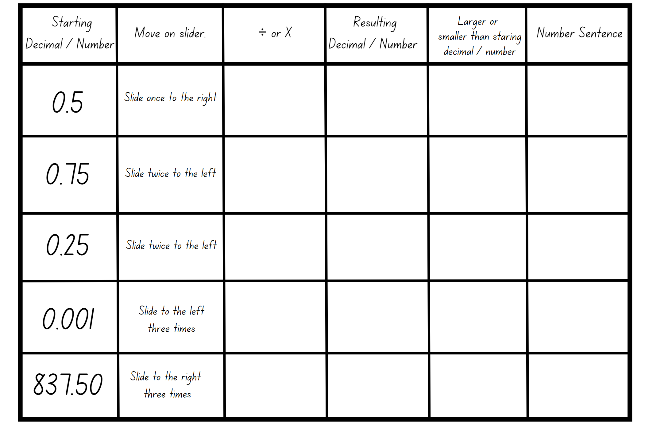

# Resource 12 – equivalent number sentence

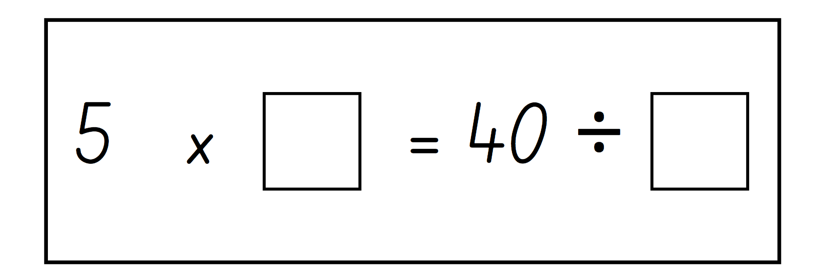

# Resource 13 – number equivalence

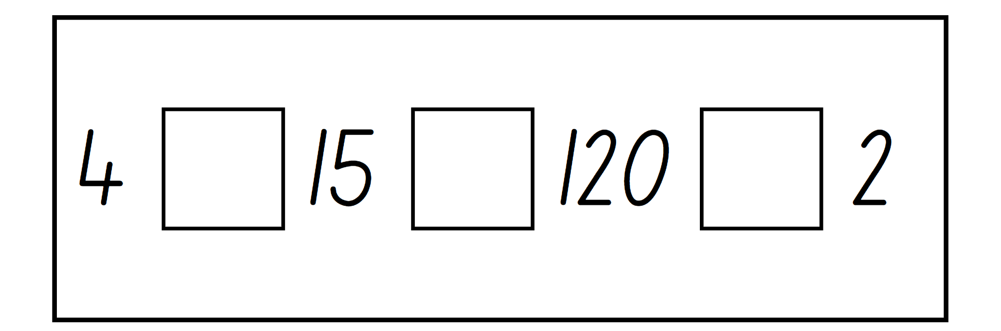

# Resource 14 – smiley problem

Seven rectangles containing number sentences with missing information. Missing information is indicated with different emojis.
Sentence 1 - heart times heart +1 = star.
Sentence 2 - star times star = alien.
Sentence 3 - alien times two hearts + star = 105.
Question - using the values from above - can you solve the equivalent number sentence below?
Sentence 4 - 105 times two hearts = (blank) divided by heart.
Sentence 5 - Four aliens divided by two hearts = star times (blank).
Sentence 6 - (blank) divided by star equals heart times star.
Sentence 7 - Half star times two aliens equals (blank) divided by star over heart.

# Syllabus outcomes and content

The table below outlines the [syllabus outcomes](https://curriculum.nsw.edu.au/learning-areas/mathematics/mathematics-k-10-2022/overview) and range of relevant syllabus content covered in this unit. Content is linked to [National Numeracy Learning Progression](https://www.australiancurriculum.edu.au/resources/national-literacy-and-numeracy-learning-progressions/version-3-of-national-literacy-and-numeracy-learning-progressions/) (version 3).

|  |  |  |  |  |  |  |  |  |
| --- | --- | --- | --- | --- | --- | --- | --- | --- |
| Outcomes and content | 1 | 2 | 3 | 4 | 5 | 6 | 7 | 8 |
| **Represents numbers A: Whole numbers: Recognise, represent and order numbers in the millions**  **MAO-WM-01, MA3-RN-01** |  |  |  |  |  |  |  |  |
| * Name millions using the place value grouping of ones, tens and hundreds | x |  |  |  |  |  |  |  |
| * Arrange numbers in the millions in ascending and descending order using place value | x |  |  |  |  |  |  |  |
| **Represents numbers A: Whole numbers: Apply place value to partition, regroup and rename numbers to 1 billion**  **MAO-WM-01, MA3-RN-01** |  |  |  |  |  |  |  |  |
| * Recognise 1000 thousands is 1 million and 1000 millions is 1 billion | x |  |  |  |  |  |  |  |
| **Represents numbers A: Decimals and percentages: Recognise that the place value system can be extended beyond hundredths**  **MAO-WM-01, MA3-RN-02** |  |  |  |  |  |  |  |  |
| * Express thousandths as decimals |  | x |  |  |  |  |  |  |
| * Interpret decimal notation for thousandths |  | x |  |  |  |  |  |  |
| * Indicate the place value of digits in decimal numbers of up to 3 decimal places |  | x |  |  |  |  |  |  |
| **Represents numbers A: Decimals and percentages: Compare, order and represent decimals**  **MAO-WM-01, MA3-RN-02** |  |  |  |  |  |  |  |  |
| * Compare and order decimal numbers of up to 3 decimal places |  | x |  |  |  |  |  |  |
| * Interpret zero digit(s) at the end of a decimal |  | x |  |  |  |  |  |  |
| * Compare the place value of digits by determining numbers that are 10 or 100 times the original decimal number as well as $\frac{1}{10}$ or $\frac{1}{100}$ times the original decimal numbers |  |  |  |  |  |  | x |  |
| **Represents numbers B: Decimals and percentages: Make connections between benchmark fractions, decimals and percentages**  **MAO-WM-01, MA3-RN-01, MA3-RN-02, MA3-RN-03** |  |  |  |  |  |  |  |  |
| * Recognise that the symbol % means percent and 100% is the whole amount |  |  | x |  |  |  |  |  |
| * Recall commonly used equivalent percentages, decimals and fractions including $\frac{1}{2}$, $\frac{1}{4}$, and $\frac{3}{4}$ |  |  | x |  |  |  |  |  |
| * Recognise that 10% is one-tenth of 100% and use this to find 10% of a quantity (Reasons about relations) |  |  | x |  |  |  |  |  |
| **Multiplicative relations A: Determine products and factors**  **MAO-WM-01, MA3-MR-01** |  |  |  |  |  |  |  |  |
| * Determine factors for a given whole number |  |  |  | x |  |  |  |  |
| **Multiplicative relations A: Use partitioning and place value to multiply 2-, 3- and 4-digit numbers by one-digit numbers**  **MAO-WM-01, MA3-MR-01** |  |  |  |  |  |  |  |  |
| * Use mental strategies to multiply one-digit numbers by 10, 100, 1000 and their multiples |  |  |  |  | x |  |  |  |
| * Use informal written strategies such as the area model to solve multiplication and division problems |  |  |  |  | x |  |  |  |
| * Use the distributive property with the area model to partition numbers in representing multiplication problems |  |  |  |  | x |  |  |  |
| * Record the product of multiplying by a one-digit number using a formal algorithm |  |  |  |  | x |  |  |  |
| **Multiplicative relations B: Select and apply strategies to solve problems involving multiplication and division with whole numbers**  **MAO-WM-01, MA3-MR-01** |  |  |  |  |  |  |  |  |
| * Select and use efficient strategies to multiply whole numbers of up to 4 digits by one- and 2-digit numbers |  |  |  |  | x | x |  |  |
| * Solve word problems involving rates using multiplication and division (Reasons about relations) |  |  |  |  |  | x |  |  |
| **Multiplicative relations B: Multiply and divide decimals by powers of 10**  **MAO-WM-01, MA3-MR-01** |  |  |  |  |  |  |  |  |
| * Use mental strategies to multiply benchmark decimals by single-digit numbers |  |  |  |  |  |  | x |  |
| * Compare the relative place value of digits to multiply and divide a decimal by powers of 10 |  |  |  |  | x | x | x |  |
| **Multiplicative relations B: Use equivalent number sentences involving multiplication and division to find unknown quantities**  **MAO-WM-01, MA3-MR-01** |  |  |  |  |  |  |  |  |
| * Complete number sentences that involve more than one operation by calculating missing numbers |  |  | x |  |  |  |  | x |
| * Identify and use inverse operations to assist with the solution of number sentences | x | x |  |  |  |  |  | x |
| **Multiplicative relations B: Represent and describe number patterns formed by multiples**  **MAO-WM-01, MA3-MR-01** |  |  |  |  |  |  |  |  |
| * Use a given geometric pattern involving multiples to create a table of values |  |  |  | x |  |  |  |  |
| * Describe a pattern formed by multiples in words, in terms of multiplication rather than addition |  |  |  | x |  |  |  |  |
| * Determine a rule describing the relationship between the bottom number and the top number in a table (Algebraic reasoning) |  |  |  | x |  |  |  |  |

[Mathematics K–10 Syllabus](https://curriculum.nsw.edu.au/learning-areas/mathematics/mathematics-k-10-2022/overview) © NSW Education Standards Authority (NESA) for and on behalf of the Crown in right of the State of New South Wales, 2022.

# References

This resource contains NSW Curriculum and syllabus content. The NSW Curriculum is developed by the NSW Education Standards Authority. This content is prepared by NESA for and on behalf of the Crown in right of the State of New South Wales. The material is protected by Crown copyright.

Please refer to the NESA Copyright Disclaimer for more information <https://educationstandards.nsw.edu.au/wps/portal/nesa/mini-footer/copyright>.

NESA holds the only official and up-to-date versions of the NSW Curriculum and syllabus documents. Please visit the NSW Education Standards Authority (NESA) website [<https://educationstandards.nsw.edu.au/wps/portal/nesa/home>/](https://educationstandards.nsw.edu.au/) and the NSW Curriculum website [https://curriculum.nsw.edu.au](https://curriculum.nsw.edu.au/).

[Mathematics K–10 Syllabus](https://curriculum.nsw.edu.au/learning-areas/mathematics/mathematics-k-10-2022/overview) © NSW Education Standards Authority (NESA) for and on behalf of the Crown in right of the State of New South Wales, 2022.

[National Numeracy Learning Progression](https://www.australiancurriculum.edu.au/resources/national-literacy-and-numeracy-learning-progressions/version-3-of-national-literacy-and-numeracy-learning-progressions/) © Australian Curriculum, Assessment and Reporting Authority (ACARA) 2010 to present, unless otherwise indicated. This material was downloaded from the [Australian Curriculum](http://www.australiancurriculum.edu.au/) website (National Numeracy Learning Progression) (accessed 11 October 2023) and was not modified.

APSMO (Australasian Problem Solving Mathematical Olympiads) (2021) ‘[Eclairs and Doughnuts](https://apsmo.edu.au/problems/eclairs-and-doughnuts/)’, Problems, APSMO website, accessed 26 September 2023.

Kaplinsky R (2016–2023) ‘[Multiply and Divide Within a Hundred 1](https://www.openmiddle.com/multiply-and-divide-within-a-hundred-1/)’, Grade 3, Open Middle website, accessed 11 October 2023.

New Zealand Ministry of Education (n.d.) ‘[Tens Time](https://nzmaths.co.nz/resource/tens-time)’, Resources, NZ Maths website, accessed 11 October 2023.

Online Calculator (2023) [*Full Screen Calculator*](https://www.online-calculator.com/full-screen-calculator/), Online Calculator website, accessed 11 October 2023.

Siemon D (1993) *Target practice*, [*Resources and Workbook for Primary Mathematics and Science Specialists (PMSS) (PDF 4.5 MB)*](https://fusecontent.education.vic.gov.au/04b725e0-6f9a-433d-bbd2-1805777989ea/PMSS%20PL%20Block%20THREE%20Workbook.pdf), Department of Education Victoria, accessed 26 September 2023

State of New South Wales (Department of Education) (2023) *Benchmark problems*, [*Part 2: Proportional thinking with fractions, decimals and percentages (PDF 1.2 MB)*](https://education.nsw.gov.au/content/dam/main-education/en/home/teaching-and-learning/curriculum/literacy-and-numeracy/teaching-and-learning-resources/numeracy/proportional-thinking-part-2.pdf), NSW Department of Education website, accessed 26 September 2023.

State of New South Wales (Department of Education) (2023) *Dividing with Decimals*, [*Multiplying and dividing decimals*](https://resources.education.nsw.gov.au/api/v1/blob-store/dXJoX3JlYWRpbmdhbmRudW1lcmFjeV8xNEx1QTRVQkZHVURld2kwYXZPaA===/TXVsdGlwbHlpbmcgYW5kIGRpdmlkaW5nIGRlY2ltYWxzLmRvY3g==?versionid=) *(DOCX 687 KB)*, NSW Department of Education website, accessed 26 September 2023

State of New South Wales through the NSW Department of Education and Training (2010) *Houses*, [*Talking about Patterns & Algebra: Early Stage 1 to Stage 3*](https://education.nsw.gov.au/teaching-and-learning/curriculum/mathematics/mathematics-curriculum-resources-k-12/mathematics-k-6-resources/talking-about-patterns-and-algebra), NSW Department of Education website, accessed 26 September 2023.

Sullivan P (2018) *Challenging mathematical tasks: Unlocking the potential of all students*, Oxford University Press Australia and New Zealand, Great Britain.

Sullivan P and Lilburn P (2017) Open-ended maths activities: Using ‘Good’ Questions to Enhance Learning in Mathematics, Revised edn, Oxford University Press Australia and New Zealand, Great Britain.

Topmarks Online Ltd (1998–2024) [*Moving Digit Cards*](https://www.topmarks.co.uk/Flash.aspx?f=MovingDigitCards), Topmarks website, accessed 11 October 2023.

## Further reading

Van de Walle J, Karp K, Bay-Williams JM, Brass A, Bentley B, Ferguson S, Goff W, Livy S, Marshman M, Martin D, Pearn C, Prodromou T, Symons D and Wilkie K (2019) Primary and Middle Years Mathematics: Teaching Developmentally, 1st Australian edn, Pearson Education Australia, Melbourne.

**© State of New South Wales (Department of Education), 2024**

The copyright material published in this resource is subject to the Copyright Act 1968 (Cth) and is owned by the NSW Department of Education or, where indicated, by a party other than the NSW Department of Education (third-party material).

Copyright material available in this resource and owned by the NSW Department of Education is licensed under a [Creative Commons Attribution 4.0 International (CC BY 4.0) license](https://creativecommons.org/licenses/by/4.0/).

[](https://creativecommons.org/licenses/by/4.0/)

This license allows you to share and adapt the material for any purpose, even commercially.

Attribution should be given to © State of New South Wales (Department of Education), 2024.

Material in this resource not available under a Creative Commons license:

* the NSW Department of Education logo, other logos and trademark-protected material
* material owned by a third party that has been reproduced with permission. You will need to obtain permission from the third party to reuse its material.

**Links to third-party material and websites**

Please note that the provided (reading/viewing material/list/links/texts) are a suggestion only and implies no endorsement, by the New South Wales Department of Education, of any author, publisher, or book title. School principals and teachers are best placed to assess the suitability of resources that would complement the curriculum and reflect the needs and interests of their students.

If you use the links provided in this document to access a third-party's website, you acknowledge that the terms of use, including licence terms set out on the third-party's website apply to the use which may be made of the materials on that third-party website or where permitted by the Copyright Act 1968 (Cth). The department accepts no responsibility for content on third-party websites.