Mathematics Stage 3 – Unit 33
Multiplicative thinking involves flexible use of multiplication and division concepts, strategies and representations

Contents
Unit description and duration 5
Syllabus outcomes 5
Working mathematically 6
Student prior learning 6
Lesson overview and resources 8
Lesson 1 12
Daily number sense – missing brackets – 15 minutes 12
Core lesson – fences and posts – 40 minutes 15
Consolidation and meaningful practice – 15 minutes 20
Lesson 2 22
Daily number sense – target 20 – 10 minutes 22
Core lesson 1 – strategies to multiply – 30 minutes 23
Core lesson 2 – Same or different? – 15 minutes 27
Discuss and connect the mathematics – 5 minutes 27
Lesson 3 29
Daily number sense – grouping symbol problems – 15 minutes 29
Core lesson – eliminating spaceships game – 40 minutes 30
Discuss and connect the mathematics – 10 minutes 34
Lesson 4 36
Daily number sense – 10 minutes 36
Core lesson 1 – using mental strategies – 15 minutes 36
Core lesson 2 – multiplying and dividing by the powers of 10 – 25 minutes 38
Consolidation and meaningful practice – 10 minutes 40
Lesson 5 41
Daily number sense – How much sushi? – 10 minutes 41
Core lesson – benchmark operations – 35 minutes 42
Consolidation and meaningful practice – 15 minutes 45
Lesson 6 47
Daily number sense – How much more? – 10 minutes 47
Core lesson – mystery operations – 35 minutes 49
Discuss and connect the mathematics – 15 minutes 51
Lesson 7 53
Daily number sense – What could be the problem? – 10 minutes 53
Core lesson – using grouping symbols – 40 minutes 54
Discuss and connect the mathematics – 10 minutes 56
Lesson 8 59
Daily number sense – 10 minutes 59
Core lesson 1 – vertical double number line – 15 minutes 59
Core lesson 2 – rates word problems – 25 minutes 61
Discuss and connect the mathematics – 10 minutes 63
Resource 1 – think board 64
Resource 2 – grouping symbol problems 65
Resource 3 – number slider 66
Resource 4 – apple juice 68
Resource 5 – student workbook example 69
Resource 6 – hundreds chart 70
Resource 7 – Who is correct? 71
Resource 8 – more grouping symbols 72
Resource 9 – Rob’s bricklaying 73
Resource 10 – solving the problem 74
Syllabus outcomes and content 75
References 79
Further reading 80

Unit description and duration
This unit develops the big idea that multiplicative thinking involves flexible use of multiplication and division concepts, strategies and representations.
In this 2-week unit students are provided opportunities to:
- multiply and divide decimals by powers of 10
- investigate the order of operations using real-life contexts
- select and apply strategies to solve problems involving multiplication and division with whole numbers.

Syllabus outcomes
- MAO-WM-01 develops understanding and fluency in mathematics through exploring and connecting mathematical concepts, choosing and applying mathematical techniques to solve problems, and communicating their thinking and reasoning coherently and clearly
- MA3-RN-01 applies an understanding of place value and the role of zero to represent the properties of numbers
- MA3-MR-01 selects and applies appropriate strategies to solve multiplication and division problems
- MA3-MR-02 constructs and completes number sentences involving multiplicative relations, applying the order of operations to calculations
- MA3-RFQ-01 compares and orders fractions with denominators of 2, 3, 4, 5, 6, 8 and 10

Working mathematically
In the Mathematics K–10 Syllabus, there is one overarching Working mathematically outcome (MAO-WM-01). The Working mathematically processes should be embedded within the concepts being taught. The Working mathematically processes present in the Mathematics K–10 Syllabus are:
- communicating
- understanding and fluency
- reasoning
- problem solving.
Mathematics K–10 Syllabus © NSW Education Standards Authority (NESA) for and on behalf of the Crown in right of the State of New South Wales, 2022.

Student prior learning
Before engaging in these teaching and learning activities, students would benefit from prior experience with:
- using partitioning and place value to multiply 2-, 3- and 4-digit numbers by one-digit numbers
- determining products and factors
- representing and solving division problem with whole number remainders.
In NSW classrooms there is a diverse range of students, including Aboriginal and/or Torres Strait Islander students, students learning English as an additional language or dialect, high potential and gifted students and students with disability. Some students may identify with more than one of these groups or possibly all of them. Refer to Curriculum planning for every student – advice for further information.

Lesson overview and resources
The table below outlines the sequence and approximate timing of lessons, learning intentions and resources.
Lesson | Content | Duration and resources
Lesson 1  Daily number sense learning intention:  - explore the use of brackets and the order of operations to write number sentences | Lesson core concept: number patterns can be multiplicative.  Core concept learning intention:  - represent and describe number patterns formed by multiples | Lesson duration: 70 minutes  - Individual whiteboards  - Writing materials
Lesson 2  Daily number sense learning intention:  - explore the use of brackets and the order of operations to write number sentences | Lesson core concept: known number facts and strategies support multiplicative understanding.  Core concept learning intentions:  - select and apply strategies to solve problems involving multiplication and division with whole numbers  - use equivalent number sentences involving multiplication and division to find unknown quantities | Lesson duration: 60 minutes  - Resource 1 – think board  - Digital area model tool  - 9-sided dice  - Calculators  - Individual whiteboards  - Writing materials
Lesson 3  Daily number sense learning intention:  - explore the use of brackets and the order of operations to write number sentences | Lesson core concept: place value understanding supports mathematicians to multiply and divide decimals by powers of 10.  Core concept learning intention:  - multiply and divide decimals by powers of 10 | Lesson duration: 65 minutes  - Resource 2 – grouping symbol problems  - Resource 3 – number slider  - 9-sided dice  - Individual whiteboards  - Writing materials
Lesson 4  Daily number sense learning intention:  - teacher-identified task based on student needs | Lesson core concept: flexible methods of computation in multiplication and division involve composing and decomposing numbers.  Core concept learning intentions:  - select and apply strategies to solve problems involving multiplication and division with whole numbers  - multiply and divide decimals by powers of 10. | Lesson duration: 60 minutes  - Individual whiteboards  - Writing materials
Lesson 5  Daily number sense learning intention:  - use equivalence to add and subtract fractional quantities | Lesson core concept: flexible methods of computation in multiplication and division involve composing and decomposing numbers.  Core concept learning intentions:  - select and apply strategies to solve problems involving multiplication and division with whole numbers  - multiply and divide decimals by powers of 10 | Lesson duration: 60 minutes  - Resource 4 – apple juice  - Individual whiteboards  - Writing materials
Lesson 6  Daily number sense learning intention:  - use equivalence to add and subtract fractional quantities. | Lesson core concept: brackets are symbols used to group things together.  Core concept learning intention:  - explore the use of brackets and the order of operations to write number sentences. | Lesson duration: 60 minutes  - Resource 5 – student workbook example  - Resource 6 – hundreds chart  - Fraction strips  - Writing materials
Lesson 7  Daily number sense learning intention:  - use equivalence to add and subtract fractional quantities | Lesson core concept: the order of operations is important to solve mathematics problems.  Core concept learning intention:  - explore the use of brackets and the order of operations to write number sentences | Lesson duration: 60 minutes  - Resource 7 – Who is correct?  - Resource 8 – more grouping symbols  - Writing materials
Lesson 8  Daily number sense learning intention:  - teacher-identified task based on student needs | Lesson core concept: worded problems can be solved using multiplicative thinking.  Core concept learning intention:  - select and apply strategies to solve problems involving multiplication and division with whole numbers. | Lesson duration: 60 minutes  - Resource 9 – Rob’s bricklaying  - Resource 10 – solving the problem  - Individual whiteboards  - Writing materials

Lesson 1
Core concept: number patterns can be multiplicative.

Daily number sense – missing brackets – 15 minutes
Daily number sense activities for Lessons 1 to 3 ‘activate’ prior number knowledge and support the learning of new content in the unit. These activities can also assist teachers to identify the starting points for learning by revealing the extent of students’ existing knowledge.
The table below contains a suggested learning intention and success criteria. These are best co-constructed with students.
Daily number sense learning intention | Daily number sense success criteria
Students are learning to:  - explore the use of brackets and the order of operations to write number sentences. | Students can:  - recognise the need to agree on the order in which to perform operations  - use grouping symbols () in number sentences to indicate operations that must be performed first.
Note: the Stage 3 teaching advice states that the order of operations convention is to be used to reduce the risk of misunderstanding. In this way, complete all multiplications and divisions working left to right before adding and subtracting. Grouping symbols are used to indicate what to do first or to make certain the order is clear. Mnemonics like BOMDAS, BIDMAS or PEMDAS are often misleading as they suggest an absolute order between addition (A) and subtraction (S) or multiplication (M) and division (D) (NESA 2022a). Order of operations has previously been explored in Stage 3 Year A Unit 7 and Stage 3 Year B Unit 27.
- Revise that all multiplication and division operations are completed by working left to right, before adding and subtracting. To change this order, grouping symbols are used to indicate what to do first.
- Write the following equation 3 + 5 × 3 = 24 on the whiteboard. Ask:
- Is this statement true?
- Can you explain the misconception in this calculation?
- How could we use grouping symbols to get different answers to the same equation?
- Draw the grouping symbols on the example to show how they make the statement true: (3 + 5) × 3 = 24.
- Write the equation 7 + 6 × 4 – 2 = 26 on the whiteboard. Students use individual whiteboards to add grouping symbols and make the equation true.
- Students demonstrate how they used grouping symbols to get the answer 26.
- Ask: How could you use grouping symbols to get the answer of 50 from the same equation? Students turn and talk to compare answers, justifying their placement of the grouping symbols.
- Ask: How could you use grouping symbols to get the answer of 19 from the same equation? After comparing answers, students justify their placement of the grouping symbols.
- Pose the question: I can use the grouping symbols in 2 different ways to get 29 as my answer. How can this work?
- Select students to explain how they used the grouping symbols differently to get the same answer (see Figure 1).
Figure 1 – example of student responses
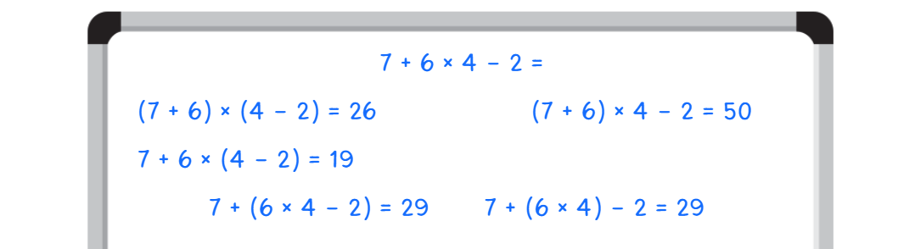
- Write the following equation on the board: 8 − 12 ÷ 6 + 14 = _?
- Ask students to record the variety of ways they can use grouping symbols to solve the equation.
- Students turn and talk to share their ideas with a partner.
This table details opportunities for assessment.
Assessment opportunities | Links
What to look for:  - Can students recognise the need to agree on the order in which to perform operations? [MAO-WM-01, MA3-MR-02]  - Can students use grouping symbols () in number sentences to indicate operations that must be performed first?  [MAO-WM-01, MA3-MR-02] | Links to National Numeracy Learning Progressions (NNLP):  - NPA5.

Core lesson – fences and posts – 40 minutes
The table below contains a suggested learning intention and success criteria. These are best co-constructed with students.
Core concept learning intention | Core concept success criteria
Students are learning to:  - represent and describe number patterns formed by multiples. | Students can:  - determine a rule describing the relationship between the bottom number and the top number in a table.
This lesson is an adaptation of Fencing the Freeway (PDF 69.7 KB) from Scaffolding Numeracy in the Middle Years by State of Victoria Department of Education and Early Childhood Development (DEECD).
- Pose the following question: Farmer Cal has recently purchased a block of land for his new cattle business. To keep his cattle safe, he needs to fence his property. Farmer Cal knows that he will need one post for every 2 metres of fencing and one at each end.
- Provide students with individual whiteboards. Ask them to record a visual representation of the number of posts required for 4 metres of fencing (see Figure 2).
Figure 2 – example of visual representation
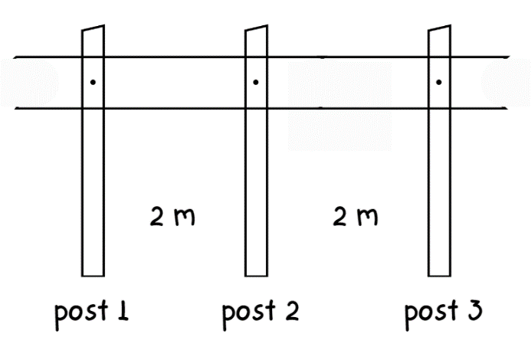
- In pairs, students discuss and record the number of posts required for:
- 12 metres of fencing
- 24 metres of fencing
- 36 metres of fencing.
- Regroup as a class and select pairs of students to share their visual representations on the whiteboard.
- Discuss the different strategies used to calculate the number of posts required for each length of fencing (see Figure 3).
Figure 3 – example of visual representation
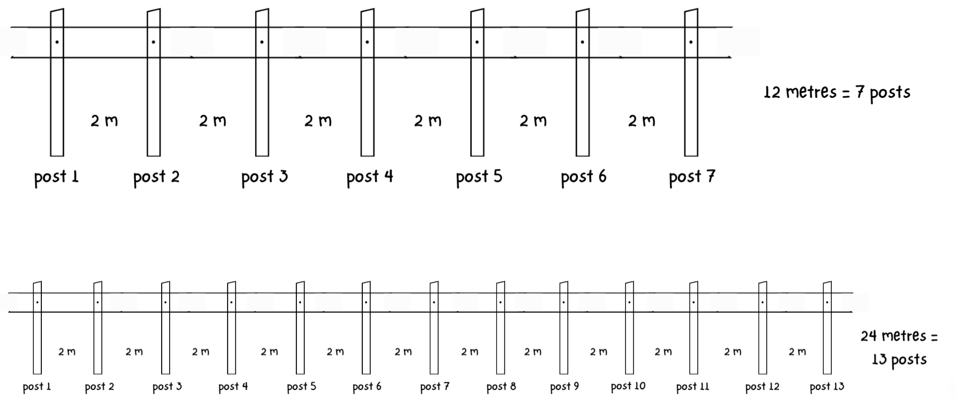
- Ask:
- What do you notice is the same?
- What do you notice is different?
- Is there a more effective way to calculate the number of posts required?
- Draw the following table to show how information from the visual representation can be organised:
Length of fencing  (in metres) | 2 | 4 | 6 | 8 | 10 | 12 | … | 24 | … | 36
Number of posts | 2 | 3 | 4 | 5 | 6 | 7 | … | 13 | … | 19
- Ask if students notice a pattern forming.
- Explain that there is a pattern and a rule. The rule describes the relationship between the length of fencing and number of posts. For every 2 metres of fencing, there is a need for one post. There is always an existing post at the beginning of the fence line. In this example, the number of posts required is determined by the total length of fencing ÷ 2 posts + 1 starting post.
- In pairs, students calculate and record the number of posts required for the following lengths of fencing using a table.
- 120 metres of fencing
- 156 metres of fencing
- 198 metres of fencing.
- Regroup as a class and select pairs of students to justify their calculations.
- Discuss when it is important to find a pattern and a rule to describe the relationship between the bottom and the top number in a table. For example, placing an order for the correct number of posts to be delivered before fencing the property.
This table details opportunities for differentiation.
Too hard? | Too easy?
Students cannot determine a rule describing the relationship between the bottom number and the top number in a table.  - Support students complete a simpler problem using string and craft sticks to model it. For example, Farmer Pat wants a new vegetable garden. He needs to put a small fence along the edge of the garden. Farmer Pat knows he needs one post at the start and one post for every 20 centimetres of fencing. How many posts will he need for 100 centimetres of fencing? Students record their results in a visual representation and a table.  - Students draw an additional row in the table. Model recording a visual representation of the posts in the first few cells. Use ~ and * to represent a length of fencing and a post. For example, * ~ ~ * ~ ~ * represents 3 posts and 4 metres of fencing. This provides a visual representation of the pattern with the first few numbers in the set. Encourage students to continue the pattern by recording the numbers, as continuing the visual representation for large numbers is a less efficient strategy. | Students can determine a rule describing the relationship between the bottom number and the top number in a table.  - Students create a word problem for a partner to solve using a given set of values in a table.  - Pose the question: Farmer Cal wishes to install barbed wire along the top of his new fencing to prevent trespassers. For every one metre of barbed wire, he needs to hammer a nail into each post to secure the clip to hold the wire. How many clips and nails will he need for 100 metres of barbed wire?

Consolidation and meaningful practice – 15 minutes
- Pose the question: Farmer Cal has had the materials for the fence delivered. The company has advised that to make the fence sturdy, he needs to use a combination of 10-centimetre and 20-centimetre-wide posts. For every 2 metres, he will install a 10-centimetre post. After every 4 metres, he will need to install a 20-centimetres wide post. How many 20-centimetre posts are required to fence 50 metres?
- Discuss the different possible strategies to solve this problem. Students record a visual representation of fencing (see Figure 4).
Figure 4 – visual representation of posts
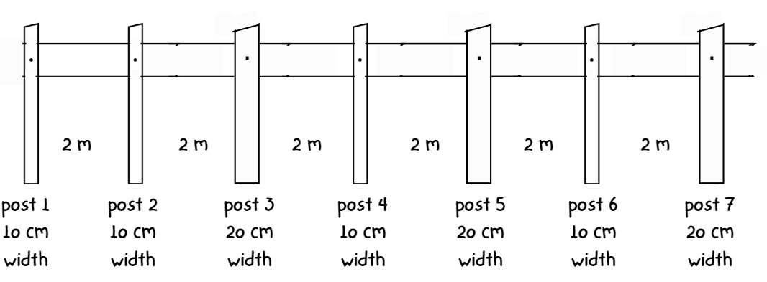
- Students turn and talk to discuss how they could record this in a table.
This table details an opportunity for assessment.
Assessment opportunity | Links
What to look for:  - Can students determine a rule describing the relationship between the bottom number and the top number in a table?  [MAO-WM-01, MA3-MR-01] | Links to National Numeracy Learning Progressions (NNLP):  - NPA5.

Lesson 2
Core concept: known number facts and strategies support multiplicative understanding.

Daily number sense – target 20 – 10 minutes
The table below contains a suggested learning intention and success criteria. These are best co-constructed with students.
Daily number sense learning intention | Daily number sense success criteria
Students are learning to:  - explore the use of brackets and the order of operations to write number sentences. | Students can:  - use grouping symbols () in number sentences to indicate operations that must be performed first.
This lesson is an adaptation of ‘Target 20’ from Mindset Mathematics: Visualizing and Investigating Big Ideas, Grade 4 by Boaler et al.
- Write 4 numbers on the whiteboard. For example, 1, 3, 5, 6.
- Explain that the aim of this activity is to use a combination of numbers to achieve a target number using grouping symbols and order of operations.
- Ask students what numbers can be made by combining 1, 3, 5 and 6 using addition, subtraction, multiplication or division.
- Demonstrate writing number sentences using 1, 3, 5 and 6, with operations and grouping symbols to achieve a target number of 20. The numbers can be used in any order. For example, (6 – 1) + 3 × 5 = 20.
- Provide pairs of students with four 9-sided dice and individual whiteboards.
- Students roll the 4 dice and record the 4 digits on their whiteboards.
- In pairs, students find and record solutions to achieve a target number of 20 using the 4 digits, order of operations and grouping symbols.
This table details an opportunity for assessment.
Assessment opportunity | Links
What to look for:  - Can students use grouping symbols () in number sentences to indicate operations that must be performed first?  [MAO-WM-01, MA3-MR-02] | Links to National Numeracy Learning Progressions (NNLP):  - NPA5.

Core lesson 1 – strategies to multiply – 30 minutes
The table below contains suggested learning intentions and success criteria. These are best co-constructed with students.
Core concept learning intentions | Core concept success criteria
Students are learning to:  - select and apply strategies to solve problems involving multiplication and division with whole numbers  - use equivalent number sentences involving multiplication and division to find unknown quantities. | Students can:  - select and use efficient strategies to multiply whole numbers of up to 4 digits by one- and 2-digit numbers  - determine why different division questions have the same answer  - identify and use inverse operations to assist with the solution of number sentences.
- Write the equation 248 × 52 = _? on the whiteboard. Ask students to share strategies that can be used to find the product.
- Explain that 248 × 52 can be solved using different strategies such as:
- the distributive property
- the area model and partial products
- mental strategies such as estimating and rounding.
- Demonstrate and discuss using Resource 1 – think board to record different strategies for solving (see Figure 5).
Figure 5 – teacher think board example
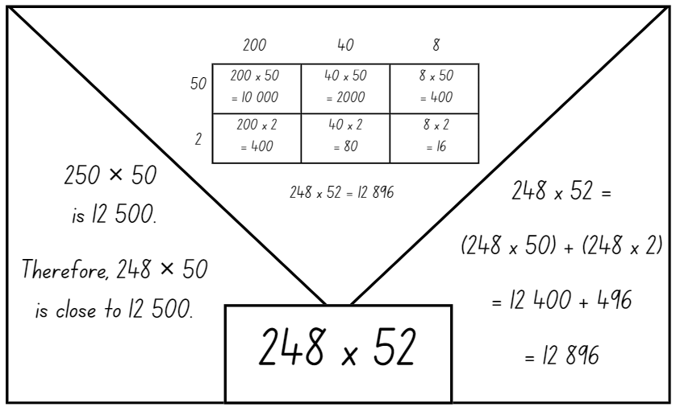
- Provide students with Resource 1 – think board and calculators.
- Write the following on the whiteboard:
- 275 × 42
- 315 × 54
- 4512 × 58.
- Students use Resource 1 – think board to record the different strategies they could use to find the product for each equation. After recording their strategies, students check their answers using a calculator.
Note: Resource 1 – think board can be put in a plastic sleeve to allow students to use the resource more than once. Alternatively, students can draw their own representation of a think board on an individual whiteboard or in their workbook.
- Students turn and talk to discuss the strategies used, justifying their choices.
- Regroup as a class to discuss the different strategies. Determine if there is a preferred choice of strategy when multiplying large numbers, with students justifying their reasoning.
- This table details opportunities for differentiation.
Too hard? | Too easy?
Students cannot select and use different strategies to multiply whole numbers of up to 4 digits by one- and 2-digit numbers.  - Support students to use the area model to multiply whole numbers of up to 3 digits by one- and 2-digit numbers. Demonstrate adding an extra column or row when a new place value is introduced. Students could use a digital area model tool.  - Model the use of distributive property to write the equation. Allow students to use calculators to determine the answers. | Students can select and use different strategies to multiply whole numbers of up to 4 digits by one- and 2-digit numbers.  - Provide students with a partially filled area model and whole numbers of up to 4 digits to find missing values of the multiplier.  - Students create their own equations and swap with a partner to solve. They use non-standard partitioning and the distributive property to solve the equations.

Core lesson 2 – Same or different? – 15 minutes
- Write the equations 42 ÷ 2 = 21 and 84 ÷ 4 = 21. Discuss what students notice about the 2 equations.
- Explain that although both have a different dividend and divisor, they both have the same quotient.
- Demonstrate the use of inverse operations to find different multiplication and division equations with the same multiplier and quotient. For example, 21 × 2 = 42 and 42 ÷ 2 = 21, or 21 × 4 = 84 and 84 ÷ 4 = 21.
- Starting with the multiplier and quotient 13, write on the whiteboard:
- 13 × 2 = 26
- 26 ÷ 2 = 13
- 13 × 4 = 52
- 52 ÷ 4 = 13.
- In pairs, students choose a multiplier and quotient between 15 and 25 and write a set of 4 equations that demonstrate the use of inverse operations. Repeat, if time allows.

Discuss and connect the mathematics – 5 minutes
- Select pairs of students to share their set of equations with the class.
- Discuss how different division questions can have the same answer. Emphasise the multiplicative relationship between the dividend and the divisor.
This table details opportunities for assessment.
Assessment opportunities | Links
What to look for:  - Can students select and use efficient strategies to multiply whole numbers of up to 4 digits by one- and 2-digit numbers?  [MAO-WM-01, MA3-MR-01]  - Can students determine why different division questions have the same answer? [MAO-WM-01, MA3-MR-01]  - Can students identify and use inverse operations to assist with the solution of number sentences? [MAO-WM-01, MA3-MR-01] | Links to National Numeracy Learning Progressions (NNLP):  - MuS7, MuS8  - NPA3, NPA4.  Links to suggested Interview for Student Reasoning (IfSR) tasks:  - IfSR-MT: 3A.10.

Lesson 3
Core concept: place value understanding supports mathematicians to multiply and divide decimals by powers of 10.

Daily number sense – grouping symbol problems – 15 minutes
The table below contains a suggested learning intention and success criteria. These are best co-constructed with students.
Daily number sense learning intention | Daily number sense success criteria
Students are learning to:  - explore the use of brackets and the order of operations to write number sentences. | Students can:  - investigate the order of operations using real-life contexts.
- Write the equation 50 ÷ 2 + 1 = 26 on the whiteboard. Display Resource 2 – grouping symbol problems. Ask which of the problems is true for the written equation.
- Students turn and talk about which of the problems is true for the written equation.
- Write the equation 50 × 2 + 1 = 101 on the whiteboard. Students Think-Pair-Share to create examples of real-life contexts to match the equation.
- In pairs, students record their word problems on individual whiteboards.
- Students swap with another pair to test if the equation is true.
This table details an opportunity for assessment.
Assessment opportunity | Links
What to look for:  - Can students investigate the order of operations using real-life contexts? [MAO-WM-01, MA3-MR-02] | Links to National Numeracy Learning Progressions (NNLP):  - NPA5.

Core lesson – eliminating spaceships game – 40 minutes
The table below contains a suggested learning intention and success criteria. These are best co-constructed with students.
Core concept learning intention | Core concept success criteria
Students are learning to:  - multiply and divide decimals by powers of 10. | Students can:  - compare the relative place value of digits to multiply and divide a decimal by powers of 10.
This activity is an adaptation of Aliens Calculator Game from Teaching and Learning about Decimals by the University of Melbourne.
- Ask students to explain what they already know about the relationship between multiplication and division.
Note: a number slider will be used to revise the concept of multiplying and dividing by the powers of 10 (10, 100, 1000). Number sliders were used in Stage 3 Year B Unit 21 and Stage 3 Year B Unit 31. Resource 3 – number slider can be used to make a slider prior to the lesson.
- Use a number slider to demonstrate multiplying a decimal by powers of 10. For example, 754.3 moved one slide to the left is multiplying by 10 which equals 7543. If the slider is moved 2 slides to the left from 754.3, it is multiplying by 100 which equals 75 430.
- Use the number slider to demonstrate dividing a decimal by powers of 10. For example, 754.3 moved one slide to the right is dividing by 10 which equals 75.43. If the slider is moved 2 slides to the right from 754.3, it is dividing by 100 which equals 7.543.
- Repeat the process with a range of 4-digit decimal numbers to consolidate student understanding.
Note: the Stage 3 teaching advice states a number slider can assist in understanding the relationship between each positional value in a decimal. Zeros as place holders can be added to a number slider as needed when multiplying and dividing by powers of 10. This assists when comparing the place value of digits by determining numbers that are 10 or 100 times the original number. A common misunderstanding is the belief that the decimal point moves when a number is multiplied or divided by a power of 10. The number slider, with its fixed decimal point, can be an effective way of addressing this misunderstanding (NESA 2022b).
- Explain that knowledge of multiplying and dividing decimals by powers of 10 can be used to play a game:
- The aim of the game is to eliminate all spaceships.
- Each spaceship is represented by a digit in the 4-digit decimal number which is created by rolling a 9-sided die 4 times. Do not repeat any digits when creating the number. For example, the number 324.5 represents 4 different spaceships. The 4-digit number must be composed of hundreds, tens, ones and tenths only.
- The 4 spaceships are eliminated by multiplying and dividing the number by the powers of 10.
- The spaceships can only be eliminated when the target digit is in the ones place.
- Students must eliminate the spaceships in ascending order. In the number 324.5 the digits 2, 3, 4 and 5 must be eliminated in that order.
- For example, in the number 324.5, the 2 must be eliminated first. 324.5 divided by 10 equals 32.45. This moves 2 into the ones place and that number is now eliminated.
- Demonstrate playing the game with the example 615.9 (see Figure 6).
Figure 6 – example gameboard
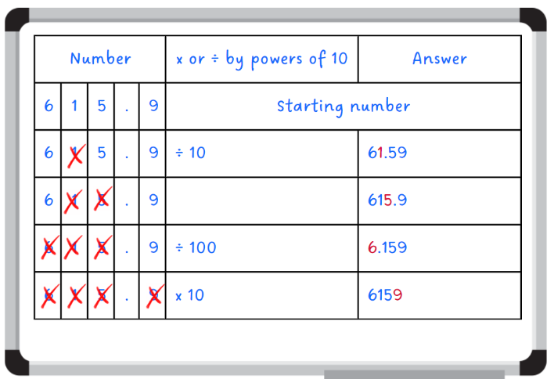
- Provide students with individual whiteboards and 9-sided die each.
- Students draw a gameboard on their whiteboard to record their calculations and eliminated spaceships (see Figure 6).
- After students have eliminated all the spaceships, they create new numbers and play the game again.
This table details opportunities for differentiation.
Too hard? | Too easy?
Students cannot compare the relative place value of digits to multiply and divide a decimal by powers of 10.  - Support students to use the number slider to find the answers when multiplying and dividing by powers of 10.  - Provide students with a 3-digit number, for example, 12.4. Assist them to multiply or divide the decimal by powers of 10 to eliminate the spaceships. | Students can compare the relative place value of digits to multiply and divide a decimal by powers of 10.  - Students modify the game by removing the number as each spaceship is eliminated, creating a new starting number. For example, 615.9 ÷ 10 = 61.59. The one has been eliminated, so the new starting number is 6.59. 6.59 × 10 = 65.9. The 5 has been eliminated, so the new starting number is 6.9. In the number 6.9, the 6 is already in the ones position, so it can be eliminated immediately. 0.9 × 10 = 9 eliminates the final spaceship.  - Students explore what happens if a 5-digit number composed of hundreds, tens, ones, tenths and hundredths is used in the game. For example, 983.24.

Discuss and connect the mathematics – 10 minutes
- Ask: Do you notice a pattern with multiplying or dividing the numbers by powers of 10?
- Remind students that when numbers are multiplied or divided by powers of 10, the decimal does not move. It is the value of the number that changes as each digit changes its place.
- Write the number 294.16 and select students to explain how to multiply or divide by powers of 10 so that:
- The number 2 is in the ones place.
- The number 9 is in the ones place.
- The number 6 is in the ones place.
This table details an opportunity for assessment.
Assessment opportunity | Links
What to look for:  - Can students compare the relative place value of digits to multiply and divide a decimal by powers of 10? [MAO-WM-01,  MA3-MR-01] | Links to National Numeracy Learning Progressions (NNLP):  - NPV8  - MuS9.  Links to suggested Interview for Student Reasoning (IfSR) tasks:  - IfSR-MT: 4A.3, 4A.4.

Lesson 4
Core concept: flexible methods of computation in multiplication and division involve composing and decomposing numbers.

Daily number sense – 10 minutes
- From a class need surfaced through formative assessment data, identify a short, focused activity that targets students’ knowledge, understanding and skills. Example activities may be drawn from the following resources:
- Mathematics K–6 resources
- Universal Resources Hub.

Core lesson 1 – using mental strategies – 15 minutes
The table below contains suggested learning intentions and success criteria. These are best co-constructed with students.
Core concept learning intentions | Core concept success criteria
Students are learning to:  - select and apply strategies to solve problems involving multiplication and division with whole numbers  - multiply and divide decimals by powers of 10. | Students can:  - select and use efficient strategies to multiply whole numbers of up to 4 digits by one- and 2-digit numbers  - use mental strategies to multiply benchmark decimals by single-digit numbers  - compare the relative place value of digits to multiply and divide a decimal by powers of 10.
- Write 3 equations on the whiteboard:
- 3.5 × 2 = _?
- 7.25 × 2 = _?
- 9.5 × 5 = _?
- Provide students with individual whiteboards to solve each equation.
- Students turn and talk to a partner to discuss the strategies they used.
- Ask:
- Could you use the same strategy to solve each of the equations?
- Which one was the easiest and which one was the most challenging?
- How did you think about the decimals to solve the equations?
- Was your strategy the same as the one used by your partner?
- Can you think of another way to solve these equations?

Core lesson 2 – multiplying and dividing by the powers of 10 – 25 minutes
- Write the number 1.425 on the whiteboard.
- Ask: Can you find the number 10 times larger than this number?
Note: students may be able to complete this mentally; however, support can be provided by using the area model (see Figure 7).
Figure 7 – student work example
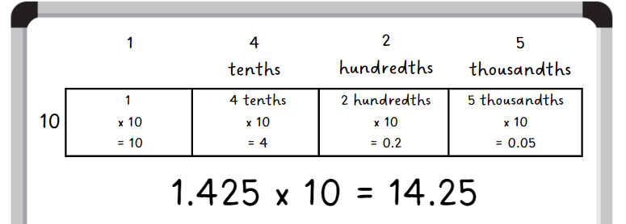
- Select students to demonstrate the strategy they used to solve the problem.
- Ask: Can you use a strategy to find the number 100 times larger than 1.425?
- Select students to demonstrate the strategy they used to solve the problem.
- Ask: Can you use a strategy to find the number 1000 times larger than 1.425?
- Select students to demonstrate the strategy they used to solve the problem.
- Write the number 3875 on the whiteboard.
- Repeat the process, with students making the number 10, 100, and 1000 times smaller.
This table details opportunities for differentiation.
Too hard? | Too easy?
Students cannot compare the relative place value of digits to multiply and divide a decimal by powers of 10.  - Support students by reducing the size of the numbers and the number of decimals they are dealing with.  - Assist students by providing resources such as a Resource 3 – number slider, hundreds and/or multiplication charts to support multiplicative understanding. | Students can compare the relative place value of digits to multiply and divide a decimal by powers of 10.  - Working in pairs, one student gives their partner a decimal number (for example 0.85). The partner shows 2 different ways they can create this decimal number using either multiplication or division. For example, 8.5 divided by 10 and 850 divided by 1000.  - Challenge students to investigate the inverse nature of multiplication and division by finding as many facts as they can for a decimal number. For example, using 0.65, we know that 0.65 × 10 = 6.5 and 6.5 ÷ 10 = 0.65.

Consolidation and meaningful practice – 10 minutes
- Write the number 245 on the whiteboard.
- Students record the numbers 10, 100 and 1000 times larger and smaller on their whiteboard.
- Students compare their numbers with a partner. They read the numbers aloud and explain the strategy they used.
This table details opportunities for assessment.
Assessment opportunities | Links
What to look for:  - Can students select and use efficient strategies to multiply whole numbers of up to 4 digits by one- and 2-digit numbers?  [MAO-WM-01, MA3-MR-01]  - Can students use mental strategies to multiply benchmark decimals by single-digit numbers? [MAO-WM-01, MA3-MR-01]  - Can students compare the relative place value of digits to multiply and divide a decimal by powers of 10? [MAO-WM-01,  MA3-MR-01] | Links to National Numeracy Learning Progressions (NNLP):  - MuS7, MuS8, MuS9  - NPV8.  Links to suggested Interview for Student Reasoning (IfSR) tasks:  - IfSR-MT: 4A.3, 4A.4, 4A.7.

Lesson 5
Core concept: flexible methods of computation in multiplication and division involve composing and decomposing numbers.

Daily number sense – How much sushi? – 10 minutes
Daily number sense activities for Lessons 5 to 7 ‘loop’ back to concepts and procedures covered in previous units to assist students to build an increasingly connected network of ideas. These concepts may differ from the core concepts being covered by the unit.
The table below contains a suggested learning intention and success criteria. These are best co-constructed with students.
Daily number sense learning intention | Daily number sense success criteria
Students are learning to:  - use equivalence to add and subtract fractional quantities. | Students can:  - solve word problems involving adding or subtracting fractional quantities with related denominators.
- Pose the following question: Zahraa and Michele shared a sushi roll. Zahraa ate $\frac{3}{4}$ of the sushi roll and Michele ate $\frac{1}{8}$ of the sushi roll. How much of the sushi roll is left?
- In pairs, students record their ideas on individual whiteboards using diagrams and numerals to represent their thinking.
- Ask:
- What strategy did you use to find how much of the sushi roll is left?
- Is $\frac{3}{4}$ larger than $\frac{1}{8}$? How do you know?
- Did building up to the whole or taking away from the whole make this task easier? Why or why not?
This table details an opportunity for assessment.
Assessment opportunity | Links
What to look for:  - Can students solve word problems involving adding or subtracting fractional quantities with related denominators? [MAO-WM-01, MA3-RQF-01] | Links to National Numeracy Learning Progressions (NNLP):  - InF8.  Links to suggested Interview for Student Reasoning (IfSR) tasks:  - IfSR-MT: 4B.1.

Core lesson – benchmark operations – 35 minutes
The table below contains suggested learning intentions and success criteria. These are best co-constructed with students.
Core concept learning intentions | Core concept success criteria
Students are learning to:  - select and apply strategies to solve problems involving multiplication and division with whole numbers  - multiply and divide decimals by powers of 10. | Students can:  - solve word problems involving rates using multiplication and division  - use mental strategies to multiply benchmark decimals by single-digit numbers  - compare the relative place value of digits to multiply and divide a decimal by powers of 10.
This activity is an adaptation of ‘Multiplying and dividing numbers with decimal parts by 10, 100, etc.’ from Building Engagement in Middle Years Mathematics: Learning sequences for mixed-ability classrooms by Sullivan.
- Pose the following question: If 5 × 2 = 10 and 50 × 2 = 100, can you work out the product of 0.5 × 2?
- In pairs, students represent how they would solve this equation on an individual whiteboard.
- Explain that when multiplying or dividing by 10 or 100, it is the value of the number that changes, as each digit changes in place value. For example, 0.5 × 2 will be less than 10. The answer is 1.
Note: remind students that the benchmark decimal of 0.5 is equivalent to the fraction of $\frac{1}{2}$.
- Pose the following question: If 5 × 2 = 10 and 0.5 × 2 = 1, what is the product of 1.5 × 2?
- Ask students to use their whiteboards to record a visual representation to solve 1.5 × 2.
- Demonstrate the use of the area model as an effective visual representation to multiply 1.5 × 2 (see Figure 8).
Figure 8 – use of area models
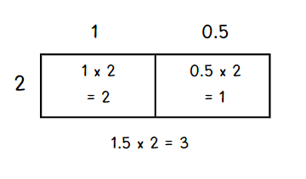
- If students didn’t use an area model to find a solution, they can record the example on their whiteboard.
- Write the equations 25 × 9 = 225 and 25 × 90 = 2250 on the whiteboard.
- Using these, students estimate the product of the following number sentences before solving:
- 2.5 × 9 = _?
- 25 × 0.9 − _?
- 0.25 × 9 = _?
This table details opportunities for differentiation.
Too hard? | Too easy?
Students cannot compare the relative place value of digits to multiply and divide a decimal by powers of 10.  - Support students to say the equation aloud to reinforce the connection to fractional language. For example, students say aloud, ‘Half of 9 is zero and 5 tenths times 9’.  - Support students to find a tenth of the single-digit number before multiplying the decimal. For example, explain that 0.1 × 2 is $\frac{1}{10}$ of 2, which equals 0.2. | Students can compare the relative place value of digits to multiply and divide a decimal by powers of 10.  - Pose the following question: If 75 × 5 = 375 and 75 × 50 = 3750, what is 7.5 × 5 and 75 × 0.5?  - Provide students with a 10-sided die. Students roll the die 3 times and record different multiplication statements using the 3 digits. For example, die rolls of 5, 6 and 9 can be written as 5.6 × 9, 6.5 × 9 or 9.6 × 5. Students estimate the product through reasoning, then record the product of each.

Consolidation and meaningful practice – 15 minutes
- Display Resource 4 – apple juice. In pairs, students work out the following:
- How many litres of juice will Farmer Joe need for 10 jugs?
- How many litres of juice will he need for 100 jugs?
- How many litres of juice will he need for 5 jugs?
- Ask students to share the strategies they used to solve each of these problems. Ensure they understand that 0.2 L becomes 1.25 L when multiplied by 5.
This table details opportunities for assessment.
Assessment opportunities | Links
What to look for:  - Can students solve word problems involving rates using multiplication and division? [MAO-WM-01, MA3-MR-01]  - Can students use mental strategies to multiply benchmark decimals by single-digit numbers? [MAO-WM-01, MA3-MR-01]  - Can students compare the relative place value of digits to multiply and divide a decimal by powers of 10? [MAO-WM-01,  MA3-MR-01] | Links to National Numeracy Learning Progressions (NNLP):  - NPV8  - MuS7, MuS8, MuS9  - PrT4.  Links to suggested Interview for Student Reasoning (IfSR) tasks:  - IfSR-MT: 4A.3, 4A.4, 4A.7.

Lesson 6
Core concept: brackets are symbols used to group things together.

Daily number sense – How much more? – 10 minutes
The table below contains a suggested learning intention and success criteria. These are best co-constructed with students.
Daily number sense learning intention | Daily number sense success criteria
Students are learning to:  - use equivalence to add and subtract fractional quantities. | Students can:  - represent fractional quantities with the same or related denominators to add and subtract fractions.
- Pose the following question: How much more is $\frac{3}{6}$ than $\frac{1}{3}$?
- Using fractions strips, students compare the fractions to determine the answer. The fraction strips and their answer can be recorded in their workbooks.
- Students turn and talk to compare and justify their answers.
- Display Resource 5 – student workbook example. Ask:
- Does it matter if the length of your fraction strip is different in each representation? Why or why not?
- What do you notice about the denominators in this task?
- If I have $\frac{1}{3}$, how many thirds need to be added to make the equal whole?
- If I have $\frac{3}{6}$, how many sixths need to be subtracted to make $\frac{1}{6}$?
- If I have $\frac{1}{3}$ and I add $\frac{2}{6}$, what fraction quantity would I have? Is there more than one answer to this?
Note: the Stage 3 teaching advice states it is important that students understand the need for equal wholes to compare fractions. When fractions are quantities, the equal whole is the unit ‘1’ (NESA 2022c).
This table details an opportunity for assessment.
Assessment opportunity | Links
What to look for:  - Can students represent fractional quantities with the same or related denominators to add and subtract fractions?  [MAO-WM-01, MA3-RQF-01] | Links to National Numeracy Learning Progressions (NNLP):  - InF8.

Core lesson – mystery operations – 35 minutes
The table below contains a suggested learning intention and success criteria. These are best co-constructed with students.
Core concept learning intention | Core concept success criteria
Students are learning to:  - explore the use of brackets and the order of operations to write number sentences. | Students can:  - use grouping symbols () in number sentences to indicate operations that must be performed first  - solve problems involving grouping symbols.
This activity is an adaptation of Operation overload from Arc Learning Sequences by State Government of Victoria.
- Revise the role of order of operations in equations with students. Demonstrate that when grouping symbols are used, the combination of numbers and operations will affect the final answer. For example, 1 + 2 × 3 = 7, but (1 + 2) × 3 =9.
Note: the Stage 3 teaching advice states that the order of operations convention is to be used to reduce the risk of misunderstanding. In this way, complete all multiplications and divisions working left to right before adding and subtracting. Grouping symbols are used to indicate what to do first or to make certain the order is clear. Mnemonics like BOMDAS, BIDMAS or PEMDAS are often misleading as they suggest an absolute order between addition (A) and subtraction (S) or multiplication (M) and division (D) (NESA 2022a).
- Explain that this activity uses the same 4 numbers and they must stay in the same order. The aim is to use them to create as many equations as possible with different products. Any of the operations and grouping symbols can be used in the equations.
- Demonstrate an example of the activity by using the digits 1, 2, 3 and 4 (see Figure 9).
Figure 9 – teacher example
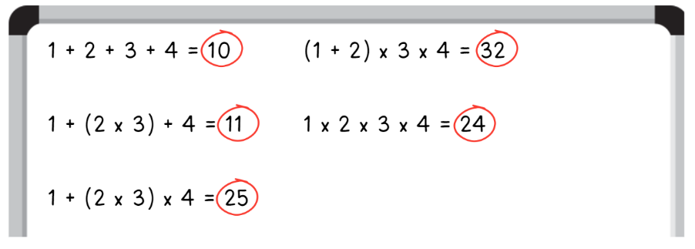
- Provide students with Resource 6 – hundreds chart and display the numbers 5, 6, 7, 8 on the whiteboard.
- In pairs, students use the 4 digits in that order to create as many equations as possible with products between 1 and 100. Remind them that they can choose to use any operation, as well as grouping symbols. They record their results on Resource 6 – hundreds chart.
- Students compare their equations with another group to compare recordings.
This table details opportunities for differentiation.
Too hard? | Too easy?
Students cannot solve problems involving grouping symbols.  - Assist students by reducing the operations used in multiplication and addition.  - Support students by allowing the use of a calculator to determine the total of their equations. | Students can solve problems involving grouping symbols.  - Allow students to select any 4 digits. Once selected, the digits must be placed in an order and must remain in that order for the duration of the task. For example, 1, 9, 3 and 7. Using any mathematical operation, students must create equations that equal as many numbers between 0 and 100 as possible. For example, 19 + 3 − 7 = 15 and (1 + 9) × 3 + 7 = 37.  - In pairs, students roll four 9-sided dice. Student A selects a 2-digit target number. Both students record an equation using the digits rolled, with grouping symbols, to create an answer closest to the target number. Repeat the process with Student B selecting the next target number.

Discuss and connect the mathematics – 15 minutes
- In small groups, students use different number sets and combinations of operations to find 2 or more equations that result in the same answer. For example, 1 + 2 + 3 + 4 = 10 and 4 + 5 − 6 + 7 = 10.
This table details opportunities for assessment.
Assessment opportunities | Links
What to look for:  - Can students use grouping symbols () in number sentences to indicate operations that must be performed first? [MAO-WM-01, MA3-MR-02]  - Can students solve problems involving grouping symbols?  [MAO-WM-01, MA3-MR-02] | Links to National Numeracy Learning Progressions (NNLP):  - NPA5.

Lesson 7
Core concept: the order of operations is important to solve mathematics problems.

Daily number sense – What could be the problem? – 10 minutes
The table below contains a suggested learning intention and success criteria. These are best co-constructed with students.
Daily number sense learning intention | Daily number sense success criteria
Students are learning to:  - use equivalence to add and subtract fractional quantities. | Students can:  - solve word problems involving adding or subtracting fractional quantities with related denominators.
- Write the following on the whiteboard: The answer is $\frac{6}{8}$.
- Students write a real-world problem using addition or subtraction to match the answer. For example, Jemma served 2 different flavoured slab cakes at her birthday party. At the end of the party, she had $\frac{1}{4}$ of the chocolate slab cake left and $\frac{1}{2}$ of the vanilla slab cake left. How much slab cake did Jemma have left at the end of her birthday party?
- In pairs, students create problems to reflect the answer $\frac{6}{8}$. Encourage students to create both addition and subtraction problems.
- Students share the word problems created.
This table details an opportunity for assessment.
Assessment opportunity | Links
What to look for:  - Can students solve word problems involving adding or subtracting fractional quantities with related denominators?  [MAO-WM-01, MA3-RQF-01] | Links to National Numeracy Learning Progressions (NNLP):  - InF8.  Links to suggested Interview for Student Reasoning (IfSR) tasks:  - IfSR-MT: 4B.1.

Core lesson – using grouping symbols – 40 minutes
The table below contains a suggested learning intention and success criteria. These are best co-constructed with students.
Core concept learning intention | Core concept success criteria
Students are learning to:  - explore the use of brackets and the order of operations to write number sentences. | Students can:  - investigate the order of operations using real-life contexts  - solve problems involving grouping symbols.
This lesson is an adaptation of ‘Order of operations’ from Teaching Mathematics: Foundations to Middle Years by Siemon et al.
- Display Resource 7 – Who is correct? Provide students with whiteboards to solve the problem.
- Students turn and talk to discuss which answer is correct and why.
- Ask:
- How do you know which response is the correct answer? (Matt did. He applied the order of operations with the equation).
- How did you work this out? (Various student responses).
- What errors were made in the incorrect calculation? (Gabby didn’t apply the order of operations with the equation).
- Revise that:
- grouping symbols are used to change the order by indicating what to do first when solving an equation
- this ensures the equation is accurately communicating the problem needing to be solved
- in the absence of grouping symbols, all multiplication and division operations are still completed first by working from left to right. Adding and subtracting happens after this.
- Display Resource 8 – more grouping symbols. Students work in pairs to solve the word problems They use grouping symbols to ensure the equation is solved in the correct sequence.
- Select students to demonstrate how they were able to use grouping symbols to solve each equation, discussing the strategies they used.
This table details opportunities for differentiation.
Too hard? | Too easy?
Students cannot investigate the order of operations using real-life contexts.  - Provide students with concrete materials such as counters to assist them when calculating the answer to each equation.  - Support students in writing equations to reflect word problems using real-life contexts. For example, 5 plants = $9 + $9 + $9 + $9 + $9 = $45 and 3 more plants = $12 + $12 + $12 = $36. | Students can investigate the order of operations using real-life contexts.  - Pose the problem: I found 6 frogs and 4 spiders. How many creatures’ legs did I find altogether? If we had 5 boxes and each box could only contain 12 legs, which creature combinations could be used? (For example, boxes 1 to 4 would contain a frog and a spider each, but box 5 would contain 3 frogs).  - Ask students to create different sets of word problems for a partner to solve with examples such as distance and time travelled. For example, Peter can run a kilometre in 6 minutes. However, he has realised that to run further distances, he must rest for 2 minutes after every 3 km. How long will it take for him to run a 42 km marathon?

Discuss and connect the mathematics – 10 minutes
This activity is an adaptation of Order of Operations 5 by Rawding from the Open Middle website.
- Draw Figure 10 on the whiteboard.
Figure 10 – order of operations task
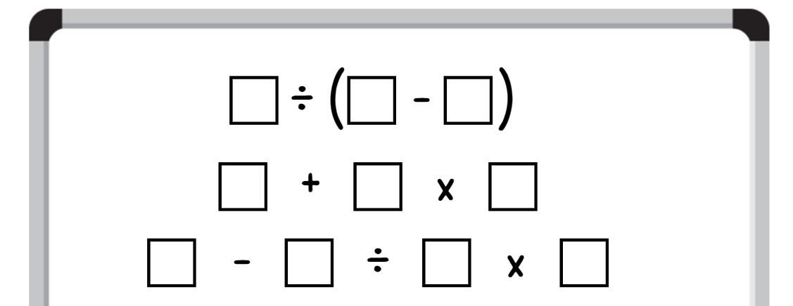
- Using the digits 0–9 only once each, students place a digit in each box so that each equation equals a different odd number. For example, 7 ÷ (6 − 5) = 7, 1 + 2 × 0 = 1, 9 − 8 ÷ 4 × 3 = 3.
- Students compare their answers with a partner, discussing the strategies they used to complete the task.
This table details opportunities for assessment.
Assessment opportunities | Links
What to look for:  - Can students investigate the order of operations using real-life contexts? [MAO-WM-01, MA3-MR-02]  - Can students solve problems involving grouping symbols?  [MAO-WM-01, MA3-MR-02] | Links to National Numeracy Learning Progressions (NNLP):  - NPA5.

Lesson 8
Core concept: worded problems can be solved using multiplicative thinking.

Daily number sense – 10 minutes
- From a class need surfaced through formative assessment data, identify a short, focused activity that targets students’ knowledge, understanding and skills. Example activities may be drawn from the following resources:
- Mathematics K–6 resources
- Universal Resources Hub.

Core lesson 1 – vertical double number line – 15 minutes
The table below contains a suggested learning intention and success criteria. These are best co-constructed with students.
Core concept learning intention | Core concept success criteria
Students are learning to:  - select and apply strategies to solve problems involving multiplication and division with whole numbers. | Students can:  - select and use efficient strategies to multiply whole numbers of up to 4 digits by one- and 2-digit numbers  - solve word problems involving rates using multiplication and division.
This activity is an adaptation of ‘Double number line’ from A Practical Guide to Transforming Primary Mathematics: Activities and tasks that really work by Askew.
- Pose the problem: A baby frog takes 4 jumps for every one jump that her mother takes. How many jumps will the baby frog take if the mother frog takes 8 jumps?
- Draw a vertical double number line on the board (see Figure 11). Explain that this vertical double number line has 2 different scales on it that are in proportion to each other.
Figure 11 – double number line
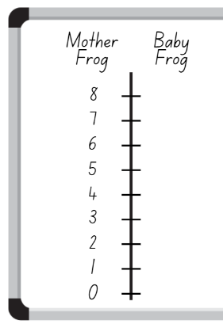
- Explain that students will use the information from the problem to complete the other side of the vertical double number line. For example, we know the baby frog takes 4 jumps for every jump the mother takes, so the first number on the right of the vertical double number line is 4.
- Students draw a vertical double number line on whiteboards. They use this to record their solution to the problem.
- Select students to share their answers. Use these to fill in the right side of the vertical double number line on the board.
- Pose the problem: If the baby frog takes 16 jumps, how many jumps will the mother frog have taken?
- Students use the vertical double number line to calculate the answer to this question. Then they turn and talk to a partner to compare and discuss their results.
- Ask: Can you write a rule to describe what is happening in this problem?
- Choose some students to share their rule with the class.

Core lesson 2 – rates word problems – 25 minutes
This activity is an adaptation of ‘Equivalent ratio problems’ from Teaching Mathematics: Foundations to Middle Years by Siemon et al.
- Pose the problem: Rob laid 36 bricks in 45 minutes. How many bricks might Rob lay in 9 hours?
- Display Resource 9 – Rob’s bricklaying.
- Students turn and talk to a partner, discussing how they would use the vertical double number line to solve this problem.
- Select students to share their ideas.
- Display Resource 10 – solving the problem. Discuss that one way to solve the problem is to reduce the quantities to something easier. The quantities on both sides of the vertical number line are divisible by 3. This means the 45-minute section can be partitioned into 15-minute periods. At this rate, Rob can lay 12 bricks in 15 minutes.
- On individual whiteboards, students use this information to solve the original problem of how many bricks Rob will lay in 9 hours.
This table details opportunities for differentiation.
Too hard? | Too easy?
Students cannot solve word problems involving rates using multiplication and division.  - Provide a scaffolded version of the vertical double number line with 15-minute periods already marked to support student understanding.  - Students work out how many bricks Rob laid in one hour.  - Provide concrete materials such as counters to assist calculations and visualise proportions. | Students can solve word problems involving rates using multiplication and division.  - Ask students to solve the following problem:  - Rob laid 264 bricks the next day. How many hours did Rob work that day?  - The following day, Rob worked 7 and $\frac{3}{4}$ hours. How many bricks did he lay in that time?  - Students create their own word problems involving rates for their classmates to complete. Students should use the vertical double number line to solve the word problems.

Discuss and connect the mathematics – 10 minutes
- Students complete a gallery walk to observe how other students have recorded their ideas on the vertical double number line. Ask:
- Did you notice someone who used the same strategy as you?
- Did you notice someone who used a different strategy to you?
- Did you see a strategy that you would use next time? Why?
- Did you notice someone who used another representation to solve the problem? (For example, an area model).
- How many bricks did Rob lay in 9 hours?
This table details opportunities for assessment.
Assessment opportunities | Links
What to look for:  - Can students select and use efficient strategies to multiply whole numbers of up to 4 digits by one- and 2-digit numbers?  [MAO-WM-01, MA3-MR-01]  - Can students solve word problems involving rates using multiplication and division? [MAO-WM-01, MA3-MR-01] | Links to National Numeracy Learning Progressions (NNLP):  - MuS7, MuS8  - PrT4.

Resource 1 – think board
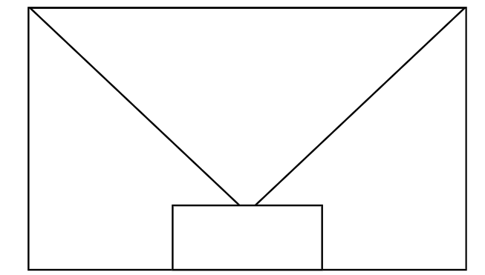

Resource 2 – grouping symbol problems
There are 50 students going on an excursion. Two buses have been booked. The students have been allocated a bus each, with one supervising teacher on each bus. How many people will board each bus?
There are 50 students going on an excursion. Two buses have been booked for an even allocation of students on each bus. A new student has recently enrolled and will be attending the excursion. How many students will there be on each bus?
There are 50 students in Year 5. They will be evenly allocated to 2 different Year 6 classes next year.

Resource 3 – number slider
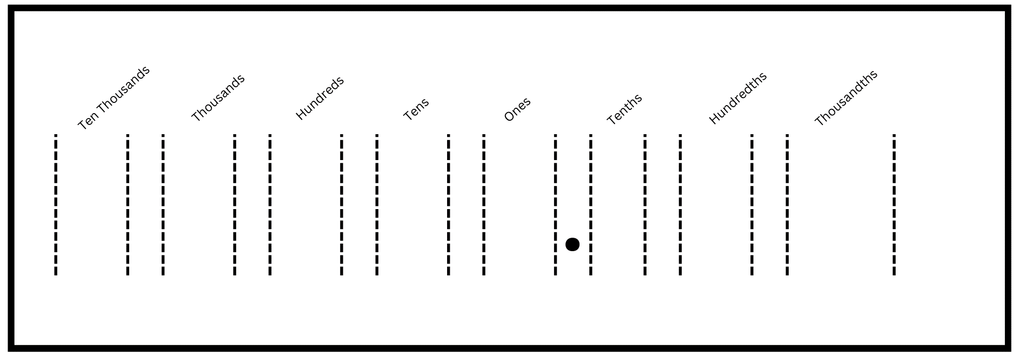

Resource 4 – apple juice

Resource 5 – student workbook example
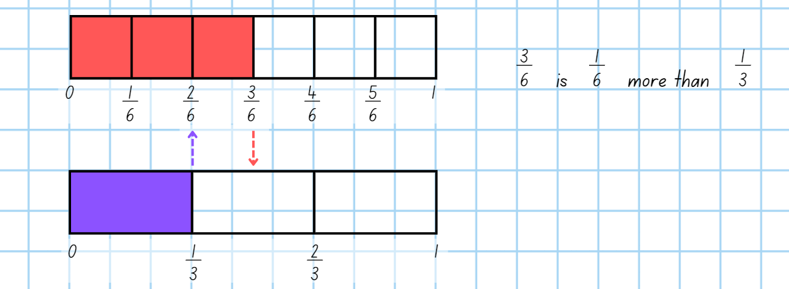

Resource 6 – hundreds chart
= 0 | = 1 | = 2 | = 3 | = 4 | = 5 | = 6 | = 7
= 8 | = 9 | = 10 | = 11 | = 12 | = 13 | = 14 | = 15
= 16 | = 17 | = 18 | = 19 | = 20 | = 21 | = 22 | = 23
= 24 | = 25 | = 26 | = 27 | = 28 | = 29 | = 30 | = 31
= 32 | = 33 | = 34 | = 35 | = 36 | = 37 | = 38 | = 39
= 40 | = 41 | = 42 | = 43 | = 44 | = 45 | = 46 | = 47
= 48 | = 49 | = 50 | = 51 | = 52 | = 53 | = 54 | = 55
= 56 | = 57 | = 58 | = 59 | = 60 | = 61 | = 62 | = 63
= 64 | = 65 | = 66 | = 67 | = 68 | = 69 | = 70 | = 71
= 72 | = 73 | = 74 | = 75 | = 76 | = 77 | = 78 | = 79
= 80 | = 81 | = 82 | = 83 | = 84 | = 85 | = 86 | = 87
= 88 | = 89 | = 90 | = 91 | = 92 | = 93 | = 94 | = 95
= 96 | = 97 | = 98 | = 99 | = 100

Resource 7 – Who is correct?
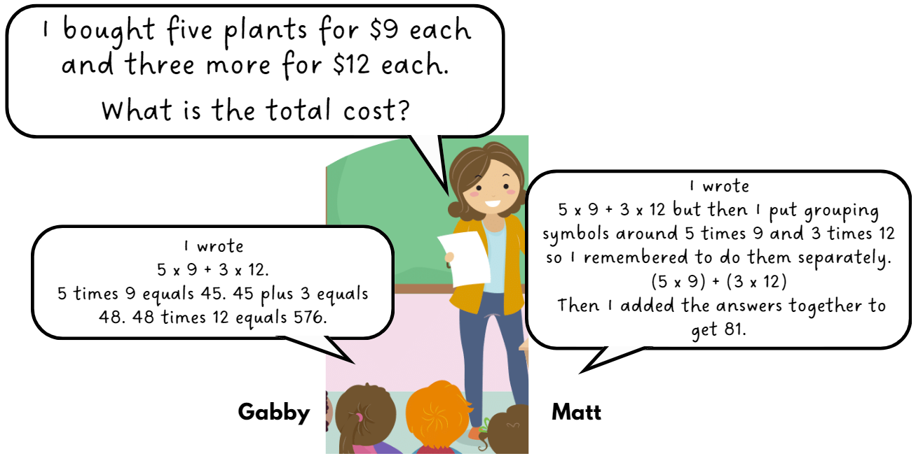

Resource 8 – more grouping symbols
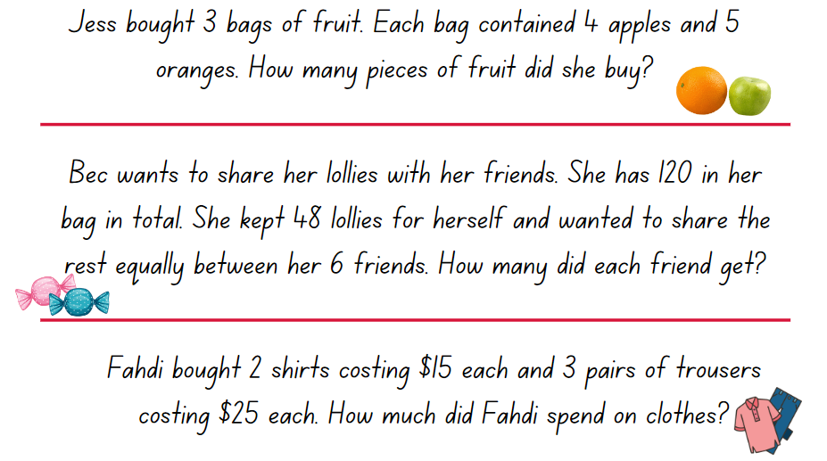

Resource 9 – Rob’s bricklaying
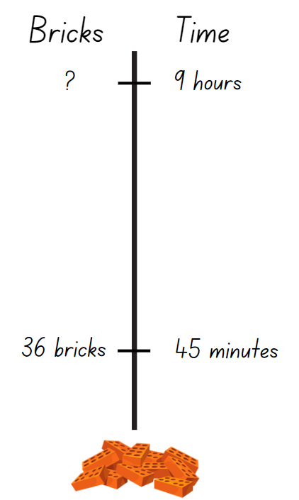

Resource 10 – solving the problem
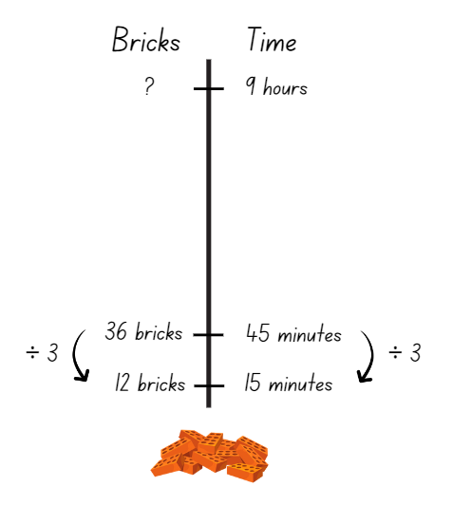

Syllabus outcomes and content
The table below outlines the syllabus outcomes and range of relevant syllabus content covered in this unit. Content is linked to National Numeracy Learning Progression (version 3).
Outcomes and content | 1 | 2 | 3 | 4 | 5 | 6 | 7 | 8
Represents numbers A: Whole numbers: Apply place value to partition, regroup and rename numbers to 1 billion
MAO-WM-01, MA3-RN-01
- Regroup numbers in different forms (Reasons about quantity) |  | x
Multiplicative relations B: Select and apply strategies to solve problems involving multiplication and division with whole numbers
MAO-WM-01, MA3-MR-01
- Select and use efficient strategies to multiply whole numbers of up to 4 digits by one- and 2-digit numbers |  | x |  | x |  |  |  | x
- Solve word problems involving rates using multiplication and division (Reasons about relations) |  |  |  |  | x |  |  | x
- Determine why different division questions have the same answer (Reasons about relations) |  | x
Multiplicative relations B: Multiply and divide decimals by powers of 10
MAO-WM-01, MA3-MR-01
- Use mental strategies to multiply benchmark decimals by single-digit numbers |  |  |  | x | x
- Compare the relative place value of digits to multiply and divide a decimal by powers of 10 |  |  | x | x | x
Multiplicative relations B: Use equivalent number sentences involving multiplication and division to find unknown quantities
MAO-WM-01, MA3-MR-01
- Identify and use inverse operations to assist with the solution of number sentences |  | x
Multiplicative relations B: Represent and describe number patterns formed by multiples
MAO-WM-01, MA3-MR-01
- Determine a rule describing the relationship between the bottom number and the top number in a table (Algebraic reasoning) | x
Multiplicative relations B: Explore the use of brackets and the order of operations to write number sentences
MAO-WM-01, MA3-MR-01, MA3-MR-02
- Recognise the need to agree on the order in which to perform operations | x
- Use grouping symbols () in number sentences to indicate operations that must be performed first | x | x |  |  |  | x
- Investigate the order of operations using real-life contexts |  |  | x |  |  |  | x
- Solve problems involving grouping symbols |  |  |  |  |  | x | x
Representing quantity fractions B: Use equivalence to add and subtract fractional quantities
MAO-WM-01, MA3-RQF-01
- Solve word problems involving adding or subtracting fractional quantities with related denominators |  |  |  |  | x |  | x
- Represent fractional quantities with the same or related denominators to add and subtract fractions (Reasons about relations) |  |  |  |  |  | x
Mathematics K–10 Syllabus © NSW Education Standards Authority (NESA) for and on behalf of the Crown in right of the State of New South Wales, 2022.

References
This resource contains NSW Curriculum and syllabus content. The NSW Curriculum is developed by the NSW Education Standards Authority. This content is prepared by NESA for and on behalf of the Crown in right of the State of New South Wales. The material is protected by Crown copyright.
Please refer to the NESA Copyright Disclaimer for more information https://educationstandards.nsw.edu.au/wps/portal/nesa/mini-footer/copyright.
NESA holds the only official and up-to-date versions of the NSW Curriculum and syllabus documents. Please visit the NSW Education Standards Authority (NESA) website https://educationstandards.nsw.edu.au/wps/portal/nesa/home/ and the NSW Curriculum website https://curriculum.nsw.edu.au.
Mathematics K–10 Syllabus © NSW Education Standards Authority (NESA) for and on behalf of the Crown in right of the State of New South Wales, 2022.
National Numeracy Learning Progression © Australian Curriculum, Assessment and Reporting Authority (ACARA) 2010 to present, unless otherwise indicated. This material was downloaded from the Australian Curriculum website (National Numeracy Learning Progression) (accessed 12 December 2023) and was not modified.
Askew M (2016) A Practical Guide to Transforming Primary Mathematics: Activities and tasks that really work, 1st edn, Routledge, United States of America.
Boaler J, Munson J and Williams C (2017) Mindset Mathematics: Visualizing and Investigating Big Ideas, Grade 4, 1st edn, Jossey-Bass, United States of America.
NESA (NSW Education Standards Authority) (2022a) Teaching advice for Multiplicative relations B, NESA website, accessed 26 March 2024.
NESA (NSW Education Standards Authority) (2022b) Teaching advice for Represents numbers A, NESA website, accessed 26 March 2024.
NESA (NSW Education Standards Authority) (2022c) Teaching advice for Representing quantity fractions B, NESA website, accessed 26 March 2024.
Rawding M (2018) ‘Order of Operations 5’, Grade 5, Open Middle website, accessed 18 January 2024.
Siemon D, Warren E, Beswick K, Faragher R, Miller J, Horne M, Jazby D, Breed M, Clark J and Brady K (2020) Teaching Mathematics: Foundations to Middle Years, 3rd edn, Oxford University Press Australia and New Zealand.
State Government of Victoria (Department of Education) (2022) ‘Operation Overload’ It's All in the Numbers: Stages, Arc Learning Sequences website, accessed 4 December 2023.
State of Victoria Department of Education and Early Childhood Development (DEECD) (2008) Fencing the Freeway (PDF 69.7 KB), Victoria State Government Department of Education, accessed 4 December 2023.
Sullivan P (2021) Building Engagement in Middle Years Mathematics: Learning sequences for mixed-ability classrooms, 1st edn, Oxford University Press Australia and New Zealand, Victoria.
University of Melbourne (2006) Aliens Calculator Game, Teaching and Learning About Decimals website, accessed 4 December 2023.

Further reading
Van de Walle J, Karp K, Bay-Williams JM, Brass A, Bentley B, Ferguson S, Goff W, Livy S, Marshman M, Martin D, Pearn C, Prodromou T, Symons D and Wilkie K (2019) Primary and Middle Years Mathematics: Teaching Developmentally, 1st Australian edn, Pearson Education Australia, Melbourne.
© State of New South Wales (Department of Education), 2024
The copyright material published in this resource is subject to the Copyright Act 1968 (Cth) and is owned by the NSW Department of Education or, where indicated, by a party other than the NSW Department of Education (third-party material).
Copyright material available in this resource and owned by the NSW Department of Education is licensed under a Creative Commons Attribution 4.0 International (CC BY 4.0) license.
This license allows you to share and adapt the material for any purpose, even commercially.
Attribution should be given to © State of New South Wales (Department of Education), 2024.
Material in this resource not available under a Creative Commons license:
- the NSW Department of Education logo, other logos and trademark-protected material
- material owned by a third party that has been reproduced with permission. You will need to obtain permission from the third party to reuse its material.
Links to third-party material and websites
Please note that the provided (reading/viewing material/list/links/texts) are a suggestion only and implies no endorsement, by the New South Wales Department of Education, of any author, publisher, or book title. School principals and teachers are best placed to assess the suitability of resources that would complement the curriculum and reflect the needs and interests of their students.
If you use the links provided in this document to access a third-party's website, you acknowledge that the terms of use, including licence terms set out on the third-party's website apply to the use which may be made of the materials on that third-party website or where permitted by the Copyright Act 1968 (Cth). The department accepts no responsibility for content on third-party websites.

