Mathematics Stage 3 – Unit 38

Questions can be asked and answered by interpreting data

Contents

Unit description and duration 5

Syllabus outcomes 5

Working mathematically 6

Student prior learning 6

Lesson overview and resources 8

Lesson 1 13

Daily number sense – farmer’s market – 15 minutes 13

Core lesson – chance of winning – 40 minutes 15

Discuss and connect the mathematics – 10 minutes 20

Lesson 2 22

Daily number sense – lolly shop – 10 minutes 22

Core lesson – mystery spinner – 40 minutes 23

Discuss and connect the mathematics – 10 minutes 27

Lesson 3 30

Daily number sense – fractions of chocolates – 10 minutes 30

Core lesson – Scissors, Paper, Rock – 40 minutes 31

Discuss and connect the mathematics – 10 minutes 37

Lesson 4 39

Daily number sense – 10 minutes 39

Core lesson – fair and unfair games – 45 minutes 39

Discuss and connect the mathematics – 15 minutes 43

Lesson 5 45

Daily number sense – determining percentages – 10 minutes 45

Core lesson – mystery bag – 45 minutes 48

Consolidation and meaningful practice – 15 minutes 52

Lesson 6 56

Daily number sense – estimate discounts – 10 minutes 56

Core lesson 1 – data in the media – 15 minutes 57

Core lesson 2 – misleading graphs – 25 minutes 60

Discuss and connect the mathematics – 10 minutes 62

Lesson 7 64

Daily number sense – sales price – 10 minutes 64

Core lesson – Great Barrier Reef data – 35 minutes 65

Consolidation and meaningful practice – 15 minutes 68

Lesson 8 70

Daily number sense – 10 minutes 70

Core lesson – comparing and interpreting data – 35 minutes 70

Consolidation and meaningful practice – 15 minutes 74

Resource 1 – farmer’s market cards 78

Resource 2 – room maze 79

Resource 3 – lolly shop cards 80

Resource 4 – spinners 81

Resource 5 – mystery spinner 82

Resource 6 – box of chocolates 83

Resource 7 – SPR instructions 84

Resource 8 – game outcomes 85

Resource 9 – recording sheet 1 86

Resource 10 – recording sheet 2 87

Resource 11 – bag recording sheet 88

Resource 12 – class recording sheet 89

Resource 13 – reef fish samples 90

Resource 14 – clothes shop 91

Resource 15 – data types 92

Resource 16 – average global temperatures 93

Resource 17 – misleading graphs 94

Resource 18 – sale items 98

Resource 19 – alternative holiday destinations 99

Resource 20 – reef visitors 100

Resource 21 – visitors data sheet 101

Resource 22 – barrier reef weather 102

Resource 23 – coral bleaching data 103

Resource 24 – comparing graphs 104

Resource 25 – rising sea temperatures A 105

Resource 26 – data information sheet 106

Resource 27 – rising sea temperatures B 107

Resource 28 – reefs at risk 108

Syllabus outcomes and content 109

References 115

Further reading 116

# Unit description and duration

This unit develops the big idea that questions can be asked and answered by interpreting data.

In this 2-week unit students are provided opportunities to:

* create random generators and describe probabilities using fractions
* conduct chance experiments with both small and large numbers of trials and compare observed frequencies with expected results
* interpret and compare a range of data displays, including data presented in digital media and elsewhere.

## Syllabus outcomes

* **MAO-WM-01** develops understanding and fluency in mathematics through exploring and connecting mathematical concepts, choosing and applying mathematical techniques to solve problems, and communicating their thinking and reasoning coherently and clearly
* **MA3-RN-03** determines percentages of quantities, and finds equivalent fractions and decimals for benchmark percentage values
* **MA3-RQF-02** determines $\frac{1}{2},\frac{1}{4}, \frac{1}{5}$ and $\frac{1}{10}$ of measures and quantities
* **MA3-DATA-01** constructs graphs using many-to-one scales
* **MA3-DATA-02** interprets data displays, including timelines and line graphs
* **MA3-CHAN-01** conducts chance experiments and quantifies the probability

## Working mathematically

In the Mathematics K–10 Syllabus, there is one overarching Working mathematically outcome (**MAO-WM-01**). The Working mathematically processes should be embedded within the concepts being taught. The Working mathematically processes present in the Mathematics K–10 Syllabus are:

* communicating
* understanding and fluency
* reasoning
* problem solving.

[Mathematics K–10 Syllabus](https://curriculum.nsw.edu.au/learning-areas/mathematics/mathematics-k-10-2022/overview) © NSW Education Standards Authority (NESA) for and on behalf of the Crown in right of the State of New South Wales, 2022.

## Student prior learning

Before engaging in these teaching and learning activities, students would benefit from prior experience with:

* representing and interpreting data presented in tables, column graphs and line graphs
* interpreting and comparing data through measure of central tendency such as range and mode
* predicting and describing possible outcomes from chance experiments.

In NSW classrooms there is a diverse range of students, including Aboriginal and/or Torres Strait Islander students, students learning English as an additional language or dialect, high potential and gifted students, and students with disability. Some students may identify with more than one of these groups or possibly all of them. Refer to [Curriculum planning for every student – advice](https://education.nsw.gov.au/teaching-and-learning/curriculum/planning-programming-and-assessing-k-12/advice-on-curriculum-planning-for-every-student-k-12) for further information.

# Lesson overview and resources

The table below outlines the sequence and approximate timing of lessons, learning intentions and resources.

|  |  |  |
| --- | --- | --- |
| Lesson | Content | Duration and resources |
| **Lesson 1**  **Daily number sense learning intention:**   * find fractional quantities of whole numbers (halves, quarters, fifths and tenths) | **Lesson core concept**: random generators produce data with variation.  **Core concept learning intention**:   * create random generators and describe probabilities using fractions | **Lesson duration**: 65 minutes   * Resource 1 – farmer’s market cards * Resource 2 – room maze * 6-sided dice * Individual whiteboards * Writing materials |
| **Lesson 2**  **Daily number sense learning intention:**   * find fractional quantities of whole numbers (halves, quarters, fifths and tenths) | **Lesson core concept**: mathematicians describe probabilities using fractions.  **Core concept learning intentions**:   * collect categorical and discrete numerical data by observations or survey * create random generators and describe probabilities using fractions | **Lesson duration**: 60 minutes   * Resource 3 – lolly shop cards * Resource 4 – spinners * Resource 5 – mystery spinner * Playing cards * Paper clip * Pen * Student workbooks * Writing materials |
| **Lesson 3**  **Daily number sense learning intention:**   * find fractional quantities of whole numbers (halves, quarters, fifths and tenths) | **Lesson core concept**: expected and observed probabilities describe possible outcomes.  **Core concept learning intentions**:   * compare observed frequencies of outcomes with expected results * conduct chance experiments with both small and large numbers of trials | **Lesson duration**: 60 minutes   * Resource 6 – box of chocolates * Resource 7 – SPR instructions * Resource 8 – game outcomes * Resource 9 – recording sheet 1 * Writing materials |
| **Lesson 4**  **Daily number sense learning intention:**   * teacher-identified task based on student needs | **Lesson core concept**: expected and observed probabilities describe possible outcomes.  **Core concept learning intentions**:   * compare observed frequencies of outcomes with expected results * conduct chance experiments with both small and large numbers of trials | **Lesson duration**: 70 minutes   * Resource 10 – recording sheet 2 * Calculators * Writing materials |
| **Lesson 5**  **Daily number sense learning intentions:**   * make connections between benchmark fractions, decimals and percentages * determine percentage discounts of 10%, 25% and 50% | **Lesson core concept**: repeated trials identify data variation.  **Core concept learning intentions**:   * choose and use appropriate tables and graphs * conduct chance experiments with both small and large numbers of trials | **Lesson duration**: 70 minutes   * Resource 11 – bag recording sheet * Resource 12 – class recording sheet * Resource 13 – reef fish samples * Interlocking cubes * Paper bags * Pegs * Sticky notes * String (cut into 1 metre strips) * Writing materials |
| **Lesson 6**  **Daily number sense learning intention:**   * determine percentage discounts of 10%, 25% and 50% | **Lesson core concept**: mathematicians critically interpret and evaluate real-world data.  **Core concept learning intention**:   * interpret data presented in digital media and elsewhere | **Lesson duration**: 60 minutes   * Resource 14 – clothes shop * Resource 15 – data types * Resource 16 – average global temperatures * Resource 17 – misleading graphs * Student workbooks * Writing materials |
| **Lesson 7**  **Daily number sense learning intention:**   * determine percentage discounts of 10%, 25% and 50% | **Lesson core concept**: data is used in everyday contexts and influences daily practices.  **Core concept learning intentions**:   * interpret and compare a range of data displays * interpret data presented in digital media and elsewhere | **Lesson duration**: 60 minutes   * Resource 18 – sale items * Resource 19 – alternative holiday destinations * Resource 20 – reef visitors * Resource 21 – visitors data sheet (A3 copies) * Resource 22 – barrier reef weather * Writing materials |
| **Lesson 8**  **Daily number sense learning intention:**   * teacher-identified task based on student needs | **Lesson core concept**: statistical reasoning helps mathematicians interpret and make inferences about real-world data.  **Core concept learning intentions**:   * interpret and compare a range of data displays * interpret data presented in digital media and elsewhere | **Lesson duration**: 60 minutes   * Resource 23 – coral bleaching data * Resource 24 – comparing graphs * Resource 25 – rising sea temperatures A * Resource 26 – data information sheet * Resource 27 – rising sea temperatures B * Resource 28 – reefs at risk * Writing materials |

# Lesson 1

**Core concept**: random generators produce data with variation.

## Daily number sense – farmer’s market – 15 minutes

Daily number sense activities for Lessons 1 to 3 ‘activate’ prior number knowledge and support the learning of new content in the unit. These activities can also assist teachers to identify the starting points for learning by revealing the extent of students’ existing knowledge.

The table below contains a suggested learning intention and success criteria. These are best co-constructed with students.

|  |  |
| --- | --- |
| Daily number sense learning intention | Daily number sense success criteria |
| Students are learning to:   * find fractional quantities of whole numbers (halves, quarters, fifths and tenths). | Students can:   * calculate quarters and fifths of whole numbers that are multiples of the denominator, using a tape diagram. |

1. Provide students with Resource 1 – farmer’s market cards, a 6-sided die and an individual whiteboard. Remind students how to play Farmer’s Market as introduced in [Stage 3 Unit 24](https://education.nsw.gov.au/teaching-and-learning/curriculum/mathematics/planning-programming-and-assessing-mathematics-k-6/mathematics-3-6-units#:~:text=DOCX%202.4%20MB)-,Unit%2024%20%E2%80%93%20Fractions%20represent%20multiple%20ideas%20and%20can%20be%20represented%20in%20different%20ways,-Representing%20quantity%20fractions):
2. Have all the cards face up.
3. Player 1 rolls the die. This will be the denominator for the unit fraction. For example, if a 5 is rolled, the fraction would be $\frac{1}{5}$. If a 1 is rolled, roll again.
4. Choose a produce card.
5. Calculate the fraction of the produce you have picked. For example, if the card is 20 lemons, calculate $\frac{1}{5}$ of 20 = 4.
6. Draw a tape diagram to record the fractional thinking.

**Note:** a tape diagram is a type of bar model used in previous units.

1. Once a produce card has been used, flip it over. It can no longer be used in this round.
2. Player 2 repeats the same steps.
3. If a player rolls a denominator that cannot be used on the cards without a remainder, they miss their turn.
4. Continue until all the cards have been used.
5. The winner is the player with the largest collection of produce items.

This table details opportunities for assessment.

|  |  |
| --- | --- |
| Assessment opportunities | Links |
| What to look for:   * Can students calculate quarters and fifths of whole numbers that are multiples of the denominator, using a tape diagram?  **[MAO-WM-01, MA3-RQF-02]** | Links to [National Numeracy Learning Progressions](https://www.australiancurriculum.edu.au/resources/national-literacy-and-numeracy-learning-progressions/version-3-of-national-literacy-and-numeracy-learning-progressions/) (NNLP):   * InF8. |

## Core lesson – chance of winning – 40 minutes

The table below contains a suggested learning intention and success criteria. These are best co-constructed with students.

|  |  |
| --- | --- |
| Core concept learning intention | Core concept success criteria |
| Students are learning to:   * create random generators and describe probabilities using fractions. | Students can:   * record the outcomes for chance experiments where the outcomes are not equally likely to occur and assign probabilities to the outcomes using fractions * use knowledge of benchmark fractions, decimals and percentages to assign probabilities to the likelihood of outcomes. |

This lesson is an adaptation of ‘Keys to a new car’ from Primary and Middle Years Mathematics: Teaching Developmentally by Van de Walle et al.

1. Display Resource 2 – room maze. Pose the following problem: You are in a game show and can win a trip to Disneyland. To win, you need to make it through the maze to the room with the tickets.

**Note:** the tickets can be placed in either Room A or Room B. The results may look random but can be described mathematically using fractions or percentages.

1. Explain that at the start and at each fork, the spinner must be spun and the coloured path followed. Once either room has been reached the game is over, there is no going backwards.
2. Ask the following question: In which room should you place the ticket to have the best chance of winning the trip?
3. Allow students time to think and then [turn and talk](https://education.nsw.gov.au/teaching-and-learning/curriculum/literacy-and-numeracy/teaching-and-learning-resources/numeracy/talk-moves) about which room they would select and why.
4. Select students to share their choice of room and explain their thinking. Use the following prompt box to facilitate discussions.

The table below outlines stimulus prompts to generate conversation about the topic, along with anticipated responses from students.

|  |  |
| --- | --- |
| Prompts | Anticipated student responses |
| * Why did you select Room A? | * Because it had 3 lines and 3 arrows going into it, while Room B only had 2 of each. It looks like there are more options to get to Room A.   **Note:** this is an incorrect response as the student has not taken a probability view but a counting view. |
| * Why did you select Room B? | * There is more red on the 3 spinners so that must mean that Room B would have the better chance. |
| * Did the start spinner impact your room decision? | * The start spinner had mostly red, and only smaller blue or orange parts. So, I picked Room B. |
| * Can you represent the probability of each option on the start spinner as a fraction? | $\frac{1}{2}$* red travelling to Fork 1, $\frac{1}{4}$ orange travelling to Fork 2 and $\frac{1}{4}$ blue travelling straight to Room A. |
| * What about the spinners at Fork 1 and Fork 2? | * Fork 1 has $\frac{3}{4}$ to Room B and $\frac{1}{4}$ to Room A. * Fork 2 has $\frac{3}{4}$ to Room B and $\frac{1}{4}$ to Room A. |

1. Explain that students will record the probabilities of the start spinner using an area model. Instruct students to draw a large rectangle in their workbooks and represent and label the fractional part (see Figure 1).

Figure 1 – starting probabilities

An area model of a rectangle divided into one half and 2 quarters. The half is labelled Fork 1. One quarter is labelled Room A and the other quarter is labelled Fork 2.



1. Once students have represented the starting probabilities, instruct them to further subdivide the area model in Figure 1 to show the Fork 1 and Fork 2 probabilities, colouring the parts to show the probability for each room (see Figure 2).

Figure 2 – room probabilities

A rectangle divided into 16 cells to represent the probability of reaching 2 rooms depending on which fork is taken. It shows that Room A will be reached 7 out of 16 times and Room B will be reached 9 out of 16 times.


1. Once students have represented Fork 1 and Fork 2 probabilities, they calculate the chance of ending in each room.

**Note:** Stage 3 students are not expected to multiply fractions. Emphasis calculating can be done by counting the sections for each room in the completed area model. For example, students will end in Room A $\frac{7}{16}$ of the time and Room B $\frac{9}{16}$ of the time.

This table details opportunities for differentiation.

|  |  |
| --- | --- |
| Too hard? | Too easy? |
| Students cannot record the outcomes for chance experiments where the outcomes are not equally likely to occur and assign probabilities to the outcomes using fractions.   * Revisit spinners where the outcomes are equally likely. Model to students how to record outcomes and assign probabilities. * Support students to recognise probability as a fraction. Record the denominator as the total number of possible outcomes and the numerator as the number of times that each outcome occurred. | Students can record the outcomes for chance experiments where the outcomes are not equally likely to occur and assign probabilities to the outcomes using fractions.   * Students create their own version of the game with spinners and a prize, swapping with a partner to solve. * Challenge students to represent the problem in a different way. For example, by using a tree diagram. |

## Discuss and connect the mathematics – 10 minutes

1. Regroup as a class and summarise the lesson together. To draw out key mathematical ideas, ask the following questions:

* Did you select the room with the best chance of winning the ticket?
* Were the results what you expected? Why or why not?
* Did using the area model to represent the expected outcomes help?
* Do you know another way to present the problem other than an area model?
* How could you change the chance of winning by modifying the spinners?

This table details opportunities for assessment.

|  |  |
| --- | --- |
| Assessment opportunities | Links |
| What to look for:   * Can students record the outcomes for chance experiments where the outcomes are not equally likely to occur and assign probabilities to the outcomes using fractions?  **[MAO-WM-01, MA3-CHAN-01]** * Can students use knowledge of benchmark fractions, decimals and percentages to assign probabilities to the likelihood of outcomes? **[MAO-WM-01, MA3-CHAN-01]** | Links to [National Numeracy Learning Progressions](https://www.australiancurriculum.edu.au/resources/national-literacy-and-numeracy-learning-progressions/version-3-of-national-literacy-and-numeracy-learning-progressions/) (NNLP):   * UnC4, InF6, PrT3. |

# Lesson 2

**Core concept**: mathematicians describe probabilities using fractions.

## Daily number sense – lolly shop – 10 minutes

The table below contains a suggested learning intention and success criteria. These are best co-constructed with students.

|  |  |
| --- | --- |
| Daily number sense learning intention | Daily number sense success criteria |
| Students are learning to:   * find fractional quantities of whole numbers (halves, quarters, fifths and tenths). | Students can:   * find $\frac{1}{2}$, $\frac{1}{4}$, $\frac{1}{5}$ and $\frac{1}{10}$ of collections using a tape diagram. |

**Note:** this activity is similar to the farmer’s market in Lesson 1, building on quarters and fifths.

1. Provide students with Resource 3 – lolly shop cards and a deck of cards with 3, 6, 7, 8, 9 and picture cards removed.
2. Place lolly shop cards in one pile and place playing cards into a separate pile.
3. Player 1 flips over a card. This will be the denominator for the unit fraction. For example, a 10 is flipped, so the fraction would be $\frac{1}{10}$.
4. Player 1 then flips over a lolly shop card and calculates the fraction by drawing a bar model or a tape diagram to record the fractional thinking.
5. Player 2 repeats the same steps.
6. If a player picks a denominator that cannot be used on the lolly shop cards without a remainder, they miss their turn.
7. Play continues until all the cards have been used. The winner is the player with the most lollies after all the cards have been played.

This table details opportunities for assessment.

|  |  |
| --- | --- |
| Assessment opportunities | Links |
| What to look for:   * Can students find $\frac{1}{2}$, $\frac{1}{4}$, $\frac{1}{5}$ and $\frac{1}{10}$ of collections using a tape diagram? **[MAO-WM-01, MA3-RQF-02]** | Links to [National Numeracy Learning Progressions](https://www.australiancurriculum.edu.au/resources/national-literacy-and-numeracy-learning-progressions/version-3-of-national-literacy-and-numeracy-learning-progressions/) (NNLP):   * InF8. |

## Core lesson – mystery spinner – 40 minutes

The table below contains suggested learning intentions and success criteria. These are best co-constructed with students.

|  |  |
| --- | --- |
| Core concept learning intentions | Core concept success criteria |
| Students are learning to:   * collect categorical and discrete numerical data by observations or survey * create random generators and describe probabilities using fractions. | Students can:   * collect data through observations * create random generators to follow specified probabilities or proportions * record the outcomes for chance experiments where the outcomes are not equally likely to occur and assign probabilities to the outcomes using fractions * use knowledge of benchmark fractions, decimals and percentages to assign probabilities to the likelihood of outcomes. |

This lesson is an adaptation of ‘Mystery Spinner’ from Mathematics Assessment for Learning: Rich Tasks and Work Samples by Downton et al.

1. Display Resource 4 – spinners and ask the following questions:

* What is similar about the spinners?
* What is different about the spinners?
* Is the likelihood of landing on green the same on each spinner? Explain.

1. Explain that a mystery spinner will now be used. Students are to record the outcomes of the spins using tally marks.
2. Use Resource 5 – mystery spinner, a paper clip and a pen and call out the results of 10 spins. Make sure students cannot see the spinner.
3. Students use the data they collect to draw a spinner in their workbook that could produce the observed frequency (see Figure 3).

Figure 3 – observed frequency

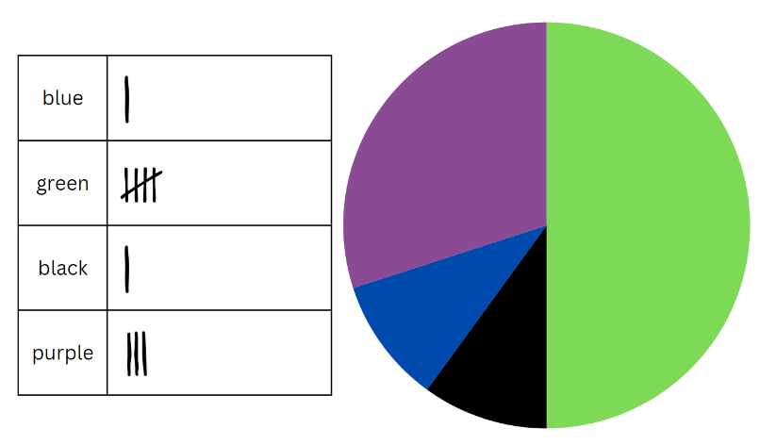

**Note:** spinners do not need to be exact, as drawing a spinner by hand can be difficult.

1. Select students to share their spinner. Ask the following questions:

* Why have you drawn your spinner in that way? (Students are to explain how the proportions resulted from the observed frequency of spins.)
* Could you describe the chance of spinning each colour using a fraction? (The total outcomes of the spinner should add to one, as the total of the probabilities of the outcomes equal one.)

1. Explain that a further 10 spins will be made and added to the existing tally marks. Call out another 10 spins from the mystery spinner.
2. Students use the collected data from the total of 20 spins to draw a new spinner below the first spinner.
3. Once students have drawn the spinner from 20 mystery spins, they label the parts of spinner with both fractions and percentages (see Figure 4). Highlight that the outcomes of the spinner should add to one, as the total of the probabilities of the outcomes equal one.

Figure 4 – labelled spinner

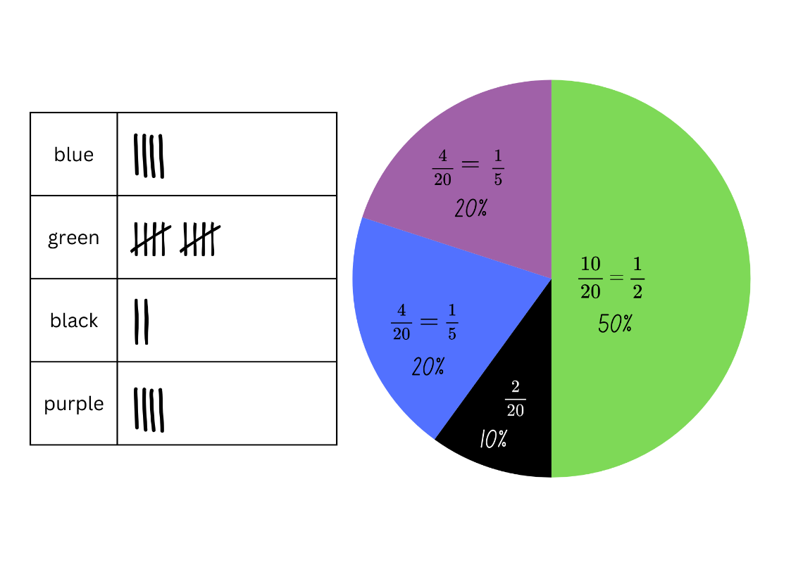

This table details opportunities for differentiation.

|  |  |
| --- | --- |
| Too hard? | Too easy? |
| Students cannot collect data to create a spinner and describe probabilities using fractions and decimals.   * Provide students with a prefilled data set using tally marks for 10 spins, using just 2 colours. Model how to use the data to create the required spinner. Repeat with a data set including 3 colours. * Assist students to create fractions for each part of the spinner. Highlight that there were 20 spins so 20 is the whole. Identify that this is represented by the denominator, while the number recorded with tally marks will be the numerator. Support students to create equivalent fractions as in Figure 4. | Students can collect data to create a spinner and describe probabilities using fractions and decimals.   * Play [Mystery Spinner: Challenge](https://www.abc.net.au/education/mystery-spinner-challenge/13828198) from ABC Education. Students recreate a mystery spinner to try and match the results on the graph. * Students conduct an experiment: Predict how often a bottle-top lid thrown into the air 20 times will land upside down, right-side up or on its side. They record their prediction on a probability scale as a fraction, decimal or percentage. After tossing the lid, they record the observed frequency and compare to initial predictions. |

## Discuss and connect the mathematics – 10 minutes

1. Display the mystery spinner to the class and ask the following questions:

* What fraction of the total is represented by each section of the mystery spinner? How did you calculate this?
* How close was the mystery spinner to your final spinner?
* What was different? What was similar?
* How did your understanding of probability help to create your mystery spinner?
* How many spins would be enough to make a strong prediction? Is 20 enough?
* If this activity was repeated with a different mystery spinner, would your knowledge of probability help you to create a spinner that is closer?
* Could a mystery spinner with 4-quarters result in the collected data? Why or why not?

This table details opportunities for assessment.

|  |  |
| --- | --- |
| Assessment opportunities | Links |
| What to look for:   * Can students collect data through observations?  **[MAO-WM-01, MA3-DATA-01]** * Can students create random generators to follow specified probabilities or proportions? **[MAO-WM-01, MA3-CHAN-01]** * Can students record the outcomes for chance experiments where the outcomes are not equally likely to occur and assign probabilities to the outcomes using fractions?  **[MAO-WM-01, MA3-CHAN-01]** * Can students use knowledge of benchmark fractions, decimals and percentages to assign probabilities to the likelihood of outcomes? **[MAO-WM-01, MA3-CHAN-01]** | Links to [National Numeracy Learning Progressions](https://www.australiancurriculum.edu.au/resources/national-literacy-and-numeracy-learning-progressions/version-3-of-national-literacy-and-numeracy-learning-progressions/) (NNLP):   * IRD3, IRD4, IRD5 * UnC4, InF6, PrT3. |

# Lesson 3

**Core concept**: expected and observed probabilities describe possible outcomes.

## Daily number sense – fractions of chocolates – 10 minutes

The table below contains a suggested learning intention and success criteria. These are best co-constructed with students.

|  |  |
| --- | --- |
| Daily number sense learning intention | Daily number sense success criteria |
| Students are learning to:   * find fractional quantities of whole numbers (halves, quarters, fifths and tenths). | Students can:   * solve word problems involving a fraction of a quantity * find $\frac{1}{2}$, $\frac{1}{4}$, $\frac{1}{5}$ and $\frac{1}{10}$ of collections. |

1. Display Resource 6 – box of chocolates. Students work on a solution, recording their ideas on an individual whiteboard.
2. Discuss the task. Ask the following questions:

* How many caramel chocolates are there?
* How many Turkish delight chocolates are there?
* Does the grid help solve the task? Why or why not?
* Could a bar model or tape diagram help with this task?
* Why was it important to look at the denominator for this task?
* What connections can you see between the denominator and the number of each flavour of chocolate?
* How did you calculate the fraction of peppermint chocolates?

This table details opportunities for assessment.

|  |  |
| --- | --- |
| Assessment opportunities | Links |
| What to look for:   * Can students solve word problems involving a fraction of a quantity? **[MAO-WM-01, MA3-RQF-02]** * Can students find $\frac{1}{2}$, $\frac{1}{4}$, $\frac{1}{5}$ and $\frac{1}{10}$ of collections?  **[MAO-WM-01, MA3-RQF-02]** | Links to [National Numeracy Learning Progressions](https://www.australiancurriculum.edu.au/resources/national-literacy-and-numeracy-learning-progressions/version-3-of-national-literacy-and-numeracy-learning-progressions/) (NNLP):   * InF8. |

## Core lesson – Scissors, Paper, Rock – 40 minutes

The table below contains suggested learning intentions and success criteria. These are best co-constructed with students.

|  |  |
| --- | --- |
| **Core concept learning intentions** | **Core concept success criteria** |
| Students are learning to:   * compare observed frequencies of outcomes with expected results * conduct chance experiments with both small and large numbers of trials. | Students can:   * distinguish between and compare the frequency of an outcome and the probability of an outcome in a chance experiment * explain why observed frequencies of outcomes in chance experiments may differ from expected frequencies, and how this relates to randomness * determine and discuss the differences between the expected probabilities and the observed probabilities after both small and large numbers of trials. |

**Note:** Scissors, Paper, Rock is a learning sequence completed over Lesson 3 and Lesson 4 of this unit. Students investigate expected and observed outcomes and explore the effect of randomness on chance experiments. Chance B has a high vocabulary demand on students (see the word list in [Teaching advice for Chance B](https://curriculum.nsw.edu.au/learning-areas/mathematics/mathematics-k-10-2022/content/stage-3/fa6dbbaafc?show=advice)). The activities provide support for students to engage with and use content-specific vocabulary.

1. Display Resource 7 – SPR instructions and explain the rules of Scissors, Paper, Rock (SPR).
2. Introduce a class tournament by viewing a game of SPR online. Alternatively, 2 students can model some introductory games to establish or refresh the rules before all students play.
3. Ask: Do you think winning Scissors, Paper, Rock is based on chance? Why or why not? Students [turn and talk](https://education.nsw.gov.au/teaching-and-learning/curriculum/literacy-and-numeracy/teaching-and-learning-resources/numeracy/talk-moves) to discuss.
4. Provide some information about SPR: the game originated in China and has been played for over 2000 years, making it one of the oldest games in the world. Many people think it has remained popular because it is based on chance, which makes it a fair method of choosing between 2 people.
5. Draw a probability scale on the board. Select students to estimate the probability of winning and explain their thinking.
6. Ask how mathematicians might work out whether winning SPR is based on chance. If not elicited by students, discuss the following:

* predicting the likelihood of a win, loss or draw by listing and comparing all possible SPR outcomes
* communicating the likelihood of winning a game of SPR on a probability scale
* comparing predictions about how often people win, lose and draw SPR to the frequency of these outcomes in real life games.

1. Display Resource 8 – game outcomes and explain how the table lists all possible outcomes of the game. Provide students with thinking time to review the table. Ask the following questions:

* What is the total number of possible outcomes for the game?
* How many possible ways does each player win, lose or draw the game?

1. Revise the term ‘expected frequency’ as the number of times a particular outcome, in this case winning or losing, is predicted to happen in a chance experiment.
2. Using Resource 8 – game outcomes, students identify:

* the expected frequency of winning, losing and drawing SPR
* the expected probability, for example, winning a game 3 out of 9 times can be represented as having a probability of 33% or $\frac{1}{3}$.

1. Provide students with Resource 9 – recording sheet 1. Students enter the expected frequency and probability values into Table 3. Ask the following questions:

* Is one outcome more likely than the others?
* Does this change your thinking about whether SPR is a game of chance or skill? Explain your thinking.
* Is there a 50/50 chance of winning if losing, winning and drawing are all equally likely outcomes? Why or why not? (Where there are 3 equally likely outcomes, the chance of one of them occurring is one-third rather than one-half or 50/50.)

1. Explain that students will carry out a probability experiment. Each game of SPR played during the experiment is called a trial.
2. In groups of 3, students run 21 trials of SPR. Two students in each group are players and one is the recorder. Using Table 1 on Resource 9 – recording sheet 1, the recorder notes down the number of:

* wins for Player 1 and Player 2
* draws.

1. Students enter the group’s observed frequency for each outcome into Table 3 of Resource 9 – recording sheet 1.
2. Discuss the findings and encourage students to use topic-specific vocabulary, such as outcome, trial, experiment, observed frequency and expected frequency. Ask the following questions:

* What were the outcomes of your experiment?
* Does each outcome appear an equal number of times as predicted by the expected frequency?
* Why might the expected frequency and the observed frequency be the same or different?

1. The recorder from each group calls out their results and the data from the whole class is collated in Table 2 of Resource 9 – recording sheet 1.
2. Model calculating the average of the observed frequency by adding the results in each column and dividing the total by the number of groups.
3. Students record the average observed frequency of class trials in their probability table.

**Note:** Stage 3 students are not expected to calculate the mean of a set of data. This is a Stage 4 syllabus outcome. In this activity, teachers calculate the mean to provide students with the average of a data set produced by their class. It is likely that there will be less variation in the class dataset but not certain. Varying outcomes for observed frequency should be considered when planning the lesson.

1. Students compare the expected frequency of winning 21 games to the observed frequency from the class trials. Explore the variations by using the prompt box below.

The table below outlines stimulus prompts to generate conversation about the topic, along with anticipated responses from students.

|  |  |
| --- | --- |
| Prompts | Anticipated student responses |
| * Is the data from the class or group trials equal to the expected frequency? Why or why not? | * We can’t always predict the exact outcomes of chance events. The outcome of chance events is random. |
| * Why might the data from the class trials be closer to the expected frequency? | * Data has been collected from more trials and the more you have, the more accurate the result of the experiment becomes. It is called the law of large numbers. |
| * Why might the data from the group trials be closer to the expected frequency? | * The outcomes of the trials are random and sometimes a result will appear more often by chance. |
| * How do the observed frequencies of winning compare to your original guess? | * They were close, the evidence supports my prediction. * They didn’t really reflect my hunch; I wonder what would happen if we did more trials. * They weren’t the same, I think it depends on who is playing. |

This table details opportunities for differentiation.

|  |  |
| --- | --- |
| Too hard? | Too easy? |
| Students cannot distinguish between the frequency of an outcome and the probability of an outcome in a chance experiment.   * Support students to revise and compare the definition of frequency (the number of times an outcome occurs in an experiment) and probability (the chance that an outcome will occur in an experiment ordered on a scale from 0 to 1). * Students distinguish between frequency and probability in a simpler chance experiment with fewer variables such as tossing a coin. | Students can distinguish between the frequency of an outcome and the probability of an outcome in a chance experiment.   * Students investigate other ways of representing and calculating probability in this experiment such as tree diagrams. * Students compare the probabilities from 2 experiments. Pose the following scenario: In one experiment a coin is dropped 600 times, in another experiment, a coin is dropped 6000 times. Students discuss how they think the probabilities from these 2 experiments will compare and explain their thinking. |

## Discuss and connect the mathematics – 10 minutes

1. Regroup as a class and summarise the lesson together. Draw out key mathematical ideas by asking the following questions:

* What are the different ways you can communicate the likelihood of an event occurring? (For example, commonly used chance words, expected and observed frequency, expected and observed probability.)
* Which of these options do you prefer? Why?
* When would it be important to use mathematics to communicate the probability or frequency of a real-world event? Why?

This table details opportunities for assessment.

|  |  |
| --- | --- |
| Assessment opportunities | Links |
| What to look for:   * Can students distinguish between and compare the frequency of an outcome and the probability of an outcome in a chance experiment? **[MAO-WM-01, MA3-CHAN-01]** * Can students explain why observed frequencies of outcomes in chance experiments may differ from expected frequencies, and how this relates to randomness? **[MAO-WM-01, MA3-CHAN-01]** * Can students determine and discuss the differences between the expected probabilities and the observed probabilities after both small and large numbers of trials? **[MAO-WM-01, MA3-CHAN-01]** | Links to [National Numeracy Learning Progressions](https://www.australiancurriculum.edu.au/resources/national-literacy-and-numeracy-learning-progressions/version-3-of-national-literacy-and-numeracy-learning-progressions/) (NNLP):   * UnC2, UnC3, UnC4, UnC5. |

# Lesson 4

**Core concept**: expected and observed probabilities describe possible outcomes.

## Daily number sense – 10 minutes

1. From a class need surfaced through formative assessment data, identify a short, focused activity that targets students’ knowledge, understanding and skills. Example activities may be drawn from the following resources:

* [Mathematics K–6 resources](https://education.nsw.gov.au/teaching-and-learning/curriculum/mathematics/mathematics-curriculum-resources-k-12/mathematics-k-6-resources)
* [Universal Resources Hub](https://resources.education.nsw.gov.au/home).

## Core lesson – fair and unfair games – 45 minutes

The table below contains a suggested learning intention and success criteria. These are best co-constructed with students.

|  |  |
| --- | --- |
| Core concept learning intention | Core concept success criteria |
| Students are learning to:   * compare observed frequencies of outcomes with expected results * conduct chance experiments with both small and large numbers of trials. | Students can:   * **use the term *frequency* to describe the number of times a particular outcome occurs in a chance experiment** * discuss the fairness of simple games involving chance and the idea of randomness * determine and discuss the differences between the expected probabilities and the observed probabilities after both small and large numbers of trials. |

1. Tell students they will continue to explore probability and chance through Scissors, Paper, Rock. Remind them that many people think SPR has remained popular because it is based on chance and this makes it a fair method of choosing between 2 people.
2. Ask: ‘What do you think makes a game fair?’ If not elicited, explain that a fair game means there is an equal chance of winning or losing.
3. If SPR were a fair game, what would be the probability of winning, losing and drawing?
4. Ask students to look at the data they collected from their experiment in Lesson 3. Ask the following questions:

* Did you observe students winning, losing and drawing an equal number of times in Test 1?
* Does that mean the game is fair? Why or why not?
* What would happen if we repeated the test and increased the number of trials?
* Apart from the number of trials, what else might contribute to an unequal distribution of outcomes in the game?

1. Explain that for all possibilities to have an equal chance of occurring, the choice of hand gesture must be random.
2. Ask students if they sometimes use a strategy to choose their hand gesture, for example, depending on their own or their partner’s choices in the previous round. How might that effect whether the outcomes occur randomly?
3. Students run a second experiment (Test 2) to determine whether random hand gestures produce observed probabilities closer to the expected probability. Explain that the players will close their eyes to ensure their choice of gesture is random and not based on a strategy related to their partner’s choice. Random generators such as dice or spinners could also be used to select the hand gesture.
4. In groups of 3, students complete Test 2 by conducting another 21 trials of SPR, this time with their eyes closed. The recorder should not tell the players who wins each game.
5. Provide students with Resource 10 – recording sheet 2. The recorder notes the outcome of each game in Table 1 of Resource 10 – recording sheet 2.
6. After all the trials are completed, students compare their group’s observed frequency of winning, losing and drawing in Test 2 to the expected frequency. Ask:

* Did playing with closed eyes affect the observed frequency of the game’s outcomes? How?
* Did anyone win more games in Test 1 than in Test 2. What did you do differently?

1. The recorder from each group calls out their results so the whole-class data can be collated in Table 2 of Resource 10 – recording sheet 2.
2. Calculate the average of the observed frequency for each outcome by adding the results in each column and dividing the total by the number of groups. Students record the data.

**Note:** students are not expected to calculate the mean of a set of data until Stage 4. In this activity, teachers calculate the mean to provide students with the average of a dataset produced by their own class.

1. Provide students with a calculator. As a class, work out the observed probability of the class data set.
2. Students calculate the observed probabilities for Test 1 and Test 2 and record them in the table.
3. Focusing on the results from Test 2, students [Think-Pair-Share](https://app.education.nsw.gov.au/digital-learning-selector/LearningActivity/Card/645) to discuss the following questions:

* Which is closer to the expected probability – the observed probability of the combined class trials or your individual group’s trials?
* What might be the reason for this?
* What would happen if we kept increasing the number of trials?

**Note:** it is likely that there will be less variation in the larger class dataset but not certain. Varying outcomes for observed frequency should be considered while planning the lesson.

1. Students compare the data from Test 1 and Test 2 and [Think-Pair-Share](https://app.education.nsw.gov.au/digital-learning-selector/LearningActivity/Card/645) to discuss the following questions:

* Is the class’s observed probability of winning the same in Test 1 and Test 2? What reasons might there be for this?
* Is playing the game with your eyes open or closed more likely to produce a fair game? Why or why not?
* Can you think of other ways to make the game fair?

This table details opportunities for differentiation.

|  |  |
| --- | --- |
| **Too hard?** | **Too easy?** |
| Students cannot discuss the fairness of simple games involving chance and the idea of randomness.   * Clarify the content-specific definition of fairness in probability as a game where there are equal chances of winning and losing. Compare this to the common understanding of everyone being treated equally. * Discuss suggestions for identifying whether a game is fair such as listing the possible events and possible outcomes using informal diagrams. | Students can discuss the fairness of simple games involving chance and the idea of randomness.   * Students investigate other games involving chance, such as throwing dice, and answer the following questions: * Is the game fair? * How do we know it is fair? * What is the probability of winning? * How do we know that this is the probability? |

## Discuss and connect the mathematics – 15 minutes

1. Watch the clip from ABC’s Catalyst program [How to win at rock-paper-scissors (3:08)](https://www.abc.net.au/education/catalyst-how-to-win-at-rock-paper-scissors/13720728). Ask the following questions:

* After exploring the probability of winning SPR, have you changed your mind about whether it is a game of skill or chance?
* Many people say SPR has remained popular over 2000 years because it is a game of chance. Do you agree?
* How can a mathematical understanding of chance help you decide whether a game is fair to all players?

This table details opportunities for assessment.

|  |  |
| --- | --- |
| **Assessment opportunities** | **Links** |
| What to look for:   * **Can students use the term *frequency* to describe the number of times a particular outcome occurs in a chance experiment?  [MAO-WM-01, MA3-CHAN-01]** * Can students discuss the fairness of simple games involving chance and the idea of randomness?  **[MAO-WM-01, MA3-CHAN-01]** * Can students determine and discuss the differences between the expected probabilities and the observed probabilities after both small and large numbers of trials? **[MAO-WM-01, MA3-CHAN-01]** | Links to [National Numeracy Learning Progressions](https://www.australiancurriculum.edu.au/resources/national-literacy-and-numeracy-learning-progressions/version-3-of-national-literacy-and-numeracy-learning-progressions/) (NNLP):   * UnC2, UnC3, UnC5. |

# Lesson 5

**Core concept**: repeated trials identify data variation.

## Daily number sense – determining percentages – 10 minutes

Daily number sense activities for Lessons 5 to 7 ‘loop’ back to concepts and procedures covered in previous units to assist students to build an increasingly connected network of ideas. These concepts may differ from the core concepts being covered by the unit.

The table below contains a suggested learning intention and success criteria. These are best co-constructed with students.

|  |  |
| --- | --- |
| Daily number sense learning intention | Daily number sense success criteria |
| Students are learning to:   * make connections between benchmark fractions, decimals and percentages * determine percentage discounts of 10%, 25% and 50%. | Students can:   * recall commonly used equivalent percentages, decimals and fractions including $\frac{1}{2}$, $\frac{1}{4}$, and $\frac{3}{4}$* equate 10% to dividing by 10, 25% to finding a quarter by dividing by 4, and 50% to finding half. |

1. Provide small groups with sticky notes, pegs and 1 metre of string.
2. Groups construct a number line from zero to one, showing known decimals and percentages (see Figure 5).

Figure 5 – number line

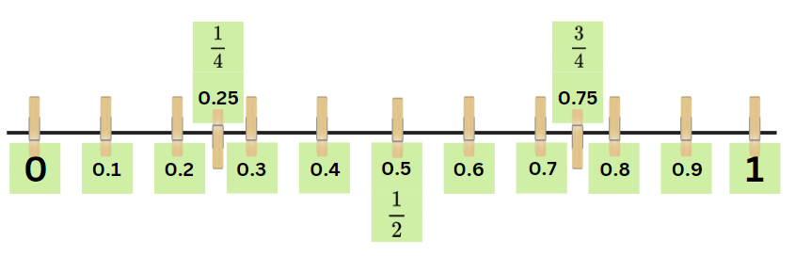

1. Remind students that percentage relies on an understanding of fractions and decimals.

**Note:** a percentage is a fraction out of 100 and can be expressed as a decimal with hundredths. Students can make connections easily when both fractions and decimals are illustrated as hundredths, for example, $\frac{75}{100 }$ equals 0.75, which is equivalent to 75%. When 0.75 is read as 75 hundredths, students can more easily connect it with $\frac{75}{100}$. At this level, it is appropriate to focus on known benchmarks such as 50%, 25% and 10%. The link between hundredths and percent can be made using a hundredths diagram (Siemon et al. 2022).

1. Write 10%, 25% and 50% on the board. Highlight the connection to known decimals and fractions, for example 10% = $\frac{10}{100}$ = $\frac{1}{10}$, 50% = $\frac{50}{100}$ = $\frac{1}{2}$, 25% = $\frac{25}{100}$ = $\frac{1}{4}$.
2. Revisit how our base-10 number system makes it easy to find 10% of a quantity. For example, 10% of 150 is 15, because 150 is 10 lots of 15. Therefore, 20% of 150 is 2 lots of 15, 30% is 3 lots of 15 and so on.
3. Explain that 10% is equivalent to dividing the total amount by 10, 25% is dividing by 4, 50% is dividing by 2 and 75% is dividing by 4 to determine 25% and then multiplying by 3.
4. Students represent these percentages on their number line using a different coloured sticky note (see Figure 6).

Figure 6 – number line with percentages

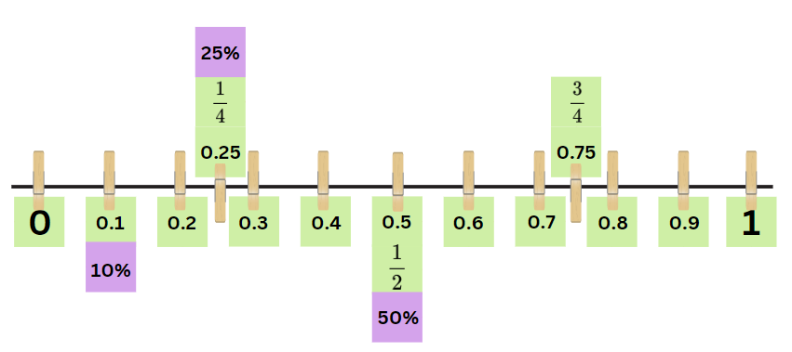

1. Groups share and discuss their number lines.

This table details opportunities for assessment.

|  |  |
| --- | --- |
| Assessment opportunities | Links |
| What to look for:   * Can students recall commonly used equivalent percentages, decimals and fractions including $\frac{1}{2}$, $\frac{1}{4}$ and $\frac{3}{4}$?  **[MAO-WM-01, MA3-RN-02, MA3-RN-03]** * Can students equate 10% to dividing by 10, 25% to finding a quarter by dividing by 4, and 50% to finding half?  **[MAO-WM-01, MA3-RN-02, MA3-RN-03]** | Links to [National Numeracy Learning Progressions](https://www.australiancurriculum.edu.au/resources/national-literacy-and-numeracy-learning-progressions/version-3-of-national-literacy-and-numeracy-learning-progressions/) (NNLP):   * PrT1, PrT2, UnM8. |

## Core lesson – mystery bag – 45 minutes

The table below contains suggested learning intentions and success criteria. These are best co-constructed with students.

|  |  |
| --- | --- |
| Core concept learning intentions | Core concept success criteria |
| Students are learning to:   * choose and use appropriate tables and graphs * conduct chance experiments with both small and large numbers of trials. | Students can:   * tabulate collected data with and without the use of digital technologies such as spreadsheets * determine the likely make up of a large collection of objects, by sampling objects and returning them to the collection before the next sample. |

**Note:** the purpose of this lesson is for students to use various trial sizes to find the composition of an unknown collection, recognising that larger trials enhance accurate predictions. This lesson revisits content introduced in Lesson 8 of [Unit 28](https://education.nsw.gov.au/teaching-and-learning/curriculum/mathematics/planning-programming-and-assessing-mathematics-k-6/mathematics-3-6-units#tabs_727018652_copy__41337541:~:text=Unit%2028%20%E2%80%93%20Visual%20representations%20help%20understand%20aspects%20of%20our%20world%20(chance%20and%20position)).

Paper bags should be prepared prior to the lesson. Each bag contains 10 strips of paper. Each strip has the name of one of 4 different student names written on it so some names will be repeated (for example, 4 × Harry, 3 × Miriam, 2 × Jia, 1 × Kevin). All bags have the same contents. Keep one bag as the teaching example bag.

1. Display the example paper bag and tell the students that it contains 10 slips of paper. On each slip is a name of a student in the class. A student’s name may be in the bag more than once. Keep the names and the proportions of names unknown to the students.
2. Explain that students will be trying to determine which names are in the bag by running different numbers of trials. Ask the following questions:

* How might you determine which names and how many of each name might be in the bag? Why do you think that?
* If you know that there are 10 names in the bag, what number of draws or trials could you start with to make a reasonable prediction? Why do you think that?

1. Provide groups of 4 or 5 students with Resource 11 – bag recording sheet and a paper bag. Ensure it has the same names and proportions as the displayed paper bag.
2. Each group removes one name out of the paper bag (without looking inside it). They record it on the first fraction strip on Resource 11 – bag recording sheet.
3. They return the name to the bag and remove a second name (without looking inside). They record their selection, then repeat the process for a total of 10 times.
4. Each group transfers their data from the fraction strip into the table on Resource 11 – bag recording sheet. This records the frequency that each different name was removed from the bag.
5. Remind students that frequency means how often a particular outcome occurs. Some groups might randomly select strips of paper that show examples of multiple different names, while other groups random selections might show a smaller range of names.
6. Using the observed frequencies from the 10 trials, students predict the names and number of names in each bag. Ask the following questions:

* Are 10 trials enough to make an accurate prediction? How could we make a more accurate prediction?
* How many trials do you think you need to make an accurate prediction? Why do you think this?

1. Students repeat the process of removing names to complete their remaining fraction strips on Resource 11 – bag recording sheet. They complete the tally chart on Resource 11 – bag recording sheet to keep track of the observed frequency of each name as it is removed.
2. Ask students to now make predictions of the contents of the bag. They justify the reasons for their predictions to a partner.
3. Explain that students will now combine each group’s data. Record the combined data in a table on the board using Resource 12 – class recording sheet.
4. Using this combined data, students make predictions about the variety of different names in the bag and how many of each name there might be. They discuss with a partner if and why their predictions have changed.
5. Reveal the contents of the bag to the students. Discuss the following questions:

* Were your predictions correct? Why or why not?
* Is it always better to conduct large numbers of trials in a chance experiment? Why or why not?
* Can you think of occasions in everyday life where people make probability predictions based on gathering data from sampling? (For example, polls at election time or shopping recommendations using social media browsing.)
* What other real-world scenarios can you think of where sampling replacement can be used? (For example, tagging wildlife for environmental research.)
* Why do you think sampling with replacement would be used in these situations?

This table details opportunities for differentiation.

|  |  |
| --- | --- |
| Too hard? | Too easy? |
| Students cannot determine the likely make up of a large collection of objects, by sampling objects and returning them to the collection before the next sample.   * Reduce the number of variables for the students. For example, adjust the number of student names used and number of names in the bag. * Review how sampling provides a clue to the likelihood of the total number of names in the bag. | Students can determine the likely make up of a large collection of objects, by sampling objects and returning them to the collection before the next sample.   * Students design and test a small, medium and large number of trials that would be appropriate using a bag containing 8, 15 or 20 names. * Students represent the number of names recorded as fractions from each trial. They compare this to the actual amount in the bag and reflect on the trial that provided the greatest accuracy. |

## Consolidation and meaningful practice – 15 minutes

**Note:** the Stage 3 [Teaching advice for Chance B](https://curriculum.nsw.edu.au/learning-areas/mathematics/mathematics-k-10-2022/content/stage-3/fa6dbbaafc?show=advice#:~:text=Teaching%20advice%20for%20Chance%20B) states that Monte Carlo methods or Monte Carlo experiments are the names given to using repeated random sampling to approximate the theoretical probability. These chance experiments are useful in situations where we are uncertain about or cannot calculate the theoretical probabilities. For example, using collected data to approximate the likelihood of each landing position when tossing a paper cup (NESA 2022).

1. Explain to students that scientists use sampling with replacement (Monte Carlo methods) to determine the number of different species of fish that live in the Great Barrier Reef. According to the Australian Institute of Marine Science (n.d.), the core survey reef sample comprises of 2 components:

* Manta tow surveys, which collect information in a standard reef slope habitat around the perimeter of each reef. A snorkel diver is towed behind a small boat to make direct observation on the condition of corals. The survey boat stops every couple of minutes and the snorkel diver reports back to the recorder on the boat about coral cover and other important information about the reef.
* Fixed site surveys, in which reef fish, animals and plants on the reef surface are surveyed at three sites, in a habitat that is the same across reefs.

1. Display Resource 13 – reef fish samples. Discuss that the resource shows 4 samples of different species of fish collected from one of the reefs in the Southern Great Barrier Reef in January. Each sample included 25 fish and were taken from the same reef.
2. The first sample taken consisted of 10 clownfish, 6 parrotfish, 4 pufferfish, 3 surgeonfish and 2 lionfish. The fish were counted and immediately returned to the reef. Explain that this process was repeated another 3 times as shown in Resource 13 – reef fish samples.
3. Use the following prompt box to facilitate a discussion around the collected samples and the Monte Carlo method.

The table below outlines stimulus prompts to generate conversation about the topic, along with anticipated responses from students.

|  |  |
| --- | --- |
| Prompts | Anticipated student responses |
| * If another 4 samples of 25 fish were collected in the same area in another 2 weeks’ time, what similarities do you think there could be? | * I think there will be more clownfish than any other fish because each sample had the highest number of them. * There would be a similar amount of parrotfish because there was a consistent amount collected from each sample (6, 8, 6, 8). * There could be low numbers of pufferfish. The first sample contained 4 and the last sample only contained one. |
| * If a sample of another 25 fish were collected from a different reef, at a different time, do you think there would be similarities to the sample previously collected? What could make this sample varied? | * I think the results would be the same because the numbers and species were consistent in all 4 samples already taken. * I think they would be different. The sample could vary depending on the location of the reef, for example if it were taken from a reef located in the northern part. * The climate could make a difference to the number of species of fish being found and therefore the number that is counted. |
| * A total of 100 fish were collected over these 4 samples, what is the overall percentage of: * clownfish * parrotfish * surgeonfish * lionfish * pufferfish. | * Clownfish accounted for 40% of the sample. * Parrotfish accounted for 28% of the sample. * Surgeonfish accounted for 12% of the sample. * There were equal amounts of pufferfish and lionfish found. They each accounted for 10% of the sample. |
| * Is collecting 25 fish from each sample enough to make an accurate prediction? How can we make a more accurate prediction? | * No. It could be the same fish that were being selected because they were released back into the reef immediately after being counted. * No. I think there needs to be more samples collected as the Great Barrier Reef is quite large and has many different reefs in different areas. * I think more consecutive samples need to be collected. |
| * What sample size do you think needs to be collected to make an accurate prediction? | * Instead of a total of 100 fish collected, it could be double the number of fish in each sample and double the number of samples. * I think larger samples over a longer amount of time would be more accurate. * The Great Barrier Reef is already collecting data in 2 different ways to assist them to get a more accurate prediction. These are the manta tow surveys and the fixed reef surveys. |

This table details opportunities for assessment.

|  |  |
| --- | --- |
| Assessment opportunities | Links |
| What to look for:   * Can students tabulate collected data with and without the use of digital technologies such as spreadsheets?  **[MAO-WM-01, MA3-DATA-01]** * Can students determine the likely make up of a large collection of objects, by sampling objects and returning them to the collection before the next sample? **[MAO-WM-01, MA3-CHAN-01]** | Links to [National Numeracy Learning Progressions](https://www.australiancurriculum.edu.au/resources/national-literacy-and-numeracy-learning-progressions/version-3-of-national-literacy-and-numeracy-learning-progressions/) (NNLP):   * IRD3, IRD4, IRD5 * UnC2, UnC3, UnC5. |

# Lesson 6

**Core concept**: mathematicians critically interpret and evaluate real-world data.

## Daily number sense – estimate discounts – 10 minutes

The table below contains a suggested learning intention and success criteria. These are best co-constructed with students.

|  |  |
| --- | --- |
| Daily number sense learning intention | Daily number sense success criteria |
| Students are learning to:   * determine percentage discounts of 10%, 25% and 50%. | Students can:   * use mental strategies to estimate discounts of 10%, 25% and 50%. |

1. Display Resource 14 – clothes shop. Explain that students will use mental strategies to calculate the discount for each piece of clothing.
2. Students choose an item and calculate a percentage discount amount of either 10%, 25% or 50%. All items must have a discount applied to them. All 3 discount percentages should be calculated at least once during the task.

**Note:** in this task, students are only required to calculate the discount amount, not the price of the item after the discount has been applied.

1. Students [turn and talk](https://education.nsw.gov.au/teaching-and-learning/curriculum/literacy-and-numeracy/teaching-and-learning-resources/numeracy/talk-moves), discussing their strategies and solutions.
2. Select students to share and explain their strategies and answers, recording their responses on the board. When all items of clothing are discussed, reveal the discounts. For example, 10% of the jumper is $8, 25% is $20 and 50% is $40.

**Note:** some students may need a 100 grid to help calculate the discount.

This table details opportunities for assessment.

|  |  |
| --- | --- |
| Assessment opportunities | Links |
| What to look for:   * Can students use mental strategies to estimate discounts of 10%, 25% and 50%? **[MAO-WM-01, MA3-RN-03]** | Links to [National Numeracy Learning Progressions](https://www.australiancurriculum.edu.au/resources/national-literacy-and-numeracy-learning-progressions/version-3-of-national-literacy-and-numeracy-learning-progressions/) (NNLP):   * PrT1, PrT2, UnM8. |

## Core lesson 1 – data in the media – 15 minutes

The table below contains a suggested learning intention and success criteria. These are best co-constructed with students.

|  |  |
| --- | --- |
| Core concept learning intention | Core concept success criteria |
| Students are learning to:   * interpret data presented in digital media and elsewhere. | Students can:   * interpret data representations found in digital media and in factual texts * identify sources of possible bias in representations of data in the media * identify misleading representations of data in the media. |

**Note:** for each lesson on data, students can enhance their understanding by using consistent definitions such as those on Resource 15 – data types.

1. Discuss how data representations in the media can often be biased and sometimes misleading.

**Bias**: systematic favouring of certain outcomes more than others, due to unfair influence (knowingly or otherwise).

1. Highlight that there are various influences on data collection and representation, such as who created or paid for the data collection, and whether the representation is part of an advertisement.
2. Discuss elements of effective and misleading data representations in the media. Students record this in their workbook using a [T-chart](https://app.education.nsw.gov.au/digital-learning-selector/LearningActivity/Card/599). See Table 1 for possible responses.

Table 1 – data representations in the media

|  |  |
| --- | --- |
| Effective data representations in the media | Misleading data representations in the media |
| * accurately represent the whole data set * grab the reader’s attention * show trends or changes * are easy to read and understand * have a title and labels * uses colour or patterns to show differences. | * use incorrect displays for the data type * manipulate the axes or scale * use uneven intervals on the axes * leave out relevant data * have missing units or axes labels * exaggerate or minimise differences between numerical values. |

1. Explain that students will be examining 2 displays of climate data and looking for the elements of effective and/or misleading representation.
2. Provide the context that a one-degree global change in temperature is significant because it takes a vast amount of heat to warm all the earth’s oceans, atmosphere and land by that much. The last Ice Age was associated with a 2- to 4-degree drop in temperature so small changes can be important.
3. Display Resource 16 – average global temperatures. Students use the class T-chart to assess each graph. Ask the following questions:

* What do you notice first about the graph labelled ‘Average global temperature A’?
* What do you notice first about the graph labelled ‘Average global temperature B’?
* What numbers do you see?
* Describe the shape of the graphs using words and numbers.
* How does the scale of the vertical axis change how you think about the data? (Graph B highlights small changes in temperature by starting at 13° and having a smaller range of intervals.)
* What information seems to be most important in Graph A? What information seems most important in Graph B?
* What is each graph trying to tell you?
* Could either graph be misleading? Why or why not? Explain.
* What do you wonder about
* Who made each graph?
* Why was each graph made?

## Core lesson 2 – misleading graphs – 25 minutes

1. Provide one graph from Resource 17 – misleading graphs to pairs, ensuring a mix of all graphs across the class.
2. Explain that students need to:

* identify whether the data in the graph is poorly displayed and/or misleading
* if misleading, discuss how and why
* recreate the graph in their workbook, so it is an efficient and true representation of the data.

1. Select students to share both their misleading graph and recreated efficient graph. They explain the elements they changed and why.
2. Prompt the class to ask the following clarifying questions:

* What did you identify as poorly displayed and/or misleading in the graph?
* What did you change so the graph was a true representation?
* Would you use a different type of graph to represent the same data?

This table details opportunities for differentiation.

|  |  |
| --- | --- |
| Too hard? | Too easy? |
| Students cannot identify sources of possible bias and misleading representation of data in the media.   * Support students to identify which elements of the graph are misleading and explain why. * Provide simplified data representations with only one misleading element for students to identify and fix. | Students can identify sources of possible bias and misleading representation of data in the media.   * Challenge students to examine current media and advertising material for real-life examples of misleading data and possible source of bias. * Students create and conduct a survey from peers in the class that will provide biased data. |

## Discuss and connect the mathematics – 10 minutes

1. Regroup and summarise the lesson together, drawing out key mathematical ideas. Ask the following questions:

* What are some positive uses of data representations in the media and factual texts?
* What are some negative uses of data representations in the media and factual texts?
* What are some of the common problems with the way data is represented in the media?
* Why are some data representations misleading?
* How do you identify potentially misleading representations?
* What are some possible consequences of misleading representations?
* Will you look at data representations in the media and factual texts differently now? Why or why not?

This table details opportunities for assessment.

|  |  |
| --- | --- |
| Assessment opportunities | Links |
| What to look for:   * Can students interpret data representations found in digital media and in factual texts? **[MAO-WM-01, MA3-DATA-02]** * Can students identify sources of possible bias in representations of data in the media? **[MAO-WM-01, MA3-DATA-02]** * Can students identify misleading representations of data in the media? **[MAO-WM-01, MA3-DATA-02]** | Links to [National Numeracy Learning Progressions](https://www.australiancurriculum.edu.au/resources/national-literacy-and-numeracy-learning-progressions/version-3-of-national-literacy-and-numeracy-learning-progressions/) (NNLP):   * IRD4, IRD5, IRD6. |

# Lesson 7

**Core concept**: data is used in everyday contexts and influences daily practices.

## Daily number sense – sales price – 10 minutes

The table below contains a suggested learning intention and success criteria. These are best co-constructed with students.

|  |  |
| --- | --- |
| Daily number sense learning intention | Daily number sense success criteria |
| Students are learning to:   * determine percentage discounts of 10%, 25% and 50%. | Students can:   * calculate the sale price of an item after a discount of 10%, 25% and 50%. |

1. Revise student understanding of calculating discounts. For example, that 10% is dividing by 10, 25% is dividing by 4 and 50% is dividing by 2.
2. Display Resource 18 – sale items. Explain that students will calculate the sale price after the discount that is in the red sale sticker has been applied. For example, the headphones are $90 and have a discount of 50%, so the sale price would be $45.
3. Students record the sale price after the discount for each item in their workbook.
4. Once students have completed recording the sale price, select students to share and explain their working.

This table details opportunities for assessment.

|  |  |
| --- | --- |
| Assessment opportunities | Links |
| What to look for:   * Can students calculate the sale price of an item after a discount of 10%, 25% and 50%? **[MAO-WM-01, MA3-RN-03]** | Links to [National Numeracy Learning Progressions](https://www.australiancurriculum.edu.au/resources/national-literacy-and-numeracy-learning-progressions/version-3-of-national-literacy-and-numeracy-learning-progressions/) (NNLP):   * PrT1, PrT2, UnM8. |

## Core lesson – Great Barrier Reef data – 35 minutes

The table below contains suggested learning intentions and success criteria. These are best co-constructed with students.

|  |  |
| --- | --- |
| Core concept learning intentions | Core concept success criteria |
| Students are learning to:   * interpret and compare a range of data displays * interpret data presented in digital media and elsewhere. | Students can:   * interpret side-by-side column graphs for 2 categorical variables * interpret data representations found in digital media and in factual texts. |

1. Explain that data displays are visual representations of information, such as graphs or tables. They help readers understand and interpret data.

**Note:** the Stage 3 [Teaching advice for Data B](https://curriculum.nsw.edu.au/learning-areas/mathematics/mathematics-k-10-2022/content/stage-3/fa0c228e92?show=advice&ta_scroll=no#:~:text=Teaching%20advice%20for%20Data%20B) states the types of data that could be selected for interpretation include census data, environmental audits of resources such as water and energy, and sports statistics (NESA 2022).

1. Discuss that according to the Great Barrier Reef Foundation (2024), coral bleaching describes a natural process where corals lose their vibrant colours and turn white. This happens when corals are under stress due to an environmental disturbance. Coral bleaching is usually triggered by heat stress caused by increased water temperatures and ultraviolet (UV) radiation. It can occur due to other factors such as changes in water quality.
2. Display Resource 19 – alternative holiday destinations. Tell students they will be interpreting side-by-side column graphs with 2 categorical (different) variables.
3. Explain that this graph shows the percentage of tourists from various countries who would consider alternative holiday destinations (either within Australia or abroad) if coral bleaching continues to destroy the Great Barrier Reef. Ask the following questions:

* What do you notice about the data?
* Which country has the most people who will choose to travel to different destinations within Australia? Which country had the least?
* Which country had the most people who will choose to travel to other countries if coral bleaching continued to occur in the Great Barrier Reef? Which country had the least?
* What is the percentage difference between the people in each country wanting to visit other destinations within Australia compared to travelling to other countries?
* Is there anything that surprised you about this data?
* Who might find this data useful? Why?
* How else could this data be represented?
* Why do you think coral bleaching contributes to tourists deciding not to visit the Great Barrier Reef?
* Why do you think China has the largest number of tourists who will choose to visit other destinations within Australia instead of travelling to another country?
* Why would you use a side-by-side column graph to display this data?
* Is there a better way to display this data?

1. Display Resource 20 – reef visitors. Place students in groups of 3 or 4 and provide an A3 copy of Resource 21 – visitors data sheet. Explain that they will be completing the sheet, providing as much detail as possible.
2. Once completed, students [turn and talk](https://education.nsw.gov.au/teaching-and-learning/curriculum/literacy-and-numeracy/teaching-and-learning-resources/numeracy/talk-moves) with another group to discuss the similarities and differences between their answers.
3. Regroup and discuss answers to each question on students' data sheet. Ask the following questions:

* Were there any similarities or differences about the answers collected in your groups?
* Does the data support different interpretations?
* Can you see any patterns or trends?
* Do you think using a side-by-side column graph would be the most effective way to represent this data?
* Who might collect this data about tourists visiting the Great Barrier Reef?
* What might this data be used for?

This table details opportunities for differentiation.

|  |  |
| --- | --- |
| Too hard? | Too easy? |
| Students cannot interpret side-by-side column graphs for 2 categorical variables.   * Ask questions related to only one variable in each graph. * Support students to focus on one column before comparing domestic and international visitors. | Students can interpret side-by-side column graphs for 2 categorical variables.   * Students brainstorm examples of their own questions to ask about the Great Barrier Reef data. * Students create their own data about a topic of interest. They represent this in a side-by-side column graph. |

## Consolidation and meaningful practice – 15 minutes

1. Display Resource 22 – barrier reef weather. Ask the following questions:

* What do you notice about this data?
* When would be the most favourable time to visit the Great Barrier Reef? Why?
* When would be the least favourable time to visit the Great Barrier Reef? Why?
* What is the difference in days of rainfall between January and July? (13 days).
* Why do you think there is more rainfall in January and December?
* Do you think this data would impact tourism to the area? Why or why not?
* Do you have any wonderings about the data?
* How else could this data have been represented?
* Who would find this data useful and why?

This table details opportunities for assessment.

|  |  |
| --- | --- |
| Assessment opportunities | Links |
| What to look for:   * Can students interpret side-by-side column graphs for 2 categorical variables? **[MAO-WM-01, MA3-DATA-02]** * Can students interpret data representations found in digital media and in factual texts? **[MAO-WM-01, MA3-DATA-02]** | Links to [National Numeracy Learning Progressions](https://www.australiancurriculum.edu.au/resources/national-literacy-and-numeracy-learning-progressions/version-3-of-national-literacy-and-numeracy-learning-progressions/) (NNLP):   * IRD4, IRD5. |

# Lesson 8

**Core concept**: statistical reasoning helps mathematicians interpret and make inferences about real-world data.

## Daily number sense – 10 minutes

1. From a class need surfaced through formative assessment data, identify a short, focused activity that targets students’ knowledge, understanding and skills. Example activities may be drawn from the following resources:

* [Mathematics K–6 resources](https://education.nsw.gov.au/teaching-and-learning/curriculum/mathematics/mathematics-curriculum-resources-k-12/mathematics-k-6-resources)
* [Universal Resources Hub](https://resources.education.nsw.gov.au/home).

## Core lesson – comparing and interpreting data – 35 minutes

The table below contains suggested learning intentions and success criteria. These are best co-constructed with students.

|  |  |
| --- | --- |
| Core concept learning intentions | Core concept success criteria |
| Students are learning to:   * interpret and compare a range of data displays * interpret data presented in digital media and elsewhere. | Students can:   * interpret and compare different displays in terms of the shape of the distribution, including the range and the most frequent value (mode) * interpret data representations found in digital media and in factual texts. |

1. Explain that the spread of data can be shown on a graph or in a table. The analysis of this data is sometimes called statistics. In statistics:

* the spread of data is called the distribution
* the range of the data refers to how far it is spread out between the highest and the lowest data points
* the mode relates to the most frequently occurring data point.

1. Display Resource 23 – coral bleaching data. Explain that the data display shows the coral bleaching of both the northern and southern sections of the Great Barrier Reef.
2. Revisit the coral bleaching description from Lesson 7. Students [turn and talk](https://education.nsw.gov.au/teaching-and-learning/curriculum/literacy-and-numeracy/teaching-and-learning-resources/numeracy/talk-moves) to discuss what they notice about the data display.
3. Regroup and ask the following questions:

* What is the data telling us?
* What type of graph is this?
* What is the range of this data set?
* What is the mode of this data set?
* Do you think this graph would be the best way to represent this data? Why or why not?
* Based on this data, what do you think may happen to the coral in the Great Barrier Reef in the next 10 years?
* Do you have any other wonderings about this data?
* Who might find this data useful?

1. Display Resource 24 – comparing graphs. Ask:

* Which data representation is easiest to interpret? Why?
* Which data representation provides the most information? Explain why.

1. Watch [How Scientists are Restoring the Great Barrier Reef | Travel + Leisure (7:32)](https://www.youtube.com/watch?v=8hknaJQRh8s) (1:22–4:22) about the restoration of coral on the Great Barrier Reef. Ask:

* What are scientists doing to help maintain coral in the Great Barrier Reef?
* Does the information from the video support the data in the graphs about coral bleaching we saw? Why or why not?
* Does the information in the video change your opinion about what could happen to the coral in the Great Barrier Reef in the next 10 years? Why or why not?
* How could the data about reef revitalisation from the video be collected and displayed?

1. Display Resource 25 – rising sea temperatures A. Remind students of the context of small rises in temperature provided in Lesson 6. Explain that a one-degree global change in sea temperature is significant, as it will increase sea levels, and impact ecological systems and biodiversity.
2. Small groups use an A3 copy of Resource 26 – data information sheet to answer the questions, providing as much detail as possible.
3. Regroup and select students to present their findings. Ask the following questions:

* What is the range of the data?
* What is the mode of the data?
* What overall conclusions can be made about rising temperatures in the Great Barrier Reef based on this data?
* Do you have any other wonderings about the data?
* Was this graph an effective way to display the data? Why or why not?
* How else could this data be represented?

This table details opportunities for differentiation.

|  |  |
| --- | --- |
| Too hard? | Too easy? |
| Students cannot interpret and compare data representations found in digital media and in factual texts.   * Provide students with a simpler graph, Resource 27 – rising sea temperatures B. Support them to describe the data points and the scale used. * Support students to interpret the data in Resource 27 – rising sea temperatures B. | Students can interpret and compare data representations found in digital media and in factual texts.   * Challenge students to predict the sea water temperature over the next 10 years. They continue the line graph and give reasons for their predictions. * Students write 3 questions about Resource 25 – rising sea temperatures A. They swap questions with a partner, discussing their responses and comparing their reasoning. |

## Consolidation and meaningful practice – 15 minutes

1. Display Resource 28 – reefs at risk. Explain to students that this graph displays the level of risks to reefs around the world. The threats referred to as risks in this data include marine pollution and damage, overfishing, coastal development and the rise in sea temperatures.
2. Use the prompt box below to facilitate a discussion.

The table below outlines stimulus prompts to generate conversation about the topic, along with anticipated responses from students.

|  |  |
| --- | --- |
| Prompts | Anticipated student responses |
| * Which areas are the most threatened? | * Southeast Asia and the Atlantic. |
| * Which areas are the least threatened? | * Australia is by far the least threatened. |
| * What is the range of this data set? | * The data is described in the range from low to very high. |
| * What is the range of the percentage of coral under very high threat? | * From 5% to 20%. |
| * How do you think this international data was collected and collated? | * A team of researchers who travel to various destinations, collecting data on this throughout the world. * Use of satellite images. * Research conducted by individual research teams and then collated. |
| * The threats included in this data were marine pollution and damage, overfishing, coastal development and rise in sea temperatures. What other threats do you think could contribute to the decline of international reefs? | * Cyclones, storms, floods, hurricanes and other weather events. * Tourism. Too many visitors could cause water pollution. * Sediment and nutrient pollution from sewerage. * Crown-of-thorns starfish and other damaging marine life. |
| * Does the information from the previous video match the data in the graph about coral bleaching? Why or why not? | * Yes. The graph we just looked at stated that there has been a decline in coral reefs not only in Australia, but around the world. This correlates to the information presented in the video. * No. The data we looked at in the graph did not mention cyclones or weather events contributing to coral bleaching as it did in the video. |
| * Do you think there could be another way this data could be represented? Why or why not? | * Yes. I think there could be other data displays that could show this data more effectively. The percentages aren’t clear enough and it is hard to work out the exact amount. * No. The column graph is colour coded for each level of threat and can be easily understood. Having the columns next to each other like that shows a comparison of each area and how much of a threat they are at each level. |

This table details opportunities for assessment.

|  |  |
| --- | --- |
| Assessment opportunities | Links |
| What to look for:   * Can students interpret and compare different displays in terms of the shape of the distribution, including the range and the most frequent value (mode)? **[MAO-WM-01, MA3-DATA-02]** * Can students interpret data representations found in digital media and in factual texts? **[MAO-WM-01, MA3-DATA-02]** | Links to [National Numeracy Learning Progressions](https://www.australiancurriculum.edu.au/resources/national-literacy-and-numeracy-learning-progressions/version-3-of-national-literacy-and-numeracy-learning-progressions/) (NNLP):   * IRD4, IRD5. |

# Resource 1 – farmer’s market cards

Cards with images of fruit and vegetables with a number above. The images are as follows:
6 carrots.
12 broccoli.
20 lemons.
24 strawberries.
30 cauliflower.
36 cobs of corn.
40 grapes.
48 tomatoes.
54 oranges.
60 pears.

# Resource 2 – room maze

Room maze resource. There are 3 spinners. Fork 1 spinner – a circle with 75% shaded red and 25% shaded blue. The arrow is pointing to blue.

Start spinner – a circle with 50% shaded red, 25% shaded orange and 25% shaded blue.

Fork 2 spinner with 75% shaded red and 25% shaded blue. The arrow is pointing to red.
There is a maze showing that Room A leads to Fork 1, start and Fork 2. Room B leads to Fork 1 and Fork 2.

# Resource 3 – lolly shop cards

Lolly shop cards with pictures of lollies and numbers underneath.
There are:
72 jellybeans.
35 gummy bears.
30 worms.
60 fairy floss.
42 rainbow straps.
80 chocolate bars.
120 marshmallows.
64 packets of chewing gum.

# Resource 4 – spinners

Four pie charts representing spinners.

Pie chart 1 shows three-quarters green, one-eighth orange and one-eighth purple.

Pie chart 2 shows one-quarter orange, one quarter blue, one-eighth purple and three-eighths green.

Pie chart 3 shows one-quarter orange, one-quarter purple, one-quarter green and one-quarter blue.

Pie chart 4 shows one-half green, one-sixth blue, one-sixth purple and one-sixth orange.


# Resource 5 – mystery spinner

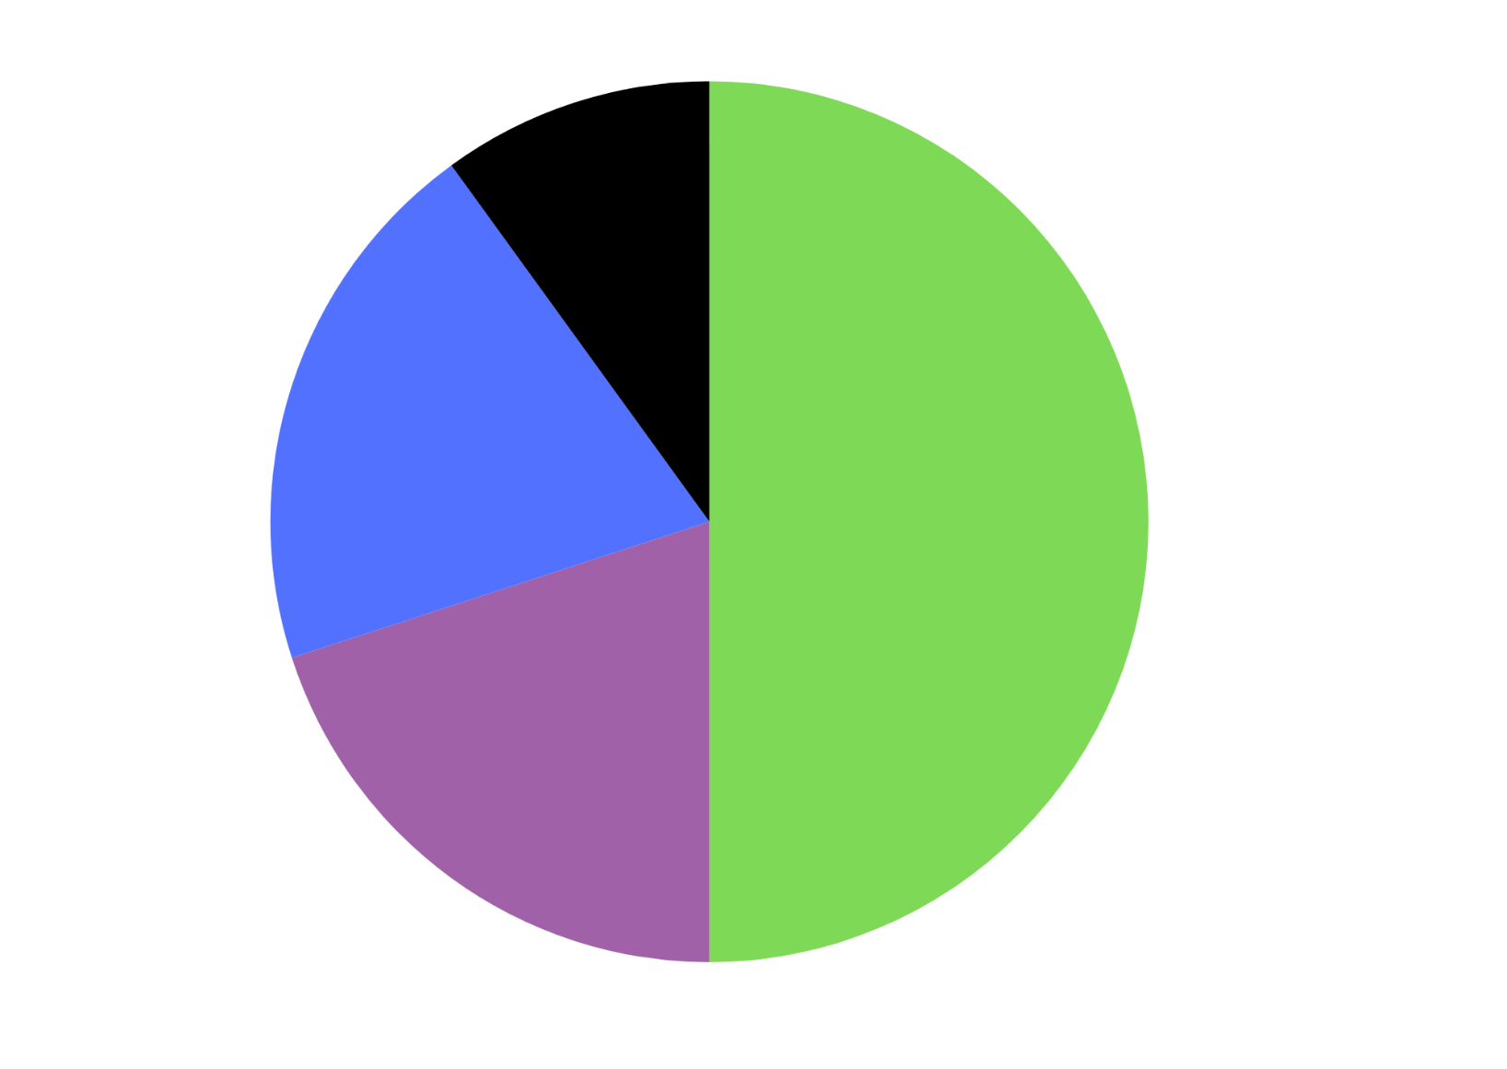

# Resource 6 – box of chocolates

I have a box of chocolates with 4 flavours. A quarter of my chocolates are caramel, and one-fifth of my chocolates are Turkish delight. How many caramel chocolates are there?

How many Turkish delights are there?

Two of my chocolates are peppermint. What fraction of the box would contain peppermint chocolates?

How many white raspberry chocolates make up the box?

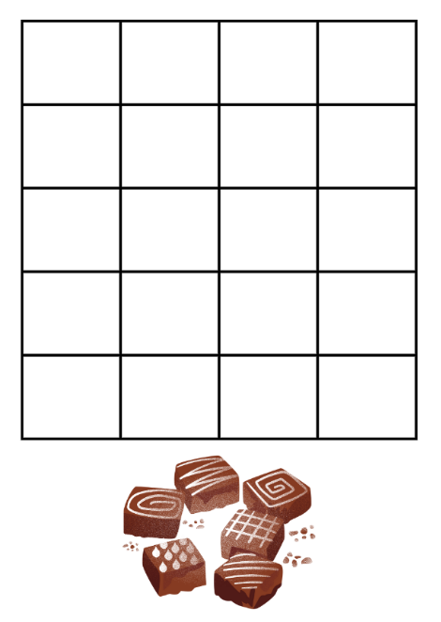

# Resource 7 – SPR instructions

|  |  |
| --- | --- |
| **Scissors – Paper – Rock**  Two players face each other and choose a hand gesture to represent either Scissors, Paper or Rock.  The hand gestures are made by the players on the count of 3 or by chanting Scissor, Paper, Rock.  The winner of the turn is determined by the following:   * Scissors beats Paper (scissors cut paper) * Paper beats Rock (paper covers rock) * Rock beats Scissors (rock blunts scissors) * If both players choose the same gesture, the turn is a draw. | **Diagram for Scissors - Paper - Rock. Scissors is 2 fingers extended, paper is an open hand and rock is a closed fist. Scissors beats paper, which beats rock. Rock beats scissors.** |

# Resource 8 – game outcomes

A table showing the possible outcomes of a game of Scissors-Paper-Rock. The possible outcomes are as follows:

Player 1 and Player 2, both rock = draw.

Player 1 paper, Player 2 rock = Player 1 wins.

Player 1 scissors, Player 2 rock = Player 2 wins.

Player 1 rock, Player 2 scissors = Player 2 wins.

Player 1 paper, Player 2 paper  = draw.
Player 1 scissors, Player 2 paper = Player 1 wins.

Player 1 rock, Player 2 scissors = Player 1 wins.

Player 1 paper, Player 2 scissors = Player 2 wins.

Both player 1 and 2 rock = draw.

# Resource 9 – recording sheet 1

Recording sheet with 3 separate tables for trials and observed frequency.

Table 1 is labelled Test 1: Observed Frequency: Group. There are columns for: Player 1 win, Player 2 Win and Draw. There is space for 21 trials and a row for totals.

Table 2 is labelled Test 1: Observed Frequency – class. There are columns for Player 1 win, Player 2 Win and Draw. There is space for 12 groups to record their data. The final row has space for the mean to be calculated.

Table 3 is labelled Probability Table with rows for Expected probability, Expected frequency, Observed Frequency Group and Observed Frequency Class with columns for Player 1 win, Player 2 Win and Draw.

# Resource 10 – recording sheet 2

Recording sheet with 3 separate tables for trials and observed frequency.

Table 1 is labelled Test 2: Observed Frequency: Group. There are columns for: Player 1 win, Player 2 Win and Draw. There is space for 21 trials and a row for totals.

Table 2 is labelled Test 1: Observed Frequency – class. There are columns for Player 1 win, Player 2 Win and Draw. There is space for 12 groups to record their data. The final row has space for the mean to be calculated.

Table 3 is labelled Probability Table – Test 1 versus Test 2 with rows for Expected Probability, Expected Frequency, Observed Probability for the Class in Test 1, Observed Probability for the Class in Test 2, Observed Probability for the Group in Test 1 and Observed Probability for the Group in Test 2. There are columns for Player 1 win, Player 2 Win and Draw.

# Resource 11 – bag recording sheet

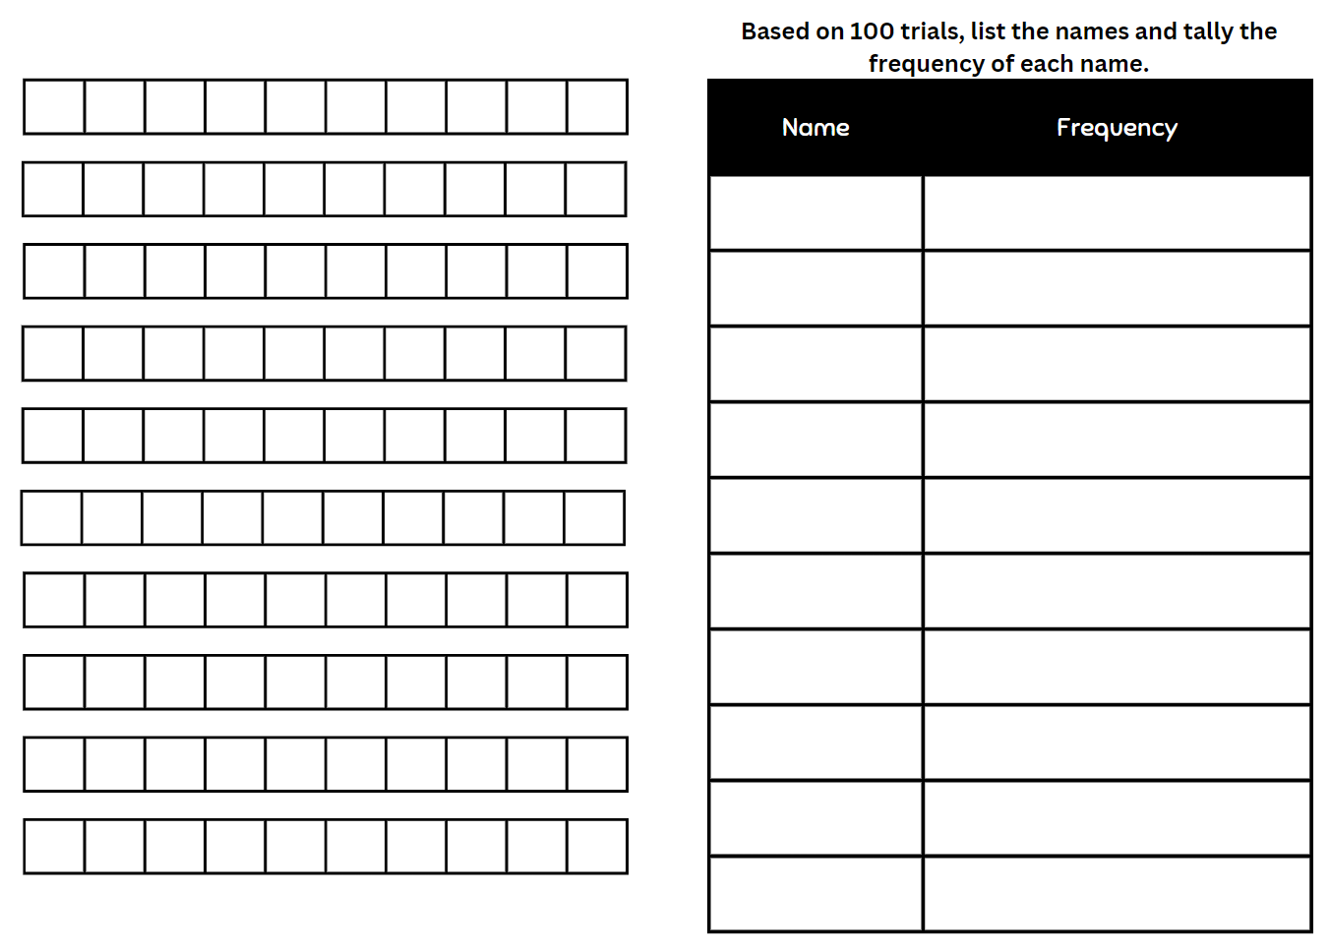

# Resource 12 – class recording sheet

Based on 1000 trials completed as a class, complete the names and tally the frequency.

|  |  |
| --- | --- |
| 1000 trials | Frequency |
|  |  |
|  |  |
|  |  |
|  |  |
|  |  |
|  |  |
|  |  |
|  |  |
|  |  |
|  |  |

# Resource 13 – reef fish samples

Four boxes with different samples of fish taken from the Great Barrier reef. 

Sample 1 has 10 clownfish, 4 pufferfish, 6 parrotfish, 3 surgeonfish and 2 lionfish. 

Sample 2 shows 13 clownfish, 2 pufferfish, 8 parrotfish and 2 lionfish.

Sample 3 shows 8 clownfish, 3 pufferfish, 6 parrotfish, 4 surgeonfish and 4 lionfish.

Sample 4 shows 9 clownfish, 1 pufferfish, 8 parrotfish, 5 surgeonfish and 2 lionfish.

# Resource 14 – clothes shop

A jacket with the price tag of $80.
A pair of shoes with a price tag of $120.
Sunglasses with a price tag of $70.
Jeans with a price tag of $65.
Shirts with a price tag of $40.

# Resource 15 – data types

A multi-part resource that includes a flow diagram and a series of representations and descriptions of different data types. 

The flow diagram begins with a tile that says ‘Collect Data’. The diagram then splits into 2.

On the left-hand side is a tile for continuous data, followed by a tile for numerical data and an image of a line graph. This element has a note to say that it is for Stage 3.

The right-hand side of the flow chart begins with a tile that says ‘Discrete’. ‘Discrete’ is then separated into 2 more tiles called ‘Numerical’ and ‘Categorical’. Both of these are annotated to say that they are for Stage 2 and Stage 3. The numerical tile is linked to an image of a column graph.

The ‘Categorical’ tile is further split into tiles labelled ordinal and nominal. Both of these data types are annotated to say that they are for Stage 3. ‘Ordinal’ is linked to an image of a Likert scale. ‘Nominal’ is linked to an image of 3 eyes of different colour.

There are 7 additional elements to represent and describe different terms used in the syllabus. There are 3 types of data classifications: data, discrete and continuous. 

The Data classification contains the Variable and Numerical variable elements.

Variable – Something measurable or observable that is expected to change either over time or between observations, such as hair colour.

Numerical variable – Variables that are numbers. Adding, subtracting or calculating an average makes sense, such as the number of children in a family.

The Discrete classification contains the Discrete numerical data, Categorical data, Ordinal categorical data and Nominal data elements.

Discrete numerical data – Describes items or events that can only be counted in whole number values, where number where values in between the whole numbers cannot be found or labelled in the data display, such as the number of children in a family.

Categorical data – Describes a quality or characteristic of something. Values belong to exactly one category, such as blood type. 

Ordinal categorical data – Categories can be ranked or ordered. The order is clear but not the distance between each position, such as a feedback scale. 

Nominal data – No meaningful order between the categories, such as eye colour. 

The Continuous classification contains the Continuous numerical data element.

Continuous numerical data – Values between the whole numbers are meaningful and are labelled in the data display, such as temperature 19.8° or fuel prices $1.78.

The resource has the following note:

Stage 2 teaching advice states that students are not expected to classify the type of data they are collecting.

# Resource 16 – average global temperatures

Two graphs labelled 'Average global temperature A' and 'Average global temperature B' showing average global temperatures from 1900 to 2000. 

Graph A has a range from 0 to 30 degrees and Graph B has a range of 13 to 17 degrees.

# Resource 17 – misleading graphs

A side-by-side column graph displaying test scores over the months of the year 2017. 

It is intentionally misleading and inaccurate. This includes a missing label and a repeated percentage. 

The y-axis, named ‘Grades’, starts at 80% and is labelled 81%, 82%, 83%, 84%, 84%. 

The x-axis, named ‘Test date’, is labelled February, April, May, June.

Column graph showing students' favourite colours. The colours are blue, green, red, purple and pink. 

The y-axis is labelled 0, 5, 10, 15, 20, 25. 

The x-axis is labelled blue with a green column, green with a red column, red with a blue column, purple with a pink column and pink with a purple column. 

The misleading representation is that the colours of each column do not match the label.

Column graph showing days kids are missing from school. 

Months are November, December, January, February and March. 

The number range is from 0 to 30, represented in increments of 5.

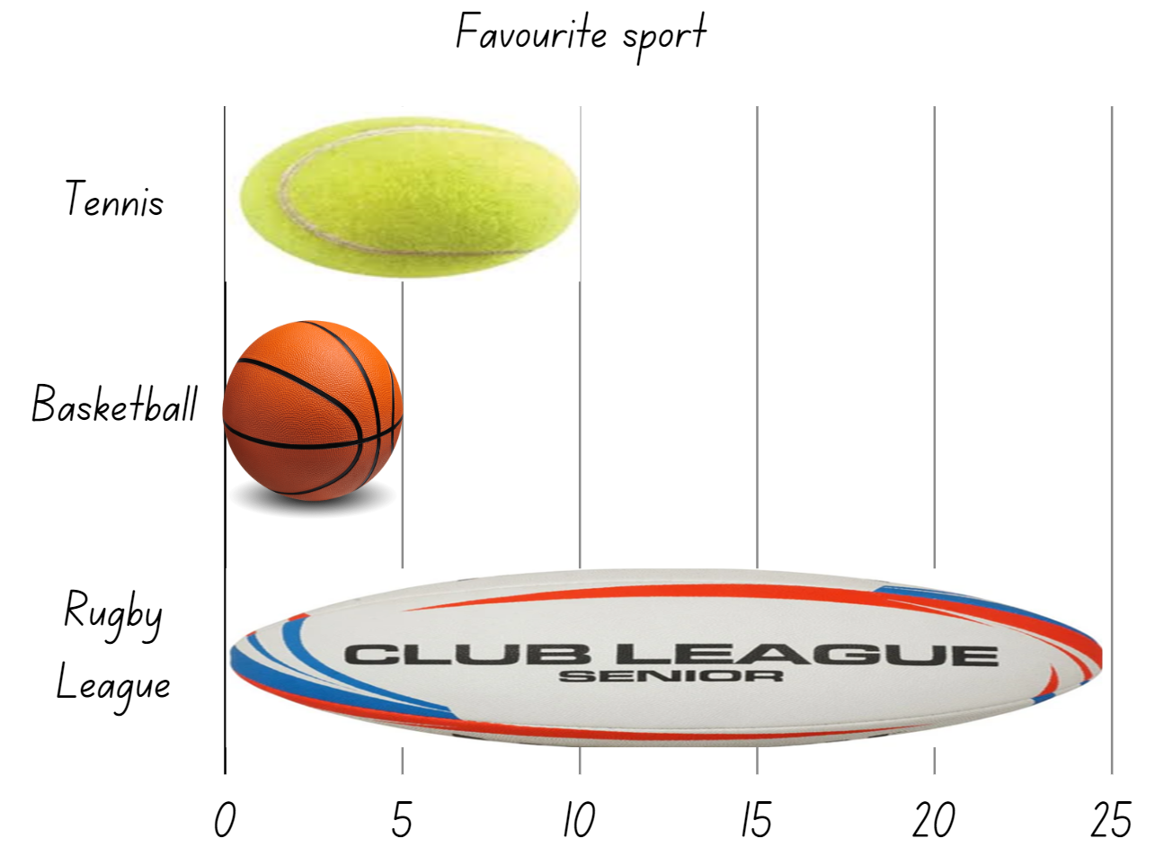

# Resource 18 – sale items

Different items with price tags and sale tags.
Video game controller with a price tag of $65 and a discount tag of 25%. Headphones with a price tag of $90 and a sales tag of 50% off. A phone watch with a price tag of $250 and a 10% off tag. A tablet with a price tag of $320 and a sales tag of 10%. A wireless speaker with a price tag of $120 and a sales tag of 50%.

# Resource 19 – alternative holiday destinations

Side-by-side column graph of the percentage of tourists visiting Australia, and the percentage of tourists visiting other countries.

Australia has 70% wanting to visit other destinations within Australia and 30% would go to other countries. 

USA has 45% wanting to visit other destinations within Australia and 55% would go to other countries. 

England had 40% wanting to visit other destinations within Australia and 60% would go to other countries. 

China had 60% wanting to visit other destinations within Australia and 40% would go to other countries.


# Resource 20 – reef visitors

Side-by-side column graph showing visitors to the Great Barrier Reef.

2014 – six million domestic and one million international visitors.

2015 – 6.2 million domestic and 1.2 million international visitors.

2016 – 6.3 million domestic and 1.3 international visitors.

2017– 7 million domestic and 1.5 million international visitors.

2018 – 7.1 million domestic and 1.7 million international visitors.

2019 – 7.5 million domestic and 1.8 million international visitors.

2020 – 1 million domestic and 300 thousand international visitors.

2021 – 2.5 million domestic and 500 thousand international visitors.

2022 – 4 million domestic and 2.5 million international visitors.

2023 – 6 million domestic and 5 million international visitors.

# Resource 21 – visitors data sheet

|  |  |
| --- | --- |
| Questions | Answers |
| Which years saw the most visitors visit the reef? Why do you think that was? |  |
| Why do you think there was a decline in both international and domestic visitors in 2020 and 2021? |  |
| What do you think the decline in visitors means for Australia? |  |
| Why do you think there has been increase of international visitors in 2023? |  |
| Based on the data we have seen, what do you think may happen to the number of tourists visiting the Great Barrier Reef? Why? |  |

# Resource 22 – barrier reef weather

Side-by-side graph of days of sun and days of rain over the year at the Great Barrier Reef.

January – 16 days of sun and 15 days of rain.

February – 11 days of sun and 17 days of rain.

March – 20 days of sun and 11 days of rain.

April – 24 days of sun and 6 days of rain.

May – 28 days of sun and 3 days of rain.

June – 28 days of sun and 2 days of rain.

July – 29 days of sun and 2 days of rain.

August – 30 days of sun and 1 day of rain.

September – 28 days of sun and 2 days of rain.

October – 27 days of sun and 3 days of rain.

November – 22 days of sun and 8 days of rain.

December – 20 days of sun and 11 days of rain.

# Resource 23 – coral bleaching data

A line graph displaying coral bleaching data. The numbers of coral bleached in each year are as follows:
1350 in 2006.
1350 in 2008.
1680 in 2010.
1900 in 2012.
2450 in 2014.
2650 in 2016.
2950 in 2018.
3200 in 2020.

# Resource 24 – comparing graphs

Two side-by-side graphs: a line graph and column graph representing the rate of coral bleaching on the Great Barrier Reef.

The x-axis in the line graph shows the date as years, ranging from 2006 to 2020 and the y-axis represents the number of coral bleached ranging from 0 to 3500.

The x-axis in the column graph shows the date as years, ranging from 2006 to 2020 and the y-axis represents the number of coral bleached ranging from 0 to 3500.

# Resource 25 – rising sea temperatures A

Column graph showing rising sea temperatures. 

The x-axis shows a timeline from 1910 to 2020 at 10 year intervals and the y-axis shows degrees in Celsius from −1 to 1 degree.

# Resource 26 – data information sheet

|  |  |
| --- | --- |
| Questions | Answers |
| Which year saw the largest increase in sea temperatures? |  |
| Which year saw the largest decrease in sea temperatures? |  |
| Who might use this data about rising sea temperatures? |  |
| In which year did the timeline begin and end? |  |
| If the same data was collected for the next 10 years, what do you think it would tell us? |  |

# Resource 27 – rising sea temperatures B

Column graph showing rising sea temperatures. 

The x-axis shows a timeline from 1940 to 2020 at 5 year intervals and the y-axis shows degrees in Celsius from −1 to 1 degree.

# Resource 28 – reefs at risk

Graph showing reefs at risk. X-axis shows different regions: Atlantic, Australia, Indian Ocean, Middle East, Pacific, South East Asia. Y-axis shows percentage of coral under threat.
Colour-coded to represent very high, high, medium and low levels of threat.

# Syllabus outcomes and content

The table below outlines the [syllabus outcomes](https://curriculum.nsw.edu.au/learning-areas/mathematics/mathematics-k-10-2022/overview) and range of relevant syllabus content covered in this unit. Content is linked to [National Numeracy Learning Progression](https://www.australiancurriculum.edu.au/resources/national-literacy-and-numeracy-learning-progressions/version-3-of-national-literacy-and-numeracy-learning-progressions/) (version 3).

|  |  |  |  |  |  |  |  |  |
| --- | --- | --- | --- | --- | --- | --- | --- | --- |
| Outcomes and content | 1 | 2 | 3 | 4 | 5 | 6 | 7 | 8 |
| **Representing numbers B**: Decimals and percentages: Make connections between benchmark fractions, decimals and percentages  **[MAO-WM-01, MA3-RN-03]** |  |  |  |  |  |  |  |  |
| * Recall commonly used equivalent percentages, decimals and fractions including $\frac{1}{2}$, $\frac{1}{4}$ and $\frac{3}{4}$ |  |  |  |  | x |  |  |  |
| **Representing numbers B**: Decimals and percentages: Determine percentage discounts of 10%, 25% and 50%  **[MAO-WM-01, MA3-RN-03]** |  |  |  |  |  |  |  |  |
| * Equate 10% to dividing by 10, 25% to finding a quarter by dividing by 4, and 50% to finding half |  |  |  |  | x |  |  |  |
| * Use mental strategies to estimate discounts of 10%, 25% and 50% |  |  |  |  |  | x |  |  |
| * Calculate the sale price of an item after a discount of 10%, 25% and 50% |  |  |  |  |  |  | x |  |
| **Representing quantity fractions B**: Find fractional quantities of whole numbers (halves, quarters, fifths and tenths)  **[MAO-WM-01, MA3-RQF-02]** |  |  |  |  |  |  |  |  |
| * Calculate quarters and fifths of whole numbers that are multiples of the denominator, using a tape diagram | x | x |  |  |  |  |  |  |
| * Solve word problems involving a fraction of a quantity |  | x | x |  |  |  |  |  |
| * Find $\frac{1}{2},\frac{1}{4},\frac{1}{5}$ and $\frac{1}{10}$ of collections, expressing remainders as decimals |  | x | x |  |  |  |  |  |
| **Data A**: Collect categorical and discrete numerical data by observation or survey  **[MAO-WM-01, MA3-DATA-01, MA3-DATA-02]** |  |  |  |  |  |  |  |  |
| * Collect ordinal or nominal categorical data, and discrete numerical data through observation or by conducting surveys |  | x |  |  |  |  |  |  |
| **Data A**: Choose and use appropriate tables and graphs  **[MAO-WM-01, MA3-DATA-01, MA3-DATA-02]** |  |  |  |  |  |  |  |  |
| * Tabulate collected data with and without the use of digital technologies such as spreadsheets |  |  |  |  | x |  |  |  |
| **Data B**: Interpret and compare a range of data displays  **[MAO-WM-01, MA3-DATA-01, MA3-DATA-02]** |  |  |  |  |  |  |  |  |
| * **Interpret side-by-side column graphs for 2 categorical variables** |  |  |  |  |  |  | x |  |
| * Interpret and compare different displays in terms of the shape of the distribution, including the range and the most frequent value (mode) |  |  |  |  |  |  |  | x |
| **Data B**: Interpret data presented in digital media and elsewhere  **[MAO-WM-01, MA3-DATA-01, MA3-DATA-02]** |  |  |  |  |  |  |  |  |
| * Interpret data representations found in digital media and in factual texts |  |  |  |  |  | x | x | x |
| * Identify sources of possible bias in representations of data in the media (Statistical reasoning) |  |  |  |  |  | x |  |  |
| * Identify misleading representations of data in the media |  |  |  |  |  | x |  |  |
| **Chance B**: Compare observed frequencies of outcomes with expected results  **[MAO-WM-01, MA3-CHAN-01]** |  |  |  |  |  |  |  |  |
| * **Use the term** frequency **to describe the number of times a particular outcome occurs in a chance experiment** |  |  |  | x |  |  |  |  |
| * **Distinguish between the frequency of an outcome (the number of times it occurs) and the probability of an outcome in a chance experiment** |  |  | x |  |  |  |  |  |
| * Compare the expected frequencies of outcomes of chance experiments with observed frequencies, including where the outcomes are not equally likely |  |  | x |  |  |  |  |  |
| * Discuss the fairness of simple games involving chance and the idea of randomness |  |  |  | x |  |  |  |  |
| * Explain why observed frequencies of outcomes in chance experiments may differ from expected frequencies, and how this relates to randomness |  |  | x |  |  |  |  |  |
| **Chance B**: Create random generators and describe probabilities using fractions  **[MAO-WM-01, MA3-CHAN-01** |  |  |  |  |  |  |  |  |
| * **Create random generators to follow specified probabilities or proportions** |  | x |  |  |  |  |  |  |
| * **Record the outcomes for chance experiments where the outcomes are not equally likely to occur and assign probabilities to the outcomes using fractions (denominators of 2, 3, 4, 5, 6, 8 and 10)** | x | x |  |  |  |  |  |  |
| * Use knowledge of benchmark fractions, decimals and percentages to assign probabilities to the likelihood of outcomes | x | x |  |  |  |  |  |  |
| **Chance B**: Conduct chance experiments with both small and large numbers of trials  **[MAO-WM-01, MA3-CHAN-01]** |  |  |  |  |  |  |  |  |
| * **Determine and discuss the differences between the expected probabilities and the observed probabilities after both small and large numbers of trials** |  |  | x | x |  |  |  |  |
| * Determine the likely make up of a large collection of objects, by sampling objects and returning them to the collection before the next sample (sampling with replacement) |  |  |  |  | x |  |  |  |

[Mathematics K–10 Syllabus](https://curriculum.nsw.edu.au/learning-areas/mathematics/mathematics-k-10-2022/overview) © NSW Education Standards Authority (NESA) for and on behalf of the Crown in right of the State of New South Wales, 2022.

# References

This resource contains NSW Curriculum and syllabus content. The NSW Curriculum is developed by the NSW Education Standards Authority. This content is prepared by NESA for and on behalf of the Crown in right of the State of New South Wales. The material is protected by Crown copyright.

Please refer to the NESA Copyright Disclaimer for more information <https://educationstandards.nsw.edu.au/wps/portal/nesa/mini-footer/copyright>.

NESA holds the only official and up-to-date versions of the NSW Curriculum and syllabus documents. Please visit the NSW Education Standards Authority (NESA) website <https://educationstandards.nsw.edu.au> and the NSW Curriculum website [https://curriculum.nsw.edu.au](https://curriculum.nsw.edu.au/).

[Mathematics K–10 Syllabus](https://curriculum.nsw.edu.au/learning-areas/mathematics/mathematics-k-10-2022/overview) © NSW Education Standards Authority (NESA) for and on behalf of the Crown in right of the State of New South Wales, 2022.

[National Numeracy Learning Progression](https://www.australiancurriculum.edu.au/resources/national-literacy-and-numeracy-learning-progressions/version-3-of-national-literacy-and-numeracy-learning-progressions/) © Australian Curriculum, Assessment and Reporting Authority (ACARA) 2010 to present, unless otherwise indicated. This material was downloaded from the [Australian Curriculum](http://www.australiancurriculum.edu.au/) website (National Numeracy Learning Progression) (accessed 4 April 2024 and was not modified.)

ABC (Australian Broadcasting Corporation) (19 January 2022) ['Catalyst: How to win at rock-paper-scissors' [video]](https://www.abc.net.au/education/catalyst-how-to-win-at-rock-paper-scissors/13720728)*,* *Catalyst*, ABC Education website, accessed 9 April 2024.

**AIMS (Australian Institute of Marine Science) (n.d.) ‘**[Reef monitoring sampling methods](https://www.aims.gov.au/research-topics/monitoring-and-discovery/monitoring-great-barrier-reef/reef-monitoring-sampling-methods)**’,** Monitoring the Great Barrier Reef**, AIMS website,** accessed 9 April 2024.

Downton A, Knight R, Clarke D and Lewis G (2015) *Mathematics Assessment for Learning: Rich Tasks & Work Samples*, 3rd edn, Australian Catholic University and Catholic Education Office, Melbourne.

Great Barrier Reef Foundation (7 March 2024) [‘What is coral bleaching?’](https://www.barrierreef.org/news/explainers/what-is-coral-bleaching), News, Great Barrier Reef Foundation website, accessed 19 July 2024.

NESA (NSW Education Standards Authority) (2022) ‘[Stage 3: Teaching advice for Chance B](https://curriculum.nsw.edu.au/learning-areas/mathematics/mathematics-k-10-2022/content/stage-3/fa6dbbaafc?show=advice)’, Mathematics K–10 Syllabus, NESA website, accessed 10 July 2024.

NESA (2022) ‘[Stage 3: Teaching advice for Data B](https://curriculum.nsw.edu.au/learning-areas/mathematics/mathematics-k-10-2022/content/stage-3/fa0c228e92?show=advice&ta_scroll=no#:~:text=Teaching%20advice%20for%20Data%20B)’, Mathematics K–10 Syllabus, NESA website, accessed 10 July 2024.

Siemon D, Warren E, Beswick K, Faragher R, Miller J, Horne M, Jazby D, Breed M, Clark J and Brady K (2020) Teaching Mathematics: Foundation to Middle Years, 3rd edn, Oxford University Press Australia and New Zealand

Travel + Leisure (6 December 2019) ['How Scientists Are Restoring The Great Barrier Reef | Travel + Leisure' [video]](https://www.youtube.com/watch?v=8hknaJQRh8s), Travel + Leisure, YouTube, accessed 9 April 2024.

Van de Walle J, Karp K, Bay-Williams JM, Brass A, Bentley B, Ferguson S, Goff W, Livy S, Marshman M, Martin D, Pearn C, Prodromou T, Symons D and Wilkie K (2019) Primary and Middle Years Mathematics: Teaching Developmentally, 1st Australian edn, Pearson Education Australia, Melbourne.

## Further reading

Camper Champ (2023) ‘[*Queensland Tourism Statistics*](https://camperchamp.com.au/statistics/australia/queensland-tourism/#how-many-people-visited-queensland-in-2021)’, Australian Travel Statistics: Statistics by Location, Camper Champ website, accessed 9 April 2024.

TravelOnline (n.d.) [*Great Barrier Reef Weather & Climate*](https://www.great-barrier-reef.com/great-barrier-reef-weather.html), Great-Barrier-Reef.com, accessed 9 April 2024.

Li T, Huang J, Du H, Liu X, Zhong C and Lin S (2022) ‘[Coral bleaching from a nutrient perspective is understudied: A bibliometric survey’](https://www.frontiersin.org/journals/marine-science/articles/10.3389/fmars.2022.926783/full), Frontiers in Marine Science, 9, doi:10.3389/fmars.2022.926783, accessed 19 July 2024.

Swann T and Campbell R (20 June 2016) ‘[Great Barrier Reef Bleached: Coral Bleaching, the Great Barrier Reef and potential impacts of tourism](https://australiainstitute.org.au/report/great-barrier-bleached/)’, *The Australia Institute*, accessed 9 April 2024.

Taylor L (13 May 2013) ‘[Great Barrier Reef is at risk even if it doesn't make Unesco's danger list](https://www.theguardian.com/environment/planet-oz/2013/may/13/great-barrier-reef-unesco-danger)’, *The Guardian*, accessed 9 April 2024.

The Nature Conservancy (2024) ‘[Status of Coral Reefs](https://reefresilience.org/stressors/reefs-are-at-risk/)’, Threats, Reef Resilience Network website, accessed 9 April 2024.

**© State of New South Wales (Department of Education), 2024**

The copyright material published in this resource is subject to the *Copyright Act 1968* (Cth) and is owned by the NSW Department of Education or, where indicated, by a party other than the NSW Department of Education (third-party material).

Copyright material available in this resource and owned by the NSW Department of Education is licensed under a [Creative Commons Attribution 4.0 International (CC BY 4.0) license.](https://creativecommons.org/licenses/by/4.0/)

**[](https://creativecommons.org/licenses/by/4.0/)**

This license allows you to share and adapt the material for any purpose, even commercially.

Attribution should be given to © State of New South Wales (Department of Education), 2024.

Material in this resource not available under a Creative Commons license:

* the NSW Department of Education logo, other logos and trademark-protected material
* material owned by a third party that has been reproduced with permission. You will need to obtain permission from the third party to reuse its material.

**Links to third-party material and websites**

Please note that the provided (reading/viewing material/list/links/texts) are a suggestion only and implies no endorsement, by the New South Wales Department of Education, of any author, publisher, or book title. School principals and teachers are best placed to assess the suitability of resources that would complement the curriculum and reflect the needs and interests of their students.

If you use the links provided in this document to access a third-party's website, you acknowledge that the terms of use, including licence terms set out on the third-party's website apply to the use which may be made of the materials on that third-party website or where permitted by the *Copyright Act 1968* (Cth). The department accepts no responsibility for content on third-party websites.