Mathematics Stage 3 – Unit 39
Angles are the primary structural component of many shapes

Contents
Unit description and duration 6
Syllabus outcomes 6
Working mathematically 7
Student prior learning 7
Lesson overview and resources 9
Lesson 1 15
Daily number sense – integer place value game – 10 minutes 15
Core lesson 1 – theme park timetable – 40 minutes 17
Discuss and connect the mathematics – 10 minutes 22
Lesson 2 24
Daily number sense – integer number line – 10 minutes 24
Core lesson 1 – time intervals as decimals – 20 minutes 27
Core lesson 2 – 24-hour time – 25 minutes 29
Consolidation and meaningful practice – 15 minutes 31
Lesson 3 33
Daily number sense – classroom number line – 10 minutes 33
Core lesson – dissecting 2D shapes – 35 minutes 35
Consolidation and meaningful practice – 15 minutes 38
Lesson 4 41
Daily number sense – 10 minutes 41
Core lesson – translate, reflect and rotate – 40 minutes 41
Consolidation and meaningful practice – 10 minutes 44
Lesson 5 46
Daily number sense – decoration word problem – 10 minutes 46
Core lesson 1 – all about angles – 10 minutes 48
Core lesson 2 – Ferris wheel angles – 40 minutes 50
Discuss and connect the mathematics – 10 minutes 52
Lesson 6 54
Daily number sense – fraction inquiry– 10 minutes 54
Core lesson 1 – investigating adjacent angles – 10 minutes 56
Core lesson 2 – park map – 35 minutes 58
Discuss and connect the mathematics – 10 minutes 61
Lesson 7 63
Daily number sense – fraction bingo – 15 minutes 63
Core lesson – design a rollercoaster 1 – 45 minutes 65
Discuss and connect the mathematics – 5 minutes 68
Lesson 8 70
Daily number sense – 10 minutes 70
Core lesson – design a rollercoaster 2 – 30 minutes 70
Discuss and connect the mathematics – 20 minutes 73
Resource 1 – integer place value gameboard 76
Resource 2 – theme park timetable 77
Resource 3 – ZOOM strategy 78
Resource 4 – theme park questions 79
Resource 5 – time misconceptions 80
Resource 6 – time intervals 81
Resource 7 – time memory 82
Resource 8 – 24-hour time 84
Resource 9 – 24-hour timetable 85
Resource 10 – planning a day 86
Resource 11 – theme park signs 87
Resource 12 – tangram animal silhouettes 88
Resource 13 – tangram 89
Resource 14 – demolition derby design 90
Resource 15 – True or false? 91
Resource 16 – decoration fractions 93
Resource 17 – all about angles 94
Resource 18 – Ferris wheel 1 95
Resource 19 – Ferris wheel 2 96
Resource 20 – Is he correct? 97
Resource 21 – blank tape diagram 98
Resource 22 – park map 99
Resource 23 – using a protractor 100
Resource 24 – Elyssa’s path 101
Resource 25 – fraction wall 102
Resource 26 – bingo questions 103
Resource 27 – rollercoasters 104
Resource 28 – designing for thrill 105
Resource 29 – designing for safety 106
Resource 30 – feedback criteria 107
Syllabus outcomes and content 108
References 113

Unit description and duration
This unit develops the big idea that angles are the primary structural component of many shapes.
In this 2-week unit students are provided opportunities to:
- solve problems involving duration, using 12- and 24-hour time
- investigate angles on a straight line, angles at a point and the relationships formed by the intersection of straight lines
- dissect two-dimensional shapes and rearrange them using translations, reflections and rotations.

Syllabus outcomes
- MAO-WM-01 develops understanding and fluency in mathematics through exploring and connecting mathematical concepts, choosing and applying mathematical techniques to solve problems, and communicating their thinking and reasoning coherently and clearly
- MA3-RN-01 applies an understanding of place value and the role of zero to represent the properties of numbers
- MA3-RQF-02 determines $\frac{1}{2}$, $\frac{1}{4}$, $\frac{1}{5}$ and $\frac{1}{10}$ of measures and quantities
- MA3-GM-03 measures and constructs angles, and identifies the relationships between angles on a straight line and angles at a point
- MA3-2DS-01 investigates and classifies two-dimensional shapes, including triangles and quadrilaterals based on their properties
- MA3-NSM-02 measures and compares duration, using 12- and 24-hour time and am and pm notation.

Working mathematically
In the Mathematics K–10 Syllabus, there is one overarching Working mathematically outcome (MAO-WM-01). The Working mathematically processes should be embedded within the concepts being taught. The Working mathematically processes present in the Mathematics K–10 Syllabus are:
- communicating
- understanding and fluency
- reasoning
- problem solving.
Mathematics K–10 Syllabus © NSW Education Standards Authority (NESA) for and on behalf of the Crown in right of the State of New South Wales, 2022.

Student prior learning
Before engaging in these teaching and learning activities, students would benefit from prior experience with:
- comparing 12- and 24-hour time systems and converting between them
- using the terms translate, reflect and rotate to describe transformations of two-dimensional shapes, and creating two-dimensional shapes that result from combining and splitting common shapes and describing the result
- recognising that a right angle is 90°, a straight angle is 180°, an angle of revolution is 360° and measuring angles using a protractor.
In NSW classrooms there is a diverse range of students, including Aboriginal and/or Torres Strait Islander students, students learning English as an additional language or dialect, high potential and gifted students and students with disability. Some students may identify with more than one of these groups or possibly all of them. Refer to Curriculum planning for every student – advice for further information.

Lesson overview and resources
The table below outlines the sequence and approximate timing of lessons, learning intentions and resources.
Lesson | Content | Duration and resources
Lesson 1  Daily number sense learning intention:  - locate and represent integers on a number line | Lesson core concept: mental strategies can help to calculate the duration of events.  Core concept learning intention:  - solve problems involving duration, using 12- and 24-hour time | Lesson duration: 60 minutes  - Resource 1 – integer place value gameboard  - Resource 2 – theme park timetable  - Resource 3 – ZOOM strategy  - Resource 4 – theme park questions  - 9-sided dice (2 per student pair)  - Paperclips  - Writing materials
Lesson 2  Daily number sense learning intention:  - locate and represent integers on a number line | Lesson core concept: events can be scheduled in 12 and/or 24-hour time.  Core concept learning intention:  - solve problems involving duration, using 12- and 24-hour time | Lesson duration: 70 minutes  - Resource 2 – theme park timetable  - Resource 3 – ZOOM strategy  - Resource 5 – time misconceptions  - Resource 6 – time intervals  - Resource 7 – time memory  - Resource 8 – 24-hour time  - Resource 9 – 24-hour timetable  - Resource 10 – planning a day  - Individual whiteboards  - Scissors  - Writing materials
Lesson 3  Daily number sense learning intention:  - locate and represent integers on a number line | Lesson core concept: two-dimensional shapes can be cut and rearranged to create new shapes.  Core concept learning intention:  - dissect two-dimensional shapes and rearrange them using translations, reflections and rotations | Lesson duration: 60 minutes  - Resource 11 – theme park signs  - Resource 12 – tangram animal silhouettes  - Resource 13 – tangram  - Scissors  - Sticky notes  - Writing materials
Lesson 4  Daily number sense learning intention:  - teacher-identified task based on student needs | Lesson core concept: objects can be designed by rotating, reflecting and translating two-dimensional shapes.  Core concept learning intention:  - dissect two-dimensional shapes and rearrange them using translations, reflections and rotations | Lesson duration: 60 minutes  - Resource 14 – demolition derby design  - Resource 15 – True or false?  - Website: Interactive pattern shapes  - Digital devices  - Writing materials
Lesson 5  Daily number sense learning intention:  - find fractional quantities of whole numbers (halves, quarters, fifths and tenths) | Lesson core concept: angles can be found in the world around us.  Core concept learning intentions:  - investigate the relationships formed by the intersection of straight lines  - investigate angles on a straight line and angles at a point | Lesson duration: 70 minutes  - Resource 16 – decoration fractions  - Resource 17 – all about angles  - Resource 18 – Ferris wheel 1  - Resource 19 – Ferris wheel 2  - Resource 20 – Is he correct?  - Individual whiteboards  - Writing materials
Lesson 6  Daily number sense learning intention:  - find fractional quantities of whole numbers (halves, quarters, fifths and tenths) | Lesson core concept: adjacent angles are formed when lines intersect.  Core concept learning intentions:  - use a protractor to measure and identify types of angles  - investigate the relationships formed by the intersection of straight lines  - investigate angles on a straight line and angles at a point | Lesson duration: 65 minutes  - Resource 17 – all about angles  - Resource 21 – blank tape diagram  - Resource 22 – park map  - Resource 23 – using a protractor  - Resource 24 – Elyssa’s path  - Individual whiteboards  - Protractors  - Rulers  - Tracing paper  - Writing materials
Lesson 7  Daily number sense learning intention:  - find fractional quantities of whole numbers (halves, quarters, fifths and tenths) | Lesson core concept: designing allows us to investigate angles and their relationships.  Core concept learning intentions:  - use a protractor to measure and identify types of angles  - investigate the relationships formed by the intersection of straight lines | Lesson duration: 65 minutes  - Resource 25 – fraction wall  - Resource 26 – bingo questions  - Resource 27 – rollercoasters  - Resource 28 – designing for thrill  - Resource 29 – designing for safety  - Website: Canva or Microsoft PowerPoint  - Individual whiteboards  - Writing materials
Lesson 8  Daily number sense learning intention:  - teacher-identified task based on student needs | Lesson core concept: designing allows us to investigate angles and their relationships.  Core concept learning intentions:  - use a protractor to measure and identify types of angles  - investigate the relationships formed by the intersection of straight lines | Lesson duration: 60 minutes  - Resource 28 – designing for thrill  - Resource 29 – designing for safety  - Resource 30 – feedback criteria  - Writing materials

Lesson 1
Core concept: mental strategies can help to calculate the duration of events.

Daily number sense – integer place value game – 10 minutes
Daily number sense activities for Lessons 1 to 3 ‘activate’ prior number knowledge and support the learning of new content in the unit. These activities also assist teachers to identify the starting points for learning by revealing the extent of students’ existing knowledge.
The table below contains a suggested learning intention and success criteria. These are best co-constructed with students.
Daily number sense learning intention | Daily number sense success criteria
Students are learning to:  - locate and represent integers on a number line. | Students can:  - use the term integers to describe positive and negative whole numbers and zero  - recognise the location of negative whole numbers in relation to zero and place them on a number line.
This lesson is an adaptation of The place value game from Mathematics K–6 resources by State of New South Wales (Department of Education).
Integer: a whole number, positive, negative or zero, for example −3, −2, −1, 0, 1, 2 ...
Negative number: a number less than zero, written with a minus sign. These integers are read as, for example, ‘negative 3’, not ‘minus 3’.
- Revise the definition of integers and negative numbers.
- Provide student pairs with two 9-sided dice, a paperclip and Resource 1 – integer place value gameboard.
- Students roll the dice and create a 2-digit integer. For example, if 5 and 3 are rolled, they could make 53 or 35. Students then spin the spinner to determine if their integer is positive or negative. Players record their integer in the most appropriate position between −99 and 99 (see Figure 1).
Figure 1 – integer place value gameboard example
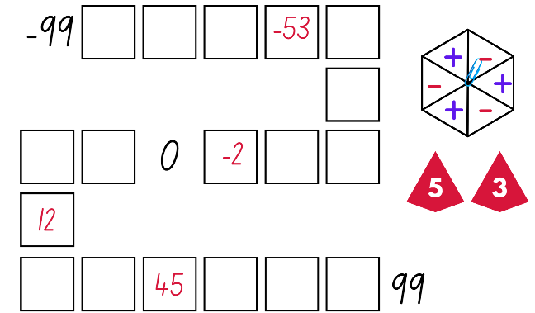
- If the integer cannot be placed on the gameboard, students miss their turn. Play continues until all boxes are filled.
Note: this game can also be played as whole class. Using a reusable sleeve for the gameboard will allow students to play multiple games.
This table details opportunities for assessment.
Assessment opportunities | Links
What to look for:  - Can students use the term integers to describe positive and negative whole numbers and zero? [MAO-WM-01, MA3-RN-01]  - Can students recognise the location of negative whole numbers in relation to zero and place them on a number line?  [MAO-WM-01, MA3-RN-01] | Links to National Numeracy Learning Progressions (NNLP):  - NPV9.

Core lesson 1 – theme park timetable – 40 minutes
The table below contains a suggested learning intention and success criteria. These are best co-constructed with students.
Core concept learning intention | Core concept success criteria
Students are learning to:  - solve problems involving duration, using 12- and 24-hour time. | Students can:  - use start and finish times to calculate the elapsed time of events  - add and subtract time mentally using bridging strategies  - round answers to time calculations to the nearest hour.
The lessons in this unit revolve around a common theme, exploring authentic, real-world experiences at a theme park.
- Explain that schedules and timetables are tools used to communicate events and the duration of these events.
- Display Resource 2 – theme park timetable. Ask students what they notice about the features of the timetable. For example, some of the times for the shows overlap. Ask the following questions:
- Where have you seen timetables used as a way of organising and communicating time?
- Have you seen a timetable like this before? Where? Did you find it useful?
- Pose the question: Gabriella attended the 'Feed the animals’ session. What is the elapsed time of this event?
Elapsed time: the amount of time between the start time and the end time of an activity or event. For example, my piano lesson starts at 10 past 4 and goes until a quarter to 5. The lesson is 35 minutes long.
- Revisit the ZOOM strategy for calculating elapsed time by displaying Resource 3 – ZOOM strategy.
- Demonstrate how to use the ZOOM strategy to determine the elapsed time between 11:40 am and 1:10 pm (see Figure 2).
Figure 2 – ZOOM strategy example
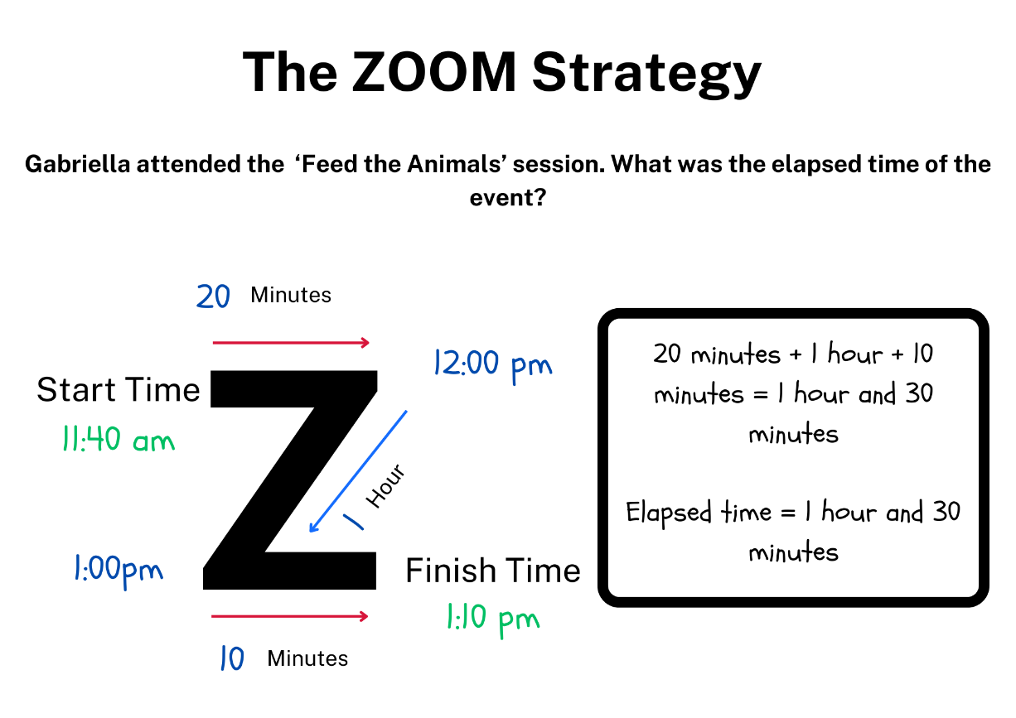
- Model these steps:
- Identify the start time and the end time (and place it on either end of the ’Z’).
- Bridge the starting minutes to the closest hour.
- Identify how many hours until the finish time.
- Identify how many minutes (if any) remain until the finish time.
- Add the hours and minutes together to find the total time.
- Ask students to round the finish time of 1:10 pm to the nearest hour.
- Explain that another bridging strategy to calculate elapsed time is to use an empty number line.
- Draw a number line on the board, marked with the times 11:40 am to 1:10 pm.
- Demonstrate how to use an empty number line to calculate elapsed time by bridging to the closest hour (see Figure 3). Model how to:
- add the remaining minutes from the current time to the next whole hour first, using one or more jumps
- use jumps to add any whole hours if needed
- add any more minutes needed to get to the final time, using one or more jumps.
Figure 3 – number line example
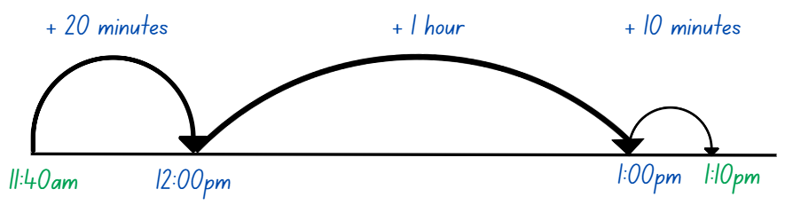
- Display Resource 2 – theme park timetable and provide students with Resource 4 – theme park questions.
- Students work in pairs to mentally use the ZOOM strategy or a blank number line to work out the elapsed time of events and round to the nearest hour.
Note: if the elapsed time has a finish time that is on the hour, students will not need to use the final line of the ZOOM model as there are no remaining minutes to add.
This table details opportunities for differentiation.
Too hard? | Too easy?
Students cannot use start and finish times to calculate the elapsed time of events  - Students are given a copy of the ZOOM strategy or a blank number line and whiteboards to record their thinking.  - Assist students by modifying the times of the timetable or the questions so that students only need to calculate elapsed time to the nearest hour. | Students can use start and finish times to calculate the elapsed time of events.  - Challenge students to mentally calculate the total number of hours that events run throughout the day.  - Students create their own elapsed time questions for a partner to solve using the ZOOM strategy.

Discuss and connect the mathematics – 10 minutes
- Regroup and ask the following questions:
- What strategy did you use to calculate the elapsed time? Why was that strategy the most effective?
- Are there any other strategies you could use to calculate elapsed time?
- Was bridging to the nearest hour an effective strategy to work out elapsed time?
- Why would it be important to understand strategies for working out the elapsed time of events?
- Why is calculating elapsed time a useful skill?
- What makes timetables an efficient way to communicate information?
- Did you find rounding to the nearest hour challenging? Why or why not?
- When could rounding to the nearest hour be helpful?
This table details opportunities for assessment.
Assessment opportunities | Links
What to look for:  - Can students use start and finish times to calculate the elapsed time of events? [MAO-WM-01, MA3-NSM-02]  - Can students use mental strategies to calculate elapsed time using bridging strategies? [MAO-WM-01, MA3-NSM-02]  - Can students round answers to time calculations to the nearest minute or hour? [MAO-WM-01, MA3-NSM-02] | Links to National Numeracy Learning Progressions (NNLP):  - MeT4, MeT5.

Lesson 2
Core concept: events can be scheduled in 12 and/or 24-hour time.

Daily number sense – integer number line – 10 minutes
The table below contains a suggested learning intention and success criteria. These are best co-constructed with students.
Daily number sense learning intention | Daily number sense success criteria
Students are learning to:  - locate and represent integers on a number line. | Students can:  - recognise the location of negative whole numbers in relation to zero and place them on a number line  - use the term integers to describe positive and negative whole numbers and zero
This activity is an adaptation of Finding numbers on a number line from Mathematics K–6 resources by State of New South Wales (Department of Education).
- Draw a number line on the board with points A, B, C, D, E, F evenly spaced along it (see Figure 4).
Figure 4 – number line 1
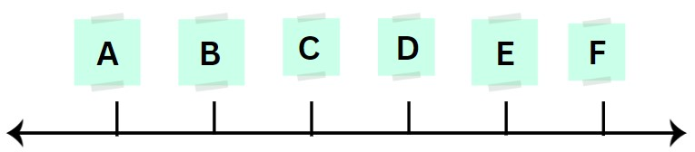
- Ask students to identify what integers could be placed on the number line at each point.
- Students record their answers on individual whiteboards.
- Add a zero to the number line between point C and D (see Figure 5).
Figure 5 – number line 2
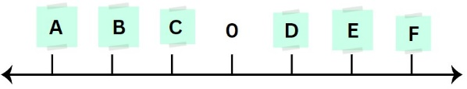
- Ask students what they notice about the number line now and if some of the integers at each point need to change.
- Students record their responses on individual whiteboards.
- Students turn and talk and compare responses.
- Ask the following questions:
- Is there more than one way to complete the number line? What is another way you could complete it? Explain your reasoning.
- If I moved the points so that they were no longer evenly spaced on the number line, would that change the integers at the points? How?
- Will the integers change if I move the zero between E and F? Why? (see Figure 6)
Figure 6 – number line 3
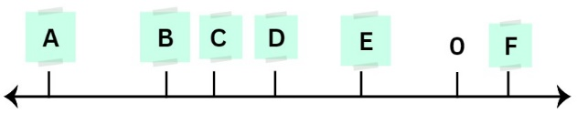
- Mark point F as 5 and point D as −20 (see Figure 7).
Figure 7 – number line 4
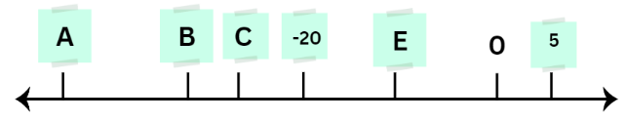
- Ask students to describe what happens, if you start at 5 and end at −20.
Note: there is no expectation for students to record the equation of negative numbers resulting from subtraction.
This table details opportunities for assessment.
Assessment opportunities | Links
What to look for:  - Can students recognise the location of negative whole numbers in relation to zero and place them on a number line?  [MAO-WM-01, MA3-RN-01]  - Can students use the term integers to describe positive and negative whole numbers and zero? [MAO-WM-01, MA3-RN-01] | Links to National Numeracy Learning Progressions (NNLP):  - NPV9.

Core lesson 1 – time intervals as decimals – 20 minutes
The table below contains a suggested learning intention and success criteria. These are best co-constructed with students.
Core concept learning intention | Core concept success criteria
Students are learning to:  - solve problems involving duration, using 12- and 24-hour time. | Students can:  - represent commonly used time intervals as decimals  - solve a variety of problems involving duration, including where times are expressed in 12-hour and 24-hour notation.
- Display Resource 5 – time misconceptions.
- Ask students to discuss whether they think Ben or Harrison is correct, justifying their reasoning.
- Ask the following questions:
- How many minutes in an hour, half an hour, a quarter of an hour?
- How do we write a half and a quarter as a decimal?
- Is 30 minutes equal to 0.3 or 0.5? Why?
- Explain to students that decimals can be used to represent time intervals.
- Display Resource 6 – time intervals. Discuss the clock with students and what each shaded section represents.
- Explain to students that the base-10 system is not used with time. One whole is equal to 60, so half an hour is 30 minutes and a quarter of an hour is 15 minutes (the bar model shows this equivalence).
- Use Resource 5 – time misconceptions as an example. Harrison is correct because 2 and a half hours is equivalent to 2 hours and 30 minutes, so it would be written as 2.5, not as 2.3.
- Discuss that if 4 hours and 15 minutes has passed, we write this as 4.25 because .25 represents a quarter.
- Provide student pairs copies of Resource 7 – time memory. Students cut out the cards, shuffle the cards and place them facedown.
- Player 1 selects one card and then selects another card. If the cards match, the student keeps the 2 cards and has another turn. If there is no match, the student returns the cards facedown and Player 2 takes a turn.
- Play continues until there are no cards left. The player with the greatest number of cards at the end of the game wins.

Core lesson 2 – 24-hour time – 25 minutes
- Revisit 24-hour time. Explain that 24-hour time is used to avoid confusion between am and pm.
- Display Resource 8 – 24-hour time.
- Highlight the timeline. Explain that with 12-hour time, the day is divided into 2 equal 12-hour periods. To distinguish between the morning and the afternoon, we use the notation ‘am’ (midnight to midday) and ‘pm’ (midday to midnight). In 24-hour time, the day runs from midnight to midnight. For any time before 10:00 am, a zero is placed at the beginning. For example, 2:00 am is written as 02:00.
- Highlight the clock. Explain that the inner circle of the clock displays the morning and the outer circle displays the afternoon in 24-hour time. Display Resource 9 – 24-hour timetable.
- Pose the problem: Shaireen has just finished watching the character parade and wants to stay to watch the laser show. How long does she have to wait?
- Students mentally calculate the answer. Remind students to use the ZOOM strategy or the empty number line from Lesson 1. Discuss with students how this time interval could be converted into a decimal.
- Explain: Shaireen had to wait 4 hours and 45 minutes to watch the laser show. Discuss that the 4 hours and 45 minutes can be represented as 4.75 in decimal notation.
- Provide students with a copy of Resource 10 – planning a day.
- Explain to students that they will be planning a day at the theme park. The day needs to include at least 4 events from the timetable. Times are filled in using 24-hour time notation.
- Students turn and talk to discuss their daily schedules and the intervals between each event.
- Regroup and ask the following questions:
- Was it easier or more difficult to plan a schedule using 24-hour time?
- What was easier about using 24-hour time? What was more challenging? Explain your thinking.
- When would it be more appropriate to use a 24-hour timetable?
- Have you seen a 24-hour timetable in your everyday life? Why was it in this format?
This table details opportunities for differentiation.
Too hard? | Too easy?
Students cannot solve a variety of problems involving duration, including where times are expressed in 12-hour and 24-hour notation.  - Support students by reducing the number of events they include in their daily plan.  - Assist students by providing them with a copy of Resource 3 – ZOOM strategy from Lesson 1 and modelling its use. | Students can solve a variety of problems involving duration, including where times are expressed in 12-hour and 24-hour notation.  - Explain to students they only have 3 hours at the theme park. What shows or activities would they go to or do to make the most of their time and get as close to 3 hours as possible?  - Students use Resource 2 – theme park timetable from Lesson 1 to create problems for a partner to solve.

Consolidation and meaningful practice – 15 minutes
- Display Resource 9 – 24-hour timetable. Students use individual whiteboards to record answers to the following questions:
- Evan wanted to see the horse-riding and then go home. His sister wanted to stay until the fireworks display finished. How long does Evan have to wait for his sister?
- Melanie finished buying a show bag at 18:30. It will take her 10 minutes to walk to the miraculous motorbike show. How long does she have to wait until the show starts?
- Jayden finished riding the hammer throw at 13:30. The food court is 15 minutes away. Will he make it there on time to have lunch with the characters?
- Daniel performed in the dare devil acrobatic show. He finished changing out of his costume at 17:00. Can he make it in time to see the band if the walk to the theatre is 10 minutes?
- On Saturday, Taylor is helping at the animal show. She is then helping at the demolition derby. Before going home, she also must help set up the laser show. How long does Taylor have to wait between each event she is helping at?
This table details opportunities for assessment.
Assessment opportunities | Links
What to look for:  - Can students represent commonly used time intervals as decimals? [MAO-WM-01, MA3-NSM-02]  - Can students solve a variety of problems involving duration, including where times are expressed in 12-hour and 24-hour notation? [MAO-WM-01, MA3-NSM-02] | Links to National Numeracy Learning Progressions (NNLP):  - MeT5.

Lesson 3
Core concept: two-dimensional shapes can be cut and rearranged to create new shapes.

Daily number sense – classroom number line – 10 minutes
The table below contains a suggested learning intention and success criteria. These are best co-constructed with students.
Daily number sense learning intention | Daily number sense success criteria
Students are learning to:  - locate and represent integers on a number line. | Students can:  - recognise the location of negative whole numbers in relation to zero and place them on a number line  - use the term integers to describe positive and negative whole numbers and zero.
This activity is an adaptation of ‘What’s in the box?’ from Learning to Think Mathematically with the Number Line by Frykholm.
- Create a large-scale number line on the floor of the classroom or in an outdoor space. Using sticky notes, write the integer −50 and place it near the start of the number line (see Figure 8).
Figure 8 – number line 1
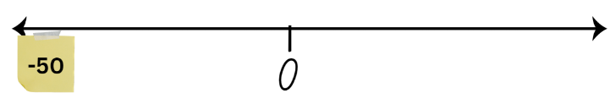
- Take a sticky note with the integer −25 and ask students where this sticky note should be positioned on the number line. Prompt students to place it halfway between 0 and −50 (see Figure 9).
Figure 9 – number line 2
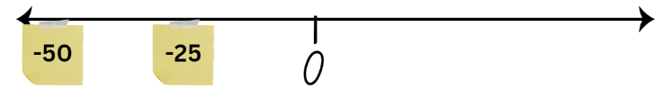
- Next, take a sticky note with the integer 25 on it and select a student to place it on the number line. Have the student explain the reasoning for their placement.
Note: students need to understand that negative numbers and positive numbers need to be the same distance away from the 0, for example, −25 is the same distance away from the 0 as 25 (see Figure 10).
Figure 10 – number line 3
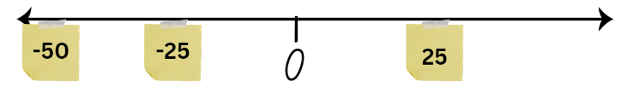
- Repeat Step 3 with the integers: 10, −24, −5, 50.
- Place 3 blank sticky notes at random places on the number line (see Figure 11).
Figure 11 – number line 4
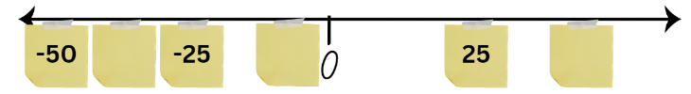
- In pairs, students choose integers that could be written on the blank sticky notes, justifying their thinking.
- Regroup as a class. Select students to share their reasoning and ideas.
This table details opportunities for assessment.
Assessment opportunities | Links
What to look for:  - Can students recognise the location of negative whole numbers in relation to zero and place them on a number line?  [MAO-WM-01, MA3-RN-01]  - Can students use the term integers to describe positive and negative whole numbers and zero? [MAO-WM-01, MA3-RN-01] | Links to National Numeracy Learning Progressions (NNLP):  - NVP9.

Core lesson – dissecting 2D shapes – 35 minutes
The table below contains a suggested learning intention and success criteria. These are best co-constructed with students.
Core concept learning intention | Core concept success criteria
Students are learning to:  - dissect two-dimensional shapes and rearrange them using translations, reflections and rotations. | Students can:  - use the terms translate, reflect and rotate to describe transformations of two-dimensional shapes  - dissect and rearrange one shape to make another.
- Revise the terms translation, reflection and rotation.
Translation: in a translation (slide), every point on the original image moves in the same direction for the same distance to transform the new image.
Reflection: a reflection (flip) requires a line of reflection. A reflection is a transformation in which an object is flipped across the line of reflection.
Rotation: a rotation (turn) requires a centre of rotation (a point) and a degree of rotation, for example, 90 degrees or a $\frac{1}{4}$ turn.
- Provide each student with Resource 11 – theme park signs.
- Explain that the owners of the theme park wish to design new ride signs. To save materials and wastage, they want to use the existing sign and dissect and rearrange it to make another. They have asked your class to identify any smaller shapes that could be created by splitting the existing trapezium signs into new shapes.
- Students use a ruler to draw lines, splitting each trapezium into 2 or more common shapes. Students describe the common shapes created and record the description next to each trapezium.
- Provide students with scissors to cut the signs into smaller shapes which can be rearranged into as many new shapes as possible.
- Students record their thinking about how the new shapes have been rearranged (see Figure 12).
Figure 12 – student work example
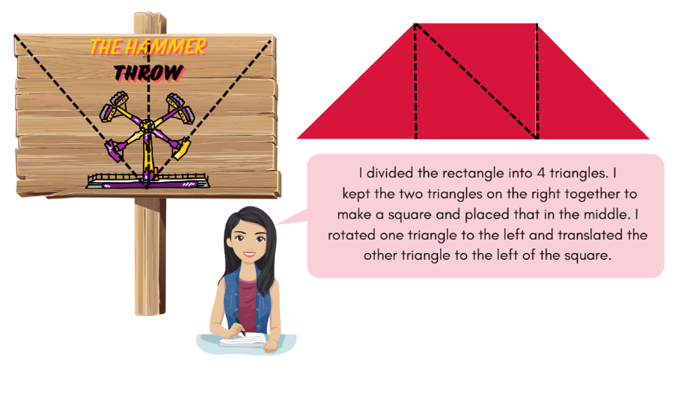
- Students conduct a gallery walk to see the differences and similarities between the new shapes they have made.
- Ask students to find a partner who created different shapes to them and discuss different strategies they used.
This table details opportunities for differentiation.
Too hard? | Too easy?
Students cannot dissect and rearrange one shape to make another.  - Model how to dissect and rearrange a rectangle to make another shape. Encourage students to remake the rectangle and then rearrange that to make a different shape.  - Provide students with grid or isometric dot paper to draw their rectangles. Students cut out their rectangle and use this to create a new shape. | Students can dissect and rearrange one shape to make another.  - Challenge students to rearrange a polygon using a combination of rotations, translations or reflections.  - Encourage students to use Polypad to investigate dissecting and rearranging a shape to make another.

Consolidation and meaningful practice – 15 minutes
- Display Resource 12 – tangram animal silhouettes.
- Provide students with Resource 13 – tangram. Explain to students that they are going to dissect the tangram square into smaller shapes. They will then rearrange the dissected pieces to create the animal shapes. Remind students that they will need to rotate and reflect the pieces.
- Students work in pairs to rearrange the tangram into the animal shapes (see Figure 13).
Figure 13 – tangram answers
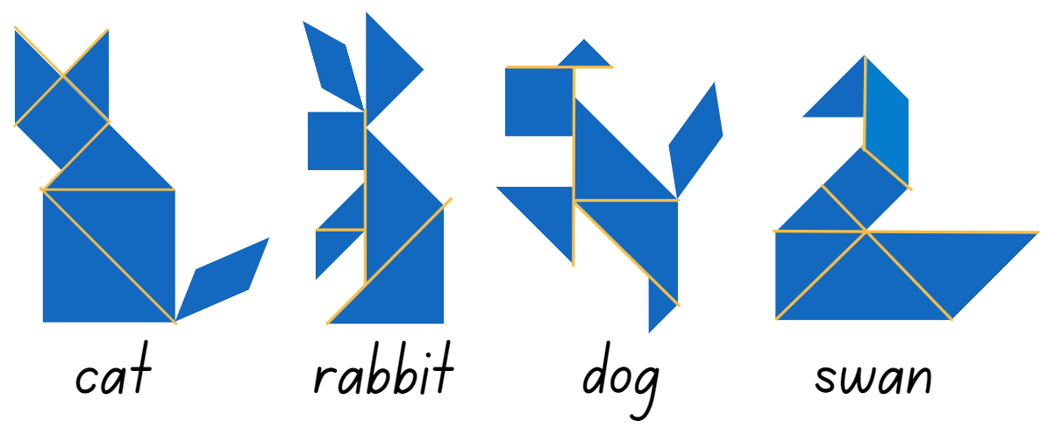
- Regroup and ask the following questions:
- Were you able to rearrange the tangram into the animal shapes?
- Did you have to rotate and reflect the pieces to match the silhouette?
- Were any of the shapes more difficult to create than others? Why?
- Were there any shapes you were unable to create?
- Did you rearrange the tangram into another shape that wasn’t displayed? Describe your shape.
This table details opportunities for assessment.
Assessment opportunities | Links
What to look for:  - Can students use the terms translate, reflect, and rotate to describe transformations of two-dimensional shapes?  [MAO-WM-01, MA3-2DS-01]  - Can students dissect and rearrange one shape to make another? [MAO-WM-01, MA3-2DS-02] | Links to National Numeracy Learning Progressions (NNLP):  - UGP5, UGP6.

Lesson 4
Core concept: objects can be designed by rotating, reflecting and translating two-dimensional shapes.

Daily number sense – 10 minutes
- From a class need surfaced through formative assessment data, identify a short, focused activity that targets students’ knowledge, understanding and skills. Example activities may be drawn from the following resources:
- Mathematics K–6 resources
- Universal Resources Hub.

Core lesson – translate, reflect and rotate – 40 minutes
The table below contains a suggested learning intention and success criteria. These are best co-constructed with students.
Core concept learning intention | Core concept success criteria
Students are learning to:  - dissect two-dimensional shapes and rearrange them using translations, reflections and rotations. | Students can:  - use the terms translate, reflect and rotate to describe transformations of two-dimensional shapes  - recognise that translations, reflections or rotations change the position and orientation but not the size of shapes.
- Revise the terms translate, reflect and rotate from Lesson 3.
- In pairs, students use a digital device and the interactive pattern shapes website to experiment with translating, reflecting and rotating various two-dimensional shapes. Encourage students to describe the transformations to their partner as they work. Ensure students understand how to translate, reflect and rotate a variety of shapes.
- Display Resource 14 – demolition derby design.
- Explain that the owner of the theme park is looking for a new design for one of their demolition derby trucks. They would like a design that includes various two-dimensional shapes that have been rotated, reflected and translated. This is an example of one of the designs they already have of one of their trucks.
- Model how to add the truck template to the interactive pattern shapes workspace by selecting the Outline library icon and selecting the image of the truck.
Note: the Outline library icon is represented by a boat image in the bottom left-hand corner. To locate the truck icon, move the scroll bar to the far right. To rotate the shapes, drag an additional shape onto the workspace. Select the additional shape and select and drag the rotate button at the top of the shape to rotate the shape by a quarter-turn, half-turn or three-quarter turn.
- Students create their own demolition derby truck by manipulating shapes using the interactive pattern shapes website. They write a description of how the two-dimensional shapes were used to create their design, using the terminology of rotating, reflecting and translating.
- Students turn and talk with a partner to share their designs. Ask the following questions:
- Was it easier to translate, rotate or reflect the two-dimensional shapes to create your demolition derby truck? Which one did you use the most?
- Did the size of the shapes change when the position and orientation of the shapes changed? Why or why not?
This table details opportunities for differentiation.
Too hard? | Too easy?
Students cannot use the terms translate, reflect and rotate to describe transformations of two-dimensional shapes.  - Provide students with pattern blocks to create their demolition derby designs. Support students to convert their ideas onto the interactive pattern shapes website.  - Assist students with understanding the vocabulary of translate, reflect and rotate through discussion and modelling. | Students can use the terms translate, reflect and rotate to describe transformations of two-dimensional shapes.  - Challenge students to use the interactive pattern shapes website to create their own carnival stall and ride using two-dimensional shapes that have been translated, reflected and rotated.  - Provide students with isometric dot paper and challenge them to draw their own theme park related objects using two-dimensional shapes.

Consolidation and meaningful practice – 10 minutes
- Display Resource 15 – True or false?
- Explain to students that the black dot on the shape represents the starting point to assist identifying if the shape has been translated, reflected or rotated.
- Ask students to discuss each statement and decide if it is true or false, justifying their reasoning. Select students to model how a false statement could be made true.
- Ask the following questions:
- Did the size of the shapes change when the position and orientation of the shapes change? Why or why not?
- Was the black dot helpful? How?
This table details opportunities for assessment.
Assessment opportunities | Links
What to look for:  - Can students use the terms translate, reflect, and rotate to describe transformations of two-dimensional shapes?  [MAO-WM-01, MA3-2DS-01]  - Can students recognise that translations, reflections or rotations change the position and orientation but not the size of shapes? [MAO-WM-01, MA3-2DS-01] | Links to National Numeracy Learning Progressions (NNLP):  - UGP5, UGP6.

Lesson 5
Core concept: angles can be found in the world around us.

Daily number sense – decoration word problem – 10 minutes
Daily number sense activities for Lessons 5 to 7 ‘loop’ back to concepts and procedures covered in previous units to assist students to build an increasingly connected network of ideas. These concepts may differ from the core concepts being covered by the unit.
The table below contains a suggested learning intention and success criteria. These are best co-constructed with students.
Daily number sense learning intention | Daily number sense success criteria
Students are learning to:  - find fractional quantities of whole numbers (halves, quarters, fifths and tenths). | Students can:  - solve word problems involving a fraction of a quantity.
Note: this activity consolidates concepts covered in Stage 3 Year B Unit 36. A think aloud example was modelled in Lesson 7 of that unit and can be applied to the following word problem.
- Display Resource 16 – decoration fractions.
- Read the word problem, asking students to highlight the important information.
- In pairs, students work to find the solution.
- Regroup and select students to share their strategies and solutions. Ask the following questions:
- How did you split the problem into parts to solve it?
- What fraction of the balloons is 24?
- What is $\frac{1}{5}$ of the total amount?
- How many purple balloons did Gigi buy?
- What was the total amount of balloons?
- What strategy did you use to solve the problem?
- Were there strategies that other pairs used that you didn’t think of?
- Which strategy was the most effective in solving this problem?
Note: consider the use of a bar model to demonstrate the problem solving and strategies applied by the students (see Figure 14).
Figure 14 – bar model sample
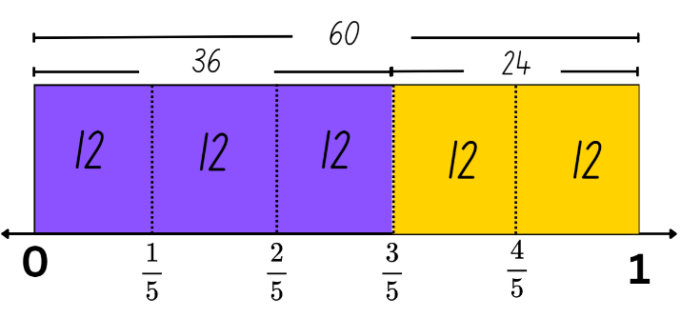
This table details an opportunity for assessment.
Assessment opportunity | Links
What to look for:  - Can students solve word problems involving a fraction of a quantity? [MAO-WM-01, MA3-RQF-02] | Links to National Numeracy Learning Progressions (NNLP):  - InF8.

Core lesson 1 – all about angles – 10 minutes
The table below contains suggested learning intentions and success criteria. These are best co-constructed with students.
Core concept learning intentions | Core concept success criteria
Students are learning to:  - investigate the relationships formed by the intersection of straight lines  - investigate angles on a straight line and angles at a point. | Students can:  - recognise right angles, angles on a straight line and angles at a point embedded in diagrams  - recognise that perpendicular lines intersect at right angles (90°)  - investigate angles at a point and establish that they form an angle of revolution and add to 360°.
- Provide students with individual whiteboards.
- Ask students to represent and record what they know about angles on their whiteboard (see Figure 15).
Figure 15 – student work sample
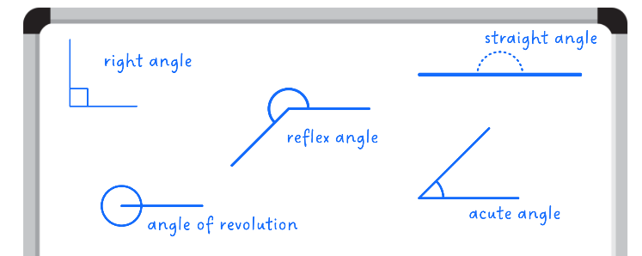
- Display Resource 17 – all about angles. In pairs, students compare their answers, discussing their representations. Ask the following questions:
- Did you record all the different types of angles? How do you know?
- Can you identify the vertex and the arms in each angle?
- What is the difference between a reflex and an obtuse angle?
- Can you see any of these angles in our classroom?

Core lesson 2 – Ferris wheel angles – 40 minutes
- Display Resource 18 – Ferris wheel 1.
- Ask students to identify the vertex. Ensure students understand that intersecting lines create an angle.
- Pose question: When all lines meet at one point, what is the angle that is formed called? How many degrees is this angle?
Note: ensure students understand that angles form around a point are called a revolution and the sum of these angles is 360º.
- Ask students to identify the known angles created by the yellow lines.
- Select students to share their ideas.
- Provide students with Resource 19 – Ferris wheel 2.
- Students identify and label the different types of angles. Ensure students find a variety of angles and identify them in different locations in the image.
- Students form pairs and share their labelled diagram, justifying their choices.
This table details opportunities for differentiation.
Too hard? | Too easy?
Students cannot recognise right angles, angles on a straight line and angles at a point embedded in diagrams.  - Provide students with Resource 17 – all about angles to support their ability to recognise angles.  - Assist students by reducing the number of different angles they are searching for. Ask them to identify right angles only. When they have identified several right angles, ask them to identify angles on a straight line only. | Students can recognise right angles, angles on a straight line and angles at a point embedded in diagrams.  - Using a digital platform, such as Canva, students create an image with a variety of angles (see Figure 16). They show their image to a partner and ask them to identify the angles.  Figure 16 – digital image example  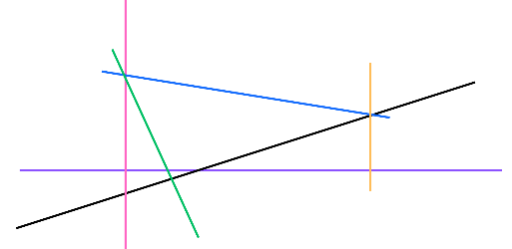  - Students look around different areas of the school, such as the playground, library, office, canteen, and take photos. Using the photos, students identify angles found within their school environment.

Discuss and connect the mathematics – 10 minutes
- Display Resource 20 – Is he correct?
- Ask students to Think-Pair-Share if they agree with Harrison’s answer, justifying their reasoning.
This table details opportunities for assessment.
Assessment opportunities | Links
What to look for:  - Can students recognise right angles, angles on a straight line and angles at a point embedded in diagrams?  [MAO-WM-01, MA3-GM-03]  - Can students recognise that perpendicular lines intersect at right angles (90°)? [MAO-WM-01, MA3-GM-03]  - Can students investigate angles at a point and establish that they form an angle of revolution and add to 360°?  [MAO-WM-01, MA3-GM-03] | Links to National Numeracy Learning Progressions (NNLP):  - UuM8, UGP5, UGP6.

Lesson 6
Core concept: adjacent angles are formed when lines intersect.

Daily number sense – fraction inquiry– 10 minutes
The table below contains a suggested learning intention and success criteria. These are best co-constructed with students.
Daily number sense learning intention | Daily number sense success criteria
Students are learning to:  - find fractional quantities of whole numbers (halves, quarters, fifths and tenths). | Students can:  - calculate quarters and fifths of whole numbers that are multiples of the denominator, using a tape diagram.
This activity is an adaptation of Fraction of a number inquiry from Inquiry Maths by Hindle.
- Write the following on the board: $\frac{2}{5}$ of 40 = $\frac{4}{5}$ of 20.
- Discuss strategies that would prove whether the equation is true or false. Prompt students to use a tape diagram to calculate the answer.
- Provide students with individual whiteboards. Explain that they need to determine whether the equation is true or false and justify their answer using a tape diagram.
- Students turn and talk, sharing their diagrams and reasoning.
- Regroup and ask the following questions:
- Is the equation true or false? Explain your reasoning.
- Was using the tape diagram helpful to figure out the fraction of the quantity? Why or why not?
- What is another way you could have solved this problem?
- Do you see any connections to other mathematical concepts?
- Use Resource 21 – blank tape diagram to model the problem solving and strategies applied by the students (see Figure 17).
Figure 17 – tape diagram sample
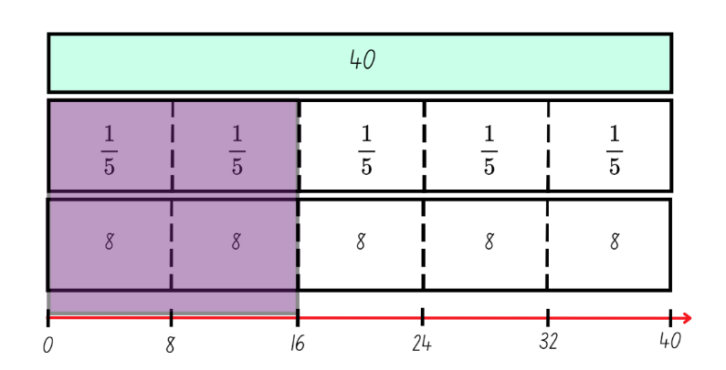
This table details an opportunity for assessment.
Assessment opportunity | Links
What to look for:  - Can students calculate quarters and fifths of whole numbers that are multiples of the denominator, using a tape diagram?  [MAO-WM-01, MA3-RQF-02] | Links to National Numeracy Learning Progressions (NNLP):  - InF8.

Core lesson 1 – investigating adjacent angles – 10 minutes
The table below contains suggested learning intentions and success criteria. These are best co-constructed with students.
Core concept learning intentions | Core concept success criteria
Students are learning to:  - use a protractor to measure and identify types of angles  - investigate the relationships formed by the intersection of straight lines  - investigate angles on a straight line and angles at a point. | Students can:  - create and identify angles of up to 360° using a protractor  - identify the vertex and arms of angles formed by intersecting lines  - investigate adjacent angles that form a right angle and establish that they add to 90°  - investigate adjacent angles on a straight line and establish that they add to 180°  - investigate angles at a point and establish that they form an angle of revolution and add to 360°.
Adjacent angles: angles that share a vertex and an arm. They do not overlap.
- Review Resource 17 – all about angles.
- Draw a right angle on the board with an intersecting line. Label one of the angles as 60° (see Figure 18).
Figure 18 – adjacent angle example
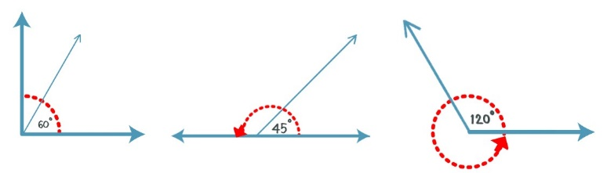
- Ask the following questions:
- How many degrees are in a right angle?
- What is the measurement of the adjacent angle in degrees? How do you know?
- What if I changed the size of the angle to 45°?
- Repeat these steps with a straight angle and an angle of revolution (see Figure 18).

Core lesson 2 – park map – 35 minutes
- Provide students with Resource 22 – park map. Highlight angles a–h on the map, the roads (blue, solid lines) and the walking paths (pink dotted lines).
- Explain that students are going to calculate and record the size of the missing adjacent angles.
- Students work in pairs to record the adjacent angles.
- Regroup and ask the following questions:
- How did you know the size of the adjacent angle?
- Did you notice anything about the relationship between the angle on the straight line and the angle at a point?
- How would you describe the 2 lines that make a right angle?
- How could you check your answer? Is there a tool we could use?
- Display Resource 23 – using a protractor and revise how to measure angles.
- Guide students in measuring angles from the map, ensuring they are using the protractor correctly. Determine whether the measurements recorded earlier were correct.
- Provide students with tracing paper and explain that they are going to record their trip to the theme park by tracing their path as they visit all the attractions.
Note: ensure students are using a ruler to trace their paths. Lines will need to connect to create a vertex for measuring angles later in the lesson.
- Students will need to:
- start at the entrance next to the gift shop
- go on at least 4 rides
- have lunch in the food court
- watch at least one show.
- Once students have traced their path, ask them to lift the tracing paper to reveal a page of intersecting lines and angles (see Figure 19).
- Students measure the angles using a protractor and label them on the tracing paper.
Figure 19 – student work sample
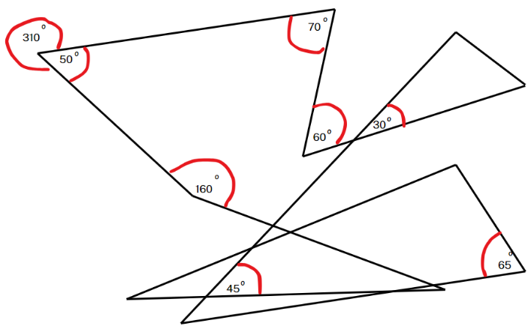
This table details opportunities for differentiation.
Too hard? | Too easy?
Students cannot create and identify angles of up to 360° using a protractor.  - Provide the students with a right-angle tester (square pattern block or folded paper) and allow them to compare the angles as more than or less than 90°. Students record the adjacent angles as obtuse and acute angles. Provide students with Resource 17 – types of angles to support their ability to identify angles.  - Reduce the criteria for students when tracing their path on the map, ensuring they only have 3 or 4 angles to measure. Assist students when measuring with the protractor. | Students can create and identify angles of up to 360° using a protractor.  - Using a digital platform, such as Canva, students create their own map and use the line feature to create angles. Student measure and record angles using a digital protractor.  - Provide students with a copy of the ‘9 dot circles printable sheet’ from Triangles in Circles by NRICH. Students draw lines, joining the centre dot and any dots on the edge (see Figure 20). Students measure and label the internal angles of the shape they created with a protractor.  Figure 20 – NRICH problem  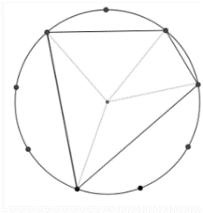  Adapted from University of Cambridge (n.d.).

Discuss and connect the mathematics – 10 minutes
- Display Resource 24 – Elyssa’s path. Explain that this is Elyssa’s path through the theme park. When sharing, her partner noticed some errors with her measurements. Can you spot Elyssa’s mistakes?
- Ask students to Think-Pair-Share Elyssa’s errors, justifying their reasoning.
Note: there are 4 errors within the Resource 24 – Elyssa’s path. These include incorrect measurement of a right angle, incorrect measurement of an adjacent angle on a straight line, incorrect measurement of an adjacent angle at a point and the incorrect use of a protractor.
This table details opportunities for assessment.
Assessment opportunities | Links
What to look for:  - Can students identify the vertex and arms of angles formed by intersecting lines? [MAO-WM-01, MA3-GM-03]  - Can students investigate adjacent angles that form a right angle and establish that they add to 90°? [MAO-WM-01, MA3-GM-03]  - Can students investigate adjacent angles on a straight line and establish that they add to 180°? [MAO-WM-01, MA3-GM-03]  - Can students investigate angles at a point and establish that they form an angle of revolution and add to 360°?  [MAO-WM-01, MA3-GM-03]  - Can students create and identify angles of up to 360° using a protractor? [MAO-WM-01, MA3-GM-03] | Links to National Numeracy Learning Progressions (NNLP):  - UuM8, UGP5, UGP6.

Lesson 7
Core concept: designing allows us to investigate angles and their relationships.

Daily number sense – fraction bingo – 15 minutes
The table below contains a suggested learning intention and success criteria. These are best co-constructed with students.
Daily number sense learning intention | Daily number sense success criteria
Students are learning to:  - find fractional quantities of whole numbers (halves, quarters, fifths and tenths). | Students can:  - find $\frac{1}{2}$, $\frac{1}{4}$, $\frac{1}{5}$ and $\frac{1}{10}$ of collections, expressing remainders as decimals.
- Display Resource 25 – fraction wall. Highlight equivalence between benchmark fractions and decimals.
- Review that$\frac{1}{2}$ is expressed as 0.5 when written as a decimal. Repeat with $\frac{1}{4}$ as .25, $\frac{3}{4}$ as .75 and $\frac{1}{10}$ as .10.
- Explain to students that they will be calculating $\frac{1}{2}$ and $\frac{1}{4}$ of numbers where all the answers will have a remainder.
- Explain that $\frac{1}{4}$ is equal to a half of a half.
- Model how to apply this concept to fractions of a collection. For example, to calculate $\frac{1}{4}$ of 10, we can calculate $\frac{1}{2}$ of 10 is 5 and then $\frac{1}{2}$ of 5 is 2$\frac{1}{2}$, which can be expressed as 2.5.
- Provide students with individual whiteboards and ask them to create a 3 × 3 bingo board.
- Ask students to fill the bingo board with numbers between 1–15. Explain all answers will have a remainder of $\frac{1}{2}$, so each number they write must have a decimal value of .5 such as 3.5, 4.5 (see Figure 21).
Figure 21 – sample bingo board
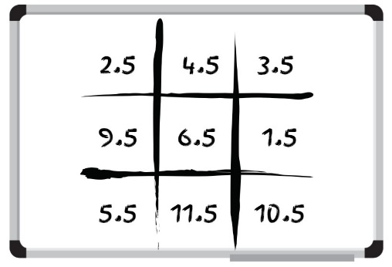
- Read the questions from Resource 26 – bingo questions.
- Students cover with counters or mark off numbers on their bingo board.
- The winner is the first student to cover or mark off all their numbers.
This table details an opportunity for assessment.
Assessment opportunity | Links
What to look for:  - Can students find $\frac{1}{2}$, $\frac{1}{4}$, $\frac{1}{5}$ and $\frac{1}{10}$ of collections, expressing remainders as decimals? [MAO-WM-01, MA3-RQF-02] | Links to National Numeracy Learning Progressions (NNLP):  - InF8.

Core lesson – design a rollercoaster 1 – 45 minutes
The table below contains suggested learning intentions and success criteria. These are best co-constructed with students.
Core concept learning intentions | Core concept success criteria
Students are learning to:  - use a protractor to measure and identify types of angles  - investigate the relationships formed by the intersection of straight lines. | Students can:  - create and identify angles of up to 360° using a protractor  - identify angle types formed by the intersection of straight lines, including right angles (90°), angles on a straight line (add to 180°) and angles at a point that form an angle of revolution (add to 360°)  - recognise that perpendicular lines intersect at right angles (90°)  - investigate adjacent angles that form a right angle and establish that they add to 90° and on a straight line and establish that they add to 180°  - investigate angles at a point and establish that they form an angle of revolution and add to 360°.
Note: this design task is planned to be completed over Lesson 7 and Lesson 8 of this unit. Groups can work at their own pace, with teacher assistance when required. The expectation is that students will work through the success criteria across the 2 days.
- Pose the scenario: the theme park has decided a new rollercoaster will bring in more customers. They have asked you to design this. You will have 2 tasks to complete during the design process. The first task will involve designing for thrill. The second task will involve designing for safety.
- Brainstorm what makes an exciting rollercoaster. Show the class Resource 27 – rollercoasters, including video clips of rollercoasters. Discuss the features that are common and uncommon within these examples. Encourage students to find their own examples to discuss with the class.
- Display and read Resource 28 – designing for thrill and Resource 29 – designing for safety. Clarify any elements of the task as needed.

Note: the design task can be approached in a way that suit the needs in your class. This could mean providing students with both resources and allowing them to work through them at their own pace or giving the resources one at a time and bringing the students back together when ready to move on to the next task. Monitor students, providing feedback, support and challenge where required. These tasks could be completed on paper or using digital software such as Canva or PowerPoint.
- Working in pairs or groups of 3, provide students with copies of Resource 28 – designing for thrill and Resource 29 – designing for safety.
- Students work through the design tasks.
This table details opportunities for differentiation.
Too hard? | Too easy?
Students cannot create and identify angles of up to 360° using a protractor.  - Assist students to identify the angle they are going to measure. It could be shaded in or highlighted to make it clearer to see.  - Support students to align their protractor accurately, then count the number of degrees in the angle starting from 0°. | Students can create and identify angles of up to 360° using a protractor.  - Use digital software such as Canva or PowerPoint to create a line artwork. Students print their artwork and use a protractor to calculate the angles created by the lines.  - Challenge students to find images of rollercoasters in books or on the internet. Ask students to categorise, measure and record the size of the angles in one of the rollercoasters. Have students determine which type of angle is most common and reflect on why.

Discuss and connect the mathematics – 5 minutes
- Engage students in a whole-class discussion about their rollercoaster design so far. Prompts could include:
- Have you found anything challenging?
- Which strategies have you used to design the rollercoaster, while making sure to include the appropriate angles?
- Were you able to solve any calculations mentally?
- Have you checked your solutions using more than one method?
This table details opportunities for assessment.
Assessment opportunities | Links
What to look for:  - Can students create and identify angles of up to 360° using a protractor? [MAO-WM-01, MA3-GM-03]  - Can students identify angle types formed by the intersection of straight lines, including right angles (90°), angles on a straight line (add to 180°) and angles at a point that form an angle of revolution (add to 360°)? [MAO-WM-01, MA3-GM-03]  - Can students recognise that perpendicular lines intersect at right angles (90°)? [MAO-WM-01, MA3-GM-03]  - Can students investigate adjacent angles that form a right angle and establish that they add to 90° and on a straight line and establish that they add to 180°? [MAO-WM-01, MA3-GM-03]  - Can students investigate angles at a point and establish that they form an angle of revolution and add to 360°?  [MAO-WM-01, MA3-GM-03] | Links to National Numeracy Learning Progressions (NNLP):  - UuM8, UGP5, UGP6.

Lesson 8
Core concept: designing allows us to investigate angles and their relationships.

Daily number sense – 10 minutes
- From a class need surfaced through formative assessment data, identify a short, focused activity that targets students’ knowledge, understanding and skills. Example activities may be drawn from the following resources:
- Mathematics K–6 resources
- Universal Resources Hub.

Core lesson – design a rollercoaster 2 – 30 minutes
The table below contains suggested learning intentions and success criteria. These are best co-constructed with students.
Core concept learning intentions | Core concept success criteria
Students are learning to:  - use a protractor to measure and identify types of angles  - investigate the relationships formed by the intersection of straight lines. | Students can:  - create and identify angles of up to 360° using a protractor  - identify angle types formed by the intersection of straight lines, including right angles (90°), angles on a straight line (add to 180°) and angles at a point that form an angle of revolution (add to 360°)  - recognise that perpendicular lines intersect at right angles (90°)  - investigate adjacent angles that form a right angle and establish that they add to 90°, and on a straight line, establish that they add to 180°  - investigate angles at a point and establish that they form an angle of revolution and add to 360°.
Note: Lesson 8 is a continuation of Lesson 7 – a 2-lesson design task. You might like to start your lesson with feedback from Lesson 7, including a review of any challenges you noticed students facing.
- Students return to their pairs or groups and continue with their design task.
- Monitor progress as students work, providing feedback and support and challenging students where needed.
- Regroup and display Resource 30 – feedback criteria.
- Discuss the criteria that will be used to assess elements for students’ rollercoaster designs.
- Students swap their designs with another pair or group. Using the Resource 30 – feedback criteria, students assess the other pair’s or group’s design, providing feedback on areas they have completed well and areas for improvement (see Figure 22).
Figure 22 – student work example
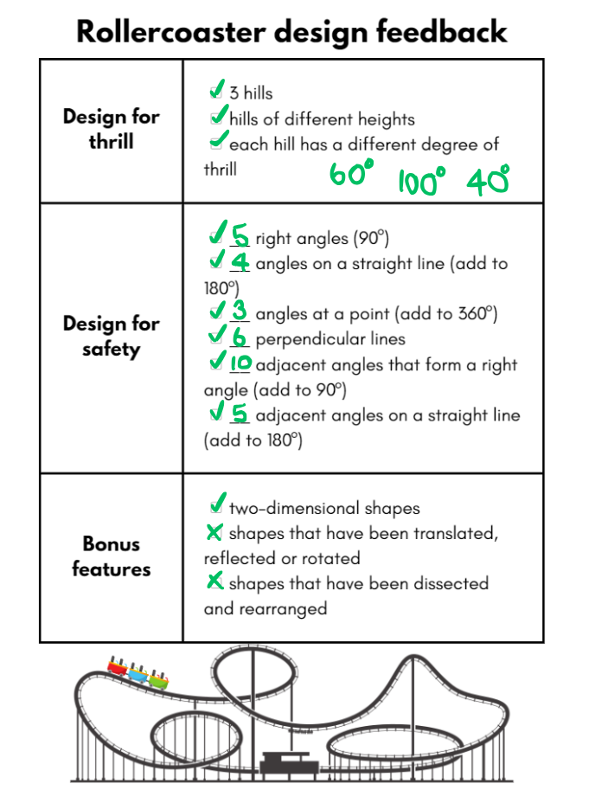
- Students return the designs and feedback to their original owners.
- Members of each pair or group review the feedback provided and make changes to their design where needed.
This table details opportunities for differentiation.
Too hard? | Too easy?
Students cannot identify angle types formed by the intersection of straight lines, including right angles (90°), angles on a straight line (add to 180°) and angles at a point that form an angle of revolution (add to 360°).  - Assist students to use 2 craft sticks to create a right angle. Use this angle identifier to confirm that an angle has 90°. They could also use one craft stick to identify a straight angle (180°).  - Support students to highlight or colour on type of angle at a time. | Students can identify angle types formed by the intersection of straight lines, including right angles (90°), angles on a straight line (add to 180°) and angles at a point that form an angle of revolution (add to 360°).  - Use digital software such as Canva or PowerPoint to create the support structure for each hill.  - Challenge students to use digital software such as Canva or PowerPoint to create a poster to identify the different angle types needed within their safety structure.

Discuss and connect the mathematics – 20 minutes
- Students complete a gallery walk.
- Join pairs or groups together to share and compare their designs. Ask each group to:
- explain and justify their rollercoaster design choices
- share the strategies they used and how they checked their answers
- acknowledge feedback given and the changes they made to their design to reflect this feedback
- identify parts of the lesson they found challenging and those that weren’t as challenging.
- At the end of the discussion, students write a personal reflection of their use of angles during this design task. Some prompts might include:
- Where have you been flexible in your thinking?
- When did you explain your thinking clearly?
- Can you provide an example of when you were accurate and efficient to solve the task?
- What are 2 connections you can make about angles?
This table details opportunities for assessment.
Assessment opportunities | Links
What to look for:  - Can students create and identify angles of up to 360° using a protractor? [MAO-WM-01, MA3-GM-03]  - Can students identify angle types formed by the intersection of straight lines, including right angles (90°), angles on a straight line (add to 180°) and angles at a point that form an angle of revolution (add to 360°)? [MAO-WM-01, MA3-GM-03]  - Can students recognise that perpendicular lines intersect at right angles (90°)? [MAO-WM-01, MA3-GM-03]  - Can students investigate adjacent angles that form a right angle and establish that they add to 90°, and on a straight line, establish that they add to 180°? [MAO-WM-01, MA3-GM-03]  - Can students investigate angles at a point and establish that they form an angle of revolution and add to 360°?  [MAO-WM-01, MA3-GM-03] | Links to National Numeracy Learning Progressions (NNLP):  - UuM8, UGP5, UGP6.

Resource 1 – integer place value gameboard
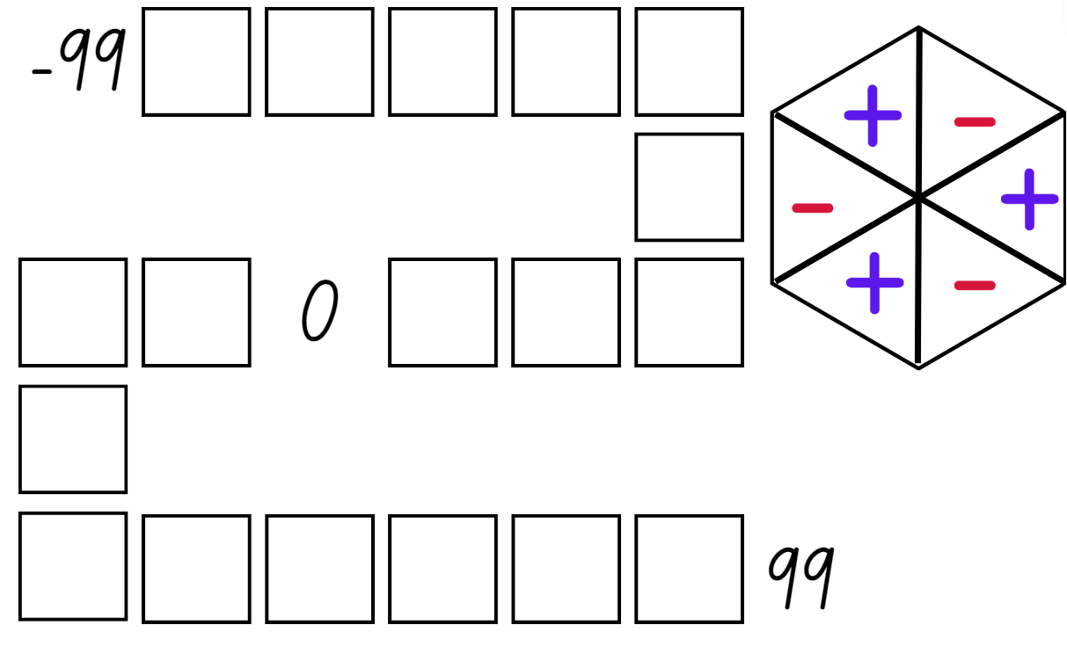

Resource 2 – theme park timetable
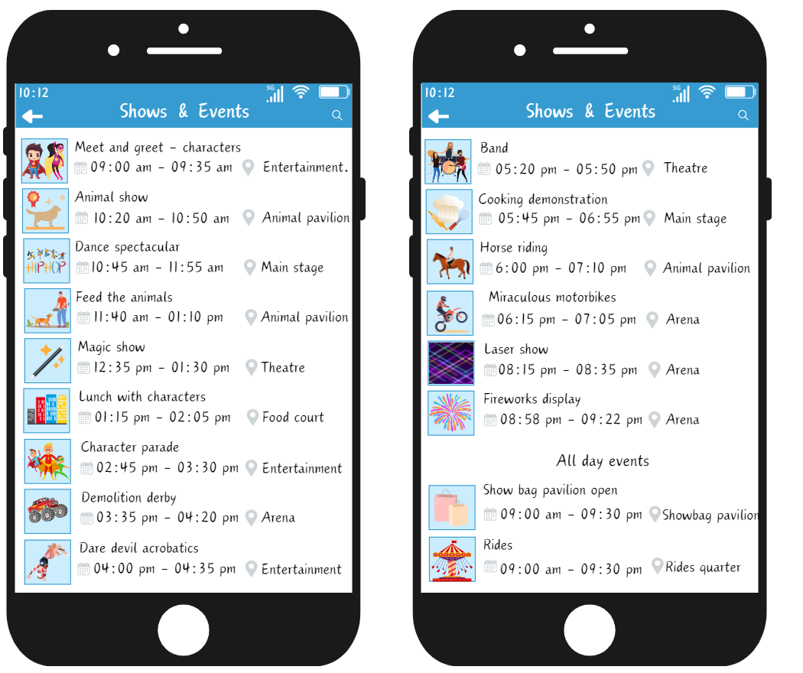

Resource 3 – ZOOM strategy
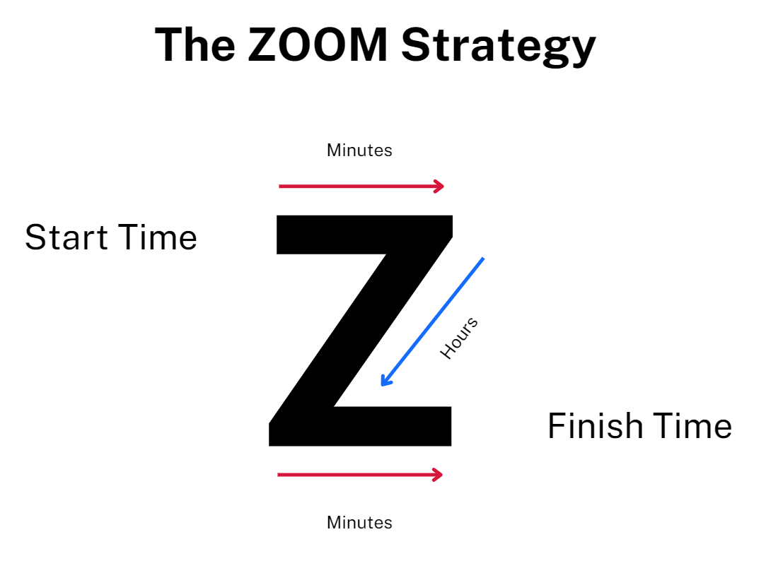

Resource 4 – theme park questions
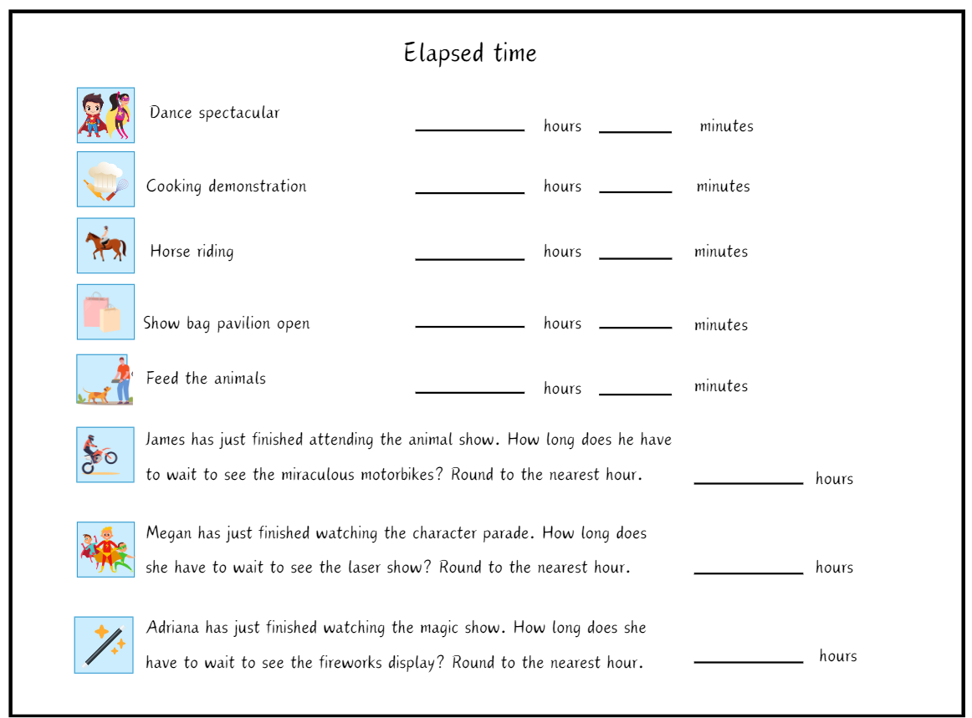

Resource 5 – time misconceptions
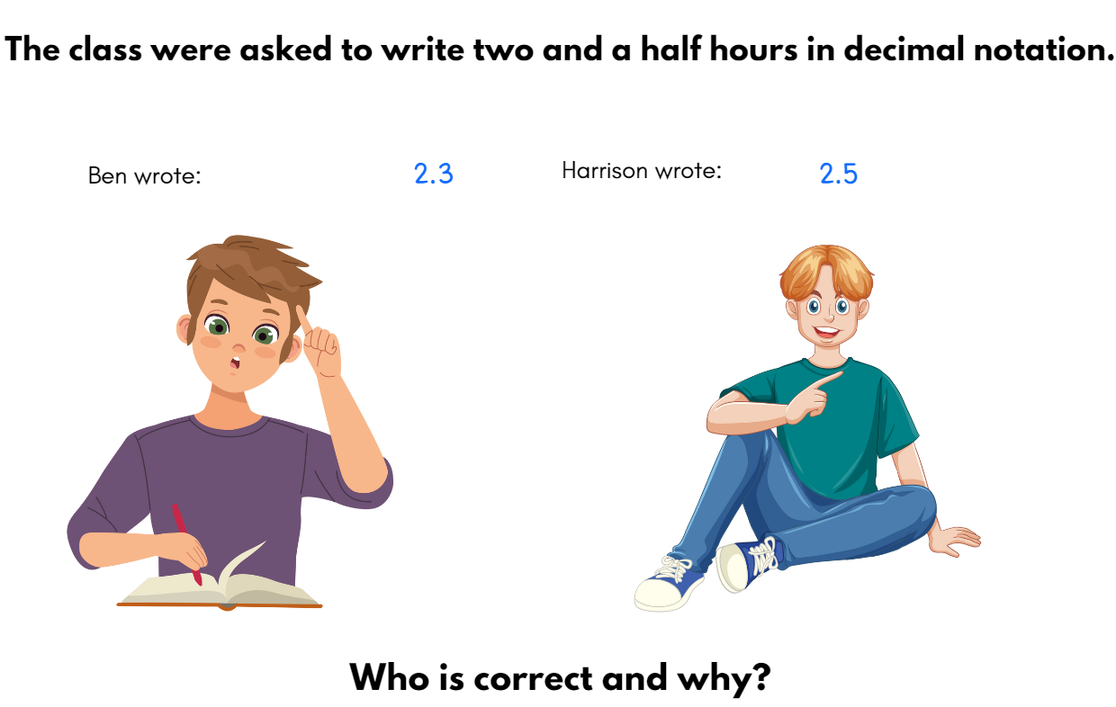

Resource 6 – time intervals
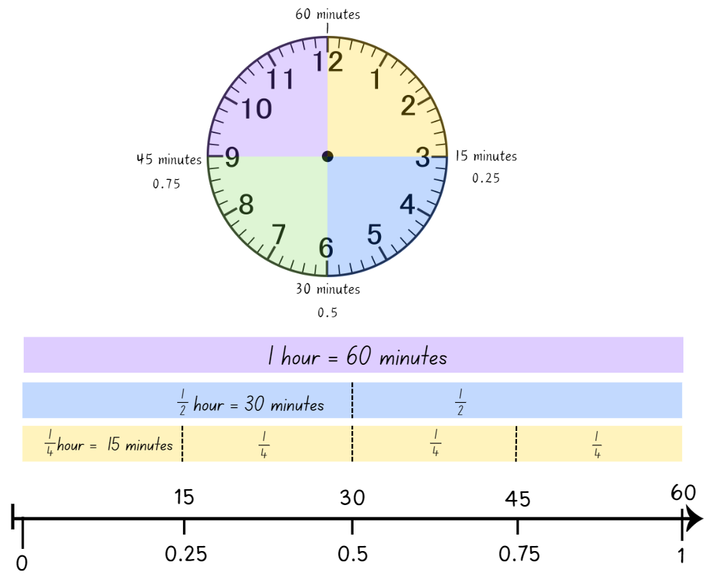

Resource 7 – time memory
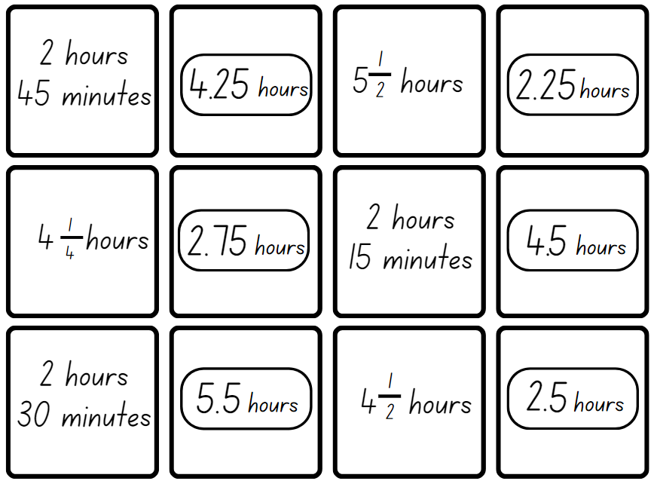
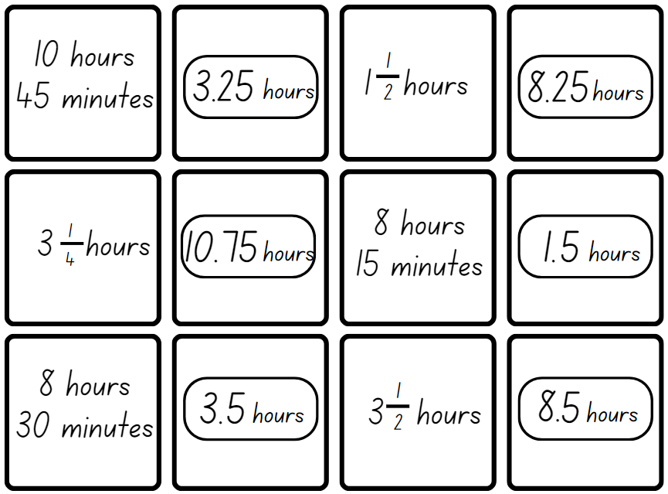

Resource 8 – 24-hour time
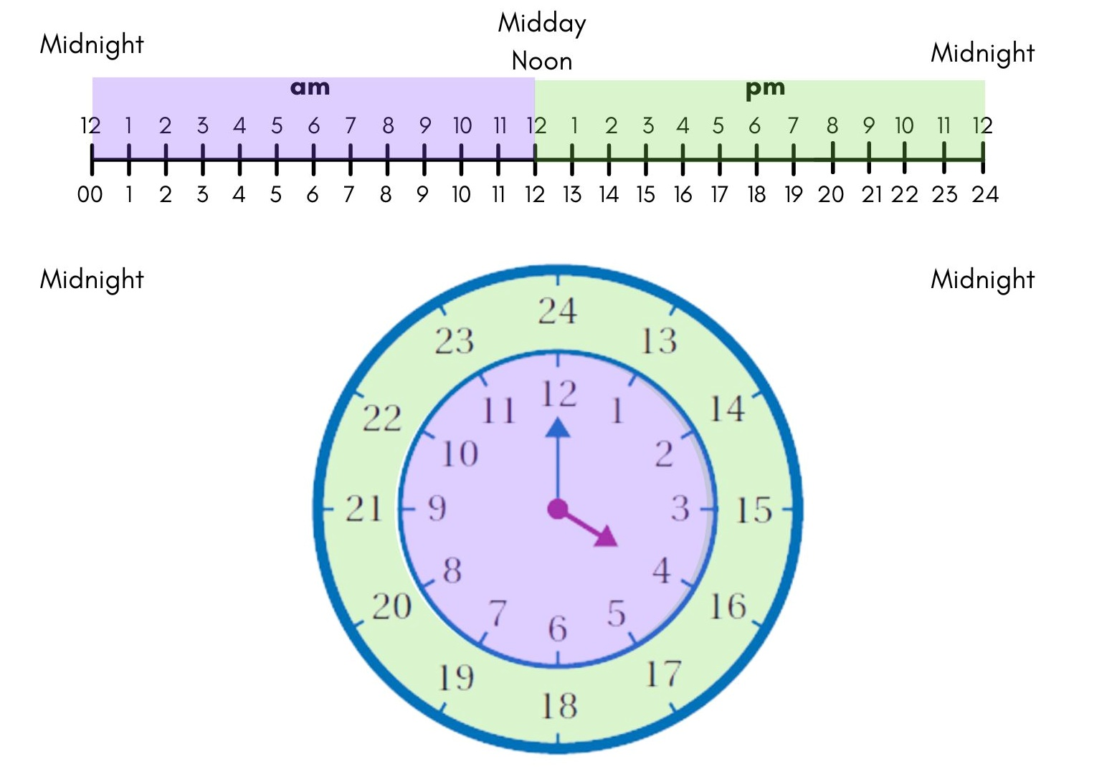

Resource 9 – 24-hour timetable
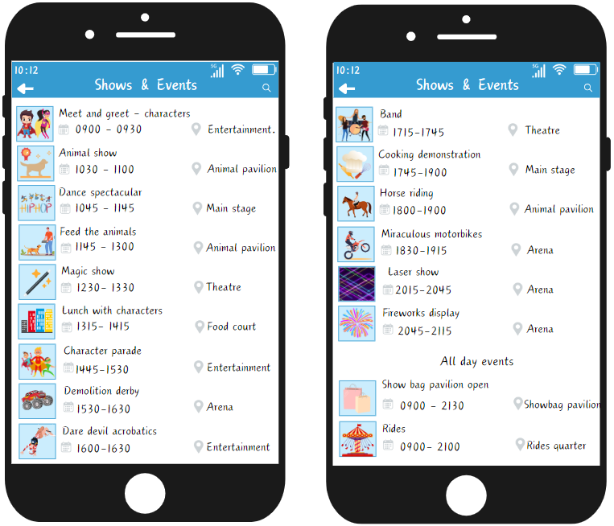

Resource 10 – planning a day
Activity | Start | Finish | Activity time elapsed | Decimal notation | Time between activities | Decimal notation

Resource 11 – theme park signs
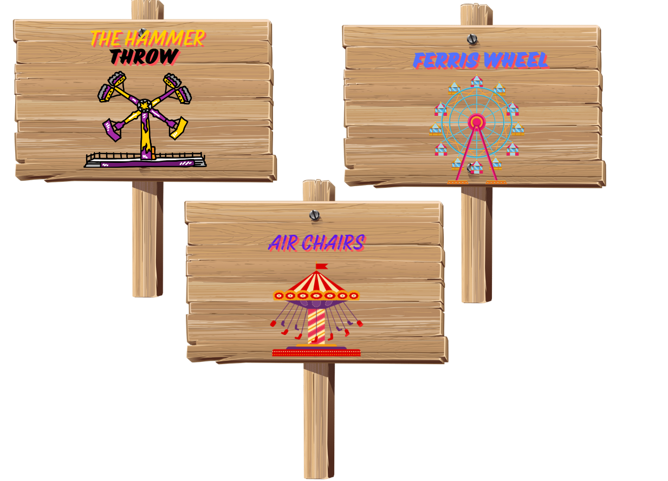

Resource 12 – tangram animal silhouettes
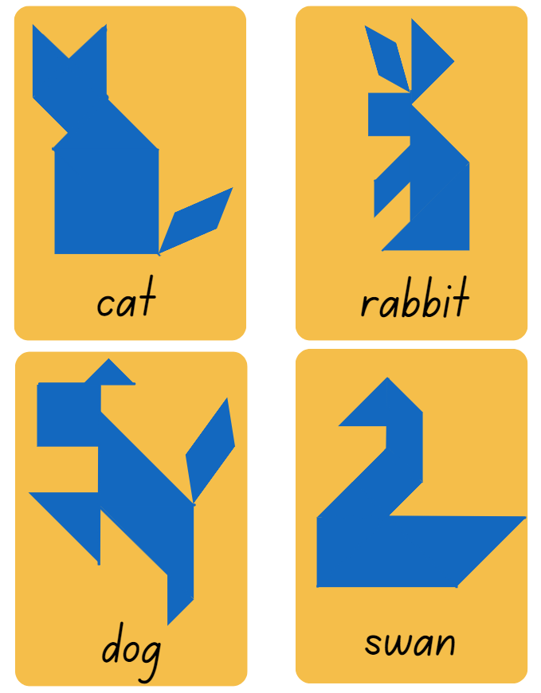

Resource 13 – tangram


Resource 14 – demolition derby design
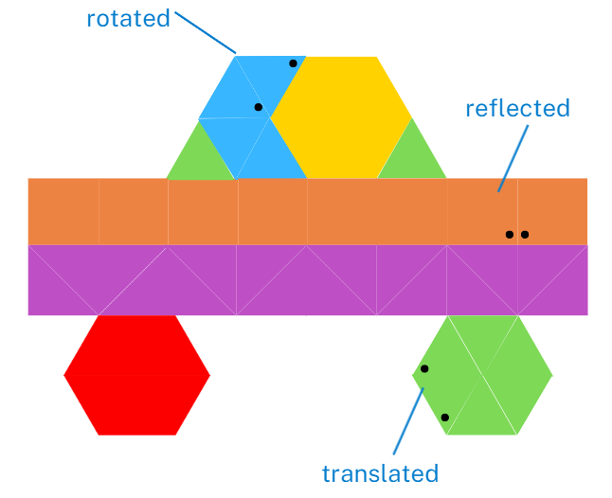

Resource 15 – True or false?
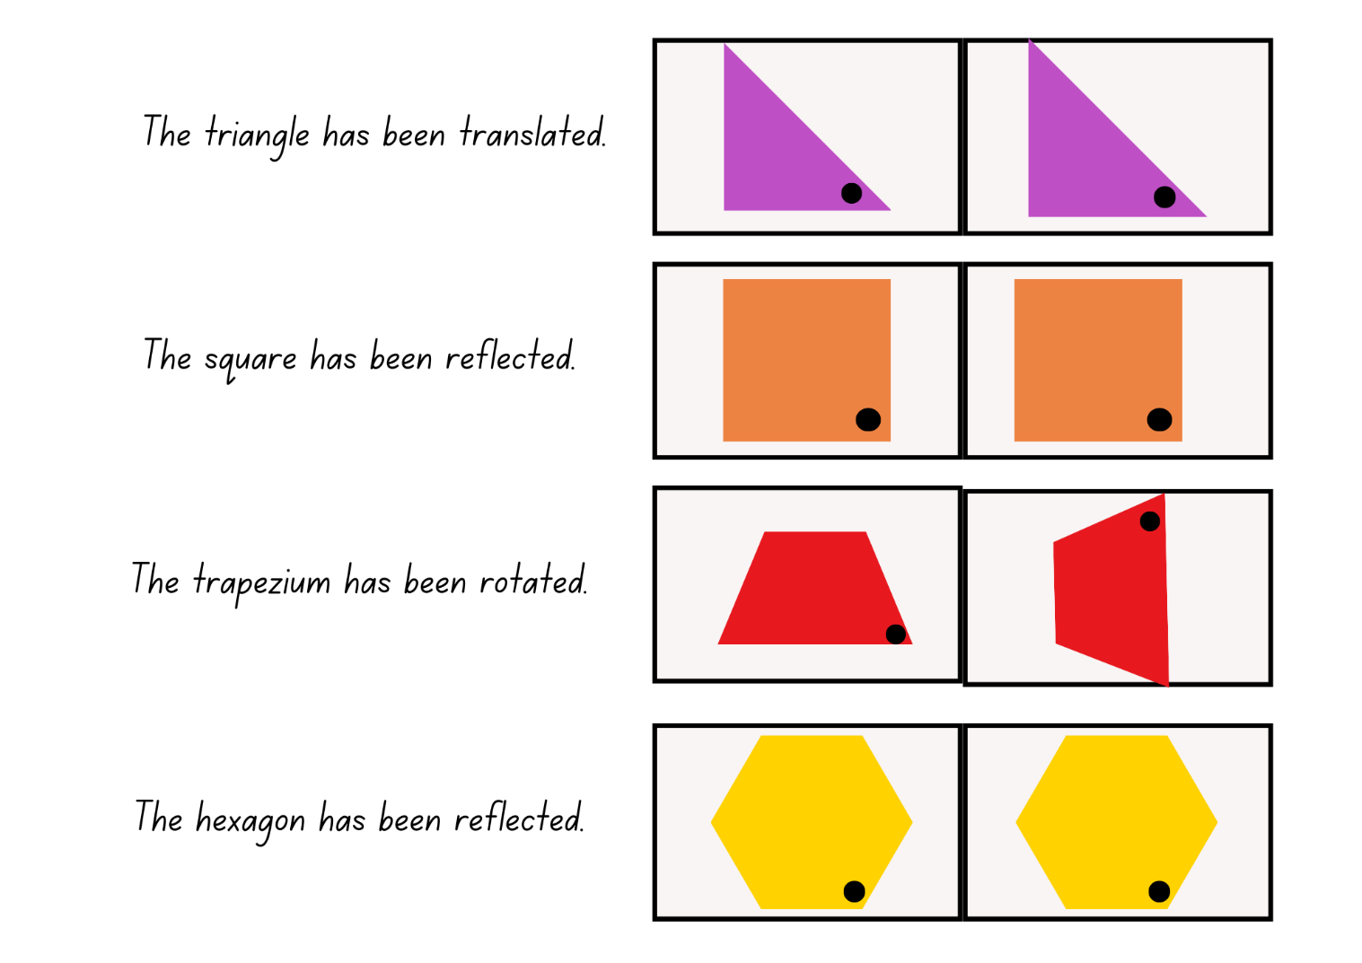
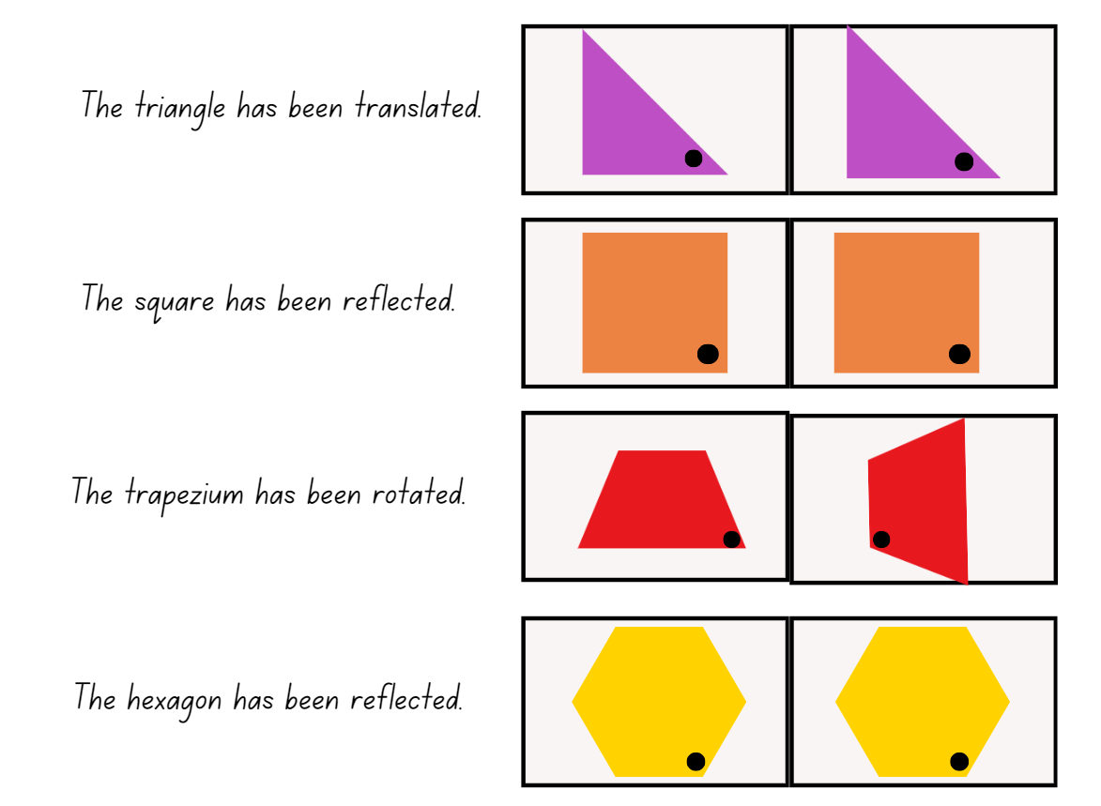

Resource 16 – decoration fractions
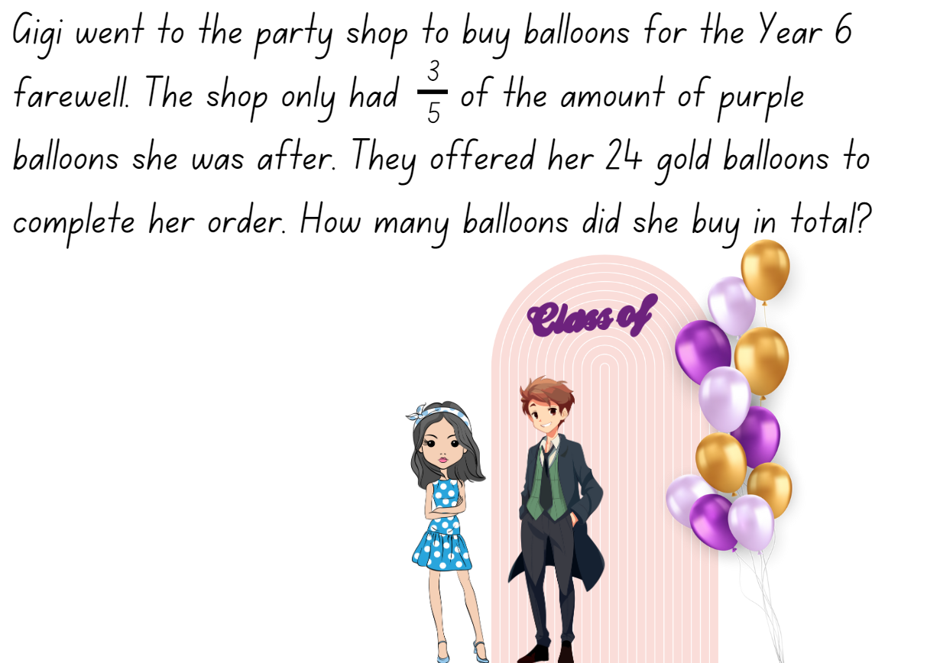

Resource 17 – all about angles
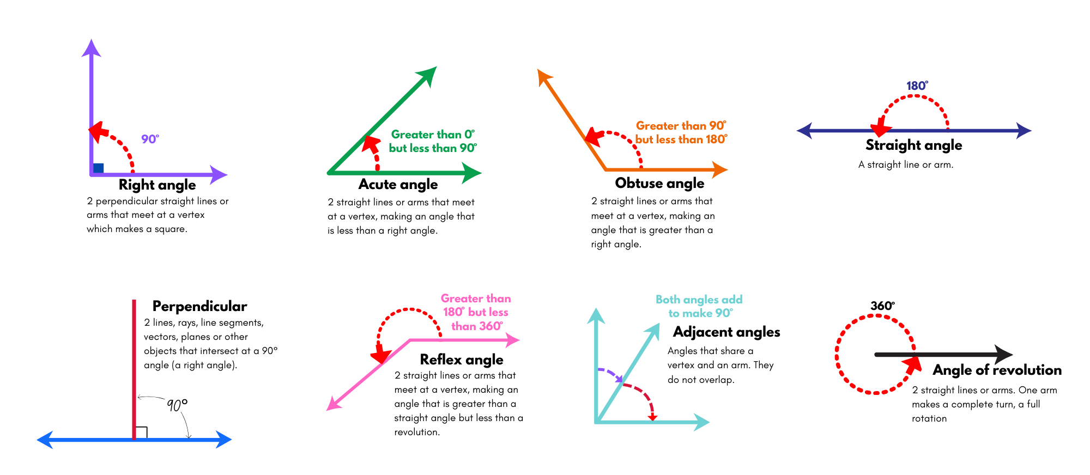

Resource 18 – Ferris wheel 1
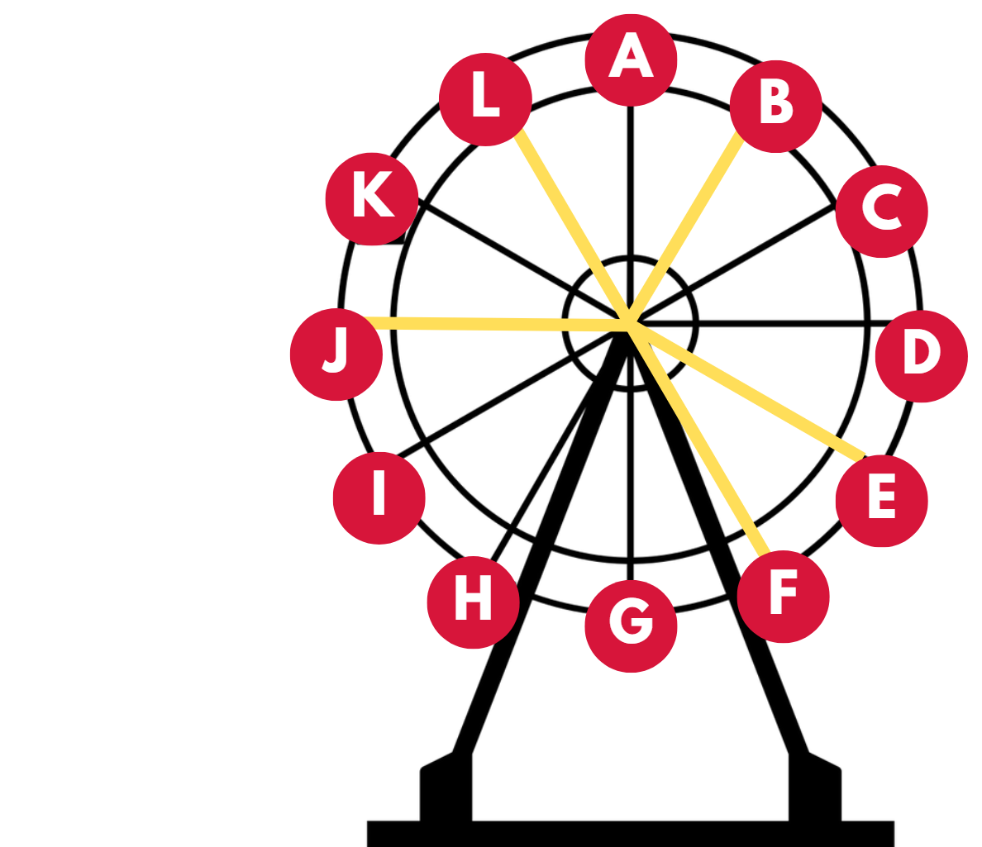

Resource 19 – Ferris wheel 2
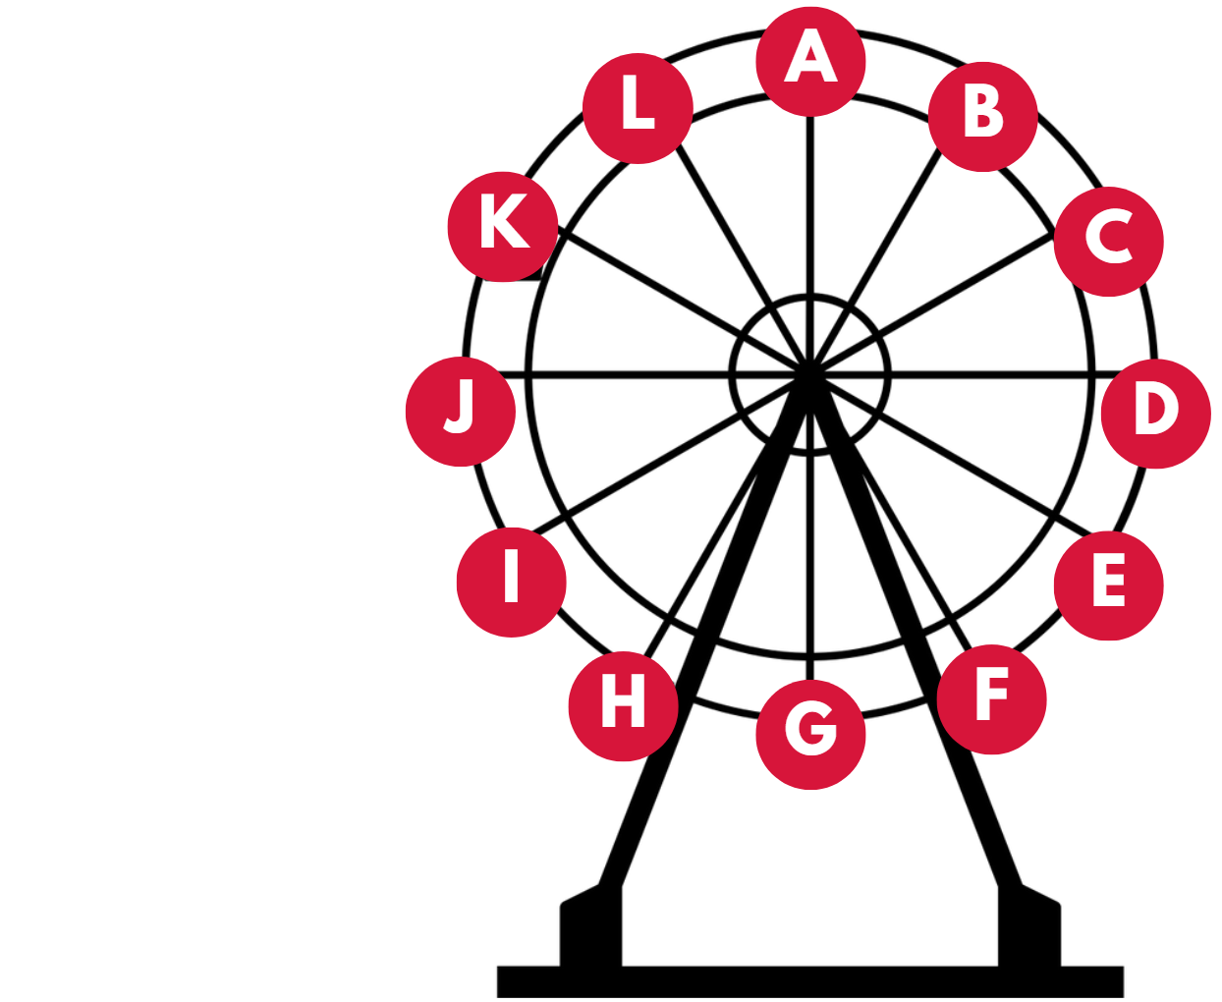

Resource 20 – Is he correct?
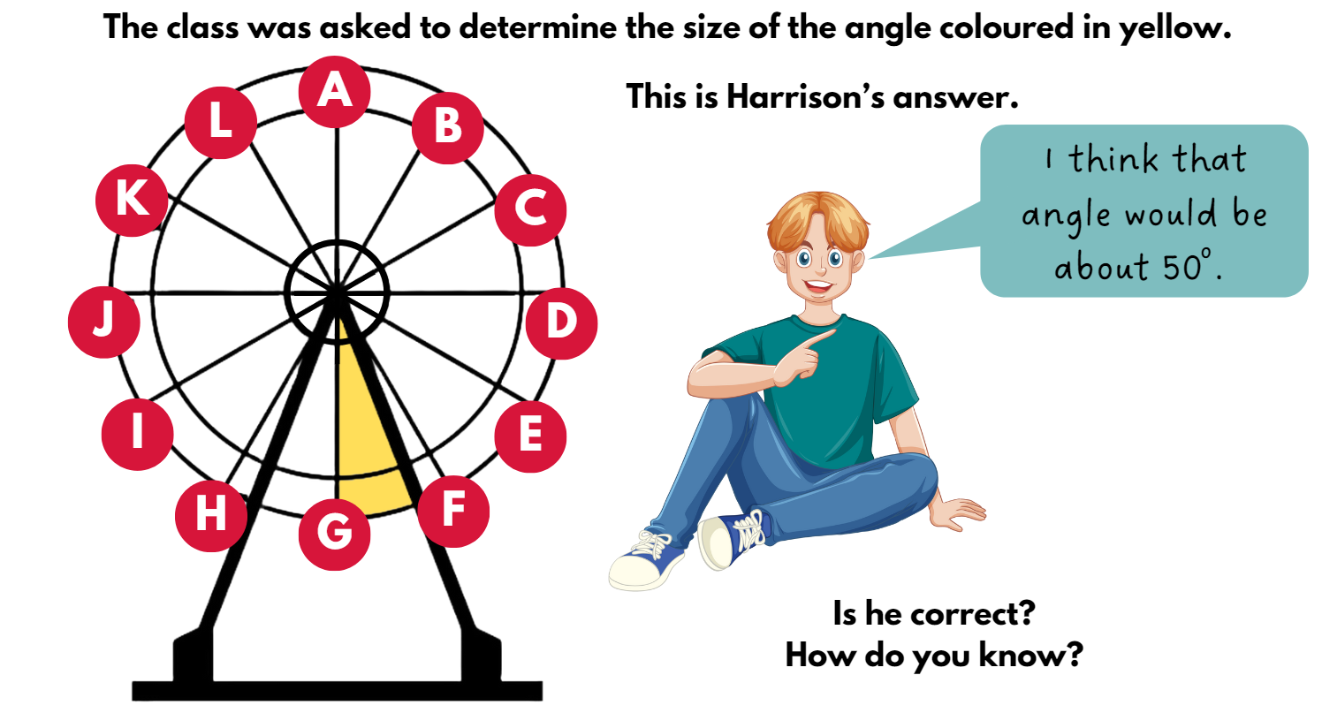

Resource 21 – blank tape diagram
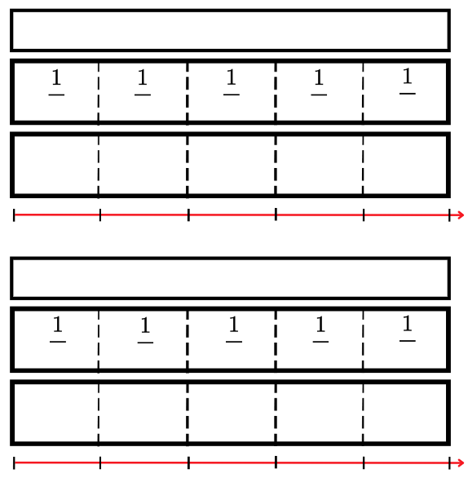

Resource 22 – park map
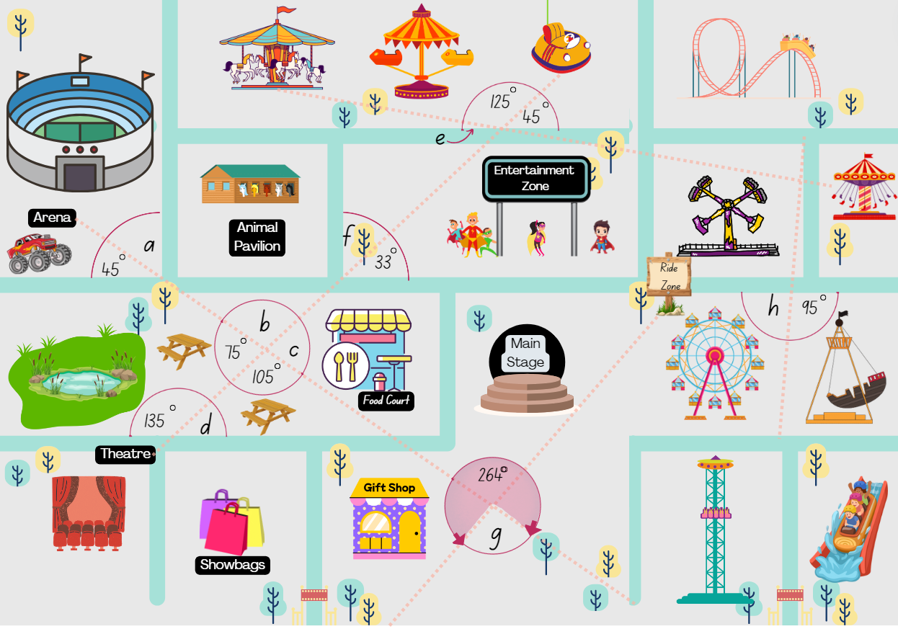

Resource 23 – using a protractor
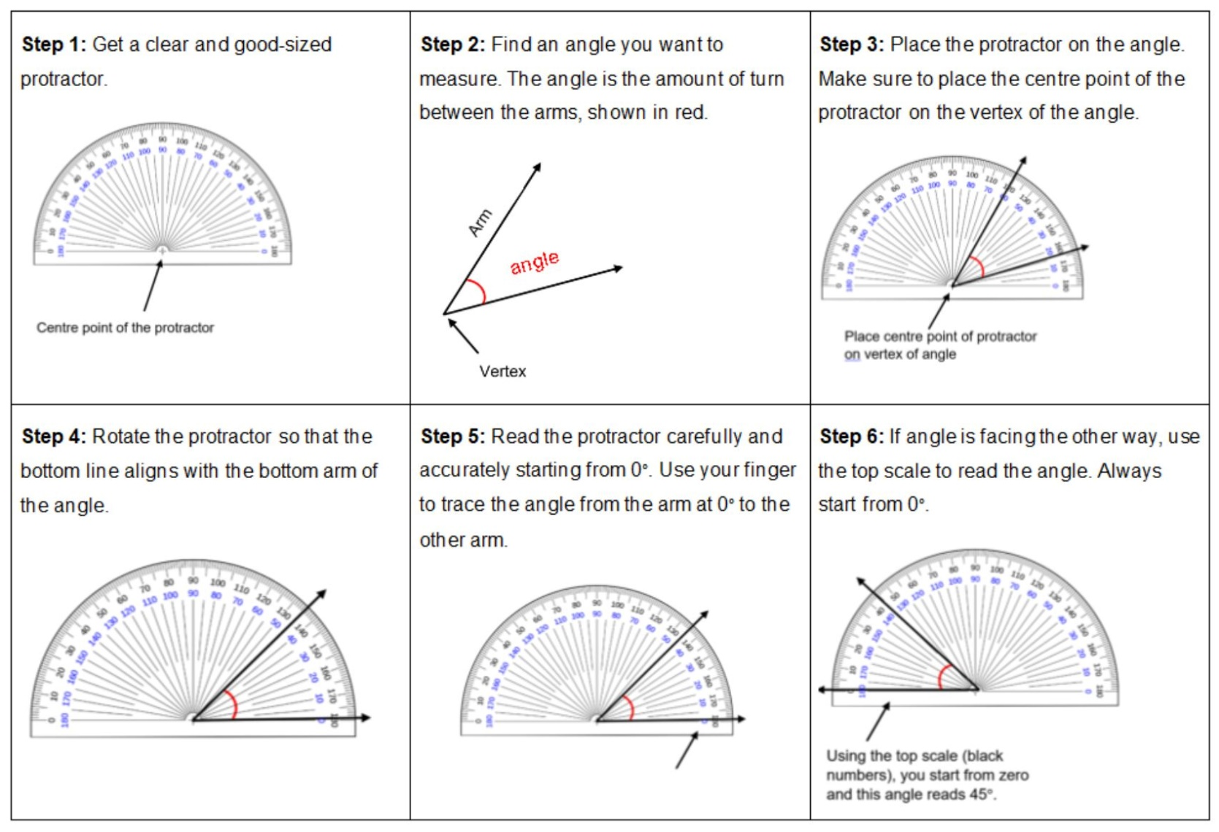

Resource 24 – Elyssa’s path
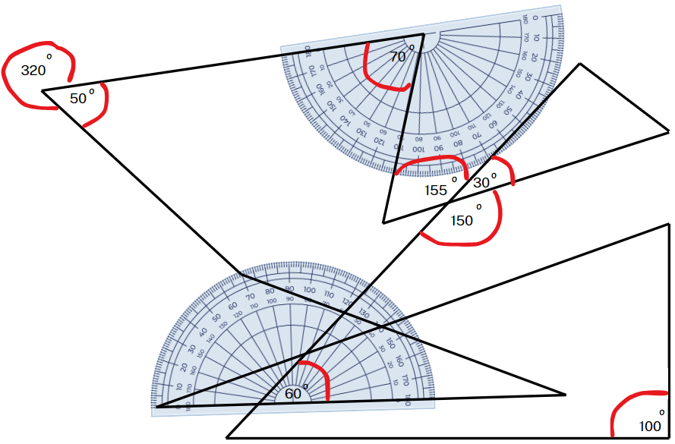

Resource 25 – fraction wall
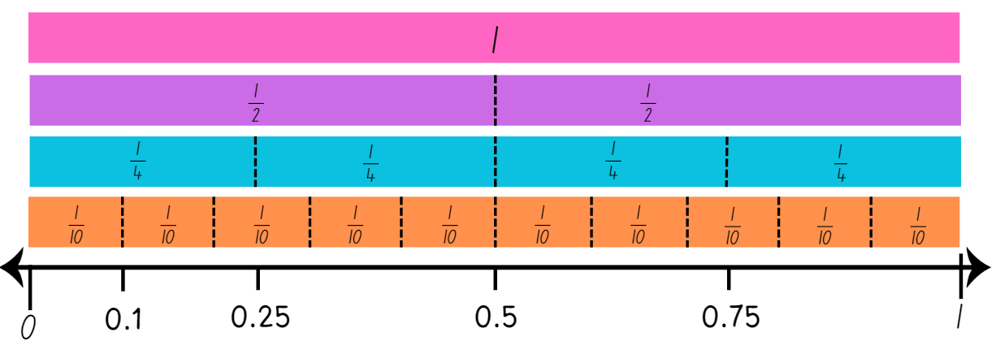

Resource 26 – bingo questions
- $\frac{1}{4}$of 6  - $\frac{1}{2}$of 23  - $\frac{1}{4}$of 18  - $\frac{1}{2}$ of 5  - $\frac{1}{4}$of 50  - $\frac{1}{2}$of 15  - $\frac{1}{4}$of 22 | - $\frac{1}{2}$of 17  - $\frac{1}{4}$of 26  - $\frac{1}{2}$of 29  - $\frac{1}{4}$of 14  - $\frac{1}{2}$of 19  - $\frac{1}{2}$of 27  - $\frac{1}{4}$of 42

Resource 27 – rollercoasters
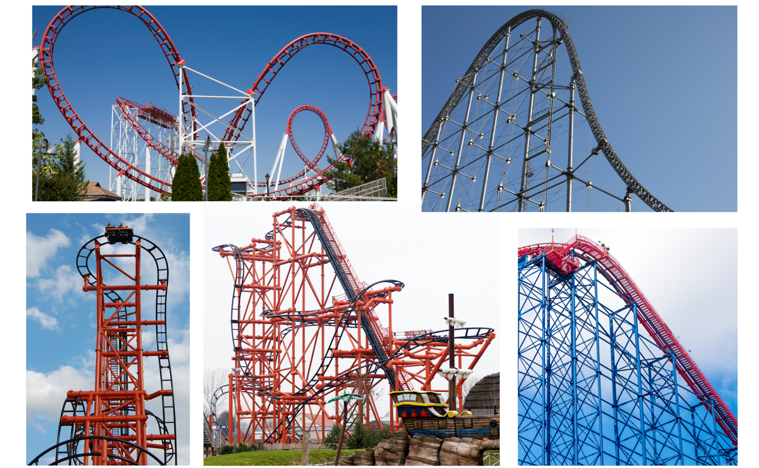

Resource 28 – designing for thrill
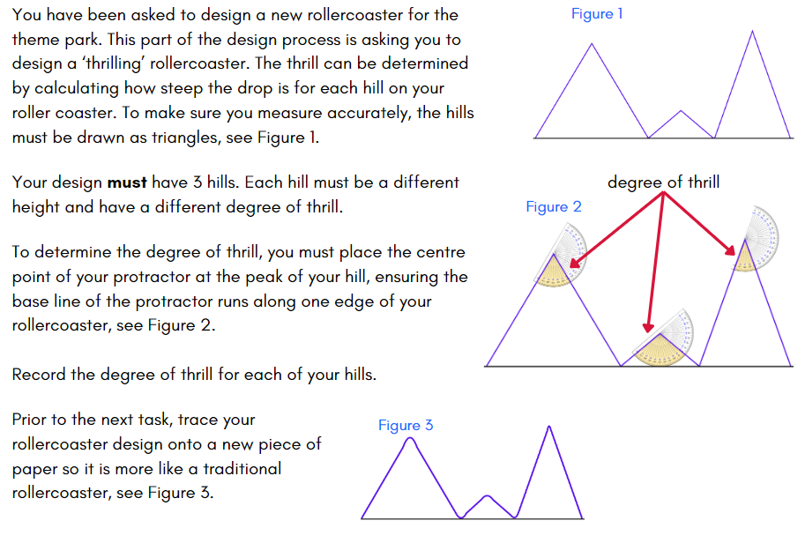

Resource 29 – designing for safety
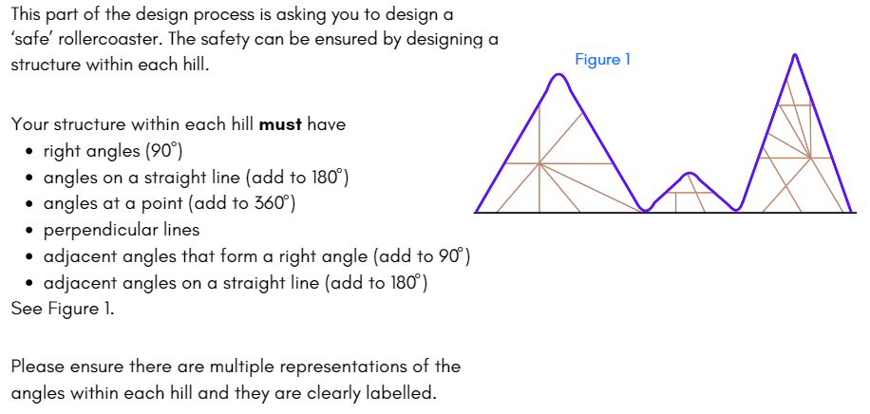

Resource 30 – feedback criteria
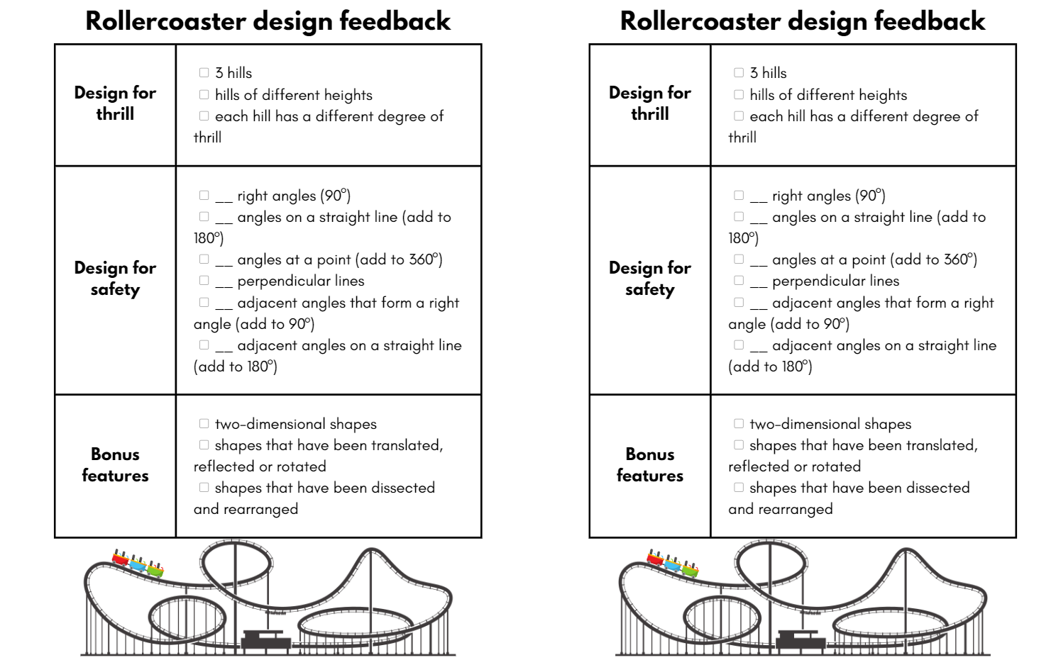

Syllabus outcomes and content
The table below outlines the syllabus outcomes and range of relevant syllabus content covered in this unit. Content is linked to National Numeracy Learning Progression (version 3).
Outcomes and content | 1 | 2 | 3 | 4 | 5 | 6 | 7 | 8
Represents numbers B: Whole numbers: Locate and represent integers on a number line
[MAO-WM-01, MA3-RN-01]
- Recognise the location of negative whole numbers in relation to zero and place them on a number line | x | x | x
- Use the term integers to describe positive and negative whole numbers and zero | x | x | x
Representing quantity fractions B: Find fractional quantities of whole numbers (halves, quarters, fifths and tenths)
[MAO-WM-01, MA3-RQF-02]
- Calculate quarters and fifths of whole numbers that are multiples of the denominator, using a tape diagram |  |  |  |  |  | x
- Solve word problems involving a fraction of a quantity |  |  |  |  | x
- Find $\frac{1}{2}$, $\frac{1}{4}$, $\frac{1}{5}$ and $\frac{1}{10}$ of collections, expressing remainders as decimals |  |  |  |  |  |  | x
Geometric measure A: Angles: Estimate, measure and compare angles using degrees
[MAO-WM-01, MA3-GM-03]
- Measure angles of up to 360° using a protractor |  |  |  |  |  | x | x | x
Geometric measure A: Angles: Use a protractor to measure and identify types of angles
[MAO-WM-01, MA3-GM-03]
- Create angles of up to 360° using a protractor |  |  |  |  |  |  | x | x
Geometric measure B: Angles: Investigate angles on a straight line and angles at a point
[MAO-WM-01, MA3-GM-03]
- Recognise right angles, angles on a straight line and angles at a point embedded in diagrams (Reasons about spatial orientation) |  |  |  |  | x
- Identify the vertex and arms of angles formed by intersecting lines |  |  |  |  |  | x
Geometric measure B: Angles: Investigate the relationships formed by the intersection of straight lines
[MAO-WM-01, MA3-GM-03]
- Identify angle types formed by the intersection of straight lines, including right angles (90°), angles on a straight line (add to 180°) and angles at a point that form an angle of revolution (add to 360°) |  |  |  |  |  |  | x | x
- Recognise that perpendicular lines intersect at right angles (90°) |  |  |  |  | x |  | x | x
- Investigate adjacent angles that form a right angle and establish that they add to 90° |  |  |  |  |  | x | x | x
- Investigate adjacent angles on a straight line and establish that they add to 180° |  |  |  |  |  | x | x | x
- Investigate angles at a point and establish that they form an angle of revolution and add to 360° |  |  |  |  | x | x | x | x
Two-dimensional spatial structure B: 2D shapes: Dissect two-dimensional shapes and rearrange them using translations, reflections and rotations
[MAO-WM-01, MA3-2DS-01]
- Use the terms translate, reflect and rotate to describe transformations of two-dimensional shapes |  |  | x | x |  |  |  | x
- Dissect and rearrange one shape to make another |  |  | x |  |  |  |  | x
- Recognise that translations, reflections or rotations change the position and orientation but not the size of shapes (Reasons about spatial orientation) |  |  |  | x |  |  |  | x
Non-spatial measure B: Time: Solve problems involving duration, using 12- and 24-hour time
[MAO-WM-01, MA3-NSM-02]
- Use start and finish times to calculate the elapsed time of events | x
- Add and subtract time mentally using bridging strategies | x
- Round answers to time calculations to the nearest minute or hour | x
- Represent commonly used time intervals as decimals |  | x
- Solve a variety of problems involving duration, including where times are expressed in 12-hour and 24-hour notation |  | x
Mathematics K–10 Syllabus © NSW Education Standards Authority (NESA) for and on behalf of the Crown in right of the State of New South Wales, 2022.

References
This resource contains NSW Curriculum and syllabus content. The NSW Curriculum is developed by the NSW Education Standards Authority. This content is prepared by NESA for and on behalf of the Crown in right of the State of New South Wales. The material is protected by Crown copyright.
Please refer to the NESA Copyright Disclaimer for more information https://educationstandards.nsw.edu.au/wps/portal/nesa/mini-footer/copyright.
NESA holds the only official and up-to-date versions of the NSW Curriculum and syllabus documents. Please visit the NSW Education Standards Authority (NESA) website https://educationstandards.nsw.edu.au and the NSW Curriculum website https://curriculum.nsw.edu.au.
Mathematics K–10 Syllabus © NSW Education Standards Authority (NESA) for and on behalf of the Crown in right of the State of New South Wales, 2022.
National Numeracy Learning Progression © Australian Curriculum, Assessment and Reporting Authority (ACARA) 2010 to present, unless otherwise indicated. This material was downloaded from the Australian Curriculum website (National Numeracy Learning Progression) (accessed 20 May 2024) and was not modified.
Amplify Education (2024) Amplify Polypad, Amplify Polypad website, accessed 20 May 2024.
Frykholm J (2010) ‘Learning to Think Mathematically with the Number Line: A Resource for Teachers, A Tool for Young Children’, The Math Learning Center, accessed 20 June 2024.
Hindle H (n.d.) 'Fraction of a number inquiry’, Number prompts: Fractions, Inquiry Maths website, accessed 20 May 2024.
State of New South Wales (Department of Education) (2023) ‘Finding numbers on a number line’, Mathematics K–6 resources, NSW Department of Education website, accessed 20 May 2024.
State of New South Wales (Department of Education) (2023) ‘Place value game’, Mathematics K–6 resources, NSW Department of Education website, accessed 20 May 2024.
University of Cambridge (n.d.) Triangles in Circles, NRICH website, accessed 5 August 2024.

© State of New South Wales (Department of Education), 2024
The copyright material published in this resource is subject to the Copyright Act 1968 (Cth) and is owned by the NSW Department of Education or, where indicated, by a party other than the NSW Department of Education (third-party material).
Copyright material available in this resource and owned by the NSW Department of Education is licensed under a Creative Commons Attribution 4.0 International (CC BY 4.0) license.

This license allows you to share and adapt the material for any purpose, even commercially.
Attribution should be given to © State of New South Wales (Department of Education), 2024.
Material in this resource not available under a Creative Commons license:
- the NSW Department of Education logo, other logos and trademark-protected material
- material owned by a third party that has been reproduced with permission. You will need to obtain permission from the third party to reuse its material.
Links to third-party material and websites
Please note that the provided (reading/viewing material/list/links/texts) are a suggestion only and implies no endorsement, by the New South Wales Department of Education, of any author, publisher, or book title. School principals and teachers are best placed to assess the suitability of resources that would complement the curriculum and reflect the needs and interests of their students.
If you use the links provided in this document to access a third-party's website, you acknowledge that the terms of use, including licence terms set out on the third-party's website apply to the use which may be made of the materials on that third-party website or where permitted by the Copyright Act 1968 (Cth). The department accepts no responsibility for content on third-party websites.

